**Chapter 1: PROJECT DEFINITION**

This document is intended for understanding the definition of requirements that are necessary for the development of the Application of Mood player.

The main purpose of this project is to develop a music mood music player.

**Chapter 2: INTRODUCTION**

## 1.1. Project summary:

The aim of this project is to develop a mood music player which will scan the user face and will play appropriate songs.

## 1.2. Purpose:

The Purpose of this Project is to create an android application in which a song play according to Facial mood of user.

## 1.3. Scope:

This is a music application having capabilities to select songs manually as well as according to the mood of the user by scanning the user’s face.

## 1.4. Objective:

The Main objective of this Project is to play a song according to Mood of user.

**Chapter 3: Software and Hardware Requirements**

* 1. **Hardware Requirements**
* Touch Screen Smart Phone with some basic features like camera and speaker.

**3.2 Software Requirements**

To run this application the in smartphone it will requires android API greater than or equal to 16 ( i.e Jelly Bean ).

**Chapter 4: Major Functionality**

1. Firstly there is home screen where there is two button one is detect mood button and another is music player button

.

1. When the music player button is clicked music player is opened.

a. Music player has features like play, pause, stop, next etc.

1. When Detect mood is clicked the new screen is popped with select image button.
   1. On clicking select image button camera is opened.
   2. We have to click photo having face in it.
   3. Then the photo will be given to Emotion API provided by Microsoft cognitive

Services, they will detect the mood of the face and provide to the user.

* 1. After Mood is detected Music player is opened and will play music according to user’s mood by selecting the mood folder created in specific location.

1. Music Player can play music in background. And we change the music from notification bar also or from lock screen.
2. We can also play music from internet by providing link to that music.

**Chapter 5: Diagrams**

* **Use case Diagram**

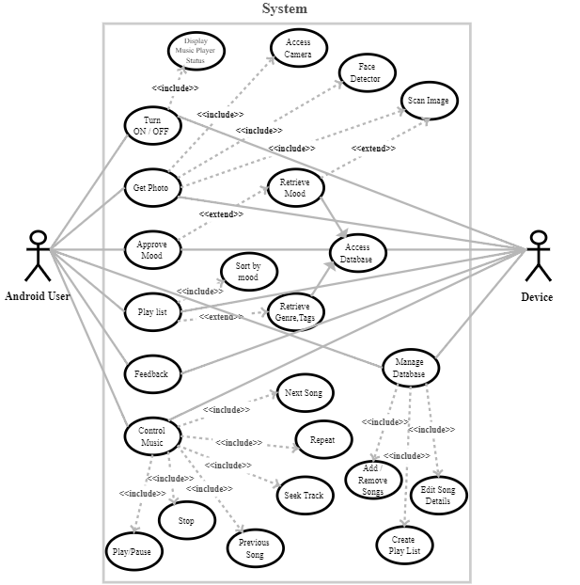

Diagram 1.1 Use Case diagram

* **Sequence Diagram**

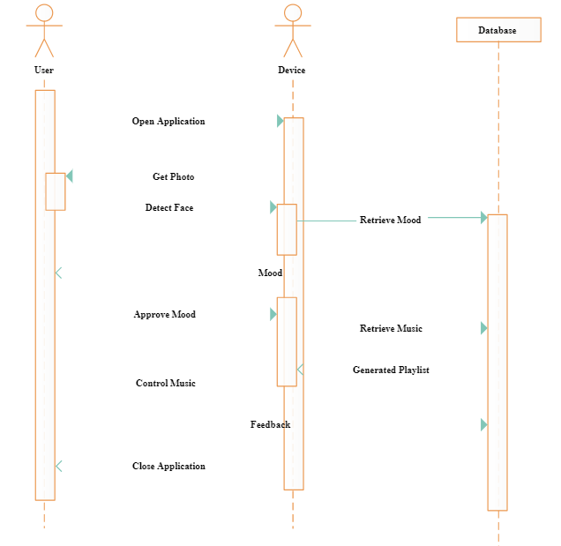

Diagram 1.2 Sequence Diagram

**Data Flow Diagram (LEVEL1)**

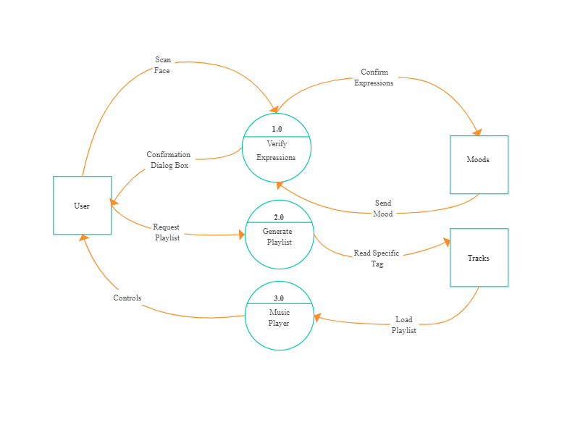

Diagram 1.3 Data Flow Diagram

-

**Chapter 6: Screenshots**

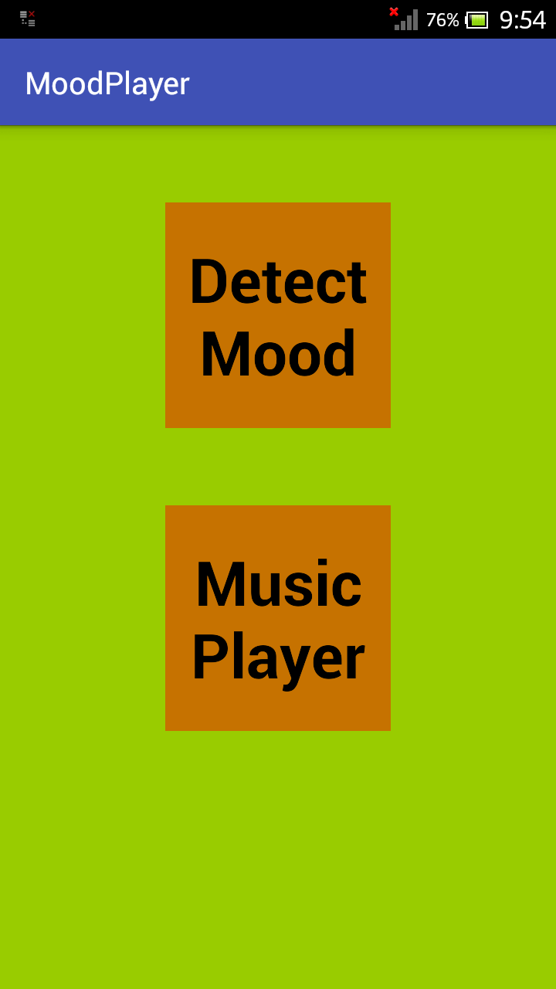

Figure 1.1 Home screen

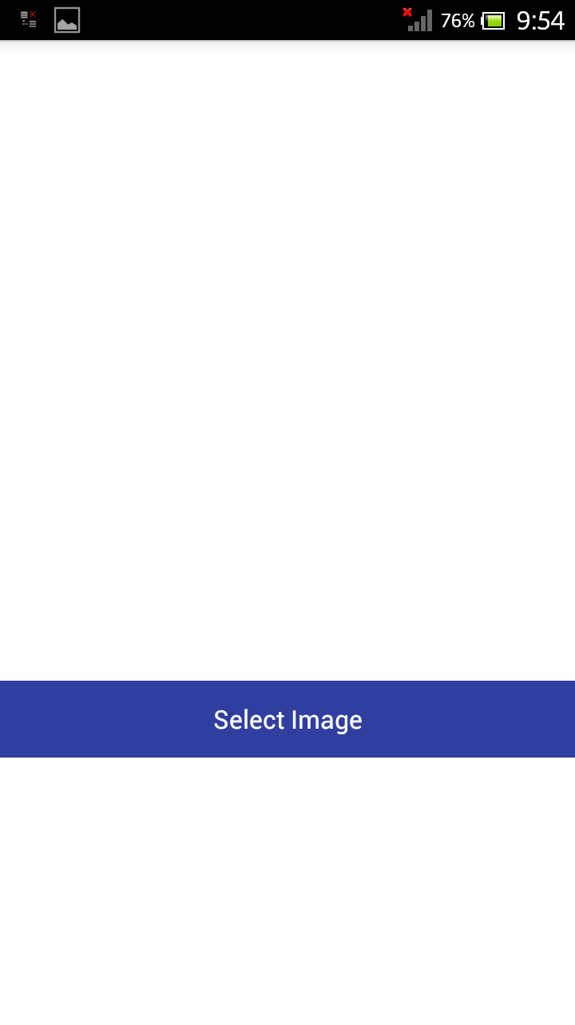

Figure 1.2 Detect Mood Screen

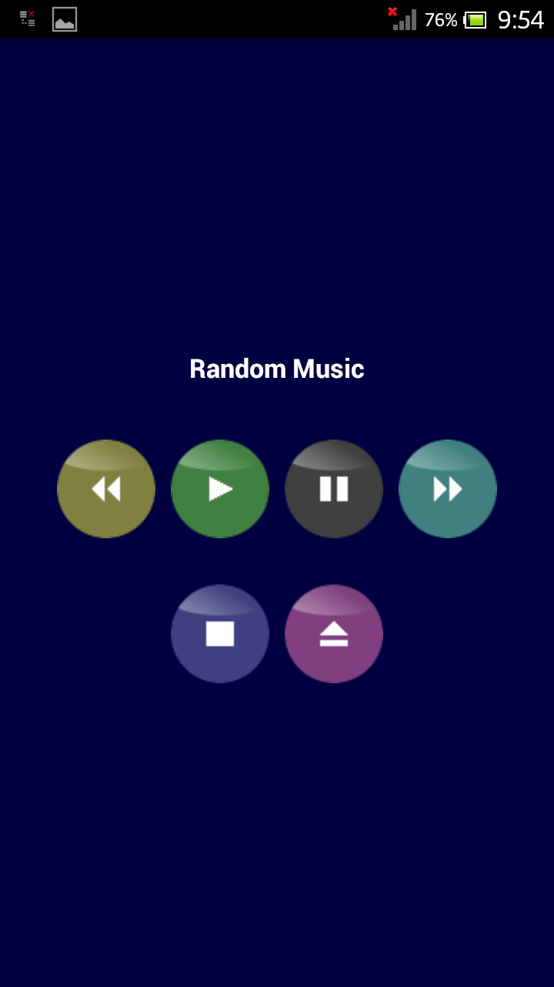

Figure 1.3 Music player Screen

**Chapter 7: Limitations**

* Internet service must required to run this Application.
* In music player we cannot skip music duration or cannot play music from specific time.

**Chapter 8: Outcome**

An innovative and creative music player having features like face analysis and playing music accordingly.

**Chapter 9: Future Enhancement**

We can enhance the feature of music player by adding feature seek bar llist view of music.

Adding feature where user can create playlist from app also.

**Chapter 10: Bibliography & References**

Microsoft Cognitive Services.

https://docs.microsoft.com/en-us/azure/cognitive-services/emotion/home

Google Developer sites.

https://developer.android.com/guide/topics/media/mediaplayer.html

https://www.cse.iitb.ac.in/~pb/papers/icon10-emotion.pdf

https://www.facedetetion.com