EXPERIMENT 1
Question 1:
Create a NumPy array containing the integers from 1 to 20. Perform the following operations:
1. Display the array.
2. Find the shape of the array.
3. Find the maximum and minimum values.
4. Calculate the mean and standard deviation.
5. Reshape the array into a 4 × 5 matrix.
6. Display the second row of the matrix.
7. Display the third column of the matrix.

CODE:
import numpy as np

arr = np.arange(1,21)
print("\nArray: ", arr)

print("\nShape of the array: ")
print(arr.shape)

print("\nMax value: ")
print(arr.max())

print("\nMin value:")
print(arr.min())
print("Mean: ")
print(arr.mean())

print("\nSTandard deviation: ")
print(arr.std())

matrix = arr.reshape(4,5)
print("\nMatrix: ", matrix)

print("\n2nd row of matrix: ", matrix[1])
print("\n3rd column: ", matrix[:,2])

OUTPUT:
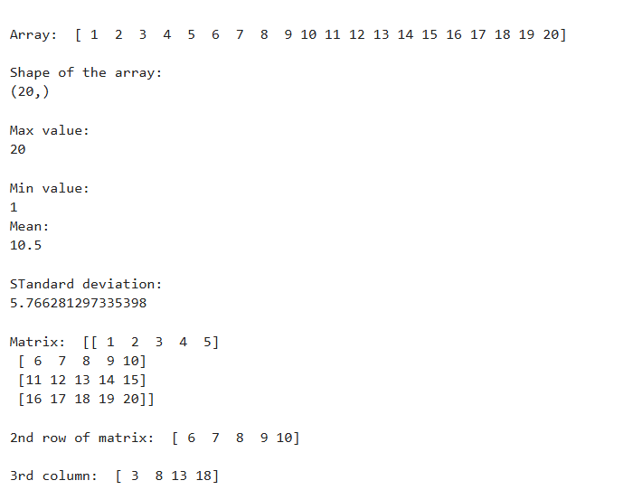

Question 2:
Create two NumPy arrays:
A = [10, 20, 30, 40, 50]
B = [5, 10, 15, 20, 25]
Perform:
1. Addition of A and B.
2. Subtraction of B from A.
3. Element-wise multiplication.
4. Element-wise division.
5. Find the sum of all elements in A.

CODE:
import numpy as np

A = np.array([10,20,30,40,50])
B = np.array([5,10,15,20,25])

addition = A + B
print("\nAddition: ", addition)

subtraction = A - B
print("\nSubtraction: ", subtraction)

mult = A * B
print("\nMultiplication: ", mult)

div = A / B
print("\nDivision : ", div)

sum_A = np.sum(A)
print("\nSUm of A: ", sum_A)

OUTPUT:
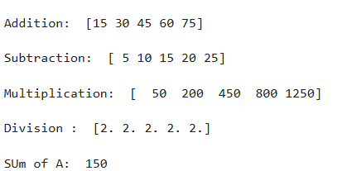

Question 3:
Create a DataFrame using the following student data:
Roll No Name Marks
101 Ravi 85
102 Priya 92
103 Kiran 78
104 Anu 88
105 Sita 95
Perform the following operations:
1. Display the DataFrame.
2. Display the first three records.
3. Find the average marks.
4. Find the student with the highest marks.
5. Find the student with the lowest marks.
6. Add a new column called "Grade" using:
o A for Marks ≥ 90
o B for Marks between 80 and 89
o C for Marks < 80

CODE:
import pandas as pd

data = {
"Roll no":[101,102,103,104,105],
"NAme":["Ravi", "Priya", "Kiran", "Anu", "Sita"],
"Marks":[85,92,78,88,95]
}

df = pd.DataFrame(data)
print("\nDataframe\n", df)

print("\nFirst 3 recs: ", df.head(3))

avg_marks = df["Marks"].mean()
print("\nAverage marks: ", avg_marks)

max_mark = df["Marks"].max()
print("\nMaximum marks: ", max_mark)

min_marks = df["Marks"].min()
print("\nMinimum marks", min_marks)

def grade(Marks):
if Marks >= 90:
return "A"
elif Marks >= 80 and Marks <= 89:
return "B"
else:
return "C"
df["Grade"] = df["Marks"].apply(grade)
print(df)

OUTPUT:
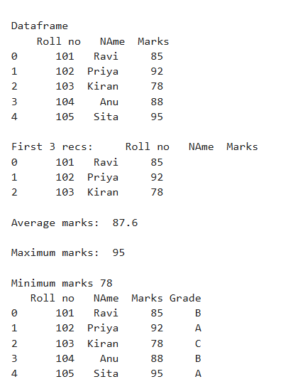
Question 4:
Create a DataFrame containing the following information:

Product | Price | Quantity
Laptop | 50000 | 10
Mouse | 500 | 50
Keyboard | 1200 | 30
Monitor | 10000 | 15

Perform:
- Calculate the total value of each product using:
- Total Value = Price × Quantity
- 2. Add the Total Value column.
- 3. Find the product with the highest total value.
- 4. Calculate the overall inventory value.

CODE:
import pandas as pd

data = {
"Product":["Laptop", "Mouse", "Keyboard", "Monitor"],
"Price":[50000,500,1200,10000],
"Quantity":[10,50,30,15]
}
df = pd.DataFrame(data)
print("\nDataframe\n", df)

df["Total"] = df["Price"] * df["Quantity"]

highest_val_pdt = df.loc[df["Total"].idxmax()]
print("\nHighest value product: ", highest_val_pdt)

inventory_value = df["Total"].sum()
print("\nOverall inventory value: ", inventory_value)

OUTPUT:
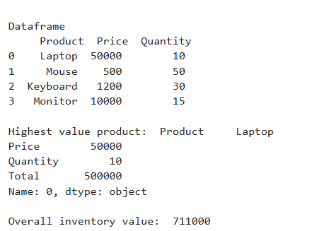

Question 5:
Download the Iris dataset from Scikit-learn and perform the following:
1. Load the dataset into a Pandas DataFrame.
2. Display the first five records.
3. Find the number of rows and columns.
4. Display column names.
5. Check for missing values.
6. Generate summary statistics using describe().
7. Find the number of samples belonging to each class.

CODE:
import pandas as pd
from sklearn.datasets import load_iris

iris = load_iris()
df = pd.DataFrame(data=iris.data, columns=iris.feature_names)
df['species'] = iris.target

species_map = {i: name for i, name in enumerate(iris.target_names)}
df['species'] = df['species'].map(species_map)

print("2. First five records:")
print(df.head())
print("\n" + "="*50 + "\n")

rows, cols = df.shape
print(f"3. Number of Rows: {rows}")
print(f" Number of Columns: {cols}")
print("\n" + "="*50 + "\n")

print("4. Column names:")
print(list(df.columns))
print("\n" + "="*50 + "\n")

print("5. Missing values per column:")
print(df.isnull().sum())
print("\n" + "="*50 + "\n")

print("6. Summary statistics:")
print(df.describe())
print("\n" + "="*50 + "\n")

print("7. Number of samples per class:")
print(df['species'].value_counts())

OUTPUT:
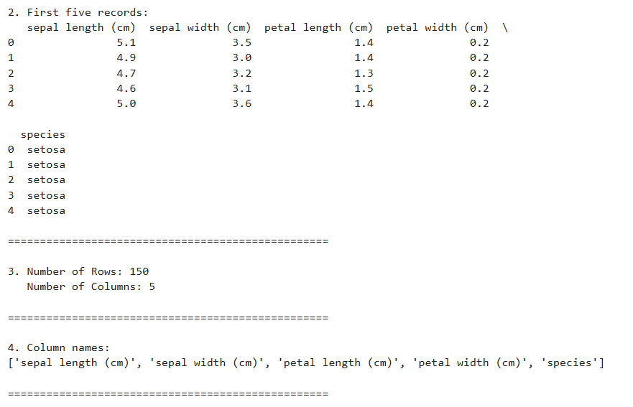
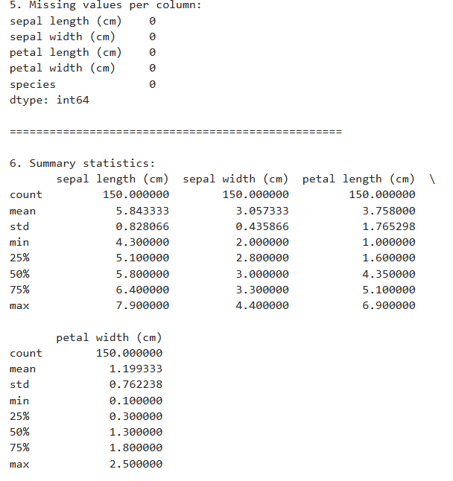
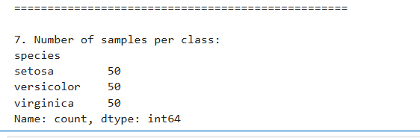

EXPERIMENT 2
AIM:
To perform exploratory data analysis (EDA) on a student performance dataset using Pandas and Matplotlib.

Dataset: Create a CSV file named student_data.csv with the following data:
RollNo | Name | Gender | Attendance | InternalMarks | ExternalMarks
101 | Ravi | M | 85 | 32 | 55
102 | Priya | F | 92 | 38 | 58
103 | Kiran | M | 78 | 28 | 45
104 | Anu | F | 95 | 40 | 60
105 | Sita | F | 88 | 35 | 54
106 | Raj | M | 70 | 25 | 40
107 | Divya | F | 90 | 37 | 57
108 | Arun | M | 82 | 30 | 48
109 | Keerthi | F | 96 | 39 | 59
110 | Naveen | M | 75 | 27 | 44

Tasks:
Task A: Dataset Loading and Inspection
• Import the necessary Python libraries.
• Load the dataset into a Pandas DataFrame.
• Display the first five records.
• Display the last five records.
• Find the total number of rows and columns.
• Display the names of all columns.
• Display the data type of each column.
• Generate dataset information using info().

CODE:
import pandas as pd

data = {
"Roll No": [101,102,103,104,105,106,107,108,109,110],
"Name": ["Ravi", "Priya", "Kiran", "Anu", "Sita", "Raj", "Divya", "Arun", "Keerthi", "Naveen"],
"Gender":['M', 'F','M', 'F', 'F','M', 'F', 'M', 'F', 'M'],
"Attendance":[85,92,78,95,88,70,90,82,96,75],
"InternalMarks": [32,38,28,40,35,25,37,30,39,27],
"ExternalMarks":[55,58,45,60,54,40,57,48,59,44]
}
df = pd.DataFrame(data)
print(df)
print()
df.to_csv("students.csv")
print("\nFirst 5\n",df.iloc[5])
print("\nLast 5\n",df.iloc[-5])
print("\nShape: ",df.shape)
print()
print(df.columns.tolist())
print()
print(df.dtypes)
print()
print(df.info())
OUTPUT :
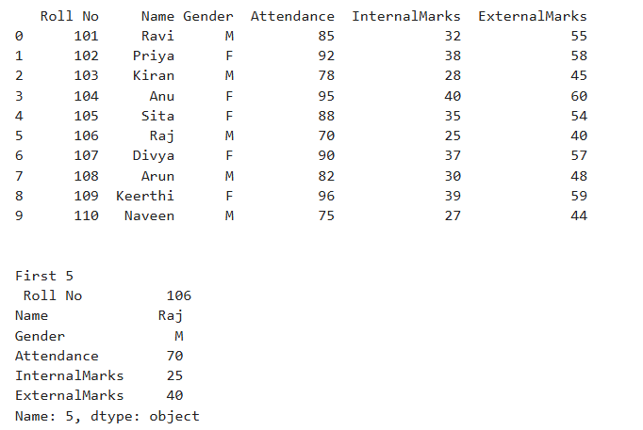
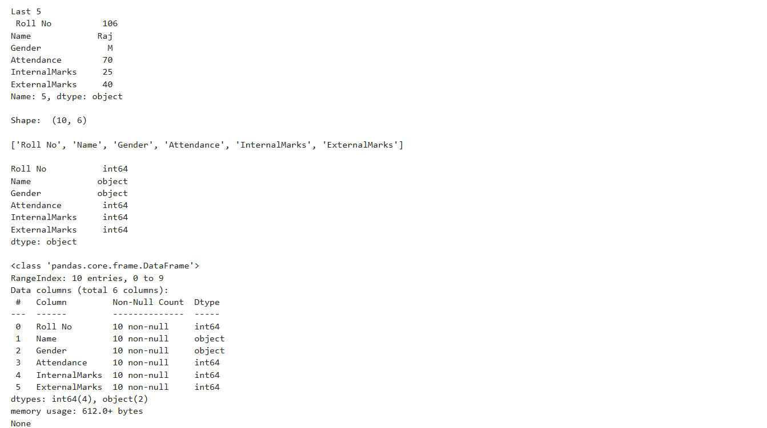

Task B: Statistical Analysis
• Calculate the mean attendance of all students.
• Calculate the average Internal Marks.
• Calculate the average External Marks.
• Find the maximum Internal Marks.
• Find the minimum Internal Marks.
• Find the maximum External Marks.
• Find the minimum External Marks.
• Calculate the standard deviation of Internal Marks.
• Generate summary statistics using describe().

CODE:
# 2.Stat analysis
att_mean = df['Attendance'].mean()
print("Mean attendance: ", att_mean)

avg = df['InternalMarks'].mean()
print("Average internal marks: ", avg)

ext_avg = df['ExternalMarks'].mean()
print("Average external marks: ", ext_avg)

min_int = df['InternalMarks'].min()
print("Minimum internal marks: ", min_int)

max_int = df['InternalMarks'].max()
print("Maximum internal marks: ", max_int)

min_ext = df['ExternalMarks'].min()
print("Minimum external marks: ", min_ext)

max_int = df['ExternalMarks'].max()
print("Maximum external marks: ", max_int)

std_dev = df['InternalMarks'].std()
print("Standard deviation of external marks: ", std_dev)

print(df.describe())

OUTPUT :
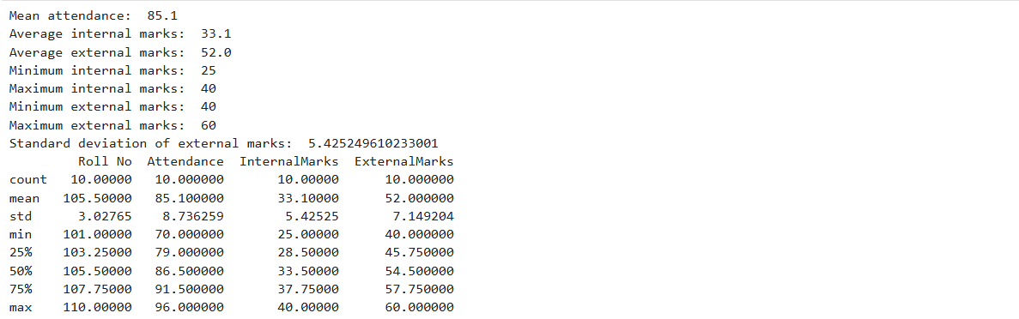

Task C: Data Manipulation
• Create a new column named TotalMarks.
• TotalMarks=InternalMarks+ExternalMarks
• Create a new column named Percentage.
- Percentage=TotalMarks/100×100
- • Display the updated DataFrame.
CODE:
# 3. Data manipulation
df['Total Marks'] = df['InternalMarks'] + df['ExternalMarks']
df['Percentage'] = (df['Total Marks'] / 100) * 100
print(df)
OUTPUT:
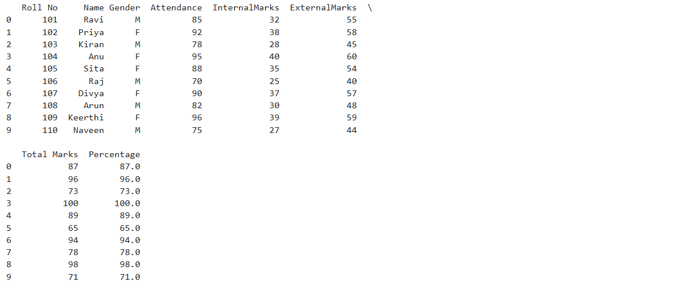

Task D: Filtering and Searching
• Display the details of students whose attendance is greater than 90%.
• Display the details of students whose TotalMarks exceed 90.
• Display the details of female students.
• Display the details of male students.
• Display students whose ExternalMarks are less than 50.

CODE:
# 4. Filtering and searcging
gr = df[df['Attendance'] > 90]
print("Students with attendance > 90: \n", gr)
print()
tot90 = df[df['Total Marks'] > 90]
print("\nStudents whose total marks exceed 90: \n", tot90)
print("\nFemale Students: \n", df[df["Gender"] == 'F'])
print("\nMAle students: \n", df[df['Gender'] == 'M'])
print("\nStudents with externals less than 50: \n", df[df['ExternalMarks'] < 50])

OUTPUT:
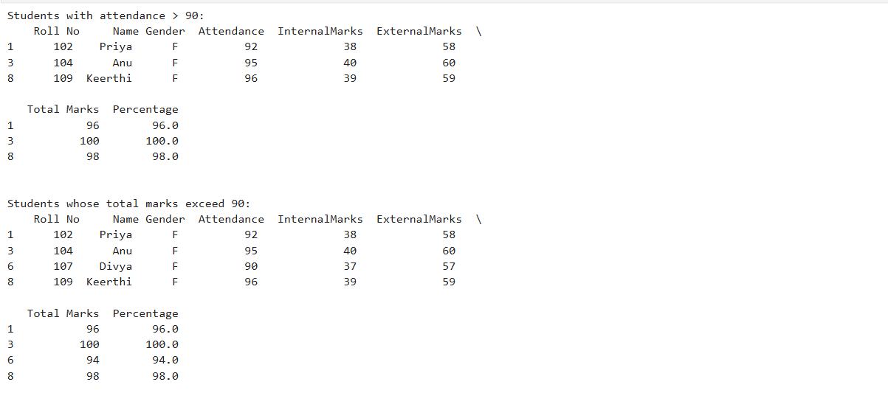
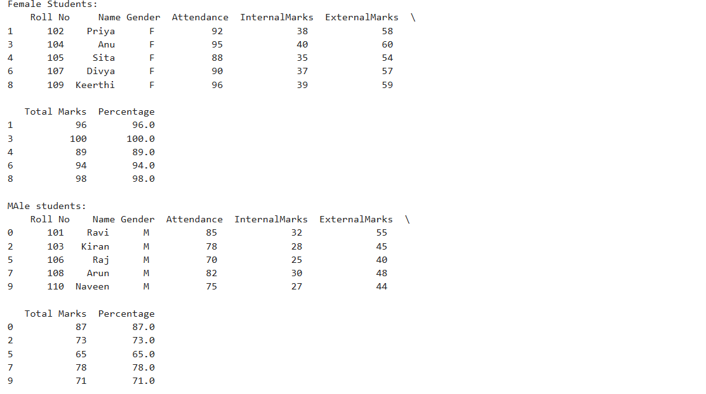
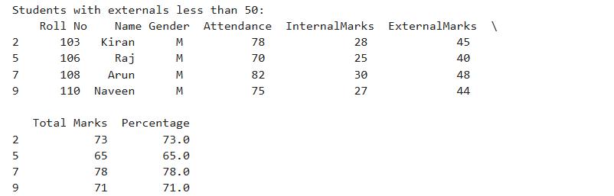
Task E: Ranking and Comparison
• Identify the student with the highest TotalMarks.
• Identify the student with the lowest TotalMarks.
• Display the top three performers based on TotalMarks.
• Display the bottom three performers based on TotalMarks.
• Determine how many students scored above the class average.

CODE:
# 5. ranking and comparison
print("Student with highest total marks: \n", df[df['Total Marks'] == df['Total Marks'].max()])
print("\nStudent with lowest total marks: \n", df[df['Total Marks'] == df['Total Marks'].min()])
print("\nTop3 performers: \n", df.nlargest(3, 'Total Marks'))
print("\nBottom 3 performers: \n", df.nsmallest(3, 'Total Marks'))

class_avg = df['Total Marks'].mean()
print("\nClass average: \n", class_avg)
above_avg = (df[df['Total Marks'] > class_avg])
print("\nStudents > class average: \n", above_avg)

OUTPUT:
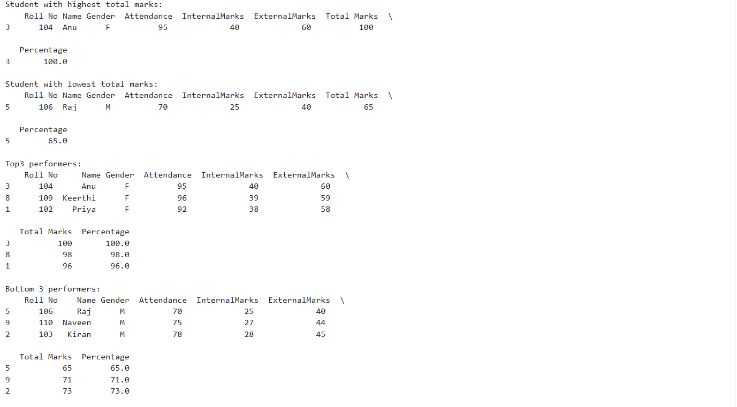
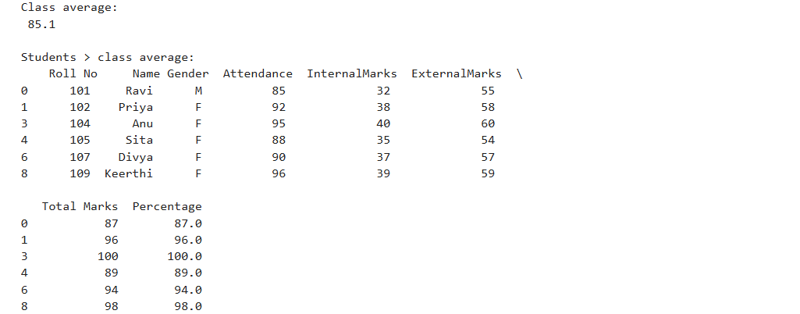

Task F: Group-wise Analysis
• Calculate the average TotalMarks of male students.
• Calculate the average TotalMarks of female students.
• Compare the average attendance of male and female students.

CODE:
# 6. Group-wise Analysis
male_avg = df[df['Gender'] == 'M']['Total Marks'].mean()
print("\nMale student avg mark: ", male_avg)

female_avg = df[df['Gender'] == 'F']['Total Marks'].mean()
print("\nFemale student avg mark: ", female_avg)

print(df.groupby('Gender')[['Attendance']].mean())

OUTPUT:
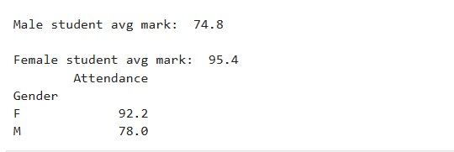

Task G: Data Visualization
• Plot a bar chart showing TotalMarks of all students.
• Plot a histogram of Attendance.
• Plot a pie chart showing the distribution of male and female students.
• Plot a scatter plot between Attendance and TotalMarks.
• Interpret the relationship between Attendance and TotalMarks.

CODE:
# 7. Data Visualization
#bar graph
import matplotlib.pyplot as plt
plt.figure(figsize=(8,5))
plt.bar(df['Name'], df['Total Marks'], color='skyblue')
plt.title("Total marks of all students")
plt.xlabel('Student Name')
plt.ylabel('Total Marks')
plt.show()

#histogram
plt.figure(figsize=(8,5))
plt.hist(df['Attendance'], bins=5, color='lightgreen', edgecolor='black')
plt.title("\nDistribution of attendance")
plt.xlabel('Student Name')
plt.ylabel('Attendance')
plt.show()

#pie chart
plt.figure(figsize=(6,6))
gender_counts = df['Gender'].value_counts()
plt.pie(gender_counts, labels=gender_counts.index, autopct='%1.1f%%', colors=['coral', 'lightblue'], startangle=90)
plt.title('Distribution of male and female students')
plt.show()

#scatter plot
plt.figure(figsize=(8, 5))
plt.scatter(df['Attendance'], df['Total Marks'], color='purple', s=100) # s=100 makes the dots larger
plt.title('Attendance vs Total Marks')
plt.xlabel('Attendance')
plt.ylabel('Total Marks')
plt.grid(True, linestyle='--', alpha=0.6) # Adds a subtle grid for readability
plt.show()

# There is a correlation between attendance and total marks. As the attendance of the student increases,
#their total marks also increase. In the above dataset given, students with the highest attendances have received the highest marks comparitively
#with those with less attendance

OUTPUT:
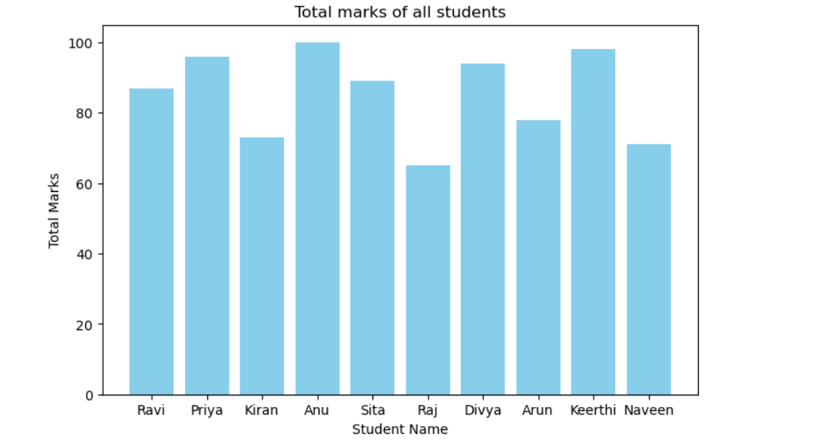
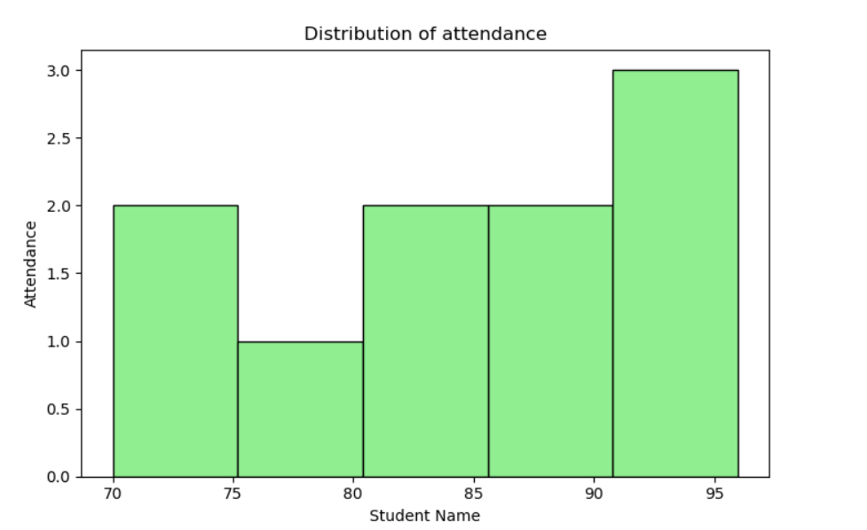
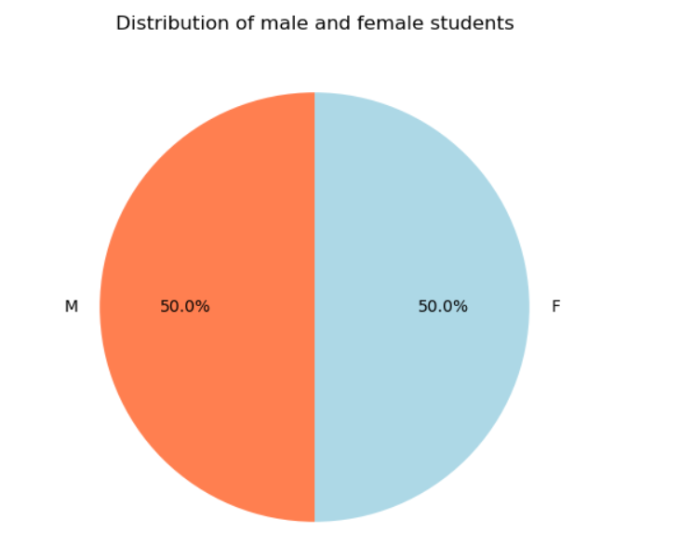
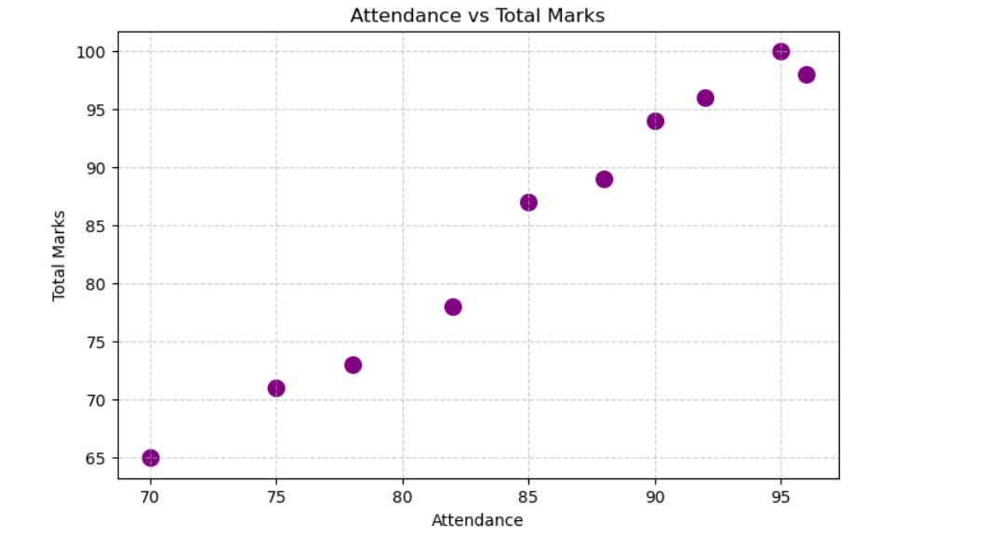

Task H: Observations
• Write any three observations based on the analysis performed.
• State whether higher attendance appears to be associated with better academic performance.

- Female students have outperformed male students in both marks and attendance
- All the top 3 performers have maintained an attendance over 90
- The guy with the least attendance have scored the least marks among all
- Yes, higher attendance appears to be strongly associated with better academic performance

