**23CSE111**

**OBJECT ORIENTED PROGRAMMING**

**LAB REPORT**



**Department of Computer Science Engineering**

**Amrita School of Computing**

**Amrita Vishwa Vidyapeetham,**

**Amaravati Campus**

**Name: M.Nishanth**

**Roll No: AV.SC.U4CSE24217**

**Verified By :**

**INDEX**

|  |  |  |
| --- | --- | --- |
| S.NO | EXPERIMENT | SIGNATURE |
| 1. | Installing java in our device. |  |
| 2. | Program for entering student details. |  |
| 3. | Program to calculate the simple intrest |  |
| 4. | To find Fibonacci series upto some number. |  |
| 5. | To find temperature in Celsius. |  |
| 6. | To find factorial of a given number. |  |
| 7. | Program to convert from Celsius to fahrenhiet |  |
| 8. | Program to calculate the area of a triangle using heron’s formula. |  |
| 9. | To create java program with following instructions  1.Create a class with name car  2. Create four attributes named car_color ,Car_brand,fuel_type,mileage  3. Create three methods named start(), stop(). Service()  4. Create three objects named car1,car2 and car3 |  |
| 10. | To create a class bankAccount with methods deposit() and withdrawl |  |
| 11. | Write a java program with class named “book”. the class should contain various attributes such as title, author, year of publication. it should also contain a constructor with parameters which initializes title, author, year of publication and create a method which displays the details of 2 books. |  |
| 12. | Write a java program with class named “myclass” with a static variable count of int type. intialize it to zero and a constant variable “pi” of type double initialized to “3.14” as attributes of that class. now define a constructor for “myclass”, that increments the count variable each time an object of “myclass” is created. finally, print the final values of ‘count’ and ‘pi’ variables and create 3 objects. |  |
| 13. | create a calculator using the operations add, subtarct, multiplication and division using multilevel inheritance and display the desired output. |  |
| 14. | A vehicle rental company wants to develop a system that maintains information about different types of vehicles available for rent. The company rents out cars , bikes and  trucks and they need a program to store details about each vehicle, such as brand and speed.  *Cars should have an additional property such as number_of_doors .  *Bikes should have a property indicating whether they have gears or not.  *Truck should have a property of their capacity(in tons).  *Every class should have a constructor. |  |
| 15. | Write a java program to create a Vehicle class with a method displayInfo().Override this method in the car subclass to provide specific information about a car. |  |
| 16 | Create a calculator class with overloaded methods to perform addition:  1.add two integers  2.add 2 doubles  3.add 3 integers |  |
| 17 | Create a shape class with a method “calculateArea()” that is overloaded for different shapes(ex:square,rectangle,triangle).then create a subclass “Circle” that overrides the calcArea() method for a circle. |  |
| 18. | A college is developing an automated admission system that verifies student’s eligibility for Undergraduate(UG) and Postgraduate(PG) programs. Each program has different eligibility criteria based on the student’s percentage in their previous qualification.  CONDITION:  1.UG admission require minimum of 60%,PG admission require minimum of 70%. |  |
| 19 | WRITE A JAVA PROGRAM TO CREATE AN ABSTRACT CLASS “ANIMAL” WITH AN ABSTRACT METHOD CALLED “Sound()”. CREATE SUBCLASSES LION AND TIGER THAT EXTEND THE ANIMAL CLASS ANDIMPLEMENT THE “Sound()” METHOD TO MAKE A SPECIFIC SOUND FOR EACH ANIMAL. |  |
| 20 | WRITE A JAVA PROGRAM TO CREATE AN ABSTRACT CLASS “SHAPE3D”  WITH ABSTRACT METHODS “calculateVolume()” AND  “calculateSurfacArea()”. CREATE SUBCLASSES SPHERE AND CUBE THAT  EXTEND THE SHAPE3D CLASS AND IMPLEMENT THE RESPECTIVE  METHODS TO CALCULATE THE VOLUME AND SURAFEC AREA OF EACH  SHAPE. |  |
| 21 | WRITE A JAVA PROGRAM USING AN ABSTRACT  CLASS TO DEFINE A METHOD FOR PATTERN  PRINTING.  CREATE AN ABSTRACT CLASS NAMED  “PatternPrinter” WITH AN ABSTRACT  METHOD “Printpattern(int)” AND A CONCRETE  METHOD TO DISPLAY THE PATTERN TITLE.  IMPLEMENT 2 SUBCLASSES,  1.STAR PATTERN PRINTS A RIGHT ANGLED TRIANGLE OF STARS  2.NUMBER PATTERN PRINTS A RIGHT ANGLED TRAINGLE OF INCREASING NUMBERS.  IN THE MAIN METHOD, CREATE OBJECTS OF BOTH SUBCLASSES AND PRINT PATTERN FOR A GIVEN NUMBER OF ROWS. |  |
| 22 | WRITE A JAVA PROGRAM TO CREATE AN  INTERFACE “Playable” WITH A  METHOD “Play()” THAT TAKES NO ARGUMENTS  AND RETURNS VOID.  CREATE 3 CLASSES Football, Volleyball and  Basketball THAT IMPLEMENTS  THE Playable INTERFACE ABD OVERRIDE THE  play() METHOD TO PLAY RESPECTIVE SPORTS |  |
| 23 | WRITE A JAVA PROGRAM TO CREATE AN  INTERFACE “Shape” WITH THE  “getPerimeter()” METHOD. CREATE 3 CLASSES  “Rectangle”, “Circle” and  “Triangle” THAT IMPLEMENTS THE SHAPE  INTERFACE. IMPLEMENT THE  “getPerimter()” METHOD FOR EACH OF 3  CLASSES. |  |

**OBJECT ORIENTED PROGRAMMING LAB REPORT**

**TASK 1: JAVA INSTALLATION ON WINDOWS**

**STEP 1:** Go to the official website.

STEP 2: Install JDK 21.

STEP 2: Environmental Variable Set-Up.

STEP 3: Set the path to C:\Program Files\Java\JDK 21\Bin

(The files will be stored in the bin)

STEP 4: Search for the environmental variables in the Environmental Variable Set-Up.

STEP 5: Select the path in system variables for multiple users.

STEP 7: Paste the above selected path in the “New” section.

STEP 8: Go to the Command Prompt Window and verify the installation by typing “—version” or “javac –version”.

**TASK 2: First Java Program**

AIM: **Execute First Java Program with Student Details.**

**PROGRAM:**

**OUTPUT:**

**ERRORS:**

|  |  |  |
| --- | --- | --- |
| **1** | Syntax error | Semicolon Added |
| **2** | Runtime Error | Copied correct path |
| **3** | Name Error | Rectified |

**WEEK-2**

**AIM: WRITE A JAVA PROGRAM TO CALCULATE THE SIMPLE INTEREST WITH INPUTS**

**PROGRAM:**

public class SimpleInterest {

    public static void main(String[] args) {

        Scanner scanner = new Scanner(System.in);

        System.out.print("Enter the principal amount: ");

        double principal = scanner.nextDouble();

        System.out.print("Enter the rate of interest (in %): ");

        double rate = scanner.nextDouble();

        System.out.print("Enter the time period (in years): ");

        double time = scanner.nextDouble();

        double simpleInterest = (principal * rate * time) / 100;

        System.out.println("The Simple Interest is: " + simpleInterest);

        scanner.close();

    }

}

**OUTPUT:**

**NEGATIVE CASE:**

1.When we give input in decimal form for principal value it will show error.

2.It can’t compile the code and can’t show the output

**IMPORTANT POINTS:**

1.We have used scanner method to give input to the code

2.Formula of simple interest is (P*T*R)/100

3.We have assigned values for P,T,R

**Errors:**

|  |  |  |  |
| --- | --- | --- | --- |
| **S.No** | **Error Type** | **Reason for error** | **Rectification** |
| 1 | Runtime error | Incorrect path | Copied correct path |
| 2 | Syntax error | { missing | { added |

1. **AIM: WRITE A JAVA PROGRAM TO FIND THE FACTORIAL OF A NUMBER**

**PROGRAM:**

import java.util.Scanner;

public class FactorialCalculator {

public static void main(String[] args) {

Scanner scanner = new Scanner(System.in);

System.out.print("Enter a number: ");

int number = scanner.nextInt();

int result = factorial(number);

System.out.println("Factorial of " + number + " is: " + result);

scanner.close();

}

public static int factorial(int n) {

if (n == 0) {

return 1;

} else {

return n * factorial(n - 1);

}

}

}

OUTPUT:

**NEGATIVE CASE:**

1.When we give input in decimal form for principal value it will show error.

2.It can’t compile the code and can’t show the output.

**ERROR:**

|  |  |  |  |
| --- | --- | --- | --- |
| **S.No** | **Error type** | **Reason for error** | **rectification** |
|  | Logical error | Incorrect input | Correcting input |
|  | Runtime error | Incorrect path | Using correct path |

**IMPORTANT POINTS:**

1. **Importing Scanner:**
   * The code imports the Scanner class from the java.util package to read user input.
2. **Main Method:**
   * The main method is the entry point of the program. It creates a Scanner object to read user input and prompts the user to enter a number**.**
3. **Factorial Calculation: The factorial method is defined as a static method that takes an integer n and returns the factorial of n.**
   * method uses recursion to calculate the factorial. If n is 0, it returns 1 (base case). Otherwise, it returns n * factorial (n - 1).
4. **Closing Scanner:**
   * The scanner.close() method is called to close the Scanner object and release the resources associated with it.
5. **Recursion:**

The use of recursion in the factorial method is a key point. It repeatedly calls itself with decremented values of n until it reaches the base case

**3 . AIM:WRITE A JAVA PROGRAM TO CONVERT CELCIUS TO FAHRENHEIT**

**PROGRAM :**

import java.util.Scanner;

public class CelsiusToFahrenheit {

public static void main(String[] args) {

Scanner scanner = new Scanner(System.in);

System.out.print("Enter temperature in Celsius: ");

double celsius = scanner.nextDouble();

double fahrenheit = celsiusToFahrenheit(celsius);

System.out.println("Temperature in Fahrenheit: " + fahrenheit);

scanner.close();

}

public static double celsiusToFahrenheit(double celsius) {

return (celsius * 9/5) + 32;

}

}

**OUTPUT:**

**NEGATIVE CASE:**

**IMPORTANT POINTS TO NOTE:**

**1. Importing Scanner Class:**

* The Scanner class is imported from java.util.Scanner to take user input.

**2. Class Declaration:**

* The class name CelsiusToFahrenheit follows Java naming conventions (PascalCase).

**3. Main Method:**

* The public static void main(String[] args) method is the entry point of the program

|  |  |  |  |
| --- | --- | --- | --- |
| **S.No** | **Error type** | **Reason for error** | **rectification** |
| **1.** | **Logical error** | **Incorrect input** | **Correcting input** |
| **2.** | **Runtime errror** | **Incorrect path** | **Using correct path** |

**3.AIM: JAVA PROGRAM TO CONVERT FAHRENHEIT TO CELCIUS**

**PROGRAM:**

import java.util.Scanner;

public class FahrenheitToCelsius {

public static void main(String[] args) {

Scanner scanner = new Scanner(System.in);

System.out.print("Enter temperature in Fahrenheit: ");

double fahrenheit = scanner.nextDouble();

double celsius = fahrenheitToCelsius(fahrenheit);

System.out.println("Temperature in Celsius: " + celsius);

scanner.close();

}

public static double fahrenheitToCelsius(double fahrenheit) {

return (fahrenheit - 32) * 5/9;

}

}

**OUTPUT:**

**NEGATIVE CASE:**

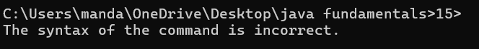

**IMPORTANT POINTS:**

* import java.util.Scanner; is used to include the Scanner class to take user input.

**1.Class Declaration:**

* The class is named FahrenheitToCelsius which follows Java naming conventions.

**2. Main Method:**

* The program execution starts from the main() method:

public static void main(String[] args)

**3.Scanner Class:**

* The Scanner object is created to take input from the user:

Scanner scanner = new Scanner(System.in);

**ERRORS:**

|  |  |  |  |
| --- | --- | --- | --- |
| **S.No** | **Error type** | **Reason for error** | **Rectification** |
| 1. | Logical error | Due to incorrect input | Corrected by giving correct input |
| 2. | Runtime error | Incorrect path | Using correct path |

**5 . AIM: WRITE A JAVA PROGRAM TO FIND THE AREA OF A TRIANGLE**

**PROGRAM:**

import java.util.Scanner;

public class TriangleArea {

public static void main(String[] args) {

Scanner scanner = new Scanner(System.in);

System.out.print("Enter the base of the triangle: ");

double base = scanner.nextDouble();

System.out.print("Enter the height of the triangle: ");

double height = scanner.nextDouble();

double area = calculateArea(base, height);

System.out.println("The area of the triangle is: " + area);

scanner.close();

}

public static double calculateArea(double base, double height) {

return (base * height) / 2;

}

}

**OUTPUT:**

**IMPORTANT POINTS:**

**User Input:**

* The user is prompted to enter:
  + Base of the triangle
  + Height of the triangle

**Method Call:**

* The method calculateArea(base, height) is called to calculate the area of the triangle.

**Return Value:**

* The method returns the area value to the main() method.

**ERRORS:**

|  |  |  |  |
| --- | --- | --- | --- |
| **S.No** | **Error type** | **Reason for error** | **rectification** |
| **2.** | **Runtime errror** | **Incorrect path** | **Using correct path** |
| **3.** | **Syntax error** | **No semicoln** | **Using semicoln** |

**6. AIM: WRITE A JAVA PROGRAM TO FIND THE AREA OF A RECTANGLE**

**PROGRAM:**

import java.util.Scanner;

public class RectangleArea {

public static void main(String[] args) {

Scanner scanner = new Scanner(System.in);

System.out.print("Enter the length of the rectangle: ");

double length = scanner.nextDouble();

System.out.print("Enter the width of the rectangle: ");

double width = scanner.nextDouble();

double area = calculateArea(length, width);

System.out.println("The area of the rectangle is: " + area);

scanner.close();

}

public static double calculateArea(double length, double width) {

return length * width;

}

}

**OUTPUT:**

**NEGATIVE CASE:**

**IMPORTANT POINTS:**

**1. Purpose:** The program calculates the area of a rectangle based on the user-provided length and width.

**2. User Input:**

* It prompts the user to input the rectangle's length and width.
* The input is read using the Scanner class and stored as double values to allow for decimal measurements.

**3.Modularity:**

* The calculation logic is placed in a separate method, calculateArea(), which takes length and width

**ERRORS:**

|  |  |  |
| --- | --- | --- |
| **1** | **Syntax error** | **Semicolon added** |
| **2.** | **Name error** | **rectified** |

**7.AIM: WRITE A JAVA PROGRAM FOR FIBONACCI SEQUENCE**

**PROGRAM:**

import java.util.Scanner;

public class Fibonacci {

public static void main(String[] args) {

Scanner sc = new Scanner(System.in);

int num;

int f3;

int f1 = 0;

int f2 = 1;

int i = 2;

System.out.print("Enter a number: ");

num = sc.nextInt();

System.out.println(f1);

System.out.println(f2);

while(i < num) {

f3 = f1 + f2;

f1 = f2;

f2 = f3;

System.out.println(f3);

i = i + 1;

}

sc.close();

}

}

**OUTPUT:**

**NEGATIVE CASE:**

1.I have rearranged the starting two elements from 0 and 1 to 1 and 0.

2.Therefore, the order of Fibonacci series is changed.

**ERRORS:**

|  |  |  |  |
| --- | --- | --- | --- |
| **S.No** | **Error type** | **Reason for error** | **Rectification** |
| 1 | Name error | Incorrect usage of function | Correcting by using correct formula |
| 2 | Syntax error | No semicolon | Semicolon added |
| 3 | Runtime error | Incorrect path | Copied correct path |

**IMPORTANT POINTS:**

1. Importing Scanner:

* The code imports the Scanner class from the java.util package to read user input.

2. Class Declaration:

* The code declares a class named fibo.

3. Main Method:

* The main method is the entry point of the program. It creates a Scanner object to read user input and prompts the user to enter a number.

4. Variable Initialization:

* The code initializes variables:
  + num: The number of Fibonacci terms to be generated.
  + f3: Used to store the next Fibonacci term.
  + f1 and f2: The first two terms of the Fibonacci sequence, initialized to 0 and 1, respectively.
  + i: Counter variable initialized to 2 since the first two terms are already known.

**WEEK-3**

**Aim:**

**To create java program with following instructions**

**1.Create a class with name car**

**2. Create four attributes named car colour ,Car brand, fuel type, mileage**

**3. Create three methods named start(), stop(). Service()**

**4. Create three objects named car1, car2 and car3**

**PROGRAM:**

import java.util.*;

class car

{

    public String Car_color;

    public String Car_brand;

    public String fuel_type;

    public int mileage;

   public void start()

   {

       System.out.println("Car Started:");

       System.out.println("Car color is :"+Car_color);

       System.out.println("Car Brand is:"+Car_brand);

       System.out.println("Car fuel type is:"+fuel_type);

       System.out.println("Car mileage is:"+mileage);

   }

    public void service()

   {

       System.out.println("Car Started:");

       System.out.println("Car color is :"+Car_color);

       System.out.println("Car Brand is:"+Car_brand);

       System.out.println("Car fuel type is:"+fuel_type);

       System.out.println("Car mileage is:"+mileage);

   }

    public void stop()

   {

       System.out.println("Car Started:");

       System.out.println("Car color is :"+Car_color);

       System.out.println("Car Brand is:"+Car_brand);

       System.out.println("Car fuel type is:"+fuel_type);

       System.out.println("Car mileage is:"+mileage);

   }

   public static void main(String args[])

   {   System.out.println("\nNishanth\n\n");

       car car1 = new car();

       car1.Car_color = "Black";

       car1.Car_brand = "Mercedes";

       car1.fuel_type = "Diesel";

       car1.mileage = 100;

      car1.start();

       car car2 = new car();

       car2.Car_color = "White";

       car2.Car_brand = "BMW";

       car2.fuel_type = "Petrol";

       car2.mileage = 200;

       car2.stop();

       car car3 = new car();

       car3.Car_color = "Red";

       car3.Car_brand = "Skoda";

       car3.fuel_type = "Petrol";

       car3.mileage = 300;

      car3.service();

    }

}

**OUTPUT:**

**CLASS DIAGRAM:**

|  |
| --- |
| car |
| - Car_color: String  - Car_brand: String  - fuel_type: String  - mileage: int |
| + start(): void  + service(): void  + stop(): void |

**IMPORTANT POINTS**:

1. The car class has four attributes: Car_color, Car_brand, fuel_type, and mileage.

2. It also has three methods: start(), service(), and stop().

3. The start(), service(), and stop() methods all print the same details about the car.

4. Each method prints the car's color, brand, fuel type, and mileage to the console

5. The main method creates three instances of the car class: car1, car2, and car3.

6. Each car object is assigned specific values for Car_color, Car_brand, fuel_type, and mileage**.**

**AIM:**

**WRITE A JAVA CLASS FOR A BANK ACCOUNT WITH DEPOSIT() AND WITHDRAW() AS METHODS.**

**PROGRAM:**

class BankAccount {

    private double balance;

    public BankAccount(double initialBalance) {

        if (initialBalance > 0) {

            this.balance = initialBalance;

        } else {

            this.balance = 0;

        }

    }

    public void deposit(double amount) {

        if (amount > 0) {

            balance += amount;

            System.out.println("Deposited $:" + amount);

        } else {

            System.out.println("Deposited amount must be positive");

        }

    }

    public double getBalance() {

        return balance;

    }

}

public class Main1 {

    public static void main(String args[]) {

        BankAccount account = new BankAccount(50000);

        account.deposit(25000);

        System.out.println("Current Balance is:" + account.getBalance());

    }

}

**OUTPUT:**

**CLASS DIAGRAM:**

|  |
| --- |
| **BankAccount** |
| -balance: double |
| +BankAccount(doubleinitialBalance  +deposit(doubleamount): void  + getBalance(): double |

**IMPORTANT POINTS:**

The Bank Account class has a private attribute balance to store the account balance.

* The class has a constructor, BankAccount(double initialBalance), which initializes the balance. If the initial balance is not positive, it sets the balance to 0.
* The deposit(double amount) method adds a positive amount to the balance and prints a message. If the deposit amount is not positive, it prints an error message.
* The getBalance() method returns the current balance of the account.
* The Main1 class contains the main method, which serves as the entry point of the program.
* In the main method, an instance of Bank Account is created with an initial balance of 1000.

**WEEK-4**

**1.AIM: WRITE A JAVA PROGRAM WITH CLASS NAMED “Book”. THE CLASS SHOUKD CONTAIN VARIOUS ATTRIBUTES SUCH AS TITLE, AUTHOR, YEAR OF PUBLICATION. IT SHOULD ALSO CONTAIN A CONSTRUCTOR WITH PARAMETERS WHICH INITIALIZES TITLE, AUTHOR, YEAR OF PUBLICATION AND CREATE A METHOD WHICH DISPLAYS THE DETAILS OF 2 BOOKS.**

**PROGRAM:**

public class Book {

public String title;

public String author;

public int year;

Book(String title, String author, int year) {

this.title = title;

this.author = author;

this.year = year;

}

public void displayDetails() {

System.out.println("Title: " +title);

System.out.println("Author: " +author);

System.out.println("Year of Publication" +year);

}

public static void main(String[] args) {

Book b1 = new Book("Math", "Ramanujan", 1950);

Book b2 = new Book("Physics", "CV Raman", 1960);

b1.displayDetails();

b2.displayDetails();

}

}

**OUTPUT:**

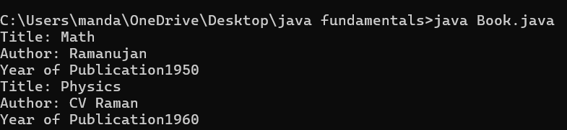

**NEGATIVE CASE:**

**ERROR:**

|  |  |  |  |
| --- | --- | --- | --- |
| **S.No** | **ERROR TYPE** | **Reason for error** | **Rectification** |
| **1.** | Syntax error | No semicolon | Semicolon added |
| **2.** | Runtime error | Incorrect path | Copied correct path |

**CLASS DIAGRAM:**

|  |
| --- |
| Book |
| -title: String  -author: String  -year: int |
| + Book(title: String, author:String, year: int) + displayDetails(): void |

**IMPORTANT POINTS:**

1. **Constructor**:

* The constructor Book(String, String, int) is used to initialize the object when it is created.
* The keyword **this** is used to differentiate between class attributes and constructor parameters.

2.**Method**:

* The method displayDetails() is used to display the book details.
* The **System.out.println()** method prints the details to the console.

3. **Object Creation**:

* Two objects b1 and b2 are created using the constructor.

**2.AIM: WRITE A JAVA PROGRAM WITH CLASS NAMED “MyClass” WITH A STATIC VARIABLE COUNT OF INT TYPE. INTIALIZE IT TO ZERO AND A CONSTANT VARIABLE “Pi” OF TYPE DOUBLE INITIALIZED TO “3.14” AS ATTRIBUTES OF THAT CLASS. NOW DEFINE A CONSTRUCTOR FOR “MyClass”, THAT INCREMENTS THE COUNT VARIABLE EACH TIME AN OBJECT OF “MyClass” IS CREATED. FINALLY, PRINT THE FINAL VALUES OF ‘COUNT’ AND ‘PI’ VARIABLES AND CREATE 3 OBJECTS.**

**PROGRAM:**

public class MyClass {

static int count = 0;

static final double pi = 3.14;

MyClass() {

count++;

}

public static void main(String[] args) {

MyClass obj1 = new MyClass();

MyClass obj2 = new MyClass();

MyClass obj3 = new MyClass();

System.out.println("Count: " +count);

System.out.println("Pi: " +pi);

}

}

**OUTPUT:**

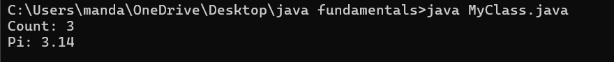

**NEGATIVE CASE:**



**ERROR:**

|  |  |  |  |
| --- | --- | --- | --- |
| **S.No** | **Error Type** | **Reason for error** | **Rectification** |
| **1.** | No class | No class name declared | Created class named ‘MyClass’ |
| **2.** | Syntax error | Not added keyword | Added keyword named ‘new’ |

**CLASS DIAGRAM:**

|  |
| --- |
| MyClass |
| -count: int (static)  -pi: double (static, final) |
| +MyClass()  +main(args: String[]):void |

**IMPORTANT POINTS:**

**1.Static Keyword**

* Static members belong to the **class, not to individual objects**.
* Only one copy of the static variable is maintained for all objects.

**2.Static Variable**

* **static int count**:
  + Shared among all objects of the class.
  + It is initialized only once and not for every object.
  + It increments every time the constructor is called.

**3.Final Variable**

* **static final double pi**:
  + The **final** keyword makes the variable constant.
  + Its value **cannot be changed** once assigned.
  + It must be initialized at the time of declaration.

**WEEK-5**

**AIM: Create a calculator using the operations add, subtract, multiplication and division using multilevel inheritance and display the desired output.**

**PROGRAM:**

import java.util.Scanner;

class Addition {

    public int add(int a, int b) {

        return a + b;

    }

}

class Subtraction extends Addition {

    public int subtract(int a, int b) {

        return a - b;

    }

}

class MultiplicationDivision extends Subtraction {

    public int multiply(int a, int b) {

        return a * b;

    }

    public double divide(int a, int b) {

        if (b == 0) {

            System.out.println("Division by zero is not allowed.");

            return 0;

        }

        return (double) a / b;

    }

}

public class Calculator {

    public static void main(String[] args) {

        int num1 = 25;

        int num2 = 2;

        MultiplicationDivision calculator = new MultiplicationDivision();

        System.out.println("Number 1: " + num1);

        System.out.println("Number 2: " + num2);

        System.out.println("Result (Addition): " + calculator.add(num1, num2));

        System.out.println("Result (Subtraction): " + calculator.subtract(num1, num2));

        System.out.println("Result (Multiplication): " + calculator.multiply(num1, num2));

        System.out.println("Result (Division): " + calculator.divide(num1, num2));

    }

}

**OUTPUT:**

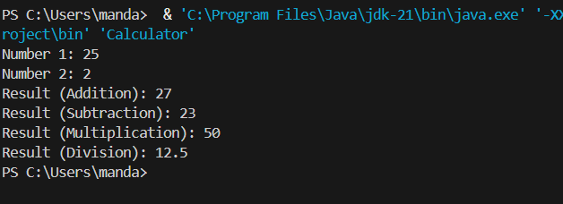

**NEGATIVE CASE:**

**ERROR TABLE:**

|  |  |  |
| --- | --- | --- |
| **S.No** | **Error** | **Rectificaton** |
| **1.** | Compiliation error | Removed the ‘public‘from main class |

**CLASS DIAGRAM:**

|  |
| --- |
| Addition |
| **+ add(int a, int b): int** |

|  |
| --- |
| **Subtraction** |
| **+ subtract (int a, int b): int** |

|  |
| --- |
| **MultiplicationDivision** |
| **+multiply(inta ,int b): int**  **+divide(int a, int b): int** |

**IMPORTANT POINTS:**

**1. Inheritance Hierarchy**

* The code demonstrates **multi-level inheritance**:
  + Addition → Subtraction → MultiplicationDivision
* Each child class **extends** the previous one, inheriting its methods while adding new functionality.

**2. Method Overloading vs. Overriding**

* There is **no method overriding** here (no method is redefined in child classes).
* Instead, each subclass **adds new methods**:
  + Addition → add()
  + Subtraction → subtract()
  + MultiplicationDivision → multiply(), divide()

**AIM:**

**Create a base class BankAccount with methods deposit and withdraw. create a 2 subclasses SavingsAcc and CheckingAcc and override the withdraw method in each subclass to impose different withdraw limits and fees and create a constructor and withdraw method in base class.**

**PROGRAM:**

public class BankAcc {

    protected double balance;

    public BankAcc(double initialBalance) {

        this.balance = initialBalance;

    }

    public void deposit(double amount) {

        if (amount > 0) {

            balance += amount;

            System.out.println("Deposited: Rupees" + amount);

        } else {

            System.out.println("Deposit amount must be positive.");

        }

    }

    public void withdraw(double amount) {

        if (amount > 0 && amount <= balance) {

            balance -= amount;

            System.out.println("Withdrawn: rupees" + amount);

        } else {

            System.out.println("Insufficient balance or invalid amount.");

        }

    }

    public void displayBalance() {

        System.out.println("Current Balance: Rupees" + balance);

    }

}

class SavingsAccount extends BankAcc {

    private static final double WITHDRAW_LIMIT = 1000.0;

    public SavingsAccount(double initialBalance) {

        super(initialBalance);

    }

    @Override

    public void withdraw(double amount) {

        if (amount > WITHDRAW_LIMIT) {

            System.out.println("Withdrawal amount exceeds the limit of Rupees" + WITHDRAW_LIMIT);

        } else if (amount > 0 && amount <= balance) {

            balance -= amount;

            System.out.println("Withdrawn from Savings Account: Rupees" + amount);

        } else {

            System.out.println("Insufficient balance or invalid amount.");

        }

    }

}

class CheckingAccount extends BankAcc {

    private static final double TRANSACTION_FEE = 2.0;

    public CheckingAccount(double initialBalance) {

        super(initialBalance);

    }

    @Override

    public void withdraw(double amount) {

        double totalAmount = amount + TRANSACTION_FEE;

        if (amount > 0 && totalAmount <= balance) {

            balance -= totalAmount;

            System.out.println("Withdrawn from Checking Account: Rupees" + amount + " (Fee: Rupees" + TRANSACTION_FEE + ")");

        } else {

            System.out.println("Insufficient balance or invalid amount.");

        }

    }

}

public class Main {

    public static void main(String[] args) {

        SavingsAccount savings = new SavingsAccount(2000.0);

        savings.displayBalance();

        savings.deposit(500.0);

        savings.withdraw(1200.0); // Exceeds limit

        savings.withdraw(800.0);  // Valid withdrawal

        savings.displayBalance();

        System.out.println();

        CheckingAccount checking = new CheckingAccount(1500.0);

        checking.displayBalance();

        checking.deposit(300.0);

        checking.withdraw(100.0);  // Includes transaction fee

        checking.withdraw(2000.0); // Insufficient balance

        checking.displayBalance();

    }

}

**OUTPUT:**

**NEGATIVE CASE:**

**ERROR TABLE:**

|  |  |  |
| --- | --- | --- |
| **S.No** | **Error** | **Rectification** |
| **1.** | Compiliation error | Removed the ‘public’ from main class |
| **2.** | Syntax Error | Added parenthesis |

**CLASS DIAGRAM:**

|  |
| --- |
| BankAcc |
| * + Balance: double |
| + BankAcc(initialBalance: double)  + deposit(amount: double) : void  + withdraw(amount: double) : void  + displayBalance() : void |

|  |
| --- |
| SavingsAcc |
| -WITHDRAW_LIMIT: double = 1000.0  + withdraw(amount: double) : void |

|  |
| --- |
| CheckingAcc |
| - TRANSACTION_FEE: double = 2.0 |
| + withdraw(amount: double) : void |

**IMPORTANT POINTS:**

1. BankAcc is the parent class with:
   * A protected balance attribute
   * Public methods for deposit, withdraw, and displayBalance
   * A constructor
2. SavingsAccount extends BankAcc and:
   * Has a constant WITHDRAW_LIMIT
   * Overrides the withdraw method to enforce the limit
3. CheckingAccount extends BankAcc and:
   * Has a constant TRANSACTION_FEE
   * Overrides the withdraw method to include the fee

**AIM:**

**A vehicle rental company wants to develop a system that maintains**

**Information about different types of vehicles available for rent**

**The Company rents out cars, bikes and truck and they need a program to**

**Store details about each vehicle, such as brand and speed**

**Cars should have an additional property: number of doors**

**Bikes should have a property indicating whether they have gears or not**

**The system should also include a function to display details about each vehicle**

**And indicate when a vehicle is starting**

**PROGRAM:**

class vehicle{

    String brand;

    int speed;

    public vehicle(String brand,int speed){

        this.brand=brand;

        this.speed=speed;

    }

    public static void main(String[] args) {

        car obj1=new car("ford",34,4);

        bike obj2=new bike("hero",100,true);

        truck obj3=new truck("tata",60,40);

    }

}

class car extends vehicle{

    int noofdoors;

    public car(String brand, int speed,int noofdoors) {

        super(brand, speed);

        this.noofdoors=noofdoors;

        System.out.println("Brand of car is:"+brand);

        System.out.println("Speed of car is:"+speed);

        System.out.println("no of doors of car:"+noofdoors);

    }

}

class bike extends vehicle{

    boolean gears;

 public bike(String brand,int speed,boolean gears){

        super(brand, speed);

        this.gears=gears;

        System.out.println("Brand of bike is:"+brand);

        System.out.println("Speed of bike is:"+speed);

        System.out.println("Gears of bike:"+gears);

    }

}

class truck extends vehicle{

    int weight;

    public truck(String brand,int speed,int weight){

        super(brand,speed);

        this.weight=weight;

        System.out.println("Brand name is:"+brand);

        System.out.println("Speed of Truck is:"+speed);

        System.out.println("Weight of load is"+weight);

    }

}

**OUTPUT:**

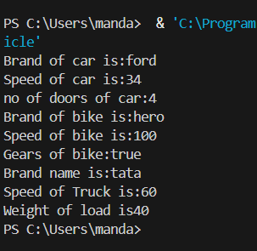

**NEGATIVE CASE:**

**ERROR TABLE:**

|  |  |  |
| --- | --- | --- |
| **S.No** | **Error** | **Rectification** |
| **1.** | Compiliation error | Removed the ‘public’ from main class |
| **2.** | Syntax Error | Added parenthesis |

**CLASS DIAGRAM:**

|  |
| --- |
| Class Vehicle |
| **+** Brand: string  +speed: int |
| Vehicle(String brand, int speed) |

|  |
| --- |
| Class Car |
| +noofdoors: int |
| +car(String brand, int speed, int noofdoors) |

|  |
| --- |
| Class Bike |
| +gears: bool |
| +bike( String brand, int speed, bool gears) |

|  |
| --- |
| Class truck |
| +weight: int |
| +truck(String brand, int speed,int weight) |

**IMPORTANT POINTS:**

1. Inheritance Hierarchy:
   * The code demonstrates a simple inheritance hierarchy where car, bike, and truck classes all inherit from the base vehicle class.
2. Base Class (vehicle):
   * Contains common properties for all vehicles: brand (String) and speed (int)
   * Has a constructor that initializes these properties
   * The main method is placed in the base class (unconventional but valid)

**WEEK-6**

**AIM:**

**WRITE A JAVA PROGRAM TO CREATE A “VEHICLE” CLASS WITH A METHOD “displayInfo()”. OVERRIDE THIS METHOD IN THE SUBCLASS TO PROVIDE SPEICIFIC INFO ABOUT THE CAR.**

**CLASS DIAGRAM:**

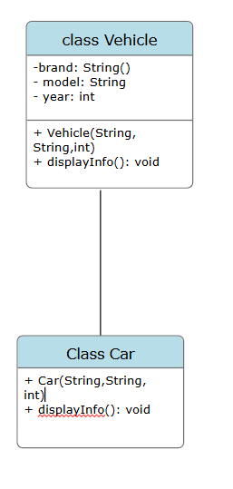

**PROGRAM:**

public class Vehicle {

    public String brand;

    public String model;

    public int year;

    public Vehicle(String brand, String model, int year) {

        this.brand = brand;

        this.model = model;

        this.year = year;

    }

    public void displayInfo() {

        System.out.println("Vehicle Information:");

        System.out.println("Brand: " + brand);

        System.out.println("Model: " + model);

        System.out.println("Year of Manufacturing: " + year);

    }

    public static void main(String[] args) {

        System.out.println("Nishanth,24217,cse-c");

        Vehicle vehicle = new Vehicle("Toyota", "Camry", 1990);

        Car car = new Car("Mitsubishi", "Pajero", 1995);

        vehicle.displayInfo();

        car.displayInfo();

    }

}

class Car extends Vehicle {

    public Car(String brand, String model, int year) {

        super(brand, model, year);

    }

    public void displayInfo() {

        System.out.println("Car Details:");

        System.out.println("Brand: " + brand);

        System.out.println("Model: " + model);

        System.out.println("Year of Manufacturing: " + year);

    }

}

**OUTPUT:**

**POSITIVE CASE:**

**NEGATIVE CASE:**



**ERROR TABLE:**

|  |  |  |
| --- | --- | --- |
| **S.NO** | **ERROR** | **RECTIFICATION** |
| **1.** | Compilation error | Added the public static to the subclass |
| **2.** | Syntax error | Added the parenthesis |

**IMPORTANT POINTS:**

1. **Encapsulation**:
   * The fields brand, model, and year are public, which is not ideal for encapsulation. Typically, fields should be private, and accessors (getters) and mutators (setters) should be used to access and modify them.

Method Overriding:

The Car class overrides the displayInfo() method from the Vehicle class.

Static Inner Class:

By making Car a static inner class, it can be instantiated directly using new Car without needing an instance of Vehicle.

**AIM:**

**A college is developing an automated admissions system that verifies student eligibility for ug and pg programs. Each program has different eligibility criteria based on the students percentages in their previous qualifications.**

**1. UG requires minimum 60%**

**2. ⁠PG requires minimum 70%**

**CLASS DIAGRAM:**

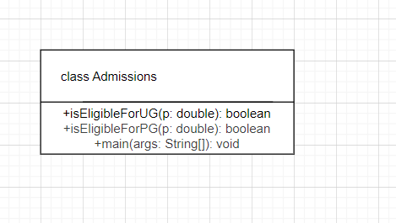

**PROGRAM:**

public class Admissions {

    public boolean isEligibleForUG(double percentage) {

        return percentage >= 60.0;

    }

    public boolean isEligibleForPG(double percentage) {

        return percentage >= 70.0;

    }

    public static void main(String[] args) {

        Admissions admissions = new Admissions();

        double studentPercentageUG = 65.05;

        double studentPercentagePG = 72.45;

        if (admissions.isEligibleForUG(studentPercentageUG)) {

System.out.println(“Nishanth,24217,cse-c”);

            System.out.println("Student is eligible for UG program.");

        } else {

            System.out.println("Student is not eligible for UG program.");

        }

        if (admissions.isEligibleForPG(studentPercentagePG)) {

            System.out.println("Student is eligible for PG program.");

        } else {

            System.out.println("Student is not eligible for PG program.");

        }

    }

}

**OUTPUT:**

**NEGATIVE CASE:**

**ERROR TABLE:**

|  |  |  |
| --- | --- | --- |
| **S.NO** | **ERROR** | **RECTIFICATION** |
| **1.** | Syntax error | Added the bracket “}” |
| **2.** | Undefined PrintStream | **“**System.out.println” |

**IMPORTANT POINTS:**

1. Class Definition: The Admissions class checks student eligibility for UG and PG programs.
2. UG Eligibility Method: isEligibleForUG returns true if the percentage is 60% or higher.
3. PG Eligibility Method: isEligibleForPG returns true if the percentage is 70% or higher.

**AIM:**

**CREATE A CALCULATOR CLASS WITH OVERLOADED METHODS TO PERFORM ADDITION.**

* + 1. **ADD TWO INTEGERS**
    2. **ADD 2 DOUBLES**
    3. **ADD 3 INTEGERS**

**CLASS DIAGRAM:**

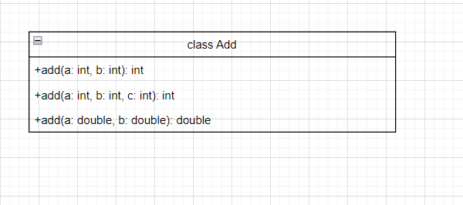

**PROGRAM:**

public class Add {

    public int add(int a, int b) {

        return a + b;

    }

    public double add(double a, double b) {

        return a + b;

    }

    public int add(int a, int b, int c) {

        return a + b + c;

    }

    public static void main(String[] args) {

        Add calculator = new Add();

        int sumIntegers = calculator.add(5, 10);

        System.out.print("Nishanth,24217,cse-c\n");

        System.out.println("Sum of two integers: " + sumIntegers);

        double sumDoubles = calculator.add(5.5, 10.5);

        System.out.println("Sum of two doubles: " + sumDoubles);

        int sumThreeIntegers = calculator.add(5, 10, 15);

        System.out.println("Sum of three integers: " + sumThreeIntegers);

    }

}

**OUTPUT:**

**NEGATIVE CASE:**

**ERROR TABLE:**

|  |  |  |
| --- | --- | --- |
| **S.NO** | **ERROR** | **RECTIFICATION** |
| **1.** | Undefined methods | Replaced Calculator with add in the main method |
| **2.** | Syntax error | Added the semicolon |
| **3.** | Compilation error | Rectified the main method |

**IMPORTANT POINTS:**

**Method Overloading (Core Concept)**

* Three add() methods with:
  + Different **number of parameters**: 2 and 3
  + Different **parameter types**: int and double

Addition Methods:

add(int a, int b): Adds two integers and returns the result.

add(double a, double b): Adds two doubles and returns the result.

add(int a, int b, int c): Adds three integers and returns the result.

**AIM:**

**CREATE A SHAPE CLASS WITH A METHOD “calculateArea()” THAT IS OVERLOADED FOR DIFFERENT SHAPES (E.G., SQUARE, CIRCLE, TRAINGLE,ETC). THEN CREATE A SUBCLASS “Circle” THAT OVERRIDES THE “calculateArea()” METHOD FOR A CIRCLE:**

**CLASS DIAGRAM:**

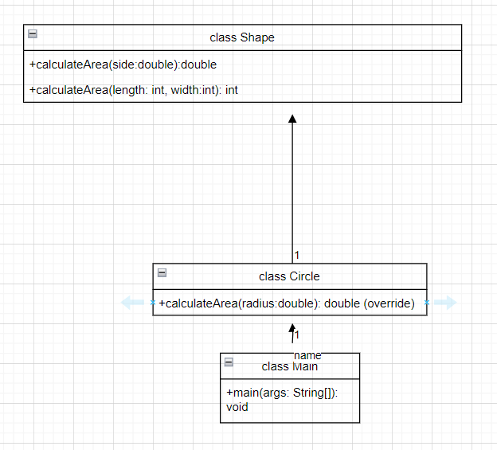

**PROGRAM:**public class Shape {

    public double calculateArea(double side) {

        return side * side;

    }

    public int calculateArea(int length, int width) {

        return length * width;

    }

}

class Circle extends Shape {

        @Override

    public double calculateArea(double radius) {

        return 3.14 * radius * radius;

    }

}

class Main {

    public static void main(String args[]) {

        Circle obj1 = new Circle();

        Shape obj2 = new Shape();

        System.out.println("The area of a square is: " + obj2.calculateArea(2.0));

        System.out.println("The area of a circle is: " + obj1.calculateArea(3.0));

        System.out.println("The area of a rectangle is: " + obj2.calculateArea(3, 4));

    }

}

**OUTPUT:**

**NEGATIVE CASE:**

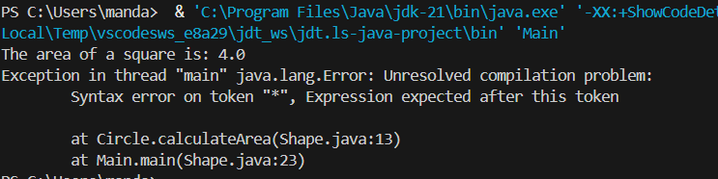

**ERROR TABLE:**

|  |  |  |
| --- | --- | --- |
| **S.NO** | **ERROR** | **RECTIFICATION** |
| **1.** | Incorrect formula | Corrected formula |
| **2.** | Syntax error | Inserted “}” |

**IMPORTANT POINTS:**

1.Class Shape demonstrates methodoverloading with calculateArea() for square and rectangle.

2.Class Circle extends Shape and overrides the calculateArea(double) method.

3. The overridden method in Circle calculates the area **of a** circle using πr²

**WEEK-7**

**AIM:**

**WRITE A JAVA PROGRAM TO CREATE AN ABSTRACT CLASS “ANIMAL” WITH AN ABSTRACT METHOD CALLED “Sound()”. CREATE SUBCLASSES LION AND TIGER THAT EXTEND THE ANIMAL CLASS AND IMPLEMENT THE “Sound()” METHOD TO MAKE A SPECIFIC SOUND FOR EACH ANIMAL.**

**CLASS DIAGRAM:**

**PROGRAM:**

abstract class Animal {

    abstract void sound();

}

class Lion extends Animal {

    @Override

    void sound() {

        System.out.println("A Lion roars!");

    }

}

class Tiger extends Animal {

    @Override

    void sound() {

        System.out.println("A Tiger growls!");

    }

}

public class Sounds {

    public static void main(String[] args) {

System.out.println(“Nishanth,24217,cse-c”);

        Lion lion = new Lion();

        lion.sound();

        Tiger tiger = new Tiger();

        tiger.sound();

    }

}

**OUTPUT:**

**POSITIVE CASE:**

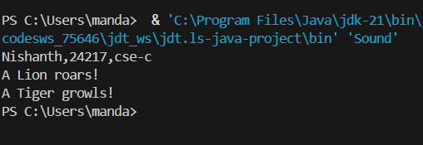

**NEGATIVE CASE:**

**ERROR TABLE:**

|  |  |  |
| --- | --- | --- |
| **S.NO** | **ERROR** | **RECTIFICATION** |
| **1.** | Compilation error | Named the main class with another name |
| **2.** | Syntax error | Corrected spelling |

**IMPORTANT POINTS:**

**1.Abstract Class:**

* Animal is an abstract class that cannot be instantiated directly.
* It contains an abstract method sound() which must be implemented by all subclasses**.**

**2. Method Overriding:**

* Both Lion and Tiger override the sound() method of Animal to provide their own implementation

**AIM:**

**WRITE A JAVA PROGRAM TO CREATE AN ABSTRACT CLASS “SHAPE3D”**

**WITH ABSTRACT METHODS “calculateVolume()” AND**

**“calculateSurfacArea()”. CREATE SUBCLASSES SPHERE AND CUBE THAT**

**EXTEND THE SHAPE3D CLASS AND IMPLEMENT THE RESPECTIVE**

**METHODS TO CALCULATE THE VOLUME AND SURAFEC AREA OF EACH**

**SHAPE.**

**CLASS DIAGRAM:**

**PROGRAM:**

abstract class Shapes3D {

    public abstract double calculateVolume();

    public abstract double calculateSurfaceArea();

}

class Sphere extends Shapes3D {

    private double radius;

    public Sphere(double radius) {

        this.radius = radius;

    }

    public double calculateVolume() {

        return (4.0 / 3.0) * Math.PI * Math.pow(radius, 3);

    }

    public double calculateSurfaceArea() {

        return 4 * Math.PI * Math.pow(radius, 2);

    }

}

class Cube extends Shapes3D {

    private double side;

    public Cube(double side) {

        this.side = side;

    }

    public double calculateVolume() {

        return Math.pow(side, 3);

    }

    public double calculateSurfaceArea() {

        return 6 * Math.pow(side, 2);

    }

}

public class Shapes3DImplementation {

    public static void main(String[] args) {

        Sphere sphere = new Sphere(5);

        System.out.print("Nishanth,24217,cse-c\n");

        System.out.println("Sphere Volume: " + sphere.calculateVolume());

        System.out.println("Sphere Surface Area: " + sphere.calculateSurfaceArea());

        Cube cube = new Cube(3);

        System.out.println("Cube Volume: " + cube.calculateVolume());

        System.out.println("Cube Surface Area: " + cube.calculateSurfaceArea());

    }

}

**OUTPUT:**

**POSITIVE CASE:**

**NEGATIVE CASE:**

**ERROR TABLE:**

|  |  |  |
| --- | --- | --- |
| **S.NO** | **ERROR** | **RECTIFICATION** |
| **1.** | Unable to initialize main class Shapes | Spelling error in “Sttring” |
| **2.** | Syntax error | Inserted “}” |

**IMPORTANT POINTS:**

1. Demonstrates abstraction with an abstract class Shapes3D, and methodoverriding in Sphere and Cube to provide specific implementations for volume and surface area.

2. Shows constructorusage, encapsulation with private fields, and **polymorphic design potential** for 3D shapes.

**AIM:**

**WRITE A JAVA PROGRAM USING AN ABSTRACT CLASS TO DEFINE A METHOD FOR PATTERN PRINTING.**

**CRAETE AN ABSTRACT CLASS NAMED “PatternPrinter” WITH AN ABSTRACT METHOD “Printpattern(int)” AND A CONCRETE METHOD TO DISPLAY THE PATTERN TITLE.**

**IMPLEMENT 2 SUBCLASSES,**

**1.STAR PATTERN PRINTS A RIGHT ANGLED TRIANGLE OF STARS**

**2.NUMBER PATTERN PRINTS A RIGHT ANGLED TRAINGLE OF INCREASING NUMBERS.**

**IN THE MAIN METHOD, CREATE OBJECTS OF BOTH SUBCLASSES AND PRINT PATTERN FOR A GIVEN NUMBER OF ROWS.**

**CLASS DIAGRAM:**

**PROGRAM:**

abstract class PatternPrinter {

    public abstract void printPattern(int rows);

    public void displayTitle(String title) {

        System.out.println(title);

    }

}

class StarPattern extends PatternPrinter {

    @Override

    public void printPattern(int rows) {

        for (int i = 1; i <= rows; i++) {

            for (int j = 1; j <= i; j++) {

                System.out.print("* ");

            }

            System.out.println();

        }

    }

}

class NumberPattern extends PatternPrinter {

    public void printPattern(int rows) {

        int number = 1;

        for (int i = 1; i <= rows; i++) {

            for (int j = 1; j <= i; j++) {

                System.out.print(number + " ");

                number++;

            }

            System.out.println();

        }

    }

}

public class PatternPrint {

    public static void main(String[] args) {

        PatternPrinter starPattern = new StarPattern();

        starPattern.displayTitle("Star Pattern:");

        starPattern.printPattern(5);

        PatternPrinter numberPattern = new NumberPattern();

        numberPattern.displayTitle("Number Pattern:");

        numberPattern.printPattern(5);

    }

}

**OUTPUT:**

**POSITIVE CASE:**

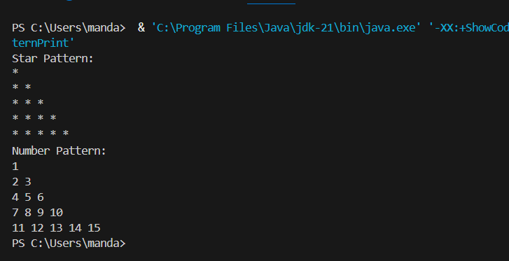

**NEGATIVE CASE:**

**ERROR TABLE:**

|  |  |  |
| --- | --- | --- |
| **S.NO** | **ERROR** | **RECTIFICATION** |
| **1.** | Main method not found in class PatternPrinter | Named the class with main function as PatternPrint |

**IMPORTANT POINTS:**

**Class StarPattern:**

* This class extends PatternPrinter and provides an implementation for the printPattern method.

**Class NumberPattern:**

* This class also extends PatternPrinter and implements the printPattern method.

**Abstract Class PatternPrinter:**

* This is an abstract class that defines a blueprint for pattern printing.
* It contains an abstract method printPattern(int rows) which must be implemented by any subclass.

**WEEK-8**

**AIM:**

**WRITE A JAVA PROGRAM TO CREATE AN INTERFACE “Shape” WITH THE**

**“getPerimeter()” METHOD. CREATE 3 CLASSES “Rectangle”, “Circle” and**

**“Triangle” THAT IMPLEMENTS THE SHAPE INTERFACE. IMPLEMENT THE**

**“getPerimter()” METHOD FOR EACH OF 3 CLASSES.**

**CLASS DIAGRAM:**

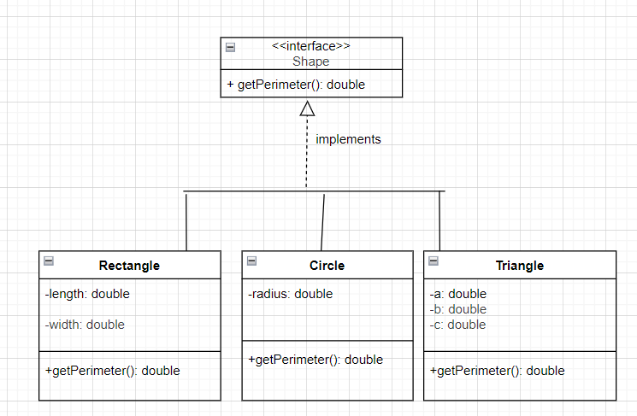

**PROGRAM:**

 interface Shape {

    double getPerimeter();

}

class Rectangle implements Shape {

    private double length;

    private double width;

    public Rectangle(double length, double width) {

        this.length = length;

        this.width = width;

    }

    public double getPerimeter() {

        return 2 * (length + width);

    }

}

class Circle implements Shape {

    private double radius;

    public Circle(double radius) {

        this.radius = radius;

    }

    public double getPerimeter() {

        return 2 * Math.PI * radius;

    }

}

class Triangle implements Shape {

    private double a;

    private double b;

    private double c;

    public Triangle(double a, double b, double c) {

        this.a = a;

        this.b = b;

        this.c = c;

    }

    public double getPerimeter() {

        return a + b + c;

    }

}

public class ShapeTEST {

    public static void main(String[] args) {

        System.out.println("Nishanth,av.sc.u4cse24217,cse-c");

        Shape rectangle = new Rectangle(2, 3);

        System.out.println("Perimeter of rectangle: " + rectangle.getPerimeter());

        Shape circle = new Circle(2);

        System.out.println("Perimeter of circle: " + circle.getPerimeter());

        Shape triangle = new Triangle(3, 4, 5);

        System.out.println("Perimeter of triangle: " + triangle.getPerimeter());

    }

}

**OUTPUT:**

**POSITIVE CASE:**

**NEGATIVE CASE:**

**ERROR TABLE:**

|  |  |  |
| --- | --- | --- |
| **S.NO** | **ERROR** | **RECTIFICATION** |
| **1.** | Exception in thread "main" java.lang.Error | Corrected the syntax error from “interfaces” to interface |

**IMPORTANT POINTS:**

1. **Interface Shape:**
   * Defines a contract with a single method getPerimeter().
   * Any class implementing this interface must provide an implementation for the getPerimeter() method.

**Class ShapeTEST:**

* Contains the main method, serving as the entry point for the program.
* Prints a header with a name and identifier.
* Creates instances of Rectangle, Circle, and Triangle using the Shape interface reference.
* Demonstrates polymorphism by using the Shape interface to reference different shape objects (Rectangle, Circle, Triangle).
* Allows for calling the getPerimeter() method on these objects through the interface reference.

**AIM:**

**WRITE A JAVA PROGRAM TO CREATE AN INTERFACE “Playable” WITH A**

**METHOD “Play()” THAT TAKES NO ARGUMENTS AND RETURNS VOID.**

**CREATE 3 CLASSES Football, Volleyball and Basketball THAT IMPLEMENTS**

**THE Playable INTERFACE ABD OVERRIDE THE play() METHOD TO PLAY**

**RESPECTIVE SPORTS.**

**CLASS DIAGRAM:**

**PROGRAM:**

interface Playable {

    void play();

}

class Football implements Playable {

    public void play() {

        System.out.println("I play Football.");

    }

}

class Volleyball implements Playable {

    public void play() {

        System.out.println("I play Volleyball.");

    }

}

class Basketball implements Playable {

    public void play() {

        System.out.println("I play Basketball.");

    }

}

class PlayableMain {

    public static void main(String[] args) {

        System.out.println("Nishanth, av.sc.u4cse24217, cse-c");

        Playable p1 = new Football();

        Playable p2 = new Volleyball();

        Playable p3 = new Basketball();

        p1.play();

        p2.play();

        p3.play();

    }

}

**OUTPUT:**

**POSITIVE CASE:**

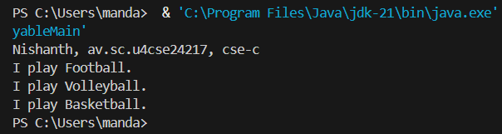

**NEGATIVE CASE:**

**ERROR TABLE:**

|  |  |  |
| --- | --- | --- |
| **S.NO** | **ERROR** | **RECTIFICATION** |
| **1.** | Syntax error | Inserted “}” |

**IMPORTANT POINTS:**

1.The Playable interface type is used as a reference (Playable p1, p2, p3) to objects of different implementing classes.

2.This demonstrates runtime polymorphism — the method that gets called is determined by the actual object type.

3. New instances of Football, Volleyball, and Basketball are created and assigned to interface-type references.