Software Requirements
Specification
for
TrustLens
Version 1.0
Prepared by:
S.Nishanth 24BRS1118
Niranjna Karthikeyan 24BRS1353
CSE Ai and Robotics
Software Engineering BCSE301L
Software Requirement Specification
Faculty: Softya Sebastian
Semester: Fall Semester(5th) Year: 2026
Date: 22 August 2026

Page i
Table of Contents
1. Introduction 1
1.1 Purpose 1
1.2 Document Conventions 1
1.3 Intended Audience and Reading Suggestions 1
1.4 Product Scope 1
2. Overall Description 2
2.1 Product Perspective 2
2.2 Product Functions 3
2.3 User Classes and Characteristics 3
2.4 Operating Environment 4
2.5 Design and Implementation Constraints 4
2.6 Documentation for Users 4
2.7 Assumptions and Dependencies 4
External Interface Requirements 5
3.1 User Interfaces 5
3.2 Hardware Interfaces 5
3.3 Software Interfaces 5
3.4 Communications Interfaces 6
4.System Features 6
5.Other Nonfunctional Requirements 12
5.1 Performance Requirements 12
5.2 Safety Requirements 12
5.3 Security Requirements 13
5.5 Business Rules 14
6. Other Requirements 14
Pipeline and domain terms 15
Evidence and provenance grades 15
India-specific terms 16
Appendix B: Analysis Models 17
B.1 ER Diagram 17
B.2 Data Flow Diagrams 18
B.3 Use Case Diagram 20
Appendix C: To Be Determined List 21

Page ii
List of Figures
Figure B-1 — TrustLens entity relationship model ................................................................................................................ 17
Figure B-2 — Level 0 context diagram .................................................................................................................................. 18
Figure B-3 — Level 1 data flow diagram ............................................................................................................................... 19
Figure B-4 — Level 2 data flow diagram, process 3.0 exploded into five sub-processes ...................................................... 20
Figure B-5 — TrustLens use case diagram ............................................................................................................................. 21
Revision History
Name | Date | Reason For Changes | Version
SRS Creation | 22nd  August  2026 | First SRS. Requirements taken from the programme charter and rearranged into the IEEE 830 / Wiegers structure. | 1.0

Introduction

1.1 Purpose
TrustLens detects scam and preserves evidence for Indian digital fraud. A user having received a suspicious SMS, WhatsApp message, email or a link, may upload it and receive an evaluation of how risky the message looks, the degree of the system's certainty and the official advisory upon which this decision is based. It also preserves the uploaded content with a hash for future use as evidence, and compiles it into a report to present at a bank or at the police.
This document addresses the complete product, not any particular module of it. It describes release 1.0, which is the SMS path end-to-end, and what follows afterwards (enrichment adapters, AI assistance and analytics), to make the dividing line explicit rather than implicit. This document describes the software's requirements, not its design.

1.2 Document Conventions
IEEE 830-1998 structure and Wiegers template have been used. Requirements are numbered in accordance with their location in the document, so that requirement 4.3.3.2 is the second functional requirement of feature 4.3. A shall indicates a binding requirement; should indicates a recommendation and never occurs in a numbered requirement.
Priority is assigned to each feature in its 4.x.1 subsection: High is the condition for the completion of release 1.0, Medium is desirable but not required for shipping and Post-MVP is specified here but implemented afterwards. Post-MVP requirements within a High-priority feature are highlighted wherever they occur.
All requirements are drawn from the programme charter, derived from the project brief. Nothing has been created in the process of moving requirements from there to this document. Some of them are based on our engineering judgment rather than instructions and are flagged accordingly wherever they occur.

1.3 Intended Audience and Reading Suggestions
Intended for the project team and the faculty that reviews it. In a real world setting this document would also be read by developers, testers and whomever pays for the product.
Read it in order. Sections 1 and 2 provide the context. Section 3 makes a clear division between TrustLens and everything else. Section 4 is the part developers will base their work on, and Section 5 covers quality attributes of the system independent of the features. Appendix C contains the list of yet undetermined things and should be read before treating any of this as final.

1.4 Product Scope
Digital fraud in India tends to run as a staged funnel: the victim is contacted, given a pretext, pushed into either trusting or fearing the caller, asked for a credential or a payment, and then told to keep quiet. The damaging step is almost always performed by the victim, whether that is entering a UPI PIN, scanning a QR code, installing an APK, or paying a "fine" to somebody claiming to be a police officer.
There is already a lot of official guidance on this from I4C, CERT-In, RBI, NPCI, SEBI and DoT. The problem is that it is not in a form software can use. It sits in advisory PDFs and press releases written for people to read, and it goes out of date. TrustLens is an attempt to close the gap between that published guidance and a decision somebody can act on when they need it.
What the product should achieve:
- Give a verdict that keeps risk and confidence as two separate things and shows the evidence for both.
- Make every finding traceable, from the submitted content through the extracted indicators and matched rules to the official source behind the rule.
- Preserve the submitted evidence with integrity metadata and turn it into a report bundle.
- Make a decision taken today reproducible months later from the stored evidence and the rule-set version that was used.
Out of scope. TrustLens does not file reports with any authority automatically, issue an official determination of fraud, or give legal advice. It does not block, intercept or change any message, call or payment, and it does not run as a device agent or read device state. It does not let an AI model make the final decision, does not retrain itself on user feedback without a human approving the change, and does not try to identify or profile individual offenders.
One limitation worth stating up front. There is no labelled real-world corpus of Indian scam messages available to us and we cannot obtain one within this project, so precision, recall and false-positive rate cannot be measured. No accuracy claim appears anywhere in this document. What can be proven without such a corpus, such as determinism, traceability and schema conformance, is specified in Section 5.4 with a verification method attached to each.
1.5 REFERENCES
# | Document | Location
R1 | Programme charter, the source of every requirement here | docs/00-program/PROGRAM-001-program-charter.md
R2 | Glossary, assumption, risk and conflict registers | docs/00-program/
R3 | Source inventory: 26 sources graded, 11 verified | docs/01-research/RESEARCH-001-source-inventory.md
R4 | Scam taxonomy: 10 categories, 41 subcategories | docs/01-research/RESEARCH-002-scam-taxonomy.md
R5 | Evidence matrix: 30 starter rules graded | docs/01-research/RESEARCH-004-evidence-matrix.md
R6 | Research gap register: 22 open gaps | docs/01-research/RESEARCH-005-gap-register.md
R7 | ADR-0003, rule representation format, and the rule  JSON Schema | adr/, knowledge/schemas/rule.schema.json
R8 | IEEE Std 830-1998 and the K. E. Wiegers SRS template (1999) | Structure used for this document
R9 | Analysis models: ER, DFD levels 0 to 2, use case | docs/05-architecture/diagrams/, reproduced in Appendix B

Overall Description

Product Perspective
TrustLens is a new, self-contained product. It does not replace anything, it is not part of a product family, and it does not extend an existing tool. There is no legacy code and no earlier deployment to work around.
It is not self-sufficient in knowledge, though. Everything it can detect comes from a curated knowledge base built out of published official guidance, and that guidance reaches the system through a governed pipeline with a human in it rather than an automatic feed. A TrustLens with an empty rule set is a working system that detects nothing.
The product boundary is drawn as a level 0 data flow diagram in Appendix B, Figure B-2. TrustLens exchanges data with nine outside parties: the reporting user, an analyst, an administrator, the report recipient, the official guidance bodies whose advisories feed the knowledge base, a knowledge editor, a knowledge approver, and two Post-MVP providers for threat intelligence and AI assistance. The eighteen flows crossing that boundary are labelled F1 to F18 on the diagram.
Two of those are worth calling out. The report recipient link is outbound only and always user-initiated, never an automatic submission. The guidance bodies link is inbound only, and everything arriving on it is graded before it is allowed to affect a rule.

Product Functions
- Ingest and preserve evidence — check the submitted artifacts, hash each one, record chain-of-custody metadata
- Normalise and extract — canonical form, language and script, then entities, indicators and negative indicators
- Evaluate rules and score — run a pinned rule set and compute risk, confidence, severity and evidence quality as four separate numbers
- Compose explanation — what matched, what did not and why, what reduced the risk, and which official source backs each finding
- Route and adjudicate — send uncertain cases to an analyst and record the decision with its reasoning
- Assemble report bundle — build an exportable package from a case, disclaimer attached
- Govern the knowledge base — grade sources, validate and lint draft rules, run review and approval, publish and roll back versions
- Administer, audit and observe — authentication, role-based access, retention policy, audit events

User Classes and Characteristics

According to expectations, the TrustLens will have six different classes of users. The first two of them will be users reporting suspicious messages, while the other four will help reviewing cases or managing the system.

Reporting User – General (P1):
Regular user receiving a suspicious SMS message, WhatsApp message, email or link and needing to know whether this is most likely a scam. This user might not be technically proficient, so the output will need to be plain, unambiguous and recommendable action.
Reporting User – High-Risk (P2):
This user type is a high-risk user who could be at increased risk of being scammed, e.g., elderly users or people receiving urgent or threatening messages. The output should be straightforward and reassuring without using overly technical terms.
Analyst (P3):
The analyst needs to review cases that are not determined by the system with enough confidence to give a clear result. For this reason, he/she will need access to the risk score, identified indicators, and the reason for this result.
Knowledge Editor (P4):
The knowledge editor develops and updates scam detection rules according to official advisories and known patterns of fraud. He/She will be able to create rules but will not have direct possibility to publish them.
Knowledge Approver (P5):
The knowledge approver reviews the rules developed by the knowledge editor before using them in the system. He/She can accept, reject and roll back rules.
Administrator (P6):
The administrator manages the general platform of TrustLens, including configuration of the system, monitoring, access management, retention and other operations. Administrators do not require access to actual user-submitted content.

Operating Environment
Current evergreen browsers on mobile and desktop, mobile first, since the primary user is assumed to be on a phone.
No native mobile app in release 1.0. React with TypeScript in strict mode on the frontend, Java 21 with Spring Boot 3.x as a modular monolith on the backend, and PostgreSQL 16 behind it. The Python and FastAPI service for AI and advanced extraction is a separate deployable and is deferred to a later phase. Docker and Docker Compose locally, GitHub Actions for CI. Local and test environments only for now: no production deployment happens during this project, and the hosted target has not been decided.

Design and Implementation Constraints

ID | Constraint
2.5.1 | No automatic submission of legal or regulatory reports, to any authority, by any route.
2.5.2 | No accuracy claim unless it comes from a reproducible evaluation on a described dataset, and no fabricated advisories, citations, statistics or datasets. Synthetic examples shall be labelled synthetic.
2.5.3 | The rule engine is the decision authority. AI output is advisory and never authoritative.
2.5.4 | Java 21 with Spring Boot on the backend, React with TypeScript on the frontend. The Python service is deferred. Delivery capacity is one engineer plus AI assistance.
2.5.5 | Docker and PostgreSQL are missing from the development machine, so implementation is blocked until they are installed.
2.5.6 | Rules are versioned JSON data validated by a published JSON Schema and a cross-file linter, never engine code. Adding a new scam type means writing one JSON file.
2.5.7 | Rule identifiers are neutral .Source attribution is carried as data, not embedded in the key.
2.5.8 | No rule may fire on a single indicator, and no rule may fire on weak indicators alone. Enforced at load time, not by convention. Severity is an ordinal from low to critical , numeric risk or confidence values are not stored on a rule.

Documentation for Users
Included with the software: help and tips in-product and on the first run; a guide to understanding a verdict, a README file in each report bundle explaining its content, how to verify the hash, and the disclaimer; a guide for analyst adjudication; a guide to writing rules with a worked example for each rule shape, and a list of lint errors; an approval and rollback runbook; an operations runbook; and an API documentation generated from the Open API document. Online content in HTML format, any content intended to exit the system and go with the user in PDF format.

Assumptions and Dependencies
Assumptions about the project:

• There are no end users, analysts, or stakeholders within an official body, so all personas and journeys in this document are our own inferences. This assumption is load-bearing, and we have low confidence in it.
• The deployment is single tenant, release 1.0 will be in English only (the architecture is multilingual,
but the content is not), and there is no processing of actual user data during the course of the
project. All the data used are synthetic and marked accordingly.
• The users submit the content after the event, typically using a mobile device, not while an attack is ongoing, so the latency requirement is measured in seconds, not milliseconds.
• The submitted content regularly includes live sensitive data (like OTPs, account numbers, and VPAs), and therefore has to be treated as sensitive from the moment of receipt, prior to classification.
• There is no budget for paying for threat intelligence services, so all relevant adapters would be targeting their free tiers or would be stubbed.
• TrustLens has neither any registration nor official recognition by nor any relationship with any bodies providing guidelines.
• Default evidence retention period is 90 days. This is a placeholder value, not a policy decision. The Digital Personal Data Protection Act 2023 of India is very likely to apply, but this has not been confirmed and no compliance claim is being made in this document.
• In the course of development, rule authoring and rule approval are performed by the same person. The separation of duties principle is implemented and tested even though it is not enforced organizationally.

Dependencies of the project:

The retrieval of official source documents is somewhat manual. This was confirmed by our tests: i4c.mha.gov.in, pib.gov.in and npci.org.in do not allow automated retrieval, while cert-in.org.in, niti.gov.in and rbi.org.in do allow it. Any advisory ingestion process would have to include a human retrieval stage and full automation would not be possible.

External Interface Requirements

3.1 User Interfaces
One responsive web application, mobile first, with dynamic navigation based on role. There is no client installation for release 1.0.
Nine screens. Submit, Verdict, Evidence detail and Correction are the screens for the reporting user: Paste/upload evidence with context of sender and channel, read the verdict with separate risk and confidence score, drill down into indicators and rules, and correct a mis extracted entity. The Case screen groups a single incident and exports a bundle. Review queue shows the analyst the list of unclear cases and score break-down with adjudication controls. Rule authoring and Approval are the screens for the knowledge editor and approver respectively; the latter also shows the diff, impact analysis and regression report. The Administration screen has configuration, thresholds, retention policy, feature flags and health dashboard.

3.2 Hardware Interfaces

3.3 Software Interfaces

# | Component | Purpose
3.3.1 | PostgreSQL 16 | Primary datastore for evidence, cases, findings, pinned analyses and audit events. Reached through a connection pool over TLS.
3.3.2 | Rule JSON Schema, version 1.0 | The single authority on rule structure. The Java loader validates rule documents against the schema file itself, not a reimplementation of it.
3.3.3 | Cross-file rule linter | Enforces the constraints a single-document schema cannot express, checking a rule against the indicator registry, the taxonomy and the verification manifest. Returns a verdict naming the layer that caught the problem. Runs in CI before any rule can be published.
3.3.4 | Source verification manifest | Maps source identifiers to a verification status and grade. A rule cannot claim a grade the manifest contradicts.
3.3.5 | OCR engine  (Post-MVP) | Extracts text from image artifacts with a per-block confidence value that feeds evidence quality. Engine not yet selected.
3.3.6 | URL /  threat-intelligence providers (Post-MVP) | Take a URL or domain and return a reputation verdict, labelled non-authoritative. Several providers behind one provider-agnostic adapter.
3.3.7 | AI assist provider  (Post-MVP) | Takes an isolated content prompt and returns schema-constrained JSON. Extraction help and draft rule suggestions, advisory only.
3.3.8 | Identity provider | Takes credentials or a federated assertion and returns an authenticated principal with roles. Not yet selected.

3.4 Communications Interfaces
HTTPS only, TLS 1.3, versioned REST over JSON defined by OpenAPI specification from which reference implementation is derived. Asynchronous messaging only where justified by the workload. JSON payload, UTF-8 everywhere, with the original byte stream of the uploaded content preserved next to the normalised representation. Each request has a correlation identifier which is propagated throughout the logs and audit events.
Export of the report is done via authenticated and access-controlled download. There is no report transmission to any authority via any protocol, which is ensured by the absence of the feature rather than by the configuration option. TrustLens does not send any SMS messages and does not generate notifications about scam activity; transactional emails, if implemented, will be limited to account and access features. Enrichment requests (Post-MVP) are made over HTTPS with a per-provider timeout and circuit breaker; failure of the provider causes degradation of the output rather than the failure of the upload process. Public endpoints are subject to rate limiting.

4.System Features

4.1 Submission and Evidence Preservation
4.1.1 Description and Priority
Extracts content from the reporting user, validates it, and preserves each piece with integrity metadata before
performing any analysis. It is done purposefully first in order to guarantee the integrity of the evidence and make
it independent of whatever analysis may conclude. High priority.
4.1.2 Stimulus/Response Sequences
S1 User pastes SMS or chat text and submits – System accepts the artifact, hashes it, notes the capture time and
chain-of-custody metadata, creates a submission and initiates the analysis.
S2 User uploads a screenshot which is too large or of an unsupported media type – System rejects the upload
before any processing, states the limit and acceptable types and keeps the rest of the submission.
4.1.3 Functional Requirements
4.1.3.1: The system shall accept free-text submission of SMS, WhatsApp or other chat message bodies.
4.1.3.2: The system shall accept URL submission.
4.1.3.3: The system shall accept email content including headers.
4.1.3.4: The system shall accept screenshot and image upload. (Post-MVP)
4.1.3.5: The system shall support grouping multiple artifacts into a single submission and a single case.
4.1.3.6: The system shall validate media type, size and structure prior to processing, and reject unsafe uploads without
processing them.
4.1.3.7: The system shall accept optional user-supplied context including sender, channel and description.
4.1.3.8: The system shall compute and store a cryptographic hash of every evidence item upon ingest, along with its
chain-of-custody metadata.
4.1.3.9: The system shall preserve the original submitted content unmodified, along with any normalised form
derived from it.

4.2 Normalisation and Evidence Extraction
4.2.1 Description and Priority
Converts preserved artifacts to canonical form and derives what will be detected: entities, indicators and
negative indicators. The aim of extraction is high recall and it assigns no score to anything as an observation is not
a finding yet. High priority.
4.2.2 Stimulus/Response Sequences
S1 Artifact is fed into extraction process – System converts it to canonical form, identifies the language and script,
and extracts entities and indicators.
S2 Content includes "Your OTP is 452901. Never share it with anyone." – System extracts both OTP reference and
self-protection warning, the latter being negative indicator and making sure that the message is not treated as
credential request
4.2.3 Functional Requirements
4.2.3.1: The system must deterministically normalise the content to a canonical form so that the same input always
Gives the same canonical output.
4.2.3.2: The system must be able to identify the language and script of the content which is submitted.
4.2.3.3: The system must be able to deal with code-mixed and transliterated input in Indian languages. (Post-MVP)
4.2.3.4: The system is to extract text from screenshots using OCR and should record a confidence value for each block
adds to the quality of evidence. (Post-MVP)
4.2.3.5: The system must extract entities of at least the following types: URL, phone number, UPI VPA, and monetary amount.
The organisation name, the application name and the account reference.
4.2.3.6: The system is to extract the indicators within the defined families of indicators, and none of the extracted indicators shall carry
a score.
4.2.3.7: The system must identify negative indicators which inhibit a rule or lower the level of risk.
4.2.3.8: The system must allow a user to correct an extraction error and then re-evaluate the submission, retaining both the original and the version that has been corrected.

4.3 The detection and scoring based on rules
4.3.1 Description and Priority
The product's main feature is to take the evidence that has been extracted, apply to it a versioned rule set that is fixed, and then output a risk assessment.
Confidence, severity, and evidence quality are four separate values. Rules are built from several parts, so no single
The indicator itself will never lead to a conclusion.
It is a high priority and represents the most risky feature in the product; in both cases, a failure undermines trust by missing a real attack.
Indicating a bank's own anti-fraud notice as a scam.
4.3.2 Stimulus/Response Sequences
S1 A suppression rule's condition is met — System suppresses the affected finding and records the suppression as an
not as the absence but as the explicit result.
S2 Evidence is too thin to conclude anything — System returns INSUFFICIENT_EVIDENCE instead of a low-risk
verdict.
4.3.3 Functional Requirements
4.3.3.1: The system is to evaluate the rules deterministically based on the extracted evidence.
4.3.3.2: The system must support composite rules which involve combinations of indicators covering at least two different
evidence classes.
4.3.3.3: The system must provide for suppression rules, exceptions and exclusions.
4.3.3.4: The system must calculate the risk, confidence, severity and evidence quality as individual values and must never
Put them together into one value, either in the pipeline or in the interface.
4.3.3.5: The system must be able to deal with correlated signals without doubling up on their contribution. (Post-MVP)
4.3.3.6: The system must return an explicit INSUFFICIENT_EVIDENCE result in the case where the evidence does not
support a conclusion.
4.3.3.7: The system must send evaluations beyond a set uncertainty threshold to human review.
4.3.3.8: The system must fix the rule-set version to each evaluation.
4.3.3.9: The system must replay a previous evaluation and produce its result precisely.
4.3.3.10: The system must resolve the conflicts between the competing positive and negative indicators by means of a defined and recorded precedence
4.3.3.11: If the rule is malformed or an evaluation times out or if the evidence is partial, the system must fail safely and produce no finding
That varies according to the incomplete evaluation.
4.4 Explanation of Findings
4.4.1 Description and Priority
Makes it possible for a person to check the evaluation. It is not necessary for the system to explain why it made its decision,
yet it fails to explain the reasons behind this, such as what it rejected and why it doesn't have greater confidence. This point is of high importance.
4.4.2 Stimulus/Response Sequences
S1 User opens the detail view — System lists matched rules with their contributing indicators, rules considered but not
Together with the reason, the negative evidence which lowered the risk, and the full score analysis.
The level of confidence is limited—the system explains the reason for this and also indicates what additional context would be needed to increase the confidence.
4.4.3 Functional Requirements
4.4.3.1: The system must indicate which rules matched, along with the indicators that contributed to the match.
4.4.3.2: The system must indicate the rules that were taken into account but did not match, together with the reasons why.
4.4.3.3: The system is to provide negative evidence which will serve to reduce the risk.
4.4.3.4: The system must give a complete score breakdown for each component that is calculated.
4.4.3.5: The system must explain the reasons why confidence is limited and indicate what context is missing.
4.4.3.6: The system must display the source references associated with each matched rule, together with that of each source
grade.
4.4.3.7: The system must provide an explanation in plain language together with an optional technical detail view.
4.4.3.8: The system must explain the method by which an analyst be able to verify a conclusion on his own. (Post-MVP)
4.5 Analysis by and Settlement by the Analyst
4.5.1 Description and Priority
The judgement of humans in the cases in which the engine is unsure. Although feedback is recorded it never causes learning: an
The case is not changed by adjudication but by the rule set. Medium priority.
4.5.2 Stimulus/Response Sequences
S1 A case goes past the uncertainty threshold — System puts it in the review queue with the full breakdown and what
did not match.
S2 Analyst agrees, disagrees or overrides — System records the adjudication with its reasoning, writes an audit event
and updates the case.
4.5.3 Functional Requirements
4.5.3.1: The system is to present the queued cases to the analyst together with the full score breakdown and the rules which did not
match.
4.5.3.2: The system must allow analysts to make adjudications together with a recorded reason and have to write an audit record in each case.
override.
4.5.3.3: The system must record the users' feedback regarding the findings without causing any automatic alteration of the rules, thresholds or scoring.
4.6 Case Management and Report Bundle
4.6.1 Description and Priority
It compiles all the information relating to a single incident and creates the artifact that the user ultimately keeps. The bundle has only
If something is reproducible then the same case has to generate an identical bundle later. That's a high priority.
4.6.2 Stimulus/Response Sequences
S1 User requests a report for a case — System assembles the evidence with its hashes, the findings, the explanations,
Put the source citations and the disclaimer together in a structured bundle.
S2 The same bundle is regenerated six weeks later — System reproduces an identical bundle from the stored evidence
and the pinned analysis.
4.6.3 Functional Requirements
4.6.3.1: The system must create and manage cases, these cases being used to group together submissions, findings and analyst notes.
4.6.3.2: The system is to produce a structured report bundle in accordance with the defined report contract.
4.6.3.3: The system must generate a report bundle that is exactly the same as the one produced from the stored evidence and the pinned analysis data.
4.6.3.4: The system must offer report export via an authenticated and access-controlled channel, and must not
Send a report automatically to any authority.
4.6.3.5: Every report bundle must include a clear disclaimer stating that it is not an official one.
determination of fraud.
4.7 Knowledge Base Governance
4.7.1 Description and Priority
The way in which knowledge is incorporated into the product is what enables a new kind of scam to be added without having to alter the engine code, and
What prevents a rule from claiming evidence for which it has none? A matter of high priority.
4.7.2 Stimulus/Response Sequences
S1 Editor submits a rule that would fire on one weak indicator — System rejects it at load time and names the
The constraint and the layer which intercepted it.
S2 Editor submits a rule citing a source graded RETRIEVAL_FAILED — System rejects the claimed provenance
grade.
4.7.3 Functional Requirements
4.7.3.1: The system must store the rules as versioned, schema-validated data and must not represent the rule logic in the engine.
code.
4.7.3.2: Any rule that fails schema validation or cross-file lint must be rejected by the system at load time.
4.7.3.3: The system must keep its scam taxonomy updated with different versions separate from the engine code.
4.7.3.4: The system must support the entire rule lifecycle, including draft, peer review, security review, approval, publication, and deprecation.
retire.
4.7.3.5: The system must have at least one source reference with a provenance grade for each non-heuristic rule.
Any rule must be marked as heuristic if it does not have such a source.
4.7.3.6: The system must reject any rule in which the stated source grade is in conflict with the source verification manifest.
4.7.3.7: The system must allow a rollback to a previously published rule-set version without affecting any completed
evaluation. (Post-MVP)
4.7.3.8: An impact analysis is to be carried out by the system whenever a rule, a taxonomy term or a source changes. (Post-MVP
4.7.3.9: The system must enable a new kind of scam to be added using only data and configuration, with no change to
engine code.
4.8 Identity, Access and Audit
4.8.1 Description and Priority
Establishes who is allowed to do what, and makes the security- and knowledge-relevant actions permanently
reviewable. High priority.
4.8.2 Stimulus/Response Sequences
An editor attempts to publish a rule set but the system refuses to do so since the approver role is required for publication.
S2 A security- or knowledge-relevant action happens — System writes an immutable audit event with actor, action,
target, timestamp, and correlation identifier.
4.8.3 Functional Requirements
4.8.3.1: The system must verify the users.
4.8.3.2: The system must enforce role-based access control with regard to the reporting user, the analyst, and the knowledge editor,
The roles of knowledge approver and administrator.
4.8.3.3: The system must record immutable audit events for actions which are relevant to security and knowledge.
4.8.3.4: The system must allow data export and deletion requests and provide audit evidence to show that these requests have been fulfilled.
4.8.3.5: The system must apply the retention class that has been configured to the content which is submitted and must not retain it beyond that.
class.
4.9 Enrichment and AI Help
4.9.1 Description and Priority
There are two optional features associated with feature flags. Both of them are advisory in nature since neither can determine the outcome, and the system has
to function when both are switched off. After the MVP, it is of low priority for 1.0, but it is the highest risk mentioned in the document,
That is where a model could make the decision without anyone noticing if the boundary is not enforced.
4.9.2 Stimulus/Response Sequences
The system completes the analysis without waiting and notes the degradation even if the provider times out or errors.
S2 The model produces output which does not conform to the schema — the system then rejects this output and continues without deviation.
4.9.3 Functional Requirements
4.9.3.1: The system must have URL and threat-intelligence adapters located behind a provider-agnostic interface.
4.9.3.2: The system is capable of operating completely even if one of the external providers is unavailable.
4.9.3.3: All AI-assisted features must be gated using feature flags.
4.9.3.4: The system must check the AI output against strict schemas and reject any output that fails to conform.
4.9.3.5: The system must ensure that observations derived from the model are clearly distinguished from deterministic results both when they are stored and when they are provided through the API.
the responses and in the interface.
4.9.3.6: Human approval must be obtained before any rule suggested by the AI is published.
4.9.3.7: When AI assistance is not available the system will operate in a deterministic-only mode, via the core path
unaffected.
4.9.3.8: The system must ensure that the content which is submitted is separated from the model instructions so that the content cannot alter the model behaviour .
4.10 Analytics
4.10.1 Description and Priority
Reporting relating to operational activities and in terms of knowledge quality. It states what the system did, not making any claim as to how
The system is accurate. After the MVP, it is low priority.
4.10.2 Stimulus/Response Sequences
The approver examines the quality of the knowledge — the system providing information on the rules used, the extent of their coverage and their contribution.
S2 Analyst reviews adjudication history — System reports adjudicated false positives and negatives by category,
limited to the dataset upon which they were measured.
4.10.3 Functional Requirements
4.10.3.1: The system is to report on rule usage, coverage and contribution.
4.10.3.2: The system must report the false positives and negatives that have been adjudicated, grouped by category, and must state the dataset and
Its limitations together with any such figure.
4.10.3.3: The system is to provide a report on operational quality covering volume, latency and the depth of the review queue.
4.10.3.4: The system must limit the rate at which public endpoints are accessed and guard them against abuse.

5.Other Nonfunctional Requirements

5.1 Performance Requirements
ID | Category | Requirement
5.1.1 | Performance | Analysis of a text-only submission shall complete in under 2 seconds at the 95th percentile.
5.1.2 | Performance | Analysis of a screenshot submission that needs OCR shall complete in under 10 seconds at the 95th percentile.  (Post-MVP)
5.1.3 | Reliability | Rule-set load and validation shall finish before the system accepts traffic. A rule set that fails validation shall stop startup rather than degrade at runtime.

5.2 Safety Requirements
ID | Category | Requirement
5.2.1 | Safety | The system shall not present a verdict in a way that implies an official determination of fraud.
5.2.2 | Safety | The system shall not present recommendations as legal advice. Recommended actions shall be safety actions only.
5.2.3 | Safety | The system shall route ambiguous or weakly supported cases to review, or return INSUFFICIENT_EVIDENCE, rather than presenting an uncertain conclusion as a certain one.
5.2.4 | Safety | For coercion scenarios such as digital arrest, the explanation shall plainly contradict what the scammer claimed, and shall not amplify urgency or fear.
5.2.5 | Safety | The system shall not block, intercept or modify any message, call or payment.
ID | Category | Requirement
5.2.6 | Safety | Where the knowledge base cannot support a conclusion in the submitted language, the system shall say so explicitly rather than returning a weak result that reads as safety.

5.3 Security Requirements
ID | Category | Requirement
5.3.1 | Security | All data shall be encrypted in transit using TLS 1.3 and at rest using AES-256.
5.3.2 | Privacy | Logs shall contain no secrets, no personally identifiable information and no raw submitted evidence. This shall be verified by automated scanning.
5.3.3 | Privacy | Submitted content shall be treated as sensitive from the moment it is ingested, before any classification decision is made about it.
5.3.4 | Auditability | Security- and knowledge-relevant actions shall be recorded immutably, covering 100% of the defined event set.
5.3.5 | Access control | Access to case content shall be restricted by role. The administrator role shall be able to operate the platform without access to submitted content.
5.3.6 | Security | Uploaded files shall be validated and handled so that a malicious upload cannot execute or escape its processing context.
5.3.7 | Security | Submitted content shall never be interpretable as an instruction by any downstream component, including AI-assisted ones.
5.3.8 | Privacy | The system shall not identify or profile individual suspected offenders.

5.4 Software Quality Attributes

5.4.1 Provable
ID | Attribute | Requirement | Verified by
5.4.1.1 | Determinism | Identical evidence, rule-set version and configuration shall produce identical output, on 100% of golden-case replays. | Automated replay suite
5.4.1.2 | Explainability | No finding shall exist without a complete evidence, rule and source trace. | Property test
5.4.1.3 | Extensibility | A new scam type shall be addable with zero engine lines changed. | Integration test
5.4.1.4 | Correctness of knowledge | Every published rule shall pass schema validation and cross-file lint. | CI gate
5.4.1.5 | Traceability | Every non-heuristic published rule shall carry a graded source reference, and every rule without one shall be labelled heuristic. | CI gate
5.4.1.6 | Accessibility | Release 1.0 journeys shall meet WCAG 2.2 AA. | Automated and manual audit
5.4.1.7 | Testability | Automated gates shall exist at unit, schema, property, integration, contract and end-to-end level. | CI
5.4.1.8 | Reproducibility | A clean clone shall build and run without manual intervention. | CI
5.4.1.9 | Observability | All services shall emit structured logs with correlation identifiers, plus metrics and health checks. | Operational review
5.4.1.10 | Maintainability | A new scam type shall be addable by a knowledge editor without a developer being involved. | Integration test
ID | Attribute | Requirement | Verified by
5.4.1.11 | Availability of core path | The core analysis path shall complete when enrichment or AI assistance is unavailable. | Fault-injection test

5.5 Business Rules
ID | Rule
5.5.1 | The rule engine decides. AI assists interpretation and extraction; it never overrides deterministic evidence and is never the final authority.
5.5.2 | Risk and confidence are separate quantities and are never collapsed into one number, anywhere.
5.5.3 | A new scam type is added through data, not code.
5.5.4 | No rule fires on a single indicator. Every published rule needs a combination spanning at least two distinct evidence classes.
5.5.5 | Publication takes two roles. An editor may author and submit; only an approver may publish, reject or roll back. During development one person may hold both roles, but the system enforces the separation regardless.
5.5.6 | A rule may not claim evidence it does not have. A rule whose source grade contradicts the verification manifest cannot be published, and an unsupported or heuristic rule cannot enter the published set at all.
5.5.7 | TrustLens files nothing on anyone's behalf. Report bundles leave only through a user-initiated, access-controlled export.
5.5.8 | Feedback never auto-trains. No user or analyst action changes a rule, a threshold or a score without human adjudication and the approval workflow.
5.5.9 | Uncertainty is shown, not hidden. INSUFFICIENT_EVIDENCE is a first-class outcome, not a failure state, and synthetic content is always labelled synthetic.
5.5.10 | Administrators operate the platform; they do not read cases. Platform administration does not carry access to submitted content.

6. Other Requirements
Database. Evidence, cases, findings, pinned analyses and audit events must be stored so that every evaluation’s inputs and every rule-set version can be found again for replay during the retention period. Audit events must be append-only. When deletion occurs under the retention policy or on a user’s request the submitted content must be removed,. The audit evidence that the deletion took place must remain. Internationalisation. All user-facing text must be externalised for translation starting from the release. Language and script must be first-class fields in the rule schema of being added later. Even though release 1.0 will contain English the system must show which languages it supports and must flag any unsupported input. The decision on which Indian languages will appear in release 1.0 has not been made. Legal. TrustLens does not have any registration, official status or relationship with anybody whose guidance it cites. Every report bundle and every verdict view must carry the "not a determination" disclaimer. No statement in the product may claim an obligation unless it has been verified against a primary source. Reuse. The rule schema, indicator registry, scam taxonomy and source verification manifest are data artifacts. They are independent of the engine that reads them so a future device-side or partner component can reuse them without reimplementation. Deliberately not included in this document following IEEE 830 are project cost, delivery schedule and staffing; design solutions such as module partitioning and data-structure choice; and product assurance procedures such, as QA and configuration management. Those items belong in the roadmap the architecture decision records and the test strategy.

Appendix A: Glossary
Decision quantities
Term | Definition | What it is not
Severity | How much harm the scam pattern would cause if the finding is right. A property of the scam class, mostly fixed per rule. Ordinal: LOW, MEDIUM, HIGH, CRITICAL. | Not a measure of whether the pattern is actually present.
Risk | Computed exposure for this particular submission. A function of severity and the strength of the matched evidence. Bounded, decomposable, reproducible. | Not a probability, and not "how sure we are".
Confidence | How much the system trusts its own analysis of this submission: extraction quality, corroboration across independent indicators, completeness of context. | Not risk. A confident finding can be low risk.
Evidence quality | How reliable the inputs were: OCR fidelity, truncation, known sender, whether enrichment succeeded. Feeds confidence. | Not the reliability of the rule's source.

Pipeline and domain terms

Term | Definition
Submission | One act of sending content for analysis. Contains one or more artifacts.
Artifact | A single piece of submitted content: a text body, a URL, an image, an email source. Immutable once stored.
Entity | A concrete identifiable thing found in the content: URL, phone number, UPI VPA, amount, organisation, app name, account reference.
Indicator | An observed signal belonging to an indicator family, for example CREDENTIAL_REQUEST or SECRECY_DEMAND. Carries no score.
Negative indicator | An observed signal that reduces risk or suppresses a rule, for example "never share this OTP".
Rule | A versioned, declarative, source-referenced statement that a named combination of indicators is a recognised scam pattern. Stored as validated data, not code.
Rule set | A versioned collection of rules published together. Evaluations pin the version they used.
Evaluation | One deterministic run of a rule set against one submission's extracted evidence.
Case | A durable container grouping the submissions, evidence, findings, notes and reports for one incident.
Report bundle | A reproducible, exportable package assembled from a case. Assists reporting; not an official determination.

Evidence and provenance grades
Grade | Meaning
PRIMARY_VERIFIED | The issuing body's own document was retrieved and the specific claim was located inside it.
PRIMARY_CITED_UNVERIFIED | A specific primary document is cited but has not been retrieved and checked.
Grade | Meaning
INDEX_ONLY | The citation resolves to a listing or index page, not to a document that substantiates the claim. Not sufficient on its own.
SECONDARY | The claim comes from a synthesis or a commentary about a primary source.
HEURISTIC | An engineering judgement with no source claim. Has to be labelled as such.
SYNTHETIC | Example content written for testing. Never presented as a real sample.

India-specific terms
Term | Definition
UPI | Unified Payments Interface, India's real-time retail payment system, operated by NPCI.
UPI PIN | The secret that authorises sending money over UPI. Receiving money never needs it, which is the basis of several rules.
VPA | Virtual Payment Address, the name bank identifier used to address UPI payments.
OTP | One-Time Password. Note the difference between a message delivering one and a message requesting one.
KYC | Know Your Customer, regulated identity verification. A frequent scam pretext.
Digital arrest | A coercion scam that impersonates law enforcement, alleges criminal involvement, demands secrecy and extracts payment under threat of arrest.
USSD | Telephony short codes such as *21#, abused to silently enable call forwarding.

Appendix B: Analysis Models

B.1 ER Diagram
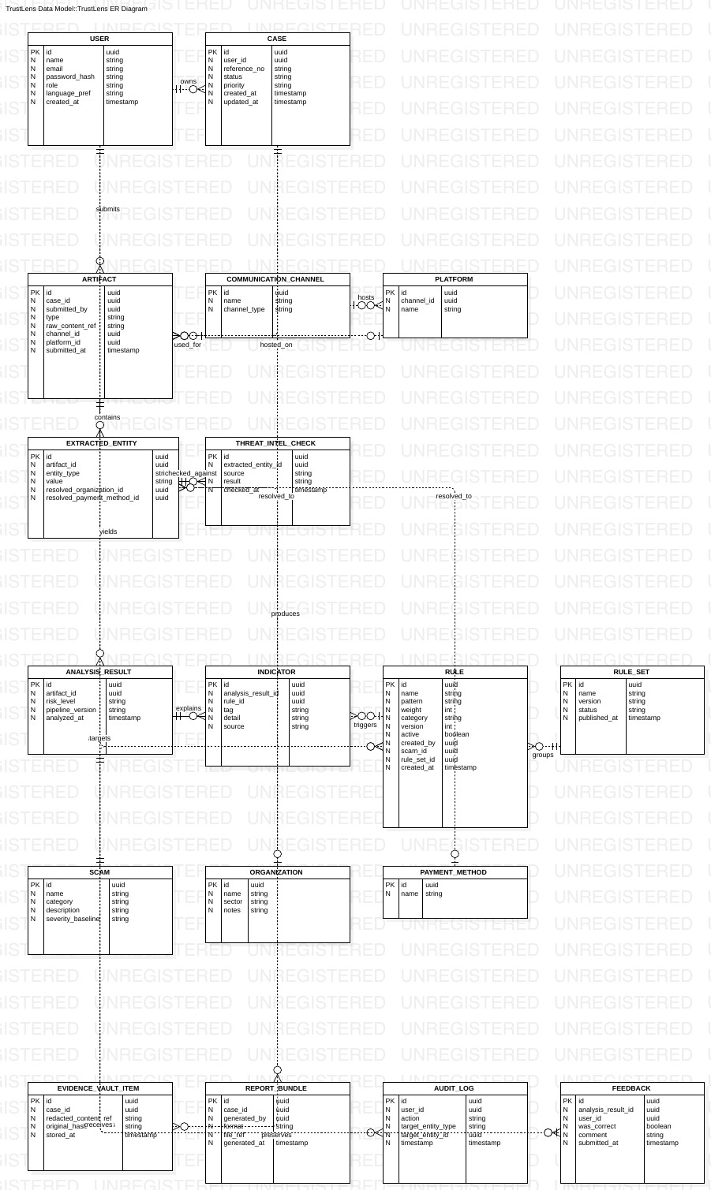
Figure B-1 — TrustLens entity relationship model

B.2 Data Flow Diagrams
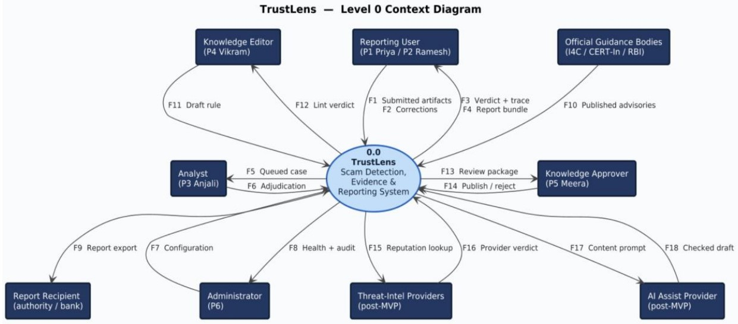
Figure B-2 — Level 0 context diagram. One process, nine external entities, eighteen flows.
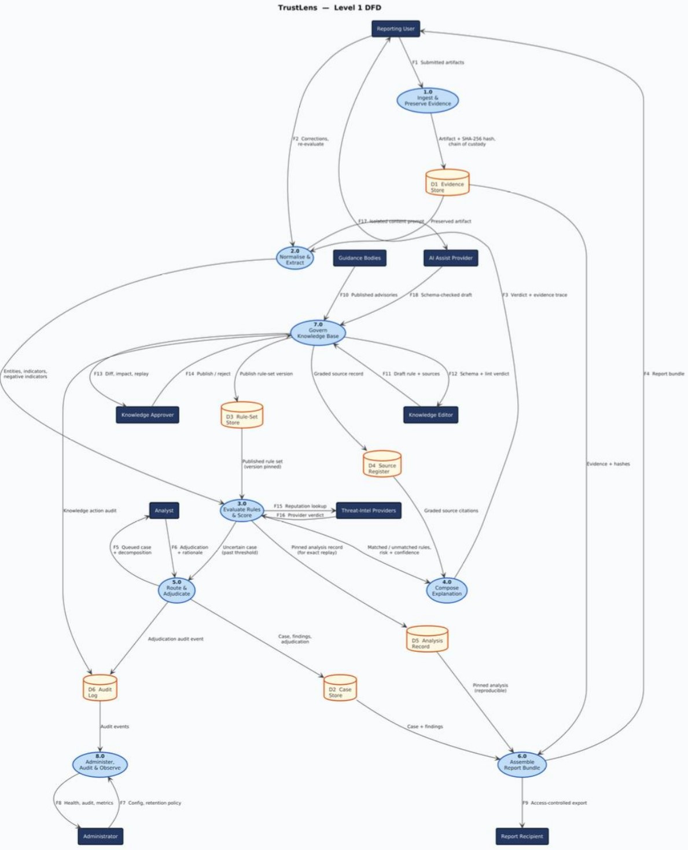
Figure B-3 — Level 1 data flow diagram. Eight processes, six data stores.

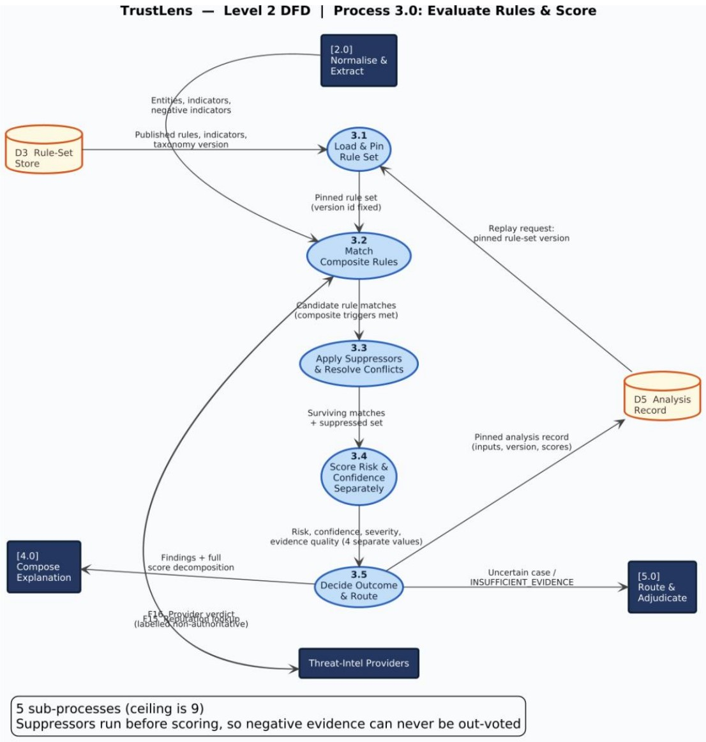
Figure B-4 — Level 2 data flow diagram, process 3.0 exploded into five sub-processes.

B.3 Use Case Diagram
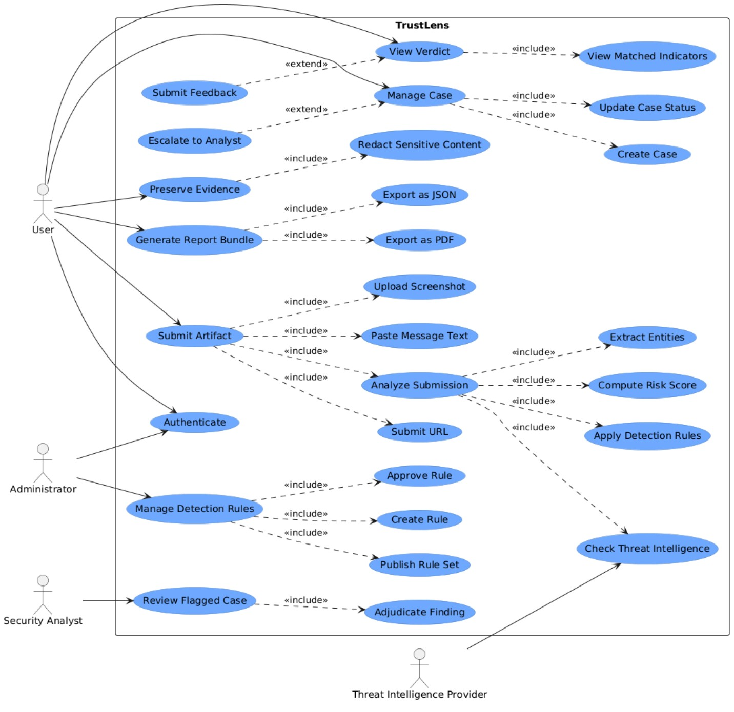
Figure B-5 — TrustLens use case diagram

Appendix C: To Be Determined List
These are the things that are genuinely still open. Nothing in this list is quietly treated as settled elsewhere in the document.

ID | Item | What it blocks
C.1 | No end user, analyst or knowledge editor has validated any persona or journey. | Confidence in Section 2.3 and much of Section 4
C.2 | Data retention period and legal basis are undecided, and DPDP applicability is unverified. | 4.8.3.4, 4.8.3.5, 5.3.3, Section 6
C.3 | Docker and PostgreSQL are not installed on the development machine. | All implementation
C.4 | Which Indian languages are in release 1.0 scope. Currently English only, and no verified source gives us non-English cues. | 4.2.3.3, 5.2.6, Section 6
C.5 | Deployment target unknown, local only or hosted. | Section 2.4 and the operational requirements
C.6 | OCR engine not selected, and there is no guidance on OCR quality for Indian scripts. | 4.2.3.4, 5.1.2
C.7 | The negative-indicator library does not exist yet. The research package gave us zero suppressive signals. | 4.2.3.7, 4.3.3.3, and therefore the whole false-positive strategy
C.8 | The reduction maths for REDUCE-type suppression rules is undefined. Only SUPPRESS is currently expressible. | 4.3.3.3, 4.3.3.10
C.9 | Seven I4C-attributed rule bases and three commercial-source rule bases could not be retrieved, so the rules resting on them stay unpublished. | Detection coverage at release
C.10 | No labelled real-world corpus exists, so accuracy is unmeasurable. This one cannot be closed within this project and is recorded so it is not quietly forgotten. | Section 5.4.2 and any accuracy claim
C.11 | The project has no end date, so no requirement in this document is time-boxed. | Release planning

