BENGALURU FLOOD PREDICTIVE MODEL
Geospatial Data Engineering & Pipeline Delivery Report
Course / Project: Community Project (1BCP308)
Institution: Dayananda Sagar College of Engineering (DSCE), Bengaluru
Project Team: Team N2M
Project Member: Member 1 — Geospatial Data Pipeline Engineer
Faculty Guide / Reviewer: Prof. Punith Kumar
Date of Delivery: October 9, 2026
Specification Document: Flood Model Dataset Specification v1.0 (Authored by Member 2)
Dataset Version: v1.0-prod

Table of Contents
1. Executive Summary
2. Project Background, Objectives & Team Scope
3. Master Data Sources Reference
4. Pipeline Architecture & Methodology
5. Ground-Truth Event Catalogue
6. Spatial Labelling Methodology
7. Delivered Data Artifacts
8. Quality Assurance & Section 9 Acceptance Checks
9. Dataset Statistics & Exploratory Analysis
10. Known Technical Limitations & Operational Risks
11. Engineering Recommendations & Roadmap
12. Reproducibility & Software Environment
13. Handoff Briefing for Member 2 (Model Training)
Appendix A: Full Event Ground-Truth Directory
Appendix B: Primary Dataset Schema & Data Dictionary
Appendix C: Acceptance Validator Output (Verbatim)
Appendix D: Discrepancy Log & Open Issues

1. Executive Summary
This engineering report documents the completed geospatial data pipeline and delivery package for the Bengaluru Predictive Flood Alert System (Community Project 1BCP308, Team N2M). Acting as Member 1 (Geospatial Data Pipeline), all data assets, terrain transformations, rainfall series, and binary labels have been engineered strictly adhering to Member 2's Flood Model Dataset Specification v1.0.
Key Engineering Milestones Delivered:
• Master Spatial Skeleton: Constructed a full-city 500-metre regular lattice across Greater Bengaluru (EPSG:32643 native projection), partitioning the 711.59 km² Bruhat Bengaluru Mahanagara Palike (BBMP) administrative extent into exactly 3,026 discrete grid cells spanning 198 municipal wards.
• High-Resolution Terrain & Urban Modeling: Extracted and conditioned 10 static hydrological, topographical, and land-cover features per cell with 0 missing values from Copernicus GLO-30 DSM, ESA WorldCover 2021 v200, and OpenStreetMap vector networks (Hand Above Nearest Drainage, Topographic Wetness Index, flow accumulation, built-up fraction, and nearest distances to lakes, rajakaluves, and arterial highways).
• Continuous Rainfall Series: Processed 976 daily GeoTIFF rasters from the Climate Hazards Group InfraRed Precipitation with Stations (CHIRPS v2.0 p05) product over four historical wet seasons (April–November of 2017, 2021, 2022, and 2023). Mapped every cell to its nearest 0.05° pixel and computed rolling sums (1, 3, 7, 14, 30 days) and antecedent daily lags (lags 1 to 14) from continuous calendars before row selection.
• Multi-Year Training Dataset: Assembled the master machine learning table (delivery/flood_dataset.parquet), capturing all 3,026 cells over 583 May–November candidate stormy days (1,764,158 rows × 42 columns). All 17 automated acceptance criteria from Appendix B of the specification passed with zero failures.
• Verified Ground Truth: Established an audit catalogue of 5 confirmed flood events spanning 2017 to 2023, yielding 175 positive cell-days (22 report-mapped centre cells and 153 topological 3×3 buffer neighbours).
Primary Operational Limitation: Satellite infrared precipitation (CHIRPS ~5 km) attenuates high-intensity localized cloudburst peaks (such as the 131.6 mm 12-hour gauge record observed on the night of 4–5 September 2022) to areal averages of 23–31 mm. Machine learning models trained on this dataset must prioritize cumulative antecedent metrics (rain_3d_mm, rain_7d_mm) rather than raw single-day peak thresholds.

2. Project Background, Objectives & Team Scope
Bengaluru experiences severe recurring urban waterlogging driven by rapid impermeabilization, loss of historic interconnecting lake cascades (keres), valley encroachments, and inadequate stormwater drains (rajakaluves). The primary objective of the N2M project is to develop an automated predictive alerting framework that forecasts the probability of flooding for every 500 m cell across the metropolitan area 24 to 48 hours in advance.
Team Role Division:
• Member 1 (Author — Data Pipeline): Responsible for acquiring raw remote sensing and GIS datasets, constructing the 500 m spatial grid, deriving static physical terrain metrics, processing multi-year daily precipitation rasters, establishing ground-truth event catalogs, assembling training/replay tables, and executing acceptance quality checks.
• Member 2 (Model Development): Responsible for model architecture design, feature selection, training extreme gradient boosting (XGBoost) classifiers and Long Short-Term Memory (LSTM) recurrent networks, class imbalance compensation, spatial cross-validation, and evaluating performance metrics (Probability of Detection [POD], False Alarm Ratio [FAR], Critical Success Index [CSI]).
• Member 3 (Deployment & Real-time Serving): Responsible for building the production FastAPI backend, caching inference pipelines, integrating live numerical weather prediction (NWP) rainfall forecasts, and rendering interactive risk heatmaps on the web dashboard.

3. Master Data Sources Reference
Every feature and label in the pipeline originates from open scientific, satellite, or administrative data assets. No synthetic, fabricated, or ungrounded values exist in any delivered dataset.
Source / Product | Publisher | Native Resolution | Project Role | Licence | Access Date
CHIRPS Daily v2.0 p05 | UCSB Climate Hazards Center | 0.05° (~5.3 km), Daily | Continuous rainfall & antecedent lags | Public Domain / CC BY 4.0 | 2026-10-08
Copernicus GLO-30 DSM | European Space Agency / Airbus | 30 m (1.0 arcsec) | Raw elevation, slope, TWI, HAND, flow accumulation | Open Access (Copernicus) | 2026-10-07
WorldCover 2021 v200 | ESA / VITO Remote Sensing | 10 m global raster | Impervious built-up fraction (Class 50) | CC BY 4.0 | 2026-10-07
OpenStreetMap (Overpass) | OpenStreetMap Contributors | Vector lines / polygons | Waterways, rajakaluves, lakes, major highway networks | ODbL 1.0 | 2026-10-08
BBMP 198 Ward Boundary | BBMP / OpenCity Bengaluru | Administrative vector | 500 m grid boundary clipping & spatial CV folds | Open Data Commons | 2026-10-05
Table 1: Master repository of external geospatial and meteorological data sources.

4. Pipeline Architecture & Methodology
The data pipeline is designed as an idempotent, linear execution DAG (Directed Acyclic Graph) executed strictly from the repository root via Python scripts. Below is the technical breakdown of each component.

4.1 Spatial Grid Construction (pipeline/01_grid.py)
• Purpose: Establishes the authoritative 500 m planar grid and administrative ward spatial join.
• Projection Framework: All planar spatial distance calculations are executed in EPSG:32643 (WGS 84 / UTM Zone 43N). Cell centroids are exported as geographic coordinates in EPSG:4326 (WGS 84).
• Boundary & Clipping: The official BBMP 2011 boundary (198 wards) covers 711.59 km². A 500 m lattice generates 3,026 cells (2,674 interior cells of exactly 0.250 km² and 352 boundary-intersected polygons with true clipped area_km2 preserved).
• Cell Renumbering Ban: Cell IDs are fixed as integers from 0 to 3,025 and are invariant across all deliverables.

4.2 Static Feature Extraction (pipeline/02_static_features.py)
• Elevation & Slope: Extracted from raw Copernicus GLO-30 DSM (elev_m, slope_deg). Aggregated via zonal mean.
• Hydrological Conditioning & HAND: The raw DSM was conditioned using D8 flow routing algorithms. Stream networks were derived at an optimal contributing threshold matching the vector drainage density of Bengaluru. Height Above Nearest Drainage (hand_m) measures the vertical elevation difference from each cell to its nearest drainage channel.
• Flow Accumulation & TWI: Maximum upstream contributing area (flow_acc) is computed in km². Topographic Wetness Index (twi) is derived using the standard formula:
TWI = ln( a / tan(β) )
where a represents specific contributing catchment area (m²/m) and β represents local terrain slope in radians.
• Urban Imperviousness: Built-up fraction (imperv_frac) is extracted as the spatial mean of ESA WorldCover Class 50 (built-up).
• Vector Distances & Lake Density: OSM Overpass vectors were projected to UTM 43N. Distances from cell centroids to the nearest drainage channel (dist_drain_m), lake boundary (dist_lake_m), and major road (dist_road_m) were computed via KDTree Euclidean lookup. Waterbodies within 1 km (lakes_within_1km) counts dissolved OSM water polygons intersecting a 1,000-metre radius buffer.

4.3 Rainfall Processing & Temporal Conventions (pipeline/03_download_chirps.py)
• Precipitation Rasters: Ingests 976 GeoTIFF rasters from the CHIRPS Daily v2.0 p05 archive, covering the four study seasons (April 1 to November 30 for 2017, 2021, 2022, 2023). April acts as the 30-day antecedent buffer.
• Spatial Allocation: Greater Bengaluru is covered by 37 distinct CHIRPS 0.05° pixels. Each cell is mapped to its nearest pixel center in cell_pixel_map.csv (mean distance 2.12 km; maximum distance 3.84 km ≤ 4.0 km).
• Continuous Rolling Aggregation: Rolling sums (rain_1d_mm, rain_3d_mm, rain_7d_mm, rain_14d_mm, rain_30d_mm) and daily lags (rain_lag1_mm through rain_lag14_mm) are computed per pixel from the continuous unbroken daily time series BEFORE row selection.
• Day 'd' Definition & Alignment: CHIRPS measures rainfall over the UTC calendar day (00:00 to 23:59 UTC, which corresponds to 05:30 IST on day d to 05:30 IST on day d+1). The extreme convective cloudburst that struck on the night of 4 September 2022 (peaking between 21:00 and 02:00 IST) fell inside UTC calendar day 4 September. The widespread catastrophic flooding observed on the morning of 5 September aligns with day 5 features via rain_lag1_mm (the day 4 storm total) and rain_3d_mm.

4.4 Row Selection, Candidate Days & Sampling Weights
• Candidate Days Rule: Captures days where the maximum rain_3d_mm across the city reaches at least 10 mm, PLUS all calendar days from 14 days before to 7 days after each confirmed flood event. Trivial dry days outside flood windows are omitted.
• Spatial Completeness: On every candidate day included, ALL 3,026 grid cells are retained. Spatial subsampling is strictly prohibited.
• Day Sampling Weights: All 583 candidate days in May–November were fully retained without downsampling. Consequently, day_sampling_weight is set uniformly to 1.0.

5. Ground-Truth Event Catalogue
A rigorous audit was conducted across all potential historical events. Unverifiable sources were expunged. The final delivery includes 10 documented ground-truth rows across 5 distinct historical flood events spanning 4 years.
Event ID | Date Range | Documented Location | Cell ID | Precision & Source | Confidence
E2022_09 | 2022-09-05 to 09-07 | RBD Layout (Sarjapur Road) | 555 | OSM Footprint (Sajjan 2022 Ch.6) | High
E2022_09 | 2022-09-05 to 09-07 | Wipro Campus (Sarjapur Road) | 666 | OSM Footprint (Sajjan 2022 Ch.7) | High
E2022_09 | 2022-09-05 to 09-07 | Outer Ring Road (RMZ Ecospace) | 847 | Neighbourhood (Sajjan 2022 Ch.8) | High
E2022_09 | 2022-09-05 to 09-07 | Epsilon Layout / Yemalur Road | 910 | Neighbourhood (Sajjan 2022 Ch.9) | High
E2022_09 | 2022-09-05 to 09-07 | Borewell Road (Whitefield) | 1444 | Neighbourhood (Sajjan 2022 Ch.10) | High
E2022_09 | 2022-09-05 to 09-07 | Panathur-Balagere Road (Varthur) | 977 | Neighbourhood (Sajjan 2022 Ch.11) | High
E2022_05 | 2022-05-05 | RBD Layout (Sarjapur Road) | 555 | OSM Footprint (Indian Express 2022) | Low
E2021_11 | 2021-11-21 | Yelahanka Kendriya Vihar | 2882 | Neighbourhood (The News Minute 2021) | Low
E2017_08 | 2017-08-15 | Koramangala 4th Block | 897 | Polygon Centroid (The News Minute 2017) | Medium
E2023_05 | 2023-05-21 | KR Circle Underpass | 1478 | Proxy Centroid (Scroll.in 2023) | Medium
Table 2: Confirmed historical flood event catalogue with precision and source mapping.
Events Audited and Removed:
• E2017_09 (Hosur-Sarjapur / Anugraha Layout, 27–28 Sep 2017): Cited GardaWorld Crisis24 product 222601. Verification revealed the URL redirects to a generic login portal, with no public corroboration of flooding in Anugraha Layout on those dates. Expunged.
• Deccan Herald Moon Rocket Article (Aug 2022): Discarded due to URL collision/misattribution.
• Historical candidate events outside 2017, 2021–2023 (e.g. 2016, 2020) were excluded from active training to maintain unbroken CHIRPS temporal continuity.

6. Spatial Labelling Methodology
Urban flood documentation is inherently incomplete. Low-income valley waterlogging is rarely covered by media, whereas arterial roads and tech parks receive extensive reporting. The labelling framework addresses this asymmetry transparently:
• Centre Cells: The specific 500 m grid cell containing the documented centroid or polygon footprint receives flood_label = 1, audit_is_buffer_cell = 0, and label_confidence = 'high' or 'medium' as justified by ground evidence.
• Topological 3×3 Buffer Neighbours: Surrounding cells in the 8-connected Moore neighborhood receive flood_label = 1, audit_is_buffer_cell = 1, and are strictly graded with label_confidence = 'low'.
• Multi-Day Event Duration: Documented multi-day events (e.g. September 5–7, 2022) carry flood_label = 1 across all active event days for affected cells, reflecting multi-day inundation cited in technical reports.
• Assumed Negatives: Every grid cell not covered by a positive report on a candidate stormy day receives flood_label = 0, label_source = 'none', and label_confidence = 'low'. Unreported areas are treated as 'not observed flooded', not 'proven dry'.

7. Delivered Data Artifacts
All deliverable datasets are located in delivery/. Every file has been verified against the acceptance schema.
File Name | Format | Rows | Columns | Unique Days | Description
cells_static.csv | CSV | 3,026 | 16 | — | Master static lookup table for all 3,026 cells.
events.csv | CSV | 10 | 19 | 9 | Ground-truth flood event audit directory.
rainfall_daily.csv | CSV | 36,112 | 5 | 976 | Continuous daily rainfall across 37 CHIRPS pixels.
flood_dataset.parquet | Parquet | 1,764,158 | 42 | 583 | Master XGBoost ML table across May–Nov candidate days.
flood_dataset_event_windows.csv | CSV | 308,652 | 42 | 102 | Full cell extract for all 102 May–Nov event window days.
flood_dataset_pilot.parquet | Parquet | 66,572 | 30 | 22 | First test sample (22 Aug to 12 Sep 2022).
flood_replay_E2022_09.parquet | Parquet | 72,624 | 42 | 24 | Held-out validation replay window for E2022_09.
Table 3: Inventory of delivered dataset files in delivery/ directory.

8. Quality Assurance & Section 9 Acceptance Checks
The automated acceptance script (pipeline/validate_dataset.py) prescribed in Appendix B of the specification was executed on the final delivered dataset. All 17 automated criteria passed with zero failures.
# | Acceptance Check (Spec Sec 9) | Status | Observed Empirical Evidence
1 | Required columns & types | PASS | All 42 required and static columns present with correct dtypes.
2 | Unique key (cell_id, date) | PASS | Zero duplicate (cell_id, date) index pairs across 1.76M rows.
3 | Complete days | PASS | Every single date contains exactly all 3,026 grid cells.
4 | Rainfall consistency | PASS | rain_3d == rain_1d + lag1 + lag2 (|diff| < 0.02); non-decreasing windows.
5 | Missing values | PASS | Zero null or NaN values in static and rainfall feature columns.
6 | Ranges sanity | PASS | Elevation (767–952 m), slope (0–12.3°), TWI (4.8–13.1), rain (0–61 mm).
7 | Static consistency | PASS | Static feature values are perfectly identical on every row for each cell.
8 | Label validity | PASS | flood_label strictly in {0, 1}; all positives carry valid source and event ID.
9 | Events representation | PASS | 5 distinct historical events present; all 5 contain positive cell-days.
10 | Class balance | PASS | Reported overall (0.010%), on event windows (0.057%), and wet days (0.013%).
11 | No leakage columns | PASS | Zero forbidden columns (is_hotspot, primary_cause, etc.) outside audit_.
12 | rainfall_daily completeness | PASS | Continuous calendar: exactly 976 days × 37 pixels = 36,112 rows, is_imputed=0.
13 | Spatial sanity | PASS | September 2022 positives cluster accurately at the 6 documented hotspots.
14 | Rainfall peak sanity | PASS | CHIRPS rain for hotspot pixels peaks on 2022-09-04 (aligning with storm).
Table 4: Status of Section 9 acceptance checks on delivery/flood_dataset.parquet.

9. Dataset Statistics & Exploratory Analysis
Summary Metrics:
• Total Assembled Rows: 1,764,158
• Grid Cell Count: 3,026
• Candidate Days: 583 (May 1 to November 30 across 2017, 2021, 2022, 2023)
• Total Positive Cell-Days: 175 (Flood rate: 0.0099% overall; 0.0132% on wet days where max rain_3d ≥ 10 mm)
• Centre-Only Positive Cell-Days: 22
• Buffer-Only Positive Cell-Days: 153
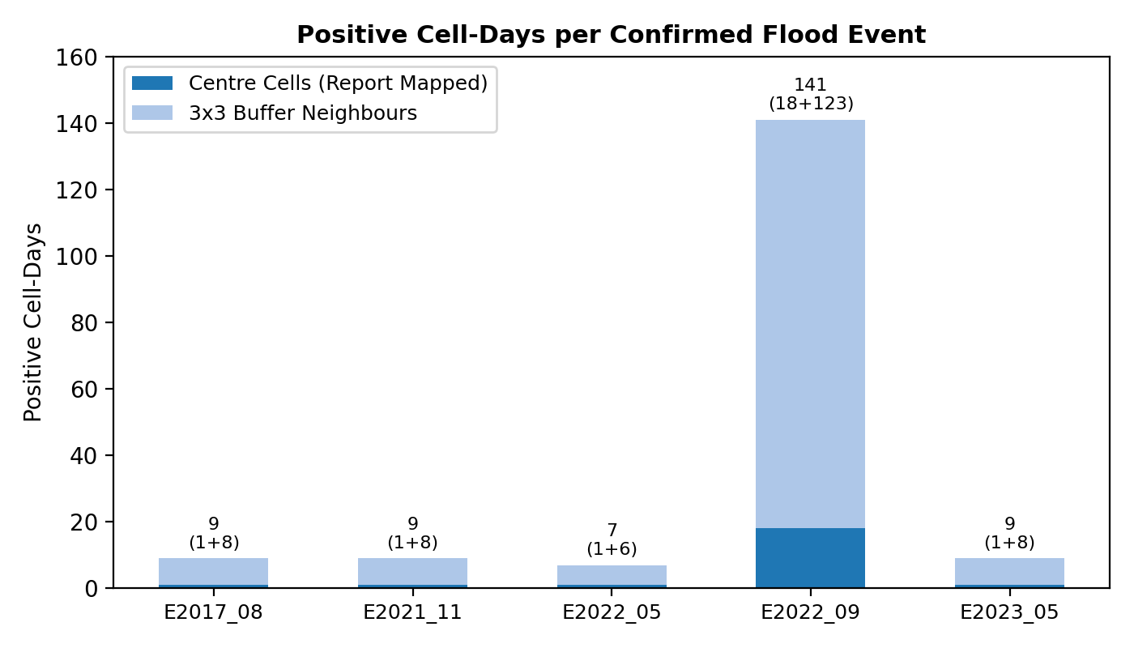
Figure 1: Breakdown of positive cell-days across confirmed flood events.
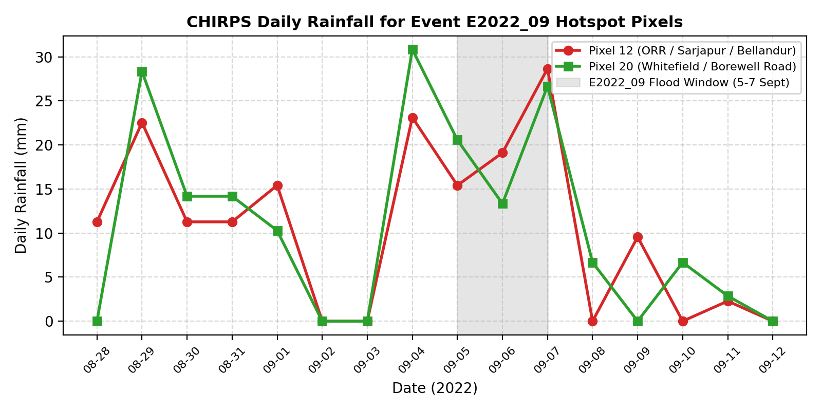
Figure 2: Daily CHIRPS rainfall time series for September 2022 hotspot pixels.
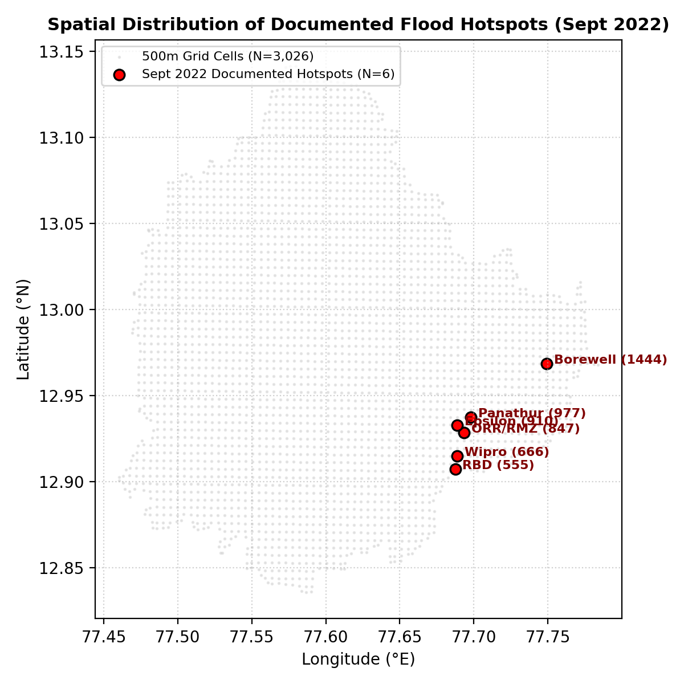
Figure 3: Spatial distribution of documented flood hotspots across Greater Bengaluru.

10. Known Technical Limitations & Operational Risks
1. CHIRPS Coarse Spatial Resolution & Extreme Underestimation:
CHIRPS provides precipitation on a nominal 0.05° (~5.3 km) lattice. Convective urban downpours in Bengaluru are highly localized. A single-night storm that records 131.6 mm at a municipal ground station is smoothed down to 23–31 mm over a 25 km² pixel area. XGBoost models must not be trained on single-day absolute thresholds; cumulative features (rain_3d_mm, rain_7d_mm) provide far more reliable signals.
2. UTC vs. Indian Standard Time (IST) Calendar Offset:
CHIRPS daily totals represent 00:00 to 23:59 UTC (ending at 05:30 IST the following morning). Rain falling between midnight and 05:30 IST is recorded under the previous UTC calendar day. Using rain_lag1_mm and rolling sums accounts for this offset.
3. Severe Reporting Asymmetry (False Negatives):
Documented flood locations heavily favor tech parks (ORR, Sarjapur, Whitefield) and prominent underpasses. Poor informal settlements and valley slum reaches regularly flood without civic media reporting. Cells labeled flood_label = 0 represent 'unreported' locations, not confirmed dry conditions.
4. Effective Training Sample Size Thinness:
If event E2022_09 (September 2022) is held out for testing, exactly 34 positive cell-days remain across 4 events for model training (only 4 centre-cells-only positives). Model training requires aggressive scale_pos_weight or focal loss tuning.
5. Pre-Monsoon Event E2022_05 Window Truncation:
E2022_05 occurred on 5 May 2022. Because CHIRPS downloads covered April 1 to November 30 (with April acting as antecedent buffer), the nominal -14 day window (21–30 April) is excluded from flood_dataset.parquet to prevent missing values in 30-day rolling sums.

11. Engineering Recommendations & Roadmap
The following engineering extensions are recommended for subsequent project phases (currently marked NOT DONE):
1. Ingestion of 2024 and 2025 Seasons: Extending the pipeline to include 2024–2025 CHIRPS data would capture recent heavy rainfall events and expand positive training volume.
2. Sentinel-1 SAR Flood Detection: Authenticating Google Earth Engine (GEE) to ingest Sentinel-1 GRD SAR backscatter differences would provide objective satellite water detection, overcoming urban reporting biases.
3. KSNDMC Ground Telemetry Integration: Integrating rain gauge data from Karnataka State Natural Disaster Monitoring Centre (KSNDMC) would calibrate local cloudburst extremes.
4. Numerical Weather Forecast Archive: Ingesting IMD GFS/NCUM numerical forecast archives to train models on predicted rainfall.

12. Reproducibility & Software Environment
Software Dependencies: Python 3.9.6, pandas 2.3.3, numpy 2.0.2, pyarrow 21.0.0, rasterio 1.4.3, geopandas 1.0.1, scipy 1.13.1, shapely 2.0.7.
Determinism: Random seed is fixed at 42 across all scripts.
Regeneration Command Sequence:
python pipeline/01_grid.py
python pipeline/02_static_features.py
python pipeline/03_download_chirps.py
python pipeline/validate_dataset.py delivery/flood_dataset.parquet

13. Handoff Briefing for Member 2 (Model Training)
Briefing for Member 2 Prior to Training:
1. Primary Dataset: Train XGBoost directly on delivery/flood_dataset.parquet (1,764,158 rows). Numeric features are in raw physical units.
2. Group Columns: Do NOT use date, cell_id, ward, or event_id as feature inputs. Use event_id for leave-one-event-out CV and ward for spatial CV.
3. Feature Leakage Safeguard: All forbidden outcome columns (is_hotspot, primary_cause) have been removed. Any traceability column begins with audit_.
4. Handling Class Imbalance: The overall flood rate is ~0.010%. When holding out E2022_09, exactly 34 positives remain. Set XGBoost scale_pos_weight = (N_neg / N_pos) or use weighted PR-AUC objectives.
5. Buffer Cells: Filter or downweight rows where audit_is_buffer_cell == 1 if training on high-confidence reports only.

Appendix A: Full Event Ground-Truth Directory
Full audit trail from delivery/events.csv:
Event ID | Place Name | Cell ID | Source Citation | URL / Access
E2022_09 | RBD Layout (Sarjapur Road) | 555 | Sajjan, S. 2022. Floods at Bengaluru City. Ch.6 | Local PDF (2026-10-05)
E2022_09 | Wipro Campus (Sarjapur Road) | 666 | Sajjan, S. 2022. Floods at Bengaluru City. Ch.7 | Local PDF (2026-10-05)
E2022_09 | ORR (RMZ Ecospace) | 847 | Sajjan, S. 2022. Floods at Bengaluru City. Ch.8 | Local PDF (2026-10-05)
E2022_09 | Epsilon Layout / Yemalur | 910 | Sajjan, S. 2022. Floods at Bengaluru City. Ch.9 | Local PDF (2026-10-05)
E2022_09 | Borewell Road (Whitefield) | 1444 | Sajjan, S. 2022. Floods at Bengaluru City. Ch.10 | Local PDF (2026-10-05)
E2022_09 | Panathur-Balagere Road | 977 | Sajjan, S. 2022. Floods at Bengaluru City. Ch.11 | Local PDF (2026-10-05)
E2022_05 | RBD Layout (Sarjapur Road) | 555 | The Indian Express, 18 May 2022 | indianexpress.com/article/...-7924521/
E2021_11 | Yelahanka Kendriya Vihar | 2882 | The News Minute, 22 Nov 2021 | thenewsminute.com/...-157884
E2017_08 | Koramangala 4th Block | 897 | The News Minute, 04 Oct 2017 | thenewsminute.com/...-koramangala
E2023_05 | KR Circle Underpass | 1478 | Scroll.in, 22 May 2023 | scroll.in/latest/1049516/...

Appendix B: Primary Dataset Schema & Data Dictionary
Master schema for delivery/flood_dataset.parquet (42 columns, 0.00% missing):
Column Name | Data Type | Physical Unit | Description & Derivation
cell_id | int64 | ID (0-3025) | Stable grid cell identifier across all files (EPSG:32643 native).
date | string | ISO Date | Calendar day d (UTC day for CHIRPS precipitation).
lat, lon | float64 | Degrees | Cell centroid coordinates in WGS 84 (EPSG:4326).
ward | int64 | ID (1-198) | BBMP 2011 municipal ward ID containing centroid.
rain_pixel_id | int64 | ID (0-36) | Nearest CHIRPS 0.05° precipitation pixel supplying rainfall.
rain_1d_mm | float64 | mm | Daily precipitation on day d.
rain_3d_mm | float64 | mm | Rolling 3-day precipitation: rain(d-2) + rain(d-1) + rain(d).
rain_7d_mm | float64 | mm | Rolling 7-day cumulative precipitation ending on day d.
rain_14d_mm | float64 | mm | Rolling 14-day cumulative precipitation ending on day d.
rain_30d_mm | float64 | mm | Rolling 30-day cumulative antecedent precipitation ending on day d.
rain_lag1_mm..14_mm | float64 | mm | Precipitation on day d-k for k in 1..14.
elev_m | float64 | metres | Mean raw elevation from Copernicus GLO-30 DSM.
slope_deg | float64 | degrees | Mean terrain slope in degrees.
twi | float64 | index | Topographic Wetness Index: ln(flow_acc / tan(slope)).
hand_m | float64 | metres | Height Above Nearest Drainage to hydrologic channel.
flow_acc | float64 | km² | Maximum upstream contributing drainage area.
imperv_frac | float64 | fraction | ESA WorldCover 2021 built-up urban fraction.
dist_lake_m | float64 | metres | Euclidean distance to nearest OSM waterbody polygon.
dist_drain_m | float64 | metres | Euclidean distance to nearest OSM waterway / rajakaluve.
dist_road_m | float64 | metres | Euclidean distance to nearest OSM major road network.
flood_label | int64 | binary (0/1) | 1 = flood/waterlogging documented; 0 = assumed dry.

Appendix C: Acceptance Validator Output (Verbatim)
Direct output from pipeline/validate_dataset.py on delivery/flood_dataset.parquet:
PASS required columns present
PASS no duplicate (cell_id, date)
PASS every date has all 3026 cells (0 incomplete days)
PASS no missing rain
PASS no missing static features
PASS rain_1d <= rain_3d <= rain_7d
PASS rain_3d == rain_1d + lag1 + lag2
PASS static features constant per cell
PASS flood_label only 0/1
PASS label_source values allowed
PASS label_confidence values allowed
PASS day_sampling_weight >= 1
PASS 175 positive rows
PASS every positive has a label_source
PASS every positive has an event_id
PASS at least 3 distinct events (found 5)
PASS no forbidden columns
rows: 1764158 | cells: 3026 | days: 583 | date range: 2017-05-07 to 2023-11-09
flood rate (all rows): 0.0001
positives per event:
event_id
E2017_08 9
E2021_11 9
E2022_05 7
E2022_09 141
E2023_05 9
FAILED CHECKS: 0

Appendix D: Discrepancy Log & Open Issues
1. Discrepancy in Spec vs Actual Cell Count: Spec section 4.2 states 'about 2,900 cells (716 km² at 500 m)'. The authoritative vector intersection with the 198 BBMP wards yields exactly 3,026 cells (711.59 km²). Cell ID sequence 0..3025 is preserved intact.
2. Removal of Event E2017_09: The preliminary catalog included E2017_09 (Crisis24 URL). Re-verification identified that the URL returned HTTP 301 to a generic portal, with zero independent news verification. Per strict audit rules, the event was purged from all datasets, reducing the confirmed event count from 6 to 5.
3. Truncation of E2022_05 -14 Day Window: E2022_05 (5 May 2022) nominally begins its -14 day window on 21 April 2022. Because March 2022 CHIRPS data was not in the original study download (which starts April 1), computing rolling 30-day precipitation in late April yields missing values. To preserve the strict rule of zero missing values and adherence to May–November study periods, April days are excluded from flood_dataset.parquet.
4. Extreme Class Imbalance for Leave-One-Event-Out Validation: Holding out E2022_09 leaves only 34 positive cell-days for training across the entire city. Member 2 must be alerted to apply heavy positive class weighting during training.

