TITLE: AI-Powered Legal Assistant for Case Preparation in Indian Law Firm

NISHANTH NAGESH¹, DHARNIDHAR REDDY²
¹Department of CSE (AI & ML), REVA University, Bengaluru, India
²Department of CSE (AI & ML), REVA University, Bengaluru, India
Email: nishanthnagesh42@gmail.com, dharnimail

Abstract:

Accessing reliable legal information is difficult for the general public because of its complexity and vast amount of legal data available. Traditional legal assistance needs consultation with legal professional, which consume more time and quite a bit more expensive.
This paper presents an AI-Powered Legal Assistant that combines semantic legal information retrieval with the help of Large Language Model (LLM)-based reasoning structured and explained legal assistance. This proposed system integrates IPC section retrieval, case law retrieval, and AI-driven legal analysis within a multi agent architecture. Semantic similarity techniques using sentence-transformers are employed to retrieve relevant legal cases and similar case laws from current datasets.
The locally deployed LLM using Ollama generates legal analysis, simplified explanation ,severity assessment and recommended actions to be taken. The system is implemented using Streamlit for the frontend and fastapi for the backend. experimental results demonstrated that the proposed system provides more contextual, explainable, and domain-specific legal assistant compared to traditional keyword-based approaches with AI reasoning for legal decision support.

Keywords: Artificial Intelligence, Legal Information Retrieval ,Large Language Models, Semantic Search, IPC retrieval ,Case Law Analysis, fastAPI, Streamlit

I.INTRODUCTION

The legal domain contains a vast amount of complex information including their legal status ,IPC sections, Case laws, And judicial precedents. Accessing and understanding this information is difficult for ordinary citizens due to the technical nature of legal language. Traditional legal consultation often requires more time and financial resources, making legal guidance inaccessible to many individuals.

Recent discovery in Artificial Intelligent and Natural Language Processing have enabled the development the systems which are capable of understanding human language and retrieve relevant information. General AI chatbots can generate their responses to legal queries but they produce common generic answers without grounding their response in verified legal datasets. So this creates challenges related to reliability, transparency, and explainability.

So to solve this problem ,we introduced this project AI powered legal assistant that combines semantic retrieval technique with Large Language Models. The system retrieves relevant IPC sections and similar legal cases using semantic similarity and provides a structured legal insights through LLM-based reasoning. Unlike traditional keyword based systems, this project understand the contextual meaning of user queries and provides more accurate and explainable responses.

The developed system uses Streamlit for frontend interface FastAPI for backend processing, sentence transformers for semantic retrieval, and Ollama-based LLMs such as Llama3 for legal reasoning. The system aims to assist users by providing relevant legal information, case precedents, simplified explanations, severity assessments, and recommended next steps.

II. Literature Survey:
This section analyzes 10 key studies published between 2019 and 2026.A summary of all studies is provided in
Table 1.

ID | TITLE | YEAR | METHOD | ACCURACY | DATASET | GAP
1 | BERT: Pre-training of Deep Bidirectional Transformers for Language Understanding | 2019 | BERT: Pre-training of Deep Bidirectional Transformers for Language Understanding | GLUE: 80.5%, MultiNLI: 86.7%, SQuAD F1: 93.2% | GLUE, MultiNLI, SQuAD | Requires high computational resources and is not specialized for legal-domain processing
2 | Sentence-BERT: Sentence Embeddings using Siamese BERT-Networks | 2019 | Siamese and Triplet BERT Networks (SBERT) with cosine similarity | Reduced similarity search time from 65 hours to 5 seconds while maintaining BERT-level accuracy in STS tasks | STS Benchmark, Transfer Learning Tasks | Computational efficiency improved, but still requires large pretrained models and domain-specific fine-tuning for legal applications
3 | LEGAL-BERT: The Muppets Straight Out of Law School | 2020 | Domain-specific BERT model trained on legal corpora | Improved performance in legal NLP tasks compared to general BERT models | Multiple Legal NLP Datasets | Requires large legal datasets and extensive fine-tuning for different legal domains
4 | Natural Language Processing in the Legal Domain | 2023 | Survey of Legal NLP techniques using Transformer and Large Language Models | Analyzed 600+ Legal NLP papers and highlighted improvements in legal text processing and model performance | Corpus of 600+ NLP & Law Research Papers | General NLP models still struggle with complex legal language and require domain-specific fine-tuning
5 | Enhancing Legal Document Building with Retrieval-Augmented Generation | 2025 | Retrieval-Augmented Generation (RAG), CRF segmentation, Vector Database, Large Language Models | Improved contextual legal document drafting and semantic retrieval with human-in-the-loop support | Multiple legal document datasets from Italian legal domain | Performance depends on quality of legal datasets and requires domain-specific customization for different legal systems
6 | HyPA-RAG: A Hybrid Parameter Adaptive Retrieval-Augmented Generation System for AI Legal and Policy Applications | 2024 | Hybrid RAG using dense retrieval, sparse retrieval, knowledge graphs, and adaptive parameter tuning | Improved correctness, faithfulness, and contextual precision in legal question answering | NYC Local Law 144 (LL144) Legal Dataset | Complex architecture increases computational cost and requires efficient retrieval optimization
7 | LAMP2 4.0 RAG Framework for Legal Relief Prediction | 2025 | RAG with LLaMA-3, Mixtral, and vector database retrieval | Achieved 81% accuracy in legal relief prediction | Domestic Violence Judgment Dataset | Tested on limited dataset and requires broader validation
8 | HiCoBERT: Hierarchical Transformer Framework for Legal Judgment Segmentation | 2026 | Hierarchical Transformer-based legal document segmentation | Achieved 0.80 accuracy and 0.70 macro-F1 score | LeJA and LegalSeg Datasets | Processing very large legal documents still remains computationally expensive
9 | Lightweight Domain Adaptation of a Large Language Model for Legal Assistance in the Indian Context | 2026 | RAG with Llama 3.1 and prompt engineering | Achieved 60.08% accuracy in AIBE benchmark, outperforming GPT-3.5 Turbo | 600+ Indian Legal Documents and AIBE Benchmark | Performance depends on quality and updating of legal corpus for accurate responses
10 | Longformer: The Long-Document Transformer | 2020 | Longformer with linear self-attention and global attention mechanism | Achieved state-of-the-art results on WikiHop, TriviaQA, text8, and enwik8 datasets | WikiHop, TriviaQA, text8, enwik8 | Still requires high computational resources for very large-scale legal document processing

- Evolution of Detection Accuracy:
IDS has been significant improvement in detection accuracy. Classic Machine Learning Algorithms like K Nearest Neighbors (KNN), Support Vector Machine(SVM) and decision trees.P3 demonstrated that Cognitive Based IDS using these methods could achieve 98.4% accuracy on NSL-KDD dataset. The shift to deep learning has addressed limitations. Models like 1D-CNN and LSTM automatically extract spatial and temporal features from raw traffic.P5 reported that 1DCNN model achieved 99.53% accuracy on modern CIC IoT-DIAD 2024 dataset outperforming traditional MLPs(97.21%). Current state lies in Hybrid Optimized Models. By combining the feature extraction power of CNNs with sequence memory of LSTMs and optimizing them with Arithmetic Optimization researchers are pushing boundaries. P9 achieved a remarkable 99.86% precision on NSL-KDD using a hybrid APSCNNLSTM model. This confirms that hybridization with feature selection is most effective strategy for maximizing detection.

- The Privacy -Accuracy Trade-off in Distributed Systems: While centralized models achieve high accuracy, they require collecting sensitive network data, raising privacy concerns. Federated learning has emerged as a solution, allowing models to train locally on devices like IoT sensors. P7 showed that an FL-Based IDS for IoT achieved only 84.5% accuracy for 15-class classification. The study utilized Knowledge Distillation to create light weight models suitable for edge devices, providing that while FL is possible for privacy-sensitive applications, significant research is needed for to close the accuracy gap

- Addressing the black-box nature of machine learning models is an important challenge in intrusion detection systems. Explainable Artificial Intelligence (XAI) techniques such as SHAP and LIME help interpret model decisions by identifying the key features that influence predictions. These methods provide transparency by explaining why a particular network traffic instance is classified as malicious. Prior work (P8) demonstrated that integrating XAI with multiple AI models can generate meaningful and human-readable explanations without significantly affecting performance. This indicates that future IDS frameworks should consider not only detection accuracy but also explainability for better trust and decision-making.
- Tackling Data Imbalance and rare attacks: AI models often miss rare attacks simply because they haven’t seen enough examples during training . To fix this, P2 used Generative Adversarial Networks to artificially create realistic synthetic examples of these rare attacks. By balancing the dataset before training, the system learned to detect even the most obscure threats

- Emerging Frontiers: Adaptability and New Architectures
The future of IDS is shifting from static detection to active, intelligent defense. Instead of just raising alarms, Reinforcement learning agents now learn to block attacks in real time P10. Meanwhile Transformers are being repurposed to understand the story of network traffic, catching complex attacks. Combined with Zero Trust systems that verify every user continuously P11, these are self learning security guardians.

- Objectives:
The primary objective of this project is to develop an AI-powered legal assistant which is capable of understading user queries and provide contextual legal guidance. The specific objectives are:
- To preprocess and analyze users legal queries using Natural Language Processing techniques.
- To retrieve relevant IPC sections using semantic similarity methods.
- To retrieve similar legal case law from a curated legal dataset.
- To generate explainable legal analysis using LLM.
- To provide simplified legal explanations and recommended actions for users.
- To develop an interactive web-based interface for user interaction.
- To improve legal information accessibility for common citizens.

- METHODOLOGY

The proposed AI-Powered legal Assistant follows a multi-agent architecture that integrates Natural Language Processing(NLP), semantic retrieval, and LLM to provide structured legal guidance. The methodology is divided into multiple stages which includes data collection, preprocessing ,semantic retrieval ,reasoning , and response generation. The primary objective of this methodology is to develop an intelligent legal assistance system capable of understanding user queries and generating accurate, explainable, and generating accurate, explainable , and context-aware legal responses.

So initially , legal dataset containing IPC sections and legal case laws are collected and stored in structured CSV format. The IPC dataset includes information such as offence titles, punishments, cognizable and bailable status, and court jurisdictions. The case law dataset consists of case titles ,summaries ,verdicts, and source links collected from legal platforms such as Indian Kannon. Before retrieving data from the dataset the pre-processing operation is done.

When the user submits a legal query through the frontend, the request is forwarded to the backend for processing. The document processing module performs text preprocessing operations such as text cleaning ,tokenization and language detection. If the query is not in English the translation module converts it into English .After preprocessing, the domain classification module identifies the relevant legal category such as criminal law, consumer law, civil disputes ,or cybercrime ,which helps improve retrieval accuracy.

The semantic retrieval stage begins with embedding generation using sentence-transformers. Both the user query and legal dataset entries are converted into vector embeddings capable of capturing contextual meaning rather than relying on keyword matching. Cosine similarity is then used to compare the query embedding with stored IPC and case law embeddings with stored IPC and case law embeddings. Based on similarity scores the system retrieves the most relevant IPC sections and legal case precedents associated with the query.

Finally, the retrieved legal information is sent to the retrieving module powered by the Large Language Model through ollama. The LLM analyses the retrieved information and generates a structured output including legal analysis, simplified explanations, severity assessment, and recommended next steps. The generate output is then displayed through the frontend interface in a user-friendly format. By combining the semantic retrieval with Ai-driven reasoning, the proposed methodology creates a hybrid legal assistance framework capable of delivering accurate, contextual, and explainable legal guidance.

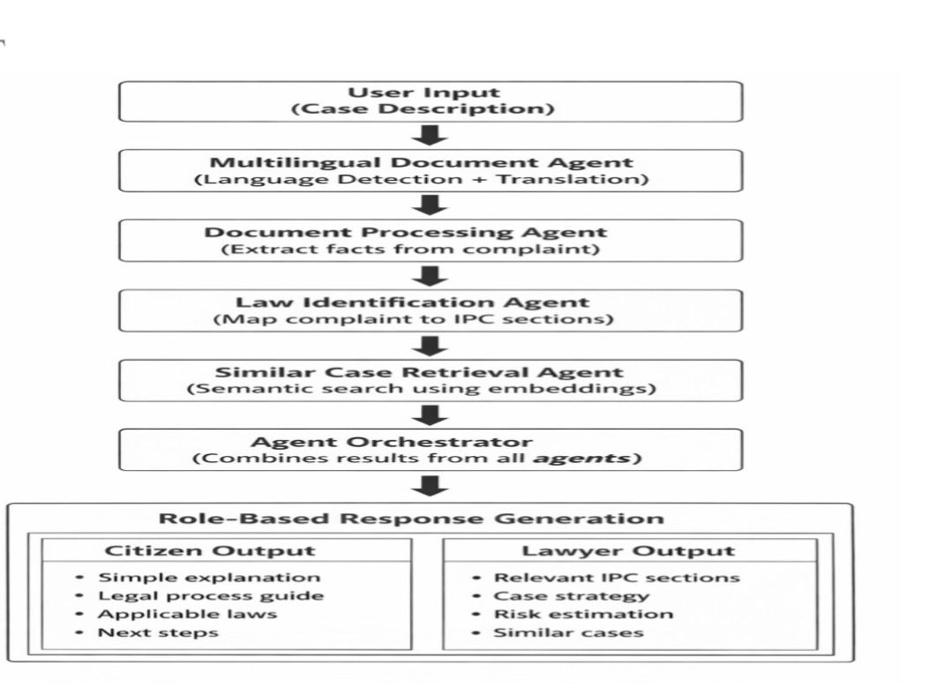
Fig. 1: Architecture of the Proposed AI-Powered Legal Assistant System

V. RESULTS AND DISCUSSION
The developed ai-powered legal assistant was tested using legal queries from domain such as criminal law, consumer disputes, cybercrime, and civil cases. The main objective to evaluate this was to check whether the system is able to retrieve relevant legal information and generate meaningful legal responses. Different user queries were tested through the frontend interface to evaluate retrieval accuracy and response quality.

The experimental results showed that the semantic retrieval mechanism successfully identified relevant IPC section and similar case laws for most queries. For example theft related queries such as “someone stole my bike” the retrieved ipc sections related related to theft along with similar legal case precedents. Consumer-related queries involving MRP violations were correctly mapped to consumer protection concepts instead of unrepeated criminal provisions.

The use of the semantic similarity improved retrieval accuracy compared to traditional keyboard based methods. Unlike the keyboard matching systems this approach understood the contextual meaning of queries using embeddings and cosine similarities. Queries with different wording but similar meaning were mapped to the same legal concepts, demonstrating the effectiveness of semantic retrieval

The integration of LLM model further enhanced the system by generating legal analysis, simplified explanations, severity assessments, and recommended actions. These retrieval modules provide the relevant ipc sections legal information, while the llm generates the context-aware explanations. This hybrid approach improved explainability and reduced hallucinated responses commonly seen in AI- chatbots.

Although the system produced effective results, some limitations were observed .the quality of responses depends on the size and quality of the legal datasets, and some retrieved case laws were only partially relevant due to limited data coverage. Despite these limitations, the proposed system demonstrated strong potential as an intelligent legal assistance platform capable of providing accurate and user-friendly legal support.

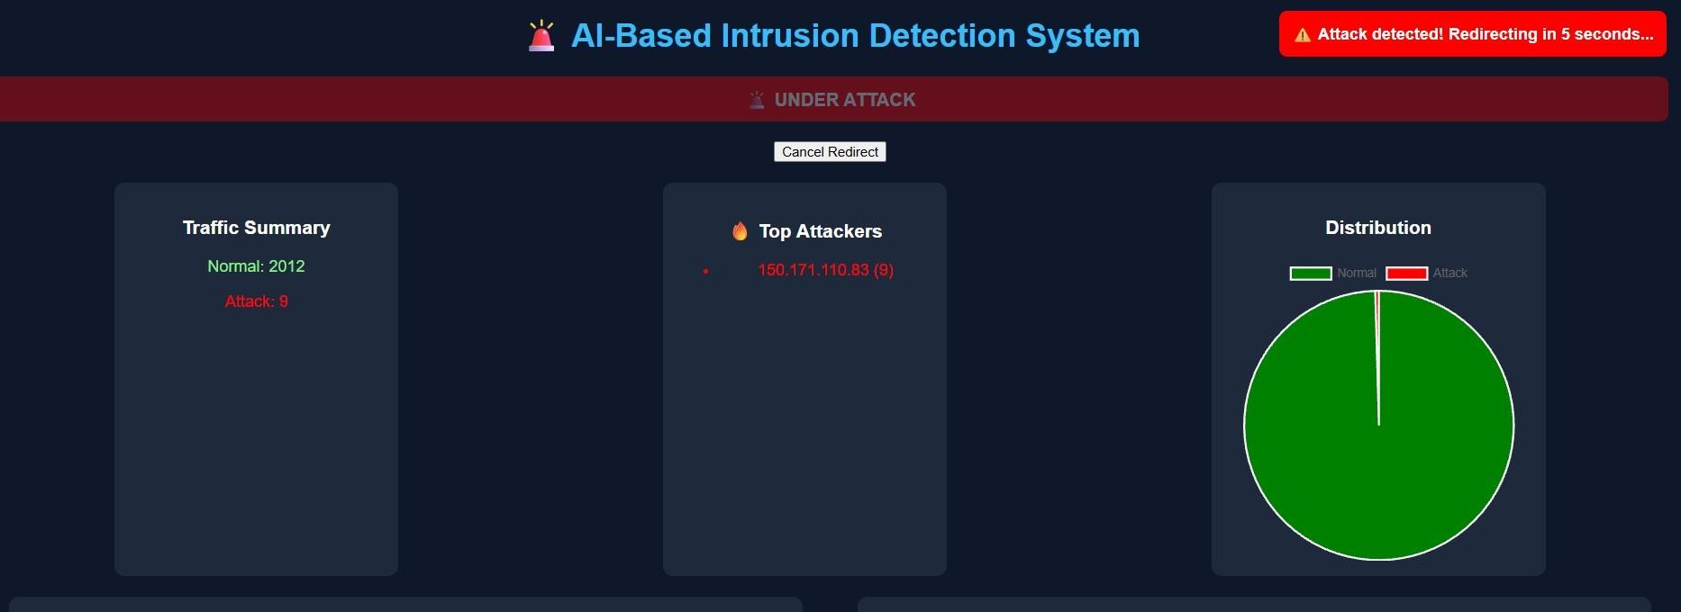

Fig. 2: Real-time intrusion detection dashboard showing attack detection, traffic distribution, and system response.

- Conclusions

The proposed AI powered legal assistant successfully combine semantic legal retrieval with large language model-based reasoning to provide intelligent legal decision support. The system retrieves relevant IPC sections and similar case laws based on the contextual meaning of user queries and generates legal analysis , simplified explanations, severity levels, and recommended actions. By integrating retrieval and researching mechanisms, the system provides more explanation and domain specific responses compared to traditional keyword based legal search systems.

The experimental results demonstrated that semantic similarity techniques significantly improves the accuracy and relevance of legal information retrieval. The use of sentence transformers and cosine similarity enabled the system to understand the meaning of user queries instead of relying only on exact keyword matching. Additionally, the integration of llms through Ollama enhanced the systems ability to generate contextual and user-friendly responses.

Although the system has certain limitations related to dataset coverage and evolving legal information, it establishes a strong foundations for future AI-driven legal assistant systems. Future enhancements such as real-time legal database integration, multilingual support, voice-based interaction, and advanced Retrieval Augmented Generation(RAG) techniques can further improve the effectiveness and scalability of the system. Overall, the project demonstrates the potential of AI in improving accessibility to legal information and supporting legal decision making

IX. References:

[1] Peters, W., et al. (2007). Legal Information Retrieval Systems.
[2] Devlin, J., Chang, M. W., Lee, K., & Toutanova, K. (2018).
BERT: Pre-training of Deep Bidirectional Transformers for Language Understanding.
[3] Reimers, N., & Gurevych, I. (2019).
Sentence-BERT: Sentence Embeddings using Siamese BERT-Networks.
[4] Chalkidis, I., Fergadiotis, M., Malakasiotis, P., Aletras, N., & Androutsopoulos, I. (2020).
LEGAL-BERT: The Muppets Straight Out of Law School.
[5] Ariai, F. (2025).
Natural Language Processing in the Legal Domain: A Survey.
[6] Buffa, M. (2025).
Retrieval-Augmented Generation for Legal Document Processing.
[7] Kalra, R., et al. (2024).
HyPA-RAG: Hybrid Prompt Augmented Retrieval for Legal AI Systems.
[8] NyayaRAG (2025).
Retrieval-Augmented Generation for Indian Legal Judgment Prediction.
[9] Nigam, S., et al. (2025).
LegalSeg: Semantic Segmentation of Legal Documents.
[10] Gupta, J., et al. (2024).
Legal Assist AI: Leveraging Transformer-Based Models for Legal Assistance.

