EXP-5 (COMPUTATION OF FIRST AND FOLLOW) DATE:17/02/2022

COMPUTATION OF FIRST:

Aim: To Compute the First For the Given Productions

Algorithm:

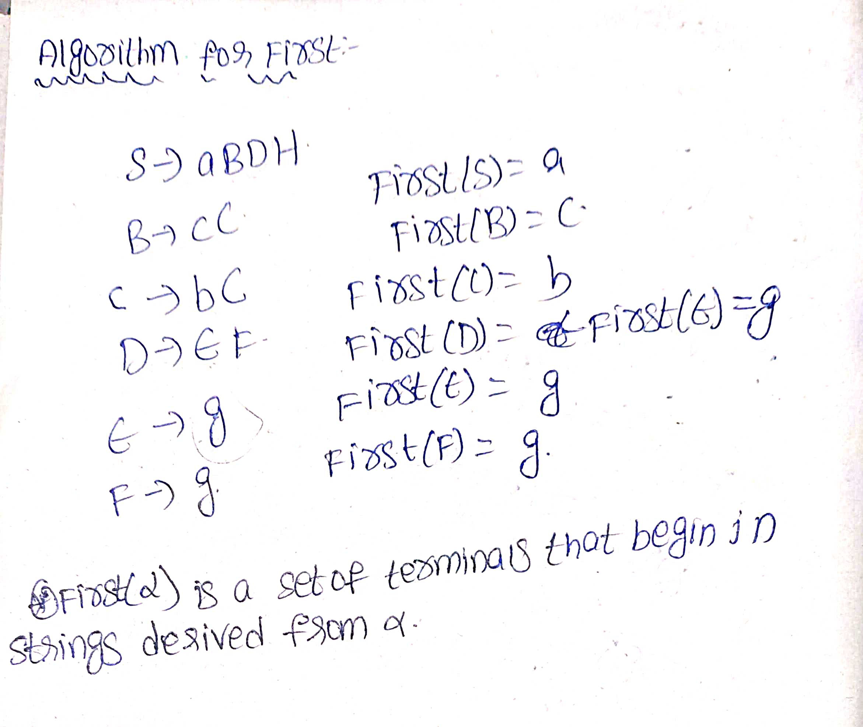

CODE:

#include<stdio.h>

#include<string.h>

#include<ctype.h>

char gram[10][10],first[10];

int k=0,n;

void funcfirst(char g,int n)

{

int i,j;

if(!(isupper(g)))

first[k++]=g;

else

{

for(i=0;i<n;i++)

{

if(gram[i][0]==g)

{

if(islower(gram[i][3]))

first[k++]=gram[i][3];

else

funcfirst(gram[i][3],n);

}

}

}

}

int main()

{

char nt;

printf("Enter No of Productions ");

scanf("%d",&n);

printf("Enter the Productions");

for(int i=0;i<n;i++)

{

scanf("%s",gram[i]);

}

for(int i=0;i<n;i++)

{

k=0;

funcfirst(gram[i][0],n);

printf("First of of %c is {",gram[i][0]);

for(int i=0;i<k;i++)

{

printf(" %c ",first[i]);

}

printf("}");

printf("\n");

}

return 0;

}

OUTPUT:

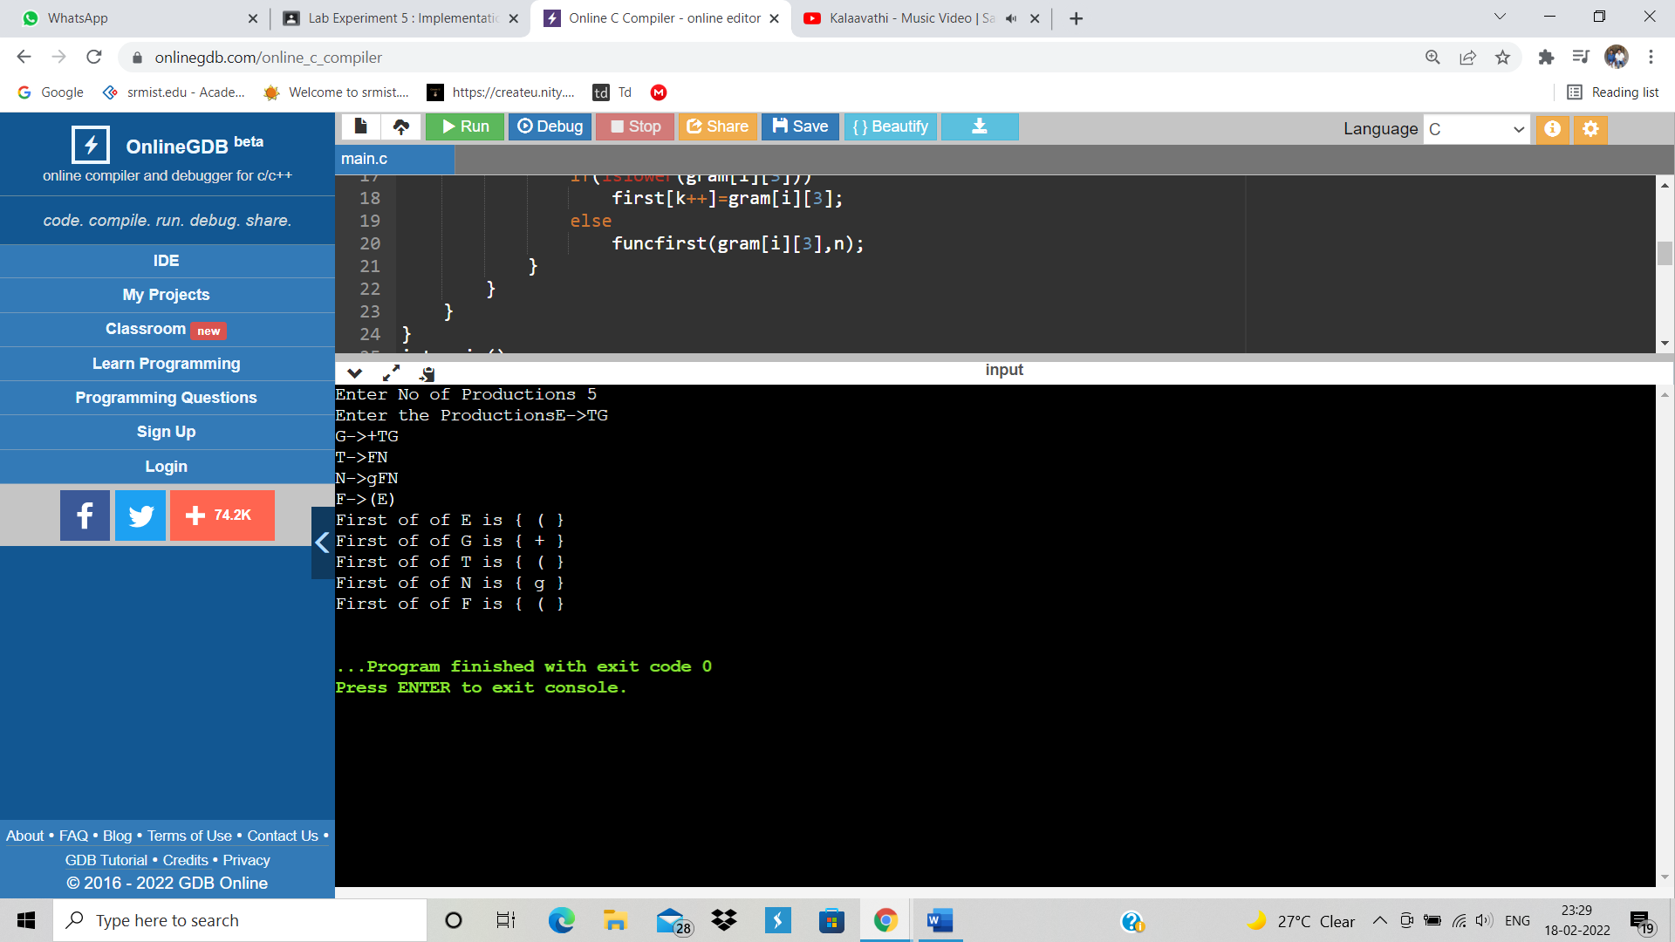

RESULT: Hence First is Implemented.

COMPUTATION OF FOLLOW:

Aim: To Compute The Follow for given Grammer.

Algorithm:

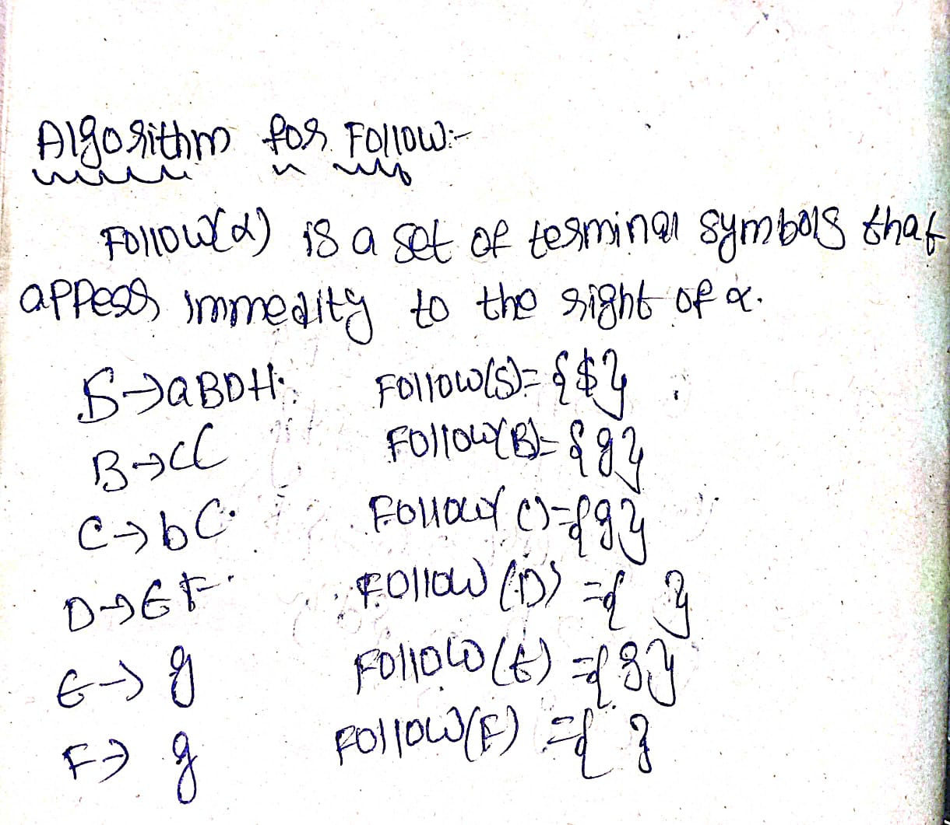

CODE:

#include<stdio.h>

#include<string.h>

#include<ctype.h>

char gram[10][10],res[10];

int k=0;

void first(char g,int n)

{

if(!(isupper(g)))

res[k++]=g;

else

{

for(int i=0;i<n;i++)

{

if(gram[i][0]==g)

{

if(islower(gram[i][3]))

res[k++]=gram[i][3];

else

first(gram[i][3],n);

}

}

}

}

void follow(char c,int n)

{

if(gram[0][0]==c)

res[k++]='$';

for(int i=0;i<n;i++)

{

for(int j=3;j<strlen(gram[i]);j++)

{

if(gram[i][j]==c)

{

if(gram[i][j+1]!='\0')

first(gram[i][j+1],n);

if(gram[i][j+1]=='\0' && c!=gram[i][0])

follow(gram[i][0],n);

}

}

}

}

int main()

{

char nt;

int n;

printf("Enter No of Productions ");

scanf("%d",&n);

printf("Enter the Productions");

for(int i=0;i<n;i++)

{

scanf("%s",gram[i]);

}

for(int i=0;i<n;i++)

{

k=0;

follow(gram[i][0],n);

printf("Follow of of %c is {",gram[i][0]);

for(int i=0;i<k;i++)

{

printf(" %c ",res[i]);

}

printf("}");

printf("\n");

}

return 0;

}

OUTPUT:

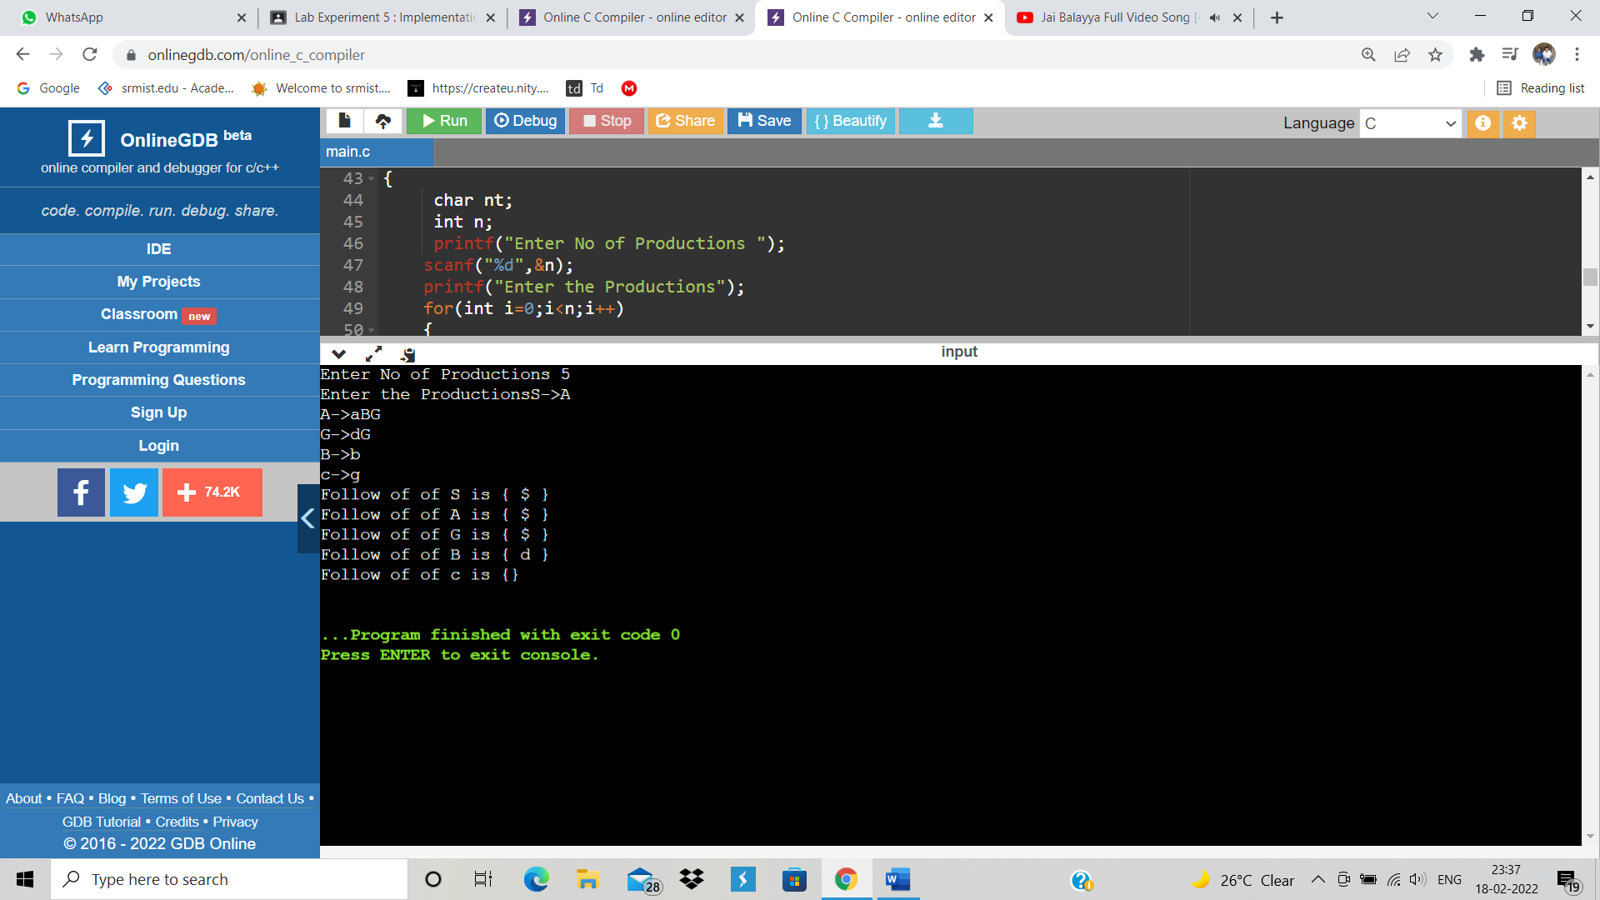

RESULT: HENCE FOLLOW IMPLEMENTED.

M.NISHANTH(RA1911003010772)