IMPLEMENTATION OF PREDECTIVE PARSING TABLE (LL(1))

(02/03/2022)

Aim: To Find the Predective parsing table for given Grammar

Algo:

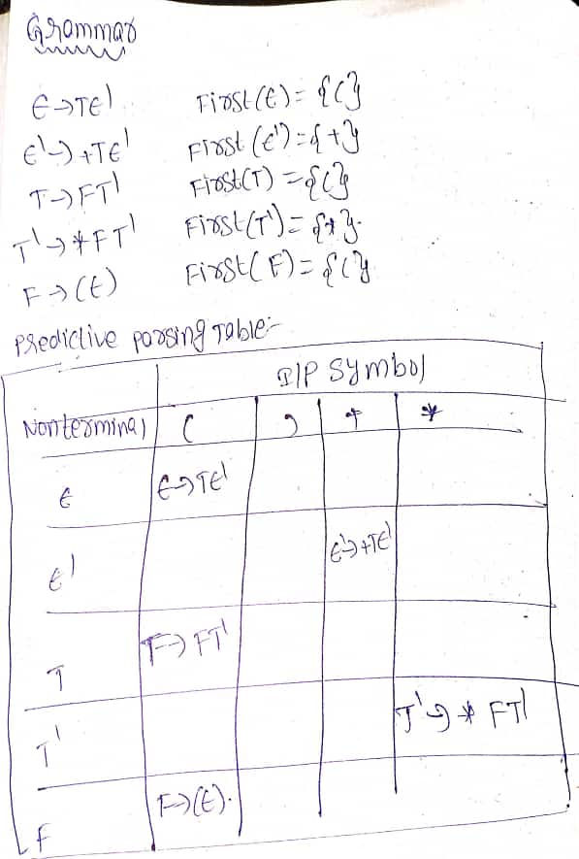

CODE:

#include<stdio.h>

#include<string.h>

#include<ctype.h>

char gram[10][10],first[10];

int k=0,n;

void funcfirst(char g,int n)

{

int i,j;

if(!(isupper(g)))

first[k++]=g;

else

{

for(i=0;i<n;i++)

{

if(gram[i][0]==g)

{

if(islower(gram[i][3]))

first[k++]=gram[i][3];

else

funcfirst(gram[i][3],n);

}

}

}

}

int main()

{

char nt;

printf("Enter No of Productions ");

scanf("%d",&n);

printf("Enter the Productions");

for(int i=0;i<n;i++)

{

scanf("%s",gram[i]);

}

printf("...PREDECTIVE PARSING TABLE LL(0)...\n");

for(int i=0;i<n;i++)

{

k=0;

funcfirst(gram[i][0],n);

printf("%s--->",gram[i]);

for(int j=0;j<k;j++)

{

printf("{%c,%c}",gram[i][0],first[j]);

}

printf("\n");

}

return 0;

}

OUTPUT:

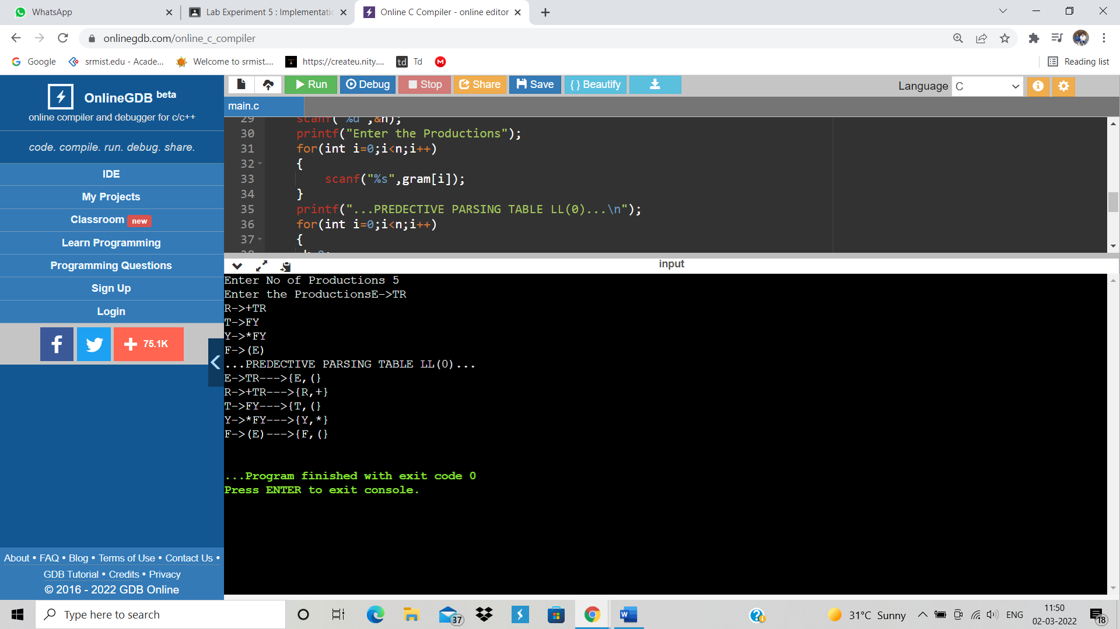

RESULT: Hence Predective Parsing Table is Constructed For Given Grammar

M.NISHANTH(RA1911003010772)