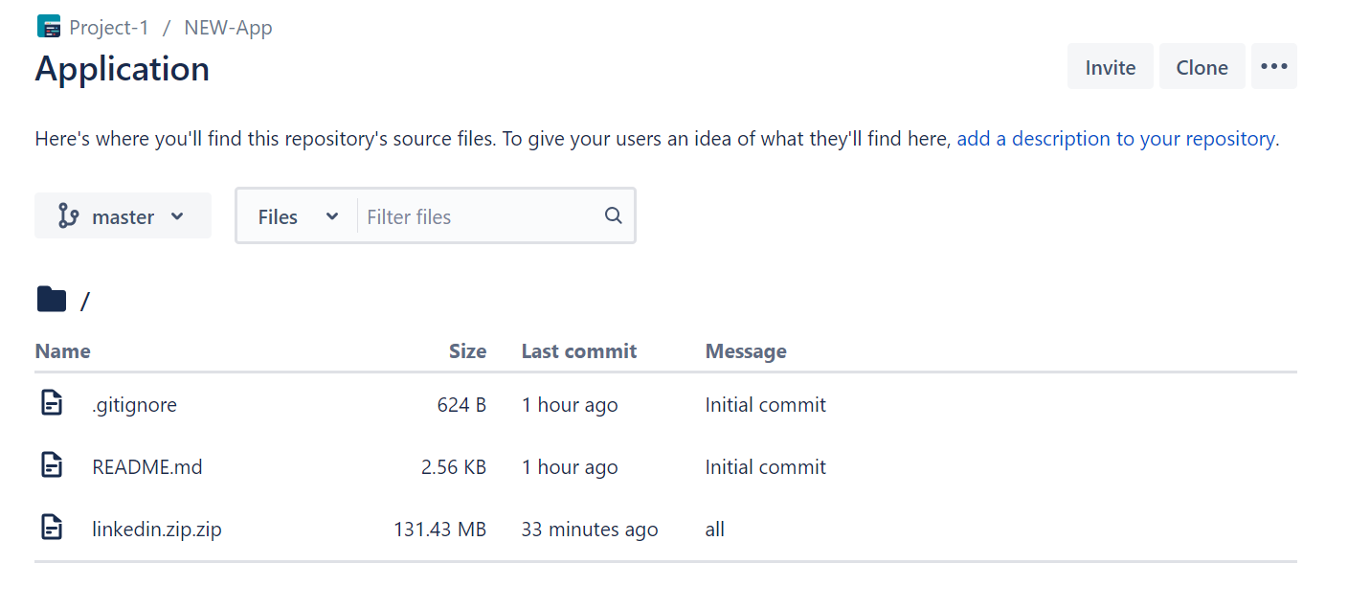

This is Bit-Bucket Repo to Migrate Git Hub.

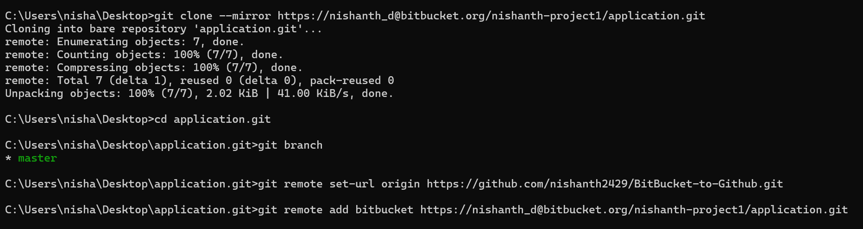

* 1🡺 Clone your Bitbucket repo to local

🡺$ git clone --mirror <https://nishanth_d@bitbucket.org/nishanth-project1/application.git>

* $ cd /application

2🡺Create GitHub repo where we need to migrate our bitbucket repo.

🡺Set the remote origin url i.e. the GitHub url where data will now be pushed

* $ git remote set-url origin <https://github.com/nishanth2429/BitBucket-to-Github.git>

3🡺Add bitbucket url that’s need to be mirror, same as in Step:1

* $ git remote add bitbucket <https://nishanth_d@bitbucket.org/nishanth-project1/application.git>

4🡺Mirroring complete Bit Bucket repo to GitHub. This will push all Bit Bucket repo stuff i.e. history/code/branches/commit to GitHub.

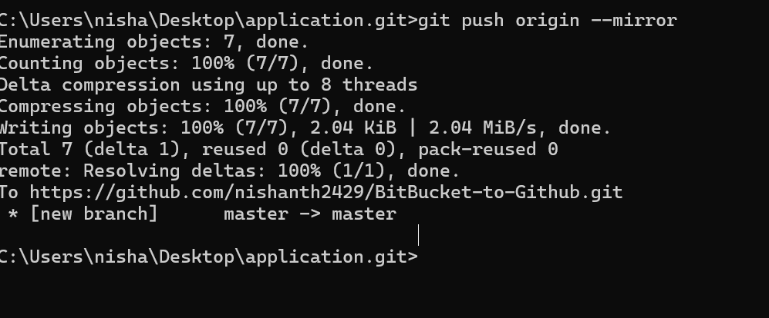

🡺 $ git push origin –mirror

🡺in GitHub 