Comparative Analysis of 10 Research Papers
and Proposed Model Selection
Explainable AI Framework for Employee Attrition Prediction

Comparative Analysis of the 10 Research Papers
No. | Research Paper | Techniques Used | Purpose | Limitation
1 | IBM Employee Attrition Analysis — Yang & Islam (2020) | Correlation Matrix, Random Forest, K-Means Clustering, Logistic Regression | Identify major factors influencing employee attrition and analyze why employees leave. | Uses a single IBM dataset, so findings may have limited generalizability to other organizations.
2 | Predict Employee Attrition Using Multiple Machine Learning Techniques — Ghanem & Al-Alawi (2024) | Random Forest, XGBoost, Decision Tree, Bernoulli Naive Bayes, KNN, SVM, Logistic Regression, Oversampling, GridSearchCV | Compare multiple ML algorithms and identify an effective model for employee attrition prediction. | Dataset has class imbalance and results may not generalize well to other organizations; more datasets are needed.
3 | Employee Attrition Prediction using Machine Learning: A Data-Driven Approach for Workforce Analytics (2025) | Logistic Regression, Gradient Boosting, Random Forest, SVM, Gaussian Naive Bayes, Feature Engineering | Predict employee attrition and identify important employee characteristics for retention strategies. | Primarily focused on prediction and model comparison; broader real-world validation is still needed.
4 | A Stacking Ensemble Framework for Predicting Employee Turnover: Explainable AI with SHAP — Rahman et al. (2025/2026) | Machine Learning, Ensemble Learning, Deep Learning, Stacking, SHAP | Predict employee turnover using ensemble approaches and explain model predictions using SHAP. | Relies on the IBM HR Analytics dataset, limiting generalizability to different organizations and workforce environments.
5 | Integrating Machine Learning and Explainable AI for Employee Attrition Prediction in HR Analytics (2026) | Machine Learning, SHAP, Feature Selection, Data Balancing, Hyperparameter Optimization | Combine accurate attrition prediction with explainable AI so HR teams can understand factors behind predictions. | Synthetic/benchmark datasets may not represent real-world organizations; SHAP may not fully capture complex feature interactions.
6 | Employee Attrition Prediction Using Bayesian Optimized Stacked Ensemble Learning and Explainable AI — Konar et al. (2025) | Stacking, XGBoost, Random Forest, Bayesian Optimization, SHAP, LIME | Improve attrition prediction and explain why employees are predicted to leave. | Mainly evaluated on benchmark data; broader organizational validation is still needed.
7 | Integrating Machine Learning and Explainable AI for Employee Attrition Prediction in HR Analytics — Al-Ali et al. (2026) | Adaptive Boosting, Histogram Gradient Boosting, SHAP, Feature Selection, Data Balancing | Combine accurate attrition prediction with explainability, fairness and actionable HR insights. | Existing HR datasets may not fully represent different real-world organizations.
8 | Explainable AI for Employee Turnover Prediction: A SHAP-Based Intelligent Analytics Approach — Haijie Jia (2026) | XGBoost, Random Forest, LightGBM, Logistic Regression, SHAP, SMOTE, fairness audit | Provide global, local and interaction-based explanations for employee turnover prediction. | Feature importance and subgroup effects can vary between datasets, requiring validation for each deployment.
9 | Predicting Employee Attrition: XAI-Powered Models for Managerial Decision-Making (2025) | Transformer, GAN-based oversampling, SHAP | Handle class imbalance and provide transparent attrition predictions for HR managers. | Authors identify the need for validation across more industries and lightweight real-time implementation.
10 | Employee Attrition Prediction: An Exploratory and Statistically Robust Ensemble Learning Model (2026) | SHAP, LIME, Optuna, Random Oversampling, Ensemble Learning | Combine accurate prediction with global/local explanations and identify important retention factors. | Uses benchmark datasets, so real-world organizational validation remains important.

2. Overall Comparative Findings
Machine Learning Models
The ten research papers use a broad range of machine-learning techniques, including Logistic Regression, Random Forest, XGBoost, Gradient Boosting, SVM, Naive Bayes, LightGBM, stacking and deep-learning approaches.
Based on the literature analysis, this project proposes a hybrid classification approach using Random Forest, an Artificial Neural Network (ANN), and probability fusion:
- Random Forest
- Probability Fusion
The proposed approach combines a tree-based ensemble model (Random Forest) with a neural-network model (ANN). Their predicted probabilities are combined through probability fusion to produce the final attrition-risk prediction. The exact fusion rule and model performance must be confirmed from the implemented code and measured results.
Explainable AI
Explainable AI is an important component of recent employee attrition research. SHAP is widely used to understand feature contributions, while LIME provides local explanations for individual predictions.
Where implemented and validated in the project, the system uses:
- SHAP to estimate feature contributions for the model being explained.
- LIME to provide local explanations for individual employee predictions.
This allows the system to provide both an attrition prediction and an understandable explanation of the factors influencing that prediction.
Class Imbalance
Employee attrition datasets generally contain fewer employees who leave compared with employees who stay. This creates a class imbalance problem.
To address this issue, SMOTE (Synthetic Minority Over-sampling Technique) may be used if enabled in the existing training pipeline.
If SMOTE is used, it must be applied only to the training data after the train-test split. The original test dataset must remain untouched for final evaluation.
Validation and Generalization
A recurring limitation in the reviewed literature is the dependence on benchmark or IBM HR Analytics datasets. Therefore, model evaluation must be performed carefully, and results should not be generalized to other organizations without additional validation.
Practical HR Decision Support
Recent studies increasingly focus on explainability and actionable HR insights. This project proposes combining attrition-risk prediction from Random Forest and ANN with probability fusion. SHAP and LIME can be used where implemented to help users inspect factors associated with predictions; these explanations indicate model associations, not causes.
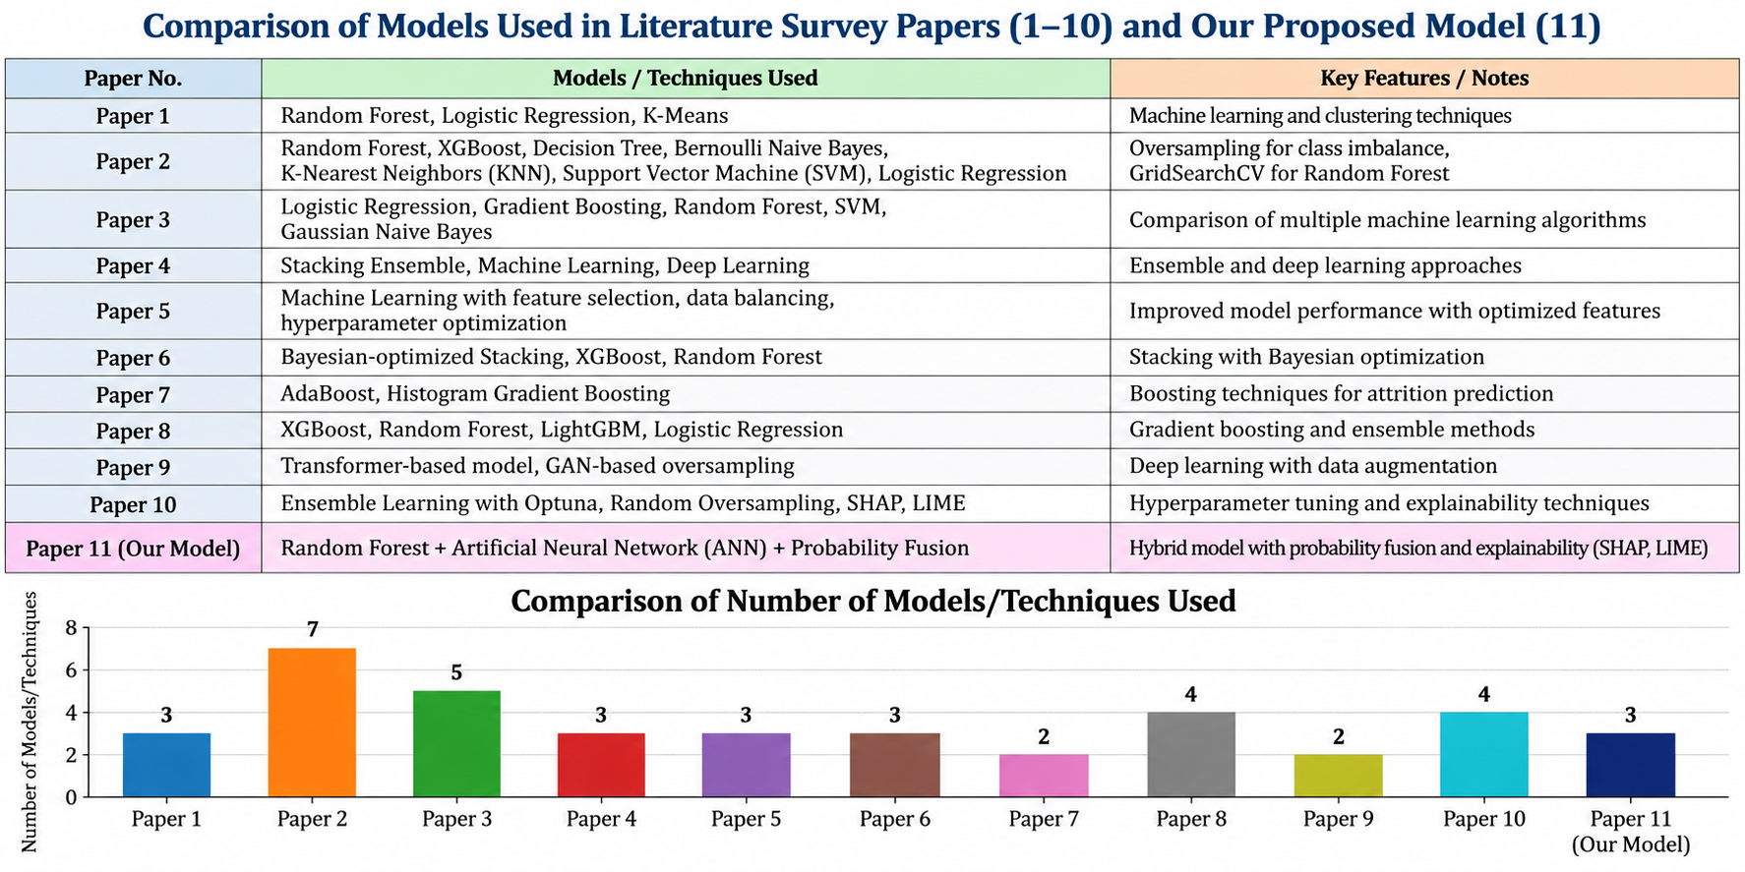

3. Research Gaps Identified from the 10 Papers
The following research gaps were identified from the literature:
- Limited generalizability: Many studies rely on benchmark or IBM HR datasets.
- Class imbalance: Attrition datasets commonly contain fewer Leave cases than Stay cases.
- Explainability: Although Explainable AI is increasingly used, the type and depth of explanations vary across studies.
- Prediction versus interpretation: Many studies focus mainly on model performance rather than providing understandable explanations for individual predictions.
- Real-world validation: Cross-organizational and real-world validation remains limited.
- Model selection: A systematic comparison of multiple suitable models is important instead of selecting a model without empirical evaluation.
- Hybrid modeling: Combining a tree-based model and a neural network through probability fusion is a design choice that should be evaluated against each component model using the same held-out test data.

4. Proposed Model Selection Strategy
Based on the comparative analysis, the proposed model combines Random Forest and an Artificial Neural Network (ANN), then fuses their predicted probabilities for employee attrition prediction.
4.1 Random Forest
Random Forest is an ensemble learning algorithm that combines multiple decision trees to produce a classification and an estimated probability.
Purpose:
- Models nonlinear relationships between structured HR attributes.
- Combines predictions from multiple decision trees to improve robustness.
- Provides class probabilities that can be used by the probability-fusion stage.
- Can provide a useful component-model comparison and feature-importance information.
4.2 Artificial Neural Network (ANN)
An Artificial Neural Network (ANN) learns patterns in structured HR features through connected computational units arranged in layers.
Purpose:
- Can learn nonlinear relationships among structured HR features.
- Provides a neural-network component to complement Random Forest.
- Produces predicted probabilities for the fusion stage.
- Must be evaluated on the same held-out test data as Random Forest.
4.3 Probability Fusion
Probability fusion combines the attrition probabilities produced by Random Forest and ANN into one final prediction.
Purpose:
- Combines the outputs of two different model families.
- Uses the predicted probabilities from Random Forest and ANN rather than inventing extra input data.
- Produces a final fused probability that can be converted into a Leave/Stay prediction using the implemented decision threshold.
- Requires the actual fusion rule to be implemented and documented; do not assume a formula that is not present in the code.
The fused model should be compared with Random Forest alone and ANN alone using the same untouched test set and standard metrics. The final selection must be based on actual experimental results, not assumed superiority.

5. Structured HR Data and Model Feature Fusion
The current model choice uses structured HR data only. It does not require employee comments, reviews, TF-IDF features or BERT embeddings.
5.1 Structured HR Features
Structured HR features are tabular employee attributes, such as age, job role, monthly income, job level, overtime and years at the company, where available in the selected dataset.
Before model training, structured features should be prepared using appropriate preprocessing:
- Handle missing values and duplicate records as appropriate.
- Encode categorical columns and scale numerical columns when required by the chosen preprocessing pipeline.
Fit preprocessing steps using the training data only, then apply the fitted transformations to the held-out test data.
Use the same processed feature definitions consistently for training, validation and prediction.
5.2 Hybrid Probability Fusion
The hybrid model uses two prediction branches: Random Forest and ANN. Each branch estimates the probability of employee attrition from structured HR features.
The probability-fusion stage:
- Receives the predicted attrition probabilities from Random Forest and ANN.
- Combines the probabilities according to the fusion method implemented in the project.
- Generates a final attrition-risk probability.
- Supports a final Leave/Stay classification based on the selected threshold.
Fusion must use actual model outputs; the rule (for example, a weighted average or mean) should be stated only if that is what the code implements.
The current proposed model is Random Forest + ANN + probability fusion, using structured HR features only. TF-IDF and BERT are not part of this model version.
Data-scope note: Use the selected structured HR dataset only. Do not generate artificial employee comments or claim to use textual data in this model.

6. Class Imbalance Handling Using SMOTE
Employee attrition datasets are usually imbalanced because the number of employees who stay is significantly larger than the number of employees who leave.
To address this issue, SMOTE (Synthetic Minority Over-sampling Technique) may be used if enabled in the existing training pipeline.
The correct procedure is:
Original Dataset
↓
Train-Test Split
↓
Training Data
↓
Apply SMOTE Only to Training Data
↓
Train Models
↓
Original Unseen Test Data
↓
Final Evaluation
SMOTE is never applied to the test data.
This approach prevents data leakage and ensures that the evaluation represents performance on unseen employee records.

7. Explainable AI
Explainable AI is an important component of the project because employee attrition prediction should not be treated as a black-box decision.
The project uses two Explainable AI techniques:
7.1 SHAP
SHAP (SHapley Additive exPlanations) explains the contribution of individual features to a model prediction.
For employee attrition prediction, SHAP can show:
- Which features increase attrition risk.
- Which features decrease attrition risk.
- The relative importance of employee features.
- How individual features influence the specific model output being explained.
SHAP should be connected to a model/output that the implementation actually supports. For a fused predictor, document whether explanations describe the Random Forest branch, ANN branch or final fused output.
7.2 LIME
LIME (Local Interpretable Model-Agnostic Explanations) explains individual predictions by creating a locally interpretable approximation of the model.
For an individual employee, LIME can show:
- Features supporting the Leave prediction.
- Features supporting the Stay prediction.
- The contribution of important features for that particular employee.
Where implemented, the Explainable AI flow is:
Structured HR features → Random Forest + ANN → Probability Fusion → Final Prediction → SHAP/LIME explanations for the supported model output

8. Proposed Research Contribution
The proposed contribution of the project is an Explainable AI Framework for Employee Attrition Prediction.
The proposed framework:
- Combines Random Forest and ANN using probability fusion; evaluates each component separately as well as the fused model.
- Uses structured HR data as the only input data source for this model version.
- Uses SMOTE only on training data to address class imbalance.
- Fuses the predicted attrition probabilities from Random Forest and ANN using the fusion rule implemented in code.
- Evaluates Random Forest, ANN and the fused model using the same untouched test set.
- Uses SHAP to explain feature contributions where supported by the implemented model.
- Uses LIME for local explanations where supported by the implemented prediction pipeline.
- Evaluates the models using Accuracy, Precision, Recall, F1-Score, ROC-AUC and Confusion Matrix.
- Provides an understandable prediction interface for employee attrition analysis.

