1.

MISSING VALUES:

FIXING DATATYPES:

HANDLING DUPLICATES:

NORMALIZATION:

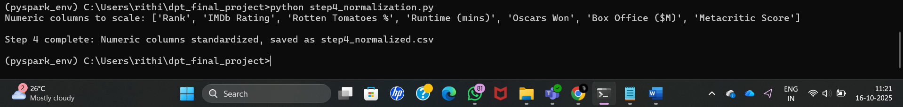

FEATURE GENERALIZATION:

2.

