**CS171 Process Book**

Global Health Infrastructure and Medical Tourism

Nishanth Nayakanti

**Table of Contents:**

* Overview and Motivation:
* Related Work:
* Questions:
* Data: Source, scraping method, cleanup, etc.
* Exploratory Data Analysis:
* Design Evolution:
* Implementation:
* Evaluation:

**Overview and Motivation:**

Motivation of the project is to build a tool to analyze the health infrastructure of all the countries and factors influencing Medical tourism.

**Questions:**

1. Is overall health (for example life expectancy) correlated to Health infrastructure of country (health spending, Health Personnel, Hospitals)?
2. How did overall health of the countries change over time?
3. How did health infrastructure of all countries change over time?
4. Compare health spending, infrastructure and life expectancy of the countries over time?
5. Which countries are good for medical tourism?

Here are top reasons why a particular destination might be good for medical tourism.

1. Potential for Cost savings on medical procedures
2. Government and Private sector investment in healthcare infrastructure
3. History of Healthcare innovation and achievement.
4. Demonstrate commitment to international accreditation

Is it possible to predict if a country is good for medical tourism with the open data available?

* **Data:**

**Source**

1. Health expenditure per capita

<http://data.worldbank.org/indicator/SH.XPD.PCAP>

1. Physicians per 1000

<http://data.worldbank.org/indicator/SH.MED.PHYS.ZS>

1. Hospital Beds per 1000

<http://data.worldbank.org/indicator/SH.MED.BEDS.ZS>

1. Life expectancy at birth:

<http://data.worldbank.org/indicator/SP.DYN.LE00.IN>

1. Best Hospitals in the world (Academic point of view)

<http://hospitals.webometrics.info/en/world>

1. Internationally Accredited Hospitals:

[http://www.jointcommissioninternational.org/about-jci/jci-accredited-organizations/](http://www.jointcommissioninternational.org/about-jci/jci-accredited-organizations/" \t "_blank)

1. Consumer Price Index

[http://www.numbeo.com/cost-of-living/rankings\_by\_country.jsp](http://www.numbeo.com/cost-of-living/rankings_by_country.jsp" \t "_blank)

[http://www.numbeo.com/cost-of-living/cpi\_explained.jsp](http://www.numbeo.com/cost-of-living/cpi_explained.jsp" \t "_blank)

**Scraping method:**

The below 4 modules doesn’t need any processing, they are well formatted datasets available at <http://data.worldbank.org>

1. Health expenditure per capita
2. Physicians per 1000
3. Hospital beds per 1000
4. Life expectancy at Birth

5. Best Hospitals in the world:

Hospital ranking data should be scraped from a website. Processing for this data will be done as part of data scraping. I am planning to implement data scraping/processing in **Python.**

I would like to get the data in the below format

|  |  |  |  |
| --- | --- | --- | --- |
| Rank | Institution | Country | Continent |
| 1 | Cleveland Clinic | U.S | North America |

1. Internationally Accredited Hospitals:

This data will need substantial data scraping. Processing will be done as a part of data scraping. I am planning to implement data scraping/processing in **Python**

|  |  |
| --- | --- |
| Country | Hospital |
| Singapore | Singapore National Eye Centre |

1. Consumer Price index:

This data needs to be scraped from a website. But it seems to be fairly straightforward.

|  |  |  |
| --- | --- | --- |
| Country | Consumer Price Index | Purchasing Power |
| India | 26.27 | 65.79 |

* **Design Evolution**

**First design in Project proposal:**

**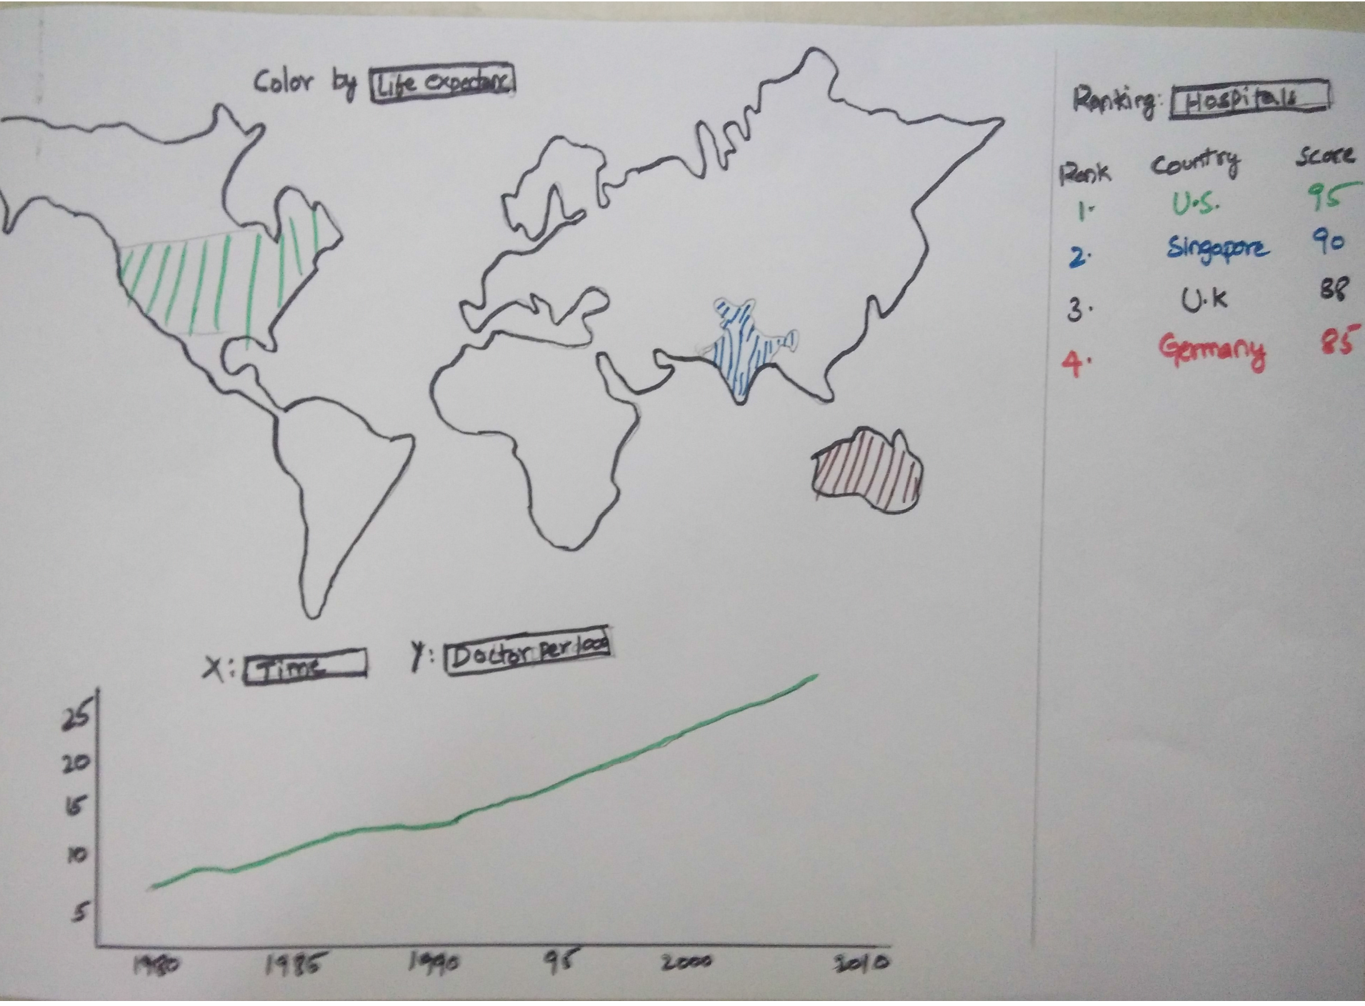**

1. Choropleth map with color coding on top
2. Line graph with **year/time** onXAxis on bottom
3. Ranking of countries based on top hospitals on right

**Cons:**

**Line graph with year/time on Xaxis and parameters like (Life Expectancy, Pcap health spending, Physicians per 1000):**

All the indicators/parameters will increase with time, there is not much to visualize or analyze

**Ranking of Countries based on hospitals:**

Country rankings based on hospitals is not enough to know if a country is good for medical tourism.

**Current Design choice:**

Dividing the project into two parts/visualizations

1. **Change of Global Health Infrastructure and Life expectancy over time**

1. Is overall health (for example life expectancy) correlated to Health infrastructure of country (health spending, Health Personnel)?

2. How did overall health of the countries change over time?

3. How did health infrastructure of all countries change over time?

4. Compare health spending, infrastructure and life expectancy of the countries over time?

1. **Medical Tourism**

1. Which countries are good for medical tourism?

**Part a:**

Design:

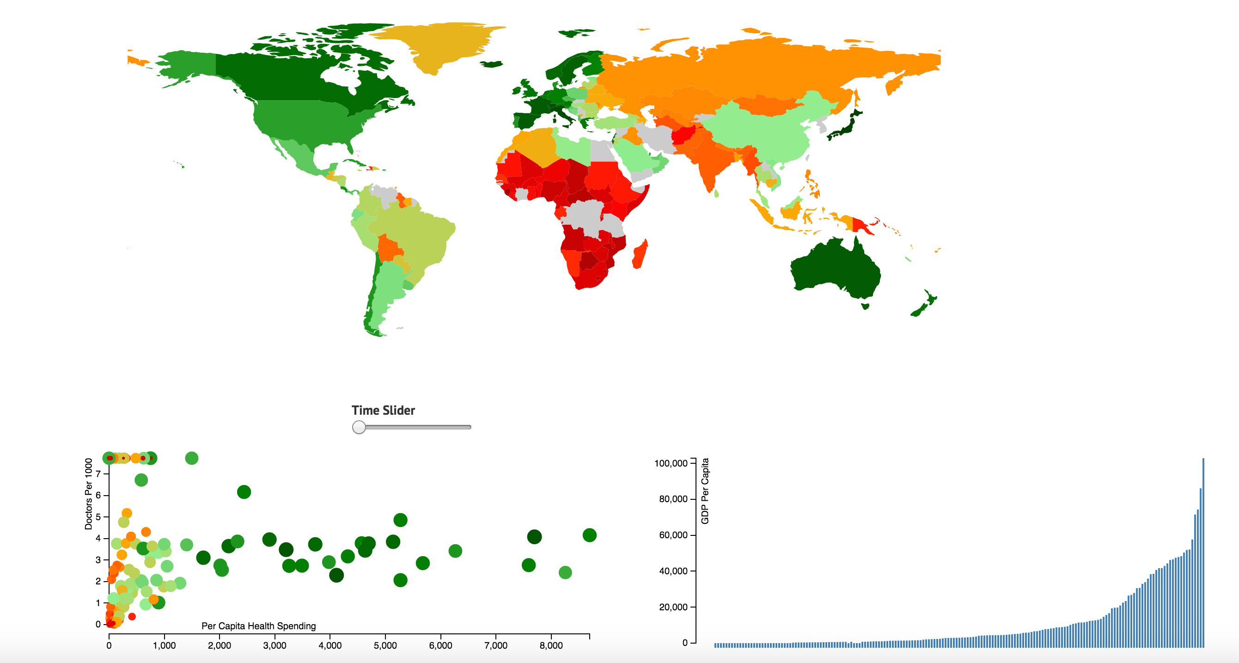

1. Choropleth map with color representing Life Expectancy
2. Scatter Plot with Percapita Health spending on xaxis and Physicians per 1000 on yaxis. Life Expectancy is coded in both Radius and color of the circle. Same color coding used as choropleth map
3. Histogram with each rectangle representing a country and percapita GDP on yaxis. Brush is implemented to select a range of countries.

**Scatter Plot:**

**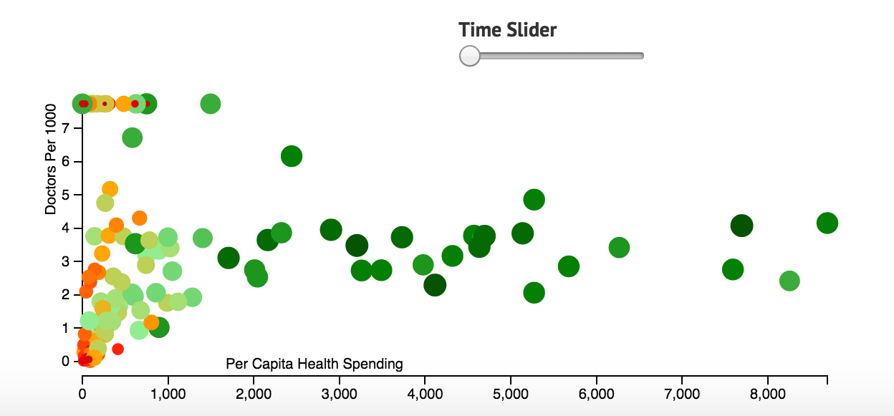**

**XAxis:** Per Capita Health Spending

**YAxis:** Physicians per 1000

Life Expectancy is coded both in color and radius of the circle.

**Time Slider:**

Time Slider is used to visualize the changes over time in all the 3 views.

**Challenge:**

There are around 200 countries, so the scatter plot is messy. We need a way to select few countries

**Histogram with Brush Selection:**

**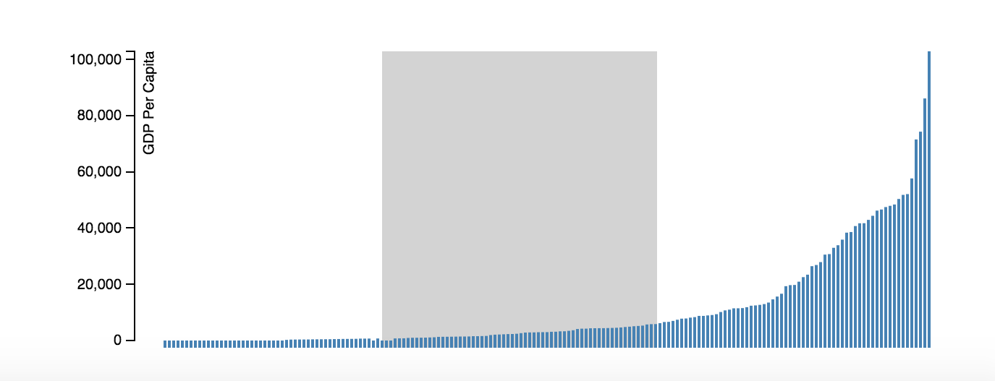**

**YAxis:** GDP per capita

Each rectangle represents a country sorted in ascending order. Brush selection can be used to select a set of countries in a particular range of Percapita income.

**Data Structure for part a:**

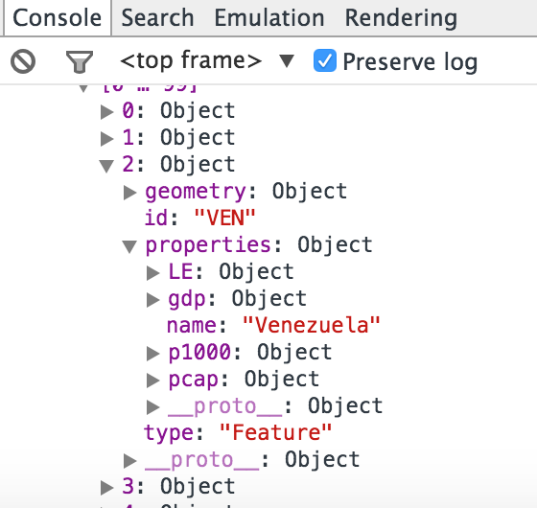

Each Object represents a Country.

* Geometry: data of geojson for choropleth map
* LE: Life expectancy data for each country for all the years
* Gdp: GDP per capita income for all the years
* P1000: Physicians per 1000 people for all the years
* Pcap: Per capita health spending for all the years.