**Project Name:**

Global Health Infrastructure and Medical Tourism

* **Background and Motivation.** Discuss your motivations and reasons for choosing this project, especially any background or research interests that may have influenced your decision.

Motivation of the project is to build a tool to analyze the health infrastructure of all the countries and factors influencing Medical tourism.

Few months back, I was exploring the options for medical tourism for one of my family members. That’s how I got to know about it.

I am taking this project as an opportunity to explore more about the topic.

* **Project Objectives.** Provide the primary questions you are trying to answer with your visualization. What would you like to learn and accomplish? List the benefits.

1. Is overall health(for example life expectancy) correlated to Health infrastructure of country( health spending, Health Personnel, Hospitals) ?
2. How did overall health of the countries change over time?
3. How did health infrastructure of all countries change over time?
4. Compare health spending, infrastructure and life expectancy of the countries over time?
5. Which countries are good for medical tourism?

Here are top reasons why a particular destination might be good for medical tourism.

1. Potential for Cost savings on medical procedures
2. Governament and Private sector investment in healthcare infrastructure
3. History of Healthcare innovation and achievement.
4. Demonstrate commitment to international accreditation

Is it possible to predict if a country is good for medical tourism with the open data available?

* **Data.** From where and how are you collecting your data? If appropriate, provide a link to your data sources.

1. Health expenditure per capita

<http://data.worldbank.org/indicator/SH.XPD.PCAP>

1. Physicians per 1000 <http://data.worldbank.org/indicator/SH.MED.PHYS.ZS>
2. Hospital Beds per 1000

<http://data.worldbank.org/indicator/SH.MED.BEDS.ZS>

1. Life expectancy at birth: <http://data.worldbank.org/indicator/SP.DYN.LE00.IN>
2. Best Hospitals in the world (Academic point of view)

<http://hospitals.webometrics.info/en/world>

1. Internationally Accredited Hospitals:

<http://www.jointcommissioninternational.org/about-jci/jci-accredited-organizations/>

1. Consumer Price Index

<http://www.numbeo.com/cost-of-living/rankings_by_country.jsp>

* **Data Processing.** Do you expect to do substantial data cleanup? What quantities do you plan to derive from your data? How will data processing be implemented?

The below 4 modules doesn’t need any processing, they are well formatted datasets available at <http://data.worldbank.org>

1. Health expenditure per capita
2. Physicians per 1000
3. Hospital beds per 1000
4. Life expectancy at Birth

5. Best Hospitals in the world:

Hospital ranking data should be scraped from a website. Processing for this data will be done as part of data scraping. I am planning to implement data scraping/processing in **Python.**

I would like to get the data in the below format

|  |  |  |  |
| --- | --- | --- | --- |
| Rank | Institution | Country | Continent |
| 1 | Cleveland Clinic | U.S | North America |

1. Internationally Accredited Hospitals:

This data will need substantial data scraping. Processing will be done as a part of data scraping. I am planning to implement data scraping/processing in **Python**

|  |  |
| --- | --- |
| Country | Hospital |
| Singapore | Singapore National Eye Centre |

1. Consumer Price index:

This data needs to be scraped from a website. But it seems to be fairly straightforward.

|  |  |  |
| --- | --- | --- |
| Country | Consumer Price Index | Purchasing Power |
| India | 26.27 | 65.79 |

* **Visualization.** How will you display your data? Provide some general ideas that you have for the visualization design. Include sketches of your design.

I will be implementing multiple coordinated view system

1. **World view**

a. Choropleth map with an option to color countries based on life expectancy, percapita health spending, doctors per 1000

b. Scatter plot below the map with options to show the change of life expectancy, percapita health spending and doctors per 1000 over time.

d. Ranking of the countries based on Hospital rankings will be shown on the right side of the page

2. **Selected Country view.**

a. The same scatter plot will show data for the selected country.

b. Overall Rank of the country in different categories like Health spending, number of accredited Hospitals, number of doctors per 1000, life_expectancy.

c. How good is the Selected country for Medical Tourism?

Country with high number of Accredited Hospitals but with less Consumer price index may be good place for medical tourism.

**World View Sketch:**

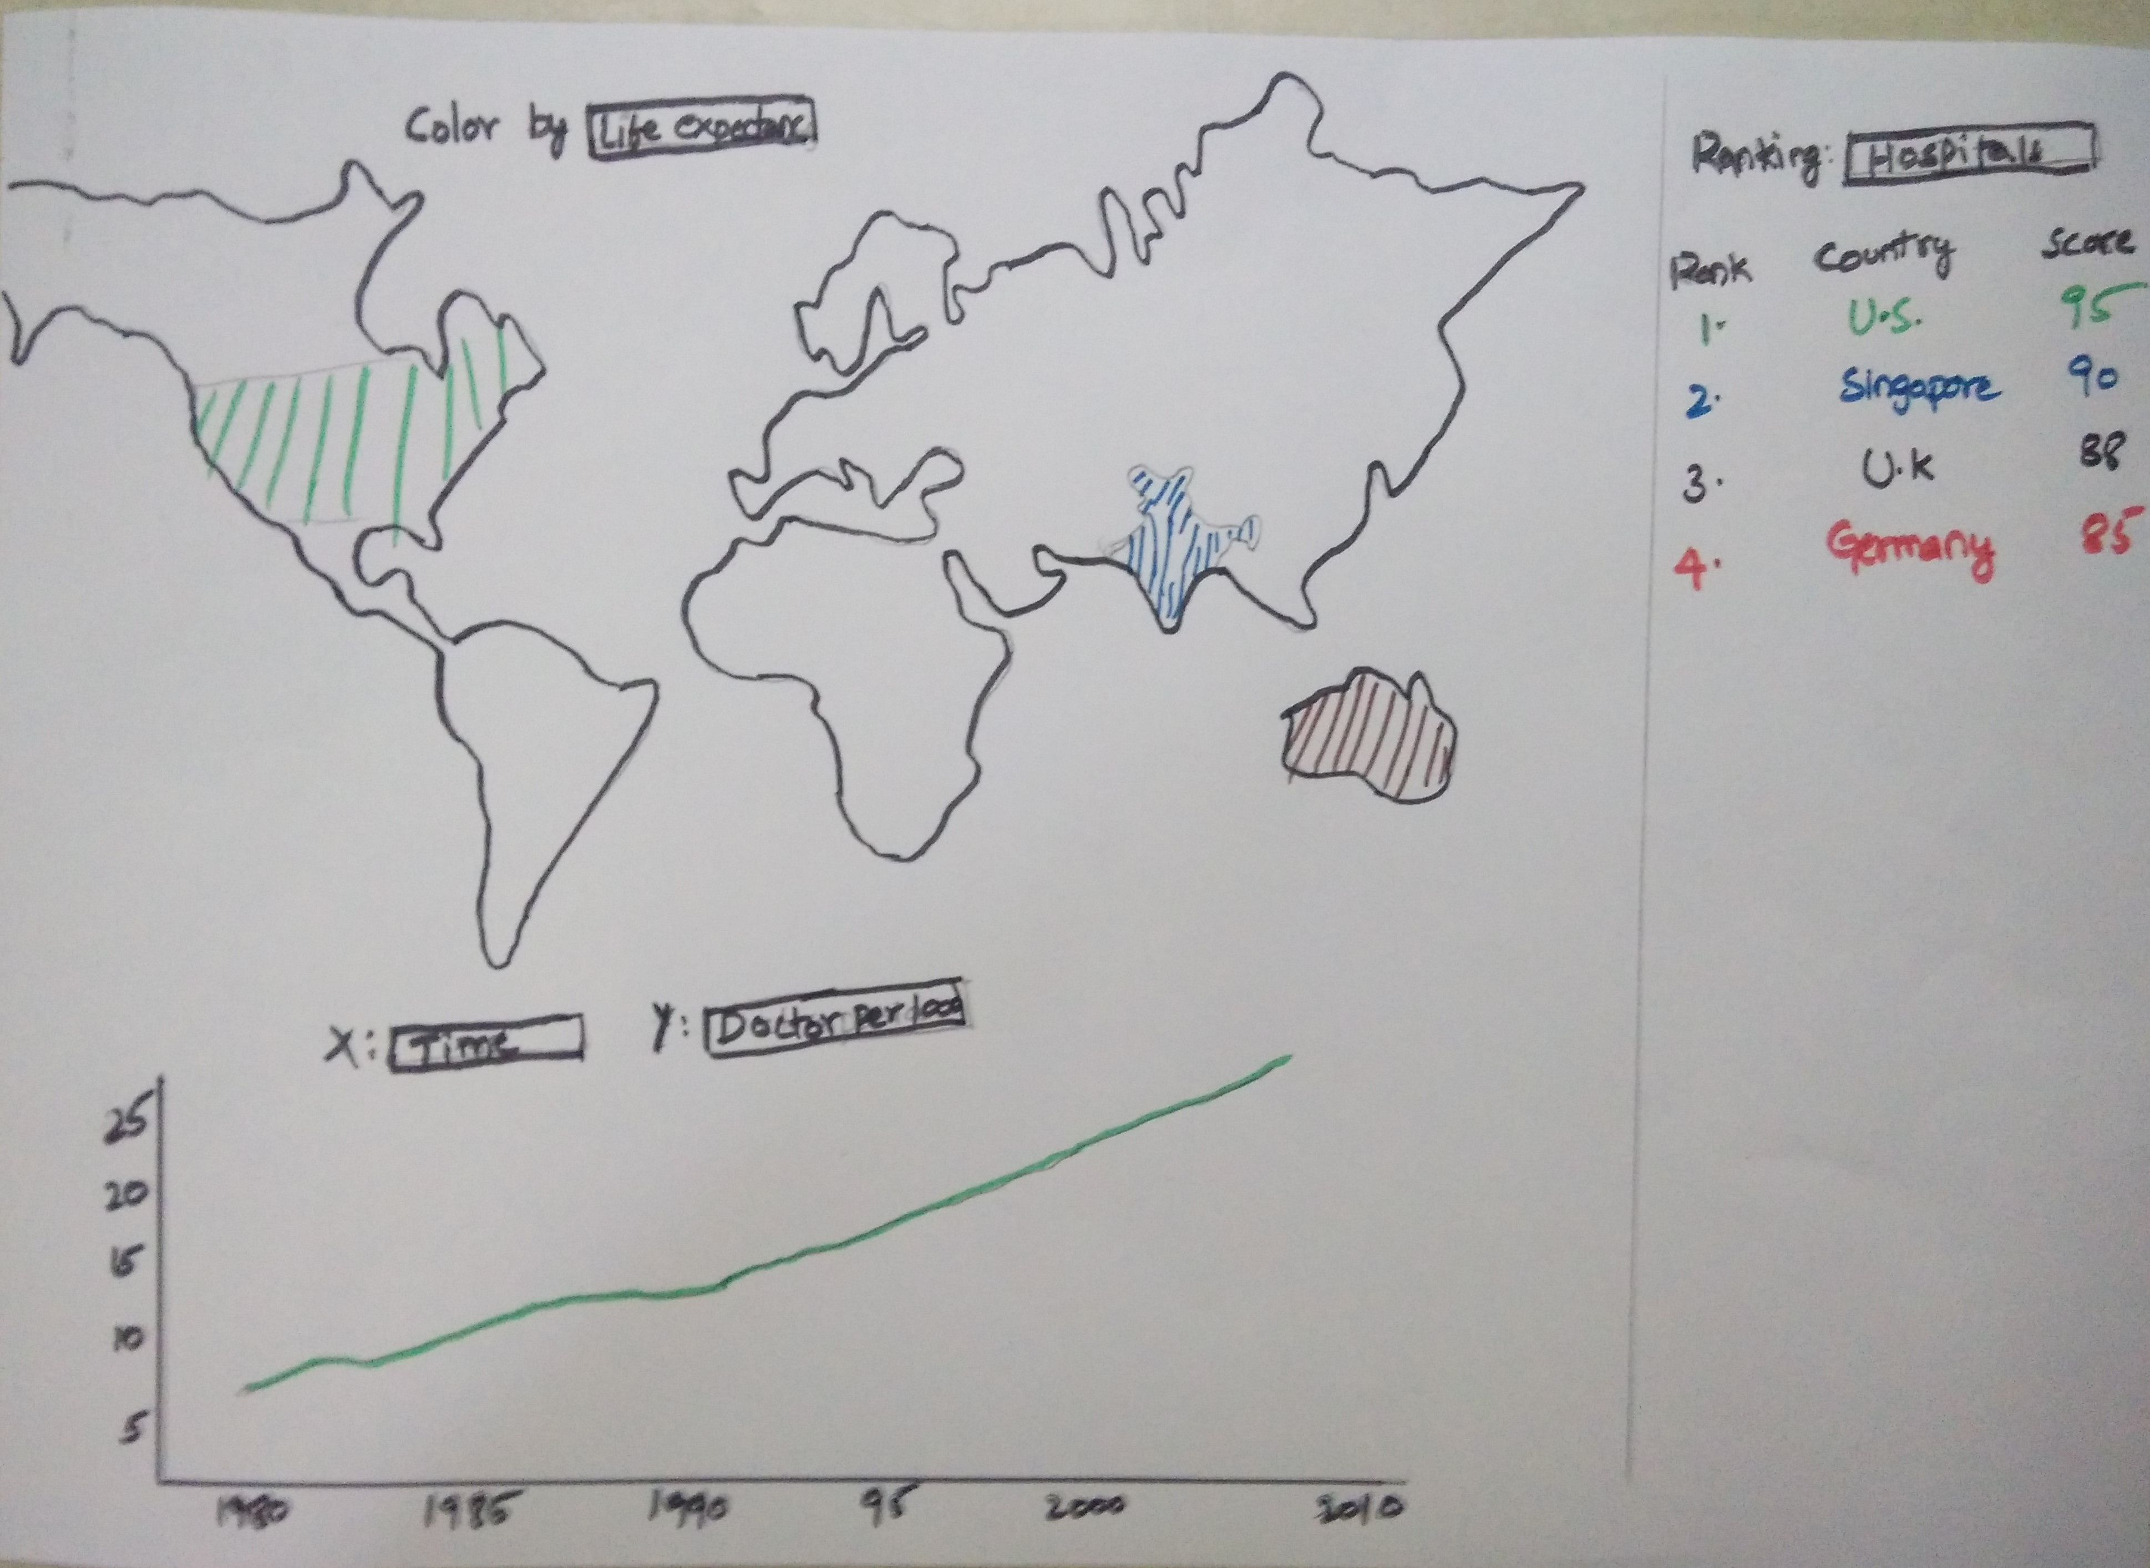

* **Must-Have Features.** These are features without which you would consider your project to be a failure.

**1. World View**

a. Choropleth map with an option to color countries based on life expectancy, percapita health spending, doctors per 1000

b. Scatter plot with options to show the change of life expectancy, percapita health spending and doctors per 1000 over time.

c. Pie chart with options to show the distribution of countries with different ranges of life_expentancy, health spending and doctors per 1000 over time.

**2. Selected Country view**

a. The same scatter plot will show data for the selected country.

b. Overall Rank of the country in different categories like Health spending, number of accredited Hospitals, number of doctors per 1000, life_expectancy.

* **Optional Features.** Those features which you consider would be nice to have, but not critical.

1. **World view**

Ranking of the countries based on Hospital rankings

1. **Selected Country view**

How good is the Selected country for Medical Tourism?

Country with high number of Accredited Hospitals but with less Consumer price index may be good place for medical tourism.

* **Project Schedule.** Make sure that you plan your work so that you can avoid a big rush right before the final project deadline, and delegate different modules and responsibilities among your team members. Write this in terms of weekly deadlines.

**Week1 (6/4/2015 to 11/4/2015)**

1. Develop the required basic structure for Chloropeth Map

**Week 2 (12/4/2015 to 18/4/2015)**

1. Develop world view (excluding hospital rankings)
2. Implement multiple coordinated view for selected country from world view

**Week 3 (19/4/2015 to 25/4/2015)**

4. Data Scraping for datasets 5,6 and 7

1. Implement Country rankings based on accredited and best hospitals in world view

**Week 4 (26/4/2015 to 02/5/2015)**

1. Develop a view to show how good a country is for medical tourism.