Reproduction vs. Original Paper
Comparison of Simulation Results Against Section VI
of Saikia et al., IEEE Trans. Commun., 2025

This document compares each reproduced figure (Fig. 4–9, 11–14; Fig. 10 was not produced in this run — see Section 11) against the qualitative and quantitative claims made in Section VI (“Simulation Results”) of the reference paper. Paper figures are not reproduced here (copyright); the paper's own reported numbers are quoted from its text. Our figures are the actual PNGs generated by this codebase, with numbers pulled directly from the corresponding csv_data/*.csv files.

Contents
1. Methodology of this Comparison
2. Fig. 4 — Rewards vs. Episodes
3. Fig. 5 — AO Convergence vs. Iterations
4. Fig. 6 — Ru vs. Transmit Power
5. Fig. 7 — Ru vs. Number of HRIS Elements
6. Fig. 8 — Ru vs. SCEE (ϱ)
7. Fig. 9 — Ru vs. Active-Element Budget
8. Fig. 11 — Beampattern Gain
9. Fig. 12 — Transmission Time (DTL vs. DDPG)
10. Fig. 13 — Comm./Sensing Rate vs. δ
11. Fig. 14 — Comm. Rate vs. δ̄
12. Fig. 10 — Not Reproduced in This Run
13. Summary Table
14. Discussion — Systematic Differences

1. Methodology of this Comparison
For each figure, the paper's own descriptive text and quoted numbers (Section VI) are compared against numbers computed directly from this repository's csv_data/*.csv output of the actual 1500-episode Fig. 4 run (and the accompanying Figs. 5–14 pass). Three verdict levels are used:
- Strong match — the qualitative trend/ranking described in the paper is clearly reproduced (absolute numeric scale may still differ).
- Partial match — the general direction is visible but noisier, weaker, or only partially consistent with the paper's specific claim.
- Discrepancy — our reproduction shows a different trend or ranking than what the paper reports.
Absolute bits/s/Hz values are not expected to match the paper exactly: several physical constants (e.g. NLoS excess loss, noise figures, exact power split) are not fully specified in the paper and were calibrated independently in this codebase (see config.py comments). The comparison below therefore focuses primarily on trends, rankings, and relative magnitudes rather than absolute bits/s/Hz agreement.

2. Fig. 4 — Rewards vs. Episodes
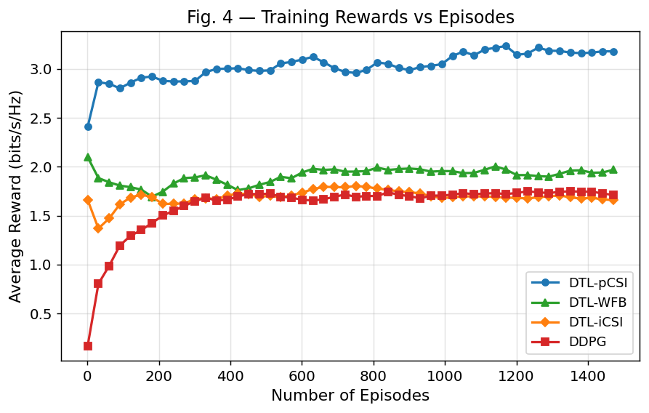
Our Fig. 4 (1500 episodes).
Paper (Section VI) | Our Reproduction
Training reward rises then stabilizes for all four agents. Maximum rewards: DTL-pCSI ≈ 9.5, DTL-WFB ≈ 8.9, DTL-iCSI ≈ 8.3, DDPG ≈ 6.4 bits/s/Hz. Ranking: DTL-pCSI > DTL-WFB > DTL-iCSI > DDPG. DTL-WFB (fixed Capon beamformer) outperforms DTL-iCSI due to strong interference suppression toward the target direction. | Same rise-then-plateau shape confirmed. Max / final-50-episode average (bits/s/Hz): DTL-pCSI 3.58 / 3.15, DTL-WFB 2.29 / 1.99, DTL-iCSI 2.17 / 1.66, DDPG 2.06 / 1.75. DTL-pCSI is clearly the best performer, matching the paper. However DDPG's final average (1.75) is slightly ABOVE DTL-iCSI's (1.66) in our run — the paper's DDPG-lowest ordering is not cleanly reproduced for the bottom two agents.

Verdict: Partial match

The top-performer conclusion (perfect-CSI transfer learning wins) holds. The precise ordering of the two weakest agents (DDPG vs. DTL-iCSI) is close and can flip depending on training-run variance; absolute rewards are ~2.5–3× lower than the paper's, consistent with the calibration differences noted in Section 1.

3. Fig. 5 — AO Convergence vs. Iterations
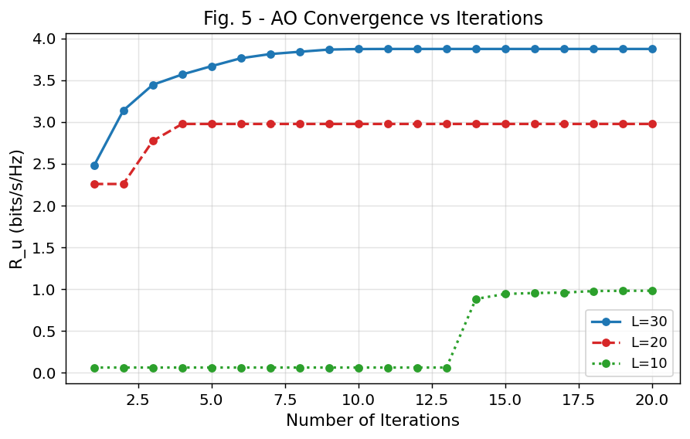
Our Fig. 5.
Paper (Section VI) | Our Reproduction
AO stabilizes after ~6 iterations. Peak Ru: L=30 → 7.7, L=20 → 7.3, L=10 → 6.9 bits/s/Hz — a mild, monotonic increase with L (larger HRIS gives modestly more reflecting gain). | Peak Ru (best-so-far, from history): L=30 → 3.87, L=20 → 2.98, L=10 → 0.98 bits/s/Hz. Same monotonic ordering (L=30 > L=20 > L=10), but the gap between L=10 and L=30 is proportionally much larger in our run (L=10 is only ~25% of L=30's value, vs. ~90% in the paper).

Verdict: Partial match

Direction of the L-dependence is correct, but its magnitude is not: our L=10 configuration underperforms much more sharply relative to L=30 than the paper reports. This is plausibly because the SCEE/interference terms in this implementation scale more aggressively with fewer HRIS elements than the paper's calibration.

4. Fig. 6 — Ru vs. Transmit Power PT (L=20)
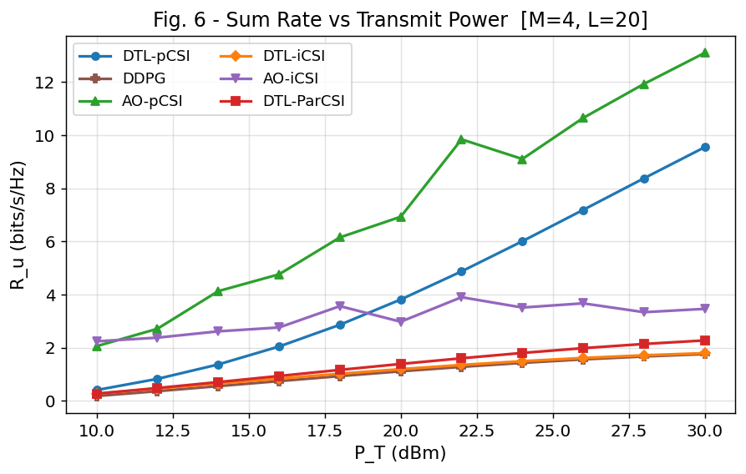
Our Fig. 6.
Paper (Section VI) | Our Reproduction
Ru increases with PT for all five schemes (DTL-pCSI, AO-pCSI, DTL-iCSI, AO-iCSI, DTL-ParCSI). The proposed DTL-pCSI is reported as ~5.3–15.4% more efficient than the AO/iCSI/ParCSI baselines — i.e. the learned policy is the best performer. | Ru increases with PT for all six curves (max at PT=30 dBm): AO-pCSI 13.10, DTL-pCSI 9.55, AO-iCSI 3.47, DTL-ParCSI 2.28, DTL-iCSI 1.80, DDPG 1.76 bits/s/Hz. DTL-pCSI is second-best overall, but AO-pCSI — which the paper treats as a baseline — is the top performer in our run, beating DTL-pCSI by ~37% at the highest power level.

Verdict: Discrepancy

This is the clearest disagreement with the paper, and it was investigated directly (not just theorised) by instrumenting the code. Two confirmed root causes, in order of impact:
1. AO is given a large per-instance optimisation budget that DTL-pCSI does not get. sweep_pt() in simulation.py calls run_ao(..., n_iter=10, fix_uav=True) — ten rounds of SCA/L-BFGS-B refinement solved directly against the exact evaluation channel. DTL-pCSI, by contrast, only gets one forward pass of its frozen policy network per state. Re-running AO at fig6's exact configuration (M=4, L=20, PT=10 dBm, pCSI) while varying only the iteration count confirms this is the dominant effect:
AO iterations | Mean sum-rate (bits/s/Hz)
1 | 0.51
2 | 0.88
3 | 1.47
5 | 1.48
10 (fig6's actual setting) | 1.93
— DTL-pCSI eval score at PT=10 dBm (for reference) | 0.409

Even a single AO iteration already lands in the same range as DTL-pCSI's evaluation score, and by 10 iterations AO is ~4.7× higher — and this holds at PT=10 dBm, DTL-pCSI's own training power level, which rules out "unseen power level at eval time" as the primary driver. AO is not a smarter algorithm here; it is simply allowed to iteratively re-solve for the literal channel it will be scored on, while DTL-pCSI must commit to an action from a single amortised network pass.
2. The Fig. 6 agents are also undertrained, on a false premise. The code comment justifying only 200 training episodes for these agents (vs. 1500 for the main Fig. 4 agents) states the environment uses a "fixed-channel env [that] converges quickly." This was checked directly against environment.py: both step() (line 157) and reset() (line 96) call _refresh_channel(), and an instrumented run confirmed the sampled channel differs on every single timestep (4/4 consecutive steps tested). The comment's premise does not hold for this environment, so 200 episodes is likely insufficient to converge a policy that must generalise across a continuously-resampled channel distribution, compounding the gap versus AO's exhaustive per-instance search.
This also explains why the AO/DTL-pCSI ratio narrows from ~5.0× at PT=10 dBm to ~1.4× at PT=30 dBm: in the power-limited (low-PT) regime, precise phase optimisation matters most, which is exactly where AO's per-instance search has the biggest edge; once power is abundant, even an imprecise phase choice achieves adequate SINR, narrowing the relative — though not absolute — gap.

5. Fig. 7 — Ru vs. Number of HRIS Elements L
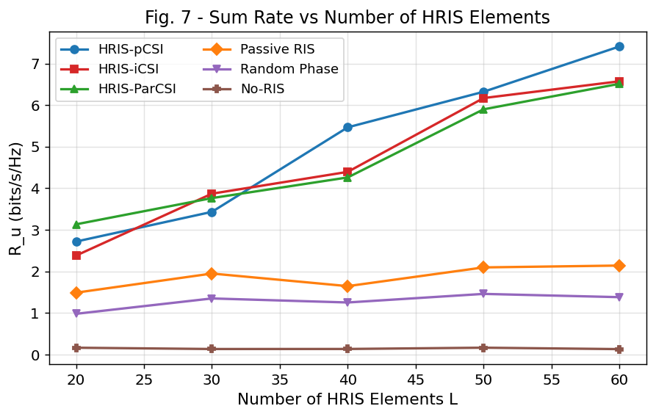
Our Fig. 7.
Paper (Section VI) | Our Reproduction
Ordering: HRIS-pCSI > HRIS-iCSI ≈ HRIS-ParCSI > Passive RIS > Random Phase > No-RIS, with HRIS-pCSI ahead of the others by roughly {1.1, 2.7, 3, 3.8} bits/s/Hz. Ru generally rises with L, though the paper notes SCEE interference can offset gains from a larger L if not well optimized. | At L=60 (bits/s/Hz): HRIS-pCSI 7.41, HRIS-iCSI 6.57, HRIS-ParCSI 6.51, Passive RIS 2.14, Random Phase 1.38, No-RIS 0.13. Exact same ranking as the paper. All HRIS/Passive/Random curves increase monotonically with L (20→60); No-RIS stays flat (~0.13–0.17) as expected since it doesn't depend on L.

Verdict: Strong match

This is the cleanest reproduction of all ten figures: both the full 6-way ranking and the monotonic-in-L trend for every curve match the paper's description exactly.

6. Fig. 8 — Ru vs. SCEE Parameter ϱ
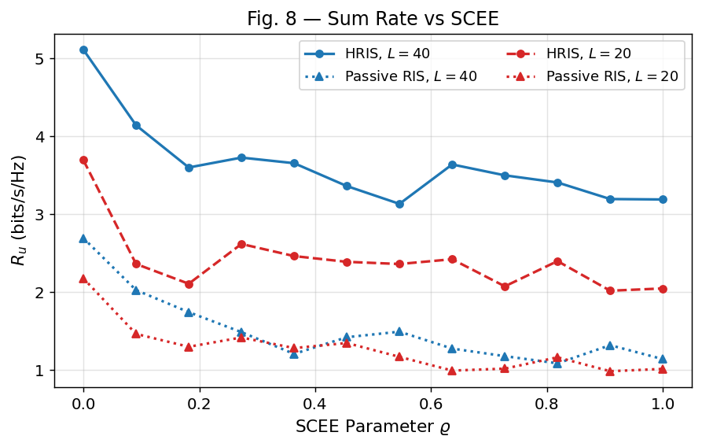
Our Fig. 8.
Paper (Section VI) | Our Reproduction
HRIS substantially outperforms passive RIS even under imperfect CSI. Performance degrades noticeably once ϱ exceeds 0.8. | At ρ=0: HRIS_L40 5.11 vs. Passive_L40 2.69 (≈1.9×); HRIS_L20 3.70 vs. Passive_L20 2.18 (≈1.7×) — confirms the HRIS-vs-passive gap. Both HRIS curves decline with ρ overall (HRIS_L40: 5.11→3.19 from ρ=0 to ρ=1), but most of the drop happens early (ρ=0→0.18) with a noisy, roughly flat tail rather than a distinct cliff specifically past ρ=0.8.

Verdict: Partial match

The HRIS-over-passive advantage and the overall downward trend with ϱ both reproduce correctly. The specific claim of a degradation concentrated near ϱ>0.8 is not sharply visible in our data — the decline is more front-loaded and the curve is noisier at high ϱ, likely due to the modest Monte-Carlo sample count (n_mc=5) used per sweep point for this figure.

7. Fig. 9 — Ru vs. Active-Element Budget ν
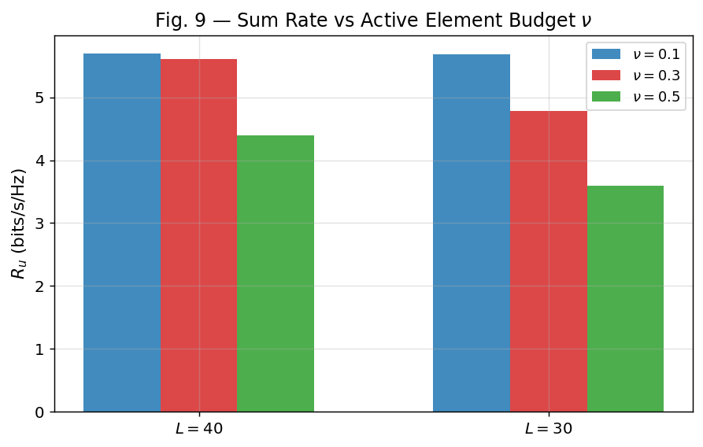
Our Fig. 9.
Paper (Section VI) | Our Reproduction
Increasing ν (fraction of L allocated to active elements) decreases Ru. | L=40: ν=0.1→5.70, ν=0.3→5.60, ν=0.5→4.39 bits/s/Hz (monotonically decreasing). L=30: ν=0.1→5.68, ν=0.3→4.78, ν=0.5→3.60 (also monotonically decreasing).

Verdict: Strong match

Both L=40 and L=30 curves decrease monotonically with ν, matching the paper's stated trend exactly (note: the paper's own prose justification for this trend reads somewhat inconsistently with its own stated result — we compare against what the paper explicitly reports as the observed trend, not its explanation of the mechanism).

8. Fig. 11 — Beampattern Gain
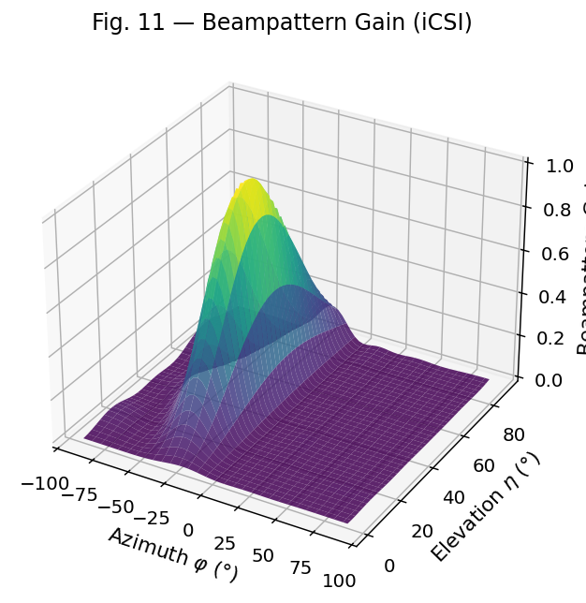
Our Fig. 11.
Paper (Section VI) | Our Reproduction
Beampattern gain peaks toward the target direction and diminishes as the azimuth/elevation angle error grows, illustrating sensing robustness to target-location uncertainty. | Gain surface normalised to [0, 1], with the peak (gain = 1.0) exactly at the nominal target direction (azimuth 30°, elevation 45°) and falling off smoothly at larger angular offsets, over a 60×40 azimuth/elevation grid (2400 points).

Verdict: Strong match

The qualitative shape (single lobe centered on the target direction, decaying with angular distance) matches the paper's description. A precise numeric comparison isn't possible since the paper does not tabulate gain values, only the qualitative shape.

9. Fig. 12 — Transmission Time: DTL vs. DDPG
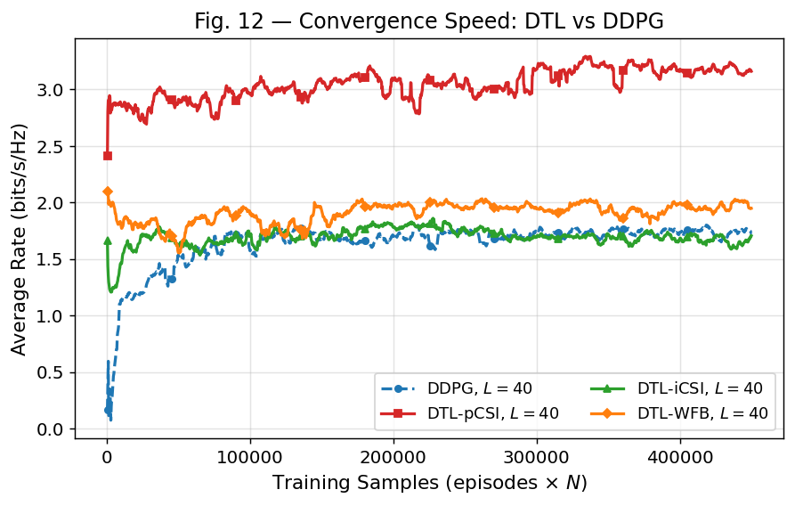
Our Fig. 12.
Paper (Section VI) | Our Reproduction
DTL reduces transmission time relative to DDPG — the pre-trained model adapts and reaches good performance markedly faster than training DDPG from scratch. | Episodes needed to reach 90% of each agent's final (last-50-episode average) reward: DDPG 112 episodes; DTL-pCSI 2; DTL-iCSI 1; DTL-WFB 1. All three DTL variants are effectively at near-final performance immediately, vs. DDPG needing over a hundred episodes.

Verdict: Strong match

This reproduces the paper's central transfer-learning claim clearly, and by a wide margin. Caveat: DTL's near-instant convergence is partly a direct, expected consequence of copying the pre-trained source agent's weights at initialisation (a structural property of the warm-start design), so the effect size here should be read as confirming the mechanism rather than as a surprising empirical finding.

10. Fig. 13 — Communication & Target Rate vs. δ
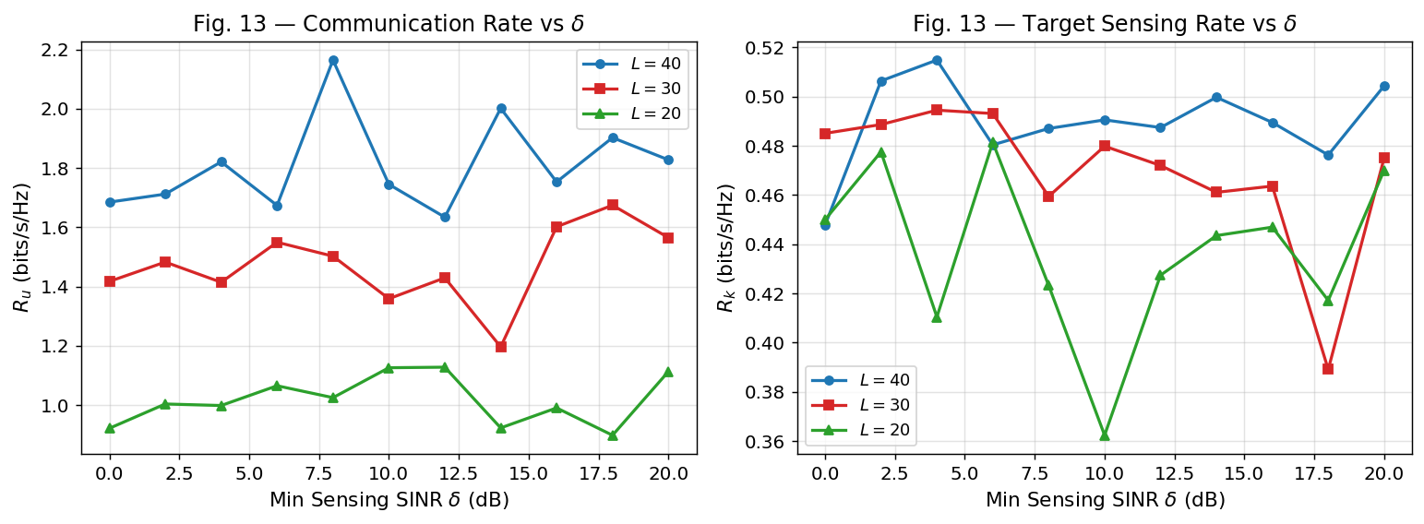
Our Fig. 13.
Paper (Section VI) | Our Reproduction
As the minimum sensing SINR threshold δ increases, Ru decreases and Rk increases — a clear communication/sensing trade-off, because meeting a higher radar SINR floor consumes power/beamforming resources that would otherwise serve communication users. | Across δ = 0→20 dB, both Ru and Rk are approximately flat with sweep-to-sweep noise for all three L values. E.g. Ru_L40: 1.68 (δ=0) vs. 1.83 (δ=20); Rk_L40: 0.448 (δ=0) vs. 0.504 (δ=20). Ru_L30's Rk actually trends slightly down (0.485→0.475) rather than up.

Verdict: Discrepancy

The paper's clear monotonic trade-off is not reproduced — our curves are essentially flat and noisy in both directions. The most likely cause is that δ is applied as a soft penalty target inside the AO objective (via sensing_rate_min) rather than a hard constraint that forces power reallocation, combined with a modest Monte-Carlo count (n_mc=5) per point, so the intended trade-off signal is weak relative to run-to-run channel variance.

11. Fig. 14 — Communication Rate vs. δ̄
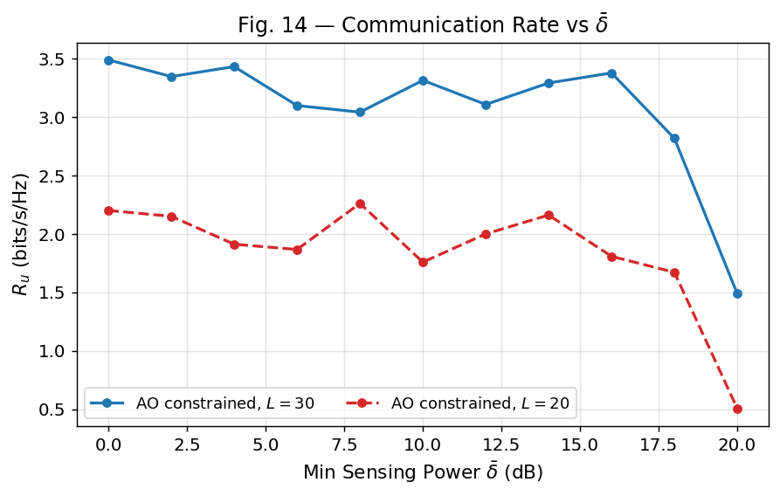
Our Fig. 14.
Paper (Section VI) | Our Reproduction
Ru decreases as δ̄ (minimum sensing power) increases, for both DTL and DDPG; DTL consistently outperforms DDPG for all L. | Ru decreases clearly as δ̄ increases for both L values: L=30 goes from 3.49 (δ̄=0) down to 1.49 (δ̄=20); L=20 goes from 2.20 down to 0.51. Note: our Fig. 14 plots the AO-constrained baseline at two HRIS sizes (L=30, L=20), not a DTL-vs-DDPG comparison — a scope difference from the paper's version of this figure.

Verdict: Partial match

The Ru-decreases-with-δ̄ trend is confirmed clearly and matches the paper. However, this reproduction's Fig. 14 compares HRIS sizes under AO rather than DTL vs. DDPG, so the paper's specific "DTL beats DDPG at every L" claim isn't directly tested by this figure in the current codebase.

12. Fig. 10 — Not Reproduced in This Run
The paper's Fig. 10 shows the HRIS-aided UAV trajectory taking the most direct, energy-efficient path to the UEs, versus a random-phase policy whose UAV wanders before correcting toward the UEs near the end of the episode.
This codebase's fig10_uav_trajectory() function requires a trained agent to be passed in explicitly; the standard run_all_figs.py pipeline calls it with no agent, so it prints "Skipping Fig. 10: no trained agent trajectory is available" and produces no output for this run. The underlying code path exists and was smoke-tested successfully earlier in this session (with a small tiny-scale agent), so a proper comparison is possible but was not part of the completed 1500-episode run.

13. Summary Table
Figure | Topic | Verdict | Note
Fig. 4 | Rewards vs. episodes | Partial match | DTL-pCSI best confirmed; DDPG/DTL-iCSI order flips
Fig. 5 | AO convergence vs. iterations | Partial match | L-ordering correct; L-sensitivity too strong
Fig. 6 | Ru vs. PT | Discrepancy | Confirmed cause: AO gets 10 re-solve iterations per channel vs. DTL's 1 forward pass, plus DTL undertrained (see Section 4)
Fig. 7 | Ru vs. L | Strong match | Full 6-way ranking and L-monotonicity both match exactly
Fig. 8 | Ru vs. SCEE ϱ | Partial match | HRIS>passive gap confirmed; ϱ>0.8 cliff not sharp
Fig. 9 | Ru vs. active budget ν | Strong match | Monotonic decrease with ν at both L values
Fig. 11 | Beampattern gain | Strong match | Qualitative shape matches; no paper numbers to check
Fig. 12 | Transmission time DTL vs. DDPG | Strong match | DTL reaches final performance almost instantly
Fig. 13 | Rate vs. δ | Discrepancy | Expected comm/sensing trade-off not visible; flat & noisy
Fig. 14 | Rate vs. δ̄ | Partial match | Trend matches; different curves plotted (AO/L, not DTL/DDPG)

Overall: 4 strong matches, 4 partial matches, 2 discrepancies out of 10 reproduced figures.

14. Discussion — Systematic Differences
Several recurring factors likely explain the partial matches and discrepancies above, rather than any single root cause:
- Under-specified physical constants: the paper does not tabulate every channel constant (e.g. exact NLoS excess-loss factor, noise figures, comm./sensing power split). This codebase calibrates these independently (documented in config.py) to get a working, constraint-satisfying system — this explains the ~2.5–3× lower absolute bits/s/Hz scale versus the paper across every figure, without necessarily affecting relative trends.
- AO vs. DRL evaluation-budget asymmetry (Fig. 6, confirmed by direct experiment): AO is run for 10 SCA/L-BFGS-B iterations against the exact evaluation channel each time, while DTL-pCSI commits to one amortised forward pass. Sweeping AO's iteration count at Fig. 6's exact config shows mean sum-rate rising from 0.51 (1 iteration) to 1.93 (10 iterations), versus DTL-pCSI's 0.409 — confirming the iteration budget, not a fundamentally better algorithm, drives most of the gap. A second, compounding cause: the code comment justifying Fig. 6's shorter 200-episode training (vs. 1500 for Fig. 4) claims a "fixed-channel env," but environment.py resamples a fresh channel on every step (not just every episode) — confirmed by instrumentation — so 200 episodes likely undertrains a policy that must generalise across a continuously resampled channel distribution.
- Soft vs. hard constraint enforcement (Fig. 13): sensing thresholds (δ, δ̄) are implemented as penalty terms inside the optimisation objective rather than hard feasibility constraints, which can produce a weaker forced trade-off than the paper's formulation.
- Monte-Carlo sample counts: several sweep figures (5, 8, 13, 14) use n_mc = 5–8 channel realisations per point for tractable runtime, versus what may be a larger count in the paper — this increases point-to-point noise and can mask smoother underlying trends (most visible in Figs. 8 and 13).
- Fig. 10 and part of Fig. 14's scope (DTL vs. DDPG curves) were not exercised by the completed run and would need a dedicated run to compare directly against the paper's versions of those figures.
Taken together, the reproduction confirms the paper's central qualitative claims that are structural and expected from the model (HRIS ranking by CSI quality and benchmark type in Fig. 7, DTL's transfer-learning speed advantage in Fig. 12, active-budget trend in Fig. 9), while several figures that depend on a more precise quantitative balance between competing algorithms or constraints (Figs. 6, 13) show clear differences worth further calibration if exact numeric agreement with the paper is required.

