1. Install dependencies from ```package.json```

2. To run the program, open terminal and type ```npm run dev``` (nodemon) or ```npm run start```

3. Create an admin as shown: 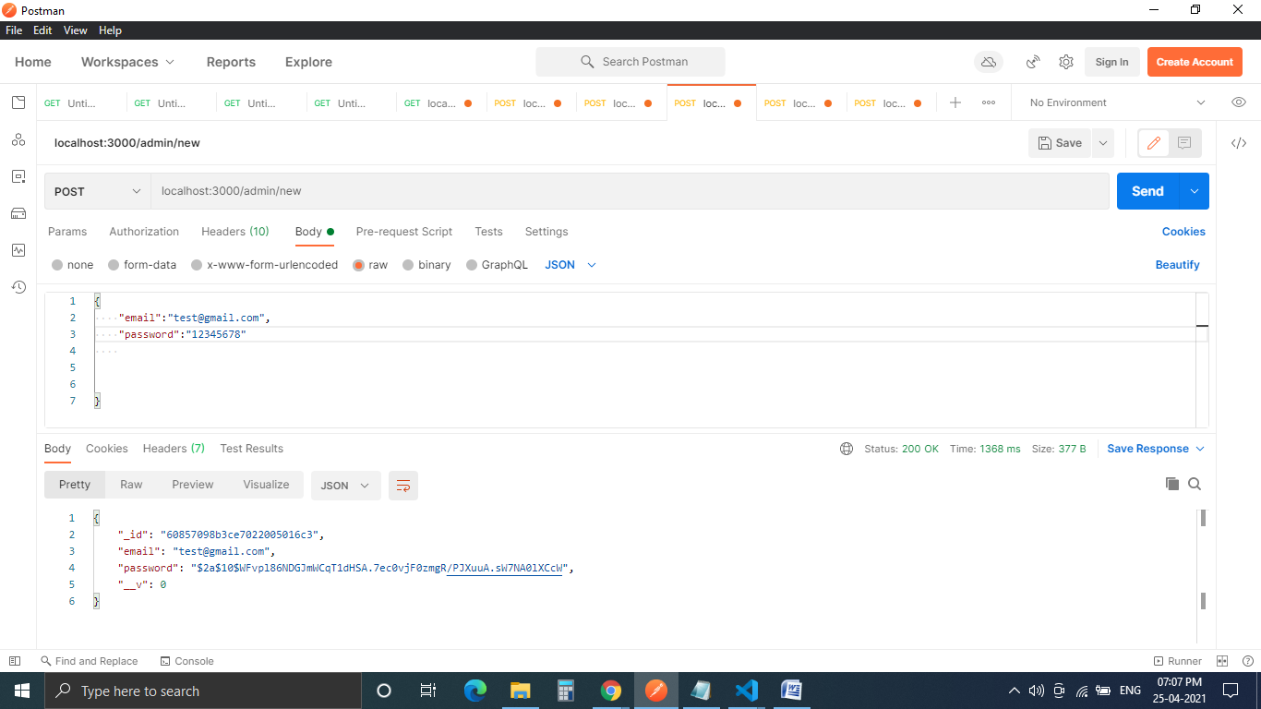

The password is hashed.

4. Once admin is created, login:

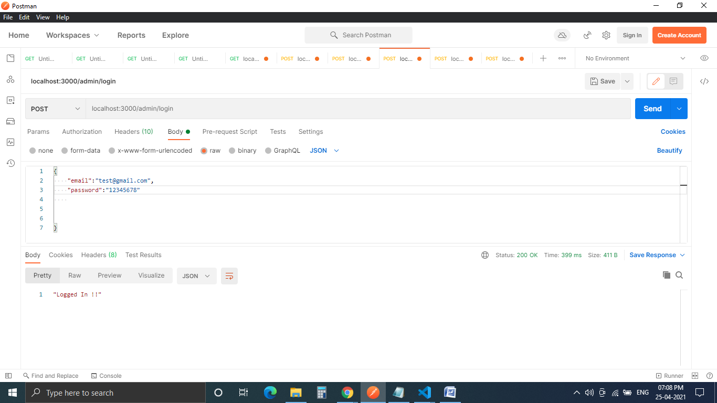

On successful login, you will get a message as shown. Now go to “Headers” and copy the auth-token as shown: 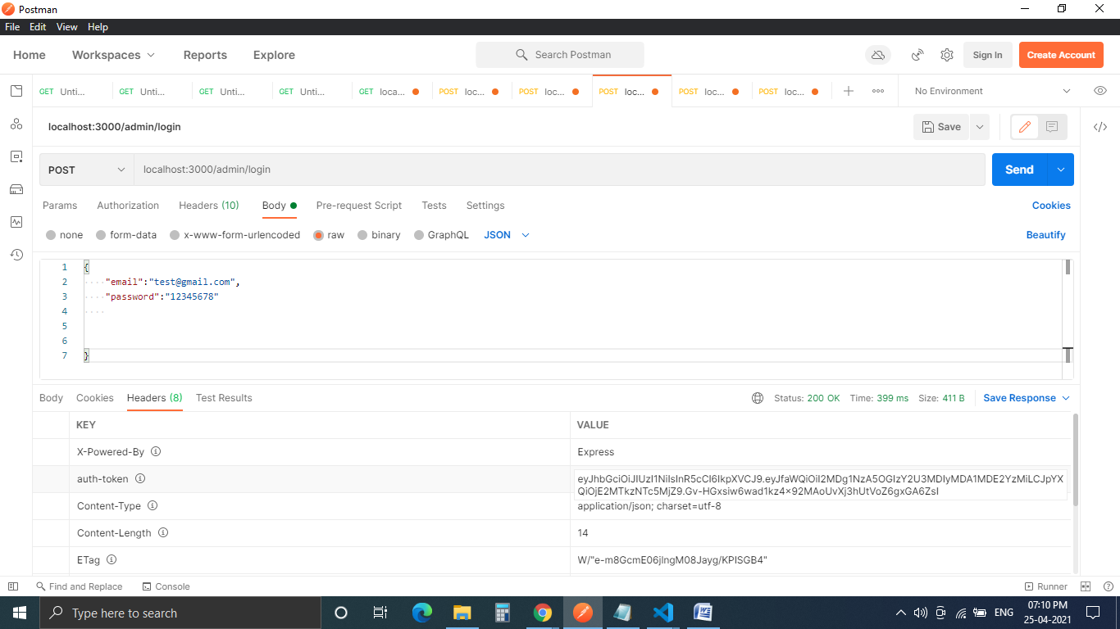

5. Please paste this auth-token in the Headers of every route you want to access. 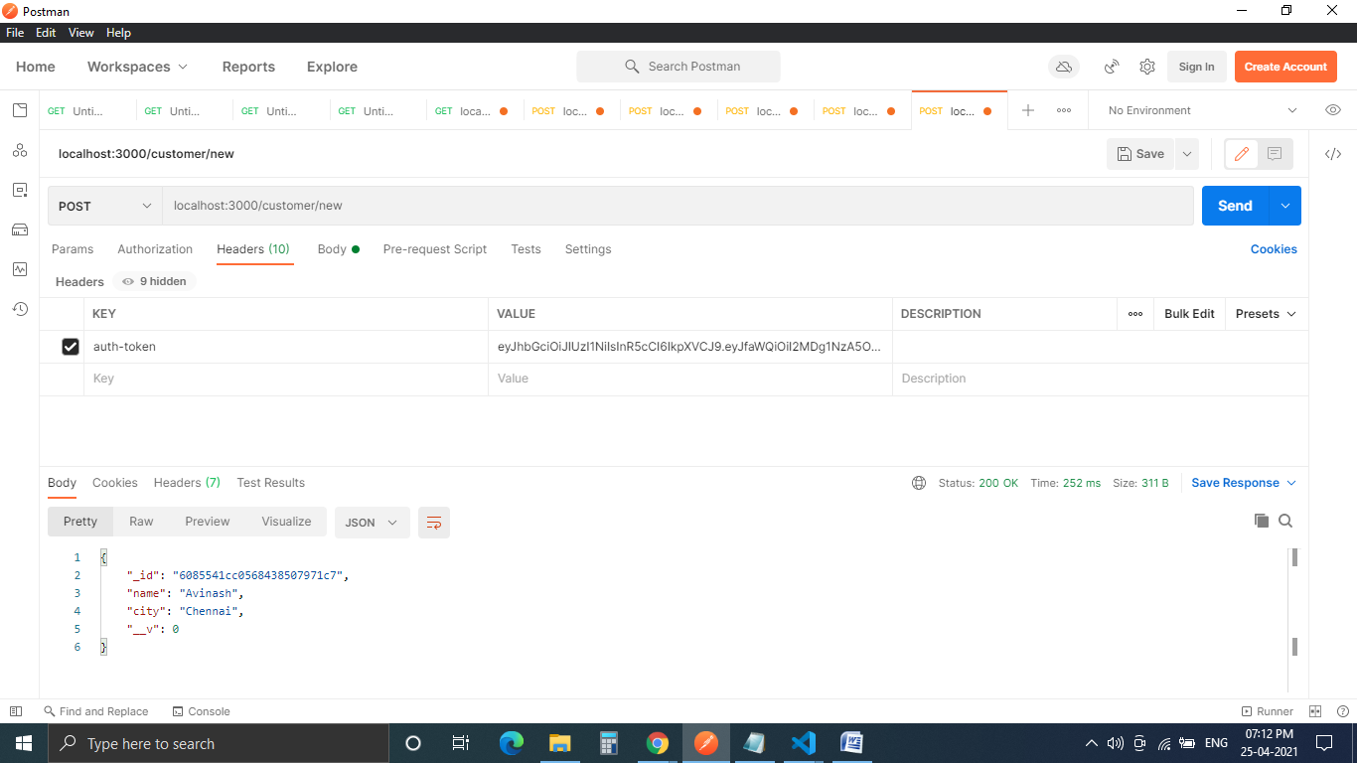

If auth-token is not pasted/checked in the header, you get an “Access Denied” message:

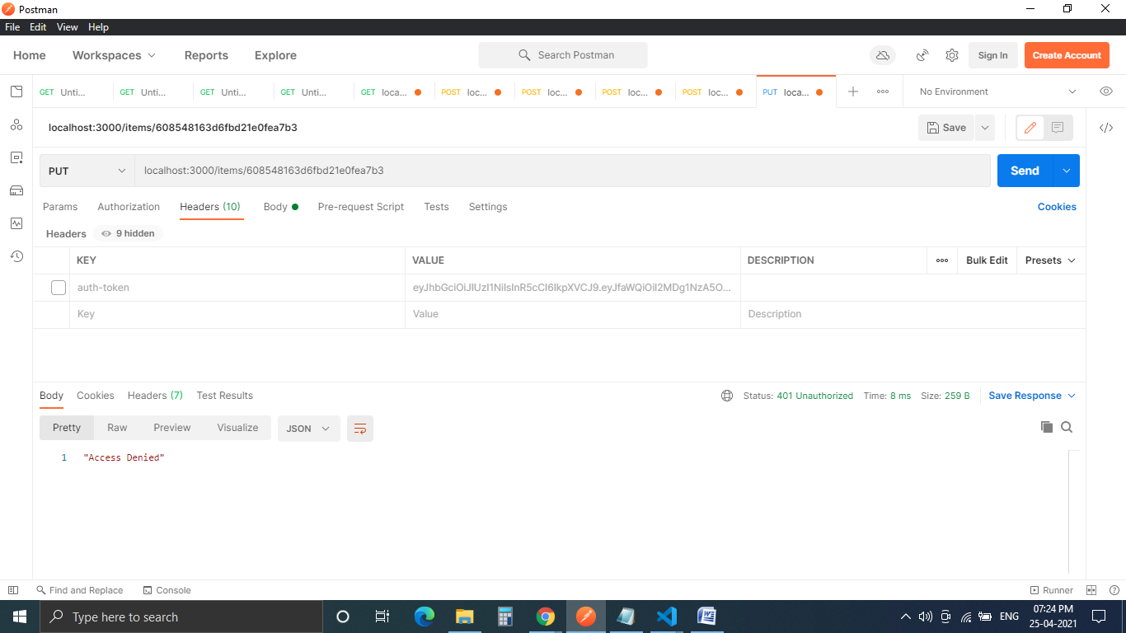

6. To create a new customer (after pasting the auth-token in the header):

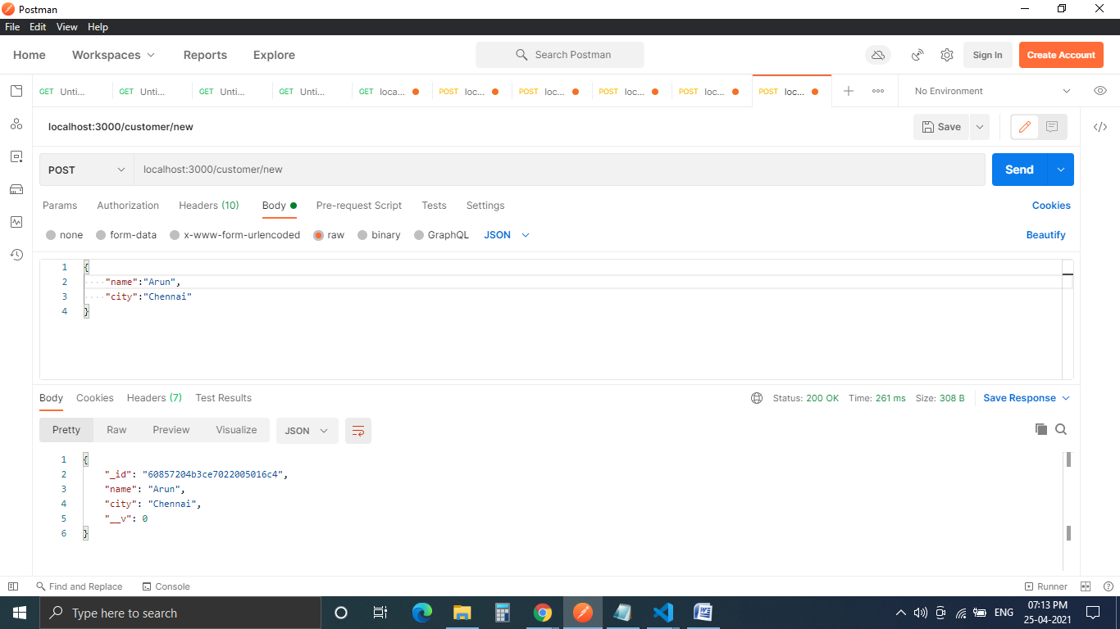

7. To update an existing customer, mention the customer’s ID in the PUT method of the below route: 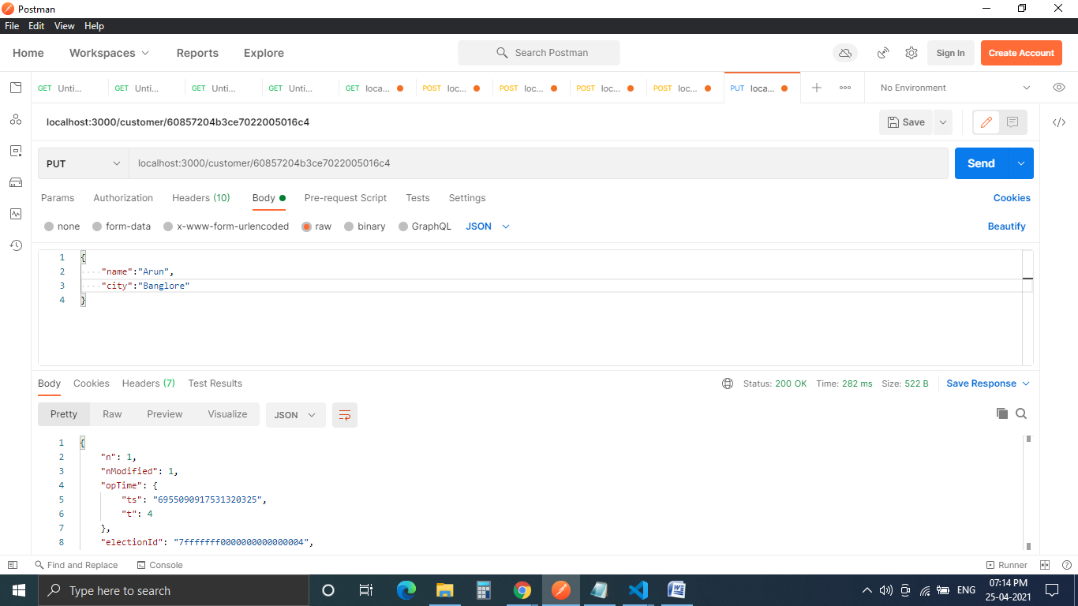

Verify the change in the DB: 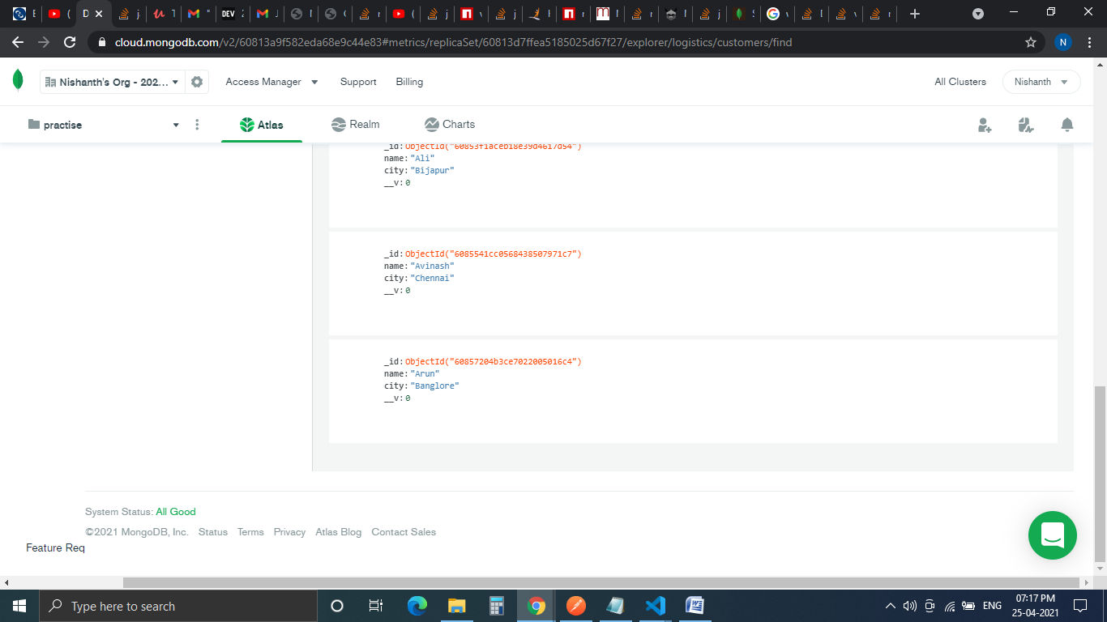”city” field of Arun is changed to “Banglore”.

8. Use this method to retrieve all customers in the DB:

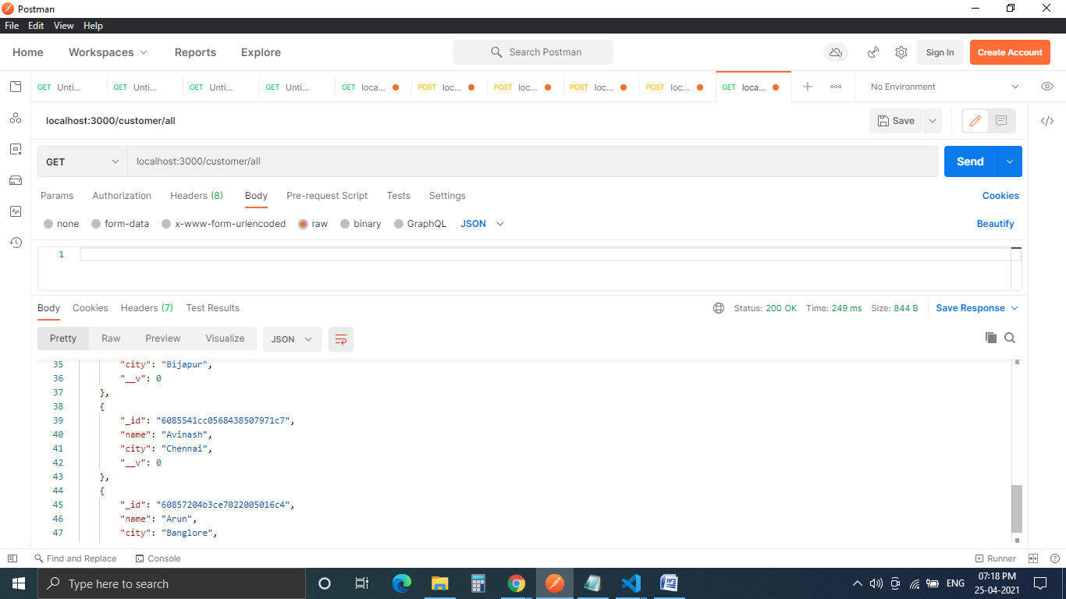

9. Create item: 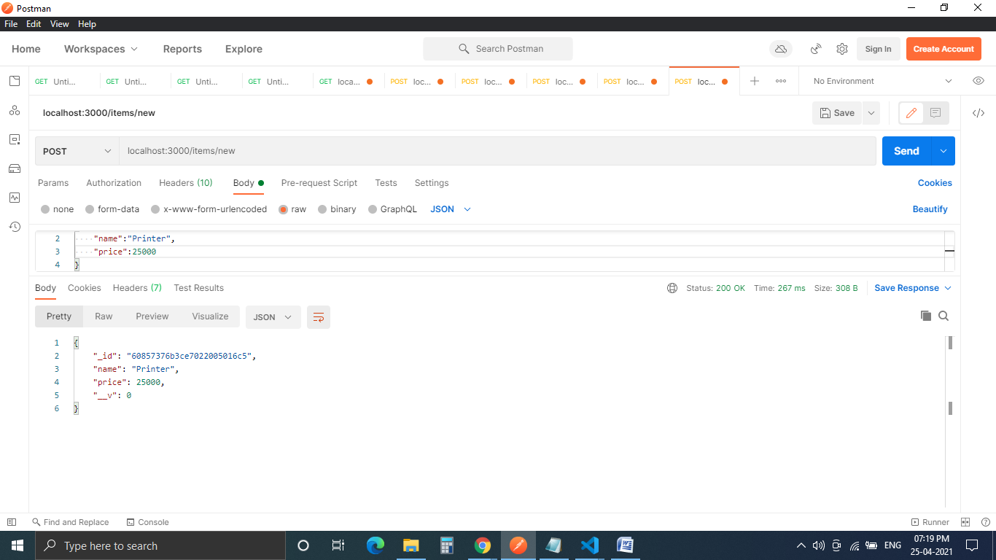

10. Get all existing items in DB:

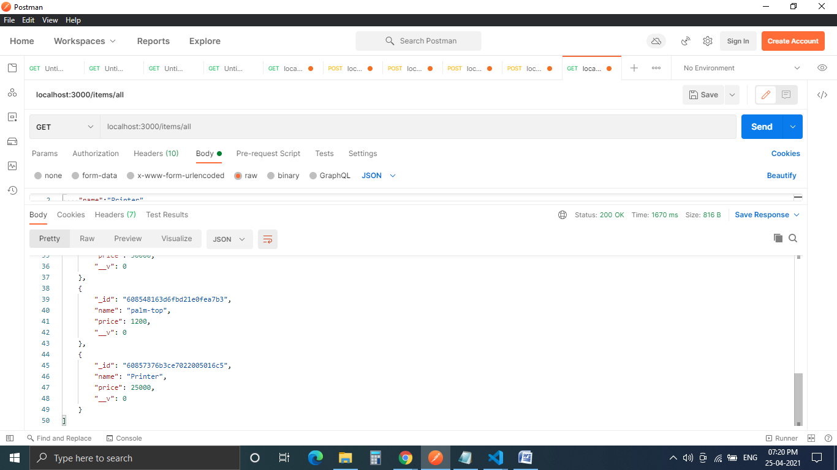

11. Get a specific item from the DB by including its ID in the URL:

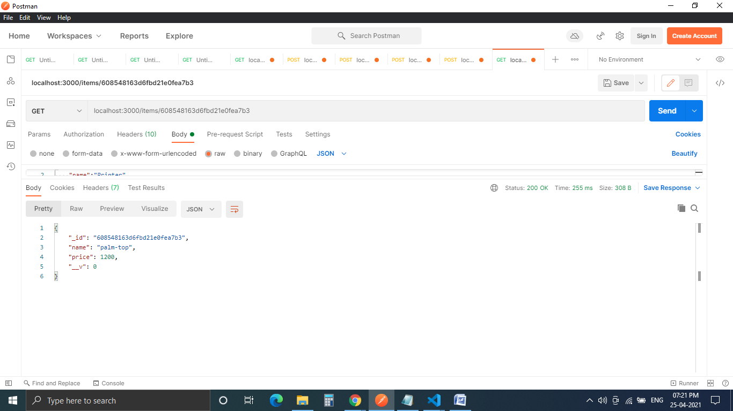

12. Update an item, here I have taken the same item shown in the previous screenshot and updated it name and price fields: 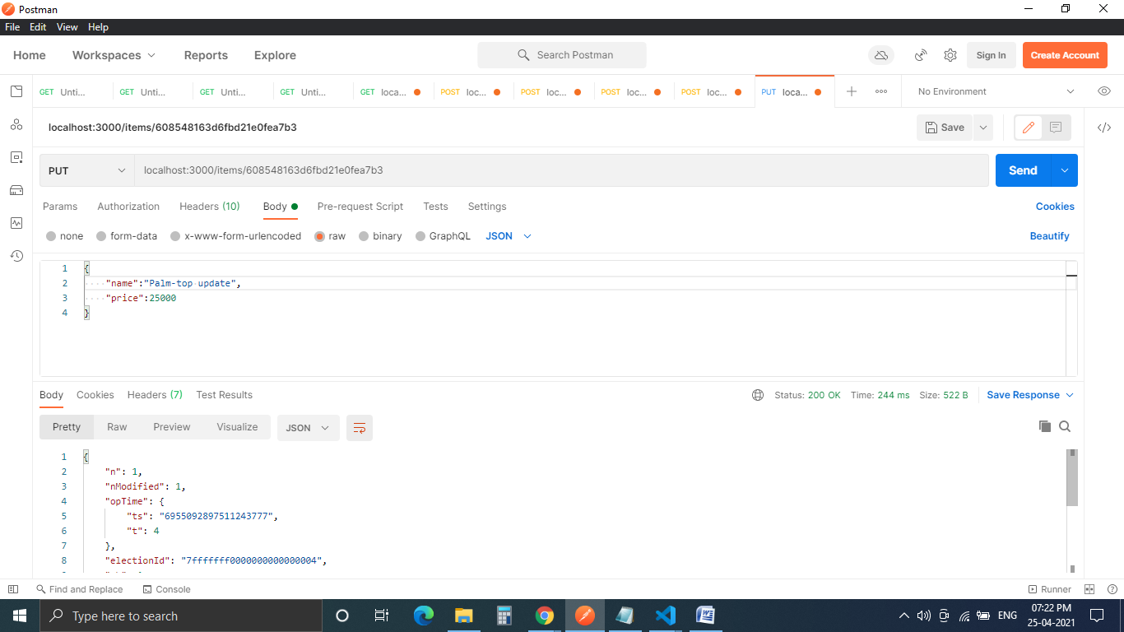

Verify in the DB, name is changed to Palm-top update: 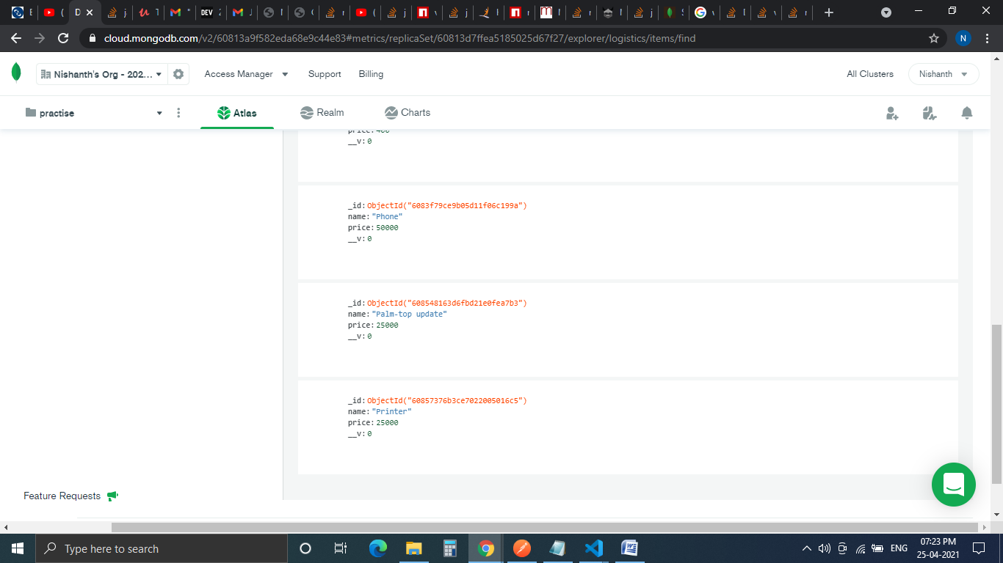

13. Create a delivery vehicle:

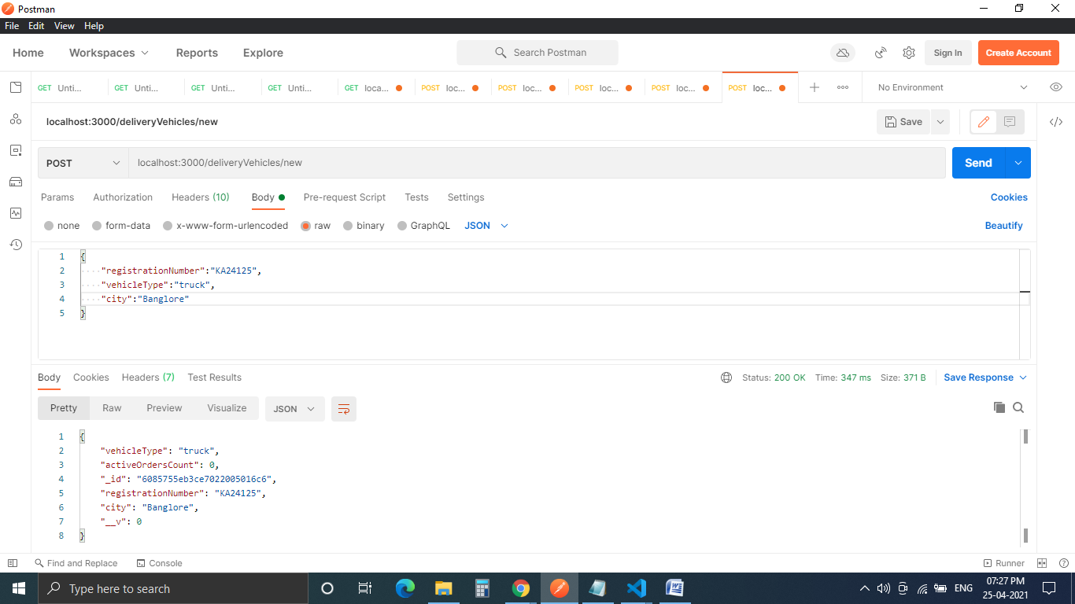

14. If registration number is not alpha numeric, you get an error as shown:

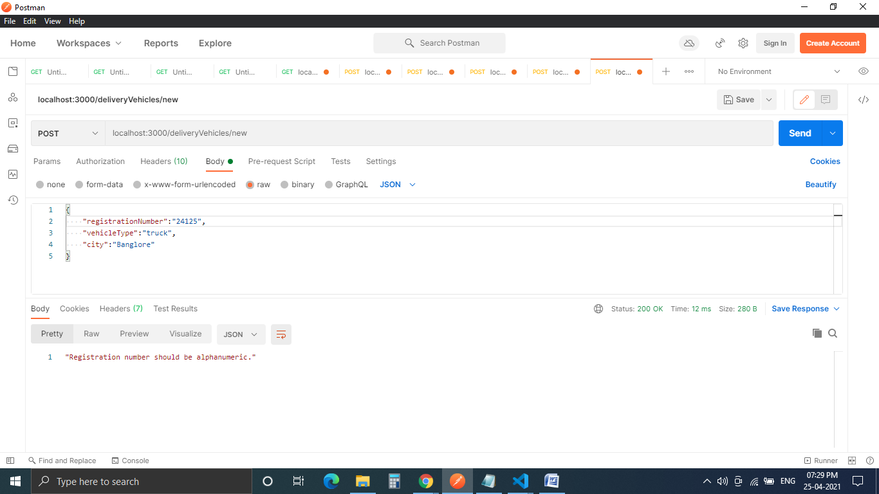

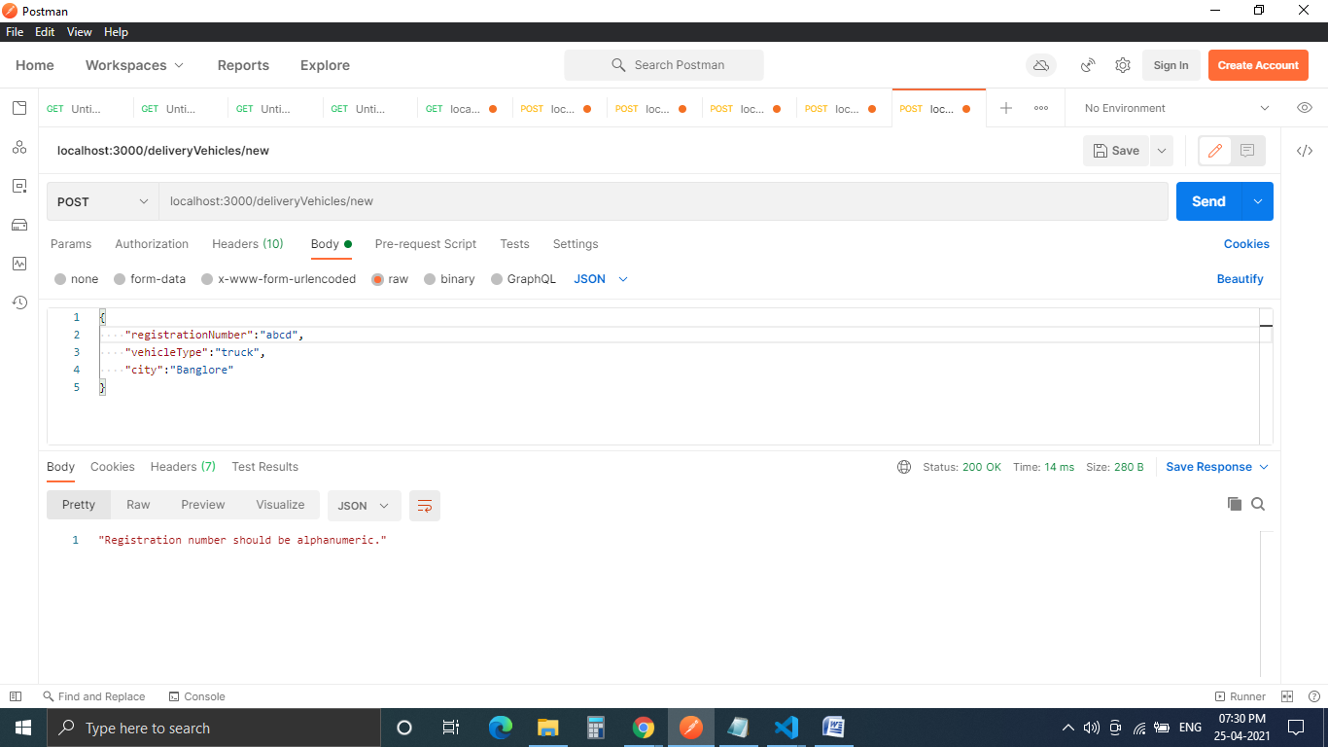

15. Get all delivery vehicles in the DB: 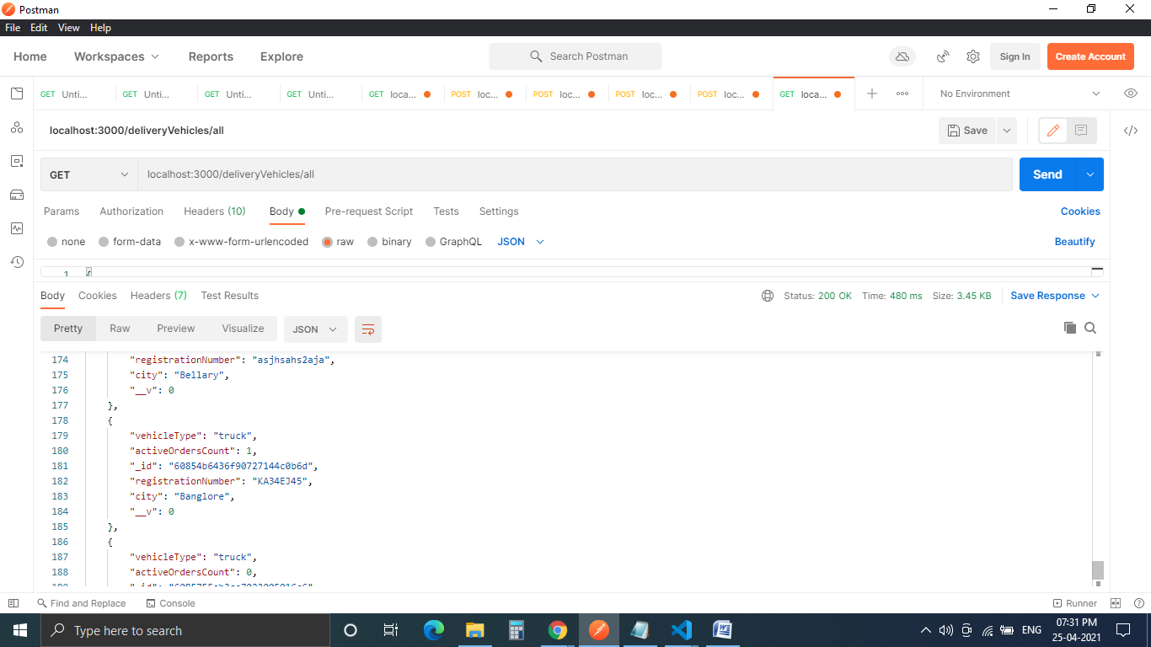

16. Get a specific delivery vehicle by including its ID in the URL: 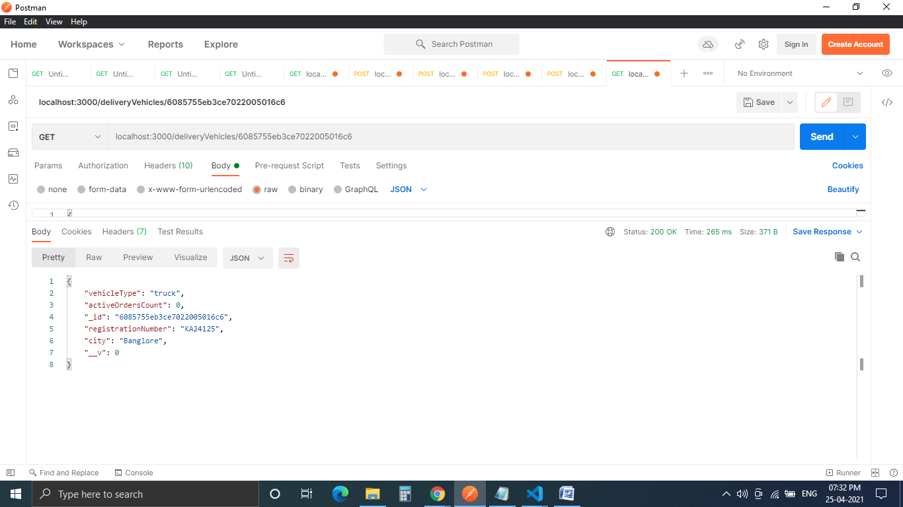

17. Update a delivery vehicle by including its ID in the URL: 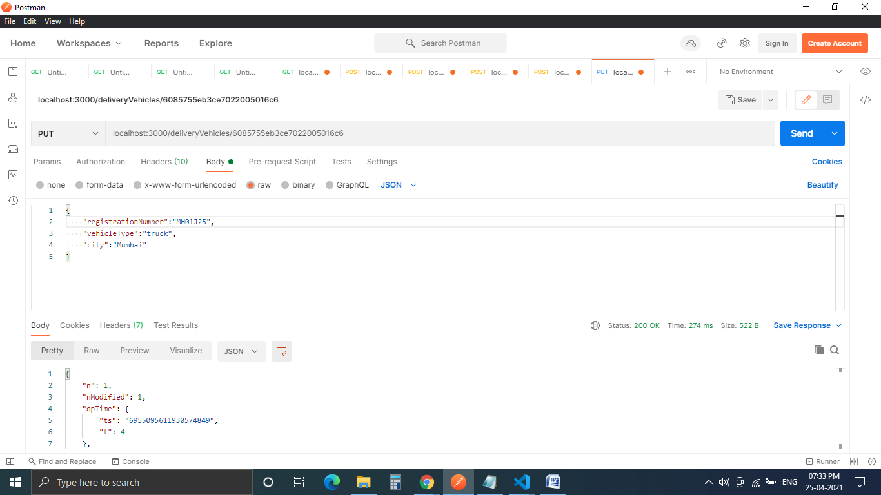

Verify in the DB: 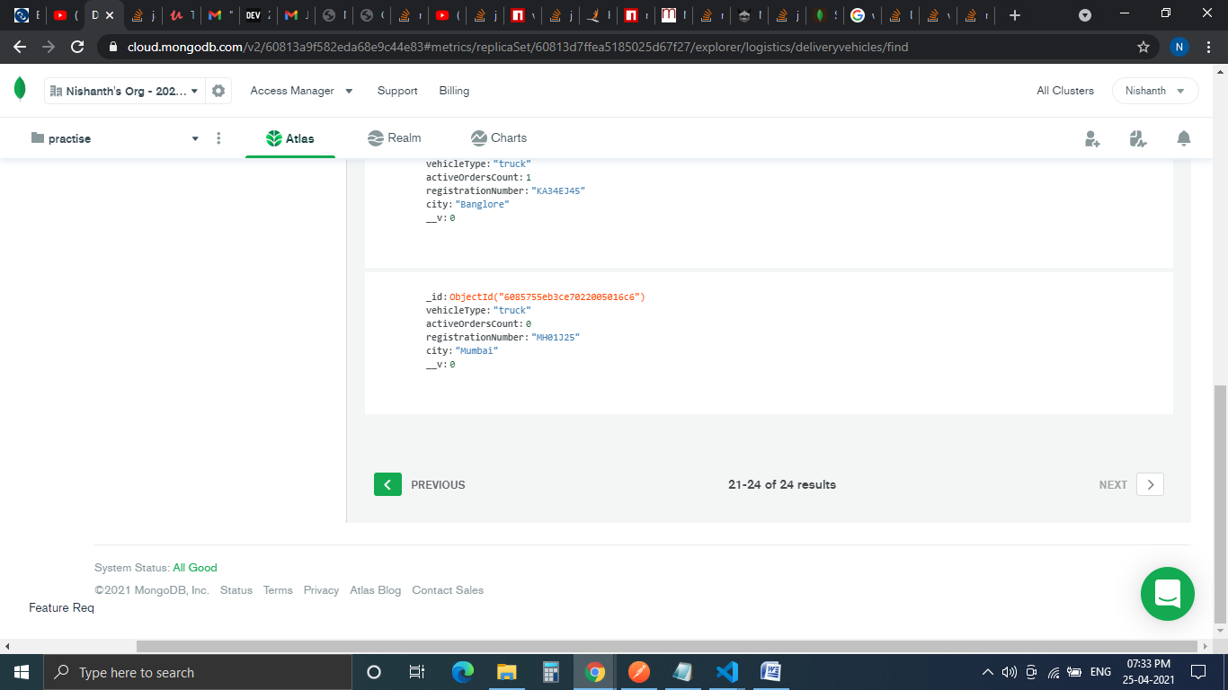

18. Placing an order:

Input the itemId and customerId, all other fields including an invoice is auto generated as shown. The activeOrderCount of delivery vehicle will be incremented and can be verified in the DB. The price of the item is fetched from the item DB through the item ID, order number is auto generated.

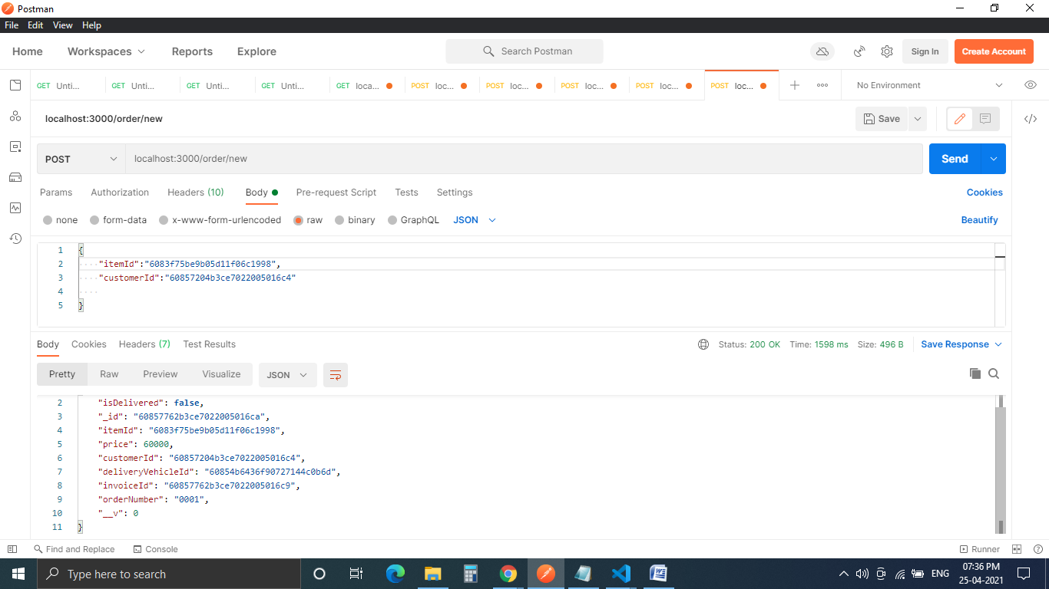

19. If the delivery vehicle’s city and customer city is not matching or if no trucks are available or if active orders count of the truck is already 2, an order cannot be placed and you get a message like this: 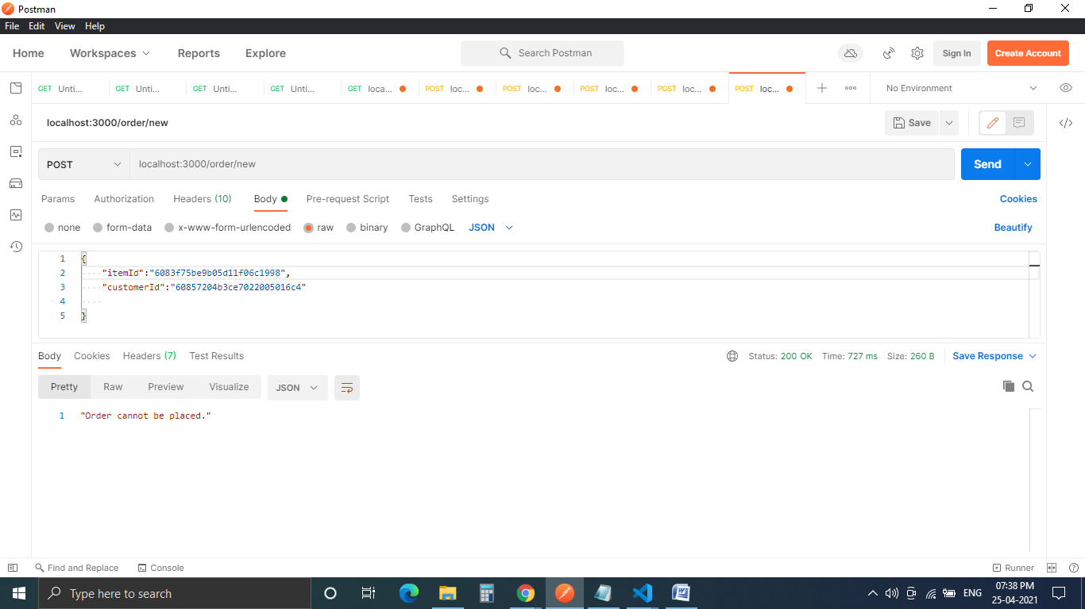

20. To deliver an order: 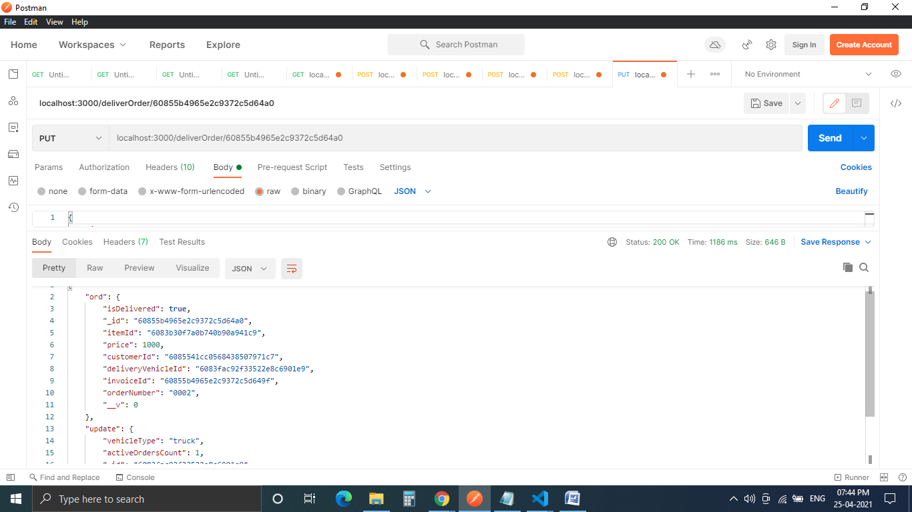

Once order is delivered, both the updated fields of “isDelivered”(where the value will be updated to true) in order and activeOrderCount (where the value will be decremented) of delivery vehicle can be observed in the DB.

21. To get all invoices in the DB: 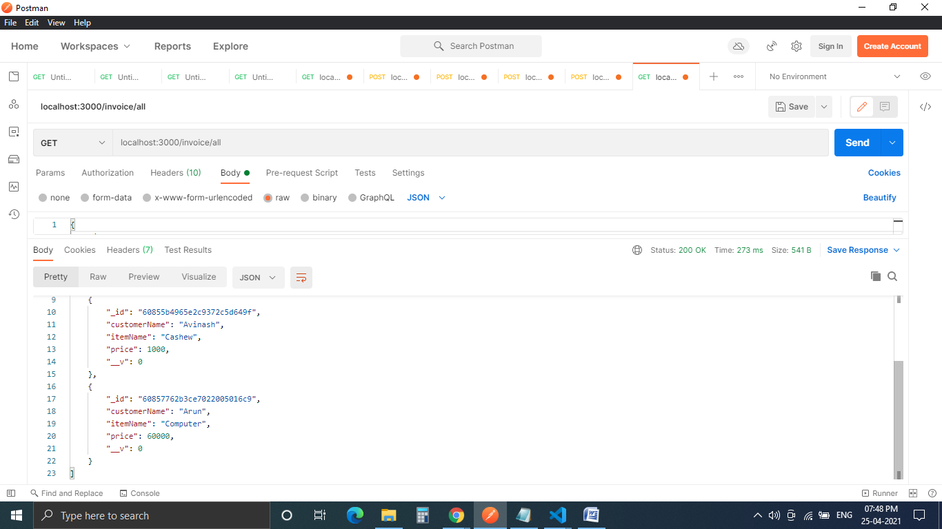

22. To get a specific invoice, mention the invoice ID in the URL: 