MEDIXAI: Explainable AI Based Medical Expert System Using Rule Based Reasoning
A PROJECT REPORT

Submitted by

NAVEEN RAJ P (241901070)
NISHANTH ELANGO RAJAN (241901075)
in partial fulfillment for the award of the degree of

BACHELOR OF ENGINEERING
in
COMPUTER SCIENCE AND ENGINEERING (CYBER SECURITY)


RAJALAKSHMI ENGINEERING COLLEGE

An Autonomous Institute

CHENNAI

NOVEMBER 2026

RAJALAKSHMI ENGINEERING COLLEGE CHENNAI
BONAFIDE CERTIFICATE

Certified that this project report “MEDIXAI: Explainable AI Based Medical Expert System Using Rule Based Reasoning” is the bonafide work of Naveen Raj P (241901070) and Nishanth Elango Rajan (241901075), who carried out the project work under my supervision.

SIGNATURE
Dr. Bhuvana S, Ph.D.,

ASSISTANT PROFESSOR(SG)
Department of Computer Science and Engineering (Cyber Security) Rajalakshmi Engineering College Chennai - 602 105

Submitted to Project Viva-Voce Examination held on

SIGNATURE OF THE INTERNAL EXAMINER
ABSTRACT
MEDIXAI is an explainable medical expert-system project designed to demonstrate classical artificial intelligence through explicit knowledge representation and rule-based reasoning. The project addresses the limitations of simple symptom lookup by presenting several supported hypotheses together with the evidence behind each result. The system uses explicit rules and excludes machine learning and deep learning.
The available Python prototype contains 38 disease cards, 104 distinct symptom labels and 228 weighted mappings. It normalizes input, ranks candidate cards by weighted symptom coverage, reduces a score when required symptoms are missing, verifies the requirements of the leading hypothesis and generates an explanation. A pairwise consistency check identifies selected conflicting observations. These operations illustrate knowledge-based reasoning, while formal multi-step chaining and resolution remain proposed extensions.
The design extends this core into a modular Flask and SQLite application with a browser interface, knowledge administration, optional consultation history and PDF reports. Security requirements cover input validation, ownership checks, rule integrity and restricted data storage. Worked examples demonstrate the scoring arithmetic and its limitations. The percentages represent rule-match scores, not diagnostic probabilities or measured medical accuracy. The project establishes an educational framework for traceable inference; clinical use and treatment decisions remain outside the validated scope.
The proposed consultation workflow separates input correction, candidate evaluation and presentation. Observations are validated before inference, and each result retains the matched weight, total card weight, missing required symptoms and penalty status. This shared evidence record is intended to keep the browser explanation, optional history entry and exported report consistent. A published knowledge version provides a stable context for reproducing a saved calculation.
The evaluation plan combines controlled arithmetic examples with proposed checks for conflicting observations, unknown identifiers, explanation fidelity and access control. Future work includes explicit present, absent and unknown states, focused follow-up questions and separately tested formal reasoning demonstrations. The project emphasizes reproducibility and a clear account of implemented behavior as the basis for further development.
Keywords: MEDIXAI, Rule-Based Expert System, Classical Artificial Intelligence, Explainable AI, Forward Chaining, Medical Decision Support.

ACKNOWLEDGEMENT
We express our sincere thanks to our beloved and honourable chairman Mr. S. Meganathan B.E., F.I.E., and the chairperson Dr. M. Thangam Meganathan Ph.D., for their timely support and encouragement.
We are greatly indebted to our respected and honourable principal Dr. S.N. Murugesan M.E., Ph.D., for his able support and guidance. We express our sincere thanks to Dr. P. Tamilselvi Ph.D., Professor and Head, Department of Computer Science and Engineering (Cyber Security).
We also extend our sincere and hearty thanks to our internal guide Ms. Divya R, for her valuable guidance and motivation during the completion of this project. We would like to extend our special gratitude to our mentor Dr. Bhuvana S, Ph.D., Assistant Professor (SG), for her constant guidance, valuable suggestions and continuous encouragement throughout our project journey. Our sincere thanks to our family members, friends and other staff members of computer science engineering.

NAVEEN RAJ P (241901070)
NISHANTH ELANGO RAJAN (241901075)

TABLE OF CONTENTS
CHAPTER NO. | TITLE | PAGE NO.
 | ABSTRACT | iii
 | ACKNOWLEDGEMENT | iv
 | LIST OF TABLES | xi
 | LIST OF FIGURES | xii
1 | INTRODUCTION | 1
 | 1.1 Background | 1
 | 1.2 Problem Statement | 1
 | 1.2.1 Reasoning workflow and project context | 1
 | 1.3 Objectives | 2
 | 1.4 Scope | 2
 | 1.4.1 Scope boundaries and acceptance | 2
 | 1.5 Security Requirements and Security Considerations | 3
 | 1.6 SDG Alignment | 3
 | 1.6.1 Applying the requirements | 3
2 | LITERATURE REVIEW | 4
 | 2.1 Existing System with Security Approaches | 4
 | 2.1.1 Implications for the design | 4
 | 2.1.2 Comparison of project baselines | 5
 | 2.2 Research Gaps | 5
 | 2.2.1 Priorities arising from the gaps | 5
 | 2.3 Proposed System | 6
 | 2.3.1 Overview of the proposed system | 6
 | 2.3.2 Objectives of the proposed system | 6
 | 2.3.3 Advantages of the proposed system | 6
 | 2.3.4 Proposed consultation experience | 6
3 | SYSTEM DESIGN | 7
 | 3.1 System Architecture | 7
 | 3.1.1 Layer interaction | 7
 | 3.1.2 Hardware and software requirements | 8
 | 3.1.3 Development and deployment preparation | 8
 | 3.2 Module Design | 9
 | 3.2.1 Module contracts and error handling | 9
 | 3.2.2 Database design | 10
 | 3.2.3 Persistence workflow | 10
 | 3.3 Data Flow and UML Diagrams | 11
 | 3.3.1 Consultation data flow | 11
 | 3.3.2 Use case diagram | 12
 | 3.3.3 Consultation activity diagram | 13
 | 3.3.4 Consultation sequence diagram | 14
 | 3.3.5 Entity relationship overview | 15
 | 3.3.6 Diagram interpretation | 16
 | 3.3.6.1 Reading the data flow | 16
 | 3.3.6.2 Actor responsibilities | 16
 | 3.3.6.3 Decision points and termination | 16
 | 3.3.6.4 Consistency across the request | 16
 | 3.4 Threat Model and Attack Surface | 17
 | 3.4.1 Reviewing an attack path | 17
 | 3.5 Security Controls | 18
 | 3.5.1 Verification and maintenance | 18
4 | SYSTEM DESCRIPTION | 19
 | 4.1 Data Collection | 19
 | 4.1.1 Knowledge review procedure | 19
 | 4.2 Data Preprocessing | 20
 | 4.2.1 Normalization examples and boundaries | 20
 | 4.3 Algorithms and Methodology | 21
 | 4.3.1 Knowledge representation | 21
 | 4.3.2 Forward and backward reasoning | 21
 | 4.3.3 Evidence representation and traceability | 21
 | 4.3.4 Weighted matching and ranking | 22
 | 4.3.4.1 Interpreting the score | 22
 | 4.3.5 Backward verification and consistency checking | 23
 | 4.3.6 Resolution and contradiction handling | 23
 | 4.3.6.1 Unknown evidence and bounded reasoning | 23
 | 4.4 Results and Discussion | 24
 | 4.4.1 Worked scoring examples | 24
 | 4.4.1.1 Reproducing a worked example | 24
 | 4.4.2 Deterministic behavior checks | 25
 | 4.4.2.1 Extending the behavior checks | 25
 | 4.4.3 Evaluation plan and limitations | 26
 | 4.4.3.1 Evaluation records and reporting | 26
5 | CONCLUSION | 27
 | 5.1 Development priorities | 27
 | REFERENCES | 28
 | APPLICATION SCREENSHOTS | 29
 | S.1 Symptom workspace | 29
 | S.2 Rule-match results and premise check | 30
 | S.3 Knowledge-base browser | 31
 | S.4 Reasoning methods and safety information | 32
 | APPENDIX A KNOWLEDGE BASE INVENTORY | 33
 | A.1 Disease inventory | 33
 | A.2 Disease inventory continued | 34
 | A.2.1 Coverage and review status | 34
 | APPENDIX B PROPOSED DATA DICTIONARY | 35
 | B.1 Knowledge data dictionary | 35
 | B.1.1 Publication checks | 35
 | B.2 Application data dictionary | 36
 | B.2.1 Storage and retrieval checks | 36
 | APPENDIX C INFERENCE PSEUDOCODE | 37
 | C.1 Prototype scoring behavior | 37
 | C.1.1 Implementation notes | 37
 | C.2 Proposed controlled inference workflow | 38
 | C.2.1 Workflow outcomes | 38
 | APPENDIX D IMPLEMENTATION AND ACCEPTANCE PLAN | 39
 | D.1 Planned acceptance tests | 39
 | D.1.1 Acceptance evidence record | 39
 | D.2 Development milestones | 40

LIST OF TABLES
TABLE NO. TITLE PAGE NO.
1.1 Project objectives and acceptance evidence 2
1.2 SDG alignment 3
2.1 Literature and design relevance 4
2.2 Comparison of the project baselines 5
3.1 Hardware requirements 8
3.2 Software requirements 8
3.3 Core module responsibilities 9
3.4 Planned database tables 10
3.5 Threat model 17
3.6 Security controls and verification 18
4.1 Knowledge-base inventory 19
4.2 Preprocessing behavior and planned changes 20
4.3 Worked candidate scores 24
4.4 Reconstructed logic checks 25
4.5 Planned evaluation measures 26
A.1 Disease inventory 33
A.2 Disease inventory continued 34
B.1 Knowledge data dictionary 35
B.2 Application data dictionary 36
D.1 Planned acceptance tests 39
D.2 Proposed development milestones 40

LIST OF FIGURES
FIGURE NO. TITLE PAGE NO.
3.1 MEDIXAI system architecture 7
3.2 MEDIXAI consultation data flow 11
3.3 MEDIXAI use case diagram 12
3.4 MEDIXAI consultation activity diagram 13
3.5 MEDIXAI consultation sequence diagram 14
3.6 MEDIXAI entity relationship overview 15
S.1 MEDIXAI symptom workspace 29
S.2 MEDIXAI rule-match results and premise check 30
S.3 MEDIXAI knowledge-base browser 31
S.4 MEDIXAI reasoning methods and safety information 32

CHAPTER 1
INTRODUCTION

1.1 BACKGROUND
MEDIXAI is an academic expert system that demonstrates how explicit knowledge and logical
reasoning can turn symptom observations into ranked disease hypotheses. Its purpose is to
make each result inspectable: a reader should be able to identify the matched symptoms,
missing conditions and calculation behind the ranking. The project uses classical artificial
intelligence through explicit rules, knowledge representation and transparent reasoning.
The project has two levels of development. A Python command-line prototype illustrates
symptom matching, weighted scoring, required-symptom verification and explanation
generation. A proposed web application separates the user interface, inference engine and
knowledge repository so that the same reasoning procedures can operate on an updated
knowledge base. Machine learning, deep learning and trained prediction models are
outside the scope.

1.2 PROBLEM STATEMENT
A simple symptom-to-disease lookup can hide why an answer was selected and can fail when
only part of a rule is satisfied. MEDIXAI addresses the engineering problem of ranking several
supported hypotheses while exposing their evidence and limitations. It must also manage
inconsistent input and protect sensitive information if consultation history is introduced. A
ranking is an educational output, not a verified medical diagnosis.

1.2.1 Reasoning workflow and project context
A consultation can be understood as a sequence of evidence-handling steps. The user supplies
observations, the system converts them into canonical symptom identifiers, and the inference
procedure compares those identifiers with the stored disease cards. The output must preserve
the connection between an observation and its contribution to a score. This sequence gives
students a practical way to connect knowledge representation with the result shown on screen.
The main engineering challenge is to keep that explanation consistent as the application grows.
A change to a symptom weight should be visible in the knowledge version and in any newly
generated result. An earlier saved consultation should retain its original evidence. These
requirements make reproducibility, maintainability and clear communication central to the
project, alongside the ranking calculation itself.
The report therefore treats the prototype as a worked foundation for an educational application.

1.3 OBJECTIVES
Table 1.1 links the project objectives to acceptance evidence. The primary goal is an explainable expert system with outputs traceable to facts, rules and weights. Keeping domain knowledge separate from inference makes changes reviewable and avoids rewriting application logic for every new disease.
Table 1.1 Project objectives and acceptance evidence

Objective | Evidence required
Represent domain knowledge | Structured disease cards, symptom identifiers and required-  symptom sets.
Rank multiple hypotheses | Reproducible scores and ordering for fixed inputs.
Explain each result | Matched and missing evidence, penalty status and rule  identifiers.
Verify logical support | Goal-directed checks of the selected hypothesis.
Handle inconsistent input | Visible conflicts and a defined correction workflow.
Support secure expansion | Documented access controls, schema and test cases.

1.4 SCOPE
The project covers requirements, literature review, system design, inspection of the prototype
and deterministic scoring examples. The planned application includes guest access, registration,
a symptom interface, ranked results, explanations, consultation history, PDF export and
knowledge administration. It uses Python, Flask, SQLite and HTML/CSS/JavaScript. These
application features remain design commitments until implemented and tested.
Clinical deployment, prescription generation, medication dosages, hospital integration and
claims of diagnostic accuracy are excluded. No patient dataset is used to train or validate the
supplied prototype.

1.4.1 Scope boundaries and acceptance
Acceptance should be based on observable software behavior. For a fixed observation set and
knowledge snapshot, the engine should produce the same scores, the same required-symptom
status and a consistent candidate order. A reviewer should be able to recalculate a displayed
value from the recorded weights without relying on hidden application state.
The browser interface should distinguish a completed calculation from a saved consultation. A
guest may inspect a result without creating an account, while persistent history requires an
explicit storage action.

1.5 SECURITY REQUIREMENTS AND SECURITY CONSIDERATIONS
The security design must protect consultation confidentiality, rule integrity and service
availability. Guest consultations should avoid persistent personal data. Stored histories and
generated reports must be accessible only to their owners or an explicitly authorized role.
Knowledge-base edits need separate authorization because a changed weight or rule can alter
every subsequent result.
Input must be restricted to known symptom identifiers and bounded request sizes. The
application must treat rule content as data, use parameterized database queries and avoid
executing imported expressions. Explanations should report what the engine actually evaluated.
Authentication, session protection, authorization and logging controls are proposed for the web
version; the command-line listing does not implement them.

1.6 SDG ALIGNMENT
Table 1.2 SDG alignment

S.  No. | SDG No. and  goal | Relevant target | Project contribution and alignment
1 | SDG 3  Good Health and  Well-being | 3.8  Access to essential  health services | Indirect educational alignment through  understandable health-information  workflows. No improvement in health  outcomes or access has been measured.
2 | SDG 4  Quality Education | 4.4  Technical and  vocational skills | Direct academic alignment through  knowledge engineering, logical  inference, database design and secure  software development.
Table 1.2 maps the project to SDG 3 and SDG 4 through understandable health-information workflows and technical learning. These intended contributions do not establish achievement of the UN indicators.

1.6.1 Applying the requirements
Security requirements should be attached to individual workflows. A history request needs an
owner check, a knowledge edit needs an administrative permission check, and an export needs
the same access decision as the result it represents. Keeping these decisions at the server
prevents the interface from becoming the sole enforcement point.
The educational contribution can be evaluated through student tasks such as tracing a ranking,
finding a missing requirement and explaining why two cards overlap. Such exercises connect
the project to technical learning outcomes without treating the application as evidence of
improved health-service delivery.

CHAPTER 2
LITERATURE REVIEW

2.1 EXISTING SYSTEM WITH SECURITY APPROACHES
The literature establishes rule-based consultation, goal-directed inference and explanation as
longstanding AI methods. MEDIXAI applies these ideas in a small, inspectable academic
application. Its contribution should therefore be judged by implementation clarity and
evaluation rather than by claiming that expert systems or explainability are new.
Table 2.1 Literature and design relevance

Work | Relevant contribution | Use in MEDIXAI
Russell and Norvig  AIMA, 4th edition | Logical agents, propositional  inference, forward and  backward chaining. | Terminology and distinction  between matching, entailment  and proof.
Buchanan and Shortliffe,  editors  MYCIN, 1984 | Medical expert-system rules,  uncertainty and explanation. | Historical foundation; no  transfer of clinical validation.
van Melle, Shortliffe and  Buchanan  EMYCIN, 1984 | A reusable consultation  engine separated from domain  knowledge. | Basis for the proposed expert-  system shell.
OWASP  ASVS 5.0.0, 2025 | Requirements for application  security verification. | Reference for web security  requirements and tests.
Table 2.1 relates the AI literature to reasoning methods and the ASVS standard to security requirements. The historical expert-system works support the design foundations; they are not current web-security standards.

2.1.1 Implications for the design
The separation between a knowledge base and an inference engine is particularly useful for this
project. Students can inspect a card, change a reviewed weight in a controlled copy, and
observe the effect on ranking without changing the procedure that evaluates every card. This
makes the source of a changed result easier to identify.
Explanation also needs a precise meaning. In MEDIXAI, it should identify selected evidence,
missing required evidence, the denominator used for coverage and any applied penalty. A
persuasive paragraph generated independently of those values would not establish explanation
fidelity. The design consequently favors an evidence record that can be rendered consistently in
the browser and in an exported report.
The literature review guides terminology and architecture.

2.1.2 Comparison of project baselines
Table 2.2 compares the initial five-disease example with the expanded prototype and planned application. The initial example requires all listed symptoms, then uses partial matching and a combined yes/no question. The expanded prototype adds weighted ranking, missing-required-symptom checks and selected contradiction pairs.
Table 2.2 Comparison of the project baselines

Dimension | Initial example | Expanded prototype and proposed  application
Knowledge  representation | Five symptom lists in  Python. | 38 weighted cards in the listing;  database storage proposed.
Partial evidence | Match count and one follow-  up prompt. | Weighted ranking and explicit  required-symptom penalty.
Explanation | Final label and treatment  text. | Matched/missing evidence; detailed  rule trace proposed.
Input consistency | No dedicated conflict list. | Three pair checks; correction gate  proposed.
Security | Local execution only. | Web authorization and private history  proposed.

2.2 RESEARCH GAPS
The prototype lacks a formal rule agenda, multi-step proof traces, calibrated scores, source
provenance for individual rules and validated medical ground truth. It also does not distinguish
an explicitly absent symptom from one that was never asked about. These gaps motivate
engineering and evaluation work; they do not establish superiority over commercial symptom
checkers.

2.2.1 Priorities arising from the gaps
The first improvement should be a stable representation of observations. Present, absent and
unknown states need distinct values so that unanswered questions do not silently become
negative evidence. The next priority is a result contract that records exactly which weights and
requirements were evaluated for each candidate.
A later formal reasoning module should be introduced with its own rule syntax, stopping
conditions and proof records. Testing it separately from the weighted matcher would make its
contribution assessable. Security and usability evaluation should likewise use explicit
scenarios, rather than treating a larger knowledge base or an attractive interface as evidence that
the identified gaps have been resolved.

2.3 PROPOSED SYSTEM

2.3.1 Overview of the proposed system
The proposed system is a modular web application with an independent inference service. The
service accepts validated observations, reads a versioned knowledge snapshot and returns
candidate results with a structured explanation. Flask routes coordinate the request, SQLite
stores the knowledge and optional history, and the browser displays the outcome.

2.3.2 Objectives of the proposed system
The application will expose several hypotheses, show the contribution of each selected
symptom and ask focused follow-up questions when important evidence is unknown. A
knowledge administrator will maintain disease cards and rule metadata through controlled
forms. Saved reports will retain the knowledge version so that an earlier result remains
understandable after later edits.

2.3.3 Advantages of the proposed system
Separating the layers allows the interface and database to change without rewriting the scoring
procedure. Structured explanations make defects easier to locate, and explicit missing evidence
helps students understand why a hypothesis lacks support. The planned novelty is the
integration of transparent ranking, traceable reasoning and maintainable knowledge in one
educational workflow.
These advantages are design expectations. Reuse in another domain must be demonstrated with
a second knowledge base, and usability must be measured with users. Better clinical accuracy
cannot be inferred from a larger disease list or a more polished interface.

2.3.4 Proposed consultation experience
The interaction should begin with a clear symptom-selection form and a short explanation of
how observations will be used. Before inference, the server checks the submitted identifiers and
returns any conflicts for correction. Once the input is accepted, the result view presents a
ranked list together with matched evidence and missing requirements for each displayed
candidate.
Follow-up questions should be optional, focused and bounded. A response updates the current
observation set and triggers a fresh calculation against the same knowledge snapshot. If the user
decides to save, the application stores the resulting evidence and version together. The export
then presents that same snapshot, so differences between an on-screen result and a downloaded
report can be detected during testing.
This workflow turns explainability into a visible part of the consultation rather than a separate
summary appended after scoring.

CHAPTER 3
SYSTEM DESIGN

3.1 SYSTEM ARCHITECTURE
The proposed architecture uses a browser presentation layer, a Flask application layer, an
inference service and a SQLite persistence layer. The boundary between the browser and server
is untrusted. The inference service receives canonical facts rather than raw form text.
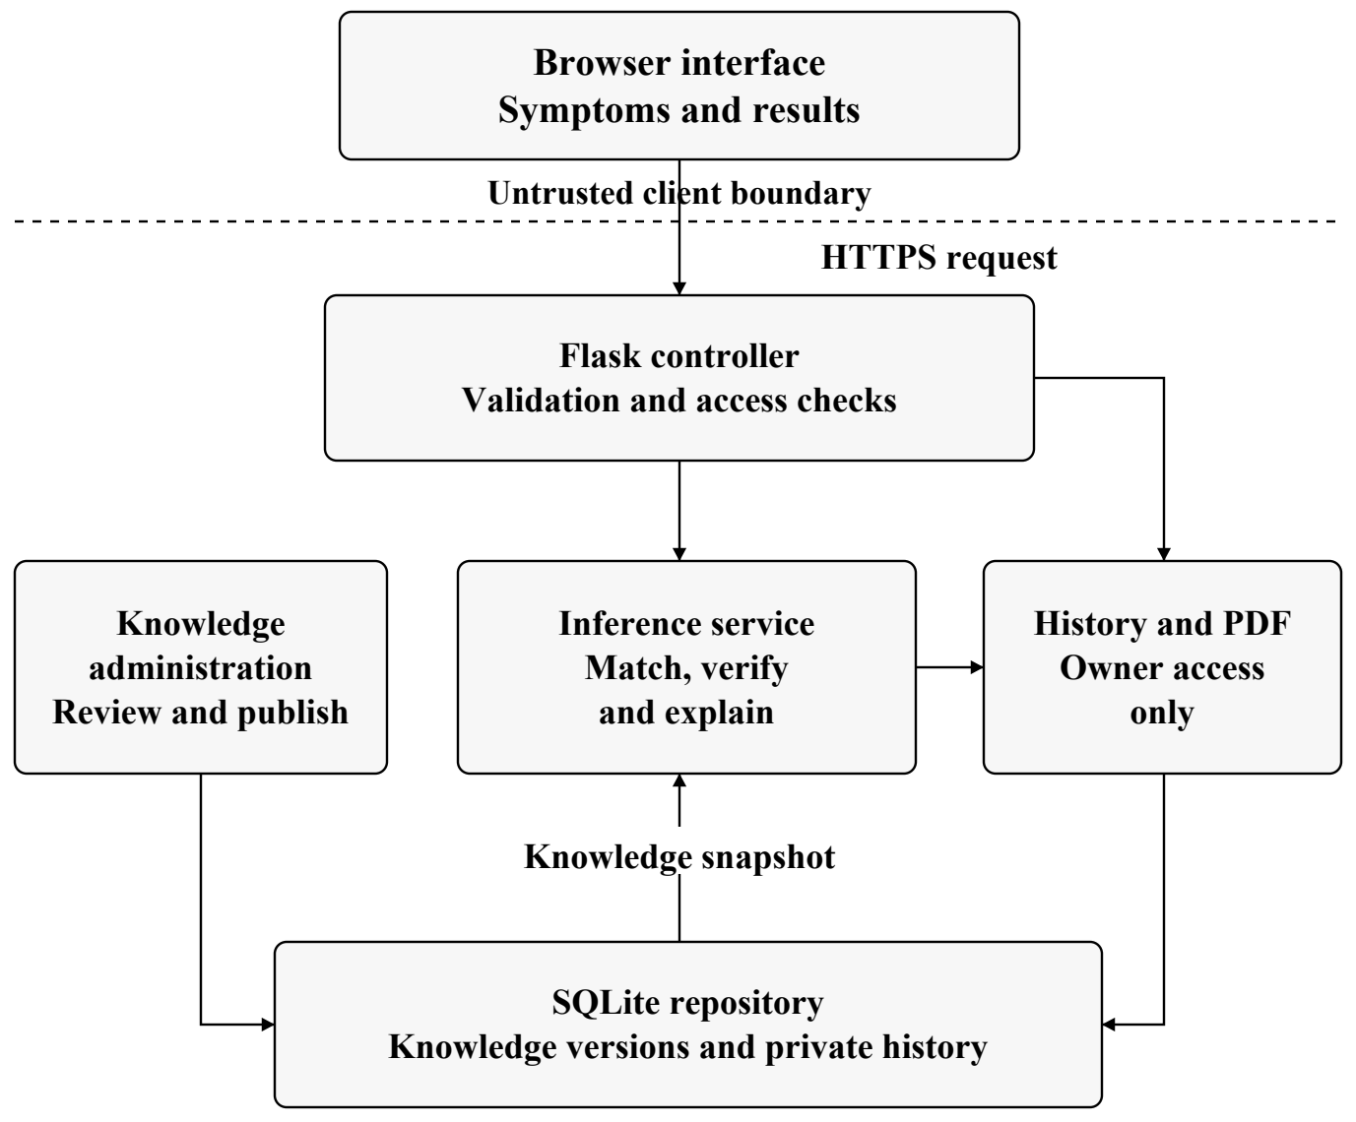
Figure 3.1 MEDIXAI system architecture
Figure 3.1 separates the browser, controller, inference service and repository. Each consultation uses an immutable knowledge snapshot, and one result object supplies the web explanation, optional history and PDF export. Knowledge editing follows a separate administrative path. This is the target web design; the original prototype is a single Python class.

3.1.1 Layer interaction
Each layer should expose a narrow contract: validated observations enter the inference service,
and structured evidence leaves it. Database access belongs in the repository, while request
validation and owner checks belong in the application workflow. This division makes failures
easier to isolate and allows the same calculation to support several presentation formats.

3.1.2 Hardware and software requirements
Table 3.1 Hardware requirements

Component | Proposed development configuration
Processor | General-purpose dual-core processor or better.
Memory | 4 GB RAM minimum planning allowance; 8 GB preferred for  development tools.
Storage | At least 1 GB free for source, dependencies and demonstration  outputs.
Graphics | No dedicated GPU required by the rule-based design.
Network | Local development can use loopback; hosting requires a secured  network connection.
Table 3.2 Software requirements

Component | Role
Python 3 | Core logic and application code.
Flask | Planned HTTP routes and server-side application workflow.
SQLite | Planned relational knowledge and consultation storage.
HTML, CSS and  JavaScript | Browser forms and results presentation.
ReportLab | Planned PDF consultation report generation.
Chart.js | Optional visualization of rule-match scores.
Git and an editor | Version control, development and review.
Table 3.1 lists planned hardware allowances; Table 3.2 identifies the software components. These are planning assumptions, not measured minimum requirements. Dependencies must be pinned and tested; inference needs no external AI API or model-training service.

3.1.3 Development and deployment preparation
A reproducible setup should record the interpreter version, installed dependencies and database
initialization steps. A small demonstration knowledge snapshot and fixed sample inputs should
accompany the source so that another student can verify the calculation before enabling account
or history features.
Hosting introduces configuration choices that local execution does not exercise. The
implementation plan should therefore distinguish a local demonstration from a
network-accessible application and record the settings used for each verified build.

3.2 MODULE DESIGN
Table 3.3 defines the five core AI modules, their inputs and their outputs. Their interfaces should return structured data, allowing the command-line demonstration and web application to share the same inference engine.
Table 3.3 Core module responsibilities

Module | Input | Output
Symptom collection | Entered or selected symptoms. | Canonical observation set and  input errors.
Knowledge base | Reviewed disease cards and  rule records. | Versioned knowledge snapshot.
Inference engine | Facts and a knowledge  snapshot. | Ranked candidates and required-  symptom status.
Consistency  checking | Positive and negative  observations. | Conflict pairs and correction  requests.
Explanation and  output | Candidate record and  evidence trace. | Readable explanation and  educational guidance.
A result record should carry the disease identifier, score, matched symptoms, missing required
symptoms, total possible weight, applied penalty and knowledge version. This contract makes a
score independently checkable. Rule identifiers should refer to actual rules evaluated; a
displayed identifier alone does not demonstrate that a formal proof was executed.
The current explanation routine describes only the highest-ranked candidate in detail. The
proposed interface extends the same evidence view to each displayed candidate.

3.2.1 Module contracts and error handling
Validation errors should be returned as structured messages that identify the affected input
without exposing internal exceptions. The inference module should receive an already validated
knowledge snapshot, but it should still reject an invalid scoring denominator rather than return
a misleading value.
The explanation module should consume the candidate record directly. It should not repeat the
scoring procedure in a second implementation, because two copies could diverge after a
maintenance change. Returning all evidence in one shared record also makes it possible to
compare the browser, stored history and PDF output during acceptance testing.
Clear contracts allow each module to be reviewed with small controlled examples before the
full application is assembled.

3.2.2 Database design
The supporting modules provide the planned application workflow. Authentication manages
registered and guest access. Consultation routes pass validated observations to the engine.
History and report modules use the same result snapshot. Administrative routes manage
knowledge separately from personal consultation data.
Table 3.4 Planned database tables

Table | Purpose
users | Account identity, password hash and role.
disease_categories | Disease grouping labels.
symptom_categories | Symptom grouping labels.
diseases | Disease name, description and status metadata.
symptoms | Canonical symptom codes and display names.
disease_symptoms | Weighted many-to-many symptom mapping.
treatments | Reviewed educational guidance text.
precautions | Reviewed caution and referral text.
rules | Rule identity, conditions and priority metadata.
diagnosis_history | Owned consultation and result snapshot.
history_symptoms | Observations linked to a saved consultation.
Table 3.4 organizes the eleven planned tables for knowledge, accounts and consultation history. Validation, review and snapshot fields support the design without implying that the database is already implemented. Appendix B defines proposed constraints.

3.2.3 Persistence workflow
Knowledge maintenance and consultation storage have different lifecycles. A reviewed
knowledge change creates a published version for later consultations. Saving a consultation
records the observations and complete result produced by the version already in use. These
operations should not share an implicit update path.
The repository should group related writes into a transaction so that a history record cannot be
presented as complete when its observations have not been stored. A failed write should leave
the user with a clear outcome and preserve the current displayed result for a deliberate retry.
Retrieval should return a complete snapshot rather than rebuild an old consultation from the
active knowledge base. This keeps historical evidence stable after a later publication.

3.3 DATA FLOW AND UML DIAGRAMS

3.3.1 Consultation data flow
The data flow separates consultation evidence from administrative knowledge changes. A
registered user may explicitly save a consultation. Guest requests are processed without
persistent history by default.
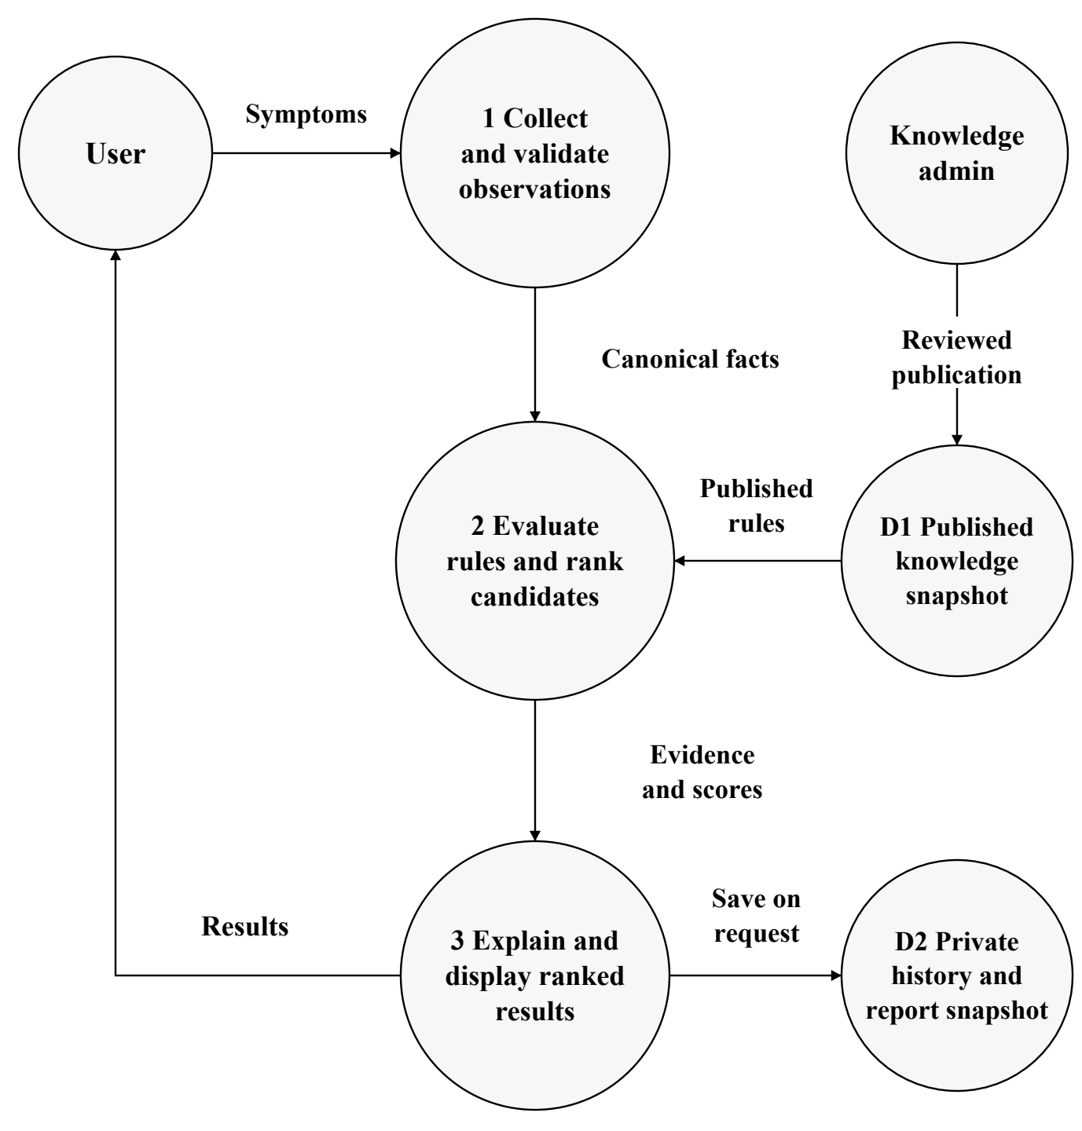
Figure 3.2 MEDIXAI consultation data flow
Figure 3.2 traces observations through collection, inference and result display using circular nodes. Published knowledge versions prevent an administrative edit from changing an in-progress consultation. Optional saving and export use the current or stored result snapshot and require the same ownership checks as the results page.

3.3.2 Use case diagram
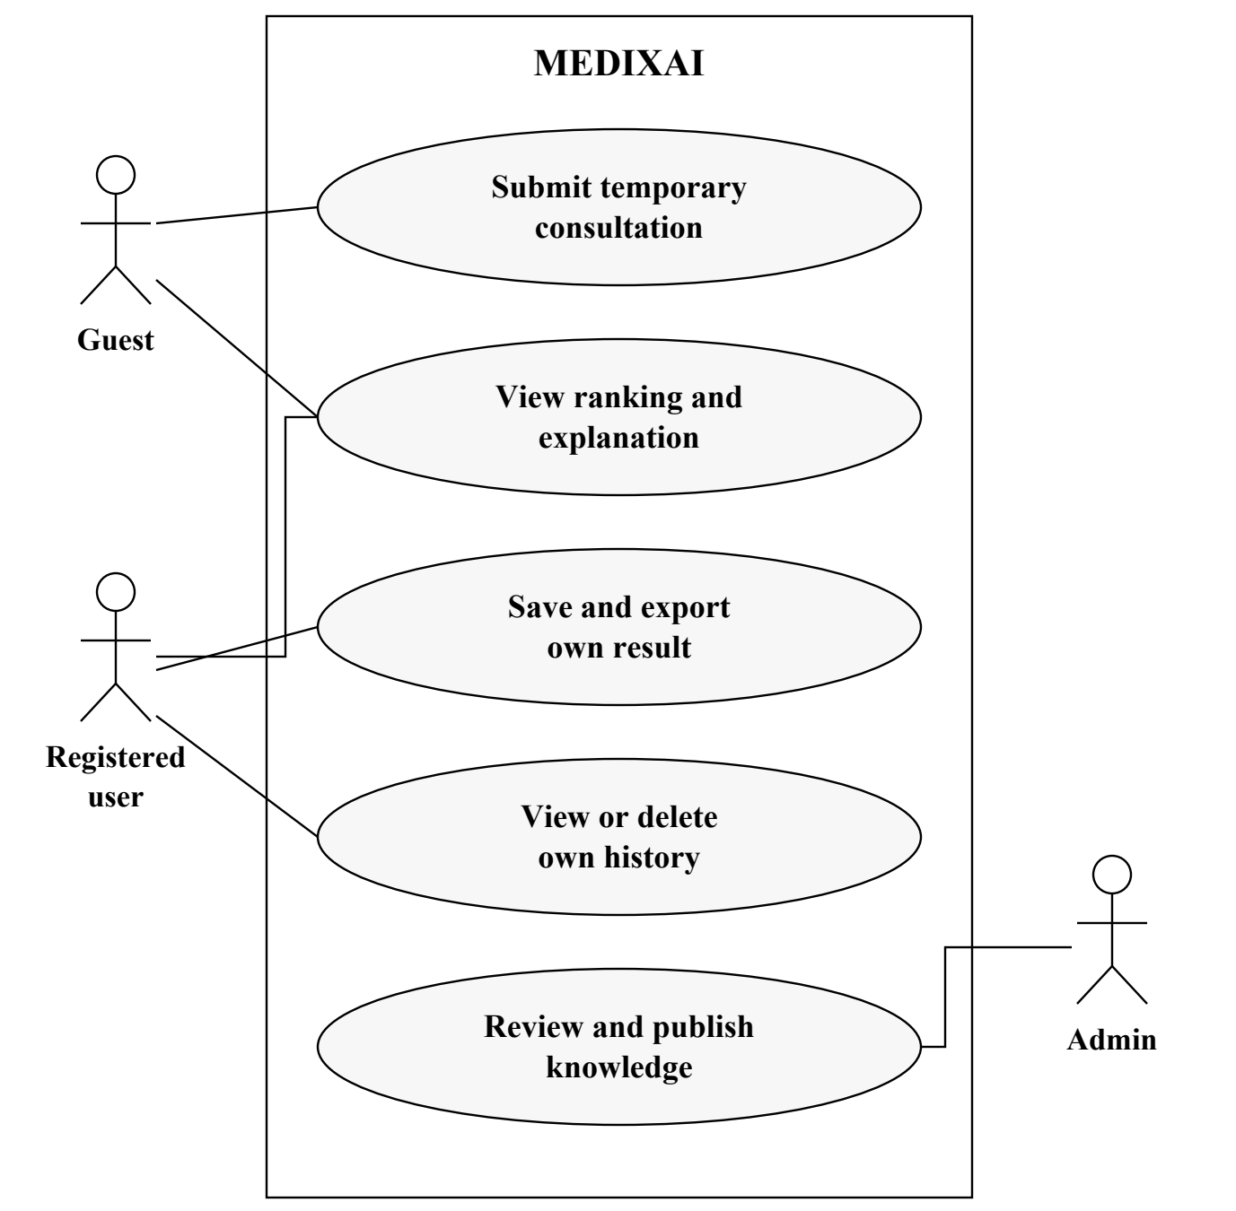
Figure 3.3 MEDIXAI use case diagram
Figure 3.3 shows that guests can submit temporary consultations and inspect explanations. Registered users can also save, view and delete their own history. Administrators maintain knowledge records, but that role does not automatically permit access to every personal consultation.
Each history or report request must be authorized at the server. Hiding a navigation link is
insufficient because a user could directly request a resource identifier. The user interface should
explain when data will be saved and provide a clear way to end the consultation.

3.3.3 Consultation activity diagram
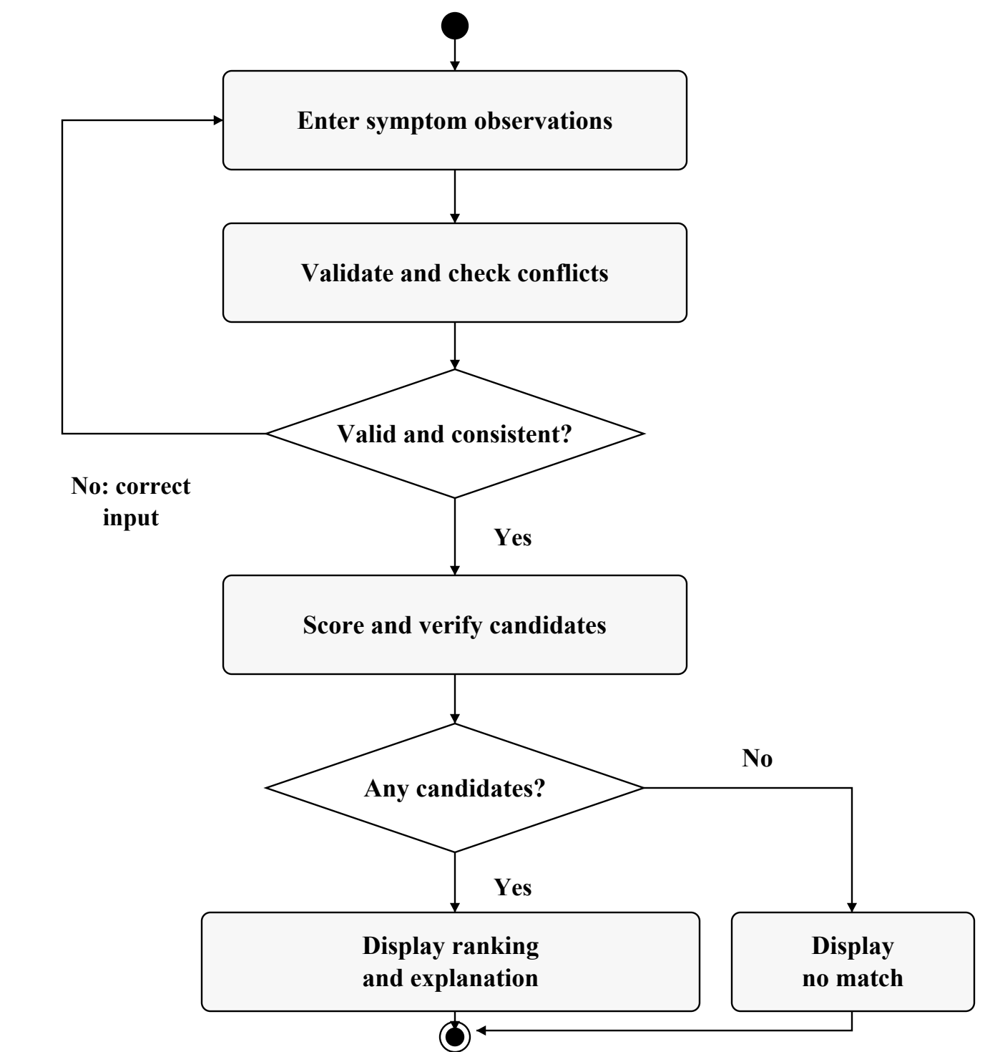
Figure 3.4 MEDIXAI consultation activity diagram
Figure 3.4 returns invalid or conflicting observations to the input stage. Unknown answers remain unknown rather than becoming absent symptoms. The proposed correction gate differs from the original prototype, which prints a contradiction warning and continues to calculate rankings.

3.3.4 Consultation sequence diagram
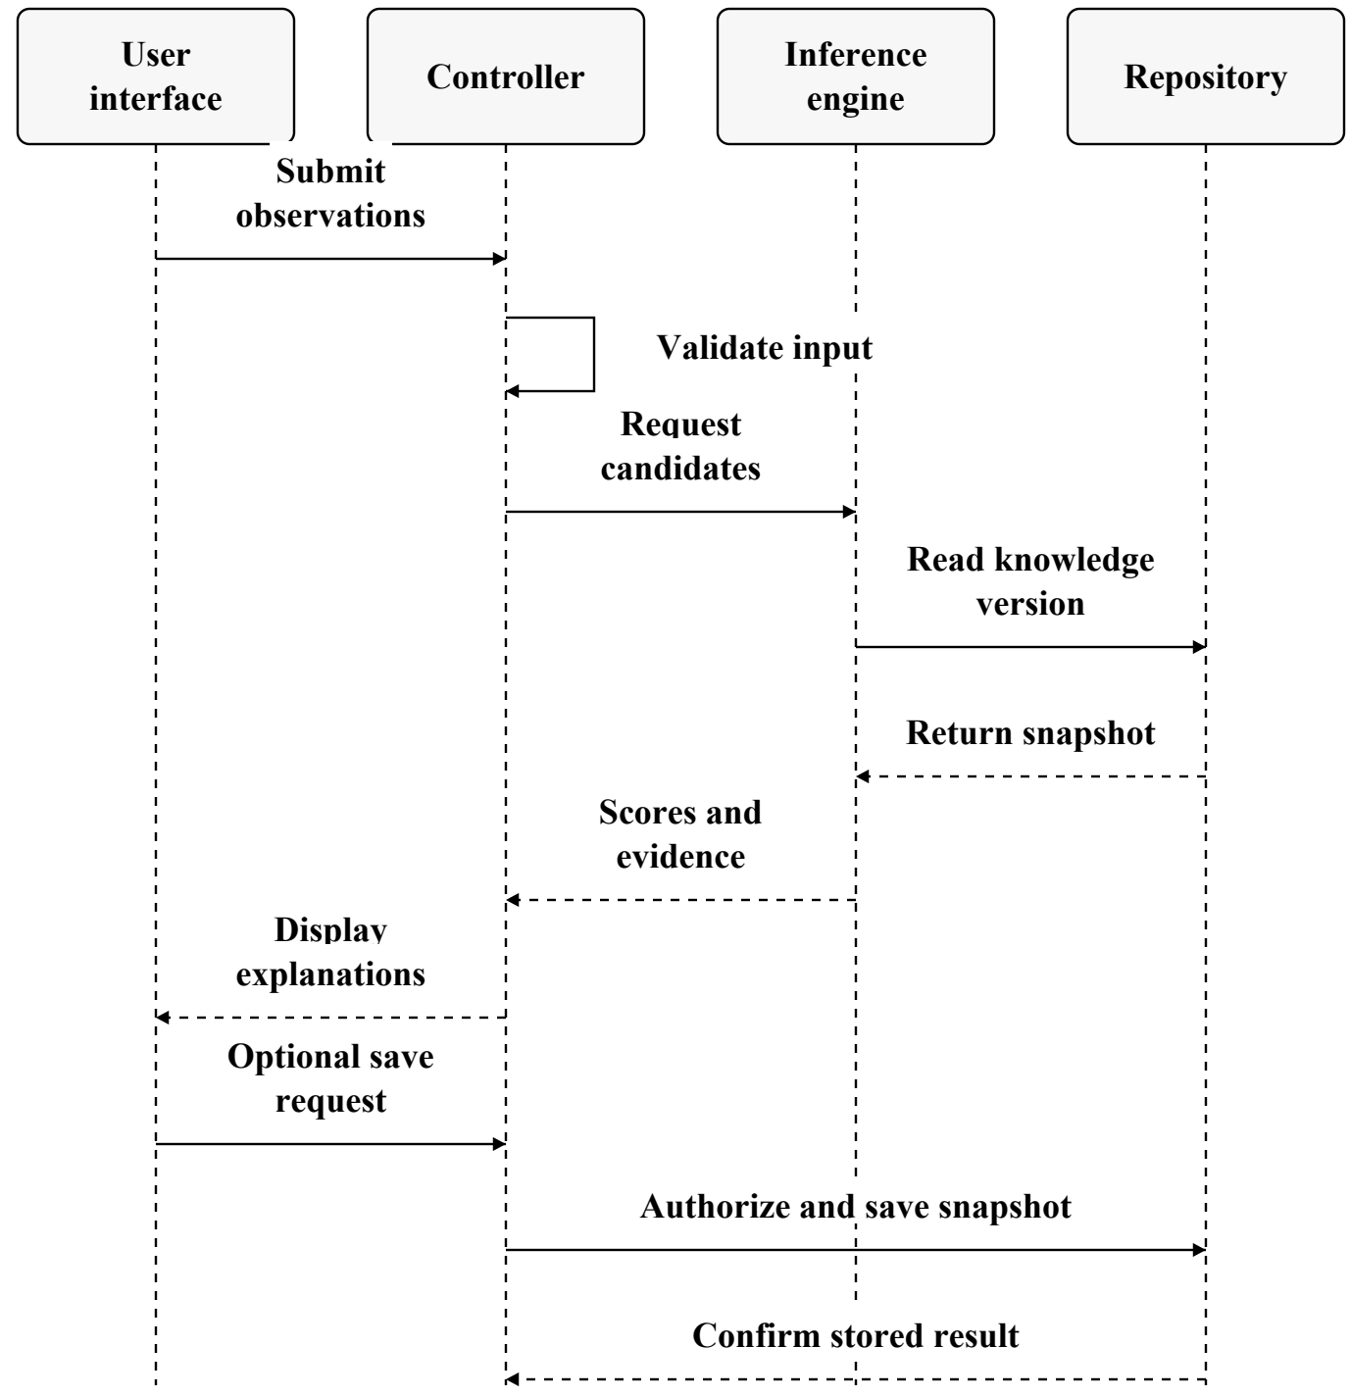
Figure 3.5 MEDIXAI consultation sequence diagram
Figure 3.5 shows the controller validating input before invoking the engine. The repository supplies one knowledge version, and the engine returns candidates with evidence. Saving follows ownership and consent checks; a failed save must not be presented as a successfully stored report.
The sequence is a design specification for the web version. It does not imply that the
authentication, persistence or export routes have been implemented.

3.3.5 Entity relationship overview
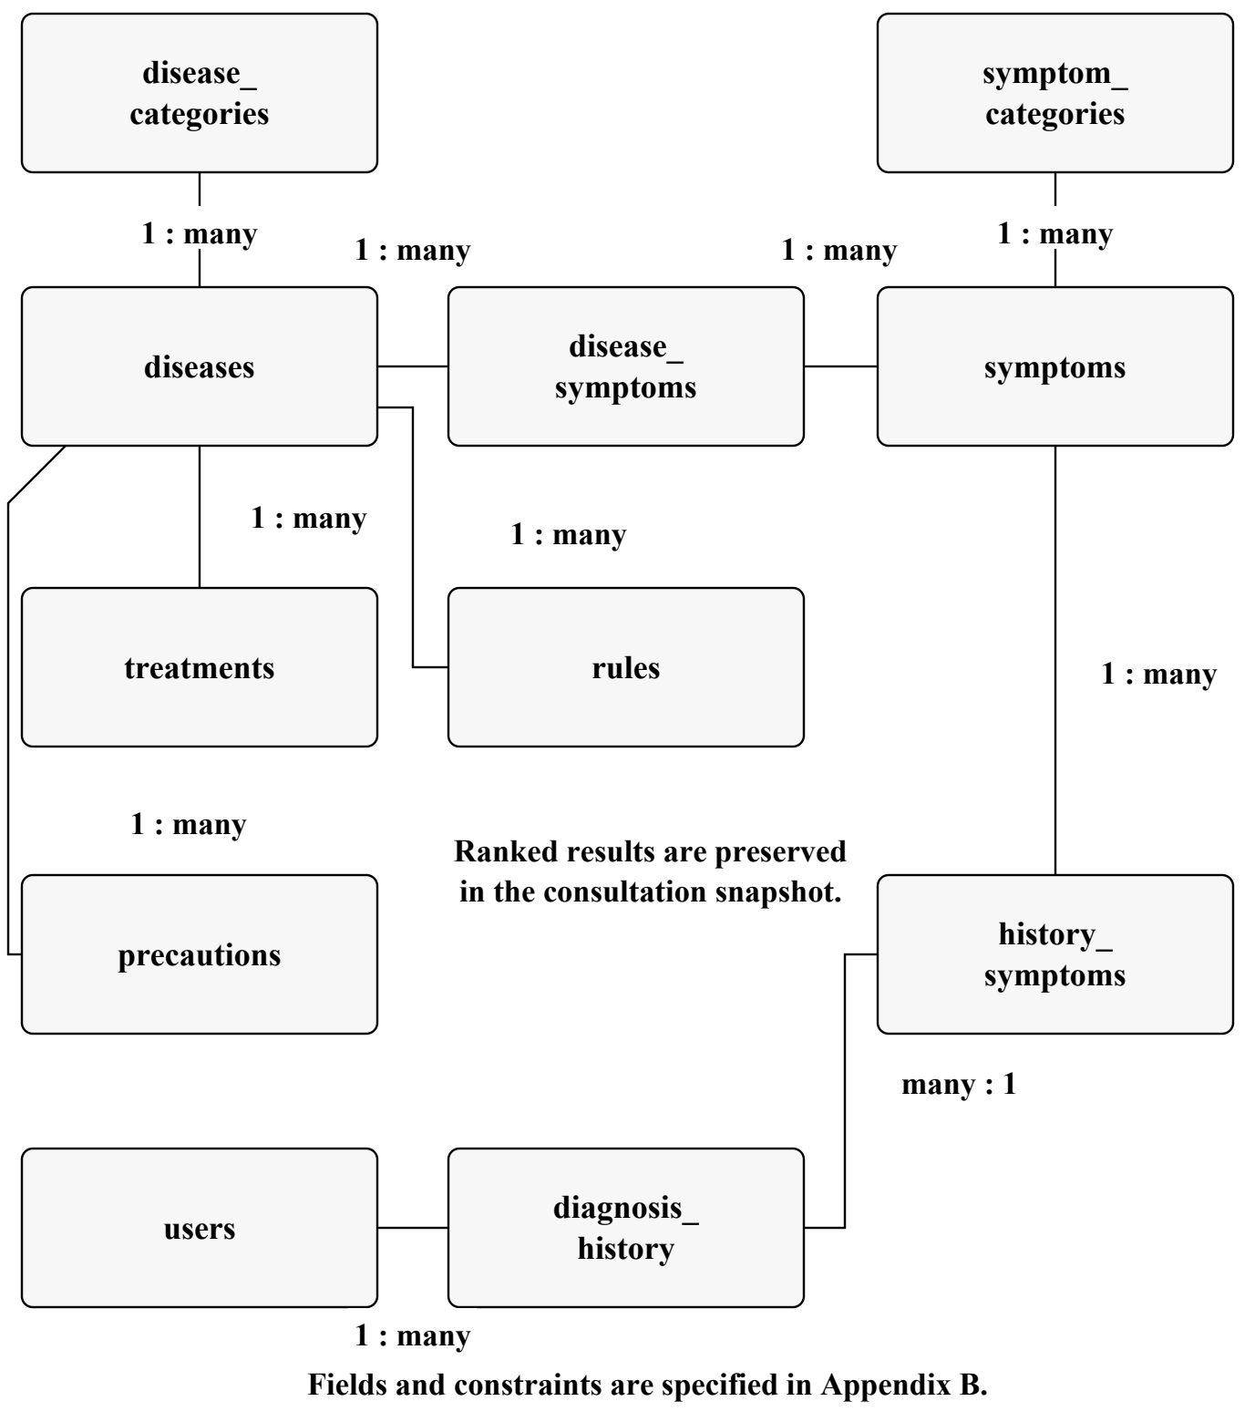
Figure 3.6 MEDIXAI entity relationship overview
Figure 3.6 connects diseases and symptoms through disease_symptoms and records consultation observations in history_symptoms. A result snapshot in diagnosis_history preserves every displayed candidate and its explanation; storing only the top disease would discard the ranked output.
Foreign keys, uniqueness constraints and reviewed publication states protect the knowledge
structure. The diagram summarizes the eleven logical tables; Appendix B specifies proposed
field and validation choices.
The junction tables should reject duplicate links. History ownership and knowledge-version
information must remain available when interpreting a saved result.

3.3.6 Diagram interpretation

3.3.6.1 Reading the data flow
The numbered processes describe transformations of data rather than individual web pages.
Collection produces canonical observations; evaluation produces candidates and evidence;
presentation converts that evidence into a readable result. A private history write is a separate
optional branch, and knowledge publication is controlled independently of the consultation
request.

3.3.6.2 Actor responsibilities
Permissions should be expressed in terms of actions and resources. Viewing an explanation for
the current temporary consultation does not require the same permission as retrieving an older
saved report. A registered account can manage its own stored consultations, while knowledge
publication belongs to the administrative workflow.
The use case boundary helps identify acceptance scenarios.

3.3.6.3 Decision points and termination
The first decision checks whether the observations are suitable for evaluation. A correction
response should identify the specific conflicting or unknown identifier and retain the other valid
selections. This avoids forcing the user to restart the consultation after a recoverable input
problem.
The second decision distinguishes a ranked result from a no-match outcome. Both are valid end
states of the calculation and should explain what happened.

3.3.6.4 Consistency across the request
The knowledge read should return both the card data and its version identifier. The engine must
use that returned snapshot throughout the calculation, even if an administrator publishes a
newer version before the response is displayed.
A save response should identify the stored consultation only after the transaction succeeds.

3.4 THREAT MODEL AND ATTACK SURFACE
Assets include symptom observations, account credentials, consultation reports, rule weights
and administrative privileges. Relevant actors include an ordinary user, an unauthorized visitor,
a compromised account and an administrator making an accidental error. The browser, upload
interface, report endpoint and editable knowledge base form the main attack surfaces.
Table 3.5 Threat model

Threat | Affected asset or boundary | Proposed response
Account  spoofing | Login and session boundary. | Password hashing, secure sessions and  throttled login attempts.
Rule tampering | Knowledge editing and  import. | Restricted roles, schema checks and  versioned publication.
Information  disclosure | History and report  identifiers. | Owner checks and nonpublic report  storage.
Injection | Database queries and  rendered text. | Parameterized SQL and context-  appropriate escaping.
Denial of  service | Large inputs or expensive  inference. | Request limits and bounded inference  work.
Untraceable  edits | Rule changes and  publication. | Audit actor, time and version without  raw symptom logs.
Table 3.5 maps account spoofing, rule tampering, disclosure, injection, denial of service and untraceable edits to responses in the proposed web system. Python-file modification and terminal disclosure are more immediate local-prototype risks. Clinical misuse remains an output-design risk addressed by the limits in Chapter 4.

3.4.1 Reviewing an attack path
A useful review follows a request from entry to storage and back to output. For example, a
report identifier supplied by the browser must be checked against the authenticated owner
before any snapshot is read or rendered. Knowledge publication similarly needs authorization
before a validated draft becomes active.
The same exercise should cover failure cases. An oversized request should terminate before
expensive work, and a rejected administrative change should leave the published version intact.
Error messages should help the user recover without revealing another account, a private report
path or unnecessary application internals.
These scenarios convert the threat model into concrete checks that can be repeated against an
implemented build.

3.5 SECURITY CONTROLS
Table 3.6 Security controls and verification

Control | Implementation requirement | Verification evidence
Authentication | Store password hashes; rotate the  session at login. | Inspect stored credentials and test  session transitions.
Authorization | Enforce ownership on history,  deletion and export. | A second account cannot read or  alter the first account's objects.
Input validation | Accept known identifiers and  bounded observation counts. | Unknown, malformed and  oversized requests are rejected.
Rule integrity | Review knowledge edits and  publish versioned snapshots. | Invalid or unauthorized edits  cannot become active.
Data protection | Use HTTPS when hosted; keep  reports outside public assets. | Check transport settings and direct  report access.
Logging | Record security events without  raw health details or secrets. | Inspect logs for sensitive content  and access restrictions.
Table 3.6 links security controls to implementation requirements and verification evidence. These are proposed ASVS-informed checks, not a compliance claim. State-changing requests also need CSRF protection, output must be escaped, and development debugging must be disabled when hosted.
For privacy, the default guest path should avoid saving names, ages and symptom histories.
Where registered users choose storage, the application needs an explicit retention policy and
deletion behavior. Backup access must be restricted, and restoration must be tested before
backup reliability is claimed.

3.5.1 Verification and maintenance
Controls should be checked at the boundary where they are enforced. An ownership test should
request another account's history directly; an input test should submit a malformed identifier to
the server; a publication test should attempt to activate an invalid card. A successful browser
interaction alone does not exercise these denied paths.
The project should retain a compact verification record containing the scenario, expected
behavior, actual behavior and application version. When a route or data model changes, the
affected scenarios can be rerun. This makes the security requirements maintainable and keeps
untested design intentions separate from demonstrated controls.
Log entries should be limited to the information needed to diagnose or audit the event, with
consultation content excluded unless a justified and authorized workflow requires it.

CHAPTER 4
SYSTEM DESCRIPTION

4.1 DATA COLLECTION
The working knowledge is a manually authored set of disease cards rather than a patient
training dataset. The current knowledge base contains 38 disease entries, 104 distinct symptom
identifiers and 228 weighted disease-symptom mappings. Each card contains six weighted
symptoms. Expansion to 40 disease cards remains a development target rather than the verified
count.
Table 4.1 Knowledge-base inventory

Category | Disease cards | Weighted  mappings
Respiratory | 8 | 48
Viral | 6 | 36
Bacterial | 5 | 30
Digestive | 5 | 30
Skin | 4 | 24
Neurological | 3 | 18
Urinary | 3 | 18
Miscellaneous | 4 | 24
TOTAL | 38 | 228
Table 4.1 summarizes 38 disease cards and 228 weighted mappings across eight categories. These categories reproduce prototype organization, not a medical ontology. Appendix A lists the disease labels. Weights and required symptoms lack documented clinical calibration; practical health use would require expert review, source provenance and independent validation.

4.1.1 Knowledge review procedure
A proposed review record should identify the card, the reviewer, the knowledge version and the
reason for a change. Structural checks can confirm that identifiers are unique and weights are
positive, but they cannot establish that a symptom association is medically correct.
Before extending the inventory, the development team should resolve duplicate labels,
document aliases and keep incomplete cards inactive. This allows educational coverage to grow
without confusing record count with validated quality.

4.2 DATA PREPROCESSING
The prototype trims leading and trailing spaces, converts text to lowercase, replaces spaces and
hyphens with underscores, and ignores empty comma- separated entries. Inference converts the
observations to a set, so repeated symptoms do not increase the score.
Table 4.2 Preprocessing behavior and planned changes

Input issue | Prototype behavior | Proposed handling
Case and  separators | High Fever becomes  high_fever. | Keep canonical normalization.
Duplicate  symptoms | Set membership prevents  double counting. | Deduplicate and display once.
Unknown terms | No matching rule contribution. | Show an error and suggest valid  choices.
Related terms | fever and high_fever remain  different keys. | Use reviewed relationships; do not  infer aliases automatically.
Missing  observation | Treated as not selected. | Record present, absent or unknown  explicitly.
Contradictory  terms | Warns and continues ranking. | Ask for correction before  proceeding.
Table 4.2 compares normalization, duplicate handling, unknown states and conflict correction. The interface should submit stable symptom identifiers, which the server validates; browser changes must not introduce unauthorized rules, fields or weights.
The existing diarrhea/constipation pair is a project consistency heuristic, not a universal
medical contradiction. Time-dependent observations need context; the proposed model should
record one defined consultation window.

4.2.1 Normalization examples and boundaries
Normalization should produce a canonical identifier rather than a new interpretation of the
user's statement. A reviewed alias can map to an existing code, while an unrecognized term
should be returned for correction. The original display label can remain readable without
becoming a second identifier.
Duplicate selections should collapse to one observation before scoring. An explicit negative
answer should retain its own state, and a skipped question should remain unknown. Recording
these choices in preprocessing makes the later score and missing-evidence explanation easier to
reproduce.

4.3 ALGORITHMS AND METHODOLOGY

4.3.1 Knowledge representation
For one consultation, each selected symptom acts as a ground proposition. The prototype stores
disease metadata and a weighted mapping in a Python dictionary. Its required list specifies
conditions that must be present for a hypothesis to pass the implemented backward check. A
first-order representation can instead attach observations to a patient variable, but the supplied
listing does not implement unification or a general first-order prover.
Example conceptual rule
HasSymptom(p, runny_nose) AND
HasSymptom(p, sneezing)
IMPLIES Candidate(p, Common_Cold)
Candidate means supported by an educational rule, not medically confirmed. Weighted
matching and logical entailment serve different purposes: a score measures coverage of a card,
while a rule check asks whether specified premises are satisfied. The application should expose
both rather than interpret a large score as a proof.

4.3.2 Forward and backward reasoning
Forward chaining starts with known facts and derives consequences from satisfied rules.
Backward chaining starts with a goal and checks the premises that support it. In MEDIXAI,
the current methods are narrower: the forward_chaining function scans weighted symptom
cards, and backward_chaining checks a required-symptom set. Multi-step rule firing, an agenda
and a proof graph are proposed extensions.
No weights are learned from data. The score is deterministic for a fixed symptom set, card
ordering and knowledge version.

4.3.3 Evidence representation and traceability
A useful working fact record contains a canonical symptom identifier and an observation state.
The inference result can then record which facts matched a card, which required facts were
missing and which conditions were not evaluated. This keeps input representation separate
from presentation text.
For a future multi-step rule engine, the trace should additionally record the rule identifier, the
premises used and the newly derived conclusion. Repeated derivations should not create an
endless agenda. A stopping condition and a clear distinction between supplied facts and derived
facts are therefore part of the proposed methodology.
These trace records support inspection of the reasoning process without claiming that the
current weighted matcher already performs formal logical proof.

4.3.4 Weighted matching and ranking
For disease d, let W be the sum of all six symptom weights and M the sum of weights for
symptoms present in the input. The prototype first rounds the base score to two decimal places.
If any required symptom is missing, it multiplies that rounded score by 0.60 and rounds again.
BaseScore(d) = round(100 * M / W, 2)
FinalScore(d) = BaseScore(d)
when all required symptoms are present
FinalScore(d) = round(0.60 * BaseScore(d), 2)
when at least one required symptom is missing
Only cards with at least one matched symptom enter the ranking. Results are sorted in
descending score order, and the command-line output prints at most ten. Ties retain the
dictionary order because Python sorting is stable; the proposed application should document a
stable secondary key or display ties explicitly.
The penalty is applied once whether one or several required symptoms are missing. It is a
heuristic project choice, not a medically established likelihood adjustment. Unrelated extra
symptoms do not reduce the score, so selecting more symptoms can make many cards appear
strongly supported.
Scores need not sum to 100 across diseases. A 100 percent score means that all weighted
symptoms on one card were selected. It does not mean 100 percent diagnostic accuracy or
certainty. The interface should label the value as a rule- match score.

4.3.4.1 Interpreting the score
The denominator belongs to the candidate card, not to the number of observations entered by
the user. Two candidates can therefore receive different percentages from overlapping evidence
because their total weights differ. A displayed explanation should show both matched weight
and total weight so that this difference is visible.
The required-symptom penalty is applied once when the required set is incomplete. The
implementation should record the missing set and the applied factor explicitly. It should not
repeatedly multiply the score for each missing symptom unless a separately specified algorithm
intentionally changes that behavior.
Stable sorting also needs a documented tie policy. Retaining stored order makes the prototype
reproducible for a fixed dictionary, but that order should not be presented as additional
evidence. A proposed interface can show tied scores clearly and let the user compare their
supporting observations.

4.3.5 Backward verification and consistency checking
The expanded backward method examines the highest-ranked candidate and returns the
required symptoms absent from the input. It does not recursively derive subgoals and does not
ask interactive follow-up questions. The earlier five-disease example does ask one combined
question, but that behavior should not be attributed to the expanded listing.
A proposed follow-up loop should ask about one unresolved requirement at a time, accept
present/absent/unknown answers, and recompute the ranking after each response. It should stop
when the user declines, the evidence is sufficient for the rule check, or a configured question
limit is reached.

4.3.6 Resolution and contradiction handling
The prototype detects three specified pairs: fever with no_fever, high_fever with no_fever, and
diarrhea with constipation. This is pairwise consistency checking. Full propositional resolution
requires clauses and a refutation procedure, as illustrated below.
Illustrative Horn rule: A AND B IMPLIES C
Clause form: NOT A OR NOT B OR C
Facts: A, B
Negated query: NOT C
Resolve with A: NOT B OR C
Resolve with B: C
Resolve with NOT C: empty clause
This trace demonstrates entailment in the toy rule system. It is a proposed teaching example,
not an executed capability of the medical prototype and not a proof of a medical diagnosis.

4.3.6.1 Unknown evidence and bounded reasoning
A missing requirement and an explicitly absent requirement are different observations. A
focused follow-up question should preserve that distinction and allow the user to decline.
Recalculation should use the updated observation set while retaining the same knowledge
version for the consultation.
A formal resolution exercise should retain each derived clause and its parent clauses so that an
examiner can follow the refutation. Repeated clauses should be detected, and a resource limit
should terminate the demonstration predictably. These requirements concern the proposed
teaching module, which remains separate from pairwise conflict checks in the prototype.
Testing should verify both a successful derivation and an inconclusive case. The output must
state which reasoning procedure actually ran, rather than use a general label that hides
differences between matching, verification and proof.

4.4 RESULTS AND DISCUSSION

4.4.1 Worked scoring examples
The following values were recalculated from the expanded dictionary using a faithful
reconstruction of its normalization, matching, rounding and penalty rules. They are
deterministic software examples, not patient outcomes, clinical tests or execution evidence for
the proposed web application.
Table 4.3 Worked candidate scores

Input and candidate | Matched / total  weight | Penalty | Score
runny_nose + sneezing  Common Cold | 19 / 43 | None | 44.19
runny_nose + sneezing  Allergic Rhinitis | 19 / 45 | None | 42.22
runny_nose + dry_cough  Common Cold | 18 / 43 | x 0.60 | 25.12
high_fever + body_pain + headache +  rash  Dengue Fever | 34 / 46 | None | 73.91
Same four symptoms  Influenza | 24 / 45 | x 0.60 | 32.00
In Table 4.3, Common Cold's required symptoms contribute 10 + 9 = 19 out of 43, producing 44.19. When sneezing is missing, round(100 x 18 / 43, 2) = 41.86; the penalty gives round(41.86 x 0.60, 2) = 25.12.
The close Common Cold and Allergic Rhinitis scores illustrate overlapping rules. The system
should show the evidence for both candidates and request missing information instead of
claiming that the higher score is medically correct.

4.4.1.1 Reproducing a worked example
A reproducible example should retain the selected symptom identifiers, the candidate card,
each matched weight, the total card weight and the rounding order. The reviewer can then
calculate the unpenalized percentage before checking whether the required set triggers the
factor.
When examples are moved into automated tests, expected values should remain fixed and
readable. Any later change to a card should be reviewed separately from a change to the scoring
procedure so that a changed result has an identifiable cause.

4.4.2 Deterministic behavior checks
Table 4.4 Reconstructed logic checks

Case | Observation | Interpretation
Complete Cold  card | Common Cold scores 100.00. | All six card symptoms are  matched.
Two required Cold  symptoms | Cold 44.19; Allergic Rhinitis 42.22. | Multiple rules can have  support.
One requirement  missing | Cold scores 25.12 for runny_nose and  dry_cough. | Single 0.60 penalty is  applied.
Four-symptom  example | Dengue 73.91; Influenza 32.00. | Weights and requirements  affect order.
Repeated symptom | Repeated runny_nose leaves 44.19  unchanged. | Set membership prevents  double counting.
Unknown term | No candidates for unlisted_symptom. | No supported dictionary  match.
Empty input | No candidates. | Empty evidence has no  matches.
fever + no_fever | Pair is flagged; ranking logic still  produces candidates. | Warning does not stop the  prototype.
Table 4.4 checks complete and partial evidence, penalties, duplicates, unknown terms, empty input and conflicts. The reconstructed calculations establish software behavior. Inspection of diagnose() shows no early return after a contradiction warning. No performance timings or clinical accuracy measurements were supplied.
The no-match path returns before the final academic disclaimer in the listing. The planned
application should place its educational-use notice consistently on every result state, including
errors and empty results.

4.4.2.1 Extending the behavior checks
Additional controlled cases should cover a score tie, multiple missing required symptoms and a
knowledge card rejected during loading. The tie case checks ordering; the missing-evidence
case checks that the penalty is applied once; the invalid-card case checks that malformed
knowledge cannot reach the calculation.
A useful test record includes the complete input and expected evidence, not only the top
candidate. This detects regressions in missing-symptom lists and explanations even when the
first-ranked disease happens to remain unchanged.

4.4.3 Evaluation plan and limitations
Table 4.5 defines planned checks for correctness, explanation fidelity, robustness, performance, security and usability. Compare exact matching, unweighted overlap and weighted ranking using the same knowledge base and inputs; this separates the algorithm effect from changes in the disease list.
Table 4.5 Planned evaluation measures

Measure | How it will be evaluated
Functional correctness | Expected score, ranking, missing evidence and conflict status for  controlled cases.
Explanation fidelity | Recompute each displayed score from the evidence shown to the  user.
Robustness | Unknown identifiers, duplicates, contradictory input and  maximum-size requests.
Performance | Report machine configuration, knowledge size, repetitions and  latency distribution.
Security | Ownership isolation, unauthorized edits, injection attempts and  report access.
Usability | Observe whether students can explain a result and identify  missing evidence.
Diagnostic accuracy, precision and recall would require an independently labelled,
appropriately reviewed clinical evaluation set. They cannot be derived from rule-match
percentages. No such dataset or measurements are available for this project.
Other limitations include hand-selected weights, incomplete vocabulary, no temporal context,
no calibrated uncertainty and static emergency metadata. In particular, a false emergency flag
does not establish that a user is safe.

4.4.3.1 Evaluation records and reporting
Each comparison should retain its knowledge version, fixed case set and expected outputs.
Performance measurements should state whether they cover only the inference function or the
entire request, because validation, storage and PDF generation introduce separate work.
Usability tasks should ask participants to interpret a score, identify a missing requirement and
recognize a no-match result. Observations from those tasks can guide wording and layout
changes. They should be reported as evidence about interaction with the educational system,
with the sample and procedure described clearly.

CHAPTER 5
CONCLUSION
MEDIXAI provides a concrete setting for studying knowledge-based AI through explicit
symptom facts, weighted disease cards and inspectable reasoning. The design defines the
functional scope, proposed application architecture, module interfaces, data model and security
requirements. The expanded prototype supplies 38 disease cards with 228 weighted mappings
and demonstrates deterministic candidate ranking.
The worked examples show how required-symptom penalties change a score and how
overlapping evidence produces several candidates. They also reveal why match coverage must
be separated from medical accuracy. The current forward and backward methods are limited to
card evaluation and required-set checking, while pairwise contradiction detection remains
distinct from a full resolution prover.
The next development stage should first validate the knowledge schema and provenance,
implement an inference interface with evidence traces, and add controlled tests. The database
and application routes can then be integrated with ownership checks, private history and
consistent report generation. A later evaluation should compare reasoning variants using fixed
inputs and review the usability of explanations.
Future extensions include explicit negative and unknown observations, focused follow-up
questions, multi-step Horn-rule reasoning and a bounded resolution demonstration.
Cross-domain reuse should be tested with a second, nonmedical knowledge base. Clinical use
would require a separate body of expert review and validation; it is not an outcome established
by this academic project.

5.1 Development priorities
The immediate priority is an implementation that preserves the report's evidence contract from
input to export. Canonical observations, a fixed knowledge version and structured candidate
records provide a common foundation for the interface, database and test suite. Completing
these elements first makes later feature work easier to evaluate.
The next priority is repeatable verification. The arithmetic examples can become controlled
regression cases, while the proposed acceptance scenarios can exercise input correction,
ownership, publication and export consistency. Results should be recorded only after execution
against an identified build.
The project's academic value lies in showing how knowledge, inference and explanation fit
together in a system that can be inspected.

REFERENCES
[1] MEDIXAI Development Group. (2026). Project Planning and Database Architecture Specifications. Internal design logs and feature roadmap.
[2] Russell, S., & Norvig, P. (2020). Artificial intelligence: A modern approach (4th US ed.). Pearson. https://aima.cs.berkeley.edu/
[3] Buchanan, B. G., & Shortliffe, E. H. (Eds.). (1984). Rule-based expert systems: The MYCIN experiments of the Stanford Heuristic Programming Project. Addison-Wesley. https://www.shortliffe.net/Buchanan-Shortliffe-1984/MYCIN%20Book.htm
[4] van Melle, W., Shortliffe, E. H., & Buchanan, B. G. (1984). EMYCIN: A knowledge engineer's tool for constructing rule-based expert systems. In B. G. Buchanan & E. H. Shortliffe (Eds.), Rule-based expert systems: The MYCIN experiments of the Stanford Heuristic Programming Project (pp. 302-313). Addison-Wesley. https://people.dbmi.columbia.edu/~ehs7001/Buchanan-Shortliffe-1984/Chapter-15.pdf
[5] OWASP Foundation. (2025). Application Security Verification Standard (Version 5.0.0). https://owasp.org/projects/asvs
[6] United Nations Department of Economic and Social Affairs. (n.d.). Goal 3: Good health and well-being (Target 3.8). Retrieved September 27, 2026, from https://sdgs.un.org/goals/goal3
[7] United Nations Department of Economic and Social Affairs. (n.d.). Goal 4: Quality education (Target 4.4). Retrieved September 27, 2026, from https://sdgs.un.org/goals/goal4
[8] Forgy, C. L. (1982). Rete: A fast algorithm for the many pattern/many object pattern match problem. Artificial Intelligence, 19(1), 17-37. https://doi.org/10.1016/0004-3702(82)90020-0
[9] Secret Society Software, LLC. (2025). CLIPS reference manual: Volume I, Basic programming guide (Version 6.4.2). https://www.clipsrules.net/documentation/v642/bpg642.pdf
[10] Phillips, P. J., Hahn, C. A., Fontana, P. C., Yates, A. N., Greene, K. K., Broniatowski, D. A., & Przybocki, M. A. (2021). Four principles of explainable artificial intelligence (NISTIR 8312). National Institute of Standards and Technology. https://doi.org/10.6028/NIST.IR.8312

APPLICATION SCREENSHOTS

S.1 Symptom workspace
The browser demonstration presents symptom selection and transparent rule-based reasoning in one workspace. The screenshots in this section document the visible demonstration interface. The server, account and private-history architecture discussed earlier remains a separate design.
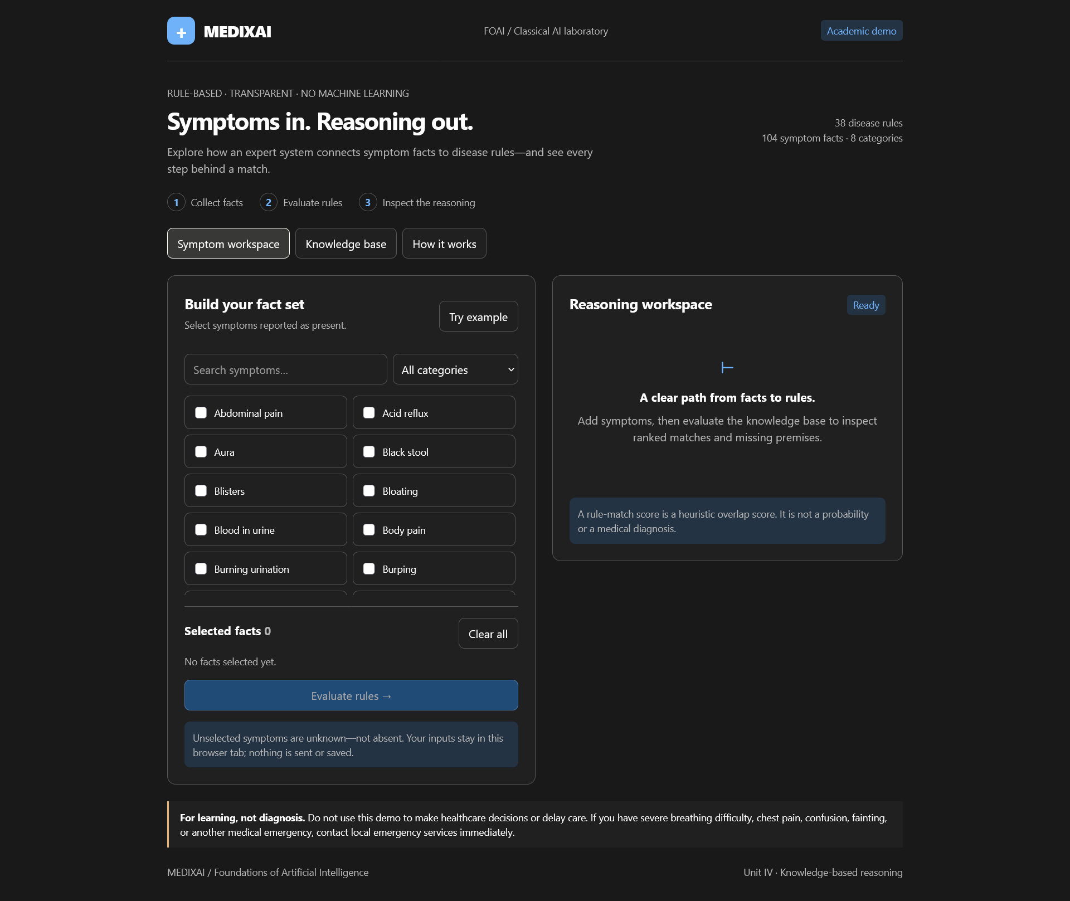
Figure S.1 MEDIXAI symptom workspace
Figure S.1 shows the initial symptom workspace before evidence is selected. Search and category controls help locate symptom facts, while the selected-facts area records the consultation input. The reasoning panel waits for evaluation and distinguishes a heuristic rule-match score from a medical diagnosis.

S.2 Rule-match results and premise check
This screen records a consultation after four facts have been selected. The interface places the active observations beside ranked candidate cards, allowing the user to compare the input with the evidence supporting a selected result.
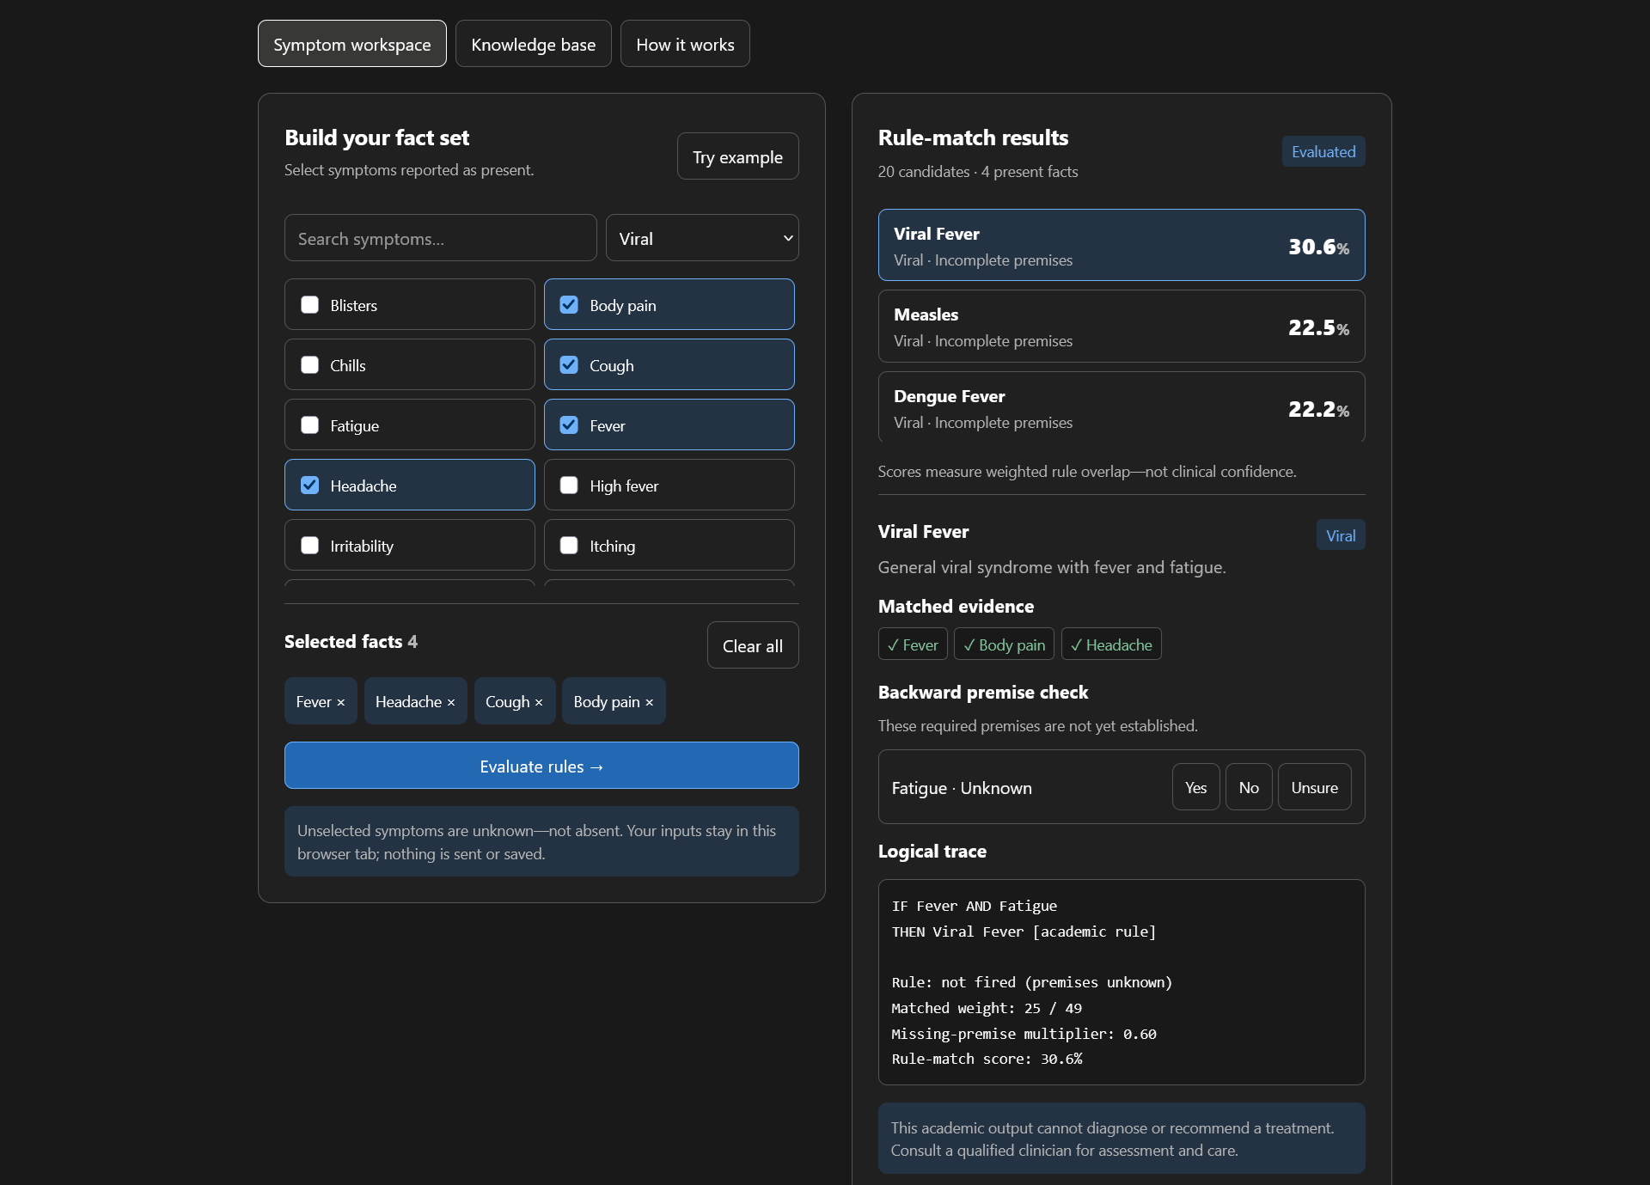
Figure S.2 MEDIXAI rule-match results and premise check
Figure S.2 shows Fever, Headache, Cough and Body pain as the selected facts. Viral Fever appears with a 30.6 percent rule-match score and incomplete premises. Its detail panel lists matched evidence, identifies Fatigue as unknown, and displays the matched weight of 25 out of 49 with a 0.60 multiplier. The Yes, No and Unsure controls support a focused premise check. These displayed values describe this screenshot, rather than a clinical validation result.

S.3 Knowledge-base browser
The knowledge-base view provides a separate place to inspect the demonstration rules. Search and category labels support browsing, while each disease card offers access to the rule conditions and symptom weights used by the interface.
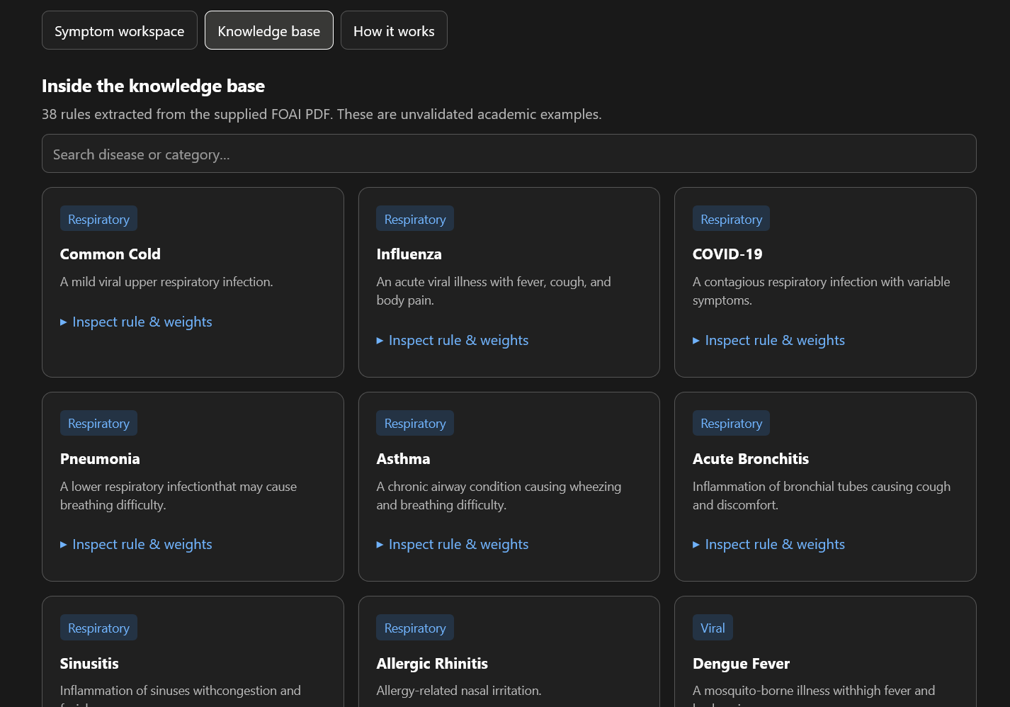
Figure S.3 MEDIXAI knowledge-base browser
Figure S.3 shows disease cards for Common Cold, Influenza, COVID-19, Pneumonia, Asthma and Acute Bronchitis, with additional cards visible below. The category badges organize the records, and the Inspect rule & weights action makes each card reviewable. The page identifies 38 academic rules and states that they are unvalidated examples. This view supports inspection of project coverage and rule content; it does not establish the correctness of the medical associations.

S.4 Reasoning methods and safety information
The explanation view documents how the browser demonstration treats facts, rule matches and missing premises.
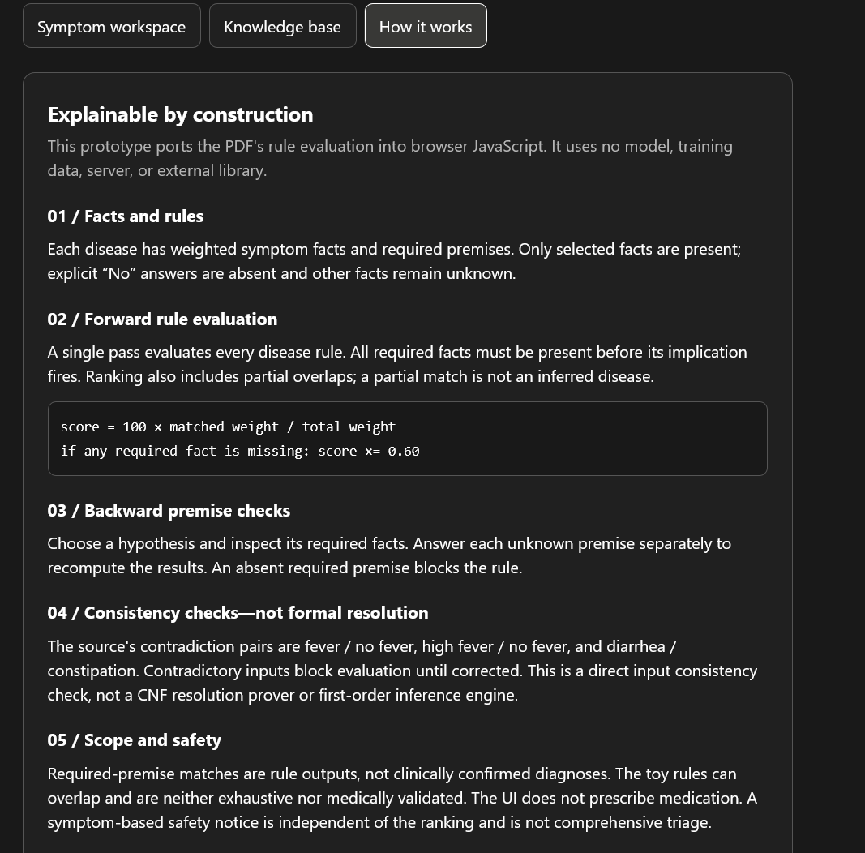
Figure S.4 MEDIXAI reasoning methods and safety information
Figure S.4 explains forward rule evaluation, the 0.60 missing-premise multiplier and backward premise checks. It distinguishes present, absent and unknown observations and describes direct consistency checks rather than formal resolution. The scope section states the academic limits of the demonstration. Together, these explanations help a reader connect the visible result to the reasoning procedure and distinguish rule support from a confirmed diagnosis.

APPENDIX A
KNOWLEDGE BASE INVENTORY

A.1 Disease inventory
Table A.1 lists entries 1-19 from the 38-card knowledge base, grouped by category. The entry numbers are report indices, not database identifiers. The categories reproduce the prototype labels.
Table A.1 Disease inventory

No. | Disease label | Category
1 | Common Cold | Respiratory
2 | Influenza | Respiratory
3 | COVID-19 | Respiratory
4 | Pneumonia | Respiratory
5 | Asthma | Respiratory
6 | Acute Bronchitis | Respiratory
7 | Sinusitis | Respiratory
8 | Allergic Rhinitis | Respiratory
9 | Dengue Fever | Viral
10 | Chickenpox | Viral
11 | Typhoid Fever | Bacterial
12 | Tuberculosis | Bacterial
13 | Food Poisoning | Digestive
14 | Gastritis | Digestive
15 | Eczema | Skin
16 | Migraine | Neurological
17 | Urinary Tract Infection | Urinary
18 | Kidney Stones | Urinary
19 | Heat Stroke | Miscellaneous
The source listing contains 38 entries. The planned expansion target is 40 disease cards.
Use stable identifiers when importing these labels. A display-name correction should not create
a second card or break the link to an earlier saved consultation. Keep the imported inventory
tied to its knowledge version.

A.2 Disease inventory continued
Table A.2 Disease inventory continued

No. | Disease label | Category
20 | Dehydration | Miscellaneous
21 | Measles | Viral
22 | Mumps | Viral
23 | Hand Foot and Mouth Disease | Viral
24 | Viral Fever | Viral
25 | Cholera | Bacterial
26 | Whooping Cough | Bacterial
27 | Bacterial Meningitis | Bacterial
28 | Gastroenteritis | Digestive
29 | GERD | Digestive
30 | Peptic Ulcer | Digestive
31 | Ringworm | Skin
32 | Scabies | Skin
33 | Psoriasis | Skin
34 | Tension Headache | Neurological
35 | Vertigo | Neurological
36 | Cystitis | Urinary
37 | Iron Deficiency Anemia | Miscellaneous
38 | Heat Exhaustion | Miscellaneous
Table A.2 lists entries 20-38, each with six weighted mappings. The inventory shows project coverage, not validated associations, severity or guidance.

A.2.1 Coverage and review status
Category labels support organization and browsing; they do not change the scoring formula.
The loader should preserve a clear mapping from each disease card to its six symptom weights
and required-symptom set.
Any new card should be structurally validated and assigned a review status before publication.

APPENDIX B
PROPOSED DATA DICTIONARY

B.1 Knowledge data dictionary
Table B.1 Knowledge data dictionary

Table | Key fields | Constraints and notes
disease_categories | category_id, name | Integer primary key; unique  name.
symptom_categories | category_id, name | Integer primary key; unique  name.
diseases | disease_id, category_id, name,  description, severity,  emergency | Foreign key to category; unique  canonical name; reviewed  status and source metadata  proposed.
symptoms | symptom_id, category_id, code,  display_name | Unique canonical code;  reviewed aliases managed  explicitly.
disease_symptoms | disease_id, symptom_id,  weight, required | Composite primary key; both  foreign keys; positive bounded  weight; required is 0 or 1.
rules | rule_id, disease_id, premises,  conclusion, priority, version | Validated structured conditions;  inactive until reviewed; never  executable Python text.
Table B.1 defines knowledge records, keys and validation constraints. Rules need structured conditions; a disease identifier and score threshold do not encode an arbitrary logical rule. Required and optional symptom sets can support the first implementation, with complex clauses added after their evaluation semantics are defined.
All six current card weights are positive. The loader must reject an empty or zero-total card to
prevent division by zero.

B.1.1 Publication checks
Before a knowledge version becomes active, validate every foreign key, symptom code,
required flag and scoring denominator. All required symptoms should also occur in the card's
weighted mapping so that the explanation can account for them.
A rejected draft should produce a reviewable error list and leave the last published snapshot
available. Successful publication should identify the exact version used by subsequent
consultations.

B.2 Application data dictionary
Table B.2 Application data dictionary

Table | Key fields | Constraints and notes
users | user_id, username,  password_hash, role | Unique username; no plaintext  password; limited roles.
treatments | treatment_id, disease_id,  guidance_text, review_status | Reviewed educational  information; automatic dosage  generation excluded.
precautions | precaution_id, disease_id, text,  review_status | Foreign key; validated text and  publication status.
diagnosis_history | history_id, user_id, created_at,  knowledge_version,  result_snapshot | User ownership; immutable  result snapshot; retention and  deletion policy.
history_symptoms | history_id, symptom_id,  observation_state | Composite primary key;  present, absent or unknown;  consistent consultation context.
Table B.2 defines account, guidance and consultation-history records with their constraints. A result snapshot preserves the ranked list, weights and explanation evidence. Its knowledge_version supports reproducibility after rule changes. A normalized result table could be added if reporting needs justify expanding the eleven-table design.
Foreign-key checks must be enabled for each SQLite connection. Administrative deletion
should not silently remove information needed to interpret old results; deactivation or versioned
replacement is preferable. Guest results should remain transient unless the user explicitly
chooses a storage workflow.

B.2.1 Storage and retrieval checks
The history write should store the result and its observation rows atomically. Retrieval should
check ownership before returning either the observation list or the snapshot, including when the
request is made through an export route.
Retention and deletion behavior should be specified before personal histories are enabled. Tests
should confirm that deleting one account's consultation does not alter shared knowledge records
or another account's data.
The stored snapshot should retain the evidence needed to explain the original ranking, even
when display labels or active knowledge cards change later.

APPENDIX C
INFERENCE PSEUDOCODE

C.1 Prototype scoring behavior
INPUT: symptom_text, knowledge_base
S = set(normalize(nonempty comma-separated tokens))
results = []
FOR each disease d in stored order:
matched = keys(d.weights) intersect S
IF matched is empty:
CONTINUE
M = sum(d.weights[s] for s in matched)
W = sum(all values in d.weights)
score = round(100 * M / W, 2)
missing_required = d.required minus S
IF missing_required is not empty:
score = round(0.60 * score, 2)
append disease, score, matched,
missing_required to results
STABLE SORT results by descending score
RETURN results
The pseudocode describes the expanded scoring method without reproducing medical
guidance. The interface prints the first ten ranked candidates, verifies the required symptoms of
the first candidate and then explains that candidate. The proposed implementation should return
this information in a structured record.
For D cards, at most K symptoms per card and U submitted symptoms, set construction costs
O(U), card scanning costs O(DK), and sorting costs O(D log D), under ordinary hash-set
assumptions. These are analytical bounds, not benchmark results.

C.1.1 Implementation notes
Keep the rounding order identical across the reusable engine and its regression examples. A
required-symptom penalty changes the already rounded percentage in the prototype, so
delaying all rounding until display can produce a different result.
The returned candidate should carry enough evidence to regenerate the explanation without
rerunning the calculation. This also supports a direct comparison between a saved snapshot and
its exported representation.

C.2 Proposed controlled inference workflow
INPUT: validated observation identifiers
load one reviewed knowledge snapshot
reject malformed or unknown observations
conflicts = check_contextual_conflicts(observations)
IF conflicts exist:
RETURN correction request
candidates = score_cards(observations, snapshot)
IF candidates are empty:
RETURN no-match result with educational notice
FOR each displayed candidate:
verify required evidence
construct explanation from the same result data
IF user accepts follow-up and unknown evidence exists:
ask one bounded question
update observation state and recompute
DISPLAY candidates, explanations and knowledge version
IF user requests saving:
authorize ownership and store result snapshot
This workflow is a proposed extension. It introduces an input correction gate, explicit unknown
states and consistent output notices. A separate Horn-rule module may later maintain an agenda
and record each fired rule. That addition must be evaluated independently of the existing
weighted matcher.
A resolution demonstration should use finite clauses, a defined inference limit and a proof
trace. Failure to find a refutation within a resource limit must be reported as inconclusive rather
than false.

C.2.1 Workflow outcomes
Define separate result types for correction required, no match, ranked output and storage
failure. Each type should identify the next available action so that the interface does not
represent an incomplete request as a successful consultation.
The save operation should use the result already computed for the current knowledge version. It
should not silently recalculate against newly published cards while presenting the earlier
explanation.

APPENDIX D
IMPLEMENTATION AND ACCEPTANCE PLAN

D.1 Planned acceptance tests
Table D.1 Planned acceptance tests

ID | Scenario | Acceptance condition
T01 | Canonical and duplicate  symptoms | Equivalent selections yield identical scores.
T02 | Missing required evidence | Penalty and missing list agree with the card.
T03 | Conflicting observations | Web workflow requests correction before  ranking.
T04 | Unknown symptom identifier | Server rejects the identifier with a clear error.
T05 | Cross-account history access | Request is denied without exposing consultation  data.
T06 | Unauthorized knowledge edit | Request is denied and recorded as a security  event.
T07 | Malformed or zero-weight  card | Publication is rejected before inference.
T08 | Score explanation and PDF | UI, stored snapshot and export show the same  evidence.
T09 | Knowledge update during a  session | Consultation uses one consistent version.
T10 | No match or failed request | No disease certainty is asserted; notice remains  visible.
Table D.1 states planned application acceptance criteria, distinct from the reconstructed arithmetic examples in Chapter 4. These scenarios have not been reported as passed. Each executed test should record its input, expected output, actual result and tested software version.

D.1.1 Acceptance evidence record
For each executed scenario, record the test identifier, input, expected result, actual result and
software version. Include the knowledge version whenever the scenario depends on scoring. A
failed case should retain enough evidence to reproduce the problem.
Repeat related cases after a fix. A change to export formatting, for example, should still
preserve the evidence checked by T08, while a change to publication must preserve the
consistent consultation behavior checked by T09.
Keep the test evidence with the reviewed application build.

D.2 Development milestones
Table D.2 Proposed development milestones

Stage | Deliverable | Exit condition
1  Knowledge review | Canonical cards and  provenance fields. | All records validate; gaps and review  status are visible.
2  Inference core | Reusable engine and  explanation schema. | Deterministic logic tests pass.
3  Persistence | Eleven-table database and  repository. | Relationships, snapshots and rollback  are tested.
4  Application | Guest workflow, login, results  and history. | Ownership and input controls pass  acceptance tests.
5  Administration  and export | Reviewed knowledge editing  and PDF reports. | Unauthorized edits fail; outputs  remain consistent.
6  Evaluation | Comparative tests and final  report update. | Measured results replace planned  evaluation claims.
Table D.2 orders development milestones by dependency and defines their exit conditions. Knowledge validation precedes integration so that interface work does not conceal reasoning defects. Authentication and ownership checks must be completed before personal consultations are stored.
For the final review, preserve a fixed knowledge snapshot, sample inputs, expected calculations
and the tested software version. This evidence will let an examiner reproduce a result and
distinguish implemented functionality from future work.

