FIFA 2017
Nishanth Gandhidoss, Raghavendran Shankar, Joshua Marshall
9/13/2017

FIFA 2017
FIFA 2017 is an 2017 version of EA Sports game on Football(soccer) that have been around for a more than decade. The data is scraped from https://www.fifaindex.com/ and provided as a competition on https://www.kaggle.com. The data consists of attributes of the player ranging from their professional, demographic, skills etc. information.
Load the data
Let us load the data first.

Dimensions of the Data
## [1] 17588 53
Data has 17588 samples with 53 variables in it.

Variables Word cloud
Let us visualize the word cloud for the whole variables in our dataset.
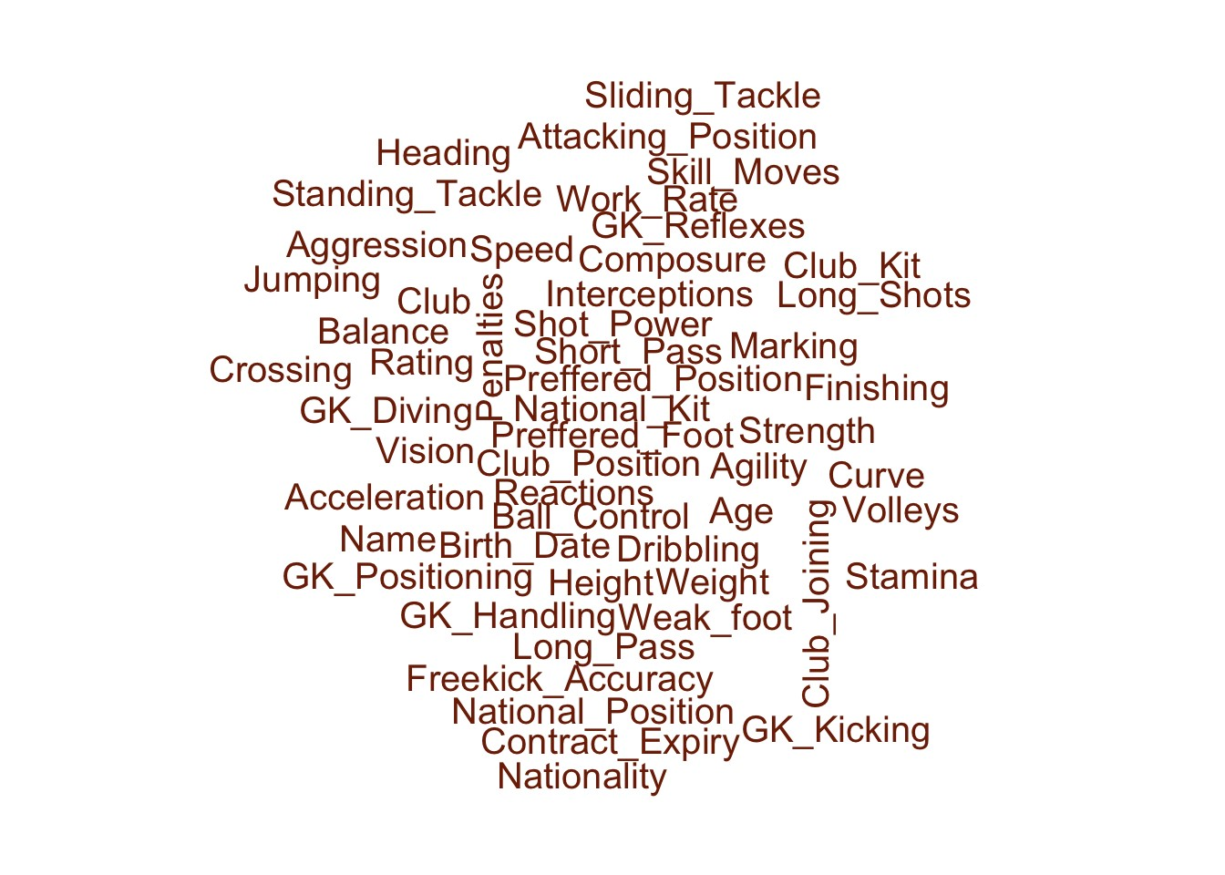
As we have seen the whole variable word cloud let us see the continuous and categorical variable’s word cloud.
Categorical Variables
## Warning in wordcloud(word_cloud_factor$col_name_factor, freq =
## word_cloud_factor$col_name_factor_values, : Preffered_Position could not be
## fit on page. It will not be plotted.
## Warning in wordcloud(word_cloud_factor$col_name_factor, freq =
## word_cloud_factor$col_name_factor_values, : Birth_Date could not be fit on
## page. It will not be plotted.
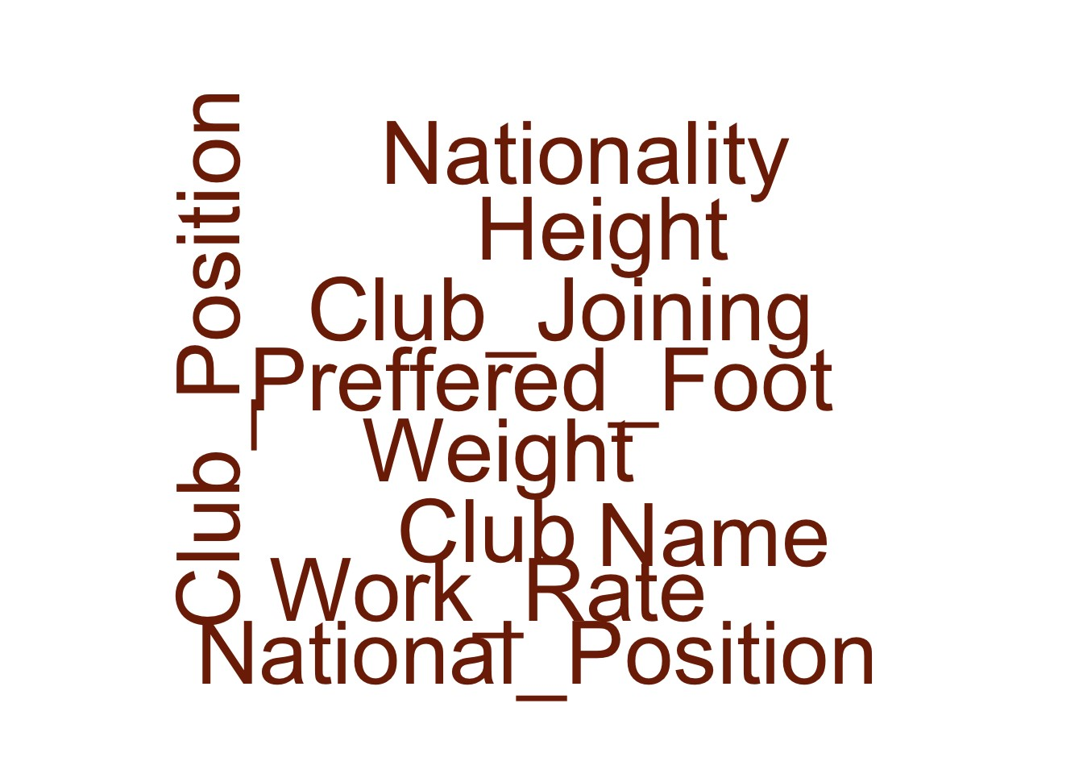
Continuous Variable
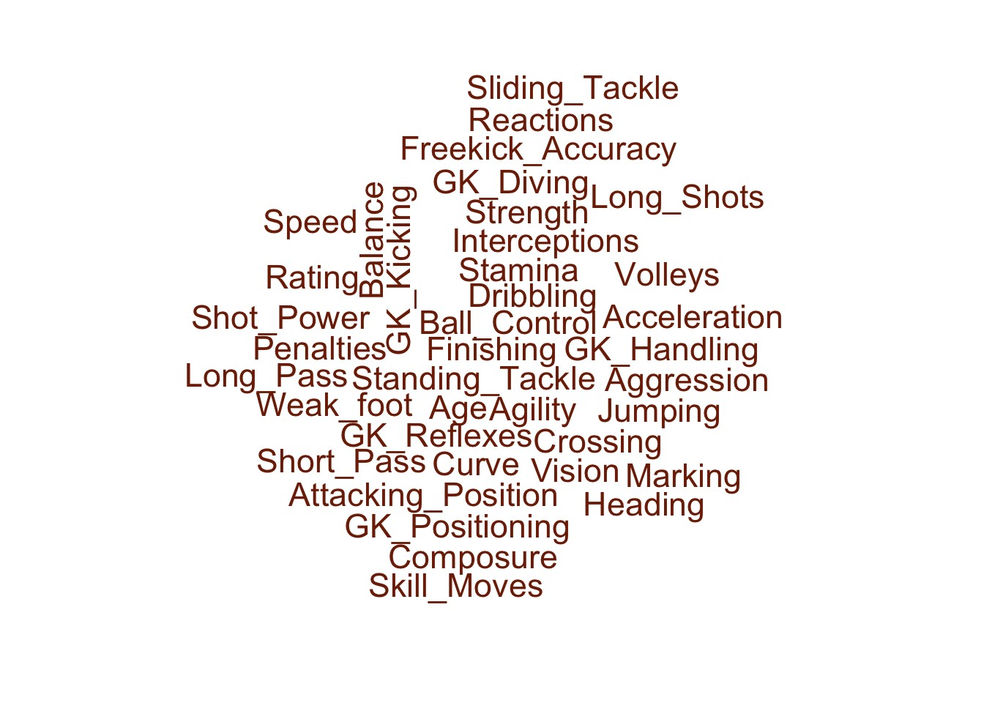

Goal of the study
Now we are going to describe the goal of our study.
Predicting the player rating
Player field position

Missing values in the data
Regarding the missing values in the predictors, the below image shows the missing values with the white places in the plot.
The above map shows the missing values in white.
Thus we have the column names and number of missing values in each of the columns. To understand things more clear, lets filter out only those column having missing values leaving others.

## National_Position National_Kit Club_Position Club_Kit
## 16513 16513 1 1
## Club_Joining Contract_Expiry
## 1 1

Imputation of missing values
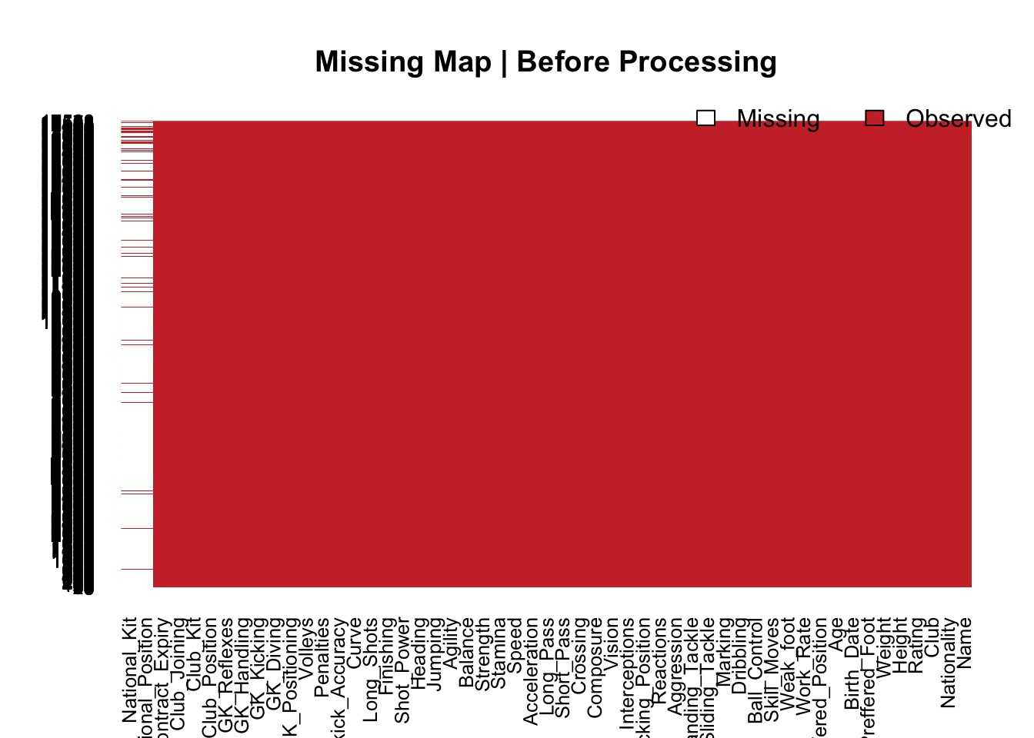
The Variables National_Position, National_Kit, Club_Kit, Club_joining, Contract_Expiry, Club_Position have atleast one missing value in the data. As the number of outliers is large in Club_fit and Contract_Expiry, the missing values are imputed by median value, The variables National_Position and National_kit are removed as they are not wanted.
The Club_position and Club_Joining have missing categorical values which are imputed by mode.
Conversion of Height and Weight to numerical values
The height and weight variable are converted to numerical values
Missing values verification of data
The data after imputation is verified for missing values. It is found that there is no missing value in the predictors.

Skewness
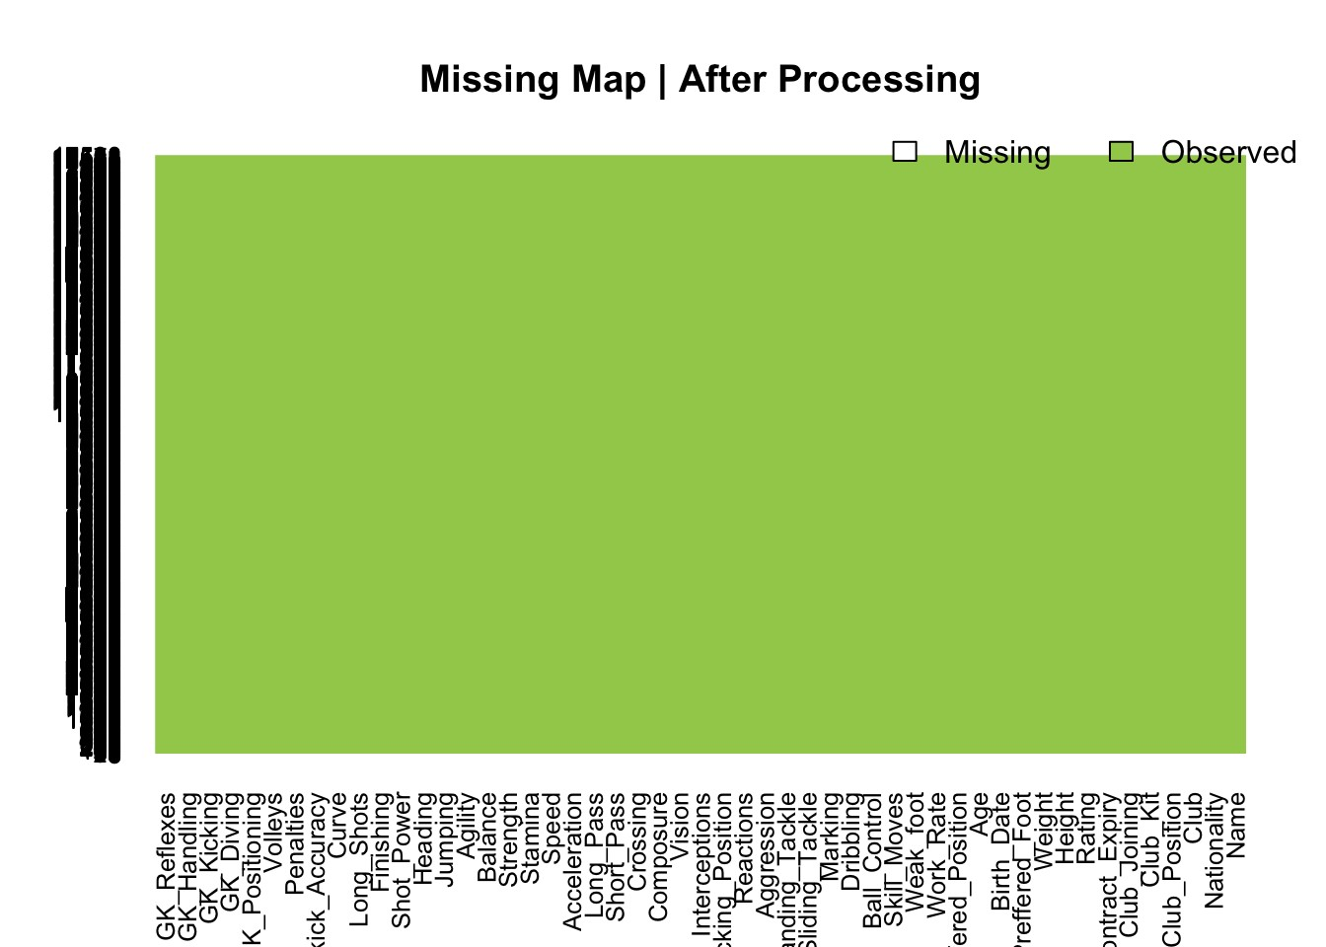
The Skewness for numerical predictors are found. The highly skewed variable (skewness > 1) is plotted in histogram
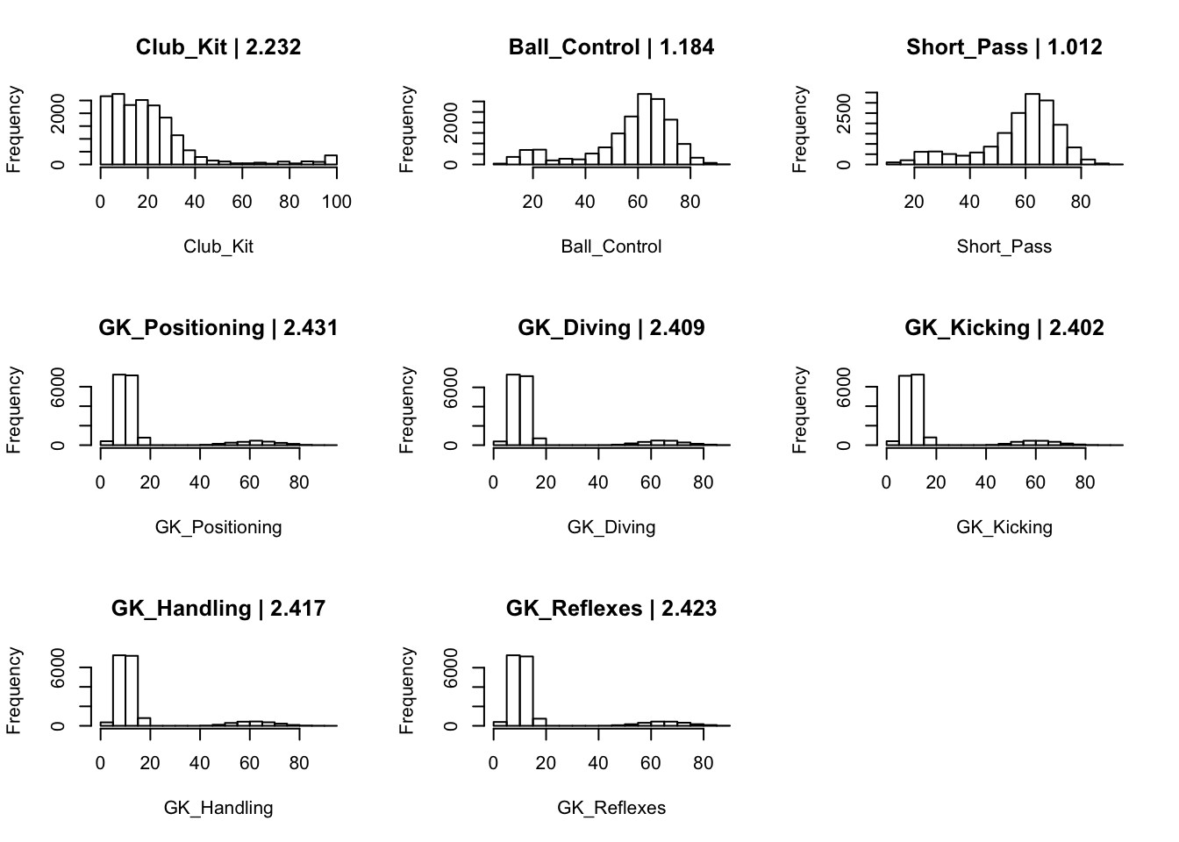

Box Cox Transformation
The Box Cox transformation is used to normalize the highly skewed predictos. Here, the highly skewed predictors are Club_kit, Ball_control,
Dribbling, Short_Pass, Gk_Positioning, Gk_Diving,Gk_Kicking,Gk_Handling and Gk_Reflexes

## column skew_measures
## 1 Club_Kit -0.106
## 2 Ball_Control -0.468
## 3 Short_Pass -0.372
## 4 GK_Positioning -0.357
## 5 GK_Diving -0.27
## 6 GK_Kicking -0.4
## 7 GK_Handling -0.343
## 8 GK_Reflexes -0.295

Correlation between Continuous predictors
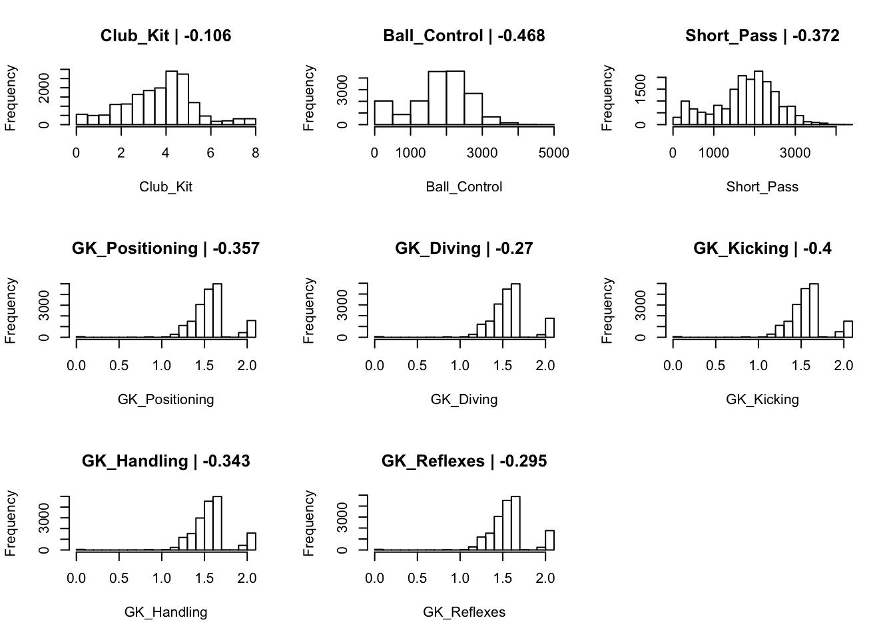
The relationship between the predictors can be understood by seeing the correlation between the predictors. We can calculate the correlation and plot it visualize those. By this way, we can remove the one of the two predictors which are highly correlated with each other. Let see the correaltion first.
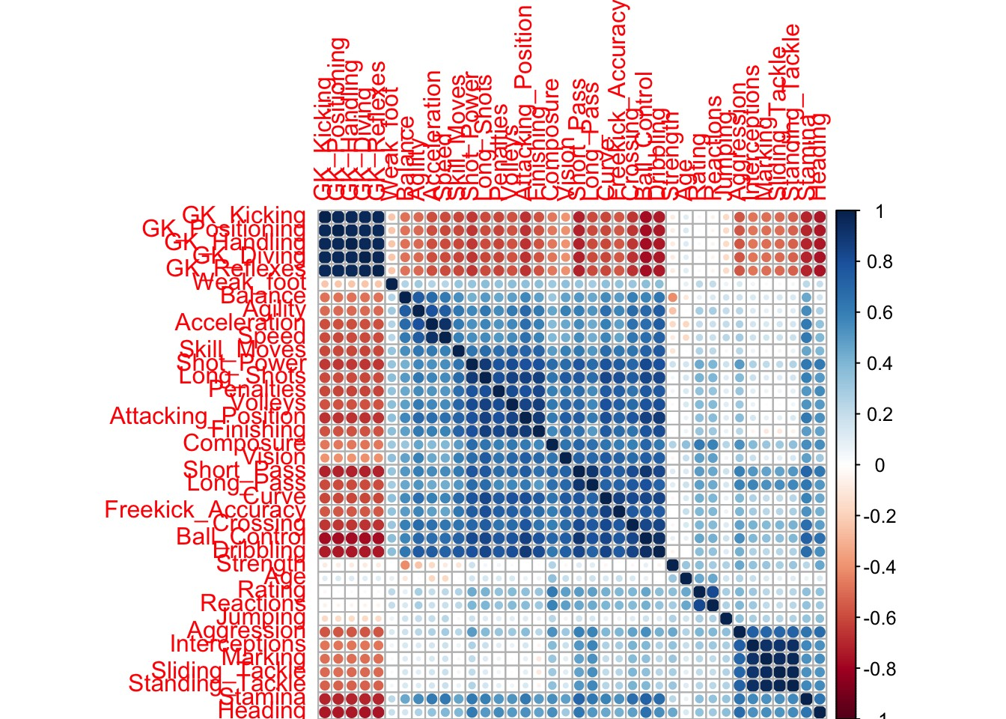
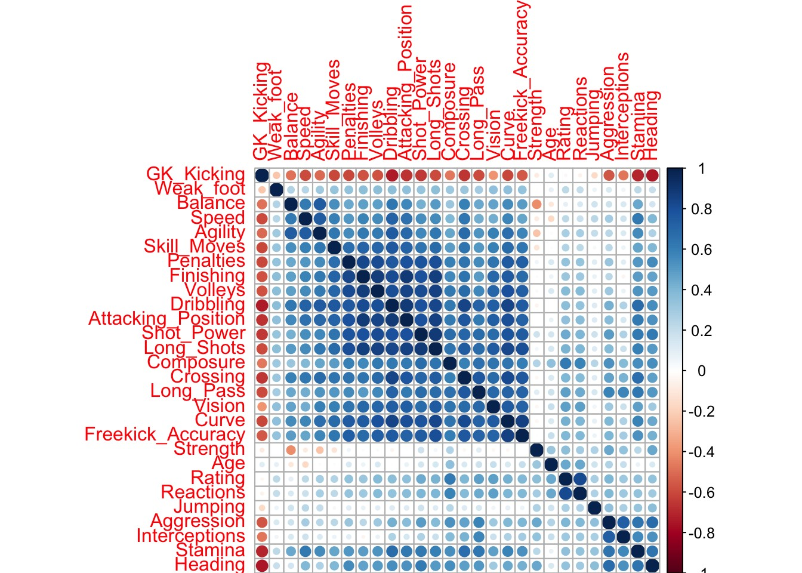
## [1] "The variables that are removed after performing correlation check are"

## [1] "Ball_Control" "Short_Pass" "GK_Diving"
## [4] "GK_Reflexes" "GK_Handling" "GK_Positioning"
## [7] "Acceleration" "Standing_Tackle" "Sliding_Tackle"
## [10] "Marking"

