**MADRAS INSTITUTE OF TECHNOLOGY**

**CHROMPET**



**DEPARTMENT OF INSTRUMENTATION ENGINEERING**

**A PROJECT REPORT**

**ON**

**“ECG’s QRS peak & Heart Rate Detection using Discrete Wavelet Transform”**

**Submitted by:**

**NAME : Srinishanth R**

**REG NO: 2018505547**

**DATE : 16 JUN 2021**

**ECG’s QRS peak & Heart Rate Detection using Discrete Wavelet Transform**

**ABSTRACT**:

This project aims at the detection of QRS peak from the ECG signal using wavelet coefficients. An enhanced algorithm has been proposed in this work in order to improve the performance of QRS detection. This method has been tested on some of the database signals from physionet atm.

* Finding QRS Peak of ECG signal using Discrete Wavelet Transform(DWT) .
* Estimating Heart rate of a person using the R-Peak occurrences.

**THEORY**:

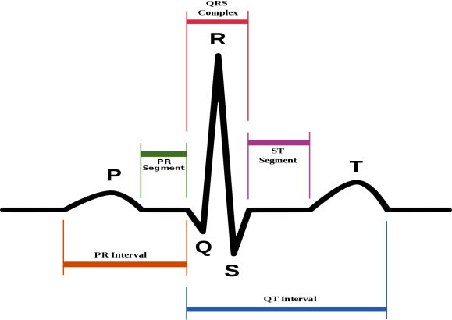The QRS complex is the combination of 3 deflections on a typical Electrocardiogram (ECG).

Q – First negative deflection

R – Largest positive deflection

S – Second negative deflection

It corresponds to the depolarization of the right and

left ventricles of the human heart and contraction of the large

ventricular muscles.

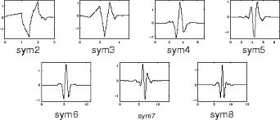Using Symlet4 wavelet for ECG signal analysis:

The Sym4 wavelet resembles the QRS complex,

which makes it good choice for QRS detection.

DWT based QRS Detection:

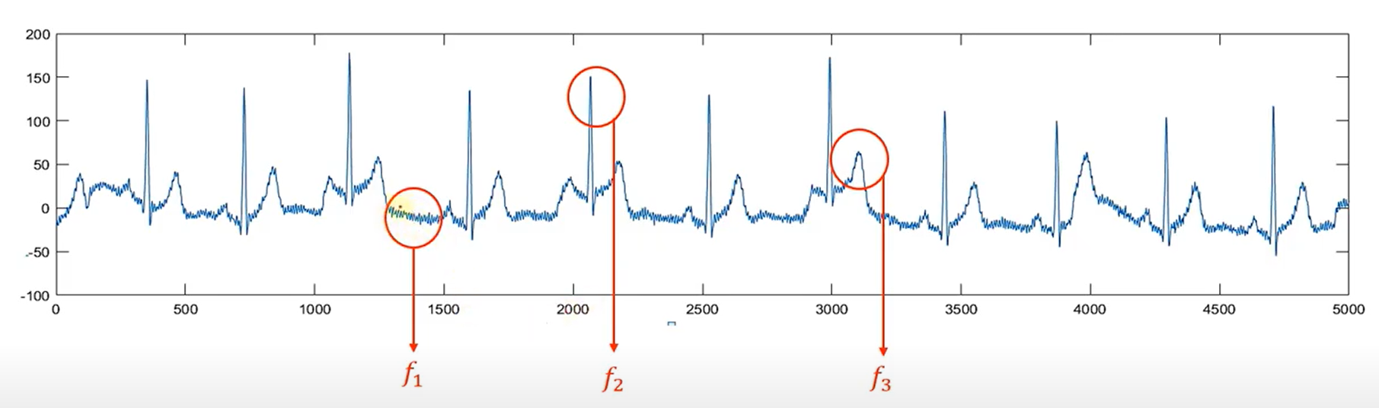

f1>f2>f3

Here in this ECG signal f1 is high frequency noise, f2 is the qrs peak frequency and f3 is slow varying component before and after qrs complex.

We need to preserve these peaks that is f2 frequency so we go with **band pass filtering** to remove all the high frequencies(f1) and low frequencies(f3).

Therefore R peaks (f2) is preserved while other frequencies is get suppressed.

This can be achieved with help of the **wavelet transform,** although it can be done with various filters wavelet transform is more robust. In some cases qrs complex may not that sharp it may be wider where BPF fails to obtain the peaks.

* Wavelet transform separates signal components into different frequency bands.
* This BPF can be achieved by eliminating wavelet coefficients of some lower scales (high frequency) and higher scales (low frequency) of ECG signal.
* For this purpose, undecimated wavelet transform is used to get wavelet coefficients.
* 4-level decomposition of ECG signal is given below:

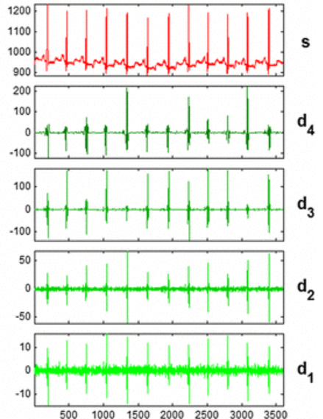

* Here d1 and d2 will be eliminated since it contains very high frequency.
* d3 & d4 will be considered for getting BPF effect.
* Just by considering d3 & d4 and taking inverse wavelet transform, we get :

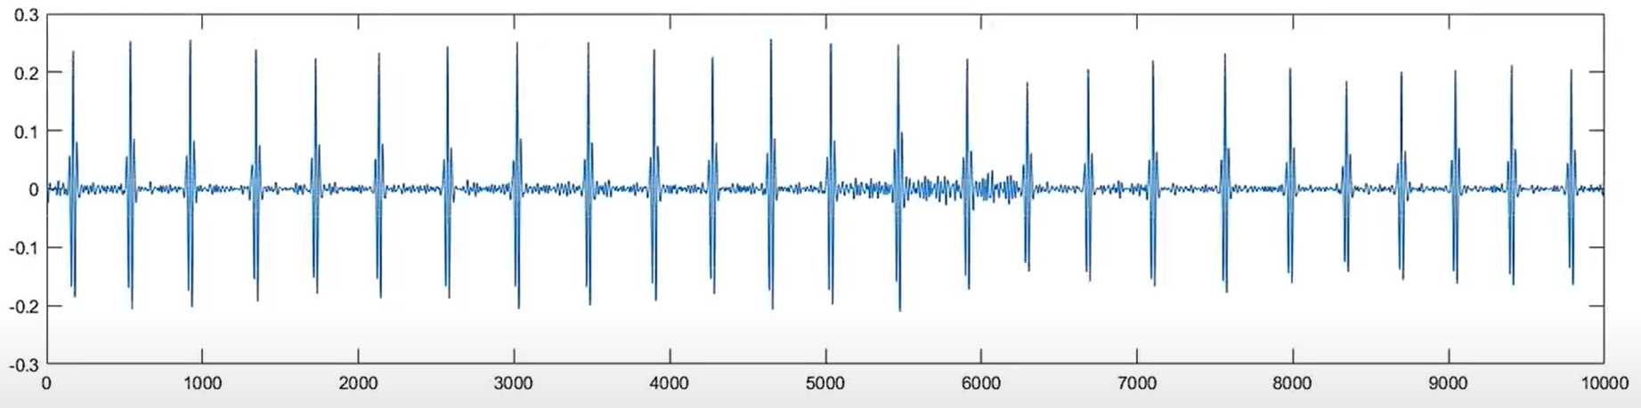

* From this reconstructed signal with only d3 and d4, we can see that R-peaks are well represented.
* With the help of a standard peak detection algorithm, we can locate these R-peaks.
* Also number of total R-peaks can be found for given time interval by which we can find Heart rate.

**MATLAB CODE:**

[filename,pathname] = uigetfile('*.*','Select the ECG Signal'); % To get the dataset

filewithpath = strcat(pathname,filename);

Fs = input('Enter Sampling Rate: ');

ecg = load(filename); % Reading ECG signal

ecgsig = (ecg.val)./200; % Normalize Gain

t = 1:length(ecgsig); % Number of samples

tx = t./Fs; % Getting Time vector in seconds

wt = modwt(ecgsig,4,'sym4'); % 4-level undecimated DWT using sym4

wtrec = zeros(size(wt)); % Initializing variable

wtrec(3:4,:) = wt(3:4,:); % Extracting only d3 & d4 coefficients

y = imodwt(wtrec,'sym4'); %IDWT with only d3 and d4

y = abs(y).^2;% Magnitude square

avg=mean(y); %Getting average of y^2 as threshold

[Rpeaks,locs] = findpeaks(y,t,'MinPeakHeight',8*avg,'MinPeakDistance',50);

nohb = length(locs); % number of heart beats

timelimit = length(ecgsig)/Fs;

hbpm = (nohb * 60)/timelimit;% Getting BPM

disp(strcat('Heart Rate = ',num2str(hbpm)))

% Plotting ECG and R- Peaks detection %

subplot(211)

plot(tx,ecgsig)

xlim([0,timelimit]);

grid on;

xlabel('seconds')

title('ECG signal')

subplot(212)

plot(t,y)

grid on;

xlim([0,length(ecgsig)]);

hold on

plot(locs,Rpeaks,'ro')%R-peaks with Red dot

xlabel('Samples')

title(strcat('R peaks found and Heart rate: ',num2str(hbpm)))

**RESULT:**

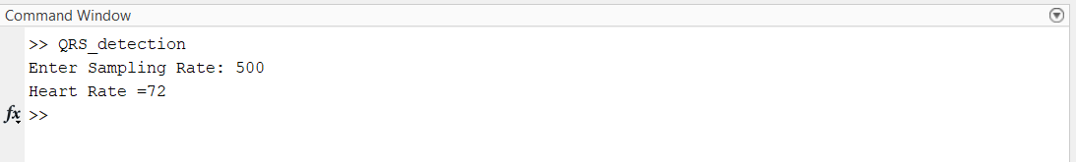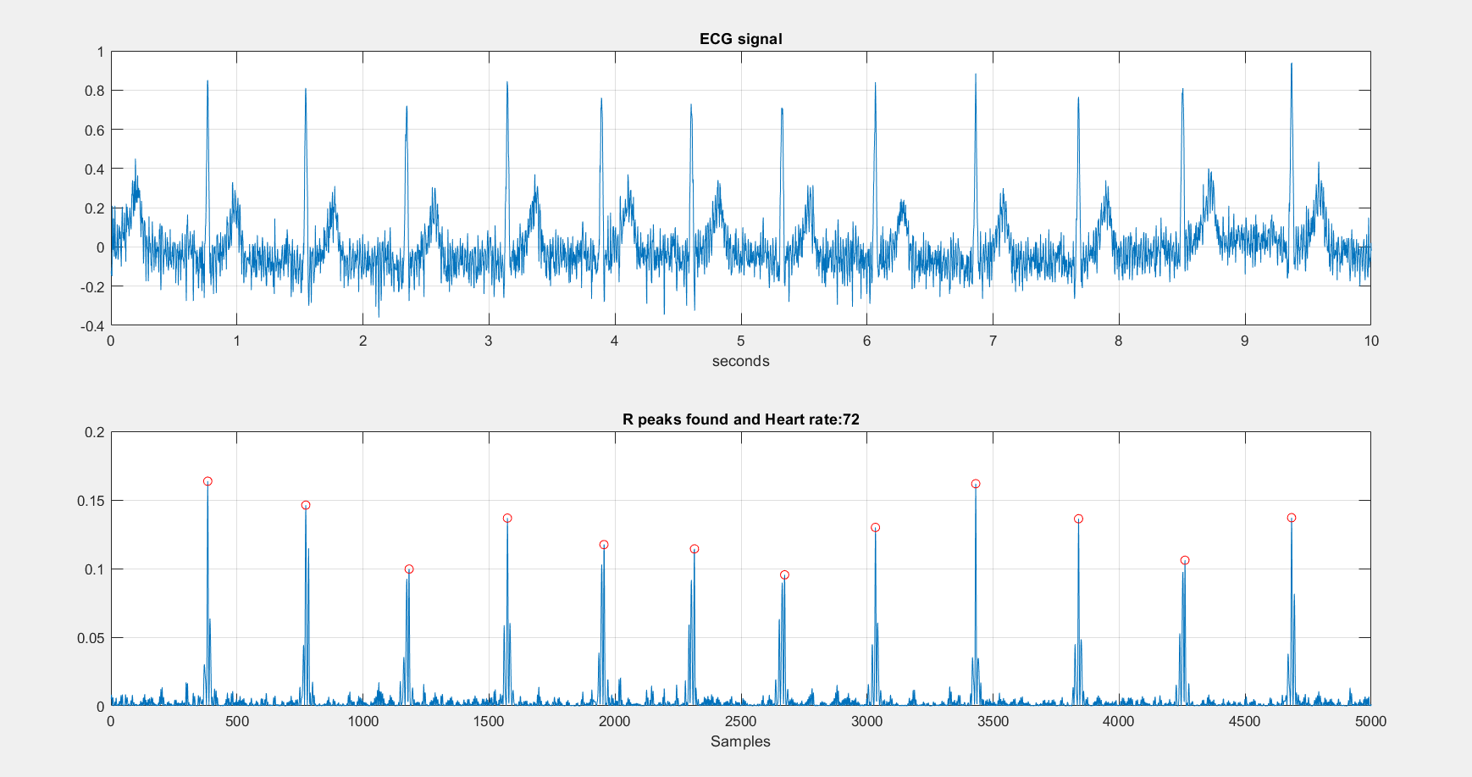

Hence the QRS peak is detected using discrete wavelet transform and the heart rate is estimated using R-peaks occurences.