**Exploratory Data Analysis**

In this milestone, we will see exploratory data analysis.

**Descriptive Statistical**

Descriptive analysis is to study the basic features of data with the statistical process. Here pandas has a worthy function called describe. With this describe function we can understand the unique, top and frequent values of categorical features. And we can find mean, std, min, max and percentile values of continuous features.

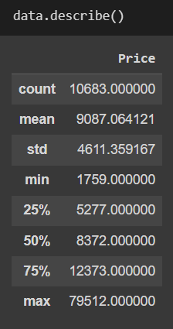

### Visual Analysis

* Plotting countplots for categorical data
* 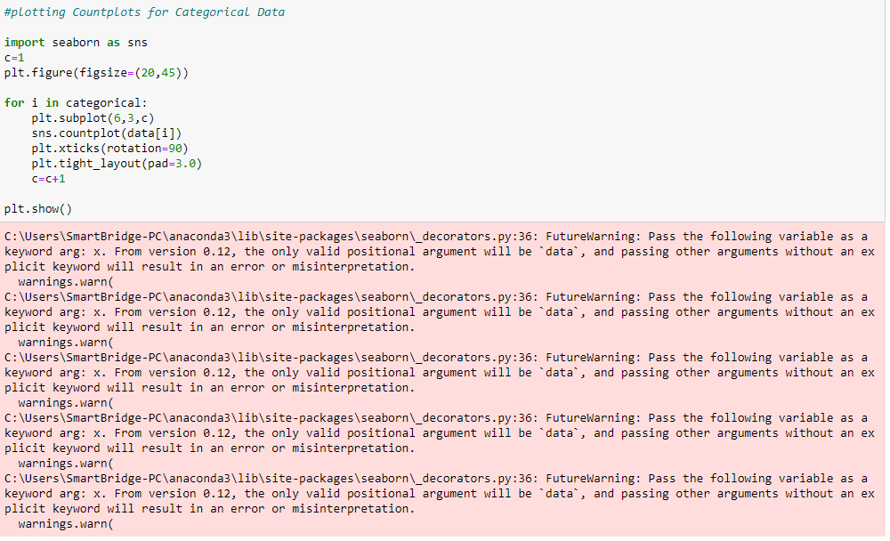
* 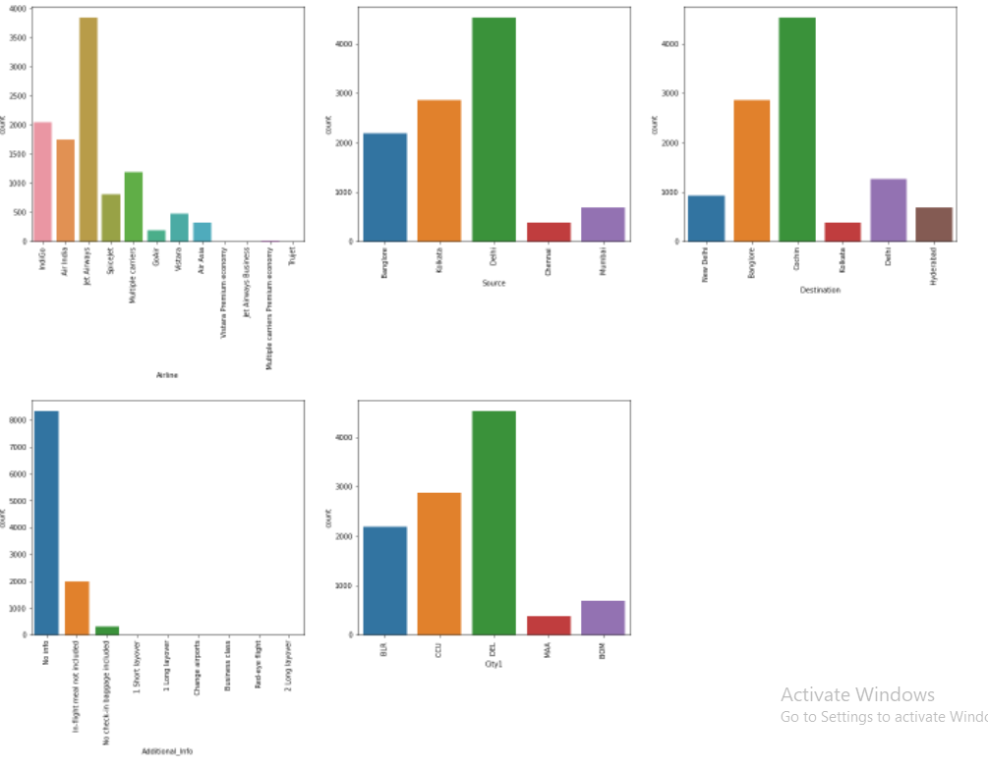

**We Now Plot Distribution Plots To Check The Distribution In Numerical Data (Distribution Of 'Price' Column)**

* The seaborn.displot() function is used to plot the displot. The displot represents the univariate distribution of data variable as an argument and returns the plot with the density distribution. Here, I used distribution(displot) on 'Price' column.
* It estimates the probability of distribution of continous variable across various data.

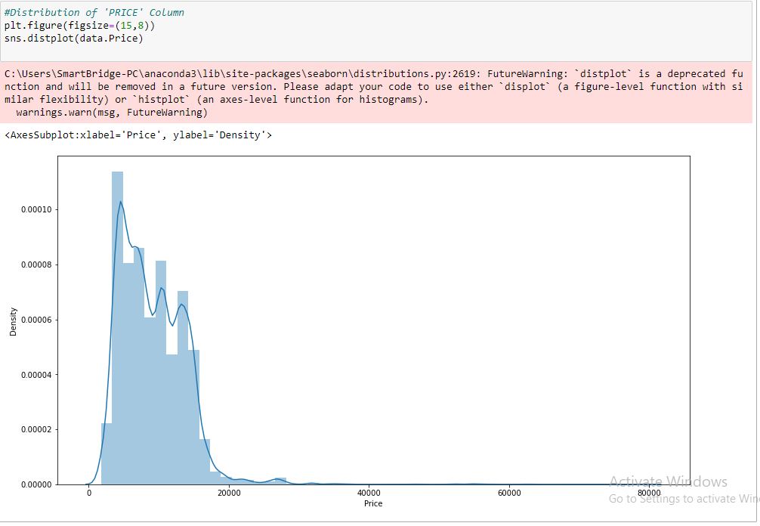

**Checking The Correlation Using HeatMap**

* Here, I 'm finding the correlation using HeatMap. It visualizes the data in 2-D colored maps making use of color variations. It describes the relationship variables in form of colors instead of numbers it will be plotted on both axes.
* So, by this heatmap we found that correlation between 'Arrival_date' and 'Date'. Remaining all columns don't have the any Correlation.

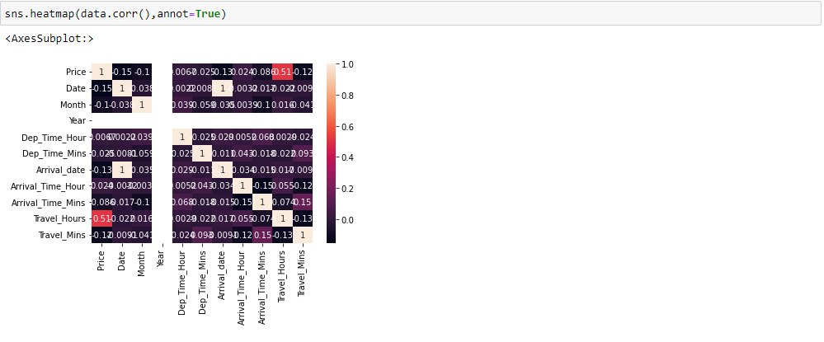

**Outlier Detection For 'Price' Column**

Sometimes it's best to keep outliers in your data. it captures the valuable information and they can effect on statistical results and detect any errors in your statistical process. Here, we are checking Outliers in the 'Price' column.

