React JS
Syllabus:
- Introduction to React JS
- Features of React JS
- Advantages of React JS
- Virtual Dom VS Real Dom
- JSX
- Components [CBC&FBC]
- Props
- States
- Content-API
- HOC
- Forms
1.Controlled Forms
2.Uncontrolled Forms
- Refs
- Axios
- UseEffect
- Routers

Es-6 Features
Let
Const
Arrow-Function
Promises
Destructuring
Rest Parameter & Spread Operator

React JS:
- React JS is a JS Library, it is used to build a single page application
Code: Set of Instructions is called as code.
Library: Set of Predefined codes is called as Library.
Eg: JQuery, React JS
Framework: Collections of some libraries
Eg: Angular JS, Express JS, Next JS

History of React JS
- Jorden Walke Developed React JS in year 2011 by the company Facebook.
- In the year 2011 React JS used in a Facebook Application
- In the year 2012 React JS used in an Instagram Application
- Finally in the year 2013 React JS was made as Open Source
Features/Characteristics of React JS
- React JS is an open-source language
- It is used to build a Single page Application
- It is one of the Java Script Library
- React JS follows unidirectional way or one way data binding
Note:
We can send the data from parent to child not from child to parent
- React JS is a declarative in nature (collections of some predefined codes)
- React JS follows the virtual DOM
- React JS follows the component-based architecture (Breaking down large pages into individual pages or separate pages is called component-based architecture)
- Learn once write anywhere
Advantages of React JS

React JS Installation
We can install React JS in 3 ways
- CLI (Command Line Interface)
- create-react-app
- Vite
npm-Node Package Manager is used to manage all the packages
npx- Node Package Executer or Executable is used to run the packages

Virtual DOM Vs Real DOM:
Real DOM:
- Real DOM is the document at the end that users can see.
- Virtual DOM is a copy of real DOM which react maintains. React will do all the changes in Virtual DOM.
- Virtual DOM is nothing but a clone copy/Xerox copy of Real DOM.
Virtual DOM:
- Virtual DOM is a copy of real DOM, you can say it’s a clone of Real DOM.
- Whatever the updates we do on the react components will not be reflected on the real DOM or on the UI directly.
- It does all the manipulation in Virtual DOM itself and then renders those changer in the real DOM so in this way we do not need to update the real DOM again and again.
Diffing:
- React always compares the virtual DOM with Real DOM.
- If there is any mismatch of nodes/properties/property values then virtual DOM will patch those things by using diff algorithm.
- React compares from the root element to the end of all the branches.
- This process is called diffing and the algorithm used is called diffing algorithm.
- It can change 2,00,000 nodes/sec.
Reconciliation:
- The process of virtual DOM comparing with Real DOM and rendering all the updated components into Real DOM by using diff algorithm called Reconciliation.
- It is dependent on:
- Virtual DOM
- Diffing algorithm.
Patching: The process of updating a missing node is called as patching.
Diffing Algorithm: To Achieve a Reconciliation process, we use an algorithm called as diffing algorithm.
Project Folder Structure:
Project
>node modules (Folder)
>public (Folder)
>src (Folder)
>main.jsx (root element)
>App.jsx (Parent Component)
>global.css
>Package. json (Files)
>Package-lock. json (Files)
>index.html (file)

- main.jsx is the root element
- App.jsx is the parent component or top-level element
- index.html is the entry level point
React Libraries:
1.React Library:
- react library is used to maintain all the components, states and handling events and states.
- react is a core internal library.
- import React from ‘react’;
2.React DOM:
- React Dom is responsible for rendering (Displaying) all components into the UI
- import ReactDOM from ‘react-dom/client’;
3.createRoot (): createRoot is a method which acts like bridge connector between index.html and main.jsx.
4.render (): render is a method which is used to display data on the UI
- Render method will accept strings, jsx elements, components.
Rendering a component
createRoot (document. getElementById(‘root’)). render (
<App></App>
)
Rendering a jsx element
createRoot (document. getElementById(‘root’)). render (
<h1> Hello all</h1>
)
Rendering a String
createRoot (document. getElementById(‘root’)). render (
“Good Moring All”
)
Note:
- npm install is used to install node modules.
Components:
- Components are the core building parts of UI
- Components are reusable
- Components are independent
- Webpages are Divided into multiple components and then will be joining together in a parent component [App.jsx]
- We have two types of components
- Class-Based Component [CBC]
- Function-Based Component [FBC]
Rules of Components:
- Component name always starts with uppercase
App, Login, Register
- Component should have the extension of. jsx
- We can represent component in two ways
- Paired Component (<App></App>)
- Self-Closing Component (<App/>)
Types of Components:
- Class-Based Component [CBC]:
- Class-Based Component is also called as stateful component (we have state object in class-based component so will call CBC as stateful component)
- Syntax: class App extends component {
Render () {
return (
<h1>I am CBC</h1>
)
}
}
export default App
- Function-Based Component [FBC]:
- FBC is also called as stateless Component (We don’t have any state objects in FBC so we call it as stateless Component)
- Syntax:
Using ArrowFunction:
Const Number= () => {
return (
<h1> I am Number </h1>
)
}
export default Number

Using Named Function:

Function App () {
return (
<h1> I am FBC </h1>
)
}
export default App

React Fragments:
- JSX will return only one element.
- If we want to return more than one element, then we have to enclose the element in a parent element.
- That parent element might be any element. If there is no use of parent element in code, just use React. Fragment which will act as parent but nothing will be rendered into the UI.
- Instead of writing we can use (<> </>) also which is similar to Fragment.
Ex:
(<React.Fragment>
<h1>Element 1</h1>
<h2>Element 2</h2>
Or
(<>
<h1> Element 1</h1>
<h2>Element 2</h2>
</>)
JSX:
- JSX - JavaScript xml
- It is a combination of HTML and JS
- It is Template Language.
- JSX is similar to HTML but not HTML.
- React JS Always uses the JSX code.
- JSX is a case-sensitive language
Rules of JSX:
- JSX always returns one element.
- JSX elements are case-sensitive.
- We can write JS code in JSX with expression.
- Common Keywords in JS will be changed in JSX.
- Class- className
- For- htmlFor
- In JSX attributes must be in lower Camel case.
- In JSX every element should have a closing tag.

Props:
- Props are nothing but properties.
- Props are object.
- Props are used to send the data from one component to another component or used to transfer data from parent to child component.
- Props are available in both class-based component and function-based component.
- Props can be transferred with the help of attributes.
- Props are immutable objects.
Props-Drilling:
- It is a process by which you can pass the data from one part of the react to another by going through other parts that do not need the data but only help in passing it around.
States:
- States is a JavaScript object.
- States are used to store the data in components level and update the data in components level and update the data.
- By default, states are available in [CBC].
- States are mutable in nature.
- States can hold or store two types of data
1.Null
2.Object
- We can initialize state object in two ways
1.Constructor-way
2.State object way
Hooks:
- Hooks are the JS objects
- Hooks always starts with the prefix ‘use’
- Whenever we want to use the hooks, it is mandatory to import necessary library
Usage of Hooks (or) Definition of Hook:
- To utilize the features of CBC in FBC we need to go for hooks
- Hooks are available only in FBC

Example:
Basic Hooks
useState ()
useContext ()
useEffect ()
Advance Hooks
useMemo ()
useCallBack ()
useRef ()
useRouter ()
Syntax of useState ()
Const [ count, setCount] = useState (0);

Current state function to Hook initial Value
Update

React-CSS
- React CSS is used to apply styling effects for the web pages
- CSS is used to add colours and effects to web pages
- CSS was introduced by Hakon Wium Lie
- In React we can add CSS in multiple ways
1.Inline
2.Global
3.Module
Framework of CSS
1.Material UI
2.BootStrap
3.Tailwind
Context-API:
- Sharing the data b/w the components without taking the help of intermediate components is called as Contexts-API

App.jsx

Component A Component B Component C
Component D Component E
Component F

Steps:
- Create Context

Higher Order Component
- In short we call it ad HOC
- HOC is alternative for props drilling
- To share common functionalities between the components we can go for HOC.
- Higher order component is a component that receives another component as an argument and returns that particular component that it received.
- It is also an alternative for props drilling.
- HOC will return one function in that we have to specify what to render into the UI by using return keyword.
- Here is an example of HOC on the basis of sending the props to the ChildComponentA & ChildComponentB via the HOC component.
- Points to remember:
- While exporting wrap in HOC component.
- HOC will return a function. Now inside this function we have to return JSX.

Refs
- Refs are nothing but references.
- Refs are used to target a particular DOM node or DOM element
- It is used to target real DOM
- Refs are available in CBC
- If I want to utilize ref concept in FBC we need to useRef() Hook.
Steps to create in FBC
- Import the useRef() hook
- Store a useRef() in one variable
- Pass a ref Attribute in a DOM Element
Practical Usage of Refs
- Media Tags
- Form handling
- Animations
Note: - Don’t Over use Ref

UseEffect:
- UseEffect is a Hook Available in a function-based component
- UseEffect is to used to control the side effect of React-JS component
- Side effects can be a fetching a data, updating something on the DOM or timer
- UseEffect will take two different components.
1.Arrow Function
2.Depenedency Array
Syntax:
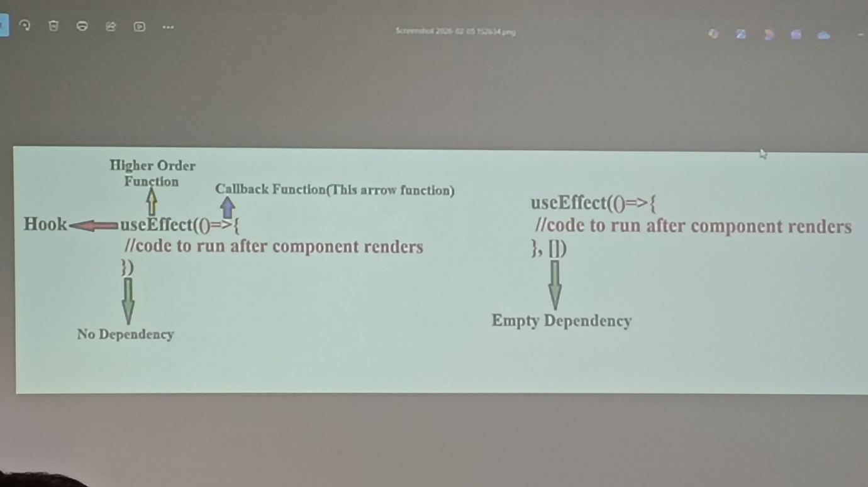
Axios
Axios is used to in react js get the data from the backend
In Axois we have 4 Methods
- Get: It is used to fetch the data
- Post: It is used to insert the data
- Put: It is used to update the data
- Delete: It is used to delete the data

