CPU_Plugin Generator Tool

Model Integrated Computing

ECE-505

Presented by: Nishanth Prakash

University of Arizona

Tucson, AZ, USA

Table of Contents

Entire Model: The overview of the Interpreter 3

1st Example: UserProcessCounter 4

2nd Example: MemoryLoad 5

3rd Example: Shared_Folders 6

Table of Figures

Figure 1: CPU_Plugin Generator 3

Figure 2: Model consisting of userProcessCounter 4

Figure 3: Results after executing the code 4

Figure 4: Model consisting of MemoryLoad 5

Figure 5: Results after executing the code 5

Figure 6: Model consisting of Shared_Folders 6

Figure 7: Results after executing the code 6

In this documentation, I would be showing 3 different models that can be formed using CPU_Plugin Generator tool.

# Entire Model: The overview of the Interpreter

Figure 1 shows the entire CPU_Plugin Generator interpreter.

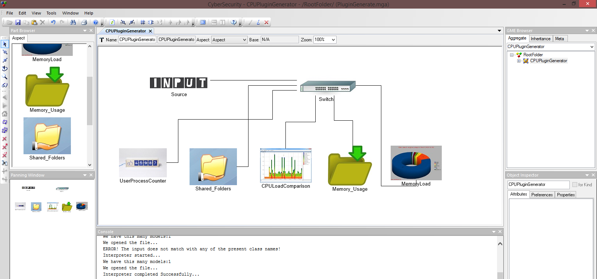

Figure 1: CPU_Plugin Generator

# 1st Example: UserProcessCounter

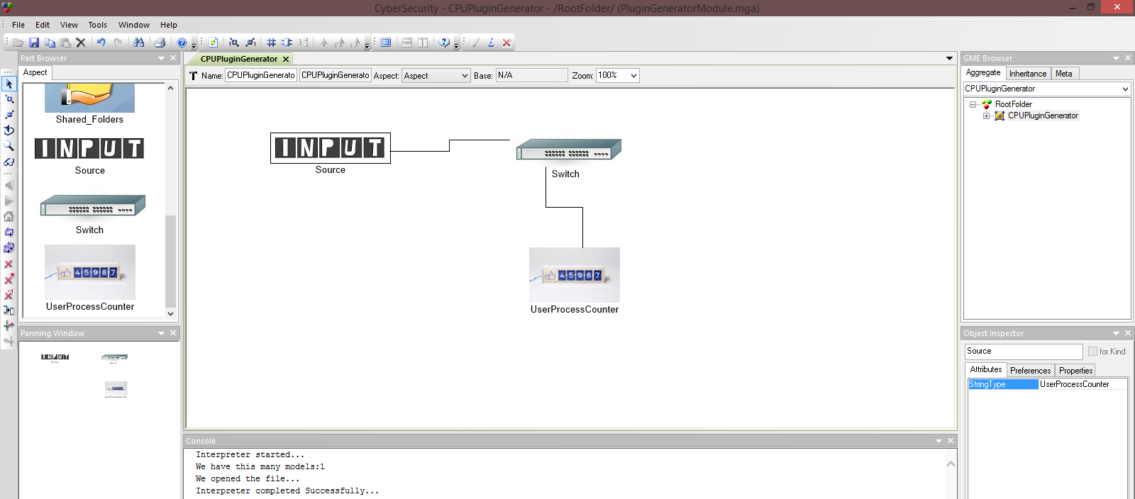

Figure 2: Model consisting of userProcessCounter

Figure 2. Consists of a model containing User Open Processes. This will count the current number of open processes in the main memory of the computer.

Output: The output generated by the CPU_Plugin Generator interpreter tool is a class called check_user_open_processes as shown below.



When you run the above code using the Nagios tool, you would get the results as shown in Figure 3.

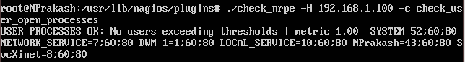

Figure 3: Results after executing the code

# 2nd Example: MemoryLoad

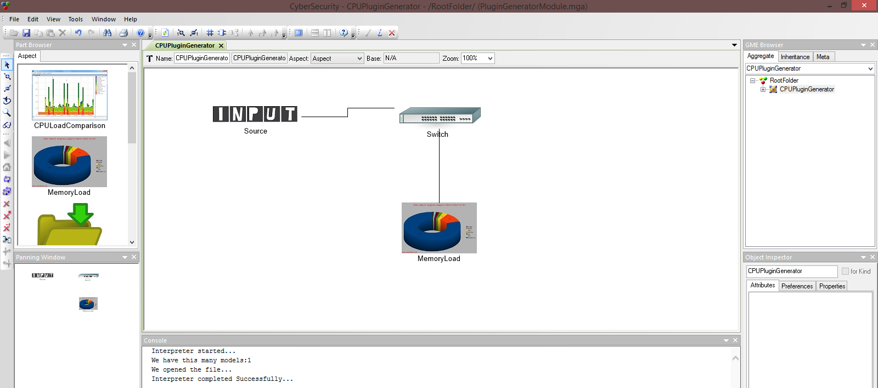

Figure 4: Model consisting of MemoryLoad

Figure 4. Consists of a model containing MemoryLoad. This will count the current number of open processes in the main memory of the computer.

Output: The output generated by the CPU_Plugin Generator interpreter tool is a class called check_hardware_memory_load as shown below.



When you run the above code by using the Nagios tool, you would get the results as shown in Figure 5.

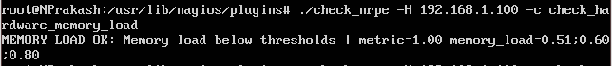

Figure 5: Results after executing the code

# 3rd Example: Shared_Folders

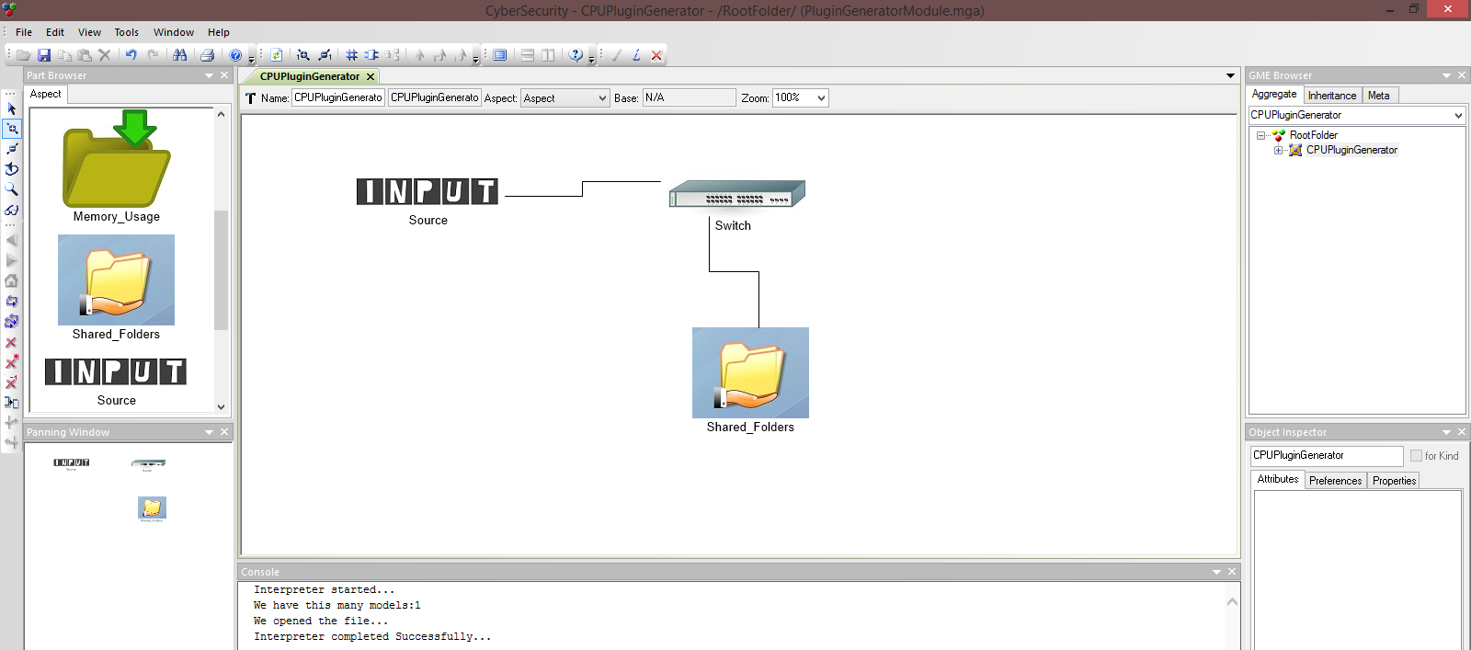

Figure 6: Model consisting of Shared_Folders

Figure 6. Consists of a model containing Shared_Folders. This will count the current number of shared folders of the computer.

Output: The output generated by the CPU_Plugin Generator interpreter tool is a class called check_machine_shared_folders as shown below.



When you run the above code using the Nagios tool, you would get the results as shown in Figure 7.

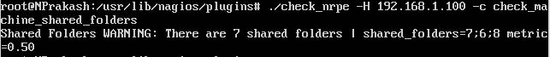

Figure 7: Results after executing the code