**Center Tendency:**

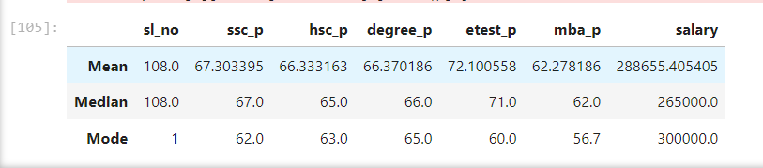

1. Students are having only above 60%.We can consider as average students.
2. In-between Mean and Median are having 2000rs difference on salary.Outlier are there.We should choose median value here.
3. In mode,Most students are getting only 60 marks on average.
4. Depends on mean,We can give salary 280000rs for who is going to join in future for whoelse getting this above 60 to 70% mark.
5. For mode,3lkhs are earing more people.
6. When compare to degree_p,People are getting good percentile on mba_p.
7. In mode,most people gets 60.0 marks on etest_p,when compare to median is 71% and mean is 72%.We can consider as average marks as same as other parameter.

**Percentile:**

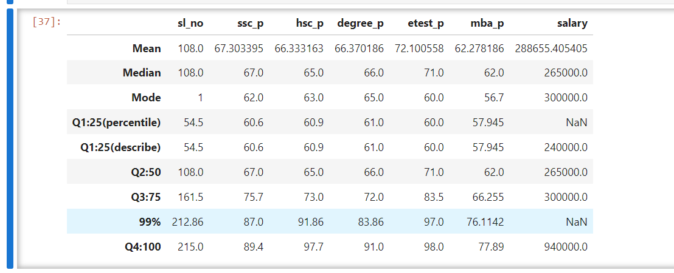

1.For SSC_P column vs Salary, Q4 is high when compare with Q3 in ssc_p,We can clearly see salary also high.In future,We recruit the new person in company,If he/she has good in scores,we can give high salary.

2.In overall data of mba_p,For maximum we have 77.89% in Q4:100 ,Our employee might be having poor in business and administration roles.

3.In overall data, Q4 vs Q3 is quite high when compared to Q3 vs Q2 and Q2 vs Q1.

4.In coding perceptive,We should think outlier are there or not,Q4 can be having outlier.

**HSK:**

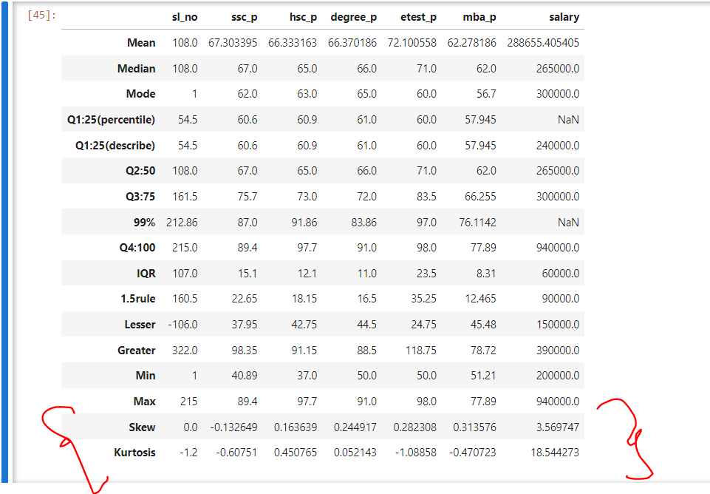

1.Let us assume example of salary from 1 to 100 marks.

2.SSC_P, For skew(Negative skewness) mode is higher which means repetition counts are more. For kurtosis Having more information in starting to ending in column in graph.

3.hsc_p, For skew(Positive skewness) means mean value is good and For kurtosis Having more information in starting to ending in column in graph.