Multi-Threaded Video Segmentation
An operating-system-level study of chunk-based data parallelism with POSIX threads
Operating Systems course project report
Group members: ______________________________
8 October 2026

Summary
A video is split in time into shots (where the camera cuts) and scenes (groups of shots). The classical method used is a colour histogram per frame, a distance between consecutive histograms, and an adaptive threshold. The frames are independent, which makes the job a natural case of data parallelism: worker threads claim chunks of frames, compute their histograms and write to their own slice of the result. The report explains the algorithm and the parallel design, gives the accuracy, and then studies, at the operating-system level, how well that parallelism uses the machine.
- Speed. Throughput rises from about 12,858 frames per second with one worker to about 67,674 with twelve, a speedup of 5.17x at 12 workers (3.44x at 4 workers), on 11 real videos. The output is bit-identical at every worker count.
- Baseline check. Left to the scheduler, the single-threaded baseline ran 1% slower than when pinned to a performance core; against the pinned baseline the 12-worker speedup is 5.17x (5.24x against the unpinned one).
- Accuracy. Hard cuts agree with an independent detector at F1 0.91. Scene grouping reaches F1 about 0.35 against human labels, measured by leave-one-video-out testing (Section 4).
- When threads pay off. On this project's laptop (Device 2), a fixed number of workers beats a pure sequential loop from about 12 to 24 frames of 160x90 video, roughly 1 to 2 ms of work, and gives 2x from about 48 frames and 5.0x at 14,000 frames; on the second laptop (measured by zhaymn) the break-even is 8 frames and the best speedup 6.8x (Section 5.2).
- What limits scaling. Section 5 separates core type, hyper-threading, file I/O and compute with controlled experiments, and looks at what each worker thread actually did.

1. Scope
Video segmentation here means temporal segmentation: finding where one shot ends and the next begins, and grouping shots into scenes. The algorithm is deliberately classical and light, so that the cost of the work is dominated by reading and processing frames. That makes it a clean workload for studying threads: what the operating system does with them, how the cores are used, and where the speedup stops.
Two laptops were used, both under Windows 11 (Device 1's study also includes Linux under WSL2):
 | Device 1 | Device 2 (this project's laptop)
CPU | Intel Core i5-13450HX | Intel Core i5-12450HX
Cores | 6 performance + 4 efficiency, 16 hardware threads | 4 performance (hyper-threaded) + 4 efficiency, 12 hardware threads
Memory | 15.7 GB | 15.7 GB
Software | Windows 11, MinGW-w64 GCC 16.2; WSL2 Ubuntu 24.04, GCC 13.3 | Windows 11, MinGW-w64 GCC 16.2; WSL2 Ubuntu 22.04, GCC 11.4
Measured by | zhaymn (benchmark harness tools/osbench.c) | this project's author

Credit. The operating-system benchmark harness (tools/osbench.c, tools/analyze_osbench.py) and all Device 1 measurements and the HTML report in results/os_analysis/ were written and produced by zhaymn, a collaborator on this repository. Device 1 numbers in this report are taken from those files; they were not re-measured by us.

2. The algorithm: colour histograms, the classical way

2.1 Input
Each video is decoded once into a raw file of BGR frames with no header. Frame i sits at byte offset i x width x height x 3, so any thread can jump straight to any frame with one seek. Decoding is therefore not part of the timings; reading a frame means a file read served from the operating system's cache. All main experiments use 160x90 frames (43 KB each).

2.2 One histogram per frame
A colour histogram counts how many pixels of a frame fall into each colour bucket. Every pixel is converted to hue and saturation (brightness is ignored, so lighting changes matter less), hue is cut into 8 bins and saturation into 8 bins, giving 64 buckets. The counts are divided by the number of pixels, so every frame becomes 64 numbers that add up to 1. Two frames of the same shot have almost the same histogram, even when objects inside the picture move, because the histogram says what colours are present and not where.
c/common.c: the histogram of one frame
void frame_hist(const uint8_t *bgr, int npix, float *out) {
int cnt[NBINS];
memset(cnt, 0, sizeof cnt);
for (int i = 0; i < npix; i++) {
int b = bgr[3 * i], g = bgr[3 * i + 1], r = bgr[3 * i + 2];
int mx = r > g ? (r > b ? r : b) : (g > b ? g : b);
int mn = r < g ? (r < b ? r : b) : (g < b ? g : b);
int d = mx - mn;
int s = mx ? (255 * d) / mx : 0;
float h = 0.f;
if (d) {
if (mx == r) h = 60.f * (float)(g - b) / d;
else if (mx == g) h = 120.f + 60.f * (float)(b - r) / d;
else h = 240.f + 60.f * (float)(r - g) / d;
if (h < 0) h += 360.f;
}
int hb = (int)(h * 0.5f * HBINS / 180.f);
if (hb >= HBINS) hb = HBINS - 1;
int sb = s * SBINS / 256;
cnt[hb * SBINS + sb]++;
}
float inv = 1.f / (float)npix;
for (int i = 0; i < NBINS; i++) out[i] = cnt[i] * inv;
}

2.3 Distance between consecutive frames
The difference between frame i-1 and frame i is the Bhattacharyya distance of their histograms p and q, in the form used by OpenCV:
d(p, q) = sqrt( 1 - sum over buckets of sqrt( p_i x q_i ) )
d is 0 for identical histograms and 1 for histograms with no colour in common. Inside a shot d stays near 0.02; at a hard cut it jumps to between 0.4 and 0.8 for exactly one frame.
c/common.c: the distance
float bhattacharyya(const float *a, const float *b) {
float bc = 0.f;
for (int i = 0; i < NBINS; i++) bc += sqrtf(a[i] * b[i]);
float v = 1.f - bc;
return v > 0.f ? sqrtf(v) : 0.f;
}

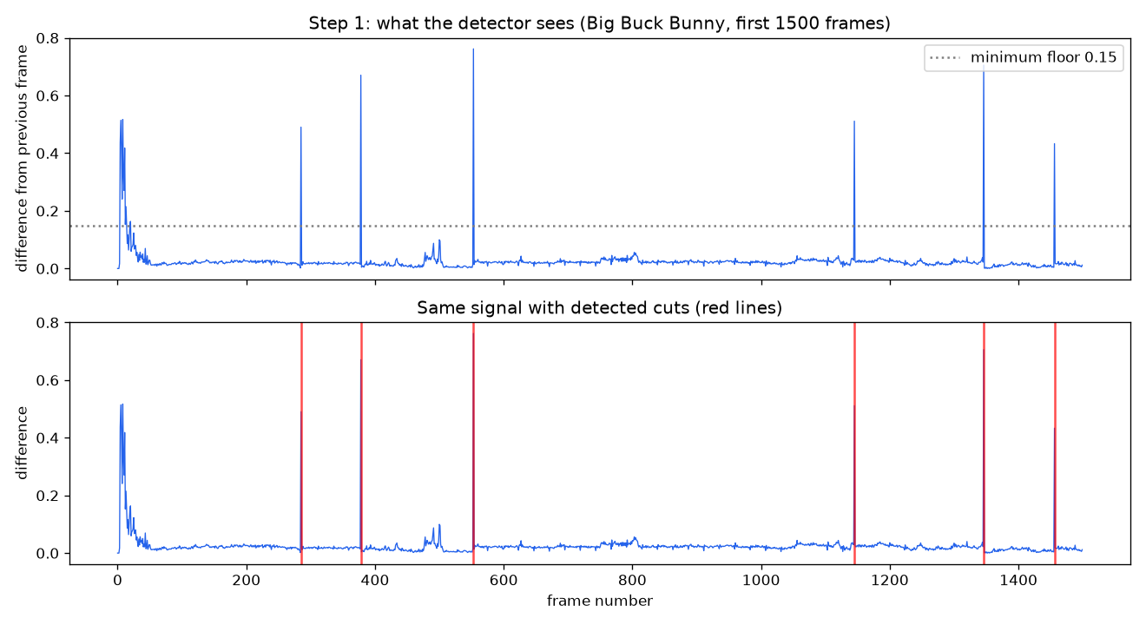
Figure 1. Frame-to-frame distance on a real video (first 1,500 frames). Each tall spike is a hard cut; the red lines in the lower panel are the detected cuts.

2.4 Adaptive threshold: from distances to shots
A fixed threshold would fail, because busy scenes have a higher baseline than calm ones. Instead a frame is declared a cut when its distance (a) exceeds the mean plus 4 standard deviations of the 25 frames around it, centre excluded, (b) is above an absolute floor of 0.15, (c) is the local maximum of that window, and (d) is at least 8 frames away from a stronger cut. The window statistics come from prefix sums, so each frame costs constant time. The step runs once, after all workers have finished, on the merged signal, so chunk borders cannot create inconsistent thresholds. The frames between two cuts form a shot.
c/threshold.c: the adaptive threshold (serial stage)
long adaptive_threshold(const float *diffs, long n, int window, double k,
int min_gap, double min_abs, long *cuts_out) {
if (n <= 0) return 0;
int half = window / 2;
/* prefix sums -> O(1) window mean/std for every position */
double *c1 = malloc((n + 1) * sizeof(double));
double *c2 = malloc((n + 1) * sizeof(double));
c1[0] = c2[0] = 0;
for (long i = 0; i < n; i++) {
c1[i + 1] = c1[i] + diffs[i];
c2[i + 1] = c2[i] + (double)diffs[i] * diffs[i];
}
long nc = 0;
for (long i = 1; i < n; i++) {
long lo = i - half < 0 ? 0 : i - half;
long hi = i + half + 1 > n ? n : i + half + 1;
double cnt = (double)(hi - lo - 1);
if (cnt < 1) cnt = 1;
double d = diffs[i];
double s1 = c1[hi] - c1[lo] - d; /* leave centre out */
double s2 = c2[hi] - c2[lo] - d * d;
double mean = s1 / cnt;
double var = s2 / cnt - mean * mean;
double sd = var > 0 ? sqrt(var) : 0;
if (!(d > mean + k * sd) || d < min_abs) continue;
int is_max = 1; /* local maximum? */
for (long j = lo; j < hi; j++)
if (diffs[j] > d) { is_max = 0; break; }
if (!is_max) continue;
if (nc > 0 && i - cuts_out[nc - 1] < min_gap) {
if (d > diffs[cuts_out[nc - 1]]) cuts_out[nc - 1] = i;
continue;
}
cuts_out[nc++] = i;
}
free(c1);
free(c2);
return nc;
}

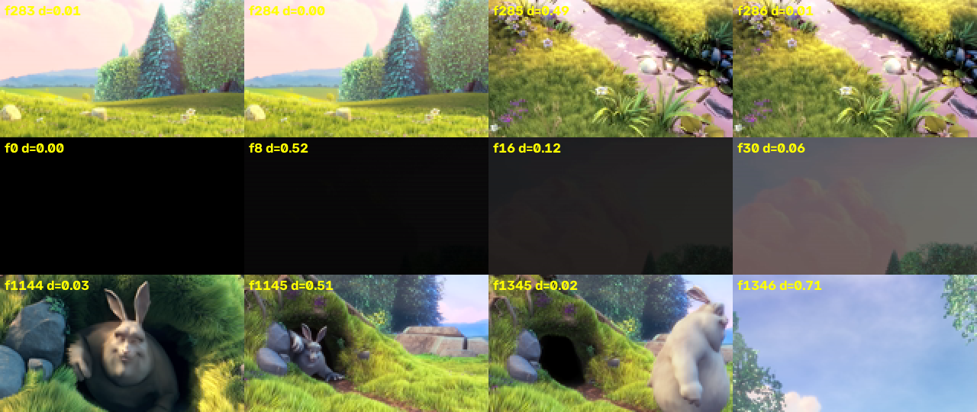
Figure 2. A hard cut changes the picture in one frame (top); a fade changes it over many frames and does not produce a spike (middle). The method finds hard cuts and mostly misses fades.

2.5 Grouping shots into scenes
A scene is a group of consecutive shots about one place or event. Each shot is described by three keyframes (at 30%, 50% and 70% of the shot), each with a global colour histogram, a 3x3 grid of colour histograms (which keeps layout) and a 3x3 grid of edge-orientation histograms. The distance between two shots is the smallest chi-square distance over their keyframe pairs. Shots are linked to similar shots shortly before them by a dynamic programme (an adaptation of the shot-thread formulation of Liu et al., 2013), overlapping links form phases, and a second dynamic programme groups phases into scenes. The parameters (distance limit, link cost, scene cost) are chosen by cross-validation (Section 4.2).

3. How the data parallelism works

3.1 Why frames can be processed in parallel
The histogram of frame i depends only on frame i. The distance needs the histogram of frame i-1, but that is cheap to recompute, so the only coupling between frames is one extra frame at the start of each chunk. This is data parallelism: every thread does the same job on a different piece of the data.

3.2 The design
Step | What happens | Why it is efficient
1. Split | The video is cut into workers x 4 contiguous chunks of frames. | Contiguous chunks give sequential file reads; 4 per worker allows load balancing.
2. Claim | Each worker repeatedly takes the next unclaimed chunk number from a shared counter protected by one pthread_mutex_t. | The lock is held for a few nanoseconds and taken only about 4 times per worker; faster cores simply take more chunks.
3. Own file handle | Each worker opens the file itself and seeks to its chunk. | No shared file position, so no locking around reads.
4. Overlap | A chunk starting at frame s first reads frame s-1 to obtain the previous histogram. | Makes the first difference of every chunk correct; costs one extra frame per chunk.
5. Compute and store | For each frame: read, histogram, distance to the previous histogram, write into diffs[i] and hists[i]. | Each worker writes only its own slice, so there are no data races and no lock on the output.
6. Join, then serial stage | pthread_join on all workers, then the adaptive threshold runs once. | Join is the barrier; the only serial work is about 20 microseconds.

c/arch_a.c: process one chunk (overlap frame, then histogram and distance per frame)
static void process_chunk(const Video *v, ShotResult *r, FILE *f, uint8_t *buf,
long start, long end) {
int npix = v->w * v->h;
float prev[NBINS];
int have_prev = 0;
if (start > 0) { /* 1-frame overlap */
fseeko(f, (off_t)(start - 1) * (off_t)v->frame_bytes, SEEK_SET);
if (fread(buf, 1, v->frame_bytes, f) == v->frame_bytes) {
frame_hist(buf, npix, prev);
have_prev = 1;
}
} else {
fseeko(f, 0, SEEK_SET);
}
for (long i = start; i < end; i++) {
if (fread(buf, 1, v->frame_bytes, f) != v->frame_bytes) break;
float *h = r->hists + (size_t)i * NBINS;
frame_hist(buf, npix, h);
r->diffs[i] = have_prev ? bhattacharyya(prev, h) : 0.f;
for (int b = 0; b < NBINS; b++) prev[b] = h[b];
have_prev = 1;
}
}

c/arch_a.c: the worker thread (claims chunks through the mutex-protected counter)
static void *worker(void *arg) {
Shared *sh = arg;
FILE *f = fopen(sh->v->path, "rb");
uint8_t *buf = malloc(sh->v->frame_bytes);
for (;;) {
pthread_mutex_lock(&sh->lock); /* critical section */
long k = sh->next++;
pthread_mutex_unlock(&sh->lock);
if (k >= sh->n_chunks) break;
long s, e;
chunk_range(sh->v->n, sh->n_chunks, k, &s, &e);
if (e > s) process_chunk(sh->v, sh->r, f, buf, s, e);
}
free(buf);
fclose(f);
return NULL;
}

c/arch_a.c: creating the workers, joining them, then the serial threshold
int detect_chunked(const Video *v, int nthreads, int chunks_per_thread,
ShotResult *r) {
double t0 = now_sec();
Shared sh = {.v = v, .r = r, .n_chunks = (long)nthreads * chunks_per_thread,
.next = 0};
if (sh.n_chunks > v->n) sh.n_chunks = v->n;
pthread_mutex_init(&sh.lock, NULL);
pthread_t *th = malloc(nthreads * sizeof *th);
for (int i = 0; i < nthreads; i++)
pthread_create(&th[i], NULL, worker, &sh);
for (int i = 0; i < nthreads; i++) pthread_join(th[i], NULL);
pthread_mutex_destroy(&sh.lock);
free(th);
double t1 = now_sec();
/* serial stage, after the merge */
r->ncuts = adaptive_threshold(r->diffs, v->n, 25, 4.0, 8, 0.15, r->cuts);
double t2 = now_sec();
r->t_parallel = t1 - t0;
r->t_threshold = t2 - t1;
r->t_total = t2 - t0;
return 0;
}

3.3 Parallel parts of the scene stage
Two scene-stage steps are data parallel in the same way: computing the keyframe descriptors (threads split the shots between them, each with its own file handle) and computing the shot-to-shot distances (threads split the rows). The dynamic programmes that follow are recurrences, where each step needs the previous one, so they run on one thread. For a typical video of a few hundred shots the whole scene stage takes well under a millisecond, so the frame stage dominates the run time.
c/features.c: the keyframe worker (each thread describes the keyframes of its own shots)
static void *kf_worker(void *arg) {
Job *j = arg;
FILE *f = fopen(j->v->path, "rb");
uint8_t *buf = malloc(j->v->frame_bytes);
if (!f || !buf) return NULL;
for (long s = j->lo; s < j->hi; s++) {
long len = j->shots[s].end - j->shots[s].start;
for (int k = 0; k < KF_PER_SHOT; k++) {
long fr = j->shots[s].start + len * (2 * k + 1) / (2 * KF_PER_SHOT);
fseeko(f, (off_t)fr * (off_t)j->v->frame_bytes, SEEK_SET);
float *dst = j->out + ((size_t)s * KF_PER_SHOT + k) * FD_TOTAL;
if (fread(buf, 1, j->v->frame_bytes, f) == j->v->frame_bytes)
frame_rich(buf, j->v->w, j->v->h, dst);
}
}
free(buf);
fclose(f);
return NULL;
}

3.4 Correctness
Parallelism changes the order of work, not the answer. The per-frame distance signal and the cut list are bit-identical between the single-threaded loop and the threaded detector at 1, 2, 4 and 8 workers, and at 1, 4, 16 and 64 chunks per worker (tests/test_invariance.py, all tests pass). That is direct evidence that the one-frame overlap is right.

4. Accuracy

4.1 Shot (cut) detection
Test | Precision | Recall | F1 | Note
Synthetic video, 241 true cuts | 1.000 | 1.000 | 1.000 | Easy by construction; validates the pipeline
Big Buck Bunny against the ffmpeg scene detector (122 reference cuts, 137 found) | 0.861 | 0.967 | 0.911 | The reference is another detector, not human labels; the extra 15 cuts were not inspected

Only hard cuts are found. A fade or dissolve changes the picture slowly and produces no spike, so it is mostly missed (Figure 2).

4.2 Scene grouping against human labels
The RAI broadcast dataset provides human-marked scene boundaries for 10 videos: 126 scenes, 116 true boundaries. Before tuning, the evaluation was audited: the labels are aligned with the frames (no gaps, last labelled frame equals the frame count), the scorer agrees with an independent re-implementation, and 91% of true scene boundaries lie within 2 seconds of a detected cut, so shot detection is not the limit.
To avoid scoring parameters on the data they were tuned on, leave-one-video-out testing was used: for each video, the parameters (672 combinations) are chosen on the other nine and scored on the held-out one. A boundary counts as correct within a tolerance of 2 seconds (1 and 5 seconds are also reported). Intervals come from resampling whole videos.
Shot description | F1 1 s | F1 2 s | F1 5 s | F1 2 s interval
Mean global histogram (original, tuned) | 0.219 | 0.287 | 0.362 | 0.20-0.36
Global histogram, 1 keyframe | 0.249 | 0.304 | 0.405 | 0.22-0.36
Global histogram, 3 keyframes | 0.242 | 0.304 | 0.394 | 0.23-0.36
3x3 colour grid, 3 keyframes | 0.247 | 0.290 | 0.328 | 0.23-0.35
3x3 edge orientation, 3 keyframes | 0.161 | 0.239 | 0.367 | 0.17-0.32
Global + colour grid + edge orientation, 3 keyframes (main) | 0.284 | 0.348 | 0.468 | 0.25-0.44
Reference: every detected cut called a scene boundary | 0.156 | 0.167 | 0.179 | 0.13-0.21
Reference: evenly spaced scenes (true scene count) | 0.017 | 0.043 | 0.172 | 0.01-0.07

- The honest scene score is about 0.35 (F1 at 2 s). It clearly beats the references, which are the real bar. Most of the improvement over an earlier 0.13 came from tuning and evaluating properly (the original method already reaches 0.29 when tuned this way), not from the richer description; the 0.06 gain from the grid and edge features lies within the interval overlap on only 116 boundaries.
- It still over-splits: 176 scenes predicted against 126 true. A scene boundary is a change of story or place, which colour and edge statistics capture only partly.
- The test set is small, so differences of a few hundredths in F1 cannot be distinguished.

5. Operating-system-level analysis

5.1 Method and measurement conditions
- Harnesses. tools/osstudy.c (Device 2) and tools/osbench.c (Device 1, by zhaymn), both linking the same detector code from c/. Frames come from the operating system's file cache (warm), so decoding is excluded.
- Baselines. The single-threaded baseline is the plain loop in c/seq.c. On a hybrid CPU it must be pinned to a fast performance core, otherwise Windows may run it on a slow efficiency core and inflate every speedup.
- Controls. CPU sets are applied with SetProcessAffinityMask; workload variants isolate causes; every point records the median, the best time, the 90th percentile and user and kernel CPU time.
- Shared machine. Device 2 was in use during the measurements, with other applications open. To keep the results trustworthy the studies ran at high priority, interleaved all configurations in round-robin rounds (so drifting background load hits every configuration equally) and used the best of the rounds (interference only ever adds time). Background load was logged around every stage, and the noise level of every set is reported. Sets that include the efficiency cores were the most disturbed (Windows places background work there); the sets restricted to performance cores were the cleanest.
- Discarded data. A first attempt at the crossover study and at the Device 2 replication was thrown away: launched from a background chain, it capped the speedup at 1.8x for every job size and for every worker count from 4 to 12, and 2 workers gave no speedup at all. That pattern matches four efficiency cores, and the same program started from the foreground scaled normally (5.0x at 14,000 frames), so the first attempt was a launch problem and not a property of the code or the algorithm. Its files are kept in results/os_study/invalid_try1/; every number reported here comes from a run that passed the check '12 workers must exceed 3.5x at 14,000 frames'.
Noise indicator per CPU set (fraction of configurations whose 90th-percentile time exceeded 1.5x their best time):
all: 94% noisy configs, attempts=1
p4: 8% noisy configs, attempts=1
e4: 67% noisy configs, attempts=1
core8: 100% noisy configs, attempts=1
c1: 0% noisy configs, attempts=1
all: pass 1 94% noisy, pass2 6% noisy -> merged by best time (30 rounds per point)
e4: pass 1 67% noisy, pass2 8% noisy -> merged by best time (30 rounds per point)
core8: pass 1 100% noisy, pass2 83% noisy -> merged by best time (30 rounds per point)

Background CPU load sampled just before and after each stage (percent of the whole CPU):
all before: ac_power=yes battery=100% background_cpu_load=92.4%
all after: ac_power=yes battery=100% background_cpu_load=85.4%
p4 before: ac_power=yes battery=100% background_cpu_load=98.8%
p4 after: ac_power=yes battery=100% background_cpu_load=83.2%
e4 before: ac_power=yes battery=100% background_cpu_load=38.1%
e4 after: ac_power=yes battery=100% background_cpu_load=34.0%
core8 before: ac_power=yes battery=100% background_cpu_load=31.8%
core8 after: ac_power=yes battery=100% background_cpu_load=70.2%
c1 before: ac_power=yes battery=100% background_cpu_load=20.2%
c1 after: ac_power=yes battery=100% background_cpu_load=30.1%

5.2 The data-size study: when do threads pay off, and how throughput grows with the job
Starting threads costs time, so a small job is faster sequentially. The study varies the number of frames in the job from 1 to 16,384 (and the frame size from 32x18 to 1280x720 on Device 1), measures the sequential loop and the threaded detector at several worker counts with many repetitions, and reports the best worker count at each size. The same harness ran on both laptops.
Crossover study on Device 2. The practical question is: if a program uses a fixed number of workers (2, 4, 8 or 12), from what job size is that faster than a pure sequential loop, in which no thread is created at all? The sequential loop is pinned to the fastest performance-core thread; sizes from 0 to 14,000 frames of 160x90 video; 25 interleaved rounds, best of rounds. The fixed cost is measured directly with zero frames of work, and the break-even is compared with a model.
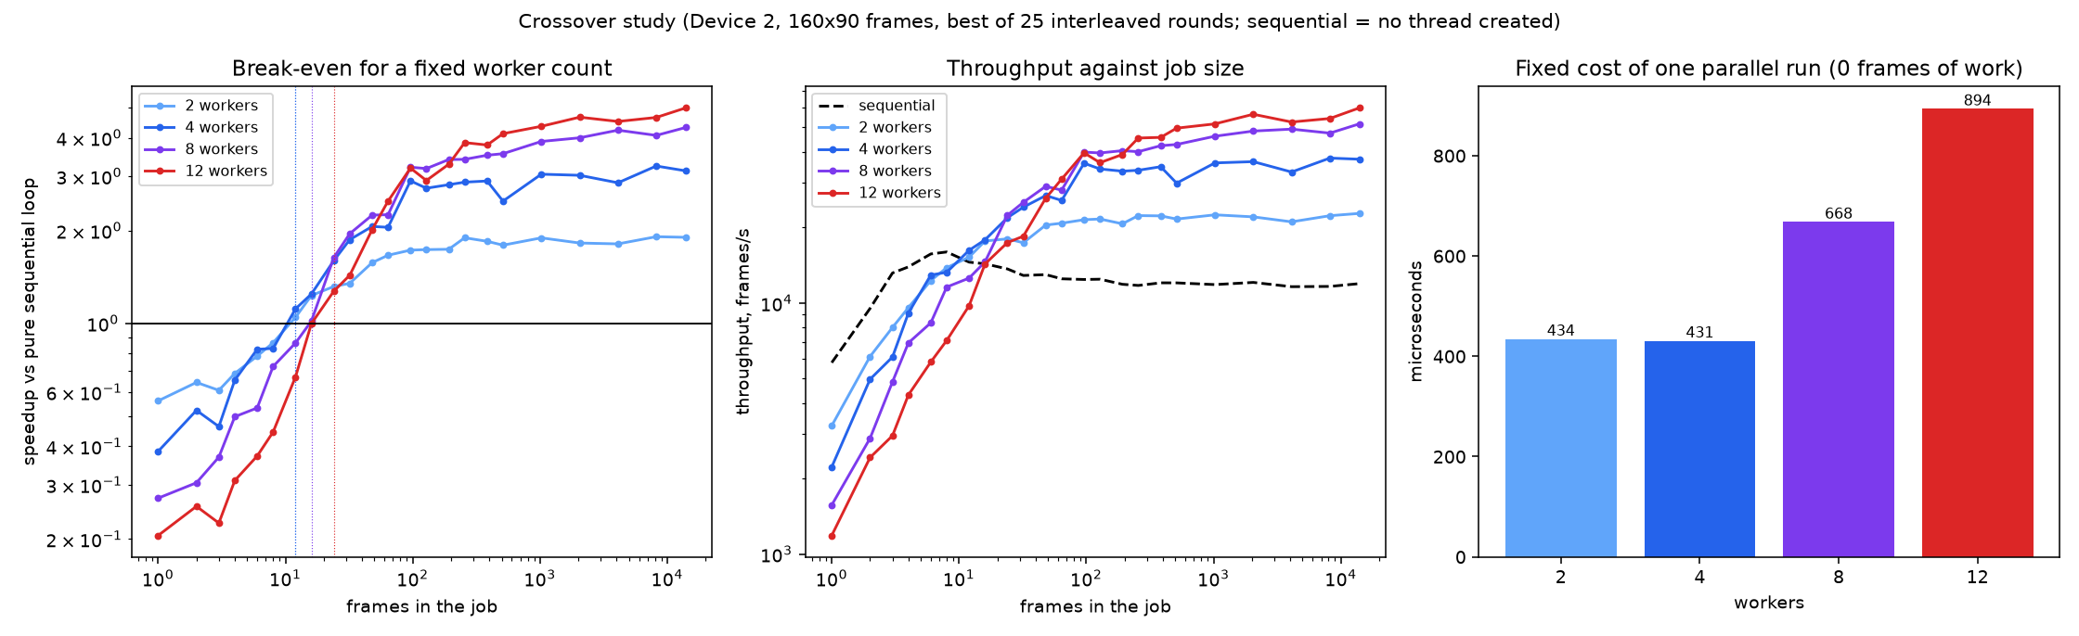
Figure 3. Left: speedup over the pure sequential loop against the number of frames (dotted lines: break-even). Middle: throughput against job size. Right: fixed cost of one parallel run, measured with zero frames of work. Device 2.
workers | fixed cost O(P) | break-even (first size from which threads win) | sequential work there | data there | 2x from | 90% of best speedup from | model prediction N* | best speedup
2 | 434 us | 12 frames | 0.83 ms | 0.52 MB | - frames | 96 frames | 11 frames | 1.91x
4 | 431 us | 12 frames | 0.83 ms | 0.52 MB | 48 frames | 8192 frames | 8 frames | 3.24x
8 | 668 us | 16 frames | 1.12 ms | 0.69 MB | 48 frames | 1024 frames | 10 frames | 4.32x
12 | 894 us | 24 frames | 1.76 ms | 1.04 MB | 48 frames | 2048 frames | 13 frames | 5.01x

- Device 2 break-even for a fixed number of workers is 12 to 24 frames, and the speedup then grows with the job until it reaches the machine's capacity (Section 5.6). The full table is below.
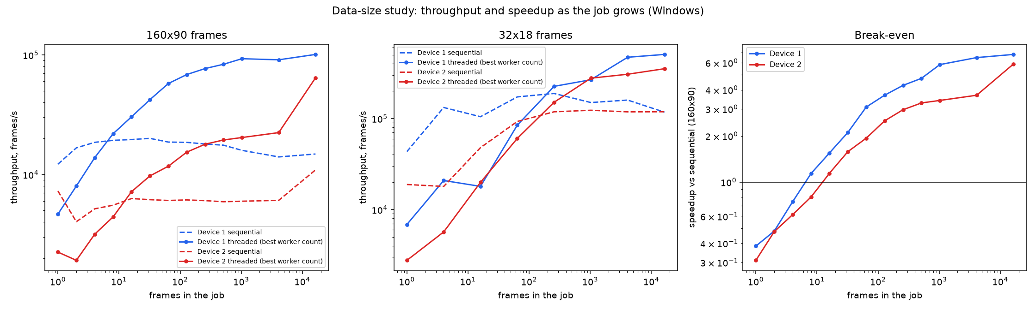
Figure 4. Throughput (frames per second) of the sequential loop (dashed) and the threaded detector (solid) against the size of the job, for 160x90 and 32x18 frames, and the resulting speedup. Windows, both devices.
device | frame size | frames | data (MB) | sequential fps | threaded fps (best P) | speedup | best P
1 | 160x90 | 1 | 0.04 | 12210 | 4671 | 0.38x | 4
1 | 160x90 | 8 | 0.35 | 19291 | 21936 | 1.14x | 6
1 | 160x90 | 64 | 2.76 | 18660 | 57569 | 3.09x | 8
1 | 160x90 | 1024 | 44.24 | 15915 | 92842 | 5.83x | 12
1 | 160x90 | 4096 | 176.95 | 14022 | 90897 | 6.48x | 16
1 | 160x90 | 16384 | 707.79 | 14830 | 100805 | 6.80x | 8
2 | 160x90 | 1 | 0.04 | 7267 | 2245 | 0.31x | 2
2 | 160x90 | 8 | 0.35 | 5537 | 4427 | 0.80x | 6
2 | 160x90 | 64 | 2.76 | 6065 | 11726 | 1.93x | 6
2 | 160x90 | 1024 | 44.24 | 5978 | 20366 | 3.41x | 6
2 | 160x90 | 4096 | 176.95 | 6079 | 22388 | 3.68x | 12
2 | 160x90 | 16384 | 707.79 | 10922 | 64210 | 5.88x | 16
1 | 32x18 | 1 | 0.00 | 43290 | 6849 | 0.16x | 2
1 | 32x18 | 64 | 0.11 | 172507 | 84422 | 0.49x | 4
1 | 32x18 | 1024 | 1.77 | 149570 | 266258 | 1.78x | 4
1 | 32x18 | 4096 | 7.08 | 159244 | 470097 | 2.95x | 16
1 | 32x18 | 16384 | 28.31 | 117259 | 504847 | 4.31x | 12
2 | 32x18 | 1 | 0.00 | 18832 | 2768 | 0.15x | 4
2 | 32x18 | 64 | 0.11 | 92673 | 60377 | 0.65x | 2
2 | 32x18 | 1024 | 1.77 | 123046 | 276914 | 2.25x | 8
2 | 32x18 | 4096 | 7.08 | 118206 | 305936 | 2.59x | 6
2 | 32x18 | 16384 | 28.31 | 118518 | 351800 | 2.97x | 6

Break-even by frame size, Device 1 (zhaymn), best worker count at each size:
frame size | threads first beat sequential at | sequential work then | >=2x from | >=4x from | best speedup (best worker count)
32x18 | 256 frames | 1.36 ms | 4096 | 16384 | 4.31x
160x90 | 8 frames | 0.41 ms | 32 | 256 | 6.80x
640x360 | 2 frames | 6.28 ms | 8 | 128 | 5.98x
1280x720 | 4 frames | 14.07 ms | 8 | 128 | 5.19x

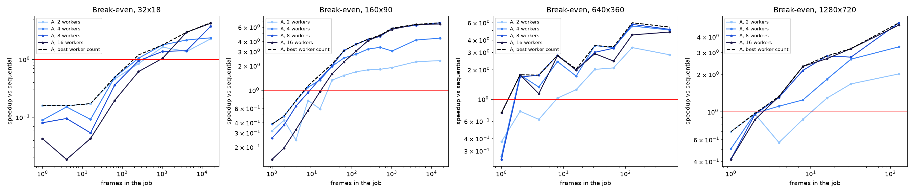
Figure 5. Speedup against the number of frames for four frame sizes (Device 1, Windows). Above the red line threads win.
- Device 2, fixed worker counts, against a pure sequential loop in which no thread is created: threads break even at about 12 frames of 160x90 video for 2 and 4 workers, 16 frames for 8 workers and 24 frames for 12 workers, that is when the sequential job takes about 0.8 to 1.8 ms (0.5 to 1.0 MB of frames). Below that the fixed cost of the parallel run is larger than the work it saves.
- Threads give 2x from about 48 frames (4, 8 and 12 workers) and 90% of their best speedup from about 100 frames (2 workers), 1,000 frames (8 workers) and 2,000 frames (12 workers). The best speedups are 1.9x, 3.2x, 4.3x and 5.0x for 2, 4, 8 and 12 workers. More workers need larger jobs to pay off, because the fixed cost grows with the worker count (434, 431, 668 and 894 microseconds).
- The model N_be = O(P) / (t1 x (1 - 1/S)), with O(P) the fixed cost, t1 the sequential time per frame and S the large-job speedup, predicts break-evens of 8 to 13 frames, the right order of magnitude; the measured values (12 to 24) are up to twice as large, probably because the first frames of a threaded run execute more slowly than the steady state the model assumes (not tested).
- The same sweep run on both laptops agrees in shape: for 160x90 frames Device 1 (zhaymn) breaks even at 8 frames and reaches 6.8x at 16,384 frames, Device 2 at 16 frames and 5.9x; for 32x18 frames both break even at 256 frames and reach 4.3x and 3.0x. Device 2 is later and lower, consistent with its 4+4 cores against 6+4 and its higher fixed cost.
- The rule is about work, not frame count: threads win once the sequential job takes more than about 1 to 2 ms. The videos in this project have about 14,000 frames, far above break-even; a program that handles small inputs should fall back to the sequential loop below about 50 frames of 160x90 video.
Caveats: the speedup at each size is the best over worker counts (a fixed count does worse on small jobs); the unpinned Windows baseline may flatter small sizes; the largest frame sizes show noisier times.

5.3 The overhead study: what a parallel run costs before it does any work
Running the threaded detector on zero frames isolates the fixed cost: creating the worker threads, each opening its own file handle and allocating its frame buffer, one claim from the mutex-protected counter, and the join. The cost grows roughly linearly with the worker count. Separately, the cost of individual operating-system operations was measured.
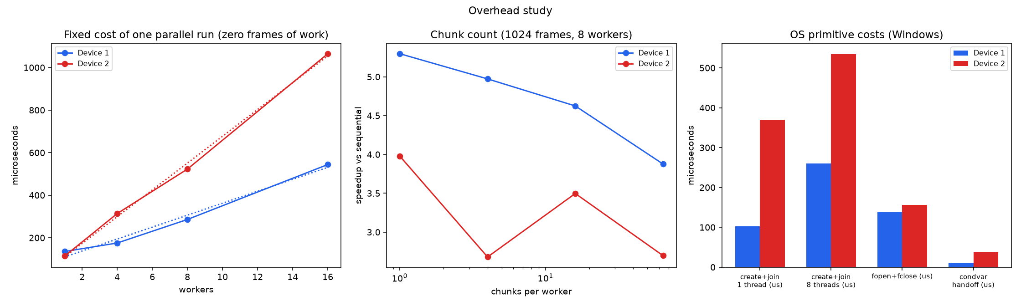
Figure 6. Left: fixed cost of one parallel run against the number of workers (dotted: straight-line fit). Middle: effect of the number of chunks per worker. Right: costs of OS primitives. Both devices, Windows.
device | fixed cost of one parallel run (a + b x workers, us) | create+join 1 thread (us) | create+join 8 threads (us) | fopen+fclose (us) | mutex uncontended (ns)
1 | 82 + 28 x P | 103 | 260 | 138 | 18
2 | 47 + 63 x P | 369 | 534 | 156 | 16

- The fixed cost of one parallel run on Device 2 is about 430 microseconds for 2 to 4 workers, 670 for 8 and 890 for 12 (zero frames of work, best of 25 rounds). The straight-line fit of the chunked detector gives 47 + 63 microseconds per worker on Device 2 against 82 + 28 on Device 1: Device 2 pays about twice as much per worker.
- Creating and joining one thread cost 369 microseconds on Device 2 against 103 on Device 1, and 8 threads 534 against 260; `fopen` plus `fclose` cost 156 against 138 and an uncontended mutex 16 against 18 nanoseconds. The primitive costs come from a single short measurement each (not best-of-N) and are sensitive to background load; the reason for the higher thread cost on Device 2 was not isolated.
- Thread creation and file opening dominate the fixed cost; the mutex is negligible (tens of nanoseconds per claim, about four claims per worker per run).
- Chunk count matters when chunks become tiny. For a 1,024-frame job with 8 workers, Device 1's speedup falls from 5.3x with one chunk per worker to 3.9x with 64 (512 chunks of 2 frames, each recomputing one overlap frame); Device 2 shows the same direction but non-monotonically (4.0, 2.7, 3.5, 2.7). For a whole 14,000-frame video the effect is small (earlier chunk study: flat from 1 to 64), which is why the design uses 4 chunks per worker.

5.4 Efficient reading: how frames get to the workers
Every frame must travel from the file cache to a worker. Eleven strategies were compared on Device 2, each at 1 to 12 workers: fread with one frame per call (what the detector uses), fread with 4, 16 and 64 frames per call, Win32 ReadFile with a sequential-access hint (1 and 16 frames per call), a memory-mapped file with and without prefetching, a no-file-access ceiling (histograms of frames already in memory) and read-only variants without any computation. The gap to the ceiling is the price of reading.
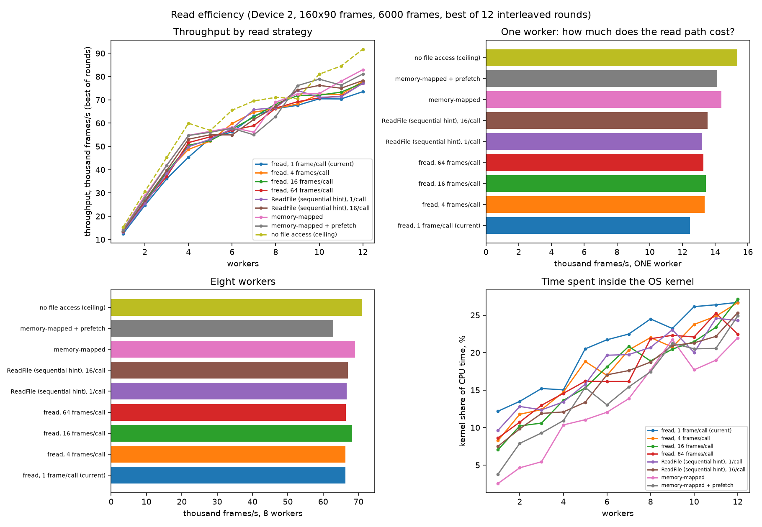
Figure 7. Throughput by read strategy (top left), one worker (top right), eight workers (bottom left), and kernel share of CPU time (bottom right). Device 2.
read strategy | 1 worker (fps) | 4 workers | 8 workers | 12 workers | kernel share at 8 workers | best / ceiling at 8
fread, 1 frame/call (current) | 12463 | 45379 | 66235 | 73523 | 24% | 93%
fread, 4 frames/call | 13366 | 48714 | 66233 | 77940 | 22% | 93%
fread, 16 frames/call | 13438 | 50443 | 68242 | 77237 | 19% | 96%
fread, 64 frames/call | 13280 | 51646 | 66447 | 77109 | 22% | 93%
ReadFile (sequential hint), 1/call | 13172 | 49861 | 66631 | 77123 | 21% | 94%
ReadFile (sequential hint), 16/call | 13540 | 53112 | 67047 | 78306 | 19% | 94%
memory-mapped | 14383 | 54758 | 68988 | 82973 | 18% | 97%
memory-mapped + prefetch | 14122 | 54687 | 62807 | 81119 | 17% | 88%
no file access (ceiling) | 15340 | 59966 | 71071 | 91747 | 18% | 100%
(read only, no compute) io | 114264 | 244200 | 264760 | 273560 | 66% | -
(read only, no compute) rfio16 | 204290 | 476380 | 438468 | 392259 | 48% | -

The earlier four-way split on all 12 CPUs (full, compute only, read only, memory-mapped), frames per second:
workers | full | compute | io | mmap
1 | 9856 | 11208 | 98070 | 10842
2 | 16161 | 22032 | 138378 | 21134
3 | 21891 | 27205 | 148821 | 22591
4 | 27370 | 33439 | 178313 | 32257
5 | 33770 | 42181 | 223681 | 36595
6 | 39418 | 46145 | 178286 | 43009
7 | 45665 | 51284 | 234329 | 47086
8 | 50337 | 61436 | 222007 | 55979
9 | 50544 | 68463 | 206712 | 63155
10 | 62911 | 60079 | 215124 | 67041
11 | 68552 | 51573 | 240048 | 57796
12 | 72143 | 63442 | 231535 | 58545

Device 1 (zhaymn) measured on Windows that 35 to 50% of worker CPU time is kernel time, almost all of it copying frames out of the file cache inside ReadFile, against 10 to 15% on Linux (WSL2); at 16 workers the job used 1.7x (Linux) to 2.3x (Windows) the CPU time of the sequential loop for the same frames.
- Reading costs about 19% of single-thread speed. One worker reaches 12.5k frames per second with fread against a 15.3k ceiling with no file access at all.
- Memory-mapping recovers most of it: 14.4k frames per second with one worker (94% of the ceiling), 69.0k with 8 workers (97%) and 83.0k with 12 workers (90%), which is 13% above fread at 12 workers. The mapping removes the read call and the copy.
- Reading larger batches helps a little: 16 frames per fread call gives +8% with one worker and +11% with four, but only +3 to +5% with 8 to 12 workers; Win32 ReadFile with a sequential hint is about the same as fread; prefetching the mapped range did not help.
- The file cache is never the bottleneck here. Reading alone costs 9 microseconds per frame against about 80 microseconds for the whole frame, and it tops out near 270k frames per second (about 11.7 GB/s), several times what the detector needs (about 75k frames per second, 3.2 GB/s).
- Kernel time grows with the worker count (24% of CPU time at 8 workers with fread, against 18% for the no-read ceiling, whose kernel time is thread start-up and page faults), but the larger effect on scaling is core type, not the read path.

5.5 Throughput and scaling with the number of workers
Chunk-based detector on 4 real videos, one to twelve workers; speedup is relative to the single-threaded baseline pinned to the fastest performance-core thread.
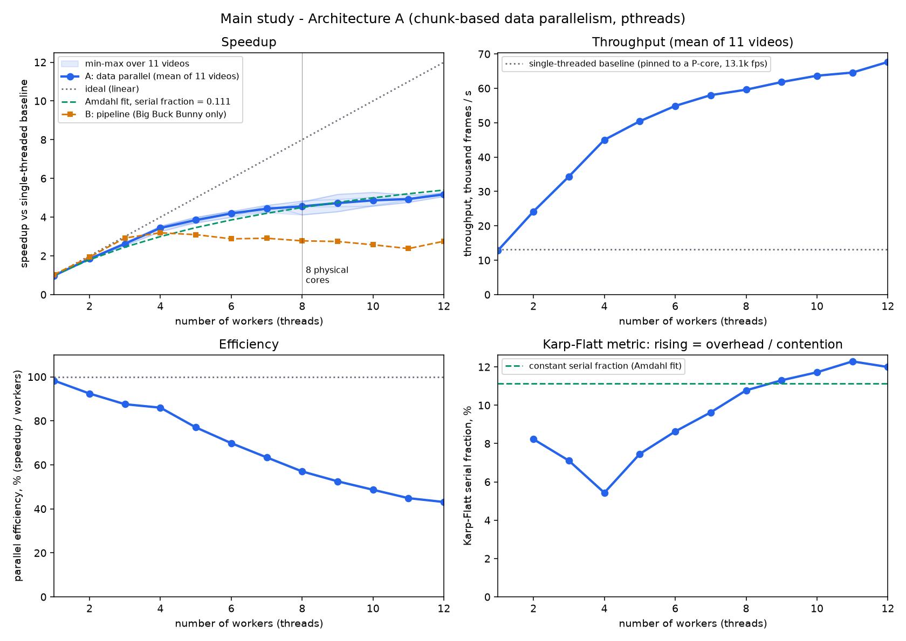
Figure 8. Speedup, throughput, efficiency and Karp-Flatt metric against the number of workers.
workers | mean_seconds | frames_per_s | speedup | speedup_min | speedup_max | efficiency_pct | karp_flatt_pct
1 | 1.1175 | 12858 | 0.98 | 0.95 | 1.0 | 98
2 | 0.5942 | 24182 | 1.85 | 1.83 | 1.86 | 92 | 8.2
3 | 0.4182 | 34359 | 2.63 | 2.53 | 2.7 | 88 | 7.1
4 | 0.3198 | 45016 | 3.44 | 3.26 | 3.53 | 86 | 5.4
5 | 0.2858 | 50433 | 3.85 | 3.7 | 4.0 | 77 | 7.5
6 | 0.2625 | 54890 | 4.19 | 4.0 | 4.31 | 70 | 8.6
7 | 0.2478 | 58022 | 4.44 | 4.24 | 4.62 | 63 | 9.6
8 | 0.2415 | 59611 | 4.56 | 4.12 | 4.83 | 57 | 10.8
9 | 0.2335 | 61832 | 4.73 | 4.28 | 5.18 | 53 | 11.3
10 | 0.2265 | 63677 | 4.87 | 4.57 | 5.28 | 49 | 11.7
11 | 0.2228 | 64590 | 4.94 | 4.76 | 5.15 | 45 | 12.3
12 | 0.2122 | 67674 | 5.17 | 5.07 | 5.27 | 43 | 12.0

Workers | Speedup vs pinned baseline | Speedup vs unpinned baseline
2 | 1.85x | 1.87x
4 | 3.44x | 3.49x
6 | 4.19x | 4.25x
8 | 4.56x | 4.62x
10 | 4.87x | 4.93x
12 | 5.17x | 5.24x

- Near-linear to 4 workers, then a bend. With the baseline pinned to the fastest performance-core thread, speedup is 3.4x at 4 workers (86% efficiency), 4.6x at 8 and 5.2x at 12 (43% efficiency), i.e. from 12,900 to 67,700 frames per second on four videos (best of 7 runs). The first study, on all 11 videos (median of 5 runs, unpinned baseline), gave 5.19x at 12 workers, which agrees.
- The shortfall is not serial code. The Karp-Flatt serial fraction rises from 5.4% at 4 workers to 12.0% at 12; a fixed serial part would keep it constant. The only serial step, the threshold, takes about 20 microseconds. Sections 5.4 to 5.7 show where the rest goes: the extra workers run on slower resources (hyper-thread siblings and efficiency cores).
- Baseline check. The unpinned baseline was only about 1% slower than the one pinned to the fastest performance-core thread, so the speedup at 12 workers is 5.17x against the pinned and 5.24x against the unpinned baseline: the headline was not inflated on this machine. On Device 1, zhaymn observed Windows putting the unpinned baseline on an efficiency core, so this effect depends on the machine and the run, and the baseline should always be pinned.

5.6 Scaling inside different sets of CPUs (Device 2)
To find out what ends the scaling, the same workload was run with the process restricted to different sets of logical CPUs. The machine has 4 performance cores with two hardware threads each (logical CPUs 0 to 7) and 4 efficiency cores (8 to 11). The sets include one single logical CPU, so threads that share one core can be compared with threads on separate cores.
Logical CPU | Physical core | Class (from Windows)
0 | 0 | performance core
1 | 0 | performance core
2 | 2 | performance core
3 | 2 | performance core
4 | 4 | performance core
5 | 4 | performance core
6 | 6 | performance core
7 | 6 | performance core
8 | 8 | efficiency core
9 | 9 | efficiency core
10 | 10 | efficiency core
11 | 11 | efficiency core

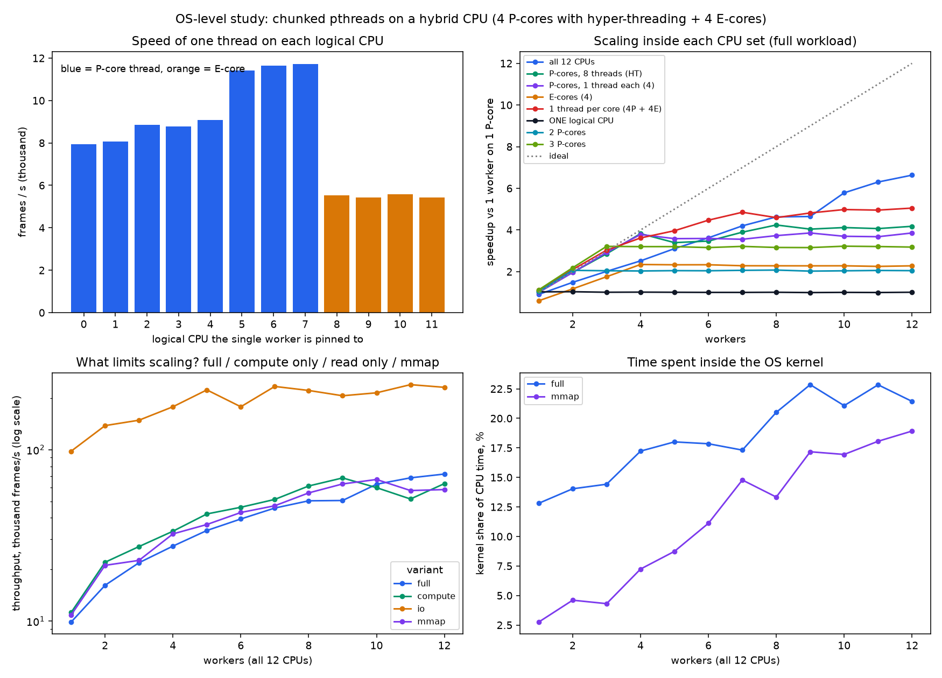
Figure 9. Top left: speed of one thread pinned to each logical CPU. Top right: scaling inside each CPU set. Bottom left: which part limits scaling. Bottom right: share of CPU time spent in the kernel.
Speedup of the full workload against one worker on one performance core, by CPU set:
workers | all | p8 | p4 | e4 | core8 | c1 | c2 | c3
1 | 0.91 | 1.10 | 1.00 | 0.60 | 1.12 | 1.03 | 1.04 | 1.13
2 | 1.49 | 1.96 | 1.96 | 1.17 | 2.10 | 1.04 | 2.06 | 2.19
3 | 2.01 | 2.86 | 2.92 | 1.76 | 3.03 | 1.01 | 2.04 | 3.21
4 | 2.52 | 3.82 | 3.78 | 2.34 | 3.62 | 1.02 | 2.03 | 3.20
5 | 3.10 | 3.39 | 3.58 | 2.33 | 3.96 | 1.01 | 2.05 | 3.20
6 | 3.62 | 3.47 | 3.59 | 2.33 | 4.47 | 1.00 | 2.04 | 3.16
7 | 4.20 | 3.89 | 3.55 | 2.28 | 4.85 | 1.00 | 2.06 | 3.21
8 | 4.63 | 4.24 | 3.73 | 2.28 | 4.59 | 1.01 | 2.08 | 3.16
9 | 4.65 | 4.04 | 3.86 | 2.28 | 4.82 | 0.99 | 2.02 | 3.15
10 | 5.78 | 4.12 | 3.70 | 2.28 | 4.98 | 1.00 | 2.04 | 3.22
11 | 6.30 | 4.07 | 3.68 | 2.25 | 4.95 | 1.00 | 2.06 | 3.21
12 | 6.63 | 4.18 | 3.86 | 2.28 | 5.05 | 1.01 | 2.05 | 3.18

- Single-thread speed: best P-core thread 11726 fps, best E-core 5569 fps -> P is 2.11x faster than E.
- all 12 CPUs: best speedup 6.63x at 12 workers
- P-cores, 8 threads (HT): best speedup 4.24x at 8 workers
- P-cores, 1 thread each (4): best speedup 3.86x at 12 workers
- E-cores (4): best speedup 2.34x at 4 workers
- 1 thread per core (4P + 4E): best speedup 5.05x at 12 workers
- ONE logical CPU: best speedup 1.04x at 2 workers
- 2 P-cores: best speedup 2.08x at 8 workers
- 3 P-cores: best speedup 3.22x at 10 workers
- variant full: 9.9k frames/s with 1 worker, 72.1k with 12 workers (best 72.1k)
- variant compute: 11.2k frames/s with 1 worker, 63.4k with 12 workers (best 68.5k)
- variant io: 98.1k frames/s with 1 worker, 231.5k with 12 workers (best 240.0k)
- variant mmap: 10.8k frames/s with 1 worker, 58.5k with 12 workers (best 67.0k)
- Performance cores scale almost perfectly, one core at a time: 2 cores give 2.06x, 3 cores 3.21x and 4 cores (one thread each) 3.78x, 94% of ideal. Extra workers beyond the number of cores add nothing and cost almost nothing.
- A hyper-thread sibling adds only about 12% of a core: 8 threads on the 4 performance cores give 4.24x against 3.78x with one thread per core.
- Each efficiency core adds about half to 0.6 of a performance-core thread: one E-core thread ran at 5.6k frames per second against 11.7k for the fastest P-core thread, and four E-cores together give 2.3x.
- The plateau is the capacity of the machine. Adding what the pieces contribute, 3.78 (four P-cores) + 0.46 (their hyper-threads) + 2.3 (four E-cores) = about 6.5x, which matches the 6.6x measured with all 12 CPUs. Threading overhead is not what ends the scaling.
- One single logical CPU: 1.0x for 1 to 12 workers. Threads that share one CPU add no speed, and time-slicing 12 of them costs under 3%: more threads than CPUs is harmless but useless.
- With placement left to the scheduler, 4 workers reach only 2.5x, against 3.8x when pinned one per performance core. Windows does not always put four workers on four separate performance cores; each worker visited about three different logical CPUs (Section 5.7).
- One hardware thread on each of the 8 physical cores (4P + 4E): 5.0x against an ideal of about 6.1x. This test harness splits the frames equally between workers, so the slower E-core workers finish last; the real detector claims chunks dynamically and avoids that (Section 5.7).

5.7 Worker-level analysis (Device 2)
For each worker thread the harness recorded how many chunks and frames it processed, its busy time, its user and kernel CPU time, and the logical CPU each chunk started on. This shows how well dynamic scheduling balances the load and what the operating system does with the threads.
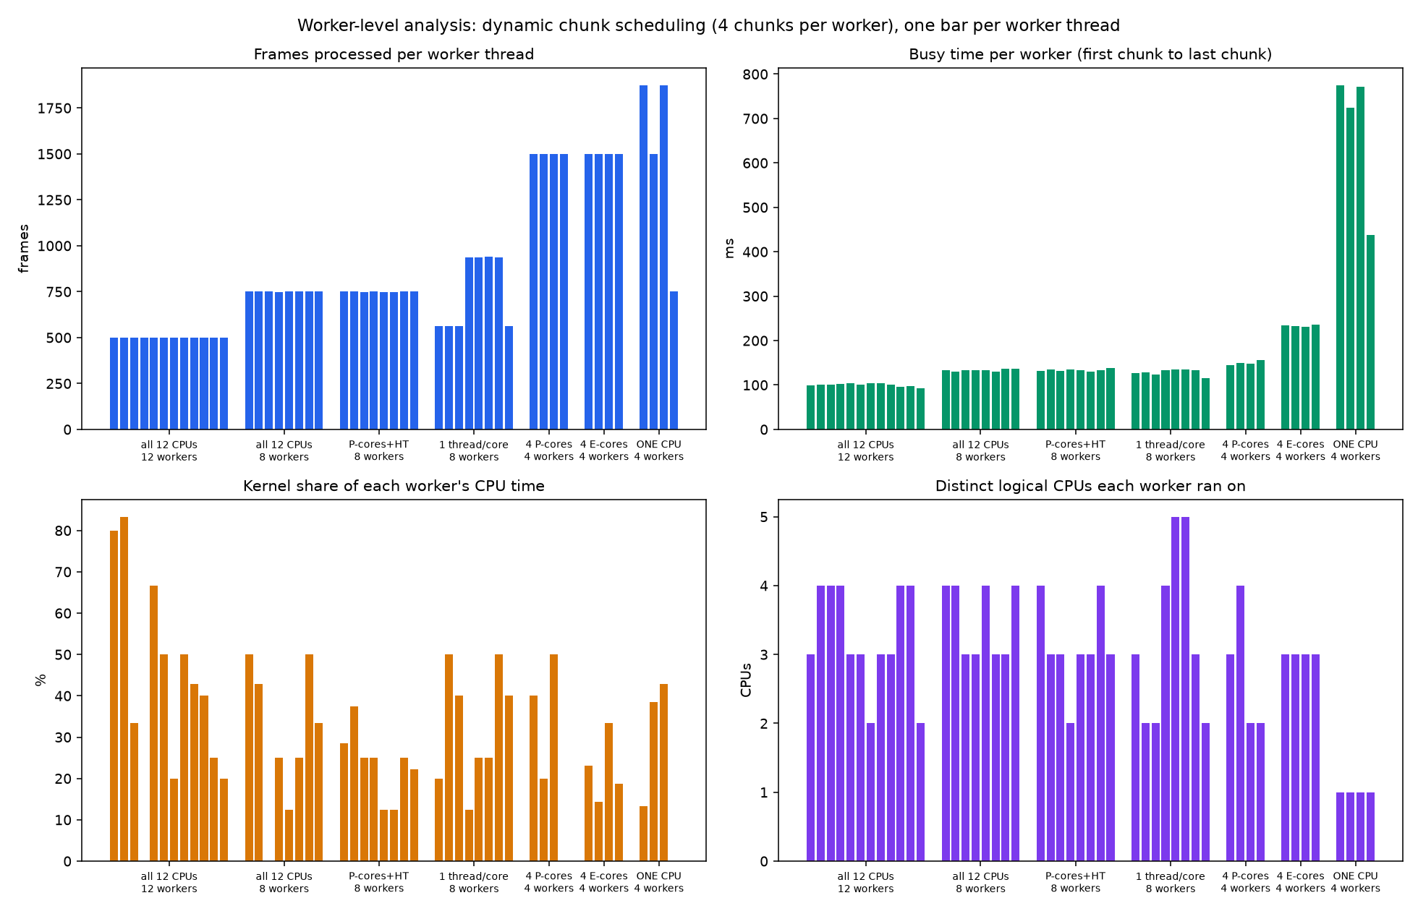
Figure 10. One bar per worker thread, for several CPU sets: frames processed, busy time, kernel share of CPU time, and number of different logical CPUs each worker ran on.
config | wall (median run, s) | frames/worker min-max | load imbalance (max/mean frames) | chunks started on P / E cores | distinct CPUs per worker (mean) | kernel share of CPU time
all 12 CPUs, 12 workers | 0.115 | 500-500 | 1.00 | 71% / 29% | 3.2 | 44%
all 12 CPUs, 8 workers | 0.142 | 749-751 | 1.00 | 69% / 31% | 3.5 | 30%
P-cores+HT, 8 workers | 0.145 | 748-752 | 1.00 | 100% / 0% | 3.1 | 23%
1 thread/core, 8 workers | 0.137 | 562-939 | 1.25 | 69% / 31% | 3.2 | 31%
4 P-cores, 4 workers | 0.158 | 1500-1500 | 1.00 | 100% / 0% | 2.8 | 28%
4 E-cores, 4 workers | 0.238 | 1500-1500 | 1.00 | 0% / 100% | 3.0 | 22%
ONE CPU, 4 workers | 0.810 | 750-1875 | 1.25 | 100% / 0% | 1.0 | 27%

- With threads free to move (all 12 CPUs) every worker processed exactly the same number of frames (500 each at 12 workers): the operating system time-slices and migrates threads, so each worker spent about 71% of its chunks on performance cores and 29% on efficiency cores, and visited about 3.2 different logical CPUs.
- With the process restricted to one hardware thread per physical core (4 performance + 4 efficiency CPUs) and 8 workers, the chunk counter did the balancing: workers that sat on performance cores took up to 939 frames and workers on efficiency cores 562, a ratio of 1.67 that matches the speed ratio of the two core types. Dynamic chunk claiming is what keeps a machine with mixed core speeds busy.
- Four workers on one logical CPU finished in 0.81 s, about the sequential time, with the frames shared unevenly (750 to 1875): time-slicing, no speedup.
- Kernel time is 22 to 44% of each worker's CPU time and grows with the number of workers (44% at 12 workers): copying frames out of the file cache and thread scheduling.

5.8 Hybrid cores and the baseline problem
On a CPU with performance and efficiency cores, the operating system decides where a thread runs. Device 1 measured a single thread to be 2.6 to 5.4 times slower on an efficiency core than on a performance core and observed Windows placing the unpinned baseline on an efficiency core, which makes the sequential time too slow and every speedup too good. This is why Section 5.5 reports the speedup against a baseline pinned to a fast performance core, and against the unpinned one.
- Device 2 measured an efficiency-core thread at 5.6k frames per second against up to 11.7k for a performance-core thread, so an E-core is about 0.47 of a P-core thread (Device 1 reported 2.6 to 5.4 times slower).
- Performance-core threads were not all equal in the single-thread test (7.9k to 11.7k frames per second between the lowest and the highest numbered CPU); the likely cause is interrupts and background work landing on the low-numbered CPUs, but this was not tested. It is the reason the baseline is pinned to the fastest measured thread.

6. How the design uses threads efficiently, and where it does not

6.1 What is efficient
- Independent work per frame. No dependency between workers except one overlap frame per chunk, under 2% redundant work for chunks of at least 64 frames.
- Dynamic chunk claiming. One mutex, taken about four times per worker per run, costing 18 to 60 ns each: below 0.01% of the run. Faster or less loaded cores take more chunks, which matters on a hybrid CPU.
- No locks on the results. Each worker writes only its own slice of the output arrays.
- One file handle per thread. No shared file position and no lock around reads.
- Almost no serial code. After the join only the 20-microsecond threshold step runs, so Amdahl's law is not what limits scaling.
- Threads only where worth it. The worker count is fixed per run; the crossover study shows that jobs of about 1 to 2 ms of sequential work or more benefit.

6.2 What is not efficient
- Beyond the performance-core thread count, extra workers add little wall-clock speed and a lot of CPU time (1.7 to 2.3x the sequential CPU time at 16 workers, Device 1).
- The read path. fread copies every frame out of the file cache; on Windows this is 35 to 50% of worker CPU time. Memory-mapping removes the copy and the read call (variant mmap in Section 5.5).
- Thread start-up is paid on every call; a small thread pool would remove 0.1 to 0.6 ms per call when the detector is called repeatedly.
- A pipeline design (one reader feeding workers through a queue) scaled worse than chunked workers (peak 3.8x against 5.2x on the same video), because the single reader and the queue lock become the bottleneck.

6.3 Recommendations
Fall back to a sequential loop below about 1 ms of work; cap the workers near the performance-core thread count; use chunks of at least 64 frames; memory-map the video; reuse threads through a small pool. These follow from the measurements and were suggested by zhaymn's analysis; only the memory-mapping effect is tested here, in Section 5.4.

7. Limitations
- Decoding is not measured. Frames are pre-decoded to raw; real codec decoding is excluded.
- Two laptops and a warm file cache. Numbers are not portable. Device 2 was measured on a shared machine using high priority, interleaved rounds and best-of-N; Device 1 was measured by zhaymn under their own conditions, with run-to-run variation of 15 to 30% on Windows.
- Device 2 coverage. Device 2 has the crossover study, the replicated sweeps (160x90 and 32x18), the overhead and primitive costs, the read-strategy study, the CPU-set scaling, the per-worker analysis and the pinned-baseline main study. It was not measured on Linux, nor with 640x360 and 1280x720 frames, nor at high priority in the replicated sweep (Device 1 only).
- Absolute speedups differ by about 15% between harnesses: 5.2x for the real detector on four videos (14,000 frames each), 5.0x in the crossover study (14,000 frames), 5.9x in the replicated sweep (16,384 synthetic frames) and 6.6x in the CPU-set harness (6,000 frames, equal static split, no result storage). This is the same size as the run-to-run variation; the real detector on real videos (5.2x, and 5.19x on 11 videos) is the headline figure.
- Linux is WSL2, a virtual machine, not native Linux.
- Hybrid-core explanations rest on the controlled CPU-set experiments; no hardware performance counters were used.
- Hard cuts only; fades and dissolves are mostly missed. The cut accuracy is measured against another detector, not human labels.
- Scene accuracy is moderate (F1 about 0.35) on a small test set of 116 boundaries; the gain from the richer shot description is not statistically established.

8. Conclusion
The classical histogram detector is a clean case of data parallelism, and the chunk-based design with a mutex-protected chunk counter, one file handle per thread, disjoint output slices and a post-join threshold produces identical results at every worker count. It reaches a speedup of 5.17x at 12 workers on Device 2 (3.44x at 4), and 6 to 7x on Device 1, with almost no serial code. A fixed number of workers beats a pure sequential loop from about 12 to 24 frames of 160x90 video on Device 2 (about 1 to 2 ms of work) and from 8 frames on Device 1. The controlled experiments of Section 5 separate the effect of core type, hyper-threading, file reads and compute on the speedup, and the worker-level analysis shows how the scheduler spreads the chunks. Accuracy is good for hard cuts (F1 0.91) and moderate for scenes (F1 about 0.35).

Appendix A. Files and how to run
File | Purpose
c/common.[ch], c/threshold.c | histogram, distance, adaptive threshold
c/seq.c, c/arch_a.c | single-threaded baseline; chunk-based data-parallel detector
c/arch_b.c | pipeline (reader / queue / workers) used as a comparison
c/scenes.[ch], c/features.[ch], c/scene_api.c | scene stage and keyframe descriptors
tools/osstudy.c, tools/cpu_topology.c | Device 2 OS study: CPU sets, variants, per-worker analysis, per-CPU speed
tools/osbench.c, tools/analyze_osbench.py (zhaymn) | OS benchmark harness: break-even sweeps, overheads, primitives
tools/replicate_zhaymn.py, plot_devices.py | re-run of the whole Device 1 study on Device 2, and two-device comparison
tools/run_all_os.py, quiet.py | one command for the OS study; --level 1/2/3, --robust
tools/study.py, plot_study.py, scene_cv.py, audit_metric.py | main scaling study, scene evaluation and metric audit
tests/test_invariance.py | thread-count and chunk-size invariance tests

Everything for the OS study: python tools/run_all_os.py --level 1 --robust (about 20 minutes, works on a busy laptop); --level 3 adds the full replication of Device 1's study. Data and figures are written to results/.

Appendix B. References and credits
- zhaymn: OS-level benchmark harness, Device 1 measurements and analysis (repository results/os_analysis/, tools/osbench.c).
- Zhang, H. J., Kankanhalli, A., Smoliar, S. W. (1993). Automatic partitioning of full-motion video. Multimedia Systems, 1(1).
- Yeo, B.-L., Liu, B. (1995). Rapid scene analysis on compressed video. IEEE Trans. Circuits and Systems for Video Technology, 5(6).
- Bhattacharyya, A. (1943). On a measure of divergence between two statistical populations defined by their probability distributions. Bull. Calcutta Math. Soc., 35.
- Liu, C., Wang, D., Zhu, J., Zhang, B. (2013). Learning a contextual multi-thread model for movie/TV scene segmentation. IEEE Trans. Multimedia, 15(4).
- Baraldi, L., Grana, C., Cucchiara, R. RAI scene dataset (ten broadcast videos with human scene labels).
- Blender Foundation. Big Buck Bunny (2008), Creative Commons Attribution 3.0.
- Karp, A. H., Flatt, H. P. (1990). Measuring parallel processor performance. Communications of the ACM, 33(5).

