AIM:

**OUTPUT: t-test statistical test**

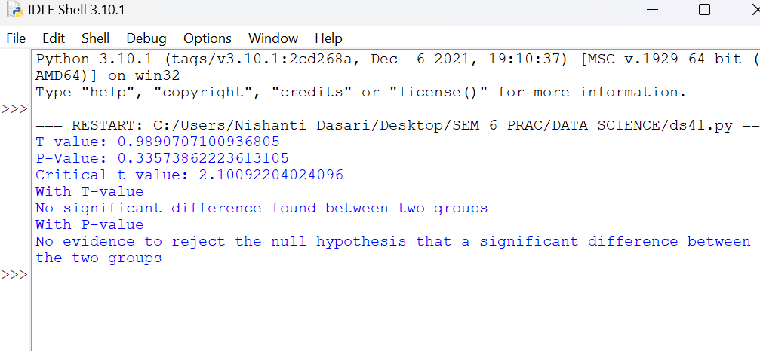

**2) TWO-test Hypothesis**

