**INPUT: Introduction To Excel**

1. **Perform Conditional Formatting On A Dataset Using Various Criteria.**

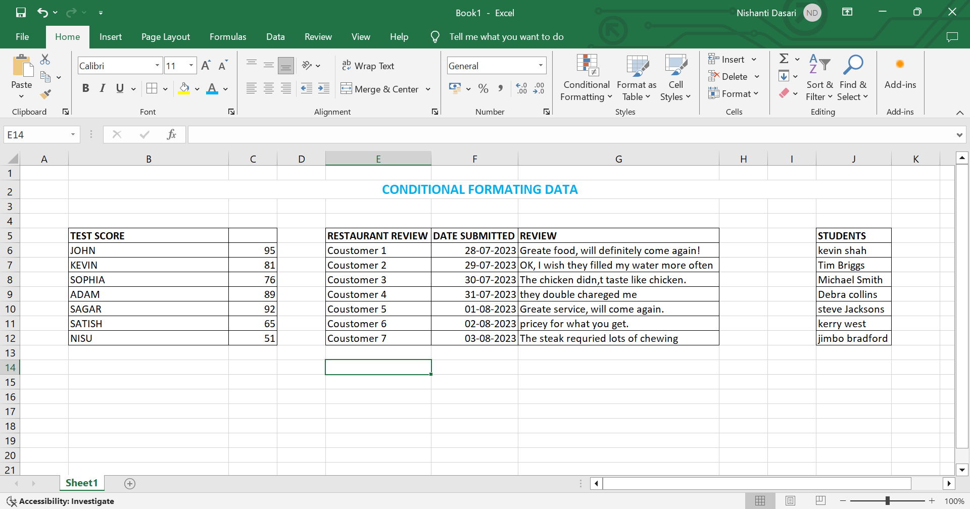

1. **Create A Pivot Table to Analyse and Summarize Data.**

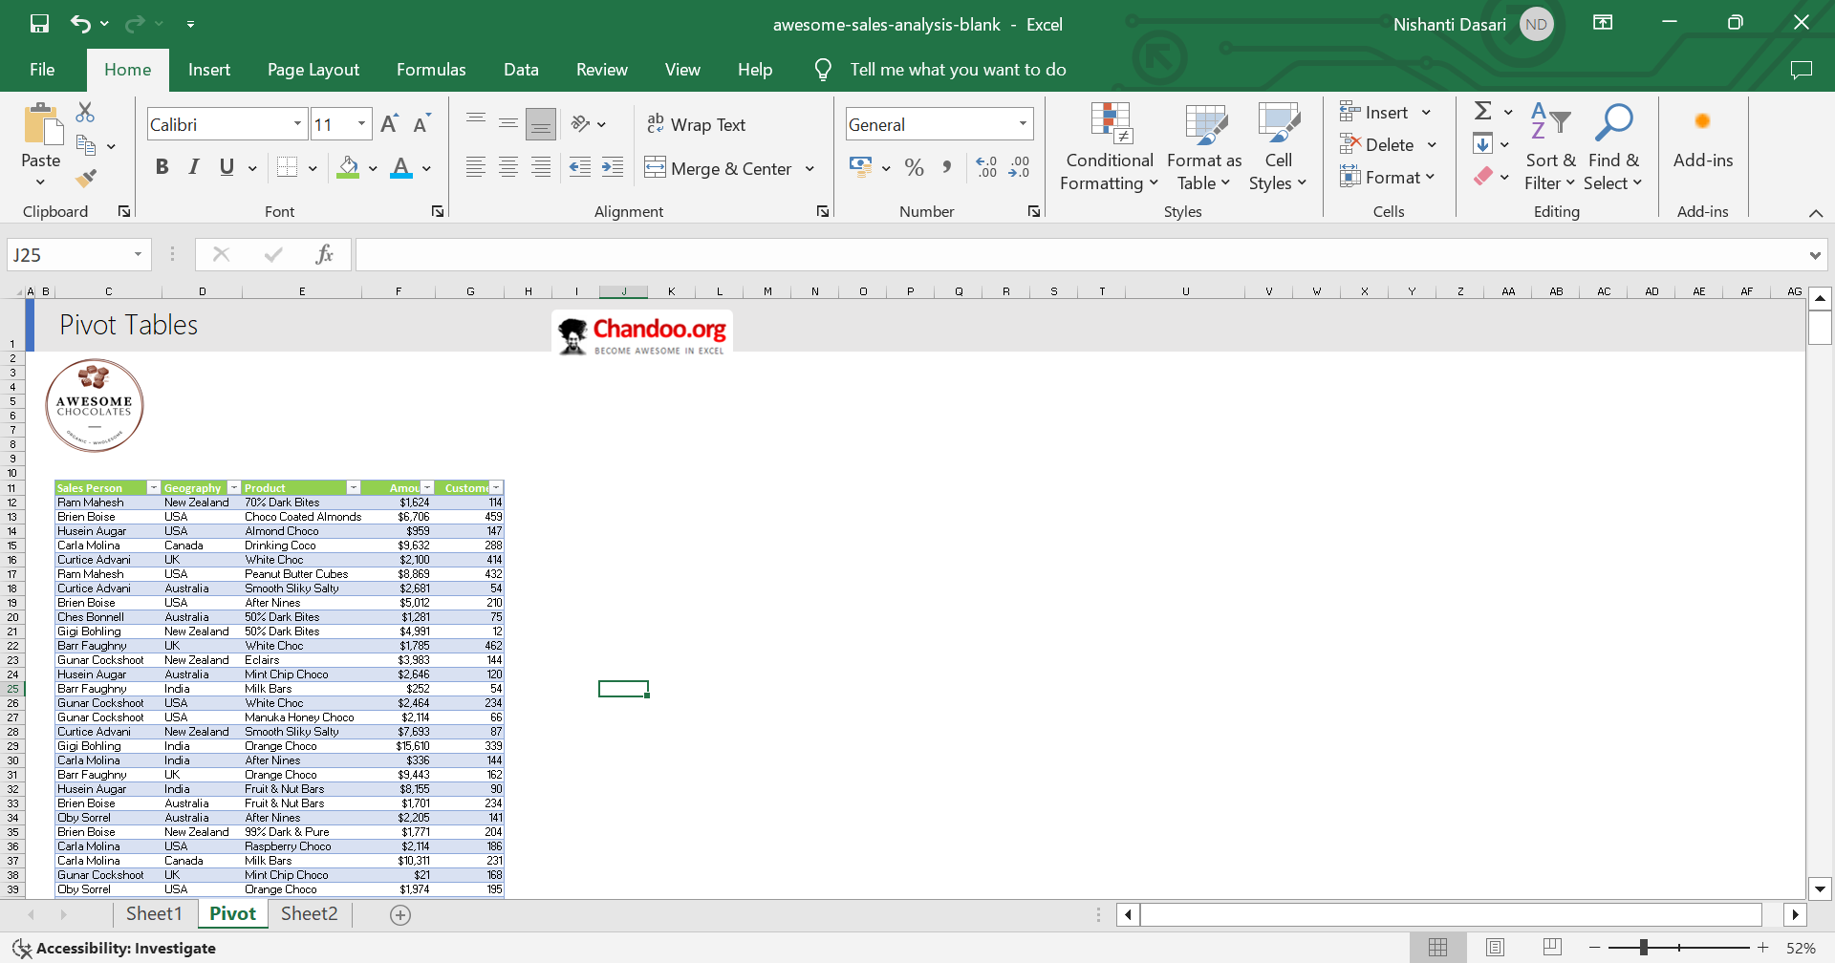

1. **Perform What-If Analysis Using Goal Seek to Determine Input Values for Desired Output.**

