

16

**GOOGLE ANALYTICS**

**DIRECTED STUDY**

**Jinsiwale, Nishant**

**Google Analytics**

1. **Comprehensive Overview:**

Google Analytics is a Free service offering a simple way to track metrics on your Website with the addition of a small snippet of code placed on all pages of your Website. Google Analytics allows you to see how visitors found your site, what pages they visited, how long they stayed on your site, among many other facts and figures. Properly understanding and interpreting the data available through Google Analytics will allow you to improve your Website, increase your conversions and increase your Website's effectiveness. **[1]**

Google Analytics (GA) is an easy-to-use tool to measure activity on a website. A basic setup might take as little as a few minutes, and many of the standard reports are quite accessible and understandable without any special training or prior knowledge of web analytics. **[2]**  
**[1]** [**http://www.epower.com/google-analytics-glossary**](http://www.epower.com/google-analytics-glossary) **[2] Page 3, Practical Google Analytics and Google Tag Manager for Developers**

**2) List of Ten Topics :**

* 1. **Traffic :**

The total number of visits to a particular Website is termed as Traffic. Within Google Analytics, traffic can be divided into multiple categories including, direct, organic and paid. The categories are explained below :

* + 1. **Direct Traffic:**

Ideally, this is the traffic that came to a site via bookmarks or by directly typing in the URL. In reality, it is the traffic for which the code couldn't determine a source. Depending on the site and the browser, some links may not show a referrer and instead would be categorized as direct. Using [campaign variables](http://www.analyticsmarket.com/freetools/urlbuilder) will get around this misrepresentation every time. **[3]**

* + 1. **Paid Traffic:**

This consists of visitors who come to your Website from Google AdWords ads, paid search engine keywords and other online paid ad campaigns. When investing in an advertising campaign, this data will show you how effective your paid online marketing program is. **[4]**

* + 1. **Organic Traffic:**

 This is the traffic that is referred by an unpaid search engine listing, e.g. a Google.com search. **[5]**

**[3][4] - http://www.analyticsmarket.com/blog/google-analytics-definitions  
[5] - http://analytics.blogspot.com/2009/08/back-to-basics-direct-referral-or.html**

* 1. **Devices :**

Google Analytics has an ability to see a wealth of data, especially if [goal tracking](https://www.hallaminternet.com/2014/how-to-setup-a-goal-in-google-analytics/) and [ecommerce tracking](https://www.hallaminternet.com/2013/direct-adwords-profitability-google-analytics/) are fully setup. And the below images show a dashboard of Device Categorized report of Revenue collected in Google Analytics platform. **[6]**

[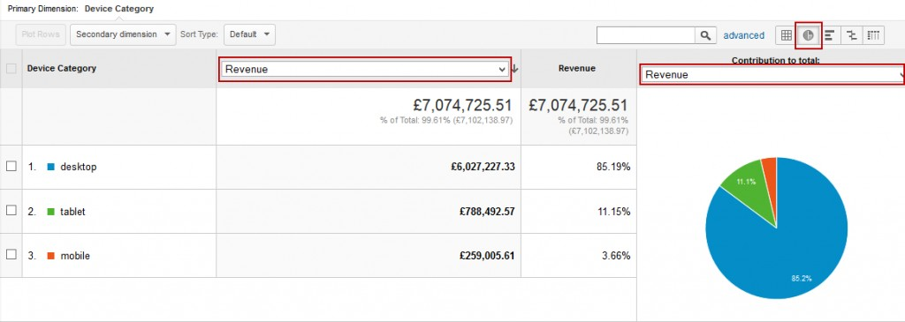](https://www.hallaminternet.com/assets/05-02-201413-55-52-3332-1024x365.jpg)

[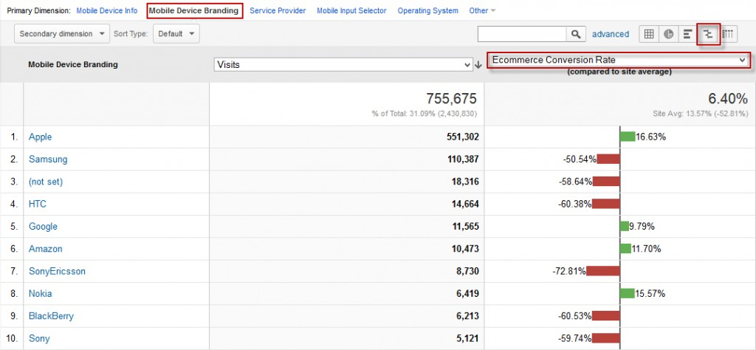](https://www.hallaminternet.com/assets/05-02-201414-12-08-3331-1024x474.jpg)

**[6] -** [**https://www.hallaminternet.com/google-analytics-desktop-vs-mobile-vs-tablet-metrics/#sthash.mTrKpFdF.dpuf**](https://www.hallaminternet.com/google-analytics-desktop-vs-mobile-vs-tablet-metrics/#sthash.mTrKpFdF.dpuf)

* 1. **Channel :**

The default system channel definitions reflect Analytics' current view of what constitutes each channel in the Default Channel Grouping. While these definitions may evolve as the market evolves, we provide the current definitions here for your information. **[7]**

|  |  |
| --- | --- |
| **Channel** | **Description** |
| Direct | Source exactly matches Direct AND Medium exactly matches (not set) OR Medium exactly matches (none) |
| Organic Search | Medium exactly matches organic |
| Social | Social Source Referral exactly matches Yes OR Medium matches regex ^(social|social-network|social-media|sm|social network|social media)$ |
| Email | Medium exactly matches email |
| Affiliates | Medium exactly matches affiliate |
| Referral | Medium exactly matches referral |
| Paid Search | Medium matches regex ^(cpc|ppc|paidsearch)$ AND Ad Distribution Network does not exactly match Content |
| Other Advertising | Medium matches regex ^(cpv|cpa|cpp)$ |
| Display | Medium matches regex ^(display|cpm|banner)$ OR Ad Distribution Network exactly matches Content |

**[7] - https://support.google.com/analytics/answer/3297892?hl=en**

* 1. **Site Performance :**

Google Analytics offers several powerful reports that can help businesses monitor how quickly web pages are loading and identify what factors may be causing poor performance. How quickly a website loads can have a direct impact on user experience and, in the case of ecommerce sites, user experience can have a direct impact on conversions, sales, and profit.

Google Analytics captures load times and other page performance data from about one percent of a site’s total traffic. This metric is made up of two factors, including the time it takes the server to respond to the page request and the time it takes the browser to parse, download, and display the page.

Google Analytics also breaks down the individual steps in the page loading process, capturing, among other things, the following items.

* **Average Redirection Time.** Measures how long it takes the site to redirect from one URL to another before the page is fetched.
* **Average Domain Lookup Time.** Measures the time spent associating a domain name with its assigned server. In some cases, changing the company that provides a site’s DNS registration can improve this aspect of page performance.
* **Average Server Connection Time.** Measures the time needed to connect to the web server.
* **Average Server Response Time.** Measures the time necessary for the server to respond, including the time the response takes to get to the user’s browser.
* **Average Page Download Time.** Measures how long it takes the browser to download the page content.
* **Average Document Interactive Time.** Measures the average number of seconds the browser requires to parse the page’s document object model (DOM) to a point at which the user can begin interacting the page, even if the page DOM has not completely loaded.
* **Average Document Content Loaded Time.** Measures the average number of seconds needed for the browser to parse the DOM completely, but not to a point at which not all of the style sheets or pictures have completely loaded. **[8]**

**[8] - http://www.practicalecommerce.com/articles/69720-Use-Google-Analytics-Site-Speed-to-Identify-Performance-Problems**

* 1. **) Goals :**

A measure of something you want to track in Google Analytics that you define as a success. Goals must relate to a quantifiable action that your Website's visitors take, such as product purchases, newsletter sign ups, or downloads. Goals are set up in Google Analytics to track conversions. **[9]**

* 1. **Funnels :**

Series of steps a visitor completes to reach an end goal. Google Analytics allows you to indicate up to ten pages in each funnel definition. Creating funnels can show you where visitors abandon the process during the path to conversion. [10]

**[9][10] - http://www.epower.com/google-analytics-glossary**

* 1. **Multi-Channel Attribution :**

In Analytics, conversions and Ecommerce transactions are credited to the last campaign, search, or ad that referred the user when he or she converted. But what role did prior website referrals, searches, and ads play in that conversion? How much time passed between the user's initial interest and his or her purchase?

*The*Multi-Channel Funnels reports answer these questions and others by showing how your marketing channels (i.e., sources of traffic to your website) work together to create sales and conversions.

For example, many people may purchase on your site after searching for your brand on Google. However, they may have been introduced to your brand via a blog or while searching for specific products and services. *The*Multi-Channel attributionreports show how previous referrals and searches contributed to your sales. **[11]**

**[11] - https://support.google.com/analytics/answer/1191180?hl=en**

* 1. **Data Administration :**

The Admin tab of Google Analytics gives you access to all of GA’s settings, and you’ll find that it’s organized in the same way, by account, property, and view (from left to right). Each of the three columns is a menu of settings for that level, and the drop-down menus at the top of each column control which account, property, or view you’re seeing.

What you’ll see in the Admin tab depends on which level of permissions your login has to GA. There are several levels of permissions that can be assigned to a login:

* ***Read & Analyze*** is the most basic level of permissions. This allows a user to view reporting data and create personal customizations, such as custom reports, alerts, dashboards, or segments.
* ***Collaborate*** is the next level. It includes everything that Read & Analyze can do, as well as the ability to share customizations with other users.
* ***Edit*** includes everything that Collaborate can do, with the addition of the ability to change settings in the Admin area.
* ***Manage Users*** is a separate permissions level from Read & Analyze, Collaborate, or Edit, and does *not* include those abilities (though it can be given in addition to them for a user). Manage Users gives the ability to add or remove permissions for other logins. **[12]**

**[12] – Page 5, Practical Google Analytics and Google Tag Manager for Developers**

* 1. **Data Collection :**

Google Analytics captures a wide variety of data. Data is sent to GA by means of a tracking ***hit***. Each hit is a bundle of data about some specific type of interaction (viewing a page, for example).

GA specifies the format for this hit data with a data collection specification called the Measurement Protocol. The Measurement Protocol is agnostic about the source of the data—as long as the hit is in the right format, the data will be collected into Google Analytics. **[13]**

**[13] - Page 6, Practical Google Analytics and Google Tag Manager for Developers**

**3) Analytics and ROI for Managers:**

* 1. **Defining ROI :**

ROI is the gain from any spending minus the cost of the investment divided by the cost. This calculation yields a percentage either gained or lost from your investment

ROI is usually expressed as a percentage and is typically used for personal financial decisions, to compare a company's profitability or to compare the efficiency of different investments. The return on investment formula is:   
**ROI = (Net Profit / Cost of Investment) x 100**. **[14]**

For example, suppose Joe invested $1,000 in Slice Pizza Corp. in 2010 and sold his [shares](http://www.investopedia.com/terms/s/shares.asp) for a total of $1,200 a year later. To calculate the return on his investment, he would divide his profits ($1,200 - $1,000 = $200) by the investment cost ($1,000), for a ROI of $200/$1,000, or 20%. **[15]**

**[14] -** [**www.investinganswers.com/financial...analysis/return-investment-roi-1100**](http://www.investinganswers.com/financial...analysis/return-investment-roi-1100)

**[15] -  [http://www.investopedia.com/terms/r/returnoninvestment.asp#ixzz46KALt9BD](http://www.investopedia.com/terms/r/returnoninvestment.asp" \l "ixzz46KALt9BD)** 

**3.2) Types of Returns-based Analysis :**

Returns-based style analysis is a statistical technique used in [finance](https://en.wikipedia.org/wiki/Finance) to deconstruct the returns of investment strategies using a variety of explanatory variables. [16]

Returns-based style analysis is a statistical technique that identifies what combination of long positions in passive indexes would have most closely replicated the actual performance of a fund over a specified time period. And it can be classified in the following terms :

**3.2.1) Benchmark Indices**:

A popular application of returns-based style analysis is to use the weights or exposures to passive indexes to create a benchmark for the purpose of attribution analysis. A benchmark created with returns-based style analysis meets the major criteria for appropriately measuring manager performance: it is identifiable in advance, it is a viable alternative, it is not easily beaten, and it is easily constructed.

**3.2.2) Asset Allocation Policy :**

The other common application of returns-based style analysis is in implementing a strategic asset allocation policy. Investors have increasingly focused on targeting a given asset mix in hopes of locking in an expected rate of long-term return and risk

**3.2.3) Paradigm Shift :**

It is important to understand that estimating the historical behavior of a fund based on performance—as returns-based style analysis does—differs dramatically from calculating portfolio characteristics based on the portfolio holdings of a mutual fund. **[17]**

**[16] -** [**https://en.wikipedia.org/wiki/Returns-based_style_analysis**](https://en.wikipedia.org/wiki/Returns-based_style_analysis)

**[17]<https://corporate.morningstar.com/ib/documents/MethodologyDocuments/IBBAssociates/ReturnsBasedAnalysis.pdf>**

* 1. **Return on Engagement :**

One of the original variations on ROI is return on engagement (ROE), which measures the effect your organization’s social media activities have on engagement rates. It assumes that engagement with content leads to greater awareness, which then leads to higher likelihood of consideration, which then leads to greater likelihood to buy. The math behind ROE tends to vary, which is one of its primary issues, but it is calculated primarily by understanding the effect a community manager has on talking to someone after that person has mentioned the brand online. For example, if your company’s community manager reaches out to someone who has made a complaint about the brand and is able to rectify that complaint, then a potential ROE calculation might be the time it took to make the contact and resolve the issue. **[18]**

**[18] – Page 277, DigitalMarketingAnalytics, Chuck Hemann and Ken Burbary**

**3.4) Return on Marketing Investment (ROMI)**

ROMI is the contribution to profit attributable to [marketing](https://en.wikipedia.org/wiki/Marketing) (net of marketing spending), divided by the marketing 'invested' or risked.

The purpose of ROMI is to measure the degree to which spending on marketing contributes to profits. Marketers are under more and more pressure to “show a return” on their activities.**[19]**

Return on marketing investment (ROMI) is a metric used to measure the overall effectiveness of a marketing campaign to help marketers make better decisions about allocating future investments. In the simplest sense, ROMI is measured by comparing revenue gains against marketing investment. This calculation, however, reflects only the direct impact of marketing investment on a business's revenue. **[20]**

**[19] - https://en.wikipedia.org/wiki/Return_on_marketing_investment**

**[20] - (http://whatis.techtarget.com/definition/return-on-marketing-investment-ROMI)**

**3.5) Return on Marketing Investment (ROMI)**

ROAS measures gross revenue generated for every dollar spent on advertising. It is an advertiser-centric metric that gauges the effectiveness of online advertising campaigns.

**ROAS = revenue from ad campaign / cost of ad campaign**

With ROAS, marketing is considered a necessary cost of doing business vs. ROI, where marketing is an investment to grow a business’s profits incrementally. **[21]**

ROAS measures how much revenue you are making for every dollar you spend on advertising. It offers the direct result of each advertising dollar you spend.**[22]**

**[21] -** [**http://adexchanger.com/data-driven-thinking/roi-vs-roas-which-is-the-better-metric-for-digital-advertisers/**](http://adexchanger.com/data-driven-thinking/roi-vs-roas-which-is-the-better-metric-for-digital-advertisers/)

**[22] -** [**https://www.techwyse.com/blog/website-analytics/the-return-on-advertising-spend-metric/**](https://www.techwyse.com/blog/website-analytics/the-return-on-advertising-spend-metric/)

**3.6) Return on Influence:**

Likely the most popular variation on ROI is return on influence, which is an attempt to calculate how a particular activity in social media changes behavior.

The fundamental issue with the notion of return on influence is that it is not necessarily tied to a sales behavior. Sure, digital marketers could design a program in order to engage influencers to ultimately result in an increase in the number of purchases, but that is not often done. Most often digital marketers create influencer programs in order to grow volume of conversation and increase reach. A sale that results from that activity is great, but digital marketers often do not set up the mechanism to track that sort of behavior. The other fundamental issue with return on influence is that those who espouse its value assert that each entry into a social conversation creates influence or a transaction. **[23]**

**3.7) Return on Experience**

Perhaps the most radical variation of ROI is return on experience, which takes the notion of ROI and completely stands it on its head. The idea is for the brand to go above and beyond what the customer expects and earn outsized exposure by shocking the customer. Some believe that this type of shock to your customer will earn rapid word of mouth and will therefore reduce the cost per customer acquired. **[24]**

**3.8) Understanding the Top-Down Revenue :**

The three top-down revenue-tracking approaches discussed here offer marketers insight into how social media programs are performing.

These are the three types of top-down revenue measurement approaches:

**3.8.1) Anecdote:**

This is probably the most common of the three, and it involves a verbal “share” of a relationship between a social media activity and a sale.

This is likely to be the least concrete of the models we talk about here, but an anecdote is simply a verbally expressed relationship between social (or even digital) media and sales. Altimeter indicates that this is likely to be seen in large, often B2B, companies with high consideration and long sales cycles, but it would not be hard to visualize a consumer example of this type of activity. An example of this sort of anecdotal relationship could be something like you tweeting that you’re interested in buying a car. Let’s say that Scott Monty, global social media lead for Ford, follows up on your comment with a reply directing you to the Ford.com website. You might then reply to Scott to indicate that you are now much more likely to buy a car, thanks to his outreach. Is it a direct sale? No. Did Scott just create an opportunity for a sale to take place? Absolutely. And that kind of activity needs to be tracked whenever possible by the measurement or market research team.

**3.8.2) Correlation Analysis :**

A correlation analysis takes a certain type of social media behavior and tries to establish a relationship between it and some other activity.

This type of analysis is used to identify patterns in behavior. It could be anything: comparing likes on Facebook to sales, the relationship between engagement on Twitter and in-store traffic, or even more advanced models that look at economic indicators and marketing activities. The best thing about this type of analysis is that it can establish a relationship between social strategies, tactics, and business outcomes. It’s a well-established statistical approach so unlike return on engagement or return on influence you should not receive any pushback from internal stakeholders who are questioning the methodology.

**3.8.3) A/B Testing:**

In this type of analysis, a marketer attempts to understand the effectiveness of two versions of some type of content (for example, a web page, a marketing email, or a social media advertisement) in order to determine which has the best response rate. Multivariate testing can be thought of as many different A/B tests happening simultaneously.

Multivariate testing allows Internet marketers to ensure that visitors are being shown the right offers, content, and layout. **[25]**

**3.9) Utilizing Bottom-Up vs Top-Down Measurement Approaches:**

The bottom-up measurement models offer a bit more detail than the top-down approaches. This does not make them better than top-down approaches, as each organization needs to consider its goals before picking an approach. The reality is that both types of approaches need to be utilized in some form to tell a complete story.

The three primary methods of tracking revenue impact using bottom-up techniques:

**3.9.1) Linking & Tagging:**

Probably the most familiar method for seasoned digital marketers, linking and tagging uses a series of codes in order to track how a person comes to purchase your product.

the linking and tagging approach enables marketers to apply a short link, ROI tag, or cookie to a site in order to track the source of a conversion. A short link is simply a long URL that has been shortened using one of a number of link-shortening services (such as bitly or tinyurl). Marketers can use a shortened URL to easily track clicks to a web property or an ecommerce site where the end user may make a purchase. A cookie is usually a small piece of data sent from a website and stored in a user’s web browser while the user is browsing a website. When the user browses the same website in the future, the data stored in the cookie can be retrieved by the website to notify the website of the user’s previous activity. This allows a marketer to follow a particular person’s path to purchase as she lands on the page and eventually surfs around it before buying.

**3.9.2) Integrated:**

Just as the name implies, integrated measurement utilizes multiple techniques in order to gather information about how a particular person makes a purchase.

The integrated measurement approach utilizes an application, typically installed on a social property (most often Facebook) in order to track the user’s activity. This application can be a way to serve up special content to users or direct them toward a place where they can either receive a coupon or make a purchase directly. The best part about an integrated approach is that it tends to be very data rich. Here’s what this means for communicators:

• **Understanding consumer behavior:**  
 If you build an application that serves multiple types of content, these apps can help you understand what consumers want to see based on what they interact with the most.

• **Gathering consumer data:**

Most of these applications “force” users to enter a name and an email address. The email address can be valuable when it is cross-referenced against an existing email database. However, the best applications gather that information as well as other demographic characteristics that can be very valuable for future testing.

**3.9.3) Direct Commerce:**

This is probably the first “no duh” approach that we have outlined, but the direct commerce route utilizes some sort of selling functionality within the social network your brand is utilizing.

The most common method of doing this today is by creating a storefront on a social platform, such as Facebook, and selling your products directly from there. The direct (social) commerce route is the newest and has the most potential for direct correlation to sales. It is not something that very many have undertaken so far, and it probably will evolve to something well beyond a Facebook storefront.

The birth of social commerce in seven different dimensions are explained below:

• **Multichannel marketing**:   
This represents the shift from two marketing channels to five pillars (.com, brick-and-mortar, partners, employees, and customers).

• **New media networks**:   
Individual communities are forming across a variety of social media channels.

• **Customers reached through search:** Many of your customers might turn to a search engine before they ever look to you for information.

**• A new content model**:   
 This should go without saying, but customer driven content drives the highest conversion.

• **A new approach for retail**:   
 By understanding the effectiveness of each partner or OEM, you know how to build the right retail mix by brand, geography, and topic.

• **More effective media planning**:  
 Using data, we can become even smarter about how we target different types of paid, owned, earned, or shared media activities.

• **New demand:** Creating new demand requires a focus on the broader community and not the influencers in order to drive sales. **[26]**

**[23] - Page 278, DigitalMarketingAnalytics, Chuck Hemann and Ken Burbary**

**[24] - Page 280, DigitalMarketingAnalytics, Chuck Hemann and Ken Burbary**

**[25] - Page 281, DigitalMarketingAnalytics, Chuck Hemann and Ken Burbary**

**[26] - Page 284, DigitalMarketingAnalytics, Chuck Hemann and Ken Burbary**

**4) Guided Labs & Tutorials:**

**Unit 1: Platform Fundamentals:**

**Lesson 1: Course Overview**

When you know how Google Analytics works, you’ll be able to make informed decisions about how to collect the data you need. And, understanding the platform will help you better interpret and analyze your data since you’ll know where the data came from, and why it looks the way it does in your reports.

We’ll start this course by reviewing the structure of a Google Analytics account, and we’ll introduce you to the Google Analytics data model. From there, we’ll focus on the four components of the platform:

* **Collection**
* **Processing**
* **Configuration**
* **Reporting**

**Collection:**

To collect data, you need to add Google Analytics code to your website, mobile app or other digital environment you want to measure. This tracking code provides a set of instructions to Google Analytics, telling it which user interactions it should pay attention to and which data it should collect. The way the data is collected depends on the environment you want to track.

**Processing & Configuration**

During data processing, Google Analytics transforms the raw data from collection using the settings in your Google Analytics account. These settings, also known as the configuration, help you align the data more closely with your measurement plan and business objectives.

**Reporting**

After Google Analytics has finished processing, you can access and analyze your data using the reporting interface, which includes easy-to-use reporting tools and data visualizations. It’s also possible to systematically access your data using the Google Analytics Core Reporting API. Using the API you can build your own reporting tools or extract your data directly into third-party reporting tools.

**Lesson 2: Platform Components**

**1. Collection  
  2. Configuration   
  3. Processing  
 4. Reporting**

#### [27]

[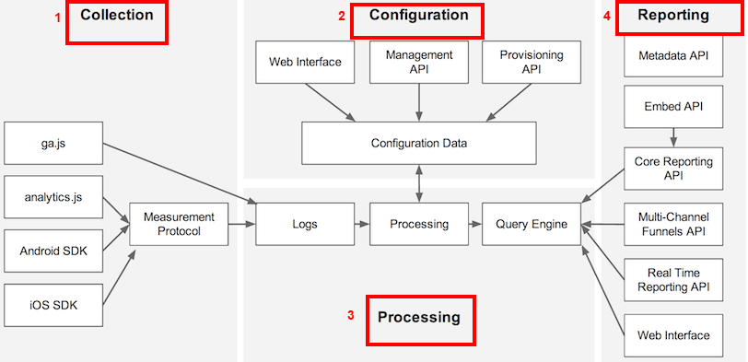](http://i0.wp.com/ppcsuccesscenter.com/wp-content/uploads/2014/09/how-google-analytics-works.png)

[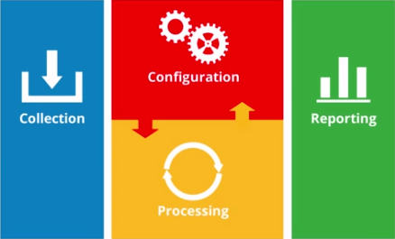](http://i2.wp.com/ppcsuccesscenter.com/wp-content/uploads/2014/09/Google-Analytics-Platform-Principles.png)

**Lesson 3: Data Model :**

In the basic data model used in Google Analytics, the user (visitor) interacts with your content over a period of time, and the engagement with your site is broken down into a hierarchy.

The diagram illustrates this model for a single visitor to your site, where each block represents the number of user sessions and interactions from that particular user.

**Each level in this model is defined as follows:**

|  |  |
| --- | --- |
| * **User (visitor)**—the client that visits the site, such as the browser or mobile phone operated by a person. * **Session (visit)**—the period of time during which the visitor is active on the site. * **Interaction (hit)**—the individual activities that send a GIF request (hit) to the Analytics servers. These are typically characterized by a pageview, but can include: * a pageview * an event (e.g. click on a movie button) * a transaction * a social interaction | https://analyticsacademy.withgoogle.com/course02/assets/img/GoogleAnalyticsAcademy-PlatformPrinciples-Lesson1.3-OverviewoftheGoogleAnalyticsdatamodel-Resource-000.png |

Each of these three levels of interaction defines a specific *scope* of user engagement. This distinction is important in Google Analytics because you may want to do analysis of your data at a particular scope. For example, you might want to measure the number of sessions where users removed an item from their shopping cart. For this particular case, you would be doing a session-level analysis that includes each session during which an item was removed from a cart, even if the sessions are from the same user. On the other hand, you might want to measure the number of unique users who removed items from their shopping cart at any time, regardless of session. For this example, you would be doing a user-level analysis. **[27]**

**[27] - https://analyticsacademy.withgoogle.com/course02/assets/html/GoogleAnalyticsAcademy-PlatformPrinciples-Lesson1.3-OverviewoftheGoogleAnalyticsdatamodel-Resource.html**

**Unit 2: Collection**

**Lesson 1: Data Collection Overview:**

Collection of data makes up the first one of the four main components that Google analytics depends on to generate reports. Google analytics is a powerful platform as it helps you to collect and measure user engagements and activities across different devices and environment.

Google Analytics lets you collect users interactions if you own [websites](https://developers.google.com/analytics/devguides/collection/analyticsjs/), [Android](https://developers.google.com/analytics/devguides/collection/android/v4/), [iOS](https://developers.google.com/analytics/devguides/collection/ios/v3/), or any digitally connected environment **[28]**

**Lesson 2: Website Data Collection:**

If you would like to track a website, you should generate a small piece of JavaScript code in order to gather information.  The code is easy to be set up on Google Analytics interface. Only you will need to follow simple and easy steps to have that snippet.

When you are done with setting up the [web-tracking code](https://developers.google.com/analytics/devguides/collection/analyticsjs/), you are going to copy and paste that code into every page of your website. Two things you should do keep in mind:

1. **Place the code in the header, i.e. before the closing </head>**
2. **The code should be located in every page.**  **[29]**

**Lesson 3: Mobile App Data Collection:**

Google Analytics is able of collecting data across many devices and environments. Said that, the way to implement the code and how data will be collected will **differ from website tracking**. The collection process is different in measuring interactions on Mobile app from websites. Mobile tracking – opposed to website tracking that use JavaScript – uses [SDK (Software Development Kit)](http://en.wikipedia.org/wiki/Software_development_kit) to collect user engagements on a certain operating system. **[30]**

**Lesson 3: Measurement Protocol Data Collection:**

The Google Analytics Measurement Protocol allows developers to make HTTP requests to send raw user interaction data directly to Google Analytics servers. This allows developers to measure how users interact with their business from almost any environment. Developers can then use the Measurement Protocol to:

* + - **Measure user activity in new environments.**
    - **Tie online to offline behavior.**
    - **Send data from both the client and server. [31]**

The [Measurement Protocol](https://developers.google.com/analytics/devguides/collection/protocol/v1/) lets you send data to Google Analytics from any web-connected device. Recall that the Google Analytics JavaScript and mobile SDKs automatically build hits to send data to Google Analytics. However, when you want to collect data from a different device, you must manually build the data collection hits. The Measurement Protocol defines how to construct the hits and how to send them to Google Analytics. **[32]**

**[27] [28] [29] [30] [31] [32] - http://ppcsuccesscenter.com/2014/09/18/four-main-components-of-google-analytics/**

**UNIT 3 : Processing & Configuration:**

**Lesson 1: Processing & Configuration Overview:**

GA is a super statistician and learning machine par excellence. Regardless of how data collected (JS or SDK ), when certain interactions or engagements (hits) took place in your website or app, they are sent right away to Google Analytics servers to be processed. In other words, this can be expressed as a transformation phase where raw data is being transformed into valuable insights and well organized data.

Transformation of data happens in four ways during processing. With configuration settings in your Properties and Views, you can take full control of how your data will be transformed or processed.

**First**, the collected hits are sorted by Google Analytics into users and sessions. Hits are the users interactions or engagements that occurred in your website or app. Remember, GA platform uses a number of rules to distinguish users and sessions. You can configure these rules in the configuration settings.

**Second**, importing data is possible with Google Analytics. For example, if you want your Google AdWords , Google webmaster tools or even non-Google data to be processed on Google Analytics, you need only to configure them on your account settings.

**Third**, any configurations that have been made will be processed the way it was configured.

**In the end**, here Google analytics utilizes a process named ” aggregation” where it presents and makes data ready in meaningful database tables. And voila, your data can be extracted easily any times you needthem.   [33]

**Lesson 2: Processing hits into sessions & users:**

**Users, sessions and interactions** are three ingredients that Google Analytics employs to organize data. Basically, those components come from the hits that Google Analytics tracking code send to its servers.

To explain, GA transforms **hits** into **users** by assigning a unique ID each time a visitor is being detected on the website based on the device (Desktop, mobile, app). This is how GA records a  New User. On other hands, a Returning User is counted when that Unique Id is being matched.

If those IDs erased or deleted by removing cookies on a browser or by re-installing an app, Google Analytics will create a new brand Unique ID. As a result, a New User will be computed instead of a Returning User.

**Sessions**are –in many analytics platforms– known as an amount of interactions, engagements, or hits from a specific user during a limited period of time. For instance, this may include social interactions, e-commerce transactions or page views.**[34]**

**Lesson 3: Importing Data into Google Analytics :**

There are two ways to add data into your Google Analytics account without using the tracking code: through account linking and through Data Import. Both are managed via your Configuration settings in the Admin section of Google Analytics. Any data that you add from these sources will be processed along with all the hits you collect from the tracking code.**[35]**

**3.1) Account Linking:**

You can link various Google products directly to Google Analytics via your   
 account settings. This includes:

* [Google AdWords](https://support.google.com/analytics/answer/1033961)
* [Google AdSense](https://support.google.com/adsense/answer/2495976)
* [Google Webmaster Tools](https://support.google.com/analytics/answer/1308621)

When you link a product, data from that product flows into your Analytics account. For example, if you link AdWords to Google Analytics, you’ll see your AdWords click, impression and cost data in your Analytics reports.

**3.2) Data Import:**

In addition to account linking, you can add data to Google Analytics using the [Data Import](https://support.google.com/analytics/answer/3191589) feature. This might include advertising data, customer data, product data, or any other data.

To import data into Google Analytics there must a “key” that exists both in the data that Google Analytics collects and in the data you want to import. The key is the common element that connects the two sets of data.

There are two ways to import data into Google Analytics:

1. [**Dimension Widening**](https://support.google.com/analytics/answer/3191417)
2. [**Cost Data Import**](https://support.google.com/analytics/answer/2803329)

**3.2.1) Dimension Widening:**

With Dimension Widening, you can import just about any data into Google Analytics. For example, if you’re a publisher you might want to segment your data based on the author and topic of your online articles. While this data is not normally collected by Google Analytics, you might have it stored in an internal system.

With Dimension Widening, you could import author and topic as new dimensions for your content pages. You could use each article’s page URL as the “key” that links the new data to your existing Google Analytics data. Once added, author and topic would be treated just like any other dimensions in Google Analytics -- you could add these dimensions to custom reports, dashboards or segments.

You can add data using Dimension Widening either by uploading a file or by using the Google Analytics APIs. Uploading a file, like a spreadsheet or .CSV, is easy, but it can be time consuming if you need add data often. To save time, you can build a program that uses the APIs to automatically send data into Google Analytics on a regular basis. **[36]**

**3.2.2) Cost Data Import:**

The other kind of data import is called Cost Data Import. You use this feature specifically to add data that shows the amount of money you spent on your non-Google advertising. Importing cost data lets Google Analytics calculate the return-on-investment of your non-Google ads. This is helpful when you want to compare the performance of your advertising campaigns.

To import cost data for a specific advertising campaign, you have to have a file that includes both the campaign source and the campaign medium. This information provides the key that can link the two data sources together **[37]**

**Lesson 3: Transforming & Aggregating Data:**

An important part of processing is data transformation and aggregation. This is how Google Analytics applies your configuration settings to all of your data and prepares it for your reports.

**The role of configuration settings during processing**

Your configuration settings can impact your reports in one of three ways: by including data, excluding data, or modifying how data appears in a reporting View.

There are a lot of configuration options in Google Analytics, but we’re going to talk about a few of the most important ones that everyone should try: Filters, Goals, and Grouping.

**Common configuration settings:**

**4.1) Filters:**

[Filters](https://support.google.com/analytics/answer/1033162) provide a flexible way you can modify the data within each view. You can use them to exclude data, include data, or actually change how the data looks in your reports. Filters help you transform the data so it’s better aligned with your reporting needs.

For example, you can create a filter to exclude traffic from a particular IP address or to convert messy page URLs into readable text. During processing, Google Analytics checks each data hit against your filters. If a hit matches the logic in a filter, that data is modified. If you excluded traffic from a specific IP address, for example, any hit coming from that IP address will be permanently removed from your report data.

**4.2) Goals:**

Another way to transform your data is to set up [Goals](https://support.google.com/analytics/answer/1012040). When you set up Goals, Google Analytics creates new metrics for your reports, like conversions and conversion rates.

Goals let you specify which pageviews, screen views or other hits should be used to calculate conversions. You can, for example, set up a Goal to track newsletter sign-ups. Each time a user completes a sign-up, a conversion is logged in your Google Analytics account. Using the conversion metrics, you can analyze whether or not you’re meeting your business objectives.

**4.3) Channel Grouping and Content Grouping**

Grouping is another way you can transform your data. With grouping, you can aggregate certain pieces of data together so you can analyze the collective performance. You can create two types of groups in Google Analytics: Channel groups and Content groups.

A [Channel Group](https://support.google.com/analytics/answer/3196908) is a collection of common marketing activities. For example, Display Advertising, Social media, Email marketing, and Paid Search are four common channel groups that are each a roll-up of several marketing activities.

[Content Groups](https://support.google.com/analytics/answer/2853423) are like Channel Groups, except you use them to create and analyze a collection of content. For example, if you’re an ecommerce business, you might want to group all of your product pages together, like t-shirts, jeans, and hats, into a group call *Product Pages*, and group all of your content pages, like blog posts, together in another group called *Content Pages*. This would let you quickly see how well the *Product Pages* group and the *Content Pages* group each performed in aggregate.

**Data aggregation**

During aggregation, Google Analytics creates and organizes your report dimensions into tables, called aggregate tables. Google Analytics pre-calculates your reporting metrics for each value of a dimension and stores them in the corresponding table. When you open a Google Analytics report, a query is sent to the aggregate tables that are full of this prepared data, and returns the specific dimensions and metrics for the report. Storing data in these tables makes it faster for your reports to access data when you request it. **[40]**

**[33][34][35][36][37][38][39][40] -** [**http://ppcsuccesscenter.com/2014/09/18/four-main-components-of-google-analytics**](http://ppcsuccesscenter.com/2014/09/18/four-main-components-of-google-analytics)

**UNIT 4 : Reporting :**

**Lesson 1: Reporting Overview:**

It is important to keep in mind that GA reporting system is based on blending or **combining different dimensions with corresponding metrics**. In this way, you are able to create or generate almost indefinite reports to analyze in GA. **[41]**

**Lesson 2: Building reports with Dimensions & Metrics**

Reporting in Google Analytics depends so heavily on Dimensions and Metrics blocks to create data tables or charts. Simply put, **a dimension represents a reference information about something that can be measurable**. In other words, a Google Analytics dimension is a given descriptive attribute or characteristic to a certain object that can have many different values or percentages. Let’s put an example here, Geo network in Google Analytics could have dimensions such as Continent, Sub-Continent, Country / Territory, Region, Metro (Designated Market Area), City, Latitude, Longitude etc. Country / Territory name dimension could have values like Morocco, France, Cyprus, USA, Canada.**[42]**

On other hands, Google Analytics **metrics are used to measure and count data( quantitative measurements)**. To explain more, metrics are used as individual elements in a dimension that is measured with a ratio, percentage, or sum. For instance, the dimension “Country/Territory can be tied up with metrics like Sessions (total number of sessions within the date range), %New Sessions, New Users, Bounce Rate, Avg. Session Duration. [43]

**Lesson 3: The Reporting API:**

The Google Analytics Core Reporting API gives you access to most of the report data in Google Analytics. With the Core Reporting API you can:

* Build custom dashboards to display Google Analytics data.
* Save time by automating complex reporting tasks.
* Integrate your Google Analytics data with other business applications. **[44]**

There are 3 fundamental concepts underlying the Core Reporting API:

**How reports relate to users and views (profiles).**

To request report data for a user, your application must identify the user and specify a view (profile) for which to retrieve the data. A user is identified by obtaining [authorization credentials](https://developers.google.com/analytics/devguides/reporting/core/v3/gdataAuthorization) and passing them in each API request. A view (profile) is part of the Google Analytics [configuration hierarchy](https://developers.google.com/analytics/devguides/config/mgmt/v3/#concepts) and identified by a view (profile) ID. **[45]**

**The structure of a report and how to build queries**

You query the API for Google Analytics report data, which consists of dimensions and metrics. Metrics are the individual measurements of user activity on your property, such as sessions and page views. Dimensions break down metrics across some common criteria, such as country or browser. When you build a query, you specify which dimensions and metrics you want in your report data. **[46]**

**Working with the API response**

The data returned form the API can be thought of as a table with a header and a list of rows. Each API response consists of a header that describes the name and data type of each column. The response also contains a list of rows, where each row is a list of cells with data in the same order as the headers. You use the information in the header to determine the type of data in each cell. **[47]**

**[41] [42] [43] -** [**http://ppcsuccesscenter.com/2014/09/18/four-main-components-of-google-analytics**](http://ppcsuccesscenter.com/2014/09/18/four-main-components-of-google-analytics) **[44][45][46][47] - https://developers.google.com/analytics/devguides/reporting/core/v3/#queries**