CHAPTER 5
State Estimation, Parameter Identification and Twin Synchronization

Introduction
A digital twin earns its name only if it stays close to the asset it represents. Chapter 4 supplied the models; this chapter supplies the mechanism that keeps those models aligned with reality while the asset operates. The mechanism is estimation. Sensors measure a few quantities, with noise, offsets, delays and gaps. The quantities that matter for decisions, such as the state of charge of a battery, the temperature of a winding that has no sensor, the resistance of a cell that is slowly ageing or the angles of a power network, are usually not measured at all. They must be inferred from the measurements through a model, and the inference must report how uncertain it is. A twin that produces a number without an honest uncertainty cannot be trusted by the operator, the controller or the maintenance planner that uses it.
Estimation has a long history in electrical engineering. Gauss and Legendre introduced least squares around 1800 to fit orbits to imperfect astronomical observations. Wiener's filter of the 1940s treated signals as random processes. Kalman's recursive filter of 1960 reformulated the problem in state space, and within a few years it guided the Apollo spacecraft. Power-system state estimation, introduced by Schweppe in 1970, applied weighted least squares to network measurements and is still the core of every control centre. Since then the field has added nonlinear filters (the extended and unscented Kalman filters and particle filters), optimization-based estimators such as moving horizon estimation, robust methods that resist bad data, and system-identification methods that recover model parameters from operating records. Battery management systems, motor drives, grid control centres and phasor-based monitoring all rely on these methods today.
The chapter is organized around one running data set: a synthetic lithium-ion cell, C-1, whose terminal voltage and current are recorded every second for two hours while its resistance ages. Because the data are synthetic, the true state of charge, polarization voltage, resistance and current-sensor offset are known at every sample, so every estimator can be scored against the truth, something field data never allow. The chapter first frames estimation as recursive Bayesian inference and sets out the two limits that no algorithm can cross: observability of the states and identifiability of the parameters. It then derives least squares as a geometric projection and extends it to weighted, recursive and output-error forms, showing how ill-conditioning and errors-in-variables bias arise and how they are avoided.
The Kalman filter is built from a scalar hand example to the matrix form, and every term is given a physical reading. Its consistency is tested with the normalized innovation squared, which needs only field data, and the normalized estimation error squared, which needs the truth; a Monte Carlo study shows that the first can look perfect while the second exposes a filter that is nine times overconfident. Extended and unscented Kalman filters, particle filters and moving horizon estimation are then compared on the same cell, with their costs. Robust M-estimation handles glitches, joint state-parameter estimation tracks the ageing resistance, and multi-rate, delayed, out-of-sequence and missing data are handled at their own timestamps, with holdover times derived from the model.
The last part of the chapter widens the meaning of synchronization. A filter can report an excellent fit while the twin uses a stale network topology, an outdated parameter set, a misaligned clock or the wrong version of a look-up table, and no estimator can detect a wrong model that explains the data equally well. Synchronization is therefore treated as a contract over six dimensions (topology, state, parameters, time, model version, and uncertainty and trust), each with its own metric and tool, supervised by a state machine that degrades, holds over, resynchronizes or rolls back the twin. A complete, reproducible battery twin that estimates its current-sensor offset as a state brings all of this together and reaches a state-of-charge error of about a hundredth of a percentage point with intervals whose coverage matches their stated confidence.
Level A examples can be worked by hand, Level B examples combine several effects, and Level C examples use the full synthetic record with every parameter published so that they can be reproduced. Boxes marked Advanced cover the information form, sigma-point weights, particle degeneracy, the arrival cost, delayed-measurement cross-covariances and adaptive noise estimation. Section 5.15 reviews current research, from learning-aided Kalman filters and PMU-based dynamic state estimation to distributed estimation and field-verifiable uncertainty.
After studying this chapter, the reader will be able to explain why a twin must estimate what it cannot measure and to separate states, parameters, disturbances and sensor biases in a model. The reader will be able to derive least squares geometrically and as normal equations, to extend it to weighted, recursive and prediction-error forms, and to recognize ill-conditioning, lack of excitation and errors-in-variables bias. The reader will be able to distinguish observability from identifiability and quantify both with Gramians, condition numbers and Fisher information. The reader will be able to derive the Kalman filter, explain every term physically, and tune and validate it with NIS, NEES, whiteness and Monte Carlo consistency; to apply extended and unscented Kalman filters, particle filters and moving horizon estimation and choose among them; and to make estimation resistant to outliers. Finally, the reader will be able to estimate states and parameters jointly, fuse multi-rate, delayed and out-of-sequence data with honest holdover, and treat synchronization as a contract over topology, state, parameters, time, model version and trust, detecting when a numerically good estimate is invalid and resynchronizing or rolling back the twin.
How to read this chapter
Sections 5.1 to 5.5 build every idea from a scalar or two-parameter example before the matrix form, and need only Chapter 4's models and first-year probability. Paragraphs marked [Advanced] (information form, sigma-point weights, particle degeneracy, arrival cost, delayed-measurement cross-covariance) can be skipped on a first reading. Worked examples carry a level: Level A hand-solvable, Level B realistic with coupled effects, Level C noisy data, constraints or real-time computation with every parameter published.
The chapter uses one running data set, the synthetic battery cell C-1 of Table 5.1, and the M-07 motor of Chapters 1 to 4. Methods are labelled established, emerging or research-stage; every major section ends with What the digital twin adds.

5.1 Why estimation?
Start with something every reader has met. A capacitor is charged through a resistor, and the circuit has a voltmeter on the supply but none on the capacitor. Is the capacitor voltage known? Not by measurement; but if the model of Chapter 4 (Equation (4.3)) and the supply voltage are trusted, it can be computed, and every new measurement that depends on it, such as the supply current, can correct the computation. That is estimation: inferring a quantity that is not measured from quantities that are, through a model, with an honest statement of how uncertain the result is.
The quantity of real interest in this chapter is of exactly this kind. A battery management system on the Plant P-1 test bench reports, every second, the terminal voltage and current of a reference cell called C-1. What the operator wants is something it does not measure: how much charge is left (the state of charge, SOC) and how much the internal resistance has grown with age. Nobody can put a probe on SOC. It has to be inferred from how the voltage responds to current, through a model, and the inference must survive a current sensor with an unknown offset, voltage noise, an uncertain starting point, ageing, and data that arrive late or not at all (Figure 5.1).
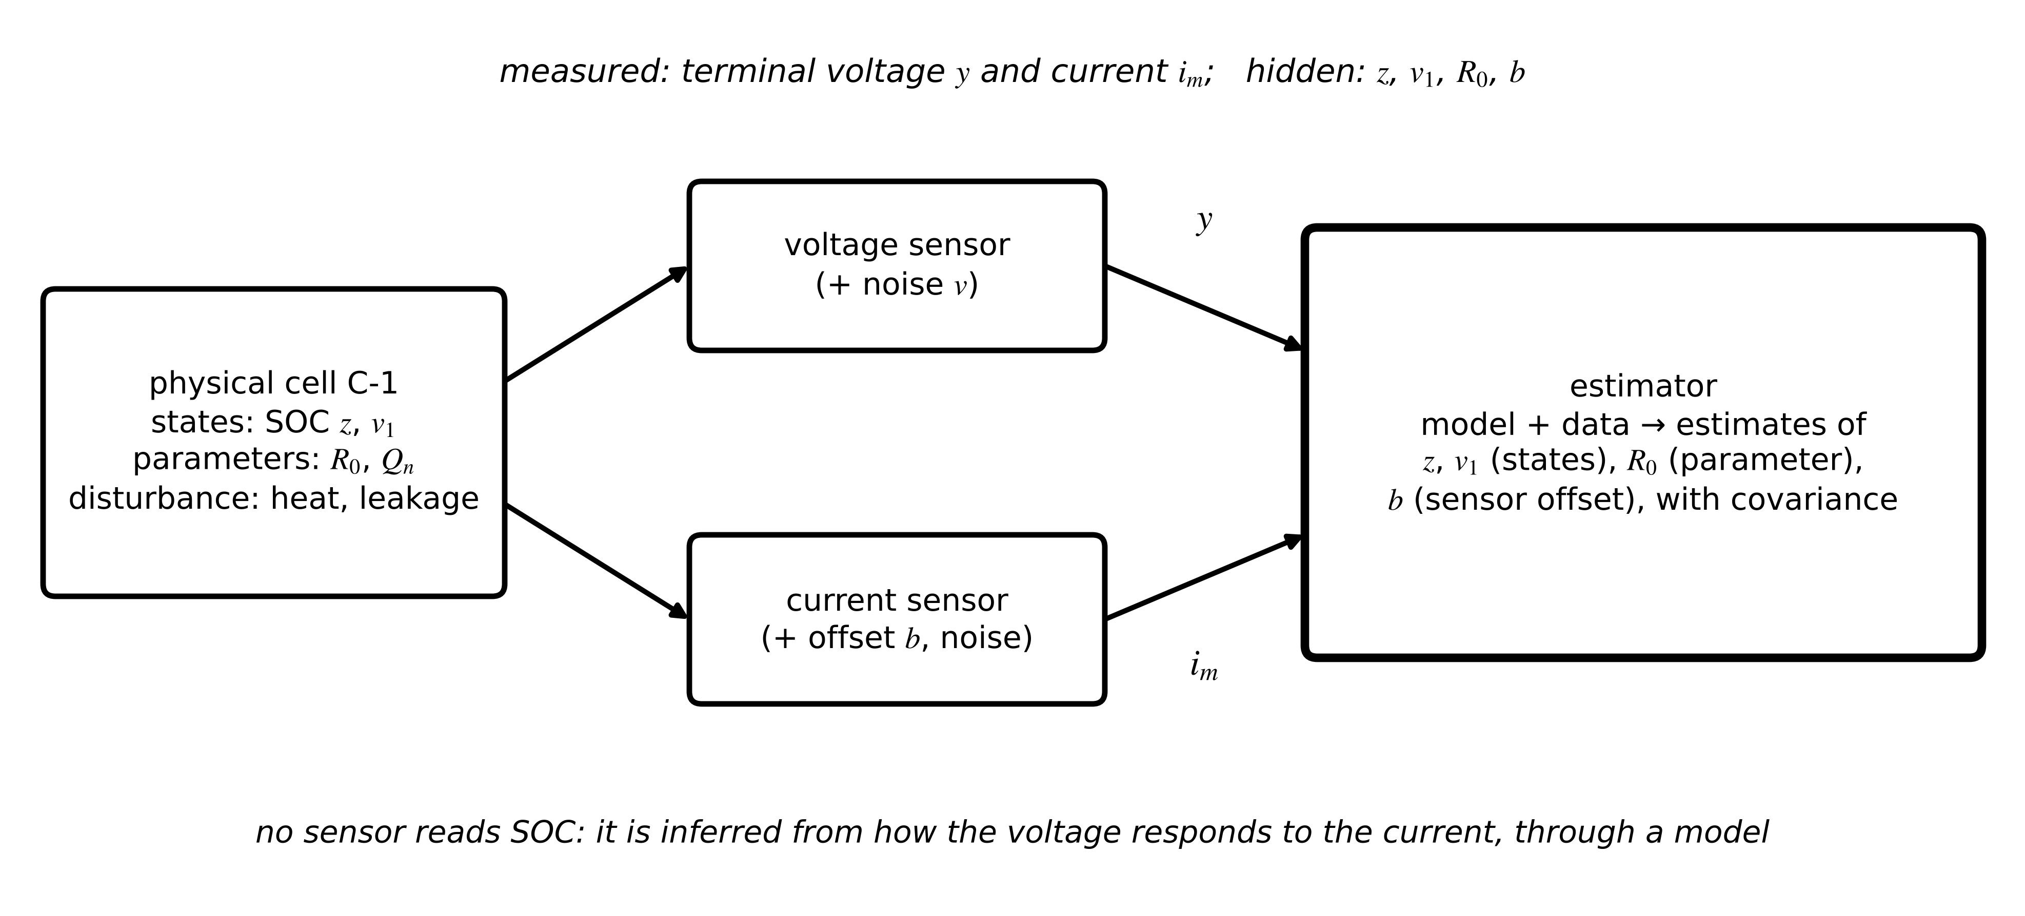
Figure 5.1. The hidden-state problem for cell C-1. Two quantities are measured (terminal voltage and current); the states, the ageing parameter and the current-sensor bias are not, and must be inferred through a model.
Four kinds of unknown appear in that picture, and an estimator treats each differently. A state changes from sample to sample and summarizes the asset's present condition: SOC $z$ and the polarization voltage $v_{1}$. A parameter is constant or changes slowly: the ohmic resistance $R_{0}$, the capacity $Q_{n}$. A disturbance is an unmeasured input that pushes the states: an unknown heat load, a parasitic current. A sensor bias is a slowly varying error in a measurement: the 0.05 A current offset. Bias and disturbance often look alike in the data; a bias corrupts what the twin believes the input was, a disturbance changes what the asset actually did. The choice of which unknowns to estimate, and which to treat as noise, is the first design decision of every estimator in this chapter.
Chapter 1 introduced synchronization as a gain that pulls the twin's state towards the measurements (Section 1.6). This chapter supplies the theory behind that gain and extends it in two directions: to parameters, which drift as assets age, and to everything else that can make a twin disagree with its asset without any estimator noticing. The 2026 reviews of energy twins all name real-time, adaptive synchronization among the hardest open requirements [1], [2], [3], and the ITU-T architecture for power-grid twins makes continuous synchronization of multi-source data a core function [4].
What the digital twin adds
Synchronized: nothing yet; the hidden quantities are named.
Estimated or updated: the classification of each unknown as state, parameter, disturbance or bias.
Uncertainty carried: the reason estimation exists at all.
Decision enabled: which unknowns the twin must estimate for its purpose.
Validated by: a model and sensor list that make the unknowns inferable (Section 5.3).

5.2 The estimation problem

5.2.1 Model, noise and the running data set
Take the first-order equivalent-circuit model of Chapter 4 (Equation (4.31)), sampled every $T_{s}$ seconds with the current held constant over each interval. In the general discrete form used throughout this chapter,
$x_{k+1}=f\left(x_{k},u_{k},θ\right)+w_{k}, y_{k}=h\left(x_{k},u_{k},θ\right)+v_{k}$ (5.1)
where $x_{k}$ is the state vector at sample $k$, $u_{k}$ the known input (current, positive on discharge), $θ$ the parameter vector, $f$ the process model, $h$ the measurement model, $w_{k}$ the process noise and $v_{k}$ the measurement noise. For cell C-1 the exact zero-order-hold discretization of Chapter 4 gives the linear process model and nonlinear measurement
$\left[\begin{matrix}z_{k+1} \\ v_{1,k+1}\end{matrix}\right]=\left[\begin{matrix}1 & 0 \\ 0 & a_{1}\end{matrix}\right]\left[\begin{matrix}z_{k} \\ v_{1,k}\end{matrix}\right]+\left[\begin{matrix}-T_{s}/\left(3600 Q_{n}\right) \\ R_{1}\left(1-a_{1}\right)\end{matrix}\right]i_{k}+w_{k}, y_{k}=OCV\left(z_{k}\right)-R_{0}i_{k}-v_{1,k}+v_{k}$ (5.2)
with $a_{1}=e^{-T_{s}/τ_{1}}$, $i_{k}$ in amperes, $Q_{n}$ in A·h and $OCV(z)$ the open-circuit voltage curve. The process noise is not a physical noise source inside the cell: it stands for everything the model does not capture, such as current-sensor error integrated into SOC and unmodelled diffusion. The measurement noise is the voltage sensor's own error (Chapter 3). Both are taken as zero mean, white and mutually uncorrelated, with covariances $Q$ and $R$:
$𝔼\left[w_{k}w_{j}^{⊤}\right]=Q δ_{kj}, 𝔼\left[v_{k}v_{j}^{⊤}\right]=R δ_{kj}, 𝔼\left[w_{k}v_{j}^{⊤}\right]=0$ (5.3)
where $𝔼[·]$ is the expectation and $δ_{kj}$ the Kronecker delta. Table 5.1 defines the running data set. It is synthetic, generated from (5.2) with the stated parameters, so that every estimate can be compared with a truth that field data never provide (Figure 5.2).
Table 5.1. Running data set: reference cell C-1 (synthetic; NumPy default_rng(2026))
Quantity | Value | Remark
Chemistry, capacity $Q_{n}$ | NMC, 50 A·h | OCV cubic from 3.00 V (0 %) to 4.20 V (100 %), monotone
OCV slope | 0.69 V at 50 %, 0.62 V at 60 %, 0.85 V at 80 % | 6.2 to 8.5 mV per percentage point
$R_{0}$ | 1.50 mΩ, rising linearly to 2.25 mΩ between 60 and 90 min | ageing step for Sections 5.10 and 5.12
$R_{1}$, $τ_{1}$ | 1.00 mΩ, 20 s | $C_{1}$ = 20 kF
Sampling, length | $T_{s}$ = 1 s, 7200 s
Current profile | random levels from −40 to +60 A, 20 to 180 s each | SOC falls from 80 % to 34 %
Voltage noise | $σ_{v}$ = 2 mV | white, normal
Current sensor | offset 0.05 A, noise 0.1 A | offset unknown to estimators
Estimator start | ${\hat{z}}_{0}$ = 60 % (true 80 %) | deliberately wrong

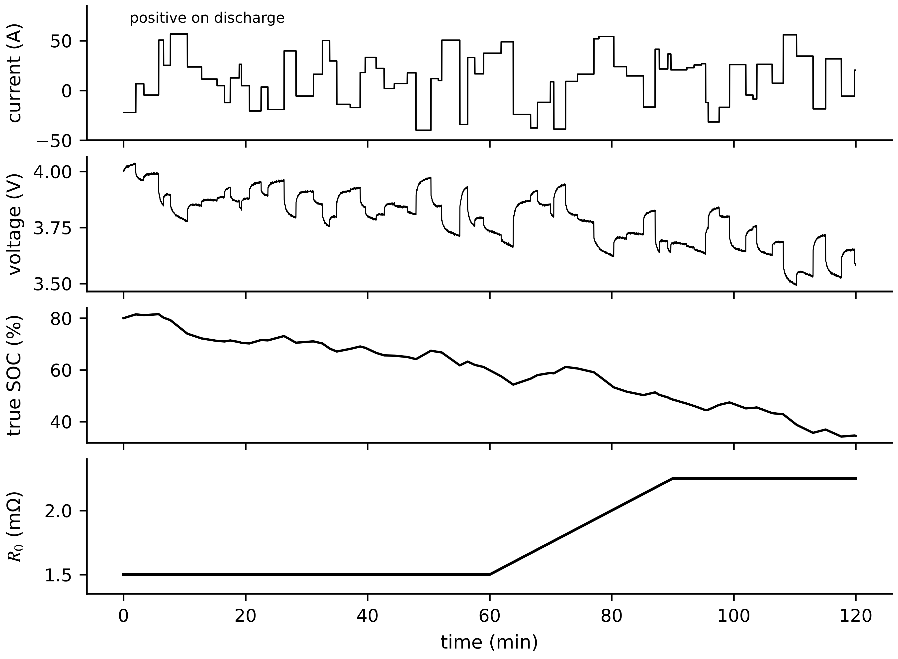
Figure 5.2. The running data set: current, measured terminal voltage, true SOC, and the true ohmic resistance with its ageing ramp between 60 and 90 minutes.

5.2.2 Estimation as recursive Bayesian inference
An estimator returns, in principle, a probability density for the state given all measurements so far, $Y_{k}=\{y_{1},…,y_{k}\}$. Two steps update it at each sample. The prediction propagates the density through the process model (the Chapman-Kolmogorov equation), and the update folds in the new measurement by Bayes' rule:
$p\left(x_{k}|Y_{k-1}\right)=\int{p}\left(x_{k}|x_{k-1}\right)p\left(x_{k-1}|Y_{k-1}\right)dx_{k-1}, p\left(x_{k}|Y_{k}\right)=\frac{p\left(y_{k}|x_{k}\right)p\left(x_{k}|Y_{k-1}\right)}{p\left(y_{k}|Y_{k-1}\right)}$ (5.4)
where $p(x_{k}|x_{k-1})$ is the transition density implied by the process model, $p(y_{k}|x_{k})$ the likelihood implied by the measurement model and the denominator a normalizing constant. The conditional mean of the posterior is the minimum mean-square-error estimate; its peak is the maximum a posteriori (MAP) estimate. The scalar Gaussian case shows what the update does (Figure 5.3). If the prior is normal with mean ${\hat{x}}^{-}$ and variance $P^{-}$ and the measurement $y=x+v$ has noise variance $R$, the product of the two Gaussians is Gaussian because their exponents add; completing the square in $x$ gives
$\hat{x}=\frac{R {\hat{x}}^{-}+P^{-}y}{P^{-}+R}={\hat{x}}^{-}+\frac{P^{-}}{P^{-}+R}\left(y-{\hat{x}}^{-}\right), \frac{1}{P}=\frac{1}{P^{-}}+\frac{1}{R}$ (5.5)
a weighted average leaning towards the more certain source, with precisions (inverse variances) that add. The factor $P^{-}/(P^{-}+R)$ is the scalar Kalman gain. In matrix form, with measurement matrix $H$, precision addition becomes the information form $P_{k|k}^{-1}=P_{k|k-1}^{-1}+H^{⊤}R^{-1}H$: each measurement adds information $H^{⊤}R^{-1}H$ in the directions it can see and none in the others. The recursion (5.4) is exact and in general uncomputable; every estimator of this chapter approximates it. The Kalman filter is its exact solution for linear models with Gaussian noise; extended and unscented filters approximate a nonlinear problem by a Gaussian one; the particle filter approximates the density with samples; moving horizon estimation computes the MAP estimate over a window.
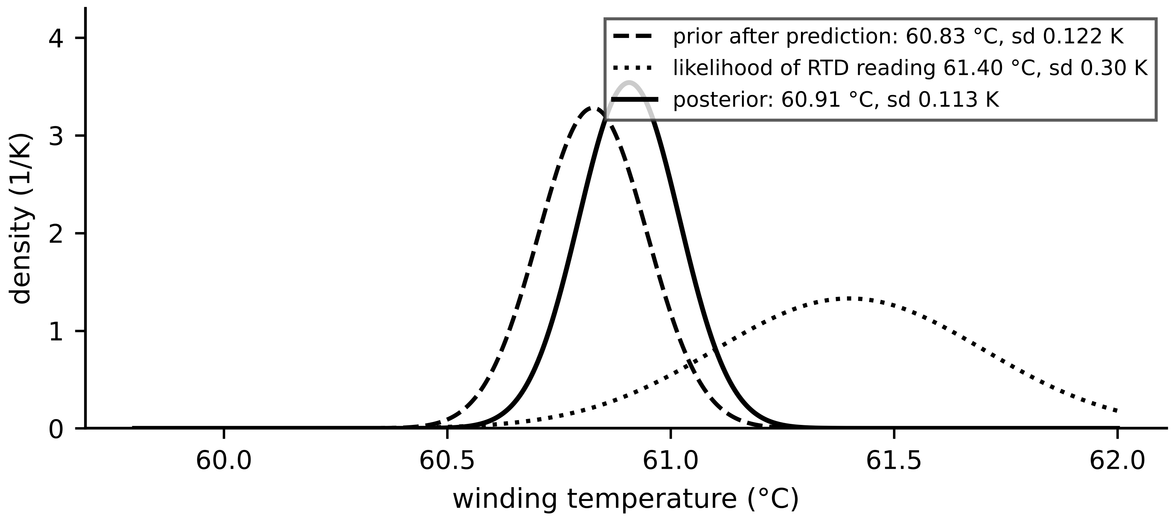
Figure 5.3. One Bayesian cycle for the M-07 winding temperature (Example 5.6). The prior after prediction and the likelihood of the new RTD reading combine into a narrower posterior that lies between them, closer to the more certain source.
What the digital twin adds
Synchronized: a probability density, summarized by a mean and covariance, not a single number.
Estimated or updated: prior and posterior at each sample.
Uncertainty carried: process noise $Q$ for model error, measurement noise $R$ for sensors.
Decision enabled: which approximation of (5.4) the twin can afford.
Validated by: comparing estimates with the synthetic truth of Table 5.1.

5.3 Observability and identifiability: what no estimator can do
Two questions come before any estimator is chosen, and the answers are properties of the model and the sensors, not of the algorithm. Observability asks whether the states can be reconstructed from the measured outputs; identifiability asks whether the parameters can be determined from the data of a given experiment. Chapter 4 introduced both (Sections 4.11 and 4.12). This section turns them into numbers an estimator designer uses.

5.3.1 Observability in practice
For cell C-1, linearizing (5.2) about an operating point gives the measurement row and the two-step observability matrix
$H=\left[\begin{matrix}{OCV}^{′}(z) & -1\end{matrix}\right], 𝒪=\left[\begin{matrix}H \\ HF\end{matrix}\right]=\left[\begin{matrix}{OCV}^{′}(z) & -1 \\ {OCV}^{′}(z) & -a_{1}\end{matrix}\right], det𝒪={OCV}^{′}(z)\left(1-a_{1}\right)$ (5.6)
where $F=diag(1,a_{1})$ and $OCV'(z)$ is the slope of the curve. The determinant is non-zero whenever the curve has a slope, so SOC is observable in the rank sense. How well depends on the slope: with 2 mV of voltage noise one sample resolves SOC to about $0.002/0.69=0.29$ percentage points at a slope of 0.69 V per unit SOC, but only to 10 points on the 0.02 V per unit plateau of a lithium iron phosphate (LFP) cell, and the condition number of $𝒪$ rises from 85 to 1950. An observable state can still be practically unobservable. The quantitative measures are the observability Gramian and the steady-state estimation covariance; for a discrete model over $N$ samples,
$W_{o}(N)=\sum_{k=0}^{N-1}{{\left(F^{⊤}\right)}^{k}}H^{⊤}R^{-1}HF^{k}, cov\left({\hat{x}}_{0}\right)⪰W_{o}(N)^{-1}$ (5.7)
which is the information (Fisher) matrix for the initial state from $N$ noisy outputs: directions with small Gramian eigenvalues are estimated with large variance whatever filter is used.
Example 5.1 (Level B) Sensor placement on motor M-07, revisited
Given. The two-node thermal model of Chapter 4 ($C_{1}=2500$, $C_{2}=6500$ J/K, $R_{12}=0.08$, $R_{2a}=0.12$ K/W), $T_{s}=30$ s, process noise 0.05 K per step per node, sensor noise 0.3 K. Options: RTD in the winding, sensor on the frame, both (Figure 5.4).
Find. Observability rank and condition number of $𝒪$, steady-state posterior standard deviations from the Kalman filter (Section 5.5.4), and the choice for an overheating advisory.
Solution. All three options have rank 2. Condition numbers: 13.2 (winding), 35.9 (frame), 1.1 (both). Posterior standard deviations (winding, frame): 0.105 and 0.124 K with the winding RTD; 0.119 and 0.101 K with the frame sensor; 0.095 and 0.097 K with both.
Interpretation. Rank passes everywhere and decides nothing; the condition number and covariance do. For an advisory driven by winding temperature the winding RTD is the choice. A criterion based on total variance would prefer the frame sensor, which is why the criterion must follow the twin's purpose (Chapter 3, Section 3.14).
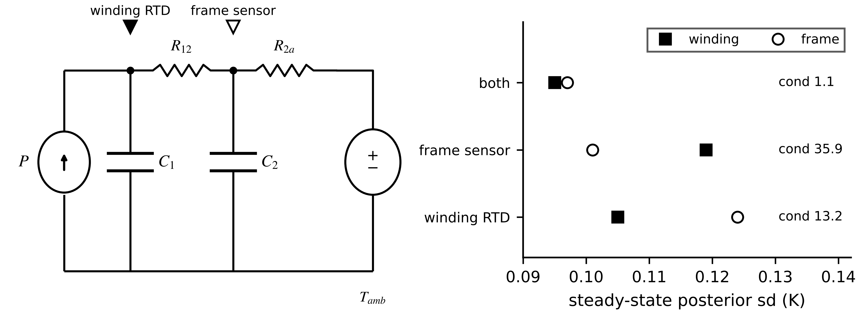
Figure 5.4. Sensor placement on the two-node M-07 model. Left: network with the two candidate sensor positions. Right: steady-state posterior standard deviations of winding and frame temperature, and the condition number of the observability matrix, for each option.

5.3.2 Identifiability, excitation and Fisher information
Parameters are identifiable only if the experiment makes them affect the output differently. For a model linear in its parameters, $y_{k}=φ_{k}^{⊤}θ+v_{k}$, the Fisher information from $N$ samples with noise variance $σ^{2}$ and the Cramér-Rao bound are
$ℐ(θ)=\frac{1}{σ^{2}}\sum_{k=1}^{N}{φ_{k}}φ_{k}^{⊤}, cov\left(\hat{θ}\right)⪰ℐ(θ)^{-1}$ (5.8)
and a regressor is persistently exciting of order $n$ when $\sum_{k}{φ_{k}}φ_{k}^{⊤}$ stays positive definite over every long enough window, so information keeps arriving in every parameter direction. In frequency terms the input must contain at least as many distinct frequencies as half the number of parameters, placed where the parameters act. For the polarization branch of C-1 the corner frequency is $1/(2πτ_{1})=8$ mHz, and the current profile must carry energy there (Figure 5.5); for the heat run of Chapter 4 the record must cover about one time constant before $R_{th}$ and $C_{th}$ separate. Two parameters whose regressors are proportional cannot be separated by any amount of data from that experiment: only their combination is identifiable.
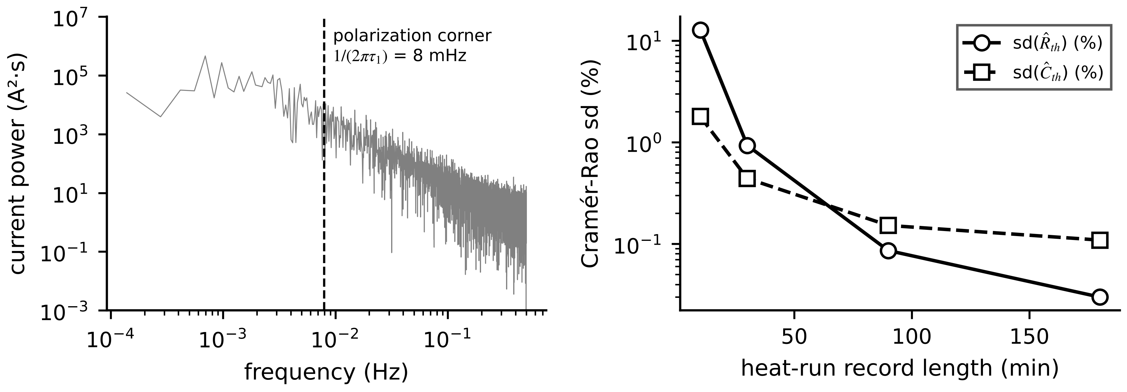
Figure 5.5. Excitation and identifiability. Left: power spectrum of the C-1 current; the polarization parameters are informed by energy near the 8 mHz corner. Right: Cramér-Rao standard deviations of the M-07 heat-run parameters against record length (Chapter 4).
Table 5.2. Observability and identifiability compared
Property | Question | Depends on | Test | Remedy when weak
observability | can the states be reconstructed from outputs? | model, sensors, operating point | rank and condition of $𝒪$; Gramian (5.7) | add or move sensors; operate where slopes are larger
identifiability | can the parameters be determined from this experiment? | model, sensors, input signal | Fisher information (5.8); correlation of estimates | richer excitation; longer records; reparameterize
both, for joint estimation | are states and parameters separable together? | all of the above | observability of the augmented model (Section 5.10) | fix weakly identifiable parameters offline

Box 5.1 No estimator can recover an unobservable state or an unidentifiable parameter
Suppose an engineer builds a Kalman filter on the as-designed two-node M-07 model with only a frame sensor, but a design change has thermally decoupled the winding from the frame. The filter runs, converges and reports a small, steady covariance for the winding temperature, because its covariance is computed from the model it was given, not from the physics that now holds. Its winding estimate is simply the model's open-loop prediction with a confident label. Observability and identifiability must be checked against the asset as built, and re-checked when it changes; covariance alone cannot reveal their loss.

What the digital twin adds
Synchronized: only states and parameters that the sensors and inputs make inferable.
Estimated or updated: Gramians, condition numbers and Fisher information.
Uncertainty carried: lower bounds on achievable estimation variance.
Decision enabled: sensor placement and experiment design before any filter is tuned.
Validated by: re-checking observability when the asset or its operating region changes.

5.4 Least squares and parameter identification

5.4.1 Least squares as a projection
Begin with geometry. Stack $N$ measurements into a vector $Y$ and the regressors into an $N×p$ matrix $H$ whose columns $h_{1},…,h_{p}$ span a subspace of possible predictions $Hθ$ (Figure 5.6). The least-squares estimate is the point in that subspace closest to $Y$, so the residual $r=Y-H\hat{θ}$ must be perpendicular to every column, $H^{⊤}r=0$. That orthogonality condition is the normal equation, and it gives the estimate and the projection matrix directly:
$H^{⊤}\left(Y-H\hat{θ}\right)=0 ⇒ \hat{θ}={\left(H^{⊤}H\right)}^{-1}H^{⊤}Y, \hat{Y}=H\hat{θ}=ΠY, Π=H{\left(H^{⊤}H\right)}^{-1}H^{⊤}$ (5.9)
The same result follows from minimizing $J(θ)=‖Y-Hθ‖^{2}$ by setting its gradient $-2H^{⊤}(Y-Hθ)$ to zero. If the noise is zero-mean with covariance $σ^{2}I$, the estimate is unbiased and its covariance and the unbiased noise-variance estimate are
$cov\left(\hat{θ}\right)=σ^{2}{\left(H^{⊤}H\right)}^{-1}, {\hat{σ}}^{2}=\frac{{\left\|Y-H\hat{θ}\right\|}^{2}}{N-p}$ (5.10)
Ill-conditioning is visible in the same matrix (Figure 5.7): when the columns of $H$ are nearly parallel, $H^{⊤}H$ is nearly singular, the cost has a long flat valley and the estimate is very sensitive to noise. The condition number $κ(H)=σ_{max}/σ_{min}$ of the singular values measures it; relative errors in the data can be amplified up to $κ$ times in the estimate.
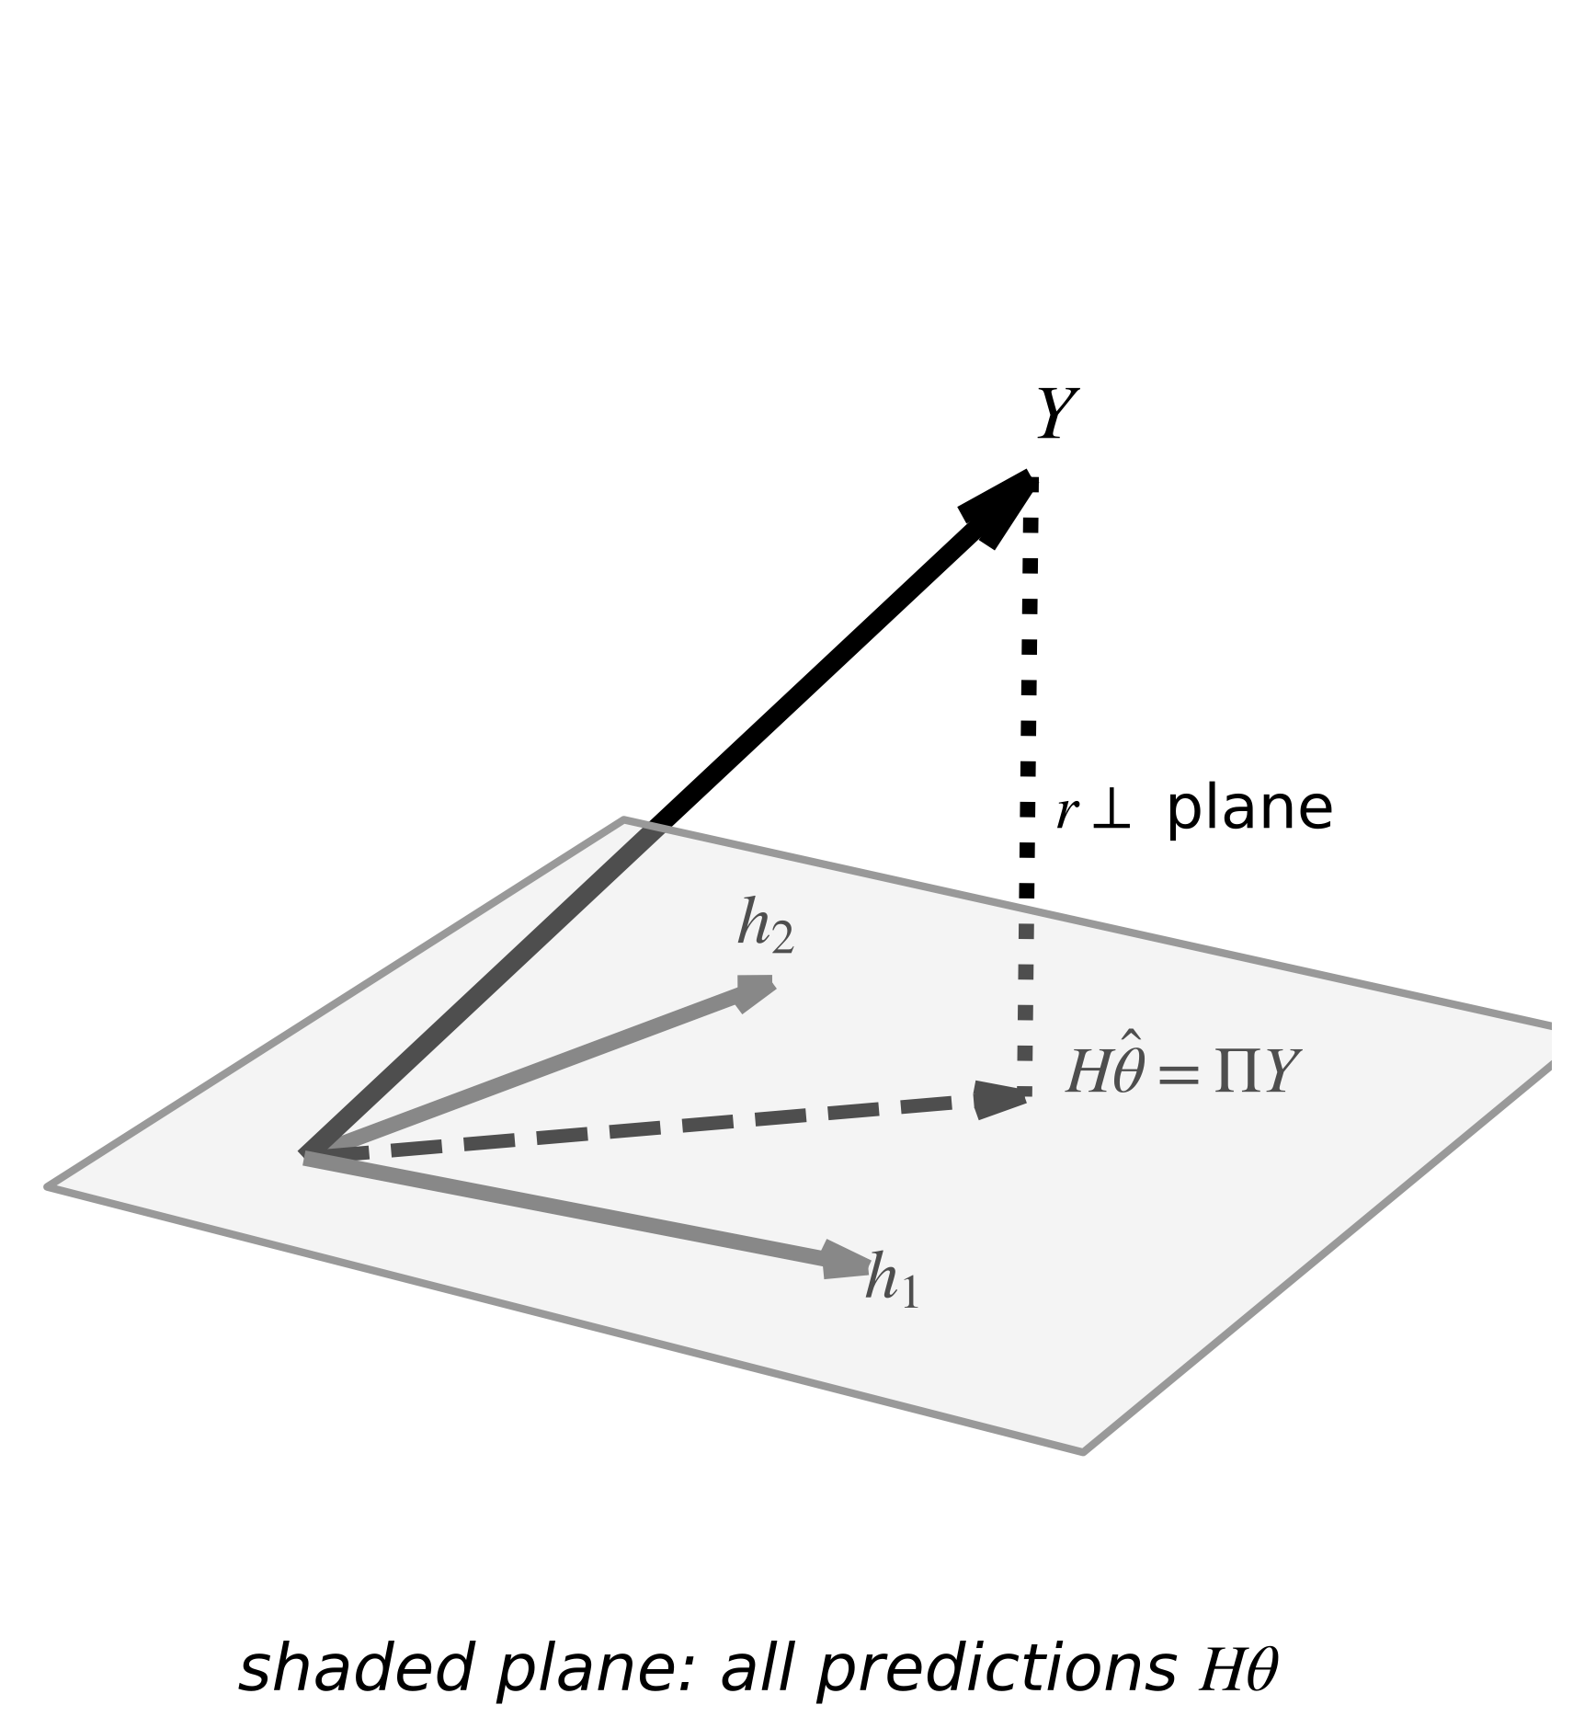
Figure 5.6. Least squares as projection. The prediction $H\hat{θ}$ is the orthogonal projection of the measurement vector onto the plane spanned by the regressor columns; the residual is perpendicular to that plane.
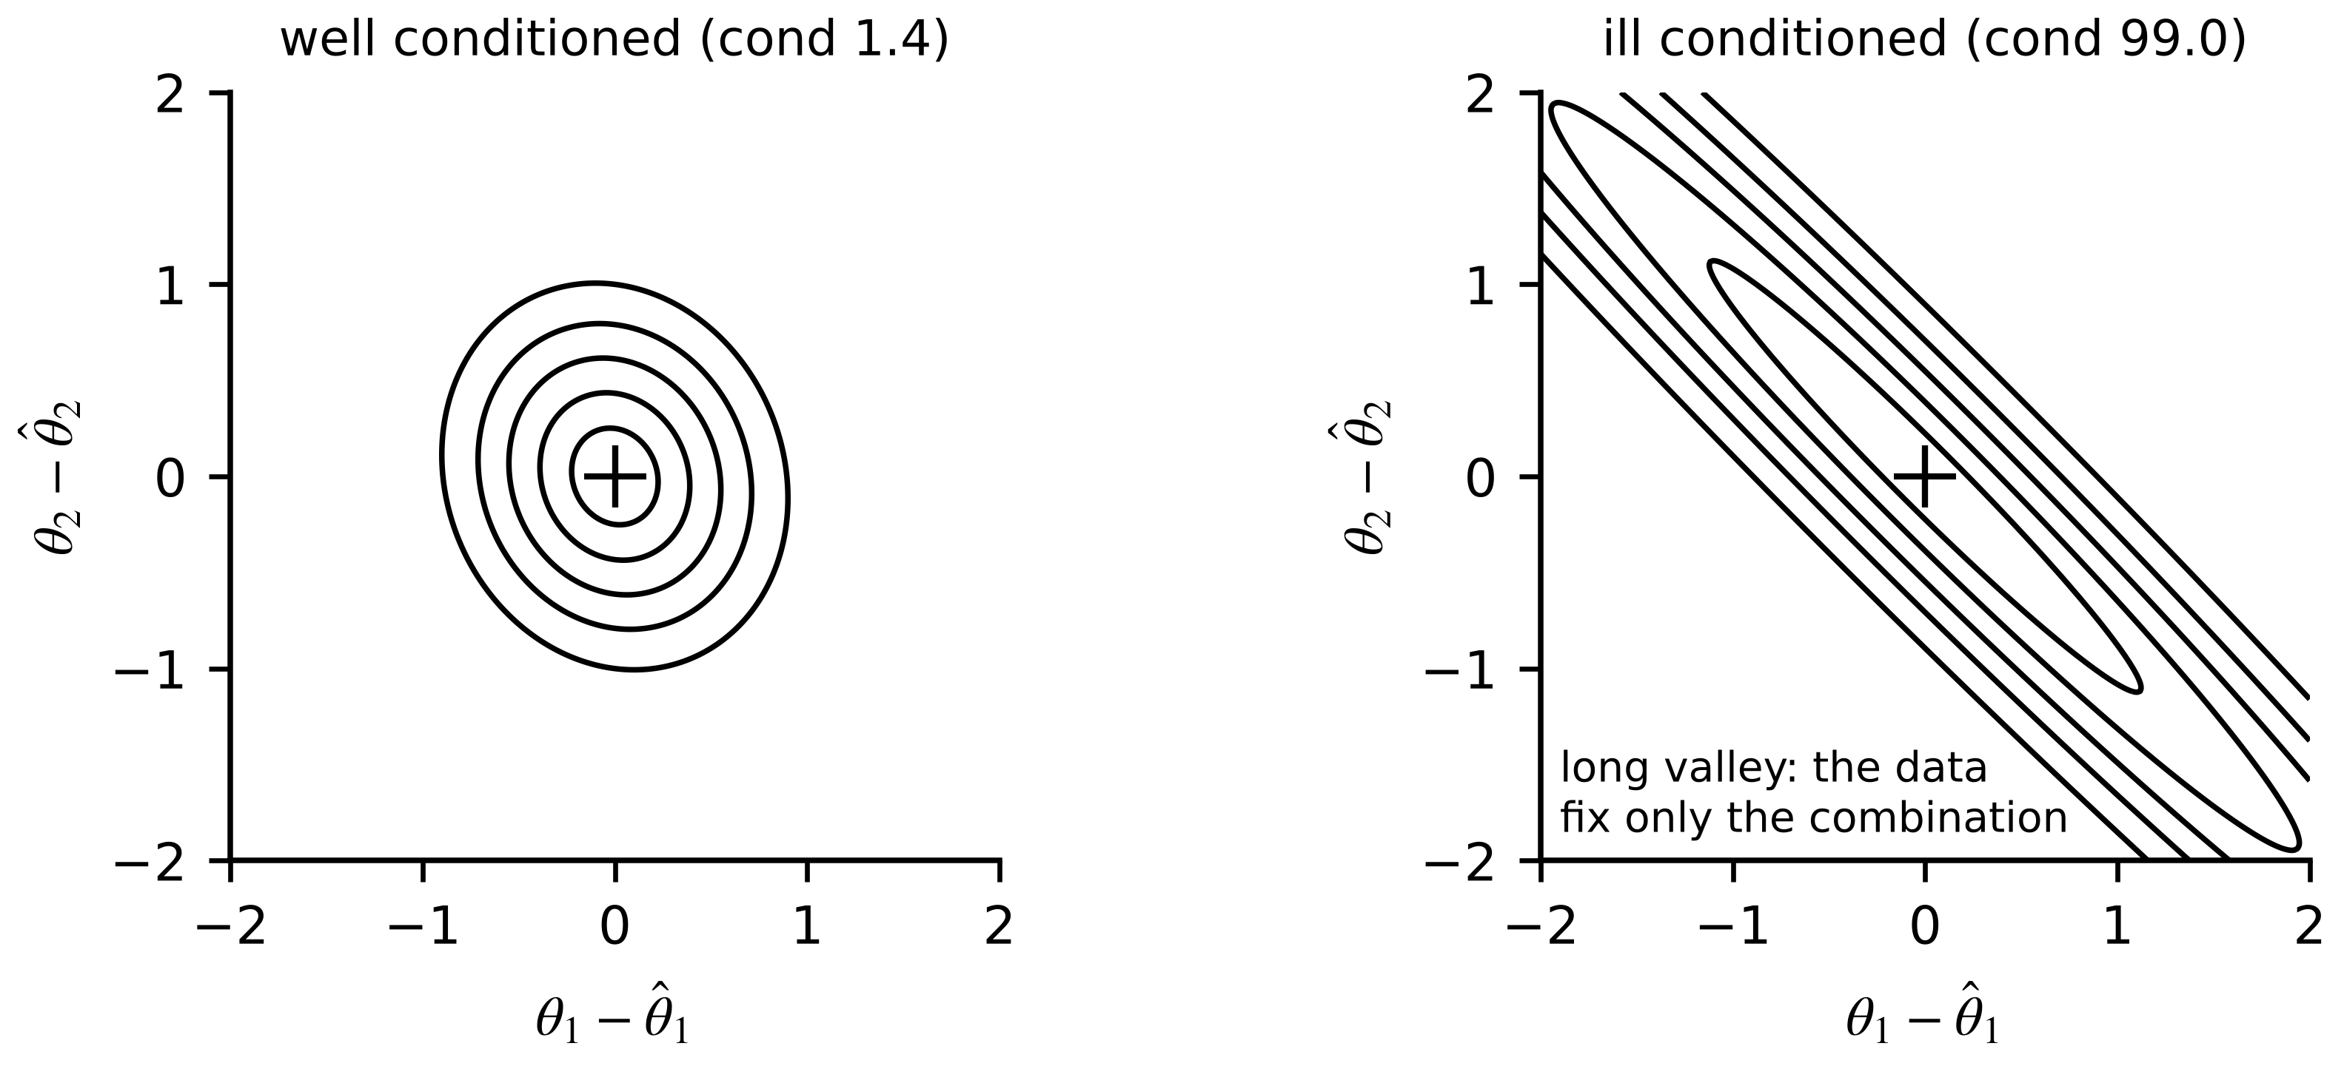
Figure 5.7. Contours of the least-squares cost around the estimate for a well-conditioned and an ill-conditioned regressor. In the second the data cannot separate the two parameters, only their combination.
Example 5.2 (Level A) Ohmic resistance of cell C-1 from current steps
Given. Five current steps $Δi=[20,40,60,-20,-40]$ A produce instantaneous voltage drops $Δv=[30.2,59.7,90.4,-29.8,-60.3]$ mV. Model: $Δv=R_{0}Δi+$ noise.
Find. ${\hat{R}}_{0}$, the residuals, ${\hat{σ}}^{2}$ and the standard deviation of ${\hat{R}}_{0}$.
Solution. With one parameter, (5.9) becomes ${\hat{R}}_{0}=\sum{Δ}iΔv/\sum{Δ}i^{2}=11 424/7600=1.5032$ mΩ. Residuals $[0.14,-0.43,0.21,0.26,-0.17]$ mV; ${\hat{σ}}^{2}=0.0861$ mV² from (5.10) with $N-p=4$; standard deviation $\sqrt{0.0861/7600}=0.0034$ mΩ.
Interpretation. Large steps carry the most information because $Δi$ enters squared. A test designer who wants a precise $R_{0}$ uses large, fast current steps, which also separate the instantaneous drop from the slower polarization.

5.4.2 Weighted least squares and bad data
When measurements have different accuracies, each residual is weighted by the inverse of its variance. Minimizing $J(θ)=(Y-Hθ)^{⊤}R^{-1}(Y-Hθ)$ gives
$\hat{θ}={\left(H^{⊤}R^{-1}H\right)}^{-1}H^{⊤}R^{-1}Y, cov\left(\hat{θ}\right)={\left(H^{⊤}R^{-1}H\right)}^{-1}$ (5.11)
where $R$ is the measurement covariance. Weighted least squares (WLS) is the engine of power-system state estimation, which synchronizes the twins of transmission and distribution networks (Chapter 11). For the DC power-flow model each line flow is $P_{ij}=(θ_{i}-θ_{j})/x_{ij}$ and each injection the sum of its line flows, so the measurements are linear in the bus angles. Gross measurement errors are detected with the weighted residual sum $J(\hat{θ})$, which is chi-square with $m-n$ degrees of freedom when the model is right, and located with normalized residuals, which divide each residual by its own standard deviation $Ω_{ii}^{1/2}$ [5]:
$J\left(\hat{θ}\right)∼χ_{m-n}^{2}, Ω=R-H{\left(H^{⊤}R^{-1}H\right)}^{-1}H^{⊤}, r_{N,i}=\frac{r_{i}}{\sqrt{Ω_{ii}}}$ (5.12)
Example 5.3 (Level B) A three-bus network with a bad meter
Given. Buses 1 (reference, $θ_{1}=0$), 2 and 3; reactances $x_{12}=0.10$, $x_{13}=0.25$, $x_{23}=0.20$ pu. True angles $θ_{2}=-0.050$, $θ_{3}=-0.100$ rad. Five meters: flows $P_{12}$, $P_{13}$, $P_{23}$ ($σ=0.01$ pu) and injections $P_{2}$, $P_{3}$ ($σ=0.02$ pu). Readings (seed 2026): $z=[0.4921, 0.4024, 0.2310, -0.2221, -0.6372]$ pu.
Find. (a) $H$ and the estimate. (b) The chi-square test. (c) The effect of a 0.20 pu gross error on $P_{2}$, and its removal.
Solution. (a) With $x=[θ_{2},θ_{3}]^{⊤}$: $H=[-10, 0; 0, -4; 5, -5; 15, -5; -5, 9]$. (5.11) gives ${\hat{θ}}_{2}=-0.0490$, ${\hat{θ}}_{3}=-0.0980$ rad. (b) $J=4.39$ against $χ_{3,0.95}^{2}=7.81$: consistent; largest $|r_{N}|=1.77$. (c) With $P_{2}$ read as $-0.0221$: $J=97.4$, normalized residuals $[7.31, 0.95, -4.57, 9.75, 1.47]$; the largest, 9.75, is on $P_{2}$. Removing it gives $\hat{θ}=[-0.0497, -0.0979]$ rad.
Interpretation. The gross error also inflated the residuals of the healthy $P_{12}$ and $P_{23}$ meters, because least squares spreads an error over every measurement it touches; only the normalized residual, which accounts for each meter's leverage, points at the right one (Figure 5.8).
Figure 5.8. Left: the three-bus network with its five meters. Right: absolute normalized residuals with clean data and with a 0.20 pu error on the injection meter $P_{2}$, against the usual threshold of 3.

5.4.3 Recursive least squares and forgetting
A twin receives data one sample at a time and cannot re-solve (5.9) each time. Write the information after $k$ samples as $P_{k}^{-1}=P_{k-1}^{-1}+φ_{k}φ_{k}^{⊤}$ and apply the matrix-inversion lemma $(A+bc^{⊤})^{-1}=A^{-1}-A^{-1}bc^{⊤}A^{-1}/(1+c^{⊤}A^{-1}b)$; the estimate then updates with a gain, the prediction error and a covariance that never needs inverting (Figure 5.9). Weighting old data by $λ^{k-j}$ with a forgetting factor $0<λ≤1$ gives
$K_{k}=\frac{P_{k-1}φ_{k}}{λ+φ_{k}^{⊤}P_{k-1}φ_{k}}, {\hat{θ}}_{k}={\hat{θ}}_{k-1}+K_{k}\left(y_{k}-φ_{k}^{⊤}{\hat{θ}}_{k-1}\right), P_{k}=\frac{1}{λ}\left(P_{k-1}-K_{k}φ_{k}^{⊤}P_{k-1}\right)$ (5.13)
For a constant regressor the forgetting factor sets three linked quantities: the effective memory, the standard deviation of the estimate relative to a single sample, and the lag behind a parameter changing at a constant rate,
$N_{mem}=\frac{1}{1-λ}, \frac{σ_{\hat{θ}}}{σ}=\sqrt{\frac{1-λ}{1+λ}}, lag=\frac{λ}{1-λ} samples$ (5.14)
so $λ=0.99$ remembers about 100 samples, gives 0.071 of a single sample's noise and lags 99 samples. Without excitation ($φ_{k}=0$) the covariance update reduces to $P_{k}=P_{k-1}/λ$, which grows without bound: the classic ‘wind-up’ of constant forgetting, avoided by directional forgetting or by freezing updates when excitation is low.
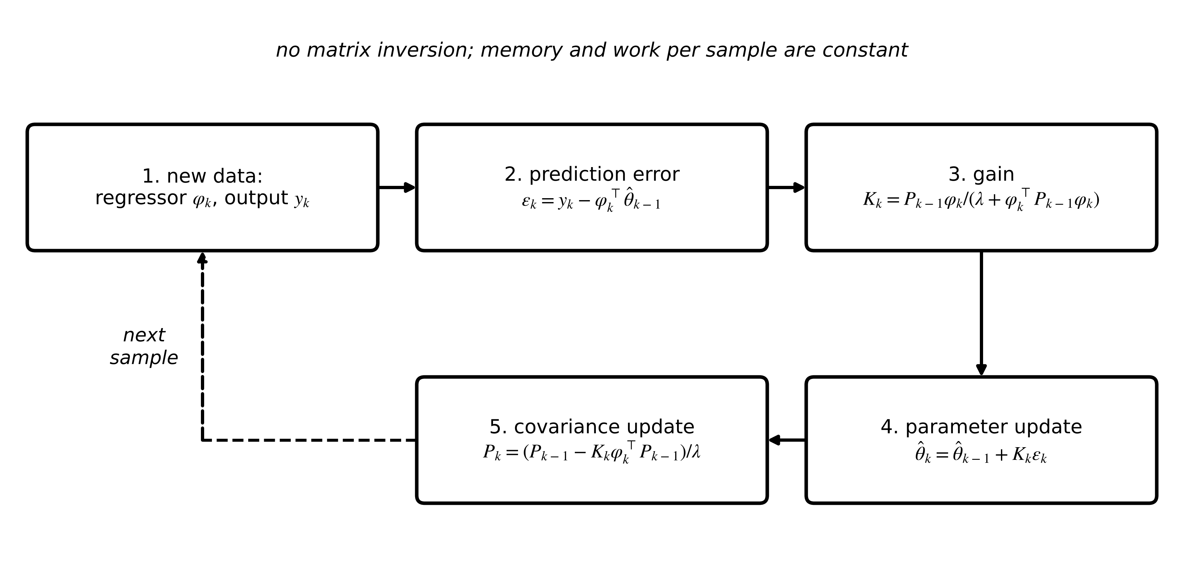
Figure 5.9. The recursive least-squares cycle. Each sample adds its information through a gain, without matrix inversion; the forgetting factor $λ$ discounts old data.
Example 5.4 (Level A) Two RLS updates by hand
Given. The model $Δv=R_{0}Δi$ of Example 5.2, in mΩ and A, starting from ${\hat{R}}_{0}=1.0$ mΩ with $P_{0}=1.0$ (a deliberately vague prior), $λ=1$. Data: (20 A, 30.2 mV), then (40 A, 59.7 mV).
Find. Gain, estimate and covariance after each step.
Solution. Step 1: $K=1×20/(1+20×1×20)=0.04988$; ${\hat{R}}_{0}=1.0+0.04988(30.2-20)=1.5087$ mΩ; $P=(1-0.04988×20)×1=0.00249$. Step 2: $K=0.00249×40/(1+{40}^{2}×0.00249)=0.01999$; ${\hat{R}}_{0}=1.5087+0.01999(59.7-60.35)=1.4958$ mΩ; $P=0.00050$.
Interpretation. One sample moves the vague prior almost all the way; the second refines it, and the covariance falls by a factor of five as information accumulates. The batch estimate of Example 5.2 is reached as more steps arrive.

5.4.4 Identifying the cell model: errors-in-variables bias and the output-error fix
The polarization parameters of C-1 can be written as a linear regression. With the voltage drop $u_{k}=OCV(z_{k})-y_{k}=R_{0}i_{k}+v_{1,k}+$ noise and $v_{1,k}=a_{1}v_{1,k-1}+R_{1}(1-a_{1})i_{k-1}$, eliminating $v_{1}$ gives an autoregressive model with exogenous input (ARX),
$u_{k}=a_{1}u_{k-1}+b_{0}i_{k}+b_{1}i_{k-1}+ε_{k}, b_{0}=R_{0}, b_{1}=R_{1}\left(1-a_{1}\right)-a_{1}R_{0}, τ_{1}=-\frac{T_{s}}{lna_{1}}$ (5.15)
where $ε_{k}$ is the equation error. Its regressor $u_{k-1}$ contains last sample's measurement noise, which is correlated with $ε_{k}$ (the noise enters $ε_{k}$ as $v_{k}-a_{1}v_{k-1}$). Least squares then converges to the wrong value, the errors-in-variables bias [6]; to first order the autoregressive coefficient shrinks towards zero:
${\hat{a}}_{1}→a_{1}\left(1-\frac{σ_{v}^{2}}{var\left(u\right)}\right)-(cross terms)$ (5.16)
The cure is to stop putting noisy outputs in the regressor. A prediction-error or output-error method simulates the model from the input alone and minimizes the simulated-output error over the parameters, with a nonlinear least-squares solver such as Levenberg-Marquardt:
$\hat{θ}=arg\min_{θ}\sum_{k=1}^{N}{{\left[u_{k}-{\hat{u}}_{k}(θ)\right]}^{2}}, {\hat{u}}_{k}(θ)=R_{0}i_{k}+{\hat{v}}_{1,k}(θ), {\hat{v}}_{1,k+1}=a_{1}{\hat{v}}_{1,k}+R_{1}\left(1-a_{1}\right)i_{k}$ (5.17)
Example 5.5 (Level B) ARX against output-error identification of cell C-1
Given. The first 3000 s of the running data set, with the drop $u_{k}$ formed from the true SOC and the true current (a bench calibration with the current offset removed). (i) ARX by (5.9). (ii) Output error by (5.17), Levenberg-Marquardt from $R_{0}=R_{1}=1$ mΩ, $τ_{1}=10$ s.
Find. The estimates of $R_{0}$, $R_{1}$, $τ_{1}$ by both methods, the regressor condition number and the residual standard deviation.
Solution. (i) ARX: ${\hat{a}}_{1}=0.9027$, ${\hat{R}}_{0}=1.500$ mΩ, ${\hat{R}}_{1}=0.932$ mΩ, ${\hat{τ}}_{1}=9.8$ s (true 20 s), condition number 4019, residual standard deviation 2.70 mV. (ii) Output error: ${\hat{R}}_{0}=1.5008±0.0055$ mΩ, ${\hat{R}}_{1}=1.0003±0.0053$ mΩ, ${\hat{τ}}_{1}=20.07±0.17$ s, residual RMS 2.01 mV (the sensor noise), in six function evaluations.
Interpretation. ARX recovers $R_{0}$ (its regressor $i_{k}$ is clean) and halves the time constant, whose regressor is the noisy $u_{k-1}$. The bias is not noise; more data make it more certain, not smaller. Output error is iterative and unbiased. A twin can use both: ARX to initialize, output error to calibrate, and recursive or joint estimation to track changes.
Two further tools keep identification well posed. Regularization adds a penalty that pulls the estimate towards a prior value $θ_{0}$ (ridge regression, or Tikhonov), $\hat{θ}=(H^{⊤}H+γI)^{-1}(H^{⊤}Y+γθ_{0})$; it trades a small bias for a large reduction in variance when $H$ is ill-conditioned, and with $γ=σ^{2}/σ_{θ}^{2}$ it is exactly the Bayesian MAP estimate with prior standard deviation $σ_{θ}$. Constraints encode physics the data alone cannot enforce: resistances and capacities are positive, a time constant lies in a known range. Bounded least squares, or projection of an unconstrained estimate onto the feasible set (Section 5.9), keeps estimates physical.
What the digital twin adds
Synchronized: model parameters to the asset's present values.
Estimated or updated: $\hat{θ}$ with covariance, recursively or by batch recalibration.
Uncertainty carried: noise-driven variance and, if ignored, errors-in-variables bias.
Decision enabled: which parameters to identify online and which offline, and with what excitation.
Validated by: residuals at the noise floor, parameter uncertainty and physical bounds.

5.5 The Kalman filter

5.5.1 The scalar filter first
Take the M-07 winding temperature of Chapter 1: $x_{k+1}=ax_{k}+b_{k}+w_{k}$ with $a=e^{-T_{s}/τ}$, a known input term $b_{k}$, process noise of variance $Q$, and an RTD reading $y_{k}=x_{k}+v_{k}$ with noise variance $R$. Starting from a posterior mean ${\hat{x}}_{k-1|k-1}$ and variance $P_{k-1|k-1}$, the mean and variance are propagated through the model, because the variance of $aX+W$ is $a^{2}var(X)+Q$ for independent $X$ and $W$:
${\hat{x}}_{k|k-1}=a{\hat{x}}_{k-1|k-1}+b_{k}, P_{k|k-1}=a^{2}P_{k-1|k-1}+Q$ (5.18)
and then corrected by the Gaussian update (5.5), with the innovation $e_{k}$, its variance $S_{k}$ and the gain $K_{k}$:
$e_{k}=y_{k}-{\hat{x}}_{k|k-1}, S_{k}=P_{k|k-1}+R, K_{k}=\frac{P_{k|k-1}}{S_{k}}, {\hat{x}}_{k|k}={\hat{x}}_{k|k-1}+K_{k}e_{k}, P_{k|k}=\left(1-K_{k}\right)P_{k|k-1}$ (5.19)
Each term has a physical reading. Prediction lets the model carry the estimate forward and makes it less certain by $Q$, the model's honesty about what it ignores. The innovation is the surprise in the new reading. The gain is the share of that surprise the filter believes: near 1 when the prior is vague, near 0 when the sensor is noisy. The update always reduces the variance (Figure 5.10), and from any starting variance the cycle converges to a steady state.
Example 5.6 (Level A) One Kalman cycle for the M-07 winding, by hand
Given. $a=e^{-30/1800}=0.98347$; loss 400 W at 30 °C ambient, so $b_{k}=(1-a)(30+0.20×400)=1.818$ K; $Q=0.0025$ K², $R=0.09$ K². Previous posterior 60.0 °C with variance 0.0127 K². New reading 61.4 °C.
Find. The prediction, innovation, gain, posterior and its variance, and the normalized innovation squared $e_{k}^{2}/S_{k}$.
Solution. (5.18): ${\hat{x}}_{k|k-1}=0.98347×60.0+1.818=60.826$ °C; $P_{k|k-1}={0.98347}^{2}×0.0127+0.0025=0.01478$ K². (5.19): $e_{k}=0.574$ K; $S_{k}=0.10478$ K²; $K_{k}=0.1411$; ${\hat{x}}_{k|k}=60.907$ °C; $P_{k|k}=0.01270$ K² (standard deviation 0.113 K); $e_{k}^{2}/S_{k}=3.14$.
Interpretation. The posterior variance returned to its starting value: the filter is in steady state, with the gain of 0.141 that Chapter 1 found from the scalar Riccati equation (Figure 5.3). The normalized innovation of 3.14 is below the 95 % chi-square threshold of 3.84 for one degree of freedom, so this sample raises no concern; one value proves little either way (Section 5.5.5).
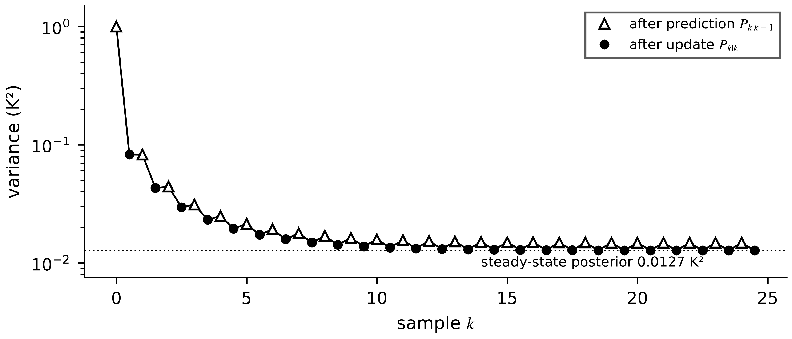
Figure 5.10. Covariance of the scalar M-07 filter starting from a vague prior of 1 K². Each prediction raises the variance by the model term, each update lowers it; within about ten samples the sawtooth settles at the steady-state posterior of 0.0127 K².

5.5.2 The matrix filter
For the linear model $x_{k+1}=Fx_{k}+Gu_{k}+w_{k}$, $y_{k}=Hx_{k}+v_{k}$ the same two steps hold with matrices (Figure 5.11) [7]. Prediction propagates the mean and, by $cov(FX+W)=F cov(X)F^{⊤}+Q$, the covariance:
${\hat{x}}_{k|k-1}=F{\hat{x}}_{k-1|k-1}+Gu_{k-1}, P_{k|k-1}=FP_{k-1|k-1}F^{⊤}+Q$ (5.20)
The update is a linear correction ${\hat{x}}_{k|k}={\hat{x}}_{k|k-1}+K_{k}e_{k}$. For any gain the posterior error is $(I-K_{k}H){\tilde{x}}_{k|k-1}-K_{k}v_{k}$, so its covariance is the Joseph form; minimizing its trace over $K_{k}$ (differentiating with $∂ tr(KA)/∂K=A^{⊤}$ and $∂ tr(KBK^{⊤})/∂K=2KB$) gives the Kalman gain:
$P_{k|k}=\left(I-K_{k}H\right)P_{k|k-1}{\left(I-K_{k}H\right)}^{⊤}+K_{k}RK_{k}^{⊤}, K_{k}=P_{k|k-1}H^{⊤}S_{k}^{-1}, S_{k}=HP_{k|k-1}H^{⊤}+R$ (5.21)
with innovation $e_{k}=y_{k}-H{\hat{x}}_{k|k-1}$. Substituting the optimal gain simplifies the covariance to $P_{k|k}=(I-K_{k}H)P_{k|k-1}$; the Joseph form is kept in software because it stays symmetric and positive definite under rounding. For Gaussian noise the filter is the exact conditional mean; for any noise with these first two moments it is the best linear estimator.
Figure 5.11. Signal flow of the matrix Kalman filter: prediction, output prediction, innovation and gain, update, and the one-sample delay that turns the posterior into the next prior; the consistency monitor watches the innovations.

5.5.3 The innovation and the steady state
When the model and noise statistics are right, the innovation sequence is zero-mean and white with covariance $S_{k}$: $𝔼[e_{k}]=0$, $𝔼[e_{k}e_{j}^{⊤}]=S_{k}δ_{kj}$. It is the only quantity a twin can compute in the field that tests the whole filter, and Section 5.12 builds monitoring on it (Figure 5.12). For a time-invariant, observable model the prior covariance converges to the solution of the discrete algebraic Riccati equation (DARE), with constant gain:
$P_{∞}=FP_{∞}F^{⊤}+Q-FP_{∞}H^{⊤}{\left(HP_{∞}H^{⊤}+R\right)}^{-1}HP_{∞}F^{⊤}, K_{∞}=P_{∞}H^{⊤}{\left(HP_{∞}H^{⊤}+R\right)}^{-1}$ (5.22)
For the scalar random walk ($F=H=1$) it reduces to $P^{2}-QP-QR=0$, so $P_{∞}=(Q+\sqrt{Q^{2}+4QR})/2$. A steady-state filter costs a few multiplications per step and suits embedded twins whose models do not change.
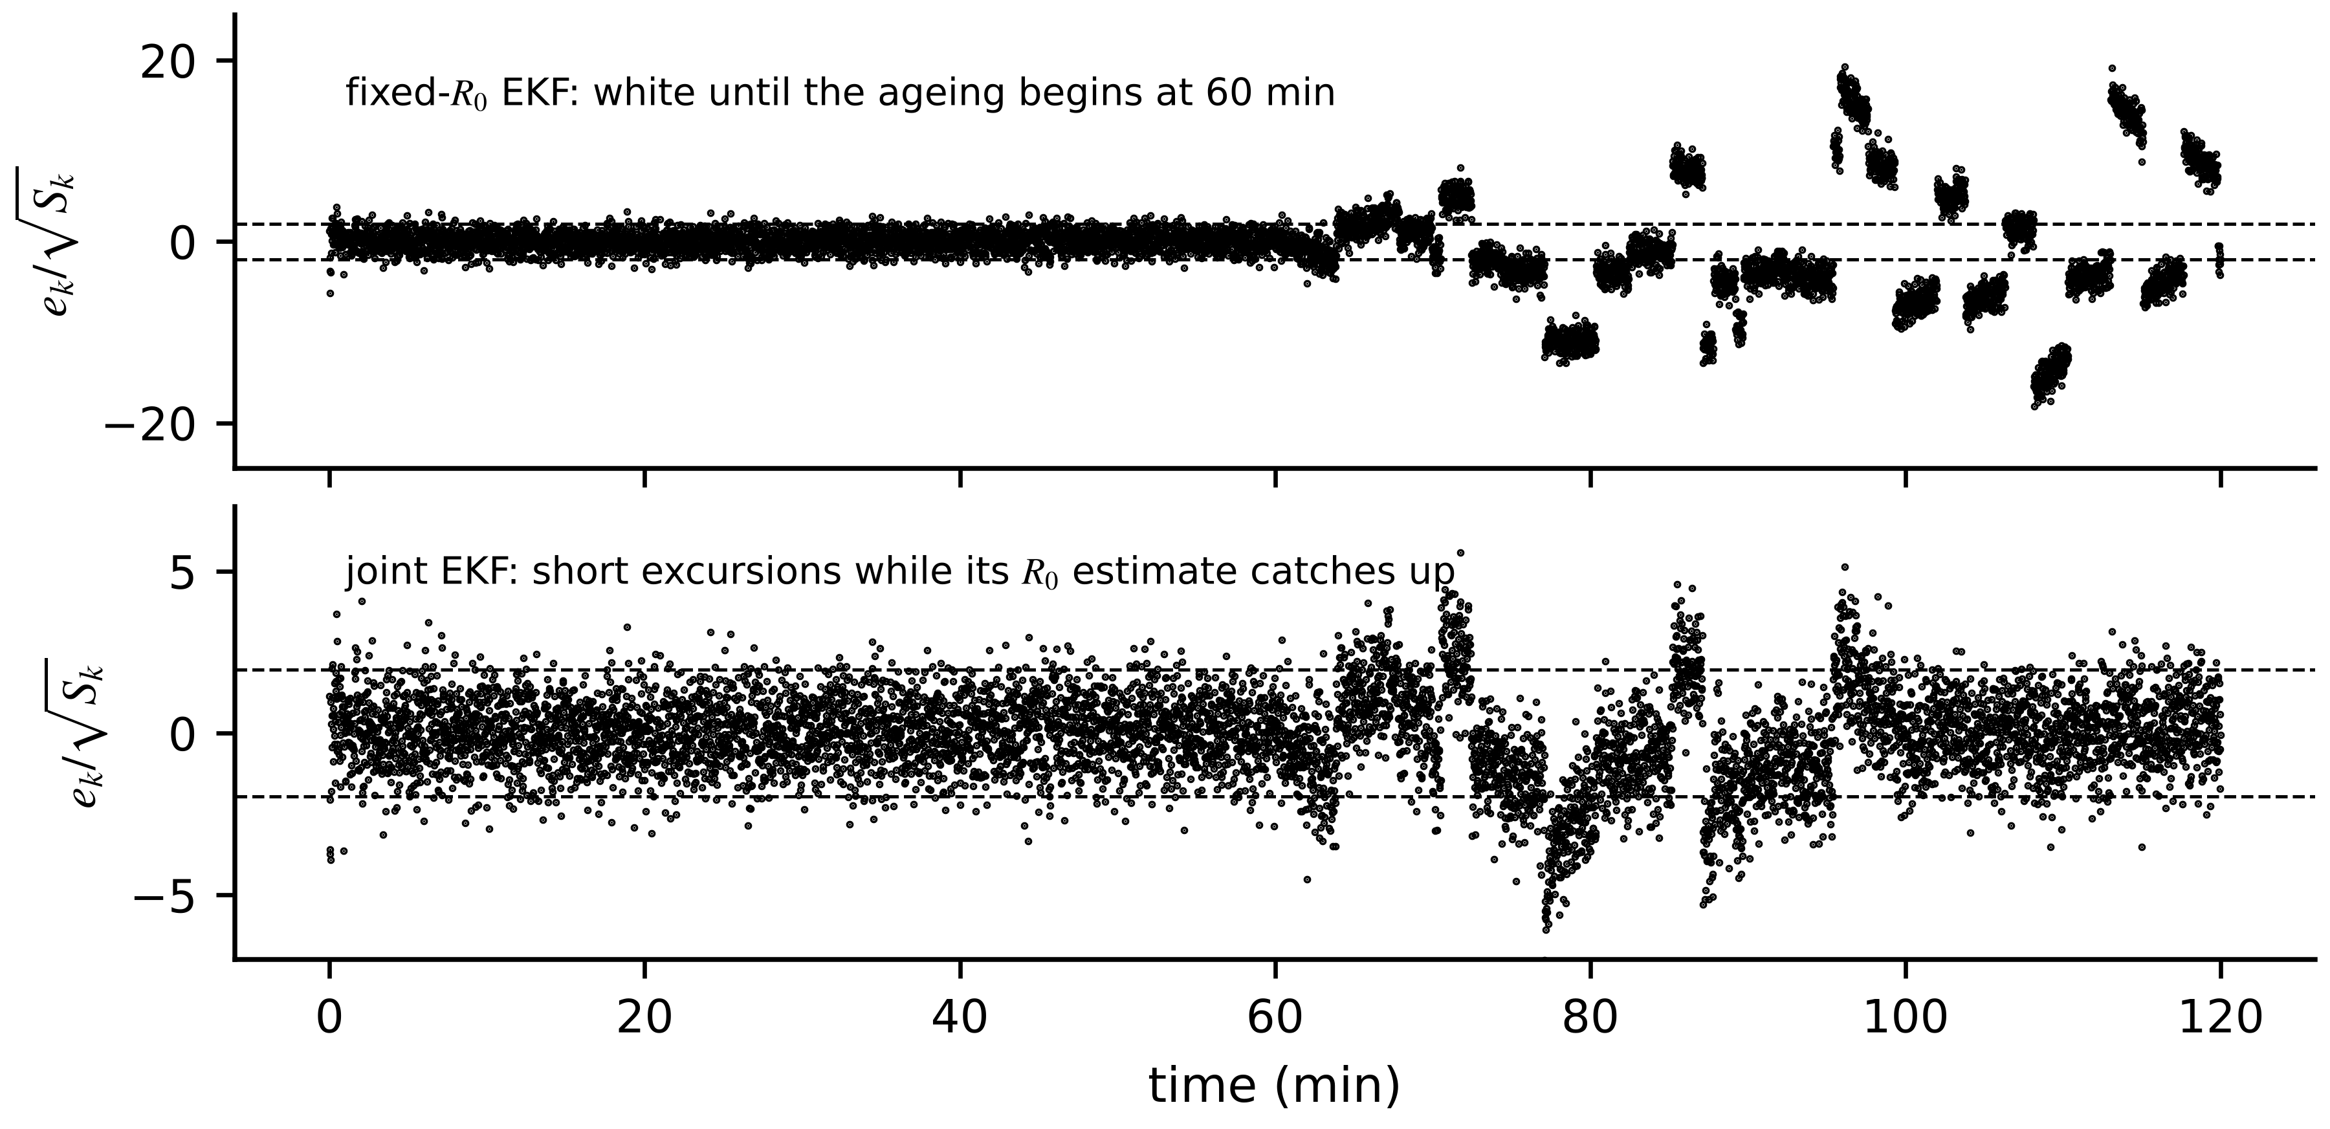
Figure 5.12. Normalized innovation sequences on cell C-1. Top: the EKF with fixed $R_{0}$ stays white until the ageing begins at 60 min, then drifts far outside ±1.96. Bottom: the joint EKF of Section 5.10 shows short excursions while its resistance estimate catches up.

5.5.4 Choosing Q and R
$R$ comes from the sensor: the voltage noise of Table 5.1 gives $R=(2 mV)^{2}$, plus any quantization and timing terms from Chapter 3. $Q$ is harder because it represents what the model leaves out. For SOC, the dominant unmodelled effect is the current-sensor error integrated over a sample; an equivalent current uncertainty $i_{eq}$ gives $Q_{z}=(T_{s}i_{eq}/3600Q_{n})^{2}$. Using only the sensor noise (0.1 A) ignores the unknown offset; using a large value makes the filter sluggish. The honest test is consistency (Section 5.5.5). Two practical rules help: $Q$ should cover every error the model cannot represent, including slow biases; and too small a $Q$ is more dangerous than too large, because an overconfident filter stops listening to data.
[Advanced] Estimating R and Q from the innovations
When the noise statistics are uncertain, the innovations themselves carry information about them, because for a correct filter $E\left[e_{k}e_{k}^{⊤}\right]=S_{k}=H_{k}P_{k|k−1}H_{k}^{⊤}+R$. Averaging the innovation outer products over a window of $W$ samples and subtracting the part the filter predicts from its own covariance gives an estimate of the measurement covariance [8]:
${\hat{C}}_{e,k}=\frac{1}{W}\sum_{j=k−W+1}^{k}{e_{j}}e_{j}^{⊤}, {\hat{R}}_{k}={\hat{C}}_{e,k}−\frac{1}{W}\sum_{j=k−W+1}^{k}{H_{j}}P_{j|j−1}H_{j}^{⊤}$
For example, if the C-1 voltage innovations over the last 60 s have a sample variance of $2.1×{10}^{−5}$ V² while $HP^{−}H^{⊤}$ averages $0.8×{10}^{−5}$ V², then $\hat{R}=1.3×{10}^{−5}$ V², a noise standard deviation of 3.6 mV rather than the assumed 2 mV, and $R$ should be raised. Three cautions apply. The window must be long enough for the sample variance to settle (its relative standard deviation is about $\sqrt{2/W}$, 18 % for $W=60$); the estimate must be kept positive definite, for example by flooring it at the sensor's data-sheet value; and $Q$ is much harder to estimate this way, because a wrong $Q$ and a wrong $R$ can produce the same innovation variance. Adaptive tuning is therefore a supplement to the Monte Carlo NEES tuning of Section 5.5.5, not a replacement for it, and every adaptation must be logged as part of the twin's synchronization record (Section 5.13).

5.5.5 Consistency: NIS, NEES and whiteness
A filter is consistent when its reported covariance matches its actual errors. Three statistics test it [9]. The normalized innovation squared (NIS) needs only field data; the normalized estimation error squared (NEES) needs the true state and is used with simulation or commissioning data; for a correct filter both are chi-square:
$ε_{y,k}=e_{k}^{⊤}S_{k}^{-1}e_{k}∼χ_{m}^{2}, ε_{x,k}={\left(x_{k}-{\hat{x}}_{k|k}\right)}^{⊤}P_{k|k}^{-1}\left(x_{k}-{\hat{x}}_{k|k}\right)∼χ_{n}^{2}$ (5.23)
where $m$ and $n$ are the measurement and state dimensions. Averaged over $N$ samples, or over $N$ independent Monte Carlo runs, $N\overline{ε}$ is $χ_{Nm}^{2}$ (or $χ_{Nn}^{2}$), which gives a two-sided acceptance band, and whiteness is tested with the normalized autocorrelation of the innovations:
$\frac{χ_{Nm, α/2}^{2}}{N}≤{\overline{ε}}_{y}≤\frac{χ_{Nm, 1-α/2}^{2}}{N}, {\hat{ρ}}_{l}=\frac{\sum_{k}{e_{k}}e_{k+l}}{\sum_{k}{e_{k}^{2}}}, \left|{\hat{ρ}}_{l}\right|≤\frac{1.96}{\sqrt{N}}$ (5.24)
Example 5.7 (Level A) Reading a NIS band
Given. A scalar filter reports five consecutive NIS values: 0.10, 0.15, 0.08, 0.12, 0.09. A second filter's mean NIS over 50 samples is 1.38.
Find. The 95 % bands for 5 and 50 samples and the verdict on each filter.
Solution. With $m=1$: for $N=5$ the band is 0.166 to 2.567; the mean 0.108 lies below it, so the first filter is underconfident ($R$ or $Q$ too large). For $N=50$ the band is 0.647 to 1.428; 1.38 lies inside it.
Interpretation. Five samples give a band wider than a factor of 15, so short windows only catch gross errors; the second filter passes, but only for the data it saw. Bands narrow as $1/\sqrt{N}$.
Example 5.8 (Level C) Monte Carlo consistency of the C-1 SOC filter
Given. The EKF of Section 5.6 on 30 synthetic records of Table 5.1 generated with seeds 100 to 129, run for 1800 s from the wrong 60 % start; three tunings of $i_{eq}$: 0.12 A (sensor noise only), 0.3 A and 0.6 A. Statistics over 600 to 1800 s.
Find. The mean NIS and mean NEES over the 30 runs, and the fraction of time the run-averaged NEES lies in its 95 % band ($n=2$, $N=30$: 1.35 to 2.78).
Solution. All three filters give mean NIS close to 1 (Figure 5.13). Mean NEES: 8.90 for 0.12 A (overconfident, never in the band), 2.24 for 0.3 A (in the band 88 % of the time), 0.95 for 0.6 A (underconfident, never in the band).
Interpretation. NIS cannot tell the three filters apart, because the voltage measurement is so informative that innovations look perfect either way; only NEES, which needs the truth, reveals that the 0.12 A filter claims nine times less state variance than its errors have. Tuning is therefore finished in simulation and on commissioning data with known truth, then monitored in the field with NIS. The 0.3 A filter's NEES creeps up late in the record as the unmodelled 0.05 A offset accumulates, a reminder to estimate biases rather than hide them in $Q$.
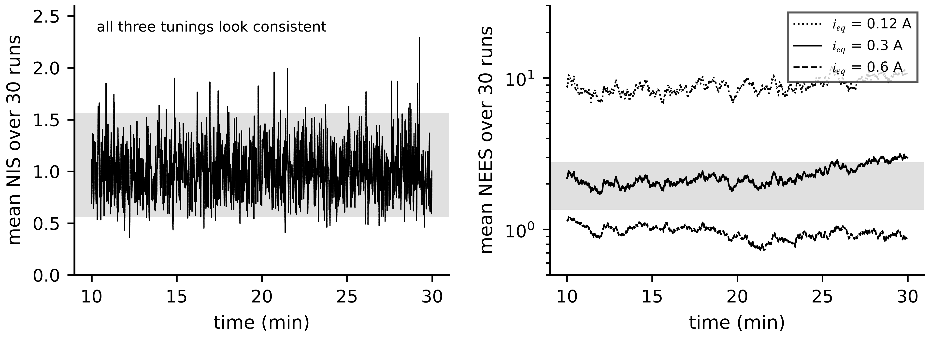
Figure 5.13. Run-averaged NIS (left) and NEES (right) over 30 Monte Carlo runs for three tunings of the C-1 SOC filter, with the 95 % acceptance bands shaded. All three pass the NIS test; only $i_{eq}$ = 0.3 A passes NEES.
What the digital twin adds
Synchronized: state mean and covariance, updated every sample.
Estimated or updated: gain, innovation, NIS; NEES during commissioning.
Uncertainty carried: covariance that is tested, not assumed, to be honest.
Decision enabled: trust in the state for downstream decisions; $Q$ and $R$ tuning.
Validated by: NIS, NEES and whiteness bands, Monte Carlo on synthetic truth.

5.6 The extended Kalman filter
The C-1 measurement is nonlinear through $OCV(z)$. The extended Kalman filter (EKF) keeps the Kalman equations and replaces $F$ and $H$ by Jacobians evaluated at the current estimate, propagating the mean through the nonlinear model itself (Figure 5.14):
${\hat{x}}_{k|k-1}=f\left({\hat{x}}_{k-1|k-1},u_{k-1}\right), F_{k}={\left.\frac{∂f}{∂x}\right|}_{{\hat{x}}_{k-1|k-1}}, H_{k}={\left.\frac{∂h}{∂x}\right|}_{{\hat{x}}_{k|k-1}}, e_{k}=y_{k}-h\left({\hat{x}}_{k|k-1},u_{k}\right)$ (5.25)
after which (5.20) and (5.21) are applied with $F_{k}$ and $H_{k}$. For C-1, $F=diag(1,a_{1})$ is exact and $H_{k}=[OCV'(\hat{z}), -1]$. The EKF inherits the linearization error of Chapter 4 (Equation (4.34)): when the prior is far from the truth, the slope used is wrong, the first updates overshoot, and the reported covariance can be badly optimistic. An iterated EKF re-linearizes within the update and helps at start-up.
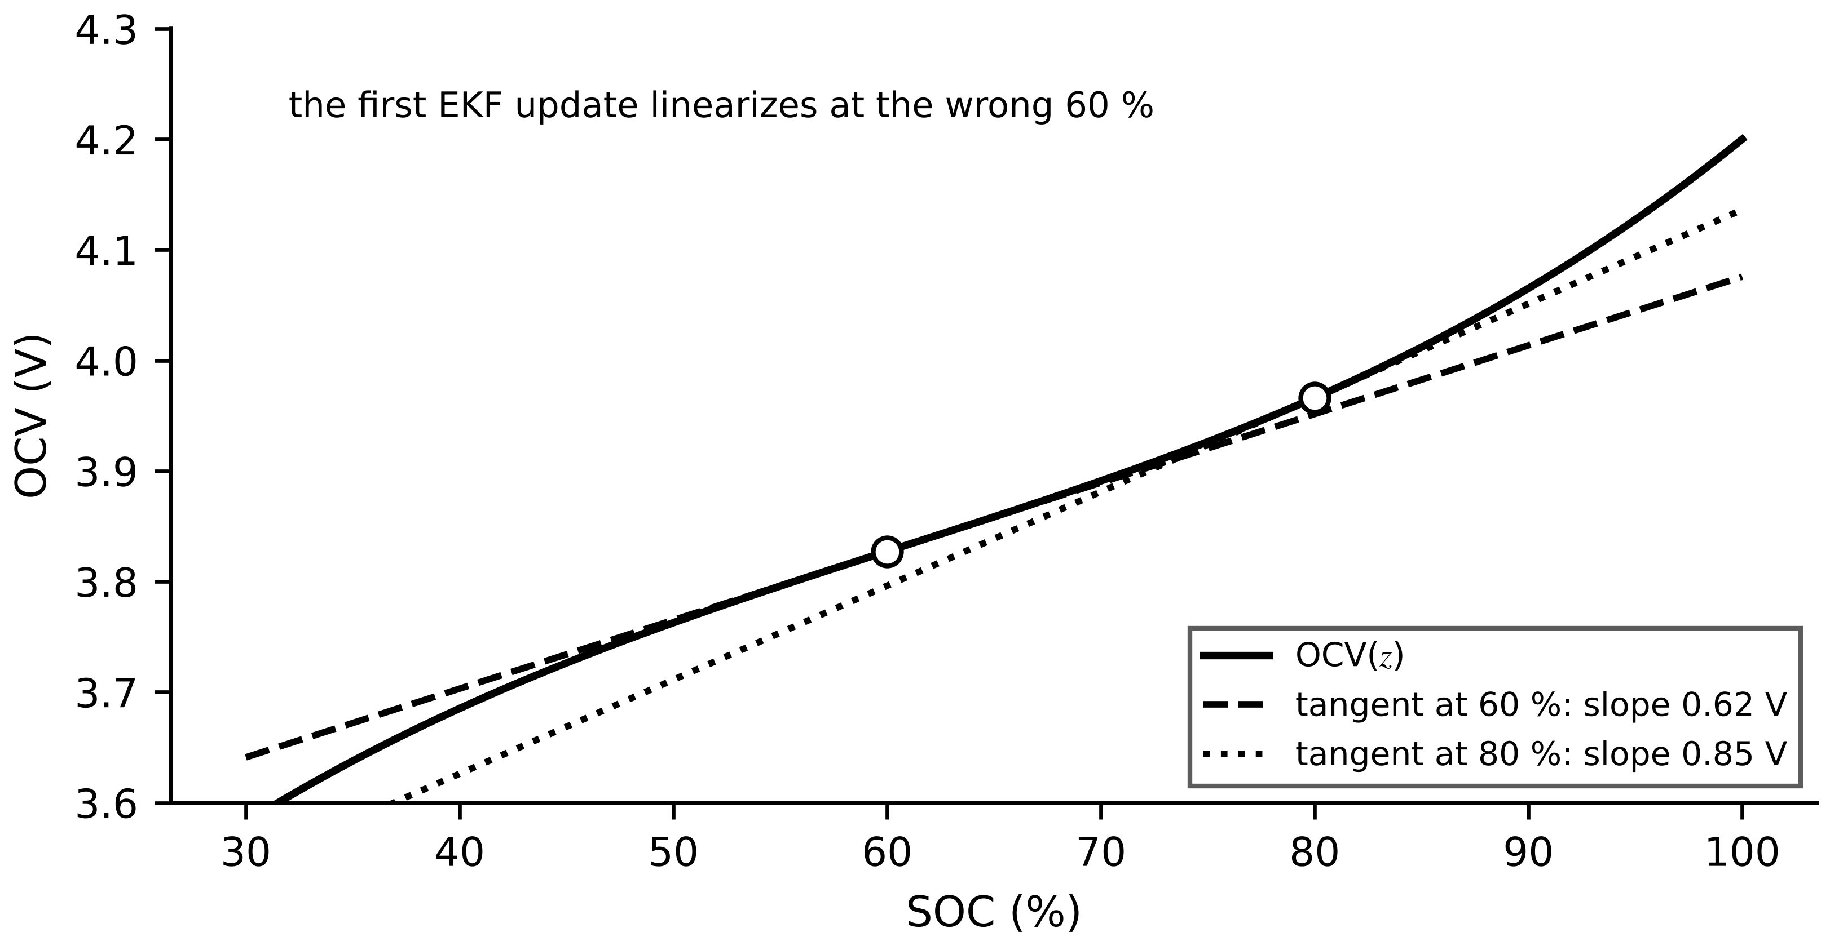
Figure 5.14. EKF linearization on the C-1 OCV curve. The first update uses the tangent at the wrong 60 % guess (slope 0.62 V), not at the true 80 % (slope 0.85 V), which makes it overshoot.
Example 5.9 (Level B) SOC of cell C-1 from a wrong start
Given. The running data set; $R=(2 mV)^{2}$; ${\hat{x}}_{0}=[0.60, 0]^{⊤}$ with $P_{0}=diag({0.20}^{2}, (5 mV)^{2})$; $i_{eq}=0.6$ A; $R_{0}$ known (1.50 mΩ) in the first hour.
Find. (a) The first update by hand. (b) The SOC error over 600 to 3600 s. (c) The comparison with coulomb counting.
Solution. (a) At $k=0$ the measured voltage is 4.0037 V with $i_{0}=-21.97$ A (charging). $h(\hat{x})=OCV(0.60)-R_{0}i_{0}=3.8603$ V, so $e_{0}=0.1434$ V. With $H_{0}=[0.621, -1]$: $S_{0}={0.621}^{2}×0.04+25×{10}^{-6}+4×{10}^{-6}=0.01545$ V², $K_{0,z}=0.04×0.621/0.01545=1.61$; SOC jumps to $0.60+1.61×0.1434=0.830$ against a true 0.800, and its standard deviation falls from 20 to 0.87 points. (b) RMS error 0.015 points. (c) Coulomb counting from 60 % stays about 20 points wrong for the whole record (Figure 5.15).
Interpretation. The overshoot of 3 points comes from linearizing at 60 %; the next updates, linearized nearer the truth, remove it within seconds. Coulomb counting cannot recover from a wrong start at all, because nothing in it compares the model with the voltage.
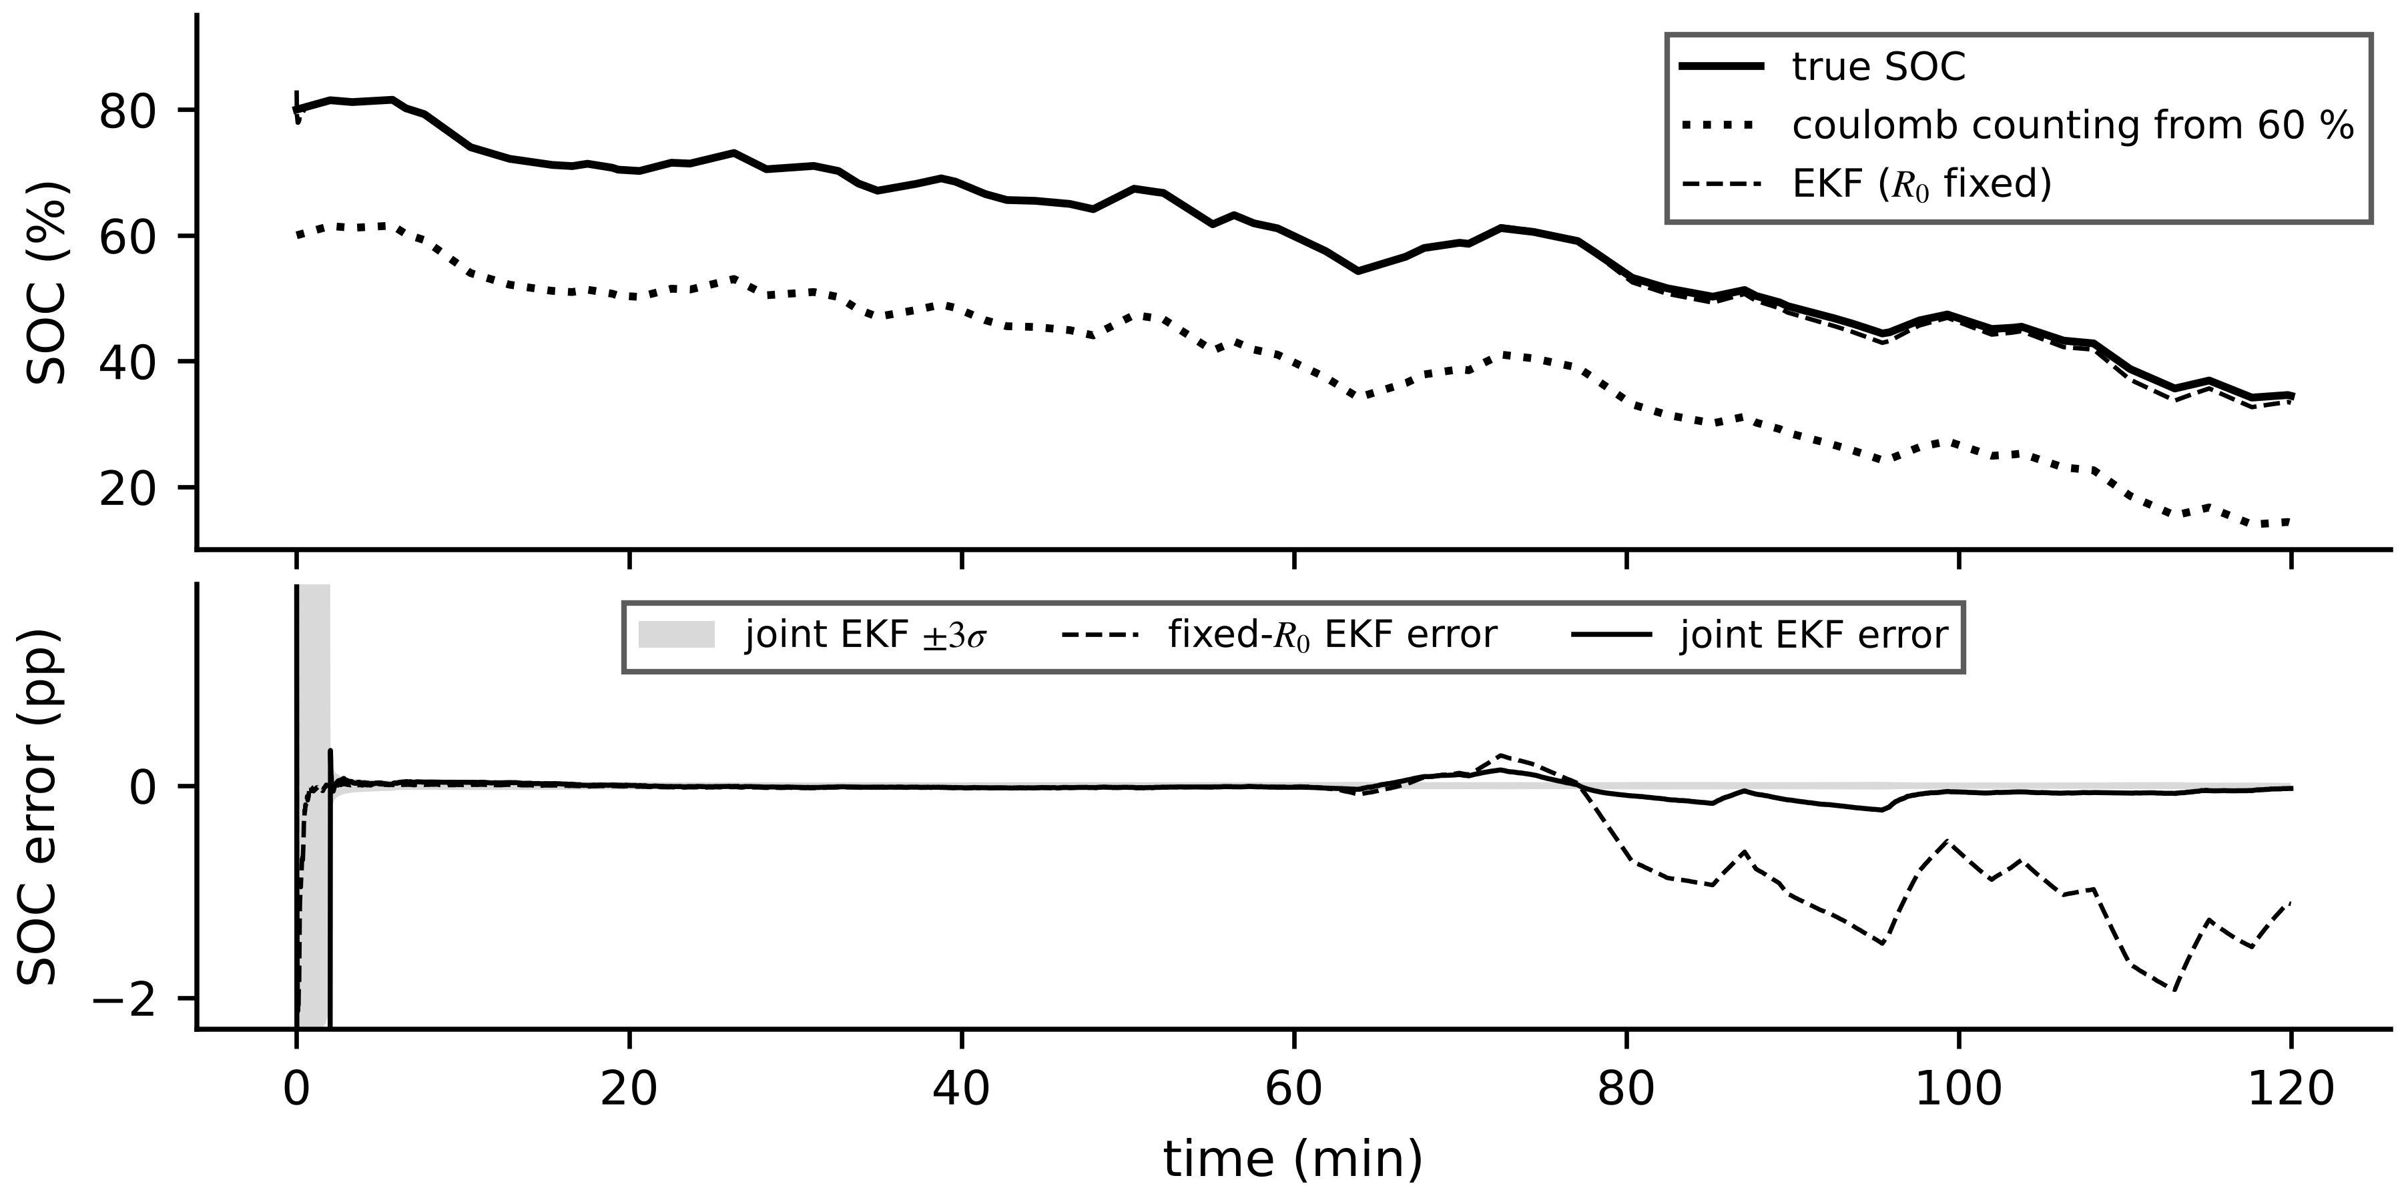
Figure 5.15. EKF on cell C-1. Top: true SOC, coulomb counting from the wrong 60 % start and the fixed-$R_{0}$ EKF. Bottom: SOC error of the fixed-$R_{0}$ EKF, which grows after the resistance begins to age, and of the joint EKF of Section 5.10 with its $±3σ$ band.
What the digital twin adds
Synchronized: nonlinear states through local linearization at each sample.
Estimated or updated: Jacobians at the current estimate; SOC and polarization.
Uncertainty carried: covariance that may be optimistic far from the truth.
Decision enabled: SOC for dispatch within seconds of start-up.
Validated by: NEES on synthetic runs, then NIS in the field.

5.7 The unscented Kalman filter
Instead of linearizing the function, the unscented transform propagates a small, deterministic set of sample points, the sigma points, that match the mean and covariance of the prior, and recomputes the moments from the transformed points [10]. For an $n$-dimensional state with mean $\hat{x}$ and covariance $P$, with $\sqrt{·}$ a matrix square root (Cholesky) and $(·)_{i}$ its $i$-th column,
$𝒳_{0}=\hat{x}, 𝒳_{±i}=\hat{x}±{\left(\sqrt{(n+λ_{u})P}\right)}_{i}, W_{0}^{(m)}=\frac{λ_{u}}{n+λ_{u}}, W_{0}^{(c)}=W_{0}^{(m)}+1-α^{2}+β, W_{±i}=\frac{1}{2(n+λ_{u})}$ (5.26)
where $λ_{u}=α^{2}(n+κ)-n$ is a scaling parameter, $α$ sets the spread, $κ$ is a secondary scaling and $β=2$ is optimal for Gaussian priors. Each point is passed through the nonlinear function, $𝒴_{i}=h(𝒳_{i})$, and the predicted output, its covariance and the cross-covariance follow as weighted sums:
$\hat{y}=\sum_{i}{W_{i}^{(m)}}𝒴_{i}, S=\sum_{i}{W_{i}^{(c)}}\left(𝒴_{i}-\hat{y}\right){\left(𝒴_{i}-\hat{y}\right)}^{⊤}+R, P_{xy}=\sum_{i}{W_{i}^{(c)}}\left(𝒳_{i}-\hat{x}\right){\left(𝒴_{i}-\hat{y}\right)}^{⊤}, K=P_{xy}S^{-1}$ (5.27)
The unscented transform captures the mean shift that curvature produces, which linearization misses, at the cost of $2n+1$ function evaluations per step and no Jacobians (Figure 5.16).
Example 5.10 (Level A) Linearization against the unscented transform on a square law
Given. $x∼𝒩(1, {0.5}^{2})$ and $y=x^{2}$. Exact moments: $𝔼[y]=μ^{2}+σ^{2}=1.25$, $var(y)=4μ^{2}σ^{2}+2σ^{4}=1.125$.
Find. Mean and variance by first-order linearization and by the unscented transform with $n=1$, $κ=2$, $α=1$ ($λ_{u}=2$).
Solution. Linearization: mean $g(μ)=1.00$, variance $(2μ)^{2}σ^{2}=1.00$. Unscented: points 1 and $1±\sqrt{3}×0.5$, that is 1.866 and 0.134, with weights 2/3, 1/6, 1/6; transformed values 1, 3.482, 0.018; mean $\frac{2}{3}+\frac{1}{6}(3.482+0.018)=1.250$; variance 1.125, both exact.
Interpretation. These moments use $β=0$: with $α=1$ the scaled transform reduces to the original unscented transform only when $β=0$, and the value $β=2$ quoted above for Gaussian priors would add $2×{\left(1−1.25\right)}^{2}=0.125$ to the variance, reporting 1.25. Linearization misses the mean shift entirely. For cell C-1, whose OCV curve is gently curved, the difference is small: over 600 to 3600 s the UKF reaches an SOC RMS error of 0.015 points, as the EKF does, at about 1.3 times its computation per step in the same software. The UKF earns its cost where curvature is strong or Jacobians are hard to derive.
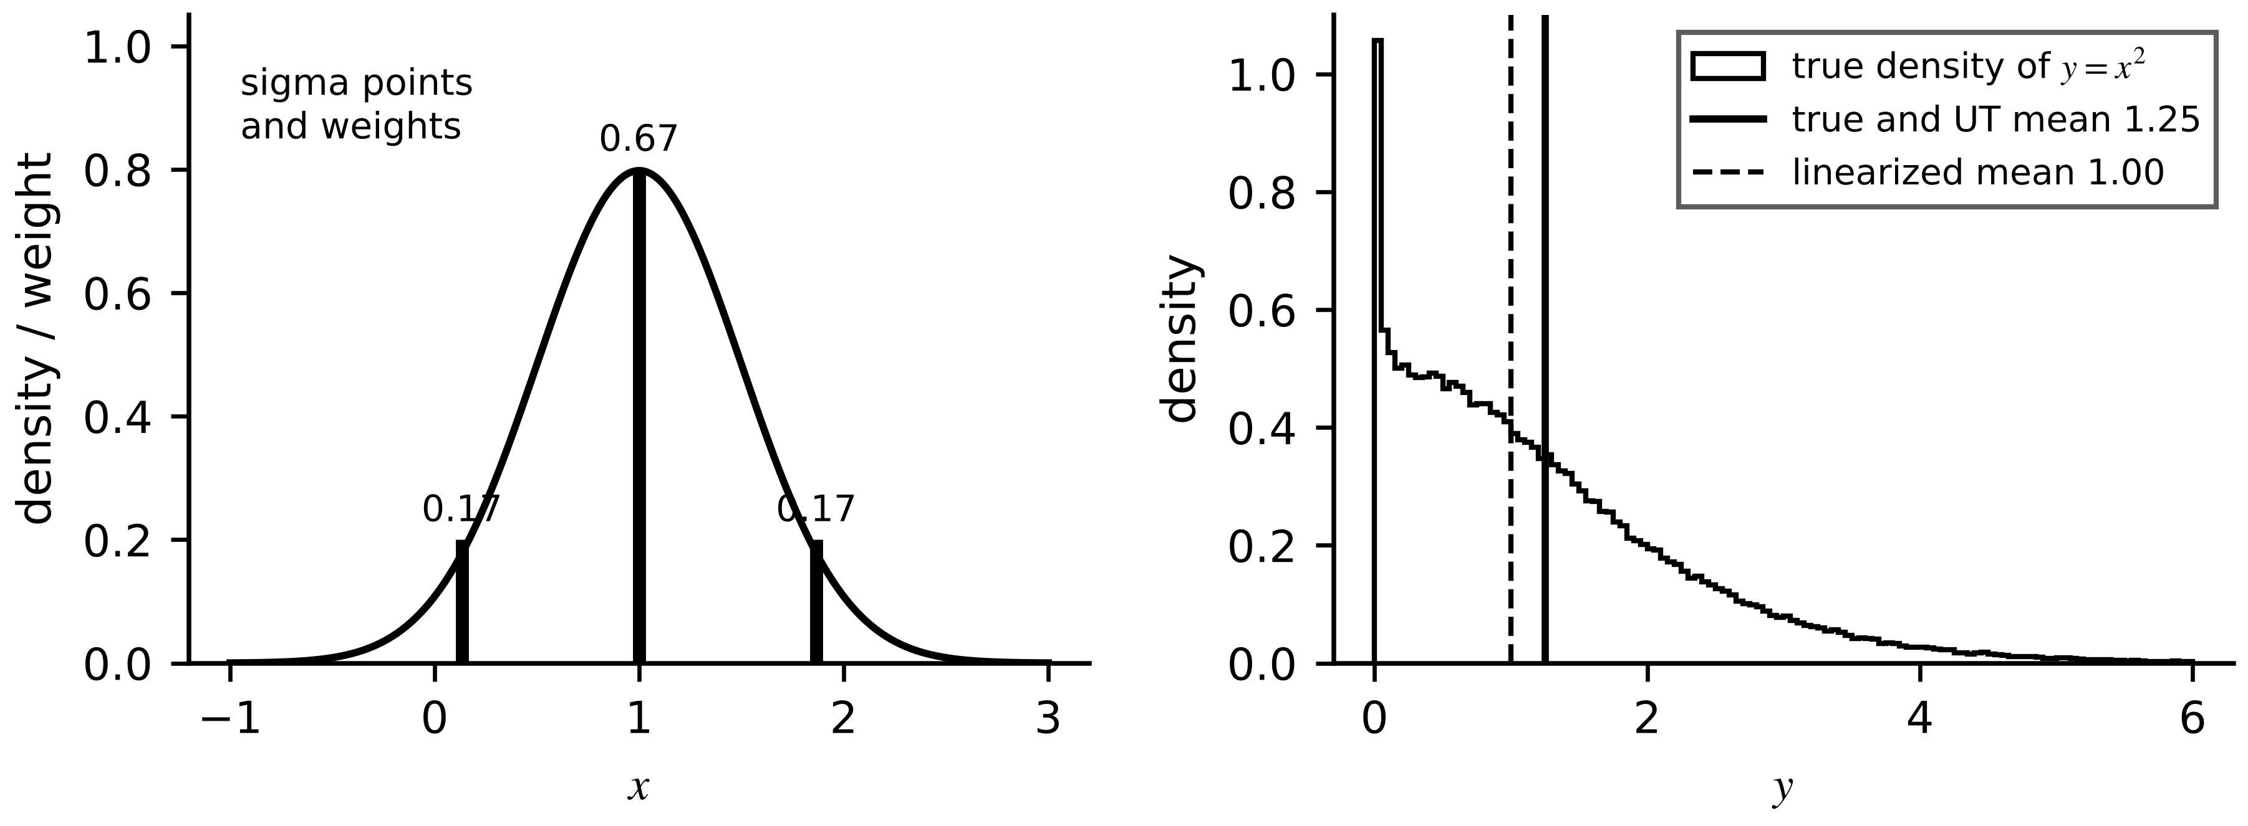
Figure 5.16. The unscented transform on $y=x^{2}$. Left: three sigma points and their weights on the prior. Right: the true density of $y$, whose mean (1.25) the transform recovers exactly while linearization reports 1.00.

5.8 Particle filtering
When the posterior is far from Gaussian (several peaks, hard bounds, heavy tails), the particle filter represents it with $N_{p}$ weighted samples $\{x_{k}^{(j)},w_{k}^{(j)}\}$ [11]. Each step moves every particle through the process model with sampled noise, multiplies its weight by the likelihood of the new measurement and normalizes; the estimate is the weighted mean. Because weights concentrate on a few particles, the filter monitors the effective sample size and resamples (duplicating heavy particles, dropping light ones) when it falls too low:
$x_{k}^{(j)}∼p\left(x_{k}|x_{k-1}^{(j)}\right), w_{k}^{(j)}∝w_{k-1}^{(j)} p\left(y_{k}|x_{k}^{(j)}\right), \sum_{j}{w_{k}^{(j)}}=1, {\hat{x}}_{k}=\sum_{j}{w_{k}^{(j)}}x_{k}^{(j)}, N_{eff}=\frac{1}{\sum_{j}{{\left(w_{k}^{(j)}\right)}^{2}}}$ (5.28)
Example 5.11 (Level B) A particle filter on cell C-1
Given. $N_{p}=500$ particles, initial SOC uniform between 30 and 95 % (a vague prior), polarization $𝒩(0, (5 mV)^{2})$, process noise as the EKF with the SOC term scaled by 3 to keep the cloud from collapsing; systematic resampling when $N_{eff}<250$; seed 7. Separately, ten particles with weights 0.35, 0.30, 0.15, 0.10, 0.04, 0.02, 0.01, 0.01, 0.01, 0.01.
Find. SOC RMS error over 600 to 3600 s, resampling count over the record, and $N_{eff}$ of the ten-particle example.
Solution. RMS error 0.012 points; 848 resamplings in 7200 steps, because the 2 mV likelihood is sharp. Ten particles: $\sum{w^{2}}=0.2474$, $N_{eff}=4.04<5$: resample.
Interpretation. After the first sample the particles far from 80 % carry almost no weight (Figure 5.17): a single precise measurement collapses the vague prior. On this nearly Gaussian problem the particle filter matches the EKF at much higher cost; its value appears when the density is genuinely non-Gaussian, which is exactly when the EKF's consistency tests start to fail.
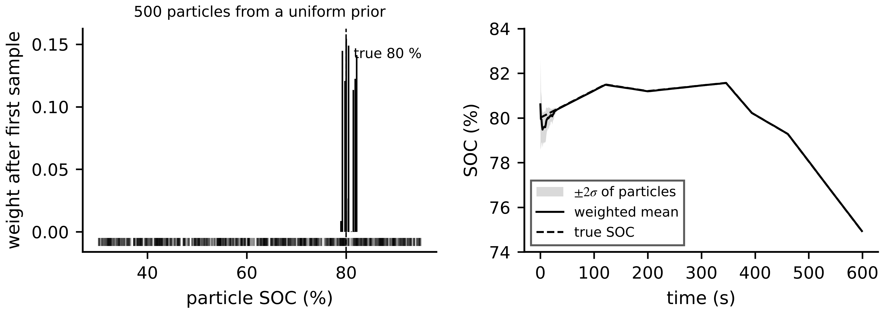
Figure 5.17. Particle filter on cell C-1. Left: weights of the 500 particles after the first sample, concentrated near the true 80 %. Right: weighted mean and ±2σ of the particles against the true SOC over the first ten minutes.

5.9 Moving horizon estimation and robust estimation

5.9.1 Moving horizon estimation and constraints
Moving horizon estimation (MHE) computes the MAP estimate over a window of the last $N_{h}$ samples, by optimization, with constraints if needed (Figure 5.18) [12]:
$\min_{x_{k-N_{h}},…,x_{k}}{\left\|x_{k-N_{h}}-{\overline{x}}_{k-N_{h}}\right\|}_{Π^{-1}}^{2}+\sum_{j=k-N_{h}}^{k-1}{{\left\|w_{j}\right\|}_{Q^{-1}}^{2}}+\sum_{j=k-N_{h}}^{k}{{\left\|y_{j}-h\left(x_{j}\right)\right\|}_{R^{-1}}^{2}} s.t. x_{j}∈𝕏$ (5.29)
where $‖a‖_{M}^{2}=a^{⊤}Ma$, $w_{j}=x_{j+1}-f(x_{j},u_{j})$, $\overline{x}$ and $Π$ summarize all data older than the window (the arrival cost) and $𝕏$ is the feasible set, for example $0≤z≤1$. For a linear model without constraints and a one-sample window with $Π=P_{k|k-1}$, setting the gradient of (5.29) to zero returns exactly the Kalman update. A cheap approximation of a constrained update projects the unconstrained estimate onto the constraint $D^{⊤}x≤d$ in the metric of $P$:
${\hat{x}}_{c}=\hat{x}-\frac{PD}{D^{⊤}PD}\left(D^{⊤}\hat{x}-d\right) if D^{⊤}\hat{x}>d$ (5.30)
which moves every correlated state, not only the violating one.
Example 5.12 (Level A) SOC near full charge
Given. At the end of a charge the update alone moves cell C-1's SOC to 1.023 and its polarization to 13.1 mV. The covariance has SOC standard deviation 0.010, polarization standard deviation 2 mV and correlation 0.6.
Find. The constrained estimate with $z≤1$ from (5.30).
Solution. $P=[1.0×{10}^{-4}, 1.2×{10}^{-5}; 1.2×{10}^{-5}, 4×{10}^{-6}]$, $D=[1, 0]^{⊤}$; $PD/(D^{⊤}PD)=[1, 0.12]^{⊤}$; violation 0.023; ${\hat{x}}_{c}=[1.000, 0.01034]^{⊤}$: SOC 100 %, polarization 10.3 mV.
Interpretation. Clipping SOC alone would leave the polarization at 13.1 mV, inconsistent with the correlation the filter had learned. MHE does this automatically over its whole window; its cost grows roughly linearly with the horizon for a structured solver.
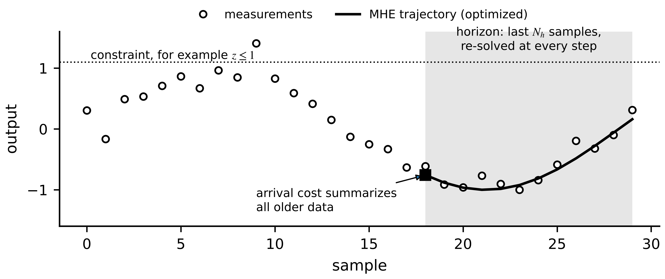
Figure 5.18. Moving horizon estimation: the trajectory over the last $N_{h}$ samples is optimized at every step, subject to constraints, with an arrival cost summarizing all older data.

5.9.2 Outliers, heavy tails and M-estimation
Least squares and Kalman updates give every residual a weight that grows with its size, so a single wild value can move the estimate a long way. Real sensor data have heavier tails than the Gaussian: glitches, saturations, timestamp errors (Chapter 3). M-estimation replaces the quadratic loss by one that grows more slowly for large residuals (Figure 5.19) [13]; with the Huber loss and a residual scale $s$,
$\hat{θ}=arg\min_{θ}\sum_{k}{ρ}\left(\frac{r_{k}(θ)}{s}\right), ρ(u)=\left\{\begin{matrix}u^{2}/2 & |u|≤c \\ c|u|-c^{2}/2 & |u|>c\end{matrix}\right., w(u)=min\left(1,\frac{c}{|u|}\right)$ (5.31)
solved by iteratively reweighted least squares, re-running (5.11) with weights $w(r_{k}/s)/s^{2}$ until they settle. The constant $c=1.345$ keeps 95 % efficiency for Gaussian data, and the scale is estimated with an outlier-resistant statistic, for example $1.4826$ times the median absolute deviation. In a Kalman filter the same idea scales the measurement variance by $1/w$ for large normalized innovations, or gates them out (Chapter 3, Section 3.13).
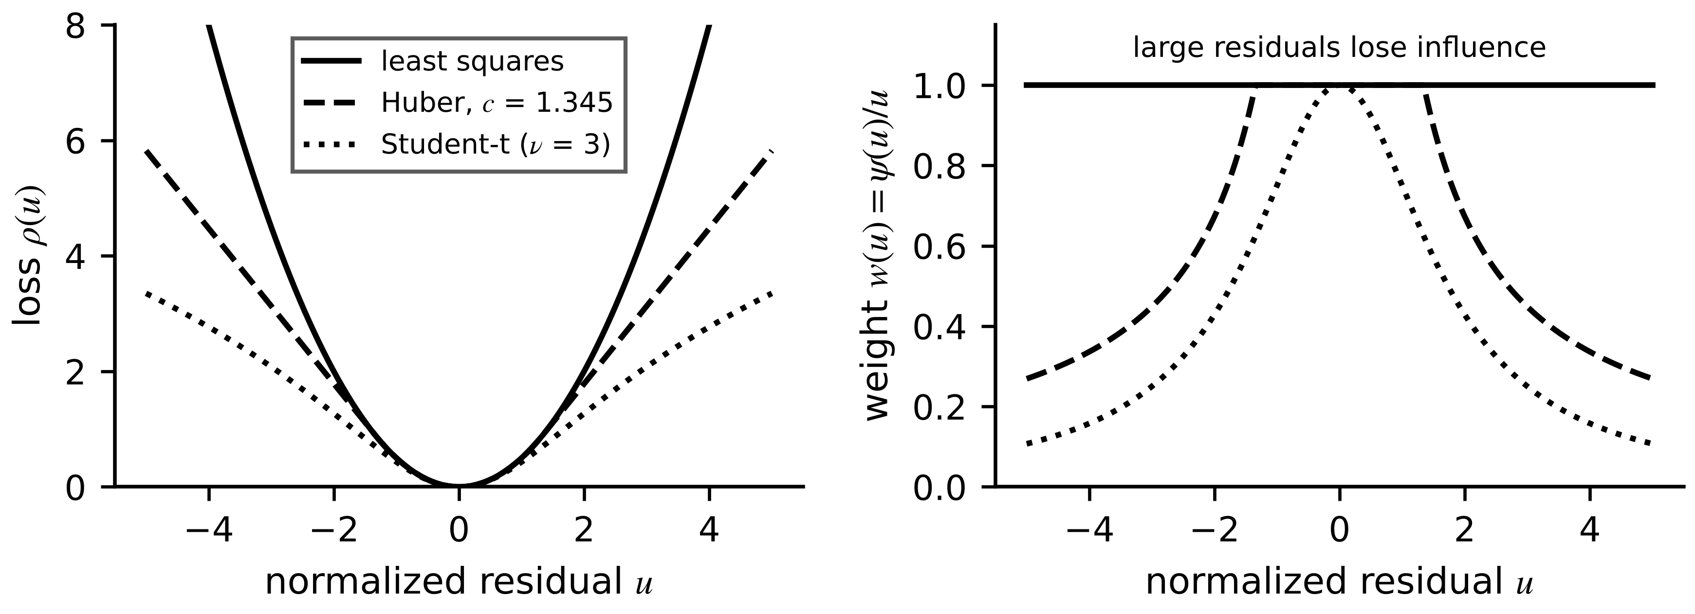
Figure 5.19. Robust losses. Left: quadratic, Huber and Student-t losses against the normalized residual. Right: the corresponding weights; large residuals lose influence under the robust losses.
Example 5.13 (Level B) A glitch in the resistance test
Given. The current-step data of Example 5.2 plus a sixth step, 30 A, whose voltage reads 60.0 mV because of a sensor glitch (the true drop would be about 45 mV). Residual scale $s=0.3$ mV, $c=1.345$.
Find. ${\hat{R}}_{0}$ by least squares and by Huber M-estimation, and the final weights.
Solution. Least squares: 1.556 mΩ, 3.5 % high. Huber, by reweighted least squares (ten iterations): 1.505 mΩ; the glitch receives weight 0.027, the 40 A step 0.79, all others 1.
Interpretation. The Huber estimate is within 0.14 % of the clean result of Example 5.2. A Huber loss tolerates occasional bad data; it does not tolerate a coordinated attack that keeps every residual small. That border, where bad data ends and malicious data begin, is the subject of Chapter 14.
What the digital twin adds
Synchronized: states within physical bounds, resistant to occasional bad data.
Estimated or updated: windowed MAP trajectory; robust weights per residual.
Uncertainty carried: arrival cost and down-weighted measurements.
Decision enabled: estimates that stay physical near limits and stable under glitches.
Validated by: injected outlier and constraint tests during commissioning.

5.10 Joint and dual state-parameter estimation
When a parameter drifts during operation, a filter with the old value blames the voltage error on the wrong quantity. The joint approach appends the parameter to the state as a slowly varying random walk and estimates both with one filter, as in early battery-management filters [14] (Figure 5.20):
$x_{a,k}=\left[\begin{matrix}x_{k} \\ θ_{k}\end{matrix}\right], x_{a,k+1}=\left[\begin{matrix}f\left(x_{k},u_{k},θ_{k}\right) \\ θ_{k}\end{matrix}\right]+\left[\begin{matrix}w_{k} \\ w_{θ,k}\end{matrix}\right], cov\left(w_{θ}\right)=Q_{θ}$ (5.32)
For cell C-1 the augmented state is $[z, v_{1}, R_{0}]^{⊤}$ and the measurement Jacobian gains a column, $H=[OCV'(z), -1, -i_{k}]$: the resistance is visible only when current flows. Three pitfalls follow. Tuning: $Q_{θ}$ sets the trade-off between lag and noise, as the forgetting factor does in RLS. Excitation: when $i_{k}=0$ the parameter receives no information and its variance grows by $Q_{θ}$ per step. Artificial correlation: the filter learns a correlation between state and parameter errors from the model structure, and an error in one is partly blamed on the other; an observable-looking augmented model can still separate them poorly, which must be checked with the augmented observability matrix. Dual estimation runs two filters, one for states with the parameter fixed and one for the parameter with the state fixed, exchanging estimates; it is cheaper and avoids some cross-coupling, at the price of ignoring the cross-covariance.
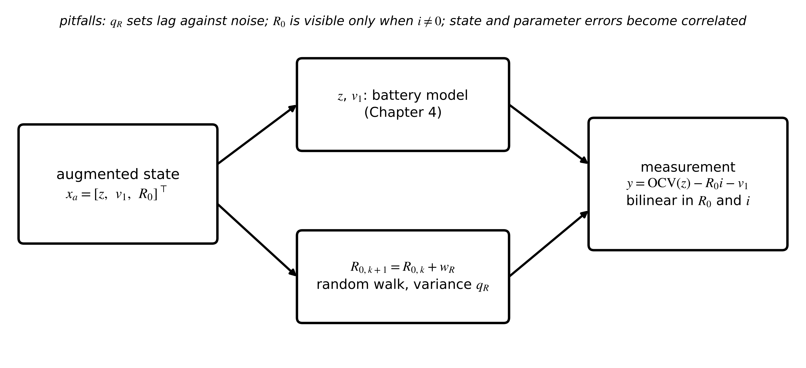
Figure 5.20. The augmented state-parameter model for cell C-1. The resistance enters the measurement multiplied by the current, so it is observable only when current flows.
Example 5.14 (Level C) Tracking the ageing resistance of cell C-1
Given. The whole running data set, in which $R_{0}$ rises from 1.50 to 2.25 mΩ between 3600 and 5400 s. Filter 1: the EKF of Example 5.9 with $R_{0}$ fixed at 1.50 mΩ. Filter 2: the joint EKF with (5.32), $q_{R}=(0.2 μΩ)^{2}$ per step and initial $R_{0}$ standard deviation 0.5 mΩ. Also RLS with $λ=1$, 0.999 and 0.99 on the ARX model of (5.15).
Find. SOC error and mean NIS in the final 30 minutes, the final resistance estimates, the 90 % lag of the joint estimate, and the effect of $q_{R}$.
Solution. Table 5.3, Table 5.4 and Figure 5.21. Fixed filter: SOC RMS error 1.23 points (maximum 1.92), mean NIS 70.5. Joint EKF: 0.10 points (maximum 0.23), mean NIS 1.60, ${\hat{R}}_{0}=2.239±0.004$ mΩ against 2.250, reaching 90 % of the step 590 s after the truth. RLS ends at 1.749 ($λ=1$), 2.160 (0.999) and 2.188 mΩ (0.99).
Interpretation. With the wrong resistance the fixed filter blames the voltage error on SOC and is off by up to two points; its NIS of 70 shouts that something is wrong, which Section 5.12 turns into an alarm. The joint filter keeps SOC to a tenth of a point. Table 5.4 shows the price of each $q_{R}$: the smallest never catches the ramp, the largest tracks it within 106 s but is four times noisier in healthy operation. $q_{R}$ should be set from the expected ageing rate, and the choice validated like any other tuning.
Table 5.3. Fixed-parameter and joint estimation on cell C-1 (final 1800 s of the synthetic record)
Estimator | SOC RMS error (pp) | SOC max error (pp) | Mean NIS | $R_{0}$ at 7200 s (mΩ)
EKF, $R_{0}$ fixed at 1.50 mΩ | 1.23 | 1.92 | 70.5 | 1.50 (fixed)
joint EKF, $q_{R}=(0.2 μΩ)^{2}$ | 0.10 | 0.23 | 1.60 | 2.239 ± 0.004 (true 2.250)
RLS on ARX, λ = 1 |  |  |  | 1.749
RLS on ARX, λ = 0.99 |  |  |  | 2.188

Table 5.4. Effect of the parameter random-walk intensity on the joint EKF
$\sqrt{q_{R}}$ per step | sd of ${\hat{R}}_{0}$ in healthy hour (µΩ) | 90 % lag behind the truth | ${\hat{R}}_{0}$ error, last 1000 s (µΩ) | SOC RMS, last 30 min (pp)
0.05 µΩ | 1.0 | not reached | −252 | 0.49
0.2 µΩ | 2.2 | 590 s | −24 | 0.10
1.0 µΩ | 8.1 | 106 s | −10 | 0.02

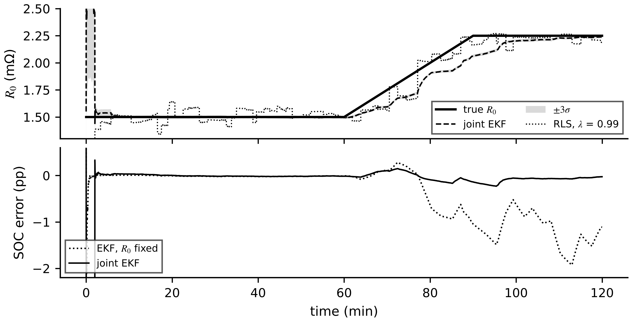
Figure 5.21. Joint estimation on cell C-1. Top: true resistance, joint-EKF estimate with ±3σ band and RLS with λ = 0.99. Bottom: SOC error of the fixed-resistance EKF and of the joint EKF.
What the digital twin adds
Synchronized: states and slowly drifting parameters together.
Estimated or updated: augmented state with cross-covariance; $q_{R}$ tuned to the ageing rate.
Uncertainty carried: parameter variance that grows when excitation stops.
Decision enabled: ageing tracking and maintenance advisories (Chapter 12).
Validated by: synthetic ageing scenarios with known truth, and parameter-drift plausibility.

5.11 Multi-rate, delayed and missing data

5.11.1 Fusing measurements taken at different times
Twin data arrive at different rates and with different delays (Figure 5.22): voltage and current every second, an OCV-based SOC check every few minutes and seconds late, a thermal reading every 30 s. The rule is to process each measurement at the time it was taken, never at the time it arrived. When two sensors report the same quantity at different instants, the older reading has to be aged to the present before fusion; for a quantity that diffuses like a random walk with intensity $q_{d}$ (units² per second), its uncertainty after an age $Δt$ is
$u_{B}(t)=\sqrt{u_{B}^{2}+q_{d} Δt}, \hat{x}=\frac{x_{A}/u_{A}^{2}+x_{B}/u_{B}(t)^{2}}{1/u_{A}^{2}+1/u_{B}(t)^{2}}$ (5.33)
which is exactly what a Kalman filter does when it predicts to each measurement's timestamp before updating.
Example 5.15 (Level A) Fusing an older reading
Given. Sensor A reports at 100.00 s with $u_{A}=0.3$ K. Sensor B's latest reading is stamped 99.70 s with $u_{B}=0.4$ K. The process diffuses at $q_{d}=0.25$ K²/s.
Find. B's uncertainty at 100.00 s, the fusion weights and the fused uncertainty.
Solution. (5.33): $u_{B}=\sqrt{0.16+0.25×0.30}=0.485$ K. Weights $w_{A}=(1/0.09)/(1/0.09+1/0.235)=0.723$, $w_{B}=0.277$. Fused uncertainty $(1/0.09+1/0.235)^{-1/2}=0.255$ K.
Interpretation. Three tenths of a second of age cost sensor B about a quarter of its weight: 0.28 against 0.36 for a reading of the same age as A's.
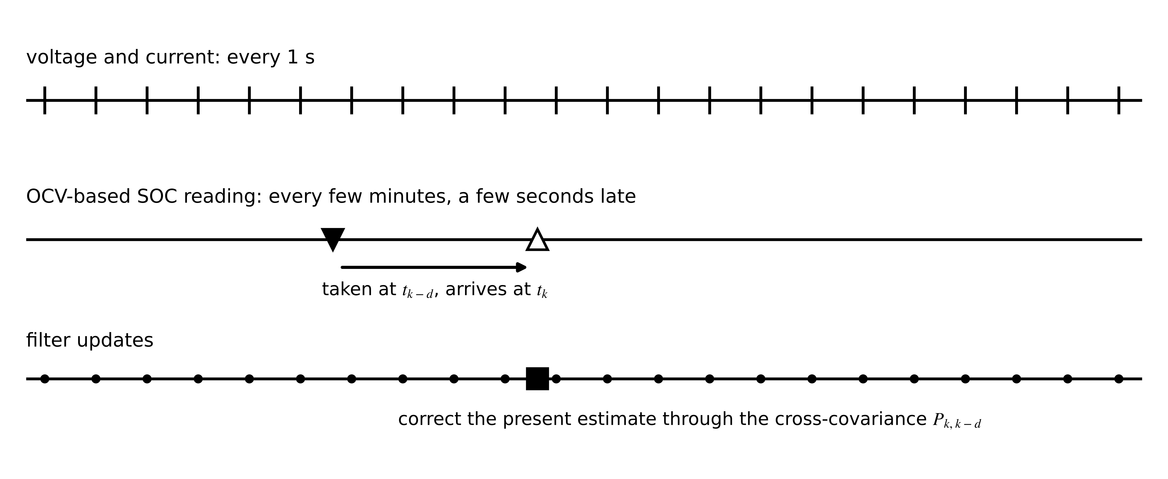
Figure 5.22. Multi-rate and delayed measurements. Voltage and current arrive every second; an OCV-based SOC check is taken at $t_{k-d}$ and arrives at $t_{k}$; the filter corrects its present estimate through the cross-covariance between the two times.
[Advanced] Delayed measurements. A measurement $y_{k-d}$ taken $d$ samples ago can update the present state without re-running the filter, provided the filter stored the prior at $k-d$ and propagated the cross-covariance $P_{k,k-d}=cov(x_{k},x_{k-d})$ alongside its own covariance [15]:
${\hat{x}}_{k|k,d}={\hat{x}}_{k|k}+P_{k,k-d}H^{⊤}S_{k-d}^{-1}\left(y_{k-d}-H{\hat{x}}_{k-d|k-d-1}\right), P_{k,k-d}=∏_{j=k-d}^{k-1}\left(F_{j}\left(I-K_{j}H_{j}\right)\right)P_{k-d|k-d-1}$ (5.34)
where the product runs over the intermediate steps (ordered from the most recent on the left). For a pure integrator such as SOC with no intermediate updates, $P_{k,k-d}=P_{k-d|k-d-1}$ and the correction passes unchanged to the present.
Example 5.16 (Level B) A delayed OCV-based SOC check
Given. A BESS twin integrates SOC every second. An OCV-based SOC reading taken 5 s ago reads 50.2 % with standard deviation 0.5 points; the filter's prior at that time was 51.0 % with standard deviation 1.0 point; no other SOC information arrived since, and process noise over 5 s is negligible. The present estimate is 49.6 %.
Find. The gain, the correction, the updated present estimate and its standard deviation.
Solution. $S={1.0}^{2}+{0.5}^{2}=1.25$; $K=1.0/1.25=0.80$; correction $0.80×(50.2-51.0)=-0.64$ points, applied to the present: 48.96 %; standard deviation $\sqrt{(1-0.8)×1.0}=0.45$ points.
Interpretation. The correction is computed against the prior at the time the reading was taken. Applying the 50.2 % reading against the present 49.6 % would have moved SOC upwards, in the wrong direction.

5.11.2 Out-of-sequence measurements
Networks reorder messages, so a sample can arrive after a newer one (Figure 5.23). Three strategies exist: reprocess (roll back to the older sample's time and re-run the filter, exact but costly), discard (honest: less information, larger variance), or apply the late sample naively as if it were current (wrong).
Example 5.17 (Level B) A delayed RTD sample on motor M-07
Given. The M-07 filter of Example 5.6, now heating towards 114 °C at 420 W. Posterior at sample $k-1$: 100.00 °C, variance 0.0127 K². Sample $k$ reads 100.35 °C but arrives after sample $k+1$, which reads 100.52 °C.
Find. The estimate after both samples by reprocessing, by discarding sample $k$, and by naive late application.
Solution. Reprocessing: 100.482 °C, variance 0.01270 K². Discarding: 100.469 °C, variance 0.01416 K². Naive: 100.452 °C, variance 0.01223 K².
Interpretation. Discarding is honest: its variance is larger because it used less information. The naive update moves the estimate the wrong way, because the late reading is compared with a prediction for a later, hotter instant, and it reports a variance smaller than the exact solution's (Figure 5.23). On a fast electrical signal the same mistake produces errors as large as the signal's change over the delay.
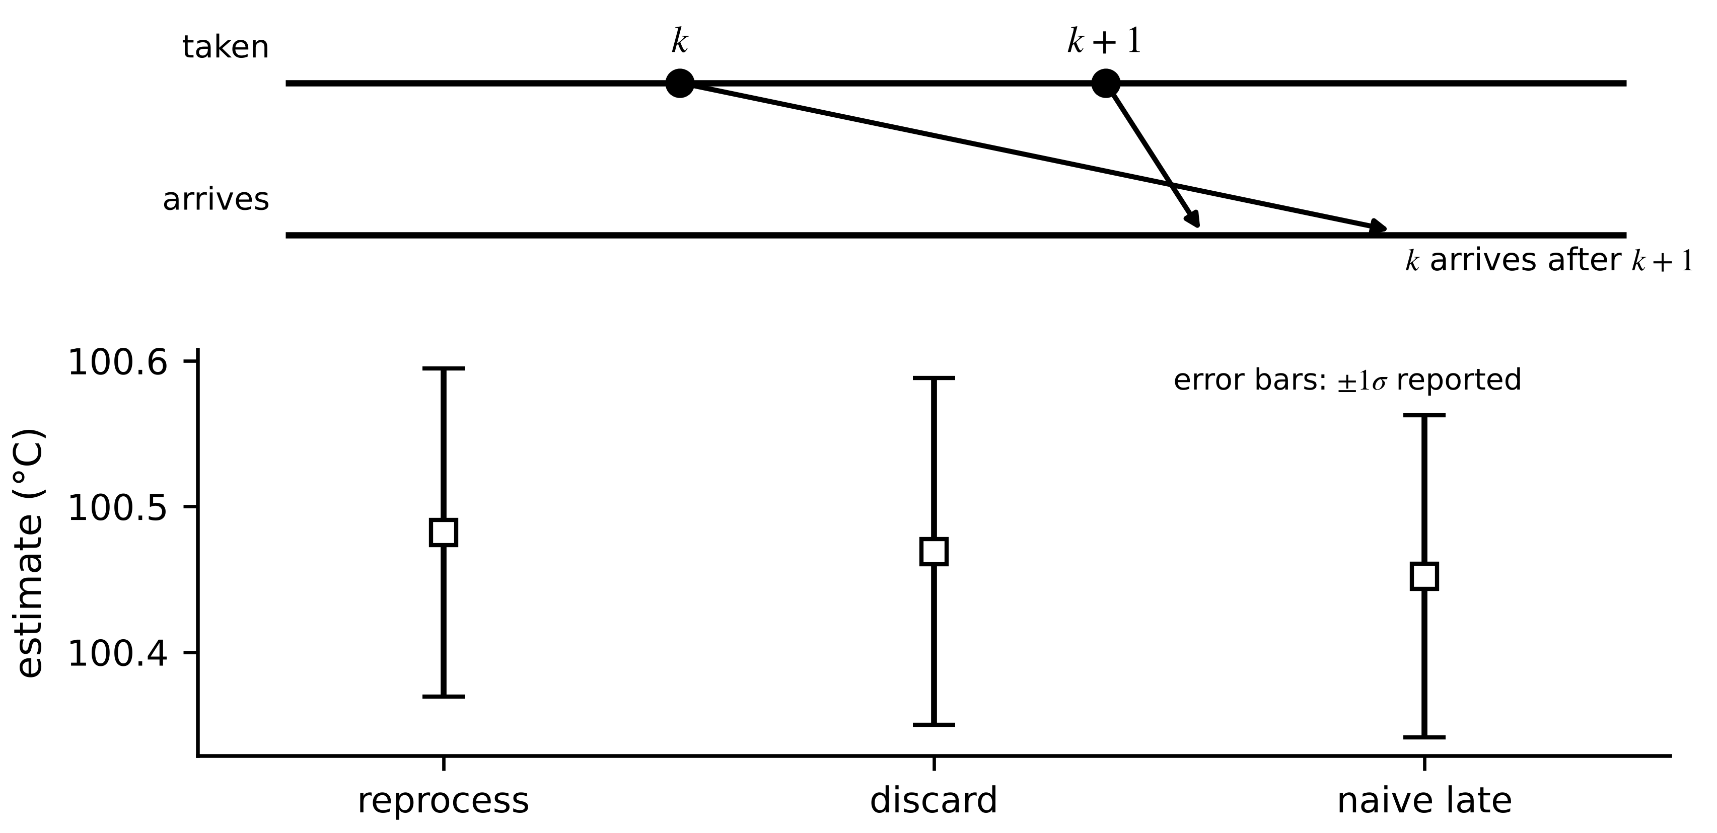
Figure 5.23. Out-of-sequence handling. Top: sample $k$ arrives after sample $k+1$. Bottom: estimates and reported ±1σ for reprocessing, discarding and naive late application; the naive result is both shifted and overconfident.

5.11.3 Missing data and holdover
When data stop, the filter keeps predicting and its covariance grows; no update arrives to shrink it. For SOC with an assumed current whose uncertainty is $σ_{i}$, the standard deviation grows linearly with the time without data, and the twin can declare in advance how long it may hold over before its budget $σ_{max}$ is spent (Figure 5.24):
$σ_{z}(t)=\sqrt{σ_{z,0}^{2}+{\left(\frac{σ_{i} t}{3600 Q_{n}}\right)}^{2}}, t_{hold}=\frac{3600 Q_{n}}{σ_{i}}\sqrt{σ_{max}^{2}-σ_{z,0}^{2}}$ (5.35)
with SOC as a fraction. A 50 A·h twin entering holdover with $σ_{z,0}=0.2$ points, an assumed-current uncertainty of 0.5 A and a 2-point budget can hold over for $t_{hold}=7164$ s, about two hours; with 2 A uncertainty, half an hour. Holdover is honest only if the covariance really grows; a twin that freezes its last estimate and its last covariance during an outage claims a confidence it no longer has.
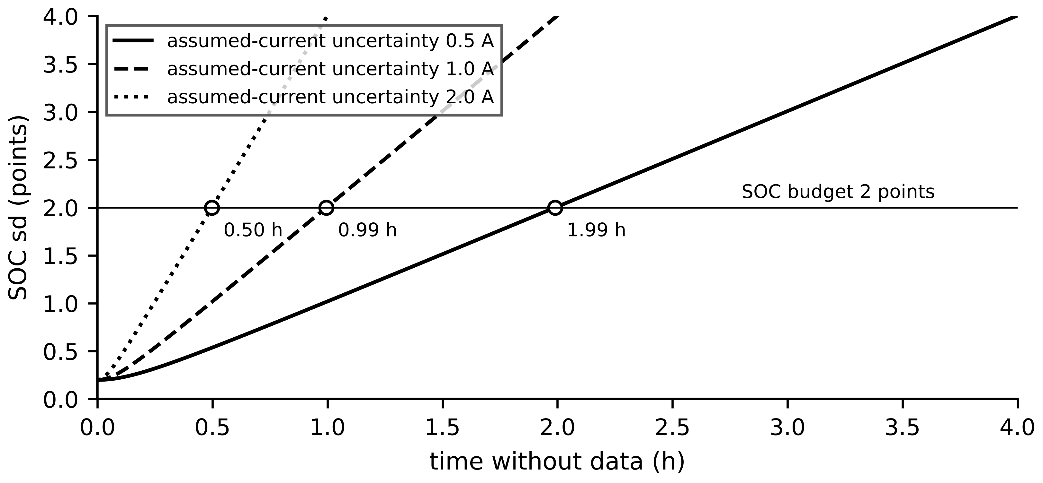
Figure 5.24. SOC uncertainty during a data outage for three assumed-current uncertainties, with the 2-point budget. The holdover time is fixed by the model and the budget, not by convention.
What the digital twin adds
Synchronized: every measurement at its own timestamp, whatever its arrival order.
Estimated or updated: corrections from delayed and out-of-sequence data; growing covariance in holdover.
Uncertainty carried: age of each measurement and the holdover budget.
Decision enabled: reprocess, discard or reject; how long a twin may run without data.
Validated by: replaying delayed, reordered and missing data at commissioning.

5.12 Residual monitoring and estimator validation

5.12.1 Detecting that the model no longer fits
The innovations of a correct filter are white with known covariance, so their windowed sum is chi-square. A windowed NIS test over the last $W$ samples raises an alarm when
$\sum_{j=k-W+1}^{k}{e_{j}^{⊤}}S_{j}^{-1}e_{j}>χ_{Wm, 1-α}^{2}$ (5.36)
An alarm says the model no longer fits; it does not say why. Table 5.5 lists three common causes and how to tell them apart before acting.
Table 5.5. Innovation signatures of three causes (distinguish before acting)
Cause | Innovation signature | Other evidence | Response
sensor noise larger than $R$ | zero mean, variance above $S$, white | redundant sensor agrees with the model | revise $R$; check the sensor
operating point outside the model's validity | bias or variance growth that follows load, temperature or SOC | returns to normal with the operating point | restrict the envelope; extend the model
true degradation or fault | persistent, growing bias independent of operating point | parameter estimates drift; other assets unaffected | joint estimation; maintenance advisory (Chapter 12)

Example 5.18 (Level B) Detecting the resistance ageing of cell C-1
Given. The fixed-resistance EKF of Example 5.14 with (5.36), $W=60$ s, $m=1$.
Find. The threshold for $α=0.001$; false alarms during the healthy period 660 to 3600 s at $α=0.001$ and 0.01; the time of the first alarm after the ageing begins at 3600 s.
Solution. $χ_{60,0.999}^{2}=99.6$, a mean NIS of 1.66 over the window. In 2940 healthy windows one exceeds it at $α=0.001$, and 66 do at $α=0.01$ (threshold 88.4), more than the nominal 29 because overlapping windows share samples. The first alarm comes at 3733 s, 133 s after the resistance began to rise, when it had grown by 3.7 % to 1.555 mΩ (Figure 5.25).
Interpretation. The joint filter of Example 5.14 also alarms briefly while its estimate catches up, but its resistance estimate is rising at the same moment, which is the evidence that separates degradation from a sensor or operating-point problem in Table 5.5.
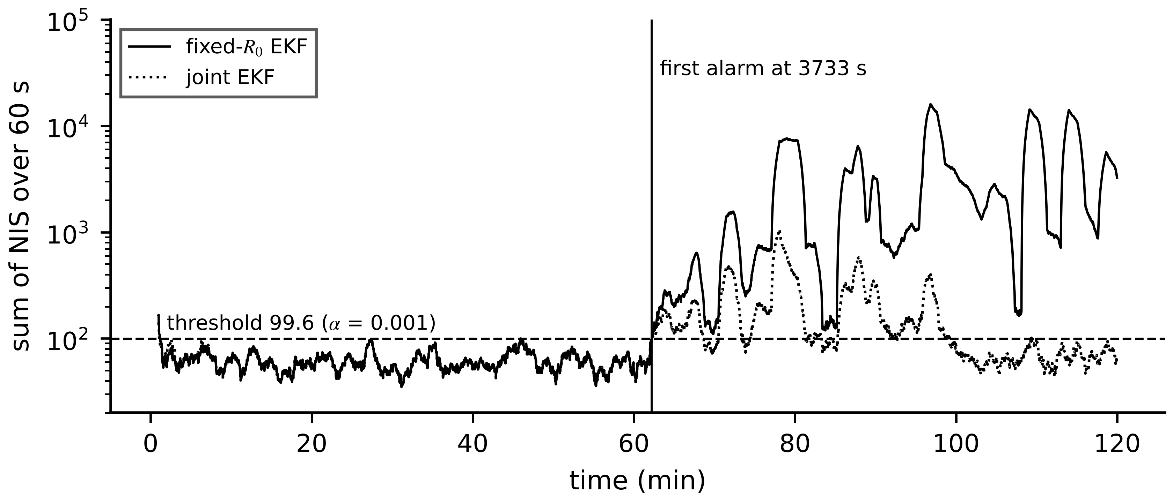
Figure 5.25. Innovation monitoring on cell C-1: windowed NIS over 60 s of the fixed-resistance EKF and of the joint EKF, against the α = 0.001 threshold. The fixed filter alarms 133 s after the ageing begins.

5.12.2 A validation workflow for estimators
An estimator is accepted, like any model (Chapter 4, Section 4.15), against criteria stated before testing (Figure 5.26). Five checks build on each other. Design-data consistency: Monte Carlo runs on synthetic data with known truth, with run-averaged NEES inside its band (Example 5.8). Field consistency: NIS and whiteness on held-out field data. Coverage: the fraction of truth values inside the reported intervals, where any truth exists (bench references, periodic full charges for SOC):
${\hat{cov}}_{95}=\frac{1}{N}\sum_{k=1}^{N}{1}\left[\left|x_{k}-{\hat{x}}_{k}\right|≤1.96\sqrt{P_{k}}\right]$ (5.37)
which should be close to 0.95; much lower coverage means an overconfident estimator, more dangerous than an inaccurate one. Out-of-distribution (OOD) and fault injection: runs at temperatures, currents and ageing states outside the tuning data, and with injected sensor faults, delays and dropouts. Safe fallback: what the twin reports when any check fails, for example SOC from coulomb counting with a covariance that grows by (5.35) and an ‘unsynchronized’ flag (Section 5.13).
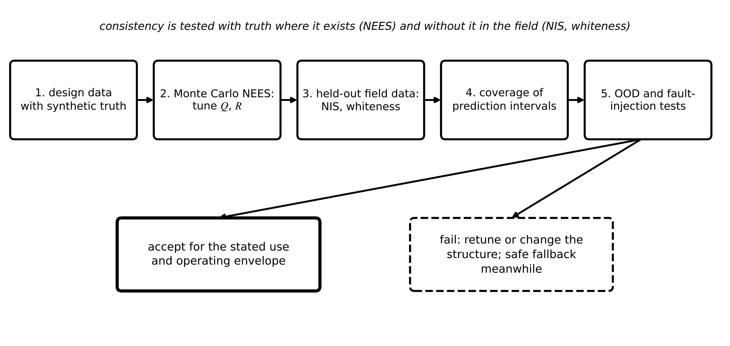
Figure 5.26. Estimator validation workflow: from Monte Carlo NEES on synthetic truth through field NIS and whiteness, coverage and out-of-distribution tests to acceptance for a stated envelope, with a safe fallback when any check fails.
What the digital twin adds
Synchronized: a continuous check that the twin still fits its asset.
Estimated or updated: windowed NIS, whiteness, coverage.
Uncertainty carried: false-alarm rate and detection delay of the monitor itself.
Decision enabled: alarm, diagnose with Table 5.5, or fall back.
Validated by: the five-step workflow, repeated after every model or tuning change.

5.13 Synchronization beyond state estimation
Everything so far kept the twin's state and parameters aligned with the asset, assuming the twin had the right model, the right network, the right clock and the right version of every table. In operation those assumptions fail more often than the filters do, and when they fail a filter can report a numerically excellent estimate that is simply wrong. Synchronization is therefore a contract over six dimensions (Figure 5.27), each with its own drift, metric and tool.
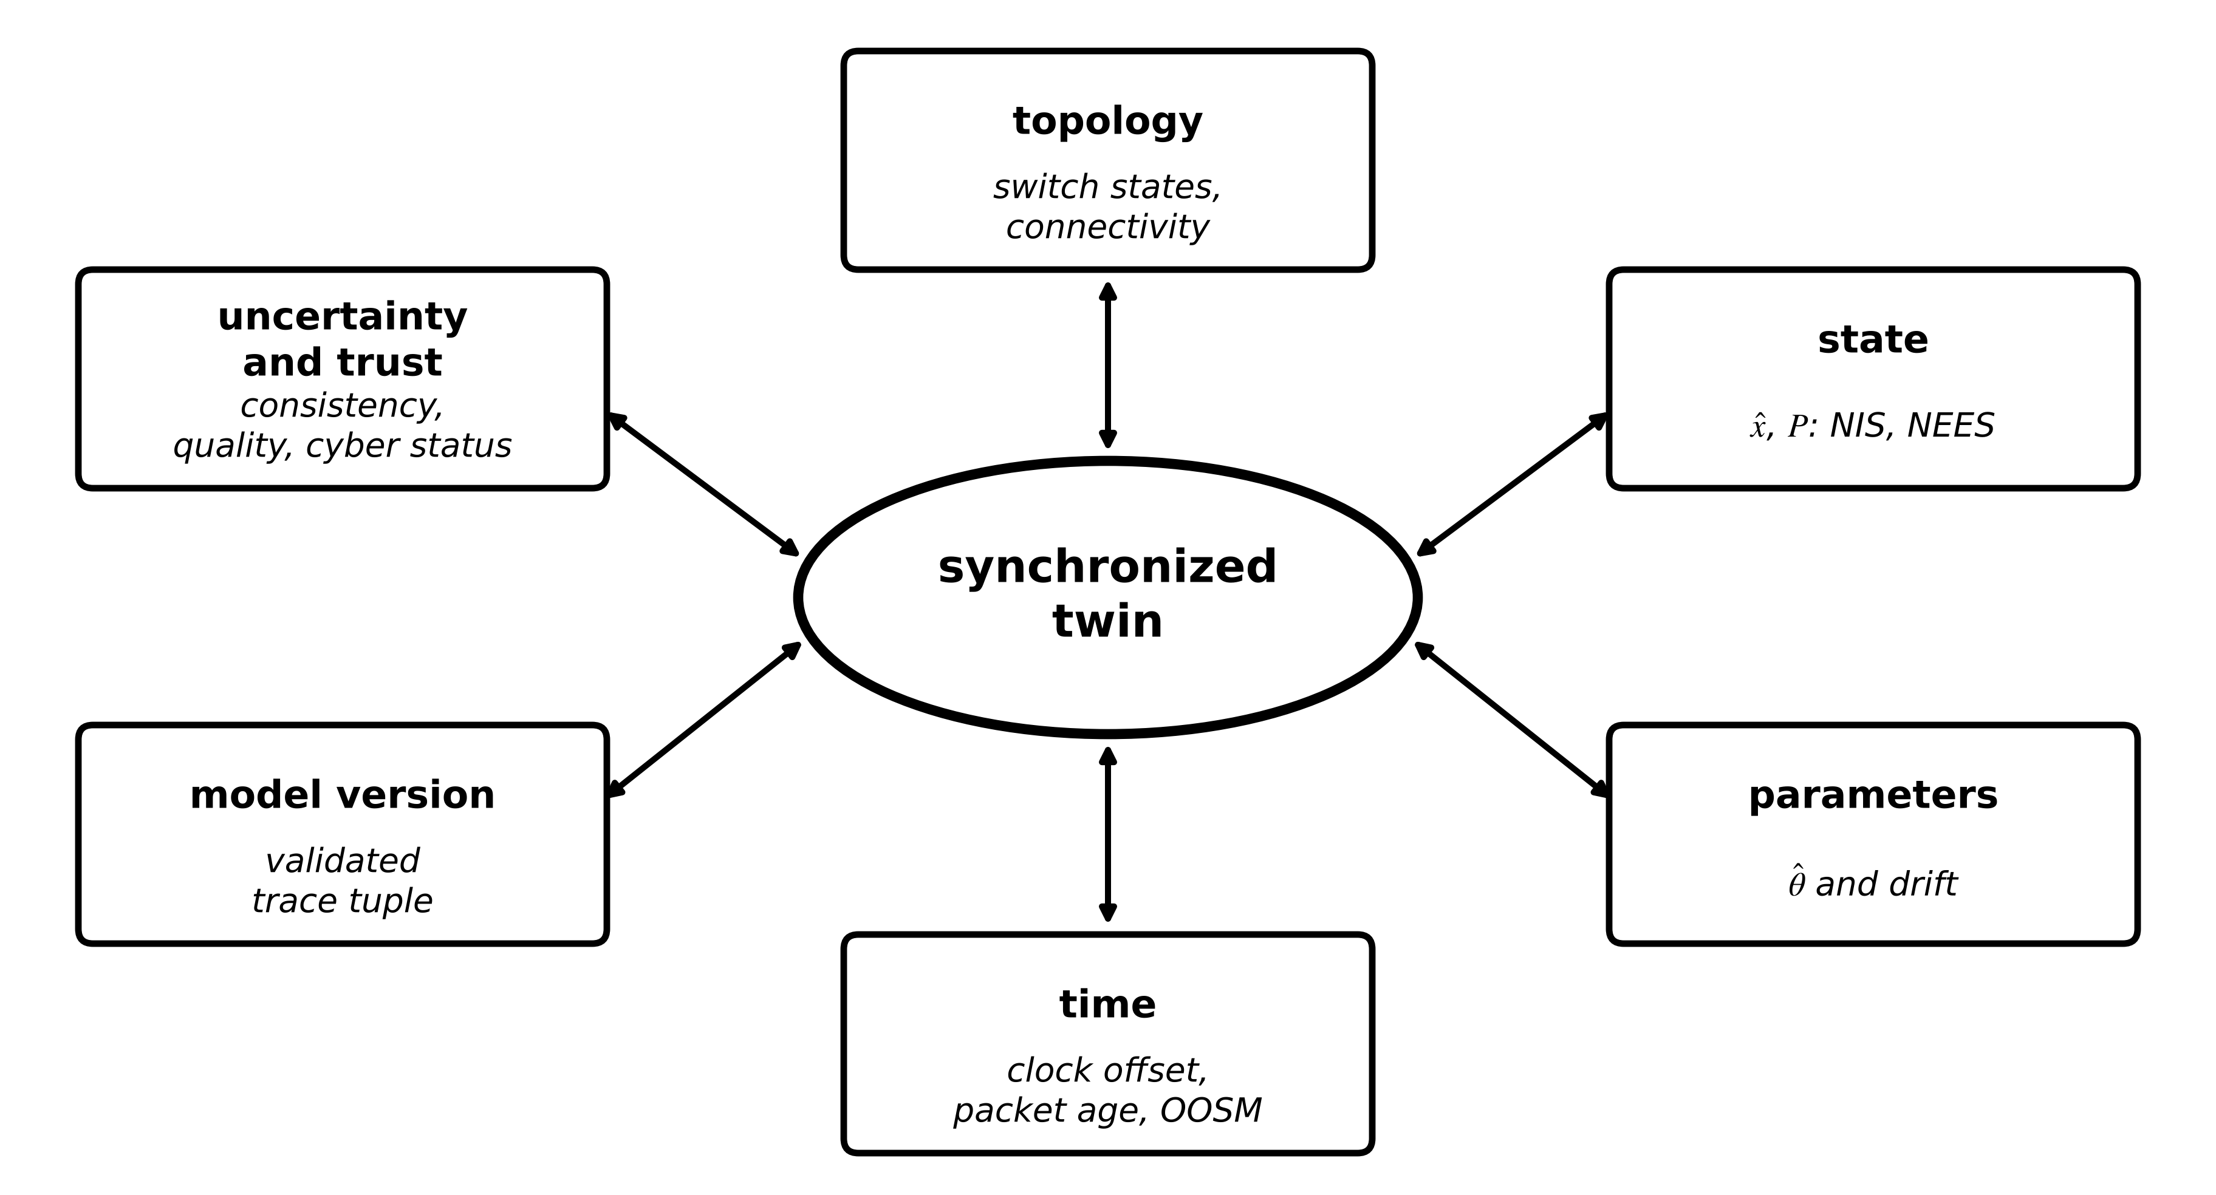
Figure 5.27. The six dimensions of twin synchronization. A twin is synchronized only when every dimension is checked; a state estimate can be precise while the topology, a parameter set, the clock or the model version is stale.
Table 5.6. The synchronization contract: six dimensions
Dimension | What drifts apart | Metric | Primary tool | Failure if neglected
topology | switch and breaker states, connectivity, asset replacements | topology change log against measured flows; residual pattern | topology processor, status inputs (Chapter 11) | many simultaneous ‘bad data’; confidently wrong network state
state | twin estimate against the asset's present state | NIS in operation; NEES and coverage at commissioning | Kalman family, MHE (5.5 to 5.9) | estimate lags or diverges
parameters | twin parameters against the aged asset | parameter innovation, drift of $\hat{θ}$, windowed NIS | RLS, joint estimation, recalibration (5.4, 5.10) | structure right, coefficients stale
time | twin ‘now’ against data timestamps | clock offset, packet age, out-of-sequence count | PTP and timestamping (Chapter 3), 5.11 | measurements misattributed in time
model version | deployed model and tables against the validated ones | trace tuple and hashes (Chapter 2) | configuration control, rollback | uncertified model runs unnoticed
uncertainty and trust | reported confidence against actual error; data trust | coverage, consistency, quality flags, cyber alerts | validation workflow (5.12), Chapter 14 | overconfident twin drives wrong decisions

Example 5.19 (Level C) A numerically excellent estimate with a stale OCV table
Given. The SOC EKF of Example 5.9 on the first hour of the running data set, but the twin's OCV table is a stale version for an earlier cell lot that reads 20 mV high everywhere; nothing else changes.
Find. SOC error, the filter's reported standard deviation and the mean NIS over 600 to 3600 s.
Solution. Mean SOC error $-2.88$ points (RMS 2.88); reported standard deviation 0.011 points; mean NIS 1.44 (Figure 5.28).
Interpretation. The filter fits the voltage almost as well as before by shifting its SOC by about $0.020/0.69≈2.9$ points, and reports a confidence 260 times tighter than its real error. A NIS of 1.44 is easily blamed on noise. Only the version dimension catches this: the twin's trace tuple would show an OCV table whose hash does not match the validated set for this cell lot (Chapter 2, Section 2.6). No estimator can detect a wrong model that explains the data equally well.
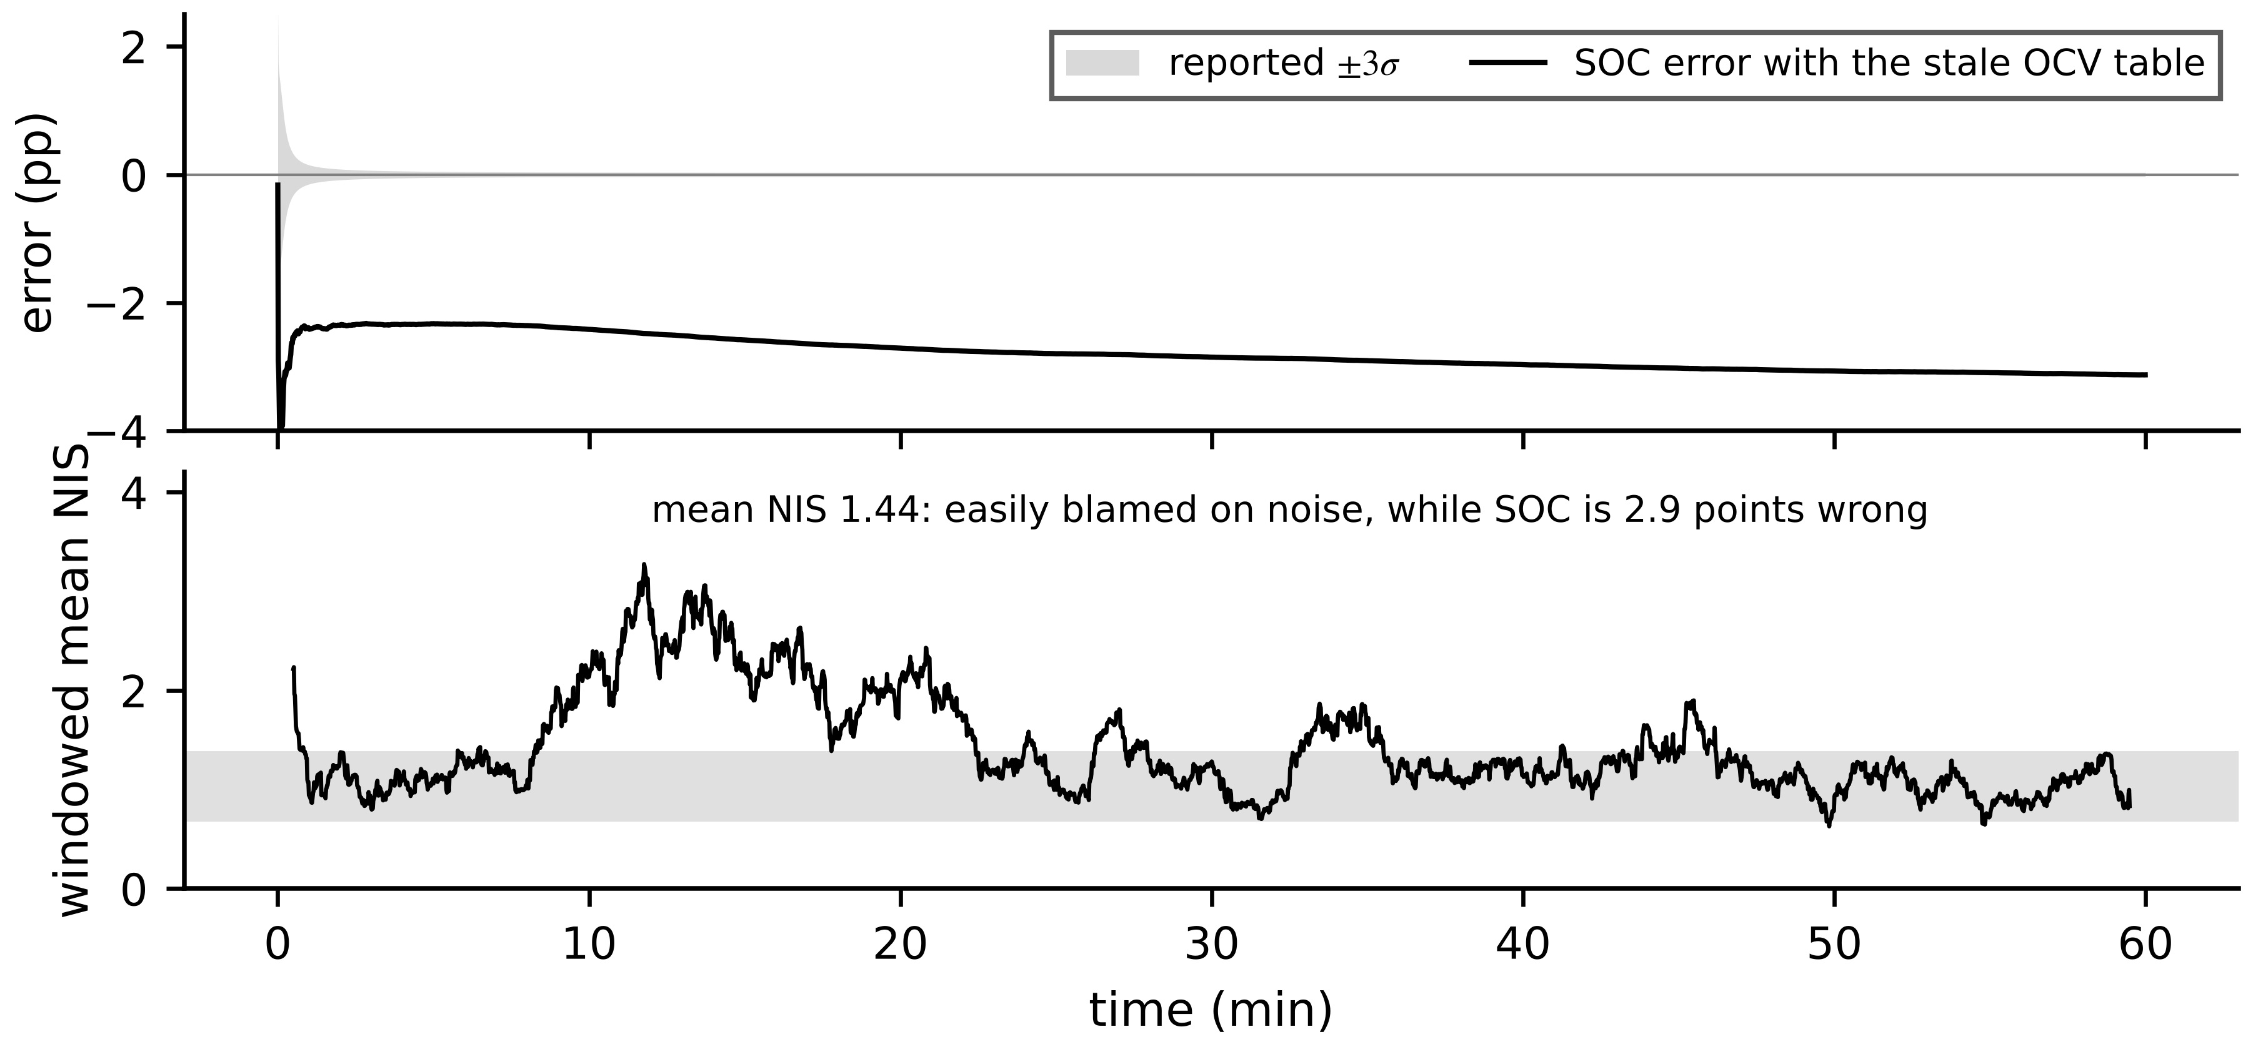
Figure 5.28. Model-version mismatch. Top: SOC error with the stale OCV table and the filter's reported ±3σ band, which does not contain the error. Bottom: windowed NIS, only mildly raised.
Example 5.20 (Level B) A stale topology in the three-bus estimator
Given. The network of Example 5.3. Line 2-3 is opened for maintenance, but the twin's topology still has it in service. Loads are unchanged ($P_{2}=-0.25$, $P_{3}=-0.65$ pu), so the true angles become $θ_{2}=-0.025$, $θ_{3}=-0.1625$ rad and the $P_{23}$ meter reads about zero. Readings with noise (seed 11): $z=[0.2503, 0.6636, 0.0122, -0.2602, -0.6560]$ pu.
Find. The WLS result with the stale topology, the effect of removing the largest normalized residual, and the result with the correct topology.
Solution. Stale: $J=1746$ against $χ_{3,0.95}^{2}=7.81$, normalized residuals $[-27.9, 36.5, -30.0, -6.4, -2.8]$, estimate $[-0.040, -0.090]$ rad. Removing the largest ($P_{13}$) leaves $J=411$ and an estimate $[-0.030, -0.056]$ rad, worse than before. Correct topology: $J=1.81$, estimate $[-0.0252, -0.1655]$ rad.
Interpretation. A stale topology looks like many meters going bad at once, and bad-data removal makes it worse, because it deletes good meters to fit a wrong model. When several large normalized residuals appear together, the topology dimension is checked first.

5.13.1 Resynchronization and rollback
When data return after an outage, or a dimension is repaired, the twin resynchronizes through a state machine (Figure 5.29). The rule is never to adopt a returning value blindly or reject it for disagreeing: test it for consistency against the propagated prediction with its grown covariance, fuse it if consistent, and if a dimension cannot be restored to a validated configuration, roll back to the last validated model version and parameter set, recorded in the digital thread (Chapter 2, Section 2.7).
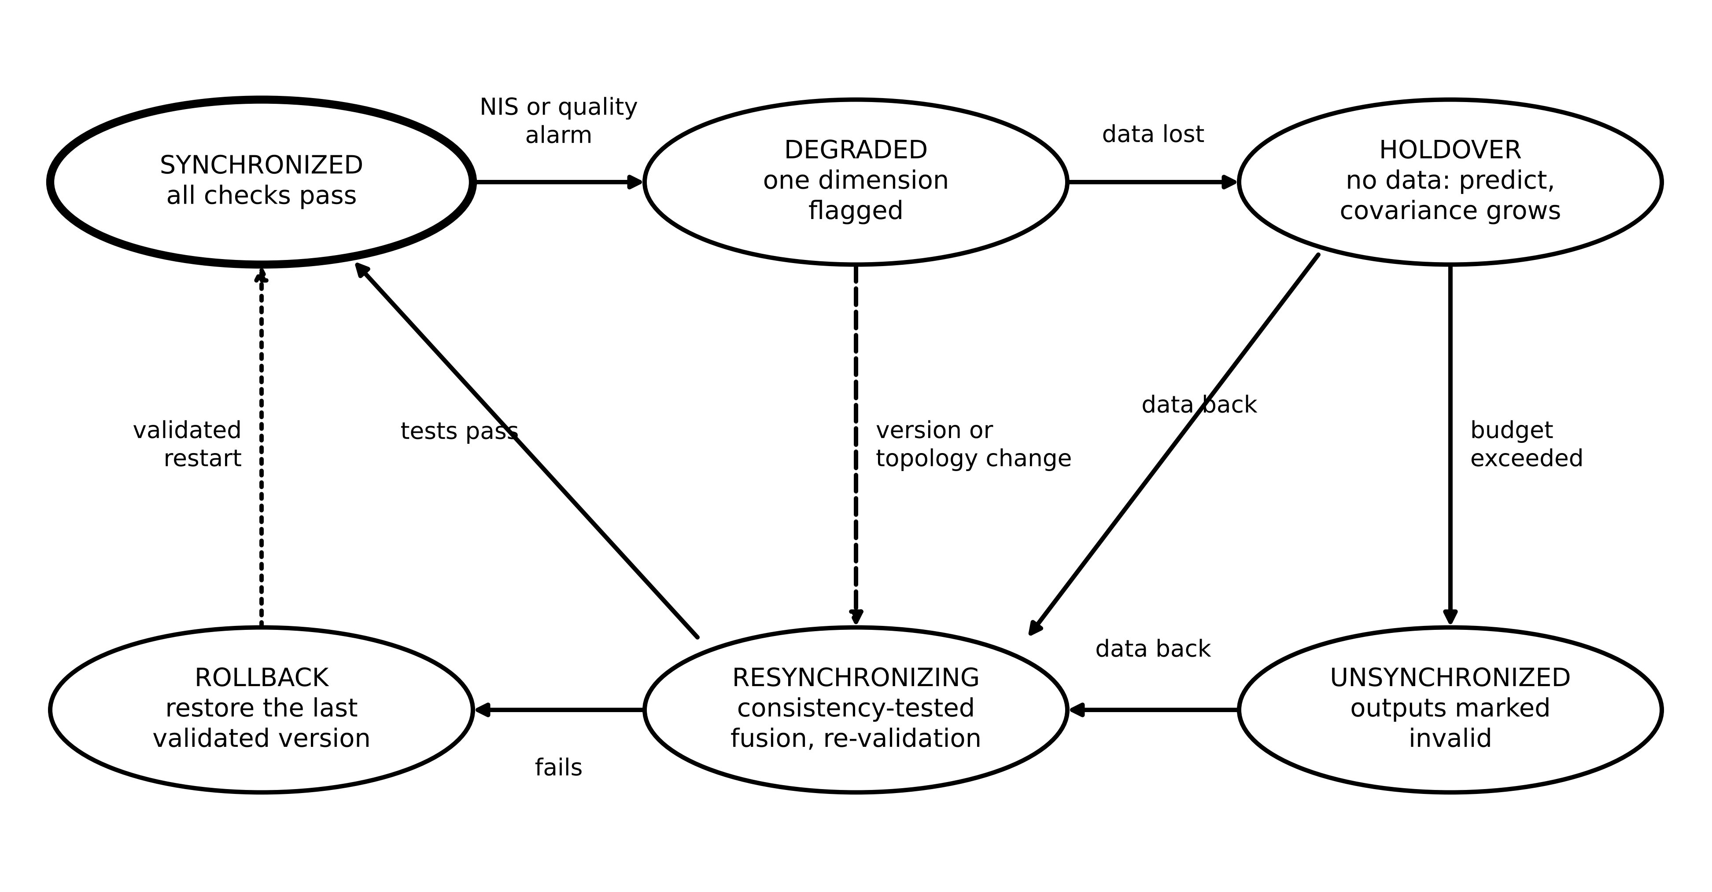
Figure 5.29. The synchronization state machine. A twin moves from synchronized to degraded, holdover or unsynchronized as dimensions fail, and returns only through a resynchronization step whose consistency tests pass, or through rollback to the last validated version.
Example 5.21 (Level B) Resynchronizing a battery twin after a 45-minute outage
Given. A 100 A·h battery twin loses its data link for 45 minutes during charging. Before the outage its SOC estimate is 62.0 % with standard deviation 0.8 points and the charging current is 15.0 A, assumed constant with an uncertainty of 1 A. At reconnection an OCV-based SOC reading of 71.5 % (standard deviation 0.5 points) is available; the link's timestamps show that data resumed 3 s before the twin's clock registered it.
Find. (a) The predicted SOC and its uncertainty at reconnection. (b) Whether the OCV reading is consistent. (c) The resynchronized SOC. (d) The order in which the dimensions are handled.
Solution. (a) Charge added $15.0×0.75=11.25$ A·h, 11.25 points: prediction 73.25 %; the current uncertainty adds 0.75 points, so the standard deviation is $\sqrt{{0.8}^{2}+{0.75}^{2}}=1.10$ points. (b) Innovation $-1.75$ points; variance ${1.10}^{2}+{0.5}^{2}=1.45$; normalized squared innovation 2.11 < 3.84: consistent at 95 %. (c) Gain 0.828; SOC $73.25-0.828×1.75=71.80$ %, standard deviation 0.45 points. (d) Clock first (realign the 3 s so samples carry correct times), then model version and topology (confirm nothing changed during the outage), then state (the fusion above), then parameters (resume joint estimation), and finally restore the trust status to synchronized once the windowed NIS is back in its band.
Interpretation. The returning reading was neither simply adopted nor rejected; it was tested and fused according to both uncertainties, and the result is better than either source. Doing the dimensions in the wrong order (fusing state before fixing the clock) would compare values from different instants.
What the digital twin adds
Synchronized: topology, state, parameters, time, model version and trust, together.
Estimated or updated: per-dimension status and the overall synchronization state.
Uncertainty carried: honest confidence, downgraded when any dimension is unverified.
Decision enabled: use, flag, resynchronize or roll back the twin.
Validated by: injected version, topology, clock and outage faults at commissioning.

5.14 Case study: a complete, reproducible battery twin (Level C)

5.14.1 Specification
The pieces now assemble into one twin for cell C-1 (Figure 5.30). Data: voltage, current and temperature every second, with PTP time and the quality checks of Chapter 3. Estimator: an EKF with augmented state $[z, v_{1}, R_{0}, b]^{⊤}$, where $b$ is the current-sensor offset modelled as a slow random walk, so the measured current $i_{m}$ is corrected as $i=i_{m}-b$ in both the process and the measurement models. Tuning from Monte Carlo NEES: $i_{eq}=0.3$ A, $q_{R}=(1 μΩ)^{2}$, $q_{b}=(10 μA)^{2}$ per step; initial standard deviations 20 points for SOC, 5 mV, 0.5 mΩ and 0.2 A. Monitoring: windowed NIS ($W=60$, $α=0.001$) and coverage checks against periodic full-charge references. Synchronization manager: the contract of Table 5.6, with holdover by (5.35) and rollback to the registered model version. Offline: output-error recalibration of $R_{1}$, $τ_{1}$ and $Q_{n}$ on stored data.
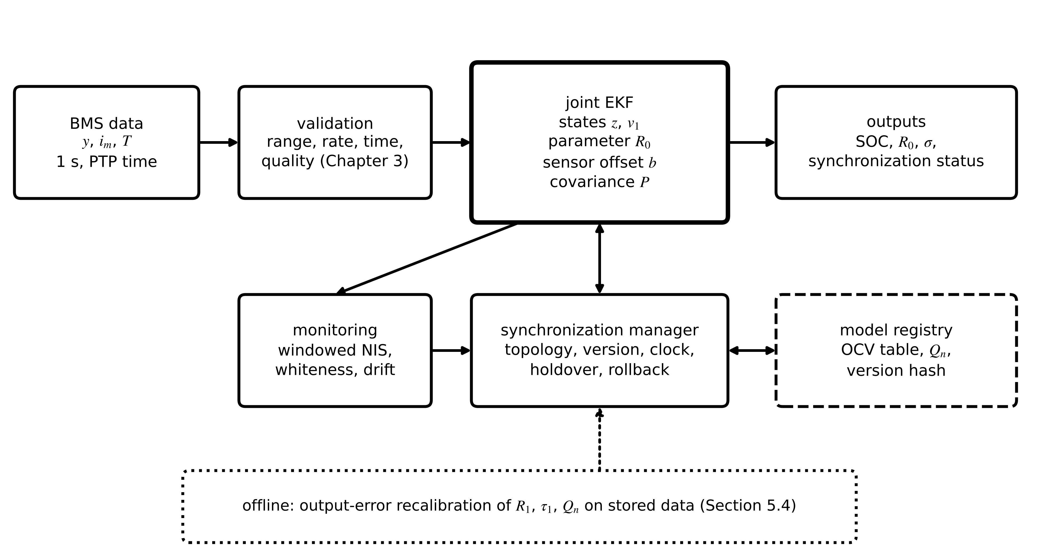
Figure 5.30. Architecture of the cell C-1 twin: validated data feed a joint EKF; monitoring and a synchronization manager supervise it against the model registry; offline output-error recalibration updates the slow parameters.

5.14.2 Results
Table 5.7. Cell C-1 twin on the full synthetic record (errors over 600 to 7200 s; interpreted Python, about 34 µs per step)
Estimator | SOC RMS error (pp) | SOC max error (pp) | 95 % coverage | Notes
coulomb counting from the 60 % guess | 20.1 | 20.2 | not applicable | no correction from voltage
EKF, $R_{0}$ fixed, $i_{eq}$ = 0.6 A | 0.70 | 1.92 | 0.40 | fails after ageing begins
joint EKF ($z$, $v_{1}$, $R_{0}$), $i_{eq}$ = 0.6 A | 0.073 | 0.23 | 0.46 | offset hidden in $Q$: overconfident
twin: joint EKF with offset state ($z$, $v_{1}$, $R_{0}$, $b$), $i_{eq}$ = 0.3 A | 0.012 | 0.024 | 0.93 | offset estimated as 0.0499 A (true 0.050)

Table 5.7 carries the chapter's main lesson in four rows. Coulomb counting never recovers from a wrong start. A filter with a fixed, ageing parameter fails silently until its NIS alarm. A joint filter that tracks the resistance but hides the current offset inside its process noise is accurate yet overconfident: its 95 % intervals contain the truth only 46 % of the time. Estimating the offset as a state, and tuning by Monte Carlo NEES, gives the most accurate filter and, more importantly, one whose stated uncertainty is honest (93 % coverage, mean NIS 1.06). Every number regenerates from Table 5.1, the stated tunings and NumPy default_rng(2026).
What the digital twin adds
Synchronized: SOC, polarization, resistance and sensor offset, with every synchronization dimension supervised.
Estimated or updated: four-state augmented EKF with offset estimation.
Uncertainty carried: covariance verified by coverage, not only by NIS.
Decision enabled: dispatchable energy with an honest confidence; ageing advisories.
Validated by: Monte Carlo NEES, coverage, injected faults and the synchronization contract.

5.15 Recent developments and open research problems
Estimation and synchronization for twins are active research fields; each development is labelled with its status in 2026. The 2026 reviews emphasize adaptive synchronization and real-time validation at utility scale [1], [2], [3], and the ITU-T architecture for power-grid twins puts continuous synchronization and model management at its core [4].
Learning-aided Kalman filters (research, early applications). Neural networks learn the gain or the noise statistics where models are partly known [16]; open problem: consistency guarantees out of distribution. Dynamic state estimation with PMUs (transmission pilots). EKF and UKF on generator and converter states using synchrophasors (Chapter 11); open problem: scale and model errors in inverter-dominated grids. Robust and resilient estimation (some production use). Huber and other M-estimators, gating and chi-square monitoring in grid estimators; the line between bad data and attack is the subject of Chapter 14. Distributed and federated estimation (research). Consensus and covariance-intersection filters for multi-owner twins, where cross-correlations are unknown [17]. Physics-informed and hybrid estimators (research). Hybrid models (Chapter 6) inside filters, with learned residual terms. Field-verifiable uncertainty (open). Coverage without ground truth, from innovation-based tests and occasional reference measurements.
Dynamic state estimation in practice (established framework, transmission pilots). An IEEE task force has defined dynamic state estimation, separated it from static, tracking and forecasting-aided estimation, and set out its applications and open problems, notably model errors and computational scale in grids with many converters [18]. Cloud battery twins (early deployments). A cloud battery management system that estimates SOC with an extended Kalman filter and SOH from capacity and resistance has been demonstrated as a battery digital twin [19]; open problem: holdover and resynchronization when the link to the cloud fails, which is exactly the problem of Sections 5.11.3 and 5.13.1.
Table 5.8. Emerging directions with a measurable research target
Direction | Status | Measurable target
learning-aided Kalman filters | research, early applications | NEES within its band on held-out, out-of-distribution data
PMU-based dynamic state estimation | transmission pilots | estimation error and time per step for a stated network size
robust (Huber) estimation | some production use | bias under injected bad data against efficiency on clean data
distributed and federated estimation | research | consistency under unknown cross-correlation; communication per step
synchronization contracts | emerging | time to detect stale topology, parameter set or model version in replay tests
field-verifiable uncertainty | open | coverage of intervals without ground truth, validated against occasional references

5.16 How this chapter feeds the rest of the book
From Chapter 3 this chapter took timestamped, quality-flagged measurements with their variances; from Chapter 4 it took the models, their linearizations, observability and identifiability. It hands to every later chapter synchronized states and parameters with honest covariances and a synchronization status. Chapter 6 adds learned and hybrid models to the estimators. Chapters 7 to 11 instantiate the filters for converters, renewables, batteries, vehicles and grids (where WLS and dynamic state estimation run the network twin). Chapter 12 builds diagnosis and prognosis on the innovations and parameter drifts of Sections 5.10 and 5.12; Chapter 13 uses the estimated states and their uncertainty for control and optimization; Chapter 14 asks what happens when the measurements themselves are attacked.

Chapter summary
A twin must estimate what it cannot measure, and it must say how sure it is. The chapter separated states, parameters, disturbances and sensor biases, framed estimation as recursive Bayesian inference, and placed two limits no estimator can cross: observability and identifiability, quantified by Gramians, condition numbers and Fisher information. Least squares was derived as a projection, extended to weighted, recursive and output-error forms, and shown to suffer ill-conditioning, lack of excitation and errors-in-variables bias (an ARX time constant of 9.8 s against a true 20 s, corrected by output error). The Kalman filter was built from a scalar hand example to matrix form, tuned with Monte Carlo NEES, and its consistency tested with NIS, NEES and whiteness; NIS alone could not distinguish filters whose NEES differed ninefold.
Extended and unscented Kalman filters, particle filters and moving horizon estimation were compared on the same cell; robust M-estimation removed the effect of a glitch; joint estimation tracked a 50 % resistance rise with SOC error a tenth of a point, with the random-walk intensity setting lag against noise. Multi-rate, delayed and out-of-sequence data were processed at their own timestamps, and holdover times were derived from the model. Synchronization was then extended beyond state estimation to six dimensions, with examples in which a stale OCV table produced a confidently wrong SOC and a stale topology defeated bad-data processing. The complete C-1 twin, which estimates the current-sensor offset as a state, reached 0.012-point SOC error with 93 % coverage of its 95 % intervals.
Table 5.9. Key relationships of Chapter 5
Relationship | Expression | Eq.
Model and noise | $x_{k+1}=f(x_{k},u_{k},θ)+w_{k}$; $y_{k}=h(x_{k})+v_{k}$; $Q$, $R$ | (5.1), (5.3)
Bayesian recursion | prediction (Chapman-Kolmogorov) and Bayes update | (5.4)
Gaussian update | $\hat{x}={\hat{x}}^{-}+\frac{P^{-}}{P^{-}+R}(y-{\hat{x}}^{-})$; $1/P=1/P^{-}+1/R$ | (5.5)
Observability and Fisher information | $W_{o}=\sum{(}F^{⊤})^{k}H^{⊤}R^{-1}HF^{k}$; $ℐ=σ^{-2}\sum{φ}φ^{⊤}$ | (5.7), (5.8)
Least squares | $\hat{θ}=(H^{⊤}H)^{-1}H^{⊤}Y$; WLS with $R^{-1}$ | (5.9), (5.11)
Normalized residual | $r_{N,i}=r_{i}/\sqrt{Ω_{ii}}$ | (5.12)
RLS and forgetting | gain, update, covariance; $N_{mem}=1/(1-λ)$ | (5.13), (5.14)
Output-error identification | $argmin\sum{[}u_{k}-{\hat{u}}_{k}(θ)]^{2}$ | (5.17)
Kalman prediction and update | $P_{k|k-1}=FPF^{⊤}+Q$; $K=PH^{⊤}S^{-1}$; Joseph form | (5.20), (5.21)
Riccati steady state | DARE for $P_{∞}$, $K_{∞}$ | (5.22)
Consistency tests | NIS $∼χ_{m}^{2}$; NEES $∼χ_{n}^{2}$; bands; whiteness | (5.23), (5.24)
EKF | Jacobians $F_{k}$, $H_{k}$ at the estimate | (5.25)
UKF | sigma points and weights; moments by weighted sums | (5.26), (5.27)
Particle filter | weights, $N_{eff}=1/\sum{w^{2}}$ | (5.28)
MHE and projection | windowed MAP with arrival cost; projected update | (5.29), (5.30)
Huber M-estimation | $ρ(u)$, $w(u)=min(1,c/|u|)$ | (5.31)
Augmented model | $x_{a}=[x;θ]$ with random-walk $θ$ | (5.32)
Delayed measurement; holdover | cross-covariance correction; $t_{hold}$ | (5.34), (5.35)
Windowed NIS; coverage | $\sum{e^{⊤}}S^{-1}e>χ_{Wm,1-α}^{2}$; ${\hat{cov}}_{95}$ | (5.36), (5.37)

Exercises
Fifteen exercises follow. Exercises 5.1 to 5.5 cover the estimation problem, least squares and identification; 5.6 to 5.10 cover Kalman filtering, consistency and nonlinear and constrained estimation; 5.11 to 5.14 treat joint estimation, timing, holdover and synchronization; and 5.15 is a research-level design project. Most exercises link a concept or derivation to a numerical application. Complete solutions to all fifteen are given in the answer key.

Group A: the estimation problem and least squares
5.1 Unknowns, observability and identifiability. (a) For cell C-1, classify SOC, polarization voltage, ohmic resistance, capacity, an unknown parasitic current and the 0.05 A current-sensor offset as state, parameter, disturbance or sensor bias, and say how an estimator treats each. (b) Distinguish observability from identifiability, with one quantitative test for each. (c) A model has two parameters whose regressor columns are exactly proportional (the second column of $H$ is twice the first). Explain what least squares can and cannot determine, and what would fix it.
5.2 Least squares as a projection. (a) Derive the normal equations (5.9) from the orthogonality of the residual to the columns of $H$. (b) Given $H={\left[2, 3, 5\right]}^{⊤}$ and $Y={\left[4.1, 6.2, 9.8\right]}^{⊤}$, compute the estimate of one parameter. (c) With $σ^{2}=0.04$, compute its variance and standard deviation. (d) Describe what ill-conditioning looks like geometrically and in the cost contours.
5.3 Weighted and robust estimation. (a) Two meters read the same quantity: 10.2 ($σ=0.1$) and 9.9 ($σ=0.3$). Find the WLS estimate and its standard deviation. (b) Show whether the two readings are consistent at about three standard deviations. (c) A residual is 4 times its scale. Find its Huber weight with $c=1.345$, and explain how iteratively reweighted least squares uses it.
5.4 Recursive least squares and forgetting. (a) Derive the RLS update (5.13) with $λ=1$ from $P_{k}^{−1}=P_{k−1}^{−1}+φ_{k}φ_{k}^{⊤}$ and the matrix-inversion lemma. (b) Derive (5.14) for a constant regressor. (c) For $λ=0.98$, find the memory, the standard-deviation factor and the lag. (d) An estimator uses $λ=0.995$ during a long rest with no current. What happens to $P$, and what should be done?
5.5 Errors-in-variables bias. (a) Explain why ARX identification of the polarization time constant of C-1 is biased while an output-error fit is not. (b) A first-order process $x_{k}=0.9x_{k−1}+η_{k}$ with $var\left(x\right)=1$ is measured as $u_{k}=x_{k}+v_{k}$ with $var\left(v\right)=0.25$, sampled every second. Least squares regresses $u_{k}$ on $u_{k−1}$. Find the limit of the estimated coefficient and the time constant it implies, against the true one. (c) Does more data help?

Group B: Kalman filtering and its relatives
5.6 The scalar filter. (a) Derive the scalar Kalman update (5.5) from the product of a Gaussian prior and a Gaussian likelihood. (b) A scalar filter has $F=1$, $Q=0.01$, $H=1$, $R=0.25$ and $P_{k−1|k−1}=0.5$. Compute $P_{k|k−1}$, $S_{k}$, $K_{k}$ and $P_{k|k}$. (c) Solve the scalar Riccati equation for the steady-state prior variance and gain.
5.7 The gain and the moving horizon. (a) Derive the Kalman gain in (5.21) by minimizing the trace of the Joseph-form covariance. (b) Show that (5.29) with a linear model, no constraints, a one-sample window and $Π=P_{k|k−1}$ gives the Kalman update.
5.8 Consistency. (a) Why can NIS look perfect while NEES shows an overconfident filter? What does each require? (b) Find the 95 % band for the mean NEES of a two-state filter averaged over 50 Monte Carlo runs at one time step. (c) Find the threshold of the windowed NIS test (5.36) for $W=30$, $m=1$, $α=0.01$. (d) A filter shows mean NIS 1.0 and mean NEES 14 on commissioning data. What is wrong and which way should $Q$ move? (e) A twin's innovations stay positive over 50 consecutive samples. What does this say?
5.9 Nonlinear transforms and particles. (a) For $x∼N\left(2, {0.3}^{2}\right)$ and $y=x^{2}$, compute the exact mean and variance of $y$ and the linearized values, and state what the unscented transform with $n=1$, $α=1$, $κ=2$, $β=0$ returns. (b) When is the unscented transform worth its cost over linearization, and when is a particle filter worth its cost over both? (c) Ten particles have weights 0.35, 0.30, 0.15, 0.10, 0.04, 0.02, 0.01, 0.01, 0.01, 0.01. Compute $N_{eff}$ and decide whether to resample at $N_{p}/2$.
5.10 Constrained update. An unconstrained estimate is $\hat{x}={\left[1.015, 0.020\right]}^{⊤}$ (SOC, polarization in volts) with $P=\left[1.0×{10}^{−4}, 5×{10}^{−6}; 5×{10}^{−6}, 4×{10}^{−6}\right]$. Apply (5.30) with $z≤1$, and explain why clipping SOC alone is wrong.

Group C: joint estimation, timing and synchronization
5.11 Joint state-parameter estimation. (a) List three pitfalls of augmented state-parameter estimation and how to detect each. (b) In the joint EKF of Example 5.14 with $\sqrt{q_{R}}=0.2$ µΩ per step, the resistance standard deviation is 2.2 µΩ when a 600 s rest with zero current begins. What is it at the end of the rest, and why? (c) How should $q_{R}$ be chosen?
5.12 Delayed and out-of-sequence data. (a) Repeat Example 5.15 with $q_{d}=0.5$ K²/s. (b) Why must a measurement be processed at the time it was taken? (c) Explain why the naive late update of Example 5.17 reports a smaller variance than exact reprocessing, and why that is dangerous.
5.13 Holdover. Derive (5.35) for SOC with an assumed-current uncertainty $σ_{i}$, and find $t_{hold}$ for a 100 A·h twin with $σ_{z,0}=0.5$ points, $σ_{i}=1$ A and a 3-point budget. What happens to the holdover time if the current uncertainty doubles?
5.14 The synchronization contract. (a) Give an example in which a numerically excellent state estimate is invalid, and name the dimension that catches it. (b) Classify each as a topology, state, parameter, time or model-version issue: (i) SOC 8 points off after months of operation while NIS is normal; (ii) new firmware changes a register scale; (iii) samples from one gateway arrive with timestamps 2 s in the future; (iv) capacity has faded by 10 %; (v) a feeder switch was closed but the twin shows it open. (c) Propose one quantitative indicator for each row of Table 5.6.

Group D: research project
5.15 Estimation for an LFP twin and a converter. (a) Propose an SOC estimation and synchronization strategy for an LFP cell whose OCV slope on its plateau is 0.02 V per unit SOC, using the observability analysis of Section 5.3. (b) Design an MHE cost and constraint set for estimating a converter's duty cycle, which must stay within 0.1 to 0.9, using (5.29). (c) The windowed innovation variance of a voltage channel is $2.1×{10}^{−5}$ V² while the filter's $HP^{−}H^{⊤}$ averages $0.8×{10}^{−5}$ V². Estimate $R$ with the Advanced box of Section 5.5.4 and state the cautions.

Answer key
5.1 (a) State: SOC and polarization voltage (they change every sample and summarize the present condition). Parameters: ohmic resistance and capacity (constant or slowly drifting; tracked as random walks if they age). Disturbance: the parasitic current (it changes what the cell actually does). Sensor bias: the current offset (it corrupts what the twin believes the input was). States are propagated by the model, parameters are held or slowly updated, disturbances are added as inputs or absorbed in $Q$, and biases are best estimated as additional states rather than hidden in $Q$.
(b) Observability asks whether the states can be reconstructed from the outputs; test: rank and condition number of $O$ or the observability Gramian (5.7). Identifiability asks whether the parameters are determined by the data of a given experiment; test: the Fisher information (5.8) and the correlation of the estimates.
(c) $H^{⊤}H$ has rank 1 and is singular; only the combination $θ_{1}+2θ_{2}$ is determined. More data of the same kind cannot fix it; a different experiment that makes the two regressors differ, or a prior on one parameter, can.
5.2 (a) The prediction $H\hat{θ}$ is the point of the column space closest to $Y$, so the residual is perpendicular to every column: $H^{⊤}\left(Y−H\hat{θ}\right)=0$, giving $\hat{θ}={\left(H^{⊤}H\right)}^{−1}H^{⊤}Y$.
(b) $H^{⊤}H=4+9+25=38$; $H^{⊤}Y=8.2+18.6+49.0=75.8$; $\hat{θ}=1.995$.
(c) $σ^{2}/\left(H^{⊤}H\right)=0.04/38=1.05×{10}^{−3}$; standard deviation 0.032.
(d) The columns of $H$ are nearly parallel, so the plane they span is poorly defined; $H^{⊤}H$ is nearly singular, the cost contours are long, narrow ellipses (a flat valley), and noise moves the estimate far along the valley. The condition number $κ\left(H\right)$ measures how much relative data errors can be amplified.
5.3 (a) Weights $1/0.01=100$ and $1/0.09=11.1$: $\hat{x}=\left(100×10.2+11.1×9.9\right)/111.1=10.17$; standard deviation $1/\sqrt{111.1}=0.095$.
(b) The difference 0.3 against $\sqrt{{0.1}^{2}+{0.3}^{2}}=0.316$ is about one standard deviation: consistent.
(c) $w=min\left(1, 1.345/4\right)=0.336$. Iteratively reweighted least squares solves the weighted problem (5.11) with each residual's weight multiplied by $w\left(r_{k}/s\right)$, recomputes the residuals and weights, and repeats until the weights settle; large residuals end with small weights and lose influence.
5.4 (a) The lemma with $A=P_{k−1}^{−1}$, $b=c=φ_{k}$ gives $P_{k}=P_{k−1}−P_{k−1}φ_{k}φ_{k}^{⊤}P_{k−1}/\left(1+φ_{k}^{⊤}P_{k−1}φ_{k}\right)$. Substituting into ${\hat{θ}}_{k}=P_{k}\left(P_{k−1}^{−1}{\hat{θ}}_{k−1}+φ_{k}y_{k}\right)$ and simplifying gives ${\hat{θ}}_{k}={\hat{θ}}_{k−1}+K_{k}\left(y_{k}−φ_{k}^{⊤}{\hat{θ}}_{k−1}\right)$ with $K_{k}=P_{k−1}φ_{k}/\left(1+φ_{k}^{⊤}P_{k−1}φ_{k}\right)$.
(b) For a constant regressor the estimate is the exponentially weighted mean j​1−λλjyk−j. Its variance is σ21−λ2j​λ2j=σ21−λ/1+λ; its memory is the sum of weights normalized by the first, $1/\left(1−λ\right)$; and for a ramp its delay is the mean age j​1−λλjj=λ/1−λ samples.
(c) Memory 50 samples; factor $\sqrt{0.02/1.98}=0.100$; lag 49 samples.
(d) With $φ_{k}=0$, $P_{k}=P_{k−1}/0.995$ grows by 0.5 % per sample without bound (wind-up), so the first excitation after the rest causes a violent jump in the estimate. Freeze updates when excitation is low, or use directional forgetting.
5.5 (a) The ARX regressor $u_{k−1}$ contains the previous measurement noise, which is correlated with the equation error $v_{k}−a_{1}v_{k−1}$; least squares then converges to a biased value. The output-error method simulates the model from the clean input alone, so no noisy output enters the regressors.
(b) $cov\left(u_{k},u_{k−1}\right)=0.9 var\left(x\right)=0.9$ and $var\left(u\right)=1.25$, so $\hat{a}→0.9/1.25=0.72$. The implied time constant is $−1/ln0.72=3.0$ s against the true $−1/ln0.9=9.5$ s.
(c) No. The bias is a limit, not noise: more data make the wrong value more certain.
5.6 (a) The product of $exp\left[−{\left(x−{\hat{x}}^{−}\right)}^{2}/\left(2P^{−}\right)\right]$ and $exp\left[−{\left(y−x\right)}^{2}/\left(2R\right)\right]$ has exponent $−\frac{1}{2}\left[\left(1/P^{−}+1/R\right)x^{2}−2\left({\hat{x}}^{−}/P^{−}+y/R\right)x+…\right]$. Completing the square gives a Gaussian with precision $1/P=1/P^{−}+1/R$ and mean $\hat{x}=P\left({\hat{x}}^{−}/P^{−}+y/R\right)={\hat{x}}^{−}+\frac{P^{−}}{P^{−}+R}\left(y−{\hat{x}}^{−}\right)$.
(b) $P_{k|k−1}=0.51$; $S_{k}=0.76$; $K_{k}=0.671$; $P_{k|k}=0.168$.
(c) $P^{2}−QP−QR=0$: $P_{∞}=\left(Q+\sqrt{Q^{2}+4QR}\right)/2=0.0552$; $K_{∞}=0.0552/0.3052=0.181$.
5.7 (a) $trP=tr\left[\left(I−KH\right)P^{−}{\left(I−KH\right)}^{⊤}+KRK^{⊤}\right]$. Differentiating with respect to $K$: $−2P^{−}H^{⊤}+2K\left(HP^{−}H^{⊤}+R\right)=0$, so $K=P^{−}H^{⊤}S^{−1}$.
(b) The cost becomes $∥x−{\hat{x}}_{k|k−1}∥_{P^{−1}}^{2}+∥y−Hx∥_{R^{−1}}^{2}$. Setting its gradient to zero gives $x={\hat{x}}_{k|k−1}+{\left(P^{−1}+H^{⊤}R^{−1}H\right)}^{−1}H^{⊤}R^{−1}\left(y−H{\hat{x}}_{k|k−1}\right)$, the Kalman update in information form, which equals ${\hat{x}}_{k|k−1}+K\left(y−H{\hat{x}}_{k|k−1}\right)$ by the matrix-inversion lemma.
5.8 (a) NIS tests the output prediction and needs only measurements; NEES tests the state covariance and needs the true state, available only in simulation or commissioning. When the measurement is very informative, innovations look correct even if the state covariance is far too small, so only NEES exposes the overconfidence.
(b) $N{\overset{‾}{ε}}_{x}∼χ_{100}^{2}$: band $74.2/50=1.48$ to $129.6/50=2.59$.
(c) $χ_{30,0.99}^{2}=50.9$, a mean NIS of 1.70.
(d) The filter is overconfident: its covariance is about seven times too small. $Q$ must increase, or a missing bias state must be added.
(e) For zero-mean white innovations, fifty positive values in a row have probability ${0.5}^{50}≈{10}^{−15}$: the model is biased, from a parameter drift, a sensor bias or a wrong model version.
5.9 (a) Exact mean $μ^{2}+σ^{2}=4.09$, variance $4μ^{2}σ^{2}+2σ^{4}=1.456$. Linearized 4.00 and 1.44. With $λ_{u}=2$ the sigma points are $2$ and $2±\sqrt{3}×0.3$ with weights 2/3, 1/6, 1/6; because $y$ is quadratic, the transform returns the exact mean 4.09 and, with $β=0$, the exact variance 1.456.
(b) The unscented transform is worth its cost when curvature over the uncertainty range is strong enough to shift the mean or when Jacobians are hard to derive; it costs $2n+1$ model evaluations. A particle filter is worth its cost when the posterior is genuinely non-Gaussian (several peaks, hard bounds, heavy tails), which shows up as failing consistency tests of the Gaussian filters.
(c) $∑w^{2}=0.2474$, $N_{eff}=4.04<5$: resample.
5.10 $PD/\left(D^{⊤}PD\right)={\left[1, 0.05\right]}^{⊤}$; violation 0.015; ${\hat{x}}_{c}={\left[1.000, 0.020−0.05×0.015\right]}^{⊤}={\left[1.000, 0.01925\right]}^{⊤}$. Clipping SOC alone would leave the polarization inconsistent with the correlation the filter has learned between the two errors; the projection moves every correlated state in proportion to its covariance with SOC.
5.11 (a) Tuning: $q_{R}$ trades lag against noise; detect by replaying ageing scenarios with known truth. Excitation: without current the parameter receives no information; detect from the growth of its variance. Artificial correlation: state and parameter errors become correlated and an error in one is blamed on the other; detect with the augmented observability matrix and the estimated correlation coefficient.
(b) With $i_{k}=0$ the measurement Jacobian column $−i_{k}$ is zero, so only the random walk acts: variance grows by $600×{\left(0.2\right)}^{2}=24$ µΩ², and the standard deviation becomes $\sqrt{{2.2}^{2}+24}=5.4$ µΩ. The estimate itself does not move; it simply becomes less certain until current flows again.
(c) From the expected ageing rate over the time scale of interest, then validated on synthetic ageing scenarios: too small and the filter cannot follow real ageing (Table 5.4, first row), too large and the estimate is noisy in healthy operation.
5.12 (a) $u_{B}=\sqrt{0.16+0.15}=0.557$ K; $w_{A}=\left(1/0.09\right)/\left(1/0.09+1/0.31\right)=0.775$, $w_{B}=0.225$; fused uncertainty 0.264 K.
(b) Because the model relates each measurement to the state at the instant it was taken; comparing it with the state at another instant attributes the change in between to measurement error.
(c) The late reading is compared with a prediction for a later, different instant and treated as new, independent information on top of the newer sample, so the variance shrinks as if more information had arrived than really did. Downstream decisions inherit a false confidence.
5.13 Without updates, SOC integrates the assumed current; an error of standard deviation $σ_{i}$ held over time $t$ adds an SOC error $σ_{i}t/\left(3600Q_{n}\right)$, independent of the initial error, so the variances add: $σ_{z}^{2}\left(t\right)=σ_{z,0}^{2}+{\left(σ_{i}t/3600Q_{n}\right)}^{2}$. Setting $σ_{z}=σ_{max}$ and solving gives (5.35). Here $t_{hold}=\left(3600×100/1.0\right)\sqrt{{0.03}^{2}−{0.005}^{2}}=10 649$ s, about 2.96 h. Doubling $σ_{i}$ halves the holdover time.
5.14 (a) A stale OCV table 20 mV high (Example 5.19): SOC is 2.9 points wrong while the reported standard deviation is 0.011 points and NIS is nearly normal. The model-version dimension catches it through the hash of the deployed table.
(b) (i) parameter or model version (capacity or OCV table), appearing as state error; (ii) model version (data mapping); (iii) time; (iv) parameter; (v) topology.
(c) Topology: number of simultaneous large normalized residuals; state: windowed NIS; parameters: drift rate of $\hat{θ}$ against its plausible range; time: clock offset and packet age; model version: trace-tuple hash match; uncertainty and trust: coverage against reference measurements and the rate of quality flags.
5.15 (a) On the plateau one sample resolves SOC only to about $0.002/0.02=10$ points, so voltage updates carry little information. Use coulomb counting with the current offset estimated as a state, widen the holdover budget, and resynchronize SOC at the steep ends of the OCV curve (full charge, deep discharge) or after rest periods when the OCV can be read; report a growing covariance on the plateau rather than a false confidence.
(b) Minimize $∥d_{k−N_{h}}−\overset{‾}{d}∥_{Π^{−1}}^{2}+∑∥w_{j}∥_{Q^{−1}}^{2}+∑∥y_{j}−h\left(x_{j},d_{j}\right)∥_{R^{−1}}^{2}$ over the window, with the duty cycle as a state or input to be estimated, subject to $0.1≤d_{j}≤0.9$; the arrival cost summarizes older data. Validate on simulated runs with the duty cycle at and near its limits.
(c) $\hat{R}=2.1×{10}^{−5}−0.8×{10}^{−5}=1.3×{10}^{−5}$ V², a standard deviation of 3.6 mV. Cautions: with $W=60$ the sample variance has about 18 % relative uncertainty; $\hat{R}$ must stay positive definite; $Q$ and $R$ cannot be separated reliably from the innovation variance alone; and every adaptation must be logged.

References
[1] A. Abuabed and J. Kittur, "A systematic literature review on the use of digital twin technology in electrical engineering research and applications," Front. Smart Grids, vol. 5, Art. no. 1805035, Jun. 2026, doi: 10.3389/frsgr.2026.1805035.
[2] P. R. Satpathy and V. K. Ramachandaramurthy, "Digital twins in energy and power systems: Architectures, applications, enabling tools, and actionable roadmap for utility-scale implementation," Appl. Energy, vol. 420, Art. no. 128129, Oct. 2026, doi: 10.1016/j.apenergy.2026.128129.
[3] R. Manimaran et al., "Recent updates in digital twin driven smart energy systems for intelligent grid integration," Discover Appl. Sci., vol. 8, Art. no. 803, May 2026, doi: 10.1007/s42452-026-08720-z.
[4] ITU-T Recommendation Y.4517 (06/2026), Architecture of the Digital Twin System in Power Grid. Geneva, Switzerland: International Telecommunication Union, 2026.
[5] A. Abur and A. G. Expósito, Power System State Estimation: Theory and Implementation. New York, NY, USA: Marcel Dekker, 2004.
[6] L. Ljung, System Identification: Theory for the User, 2nd ed. Upper Saddle River, NJ, USA: Prentice Hall, 1999.
[7] R. E. Kalman, "A new approach to linear filtering and prediction problems," J. Basic Eng., vol. 82, no. 1, pp. 35-45, 1960.
[8] R. K. Mehra, "On the identification of variances and adaptive Kalman filtering," IEEE Trans. Autom. Control, vol. 15, no. 2, pp. 175-184, Apr. 1970.
[9] Y. Bar-Shalom, X. R. Li, and T. Kirubarajan, Estimation with Applications to Tracking and Navigation. New York, NY, USA: Wiley, 2001.
[10] S. J. Julier and J. K. Uhlmann, "Unscented filtering and nonlinear estimation," Proc. IEEE, vol. 92, no. 3, pp. 401-422, Mar. 2004.
[11] M. S. Arulampalam, S. Maskell, N. Gordon, and T. Clapp, "A tutorial on particle filters for online nonlinear/non-Gaussian Bayesian tracking," IEEE Trans. Signal Process., vol. 50, no. 2, pp. 174-188, Feb. 2002.
[12] C. V. Rao, J. B. Rawlings, and D. Q. Mayne, "Constrained state estimation for nonlinear discrete-time systems: Stability and moving horizon approximations," IEEE Trans. Autom. Control, vol. 48, no. 2, pp. 246-258, Feb. 2003.
[13] P. J. Huber, "Robust estimation of a location parameter," Ann. Math. Stat., vol. 35, no. 1, pp. 73-101, 1964.
[14] G. L. Plett, "Extended Kalman filtering for battery management systems of LiPB-based HEV battery packs: Part 3. State and parameter estimation," J. Power Sources, vol. 134, no. 2, pp. 277-292, 2004.
[15] Y. Bar-Shalom, "Update with out-of-sequence measurements in tracking: Exact solution," IEEE Trans. Aerosp. Electron. Syst., vol. 38, no. 3, pp. 769-777, Jul. 2002.
[16] G. Revach, N. Shlezinger, X. Ni, A. L. Escoriza, R. J. G. van Sloun, and Y. C. Eldar, "KalmanNet: Neural network aided Kalman filtering for partially known dynamics," IEEE Trans. Signal Process., vol. 70, pp. 1532-1547, 2022.
[17] S. J. Julier and J. K. Uhlmann, "A non-divergent estimation algorithm in the presence of unknown correlations," in Proc. American Control Conf., Albuquerque, NM, USA, 1997, pp. 2369-2373.
[18] J. Zhao et al., "Power system dynamic state estimation: Motivations, definitions, methodologies, and future work," IEEE Trans. Power Syst., vol. 34, no. 4, pp. 3188-3198, Jul. 2019, doi: 10.1109/TPWRS.2019.2894769.
[19] W. Li, M. Rentemeister, J. Badeda, D. Jöst, D. Schulte, and D. U. Sauer, "Digital twin for battery systems: Cloud battery management system with online state-of-charge and state-of-health estimation," J. Energy Storage, vol. 30, Art. no. 101557, 2020.

