CHAPTER 8
Digital Twins for Solar PV and Wind Energy Systems

Introduction
Solar photovoltaic and wind plants now supply the largest share of new generating capacity in most power systems, and they differ from every other plant in this book in one respect: their fuel is the weather. A coal or gas unit produces what its operator schedules; a PV array produces what the sky allows, and a wind turbine what the atmosphere delivers through a rotor whose aerodynamics change with every gust. This makes the question a digital twin must answer unusually sharp. When a plant produces less than expected, was the weather different from what the twin assumed, did the instruments that measure the weather drift, or did the equipment lose performance? Answering it is the purpose of the PV and wind twins built in this chapter.
Both technologies have long histories behind their present scale. The silicon solar cell was demonstrated at Bell Laboratories in 1954 with about 6 % efficiency; commercial modules now exceed 22 %, and the physics that limits them, the band gap and the losses it implies, is the same as in the first cells. Electricity-generating wind turbines date from the late nineteenth century, but the modern three-bladed, variable-speed, pitch-regulated machine emerged in the 1980s and 1990s and has since grown to rotors of well over 200 m on offshore turbines. In both fields the physical models used by designers, the single-diode model of the cell and the momentum theory of the rotor, are decades old. What is new is that plants now carry enough measurement, from string currents and inverter I-V sweeps to SCADA, condition monitoring and nacelle lidar, for those models to be kept synchronized with the plant in operation.
The chapter is organized in three parts. Part A builds the PV twin: the photovoltaic effect and the plant hierarchy from cell to inverter; the single-diode model, its scaling to arrays and its identifiability limits; the environment of the array, from sun position and plane-of-array irradiance to cell temperature, bifacial gain, soiling, shading and mismatch; maximum power point tracking; performance metrics; and the synchronization layer that reconciles weather inputs, electrical output, availability and slow states such as soiling. Part B builds the wind twin: the Betz limit derived from momentum theory, the power-coefficient surface, the operating regions and control laws, one- and two-mass drivetrain models and fatigue loads, the wind resource and annual energy with its P50 and P90 uncertainty, wakes from one turbine to a farm, and the synchronization layer that estimates the wind the rotor actually sees and detects yaw misalignment. Part C turns to the questions that both plants share: probabilistic forecasting against honest baselines, ramp-rate control with storage, and a hybrid PV-wind plant behind one grid connection.
A running example connects the parts. Plant P-1 of Chapter 2 has a 1.2 MWp PV array; this chapter adds a 2 MW wind turbine, T-1, behind the same 2 MVA transformer. Every model is evaluated with published parameters, and every synthetic data set is generated from stated seeds, so that each estimate can be compared with a known truth. Several results recur because they carry general lessons. Four datasheet numbers cannot fix five single-diode parameters, and the parameter sets that fit them equally well disagree by 14 % at low irradiance. Bypass diodes turn an apparent 18 % mismatch loss into 5 %, while a tracker trapped on a local peak loses 70 % of a shaded string's power. A nacelle anemometer can imply a power coefficient above the Betz limit, and the twin's first task is then to flag the instrument, not the turbine. A two-mass drivetrain reveals a shaft-torque peak of 1.5 times rated after a grid dip that a one-mass model cannot show.
The emphasis throughout is on the synchronization that turns a yield model into a twin. A plant's performance ratio measures what it delivered against what the weather offered, but it does not explain a shortfall. The twin does that by comparing measured and predicted current, voltage and power at the finest level the instrumentation allows, by estimating hidden states such as soiling with a Kalman filter, and by separating look-alike faults with a second, independent reference. The same logic applies to wind, where the rotor itself becomes the best anemometer once its aerodynamic torque is estimated, and where small deficits such as a yaw offset need days of 10-minute data and a cumulative-sum test to be detected reliably. Forecasting is treated in the same spirit: a forecaster must beat smart persistence, not only persistence, and its intervals must be calibrated in every operating condition, not only on average.
The chapter draws on the earlier ones: modelling and discretization from Chapter 4, estimation, residual tests and change detection from Chapter 5, learning and calibrated uncertainty from Chapter 6, and the converter models from Chapter 7. Where a standard defines a quantity, such as the performance ratio in IEC 61724-1, the module temperature model in IEC 61853 or the power curve in IEC 61400-12, the chapter follows it. Methods are labelled established, emerging or research-stage, and every major section ends with what the digital twin adds.
After studying this chapter, the reader will be able to explain the photovoltaic effect and follow a PV plant from cell to inverter, derive and fit the single-diode model and recognize what a datasheet cannot determine, and compute plane-of-array irradiance, cell temperature, bifacial, soiling, shading and mismatch effects with their uncertainty. The reader will be able to explain maximum power point tracking and local-peak trapping, compute plant performance metrics, and build a PV synchronization layer that isolates faults with residual ratios and tracks soiling with a filter. On the wind side, the reader will be able to derive the Betz limit and the optimal torque law, use the power-coefficient surface and the operating regions, model one- and two-mass drivetrains and fatigue loads, estimate annual energy with P50 and P90 uncertainty, compute wake losses with top-hat and Gaussian models and judge the maturity of wake steering, and detect power-curve deviations such as yaw misalignment from SCADA data. Finally, the reader will be able to produce and validate probabilistic forecasts against persistence baselines, size storage for ramp-rate limits and operate a hybrid PV-wind twin behind a shared grid connection.
How to read this chapter
Part A (Sections 8.2 to 8.7) covers PV, Part B (Sections 8.8 to 8.13) wind, and Part C (Sections 8.14 to 8.17) forecasting, ramp control and the hybrid plant. Each part starts from physical intuition and a diagram before equations; paragraphs marked [Advanced] (Lambert W solutions, Gaussian wakes, wake steering, conditional calibration) can be skipped on a first reading. Worked examples carry a level: Level A hand-solvable, Level B several coupled effects, Level C noisy data, constraints or uncertainty with every parameter published.
Chapter 4 supplied the modelling tools, Chapter 5 the estimators, Chapter 6 the forecasting and uncertainty methods, and Chapter 7 the converter models; this chapter recaps them briefly and builds the PV- and wind-specific twin on top. Methods are labelled established, emerging or research-stage; every major section ends with What the digital twin adds.

8.1 Two weather-driven plants inside one twin
Plant P-1 of Chapter 2 has a 1.2 MWp PV array feeding two 550 kVA inverters. This chapter adds a 2 MW wind turbine, called T-1, connected behind the same 2 MVA transformer. The two plants share a grid connection and a weather system but little else: the PV array answers a passing cloud within seconds, while the turbine's rotor stores several seconds of rated energy and its drivetrain rings at about two hertz. Their operators ask different questions. On the PV side: is this week's 2 % shortfall soiling, a failed string or a drifting irradiance sensor? On the wind side: is the turbine producing what its power curve promises, and if not, why? For the site: how much energy will the shared connection carry tomorrow, and how much will have to be curtailed?
All the numbers in this chapter come from synthetic but physically consistent models with published parameters. Among them: a perturb-and-observe tracker loses 70 % of a partially shaded string's power by locking onto a local peak; one module with 18 % less current costs its string 5 %, not 18 %, once bypass diodes are modelled; three failed strings out of 150 show in the twin's daily energy ratio within a day or two, and in string currents within the first hour; an 8° yaw offset costing 1.8 % of energy is detected from 10-minute SCADA data in about two days; a grid dip excites a 2 Hz drivetrain mode that raises shaft torque to 1.50 times rated, invisible to a one-mass model; and the PV and wind plants behind one 2 MVA connection lose 2.7 % of their energy to curtailment while raising the connection's utilization from 35 % to 44 %.
The 2026 reviews of energy twins describe the same shift this chapter makes: from static yield models towards twins that synchronize continuously with multi-source data, carry their uncertainty and support prescriptive decisions [1], [2], [3], within architectures such as ITU-T Y.4517 for power-grid twins [4].

8.2 The physical PV plant: from photon to array

8.2.1 The photovoltaic effect
Why does light make a current? A semiconductor such as silicon has a band gap $E_{g}$ (1.12 eV for silicon) between electron states that are bound and states in which electrons are free to move. A photon with energy $hν>E_{g}$ can lift an electron across the gap, leaving a hole behind: an electron-hole pair (Figure 8.1). On its own the pair recombines within microseconds and the energy becomes heat. A solar cell keeps them apart with a p-n junction: where p-type and n-type silicon meet, a thin depletion region forms with a built-in electric field that sweeps electrons to the n side and holes to the p side. Connected through a load, the separated charges drive a current. Two limits follow directly. Photons with $hν<E_{g}$ are not absorbed, and the excess energy $hν-E_{g}$ of energetic photons is lost as heat within picoseconds, which is why a single-junction cell cannot exceed about 33 % efficiency (the Shockley-Queisser limit). And the current is proportional to the photon flux, while the voltage is limited by the junction, which is why current scales with irradiance and voltage only logarithmically.
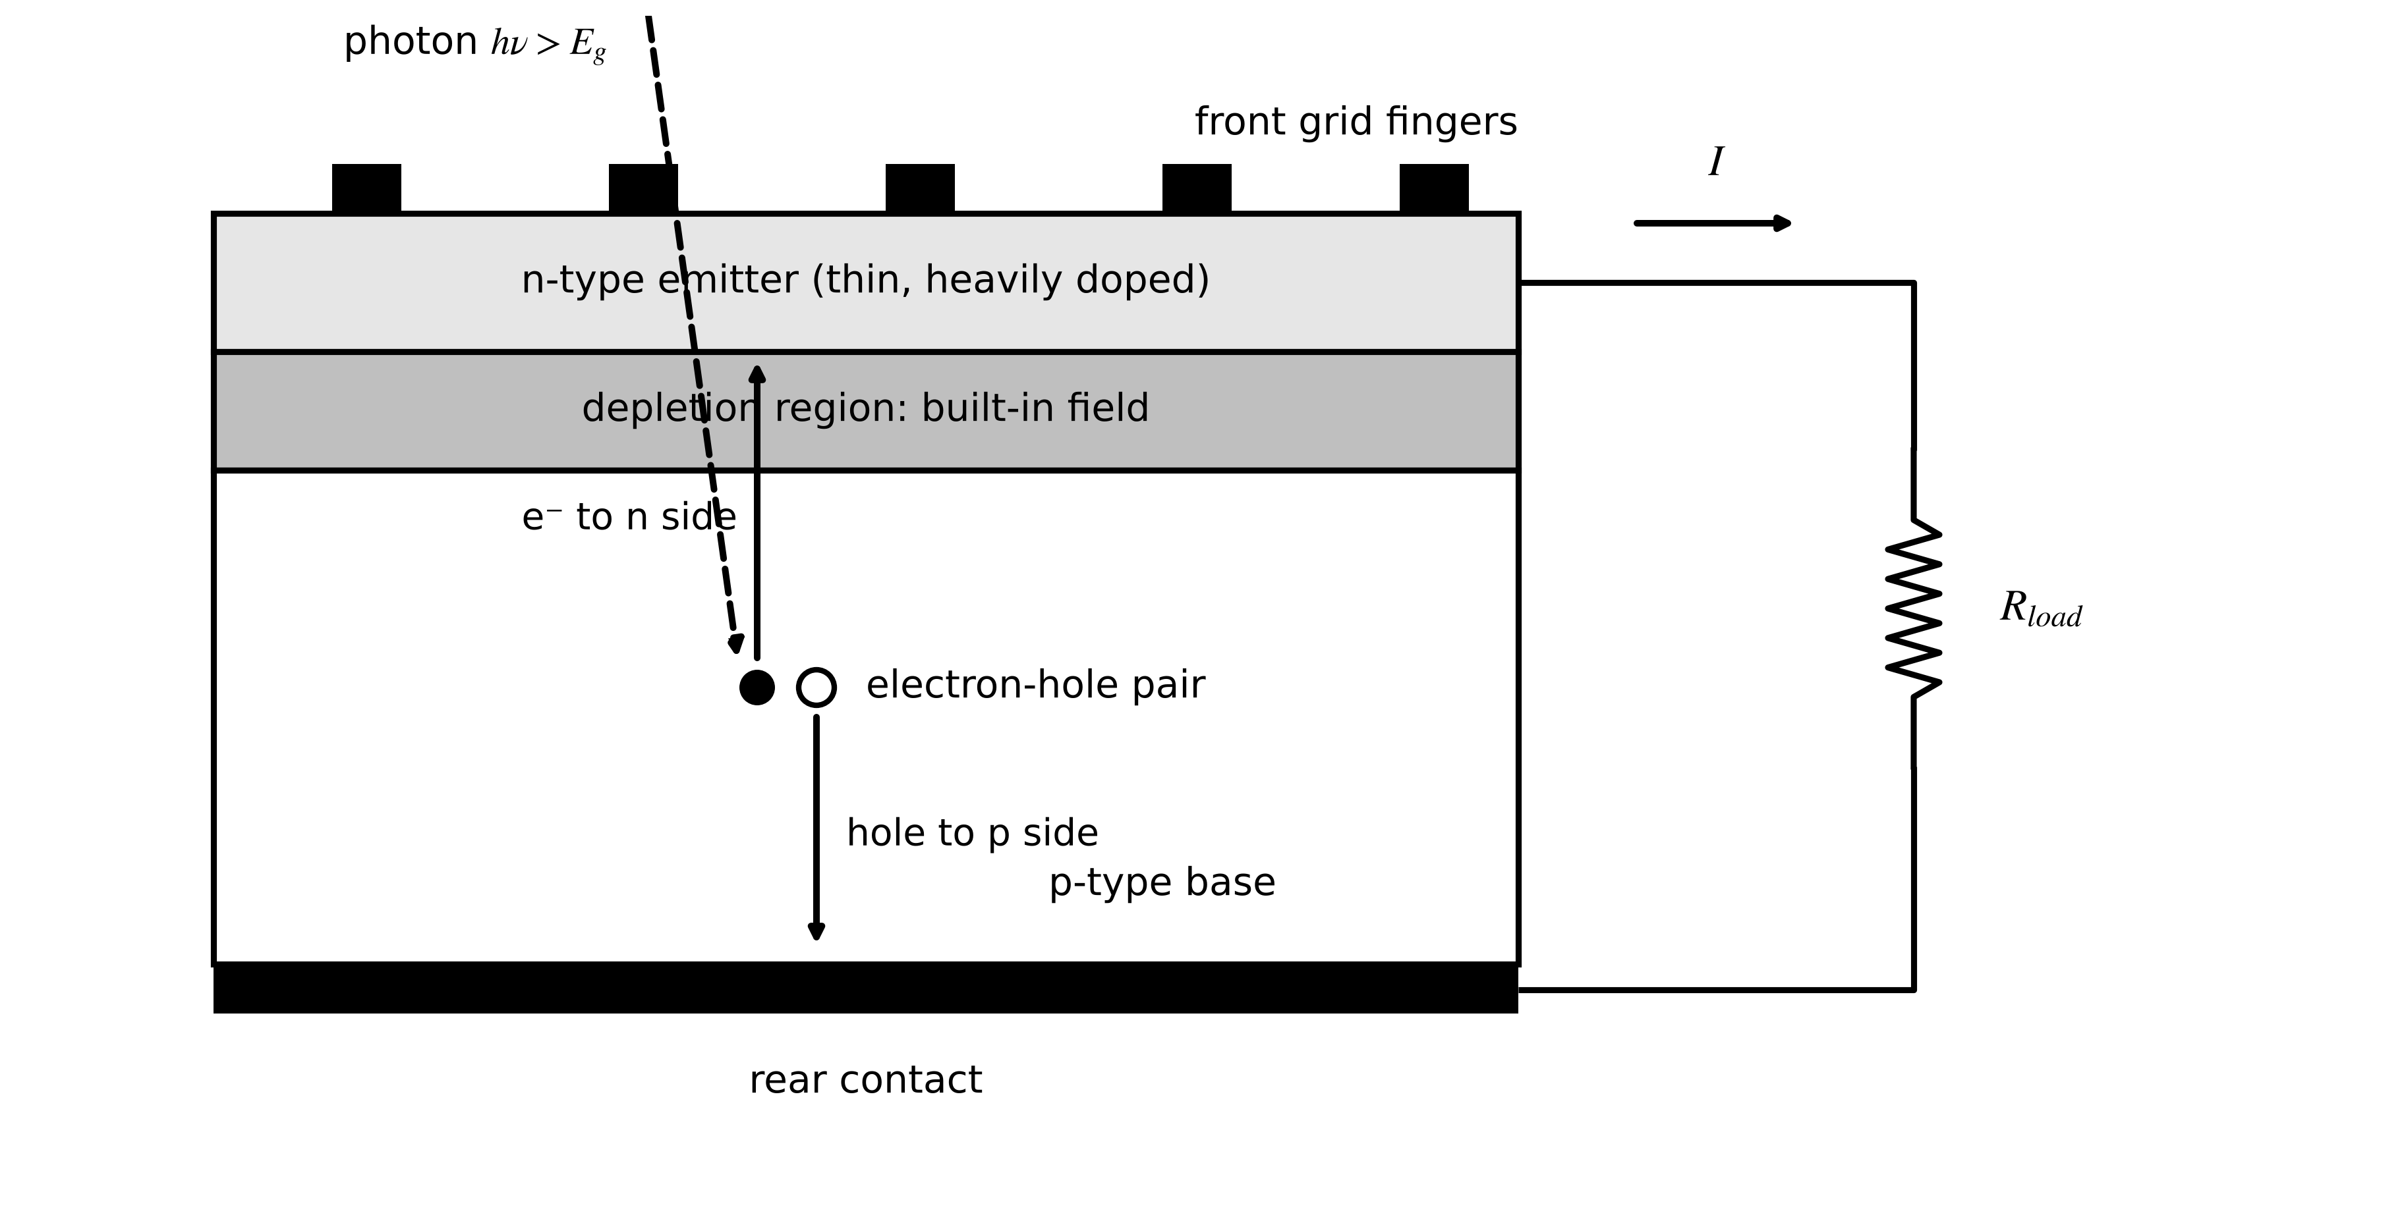
Figure 8.1. The photovoltaic effect in a p-n junction cell: absorbed photons create electron-hole pairs, the built-in field of the depletion region separates them, and the front grid and rear contact deliver the current to a load.
The short-circuit current density follows from the photon flux. For a cell of area $A_{c}$ and external quantum efficiency $EQE(λ)$ under spectral irradiance $E(λ)$, with $q$ the elementary charge and $hc/λ$ the photon energy,
$I_{sc}=qA_{c}\int{EQE}(λ)\frac{E(λ)λ}{hc} dλ$ (8.1)
Under the standard AM1.5 spectrum, silicon's maximum is about 44 mA/cm²; real cells reach about 41 mA/cm².
Example 8.1 (Level A) From one cell to the P-1 module
Given. Square silicon cells of 156.75 mm side (245.7 cm²) delivering 42.3 mA/cm² at STC, with 0.6875 V at open circuit and 0.567 V at maximum power; 72 cells in series; module area 1.94 m².
Find. Cell short-circuit current, module $V_{oc}$ and $V_{mp}$, and module efficiency if $I_{mp}=9.80$ A.
Solution. (8.1) in its integrated form: $I_{sc}=245.7×0.0423=10.4$ A, the same for the series chain. $V_{oc}=72×0.6875=49.5$ V; $V_{mp}=72×0.567=40.8$ V; $P_{mp}=40.8×9.80=399.8$ W; efficiency $399.8/(1000×1.94)=20.6$ %.
Interpretation. Series connection raises voltage at constant current; parallel connection (half-cells, parallel strings) raises current at constant voltage. Every PV design trades the two to fit the inverter's voltage and current window, and the twin inherits that layout in its parameter scaling (Section 8.3.2).

8.2.2 Module, string, array and inverter
Cells are connected in series inside a module to reach a useful voltage (Figure 8.2). The P-1 module has 72 cells, about 41 V and 9.8 A at maximum power and 400 W. Because one shaded or cracked cell in a series chain would limit the whole chain's current and could be driven into reverse breakdown, each third of the module (24 cells) is bridged by a bypass diode, which conducts when its cell group can no longer carry the string current. Modules are connected in series into strings of 20 (about 820 V) and strings in parallel into arrays; Plant P-1's 150 strings feed two central inverters through combiner boxes with string fuses and, optionally, string-current measurement. The inverter tracks the array's maximum power point (Section 8.5) and converts to AC (Chapter 7). Larger plants use string inverters (one per few strings, many MPPT inputs) or module-level power electronics; the choice decides what the twin can observe.
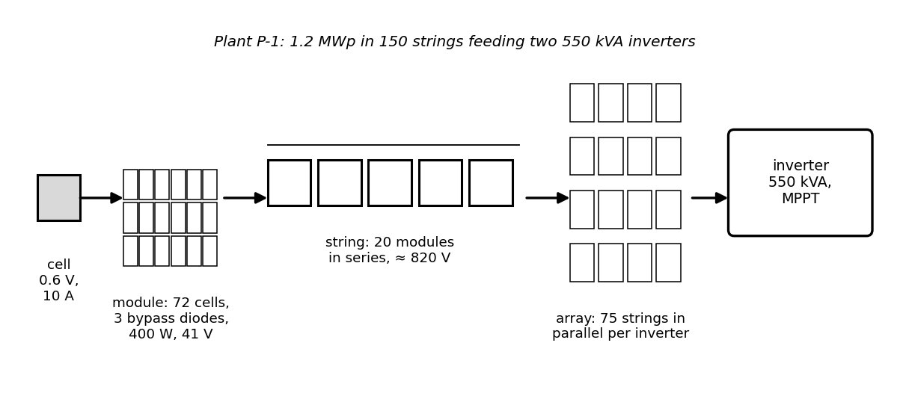
Figure 8.2. The PV hierarchy of Plant P-1: cell, 72-cell module with three bypass diodes, 20-module string, array of parallel strings and central inverter.
What the digital twin adds
Synchronized: nothing yet; the physical hierarchy defines what the twin's model must contain.
Estimated or updated: the electrical layout, which fixes the scaling of every parameter.
Uncertainty carried: none yet.
Decision enabled: where sensors (string currents, module temperatures) can see faults.
Validated by: as-built drawings and commissioning I-V sweeps.

8.3 The single-diode model: the twin's core forward model

8.3.1 Derivation
An illuminated cell is a current source in parallel with the junction diode: the photocurrent $I_{ph}$ is generated, and part of it flows back through the forward-biased junction instead of the load. Two loss paths complete the picture (Figure 8.3): a series resistance $R_{s}$ (contacts, fingers, ribbons) and a shunt resistance $R_{sh}$ (leakage across the junction edges and defects). Kirchhoff's current law at the diode node, with the Shockley diode law for the junction voltage $V+IR_{s}$, gives the implicit I-V characteristic of a module of $N_{s}$ series cells:
$I=I_{ph}-I_{0}\left[exp\left(\frac{V+IR_{s}}{a}\right)-1\right]-\frac{V+IR_{s}}{R_{sh}}, a=\frac{nN_{s}kT_{c}}{q}$ (8.2)
where $I_{0}$ is the diode saturation current, $n$ the ideality factor (1 for ideal diffusion current, up to 2 for recombination in the depletion region), $k$ Boltzmann's constant, $T_{c}$ the cell temperature in kelvin and $a$ the modified ideality factor, in volts. The sign convention is the generator convention: current leaving the positive terminal is positive. Because $I$ appears on both sides, the equation is solved iteratively (Newton's method on $I$) or exactly with the Lambert W function, $W(x)e^{W(x)}=x$:
$I=\frac{R_{sh}\left(I_{ph}+I_{0}\right)-V}{R_{s}+R_{sh}}-\frac{a}{R_{s}}W\left[\frac{R_{s}R_{sh}I_{0}}{a\left(R_{s}+R_{sh}\right)}exp\left(\frac{R_{sh}\left(R_{s}I_{ph}+R_{s}I_{0}+V\right)}{a\left(R_{s}+R_{sh}\right)}\right)\right]$ (8.3)
Three points of the curve summarize it: short circuit ($V=0$, $I≈I_{ph}$), open circuit ($I=0$, $V_{oc}≈aln(I_{ph}/I_{0}+1)$) and the maximum power point $(V_{mp},I_{mp})$, where $dP/dV=I+V dI/dV=0$. Their ratio is the fill factor $FF=V_{mp}I_{mp}/(V_{oc}I_{sc})$, typically 0.75 to 0.83. Limiting cases check the model: with $R_{s}→0$ and $R_{sh}→∞$ it reduces to the ideal diode equation; in the dark ($I_{ph}=0$) it is a resistive diode. It fails in reverse bias beyond breakdown (where bypass diodes take over), at very low irradiance where a second diode is needed, and for thin-film technologies with voltage-dependent collection.
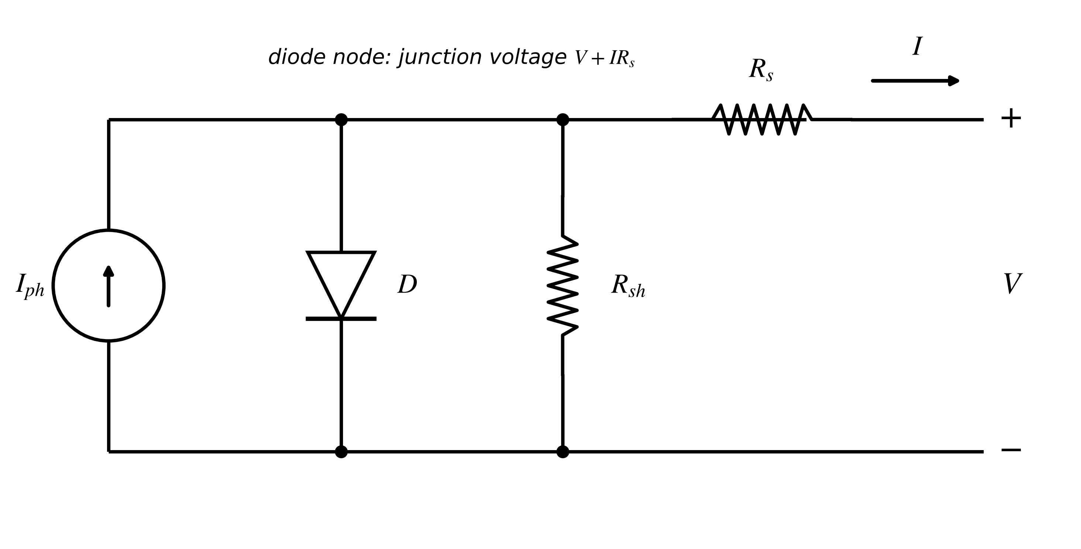
Figure 8.3. Single-diode equivalent circuit of a PV cell or module: photocurrent source, junction diode, shunt resistance and series resistance.

8.3.2 Scaling from cell to array
Connecting $N_{ss}$ identical modules in series multiplies voltage, and $N_{p}$ strings in parallel multiplies current. Applying (8.2) to the whole array with identical elements gives the same form with scaled parameters:
$I_{ph,arr}=N_{p}I_{ph}, I_{0,arr}=N_{p}I_{0}, a_{arr}=N_{ss}a, R_{s,arr}=\frac{N_{ss}}{N_{p}}R_{s}, R_{sh,arr}=\frac{N_{ss}}{N_{p}}R_{sh}$ (8.4)
valid only while all elements see the same irradiance and temperature; mismatch (Section 8.4.5) breaks it. For P-1, with 20 modules per string and 75 strings per inverter, $R_{s,arr}=(20/75)×0.307=0.082$ Ω per inverter.

8.3.3 Irradiance, temperature and what each parameter does
The photocurrent is proportional to the effective irradiance $G$ reaching the cells and rises slightly with temperature; the saturation current rises steeply with temperature through the band gap; the thermal voltage rises linearly (Figure 8.4, Figure 8.5). With reference values at standard test conditions (STC: 1000 W/m², 25 °C, AM1.5) marked ref and the short-circuit temperature coefficient $α_{I}$,
$I_{ph}=\frac{G}{G_{ref}}I_{ph,ref}\left[1+α_{I}\left(T_{c}-T_{ref}\right)\right], I_{0}=I_{0,ref}{\left(\frac{T_{c}}{T_{ref}}\right)}^{3}exp\left[\frac{E_{g}}{nk}\left(\frac{1}{T_{ref}}-\frac{1}{T_{c}}\right)\right], a=a_{ref}\frac{T_{c}}{T_{ref}}$ (8.5)
The consequences are what operators see: current, and hence power, rises in proportion to irradiance, while voltage rises only logarithmically; heat lowers $V_{oc}$ by about 0.3 % per kelvin, so maximum power falls by 0.3 to 0.4 %/K for crystalline silicon. Each parameter bends a different part of the curve, which is what makes them diagnosable: $I_{ph}$ scales the current plateau, $I_{0}$ and $a$ set the knee and $V_{oc}$, $R_{s}$ tilts the curve near open circuit (lower fill factor at high current), and $R_{sh}$ tilts it near short circuit (worst at low irradiance).
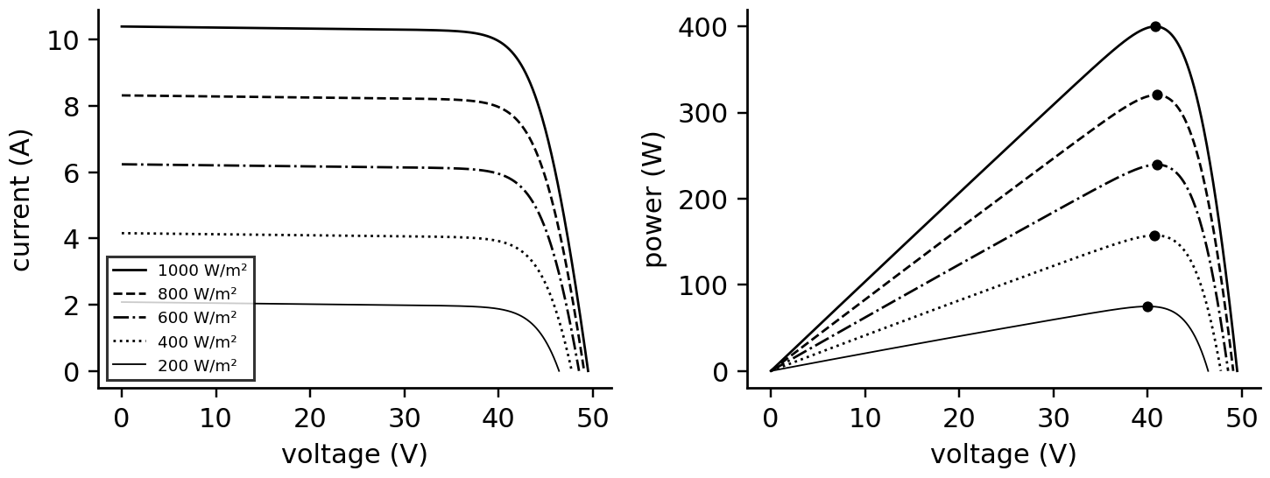
Figure 8.4. I-V (left) and P-V (right) curves of the P-1 module at 25 °C for irradiances from 200 to 1000 W/m², with the maximum power points marked. Current scales with irradiance; voltage changes only logarithmically.
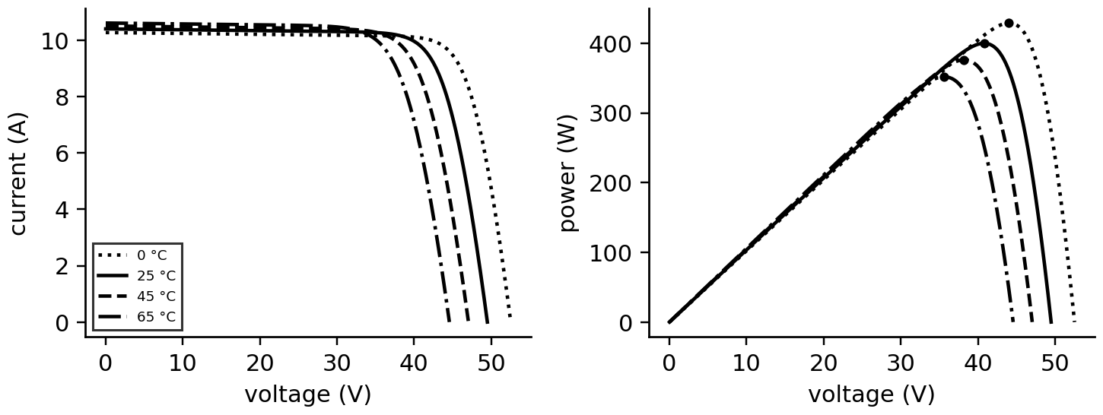
Figure 8.5. I-V and P-V curves of the P-1 module at 1000 W/m² for cell temperatures from 0 to 65 °C. Higher temperature lowers open-circuit voltage and maximum power.

8.3.4 Fitting the model to a datasheet, and what it cannot determine
A datasheet gives four points of information at STC ($I_{sc}$, $V_{oc}$, $I_{mp}$, $V_{mp}$, plus the zero slope of power at the maximum power point) and temperature coefficients. Writing (8.2) at the three points and $dP/dV=0$ at the fourth gives four equations for five unknowns ($I_{ph}$, $I_{0}$, $n$, $R_{s}$, $R_{sh}$); a fifth condition must come from somewhere else.
Example 8.2 (Level B) Fitting the P-1 module and testing identifiability
Given. A 400 W module: $I_{sc}=10.40$ A, $V_{oc}=49.5$ V, $I_{mp}=9.80$ A, $V_{mp}=40.8$ V, 72 cells, $α_{I}=+0.05$ %/K, $β_{V_{oc}}=-0.29$ %/K.
Find. (a) The parameters with $n=1.0$, 1.1 and 1.2. (b) The predicted power at STC and at 200, 100 and 50 W/m². (c) Predictions at 800 W/m², 45 °C and 1000 W/m², 65 °C for $n=1.0$.
Solution. (a) Solving the four STC equations by least squares to residuals below ${10}^{-14}$: $n=1.0$: $I_{ph}=10.410$ A, $I_{0}=2.45×{10}^{-11}$ A, $R_{s}=0.307$ Ω, $R_{sh}=322$ Ω; $n=1.1$: $R_{s}=0.267$ Ω, $R_{sh}=496$ Ω; $n=1.2$: $R_{s}=0.228$ Ω, $R_{sh}=1069$ Ω. (b) All three give 399.8 W at STC. At 200 W/m²: 74.9, 75.2 and 75.4 W; at 100 W/m²: 34.3, 35.1 and 35.8 W; at 50 W/m²: 14.5, 15.6 and 16.6 W, a 14 % spread. (c) 301.2 W at 800 W/m², 45 °C; 351.7 W at 1000 W/m², 65 °C (−0.30 %/K). The $n=1.0$ set predicts $β_{V_{oc}}=-0.25$ %/K with the band-gap law of (8.5), against −0.29 %/K on the datasheet.
Interpretation. The four STC numbers cannot separate the ideality factor from the resistances: each set compensates the others and is indistinguishable at STC, yet they diverge at low irradiance, where plants spend many hours (Chapter 4, Section 4.12). The voltage temperature coefficient is not reproduced exactly either, which shows the model-form limit of a fixed band gap. The cure is more information: flash-test curves at several irradiances and temperatures (IEC 61853-1 [5]) or, in operation, I-V sweeps recorded by the inverter, which a twin can use to re-fit the parameters on site.
Table 8.1. Single-diode parameters: what each one does and how it ages
Parameter | Effect on the curve | Typical ageing | Best observed from
$I_{ph}$ | scales current plateau with irradiance | soiling, browning, cracks (as effective loss) | current at high irradiance
$I_{0}$, $n$ ($a$) | set the knee and $V_{oc}$ | rarely; PID raises recombination | $V_{oc}$ and its temperature dependence
$R_{s}$ | tilts curve near $V_{oc}$; lowers fill factor at high current | solder and ribbon fatigue | slope near $V_{oc}$, fill factor at high irradiance
$R_{sh}$ | tilts curve near $I_{sc}$; hurts low irradiance | potential-induced degradation, cracks | slope near $I_{sc}$, morning performance

What the digital twin adds
Synchronized: the module's I-V curve to irradiance and cell temperature.
Estimated or updated: $I_{ph}$, $I_{0}$, $n$, $R_{s}$, $R_{sh}$ from datasheet, flash tests or field I-V sweeps.
Uncertainty carried: non-identifiability between $n$ and the resistances, largest at low irradiance.
Decision enabled: expected power at any condition; parameter drift as a health signal.
Validated by: I-V sweeps at several irradiances against model predictions.

8.4 The environment of the array: irradiance, temperature, soiling, shading and mismatch

8.4.1 Sun position and plane-of-array irradiance
A module responds to the irradiance on its own plane, not to the horizontal irradiance most weather stations report. The physical question is how much of the sun's beam and of the sky's diffuse light falls on a tilted surface (Figure 8.6). The sun's position follows from the declination $δ_{s}$ (the sun's latitude, varying over the year), the hour angle $ω_{h}$ (15° per hour from solar noon) and the site latitude $φ$; for a surface tilted at $β$ facing the equator, the incidence angle replaces $φ$ by $φ-β$:
$δ_{s}={23.45}^{∘}sin\left[\frac{{360}^{∘}\left(284+d_{n}\right)}{365}\right], cosθ_{z}=sinφsinδ_{s}+cosφcosδ_{s}cosω_{h}, cosθ_{i}=sinδ_{s}sin(φ-β)+cosδ_{s}cos(φ-β)cosω_{h}$ (8.6)
where $d_{n}$ is the day of the year and $θ_{z}$, $θ_{i}$ the zenith and incidence angles. The plane-of-array (POA) irradiance adds the beam projected on the plane, the diffuse irradiance seen by the plane (isotropic sky model) and the light reflected from the ground with albedo $ρ_{g}$:
$G_{poa}=G_{bn}max\left(cosθ_{i},0\right)+G_{dh}\frac{1+cosβ}{2}+G_{h}ρ_{g}\frac{1-cosβ}{2}, G_{h}=G_{bn}cosθ_{z}+G_{dh}$ (8.7)
where $G_{bn}$ is the direct normal irradiance, $G_{dh}$ the diffuse horizontal and $G_{h}$ the global horizontal. The isotropic model underestimates diffuse light near the sun on clear days; anisotropic models (Hay-Davies, Perez) correct this, but every transposition carries an error of typically 2 to 5 % on hourly data, which is why a POA pyranometer or reference cell is the twin's preferred irradiance sensor.
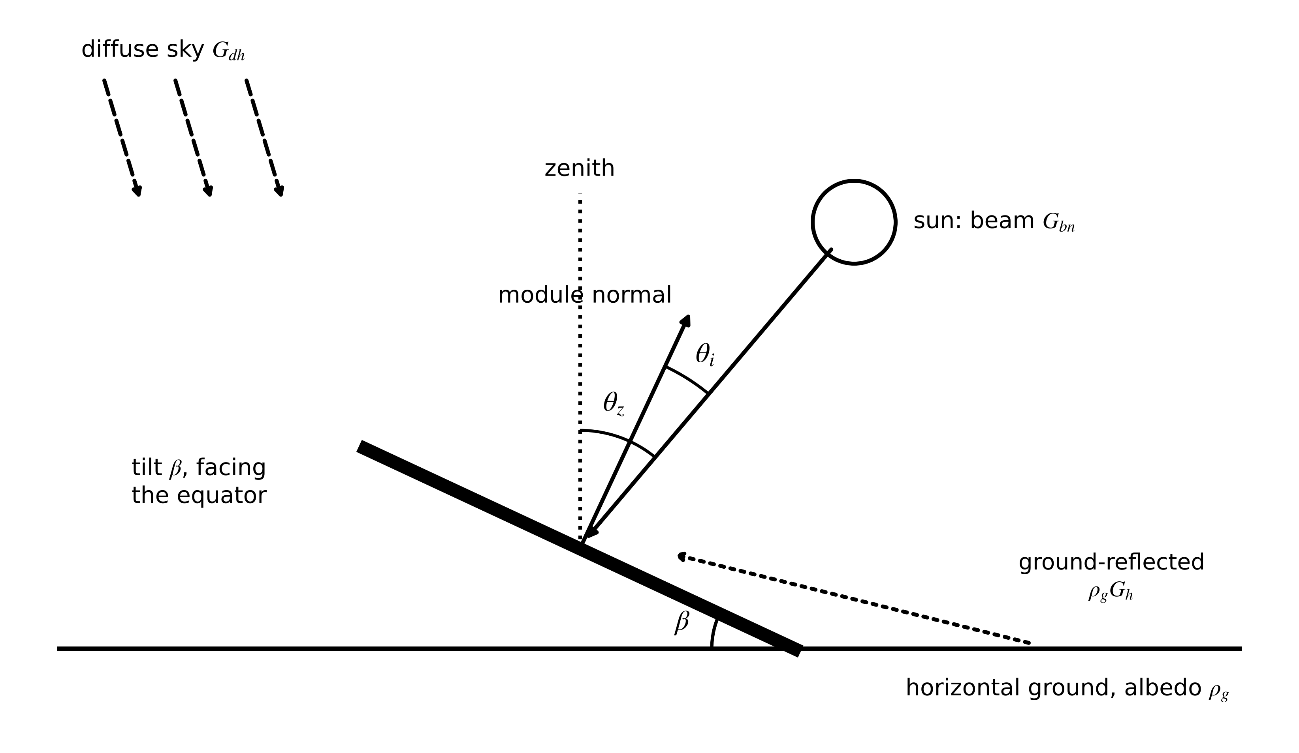
Figure 8.6. Plane-of-array geometry: beam irradiance arrives at incidence angle $θ_{i}$ to the module normal; diffuse sky light and ground-reflected light add to it.
Example 8.3 (Level A) Plane-of-array irradiance at 3 p.m. on the summer solstice
Given. Latitude 26.3° N, tilt 25° facing south, 21 June ($d_{n}=172$), 3 p.m. solar time; $G_{bn}=800$ W/m², $G_{dh}=120$ W/m², $ρ_{g}=0.2$.
Find. $δ_{s}$, $θ_{z}$, $θ_{i}$ and $G_{poa}$.
Solution. (8.6): $δ_{s}=23.45°$, $ω_{h}=45°$, $θ_{z}=40.7°$, $θ_{i}=48.9°$. $G_{h}=800cos40.7°+120=726$ W/m². (8.7): $G_{poa}=800×0.658+120×0.953+726×0.2×0.047=647$ W/m².
Interpretation. In a summer afternoon the tilted array receives 11 % less than a horizontal sensor. A twin fed by a horizontal pyranometer must transpose its reading, and the transposition error enters its uncertainty budget (Section 8.4.6).

8.4.2 Cell temperature
The module heats until absorbed irradiance balances heat lost to the air. A steady-state energy balance with a constant heat-loss coefficient $U_{0}$ and a wind-dependent coefficient $U_{1}$ gives the Faiman model used in IEC 61853-2 [6]:
$T_{c}=T_{a}+\frac{G_{poa}}{U_{0}+U_{1}v_{w}}, P_{mp}≈P_{mp,ref}\frac{G_{poa}}{G_{ref}}\left[1+γ\left(T_{c}-T_{ref}\right)\right]$ (8.8)
where $T_{a}$ is ambient temperature, $v_{w}$ wind speed in m/s, typical coefficients $U_{0}=25$ W/(m²·K) and $U_{1}=6.84$ W·s/(m³·K), and $γ$ the power temperature coefficient. At 900 W/m², 35 °C and 1 m/s wind, $T_{c}=63.3$ °C, and with $γ=-0.35$ %/K the module loses 13.4 % of its STC power to heat. The steady model lags behind fast irradiance changes: the module's thermal time constant is several minutes, so a twin running at seconds adds a first-order filter.

8.4.3 Angle of incidence, spectrum and bifacial gain
At oblique incidence more light is reflected by the glass. The incidence-angle modifier, for example the ASHRAE form $IAM(θ_{i})=1-b_{0}(1/cosθ_{i}-1)$ with $b_{0}≈0.05$, multiplies the beam component: 0.985 at 40°, 0.95 at 60°, 0.86 at 75°. The spectrum changes with air mass and clouds; spectral corrections matter most for thin-film technologies and, for silicon, are usually within ±2 %. Bifacial modules also collect light on their rear side, mostly reflected from the ground (Figure 8.7). With rear irradiance $G_{r}$, bifaciality factor $φ_{bi}$ (rear-to-front efficiency, 0.7 to 0.9) and rear shading or mismatch loss $s_{r}$,
$G_{eff}=G_{f}+φ_{bi}\left(1-s_{r}\right)G_{r}$ (8.9)
With $G_{f}=850$ W/m², $G_{r}=100$ W/m², $φ_{bi}=0.8$ and 5 % rear shading, $G_{eff}=926$ W/m², an 8.9 % gain. The rear irradiance depends on albedo, row spacing, mounting height and the tracker angle, and is the most uncertain term in bifacial yield; twins of bifacial plants therefore benefit from rear-side reference cells.
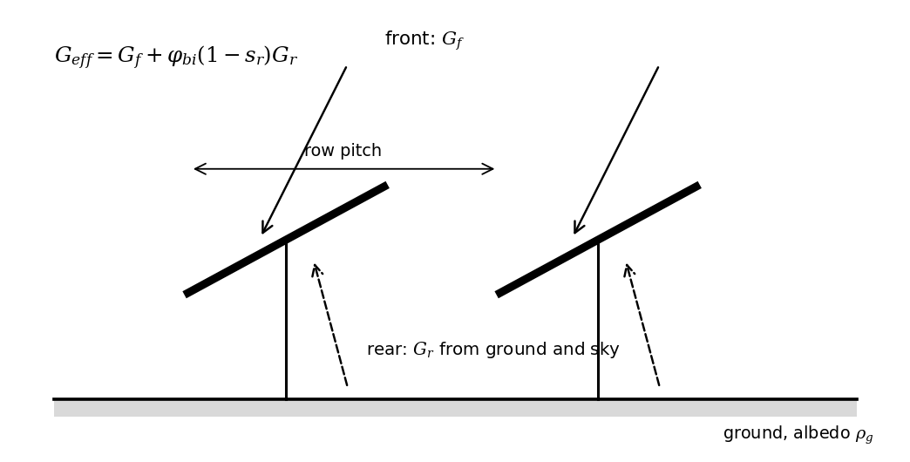
Figure 8.7. Bifacial modules collect front irradiance from the sky and rear irradiance reflected from the ground; the rear contribution depends on albedo, row pitch and mounting height.

8.4.4 Soiling
Dust, pollen and bird droppings scatter and absorb light before it reaches the cells. The soiling ratio $SR=P_{soiled}/P_{clean}$ falls gradually between rain events and cleanings, typically 0.1 to 0.3 % per day in dry, dusty climates (worldwide it costs at least 3 to 4 % of solar production even with optimized cleaning [7]), and recovers when rain or washing removes the deposit. Because it is a slow multiplicative loss on all strings together, it is easily confused with a drifting pyranometer; separating the two needs a second, independent irradiance reference (a cleaned reference cell or satellite irradiance) (Section 8.7).

8.4.5 Shading, bypass diodes and mismatch
When one cell group in a series string receives less light, it can no longer carry the string's current. Without protection the healthy groups would drive it into reverse bias, dissipating power as a hot spot. The bypass diode across each 24-cell group (Figure 8.8) conducts instead, and the string's I-V curve becomes the sum of group curves, each clamped at about −0.5 V, with steps where groups are bypassed. The P-V curve then has several local maxima.
Example 8.4 (Level B) A partially shaded P-1 string
Given. A string of 20 P-1 modules, each with three bypass diodes (0.5 V), at 25 °C. Five modules are shaded to 200 W/m²; the rest receive 1000 W/m².
Find. The local and global maxima of the string's P-V curve, from the single-diode model of each cell group with bypass clamping.
Solution. Unshaded, the string gives 7997 W at 816 V. Shaded, there are two maxima (Figure 8.8): 5924 W at 605 V and 9.80 A with the 15 shaded groups bypassed (global), and 1778 W at 909 V and 1.96 A with every group carrying the shaded current (local).
Interpretation. A 25 % shading of modules costs 26 % of power if the tracker finds the global peak and 78 % if it does not. Which one it finds is a question for the MPPT (Section 8.5).
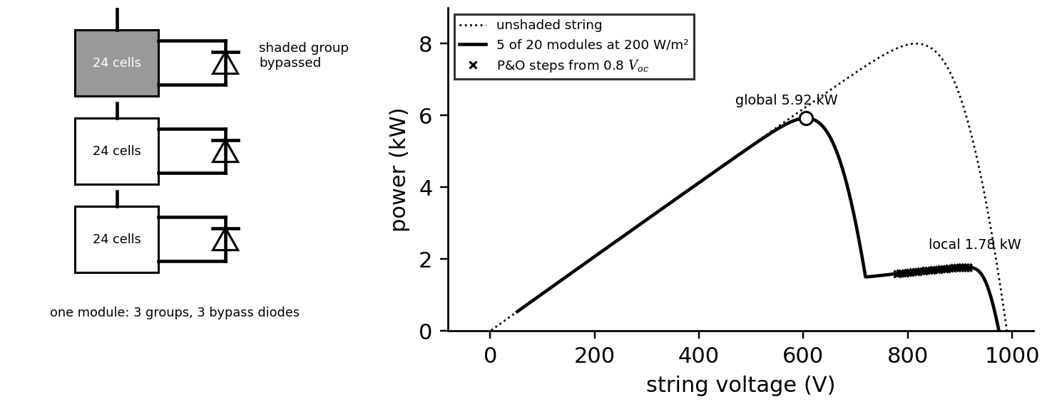
Figure 8.8. Left: one module with three 24-cell groups and their bypass diodes; a shaded group is bypassed. Right: P-V curves of a 20-module string unshaded and with five modules at 200 W/m², and the steps of a perturb-and-observe tracker starting at 0.8 $V_{oc}$.
Mismatch is the general case: modules in a string differ because of manufacturing tolerance, uneven soiling, cracks or ageing. The mismatch loss compares the string's maximum with the sum of its modules' individual maxima:
$L_{mm}=1-\frac{P_{mp,string}}{\sum_{j=1}^{N_{ss}}{P_{mp,j}}}$ (8.10)
Example 8.5 (Level B) One module with 18 % less current
Given. A string of 20 P-1 modules at STC, one of which has 18 % less photocurrent (cracked cells), with three bypass diodes per module.
Find. The string maximum, the mismatch loss (8.10), and a comparison with a model without bypass diodes.
Solution. The string curve has two maxima: 7582 W at 774 V and 9.80 A with the weak module bypassed (global), and 7281 W at 867 V and 8.4 A with the whole string at the weak module's current. The weak module alone would deliver 328 W, so the sum of maxima is $19×399.8+328=7925$ W and $L_{mm}=343/7925=4.3$ %; the loss against a healthy string is 5.2 %. A model without bypass diodes forces the whole string to the weak current and predicts 18 % loss.
Interpretation. Bypass diodes cap the damage one weak module can do at about its own power, provided the tracker finds the right peak. The voltage drop of about one module voltage at normal current is also a diagnostic signature: all three groups of one module are bypassed.

8.4.6 Uncertainty of the power prediction
Every input of (8.8) is measured with error. To first order (Chapter 3, Section 3.6), for independent irradiance and temperature uncertainties $u_{G}$ and $u_{T}$,
$\frac{u_{P}}{P}=\sqrt{{\left(\frac{u_{G}}{G}\right)}^{2}+{\left(γu_{T}\right)}^{2}+{\left(\frac{u_{tr}}{G}\right)}^{2}+u_{mod}^{2}}$ (8.11)
where $u_{tr}$ is the transposition error (zero for a POA sensor) and $u_{mod}$ the model-form error of the power model itself. For a 100 kW array with a 2 % irradiance uncertainty (20 W/m² at 1000 W/m²) and a 1.5 K temperature uncertainty: 2.0 kW and 0.53 kW, combining to 2.07 kW, so irradiance dominates. A secondary-standard pyranometer reaches about 1.5 to 2 % on hourly sums; a reference cell matched to the module technology reduces spectral and angular errors.
What the digital twin adds
Synchronized: effective irradiance and cell temperature on each part of the array.
Estimated or updated: transposition, soiling ratio, shading pattern, mismatch.
Uncertainty carried: sensor, transposition and model-form errors combined by (8.11).
Decision enabled: separating environment from equipment before any fault is declared.
Validated by: POA reference cells, rear-side sensors, I-V sweeps of shaded strings.

8.5 Maximum power point tracking and its transient behaviour
The array's maximum power point moves with every cloud and every degree of temperature, so the inverter must search for it continuously. Perturb and observe (P&O) changes the operating voltage by a step $ΔV$, measures power, and keeps the direction if power rose and reverses it if power fell. Incremental conductance (InC) uses the condition for the maximum directly. Since $P=VI$,
$\frac{dP}{dV}=I+V\frac{dI}{dV}=0 ⇔ \frac{dI}{dV}=-\frac{I}{V}, \frac{dI}{dV}>-\frac{I}{V}: increase V, \frac{dI}{dV}<-\frac{I}{V}: decrease V$ (8.12)
with $dI/dV$ estimated from successive samples. Both methods settle into a three-point oscillation around the maximum, of size set by the step; a larger step tracks fast irradiance changes better but oscillates more, and a P&O tracker can be misled when irradiance changes during a perturbation, reading the change as the result of its own step (Figure 8.9). Adaptive step sizes and InC reduce both effects. The tracker sits in the converter control loop of Chapter 7; for the twin, what matters is that it adds a dynamic, controller-dependent loss between the available and the delivered power, which the twin models explicitly rather than assuming perfect tracking.
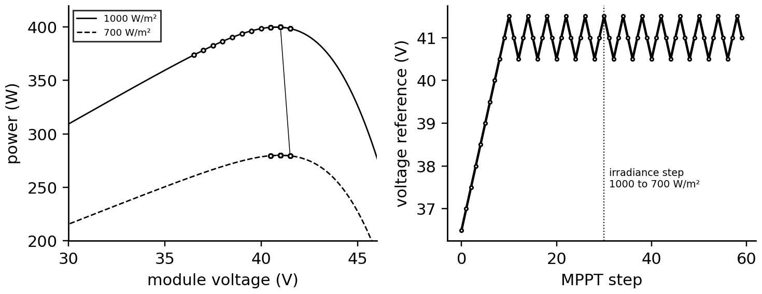
Figure 8.9. P&O tracking on the P-1 module. Left: operating points climbing to the maximum and oscillating around it, then moving to the new curve after an irradiance step from 1000 to 700 W/m². Right: the voltage reference over the same steps.
Example 8.6 (Level B) A tracker trapped by shading
Given. The shaded string of Example 8.4; a P&O tracker starting at 0.8 $V_{oc}$ with 5 V steps; for comparison, a periodic sweep of 40 voltage points.
Find. Where P&O settles and what the sweep finds.
Solution. P&O climbs the high-voltage peak and oscillates around 1777 W at about 910 V (Figure 8.8), 70 % below the global maximum of 5924 W. The 40-point sweep finds 5920 W.
Interpretation. Under shade the tracker, not the shade, causes most of the loss. A twin detects this directly: from measured irradiance and its string model it predicts the global maximum, and a measured power near a local peak is the signature of a trapped tracker. Global MPPT methods (periodic sweeps, model-guided jumps to the predicted peak) are established in commercial inverters; the twin can supply the predicted peak voltage.
What the digital twin adds
Synchronized: the operating point against the twin's predicted global maximum.
Estimated or updated: tracking efficiency, local-peak trapping events.
Uncertainty carried: model error in the predicted maximum under non-uniform irradiance.
Decision enabled: trigger a sweep or retune the tracker; separate tracking loss from equipment loss.
Validated by: inverter I-V sweeps against the model's string curves.

8.6 Plant performance metrics: yield, performance ratio and degradation
Plant-level metrics normalize energy by what the weather offered. The specific yield $Y_{f}$ is energy per installed kilowatt-peak, the reference yield $Y_{r}$ is the POA irradiation in kWh/m² divided by 1 kW/m², and the performance ratio (IEC 61724-1 [8]) is their quotient. Correcting each interval's expected power to 25 °C removes the climate's temperature effect; the degradation rate follows from PR in successive years:
$Y_{f}=\frac{E_{AC}}{P_{STC}}, Y_{r}=\frac{H_{poa}}{G_{ref}}, PR=\frac{Y_{f}}{Y_{r}}, PR_{T}=\frac{\sum_{k}{P_{AC,k}}}{\sum_{k}{P_{STC}}\frac{G_{poa,k}}{G_{ref}}\left[1+γ\left(T_{c,k}-25\right)\right]}, R_{d}=\frac{PR_{1}-PR_{n}}{PR_{1}(n-1)}$ (8.13)
with $E_{AC}$ the AC energy, $H_{poa}$ the POA irradiation and $P_{STC}$ the rated DC power. The capacity factor $CF=E_{AC}/(P_{rated}·8760 h)$ completes the set. Field studies report median degradation rates of about 0.5 to 0.8 % per year for crystalline silicon [9]; year-on-year methods that compare the same calendar days remove seasonal bias and are preferred to a single linear fit.
Example 8.7 (Level B) One synthetic year of the P-1 array
Given. An hourly year for the 1.2 MWp array at 26.3° N, 25° tilt (NumPy default_rng(2026)): clear-sky irradiance scaled by an autoregressive clear-sky index around random daily clearness, with a cloudier monsoon from day 180 to 270; diffuse fraction by the Erbs correlation; isotropic transposition; Faiman temperature; $γ=-0.35$ %/K; inverter efficiency 0.97; soiling falling 0.15 % per day, reset by rain (half of monsoon days, 2 % of other days) and by cleaning on days 120 and 300; three of 150 strings failing open on day 200.
Find. Energy, specific yield, PR, $PR_{T}$, capacity factor and the soiling loss.
Solution. 1794 MWh from 1706 kWh/m² of POA irradiation: specific yield 1495 kWh/kWp, PR 0.876, $PR_{T}$ 0.940, capacity factor 17.1 %. Soiling costs 2.3 % of the year's energy.
Interpretation. The six points between PR and $PR_{T}$ are temperature, not fault. Neither metric reveals the 2.3 % soiling loss or the string failure: plant metrics measure performance; they do not diagnose it. That is the job of the synchronized twin in the next section.
What the digital twin adds
Synchronized: delivered energy against weather-normalized expectation.
Estimated or updated: PR, temperature-corrected PR, degradation rate.
Uncertainty carried: irradiance measurement dominates PR uncertainty.
Decision enabled: contractual performance, long-term trends, warranty claims.
Validated by: IEC 61724-1 procedures and independent irradiance references.

8.7 PV plant-level synchronization and uncertainty
A static yield model predicts what a plant should produce on an average day. A twin must instead explain what the plant is producing today, and that requires continuously reconciling five things that all change: the weather input (is the pyranometer right?), the measured electrical output, the availability of equipment (which strings, inverters and trackers are running), the slow states (soiling, degradation, tracker misalignment) and the model parameters themselves (Figure 8.10). This section builds that reconciliation.
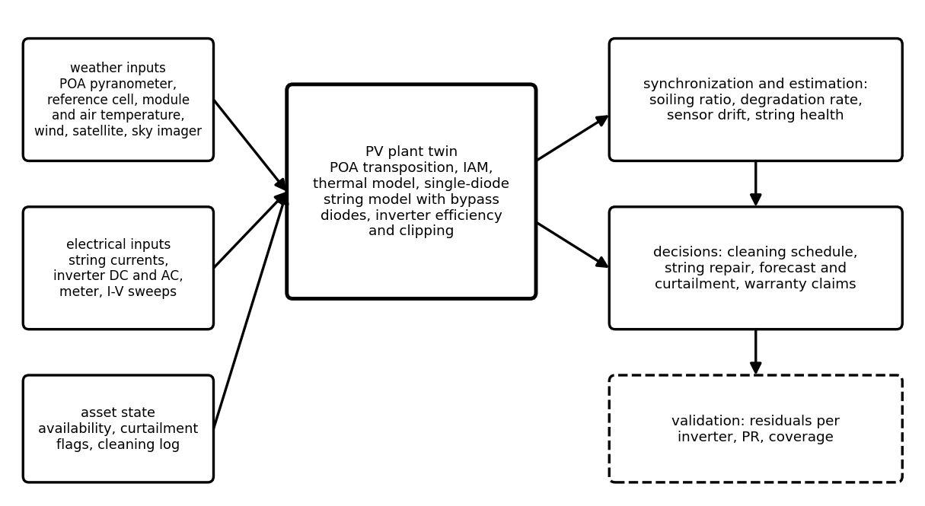
Figure 8.10. PV plant twin architecture: weather, electrical and asset-state inputs feed the physical model; synchronization estimates soiling, degradation, sensor drift and string health; decisions and validation follow.

8.7.1 Residual ratios and fault isolation
The twin compares measured and modelled quantities at the finest level the instrumentation allows. Ratios of measured to predicted current, voltage and power separate fault classes, because each fault acts on a different part of the I-V curve (Section 8.3.3):
$ρ_{I}=\frac{I_{m}}{I_{DT}}, ρ_{V}=\frac{V_{m}}{V_{DT}}, ρ_{P}=\frac{\sum_{k∈day}{P_{m,k}}}{\sum_{k∈day}{P_{DT,k}}}$ (8.14)
where the twin's prediction uses measured irradiance and temperature but assumes a clean, fully available plant. Table 8.2 lists the signatures and the test that separates look-alikes.
Table 8.2. PV fault signatures in the current and voltage ratios (string level unless stated)
Condition | $ρ_{I}$ | $ρ_{V}$ | Other evidence | Separating test
uniform soiling | below 1, slowly falling | about 1 | recovers after rain or cleaning | clean reference cell or satellite
pyranometer drift | biased, all strings equally | about 1 | same on every string | second irradiance reference
partial shading | varies with time of day | drops at the global peak | multiple peaks in I-V sweep | repeats daily at same sun position
open string (fuse, connector) | zero on that string | unchanged | combiner current falls by $1/N_{p}$ | string-current monitoring
shorted bypass diode | 1 | down by about one third of a module | permanent, no daily pattern | I-V sweep, thermography
degraded module (cracks, PID) | slightly below 1 | slightly below 1 | grows slowly | electroluminescence, I-V sweep
rising series resistance | about 1 | below 1 at high current | fill factor falls | slope near $V_{oc}$
falling shunt resistance | below 1 at low irradiance | about 1 | worse in mornings | slope near $I_{sc}$
temperature sensor error | 1 | biased | power ratio normal | compare with (8.8)

Example 8.8 (Level B) Finding the failed strings of Plant P-1
Given. The year of Example 8.7, with measurement noise (pyranometer 2 %, cell temperature 1 K, meter 0.5 %). The twin's daily ratio $ρ_{P}$ has a standard deviation of 0.70 % on clean, healthy days (44 days). Three of 150 strings fail open on day 200.
Find. The change in $ρ_{P}$, whether one day reveals it, how much averaging helps, and the role of string currents.
Solution. Three open strings remove 2.0 % of the array. The mean ratio falls from 1.000 over days 190 to 199 to 0.977 over days 200 to 209, a drop of 2.4 % (0.15 points of which is soiling). A 3σ threshold on one day is 2.1 %, so a single day is a marginal detection; the mean of three days ($σ=0.40$ %) makes it a 6σ event. With string-current monitoring the three strings read zero from the first hour and Table 8.2 identifies the fault without any model.
Interpretation. Plant-level residuals detect what the plant's instrumentation allows, and slowly. A PV twin's sensitivity is set by its sensor placement: one pyranometer and one meter per inverter detect a 2 % fault in days; string currents detect it in minutes and locate it.

8.7.2 Estimating the soiling state
Soiling is a slow, hidden state: it falls between rain events and resets when it rains or the array is cleaned. A scalar Kalman filter (Chapter 5) tracks it from the daily ratio with a drift model and resets driven by the rain record and the cleaning log:
$s_{k|k-1}=\left\{\begin{matrix}1 & rain or cleaning on day k \\ s_{k-1|k-1}-r_{s} & otherwise\end{matrix}\right., s_{k|k}=s_{k|k-1}+K_{k}\left(ρ_{P,k}-s_{k|k-1}\right)$ (8.15)
where $r_{s}$ is the expected soiling rate and $K_{k}$ the Kalman gain from the drift and measurement variances. The estimate then feeds a cleaning decision: clean when the cumulative energy lost since the last cleaning, valued at the tariff, exceeds the cost of washing.
Example 8.9 (Level C) Tracking soiling with the twin
Given. The daily ratios of Example 8.7 up to day 199 (before the string failure); drift model 0.15 % per day with a process standard deviation of 0.05 % per day; measurement standard deviation 0.7 %; rain days from the site's weather record and the two cleaning days.
Find. The accuracy of the soiling estimate.
Solution. The filter's estimate follows the true soiling ratio with an RMS error of 0.16 percentage points and a maximum of 0.63 points (Figure 8.11).
Interpretation. The twin knows the soiling loss to a few tenths of a per cent, far better than any single day's ratio, because it combines the physics of accumulation with the measurements. After day 200 the string failure would masquerade as soiling unless availability is estimated separately, which is why string currents and the soiling filter belong together.
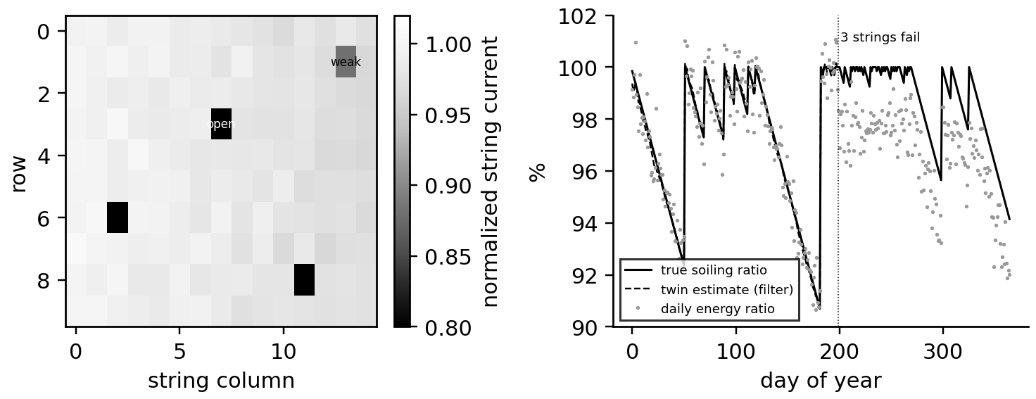
Figure 8.11. Left: normalized string currents across the array on one day, showing a soiling gradient, three open strings and one weak string. Right: the daily energy ratio, the true soiling ratio and the twin's filtered estimate over the synthetic year.

8.7.3 Degradation mechanisms and imaging
Slow degradation changes the single-diode parameters in characteristic ways (Table 8.3). Imaging turns these mechanisms into pictures: drone-borne infrared thermography shows hot cells, bypassed groups and open strings across whole plants; electroluminescence imaging, in which the module is driven with forward current in the dark, shows cracks and inactive areas. The twin directs these inspections to where its residuals point, and uses their findings to update its parameters.
Table 8.3. Degradation mechanisms of current PV technologies and how they are detected
Mechanism | Affected technologies | Electrical signature | Detection
potential-induced degradation (PID) | p-type PERC, some n-type | falling $R_{sh}$, strongest at the negative end of the string | string-position pattern, EL imaging
light- and elevated-temperature-induced degradation (LeTID) | PERC | current and voltage loss over the first years, partial recovery | trend of $ρ_{I}$, $ρ_{V}$
UV-induced degradation (UVID) | TOPCon, heterojunction | voltage and fill-factor loss | $V_{oc}$ trend, spectral response
cell cracks | all, after hail, transport, snow load | current loss in cell groups, bypass activation | EL imaging, I-V sweep
solder-bond and ribbon fatigue | all | rising $R_{s}$, falling fill factor | slope near $V_{oc}$, IR hot spots
encapsulant browning, delamination | older EVA modules | current loss, moisture ingress | visual, IR, insulation monitoring

What the digital twin adds
Synchronized: weather inputs, electrical output, availability and slow states, reconciled daily and intra-day.
Estimated or updated: soiling ratio, string health, sensor drift, degradation, model parameters.
Uncertainty carried: filter covariances; separation of look-alike faults by second references.
Decision enabled: cleaning, string repair, sensor recalibration, inspection targeting.
Validated by: string currents, reference cells, satellite irradiance, inspection findings.

8.8 The physical wind turbine and the Betz limit

8.8.1 From wind to grid
A horizontal-axis turbine converts the kinetic energy of the air passing through its rotor into shaft power and then electricity (Figure 8.12). The blades, whose pitch angle $β$ can be changed, drive a hub on a main shaft; a gearbox (absent in direct-drive designs) raises the speed for the generator; a power converter (Chapter 7) interfaces the generator to the grid; a yaw drive turns the nacelle into the wind, guided by a wind vane, while a nacelle anemometer measures wind speed behind the rotor. T-1 is a 2 MW turbine with an 82 m rotor ($R=41$ m, swept area 5281 m²), a three-stage gearbox and a doubly fed or full-converter generator.
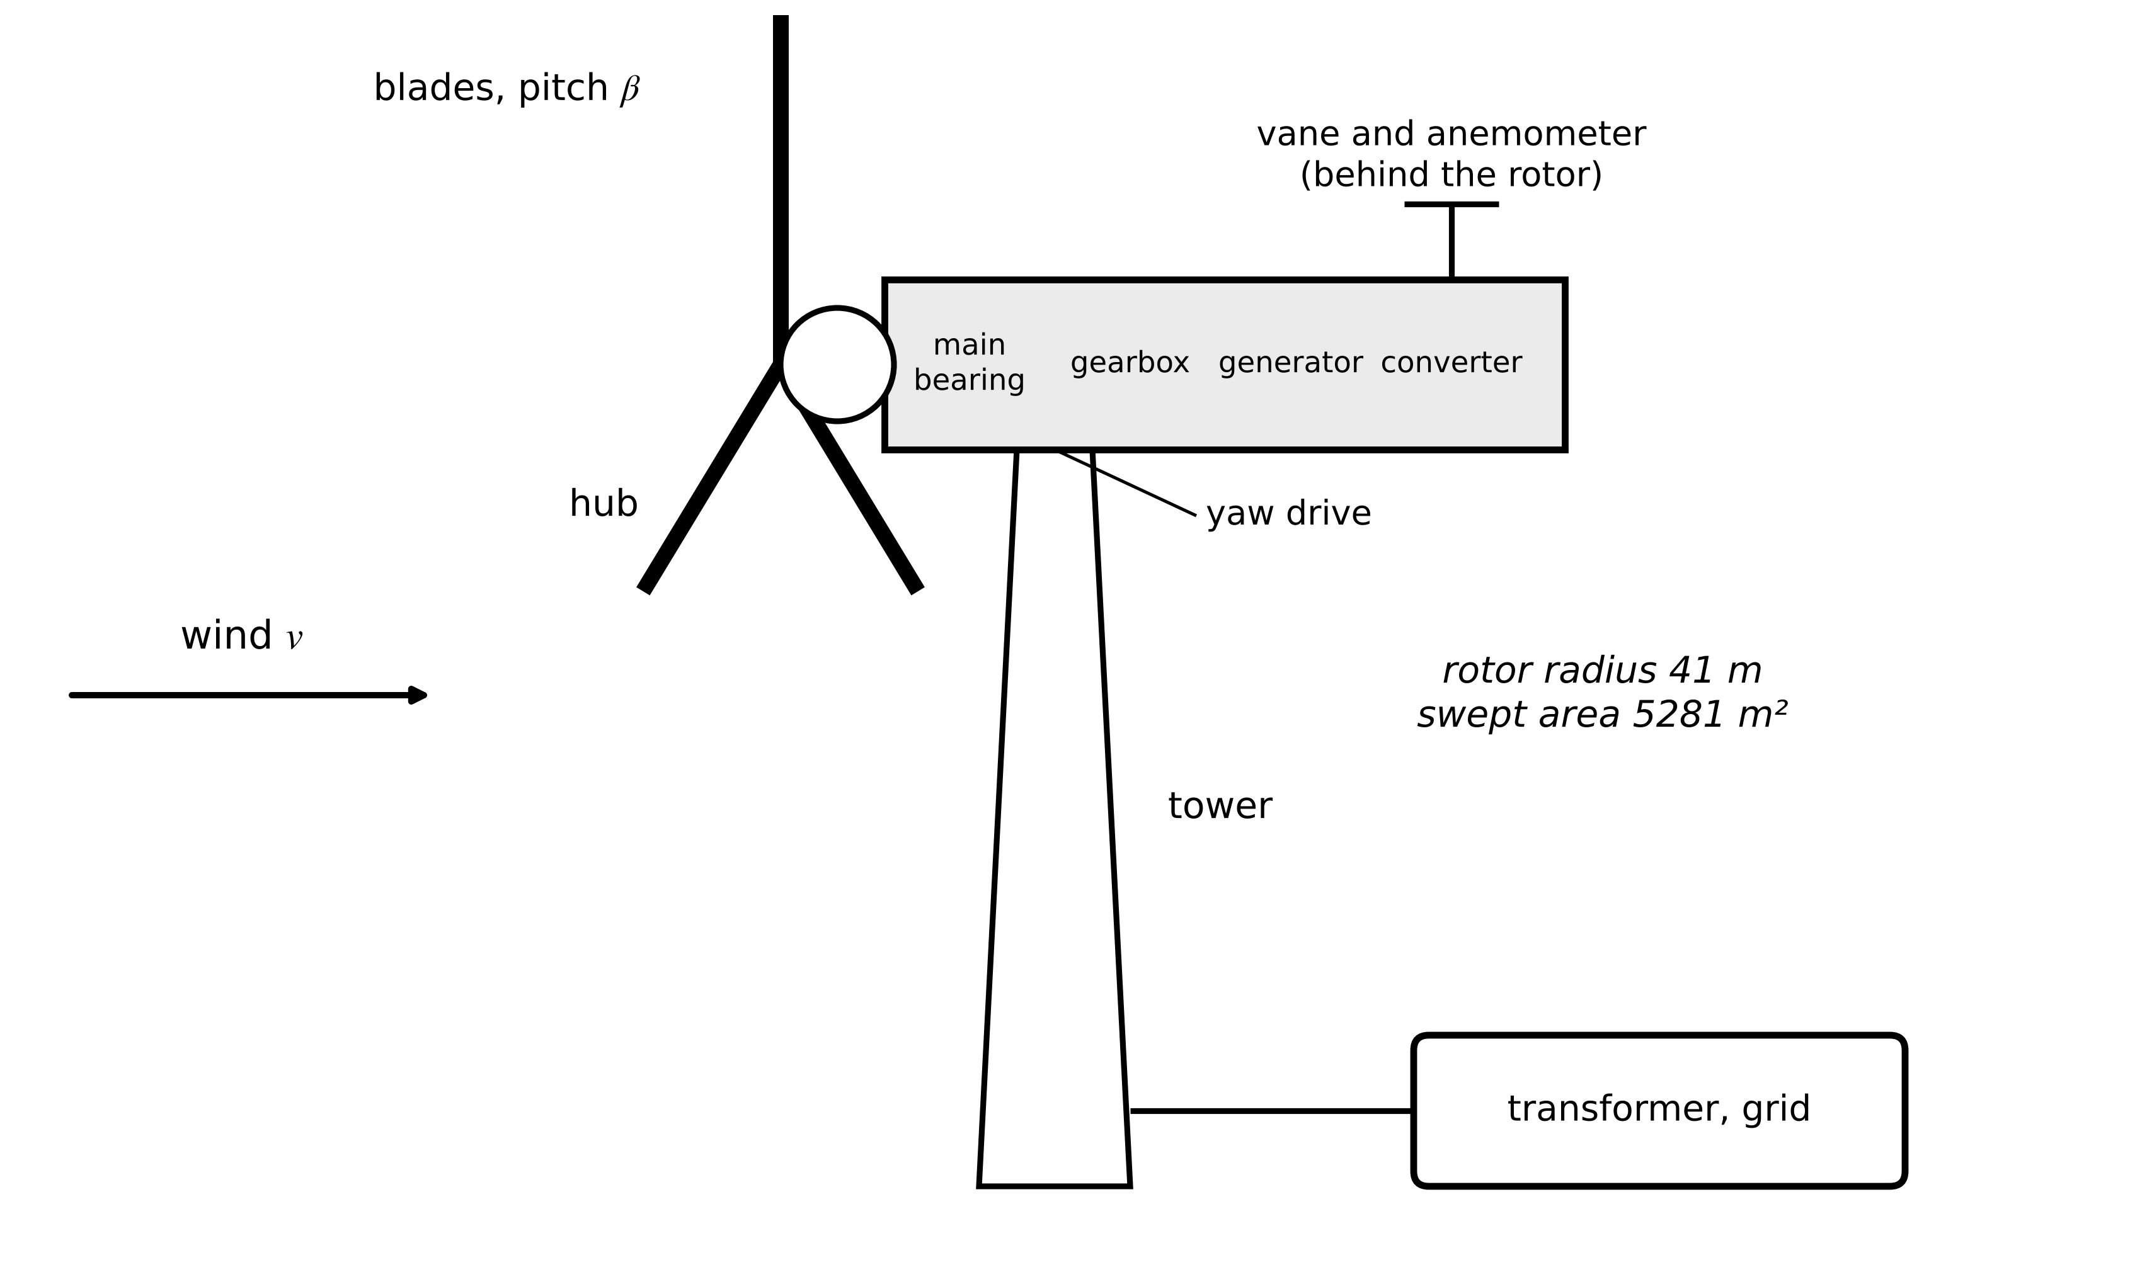
Figure 8.12. Anatomy of a horizontal-axis wind turbine: pitchable blades and hub, nacelle with main bearing, gearbox, generator and converter, yaw drive with wind vane and anemometer, and tower.

8.8.2 The power in the wind and the Betz limit
Air of density $ρ$ crossing an area $A$ at speed $v$ carries kinetic power $P_{wind}=\frac{1}{2}\dot{m}v^{2}=\frac{1}{2}ρAv^{3}$, with mass flow $\dot{m}=ρAv$. The cube makes wind speed the dominant uncertainty of every wind twin: 1 % in speed is 3 % in power. How much of this can a rotor extract? Model the rotor as a thin actuator disk in a stream tube (Figure 8.13), with steady, incompressible, inviscid flow and no swirl. The air slows from $v$ far upstream to $v_{d}$ at the disk and $v_{w}$ far downstream. Momentum conservation gives the thrust; Bernoulli's equation, applied separately upstream and downstream of the disk (energy is extracted at the disk, so it cannot be applied across it), gives the pressure jump across the disk:
$F_{T}=\dot{m}\left(v-v_{w}\right)=ρA_{d}v_{d}\left(v-v_{w}\right), Δp=\frac{1}{2}ρ\left(v^{2}-v_{w}^{2}\right), F_{T}=A_{d}Δp ⇒ v_{d}=\frac{v+v_{w}}{2}$ (8.16)
so the disk sees the average of the upstream and wake speeds. Defining the axial induction factor $a$ by $v_{d}=v(1-a)$, the wake speed is $v_{w}=v(1-2a)$, and the extracted power and thrust are
$P=F_{T}v_{d}=\frac{1}{2}ρA_{d}v^{3}·4a(1-a)^{2}, C_{P}=4a(1-a)^{2}, C_{T}=4a(1-a), \frac{dC_{P}}{da}=0 ⇒ a=\frac{1}{3}, C_{P,max}=\frac{16}{27}=0.593$ (8.17)
The Betz limit says that no rotor can extract more than 59.3 % of the power in the wind crossing it: stopping the air completely would block the flow. Real rotors reach $C_{P}$ of 0.45 to 0.50, losing the rest to wake rotation, blade drag, tip losses and finite blade number. The model fails for $a>0.4$ (turbulent-wake state, where empirical thrust corrections are needed) and does not apply to ducted rotors.
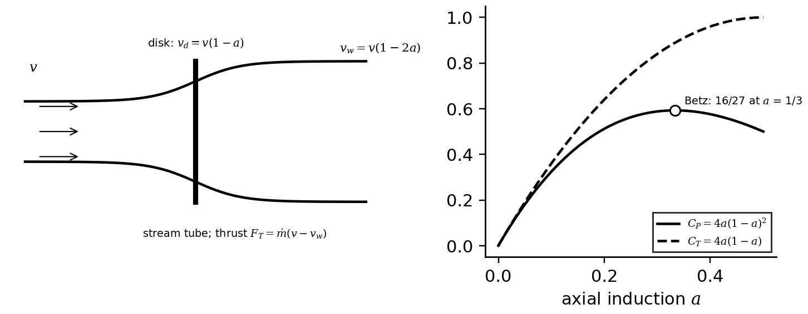
Figure 8.13. Left: actuator disk in a stream tube; the air slows to $v(1-a)$ at the disk and $v(1-2a)$ in the far wake. Right: power and thrust coefficients against axial induction; power peaks at the Betz limit of 16/27 at $a=1/3$.
Example 8.10 (Level A) A power coefficient that cannot be right
Given. SCADA reports 1480 kW from T-1 (5281 m²) at a nacelle wind speed of 9.0 m/s, with density corrected to 1.15 kg/m³.
Find. The implied power coefficient and its meaning for the twin.
Solution. $P_{wind}=0.5×1.15×5281×{9.0}^{3}=2.214$ MW; $C_{P}=1480/2214=0.669$, above the Betz limit. For a realistic $C_{P}=0.50$ the free wind speed would be 9.9 m/s.
Interpretation. The turbine is not breaking physics; the wind speed is wrong. The nacelle anemometer sits in air the rotor has already slowed and reads low unless a nacelle transfer function corrects it (IEC 61400-12-2 [10]). The twin should flag the anemometer, not the turbine, and the Betz limit is its first consistency check.
What the digital twin adds
Synchronized: rotor power against the power available in the measured wind.
Estimated or updated: the implied power coefficient as a consistency check.
Uncertainty carried: wind-speed error amplified threefold in power.
Decision enabled: flag anemometers and transfer functions before blaming the turbine.
Validated by: Betz check, nacelle transfer function, met-mast or lidar comparison.

8.9 Power coefficient, power curve and control

8.9.1 Tip-speed ratio and the power-coefficient surface
A blade section meets the air at an angle set by the wind speed and its own rotational speed, so performance depends on their ratio, the tip-speed ratio, and on the blade pitch. With rotor speed $ω_{r}$, $λ=ω_{r}R/v$. Blade-element momentum theory gives $C_{P}(λ,β)$ for a specific blade; for teaching and control design a widely used analytic fit is
$C_{P}(λ,β)=0.5176\left(\frac{116}{λ_{i}}-0.4β-5\right)e^{-21/λ_{i}}+0.0068λ, \frac{1}{λ_{i}}=\frac{1}{λ+0.08β}-\frac{0.035}{β^{3}+1}$ (8.18)
with $β$ in degrees. Its maximum, 0.480 at $λ_{opt}=8.1$ and $β=0$, is used for T-1 throughout (Figure 8.14). Pitching the blades (raising $β$) lowers $C_{P}$ at every tip-speed ratio, which is how power is limited above rated wind speed.
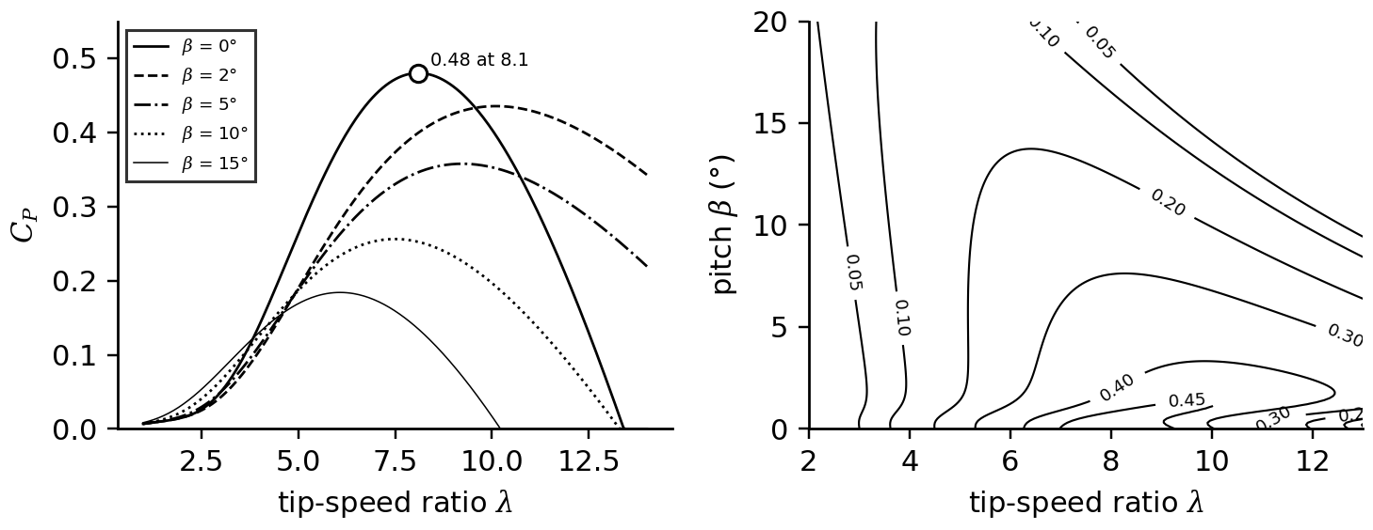
Figure 8.14. Left: power coefficient against tip-speed ratio for several pitch angles, from (8.18). Right: contours of the $C_{P}(λ,β)$ surface; the controller keeps the rotor near the peak below rated wind and moves along rising pitch above it.

8.9.2 Operating regions and the power curve
A variable-speed, pitch-regulated turbine operates in four regions (Figure 8.15). Region I, below the cut-in speed (3 m/s), produces nothing. In region II the controller holds $λ$ at $λ_{opt}$ and $β=0$ to capture the most power, so rotor speed rises in proportion to wind. Region II½ begins when the rotor reaches its speed limit (for T-1, 2.0 rad/s or 19.1 r/min at 10.1 m/s, set by tip noise and loads): speed is held and $λ$ falls below optimum until rated power is reached (11.2 m/s). In region III, up to cut-out (25 m/s), pitch control holds power at rating (Figure 8.16). The power curve that results is the turbine's contract with its owner, measured according to IEC 61400-12-1 [11].
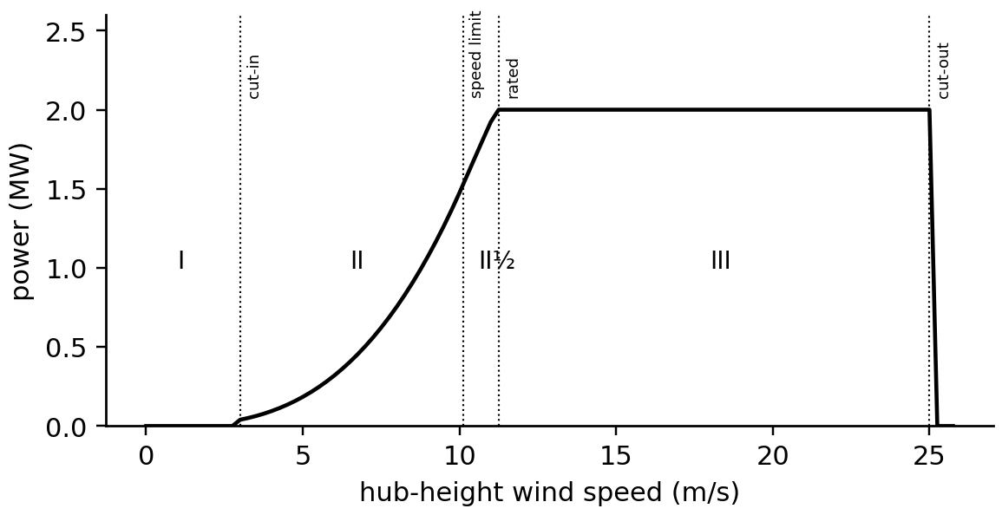
Figure 8.15. Power curve of T-1 from (8.18) with generator and converter efficiency 0.95, showing cut-in, the speed-limit transition, rated speed and cut-out, and operating regions I, II, II½ and III.

8.9.3 The optimal torque law and pitch control
How does the controller hold $λ_{opt}$ without measuring wind, which it cannot do accurately? In region II the power at optimum is $P=\frac{1}{2}ρπR^{2}C_{P,max}v^{3}$; substituting $v=ω_{r}R/λ_{opt}$ and dividing by $ω_{r}$ gives the rotor torque that, applied as generator torque, makes optimum operation a stable equilibrium:
$T_{g}=k_{opt}ω_{r}^{2}, k_{opt}=\frac{1}{2}ρπR^{5}\frac{C_{P,max}}{λ_{opt}^{3}}$ (8.19)
If a gust speeds the rotor beyond its optimum, aerodynamic torque rises less than $k_{opt}ω_{r}^{2}$ and the rotor slows back; the controller needs only rotor speed. In region III a pitch controller, typically PI with gains scheduled against pitch angle because the aerodynamic sensitivity $∂P/∂β$ changes strongly with wind speed, holds speed and power; the pitch actuator's rate limit (typically 5 to 10 °/s) bounds how fast it can reject gusts.
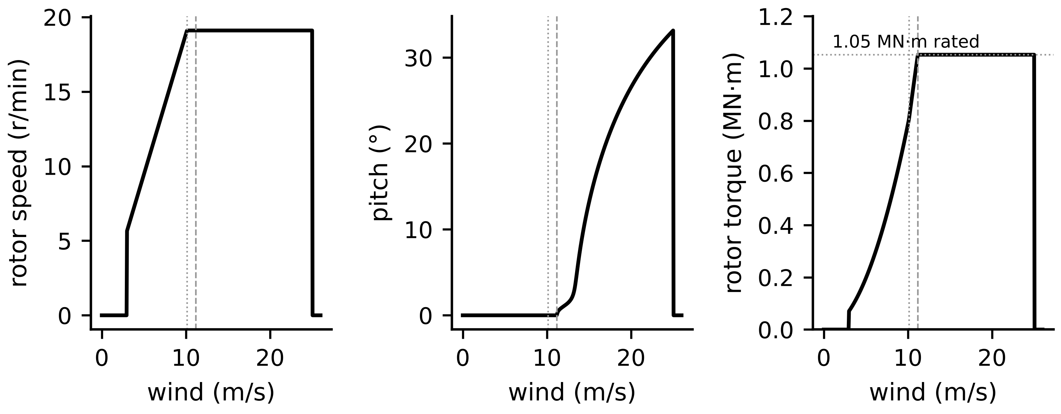
Figure 8.16. Control variables of T-1 against wind speed: rotor speed rises in region II and is held above 10.1 m/s; pitch stays at zero until rated and then rises; rotor-side torque follows (8.19) and is held at rated.
Example 8.11 (Level A) The optimal torque gain of T-1
Given. $R=41$ m, $ρ=1.225$ kg/m³, $C_{P,max}=0.480$ at $λ_{opt}=8.1$.
Find. $k_{opt}$ and the generator torque (referred to the rotor) at 1.5 and 2.0 rad/s.
Solution. $k_{opt}=0.5×1.225×π×{41}^{5}×0.480/{8.1}^{3}=2.01×{10}^{5}$ N·m·s²; torque 0.45 MN·m at 1.5 rad/s and 0.81 MN·m at 2.0 rad/s.
Interpretation. $k_{opt}$ depends on $C_{P,max}$ and $λ_{opt}$, which change when blades erode or ice. A twin that estimates the rotor-effective wind can check whether the turbine still sits at its optimum and propose a retuned gain (Section 8.13).

8.9.4 Density and turbulence in the measured power curve
Air density changes the power at a given wind speed. Warranty curves are specified at 1.225 kg/m³; IEC 61400-12-1 normalizes measured wind speeds rather than powers, and turbulence makes a 10-minute mean power differ from the power at the mean wind because of the curve's curvature (Jensen's inequality):
$v_{n}=v{\left(\frac{ρ}{ρ_{ref}}\right)}^{1/3}, \overline{P}≈P(\overline{v})+\frac{1}{2}P^{′′}(\overline{v})σ_{v}^{2}$ (8.20)
where $σ_{v}$ is the standard deviation of wind speed within the interval. Below the knee $P''>0$ and turbulence raises mean power; near rated $P''<0$ and turbulence lowers it.
Example 8.12 (Level A) Comparing a summer measurement with the warranty curve
Given. On a hot afternoon T-1 produces 720 kW in a 10-minute interval at a mean wind speed of 8.0 m/s and air density 1.15 kg/m³; the warranty curve, at 1.225 kg/m³, gives 755 kW at 8.0 m/s.
Find. The density-normalized wind speed, the expected power and the verdict.
Solution. (8.20): $v_{n}=8.0×(1.15/1.225)^{1/3}=7.83$ m/s; the curve gives 709 kW there.
Interpretation. Against the uncorrected curve the turbine looks 4.6 % short; against the normalized one it produces 1.6 % more than expected, well within a single interval's scatter. Without normalization every hot or high-altitude period looks like a fault.
What the digital twin adds
Synchronized: rotor speed, pitch, power and the wind the rotor actually experiences.
Estimated or updated: $C_{P}$ operating point, $k_{opt}$, normalized power curve.
Uncertainty carried: density, turbulence and anemometer effects on the measured curve.
Decision enabled: separating environmental from equipment deviations; controller retuning.
Validated by: IEC 61400-12 power-curve tests and nacelle transfer functions.

8.10 Drivetrain, structure and loads

8.10.1 One-mass and two-mass drivetrain models
For energy studies the rotor, shaft, gearbox and generator turn together as one rigid body (Figure 8.17). Referring the generator inertia $J_{g}$ and torque $T_{g}$ to the low-speed shaft through the gear ratio $N_{gb}$ (kinetic energy and power are conserved, so inertia scales with $N_{gb}^{2}$ and torque with $N_{gb}$), Newton's law for rotation gives
$J_{eq}{\dot{ω}}_{r}=T_{a}-N_{gb}T_{g}, J_{eq}=J_{r}+N_{gb}^{2}J_{g}$ (8.21)
where $T_{a}$ is the aerodynamic torque. The shaft, however, is a torsional spring: when the generator torque changes suddenly (a grid fault, a converter trip), the rotor and generator inertias oscillate against each other. Modelling the low-speed shaft as stiffness $K$ and damping $D$ between the rotor and the referred generator inertia $J_{g}'=N_{gb}^{2}J_{g}$, with shaft twist $θ_{s}$,
$J_{r}{\dot{ω}}_{r}=T_{a}-Kθ_{s}-D\left(ω_{r}-ω_{g}\right), J_{g}^{′}{\dot{ω}}_{g}=Kθ_{s}+D\left(ω_{r}-ω_{g}\right)-N_{gb}T_{g}, {\dot{θ}}_{s}=ω_{r}-ω_{g}$ (8.22)
Subtracting the two equations divided by their inertias and setting $D=0$ gives ${\ddot{θ}}_{s}=-K(1/J_{r}+1/J_{g}')θ_{s}+…$, so the torsional mode has natural frequency
$ω_{n}=\sqrt{K\frac{J_{r}+J_{g}^{′}}{J_{r}J_{g}^{′}}}, D=2ζω_{n}\frac{J_{r}J_{g}^{′}}{J_{r}+J_{g}^{′}}$ (8.23)
with damping ratio $ζ$. Forgetting the referral of $J_{g}$ through $N_{gb}^{2}$ is the commonest error in drivetrain twins.
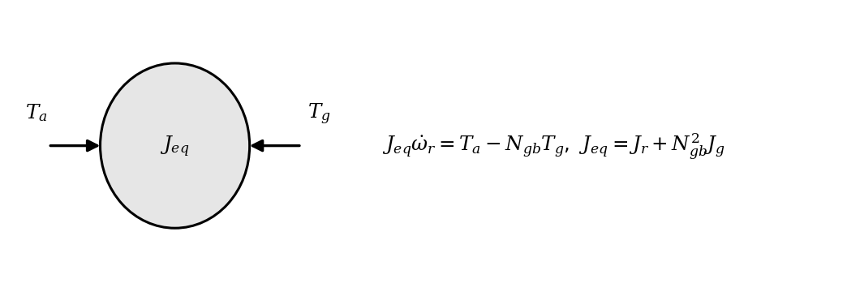
Figure 8.17. One-mass drivetrain: rotor, shaft and generator lumped into one inertia referred to the low-speed shaft.
Example 8.13 (Level B) The torsional mode of T-1 and what a grid dip does to it
Given. $J_{r}=5.0×{10}^{6}$ kg·m², $J_{g}=90$ kg·m² on the high-speed shaft, $N_{gb}=100$, $K=1.2×{10}^{8}$ N·m/rad, $ζ=2$ %. At rated operation ($ω_{r}=2.0$ rad/s, aerodynamic torque 1.05 MN·m) a grid fault cuts generator torque by 40 % for 150 ms.
Find. The natural frequency, the error made without referral, and the shaft-torque response from (8.22), against the one-mass model.
Solution. $J_{g}'=9.0×{10}^{5}$ kg·m²; (8.23): $ω_{n}=12.5$ rad/s, $f_{n}=2.0$ Hz. Without referral, 184 Hz, 92 times too high. Integrating (8.22) at 1 ms, the shaft torque swings between 0.49 and 1.58 MN·m, a peak of 1.50 times rated (Figure 8.18); the one-mass model shows only a speed rise of 0.011 rad/s.
Interpretation. The torque overshoot is what fatigues gear teeth and bearings, and it is invisible both to a one-mass twin and to 10-minute SCADA averages. Resolving a 2 Hz oscillation needs sampling at 20 Hz or faster (condition-monitoring rates). A twin for loads and control uses (8.22); a twin for energy yield can use (8.21).
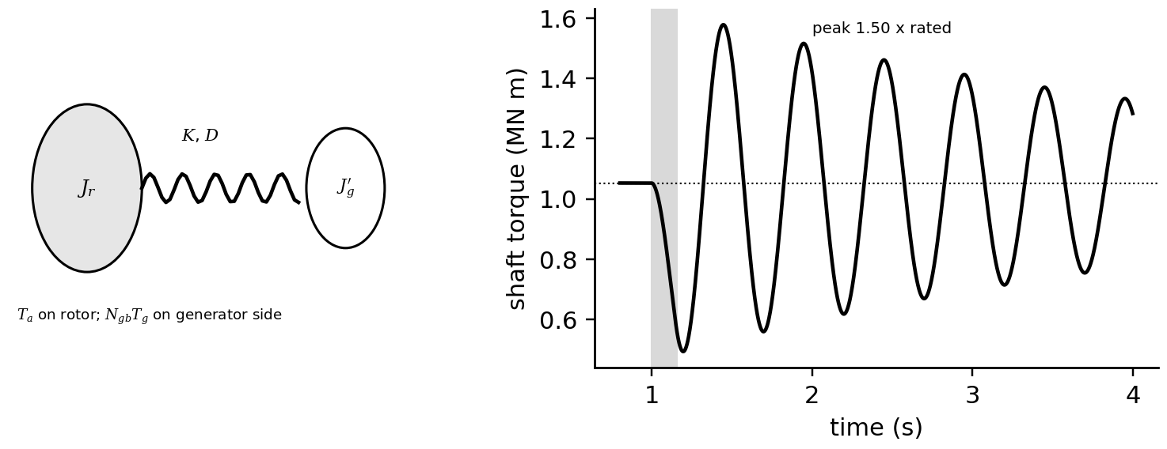
Figure 8.18. Left: two-mass drivetrain with rotor inertia, torsional shaft stiffness and damping, and referred generator inertia. Right: shaft torque after a 150 ms, 40 % generator-torque dip (shaded): the 2 Hz mode peaks at 1.50 times rated.

8.10.2 Tower, blades and fatigue loads
Beyond the drivetrain, the turbine is a flexible structure. The tower bends fore-aft and side-to-side with first natural frequencies typically between the rotor frequency (1P) and the blade-passing frequency (3P for three blades), a soft-stiff design that must avoid resonance at every operating speed; blades bend in flap (out of the rotor plane) and edge (in the plane) and see gravity load once per revolution. A Campbell diagram plots these natural frequencies against rotor speed together with the 1P, 3P and 6P excitation lines, and the controller avoids dwelling at crossings. Fatigue damage from variable-amplitude loads is summarized by the damage-equivalent load: the constant-amplitude range that, over $N_{eq}$ cycles, causes the same damage as the rainflow-counted load history with $n_{i}$ cycles of range $S_{i}$ and S-N curve exponent $m$ (about 4 for steel, 10 for composite blades):
$DEL={\left(\frac{\sum_{i}{n_{i}}S_{i}^{m}}{N_{eq}}\right)}^{1/m}$ (8.24)
Two million cycles of 5 MN·m and 500 cycles of 40 MN·m on a tower base give, with $m=4$ and $N_{eq}={10}^{7}$, a DEL of 3.99 MN·m; the 500 large cycles cause half the damage. Load twins estimate these histories from SCADA, strain gauges or virtual sensors, which is one of the most mature commercial uses of wind-turbine twins.

8.10.3 Generators and converters
Modern turbines use either a doubly fed induction generator, whose rotor converter handles only the slip power (about 30 % of rating), or a full-converter synchronous generator (permanent-magnet or electrically excited, often direct-drive). Their electrical models, losses and faults are those of Chapter 7; the wind twin couples them to the aerodynamic and drivetrain models through generator torque and speed.
What the digital twin adds
Synchronized: rotor and generator speed, shaft torque, structural responses.
Estimated or updated: torsional frequency and damping, damage-equivalent loads.
Uncertainty carried: stiffness, damping and load-history uncertainty in fatigue estimates.
Decision enabled: load-aware control, inspection intervals, life extension.
Validated by: CMS vibration spectra, strain measurements, grid-fault recordings.

8.11 Wind resource and annual energy

8.11.1 The wind-speed distribution
Annual energy depends on how often each wind speed occurs. Hourly wind speeds at most sites follow a Weibull distribution with shape $k$ (around 2) and scale $c$; its mean involves the gamma function, and measured speeds are extrapolated to hub height with a power-law shear exponent $α_{s}$ (Figure 8.19):
$f(v)=\frac{k}{c}{\left(\frac{v}{c}\right)}^{k-1}e^{-(v/c)^{k}}, \overline{v}=c Γ\left(1+\frac{1}{k}\right), v_{hub}=v_{ref}{\left(\frac{z_{hub}}{z_{ref}}\right)}^{α_{s}}$ (8.25)

8.11.2 Annual energy production
Multiplying the power curve by the probability of each speed and integrating gives the gross annual energy production; losses (availability, wakes, electrical, curtailment) reduce it to net:
$AEP=8760\int_{0}^{∞}{P}(v)f(v) dv·∏_{j}\left(1-L_{j}\right), CF=\frac{AEP}{P_{rated}·8760}$ (8.26)
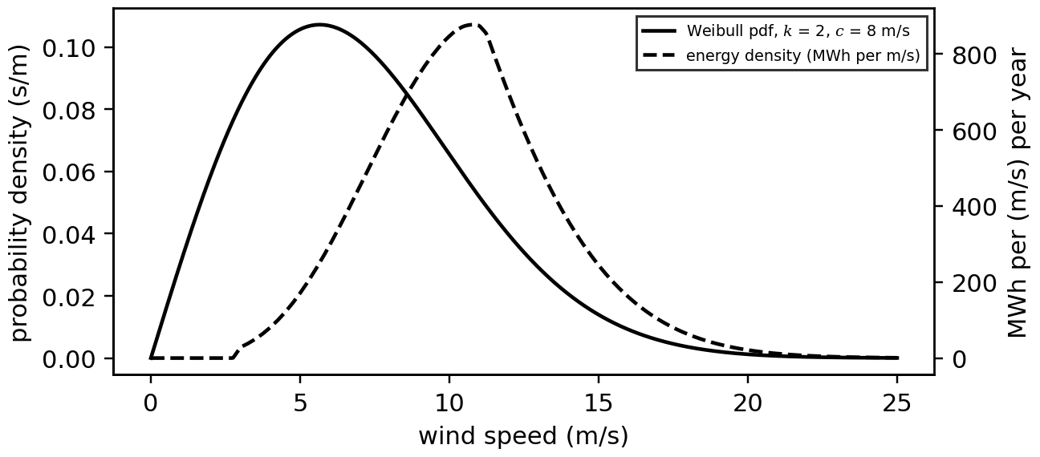
Figure 8.19. Weibull distribution of hourly wind speed at the T-1 site ($k=2$, $c=8$ m/s) and the resulting energy density per unit wind speed; most energy comes from speeds well above the mean.
Example 8.14 (Level B) Annual energy of T-1
Given. The T-1 power curve of Figure 8.15; Weibull $k=2$, $c=8.0$ m/s at hub height; no losses.
Find. Mean wind speed, gross AEP and capacity factor, and the sensitivity of AEP to wind speed.
Solution. $\overline{v}=8.0 Γ(1.5)=7.09$ m/s. Integrating (8.26) numerically: 6300 MWh, capacity factor 36.0 %. Raising $c$ by 1 % raises AEP by 1.78 %: the sensitivity $S_{E}=1.78$.
Interpretation. Energy is less sensitive to wind speed than the cube law suggests, because rated power caps the high speeds; but a 1.78-fold sensitivity still makes wind-speed uncertainty the largest term in the energy budget.

8.11.3 Uncertainty: P50 and P90
Independent relative uncertainties in wind speed (measurement $u_{m}$, long-term correlation $u_{lt}$, vertical extrapolation $u_{ex}$), power curve $u_{pc}$ and losses $u_{L}$ combine, through the sensitivity $S_{E}$, into an energy uncertainty; with a normal distribution, the energy exceeded with probability 90 % follows:
$u_{v}=\sqrt{u_{m}^{2}+u_{lt}^{2}+u_{ex}^{2}}, u_{E}=\sqrt{{\left(S_{E}u_{v}\right)}^{2}+u_{pc}^{2}+u_{L}^{2}}, P_{90}=P_{50}\left(1-1.282 u_{E}\right)$ (8.27)
Example 8.15 (Level A) P50 and P90 for T-1
Given. Example 8.14; $u_{m}=2$ %, $u_{lt}=3$ %, $u_{ex}=2.5$ %, $u_{pc}=5$ %, $u_{L}=3$ %.
Find. $u_{v}$, $u_{E}$, P90 and P99.
Solution. $u_{v}=4.4$ %; $u_{E}=\sqrt{(1.78×0.044)^{2}+{0.05}^{2}+{0.03}^{2}}=9.8$ %; P50 = 6300 MWh, P90 = 5513 MWh, P99 = 4871 MWh.
Interpretation. Lenders finance on P90 or P99, so every point of uncertainty removed is worth money. After commissioning, the twin replaces assumed power-curve and loss values with measured ones, shrinking $u_{pc}$ and $u_{L}$.
What the digital twin adds
Synchronized: long-term resource statistics with the turbine's own measurements.
Estimated or updated: Weibull parameters, shear, measured power curve and losses.
Uncertainty carried: P50/P90 through (8.27), updated as data accumulate.
Decision enabled: financing, contracts, long-term asset planning.
Validated by: comparison of predicted and metered annual energy.

8.12 Wakes: from one turbine to a wind farm

8.12.1 Top-hat and Gaussian wake models
A turbine leaves behind a slower, more turbulent wake that recovers as it mixes with the surrounding flow. The simplest model (Jensen) assumes a top-hat deficit in a wake whose radius grows linearly with downstream distance $x$ at a rate $k_{w}$; mass conservation between the rotor and the expanded wake gives the deficit, which decays with the square of the wake radius. The Gaussian model of Bastankhah and Porté-Agel [12] assumes instead a bell-shaped profile that conserves momentum, with wake width $σ$ growing at a rate $k^{*}$ from an initial value $εD$ (Figure 8.20):
$δ_{J}=\frac{1-\sqrt{1-C_{T}}}{{\left(1+2k_{w}x/D\right)}^{2}}, δ_{G}(x,r)=\left(1-\sqrt{1-\frac{C_{T}}{8{\left(σ/D\right)}^{2}}}\right)e^{-r^{2}/2σ^{2}}, \frac{σ}{D}=k^{*}\frac{x}{D}+ε$ (8.28)
where $δ=1-u/v_{∞}$ is the velocity deficit, $D$ the rotor diameter, $r$ the radial distance from the wake centre and $ε=0.2\sqrt{β^{*}}$ with $β^{*}=\frac{1}{2}(1+\sqrt{1-C_{T}})/\sqrt{1-C_{T}}$. Deficits from several upstream turbines are combined as a root sum of squares of the velocity deficits $u_{i}δ_{i}$, each scaled by the inflow speed $u_{i}$ of the turbine that casts it (Advanced box below). The models fail in the near wake (less than about 3 D), in strongly stable atmospheres, and for large farms where the wakes modify the atmospheric boundary layer itself; computational fluid dynamics and engineering corrections address those cases.
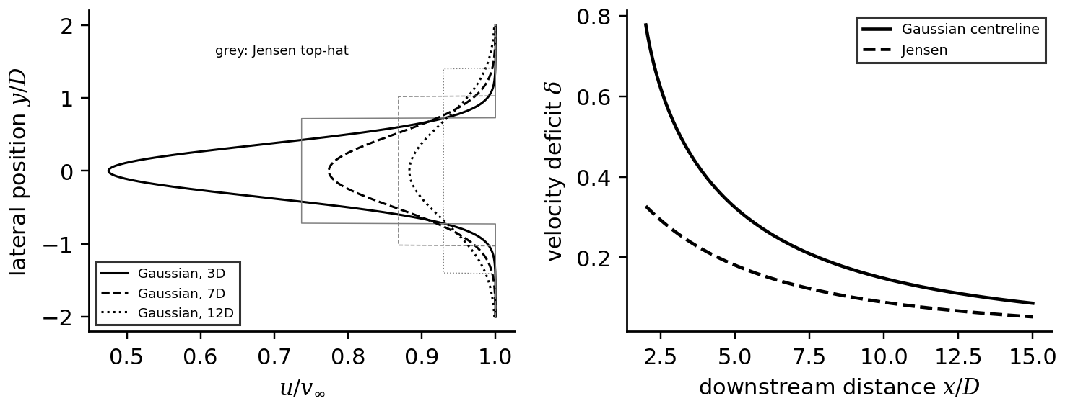
Figure 8.20. Left: lateral wake profiles at 3, 7 and 12 rotor diameters from the Gaussian model, with Jensen top-hat profiles in grey. Right: centreline deficit against downstream distance for both models ($C_{T}=0.8$).
Example 8.16 (Level B) Wake losses in a row of five turbines
Given. Five T-1 turbines in a row with 7 D spacing, free wind 8 m/s aligned with the row; thrust coefficient 0.8 below rated; Gaussian wakes with $k^{*}=0.035$ evaluated on the hub centreline, and root-sum-of-squares superposition of the velocity deficits; Weibull $k=2$, $c=8$ m/s.
Find. The speed and power at each turbine, the row efficiency, the aligned-direction wake loss over the Weibull distribution, and the farm loss if the wind blows along the row 15 % of the time.
Solution. Speeds 8.00, 6.19, 6.41, 6.38 and 6.38 m/s; powers 755, 350, 389, 384 and 383 kW; row efficiency 0.60 (Figure 8.21). Integrated over the Weibull distribution the aligned-direction loss is 29 %; weighted by 15 % of the time, 4.3 % of annual energy.
Interpretation. Wakes matter most near the knee of the power curve, where power falls with the cube of speed, and are smaller above rated. Their uncertainty, from the wake model, the atmospheric stability and the direction distribution, is among the largest in farm energy estimates; a farm twin calibrates wake parameters against its own turbine-to-turbine power ratios.
[Advanced] Where the Gaussian wake formula comes from
The Gaussian model of (8.28) follows from conservation of streamwise momentum. Far enough downstream for the pressure to have recovered, the rotor's thrust equals the momentum flux deficit carried by the wake:
$\frac{1}{2}ρC_{T}\frac{πD^{2}}{4}v_{∞}^{2}=ρ\int_{0}^{∞}{u} \left(v_{∞}−u\right) 2πr dr, u=v_{∞}\left(1−C e^{−r^{2}/2σ^{2}}\right)$
where $C$ is the centreline deficit. With $f=e^{−r^{2}/2σ^{2}}$, the integrals are $∫f 2πr dr=2πσ^{2}$ and $∫f^{2} 2πr dr=πσ^{2}$, so the right side is $ρv_{∞}^{2}πσ^{2}\left(2C−C^{2}\right)$. Equating gives a quadratic in $C$:
$C^{2}−2C+\frac{C_{T}}{8{\left(σ/D\right)}^{2}}=0 ⇒ C=1−\sqrt{1−\frac{C_{T}}{8{\left(σ/D\right)}^{2}}}$
taking the root that vanishes as the wake widens. The model needs a real root, $σ/D≥\sqrt{C_{T}/8}$: for $C_{T}=0.8$, $σ/D≥0.316$. With $ε=0.254$ and $k^{*}=0.035$ this holds only beyond $x/D=\left(0.316−0.254\right)/0.035=1.8$, which is the mathematical form of the statement that the model does not describe the near wake.
As a check against Example 8.16: at $x=7D$, $σ/D=0.035×7+0.254=0.499$, $C_{T}/\left(8×{0.499}^{2}\right)=0.401$ and $C=1−\sqrt{0.599}=0.226$, so a turbine directly behind another in an 8 m/s wind sees $8×\left(1−0.226\right)=6.19$ m/s on its hub centreline. For several upstream turbines, the velocity deficits $u_{i}δ_{i}$, each scaled by the inflow speed $u_{i}$ of the turbine that casts it, are combined as a root sum of squares; with this rule the third turbine of the row sees 6.41 m/s, slightly more than the second, because the first wake has partly recovered by 14 D and the second turbine's wake is cast from a slower inflow.
The derivation also shows what a farm twin can calibrate. Thrust is fixed by the turbine, so the free parameters are the expansion rate $k^{*}$, which depends on turbulence intensity and atmospheric stability, and the initial width $ε$. Fitting $k^{*}$ to measured turbine-to-turbine power ratios, binned by direction and stability, is the standard way of synchronizing a wake model with a real farm.

8.12.2 [Advanced] Wake steering
Yawing an upstream turbine deliberately away from the wind deflects its wake sideways, so a downstream turbine sees faster air. The upstream turbine loses power roughly as $\cos^{p}γ$ with $p≈1.9$; the downstream one gains. With the initial deflection angle of Jiménez et al. [13], $θ_{0}≈\cos^{2}γsinγ C_{T}/2$, and a wake expanding at rate $β_{w}$, the lateral deflection at distance $x$ is
$\frac{y_{c}}{D}≈\frac{θ_{0} x/D}{1+2β_{w}x/D}, P_{up}(γ)≈P_{up}(0)\cos^{1.9}γ$ (8.29)
Example 8.17 (Level C) How much can wake steering gain?
Given. Two T-1 turbines 7 D apart in line with an 8 m/s wind; the Gaussian model of Example 8.16 with the deflection (8.29), the yawed rotor's reduced thrust coefficient $C_{T}\cos^{2}γ$ ($β_{w}=0.1$).
Find. Total power against the upstream yaw offset from 0 to 30°.
Solution. At 0°: 755 + 351 = 1106 kW. The optimum is near 20°: 672 + 445 = 1117 kW, a gain of 1.0 %; beyond 25° the upstream loss dominates (Figure 8.21).
Interpretation. The gain is real but small, and it depends on the deflection model, the atmospheric stability and the accuracy of the turbines' yaw and wind-direction measurements. Field campaigns report gains of a few per cent in the affected directions [14]; wake steering is emerging technology, and a twin that recommends it must carry the uncertainty of the gain, not only its expected value.
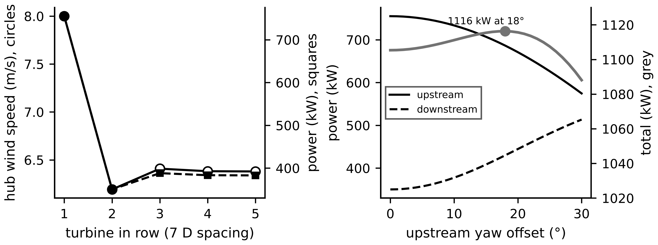
Figure 8.21. Left: wind speed and power along a row of five turbines at 7 D spacing in an 8 m/s wind. Right: upstream, downstream and combined power of two turbines against the upstream yaw offset; the combined power peaks near 20°.
What the digital twin adds
Synchronized: turbine-to-turbine power ratios with the farm's wake model.
Estimated or updated: wake expansion rate, thrust curves, stability-dependent corrections.
Uncertainty carried: wake-model and direction uncertainty in farm energy and steering gains.
Decision enabled: layout, curtailment allocation, wake-steering setpoints.
Validated by: SCADA power ratios binned by direction and stability, lidar wake scans.

8.13 Wind plant-level synchronization and uncertainty
Like the PV twin, a wind twin must reconcile continuously rather than compare against a fixed power curve. The quantities that move are the wind input (the nacelle anemometer reads behind the rotor and drifts; met masts are far away; lidars are expensive), the measured electrical output, the availability and curtailment state (a turbine limited by the grid operator is not underperforming), the control state (yaw, pitch, operating mode) and the slow parameters (power-curve shape, blade condition, icing). This section shows how each is synchronized.

8.13.1 Data sources: SCADA, condition monitoring and lidar
SCADA records about a hundred channels as 10-minute means, minima, maxima and standard deviations: wind speed and direction, power, rotor speed, pitch, yaw, temperatures and status codes. Condition-monitoring systems (CMS) record vibration at kilohertz rates in short bursts for drivetrain diagnosis. Nacelle-mounted lidars measure the inflow several rotor diameters upstream, giving the free wind speed and direction that the nacelle instruments cannot; ground-based and scanning lidars map wakes and shear. Table 8.4 lists the faults each data source reveals.
Table 8.4. Wind-turbine faults and deviations and the data that reveal them
Fault or deviation | SCADA signature (10 min) | CMS signature (kHz) | Twin method
yaw misalignment | power-curve deficit $∝1-\cos^{1.9}γ$ | none | binned power-curve residual, CUSUM; lidar
pitch misalignment or slow actuator | deficit in region II, overspeed in gusts | rotor imbalance at 1P | pitch lag, residual
blade icing or erosion | deficit at low temperature or growing over years | imbalance, noise | temperature-conditioned residual
anemometer fault | $C_{P}$ above Betz, deficit or excess everywhere | none | Betz consistency check
gearbox bearing wear | oil and bearing temperature rise | defect frequencies, sidebands | thermal residual plus envelope analysis
generator winding fault | winding temperature, current unbalance | electrical signatures | Chapter 7 methods
drivetrain torsional fatigue | invisible | 2 Hz mode amplitude | two-mass model (8.22)

Example 8.18 (Level A) SCADA against CMS data volumes for T-1
Given. SCADA: 100 channels with mean, minimum, maximum and standard deviation stored as 4-byte values every 10 minutes. CMS: 8 accelerometers at 25.6 kHz, 16-bit, 10 s bursts every 10 minutes.
Find. The daily volume of each.
Solution. SCADA: $100×4×4×144=230$ kB per day. CMS: one burst is $8×25 600×2×10=4.1$ MB; 144 bursts make 590 MB per day, about 2600 times more.
Interpretation. Raw CMS data from every turbine can be stored, but a fleet twin extracts features at the turbine (band energies, defect-frequency amplitudes, kurtosis) and keeps raw bursts locally for when an alarm needs a closer look (edge architecture, Chapter 2).

8.13.2 Estimating the wind the rotor actually sees
The rotor itself is the best anemometer: it integrates the wind over its whole disk. From the one-mass model (8.21), the aerodynamic torque can be estimated from measured rotor speed and generator torque, and then inverted through the known $C_{P}$ surface for the rotor-effective wind speed $\hat{v}$:
${\hat{T}}_{a}=J_{eq}{\dot{ω}}_{r}+N_{gb}T_{g}, {\hat{T}}_{a}=\frac{1}{2}ρπR^{3}\frac{C_{P}(λ,β)}{λ}{\hat{v}}^{2}, λ=\frac{ω_{r}R}{\hat{v}}$ (8.30)
solved for $\hat{v}$ by Newton's method at each step, or embedded in a Kalman filter (Chapter 5) with the wind as a random-walk state. The estimate is unaffected by nacelle flow distortion, and comparing it with the anemometer gives a transfer function that the twin keeps up to date; comparing it with a nacelle lidar separates rotor degradation (which biases $C_{P}$ and hence $\hat{v}$) from anemometer error.

8.13.3 Detecting yaw misalignment
A yaw vane offset makes the rotor face the wind at an angle $γ$ and loses power roughly as $1-\cos^{1.9}γ$, 1.8 % at 8°. In region II the controller cannot compensate, so the loss appears as a power-curve residual; in region III pitch control hides it. Detecting a small mean shift $δ$ in noise of standard deviation $σ$ with false-alarm and missed-detection quantiles $z_{α}$ and $z_{β}$ needs about
$n≈{\left(\frac{\left(z_{α}+z_{β}\right)σ}{δ}\right)}^{2}$ (8.31)
independent samples, which is why small deficits take days to see in 10-minute data. A cumulative-sum (CUSUM) test on the residual accumulates the evidence efficiently (Chapter 5, Section 5.12).
Example 8.19 (Level C) Detecting a yaw offset from SCADA
Given. A synthetic month of 10-minute data for T-1 (NumPy default_rng(2026)): Weibull wind ($k=2$, $c=8$ m/s) with strong persistence, 12 % turbulence, anemometer noise 2 %, power noise 1 %; from day 15 the yaw vane is offset by 8°. The twin builds a reference curve by the method of bins from days 1 to 10 and monitors the normalized residual $(P_{m}-P_{ref})/P_{ref}$ in region II (4 to 9 m/s); CUSUM reference value $0.12σ$, threshold $12σ$.
Find. The residual scatter, the detection time, the energy lost and the sample-size estimate (8.31).
Solution. On healthy days 10 to 14 the residual has a standard deviation of 10.3 % per sample and a mean of +0.2 %. The CUSUM raises no false alarm and alarms 47 hours after the offset begins (Figure 8.22). After the fault the mean residual is −1.6 %; the energy lost in the remaining 16 days is 5.0 MWh, 1.8 % of production. (8.31) with $z_{α}=2.33$, $z_{β}=1.28$, $σ=10.3$ % and $δ=1.6$ % gives about 540 region-II samples.
Interpretation. A 2 % deficit is invisible in any single sample; the twin needs days of data, which is still far faster than the annual energy review that would otherwise find it. A nacelle lidar measures the misalignment directly within hours and is the reference that validates the statistical detector.
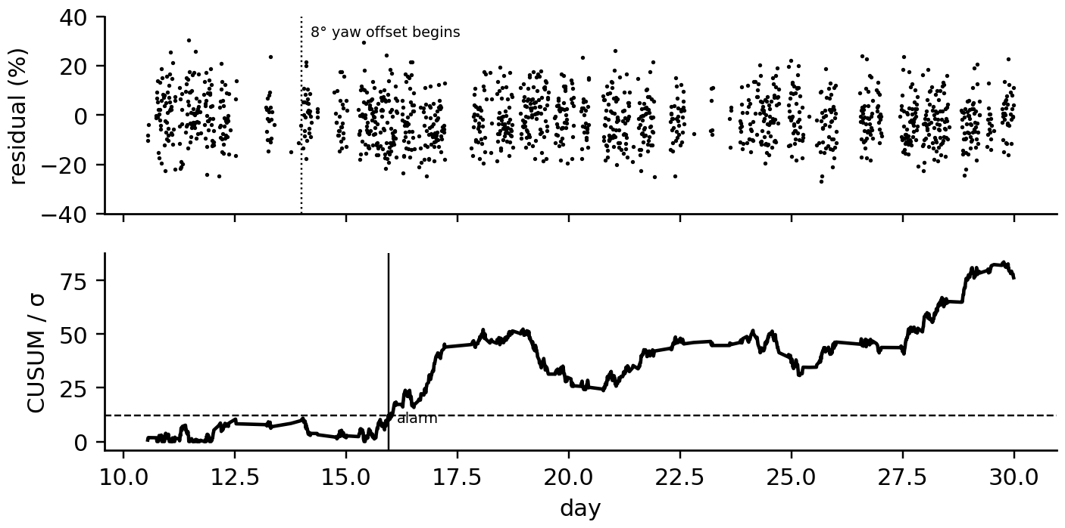
Figure 8.22. Yaw-misalignment detection on T-1. Top: normalized region-II power residual of 10-minute samples, with the 8° offset beginning at 14 days on the time axis, the start of day 15. Bottom: CUSUM statistic in units of the healthy standard deviation, with the threshold and the alarm.
What the digital twin adds
Synchronized: rotor-effective wind, operating state, availability and curtailment flags.
Estimated or updated: nacelle transfer function, yaw offset, power-curve parameters, icing state.
Uncertainty carried: residual scatter, detection delay (8.31), lidar reference uncertainty.
Decision enabled: yaw recalibration, anemometer replacement, de-icing, warranty claims.
Validated by: lidar measurements, met-mast campaigns, CMS findings.

8.14 Forecasting PV and wind power with uncertainty

8.14.1 Data sources and horizons
Forecasts serve different decisions at different horizons, and each horizon has its natural data. For seconds to 30 minutes ahead, PV twins use ground-based sky imagers that track cloud shadows approaching the plant, and wind twins use nacelle or scanning lidars and the turbines' own SCADA. For 30 minutes to a few hours ahead, geostationary satellites provide cloud-motion vectors over whole regions, and statistical models extrapolate recent measurements. Beyond a few hours, numerical weather prediction (NWP) dominates, corrected by the twin's knowledge of the plant (Model Output Statistics). Learned forecasters (Chapter 6) combine these inputs; whatever the method, two baselines and a probabilistic scoring scheme decide whether it is worth using.

8.14.2 Baselines: persistence and smart persistence
Persistence forecasts that the next value equals the last one. For PV it is a poor baseline because the sun moves; smart persistence persists the clear-sky index instead and multiplies it by the twin's clear-sky power for the target time:
${\hat{P}}_{t+h}=\frac{P_{t}}{P_{cs,t}}P_{cs,t+h}, SS=1-\frac{{RMSE}_{model}}{{RMSE}_{ref}}$ (8.32)
where $P_{cs}$ is clear-sky power from the twin's physical model and SS the skill score against a reference. A new PV method must beat smart persistence, not plain persistence; for wind, persistence remains the reference at short horizons.

8.14.3 Probabilistic forecasts and their scores
A point forecast says nothing about how wrong it might be. A probabilistic forecast gives quantiles ${\hat{q}}_{τ}$ (for example the 10 % and 90 % quantiles, an 80 % interval), and is scored by the pinball loss for each quantile and the continuous ranked probability score (CRPS) for the whole distribution, which for a set of quantiles is approximately twice the average pinball loss (Chapter 6, Section 6.8):
$L_{τ}\left(y,{\hat{q}}_{τ}\right)=max\left[τ\left(y-{\hat{q}}_{τ}\right), (τ-1)\left(y-{\hat{q}}_{τ}\right)\right], CRPS≈\frac{2}{K}\sum_{k=1}^{K}{L_{τ_{k}}}, PICP=\frac{1}{N}\sum_{n}{1}\left[{\hat{q}}_{lo,n}≤y_{n}≤{\hat{q}}_{hi,n}\right]$ (8.33)
Calibration means that the observed frequency below each quantile matches its level, checked with a reliability diagram; sharpness means narrow intervals. A forecast must be calibrated first and sharp second. Calibration overall can hide miscalibration in conditions that matter: intervals that are too wide at night and too narrow at mid-range power average out to the right coverage. Conditioning the intervals on the forecast level or the weather regime fixes this.
Example 8.20 (Level C) Hour-ahead PV forecasts for the P-1 array
Given. The synthetic P-1 year of Example 8.7; one-hour-ahead forecasts over daylight hours by persistence and smart persistence (8.32); an empirical 10 to 90 % interval from smart-persistence errors in the first half-year, tested on the second.
Find. RMSE, normalized RMSE (by rated power), skill, interval coverage and CRPS.
Solution. Persistence: 139 kW (11.6 %). Smart persistence: 67 kW (5.6 %), skill 0.52. The 10 to 90 % interval (about ±84 kW) covers 80.5 % of test hours against a nominal 80 %; conditioning on clear-sky power gives 78.9 % with 4 % narrower intervals. The CRPS from 19 quantiles is 39 kW, against a mean absolute error of 52 kW for the point forecast, and the reliability diagram lies on the diagonal (Figure 8.23).
Interpretation. Most of persistence's error is the sun's motion, which the twin's clear-sky model removes for free: the physical twin is itself a forecasting asset, and learned forecasters work best predicting the clear-sky index rather than power.
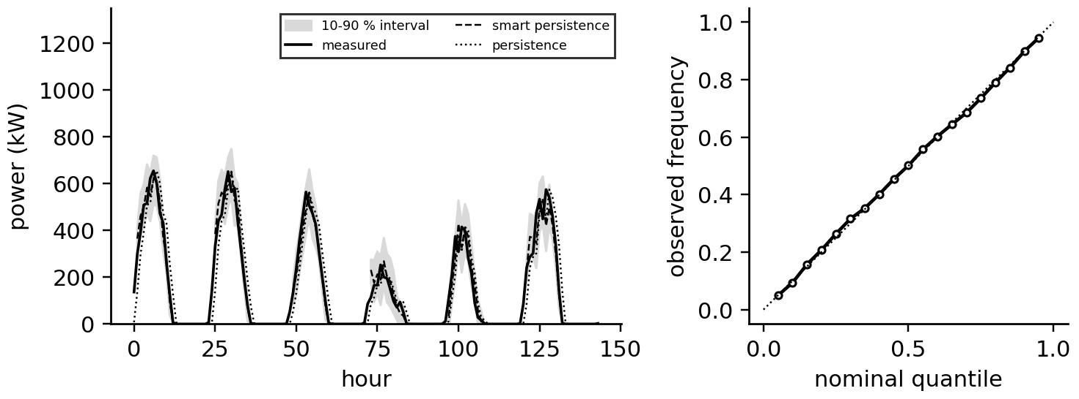
Figure 8.23. Left: six days of the synthetic P-1 series with one-hour-ahead persistence and smart-persistence forecasts and the 10 to 90 % interval. Right: reliability diagram of the 19 forecast quantiles.
Example 8.21 (Level C) Hour-ahead wind forecasts and conditional calibration
Given. A synthetic hourly year of T-1 power (NumPy default_rng(77)): Weibull wind with persistence and a diurnal cycle, the T-1 power curve and 3 % losses. Persistence forecasts one hour ahead; 10 to 90 % intervals from first-half errors, either unconditional or conditional on the forecast power level (bins at 0, 300, 800, 1400 kW).
Find. RMSE and the coverage overall and per bin.
Solution. RMSE 330 kW (16.5 % of rating). The unconditional interval covers 80.2 % overall but 95 %, 77 %, 50 % and 74 % in the four bins: too wide at low power and far too narrow on the steep part of the power curve. The conditional intervals cover 78, 79, 83 and 80 % in the same bins, 79 % overall, with slightly narrower average width (Figure 8.24).
Interpretation. Wind-power errors are largest where the power curve is steepest, so a single interval is miscalibrated exactly where ramp and reserve decisions are hardest. The twin's power curve tells the forecaster where to condition.
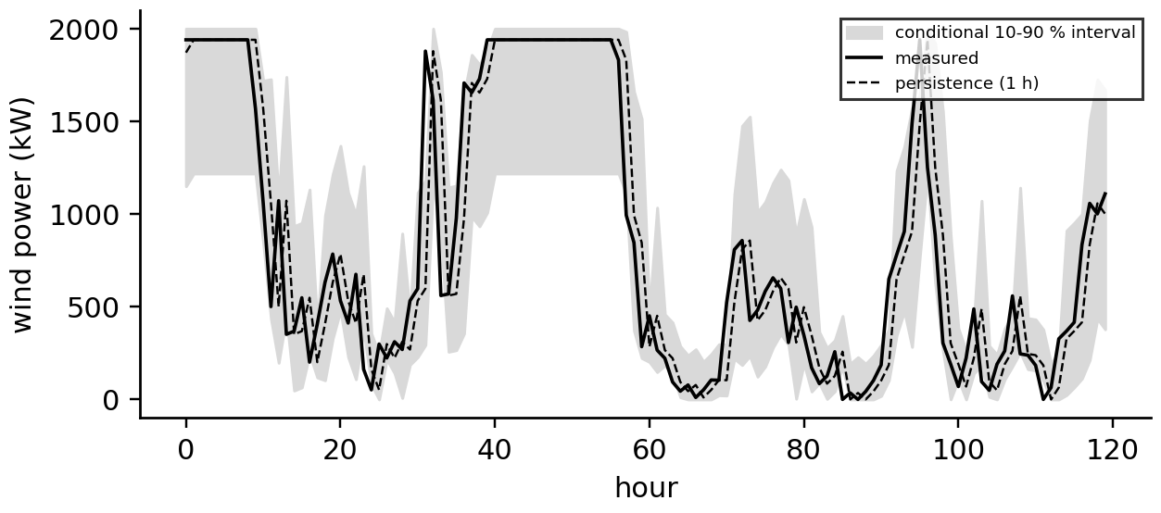
Figure 8.24. Five days of synthetic T-1 power with the one-hour persistence forecast and conditional 10 to 90 % intervals, wide on the steep part of the power curve and narrow near zero and rated power.
What the digital twin adds
Synchronized: forecasts with the plant's own clear-sky and power-curve models.
Estimated or updated: quantiles conditioned on weather regime and operating region.
Uncertainty carried: calibrated intervals, checked per condition, not only overall.
Decision enabled: market bids, reserve, curtailment planning, ramp management.
Validated by: skill against (smart) persistence, PICP, reliability diagrams, CRPS.

8.15 Ramp-rate control and storage sizing
Grid codes in many regions limit how fast a plant's output may change, typically to about 10 % of rated power per minute. A passing cloud can drop PV output by 70 % in under a minute; a battery fills the gap so that the delivered power ramps within the limit. With ramp limit $r_{max}$ (W/s), the delivered power and the battery power follow
$P_{out,k}=P_{out,k-1}+clip\left(P_{pv,k}-P_{out,k-1}, -r_{max}Δt, r_{max}Δt\right), P_{b,k}=P_{out,k}-P_{pv,k}$ (8.34)
For a worst-case step down of $ΔP$, the battery supplies a power that starts at $ΔP$ and falls linearly to zero over $ΔP/r_{max}$, so the required power and energy are
$P_{b,max}=ΔP, E_{b}=\frac{1}{2}ΔP\frac{ΔP}{r_{max}}=\frac{ΔP^{2}}{2r_{max}}$ (8.35)
The energy grows with the square of the step: halving the largest step a plant can produce (by geographic spread or by a twin forecasting the cloud and ramping down in advance) cuts the storage energy by four.
Example 8.22 (Level B) Ramp control for the P-1 array
Given. The 1.2 MWp array with a limit of 10 % of rating per minute (120 kW/min); one synthetic cloudy day at 1-minute resolution (NumPy default_rng(5)) with cloud transitions between clear and 25 % transmittance.
Find. The largest PV ramp, the number of violations, the battery power and energy needed by (8.34), and the worst-case energy (8.35) for a 900 kW step.
Solution. PV ramps reach 300 kW/min; 69 one-minute intervals violate the limit. The battery must deliver or absorb up to 540 kW and cycle 44.8 kWh (Figure 8.25). A single 900 kW step would need ${900}^{2}/(2×120)/60=56$ kWh.
Interpretation. Ramp control needs power more than energy: about 45 % of the plant's rating but only a few minutes at that power. Sky-imager forecasts let the twin ramp down before the cloud arrives, trading a little PV energy for much smaller batteries; that trade is a natural optimization for the hybrid twin.
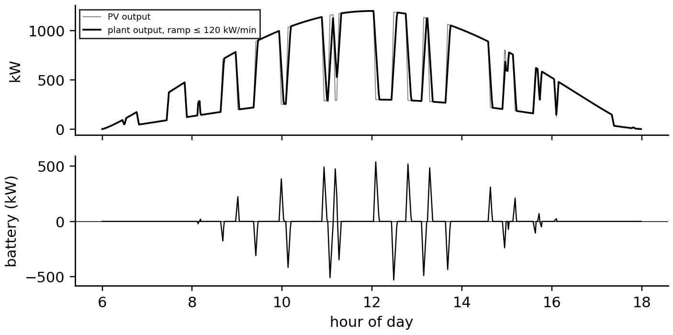
Figure 8.25. Ramp-rate control on one synthetic cloudy day. Top: PV output and the delivered output limited to 120 kW/min. Bottom: the battery power that makes up the difference.
What the digital twin adds
Synchronized: PV output, battery state and the grid-code ramp limit.
Estimated or updated: required battery power and energy from observed and forecast ramps.
Uncertainty carried: ramp statistics and forecast lead time.
Decision enabled: battery sizing, forecast-based pre-emptive ramping.
Validated by: ramp-compliance logs and battery cycling records.

8.16 Case study: the hybrid PV-wind twin of Plant P-1
The P-1 array and turbine T-1 share one 2 MVA transformer and an export limit of 2.0 MW. The hybrid twin (Figure 8.26) runs the PV twin, the wind twin and, in Chapter 9, a battery twin side by side, and adds what none of them can see alone: the shared grid constraint, the joint forecast with its uncertainty, and the decisions that trade one plant's energy against the other's.
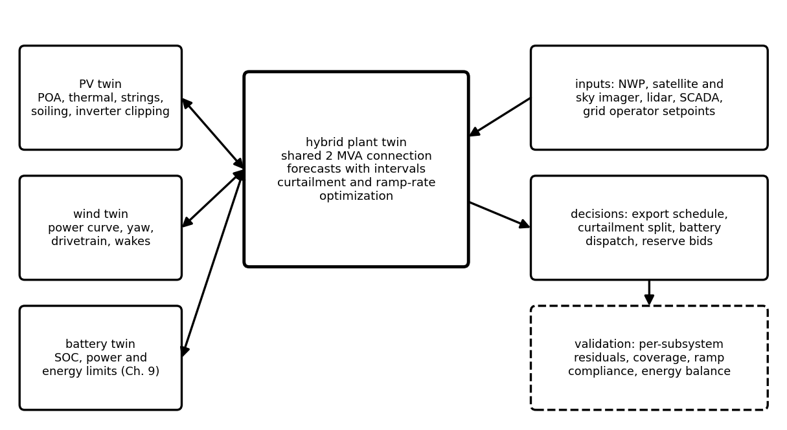
Figure 8.26. Hybrid PV-wind-battery twin: the plant twins exchange states and forecasts with a plant-level twin that manages the shared connection, curtailment, ramp-rate limits and reserve, with validation per subsystem.
With hourly outputs $P_{pv,k}$ and $P_{w,k}$, export limit $P_{lim}$ and step $Δt$, the curtailed energy, the utilization of the connection and the complementarity of the two outputs are
$E_{curt}=\sum_{k}{max}\left(0,P_{pv,k}+P_{w,k}-P_{lim}\right)Δt, U=\frac{\sum_{k}{min}\left(P_{pv,k}+P_{w,k},P_{lim}\right)Δt}{P_{lim}·8760 h}, r_{pw}=corr\left(P_{pv},P_{w}\right)$ (8.36)
Example 8.23 (Level C) Curtailment and complementarity at the shared connection
Given. The synthetic P-1 PV year (1794 MWh) and T-1 wind year (6168 MWh, capacity factor 35.2 %, with a diurnal cycle stronger at night), export limit 2.0 MW.
Find. Combined and exported energy, curtailment, the correlation of the hourly outputs and the utilization of the connection.
Solution. Combined 7962 MWh; exported 7749 MWh; curtailed 213 MWh, 2.7 % of the total, spread over 614 hours. Hourly correlation −0.09. Utilization 44.2 %, against 35.2 % with wind alone and 10.2 % with PV alone.
Interpretation. Because the wind blows somewhat more at night and the two outputs are nearly uncorrelated, adding 1.2 MWp of PV to a connection already carrying a 2 MW turbine loses only 2.7 % of the combined energy to curtailment while delivering 1581 MWh more per year through the same transformer. The hybrid twin manages that curtailment: forecasting with intervals the hours when the sum will exceed the limit, deciding which source to curtail from the value of the lost energy under each plant's tariff, or charging a battery instead (Chapter 9).
Operating with uncertainty. The probabilistic forecasts of Section 8.14 combine into a forecast of the export: the probability that the sum exceeds the limit in the next hour sets how much curtailment to schedule and how much battery headroom to keep. Because the two forecast errors are nearly independent, the width of the combined interval is close to the root sum of squares of the individual widths, smaller than their sum: complementarity reduces reserve as well as curtailment.
Table 8.5. Disaggregated validation of the PV, wind and hybrid twins
Subsystem | Quantity validated | Reference | Acceptance criterion
PV string model | string I-V curves, shading peaks | inverter I-V sweeps | power at maximum within 2 %
PV plant twin | daily energy ratio, soiling estimate | meter, clean reference cell | ratio standard deviation below 1 % on clean days
wind power curve | binned power by normalized speed | IEC 61400-12 test, lidar | bin means within measurement uncertainty
wind drivetrain | torsional frequency and damping | CMS spectra, fault recordings | frequency within 5 %
forecasts | skill, PICP, reliability, CRPS | metered power | skill > 0 against (smart) persistence; PICP within ±3 % per condition
hybrid constraint | export, curtailment, ramp compliance | grid meter, operator logs | energy balance closes within meter accuracy

Limitations. The case is synthetic so that every estimate can be compared with a known truth. Real plants add tracker faults, inverter outages, grid-operator setpoints, wake and terrain effects for which the simple models of this chapter need calibration, and data gaps that the synchronization layer must handle (Chapter 5, Section 5.11). The value of the twin is therefore measured not by the accuracy of a single model but by how well its residuals separate weather, equipment and measurement errors.

8.17 Real-time implementation
PV and wind twins span from microseconds to years (Table 8.6). The partition follows the fidelity ladder of Chapter 7: converter and MPPT behaviour on the inverter or an FPGA, cloud transients and drivetrain oscillations at sub-second to second steps on edge computers, 10-minute SCADA analysis and daily soiling filters on plant servers, and degradation and resource statistics in the cloud.
Table 8.6. Time scales of PV and wind twins
Phenomenon | Time scale | Data | Model | Twin function
converter switching, MPPT steps | µs to ms | inverter internal | Chapter 7 converter models | protection, tracking verification
cloud transients, PV ramps | 1 to 60 s | 1 s inverter data, sky imager | (8.2), (8.34) | ramp control, nowcasting
drivetrain torsion, pitch | 0.1 to 10 s | CMS, controller logs | (8.22), pitch control | loads, control tuning
turbine power, yaw | 10 min | SCADA, nacelle lidar | binned power curve, (8.30) | performance monitoring
soiling, temperature trends | days | daily energy ratios | (8.15) | cleaning, fault detection
degradation, resource | years | PR, AEP | (8.13), (8.26) | asset management, finance

8.18 Recent developments and open research problems
PV and wind twins are moving from monitoring towards prescriptive operation; each development is labelled with its status in 2026. The 2026 reviews of energy twins emphasize interoperability (IEC 61850 and CIM), hierarchical and federated architectures, adaptive synchronization and the step from descriptive to prescriptive twins [1], [2], [3], and ITU-T Y.4517 defines multi-source data, model management and continuous synchronization for power-grid twins [4].
PV. Bifacial modules on single-axis trackers are now the default for utility plants, making rear irradiance and tracker state core twin inputs (established); module-level I-V sweeps by inverters give the twin field curves for re-fitting the single-diode parameters (emerging); drone thermography and electroluminescence linked to twin residuals target inspections (established); new cell technologies (TOPCon, heterojunction, perovskite-silicon tandems) bring new degradation modes, such as UV-induced degradation and perovskite stability, whose models are still being built (research). Wind. Nacelle lidars for yaw alignment and power-curve verification (established), lidar-assisted feedforward pitch control (emerging), wake steering and farm-level control (emerging, with field results of a few per cent in affected directions [14]), virtual load sensors for life extension (established commercially), and floating offshore turbines whose platform motion couples to the rotor (research to early deployment). Forecasting. Sky-imager nowcasting and satellite cloud motion for PV, NWP ensembles post-processed with the plant twin for both, and probabilistic learning methods calibrated per condition (emerging). Hybrid plants. Co-located PV, wind and storage behind one connection, with twins optimizing curtailment, ramps and market participation under forecast uncertainty (emerging), and resilience to multiple hazards such as heat, dust, icing and storms as part of the twin's risk view (research).
Verified recent results behind these directions. For PV, a global techno-economic assessment estimated that soiling reduced worldwide solar production by at least 3 to 4 % even with optimized cleaning [7], which is why the soiling filter of Section 8.7.2 is a core twin function rather than a refinement. UV-induced degradation of high-efficiency cell architectures, including TOPCon and heterojunction, has been measured in accelerated tests with losses that differ strongly between products [15], so a twin of a new plant should treat its voltage and fill-factor trends as a monitored state from commissioning. The models of Part A are available in open, validated implementations such as pvlib python [16], which lets a twin's forward model be audited and reproduced. For wind, a utility-scale experiment that operated a farm collectively from a predictive wake model reported energy gains of 1.2 % ± 0.4 % over all wind speeds and 3.0 % ± 0.7 % between 6 and 8 m/s [17], consistent in size with the steering example of Section 8.12.2 and with earlier field campaigns [14]. For forecasting, a review that links solar forecasting to atmospheric science and grid integration sets out the verification practice used in Section 8.14, including skill against reference forecasts and probabilistic scoring [18].
Table 8.7. Emerging directions with measurable research targets
Direction | Status | Measurable target
field I-V re-fitting of PV parameters | emerging | parameter drift detection delay and low-irradiance prediction error
rear-irradiance twins for bifacial trackers | emerging | bifacial gain prediction error against rear reference cells
wake steering under uncertainty | emerging | net farm gain with confidence interval over a full year
lidar-assisted control and yaw | established to emerging | yaw error and load reduction measured against a reference turbine
conditionally calibrated probabilistic forecasts | emerging | PICP within ±3 % in every operating region, CRPS against baselines
hybrid plant optimization with storage | emerging | curtailment and ramp-violation reduction per MWh of storage

8.19 How this chapter feeds the rest of the book
From Chapter 4 this chapter took modelling and discretization, from Chapter 5 estimation and residual tests, from Chapter 6 forecasting and calibration, and from Chapter 7 the converter and generator models. It hands on PV and wind plant twins with their synchronization layers and probabilistic forecasts. Chapter 9 adds the battery that absorbs curtailment and ramps; Chapter 11 aggregates these hybrid plants in microgrids and distribution networks; Chapter 12 develops the fault-diagnosis and prognosis methods whose signatures appear in Table 8.2 and Table 8.4; Chapter 13 uses the forecasts and their intervals for dispatch and control; and Chapter 14 asks how weather inputs and SCADA data can be attacked.

Chapter summary
Part A built the PV twin from the photovoltaic effect through the hierarchy of cell, module, string and array to the single-diode model, whose parameters were fitted to a datasheet and shown to be non-identifiable from STC data alone. Plane-of-array irradiance, cell temperature, angle of incidence, bifacial gain, soiling, shading and mismatch were modelled with their uncertainty; bypass diodes turned an apparent 18 % mismatch loss into 5 %, and a P&O tracker trapped by shading lost 70 % of a string's power. Plant-level synchronization reconciled weather inputs, output, availability and slow states, tracking soiling to 0.16 percentage points and locating failed strings within hours where string currents exist.
Part B built the wind twin from the Betz limit and the $C_{P}(λ,β)$ surface through operating regions, the optimal torque law and pitch control to one- and two-mass drivetrains, where a grid dip produced a 1.5-fold shaft-torque peak at 2 Hz. Weibull statistics gave annual energy (6300 MWh, P90 5513 MWh), Gaussian wakes cost a row 40 % of its power at 8 m/s, and wake steering gained 1 % with large uncertainty. Synchronization estimated the rotor-effective wind and found an 8° yaw offset in two days. Part C produced calibrated probabilistic forecasts (smart persistence skill 0.52 for PV; conditionally calibrated intervals for wind), sized ramp-control storage from $E_{b}=ΔP^{2}/2r_{max}$, and ran a hybrid twin whose shared 2 MVA connection lost 2.7 % to curtailment while its utilization rose from 35 % to 44 %.
Table 8.8. Key relationships of Chapter 8
Relationship | Expression | Eq.
Single-diode model | $I=I_{ph}-I_{0}[e^{(V+{IR}_{s})/a}-1]-(V+IR_{s})/R_{sh}$ | (8.2)
Scaling to arrays | $I_{ph,arr}=N_{p}I_{ph}$, $a_{arr}=N_{ss}a$, $R_{s,arr}=(N_{ss}/N_{p})R_{s}$ | (8.4)
Irradiance and temperature scaling | $I_{ph}∝G$; $I_{0}∝T^{3}e^{-E_{g}/nkT}$ | (8.5)
POA irradiance | beam + diffuse + ground-reflected | (8.6), (8.7)
Cell temperature | $T_{c}=T_{a}+G/(U_{0}+U_{1}v_{w})$ | (8.8)
Bifacial irradiance | $G_{f}+φ_{bi}(1-s_{r})G_{r}$ | (8.9)
Mismatch loss | $1-P_{string}/\sum{P_{j}}$ | (8.10)
Power uncertainty | root sum of irradiance, temperature, transposition, model | (8.11)
Incremental conductance | $dI/dV=-I/V$ at the maximum | (8.12)
PR and degradation | $PR=Y_{f}/Y_{r}$; $PR_{T}$; $R_{d}$ | (8.13)
Betz limit | $C_{P}=4a(1-a)^{2}≤16/27$ | (8.16), (8.17)
$C_{P}$ surface | (8.18) | (8.18)
Optimal torque | $T_{g}=k_{opt}ω_{r}^{2}$ | (8.19)
Density normalization | $v_{n}=v(ρ/ρ_{ref})^{1/3}$ | (8.20)
Drivetrain | one-mass and two-mass; $ω_{n}$ | (8.21), (8.22), (8.23)
Damage-equivalent load | $(\sum{n_{i}}S_{i}^{m}/N_{eq})^{1/m}$ | (8.24)
Weibull and AEP | (8.25); $8760\int{P}f dv$ | (8.25), (8.26)
P90 | $P_{50}(1-1.282u_{E})$ | (8.27)
Wake deficit | Jensen and Gaussian | (8.28)
Wake steering | deflection; $\cos^{1.9}γ$ loss | (8.29)
Rotor-effective wind | torque balance and $C_{P}$ inversion | (8.30)
Detection sample size | $n≈((z_{α}+z_{β})σ/δ)^{2}$ | (8.31)
Smart persistence; skill | ${\hat{P}}_{t+h}=(P_{t}/P_{cs,t})P_{cs,t+h}$ | (8.32)
Pinball, CRPS, PICP | (8.33) | (8.33)
Ramp storage | $P_{b}=ΔP$, $E_{b}=ΔP^{2}/2r_{max}$ | (8.34), (8.35)
Hybrid curtailment and utilization | (8.36) | (8.36)

Exercises
The fifteen exercises are grouped by theme. Most combine a derivation, a conceptual question and a numerical part, so that each can be set as one assignment; the last is an open design project. Complete solutions to all fifteen are given in the Answer key.

Group A: the PV twin
8.1 Cells, modules and the single-diode model. (a) Explain the photovoltaic effect and why current scales with irradiance while voltage scales logarithmically. (b) Derive the single-diode model (8.2) from Kirchhoff's current law, and state where it fails. (c) A module has $I_{sc}=8.8$ A, $V_{oc}=37.5$ V, $I_{mp}=8.2$ A and $V_{mp}=30.1$ V; find its fill factor. (d) A cell-level fit gives $R_{s,cell}=0.006$ Ω; find $R_{s,arr}$ for 600 series cells and 6 parallel strings, and the array thermal voltage $N_{s}kT/q$ at 25 °C and $a$ for $n=1.1$.
8.2 Irradiance, temperature and uncertainty. (a) Compute $G_{poa}$ at solar noon on 21 June at 26.3° N for a 25° south-facing tilt, with $G_{bn}=850$ W/m², $G_{dh}=100$ W/m² and albedo 0.2. (b) Find the cell temperature at 900 W/m², 35 °C and 1 m/s wind, and the power loss relative to 25 °C for $γ=−0.35$ %/K. (c) A bifacial module receives 850 W/m² front and 100 W/m² rear, $φ_{bi}=0.8$, 5 % rear shading; find $G_{eff}$ and the gain. (d) A 100 kW array has $γ=−0.38$ %/K; irradiance uncertainty is 20 W/m² at 1000 W/m² and cell-temperature uncertainty 1.5 K. Find the power uncertainty with (8.11) and say which term to reduce first.
8.3 Shading, mismatch and tracking. (a) Why can four STC datasheet values not determine the five single-diode parameters, and what information fixes the problem? (b) How do bypass diodes change the effect of shading and of a weak module, and why do they create several power peaks? (c) A string of 15 modules of 320 W has one module with 12 % lower current. Estimate the loss if the string runs at the reduced current and if the weak module is bypassed. (d) Derive (8.12) and explain how an incremental-conductance tracker decides its next step.
8.4 Plant metrics and synchronization. (a) A plant's PR is 0.810 in year 1 and 0.775 in year 6. Estimate the degradation rate and comment. (b) Why must a pyranometer drift and uniform soiling be separated, and how? (c) Three of 150 strings fail open. With a daily energy-ratio standard deviation of 0.70 %, how many days of averaging make the drop a 3σ event? What changes if string currents are measured?

Group B: the wind twin
8.5 Momentum theory. (a) Derive the Betz limit (8.17) from (8.16), stating each assumption, and explain why Bernoulli's equation cannot be applied across the disk. (b) Confirm that $4a{\left(1−a\right)}^{2}$ at $a=1/3$ equals 16/27, and find $C_{T}$ and the far-wake speed ratio there. (c) A turbine with rotor area 4560 m² reports 1100 kW at 8.5 m/s with $ρ=1.2$ kg/m³. Find the implied $C_{P}$ and interpret it.
8.6 Control laws. (a) Derive the optimal torque law (8.19) and explain why it is stable without a wind measurement. (b) Compute $k_{opt}$ for a 63 m rotor with $C_{P,max}=0.45$ at $λ_{opt}=7.5$ and $ρ=1.225$ kg/m³. (c) In which operating region does a yaw offset show in the power, and why does pitch control hide it in region III?
8.7 Measured power curves. (a) Derive the turbulence correction in (8.20) by a Taylor expansion, and show that in region II, where $P∝v^{3}$, it equals $\overset{‾}{P}/P\left(\overset{‾}{v}\right)≈1+3{\left(σ_{v}/\overset{‾}{v}\right)}^{2}$. Evaluate it for 12 % turbulence intensity. (b) Find the density-normalized wind speed for 8.0 m/s at $ρ=1.10$ kg/m³. (c) Extrapolate 7.2 m/s at 60 m to 100 m with $α_{s}=0.18$.
8.8 Drivetrain and loads. (a) Derive (8.23) from the undamped form of (8.22), and explain why a grid dip produces a shaft-torque overshoot that a one-mass model cannot show. (b) A drivetrain has $J_{r}=3.8×{10}^{6}$ kg·m², $J_{g}=95$ kg·m², a 1:100 gearbox and $K=1.5×{10}^{8}$ N·m/rad. Find $f_{n}$. (c) Rainflow counting gives $2×{10}^{6}$ cycles of 5 MN·m and 500 cycles of 40 MN·m; with $m=4$ and $N_{eq}={10}^{7}$, find the DEL and the share of damage from the large cycles.
8.9 Resource and energy. (a) Find the mean wind speed of a Weibull resource with $k=2.2$ and $c=7.5$ m/s. (b) A 2 MW turbine produces 5.84 GWh in a year; find its capacity factor. (c) A project has P50 = 10.0 GWh and $u_{E}=10$ %; find P90 and P99. (d) Why is the sensitivity $S_{E}$ of energy to wind speed below 3?
8.10 Wakes. (a) Find the Jensen deficit at 5 D for $C_{T}=0.75$ and $k_{w}=0.075$, and the power ratio of the downstream turbine in region II. (b) Using the Advanced box of Section 8.12.1, derive the Gaussian centreline deficit, and evaluate it at 7 D for $C_{T}=0.8$, $k^{*}=0.035$ and $ε=0.254$. (c) From what distance does the Gaussian formula give a real deficit for these values?
8.11 Wind synchronization. (a) A turbine's power deficit appears only in region II and only below 0 °C. What is the likely cause, and why does it not appear in region III? (b) Estimate the energy loss of a 6° yaw offset and the number of region-II samples needed to detect it with $σ=10$ %, $z_{α}=2.33$ and $z_{β}=1.28$. (c) How does the rotor-effective wind estimate (8.30) separate anemometer error from rotor degradation?

Group C: forecasting, ramps and the hybrid plant
8.12 Forecast verification. (a) Why must forecast intervals be calibrated per condition, and how is calibration checked? (b) A forecast has RMSE 3.1 MW and smart persistence 4.4 MW; find the skill. (c) Find the pinball loss of a 90 % quantile of 20 MW when the observation is 17 MW and when it is 23 MW, and explain the asymmetry.
8.13 Ramp control. (a) Derive (8.35) for a step decrease of $ΔP$. (b) A 50 MW PV plant must limit ramps to 10 % of rating per minute; find the battery power and energy for an instant 30 MW drop. (c) By how much does halving the largest step reduce the storage energy, and how can a twin achieve it?
8.14 The hybrid plant. (a) How does a hybrid twin use complementarity and forecast uncertainty at a shared connection? (b) The PV and wind forecasts for the next hour have independent 80 % interval half-widths of 120 kW and 300 kW. Estimate the half-width of the combined export interval and compare it with their sum. (c) Using Example 8.23, find the energy delivered through the connection per MWh of PV added.

Group D: design project
8.15 Designing PV and wind twins. (a) Design a disaggregated validation plan in the style of Table 8.5 for a PV-battery-wind microgrid twin. (b) Propose a soiling estimator that does not rely on the plant's own pyranometer, and state how you would validate it. (c) Design a curtailment-allocation policy for the hybrid twin that uses probabilistic forecasts and two different tariffs.

Answer key
8.1 (a) A photon with energy above the band gap creates an electron-hole pair, which the junction's built-in field separates before it recombines. The number of pairs, and so the current, is proportional to the photon flux; the voltage is set by the balance between photocurrent and the diode's recombination current, which grows exponentially with voltage, so $V_{oc}≈aln\left(I_{ph}/I_{0}\right)$ grows only logarithmically with irradiance.
(b) The photocurrent source feeds the junction diode, the shunt resistance and the load in parallel; the junction voltage is $V+IR_{s}$. Kirchhoff's current law: $I=I_{ph}−I_{0}\left[exp\left(\left(V+IR_{s}\right)/a\right)−1\right]−\left(V+IR_{s}\right)/R_{sh}$. It fails beyond reverse breakdown, at very low irradiance where a second diode is needed, and for thin films with voltage-dependent collection.
(c) $FF=8.2×30.1/\left(8.8×37.5\right)=246.8/330.0=0.748$.
(d) $R_{s,arr}=\left(600/6\right)×0.006=0.6$ Ω; $N_{s}kT/q=600×0.02569=15.4$ V; $a=1.1×15.4=17.0$ V.
8.2 (a) $θ_{z}=26.3−23.45=2.85°$; $θ_{i}=\left|26.3−25−23.45\right|=22.15°$. $G_{h}=850cos2.85°+100=949$ W/m². $G_{poa}=850cos22.15°+100×0.953+949×0.2×0.047=787+95+9=891$ W/m².
(b) $T_{c}=35+900/\left(25+6.84\right)=63.3$ °C; loss $0.0035×38.3=13.4$ %.
(c) $G_{eff}=850+0.8×0.95×100=926$ W/m², a gain of 8.9 %.
(d) Irradiance term $0.02×100=2.0$ kW; temperature term $100×0.0038×1.5=0.57$ kW; combined $\sqrt{{2.0}^{2}+{0.57}^{2}}=2.08$ kW. Irradiance dominates, so a better irradiance reference (a POA reference cell matched to the module) helps most.
8.3 (a) The datasheet gives three points of the curve and the zero slope of power at the maximum: four equations for $I_{ph}$, $I_{0}$, $n$, $R_{s}$ and $R_{sh}$. Different combinations of $n$ and the resistances fit them equally well. Curves at several irradiances and temperatures (IEC 61853-1), or field I-V sweeps, add the missing information.
(b) A bypass diode conducts when its cell group cannot carry the string current, so the group is removed from the string at the cost of its voltage instead of limiting the whole string's current. The string I-V curve becomes the sum of clamped group curves with a step wherever a group is bypassed, so the P-V curve has one maximum per group of similar irradiance.
(c) At the reduced current the whole string loses about 12 %. With the weak module bypassed the string loses that module's contribution, about $1/15=6.7$ %, so the tracker should prefer the bypassed operating point; at the full current the weak module's three groups are clamped and contribute nothing.
(d) $dP/dV=d\left(VI\right)/dV=I+V dI/dV$, zero at the maximum, so $dI/dV=−I/V$ there. If $dI/dV>−I/V$ then $dP/dV>0$, the point is left of the peak and $V$ is increased; if $dI/dV<−I/V$ it is right of the peak and $V$ is decreased; equality holds the voltage. $dI/dV$ is estimated from successive samples.
8.4 (a) $R_{d}=\left(0.810−0.775\right)/\left(0.810×5\right)=0.86$ %/year, above the typical median of about 0.5 to 0.8 %/year. Before concluding degradation, check for an uncorrected soiling trend, increased clipping or sensor drift.
(b) Both lower the ratio of measured to predicted power uniformly on every string, so they look identical to the twin, but they need opposite actions: cleaning against recalibration. A second, independent irradiance reference (a cleaned reference cell or satellite irradiance) separates them, as does the recovery of the ratio after rain or cleaning, which a drifting sensor does not show.
(c) The drop is $3/150=2.0$ %. For an $n$-day mean, $σ=0.70/\sqrt{n}$ %, and $2.0≥3×0.70/\sqrt{n}$ needs $n≥1.1$: two days. String-current monitoring shows three strings at zero from the first hour and locates them.
8.5 (a) Assume steady, incompressible, inviscid flow, a uniform thin disk and no swirl. Momentum: $F_{T}=\dot{m}\left(v−v_{w}\right)=ρA_{d}v_{d}\left(v−v_{w}\right)$. Bernoulli upstream and downstream of the disk (energy is extracted at the disk, so the total head changes across it) gives $Δp=\frac{1}{2}ρ\left(v^{2}−v_{w}^{2}\right)$. With $F_{T}=A_{d}Δp$, $v_{d}=\left(v+v_{w}\right)/2$. Writing $v_{d}=v\left(1−a\right)$ gives $v_{w}=v\left(1−2a\right)$ and $P=F_{T}v_{d}=\frac{1}{2}ρA_{d}v^{3} 4a{\left(1−a\right)}^{2}$; $dC_{P}/da=4\left(1−a\right)\left(1−3a\right)=0$ at $a=1/3$.
(b) $4×\frac{1}{3}×\frac{4}{9}=\frac{16}{27}$; $C_{T}=4a\left(1−a\right)=8/9$; far-wake speed $1−2a=1/3$ of the free stream.
(c) $P_{wind}=0.5×1.2×4560×{8.5}^{3}=1.680$ MW; $C_{P}=0.655$, above the Betz limit: the measured wind speed is too low, which points to the nacelle anemometer or its transfer function, not to the turbine.
8.6 (a) At the optimum, $P=\frac{1}{2}ρπR^{2}C_{P,max}v^{3}$ with $v=ω_{r}R/λ_{opt}$; dividing by $ω_{r}$ gives $T=k_{opt}ω_{r}^{2}$ with $k_{opt}=\frac{1}{2}ρπR^{5}C_{P,max}/λ_{opt}^{3}$. If a gust accelerates the rotor beyond the optimum, $λ$ rises above $λ_{opt}$, aerodynamic torque grows more slowly than $k_{opt}ω_{r}^{2}$ and the rotor decelerates back; the reverse holds for a lull. Only rotor speed is needed.
(b) $k_{opt}=0.5×1.225×π×{63}^{5}×0.45/{7.5}^{3}=2.04×{10}^{6}$ N·m·s².
(c) In region II, where the controller cannot recover the lost aerodynamic efficiency. In region III the wind offers more power than rated, so the pitch controller simply pitches less and the power stays at rating; the offset then shows only in pitch angle and loads.
8.7 (a) $P\left(v\right)≈P\left(\overset{‾}{v}\right)+P′\left(\overset{‾}{v}\right)\left(v−\overset{‾}{v}\right)+\frac{1}{2}P″\left(\overset{‾}{v}\right){\left(v−\overset{‾}{v}\right)}^{2}$; averaging removes the linear term and leaves $\frac{1}{2}P″σ_{v}^{2}$. With $P=cv^{3}$, $P″=6cv$ and $\frac{1}{2}P″σ_{v}^{2}/P=3{\left(σ_{v}/\overset{‾}{v}\right)}^{2}$. For 12 % turbulence intensity, $3×0.0144=4.3$ % more mean power than the curve at the mean wind.
(b) $v_{n}=8.0×{\left(1.10/1.225\right)}^{1/3}=7.72$ m/s.
(c) $7.2×{\left(100/60\right)}^{0.18}=7.89$ m/s.
8.8 (a) With $D=0$, dividing the two equations of (8.22) by their inertias and subtracting gives ${\ddot{θ}}_{s}=−K\left(1/J_{r}+1/J_{g}′\right)θ_{s}+…$, so $ω_{n}=\sqrt{K\left(J_{r}+J_{g}′\right)/\left(J_{r}J_{g}′\right)}$. A sudden drop of generator torque releases the twisted shaft, and the two inertias oscillate against each other; the one-mass model has no shaft and no relative motion, so it shows only a slow speed rise.
(b) $J_{g}′=95×{100}^{2}=9.5×{10}^{5}$ kg·m²; $ω_{n}=\sqrt{1.5×{10}^{8}×4.75×{10}^{6}/\left(3.8×{10}^{6}×9.5×{10}^{5}\right)}=14.0$ rad/s; $f_{n}=2.2$ Hz.
(c) $DEL={\left[\left(2×{10}^{6}×5^{4}+500×{40}^{4}\right)/{10}^{7}\right]}^{1/4}={\left(253\right)}^{1/4}=3.99$ MN·m. The large cycles contribute $1.28×{10}^{9}$ of $2.53×{10}^{9}$: 51 % of the damage from 0.025 % of the cycles.
8.9 (a) $\overset{‾}{v}=7.5 Γ\left(1+1/2.2\right)=7.5×0.886=6.64$ m/s.
(b) $5.84/\left(2×8.76\right)=33.3$ %.
(c) P90 $=10.0\left(1−1.282×0.10\right)=8.72$ GWh; P99 $=10.0\left(1−2.326×0.10\right)=7.67$ GWh.
(d) Above rated wind speed the power is capped, and below cut-in it is zero, so a change of wind speed changes energy only through the part of the distribution on the rising part of the curve, where the local exponent is below 3 near the knee. For T-1, $S_{E}=1.78$.
8.10 (a) $δ=\left(1−\sqrt{0.25}\right)/{\left(1+2×0.075×5\right)}^{2}=0.5/3.06=0.163$; power ratio ${\left(1−0.163\right)}^{3}=0.59$.
(b) Momentum conservation with a Gaussian deficit gives $C^{2}−2C+C_{T}/\left(8{\left(σ/D\right)}^{2}\right)=0$, so $C=1−\sqrt{1−C_{T}/\left(8{\left(σ/D\right)}^{2}\right)}$. At 7 D, $σ/D=0.499$ and $C=1−\sqrt{1−0.401}=0.226$.
(c) A real root needs $σ/D≥\sqrt{0.8/8}=0.316$, so $x/D≥\left(0.316−0.254\right)/0.035=1.8$.
8.11 (a) Blade icing: it lowers aerodynamic efficiency, which shows as a power deficit in region II; in region III pitch control compensates by pitching less, so power stays at rating until icing is severe.
(b) $1−\cos^{1.9}6°=1.0$ %; $n≈{\left(3.61×10/1.04\right)}^{2}≈1200$ samples, about 8 days at 144 samples a day if every sample is in region II, and longer in practice.
(c) The rotor-effective wind is computed from rotor speed, generator torque and the $C_{P}$ surface, so it is independent of the nacelle anemometer; comparing the two exposes anemometer error. Rotor degradation lowers the true $C_{P}$, which biases the rotor-effective estimate itself; an independent nacelle lidar then distinguishes the two.
8.12 (a) Errors depend on the operating condition: wind-power errors are largest on the steep part of the power curve, PV errors in broken-cloud conditions. An interval with correct overall coverage can be far too narrow exactly where decisions are hardest. Calibration is checked with the PICP and a reliability diagram computed per condition (power bin or weather regime), not only overall.
(b) $SS=1−3.1/4.4=0.30$.
(c) At 17 MW: $\left(τ−1\right)\left(y−q\right)=\left(−0.1\right)\left(−3\right)=0.3$; at 23 MW: $τ\left(y−q\right)=0.9×3=2.7$. A 90 % quantile should be exceeded only 10 % of the time, so an exceedance is penalized nine times more than an equal shortfall.
8.13 (a) After a step down of $ΔP$ the delivered power falls at $r_{max}$, so the battery supplies the difference, which starts at $ΔP$ and falls linearly to zero over $ΔP/r_{max}$. The energy is the triangle's area, $\frac{1}{2}ΔP⋅ΔP/r_{max}=ΔP^{2}/\left(2r_{max}\right)$.
(b) $P_{b}=30$ MW; $r_{max}=5$ MW/min; $E_{b}={30}^{2}/\left(2×5\right)=90$ MW·min $=1.5$ MWh.
(c) The energy scales with the square of the step, so halving it reduces the energy to a quarter. A twin can halve the effective step by forecasting the cloud with a sky imager and ramping down in advance, trading a little PV energy for a much smaller battery.
8.14 (a) It forecasts the combined export with intervals, schedules curtailment from the probability that the sum exceeds the limit, decides which plant to curtail from the value of each plant's energy, and keeps battery headroom where needed. Because the two outputs and their forecast errors are nearly independent, both curtailment and reserve are smaller than for one plant of the combined size.
(b) $\sqrt{{120}^{2}+{300}^{2}}=323$ kW against 420 kW for the sum: independence saves 23 % of the reserve.
(c) $\left(7749−6168\right)/1794=0.88$ MWh delivered per MWh of PV produced; the remaining 12 % of the PV energy is the curtailment it causes.
8.15 Open. (a) Graded on separation of subsystems (PV strings, PV plant, wind power curve and drivetrain, battery, forecasts, the shared constraint), on the reference for each and on acceptance criteria stated in advance.
(b) For example satellite irradiance or a periodically cleaned reference cell, with the soiling estimate validated against the step changes at cleaning events and rain.
(c) Graded on use of forecast quantiles, the tariff value of each plant's energy, the battery's state of charge and the handling of the export constraint under uncertainty.

References
[1] A. Abuabed and J. Kittur, "A systematic literature review on the use of digital twin technology in electrical engineering research and applications," Front. Smart Grids, vol. 5, Art. no. 1805035, Jun. 2026, doi: 10.3389/frsgr.2026.1805035.
[2] P. R. Satpathy and V. K. Ramachandaramurthy, "Digital twins in energy and power systems: Architectures, applications, enabling tools, and actionable roadmap for utility-scale implementation," Appl. Energy, vol. 420, Art. no. 128129, Oct. 2026, doi: 10.1016/j.apenergy.2026.128129.
[3] R. Manimaran et al., "Recent updates in digital twin driven smart energy systems for intelligent grid integration," Discover Appl. Sci., vol. 8, Art. no. 803, May 2026, doi: 10.1007/s42452-026-08720-z.
[4] ITU-T Recommendation Y.4517 (06/2026), Architecture of the Digital Twin System in Power Grid. Geneva, Switzerland: International Telecommunication Union, 2026.
[5] IEC 61853-1:2011, Photovoltaic (PV) Module Performance Testing and Energy Rating, Part 1: Irradiance and Temperature Performance Measurements and Power Rating. Geneva, Switzerland: IEC, 2011.
[6] D. Faiman, "Assessing the outdoor operating temperature of photovoltaic modules," Prog. Photovolt. Res. Appl., vol. 16, no. 4, pp. 307-315, 2008.
[7] K. K. Ilse et al., "Techno-economic assessment of soiling losses and mitigation strategies for solar power generation," Joule, vol. 3, no. 10, pp. 2303-2321, 2019, doi: 10.1016/j.joule.2019.08.019.
[8] IEC 61724-1:2021, Photovoltaic System Performance, Part 1: Monitoring. Geneva, Switzerland: IEC, 2021.
[9] D. C. Jordan, K. Anderson, K. Perry, M. Muller, M. Deceglie, R. White, and C. Deline, "Photovoltaic fleet degradation insights," Prog. Photovolt. Res. Appl., vol. 30, no. 10, pp. 1166-1175, 2022.
[10] IEC 61400-12-2:2022, Wind Energy Generation Systems, Part 12-2: Power Performance of Electricity-Producing Wind Turbines Based on Nacelle Anemometry, 2nd ed. Geneva, Switzerland: IEC, 2022.
[11] IEC 61400-12-1:2022, Wind Energy Generation Systems, Part 12-1: Power Performance Measurements of Electricity Producing Wind Turbines. Geneva, Switzerland: IEC, 2022.
[12] M. Bastankhah and F. Porté-Agel, "A new analytical model for wind-turbine wakes," Renew. Energy, vol. 70, pp. 116-123, 2014.
[13] Á. Jiménez, A. Crespo, and E. Migoya, "Application of a LES technique to characterize the wake deflection of a wind turbine in yaw," Wind Energy, vol. 13, no. 6, pp. 559-572, 2010.
[14] P. Fleming et al., "Initial results from a field campaign of wake steering applied at a commercial wind farm, Part 1," Wind Energy Sci., vol. 4, no. 2, pp. 273-285, 2019.
[15] A. Sinha et al., "UV-induced degradation of high-efficiency silicon PV modules with different cell architectures," Prog. Photovolt. Res. Appl., vol. 31, no. 1, pp. 36-51, 2023.
[16] W. F. Holmgren, C. W. Hansen, and M. A. Mikofski, "pvlib python: A python package for modeling solar energy systems," J. Open Source Softw., vol. 3, no. 29, Art. no. 884, 2018, doi: 10.21105/joss.00884.
[17] M. F. Howland et al., "Collective wind farm operation based on a predictive model increases utility-scale energy production," Nature Energy, vol. 7, no. 9, pp. 818-827, 2022, doi: 10.1038/s41560-022-01085-8.
[18] D. Yang et al., "A review of solar forecasting, its dependence on atmospheric sciences and implications for grid integration: Towards carbon neutrality," Renew. Sustain. Energy Rev., vol. 161, Art. no. 112348, 2022, doi: 10.1016/j.rser.2022.112348.

