CHAPTER 4
Mathematical Modeling for Digital Twins

Introduction
A digital twin is a model that keeps running alongside the asset it represents. Chapters 1 to 3 described what the twin must do, how it is organized and how its measurements arrive. This chapter supplies the part that everything else depends on: the mathematical model. Every estimate a twin produces, every forecast it makes and every decision it supports comes from evaluating a function $f$ in $\dot{x}=f\left(x,u,θ,t\right)$. If $f$ has the wrong structure, no amount of data or computing power repairs it; if it has the right structure but is solved badly, the twin reports the solver's errors as if they were the plant's behaviour. The chapter therefore treats two subjects together: how to build models of electrical energy assets from physical laws, and how to compute, analyse, simplify and validate them so that a twin can run them in real time and trust their output.
The modelling tradition is long. Kirchhoff wrote his circuit laws in 1845, Park published the transformation that bears his name in 1929, and the state-space description that unifies most of this chapter entered engineering through the work of Kalman and others around 1960. Numerical integration grew from Euler's method of 1768 through the Runge-Kutta methods of 1895 to 1901 and the stiff solvers of the 1960s and 1970s, and model-order reduction by balanced truncation dates from Moore's paper of 1981. What is new is the use. A design model is run a few times by an engineer who interprets its output. A twin's model runs continuously, receives measurements every few milliseconds or seconds, must finish each step before a deadline, and must state how far its output can be trusted. These demands change which properties of a model matter: energy consistency, numerical stability at a fixed step, observability of the states the twin must estimate, identifiability of the parameters it must track, and a documented domain of validity.
The chapter follows a single workflow of ten steps, from system boundary to validation, and applies it to every asset of Plant P-1, the industrial plant with 20 induction motors, a 1.2 MWp photovoltaic array and a 500 kW / 1 MWh battery that runs through the book. The first models are circuits: the RC circuit introduces states, parameters, inputs, outputs, initial conditions and energy balance, and the RLC filter of the battery converter shows how a measured ringing frequency reveals an ageing capacitor. State-space models and transfer functions then put every linear model in one form. Differential-algebraic equations add the algebraic constraints of networks and the problem of consistent initialization. The electromechanical, thermal, photovoltaic and battery models follow, each derived from conservation laws with stated sign conventions, units and illustrative parameters.
The second half turns from building models to working with them. Linearization gives each nonlinear model a local linear approximation together with a measurable range of validity. Discretization and numerical integration show why stability and accuracy are different properties, why stiffness and the real-time deadline choose the solver, and why a stable plant can produce a diverging simulation. Controllability and observability, measured by Gramians rather than by rank alone, tell the twin which states it can estimate and how well. Balanced truncation reduces a model with a guaranteed error bound; sensitivities and the Fisher information decide how long a calibration experiment must last. Multi-physics coupling, multi-fidelity model sets and online fidelity switching are treated as central topics, because an operational twin always runs several models of different cost. Co-simulation through the Functional Mock-up Interface shows how sub-models from different tools are coupled and how the coupling itself can destabilize a stable system. The chapter ends with verification, validation and uncertainty propagation, the evidence that a model is fit for its intended use.
Each topic is anchored in a worked example with stated parameters, and the results can be reproduced from those parameters. Several examples use synthetic plants on purpose: when the true model is known, the error of a candidate model can be measured exactly, and a structurally wrong model can be shown to fit its calibration data and still fail validation. Levels A, B and C mark hand calculations, coupled effects and data-driven or real-time studies. Boxes marked Advanced cover the differentiation index of DAEs, Lyapunov stability, the port-Hamiltonian form that makes energy the organizing structure of a model, and other material that research readers will need and that undergraduate readers may skip on a first pass. Section 4.17 surveys current research, including physics-informed and neural ODE models, reduced models for converter-dominated grids, adaptive multi-fidelity twins and standard model exchange, with each development labelled by its status.
After studying this chapter, the reader will be able to define variables, parameters, states, inputs, outputs, algebraic constraints and initial and boundary conditions, and to apply the ten-step modelling workflow. The reader will be able to derive RC, RL, RLC, DC-machine, induction-machine, two-node thermal, single-diode PV and battery equivalent-circuit models from conservation laws, to move between state-space and transfer-function forms, and to recognize a differential-algebraic model and initialize it consistently. The reader will be able to linearize a nonlinear model with a quantified range of validity, to discretize a model exactly or numerically and to choose the method from stability regions, stiffness and the real-time deadline. The reader will be able to test stability, controllability and observability quantitatively, to reduce a model with a stated error bound and to judge parameter identifiability from sensitivities and the Fisher information. Finally, the reader will be able to assemble multi-physics and multi-fidelity model sets, to decide when a twin should switch fidelity, to couple sub-models by co-simulation with a stable macro-step, and to propagate uncertainty and separate verification, calibration, validation and predictive checks, ending with acceptance of a model for a stated use inside a stated domain.
How to read this chapter
This chapter is the mathematical backbone of the book. Sections 4.2 to 4.5 assume only first-year circuits and calculus and build every idea on an RC circuit before moving to matrices. Paragraphs and boxes marked [Advanced] (DAE index, Lyapunov theory, balanced coordinates, Fisher information) can be skipped on a first reading. Worked examples carry a level: Level A hand-solvable; Level B several coupled effects; Level C noisy data, constraints or real-time computation with all parameters published.
Chapters 1 to 3 are assumed: the M-07 thermal twin and the contract (Chapter 1), the fidelity-against-computation trade-off and timing budgets (Chapter 2), and the measurement uncertainty, timestamps and quality flags that arrive with every sample (Chapter 3). Methods are labelled established, emerging or research-stage, and every major section ends with What the digital twin adds.

4.1 From physical plant to mathematical twin
The BESS converter of Plant P-1 connects to the 415 V bus through an output filter. The filter's capacitors age: their capacitance falls and their equivalent series resistance rises. A twin that could see this would schedule a capacitor replacement before a failure, but it cannot measure capacitance directly. What it can measure is the voltage ringing after every switching event and load step. Whether the twin can turn that ringing into a capacitance estimate depends entirely on the model inside it: which quantities are states, what equations connect them, how the equations are solved on a processor every few microseconds, and whether anyone has checked that the model reproduces the real filter.
Chapter 1 wrote the plant as $\dot{x}=f(x,u,θ,t)$ and the twin as ${\dot{x}}_{T}=f(x_{T},u,\hat{θ},t)$, and used one first-order thermal model throughout. This chapter supplies $f$ for the electrical, electromechanical, thermal, photovoltaic and electrochemical assets of the book, and the mathematics that turns $f$ into a model a twin can run and trust. For the filter the answer, developed in Sections 4.4 and 4.5, is concrete: with $L=150$ µH, $C=220$ µF and 0.4 Ω of series resistance the filter rings at 850 Hz with a damping ratio of 0.24, and a 10 % loss of capacitance raises the ringing frequency by 5.7 %, which a twin sampling at tens of kilohertz can resolve.
The 2026 reviews of digital twins in energy systems stress the same point from the system side: real-time synchronization, model management and the trade-off between fidelity and speed are where twins succeed or fail [1], [2], [3], and the ITU-T recommendation for power-grid twins makes model management a core function [4]. The engineering decision this chapter enables is the choice of model structure, solver and step size for each twin function, together with the evidence that the result is valid for its intended use. The model forms derived here are the ones Chapters 5 to 13 use; later chapters reuse them rather than re-derive them.

4.2 The modelling vocabulary and a universal workflow
Before any equation, the words. Take the simplest circuit in the book, a capacitor $C$ charged from a voltage source $v_{in}(t)$ through a resistor $R$ (Figure 4.2), and name every quantity in it.
A variable is any quantity that can change during operation: $v_{in}$, the current $i$, the capacitor voltage $v_{C}$. A parameter is a quantity that is constant over the time scale of interest: $R$ and $C$. Parameters may drift slowly (capacitance falls over years), and a twin that tracks such drift treats them as slowly varying states (Chapter 5). An input $u$ is a variable imposed from outside the system boundary: $v_{in}$. A state $x$ is a variable that stores energy or another conserved quantity and therefore cannot jump; together with the inputs it determines everything else. Here the state is $v_{C}$, because the capacitor stores $\frac{1}{2}Cv_{C}^{2}$. An output $y$ is a variable the twin computes and compares with a sensor: $v_{C}$ if it is measured, or $i$. An algebraic constraint is an equation without derivatives that must hold at every instant, such as Kirchhoff's current law at a node with no capacitance. An initial condition fixes the state at $t=0$, $v_{C}(0)=v_{0}$; without it the solution is not defined. A boundary condition fixes a variable on the spatial edge of a distributed model, such as the ambient temperature at a motor's outer surface; lumped models of this chapter receive boundary conditions as inputs.
Every model in this chapter is built with the same ten steps (Figure 4.1). The order matters: states are chosen before equations, because the equations are then written for the states; and validation sends a failing model back to the assumptions or the choice of states, not to a wider tolerance.
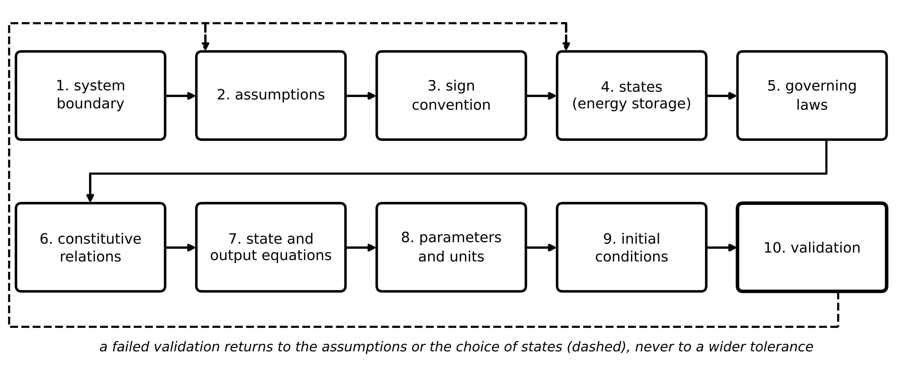
Figure 4.1. The universal modelling workflow used in this chapter. The ten steps are applied to every model from the RC circuit to the induction machine.
The governing laws are conservation laws, and four of them cover every asset in the book. Table 4.1 lists them with the energy-storage element whose state they produce. Organizing models this way has a practical benefit: every model must satisfy an energy balance, and checking it is the simplest verification test there is.
Table 4.1. Conservation laws as the organizing principle of the models in this chapter
Conserved quantity | Law | Storage element and state | Dissipation | Example in this chapter
charge | Kirchhoff current law $\sum{i}=0$ at a node | capacitor: voltage $v_{C}$ | resistor $Ri^{2}$ | RC, RLC, DC bus
magnetic flux linkage | Kirchhoff voltage law with $v=dψ/dt$ | inductor: current $i_{L}$ or flux $ψ$ | winding resistance | RL, machines
angular momentum | $J\dot{ω}=\sum{T}$ | rotor inertia: speed $ω$ | friction $Bω^{2}$ | DC and induction machines
heat (energy) | $C\dot{T}=P_{in}-P_{out}$ | heat capacity: temperature $T$ | none (heat is the end product) | thermal networks
charge in a cell | $\dot{z}=-i/(3600Q_{n})$ | electrode lithium: state of charge $z$ | $R_{0}i^{2}$, polarization | battery ECM

4.3 First-order circuits from Kirchhoff's laws

4.3.1 The RC circuit, step by step
Apply the workflow to the RC circuit. Boundary: the source, resistor and capacitor. Assumptions: lumped, linear, time-invariant elements; ideal source. Sign convention: $v_{C}$ positive at the top plate; loop current $i$ positive clockwise. State: $v_{C}$. Governing law: Kirchhoff's voltage law around the loop. Constitutive relations: Ohm's law for $R$ and $i=C dv_{C}/dt$ for the capacitor:
$v_{in}(t)=R i(t)+v_{C}(t), i(t)=C\frac{dv_{C}}{dt}$ (4.1)
where $v_{in}$, $v_{C}$ are in volts, $i$ in amperes, $R$ in ohms and $C$ in farads. State equation: eliminating $i$ gives
$\frac{dv_{C}}{dt}=-\frac{1}{RC}v_{C}+\frac{1}{RC}v_{in}, v_{C}(0)=v_{0}$ (4.2)
Units check: $RC$ is in Ω·F = s, so both sides are in V/s. For a constant input $V$ the solution is an exponential approach whose rate is the system's eigenvalue $λ$:
$v_{C}(t)=V+\left(v_{0}-V\right)e^{λt}, λ=-\frac{1}{RC}, τ=RC$ (4.3)
where $τ$ is the time constant. The response settles if and only if $λ<0$. Multiplying (4.1) by $i$ gives the power balance that every model must satisfy,
$v_{in} i=R i^{2}+\frac{d}{dt}\left(\frac{1}{2}Cv_{C}^{2}\right)$ (4.4)
source power equals dissipation plus the rate of change of stored energy. For an arbitrary input, multiplying (4.2) by the integrating factor $e^{t/τ}$ and integrating gives the free response plus a convolution of the input with the impulse response:
$v_{C}(t)=e^{λt}v_{0}+\int_{0}^{t}{e^{λ(t-σ)}}\frac{1}{RC}v_{in}(σ) dσ$ (4.5)
where $σ$ is the integration variable. Two limits check the result: as $t→∞$ with constant input, $v_{C}→V$; as $C→0$ the capacitor follows the source instantly. The same equation describes the winding temperature of motor M-07 in Chapter 1 with $v_{C}$ replaced by temperature rise, $R$ by thermal resistance, $C$ by heat capacity and $v_{in}/R$ by loss power: both systems store a conserved quantity and move it through a linear resistance.
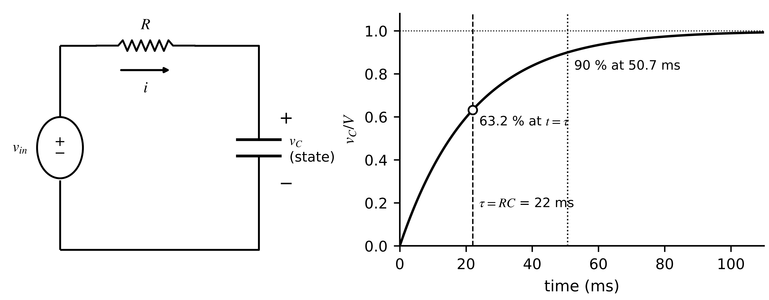
Figure 4.2. The RC circuit. Left: circuit with sign conventions; the capacitor voltage is the state because it stores energy and cannot jump. Right: step response from (4.3) with the time constant and the 90 % point marked.

4.3.2 The RL circuit
A source $v_{in}$ drives an inductor $L$ in series with $R$. With $i_{L}$ positive in the direction of the source voltage rise, Kirchhoff's voltage law and $v_{L}=L di_{L}/dt$ give, for a step $V$ from rest,
$L\frac{di_{L}}{dt}=v_{in}-R i_{L}, τ=\frac{L}{R}, i_{L}(t)=\frac{V}{R}\left(1-e^{-t/τ}\right)$ (4.6)
The inductor current is the state: it stores $\frac{1}{2}Li_{L}^{2}$ and cannot jump, which is why opening an inductive circuit produces a voltage spike. The model fails when the inductor core saturates (then $L$ depends on $i_{L}$, Section 4.9) or when the frequency is high enough for winding capacitance to matter.
Example 4.1 (Level A) RC and RL hand derivations
Given. (i) $R=2.2$ kΩ, $C=10$ µF, a 10 V step from $v_{0}=0$. (ii) $L=50$ mH, $R=10$ Ω, a 24 V step from rest.
Find. (a) $τ$, the time to 90 % and $v_{C}$ at $t=τ$ for (i). (b) $τ$, the final current, $i_{L}$ at 5 ms and the time to 95 % for (ii). (c) The energy stored at the end and the energy dissipated during charging in (i).
Solution. (a) $τ=2.2×{10}^{3}×10×{10}^{-6}=22$ ms; $t_{90}=τln10=50.7$ ms; $v_{C}(τ)=10(1-e^{-1})=6.32$ V. (b) $τ=0.05/10=5$ ms; $i_{∞}=2.4$ A; $i_{L}(5 ms)=2.4(1-e^{-1})=1.52$ A; $t_{95}=3τ=15$ ms. (c) Stored $\frac{1}{2}×{10}^{-5}×100=0.5$ mJ. The source delivers $\int{v_{in}}i dt=VQ=10×{10}^{-4}=1$ mJ, so by (4.4) the resistor dissipates the other 0.5 mJ, whatever the value of $R$.
Interpretation. Half the energy delivered to a capacitor through a resistor is always lost in the resistor, a result that only the energy balance makes obvious. Checking such balances is how a twin's model code is verified (Section 4.15).
What the digital twin adds
Synchronized: a state that stores energy and is compared with a measurement.
Estimated or updated: the time constant from the measured response.
Uncertainty carried: none yet; the parameters are taken as known.
Decision enabled: which variables to treat as states and which as parameters.
Validated by: units and power-balance checks, (4.4).

4.4 Second-order circuits: the RLC filter
Add a capacitor in series with the RL circuit (Figure 4.3). Two elements now store energy, so there are two states: the inductor current $i_{L}$ and the capacitor voltage $v_{C}$. Kirchhoff's voltage law around the loop and the two constitutive laws give
$L\frac{di_{L}}{dt}=v_{in}-R i_{L}-v_{C}, C\frac{dv_{C}}{dt}=i_{L}$ (4.7)
where $R$ is the total series resistance (winding plus the capacitor's equivalent series resistance). Eliminating $i_{L}$ gives $LC{\ddot{v}}_{C}+RC{\dot{v}}_{C}+v_{C}=v_{in}$, written with two physical parameters:
${\ddot{v}}_{C}+2ζω_{n}{\dot{v}}_{C}+ω_{n}^{2}v_{C}=ω_{n}^{2}v_{in}, ω_{n}=\frac{1}{\sqrt{LC}}, ζ=\frac{R}{2}\sqrt{\frac{C}{L}}$ (4.8)
where $ω_{n}$ is the undamped natural frequency (rad/s) and $ζ$ the dimensionless damping ratio. Trying $e^{st}$ in the homogeneous equation gives the characteristic roots $s_{1,2}=-ζω_{n}±ω_{n}\sqrt{ζ^{2}-1}$: two real roots for $ζ>1$ (overdamped), a double root for $ζ=1$, and a complex pair $-ζω_{n}±jω_{d}$ for $ζ<1$. For a step $V$ from rest in the underdamped case, the solution with $v_{C}(0)=0$ and ${\dot{v}}_{C}(0)=0$, its first peak, overshoot and 2 % settling time are
$v_{C}(t)=V\left[1-e^{-ζω_{n}t}\left(cosω_{d}t+\frac{ζ}{\sqrt{1-ζ^{2}}}sinω_{d}t\right)\right], ω_{d}=ω_{n}\sqrt{1-ζ^{2}}, M_{p}=e^{-πζ/\sqrt{1-ζ^{2}}}, t_{s}≈\frac{4}{ζω_{n}}$ (4.9)
with the first peak at $t_{p}=π/ω_{d}$. The ratio of two successive peaks one period $2π/ω_{d}$ apart gives the logarithmic decrement, which inverts for the damping ratio; with $ζ$ and $ω_{d}$ measured from a ringing waveform the physical parameters follow, with $L$ taken as known because inductors age much less than capacitors:
$δ=ln\frac{x_{k}}{x_{k+1}}=\frac{2πζ}{\sqrt{1-ζ^{2}}}, ζ=\frac{δ}{\sqrt{4π^{2}+δ^{2}}}, ω_{n}=\frac{ω_{d}}{\sqrt{1-ζ^{2}}}, \hat{C}=\frac{1}{Lω_{n}^{2}}, \hat{R}=2ζ\sqrt{L/\hat{C}}$ (4.10)
where $x_{k}$, $x_{k+1}$ are successive peak deviations from the final value. Equation (4.10) is the whole measurement principle of the capacitor-ageing twin. The energy view confirms the physics: multiplying the two lines of (4.7) by $i_{L}$ and $v_{C}$ and adding,
$E_{f}=\frac{1}{2}Li_{L}^{2}+\frac{1}{2}Cv_{C}^{2}, {\dot{E}}_{f}=v_{in}i_{L}-R i_{L}^{2}$ (4.11)
so with the input switched off the stored energy can only fall, at exactly the rate dissipated in $R$.
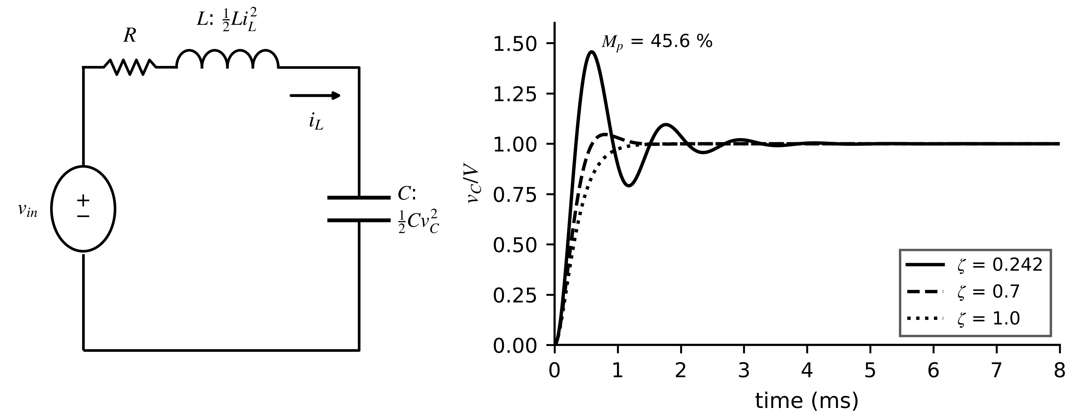
Figure 4.3. Series RLC circuit with its two energy-storing elements (left), and the capacitor-voltage step response for three damping ratios from (4.8) (right).
Example 4.2 (Level B) The BESS converter output filter and its ageing signature
Given. $L=150$ µH, $C=220$ µF, total series resistance $R=0.4$ Ω; the capacitor voltage is measured. Later the capacitance falls by 10 %.
Find. (a) $ω_{n}$, $f_{n}$, $ζ$, ringing frequency, overshoot, peak time and settling time. (b) The logarithmic decrement and the ratio of successive peaks. (c) The new ringing frequency, and the capacitance recovered from it with (4.10). (d) The characteristic impedance used to size a damping branch.
Solution. (a) $ω_{n}=1/\sqrt{150×{10}^{-6}×220×{10}^{-6}}=5505$ rad/s, $f_{n}=876$ Hz; $ζ=0.2\sqrt{220/150}=0.242$; $f_{d}=876\sqrt{1-{0.242}^{2}}=850$ Hz; $t_{p}=π/5341=0.588$ ms; $M_{p}=e^{-π×0.242/0.970}=45.6$ %; $t_{s}=4/(0.242×5505)=3.0$ ms. (b) $δ=1.569$; each peak is $e^{1.569}=4.80$ times the next. (c) With $C'=0.9C$, $ζ'=0.230$ and $f_{d}'=899$ Hz, a rise of 5.7 %; inverting with $δ'=1.483$ gives $\hat{C}=198.0$ µF, the true value. (d) $Z_{0}=\sqrt{L/C}=0.83$ Ω.
Interpretation. The ringing frequency is a sensitive, directly measurable indicator of capacitance, so the twin should compare the measured ringing, not only the settled voltage, with its prediction. Damping by series resistance would dissipate $I^{2}R$ continuously (90 W at 15 A through 0.4 Ω); practical filters use an $R_{d}C_{d}$ branch with $R_{d}≈Z_{0}$, which damps the resonance without carrying load current.
For networks larger than one loop, Kirchhoff's current law at every non-reference node, with conductance matrix $G_{n}$, capacitance matrix $C_{n}$ and injected source currents $i_{s}$, gives the nodal form used by circuit simulators:
$C_{n}\dot{v}+G_{n}v=i_{s}(t)$ (4.12)
where $v$ is the vector of node voltages; inductor currents and voltage sources are added as extra unknowns in modified nodal analysis. When $C_{n}$ is singular (a node without capacitance), (4.12) is a differential-algebraic equation (Section 4.6).
What the digital twin adds
Synchronized: inductor current and capacitor voltage, the two energy states.
Estimated or updated: $\hat{C}$ and $\hat{R}$ from ringing frequency and decay, (4.10).
Uncertainty carried: frequency and decrement uncertainty propagate into $\hat{C}$.
Decision enabled: capacitor replacement before failure.
Validated by: comparing predicted and measured ringing after load steps.

4.5 State-space models and transfer functions

4.5.1 The state-space form
Any linear lumped model can be written in the state-space form (Figure 4.4), with the state vector $x$, input vector $u$ and output vector $y$:
$\dot{x}=Ax+Bu, y=Cx+Du$ (4.13)
where $A$ ($n×n$) is the system matrix, $B$ the input matrix, $C$ the output matrix and $D$ the direct feedthrough. For the RLC filter with $x=[i_{L}, v_{C}]^{⊤}$, $u=v_{in}$ and $y=v_{C}$, reading the coefficients off (4.7):
$A=\left[\begin{matrix}-R/L & -1/L \\ 1/C & 0\end{matrix}\right], B=\left[\begin{matrix}1/L \\ 0\end{matrix}\right], C=\left[\begin{matrix}0 & 1\end{matrix}\right], D=0$ (4.14)
The solution generalizes (4.5) with the scalar exponential replaced by the matrix exponential, and the matrix exponential is computed from the eigenvalues when $A$ has $n$ independent eigenvectors collected in $V$:
$x(t)=e^{At}x(0)+\int_{0}^{t}{e^{A(t-σ)}}Bu(σ) dσ, e^{At}=\sum_{k=0}^{∞}{\frac{(At)^{k}}{k!}}=Ve^{Λt}V^{-1}$ (4.15)
where $Λ$ is diagonal with the eigenvalues $λ_{i}$, roots of $det(λI-A)=0$. The response is a sum of modes $e^{λ_{i}t}$: each real part sets a decay rate, each imaginary part an oscillation. The model is asymptotically stable when every $Re λ_{i}<0$. For the filter, $λ=-1333±j5341$ s⁻¹: decay rate $ζω_{n}$ and ringing at $ω_{d}$, exactly as found in Section 4.4.
Example 4.3 (Level A) Modal solution of the two-node thermal model
Given. The two-node M-07 model of Section 4.8.1 ($C_{1}=2500$, $C_{2}=6500$ J/K, $R_{12}=0.08$, $R_{2a}=0.12$ K/W) in state-space form with $x=[θ_{1}, θ_{2}]^{⊤}$ (rises above ambient), $u=P$; a 420 W step from ambient.
Find. (a) $A$ and its eigenvalues. (b) The steady state. (c) The rises at 10 and 30 minutes from (4.15), using $x(t)=A^{-1}(e^{At}-I)Bu$ for a constant input.
Solution. (a) $A=[-0.005, 0.005; 0.001923, -0.003205]$ s⁻¹; eigenvalues $-7.33×{10}^{-3}$ and $-8.74×{10}^{-4}$ s⁻¹ (136 s and 1144 s). (b) $x_{∞}=-A^{-1}Bu=[84.0, 50.4]$ K. (c) At 10 min: $θ_{1}=42.8$ K, $θ_{2}=16.6$ K; at 30 min: 69.6 K and 38.5 K.
Interpretation. After 10 minutes the winding is already 26 K above the frame, a gap the single-node model cannot show. The fast mode (136 s) fills the winding-to-frame gap; the slow mode (1144 s) carries the whole machine to its steady state.
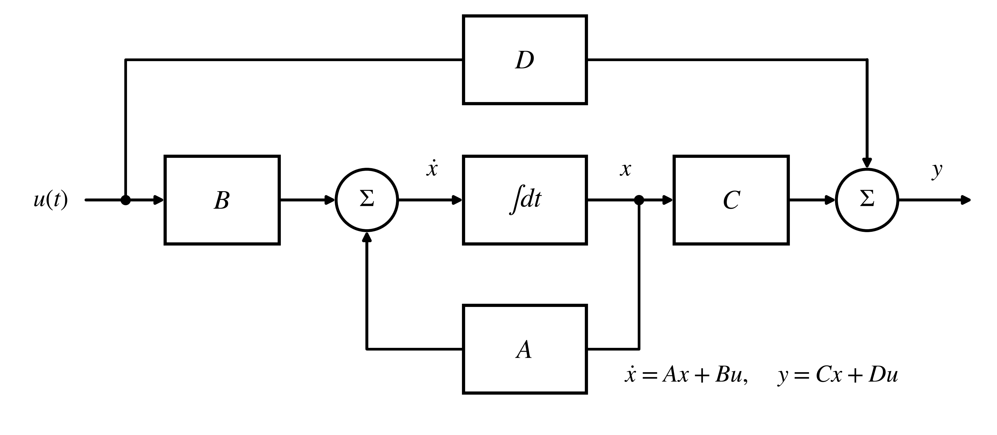
Figure 4.4. State-space block diagram. The integrator holds the state; $A$ feeds it back, $B$ injects the input, $C$ forms the output and $D$ passes the input directly.
Table 4.2. State-space realizations of the same model and when each is used
Realization | States | Strength | Limitation | Used for
physical (energy variables) | capacitor voltages, inductor currents, speeds, temperatures | directly comparable with sensors; parameters keep meaning | matrices may be badly scaled | the twin's own state
controllable canonical | polynomial coefficients in one row | pole placement is direct | numerically fragile for high order | state-feedback design (Ch. 13)
observable canonical | coefficients in one column | observer design is direct | states lose physical meaning | observers (Ch. 5)
modal (diagonal) | eigenvector coordinates | separates fast and slow modes | complex for oscillatory modes | stiffness analysis
balanced | coordinates ordered by Hankel singular value | reduction with error bound | states lose physical meaning | model-order reduction (Section 4.12)

4.5.2 Transfer functions, poles and zeros
The Laplace transform $X(s)=\int_{0}^{∞}{x}(t)e^{-st}dt$, with $L\{\dot{x}\}=sX(s)-x(0)$, turns (4.13) into algebra. With zero initial state, $sX=AX+BU$ gives $X=(sI-A)^{-1}BU$, and the transfer function from input to output is
$G(s)=\frac{Y(s)}{U(s)}=C{\left(sI-A\right)}^{-1}B+D, {\left(sI-A\right)}^{-1}=\frac{adj(sI-A)}{det(sI-A)}$ (4.16)
so the poles of $G$ are the roots of $det(sI-A)$, the eigenvalues of $A$, unless a pole is cancelled by a zero. For the filter, (4.14) gives
$G(s)=\frac{V_{C}(s)}{V_{in}(s)}=\frac{1/(LC)}{s^{2}+(R/L)s+1/(LC)}=\frac{ω_{n}^{2}}{s^{2}+2ζω_{n}s+ω_{n}^{2}}$ (4.17)
with no zeros and a peak gain near $ω_{n}$ that grows as $ζ$ falls (Figure 4.5). The final-value theorem, $\lim_{t→∞}y=\lim_{s→0}sY(s)$, valid for stable systems, gives the steady state without solving anything: $G(0)=1$ here. Zeros matter elsewhere: a zero in the right half-plane, as in the boost converter of Chapter 7, makes the output first move the wrong way.
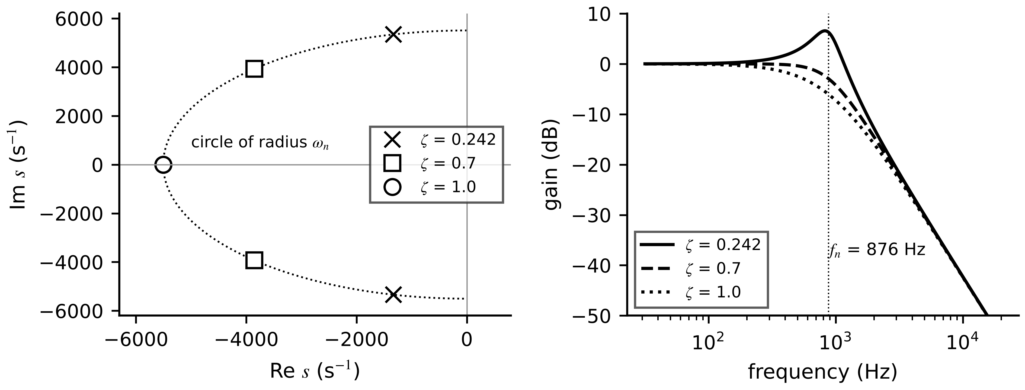
Figure 4.5. Left: poles of the filter for three damping ratios; all lie on a circle of radius $ω_{n}$, and falling damping moves them towards the imaginary axis. Right: Bode magnitude of (4.17), with the resonance peak at low damping.
Per-unit scaling. Large models mix volts and kilovolts, milliseconds and hours. Scaling each variable by a base value, $x_{pu}=x/x_{base}$ and $t_{pu}=ω_{b}t$, makes states comparable and improves the conditioning of every matrix computation in Sections 4.10 to 4.12.
What the digital twin adds
Synchronized: a state vector whose meaning is fixed by the realization chosen.
Estimated or updated: eigenvalues, poles and steady-state gains from $A$, $B$, $C$, $D$.
Uncertainty carried: pole locations move with parameter uncertainty.
Decision enabled: which realization a twin, an observer or a controller should use.
Validated by: comparing predicted and measured frequency responses.

4.6 Constrained models: differential-algebraic equations
Some variables in electrical networks have no memory of their own. A DC bus node with no capacitance, the current of an ideal voltage source, or the power balance of a converter switching faster than anything else in the model: each is fixed at every instant by an algebraic equation. A model is algebraic when its outputs depend only on present inputs, an ordinary differential equation (ODE) when every unknown has memory, and a differential-algebraic equation (DAE) when both kinds appear. The semi-explicit DAE form is
$\dot{x}=f\left(x,z,u,t\right), 0=g\left(x,z,u,t\right)$ (4.18)
where $x$ are differential states, $z$ algebraic variables that appear without derivatives, and $g$ the constraints, typically Kirchhoff's current law at nodes without capacitance or a converter's instantaneous power balance $v_{dc}i_{dc}=v_{a}i_{a}+v_{b}i_{b}+v_{c}i_{c}$ when switching losses are neglected. If the Jacobian $∂g/∂z$ is non-singular, $z$ can be solved from $g=0$ at every step and the model behaves like an ODE.
[Advanced] The differentiation index
The differentiation index is the number of times $g$ must be differentiated before $\dot{z}$ can be solved for. Differentiating $g=0$ along a solution gives $\frac{∂g}{∂x}\dot{x}+\frac{∂g}{∂z}\dot{z}+\frac{∂g}{∂u}\dot{u}=0$, so if $∂g/∂z$ is invertible one differentiation produces an ODE for $z$: index 1. Circuit simulators and power-system network models are normally index 1 [5].
A capacitor $C$ placed directly across an ideal voltage source $E(t)$ is index 2: the constraint $0=v_{C}-E(t)$ does not contain the source current at all; differentiating once gives ${\dot{v}}_{C}=\dot{E}$, and with $C{\dot{v}}_{C}=i_{E}$ the source current is $i_{E}=C\dot{E}(t)$, a function of the input's derivative. A step in $E$ demands an infinite current, a physical idealization a solver faithfully tries to reproduce. Adding the source's small internal resistance returns the model to index 1. Ideal switches, voltage sources in parallel with capacitors and inductors in series with current sources produce index 2 or higher, which index-1 solvers handle poorly.

A DAE brings a problem an ODE does not have: its initial condition must satisfy the constraint, $g(x(0),z(0),u(0),0)=0$, and finding it may mean solving a nonlinear equation with several roots. A twin that restarts after an outage with stored values that no longer satisfy the constraints starts from an inconsistent state. Newton's method on the constraint is the usual tool:
$z^{(m+1)}=z^{(m)}-{\left(\frac{∂g}{∂z}\right)}^{-1}g\left(x,z^{(m)},u\right)$ (4.19)
where $m$ is the iteration count. Its convergence is fast near a root and its result depends on the starting point.
Example 4.4 (Level B) Consistent initialization of a DC bus with a constant-power load
Given. A DC bus connects a battery (open-circuit voltage $E=800$ V behind $R_{0}=0.1$ Ω), a PV converter injecting $i_{pv}=100$ A, and a tightly regulated converter load drawing constant power $P=150$ kW (Figure 4.6). The bus has no capacitance in the first model.
Find. (a) The model class and the consistent bus voltage. (b) Newton iterations from 400 V and from 25 V. (c) The largest load for which a solution exists. (d) The small-signal impedance of the load and the bus eigenvalue if $C_{bus}=2$ mF is added.
Solution. (a) Battery current $(E-V)/R_{0}$; Kirchhoff at the bus $(E-V)/R_{0}+i_{pv}-P/V=0$ has no derivative, so with the battery's SOC equation the model is an index-1 DAE. Multiplying by $R_{0}V$: $V^{2}-(E+R_{0}i_{pv})V+R_{0}P=0$, roots $[810±\sqrt{{810}^{2}-60 000}]/2=791.04$ V and 18.96 V. Only the high root is physical (the low one needs 7.8 kA of battery current). (b) From 400 V: 811.03, 791.05, 791.038 V; from 25 V: 16.96, 18.75, 18.96 V, the wrong root, reached just as quickly. (c) Real roots need $(E+R_{0}i_{pv})^{2}≥4R_{0}P$: $P_{max}={810}^{2}/0.4=1.64$ MW at $V=405$ V; beyond it no operating point exists, which is voltage collapse. (d) The load current $P/V$ has slope $-P/V^{2}$, so $Z_{CPL}=-V^{2}/P=-4.17$ Ω; with $C_{bus}$, $C_{bus}\dot{V}=(E-V)/R_{0}+i_{pv}-P/V$ has eigenvalue $-1/(R_{0}C_{bus})+P/(V^{2}C_{bus})=-4880$ s⁻¹.
Interpretation. The initialization routine must start from a physically justified guess (the open-circuit voltage) and check the result against limits. The negative incremental resistance of a constant-power load pushes the eigenvalue towards instability; adding capacitance removes the algebraic constraint but introduces a fast mode the solver must handle (Section 4.10).
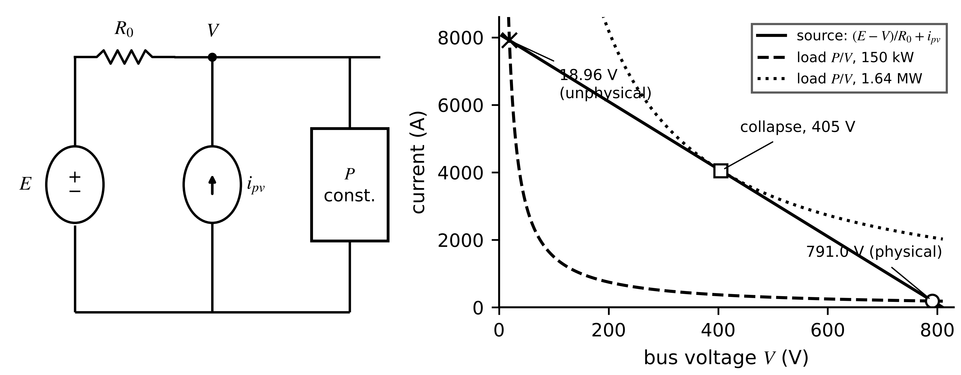
Figure 4.6. The DC bus of Example 4.4. Left: circuit. Right: the constraint as the intersection of the source line with the constant-power hyperbola, at 150 kW and at the 1.64 MW collapse limit; only the high-voltage intersection is a physical operating point.
What the digital twin adds
Synchronized: differential states and algebraic variables that satisfy the constraints.
Estimated or updated: a consistent initial state after every restart.
Uncertainty carried: the possibility of a wrong root; distance to collapse.
Decision enabled: whether a bus or network model needs capacitance or a DAE solver.
Validated by: checking constraint residuals and physical limits after initialization.

4.7 Electromechanical models

4.7.1 The DC machine
A DC machine converts electrical to mechanical power through two coupling constants (Figure 4.7). Take the armature current $i_{a}$ positive into the positive terminal and the speed $ω$ positive in the motoring direction. Kirchhoff's voltage law around the armature and Newton's law for rotation give
$L_{a}\frac{di_{a}}{dt}=v_{a}-R_{a}i_{a}-K_{e}ω, J\frac{dω}{dt}=K_{t}i_{a}-Bω-T_{L}$ (4.20)
where $v_{a}$ is the armature voltage (V), $R_{a}$, $L_{a}$ the armature resistance and inductance, $K_{e}$ the back-EMF constant (V·s/rad), $K_{t}$ the torque constant (N·m/A), $J$ the rotor inertia (kg·m²), $B$ the viscous friction coefficient (N·m·s/rad) and $T_{L}$ the load torque. Why is $K_{t}=K_{e}$? Multiplying the electrical equation by $i_{a}$ and the mechanical one by $ω$ and adding gives the power balance
$v_{a}i_{a}=R_{a}i_{a}^{2}+\frac{d}{dt}\left(\frac{1}{2}L_{a}i_{a}^{2}+\frac{1}{2}Jω^{2}\right)+Bω^{2}+T_{L}ω+\left(K_{e}-K_{t}\right)i_{a}ω$ (4.21)
The last term would be power created in the air gap; conservation of energy makes it vanish, so $K_{t}=K_{e}$ in SI units. With $x=[i_{a}, ω]^{⊤}$ and $u=v_{a}$, the system matrix, characteristic polynomial and voltage-to-speed transfer function are
$A=\left[\begin{matrix}-R_{a}/L_{a} & -K_{e}/L_{a} \\ K_{t}/J & -B/J\end{matrix}\right], \frac{Ω(s)}{V_{a}(s)}=\frac{K_{t}}{\left(L_{a}s+R_{a}\right)\left(Js+B\right)+K_{t}K_{e}}$ (4.22)
The product $K_{t}K_{e}$ couples the two first-order factors; neglecting it splits the model into $L_{a}/R_{a}$ and $J/B$, which the example below tests. In steady state, neglecting friction, speed falls linearly with load torque, $ω_{ss}=v_{a}/K_{e}-R_{a}T_{L}/(K_{t}K_{e})$.
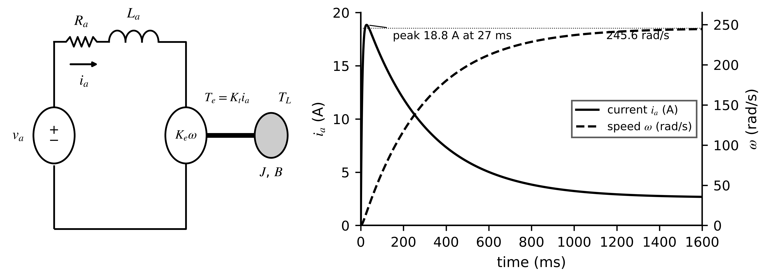
Figure 4.7. DC machine. Left: armature circuit with back EMF and the rotor with torque, inertia and friction. Right: armature current and speed after a 24 V step from rest (Example 4.5), showing the fast electrical and slower electromechanical modes.
Example 4.5 (Level B) DC actuator transient and its time constants
Given. $R_{a}=1.2$ Ω, $L_{a}=8$ mH, $K_{e}=K_{t}=0.085$ V·s/rad, $J=0.0021$ kg·m², $B=0.0009$ N·m·s/rad, no load; a 24 V step from rest.
Find. (a) $A$, its eigenvalues and time constants, against the guesses $L_{a}/R_{a}$ and $J/B$. (b) The steady-state speed and current. (c) The peak current and its time. (d) The effect of a 10 % increase in $J$.
Solution. (a) $A=[-150, -10.63; 40.48, -0.429]$ s⁻¹; characteristic polynomial $s^{2}+150.43s+494.3$; eigenvalues $-147.1$ and $-3.36$ s⁻¹, time constants 6.8 ms and 0.297 s. $L_{a}/R_{a}=6.7$ ms is close to the fast one; $J/B=2.33$ s is wrong by a factor of eight, because back EMF acts as electrical damping $K_{t}K_{e}/R_{a}$, giving $τ_{em}=JR_{a}/(K_{t}K_{e})=0.349$ s. (b) Gain $K_{t}/(R_{a}B+K_{t}K_{e})=10.23$ rad/s per volt, so 245.6 rad/s (2345 r/min); steady current $Bω/K_{t}=2.60$ A. (c) Simulation gives a peak of 18.8 A at 27 ms (Figure 4.7); speed reaches 62 % of its final value at 0.297 s. (d) Eigenvalues $-147.3$ and $-3.05$ s⁻¹: the slow time constant rises to 0.328 s, about 10 %, while the fast one barely moves.
Interpretation. A twin estimating inertia from $J/B$ would be badly wrong; the full eigenvalues must be used whenever the coupling term is comparable to the diagonal terms. The slow mode carries the inertia information, so an inertia-tracking twin needs speed transients, not current transients.

4.7.2 The induction machine in the dq frame
The squirrel-cage induction machine is the book's workhorse (M-07 and its nineteen companions). For the stator, Kirchhoff's voltage law in each phase gives $v_{abc}=R_{s}i_{abc}+dψ_{abc}/dt$, but the flux linkages depend on rotor position through sinusoidally varying mutual inductances, so the coefficients vary with time. Park's transformation removes that dependence by projecting the three phase quantities onto two orthogonal axes rotating at angle $θ$ (Figure 4.8) [6]:
$\left[\begin{matrix}f_{d} \\ f_{q} \\ f_{0}\end{matrix}\right]=\frac{2}{3}\left[\begin{matrix}cosθ & cos(θ-2π/3) & cos(θ+2π/3) \\ -sinθ & -sin(θ-2π/3) & -sin(θ+2π/3) \\ 1/2 & 1/2 & 1/2\end{matrix}\right]\left[\begin{matrix}f_{a} \\ f_{b} \\ f_{c}\end{matrix}\right]$ (4.23)
Example 4.6 (Level A) Park transformation of a lagging current
Given. Balanced phase currents $i_{a}=20cos(ωt-30°)$ A (and $i_{b}$, $i_{c}$ shifted by $∓120°$), transformed with (4.23) at $θ=ωt$.
Find. $i_{d}$, $i_{q}$ and $i_{0}$, and their behaviour in time.
Solution. Substituting and using $\sum_{k}{\cos^{2}}(·)=3/2$: $i_{d}=20cos30°=17.32$ A, $i_{q}=-20sin30°=-10.0$ A, $i_{0}=0$, all constant in time. A numerical check at $ωt=0.7$ rad gives the same values.
Interpretation. In the rotating frame a balanced sinusoidal current becomes two constants, whose ratio is the power-factor angle. Twins and controllers of machines and converters work in this frame because steady operation is a fixed point, and any oscillation in $i_{d}$, $i_{q}$ reveals imbalance or a fault.
where $f$ is any voltage, current or flux, and the factor 2/3 makes the transformation amplitude-invariant: a balanced set of amplitude $F$ maps to a dq vector of length $F$ (the power-invariant variant uses $\sqrt{2/3}$ instead; the convention must be stated, since torque formulas differ by 3/2). Because the frame rotates at $ω=dθ/dt$, differentiating the transformed flux adds a speed voltage. Choosing the frame to rotate at the supply frequency $ω_{e}$ makes balanced sinusoidal quantities constant. Writing the voltage equations for stator and rotor with flux linkages as states (rotor quantities referred to the stator, rotor voltage zero for a squirrel cage) gives
${\dot{ψ}}_{ds}=v_{ds}-R_{s}i_{ds}+ω_{e}ψ_{qs}, {\dot{ψ}}_{qs}=v_{qs}-R_{s}i_{qs}-ω_{e}ψ_{ds}, {\dot{ψ}}_{dr}=-R_{r}i_{dr}+\left(ω_{e}-ω_{r}\right)ψ_{qr}, {\dot{ψ}}_{qr}=-R_{r}i_{qr}-\left(ω_{e}-ω_{r}\right)ψ_{dr}$ (4.24)
where subscripts $d,q$ denote axes and $s,r$ stator and rotor, and $ω_{r}$ is the rotor speed in electrical rad/s. Fluxes and currents are linked by $ψ_{ds}=L_{s}i_{ds}+L_{m}i_{dr}$ and $ψ_{dr}=L_{r}i_{dr}+L_{m}i_{ds}$ (identically for $q$), with $L_{s}=L_{ls}+L_{m}$, $L_{r}=L_{lr}+L_{m}$; inverting axis by axis recovers the currents, and the air-gap power gives the torque, which completes the model with Newton's law:
$i_{ds}=\frac{L_{r}ψ_{ds}-L_{m}ψ_{dr}}{L_{s}L_{r}-L_{m}^{2}}, T_{e}=\frac{3}{2}\frac{p}{2}\left(ψ_{ds}i_{qs}-ψ_{qs}i_{ds}\right), \frac{2J}{p}\frac{dω_{r}}{dt}=T_{e}-T_{L}-B\frac{2}{p}ω_{r}$ (4.25)
where $p$ is the number of poles. The model has five states, is nonlinear through the products of speed and flux, and assumes a linear magnetic circuit, sinusoidal windings and no core loss. In steady state the derivatives vanish and the familiar per-phase circuit returns, with slip $s=(ω_{e}-ω_{r})/ω_{e}$. Replacing supply, stator impedance and magnetizing reactance by a Thévenin equivalent $V_{th}$, $R_{th}+jX_{th}$, the torque and its maximum are
$T_{e}(s)=\frac{3{\left|V_{th}\right|}^{2}R_{r}/s}{ω_{sm}\left[{\left(R_{th}+R_{r}/s\right)}^{2}+{\left(X_{th}+X_{lr}\right)}^{2}\right]}, s_{max}=\frac{R_{r}}{\sqrt{R_{th}^{2}+{\left(X_{th}+X_{lr}\right)}^{2}}}$ (4.26)
where $ω_{sm}=2ω_{e}/p$ is the synchronous mechanical speed and $X_{lr}=ω_{e}L_{lr}$. The copper loss $P_{cu}=3|I_{s}|^{2}R_{s}+3|I_{r}|^{2}R_{r}$ is the input of the thermal twin of Chapter 1.
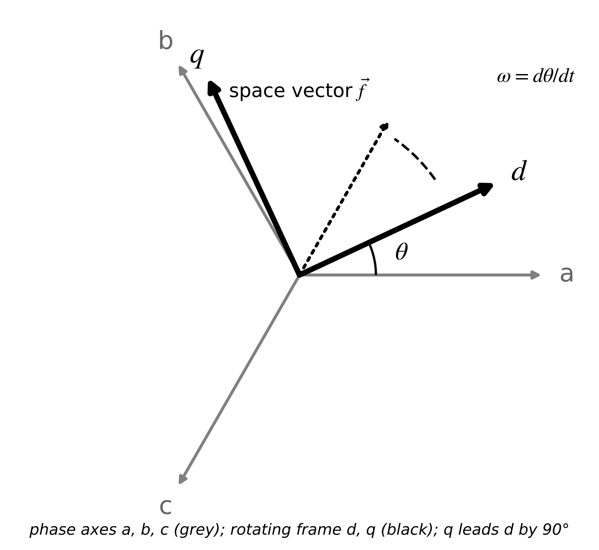
Figure 4.8. Stationary phase axes a, b, c and the rotating dq frame at angle $θ$. In a frame rotating at the supply frequency, balanced sinusoidal quantities become constant.
Example 4.7 (Level C) Direct-on-line start of a 7.5 kW motor
Given. An illustrative parameter set for a 7.5 kW, 400 V, 50 Hz, four-pole motor of the M-07 class: $R_{s}=0.80$ Ω, $R_{r}=0.70$ Ω, $L_{ls}=L_{lr}=4.0$ mH, $L_{m}=0.13$ H, $J=0.05$ kg·m², $B=0.005$ N·m·s/rad. The motor starts direct-on-line with no load; 49 N·m (rated) is applied at 1.0 s. The five-state model is integrated with an adaptive stiff solver (relative tolerance ${10}^{-7}$).
Find. (a) Peak starting current and torque, run-up time and loaded speed, slip, current and torque. (b) An independent steady-state check with (4.26).
Solution. (a) The simulation (Figure 4.9) gives a peak stator current of 95.8 A RMS, torque pulsations up to 222 N·m in the first cycles from the DC offset of the stator flux, run-up to 1450 r/min in 0.079 s, and under rated load 1440 r/min (slip 4.03 %), 13.7 A RMS and 49.75 N·m (49 N·m load plus 0.75 N·m friction). (b) With $X_{m}=40.84$ Ω: $|V_{th}|=224.0$ V, $R_{th}=0.753$ Ω, $X_{th}=1.233$ Ω; $s_{max}=0.269$, $T_{max}=142.9$ N·m, locked-rotor torque 81 N·m, and at the simulated slip (4.26) returns 49.75 N·m, matching the simulation.
Interpretation. The thermal twin needs only the loss this model produces, so it can run a much simpler model; a twin that must detect broken rotor bars, supply imbalance or torque oscillations needs this model and a stiff solver. The rotor fluxes are not measurable on a squirrel-cage machine, which is why Chapter 5 estimates them.
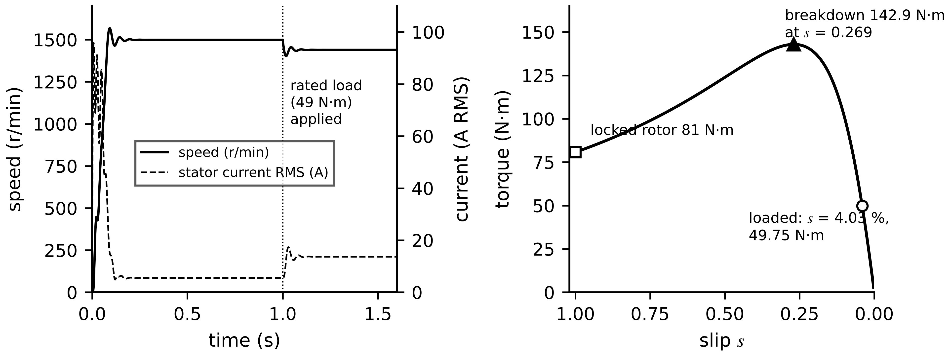
Figure 4.9. Direct-on-line start of Example 4.7. Left: speed and stator current RMS, with rated load applied at 1.0 s. Right: steady-state torque-slip curve from (4.26) with breakdown, locked-rotor and loaded points.
What the digital twin adds
Synchronized: currents, fluxes and speed in a frame where steady quantities are constant.
Estimated or updated: inertia, friction, rotor resistance and unmeasurable rotor flux (Chapter 5).
Uncertainty carried: frame convention, magnetic linearity and parameter drift with temperature.
Decision enabled: which electromechanical detail each twin function needs.
Validated by: power balance (4.21) and steady-state checks against (4.26).

4.8 Thermal, photovoltaic and battery models

4.8.1 The two-node thermal network
Chapter 1 lumped the whole motor into one heat capacity. That model cannot tell the winding from the frame, and the winding is what fails. The physical question is how heat generated in the copper reaches the air, and where it waits on the way (Figure 4.10). With winding temperature $T_{1}$, frame temperature $T_{2}$, loss $P$ injected at the winding and heat flows counted positive from hot to cold, an energy balance on each node gives
$C_{1}{\dot{T}}_{1}=P-\frac{T_{1}-T_{2}}{R_{12}}, C_{2}{\dot{T}}_{2}=\frac{T_{1}-T_{2}}{R_{12}}-\frac{T_{2}-T_{amb}}{R_{2a}}$ (4.27)
where $C_{1}$, $C_{2}$ are heat capacities (J/K), $R_{12}$ the winding-to-frame and $R_{2a}$ the frame-to-ambient thermal resistance (K/W). For M-07 an illustrative split consistent with Chapter 1 ($R_{th}=0.20$ K/W, $C_{th}=9000$ J/K) is $R_{12}=0.08$, $R_{2a}=0.12$ K/W, $C_{1}=2500$, $C_{2}=6500$ J/K; Chapters 3 and 5 use the same values. The eigenvalues are $-7.33×{10}^{-3}$ and $-8.74×{10}^{-4}$ s⁻¹ (time constants 136 s and 1144 s): the winding heats quickly above the frame and the frame follows slowly. In steady state at 420 W the winding sits $420×0.20=84$ K and the frame $420×0.12=50.4$ K above ambient.
Where do these numbers come from? Inside a solid, heat obeys the conduction equation, and a thermal network is its spatial discretization into lumps, each with a capacity and resistances computed from geometry:
$ρc_{p}\frac{∂T}{∂t}=∇·\left(k∇T\right)+q_{v}, C_{i}=ρc_{p}V_{i}, R_{cond}=\frac{ℓ}{kA}, R_{conv}=\frac{1}{h_{c}A}$ (4.28)
where $ρ$ is density, $c_{p}$ specific heat, $k$ thermal conductivity, $q_{v}$ volumetric heat generation, $V_{i}$ the lump volume, $ℓ$ a conduction length, $A$ an area and $h_{c}$ the convective coefficient. 0.5 mm of slot insulation ($k=0.2$ W/(m·K)) over 0.05 m² gives 0.05 K/W; a 0.5 m² frame with $h_{c}=25$ W/(m²·K) gives 0.08 K/W; 12 kg of copper gives 4620 J/K: the right orders for the illustrative values, whose exact numbers come from calibration. For $n$ nodes the balances form $C_{th}\dot{T}=-G_{th}T+P+g_{a}T_{amb}$, the thermal twin of (4.12). The losses depend on temperature because copper resistance rises with it, $R_{cu}(T)=R_{cu,ref}[1+α_{cu}(T-T_{ref})]$ with $α_{cu}=0.00393$ K⁻¹: hotter winding, more loss, hotter winding. Section 4.15 shows what happens to a twin that omits this feedback.
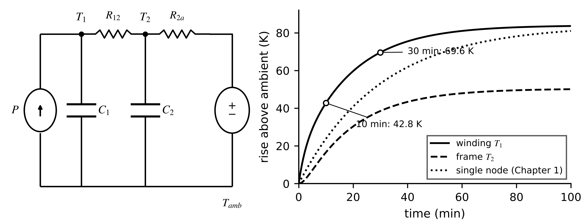
Figure 4.10. Two-node thermal network of motor M-07 (left) and the winding and frame rises after a 420 W step from ambient, against the single-node model of Chapter 1 (right). The single node cannot show the fast winding rise above the frame.

4.8.2 The single-diode PV model
A PV cell is a large-area diode that generates current when lit. The physical picture is a current source proportional to irradiance in parallel with the junction diode, with a shunt resistance for leakage and a series resistance for contacts and fingers (Figure 4.11) [7]. Kirchhoff's current law at the diode node gives the implicit characteristic of a module of $N_{s}$ cells:
$I=I_{ph}-I_{0}\left[exp\left(\frac{V+IR_{s}}{a}\right)-1\right]-\frac{V+IR_{s}}{R_{sh}}, a=nN_{s}\frac{kT}{q}$ (4.29)
where $I$, $V$ are module current and voltage, $I_{ph}$ the photocurrent, $I_{0}$ the diode saturation current, $n$ the ideality factor, $k$ Boltzmann's constant, $q$ the elementary charge and $T$ the cell temperature in kelvin ($kT/q=25.69$ mV at 25 °C). Because $I$ appears on both sides, (4.29) is solved by Newton iteration on $F(I)=I_{ph}-I_{0}[e^{(V+{IR}_{s})/a}-1]-(V+IR_{s})/R_{sh}-I$, or exactly with the Lambert W function [8]:
$I=\frac{R_{sh}\left(I_{ph}+I_{0}\right)-V}{R_{s}+R_{sh}}-\frac{a}{R_{s}}W\left(\frac{R_{s}I_{0}R_{sh}}{a\left(R_{s}+R_{sh}\right)}exp\frac{R_{sh}\left[R_{s}\left(I_{ph}+I_{0}\right)+V\right]}{a\left(R_{s}+R_{sh}\right)}\right)$ (4.30)
where $W(·)$ is the principal branch, defined by $W(x)e^{W(x)}=x$. The parameters move with irradiance $G$ and temperature: $I_{ph}=(G/G_{ref})[I_{ph,ref}+K_{i}(T-T_{ref})]$, and $I_{0}$ grows steeply with temperature through the band gap, which is why open-circuit voltage $V_{oc}≈aln(I_{ph}/I_{0}+1)$ falls as cells heat. For an illustrative 60-cell module with $I_{ph}=9.80$ A, $I_{0}=1.0×{10}^{-10}$ A, $n=1.05$, $R_{s}=0.30$ Ω, $R_{sh}=300$ Ω at 25 °C, the model gives $I_{sc}=9.79$ A, $V_{oc}=40.94$ V and a maximum power point of 306.6 W at 33.33 V and 9.198 A; Newton's method started at $I=I_{ph}$ converges in three iterations to the Lambert W result. The model's diagnostic value is that $R_{s}$ rises with connector and solder-bond degradation while $R_{sh}$ falls with cracks and moisture, and the two bend the curve in different places, which an efficiency model cannot distinguish.
Example 4.8 (Level B) Effect of cell temperature on the PV model
Given. The illustrative module at 50 °C instead of 25 °C, with $I_{ph}$ rising by $K_{i}=5$ mA/K and $I_{0}$ following $I_{0}=I_{0,ref}(T/T_{ref})^{3}exp[\frac{qE_{g}}{nk}(\frac{1}{T_{ref}}-\frac{1}{T})]$ with $E_{g}=1.12$ eV.
Find. $I_{0}$, $a$, $V_{oc}$, the maximum power point and the temperature coefficients of $V_{oc}$ and of maximum power.
Solution. $I_{0}=3.16×{10}^{-9}$ A (32 times higher); $a=1.754$ V; $I_{ph}=9.925$ A. Solving (4.30): $V_{oc}=38.34$ V and maximum power 282.7 W at 30.6 V. Coefficients: $(38.34-40.94)/25=-0.104$ V/K ($-0.25$ %/K) and $-0.31$ %/K for power.
Interpretation. The saturation current's steep rise dominates: a 25 K warmer module loses about 8 % of its power. A PV twin that ignores cell temperature misreads every hot afternoon as degradation.
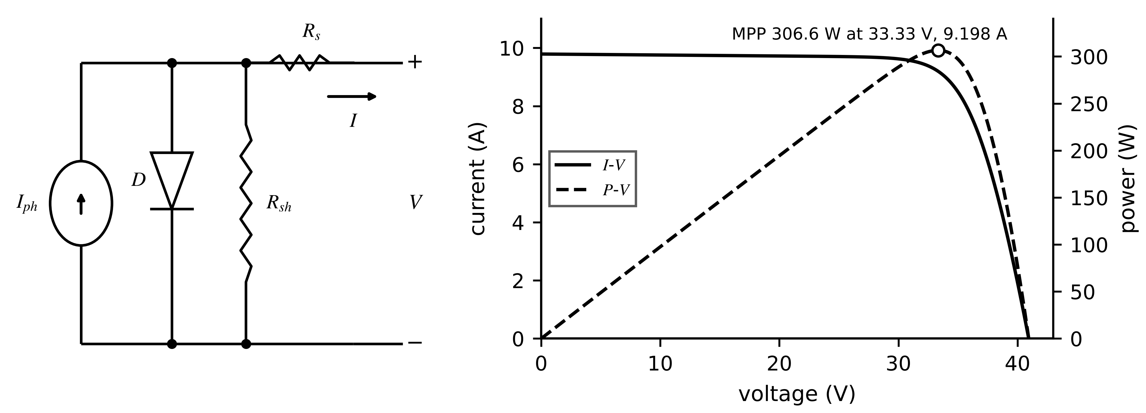
Figure 4.11. Single-diode PV model. Left: equivalent circuit with photocurrent source, diode, shunt and series resistances. Right: I-V and P-V curves of the illustrative 60-cell module with the maximum power point.

4.8.3 Battery equivalent-circuit models
A cell's terminal voltage differs from its open-circuit voltage (OCV) by an instantaneous ohmic drop and slower polarization from diffusion and charge transfer. Equivalent-circuit models (ECMs) represent these with resistors and RC branches, in a hierarchy of fidelity (Figure 4.12) [9]. The first-order (Thevenin) model is
$v_{t}=OCV(z)-R_{0}i-v_{1}, {\dot{v}}_{1}=-\frac{v_{1}}{R_{1}C_{1}}+\frac{i}{C_{1}}, \dot{z}=-\frac{η i}{3600 Q_{n}}$ (4.31)
where $v_{t}$ is the terminal voltage, $i$ the current (positive on discharge), $z$ the state of charge (fraction), $OCV(z)$ a measured, chemistry-specific function, $R_{0}$ the ohmic resistance, $R_{1}C_{1}$ the polarization branch with voltage $v_{1}$, $Q_{n}$ the capacity in A·h and $η$ the coulombic efficiency. The states are $z$ and $v_{1}$. The pulse heats the cell; the heat generated is the irreversible loss plus a reversible (entropic) term, and resistances follow an Arrhenius law in temperature:
${\dot{Q}}_{gen}=i^{2}R_{0}+i v_{1}-i T\frac{∂ OCV}{∂T}, R_{0}(T)=R_{0,ref}exp\left[\frac{E_{a}}{R_{g}}\left(\frac{1}{T}-\frac{1}{T_{ref}}\right)\right]$ (4.32)
where $∂OCV/∂T$ is the entropic coefficient (V/K), $E_{a}$ an activation energy (J/mol) and $R_{g}=8.314$ J/(mol·K). With $E_{a}=20$ kJ/mol, $R_{0}$ at 0 °C is 2.09 times its value at 25 °C, which is why a battery twin needs its thermal model even when only voltage matters. Higher-fidelity electrochemical models, the single-particle model and the pseudo-two-dimensional (P2D) model, solve diffusion equations in the electrodes and resolve lithium concentration; they are needed for limits such as lithium plating and are reduced or replaced by surrogates for online use (Section 4.13, Chapter 9).
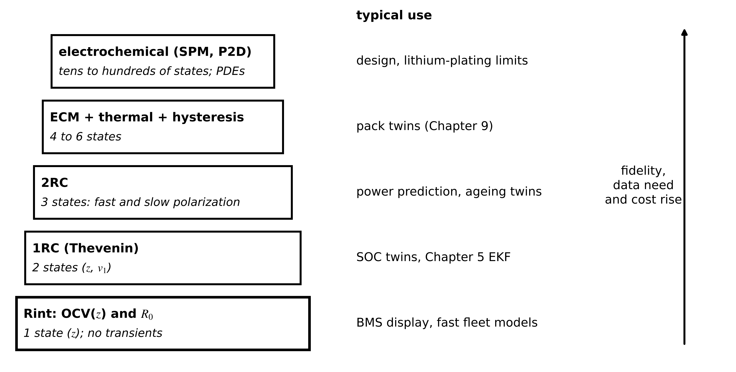
Figure 4.12. Battery model hierarchy from the Rint model to electrochemical models, with the number of states and typical use. Fidelity, data need and computational cost rise together.
Example 4.9 (Level A) Pulse response of an LFP cell
Given. A 100 Ah LFP cell at 50 % SOC: $R_{0}=1.0$ mΩ, $R_{1}=0.6$ mΩ, $C_{1}=50$ kF ($τ_{1}=30$ s), $η=1$; OCV slope about 0.3 mV per per cent near 50 %; entropic coefficient $-0.1$ mV/K at 298 K. A 100 A discharge pulse lasts 60 s, then 120 s of rest.
Find. (a) The instantaneous drop. (b) $v_{1}$ at the end of the pulse and after the rest. (c) The SOC change and its OCV effect. (d) The heat generation at the end of the pulse.
Solution. (a) $R_{0}i=0.100$ V. (b) From (4.31), $v_{1}(60)=iR_{1}(1-e^{-60/30})=0.060×0.865=0.0519$ V; after rest $0.0519e^{-4}=0.00095$ V. (c) $100×60/(3600×100)=1.67$ % of SOC, moving the OCV by only about 0.5 mV. (d) $i^{2}R_{0}=10.0$ W, $iv_{1}=5.2$ W, reversible $-100×298×(-{10}^{-4})=3.0$ W: about 18.2 W in total.
Interpretation. The pulse identifies $R_{0}$ from the instantaneous step and $R_{1}C_{1}$ from the relaxation, while the SOC is almost invisible in the voltage because the LFP OCV curve is so flat. This is the observability problem Chapter 1 met when resynchronizing SOC from OCV, now visible in the model.
Example 4.10 (Level B) Identifying the ECM from a pulse and its relaxation
Given. At the end of the 100 A, 60 s pulse of Example 4.9 the current is switched off. The terminal voltage jumps up by 0.100 V at once, then the remaining polarization falls from 51.9 mV to 19.1 mV in the next 30 s.
Find. $R_{0}$, $τ_{1}$, $R_{1}$ and $C_{1}$.
Solution. $R_{0}=0.100/100=1.0$ mΩ from the instantaneous jump. From $v_{1}(t)=v_{1}(0)e^{-t/τ_{1}}$: $τ_{1}=30/ln(51.9/19.1)=30.0$ s. From $v_{1}(60)=iR_{1}(1-e^{-60/τ_{1}})$: $R_{1}=0.0519/(100×0.865)=0.60$ mΩ; $C_{1}=τ_{1}/R_{1}=50$ kF.
Interpretation. Each parameter comes from a different part of the waveform: $R_{0}$ from the edge, $τ_{1}$ from the relaxation shape, $R_{1}$ from its amplitude. A twin that sees only slow, smooth currents cannot separate them; Section 4.12 makes this formal.
What the digital twin adds
Synchronized: temperatures, PV operating point, SOC and polarization voltage.
Estimated or updated: thermal resistances, $R_{s}$ and $R_{sh}$, $R_{0}$, $R_{1}C_{1}$ and capacity.
Uncertainty carried: temperature dependence, OCV-curve flatness, lumping error.
Decision enabled: which model level each asset twin needs (Figure 4.12).
Validated by: heat runs, I-V traces and pulse tests against model predictions.

4.9 Nonlinear models and local linearization
Most of the models above are nonlinear: the PV characteristic is exponential, the constant-power load is a hyperbola, the induction machine multiplies speed by flux. Estimators, controllers and stability tests are built on linear models, so the twin needs a linear model that is accurate near its present operating point, and a number for how near is near enough (Figure 4.13).
For $\dot{x}=f(x,u)$ with an operating point $(x_{0},u_{0})$, a first-order Taylor expansion with $δx=x-x_{0}$ and $δu=u-u_{0}$ gives the linearization with Jacobian matrices:
$δ\dot{x}≈A_{0} δx+B_{0} δu, A_{0}={\left.\frac{∂f}{∂x}\right|}_{x_{0},u_{0}}, B_{0}={\left.\frac{∂f}{∂u}\right|}_{x_{0},u_{0}}$ (4.33)
where entry $(i,j)$ of $A_{0}$ is $∂f_{i}/∂x_{j}$. The discarded remainder follows from Taylor's theorem with the Hessian $H_{i}=∂^{2}f_{i}/∂x^{2}$ at some point $ξ$ between $x_{0}$ and $x_{0}+δx$. If $M$ bounds the size of the second derivative over the region of interest, the linearization error and the largest excursion that keeps it below a tolerance $ε$ are
$f_{i}\left(x_{0}+δx\right)=f_{i}\left(x_{0}\right)+∇f_{i}^{⊤}δx+\frac{1}{2}δx^{⊤}H_{i}(ξ) δx, \left|e_{lin}\right|≤\frac{1}{2}M{\left\|δx\right\|}^{2}, {\left\|δx\right\|}_{max}≈\sqrt{\frac{2ε}{M}}$ (4.34)
The last relation turns ‘close to the operating point’ into a number: where the model bends sharply, the linear model is valid only over a small range, and every operating point has its own linear model.
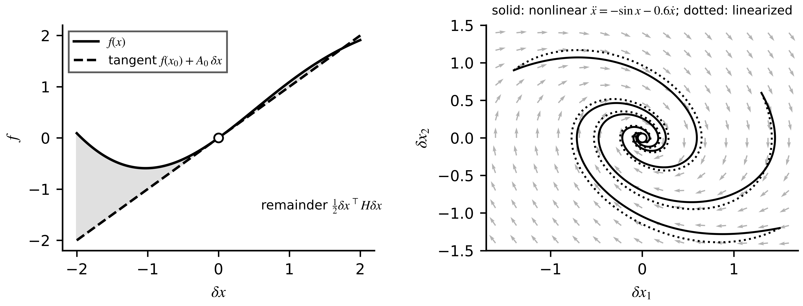
Figure 4.13. Linearization geometry. Left: a nonlinear function and its tangent at the operating point; the shaded gap is the second-order remainder. Right: trajectories of a nonlinear two-state system (solid) and of its Jacobian linearization (dotted) from three starting points; they agree near the equilibrium and part company further away.
Example 4.11 (Level B) How far does a PV linearization hold?
Given. The module of Section 4.8.2, linearized at 28.0 V (flat part of the curve) and at the maximum power point, 33.33 V.
Find. (a) The slope $dI/dV$ and curvature $d^{2}I/dV^{2}$ at each point. (b) The linearization error for steps of 0.5, 1 and 2 V. (c) The range predicted by (4.34) for a 1 % current error.
Solution. (a) Implicit differentiation of (4.29) gives $dI/dV=-(g_{d}+1/R_{sh})/[1+R_{s}(g_{d}+1/R_{sh})]$ with diode conductance $g_{d}=(I_{0}/a)e^{(V+{IR}_{s})/a}$. At 28.0 V: $I=9.677$ A, $dI/dV=-0.0154$ A/V, $d^{2}I/dV^{2}=-0.0074$ A/V². At 33.33 V: $g_{d}=0.298$ S, $I=9.198$ A, $dI/dV=-0.276$ A/V, $d^{2}I/dV^{2}=-0.142$ A/V²; and $I+V dI/dV≈0$ confirms the maximum power point. (b) See Table 4.3. (c) $\sqrt{2×0.097/0.0074}=5.1$ V at 28 V and $\sqrt{2×0.092/0.142}=1.14$ V at the knee; the table confirms both.
Interpretation. The same 2 V excursion costs 0.24 % on the flat part and 4.5 % at the knee (Figure 4.14). A maximum power point tracker operates exactly at the knee, and its operating point moves with weather, so a twin should propagate the nonlinear model and re-linearize whenever it needs a linear one, as the extended Kalman filter of Chapter 5 does.
Table 4.3. Linearization error of the PV current (per cent of the exact value)
Operating point | δV = 0.5 V | δV = 1 V | δV = 2 V | Range for 1 % from (4.34)
28.0 V (flat region) | 0.01 | 0.05 | 0.24 | 5.1 V
33.33 V (maximum power point) | 0.21 | 0.92 | 4.46 | 1.14 V

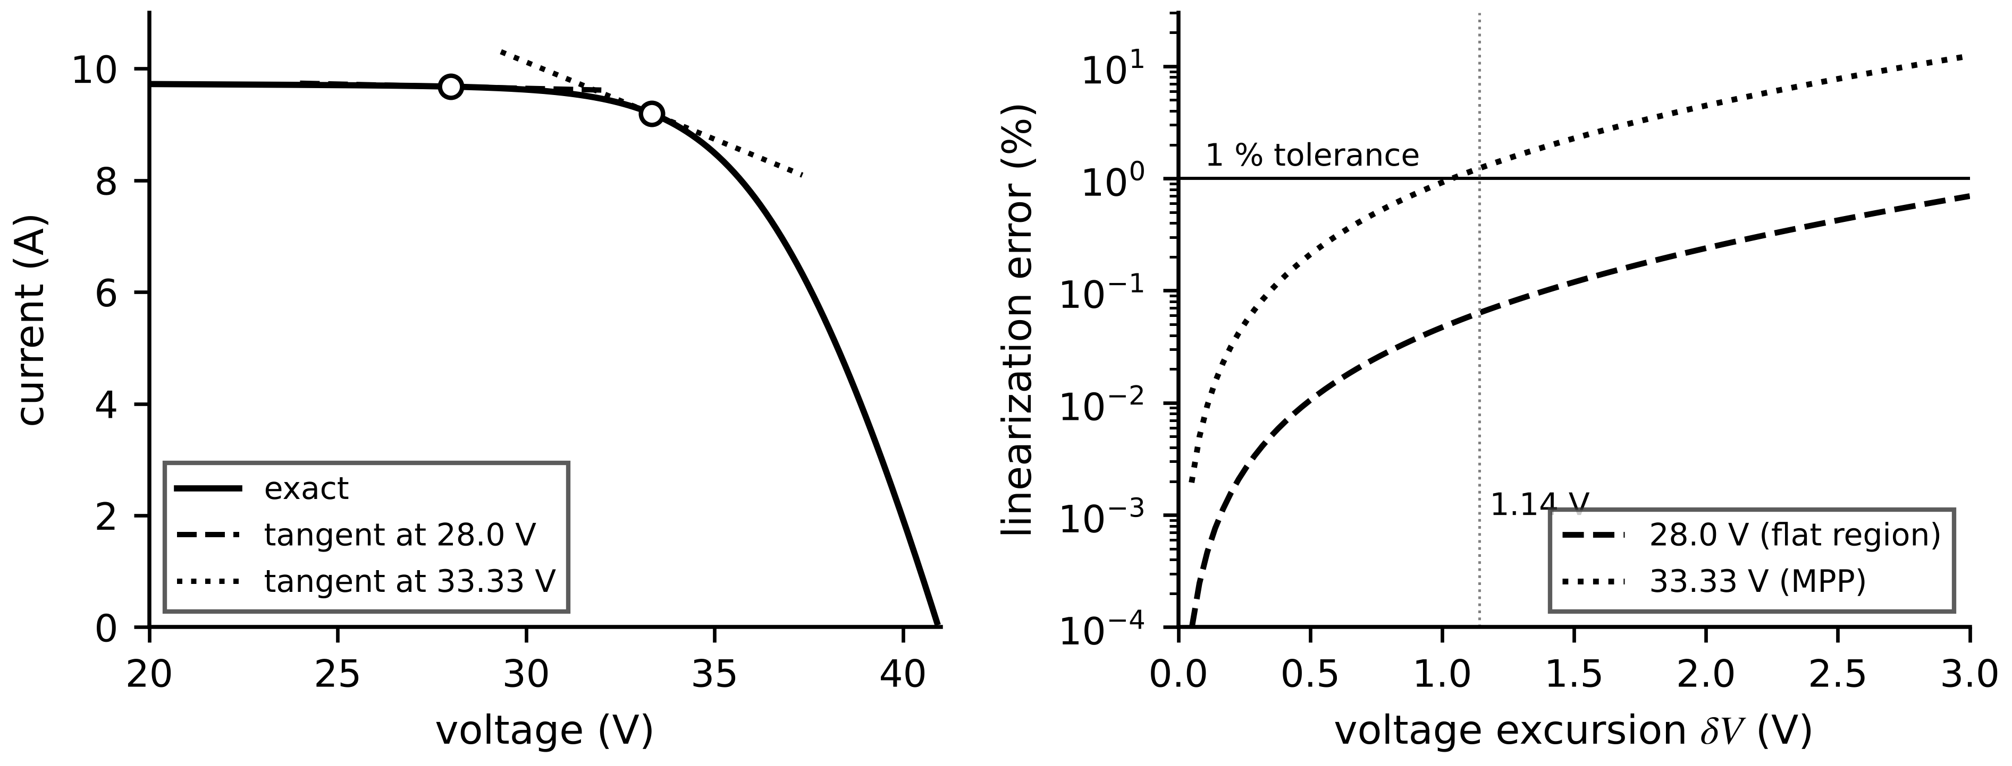
Figure 4.14. Left: PV I-V curve with tangent linearizations at 28 V and at the maximum power point. Right: linearization error against excursion, with the 1 % tolerance; the knee tolerates five times less excursion.
The DC bus of Example 4.4 gives a second lesson: linearizing the constant-power load produced a negative incremental resistance $-V^{2}/P$, which pushed the bus eigenvalue towards the right half-plane although every source and cable is passive. In impedance form, a source with output impedance $Z_{o}(s)$ feeding a converter with input impedance $Z_{i}(s)$ stays stable when $|Z_{o}(jω)/Z_{i}(jω)|≪1$ at all frequencies (Middlebrook's criterion [10]). Linearization is how such instabilities are found before they are met in the field.
What the digital twin adds
Synchronized: a nonlinear state, with a linear model refreshed at each operating point.
Estimated or updated: Jacobians $A_{0}$, $B_{0}$ and the curvature bound $M$.
Uncertainty carried: linearization error (4.34) added to model error.
Decision enabled: when one linear model suffices and when to re-linearize.
Validated by: comparing linear and nonlinear predictions over the operating envelope.

4.10 Discretization and numerical integration
A twin runs on a processor and must advance its model from $x_{k}$ at $t_{k}$ to $x_{k+1}$ at $t_{k}+h$, with step size $h$. The physical question is simple: how wrong is the computed trajectory, and can the computation become unstable when the physics is not?

4.10.1 Exact discretization with a zero-order hold
For a linear model with the input held constant over each step (zero-order hold, ZOH, Figure 4.15), applying (4.15) over one interval gives an exact recursion, and one exponential of an augmented matrix delivers both discrete matrices without inverting $A$, which may be singular (an integrator such as the SOC equation):
$x_{k+1}=A_{d}x_{k}+B_{d}u_{k}, A_{d}=e^{Ah}, B_{d}=\int_{0}^{h}{e^{Aσ}}dσ B, exp\left(\left[\begin{matrix}A & B \\ 0 & 0\end{matrix}\right]h\right)=\left[\begin{matrix}A_{d} & B_{d} \\ 0 & I\end{matrix}\right]$ (4.35)
Each continuous eigenvalue maps to $z_{i}=e^{λ_{i}h}$, so the left half-plane maps into the unit disk and a stable model stays stable for every $h$. The proviso is the hold itself: the result is exact only if the input really is constant between samples. Chapter 1 used the scalar form for the motor thermal twin.
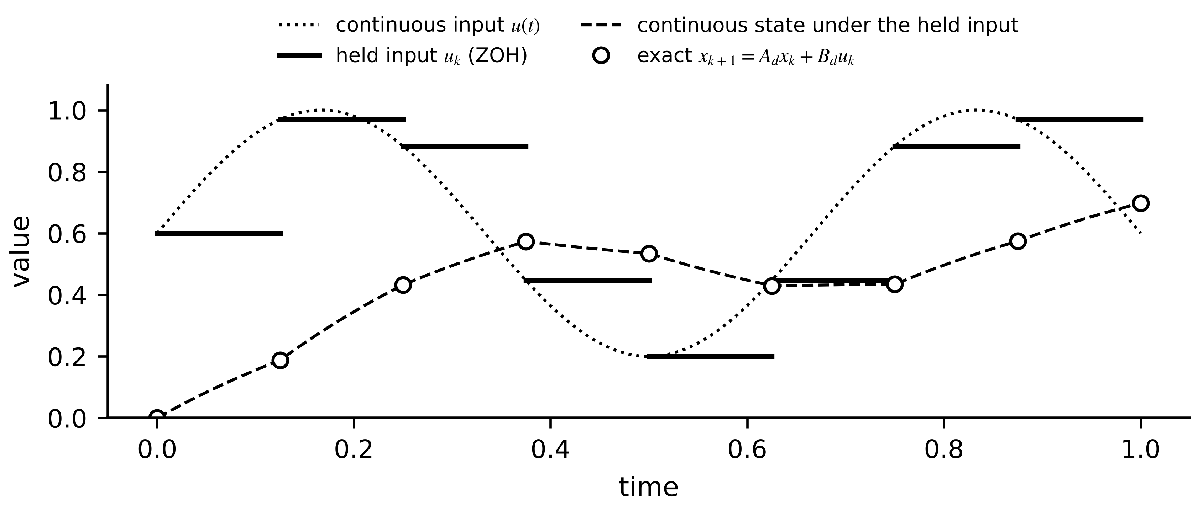
Figure 4.15. Exact ZOH discretization. The continuous input (dotted) is held at each sample (solid steps); the continuous state under the held input (dashed) passes exactly through the discrete states (circles).

4.10.2 Numerical methods and their errors
For nonlinear models or inputs that vary within a step, four methods cover almost all real-time practice (Figure 4.16). For $\dot{x}=f(x,u)$, forward Euler (FE), backward Euler (BE), the trapezoidal rule (TR) and the classical fourth-order Runge-Kutta method (RK4) are
$FE: x_{k+1}=x_{k}+hf_{k}, BE: x_{k+1}=x_{k}+hf_{k+1}, TR: x_{k+1}=x_{k}+\frac{h}{2}\left(f_{k}+f_{k+1}\right)$ (4.36)
$k_{1}=f\left(x_{k}\right), k_{2}=f\left(x_{k}+\frac{h}{2}k_{1}\right), k_{3}=f\left(x_{k}+\frac{h}{2}k_{2}\right), k_{4}=f\left(x_{k}+hk_{3}\right), x_{k+1}=x_{k}+\frac{h}{6}\left(k_{1}+2k_{2}+2k_{3}+k_{4}\right)$ (4.37)
where $f_{k}=f(x_{k},u_{k})$. BE and TR are implicit: $x_{k+1}$ appears on both sides, so a nonlinear $f$ needs a Newton iteration $x^{(m+1)}=x^{(m)}-(I-hJ_{f})^{-1}[x^{(m)}-x_{k}-hf(x^{(m)})]$ at each BE step, with $J_{f}=∂f/∂x$; for a linear model one precomputed inverse suffices. Comparing one step of each method with the Taylor series of the exact solution gives the local truncation error, and $N=T/h$ such errors accumulate into the global error:
$τ_{FE}=\frac{h^{2}}{2}\ddot{x}+O\left(h^{3}\right), τ_{BE}=-\frac{h^{2}}{2}\ddot{x}+O\left(h^{3}\right), τ_{TR}=-\frac{h^{3}}{12}\overset{⃛}{x}+O\left(h^{4}\right), \left\|x_{N}-x(T)\right\|≤Kh^{p}$ (4.38)
where $p$ is the order: 1 for FE and BE, 2 for TR, 4 for RK4, and $K$ depends on the model and on $T$ but not on $h$.
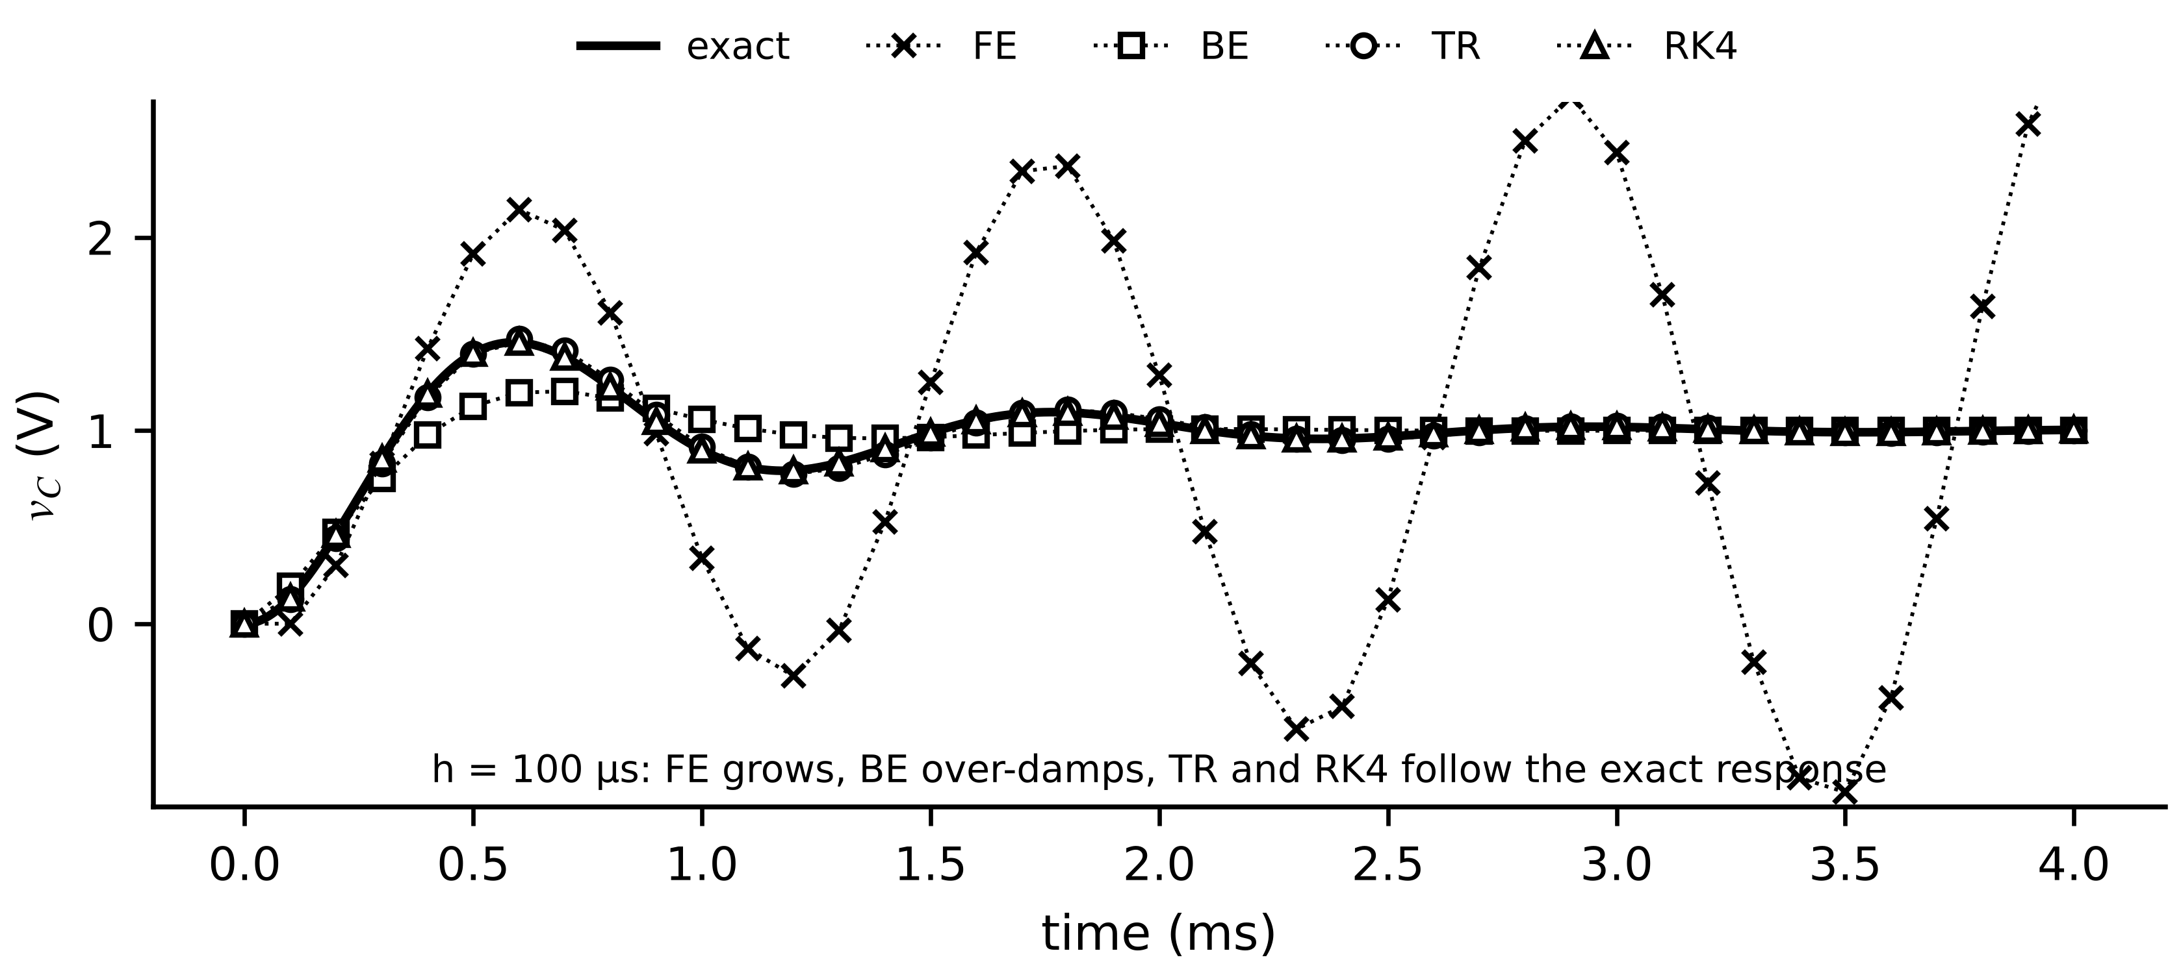
Figure 4.16. Four methods against the exact solution for a 1 V step on the BESS filter at h = 100 µs. FE grows, BE damps the ringing away, TR and RK4 follow it.

4.10.3 Stability regions and stiffness
Apply each method to the test equation $\dot{x}=λx$, where $λ$ stands for one eigenvalue of a linearized model. Each step multiplies $x$ by an amplification factor:
$R_{FE}=1+hλ, R_{BE}=\frac{1}{1-hλ}, R_{TR}=\frac{1+hλ/2}{1-hλ/2}, R_{RK4}=\sum_{j=0}^{4}{\frac{(hλ)^{j}}{j!}}, R_{ZOH}=e^{hλ}$ (4.39)
and the numerical solution stays bounded when $|R(hλ)|≤1$ (Figure 4.17). BE and TR are A-stable: stable for every $λ$ with negative real part, whatever $h$. FE is stable only inside the disk $|1+hλ|≤1$, which for a real eigenvalue means $h≤2/|λ|$; RK4 reaches $hλ≈-2.79$ on the real axis. BE is also L-stable: $R_{BE}→0$ as $hλ→-∞$, so unresolved fast modes are damped, whereas $R_{TR}→-1$ lets them ring. A model is stiff when its eigenvalues differ widely in magnitude (Figure 4.18):
$S=\frac{\max_{i}\left|Re λ_{i}\right|}{\min_{i}\left|Re λ_{i}\right|}$ (4.40)
For an explicit method the fastest mode fixes the largest stable step, however slowly the quantities of interest change.
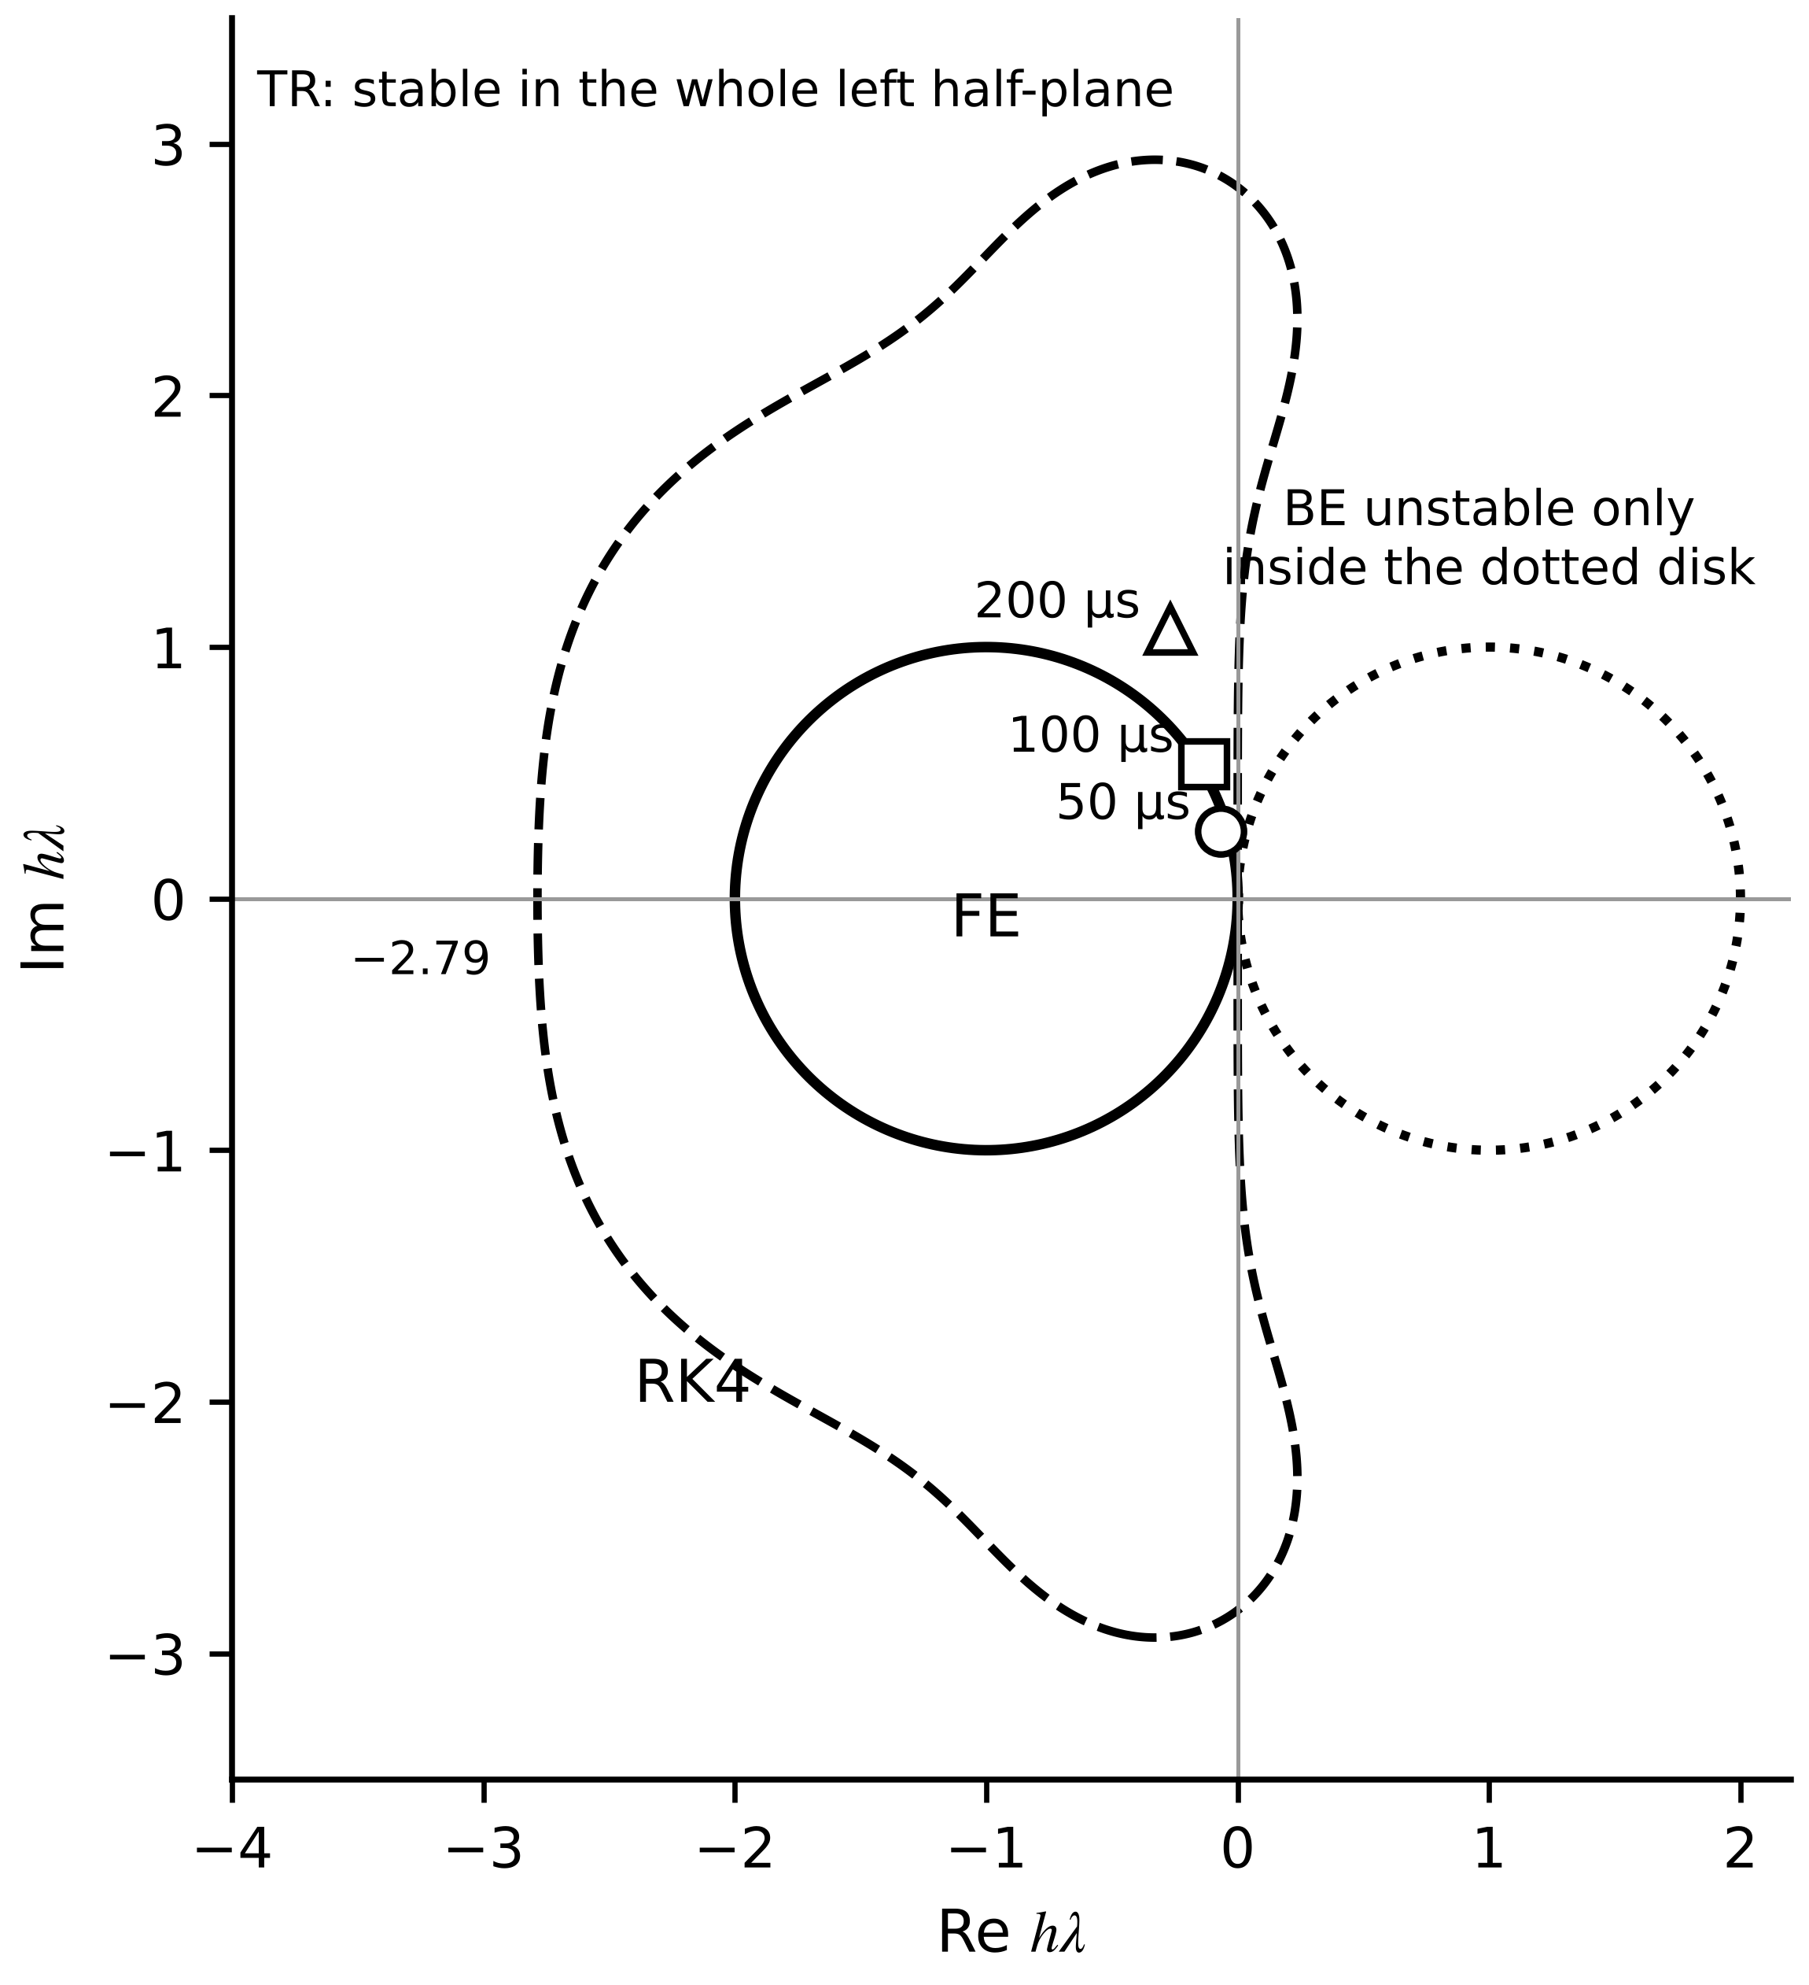
Figure 4.17. Stability regions in the complex $hλ$ plane: FE inside the solid disk, RK4 inside the dashed region, BE outside the dotted disk, TR in the whole left half-plane. Markers show the filter eigenvalue at h = 50, 100 and 200 µs.
Example 4.12 (Level B) Five methods on the same filter
Given. The RLC filter of Example 4.2 with a 1 V input step from rest, simulated for 5 ms at steps from 10 to 400 µs; the exact solution comes from the augmented matrix exponential at every output time.
Find. The maximum error of $v_{C}$ for each method, the stability of FE and the damping of BE at 200 µs.
Solution. Table 4.4 lists the errors. With $λ=-1333±j5341$ s⁻¹, $|1+hλ|=0.971$ at 50 µs and 1.018 at 100 µs, so FE loses stability between them. At 200 µs BE multiplies the oscillation by $|R_{BE}|=0.60$ per step against the true 0.77, so its 0.39 V error is excess damping, not instability. TR at 10 and 50 µs gives observed order $ln(9.8×{10}^{-3}/3.9×{10}^{-4})/ln5=2.0$, RK4 gives 4.0, as theory predicts. ZOH is exact to round-off at every step.
Interpretation. Stability and accuracy are different properties. BE at 400 µs is perfectly stable and nearly useless, having damped away the very ringing the capacitor-ageing twin needs. A diverging simulation says the method or step is wrong, not that the plant is unstable.
Table 4.4. Maximum error in $v_{C}$ (V) for a 1 V step on the filter (synthetic computation)
Step h | FE | BE | TR | RK4 | ZOH
10 µs | 4.3e−2 | 3.9e−2 | 3.9e−4 | 1.2e−7 | 3e−14
50 µs | 0.31 | 0.17 | 9.8e−3 | 7.9e−5 | 2e−14
100 µs | 2.3 (unstable) | 0.27 | 3.9e−2 | 1.3e−3 | 2e−14
200 µs | 400 (unstable) | 0.39 | 0.15 | 2.2e−2 | 2e−14
400 µs | 1.2e4 (unstable) | 0.49 | 0.43 | 0.38 | 5e−15

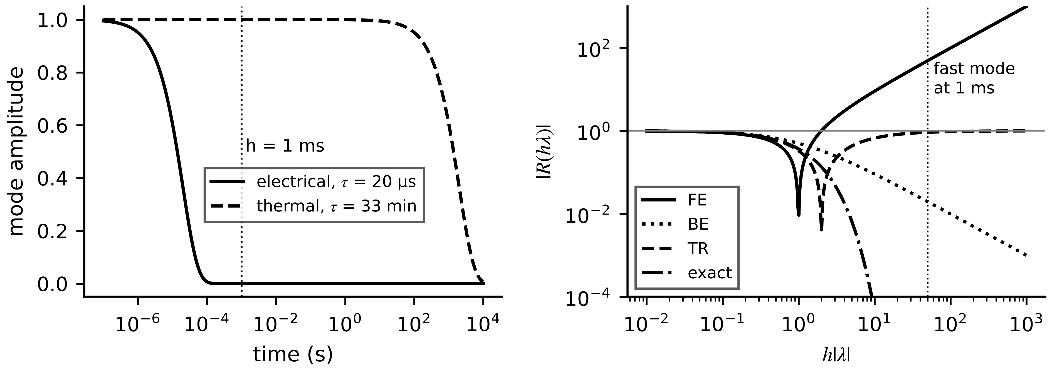
Figure 4.18. Stiffness. Left: an electrical mode (20 µs) and a thermal mode (33 min) on one log time axis; a 1 ms step resolves only the second. Right: amplification factors against $h|λ|$; FE exceeds 1, TR tends to 1 in magnitude (ringing), BE tends to 0.
Example 4.13 (Level A) An electro-thermal twin with a 1 ms step
Given. Eigenvalues $λ_{f}=-5×{10}^{4}$ s⁻¹ (electrical) and $λ_{s}=-5×{10}^{-4}$ s⁻¹ (thermal, 33 min); the twin must run at $h=1$ ms, set by the thermal monitoring task.
Find. The stiffness ratio; whether FE, RK4, TR and BE are stable for the fast mode; the largest stable FE and RK4 steps.
Solution. $S={10}^{8}$. FE: $|1-50|=49$, unstable; stable only for $h≤40$ µs. RK4: stable for $h≤2.79/5×{10}^{4}=56$ µs. TR: $R=(1-25)/(1+25)=-0.923$, stable, but the fast mode flips sign every step and decays by only 8 % per step. BE: $R=1/51=0.0196$; the fast mode is gone within a step.
Interpretation. An explicit method would need a step 25 times smaller purely for stability. BE is the safe default here; TR is more accurate for resolved modes but lets unresolved fast modes ring, so real-time simulators often switch to a few BE steps after each discontinuity.

4.10.4 Frequency warping and the real-time constraint
Applied to a transfer function, TR is Tustin's method, $s←\frac{2}{h}\frac{z-1}{z+1}$. On the unit circle $z=e^{jΩh}$ the discrete model at frequency $Ω$ behaves like the continuous model at $ω=\frac{2}{h}tan\frac{Ωh}{2}$, so every resonance shifts down: $Ω=\frac{2}{h}arctan\frac{ωh}{2}$. For the filter resonance at 876 Hz and $h=100$ µs the discrete model resonates at 855 Hz, 2.4 % low; a capacitor-ageing twin that took this at face value would report a capacitance about 5 % high, since $C∝1/f^{2}$. Prewarping the design frequency removes the shift. Offline solvers adapt their step from an embedded error estimate, $h_{new}=h(tol/{err}_{k})^{1/(p+1)}$; a real-time twin cannot, because its step is tied to sampling and must finish in time:
$W(h)+T_{io}≤h$ (4.41)
where $W(h)$ is the worst-case execution time of one step on the target processor and $T_{io}$ the input-output time (Chapter 2, Section 2.10). This constraint, not accuracy alone, is why real-time electrical simulators favour fixed-step implicit methods with precomputed matrices.
What the digital twin adds
Synchronized: a discrete-time state advanced at the twin's own step.
Estimated or updated: $A_{d}$, $B_{d}$ offline; Newton iterations online for implicit methods.
Uncertainty carried: truncation error (4.38) and frequency warping, measured not assumed.
Decision enabled: method and step for each sub-model from stiffness and deadline.
Validated by: observed order of accuracy and comparison with exact or reference solutions.

4.11 Stability, controllability and observability
A linear model $\dot{x}=Ax+Bu$ is asymptotically stable if and only if every eigenvalue of $A$ has a negative real part; a discrete model $x_{k+1}=A_{d}x_{k}$ if every eigenvalue lies inside the unit circle. Two further questions decide whether a twin can be synchronized and a plant controlled: can the input move the state anywhere, and can the measured output reveal the state?
[Advanced] Lyapunov stability and energy
Lyapunov's theorem gives a test that extends to nonlinear models: $\dot{x}=Ax$ is stable if and only if, for a symmetric positive-definite $Q$, the equation $A^{⊤}P+PA=-Q$ has a symmetric positive-definite solution $P$. Along any trajectory, $V(x)=x^{⊤}Px$ changes at the rate $\dot{V}=x^{⊤}(A^{⊤}P+PA)x=-x^{⊤}Qx<0$, so $V$, positive everywhere except at the origin, can only decrease. For the two-node thermal model with $Q=I$ the solution has eigenvalues 67.1 and 662.9, both positive.
Physical energy is often a Lyapunov function. For the RLC filter with the input off, $V=E_{f}$ from (4.11) gives $\dot{V}=-Ri_{L}^{2}≤0$, which proves stability for every positive $R$, $L$, $C$ without computing an eigenvalue. Passivity-based stability analysis of converter networks builds on this idea.

[Advanced] The port-Hamiltonian form: energy as the organizing structure
Every model in this chapter stores energy in some elements, dissipates it in others and exchanges it with its surroundings through ports. The port-Hamiltonian form writes this structure explicitly [11]:
$\dot{x}=\left[J\left(x\right)−R\left(x\right)\right]∇H\left(x\right)+G u, y=G^{⊤}∇H\left(x\right), J=−J^{⊤}, R=R^{⊤}≽0$
where $H\left(x\right)$ is the stored energy, $J$ describes lossless interconnection, $R$ dissipation, and the pair $\left(u,y\right)$ is a power port whose product $y^{⊤}u$ is the power supplied. Along any trajectory, $\dot{H}=∇H^{⊤}\left(J−R\right)∇H+∇H^{⊤}Gu=−∇H^{⊤}R∇H+y^{⊤}u≤y^{⊤}u$, because $∇H^{⊤}J∇H=0$ for a skew-symmetric $J$: the stored energy can grow only by the power supplied at the port, which is the definition of a passive system. For the RLC filter, take the energy variables $x={\left[ϕ, q\right]}^{⊤}={\left[Li_{L}, Cv_{C}\right]}^{⊤}$, so that $H=ϕ^{2}/\left(2L\right)+q^{2}/\left(2C\right)$ and $∇H={\left[i_{L}, v_{C}\right]}^{⊤}$. Then (4.7) takes the port-Hamiltonian form with $J_{12}=−1$, $J_{21}=1$ and $J_{11}=J_{22}=0$, dissipation matrix $diag\left(R, 0\right)$, $G={\left[1 0\right]}^{⊤}$, input $u=v_{in}$ and output $y=i_{L}$, and $\dot{H}=−Ri_{L}^{2}+v_{in}i_{L}$ is exactly (4.11).
Two consequences matter for twins. First, connecting port-Hamiltonian sub-models through power-conserving interconnections (Kirchhoff's laws, a shaft, a heat path) gives another port-Hamiltonian model, so a plant model assembled from passive parts is stable by construction; this is the structural reason why co-simulation interfaces should conserve energy (Section 4.14). Second, a discretization that preserves the structure keeps the energy balance exact at every step. The implicit midpoint rule, which coincides with the trapezoidal rule for linear models, gives $H_{k+1}−H_{k}=−h {\overline{∇H}}^{⊤}R \overline{∇H}+h {\overset{‾}{y}}^{⊤}\overset{‾}{u}$ for quadratic $H$, with bars denoting midpoint values. Checking this discrete balance is a stronger verification test than the observed order of accuracy, because it fails for any error that creates or destroys energy. Port-Hamiltonian models of converters, machines and grids are an active research area.

For a linear model with $n$ states, controllability (some input moves the state from any value to any other in finite time) and observability (the state can be reconstructed from the output over a finite interval) are tested by the ranks of [12]
$𝒞=\left[\begin{matrix}B & AB & ⋯ & A^{n-1}B\end{matrix}\right], 𝒪=\left[\begin{matrix}C \\ CA \\ ⋮ \\ CA^{n-1}\end{matrix}\right], rank 𝒞=n, rank 𝒪=n$ (4.42)
The rank conditions follow from (4.15) and the Cayley-Hamilton theorem, which writes every power $A^{k}$ with $k≥n$ in terms of $I,A,…,A^{n-1}$. The Popov-Belevitch-Hautus test points to the culprit: the model is observable if and only if $rank[λ_{i}I-A; C]=n$ for every eigenvalue $λ_{i}$, and a failing eigenvalue identifies exactly which mode cannot be seen. For nonlinear models the tests apply to the linearization at a stated operating point.
A rank answers yes or no. A twin needs to know how well, with real noisy sensors. The observability and controllability Gramians answer that (Figure 4.19). For a stable model, $W_{o}$ solves a Lyapunov equation, and the output energy from an initial error $x_{0}$ with no input, and the best achievable covariance of an estimate of $x_{0}$ from output measured with white noise of intensity $σ_{n}^{2}$ over $[0,T]$, are
$A^{⊤}W_{o}+W_{o}A+C^{⊤}C=0, E_{y}\left(x_{0}\right)=\int_{0}^{∞}{{\left\|y\right\|}^{2}}dt=x_{0}^{⊤}W_{o}x_{0}, cov\left({\hat{x}}_{0}\right)⪰σ_{n}^{2}W_{o}(T)^{-1}$ (4.43)
so directions with small Gramian eigenvalues produce little output and are estimated with large variance; the condition number of $𝒪$ or $W_{o}$ summarizes how unevenly the state is seen. Dually, $AW_{c}+W_{c}A^{⊤}+BB^{⊤}=0$, and $x_{f}^{⊤}W_{c}^{-1}x_{f}$ is the least input energy that reaches $x_{f}$: directions with small $W_{c}$ are controllable in theory and expensive in practice.
Example 4.14 (Level B) Estimating the winding temperature from a frame sensor
Given. The two-node model of Section 4.8.1 with only the frame measured, $C=[0 1]$. Three cases: $R_{12}=0.08$ K/W (nominal), 0.8 and 8 K/W (winding increasingly isolated from the frame). Sampling 30 s.
Find. (a) $rank 𝒪$. (b) The output energy produced by a 1 K error in $T_{1}$ alone and in $T_{2}$ alone, from (4.43). (c) The condition number of the sampled observability matrix $[C; CA_{d}]$.
Solution. (a) $𝒪=[0, 1; 1/(R_{12}C_{2}), -1/(R_{12}C_{2})-1/(R_{2a}C_{2})]$ has rank 2 for every finite $R_{12}$: observable in all three cases. (b) Winding: 35.2, 14.6 and 2.13 K²·s; frame: 299, 352 and 384 K²·s. (c) 36, 342 and 3405.
Interpretation. The rank test passes in every case, yet at $R_{12}=8$ K/W a winding error produces sixteen times less signal than at the nominal value, and the condition number rises a hundredfold. Physical coupling between the unmeasured and the measured state is what makes estimation possible; Chapter 3 (Section 3.14) used the same model to choose where to place the sensor.
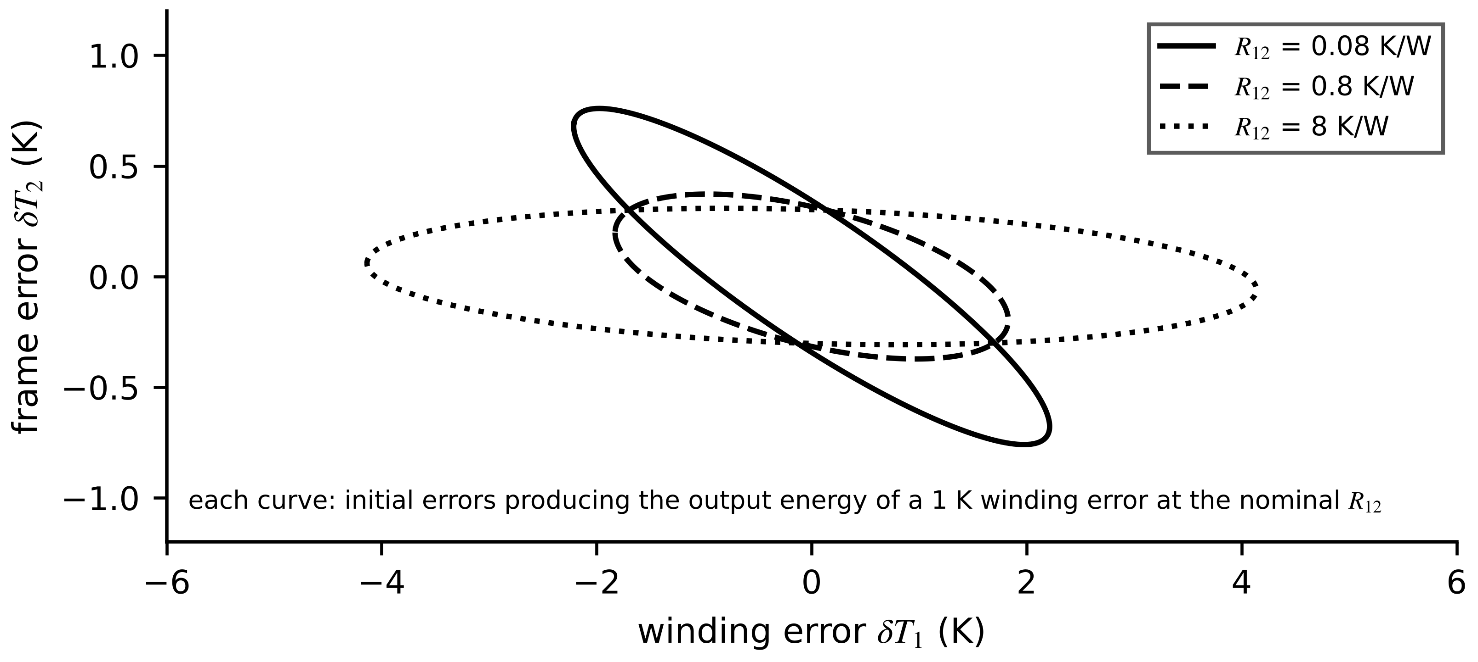
Figure 4.19. Observability geometry for the frame-sensor case. Each ellipse contains the initial errors that produce the same output energy; as the winding is isolated from the frame the ellipse stretches along the winding axis, meaning winding errors become nearly invisible.
What the digital twin adds
Synchronized: only the states that the sensors make observable with useful accuracy.
Estimated or updated: Gramians, condition numbers and the PBH test per operating point.
Uncertainty carried: the Cramér-Rao-type bound (4.43) on state estimates.
Decision enabled: sensor placement and which states an estimator should promise.
Validated by: comparing predicted estimation variance with innovation statistics (Chapter 5).

4.12 Model-order reduction, sensitivity and identifiability

4.12.1 Balanced truncation
A detailed model with many states may be too slow for the twin's deadline, yet most of its states may barely matter between input and output. The question is which states can be dropped, and with what error. The Hankel singular values answer it: they measure, for each direction, how strongly the input reaches it and how strongly it reaches the output at once,
$σ_{i}=\sqrt{λ_{i}\left(W_{c}W_{o}\right)}, σ_{1}≥σ_{2}≥…≥σ_{n}>0$ (4.44)
They are invariant to coordinate changes, because under $\tilde{x}=Tx$ the Gramians transform as $TW_{c}T^{⊤}$ and $T^{-⊤}W_{o}T^{-1}$ and their product by similarity. In balanced coordinates both Gramians equal $diag(σ_{i})$; partitioning the model into retained states $x_{1}$ ($r$ of them) and discarded states $x_{2}$ and keeping $(A_{11},B_{11},C_{1})$ gives a stable reduced model with a guaranteed error bound on the peak gain over all frequencies [13], [14]:
${\left\|G-G_{r}\right\|}_{∞}≤2\sum_{i=r+1}^{n}{σ_{i}}$ (4.45)
Truncation matches high frequencies well but not the steady state. Singular perturbation (residualization) makes the opposite trade: it sets ${\dot{x}}_{2}=0$, solves for $x_{2}$ and substitutes, preserving the DC gain exactly and obeying the same bound:
$A_{r}=A_{11}-A_{12}A_{22}^{-1}A_{21}, B_{r}=B_{1}-A_{12}A_{22}^{-1}B_{2}, C_{r}=C_{1}-C_{2}A_{22}^{-1}A_{21}, D_{r}=-C_{2}A_{22}^{-1}B_{2}$ (4.46)
Example 4.15 (Level B) Reducing a six-node winding thermal ladder
Given. A six-node ladder for the M-07 winding: six capacities of 1500 J/K joined by 0.03 K/W, the last node connected to ambient through 0.05 K/W (total 0.20 K/W and 9000 J/K, as in Chapter 1). Input: loss at node 1; output: node 1 temperature; a 420 W step.
Find. (a) The Hankel singular values. (b) The bound $2U\sum_{i>r}{σ_{i}}$ and the actual maximum error for $r=1,2,3$ by truncation. (c) The behaviour of the residualized order-2 model.
Solution. (a) $σ=[9.08×{10}^{-2}, 8.35×{10}^{-3}, 7.70×{10}^{-4}, 3.99×{10}^{-5}, 8.9×{10}^{-7}, 5.3×{10}^{-9}]$ K/W. (b) Table 4.5: bounds 7.70, 0.68 and 0.034 K; the actual maximum errors equal the bounds and occur in steady state. (c) The residualized model has zero steady-state error but an initial jump of 0.68 K from its feedthrough $D_{r}$, decaying within minutes (Figure 4.20).
Interpretation. For an RC ladder (a symmetric, passive system) the bound is attained exactly at zero frequency, so truncation's whole error is a steady-state offset. Residualization removes that offset and moves the error to the first seconds. The choice follows the twin's use: for a 30-minute overheating forecast, residualized order 2 is ideal; for the first seconds after a short circuit, truncation is better.
Table 4.5. Balanced truncation of the six-node ladder for a 420 W step (synthetic computation)
Order r | Bound $2U\sum_{i>r}{σ_{i}}$ (K) | Truncated: maximum error (K) | Residualized: steady-state error (K)
1 | 7.70 | 7.70 (steady state) | 0
2 | 0.68 | 0.68 (steady state) | 0 (initial jump 0.68)
3 | 0.034 | 0.034 (steady state) | 0

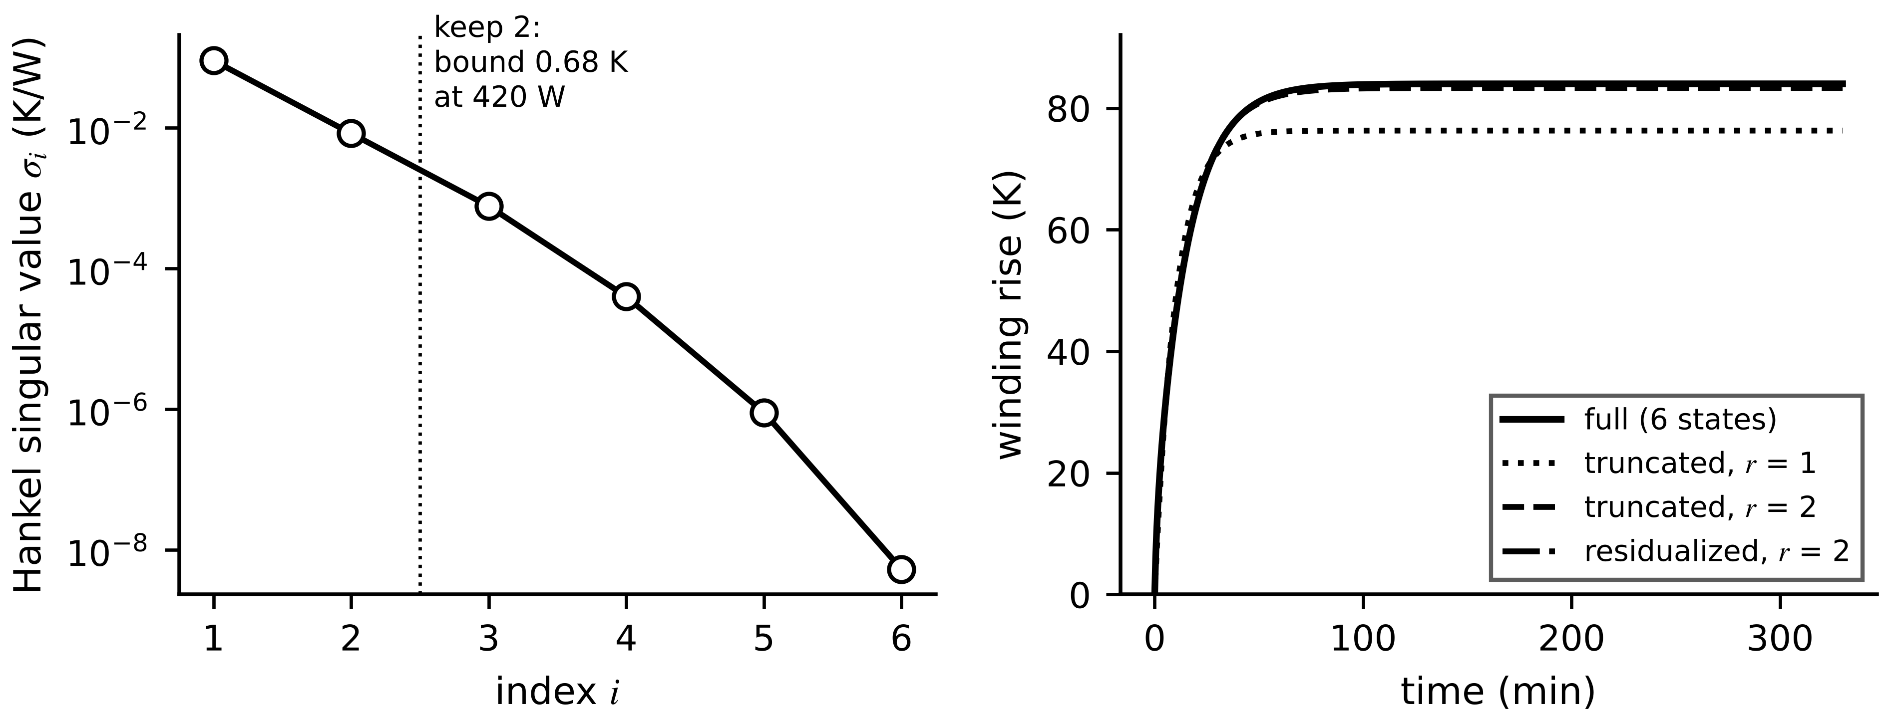
Figure 4.20. Balanced truncation of the six-node ladder. Left: Hankel singular values on a log scale; the drop after the second suggests order 2. Right: step response of the full model, truncated models of order 1 and 2, and the residualized order-2 model.

4.12.2 Sensitivity, Fisher information and identifiability
A parameter is structurally identifiable if perfect, noise-free data from the planned experiment determine it uniquely, and practically identifiable if the finite, noisy data actually available determine it with acceptable uncertainty [15]. If $\dot{T}=α[P-β(T-T_{amb})]$ is calibrated on steady-state data only, $\dot{T}=0$ removes $α$ from every equation: the heat capacity is structurally non-identifiable from that experiment, and more of the same data cannot help.
Practical identifiability is measured with sensitivities. For $\dot{x}=f(x,u,θ)$ with output $y=h(x,θ)$, differentiating the model with respect to $θ$ gives the sensitivity equations, integrated alongside the model; for $N$ samples with independent noise of variance $σ^{2}$ the sensitivity matrix gives the Fisher information and the Cramér-Rao bound:
${\dot{S}}_{x}=\frac{∂f}{∂x}S_{x}+\frac{∂f}{∂θ}, S_{k,j}=\frac{∂y_{k}}{∂θ_{j}}, {\overline{S}}_{k,j}=\frac{∂y_{k}}{∂θ_{j}}\frac{θ_{j}}{y_{k}}, F=\frac{1}{σ^{2}}S^{⊤}S, cov\left(\hat{θ}\right)⪰F^{-1}$ (4.47)
where $S_{x}=∂x/∂θ$ and $\overline{S}$ the normalized sensitivity (per-unit output change per per-unit parameter change). A singular $F$ signals structural non-identifiability for the experiment; a nearly singular $F$, or a correlation $ρ_{ij}=Σ_{ij}/\sqrt{Σ_{ii}Σ_{jj}}$ near ±1 in $Σ=F^{-1}$, signals practical non-identifiability. The estimate itself comes from nonlinear least squares by Gauss-Newton steps, $θ^{(m+1)}=θ^{(m)}+(S^{⊤}S)^{-1}S^{⊤}r$, with $r$ the residuals; the matrix that measures identifiability also drives the fit, so a nearly singular $F$ appears in practice as a slow, wandering fit. Adding $μI$ to $S^{⊤}S$ gives the Levenberg-Marquardt method.
Example 4.16 (Level B) How long must a heat run last?
Given. The single-node M-07 model $T(t)=T_{amb}+R_{th}P(1-e^{-t/(R_{th}C_{th})})$ with $R_{th}=0.20$ K/W, $C_{th}=9000$ J/K, a 420 W step, RTD noise $σ=0.3$ K, samples every 30 s.
Find. The Cramér-Rao standard deviations of ${\hat{R}}_{th}$ and ${\hat{C}}_{th}$ and their correlation for records of 10, 30, 90 and 180 minutes.
Solution. From (4.47) with numerical sensitivities: Table 4.6 and Figure 4.21.
Interpretation. Ten minutes of heating, a third of a time constant, fixes the initial slope $P/C_{th}$ but barely constrains $R_{th}$, which governs the final value; the estimates are almost perfectly correlated. Both parameters are structurally identifiable in every case and practically identifiable only from about half an hour on. Experiment design, not a better algorithm, is the cure.
Table 4.6. Cramér-Rao bounds for the heat-run calibration (synthetic, σ = 0.3 K, 30 s sampling)
Record | sd(${\hat{R}}_{th}$) | sd(${\hat{C}}_{th}$) | Correlation
10 min | 12.7 % | 1.8 % | 0.958
30 min | 0.93 % | 0.44 % | 0.930
90 min | 0.09 % | 0.15 % | 0.778
180 min | 0.03 % | 0.11 % | 0.532

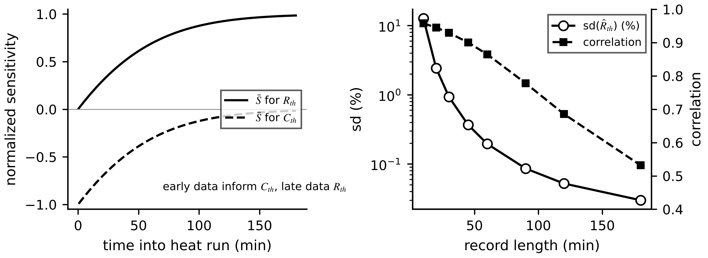
Figure 4.21. Left: normalized sensitivities of the winding temperature to $R_{th}$ and $C_{th}$ along a three-hour heat run (grey scale); early data inform $C_{th}$, late data $R_{th}$. Right: Cramér-Rao standard deviation of ${\hat{R}}_{th}$ and the correlation of the two estimates against record length.
What the digital twin adds
Synchronized: a reduced model with a known error bound and identifiable parameters.
Estimated or updated: Hankel singular values, sensitivities, Fisher information.
Uncertainty carried: reduction error (4.45) and parameter covariance $F^{-1}$.
Decision enabled: model order and the length and content of calibration experiments.
Validated by: comparison with the full model and parameter-correlation checks.

4.13 Multi-physics and multi-fidelity models for operational twins
An operational twin never runs one model. It runs a set: electrical, mechanical, thermal and electrochemical sub-models that exchange quantities, each available at several levels of detail. Two questions follow, and they are central to digital-twin engineering because a real-time twin must meet its deadline while serving several purposes. How strongly are the physical domains coupled, and must they be solved together? And which level of fidelity should run now, and when should the twin switch?

4.13.1 Coupling between physical domains
Figure 4.22 shows the domains of the Plant P-1 assets and the quantities they exchange: the electrical model hands losses to the thermal model and receives temperature-dependent resistance back; the mechanical model exchanges torque and speed with the electrical one; temperature drives the Arrhenius terms of the electrochemical model. A coupling is one-way when information flows in one direction only, so the models can run in sequence, and two-way when each depends on the other, so they must be solved together or iterated.
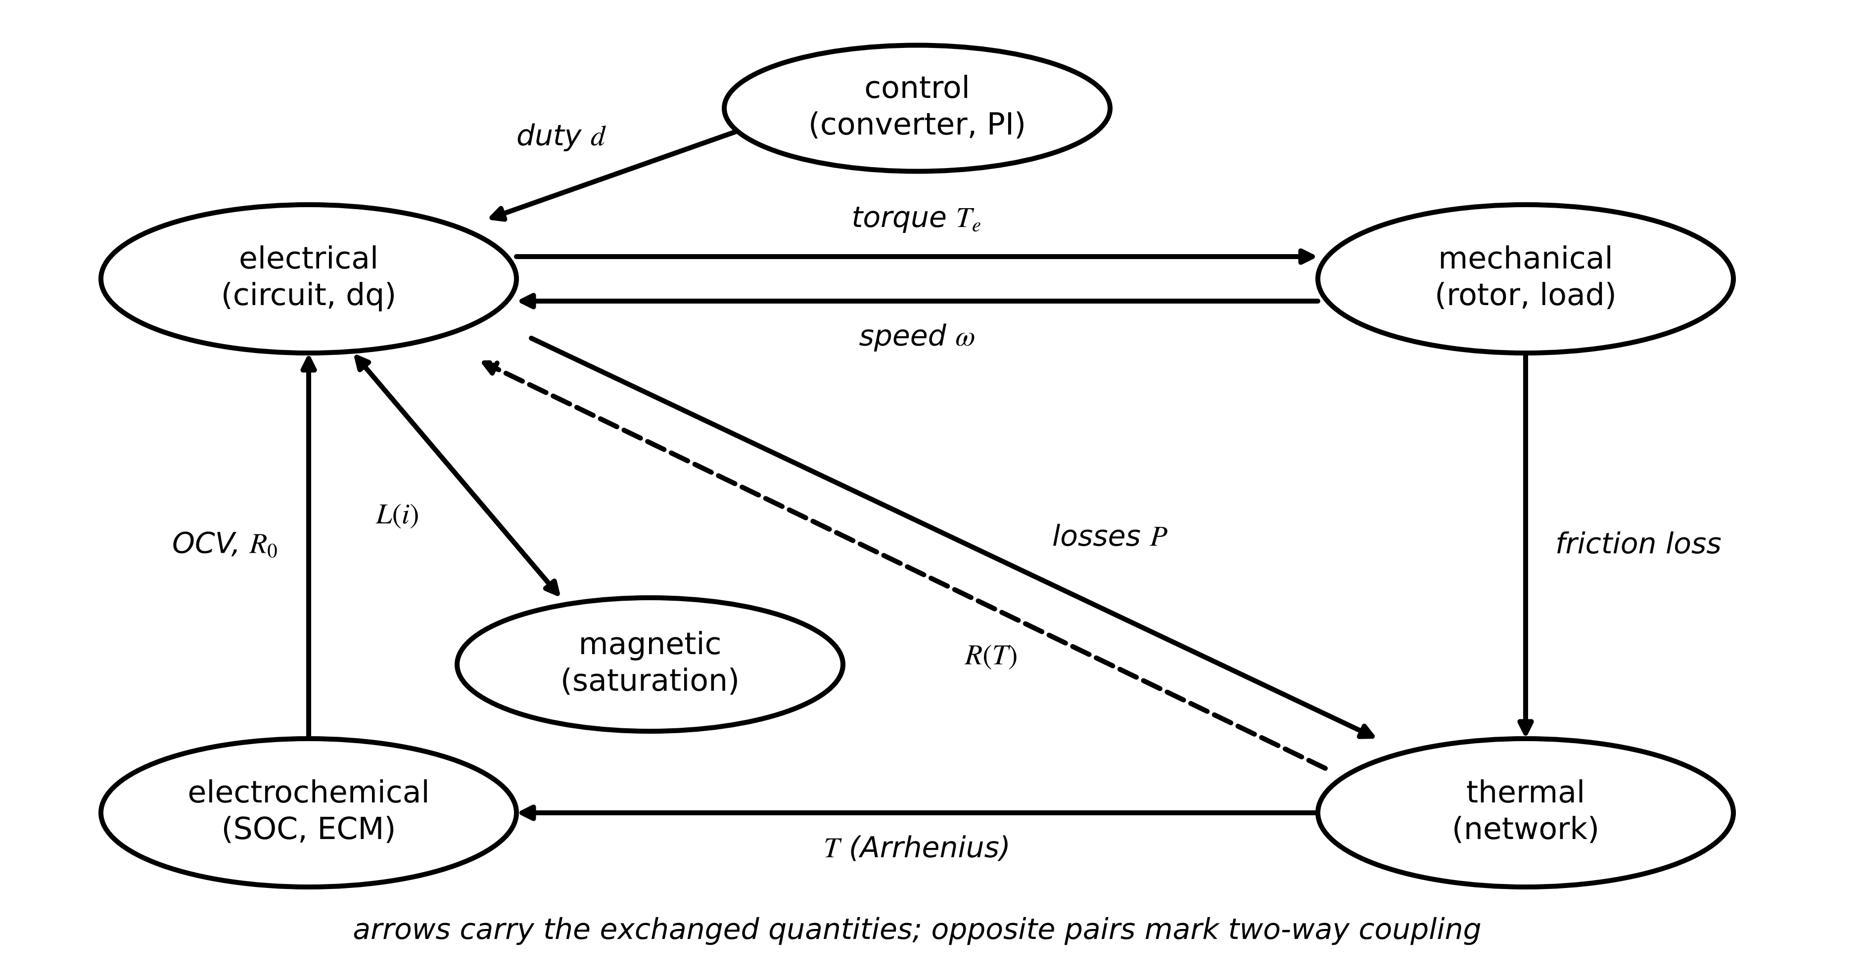
Figure 4.22. Multi-physics coupling graph of the Plant P-1 assets. Arrows carry the exchanged quantities; opposite pairs (electrical and mechanical, electrical and thermal) are two-way couplings.
How strong is a two-way coupling? The electro-thermal loop of a motor gives a clean measure. Linearizing the copper loss around a reference temperature, $P(T)≈P_{0}+γ(T-T_{ref})$ with $γ=P_{cu,0}α_{cu}$ (W/K), and inserting it into the single-node balance with $θ=T-T_{amb}$,
$C\dot{θ}=P_{0}+γ\left(θ-θ_{ref}\right)-\frac{θ}{R} ⇒ τ_{eff}=\frac{RC}{1-g}, θ_{∞}=\frac{R\left(P_{0}-γθ_{ref}\right)}{1-g}, g=Rγ$ (4.48)
where $g$ is the loop gain of the coupling. For $g≪1$ the coupling can be handled one-way (compute the loss, then the temperature); as $g$ grows the response slows and amplifies by $1/(1-g)$; at $g≥1$ the model predicts thermal runaway, a real phenomenon in semiconductors and batteries. For M-07 at 420 W with 60 % copper loss, $γ=0.6×420×0.00393=0.99$ W/K and $g=0.20×0.99=0.198$: temperature rises are amplified by 1.25 and the time constant lengthens by the same factor. Ignoring this coupling is exactly the error that sinks the single-node twin in Section 4.15.

4.13.2 The fidelity hierarchy
Every domain can be modelled at several levels (Figure 4.23). Lumped models (equivalent circuits, single or few nodes) run in microseconds with a handful of parameters and capture the dominant time constants. Reduced-order models (balanced truncation, proper orthogonal decomposition) come from a detailed model with a known error bound (Section 4.12). Detailed models (finite-element thermal and magnetic models, computational fluid dynamics, electrochemical P2D models) resolve space and take seconds to hours per run. Surrogates are fast learned approximations of detailed models, trained on their outputs; hybrid models keep a physics core and learn only the discrepancy (Chapter 6) [16], [17]. Table 4.7 compares them in the terms that matter for a twin.
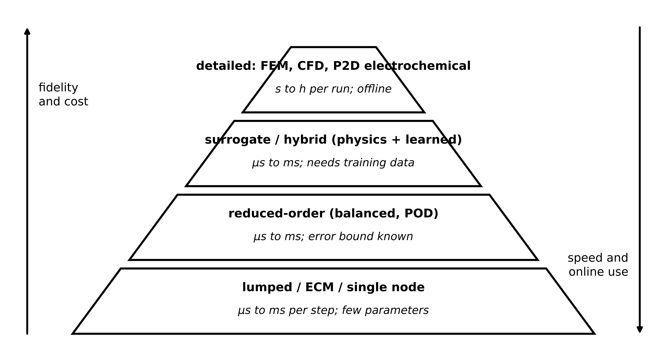
Figure 4.23. The multi-fidelity hierarchy. Detailed models at the top are accurate and slow; lumped models at the base are fast enough for every sample. Operational twins run the base and middle online and keep the top for offline calibration, auditing and training.
Table 4.7. Model fidelity levels compared
Level | Assumptions | Data need | Online cost | Strengths | Limitations | Appropriate use
lumped / ECM | uniform temperature or concentration per node; linear elements | calibration tests (heat run, pulse) | µs per step | fast, interpretable, few parameters | misses spatial gradients and hot spots | every-sample synchronization
reduced-order (BT, POD) | linear or locally linear detailed model | the detailed model | µs to ms | error bound known | valid near the reduction point | fast twins with guaranteed error
detailed (FEM, CFD, P2D) | constitutive laws resolved in space | geometry, materials, boundary conditions | s to h per run | resolves hot spots, plating, flow | too slow for real time; many parameters | design, audits, training data
surrogate (learned) | training data cover the operating envelope | many detailed-model runs | µs to ms | speed of lumped, accuracy of detailed inside envelope | no guarantee outside the envelope | fast prediction inside a validated envelope
hybrid (physics + learned) | physics core correct in structure | moderate field data | µs to ms | extrapolates better than pure data | learned part can mask physics faults | drifting or partly known physics

4.13.3 Switching fidelity online
Running the detailed model all the time wastes computation that could serve other assets; running the lumped model all the time fails exactly in the transients and overloads where accuracy matters. An adaptive twin selects, at each step, the cheapest model that is accurate enough and fast enough:
$j^{*}(t)=arg\min_{j}c_{j} subject to {\hat{e}}_{j}(t)≤ε, W_{j}+T_{io}≤h$ (4.49)
where $c_{j}$ is the cost of model $j$, ${\hat{e}}_{j}(t)$ an online error indicator, $ε$ the tolerance from the contract and $W_{j}$ the worst-case execution time. Practical error indicators are the rate of change of the inputs (fast transients excite the neglected fast modes), proximity of the predicted state to a limit (accuracy matters most near an alarm threshold), the magnitude of the residual against measurements, and an out-of-envelope flag (Chapter 1, Section 1.8). Two engineering details make switching work. Hysteresis prevents chattering: switch up when $\hat{e}>ε$, down only when $\hat{e}<ε_{d}<ε$ for a dwell time. State mapping must be consistent: when switching up, the low-order state is lifted to a high-order state that reproduces the same outputs (for the two-node thermal model, $T_{1}=T$ and $T_{2}=T_{amb}+\frac{R_{2a}}{R_{12}+R_{2a}}(T-T_{amb})$, the steady-state split); when switching down, the high-order state is projected ($T=T_{1}$). An inconsistent mapping creates a jump in the twin's output at every switch.
Example 4.17 (Level C) Adaptive fidelity switching for the M-07 thermal twin
Given. A synthetic plant: the two-node model of Section 4.8.1 with copper loss (60 % of the total) rising at 0.393 % per kelvin above 75 °C, ambient 40 °C, Euler sub-steps of 3 s, plant and twin both starting from 100 °C (winding) and 76 °C (frame), the steady state at 300 W without the loss feedback. A four-hour load profile in 20-minute blocks: 300, 300, 330, 300, 480, 480, 520, 350, 300, 300, 300, 450 W. Model A: the single-node model of Chapter 1 ($R_{th}=0.20$ K/W, $C_{th}=9000$ J/K, constant loss), cost 1 unit per step. Model B: the two-node model with temperature-dependent loss, cost 6 units. Adaptive policy: run B when the loss has changed by more than 30 W in the last 10 min or the predicted winding exceeds 110 °C; otherwise A; states mapped as above. All runs are open loop (no measurement correction), to isolate model error.
Find. RMSE and maximum winding error for A only, B only and adaptive, the fraction of time in B, and the average cost.
Solution. A only: RMSE 10.9 K, maximum 23.0 K, cost 1.0. B only: zero error here because B has the plant's structure (in practice its error would be at the noise level), cost 6.0. Adaptive: RMSE 2.5 K, maximum 6.0 K, B active 55 % of the time, average cost 3.73 units, a 38 % saving against B only (Figure 4.24). The plant peaks at 158 °C during the 520 W block, where B is active.
Interpretation. Most of A's error comes from the overload, where the electro-thermal coupling of (4.48) matters and where the advisory decision is made; switching puts the expensive model exactly there. The remaining adaptive error comes from periods in A after switching back, which a residual-based indicator with measurement correction (Chapter 5) would reduce further. Switching policies, like models, must be validated on held-out profiles.
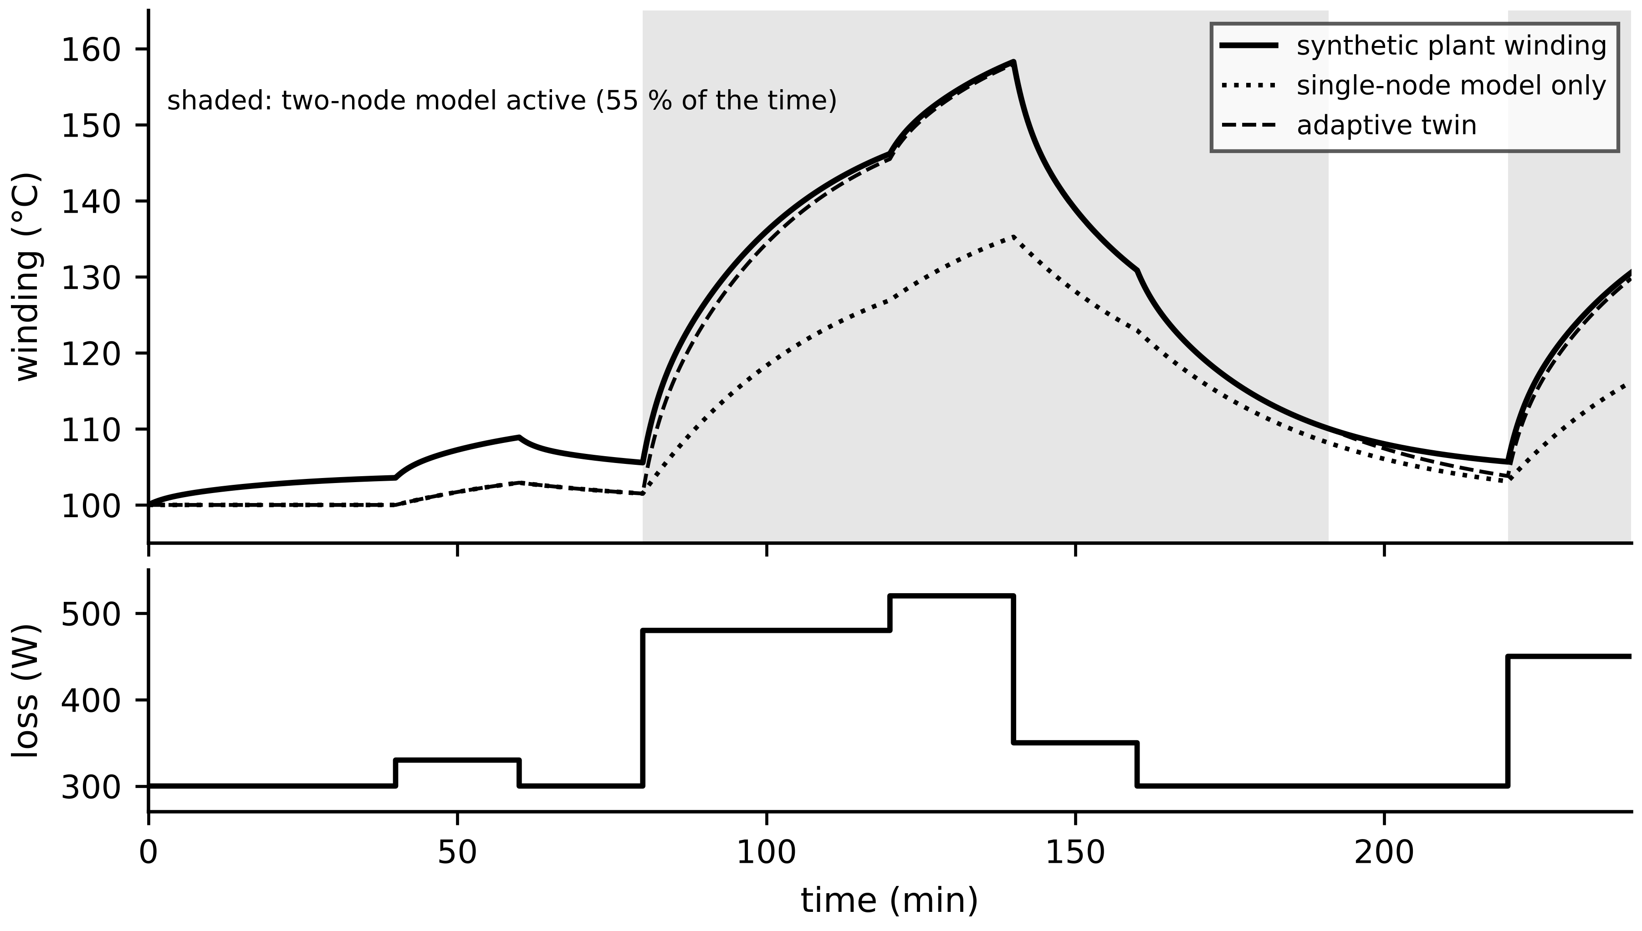
Figure 4.24. Adaptive fidelity switching for the M-07 thermal twin (Example 4.17). Top: plant winding temperature, single-node model alone and the adaptive twin; shading marks the periods in which the two-node model runs. Bottom: loss profile.
What the digital twin adds
Synchronized: a set of coupled sub-models, each at the fidelity the moment requires.
Estimated or updated: coupling loop gains, online error indicators, active model.
Uncertainty carried: model-form error per fidelity level, and mapping error at switches.
Decision enabled: which model runs now, and which coupled domains must be solved together.
Validated by: switching policy tested on held-out load profiles against the detailed model.

4.14 Co-simulation and the Functional Mock-up Interface
A plant-wide twin combines sub-models from different tools and time scales: a converter model with microsecond time constants, a battery model with seconds to hours, a thermal model with minutes. Co-simulation runs each with its own solver and exchanges interface variables only at communication points $t_{k}=kH$, where $H$ is the macro-step [18]. Between exchanges each sub-model sees the other's last value, which introduces three problems.
Coupling error. A held (zero-order) or extrapolated (first-order, from the last two exchanges) interface signal is wrong within a macro-step by, from a Taylor expansion,
$e_{ZOH}(t)≈\dot{u}\left(t_{k}\right)\left(t-t_{k}\right), e_{FO}(t)≈\frac{1}{2}\ddot{u}\left(t_{k}\right)\left(t-t_{k}\right)\left(t-t_{k-1}\right)$ (4.50)
of order $H$ and $H^{2}$ respectively. Energy imbalance. The power one side sends is computed with a held value while the other side uses its evolving value; over one macro-step the numerical scheme creates or destroys $ΔE_{k}=\int_{t_{k}}^{t_{k+1}}{[}V(t_{k})-V(t)] i(t_{k}) dt$, and its sum is a diagnostic of coupling quality. Coupling instability. The delay sits inside a feedback loop and can destabilize a coupled system whose parts are each stable. The order of advancing also matters; with $Φ_{i}$ advancing sub-model $i$ over one macro-step and $y_{i}$ its interface output,
$Jacobi: y_{1}^{k+1}=Φ_{1}\left(y_{2}^{k}\right), y_{2}^{k+1}=Φ_{2}\left(y_{1}^{k}\right); Gauss-Seidel: y_{1}^{k+1}=Φ_{1}\left(y_{2}^{k}\right), y_{2}^{k+1}=Φ_{2}\left(y_{1}^{k+1}\right)$ (4.51)
Jacobi runs both in parallel; Gauss-Seidel halves the delay in one direction and is usually more stable. When both sub-models have direct feedthrough, each output depends on the other's at the same instant: an algebraic loop, the DAE of Section 4.6 in disguise, which must be iterated to convergence within the macro-step.
Coupling stability can be predicted. For a battery that computes its current from a held bus voltage and a bus capacitor integrated over the macro-step, linearizing the update around the equilibrium voltage $V^{*}$ gives $V_{k+1}-V^{*}≈μ(V_{k}-V^{*})$ with
$μ=1-\frac{H}{R_{0}C_{bus}}+\frac{HP}{C_{bus}V^{2}}, μ>-1 ⇒ H<\frac{2}{1/\left(R_{0}C_{bus}\right)-P/\left(C_{bus}V^{2}\right)}$ (4.52)
where the constant-power term again reduces the effective damping.
Example 4.18 (Level B) Co-simulating the battery and the DC bus
Given. The DC bus of Example 4.4 with $C_{bus}=2$ mF is split into two sub-models. The battery computes $i_{b}=(E-V)/R_{0}$ from the last received bus voltage; the bus integrates $C_{bus}\dot{V}=i_{b}+i_{pv}-P/V$ with the last received $i_{b}$ (fine internal steps). The load steps from 150 to 300 kW at 2 ms. A monolithic fine-step simulation is the reference; runs last 8 ms.
Find. The new equilibrium, $μ$ and the stability limit, and the maximum voltage error and interface energy imbalance for macro-steps of 20 to 420 µs.
Solution. At 300 kW the equilibrium is 771.1 V and (4.52) gives $H<0.42$ ms. Table 4.8 and Figure 4.25 give the results: error grows roughly in proportion to $H$ until the limit, where error and energy imbalance explode.
Interpretation. The coupled system is physically stable (monolithic eigenvalue $-4748$ s⁻¹ at 300 kW), yet at 420 µs the co-simulation oscillates with growing amplitude. The macro-step must be chosen from the fastest coupled time constant, here $R_{0}C_{bus}=0.2$ ms, not from the convenience of the slowest sub-model; better still, strongly coupled fast subsystems such as these are simulated monolithically.
Table 4.8. Explicit co-simulation of battery and DC bus (synthetic; reference: monolithic solution)
Macro-step H | Amplification factor μ | Maximum voltage error (V) | Interface energy imbalance (J)
20 µs | 0.91 | 0.38 | 0.04
100 µs | 0.53 | 2.3 | 0.16
200 µs | 0.05 | 7.2 | 0.19
300 µs | −0.42 | 8.0 | 0.18
420 µs | −0.99 (limit) | 41 | −33

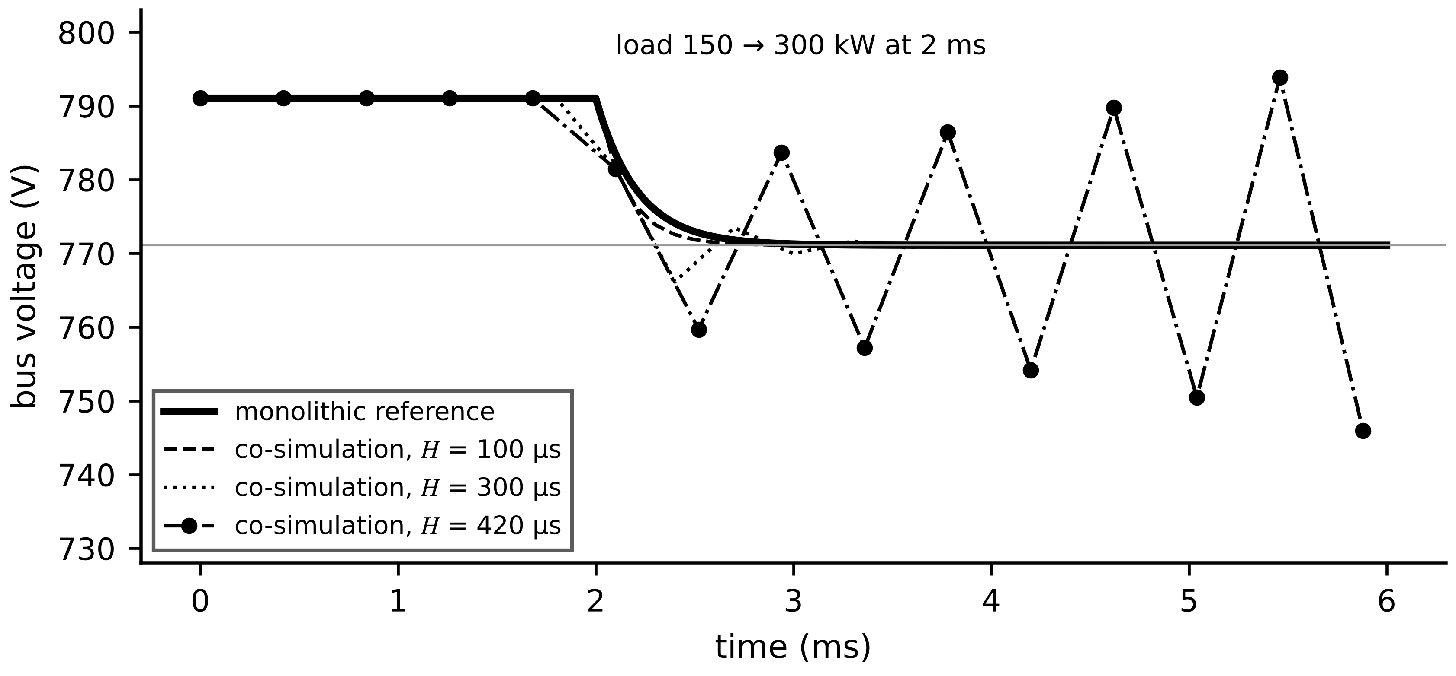
Figure 4.25. Bus voltage after the load step: monolithic reference and explicit co-simulation with macro-steps of 100, 300 and 420 µs. At 420 µs the delay in the coupling loop produces a growing oscillation although both sub-models are stable.
The Functional Mock-up Interface (FMI), maintained by the Modelica Association, standardizes how a model is packaged as a Functional Mock-up Unit (FMU): a zip archive with an XML model description and compiled code or source [19]. FMI 3.0 defines three interface types (Figure 4.26): in Model Exchange the FMU exposes derivatives and events and the importing tool integrates it; in Co-Simulation the FMU carries its own solver and advances over a communication step; in Scheduled Execution an external scheduler activates model partitions, as in real-time controllers. The companion System Structure and Parameterization (SSP) standard describes how FMUs are connected and parameterized, so a multi-vendor twin can be assembled and re-run reproducibly (established for offline studies, emerging for operational twins).
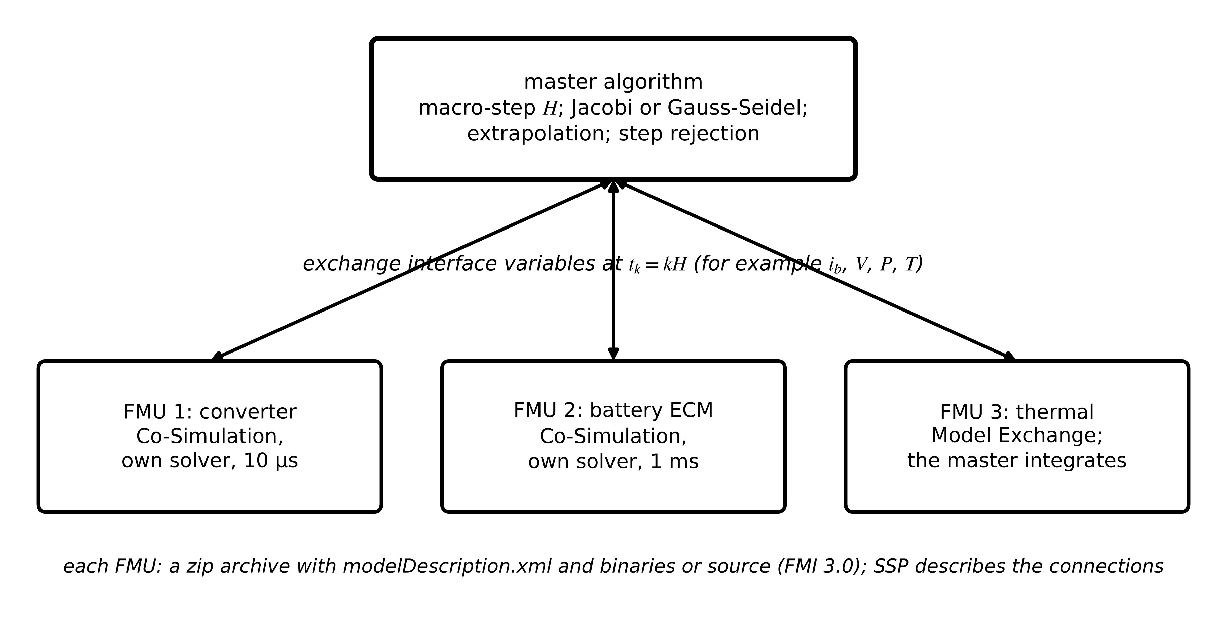
Figure 4.26. FMI co-simulation architecture. A master algorithm advances three FMUs over macro-steps and exchanges interface variables; converter and battery FMUs carry their own solvers, the thermal FMU is integrated by the master.
Table 4.9. Coupling choices for twin sub-models
Scheme | Error source | Cost per macro-step | Use
monolithic (one solver, or FMI Model Exchange) | solver error only | one stiff solve of the whole system | strongly coupled fast subsystems
explicit co-simulation, zero-order hold | one macro-step delay | one call per sub-model | weak coupling, slow interface signals
explicit, first-order extrapolation | smaller for smooth signals; overshoot at steps | one call per sub-model | smoothly varying interface signals
iterative (Jacobi or Gauss-Seidel, repeated) | converges to the coupled solution | several calls per sub-model | strong two-way coupling, algebraic loops

What the digital twin adds
Synchronized: sub-models from different tools at a common macro-step.
Estimated or updated: coupling amplification, energy imbalance per interface.
Uncertainty carried: coupling error (4.50), separate from each sub-model's own error.
Decision enabled: monolithic or co-simulated, macro-step and master algorithm.
Validated by: comparison with a monolithic reference and energy-imbalance monitoring.

4.15 Uncertainty propagation, verification and validation

4.15.1 Five different questions
Trust in a model is built by answering five questions in order (Figure 4.27). Verification asks whether the equations are solved correctly: whether the code implements the stated model, the units are consistent and the numerical error is controlled [20]. Calibration adjusts parameters so that the model fits a set of measurements. Validation asks whether the calibrated model, with no further adjustment, reproduces independent measurements well enough for its intended use. A predictive check asks whether the model's stated uncertainty is honest, by testing coverage and out-of-domain behaviour. Acceptance for intended use then states the domain of validity inside which the model may be used, and nothing outside it. The National Academies place this verification, validation and uncertainty quantification (VVUQ) at the centre of trustworthy twins [21].
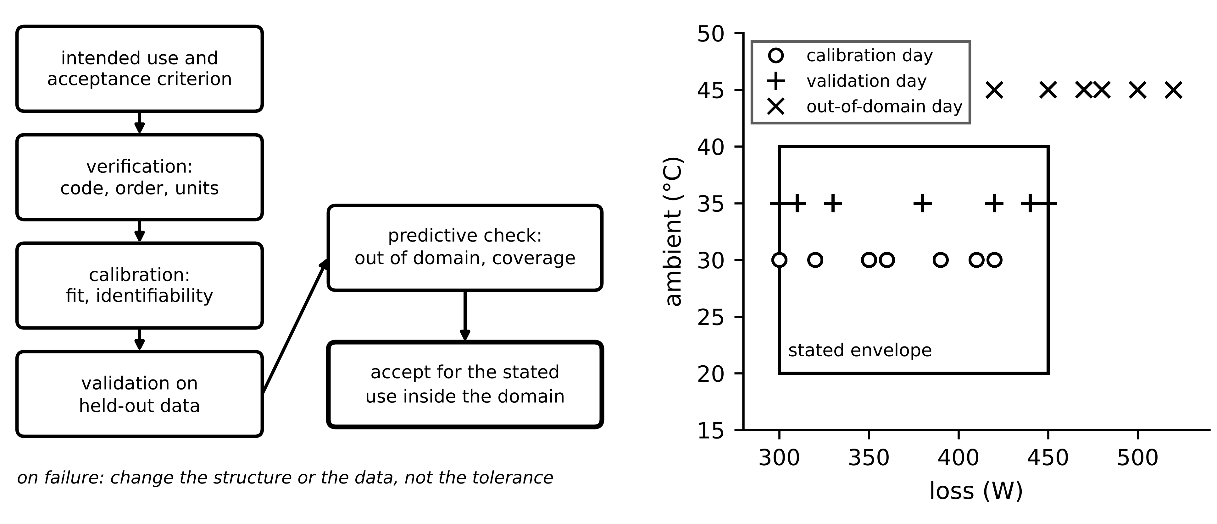
Figure 4.27. Left: the verification and validation workflow, from intended use and acceptance criterion to acceptance inside a domain. Right: domain of validity as the convex hull of calibration and validation conditions, with an out-of-domain test outside it.
A simple, powerful verification test is the observed order of accuracy. If a method of order $p$ is coded correctly its error falls as $h^{p}$, so errors $e_{1}$, $e_{2}$ at steps $h_{1}$, $h_{2}$ estimate the order, and Richardson extrapolation estimates the remaining error without knowing the exact solution:
$\hat{p}=\frac{ln\left(e_{2}/e_{1}\right)}{ln\left(h_{2}/h_{1}\right)}, x^{*}≈x_{h/2}+\frac{x_{h/2}-x_{h}}{2^{p}-1}, {\hat{e}}_{h/2}≈\frac{\left|x_{h/2}-x_{h}\right|}{2^{p}-1}$ (4.53)
From Table 4.4, RK4 at 10 and 50 µs gives $\hat{p}=4.0$ and TR gives 2.0, as theory predicts; a coding error almost always shows as a wrong observed order.

4.15.2 Propagating parameter uncertainty
Calibration leaves the parameters uncertain with covariance $Σ_{θ}$ (for least squares, approximately ${\hat{σ}}^{2}(S^{⊤}S)^{-1}$). To first order, the covariance of a prediction $y$ follows the law of propagation of Chapter 3; when the model is strongly nonlinear over the uncertainty range, Monte Carlo sampling replaces it:
$Σ_{y}≈S_{θ}Σ_{θ}S_{θ}^{⊤}, S_{θ}=\frac{∂y}{∂θ}; \overline{y}=\frac{1}{N}\sum_{j=1}^{N}{y}\left(θ^{(j)}\right), s_{y}^{2}=\frac{1}{N-1}\sum_{j=1}^{N}{{\left[y\left(θ^{(j)}\right)-\overline{y}\right]}^{2}}, se=\frac{s_{y}}{\sqrt{N}}$ (4.54)
where $θ^{(j)}$ are $N$ parameter sets drawn from their distribution and se the standard error of the Monte Carlo mean, which shrinks as $1/\sqrt{N}$ regardless of the number of parameters. For the steady-state winding temperature $T=T_{amb}+R_{th}P$ with $R_{th}=0.20±0.01$ K/W and $P=420±20$ W, the linear form gives $\sqrt{(420×0.01)^{2}+(0.20×20)^{2}}=5.8$ K and Monte Carlo agrees. Validation then compares predictions with held-out data through bias, RMSE and coverage, ${cov}_{95}=\frac{1}{N}\sum_{k}{1}[|e_{k}|≤1.96σ_{y,k}]$: a well-calibrated model covers about 95 %, and much lower coverage means the model is overconfident, which is more dangerous than being inaccurate.
Example 4.19 (Level A) Linear propagation against Monte Carlo
Given. $T-T_{amb}=R_{th}P$ with $R_{th}=0.20±0.01$ K/W and $P=420±20$ W (independent, normal, standard uncertainties).
Find. The standard uncertainty of the rise by (4.54) in linear form and by Monte Carlo with $N=200 000$, and the Monte Carlo standard error.
Solution. Linear: $\sqrt{(420×0.01)^{2}+(0.20×20)^{2}}=5.80$ K. Monte Carlo (seed 1): mean 83.98 K, standard deviation 5.79 K, standard error of the mean 0.013 K.
Interpretation. For a product of two inputs with 5 % uncertainty each the linear formula is accurate; Monte Carlo is needed when uncertainties are large or the model bends sharply, and its cost does not grow with the number of parameters.
Example 4.20 (Level C) Validating the M-07 thermal twin for 30-minute forecasting
Intended use and criterion, stated before testing. The twin forecasts the winding temperature 30 minutes ahead for overload advisories. Acceptance: forecast RMSE ≤ 2.0 K and mean bias within ±1.0 K on held-out data, within an envelope of 300 to 450 W and 20 to 40 °C ambient.
Data (synthetic, seed 2026). The ‘plant’ is the two-node model of Section 4.8.1 whose copper loss (60 % of the total) rises at 0.393 % per kelvin above 75 °C, sampled every 30 s with 0.3 K noise on winding and frame. Calibration day: one-hour loss blocks of 300, 420, 350, 390, 320, 410, 360, 300 W at 30 °C. Validation day: 330, 450, 300, 440, 380, 420, 310, 450 W at 35 °C. Out-of-domain day: 420, 520, 470, 520, 450, 500, 520, 480 W at 45 °C. Each day the plant starts from the steady state of its first block computed without the loss feedback and is integrated with 1 s Euler steps. Forecasts start from the measured state at every sample.
Candidate A: single-node twin (Chapter 1 structure). Output-error least squares on the calibration day gives ${\hat{R}}_{th}=0.2158±0.0001$ K/W and ${\hat{C}}_{th}=4467±39$ J/K, fit RMSE 1.01 K. Validation: forecast RMSE 2.23 K, bias −1.86 K, maximum error 4.39 K; it fails both criteria. Out of domain: RMSE 10.6 K, bias −10.4 K; the plant reaches 172.5 °C while the twin, run over the day, predicts 157.1 °C (Figure 4.28).
Candidate B: two-node twin with temperature-dependent loss. Fitted to winding and frame on the calibration day (fit RMSE 0.30 K, the sensor noise), with parameters within 0.2 % of the truth. Validation: forecast RMSE 0.072 K, bias 0.018 K. Out of domain: RMSE 0.080 K.
Interpretation. Candidate A fits its calibration data plausibly and still fails validation, and its heat capacity of 4467 J/K is half the physical 9000 J/K: a structurally wrong model absorbs its errors into parameters that then lose their physical meaning. Outside the envelope it under-predicts by 10 K, the dangerous direction for an overload advisory. Out-of-domain testing finds that before a motor is damaged. The remedy was a better structure (Section 4.8.1, (4.48)), not a wider tolerance.
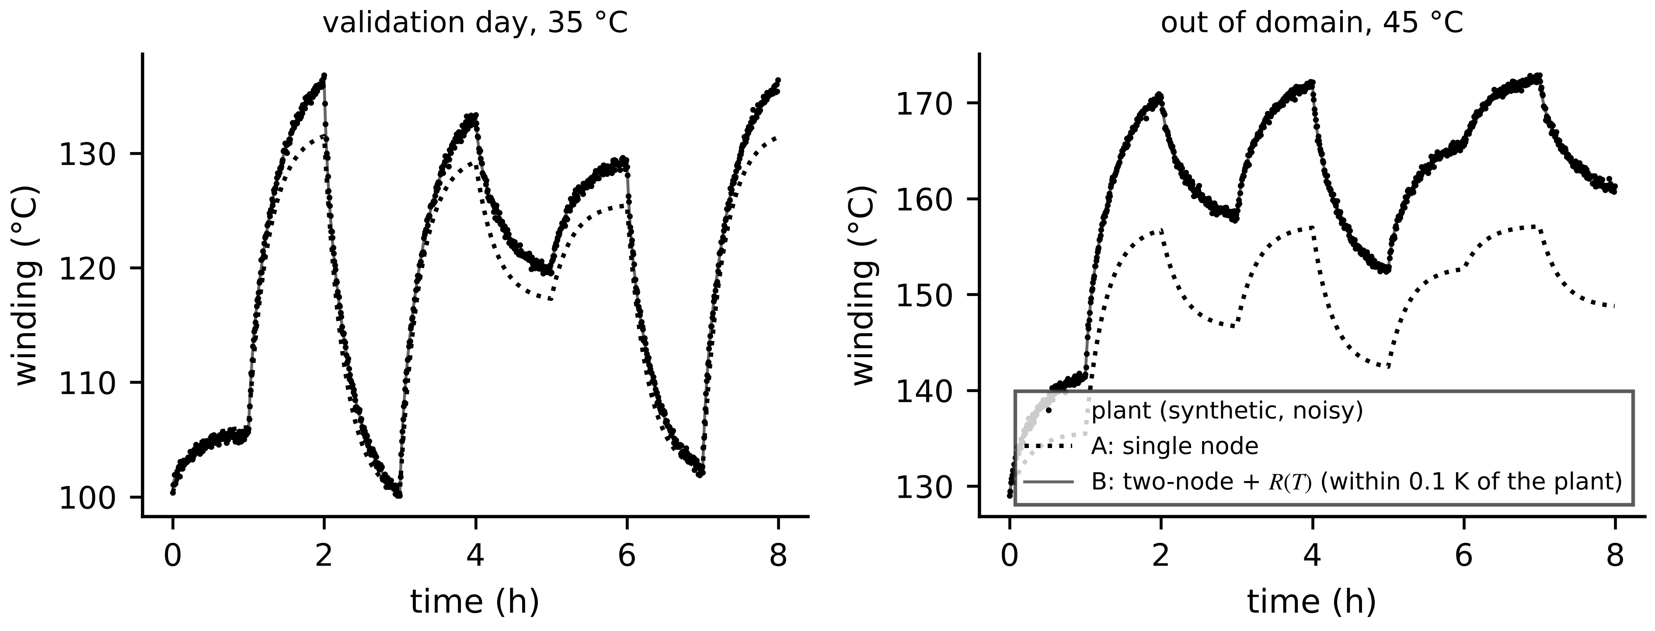
Figure 4.28. Validation of the M-07 thermal twins (Example 4.20), open-loop runs over each day. Left: validation day at 35 °C. Right: out-of-domain day at 45 °C, where the single-node twin under-predicts the synthetic plant by about 15 K at its hottest point.
Table 4.10. Validation checklist for twin models
Check | Question it answers | Response if it fails
code verification (observed order (4.53), units, energy balance) | are the equations solved correctly? | fix the code before any calibration
calibration diagnostics (fit residual against noise, parameter covariance) | did the fit converge; are parameters identifiable? | redesign the experiment (Example 4.16) or reparameterize
held-out validation against the stated criterion | does the model predict new data for its use? | change the structure; never widen the tolerance afterwards
stratified residuals (load, temperature, season) | is accuracy uniform across the envelope? | restrict the domain or add physics
residual autocorrelation | are states or modes missing? | add states rather than refit
coverage of prediction intervals | is the stated uncertainty honest? | recalibrate the uncertainty model
out-of-domain tests | how does the model fail outside its domain? | flag outputs outside the domain as unvalidated
coupling check (co-simulated models) | is the error from coupling rather than sub-models? | reduce the macro-step or iterate (Table 4.9)

What the digital twin adds
Synchronized: a model accepted for a stated use inside a stated domain.
Estimated or updated: parameter covariance, prediction intervals, coverage.
Uncertainty carried: parameter, model-form and numerical uncertainty, kept separate.
Decision enabled: accept, restrict the domain, or change the structure.
Validated by: held-out and out-of-domain tests against a criterion fixed in advance.

4.16 Case study: the Plant P-1 model set
The twins of Plant P-1 (Chapters 2 and 3) now receive their models. Table 4.11 lists, for each sub-model, its states, time scales, solver, step and coupling, with the fidelity level from Section 4.13.
Table 4.11. Model set for the Plant P-1 twins
Sub-model | States and equation | Fastest / slowest time constant | Fidelity level | Solver and step | Coupling and validation
Motor thermal (each of 20) | $T_{1}$, $T_{2}$, (4.27) with $R(T)$ | 136 s / 1144 s | lumped, two-node; single node when idle | ZOH, 30 s | stand-alone; loss from current; Example 4.20
Motor electromechanical (4 critical) | 4 fluxes, speed, (4.24) | ms / s | detailed lumped | BE or TR with Newton, 50 µs | offline diagnosis only
PV array (2 inverters) | algebraic (4.29) + module temperature | s / min | lumped, single diode | Newton or Lambert W per sample, 1 s | inputs from irradiance and temperature
BESS cell groups | $z$, $v_{1}$, (4.31) | 30 s / h | ECM; P2D offline | ZOH on linear part, 1 s | current from PCS; OCV table per chemistry
BESS converter filter | $i_{L}$, $v_{C}$, (4.14) | 0.75 ms decay / 1.2 ms period | lumped | ZOH, 10 µs on edge FPGA or DSP | ringing analysis for capacitor ageing
DC bus inside PCS | $V_{bus}$ | 0.2 ms | lumped | BE, 20 µs | monolithic with battery (Example 4.18)
11 kV / 415 V transformer thermal | 2 to 3 nodes | min / h | reduced-order (Example 4.15) | ZOH, 30 s | load from PCC meter

Three design rules from this chapter shaped the table. Fast subsystems coupled by an algebraic or near-algebraic interface (battery and bus) are simulated monolithically, never by explicit co-simulation with a macro-step near their time constant. Slow subsystems (thermal, SOC) use exact ZOH discretization at their sensors' sampling rate, so their numerical error is zero and all remaining error is model error. And every model carries a stated domain of validity, outside which its outputs are flagged as unvalidated, and a fidelity-switching rule where the purpose needs one.

4.17 Recent developments and open research problems
Modelling for twins is changing quickly, and each development is labelled with its status in 2026. The 2026 reviews converge on fidelity, real-time execution and model management as the barriers between concept and utility-scale deployment [1], [2], [3].
Physics-informed and neural ODE models (research, early deployments). Physics-informed neural networks add the residual of the governing equations to the training loss [16]; neural ordinary differential equations learn $f$ itself as a network integrated by standard solvers [17]. Open problem: validation and extrapolation guarantees. Reduced models for converter-dominated grids (research). Balanced truncation and its variants are applied to multi-inverter microgrids; open problem: reduced models valid across operating points and topologies, not one linearization. Multi-fidelity and adaptive twins (emerging). Switching rules such as (4.49), and multi-fidelity estimators that combine many cheap runs with few expensive ones; open problem: certified error indicators. Standard model exchange (established offline, emerging online). FMI 3.0 and SSP make multi-vendor twins assemblable [19]; IEEE 3835-2025 frames twins of integrated energy systems [22]; ITU-T Y.4517 puts model management into power-grid twin architecture [4]. Open problem: certified coupling that bounds error and conserves energy at FMU interfaces. Real-time electromagnetic-transient simulation (testing use). FPGA simulators run switching-level models with microsecond steps for hardware-in-the-loop testing (Chapter 7); open problem: using them online at acceptable cost. Uncertainty quantification at scale (research). Reliable prediction intervals for nonlinear, reduced and learned models in real time.
Learned dynamics inside power-system simulators (research, early tools). Physics-informed neural networks have been trained to reproduce the dynamics of power-system components faster than conventional solvers [23], and PINNSim couples one such network per component through a root-finding step to simulate a multi-machine system with larger usable time steps than the trapezoidal rule [24]. Open problem: error guarantees across operating points and topologies. Large-scale co-simulation (established for studies). HELICS couples transmission, distribution, communication and market simulators with iteration at each time step [25], and SSP 2.0, released in December 2024, adds FMI 3.0 support to the standard exchange of composite system models [26]. Open problem: coupling with certified error and energy conservation at every interface, so that a co-simulated twin can be validated as a whole.
Table 4.12. Emerging modelling directions with a measurable target
Direction | Status | Measurable target
physics-informed and neural-ODE models | research, early deployments | out-of-envelope error against a physics baseline on held-out faults
reduced models for inverter grids | research | validated error bound across a stated range of operating points
adaptive multi-fidelity twins | emerging | error and cost against a fixed high-fidelity twin on held-out profiles
FMI-based multi-vendor twins | early industrial use | coupling error and energy imbalance per interface, reported with results
real-time EMT inside twins | testing use | fidelity against latency on a stated processor
real-time uncertainty quantification | research | coverage of prediction intervals on held-out data

4.18 How this chapter feeds the rest of the book
The model forms of this chapter are the ones the later chapters use without re-deriving them. Chapter 5 takes the state-space forms (4.13) and (4.35), the linearization (4.33), the observability analysis (4.43) and the identifiability tools (4.47) to build estimators and synchronize twins. Chapter 6 adds learned and hybrid models to the hierarchy of Section 4.13. Chapters 7 to 11 instantiate the electrical, electromechanical, PV, battery and network models of Sections 4.4 to 4.8 for converters, renewables, storage, vehicles and microgrids. Chapters 12 and 13 use the validated models for diagnosis, prognosis, control and optimization, and Chapter 14 asks what happens when the data feeding these models are attacked.

Chapter summary
A twin is only as good as the function $f$ inside it, and this chapter built $f$ from conservation laws for the assets of the book, following one ten-step workflow from system boundary to validation. The RC circuit introduced states, parameters, inputs, outputs, initial conditions and the energy balance; the RLC filter showed how ringing frequency and decrement reveal capacitance; state-space and transfer-function forms tied eigenvalues to poles; and DAEs added algebraic constraints that demand consistent initialization. DC and induction machines, two-node thermal networks, the single-diode PV model and battery equivalent circuits were derived with sign conventions and illustrative parameters, and each was tied to what a twin can measure and must estimate.
The numerical half of the chapter showed that linearizations have measurable ranges, that stability and accuracy of integration methods are different properties, that stiffness and the real-time deadline choose the solver, that rank tests must be backed by Gramians and condition numbers, that balanced truncation comes with an error bound (attained in steady state for RC ladders, where residualization helps), and that experiment length decides identifiability. The flagship section treated multi-physics coupling through loop gains and multi-fidelity model sets with online switching, cutting computation by 38 % while keeping most of the accuracy where decisions are made. Co-simulation through FMI showed that a stable coupled system can be destabilized by its macro-step, and the validation example showed a structurally wrong model that fitted its calibration data and then under-predicted an overload by 15 K.
Table 4.13. Key relationships of Chapter 4
Relationship | Expression | Eq.
RC circuit | ${\dot{v}}_{C}=-v_{C}/(RC)+v_{in}/(RC)$; $τ=RC$ | (4.2), (4.3)
RLC filter | $ω_{n}=1/\sqrt{LC}$; $ζ=\frac{R}{2}\sqrt{C/L}$; logarithmic decrement | (4.8), (4.10)
State space and solution | $\dot{x}=Ax+Bu$; $x(t)=e^{At}x(0)+\int{e^{A(t-σ)}}Bu dσ$ | (4.13), (4.15)
Transfer function | $G(s)=C(sI-A)^{-1}B+D$ | (4.16)
Semi-explicit DAE | $\dot{x}=f(x,z,u)$, $0=g(x,z,u)$ | (4.18)
DC machine | $L_{a}{\dot{i}}_{a}=v_{a}-R_{a}i_{a}-K_{e}ω$; $J\dot{ω}=K_{t}i_{a}-Bω-T_{L}$ | (4.20)
Induction machine | dq flux equations; $T_{e}=\frac{3}{2}\frac{p}{2}(ψ_{ds}i_{qs}-ψ_{qs}i_{ds})$ | (4.24), (4.25)
Two-node thermal | $C_{1}{\dot{T}}_{1}=P-(T_{1}-T_{2})/R_{12}$; $C_{2}{\dot{T}}_{2}=…$ | (4.27)
PV single diode | implicit $I(V)$; Lambert W | (4.29), (4.30)
Battery ECM | $v_{t}=OCV(z)-R_{0}i-v_{1}$ | (4.31)
Linearization and its range | $A_{0}=∂f/∂x$; $‖δx‖_{max}≈\sqrt{2ε/M}$ | (4.33), (4.34)
Exact ZOH | $A_{d}=e^{Ah}$; augmented exponential | (4.35)
Amplification factors; stiffness | $R(hλ)$; $S=max|Reλ|/min|Reλ|$ | (4.39), (4.40)
Controllability, observability, Gramians | rank $𝒞$, rank $𝒪$; $A^{⊤}W_{o}+W_{o}A+C^{⊤}C=0$ | (4.42), (4.43)
Balanced truncation bound | $‖G-G_{r}‖_{∞}≤2\sum_{i>r}{σ_{i}}$ | (4.45)
Sensitivity and Fisher information | $F=S^{⊤}S/σ^{2}$; $cov(\hat{θ})⪰F^{-1}$ | (4.47)
Electro-thermal loop gain | $g=Rγ$; $τ_{eff}=RC/(1-g)$ | (4.48)
Fidelity switching | $argminc_{j}$ s.t. ${\hat{e}}_{j}≤ε$, $W_{j}+T_{io}≤h$ | (4.49)
Co-simulation stability | $μ=1-H/(R_{0}C)+HP/(CV^{2})$, $μ>-1$ | (4.52)
Observed order; uncertainty propagation | $\hat{p}=ln(e_{2}/e_{1})/ln(h_{2}/h_{1})$; $Σ_{y}≈S_{θ}Σ_{θ}S_{θ}^{⊤}$ | (4.53), (4.54)

Exercises
Fifteen exercises follow. Exercises 4.1 to 4.8 build and analyse models of circuits, machines, thermal networks and batteries; 4.9 to 4.12 cover linearization, numerical integration, observability, reduction and identifiability; 4.13 and 4.14 treat co-simulation and validation; and 4.15 is a research-level design project. Most exercises link a concept or derivation to a numerical application. Complete solutions to all fifteen are given in the answer key.

Group A: building models
4.1 Vocabulary and model classes. (a) Using the RC circuit, define state, parameter, input, output, algebraic constraint, initial condition and boundary condition, and explain why the capacitor voltage, not the current, is the state. (b) Classify as algebraic, ODE or DAE: (i) an ideal transformer's turns-ratio relation; (ii) coulomb counting of a battery's SOC in continuous time; (iii) a DC bus without capacitance joining a battery and a constant-power load. (c) State the ten steps of the modelling workflow and explain why a failed validation returns to the assumptions or the choice of states, not to a wider tolerance.
4.2 First- and second-order circuits. (a) A series RC circuit has $R=2.2$ kΩ and $C=10$ µF. Find $τ$ and the time to reach 90 % of the final voltage. (b) A series RLC circuit has $L=50$ mH, $C=100$ µF and $R=8$ Ω. Find $ω_{n}$, $ζ$, the damped frequency in hertz and the overshoot. (c) Write $A$ and $B$ for (b) with $x={\left[i_{L}, v_{C}\right]}^{⊤}$, and derive $G\left(s\right)=V_{C}\left(s\right)/V_{in}\left(s\right)$ from (4.16).
4.3 Reading a capacitor from its ringing. (a) Derive the relation between the logarithmic decrement and the damping ratio in (4.10). (b) Two successive peaks of the ringing of the circuit of Exercise 4.2(b) deviate from the final value by 0.40 V and 0.12 V, and the ringing frequency is 69.5 Hz. With $L=50$ mH known, find $ζ$, $ω_{n}$, $\hat{C}$ and $\hat{R}$. (c) By what fraction does the ringing frequency change for a 1 % loss of capacitance at small damping?
4.4 DC machine. (a) Show from the power balance (4.21) why $K_{t}=K_{e}$ in SI units. (b) A DC motor has $R_{a}=0.8$ Ω, $L_{a}=5$ mH, $K_{e}=K_{t}=0.06$ V·s/rad, $J=0.0012$ kg·m² and $B=0.0004$ N·m·s/rad. Find the eigenvalues and time constants, and compare with $L_{a}/R_{a}$ and $J/B$. (c) Explain the difference using the electrical damping $K_{t}K_{e}/R_{a}$.
4.5 Park transformation and the induction machine. (a) Apply (4.23) with $θ=0$ to the balanced set $f_{a}=1$, $f_{b}=f_{c}=−0.5$, and interpret the result. (b) Explain the factor 2/3 in (4.23) and what changes if the power-invariant form is used. (c) An induction motor has $R_{th}=0.75$ Ω, $X_{th}+X_{lr}=2.5$ Ω and $R_{r}=0.70$ Ω. Find the breakdown slip.
4.6 A DC bus as a DAE. A battery with $E=700$ V behind $R_{0}=0.2$ Ω feeds a constant-power load of $P=100$ kW; $i_{pv}=0$ and the bus has no capacitance. (a) Find the consistent bus voltage and the collapse limit. (b) Run Newton's method (4.19) from 700 V and from 20 V, and explain the result. (c) Find the incremental impedance of the load and the bus eigenvalue if $C_{bus}=1$ mF is added.
4.7 Thermal network and electro-thermal coupling. (a) For the two-node model of Section 4.8.1 at 350 W, find the steady winding and frame rises above ambient. (b) Derive (4.48). (c) A motor with $R=0.3$ K/W has 300 W of copper loss at the reference temperature ($α_{cu}=0.00393$ K⁻¹). Find $g$ and the amplification of temperature rises. When can the coupling be treated as one-way?
4.8 Battery equivalent circuit. An LFP cell has $R_{0}=1.5$ mΩ, $R_{1}=1.0$ mΩ and $τ_{1}=20$ s. (a) A 50 A, 40 s discharge pulse is applied from rest. Find the instantaneous drop and the polarization voltage at the end of the pulse. (b) Find the polarization voltage 20 s after the pulse ends. (c) Find the ohmic and polarization heat at the end of the pulse, and explain which parts of the voltage waveform identify $R_{0}$, $τ_{1}$ and $R_{1}$.

Group B: analysing and computing models
4.9 Linearization and its range. (a) The PV module of Section 4.8.2 is linearized at 30.0 V, where $I=9.624$ A and $dI/dV=−0.0439$ A/V. Predict the current at 30.8 V; the exact value is 9.579 A. (b) A model's second derivative is bounded by $M=0.5$ output units per unit². For a tolerance of 0.02 output units, find the largest excursion from (4.34). (c) Explain how (4.34) turns 'close to the operating point' into a number.
4.10 Numerical integration. (a) A model has eigenvalues $−200$ and $−0.002$ s⁻¹. Find the stiffness ratio and test forward Euler at $h=0.01$ s for the fast mode. (b) For $\dot{x}=−1000x$ and $h=1$ ms, compute the amplification factors of BE and TR and compare with $e^{−1}$. (c) A method gives errors of $2.0×{10}^{−3}$ at step $h$ and $1.25×{10}^{−4}$ at $h/2$. Find the observed order. (d) A resonance at 1.0 kHz is discretized with Tustin's method at $h=50$ µs. Where does the discrete model resonate? (e) Explain why a diverging simulation is not evidence that the plant is unstable, and why a stable simulation is not evidence of fidelity.
4.11 Controllability, observability and Gramians. (a) For $A=diag\left(−1,−5\right)$ and $B={\left[1 0\right]}^{⊤}$, form $C$, decide controllability and identify the mode that cannot be influenced; confirm with the controllability Gramian. (b) For $A=\left[−1, 1; 0, −2\right]$ and $C=\left[1 0\right]$, form $O$, decide observability and compute the observability Gramian and its eigenvalues. (c) Explain why a rank test can pass while estimation is still poor, and name the quantitative test.
4.12 Reduction and identifiability. (a) Hankel singular values are 12.0, 9.5, 1.1, 0.05 and 0.01. Choose a reduced order and state the bound (4.45). Which reduction keeps the steady-state gain exact? (b) A single-node thermal twin was calibrated only on steady-state SCADA snapshots. Which parameter is not identifiable, and what experiment fixes it? (c) For the model $y=θ_{1}\left(1−e^{−t/θ_{2}}\right)$ sampled at $t=θ_{2}$ only, show that the Fisher information matrix is singular, and state the minimum change to the experiment that makes it non-singular.

Group C: coupling and validation
4.13 Co-simulation stability. (a) Two co-simulated sub-models exchange a battery current and a bus voltage with $R_{0}=0.05$ Ω and $C_{bus}=1$ mF and negligible load. Derive the macro-step stability limit from (4.52). (b) A co-simulated twin's bus voltage oscillates although both sub-models are stable when run alone. Name two possible causes and a test that tells them apart.
4.14 Uncertainty and validation. (a) Propagate $R_{th}=0.20±0.02$ K/W and $P=420±40$ W (standard uncertainties) to the steady-state temperature rise with (4.54). (b) A second-order method gives 1.0480 at step $h$ and 1.0510 at $h/2$. Use (4.53) to estimate the exact value and the error of the finer result. (c) Distinguish verification, calibration, validation and a predictive check, and explain how a model can fit its calibration data and still fail validation. (d) A validation report shows low overall RMSE but high error at high load. Which check in Table 4.10 finds this, and what should be done?

Group D: research project
4.15 A model set for the battery converter. (a) Plan verification, calibration and validation of a battery equivalent-circuit model to be calibrated on six months of data from a home storage system. (b) A capacitor-ageing twin for the BESS filter must estimate $C$ from ringing. Choose the model, solver and step, and use (4.47) to design the excitation. (c) An adaptive twin runs a cheap model (cost 1) 70 % of the time and an expensive one (cost 8) the rest. Find the average cost and the saving against the expensive model alone, and design a fidelity-switching rule with an error indicator, hysteresis and state mapping for a transformer twin with a two-node model and a reduced FEM hot-spot model.

Answer key
4.1 (a) Variable: $v_{in}$, $i$, $v_{C}$. Parameters: $R$, $C$. Input: $v_{in}$, imposed from outside the boundary. State: $v_{C}$, because the capacitor stores $\frac{1}{2}Cv_{C}^{2}$ and its voltage cannot jump; the current can jump at a step of $v_{in}$, so it is not a state. Output: whatever is compared with a sensor, for example $v_{C}$. Algebraic constraint: Kirchhoff's voltage law $v_{in}=Ri+v_{C}$ at every instant. Initial condition: $v_{C}\left(0\right)=v_{0}$. Boundary condition: a fixed value on the spatial edge of a distributed model, received here as an input.
(b) (i) Algebraic, $v_{2}=v_{1}N_{2}/N_{1}$, no memory. (ii) ODE, $\dot{z}=−ηi/\left(3600Q_{n}\right)$. (iii) Index-1 DAE: Kirchhoff's current law at the bus is an algebraic constraint on the bus voltage, alongside the battery's differential SOC equation.
(c) System boundary, assumptions, sign convention, states, governing laws, constitutive relations, state and output equations, parameters and units, initial conditions, validation. A model that fails validation has the wrong structure or the wrong assumptions; widening the tolerance only hides the error and makes the model unsafe outside the cases tested, whereas returning to the assumptions or states fixes its cause.
4.2 (a) $τ=RC=22$ ms; $t_{90}=τln10=50.7$ ms.
(b) $ω_{n}=1/\sqrt{0.05×{10}^{−4}}=447.2$ rad/s; $ζ=\frac{R}{2}\sqrt{C/L}=4×0.0447=0.179$; $f_{d}=ω_{n}\sqrt{1−ζ^{2}}/\left(2π\right)=70.0$ Hz; $M_{p}=e^{−πζ/\sqrt{1−ζ^{2}}}=56.5$ %.
(c) $A=\left[−R/L, −1/L; 1/C, 0\right]=\left[−160, −20; 10 000, 0\right]$, $B=\left[1/L; 0\right]=\left[20; 0\right]$, $C=\left[0 1\right]$. $det\left(sI−A\right)=s^{2}+160s+200 000$ and $C adj\left(sI−A\right)B=200 000$, so $G\left(s\right)=200 000/\left(s^{2}+160s+200 000\right)$.
4.3 (a) The free response decays as $e^{−ζω_{n}t}$ and repeats every $T_{d}=2π/ω_{d}$, so $x_{k}/x_{k+1}=e^{ζω_{n}T_{d}}$ and $δ=2πζω_{n}/ω_{d}=2πζ/\sqrt{1−ζ^{2}}$. Squaring and solving for $ζ$ gives $ζ=δ/\sqrt{4π^{2}+δ^{2}}$.
(b) $δ=ln\left(0.40/0.12\right)=1.204$; $ζ=1.204/\sqrt{39.48+1.45}=0.188$. $ω_{d}=2π×69.5=436.7$ rad/s; $ω_{n}=436.7/\sqrt{1−0.0354}=444.6$ rad/s. $\hat{C}=1/\left(Lω_{n}^{2}\right)=101.2$ µF; $\hat{R}=2ζ\sqrt{L/\hat{C}}=2×0.188×22.2=8.37$ Ω.
(c) $ω_{d}≈ω_{n}=1/\sqrt{LC}$, so $Δf/f≈−\frac{1}{2}ΔC/C$: a 1 % loss of capacitance raises the ringing frequency by about 0.5 %, a change that a twin sampling well above the resonance resolves easily.
4.4 (a) Multiplying the electrical equation by $i_{a}$ and the mechanical one by $ω$ and adding gives (4.21). The term $\left(K_{e}−K_{t}\right)i_{a}ω$ would be power created or destroyed in the air gap without any storage or loss; conservation of energy requires it to vanish for every $i_{a}$ and $ω$, so $K_{t}=K_{e}$ in SI units (N·m/A equals V·s/rad).
(b) $A=\left[−160, −12; 50, −0.333\right]$; eigenvalues $−156.1$ and $−4.18$ s⁻¹; time constants 6.4 ms and 0.239 s. $L_{a}/R_{a}=6.25$ ms is close to the fast one; $J/B=3.0$ s is wrong by a factor of 12.5.
(c) Back EMF opposes any speed change through the armature resistance, acting as a viscous damping $K_{t}K_{e}/R_{a}=0.0045$ N·m·s/rad, more than ten times $B$. The slow time constant is therefore of the order of $JR_{a}/\left(K_{t}K_{e}\right)=0.267$ s (exactly 0.239 s once the inductance is included), not $J/B$.
4.5 (a) $f_{d}=\frac{2}{3}\left[1+\left(−0.5\right)cos\left(−120°\right)+\left(−0.5\right)cos120°\right]=\frac{2}{3}\left(1+0.25+0.25\right)=1$; $f_{q}=−\frac{2}{3}\left[0+\left(−0.5\right)sin\left(−120°\right)+\left(−0.5\right)sin120°\right]=0$; $f_{0}=0$. A balanced set aligned with phase a maps to a d-axis vector of its own amplitude.
(b) The factor 2/3 makes the transformation amplitude-invariant: a balanced set of amplitude $F$ becomes a dq vector of length $F$. The power-invariant form uses $\sqrt{2/3}$, giving a vector of length $\sqrt{3/2}F$ and power $p=v_{d}i_{d}+v_{q}i_{q}$ without the factor 3/2; torque formulas then lose the 3/2. Either is correct if stated, but mixing them gives a 50 % torque error.
(c) $s_{max}=0.70/\sqrt{{0.75}^{2}+{2.5}^{2}}=0.70/2.61=0.268$.
4.6 (a) $\left(700−V\right)/0.2=100 000/V$ gives $V^{2}−700V+20 000=0$, so $V=670.2$ V (physical) or 29.8 V. Real roots require ${700}^{2}≥4×0.2×P$: $P_{max}=612.5$ kW, at $V=350$ V.
(b) From 700 V: 670.21, 670.16, 670.16 V. From 20 V: 26.53, 29.46, 29.84 V, converging just as fast to the unphysical root, which would need $\left(700−29.8\right)/0.2=3.35$ kA of battery current. Newton converges to whichever root is near the starting point; the open-circuit voltage is the physically justified start.
(c) $Z_{CPL}=−V^{2}/P=−4.49$ Ω. With $C_{bus}$: $λ=−1/\left(R_{0}C_{bus}\right)+P/\left(V^{2}C_{bus}\right)=−5000+223=−4777$ s⁻¹, still stable; the negative incremental resistance reduces the damping.
4.7 (a) Winding $350×\left(0.08+0.12\right)=70$ K; frame $350×0.12=42$ K.
(b) With $P\left(T\right)=P_{0}+γ\left(T−T_{ref}\right)$ and $θ=T−T_{amb}$, the balance is $C\dot{θ}=P_{0}+γ\left(θ−θ_{ref}\right)−θ/R=P_{0}−γθ_{ref}−\left(1−Rγ\right)θ/R$. This is a first-order system with time constant $RC/\left(1−g\right)$ and steady state $R\left(P_{0}−γθ_{ref}\right)/\left(1−g\right)$, where $g=Rγ$.
(c) $γ=300×0.00393=1.18$ W/K; $g=0.354$; temperature rises are amplified by $1/\left(1−g\right)=1.55$ and the time constant lengthens by the same factor. The coupling can be treated one-way only when $g≪1$, say below 0.05, where the error is a few per cent.
4.8 (a) $R_{0}i=50×0.0015=75$ mV. $v_{1}=iR_{1}\left(1−e^{−40/20}\right)=50×0.001×0.865=43.2$ mV.
(b) $v_{1}=43.2e^{−20/20}=15.9$ mV.
(c) $i^{2}R_{0}={50}^{2}×0.0015=3.75$ W; $iv_{1}=50×0.0432=2.16$ W. $R_{0}$ comes from the instantaneous voltage step when the current switches; $τ_{1}$ from the shape of the relaxation after the pulse; $R_{1}$ from the amplitude of the polarization, $v_{1}\left(∞\right)=iR_{1}$.
4.9 (a) $9.624−0.0439×0.8=9.589$ A against 9.579 A: an error of 0.1 %.
(b) $∥δx∥_{max}=\sqrt{2×0.02/0.5}=0.283$ output-variable units.
(c) The second-order remainder of the Taylor series is at most $\frac{1}{2}M∥δx∥^{2}$. Setting it equal to the tolerance gives the largest excursion; where the model bends sharply (large $M$), as at the knee of the PV curve, the valid range is small and the twin must re-linearize more often.
4.10 (a) $S=200/0.002={10}^{5}$; $\left|1−200×0.01\right|=1$: on the stability boundary, so any larger step diverges.
(b) BE: $1/\left(1+1\right)=0.500$; TR: $\left(1−0.5\right)/\left(1+0.5\right)=0.333$; exact 0.368. BE over-damps, TR under-damps slightly.
(c) $\hat{p}=ln16/ln2=4.0$.
(d) $Ω=\left(2/h\right)arctan\left(ωh/2\right)=4×{10}^{4}arctan\left(0.157\right)=6232$ rad/s, 991.9 Hz: 0.8 % low. Prewarping the design frequency removes the shift.
(e) Divergence comes from $\left|R\left(hλ\right)\right|>1$, a property of the method and step, not of the plant; the RLC filter is stable yet forward Euler diverges at 100 µs. Conversely, BE at 400 µs is perfectly stable but damps away the ringing the twin needs: stability says nothing about accuracy.
4.11 (a) $C=\left[B AB\right]=\left[1, −1; 0, 0\right]$, rank 1: not controllable; the mode at $−5$ receives no input. The Gramian $W_{c}=diag\left(0.5, 0\right)$ is singular in the same direction.
(b) $O=\left[1, 0; −1, 1\right]$, rank 2: observable. Solving $A^{⊤}W_{o}+W_{o}A+C^{⊤}C=0$ gives $W_{o}=\left[0.5, 0.167; 0.167, 0.0833\right]$ with eigenvalues 0.559 and 0.0249: the weakly observed direction gives 22 times less output energy than the strong one.
(c) Rank only says whether a direction produces any output at all. With noise, a direction that produces little output energy is estimated with a large variance, bounded below by $σ_{n}^{2}W_{o}^{−1}$ in (4.43). The quantitative test is the eigenvalues or condition number of the observability Gramian (or of $O$).
4.12 (a) Order 3, after the drop from 1.1 to 0.05; bound $2\left(0.05+0.01\right)=0.12$. Residualization (singular perturbation) keeps the steady-state gain exact; truncation matches high frequencies.
(b) The heat capacity, or any time-constant parameter, is not identifiable from steady state because $\dot{T}=0$ removes it from every equation. A transient heat run of at least one, preferably several, time constants fixes it (Example 4.16).
(c) With one sample, $S=\left[∂y/∂θ_{1}, ∂y/∂θ_{2}\right]$ is a single row and $F=S^{⊤}S/σ^{2}$ has rank 1, so it is singular: one number cannot determine two parameters. At least two samples at different times, one of them well into the steady state, make $F$ non-singular; a long record with samples spread over several time constants makes it well-conditioned.
4.13 (a) With $P=0$, $μ=1−H/\left(R_{0}C_{bus}\right)>−1$ requires $H<2R_{0}C_{bus}=0.1$ ms; in practice a fraction of it, since $μ$ near $−1$ gives slowly decaying oscillation.
(b) Coupling instability from too large a macro-step, or an unresolved algebraic loop between sub-models with direct feedthrough. Halving the macro-step reduces or removes the first; iterating the exchange to convergence within each macro-step removes the second. Comparison with a monolithic reference confirms the diagnosis.
4.14 (a) $\sqrt{{\left(420×0.02\right)}^{2}+{\left(0.20×40\right)}^{2}}=\sqrt{70.6+64}=11.6$ K.
(b) $x^{*}≈1.0510+\left(1.0510−1.0480\right)/3=1.0520$; error of the finer result about 0.0010.
(c) Verification asks whether the equations are solved correctly; calibration fits parameters to data; validation tests the calibrated model on independent data against a criterion fixed beforehand; a predictive check tests whether the stated uncertainty is honest and how the model fails outside its domain. A structurally wrong model can absorb its errors into its parameters during calibration (Example 4.20), fitting well and then failing on new conditions.
(d) Stratified residuals. Restrict the domain of validity or add the missing physics, for example temperature-dependent losses; never widen the tolerance after seeing the result.
4.15 (a) State the intended use (for example SOC and power prediction for 15-minute dispatch) and an acceptance criterion before testing. Verify the code by energy balance and observed order. Calibrate $R_{0}$, $R_{1}C_{1}$ and capacity on pulse events from one season, checking identifiability through parameter correlations. Validate on another season, including cold days as an out-of-domain test, and check coverage of prediction intervals and residual autocorrelation.
(b) The second-order filter model (4.14) with ZOH discretization at 10 µs on the edge processor; excitation by load steps whose spectrum covers the 850 Hz resonance. The sensitivity of the ringing to $C$ and $R$ gives $F$; averaging $N$ independent events reduces the variance of $\hat{C}$ by $1/N$, which sets the number of events needed for a stated uncertainty.
(c) Cost $0.7×1+0.3×8=3.1$; saving 61 % against the expensive model. Indicators: rate of load change, proximity of the predicted hot spot to its limit and the residual magnitude. Switch up when the indicator exceeds the tolerance, down only when it falls below a lower threshold for a dwell time. When switching up, lift the two-node state to an FEM temperature field scaled to reproduce the two-node temperatures; when switching down, project the field onto the two node temperatures.

References
[1] A. Abuabed and J. Kittur, "A systematic literature review on the use of digital twin technology in electrical engineering research and applications," Front. Smart Grids, vol. 5, Art. no. 1805035, Jun. 2026, doi: 10.3389/frsgr.2026.1805035.
[2] P. R. Satpathy and V. K. Ramachandaramurthy, "Digital twins in energy and power systems: Architectures, applications, enabling tools, and actionable roadmap for utility-scale implementation," Appl. Energy, vol. 420, Art. no. 128129, Oct. 2026, doi: 10.1016/j.apenergy.2026.128129.
[3] R. Manimaran et al., "Recent updates in digital twin driven smart energy systems for intelligent grid integration," Discover Appl. Sci., vol. 8, Art. no. 803, May 2026, doi: 10.1007/s42452-026-08720-z.
[4] ITU-T Recommendation Y.4517 (06/2026), Architecture of the Digital Twin System in Power Grid. Geneva, Switzerland: International Telecommunication Union, 2026.
[5] K. E. Brenan, S. L. Campbell, and L. R. Petzold, Numerical Solution of Initial-Value Problems in Differential-Algebraic Equations. Philadelphia, PA, USA: SIAM, 1996.
[6] P. C. Krause, O. Wasynczuk, S. D. Sudhoff, and S. Pekarek, Analysis of Electric Machinery and Drive Systems, 3rd ed. Hoboken, NJ, USA: Wiley-IEEE Press, 2013.
[7] M. G. Villalva, J. R. Gazoli, and E. R. Filho, "Comprehensive approach to modeling and simulation of photovoltaic arrays," IEEE Trans. Power Electron., vol. 24, no. 5, pp. 1198-1208, May 2009.
[8] A. Jain and A. Kapoor, "Exact analytical solutions of the parameters of real solar cells using Lambert W-function," Sol. Energy Mater. Sol. Cells, vol. 81, no. 2, pp. 269-277, 2004.
[9] G. L. Plett, Battery Management Systems, Vol. I: Battery Modeling. Norwood, MA, USA: Artech House, 2015.
[10] R. D. Middlebrook, "Input filter considerations in design and application of switching regulators," in Proc. IEEE Industry Applications Society Annual Meeting, 1976, pp. 366-382.
[11] A. van der Schaft and D. Jeltsema, "Port-Hamiltonian systems theory: An introductory overview," Found. Trends Syst. Control, vol. 1, no. 2-3, pp. 173-378, 2014, doi: 10.1561/2600000002.
[12] T. Kailath, Linear Systems. Englewood Cliffs, NJ, USA: Prentice-Hall, 1980.
[13] B. C. Moore, "Principal component analysis in linear systems: Controllability, observability, and model reduction," IEEE Trans. Autom. Control, vol. 26, no. 1, pp. 17-32, Feb. 1981.
[14] A. C. Antoulas, Approximation of Large-Scale Dynamical Systems. Philadelphia, PA, USA: SIAM, 2005.
[15] E. Walter and L. Pronzato, Identification of Parametric Models from Experimental Data. London, U.K.: Springer, 1997.
[16] M. Raissi, P. Perdikaris, and G. E. Karniadakis, "Physics-informed neural networks: A deep learning framework for solving forward and inverse problems involving nonlinear partial differential equations," J. Comput. Phys., vol. 378, pp. 686-707, 2019.
[17] R. T. Q. Chen, Y. Rubanova, J. Bettencourt, and D. Duvenaud, "Neural ordinary differential equations," in Proc. Advances in Neural Information Processing Systems (NeurIPS), vol. 31, 2018.
[18] C. Gomes, C. Thule, D. Broman, P. G. Larsen, and H. Vangheluwe, "Co-simulation: A survey," ACM Comput. Surv., vol. 51, no. 3, Art. no. 49, 2018.
[19] Modelica Association, Functional Mock-up Interface Specification, Version 3.0. Linköping, Sweden: Modelica Association, May 2022.
[20] W. L. Oberkampf and C. J. Roy, Verification and Validation in Scientific Computing. Cambridge, U.K.: Cambridge Univ. Press, 2010.
[21] National Academies of Sciences, Engineering, and Medicine, Foundational Research Gaps and Future Directions for Digital Twins. Washington, DC, USA: The National Academies Press, 2024, doi: 10.17226/26894.
[22] IEEE Standard for Digital Twin Technology Framework for Integrated Energy Systems, IEEE Std 3835-2025, IEEE Standards Association, Piscataway, NJ, USA, 2025.
[23] G. S. Misyris, A. Venzke, and S. Chatzivasileiadis, "Physics-informed neural networks for power systems," in Proc. IEEE Power Energy Soc. General Meeting, Montreal, QC, Canada, 2020.
[24] J. Stiasny, B. Zhang, and S. Chatzivasileiadis, "PINNSim: A simulator for power system dynamics based on physics-informed neural networks," Electr. Power Syst. Res., vol. 235, Art. no. 110796, 2024.
[25] B. Palmintier, D. Krishnamurthy, P. Top, S. Smith, J. Daily, and J. Fuller, "Design of the HELICS high-performance transmission-distribution-communication-market co-simulation framework," in Proc. Workshop Model. Simul. Cyber-Phys. Energy Syst. (MSCPES), Pittsburgh, PA, USA, 2017.
[26] Modelica Association, System Structure and Parameterization (SSP), Version 2.0. Linköping, Sweden: Modelica Association, Dec. 2024.

