CHAPTER 1
Fundamentals and Evolution of Digital Twin Technology

Introduction
Electrical energy systems are changing faster than the tools engineers use to run them. Inverter-based generation is replacing synchronous machines, distribution feeders that were designed for one-way flow now carry rooftop export in the afternoon and electric-vehicle charging at night, and battery systems are dispatched several times a day against prices that change every few minutes. Each of these assets produces data continuously. A drive reports its current every few milliseconds, a photovoltaic (PV) inverter logs its power every few seconds, a battery management system integrates current every second, and a substation gateway forwards hundreds of telemetry points to a control centre. In parallel, every asset was designed with a model: a thermal network for a motor, an irradiance-to-power relation for a PV array, an equivalent circuit for a battery cell, an averaged model for a converter. The engineering problem that motivates this book sits in the gap between the two. The model describes the asset as it was designed and commissioned; the data describe the asset as it is now. Closing that gap continuously, with a stated accuracy and for a stated purpose, is what a digital twin is for.
The term itself has become both popular and ambiguous. Vendors apply it to three-dimensional dashboards, researchers to physics-informed neural networks, standards bodies to reference architectures, and operators to almost any model that is connected to data. Power engineers add a fair objection: transmission control centres have run state estimators on live telemetry since the 1970s, and real-time simulators have been coupled to protection hardware since the 1990s, so what is new? Both observations are correct. The concept is older than the name, and the name is now used so widely that a claim to have a twin says little until it is checked. This chapter therefore does three things before anything else. It traces where the idea came from, including its roots in power-system state estimation, synchrophasor measurement and real-time simulation. It compares the published definitions and standards up to 2026 and adopts a working definition that can be verified on site. And it turns that definition into a one-page digital-twin contract with twelve clauses, which every later chapter fills in for a particular asset class.
The chapter is built around a single machine. Motor M-07, a 7.5 kW conveyor drive in a food-processing plant called Plant P-1, appears in the first section and stays to the end. A motor was chosen deliberately. Its thermal behaviour can be derived from conservation of energy in a few lines, its state can be checked against a winding temperature sensor, and its failure mode, a blocked cooling fan, is common, costly and slow enough to be caught by software. Yet every difficulty that appears in larger twins already appears here: unmeasured states such as the winding hot spot, inputs that must be averaged correctly, parameters that drift, sensor noise and bias, timestamps that arrive late, observer gains that trade noise against speed, and the uncomfortable fact that a well-synchronized twin can hide the very fault it was built to find. Three further assets of the same plant, a rooftop PV array, a battery energy storage system (BESS) and a grid-connected converter, are introduced alongside the motor so that each idea is seen on more than one physical domain.
The material is ordered from the physical to the organizational. Sections 1.1 and 1.2 separate four ways of using one sensor reading and follow the history from simulation and state estimation to decision-capable twins. Sections 1.3 and 1.4 give the definitions, the classification into digital model, digital shadow and digital twin, the three layers of autonomy and the twelve-clause contract. Section 1.5 derives the first thermal twin from an energy balance, solves it, discretizes it exactly and performs a measurement correction by hand. Section 1.6 treats synchronization: innovations and residuals, the observer gain and its optimal value, the masking of parameter faults, multi-rate operation, the identifiability of parameters and the age of information. Section 1.7 introduces uncertainty from the start, and Section 1.8 explains how fidelity is chosen for a purpose and how error metrics mislead when their denominators, windows or sample sizes are not stated. Sections 1.9 to 1.12 cover maturity levels and the cost test for automation, lifecycle and fleet twins, placement on edge, site or cloud, and the boundary between twins and neighbouring technologies. Section 1.13 explains why electrical energy systems in particular need twins and summarizes the state of the art. Section 1.14 works examples on all four assets, and Section 1.15 runs the complete six-stage motor twin on reproducible synthetic data, from raw readings to an operator advisory, with an acceptance test, a latency budget and a tested fallback. Section 1.16 sets out recent developments and open research problems, and Section 1.17 shows how the contract carries through the remaining thirteen chapters.
The chapter is written for several readers at once. Undergraduate students need only first-year circuits, calculus and elementary probability for Sections 1.1 to 1.7 and the Level A examples. Postgraduate students and practising engineers will find the derivations marked [Advanced], the Level B examples and the case study of Section 1.15 more demanding. Research students should read Sections 1.13 and 1.16 together with the research exercise at the end of the chapter, where each open problem is stated with a measurable target. Throughout, methods are labelled as established, emerging or research-stage, synthetic data are marked as synthetic, and every standard is cited only for what its published scope says.
After studying this chapter, the reader will be able to state the working definition of a digital twin used in this book, compare it with published definitions and standards up to 2026, and explain why automatic actuation is treated as a design choice rather than part of the definition. The reader will be able to classify a physical and virtual pairing as a digital model, digital shadow or digital twin, separate automated synchronization from automated recommendation and authorized actuation, and write a twelve-clause contract for an electrical asset together with the evidence for each clause. On the mathematical side, the reader will be able to derive a first-order thermal model from conservation of energy, discretize it exactly, carry out one prediction and one correction by hand, and quantify synchronization through innovations, residuals, observer gains, parameter identifiability and the age of information. The reader will also be able to combine measurement, parameter, model-form, operating-condition and forecast uncertainty into an acceptance band, compute MAE, RMSE, NRMSE, MAPE and the coefficient of determination with their denominators stated, and recognize when each one misleads. Finally, the reader will be able to assign a maturity level, justify automation with an expected-cost test, place twin functions on edge, site or cloud, plan a twin across the lifecycle of an asset and a fleet, and run a complete twin from timestamped data to an operator advisory while separating established practice from emerging and research-stage methods.
How to read this chapter
The chapter is written in layers. Sections 1.1 to 1.5 assume only first-year circuits and calculus. Paragraphs and examples marked [Advanced] can be skipped on a first reading without losing the thread; they are aimed at postgraduate readers and practising engineers.
Worked examples carry a level. Level A examples can be solved by hand from the section just read. Level B examples combine several effects of the kind met in plant work. Level C examples (the case study of Section 1.15) involve noisy data, constraints and real-time computation, and every parameter needed to reproduce them is given.
Each major section ends with a short panel titled What the digital twin adds. It states what is synchronized, what is estimated or updated, what uncertainty is carried, what decision becomes possible and how the claim is validated. Those five lines are the difference between a twin and ordinary engineering analysis given a new name.
Methods are labelled established (in routine field use), emerging (in pilots and early products) or research-stage (published, not yet deployed at scale).

1.1 One motor, one reading, four possible responses
Start with a machine rather than a definition. Plant P-1 is a food-processing site that recurs throughout this book. It runs twenty conveyor motors (M-01 to M-20), a rooftop photovoltaic (PV) array, a battery energy storage system (BESS) and a grid-connected converter; Chapter 2 builds its architecture and later chapters add a wind turbine, an electric-vehicle charging hub and a microgrid around it. Motor M-07 is one of the twenty conveyor drives: 7.5 kW, 400 V, 50 Hz, four-pole, totally enclosed and fan cooled (TEFC). Figure 1.1 shows how it is instrumented. A Pt100 resistance temperature detector (RTD) sits in the stator winding, a current transformer (CT) is on one phase, and an accelerometer is on the drive-end bearing. All three go to an edge data-acquisition (DAQ) unit with a PTP-disciplined clock. The insulation is thermal Class F, which IEC 60085 rates at 155 °C [1]. An independent thermal overload relay protects the motor whatever any software does.
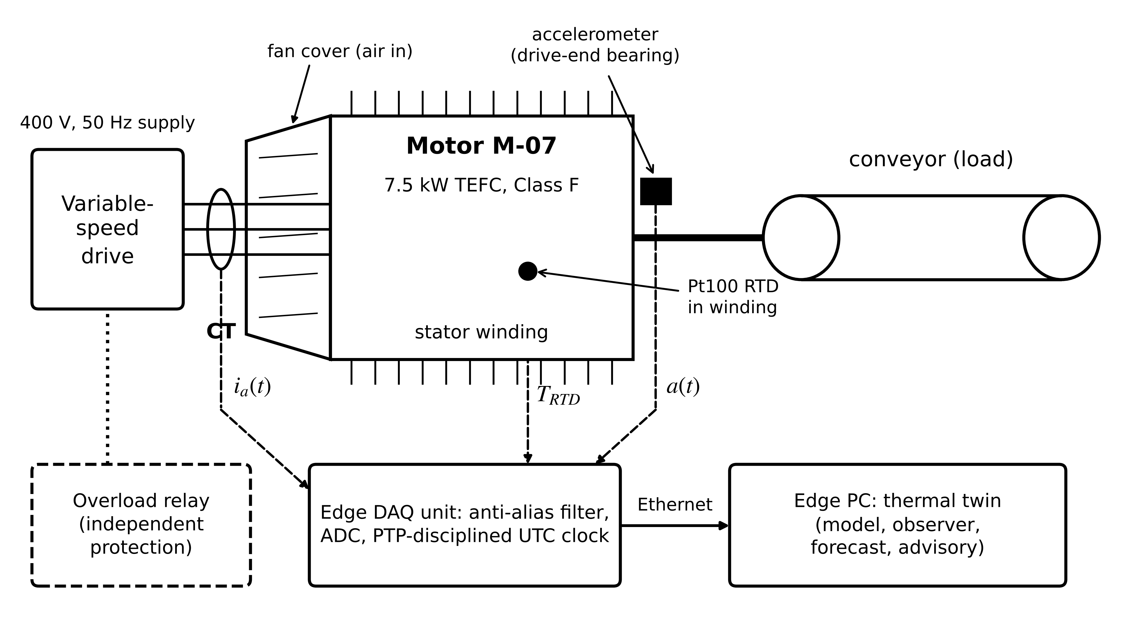
Figure 1.1. Motor M-07 in Plant P-1 and its instrumentation. Three measured signals (phase current, winding RTD, bearing vibration) reach an edge DAQ unit that timestamps them; the edge PC hosts the thermal twin. The overload relay is drawn dashed because it acts independently of the twin.
At 06:00 on a warm morning the ambient air is 30 °C, the motor has run at 90 % load for two hours, and the RTD reads 100.2 °C. Four quite different things can be done with that number. Separating them now saves a great deal of confusion later.
In the first, an engineer opens a thermal simulation built six months ago, types in 30 °C and the rated losses, and reads a predicted winding temperature. Nothing links the simulation to the motor except the engineer. In the second, RTD and CT values are streamed every 30 s into a plant historian with timestamps, and a trend screen updates by itself. In the third, software takes each new sample, updates a thermal model of M-07 and forecasts where the winding will be 30 minutes from now. In the fourth, that forecast is allowed to change something in the plant: a message to the shift supervisor recommending a lower conveyor speed or, with interlocks in place, a speed-reference change sent to the drive.
Table 1.1. Four operational stages for motor M-07 and the property each one adds
Stage | What happens | Property added | Name used in Section 1.3
A. Offline simulation | Engineer enters values by hand and reads the result | A validated model exists | Digital model
B. Automated data feed | RTD and CT sampled every 30 s, stored with UTC timestamps | Data arrive without human action | Digital shadow, if the model state is also updated automatically
C. Prediction | Model state updated from data; 30-min forecast each cycle | Synchronized state plus a predictive service | Digital twin, Levels 2 to 3
D. Authorized action | Forecast triggers an advisory or an interlocked command | Automated path back to the asset | Digital twin, Level 3 (advisory) or Level 4 (command)

Table 1.1 sets the four stages side by side. Each stage adds a property that can be checked, and each one is useful by itself. A plant that stops at Stage B has good data and no prediction, and that is a perfectly sensible place to stop if nobody needs a forecast.
The same reasoning applies to the three other assets of Plant P-1: a PV array whose inverter logs 15-minute power values, a BESS whose management system counts coulombs, and a converter whose switching model lives in a MATLAB file. In each case sensors and a model both exist. Whether a digital twin exists depends on three things: how the two are connected, how closely the model state tracks the real one, and who or what may act on the result. Figure 1.2 draws the loop that all of them share. The rest of the chapter makes each arrow in that figure quantitative.
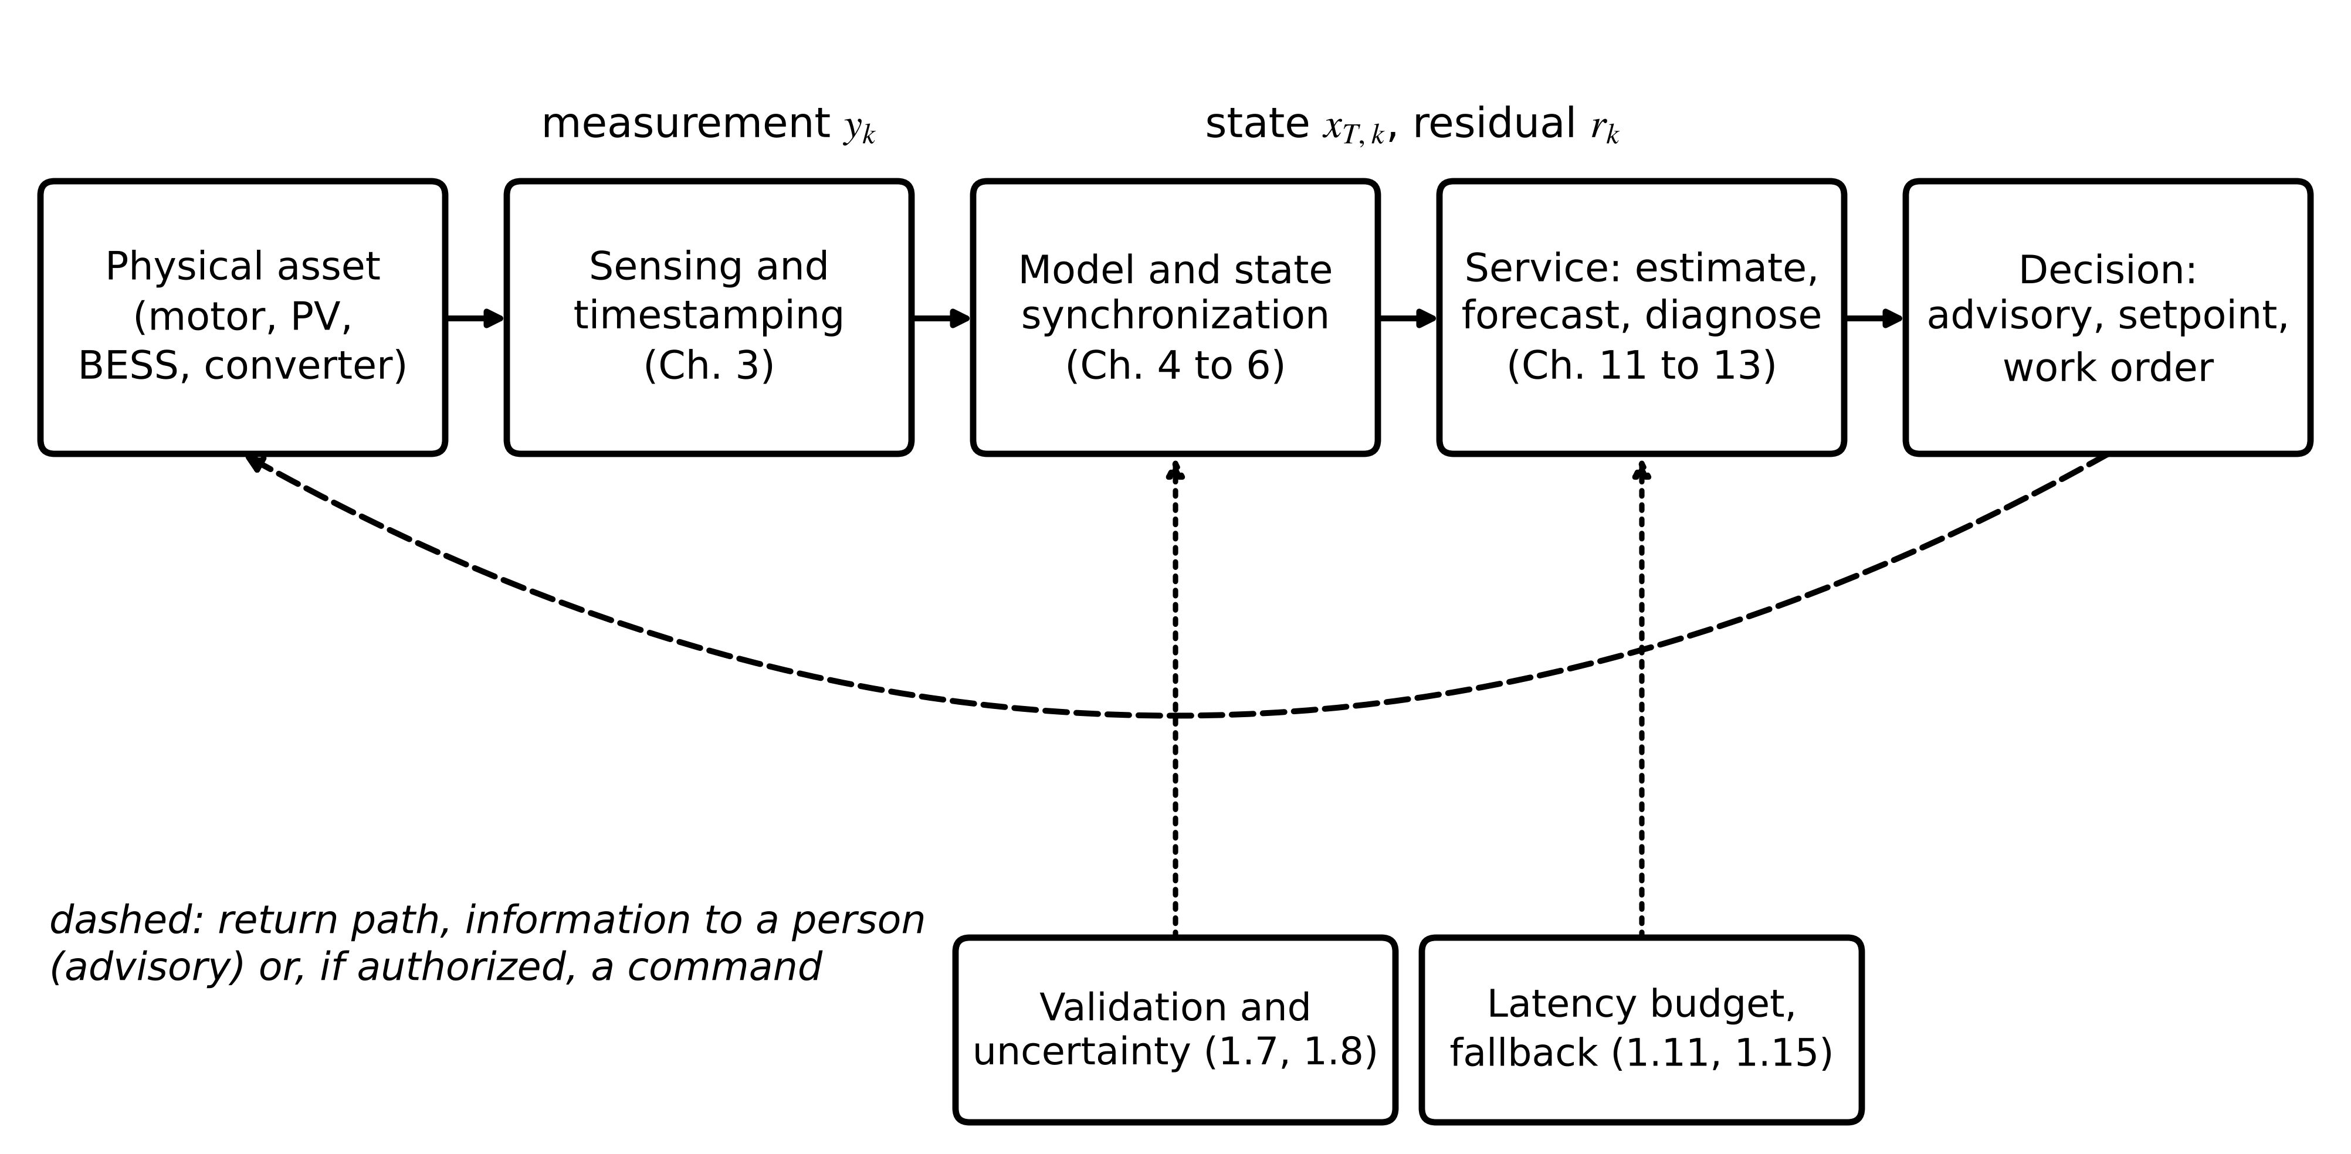
Figure 1.2. The asset, data, model and decision loop common to every twin in this book. The forward path is present in every twin; the return path is automated only for twins that issue advisories or authorized commands. The lower boxes are the checks that make the loop trustworthy.
The engineering question this section prepares is concrete. For M-07, which of Stages A to D is justified by the cost of an unplanned stop, the quality of the sensors and the consequences of a wrong automated action? Section 1.9 gives the test and Section 1.15 answers it with numbers.

1.2 From prototypes and simulation to decision-capable twins
Present-day twins did not appear in one step. Six stages, each adding one capability, lead from the engineering of the 1960s to what this book calls a decision-capable twin (Figure 1.3). The order matters more than the dates, because a deployment in the field today can still sit at any one of these stages.
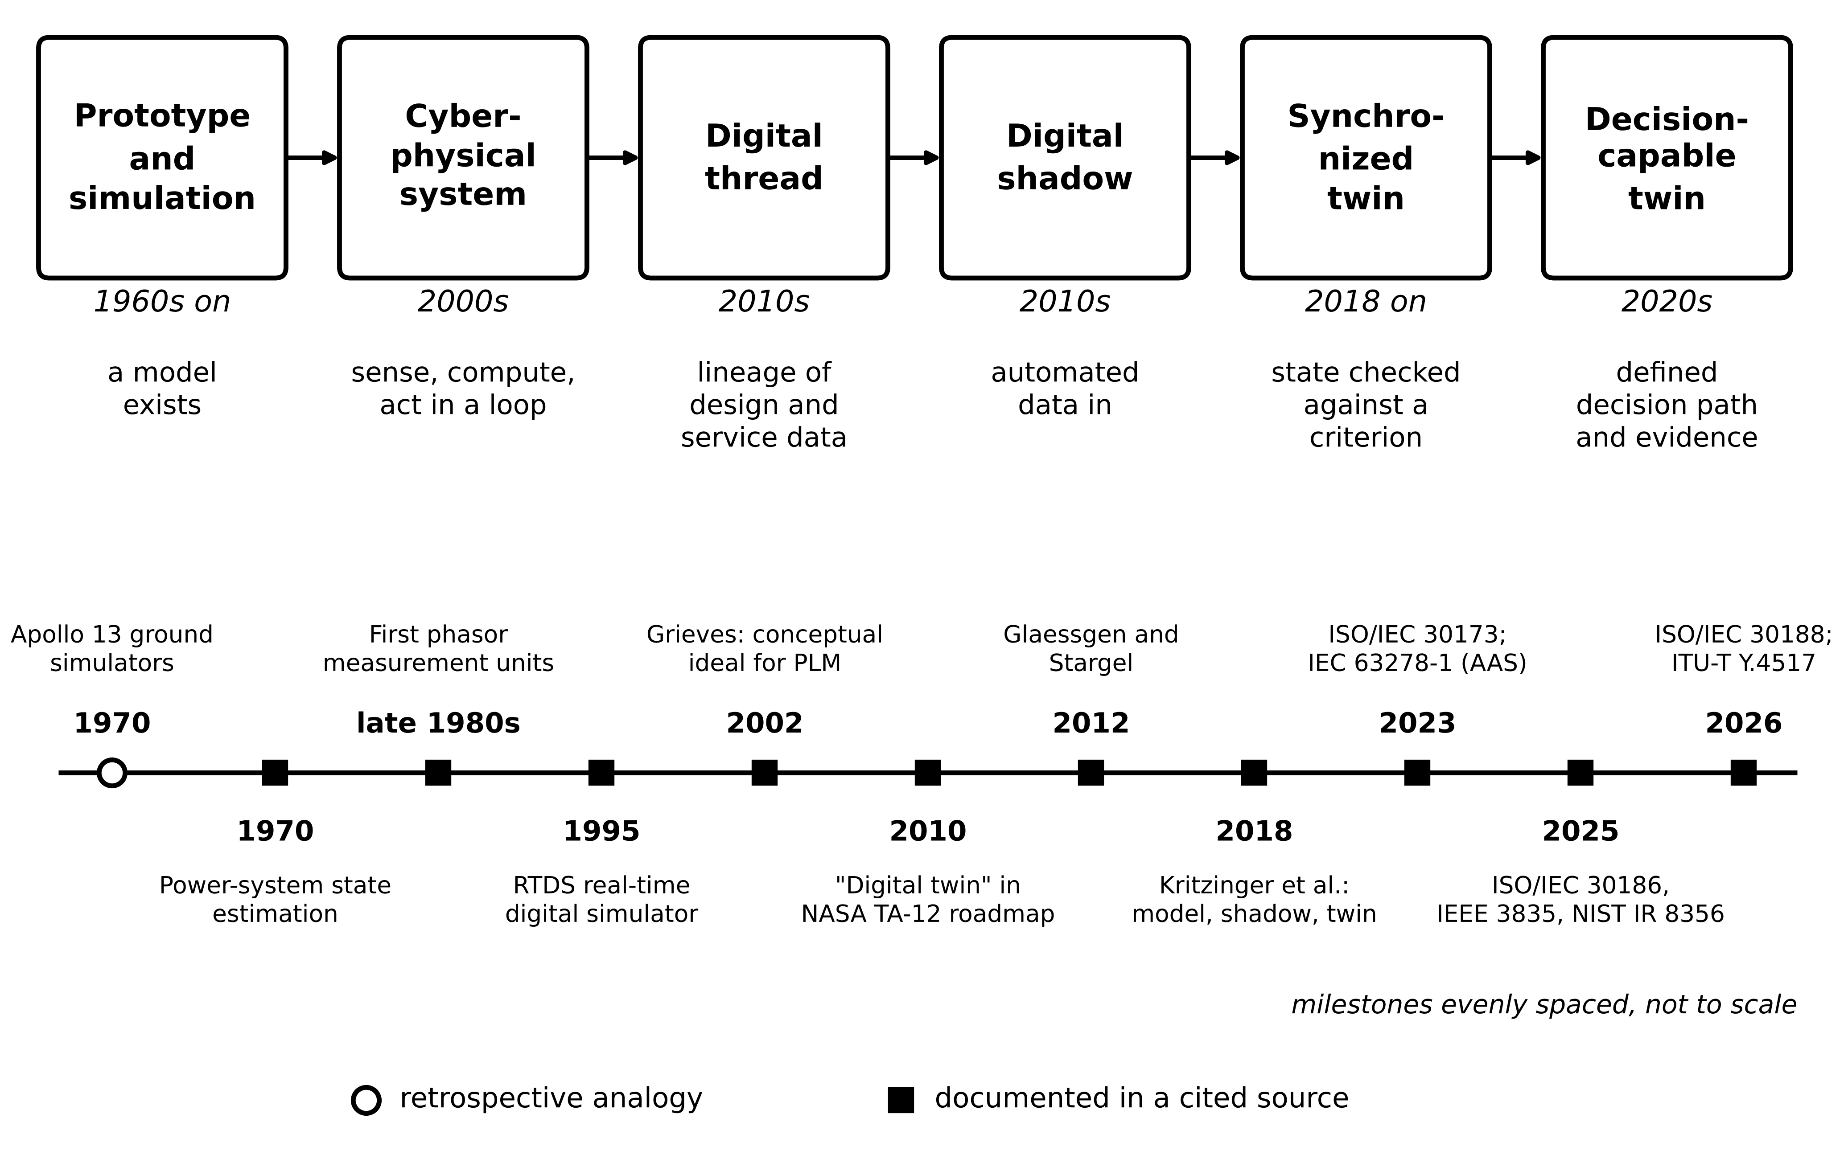
Figure 1.3. Upper row: the engineering progression from physical prototype and simulation to a decision-capable twin, with the capability each stage adds. Lower row: dated milestones, including the power-system line of state estimation (1970), phasor measurement units (late 1980s) and fully digital real-time simulation (1995). Filled squares are documented in the sources cited in Section 1.2; the open circle marks an event that later writing treats as an analogy.
Physical prototype and simulation. From the 1960s engineers built finite-element structural models, circuit simulations and lumped thermal networks to study a design before building it. Many were accurate. The data connection ran by hand: a technician measured a winding resistance on a prototype and an engineer typed it into the model. In the language of Section 1.3 these are digital models, and Stage A of Table 1.1 belongs here.
The physical counterpart as a reasoning aid. During the Apollo 13 emergency in April 1970, mission control used ground simulators, telemetry and crew procedures to rehearse a survivable return before the astronauts carried it out. The episode is widely retold as the first digital twin [2]. Zhou, Zhang and Gu, reviewing the origins of the concept, trace it instead to virtual manufacturing, model predictive control and building information modelling, and argue that present twin practice extends earlier engineering informatics rather than replacing it [3]. This book reads the Apollo connection as an analogy applied after the fact. The simulators were reconfigured by people from telemetry and voice reports; no model state was updated automatically from the spacecraft.
Power-system state estimation, synchrophasors and real-time simulation. Electrical engineers were keeping models synchronized with a physical system long before the word twin was used. In 1970 Schweppe and Wildes formulated static state estimation for power networks: a weighted least-squares fit of bus voltage magnitudes and angles to redundant telemetry, with bad data detected from the residuals [4]. Within a decade the energy management systems of transmission control centres were running such an estimator every few minutes and passing its output to contingency analysis and operator displays. Measured against the definition of Section 1.3, a control room of that kind meets most of the conditions of a digital twin: the network model is updated from measurements without manual steps, residuals are tested, and results reach the operator as advisories. Two later developments sharpened the time resolution. Phasor measurement units (PMUs), first built at Virginia Tech in the late 1980s and later standardized through the IEEE C37.118 series, stamp voltage and current phasors against a GPS time reference, so that the network state can be observed directly at tens of reports per second [5], [6]. Real-time digital simulators, of which the RTDS of the mid-1990s was the first fully digital example, made it possible to run electromagnetic-transient models in step with the wall clock and to close the loop with physical relays and controllers [7]. When power engineers say that the grid has had digital twins for fifty years, these are the systems they mean. What the older practice usually lacked, and what this book insists on, is a written, use-specific acceptance criterion and an explicit account of uncertainty.
Cyber-physical systems. A cyber-physical system (CPS) couples sensing, computation and actuation in a feedback loop around a physical process [8], [9]. A drive controller that measures current and adjusts the inverter every 100 µs is a CPS. It needs no model whose agreement with the plant is measured and reported, and that is the gap a twin fills.
Digital thread. In aerospace manufacturing the digital thread links design, production and service records of one product through its life [10]. The thread is lineage, not state: it tells you which insulation batch went into M-07, not how hot that insulation is now. Section 1.10 uses the thread to carry data between lifecycle stages of a twin.
The named concept and the digital shadow. Michael Grieves presented a "Conceptual Ideal for PLM" at the University of Michigan in 2002, built on three elements: a real space, a virtual space and a link carrying data one way and information back [11]. The phrase "digital twin" appears in NASA's 2010 Technology Area 12 roadmap and is credited to John Vickers [12]. Glaessgen and Stargel's 2012 paper gave a much-quoted aerospace definition centred on an integrated, multiphysics, probabilistic simulation of an as-built vehicle [13], and Grieves and Vickers tied the naming together in 2017 [14]. Kritzinger et al. in 2018 separated digital models, shadows and twins by asking which data flows are automated [15], and Tao et al. summarized the state of the field in 2019 [16]. Roughly a decade separates the 2002 idea from broad industrial use. What was missing was cheap sensing, networking and computing, not the concept.
Synchronized and decision-capable twins. Two further properties separate the twins of this book from a shadow. The first is a written, use-specific test of agreement between twin and asset; the National Academies report of 2024 places verification, validation and uncertainty quantification (VVUQ) at the centre of a trustworthy twin [17]. The second is a defined path from the twin's output to a decision. The 2026 systematic review of digital twins in electrical engineering by Abuabed and Kittur, which analysed 84 studies published from 2015 to 2025, names the move from descriptive and predictive twins to prescriptive ones as the main technical barrier still open [18].
Standardization has begun to settle the vocabulary. ISO 23247 parts 1 to 4 (2021) define a twin framework for manufacturing [19], [20]. ISO/IEC 30173:2023 gives concepts and terminology [21], and ISO/IEC 20924:2024 extends the IoT vocabulary to twins [22]. IEC 63278-1:2023 specifies the Asset Administration Shell, an information model that lets one vendor's software read another's twin data [23]. ISO/IEC 30186:2025 provides a generic maturity model with assessment indicators, and its informative Annex A works through a maturity assessment of a power digital twin [24]; ISO/IEC 30188:2026, published in July 2026, specifies a general reference architecture through architecture views [25]. Three documents are directly about energy: NIST IR 8356 (2025) on security and trust [26], IEEE 3835-2025 on a twin framework for integrated energy systems [27], and ITU-T Recommendation Y.4517 (06/2026) on the architecture of a digital twin system in the power grid, whose published scope covers continuous synchronization, multi-source data, model management and standardized interfaces for monitoring, analysis, prediction, optimization and decision support [28]. Chapter 2 treats these documents in detail. Only their public scope statements are used here, and compliance claims should never be made from an abstract.
Table 1.2. Evidence status of the main milestones
Year | Milestone | Evidence type | Source
1960s on | Numerical models of designs (FEA, circuit, thermal) | Documented practice | General engineering literature
1970 | Apollo 13 ground simulation and telemetry | Retrospective analogy | [2], [3]
1970 | Static state estimation of power networks | Peer-reviewed | [4]
Late 1980s | First phasor measurement units | Documented | [5]
1995 | First fully digital real-time power-system simulator | Peer-reviewed | [7]
2002 | Conceptual Ideal for PLM: real space, virtual space, link | Documented | [11]
2010 | "Digital twin" in NASA TA-12 roadmap | Documented | [12]
2018 | Model, shadow and twin classified by automated data flow | Peer-reviewed | [15]
2023 | ISO/IEC 30173 terminology; IEC 63278-1 AAS | International standards | [21], [23]
2024 | NASEM report on research gaps; TwinEU federated grid twin begins | Report; EU project record | [17], [29]
2025 | ISO/IEC 30186 maturity model; NIST IR 8356 final; IEEE 3835-2025 | Standards; government report | [24], [26], [27]
2026 | ISO/IEC 30188 reference architecture; ITU-T Y.4517 power-grid twin | International standards | [25], [28]

The practical lesson from the history is this. When a vendor or a paper claims that a system "is a digital twin", the first question is which stage of Figure 1.3 the claim actually reaches: a detailed model, a data link, a synchronized state with a stated test, or a decision path with evidence. The answer decides what evidence to ask for. Much of the credibility attached to digital twins in promotional material rests on the one milestone in Table 1.2 that is an analogy.
What the digital twin adds
Synchronized: nothing yet; this section is about where synchronization came from.
Estimated or updated: the reader's classification of a claimed twin by stage.
Uncertainty carried: whether a historical claim is documented or an analogy.
Decision enabled: what evidence to request from a vendor.
Validated by: primary sources and standards scope statements, not marketing text.

1.3 Definitions, classes of twin and layers of autonomy

1.3.1 Published definitions and the working definition
The literature does not agree on one definition, and the differences are real rather than careless. Some definitions demand automated flow in both directions. Some ask only that the virtual representation stays current. Others focus on purpose or on uncertainty and say nothing about direction. Table 1.3 sets the influential ones side by side, paraphrased, with what each requires.
Table 1.3. Selected digital twin definitions and what each requires
Source | Core requirement (paraphrased) | Automated return path required?
Grieves and Vickers, 2017 [14] | Real space, virtual space and a data and information link between them | Not stated explicitly
Glaessgen and Stargel, 2012 [13] | Integrated, multiphysics, probabilistic simulation of an as-built system, updated with sensor data and history | Not stated; emphasis on prediction
Kritzinger et al., 2018 [15] | Model (manual both ways), shadow (automated physical to virtual), twin (automated both ways) | Yes, by construction
Tao et al., 2019 [16] | Five dimensions: physical entity, virtual entity, services, data, connections | Implied through services
ISO/IEC 30173:2023 [21] | Digital representation of a target entity whose data connections let physical and digital states converge at an appropriate synchronization rate | No; convergence may run either way
VanDerHorn and Mahadevan, 2021 [30] | Fidelity set by intended use; only the detail the purpose demands | No
NASEM, 2024 [17] | Virtual representation plus bidirectional interaction: data-driven updating and decision-making in a feedback loop; VVUQ essential | Bidirectional interaction, not necessarily automatic actuation
Zomerdijk et al., 2024 [31] | Power-system-specific definition with an ecosystem architecture spanning planning to operation | Through services, as a system of systems

Two points stand out. The ISO/IEC definition speaks of convergence at an appropriate rate, which makes synchronization a design requirement tied to the use rather than a fixed number. And the National Academies report puts VVUQ at the centre, which none of the older definitions did [17]. Any single "universal" automation criterion therefore takes a side in an open debate.
Box 1.1 Working definition used in this book
A digital twin is a computational representation of a specific physical asset, process or system (i) whose state is updated from measured data without manual intervention, (ii) whose agreement with the physical counterpart is checked against a stated, use-specific acceptance criterion, and (iii) whose outputs reach a defined decision path back to that counterpart.
The unqualified term digital twin is reserved for arrangements that meet all three conditions, and digital shadow is used for one-way synchronized representations. That is a choice made for checkability, not a claim that the literature has settled the matter; under ISO/IEC 30173 some shadows would also be called twins.
Condition (iii) asks for a decision path, not for automatic actuation. An alarm, a recommended setpoint or a maintenance ticket satisfies it. Section 1.3.3 explains why.

The same five elements recur in almost every definition, and Tao et al. write them as a five-tuple [16]:
$DT=\left(PE, VE, Ss, DD, CN\right)$ (1.1)
where PE is the physical entity (the motor, array, pack or converter), VE the virtual entity (its model, built from physics, data or both, Chapters 4 to 6), Ss the services that use the synchronized state (estimation, prediction, diagnosis, optimization and control, Chapters 5, 6 and 11 to 13), DD the twin data, including timestamps and metadata without which measurements from different devices cannot be aligned, and CN the connections that carry data between them (Chapter 3). The tuple is a checklist, not an equation to solve: a proposed system that cannot name each of its five members is not yet a twin. The historian of Stage B has PE, CN and DD but no VE running on those data and no Ss. Adding a thermal model refreshed by each sample supplies VE; adding the 30-minute forecast supplies Ss.

1.3.2 Digital model, digital shadow and digital twin
Figure 1.4 draws Kritzinger et al.'s classification [15]. One question is asked twice, once per direction: is this flow automated, or does a person carry the data?
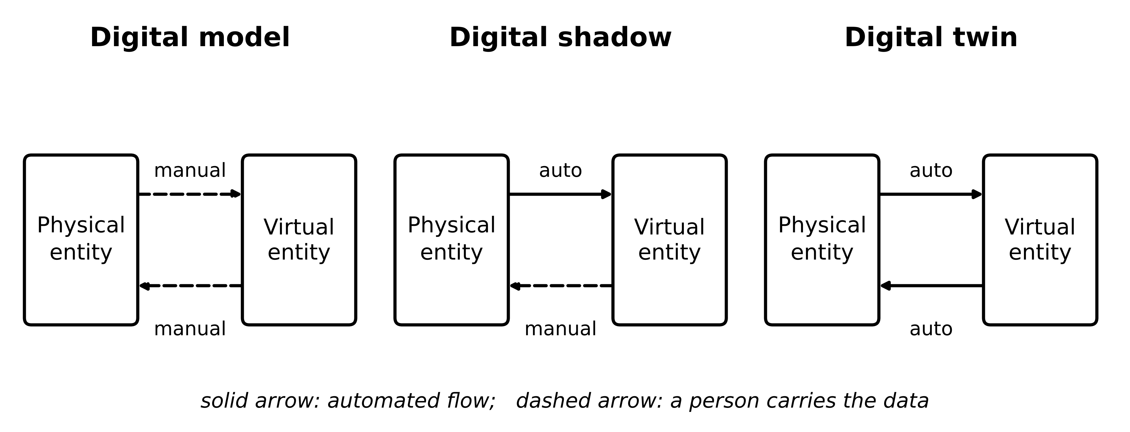
Figure 1.4. Digital model, digital shadow and digital twin distinguished by which data flows are automated. Solid arrow: automated; dashed arrow: a person carries the data.
In a digital model data move by hand both ways: the engineer measures, types, simulates and reads. In a digital shadow data flow automatically from physical to virtual and any return flow is manual. A substation mimic that refreshes from telemetry every few seconds, watched by an operator but issuing nothing, is a shadow. Calling it so is not a criticism. It is accurate labelling, because the evidence needed to trust a shadow differs from the evidence needed to trust something that issues commands. In a digital twin both directions are automated.
One borderline case is common enough to name. Automated data collection is often mistaken for an automatically updated model. If sensor values land in a database automatically but an engineer runs the model once a month on an export, the model state is updated by hand. The pipe is automated; the synchronization is not. Strictly, that is a digital model fed by a digital data infrastructure, because the test applies to the flow into the virtual object, not into storage [15].
The distinction can be written with three binary indicators. Let $a_{PV}=1$ if measurements reach the model state without manual action, $a_{VP}=1$ if information reaches the physical side without manual action, and $a_{act}=1$ if that information may change the operating point of the asset without a human decision. Table 1.4 gives the class for each combination, and the two automated directions are written as maps:
Table 1.4. Classification by the three automation indicators
$a_{PV}$ | $a_{VP}$ | $a_{act}$ | Class
0 | any | any | Digital model
1 | 0 | 0 | Digital shadow
1 | 1 | 0 | Digital twin, advisory
1 | 1 | 1 | Digital twin, actuating

$x_{T,k}=Φ_{PV}\left(x_{T,k-1}, y_{k}, u_{k}\right), c_{k}=Φ_{VP}\left(x_{T,k}\right)$ (1.2)
Here $x_{T,k}$ is the twin state after update $k$ (subscript $T$ always marks a twin quantity), $y_{k}$ the measurement received at update $k$, $u_{k}$ the known input, $Φ_{PV}$ the physical-to-virtual update map and $c_{k}$ the information sent back by the virtual-to-physical map $Φ_{VP}$ (an advisory, a setpoint or nothing). $a_{PV}=1$ means that $Φ_{PV}$ runs without a person, and $a_{VP}=1$ that $c_{k}$ is delivered without one. Section 1.6 gives $Φ_{PV}$ its first concrete form, a predictor and corrector with a gain. Each indicator can be checked from data-flow documentation and a site visit, with no appeal to intent or marketing.

1.3.3 Three layers of autonomy
"Automated in both directions" hides three different capabilities that carry very different risk. Figure 1.5 separates them.
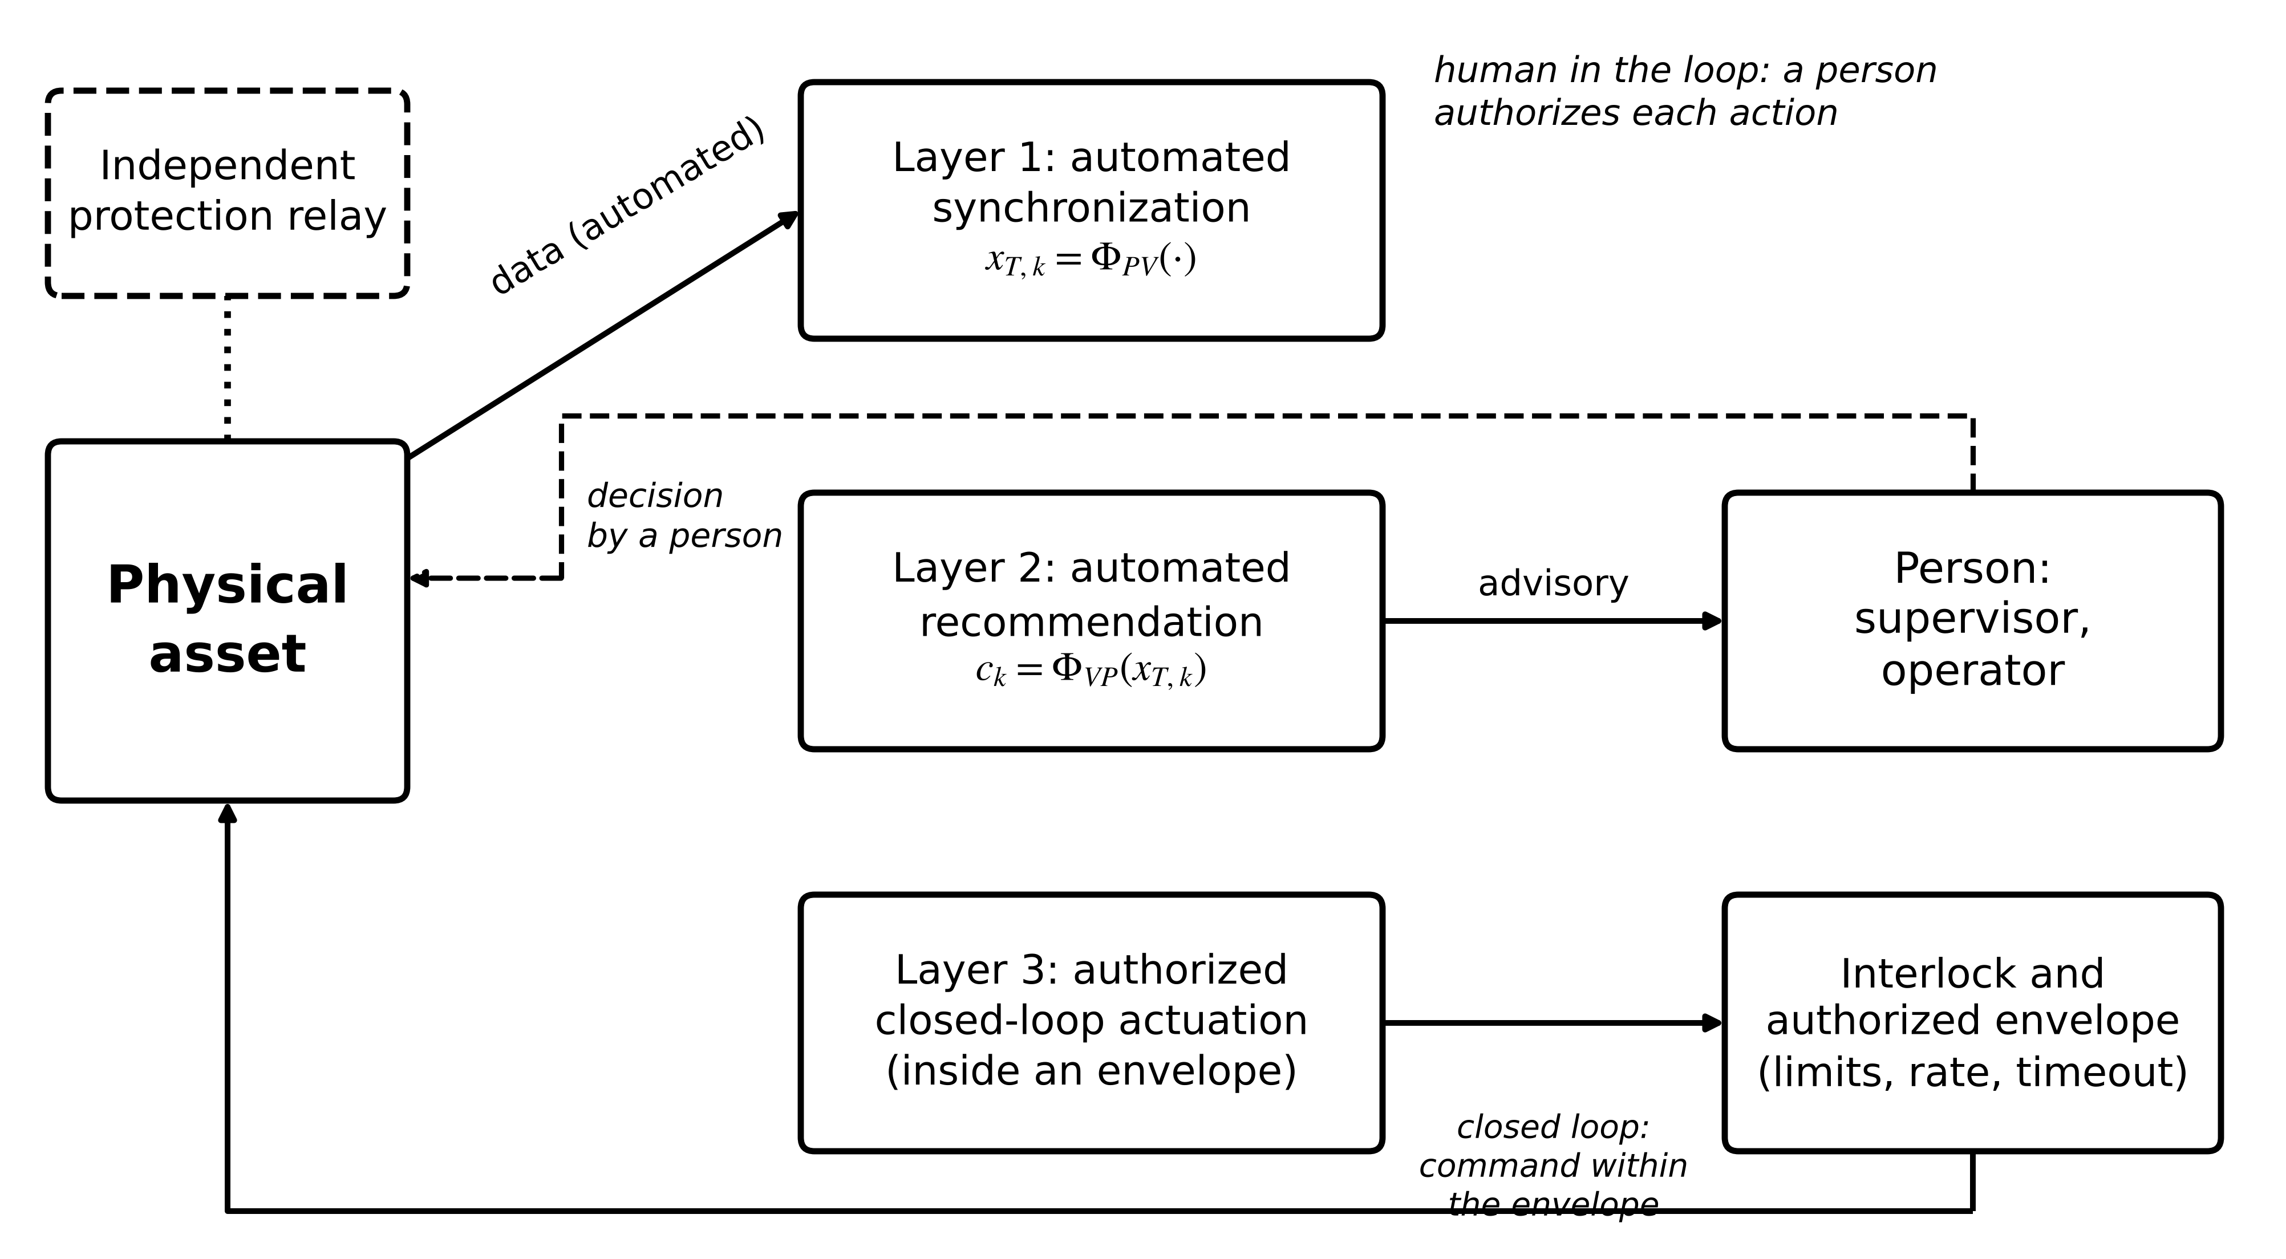
Figure 1.5. Three layers of autonomy. Layer 1 keeps the twin synchronized; Layer 2 issues recommendations that a person accepts or rejects (human in the loop); Layer 3 sends commands only through an interlock and an authorized envelope. The protection relay acts independently of all three.
Layer 1, automated synchronization, is the map $Φ_{PV}$. It changes nothing in the plant. Layer 2, automated recommendation, delivers $c_{k}$ to a person who decides; however quickly that person responds, the decision is human. Layer 3, authorized closed-loop actuation, lets $c_{k}$ change the operating point, but only inside an envelope written in advance (limits on magnitude, rate and duration, a timeout and an interlock that a protection system can override).
This book does not make Layer 3 part of the definition of a twin, for three reasons. First, many valuable twins are deliberately advisory, because every action in their plant already passes through a work-order system. Second, the risk of Layer 3 depends on what $c_{k}$ may change, and that is a design choice to be justified with costs and probabilities (Section 1.9), not a property that makes something more or less of a twin. Third, functions that must act within tens of milliseconds, such as protection, are achieved through certified relays, not through a general-purpose twin. The levels of Figure 1.5 are therefore clauses in the contract of Section 1.4, not rungs of prestige.

1.3.4 What is not a digital twin
Box 1.2 Diagnostic: what is not a digital twin?
Simulation only. A detailed model that is never updated from measurements of a specific deployed asset. However accurate, it is a digital model. Test: does any automated measurement change the model state?
Dashboard only. Live trends, alarms and a 3-D scene with no executable model that computes unmeasured states or forecasts. Test: remove the model; does anything on the screen change?
Offline machine-learning model. A network trained last year on fleet data and run on batches. It predicts, but it is bound to no specific asset and nothing checks it against that asset online. Test: is there a named physical counterpart and a running acceptance check?
Static CAD or BIM model. Geometry and nameplate data, possibly very rich, with no state. Test: does it have a variable that changes with time?
Unsynchronized replica. A model that was synchronized at commissioning and has since drifted, with no stated criterion or no evidence that the criterion still holds. Test: when was agreement last measured, and against what threshold?
Each of these is useful and may be a stage on the way to a twin (Section 1.2). The point of the diagnostic is accurate labelling, because each label implies different evidence.

Example 1.1 (Level A) Classifying five configurations
Given. (a) M-07's RTD is logged every 30 s to a historian; once a week an engineer exports a CSV file and runs the thermal model. (b) Each new RTD and CT sample is pushed to a thermal model that recomputes the winding state; a trend of predicted against measured temperature is displayed and nobody receives alarms. (c) As (b), but when the 30-minute forecast exceeds 120 °C the system sends an advisory to the shift supervisor, who decides what to do. (d) The PV array's performance model updates every 5 min from irradiance and power, and opens a cleaning ticket automatically; a technician decides whether to clean. (e) The converter's thermal model estimates junction temperature every 100 ms and lowers the current limit automatically, within limits written into the drive firmware, when the estimate exceeds 125 °C.
Find. The indicators $a_{PV}$, $a_{VP}$, $a_{act}$ and the class of each configuration from Table 1.4, and the autonomy layer of Figure 1.5 that each reaches.
Solution. (a) The model state is updated by a person, so $a_{PV}=0$: a digital model with automated data storage, no layer reached. (b) $a_{PV}=1$, nothing returns automatically, $a_{VP}=0$: a digital shadow, Layer 1. (c) $a_{PV}=1$, $a_{VP}=1$ and $a_{act}=0$ because a person authorizes any change: an advisory twin, Layer 2. (d) The ticket is information delivered without a person, $a_{VP}=1$, but the technician decides: advisory twin, Layer 2. (e) $a_{PV}=a_{VP}=a_{act}=1$ and the command is bounded by a written envelope: an actuating twin, Layer 3.
Interpretation. Moving from (a) to (b) is mainly software integration. Moving from (b) to (c) needs something different in kind: an alarm rule, an owner for the advisory and a documented response. Moving from (c) to (e) needs an envelope and evidence that automatic action is cheaper in expectation than human delay (Section 1.9). Configuration (e) is not "better" than (c); it suits a function whose time scale is too fast for a person.
What the digital twin adds
Synchronized: the twin state, by an automated map $Φ_{PV}$.
Estimated or updated: the class and the autonomy layer of a deployment.
Uncertainty carried: none yet, but condition (ii) of Box 1.1 demands a stated criterion.
Decision enabled: what label to put on a system and what evidence to request.
Validated by: data-flow documentation and a site visit, checking each indicator.

1.4 The digital-twin contract and its evidence
Definitions say what a twin is. Engineering needs something stronger: a written statement of what this twin, for this asset, promises and how the promise is checked. This book calls that statement the digital-twin contract. It is one page per deployed twin, and every later chapter fills in its clauses for a particular asset class. Having a common contract stops each chapter from redefining what a twin is, and it gives a reviewer a fixed list of questions.

1.4.1 The twelve clauses
The contract is the ordered set
$𝒞=\left(E, Π, y, x, θ, ℳ, S, U, D, V, Λ, F\right)$ (1.3)
whose twelve members are, in order: the physical entity $E$ (a serial-numbered asset, never a type); the purpose $Π$ (the question the twin answers, for example "will the winding exceed 120 °C within 30 min?"); the measured variables $y$ with sensor, rate and accuracy; the hidden states $x$ that must be inferred; the parameters $θ$, each marked fixed, tracked or learned; the model $ℳ$ with its structure, order and validity range; the synchronization rule $S$ (gain, update rate, resynchronization trigger); the uncertainty $U$ (sources and bounds, Section 1.7); the service and decision $D$ (who or what acts, at which autonomy layer); the validation criterion $V$ (metric, window, threshold, envelope, Section 1.8); the latency $Λ$ (deadline and worst case, Section 1.11); and the fallback $F$ (what happens when the twin fails, Section 1.15). Figure 1.6 groups them.
Figure 1.6. The canonical digital-twin contract used throughout the book. Clauses are numbered as in (1.3) and grouped into what the twin is about, what state it carries, how it stays synchronized, and how it is used and checked.
Three rules apply to every clause. It must be specific: "high accuracy" is not a validation criterion, "one-step RMSE below 1.0 K on a held-out week" is. It must be evidenced: each clause names the record that proves it. And it must be versioned: when the model, sensor or envelope changes, the contract changes and the old version is kept. Table 1.5 fills the contract for M-07 and lists the evidence for each clause.
Table 1.5. Digital-twin contract for the M-07 thermal twin, with the evidence for each clause
# | Clause | M-07 entry | Evidence kept
1 | Physical entity $E$ | Motor M-07, serial 7.5-TEFC-0412, conveyor line 2 | Asset register entry, nameplate photo
2 | Purpose $Π$ | Warn 30 min before the winding exceeds 120 °C | Signed requirement
3 | Measured $y$ | RTD 30 s, ±0.35 K at 100 °C; CT $\overline{I^{2}}$ per 30 s | Calibration certificates, DAQ configuration
4 | Hidden $x$ | Hot-spot temperature (not estimated by this twin) | Statement of scope
5 | Parameters $θ$ | $R_{th}$ tracked; $C_{th}$ fixed at 9.0 kJ/K | Heat-run report, refit log
6 | Model $ℳ$ | One thermal node, ZOH, valid 40 to 100 % load, 20 to 35 °C | Model version, validation report
7 | Synchronization $S$ | Observer gain 0.3 every 30 s; resync after outage | Configuration file, outage log
8 | Uncertainty $U$ | RTD, parameter and forecast budget (Example 1.11) | Uncertainty budget sheet
9 | Decision $D$ | Advisory to shift supervisor (Layer 2) | Response procedure, advisory log
10 | Validation $V$ | One-step RMSE < 1.0 K; < 1 false advisory per 1000 h | Held-out test report
11 | Latency $Λ$ | End-to-end < 5 s worst case; cycle 30 s | Timing measurements
12 | Fallback $F$ | Raw RTD alarm at 130 °C plus overload relay | Fallback test record

Two clauses deserve a remark. Clause 4 records what the twin does not estimate. A one-node model cannot see the hot spot, and saying so in writing prevents somebody later from reading the twin's winding temperature as a hot-spot value. Clause 12 is not optional. A twin that can fail silently is worse than no twin, because people stop watching the raw data once they trust the model.

1.4.2 One contract, four assets
The contract does not depend on the asset. Figure 1.7 fills its main clauses for the four assets of Plant P-1. The motor twin is slow and thermal; the converter twin is fast and electrical; the battery twin integrates current; the PV twin depends on weather data. Their contracts differ in every entry but have the same twelve slots, which is what lets the later chapters (7 to 11) speak one language.
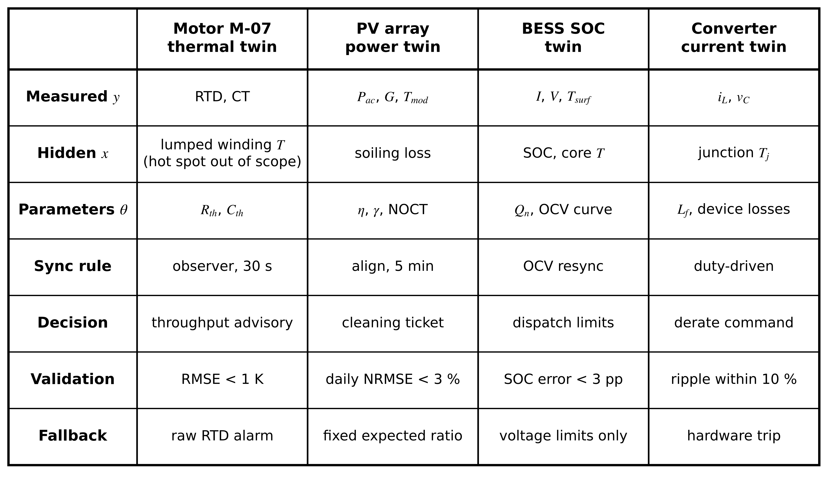
Figure 1.7. Four electrical assets of Plant P-1 mapped onto the same contract. Rows are contract clauses; columns are assets. The worked examples of Section 1.14 use exactly these entries.
Example 1.2 (Level A) Sizing three clauses of the M-07 contract
Given. M-07 has thermal time constant $τ=1800$ s, RTD noise $σ_{v}=0.3$ K and three channels (RTD temperature, CT-derived $\overline{I^{2}}$, bearing vibration RMS). Each logged record holds an 8-byte timestamp and a 4-byte value per channel. The purpose clause asks for a forecast 30 min ahead.
Find. (a) The largest update period for which forward Euler and exact discretization differ by less than ${10}^{-3}$ in the discrete pole (anticipating (1.20)), and the update period that gives at least 60 updates per time constant. (b) The daily data volume at the chosen period. (c) The tightest one-step RMSE criterion that the RTD can verify, and a defensible value for clause 10. (d) A fallback threshold that keeps at least 25 K margin to the 155 °C Class F limit for a hot spot assumed 15 K above the RTD.
Solution. (a) The pole error of Euler against the exact pole is about $1/2(T_{s}/τ)^{2}$ (derived in Section 1.5). Setting $1/2(T_{s}/τ)^{2}≤{10}^{-3}$ gives $T_{s}≤τ\sqrt{2×{10}^{-3}}=1800×0.0447=80.5$ s. Sixty updates per time constant needs $T_{s}≤1800/60=30$ s, which is the tighter requirement, so $T_{s}=30$ s. (b) One record per period holds $8+3×4=20$ bytes; there are $86 400/30=2880$ periods a day, so $2880×20=57 600$ bytes, about 56 kB a day. (c) The RMSE observed against the RTD cannot fall below the RTD noise itself, 0.3 K, and Section 1.7 adds the RTD tolerance (0.20 K standard uncertainty), giving a floor near 0.36 K. A criterion of 1.0 K leaves margin for model error and is verifiable. (d) Hot spot at the alarm point is $T_{alarm}+15$; requiring $T_{alarm}+15≤155-25$ gives $T_{alarm}≤115$ °C. The case study keeps 130 °C for the raw-RTD fallback alarm, accepting a 10 K margin at the assumed hot spot because the independent overload relay remains as a second layer; with the 25 K margin rule stated here the fallback would be 115 °C. Either value is acceptable once it is written into clause 12 together with its justification.
Interpretation. Clause 7 (rate) is set by the thermal physics, clause 10 by the sensor, and clause 12 by the insulation limit and a margin policy. None of them is a free choice once the purpose and the asset are fixed. That is the value of writing the contract before writing code.
What the digital twin adds
Synchronized: what clause 7 says, at the rate it states.
Estimated or updated: the hidden states of clause 4 and the tracked parameters of clause 5.
Uncertainty carried: clause 8, quantified in Section 1.7.
Decision enabled: clause 9, at a stated autonomy layer.
Validated by: clause 10, with the evidence listed in Table 1.5.

1.5 The mathematical bridge: a first thermal twin from an energy balance
This section builds the first physical twin of the book slowly, so that a reader with first-year circuits and calculus can follow every line. The physical question is simple: given the losses in M-07's winding and the air around it, how hot is the winding now, and how hot will it be in 30 minutes?

1.5.1 Five ideas needed before any residual
Notation first. A quantity with subscript $T$ belongs to the twin, a hat denotes an estimate produced by an estimator, and subscript $k$ denotes a value sampled at timestamp $t_{k}$. Units follow SI; temperatures are quoted in °C for readability and temperature differences in kelvin (K).
A state vector collects the quantities that summarize the asset's condition at an instant. For M-07 a minimal state is the winding temperature; a richer one adds the core and frame temperatures:
$x(t)={\left[x_{1}(t), x_{2}(t), …, x_{n}(t)\right]}^{⊤}∈ℝ^{n}, x={\left[T_{w} T_{core} T_{frame}\right]}^{⊤}$ (1.4)
where $⊤$ denotes transposition, $ℝ^{n}$ the space of real $n$-vectors, and $T_{w}$, $T_{core}$, $T_{frame}$ the winding, core and frame temperatures in °C.
Some states are measured and some are not. The RTD reads the winding at one point; nothing reads the hot spot. That is the main reason a model exists at all. When sensors read states directly the output map is a selection matrix:
$y=Hx, H=\left[1 0 0\right]$ (1.5)
where $H$ has one row per sensor and a single 1 in the column of the state that sensor reads. States with no 1 in any row of $H$ are hidden and must be inferred through the model.
Measurements are samples, not signals. A DAQ reads the sensor at instants $t_{k}$ and attaches a timestamp. If the timestamp is late by $δt$, the sample actually taken at $t_{k}$ is compared with the twin's value at $t_{k}+δt$. A Taylor expansion $y(t_{k}+δt)=y(t_{k})+\dot{y}(t_{k})δt+1/2\ddot{y}(t_{k})δt^{2}+…$ gives the apparent error
$r_{skew}≈\dot{y} δt$ (1.6)
where $\dot{y}$ is the rate of change of the measured quantity and the neglected term is second order in $δt$. With the full-load loss applied to a cold winding, M-07's winding heats at most at $400/9000=0.044$ K/s, so a 2 s skew costs only 0.09 K. A PV array whose output falls 2.7 kW in a few seconds under a cloud edge turns the same 2 s skew into a residual of the order of a kilowatt (Section 1.14). There, timestamp quality matters more than model quality. Chapter 3 treats clock synchronization.
Units must be carried explicitly. A residual of 0.5 means nothing until it is 0.5 K, 0.5 A or 0.5 percentage points of state of charge. Vectors of mixed units cannot be summarized by one norm without normalization (Section 1.8).
Every measurement carries noise and bias. A Class A Pt100 RTD has a tolerance of $±(0.15+0.002|t|)$ °C by IEC 60751 [32], that is ±0.35 °C at 100 °C, before wiring and converter errors. A measurement is modelled as the true output plus a bias and a random part:
$y_{k}=h\left(x(t_{k})\right)+b+v_{k}, 𝔼\left[v_{k}\right]=0, 𝔼\left[v_{k}^{2}\right]=σ_{v}^{2}, 𝔼\left[v_{j}v_{k}\right]=0 (j≠k)$ (1.7)
where $b$ is a constant bias (calibration error), $v_{k}$ zero-mean random noise of standard deviation $σ_{v}$, and $𝔼[·]$ the expectation. The last condition makes the noise white. Averaging $N$ samples reduces the random part by $\sqrt{N}$ and leaves the bias untouched, a distinction that comes back in every chapter. Figure 1.8 places state, input, parameter, output and residual on the motor.
Figure 1.8. State, input, parameter, output and residual for the winding thermal twin. Inputs are known or measured; the state and the true parameters are hidden; the residual compares the measured and predicted outputs.

1.5.2 Deriving the winding model step by step
Figure 1.9 shows the physical path of the heat and its electrical analogue. Losses in the copper heat the winding; heat crosses the slot insulation by conduction, passes through the core and frame, and leaves the frame surface by convection to the air the fan blows over it. The simplest useful model lumps the whole winding into one thermal mass. That assumption is stated now and checked later: it holds when temperature differences inside the winding are small compared with the winding-to-ambient difference.
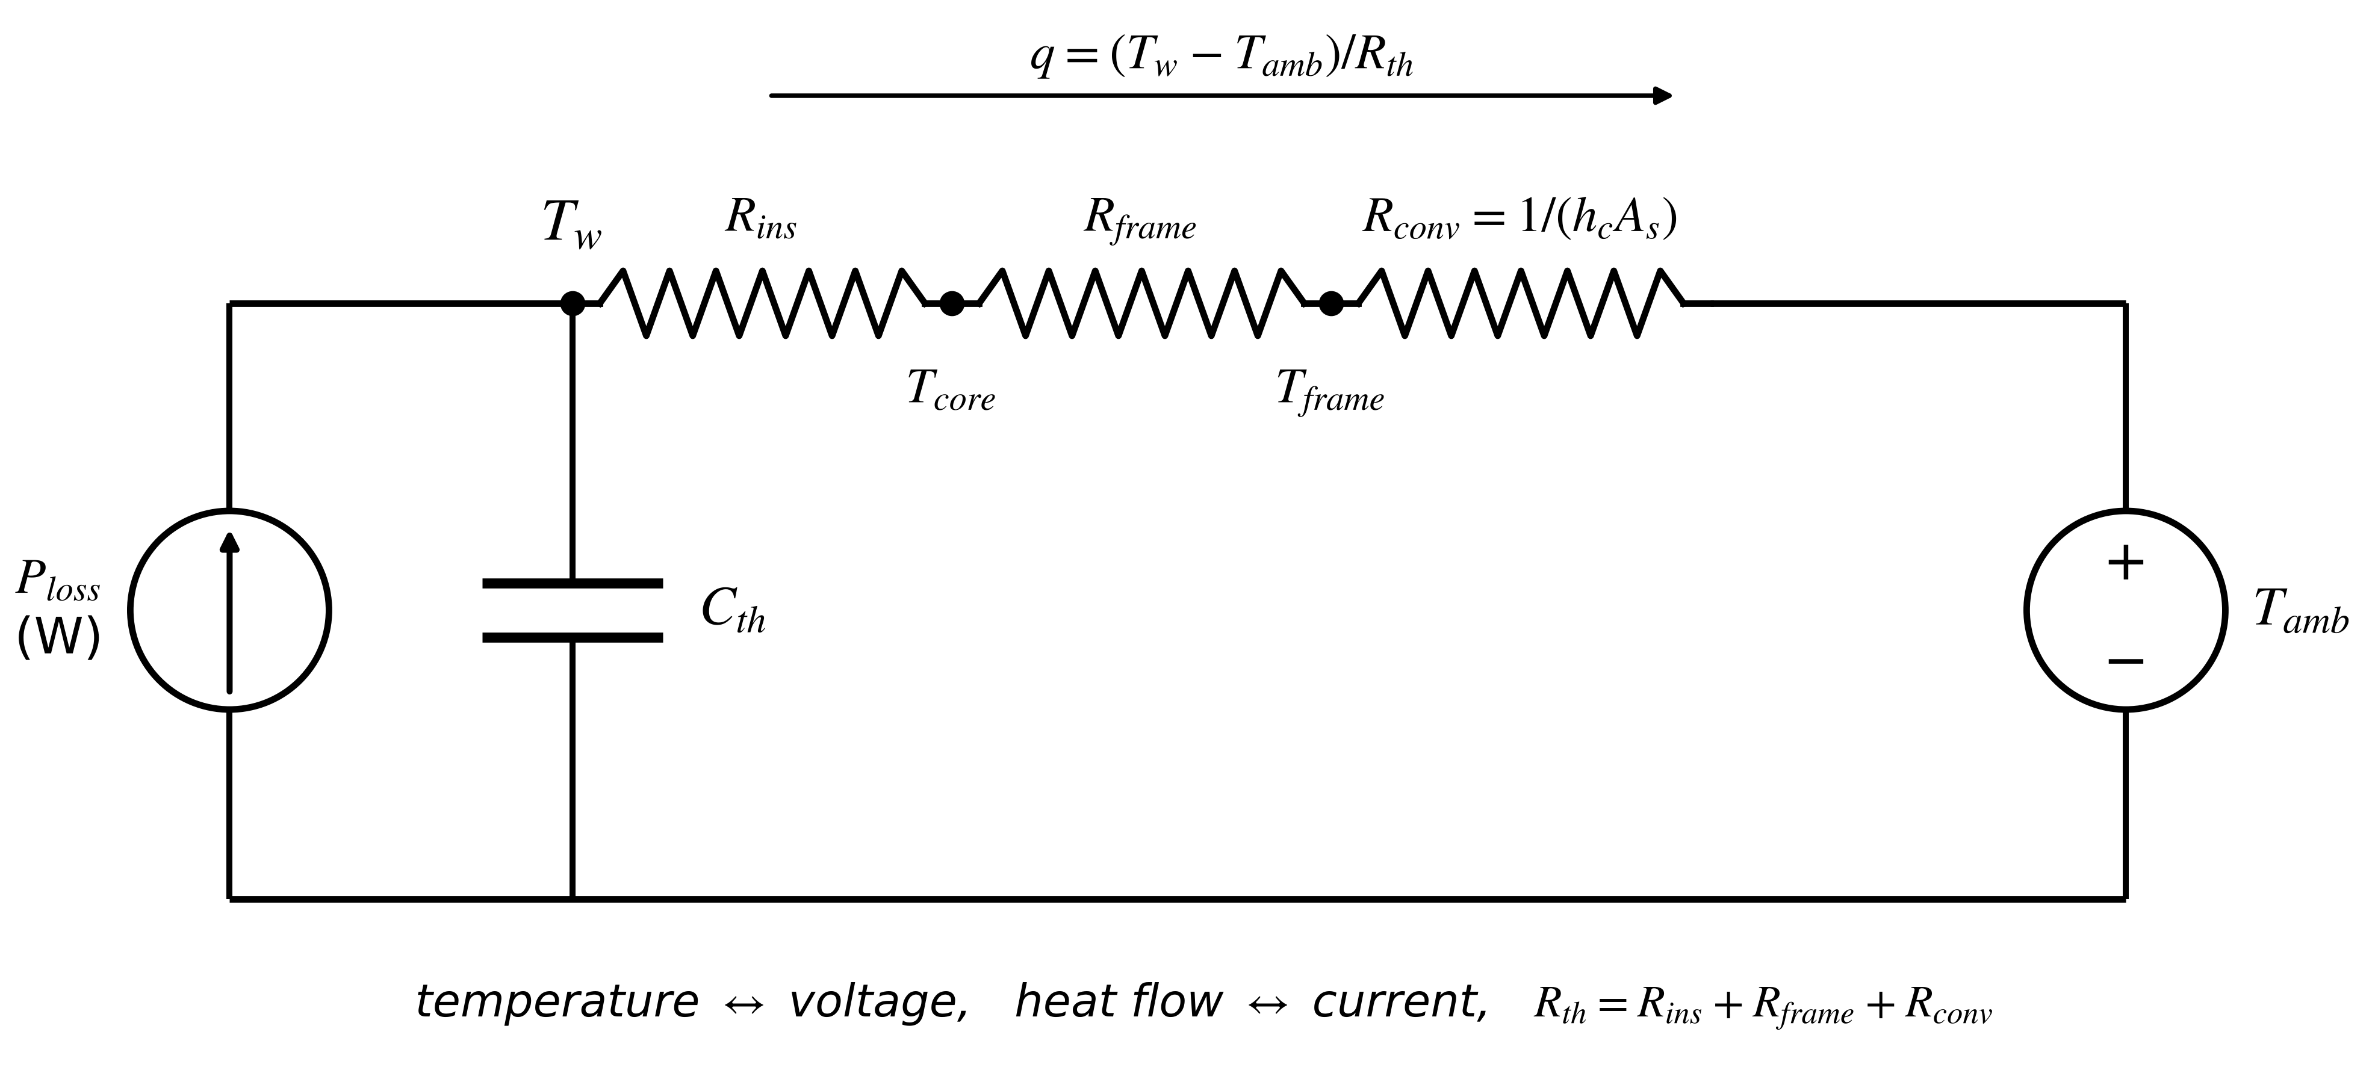
Figure 1.9. Thermal network of M-07 and its electrical analogue. Loss power is a current source, heat capacity a capacitor, each conduction or convection stage a resistor, and the ambient an ideal voltage source. The one-node twin keeps $C_{th}$ and the series sum $R_{th}$.
Step 1, stored energy. Relative to ambient, the thermal energy stored in a body of heat capacity $C_{th}$ at temperature $T$ is $E=C_{th}(T-T_{amb})$ joules, where the heat capacity sums over the materials that heat together:
$C_{th}=\sum_{i}{m_{i}} c_{p,i}$ (1.8)
with $m_{i}$ the mass (kg) and $c_{p,i}$ the specific heat (J/(kg·K)) of material $i$.
Step 2, conservation of energy. The rate of change of stored energy equals heat generated minus heat removed. With heat leaving the winding counted positive (the sign convention used throughout the book):
$\frac{dE}{dt}=P_{loss}(t)-q(t)$ (1.9)
where $P_{loss}$ is the loss power dissipated in the winding (W) and $q$ the heat flow out of it (W).
Step 3, heat removal. Each stage of the heat path is a thermal resistance, and stages in series add:
$R_{th}=R_{ins}+R_{frame}+R_{conv}, R_{ins}=\frac{δ_{ins}}{k_{ins}A_{ins}}, R_{conv}=\frac{1}{h_{c}A_{s}}$ (1.10)
where $δ_{ins}$ is the insulation thickness (m), $k_{ins}$ its thermal conductivity (W/(m·K)), $A_{ins}$ the slot-wall area (m²), $h_{c}$ the convective heat-transfer coefficient (W/(m²·K)) and $A_{s}$ the frame surface area (m²). Heat then flows in proportion to the temperature difference, $q=(T-T_{amb})/R_{th}$. A blocked fan lowers $h_{c}$ and raises $R_{conv}$, which is exactly the fault of Section 1.15.
Step 4, substitute. With $C_{th}$ constant and $T_{amb}$ slowly varying, $dE/dt=C_{th} dT/dt$ and
$C_{th}\frac{dT}{dt}=P_{loss}(t)-\frac{T(t)-T_{amb}}{R_{th}}$ (1.11)
Units check: the left side is (J/K)(K/s) = W and the right side W minus K/(K/W) = W. Dividing by $C_{th}$ and defining the thermal time constant
$τ=R_{th}C_{th}$ (1.12)
gives the state-space form that the twin actually runs. Naming each symbol by its role:
$\dot{x}=-\frac{1}{τ}x+\frac{1}{C_{th}}u_{1}+\frac{1}{τ}u_{2}, y_{k}=x(t_{k})+v_{k}$ (1.13)
with state $x=T$ (hidden in general, measured here at one point), inputs $u_{1}=P_{loss}$ and $u_{2}=T_{amb}$, parameters $θ=(R_{th},C_{th})$ and output $y$ the RTD reading. This is the scalar case of $\dot{x}=Ax+Bu$ with $A=-1/τ$ and $B=[1/C_{th} 1/τ]$.
Step 5, solve for a step. For $T(0)=T_{0}$ and constant $P_{loss}$ and $T_{amb}$, the homogeneous solution decays as $e^{-t/τ}$ and the particular solution is the steady state $T_{∞}$, found by setting $dT/dt=0$ in (1.11). Hence
$T(t)=T_{∞}+\left(T_{0}-T_{∞}\right)e^{-t/τ}, T_{∞}=T_{amb}+R_{th}P_{loss}$ (1.14)
Two limits confirm the result: at $t=0$ it returns $T_{0}$, and as $t→∞$ it returns $T_{∞}$. Setting the covered fraction of the rise $1-e^{-t/τ}=p$ gives the time to cover a fraction $p$:
$t_{p}=-τln(1-p)$ (1.15)
so the winding covers 63.2 % of its rise in one time constant, 95 % in $3.0τ$ and 99 % in $4.6τ$. For a load that varies arbitrarily, multiplying (1.11) by the integrating factor $e^{t/τ}$ and integrating from 0 to $t$ gives the general solution
$T(t)=T_{amb}+\left(T_{0}-T_{amb}\right)e^{-t/τ}+\frac{1}{C_{th}}\int_{0}^{t}{e^{-(t-σ)/τ}}P_{loss}(σ) dσ$ (1.16)
with constant ambient and $σ$ an integration variable. The winding temperature is a weighted memory of past losses, recent losses weighted most, with a memory length of about $τ$.
Limiting cases and where the model fails. As $C_{th}→0$ the winding follows losses instantly, $T=T_{amb}+R_{th}P_{loss}$, which is the quasi-static model often used in drive firmware. As $R_{th}→∞$ (no cooling) (1.11) reduces to $C_{th}\dot{T}=P_{loss}$, adiabatic heating, which is the right model for a stalled rotor over a few seconds. The one-node model fails when internal gradients are large (hot spot far above the RTD), when the fan stops (a TEFC fan stopping can change $R_{th}$ several-fold, so $R_{th}$ is no longer a constant), and when the copper resistance changes appreciably with temperature, which makes $P_{loss}$ depend on $T$ (Section 1.5.4).

1.5.3 From continuous to discrete time
A computer advances the twin in steps of length $T_{s}$. For a linear system $\dot{x}=Ax+Bu$ with the input held constant between samples (zero-order hold, ZOH), the variation-of-constants formula over one interval gives
$x_{k+1}=A_{d}x_{k}+B_{d}u_{k}, A_{d}=e^{{AT}_{s}}, B_{d}=\int_{0}^{T_{s}}{e^{Aσ}}dσ B$ (1.17)
where $e^{{AT}_{s}}$ is the matrix exponential. Chapter 4 derives (1.17) in full. For the scalar winding, applying (1.14) from $t_{k}$ to $t_{k}+T_{s}$ with $P_{loss}$ and $T_{amb}$ held constant gives the exact sampled model
$T_{k+1}=a T_{k}+(1-a)\left(T_{amb}+R_{th}P_{loss,k}\right), a=e^{-T_{s}/τ}$ (1.18)
which is a weighted average of the present temperature and the steady state that the present input would produce. Forward Euler replaces the derivative by a finite difference, $\dot{T}≈(T_{k+1}-T_{k})/T_{s}$, and gives instead
$T_{k+1}=T_{k}+\frac{T_{s}}{C_{th}}\left(P_{loss,k}-\frac{T_{k}-T_{amb}}{R_{th}}\right)$ (1.19)
whose pole is $a_{E}=1-T_{s}/τ$. Expanding the exact pole, $e^{-T_{s}/τ}=1-T_{s}/τ+1/2(T_{s}/τ)^{2}-…$, shows that the two agree to first order and differ by
$a_{E}-a=-\frac{1}{2}{\left(\frac{T_{s}}{τ}\right)}^{2}+O\left({\left(\frac{T_{s}}{τ}\right)}^{3}\right)$ (1.20)
The Euler model is stable only while $|1-T_{s}/τ|<1$, that is $T_{s}<2τ$, and it oscillates for $T_{s}>τ$. Requiring the pole error to stay below a tolerance $ε$ gives the sampling rule $T_{s}≤τ\sqrt{2ε}$, used in Example 1.2. Figure 1.10 shows how quickly the two poles part. The ZOH form stays exact for any $T_{s}$ provided the inputs really are constant between samples, and that proviso is the practical limit, as Figure 1.11 shows: the loss follows the load current, which can change within seconds, so the twin must hold the interval mean of the input, not a single instantaneous reading.
Figure 1.10. Left: exact ZOH pole and forward-Euler pole against $T_{s}/τ$. Right: relative difference. At M-07's 30 s update ($T_{s}/τ=1/60$) the difference is 0.014 %; it reaches 0.5 % at $T_{s}=τ/10$.
Figure 1.11. Continuous-to-discrete synchronization. Top: the physical winding temperature and the samples $y_{k}$ taken at $t_{k}$. Middle: the continuous loss and the zero-order hold of its interval mean that the twin uses. Bottom: each sample is timestamped when taken and used by the twin only after the latency $d$.
With the model discretized, the first measurement correction can be written. When the RTD sample $y_{k+1}$ arrives, the twin compares it with its prediction $T_{T,k+1}^{-}$ (the minus sign marks a value before correction) and moves part of the way towards it:
${\hat{T}}_{T,k+1}=T_{T,k+1}^{-}+L\left(y_{k+1}-T_{T,k+1}^{-}\right), 0≤L≤1$ (1.21)
where $L$ is the correction gain. $L=0$ ignores the sensor and runs the model open loop; $L=1$ discards the model and copies the sensor. Section 1.6 shows how to choose $L$ between those extremes.
Table 1.6. Parameters of motor M-07 (single-node model). Illustrative values representative of a 7.5 kW TEFC machine, used throughout the book.
Quantity | Symbol | Value | Remark
Rated output | $P_{N}$ | 7.5 kW | 400 V, 50 Hz, 4-pole, TEFC
Insulation class |  | F (155 °C) | IEC 60085 [1]
Winding-to-ambient thermal resistance | $R_{th}$ | 0.20 K/W | lumped, fan running
Heat capacity, winding node | $C_{th}$ | 9.0 kJ/K | lumped
Thermal time constant | $τ$ | 1800 s (30 min) | (1.12)
Loss mapped to winding node, full load | $P_{loss}$ | 400 W | about 350 W copper plus 50 W iron
Phase resistance at 20 °C | $R_{ph,ref}$ | 0.50 Ω | copper, $α_{cu}=0.00393$ K⁻¹
Ambient temperature | $T_{amb}$ | 30 °C | plant hall
Twin update period | $T_{s}$ | 30 s | $T_{s}/τ=1/60$
RTD noise (1σ) | $σ_{v}$ | 0.3 K | includes converter

Example 1.3 (Level A) Thermal resistance and heat capacity from geometry, and the effect of a blocked fan
Given. M-07's slot insulation is 0.5 mm thick with $k_{ins}=0.2$ W/(m·K) over $A_{ins}=0.05$ m². Core and frame conduction add 0.07 K/W. The fan-cooled frame has $h_{c}=25$ W/(m²·K) over $A_{s}=0.5$ m². The winding holds 12 kg of copper ($c_{p}=385$ J/(kg·K)), and the heat run identified a lumped $C_{th}=9.0$ kJ/K.
Find. (a) $R_{ins}$, $R_{conv}$ and $R_{th}$. (b) The copper share of $C_{th}$ and $τ$. (c) $R_{th}$, $τ$ and the steady-state winding temperature at 400 W and 30 °C if debris halves $h_{c}$.
Solution. (a) From (1.10): $R_{ins}=0.5×{10}^{-3}/(0.2×0.05)=0.050$ K/W; $R_{conv}=1/(25×0.5)=0.080$ K/W; $R_{th}=0.050+0.070+0.080=0.200$ K/W. (b) From (1.8): copper contributes $12×385=4620$ J/K, about half of the 9000 J/K identified; the rest is the iron and insulation that heat with the winding. $τ=0.20×9000=1800$ s. (c) With $h_{c}=12.5$ W/(m²·K), $R_{conv}=0.160$ K/W and $R_{th}=0.050+0.070+0.160=0.280$ K/W. Then $τ=0.28×9000=2520$ s and $T_{∞}=30+0.28×400=142$ °C, against 110 °C healthy.
Check. Convection is 40 % of the healthy resistance, so a 50 % loss of $h_{c}$ raises $R_{th}$ by 40 %, as computed. The 32 K rise in steady state is large enough to threaten the 155 °C limit at the hot spot.
Interpretation. A fan fault changes a parameter, not the structure of the model. That is why parameter tracking (Section 1.15) catches it, and also why the slower time constant means the fault takes tens of minutes to show fully in the temperature.
Example 1.4 (Level A) One thermal prediction step by hand
Given. M-07 with the parameters of Table 1.6. At sample $k$ the corrected twin state is ${\hat{T}}_{T,k}=60.0$ °C, $P_{loss,k}=400$ W and $T_{amb}=30$ °C.
Find. (a) The Euler prediction $T_{T,k+1}^{-}$ from (1.19). (b) The exact ZOH prediction from (1.18). (c) Their difference, compared with the RTD noise. (d) How many 30 s steps the winding needs to cover 95 % of its rise from ambient.
Solution. (a) Heat removed $=(60.0-30)/0.20=150$ W; net heat $=400-150=250$ W; temperature step $=(30/9000)×250=0.8333$ K; so $T_{T,k+1}^{-}=60.833$ °C. (b) $a=e^{-30/1800}=e^{-0.016667}=0.983471$ and $1-a=0.016529$; $T_{∞}=30+0.20×400=110$ °C; $T_{T,k+1}^{-}=0.983471×60.0+0.016529×110=59.008+1.818=60.826$ °C. (c) The predictions differ by $60.833-60.826=0.007$ K, about one fortieth of $σ_{v}=0.3$ K. (d) From (1.15), $t_{95}=1800ln20=5392$ s, which is $5392/30=180$ steps.
Interpretation. At $T_{s}/τ=1/60$ the choice between Euler and exact discretization is invisible against sensor noise. It matters for converters, where $T_{s}$ approaches $τ$ (Section 1.14).
Example 1.5 (Level A) One measurement correction step
Given. The ZOH prediction of Example 1.4, $T_{T,k+1}^{-}=60.826$ °C, and the next RTD sample $y_{k+1}=61.4$ °C.
Find. (a) The innovation $y_{k+1}-T_{T,k+1}^{-}$. (b) The corrected state from (1.21) for $L=0.1$, $0.3$ and $1$. (c) The residual left after correction, $y_{k+1}-{\hat{T}}_{T,k+1}$, in each case. (d) Whether this single innovation is evidence of a model error.
Solution. (a) Innovation $=61.4-60.826=0.574$ K. (b) $L=0.1$: $60.826+0.0574=60.884$ °C; $L=0.3$: $60.826+0.172=60.998≈61.00$ °C; $L=1$: 61.40 °C. (c) Remaining residual $=(1-L)×0.574$: 0.517 K, 0.402 K and 0 K. (d) No. The innovation is under two standard deviations of the RTD noise ($2×0.3=0.6$ K), so on its own it is consistent with a healthy, synchronized twin. Figure 1.12 draws the step.
Interpretation. A single residual says little. What carries information is the sequence: a zero-mean residual whose spread matches $σ_{v}$ indicates a synchronized twin, while a residual that drifts in one direction indicates a parameter or input error. Section 1.15 builds an alarm rule on that difference.
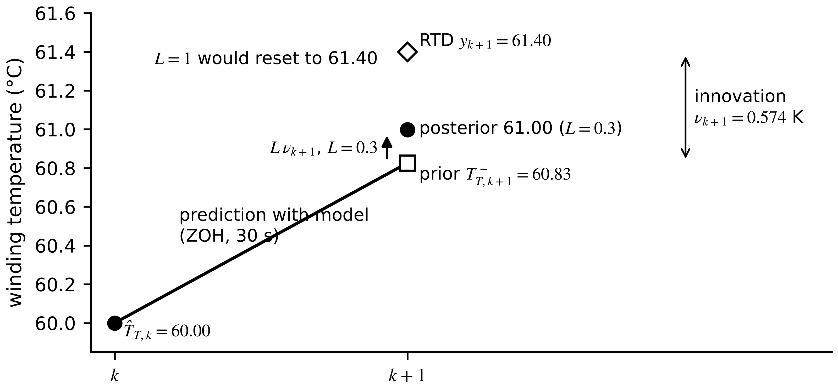
Figure 1.12. One prediction and correction step for M-07. The model carries the state from 60.00 °C to a prior of 60.83 °C; the RTD reads 61.40 °C; a gain of 0.3 moves the posterior to 61.00 °C, while a gain of 1 would reset the twin to the sensor value.

1.5.4 Realistic complications: temperature-dependent loss and fluctuating load
The loss is not a fixed input. The dominant copper loss and its temperature dependence are
$P_{loss}≈3I^{2}R_{ph}(T)+P_{fe}, R_{ph}(T)=R_{ph,ref}\left[1+α_{cu}\left(T-T_{ref}\right)\right]$ (1.22)
where $I$ is the RMS phase current, $R_{ph}$ the phase resistance, $P_{fe}$ the iron loss (nearly constant at fixed voltage and frequency), $α_{cu}=0.00393$ K⁻¹ the temperature coefficient of copper and $T_{ref}$ the reference temperature. The model is now mildly nonlinear: hotter copper dissipates more, which in turn heats it further. And because loss is quadratic in current, the average loss over an interval is not the loss at the average current:
$\overline{I^{2}}={\overline{I}}^{ 2}+var(I)$ (1.23)
where the bar is the mean over the sampling interval and var the variance within it. A fluctuating load heats the winding more than its mean current suggests, so the twin must use the mean of $I^{2}$ over each interval, an averaging step done at the DAQ.
Example 1.6 (Level B) Step response with temperature-dependent copper loss and a fluctuating load
Given. M-07 with Table 1.6. (i) From ambient, a 400 W step is applied. (ii) In a later shift the conveyor current alternates between 10 A and 16 A every 10 s. Take $R_{ph,ref}=0.50$ Ω at 20 °C and evaluate the copper resistance at 100 °C; $P_{fe}=50$ W.
Find. (a) $τ$, $T_{∞}$, the temperature at 10 min and the 95 % time for case (i). (b) For case (ii), $\overline{I}$, $\overline{I^{2}}$ and ${\overline{I}}^{2}$. (c) The copper loss computed correctly and from the mean current. (d) The steady-state temperature error of a twin that uses the mean current.
Solution. (a) $τ=0.20×9000=1800$ s; $T_{∞}=30+0.20×400=110$ °C (rise 80 K). From (1.14): $T(600)=30+80(1-e^{-1/3})=30+80×0.2835=52.68$ °C. From (1.15): $t_{95}=1800ln20=5392$ s = 89.9 min. (b) $\overline{I}=(10+16)/2=13$ A; $\overline{I^{2}}=(100+256)/2=178$ A²; ${\overline{I}}^{2}=169$ A². Consistent with (1.23): var$(I)=9$ A² and $169+9=178$. (c) $R_{ph}(100 °C)=0.50[1+0.00393×80]=0.657$ Ω. Correct: $3×178×0.657=350.9$ W. From the mean: $3×169×0.657=333.2$ W. (d) The twin underestimates the loss by 17.7 W, and the steady-state error is $R_{th}ΔP=0.20×17.7=3.5$ K, the twin reading low.
Check. The total loss with correct averaging is $350.9+50=400.9$ W, consistent with the 400 W of Table 1.6. The 95 % time is almost exactly $3τ$.
Interpretation. A 3.5 K bias is more than ten times the RTD noise and is systematic. It points the wrong way for safety: the twin is optimistic. The remedy is an input-side choice (average $I^{2}$ at the DAQ), not a better thermal model, which is why the contract records the measured variable as $\overline{I^{2}}$ per 30 s rather than "current".
What the digital twin adds
Synchronized: the winding temperature state $T$, every $T_{s}$ through (1.18) and (1.21).
Estimated or updated: the corrected state ${\hat{T}}_{T,k}$; parameters $R_{th}$, $C_{th}$ fixed for now.
Uncertainty carried: RTD noise $σ_{v}$, and the input error from averaging, (1.23).
Decision enabled: a temperature that can be forecast 30 min ahead with (1.14).
Validated by: units check, limiting cases and hand-checked steps (Example 1.4, Example 1.5).

1.6 Synchronization: residuals, innovations, observers and latency
Synchronization is the process that keeps the twin's state close to the asset's state. It has two parts that are easy to mix up: correcting the value of the state from measurements, and keeping the twin current in time despite sampling and delay. This section treats both, first with the general equations and then with M-07 numbers.

1.6.1 Plant, twin and the three comparisons
The physical plant is described by a general, possibly nonlinear, state equation and a sampled measurement equation:
$\dot{x}(t)=f\left(x(t),u(t),θ\right), y_{k}=h\left(x(t_{k}),θ\right)+v_{k}, t_{k}=t_{0}+kT_{s}$ (1.24)
where $u$ is a known or measured input, $θ$ the true physical parameters, $f$ the vector field giving the rate of change of each state, $h$ the output map, $t_{0}$ the start time and $T_{s}$ the sampling period. The twin runs the same structure, or a deliberately simplified one, with its own parameter estimate $\hat{θ}$:
${\dot{x}}_{T}(t)=f\left(x_{T}(t),u(t),\hat{θ}\right), y_{T,k}=h\left(x_{T}(t_{k}),\hat{θ}\right)$ (1.25)
Three comparisons follow, and they must not be confused. The innovation compares the new measurement with the twin's prediction before correction; the residual compares a measurement with a twin output that has not used that measurement (for example an open-loop or baseline twin, or a forecast made earlier); and the state synchronization error compares full internal states:
$ν_{k}=y_{k}-h\left(x_{T,k}^{-},\hat{θ}\right), r_{k}=y_{k}-y_{T,k}, e_{k}=x(t_{k})-x_{T}(t_{k})$ (1.26)
Here $x_{T,k}^{-}$ is the predicted (prior) twin state at $t_{k}$. Innovation and residual are computable from field data; the state error is available only in simulation, on test benches with extra sensors, or where the whole state happens to be measured. If $h$ is the identity and $v_{k}=0$, then $r_{k}=e_{k}$. Otherwise a small residual does not guarantee a small state error: an unmeasured hot spot can be badly wrong while the RTD channel matches perfectly. Observability, treated in Chapter 5, is the formal condition under which small residuals do imply small state errors.

1.6.2 The predictor and corrector, and what the gain does
For the linear sampled model (1.17), prediction followed by correction reads
$x_{T,k+1}^{-}=A_{d}{\hat{x}}_{T,k}+B_{d}u_{k}, {\hat{x}}_{T,k+1}=x_{T,k+1}^{-}+L\left(y_{k+1}-Cx_{T,k+1}^{-}\right)$ (1.27)
where $\hat{x}$ is the corrected (posterior) state, $C$ the output matrix and $L$ the gain; this is the Luenberger observer form [33], and with $L$ computed from noise statistics it becomes the Kalman filter [34] of Chapter 5. To see what $L$ does, let the plant also be driven by an unknown disturbance $w_{k}$, $x_{k+1}=A_{d}x_{k}+B_{d}u_{k}+w_{k}$, and define the posterior error $e_{k}=x_{k}-{\hat{x}}_{T,k}$. Subtracting the twin equations from the plant equations and using $y_{k+1}=Cx_{k+1}+v_{k+1}$:
$e_{k+1}=\left(I-LC\right)A_{d} e_{k}+\left(I-LC\right)w_{k}-L v_{k+1}$ (1.28)
where $I$ is the identity matrix. The error decays when every eigenvalue of $(I-LC)A_{d}$ lies inside the unit circle, and the gain places those eigenvalues. For a scalar plant $x_{k+1}=ax_{k}+bu_{k}$ measured directly ($C=1$) without disturbance, (1.28) reduces to
$e_{k+1}=(1-L) a e_{k}-L v_{k+1}$ (1.29)
so the error decays if $|(1-L)a|<1$, with an error time constant (time for the error to fall by a factor $e$)
$τ_{e}=-\frac{T_{s}}{ln\left|(1-L)a\right|}$ (1.30)
For white measurement noise the steady-state error variance follows from taking the variance of both sides of (1.29). Because $e_{k}$ depends only on past noise it is uncorrelated with $v_{k+1}$, so $σ_{e}^{2}=(1-L)^{2}a^{2}σ_{e}^{2}+L^{2}σ_{v}^{2}$, and solving:
$σ_{e}^{2}=\frac{L^{2}σ_{v}^{2}}{1-(1-L)^{2}a^{2}}$ (1.31)
Equation (1.31) states the central trade-off of synchronization. A large gain pulls the twin onto each new sample quickly but copies the sensor noise into the state; $L=1$ resets the twin to the measurement and $σ_{e}=σ_{v}$. A small gain filters noise but responds slowly to a genuine change. Table 1.7 quantifies the trade-off for M-07.
Table 1.7. Effect of the gain on convergence and noise, M-07 twin, $a=0.98347$, $T_{s}=30$ s, $σ_{v}=0.3$ K, no disturbance
Gain $L$ | Error pole $(1-L)a$ | Error time constant | Steady-state $σ_{e}$ (K)
0.1 | 0.885 | 246 s | 0.064
0.3 | 0.688 | 80 s | 0.124
0.6 | 0.393 | 32 s | 0.196
1.0 | 0 | one sample (reset) | 0.300

[Advanced] The best fixed gain and what an observer can hide
A real motor also changes in ways the model does not predict (load fluctuations inside the interval, drafts), represented by $w_{k}$ with variance $q$ per step. Repeating the variance calculation with both noise sources gives $σ_{e}^{2}(L)=\left[(1-L)^{2}q+L^{2}σ_{v}^{2}\right]/\left[1-(1-L)^{2}a^{2}\right]$. Now a gain that is too small lets the disturbance accumulate and one that is too large copies the noise, so there is a best value. Following the variance through one cycle, the prior and posterior variances are $P_{k+1}^{-}=a^{2}P_{k}+q$ and $P_{k+1}=(1-L)^{2}P_{k+1}^{-}+L^{2}σ_{v}^{2}$. Setting $dP_{k+1}/dL=0$ and substituting back gives equation (1.32) below, a scalar algebraic Riccati equation; it is the steady-state Kalman filter in its simplest form.
The less welcome property is masking. Suppose the twin's thermal resistance is wrong by $ΔR=R_{th}-{\hat{R}}_{th}$ at constant input. Plant and predictor then differ by a constant forcing $(1-a)ΔR P_{loss}$ each step, and in steady state the posterior error satisfies $e=(1-L)\left[ae+(1-a)ΔR P_{loss}\right]$ with innovation $r=e/(1-L)$, which gives equation (1.33). The observer keeps the twin's temperature useful, which is its job, and in doing so hides most of the evidence of the parameter error. A fault detector should therefore watch the residual of an uncorrected baseline twin, or the drift of re-estimated parameters, never the innovation of the corrected twin alone.

$L^{*}=\frac{P^{-}}{P^{-}+σ_{v}^{2}}, P^{-}=\frac{a^{2}P^{-}σ_{v}^{2}}{P^{-}+σ_{v}^{2}}+q$ (1.32)
$e_{ss}=\frac{(1-L)(1-a) ΔR P_{loss}}{1-(1-L)a}, r_{ss}=\frac{(1-a) ΔR P_{loss}}{1-(1-L)a}$ (1.33)
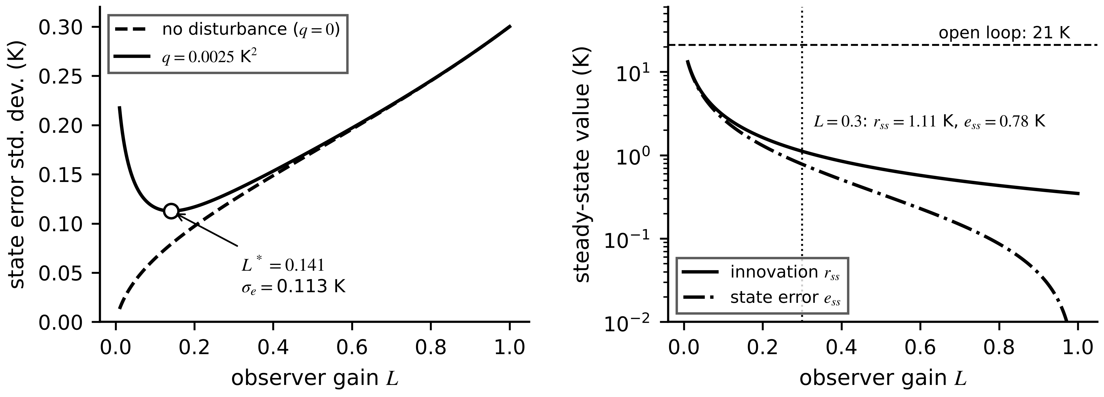
Figure 1.13. Left: steady-state state-error standard deviation against gain, without and with a process disturbance; the minimum is the Riccati gain of (1.32). Right: steady-state innovation and state error from (1.33) for a 0.05 K/W resistance error at 420 W. Larger gains keep the state accurate but shrink the innovation that would reveal the fault.
Example 1.7 (Level B) Choosing the synchronization gain for M-07
Given. $a=0.98347$, $σ_{v}=0.3$ K, $T_{s}=30$ s, and a process disturbance of 0.05 K per step ($q=0.0025$ K²).
Find. (a) For $L=0.3$ without disturbance: the error pole, $τ_{e}$ and $σ_{e}$. (b) The Riccati gain $L^{*}$, $P^{-}$ and the posterior standard deviation with the disturbance. (c) $σ_{e}$ with the disturbance at $L=0.1$ and $L=0.3$. (d) $τ_{e}$ at $L^{*}$.
Solution. (a) Pole $=(1-0.3)×0.98347=0.688$; from (1.30) $τ_{e}=-30/ln0.688=80$ s; from (1.31) $σ_{e}^{2}=0.09×0.09/(1-0.49×0.9672)=0.0081/0.5261=0.0154$ K², $σ_{e}=0.124$ K. (b) Iterating (1.32) from $P^{-}=0.01$ converges to $P^{-}=0.01478$ K² and $L^{*}=0.01478/(0.01478+0.09)=0.141$. Posterior variance $(1-L^{*})P^{-}=0.01269$ K², standard deviation 0.113 K. (c) $σ_{e}(0.1)=0.116$ K and $σ_{e}(0.3)=0.133$ K. (d) $τ_{e}=-30/ln(0.859×0.98347)=178$ s.
Interpretation. The optimum is shallow: gains from 0.1 to 0.3 cost at most 0.02 K, which is why a hand-tuned gain often works. The case study uses $L=0.3$ because it settles in 80 s rather than 178 s after a resynchronization, at a cost of 0.02 K in noise.
Example 1.8 (Level B) [Advanced] How much evidence the observer hides
Given. M-07 runs at 420 W. The twin's ${\hat{R}}_{th}$ is 0.05 K/W too low; $L=0.3$, $a=0.98347$, RTD noise 0.3 K. An alarm fires when $|r_{k}|>h$ with $h=0.9$ K ($3σ$).
Find. (a) The steady-state bias of an open-loop twin. (b) $e_{ss}$ and $r_{ss}$ of the corrected twin. (c) The fraction of the open-loop evidence left in $r_{ss}$. (d) The per-sample detection probability of the alarm and the probability of four consecutive detections.
Solution. (a) $ΔR P_{loss}=0.05×420=21$ K. (b) Denominator $1-0.7×0.98347=0.3116$; numerator for $r_{ss}$: $(1-0.98347)×21=0.3471$; $r_{ss}=1.114$ K and $e_{ss}=0.7×1.114=0.780$ K. (c) $1.114/21=5.3$ %. (d) With $r∼𝒩(1.114,{0.3}^{2})$, $p_{D}=Q((0.9-1.114)/0.3)+Q((0.9+1.114)/0.3)=Q(-0.714)+Q(6.71)=0.762$, and four in a row ${0.762}^{4}=0.338$ (the probabilities and $Q$ are defined in Section 1.9).
Interpretation. The corrected twin is only 0.78 K wrong, an excellent estimate, but the fault signature has shrunk from 21 K to 1.1 K. Good synchronization and good fault detection pull in opposite directions, which is why Section 1.15 runs two twins: a corrected one for the state and an uncorrected baseline for detection.

1.6.3 Multi-rate synchronization
Different parts of one twin need different rates. Current is sampled fast because loss depends on $I^{2}$ inside each interval; temperature moves slowly; a parameter such as $R_{th}$ changes over days and should be re-estimated over many samples so that noise averages out. Figure 1.14 shows the arrangement used for M-07. The fast-to-slow link is a windowed mean:
${\overline{I^{2}}}_{k}=\frac{1}{M}\sum_{j=1}^{M}{i_{k,j}^{2}}, M=\frac{T_{s}}{T_{f}}$ (1.34)
where $i_{k,j}$ is the $j$-th fast current sample in interval $k$, $T_{f}$ the fast sampling period and $M$ the number of fast samples per twin update. The slow-to-slower link is a parameter estimate refreshed from a window of $W$ twin updates (40 samples, 20 min, in Section 1.15). The rule of thumb is that each layer averages the layer below over a window long compared with the layer's noise correlation and short compared with the change it must follow.
Figure 1.14. Multi-rate synchronization of the M-07 twin. Fast current samples are reduced to $\overline{I^{2}}$ per 30 s window; the thermal state is corrected every 30 s; the thermal resistance is re-estimated from a 40-sample (20 min) least-squares window; forecasts are issued every 30 s.
Example 1.9 (Level B) Choosing rates for the three layers
Given. The CT is sampled at 1 kHz. The thermal twin updates every 30 s. Parameter refits use 20-min windows. Without averaging, the DAQ would pass one instantaneous RMS reading per interval.
Find. (a) $M$ in (1.34). (b) If the load of Example 1.6 alternates 10 A and 16 A every 10 s, the worst-case error in $\overline{I^{2}}$ from passing a single reading per interval, and the corresponding loss error at $R_{ph}=0.657$ Ω. (c) The number of twin updates per refit window, and the reduction of the random part of a parameter estimate relative to a single-interval estimate, assuming independent errors.
Solution. (a) $M=30/0.001=30 000$ samples per update. (b) A single reading gives either 100 or 256 A² against the true 178 A², an error of $±78$ A². The loss error is $3×78×0.657=±154$ W, which would swing $T_{∞}$ by $±0.20×154=±31$ K if it persisted. (c) $1200/30=40$ updates; random error falls by $\sqrt{40}=6.3$.
Interpretation. The mean-of-squares step is not an optional refinement. A single reading per interval makes the input error larger than any thermal model error. Averaging at the edge, before the data leave the DAQ, also cuts the data rate by a factor of 30 000.
[Advanced] Which parameters can the data reveal?
The refit of Section 1.15 estimates $R_{th}$ and holds $C_{th}$ at its heat-run value. The reason is identifiability: a parameter can be estimated from data only if changing it changes the measured output in a way that no other parameter can copy. Differentiating the step response (1.14), with $T_{∞}=T_{amb}+R_{th}P_{loss}$ and $τ=R_{th}C_{th}$, gives the two output sensitivities
$\frac{∂T}{∂R_{th}}=P_{loss}\left(1−e^{−t/τ}\right)−\left(T_{∞}−T_{0}\right)\frac{t}{R_{th}τ}e^{−t/τ}, \frac{∂T}{∂C_{th}}=−\left(T_{∞}−T_{0}\right)\frac{t}{C_{th}τ}e^{−t/τ}$
As $t→∞$ the first tends to $P_{loss}$ and the second to zero, so data taken in thermal equilibrium identify $R_{th}$ and carry no information at all about $C_{th}$. During a transient both sensitivities are non-zero and their shapes differ; the sensitivity to $C_{th}$ is largest at $t=τ$, where $te^{−t/τ}$ peaks. For M-07 after a 400 W step from 30 °C, a 10 % change in $C_{th}$ (900 J/K) moves the temperature by 2.9 K at $t=τ$ and by essentially nothing after $5τ$, while a 10 % change in $R_{th}$ (0.02 K/W) moves it by 2.1 K at $t=τ$ and by 8.0 K in steady state. A motor that runs at steady load therefore reveals its thermal resistance continuously and its heat capacity only when the load changes; this is why a five-minute start-up transient (Example 1.18) or a heat run is needed to calibrate $C_{th}$, and why a refit window that holds little transient information should not try to estimate both. Chapter 5 formalizes the argument with the Fisher information matrix and the condition of persistent excitation.

1.6.4 Latency, synchronization delay and age of information
A twin can have the right value at the wrong time. Two measures capture timeliness. The synchronization delay is a difference of timestamps,
$Δt_{sync}=t_{twin reflects event}-t_{event}$ (1.35)
which includes acquisition, transport, queuing and computation and is measurable only against a common time reference. The age of information (AoI), introduced in networking by Kaul, Yates and Gruteser [35], is the time elapsed since the newest information held by the twin was generated:
$Δ(t)=t-u(t)$ (1.36)
where $u(t)$ is the generation timestamp of the newest sample that has reached the twin by time $t$. For periodic sampling every $T_{s}$ with a constant end-to-end delay $d$, $Δ(t)$ is a sawtooth that drops to $d$ when an update arrives and grows linearly to $d+T_{s}$ before the next. Averaging one tooth, $\frac{1}{T_{s}}\int_{0}^{T_{s}}{(}d+s) ds=d+T_{s}/2$, so
$\overline{Δ}=d+\frac{T_{s}}{2}, Δ_{peak}=d+T_{s}$ (1.37)
The staleness of the information bounds the error it can cause. If the measured quantity changes no faster than $|\dot{y}|_{max}$, the twin's view lags the asset by at most
$\left|y(t)-y\left(u(t)\right)\right|≤{\left|\dot{y}\right|}_{max} Δ_{peak}$ (1.38)
Figure 1.15 shows a latency budget for M-07 and the resulting AoI sawtooth.
Figure 1.15. Top: the latency budget of one M-07 cycle; stages run in sequence and their times add to the end-to-end delay $d$. Bottom: age of information for 30 s sampling with $d=1.58$ s, with its mean and peak values from (1.37).
Example 1.10 (Level A) A simple latency budget and age of information
Given. Each M-07 cycle has acquisition, averaging and checks 0.5 s; transport 0.05 s; observer and refit 0.02 s; forecast and alarm logic 0.01 s; advisory delivery 1.0 s. $T_{s}=30$ s. The winding heats at most at 0.044 K/s.
Find. (a) The end-to-end delay $d$. (b) Mean and peak AoI. (c) The largest error caused by staleness alone. (d) The same quantities if the twin runs in the cloud, adding 0.08 s of network transit and a 2.5 s queue.
Solution. (a) $d=0.5+0.05+0.02+0.01+1.0=1.58$ s. (b) From (1.37): $\overline{Δ}=1.58+15=16.58$ s; $Δ_{peak}=31.58$ s. (c) From (1.38): $0.044×31.58=1.39$ K at the steepest part of a heat-up, and far less in normal running. (d) $d=1.58+0.08+2.5=4.16$ s; $\overline{Δ}=19.16$ s; $Δ_{peak}=34.16$ s; staleness error up to $0.044×34.16=1.50$ K.
Interpretation. For M-07 the sampling period, not the network, dominates the age of information; moving to the cloud costs 2.6 s on a 30 s cycle. For a converter twin with a 100 µs cycle the same 2.6 s would be absurd, which is why placement (Section 1.11) is decided per function, not per company.
What the digital twin adds
Synchronized: the state, at rates matched to each layer (Figure 1.14).
Estimated or updated: the corrected state, and parameters over longer windows.
Uncertainty carried: $σ_{e}$ from (1.31), and staleness from (1.38).
Decision enabled: a state fresh enough, and accurate enough, for the purpose clause.
Validated by: innovation statistics, the baseline residual, and measured delays against a common clock.

1.7 Uncertainty from the start
Every number a twin produces is uncertain, and a twin that reports a temperature without saying how uncertain it is invites the wrong decision. Chapters 3 to 6 treat each source in depth. This section names them, shows how to combine them to first order, and turns the result into the acceptance band that clause 10 of the contract needs.

1.7.1 Five sources of uncertainty
Table 1.8. Sources of uncertainty in a digital twin, illustrated on M-07
Source | M-07 example | How it enters | Reduced by | Chapter
Measurement | RTD tolerance ±0.35 K, noise 0.3 K, timestamp skew | Directly in $y_{k}$, (1.7) | calibration, averaging, clock sync | 3
Parameter | $R_{th}=0.20±0.01$ K/W from the heat run | Through the model, scaled by sensitivity | more data, identifiability, tracking | 4, 5
Model form | one node cannot represent the hot spot | A discrepancy term that no parameter can remove | richer structure, hybrid models | 4, 6
Operating condition | ambient 30 ± 0.5 °C; loss 400 ± 20 W | Through inputs $u$ | input sensing, envelope checks | 3, 5
Forecast | future load unknown over 30 min | Grows with horizon | load forecasts, scenario bounds | 6, 13

The model-form term deserves a formula, because it is the one most often forgotten. Following Kennedy and O'Hagan [36], a measurement is written as
$y_{k}=η\left(x_{k},θ\right)+δ\left(x_{k}\right)+v_{k}$ (1.39)
where $η$ is the twin's model, $δ$ a discrepancy function that represents what the model structure cannot capture, and $v_{k}$ measurement noise. If $δ$ is ignored, calibration forces $θ$ to absorb it and the fitted parameters lose their physical meaning. A one-node $R_{th}$ fitted to hot-spot data, for instance, is no longer the winding-to-ambient resistance.

1.7.2 Combining uncertainties to first order
Let a twin output be a function $f(z_{1},…,z_{n})$ of uncertain inputs $z_{i}$ with standard uncertainties $u(z_{i})$. A first-order Taylor expansion about the best estimates, $δf≈\sum_{i}{(}∂f/∂z_{i})δz_{i}$, squared and averaged with uncorrelated $δz_{i}$, gives the law of propagation of uncertainty of the GUM [37]:
$u_{c}^{2}(f)=\sum_{i=1}^{n}{{\left(\frac{∂f}{∂z_{i}}\right)}^{2}}u^{2}(z_{i})$ (1.40)
where $u_{c}$ is the combined standard uncertainty and $∂f/∂z_{i}$ the sensitivity coefficient of input $i$. For the steady-state winding temperature $T_{∞}=T_{amb}+R_{th}P_{loss}$ the sensitivities are 1, $P_{loss}$ and $R_{th}$:
$u_{c}^{2}\left(T_{∞}\right)=u^{2}\left(T_{amb}\right)+P_{loss}^{2}u^{2}\left(R_{th}\right)+R_{th}^{2}u^{2}\left(P_{loss}\right)$ (1.41)
An uncertainty given only as limits $±a$ with no preferred value inside them, such as a sensor tolerance, is treated as rectangular, and a coverage factor $k$ turns a standard uncertainty into an expanded one:
$u=\frac{a}{\sqrt{3}}, U=k u_{c} (k=2 for about 95 \% coverage)$ (1.42)
The expansion is first order. It fails when a sensitivity changes appreciably across the uncertainty range, for example near the knee of a nonlinear curve, where Monte Carlo propagation (Chapter 5) is used instead.

1.7.3 Measurement uncertainty against model error, and the acceptance band
A twin cannot be validated to a tighter tolerance than the measurement that checks it. If the model error and the measurement noise are independent and zero-mean, the RMSE observed against measurements satisfies
${RMSE}_{obs}^{2}≈{RMSE}_{model}^{2}+u_{meas}^{2}$ (1.43)
so a model error smaller than the measurement uncertainty cannot be resolved (Figure 1.16a). An acceptance band for the mean residual over a test therefore combines both:
$\left|\overline{r}\right|≤k\sqrt{u_{meas}^{2}+u_{model}^{2}}$ (1.44)
where $\overline{r}$ is the mean residual, $u_{meas}$ the standard uncertainty of the reference measurement and $u_{model}$ the model uncertainty that the contract accepts. A residual whose mean leaves the band is evidence of a model or input error (Figure 1.16b).
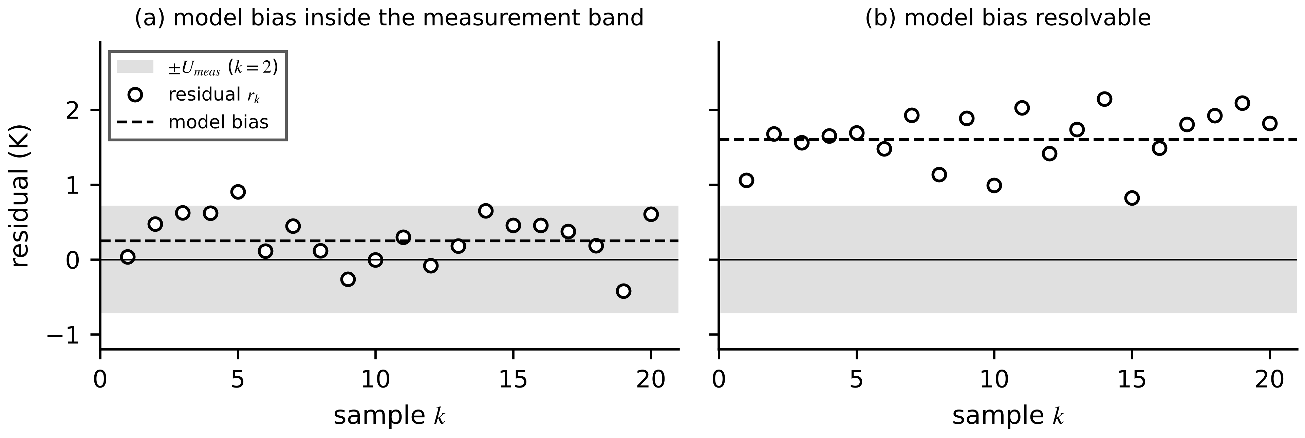
Figure 1.16. (a) A model bias of 0.25 K inside the expanded measurement band ($k=2$, $U_{meas}=0.72$ K) cannot be distinguished from a perfect model. (b) A bias of 1.6 K lies outside the band and is resolvable.
Forecast uncertainty is handled the same way. The 30-minute forecast of M-07 is
$T_{f}=b \hat{T}+(1-b)\left(T_{amb}+R_{th}P_{loss}\right), b=e^{-t_{f}/(R_{th}C_{th})}$ (1.45)
where $t_{f}$ is the horizon and the present loss is assumed to persist. Its sensitivity to $R_{th}$ includes the effect of $R_{th}$ on $b$, so it is computed numerically. Once the forecast mean $μ$ and combined uncertainty $u_{c}$ are known, the probability that the true value exceeds a limit $T_{lim}$ is, for a normal error,
$Pr\left(T>T_{lim}\right)=Q\left(\frac{T_{lim}-μ}{u_{c}}\right)$ (1.46)
with $Q$ the tail probability of the standard normal distribution (defined in (1.64)).
Example 1.11 (Level B) An uncertainty budget for the M-07 twin
Given. $T_{amb}=30 °C±0.5$ K, $R_{th}=0.20±0.01$ K/W, $C_{th}=9000$ J/K (taken as exact), $P_{loss}=400±20$ W (standard uncertainties). The RTD has tolerance ±0.35 K (rectangular) and noise 0.3 K. For the forecast, the corrected state is $\hat{T}=100$ °C with $u=0.3$ K and the loss has just risen to 420 W.
Find. (a) $T_{∞}$ at 400 W, $u_{c}$ and $U$ ($k=2$). (b) The sensitivities and contributions of the forecast (1.45) at $t_{f}=30$ min, and its combined uncertainty. (c) The probability that the steady state at 420 W exceeds the 120 °C advisory threshold. (d) The measurement standard uncertainty of the RTD and the band $2u_{meas}$.
Solution. (a) $T_{∞}=110$ °C. From (1.41): $u_{c}^{2}={0.5}^{2}+(400×0.01)^{2}+(0.20×20)^{2}=0.25+16+16=32.25$ K², $u_{c}=5.68$ K, $U=11.4$ K. (b) $b=e^{-1800/1800}=0.368$; $T_{f}=0.368×100+0.632×(30+84)=108.8$ °C. Numerically, $∂T_{f}/∂R_{th}=240$ K per K/W, $∂T_{f}/∂P=0.126$ K/W, $∂T_{f}/∂T_{amb}=0.632$, $∂T_{f}/∂\hat{T}=0.368$. Contributions: $240×0.01=2.40$ K, $0.126×20=2.53$ K, $0.632×0.5=0.32$ K, $0.368×0.3=0.11$ K. Combined: $\sqrt{{2.40}^{2}+{2.53}^{2}+{0.32}^{2}+{0.11}^{2}}=3.50$ K. (c) At 420 W, $T_{∞}=114$ °C and $u_{c}=\sqrt{0.25+(420×0.01)^{2}+16}=5.82$ K. From (1.46): $Q((120-114)/5.82)=Q(1.03)=0.15$. (d) $u_{RTD}=0.35/\sqrt{3}=0.202$ K; $u_{meas}=\sqrt{{0.202}^{2}+{0.3}^{2}}=0.362$ K; $2u_{meas}=0.72$ K.
Interpretation. Parameter and loss uncertainty dominate, each about 2.5 K in the forecast; the RTD and ambient barely matter. A central estimate of 114 °C still carries a 15 % chance of crossing 120 °C, so the decision rule should use the forecast together with its uncertainty, not the central value alone. To narrow the budget, spend effort on $R_{th}$ tracking and on the loss map, not on a better RTD.
What the digital twin adds
Synchronized: the state together with its uncertainty, not a bare number.
Estimated or updated: $u_{c}$ of each output through (1.40); the discrepancy $δ$ where it is identifiable.
Uncertainty carried: measurement, parameter, model form, operating condition and forecast (Table 1.8).
Decision enabled: probability-based rules such as (1.46).
Validated by: the acceptance band (1.44) and, for interval forecasts, coverage tests (Section 1.8).

1.8 Fidelity: purpose first, then metrics
Fidelity is how well a twin represents its asset for a stated purpose. The same twin can be excellent for one purpose and useless for another, and a more detailed model is not automatically a better twin. This section first separates six kinds of fidelity, then gives the point-error metrics with their denominators, and finally shows how a finite test turns into an acceptance decision.

1.8.1 Six types of fidelity
Table 1.9. Six fidelity types, each with the question it answers and how it is measured
Type | Question | Measured by | M-07 example
Structural | Does the model contain the right states, couplings and topology? | review against physics; residual whiteness | one node versus a three-node network
Parametric | Are the parameter values right for this asset now? | parameter error, refit drift, population z-score | ${\hat{R}}_{th}=0.20$ against 0.25 after the fan blockage
State | Is the estimated state close to the true one? | state error on a test bench; innovation statistics | winding error 0.14 K RMS in Section 1.15
Temporal | Is the twin current, and are events placed at the right time? | AoI, $Δt_{sync}$, timestamp skew | peak AoI 31.6 s
Behavioral | Does the twin reproduce outputs over the operating envelope? | RMSE, NRMSE, coverage on held-out data | one-step RMSE < 1.0 K
Decision | Does the twin lead to the same decision that perfect information would? | misdecision rate, decision cost | advisory issued in the right cases

Decision fidelity is the one that justifies the twin, so it gets a definition of its own:
$F_{D}=1-Pr\left(d_{T}≠d^{*}\right)$ (1.47)
where $d_{T}$ is the decision taken on the twin's output and $d^{*}$ the decision that would be taken with perfect knowledge of the asset. A twin with modest behavioural fidelity can have very high decision fidelity when the decision threshold is far from typical operating points, and the reverse also happens.
Why is more detail not always better? For a model that is linear in its $p$ parameters and fitted by least squares to $N$ noisy samples, the average prediction variance at the training points is $σ_{v}^{2}p/N$, because the trace of the fitting projection equals $p$ (Chapter 5). Adding structure reduces the model-form bias $δ$ but raises this variance, so the expected squared prediction error on new data behaves as
$𝔼\left[{\left(y-y_{T}\right)}^{2}\right]≈{\overline{δ}}^{ 2}+σ_{v}^{2}\frac{p}{N}+σ_{v}^{2}$ (1.48)
where ${\overline{δ}}^{2}$ is the mean squared structural discrepancy. With few calibration data, a simpler model can predict better. Extra detail also costs computation, which must fit the latency clause, and parameters, which must be identifiable from the available sensors. Figure 1.17 shows fidelity profiles required by three purposes against what the one-node M-07 model achieves.
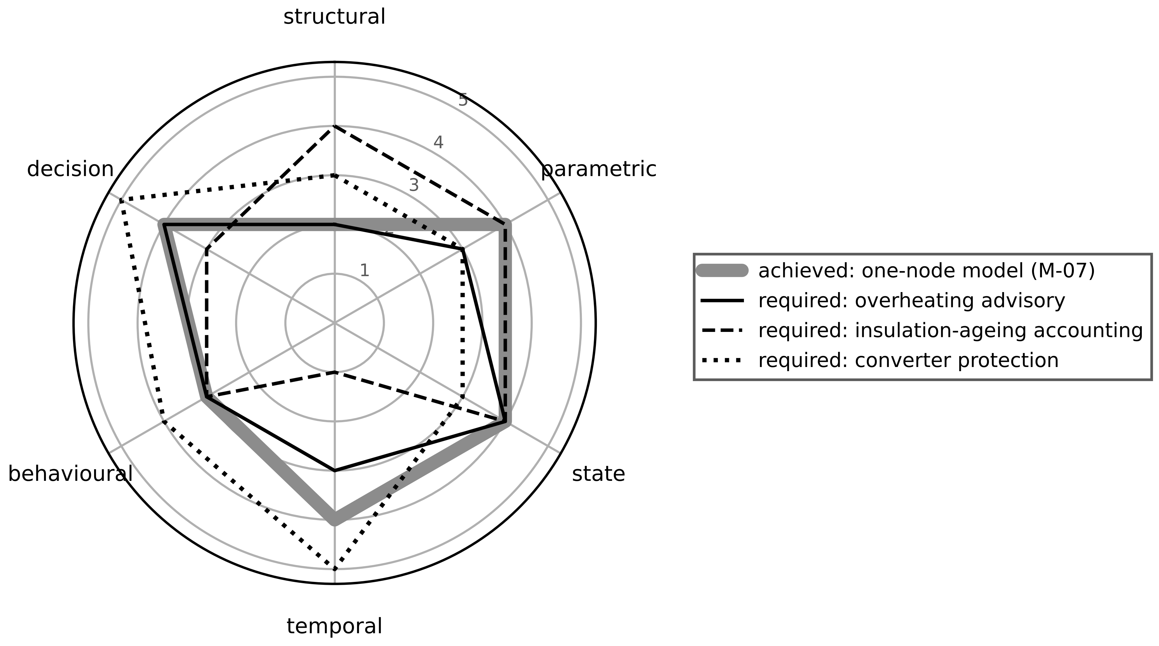
Figure 1.17. Purpose-dependent fidelity on a 1 to 5 scale for each of the six types. Lines show what three purposes require; the shaded line shows what the one-node M-07 model achieves. It meets the overheating-advisory profile but falls short of the structural fidelity that insulation-ageing accounting needs and of the temporal fidelity that converter protection needs.
Table 1.10. Modelling approaches compared by assumptions, data need, cost, strengths, limitations and appropriate use
Approach | Assumptions | Data need | Compute cost | Strengths | Limitations | Appropriate use
White box (physics) | governing laws known; parameters measurable | low (calibration) | low to high | extrapolates; parameters mean something | structure must be right; slow to build | established assets with good physics
Grey box (hybrid) | physics core plus learned correction | medium | medium | physics plus data; fewer data than black box | correction can mask physics faults | drifting or partly known physics
Black box (data) | enough representative data exist | high, incl. rare regimes | low in use, high to train | fast, flexible, no physics needed | poor outside training data | abundant data, fixed operating range

Example 1.12 (Level B) Choosing model fidelity by purpose
Given. Three candidate thermal models for M-07: (1) one node, 0.05 ms per update, winding RMSE 1.2 K, no hot-spot estimate; (2) three-node network, 0.3 ms, RMSE 0.6 K, hot-spot error 4 K; (3) reduced finite-element model, 2 s per update, RMSE 0.4 K, hot-spot error 2 K, 14 parameters. The edge PC must serve all 20 motors within the 30 s cycle using one core. Insulation ageing rate doubles for every 10 K of hot-spot temperature.
Find. (a) Core time per cycle for each model across the fleet. (b) The ageing-rate error caused by a hot-spot error of 4 K and of 2 K. (c) The model to choose for (i) the 30-min overheating advisory with a 1.5 K accuracy need, (ii) monthly insulation-ageing accounting with a 20 % allowed ageing error, (iii) an offline design study of a new frame. (d) Why model 3 is not chosen for the advisory even though its RMSE is the best.
Solution. (a) Model 1: $20×0.05=1$ ms; model 2: $20×0.3=6$ ms; model 3: $20×2=40$ s, which exceeds the 30 s cycle. (b) Ageing factor error $2^{ΔT/10}$: $2^{0.4}=1.32$, a 32 % error; $2^{0.2}=1.15$, a 15 % error. (c) (i) Model 1 meets 1.5 K and uses 0.003 % of the core; model 2 also qualifies. Choose model 1, or model 2 if the same edge PC must also support ageing accounting. (ii) Model 2 gives 32 %, above the 20 % limit; model 3 gives 15 % but cannot run in real time on one core. Ageing accounting is monthly, so model 3 can run offline on stored data, or model 2 can be improved. (iii) Model 3, since compute time is irrelevant offline and structure matters.
Interpretation. The best-scoring model is not the best twin. Model 3 fails the latency clause for the advisory, and its 14 parameters may not be identifiable from one RTD and one CT. Fidelity is chosen per purpose and per contract clause.

1.8.2 Point-error metrics and their denominators
For $N$ samples of one quantity in its own units, the standard metrics are below. Each denominator is written out because most misuse starts there.
$MAE=\frac{1}{N}\sum_{k=1}^{N}{\left|y_{k}-y_{T,k}\right|}$ (1.49)
$RMSE=\sqrt{\frac{1}{N}\sum_{k=1}^{N}{{\left(y_{k}-y_{T,k}\right)}^{2}}}$ (1.50)
$NRMSE=\frac{RMSE}{D}, D∈\left\{y_{max}-y_{min}, \overline{y}, σ_{y}, y_{rated}\right\}$ (1.51)
$MAPE=\frac{100 \%}{N}\sum_{k=1}^{N}{\left|\frac{y_{k}-y_{T,k}}{y_{k}}\right|}$ (1.52)
$R^{2}=1-\frac{\sum_{k}{{\left(y_{k}-y_{T,k}\right)}^{2}}}{\sum_{k}{{\left(y_{k}-\overline{y}\right)}^{2}}}, \overline{y}=\frac{1}{N}\sum_{k}{y_{k}}$ (1.53)
Here $y_{k}$ and $y_{T,k}$ are measured and predicted values, $D$ the stated normalizer (range, mean, standard deviation $σ_{y}$ or a rated value $y_{rated}$) and $\overline{y}$ the sample mean. MAE weights all errors equally and is easiest to explain to operators. RMSE squares errors before averaging, so a few large errors dominate it. NRMSE makes channels comparable once $D$ is stated. MAPE needs a ratio scale with a meaningful zero and values bounded away from zero. $R^{2}$, the coefficient of determination, measures the fraction of the signal's variance the twin explains.
The metrics are related, and the relations catch arithmetic errors in reports. With $e_{k}=y_{k}-y_{T,k}$, mean $\overline{e}$ and population standard deviation $s_{e}$, expanding the square in (1.50) gives the bias and spread decomposition
${RMSE}^{2}={\overline{e}}^{ 2}+s_{e}^{2}, s_{e}^{2}=\frac{1}{N}\sum_{k}{{\left(e_{k}-\overline{e}\right)}^{2}}$ (1.54)
so RMSE contains a systematic part (bias, fixed by recalibration) and a random part (spread, fixed by better modelling). Because the mean square is never smaller than the square of the mean absolute value, and no single error exceeds the sum of all,
$MAE≤RMSE≤\sqrt{N} MAE$ (1.55)
with equality on the left only when all errors have the same magnitude. Dividing numerator and denominator of (1.53) by $N$ connects $R^{2}$ to the standard-deviation-normalized RMSE:
$R^{2}=1-{\left(\frac{RMSE}{σ_{y}}\right)}^{2}$ (1.56)
where $σ_{y}$ is the population standard deviation of the measurements. The same absolute error gives a high $R^{2}$ on a signal that varies a lot and a low one on a nearly constant signal, so $R^{2}$ describes the data set as much as the twin. Spreadsheets and many papers report instead $r^{2}$, the squared correlation,
$r^{2}=\frac{{\left[\sum_{k}{\left(y_{k}-\overline{y}\right)}\left(y_{T,k}-{\overline{y}}_{T}\right)\right]}^{2}}{\sum_{k}{{\left(y_{k}-\overline{y}\right)}^{2}}\sum_{k}{{\left(y_{T,k}-{\overline{y}}_{T}\right)}^{2}}}$ (1.57)
with ${\overline{y}}_{T}$ the mean of the predictions. Adding a constant to every prediction leaves $r^{2}$ unchanged, so a twin with a large constant offset can have $r^{2}=1$. Exercise 1.9 builds a four-point case with $r^{2}=1$ and $R^{2}=0.20$.
Example 1.13 (Level A) All metrics on one residual sequence, then with one glitch
Given. Top-oil temperature of a distribution transformer every 15 min, and the twin prediction: $y=[62.0, 64.5, 67.0, 68.5, 70.0, 71.0]$ °C, $y_{T}=[61.2, 64.9, 66.1, 69.3, 70.4, 70.2]$ °C.
Find. (a) MAE, RMSE, range-normalized NRMSE, MAPE, $R^{2}$ and $r^{2}$. (b) The bias and spread parts of RMSE. (c) All of (a) again with sample 5 replaced by a sensor glitch of 78.0 °C. (d) Check $R^{2}$ through (1.56).
Solution. (a) $e=[0.8, -0.4, 0.9, -0.8, -0.4, 0.8]$ K. $\sum{|}e|=4.1$, MAE $=0.683$ K. $\sum{e^{2}}=0.64+0.16+0.81+0.64+0.16+0.64=3.05$ K², RMSE $=\sqrt{3.05/6}=0.713$ K. Range $=9.0$ K, NRMSE $=7.92$ %. Relative errors 1.290, 0.620, 1.343, 1.168, 0.571, 1.127 %, MAPE $=1.02$ %. $\overline{y}=67.167$ °C, $\sum{(}y-\overline{y})^{2}=58.33$ K², $R^{2}=1-3.05/58.33=0.948$; $r^{2}=0.957$. (b) $\overline{e}=0.150$ K and $s_{e}=0.697$ K; ${0.150}^{2}+{0.697}^{2}=0.5083={0.713}^{2}$. Spread dominates. (c) $e_{5}=78.0-70.4=7.6$ K. MAE $=11.3/6=1.883$ K; $\sum{e^{2}}=60.65$, RMSE $=3.18$ K; range 16.0 K, NRMSE $=19.9$ %; MAPE $=2.55$ %; $\sum{(}y-\overline{y})^{2}=157.0$, $R^{2}=0.614$; $r^{2}=0.744$. (d) $σ_{y}=3.118$ K, $1-(0.713/3.118)^{2}=0.948$, as in (a).
Interpretation. One bad sample multiplied RMSE by 4.5 and MAE by 2.8. Neither metric is wrong; they answer different questions. If acceptance uses RMSE, data-cleaning rules (range and rate-of-change checks) must be stated with it, or a single glitch can fail a good twin. The glitch also enlarged the range normalizer and so partly hid its own effect on NRMSE. Figure 1.18 plots both data sets.
Figure 1.18. Example 1.13. Left: measured and twin top-oil temperatures with the glitch sample marked. Right: errors for the clean and glitch data sets; one sample dominates the squared-error metrics.

1.8.3 When the reference crosses zero or barely moves
Figure 1.19 makes the zero-crossing failure visible. A 50 Hz current of 10 A peak is tracked by a twin with a phase error of only 1.15° (0.02 rad). The pointwise relative error is small at the crest and unbounded at each zero crossing, so any MAPE over the window depends on where the samples fall. The range-normalized NRMSE over the same window is 0.71 % and does not. A symmetric variant is sometimes proposed:
$sMAPE=\frac{100 \%}{N}\sum_{k=1}^{N}{\frac{2\left|y_{k}-y_{T,k}\right|}{\left|y_{k}\right|+\left|y_{T,k}\right|}}$ (1.58)
It stays finite but still inflates errors near zero and still has no meaning on interval scales such as °C. The opposite failure affects range normalization: for a quantity that barely moves during the window, the range is tiny and NRMSE explodes even when the absolute error is modest. The remedy is a normalizer fixed by engineering meaning, such as the rated temperature rise or rated current, stated in the report.
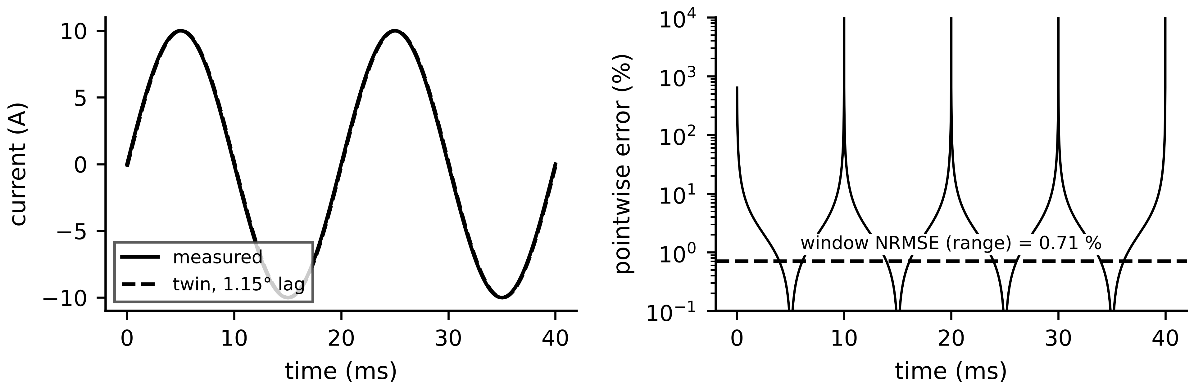
Figure 1.19. Left: measured and twin AC current with a 1.15° phase error. Right: pointwise percentage error on a log scale, unbounded at each zero crossing, against the window NRMSE of 0.71 %.
Example 1.14 (Level B) A parameter error hidden by the evaluation window
Given. M-07 receives a 400 W step from 30 °C. The twin uses ${\hat{R}}_{th}=0.256$ K/W (28 % high) with the correct $C_{th}$, so $\hat{τ}=2304$ s. Subtracting the two step responses gives the error $e(t)=R_{th}P_{loss}(1-e^{-t/τ})-{\hat{R}}_{th}P_{loss}(1-e^{-t/\hat{τ}})$.
Find. (a) The steady-state bias. (b) Range-normalized NRMSE over 0 to 60 min from seven 10-min samples and from 61 one-minute samples. (c) NRMSE over 120 to 180 min, range-normalized and normalized by the rated 80 K rise. (d) MAPE over 0 to 60 min with temperatures in °C and in K.
Solution. (a) $e(∞)=-({\hat{R}}_{th}-R_{th})P_{loss}=-0.056×400=-22.4$ K. (b) At 0, 10, ..., 60 min the physical temperatures are 30.00, 52.68, 68.93, 80.57, 88.91, 94.89, 99.17 °C and the twin's 30.00, 53.48, 71.57, 85.52, 96.27, 104.55, 110.94 °C. $\sum{e^{2}}=317.9$ K², RMSE $=6.74$ K, range 69.17 K, NRMSE $=9.7$ %. With 61 samples, RMSE $=6.42$ K and NRMSE $=9.3$ %. (c) The physical temperature moves from 108.53 to 109.80 °C (range 1.27 K) while RMSE $=20.8$ K, so the range-normalized NRMSE is about 1640 %; normalized by 80 K it is 26 %. (d) MAPE is 5.96 % in °C and 1.44 % in K.
Interpretation. This example carries the most important warning in the chapter. A sensible-looking rule ("NRMSE below 10 %") passes a twin that will be 22 K wrong in steady state, because the window stopped before the error developed (Figure 1.20). The same twin fails absurdly on a later window for the opposite reason, and MAPE changes by a factor of four with the temperature scale. The remedy: evaluate over windows that include the condition that matters (here thermal steady state), normalize by an engineering reference, and never use percentage errors on interval scales.
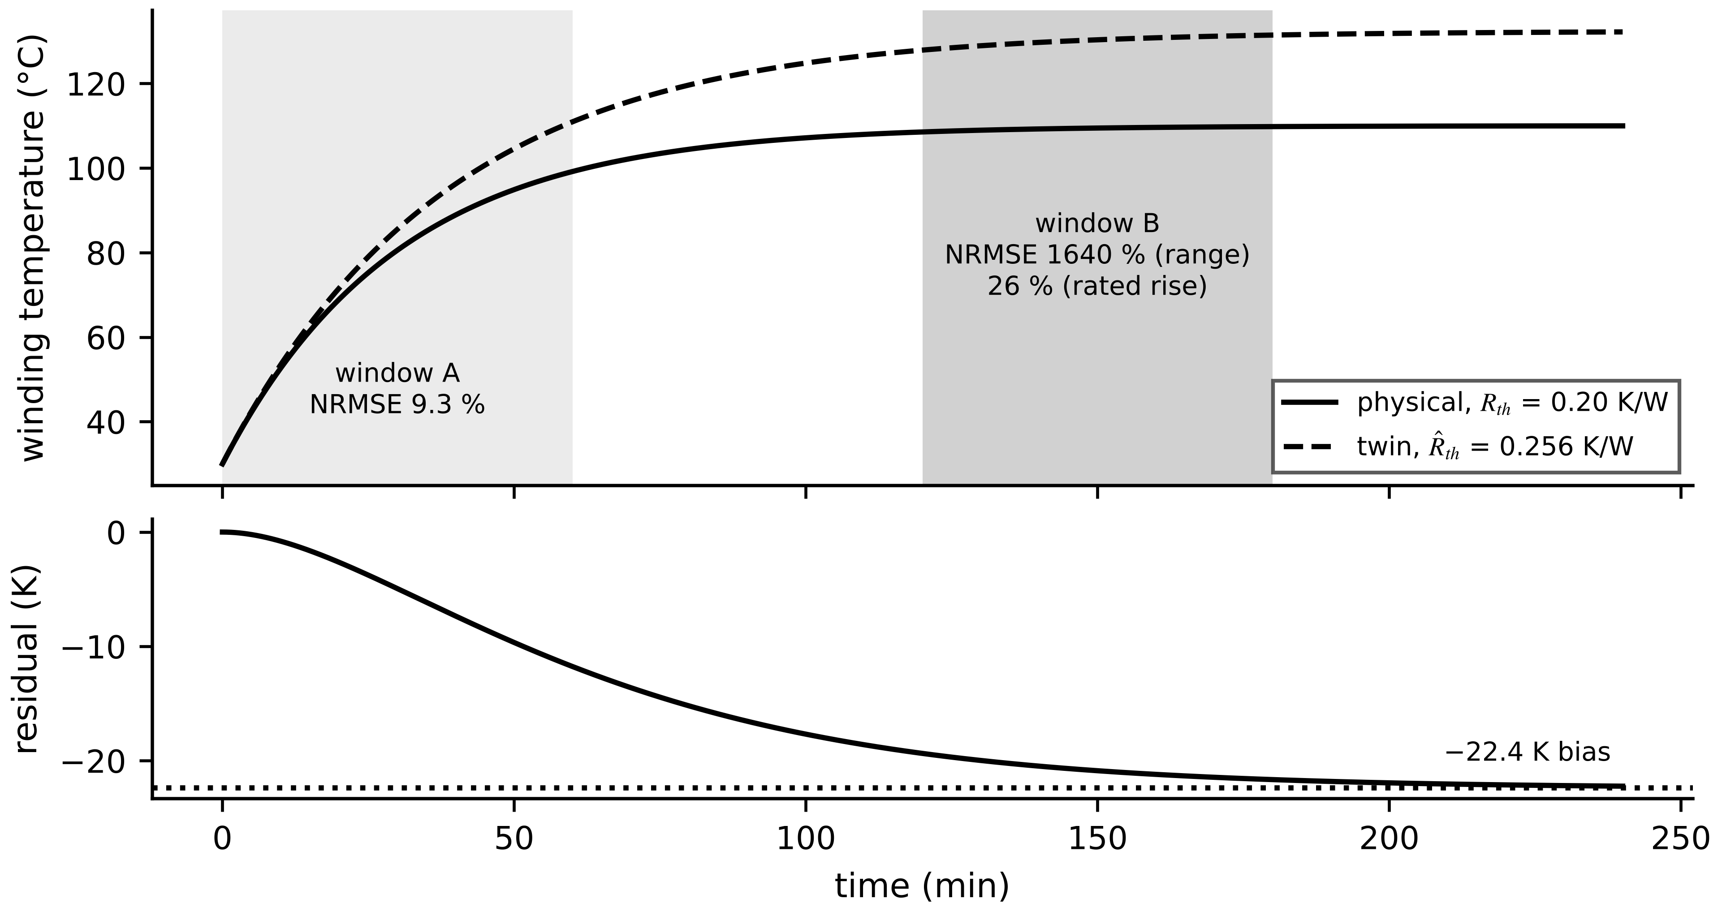
Figure 1.20. Example 1.14. Physical response and a twin with a 28 % high thermal resistance. The same twin scores 9.3 % over window A and about 1640 % over window B with range normalization (26 % with the rated rise). The residual grows towards the 22.4 K steady-state bias.

1.8.4 From a finite test to an acceptance decision
A metric computed from a finite test is itself uncertain. If $N$ errors were independent and normal with zero mean, $N {RMSE}^{2}/σ^{2}$ would follow a chi-square distribution with $N$ degrees of freedom, where $σ$ is the true error standard deviation. The two-sided 95 % confidence interval is
$RMSE\sqrt{\frac{N}{χ_{N,0.975}^{2}}}≤σ≤RMSE\sqrt{\frac{N}{χ_{N,0.025}^{2}}}$ (1.59)
where $χ_{N,p}^{2}$ is the $p$ quantile. Twin errors are rarely independent: a slowly drifting error makes successive samples alike. The lag-one autocorrelation of the residuals and the effective number of independent samples are
$ρ_{1}=\frac{\sum_{k=1}^{N-1}{\left(r_{k}-\overline{r}\right)}\left(r_{k+1}-\overline{r}\right)}{\sum_{k=1}^{N}{{\left(r_{k}-\overline{r}\right)}^{2}}}, N_{eff}≈N\frac{1-ρ_{1}}{1+ρ_{1}}$ (1.60)
with $\overline{r}$ the mean residual; the second expression holds for errors that behave as a first-order autoregressive process. Every reported metric should carry $N_{eff}$, not only $N$.
Interval forecasts need a coverage test. For a twin that reports intervals, the coverage is the fraction of held-out measurements inside the stated interval $CI_{k}$, and the normal approximation to the binomial gives a quick test against the claimed coverage $c$:
$Cov=\frac{1}{N}\sum_{k=1}^{N}{1}\left[y_{k}∈CI_{k}\right], z=\frac{\hat{Cov}-c}{\sqrt{c(1-c)/N}}$ (1.61)
where $1[·]$ is the indicator function and $\hat{Cov}$ the observed coverage.
Test data must be unseen. Parameters fitted on a data set always look good on that set. Time series are split chronologically: calibrate on the earliest block, tune gains and thresholds on the next, and report fidelity only on a final block that played no part in either. Random shuffling across blocks leaks future information into calibration and inflates every metric.
Fidelity holds only inside the envelope tested. A twin validated between 40 % and 100 % load at 20 to 35 °C ambient says nothing about a 120 % overload or a 45 °C afternoon. Figure 1.21 shows that even the rectangle of tested ranges overstates the envelope: corners where no data exist lie outside the convex hull of the test points. The twin should flag operating points outside the hull and widen its stated uncertainty there instead of extrapolating silently.
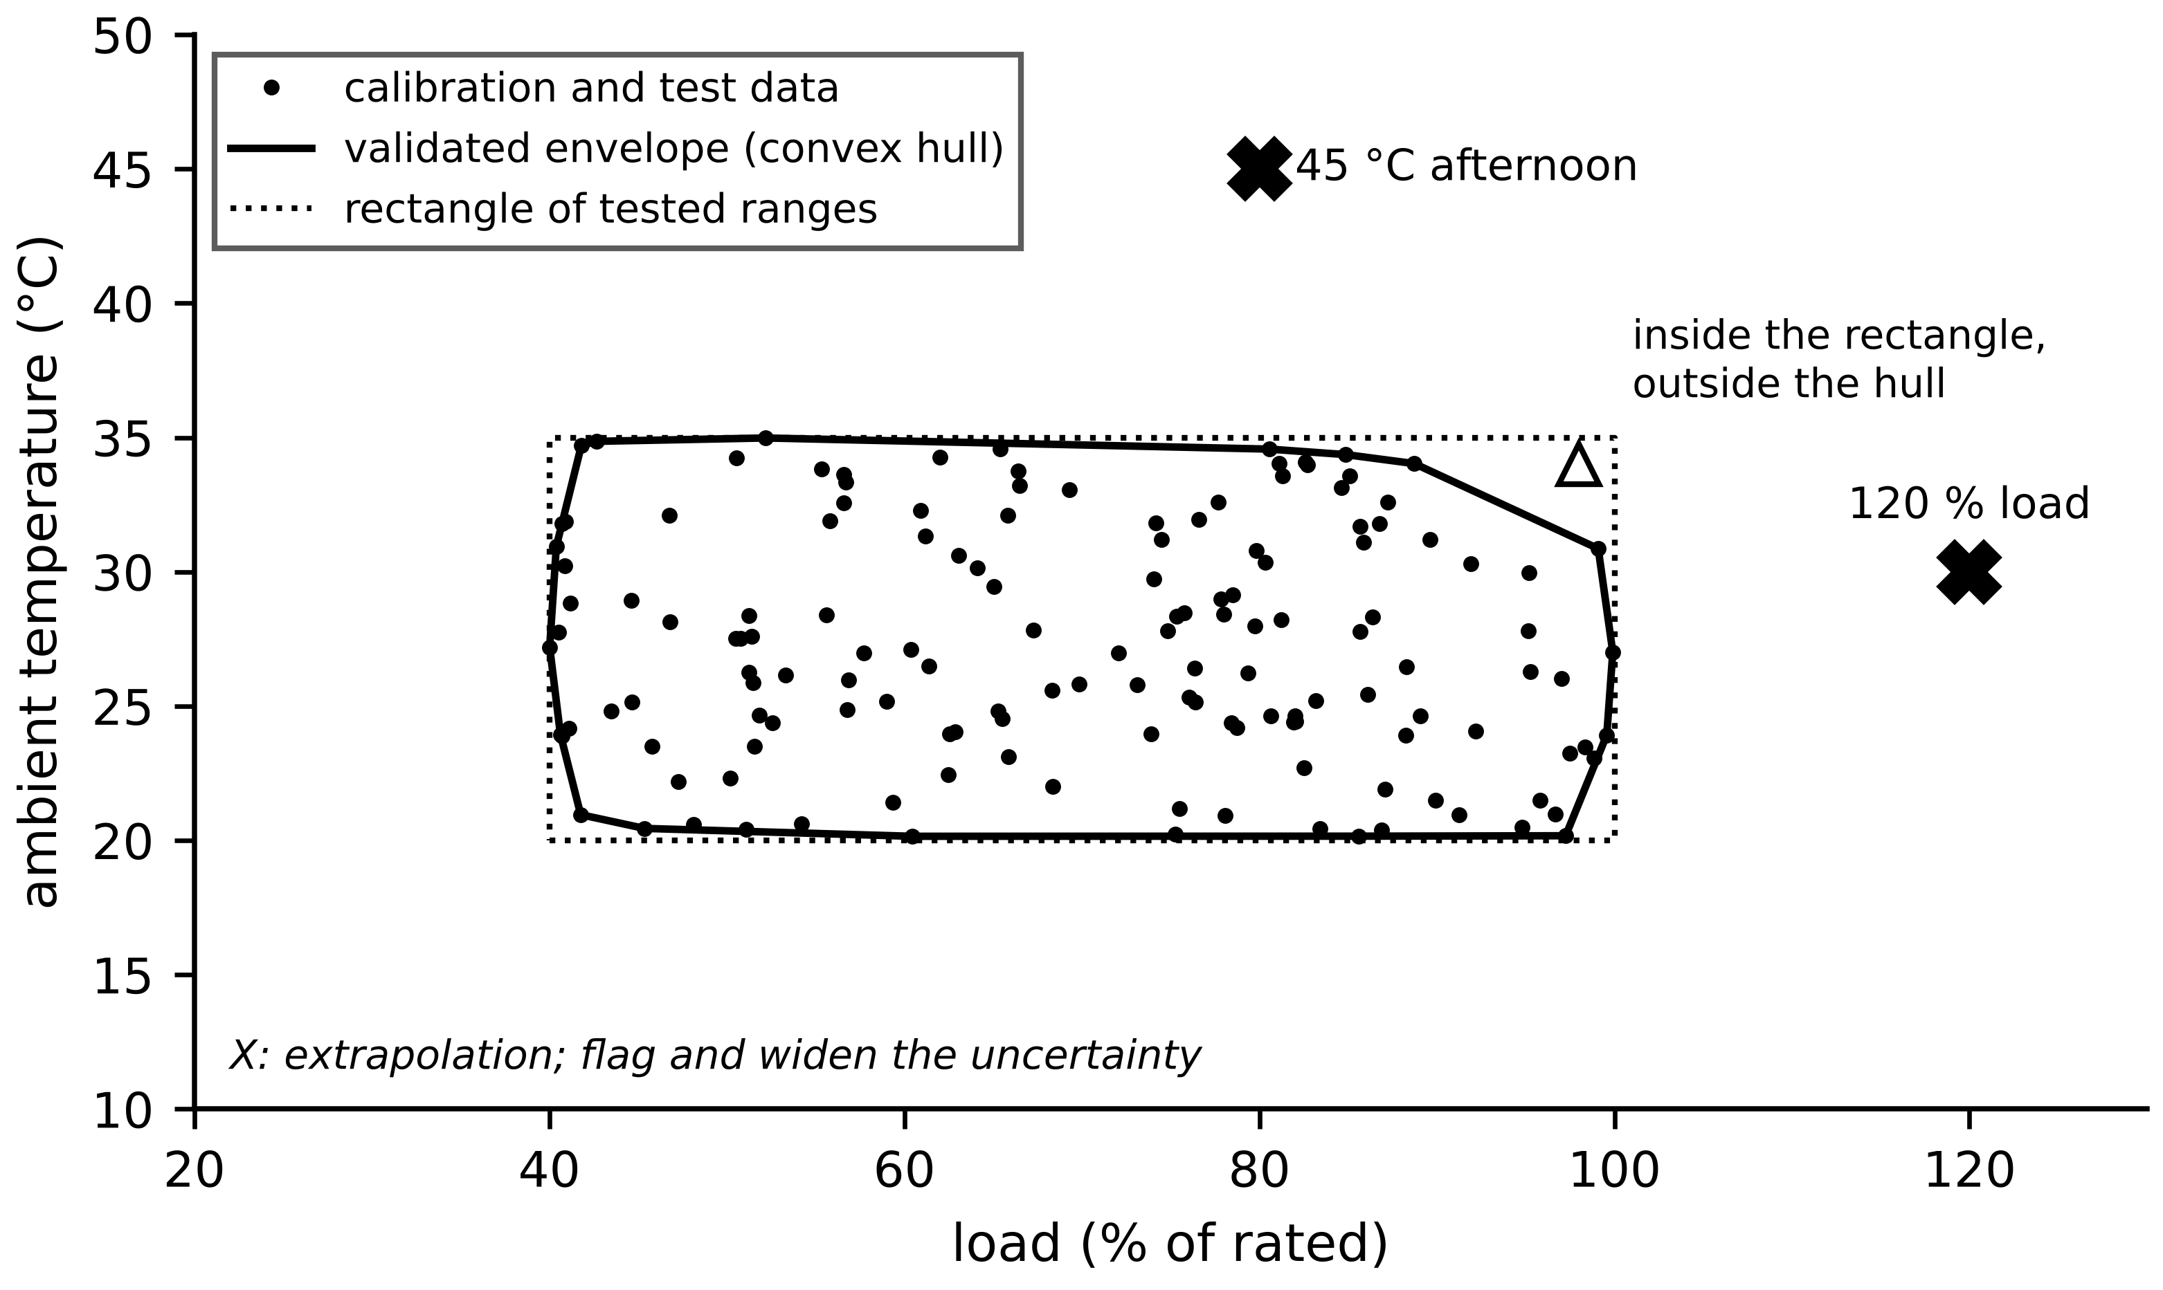
Figure 1.21. Validation envelope of the M-07 twin in the load and ambient plane. The convex hull of calibration and test data is the validated region; crosses mark extrapolation. A point can lie inside the rectangle of tested ranges and still outside the hull.
Example 1.15 (Level B) Noise floor, confidence interval, effective samples and coverage
Given. (i) The clean transformer data of Example 1.13, RMSE 0.713 K over $N=6$, with a reference sensor of $u_{meas}=0.5$ K. (ii) The 61-sample window of Example 1.14, RMSE 6.42 K, whose residual is a smooth curve. (iii) A twin claiming 95 % intervals finds 176 of 200 held-out samples inside.
Find. (a) The model's own RMSE from (1.43). (b) The 95 % interval for the true error level in (i). (c) $ρ_{1}$ and $N_{eff}$ for (ii), and the interval of (1.59) with $N=61$ and with $N=3$. (d) The coverage, $z$ and the exact binomial probability of 176 or fewer for (iii).
Solution. (a) $\sqrt{{0.713}^{2}-{0.5}^{2}}=\sqrt{0.508-0.25}=0.51$ K. (b) $χ_{6,0.975}^{2}=14.45$ and $χ_{6,0.025}^{2}=1.24$: $0.713\sqrt{6/14.45}=0.46$ K to $0.713\sqrt{6/1.24}=1.57$ K. (c) Computed from the 61 residuals, $ρ_{1}=0.96$, so $N_{eff}=61×0.04/1.96=1.3$. With $N=61$ the interval would be 5.46 to 7.80 K; even allowing $N=3$ it widens to 3.6 to 23.9 K. (d) Coverage $=0.88$; $z=(0.88-0.95)/\sqrt{0.95×0.05/200}=-4.5$; exact binomial probability $7×{10}^{-5}$.
Interpretation. Six samples cannot pin the error level to better than a factor of three. A smooth residual is worth roughly one independent sample, however many points it contains, so a narrow interval computed with $N$ would be false confidence. The intervals in (iii) are overconfident and must be widened before the twin is trusted for risk decisions.
Table 1.11. Fidelity and synchronization metrics: denominator, use and failure conditions
Metric | Denominator or reference | Suitable for | Misleads when
MAE (1.49) | none (units of $y$) | operator-facing reports | compared across channels with different units
RMSE (1.50) | none (units of $y$) | least-squares calibration; large errors matter | data contain unfiltered glitches
NRMSE (1.51) | range, mean, $σ_{y}$ or rated (state which) | comparing channels and assets | range or mean near zero or nearly constant
MAPE (1.52) | each $y_{k}$ | positive ratio-scale quantities (power, energy) | $y$ crosses or nears zero; interval scales such as °C
$R^{2}$ (1.53) | variance of $y$ | trend following of varying signals | signal nearly constant; confused with $r^{2}$
$Δt_{sync}$, AoI (1.35), (1.36) | common clock | protection, control, event reconstruction | clocks unsynchronized
Coverage (1.61) | stated interval | twins reporting uncertainty | intervals not calibrated on held-out data
$F_{D}$ (1.47) | decision with perfect information | justifying the twin | ground truth of the decision unavailable

What the digital twin adds
Synchronized: what the purpose requires, judged per fidelity type (Table 1.9).
Estimated or updated: metrics with denominators, $N_{eff}$ and coverage.
Uncertainty carried: the uncertainty of the metric itself, (1.59).
Decision enabled: accept, recalibrate or remodel, from bias and spread, (1.54).
Validated by: chronological held-out data inside a stated envelope.

1.9 Maturity levels and when to automate
Maturity scores are often asserted rather than shown: a product page states "Level 4" with no visible method. ISO/IEC 30186:2025 now gives a generic maturity model with assessment indicators [24], Pavleska aligned a power-grid taxonomy to it in 2026 and found that maturity is shaped by the owner's objectives rather than absolute [38], and Satpathy and Ramachandaramurthy proposed a weighted maturity and implementation index for utilities [39]. This book uses a simpler five-level ladder (Figure 1.22, Table 1.12) because each level is tied to a question that can be answered from documents and a site visit. The ladder describes capability; it is not a compliance scheme and maps no level onto a fidelity percentage.
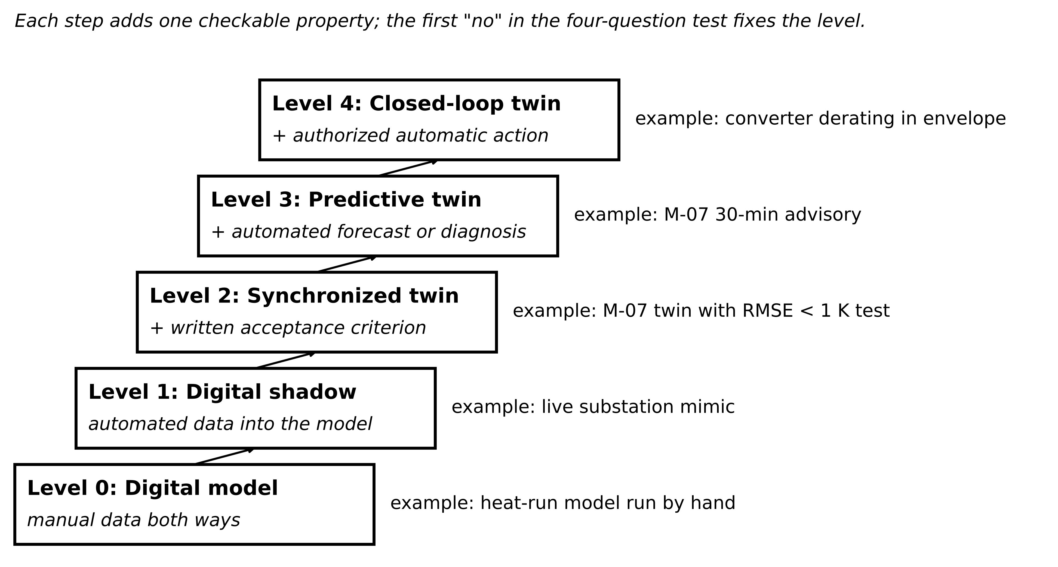
Figure 1.22. The five-level maturity ladder used in this book, with an example from Plant P-1 at each level.
Table 1.12. Maturity ladder used in this book
Level | Name | Automated data into model state? | Synchronization verified against a written criterion? | Automated predictive or diagnostic service? | Automated action on asset?
0 | Digital model | No | Not assessed | Not assessed | Not assessed
1 | Digital shadow | Yes | No | No | No
2 | Synchronized twin | Yes | Yes | No | No
3 | Predictive (advisory) twin | Yes | Yes | Yes | No, advisory to a person
4 | Closed-loop twin | Yes | Yes | Yes | Yes, within an authorized envelope

The four questions are asked in order and the first "no" fixes the level. Q1: does measured data update the model state without manual action? Q2: is synchronization checked against a written criterion (metric, window, threshold, envelope)? A dashboard showing that the model "looks right" does not satisfy Q2. Q3: does an automated service run on the synchronized state? Q4: may the twin change the asset without a human decision? An advisory that a person accepts keeps the twin at Level 3, however fast the person is.
Example 1.16 (Level A) Assigning levels to two deployments
Given. (i) A 5 MW PV plant streams inverter, irradiance and module-temperature data every 5 min into a performance model that computes expected energy per string. The expected-to-measured ratio is checked against a written criterion (daily NRMSE on AC energy below 3 % of rated, on clear-sky days, checked monthly on the previous month). When a string stays below 0.92 for three clear days, a soiling ticket opens automatically; a technician decides. (ii) A wind farm's SCADA logs 10-min averages; monthly, an engineer exports them, runs a fatigue model and schedules inspections.
Find. The answers to Q1 to Q4 and the level of each; for (ii), the smallest change that reaches Level 2.
Solution. (i) Q1 yes, Q2 yes, Q3 yes (the ticket rule runs on the synchronized state), Q4 no: Level 3. (ii) Q1 no, because the model state is updated only when the engineer runs it: Level 0, a digital model with automated storage. Level 2 needs the fatigue model to run automatically on each new data block (Q1) and a written criterion comparing predicted and measured load channels on held-out data (Q2).
Interpretation. Raising (i) to Level 4 would mean dispatching a cleaning robot without review. Whether that is wise depends on the cost comparison that follows, not on the ladder.
A higher level is not a virtue in itself. Let an automated action be wrong with probability $p_{FA}$ at cost $C_{FA}$, and let the delay of a human decision cause damage with probability $p_{late}$ at cost $C_{late}$. Automation lowers expected cost only if
$p_{late} C_{late}>p_{FA} C_{FA}$ (1.62)
and solving for the false-alarm probability gives the break-even point
$p_{FA}^{*}=\frac{p_{late} C_{late}}{C_{FA}}$ (1.63)
Where does $p_{FA}$ come from? If the healthy residual is approximately normal with zero mean and standard deviation $σ_{r}$, and an alarm is raised when $|r_{k}|>h$, the per-sample false-alarm and detection probabilities are
$p_{FA}=2 Q\left(\frac{h}{σ_{r}}\right), p_{D}(μ)=Q\left(\frac{h-μ}{σ_{r}}\right)+Q\left(\frac{h+μ}{σ_{r}}\right), Q(z)=\frac{1}{\sqrt{2π}}\int_{z}^{∞}{e^{-s^{2}/2}}ds$ (1.64)
where $h$ is the threshold, $μ$ the mean shift a fault causes and $Q$ the standard normal tail. Requiring $n$ consecutive exceedances, a persistence rule, multiplies the probabilities when successive residuals are independent:
$p_{FA,n}=p_{FA}^{ n}, p_{D,n}=p_{D}^{ n}$ (1.65)
Example 1.17 (Level B) Should the M-07 advisory become an automatic stop?
Given. An automatic stop on a false alarm costs a line stop of USD 12 000 and happens with probability 0.05 per advisory. A human response delay leads to a rewind costing USD 40 000 with probability 0.002. The residual used for the decision has $σ_{r}=0.3$ K, and the masked fault of Example 1.8 shifts it by $μ=1.114$ K.
Find. (a) Both sides of (1.62) and the decision. (b) The break-even false-alarm probability. (c) The single-sample threshold that achieves it, and $p_{D}$ for the masked fault. (d) The same with a two-sample persistence rule.
Solution. (a) $0.002×40 000=80$ against $0.05×12 000=600$ USD per advisory: keep the advisory mode. (b) $p_{FA}^{*}=80/12 000=0.0067$. (c) $2Q(h/0.3)=0.0067$ gives $h/0.3=2.71$, $h=0.81$ K; then $p_{D}=Q((0.81-1.114)/0.3)+Q((0.81+1.114)/0.3)=Q(-1.01)+Q(6.4)=0.84$. (d) Each sample may now fire with $\sqrt{0.0067}=0.082$, so $h/0.3=1.74$ and $h=0.52$ K; $p_{D}=Q((0.52-1.114)/0.3)=Q(-1.98)≈0.976$ per sample and ${0.976}^{2}=0.95$ for two in a row.
Interpretation. Automation pays only once false alarms are rarer than about 0.7 % per event. Both sides of (1.62) must refer to the same decision unit; here each 30 s residual sample is one decision, so the per-sample probabilities of (1.64) can be compared directly with the break-even value. With persistence, the threshold can come down and detection of the masked fault goes up from 0.84 to 0.95 at the same false-alarm rate. For protection that must act within tens of milliseconds, a person is not an option at all, and the function belongs in a certified relay. The level follows from the risk profile.
What the digital twin adds
Synchronized: unchanged by the level; the level is about what is done with the state.
Estimated or updated: the maturity level from four checkable questions.
Uncertainty carried: false-alarm and detection probabilities, (1.64).
Decision enabled: whether to automate, from (1.62).
Validated by: replayed normal and fault data giving measured $p_{FA}$ and $p_{D}$.

1.10 Lifecycle and hierarchy of twins

1.10.1 One asset, six lifecycle twins
A twin is not built once at commissioning and left alone. Its purpose, data and model change as the asset moves through its life, and the useful question is what each stage hands to the next. Figure 1.23 and Table 1.13 show six stages for M-07. A twin that is attached to the asset from design through retirement is what Pavleska's power-grid taxonomy calls lifecycle-integrated, as opposed to a twin built before or after the asset [38].
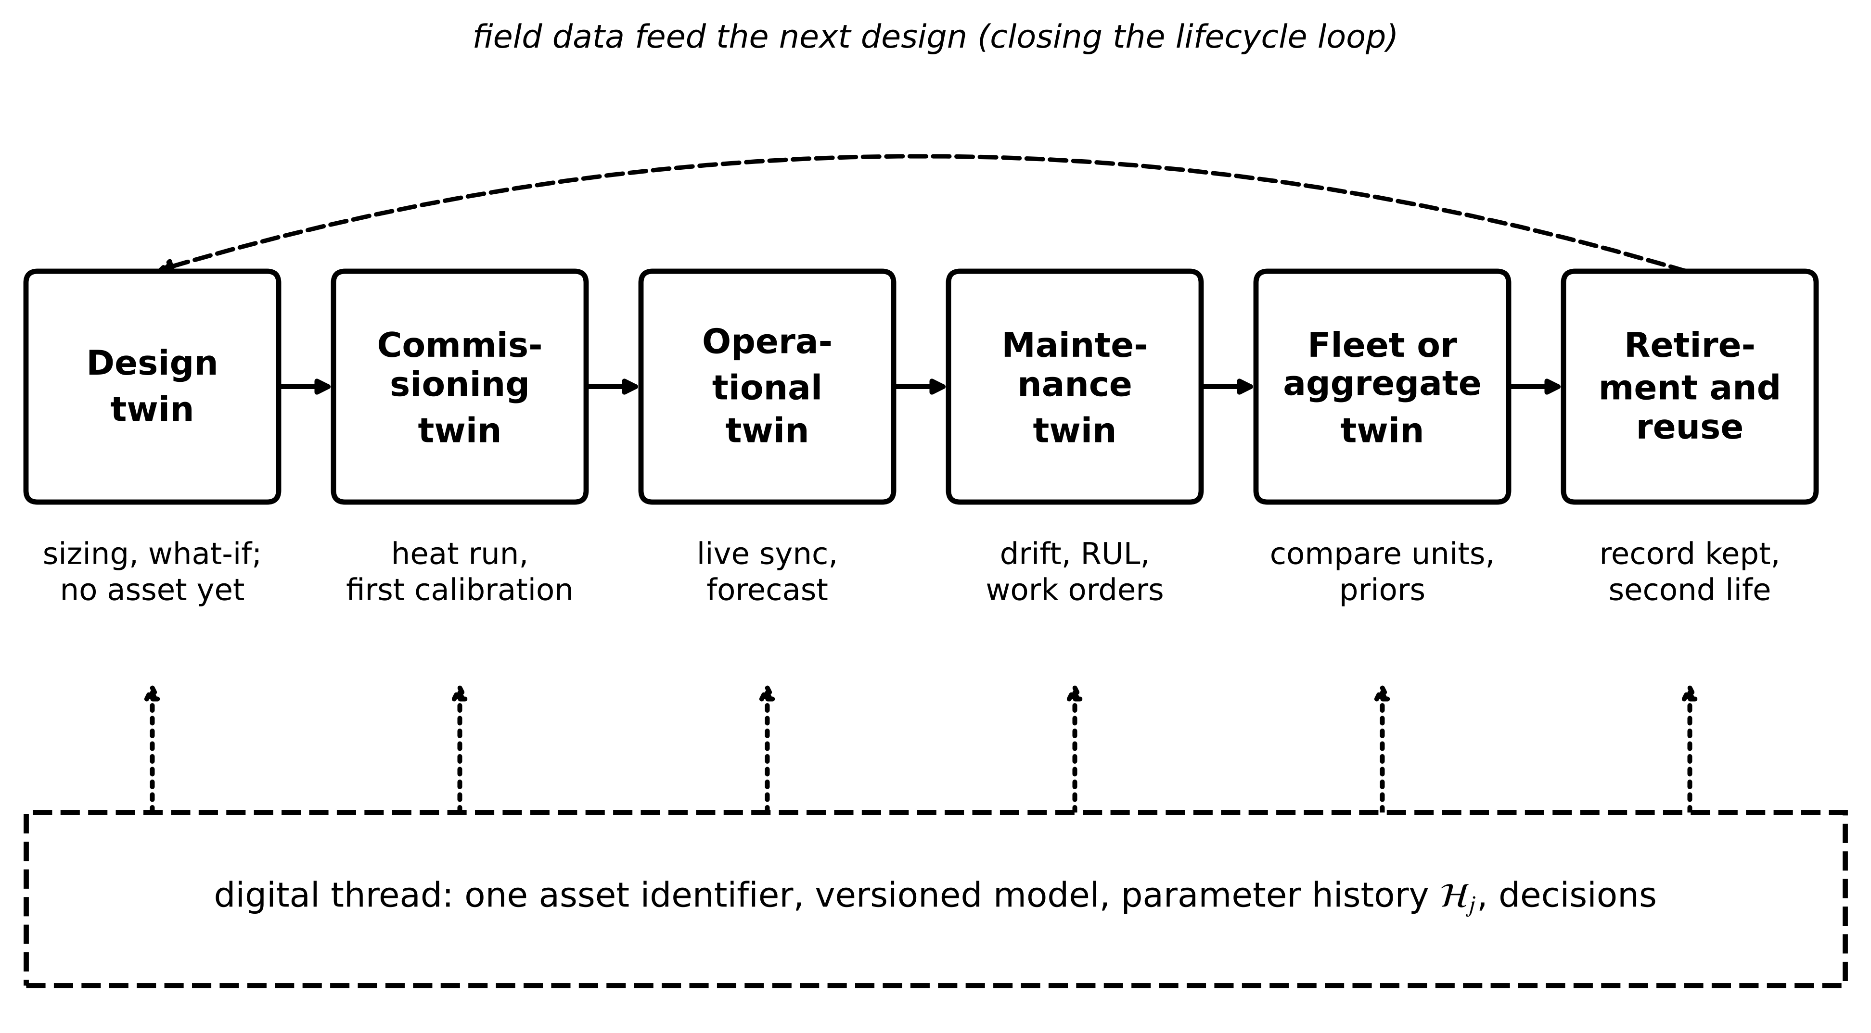
Figure 1.23. Lifecycle twins from design to retirement. The digital thread carries one identifier, a versioned model, the parameter history and the decisions taken, so that each stage inherits evidence from the last; field data feed the next design.
Table 1.13. Lifecycle stages of a twin, illustrated on M-07
Stage | Purpose | Data | Model | Typical update
Design twin | size the motor and cooling for the duty | duty cycle, catalogue data | FEM or multi-node thermal | per design iteration
Commissioning twin | first calibration, acceptance | heat run, start-up transient | one node; parameters identified | once, then on rework
Operational twin | track state, forecast | RTD, CT every 30 s | one node with observer | every 30 s
Maintenance twin | detect drift, plan work | parameter history, vibration | refit ${\hat{R}}_{th}$, trends | every 20 min to daily
Fleet or aggregate twin | compare units, share priors | all 20 instances | population model | daily to weekly
Retirement and reuse | decide rewind, reuse or scrap; inform next design | whole record $ℋ_{j}$ | ageing estimate | at decision time

Two engineering rules follow. The identifier and the model version must survive every stage, or the evidence collected early cannot be used later. And each stage has its own contract: the commissioning twin's validation criterion is an acceptance test, the operational twin's is a held-out RMSE, and the retirement twin's is whether its ageing estimate agrees with an inspection.

1.10.2 Prototype, instance, aggregate and federation
A thermal model developed once and deployed on twenty identical motors is not twenty engineering projects, and the terms should reflect that. Following Grieves and Vickers [14], a digital twin prototype (DTP) is the generic model structure with its calibration procedure. A digital twin instance (DTI) is that prototype bound to one serial-numbered asset with its own parameters and history. A digital twin aggregate (DTA) is a set of instances analysed together. Formally, instance $j$ is
${DTI}_{j}=\left(ℳ, {\hat{θ}}_{j}, ℋ_{j}\right)$ (1.66)
where $ℳ$ is the shared prototype model, ${\hat{θ}}_{j}$ the instance's parameters and $ℋ_{j}$ its data and correction history. Above the aggregate sits the federation or system of systems: twins of different asset types (motor fleet, PV array, BESS, converter) joined because they share a bus, through standard interfaces such as the Asset Administration Shell [23] and, in power systems, the IEC Common Information Model and IEC 61850 [40], [41]. Figure 1.24 shows the hierarchy. The largest federated effort to date, the Horizon Europe project TwinEU (grant 101136119, January 2024 for 36 months, about 75 partners), is building a pan-European grid twin as a federation of local twins rather than one model [29]. Its results are still to come; the design choice of federation is the lesson available now.
Figure 1.24. One prototype, many instances, one aggregate, and a federation of different asset twins. Each instance carries its own calibrated parameters (values from the running example); the aggregate compares them.
Fleet cost scales with the number of instances that must each be calibrated and maintained:
$E_{fleet}=E_{p}+N E_{i}$ (1.67)
where $E_{p}$ is the one-time prototype effort and $E_{i}$ the calibration and upkeep per instance, both in engineer-hours. The aggregate also knows something no instance does. An instance whose parameter sits far from the population is suspect:
$z_{j}=\frac{{\hat{θ}}_{j}-μ_{pop}}{σ_{pop}}$ (1.68)
with $μ_{pop}$ and $σ_{pop}$ the mean and standard deviation over the other instances. [Advanced] The population can also serve as a prior for a new instance. For normal distributions, the instance's own estimate ${\hat{θ}}_{j}$ with uncertainty $σ_{j}$ and the population combine by inverse-variance weighting:
${\tilde{θ}}_{j}=\frac{σ_{pop}^{2}{\hat{θ}}_{j}+σ_{j}^{2}μ_{pop}}{σ_{pop}^{2}+σ_{j}^{2}}, {\tilde{σ}}_{j}^{2}={\left(\frac{1}{σ_{j}^{2}}+\frac{1}{σ_{pop}^{2}}\right)}^{-1}$ (1.69)
where ${\tilde{θ}}_{j}$ and ${\tilde{σ}}_{j}$ are the combined estimate and its uncertainty. As an instance's own data accumulate, $σ_{j}$ shrinks and its own estimate takes over. The same rule would pull a genuinely degraded motor towards the fleet mean, which is why a large $|z_{j}|$ must be checked before any shrinkage is applied.
Example 1.18 (Level B) Fleet effort, an outlying instance and a new motor
Given. Prototype effort 400 engineer-hours. Calibration costs 6 h per motor with a two-hour heat run, or 0.5 h per motor if the model is identifiable from a five-minute start-up transient. Nineteen instances report ${\hat{R}}_{th}$ with mean 0.201 K/W and standard deviation 0.006 K/W; M-07 reports 0.249 K/W. A newly installed motor gives $0.230±0.020$ K/W after its first hour.
Find. (a) Fleet effort for 20 and for 200 motors by both calibration methods. (b) $z$ for M-07. (c) The combined estimate and uncertainty for the new motor, with $μ_{pop}=0.201$ and $σ_{pop}=0.006$ K/W.
Solution. (a) 20 motors: $400+20×6=520$ h against $400+20×0.5=410$ h. 200 motors: $400+1200=1600$ h against $400+100=500$ h. (b) $z=(0.249-0.201)/0.006=8.0$. (c) $\tilde{θ}=({0.006}^{2}×0.230+{0.020}^{2}×0.201)/({0.006}^{2}+{0.020}^{2})=(8.28×{10}^{-6}+80.4×{10}^{-6})/(4.36×{10}^{-4})=0.2034$ K/W; $\tilde{σ}=(1/{0.020}^{2}+1/{0.006}^{2})^{-1/2}=0.0057$ K/W.
Interpretation. At fleet scale, a modelling choice that makes calibration cheap matters more than a small gain in prototype accuracy. M-07 at eight standard deviations is either degraded or badly calibrated, and either deserves a visit. The new motor starts close to the fleet, as it should while its own data are weak.
What the digital twin adds
Synchronized: each instance with its own asset; the aggregate with the instances.
Estimated or updated: ${\hat{θ}}_{j}$ per instance, population statistics, priors.
Uncertainty carried: instance and population spread, (1.69).
Decision enabled: which unit to inspect first; how a new unit starts.
Validated by: the digital thread linking each stage's evidence (Table 1.13).

1.11 Where the twin runs: edge, site and cloud
A twin is a set of functions, and each function can run in a different place: on an edge device next to the asset, on a site server, or in a cloud. Placement is decided function by function from three numbers: the deadline, the data rate and the computing load. Figure 1.25 summarizes the trade.
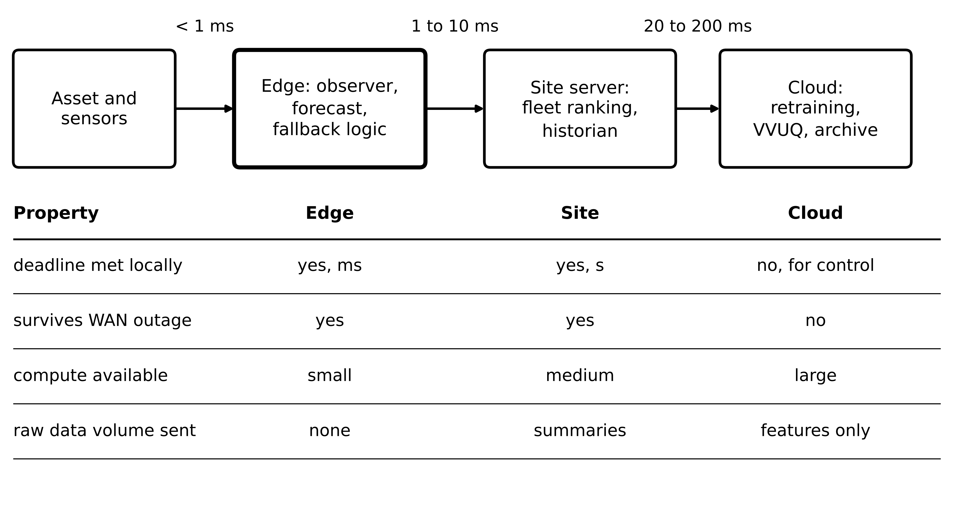
Figure 1.25. Placement of twin functions on edge, site and cloud. Typical one-way delays are shown above the arrows; the table compares the three locations on the properties that decide placement.
The end-to-end time of a function placed at location $ℓ$ is
$T_{ℓ}=T_{acq}+\frac{S}{R_{ℓ}}+T_{net,ℓ}+T_{queue,ℓ}+\frac{W}{C_{ℓ}}≤T_{deadline}$ (1.70)
where $T_{acq}$ is the acquisition time, $S$ the bits sent per cycle, $R_{ℓ}$ the link rate to location $ℓ$, $T_{net,ℓ}$ the network transit, $T_{queue,ℓ}$ the queuing delay, $W$ the computing work and $C_{ℓ}$ the computing speed there. The link must also carry the data stream continuously, which requires the link load factor
$ρ_{ℓ}=\frac{data rate}{R_{ℓ}}<1$ (1.71)
Edge placement wins when the deadline is short, when the function must keep working through a network outage (the fallback clause), or when raw data are too voluminous to send. Cloud placement wins for heavy, slow work: retraining learned models, online VVUQ studies and fleet archives. In practice a twin is split, as the M-07 twin is: observer, forecast and fallback at the edge; fleet ranking on the site server; retraining in the cloud.
Example 1.19 (Level B) Edge or cloud for two twins in Plant P-1
Given. (i) The converter twin samples three channels at 10 kHz, 16 bits each, plus an 8-byte timestamp per sample set; its derating function has a 1 ms deadline. (ii) The M-07 fleet twin sends three 4-byte values with an 8-byte timestamp per motor every 30 s for 20 motors; its ranking has a 1 h deadline. The site uplink is a 1 Mbit/s cellular link with 40 ms round trip.
Find. (a) The raw data rate of (i) with and without timestamps, and the uplink load factor. (b) Whether the derating function can run in the cloud. (c) The data rate of (ii) and its load factor. (d) A placement for each function.
Solution. (a) Values: $3×2×10 000=60 000$ B/s $=480$ kbit/s; with timestamps, $(6+8)×10 000=140 000$ B/s $=1.12$ Mbit/s. Load factor $ρ=0.48$ without and $1.12$ with timestamps, so the timestamped stream cannot even be carried. (b) No: the 40 ms round trip alone is 40 times the 1 ms deadline. (c) $20×(3×4+8)/30=13.3$ B/s, about 107 bit/s; $ρ≈{10}^{-4}$. (d) Converter derating at the edge, on the drive controller or an FPGA beside it, sending only summaries upward. Fleet ranking anywhere; the cloud is fine.
Interpretation. Placement is a per-function calculation with (1.70) and (1.71), not a company policy. The same plant correctly runs one twin function within microseconds of the asset and another in a data centre.
What the digital twin adds
Synchronized: each function at the location that meets its deadline.
Estimated or updated: the delay budget (1.70) and link load factor (1.71).
Uncertainty carried: worst-case, not mean, delays and queue lengths.
Decision enabled: where each function runs, and what survives a network outage.
Validated by: measured worst-case timing on the target hardware.

1.12 Twins and neighbouring technologies, and common misconceptions
Several terms are used interchangeably with "digital twin" often enough that an engineer needs quick, checkable tests to separate them. Figure 1.26 places them on two axes: coupling to one specific deployed asset, and the role of an executable state model. Table 1.14 gives the tests.
Figure 1.26. A digital twin and neighbouring technologies, by coupling to one deployed asset (horizontal) and role of an executable state model (vertical). Adding a state model and estimator moves a SCADA installation towards the twin corner; binding an offline ML model to one asset and updating it online moves it there from the other side.
Table 1.14. Checkable tests that separate a digital twin from neighbouring technologies
Technology | Live link to a specific asset? | Test that separates it from a twin
Offline simulation, digital model | No | Does any automated measurement update the model state? If not, it is a model, however detailed.
Hardware-in-the-loop (HIL) | No; closes the loop with a bench controller | Is the physical side a fielded asset or test hardware? HIL is a development tool, though HIL models are often reused inside twins (Chapter 7).
Digital thread | Not necessarily | Does it hold a running state, or a lineage of design and service records? The thread is provenance; the twin is state.
Cyber-physical system | Yes | Is there an explicit model whose agreement with the plant is measured? A twin is one model-centred kind of CPS.
3-D visualization, metaverse | Not necessarily | Must the scene match the asset within a stated tolerance, or only look plausible?
SCADA, historian | Yes | Does it compute unmeasured states or forecasts from a model, or only display and store?
Offline AI or ML model | No | Is it bound to one asset and checked online against it?
Asset Administration Shell [23] | Depends on use | Is it an information container describing the asset, or a running model? The AAS is an interface a twin can publish through.

Four misconceptions recur in vendor material and occasionally in research papers. A higher maturity level is always the goal. It is not; (1.62) decides, and for many protection-adjacent functions it points downward. One readiness score summarizes a twin. It cannot, because a composite of unlike quantities hides which part has degraded (Example 1.24); composite indices are used in later chapters only with disclosed weights and a sensitivity check. A twin must be three-dimensional. Most useful electrical twins have no graphics beyond trends; the M-07 twin is one differential equation. More data always improve a twin. Data from outside the envelope, with poor timestamps or with unrecorded sensor replacements, make calibration worse; quality and provenance (Chapter 3) come before volume.

1.13 Why electrical energy systems need twins, and the state of the art
The case for twins in electrical and energy systems, as distinct from industry in general, rests on three properties.
Wide and fast time scales. Electrical phenomena span more than fifteen orders of magnitude in time (Figure 1.27), from sub-microsecond switching in wide-bandgap converters to ageing over decades. No single model covers that range, and manual comparison of model and measurement works only at the slow end. A process with time constant $τ$ behaves as a first-order low-pass system with corner frequency
$f_{c}=\frac{1}{2πτ}$ (1.72)
so M-07's 30-minute thermal time constant corresponds to 88 µHz, while a converter current loop with a 100 µs time constant corresponds to 1.6 kHz. Sampling rate, model order and computing platform scale with $f_{c}$ across seven orders of magnitude between these two twins of the same plant.
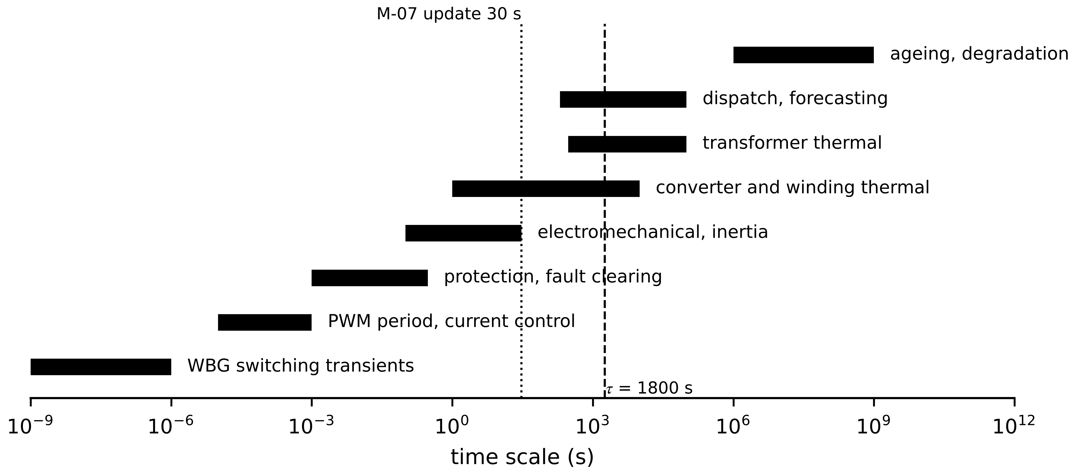
Figure 1.27. Characteristic time scales in electrical energy systems. A twin serves one band or a few neighbouring bands, and its update period and model order follow from that choice. Bars are indicative ranges from standard power-system and power-electronics practice.
Growing structural complexity. Inverter-based resources are replacing synchronous machines, distribution networks carry power both ways, and the number of controllable devices on a feeder has grown by orders of magnitude, while observability has not kept pace (Chapters 5 and 11). Interoperability across owners. A transmission operator, several distribution operators, aggregators and asset owners each hold part of the data and part of the model, so a grid twin needs common information models and data agreements before it needs better equations.
The recent literature is frank about how far practice lags the concept. Abuabed and Kittur's 2026 systematic review of 84 studies groups electrical-engineering twins into seven themes; power and energy systems dominate with 43 studies, while cybersecurity and lifecycle management appear in only five, and the authors call for standardized interoperability (CIM, IEC 61850), hierarchical and federated architectures and adaptive synchronization [18]. Satpathy and Ramachandaramurthy's 2026 review in Applied Energy analyses a four-layer architecture (physical entity, digital replica, communication, intelligent services) and proposes a phased utility-scale roadmap with a maturity and implementation index [39]. Manimaran et al. (2026) stress real-time validation, scalability, cybersecurity and the fidelity against speed trade-off, with reduced-order models and hardware acceleration as remedies [42]. Earlier reviews reach similar conclusions for power systems [43], the European grid and its regulatory barriers [44], renewables, storage and vehicle-to-grid [45], smart grids [46], microgrids [47], IoT-driven energy systems [48] and the grid as a whole [49], [50]. Table 1.15 condenses the state of the art by asset class, with the maturity labels used in this book.
Table 1.15. State of the art by asset class, condensed from the cited reviews and representative papers
Asset class | Typical twin model | Representative methods | Status | Main open limitation
Power transformer | top-oil and hot-spot thermal model | loading-guide thermal ODEs [51]; MV estimation from LV data [52] | Established (monitoring); emerging (predictive) | hot spot unmeasured; ageing models uncertain
Rotating machine | lumped or distributed thermal network; electromagnetic model | parameter identification; residual-based fault detection [48] | Established (monitoring); research (closed loop) | parameter drift with cooling; few fault data
PV plant | irradiance-to-power with temperature correction | performance ratio, expected energy, soiling detection [53] | Established | separating soiling, degradation and sensor drift
Battery storage | equivalent-circuit or electrochemical | Coulomb counting with OCV correction, Kalman filtering [54] | Established (BMS); emerging (cloud twins) | SOH ground truth; flat OCV curves
Power converter | averaged or switching model on real-time hardware | HIL; dynamic state estimation [55] | Established (HIL); research (field twins) | real-time budget; device ageing
Microgrid, distribution | power flow and dynamic models with estimation | twin-based energy management, fault location [47] | Emerging (pilots) | sparse measurements; data federation
Transmission grid | online analysis fed by SCADA and PMU | online analysis framework [56]; federated twins [43] | Established (control-room tools); research (federation) | cross-owner interoperability; governance; security

What the digital twin adds
Synchronized: the band of time scales the purpose needs, (1.72).
Estimated or updated: which asset classes are mature enough for which use.
Uncertainty carried: maturity labels distinguish evidence from promise.
Decision enabled: where to invest twin effort first in a plant.
Validated by: peer-reviewed reviews and field records, not market reports.

1.14 Worked examples across four electrical-energy domains
The four assets of Figure 1.7 now return. Each subsection states its model and its validity limits first, then works a multi-part example. All data are synthetic or illustrative and labelled as such; they are realistic in magnitude and checkable by hand.

1.14.1 Induction motor: outage and resynchronization
For a loss step $ΔP$ unseen by an open-loop twin during a communication gap of length $t_{g}$, subtracting the twin's constant temperature from the plant's response (1.14) gives the residual on reconnection:
$r\left(t_{g}\right)=R_{th} ΔP\left(1-e^{-t_{g}/τ}\right)$ (1.73)
Example 1.20 (Level B) Communication outage and resynchronization of M-07
Given. M-07 runs steadily at 300 W ($T=30+0.2×300=90$ °C). At $t=0$ the data link fails for 30 min; at the same instant, unknown to the twin, the loss rises to 400 W. During the outage the twin runs open loop on its last input.
Find. (a) The plant temperature and the residual when data return. (b) The residual afterwards if (i) both state and input are refreshed, or (ii) only the state is reset while the input stays stale at 300 W. (c) The residual 30 min after reconnection in case (ii). (d) The peak AoI during the outage.
Solution. (a) The twin stays at 90 °C. The plant follows (1.14) towards $30+0.2×400=110$ °C, reaching $110-20e^{-1}=102.64$ °C. From (1.73): $r=0.2×100×(1-e^{-1})=12.64$ K. (b)(i) After the reset the residual drops to the noise level and stays there because the twin now integrates the correct input. (ii) The twin is reset to 102.64 °C but then relaxes towards 90 °C while the plant heads towards 110 °C, so the residual grows again from zero. (c) The plant reaches $110-20e^{-2}=107.29$ °C and the stale twin $90+12.64e^{-1}=94.65$ °C, a residual of 12.6 K. (d) About 30 min plus the normal 31.6 s, roughly 1830 s.
Interpretation. A residual that collapses after resynchronization and then climbs again points to a stale input, not a bad model (Figure 1.28). Logging which inputs were fresh at each step lets an engineer tell the two apart after the event. The fallback state machine of Section 1.15 enforces the refresh of inputs as part of resynchronization.
Figure 1.28. Example 1.20. A 30-min link outage during a load step. Case (i) refreshes state and input; case (ii) resets only the state, and the residual grows again because the input is stale.

1.14.2 Photovoltaic array: a residual caused by latency, not by a fault
The array's DC power is modelled from plane-of-array irradiance $G$ (W/m²) and cell temperature $T_{c}$:
$P_{dc}=η A G\left[1+γ\left(T_{c}-25\right)\right], P_{ac}=η_{inv}P_{dc}$ (1.74)
where $η$ is the array efficiency at 25 °C, $A$ the area (m²), $γ$ the power temperature coefficient (per °C, negative for silicon) and $η_{inv}$ the inverter efficiency. A steady energy balance on the module, absorbed irradiance not converted to electricity equal to heat lost, gives $T_{c}-T_{amb}=kG$; calibrating $k$ at the nominal operating cell temperature (NOCT) condition ($G=800$ W/m², $T_{amb}=20$ °C) yields
$T_{c}=T_{amb}+\frac{NOCT-20}{800} G$ (1.75)
These relations assume steady state, wind near 1 m/s, uniform irradiance and no shading; the module's thermal lag of several minutes and partial shading need the models of Chapter 8. Recent editions of IEC 61215 [57] use the nominal module operating temperature (NMOT) in place of NOCT; the structure of (1.75) is unchanged.
Example 1.21 (Level B) PV residual from sensor latency
Given. $η=0.19$, $A=43.2$ m², $γ=-0.0040$ /°C, NOCT $=45$ °C, $T_{amb}=28$ °C, $η_{inv}=0.97$. At noon $G=950$ W/m². A cloud drops $G$ to 530 W/m² for 120 s. The irradiance sensor reaches the twin 45 s late; the inverter power reading is prompt.
Find. (a) $T_{c}$ and $P_{ac}$ at 950 and 530 W/m². (b) The residual $r=P_{ac,meas}-P_{T}$ through the transient. (c) The energy in each residual lobe. (d) The sensitivity $dP_{dc}/dG$ at 950 W/m², including cell heating.
Solution. (a) At 950 W/m²: $T_{c}=28+(25/800)×950=57.69$ °C; factor $1-0.004×32.69=0.86925$; $ηAG=7797.6$ W; $P_{dc}=6778$ W; $P_{ac}=6575$ W. At 530 W/m²: $T_{c}=44.56$ °C; factor $0.92175$; $ηAG=4350.2$ W; $P_{dc}=4010$ W; $P_{ac}=3890$ W. (b) For the first 45 s of the cloud the twin still sees 950 W/m²: $r=3890-6575=-2685$ W. From 45 s to 120 s both see 530 W/m², $r≈0$. For 45 s after the cloud clears, $r=+2685$ W. (c) $2685×45=120.8$ kJ $=0.034$ kWh in each lobe; the lobes cancel. (d) Differentiating (1.74) with (1.75): $dP_{dc}/dG=ηA[1+γ(T_{c}-25)+γkG]=8.208×[0.86925-0.11875]=6.16$ W per W/m².
Interpretation. A residual of 2.7 kW, 41 % of the output, looks like a severe fault if only its size is read. Its signature, two equal and opposite lobes each exactly one latency long (Figure 1.29), identifies a timing problem. Align data by timestamp before computing residuals, and require a residual to persist longer than the known latency before raising a fault flag. For a gradual cloud edge with slope $\dot{G}$, (1.6) and part (d) predict the residual directly, $r≈-η_{inv}(dP_{dc}/dG)\dot{G} d$.
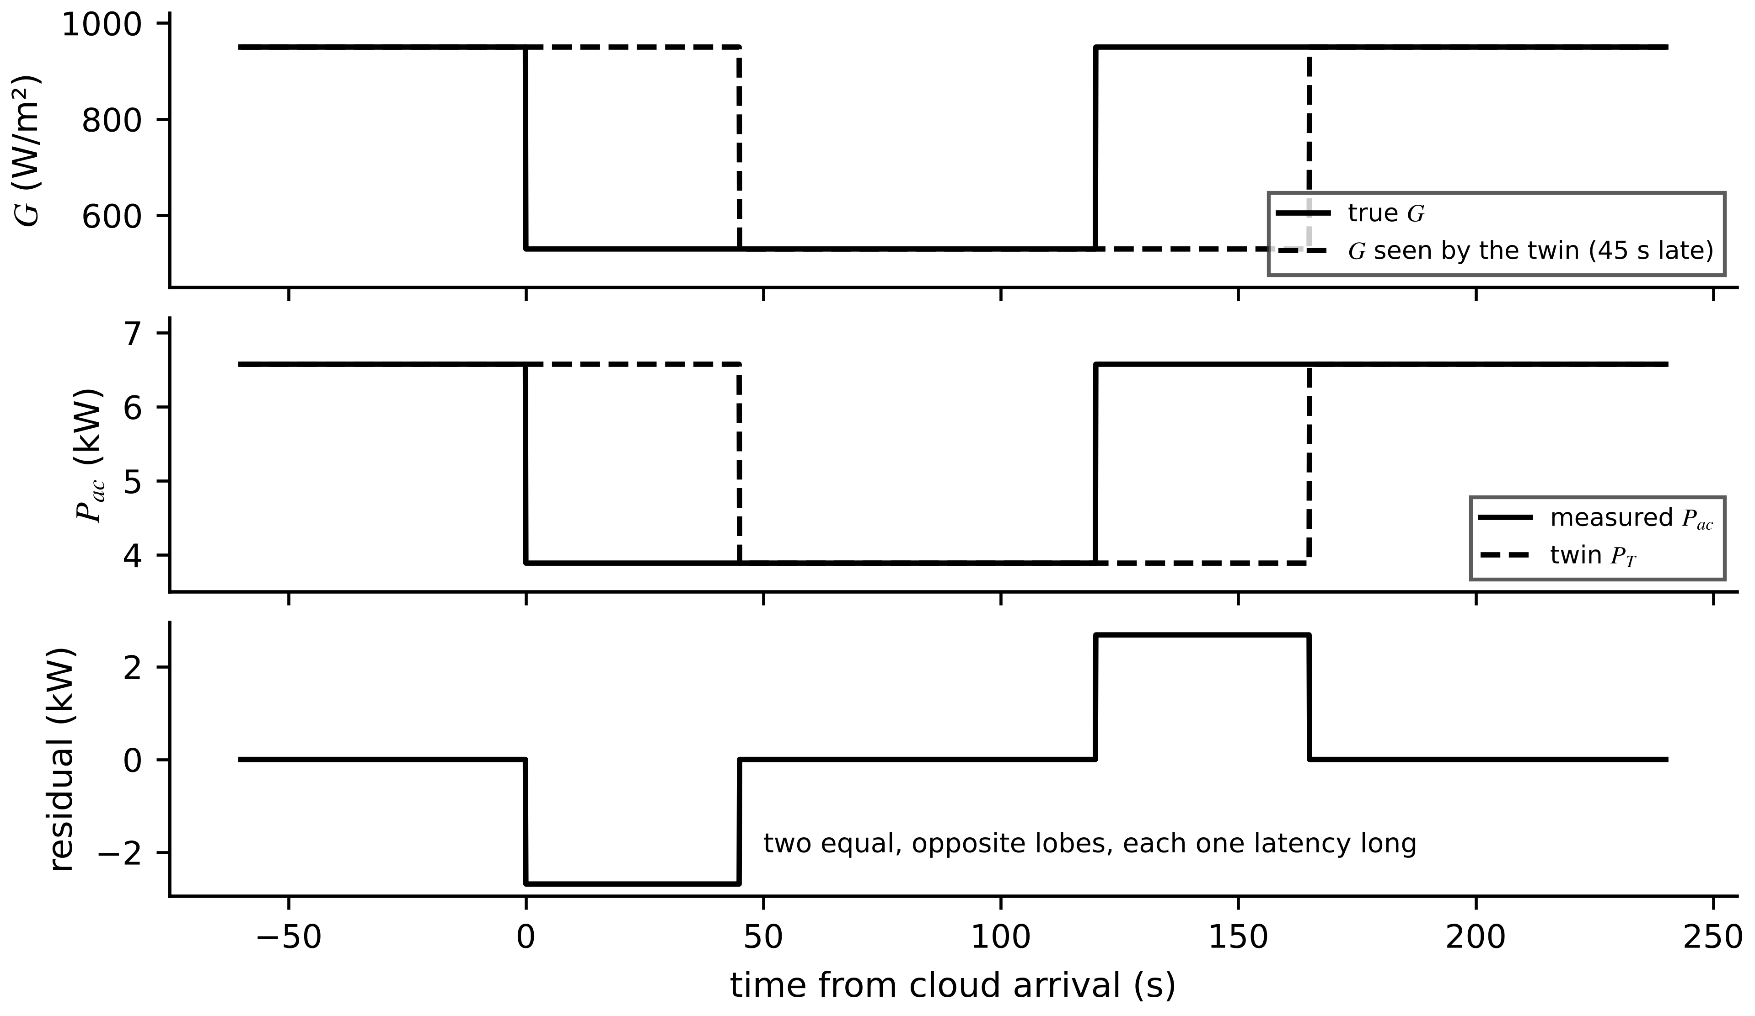
Figure 1.29. Example 1.21. True and delayed irradiance (top), measured and twin AC power (middle) and the residual (bottom): two equal and opposite lobes, each one latency long.

1.14.3 Battery storage: state-of-charge synchronization
Coulomb counting integrates measured current. With discharge current positive and SOC in percent,
${SOC}_{k+1}={SOC}_{k}-\frac{100 η_{c} I_{k} T_{s}}{3600 Q_{n}}$ (1.76)
where $Q_{n}$ is the capacity (Ah) and $η_{c}$ the coulombic efficiency (1 on discharge, slightly below 1 on charge). Any current error is integrated with the current. A constant offset $b$ (A) gives a drift growing linearly with time $t_{h}$ in hours, while zero-mean white noise of standard deviation $σ_{I}$ gives a random walk whose variance is the sum of $N=t/T_{s}$ independent terms:
$Δ{SOC}_{b}=\frac{100 b t_{h}}{Q_{n}}, σ_{SOC}(t)=\frac{100 σ_{I}\sqrt{T_{s} t}}{3600 Q_{n}}$ (1.77)
with $t$ in seconds in the second expression. Because (1.76) never corrects itself, the twin is resynchronized from the open-circuit voltage (OCV) after a rest. If the voltage has uncertainty $δV$ and the OCV curve has local slope $dV_{oc}/dSOC$, the resynchronization itself is uncertain by $ε_{OCV}≈δV/(dV_{oc}/dSOC)$. Requiring the error just before the next resynchronization to stay within a budget $ε_{max}$ gives the longest allowable interval:
$t_{max}=\frac{\left(ε_{max}-ε_{OCV}\right)Q_{n}}{100 |b|} (hours)$ (1.78)
This assumes known, constant capacity, neglects temperature effects on capacity and needs enough rest for the cell to relax; state-of-health estimation needs the models of Chapter 9 [54].
Example 1.22 (Level B) Sizing a resynchronization interval from a sensor specification
Given. $Q_{n}=60$ Ah; current-sensor offset $b=0.15$ A; noise $σ_{I}=0.05$ A at $T_{s}=1$ s; SOC budget 3 percentage points (pp); OCV resynchronization uncertainty 1 pp.
Find. (a) Offset drift over 8 h. (b) Random-walk contribution over 8 h. (c) The maximum resynchronization interval, and the interval if resynchronization were perfect. (d) $ε_{OCV}$ for a 2 mV voltage error on an NMC cell (about 7 mV per pp in mid range) and an LFP cell on its plateau (about 0.2 mV per pp).
Solution. (a) $100×0.15×8/60=2.0$ pp, a rate of 0.25 pp/h. (b) $100×0.05×\sqrt{1×28 800}/(3600×60)=0.0039$ pp; the offset dominates by about 500 times. (c) From (1.78): $(3-1)×60/(100×0.15)=8.0$ h; with perfect resynchronization, 12 h. (d) NMC: $2/7≈0.3$ pp. LFP: $2/0.2=10$ pp.
Interpretation. The interval follows from the sensor data sheet and the budget (Figure 1.30). On the flat plateau of an LFP cell, OCV cannot resynchronize SOC better than about 10 pp with a 2 mV measurement, so LFP systems resynchronize at the ends of the curve or rely on model-based estimators (Chapters 5 and 9). The slopes quoted are orders of magnitude; design must use the cell's own OCV table.
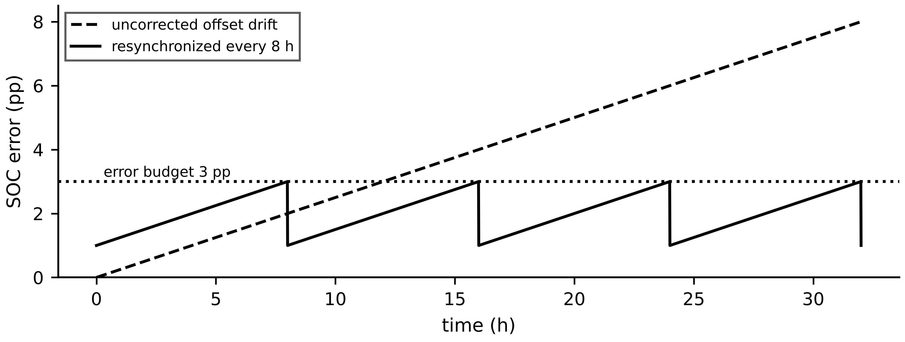
Figure 1.30. Example 1.22. Uncorrected offset drift against the sawtooth error of a twin resynchronized every 8 h, starting from the 1 pp OCV uncertainty.

1.14.4 Power converter: sampling, edge resolution and the real-time budget
A twin that must reproduce a pulse-width-modulated (PWM) leg voltage sample by sample faces two requirements. The Nyquist condition for the switching frequency is $f_{s}>2f_{sw}$, but the information in PWM lies in the timing of its edges. If edges are located only to the nearest sample, the duty-cycle resolution and the resulting error in the averaged leg voltage are
$ΔD=\frac{f_{sw}}{f_{s}}, Δ\overline{V}=V_{dc} ΔD$ (1.79)
An averaged model avoids edge sampling. Averaging the leg voltage over one period $T_{sw}=1/f_{sw}$, during which it equals $V_{dc}$ for $DT_{sw}$ and zero otherwise, gives $\overline{v}=DV_{dc}$, so the averaged twin represents the leg by $d_{k}V_{dc}$ with the duty command $d_{k}$ taken from the controller. What it omits is the ripple. For a buck-type leg with filter inductance $L_{f}$ and a nearly constant output $V_{o}=DV_{dc}$, the inductor current rises at $(V_{dc}-V_{o})/L_{f}$ for $DT_{sw}$, so
$Δi_{pp}=\frac{V_{dc} D(1-D)}{L_{f} f_{sw}}$ (1.80)
These assume ideal switches, constant $V_{dc}$ within a period and continuous conduction; losses and device stress are in Chapter 7 [58].
Example 1.23 (Level B) Can a 10 kHz platform host a switching-level twin of an 8 kHz converter?
Given. $f_{sw}=8$ kHz, $V_{dc}=700$ V, $L_{f}=1.5$ mH, $D=0.5$; the twin platform has a hard real-time step of 100 µs ($f_{s}=10$ kHz).
Find. (a) Whether the platform meets Nyquist. (b) The sampling rate for 1 % duty resolution and the resulting $Δ\overline{V}$. (c) What an averaged model at 10 kHz misses. (d) Why MAPE cannot be used on the leg voltage, and what metric to use.
Solution. (a) $2f_{sw}=16$ kHz > 10 kHz: no. The platform takes 1.25 samples per period and cannot locate edges (Figure 1.31, top). (b) From (1.79): $ΔD=0.01$ needs $f_{s}=100f_{sw}=800$ kHz, and $Δ\overline{V}=700×0.01=7$ V. (c) The ripple, (1.80): $700×0.25/(1.5×{10}^{-3}×8000)=14.6$ A peak to peak, and the ripple-dependent losses. (d) Measured from the negative rail the leg voltage is exactly zero for a fraction $1-D$ of every period, so the MAPE denominator vanishes on half the samples. Use RMSE, or NRMSE normalized by the rated voltage.
Interpretation. Meeting Nyquist is necessary but far from sufficient for switching-level fidelity: 1 % edge resolution at 8 kHz needs sub-microsecond steps, which is FPGA territory. On the 10 kHz platform the honest design is an averaged twin driven by the duty command, with the ripple added from (1.80). Claiming switching-level fidelity there would be false.
Figure 1.31. Example 1.23. An 8 kHz PWM leg voltage ($D=0.37$ drawn for clarity) sampled at 10 kHz (top) and 800 kHz (bottom). Only the second locates each edge to within 1 % of the period.
Table 1.16. Assumptions and validity limits of the four worked models
Domain | Core assumption | Breaks down when | Remedy (chapter)
Motor thermal | one lumped node, constant $R_{th}$ | hot spot needed; fan stopped; large gradients | distributed network; parameter tracking (4, 5)
PV power | steady state, NOCT or NMOT temperature model | partial shading; cell faults; fast transients | single-diode string model; thermal lag (8)
Battery SOC | Coulomb counting between OCV resyncs | long intervals with offset; flat OCV (LFP) | equivalent circuit with Kalman filter (5, 9)
Converter | averaged model at platform rate | switching-level phenomena; device stress | FPGA switching model; loss models (7)

1.14.5 A multi-channel, fleet-level example
When several channels must be ranked by one number, for instance twenty motors, a weighted index is used with the weights stated and justified:
$F_{vec}=\sum_{i=1}^{n}{w_{i}} {NRMSE}_{i}, \sum_{i=1}^{n}{w_{i}}=1, w_{i}≥0$ (1.81)
Because $F_{vec}$ is linear in the weights, the effect of changing them is exact: $ΔF_{vec}=\sum_{i}{Δ}w_{i} {NRMSE}_{i}$ with $\sum_{i}{Δ}w_{i}=0$.
Example 1.24 (Level B) Fleet triage with a weighted index and a weight-sensitivity check
Given. Seventeen motors show NRMSE below 8 % on all channels. M-07 shows thermal 22 %, vibration 11 %, current THD 7 %; M-12 shows 6 %, 16 % and 9 %. Proposed weights $w=(0.5,0.3,0.2)$ for (thermal, vibration, THD); flag threshold 10 %.
Find. (a) $F_{vec}$ for both motors. (b) The same with equal weights and with $w=(0.2,0.3,0.5)$. (c) The exact change for each motor when 0.3 of weight moves from thermal to THD. (d) What $F_{vec}$ cannot tell the engineer.
Solution. (a) M-07: $0.5×22+0.3×11+0.2×7=15.7$ %, flagged. M-12: $3.0+4.8+1.8=9.6$ %, not flagged. (b) Equal: M-07 13.3 %, M-12 10.3 %, both flagged. $(0.2,0.3,0.5)$: M-07 11.2 %, M-12 10.5 %, both flagged. (c) M-07: $0.3×(7-22)=-4.5$ points; M-12: $0.3×(9-6)=+0.9$ points. (d) Which channel drives the flag. Only the components show that M-07's problem is thermal and M-12's is vibration.
Interpretation. M-07 is flagged under every weighting; M-12's status flips (Figure 1.32). A 16 % vibration mismatch deserves a look whatever the index says, and that is exactly the information the composite suppresses. $F_{vec}$ decides where an engineer goes first. It is not a diagnosis, and a dashboard should show it only beside its components and the weight rationale.
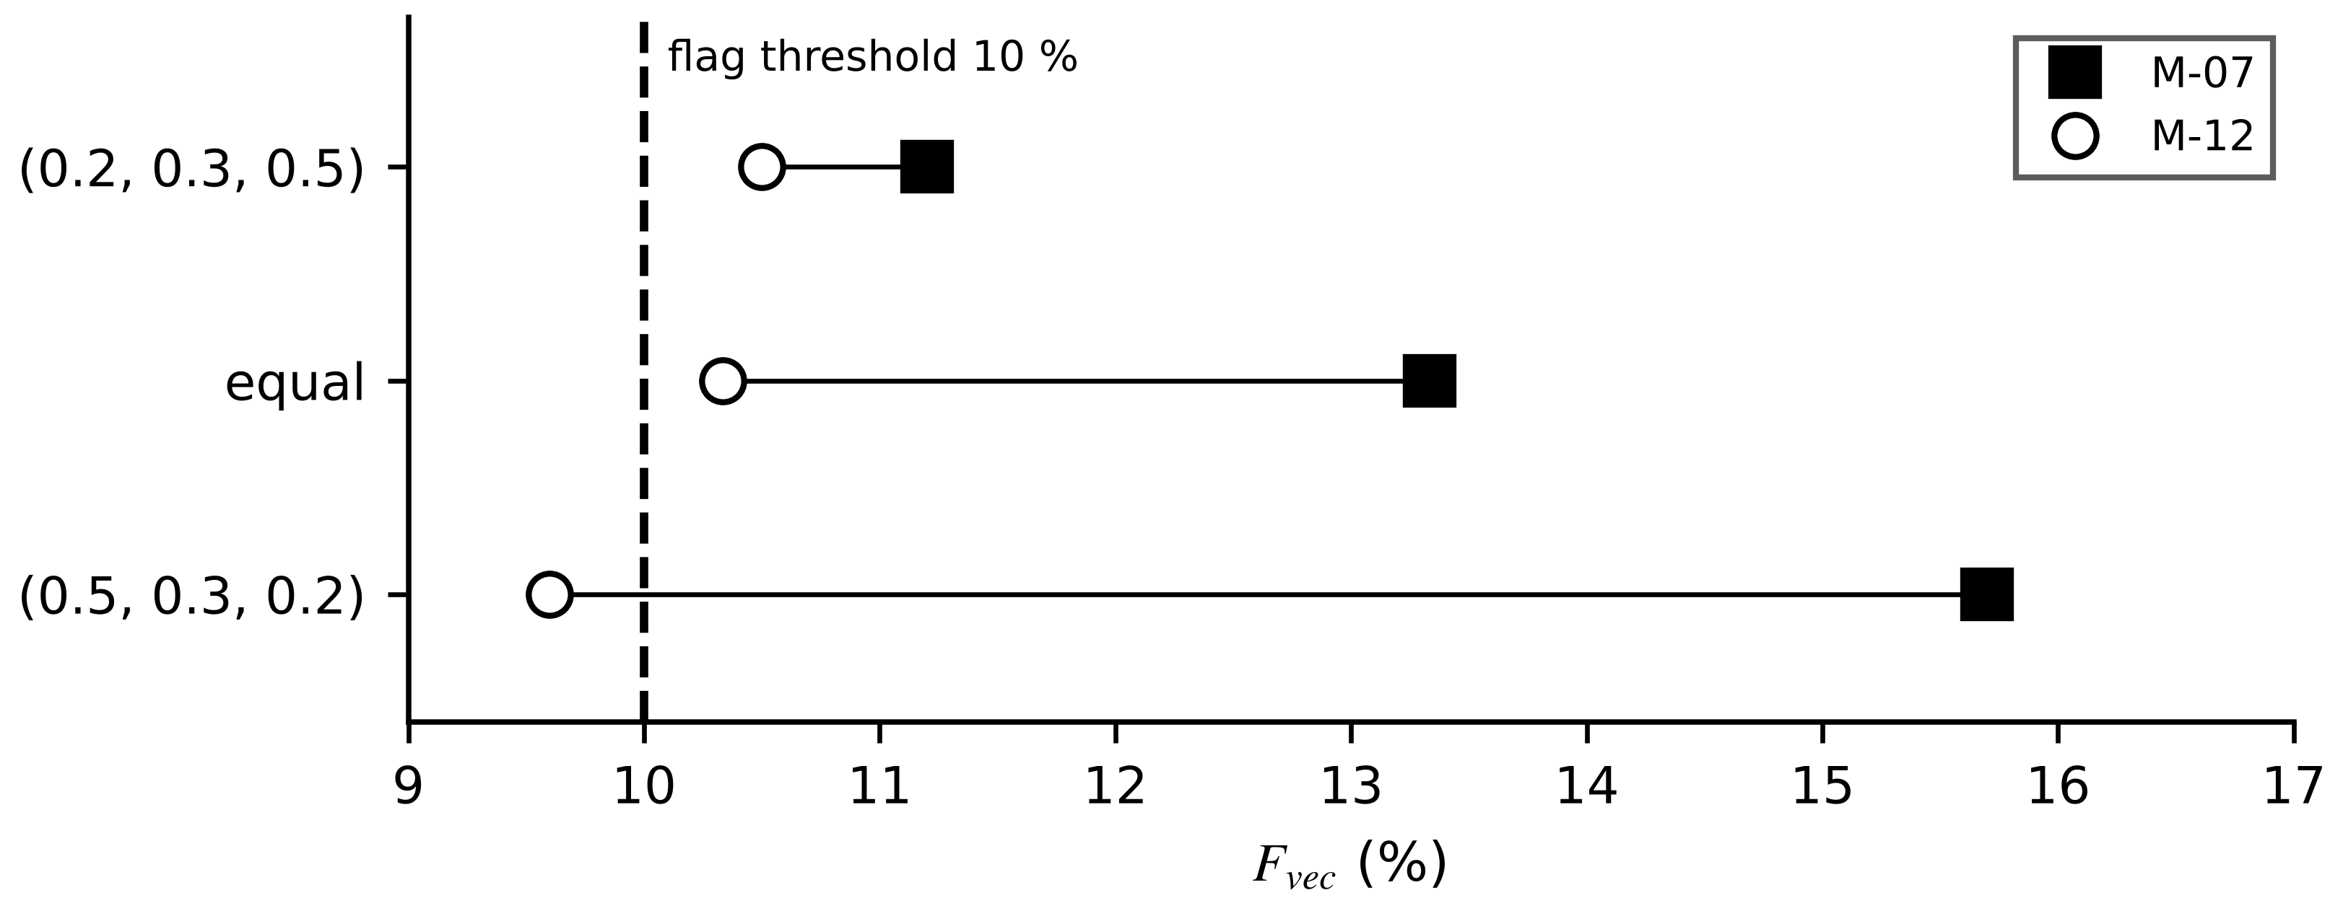
Figure 1.32. Example 1.24. $F_{vec}$ for two motors under three weightings. M-07 is flagged under all of them; M-12 changes status with the weights.

1.15 End-to-end case study: a six-stage thermal twin for motor M-07 (Level C)
This case runs the whole pipeline once, from timestamped raw readings to an operator decision, using the contract of Table 1.5. The data are synthetic: generated from the model of Section 1.5 with a known fault injected, so that the twin's estimates can be compared with a known truth. That is also why the case is reproducible; the generator is listed at the end. Nothing here should be read as a field measurement.

1.15.1 Setup, scenario and acceptance test
Parameters are those of Table 1.6. The RTD and CT are sampled by the edge DAQ; $P_{loss}$ comes from a loss map calibrated on the heat run, using $\overline{I^{2}}$ per interval. Every sample carries a UTC timestamp from a PTP-disciplined clock. At 08:00:00 the motor is in equilibrium at 350 W and 100 °C. The scripted scenario: at 08:05:00 debris partly blocks the fan inlet and the true $R_{th}$ rises from 0.20 to 0.25 K/W, unknown to anyone; at 08:20:00 production increases and the loss rises to 420 W. With the fault the new equilibrium is $30+0.25×420=135$ °C; without it, 114 °C. The advisory threshold on the forecast is 120 °C, leaving margin below the 155 °C Class F limit for the unmeasured hot spot. A thermal overload relay meeting IEC 60255-149 trips independently of the twin [59].
Before commissioning, the twin passed the acceptance workflow of Figure 1.33 on a held-out week (40 to 100 % load, 20 to 35 °C ambient): one-step RMSE below 1.0 K on the winding channel and no more than one false advisory per 1000 h of replayed normal data. ${\hat{R}}_{th}$ must stay within ±5 % of the heat-run value in normal operation; a larger deviation is itself an inspection trigger.
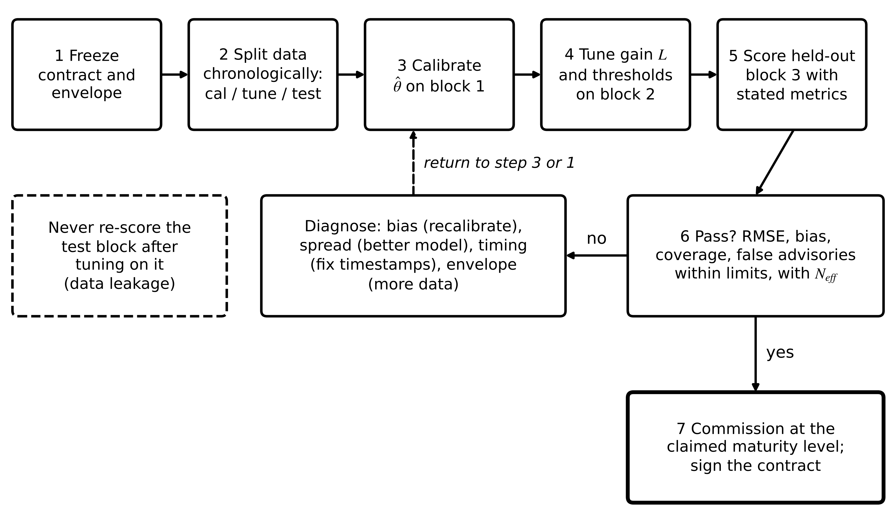
Figure 1.33. Acceptance-test workflow for a twin. The contract and envelope are frozen first; data are split chronologically; calibration, tuning and scoring each use their own block; failures are diagnosed by type before returning to calibration.

1.15.2 The six stages
Stage 1, acquire. RTD and CT are sampled; $I^{2}$ is averaged over each 30 s interval; values are range-checked (RTD 0 to 200 °C) and rate-checked (no more than 5 K in 30 s at these losses) and stamped. Stage 2, baseline model. The ZOH model (1.18) with the commissioning values ${\hat{R}}_{th}=0.20$ K/W and ${\hat{C}}_{th}=9000$ J/K predicts $T$ from $P_{loss}$ open loop. Stage 3, correction and detection. An observer (1.21) with $L=0.3$ corrects the state each sample. A detector watches the baseline residual $r_{b}=y-T_{baseline}$, not the corrected twin's innovation, which (1.33) shows would be largely hidden, and flags by the persistence rule
${flag}_{k}=∏_{j=k-n+1}^{k}1\left[\left|r_{b,j}\right|>h\right], h=2.0 K, n=4$ (1.82)
which equals 1 only when all of the last $n$ residuals exceed $h$. The threshold is about $6.7σ_{v}$, so by (1.64) a healthy sample exceeds it with probability $2.6×{10}^{-11}$, and the four-sample persistence rejects isolated spikes. Once flagged, ${\hat{R}}_{th}$ is re-estimated each sample by least squares over the last $W=40$ samples, with ${\hat{C}}_{th}$ held:
${\hat{R}}_{th,k}=arg\min_{R}\sum_{j=k-W}^{k-1}{{\left[y_{j+1}-a(R) y_{j}-\left(1-a(R)\right)\left(T_{amb}+R P_{loss,j}\right)\right]}^{2}}, a(R)=e^{-T_{s}/(R{\hat{C}}_{th})}$ (1.83)
a one-dimensional minimization solved by bounded scalar search over 0.15 to 0.35 K/W. Stage 4, forecast. From the corrected state, (1.45) with the current ${\hat{R}}_{th}$ and $P_{loss}$ gives the temperature 30 min ahead, assuming the present loss persists. Stage 5, decide. If the forecast exceeds 120 °C, an advisory is issued. Stage 6, act. The advisory goes to the shift supervisor with the evidence (residual trend, ${\hat{R}}_{th}$ history, forecast) and recommends reducing throughput and inspecting the fan inlet. No command is sent to the drive; this is a Level 3 twin.

1.15.3 Results
Table 1.17. Selected synthetic records for M-07 (RTD noise 0.3 K, readings rounded to 0.1 °C)
Time (UTC) | $P_{loss}$ (W) | RTD $y$ (°C) | Baseline twin (°C) | $r_{b}$ (K) | Corrected twin (°C) | ${\hat{R}}_{th}$ (K/W) | 30-min forecast (°C)
08:00:00 | 350 | 99.8 | 99.80 | 0.00 | 99.80 | 0.200 | 99.9
08:05:00 | 350 | 100.2 | 99.83 | 0.37 | 100.03 | 0.200 | 100.0
08:10:00 | 350 | 102.0 | 99.86 | 2.14 | 101.52 | 0.200 | 100.6
08:15:00 | 350 | 103.7 | 99.88 | 3.82 | 103.45 | 0.200 | 101.3
08:20:00 | 420 | 105.8 | 99.90 | 5.90 | 105.30 | 0.237 | 119.2
08:25:00 | 420 | 109.9 | 102.06 | 7.84 | 109.89 | 0.252 | 124.1
08:30:00 | 420 | 112.3 | 103.89 | 8.41 | 112.56 | 0.249 | 124.7
08:40:00 | 420 | 118.3 | 106.76 | 11.54 | 118.04 | 0.252 | 127.9
08:50:00 | 420 | 121.3 | 108.81 | 12.49 | 121.58 | 0.248 | 128.6
09:00:00 | 420 | 125.3 | 110.28 | 15.02 | 125.13 | 0.249 | 130.5

Figure 1.34. Case study, synthetic data. Top: RTD samples, baseline twin, corrected twin and its 30-min forecast, which crosses the 120 °C advisory threshold at 08:21. Middle: baseline residual with the persistence flag at 08:11:30. Bottom: estimated ${\hat{R}}_{th}$ converging to the injected 0.25 K/W.
Table 1.17 lists selected rows and Figure 1.34 shows all 121 samples. The sequence of events reads directly from the record. The baseline residual passes 2 K at 08:10 and satisfies the persistence rule at 08:11:30, 6.5 min after the fault; detection is limited by the thermal time constant, because the fault must heat the winding before any sensor can see it. The refit starts once 40 samples exist after the flag; ${\hat{R}}_{th}$ is 0.237 K/W at 08:20 (the window still holds pre-fault data) and settles at $0.249±0.002$ K/W after 08:30 against the injected 0.25. The forecast crosses 120 °C at 08:21, just after the load increase. The RTD first reads 120 °C at 08:44:30 and the true temperature crosses at 08:45:30, so the advisory arrives about 23.5 min ahead of the event it warns about. The baseline twin, still using 0.20 K/W, forecasts only 112.6 °C at 09:00 and would never have advised.
Figure 1.35 separates healthy from drifting behaviour. On a healthy run with the same noise, the baseline residual stays within about ±1 K. With the fan blocked it drifts steadily, while the corrected twin's innovation stays near the noise level (mean 0.04 K, standard deviation 0.36 K after 08:20). This is the masking effect of (1.33) seen in data: the corrected twin is the right tool for the state and the wrong tool for detection.
Figure 1.35. Residual evolution for a healthy asset and for the drifting asset of the case study. The baseline residual reveals the fault; the corrected twin's innovation stays near the noise and hides it.
Hand check of the 08:25 row with (1.45). ${\hat{R}}_{th}=0.252$ K/W and $P_{loss}=420$ W: $T_{∞}=30+0.252×420=135.84$ °C; $\hat{τ}=0.252×9000=2268$ s; $b=e^{-1800/2268}=e^{-0.7937}=0.4522$; forecast $=0.4522×109.89+0.5478×135.84=49.69+74.41=124.1$ °C, matching the table.
Forecast check against truth. Forecasts issued at 08:21, 08:25 and 08:30 predicted 120.2, 124.1 and 124.7 °C; the synthetic truth 30 min later was 122.2, 123.5 and 124.9 °C. The first forecast was 2.0 K low because ${\hat{R}}_{th}$ had not yet converged, a reminder that a forecast is only as good as the parameter behind it. After 08:30 the corrected twin's state error against the synthetic truth was 0.14 K RMS, well inside the RTD noise.
Operator action. Suppose the supervisor accepts the advisory and returns throughput to the 350 W level at 08:25. The winding then heads towards $30+0.25×350=117.5$ °C and stays below 120 °C, and the fan inlet is cleared at the next stop. No automatic shutdown was needed, and none would have been justified by (1.62).

1.15.4 Timing, failure behaviour and reproducibility
The stages run in sequence in each 30 s cycle, so their times add and the sum must leave margin inside the cycle:
$T_{cycle}=T_{acq}+T_{tr}+T_{obs}+T_{fc}+T_{adv}≤T_{s}$ (1.84)
with the terms for acquisition, transport, observer and refit, forecast, and advisory delivery. Table 1.18 gives design targets for an edge PC; a deployment must replace them with measured average and worst-case figures, and the worst case, not the mean, decides.
Table 1.18. Latency budget per 30 s cycle (illustrative design targets, edge PC)
Step | Average | Worst case allowed
Acquisition, $I^{2}$ averaging, range and rate checks | 0.5 s | 1.0 s
Transport to edge computer (industrial Ethernet) | 0.05 s | 0.2 s
Observer update and 40-sample least-squares refit | 0.02 s | 0.4 s
Forecast and alarm logic | < 0.01 s | 0.05 s
Advisory delivery to supervisor terminal | 1.0 s | 3.0 s
Total | about 1.6 s | < 5 s (deadline 30 s)

Missed deadlines and fallback. Figure 1.36 gives the failure logic as a state machine. If a cycle misses its deadline the twin holds its state, marks it stale and skips the forecast. After three consecutive misses, or if the RTD fails its range or rate check, the twin declares itself degraded and suppresses advisories that depend on it. When data return, it resynchronizes: it resets the state, refreshes the inputs (the lesson of Example 1.20) and returns to normal only after the residual has stayed within its band for 10 min. If the twin is unavailable for more than 15 min, the plant falls back to a fixed raw-RTD alarm plus the overload relay, and a person re-enables the twin. The fallback is documented and tested; a twin that can fail silently is worse than none.
Figure 1.36. Failure and fallback state machine of the M-07 twin. Transitions are triggered by deadlines, sensor checks and residual tests; the safe fallback state does not depend on the twin at all.
Reproducibility. The record can be regenerated with the following generator and twin loop (NumPy default_rng with seed 2026, Gaussian RTD noise 0.3 K, readings rounded to 0.1 °C).
Ts = 30 s; C = 9000 J/K; Tamb = 30 C; N = 121 samples from 08:00:00
rng = numpy.random.default_rng(2026)
R_true[k] = 0.20 K/W for t < 300 s, else 0.25 # fan inlet blocked 08:05
P[k] = 350 W for t < 1200 s, else 420 W # load step 08:20
a(R) = exp(-Ts/(R*C)); T[0] = 100 C
T[k+1] = a(R_true[k])*T[k] + (1 - a(R_true[k]))*(Tamb + R_true[k]*P[k])
y[k] = round(T[k] + rng.normal(0, 0.3), 1)
twin loop, k = 1..N-1 (T_hat[0] = Tb[0] = y[0], R_hat = 0.20):
predict Tm = a(R_hat)*T_hat[k-1] + (1 - a(R_hat))*(Tamb + R_hat*P[k-1])
correct T_hat = Tm + 0.3*(y[k] - Tm)
baseline Tb[k] = a(0.20)*Tb[k-1] + (1 - a(0.20))*(Tamb + 0.20*P[k-1])
flag latched when |y - Tb| > 2 K for 4 consecutive samples
refit if flagged and k >= 40: R_hat = argmin over [0.15, 0.35] of
sum_{j=k-40..k-1} (y[j+1] - a(R)*y[j] - (1 - a(R))*(Tamb + R*P[j]))^2
forecast b = exp(-1800/(R_hat*C)); T30 = b*T_hat + (1 - b)*(Tamb + R_hat*P[k])
advisory if T30 > 120 C

By the ladder of Section 1.9 this deployment is a Level 3 predictive twin: automated data into the model state, a written acceptance criterion, an automated diagnostic and forecasting service, and a human decision on every action. The industrial point is that the twin found a cooling fault that no fixed alarm would have caught for about another 23 minutes, with one RTD, one CT and a single differential equation.
What the digital twin adds
Synchronized: winding state every 30 s; ${\hat{R}}_{th}$ over 20-min windows.
Estimated or updated: the corrected state, the thermal resistance and the 30-min forecast.
Uncertainty carried: RTD noise, parameter convergence, forecast error checked against truth.
Decision enabled: a Level 3 advisory about 23.5 min before the threshold crossing.
Validated by: the acceptance workflow, the forecast check and a tested fallback.

1.16 Recent developments and open research problems (2024 to 2026)
Several capabilities are developing quickly. Each is given here with its status label, a constraint and, where one exists, a counterexample, so that a reader can tell evidence from promise.
Interoperable and standardized twins (established standards, emerging tooling). Information models such as the Asset Administration Shell [23], the IEC CIM [40] and IEC 61850 [41] let a twin publish parameters, states and services in vendor-neutral form. The standards base thickened markedly in 2025 and 2026 with ISO/IEC 30186 on maturity [24], ISO/IEC 30188 on reference architecture [25], IEEE 3835-2025 for integrated energy systems [27] and ITU-T Y.4517 for power-grid twins [28]. Constraint: a shared information model does not guarantee shared meaning; two vendors can fill the same field with different definitions of "rated temperature rise".
Maturity assessment and phased deployment (emerging). Utilities now ask for quantitative readiness assessments. The maturity and implementation index and phased roadmap of Satpathy and Ramachandaramurthy [39] and Pavleska's power-grid taxonomy with an open benchmarking tool [38] are recent examples. Counterexample: a weighted readiness score inherits every weakness of Example 1.24; it must be reported with its components and weight sensitivity.
Uncertainty-aware twins and online VVUQ (offline methods established, online research-stage). The National Academies place VVUQ at the centre of trustworthy twins and note that VVUQ performed while the twin operates is largely open [17]; probabilistic graphical models have been proposed as a scalable foundation for predictive twins that carry uncertainty from data to decision [60]. Constraint: calibrated uncertainty needs data from failure regimes, which electrical assets are designed to avoid.
Federated systems of twins (pilot stage). Instead of one monolithic grid model, federated architectures link local twins owned by different operators through standard interfaces, the design adopted by TwinEU [29] and analysed by Thwe et al. [43]; vision papers propose standard reference architectures for power-system twins [31], [61]. Counterexample: federation multiplies interfaces, and each new interface is a new attack surface and a new source of timestamp and unit errors [26].
Hybrid physics and data models (research-stage in the field, established in the laboratory). Physics-informed neural networks embed governing equations in a learned model so that sparse data are supplemented by physical structure [62]. Counterexample: when the embedded physics is wrong, as with the blocked fan of Section 1.15, the physics prior can slow detection of the very fault the twin exists to find. Chapter 6 treats these models.
Edge inference (deployed for simple models, research for heavy learned models). Running the twin next to the asset cuts latency and survives network outages, as in Section 1.15. Constraint: updates, security patches and version control across thousands of edge devices form a lifecycle problem that is easy to underestimate.
Agentic and language-model-assisted twins (research-stage). Since 2025 several groups have placed large language models and foundation models on top of twins: Zhou et al. describe a four-stage pipeline in which language models and agents provide the "autonomous management" stage [63], and Grid-Mind uses a language-model agent to orchestrate multi-fidelity power-system studies, reporting 84 % tool-selection accuracy on IEEE 118-bus scenarios [64]. Constraint: an agent that selects the wrong tool one time in six must stay at Layer 2 of Figure 1.5, with every number traced to a simulation result, and must never hold the authority of Layer 3.
Table 1.19. Emerging directions: status, open problem and a measurable research target
Direction | Status | Open problem | Measurable target for a research contribution
Interoperable twins | standards published; tooling maturing | semantic consistency across vendors | share of parameters exchanged without manual mapping between two vendor twins
Maturity assessment | emerging | scores that hide weak dimensions | rank stability of assets under weight perturbation
Uncertainty-aware twins | offline mature; online research | calibrated intervals from sparse fault data | coverage within ±2 % of nominal on held-out fault data
Federated grid twins | pilots (TwinEU) | consistency and latency across owners | cross-twin state mismatch and $Δt_{sync}$ at interfaces
Hybrid physics and data | research; limited field use | detecting faults that violate embedded physics | detection delay for injected parameter faults against a pure-physics baseline
Edge inference | deployed for simple models | secure lifecycle of many edge twins | worst-case execution time and patch latency across a fleet
Agentic twins | research | grounding and authority limits | share of agent outputs traceable to a verified tool result

For postgraduate readers, each row of Table 1.19 marks a thesis-sized problem with a measurable outcome. The case study of Section 1.15 already contains small versions of three of them: a parameter fault that violates the commissioned physics, a forecast whose uncertainty was not quantified online, and an edge implementation whose worst-case timing must be proven rather than assumed.

1.17 How this chapter feeds the rest of the book
The contract of Section 1.4 is the thread through the book. Figure 1.37 shows which clauses each chapter develops and Table 1.20 lists the outputs that pass forward. Chapter 2 starts from here with the 22-asset architecture of Plant P-1, placing the twenty motor instances, the PV array and the BESS into a layered architecture and standards framework.
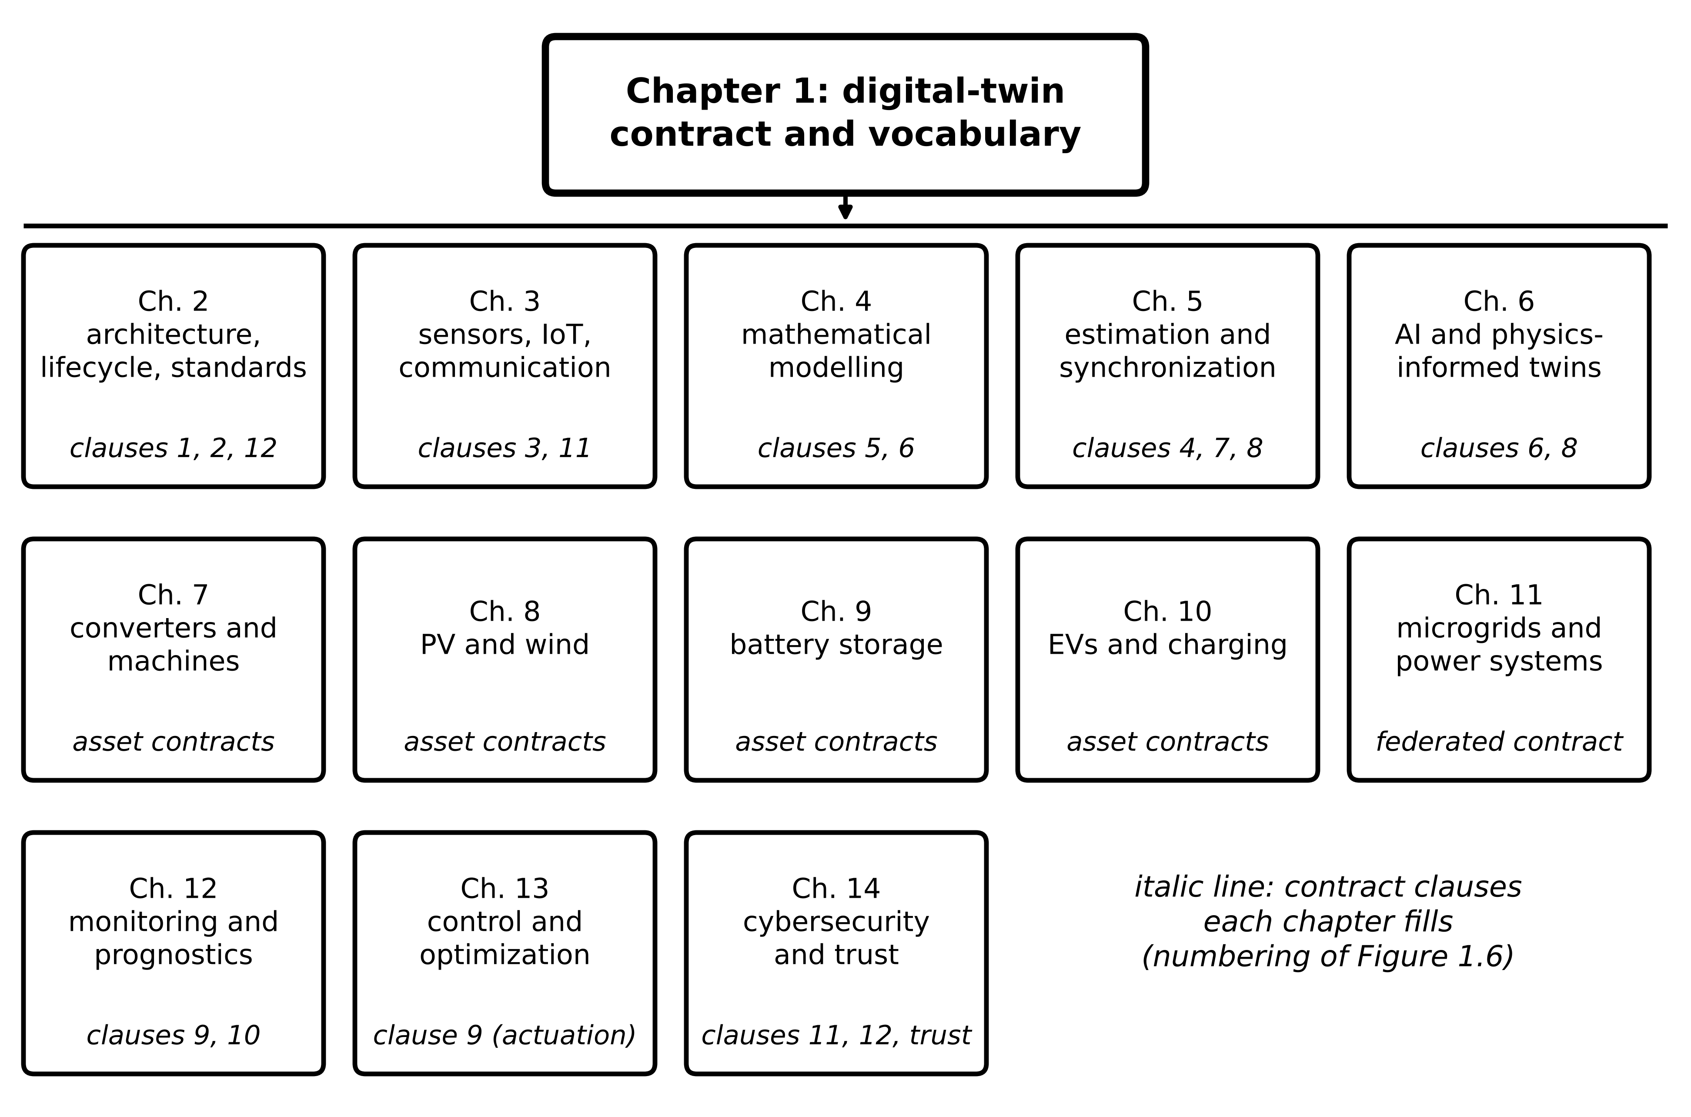
Figure 1.37. Book roadmap. Each chapter fills particular clauses of the digital-twin contract (numbered as in Figure 1.6); asset chapters 7 to 10 write complete contracts for one asset class; Chapter 11 federates them.
Table 1.20. Outputs of Chapter 1 and where they are developed
Output of Chapter 1 | Developed in
Contract clauses 1, 2, 12 (entity, purpose, fallback) and lifecycle | Chapter 2 (architecture, lifecycle, standards)
Measured variables, timestamps, latency (clauses 3, 11) | Chapter 3 (sensors, IoT, communication)
Model structure, discretization, parameters (clauses 5, 6) | Chapter 4 (mathematical modelling)
Hidden states, synchronization rule, uncertainty (clauses 4, 7, 8) | Chapter 5 (estimation and synchronization)
Data-driven and hybrid models; fidelity choice | Chapter 6 (AI and physics-informed twins)
Complete asset contracts for motor, PV, wind, BESS, EV | Chapters 7 to 10
Federated contract for a system of systems | Chapter 11 (microgrids and power systems)
Residual-based detection and prognosis (clauses 9, 10) | Chapter 12 (monitoring and prognostics)
Authorized actuation (Layer 3) and its envelope | Chapter 13 (control and optimization)
Trust in every clause; attack on synchronization | Chapter 14 (cybersecurity and trust)

Chapter summary
A digital twin, as used in this book, is a representation of a specific asset whose state is updated from measurements without manual steps, whose agreement with the asset is checked against a written, use-specific criterion, and whose outputs reach a defined decision path. Other definitions differ and the chapter set them side by side rather than declaring one universal. The history showed that power engineering has kept network models synchronized with telemetry since the 1970s, through state estimation and later through synchrophasors and real-time simulation; what this book adds is the written acceptance criterion and the explicit account of uncertainty. Kritzinger et al.'s test of which flows are automated separates models, shadows and twins, and three layers of autonomy separate automated synchronization, automated recommendation and authorized actuation. Actuation is a design choice justified by cost, not part of the definition.
The chapter introduced the twelve-clause digital-twin contract as the common language of the book and filled it for motor M-07 of Plant P-1 and, in outline, for a PV array, a BESS and a converter. The first physical twin, a one-node winding model, was derived from conservation of energy, written in state-space form, discretized exactly, and used for a hand-calculated prediction and correction. Synchronization was quantified through innovations, residuals, the observer gain trade-off (1.31), the masking of parameter faults (1.33), multi-rate layering and the age of information (1.37).
Uncertainty was treated from the start: five sources, first-order propagation (1.40), the measurement floor (1.43) and an acceptance band (1.44). Fidelity was split into six purpose-dependent types, and the point metrics were given with their denominators. A 28 % parameter error passed a 10 % NRMSE test on a short window, one glitch quadrupled RMSE, and a smooth residual of 61 samples was worth about one independent sample. The maturity ladder assigns a level by four questions, and an expected-cost inequality, not ambition, fixes the right level. Lifecycle twins, fleet hierarchies and edge or cloud placement completed the engineering picture. Worked examples in four domains produced residuals with recognizable signatures: parameter bias, stale inputs, sensor latency, integrated offset and platform timing limits. The case study joined everything into a six-stage Level 3 twin that caught a cooling fault about 23.5 minutes before a threshold crossing, with an acceptance test, latency budget and tested fallback.
Table 1.21. Key relationships of Chapter 1
Relationship | Expression | Eq.
Digital-twin contract | $𝒞=(E,Π,y,x,θ,ℳ,S,U,D,V,Λ,F)$ | (1.3)
Winding energy balance | $C_{th}\dot{T}=P_{loss}-(T-T_{amb})/R_{th}$ | (1.11)
Exact sampled thermal model | $T_{k+1}=aT_{k}+(1-a)(T_{amb}+R_{th}P_{loss,k})$, $a=e^{-T_{s}/τ}$ | (1.18)
Euler pole error | $a_{E}-a≈-1/2(T_{s}/τ)^{2}$ | (1.20)
Innovation, residual, state error | $ν_{k}$, $r_{k}=y_{k}-y_{T,k}$, $e_{k}=x-x_{T}$ | (1.26)
Observer error variance | $σ_{e}^{2}=L^{2}σ_{v}^{2}/[1-(1-L)^{2}a^{2}]$ | (1.31)
Masking of a parameter error | $r_{ss}=(1-a)ΔR P/[1-(1-L)a]$ | (1.33)
Age of information | $\overline{Δ}=d+T_{s}/2$, $Δ_{peak}=d+T_{s}$ | (1.37)
Uncertainty propagation | $u_{c}^{2}=\sum_{i}{(}∂f/∂z_{i})^{2}u^{2}(z_{i})$ | (1.40)
Acceptance band | $|\overline{r}|≤k\sqrt{u_{meas}^{2}+u_{model}^{2}}$ | (1.44)
Decision fidelity | $F_{D}=1-Pr(d_{T}≠d^{*})$ | (1.47)
RMSE split; $R^{2}$ from RMSE | ${RMSE}^{2}={\overline{e}}^{2}+s_{e}^{2}$; $R^{2}=1-(RMSE/σ_{y})^{2}$ | (1.54), (1.56)
Effective sample size | $N_{eff}≈N(1-ρ_{1})/(1+ρ_{1})$ | (1.60)
Automation criterion | $p_{late}C_{late}>p_{FA}C_{FA}$ | (1.62)
Detection probabilities | $p_{FA}=2Q(h/σ_{r})$; $p_{D,n}=p_{D}^{n}$ | (1.64), (1.65)
Population shrinkage | ${\tilde{θ}}_{j}=(σ_{pop}^{2}{\hat{θ}}_{j}+σ_{j}^{2}μ_{pop})/(σ_{pop}^{2}+σ_{j}^{2})$ | (1.69)
Placement test | $T_{ℓ}≤T_{deadline}$, $ρ_{ℓ}<1$ | (1.70), (1.71)
SOC resync interval | $t_{max}=(ε_{max}-ε_{OCV})Q_{n}/(100|b|)$ | (1.78)

Exercises
Fifteen exercises follow. Exercises 1.1 to 1.3 test concepts, 1.4 to 1.7 ask for derivations, 1.8 to 1.14 are numerical design problems and 1.15 is a research-level project. Most exercises contain linked parts that build on one another. Complete solutions to all fifteen are given in the answer key.

Group A: concepts
1.1 Classification and maturity. (a) A wind turbine's SCADA system logs 10-min averages automatically. Once a month an engineer exports the data, runs a fatigue model and schedules inspections. Classify the deployment with Table 1.4 and with the four questions of Section 1.9, identify the first "no", and list the smallest set of changes that reaches Level 2. (b) A substation mimic refreshes from telemetry every 4 s and is watched by an operator, but issues nothing. Which conditions of Box 1.1 does it meet and which does it fail, and why is the resulting label not a criticism of the mimic? (c) A vendor claims "Level 4 maturity" for a transformer-fleet twin. State the four questions you would ask and the evidence that would make you accept the claim.
1.2 Writing a contract. Write the twelve-clause digital-twin contract for a distribution-transformer top-oil twin that warns 60 min before the top-oil temperature would exceed its loading limit. For each clause, name the record that serves as evidence, and mark the clauses that need measurements not normally available on a distribution transformer.
1.3 Synchronization, detection and autonomy. (a) Define the innovation, the residual and the state synchronization error, and say which of them can be computed from field data alone. (b) Using (1.31) and (1.33), explain why a larger observer gain improves the state estimate but weakens fault detection, and describe the two-twin arrangement that Section 1.15 uses to obtain both. (c) A language-model agent drafts maintenance advisories from the M-07 twin and selects the correct analysis tool in 84 % of test cases. At which autonomy layer of Figure 1.5 may it operate, and what measurable evidence would be needed before it could send advisories without human review?

Group B: derivations
1.4 Thermal model and discretization. (a) Starting from conservation of energy, derive (1.11) and its step response (1.14). State every assumption and give two situations in which the one-node model fails. (b) A small induction motor has $R_{th}=1.85$ K/W and $C_{th}=760$ J/K. Find its thermal time constant and the time to reach 90 % of its steady-state temperature rise. (c) For a thermal twin with $τ=600$ s, find the largest $T_{s}$ for which the forward-Euler pole differs from the exact pole by less than ${10}^{−3}$, verify the result with the exact poles, and find the update periods beyond which the Euler model oscillates and becomes unstable.
1.5 Age of information. (a) For periodic sampling with period $T_{s}$ and constant end-to-end delay $d$, derive the mean and peak age of information (1.37). (b) Show that if the delay is random with mean $\overline{d}$ and independent of the sampling, the mean age becomes $\overline{d}+T_{s}/2$. (c) An M-07-type twin updates every 10 s with $d=1.2$ s at the edge; in the cloud a further 0.08 s of transit and a 2.5 s queue are added. Find the mean and peak age for both placements and the largest staleness error (1.38) for a winding that heats at 0.044 K/s.
1.6 A sensor fault seen through an observer. M-07's RTD develops a lead-resistance fault that adds a constant +3.0 K to every reading. The motor is in thermal equilibrium and the twin uses $L=0.3$ with $a=0.98347$. (a) Find the innovation on the first sample after the fault. (b) Derive and evaluate the steady-state offset absorbed into the twin state and the steady-state innovation. (c) Would the persistence rule (1.82), applied to the corrected twin's innovation with $h=2$ K and $n=4$, detect the fault? (d) Propose a check that would detect it and explain why it works.
1.7 Uncertainty propagation. (a) Derive (1.41) from the law of propagation (1.40). (b) Evaluate $T_{∞}$, its combined standard uncertainty and the expanded uncertainty ($k=2$) for $T_{amb}=35$ °C with $u=1$ K, $R_{th}=0.25$ K/W with $u=0.02$ K/W and $P_{loss}=350$ W with $u=10$ W. (c) Assuming a normal error, find the probability that the true steady-state temperature exceeds 130 °C. (d) Which input should be measured better first, and why?

Group C: numerical design
1.8 Steady state, bias and the fleet. (a) A twin of M-07 uses an estimate ${\hat{R}}_{th}$ that is 15 % low. Find the steady-state bias at $P_{loss}=400$ W and state whether the twin is optimistic or pessimistic about insulation stress. (b) Find the largest continuous $P_{loss}$ that keeps the lumped winding at or below 130 °C for ambient temperatures of 30 °C and 45 °C. (c) A newly installed motor gives ${\hat{R}}_{th}=0.26$ K/W with standard uncertainty 0.03 K/W; the fleet has $μ_{pop}=0.20$ K/W and $σ_{pop}=0.01$ K/W. State the check that must precede shrinkage, then combine the estimates with (1.69).
1.9 Error metrics. (a) A current channel gives $y=\left[10.0, 12.0, 14.0, 16.0, 18.0\right]$ A and $y_{T}=\left[10.2, 11.7, 14.3, 15.8, 18.1\right]$ A. Compute MAE, RMSE and $R^{2}$. Replace the last measurement by a glitch of 21.0 A, recompute, and give the factor by which MAE and RMSE grow. (b) A state-of-health channel reads $y=\left[0.90, 0.85, 0.80, 0.75\right]$ and the twin reads $y_{T}=y−0.05$ everywhere. Compute $r^{2}$ and $R^{2}$ and explain the difference. (c) Derive (1.56). A twin shows RMSE 1.2 K on a channel with $σ_{y}=4.0$ K; find $R^{2}$, and find it again for the same twin on a steadier channel with $σ_{y}=1.5$ K.
1.10 PV array twin. A PV array has $η=0.21$, $A=36.0$ m², NOCT $=44$ °C, $γ=−0.0038$ /°C and $η_{inv}=0.97$. (a) Find $T_{c}$, $P_{dc}$ and $P_{ac}$ at $G=800$ W/m² and $T_{amb}=22$ °C. (b) Find the irradiance at which $P_{dc}$ first reaches 5.0 kW at the same ambient temperature, noting that the equation is quadratic in $G$. (c) The power of another array falls by 2685 W along a 4 s linear cloud-edge ramp, and its irradiance logger's clock is 1.5 s behind the inverter's. Estimate the residual caused by the clock skew alone, and say how a twin should be protected against raising a fault flag on it.
1.11 Battery state-of-charge synchronization. A 100 Ah battery has a current sensor with an offset of 0.08 A and white noise of 0.05 A at 1 s sampling. (a) Find the SOC drift caused by the offset over 10 h and the random-walk contribution over the same time. (b) Find the longest resynchronization interval for a 3 pp budget with perfect resynchronization and with a 1 pp OCV uncertainty. (c) An LFP version of the battery resynchronizes from OCV at 50 % SOC, where the slope is about 0.2 mV per pp and the voltage uncertainty is ±2 mV. Find the resynchronization uncertainty and propose two alternative strategies.
1.12 Converter twin and the real-time platform. A converter leg switches at 20 kHz with $V_{dc}=800$ V, $L_{f}=1.0$ mH and $D=0.4$. (a) Find the Nyquist minimum sampling rate and state whether a 30 kHz platform meets it. (b) Find the sampling rate needed for 0.5 % duty-cycle resolution and the corresponding error in the averaged leg voltage. (c) Find the inductor ripple that an averaged model omits. (d) Recommend a twin structure for a platform with a 20 µs hard real-time step, and justify it.
1.13 Designing the synchronization gain. (a) For the M-07 twin ($a=0.98347$, $σ_{v}=0.3$ K, $T_{s}=30$ s, no disturbance) find the gain that gives a steady-state error standard deviation of 0.10 K, and the corresponding error time constant. (b) A scalar thermal twin has $a=0.98$, $σ_{v}=0.5$ K, $q=0.01$ K² per step and $T_{s}=30$ s. Iterate (1.32) to steady state and report $P^{−}$, $L^{*}$, the posterior standard deviation and the error time constant. (c) For M-07 at 400 W, the twin's thermal resistance is 0.03 K/W too low and $L=0.5$. Find the steady-state innovation, the steady-state state error and the fraction of the open-loop evidence that the observer hides.
1.14 Detection and validation statistics. (a) A healthy residual has $σ_{r}=0.3$ K. With $h=1.2$ K, find $p_{FA}$, the detection probability for a fault that shifts the residual by 1.0 K, and both probabilities for a three-sample persistence rule. Comment on the result. (b) A twin reports 90 % prediction intervals, and 431 of 500 held-out samples fall inside. Compute the coverage, compare it with the expected count, and decide at the 1 % level whether the intervals are overconfident. (c) A test set has 120 residual samples with lag-one autocorrelation 0.8 and RMSE 1.0 K. Estimate $N_{eff}$ and compare the 95 % interval (1.59) for the true error level computed with $N=120$ and with $N_{eff}$.

Group D: research project
1.15 Research project: the M-07 twin end to end. Implement the generator and twin loop listed in Section 1.15. (a) Reproduce the key events of Table 1.17 and Figure 1.34: the flag time, the advisory time, the converged ${\hat{R}}_{th}$ and the RMS state error after 08:30. (b) Extend the record to 181 samples. Attach a $±2u_{c}$ band to every 30-min forecast, computing $u_{c}$ with (1.40) and the budget of Example 1.11, and test the coverage of the forecasts issued from 08:30 to 09:00 against the synthetic truth 30 min later over seeds 1 to 100. Repeat with a budget built from the twin's own evidence ($u\left({\hat{R}}_{th}\right)$ from the spread of the refit, $u\left(\hat{T}\right)$ equal to the observer's state error, and no input uncertainty, since the synthetic loss is exact). Interpret both results. (c) Using (1.73) and Example 1.20, state the residual signature that distinguishes a stale input from a model error after resynchronization, and specify the test that the RESYNC state of Figure 1.36 should apply. (d) The hot spot is not measured in service. Propose a validation plan that would give a defensible acceptance criterion for a hot-spot extension of the twin, and state one measurable research target.

Answer key
1.1 (a) Model state updated automatically? No: the fatigue model runs only when the engineer exports the data, so $a_{PV}=0$ and Q1 of Section 1.9 is the first "no". The deployment is Level 0, a digital model fed by automated data storage. The smallest change to Level 2 has two parts: run the fatigue model automatically on each new 10-min block, so that its state is updated without manual action (Q1), and write an acceptance criterion that compares predicted and measured load channels (for example blade-root bending moment from strain gauges) on held-out data over a stated envelope (Q2).
(b) The mimic meets condition (i) of Box 1.1 if it updates a model state automatically; a pure display of telemetry does not even do that, and a mimic with a topology processor and state estimator does. It fails condition (iii) because nothing it produces reaches a decision path automatically, and usually condition (ii) because no written acceptance criterion exists. It is therefore a digital shadow. The label is not a criticism: a shadow is the correct tool for situational awareness, and the evidence required to trust a display is much less than the evidence required to trust a system that issues advisories or commands.
(c) Q1: does measured data update the model state without manual action? Q2: is synchronization checked against a written criterion (metric, window, threshold, envelope)? Q3: does an automated predictive or diagnostic service run on the synchronized state? Q4: may the twin change the asset without a human decision, and only inside an authorized envelope? Acceptable evidence for Level 4 would be data-flow documentation and a site check for Q1; a held-out validation report with $N_{eff}$ and the envelope for Q2; service logs with measured $p_{FA}$ and $p_{D}$ for Q3; and, for Q4, the written envelope (magnitude, rate, duration, timeout), interlock and protection override, test records of the envelope, and a cost comparison of the form (1.62) showing that automatic action is cheaper in expectation than human delay. A score without these records should be reported as unverified.
1.2 A model contract (other good answers are possible): (1) Entity: transformer by serial number and location; evidence: asset register and nameplate. (2) Purpose: warn 60 min before top-oil temperature exceeds the loading limit; evidence: signed requirement. (3) Measured: top-oil temperature, load current, ambient temperature, with rates and accuracies; evidence: calibration certificates and data-acquisition configuration. (4) Hidden: winding hot spot, stated as out of scope or estimated with a stated uncertainty; evidence: scope statement. (5) Parameters: top-oil rise at rated load, oil time constant, loss ratio and oil exponent, marked fixed or tracked; evidence: factory heat-run report and refit log. (6) Model: loading-guide thermal differential equations with validity range; evidence: model version and validation report. (7) Synchronization: observer gain, update period and resynchronization trigger; evidence: configuration file and outage log. (8) Uncertainty: sensor, parameter and load-forecast contributions; evidence: uncertainty budget. (9) Decision: advisory to the control-room operator (Layer 2); evidence: response procedure and advisory log. (10) Validation: for example, 60-min forecast RMSE below 2 K over a held-out summer month including overload days, and at most one false advisory per 1000 h; evidence: held-out test report. (11) Latency: end-to-end deadline and worst case; evidence: timing measurements. (12) Fallback: loading-guide alarm on measured top-oil temperature and the existing protection; evidence: fallback test record.
Clauses that normally need additional instrumentation are clause 3 for ambient temperature at the transformer (often taken from a distant weather station) and top-oil temperature on small distribution units, and clause 4 if the hot spot is to be estimated, because validating it requires fibre-optic hot-spot sensors on at least one reference unit or a factory heat run with such sensors.
1.3 (a) The innovation $ν_{k}=y_{k}−h\left(x_{T,k}^{−}\right)$ compares a new measurement with the twin's prediction before that measurement is used. The residual $r_{k}=y_{k}−y_{T,k}$ compares a measurement with a twin output that did not use it, for example an open-loop baseline or an earlier forecast. The state synchronization error $e_{k}=x\left(t_{k}\right)−x_{T}\left(t_{k}\right)$ compares full states. The innovation and the residual can be computed from field data; the state error needs the true state, which is available only in simulation, on a test bench with extra sensors, or when the whole state happens to be measured.
(b) By (1.31), the noise passed into the state is $L^{2}σ_{v}^{2}/\left[1−{\left(1−L\right)}^{2}a^{2}\right]$, and the error pole $\left(1−L\right)a$ moves towards zero as $L$ grows, so a larger gain corrects a wrong state quickly. By (1.33), the steady-state innovation caused by a parameter error is $\left(1−a\right)ΔR P_{loss}/\left[1−\left(1−L\right)a\right]$, which shrinks as $L$ grows because the observer keeps pulling the state onto the measurement and so explains away the fault. Section 1.15 therefore runs two twins: a corrected twin ($L=0.3$) that provides the state and the forecast, and an uncorrected baseline twin with the commissioned parameters whose residual is used for detection.
(c) Layer 2 only: the agent drafts, and a person decides and sends. To move beyond review would need, at minimum, a held-out test month in which every number in each draft is traced to a logged twin output (for example 99 % of statements grounded and no unsupported recommendation), measured false-advisory and missed-advisory rates, and a cost comparison of the form (1.62) using those measured rates. An 84 % tool-selection rate means roughly one wrong tool in six; that is far from the error rates needed even for unattended advisories, and the agent should never hold Layer 3 authority.
1.4 (a) Lumping the winding into one body of heat capacity $C_{th}=∑m_{i}c_{p,i}$ at uniform temperature $T$, its stored energy relative to ambient is $E=C_{th}\left(T−T_{amb}\right)$. Conservation of energy gives $dE/dt=P_{loss}−q$. The heat path is a series of conduction and convection resistances, $R_{th}=R_{ins}+R_{frame}+R_{conv}$, so $q=\left(T−T_{amb}\right)/R_{th}$. With $C_{th}$ constant and $T_{amb}$ slowly varying, $C_{th} dT/dt=P_{loss}−\left(T−T_{amb}\right)/R_{th}$, which is (1.11). For constant $P_{loss}$ and $T_{amb}$ the homogeneous solution decays as $e^{−t/τ}$ with $τ=R_{th}C_{th}$, and the particular solution is $T_{∞}=T_{amb}+R_{th}P_{loss}$, obtained by setting $dT/dt=0$; matching $T\left(0\right)=T_{0}$ gives (1.14). Assumptions: uniform winding temperature, constant heat capacity, linear heat transfer with constant $R_{th}$, ambient slowly varying, loss independent of temperature. The model fails when internal gradients are large (the hot spot lies well above the RTD), when the fan stops or the cooling changes (so $R_{th}$ changes several-fold), and when the copper resistance rises appreciably with temperature so that the loss depends on $T$.
(b) $τ=1.85×760=1406$ s (23.4 min). From (1.15), $t_{90}=τln10=1406×2.3026=3237$ s (54.0 min).
(c) From $\frac{1}{2}{\left(T_{s}/τ\right)}^{2}≤{10}^{−3}$, $T_{s}≤600\sqrt{2×{10}^{−3}}=26.8$ s. Check: $a=e^{−26.8/600}=0.95626$ and $a_{E}=1−26.8/600=0.95528$, a difference of $0.00099$, just inside the tolerance (the third-order term reduces it slightly). The Euler pole $1−T_{s}/τ$ becomes negative, so the model oscillates, for $T_{s}>τ=600$ s, and its magnitude exceeds one, so the model is unstable, for $T_{s}>2τ=1200$ s.
1.5 (a) With an update arriving at $t=d$, the newest information was generated at $t=0$, so the age is $d$. It then grows with slope one until the next update arrives at $T_{s}+d$, just before which it equals $d+T_{s}$. Averaging one tooth, $\overline{Δ}=\frac{1}{T_{s}}\int_{0}^{T_{s}}{\left(d+s\right)} ds=d+T_{s}/2$, and the peak is $Δ_{peak}=d+T_{s}$.
(b) For an independent random delay, the area of each tooth is $dT_{s}+T_{s}^{2}/2$ for that tooth's delay. Its expectation is $\overline{d}T_{s}+T_{s}^{2}/2$, and dividing by $T_{s}$ gives $\overline{d}+T_{s}/2$. (The peak now depends on the largest delay, not on the mean.)
(c) Edge: $\overline{Δ}=1.2+5=6.2$ s and $Δ_{peak}=1.2+10=11.2$ s; staleness error up to $0.044×11.2=0.49$ K. Cloud: $d=1.2+0.08+2.5=3.78$ s, $\overline{Δ}=8.78$ s, $Δ_{peak}=13.78$ s and staleness error up to $0.044×13.78=0.61$ K. For a thermal twin either placement is acceptable; the queue, not the network transit, dominates the difference.
1.6 (a) Before the fault the twin is synchronized, so its prediction equals the true temperature; the reading jumps by 3.0 K and the first innovation is 3.0 K.
(b) In equilibrium the true temperature is constant, and the prediction is $T+a e$ where $e$ is the twin's offset. The innovation is $ν=3−ae$ and the update is $e^{+}=ae+Lν$. In steady state $e^{+}=e$, so $e\left(1−a\right)=L\left(3−ae\right)$, giving $e_{ss}=3L/\left[1−a\left(1−L\right)\right]=0.9/0.3116=2.89$ K and $ν_{ss}=3−a e_{ss}=3\left(1−a\right)/\left[1−a\left(1−L\right)\right]=0.16$ K.
(c) No. Iterating the two relations from $e=0$ gives innovations of 3.00, 2.11, 1.51 and 1.09 K on the first four samples; only the first two exceed 2 K, so four consecutive exceedances never occur. The observer interprets the sensor fault as a genuine temperature rise.
(d) Use analytical redundancy. The uncorrected baseline twin of Section 1.15 shows a step residual of +3.0 K that persists, which the rule (1.82) does flag when the step exceeds $h$. Alternatively, compare the RTD with the temperature implied by the winding resistance, measured from the voltage and current at standstill or estimated online from $R_{ph}\left(T\right)$ in (1.22); a step change in the RTD without a corresponding change in loss or resistance identifies a sensor fault rather than a thermal one.
1.7 (a) For $T_{∞}=T_{amb}+R_{th}P_{loss}$ the sensitivity coefficients are $∂T_{∞}/∂T_{amb}=1$, $∂T_{∞}/∂R_{th}=P_{loss}$ and $∂T_{∞}/∂P_{loss}=R_{th}$. Substituting into (1.40) with uncorrelated inputs gives (1.41).
(b) $T_{∞}=35+0.25×350=122.5$ °C. $u_{c}^{2}=1^{2}+{\left(350×0.02\right)}^{2}+{\left(0.25×10\right)}^{2}=1+49+6.25=56.25$ K², so $u_{c}=7.5$ K and $U=15$ K.
(c) $Pr\left(T_{∞}>130\right)=Q\left(\left(130−122.5\right)/7.5\right)=Q\left(1.0\right)=0.16$.
(d) The parameter term contributes 49 of the 56.25 K², that is 87 % of the variance. Improving the estimate of $R_{th}$, by a heat run or by online tracking, is worth far more than a better ambient sensor or loss map.
1.8 (a) ${\hat{R}}_{th}=0.85×0.20=0.17$ K/W, so the twin's steady state is $30+0.17×400=98$ °C against the true 110 °C, a bias of $−12$ K. The twin is optimistic: it underestimates insulation stress, which is the dangerous direction.
(b) From $T_{amb}+R_{th}P_{loss}≤130$: $P_{loss}≤\left(130−30\right)/0.20=500$ W at 30 °C and $\left(130−45\right)/0.20=425$ W at 45 °C.
(c) First check whether the new motor belongs to the population: $z=\left(0.26−0.20\right)/0.01=6$, far outside the fleet spread, so the motor (or its calibration) should be inspected before any shrinkage. Pulling a genuinely different unit towards the fleet mean would hide a real defect. If the inspection finds nothing wrong, (1.69) gives $\tilde{θ}=\left({0.01}^{2}×0.26+{0.03}^{2}×0.20\right)/\left({0.01}^{2}+{0.03}^{2}\right)=0.206$ K/W and $\tilde{σ}={\left(1/{0.03}^{2}+1/{0.01}^{2}\right)}^{−1/2}=0.0095$ K/W.
1.9 (a) Clean data: errors $\left[−0.2, 0.3, −0.3, 0.2, −0.1\right]$ A, MAE $=1.1/5=0.22$ A, RMSE $=\sqrt{0.27/5}=0.232$ A; $\overline{y}=14$ A and $∑{\left(y−\overline{y}\right)}^{2}=40$ A², so $R^{2}=1−0.27/40=0.993$. With the glitch the last error becomes 2.9 A: MAE $=3.9/5=0.78$ A, RMSE $=\sqrt{8.67/5}=1.317$ A; $\overline{y}=14.6$ A, $∑{\left(y−\overline{y}\right)}^{2}=71.2$ A² and $R^{2}=0.878$. MAE grows 3.5 times and RMSE 5.7 times, because squaring gives the single large error more weight.
(b) Every error is 0.05, so $∑e^{2}=4×0.0025=0.010$; $\overline{y}=0.825$ and $∑{\left(y−\overline{y}\right)}^{2}=0.0125$, so $R^{2}=1−0.010/0.0125=0.20$. The predictions are a constant shift of the measurements, so their correlation is perfect and $r^{2}=1$. The coefficient of determination penalizes the bias; the squared correlation cannot see it.
(c) Dividing the numerator and denominator of (1.53) by $N$ gives $R^{2}=1−MSE/σ_{y}^{2}=1−{\left(RMSE/σ_{y}\right)}^{2}$, with $σ_{y}$ the population standard deviation. Then $R^{2}=1−{\left(1.2/4.0\right)}^{2}=0.91$, and on the steadier channel $R^{2}=1−{\left(1.2/1.5\right)}^{2}=0.36$: the same twin, with the same absolute error, scores much worse because the signal varies less.
1.10 (a) $T_{c}=22+\left(44−20\right)/800×800=46$ °C. Temperature factor $1−0.0038×\left(46−25\right)=0.9202$; $ηAG=0.21×36×800=6048$ W; $P_{dc}=6048×0.9202=5565$ W and $P_{ac}=0.97×5565=5398$ W.
(b) With $T_{c}=22+0.03G$, $P_{dc}=7.56G\left[1−0.0038\left(0.03G−3\right)\right]=7.6462G−8.618×{10}^{−4}G^{2}$. Setting this equal to 5000 W and taking the smaller root of the quadratic gives $G=710.9$ W/m².
(c) The ramp rate is $2685/4=671$ W/s, so by (1.6) a 1.5 s skew produces a residual of about $671×1.5≈1.0$ kW for the duration of the ramp, with the opposite sign on the recovering edge. The twin should align samples by timestamp after correcting the known clock offset, and should require a residual to persist for longer than the known latency or skew before raising a fault flag.
1.11 (a) Offset drift: $100×0.08×10/100=0.8$ pp. Random walk: $100×0.05×\sqrt{1×36 000}/\left(3600×100\right)=0.0026$ pp, about 300 times smaller, so the offset dominates.
(b) From (1.78): with perfect resynchronization $t_{max}=3×100/\left(100×0.08\right)=37.5$ h; with a 1 pp OCV uncertainty, $\left(3−1\right)×100/\left(100×0.08\right)=25.0$ h.
(c) $ε_{OCV}=2/0.2=10$ pp, larger than the whole budget, so OCV resynchronization on the plateau is useless. Alternatives: resynchronize at the steep ends of the curve, for example at the end of a constant-voltage charge where the cell is known to be full, or near a low-SOC knee; or use a model-based estimator such as an equivalent-circuit Kalman filter that uses the dynamic voltage response (Chapters 5 and 9). Reducing the current offset by periodic zero-current calibration also lengthens the allowable interval.
1.12 (a) The Nyquist minimum is $2f_{sw}=40$ kHz. A 30 kHz platform does not meet it.
(b) From (1.79), $ΔD=f_{sw}/f_{s}=0.005$ requires $f_{s}=20 000/0.005=4$ MHz, and $Δ\overline{V}=800×0.005=4$ V.
(c) From (1.80), $Δi_{pp}=800×0.4×0.6/\left(1.0×{10}^{−3}×20 000\right)=9.6$ A peak to peak.
(d) A 20 µs step is 50 kHz, so it meets Nyquist but gives a duty resolution of only $20/50=40$ % per sample, which cannot place switching edges. The appropriate twin is an averaged model driven by the duty command $d_{k}$ from the controller, with the ripple added analytically from (1.80) and device losses from Chapter 7. A switching-level twin would need an FPGA running at several megahertz.
1.13 (a) Setting $L^{2}×0.09/\left[1−{\left(1−L\right)}^{2}a^{2}\right]=0.01$ and solving numerically gives $L≈0.21$. The error pole is $\left(1−0.21\right)×0.98347=0.777$, and $τ_{e}=−30/ln0.777≈119$ s.
(b) Iterating $P^{−}←a^{2}P^{−}σ_{v}^{2}/\left(P^{−}+σ_{v}^{2}\right)+q$ from any positive start converges to $P^{−}=0.0501$ K². Then $L^{*}=0.0501/\left(0.0501+0.25\right)=0.167$, the posterior variance is $\left(1−L^{*}\right)P^{−}=0.0417$ K² with standard deviation 0.204 K, and $τ_{e}=−30/ln\left[\left(1−0.167\right)×0.98\right]=148$ s.
(c) The open-loop bias is $ΔR P_{loss}=0.03×400=12$ K. From (1.33), $r_{ss}=\left(1−0.98347\right)×12/\left(1−0.5×0.98347\right)=0.1984/0.5083=0.390$ K and $e_{ss}=\left(1−L\right)r_{ss}=0.195$ K. The innovation retains $0.390/12=3.3$ % of the open-loop evidence, so the observer hides about 97 % of it.
1.14 (a) $p_{FA}=2Q\left(1.2/0.3\right)=2Q\left(4\right)=6.3×{10}^{−5}$. $p_{D}=Q\left(\left(1.2−1.0\right)/0.3\right)+Q\left(\left(1.2+1.0\right)/0.3\right)=Q\left(0.667\right)+Q\left(7.33\right)=0.252$. With three-sample persistence and independent samples, $p_{FA,3}=2.5×{10}^{−13}$ and $p_{D,3}=0.016$. The threshold is far too high for a 1 K fault: persistence reduces false alarms but also detection. A lower threshold with persistence (as in Example 1.17) or a cumulative-sum test, which accumulates small shifts over time, is needed.
(b) Coverage $=431/500=0.862$. The expected count is $450$ with standard deviation $\sqrt{500×0.9×0.1}=6.71$, so $z=\left(431−450\right)/6.71=−2.83$. The exact binomial probability of 431 or fewer is about 0.004, below 0.01, so the intervals are overconfident and must be widened before they are used for risk decisions.
(c) $N_{eff}≈120×\left(1−0.8\right)/\left(1+0.8\right)=13.3$. With $N=120$, (1.59) gives $0.89$ K to $1.14$ K; with $N_{eff}≈13$ it gives $0.72$ K to $1.61$ K, about three and a half times wider. Using the nominal $N$ would claim far more confidence than the correlated data support.
1.15 (a) A correct implementation reproduces the published record exactly: the baseline residual satisfies the persistence rule at 08:11:30; the forecast first exceeds 120 °C at 08:21:00 (120.2 °C); ${\hat{R}}_{th}$ settles at $0.249±0.002$ K/W after 08:30; the RMS state error of the corrected twin after 08:30 is 0.14 K; and the RTD first reads 120 °C at 08:44:30, giving an advisory lead of about 23.5 min.
(b) With the design-stage budget of Example 1.11, the mean $u_{c}$ of the forecasts is about 3.5 K while their actual RMS error against the truth is about 0.5 K, and all 6100 forecasts (100 seeds, 61 forecasts each) fall inside the $±2u_{c}$ band: coverage 100 % against a nominal 95 %. The intervals are far too wide, because the budget assumed ±20 W of loss uncertainty and ±0.01 K/W of parameter uncertainty that do not exist in the synthetic world. With the twin's own evidence ($u\left({\hat{R}}_{th}\right)=0.0022$ K/W, $u\left(\hat{T}\right)=0.13$ K, no input uncertainty) the mean $u_{c}$ falls to about 0.46 K and the coverage to about 93 %, close to nominal. The lesson is that an a priori budget is a design tool; once the twin runs, its interval claims must be recalibrated on held-out data, and on a real motor the loss-map uncertainty that the synthetic case omits would have to be measured, not assumed away. Because successive forecasts overlap in time, the 6100 outcomes are strongly correlated, and the effective sample size of the coverage test is much smaller than 6100.
(c) After a link outage, a stale input produces a residual that collapses on resynchronization and then grows again with the time constant of the asset, following $r\left(t\right)=R_{th}ΔP\left(1−e^{−t/τ}\right)$ from the moment of the reset (Example 1.20, case (ii)). A model error instead gives a residual that settles to a constant bias after resynchronization. The RESYNC state should therefore reset the state, refresh and timestamp every input, and remain in RESYNC until the residual has stayed inside its band for a set time (10 min in Section 1.15); a residual that leaves the band again within that time with an exponential shape is flagged as a stale input rather than accepted as normal operation.
(d) A defensible plan: install fibre-optic hot-spot sensors on one reference motor, or use a factory heat run with embedded thermocouples at the expected hot spot; split the data chronologically into calibration, tuning and test blocks; report bias and RMSE in kelvin normalized by the rated hot-spot rise, with $N_{eff}$; define an envelope that includes overload cycles, high ambient temperature and a blocked-fan condition; subtract the reference-sensor uncertainty with (1.43); and transfer the result to unsensed motors through a population prior (1.69) with an outlier check. A measurable research target could be a hot-spot estimate within 3 K RMS on held-out overload cycles, with 95 % intervals whose coverage lies within ±2 % of nominal, using only the RTD and current that are available in service.

References
[1] IEC 60085:2007, Electrical Insulation: Thermal Evaluation and Designation, 4th ed. Geneva, Switzerland: International Electrotechnical Commission, 2007.
[2] S. Ferguson, "Apollo 13: The first digital twin," Simcenter Blog, Siemens Digital Industries Software, Apr. 2020. [Online]. Available: https://blogs.sw.siemens.com/simcenter/apollo-13-the-first-digital-twin/
[3] J. Zhou, S. Zhang, and M. Gu, "Revisiting digital twins: Origins, fundamentals, and practices," Front. Eng. Manag., vol. 9, no. 4, pp. 668-676, 2022, doi: 10.1007/s42524-022-0216-2.
[4] F. C. Schweppe and J. Wildes, "Power system static-state estimation, Part I: Exact model," IEEE Trans. Power App. Syst., vol. PAS-89, no. 1, pp. 120-125, Jan. 1970, doi: 10.1109/TPAS.1970.292678.
[5] A. G. Phadke and J. S. Thorp, Synchronized Phasor Measurements and Their Applications, 2nd ed. Cham, Switzerland: Springer, 2017.
[6] IEEE Standard for Synchrophasor Measurements for Power Systems, IEEE Std C37.118.1-2011, IEEE, New York, NY, USA, 2011.
[7] R. Kuffel, J. Giesbrecht, T. Maguire, R. P. Wierckx, and P. McLaren, "RTDS: A fully digital power system simulator operating in real time," in Proc. 1st Int. Conf. Digital Power System Simulators (ICDS), College Station, TX, USA, Apr. 1995.
[8] E. A. Lee, "Cyber physical systems: Design challenges," in Proc. 11th IEEE Int. Symp. Object Oriented Real-Time Distributed Computing (ISORC), Orlando, FL, USA, 2008, pp. 363-369.
[9] E. R. Griffor, C. Greer, D. A. Wollman, and M. J. Burns, "Framework for cyber-physical systems: Volume 1, overview," National Institute of Standards and Technology, Gaithersburg, MD, USA, NIST SP 1500-201, 2017.
[10] V. Singh and K. E. Willcox, "Engineering design with digital thread," AIAA J., vol. 56, no. 11, pp. 4515-4528, 2018.
[11] M. Grieves, "Conceptual ideal for PLM," presentation, Product Lifecycle Management Development Consortium, University of Michigan, Ann Arbor, MI, USA, 2002.
[12] NASA Office of the Chief Technologist, "Technology Area 12: Materials, structures, mechanical systems, and manufacturing road map," National Aeronautics and Space Administration, Washington, DC, USA, 2010.
[13] E. H. Glaessgen and D. S. Stargel, "The digital twin paradigm for future NASA and U.S. Air Force vehicles," in Proc. 53rd AIAA/ASME/ASCE/AHS/ASC Structures, Structural Dynamics and Materials Conf., Honolulu, HI, USA, Apr. 2012, Paper AIAA 2012-1818.
[14] M. Grieves and J. Vickers, "Digital twin: Mitigating unpredictable, undesirable emergent behavior in complex systems," in Transdisciplinary Perspectives on Complex Systems, F.-J. Kahlen, S. Flumerfelt, and A. Alves, Eds. Cham, Switzerland: Springer, 2017, pp. 85-113.
[15] W. Kritzinger, M. Karner, G. Traar, J. Henjes, and W. Sihn, "Digital twin in manufacturing: A categorical literature review and classification," IFAC-PapersOnLine, vol. 51, no. 11, pp. 1016-1022, 2018.
[16] F. Tao, H. Zhang, A. Liu, and A. Y. C. Nee, "Digital twin in industry: State-of-the-art," IEEE Trans. Ind. Informat., vol. 15, no. 4, pp. 2405-2415, Apr. 2019.
[17] National Academies of Sciences, Engineering, and Medicine, Foundational Research Gaps and Future Directions for Digital Twins. Washington, DC, USA: The National Academies Press, 2024, doi: 10.17226/26894.
[18] A. Abuabed and J. Kittur, "A systematic literature review on the use of digital twin technology in electrical engineering research and applications," Front. Smart Grids, vol. 5, Art. no. 1805035, Jun. 2026, doi: 10.3389/frsgr.2026.1805035.
[19] ISO 23247-1:2021, Automation Systems and Integration: Digital Twin Framework for Manufacturing, Part 1: Overview and General Principles. Geneva, Switzerland: ISO, 2021.
[20] G. Shao, S. Frechette, and V. Srinivasan, "An analysis of the new ISO 23247 series of standards on digital twin framework for manufacturing," National Institute of Standards and Technology, Gaithersburg, MD, USA, 2023.
[21] ISO/IEC 30173:2023, Digital Twin: Concepts and Terminology. Geneva, Switzerland: ISO/IEC, 2023.
[22] ISO/IEC 20924:2024, Information Technology: Internet of Things (IoT) and Digital Twin: Vocabulary, 3rd ed. Geneva, Switzerland: ISO/IEC, 2024.
[23] IEC 63278-1:2023, Asset Administration Shell for Industrial Applications, Part 1: Asset Administration Shell Structure. Geneva, Switzerland: IEC, 2023.
[24] ISO/IEC 30186:2025, Digital Twin: Maturity Model and Guidance for a Maturity Assessment, 1st ed. Geneva, Switzerland: ISO/IEC, Jul. 2025.
[25] ISO/IEC 30188:2026, Digital Twin: Reference Architecture, 1st ed. Geneva, Switzerland: ISO/IEC, Jul. 2026.
[26] J. Voas, P. Mell, P. Laplante, and V. Piroumian, "Security and trust considerations for digital twin technology," National Institute of Standards and Technology, Gaithersburg, MD, USA, NIST IR 8356, Feb. 2025, doi: 10.6028/NIST.IR.8356.
[27] IEEE Standard for Digital Twin Technology Framework for Integrated Energy Systems, IEEE Std 3835-2025, IEEE Standards Association, Piscataway, NJ, USA, 2025.
[28] ITU-T Recommendation Y.4517 (06/2026), Architecture of the Digital Twin System in Power Grid. Geneva, Switzerland: International Telecommunication Union, 2026.
[29] European Commission, "TwinEU: Digital Twin for Europe," Horizon Europe Innovation Action, grant agreement 101136119, CORDIS project record, 2024. [Online]. Available: https://cordis.europa.eu/project/id/101136119
[30] E. VanDerHorn and S. Mahadevan, "Digital twin: Generalization, characterization and implementation," Decis. Support Syst., vol. 145, Art. no. 113524, 2021.
[31] W. Zomerdijk, P. Palensky, T. AlSkaif, and P. P. Vergara, "On future power system digital twins: A vision towards a standard architecture," Digital Twins Appl., vol. 1, no. 2, pp. 103-117, 2024, doi: 10.1049/dgt2.12020.
[32] IEC 60751:2022, Industrial Platinum Resistance Thermometers and Platinum Temperature Sensors, 3rd ed. Geneva, Switzerland: IEC, 2022.
[33] D. G. Luenberger, "An introduction to observers," IEEE Trans. Autom. Control, vol. 16, no. 6, pp. 596-602, Dec. 1971.
[34] R. E. Kalman, "A new approach to linear filtering and prediction problems," J. Basic Eng., vol. 82, no. 1, pp. 35-45, Mar. 1960.
[35] S. Kaul, R. Yates, and M. Gruteser, "Real-time status: How often should one update?" in Proc. IEEE INFOCOM, Orlando, FL, USA, 2012, pp. 2731-2735.
[36] M. C. Kennedy and A. O'Hagan, "Bayesian calibration of computer models," J. R. Stat. Soc. B, vol. 63, no. 3, pp. 425-464, 2001.
[37] JCGM 100:2008, Evaluation of Measurement Data: Guide to the Expression of Uncertainty in Measurement (GUM). Sèvres, France: Joint Committee for Guides in Metrology, 2008.
[38] T. Pavleska, "Taxonomy of digital twins for power grids," Adv. Eng. Inform., vol. 70, Art. no. 104124, Mar. 2026, doi: 10.1016/j.aei.2025.104124.
[39] P. R. Satpathy and V. K. Ramachandaramurthy, "Digital twins in energy and power systems: Architectures, applications, enabling tools, and actionable roadmap for utility-scale implementation," Appl. Energy, vol. 420, Art. no. 128129, Oct. 2026, doi: 10.1016/j.apenergy.2026.128129.
[40] IEC 61970-301, Energy Management System Application Program Interface (EMS-API), Part 301: Common Information Model (CIM) Base. Geneva, Switzerland: IEC (current edition).
[41] IEC 61850 series, Communication Networks and Systems for Power Utility Automation. Geneva, Switzerland: IEC (current editions).
[42] R. Manimaran et al., "Recent updates in digital twin driven smart energy systems for intelligent grid integration," Discover Appl. Sci., vol. 8, Art. no. 803, May 2026, doi: 10.1007/s42452-026-08720-z.
[43] M. M. Thwe, A. Ştefanov, V. S. Rajkumar, and P. Palensky, "Digital twins for power systems: Review of current practices, requirements, enabling technologies, data federation, and challenges," IEEE Access, vol. 13, pp. 105517-105540, 2025, doi: 10.1109/ACCESS.2025.3580055.
[44] B. N. Jørgensen and Z. G. Ma, "Digital twin of the European electricity grid: A review of regulatory barriers, technological challenges, and economic opportunities," Appl. Sci., vol. 15, no. 12, Art. no. 6475, 2025.
[45] A. Q. Al-Shetwi, I. E. Atawi, M. A. El-Hameed, and A. Abuelrub, "Digital twin technology for renewable energy, smart grids, energy storage and vehicle-to-grid integration: Advancements, applications, key players, challenges and future perspectives in modernising sustainable grids," IET Smart Grid, vol. 8, no. 1, Art. no. e70026, 2025.
[46] M. Jafari, A. Kavousi-Fard, T. Chen, and M. Karimi, "A review on digital twin technology in smart grid, transportation system and smart city: Challenges and future," IEEE Access, vol. 11, 2023, doi: 10.1109/ACCESS.2023.3241588.
[47] N. Bazmohammadi et al., "Microgrid digital twins: Concepts, applications, and future trends," IEEE Access, vol. 10, pp. 2284-2302, 2022.
[48] M. R. Kabir, D. Halder, and S. Ray, "Digital twins for IoT-driven energy systems: A survey," IEEE Access, vol. 12, 2024, doi: 10.1109/ACCESS.2024.3506660.
[49] M. M. H. Sifat et al., "Towards electric digital twin grid: Technology and framework review," Energy AI, vol. 11, Art. no. 100213, 2023.
[50] D.-E. A. Mansour et al., "Applications of IoT and digital twin in electrical power systems: A comprehensive survey," IET Gener. Transm. Distrib., vol. 17, no. 20, pp. 4457-4479, 2023, doi: 10.1049/gtd2.12940.
[51] IEC 60076-7:2018, Power Transformers, Part 7: Loading Guide for Mineral-Oil-Immersed Power Transformers, 2nd ed. Geneva, Switzerland: IEC, 2018.
[52] P. Moutis and O. Alizadeh-Mousavi, "Digital twin of distribution power transformer for real-time monitoring of medium voltage from low voltage measurements," IEEE Trans. Power Del., vol. 36, no. 4, pp. 1952-1963, Aug. 2021, doi: 10.1109/TPWRD.2020.3017355.
[53] A. Kavousi-Fard, M. Dabbaghjamanesh, M. Jafari, M. Fotuhi-Firuzabad, Z. Y. Dong, and T. Jin, "Digital twin for mitigating solar energy resources challenges: A perspective," Sol. Energy, vol. 274, Art. no. 112561, 2024, doi: 10.1016/j.solener.2024.112561.
[54] G. L. Plett, Battery Management Systems, Vol. I: Battery Modeling. Norwood, MA, USA: Artech House, 2015.
[55] I. Idrisov, I. Veretennikov, and F. M. Ibanez, "Dynamic state estimation in power electronics-dominated grids using a digital twin approach," IEEE Access, vol. 13, pp. 53938-53948, 2025.
[56] M. Zhou, J. Yan, and D. Feng, "Digital twin framework and its application to power grid online analysis," CSEE J. Power Energy Syst., vol. 5, no. 3, pp. 391-398, 2019.
[57] IEC 61215-2:2021, Terrestrial Photovoltaic (PV) Modules: Design Qualification and Type Approval, Part 2: Test Procedures, 2nd ed. Geneva, Switzerland: IEC, 2021.
[58] N. Mohan, T. M. Undeland, and W. P. Robbins, Power Electronics: Converters, Applications, and Design, 3rd ed. Hoboken, NJ, USA: Wiley, 2003.
[59] IEC 60255-149:2013, Measuring Relays and Protection Equipment, Part 149: Functional Requirements for Thermal Electrical Relays. Geneva, Switzerland: IEC, 2013.
[60] M. G. Kapteyn, J. V. R. Pretorius, and K. E. Willcox, "A probabilistic graphical model foundation for enabling predictive digital twins at scale," Nat. Comput. Sci., vol. 1, no. 5, pp. 337-347, 2021.
[61] Z. Song et al., "Digital twins for the future power system: An overview and a future perspective," Sustainability, vol. 15, no. 6, Art. no. 5259, 2023, doi: 10.3390/su15065259.
[62] M. Raissi, P. Perdikaris, and G. E. Karniadakis, "Physics-informed neural networks: A deep learning framework for solving forward and inverse problems involving nonlinear partial differential equations," J. Comput. Phys., vol. 378, pp. 686-707, 2019.
[63] R. Zhou et al., "Digital twin AI: Opportunities and challenges from large language models to world models," arXiv:2601.01321, Jan. 2026.
[64] M. Shamseldein, "Grid-Mind: An LLM-orchestrated multi-fidelity agent for automated connection impact assessment," arXiv:2602.20683, Feb. 2026.

