CHAPTER 3
Sensors, IoT, Data Acquisition, Communication and Connectivity

Introduction
A digital twin never sees the machine it represents. It sees numbers, and every number has travelled a long way before it reaches the model: from a winding, a busbar or a solar cell, through a sensor that converts a physical quantity into a voltage, through amplifiers and filters, through a converter that turns the voltage into an integer, through a clock that says when the integer was taken, and through one or more networks that carry it to the computer where the model runs. Each step obeys a physical law, and each law sets a limit. A current transformer saturates, a thermocouple reads the temperature of its terminal block as well as that of its tip, a converter sampling at the wrong rate creates frequencies that do not exist, a clock in holdover drifts, and a radio link loses packets in bursts. The model downstream cannot tell any of this from the number alone. This chapter is about the path between the physical quantity and the estimator, and about the information that must travel with each number so that the estimator can use it correctly.
The subject is old. Electrical engineering grew up around measurement: Kelvin's bridges, Callendar's platinum thermometer of 1887, Seebeck's thermoelectric effect, the current transformer and the moving-coil meter were all in daily use long before the first computer. What has changed is the consumer. A panel meter was read by a person who knew its class and its quirks. A twin reads thousands of channels at once, every few milliseconds or seconds, and combines them in a model that treats every sample as the true value plus random noise of known size. Supervisory control and data acquisition (SCADA) systems of the 1970s polled remote terminal units every few seconds; synchrophasors in the 1980s and 1990s introduced satellite-timed measurements with microsecond accuracy; the IEC 61850 standards after 2003 turned substation wiring into Ethernet messages; and the industrial Internet of Things made cheap wireless sensors and publish-subscribe brokers common in plants. A twin of an energy system today typically uses all of these generations together, often in one plant.
Three questions organize the chapter. The first is physical: how does each sensor work, what law governs it, and what range, bandwidth, isolation, drift and failure modes follow from that law? Current, voltage, temperature, irradiance, vibration and speed are treated in turn, each with its governing equation and a worked example from Plant P-1, the industrial plant with 20 motors, a 1.2 MWp photovoltaic array and a 500 kW / 1 MWh battery that runs through the book. The second question is metrological: how large is the error of a reading, and how is that error stated so that a model can use it? The Guide to the Expression of Uncertainty in Measurement (GUM) supplies the vocabulary and the algebra, including the correlations that appear when several channels share a reference or a calibration. The third question concerns time and transport: when exactly was a sample taken, how does it reach the twin, and how old and how trustworthy is it when it arrives? Sampling theory, clock synchronization with the Precision Time Protocol, the message flows of Modbus, CAN, IEC 61850, MQTT and OPC UA, and wireless link budgets answer it.
The three questions meet in the estimator. Chapter 1 introduced the residual between a measurement and the twin's prediction; Chapter 5 will build Kalman filters and related estimators on that residual. An estimator needs four things from each channel: a value in SI units, a timestamp on a stated timescale, a quality description that says whether the value may be used, and a variance that says how much weight it deserves. If the variance is too small, the twin follows sensor errors; if it is too large, the twin ignores good data. If a stale or substituted value is passed off as fresh, the twin is confidently wrong. Section 3.13 therefore turns quality flags, time quality and plausibility tests into decisions about the estimator's measurement variance, and Section 3.16 traces a single motor-current channel from the conductor to the number $R_{k}$ that Chapter 5 will use.
Two themes run through the examples. The first is that systematic errors, not random ones, usually dominate. A current transformer's class tolerance, a lead resistance in a two-wire RTD connection, an asymmetric network path for PTP, or a correlated converter reference all produce errors that averaging cannot remove. They must be found, bounded, calibrated or designed out. The second theme is that missing, late and manipulated data are part of normal operation. Links drop out in storms, merging units saturate the network during faults, and an attacker who knows the twin's model can inject values that pass every simple test. A demonstration on synthetic data from motor M-07 shows how much a validated data path improves estimation, and the chapter states every parameter so that the result can be reproduced.
The treatment spans several levels. Undergraduate readers will find the governing laws, the circuits and the standard formulas, each with a short numerical example labelled Level A. Postgraduate readers will find derivations, coupled effects and design trade-offs in Level B examples. Research readers will find the reproducible Level C demonstrations, the observability and Riccati-based sensor-placement method of Section 3.14, sequential change detection in Box 3.2, and a survey of open problems in Section 3.18, from spoofing-resilient time and vendor-dependent synchrophasor data quality to deterministic Ethernet and learned sensor features. Standards are cited by their current editions, and where a standard is still in preparation the text says so.
After studying this chapter, the reader will be able to explain from the governing physical law how shunts, current transformers, Rogowski coils, Hall sensors, voltage dividers and instrument transformers, resistance thermometers, thermocouples, pyranometers, accelerometers and encoders work, and to predict their range, bandwidth, isolation, drift and failure modes. The reader will be able to design a signal-conditioning chain and state the error and delay that each stage adds, and to build a GUM uncertainty budget from a measurement model through sensitivity coefficients and covariance to an expanded uncertainty. The reader will be able to choose a sampling rate and an anti-alias filter, quantify quantization, converter noise, aperture jitter and leakage, and place a timestamp correctly; to derive the PTP offset and delay estimates and quantify the errors caused by path asymmetry and holdover, converting them into phase error and total vector error. The reader will be able to follow Modbus, CAN, IEC 61850, MQTT and OPC UA as message flows with timing and to close a wireless link budget. Finally, the reader will be able to turn data-quality information into estimator decisions by gating, inflating variance, detecting bias and fusing redundant sensors, to choose a sensor layout by observability and steady-state covariance, to set calibration intervals from drift, and to trace one channel from a physical quantity to a timestamped measurement with a stated variance for the estimators of Chapter 5.
How to read this chapter
Every major topic starts with the physical question and a diagram, then the governing law, a derivation, a short example and the realistic complications. Paragraphs and examples marked [Advanced] can be skipped on first reading. Worked examples carry a level: Level A is hand-solvable; Level B couples several effects; Level C involves noisy data, constraints or real-time computation with every parameter published.
Chapters 1 and 2 are assumed: the M-07 thermal twin, the twelve-clause contract, the eight-layer stack, packet age and the self-describing message. They are recapped briefly where used. Methods are labelled established, emerging or research-stage, and each major section ends with a panel titled What the digital twin adds.

3.1 From a winding to a number
The thermal twin of motor M-07 in Chapter 1 received the number 100.2 °C every 30 s and treated it as the winding temperature. It is not quite that. It is the resistance of a platinum element embedded between two coils, converted by a transmitter into a voltage, digitized by a 16-bit converter, scaled by two constants in a configuration file, stamped with a time from a network clock, packed into a message, carried across a switched network, and checked, or not checked, before reaching the estimator. Every one of those steps can add an error, a delay or both.
Three numbers make the point. A platinum element that meets tolerance Class A of IEC 60751 may be wrong by up to ±0.35 °C at 100 °C before any electronics are involved [1]. A 2 s timestamp error costs almost nothing on the slowly heating winding (about 0.09 K), but on the PV array of Plant P-1 a cloud edge that removes 2.7 kW in a few seconds turns the same 2 s into a residual of about a kilowatt. And a 50 Hz current whose converter ripple sits at 8 kHz, sampled at the 4800 samples per second that IEC 61869-9 recommends for protection and general measurement [2], produces a false component at 1600 Hz, the 32nd harmonic, that no later processing can remove.
Recent reviews of digital twins in electrical engineering put measurement, synchronization and interoperability among the central requirements [3], [4], and the architecture recommendation for power-grid twins, ITU-T Y.4517, names continuous synchronization of multi-source data as a core function [5]. A twin cannot be more trustworthy than its inputs. Chapter 1 used the residual $r_{k}=y_{k}-y_{T,k}$ to detect faults and synchronize the model; Chapter 2 budgeted the time a sample may take to arrive. Both assumed that the sample $y_{k}$ is a correct, correctly timed number with a known uncertainty. This chapter makes that assumption checkable, channel by channel, for Plant P-1 (its 20 motors, 1.2 MWp PV array, 500 kW / 1 MWh BESS and 415 V point of common coupling, Chapter 2).
The decision this chapter enables is concrete: for each quantity a twin needs, choose the sensor, the conditioning, the sampling, the communication path and the clock, and write the validation rule that decides whether a given sample may update the twin, together with the uncertainty it carries when it does. Section 3.16 traces one channel through every step as a single worked chain.

3.2 Current sensors
A sensor converts a physical quantity into an electrical signal through a physical law. The law fixes its range, its bandwidth, whether it isolates the measuring electronics from the power circuit, how it drifts and how it fails. Current is measured in four ways in energy plants, and each answers the same physical question differently: how can a few volts at an amplifier input faithfully represent hundreds of amperes in a conductor at hundreds of volts?

3.2.1 Shunt resistor
The simplest answer is to put a known small resistance in the current path and measure the voltage across it. Ohm's law gives the signal directly, and the dissipated power follows from Joule heating:
$v_{sh}=R_{sh} i, P_{sh}=R_{sh} i^{2}, f_{L}=\frac{R_{sh}}{2πL_{sh}}$ (3.1)
where $R_{sh}$ is the shunt resistance (Ω), $i$ the current (A), $v_{sh}$ the shunt voltage (V), $P_{sh}$ the dissipated power (W), $L_{sh}$ the stray series inductance (H) and $f_{L}$ the corner frequency (Hz) above which the inductive voltage $L_{sh} di/dt$ exceeds the resistive one. A shunt measures DC and AC alike and is linear, but it is not isolated from the power circuit, it heats, and for low resistances its corner is surprisingly low, which is why coaxial and low-inductance geometries exist.

3.2.2 Current transformer
A current transformer (CT) answers the question magnetically (Figure 3.1). An iron core couples a primary of $N_{p}$ turns (usually the conductor itself, $N_{p}=1$) to a secondary of $N_{s}$ turns. Ampère's law around the core states that the net magnetomotive force equals the force needed to magnetize the core: $N_{p}i_{p}-N_{s}i_{s}=N_{p}i_{m}$, where $i_{m}$ is the magnetizing current referred to the primary. Solving for the secondary current, and defining the ratio error by comparing RMS values:
$i_{s}=\frac{i_{p}-i_{m}}{n}, n=\frac{N_{s}}{N_{p}}, ε=\frac{n I_{s}-I_{p}}{I_{p}}×100 \%$ (3.2)
where $n$ is the turns ratio, $I_{p}$ and $I_{s}$ the RMS primary and secondary currents and $ε$ the ratio error in per cent. The equivalent circuit referred to the secondary makes the error visible: the magnetizing branch $L_{m}$ steals part of the ideal current $i_{p}/n$ before it reaches the burden. The error is negative and grows at low primary current, where $i_{m}$ is a larger fraction of $i_{p}$. IEC 61869-2 therefore specifies accuracy classes by limits that widen at low current [6]: for class 0.5, ±0.5 % at 100 % and 120 % of rated current, ±0.75 % at 20 % and ±1.5 % at 5 % (Figure 3.2).
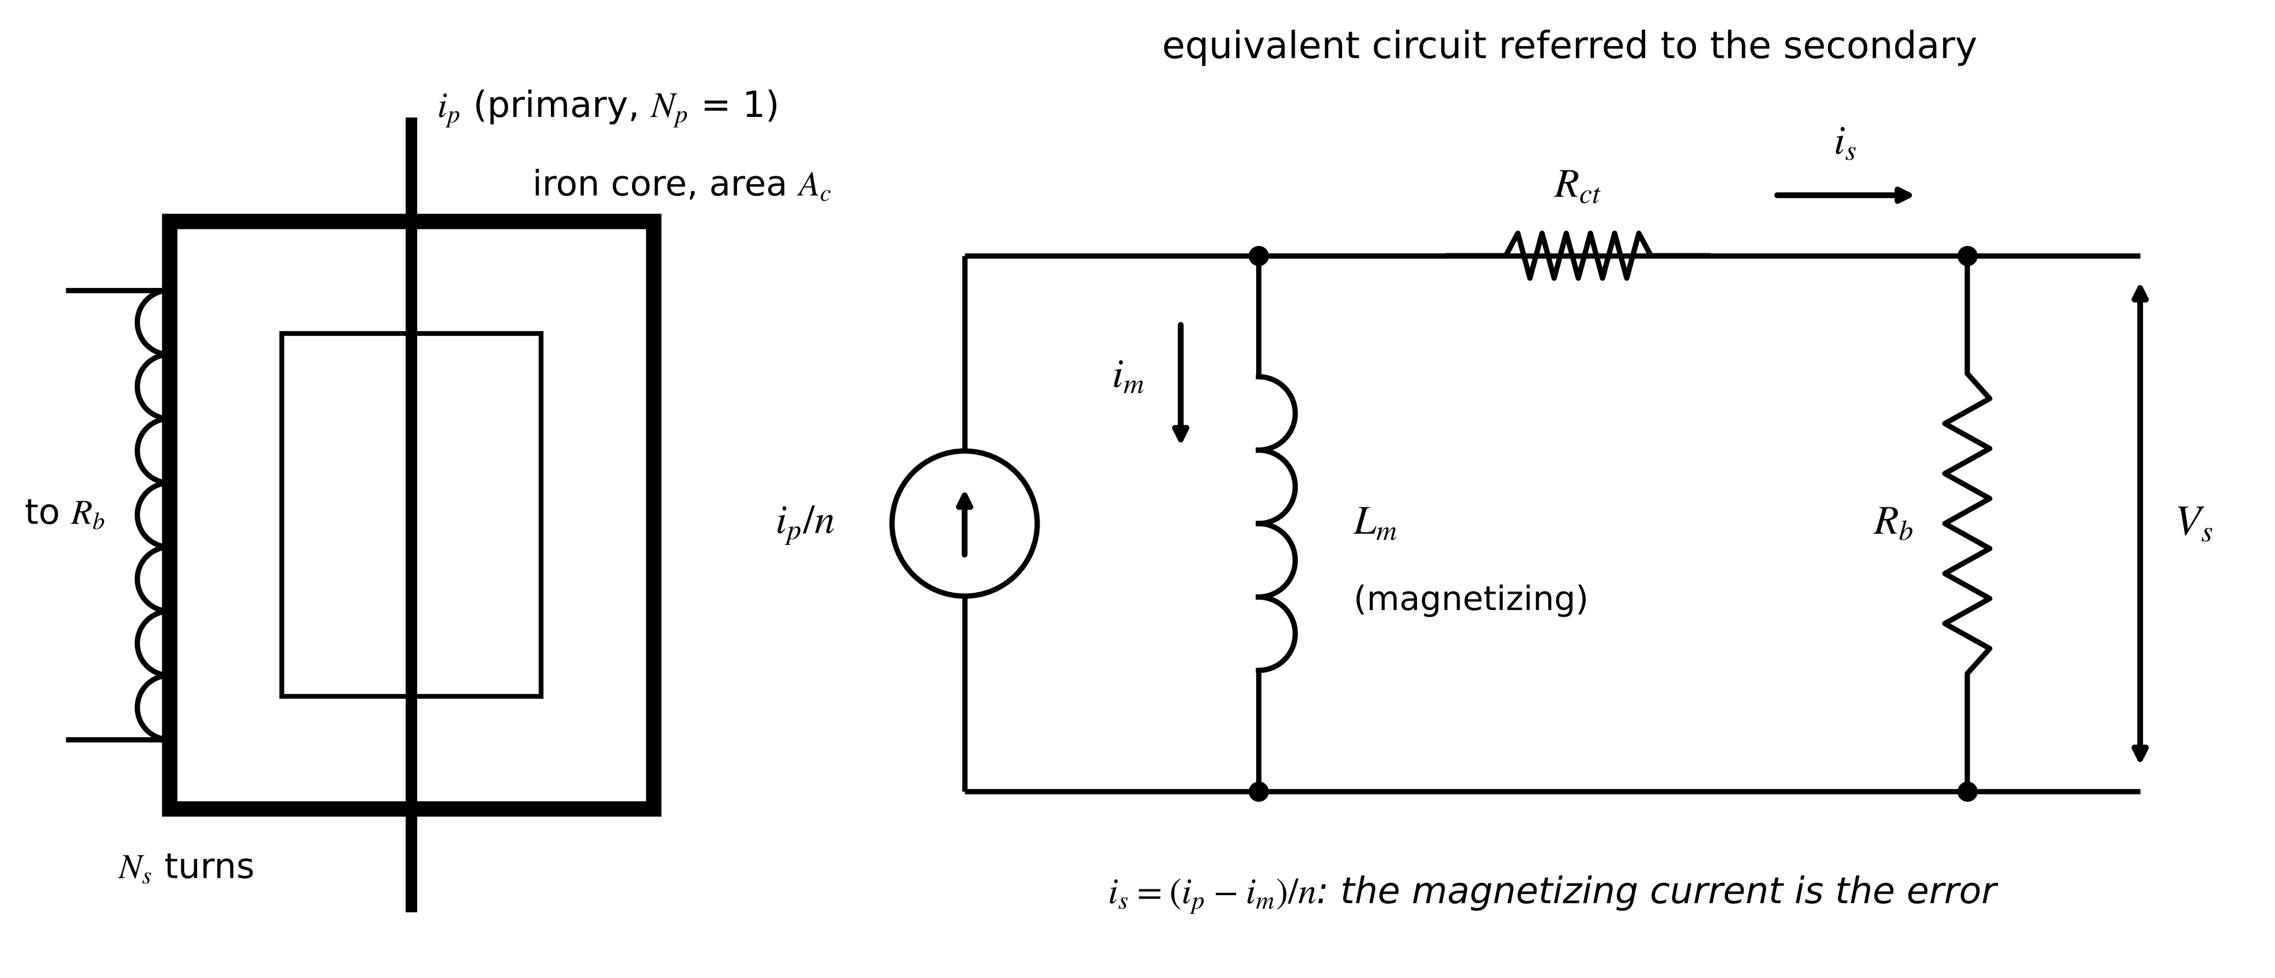
Figure 3.1. Current transformer. Left: iron core with the primary conductor through the window and the secondary winding of $N_{s}$ turns. Right: equivalent circuit referred to the secondary; the magnetizing current $i_{m}$ through $L_{m}$ is the ratio error, and the winding resistance $R_{ct}$ and burden $R_{b}$ set the voltage the core must support.
Saturation can be checked before installation. To drive the secondary current through its own winding resistance $R_{ct}$ and the connected burden $R_{b}$, the core must support a secondary voltage, and by Faraday's law that voltage needs a peak flux density in the core. For a sinusoidal flux $Φ(t)=\hat{B}A_{c}sinωt$ through $N_{s}$ turns, the induced RMS voltage is $ωN_{s}\hat{B}A_{c}/\sqrt{2}=4.44fN_{s}\hat{B}A_{c}$, so
$V_{s}=I_{s}\left(R_{ct}+R_{b}\right), \hat{B}=\frac{V_{s}}{4.44 f N_{s} A_{c}}, 4.44=\frac{2π}{\sqrt{2}}$ (3.3)
where $V_{s}$ is the RMS secondary voltage (V), $\hat{B}$ the peak flux density (T), $f$ the frequency (Hz) and $A_{c}$ the core cross-section (m²). Silicon steel saturates at about 1.5 to 1.8 T; a DC offset in a fault current and residual flux (remanence) bring saturation closer. A CT isolates, needs no supply and survives harsh environments, but it does not pass DC, it saturates on large faults, and an open secondary under load produces dangerous voltages.
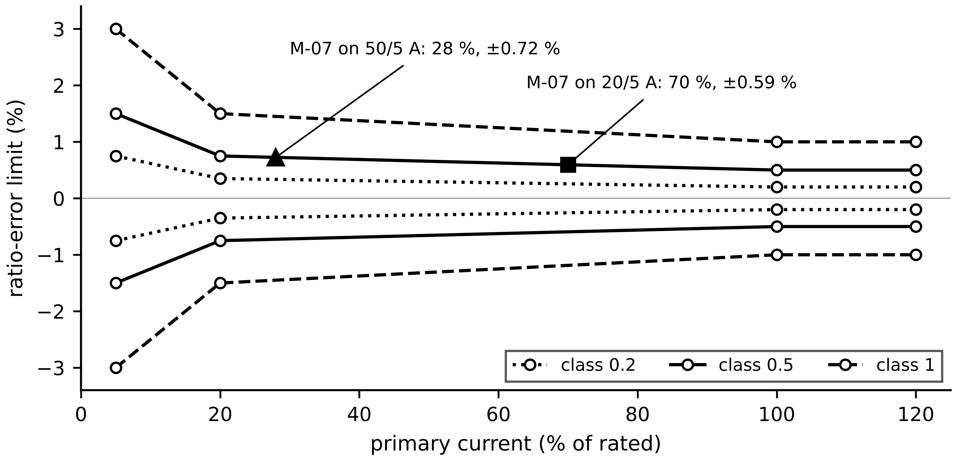
Figure 3.2. Ratio-error limits of IEC 61869-2 measuring classes against primary current. Motor M-07 at about 14 A sits at 28 % of a 50/5 A CT, where class 0.5 permits about ±0.73 % by linear interpolation between the 20 % and 100 % limits, and at 70 % of a 20/5 A CT, where the limit is about ±0.59 %.
Example 3.1 (Level B) Burden, knee point and saturation of a 200/5 A CT
Given. A 200/5 A metering CT has $N_{s}=40$ turns and core area $A_{c}=10$ cm². Winding resistance $R_{ct}=0.2$ Ω; leads 0.15 Ω each way; meter input 0.1 Ω. The core saturates at 1.6 T. Frequency 50 Hz.
Find. (a) Total secondary resistance, secondary voltage and peak flux at rated current. (b) Flux during a fault of 20 times rated current. (c) The secondary voltage at 1.6 T and the largest primary multiple before saturation. (d) The burden in VA at rated current of leads plus meter.
Solution. (a) $R_{ct}+R_{b}=0.2+0.3+0.1=0.6$ Ω; $V_{s}=5×0.6=3.0$ V; from (3.3), $\hat{B}=3.0/(4.44×50×40×{10}^{-3})=0.338$ T. (b) $20×0.338=6.76$ T, four times the saturation level: the core saturates within the first half-cycle. (c) $V_{k}=4.44×50×40×{10}^{-3}×1.6=14.2$ V, so the largest secondary current is $14.2/0.6=23.7$ A, that is 4.7 times rated. (d) $I_{s}^{2}R_{b}=25×0.4=10$ VA.
Interpretation. A metering CT is a precise instrument up to a few times rated current and a poor one beyond. A twin that uses fault waveforms from metering CTs sees clipped, distorted currents; fault records should come from protection CTs specified by their accuracy-limit factor. Halving the lead resistance raises the saturation limit, a cheap improvement.

3.2.3 Rogowski coil
Remove the iron and saturation disappears. A Rogowski coil is an air-cored toroidal winding of $N$ turns, cross-section $A$ and mean path length $ℓ$ around the conductor (Figure 3.3). Ampère's law along the coil's mean path gives the field $H=i/ℓ$; each turn links the flux $Φ=μ_{0}Ai/ℓ$; Faraday's law over $N$ turns gives the coil voltage, and an integrator recovers the current:
$v_{R}(t)=-M\frac{di}{dt}, M=\frac{μ_{0}NA}{ℓ}, v_{o}(t)=-\frac{1}{R_{i}C_{i}}\int_{0}^{t}{v_{R}} dσ=\frac{M}{R_{i}C_{i}}i(t), Δv_{o}=\frac{V_{os}}{R_{i}C_{i}}t$ (3.4)
where $M$ is the mutual inductance (H), $μ_{0}=4π×{10}^{-7}$ H/m, $R_{i}C_{i}$ the integrator time constant (s), $V_{os}$ the integrator's input offset (V) and $Δv_{o}$ the output drift it causes. The coil cannot saturate and is light and flexible, which suits fault recording and retrofits; it cannot measure DC, and integrator drift and conductor position limit its low-frequency accuracy.
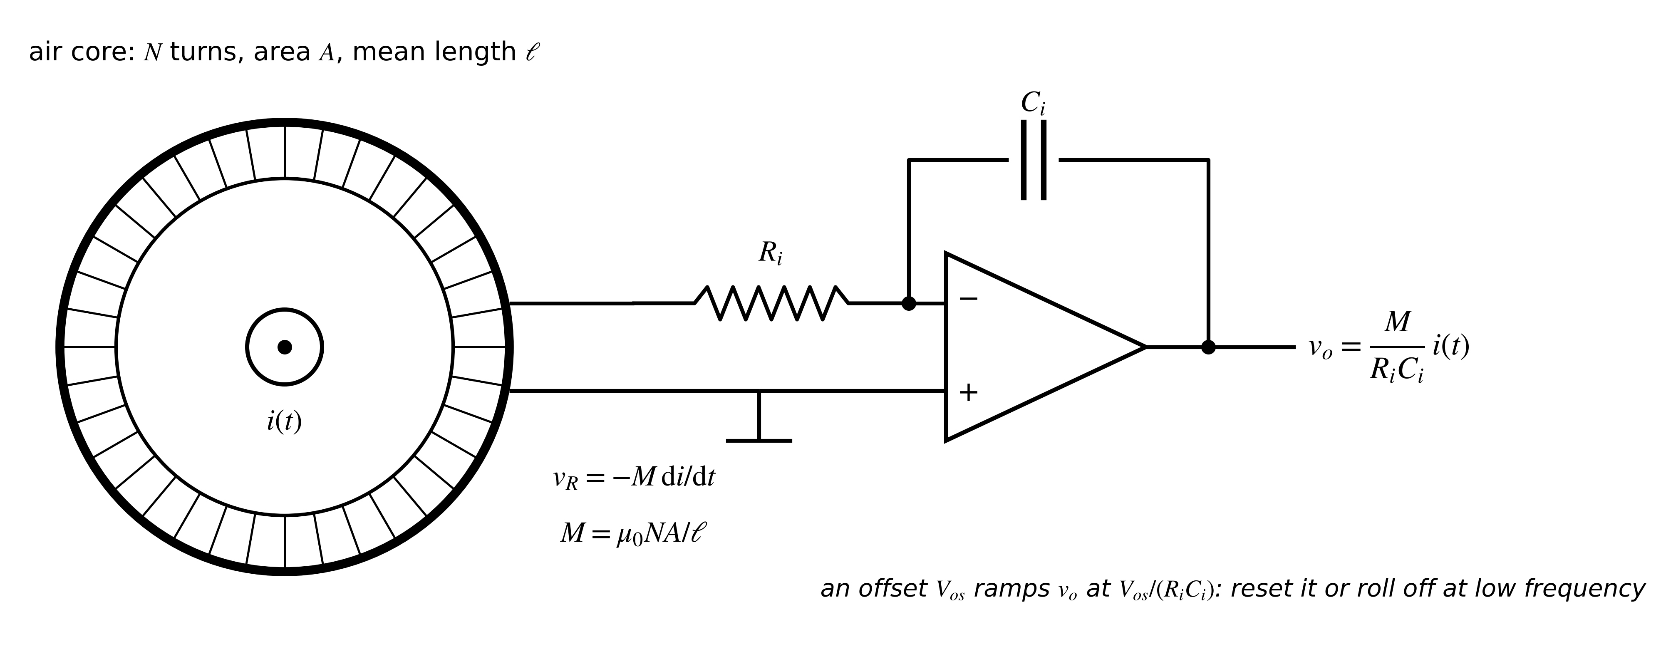
Figure 3.3. Rogowski coil and integrator. The air-cored winding produces a voltage proportional to $di/dt$; the integrator restores a voltage proportional to $i$ but also integrates its own offset.
Example 3.2 (Level A) Sizing a Rogowski integrator
Given. A coil with $N=500$ turns, $A=1$ cm², $ℓ=0.2$ m measures a 1000 A RMS, 50 Hz current. The output should be 1 V per kA. Integrator offset 1 mV.
Find. (a) $M$ and the coil's RMS output. (b) The integrator time constant. (c) The output drift rate from the offset.
Solution. (a) $M=4π×{10}^{-7}×500×{10}^{-4}/0.2=3.14×{10}^{-7}$ H; $V_{R}=ωMI=2π×50×3.14×{10}^{-7}×1000=98.7$ mV. (b) $M/(R_{i}C_{i})=1$ V/kA $={10}^{-3}$ V/A gives $R_{i}C_{i}=3.14×{10}^{-4}$ s. (c) ${10}^{-3}/3.14×{10}^{-4}=3.2$ V/s: the output reaches full scale in under a second.
Interpretation. A pure integrator is unusable; practical designs add a resistor across $C_{i}$ (a low-frequency roll-off) or reset periodically, and accept a lower-frequency limit. The coil itself is linear over a range no iron-cored sensor can match.

3.2.4 Hall-effect and closed-loop sensors
For DC with isolation, the field around the conductor is measured directly. A Hall element in the gap of a magnetic core (Figure 3.4) carries a bias current; carriers moving at drift velocity $v_{d}$ in the gap field $B$ feel the Lorentz force $qv_{d}B$ and pile up on one side until the transverse field $V_{H}/w$ balances it. With current density $I_{c}/(wt_{H})=n_{e}qv_{d}$:
$q v_{d}B=q\frac{V_{H}}{w}, v_{d}=\frac{I_{c}}{n_{e}qwt_{H}} ⇒ V_{H}=\frac{I_{c}B}{n_{e}qt_{H}}$ (3.5)
where $I_{c}$ is the element bias current (A), $n_{e}$ the carrier density (m⁻³), $q$ the elementary charge (C), $w$ and $t_{H}$ the element width and thickness (m). A thin semiconductor with low carrier density gives a large voltage. Open-loop sensors amplify $V_{H}$ directly and inherit core nonlinearity and offset drift. Closed-loop sensors drive a compensating winding until the core flux is zero; zero net magnetomotive force means
$N_{p}i_{p}=N_{s}i_{s} ⇒ i_{s}=\frac{N_{p}}{N_{s}}i_{p}, v_{out}=R_{M}i_{s}$ (3.6)
where $N_{s}$ is the compensating winding, $i_{s}$ its current and $R_{M}$ the measuring resistor. The Hall element acts only as a null detector, so its nonlinearity and gain drift drop out. Closed-loop Hall and fluxgate sensors measure DC and AC with isolation and bandwidths of tens to hundreds of kilohertz; their weaknesses are offset drift with temperature and sensitivity to stray fields.
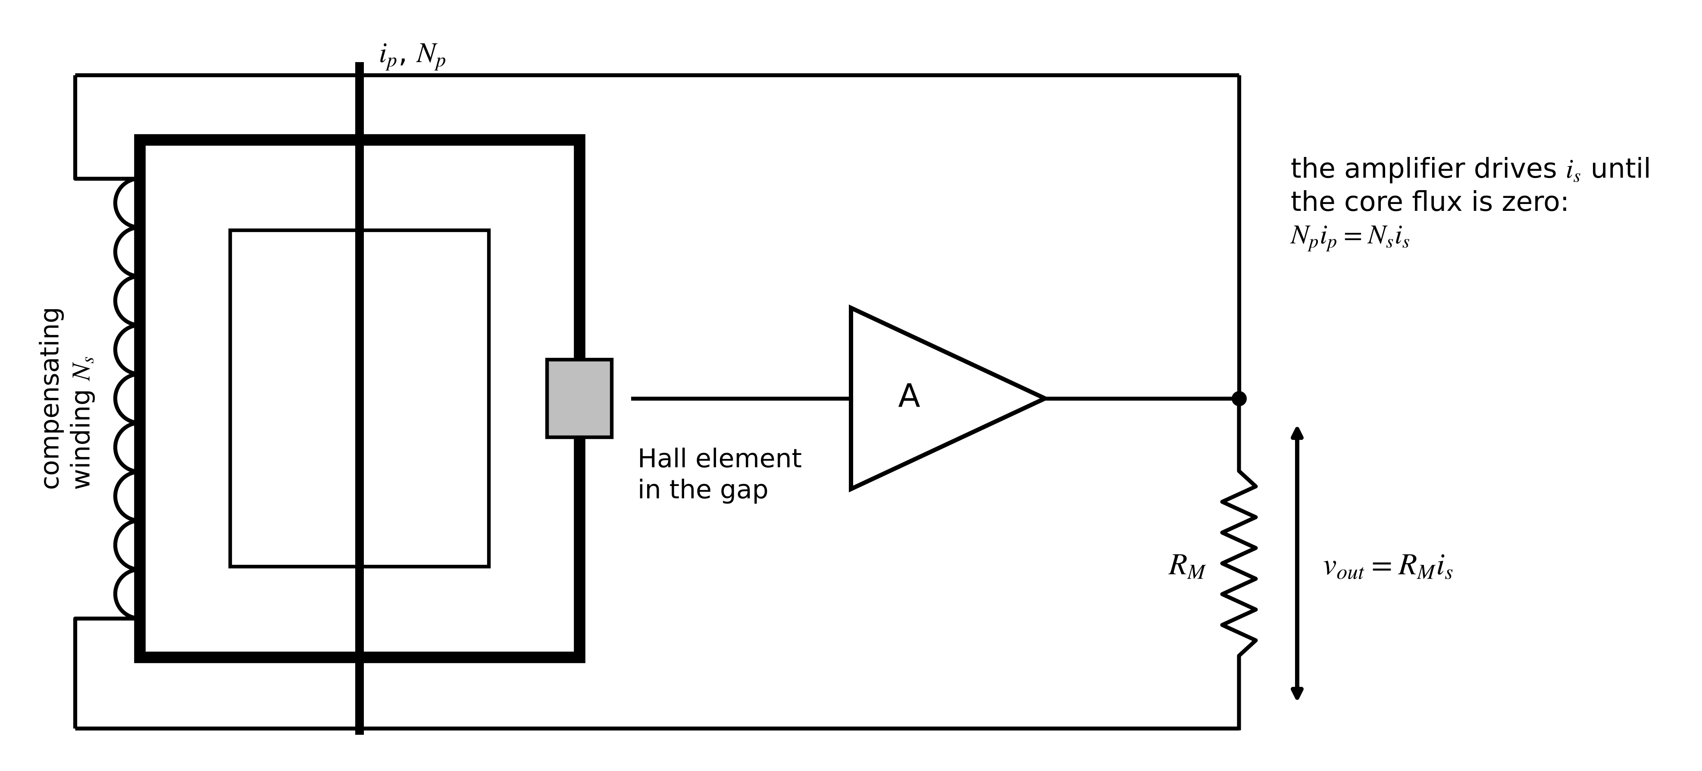
Figure 3.4. Closed-loop Hall current sensor. The Hall element in the core gap detects any residual flux; the amplifier drives the compensating winding to cancel it, so the measured secondary current is proportional to the primary.
Example 3.3 (Level B) Choosing a current sensor for the BESS converter
Given. The Plant P-1 BESS converter carries up to 200 A per phase with switching ripple at 8 kHz, and its twin needs the current including ripple. Candidate A: a 100 µΩ shunt with 2 nH stray inductance and an isolated amplifier. Candidate B: a closed-loop Hall sensor with 200 kHz bandwidth and ±0.5 A offset drift over temperature.
Find. For A: signal level, dissipation and corner frequency. For B: the relative error from offset at 20 A. A recommendation.
Solution. A: from (3.1), $v_{sh}={10}^{-4}×200=20$ mV; $P_{sh}={10}^{-4}×{200}^{2}=4$ W; $f_{L}={10}^{-4}/(2π×2×{10}^{-9})=7.96$ kHz, so at 8 kHz the inductive voltage already equals the resistive one and the ripple would read about $\sqrt{2}$ times too high. B: 0.5 A on 20 A is 2.5 % at light load; the bandwidth easily covers the ripple.
Interpretation. The shunt's geometry, not its resistance, limits it here, and it needs isolation. The Hall sensor suits the ripple, but its offset must be recalibrated at zero current whenever the converter is idle. The ripple frequency and the light-load accuracy requirement decide, not a general preference.
What the digital twin adds
Synchronized: current samples whose ratio error, phase error and bandwidth are known.
Estimated or updated: CT ratio error at the operating point; Hall offset at idle.
Uncertainty carried: class limits converted to standard uncertainty (Section 3.7).
Decision enabled: which principle measures which current, and when fault records are trustworthy.
Validated by: saturation and corner-frequency checks before installation; zero-current checks in service.

3.3 Voltage sensors
The physical question for voltage is the reverse of current: how can a few volts at an amplifier represent hundreds or thousands of volts without the amplifier, or a person, ever touching them? Three answers are used (Figure 3.5). At low voltage a resistive divider scales the voltage and an isolation amplifier carries it across a galvanic barrier. With $R_{1}$ the upper and $R_{2}$ the lower resistor and no load current,
$v_{o}=k v_{in}, k=\frac{R_{2}}{R_{1}+R_{2}}, \frac{u(k)}{k}=\frac{R_{1}}{R_{1}+R_{2}}\sqrt{{\left(\frac{u(R_{1})}{R_{1}}\right)}^{2}+{\left(\frac{u(R_{2})}{R_{2}}\right)}^{2}}$ (3.7)
where $k$ is the divider ratio and the uncertainty form follows from (3.21) of Section 3.7 with sensitivities $∂lnk/∂lnR_{2}=R_{1}/(R_{1}+R_{2})$ and $∂lnk/∂lnR_{1}=-R_{1}/(R_{1}+R_{2})$. The high side is built from several resistors in series to share voltage and power. Matched temperature coefficients matter more than absolute accuracy, because a common drift of $R_{1}$ and $R_{2}$ cancels in $k$. At medium and high voltage, inductive voltage transformers (VTs) and capacitive voltage transformers (CVTs) step the voltage down to about 100 V with ratio and phase errors bounded by IEC 61869 accuracy classes [6]. A CVT's tuned circuit distorts transients and harmonics, which matters for any twin that uses voltage waveforms rather than RMS values. Low-power instrument transformers with an electronic output feed IEC 61869-9 merging units directly (Section 3.11).
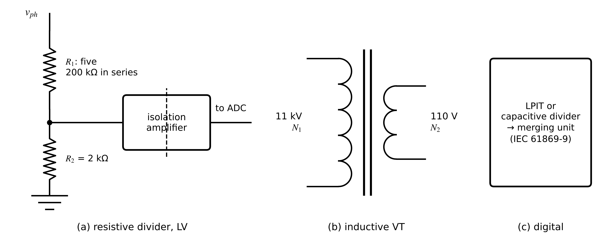
Figure 3.5. Three ways to measure voltage. (a) Resistive divider followed by an isolation amplifier at low voltage. (b) Inductive voltage transformer at medium and high voltage. (c) Low-power instrument transformer feeding a merging unit that publishes sampled values.
Example 3.4 (Level A) A divider for the 415 V bus
Given. Phase voltage 240 V RMS. $R_{1}$ is five 200 kΩ resistors in series (1 MΩ), $R_{2}=2.0$ kΩ, all with ±0.1 % tolerance and matched temperature coefficients.
Find. (a) $k$, the RMS and peak output. (b) Power in the divider. (c) The relative standard uncertainty of $k$ from the tolerances (rectangular).
Solution. (a) $k=2000/1 002 000=1.996×{10}^{-3}$; $v_{o}=0.479$ V RMS, 0.677 V peak. (b) ${240}^{2}/1.002×{10}^{6}=57.5$ mW, 11.5 mW per high-side resistor. (c) Each tolerance gives $0.1/\sqrt{3}=0.0577$ %; from (3.7), $u(k)/k=0.998×\sqrt{2}×0.0577=0.081$ %.
Interpretation. This treats $R_{1}$ as one resistor with a ±0.1 % tolerance, the conservative case in which the errors of the five resistors are fully correlated (one batch, one drift). If they are independent, $u\left(R_{1}\right)/R_{1}=0.0577/\sqrt{5}=0.0258$ % and $u\left(k\right)/k=0.998\sqrt{{0.0258}^{2}+{0.0577}^{2}}=0.063$ %. Either way the divider alone is better than a class 0.2 VT, but the isolation amplifier's gain error (typically 0.1 to 0.5 %) will dominate the budget. Calibrating the divider and amplifier together as one channel removes most of both.
What the digital twin adds
Synchronized: voltage samples with known ratio, phase error and bandwidth.
Estimated or updated: divider or VT ratio from calibration.
Uncertainty carried: ratio uncertainty, and transient distortion for CVTs.
Decision enabled: whether waveforms or only RMS values are trustworthy.
Validated by: comparison against a reference divider at commissioning.

3.4 Temperature sensors
Temperature is the quantity behind most asset twins in this book: winding, oil, junction, cell and module temperatures. The physical question is how a temperature, which carries no energy flow you can tap, becomes an electrical quantity. Two answers dominate: a resistance that changes with temperature, and a voltage generated where two metals meet.

3.4.1 Resistance temperature detectors
The resistance of platinum rises almost linearly with temperature. The Callendar-Van Dusen equation of IEC 60751 gives, for $T≥0$ °C [1],
$R(T)=R_{0}\left(1+AT+BT^{2}\right), \frac{dR}{dT}=R_{0}\left(A+2BT\right)$ (3.8)
where $R_{0}$ is the resistance at 0 °C (100 Ω for a Pt100), $T$ the temperature in °C, $A=3.9083×{10}^{-3}$ °C⁻¹ and $B=-5.775×{10}^{-7}$ °C⁻². At 100 °C a Pt100 reads 138.51 Ω and its sensitivity is 0.379 Ω/K. Class A tolerance is ±(0.15 + 0.002|T|) °C, ±0.35 °C at 100 °C. The instrument measures resistance and must invert (3.8); solving the quadratic gives
$T=\frac{-A+\sqrt{A^{2}-4B\left(1-R/R_{0}\right)}}{2B}$ (3.9)
which returns 100.00 °C for 138.5055 Ω. Three errors come from the measuring circuit rather than the element (Figure 3.6). The measuring current $I_{m}$ heats the element; two-wire leads add their resistance; and both are converted to temperature through the sensitivity:
$ΔT_{sh}=\frac{I_{m}^{2}R(T)}{δ}, ΔT_{lead}=\frac{2R_{lead}}{dR/dT}$ (3.10)
where $δ$ is the dissipation constant (W/K), which depends on how well the element couples to its surroundings, and $R_{lead}$ the resistance of each lead (Ω). With $I_{m}=1$ mA and $δ=8$ mW/K the element runs 0.017 K warm. Two 0.5 Ω leads give $1.0/0.379=2.6$ K, more than the whole Class A tolerance; a three-wire circuit cancels matched leads and a four-wire circuit removes them.
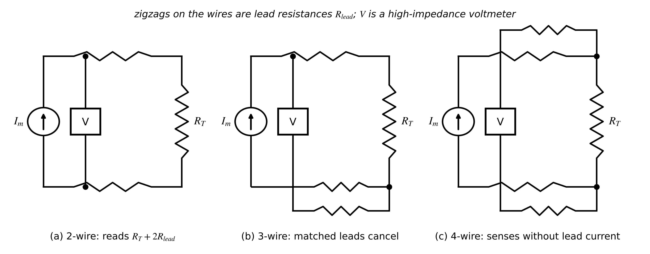
Figure 3.6. RTD measurement with constant-current excitation. (a) Two-wire: the voltmeter sees both lead resistances. (b) Three-wire: a third lead lets the instrument subtract the lead drop if the leads match. (c) Four-wire: separate sense leads carry no current, so lead resistance drops out.

3.4.2 Thermocouples and fibre-optic probes
A thermocouple generates an EMF from the Seebeck effect along two dissimilar wires, about 41 µV/K for type K (Figure 3.7). The EMF depends on both junction temperatures, so the instrument measures the cold-junction temperature $T_{ref}$ and adds back its EMF before inverting the reference function:
$E_{meas}=E(T)-E\left(T_{ref}\right) ⇒ E(T)=E_{meas}+E\left(T_{ref}\right), δT≈\frac{S\left(T_{ref}\right)}{S(T)} δT_{ref}$ (3.11)
where $E(·)$ is the reference function (EMF against a 0 °C junction, tabulated in IEC 60584-1 [7]), $S=dE/dT$ the Seebeck coefficient and $δT_{ref}$ the error in the cold-junction measurement, which passes almost one-to-one into the result. Thermocouples tolerate high temperatures and respond fast, but cold-junction compensation and wire inhomogeneity limit them to about ±1 to 2 K in practice. For transformer hot spots, fibre-optic probes in the winding avoid insulation problems altogether.
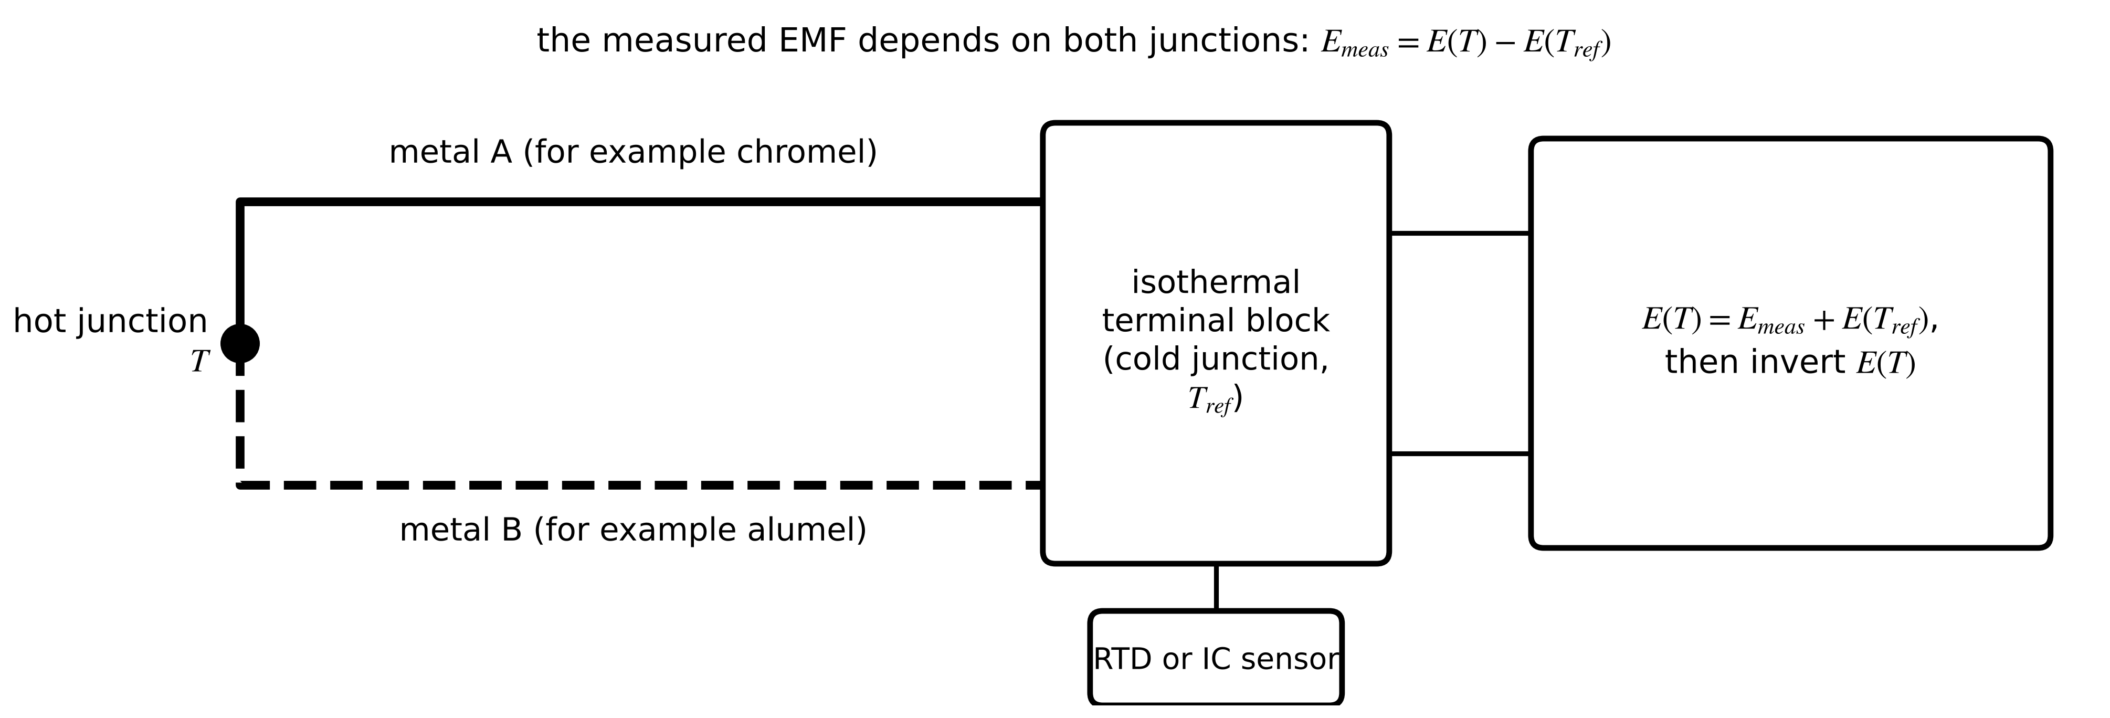
Figure 3.7. Thermocouple with cold-junction compensation. The EMF depends on the difference between the hot junction and the terminal block; a separate sensor measures the block temperature so that its EMF can be added back.
Example 3.5 (Level A) RTD and thermocouple readings at the M-07 winding
Given. (i) A Pt100 reads 138.5055 Ω with 1 mA excitation, $δ=8$ mW/K, connected two-wire with 0.5 Ω per lead. (ii) A type K thermocouple gives $E_{meas}=3.096$ mV with the terminal block at 25 °C; the reference function gives $E(25 °C)=1.000$ mV and $E(100 °C)=4.096$ mV.
Find. (a) The temperature from (3.9) ignoring errors, the self-heating and lead errors, and the indicated temperature in two-wire. (b) The thermocouple temperature. (c) The error if the block sensor reads 1 K high.
Solution. (a) 100.00 °C; self-heating ${10}^{-6}×138.5/0.008=0.017$ K; lead error 2.64 K; indicated about 102.66 °C. (b) $E(T)=3.096+1.000=4.096$ mV, so $T=100$ °C. (c) About 1 K, since the Seebeck coefficients at 25 °C and 100 °C are close.
Interpretation. In two-wire form the RTD's lead error is about seven and a half times its Class A tolerance (2.64 K against ±0.35 K); wiring, not the element, sets the accuracy. The thermocouple's accuracy is that of its cold-junction sensor.
What the digital twin adds
Synchronized: temperature values traceable to the element and its circuit.
Estimated or updated: inverted temperature; self-heating and lead corrections.
Uncertainty carried: tolerance class or calibration, circuit errors (Section 3.7).
Decision enabled: sensor type and wiring for each temperature the twin needs.
Validated by: ice-point or bath checks and resistance checks of leads.

3.5 Irradiance, vibration and speed
Irradiance. A thermopile pyranometer absorbs sunlight on a black surface under a glass dome and produces a voltage proportional to the temperature rise, hence to the irradiance (Figure 3.8):
$G=\frac{V_{p}}{S_{p}}, G_{poa}=G_{b}cosθ_{i}+G_{d}$ (3.12)
where $V_{p}$ is the thermopile voltage (V), $S_{p}$ the sensitivity (of the order of 8 to 10 µV per W/m²), $G_{poa}$ the plane-of-array irradiance, $G_{b}$ the direct-normal beam irradiance, $θ_{i}$ its angle of incidence on the plane and $G_{d}$ the diffuse and reflected irradiance on the plane. ISO 9060:2018 classifies pyranometers as class A, B or C by response time, zero offset, nonlinearity, directional and temperature response [8]. Reference cells made from the same technology as the modules respond instantly and match their spectral response. Soiling of either instrument is the dominant field failure.
Figure 3.8. Pyranometer measurement chain from sunlight to a validated irradiance value. The microvolt-level output needs a low-noise amplifier; validation uses a reference cell, a soiling flag and a night-time zero check.
Vibration. A piezoelectric accelerometer with integrated electronics (IEPE) is a mass-spring-damper mounted on the machine. With seismic mass $m$, stiffness $k$, damping $c$ and relative displacement $x_{r}$ between mass and base, Newton's law for a base acceleration $a$ and the steady-state amplitude response are
$m{\ddot{x}}_{r}+c{\dot{x}}_{r}+kx_{r}=-ma, \left|\frac{a_{meas}}{a_{true}}\right|=\frac{1}{\sqrt{{\left(1-r^{2}\right)}^{2}+{\left(2ζ_{a}r\right)}^{2}}}, r=\frac{f}{f_{r}}$ (3.13)
where $f_{r}=\frac{1}{2π}\sqrt{k/m}$ is the mounted resonance and $ζ_{a}=c/(2\sqrt{km})$ the damping ratio. Piezoelectric sensors are almost undamped, so below resonance the reading is high by $1/(1-r^{2})$ (Figure 3.9). The usable band is therefore a fraction of the mounted resonance, and a magnet mount has a much lower resonance than a stud mount.
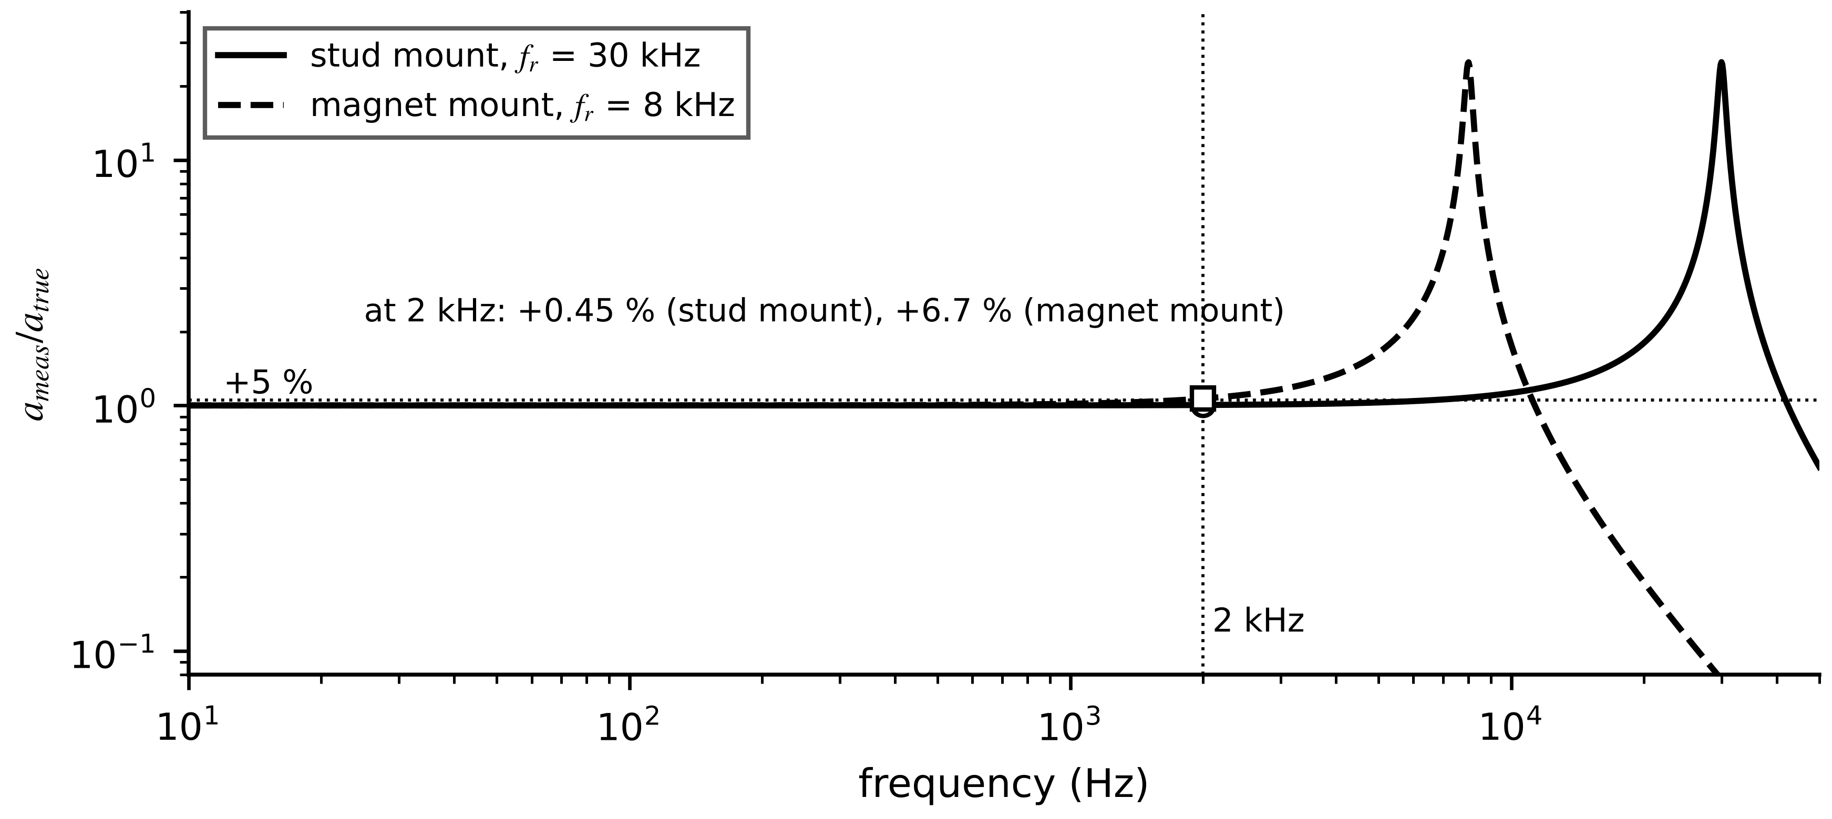
Figure 3.9. Accelerometer amplitude response for a stud mount (30 kHz resonance) and a magnet mount (8 kHz), damping ratio 0.02. At 2 kHz the stud-mounted reading is 0.45 % high and the magnet-mounted reading 6.7 % high.
Speed and position. An incremental encoder with $N_{ppr}$ lines per revolution, read in quadrature (four counts per line, Figure 3.10), gives speed from the count $ΔN$ in a gate time $T_{g}$, with a quantization of one count:
$n=\frac{60 ΔN}{4N_{ppr}T_{g}} r/min, Δn_{q}=\frac{60}{4N_{ppr}T_{g}}, n_{M/T}=\frac{60 m_{1}f_{clk}}{4N_{ppr}m_{2}}$ (3.14)
where the third form is the M/T method: $m_{1}$ encoder counts and, over exactly the same interval, $m_{2}$ cycles of a reference clock of frequency $f_{clk}$, so the interval is measured with the clock's resolution. A 1024-line encoder with a 1 ms gate resolves only 14.6 r/min; with the M/T method ($m_{1}=100$, $f_{clk}=10$ MHz, $m_{2}={10}^{6}$) the same speed is resolved to one part in ${10}^{6}$.
Figure 3.10. Quadrature encoder signals A and B (90° apart) and the resulting count, four per line. Which channel leads gives the direction of rotation.
Example 3.6 (Level B) Irradiance channel design and mounting error
Given. A pyranometer with $S_{p}=8.0$ µV per W/m² feeds a 0 to 2.5 V ADC input; the range must cover 1500 W/m². At noon it reads 7.6 mV. At a time with $θ_{i}=60°$, the sensor is accidentally tilted so that the beam meets it at 63°. Separately, a vibration sensor at 2 kHz is either stud-mounted ($f_{r}=30$ kHz) or magnet-mounted ($f_{r}=8$ kHz).
Find. (a) $G$ at noon and the amplifier gain. (b) The relative error in the beam component from the tilt. (c) The vibration reading error for both mounts.
Solution. (a) $G=7.6×{10}^{-3}/8×{10}^{-6}=950$ W/m²; full scale $1500×8×{10}^{-6}=12$ mV, so gain $2.5/0.012=208$. (b) $cos63°/cos60°=0.908$: the beam term reads 9.2 % low. (c) From (3.13) with negligible damping, $1/(1-(2/30)^{2})=1.0045$ (+0.45 %) and $1/(1-(2/8)^{2})=1.067$ (+6.7 %).
Interpretation. A three-degree mounting error costs more than the whole class A uncertainty of the pyranometer at low sun; a magnet mount costs more than the accelerometer's calibration uncertainty. Installation, not instrument class, often dominates.
Table 3.1. Sensors for electrical-energy twins compared by principle, data need, cost, strengths, limitations and use (representative values)
Sensor | Principle | Range and bandwidth | Isolation | Strength | Limitation | Use in this book
Shunt | Ohm's law (3.1) | mA to kA; DC to $f_{L}$ | none | linear, DC, cheap | heat, no isolation, inductance | converter internals
CT | magnetic coupling (3.2) | 1 A to tens of kA; 50 Hz to kHz | yes | passive, rugged | saturation, no DC, open-circuit hazard | motors, feeders, PCC
Rogowski | Faraday (3.4) | A to MA; AC to MHz | yes | no saturation, flexible | integrator drift, position | fault recording
Closed-loop Hall | null-flux (3.6) | A to kA; DC to 100 kHz+ | yes | DC and AC, wide band | offset drift, stray fields | BESS, PV strings
Divider, VT, LPIT | division or induction (3.7) | V to hundreds of kV | yes (VT); via amplifier | accurate at 50 Hz | CVT transients, ferroresonance | bus voltages
Pt100 RTD | resistance (3.8) | -200 to 600 °C; seconds | needs insulation | stable, accurate | self-heating, leads | windings, oil
Thermocouple | Seebeck (3.11) | to about 1300 °C; sub-second | none | fast, hot | cold junction, drift | heat sinks, furnaces
Pyranometer, ref. cell | thermopile, photocurrent (3.12) | 0 to 1500 W/m² | n/a | traceable class | soiling, tilt | PV twins
IEPE accelerometer | piezoelectric (3.13) | ±50 g; 1 Hz to kHz | case option | wide band | mounting, cable | bearings, gearboxes
Encoder | counting (3.14) | speed, angle | optical: yes | digital, exact count | contamination, missed counts | drives

What the digital twin adds
Synchronized: irradiance, vibration and speed with known frequency response.
Estimated or updated: plane-of-array irradiance from beam and diffuse parts.
Uncertainty carried: installation errors (tilt, mounting) next to instrument class.
Decision enabled: mounting method and amplifier gain; sensor choice from Table 3.1.
Validated by: reference-cell cross-check, night zero, mounted-resonance test.

3.6 Signal conditioning
A sensor output is rarely in the form an analog-to-digital converter (ADC) wants. A CT gives amperes; an RTD gives ohms; a shunt gives millivolts riding on hundreds of volts of common mode; and the ADC wants a voltage between 0 and its reference, from a low source impedance, free of energy above half its sampling rate. Signal conditioning bridges the gap (Figure 3.11). Each block adds a gain error, an offset, noise, a delay or a limit, and every one of them belongs in the uncertainty budget of Section 3.7.
Figure 3.11. Generic signal-conditioning chain for a current channel, with the example signal levels of Example 3.7. The isolation barrier sits between the sensor side and the ADC side, either in an isolation amplifier or in an isolated ADC.
Burden and protection. A CT secondary current becomes a voltage across a burden resistor, $v_{b}=i_{s}R_{b}$, dissipating $i_{s}^{2}R_{b}$. The burden must be small enough not to saturate the CT ((3.3)) and large enough to give a usable signal. Transient voltage suppressors, series resistors and clamp diodes protect the amplifier against surges and the inductive kick of a switching event; they add leakage currents and capacitance that must stay negligible at the signal level.
Instrumentation amplifier. A small differential signal often rides on a large common-mode voltage, for example a shunt in the positive DC bus. A three-op-amp instrumentation amplifier (INA) amplifies the difference and rejects the common part. Its gain is set by one resistor $R_{G}$, and its finite common-mode rejection ratio (CMRR) leaves an input-referred error:
$G=1+\frac{2R_{F}}{R_{G}}, v_{err,in}=\frac{v_{cm}}{CMRR}, CMRR={10}^{{CMRR}_{dB}/20}$ (3.15)
where $R_{F}$ is the internal feedback resistance (data sheets often state $G=1+49.4 kΩ/R_{G}$), $v_{cm}$ the common-mode voltage (V) and ${CMRR}_{dB}$ the rejection in decibels. CMRR falls with frequency, so the switching edges of a converter test it hardest.
Level shift and range. A single-supply ADC accepts 0 to $V_{ref}$, so a bipolar signal is shifted to mid-scale and scaled to use most of the range without clipping:
$v_{adc}=\frac{V_{ref}}{2}+G v_{in}, G≤\frac{η_{r}V_{ref}/2}{{\hat{v}}_{in,max}}$ (3.16)
where ${\hat{v}}_{in,max}$ is the largest expected peak input, including the overrange the twin must still see, and $η_{r}$ the fraction of half-range allowed (0.9 leaves headroom for offset and tolerance). Using too little of the range throws away resolution (Section 3.8.4); using too much clips the largest events.
ADC input constraints. A sampling ADC charges its internal capacitor during an acquisition time $t_{acq}$. For the error to settle below half a least significant bit of an $N$-bit converter, the driving circuit's time constant must satisfy $e^{-t_{acq}/τ}≤2^{-(N+1)}$:
$τ=R_{drv}C_{in}≤\frac{t_{acq}}{(N+1)ln2}$ (3.17)
where $R_{drv}$ is the source resistance seen by the ADC and $C_{in}$ its sampling capacitance. A 16-bit converter with 100 ns acquisition needs $τ≤8.5$ ns, which is why a dedicated driver amplifier and a small RC filter sit directly at the ADC input.
Current loops. Many field transmitters send a 4 to 20 mA current, immune to lead resistance and with a live zero that distinguishes ‘zero reading’ from ‘broken wire’. The current maps linearly onto the measured range, and the loop supply must cover every drop at full current:
$I=4+16 \frac{x-x_{lo}}{x_{hi}-x_{lo}} mA, V_{sup}≥I_{max}\left(R_{rec}+R_{cable}\right)+V_{tx,min}$ (3.18)
where $x$ is the measured quantity with range $[x_{lo},x_{hi}]$, $R_{rec}$ the receiver resistor, $R_{cable}$ the loop cable resistance and $V_{tx,min}$ the transmitter's minimum operating voltage. A reading below about 3.8 mA or above about 20.5 mA signals a fault rather than a value (NAMUR NE 43 practice).
Isolation. Galvanic isolation (isolation amplifiers, isolated ADCs, digital isolators) breaks ground loops and protects people and electronics. It is specified by working voltage, withstand voltage and creepage under IEC 61010-1 [9], and it costs gain error, offset drift and sometimes bandwidth.
Example 3.7 (Level B) Conditioning the M-07 phase-current channel
Given. M-07 draws 14 A on a 20/5 A CT (3.5 A secondary); the twin must see up to twice rated secondary current (10 A RMS) without clipping. Burden $R_{b}=0.05$ Ω. A three-op-amp INA with $R_{F}=24.7$ kΩ (so $G=1+49.4 kΩ/R_{G}$) drives a 16-bit, 0 to 3.3 V ADC with 100 ns acquisition and 10 pF input capacitance. Separately, a DC-bus shunt gives 50 mV on 10 V of common mode into an INA with 80 dB CMRR. A 4 to 20 mA RTD transmitter covers 0 to 200 °C, with a 250 Ω receiver, 25 Ω of cable and a 10 V minimum transmitter voltage.
Find. (a) Burden voltage at 3.5 A and peak at the 10 A overrange; burden power at 5 A. (b) The gain from (3.16) with $η_{r}=0.9$, and $R_{G}$. (c) The largest driver resistance from (3.17). (d) The CMRR error on the shunt. (e) The loop current at 100 °C and the minimum loop supply.
Solution. (a) $3.5×0.05=0.175$ V RMS; peak at 10 A: $10×0.05×\sqrt{2}=0.707$ V; power $25×0.05=1.25$ W. (b) $G≤0.9×1.65/0.707=2.10$; with the standard value $R_{G}=45.3$ kΩ, $G=1+49.4/45.3=2.09$. At 3.5 A the ADC sees $1.65±0.517$ V peak. (c) $τ≤100×{10}^{-9}/(17ln2)=8.5$ ns, so $R_{drv}≤850$ Ω with 10 pF; a driver amplifier with a 10 Ω, 470 pF output filter ($τ=4.7$ ns) is a typical solution. (d) $10/{10}^{4}=1$ mV, a 2 % error on 50 mV. (e) From (3.18), $4+16×100/200=12$ mA; $V_{sup}≥0.020×(250+25)+10=15.5$ V.
Interpretation. Every block shows up in the numbers: a 1.25 W burden needs a proper resistor; the gain leaves about 10 % headroom at the overrange peak for offset and tolerances; and 80 dB of CMRR is not enough for a high-side shunt with 2 % accuracy goals, where 100 dB or an isolated amplifier is needed.
What the digital twin adds
Synchronized: a voltage at the ADC that represents the physical quantity over its full range.
Estimated or updated: gain, offset and range of each conditioning stage.
Uncertainty carried: gain errors, CMRR error, settling error, loop faults.
Decision enabled: burden, gain, range and isolation for each channel.
Validated by: end-to-end calibration of sensor and conditioning together.

3.7 Measurement uncertainty

3.7.1 The measurement model and its vocabulary
The Guide to the Expression of Uncertainty in Measurement (GUM) starts from a measurement model that expresses the reported value as a function of every input that affects it [10]:
$y=f\left(x_{1},x_{2},…,x_{N}\right)$ (3.19)
where $y$ is the estimate of the measurand and $x_{i}$ are the inputs: the sensor reading, the calibration correction, the lead correction, the self-heating correction and so on. Four words must be kept apart. Bias is a systematic offset, the same error on every reading under the same conditions; calibration estimates and corrects it, averaging never removes it. Repeatability is the spread of repeated readings, quantified by a standard deviation; averaging $n$ readings reduces it by $\sqrt{n}$. Resolution is the smallest step the instrument can represent. An accuracy class is a bound on the total error of a class of instruments; it is a limit, not a standard deviation.
Each input receives a standard uncertainty $u(x_{i})$, the equivalent of one standard deviation. Type A evaluation uses the statistics of $n$ repeated observations $q_{j}$; Type B evaluation uses other information, for example a bound $±a$ that is treated as a rectangular, triangular or U-shaped distribution:
$\overline{q}=\frac{1}{n}\sum_{j=1}^{n}{q_{j}}, s^{2}=\frac{1}{n-1}\sum_{j=1}^{n}{{\left(q_{j}-\overline{q}\right)}^{2}}, u\left(\overline{q}\right)=\frac{s}{\sqrt{n}}; u_{rect}=\frac{a}{\sqrt{3}}, u_{tri}=\frac{a}{\sqrt{6}}, u_{U}=\frac{a}{\sqrt{2}}$ (3.20)
where $s$ is the experimental standard deviation with $n-1$ degrees of freedom. The rectangular result follows from the variance of a uniform distribution, $\frac{1}{2a}\int_{-a}^{a}{x^{2}}dx=a^{2}/3$. A resolution step $Δ$ is a rectangular bound of half-width $Δ/2$, giving $Δ/\sqrt{12}$.

3.7.2 Combining uncertainties with covariance
Linearizing (3.19) about the estimates gives $δy≈\sum_{i}{c_{i}}δx_{i}$ with sensitivity coefficients $c_{i}=∂f/∂x_{i}$. The variance of that sum contains the covariance of every pair, which gives the law of propagation of uncertainty:
$u_{c}^{2}(y)=\sum_{i=1}^{N}{c_{i}^{2}}u^{2}\left(x_{i}\right)+2\sum_{i=1}^{N-1}{\sum_{j=i+1}^{N}{c_{i}}}c_{j} r_{ij} u\left(x_{i}\right)u\left(x_{j}\right)$ (3.21)
where $u_{c}$ is the combined standard uncertainty and $r_{ij}$ the correlation coefficient between inputs $i$ and $j$ ($-1≤r_{ij}≤1$). In matrix form, $u_{c}^{2}=c^{⊤}U_{x}c$ with $U_{x}$ the input covariance matrix; this is the form the estimators of Chapter 5 use. Correlation arises whenever inputs share a cause: channels calibrated against the same reference, transducers powered by one drifting supply, CTs from one batch. Two special cases recur. For a product model $y=Cx_{1}^{p_{1}}x_{2}^{p_{2}}⋯$ with independent inputs, relative uncertainties add in quadrature weighted by the exponents; and for the mean of $n$ channels with equal uncertainty $u$ and pairwise correlation $r$,
${\left(\frac{u_{c}(y)}{y}\right)}^{2}=\sum_{i=1}^{N}{{\left(p_{i}\frac{u\left(x_{i}\right)}{x_{i}}\right)}^{2}}, u^{2}\left(\overline{y}\right)=\frac{u^{2}}{n}\left[1+(n-1) r\right]$ (3.22)
which falls as $1/n$ only when $r=0$ and does not fall at all when $r=1$: averaging cannot remove a shared error. The expanded uncertainty is $U=ku_{c}$. When some inputs come from few observations, the Welch-Satterthwaite formula estimates effective degrees of freedom, and $k$ is taken from Student's $t$ distribution:
$U=k u_{c}, ν_{eff}=\frac{u_{c}^{4}(y)}{\sum_{i=1}^{N}{{\left(c_{i}u\left(x_{i}\right)\right)}^{4}}/ν_{i}}$ (3.23)
where $ν_{i}$ is the degrees of freedom of input $i$ ($n-1$ for a Type A mean, effectively infinite for a well-founded Type B bound). For $ν_{eff}=10$, 95 % coverage needs $k=2.23$ rather than 2. A reported uncertainty without its coverage factor is incomplete.
Example 3.8 (Level B) A complete GUM budget for the M-07 winding RTD at 100 °C
Given. A Class A Pt100 in the winding, three-wire connection, read by a transmitter with stated accuracy ±0.10 K and display resolution 0.01 K. Ten readings in steady state give $s=0.05$ K ($ν=9$). Residual lead imbalance contributes 0.012 K and self-heating 0.017 K (both standard uncertainties). Option 2: the element is bath-calibrated with a certificate stating $U=0.08$ K at $k=2$, replacing the class tolerance.
Find. (a) The combined and expanded uncertainty of a single reading for both options. (b) The share of variance from the element tolerance in Option 1. (c) $ν_{eff}$ and the coverage factor for Option 2.
Solution. (a) Option 1: tolerance $0.35/\sqrt{3}=0.202$ K; transmitter $0.10/\sqrt{3}=0.058$ K; resolution $0.01/\sqrt{12}=0.003$ K; repeatability 0.050 K; leads 0.012 K; self-heating 0.017 K. With all $c_{i}=1$ and $r_{ij}=0$ in (3.21): $u_{c}=\sqrt{{0.202}^{2}+{0.058}^{2}+{0.003}^{2}+{0.050}^{2}+{0.012}^{2}+{0.017}^{2}}=0.217$ K, $U=0.43$ K. Option 2: the tolerance term becomes $0.08/2=0.040$ K, so $u_{c}=0.089$ K and $U=0.18$ K. (b) ${0.202}^{2}/{0.217}^{2}=87$ %. (c) Only repeatability has finite degrees of freedom: $ν_{eff}={0.0889}^{4}/({0.05}^{4}/9)=90$, so $k=t_{0.975,90}=1.99$ and $U=0.18$ K.
Interpretation. Calibrating the element shrinks the expanded uncertainty by a factor of 2.4. Chapter 1 used $σ_{v}=0.3$ K for this channel, deliberately larger than either figure, to cover installation effects (the element sits near, not at, the hot spot). That choice is now a checked result rather than an assumption.
Table 3.2. Uncertainty budget of the M-07 RTD reading at 100 °C (standard uncertainties in K)
Source | Type | Information | Distribution | Option 1 | Option 2
Element tolerance (Class A) | B | ±0.35 K bound | rectangular | 0.202 | n/a
Calibration certificate | B | $U$ = 0.08 K, $k$ = 2 | normal | n/a | 0.040
Transmitter accuracy | B | ±0.10 K bound | rectangular | 0.058 | 0.058
Resolution | B | 0.01 K step | rectangular | 0.003 | 0.003
Repeatability (single reading) | A | $s$ = 0.05 K, $n$ = 10 | normal | 0.050 | 0.050
Lead imbalance | B | estimate | normal | 0.012 | 0.012
Self-heating | B | (3.10) | normal | 0.017 | 0.017
Combined $u_{c}$ |  |  |  | 0.217 | 0.089
Expanded $U$ ($k≈2$) |  |  |  | 0.43 | 0.18

Example 3.9 (Level B) Correlated calibration errors in a three-phase average
Given. Three CTs on one feeder were calibrated against the same reference: each has calibration uncertainty $u_{cal}=0.15$ A with pairwise correlation $r=0.7$, plus independent repeatability $u_{rep}=0.05$ A. The twin uses $\overline{I}=(I_{a}+I_{b}+I_{c})/3$.
Find. $u_{c}(\overline{I})$ assuming independence, and correctly with (3.21); check with (3.22).
Solution. Each $c_{i}=1/3$. Independence: $\sqrt{3({0.15}^{2}+{0.05}^{2})}/3=0.0913$ A. With correlation: calibration terms $(1/9)×0.0225×(3+6×0.7)=0.0180$ A²; repeatability $(1/9)×3×0.0025=8.3×{10}^{-4}$ A²; $u_{c}=\sqrt{0.0188}=0.137$ A. Check: $(0.0225/3)(1+2×0.7)=0.0180$ A².
Interpretation. The correct value is 50 % larger. A twin that assumes independence overstates its confidence in exactly the quantity, three-phase power, that it uses most.
What the digital twin adds
Synchronized: each value with a standard uncertainty and, where relevant, its covariance.
Estimated or updated: $u_{c}$, $U$, $ν_{eff}$ per channel; covariance between channels.
Uncertainty carried: Type A and Type B terms, correlation from shared calibration.
Decision enabled: whether a sensor limits the twin, and where calibration pays.
Validated by: certificates, repeated readings and the budget table filed in the digital thread.

3.8 Sampling, anti-aliasing and quantization
A twin sees a waveform only at its sampling instants and only to the resolution of its converter. The physical question of this section is which information survives that double cut, and which errors it creates that cannot later be removed.

3.8.1 Spectral replicas and aliasing
Sampling at rate $f_{s}=1/T_{s}$ multiplies the signal by a train of impulses spaced $T_{s}$ apart. The Fourier transform of that train is itself a train of impulses spaced $f_{s}$ apart, so the spectrum of the sampled signal is the original spectrum repeated at every multiple of the sampling rate [11]:
$X_{s}(f)=f_{s}\sum_{m=-∞}^{∞}{X}\left(f-mf_{s}\right)$ (3.24)
where $X(f)$ is the spectrum of the continuous signal and $X_{s}(f)$ that of the sampled one (Figure 3.12). If $X(f)$ is zero at and above $f_{s}/2$, the copies do not overlap, and ideal low-pass interpolation recovers the signal exactly (the Whittaker-Shannon formula):
$x(t)=\sum_{k=-∞}^{∞}{x}[k] sinc\left(\frac{t-kT_{s}}{T_{s}}\right), sinc(u)=\frac{sinπu}{πu}$ (3.25)
If the spectrum extends beyond $f_{s}/2$, the copies overlap and a component at $f$ is indistinguishable from one at $f-mf_{s}$ for any integer $m$. It appears at the alias frequency
$f_{a}=\left|f-mf_{s}\right|, m=round\left(\frac{f}{f_{s}}\right), 0≤f_{a}≤\frac{f_{s}}{2}$ (3.26)
The Nyquist condition $f_{s}>2f_{max}$ avoids aliasing only if nothing above $f_{s}/2$ reaches the converter, which is the job of the anti-alias filter.
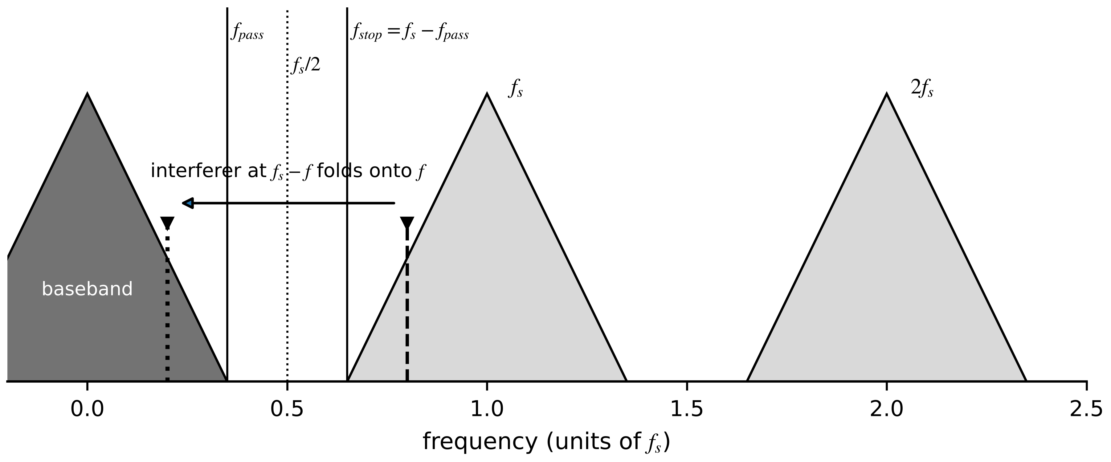
Figure 3.12. Spectral replicas of a sampled signal. A component above $f_{s}/2$ (dashed) folds back into the band of interest (dotted). The filter must reach full attenuation at $f_{stop}=f_{s}-f_{pass}$, not at $f_{s}/2$.
Example 3.10 (Level A) A false harmonic from switching ripple
Given. The BESS converter current has a 20 A RMS fundamental, a 1.2 A fifth harmonic and 1.5 A of switching ripple at 8 kHz. It is sampled at 4800 SPS, the IEC 61869-9 rate [2], without an adequate filter.
Find. Where the ripple appears and what a harmonic analysis would report.
Solution. From (3.26), $m=round(8000/4800)=2$ and $f_{a}=|8000-9600|=1600$ Hz, exactly the 32nd harmonic of 50 Hz, with about the full 1.5 A amplitude (Figure 3.13).
Interpretation. The samples satisfy ‘Nyquist’ for every component of interest (up to 2400 Hz) and still report a 32nd harmonic that does not exist. A harmonic-analysis twin would diagnose a resonance that is not there. Only filtering before sampling, or a much higher rate, prevents it.
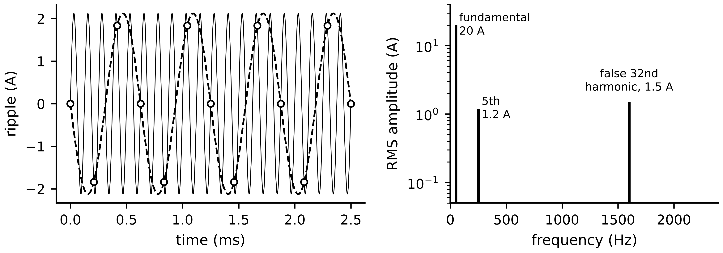
Figure 3.13. The aliasing example. Left: 8 kHz ripple (thin line) sampled at 4800 SPS; the samples trace a 1600 Hz sinusoid (dashed). Right: spectrum of one second of samples, with the fundamental, the fifth harmonic and the false 32nd harmonic.

3.8.2 Anti-alias filter design
A real filter has a passband to $f_{pass}$, a transition band and a stopband. The frequencies that fold into the passband are those above $f_{s}-f_{pass}$, so that is where the filter must reach its full attenuation. To push an interferer of amplitude $a_{int}$ below half a quantization step $Δ$, and in the worst case of a full-scale interferer,
$f_{stop}=f_{s}-f_{pass}, A_{stop}≥20\log_{10}\frac{2a_{int}}{Δ}, A_{stop}≥6.02N+1.76 dB (full scale)$ (3.27)
where $N$ is the number of bits. The Butterworth low-pass filter of order $n$ has the maximally flat response; its attenuation, the order needed to reach $A_{stop}$, and its group delay at low frequency (the sum over its poles) are
$A(f)=10\log_{10}\left[1+{\left(\frac{f}{f_{c}}\right)}^{2n}\right], n≥\frac{\log_{10}\left({10}^{A_{stop}/10}-1\right)}{2\log_{10}\left(f_{stop}/f_{c}\right)}, τ_{g}(0)=\frac{1}{2πf_{c}}\sum_{k=1}^{n}{sin}\frac{(2k-1)π}{2n}$ (3.28)
where $f_{c}$ is the −3 dB frequency and $n$ is rounded up. For $n=4$ the delay is $2.613/(2πf_{c})$, 166 µs at $f_{c}=2.5$ kHz, a term in the timing budget of Section 3.16.
Example 3.11 (Level B) Sampling rate and filter order for harmonics to the 50th order
Given. A PV inverter twin analyzes current harmonics up to the 50th (2500 Hz) with a 14-bit converter. $f_{c}=f_{pass}=2500$ Hz; full-scale interferer criterion.
Find. The required order for (a) $f_{s}=6250$ SPS, (b) 14 400 SPS, (c) 51 200 SPS with digital decimation; and the group delay of the order-4 filter.
Solution. $A_{stop}=6.02×14+1.76=86.0$ dB. (a) $f_{stop}=3750$ Hz, ratio 1.5; $n≥8.60/(2×0.176)=24.4$, so 25. (b) $f_{stop}=11 900$ Hz, ratio 4.76; $n≥6.35$, so 7. (c) $f_{stop}=48 700$ Hz, ratio 19.5; $n≥3.34$, so 4. Group delay of order 4: 166 µs (Figure 3.14).
Interpretation. A rate 25 % above Nyquist looks economical and demands an unbuildable 25th-order analog filter. Oversampling moves the difficulty from analog hardware into digital filtering, where steep filters are cheap, exact and linear in phase. A common mistake places the stopband at $f_{s}/2$, which understates the requirement.
Figure 3.14. Butterworth attenuation for orders 4, 7 and 25 with $f_{c}=2500$ Hz, with the three design points of Example 3.11 at their stopband edges and the 86 dB requirement.

3.8.3 Quantization, ENOB and aperture jitter
An $N$-bit converter with full-scale range FSR maps its input onto $2^{N}$ levels (Figure 3.15). Modelling the quantization error $e_{q}$ as uniform on $[-Δ/2,Δ/2]$, valid when the signal crosses many steps between samples,
$Δ=\frac{FSR}{2^{N}}, σ_{q}^{2}=\frac{1}{Δ}\int_{-Δ/2}^{Δ/2}{e_{q}^{2}} de_{q}=\frac{Δ^{2}}{12}$ (3.29)
A full-scale sine has power $(FSR/2)^{2}/2$, so the ideal signal-to-noise ratio, its loss for a signal of amplitude $A_{s}$ below full scale $A_{FS}$, and the effective number of bits obtained from a measured signal-to-noise-and-distortion ratio (SINAD) are
${SNR}_{q}=6.02N+1.76+20\log_{10}\frac{A_{s}}{A_{FS}} dB, ENOB=\frac{SINAD-1.76}{6.02}$ (3.30)
A 16-bit channel used 20 dB below full scale behaves like a 13-bit channel at full scale. Real converters fall short of the ideal because of thermal noise, nonlinearity and clock jitter; ENOB, measured with a pure sine as IEEE Std 1241 describes [12], is what the twin actually gets (Figure 3.16).
Figure 3.15. Quantization. Left: the staircase transfer of a coarse converter against the ideal line. Right: the error, uniform on $±Δ/2$ when the signal crosses many steps.
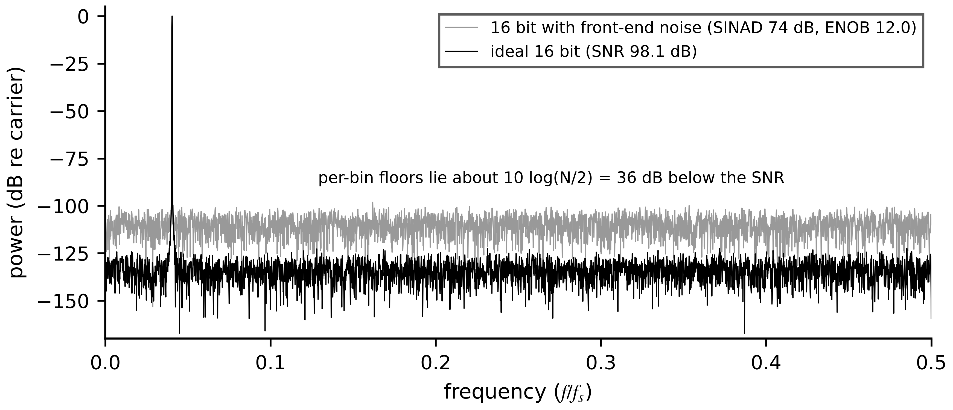
Figure 3.16. Spectra of a 16-bit converter with a near-full-scale sine (Hann window): ideal quantization only, and with front-end noise that raises the floor so that the converter delivers about 12 effective bits.
Aperture jitter. A random error $σ_{t}$ in the sampling instant turns the signal's slope into an amplitude error (Figure 3.17). For $x=Asin2πft$ the slope has RMS value $2πfA/\sqrt{2}$, so the jitter noise power is $(2πfAσ_{t})^{2}/2$ against signal power $A^{2}/2$:
${SNR}_{j}=-20\log_{10}\left(2πfσ_{t}\right)$ (3.31)
which depends on frequency, not on resolution: a perfect converter driven by a jittery clock loses bits at high frequency.
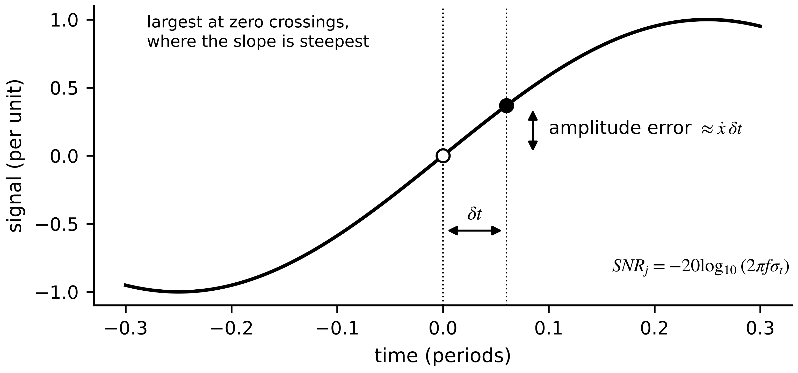
Figure 3.17. Aperture jitter. A timing error $δt$ becomes an amplitude error of about $\dot{x} δt$, largest at zero crossings where the slope is steepest.
Oversampling and noise shaping. Oversampling by OSR $=f_{s}/(2f_{B})$, with $f_{B}$ the signal bandwidth, spreads the fixed quantization noise power over $0$ to $f_{s}/2$, so only a fraction $1/OSR$ remains in band after filtering. A delta-sigma converter adds noise shaping of order $L$, pushing quantization noise out of band:
$ΔSNR=10\log_{10}OSR, {SNR}_{ΔΣ}=6.02N+1.76-10\log_{10}\frac{π^{2L}}{2L+1}+(2L+1) 10\log_{10}OSR$ (3.32)
At OSR = 64 the gain is 18.1 dB from oversampling alone, against 49.0 dB for $L=1$ and 77.4 dB for $L=2$; the price is the delay of the decimation filter, typically tens of output samples.
Example 3.12 (Level A) Quantization and jitter on the converter current channel
Given. A 16-bit converter digitizes the BESS converter current with FSR = 400 A (±200 A); its clock has 1 ns RMS jitter. A data sheet gives SINAD = 74 dB at 1 kHz.
Find. $Δ$, $σ_{q}$, ideal SNR, the jitter-limited SNR at the 8 kHz ripple and at 2500 Hz, the effective resolution for the ripple, and the ENOB from the data sheet.
Solution. $Δ=400/65 536=6.10$ mA; $σ_{q}=1.76$ mA; ${SNR}_{q}=98.1$ dB. Jitter: at 8 kHz, $-20\log_{10}(2π×8000×{10}^{-9})=86.0$ dB; at 2500 Hz, 96.1 dB. For the ripple the channel behaves like $(86.0-1.76)/6.02=14.0$ bits. Data sheet: ENOB $=(74-1.76)/6.02=12.0$ bits.
Interpretation. Quantization contributes milliamperes; the Hall offset of Example 3.3 contributes hundreds. For this channel the digitizer is not where accuracy is lost, but jitter costs two bits at the ripple frequency, which matters if the twin tracks ripple amplitude to monitor capacitor ageing.

3.8.4 Windowing and coherent sampling
The discrete Fourier transform of $M$ samples evaluates the spectrum at bin frequencies $mΔf$. If the record does not span an integer number of periods, energy leaks into neighbouring bins and can hide a small harmonic. Coherent sampling makes every harmonic fall on a bin; tapered windows such as the Hann window lower leakage at the cost of a wider main lobe [13]:
$X[m]=\sum_{k=0}^{M-1}{w}[k] x[k] e^{-j2πmk/M}, Δf=\frac{f_{s}}{M}, f_{0}=\frac{J f_{s}}{M} (J∈ℕ), w[k]=\frac{1}{2}\left[1-cos\frac{2πk}{M-1}\right]$ (3.33)
where $w[k]$ is the window, $f_{0}$ the fundamental and $J$ the number of whole cycles in the record. At 4800 SPS and exactly 50 Hz there are 96 samples per cycle, but when the grid drifts to 49.8 Hz the record is no longer coherent (Figure 3.18). Power-quality instruments track the grid frequency, resample to an integer number of cycles and window what remains.
Figure 3.18. Spectrum of a 49.8 Hz current with 0.5 % fifth and 1 % seventh harmonics over a 200 ms record at 4800 SPS. The rectangular window leaks broadly; the Hann window keeps both harmonics clear of the leakage floor.
What the digital twin adds
Synchronized: samples free of aliases, with known resolution and timing error.
Estimated or updated: spectra, RMS values and harmonics from coherent records.
Uncertainty carried: quantization $σ_{q}$, ENOB, jitter-limited SNR, filter delay.
Decision enabled: sampling rate, filter order, converter type and range for each channel.
Validated by: sine tests for ENOB and alias tests with injected out-of-band tones.

3.9 Data-acquisition architectures
The hardware that turns conditioned signals into timestamped numbers takes four forms in energy plants. A centralized unit wires every sensor to one chassis: full waveforms and one clock, at the price of long analog cables. Distributed I/O places modules near the sensors and sends digital values over a network: short cables, but every channel now depends on the network and on the modules sharing a clock. A merging unit (IEC 61869-9) is the standardized distributed form in substations: it samples instrument-transformer outputs, timestamps them from PTP and publishes them as sampled values. An intelligent sensor processes on board and sends features (RMS, spectra, alarms); data volume drops by orders of magnitude, but the raw waveform is gone unless the sensor buffers it.
One property matters more than it appears: whether channels are sampled simultaneously. A multiplexed converter samples channels in turn, so channel $j$ lags channel 1 by $(j-1)t_{mux}$. For quantities at frequency $f$ a skew $τ$ becomes a phase error, and differentiating $P=V_{rms}I_{rms}cosφ$ with respect to $φ$ gives $dP/dφ=-Ptanφ$, so
$δφ={360}^{∘}f τ, \frac{δP}{P}≈tanφ δφ_{rad}$ (3.34)
where $φ$ is the voltage-current phase angle and $δφ_{rad}$ the skew in radians. The error grows at poor power factor and, at zero power factor, appears entirely as spurious active power.
Example 3.13 (Level A) Power error from a multiplexed converter
Given. An eight-channel multiplexed unit samples voltage on channel 1 and current on channel 8, 10 µs apart per channel, on a 50 Hz feeder at power factor 0.8.
Find. The phase error and the relative power error.
Solution. $τ=7×10=70$ µs; $δφ=360×50×70×{10}^{-6}=1.26°=0.0220$ rad; $tanφ=0.75$; $δP/P≈1.65$ %.
Interpretation. Wiring order alone costs more than a class 0.5 meter's accuracy. Sample simultaneously, correct the known skew in software, or put voltage and current on adjacent channels.
Table 3.3. Data-acquisition architectures compared
Architecture | Channel timing | Noise exposure | Raw data | Data need and cost | Typical use
Centralized unit | simultaneous if hardware provides it; else skew (3.34) | high (long analog runs) | full waveform | one chassis; long cabling | test benches, single machines
Distributed I/O | good if modules share PTP | low | full waveform, network-dependent | network and clock per module | plant-wide monitoring (P-1 motors)
Merging unit (IEC 61869-9) | PTP-synchronized, 4800 or 14 400 SPS | low | sampled values | process bus, about 5 Mbit/s per unit | digital substations, PCC
Intelligent sensor | own clock; timestamp at source | lowest | features unless buffered | lowest bandwidth; on-board computing | fleet vibration monitoring

What the digital twin adds
Synchronized: channels that share a sampling clock, or whose skew is known and corrected.
Estimated or updated: power, phase and harmonics from simultaneous samples.
Uncertainty carried: skew-induced phase error (3.34).
Decision enabled: acquisition architecture per asset group.
Validated by: a known phase-shift injection at commissioning.

3.10 Synchronized measurement and time

3.10.1 Where the timestamp is taken, and clock domains
Two measurements can be compared only if their timestamps refer to the same instant on the same timescale. The first design question is where in the chain the timestamp is taken (Figure 3.19). The correct place is the sampling instant, in hardware, from a clock disciplined to a common reference. A timestamp taken later in software at send time adds the variable delay of the processing and the network stack; a timestamp taken at the broker on arrival adds the whole network delay and its jitter. Each choice puts the sample in a different clock domain, and values from different domains must not be mixed in one residual without converting their time uncertainty into value uncertainty (Section 3.13.3).
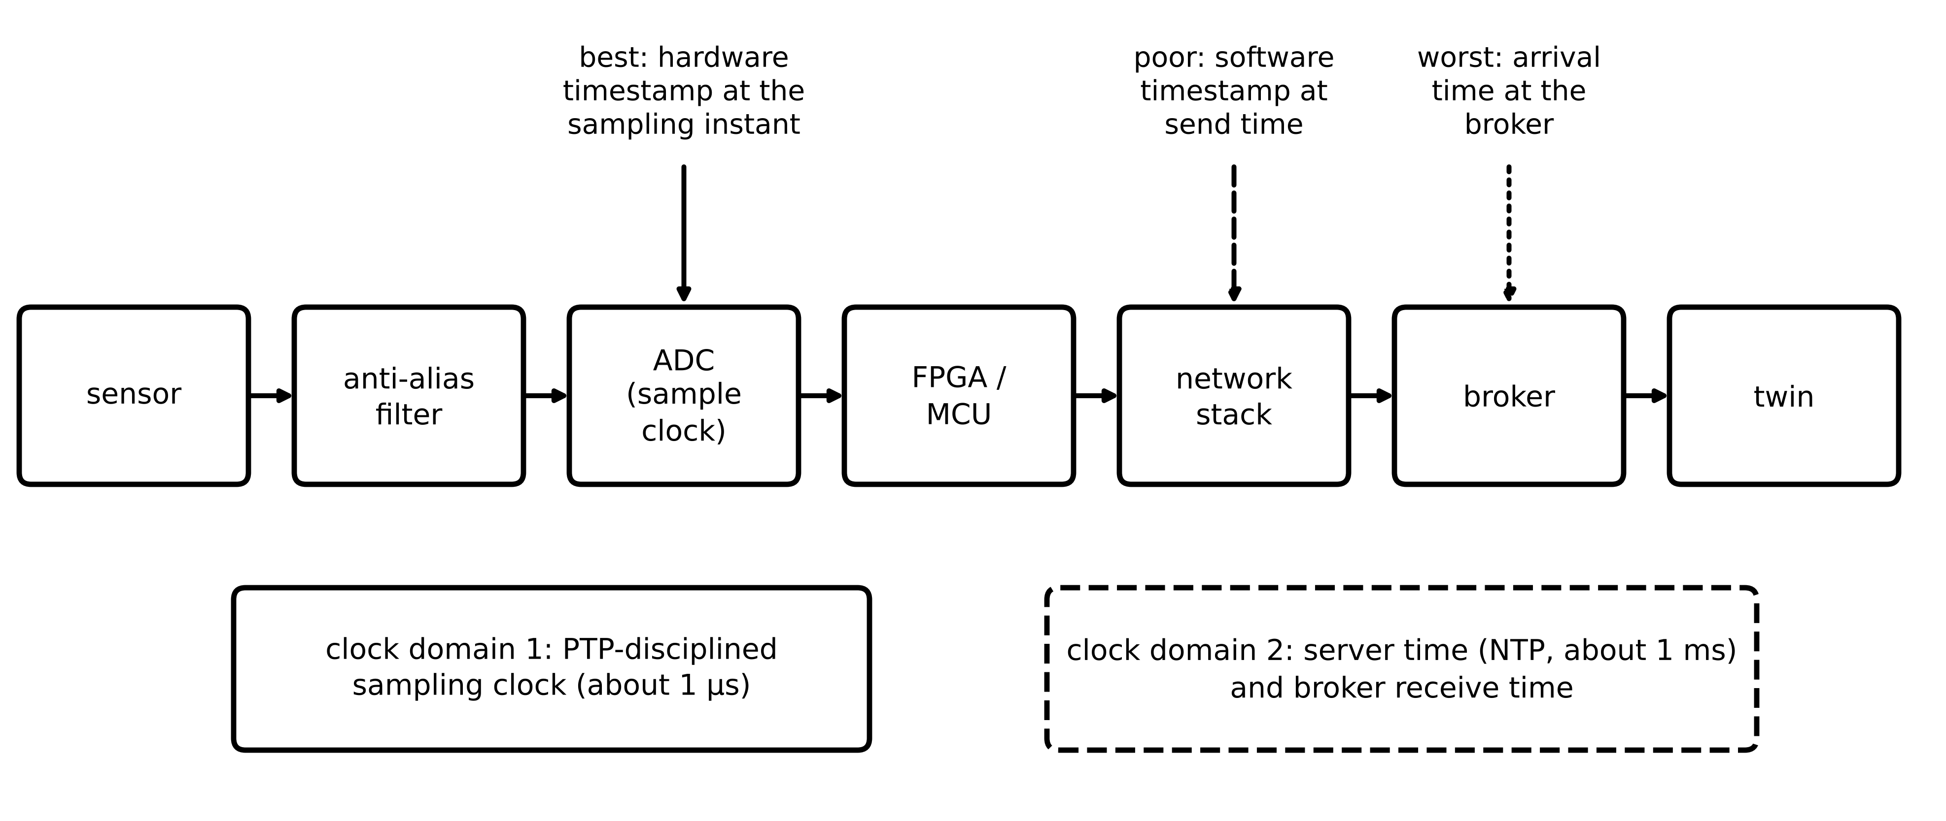
Figure 3.19. Where a timestamp can be taken. Only a hardware timestamp at the sampling instant, from a PTP-disciplined clock, places the sample correctly; software and arrival timestamps add processing and network delays from a second clock domain.
The Network Time Protocol (NTP) typically keeps software clocks within about a millisecond on a local network, enough for historians and slow thermal twins. The Precision Time Protocol (PTP) of IEEE 1588-2019 timestamps its messages in hardware at the network interface and reaches sub-microsecond agreement [14]. IEC/IEEE 61850-9-3:2016 defines the power-utility profile of PTP (Layer 2 transport, peer-to-peer delay measurement) that supports the 1 µs class needed by sampled values, differential protection and synchrophasors [15]; a second edition based on IEEE 1588-2019 is in development under an active IEEE project. IEEE 1588g-2022 introduced the optional terms timeTransmitter and timeReceiver for master and slave, now used by ITU-T and IEEE 802.1 [16]; this chapter keeps the older terms, which the 2016 utility profile still uses.

3.10.2 How PTP measures offset and delay
A master clock sends a Sync message at $t_{1}$ (master time), received by the slave at $t_{2}$ (slave time); the slave sends a Delay_Req at $t_{3}$, received by the master at $t_{4}$ (Figure 3.20). With $θ$ the slave's offset from the master and $d_{ms}$, $d_{sm}$ the one-way delays,
$t_{2}=t_{1}+d_{ms}+θ, t_{4}=t_{3}+d_{sm}-θ$ (3.35)
Two equations in three unknowns cannot be solved without an assumption. PTP assumes a symmetric path, $d_{ms}=d_{sm}=d$, and subtracting and adding the two equations gives
$\hat{θ}=\frac{\left(t_{2}-t_{1}\right)-\left(t_{4}-t_{3}\right)}{2}, \hat{d}=\frac{\left(t_{2}-t_{1}\right)+\left(t_{4}-t_{3}\right)}{2}$ (3.36)
If the path is not symmetric, substituting (3.35) into (3.36) shows the offset estimate is wrong by half the asymmetry:
$\hat{θ}-θ=\frac{d_{ms}-d_{sm}}{2}$ (3.37)
No exchange of timestamps can detect this error (Figure 3.21); it must be avoided by design (same fibre pair, transparent or boundary clocks that measure their own residence time) or calibrated; an IEEE 1588 amendment on latency and asymmetry calibration (P1588f) is in preparation. A transparent clock adds each message's residence time to a correction field, and the slave subtracts the sums $c_{ms}$, $c_{sm}$ before applying (3.36), removing switch queueing, the largest and most variable source of asymmetry. The slave's oscillator also runs at a slightly wrong rate; two successive Sync messages give the fractional frequency offset
$\hat{y}=\frac{\left(t_{2}^{′}-t_{2}\right)-\left(t_{1}^{′}-t_{1}\right)}{t_{1}^{′}-t_{1}}$ (3.38)
where primes mark the later message. The slave steers frequency with $\hat{y}$ and phase with $\hat{θ}$, a two-state tracking loop that Chapter 5 recognizes as a Kalman filter on clock offset and rate.
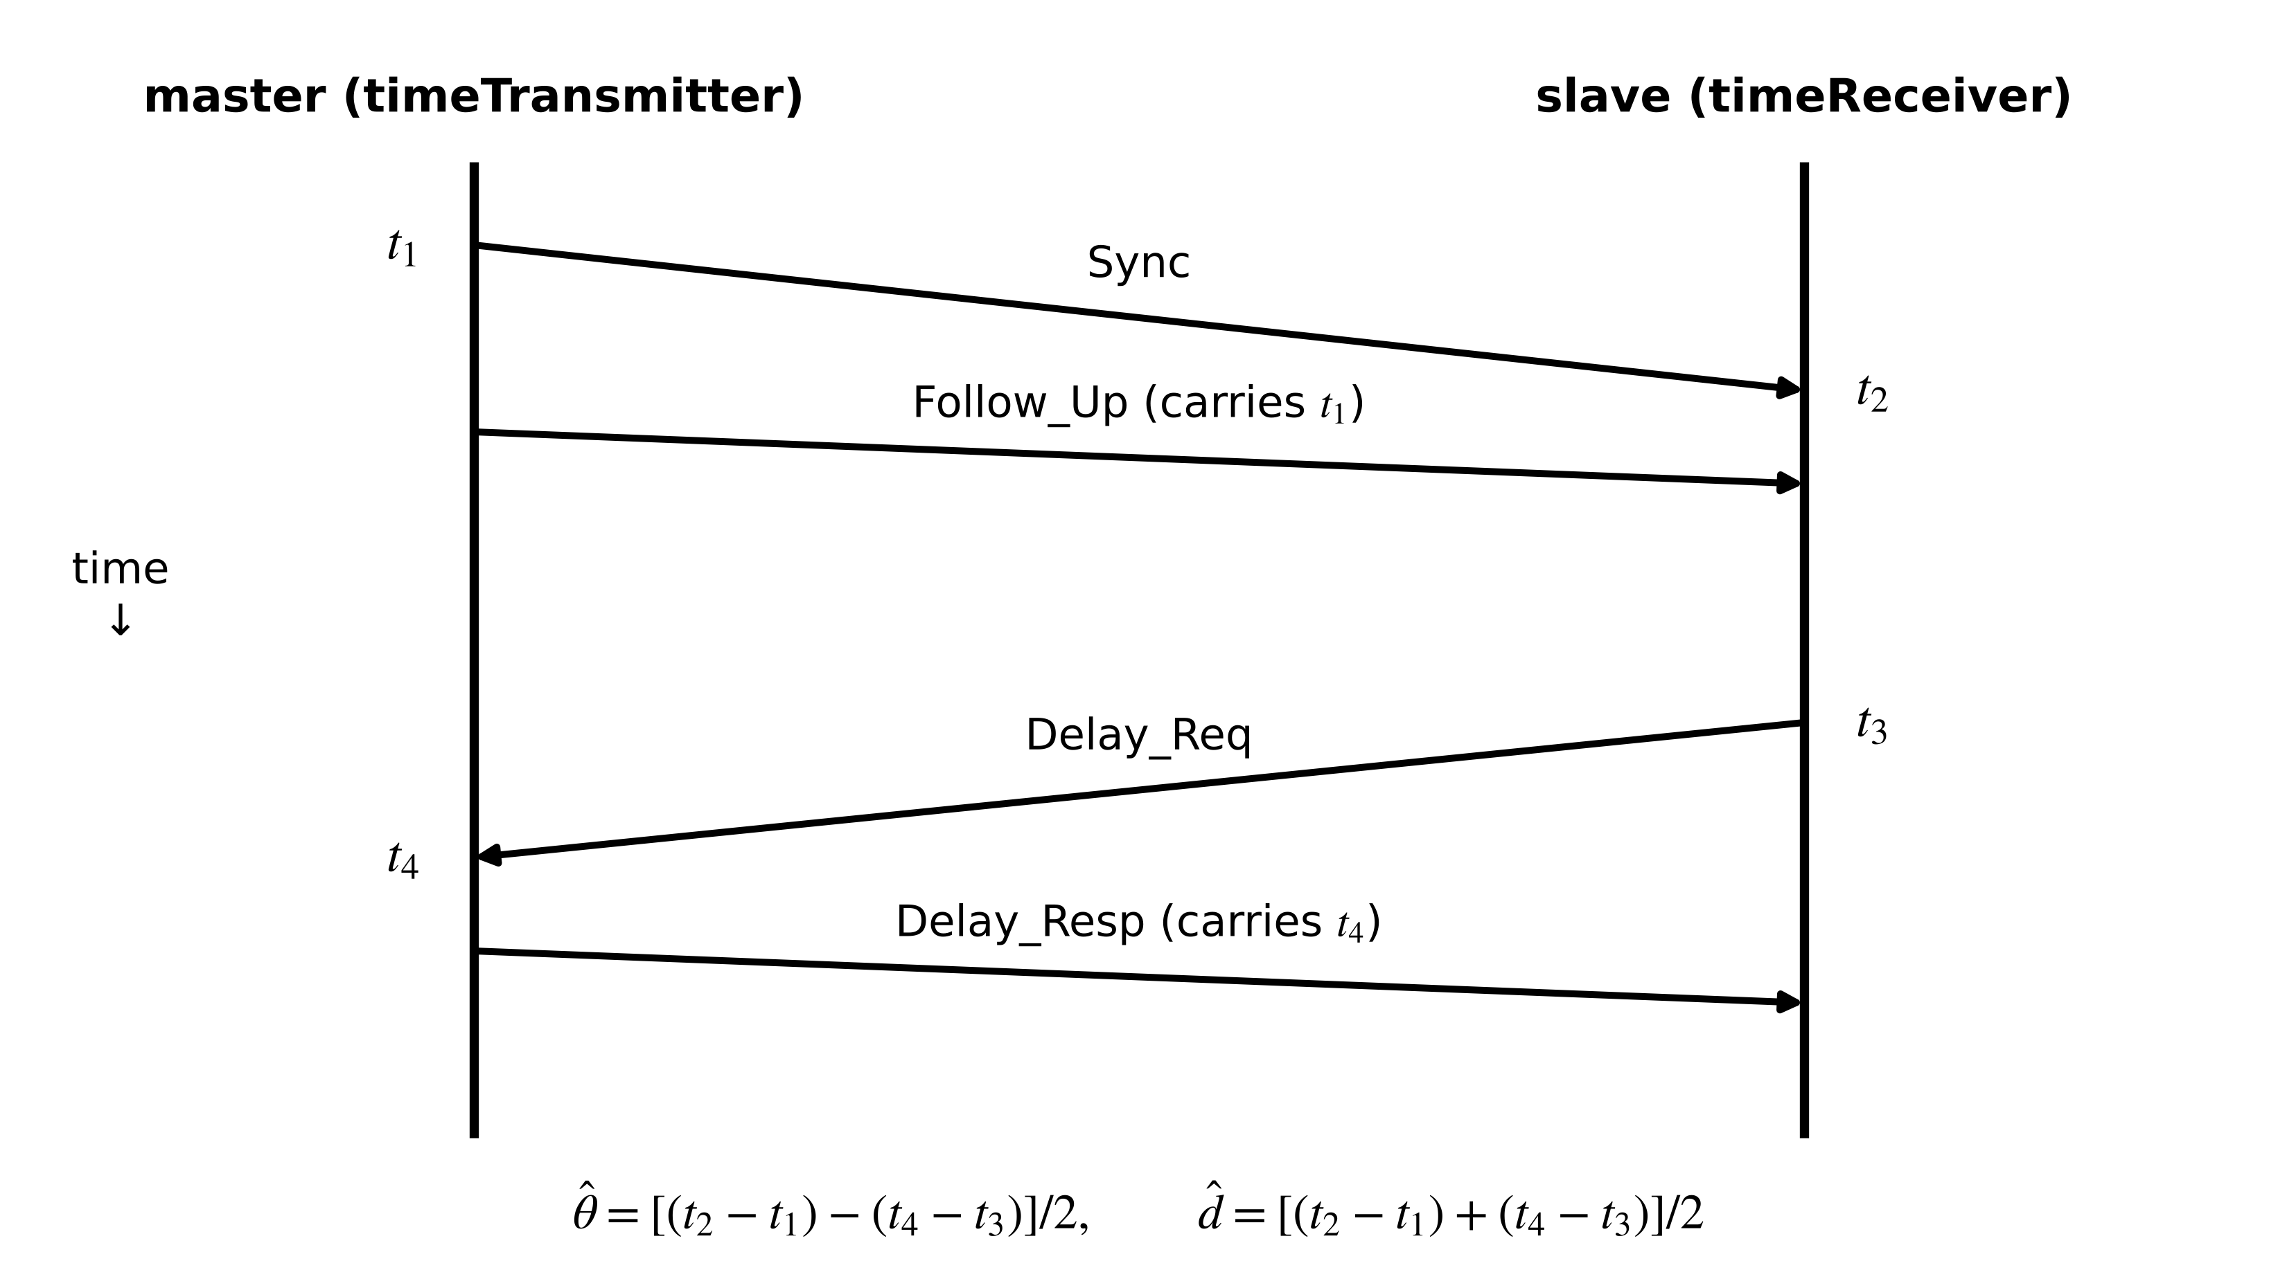
Figure 3.20. The PTP delay request-response exchange. The slave computes its offset and the mean path delay from the four timestamps.
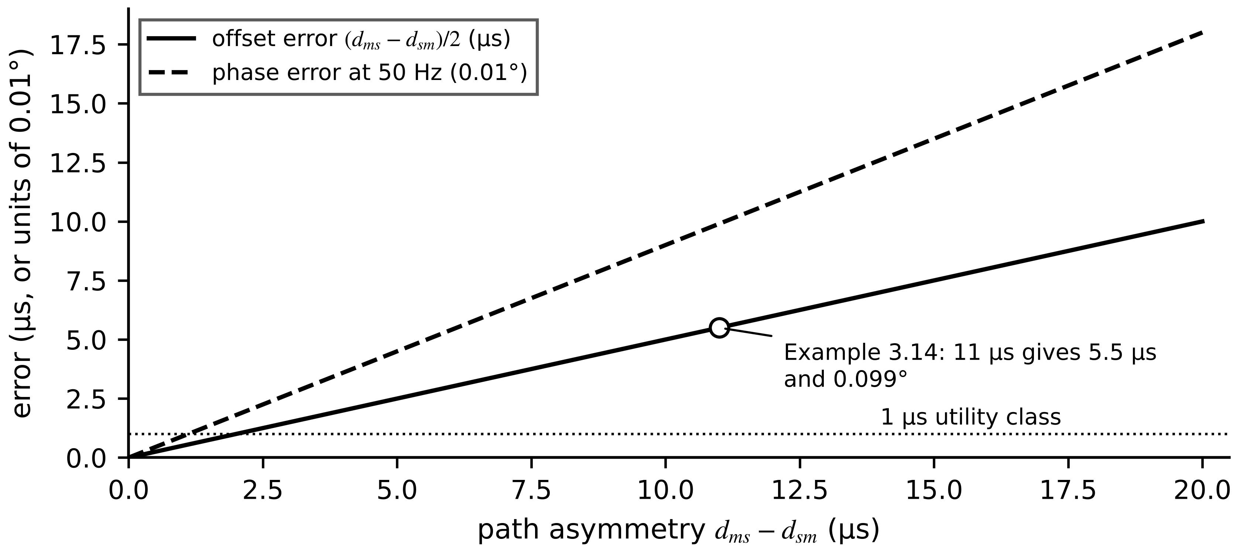
Figure 3.21. Offset error and resulting 50 Hz phase error against path asymmetry. The error is invisible to the protocol and grows linearly; 11 µs of asymmetry already exceeds the 1 µs class more than fivefold.
Example 3.14 (Level B) Clock offset and asymmetry for a substation measurement device
Given. $t_{1}=100.000000$ s, $t_{2}=100.000052$ s, $t_{3}=100.000801$ s, $t_{4}=100.000838$ s, each read on the clock that took it.
Find. (a) $\hat{d}$ and $\hat{θ}$. (b) The corrected time of a sample taken at slave time 100.001500 s. (c) The true offset if the forward delay is 50 µs and the reverse 39 µs, and the residual phase error at 50 Hz.
Solution. (a) $t_{2}-t_{1}=52$ µs, $t_{4}-t_{3}=37$ µs; $\hat{d}=44.5$ µs, $\hat{θ}=7.5$ µs (slave ahead). (b) $100.001500-0.0000075=100.0014925$ s. (c) From (3.37), the error is $(50-39)/2=5.5$ µs, so $θ=2.0$ µs (check: $52=50+θ$). Residual phase error $360×50×5.5×{10}^{-6}=0.099°$.
Interpretation. Asymmetry, not the protocol, usually limits PTP accuracy in the field. A tenth of a degree is harmless for a thermal twin and significant for a synchrophasor or a differential relay.

3.10.3 Holdover, GNSS dependency and phase error
Most PTP grandmasters take their time from a Global Navigation Satellite System (GNSS) receiver. When that reference is lost, by antenna failure, jamming or spoofing, the grandmaster continues on its own oscillator (holdover), and its time error grows as
$x(t)=x_{0}+y_{0}t+\frac{1}{2}Dt^{2}, σ_{y}^{2}\left(τ_{a}\right)=\frac{1}{2}𝔼\left[{\left({\overline{y}}_{k+1}-{\overline{y}}_{k}\right)}^{2}\right]$ (3.39)
where $x_{0}$ is the time error at loss of reference (s), $y_{0}$ the fractional frequency offset, $D$ the fractional frequency drift rate (s⁻¹) and $σ_{y}(τ_{a})$ the Allan deviation over averaging time $τ_{a}$, built from successive fractional-frequency averages ${\overline{y}}_{k}$; it stays finite for the drifting noise of oscillators and is how data sheets state holdover performance. Neglecting drift, a 1 µs budget lasts $1 μs/y_{0}$: about 10 s for a temperature-compensated crystal ($y_{0}={10}^{-7}$), about 17 min for an oven-controlled crystal (${10}^{-9}$), and about 55 h for rubidium ($5×{10}^{-12}$) (Figure 3.22). Utilities therefore add holdover oscillators, multiple constellations and terrestrial time over fibre, a resilience concern that national policy, such as the United States Executive Order 13905 on positioning, navigation and timing, has made explicit [17].
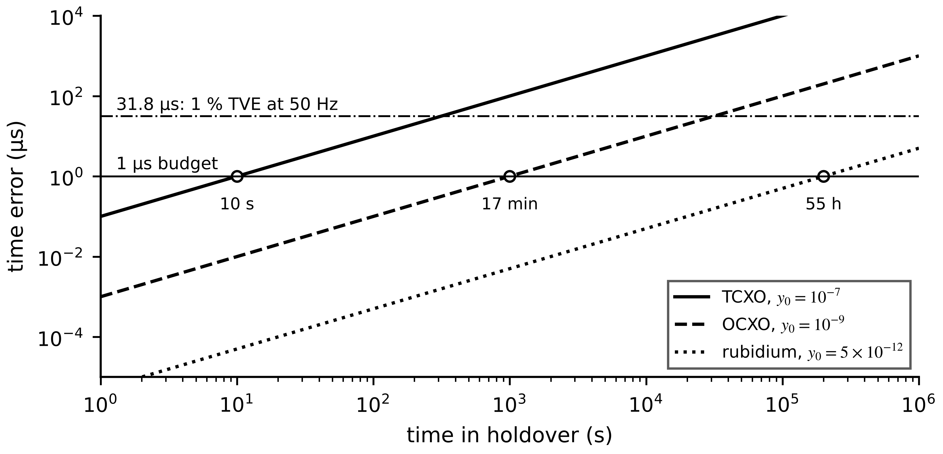
Figure 3.22. Time error during holdover for three oscillator classes (log scales), with the 1 µs power-utility budget and the 31.8 µs that alone produces 1 % total vector error at 50 Hz.
A time error $δt$ rotates a phasor by $2πf_{0}δt$. Synchrophasor accuracy is specified as total vector error (TVE), with 1 % the usual steady-state limit in IEC/IEEE 60255-118-1 [18]. Writing the estimated phasor as the true one scaled by $(1+ε)$ and rotated by $δφ$,
$TVE=\frac{\left|\hat{X}-X\right|}{|X|}=\sqrt{(1+ε)^{2}+1-2(1+ε)cosδφ}≈\sqrt{ε^{2}+δφ^{2}}$ (3.40)
where $\hat{X}$ and $X$ are the estimated and true phasors, $ε$ the relative magnitude error and $δφ$ the phase error in radians. For a pure phase error TVE ≈ $|δφ|$, so 1 % corresponds to 0.573°, or 31.8 µs at 50 Hz.
Example 3.15 (Level A) How long can a grandmaster hold the 1 µs class?
Given. An oven-controlled oscillator enters holdover with $x_{0}=0$, $y_{0}={10}^{-9}$ and an ageing drift of ${10}^{-10}$ per day. A PMU also has a 0.5 % magnitude error.
Find. (a) The time to reach 1 µs from (3.39), with and without drift. (b) The TVE once the time error reaches 10 µs.
Solution. (a) $D={10}^{-10}/86 400=1.16×{10}^{-15}$ s⁻¹; solving ${10}^{-9}t+0.5Dt^{2}={10}^{-6}$ gives $t=999$ s; without drift exactly 1000 s, about 17 min. (b) $δφ=2π×50×{10}^{-5}=3.14×{10}^{-3}$ rad; TVE $≈\sqrt{{0.005}^{2}+{0.00314}^{2}}=0.59$ %.
Interpretation. A crystal holds the utility class for minutes, not hours; any GNSS outage longer than that degrades every synchronized measurement in the plant unless a better oscillator or a second time source is present. The twin must carry the clock's quality flag with every sample.

3.10.4 Jitter and packet loss
Jitter is the variability of delay, quantified by a standard deviation or, for tails, by percentiles (Chapter 2). Packet loss removes samples. Real links lose packets in bursts, which the Gilbert-Elliott model represents as a two-state Markov chain [19]: from a good state the link enters a bad, lossy state with probability $p$ per packet and leaves it with probability $r$. Balancing the flows between states and noting that a burst ends at each step with probability $r$,
$π_{B}=\frac{p}{p+r}, P\left(L_{burst}=l\right)=r(1-r)^{l-1}, {\overline{L}}_{burst}=\frac{1}{r}$ (3.41)
where $π_{B}$ is the long-run fraction of time in the bad state and ${\overline{L}}_{burst}$ the mean burst length. Two links with the same average loss can behave very differently: isolated losses are harmless to an estimator, whereas one long burst leaves it without data exactly when a transient may occur.
What the digital twin adds
Synchronized: samples on one timescale, with a stated time quality.
Estimated or updated: clock offset, path delay and frequency; holdover time error.
Uncertainty carried: asymmetry bias, holdover growth, phase error and TVE, loss bursts.
Decision enabled: time source, oscillator class and transparent clocks per function.
Validated by: asymmetry calibration, holdover tests and time-quality monitoring.

3.11 Wired communication as message flows
A protocol is chosen for a function, and the function is judged by how its messages flow and how long they take. Three questions decide: must the delivery time be bounded by design, or is typical behaviour enough; must the data carry its own meaning (Chapter 2, Section 2.6); and what security does the protocol support.

3.11.1 Polling: Modbus
A Modbus master queries slaves one at a time [20]. Each exchange is a request, a turnaround and a response separated by silent gaps, so for $n$ devices on a serial line
$T_{poll}=\sum_{i=1}^{n}{\left(T_{req,i}+T_{turn,i}+T_{resp,i}+2T_{gap}\right)}, T_{char}=\frac{11}{B_{d}}, T_{gap}=3.5 T_{char}$ (3.42)
where $B_{d}$ is the baud rate and a character is 11 bits (start, 8 data, parity, stop). Each device gets a fresh value only once per cycle, so the polling cycle sets a floor on packet age.
Example 3.16 (Level A) Polling the Plant P-1 PV string monitors
Given. Twenty string monitors on one RS-485 line at 19 200 baud. Each poll: 8-byte request, 25-byte response, 5 ms turnaround.
Find. The polling cycle and the maximum update rate per monitor.
Solution. $T_{char}=0.573$ ms. Request 4.58 ms; response 14.32 ms; gaps $2×3.5×0.573=4.01$ ms; turnaround 5 ms; per monitor 27.9 ms; $T_{poll}=558$ ms, at most 1.8 updates per second.
Interpretation. Adequate for 1 Hz string monitoring with little reserve. Twenty more monitors, or more registers, break it; Modbus TCP removes the serial bottleneck but keeps the polling structure.

3.11.2 Priority arbitration: CAN, CAN FD and CAN XL
On a CAN bus every node may transmit when the bus is idle; simultaneous transmissions are resolved bit by bit on the identifier, because a dominant 0 overwrites a recessive 1 on the wired-AND bus (Figure 3.23). A node that sends recessive and reads dominant has lost and stops; the lowest identifier wins without being corrupted. Every node must see every dominant bit within one bit time, which limits bus length; with sample point at fraction $s_{p}$ of the bit,
$2\left(\frac{ℓ_{bus}}{v_{c}}+t_{node}\right)≤s_{p} τ_{bit} ⇒ ℓ_{bus}≤\frac{v_{c}}{2}\left(s_{p}τ_{bit}-2t_{node}\right)$ (3.43)
where $v_{c}≈2×{10}^{8}$ m/s is the cable signal speed, $t_{node}$ the transceiver and controller delay and $τ_{bit}$ the bit time: about 120 m at 500 kbit/s with the sample point at 80 % of the bit and a node delay of 200 ns, or 135 m with the sample point at 87.5 %. CAN FD and CAN XL (ISO 11898-1:2024 [21]) switch to a faster bit rate after arbitration and carry up to 64 and 2048 data bytes. With bit stuffing a Classical CAN frame with an 11-bit identifier and $s$ data bytes is at most $L_{max}$ bits long, and the worst-case response time of message $m$ follows from response-time analysis [22]:
$L_{max}=8s+47+\left\lfloor \frac{34+8s-1}{4}\right\rfloor , R_{m}=J_{m}+w_{m}+C_{m}, w_{m}=B_{m}+\sum_{j∈hp(m)}{\left\lceil \frac{w_{m}+J_{j}+τ_{bit}}{T_{j}}\right\rceil }C_{j}$ (3.44)
where $C=L_{max}τ_{bit}$ is a frame's transmission time, $J$ the queueing jitter, $T$ the period, $B_{m}$ the longest lower-priority frame already on the bus and $hp(m)$ the higher-priority messages; the recurrence is iterated from $w_{m}=B_{m}$ and converges only if the bus load $\sum{C_{i}}/T_{i}<1$, practically below 0.5.
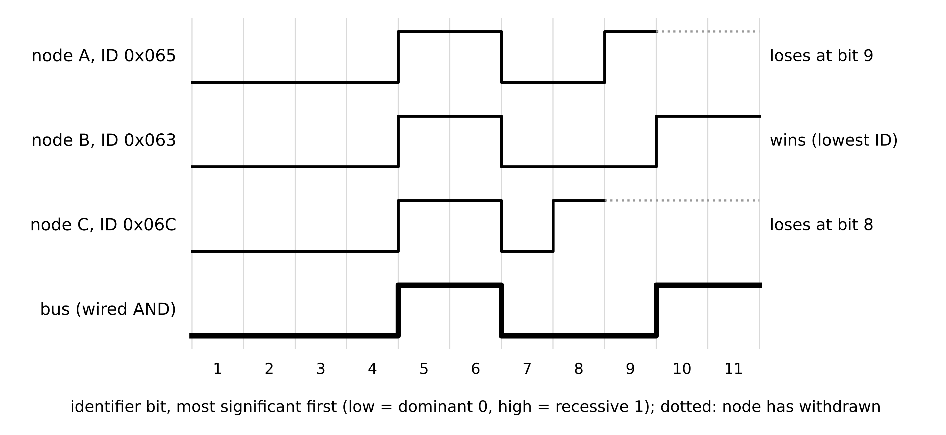
Figure 3.23. CAN bitwise arbitration. Three nodes start sending identifiers together; the bus carries the logical AND. Each node that sends a recessive 1 and reads a dominant 0 withdraws; the lowest identifier completes undisturbed.
Example 3.17 (Level A) Worst-case latency of a BMS alarm on CAN
Given. The Plant P-1 BMS bus runs Classical CAN at 500 kbit/s; all frames carry 8 data bytes. The cell over-voltage alarm has the highest priority but can be blocked by one lower-priority frame already being sent; zero jitter.
Find. $L_{max}$, $C$ and the alarm's worst-case response time.
Solution. $L_{max}=64+47+⌊97/4⌋=135$ bits; $C=270$ µs; with no higher-priority messages, $w=B=270$ µs and $R=540$ µs.
Interpretation. The bound holds however heavily the bus is loaded, which no polled or broker-based protocol can offer.

3.11.3 IEC 61850: MMS, GOOSE and sampled values
IEC 61850 defines three services with very different message flows (Figure 3.24) [23]. MMS is client-server over TCP/IP for configuration, reports and control, with typical rather than bounded delay. GOOSE multicasts events directly on Ethernet and repeats each new event at a growing interval, so a lost frame is soon replaced. With first repetition $T_{0}$ doubling to a heartbeat $T_{max}$, and independent frame loss $p_{f}$, an event is lost by time $t$ only if every copy sent so far is lost; the fastest trip messages fall in a 3 ms transfer-time class [24]. Sampled values (SV) stream digitized waveforms from merging units, whose bandwidth is
$T_{n}=min\left(T_{0} 2^{n}, T_{max}\right), P_{lost}\left(t\right)=p_{f}^{ n\left(t\right)}, B_{SV}=\frac{f_{SV}}{n_{ASDU}}×8L_{SV}$ (3.45)
where $n(t)$ is the number of copies sent by time $t$, $f_{SV}$ the sampling rate, $n_{ASDU}$ the samples packed per frame and $L_{SV}$ the frame length in bytes. With $T_{0}=2$ ms, copies leave at 0, 2, 6 and 14 ms; with $p_{f}=0.01$ four copies give ${10}^{-8}$, a best case since losses on a congested switch are correlated. At 4800 SPS with two samples per frame of about 250 bytes, one merging unit sends about 4.8 Mbit/s.
Figure 3.24. IEC 61850 message map. MMS reports and control run client-server on the station bus; GOOSE events are multicast between IEDs with repetition; sampled values stream from merging units on the process bus.

3.11.4 MQTT, Sparkplug and OPC UA
MQTT is a lightweight publish-subscribe protocol through a broker, standardized as ISO/IEC 20922 for version 3.1.1 [25]. A publisher sends to a topic; the broker forwards to subscribers (Figure 3.25). Three quality-of-service levels define the message flow: QoS 0 sends once with no acknowledgement; QoS 1 repeats until a PUBACK arrives, so duplicates are possible; QoS 2 uses a four-message handshake for exactly-once delivery at the cost of two round trips. Retained messages and a ‘last will’ let a twin see the last value and learn that a device has gone silent. MQTT fixes neither topics nor payloads; Sparkplug 3.0, published as ISO/IEC 20237:2023, adds an industrial topic namespace, payload encoding and session-state management [26]. Timing is typical, not bounded.
OPC UA (IEC 62541) combines a typed information model with client-server sessions secured by certificates and with publish-subscribe transports over UDP, MQTT or Time-Sensitive Networking [27]. In client-server mode a client creates monitored items and subscriptions and receives notifications; in PubSub mode a publisher sends datasets without a session, which is faster and scales to many readers. The OPC UA FX (field exchange) specifications extend it to controller-to-controller and field-level communication with deterministic transport over TSN [28] (emerging). Time-Sensitive Networking (TSN), consolidated in IEEE 802.1Q, adds scheduled transmission windows and shaping so that critical streams receive bounded latency on shared links [29].
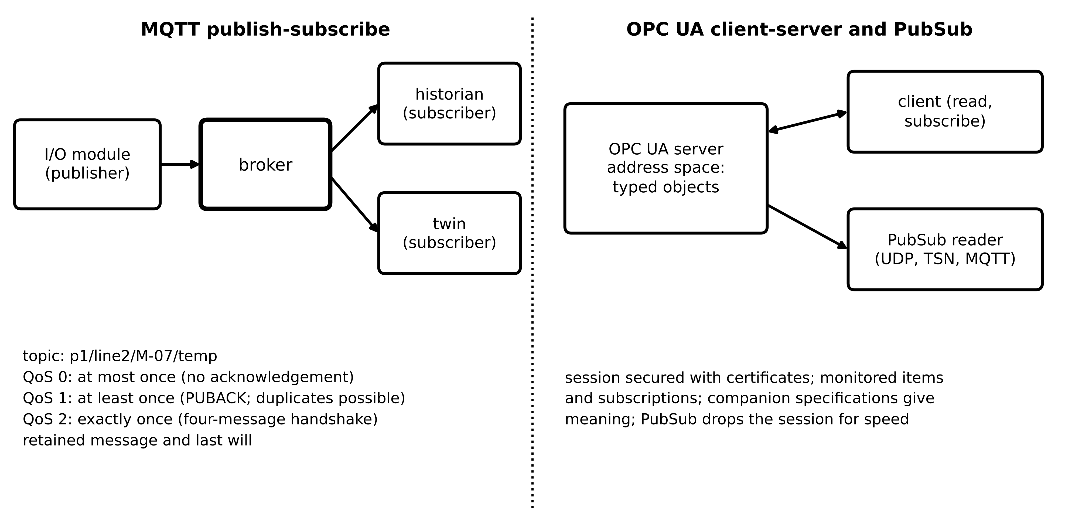
Figure 3.25. Left: MQTT publish-subscribe through a broker, with the three QoS levels. Right: OPC UA client-server sessions and PubSub datasets from one address space.
Table 3.4. Function-based protocol selection compared by timing, semantics, security and use
Function | Protocol | Delay: bounded or typical | Semantics | Security | Limitation
Protection trip between IEDs | IEC 61850 GOOSE | bounded on engineered LAN (3 ms class) | IEC 61850 data model | IEC 62351-6 | LAN-only multicast
Instrument-transformer waveforms | IEC 61850 SV (IEC 61869-9) | bounded on dedicated process bus | IEC 61850 data model | IEC 62351-6 | about 5 Mbit/s per merging unit
Substation reporting and control | IEC 61850 MMS | typical (TCP) | IEC 61850 data model | IEC 62351-4 | not for fast paths
BMS and converter-internal | CAN / CAN FD / CAN XL | bounded by (3.44) | application-defined | higher-layer add-ons | bus length (3.43)
Legacy devices | Modbus RTU / TCP | bounded cycle (serial) (3.42); typical over TCP | registers only | none natively | polling floor on age
Plant integration | OPC UA (client-server, PubSub, FX) | typical; bounded over TSN | rich information model | built in (certificates) | engineering effort
Telemetry to historian and cloud | MQTT (+ Sparkplug) | typical | payload-defined (Chapter 2) | TLS, broker authentication | broker on the path
Mixed critical and non-critical Ethernet | TSN (IEEE 802.1Q) | bounded for scheduled streams | transport only | transport only | configuration complexity
Time distribution | PTP (IEEE 1588, IEC/IEEE 61850-9-3) | accuracy target about 1 µs | n/a | IEEE 1588-2019 options | asymmetry, GNSS dependency

What the digital twin adds
Synchronized: messages whose delivery time is bounded where the function needs it.
Estimated or updated: polling cycles, worst-case CAN responses, GOOSE loss probability, SV bandwidth.
Uncertainty carried: typical versus bounded delay, loss behaviour per protocol.
Decision enabled: protocol per function from Table 3.4.
Validated by: protocol analyzers, conformance tests and timing campaigns.

3.12 Wireless connectivity

3.12.1 The link budget
A radio link closes when the received power exceeds the receiver's sensitivity by a margin that covers fading (Figure 3.26). In free space the transmitted power spreads over a sphere of area $4πd^{2}$, and a receiving antenna of gain $G_{r}$ captures it through an effective aperture $G_{r}λ^{2}/(4π)$. Multiplying the power density by the aperture gives the Friis equation, and in decibels the budget, with distance in km and frequency in GHz, reads
$P_{r}=P_{t}G_{t}G_{r}{\left(\frac{λ}{4πd}\right)}^{2}, P_{r,dBm}=P_{t}+G_{t}+G_{r}-L(d), L_{fs}=20\log_{10}d+20\log_{10}f+92.45$ (3.46)
where $P_{t}$ is the transmit power (dBm), $G_{t}$, $G_{r}$ the antenna gains (dBi) and $λ=c/f$ the wavelength. Near the ground, among buildings and vegetation, power falls faster than in free space; the log-distance model with shadowing, the outage probability for a fade margin $M$, and the thermal-noise-limited sensitivity are
$L(d)=L_{fs}\left(d_{0}\right)+10n_{p}\log_{10}\frac{d}{d_{0}}+X_{σ}, P_{out}=Q\left(\frac{M}{σ}\right), P_{sens}=-174+10\log_{10}B_{w}+NF+{SNR}_{min}$ (3.47)
where $d_{0}$ is a reference distance, $n_{p}$ the path-loss exponent (2 in free space, 2.7 to 3.5 in rural and suburban terrain), $X_{σ}$ zero-mean normal shadowing with standard deviation $σ$ (6 to 10 dB) [30], $Q$ the standard normal tail, $-174$ dBm/Hz the thermal noise density at 290 K, $B_{w}$ the bandwidth (Hz), $NF$ the noise figure and ${SNR}_{min}$ the demodulation threshold (dB). Shannon's capacity $C=B_{w}\log_{2}(1+SNR)$ explains why demodulation below the noise floor is possible only at tiny bit rates.
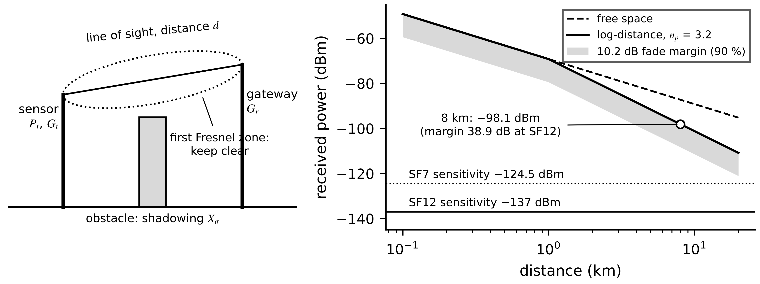
Figure 3.26. Left: link geometry with line of sight, first Fresnel zone and a shadowing obstacle. Right: received power against distance for the LoRaWAN link of Example 3.18, free space and log-distance ($n_{p}=3.2$), with the 90 % fade-margin band and the SF7 and SF12 receiver sensitivities.
Example 3.18 (Level B) A LoRaWAN sensor on a remote feeder
Given. A line-monitoring sensor 8 km from its gateway transmits at 866 MHz with $P_{t}=14$ dBm and $G_{t}=2$ dBi; $G_{r}=6$ dBi. Spreading factor 12, 125 kHz, noise figure 6 dB, ${SNR}_{min}=-20$ dB. Terrain: $n_{p}=3.2$ beyond $d_{0}=1$ km, $σ=8$ dB.
Find. (a) Sensitivity. (b) Received power in free space and with (3.47). (c) Margin and outage probability; fade margin for 90 % location reliability. (d) Shannon capacity at the threshold SNR.
Solution. (a) $-174+51.0+6-20=-137$ dBm. (b) Free space: $L=18.06-1.25+92.45=109.3$ dB, $P_{r}=-87.3$ dBm. Log-distance: $L(1)=91.2$ dB, $L=91.2+32\log_{10}8=120.1$ dB, $P_{r}=-98.1$ dBm. (c) Margin 38.9 dB; $Q(38.9/8)≈6×{10}^{-7}$; 90 % needs only $1.28×8=10.2$ dB. (d) $125 000\log_{2}(1.01)=1.8$ kbit/s; LoRa at SF12 delivers about 0.3 kbit/s.
Interpretation. Free space was 11 dB optimistic and the realistic link still closes comfortably. The real constraint is time on air: about 1.3 s per 20-byte message at SF12, so under a 1 % duty cycle the sensor may send one message about every 130 s, each carrying a handful of values. LoRaWAN suits sparse, slow line monitoring, not waveforms or control.

3.12.2 What is deployed and what is not
Table 3.5. Wireless connectivity for twins by maturity (latency figures are typical or target values, not guarantees)
Technology | Status | Typical latency | Data rate | Role | Limitation
Wi-Fi 6 / 7 (IEEE 802.11ax/be) | established | ms to tens of ms, load dependent | high | site telemetry, commissioning | contention, interference
Bluetooth Low Energy | established | tens of ms | low | handheld readout | short range
WirelessHART, ISA100.11a | established (process industry) | hundreds of ms to s | low | slow condition monitoring | scheduled mesh, low rate
LoRaWAN | established | seconds (0.06 to 1.3 s on air) | very low | sparse line and asset monitoring | duty cycle
NB-IoT, LTE-M | established (operators) | hundreds of ms to s | low | metering, remote assets | operator dependence
4G / 5G broadband | established | tens of ms | high | backhaul to cloud | not bounded
5G URLLC (Release 15 on) | emerging (pilots) | targets: 0.5 ms average; 1 ms at 99.999 % | moderate | pilots; not sole protection path | verified worst case scarce
6G | research-stage | research targets below 1 ms | n/a | none deployed | pre-standard

The 5G ultra-reliable low-latency communication (URLLC) service class introduced with 3GPP Release 15 has design targets of 0.5 ms average user-plane latency in each direction and, separately, a reliability of $1−{10}^{−5}$ for a 32-byte packet delivered within 1 ms [31]; a given private or public network delivers what its configuration, load and radio conditions allow. Sub-millisecond, microsecond-jitter figures associated with 6G are research targets [32]. A specification written today should not assume either for a protective function.
What the digital twin adds
Synchronized: wireless samples whose link closes with a stated outage probability.
Estimated or updated: received power, margin, sensitivity and time on air.
Uncertainty carried: shadowing, loss bursts and typical rather than bounded delay.
Decision enabled: which assets may use radio and for which functions.
Validated by: site surveys and long-run delivery statistics.

3.13 Data quality and validation before the estimator

3.13.1 Quality semantics
The estimators of Chapter 1 and Chapter 5 treat every sample as the true value plus zero-mean noise of known variance. In its scalar form the Kalman filter alternates a prediction and an update [33]:
${\hat{x}}_{k}^{-}=a{\hat{x}}_{k-1}+bu_{k-1}, P_{k}^{-}=a^{2}P_{k-1}+Q; K_{k}=\frac{P_{k}^{-}}{P_{k}^{-}+R_{k}}, {\hat{x}}_{k}={\hat{x}}_{k}^{-}+K_{k}\left(y_{k}-{\hat{x}}_{k}^{-}\right), P_{k}=\left(1-K_{k}\right)P_{k}^{-}$ (3.48)
where ${\hat{x}}^{-}$ and $P^{-}$ are the predicted state and variance, $a$ and $b$ the discrete model coefficients, $u$ the input, $Q$ the process-noise variance, $R_{k}$ the measurement-noise variance of sample $k$ and $K_{k}$ the gain. Everything in this section acts on $R_{k}$, or on whether the update happens at all; the prediction always runs, which is why the filter survives missing data.
Field data break the assumption in recognizable ways, so each sample travels with a quality description. IEC 61850-7-3 defines one that many twins can adopt directly [34]: a validity of good, questionable or invalid; detail flags such as overflow, out of range, bad reference, oscillatory, failure, old data, inconsistent and inaccurate; a source of process or substituted (a value entered by a person or another function rather than measured); a test flag for values produced during testing; and operator blocked. Together with the time quality of Section 3.10, these fields decide what happens to a sample (Figure 3.27). A good sample updates the twin with its normal $R_{k}$; a questionable one updates it with an inflated variance; an invalid one does not update it at all, and the reason is logged.
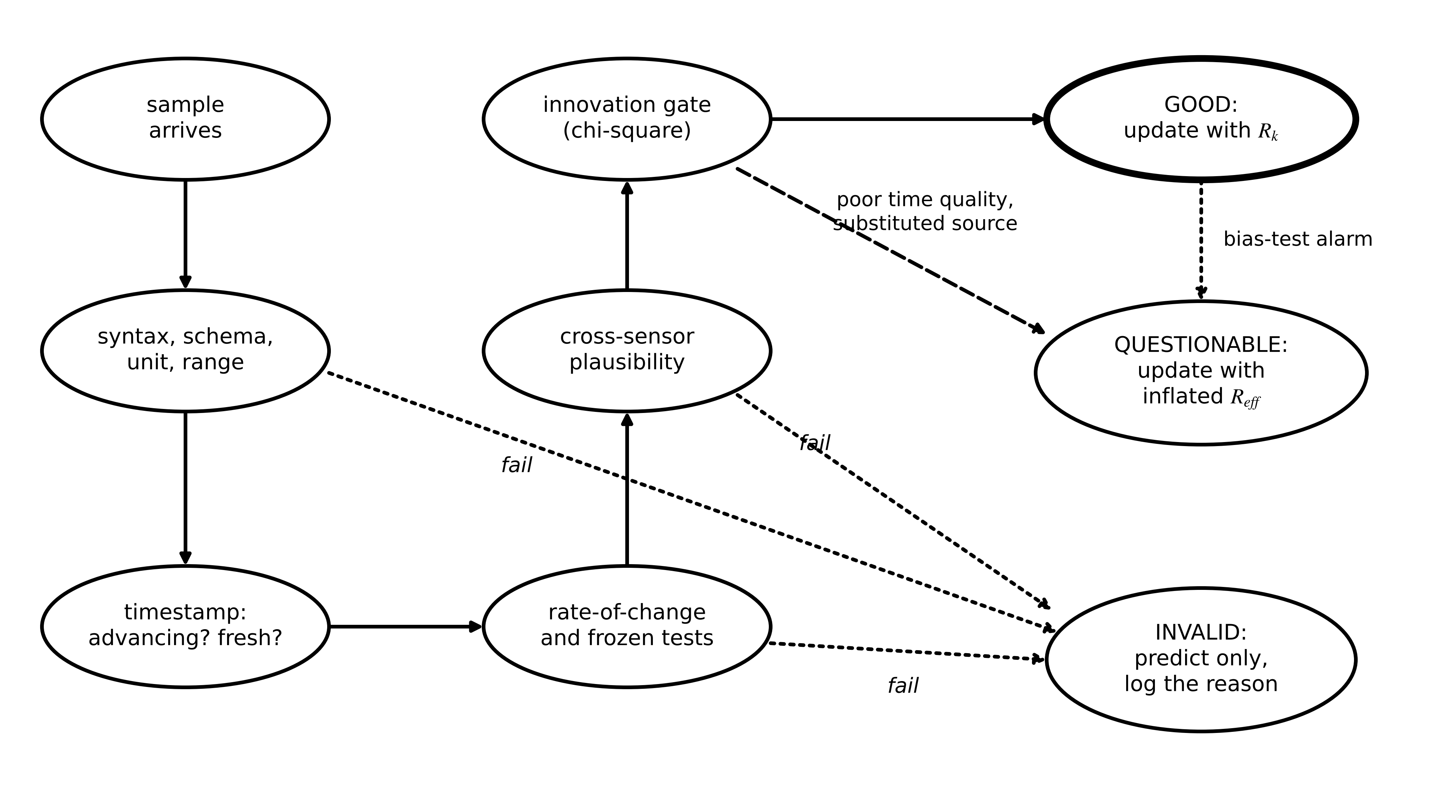
Figure 3.27. Data-quality validation as a state machine. Each sample passes syntax and range, timestamp, rate and frozen, plausibility and innovation tests in turn; the outcome is GOOD (normal update), QUESTIONABLE (update with inflated variance) or INVALID (predict only), and a persistent bias test can demote a stream.
Table 3.6. Data-quality failures, their signatures, tests and actions
Failure | Signature | Test | Action
Missing data | no sample in the expected slot | sequence number or time gap | predict only; covariance grows
Out of order | timestamp older than the last used | $t_{s,k}≤t_{last}$ | reorder within a buffer window or discard
Frozen or stale | timestamp or value stops changing | timestamp not advancing; window variance below noise floor | discard; alarm after a stated age
Spike | jump beyond physical rate | (3.49) | discard
Out of range, saturation | values at a rail or outside rating | range check; fraction near full scale | invalid, or censored ($≥$ limit)
Substituted or test | source or test flag set | quality bits | exclude from calibration; use only if stated
Clock drift, poor time quality | growing gap between device and receive time | slope of $t_{rx}-t_{s}$; time-quality field | inflate $R$ with (3.50)
Cross-sensor inconsistency | sensors of one quantity disagree | $|x_{i}-x_{j}|>3\sqrt{u_{i}^{2}+u_{j}^{2}}$ | isolate the outlier before fusion
Manipulated data | plausible values inconsistent with the model | gate (3.51), bias test (3.52) | stop updates, alarm (Chapter 14)

The rate check must allow for noise or it rejects valid samples. For two samples $Δt$ apart with noise $σ_{v}$ each and a physical rate bound $ρ_{max}$,
$\left|y_{k}-y_{k-1}\right|≤ρ_{max}Δt+3\sqrt{2} σ_{v}$ (3.49)
where $3\sqrt{2}σ_{v}$ covers the difference of two noisy samples at about three standard deviations.

3.13.2 Inflating uncertainty instead of pretending
When a sample is usable but less trustworthy, the right response is to tell the estimator by enlarging $R$, not to use it at full weight or to discard it. A value with timestamp standard uncertainty $σ_{t}$ on a signal changing at rate $\dot{y}$ carries an extra error $\dot{y}σ_{t}$; a value of age $a$ used without a model, for a quantity that drifts like a random walk of intensity $q$ (units² per second), loses confidence linearly in variance; and a value interpolated linearly across a gap of length $G$ has the variance of a Brownian bridge at time $τ$ into the gap:
$R_{eff}=σ_{v}^{2}+{\left(\dot{y}σ_{t}\right)}^{2}, R_{eff}(a)=σ_{v}^{2}+q a, u^{2}(τ)=u_{meas}^{2}+q\frac{τ(G-τ)}{G}$ (3.50)
The interpolation term is zero at the ends of the gap and largest, $qG/4$, in the middle. A Kalman filter does the equivalent automatically by predicting through the gap, which is why it should never be fed interpolated values.
Gating and bias tests. Before each update the filter compares the sample with its own prediction. With innovation $ν_{k}=y_{k}-H{\hat{x}}_{k}^{-}$ and innovation covariance $S_{k}=HP_{k}^{-}H^{⊤}+R_{k}$, the normalized innovation squared is tested against a chi-square quantile [35]:
$ε_{k}=ν_{k}^{⊤}S_{k}^{-1}ν_{k}≤χ_{m,1-α}^{2}, 𝔼\left[ε_{k}\right]=m$ (3.51)
where $m$ is the number of measured components and $α$ the false-rejection probability; for a scalar at $α=0.01$ the threshold is 6.63. The second relation is a health check on the filter itself: a long-run average of $ε_{k}$ well above $m$ means the filter is overconfident. A gate stops single wild values; it does not stop a manipulation that stays inside the gate at every step, such as a slow injected drift [36]. A windowed bias test on normalized innovations, and its sequential refinement, the cumulative-sum (CUSUM) test [37], catch that case:
$z_{W}=\frac{1}{\sqrt{W}}\sum_{i=k-W+1}^{k}{\frac{ν_{i}}{\sqrt{S_{i}}}}, \left|z_{W}\right|>h; g_{k}^{+}=max\left(0,g_{k-1}^{+}+\frac{ν_{k}}{\sqrt{S_{k}}}-κ\right), g_{k}^{+}>h_{c}$ (3.52)
where $W$ is the window length, $h$ and $h_{c}$ thresholds and $κ$ a reference value, typically half the shift to be detected. NIST IR 8356 lists manipulation of a twin's synchronization data among the threats specific to twins [38]; Chapter 14 treats it in depth, and Box 3.2 quantifies the detection delay and false-alarm rate of the CUSUM test.
Box 3.1 Missing data is not always missing at random
Interpolating across gaps, or ignoring them, assumes the data are missing completely at random: the probability of a gap does not depend on the value that would have been measured [39]. Energy systems violate this regularly. A wireless link on a wind turbine drops out most at high wind and high load; a merging unit's network saturates during a fault; a PV gateway loses power in the same grid outage it should record. Data then go missing in exactly the conditions a diagnostic twin exists to observe, and statistics from the remaining data are biased towards normal operation. A twin should record why each gap occurred, store and forward data across outages, and test whether gap frequency depends on operating conditions before using fleet statistics.

Box 3.2 [Advanced] How quickly does a CUSUM test detect a bias, and how often does it false-alarm?
Let $z_{k}=ν_{k}/\sqrt{S_{k}}$ be the normalized innovations. Without a fault they are independent with zero mean and unit variance; a bias of size $δ$ (in units of the innovation standard deviation) shifts their mean to $δ$. The one-sided statistic $g_{k}^{+}$ of (3.52) adds $z_{k}−κ$ at each step and is reset at zero. After the shift its expected increment is $δ−κ>0$, so it climbs at that rate and crosses $h_{c}$ after about $h_{c}/\left(δ−κ\right)$ samples. Before the shift the expected increment is $−κ<0$, the statistic stays near zero, and only an unusual run of noise reaches $h_{c}$. Siegmund's approximation for normal data gives the average run length (ARL) for an increment of mean $Δ$ as
$ARL\left(Δ\right)≈\frac{e^{−2Δb}+2Δb−1}{2Δ^{2}}, b=h_{c}+1.166$
where $Δ=δ−κ$ after the shift and $Δ=−κ$ before it, and the constant 1.166 corrects for the overshoot of the threshold [40]. For $κ=0.5$ and $h_{c}=5$: $b=6.166$; before a fault $ARL\left(−0.5\right)=\left(e^{6.166}−6.166−1\right)/0.5≈938$ samples between false alarms; after a one-standard-deviation bias $ARL\left(0.5\right)=\left(e^{−6.166}+6.166−1\right)/0.5≈10.3$ samples to detection, close to the simple estimate $5/0.5=10$. At a 30 s sampling interval that is about 5 minutes to detect, and a false alarm about every 8 hours, which is too frequent for an operator alarm; raising $h_{c}$ to 8 lengthens the mean time between false alarms to about $\left(e^{9.166}−10.17\right)/0.5≈1.9×{10}^{4}$ samples, roughly a week, at the cost of a delay of about 16 samples. The choice of $κ$ and $h_{c}$ is therefore a stated trade-off between detection delay and false-alarm rate, and it belongs in the twin's contract. A slow ramp, such as the manipulated stream of Section 3.13.4, is harder: the filter partly follows it, so the innovation mean grows more slowly than the injected bias, which is why the windowed test there needed 10 minutes.

Example 3.19 (Level B) Timestamp uncertainty on a PV power measurement
Given. During a cloud edge the Plant P-1 PV output falls at 675 W/s. The inverter's power reading has $σ_{v}=30$ W; its timestamp comes from an NTP clock with $σ_{t}=0.5$ s. In steady conditions the rate is below 5 W/s. Prior variance $P^{-}=(100 W)^{2}$.
Find. $\sqrt{R_{eff}}$ during the ramp and in steady conditions, and the Kalman gain in each case.
Solution. From (3.50): ramp $\sqrt{{30}^{2}+(675×0.5)^{2}}=338.8$ W; steady $\sqrt{{30}^{2}+{2.5}^{2}}=30.1$ W. Gains $K=P^{-}/(P^{-}+R)$: steady ${10}^{4}/({10}^{4}+906)=0.917$; ramp ${10}^{4}/({10}^{4}+1.148×{10}^{5})=0.080$.
Interpretation. During the ramp the twin should largely ignore this sample and trust its model; in steady conditions it should follow the sample closely. A fixed $R$ gets one case badly wrong. PTP removes the problem at its source.
Example 3.20 (Level A) Gating three samples
Given. A scalar thermal filter has prior variance $P^{-}=0.013$ K² and $σ_{v}=0.3$ K. Three innovations arrive: 1.2 K, 0.7 K and, for a sample flagged questionable with $R_{eff}=4σ_{v}^{2}$, 1.2 K. Separately, a temperature that can change by at most 2 K/s is sampled 0.5 s apart with $σ_{v}=0.2$ K and jumps by 3 K.
Find. Which innovations pass the gate at $α=0.01$, and whether the jump passes (3.49).
Solution. $S=0.013+0.09=0.103$ K². ${1.2}^{2}/0.103=14.0>6.63$: rejected. ${0.7}^{2}/0.103=4.76$: accepted. Questionable sample: $S=0.013+0.36=0.373$, ${1.2}^{2}/0.373=3.86$: accepted with low weight ($K=0.035$). Rate check: limit $2×0.5+3\sqrt{2}×0.2=1.85$ K < 3 K: rejected.
Interpretation. The same 1.2 K innovation is rejected from a sample claiming good quality and accepted, at a small gain, from one declared questionable. Honest quality flags let the estimator use imperfect data safely.

3.13.3 Fusing redundant sensors
Two or more sensors of one quantity combine into a better estimate by inverse-variance weighting (Figure 3.28). Minimizing the variance of a weighted mean $\hat{x}=\sum{w_{i}}x_{i}$ with $\sum{w_{i}}=1$ by a Lagrange multiplier gives $w_{i}∝1/u_{i}^{2}$; with two sensors whose errors correlate with coefficient $ρ$, the same minimization gives
$\hat{x}=\frac{\sum_{i}{x_{i}}/u_{i}^{2}}{\sum_{i}{1}/u_{i}^{2}}, u(\hat{x})={\left(\sum_{i}{\frac{1}{u_{i}^{2}}}\right)}^{-1/2}; w_{1}=\frac{u_{2}^{2}-ρu_{1}u_{2}}{u_{1}^{2}+u_{2}^{2}-2ρu_{1}u_{2}}, u^{2}(\hat{x})=\frac{u_{1}^{2}u_{2}^{2}\left(1-ρ^{2}\right)}{u_{1}^{2}+u_{2}^{2}-2ρu_{1}u_{2}}$ (3.53)
where $x_{i}$ are the readings and $u_{i}$ their standard uncertainties, and $w_{2}=1-w_{1}$. For the M-07 winding, an RTD reading 78.4 °C ($u=0.5$ K) fused with a thermocouple at 79.1 °C ($u=1.2$ K) gives 78.50 °C with $u=0.46$ K; with $ρ=0.3$ (a shared reference junction) the RTD gets weight 0.95 and $u=0.50$ K, no better than the RTD alone. The second sensor's real value is as an independent check that exposes a failing RTD; any inconsistent sensor is removed before fusion, not averaged in.
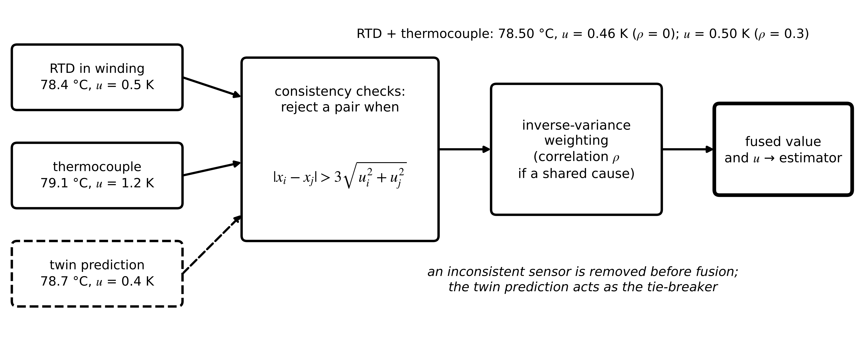
Figure 3.28. Redundant sensor fusion. Pairwise consistency checks remove an outlier first; inverse-variance weighting, with correlation where errors share a cause, then gives the fused value and its uncertainty.

3.13.4 A demonstration on the M-07 stream (Level C)
Figure 3.29 applies the validation chain to four hours of synthetic M-07 data generated with the thermal model of Chapter 1: $R_{th}=0.20$ K/W, $C_{th}=9000$ J/K, $T_{s}=30$ s, a load step from 350 W to 420 W at one hour, process noise 0.05 K per step, RTD noise $σ_{v}=0.3$ K, NumPy default_rng(2026). Five anomalies were injected: a +25 K spike at 30 min; a frozen value with a non-advancing timestamp for 15.5 min (31 samples) from 70 min, during the post-step heating; a 6.5 min dropout (13 samples) from 120 min; two samples delivered out of order at 140.5 min; and from 165 to 210 min (90 samples) a manipulated stream that starts at the true value and drifts downward by 0.03 K per sample. The naive filter uses every arriving sample with $Q=(0.05 K)^{2}$ and $R=(0.3 K)^{2}$. The validated filter adds timestamp, gate ($χ_{1,0.99}^{2}=6.63$) and bias tests ($W=20$, $h=3.5$), and after a bias alarm runs on the model alone.
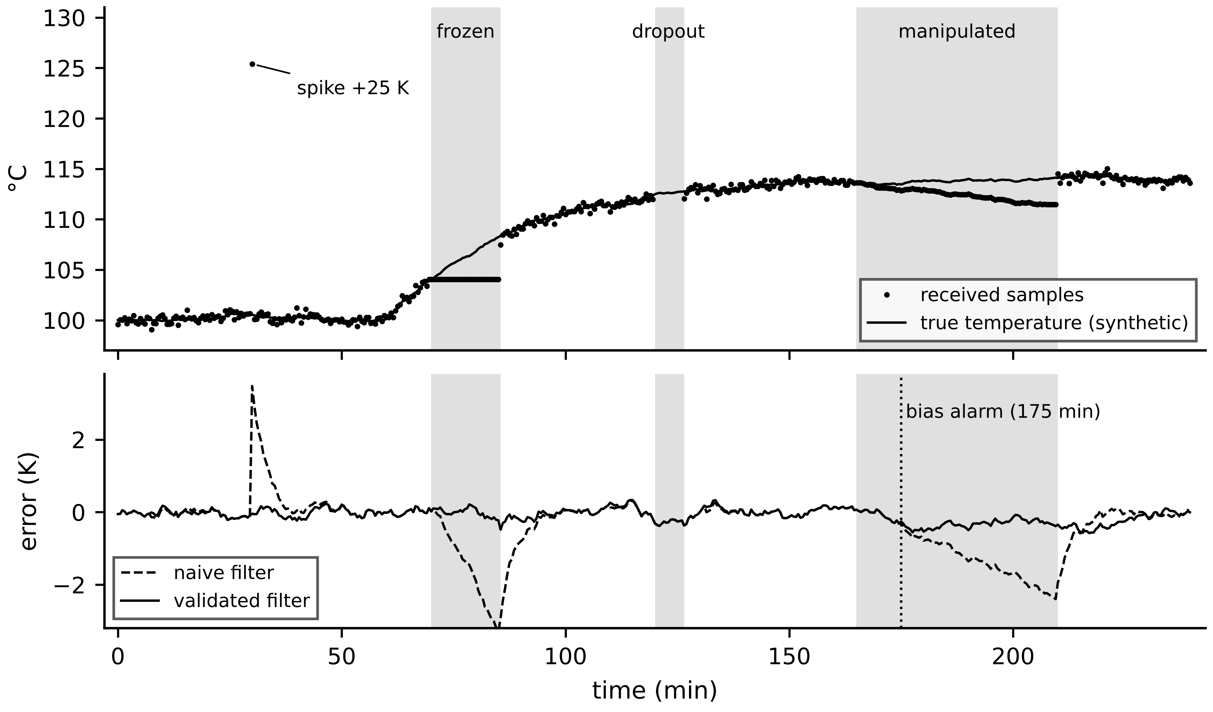
Figure 3.29. Synthetic M-07 stream with injected anomalies (top) and estimation error of the naive and validated filters (bottom). Shaded bands mark the frozen, dropout and manipulated intervals; the vertical line marks the bias alarm 10 minutes after the manipulation began.
Table 3.7. Estimation error in K on the synthetic M-07 stream (RMS over each interval; maxima in parentheses)
Interval | Naive filter | Validated filter
Spike sample | 3.47 | 0.04
Frozen value (31 samples) | 1.78 (3.29) | 0.12 (0.22)
Dropout (13 samples) | 0.28 (0.38) | 0.28 (0.38)
Manipulated stream (90 samples) | 1.30 (2.39) | 0.31 (0.56)
After manipulation (60 samples) | 0.51 (1.93) | 0.31 (0.58)
Whole record (480 samples) | 0.85 (3.47) | 0.21 (0.58)

Three observations follow. The dropout needed no special handling: the filter predicted through it and its variance rose from 0.0127 K² to 0.0350 K², exactly the model-based uncertainty growth that interpolation rules try to imitate. The frozen value was the most damaging anomaly for the naive filter, because a value that stops changing looks plausible to value-based tests until the true temperature has moved well away from it. The timestamp test rejected it at the first repeated sample; without that test the gate would have needed nine samples (4.5 minutes) to start rejecting it, and the resulting run of one-sided innovations would have triggered the bias alarm at 85.5 minutes and stopped all updates. The manipulated stream passed the gate on every sample, as expected; the bias test found it 10 minutes after it began, once the accumulated shift reached 0.6 K, after which the validated filter ran on the model alone. Every number in Table 3.7 regenerates from the stated parameters; none is a field measurement.
What the digital twin adds
Synchronized: only samples whose quality, time and plausibility support an update.
Estimated or updated: inflated $R_{eff}$, gate decisions, bias and CUSUM statistics, fused values.
Uncertainty carried: quality flags and time quality turned into variance, never discarded silently.
Decision enabled: use, down-weight or reject each sample; demote a stream after a bias alarm.
Validated by: injected-anomaly replays like Table 3.7 at commissioning.

3.14 Sensor placement, observability and redundancy
Before any sensor is bought, three questions bridge to the estimators of Chapter 5: what must be measured so that every state the twin needs can be inferred; where, at what rate and with what redundancy; and which criterion decides between candidate layouts. For a linear model $x_{k+1}=A_{d}x_{k}+w_{k}$, $y_{k}=Hx_{k}+v_{k}$ with $n$ states, the states are observable from the outputs if the observability matrix has full rank:
$𝒪={\left[H^{⊤}, {\left(HA_{d}\right)}^{⊤}, …, {\left(HA_{d}^{ n-1}\right)}^{⊤}\right]}^{⊤}, rank 𝒪=n$ (3.54)
Rank is a yes-or-no answer. The condition number of $𝒪$ says how well: a large condition number means some state combinations are barely visible and will be estimated with large variance. The quantitative criterion is the steady-state error covariance $P_{∞}$ of the Kalman filter for each candidate $H$, obtained from the discrete algebraic Riccati equation (Chapter 5); a layout is chosen to minimize the variance of the state the purpose needs, or the trace of $P_{∞}$ when all states matter. Redundancy then adds a second sensor where a single failure would leave a needed state unobservable or where an independent check is required for fault detection (Section 3.13.3). Sampling rate follows from the fastest state the purpose needs (Section 3.8), and placement from where that state is physically accessible.
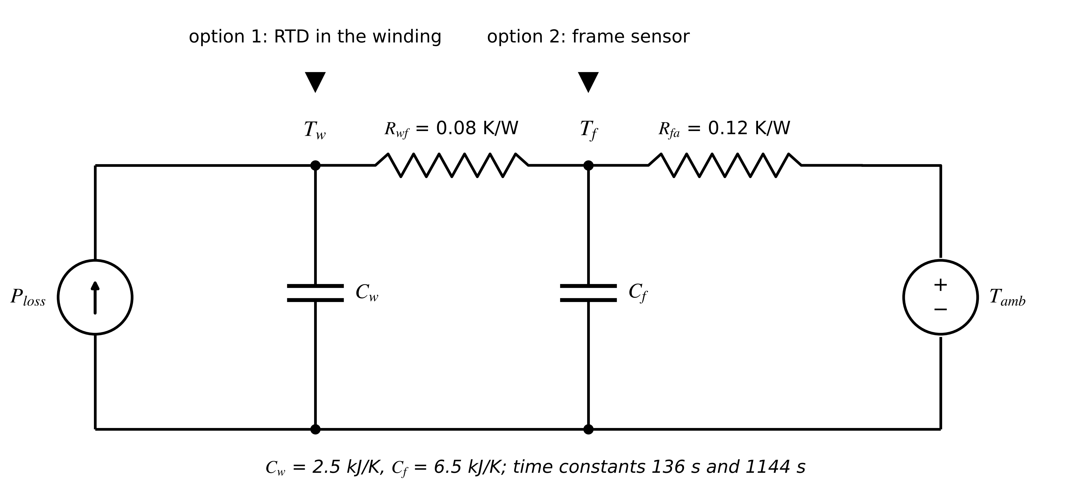
Figure 3.30. Two-node thermal network of M-07 (winding and frame) with two candidate sensor locations. The coupling resistance $R_{wf}$ makes both states observable from either sensor, with different accuracy.
Example 3.21 (Level B) Where should the M-07 temperature sensor go?
Given. A two-node model (Figure 3.30): $C_{w}=2.5$ kJ/K, $C_{f}=6.5$ kJ/K, $R_{wf}=0.08$ K/W, $R_{fa}=0.12$ K/W (the two-node M-07 model derived in Chapter 4), $T_{s}=30$ s, process noise 0.05 K per step on each node, sensor noise 0.3 K. Options: RTD in the winding only; sensor on the frame only; both.
Find. (a) The time constants of the network. (b) Observability rank and condition number of $𝒪$ for each option. (c) Steady-state posterior standard deviations of winding and frame temperature, and the trace of $P_{∞}$. (d) The choice for an overheating advisory.
Solution. (a) Eigenvalues of the continuous system give 136 s and 1144 s: a fast winding-to-frame mode and a slow mode for the whole machine. (b) All three have rank 2. Condition numbers: winding 13.2, frame 35.9, both 1.1. (c) Solving the Riccati equation: winding sensor, 0.105 K (winding) and 0.124 K (frame), trace 0.0264 K²; frame sensor, 0.119 K and 0.101 K, trace 0.0245 K²; both, 0.095 K and 0.097 K, trace 0.0184 K². (d) For the winding advisory, the winding RTD gives the lowest winding variance; the trace criterion would wrongly prefer the frame sensor. Both sensors improve the winding estimate only 10 % but add an independent check.
Interpretation. Strong thermal coupling makes either sensor sufficient for observability, so rank alone decides nothing. The criterion must follow the purpose clause of the twin's contract: minimize the variance of the quantity the decision uses. Chapter 5 develops the Riccati equation used here.
What the digital twin adds
Synchronized: states that the chosen sensors make observable with useful accuracy.
Estimated or updated: rank, condition number and $P_{∞}$ for candidate layouts.
Uncertainty carried: steady-state estimation variance per state.
Decision enabled: where to measure, how many sensors, and where redundancy pays.
Validated by: comparing predicted $P_{∞}$ with innovation statistics after installation.

3.15 Commissioning, calibration, drift and traceability
A measurement is trustworthy only if its link to the SI units is documented. Metrological traceability is an unbroken chain of calibrations, each with a stated uncertainty, from the field sensor back to a national standard (Figure 3.31); calibration laboratories in the chain are accredited to ISO/IEC 17025 [41]. Uncertainty only grows down the chain, and each certificate is a record in the digital thread of Chapter 2.
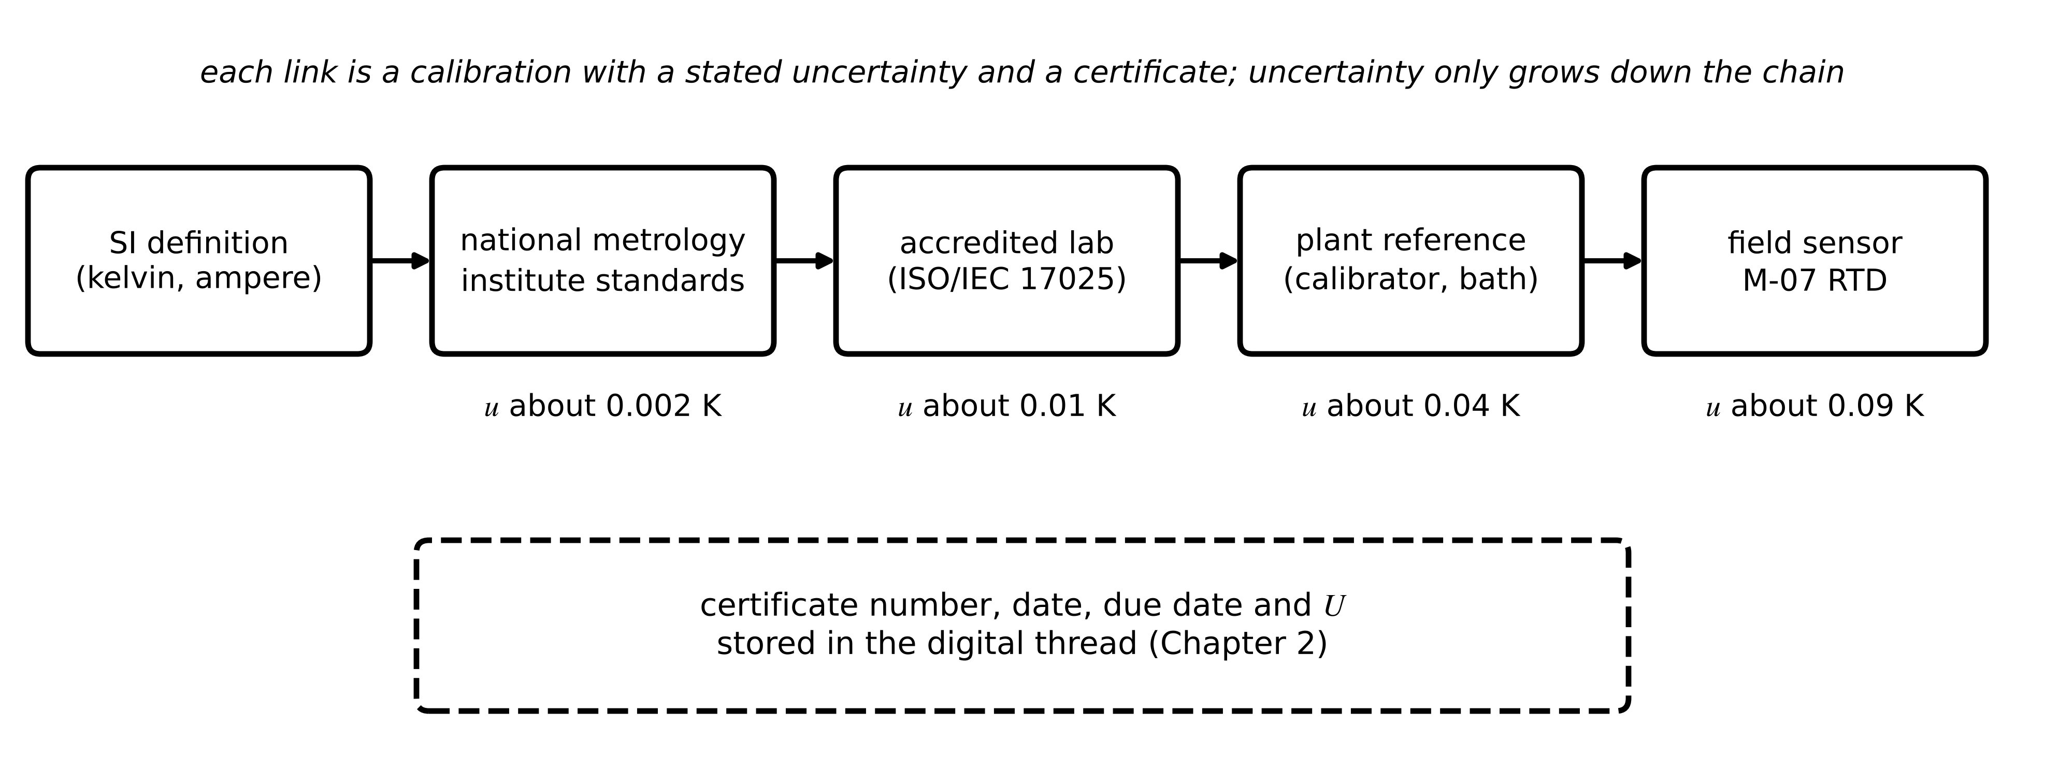
Figure 3.31. Calibration traceability chain for the M-07 RTD, with indicative standard uncertainties at each link. Certificates, dates and due dates are stored in the digital thread.
Sensors drift. If a sensor's error grows at roughly constant rate $\dot{e}$ after a calibration with expanded uncertainty $U_{0}$, and the twin's contract allows an expanded uncertainty $U_{allow}$, a conservative calibration interval follows from adding the drift linearly:
$T_{cal}≤\frac{U_{allow}-U_{0}}{\left|\dot{e}\right|}$ (3.55)
where drift is treated as a bias that grows until recalibration. Redundant sensors, the twin's own residuals and reference checks (ice point, a portable calibrator, the PV reference cell) detect faster drift between calibrations. Commissioning follows the staged pattern of Chapter 2: verify wiring and polarity (CT direction, phase sequence), check zero and span with a calibrator, compare each channel with an independent reference, confirm timestamps against a known event (a breaker operation seen by several devices), and only then let the twin use the channel.
Table 3.8. Field failure modes of instrumentation and how the twin detects them
Sensor | Failure mode | Signature in data | Detection
CT | open secondary, saturation, wrong polarity | zero or clipped current; power of wrong sign | range, waveform crest factor, power-sign check
Hall sensor | offset drift | non-zero reading at zero current | zero check when converter idle
RTD | open or shorted element, lead fault | reading at range limits; step change | range, rate, redundant sensor
Thermocouple | cold-junction error, open wire | offset; burnout to full scale | reference check; burnout detection
Pyranometer | soiling, tilt, dome condensation | ratio to reference cell drifts | cross-check, cleaning log
Accelerometer | loose mount, cable fault | lower resonance; dropouts | resonance test, burst completeness
4-20 mA loop | broken wire, short | below 3.8 mA or above 20.5 mA | loop-current check
Any digital channel | frozen value, clock loss | non-advancing timestamp, poor time quality | timestamp and time-quality tests

Example 3.22 (Level A) Calibration intervals for two Plant P-1 sensors
Given. (i) The M-07 RTD: $U_{0}=0.18$ K after bath calibration, drift up to 0.03 K per year, contract allows $U=0.5$ K. (ii) The plane-of-array pyranometer: $U_{0}=1.5$ % after calibration, sensitivity drift 1 % per year, contract allows 3 %. Soiling in the dry season removes 0.2 % per day; the contract tolerates 1 % from soiling.
Find. The calibration interval for each sensor and the cleaning interval for the pyranometer.
Solution. (i) $(0.5-0.18)/0.03=10.7$ years; in practice the RTD is checked at major overhauls. (ii) $(3-1.5)/1=1.5$ years, consistent with the common two-year practice only if drift is smaller than assumed. Cleaning: $1/0.2=5$ days in the dry season.
Interpretation. The intervals come from the twin's contract, not from habit. The pyranometer's real limit is soiling, which a cross-check against the reference cell and the module power detects daily.
What the digital twin adds
Synchronized: every channel with a traceable calibration and a known due date.
Estimated or updated: drift between calibrations from residuals and cross-checks.
Uncertainty carried: growing with time since calibration, by (3.55).
Decision enabled: calibration, cleaning and inspection schedules.
Validated by: certificates in the digital thread and commissioning records.

3.16 From physical quantity to a trustworthy timestamped measurement (Level C)
This section follows one channel, the phase current of motor M-07, through every step of the chain, and ends with the number the estimators of Chapter 5 need: a value, a timestamp, a quality and a variance $R_{k}$. Figure 3.32 shows the chain; Table 3.9 records each stage's contribution to uncertainty and delay. The design values are those of the earlier examples; a deployment replaces them with certificate and measured values.
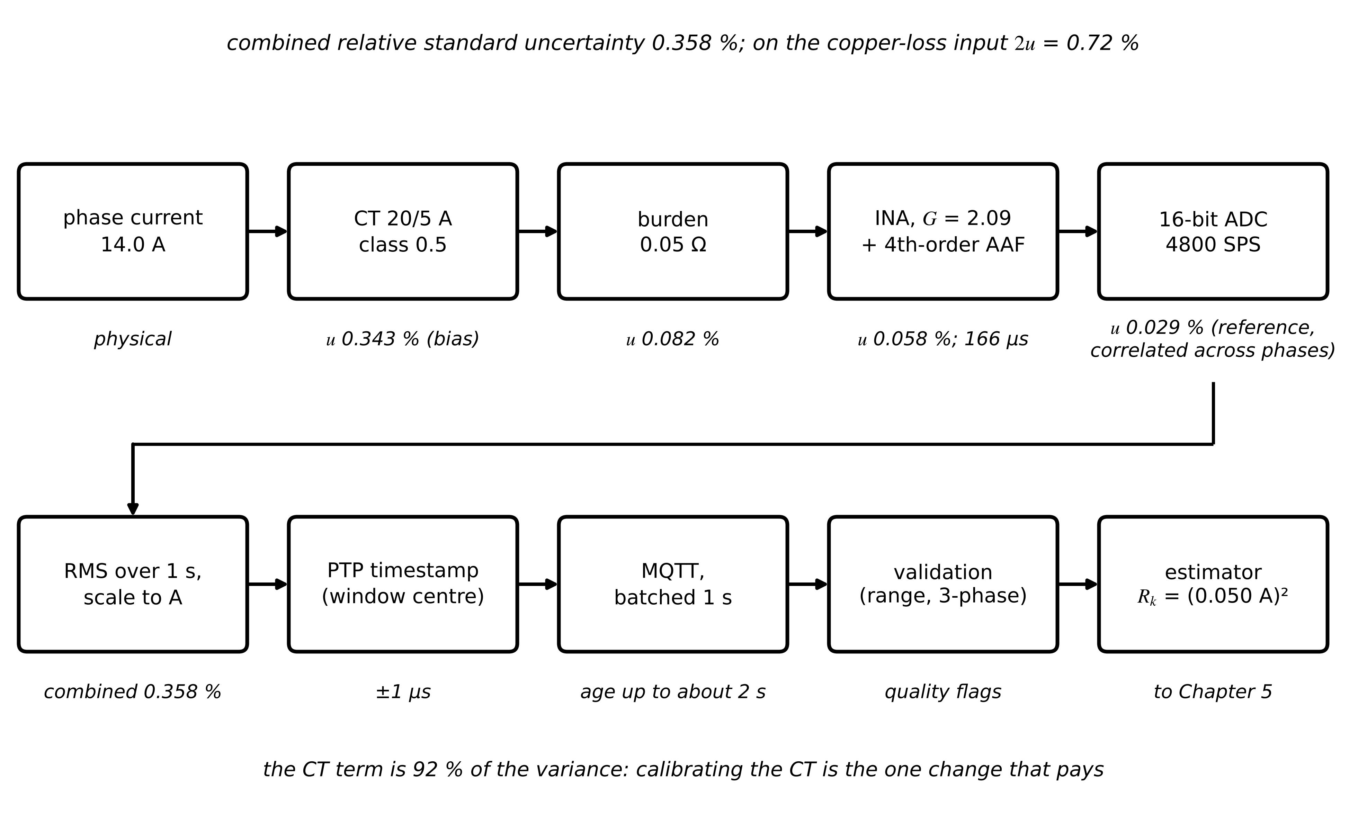
Figure 3.32. The M-07 phase-current channel from physical quantity to estimator, with each stage's standard uncertainty contribution and delay. The output is a timestamped value with quality flags and a measurement variance $R_{k}$ for Chapter 5.
Stage 1, the physical quantity. M-07 draws about 14.0 A RMS at its operating load. Stage 2, the CT (20/5 A, class 0.5): at 70 % of rating the ratio-error limit, interpolated between the 20 % and 100 % limits of IEC 61869-2, is ±0.59 %, a rectangular bound, so $u_{CT}=0.59/\sqrt{3}=0.343$ %. It is a bias for this particular CT, the same on every reading until it is calibrated. Stage 3, the burden (0.05 Ω, ±0.1 % tolerance and ±0.1 % from a 50 ppm/K coefficient over 20 K, both rectangular): $u_{b}=\sqrt{2}×0.0577=0.082$ %. Stage 4, the INA and anti-alias filter ($G=2.09$, gain error ±0.1 % after trimming): $u_{G}=0.058$ %; the fourth-order Butterworth at 2.5 kHz delays the signal by 166 µs. Stage 5, the ADC (16 bits, 4800 SPS, reference ±0.05 %): $u_{ref}=0.029$ %; quantization averaged over the 4800 samples of a one-second RMS window contributes below ${10}^{-4}$ %. Because one ADC reference serves all three phases, this term is fully correlated between phases ($r=1$ in (3.21)).
Stage 6, scaling and RMS. The value is $I=\sqrt{\frac{1}{M}\sum_{k}{v_{k}^{2}}}/(GR_{b})×n$ over $M=4800$ samples in a coherent one-second window, multiplied by the CT ratio $n=4$. Combining the independent stage terms with (3.21) and unit sensitivities in relative form ((3.22)):
$\frac{u(I)}{I}=\sqrt{u_{CT}^{2}+u_{b}^{2}+u_{G}^{2}+u_{ref}^{2}+u_{q}^{2}}=\sqrt{{0.343}^{2}+{0.082}^{2}+{0.058}^{2}+{0.029}^{2}} \%=0.358 \%$ (3.56)
so $u(I)=0.050$ A at 14.0 A, and the variance handed to the estimator is $R_{k}=(0.050 A)^{2}=2.5×{10}^{-3}$ A². Stage 7, the timestamp. The RMS value is stamped at the centre of its window from the PTP-disciplined clock (±1 µs), which for a one-second RMS value of a slowly varying load is negligible. Stage 8, the packet. The value travels in a self-describing MQTT message batched once per second (Chapter 2, Section 2.5), so its age at the fog computer is up to about 2 s. Stage 9, validation. Range (0 to 24 A), rate, timestamp advance and three-phase consistency (the three phase currents within 5 % of their mean) set the quality flags. Stage 10, the estimator. The thermal twin of Chapter 1 uses the copper loss $P_{cu}=3I^{2}R_{ph}$, whose relative uncertainty is twice that of the current by (3.22): $2×0.358=0.72$ %, about 2.5 W on 350 W if the whole loss is taken as copper loss (an upper bound), which moves the steady-state winding temperature by $R_{th}×2.5=0.50$ K.
Table 3.9. The M-07 phase-current chain: contribution of each stage (design values)
Stage | Quantity at output | Standard uncertainty (relative) | Delay or age | Nature
CT 20/5 A, class 0.5 at 70 % | 3.5 A secondary | 0.343 % | negligible | bias until calibrated
Burden 0.05 Ω | 0.175 V RMS | 0.082 % | negligible | bias, temperature-dependent
INA + anti-alias filter | 0.366 V RMS | 0.058 % | 166 µs | bias
ADC reference, quantization | counts | 0.029 %; < 0.0001 % | 4 µs conversion | correlated across phases
RMS over 1 s, scaling | 14.0 A | (combination) 0.358 % | window centre 0.5 s | value
PTP timestamp | UTC time | ±1 µs | negligible | time quality
MQTT batch, network | message | none added | up to about 2 s age | packet age
Validation | quality flags | gate decisions | about 1 ms | validity
Estimator input | $R_{k}=(0.050 A)^{2}$ | 0.72 % on copper loss | 30 s twin cycle | to Chapter 5

Two engineering conclusions follow. First, almost the whole budget is the CT's class tolerance, and it is a bias: averaging cannot reduce it, and its effect on the loss input is a systematic 0.5 K shift in the predicted winding temperature. A one-off calibration of the CT at the operating point would cut the budget by a factor of about three (to about 0.12 % with a calibration uncertainty of 0.05 %); the estimator should then carry the calibration uncertainty instead. Second, the correlated ADC reference means that the three phases share part of their error, so their average does not gain the $\sqrt{3}$ that independence would suggest (compare Example 3.9).

3.16.1 The acquisition pipeline as a timing budget
Chapter 2 wrote the end-to-end delay as a sum of stages. This chapter fills in the terms before the network:
$T_{acq}=T_{sensor}+τ_{g,AAF}+T_{conv}+T_{dec}+T_{buf}+T_{val}, \overline{T}=\sum_{i}{{\overline{T}}_{i}}, J^{2}=\sum_{i}{J_{i}^{2}}$ (3.57)
where $T_{sensor}$ is the transducer's own response, $τ_{g,AAF}$ the filter group delay (3.28), $T_{conv}$ the conversion time, $T_{dec}$ the decimation delay of an oversampling converter, $T_{buf}$ the time a sample waits for its message to fill and $T_{val}$ the validation time; for independent stages means add and so do variances, $J_{i}$ being the standard deviation of stage $i$. A high percentile is harder. Under a Gaussian assumption the 99th percentile is $\overline{T}+2.33J$. Without any distributional assumption, Cantelli's one-sided inequality bounds the tail for any distribution with that mean and variance:
$P\left(T-\overline{T}≥kJ\right)≤\frac{1}{1+k^{2}} ⇒ T^{(0.99)}≤\overline{T}+\sqrt{99} J≈\overline{T}+9.95J$ (3.58)
The gap between 2.33 and 9.95 is the price of not knowing the tail; a timing campaign (Chapter 2, Section 2.3.5) closes it with data.
Example 3.23 (Level B) Acquisition-to-estimator budget for the switchgear partial-discharge alarm
Given. The edge path of the Chapter 2 PD alarm has stage means: sensor 0.3, filter and conditioning 0.1, conversion 0.05, buffering 0.2, serialization 0.3, timestamp correction 0.02, validation 0.5 and estimator 22 ms, with total standard deviation $J=1.8$ ms. Deadline 50 ms.
Find. Mean latency, Gaussian 99th percentile and the Cantelli bound.
Solution. Mean $0.3+0.1+0.05+0.2+0.3+0.02+0.5+22=23.47$ ms; Gaussian $23.47+2.33×1.8=27.66$ ms; Cantelli $23.47+9.95×1.8=41.4$ ms.
Interpretation. Even the distribution-free bound meets 50 ms, so the design is accepted without arguing about the tail's shape. When Cantelli fails and the Gaussian estimate passes, the design is unproven and a timing campaign is required.
What the digital twin adds
Synchronized: one channel from conductor to estimator with every error and delay accounted for.
Estimated or updated: $u(I)$, $R_{k}$ and the age of each sample.
Uncertainty carried: bias and random parts separately, with cross-phase correlation.
Decision enabled: where calibration pays (the CT), and what $R_{k}$ the estimator should use.
Validated by: end-to-end calibration of the channel against a reference current.

3.17 Case study: instrumenting Plant P-1
Table 3.10 is the instrumentation specification for the Plant P-1 twins of Chapter 2, and Figure 3.33 shows the resulting map. Every row answers the questions of this chapter: which sensor, over which range, with what uncertainty, sampled how, carried by which protocol, timed by which clock, and admitted by which rule. Uncertainty figures are design values derived as in Example 3.8 and Section 3.16; they must be replaced by the installed instruments' certificate values.
Table 3.10. Instrumentation specification for Plant P-1 (design values)
Channel | Sensor | Range | $U$ ($k$ = 2) | Sampling | Protocol / clock | Validation rule
M-07 winding temperature | Pt100 Class A, calibrated, 3-wire | 0 to 200 °C | 0.18 K | 1 per 30 s | MQTT via I/O module / PTP | range, rate (3.49) (5 K per 30 s), timestamp, gate
Motor phase currents | CT 20/5 A class 0.5, burden 0.05 Ω | 0 to 24 A | 0.72 % (Section 3.16) | 4800 SPS, 1 s RMS | MQTT / PTP | range, three-phase consistency
Motor vibration (4) | IEPE accelerometer, stud mount | ±50 g, 2 Hz to 5 kHz | 5 % | 10.24 kHz bursts | intelligent sensor, MQTT / PTP | saturation, burst completeness
PV string currents (80) | Hall, open loop | 0 to 20 A | 1 % FS | 1 Hz | Modbus RTU / NTP | range, sum against inverter DC current
Plane-of-array irradiance | class A pyranometer + reference cell | 0 to 1500 W/m² | 2 % | 1 Hz | Modbus TCP / PTP | cross-check, soiling flag
BESS module voltages (240) | BMS measurement IC | 0 to 60 V | 5 mV | 1 Hz | CAN FD inside, MQTT up / PTP at gateway | range, sum against pack voltage
BESS converter currents | closed-loop Hall, 200 kHz | ±300 A | 0.5 % | 14.4 kSPS twin path | internal, MQTT summaries / PTP | zero-offset check at idle
PCC voltage and current | VT 0.2, CT 0.2S, merging unit | 415 V, 3000 A | 0.2 % | 14.4 kSPS | IEC 61850 SV / PTP (61850-9-3) | time quality, SV sequence counter
PCC frequency | derived from SV | 45 to 55 Hz | 5 mHz | 50 Hz reporting | GOOSE, MMS to fog / PTP | rate-of-change-of-frequency plausibility

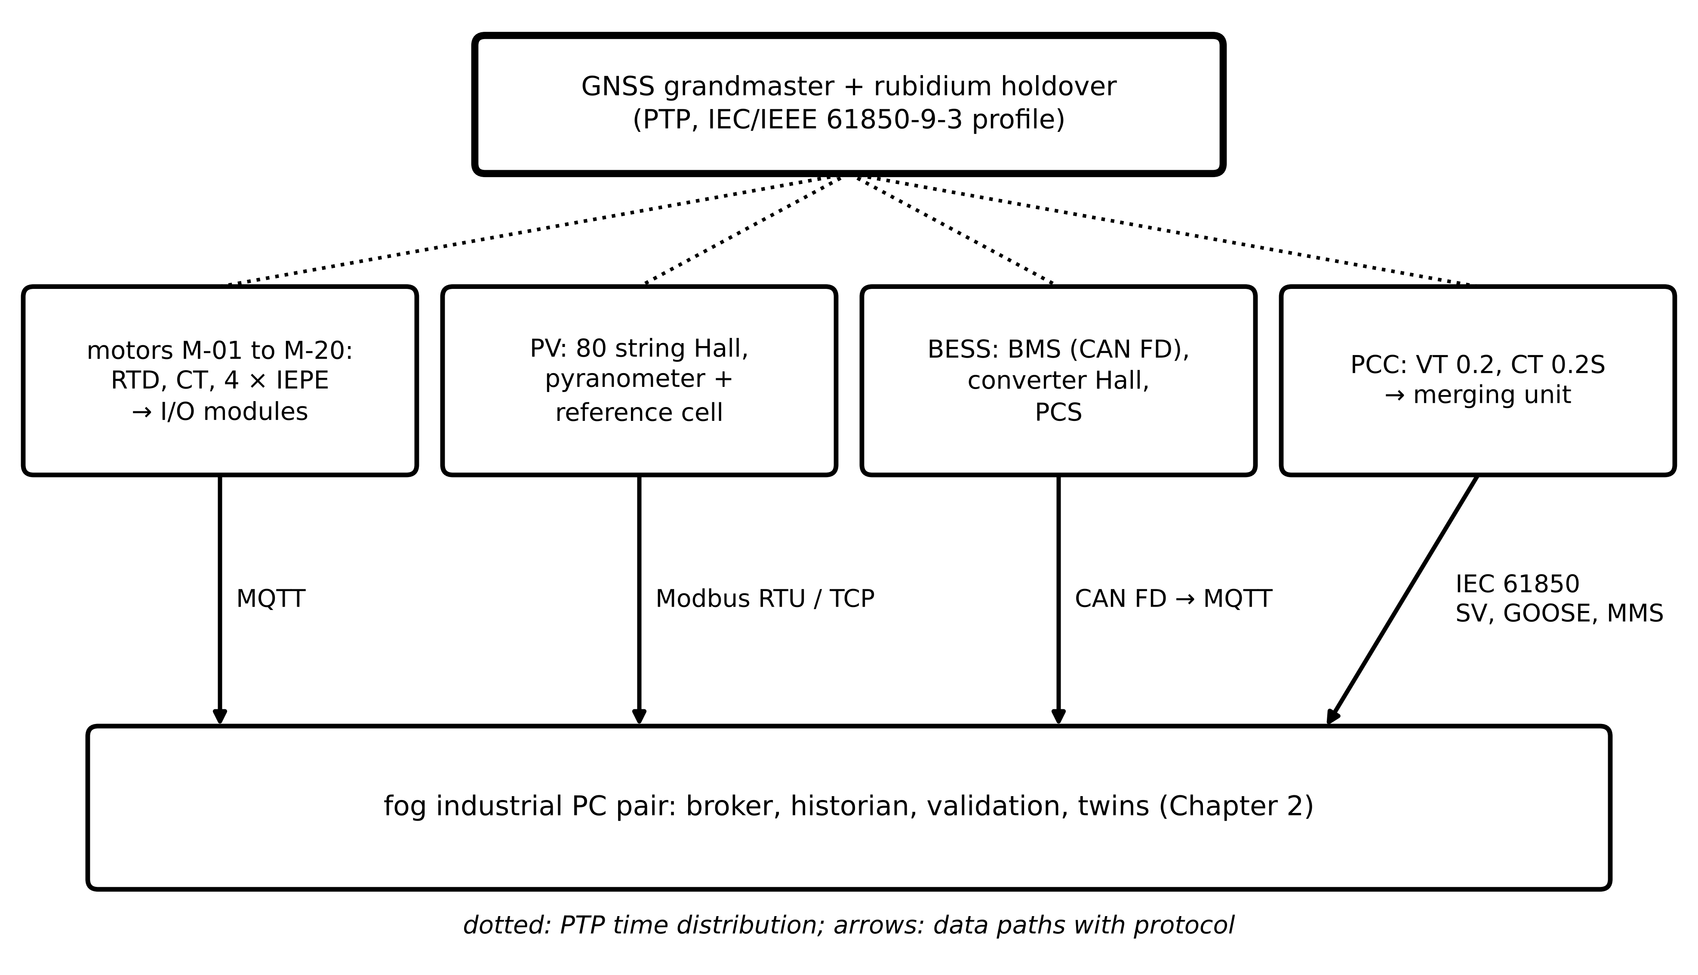
Figure 3.33. Instrumentation map of Plant P-1: sensor groups, acquisition, protocols on each data path and the PTP time distribution from a GNSS grandmaster with rubidium holdover.
Reproducibility. The synthetic data of Section 3.13.4 regenerate from the stated parameters (thermal model and load profile from Chapter 1, seed 2026, anomaly times as listed, $Q=(0.05 K)^{2}$ per step, $R=(0.3 K)^{2}$, gate 6.63, bias window $W=20$ with $h=3.5$). The placement example of Section 3.14 regenerates from the stated two-node parameters with any discrete Riccati solver. The process-noise and measurement-noise vectors (480 values each) are drawn in that order, both filters start at the true initial temperature with variance 0.0127 K², and the out-of-order pair exchanges samples 281 and 282; with these choices the gate also rejected six valid samples, against about four expected at $α=0.01$. No value in this chapter is a field measurement.

3.18 Recent developments and open research problems
Acquisition and connectivity for twins are changing quickly; each development is labelled with its status in 2026. The 2026 reviews agree on the direction: Abuabed and Kittur call for interoperability through CIM and IEC 61850, hierarchical and federated architectures and adaptive synchronization [3]; Satpathy and Ramachandaramurthy stress real-time synchronization and phased utility deployment [4]; and Manimaran et al. emphasize real-time validation, compatibility and the fidelity against speed trade-off [42].
Digital substations (established in new builds). Low-power instrument transformers and merging units publishing sampled values give twins synchronized waveforms as a by-product of protection. Open problem: twins that remain valid when SV quality and time-quality flags vary across vendors. Deterministic Ethernet (standards established, pilots). TSN and OPC UA FX bring scheduled traffic to shared networks, and the second edition of IEC/IEEE 61850-9-3 will align the utility PTP profile with IEEE 1588-2019 once published. Open problem: end-to-end bounds that include acquisition and computation. Field-level Ethernet and new CAN generations (early adoption). Single-pair Ethernet at 10 Mbit/s over long distances (IEEE 802.3cg [43]) brings IP to individual instruments, and CAN XL extends CAN payloads to 2048 bytes. Standard IIoT payloads (established). Sparkplug (ISO/IEC 20237:2023) gives MQTT telemetry a shared namespace and session state. Private 5G telemetry (pilots). Useful for mobile and hard-to-wire assets; open problem: verified worst-case latency under interference. Optical and embedded sensing (established for cables and large transformers; embedded learning research-stage). Fibre Bragg gratings and distributed temperature sensing measure along cables and inside windings; sensors with on-board learning send features instead of data, with open questions about the uncertainty of learned features. Resilient time (early deployment). Multi-source time, combining several GNSS constellations, terrestrial fibre time and holdover oscillators, counters jamming and spoofing, and receivers with several closely spaced antennas detect a spoofer by the impossible positions it produces [44]; open problem: detecting a slowly spoofed time source before its error exceeds the 1 µs class.
Field evidence on data quality (established problem, active research). Measured synchrophasor data show that the failures of Section 3.13 are common in practice. Huang et al. review the standards and data-quality requirements of synchrophasor applications and count field events of synchronization error, data loss and latency [45]. Mishra et al. analyse PMU and waveform data from a utility and show that differences in how vendors discipline their internal clocks produce periodic clock errors to which ambient-data applications are very sensitive; they separate these errors from real system dynamics and correct them after the fact [46]. Open problem: quality and time-quality flags that report such errors reliably at the source, so that a twin need not infer them from the data.
Table 3.11. Emerging directions with status and a measurable research target
Direction | Status | Measurable target
SV-based twins in digital substations | established (new builds) | twin error under SV loss; share of frames with valid quality and time quality
TSN and OPC UA FX for mixed traffic | pilots | verified worst-case delay per stream including end systems
Single-pair Ethernet instruments | early adoption | installed cost per channel against 4 to 20 mA with HART
Private 5G telemetry | pilots | 99.99th-percentile latency and outage duration over a year
Learned sensor features | research, early products | coverage of stated feature uncertainty on held-out faults
Spoofing-resilient time | early deployment | detection time for a 1 µs per minute spoofing ramp
Purpose-driven sensor placement | research | winding-temperature variance per installed sensor cost

3.19 How this chapter feeds Chapter 5
Chapter 5 builds the estimators that synchronize every twin of this book. From this chapter it receives, for each channel, four things: a value scaled to SI units; a timestamp with a stated time quality; a quality description (validity, source, test, detail flags) that decides whether and how the value is used; and a measurement variance $R_{k}$, inflated where time quality or staleness requires it, together with the covariance between channels that share a calibration or a reference. It also receives the observability analysis of Section 3.14, which tells it which states it can estimate from the installed sensors and how well. The estimator design of Chapter 5 starts exactly where Table 3.10 ends.

Chapter summary
A twin is only as trustworthy as the numbers it receives, and every number arrives through a chain of physics, electronics, software and networks. Sensors were introduced through their governing laws: Ohm's law and the inductive corner for shunts, the magnetizing error and saturation of CTs, Faraday's law for Rogowski coils, the Lorentz force and null-flux compensation for Hall sensors, dividers and instrument transformers for voltage, the Callendar-Van Dusen curve with self-heating and lead errors for RTDs, cold-junction compensation for thermocouples, and the mechanical resonance of accelerometers. Signal conditioning (burden, protection, instrumentation amplifier, level shift, settling, current loops, isolation) was designed with numbers. Uncertainty followed the GUM from measurement model to covariance, effective degrees of freedom and expanded uncertainty, with a complete RTD budget and a correlated three-phase example.
Sampling was followed from spectral replicas to alias frequencies, anti-alias design at $f_{s}-f_{pass}$, quantization, ENOB, jitter, oversampling and coherent sampling. Timing covered where timestamps are taken, PTP offset and delay with asymmetry, holdover and GNSS dependency, and total vector error. Protocols were treated as message flows with timing: Modbus polling, CAN arbitration and response-time analysis, IEC 61850 MMS, GOOSE and sampled values, MQTT with Sparkplug, OPC UA and TSN; wireless links were budgeted with realistic path loss. Data-quality semantics turned flags into estimator decisions, with rate checks, uncertainty inflation, gating, bias and CUSUM tests and fusion, demonstrated on a synthetic M-07 stream where validation cut the whole-record error from 0.85 K to 0.21 K. Sensor placement was chosen by observability and steady-state covariance, calibration intervals by drift, and one current channel was traced from conductor to a variance of $(0.050 A)^{2}$ for Chapter 5, with the CT bias identified as the term worth calibrating.
Table 3.12. Key relationships of Chapter 3
Relationship | Expression | Eq.
Shunt and corner | $v_{sh}=R_{sh}i$; $f_{L}=R_{sh}/(2πL_{sh})$ | (3.1)
CT secondary and flux | $i_{s}=(i_{p}-i_{m})/n$; $\hat{B}=V_{s}/(4.44fN_{s}A_{c})$ | (3.2), (3.3)
Rogowski and Hall | $v_{R}=-M di/dt$; $V_{H}=I_{c}B/(n_{e}qt_{H})$; $N_{p}i_{p}=N_{s}i_{s}$ | (3.4), (3.5), (3.6)
RTD and thermocouple | $R=R_{0}(1+AT+BT^{2})$; $ΔT_{lead}=2R_{lead}/(dR/dT)$; $E(T)=E_{meas}+E(T_{ref})$ | (3.8), (3.10), (3.11)
Conditioning | $G=1+2R_{F}/R_{G}$; $τ≤t_{acq}/((N+1)ln2)$; $I=4+16(x-x_{lo})/(x_{hi}-x_{lo})$ | (3.15), (3.17), (3.18)
Uncertainty propagation | $u_{c}^{2}=\sum{c_{i}^{2}}u_{i}^{2}+2\sum{\sum{c_{i}}}c_{j}r_{ij}u_{i}u_{j}$; $U=ku_{c}$ | (3.21), (3.23)
Sampling and aliasing | $X_{s}(f)=f_{s}\sum{X}(f-mf_{s})$; $f_{a}=|f-mf_{s}|$ | (3.24), (3.26)
Anti-alias design | $f_{stop}=f_{s}-f_{pass}$; Butterworth order and delay | (3.27), (3.28)
Quantization, ENOB, jitter | $σ_{q}=Δ/\sqrt{12}$; ENOB $=(SINAD-1.76)/6.02$; ${SNR}_{j}=-20\log_{10}(2πfσ_{t})$ | (3.29), (3.30), (3.31)
PTP and asymmetry | $\hat{θ}=[(t_{2}-t_{1})-(t_{4}-t_{3})]/2$; error $(d_{ms}-d_{sm})/2$ | (3.36), (3.37)
Holdover and TVE | $x=x_{0}+y_{0}t+Dt^{2}/2$; TVE $≈\sqrt{ε^{2}+δφ^{2}}$ | (3.39), (3.40)
CAN response time | $R_{m}=J_{m}+w_{m}+C_{m}$ | (3.44)
Link budget | $P_{r}=P_{t}+G_{t}+G_{r}-L(d)$; $P_{sens}=-174+10\log_{10}B_{w}+NF+{SNR}_{min}$ | (3.46), (3.47)
Uncertainty inflation | $R_{eff}=σ_{v}^{2}+(\dot{y}σ_{t})^{2}$ | (3.50)
Gate and bias tests | $ν^{⊤}S^{-1}ν≤χ_{m,1-α}^{2}$; CUSUM | (3.51), (3.52)
Fusion | inverse-variance weights; correlated form | (3.53)
Observability | $rank 𝒪=n$ | (3.54)
Calibration interval | $T_{cal}≤(U_{allow}-U_{0})/|\dot{e}|$ | (3.55)
Timing bound | $T^{(0.99)}≤\overline{T}+9.95J$ | (3.58)

Exercises
Fifteen exercises follow. Exercises 3.1 to 3.5 cover sensors, conditioning and conversion; 3.6 to 3.9 cover sampling, timing and synchronized measurement; 3.10 and 3.11 cover wired and wireless communication; 3.12 to 3.14 cover data quality, fusion and timing bounds; and 3.15 is a research-level design project. Most exercises contain linked parts, combining a derivation with a numerical application. Complete solutions to all fifteen are given in the answer key.

Group A: sensors, conditioning and conversion
3.1 Accuracy class and combined uncertainty. A pressure transducer has an accuracy class of 0.25 % of a 10 bar span. (a) Find the error bound and the standard uncertainty, stating the distribution you assume. (b) Combine it with a repeatability of 0.008 bar and a calibration standard uncertainty of 0.015 bar, assuming independence. (c) Repeat (b) with correlation $r=0.5$ between the accuracy-class and calibration terms. (d) Distinguish bias, repeatability, resolution and accuracy class, and state which of them averaging reduces.
3.2 Pt100 at 50 °C. A Class A Pt100 measures 50 °C. (a) Find its resistance from (3.8) ($A=3.9083×{10}^{−3}$ K⁻¹, $B=−5.775×{10}^{−7}$ K⁻²), its sensitivity $dR/dT$ and its Class A tolerance. (b) Find the self-heating error with 2 mA excitation and a dissipation constant of 5 mW/K. (c) The sensor is connected with two leads of 1.2 Ω each. Find the two-wire error and compare it with the tolerance. (d) Find the residual error of a three-wire connection whose leads differ by 0.1 Ω, and explain why a four-wire connection removes the lead terms.
3.3 Current transformer and Rogowski coil. (a) Derive (3.3) from Faraday's law for a sinusoidal flux. (b) A 400/5 A CT has $N_{s}=80$, $A_{c}=8$ cm² and $R_{ct}+R_{b}=1.0$ Ω. Find $V_{s}$ and $\hat{B}$ at rated current and at 15 times rated current, and decide whether the core saturates (take saturation at 1.6 T). Up to what multiple of rated current does it stay linear? (c) A Rogowski coil on the same conductor has $N=1000$, $A=0.5$ cm² and $ℓ=0.25$ m. Find its mutual inductance and the RMS coil voltage at 2000 A, 50 Hz, and explain why it does not saturate on a 30 kA fault.
3.4 Conditioning stages. (a) An instrumentation amplifier with 90 dB CMRR sees 5 V of common mode on a 20 mV differential signal. Find the input-referred error in per cent of the signal. (b) Derive the settling condition (3.17) from the exponential response of an RC input, and find the largest driving time constant for an 18-bit SAR converter with 200 ns acquisition time. (c) A 4 to 20 mA loop has a 24 V supply and a transmitter that needs at least 12 V. Find the largest total loop resistance at 20 mA and the largest cable resistance with a 250 Ω receiver.
3.5 Quantization and oversampling. (a) A 10-bit converter with a 5 V range digitizes a sensor signal. Find $Δ$, $σ_{q}$ and the ideal SNR. (b) Show that oversampling by a ratio OSR without noise shaping improves the in-band SNR by $10\log_{10}OSR$, and evaluate it for OSR = 64 in decibels and bits. (c) A second-order delta-sigma modulator with a 1-bit quantizer runs at OSR = 128. Using $SNR=6.02N+1.76−10\log_{10}\left(π^{4}/5\right)+50\log_{10}OSR$, find its ideal SNR and the equivalent number of bits.

Group B: sampling, timing and synchronized measurement
3.6 Aliasing and anti-alias design. (a) A converter current with 9 kHz ripple is sampled at 4000 SPS without filtering. Where does the ripple appear, and which harmonic of 50 Hz does it imitate? (b) Derive the Butterworth order formula in (3.28) from ${\left|H\left(f\right)\right|}^{2}=1/\left[1+{\left(f/f_{c}\right)}^{2n}\right]$. (c) A vibration signal with content to 5 kHz is digitized with 12 bits. Find the Nyquist rate, the full-scale attenuation requirement and the order needed at $f_{s}=25.6$ kHz with $f_{c}=5$ kHz. (d) What sampling rate would allow a fourth-order filter?
3.7 Skew and power uncertainty. A 16-channel multiplexed unit steps 5 µs between channels; voltage is on channel 1 and current on channel 12. (a) Find the phase error at 50 Hz and the relative power error at power factor 0.7. (b) The same feeder uses a class 1.0 VT and a class 0.5 CT. Treating the class limits as rectangular and neglecting their phase errors, find the relative standard uncertainty of power. (c) State which of the two effects should be corrected and which should be carried as uncertainty, and why.
3.8 PTP offset, delay and asymmetry. (a) Derive (3.36) from (3.35) and show that path asymmetry produces the error (3.37). (b) An exchange gives $t_{1}=50.000000$, $t_{2}=50.000031$, $t_{3}=50.000512$ and $t_{4}=50.000546$ s. Find $\hat{d}$ and $\hat{θ}$. (c) The true forward delay is 36 µs and the reverse 29 µs. Find the true offset, the error of the estimate and the resulting phase error at 50 Hz. Could any number of additional exchanges reveal this error?
3.9 Holdover and total vector error. (a) Derive the exact expression in (3.40) and its small-error approximation. (b) A PMU has 0.8 % magnitude error and 0.5° phase error. Find the TVE exactly and approximately, and decide whether it meets the 1 % limit. (c) A merging unit's timestamps are 10 µs late. Find the phase error at 50 Hz and the resulting TVE. (d) An oven-controlled oscillator enters holdover with $x_{0}=0$, $y_{0}=2×{10}^{−10}$ and an ageing drift of ${10}^{−10}$ per day. When does its time error reach 1 µs? Compare with the result that ignores drift.

Group C: communication
3.10 Polling, arbitration and response time. (a) A Modbus master polls 40 devices, each exchange taking 5 ms for the request and 8 ms for the response including turnaround and gaps. Find the cycle time and the maximum update rate per device. (b) Using (3.43), find the maximum CAN bus length at 250 kbit/s with the sample point at 87.5 % and a node delay of 200 ns. (c) Classical CAN at 250 kbit/s carries 8-byte frames. Find $L_{max}$ and $C$. A message has two higher-priority messages with 10 ms periods and can be blocked by one lower-priority frame; find its worst-case response time with zero jitter by iterating (3.44).
3.11 Wireless link budget. (a) A 2.4 GHz link over 0.3 km uses $P_{t}=20$ dBm and 5 dBi antennas at both ends. Find the received power in free space and with (3.47) using $d_{0}=0.1$ km and $n_{p}=3.5$. Does it close against a sensitivity of −95 dBm, and what is the outage probability with $σ=8$ dB shadowing? (b) Find the sensitivity of a LoRa receiver at spreading factor 7 ($SNR_{min}=−7.5$ dB), 125 kHz bandwidth and 6 dB noise figure, and compare it with SF12. (c) What fade margin gives 99 % location reliability with $σ=8$ dB?

Group D: data quality, fusion and timing bounds
3.12 Staleness, rate checks and burst loss. (a) A stream has a 1 s sampling interval and a staleness limit of 5 s. At $t=1000.0$ s the newest timestamp is 993.5 s. Is it stale? (b) A temperature can change at most 2 °C/s; a sample arrives 0.5 s after the previous one, 3 °C higher, with $σ_{v}=0.2$ °C. Apply (3.49). (c) A link follows the Gilbert-Elliott model with $p=0.02$ and $r=0.25$ per packet, all packets lost in the bad state. Find the fraction of time in the bad state, the mean burst length, the delivered fraction and the probability that a burst lasts five packets or more. Why does the same average loss matter more when it comes in bursts?
3.13 Fusion with correlated errors. (a) Derive the correlated fusion weight and variance in (3.53) by minimizing the variance of $w_{1}x_{1}+\left(1−w_{1}\right)x_{2}$. (b) Two sensors have $u_{1}=0.3$ K and $u_{2}=0.6$ K with $ρ=0.5$. Find $w_{1}$ and $u\left(\hat{x}\right)$, compare with independence and explain the result. (c) Two flow sensors read 120.4 L/min ($u=0.8$) and 118.9 L/min ($u=2.1$). Check their consistency and fuse them, assuming independence.
3.14 Timing bounds and change detection. (a) Derive the bound (3.58) from Cantelli's inequality. (b) A pipeline has stage means 0.2, 0.1, 1.5, 3.0 and 8.0 ms and a total standard deviation $J=0.9$ ms. Check a 15 ms deadline with the Gaussian 99th percentile and with (3.58), and state what evidence is still needed. (c) Using Box 3.2, find the expected detection delay and the mean number of samples between false alarms of a CUSUM test with $κ=0.5$ and $h_{c}=5$ for a bias of $1.5$ innovation standard deviations.

Group E: research project
3.15 Instrumenting a transformer twin. A 2 MVA, 11/0.415 kV oil-immersed transformer at Plant P-1 is to receive a twin that estimates the winding hot spot for overload decisions. (a) Propose a three-node thermal model (hot spot, average winding, top oil) and a sensor-placement study using (3.54) and the steady-state covariance, with a measurable acceptance criterion. (b) The top-oil RTD has $U_{0}=0.18$ K after calibration and drifts by up to 0.03 K per year; the contract allows $U=0.5$ K. Find its calibration interval. (c) The plant's vibration and temperature links drop out mostly at high load. Design a data-quality policy using Box 3.1 and explain why interpolation would bias the twin. (d) Choose the protocols for the hot-spot channel, the load currents and the tap-changer position, with reasons from Table 3.4.

Answer key
3.1 (a) $a=0.0025×10=0.025$ bar. With no other information the error is equally likely anywhere in $±a$, a rectangular distribution, so $u=a/\sqrt{3}=0.0144$ bar.
(b) $u_{c}=\sqrt{{0.0144}^{2}+{0.008}^{2}+{0.015}^{2}}=\sqrt{4.97×{10}^{−4}}=0.0223$ bar.
(c) The covariance term is $2×0.5×0.0144×0.015=2.17×{10}^{−4}$ bar², so $u_{c}=\sqrt{4.97×{10}^{−4}+2.17×{10}^{−4}}=0.0267$ bar, 20 % larger. Positive correlation adds; ignoring it understates the uncertainty.
(d) Bias is the systematic difference between the mean reading and the true value; repeatability is the scatter of repeated readings under the same conditions; resolution is the smallest change the instrument can display; the accuracy class is the manufacturer's bound on the total error under stated conditions. Averaging reduces only the random part (repeatability, and quantization when the signal moves across several codes); it does nothing to a bias or to the part of a class tolerance that is systematic for one instrument.
3.2 (a) $R=100 \left(1+3.9083×{10}^{−3}×50−5.775×{10}^{−7}×2500\right)=119.40$ Ω. $dR/dT=R_{0}\left(A+2BT\right)=100 \left(3.9083×{10}^{−3}−5.775×{10}^{−5}\right)=0.385$ Ω/K. Class A tolerance $±\left(0.15+0.002×50\right)=±0.25$ K.
(b) $P=I^{2}R={\left(2×{10}^{−3}\right)}^{2}×119.4=0.478$ mW; error $P/δ=0.478/5=0.096$ K, always positive.
(c) The meter reads $R_{T}+2R_{lead}$, so the error is $2.4/0.385=6.2$ K, about 25 times the Class A tolerance. Wiring, not the element, sets the accuracy.
(d) In a three-wire bridge or ratiometric circuit the two current-carrying leads appear in opposite arms and cancel when equal; the residual is the mismatch, $0.1/0.385=0.26$ K, still comparable with the tolerance. In a four-wire connection the voltage is sensed on two leads that carry no current, so no lead voltage drop enters the reading at all.
3.3 (a) Faraday's law for $N_{s}$ turns on a core of section $A_{c}$ gives $e=N_{s}A_{c} dB/dt$. With $B=\hat{B}sinωt$, $e=ωN_{s}A_{c}\hat{B}cosωt$, whose RMS value is $V_{s}=ωN_{s}A_{c}\hat{B}/\sqrt{2}=\left(2π/\sqrt{2}\right)fN_{s}A_{c}\hat{B}=4.44fN_{s}A_{c}\hat{B}$. Solving for $\hat{B}$ gives (3.3).
(b) At rated current $V_{s}=5×1.0=5$ V and $\hat{B}=5/\left(4.44×50×80×8×{10}^{−4}\right)=0.352$ T. At 15 times rated, $V_{s}=75$ V and $\hat{B}=5.28$ T, three times the saturation level: the core saturates within the first half-cycle and the secondary current collapses. The CT stays linear up to about $1.6/0.352=4.5$ times rated current; a protection CT for this duty needs a larger core or a lower burden.
(c) $M=μ_{0}NA/ℓ=4π×{10}^{−7}×1000×5×{10}^{−5}/0.25=2.51×{10}^{−7}$ H. $V_{R}=ωMI=2π×50×2.51×{10}^{−7}×2000=0.158$ V RMS. The coil has no iron, so its flux is proportional to the current at every level; at 30 kA it gives 2.37 V and remains linear. Its limits are the integrator's drift and noise, not saturation.
3.4 (a) $CMRR={10}^{90/20}=3.16×{10}^{4}$; the common-mode error referred to the input is $5/3.16×{10}^{4}=0.158$ mV, 0.79 % of 20 mV.
(b) After a full-scale step the capacitor voltage error decays as $e^{−t/τ}$. It must fall below half an LSB of an $N$-bit converter, $2^{−\left(N+1\right)}$ of full scale, within the acquisition time: $e^{−t_{acq}/τ}≤2^{−\left(N+1\right)}$, so $τ≤t_{acq}/\left(\left(N+1\right)ln2\right)$. For $N=18$: $τ≤200×{10}^{−9}/\left(19×0.693\right)=15.2$ ns.
(c) At 20 mA the loop must drop $24−12=12$ V across its resistance: $R_{max}=12/0.020=600$ Ω total. With a 250 Ω receiver the cable may have up to 350 Ω.
3.5 (a) $Δ=5/1024=4.88$ mV; $σ_{q}=Δ/\sqrt{12}=1.41$ mV; $SNR=6.02×10+1.76=61.96$ dB.
(b) Quantization noise of power $Δ^{2}/12$ is spread uniformly over $0$ to $f_{s}/2$. If the signal occupies only $0$ to $f_{B}$ with $f_{s}=2f_{B}⋅OSR$, a digital filter removes all noise outside the band, leaving the fraction $1/OSR$. The SNR therefore rises by $10\log_{10}OSR$. For OSR = 64 this is 18.1 dB, or $18.1/6.02=3.0$ bits: half a bit per doubling.
(c) $SNR=6.02+1.76−12.90+50\log_{10}128=−5.12+105.36=100.2$ dB; ENOB $=\left(100.2−1.76\right)/6.02=16.4$ bits from a 1-bit quantizer. Noise shaping pushes the quantization noise out of band, so each doubling of OSR gains 2.5 bits instead of half a bit.
3.6 (a) $m=round\left(9000/4000\right)=2$; $f_{a}=\left|9000−8000\right|=1000$ Hz, the 20th harmonic of 50 Hz.
(b) The attenuation in decibels is $A\left(f\right)=10\log_{10}\left[1+{\left(f/f_{c}\right)}^{2n}\right]$. Requiring $A\left(f_{stop}\right)≥A_{stop}$ gives ${\left(f_{stop}/f_{c}\right)}^{2n}≥{10}^{A_{stop}/10}−1$, so $n≥\log_{10}\left({10}^{A_{stop}/10}−1\right)/\left[2\log_{10}\left(f_{stop}/f_{c}\right)\right]$.
(c) Nyquist rate $2×5=10$ kSPS. $A_{stop}=6.02×12+1.76=74.0$ dB. $f_{stop}=25.6−5=20.6$ kHz, ratio 4.12; $n≥7.40/\left(2×0.615\right)=6.02$, so order 7.
(d) For $n=4$: $f_{stop}/f_{c}≥{10}^{7.40/8}=8.41$, so $f_{stop}≥42.1$ kHz and $f_{s}≥42.1+5=47.1$ kSPS. The standard rate 51.2 kSPS with digital decimation allows a fourth-order analog filter, as in Example 3.11.
3.7 (a) $τ=11×5=55$ µs; $δφ=360×50×55×{10}^{−6}=0.99°=0.0173$ rad. With $cosφ=0.7$, $tanφ=1.02$, and since $P=VIcosφ$, $δP/P≈tanφ δφ=1.76$ %.
(b) $u\left(P\right)/P=\sqrt{{\left(1.0/\sqrt{3}\right)}^{2}+{\left(0.5/\sqrt{3}\right)}^{2}}=0.65$ %.
(c) The skew is known exactly from the multiplexer timing, so it is a correctable systematic error: shift the current samples by 55 µs or rotate the phasor by 0.99°, after which only the uncertainty of the timing remains. The class limits bound errors that are unknown for a particular transformer, so they are carried as uncertainty unless the transformers are calibrated. Leaving the skew uncorrected would make a known error almost three times the uncertainty budget.
3.8 (a) Subtracting the second equation of (3.35) from the first gives $\left(t_{2}−t_{1}\right)−\left(t_{4}−t_{3}\right)=d_{ms}−d_{sm}+2θ$; adding gives $\left(t_{2}−t_{1}\right)+\left(t_{4}−t_{3}\right)=d_{ms}+d_{sm}$. With $d_{ms}=d_{sm}=d$ these give (3.36). Without the assumption the first relation reads $\hat{θ}=θ+\left(d_{ms}−d_{sm}\right)/2$, which is (3.37).
(b) $t_{2}−t_{1}=31$ µs, $t_{4}−t_{3}=34$ µs; $\hat{d}=32.5$ µs, $\hat{θ}=−1.5$ µs (slave behind).
(c) From $t_{2}=t_{1}+d_{ms}+θ$: $θ=31−36=−5.0$ µs (check: $34=29−θ$). The estimate is wrong by $\left(36−29\right)/2=3.5$ µs, giving $360×50×3.5×{10}^{−6}=0.063°$ at 50 Hz. No: every exchange satisfies the same two equations with three unknowns, so the asymmetry cancels identically; only calibration against an independent time reference, or a design that removes the asymmetry, reveals it.
3.9 (a) With $\hat{X}=\left(1+ε\right)Xe^{jδφ}$, ${\left|\hat{X}−X\right|}^{2}/{\left|X\right|}^{2}={\left|\left(1+ε\right)e^{jδφ}−1\right|}^{2}={\left(1+ε\right)}^{2}+1−2\left(1+ε\right)cosδφ$. For small errors $cosδφ≈1−δφ^{2}/2$, so the expression becomes $ε^{2}+\left(1+ε\right)δφ^{2}≈ε^{2}+δφ^{2}$.
(b) $δφ=0.5°=8.73×{10}^{−3}$ rad. Exact: 1.186 %; approximate: $\sqrt{{0.008}^{2}+{0.00873}^{2}}=1.184$ %. It exceeds 1 % although each error alone would pass.
(c) $δφ=360×50×{10}^{−5}=0.18°=3.14×{10}^{−3}$ rad, TVE 0.31 %, a third of the budget used by timing alone.
(d) $D={10}^{−10}/86 400=1.157×{10}^{−15}$ s⁻¹. Solving $2×{10}^{−10}t+0.5Dt^{2}={10}^{−6}$ gives $t=4930$ s (1.37 h); without drift ${10}^{−6}/\left(2×{10}^{−10}\right)=5000$ s. Drift matters little over this horizon but dominates over days.
3.10 (a) $T_{poll}=40×\left(5+8\right)=520$ ms; at most $1/0.52=1.92$ updates per second per device.
(b) $τ_{bit}=4$ µs; $ℓ_{bus}≤\left(2×{10}^{8}/2\right)\left(0.875×4×{10}^{−6}−2×2×{10}^{−7}\right)={10}^{8}×3.1×{10}^{−6}=310$ m.
(c) $L_{max}=64+47+⌊97/4⌋=135$ bits; $C=135×4=540$ µs. Iterating from $w=B=540$ µs: $w=540+2⌈\left(540+4\right)/10 000⌉×540=1620$ µs; repeating gives the same value, so $w=1620$ µs and $R=J+w+C=0+1620+540=2160$ µs.
3.11 (a) $L_{fs}=20\log_{10}0.3+20\log_{10}2.4+92.45=89.6$ dB, $P_{r}=20+5+5−89.6=−59.6$ dBm. Log-distance: $L\left(0.1\right)=80.05$ dB, $L=80.05+35\log_{10}3=96.75$ dB, $P_{r}=−66.8$ dBm. The margin is 28.2 dB; the outage probability is $Q\left(28.2/8\right)=Q\left(3.53\right)=2×{10}^{−4}$. The link closes.
(b) $P_{sens}=−174+10\log_{10}125 000+6−7.5=−124.5$ dBm, 12.5 dB less sensitive than SF12 ($−137$ dBm), in exchange for a much shorter time on air.
(c) $M=Q^{−1}\left(0.01\right) σ=2.33×8=18.6$ dB.
3.12 (a) Age $1000.0−993.5=6.5$ s, above 5 s: stale. The sample is marked old data and the estimator predicts only.
(b) Limit $2×0.5+3\sqrt{2}×0.2=1.85$ °C, below the 3 °C jump: reject as a spike.
(c) $π_{B}=0.02/0.27=0.074$; mean burst $1/r=4$ packets; delivered fraction 92.6 %. $P\left(L≥5\right)={\left(1−r\right)}^{4}=0.316$, so almost a third of bursts last at least 5 packets. An estimator tolerates isolated losses because each gap is short, but a burst leaves it predicting without data for several samples, and bursts tend to coincide with the disturbances that matter.
3.13 (a) $var\left(w_{1}x_{1}+w_{2}x_{2}\right)=w_{1}^{2}u_{1}^{2}+w_{2}^{2}u_{2}^{2}+2w_{1}w_{2}ρu_{1}u_{2}$ with $w_{2}=1−w_{1}$. Setting the derivative with respect to $w_{1}$ to zero gives $w_{1}\left(u_{1}^{2}+u_{2}^{2}−2ρu_{1}u_{2}\right)=u_{2}^{2}−ρu_{1}u_{2}$, which is the weight in (3.53); substituting back gives the variance $u_{1}^{2}u_{2}^{2}\left(1−ρ^{2}\right)/\left(u_{1}^{2}+u_{2}^{2}−2ρu_{1}u_{2}\right)$.
(b) $w_{1}=\left(0.36−0.09\right)/\left(0.09+0.36−0.18\right)=1.0$; $u^{2}=0.09×0.36×0.75/0.27=0.09$, $u=0.30$ K. Independent: $w_{1}=0.8$, $u=0.268$ K. With $ρ=u_{1}/u_{2}$ the error of the second sensor is the error of the first plus independent noise, so it carries no information about the first sensor's error; the optimal weight on it is zero.
(c) Difference 1.5 L/min against $3\sqrt{{0.8}^{2}+{2.1}^{2}}=6.7$ L/min: consistent. $w_{1}=\left(1/0.64\right)/\left(1/0.64+1/4.41\right)=0.873$; $\hat{x}=120.21$ L/min, $u=0.748$ L/min.
3.14 (a) Cantelli's inequality states $P\left(T−\overset{‾}{T}≥kJ\right)≤1/\left(1+k^{2}\right)$ for any distribution with mean $\overset{‾}{T}$ and standard deviation $J$. Setting the right side to 0.01 gives $k=\sqrt{99}=9.95$, so the 99th percentile cannot exceed $\overset{‾}{T}+9.95J$.
(b) Mean 12.8 ms. Gaussian: $12.8+2.33×0.9=14.9$ ms, passes. Cantelli: $12.8+9.95×0.9=21.8$ ms, fails. The design is unproven: a timing campaign must measure the tail, or the jitter must fall to $J≤0.22$ ms for the distribution-free bound to pass.
(c) $Δ=1.5−0.5=1.0$, $b=6.166$: $ARL\left(1.0\right)=\left(e^{−12.33}+12.33−1\right)/2=5.7$ samples, close to $5/1.0=5$. Before the fault $ARL\left(−0.5\right)≈938$ samples, as in Box 3.2.
3.15 (a) Model: hot spot $θ_{h}$, average winding $θ_{w}$ and top oil $θ_{o}$, linked by thermal resistances and capacitances identified from a heat-run test, with load losses as input. Candidate sensors: a fibre-optic probe at the expected hot spot, a winding-resistance or average-winding estimate, and a top-oil RTD. For each layout compute the rank and condition number of (3.54) and the steady-state covariance from the Riccati equation, and choose the cheapest layout whose predicted hot-spot standard deviation is below the contract value, for example 2 K. Accept the installation when the innovation statistics over a month confirm the predicted variance within a stated factor, for example a normalized innovation squared averaging $1±0.2$.
(b) $T_{cal}≤\left(0.5−0.18\right)/0.03=10.7$ years. In practice the RTD is checked against a portable calibrator at each major maintenance, and drift between checks is monitored through residuals against the oil model.
(c) Record the cause of each gap (link, power, saturation), store and forward data across outages, flag gap periods as reduced confidence, and test whether gap frequency depends on load before computing fleet or ageing statistics. Linear interpolation assumes the data are missing at random; here they are missing exactly when the load and temperature are high, so interpolated records understate peak temperatures and underestimate insulation ageing.
(d) Hot spot and top oil: an I/O module publishing by MQTT with Sparkplug, timed by PTP; seconds of delay are acceptable for a thermal state with time constants of minutes to hours. Load currents: IEC 61850 sampled values or MMS reports from the protection IED, which already measures them. Tap-changer position and alarms: IEC 61850 MMS reports or GOOSE where a protective action depends on them. Bounded delay is needed only for protection, not for the twin.

References
[1] IEC 60751:2022, Industrial Platinum Resistance Thermometers and Platinum Temperature Sensors, 3rd ed. Geneva, Switzerland: IEC, 2022.
[2] IEC 61869-9:2016, Instrument Transformers, Part 9: Digital Interface for Instrument Transformers. Geneva, Switzerland: IEC, 2016.
[3] A. Abuabed and J. Kittur, "A systematic literature review on the use of digital twin technology in electrical engineering research and applications," Front. Smart Grids, vol. 5, Art. no. 1805035, Jun. 2026, doi: 10.3389/frsgr.2026.1805035.
[4] P. R. Satpathy and V. K. Ramachandaramurthy, "Digital twins in energy and power systems: Architectures, applications, enabling tools, and actionable roadmap for utility-scale implementation," Appl. Energy, vol. 420, Art. no. 128129, Oct. 2026, doi: 10.1016/j.apenergy.2026.128129.
[5] ITU-T Recommendation Y.4517 (06/2026), Architecture of the Digital Twin System in Power Grid. Geneva, Switzerland: International Telecommunication Union, 2026.
[6] IEC 61869-2:2012, Instrument Transformers, Part 2: Additional Requirements for Current Transformers. Geneva, Switzerland: IEC, 2012.
[7] IEC 60584-1:2013, Thermocouples, Part 1: EMF Specifications and Tolerances. Geneva, Switzerland: IEC, 2013.
[8] ISO 9060:2018, Solar Energy: Specification and Classification of Instruments for Measuring Hemispherical Solar and Direct Solar Radiation. Geneva, Switzerland: ISO, 2018.
[9] IEC 61010-1:2010+AMD1:2016, Safety Requirements for Electrical Equipment for Measurement, Control, and Laboratory Use, Part 1: General Requirements. Geneva, Switzerland: IEC.
[10] JCGM 100:2008, Evaluation of Measurement Data: Guide to the Expression of Uncertainty in Measurement (GUM). Sèvres, France: Joint Committee for Guides in Metrology, 2008.
[11] A. V. Oppenheim and R. W. Schafer, Discrete-Time Signal Processing, 3rd ed. Upper Saddle River, NJ, USA: Pearson, 2010.
[12] IEEE Standard for Terminology and Test Methods for Analog-to-Digital Converters, IEEE Std 1241-2010, 2011.
[13] F. J. Harris, "On the use of windows for harmonic analysis with the discrete Fourier transform," Proc. IEEE, vol. 66, no. 1, pp. 51-83, Jan. 1978.
[14] IEEE Standard for a Precision Clock Synchronization Protocol for Networked Measurement and Control Systems, IEEE Std 1588-2019, 2020.
[15] IEC/IEEE 61850-9-3:2016, Communication Networks and Systems for Power Utility Automation, Part 9-3: Precision Time Protocol Profile for Power Utility Automation. Geneva, Switzerland: IEC; New York, NY, USA: IEEE, 2016.
[16] IEEE Standard for a Precision Clock Synchronization Protocol for Networked Measurement and Control Systems, Amendment: Master-Slave Optional Alternative Terminology, IEEE Std 1588g-2022, 2022.
[17] Executive Order 13905, "Strengthening national resilience through responsible use of positioning, navigation, and timing services," Federal Register, vol. 85, no. 32, pp. 9359-9361, Feb. 2020.
[18] IEC/IEEE 60255-118-1:2018, Measuring Relays and Protection Equipment, Part 118-1: Synchrophasor for Power Systems, Measurements. Geneva, Switzerland: IEC, 2018.
[19] E. N. Gilbert, "Capacity of a burst-noise channel," Bell Syst. Tech. J., vol. 39, no. 5, pp. 1253-1265, Sep. 1960.
[20] Modbus Organization, MODBUS Application Protocol Specification, V1.1b3, 2012.
[21] ISO 11898-1:2024, Road Vehicles: Controller Area Network (CAN), Part 1: Data Link Layer and Physical Coding Sublayer. Geneva, Switzerland: ISO, 2024.
[22] R. I. Davis, A. Burns, R. J. Bril, and J. J. Lukkien, "Controller area network (CAN) schedulability analysis: Refuted, revisited and revised," Real-Time Syst., vol. 35, no. 3, pp. 239-272, 2007.
[23] IEC 61850 series, Communication Networks and Systems for Power Utility Automation. Geneva, Switzerland: IEC (current editions).
[24] IEC 61850-5:2013, Communication Networks and Systems for Power Utility Automation, Part 5: Communication Requirements for Functions and Device Models, 2nd ed. Geneva, Switzerland: IEC, 2013.
[25] ISO/IEC 20922:2016, Information Technology: Message Queuing Telemetry Transport (MQTT) v3.1.1. Geneva, Switzerland: ISO/IEC, 2016.
[26] ISO/IEC 20237:2023, Information Technology: Sparkplug Version 3.0. Geneva, Switzerland: ISO/IEC, Oct. 2023.
[27] IEC 62541 (all parts), OPC Unified Architecture. Geneva, Switzerland: IEC.
[28] OPC Foundation, OPC UA FX (Field eXchange) Specifications, OPC 10000-80 and following parts. Scottsdale, AZ, USA: OPC Foundation (current release).
[29] IEEE Standard for Local and Metropolitan Area Networks: Bridges and Bridged Networks, IEEE Std 802.1Q-2022, 2022.
[30] T. S. Rappaport, Wireless Communications: Principles and Practice, 2nd ed. Upper Saddle River, NJ, USA: Prentice Hall, 2002.
[31] 3GPP TR 38.913 V14.3.0, Study on Scenarios and Requirements for Next Generation Access Technologies, Release 14. Sophia Antipolis, France: 3GPP, Jun. 2017.
[32] W. Saad, M. Bennis, and M. Chen, "A vision of 6G wireless systems: Applications, trends, technologies, and open research problems," IEEE Netw., vol. 34, no. 3, pp. 134-142, May/Jun. 2020.
[33] R. E. Kalman, "A new approach to linear filtering and prediction problems," J. Basic Eng., vol. 82, no. 1, pp. 35-45, 1960.
[34] IEC 61850-7-3:2010+AMD1:2020, Communication Networks and Systems for Power Utility Automation, Part 7-3: Basic Communication Structure, Common Data Classes. Geneva, Switzerland: IEC.
[35] Y. Bar-Shalom, X. R. Li, and T. Kirubarajan, Estimation with Applications to Tracking and Navigation. New York, NY, USA: Wiley, 2001.
[36] Y. Liu, P. Ning, and M. K. Reiter, "False data injection attacks against state estimation in electric power grids," ACM Trans. Inf. Syst. Secur., vol. 14, no. 1, Art. no. 13, 2011.
[37] E. S. Page, "Continuous inspection schemes," Biometrika, vol. 41, no. 1/2, pp. 100-115, 1954.
[38] J. Voas, P. Mell, P. Laplante, and V. Piroumian, "Security and trust considerations for digital twin technology," National Institute of Standards and Technology, Gaithersburg, MD, USA, NIST IR 8356, Feb. 2025, doi: 10.6028/NIST.IR.8356.
[39] R. J. A. Little and D. B. Rubin, Statistical Analysis with Missing Data, 3rd ed. Hoboken, NJ, USA: Wiley, 2019.
[40] M. Basseville and I. V. Nikiforov, Detection of Abrupt Changes: Theory and Application. Englewood Cliffs, NJ, USA: Prentice Hall, 1993.
[41] ISO/IEC 17025:2017, General Requirements for the Competence of Testing and Calibration Laboratories. Geneva, Switzerland: ISO, 2017.
[42] R. Manimaran et al., "Recent updates in digital twin driven smart energy systems for intelligent grid integration," Discover Appl. Sci., vol. 8, Art. no. 803, May 2026, doi: 10.1007/s42452-026-08720-z.
[43] IEEE Standard for Ethernet, Amendment 5: Physical Layers Specifications and Management Parameters for 10 Mb/s Operation and Associated Power Delivery over a Single Balanced Pair of Conductors, IEEE Std 802.3cg-2019, 2020.
[44] D. M. Laverty, C. Kelsey, and J. O'Raw, "GNSS time signal spoofing detector for electrical substations," IEEE Trans. Smart Grid, vol. 13, 2022, doi: 10.1109/TSG.2021.3122099.
[45] C. Huang, F. Li, D. Zhou, J. Guo, Z. Pan, Y. Liu, and Y. Liu, "Data quality issues for synchrophasor applications Part I: A review," J. Mod. Power Syst. Clean Energy, vol. 4, no. 3, pp. 342-352, 2016, doi: 10.1007/s40565-016-0217-4.
[46] C. Mishra, L. Vanfretti, J. Delaree Jr., and K. D. Jones, "Internal clock errors in synchrophasor ambient data: Effects, detection, and a posteriori estimation-based correction," Int. J. Electr. Power Energy Syst., vol. 161, Art. no. 110208, Oct. 2024.

