CHAPTER 7
Digital Twins of Power Electronic Converters and Electrical Machines

Introduction
Almost every kilowatt-hour in a modern energy system passes through a power electronic converter at least once, and much of it ends in an electrical machine. Photovoltaic arrays and batteries deliver direct current that an inverter must turn into grid-synchronous alternating current; wind turbines feed the grid through back-to-back converters; electric vehicles, heat pumps, pumps, fans and compressors run on variable-speed drives; and high-voltage direct-current links and solid-state transformers are converters at the scale of hundreds of megawatts. Converters and machines are therefore where a plant-wide digital twin meets most of its hardware, where much of its energy is lost, and where many of its failures begin: in electrolytic capacitors, power-module bond wires and solder layers, cooling fans, bearings and winding insulation.
The technology has a long history. The silicon-controlled rectifier of the late 1950s made solid-state power conversion practical; the insulated-gate bipolar transistor of the 1980s brought pulse-width modulation to industrial drives and grid inverters; and silicon-carbide MOSFETs and gallium-nitride transistors, commercial since about 2010, now switch faster, hotter and with lower loss than silicon. On the machine side, field-oriented control, introduced in the early 1970s, turned the induction motor into a servo drive by describing it in a rotating reference frame, and space-vector modulation gave converters a common language with the machines they feed. These two ideas, the averaged switching converter and the machine in the dq frame, are the foundations on which every converter and drive twin in this chapter is built.
What makes these twins demanding is the spread of time scales. A converter switches in nanoseconds and its currents ripple at tens of kilohertz; its control loops act within a millisecond; a motor winding heats over tens of minutes; and capacitors, bond wires and magnets age over years. No single model covers this range economically, so the chapter is organized around a fidelity ladder: switching models that resolve every edge, averaged models that remove the ripple, small-signal models for stability, quasi-steady loss and efficiency maps, thermal and lifetime models, and learned surrogates. Each rung serves particular twin functions, and the central design rule is to choose the coarsest rung that resolves the quantity a decision needs, then to validate it against the next finer rung.
The chapter builds the hardware from circuits and fields before building the twins. Sections 7.2 to 7.6 derive the buck, boost and bidirectional converters from volt-second and charge balance, explain how flyback, dual-active-bridge and LLC converters move energy across isolation, describe the three-phase voltage-source converter by its switch states, modulation limits and dead-time error, and show why multilevel converters exist. Section 7.7 assembles the fidelity ladder. Section 7.8 then shows step by step how a research-grade converter twin is made: every inductor, capacitor, diode and switch modelled with its parasitic resistance or threshold, the conduction cases enumerated from switch command and current polarity, the network discretized, and its parameters identified from measured waveforms by optimization. Its central lesson concerns identifiability: a twin can match measured waveforms almost perfectly while three of its resistances are wrong by up to 23 %, and the parameter covariance is the only warning.
Sections 7.9 and 7.10 move from circuits to devices and reliability: the physics that makes wide-bandgap semiconductors attractive, conduction and switching losses from datasheet values, Foster and Cauer thermal networks, mission profiles, and lifetime damage of power modules and capacitors. Sections 7.11 to 7.15 build the machine side from the Clarke and Park transformations, with one sign convention used throughout, and develop induction, permanent-magnet, synchronous reluctance and switched reluctance machines, torque-speed limits, maximum-torque-per-ampere operation, sensorless estimation and the estimation of winding and magnet temperatures from electrical signals alone. Section 7.16 treats the interactions that a twin of separate models misses: common-mode voltage and bearing currents, reflected waves on motor cables, electromagnetic interference and electrothermal coupling. Section 7.17 sizes real-time and hardware-in-the-loop implementations.
A running example ties the chapter together. Drive D-3 of Plant P-1 feeds an 11 kW surface permanent-magnet motor on a cooling-water pump from a silicon-carbide inverter. Its maintenance engineer asks how hot the uninstrumented winding and magnets are, how quickly a failing cooling fan would be noticed, and which inverter parts are consuming their life fastest. The case study of Section 7.18 answers all three on a synthetic four-hour mission whose every number can be reproduced: winding temperature within 2.7 K RMS from electrical signals, a cooling fault detected about one minute after it began, and a 4 % torque derating recommended 40 minutes before the winding would have crossed its 130 °C limit. As in earlier chapters, data are synthetic so that every estimate can be compared with a known truth, and methods are labelled established, emerging or research-stage.
After studying this chapter, the reader will be able to derive the conversion ratios, ripples and conduction-mode boundaries of the basic DC-DC converters from volt-second and charge balance, including the effect of real components, and explain how isolated, resonant and multilevel converters transfer energy and which internal states their twins must track. The reader will be able to describe the three-phase voltage-source converter by its switch states, modulation limits, dead-time error and averaged dq model, and choose the fidelity rung that each twin function needs. The reader will be able to build a component-level converter twin from its parasitic network, identify its parameters by optimization and judge their identifiability from the covariance. The reader will be able to compute device losses, junction-temperature swings and accumulated lifetime damage, and read capacitor health from ripple. On the machine side, the reader will be able to transform between abc, αβ and dq quantities consistently, model induction, permanent-magnet and reluctance machines, compute torque-speed limits, field weakening and maximum-torque-per-ampere operation, estimate temperatures and position from electrical signals while stating their validity limits, quantify converter-machine interactions, and size a real-time or hardware-in-the-loop twin.
How to read this chapter
Sections 7.2 to 7.4 build the converter foundation from circuits and waveforms and need only first-year circuits; Section 7.11 builds the machine foundation from the rotating field. Paragraphs marked [Advanced] (MMC energy balance, ultra-wide-bandgap materials, MTPV, PHIL stability) can be skipped on a first reading. Worked examples carry a level: Level A hand-solvable, Level B several coupled effects, Level C noisy data, constraints or real-time computation with all parameters stated.
Chapters 4 and 5 are assumed for state-space models, discretization and estimation; Chapter 6 for learned surrogates; Chapter 12 holds the detailed diagnosis and prognosis algorithms. Methods are labelled established, emerging or research-stage; every major section ends with What the digital twin adds.

7.1 Converters and machines inside the plant-wide twin
Plant P-1 (Chapter 2) contains more power electronics than any other kind of equipment: PV inverters, the BESS power conversion system and variable-speed drives on its pumps and conveyors. One of those drives, called D-3 in this chapter, feeds an 11 kW surface permanent-magnet synchronous motor (PMSM) on a cooling-water pump from a 650 V DC link through a two-level silicon-carbide (SiC) inverter switching at 16 kHz. Its maintenance engineer asks three questions. How hot are the motor winding and magnets right now, although neither is instrumented? If the motor's cooling fan starts to fail, how soon will the twin notice and what should the operator do? Which parts of the inverter are consuming their life fastest?
Answering them needs models of both halves of the drive and of how they interact, at very different time scales: the converter switches in nanoseconds and its currents ripple at tens of kilohertz; the winding heats over tens of minutes; magnets, capacitors and bond wires age over years. A twin must decide which of these to simulate and which to summarize, and the answer depends on the twin function. Section 7.18 gives the numbers for D-3: winding temperature estimated within 2.7 K RMS from electrical signals alone, a cooling fault detected 59 s after it began, and a 4 % torque derating recommended 40 minutes before the winding would have passed its 130 °C limit. The 2026 reviews of energy twins name real-time synchronization and phased, scalable deployment as the hard parts of such twins [1], [2]; for converters and machines, both come down to choosing the right model fidelity for each function, which Section 7.7 treats as the chapter's central question.
The chapter first builds the physical converters and machines from their circuits and fields, then their twins. Beyond drive D-3 it covers the other converters and machines found across energy systems: isolated and resonant DC-DC stages for batteries and chargers, multilevel converters for medium voltage and HVDC, devices from silicon to ultra-wide-bandgap materials, and the induction, reluctance and classical synchronous machines that sit beside the PMSM, with the switched reluctance machine developed in full. Section 7.8 shows, step by step, how a research-grade converter twin is built from the component network and synchronized with hardware by parameter identification.

7.2 The basic DC-DC converters: buck, boost and bidirectional
Every converter in this chapter, however complex, is built from one idea: an inductor or capacitor is connected to different voltages or currents for different fractions of a switching period, and the average of what it sees must be zero in steady state. Starting from the two simplest circuits makes that idea concrete before any topology is catalogued.

7.2.1 Switch states and waveforms
The buck converter (Figure 7.1) chops an input voltage $V_{in}$ with an active switch $S_{1}$ and a freewheeling switch $S_{2}$ (a diode or a synchronous MOSFET) into a pulse train, and an LC filter keeps its average. With switching period $T_{s}=1/f_{s}$ and duty cycle $D$, the inductor sees $V_{in}-V_{o}$ while $S_{1}$ conducts and $-V_{o}$ while $S_{2}$ conducts. The boost converter (Figure 7.2) swaps the positions: the inductor is charged from $V_{in}$ while $S_{1}$ shorts it to ground, and discharges into the output through $S_{2}$, so the output is higher than the input. Sign conventions used throughout: inductor current $i_{L}$ positive in the direction of power flow from input to output, capacitor current $i_{C}$ positive when charging, all voltages measured from the negative rail.
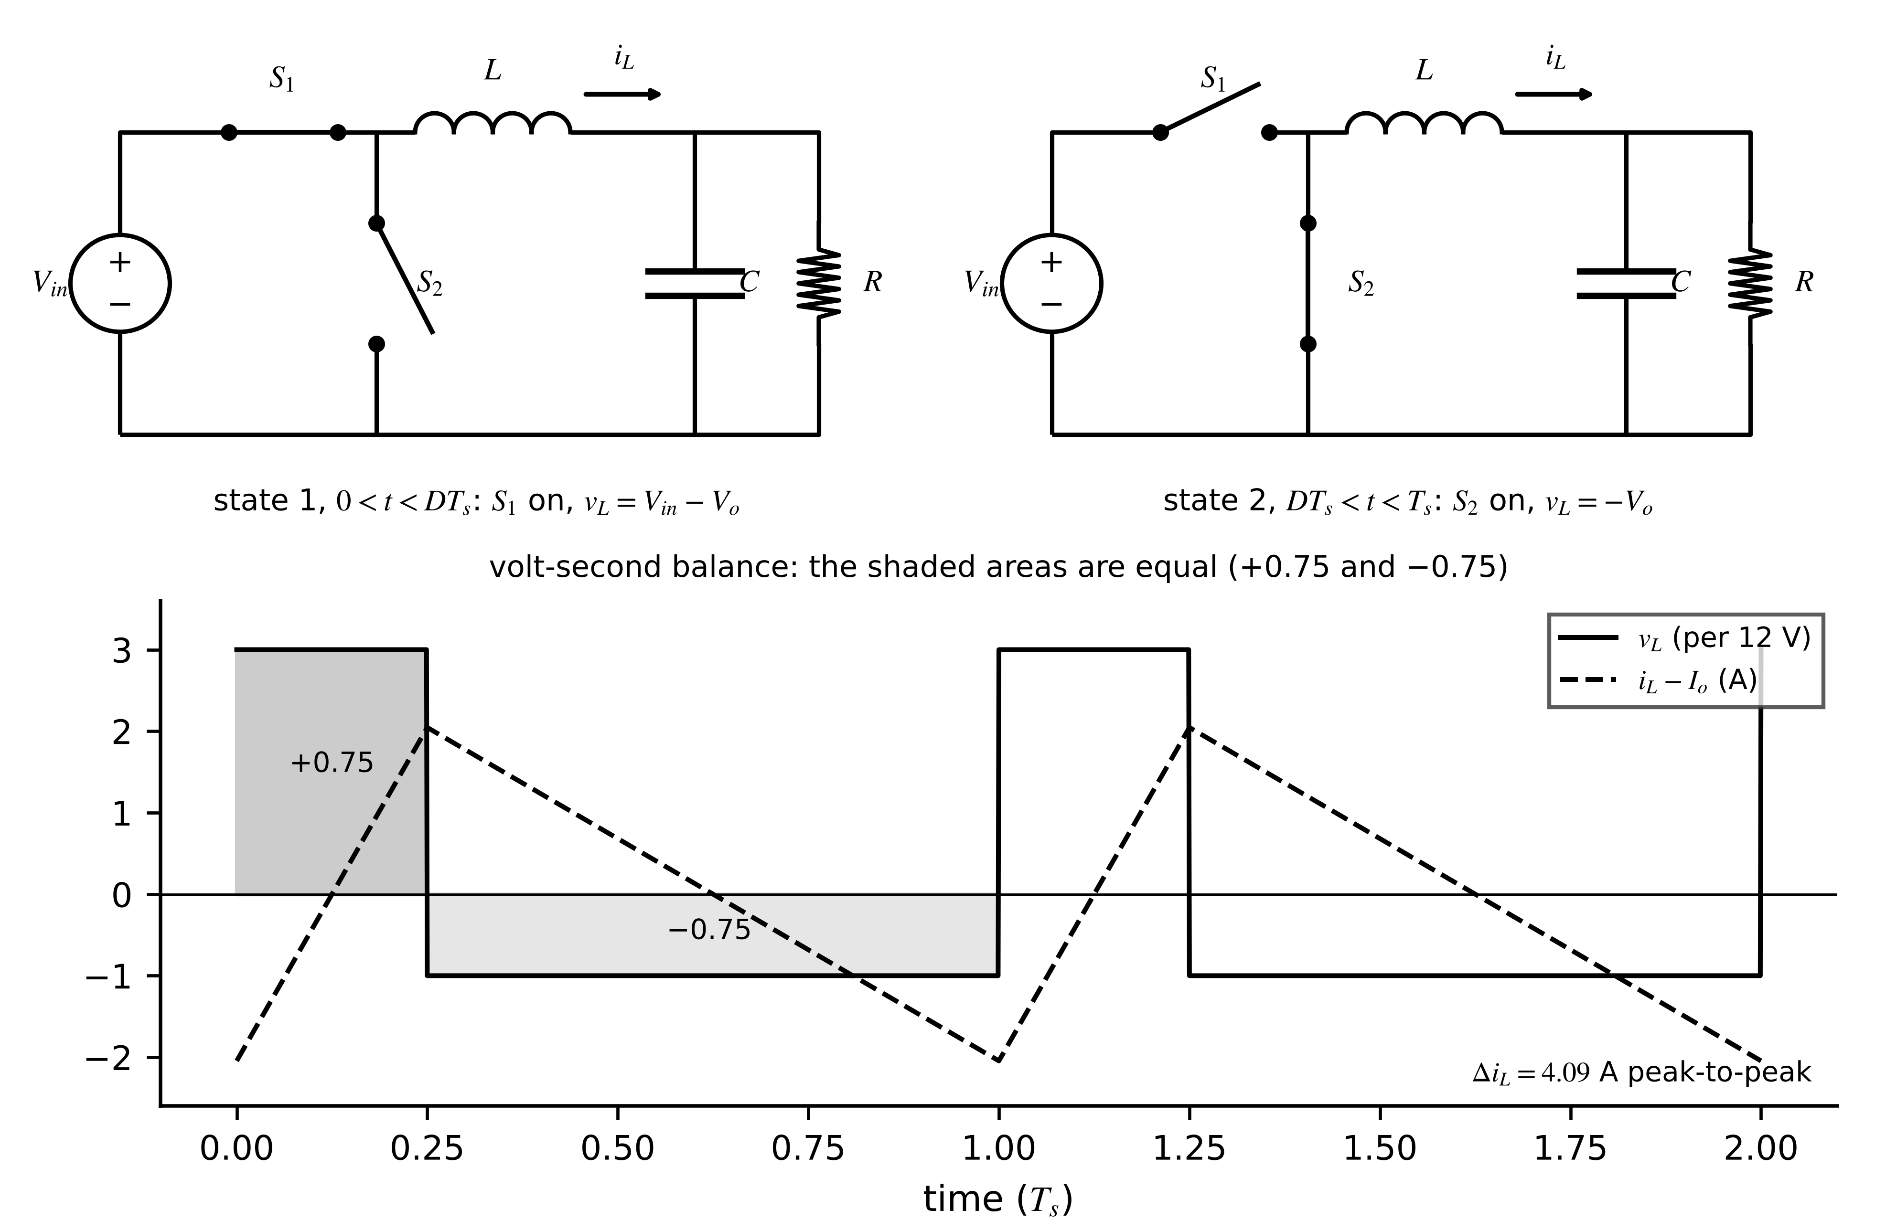
Figure 7.1. Buck converter. Top: the two switch states. Bottom: inductor voltage (scaled) and inductor current ripple for the 48 V to 12 V stage of Example 7.1; the shaded areas of the inductor voltage are equal in steady state.
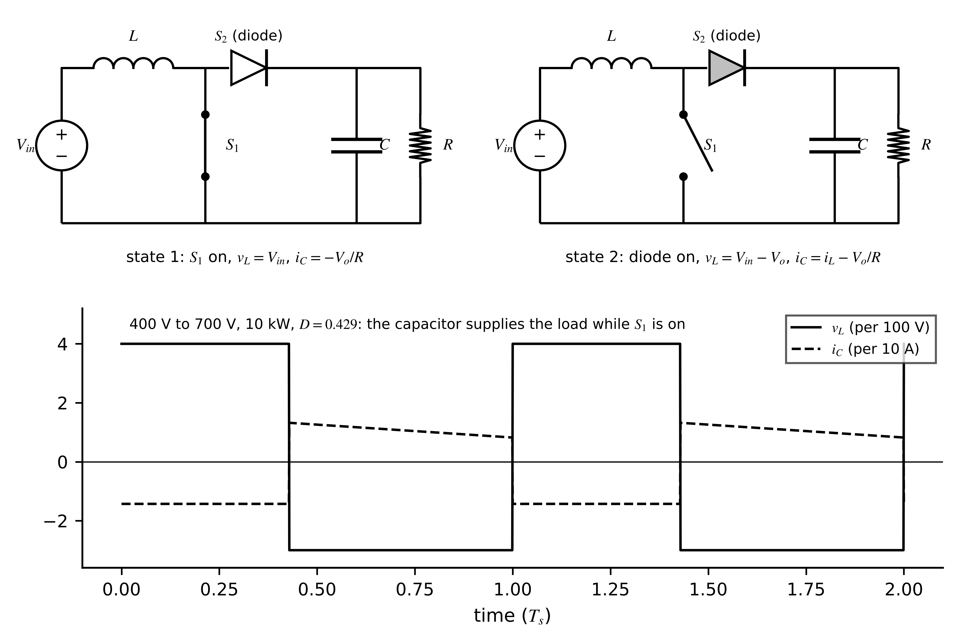
Figure 7.2. Boost converter. Top: the two switch states. Bottom: inductor voltage and capacitor current for the PV boost stage of Example 7.2; the capacitor supplies the whole load current while $S_{1}$ conducts.

7.2.2 Conversion ratio from volt-second balance
Over one period in steady state the inductor current returns to its starting value. Since $v_{L}=L di_{L}/dt$, the integral of the inductor voltage over the period is zero, the volt-second balance. For the buck and boost converters, writing the inductor voltage in each state and multiplying by the state's duration,
$\left(V_{in}-V_{o}\right)DT_{s}+\left(-V_{o}\right)(1-D)T_{s}=0 ⇒ \frac{V_{o}}{V_{in}}=D, V_{in}DT_{s}+\left(V_{in}-V_{o}\right)(1-D)T_{s}=0 ⇒ \frac{V_{o}}{V_{in}}=\frac{1}{1-D}$ (7.1)
These hold in continuous conduction mode (CCM), when the inductor current never falls to zero. The dual statement for a capacitor, charge balance, says its average current is zero; for the boost it gives the input current $I_{L}=I_{o}/(1-D)$, and power balance $V_{in}I_{L}=V_{o}I_{o}$ follows. As $D→1$ the ideal boost ratio grows without limit; real converters do not, for the reasons in Section 7.2.5.

7.2.3 Ripple
The inductor current rises during one state with slope $v_{L}/L$, so its peak-to-peak ripple follows from either state; the output capacitor of the buck receives the triangular ripple current, whose positive half delivers a charge $\frac{1}{2}·\frac{T_{s}}{2}·\frac{Δi_{L}}{2}$, while the boost capacitor supplies the full load current while $S_{1}$ is on:
$Δi_{L,buck}=\frac{V_{o}(1-D)}{Lf_{s}}, Δi_{L,boost}=\frac{V_{in}D}{Lf_{s}}; Δv_{o,buck}=\frac{Δi_{L}}{8Cf_{s}}+Δi_{L}r_{C}, Δv_{o,boost}=\frac{I_{o}D}{Cf_{s}}+{\hat{i}}_{L}r_{C}$ (7.2)
where $r_{C}$ is the capacitor's equivalent series resistance (ESR) and ${\hat{i}}_{L}$ the peak inductor current. The ESR term is often larger than the capacitive one, which is what makes output ripple a capacitor-health indicator (Section 7.10.5). Design usually fixes a ripple ratio $r_{i}=Δi_{L}/I_{L}$ of 20 to 40 % and solves for $L$.
Example 7.1 (Level A) A 48 V to 12 V buck stage
Given. $V_{in}=48$ V, $V_{o}=12$ V at 10 A, $f_{s}=100$ kHz, $L=22$ µH, $C=100$ µF with $r_{C}=10$ mΩ.
Find. Duty cycle, inductor ripple, capacitive and ESR parts of the output ripple, and the load current at the CCM/DCM boundary.
Solution. $D=0.25$. (7.2): $Δi_{L}=12×0.75/(22×{10}^{-6}×{10}^{5})=4.09$ A; capacitive ripple $4.09/(8×{10}^{-4}×{10}^{5})=51$ mV; ESR ripple $4.09×0.01=41$ mV. The boundary load current is half the ripple, 2.05 A ((7.3)).
Interpretation. The two ripple components are comparable; as the capacitor ages, its ESR rises and the in-phase component grows, which a twin can track (Section 7.10.5). A switching simulation in Section 7.7 reproduces 4.09 A and 51 mV.

7.2.4 The CCM/DCM boundary
At light load the average inductor current falls below half its ripple, the current reaches zero before the period ends and, with a diode as $S_{2}$, stays there: discontinuous conduction mode (DCM, Figure 7.3). A third, zero-current state appears, volt-second balance changes, and the ratio depends on the load. Defining the dimensionless parameter $K=2Lf_{s}/R$, the boundary and the buck DCM ratio are
$I_{o,crit,buck}=\frac{Δi_{L}}{2}=\frac{V_{o}(1-D)}{2Lf_{s}}, K_{crit,buck}=1-D, M_{buck}=\frac{2}{1+\sqrt{1+4K/D^{2}}}; K_{crit,boost}=D(1-D)^{2}, M_{boost}=\frac{1+\sqrt{1+4D^{2}/K}}{2}$ (7.3)
valid for $K<K_{crit}$. For the buck of Example 7.1 at 0.5 A ($R=24$ Ω), $K=0.183<0.75$: DCM, with $M=0.438$, so the output would rise to 21 V if the duty cycle were left at its full-load value. A twin that ignores DCM expects the wrong duty cycle and flags a healthy converter as faulty.
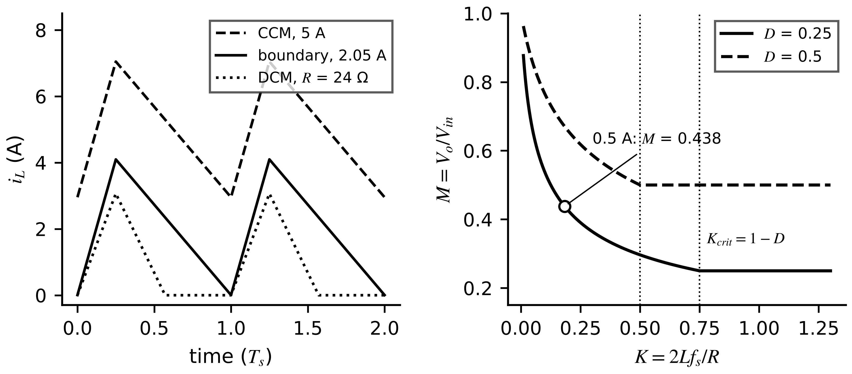
Figure 7.3. CCM/DCM boundary. Left: inductor current in CCM, at the boundary and in DCM for the buck of Example 7.1. Right: buck conversion ratio against $K=2Lf_{s}/R$ for two duty cycles; below $K_{crit}=1-D$ the ratio rises with lighter load.
Example 7.2 (Level B) Sizing the PV boost inductor for a 10 % boundary
Given. A PV boost stage of Plant P-1: $V_{in}=400$ V, $V_{o}=700$ V, 10 kW, $f_{s}=20$ kHz, $C=47$ µF. The designer wants CCM down to 10 % load.
Find. $D$, the inductance for the boundary at 1 kW, the full-load ripples, and the conversion ratio at 1 kW with that inductance.
Solution. $D=1-400/700=0.4286$; $K_{crit}=D(1-D)^{2}=0.140$. At 1 kW, $R={700}^{2}/1000=490$ Ω, so $L=K_{crit}R/(2f_{s})=1.714$ mH. At full load ($R=49$ Ω, $K=1.40$, CCM): $Δi_{L}=400×0.4286/(20 000×1.714×{10}^{-3})=5.0$ A on a 25 A input current; $Δv_{o}=14.29×0.4286/(20 000×47×{10}^{-6})=6.5$ V. At 1 kW, $K=K_{crit}$ and the DCM formula gives $M=1.750$, matching the CCM value: the boundary.
Interpretation. Below 1 kW the stage enters DCM and its small-signal behaviour changes (Section 7.7): a controller tuned for CCM becomes sluggish, and a twin must know which mode it is in from the operating point.

7.2.5 What real components change
Ideal analysis ignores four effects a twin cannot. Winding resistance $r_{L}$ adds a voltage drop $r_{L}I_{L}$ in both states; repeating the volt-second balance for the boost with it included gives
$\frac{V_{o}}{V_{in}}=\frac{1}{1-D}·\frac{1}{1+\frac{r_{L}}{(1-D)^{2}R}}, η=\frac{1}{1+\frac{r_{L}}{(1-D)^{2}R}}$ (7.4)
so the ratio peaks and then falls as $D→1$; for the PV boost with $r_{L}=0.1$ Ω, $η=99.4$ % from this term alone. Device drops and switching losses (Section 7.10) lower efficiency further and depend on temperature. Component tolerances and ageing move $L$, $C$ and ESR. Dead time and diode recovery distort the switching transitions. Each appears as a parameter the twin can estimate and track.

7.2.6 Bidirectional operation
A battery interface must both charge and discharge. Replacing the boost diode by a second active switch gives a synchronous half bridge (Figure 7.4) that works as a boost from battery to bus when the lower switch is modulated and as a buck from bus to battery when the upper switch is, with the inductor current changing sign. With the battery side at $V_{lo}$ and inductor current $I_{L}$ positive on discharge,
$P_{lo}=V_{lo}I_{L}, I_{L}>0: \frac{V_{bus}}{V_{lo}}=\frac{1}{1-D_{L}} (boost), I_{L}<0: \frac{V_{lo}}{V_{bus}}=D_{H} (buck), D_{H}=1-D_{L}$ (7.5)
Because complementary switching lets the inductor current go negative, a synchronous stage never enters DCM; at light load the current circulates through zero, with extra conduction loss. A full bridge extends operation to all four quadrants of voltage and current.
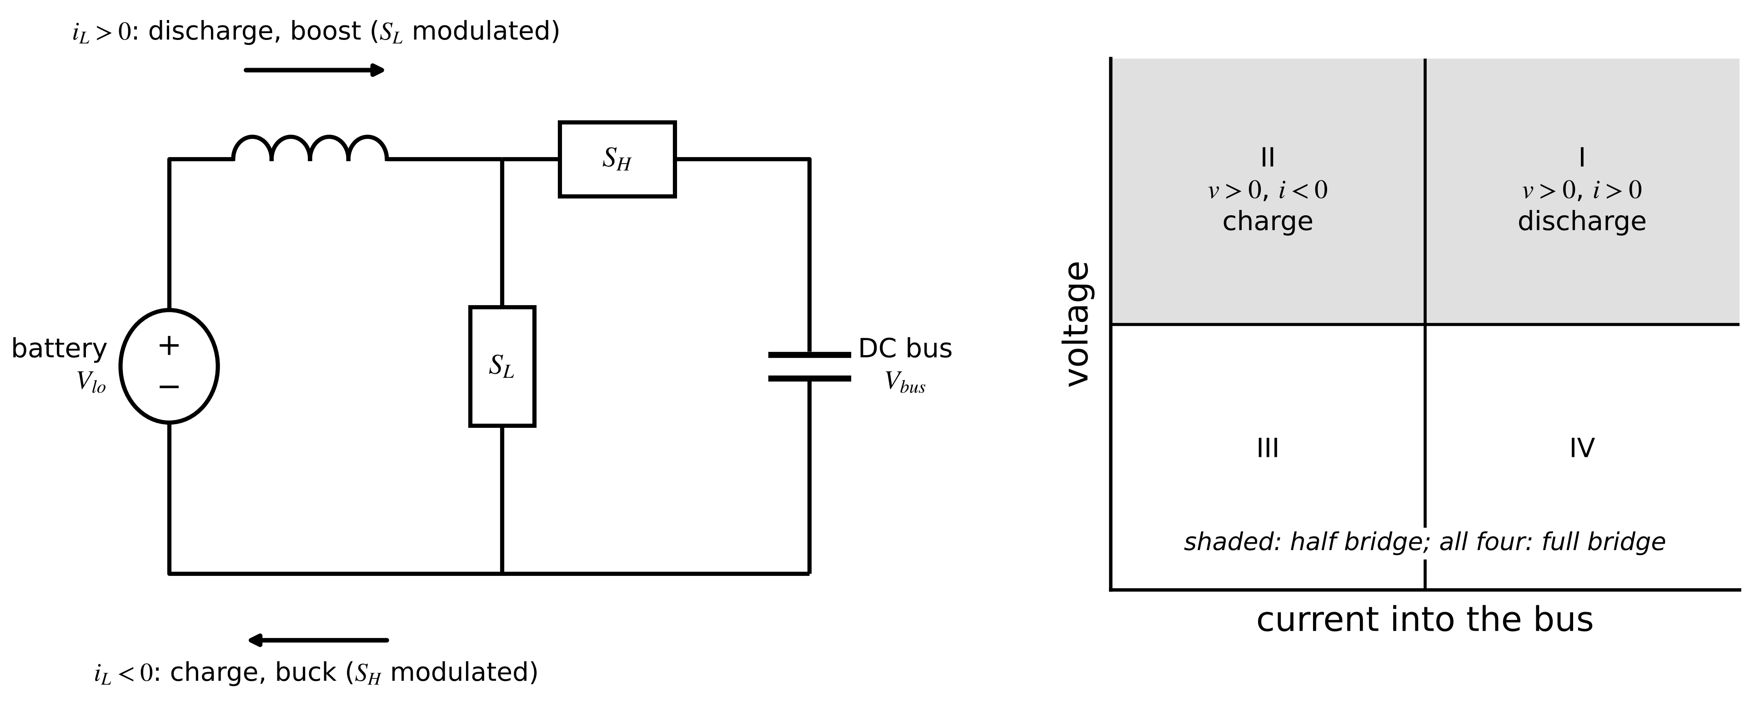
Figure 7.4. Bidirectional synchronous half bridge between a battery and a DC bus (left) and the quadrants of operation (right). The half bridge covers quadrants I and II; a full bridge covers all four.
Example 7.3 (Level A) A battery interface in both directions
Given. A 10 kW interface between a 350 V battery and a 650 V DC bus; $L=1$ mH, $f_{s}=20$ kHz.
Find. The duty cycles in discharge and charge, the inductor current at full power and its ripple.
Solution. Discharge: $D_{L}=1-350/650=0.462$. Charge: $D_{H}=350/650=0.538$, the complement. $I_{L}=10 000/350=28.6$ A, positive on discharge and negative on charge; ripple $350×0.462/({10}^{-3}×20 000)=8.1$ A in both directions.
Interpretation. One set of switches and one inductor serves both directions, and the twin's model is the same averaged circuit with the sign of $I_{L}$ flipped; only the controller's mode changes.
Table 7.1. DC-DC converter stages compared (ideal, continuous conduction)
Stage | Ratio $V_{o}/V_{in}$ | Inductor ripple | Switch voltage | States a twin tracks | Use in Plant P-1
buck | $D$ | $V_{o}(1-D)/(Lf_{s})$ | $V_{in}$ | $i_{L}$, $v_{C}$, $D$, ESR | auxiliary supplies
boost | $1/(1-D)$ | $V_{in}D/(Lf_{s})$ | $V_{o}$ | $i_{L}$, $v_{C}$, mode (CCM/DCM) | PV string stage
bidirectional half bridge | boost or buck by direction | as above | $V_{bus}$ | $i_{L}$ with sign, mode | BESS DC interface
buck-boost (inverting) | $-D/(1-D)$ | $V_{in}D/(Lf_{s})$ | $V_{in}+V_{o}$ | $i_{L}$, $v_{C}$ | small supplies

What the digital twin adds
Synchronized: inductor current, capacitor voltage and the operating mode.
Estimated or updated: duty cycle, $r_{L}$, ESR and capacitance from ripple.
Uncertainty carried: component tolerance and mode ambiguity near the boundary.
Decision enabled: whether a deviation is a fault or a mode change.
Validated by: measured ripple against (7.2) at known operating points.

7.3 Isolated and resonant DC-DC converters
Three needs drive designers beyond the buck and boost: galvanic isolation (for safety and to break ground loops), large voltage ratios that a duty cycle alone cannot reach efficiently, and high switching frequency with low loss. A transformer meets the first two; resonance meets the third. The question for a twin is not the full catalogue of topologies but how each one moves energy and which internal quantities reveal its health.

7.3.1 The flyback: a coupled inductor
A flyback stores energy in the magnetizing inductance $L_{m}$ of a coupled inductor while its primary switch is on, and releases it to the secondary when the switch turns off. Volt-second balance on $L_{m}$, with turns ratio $n=N_{p}/N_{s}$, gives the CCM ratio; the switch sees the input plus the reflected output plus a leakage spike, and the leakage energy is dissipated in a clamp each cycle; in DCM the energy per cycle sets the output power:
$\frac{V_{o}}{V_{in}}=\frac{1}{n}·\frac{D}{1-D}, V_{S,max}=V_{in}+nV_{o}+V_{spike}, P_{lk}=\frac{1}{2}L_{lk}I_{pk}^{2}f_{s}, P_{o}=\frac{1}{2}L_{m}I_{pk}^{2}f_{s}$ (7.6)
where $L_{lk}$ is the leakage inductance and $I_{pk}=V_{in}DT_{s}/L_{m}$ the peak magnetizing current.
Example 7.4 (Level A) An auxiliary flyback supply from the 400 V bus
Given. $V_{in}=400$ V, $V_{o}=24$ V, 60 W, $f_{s}=100$ kHz, design duty cycle 0.4 in CCM.
Find. (a) Turns ratio and switch voltage before the spike. (b) For a DCM design with $L_{m}=1$ mH, the peak current, duty cycle and clamp loss if $L_{lk}$ is 2 % of $L_{m}$.
Solution. (a) $n=400×0.4/(24×0.6)=11.1$; $V_{S}=400+11.1×24=667$ V. (b) $I_{pk}=\sqrt{2×60/({10}^{-3}×{10}^{5})}=1.10$ A; $D=I_{pk}L_{m}f_{s}/V_{in}=0.27$; clamp loss $\frac{1}{2}×20×{10}^{-6}×{1.10}^{2}×{10}^{5}=1.2$ W, 2 % of the output.
Interpretation. Leakage inductance is a direct efficiency term: a twin that tracks the clamp temperature can detect a transformer whose coupling has degraded.

7.3.2 The dual active bridge: power by phase shift
For tens of kilowatts with isolation in both directions, as between the Plant P-1 battery and its DC bus, the dual active bridge (DAB) places a full bridge on each side of a high-frequency transformer, with a series inductance $L$ (often the leakage) between them. Each bridge produces a square wave; the secondary wave is shifted by an angle $φ$, and the inductor voltage, the difference between the two waves, drives a current whose average product with the secondary voltage is the transferred power (Figure 7.5). Integrating the piecewise-linear inductor current over a half period gives, with $V_{1}$ and $nV_{2}$ referred to the primary,
$P=\frac{V_{1} nV_{2}}{2π^{2}f_{s}L} φ\left(π-|φ|\right), -\frac{π}{2}≤φ≤\frac{π}{2}, P_{max}=\frac{V_{1} nV_{2}}{8f_{s}L}, |φ|>\frac{π}{2}\left(1-d\right) for ZVS, d=\frac{nV_{2}}{V_{1}}<1$ (7.7)
The sign of $φ$ sets the direction of power. Zero-voltage switching (ZVS) is lost at light load when the voltages are mismatched ($d≠1$), which raises switching loss exactly where efficiency matters for idle storage.
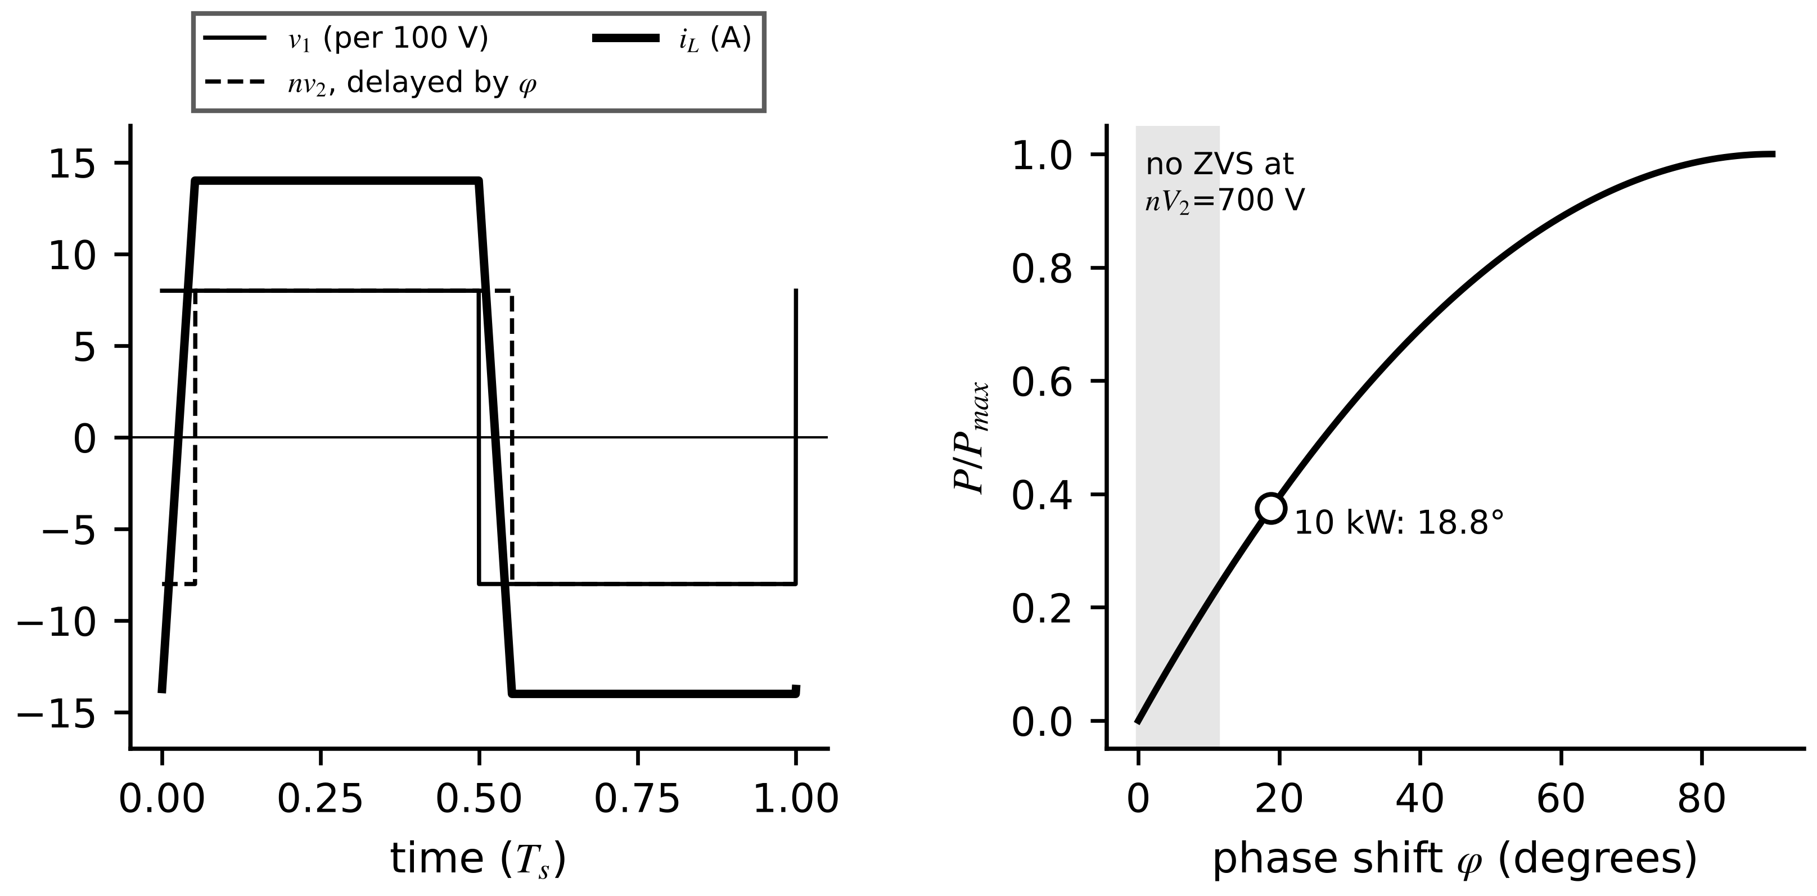
Figure 7.5. Dual active bridge. Left: primary and phase-shifted secondary square waves and the resulting inductor current over one period. Right: transferred power against phase shift, with the 10 kW operating point of Example 7.5.
Example 7.5 (Level B) A 10 kW dual active bridge for the Plant P-1 battery
Given. $V_{1}=800$ V, $nV_{2}=800$ V, $f_{s}=50$ kHz, $L=60$ µH referred to the primary.
Find. $P_{max}$, the phase shift for 10 kW, the RMS inductor current, and what changes when the battery sags so that $nV_{2}=700$ V at the same power.
Solution. $P_{max}={800}^{2}/(8×5×{10}^{4}×60×{10}^{-6})=26.7$ kW. Solving (7.7): $φ=0.329$ rad (18.8°). A piecewise-linear simulation gives 13.5 A RMS and confirms 10.0 kW. At $nV_{2}=700$ V: $φ=22.0°$ and 15.4 A RMS, 14 % more current for the same power; with $d=0.875$ the ZVS boundary is 11.25°, so this point still switches softly, but below about 5.5 kW it does not.
Interpretation. DAB loss depends on voltage mismatch as much as on power. A battery twin that knows the SOC, and hence the battery voltage, can tell the controller when to switch to an extended modulation, and can explain an efficiency drop that a power-only model would blame on ageing.
[Advanced] Deriving the DAB power, soft-switching boundary and RMS current
Measure angle as $θ=ωt$ with $ω=2πf_{s}$, write $V_{2}′=nV_{2}$ for the secondary voltage referred to the primary, and let the primary square wave be $+V_{1}$ on $[0,π)$ and the secondary $+V_{2}′$ on $[φ,π+φ)$ with $0≤φ≤π/2$. The inductor voltage is $V_{1}+V_{2}′$ on $[0,φ)$ and $V_{1}−V_{2}′$ on $[φ,π)$, and $ωL di/dθ=v_{L}$. Half-wave symmetry, $i\left(θ+π\right)=−i\left(θ\right)$, closes the cycle and fixes the two corner currents:
$i\left(0\right)=−\frac{V_{1}π+V_{2}′\left(2φ−π\right)}{2ωL}, i\left(φ\right)=\frac{V_{1}\left(2φ−π\right)+V_{2}′π}{2ωL}$
The power is the average of $v_{2}′i$ over a half period. Integrating the two linear segments gives (7.7):
$P=\frac{1}{π}\left[\int_{0}^{φ}{\left(−V_{2}′\right)} i dθ+\int_{φ}^{π}{V_{2}}′ i dθ\right]=\frac{V_{1}V_{2}′}{ωLπ} φ\left(π−φ\right)=\frac{V_{1}V_{2}′ φ\left(π−φ\right)}{2π^{2}f_{s}L}$
Soft switching needs the current to flow so that it discharges the output capacitance of the switch about to turn on. The primary bridge switches at $θ=0$ and needs $i\left(0\right)<0$; the secondary bridge switches at $θ=φ$ and needs $i\left(φ\right)>0$. With $d=V_{2}′/V_{1}<1$ the first condition always holds, and the second gives $φ>\frac{π}{2}\left(1−d\right)$, the boundary in (7.7). For $d>1$ the roles of the bridges exchange.
Because the current is piecewise linear, its RMS value follows exactly from the corner values: a segment of length $ℓ$ between values $a$ and $b$ contributes $ℓ\left(a^{2}+ab+b^{2}\right)/3$ to $∫i^{2}dθ$. With $a_{0}=i\left(0\right)$, $a_{1}=i\left(φ\right)$ and $a_{2}=−i\left(0\right)$:
$I_{rms}^{2}=\frac{φ\left(a_{0}^{2}+a_{0}a_{1}+a_{1}^{2}\right)+\left(π−φ\right)\left(a_{1}^{2}+a_{1}a_{2}+a_{2}^{2}\right)}{3π}$
For Example 7.5 ($V_{1}=V_{2}′=800$ V, $ωL=18.85$ Ω, $φ=0.329$ rad) the corner currents are $∓13.96$ A and $I_{rms}=13.5$ A, the value found there by simulation. With $V_{2}′=700$ V and $φ=0.384$ rad the corner currents become $−22.6$ A and $+7.9$ A and $I_{rms}=15.4$ A: the larger primary current carries the 14 % RMS penalty, and the positive secondary corner current confirms soft switching. At 5.5 kW that corner current reaches zero, the boundary found in Example 7.5. These closed forms are what a DAB twin evaluates every control period to predict conduction loss and the soft-switching margin from the measured voltages.

7.3.3 The LLC resonant converter
The LLC converter drives a series resonant tank (resonant inductance $L_{r}$, capacitance $C_{r}$) and the transformer's magnetizing inductance $L_{m}$ with a square wave and controls the output by frequency. With first-harmonic approximation, the load reflects to an AC resistance and the gain becomes a function of normalized frequency $f_{n}=f_{s}/f_{r}$, inductance ratio $L_{n}=L_{m}/L_{r}$ and quality factor $Q=\sqrt{L_{r}/C_{r}}/R_{ac}$ (Figure 7.6):
$f_{r}=\frac{1}{2π\sqrt{L_{r}C_{r}}}, f_{p}=\frac{1}{2π\sqrt{(L_{r}+L_{m})C_{r}}}, R_{ac}=\frac{8n^{2}}{π^{2}}R_{L}, M\left(f_{n}\right)=\frac{1}{\sqrt{{\left(1+\frac{1}{L_{n}}-\frac{1}{L_{n}f_{n}^{2}}\right)}^{2}+Q^{2}{\left(f_{n}-\frac{1}{f_{n}}\right)}^{2}}}$ (7.8)
At $f_{n}=1$ the gain is 1 for every load: the tank's impedance vanishes and the converter runs at its most efficient point, with soft switching of both bridges. Below resonance the gain can exceed 1 at light load but collapses at heavy load (high $Q$).
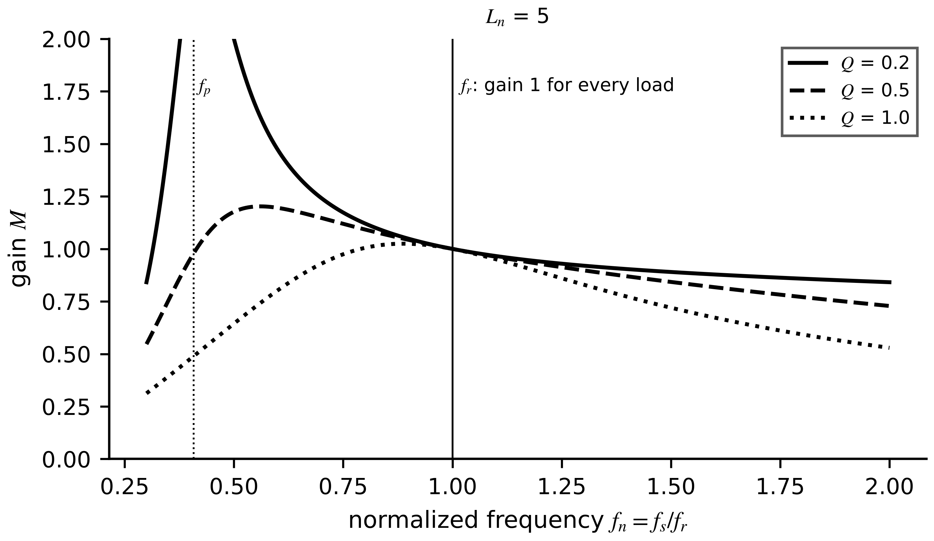
Figure 7.6. LLC gain against normalized frequency for $L_{n}=5$ and three quality factors. All curves pass through 1 at resonance; the boost available below resonance shrinks as load rises.
Example 7.6 (Level A) Designing around the resonant point
Given. $L_{r}=50$ µH, $C_{r}=50$ nF, $L_{m}=250$ µH, $n=1$, output 400 V at 3 kW.
Find. $f_{r}$, $f_{p}$, $Q$ at full load, and the gain at $f_{n}=0.8$, 1.0 and 1.2 for $Q=0.2$, 0.5 and 1.0.
Solution. $f_{r}=100.7$ kHz, $f_{p}=41.1$ kHz, $L_{n}=5$. $R_{L}=53.3$ Ω, $R_{ac}=43.2$ Ω, $\sqrt{L_{r}/C_{r}}=31.6$ Ω, so $Q=0.73$. Gains: $Q=0.2$: 1.121, 1.000, 0.940; $Q=0.5$: 1.092, 1.000, 0.929; $Q=1.0$: 1.005, 1.000, 0.891.
Interpretation. At heavy load the tank can no longer boost during a low input voltage. The LLC twin must carry $Q$ from the measured load, and a drift of the resonant frequency measured by the controller is a direct health indicator of the resonant capacitor.
Table 7.2. Isolated and resonant DC-DC converters for energy systems
Converter | Energy-transfer mechanism | Control variable | Soft switching | States a twin tracks | Typical use
flyback | stored in magnetizing inductance, released to secondary | duty cycle | no (clamp) | $i_{Lm}$, clamp temperature | auxiliary supplies < 200 W
dual active bridge | phase-shifted square waves across an inductance | phase shift | yes, near $d=1$ | $i_{L}$ RMS, $d$, ZVS margin | battery, solid-state transformer
LLC | resonant tank near $f_{r}$ | frequency | yes, near $f_{r}$ | $f_{r}$ (capacitor health), $Q$ | chargers, data-centre supplies

What the digital twin adds
Synchronized: phase shift or frequency, transformer currents and resonant frequency.
Estimated or updated: leakage and resonant parameters; ZVS margin.
Uncertainty carried: first-harmonic approximation error away from resonance.
Decision enabled: modulation strategy by operating point; component health advisories.
Validated by: measured RMS currents and efficiency against the model over the voltage range.

7.4 The three-phase voltage-source converter

7.4.1 Switch states and phase voltages
The two-level voltage-source converter (VSC) of drive D-3, of every PV inverter and of the BESS PCS has three legs, each connecting its output to the positive or negative DC rail (Figure 7.7). With $S_{k}=1$ when the upper switch of leg $k$ conducts, the pole voltage relative to the negative rail is $v_{kN}=S_{k}V_{dc}$. A balanced star-connected load has no path for the average of the three pole voltages, so subtracting it gives the phase voltages, and the eight switch combinations map to eight space vectors:
$v_{kn}=v_{kN}-\frac{v_{aN}+v_{bN}+v_{cN}}{3}, \vec{v}=\frac{2}{3}\left(v_{an}+a v_{bn}+a^{2}v_{cn}\right), a=e^{j2π/3}$ (7.9)
Six vectors of length $\frac{2}{3}V_{dc}$ form a hexagon, and two (000 and 111) are zero. The subtracted average is the common-mode voltage, which reappears in Section 7.16 as the source of bearing currents.
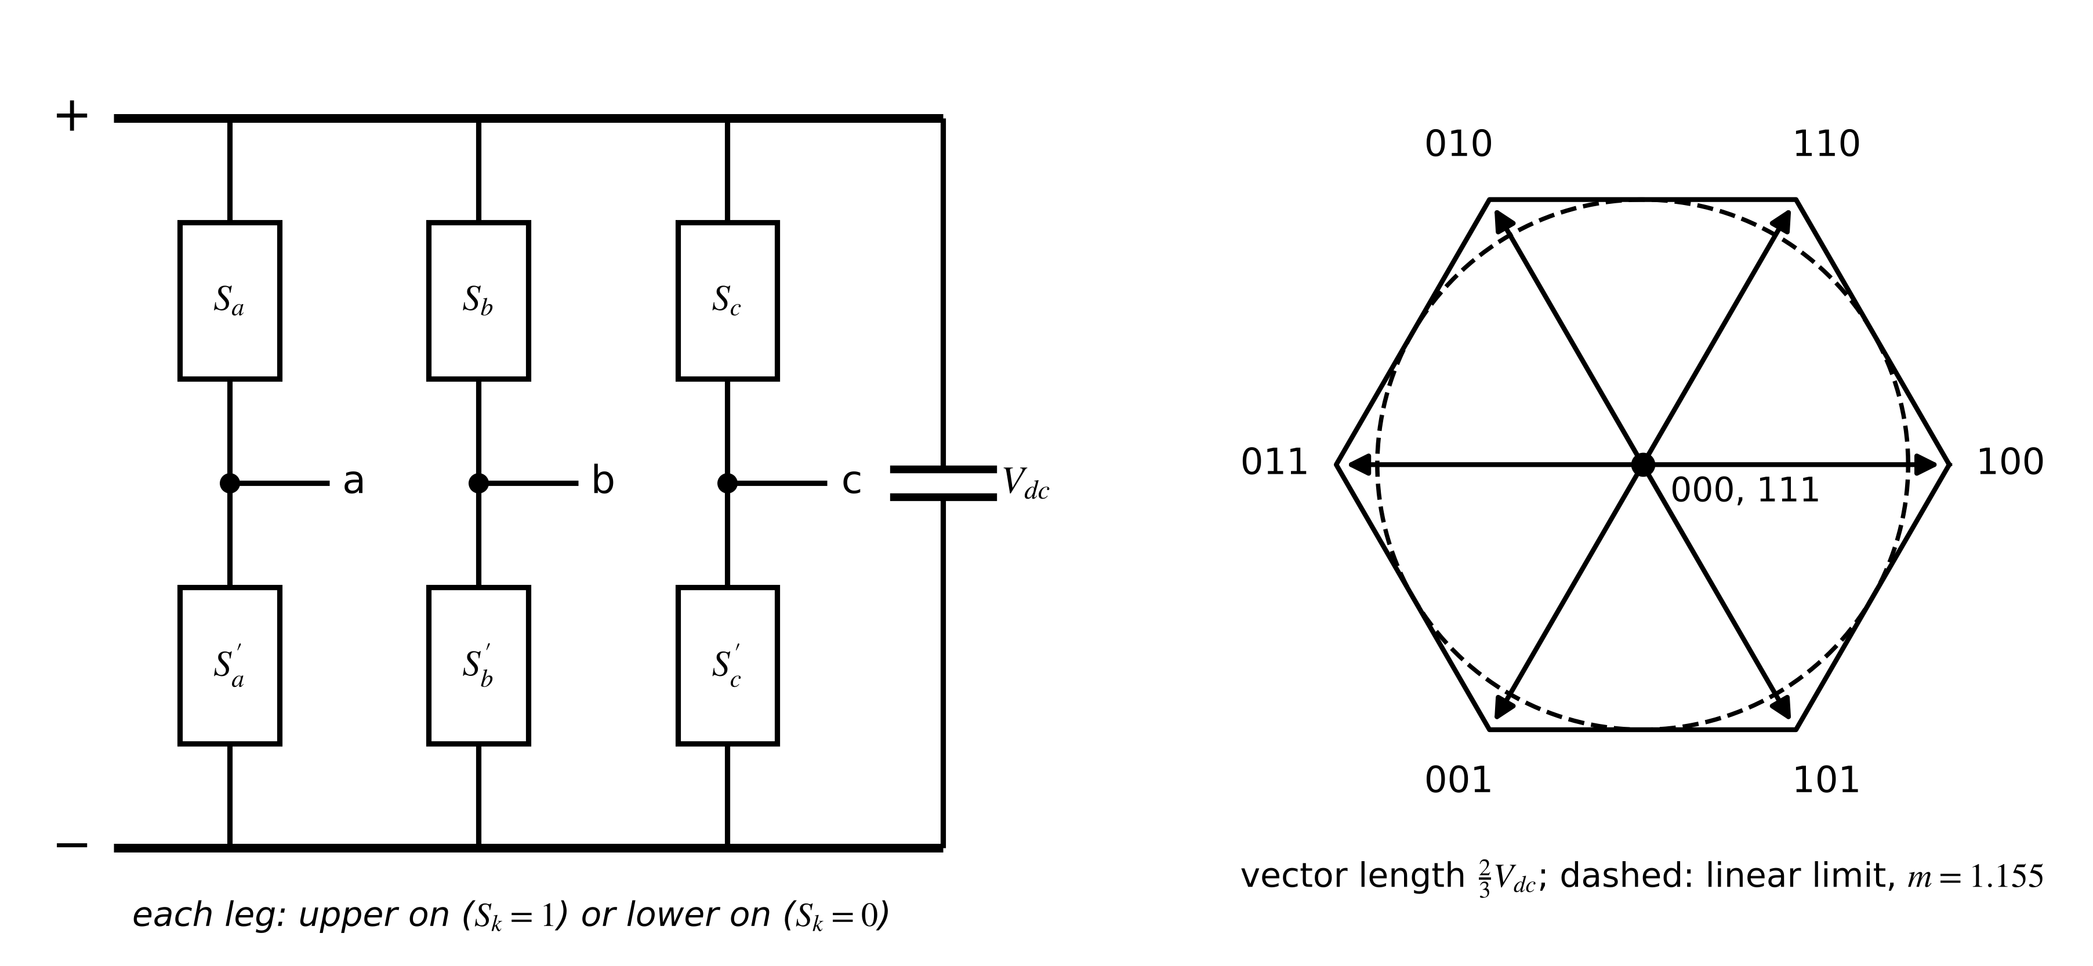
Figure 7.7. Two-level three-phase VSC: three legs between the DC rails (left) and the eight switch states as space vectors (right). The dashed circle is the largest sinusoidal voltage that stays in the linear range.

7.4.2 Modulation and its limits
Sine-triangle PWM compares each phase reference with a carrier; the averaged phase voltage is ${\overline{v}}_{an}=\frac{mV_{dc}}{2}sinωt$ with modulation index $0≤m≤1$. Adding a common-mode term, such as the min-max injection $-\frac{1}{2}(maxv_{k}+minv_{k})$, flattens the references without changing the line voltages (Figure 7.8) and extends the linear range to the inscribed circle of the hexagon, which is what space-vector modulation achieves:
$V_{LL,rms}=\frac{\sqrt{3}}{2\sqrt{2}} mV_{dc}, m_{max}=\frac{2}{\sqrt{3}}=1.155, V_{LL,rms,max}=\frac{V_{dc}}{\sqrt{2}}, f_{h}=k_{1}m_{f}f_{1}±k_{2}f_{1}$ (7.10)
where $m_{f}=f_{s}/f_{1}$ is the frequency ratio and the last expression locates the switching harmonics in sidebands around multiples of $f_{s}$ ($k_{1}$ odd with $k_{2}$ even, and vice versa). Beyond $m_{max}$ the converter overmodulates and low-order harmonics appear.
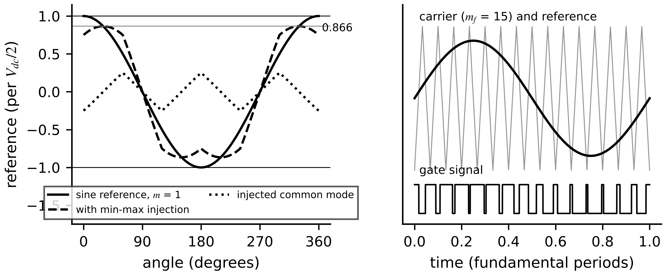
Figure 7.8. Left: a sinusoidal reference, the injected min-max common-mode component and the resulting flat-topped reference that extends the linear range by 15.5 %. Right: carrier comparison and the resulting gate signal.

7.4.3 Dead time
Both switches of a leg must never conduct together, so each turn-on is delayed by a dead time $t_{d}$. During it the current's own direction decides which diode conducts (Figure 7.9): for positive current the pole voltage stays low for $t_{d}$ longer than commanded, and for negative current it stays high $t_{d}$ longer than commanded. Averaged over a period, the pole voltage is in error by
$Δ{\overline{v}}_{kN}=-sgn\left(i_{k}\right)t_{d}f_{s}V_{dc}$ (7.11)
a square wave in phase with the current, whose fundamental is $4/π$ times its amplitude and which also contains 5th, 7th and higher harmonics.
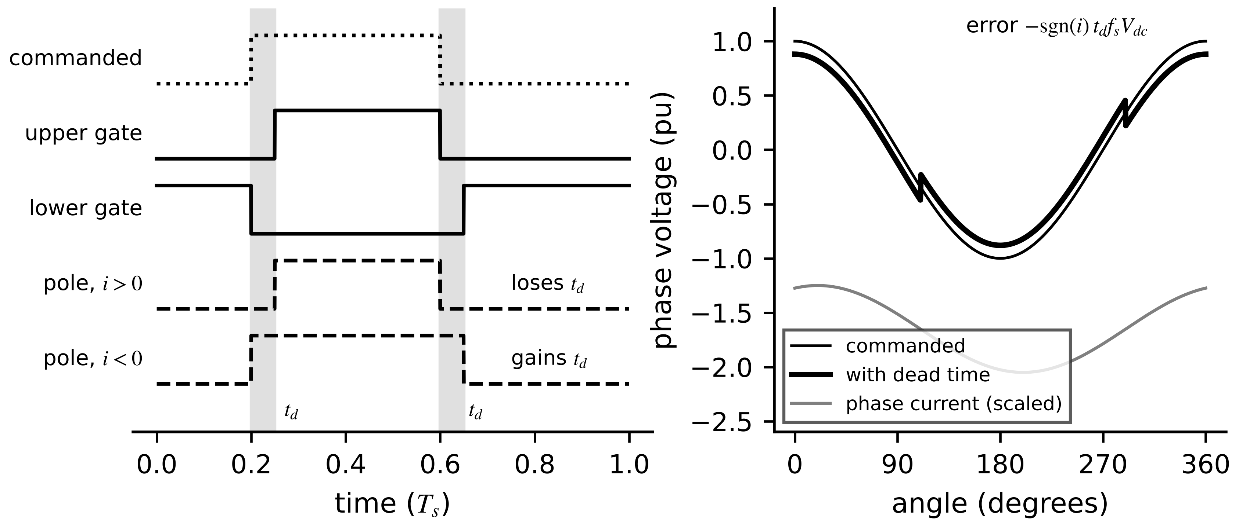
Figure 7.9. Dead time. Left: upper and lower gate signals with the dead intervals shaded, and the pole voltage for positive and negative current. Right: the resulting phase voltage, shifted by a square-wave error whose sign follows the current.
Example 7.7 (Level A) Modulation margin and dead-time error of drive D-3
Given. D-3 at its rated point: fundamental phase voltage amplitude 209.6 V, $V_{dc}=650$ V, $f_{s}=16$ kHz, $t_{d}=0.5$ µs, motor inductance 3 mH, electrical frequency 100 Hz.
Find. The modulation index and margin; the average and fundamental dead-time errors; the fifth-harmonic voltage and current.
Solution. $m=209.6/325=0.645$ against $m_{max}=1.155$: a 44 % voltage margin, which later allows field weakening. (7.11): $0.5×{10}^{-6}×16×{10}^{3}×650=5.2$ V; fundamental $\frac{4}{π}×5.2=6.6$ V, 3.2 % of the command. Fifth harmonic $\frac{4}{5π}×5.2=1.32$ V at 500 Hz; through $2π×500×0.003=9.4$ Ω it drives 0.14 A.
Interpretation. At rated speed the error is small and absorbed by the current loop; at low speed the same 6.6 V exceeds the back-EMF and limits sensorless operation (Section 7.15). Compensation adds $sgn(i_{k})t_{d}f_{s}V_{dc}$ to each reference, which is hard near current zero crossings; a twin that predicts the current sign from its model helps.

7.4.4 The averaged dq model
For control and estimation the VSC is averaged over a switching period and transformed to a frame rotating with the grid or rotor (Section 7.11). With modulation indices $m_{d}$, $m_{q}$, filter or machine resistance $R$ and inductance $L$, back-EMF or grid voltage $e_{dq}$ and DC-link capacitance $C_{dc}$, power balance between the AC and DC sides gives
$L\frac{di_{d}}{dt}=\frac{m_{d}V_{dc}}{2}-Ri_{d}+ωLi_{q}-e_{d}, L\frac{di_{q}}{dt}=\frac{m_{q}V_{dc}}{2}-Ri_{q}-ωLi_{d}-e_{q}, C_{dc}\frac{dV_{dc}}{dt}=i_{in}-\frac{3}{4}\left(m_{d}i_{d}+m_{q}i_{q}\right)$ (7.12)
with the amplitude-invariant transformation of Section 7.11. The cross-coupling terms $±ωLi$ are why current controllers add decoupling feedforward. The model is valid for frequencies well below the switching frequency; it omits ripple, dead time (unless added as a disturbance) and switching losses.
What the digital twin adds
Synchronized: switch states or modulation indices, phase currents and DC-link voltage.
Estimated or updated: dead-time error, voltage margin, current-sign uncertainty.
Uncertainty carried: inverter voltage error that biases every voltage-based estimate.
Decision enabled: modulation strategy, compensation, overmodulation limits.
Validated by: measured phase-voltage error against (7.11) across speed.

7.5 Multilevel converters
Why build a converter from many levels? A two-level leg must block the whole DC voltage in each switch and produces steps of $V_{dc}$ at every transition. At medium voltage that means series-connected devices, high $dv/dt$ and large filters. Multilevel converters synthesize the output from several smaller voltage steps, so each device blocks a fraction of the voltage, the waveform approaches a sinusoid at low switching frequency, and $dv/dt$ falls (Figure 7.10). The price is more devices and more internal states, capacitor voltages, that must be balanced and that a twin must track.
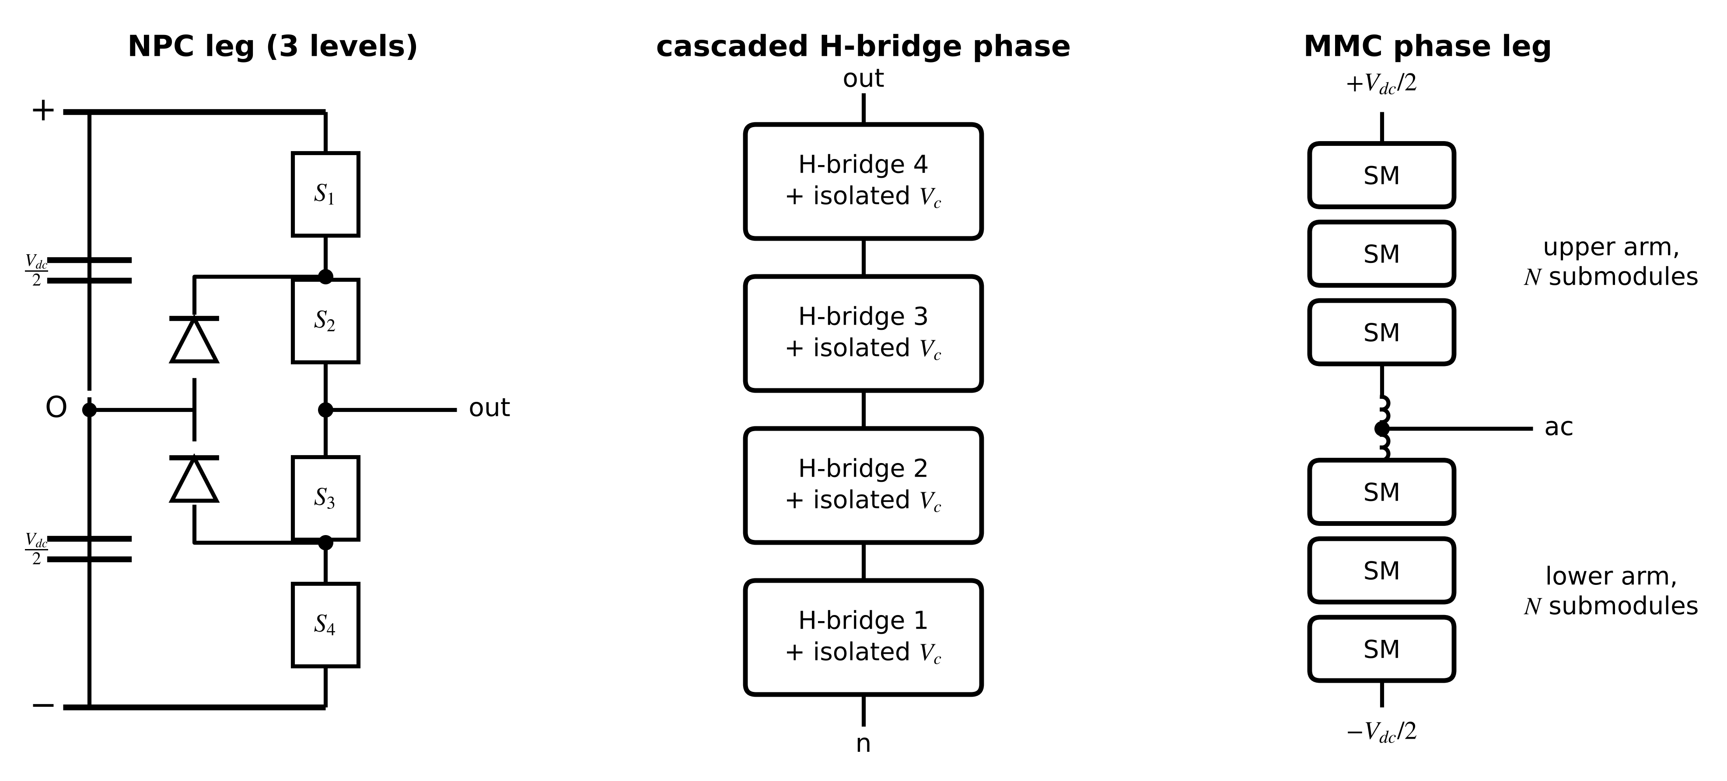
Figure 7.10. Three multilevel structures: a neutral-point-clamped (NPC) leg with clamping diodes to the DC midpoint, a cascaded H-bridge phase built from cells with isolated DC sources, and a modular multilevel converter (MMC) leg with upper and lower arms of submodules.
The neutral-point-clamped leg adds a DC midpoint O and two clamping diodes, so each phase can connect to $+V_{dc}/2$, 0 or $-V_{dc}/2$; the current drawn from the midpoint, $i_{O}=\sum_{k}{(}1-|s_{k}|)i_{k}$ with $s_{k}∈\{+1,0,-1\}$, must average to zero, or the two DC capacitors drift apart. The flying-capacitor leg uses clamping capacitors instead. The cascaded H-bridge (CHB) stacks $N$ cells per phase, each with its own isolated DC source of $V_{c}$, so that
$v_{kn}=\sum_{j=1}^{N}{s_{kj}}V_{c}, s_{kj}∈\{-1,0,+1\}, N_{ℓ,phase}=2N+1, N_{ℓ,line}=4N+1, {\hat{V}}_{h}=\frac{4V_{c}}{hπ}\sum_{j=1}^{N}{cos}\left(hα_{j}\right), f_{s,eff}=2Nf_{s}$ (7.13)
where $α_{j}$ are the switching angles of a staircase waveform and $f_{s,eff}$ is the effective switching frequency of phase-shifted carriers.
Example 7.8 (Level B) Harmonic distortion of staircase waveforms
Given. A CHB with $N=1$, 3, 5 and 9 cells per phase, staircase switching at $α_{j}=arcsin[(j-\frac{1}{2})/N]$, star connection (triplen harmonics cancel in the line voltage).
Find. The levels and the line-voltage total harmonic distortion from (7.13), summed to the 2000th harmonic.
Solution. $N=1$: 3 phase and 5 line levels, THD 31.1 %. $N=3$: 7 and 13 levels, angles 9.6°, 30.0°, 56.4°, THD 10.1 %. $N=5$: 11 and 21 levels, 6.9 %. $N=9$: 19 and 37 levels, 3.8 %.
Interpretation. Each doubling of the cell count roughly halves the distortion without high-frequency switching. For a twin the cost is state: every cell's DC voltage and health is a separate quantity to estimate.
[Advanced] The modular multilevel converter. The MMC, the workhorse of HVDC, builds each arm from $N$ half-bridge submodules with their own capacitors. With upper and lower arm voltages $v_{u}$, $v_{l}$ and currents $i_{u}$, $i_{l}$, the output voltage and the arm currents are
$v_{s}=\frac{v_{l}-v_{u}}{2}, i_{u}=\frac{i_{dc}}{3}+\frac{i_{s}}{2}+i_{z}, i_{l}=\frac{i_{dc}}{3}-\frac{i_{s}}{2}+i_{z}, ΔW_{arm}=\frac{2}{3}\frac{P}{kω}{\left[1-{\left(\frac{kcosφ}{2}\right)}^{2}\right]}^{3/2}, C_{SM}=\frac{ΔW_{arm}}{2εNV_{c}^{2}}$ (7.14)
where $i_{z}$ is the circulating current, $k=2{\hat{V}}_{s}/V_{dc}$, and $ε$ the allowed submodule voltage ripple. The arm energy oscillates at the fundamental frequency, which sizes the submodule capacitors; a twin of an MMC therefore tracks hundreds of capacitor voltages and their ageing, usually through averaged arm models rather than switching models (Section 7.7).
Table 7.3. Multilevel converter topologies compared
Topology | Levels per phase | Why it exists | Internal states to balance | Strength | Limitation
NPC (3-level) | 3 | halve device voltage with one DC link | midpoint voltage | mature, compact | unequal loss distribution
flying capacitor | $N+1$ | levels without clamping diodes | flying-capacitor voltages | redundant states | many capacitors
cascaded H-bridge | $2N+1$ | modular, low $dv/dt$ from isolated cells | each cell DC voltage | very low distortion | needs isolated sources
MMC | $N+1$ per arm | scalable to HVDC without series devices | every submodule voltage, circulating current | modular, redundant | large capacitors, complex control

What the digital twin adds
Synchronized: cell or submodule voltages and switching states, per arm or phase.
Estimated or updated: capacitor balance, circulating current, cell health.
Uncertainty carried: hundreds of states estimated from few measurements.
Decision enabled: redundancy use, cell bypass, maintenance planning.
Validated by: averaged-arm models against submodule measurements.

7.6 The DC link and filter sizing
The DC-link capacitor of a VSC is the energy buffer between source and load, and its ripple current is the main stress on the converter's shortest-lived component. The DC current drawn by the bridge is $i_{dc}=S_{a}i_{a}+S_{b}i_{b}+S_{c}i_{c}$; its average follows from power balance, and its RMS ripple, which the capacitor must carry, follows from averaging over switching and fundamental periods [3]:
${\overline{i}}_{dc}=\frac{P}{V_{dc}}=\frac{3}{4}m\hat{I}cosφ, I_{C,rms}=\hat{I}\sqrt{m\left[\frac{\sqrt{3}}{4π}+\left(\frac{\sqrt{3}}{π}-\frac{9m}{16}\right)\cos^{2}φ\right]}, C_{dc}\frac{dv_{dc}}{dt}=i_{in}-i_{dc}$ (7.15)
Two criteria size the capacitor: the energy to ride through a loss of input for a time $Δt$ while the voltage falls from $V_{1}$ to $V_{2}$, and a ripple budget $ΔV_{pp}$ for a low-frequency ripple current $I_{r}$ (RMS) at frequency $f_{r}$; and for the output filter, the switching ripple of the inductor current and the resonance of an LCL filter, damped by a resistor:
$C≥\frac{2P Δt}{V_{1}^{2}-V_{2}^{2}}, C≥\frac{2\sqrt{2} I_{r}}{2πf_{r} ΔV_{pp}}, Δi_{pp,max}≈\frac{V_{dc}}{8Lf_{s}}, f_{res}=\frac{1}{2π}\sqrt{\frac{L_{1}+L_{2}}{L_{1}L_{2}C_{f}}}, R_{d}≈\frac{1}{3ω_{res}C_{f}}$ (7.16)
Example 7.9 (Level A) Sizing a DC-link capacitor from an estimated ripple current
Given. A twin estimates a low-frequency DC-link ripple current of 8.5 A RMS at 360 Hz, with a budget of 8 V peak-to-peak on a 400 V link.
Find. The minimum capacitance, and how the same equation becomes a health indicator.
Solution. (7.16): $C≥2\sqrt{2}×8.5/(2π×360×8)=1.33$ mF. Using the RMS current directly against the peak-to-peak budget would give only 0.47 mF.
Interpretation. Rearranged for $ΔV_{pp}$ with the installed capacitance, the same equation predicts the ripple the twin should measure; measured ripple growing beyond it at the same ripple current means falling capacitance or rising ESR (Section 7.10.5).
What the digital twin adds
Synchronized: DC-link voltage, its ripple and the estimated ripple current.
Estimated or updated: capacitance and ESR from ripple at known current.
Uncertainty carried: ripple-current estimate from modulation and power factor.
Decision enabled: capacitor replacement and filter retuning.
Validated by: ripple measured against (7.16) at several operating points.

7.7 The converter and machine twin fidelity ladder
The key twin question for power electronics is not only how to model the hardware, but which model is valid for which function at which time scale. A switching model that resolves every edge is indispensable for testing protection logic and useless for a four-hour thermal mission; a loss map evaluated once a second is ideal for that mission and blind to a missing gate pulse. This section organizes the models of this chapter into a ladder (Figure 7.11) and states what each rung resolves, what time step it needs and which twin function it serves.
Figure 7.11. The converter and machine twin fidelity ladder, from device-level switching models to learned surrogates, with the time step each needs, what it resolves and its typical twin use.

7.7.1 From the switching model to the averaged model
A switched converter is a different linear circuit in each switch state. With switching function $q(t)∈\{0,1\}$ and the state-space matrices $(A_{1},B_{1})$ and $(A_{2},B_{2})$ of the two states, the exact switched model and its average over a switching period, with duty cycle $d$, are
$\dot{x}=q(t)\left(A_{1}x+B_{1}u\right)+\left(1-q(t)\right)\left(A_{2}x+B_{2}u\right), \dot{\overline{x}}=\left[dA_{1}+(1-d)A_{2}\right]\overline{x}+\left[dB_{1}+(1-d)B_{2}\right]u$ (7.17)
where $\overline{x}$ is the moving average over one period. The averaging is accurate when the state changes little within a period, that is for changes well below the switching frequency, and it removes the ripple entirely. For the buck with winding resistance $r_{L}$ and load $R$, and for the boost,
$L\frac{d{\overline{i}}_{L}}{dt}=dV_{in}-r_{L}{\overline{i}}_{L}-{\overline{v}}_{o}, C\frac{d{\overline{v}}_{o}}{dt}={\overline{i}}_{L}-\frac{{\overline{v}}_{o}}{R}; L\frac{d{\overline{i}}_{L}}{dt}=V_{in}-r_{L}{\overline{i}}_{L}-(1-d){\overline{v}}_{o}, C\frac{d{\overline{v}}_{o}}{dt}=(1-d){\overline{i}}_{L}-\frac{{\overline{v}}_{o}}{R}$ (7.18)
The switching model's step is set by the need to place switching edges accurately; with $n_{res}$ steps across the shorter switch state,
$h_{sw}≤\frac{min(D,1-D)}{n_{res} f_{s}}, N_{steps}=\frac{T_{sim}}{h}$ (7.19)
Example 7.10 (Level B) Switching against averaged simulation of the buck stage
Given. The buck converter of Example 7.1 with $r_{L}=5$ mΩ and $R=1.2$ Ω, simulated for 10 ms from rest by forward Euler: switching model with 200 steps per period (50 ns), averaged model (7.18) with 2 µs steps.
Find. Steady-state output voltage, ripples and number of steps.
Solution. The switching model takes 200 000 steps and gives a mean output of 11.950 V, an inductor ripple of 4.09 A and a capacitor voltage ripple of 51.2 mV, matching (7.2). The averaged model takes 5000 steps, runs about 20 times faster in interpreted code, and settles to 11.950 V with no ripple (Figure 7.12). Its resonance is $f_{0}=3.39$ kHz with $Q=2.56$.
Interpretation. For the average output the two models agree to the millivolt, and the averaged model is the right choice for control-loop and energy studies. For capacitor ripple, ESR estimation or switching loss, only the switching model, or an averaged model with ripple added analytically from (7.2), carries the needed information. The model follows the question.
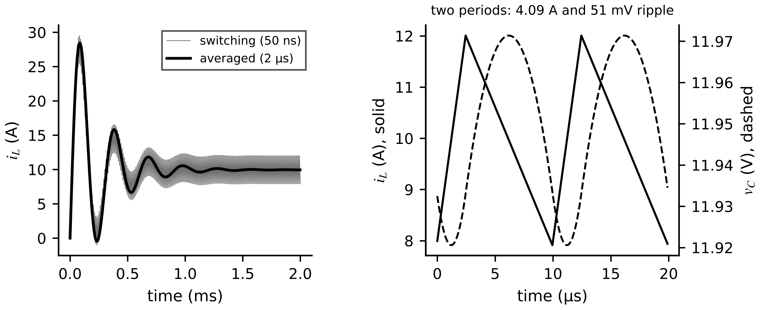
Figure 7.12. Buck converter of Example 7.10. Left: inductor current during start-up from the switching model (thin) and the averaged model (thick). Right: one steady-state switching period: inductor current and output voltage ripple.

7.7.2 Small-signal models
Linearizing the averaged model about an operating point (Chapter 4, Section 4.9) gives transfer functions from duty cycle to output for controller design (Figure 7.13). For the buck and boost,
$G_{vd,buck}(s)=\frac{V_{in}}{1+s\frac{L}{R}+s^{2}LC}, G_{vd,boost}(s)=\frac{V_{o}}{1-D}·\frac{1-s\frac{L}{(1-D)^{2}R}}{1+s\frac{L}{(1-D)^{2}R}+s^{2}\frac{LC}{(1-D)^{2}}}, ω_{z,RHP}=\frac{(1-D)^{2}R}{L}$ (7.20)
The boost has a right-half-plane zero: a step increase of duty cycle first lowers the output, because the inductor is disconnected from the output for longer before its larger current arrives. The zero limits the achievable control bandwidth to a fraction of $ω_{z,RHP}$, 1.49 kHz for the PV boost of Example 7.2 at full load. Digital control adds a delay of about one and a half sampling periods, a phase lag of $-1.5 ωT_{s}$, and averaged models are trustworthy only for $ω≪πf_{s}$.
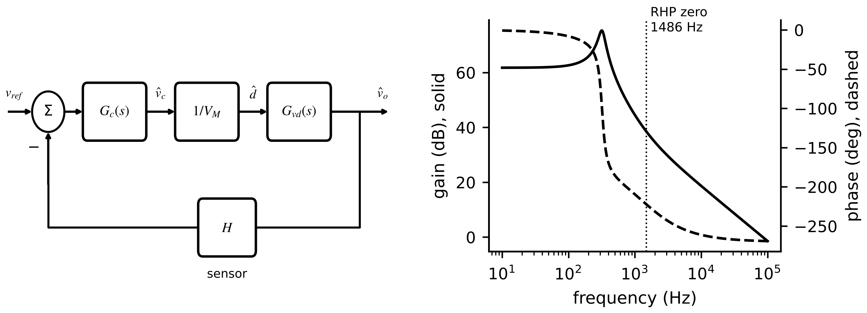
Figure 7.13. Left: small-signal voltage control loop with compensator, PWM gain, plant and sensor. Right: Bode plot of the duty-to-output transfer function of the PV boost at full load, with its right-half-plane zero at 1.49 kHz.

7.7.3 Choosing the rung
Above the averaged model sit quasi-steady models: loss maps and efficiency maps evaluated at the averaged operating point, without any electrical transients, which feed thermal and lifetime models running at seconds to hours (Section 7.10). Beside them sit surrogates: lookup tables or learned models (Chapter 6) that reproduce any rung inside a validated envelope at microseconds per call. Table 7.4 assigns a rung to each function of the D-3 twin. The rule behind it is simple: choose the coarsest rung that resolves the quantity the decision needs, at a step the hardware can meet with margin (Section 7.17), and validate it against the next finer rung.
Table 7.4. Fidelity rung by twin function for drive D-3
Twin function | Quantity needed | Rung | Time step | Validation against
protection and gate-logic HIL | edges, dead time, overcurrent within µs | switching (ideal switch) | 0.25 µs on FPGA | device-level simulation, bench tests
current-control tuning | loop response to 2 kHz | averaged dq (7.12) and small-signal | 10 to 50 µs | switching model (Section 7.18.2)
stability with grid or filter | impedances, margins | small-signal | frequency domain | frequency-response measurement
efficiency and losses | device and motor losses | quasi-steady loss map | 1 s | calorimetric or electrical efficiency test
winding, magnet, junction temperature | temperatures over minutes to hours | thermal network fed by loss map | 1 s (thermal), 1 ms (junction swing) | RTD, NTC, TSEP measurements
lifetime and maintenance | accumulated damage | lifetime model from mission profile | per cycle or per hour | power-cycling data, field returns
fleet optimization | any of the above, many units | surrogate | µs per call | the rung it replaces, inside its envelope

What the digital twin adds
Synchronized: each twin function to the rung that resolves its quantity.
Estimated or updated: averaged states, small-signal margins, losses, temperatures, damage.
Uncertainty carried: model-form error of each rung, measured against the finer rung.
Decision enabled: what to simulate where, and at what step.
Validated by: rung-against-rung comparison and measurements at the quantity of interest.

7.8 Building the component-level converter twin: from parasitic network to identified parameters
The fidelity ladder says which model a function needs; this section shows how the most informative rung, the switching model with every component's internal losses, is built and synchronized with real hardware. The procedure is the one used in recent physics-based converter twins of grid-tied PV inverters [4], [5], [6], [7] and of DC-DC and two-stage converters [8], [9], and it generalizes to any topology in this chapter. It has six steps: model each component with its parasitic elements; enumerate switch states and current polarities; write and discretize the state equations; define an objective that compares twin and sensor waveforms; identify the parasitic parameters by optimization while checking identifiability; and track the identified parameters as health indicators (Figure 7.14).
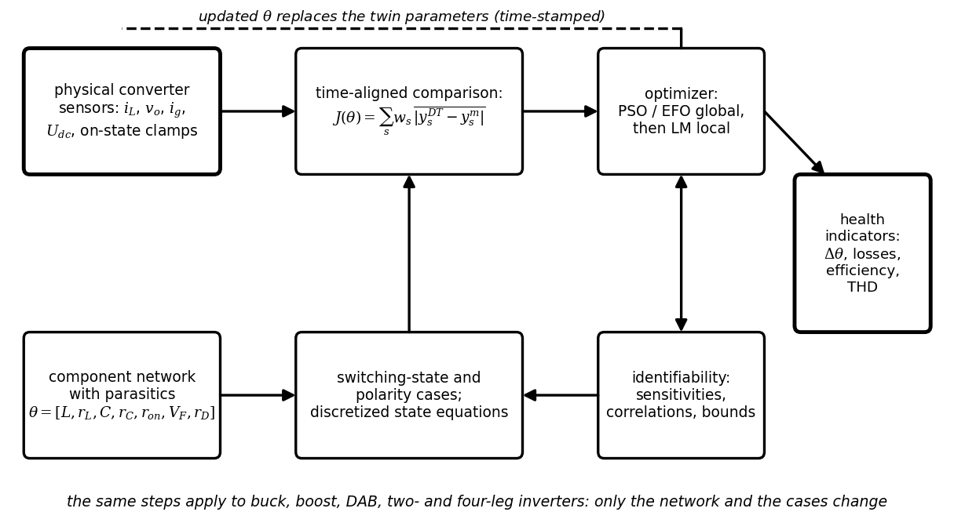
Figure 7.14. The component-level twin workflow: the physical converter and its sensors, the parasitic network with parameter vector $θ$, the case-wise discretized model, the waveform objective, the optimizer with identifiability checks, and the health indicators derived from the identified parameters.

7.8.1 Step 1: every component with its internal losses
An ideal inductor, capacitor or switch dissipates nothing, so a twin built from ideal parts reproduces waveforms roughly but cannot explain losses, efficiency or ageing. Each part is therefore modelled as an ideal element plus the series loss element that matters for its ageing (Figure 7.15): the inductor with its winding resistance $r_{L}$; the capacitor with its equivalent series resistance $r_{C}$ (the electrolytic capacitor's main ageing indicator, Section 7.10.5); the DC-link capacitor with $r_{dc}$; a conducting diode as a threshold $V_{F}$ in series with a slope resistance $r_{D}$; a MOSFET as a resistance $r_{on}$ that conducts in both directions; and an IGBT as a threshold $V_{CE0}$ plus slope resistance $r_{CE}$ that conducts forward only. With the sign conventions of Section 7.2,
$v_{L}=L\frac{di_{L}}{dt}+r_{L}i_{L}, v_{Cb}=v_{C}+r_{C}i_{C}, i_{C}=C\frac{dv_{C}}{dt}, v_{D}=V_{F}+r_{D}i_{D} (i_{D}>0), v_{DS}=r_{on}i, v_{CE}=V_{CE0}+r_{CE}i_{C} (i_{C}>0)$ (7.21)
where $v_{Cb}$ is the voltage across the capacitor branch. The parameters are read first from datasheets and then identified: datasheet values carry manufacturing tolerances of ±10 to 20 %, depend on temperature (Section 7.10.1) and drift with ageing, which is exactly what the twin must follow.
Figure 7.15. Component models used in the parasitic-aware twin. Every element is an ideal part plus a series loss part; each symbol is a parameter that the twin identifies and tracks.

7.8.2 Step 2: switch states and current polarity
With threshold elements in the network, the voltage a leg applies depends not only on its switch command but on the direction of its current, because the direction decides whether the transistor or the antiparallel diode conducts. For one leg of a two-level inverter with upper switch command $S_{1}$, phase current $i$ (positive out of the leg), DC-link voltage $U_{dc}$ and DC-link resistance $r_{dc}$, the four cases of Figure 7.16 give the leg terminal voltage relative to the negative rail:
$v_{xf}=\left\{\begin{matrix}U_{dc}-r_{dc}|i|-V_{CE0}-r_{CE}|i| & S_{1}=1, i>0 \\ U_{dc}+r_{dc}|i|+V_{F}+r_{D}|i| & S_{1}=1, i<0 \\ V_{CE0}+r_{CE}|i| & S_{1}=0, i<0 \\ -V_{F}-r_{D}|i| & S_{1}=0, i>0\end{matrix}\right.$ (7.22)
In case 2 the upper transistor is gated but the negative current flows through its antiparallel diode, and in case 4 the lower diode freewheels. The same enumeration, applied leg by leg, gives the phase voltages of a two-level, three-phase or four-leg inverter as differences of leg voltages, for example $v_{xn}=v_{xf}-v_{nf}$ with a neutral leg $n$. For a DC-DC stage the cases are switch on, switch off with the diode conducting, and switch off with the current extinguished (DCM).
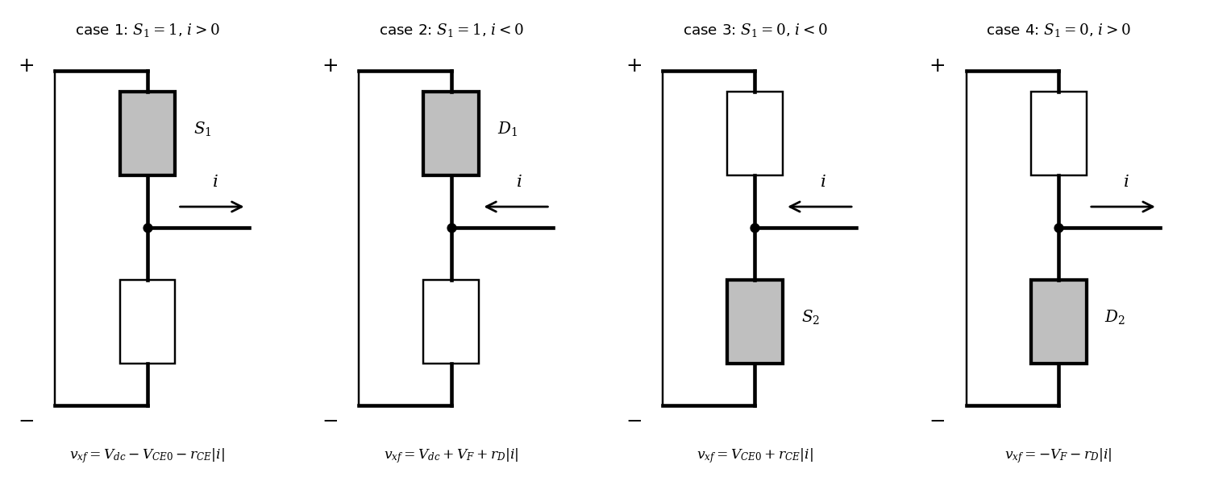
Figure 7.16. The four conduction cases of an inverter leg. The device that actually carries the current (shaded) depends on both the switch command and the current direction, and sets the leg voltage through its threshold and resistance.
Example 7.11 (Level A) Leg voltage in the four cases
Given. $U_{dc}=400$ V, $r_{dc}=12$ mΩ, IGBT $V_{CE0}=1.7$ V and $r_{CE}=21$ mΩ, diode $V_{F}=1.1$ V and $r_{D}=13.6$ mΩ, $|i|=12$ A.
Find. $v_{xf}$ in each case, and the average leg voltage over a period with duty cycle 0.6 and positive current, against the ideal 240 V.
Solution. (7.22): case 1: $400-0.144-1.7-0.252=397.90$ V; case 2: $400+0.144+1.1+0.163=401.41$ V; case 3: $1.7+0.252=1.95$ V; case 4: $-1.1-0.163=-1.26$ V. With $i>0$ the leg alternates between cases 1 and 4: $0.6×397.90+0.4×(-1.26)=238.24$ V, 1.76 V below the ideal.
Interpretation. The 1.76 V shortfall is the device contribution to the inverter voltage error of Section 7.4.3; it changes sign with the current, so it distorts current waveforms near zero crossings. A twin without these terms attributes the error to the filter or the grid and identifies wrong parameters there.

7.8.3 Step 3: case-wise state equations and their discretization
Kirchhoff's laws are written for each case with the component models inserted. For the boost converter of Section 7.2 with output capacitor ESR and load $R$, the two CCM states become
$S=1: L\frac{di_{L}}{dt}=V_{in}-\left(r_{L}+r_{on}\right)i_{L}, C\frac{dv_{C}}{dt}=-\frac{v_{C}}{R+r_{C}}; S=0: L\frac{di_{L}}{dt}=V_{in}-\left(r_{L}+r_{D}\right)i_{L}-V_{F}-v_{o}, C\frac{dv_{C}}{dt}=i_{L}-\frac{v_{o}}{R}, v_{o}=\frac{R\left(v_{C}+r_{C}i_{L}\right)}{R+r_{C}}$ (7.23)
with $i_{L}$ held at zero if it would become negative while $S=0$ (DCM). Averaging the inductor equation over a period gives the steady-state balance that reveals what the waveforms can and cannot tell apart:
$V_{in}-I_{L}\left[r_{L}+Dr_{on}+(1-D)r_{D}\right]-(1-D)\left(V_{F}+V_{o}\right)=0$ (7.24)
For a three-phase inverter with L filter, damped filter capacitor and DC link, the same procedure gives, per phase $x$ (Chapter 4 for the discretization),
$L_{f}\frac{di_{x}}{dt}+r_{f}i_{x}=v_{xn}-v_{gx}, i_{cx}=C_{f}\frac{dv_{cx}}{dt}=\frac{v_{gx}-v_{cx}}{r_{cx}}, U_{dc}=\left(i_{pv}-i_{in}\right)r_{dc}+\frac{1}{C_{dc}}\int{\left(i_{pv}-i_{in}\right)}dt, i_{in}=\sum_{x}{S_{x}}i_{x}$ (7.25)
where $r_{cx}$ lumps the damping resistor and the capacitor ESR. Implicit (backward-Euler) discretization keeps the stiff RC and RL branches stable at the twin's step $T_{s}$; for the inductor current,
$i_{x}(n+1)=\frac{T_{s}\left[v_{xn}(n+1)-v_{gx}(n+1)\right]+L_{f}i_{x}(n)}{L_{f}+r_{f}T_{s}}$ (7.26)
and similarly for the other states. Higher-order implicit schemes such as Gauss-Legendre implicit Runge-Kutta give more accuracy per step at more computation per step [7]. On an FPGA, a step of a few microseconds is achievable, which places the twin on the switching rung of the ladder.

7.8.4 Step 4: the objective function
The twin runs alongside the hardware on the same, time-stamped inputs (switching commands or modulation, source and grid voltages), and its outputs are compared with the sensors over a window of $W$ samples. A normalized mean-absolute objective over the measured signals $s$ (grid or inductor currents, output and DC-link voltages), and a signal-matching error that reports the agreement after identification, are
$J(θ)=\sum_{s}{w_{s}}\frac{\frac{1}{W}\sum_{n=1}^{W}{\left|y_{s,n}^{DT}(θ)-y_{s,n}^{m}\right|}}{\frac{1}{W}\sum_{n=1}^{W}{\left|y_{s,n}^{m}\right|}}, {SME}_{s}=\frac{100}{W}\sum_{n=1}^{W}{\frac{\left|y_{s,n}^{DT}-y_{s,n}^{m}\right|}{\left|y_{s,n}^{m}\right|}} \%, θ_{lo}≤θ≤θ_{hi}$ (7.27)
where $w_{s}$ are weights and the bounds come from datasheet tolerances widened by the expected degradation envelope (an ESR may double before end of life). In practice the denominator of SME is replaced by a signal's RMS value near zero crossings. Least squares (Chapter 5) uses the squared residuals scaled by each sensor's noise standard deviation instead, which gives parameter covariances directly.

7.8.5 Step 5: optimization and identifiability
The objective is nonlinear and may have several local minima, so identification usually combines a global, population-based search with a local refinement. A particle swarm moves each candidate $θ_{i}$ towards its own best and the swarm's best positions; a Levenberg-Marquardt step then refines the best candidate using the Jacobian $J_{r}$ of the scaled residual vector $r$ (Chapter 5, Section 5.4):
$v_{i}←wv_{i}+c_{1}r_{1}⊙\left(p_{i}-θ_{i}\right)+c_{2}r_{2}⊙\left(g-θ_{i}\right), θ_{i}←θ_{i}+v_{i}; Δθ=-{\left(J_{r}^{⊤}J_{r}+μ diagJ_{r}^{⊤}J_{r}\right)}^{-1}J_{r}^{⊤}r, cov\left(\hat{θ}\right)≈{\hat{σ}}^{2}{\left(J_{r}^{⊤}J_{r}\right)}^{-1}$ (7.28)
where $p_{i}$ is particle $i$'s best position, $g$ the swarm's best, $r_{1}$, $r_{2}$ random vectors, $w$, $c_{1}$, $c_{2}$ coefficients and $μ$ the damping factor. Electric-field-inspired optimizers (artificial electric field and electromagnetic field optimization variants) have been reported to converge in fewer iterations than PSO for converter twins [4], [5]; whatever the optimizer, the decisive question is identifiability (Chapter 4, Section 4.12). (7.24) already warns: with only $i_{L}$ and $v_{o}$ measured, $r_{L}$, $r_{on}$ and $r_{D}$ enter steady state only through the duty-weighted sum $r_{L}+Dr_{on}+(1-D)r_{D}$, so two operating duty cycles give two equations for three unknowns. The covariance in (7.28) reveals such cases as correlations near ±1 and huge standard deviations, even when the waveforms match perfectly.
Example 7.12 (Level C) Identifying the parasitic network of a boost converter
Given. A synthetic boost stage: $V_{in}=100$ V, $f_{s}=20$ kHz, true $θ=[L,r_{L},C,r_{C},r_{on},V_{F},r_{D}]=[1 mH,80 mΩ,470 µF,50 mΩ,40 mΩ,0.8 V,30 mΩ]$. A 40 ms record with load steps (40 Ω, 25 Ω, 40 Ω at 10 and 30 ms) and a duty step from 0.40 to 0.50 at 20 ms, simulated with (7.23) at 0.5 µs and sampled at 100 kHz with noise of 0.05 A on $i_{L}$ and 0.3 V on $v_{o}$ (seed 2026). Datasheet starting values $[1 mH,60,470 µF,30,35 mΩ,0.9 V,25 mΩ]$, bounds 0.5 to 1.6 times these. Run 1: $i_{L}$ and $v_{o}$ only. Run 2: adds on-state voltages of switch and diode from desaturation-type clamp circuits (5 mV noise).
Find. Estimates, errors, standard deviations and correlations; the signal-matching error; the computation.
Solution. Run 1: a 30-particle swarm over 40 iterations (32 s in vectorized interpreted code) followed by Levenberg-Marquardt (11 evaluations) gives $L$ and $C$ within 0.01 %, $V_{F}$ within 1.4 %, but $r_{L}$ −6.6 %, $r_{on}$ +14.5 % and $r_{D}$ +22.6 %, with mutual correlations of ±1.00 and standard deviations above 1000 %, while the waveform matching error is only 0.008 % (Figure 7.17, Table 7.5). Run 2: all errors are below 1.3 % except $r_{C}$ (−4.0 %), and all standard deviations are below 0.9 %.
Interpretation. A perfect waveform match did not mean correct parameters: run 1 found one of infinitely many combinations of the three resistances that explain the data equally well. Measuring the device on-state voltages broke the degeneracy. The $r_{C}$ estimate stopped at its upper bound of 48 mΩ; its −4 % error is the bound, not noise, which is why bounds must cover the degradation envelope (next example).
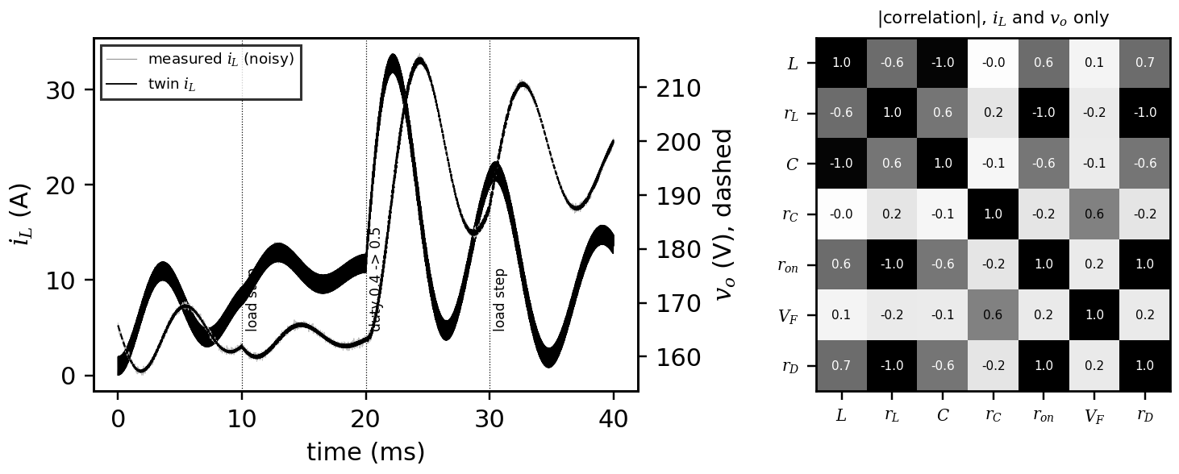
Figure 7.17. Boost identification of Example 7.12. Left: measured (grey) and twin (black) inductor current and output voltage through the load and duty steps. Right: absolute parameter correlations from run 1; the three series resistances are perfectly correlated.
Table 7.5. Identified boost parameters (synthetic; errors in per cent of the true value)
Parameter | True | Run 1 error ($i_{L}$, $v_{o}$) | Run 1 sd | Run 2 error (+ clamps) | Run 2 sd
$L$ | 1.000 mH | 0.00 | 0.03 | −0.02 | 0.02
$r_{L}$ | 80 mΩ | −6.6 | > 1000 | +1.2 | 0.26
$C$ | 470 µF | +0.01 | 0.03 | +0.02 | 0.02
$r_{C}$ | 50 mΩ | −4.0 (bound) | 1.2 | −4.0 (bound) | 0.84
$r_{on}$ | 40 mΩ | +14.5 | > 1000 | +0.03 | 0.02
$V_{F}$ | 0.80 V | −1.4 | 0.55 | +0.01 | 0.02
$r_{D}$ | 30 mΩ | +22.6 | > 1000 | −0.02 | 0.05

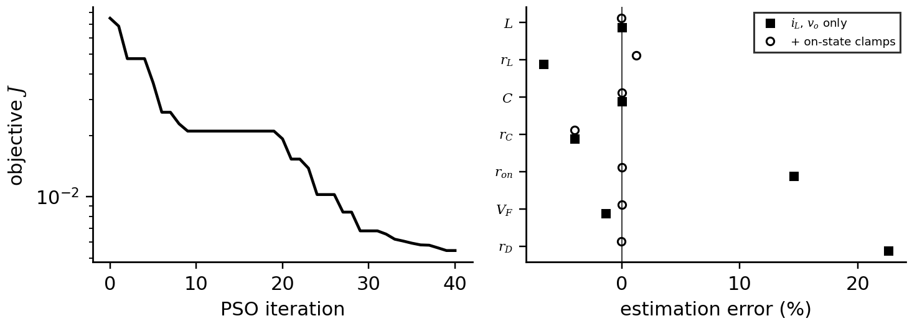
Figure 7.18. Left: convergence of the particle swarm in run 1. Right: estimation errors of the seven parameters without and with the on-state voltage clamps.

7.8.6 Step 6: health indicators and degradation tracking
Once identified, the parameters themselves are the primary health indicators, and the twin derives secondary ones from its own states: power delivered, losses and efficiency, current-tracking error, DC-link voltage ripple and current THD. For the inverter of (7.25), for example, the loss and a moving-average tracking error are
$P_{l}=P_{pv}-P_{g}, η=\frac{P_{g}}{P_{pv}}, MATE=mean\left(\frac{\left|i_{gx}^{ref}-i_{gx}^{DT}\right|}{\left|i_{gx}^{ref}\right|}\right)$ (7.29)
averaged over phases $x$. Secondary indicators are useful to operators but insensitive, as the next example shows; the identified parameters change by tens of per cent while efficiency moves by a fraction of a point.
Example 7.13 (Level B) Tracking degradation in the boost twin
Given. The converter of Example 7.12 after ageing: $C$ −15 %, $r_{C}$ doubled to 100 mΩ, $r_{on}$ +30 % to 52 mΩ. A new record (seed 7) is identified with clamps, starting from the healthy estimate, with upper bounds widened to 4 times the datasheet ESR and 2 times the datasheet resistances.
Find. Identified changes, and the losses and efficiency at $D=0.5$, 40 Ω, from the averaged model (7.24) with ESR loss.
Solution. All estimates within 0.5 % of the degraded truth; relative to the healthy estimate: $C$ −15.0 %, $r_{C}$ +107 % (the healthy value had been clipped at its bound), $r_{on}$ +29.9 %, other parameters within 1 %. Losses rise from 16.3 W to 18.1 W (Table 7.6), and efficiency falls from 98.34 % to 98.17 %.
Interpretation. Efficiency fell by 0.17 points, easily lost in measurement uncertainty; the identified parameters show unambiguously which components aged and by how much. With the earlier, narrow bounds the same run returned an ESR error of −52 % and pushed the error into $r_{L}$: bounds are part of the model and must be justified.
Table 7.6. Health indicators of the boost twin, healthy and degraded (averaged model at $D=0.5$, 40 Ω)
Quantity | Healthy (identified) | Degraded (identified) | Degraded (true)
output voltage | 196.9 V | 196.8 V | 196.8 V
inductor copper loss | 7.85 W | 7.78 W | 7.75 W
switch conduction loss | 1.94 W | 2.52 W | 2.52 W
diode loss | 5.39 W | 5.39 W | 5.39 W
capacitor ESR loss | 1.16 W | 2.41 W | 2.42 W
total loss | 16.3 W | 18.1 W | 18.1 W
efficiency | 98.34 % | 98.17 % | 98.17 %

7.8.7 Beyond pure physics: hybrid twins and stability monitoring
Two extensions are emerging. Hybrid twins keep the physics core of (7.25) as an implicit integrator and add a recurrent network that corrects unmodelled latent states, training physical parameters and network weights jointly against measurements; they keep the parameters physically meaningful while absorbing effects the equations miss, at the price of training data and time [7]. Stability monitoring evaluates an energy-like function of the twin's state error $x$; for a discrete-time linear model $x_{k+1}=Ax_{k}$ (Chapter 4, Section 4.11),
$V(x)=x^{⊤}Px, A^{⊤}PA-P=-Q, Q≻0, ΔV_{k}=V\left(x_{k+1}\right)-V\left(x_{k}\right)<0$ (7.30)
so a persistently positive $ΔV_{k}$ over a grid cycle flags a loss of stability margin, and can trigger re-identification of the parameters [5], [6]. Both methods are research-stage in field use; their validation follows the same rules as any learned or estimated model (Chapters 5 and 6).
Table 7.7. Approaches to converter twins compared
Approach | What is identified | Data need | Strength | Limitation
physics-based with optimizer | parasitic parameters of the network | short excited records | interpretable, parameter-level health | identifiability; local minima; model-form error
data-driven | input-output map | large, diverse records | no network model needed | no physical parameters; poor extrapolation
hybrid (physics core + learned correction) | parameters and network weights jointly | moderate records, training time | absorbs unmodelled effects, keeps physics | training cost; learned part can hide faults

What the digital twin adds
Synchronized: a switching-level network whose parasitic parameters match the hardware.
Estimated or updated: $L$, $C$, ESRs, device thresholds and resistances, with covariances.
Uncertainty carried: correlations that reveal unidentifiable combinations; bounds as model assumptions.
Decision enabled: component-level maintenance from parameter drift long before efficiency moves.
Validated by: SME after identification, covariance checks, and re-identification on new records.

7.9 Power semiconductor devices: from silicon to ultra-wide-bandgap materials
A power switch must block a high voltage when off and conduct with little resistance when on, and the two requirements pull against each other through the drift region, the lightly doped layer that supports the blocking voltage. With critical electric field $E_{c}$, doping $N_{D}$ and a triangular field profile at breakdown, Poisson's equation fixes the drift thickness and doping for a blocking voltage $V_{B}$; the drift resistance per unit area, thickness over conductivity $qN_{D}μ_{n}$, then gives the unipolar limit and Baliga's figures of merit [10]:
$W_{D}=\frac{2V_{B}}{E_{c}}, N_{D}=\frac{ε_{s}E_{c}^{2}}{2qV_{B}}, R_{on,sp}=\frac{W_{D}}{qμ_{n}N_{D}}=\frac{4V_{B}^{2}}{ε_{s}μ_{n}E_{c}^{3}}, BFOM=ε_{s}μ_{n}E_{c}^{3}, BHFFOM=μ_{n}E_{c}^{2}$ (7.31)
where $ε_{s}$ is the permittivity, $q$ the elementary charge and $μ_{n}$ the electron mobility. The cube of the critical field dominates, and the critical field rises roughly with the square of the bandgap, which is why wide-bandgap (SiC, GaN) and ultra-wide-bandgap materials (Ga₂O₃, diamond, AlN, GeO₂) promise far lower conduction loss at the same voltage. Thermal conductivity $k_{th}$ then decides how easily the remaining loss leaves the chip.
Table 7.8. Representative material properties of power semiconductors (reported values vary; $R_{on,sp}$ from (7.31))
Material | $E_{g}$ (eV) | $E_{c}$ (MV/cm) | $μ_{n}$ (cm²/V·s) | $k_{th}$ (W/cm·K) | BFOM vs Si | $R_{on,sp}$ at 1200 V (mΩ·cm²) | Status
Si | 1.12 | 0.3 | 1400 | 1.5 | 1 | 147 | mature (IGBT above about 600 V)
4H-SiC | 3.26 | 2.5 | 950 | 4.9 | 330 | 0.45 | mature, 650 V to 3.3 kV
GaN | 3.4 | 3.3 | 1250 | 2.3 | 910 | 0.16 | mature lateral HEMTs, 15 to 650 V
β-Ga₂O₃ | 4.85 | 8 | 250 | 0.27 | 2900 | 0.051 | early diodes, research
diamond | 5.5 | 10 | 2000 | 22 | 25 800 | 0.006 | research
AlN | 6.1 | 12 | 300 | 3.2 | 10 000 | 0.015 | research
r-GeO₂ | 4.7 | 7 (predicted) | 200 (predicted) | 0.51 | 1900 | 0.078 | early research

Example 7.14 (Level A) Die area for a 25 mΩ, 1200 V switch
Given. Table 7.8; a target drift resistance of 25 mΩ at 1200 V.
Find. Drift thickness and doping for Si and 4H-SiC, and the ideal die area $A=R_{on,sp}/R_{on}$ for Si, SiC, GaN and β-Ga₂O₃.
Solution. (7.31): Si needs 80 µm at $2.4×{10}^{14}$ cm⁻³; SiC 9.6 µm at $1.4×{10}^{16}$ cm⁻³. Areas: Si 5.9 cm², SiC 0.018 cm², GaN 0.0064 cm², β-Ga₂O₃ 0.0020 cm².
Interpretation. A unipolar silicon switch of this rating would be impractically large, which is why silicon uses bipolar IGBTs above about 600 V and pays with tail-current switching loss. SiC reaches the same resistance with a die three hundred times smaller, hence far smaller capacitances and switching energies.
SiC MOSFETs are vertical devices whose SiC/SiO₂ interface traps charge: the threshold voltage drifts under gate bias and temperature (evaluated by the JEDEC JEP184 guideline [11]), the gate oxide limits long-term reliability, and the bipolar body diode can degrade under sustained forward current. GaN HEMTs are lateral devices whose two-dimensional electron gas gives low channel resistance without doping; they have no body diode, so reverse conduction during dead time costs $V_{SD}≈V_{th}+|V_{GS,off}|$ (2 to 4 V), and their characteristic ageing effect is dynamic on-resistance after high-voltage blocking (measured by the JEDEC JEP173 method [12]). In hard switching, the output-capacitance energy is lost at every turn-on, and dead-time conduction adds to it:
$P_{oss}=E_{oss}(V)f_{s}, P_{dt}=2V_{SD}It_{d}f_{s}$ (7.32)
7 µJ at 400 V costs 0.7 W at 100 kHz but 7 W at 1 MHz, which is why megahertz GaN converters use soft switching (Section 7.3). [Advanced] Ultra-wide-bandgap materials. β-Ga₂O₃ grows from the melt like silicon, promising cheap substrates, but cannot be doped p-type and conducts heat poorly (one fifth of silicon), so its devices are thermally limited; diamond has the best figure of merit and thermal conductivity but small, costly wafers; AlN has the widest bandgap but low doping efficiency; r-GeO₂ is predicted to allow both doping types and is at the materials-growth stage [13]. Their twins will need validated thermal and reliability models before they reach products (research-stage).
Table 7.9. Device families and what their twins must model
Device | Voltage range | Switching frequency | Dominant loss | Key ageing indicator
Si IGBT with diode | 600 V to 6.5 kV | 1 to 20 kHz | switching (tail, recovery) | $V_{CE,on}$, thermal resistance
SiC MOSFET | 650 V to 3.3 kV | 10 to 100 kHz | conduction at high current | $R_{ds,on}$, threshold shift, body-diode drop
GaN HEMT | 15 to 650 V | 100 kHz to several MHz | capacitive and dead-time | dynamic $R_{ds,on}$, threshold shift
Ga₂O₃, diamond, AlN, GeO₂ | research | research | thermal (Ga₂O₃) | to be established

What the digital twin adds
Synchronized: device type and its loss and ageing models.
Estimated or updated: on-resistance, threshold, dynamic on-resistance.
Uncertainty carried: datasheet spread and immature models for new materials.
Decision enabled: device technology per voltage class and frequency.
Validated by: double-pulse tests and on-state measurements in operation.

7.10 Losses, thermal networks, mission profiles and lifetime

7.10.1 Conduction and switching losses from the datasheet
A MOSFET conducts like a resistor whose on-resistance rises with junction temperature, $R_{ds,on}(T_{j})≈R_{ds,on,25}[1+α_{R}(T_{j}-25 °C)]$. In an inverter leg with synchronous rectification each switch carries the phase current during half of each period on average, so the RMS current squared per switch is ${\hat{I}}^{2}/4$ whatever the modulation index and power factor. An IGBT instead has a knee voltage and conducts in one direction, the antiparallel diode taking the reverse current; integrating over the conduction intervals of sinusoidal modulation gives [14]
$P_{cond,sw}=R_{ds,on}\frac{{\hat{I}}^{2}}{4}, P_{cond,T}=V_{CE0}\hat{I}\left(\frac{1}{2π}+\frac{mcosφ}{8}\right)+r_{CE}{\hat{I}}^{2}\left(\frac{1}{8}+\frac{mcosφ}{3π}\right), P_{cond,D}=V_{F0}\hat{I}\left(\frac{1}{2π}-\frac{mcosφ}{8}\right)+r_{D}{\hat{I}}^{2}\left(\frac{1}{8}-\frac{mcosφ}{3π}\right)$ (7.33)
where $V_{CE0}$, $r_{CE}$, $V_{F0}$, $r_{D}$ are the knee voltages and slope resistances read from the datasheet output characteristics. At each transition current and voltage overlap for tens of nanoseconds (SiC) to a microsecond (large IGBTs); the datasheet gives the energies at a reference voltage, current and temperature, and to first order they scale linearly with each. A switch commutates only while its phase current is positive, and averaging $|i|$ over that half cycle gives $\hat{I}/π$ over the period:
$P_{sw}=\frac{f_{s}}{π}\left(E_{on,ref}+E_{off,ref}\right)\frac{V_{dc}}{V_{ref}}\frac{\hat{I}}{I_{ref}}\left[1+α_{E}\left(T_{j}-T_{ref}\right)\right], T_{j}=T_{a}+R_{th}P\left(T_{j}\right), R_{th}\frac{∂P}{∂T_{j}}<1$ (7.34)
where $α_{E}$ is the relative increase per kelvin (about 25 % over 150 K for SiC, about 90 % for silicon IGBTs). Because losses depend on temperature, junction temperature is the fixed point of the second relation, and the loop gain must be below one to avoid thermal runaway (Figure 7.19). Used in reverse, the on-state voltage at a known current gives a temperature-sensitive electrical parameter (TSEP), ${\hat{T}}_{j}=25 °C+({\hat{R}}_{ds,on}/R_{ds,on,25}-1)/α_{R}$, valid while the device has not aged.
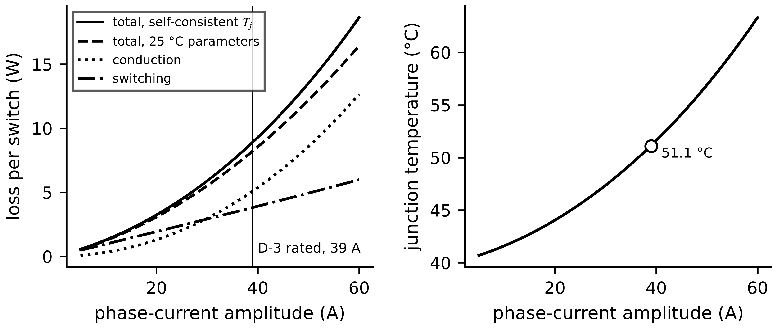
Figure 7.19. Loss per switch of the D-3 inverter against current amplitude at 650 V and 16 kHz, split into conduction and switching parts, at the self-consistent junction temperature (solid) and with 25 °C parameters (dashed); right, the corresponding junction temperature.
Example 7.15 (Level B) Losses and junction temperature of the D-3 inverter
Given. SiC MOSFET module: $R_{ds,on,25}=12$ mΩ, $α_{R}=0.0045$ K⁻¹; $E_{on}+E_{off}=1.7$ mJ at 600 V, 100 A, 25 °C, $α_{E}=0.25/150$ K⁻¹. $\hat{I}=39$ A, $V_{dc}=650$ V, $f_{s}=16$ kHz. Thermal path per switch: junction-case 0.25 K/W, case-heatsink 0.10 K/W; heatsink-ambient 0.15 K/W shared by six switches; ambient 40 °C.
Find. Conduction and switching loss per switch, junction temperature, efficiency, the error of a model frozen at 25 °C, and the loop gain.
Solution. Iterating (7.34) from 80 °C converges in three steps to $T_{j}=51.2$ °C, with the heatsink at 48.0 °C. $R_{ds,on}=13.4$ mΩ and $P_{cond}=5.10$ W; $P_{sw}=3.82$ W; 8.92 W per switch, 53.5 W for the inverter, 99.5 % efficiency at 11 kW. A 25 °C model predicts 8.22 W, 7.8 % low. With the effective resistance $0.35+6×0.15=1.25$ K/W (all six switches heat the shared sink together) and $∂P/∂T_{j}=0.027$ W/K, the loop gain is 0.033, far from runaway.
Interpretation. At rated load this drive's inverter has modest thermal stress; the temperature dependence matters more for silicon IGBTs and in overloads. The twin's value lies in tracking how losses change as the heatsink fouls or the fan weakens.

7.10.2 Foster and Cauer thermal networks
Datasheets give the junction-to-case thermal impedance $Z_{th}(t)$: the temperature rise per watt after a power step of duration $t$. It is fitted by a Foster network, a series chain of parallel RC pairs whose parameters have no physical meaning but give a closed form; a Cauer network, a ladder of resistances and capacitances to ground, follows the physical layers (chip, solder, substrate, baseplate) and can be extended to the heatsink (Figure 7.20). For a time-varying loss the temperature follows by convolution, computed exactly per Foster stage with step $h$:
$Z_{th}(t)=\sum_{i=1}^{n}{R_{i}}\left(1-e^{-t/τ_{i}}\right), τ_{i}=R_{i}C_{i}, T_{j}(t)=T_{ref}(t)+\int_{0}^{t}{P}(σ)\frac{dZ_{th}}{dt}(t-σ) dσ, θ_{i,k+1}=e^{-h/τ_{i}}θ_{i,k}+R_{i}\left(1-e^{-h/τ_{i}}\right)P_{k}$ (7.35)
where $T_{ref}$ is the case or heatsink temperature, $θ_{i}$ the rise across stage $i$ and $T_{j,k}=T_{ref,k}+\sum_{i}{θ_{i,k}}$. A Foster network fitted junction-to-case cannot simply be connected to a heatsink model, because its internal nodes are not physical; a Cauer network can. A two-stage network with $R_{1}=0.3$ K/W, $τ_{1}=0.01$ s, $R_{2}=0.5$ K/W, $τ_{2}=1.0$ s gives $Z_{th}(0.05 s)=0.298+0.024=0.322$ K/W: a short overload is limited by the chip's own small heat capacity, which is why converters tolerate brief overcurrents they could never sustain.
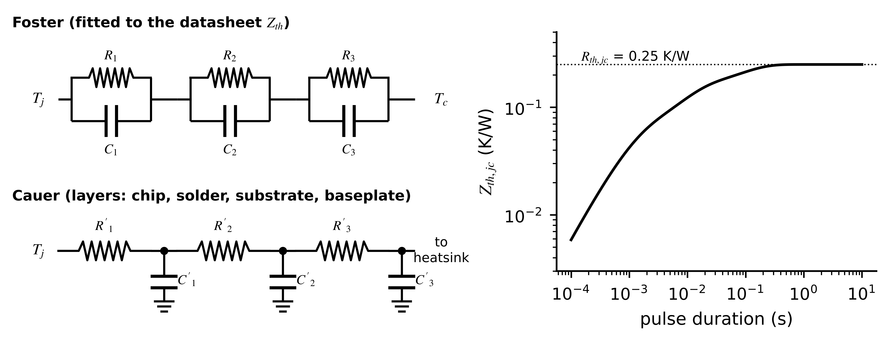
Figure 7.20. Left: Foster network fitted to the datasheet impedance, and Cauer network following the physical layers. Right: junction-to-case thermal impedance of the D-3 module, reaching its steady value of 0.25 K/W after about a second.

7.10.3 Mission profiles and junction-temperature swing
In a motor drive each switch conducts in one half of every output period, so its junction temperature ripples at the output frequency. For the D-3 module, with $R_{i}=[0.05, 0.10, 0.10]$ K/W and $τ_{i}=[0.001, 0.01, 0.1]$ s and the 8.9 W average loss of Example 7.15 split into conduction (sine-squared) and switching (sine) shapes, simulating (7.35) gives Table 7.10 and Figure 7.21: at high output frequency the thermal capacitance filters the loss pulses; at low frequency the junction follows them.
Table 7.10. Junction temperature swing against output frequency (D-3 module, 8.9 W average loss per switch)
Output frequency | Motor speed | Swing $ΔT_{j}$ (K)
100 Hz | 1500 r/min | 1.8
20 Hz | 300 r/min | 3.6
5 Hz | 75 r/min | 5.3
2 Hz | 30 r/min | 6.5
0.5 Hz | 7.5 r/min | 7.8

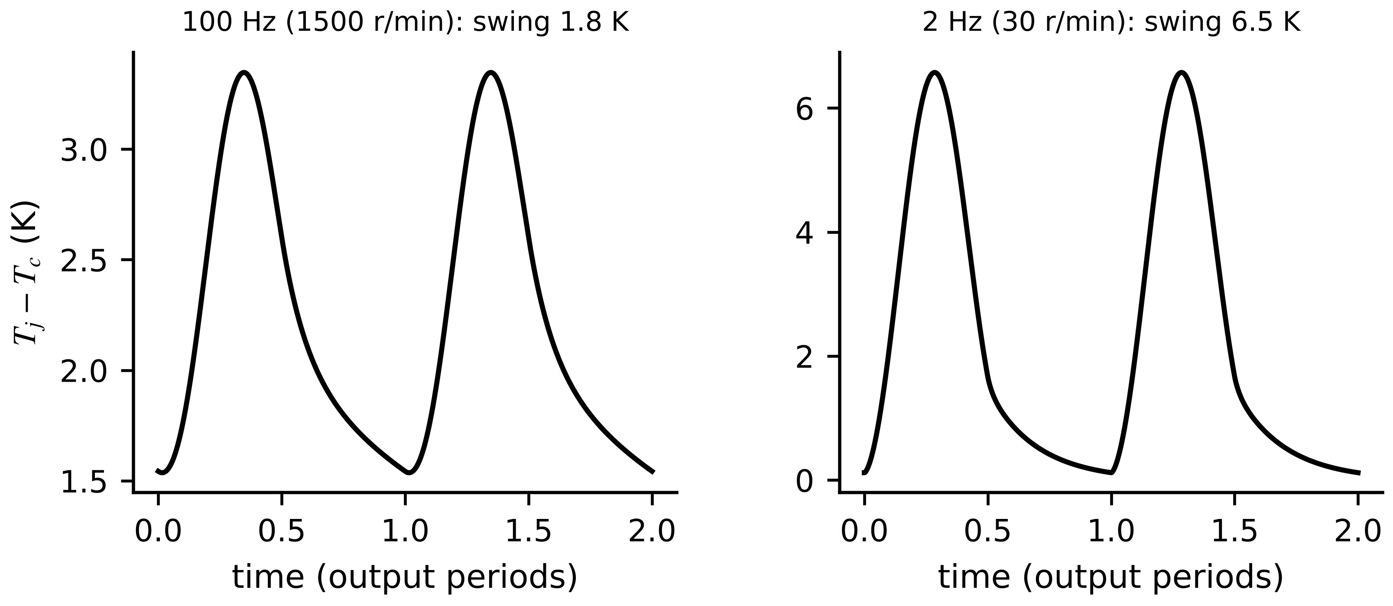
Figure 7.21. Junction temperature rise above the case over two output periods at 100 Hz and 2 Hz for the same 8.9 W average loss.

7.10.4 Lifetime damage
Temperature cycling fatigues bond wires and solder layers. Power-cycling tests give the number of cycles to failure as a Coffin-Manson law with an Arrhenius factor; a mission profile contains cycles of many amplitudes, counted by the rainflow method, and their damage is summed by Miner's rule [15], [16]:
$N_{f}=A ΔT_{j}^{-n}exp\left(\frac{E_{a}}{k_{B}T_{j,m}}\right), D_{acc}=\sum_{i}{\frac{n_{i}}{N_{f,i}}}, failure expected when D_{acc}→1$ (7.36)
where $A$ is a fitted constant, $n$ an exponent of about 5, $E_{a}$ an activation energy (about 0.8 eV), $k_{B}$ Boltzmann's constant, $T_{j,m}$ the mean junction temperature in kelvin and $n_{i}$ the counted cycles of class $i$. At equal mean temperature the damage per hour is proportional to $f_{out}ΔT_{j}^{n}$: for D-3, an hour at 7.5 r/min and full torque consumes about 7.6 times the life of an hour at full speed ($0.5×{7.8}^{5}$ against $100×{1.8}^{5}$). Miner's rule assumes damage adds linearly regardless of order, which real fatigue does not exactly obey; it is a planning tool, not a prediction of a particular failure. Extended empirical models also include the heating time, the current per bond wire and the bond-wire diameter, fitted to large power-cycling data sets [17].
Example 7.16 (Level B) Where does a PV inverter spend its life?
Given. A Plant P-1 PV inverter module with $n=5$, $E_{a}=0.8$ eV and an illustrative calibration $N_{f}=3×{10}^{4}$ cycles at $ΔT_{j}=80$ K and $T_{j,m}=100$ °C. Daily profile (Figure 7.22): one irradiance cycle of 45 K at a mean of 75 °C; 150 cloud transients of 12 K at 80 °C; and 10 hours of 50 Hz ripple of 1 K at 80 °C.
Find. Cycles to failure for each class, daily damage shares, life consumed per year by this mechanism, and the effect of a heatsink running 10 K hotter.
Solution. (7.36): $N_{f}=3.2×{10}^{6}$ (daily cycle), $1.6×{10}^{9}$ (clouds), $4.0×{10}^{14}$ (ripple). Daily damage $4.1×{10}^{-7}$: 76.4 % from the daily cycle, 22.5 % from clouds, 1.1 % from ripple; 0.015 % of life per year. A heatsink 10 K hotter multiplies the damage by 2.1 through the Arrhenius term.
Interpretation. For this module bond-wire and solder cycling is not what limits life; fans and DC-link capacitors usually are (Section 7.10.5). The model still earns its place: it ranks which duties are expensive (slow, large swings), and a fouled heatsink doubles the damage rate long before any temperature alarm. The calibration constant must come from the module maker's power-cycling data, never from this example.
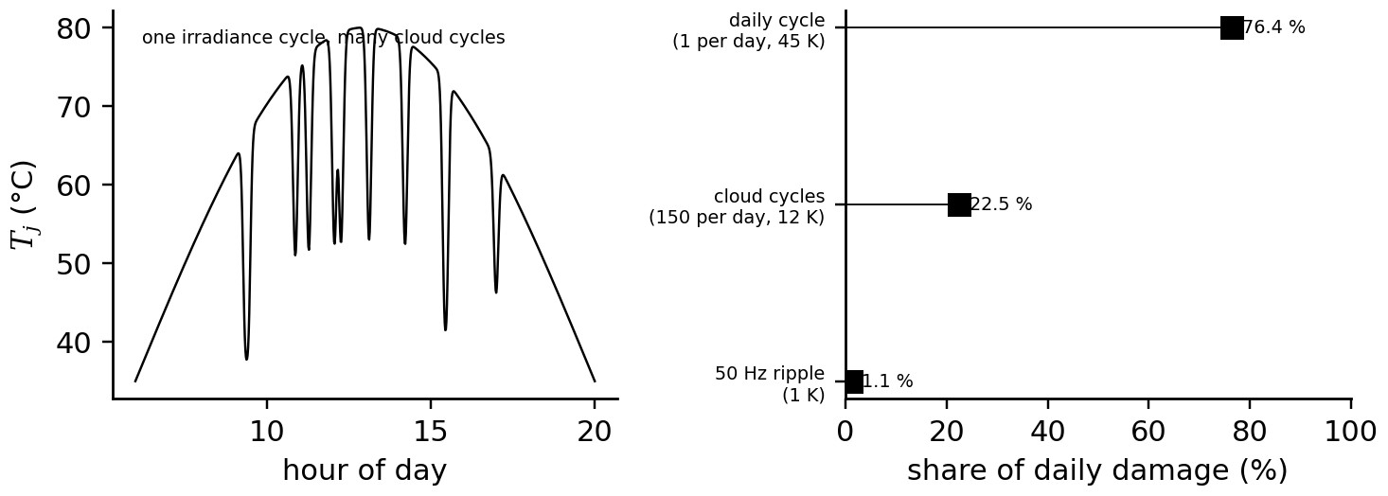
Figure 7.22. Left: synthetic junction temperature of a PV inverter over a day with cloud transients. Right: share of the daily cycling damage from each cycle class (Example 7.16).

7.10.5 Capacitor and inductor ageing
Electrolytic DC-link capacitors lose electrolyte and their ESR rises; film capacitors lose capacitance through self-healing. Life roughly halves for every 10 K of hot-spot temperature and falls with voltage stress; the hot spot follows from the ripple current through the ESR; and the twin reads both ESR and capacitance from the ripple it already measures, splitting it into the part in phase with the current ripple (resistive) and the quadrature part (capacitive) [16]:
$L=L_{0}·2^{\left(T_{0}-T_{hs}\right)/10}{\left(\frac{V_{0}}{V}\right)}^{n_{v}}, T_{hs}=T_{a}+I_{C,rms}^{2} ESR R_{th,hs}, \hat{ESR}=\frac{Δv_{ESR}}{Δi_{L}}, \hat{C}=\frac{Δi_{L}}{8f_{s}Δv_{C}}$ (7.37)
where $L_{0}$ is the rated life at temperature $T_{0}$ and voltage $V_{0}$, $n_{v}$ a voltage exponent and $R_{th,hs}$ the hot-spot thermal resistance. Inductor cores age less, but their losses $P_{v}=k_{c}f^{α_{s}}{\hat{B}}^{β_{s}}$ (Steinmetz) rise if insulation between laminations or powder grains degrades.
Example 7.17 (Level A) Capacitor health from ripple, and life consumed by a fan failure
Given. (i) The buck stage of Example 7.1 after two years: in-phase ripple 60 mV and quadrature ripple 55 mV at $Δi_{L}=4.09$ A. (ii) A DC-link capacitor rated 10 000 h at 85 °C runs at 70 °C for 5000 h, then at 95 °C for 500 h after a fan degrades.
Find. (i) ESR and capacitance. (ii) Life consumed in each period and in total.
Solution. (i) $\hat{ESR}=0.060/4.09=14.7$ mΩ (47 % up); $\hat{C}=4.09/(8×{10}^{5}×0.055)=93$ µF (7 % down). (ii) $L(70)=28 284$ h and $L(95)=5000$ h; consumed $5000/28 284=17.7$ % and $500/5000=10.0$ %; 27.7 % in total.
Interpretation. The ESR has moved far more than the capacitance, the usual early pattern, and is halfway to the common end-of-life criterion of doubled ESR. Five hundred hours of poor cooling consumed more than half as much life as the previous five thousand: a twin that watches the fan protects the capacitors as well as the motor (Section 7.18).
What the digital twin adds
Synchronized: device losses, junction and hot-spot temperatures to the operating point.
Estimated or updated: $R_{ds,on}$, thermal impedance, ESR, capacitance, accumulated damage.
Uncertainty carried: datasheet spread, lifetime-model calibration, Miner's-rule linearity.
Decision enabled: derating, duty scheduling, component replacement.
Validated by: TSEP and NTC measurements, power-cycling data, ripple-based ESR.

7.11 From abc to dq: one transformation, one sign convention
Three sinusoidal currents in windings 120° apart in space produce one magnetic field of constant strength that rotates at the supply frequency. That rotating field, not the three separate currents, is what produces torque, so it is natural to describe it as one vector. The transformation does this in two steps (Figure 7.23), and this chapter uses one convention throughout: the amplitude-invariant form, with the d axis aligned with the rotor magnet (or rotor flux) and the q axis 90 electrical degrees ahead of it in the direction of rotation.
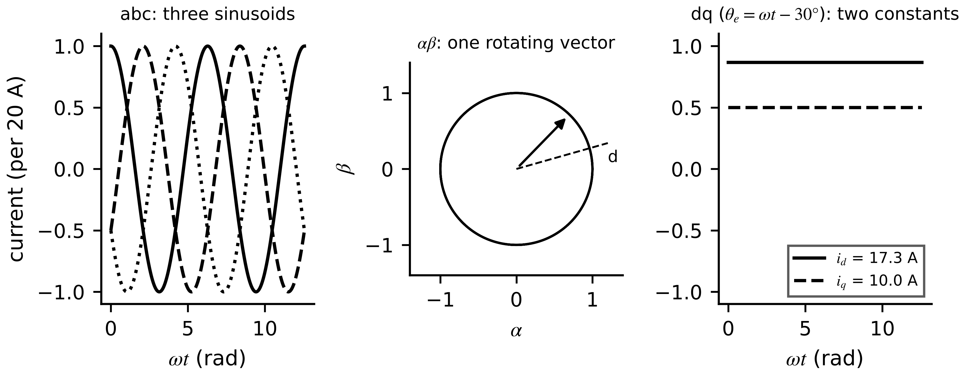
Figure 7.23. The same balanced currents in three frames: three sinusoids in abc, one vector of constant length rotating in the stationary αβ plane, and two constants in the rotating dq frame.
The Clarke transformation projects the three phase quantities onto two orthogonal stationary axes, α along phase a; the Park transformation rotates them by the rotor angle $θ_{e}$ into the dq frame:
$\left[\begin{matrix}f_{α} \\ f_{β}\end{matrix}\right]=\frac{2}{3}\left[\begin{matrix}1 & -\frac{1}{2} & -\frac{1}{2} \\ 0 & \frac{\sqrt{3}}{2} & -\frac{\sqrt{3}}{2}\end{matrix}\right]\left[\begin{matrix}f_{a} \\ f_{b} \\ f_{c}\end{matrix}\right], \left[\begin{matrix}f_{d} \\ f_{q}\end{matrix}\right]=\left[\begin{matrix}cosθ_{e} & sinθ_{e} \\ -sinθ_{e} & cosθ_{e}\end{matrix}\right]\left[\begin{matrix}f_{α} \\ f_{β}\end{matrix}\right]$ (7.38)
where $f$ stands for any voltage, current or flux, and the zero-sequence component $(f_{a}+f_{b}+f_{c})/3$ is zero for a balanced star connection. With the factor 2/3, a balanced set of amplitude $F$ maps to a vector of length $F$; power is then $p=\frac{3}{2}(v_{d}i_{d}+v_{q}i_{q})$, and the factor 3/2 reappears in every torque expression. (The power-invariant form uses $\sqrt{2/3}$ and drops the 3/2; mixing the two conventions is the commonest source of a 50 % error in a machine twin.) Because the dq frame rotates, differentiating a flux expressed in it produces a speed voltage $±ω_{e}ψ$, which is the term that converts electrical power to mechanical.
Example 7.18 (Level A) A balanced current in three frames
Given. $i_{a}=20cos(ωt)$ A with $i_{b}$, $i_{c}$ lagging by 120° and 240°, and a rotor angle $θ_{e}=ωt-30°$.
Find. $i_{α}$, $i_{β}$ at $ωt=0$, and $i_{d}$, $i_{q}$ for all $t$.
Solution. At $ωt=0$: $i_{a}=20$, $i_{b}=i_{c}=-10$ A; $i_{α}=\frac{2}{3}(20+5+5)=20$ A, $i_{β}=0$. The current vector lies at angle $ωt$ and the d axis at $ωt-30°$, so $i_{d}=20cos30°=17.3$ A and $i_{q}=20sin30°=10.0$ A, constant in time.
Interpretation. In the rotating frame a balanced steady current is two constants; their ratio is the angle between current and magnet, which the controller sets to produce torque. Any oscillation in $i_{d}$, $i_{q}$ at steady speed is information: imbalance, harmonics or a fault.
What the digital twin adds
Synchronized: phase quantities to a frame in which steady operation is constant.
Estimated or updated: rotor angle, from a sensor or an observer (Section 7.15).
Uncertainty carried: angle error, which mixes d and q quantities.
Decision enabled: decoupled control of flux and torque.
Validated by: balanced-current tests giving constant $i_{d}$, $i_{q}$.

7.12 Machine models in the rotating frame

7.12.1 One principle, three machines
Every machine in this section converts energy through the interaction of a current with a magnetic flux, and every model has the same structure: a voltage equation per winding, a flux-current relation, a torque from the power balance and Newton's law for the shaft. The DC machine of Chapter 4 is the simplest case, with speed falling linearly with torque, $ω_{m}=V_{a}/K_{e}-R_{a}T_{e}/(K_{t}K_{e})$. In AC machines the same structure appears in the dq frame.

7.12.2 The induction machine: rotor flux and slip
An induction machine has no magnet. The stator's rotating field induces rotor currents only if the rotor turns more slowly than the field; the relative speed, the slip $s=(ω_{s}-ω_{r})/ω_{s}$, is what makes torque possible (Figure 7.24). The per-phase steady-state circuit (Chapter 4, Section 4.7.2) shows the rotor resistance divided by slip: power crossing the air gap splits into rotor copper loss $sP_{ag}$ and mechanical power $(1-s)P_{ag}$. Dynamically, aligning the d axis with the rotor flux $ψ_{r}$ (field orientation) separates the stator current into a flux-producing part $i_{sd}$ and a torque-producing part $i_{sq}$, with rotor time constant $τ_{r}=L_{r}/R_{r}$ [18]:
$τ_{r}\frac{dψ_{r}}{dt}+ψ_{r}=L_{m}i_{sd}, T_{e}=\frac{3}{2}p\frac{L_{m}}{L_{r}}ψ_{r}i_{sq}, ω_{sl}=ω_{s}-ω_{r}=\frac{L_{m} i_{sq}}{τ_{r} ψ_{r}}$ (7.39)
where $p$ is the number of pole pairs and $ω_{sl}$ the slip frequency in electrical rad/s. The slip relation is the heart of indirect field orientation: the controller computes the flux angle by adding the estimated slip to the measured rotor speed. It depends on $τ_{r}$, and $R_{r}$ rises with rotor temperature, so an indirect controller drifts as the rotor heats unless $τ_{r}$ is tracked, a natural twin task.
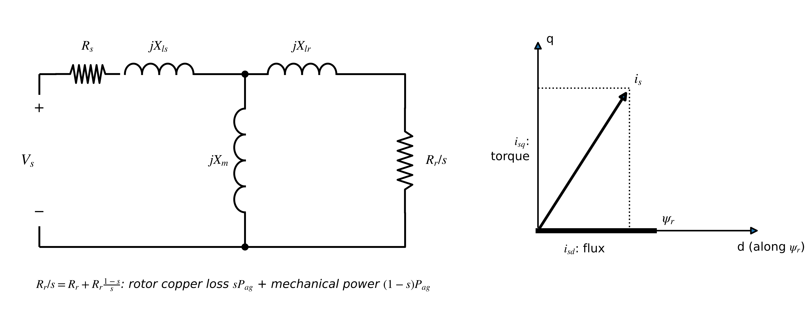
Figure 7.24. Induction machine. Left: per-phase equivalent circuit, where $R_{r}/s$ represents both rotor loss and mechanical power. Right: rotor-flux orientation, with the stator current split into flux ($i_{sd}$) and torque ($i_{sq}$) components.

7.12.3 The PMSM in the rotor frame
In a PMSM the magnet supplies the d-axis flux $ψ_{pm}$. With $L_{d}$ and $L_{q}$ the axis inductances, the flux linkages, voltage equations, torque from the power balance and shaft equation are (Figure 7.25)
$ψ_{d}=L_{d}i_{d}+ψ_{pm}, ψ_{q}=L_{q}i_{q}; v_{d}=R_{s}i_{d}+\frac{dψ_{d}}{dt}-ω_{e}ψ_{q}, v_{q}=R_{s}i_{q}+\frac{dψ_{q}}{dt}+ω_{e}ψ_{d}; T_{e}=\frac{3}{2}p\left[ψ_{pm}i_{q}+\left(L_{d}-L_{q}\right)i_{d}i_{q}\right], J\frac{dω_{m}}{dt}=T_{e}-T_{L}-Bω_{m}$ (7.40)
where $ω_{e}=pω_{m}$. Multiplying the voltage equations by $\frac{3}{2}i_{d}$ and $\frac{3}{2}i_{q}$ and adding, the speed-voltage terms give exactly $ω_{m}T_{e}$, which is how the torque expression is derived. The first torque term is the magnet torque; the second, present only when $L_{d}≠L_{q}$ (interior magnets), is reluctance torque. Saturation makes the inductances current-dependent, for example $L_{q}(i_{q})=L_{q0}/[1+(i_{q}/I_{sat})^{2}]$, and magnets weaken as they heat, $ψ_{pm}(T)=ψ_{pm,0}[1+α_{pm}(T-T_{0})]$ with $α_{pm}≈-0.0012$ K⁻¹ for NdFeB, so torque per ampere falls by about 1 % per 8 K.
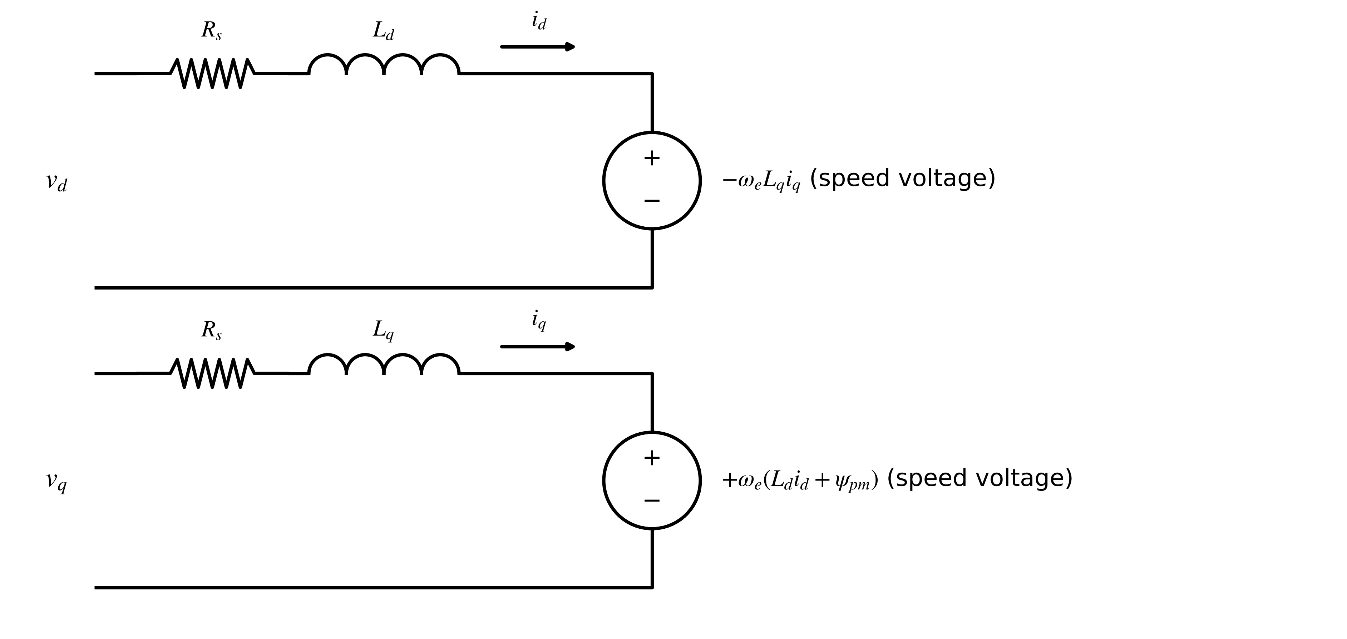
Figure 7.25. PMSM equivalent circuits in the rotor frame. Each axis has resistance, inductance and a speed voltage driven by the other axis; the magnet flux appears in the q-axis speed voltage.
Example 7.19 (Level A) Torque of a surface-magnet PMSM
Given. $ψ_{pm}=0.15$ Wb, 8 poles ($p=4$), $L_{d}=L_{q}$, $i_{q}=12$ A.
Find. The torque, and the maximum constant-torque value with a 20 A limit.
Solution. (7.40): $T_{e}=1.5×4×0.15×12=10.8$ N·m; with $i_{d}=0$, $i_{q}=20$ A: 18.0 N·m.
Interpretation. With no saliency, all current belongs on the q axis; d-axis current produces loss without torque, except when used on purpose to weaken the field (Section 7.14).

7.12.4 Other machine families
Brushless DC (BLDC) motors have trapezoidal back-EMF $e_{k}=k_{e}ω_{m}f_{k}(θ_{e})$ and are driven with 120° current blocks, giving $T_{e}=2k_{e}I$ for two conducting phases; at each commutation the torque dips or peaks by $ΔT_{e}/T_{e}=(V_{dc}-4E)/(V_{dc}+2E)$ while $V_{dc}>4E$, a six-times-electrical-frequency vibration line that a monitoring twin must treat as normal. Synchronous reluctance motors (SyRM) have no magnet and produce only reluctance torque, $T_{e,max}=\frac{3}{4}p(L_{d}-L_{q})I^{2}$, with a power factor limited to $cosφ_{max}=(ξ-1)/(ξ+1)$ for saliency ratio $ξ=L_{d}/L_{q}$. Switched reluctance motors (SRM) pull salient rotor poles towards excited stator poles with torque $T_{e}=\frac{1}{2}i^{2} dL/dθ$ in $N_{ph}N_{r}$ strokes per revolution; Section 7.13 develops their twin in detail. Classical synchronous machines deliver $P=\frac{3EV}{X_{d}}sinδ$ plus a reluctance term, and the doubly fed induction generator handles only the slip power $P_{r}≈-sP_{s}$ in its rotor converter, which is why it needs a converter of about 25 % of rating for ±25 % slip [18].
Example 7.20 (Level A) Three other machines in numbers
Given. (i) A 48 V BLDC fan drive, $k_{e}=0.05$ V·s/rad, 10 A, 1000 r/min. (ii) A SyRM with $p=2$, $L_{d}=60$ mH, $L_{q}=12$ mH, 10 A. (iii) A four-phase 8/6 SRM, inductance rising from 3 to 25 mH over 20°, 20 A.
Find. (i) Torque, back-EMF and commutation ripple, and the speed where the ripple vanishes. (ii) Maximum torque per ampere and maximum power factor. (iii) Torque, stroke angle and back-EMF at 1500 r/min.
Solution. (i) $T_{e}=1.0$ N·m; $ω_{m}=104.7$ rad/s, $E=5.24$ V; ripple $(48-20.9)/(48+10.5)=0.46$; it vanishes at $E=12$ V, 2290 r/min. (ii) $0.75×2×0.048×100=7.2$ N·m; $ξ=5$, $cosφ_{max}=0.67$. (iii) $dL/dθ=0.022/0.349=0.063$ H/rad; $T_{e}=\frac{1}{2}×400×0.063=12.6$ N·m; stroke 15°, 24 strokes per revolution; back-EMF $20×157.1×0.063=198$ V.
Interpretation. Each family has its own normal signature: BLDC commutation ripple, SyRM's low power factor (which inflates current and losses), SRM's stroke torque pulsation and high back-EMF at speed. A twin that does not model them will report them as faults.
Table 7.11. Machine families for converter-fed energy applications
Machine | Torque mechanism | States a twin tracks | Strength | Limitation | Typical use
induction | slip-induced rotor currents | $ψ_{r}$, $τ_{r}$ (rotor temperature) | rugged, no magnets | slip loss, lower efficiency | pumps, fans, conveyors (M-07)
surface PMSM | magnet torque | $ψ_{pm}$ (magnet temperature), $R_{s}$ | high efficiency | magnet cost, demagnetization risk | drive D-3
interior PMSM | magnet + reluctance | $L_{d}$, $L_{q}$ with saturation | wide field weakening | saturation-dependent model | traction, EVs
BLDC | trapezoidal magnet torque | commutation timing | simple control | commutation ripple | fans, small pumps
SyRM | reluctance torque | $L_{d}(i)$, $L_{q}(i)$ | no magnets, cool rotor | low power factor | pumps, fans
SRM | reluctance strokes | $L(θ,i)$ | rugged, no magnets | torque ripple, noise | harsh environments
synchronous / DFIG | field winding / slip power | $δ$, excitation, rotor current | grid support | brushes or slip rings | generators, wind

7.12.5 Identifying the PMSM-plus-inverter twin
The component-level approach of Section 7.8 carries over to the machine side, where the network is the dq model (7.40) fed through an inverter whose devices add the voltage error of (7.22). Lumping thresholds and dead time into a voltage $V_{th}$ and device slope resistances into $r_{d}$, the voltage actually applied to phase $k$ and the identification problem are
$v_{k}=v_{k}^{ref}-\left(V_{th}+r_{d}\left|i_{k}\right|\right)sgn\left(i_{k}\right), \hat{θ}=arg\min_{θ}\sum_{n}{{\left\|i_{dq,n}^{DT}(θ)-i_{dq,n}^{m}\right\|}^{2}}, θ=\left[R_{s},L_{d},L_{q},ψ_{pm},V_{th},r_{d}\right]$ (7.41)
with the common-mode part of the three errors removed before transforming to dq. Because $r_{d}|i_{k}| sgn(i_{k})=r_{d}i_{k}$, the device slope resistance is indistinguishable from the stator resistance: only $R_{s,eff}=R_{s}+r_{d}$ is identifiable from currents, and a DC resistance test at standstill is needed to separate them.
Example 7.21 (Level C) Identifying an interior PMSM and its inverter error
Given. The interior PMSM of Figure 7.31 with $R_{s}=0.15$ Ω, $L_{d}=2$ mH, $L_{q}=5$ mH, $ψ_{pm}=0.10$ Wb, $p=4$, fed through an inverter with $V_{th}=1.0$ V and $r_{d}=20$ mΩ. At 300, 600 and 900 r/min, steps of $v_{d}$ and $v_{q}$ around the back-EMF are applied for 120 ms each; dq currents are recorded at 10 kHz with 0.1 A noise (seed 3). Starting values 0.12 Ω, 2.2 mH, 4.5 mH, 0.105 Wb, 0.8 V, 15 mΩ.
Find. The estimates from a twin without inverter error, and from a twin with $V_{th}$ and a lumped $R_{s,eff}$.
Solution. Without the inverter model: ${\hat{R}}_{s}=0.2475$ Ω (+65 %), ${\hat{L}}_{d}$ −8.4 %, ${\hat{L}}_{q}$ +0.4 %, ${\hat{ψ}}_{pm}$ +1.8 %, all with reported standard deviations below 0.4 %, and residuals of 1.02 A RMS, ten times the sensor noise. With the inverter model: ${\hat{R}}_{s,eff}=0.1700$ Ω (true $R_{s}+r_{d}=0.170$), ${\hat{L}}_{d}=2.000$ mH, ${\hat{L}}_{q}=5.000$ mH, ${\hat{ψ}}_{pm}=0.1000$ Wb, ${\hat{V}}_{th}=1.000$ V, and residuals of 0.100 A, the noise level (Figure 7.26). Fitting $R_{s}$ and $r_{d}$ separately returns a sum of 0.170 Ω but a split that depends on the starting point.
Interpretation. The first twin was confidently wrong: small standard deviations computed from a wrong model say nothing about bias. Its residuals, ten times the noise, were the warning. Including the converter's nonlinearity in the machine twin is what makes resistance-based winding-temperature estimation (Section 7.15.2) trustworthy at low speed.
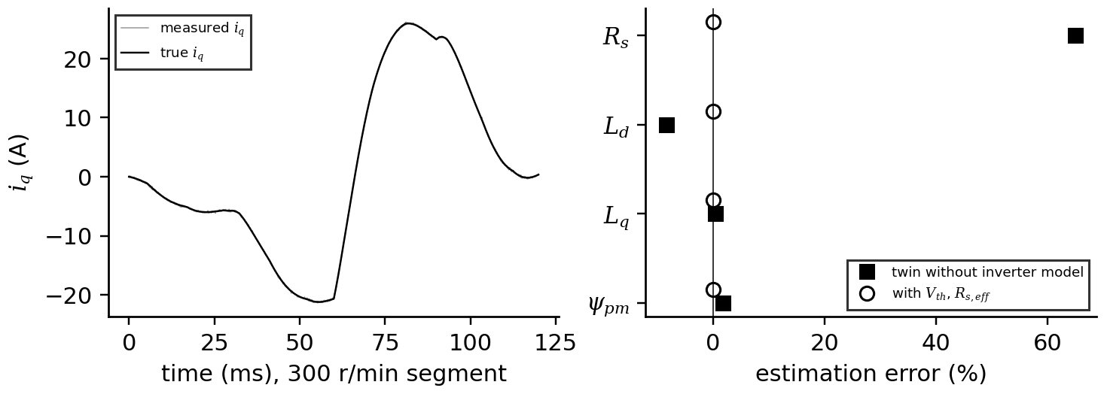
Figure 7.26. PMSM identification of Example 7.21. Left: true and measured q-axis current in the 300 r/min segment. Right: estimation errors of a twin without inverter error and of a twin with $V_{th}$ and lumped $R_{s,eff}$.
What the digital twin adds
Synchronized: dq currents, fluxes and speed of each machine.
Estimated or updated: $R_{s}$, $ψ_{pm}$, $τ_{r}$ and inductances with temperature and saturation.
Uncertainty carried: transform convention, saturation and temperature dependence.
Decision enabled: control tuning, derating, fault signatures per family.
Validated by: no-load back-EMF, locked-rotor and load tests against the model.

7.13 The switched reluctance machine in detail
The switched reluctance machine (SRM) is the simplest electrical machine to build and the most nonlinear to model, which makes it an instructive and increasingly relevant twin. Its rotor is a stack of salient laminations with no windings and no magnets; its stator carries concentrated coils on salient poles (Figure 7.27). When a phase is energized, the nearest rotor poles are pulled into alignment to minimize the magnetic circuit's reluctance; switching the phases in sequence keeps the rotor turning. With no magnets it tolerates high temperature, has no rare-earth supply risk and no back-EMF when unexcited, which suits pumps, fans, traction and aerospace actuators; its price is torque ripple, acoustic noise and a strongly saturating, position-dependent magnetic characteristic that only a nonlinear model captures [19], [20].
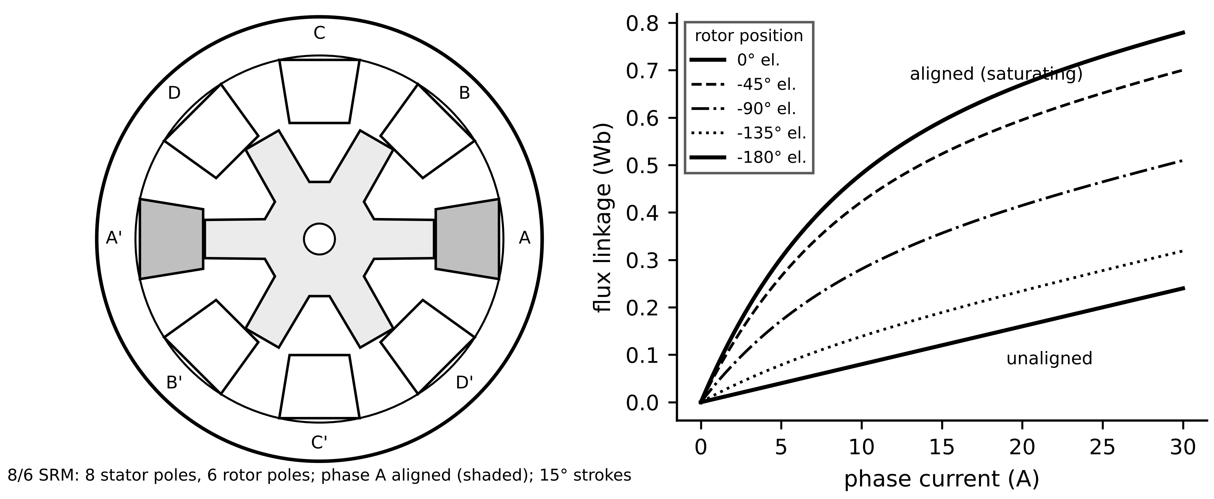
Figure 7.27. Left: cross-section of a four-phase 8/6 SRM with phase A aligned. Right: flux-linkage curves of the illustrative machine of this section from the unaligned (−180° electrical) to the aligned (0°) position; saturation bends the aligned curves.

7.13.1 Geometry, strokes and the flux-linkage map
With $N_{s}$ stator poles, $N_{r}$ rotor poles and $N_{ph}$ phases, each phase excitation moves the rotor by one stroke, and the electrical angle of a phase completes one cycle per rotor-pole pitch:
$ε=\frac{2π}{N_{ph}N_{r}}, N_{strokes}=N_{ph}N_{r} per revolution, θ_{e}=N_{r}θ-\left(j-1\right)\frac{2π}{N_{ph}} for phase j$ (7.42)
For the 8/6 machine, $ε=15°$ and 24 strokes per revolution. The machine is described by its flux-linkage map $ψ(θ,i)$: linear and low at the unaligned position (long air gap), steep at small currents and saturating at the aligned position. Measured or finite-element maps are stored as tables in industrial twins; an analytic form with few parameters is convenient for identification and teaching. With electrical position $θ_{e}$ ($0$ aligned, $±π$ unaligned), unaligned inductance $L_{u}$, unsaturated aligned inductance $L_{a}$ and a saturation flux $ψ_{sat}$, the model used here is
$ψ\left(θ_{e},i\right)=L_{u}i+w\left(θ_{e}\right)ψ_{sat}\left(1-e^{-ki}\right), w\left(θ_{e}\right)=\frac{1+cosθ_{e}}{2}, k=\frac{L_{a}-L_{u}}{ψ_{sat}}$ (7.43)
so that $∂ψ/∂i$ at zero current varies from $L_{u}$ (unaligned) to $L_{a}$ (aligned). For the illustrative 8/6 machine of this section, $L_{u}=8$ mH, $L_{a}=80$ mH, $ψ_{sat}=0.55$ Wb, phase resistance 0.5 Ω and a 300 V DC link.

7.13.2 Voltage equation and torque from co-energy
Each phase is magnetically independent to first order (mutual coupling between phases is small in short-pitched SRMs). Faraday's law with the chain rule separates a transformer term, through the incremental inductance, from a motional back-EMF term:
$v=Ri+\frac{dψ}{dt}=Ri+\frac{∂ψ}{∂i}\frac{di}{dt}+\frac{∂ψ}{∂θ}ω_{m} ⇒ \frac{di}{dt}=\frac{v-Ri-\left(∂ψ/∂θ\right)ω_{m}}{∂ψ/∂i}$ (7.44)
where $ω_{m}$ is the mechanical speed. Because the magnetic circuit saturates, torque cannot be taken from an inductance derivative alone. The energy method gives it exactly: the co-energy $W'(θ,i)=\int_{0}^{i}{ψ}(θ,i') di'$ at constant current changes with position by the mechanical work done, so
$T_{e}={\left.\frac{∂W^{′}}{∂θ}\right|}_{i}, T_{e}=\frac{dw}{dθ}ψ_{sat}\left[i-\frac{1-e^{-ki}}{k}\right] (model above), T_{e}≈\frac{1}{2}i^{2}\frac{dL}{dθ} (unsaturated limit)$ (7.45)
with $dw/dθ=-\frac{N_{r}}{2}sinθ_{e}$ in mechanical radians. Torque is positive while the rotor moves towards alignment ($w$ rising) whatever the current's sign, so current flows in one direction only. For small currents the bracket tends to $\frac{1}{2}ki^{2}$ and the linear result returns; at high current the bracket grows only linearly with $i$.
Example 7.22 (Level A) What saturation does to SRM torque
Given. The 8/6 machine above at $θ_{e}=-90°$ (midway between unaligned and aligned), currents 10 and 20 A.
Find. Torque from (7.45) and from the unsaturated formula with the same mid-position slope.
Solution. $dw/dθ=-3sin(-90°)=3$ per mechanical radian; $k=0.131$ A⁻¹. At 10 A: bracket $10-(1-e^{-1.31})/0.131=4.42$ A, so $T_{e}=3×0.55×4.42=7.3$ N·m; the unsaturated formula gives $\frac{1}{2}×100×0.072×3=10.8$ N·m. At 20 A: 21.3 N·m against 43.2 N·m.
Interpretation. At 20 A the linear model overestimates torque by a factor of two. A twin built on inductance profiles alone is useless for SRM torque, efficiency or control; the flux-linkage map is the model.

7.13.3 Energy conversion, converter and control
Over one stroke the phase operating point traces a loop in the $ψ$-$i$ plane (Figure 7.28): magnetization along a low-position curve, motion at roughly constant current towards higher curves, and demagnetization when the phase is switched off. The enclosed area is the mechanical energy converted per stroke, so average torque and the energy ratio, the converted energy divided by the energy supplied before turn-off, are
$W_{conv}=∮i dψ, {\overline{T}}_{e}=\frac{N_{ph}N_{r}}{2π}W_{conv}, E_{R}=\frac{W_{conv}}{W_{conv}+W_{ret}}$ (7.46)
where $W_{ret}$ is the magnetic energy returned to the supply during demagnetization. A low energy ratio means a larger converter for the same power, the SRM's analogue of a poor power factor. The asymmetric half bridge (Figure 7.28) gives each phase three voltages: $+V_{dc}$ with both switches on, zero with one switch on (freewheeling through a diode) and $-V_{dc}$ with both off (the diodes return energy to the link). Two control regimes follow from (7.44). At low speed the back-EMF is small and the current is regulated by hysteresis or PWM chopping to a reference between turn-on angle $θ_{on}$ and turn-off angle $θ_{off}$. At high speed the back-EMF exceeds the DC-link voltage, the current can no longer be built up during the stroke, and the drive runs in single-pulse mode, controlling only the angles: turning on earlier (in the unaligned region, where inductance is low) lets the current rise, and turning off early enough lets the flux decay before the aligned position, where it would produce negative torque.
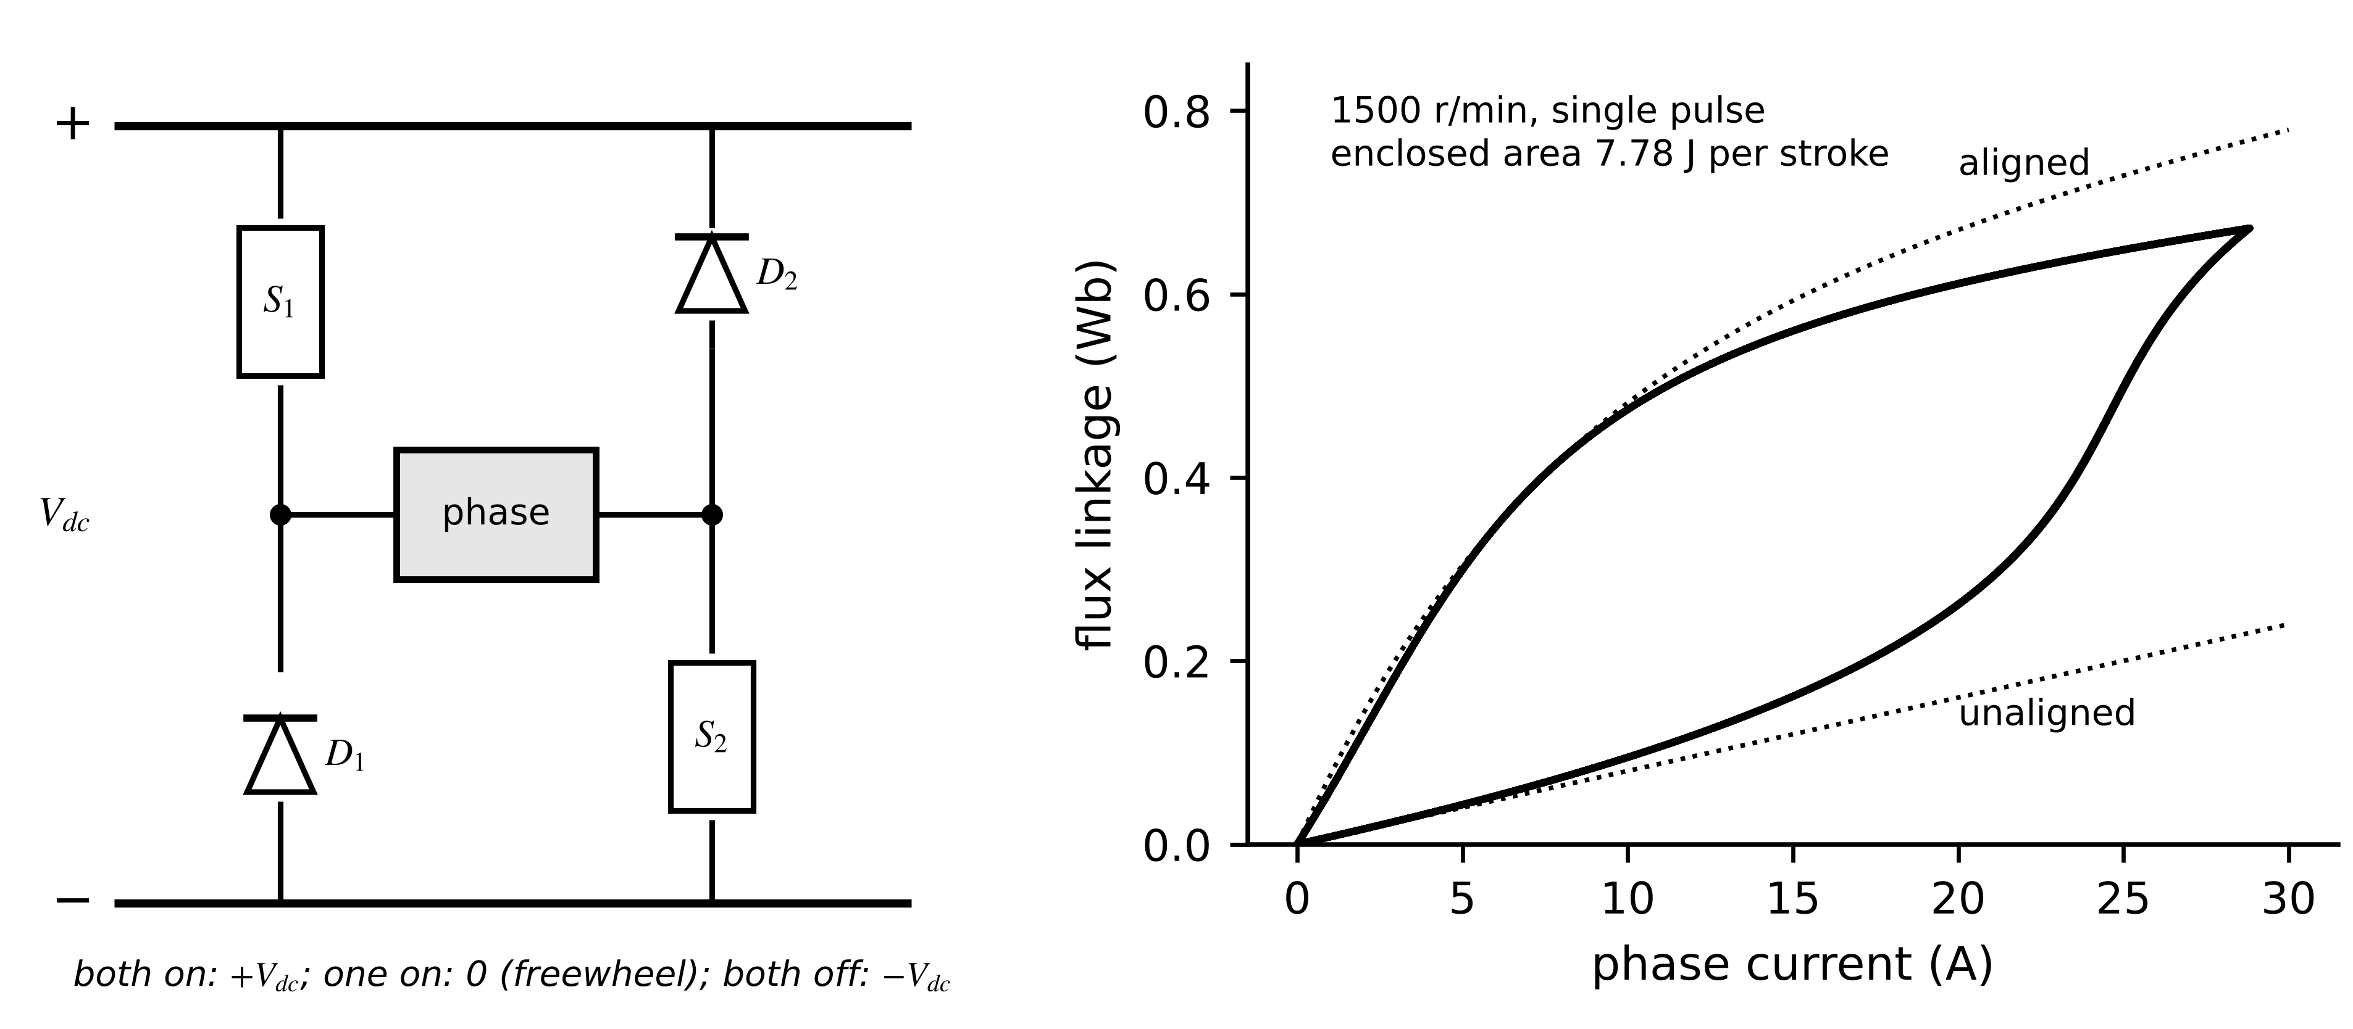
Figure 7.28. Left: asymmetric half bridge for one SRM phase, with the three voltage states. Right: flux-linkage loop of one phase over a stroke at 1500 r/min in single-pulse operation, between the unaligned and aligned curves; the enclosed area is the energy converted.
Example 7.23 (Level C) A twin of the 8/6 SRM at two speeds
Given. The 8/6 machine above, four phases, 300 V link, asymmetric half bridges, model (7.43)-(7.45) integrated at 2 µs. (i) 500 r/min with soft current chopping at 20 A between $θ_{on}=-165°$ and $θ_{off}=-35°$ electrical. (ii) 1500 r/min in single-pulse mode between $-175°$ and $-50°$.
Find. Average torque, peak-to-peak torque ripple relative to the average, mechanical power, copper loss, input power, phase RMS and peak current.
Solution. (i) 24.6 N·m, ripple 39 %, 1.29 kW, copper loss 287 W, input 1.58 kW (81 % ignoring iron and converter losses), 12.0 A RMS, 20.1 A peak. (ii) 29.7 N·m, ripple 35 %, 4.67 kW, 380 W, 5.06 kW (92 %), 13.8 A RMS, 28.8 A peak (Figure 7.29). Mechanical power is average torque times speed, and copper loss is $4R_{s}I_{rms}^{2}$; input power agrees with their sum to within 0.5 %. As a check, the flux-linkage loop of Figure 7.28 encloses 7.78 J per stroke, and 24 strokes per revolution give $7.78imes24/\left(2π\right)=29.7$ N·m.
Interpretation. The ripple comes from the handover between phases, where one phase's torque falls before the next one's rises. Torque-sharing functions or current profiling reduce it, but they need exactly the nonlinear flux-linkage map this twin carries; the same map predicts the radial forces that cause acoustic noise. The twin also shows why the angles must be re-optimized with speed: the same angles at 1500 r/min with chopping would leave the current unable to reach its reference.
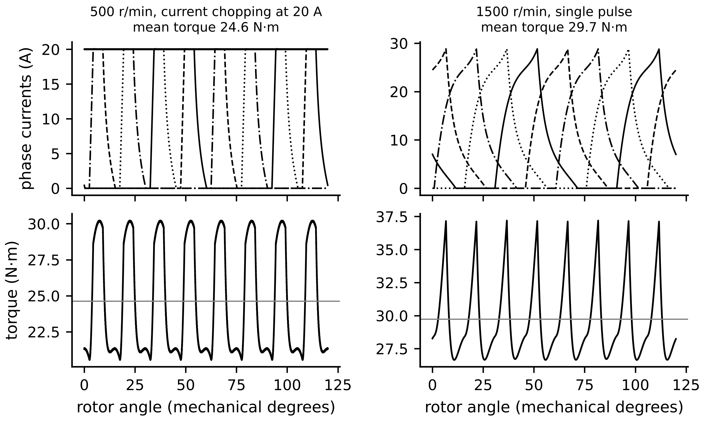
Figure 7.29. SRM twin waveforms over 120 mechanical degrees. Left: 500 r/min with current chopping at 20 A. Right: 1500 r/min in single-pulse mode. Top: the four phase currents; bottom: total torque with its commutation ripple.

7.13.4 Identifying the SRM twin and what it monitors
The flux-linkage map is identified at standstill by locking the rotor at known positions, applying voltage pulses and integrating, $ψ(t)=\int_{0}^{t}{(}v-Ri) dt'$, against the measured current; the analytic model (7.43) is then fitted by least squares, or a full table is built from many positions. In operation the twin tracks phase resistance (winding temperature), the magnetization map (which changes with rotor eccentricity or shorted turns) and the converter's devices (Section 7.8).
Example 7.24 (Level B) Fitting the magnetization model from locked-rotor tests
Given. Flux-linkage measurements at the aligned and unaligned positions from 0 to 30 A in 1 A steps, with 5 mWb noise (seed 4), generated from the true parameters $L_{u}=8$ mH, $L_{a}=80$ mH, $ψ_{sat}=0.55$ Wb.
Find. Least-squares estimates and standard deviations.
Solution. ${\hat{L}}_{u}=8.015±0.051$ mH, ${\hat{L}}_{a}=80.3±0.7$ mH, ${\hat{ψ}}_{sat}=0.547±0.003$ Wb.
Interpretation. Two positions and 62 points pin down three parameters to better than 1 %, because each parameter shapes a different part of the curves: $L_{u}$ the unaligned slope, $L_{a}$ the initial aligned slope, $ψ_{sat}$ the knee. Intermediate positions test the assumed $w(θ_{e})$ shape, which a real machine only approximates; where it fails, the twin switches to a measured table.
Table 7.12. What an SRM twin synchronizes and monitors
Quantity | How it is obtained | What it reveals
flux-linkage map $ψ(θ,i)$ | locked-rotor tests, finite elements, online refinement | torque, inductance profile, sensorless position
phase resistance | current-regulated DC test, online voltage balance | winding temperature
torque ripple and radial force | twin with measured currents | acoustic noise, need for current profiling
turn-on and turn-off angles | optimization over the twin | efficiency and torque per ampere with speed
phase symmetry | comparison of phase flux-linkage loops | open phase, shorted turns, eccentricity
converter devices | component-level identification (Section 7.8) | switch and diode ageing

What the digital twin adds
Synchronized: phase currents, rotor position and the nonlinear flux-linkage map.
Estimated or updated: $L_{u}$, $L_{a}$, $ψ_{sat}$ or a full table; resistance; optimal angles.
Uncertainty carried: map error between measured positions and mutual-coupling neglect.
Decision enabled: angle optimization, ripple and noise mitigation, phase-fault detection.
Validated by: locked-rotor flux tests and measured torque at several speeds.

7.14 Torque-speed limits, field weakening, MTPA, MTPV and efficiency maps

7.14.1 The current circle and the voltage ellipse
A drive is limited by its inverter in two ways: the current amplitude (device and winding heating) and the voltage it can apply (the DC link). In steady state the derivatives in (7.40) vanish and, neglecting $R_{s}$, the two limits become a circle and an ellipse in the $i_{d}$-$i_{q}$ plane:
$i_{d}^{2}+i_{q}^{2}≤I_{max}^{2}, {\left(ω_{e}L_{q}i_{q}\right)}^{2}+{\left(ω_{e}\left(L_{d}i_{d}+ψ_{pm}\right)\right)}^{2}≤V_{max}^{2}, V_{max}=\frac{V_{dc}}{\sqrt{3}}$ (7.47)
The ellipse shrinks as speed rises, around a centre at $i_{d}=-ψ_{pm}/L_{d}$ (the characteristic current). Below base speed the full current can be used for torque; at base speed the voltage limit is reached with $i_{d}=0$, $i_{q}=I_{max}$ for a surface PMSM. Above it, negative $i_{d}$ reduces the effective flux, field weakening, and the largest $i_{d}$ that still satisfies the voltage limit for a given $i_{q}$, and the speed limits, follow from (7.47):
$ω_{e,b}=\frac{V_{max}}{\sqrt{{\left(L_{q}I_{max}\right)}^{2}+ψ_{pm}^{2}}}, i_{d}=\frac{1}{L_{d}}\left[\sqrt{\frac{V_{max}^{2}}{ω_{e}^{2}}-{\left(L_{q}i_{q}\right)}^{2}}-ψ_{pm}\right], ω_{e,max}=\frac{V_{max}}{ψ_{pm}-L_{d}I_{max}} \left(\frac{ψ_{pm}}{L_{d}}>I_{max}\right)$ (7.48)
If the characteristic current is below $I_{max}$, the speed range is in principle unlimited (Figure 7.30).
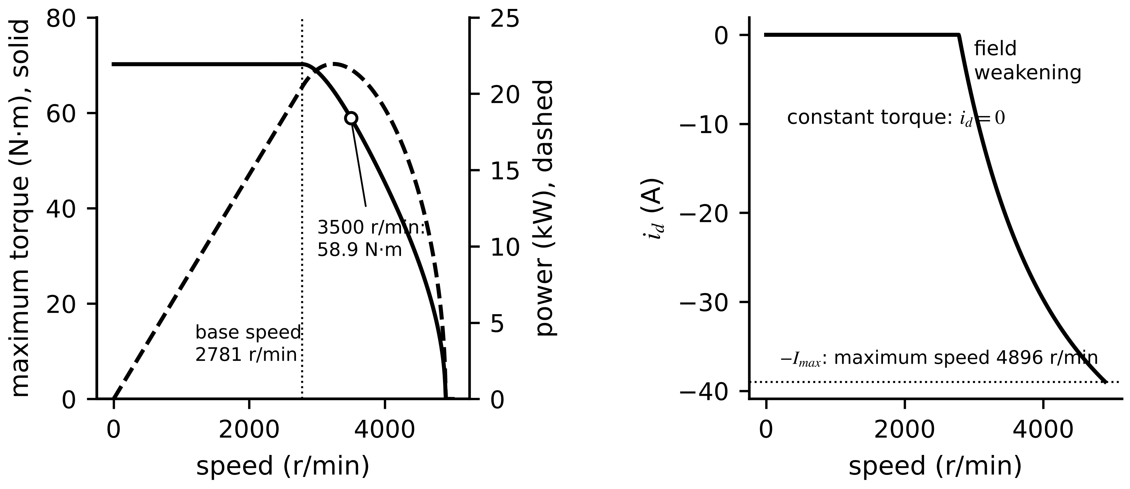
Figure 7.30. Drive D-3. Left: maximum torque and power against speed, with constant torque up to the 2781 r/min base speed and field weakening above it. Right: the d-axis current used for field weakening.
Example 7.25 (Level B) Base speed and field weakening of drive D-3
Given. D-3: $p=4$, $L_{d}=L_{q}=3$ mH, $ψ_{pm}=0.30$ Wb, $I_{max}=39$ A, $V_{dc}=650$ V.
Find. Base speed, maximum speed, rated torque, and the best currents, torque and power at 3500 r/min.
Solution. $V_{max}=375.3$ V; $LI_{max}=0.117$ Wb. (7.48): $ω_{e,b}=375.3/\sqrt{{0.117}^{2}+{0.30}^{2}}=1165$ rad/s (2781 r/min); $ω_{e,max}=375.3/(0.30-0.117)=2051$ rad/s (4896 r/min). Rated torque $1.5×4×0.30×39=70.2$ N·m. At 3500 r/min, $ω_{e}=1466$ rad/s; on the current circle, subtracting it from the ellipse gives $i_{d}=[(V_{max}/ω_{e})^{2}-ψ_{pm}^{2}-L^{2}I_{max}^{2}]/(2Lψ_{pm})=-21.2$ A, $i_{q}=32.7$ A, torque 58.9 N·m and mechanical power 21.6 kW.
Interpretation. Above base speed 21 A of the 39 A budget go into weakening the field. The electrical limits would allow twice rated power at 3500 r/min; the thermal rating does not, and the thermal twin of Section 7.15 decides how long such operation may last.

7.14.2 MTPA and MTPV
When $L_{d}≠L_{q}$, as in interior PMSMs, negative $i_{d}$ adds reluctance torque, and the current angle that gives the most torque for a given current amplitude, maximum torque per ampere (MTPA), follows from setting the derivative of (7.40) along the circle $i_{d}^{2}+i_{q}^{2}=I^{2}$ to zero:
$i_{d}^{MTPA}=\frac{ψ_{pm}-\sqrt{ψ_{pm}^{2}+8{\left(L_{q}-L_{d}\right)}^{2}I^{2}}}{4\left(L_{q}-L_{d}\right)}, i_{q}^{MTPA}=\sqrt{I^{2}-{\left(i_{d}^{MTPA}\right)}^{2}}$ (7.49)
At high speed, when the characteristic current lies inside the current circle, the voltage ellipse rather than the current limits torque, and the best point on each ellipse is maximum torque per volt (MTPV), which moves the trajectory towards $i_{d}=-ψ_{pm}/L_{d}$ (Figure 7.31). An efficiency-optimal trajectory lies near MTPA at low speed and shifts as iron losses grow with frequency.
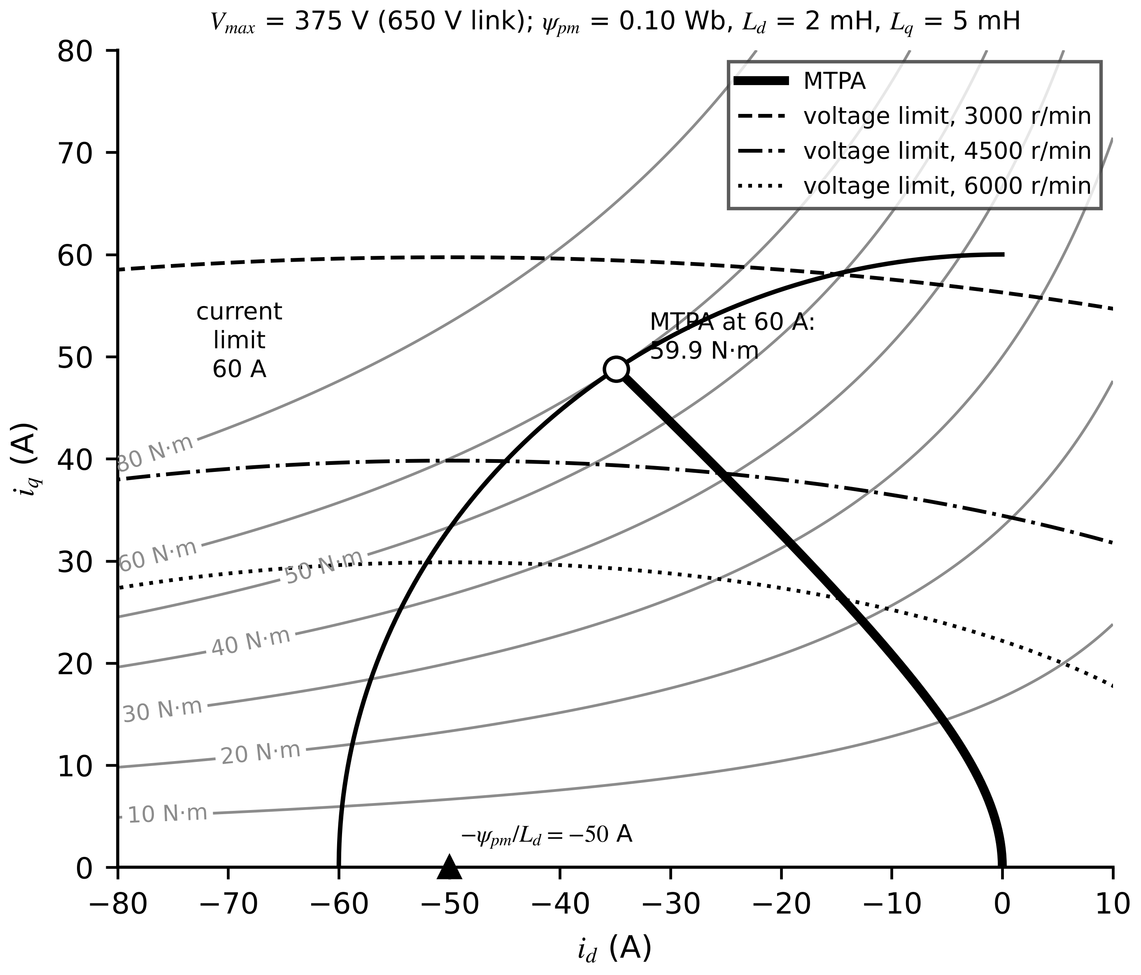
Figure 7.31. MTPA trajectory and torque contours of an illustrative interior PMSM ($ψ_{pm}=0.10$ Wb, $L_{d}=2$ mH, $L_{q}=5$ mH, $p=4$), with the 60 A current circle and voltage ellipses at three speeds. The ellipses shrink towards $-ψ_{pm}/L_{d}=-50$ A, where MTPV operation ends.
Example 7.26 (Level A) The value of MTPA
Given. The interior PMSM of Figure 7.31 at 60 A.
Find. The MTPA currents and torque, and the torque with $i_{d}=0$.
Solution. (7.49): $L_{q}-L_{d}=3$ mH; $i_{d}=[0.10-\sqrt{0.01+8×9×{10}^{-6}×3600}]/0.012=-34.9$ A; $i_{q}=48.8$ A; $T_{e}=1.5×4×[0.10×48.8+0.003×34.9×48.8]=59.9$ N·m. With $i_{d}=0$: $6×0.10×60=36.0$ N·m.
Interpretation. MTPA gives two-thirds more torque from the same current. Its accuracy depends on $L_{d}$ and $L_{q}$, which saturate with current, so the MTPA table of a real drive comes from measured flux maps; a twin that tracks magnet temperature must also shift the table, since $ψ_{pm}$ appears in (7.49).

7.14.3 Efficiency maps
An efficiency map shows drive efficiency over the whole torque-speed plane (Figure 7.32). It combines copper loss $\frac{3}{2}R_{s}(i_{d}^{2}+i_{q}^{2})$, iron loss rising with frequency (hysteresis roughly proportional to $f$, eddy currents to $f^{2}$), mechanical loss and inverter loss from Section 7.10. Efficiency is low at low torque (fixed losses dominate) and at very low speed (copper loss with little output), highest at moderate torque and speed, and falls again in deep field weakening, where $i_{d}$ adds copper loss without torque. For a twin the map is a quasi-steady model (Section 7.7): a calibrated map turns measured speed and torque into expected losses, and a growing gap between expected and measured input power is a fleet-level health indicator.
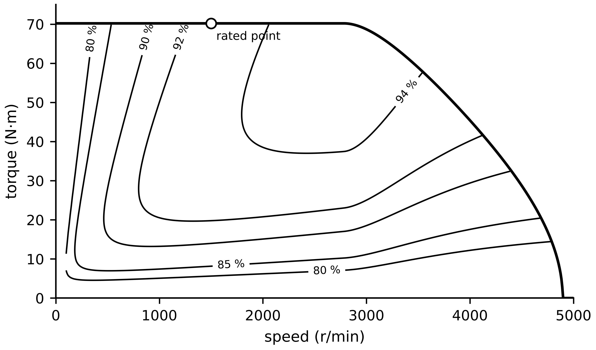
Figure 7.32. Efficiency map of drive D-3 (motor plus inverter) from an illustrative loss model: copper loss at 90 °C, iron loss with hysteresis and eddy terms, friction and the inverter losses of Section 7.10; contours from 80 to 94 %.
What the digital twin adds
Synchronized: operating point relative to current and voltage limits.
Estimated or updated: MTPA/MTPV tables with saturation and magnet temperature; efficiency map.
Uncertainty carried: inductance and loss-coefficient errors that shift limits and efficiency.
Decision enabled: torque limits, field-weakening strategy, efficient operating points.
Validated by: measured torque-speed envelope and input-power efficiency tests.

7.15 Sensorless estimation, online parameters and fault signatures

7.15.1 The low-speed limit of sensorless control
Encoderless drives estimate rotor position from the back-EMF, of amplitude $ω_{e}ψ_{pm}$ (Chapter 5 observers). The estimate is only as good as the voltage the controller believes it applies: the uncompensated dead-time error (7.11) and resistance uncertainty $ΔR_{s}\hat{I}$ set a floor $ΔV$. Requiring the back-EMF to exceed it by a margin $k_{s}$ gives a minimum speed (Figure 7.33)
$ω_{e,min}=\frac{k_{s} ΔV}{ψ_{pm}}, n_{min}=\frac{60 ω_{e,min}}{2πp}$ (7.50)
Below it, position can only be estimated by injecting a high-frequency voltage and reading the saliency response, whose signal is proportional to $L_{q}-L_{d}$; a surface PMSM offers only the weak saliency created by saturation [21]. A sensorless twin must therefore report its own validity region.
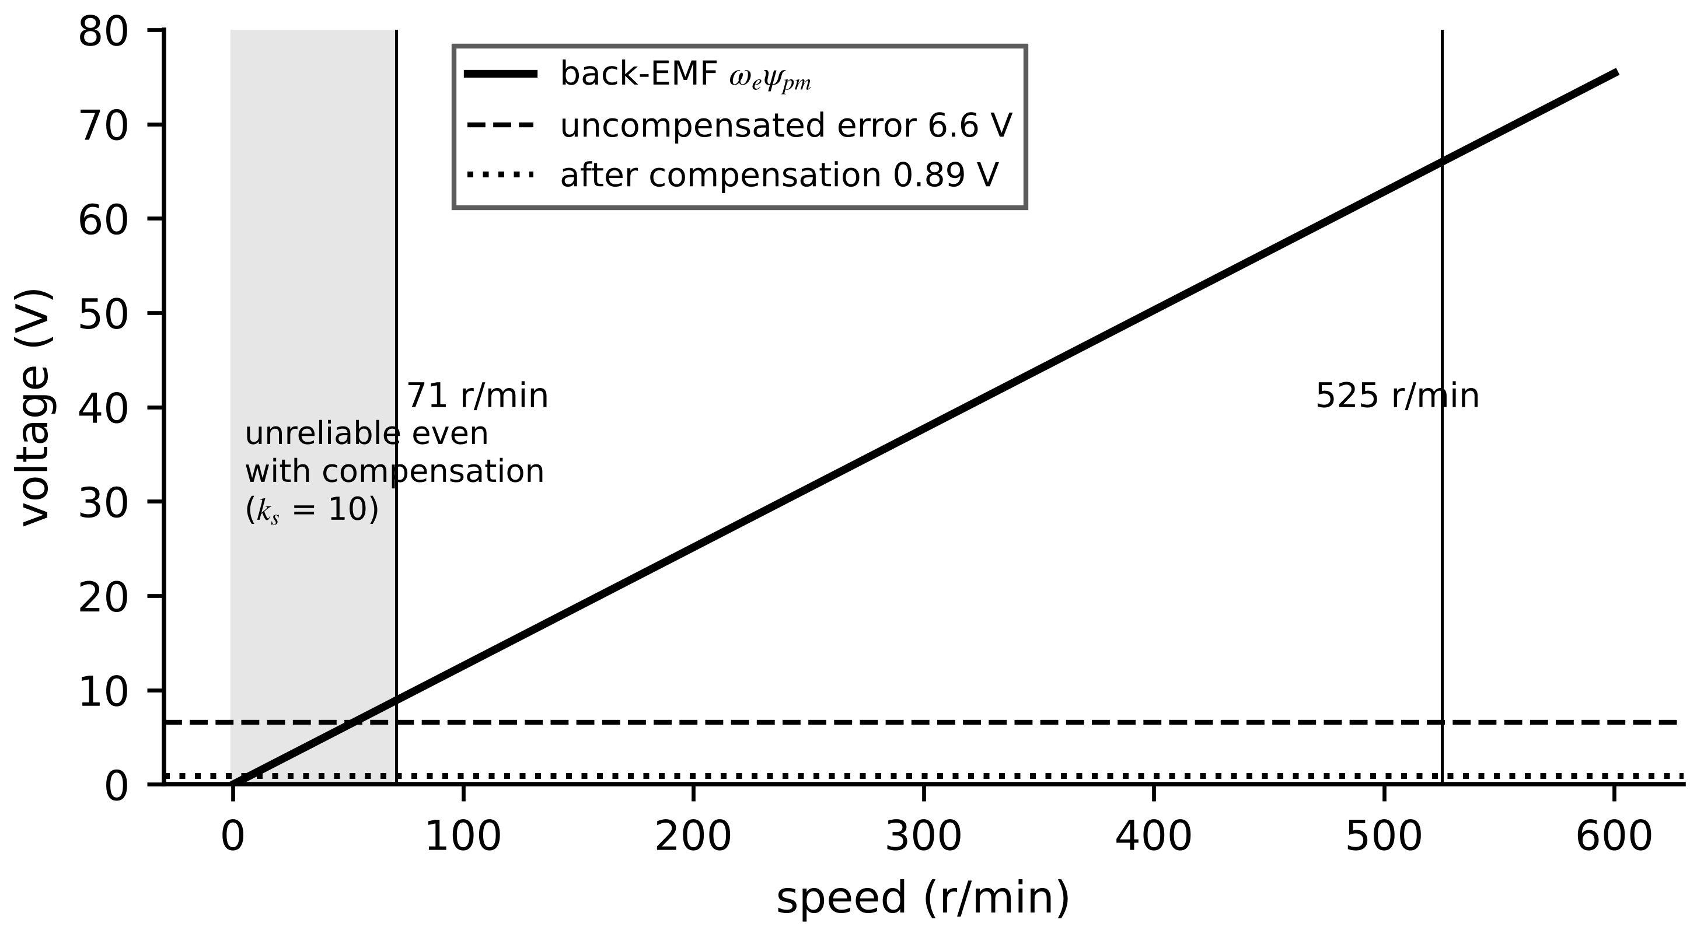
Figure 7.33. Back-EMF of drive D-3 against speed, with the uncompensated dead-time error and the residual error after compensation. With a margin of ten, back-EMF estimation is reliable above about 525 r/min uncompensated and 71 r/min compensated.
Example 7.27 (Level A) Minimum sensorless speed of drive D-3
Given. D-3 ($p=4$, $ψ_{pm}=0.30$ Wb). Uncompensated dead-time error 6.6 V; after compensation a residual of 0.5 V plus a 5 % resistance uncertainty at 39 A (0.39 V).
Find. The minimum speed with $k_{s}=1$ and with $k_{s}=10$, before and after compensation.
Solution. Back-EMF is $0.1257$ V per r/min. $k_{s}=1$: $6.6/0.1257=53$ r/min uncompensated, $0.89/0.1257=7$ r/min compensated. $k_{s}=10$: 525 and 71 r/min.
Interpretation. Compensation lowers the reliable limit sevenfold, but at pump start-up and stall the drive still needs either a sensor or injection. The margin $k_{s}$ is a design choice that the twin should state with its position estimate.

7.15.2 Winding and magnet temperature from electrical signals
Copper resistance is a thermometer: an estimate ${\hat{R}}_{s}$ gives the winding temperature, one kelvin being 0.39 % of resistance. The obvious route, regressing $v_{q}=R_{s}i_{q}+ω_{e}ψ_{pm}$ for both unknowns, fails on a pump, where $i_{q}$ and $ω_{e}$ rise together and the resistive term is a few volts against nearly 200 V (Chapter 5, Section 5.3). A small d-axis current step $Δi_{d}$ with $i_{q}$ held constant removes the speed voltage and every common error, so resistance is the only unknown; the q-axis equation then gives the magnet flux and temperature [22]:
${\hat{T}}_{w}=T_{0}+\frac{1}{α_{cu}}\left(\frac{{\hat{R}}_{s}}{R_{s0}}-1\right), {\hat{R}}_{s}=\frac{Δv_{d}}{Δi_{d}}, {\hat{ψ}}_{pm}=\frac{v_{q}-{\hat{R}}_{s}i_{q}}{ω_{e}}, {\hat{T}}_{m}=T_{0}+\frac{1}{α_{pm}}\left(\frac{{\hat{ψ}}_{pm}}{ψ_{pm,0}}-1\right), δT_{m}=\frac{δv}{ω_{e}ψ_{pm,0}α_{pm}}$ (7.51)
where $α_{cu}=0.00393$ K⁻¹ and $δT_{m}$ is the bias caused by an uncorrected voltage error $δv$: 0.2 V at 188 V back-EMF biases the magnet estimate by about −0.9 K. The injection costs $\frac{3}{2}R_{s}Δi_{d}^{2}=7.5$ W at −5 A and no torque in a surface PMSM. A recursive least-squares estimator with forgetting (Chapter 5, Section 5.4.3) combines successive averages.
Example 7.28 (Level A) From a voltage difference to a winding temperature
Given. A 1000-sample average of the d-axis voltage difference during a −5 A injection is −1.180 V, with 0.5 V noise per sample; $R_{s0}=0.200$ Ω at 20 °C; RLS with $λ=0.99$.
Find. Resistance and temperature, their standard deviations for one average, and after RLS averaging.
Solution. ${\hat{R}}_{s}=0.236$ Ω; ${\hat{T}}_{w}=20+(0.236/0.200-1)/0.00393=65.8$ °C. Noise of the average $0.5/\sqrt{1000}=0.016$ V, so 3.2 mΩ and 4.1 K. RLS with $λ=0.99$ remembers about 100 averages; by the factor $\sqrt{(1-λ)/(1+λ)}=0.071$ (Chapter 5), about 0.3 K.
Interpretation. Lag, not noise, limits this estimator: with a 100 s memory it trails a winding heating at several kelvin per minute, which is why the case study's error (2.7 K RMS) is larger than the steady noise. Fusing it with the thermal model in a Kalman filter combines the model's speed with the measurement's accuracy.

7.15.3 Fault signatures
Each failure mechanism leaves a characteristic trace in signals the drive already measures or a vibration sensor adds; the detection and prognosis algorithms belong to Chapter 12, and only the signatures are summarized here. Bearings excite defect frequencies proportional to shaft speed, found in the envelope spectrum of vibration; broken rotor bars produce current sidebands at $(1±2ks)f_{s}$; inter-turn shorts raise negative-sequence current; an open switch gives its phase current a DC component; slow ageing shows as parameter drift (Table 7.13). For a bearing with $N_{b}$ balls of diameter $d_{b}$ on pitch diameter $d_{p}$, contact angle $α$ and shaft frequency $f_{r}$, the outer- and inner-race frequencies are
$f_{BPFO}=\frac{N_{b}}{2}f_{r}\left(1-\frac{d_{b}}{d_{p}}cosα\right), f_{BPFI}=\frac{N_{b}}{2}f_{r}\left(1+\frac{d_{b}}{d_{p}}cosα\right)$ (7.52)
so a 9-ball bearing with $d_{b}/d_{p}=0.2$ at 1800 r/min has $f_{BPFO}=108$ Hz and $f_{BPFI}=162$ Hz. Because they scale with speed, the twin must compute them from measured speed in each analysis window.
Table 7.13. Fault signatures across the converter-machine twin (algorithms in Chapter 12)
Fault | Signal | Signature | Time scale
bearing defect | vibration envelope | peaks at (7.52) | weeks to months
broken rotor bar (induction) | stator current | sidebands $(1±2ks)f_{s}$ | months
stator inter-turn short | currents, voltages | negative-sequence current, local heating | minutes to hours
open switch or gate failure | phase currents | DC offset in one phase | immediate
bond-wire or solder ageing | estimated $R_{ds,on}$, $ΔT_{j}$ | slow rise at equal temperature | months to years
DC-link capacitor ageing | ripple voltage | ESR rise, capacitance loss (7.37) | months to years
cooling degradation | housing or heatsink temperature | residual against the thermal twin | hours to days

What the digital twin adds
Synchronized: rotor position, winding and magnet temperature without dedicated sensors.
Estimated or updated: $R_{s}$, $ψ_{pm}$, position, fault features.
Uncertainty carried: low-speed validity region, voltage-error bias, estimator lag.
Decision enabled: thermal derating, sensor need, maintenance triggers (Chapter 12).
Validated by: comparison with temporary sensors at commissioning.

7.16 Converter-machine interaction
The converter and the machine are not independent, and a twin that models them separately misses four interactions.
Common-mode voltage and bearing currents. The average of the three pole voltages relative to the DC-link midpoint jumps by $V_{dc}/3$ at every switching event. Coupled through the stray capacitances between winding, rotor and frame (Figure 7.34), it charges the bearing lubricant film to a fraction set by the bearing voltage ratio [23]:
$v_{cm}=\frac{v_{aN}+v_{bN}+v_{cN}}{3}-\frac{V_{dc}}{2}∈\left\{±\frac{V_{dc}}{2},±\frac{V_{dc}}{6}\right\}, v_{b}=\frac{C_{wr}}{C_{wr}+C_{rf}+C_{b}} v_{cm}$ (7.53)
where $C_{wr}$, $C_{rf}$ and $C_{b}$ are winding-to-rotor, rotor-to-frame and bearing capacitances. When $v_{b}$ exceeds the film's breakdown voltage, discharge currents pit the races and produce the fluting that later appears as a bearing-fault signature.
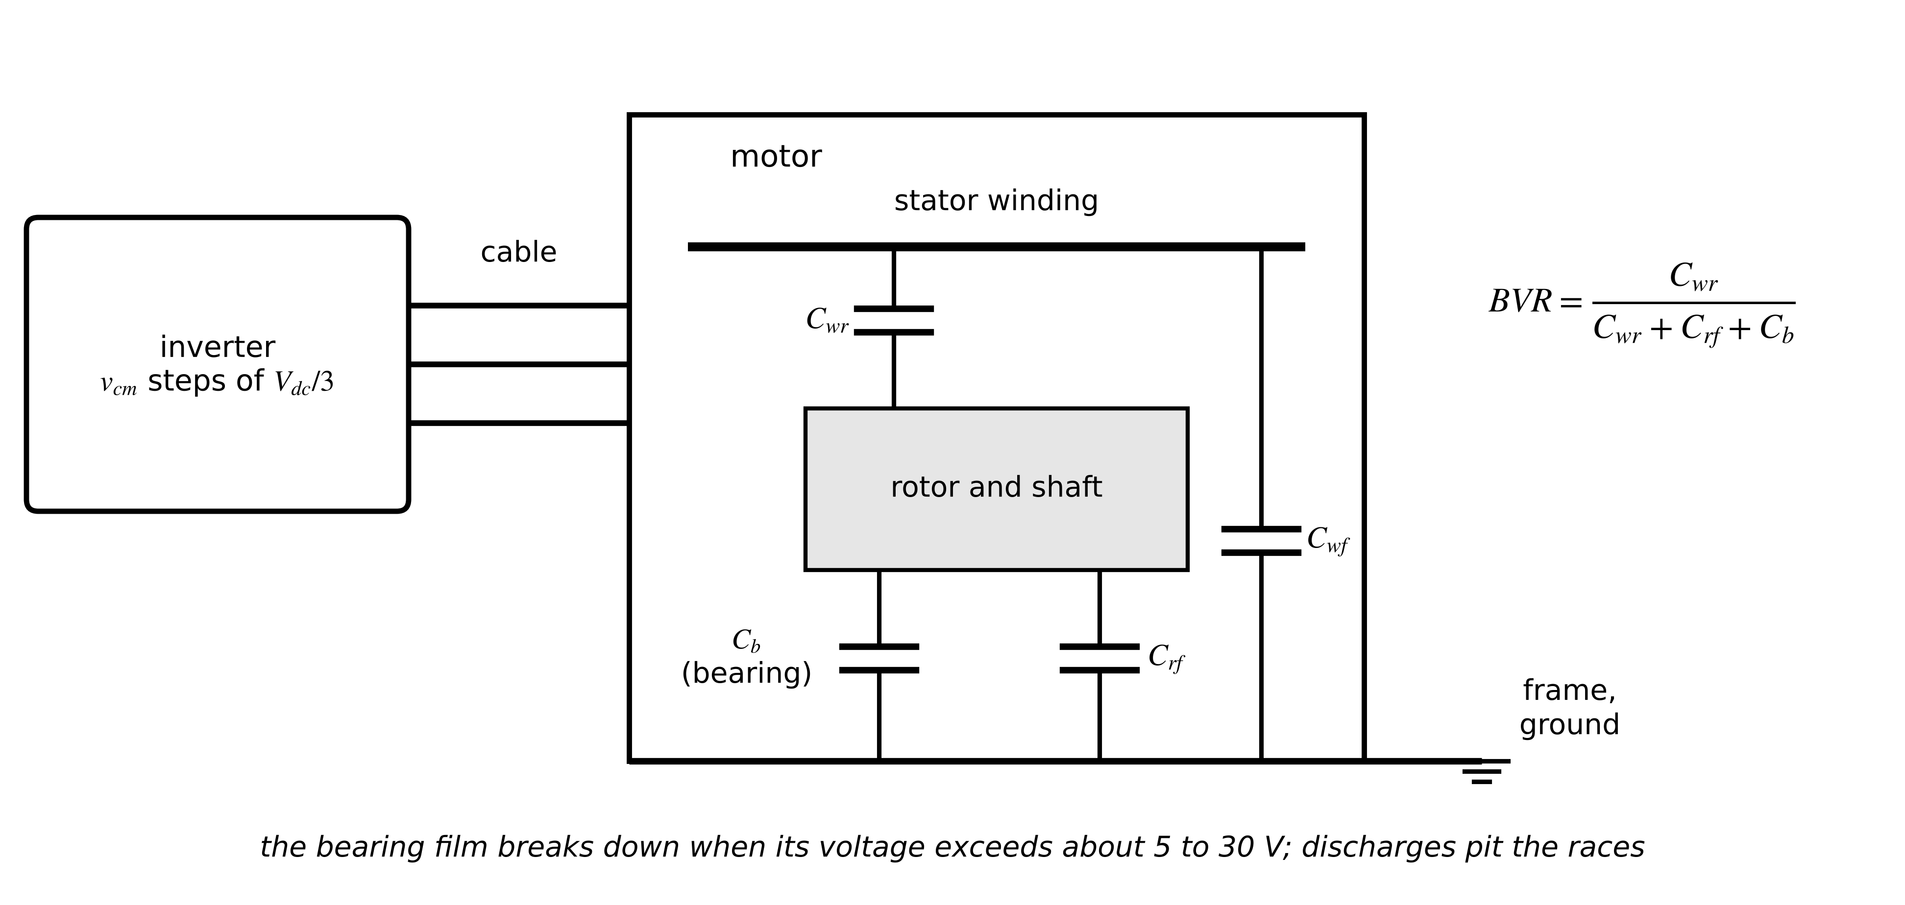
Figure 7.34. Common-mode path from inverter to bearing: the common-mode voltage drives currents through the winding-to-rotor, rotor-to-frame and bearing capacitances; the bearing voltage ratio sets the share across the lubricant film.
Reflected-wave overvoltage. A fast voltage edge travels down the cable and reflects at the motor, whose high-frequency impedance $Z_{m}$ far exceeds the cable's characteristic impedance $Z_{c}$ (Figure 7.35). The reflection coefficient, peak voltage and the cable length above which the full reflection develops (rise time $t_{r}$, propagation velocity $v_{p}$) are [24]
$Γ=\frac{Z_{m}-Z_{c}}{Z_{m}+Z_{c}}, V_{peak}≈V_{dc}\left(1+Γ\right), ℓ_{c}=\frac{v_{p}t_{r}}{2}$ (7.54)
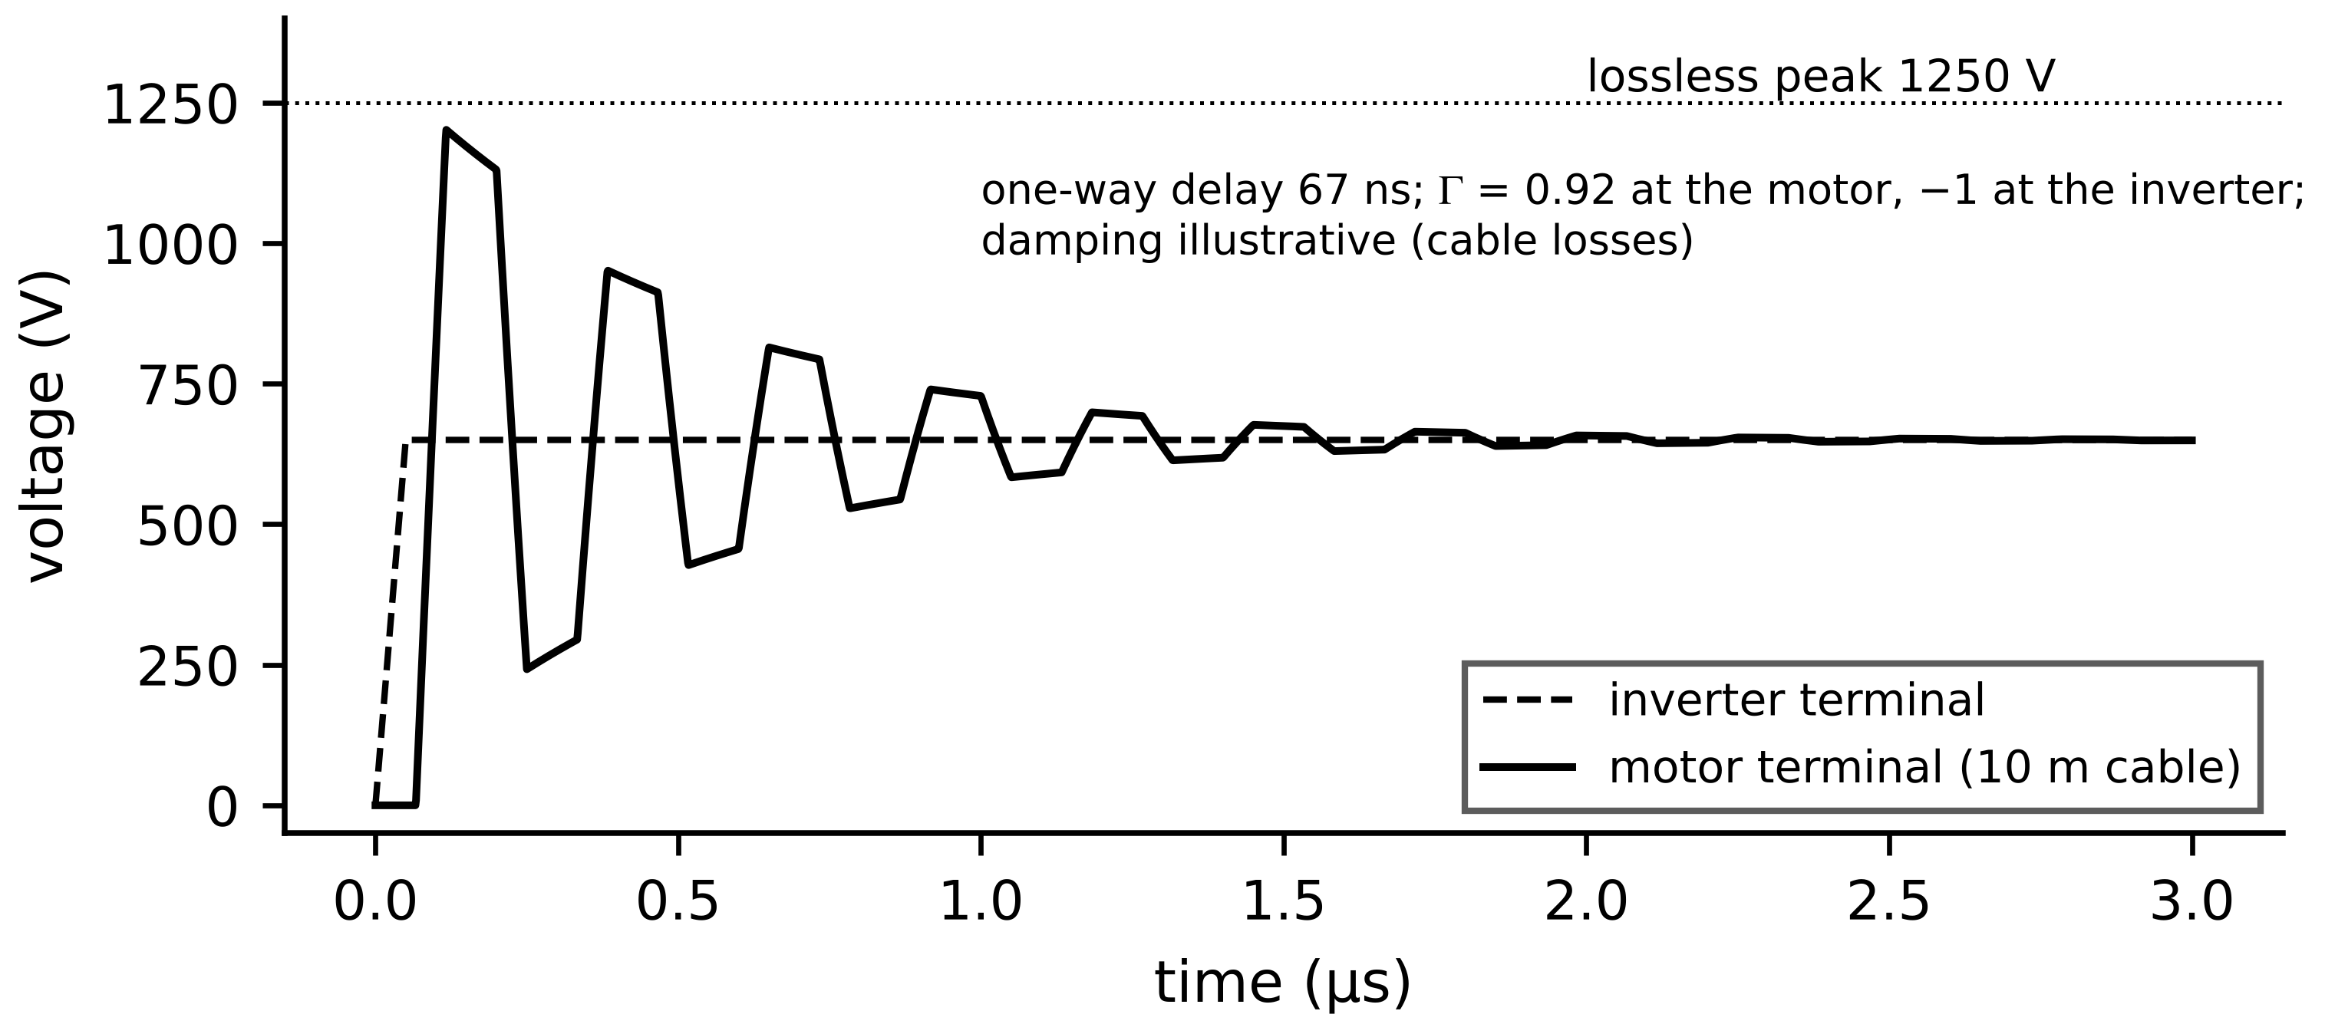
Figure 7.35. Reflected-wave overvoltage on a 10 m cable with a 50 ns SiC edge: the motor terminal rings up to almost twice the DC-link voltage before cable losses damp it.
EMI. The same edges ($dv/dt$ of tens of kV/µs for SiC) drive common-mode currents to ground through cable and motor capacitances, conducted to the supply unless filtered, and radiate from cables; faster devices trade switching loss for filter size and EMC margin. Ripple losses and thermal coupling. Switching-frequency current ripple adds copper loss $\frac{3}{2}R_{ac}I_{ripple,rms}^{2}$, with $R_{ac}$ raised by skin and proximity effects, plus extra iron loss; a machine thermal twin using only the fundamental current underestimates losses, more so at low switching frequency. Conversely, the motor's temperature changes its resistance and magnet flux, which change the current the inverter must supply and so its losses: the electrical and thermal models of converter and machine form one coupled loop.
Example 7.29 (Level B) Reflected wave and bearing voltage on drive D-3
Given. A 10 m cable with $Z_{c}=80$ Ω and $v_{p}=150$ m/µs; motor surge impedance about 2 kΩ; SiC rise time 50 ns; $C_{wr}=100$ pF, $C_{rf}=1.5$ nF, $C_{b}=200$ pF; $V_{dc}=650$ V.
Find. Critical cable length, peak motor voltage, bearing voltage ratio and peak bearing voltage, and the effect of a $dv/dt$ filter stretching the rise time to 200 ns.
Solution. $ℓ_{c}=150×0.05/2=3.75$ m, so the cable is long. $Γ=(2000-80)/2080=0.92$; $V_{peak}≈650×1.92=1250$ V. BVR $=100/1800=0.056$; with a common-mode amplitude of 325 V the bearing sees about 18 V. With 200 ns, $ℓ_{c}=15$ m and the overshoot is largely avoided.
Interpretation. 1250 V on a 400 V-class winding stresses inter-turn insulation at every edge, and 18 V across a film that breaks down at 5 to 30 V makes discharge damage likely. A twin can watch the consequences: partial-discharge activity for the winding, bearing-fault frequencies for the bearing.
What the digital twin adds
Synchronized: edges, common-mode voltage and coupled electrothermal states.
Estimated or updated: bearing voltage, reflected peak, ripple losses.
Uncertainty carried: stray capacitances and cable parameters known only roughly.
Decision enabled: filters, cable length, grounding, insulation class.
Validated by: terminal-voltage and shaft-voltage measurements at commissioning.

7.17 Real-time implementation and hardware in the loop

7.17.1 Time steps, deadlines and the hardware partition
A real-time twin advances its model in fixed steps $h$ and must finish each step, including input and output, before the next begins (Chapter 2, Section 2.10, and Chapter 4, Section 4.10):
$T_{calc}+T_{io}≤h, h_{e}<\frac{2L}{R_{s}} (forward Euler), {\overline{P}}_{j}=\frac{1}{N_{mr}}\sum_{k=(j-1)N_{mr}+1}^{{jN}_{mr}}{p_{k}}$ (7.55)
where $T_{calc}$ is the worst-case computation time, the second relation is the explicit-integration stability limit of the stator equations (30 ms for D-3, far longer than accuracy requires) and the third averages the electrical-rate losses $p_{k}$ over a thermal step of $N_{mr}$ electrical steps. The partition follows the fidelity ladder (Figure 7.36): switching-level converter and machine models run on an FPGA at sub-microsecond steps; averaged electrical, thermal and load models run on a processor at tens of microseconds to seconds; they exchange data through shared memory at the slower rate, and the thermal model returns temperatures that update $R_{s}$, $ψ_{pm}$ and $R_{ds,on}$ once per thermal step.
Figure 7.36. Hardware-in-the-loop partition for drive D-3: the real controller drives an FPGA switching model through its actual interfaces; a processor runs slower models; test automation injects faults and compares with field data. Bottom: the budget of one 0.25 µs FPGA step.

7.17.2 Switching events in a fixed-step model
A PWM edge almost never falls exactly at the start of a step. Snapping it to the nearest step edge moves each edge by up to $h$, which quantizes the effective duty cycle and adds a voltage error of up to $V_{dc}h/T_{s}$ per period, plus jitter that appears as spurious low-frequency ripple. The standard remedy timestamps each edge within the step (the controller's PWM outputs are sampled at the FPGA clock, typically 10 ns) and applies the step-averaged voltage, the switching-function average over the step:
${\overline{v}}_{kN,step}=\frac{V_{dc}}{h}\int_{t_{k}}^{t_{k}+h}{S_{k}}(t) dt, {\left|Δ\overline{v}\right|}_{snap}≤\frac{V_{dc} h}{T_{s}}$ (7.56)
which removes the quantization to first order. Diodes add a second kind of event, a current zero crossing, which a fixed-step model detects after the fact and corrects by interpolating the crossing instant within the step; models that ignore it show spurious negative diode currents and wrong dead-time behaviour.
Example 7.30 (Level B) Sizing the real-time platform for the D-3 twin
Given. D-3 switches at 16 kHz ($T_{s}=62.5$ µs). (i) A switching-level CHIL model must resolve the PWM with at least 100 steps per period; an FPGA at 100 MHz needs 25 clock cycles per state update. (ii) An averaged model for online estimation runs at 50 µs; its code takes 20 µs worst case on the target processor plus 5 µs of input and output.
Find. The FPGA step and its margin, the voltage error with and without edge interpolation at $h=0.25$ µs, and the processor margin.
Solution. (i) $h≤62.5/100=0.625$ µs; the update takes $25×10$ ns $=0.25$ µs, so $h=0.25$ µs gives 250 steps per period. Snapping edges: $|Δ\overline{v}|≤650×0.25/62.5=2.6$ V, a 1.2 % error on the 209.6 V fundamental, comparable to half the dead-time error itself; with sub-step averaging (7.56) and a 10 ns edge timestamp the error falls to 0.1 V. (ii) $20+5=25$ µs $≤50$ µs: 50 % margin.
Interpretation. Both functions are feasible, on different hardware. Edge interpolation, not a smaller step, is what makes a 0.25 µs model accurate enough to test dead-time compensation. Margins must be computed with worst-case, not average, execution time; below about 20 % there is no room for the next model update.

7.17.3 Controller and power hardware in the loop
In controller hardware-in-the-loop (CHIL) testing the real controller drives a real-time simulation through its actual interfaces. In power hardware-in-the-loop (PHIL) a power amplifier connects the simulation to real power hardware; the amplifier and its measurement add delay, and for the common ideal-transformer interface the loop formed by simulated source impedance $Z_{s}$ and hardware impedance $Z_{h}$ is stable only if
$\left|\frac{Z_{s}(jω)}{Z_{h}(jω)}\right|<1 for all ω$ (7.57)
a condition that interface delay makes harder to meet at high frequency [25]. Before a HIL model is trusted to validate a controller, it is itself validated: against offline device-level simulation for switching transients, against bench measurements of current ripple and dead-time distortion, and against field data for operating points, with the comparison quantities and tolerances written down in advance like any other acceptance test (Chapter 2, Section 2.12).
Table 7.14. Controller- and power-hardware-in-the-loop testing
Aspect | CHIL | PHIL
what is real | controller and its I/O | power hardware (converter, motor, battery)
simulated | converter, machine, load | grid or machine emulated by an amplifier
typical step | 0.1 to 1 µs (FPGA) or 10 to 50 µs (CPU, averaged) | 10 to 100 µs plus amplifier delay
main risk | model fidelity at switching level | interface instability (7.57)
twin use | validate control and protection logic | validate hardware against simulated conditions

What the digital twin adds
Synchronized: real controller or hardware with a model at a fixed, guaranteed step.
Estimated or updated: edge timestamps, losses averaged across rates, temperature feedback.
Uncertainty carried: step quantization, interface delay, model fidelity at switching level.
Decision enabled: which tests run on which platform, and whether results are trustworthy.
Validated by: HIL model against device simulation, bench and field data.

7.18 Case study: an end-to-end twin of drive D-3 (Level C)

7.18.1 Specification
Table 7.15 specifies drive D-3 and its twin completely. All data in this section are synthetic, generated from the stated models; every number can be reproduced from the table.
Table 7.15. Drive D-3 and its twin (synthetic case study)
Item | Specification
motor | surface PMSM, 11 kW, 1500 r/min, $p=4$, $R_{s}=0.20$ Ω at 20 °C, $L_{d}=L_{q}=3$ mH, $ψ_{pm}=0.30$ Wb at 20 °C ($α_{pm}=-0.0012$ K⁻¹)
inverter | two-level SiC, 650 V DC link, 16 kHz, min-max (space-vector) modulation, dead time 0.5 µs
control | field-oriented, $i_{d}=0$, PI current loops at 1 kHz bandwidth with decoupling
thermal network | winding, housing and magnet nodes: $C_{w}=4$ kJ/K, $C_{h}=20$ kJ/K, $C_{m}=3$ kJ/K, $R_{wh}=0.06$, $R_{mh}=0.20$, $R_{ha}=0.045$ K/W; ambient 35 °C; iron loss $180(n/1500)^{1.5}$ W, rotor loss $40(n/1500)^{2}$ W
mission | four hours of pump duty, NumPy default_rng(2037): speed 800 to 1800 r/min in 5 to 20 min steps, torque $70(n/1700)^{2}$ N·m
fault | cooling-fan degradation at 2.5 h: $R_{ha}$ rises by 60 % to 0.072 K/W
sensors | phase currents, DC voltage, encoder, housing NTC (0.3 K noise)
estimators | d-axis injection −5 A, one-second averages with 0.02 V noise, RLS ($λ=0.99$) for $R_{s}$; magnet flux from $v_{q}$ with a 0.2 V uncorrected bias and a 60 s moving average (7.51)
thermal twin | same network with nominal $R_{ha}$, driven by measured currents and estimated $R_{s}$
diagnostic | CUSUM on the housing residual, $κ=0.5σ$, threshold $50σ$, $σ$ from 0.5 to 2.5 h
recommendation | 10 min after an alarm, re-estimate $R_{ha}$ by least squares; forecast the remaining mission; find the torque scale that keeps $T_{w}≤130$ °C (thermal class 130 (B), IEC 60034-1 [26])
execution | electrical: switching (0.25 µs) and averaged dq models for a current step; mission: quasi-steady electrical model at 1 s with the thermal network (7.55)

7.18.2 Electrical layer
A switching simulation (sine-triangle comparison with min-max injection at 16 kHz, 0.25 µs step, regular sampling) and an averaged simulation of the same control loop were run for a q-current step from 20 to 39 A at 1500 r/min (Figure 7.37). The averaged model reaches 90 % of the step in 0.30 ms, consistent with the 1 kHz bandwidth. At 39 A the switching model's mean q-axis current is 38.98 A against 38.96 A for the averaged model, and its ripple is 1.14 A peak-to-peak, within the bound $V_{dc}/(8Lf_{s})=1.69$ A of (7.16). For the thermal and diagnostic functions the averaged and quasi-steady rungs are therefore adequate, as Table 7.4 prescribed.
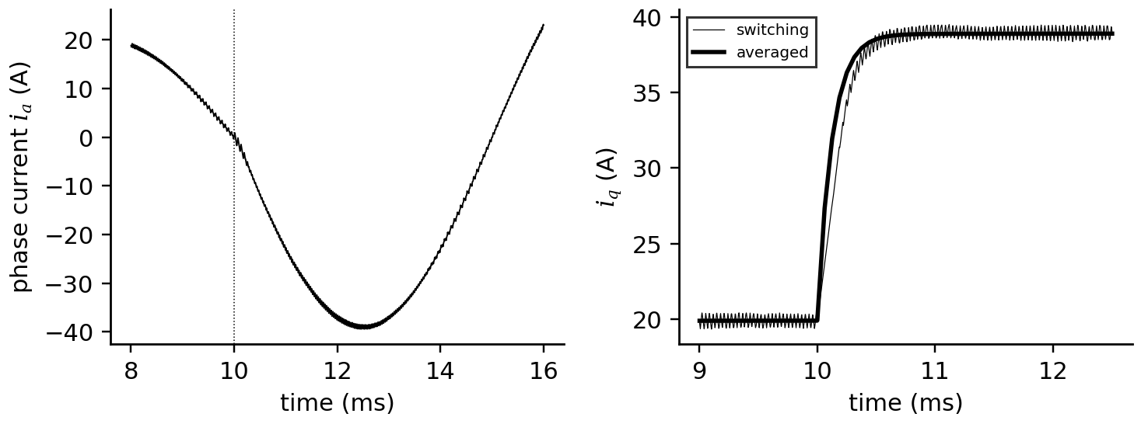
Figure 7.37. Electrical layer of the D-3 twin. Left: phase current from the switching model across a q-current step at 10 ms. Right: q-axis current from switching and averaged models; the averaged model follows the mean of the switching ripple.

7.18.3 Thermal estimation, diagnosis and recommendation
Over the four-hour mission the true winding temperature reaches 102.7 °C before the fault and 137.6 °C after it. Table 7.16 and Figure 7.38 give the twin's results.
Table 7.16. D-3 twin results on the synthetic mission (errors after the first 30 minutes)
Function | Result
winding temperature from $R_{s}$ (7.51) | RMS error 2.7 K, bias −0.04 K
magnet temperature from $ψ_{pm}$ | RMS error 1.05 K, bias −1.03 K (−0.9 K expected from the 0.2 V voltage error)
housing residual before the fault | mean 0.06 K, standard deviation 0.30 K
cooling-fault detection (CUSUM) | 59 s after onset (2 h 31 min into the mission)
$R_{ha}$ re-estimated 10 min after the alarm | 0.0719 K/W (true 0.072, nominal 0.045)
forecast peak winding temperature without action | 137.8 °C (truth 137.6 °C)
recommended torque scale | 0.959, a 4.1 % derating, issued at 2 h 41 min
peak winding temperature with the recommendation (truth) | 129.8 °C, within the 130 °C limit
lead time before the limit would have been crossed | 40 min

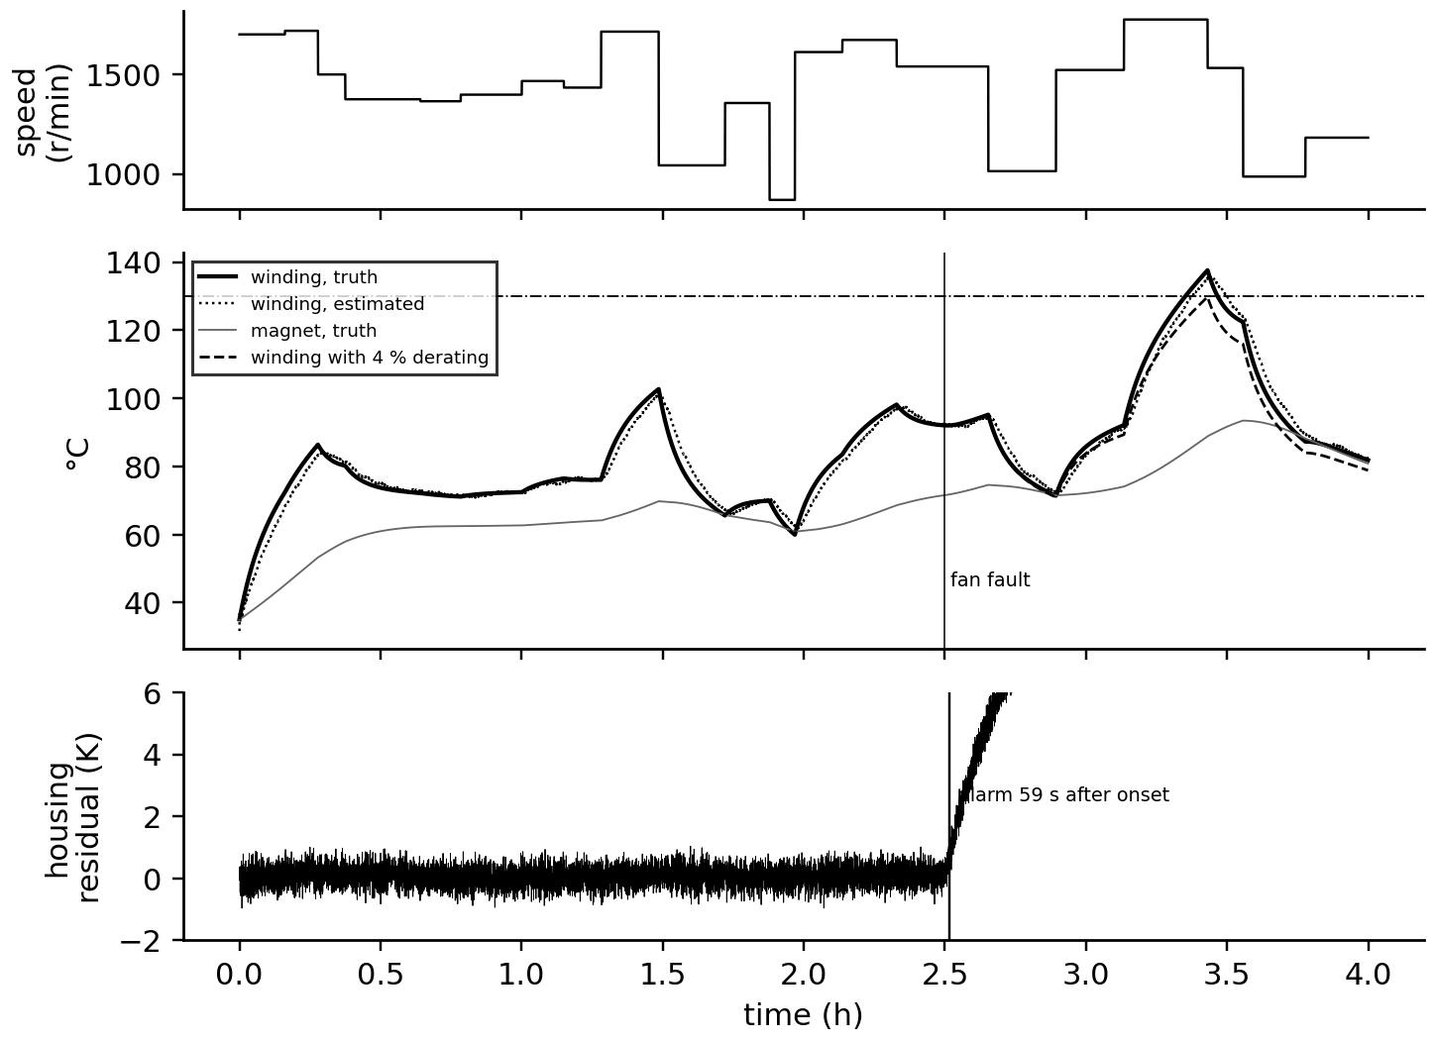
Figure 7.38. Thermal layer of the D-3 twin. Top: speed profile. Middle: true and estimated winding temperatures, true magnet temperature and the winding temperature with the recommended derating, against the 130 °C limit. Bottom: housing-temperature residual against the nominal thermal twin, with the CUSUM alarm.
The chain is the one this book has built: a physical model (Chapter 4), estimation designed around observability (Chapter 5), a residual test (Chapter 5, Section 5.12), a re-identified parameter, a forecast and an advisory limited to what the evidence supports (Chapter 1, Level 3 autonomy). Two choices made it work: an injection that made the resistance observable, and a thermal twin structured like the plant, so that the residual isolated the one parameter that changed.

7.18.4 Limitations and reproduction
The study is synthetic so that every estimate can be compared with a known truth, and its limits must be stated as plainly as its results. Plant and twin share the same thermal structure, differing only in the fan fault; a real motor has distributed hot spots, end-winding effects and a housing sensor whose position biases the residual, so field errors will be larger. The injection assumes constant $L_{d}$ over the 5 A excursion and ignores its extra iron loss. To reproduce: simulate the thermal network of Table 7.15 with a one-second forward-Euler step and the stated mission; form one-second averages of $Δv_{d}$ and $v_{q}$ with the stated noise and bias; estimate $R_{s}$ by RLS and $ψ_{pm}$ by (7.51); run the nominal thermal twin and the CUSUM; re-estimate $R_{ha}$ on the ten minutes after the alarm, starting from the twin's estimated states; then bisect the torque scale on the forecast.

7.19 Recent developments and open research problems
Converter and machine twins are moving quickly; each development is labelled with its status in 2026. The 2026 reviews of energy twins stress adaptive synchronization, scalability and the step from descriptive to prescriptive twins [1], [2]; for drives and converters these translate into the directions below.
Wide- and ultra-wide-bandgap devices (SiC and GaN established; Ga₂O₃, diamond research). Faster, hotter switching moves twins towards higher frequencies, stronger reflected-wave and bearing-current effects, and new ageing mechanisms such as threshold drift and dynamic on-resistance. Open problem: health indicators for gate-oxide ageing readable in operation. Solid-state transformers and modular converters (emerging). DAB stacks and MMCs replace line-frequency transformers in traction, data centres and grid interfaces. Open problem: twins that track hundreds of submodules and capacitors without switching-level simulation of each. Online condition monitoring of power modules (emerging). TSEP-based junction-temperature estimation and on-state-voltage tracking in operation. Open problem: separating ageing from temperature with a single measurement. Real-time multi-rate HIL (established for testing). FPGA switching models with sub-step event handling. Open problem: certified fidelity of HIL models against hardware at switching level. Component-level physics twins with online identification (emerging, laboratory-validated). Parasitic-aware switching models of PV inverters identified by population-based optimizers on FPGA and real-time simulators, with waveform agreement of about 98 % and parameter errors below 2 % reported [4], [5]; hybrid versions add learned latent-state corrections [7], and Lyapunov-based monitors add stability indices [6]. Open problem: identifiability in the field, where excitation is whatever the operation provides. Learned surrogates of loss and thermal models (emerging). Fast surrogates (Chapter 6) for fleet optimization and edge twins. Thermal neural networks keep the lumped-parameter structure and learn its parameters from data [27]. Open problem: validity outside the training envelope, especially at overload. Integrated electro-thermal-mechanical motor twins (research). Coupled electromagnetic, thermal and bearing models for prognosis (Chapter 12).
Verified recent results behind these directions. The component-level approach of Section 7.8 has a direct precedent in DC-DC converters: Peng, Zhao and Wang identified the capacitor and MOSFET health indicators of a buck converter by particle-swarm optimization against a digital twin, without extra sensing hardware [8], and real-time twins of two-stage grid-connected converters now estimate several parameters at once from discrete backward-Euler models [9]. For power modules, empirical lifetime models fitted to large power-cycling data sets add heating time, current per bond wire and bond-wire diameter to the temperature-swing law of (7.36) [17]. For wide-bandgap devices, the industry has standardized how the two ageing effects of Section 7.9 are measured: JEDEC JEP184 for bias-temperature instability of SiC MOSFETs [11] and JEP173 for the dynamic on-resistance of GaN transistors [12], which gives twins a reference against which in-operation indicators can be calibrated. For machines, thermal neural networks keep the lumped-parameter structure of the D-3 thermal twin and learn its conductances and loss terms end-to-end from measured temperatures [27], a hybrid of the kind Chapter 6 recommends.
Table 7.17. Emerging directions with a measurable research target
Direction | Status | Measurable target
WBG device ageing indicators | emerging | detection lead time for gate-oxide or dynamic $R_{ds,on}$ degradation in operation
twins of modular converters | emerging | estimation error of submodule capacitances with averaged-arm models
TSEP junction-temperature estimation | emerging | error against fibre or infrared reference over the mission
HIL model certification | established use, open method | agreement of ripple, dead-time error and transients with hardware
component-level identification in the field | emerging | parameter error and drift detection delay on operational (unplanned) excitation, with covariance reported
learned loss and thermal surrogates | emerging | error and speed-up against the quasi-steady model, inside and outside the envelope
coupled motor twins for prognosis | research | remaining-life prediction error on run-to-failure data

7.20 How this chapter feeds the rest of the book
From Chapter 4 this chapter took state-space models and discretization; from Chapter 5, estimators and residual tests; from Chapter 6, surrogates and calibrated uncertainty. It hands on converter and machine models at every rung of the fidelity ladder, and the component-level identification procedure of Section 7.8, which Chapters 8 and 9 apply to PV inverters and battery interfaces. Chapter 8 uses the PV boost, inverter and loss models for renewable twins; Chapter 9 uses the bidirectional and DAB interfaces with the battery models; Chapter 10 uses the drive and charger models for electric vehicles; Chapter 11 uses the VSC dq model and impedance views for microgrids. Chapter 12 takes the fault signatures of Table 7.13 and the lifetime models of Section 7.10 into diagnosis and prognosis, Chapter 13 the averaged models into control and optimization, and Chapter 14 asks how the converter's control and measurement paths can be attacked.

Chapter summary
The chapter built converter twins from circuits and waveforms: buck, boost and bidirectional stages from volt-second and charge balance, their ripples, the CCM/DCM boundary and the non-idealities that a twin estimates. Isolated and resonant converters were explained by how they move energy (stored magnetizing energy, phase-shifted power, resonance) and multilevel converters by why they exist. The three-phase VSC was described by its switch states, modulation limit $m_{max}=1.155$, dead-time error and averaged dq model. The flagship section organized all of this into a fidelity ladder, from switching to averaged, small-signal, quasi-steady, thermal and lifetime models and surrogates, and assigned each twin function its rung.
Section 7.8 turned the switching rung into a research-grade twin: every inductor, capacitor, diode and switch modelled with its parasitic resistance or threshold, the leg voltage written case by case from switch command and current polarity, the network discretized implicitly, and the parasitic parameters identified by a swarm search refined by Levenberg-Marquardt. The boost example showed the central lesson of identification: waveforms matched to 0.008 % while three resistances were wrong by up to 23 %, because only their duty-weighted sum was observable; on-state voltage clamps fixed it, and the identified parameters then tracked a doubled ESR and a 30 % rise in on-resistance that efficiency barely registered. The same approach identified a PMSM together with its inverter error, where omitting the inverter model biased the resistance by 65 %.
Device losses were computed from datasheet values and closed through the electrothermal loop; Foster and Cauer networks gave junction temperature, mission profiles gave temperature swings, and Coffin-Manson with Miner's rule gave damage, showing that slow, large swings and hotter heatsinks are expensive. Machines were built from the rotating field through Clarke and Park transformations with one sign convention; induction and permanent-magnet models led to torque-speed limits, field weakening, MTPA, MTPV and efficiency maps, and the switched reluctance machine was modelled from its saturating flux-linkage map and co-energy torque. Sensorless and electrical temperature estimation, fault signatures, converter-machine interaction and real-time HIL with edge interpolation completed the twin, and drive D-3 showed the whole chain: a cooling fault found in 59 s and a 4 % derating that kept the winding under its limit, issued 40 minutes ahead.
Table 7.18. Key relationships of Chapter 7
Relationship | Expression | Eq.
Buck and boost ratios | $V_{o}/V_{in}=D$; $1/(1-D)$ | (7.1)
Ripples | $Δi_{L}=V_{o}(1-D)/(Lf_{s})$; $Δv_{o}=Δi_{L}/(8Cf_{s})+Δi_{L}r_{C}$ | (7.2)
CCM/DCM boundary | $K_{crit}=1-D$ (buck), $D(1-D)^{2}$ (boost) | (7.3)
Boost with losses | $η=1/(1+r_{L}/((1-D)^{2}R))$ | (7.4)
DAB power | $P=V_{1}nV_{2}φ(π-|φ|)/(2π^{2}f_{s}L)$ | (7.7)
LLC gain | first-harmonic $M(f_{n},L_{n},Q)$ | (7.8)
VSC phase voltage; SVPWM limit | $v_{kn}=v_{kN}-\frac{1}{3}\sum{v_{jN}}$; $m_{max}=1.155$ | (7.9), (7.10)
Dead-time error | $-sgn(i)t_{d}f_{s}V_{dc}$ | (7.11)
Averaged dq VSC | (7.12) | (7.12)
State-space averaging | $\dot{\overline{x}}=[dA_{1}+(1-d)A_{2}]\overline{x}+…$ | (7.17)
Boost RHP zero | $ω_{z}=(1-D)^{2}R/L$ | (7.20)
Specific on-resistance | $4V_{B}^{2}/(ε_{s}μ_{n}E_{c}^{3})$ | (7.31)
Conduction and switching loss | $R_{ds,on}{\hat{I}}^{2}/4$; $\frac{f_{s}}{π}E\frac{V}{V_{ref}}\frac{\hat{I}}{I_{ref}}[1+α_{E}ΔT]$ | (7.33), (7.34)
Component models; leg cases | $v_{L}=L\dot{i}+r_{L}i$; $v_{D}=V_{F}+r_{D}i$; $v_{xf}$ by $S$ and $sgn(i)$ | (7.21), (7.22)
Boost with parasitics; averaged balance | (7.23); $r_{L}+Dr_{on}+(1-D)r_{D}$ observable | (7.23), (7.24)
Identification objective; optimizer | $J(θ)$, SME; PSO and Levenberg-Marquardt | (7.27), (7.28)
Thermal impedance and convolution | $Z_{th}=\sum{R_{i}}(1-e^{-t/τ_{i}})$ | (7.35)
Lifetime | Coffin-Manson and Miner | (7.36)
Capacitor life and health | $L=L_{02}^{(T_{0}-T_{hs})/10}$; ESR and $C$ from ripple | (7.37)
Clarke and Park | (7.38) | (7.38)
Induction machine | $T_{e}=\frac{3}{2}p\frac{L_{m}}{L_{r}}ψ_{r}i_{sq}$; $ω_{sl}=L_{m}i_{sq}/(τ_{r}ψ_{r})$ | (7.39)
PMSM | $T_{e}=\frac{3}{2}p[ψ_{pm}i_{q}+(L_{d}-L_{q})i_{d}i_{q}]$ | (7.40)
PMSM with inverter error | $v_{k}=v_{k}^{ref}-(V_{th}+r_{d}|i_{k}|)sgn(i_{k})$ | (7.41)
SRM flux linkage and torque | $ψ=L_{u}i+wψ_{sat}(1-e^{-ki})$; $T_{e}=∂W^{′}/∂θ$ | (7.43), (7.45)
Limits and field weakening | $ω_{e,b}$, $i_{d}$, $ω_{e,max}$ | (7.47), (7.48)
MTPA | $i_{d}^{MTPA}$ | (7.49)
Sensorless limit | $ω_{e,min}=k_{s}ΔV/ψ_{pm}$ | (7.50)
Temperatures from electrical signals | ${\hat{R}}_{s}=Δv_{d}/Δi_{d}$; ${\hat{ψ}}_{pm}=(v_{q}-{\hat{R}}_{s}i_{q})/ω_{e}$ | (7.51)
Bearing voltage; reflected wave | $v_{b}=BVR v_{cm}$; $V_{peak}≈V_{dc}(1+Γ)$; $ℓ_{c}=v_{p}t_{r}/2$ | (7.53), (7.54)
Real-time budget; edge averaging | $T_{calc}+T_{io}≤h$; $|Δ\overline{v}|≤V_{dc}h/T_{s}$ | (7.55), (7.56)

Exercises
The fifteen exercises are grouped by theme. Most combine a derivation, a conceptual question and a numerical part, so that each can be set as one assignment; the last is an open design project. Complete solutions to all fifteen are given in the Answer key.

Group A: converters
7.1 Buck and boost in CCM. (a) Derive the buck and boost conversion ratios from volt-second balance and state where they fail. (b) A buck converter has $V_{in}=48$ V, $D=0.35$, $L=100$ µH and $f_{s}=100$ kHz; find $V_{o}$ and the inductor ripple. A boost must produce 400 V from 250 V; find $D$. (c) Derive the buck output ripple $Δi_{L}/\left(8Cf_{s}\right)$ from the charge delivered by the triangular ripple current. (d) For the buck of Example 7.1, find the critical inductance for a 2 A load and state whether the converter is in CCM at 1 A.
7.2 Boundary, losses and the RHP zero. (a) Derive the boost CCM boundary $K_{crit}=D{\left(1−D\right)}^{2}$. (b) Derive the boost ratio with winding resistance, (7.4), by volt-second balance. (c) For the PV boost of Example 7.2, find the right-half-plane zero at full load and at 5 kW, and explain why it limits the voltage-loop bandwidth.
7.3 Bidirectional, isolated and resonant stages. (a) Why does a synchronous bidirectional stage never enter DCM, and what does it pay at light load? (b) A DAB has $V_{1}=nV_{2}=600$ V, $f_{s}=100$ kHz and $L=30$ µH. Find $P_{max}$ and comment on a 15 kW requirement. Using the Advanced box of Section 7.3.2, find the corner currents and RMS current at 7.5 kW. (c) An LLC tank has $L_{r}=40$ µH, $C_{r}=40$ nF and $L_{m}=200$ µH. Find $f_{r}$, $f_{p}$ and $L_{n}$.
7.4 The three-phase VSC and multilevel converters. (a) A VSC has $t_{d}=2.0$ µs, $f_{s}=12$ kHz and $V_{dc}=650$ V. Find the average pole-voltage error and its fundamental. (b) Explain why min-max injection extends the linear range by 15.5 %. (c) A cascaded H-bridge phase has four cells of 750 V. Find the phase and line-voltage levels and the peak phase voltage.
7.5 DC link and filters. (a) A DC link needs a ripple budget of 10 V peak-to-peak at 600 V with a ripple current of 12 A RMS at 300 Hz. Find the minimum capacitance. (b) An LC output filter has $L_{f}=2$ mH and $C_{f}=20$ µF. Find its resonant frequency and a damping resistance by (7.16). (c) Explain how the capacitance equation becomes a health indicator once the capacitor is installed.

Group B: building and running converter twins
7.6 Fidelity and real time. (a) For each rung of the fidelity ladder, name one twin function it serves and one it cannot. (b) A HIL simulator runs at 10 µs. How many steps fall in one period of a 50 kHz SiC converter, and what can it validate? (c) Find the edge-snapping voltage error of a HIL model at $h=0.5$ µs for $V_{dc}=800$ V and $f_{s}=20$ kHz, and the error with 10 ns edge timestamps.
7.7 Component-level identification. (a) Using (7.22) with $U_{dc}=600$ V, $r_{dc}=0$, $V_{CE0}=1.2$ V, $r_{CE}=15$ mΩ, $V_{F}=1.0$ V, $r_{D}=10$ mΩ and $\left|i\right|=20$ A, find the leg voltage in all four cases and the average voltage error at duty 0.5 with positive current. (b) A buck converter twin measures only $i_{L}$ and $v_{o}$ at one duty cycle. Which of $r_{L}$, $r_{on}$, $r_{D}$ and $V_{F}$ can be identified separately? Propose two measures that make them identifiable. (c) Why did the waveform match of 0.008 % in Example 7.12 not validate the parameters?
7.8 Device losses. (a) Derive $P_{cond}=R_{ds,on}{\hat{I}}^{2}/4$ for a synchronous inverter leg. (b) An IGBT leg has $V_{CE0}=0.9$ V, $r_{CE}=15$ mΩ, $V_{F0}=1.0$ V, $r_{D}=12$ mΩ and operates at $\hat{I}=39$ A, $m=0.645$, $cosφ=0.9$. Find transistor and diode conduction losses and compare with the SiC MOSFET of Example 7.15. (c) A GaN half bridge switches 400 V at 1 MHz; each device has $E_{oss}=5$ µJ and conducts 8 A in reverse with $V_{SD}=3$ V for 20 ns twice per period. Find $P_{oss}$ per leg and the dead-time loss. (d) Why must the electrothermal loop be iterated, and when does it run away?
7.9 Thermal networks and lifetime. (a) A Foster network has $R_{1}=0.3$ K/W, $τ_{1}=0.01$ s, $R_{2}=0.5$ K/W, $τ_{2}=1.0$ s. Find $Z_{th}$ at 0.05 s. Why can a Foster network not be connected directly to a heatsink model, while a Cauer network can? (b) Using the damage rate $f_{out}ΔT_{j}^{n}$ with $n=5$ and Table 7.10, compare an hour at 300 r/min with an hour at 1500 r/min. (c) A capacitor is rated 8000 h at 105 °C; find its life at 80 °C. A bank of four parallel units carries 17.2 A RMS; each has ESR 30 mΩ and hot-spot thermal resistance 8 K/W, ambient 50 °C, rating 5000 h at 105 °C. Find the hot-spot temperature and life.

Group C: machines and drives
7.10 Frames and PMSM torque. (a) Phase currents are $i_{a}=10$, $i_{b}=−5$, $i_{c}=−5$ A. Find $i_{α}$ and $i_{β}$ with (7.38). (b) Derive the PMSM torque in (7.40) from the power balance of its voltage equations, explain the factor 3/2, and state what happens if the power-invariant transform is mixed in. (c) A PMSM has $ψ_{pm}=0.15$ Wb, 8 poles, $L_{d}=L_{q}$ and $i_{q}=12$ A; find the torque, then the maximum constant torque at 20 A.
7.11 Limits and field weakening. (a) Derive the base and maximum speeds in (7.48) from (7.47). (b) Find them for a PMSM with $p=4$, $L_{d}=L_{q}=3$ mH, $ψ_{pm}=0.30$ Wb, $I_{max}=39$ A and $V_{max}=375.3$ V, and say whether it can reach 4000 r/min. (c) Find the d-axis current, torque and power on the current circle at 4000 r/min.
7.12 Reluctance and doubly fed machines. (a) A SyRM with $p=3$ has $L_{d}=40$ mH and $L_{q}=8$ mH. Find the maximum torque at 15 A and its maximum power factor. (b) A 3 MW DFIG operates between slips of −0.25 and +0.25; what converter rating is needed? (c) For the SRM of Section 7.13, find the torque at $θ_{e}=−60°$ and 15 A with (7.45) and with the unsaturated formula. (d) For a 12/8 three-phase SRM, find the stroke angle, the strokes per revolution and the phase-current frequency at 1500 r/min.
7.13 Estimation and fault signatures. (a) What limits sensorless control at low speed, and how does compensation change the limit? (b) A motor's resistance estimate rises from 0.2310 to 0.2350 Ω with $R_{s0}=0.200$ Ω at 20 °C. By how much has the winding temperature risen? (c) A bearing has 9 balls, $d_{b}=8$ mm, $d_{p}=40$ mm, $α=0$, at 1800 r/min. Find the outer- and inner-race defect frequencies.
7.14 Converter-machine interaction. (a) How do fast SiC edges affect motor insulation and bearings, and what can a twin monitor? (b) A drive with $V_{dc}=650$ V feeds a motor through a 20 m cable with $Z_{c}=60$ Ω and $v_{p}=150$ m/µs; the motor surge impedance is 1.5 kΩ and the rise time 100 ns. Find the critical cable length and peak motor voltage. (c) With $C_{wr}=80$ pF, $C_{rf}=1.2$ nF and $C_{b}=150$ pF, find the bearing voltage ratio and the peak bearing voltage for a 325 V common-mode step.

Group D: design project
7.15 Designing converter and drive twins. (a) Design a validation plan for a twin of a bidirectional DC-DC battery interface: measured quantities, model rungs, acceptance criteria and out-of-envelope tests. (b) Design a twin function that accumulates inverter lifetime consumption from estimated junction temperature over a mission profile, including rainflow counting and uncertainty. (c) Choose fidelity rungs and hardware for a twin of a 1 MW MMC-based solid-state transformer, using Figure 7.11.

Answer key
7.1 (a) In steady state the inductor current returns to its starting value, so the average inductor voltage is zero. Buck: $\left(V_{in}−V_{o}\right)D−V_{o}\left(1−D\right)=0$, $V_{o}/V_{in}=D$. Boost: $V_{in}D+\left(V_{in}−V_{o}\right)\left(1−D\right)=0$, $V_{o}/V_{in}=1/\left(1−D\right)$. Both assume CCM and ideal components; they fail in DCM, where the ratio depends on load, and as $D→1$ for the boost, where resistances limit the ratio (7.4).
(b) $V_{o}=0.35×48=16.8$ V; $Δi_{L}=16.8×0.65/\left({10}^{−4}×{10}^{5}\right)=1.09$ A. Boost: $D=1−250/400=0.375$.
(c) The capacitor receives the ripple current; its positive half lasts $T_{s}/2$ with peak $Δi_{L}/2$, so it delivers the triangle's area $\frac{1}{2}⋅\frac{T_{s}}{2}⋅\frac{Δi_{L}}{2}=Δi_{L}T_{s}/8$. Dividing by $C$ gives $Δv_{o}=Δi_{L}/\left(8Cf_{s}\right)$.
(d) At 2 A, $R=6$ Ω and $L_{crit}=\left(1−D\right)R/\left(2f_{s}\right)=0.75×6/\left(2×{10}^{5}\right)=22.5$ µH, so 22 µH sits at the boundary; at 1 A the converter is in DCM.
7.2 (a) At the boundary the average inductor current equals half its ripple: $V_{o}/\left(\left(1−D\right)R\right)=V_{in}D/\left(2Lf_{s}\right)$. With $V_{o}=V_{in}/\left(1−D\right)$ this gives $2Lf_{s}/R=D{\left(1−D\right)}^{2}$.
(b) On: $v_{L}=V_{in}−r_{L}I_{L}$; off: $v_{L}=V_{in}−r_{L}I_{L}−V_{o}$. Balance gives $V_{in}−r_{L}I_{L}=\left(1−D\right)V_{o}$; with $I_{L}=V_{o}/\left(\left(1−D\right)R\right)$, $V_{o}/V_{in}=\frac{1}{1−D}⋅\frac{1}{1+r_{L}/\left({\left(1−D\right)}^{2}R\right)}$.
(c) $ω_{z}={\left(1−D\right)}^{2}R/L$: full load $0.3265×49/1.714×{10}^{−3}=9334$ rad/s, 1.49 kHz; at 5 kW ($R=98$ Ω) 2.97 kHz. A duty step first moves the output the wrong way, so the loop must be slow compared with the zero, typically a crossover below about a fifth of it; the zero is lowest at full load, which sets the design.
7.3 (a) Complementary switching lets the inductor current reverse, so it never stays at zero; at light load it circulates through zero each period and its RMS value, and the conduction loss, stay close to the full-ripple value.
(b) $P_{max}={600}^{2}/\left(8×{10}^{5}×30×{10}^{−6}\right)=15$ kW, reached only at $φ=90°$, where current and reactive circulation are largest and no control margin remains; lower $L$ or raise $f_{s}$. At 7.5 kW: $φ\left(π−φ\right)=7500×2π^{2}×{10}^{5}×30×{10}^{−6}/{600}^{2}=1.234$, $φ=0.460$ rad; $ωL=18.85$ Ω, corner currents $∓600×0.920/37.70=∓14.6$ A, and $I_{rms}=14.6\sqrt{\left(φ+3\left(π−φ\right)\right)/\left(3π\right)}=14.6×0.950=13.9$ A.
(c) $f_{r}=1/\left(2π\sqrt{40×{10}^{−6}×40×{10}^{−9}}\right)=125.8$ kHz; $f_{p}=1/\left(2π\sqrt{240×{10}^{−6}×40×{10}^{−9}}\right)=51.4$ kHz; $L_{n}=5$.
7.4 (a) $2×{10}^{−6}×12×{10}^{3}×650=15.6$ V; fundamental $\frac{4}{π}×15.6=19.9$ V.
(b) The common-mode term is the same in all three phases, so it cancels from the line voltages, and it flattens the peaks of the phase references. The linear range then ends when the line voltage, not the phase voltage, reaches $V_{dc}$: $\sqrt{3}⋅mV_{dc}/2=V_{dc}$ gives $m=2/\sqrt{3}=1.155$, 15.5 % more than 1.
(c) Each cell gives $−1$, 0 or $+1$ times 750 V: $2N+1=9$ phase levels, $4N+1=17$ line levels, peak phase voltage $4×750=3000$ V.
7.5 (a) $C≥2\sqrt{2}×12/\left(2π×300×10\right)=1.80$ mF.
(b) $f_{res}=1/\left(2π\sqrt{2×{10}^{−3}×20×{10}^{−6}}\right)=796$ Hz; $R_{d}≈1/\left(3×2π×796×20×{10}^{−6}\right)=3.3$ Ω.
(c) Solved for $ΔV_{pp}$ with the installed capacitance, the equation predicts the ripple at the estimated ripple current. A measured ripple that grows at the same ripple current means falling capacitance; the part in phase with the current means rising ESR (7.37).
7.6 (a) Switching: protection and gate logic, but not a four-hour thermal mission. Averaged: current control and energy studies, but not ripple or switching loss. Small-signal: stability margins, but not large transients. Quasi-steady loss maps: efficiency and thermal input, but not a missing gate pulse. Thermal and lifetime: temperatures and damage, but not electrical transients. Surrogate: fleet optimization inside its envelope, but nothing outside it.
(b) A 50 kHz period is 20 µs, so only two steps fall in it: the model can test controller logic against an averaged plant, but not switching, dead time or ripple.
(c) $800×0.5×{10}^{−6}×20 000=8$ V; with 10 ns timestamps and sub-step averaging, $800×{10}^{−8}×20 000=0.16$ V.
7.7 (a) Case 1: $600−1.2−0.3=598.50$ V; case 2: $600+1.0+0.2=601.20$ V; case 3: $1.2+0.3=1.50$ V; case 4: $−1.0−0.2=−1.20$ V. Average $0.5×598.50−0.5×1.20=298.65$ V, 1.35 V below 300 V.
(b) Only $L$, $C$, $r_{C}$ and the lumped terms $r_{L}+Dr_{on}+\left(1−D\right)r_{D}$ and $\left(1−D\right)V_{F}$ appear separately. Vary the duty cycle over at least three levels and the load current over a wide range, and add on-state voltage clamps or a switch-node voltage measurement.
(c) Only the duty-weighted sum of the three resistances entered the waveforms, so infinitely many combinations matched them equally well; the covariance showed correlations of ±1 and standard deviations above 1000 %, which is the evidence that matters.
7.8 (a) The RMS value squared of a sinusoid of amplitude $\hat{I}$ is ${\hat{I}}^{2}/2$; with synchronous rectification each switch carries the phase current, in either direction, half of the time on average, so $P=R_{ds,on}⋅\frac{1}{2}⋅{\hat{I}}^{2}/2=R_{ds,on}{\hat{I}}^{2}/4$.
(b) $P_{cond,T}=0.9×39×\left(0.1592+0.0726\right)+0.015×1521×\left(0.125+0.0616\right)=12.4$ W; $P_{cond,D}=1.0×39×\left(0.1592−0.0726\right)+0.012×1521×\left(0.125−0.0616\right)=4.5$ W, 16.9 W per switch-diode pair against 5.1 W per SiC switch: the knee voltage dominates at this current.
(c) $P_{oss}=5×{10}^{−6}×{10}^{6}=5$ W per switch, 10 W per leg; dead-time loss $2×3×8×20×{10}^{−9}×{10}^{6}=0.96$ W.
(d) Losses rise with junction temperature, and temperature rises with losses, so the operating point is the fixed point of $T_{j}=T_{a}+R_{th}P\left(T_{j}\right)$. The iteration converges when the loop gain $R_{th} ∂P/∂T_{j}<1$; above one, a temperature rise produces more extra loss than the cooling removes, and the device runs away thermally.
7.9 (a) $0.3\left(1−e^{−5}\right)+0.5\left(1−e^{−0.05}\right)=0.298+0.024=0.322$ K/W. The internal nodes of a Foster network are mathematical, not physical: its capacitances connect node to node, so attaching a heatsink changes the heat flow inside the network in a way the fit never described. A Cauer ladder has capacitances to a thermal ground at physical layers, so a heatsink can be appended as further rungs.
(b) $20×{3.6}^{5}=12 100$ against $100×{1.8}^{5}=1890$: about 6.4 times more damage per hour at 300 r/min.
(c) $8000×2^{2.5}=45 255$ h. Bank: 4.3 A per unit, ${4.3}^{2}×0.03=0.555$ W, $T_{hs}=50+0.555×8=54.4$ °C, $L=5000×2^{5.06}≈166 000$ h.
7.10 (a) $i_{α}=\frac{2}{3}\left(10+2.5+2.5\right)=10$ A; $i_{β}=\frac{2}{3}⋅\frac{\sqrt{3}}{2}\left(−5+5\right)=0$.
(b) Multiplying the d and q voltage equations by $\frac{3}{2}i_{d}$ and $\frac{3}{2}i_{q}$ and adding gives copper loss, the rate of change of magnetic energy and the speed-voltage terms $\frac{3}{2}ω_{e}\left(ψ_{d}i_{q}−ψ_{q}i_{d}\right)=\frac{3}{2}ω_{e}\left[ψ_{pm}i_{q}+\left(L_{d}−L_{q}\right)i_{d}i_{q}\right]$, which must equal $ω_{m}T_{e}$ with $ω_{e}=pω_{m}$. The 3/2 appears because the amplitude-invariant transform keeps amplitudes, so power is $\frac{3}{2}\left(v_{d}i_{d}+v_{q}i_{q}\right)$. Mixing in the power-invariant form drops the 3/2 in one place but not another, giving errors of a factor 3/2 or 2/3 in torque, power or identified flux.
(c) $1.5×4×0.15×12=10.8$ N·m; with $i_{d}=0$ and $i_{q}=20$ A, 18.0 N·m.
7.11 (a) Base speed: at the corner of the constant-torque region $i_{d}=0$ and $i_{q}=I_{max}$; substituting into the ellipse gives $ω_{e,b}^{2}\left[{\left(L_{q}I_{max}\right)}^{2}+ψ_{pm}^{2}\right]=V_{max}^{2}$. Maximum speed: with all current on the negative d axis, $i_{q}=0$ and $i_{d}=−I_{max}$, the ellipse gives $ω_{e}\left(ψ_{pm}−L_{d}I_{max}\right)=V_{max}$, finite only if $ψ_{pm}/L_{d}>I_{max}$.
(b) $ω_{e,b}=375.3/\sqrt{{0.117}^{2}+{0.30}^{2}}=1165$ rad/s (2781 r/min); $ω_{e,max}=375.3/\left(0.30−0.117\right)=2051$ rad/s (4896 r/min). 4000 r/min is reachable with field weakening.
(c) $ω_{e}=4000×2π/60×4=1676$ rad/s; $i_{d}=\left[{\left(375.3/1676\right)}^{2}−0.09−0.0137\right]/\left(2×0.003×0.30\right)=−29.7$ A; $i_{q}=\sqrt{{39}^{2}−{29.7}^{2}}=25.3$ A; $T_{e}=6×0.30×25.3=45.5$ N·m; power $45.5×418.9=19.1$ kW.
7.12 (a) $T=\frac{3}{4}×3×0.032×225=16.2$ N·m; $ξ=5$, $cosφ_{max}=4/6=0.67$.
(b) The rotor converter handles about the slip power, 25 % of 3 MW, so 0.75 MW plus margin for reactive power and transients.
(c) $dw/dθ=−3sin\left(−60°\right)=2.60$; bracket $15−\left(1−e^{−1.964}\right)/0.1309=8.43$ A; $T_{e}=2.60×0.55×8.43=12.1$ N·m; unsaturated $\frac{1}{2}×225×0.072×2.60=21.0$ N·m, 74 % too high.
(d) $ε=360°/\left(3×8\right)=15°$; 24 strokes per revolution; phase frequency $N_{r}n/60=8×25=200$ Hz.
7.13 (a) The back-EMF falls with speed while the voltage errors of the inverter (dead time, device drops) and of the resistance estimate do not; below a speed where the back-EMF is not much larger than these errors, position from the back-EMF is unreliable. Compensation reduces the error floor, in Example 7.27 from 6.6 V to 0.89 V, lowering the limit about sevenfold; at standstill only signal injection or a sensor works.
(b) $ΔT=\left(0.2350−0.2310\right)/\left(0.2×0.00393\right)=5.1$ K.
(c) $d_{b}/d_{p}=0.2$, $f_{r}=30$ Hz: $f_{BPFO}=4.5×30×0.8=108$ Hz; $f_{BPFI}=4.5×30×1.2=162$ Hz.
7.14 (a) Fast edges reflect at the motor and nearly double the terminal voltage, stressing inter-turn insulation at every edge; the common-mode voltage charges the bearing film through stray capacitances and discharges pit the races. A twin can monitor partial-discharge activity and terminal overshoot for the winding, shaft voltage and bearing-fault frequencies for the bearing, and it can relate both to cable length, filters and switching speed.
(b) $ℓ_{c}=150×0.1/2=7.5$ m, so the 20 m cable is long; $Γ=\left(1500−60\right)/1560=0.923$; $V_{peak}≈650×1.923=1250$ V.
(c) $BVR=80/\left(80+1200+150\right)=0.056$; $v_{b}≈0.056×325=18$ V, within the 5 to 30 V range at which lubricant films break down, so discharge damage is likely without mitigation.
7.15 Open. (a) Graded on measured quantities (both currents and voltages, temperatures), the rung chosen for each function, acceptance criteria stated in advance, and out-of-envelope tests across temperature, voltage and power direction.
(b) Graded on junction-temperature estimation and its uncertainty, rainflow counting, calibration of (7.36) from the module maker's data, propagation of parameter uncertainty to the damage estimate, and reporting.
(c) For example averaged-arm models on a processor for control and energy, quasi-steady loss and thermal models for submodules, switching models only for protection HIL, with the step and hardware of each justified by Section 7.17.

References
[1] A. Abuabed and J. Kittur, "A systematic literature review on the use of digital twin technology in electrical engineering research and applications," Front. Smart Grids, vol. 5, Art. no. 1805035, Jun. 2026, doi: 10.3389/frsgr.2026.1805035.
[2] P. R. Satpathy and V. K. Ramachandaramurthy, "Digital twins in energy and power systems: Architectures, applications, enabling tools, and actionable roadmap for utility-scale implementation," Appl. Energy, vol. 420, Art. no. 128129, Oct. 2026, doi: 10.1016/j.apenergy.2026.128129.
[3] J. W. Kolar and S. D. Round, "Analytical calculation of the RMS current stress on the DC-link capacitor of voltage-PWM converter systems," IEE Proc. Electr. Power Appl., vol. 153, no. 4, pp. 535-543, 2006.
[4] K. Dutt and N. Kumar, "Development of digital twin for real-time performance assessment of grid-tied PV system," IEEE J. Emerg. Sel. Topics Ind. Electron., early access, 2026, doi: 10.1109/JESTIE.2026.3683965.
[5] R. Pandey and N. Kumar, "A digital twin-based stability monitoring and parameter estimation framework for three-phase grid-connected photovoltaic inverters," IEEE Trans. Power Electron., vol. 41, no. 4, pp. 6304-6313, Apr. 2026, doi: 10.1109/TPEL.2025.3628752.
[6] R. Pandey and N. Kumar, "State-space based digital twin of single-stage PV inverter with predictive control for real-time stability monitoring," IEEE Trans. Ind. Electron., vol. 73, no. 9, pp. 13156-13165, Sep. 2026.
[7] K. Dutt and N. Kumar, "Hybrid digital twin-based health monitoring and parameter estimation of grid-tied PV systems," IEEE Trans. Power Electron., vol. 41, no. 12, pp. 21759-21769, Dec. 2026, doi: 10.1109/TPEL.2026.3720535.
[8] Y. Peng, S. Zhao, and H. Wang, "A digital twin based estimation method for health indicators of DC-DC converters," IEEE Trans. Power Electron., vol. 36, no. 2, pp. 2105-2118, Feb. 2021, doi: 10.1109/TPEL.2020.3009600.
[9] A. Kumar and N. Kumar, "Real-time digital twin for multiparameter estimation and health assessment in a two-stage grid-connected power electronic converter," IEEE Trans. Instrum. Meas., vol. 74, 2025, doi: 10.1109/TIM.2025.3628417.
[10] B. J. Baliga, Fundamentals of Power Semiconductor Devices, 2nd ed. Cham, Switzerland: Springer, 2019.
[11] JEDEC Solid State Technology Association, JEP184: Guideline for Evaluating Bias Temperature Instability of Silicon Carbide Metal-Oxide-Semiconductor Devices for Power Electronic Conversion. Arlington, VA, USA: JEDEC, 2021.
[12] JEDEC Solid State Technology Association, JEP173: Dynamic On-Resistance Test Method Guidelines for GaN HEMT Based Power Conversion Devices. Arlington, VA, USA: JEDEC, 2019.
[13] J. Y. Tsao et al., "Ultrawide-bandgap semiconductors: Research opportunities and challenges," Adv. Electron. Mater., vol. 4, no. 1, Art. no. 1600501, 2018.
[14] N. Mohan, T. M. Undeland, and W. P. Robbins, Power Electronics: Converters, Applications, and Design, 3rd ed. Hoboken, NJ, USA: Wiley, 2003.
[15] M. Held, P. Jacob, G. Nicoletti, P. Scacco, and M.-H. Poech, "Fast power cycling test of IGBT modules in traction application," in Proc. Int. Conf. Power Electronics and Drive Systems, 1997, pp. 425-430.
[16] H. Wang, M. Liserre, and F. Blaabjerg, "Toward reliable power electronics: Challenges, design tools, and opportunities," IEEE Ind. Electron. Mag., vol. 7, no. 2, pp. 17-26, Jun. 2013.
[17] R. Bayerer, T. Herrmann, T. Licht, J. Lutz, and M. Feller, "Model for power cycling lifetime of IGBT modules: Various factors influencing lifetime," in Proc. 5th Int. Conf. Integrated Power Electronics Systems (CIPS), Nuremberg, Germany, 2008.
[18] P. C. Krause, O. Wasynczuk, S. D. Sudhoff, and S. Pekarek, Analysis of Electric Machinery and Drive Systems, 3rd ed. Hoboken, NJ, USA: Wiley-IEEE Press, 2013.
[19] R. Krishnan, Switched Reluctance Motor Drives: Modeling, Simulation, Analysis, Design, and Applications. Boca Raton, FL, USA: CRC Press, 2001.
[20] T. J. E. Miller, Switched Reluctance Motors and Their Control. Hillsboro, OH, USA: Magna Physics / Oxford Univ. Press, 1993.
[21] J. Holtz, "Sensorless control of induction machines: With or without signal injection?," IEEE Trans. Ind. Electron., vol. 53, no. 1, pp. 7-30, Feb. 2006.
[22] S. D. Wilson, P. Stewart, and B. P. Taylor, "Methods of resistance estimation in permanent magnet synchronous motors for real-time thermal management," IEEE Trans. Energy Convers., vol. 25, no. 3, pp. 698-707, Sep. 2010.
[23] D. Busse, J. Erdman, R. J. Kerkman, D. Schlegel, and G. Skibinski, "Bearing currents and their relationship to PWM drives," IEEE Trans. Power Electron., vol. 12, no. 2, pp. 243-252, Mar. 1997.
[24] E. Persson, "Transient effects in application of PWM inverters to induction motors," IEEE Trans. Ind. Appl., vol. 28, no. 5, pp. 1095-1101, Sep./Oct. 1992.
[25] G. F. Lauss, M. O. Faruque, K. Schoder, C. Dufour, A. Viehweider, and J. Langston, "Characteristics and design of power hardware-in-the-loop simulations for electrical power systems," IEEE Trans. Ind. Electron., vol. 63, no. 1, pp. 406-417, Jan. 2016.
[26] IEC 60034-1:2022, Rotating Electrical Machines, Part 1: Rating and Performance. Geneva, Switzerland: IEC, 2022.
[27] W. Kirchgässner, O. Wallscheid, and J. Böcker, "Thermal neural networks: Lumped-parameter thermal modeling with state-space machine learning," Eng. Appl. Artif. Intell., vol. 117, Art. no. 105537, 2023, doi: 10.1016/j.engappai.2022.105537.

