CHAPTER 9
Digital Twins for Battery Energy Storage Systems

Introduction
A battery is the only component in this book whose most important quantities cannot be measured at its terminals. A transformer's loading is a current, a converter's output is a voltage and a wind turbine's production is a power, but the energy left in a battery, the power it can deliver for the next ten seconds and the life it has left are all internal states. The battery management system (BMS) sees currents, cell voltages and a handful of surface temperatures; everything an operator needs is inferred from these through models. This makes the battery the clearest case for a digital twin in the whole energy system. Without a model synchronized to the measurements, a battery can only be operated conservatively, with wide margins on every limit; with one, its usable energy, power and life can be stated together with their uncertainty, and the margins can be set from evidence.
The lithium-ion cell that dominates storage today has a short history. The layered lithium cobalt oxide cathode was reported by Goodenough's group in 1980, the first commercial cells, with a carbon negative electrode, were sold by Sony in 1991, and the 2019 Nobel Prize in Chemistry recognized Goodenough, Whittingham and Yoshino for the development. Lithium iron phosphate (LFP), reported in 1997, traded some energy density for a flat voltage, long life and a far more stable chemistry, and it has become the preferred chemistry for stationary storage. That choice has a consequence that runs through this chapter: the very flatness of the LFP voltage curve, which makes it attractive for power electronics, makes its state of charge difficult to observe from voltage. A large part of the chapter is about what can and cannot be estimated from the measurements a BMS has, and about how a twin should report what it does not know.
Grid batteries now perform several services at once. The same system may shift solar energy into the evening, provide fast frequency response, absorb the ramps of a wind plant and support a weak feeder, and each service draws on the same few hundred megawatt-hours of cells. Every one of these decisions depends on a short list of questions. How much energy is stored now, and how sure are we? How much power can be delivered or absorbed for the next few seconds or hours without crossing a voltage, current or temperature limit? How fast is the battery ageing under the present duty, and what is a cycle worth once its share of the replacement cost is counted? Is any cell drifting towards an unsafe state? A battery twin answers these questions continuously, and it is the subject of this chapter.
The chapter follows the battery from electrochemistry to decisions. Section 9.2 explains how a lithium-ion cell stores energy, what intercalation and lithium inventory mean, and why each chemistry has its own voltage curve and limits; Section 9.3 builds the Plant P-1 storage system from cell to module, rack and grid connection, with its contactors and precharge circuit. Section 9.4 develops the model ladder, from the internal-resistance model through two-branch equivalent circuits with hysteresis and temperature dependence, with an exact discretization, to fractional-order, single-particle and pseudo-two-dimensional electrochemical models. Section 9.5 identifies the model from pulse tests and shows how the length of the rest decides whether the slow branch can be found at all. Sections 9.6 and 9.7 estimate state of charge with coulomb counting and Kalman filters and then treat charge, health, power and temperature as one coupled estimate.
The second half turns from states to life and safety. Section 9.8 maps degradation mechanisms such as SEI growth, lithium plating and loss of active material to the signatures a twin can observe, uses incremental-capacity analysis to separate them, and fits semi-empirical calendar and cycle ageing laws. Section 9.9 follows heat from Bernardi's energy balance, derived in an advanced box, through a core-surface model and a pack cooling loop to thermal runaway and the Semenov criterion. Section 9.10 shows why the weakest cell sets the usable charge of a string, how balancing recovers part of it and how an internal short reveals itself. Section 9.11 makes three uncertainty-aware decisions: a remaining-life forecast with a bootstrap interval, a plating-aware fast charge, and a dispatch decision that prices degradation. Section 9.12 covers the embedded implementation and hardware-in-the-loop testing, and Section 9.13 assembles the P-1 battery twin and its validation scorecard, failures included.
The running example is cell B-1, a 280 Ah LFP cell of the P-1 storage system, with synthetic but representative parameters listed in Table 9.3. Synthetic data are used deliberately: every estimate in the chapter can be compared with a known truth, every random data set is generated from a stated seed, and every number in the worked examples can be reproduced. Several results recur because they carry general lessons. On the LFP plateau a millivolt of voltage error is worth more than a percentage point of state of charge, so a filter cannot separate state of charge from hysteresis at rest and must wait for the voltage curve to steepen. A filter without hysteresis or temperature dependence can be wrong by nine or ten points. Ten kelvin of extra average temperature more than halves the life of the same cell under the same duty. A remaining-life forecast made from two years of data is honest only with an interval of about thirty per cent, and only for the temperature at which the data were gathered.
The chapter builds on the tools of earlier chapters: state-space models and discretization from Chapter 4, Kalman filters and consistency tests from Chapter 5, learned models with calibrated uncertainty from Chapter 6, and the bidirectional converters of Chapter 7 that connect batteries to the grid. Where a standard governs a quantity or a test, such as IEC 62619 for the safety of industrial lithium cells or UL 9540A for thermal-runaway propagation, the chapter follows it. Each method is labelled established, emerging or research-stage, each major section ends with what the digital twin adds, and the literature cited is limited to sources whose results could be checked.
After studying this chapter, the reader will be able to explain how a lithium-ion cell stores energy and compare chemistries and formats by voltage, power, life and safety; to define capacity, C-rate, state of charge, state of health, state of power and energy, and follow a battery from cell to grid-scale system with its BMS, contactors and precharge; and to place the equivalent-circuit, fractional-order and electrochemical models on a fidelity ladder, derive the equivalent-circuit model with its exact discretization, and relate excitation to identifiability. The reader will be able to estimate state of charge with coulomb counting and Kalman filters, explain why LFP makes this difficult and quantify the cost of omitting hysteresis or temperature; to treat charge, health, power and temperature as one coupled estimate and compute state of power from voltage, current, SOC and thermal limits; and to relate degradation mechanisms to observable signatures and to calendar and cycle ageing laws. Finally, the reader will be able to model heat generation from Bernardi's balance through core-surface and pack models to thermal-runaway criticality, to handle pack heterogeneity, balancing, internal shorts and sensor faults, to make uncertainty-aware life, fast-charging and dispatch decisions, and to validate a real-time BMS twin across temperature, state of charge, age and unseen duty.
How to read this chapter
Sections 9.2 to 9.4 build the physical battery and its models from intuition and need only the circuit and state-space ideas of Chapter 4. Estimation recaps Chapter 5 and focuses on what is specific to batteries. Paragraphs marked [Advanced] (fractional-order models, SPM/SPMe derivation, Semenov criticality, conformal life prediction) can be skipped on a first reading. Worked examples carry a level: Level A hand-solvable, Level B several coupled effects, Level C noisy data, constraints or real-time computation with all parameters published.
The running example is cell B-1 of the Plant P-1 BESS: a 280 Ah lithium iron phosphate (LFP) cell whose synthetic but representative parameters are given in Table 9.3. Chapter 5 used an NMC cell (C-1); the contrast between the two chemistries is deliberate. Methods are labelled established, emerging or research-stage; every major section ends with What the digital twin adds.

9.1 Battery storage inside the plant-wide twin
Plant P-1 has a 500 kW / 1 MWh battery energy storage system (BESS) built from 1200 LFP cells. It charges from the PV array and the grid in the early morning, provides frequency regulation through the day and discharges into the evening peak, and in Chapter 8 it absorbs the curtailment and ramps of the hybrid PV-wind plant. Its owner asks four questions every battery owner asks. How much energy is in the battery now? How much power can it deliver or absorb for the next ten seconds, or the next hour? How fast is it ageing, and how long will it last? Is any cell becoming unsafe?
None of these can be measured directly. A battery management system (BMS) measures current, cell voltages and a few temperatures; state of charge, state of health, state of power and remaining life must be estimated from them through models, and the estimates are coupled: power depends on SOC, temperature and health together. LFP makes this harder than most chemistries, because its open-circuit voltage is almost flat over the middle of its range and shows hysteresis. This chapter builds the battery twin from the electrochemistry up and works one synthetic day of P-1 data through every estimator. Among its results: a filter that omits hysteresis and the slow polarization branch misjudges SOC by up to 9 points; using 25 °C parameters at 5 °C costs up to 10 points; the same cells last 12 years at 25 °C but under 5 years at 35 °C; and the plating-aware charge that is free at 25 °C takes four times as long at 5 °C.
The 2026 reviews of energy twins identify adaptive synchronization, physics-guided models and calibrated uncertainty as the conditions for prescriptive twins [1], [2], [3]; battery twins are where these requirements meet safety, warranty and market value most directly.

9.2 The physical battery: from electrochemistry to the quantities a twin tracks

9.2.1 How a lithium-ion cell stores energy
A lithium-ion cell stores energy as lithium held at two different chemical potentials (Figure 9.1). The negative electrode, usually graphite, stores lithium between its carbon layers (intercalation, forming up to LiC₆ when full); the positive electrode, a metal oxide or phosphate such as LiFePO₄ (LFP) or Li(Ni,Mn,Co)O₂ (NMC), also hosts lithium in its crystal lattice. A porous separator keeps the electrodes apart electrically, and an electrolyte of lithium salt in organic solvent fills the pores so that lithium ions can move between them. On discharge, lithium leaves the graphite as an ion, crosses the electrolyte and inserts into the positive electrode, while its electron travels through the external circuit and delivers work; charging reverses both.
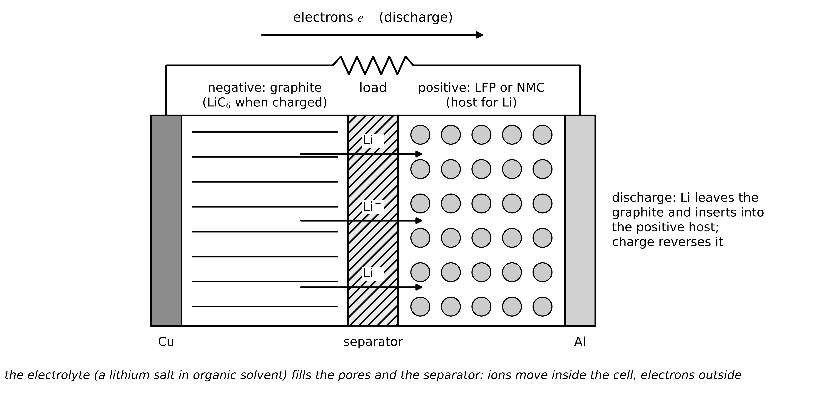
Figure 9.1. A lithium-ion cell during discharge: lithium ions leave the graphite negative electrode, cross the electrolyte and separator and insert into the positive host, while electrons flow through the external load.
Three ideas from this picture carry through the chapter. The open-circuit voltage (OCV) is the difference between the two electrodes' potentials, each a function of how full it is; its shape against SOC is a fingerprint of the chemistry (flat for LFP, sloped for NMC). The lithium inventory is the amount of cyclable lithium; side reactions that trap lithium (Section 9.8) shrink it permanently even if both electrodes are intact. And every process (ion transport in the electrolyte, charge transfer at the particle surfaces, diffusion inside the particles) takes time, which appears as polarization voltages that the models of Section 9.4 represent.

9.2.2 Chemistry and format
Table 9.1 compares the chemistries a twin will meet in stationary storage (Figure 9.2). LFP dominates because it is safer, longer-lived and free of nickel and cobalt, at the price of lower energy density and a flat, hysteretic OCV. NMC and NCA store more energy per kilogram and have sloped OCVs that make SOC easy to estimate, but release oxygen in thermal runaway. Lithium titanate (LTO) negatives cycle tens of thousands of times without plating risk at low energy density; sodium-ion cells avoid lithium and tolerate cold, with a sloped curve. Safe operating temperatures, voltages and currents are chemistry- and product-specific and must come from the cell maker's data under IEC 62619 [4]; no universal threshold applies.
Table 9.1. Cell chemistries for energy storage (typical ranges; manufacturer data govern)
Chemistry | Nominal voltage (V) | Voltage window (V) | Specific energy (Wh/kg) | Cycle life (to 80 %) | OCV slope mid-SOC | Thermal-runaway severity
LFP/graphite | 3.2 | 2.5 to 3.65 | 140 to 190 | 4000 to 10 000 | very flat, hysteretic | lower; little oxygen release
NMC/graphite | 3.6 to 3.7 | 2.8 to 4.2 | 200 to 280 | 1500 to 4000 | sloped | higher
NCA/graphite | 3.6 | 2.7 to 4.2 | 220 to 300 | 1000 to 3000 | sloped | higher
LTO negative | 2.3 to 2.5 | 1.5 to 2.8 | 60 to 110 | 10 000 to 20 000 | moderate | low
sodium-ion | 3.0 to 3.1 | 1.5 to 4.0 | 100 to 160 | 2000 to 5000 | sloped | lower

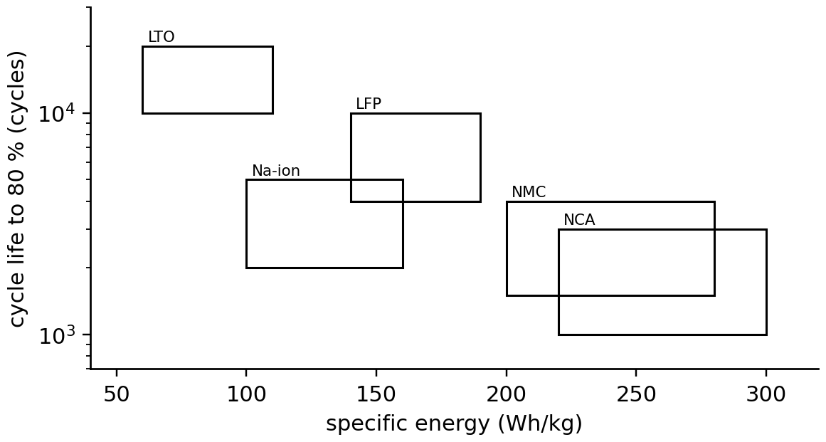
Figure 9.2. Chemistries compared by specific energy and cycle life (typical ranges): the trade between energy density and longevity is the first design choice of a storage system.
Formats matter too: cylindrical cells (18650, 21700, 4680) are rugged but need many parallel connections; pouch cells pack efficiently but need external pressure; large prismatic cans such as the 280 Ah P-1 cell reduce connections at the cost of larger internal temperature gradients, which is why core temperature (Section 9.9) matters for them.

9.2.3 The quantities a battery twin tracks
Capacity $Q$ is the charge the cell delivers between its voltage limits at a reference rate, in ampere-hours. The C-rate expresses current relative to it: 1C empties the cell in one hour, so 0.5C is 140 A for B-1. State of charge is the fraction of the present capacity remaining; with current $I$ positive on discharge (the sign convention of the whole chapter) and coulombic efficiency $η_{c}$ (about 0.99 on charge, 1 on discharge), it changes as
$z(t)=z(t_{0})-\frac{1}{3600Q}\int_{t_{0}}^{t}{η_{c}}I(τ) dτ, {SOH}_{Q}=\frac{Q}{Q_{nom}}, {SOH}_{R}=\frac{R_{0,nom}}{R_{0}}, E=\int_{z_{1}}^{z_{2}}{U}(z)Q dz$ (9.1)
with $z$ dimensionless, $Q$ in A·h, $t$ in seconds and $E$ the energy between two SOCs. State of health is defined by capacity or by resistance, and the two can diverge: a cell can keep its capacity while its resistance doubles. State of power (SOP) is the largest power the cell can deliver or absorb for a stated time without violating any limit (Section 9.7). These quantities are coupled: SOP depends on SOC, temperature and SOH; SOC depends on the present capacity; and temperature depends on the current that SOP allows.
What the digital twin adds
Synchronized: nothing yet; the physical quantities and their sign conventions are defined.
Estimated or updated: the chemistry-specific limits the twin must respect.
Uncertainty carried: manufacturing spread between cells of one type.
Decision enabled: which chemistry-specific models and limits to load.
Validated by: datasheets and cell characterization tests (Section 9.5).

9.3 From cell to grid-scale system
Cells are connected in series for voltage and in parallel for capacity. For $N_{s}$ cells in series and $N_{p}$ in parallel, under the ideal assumption that all cells are identical,
$V_{pack}=N_{s}V_{cell}, Q_{pack}=N_{p}Q_{cell}, E_{pack}=N_{s}N_{p}V_{nom}Q_{cell}$ (9.2)
The P-1 BESS (Figure 9.3) uses 16-cell modules with cell-monitoring units (CMU), 15 modules (240 cells, 768 V nominal, 600 to 876 V over the cell window) per rack with a battery management unit (BMU), contactors and fuses, and five racks in parallel on the 500 kW power conversion system (PCS): 1200 cells and 1.075 MWh of nameplate energy. Cells are not identical, and the weakest cell of a series string limits it (Section 9.10). Three layers of management protect this hierarchy: CMUs measure every cell voltage and a few temperatures and balance cells; rack BMUs measure current and insulation resistance, run the estimators and control the contactors; a system controller aggregates racks and passes limits to the PCS and the energy management system (EMS).
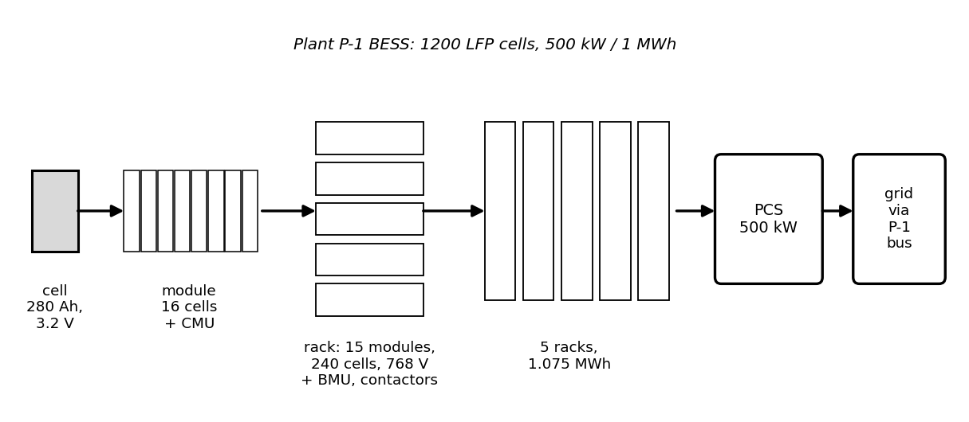
Figure 9.3. The P-1 BESS hierarchy: 280 Ah cell, 16-cell module with monitoring unit, 240-cell rack with management unit and contactors, five racks, PCS and grid connection.
Connecting a rack to the PCS DC link directly would charge its capacitance $C_{dc}$ with a destructive inrush current. The rack first closes its negative contactor and a precharge contactor in series with a resistor $R_{pre}$ (Figure 9.4); the DC-link voltage rises exponentially, and only then does the main positive contactor close:
$v_{C}(t)=V_{rack}\left(1-e^{-t/\left(R_{pre}C_{dc}\right)}\right), I_{pre}(0)=\frac{V_{rack}}{R_{pre}}, E_{pre}=\frac{1}{2}C_{dc}V_{rack}^{2}$ (9.3)
where $E_{pre}$, the energy dissipated in the resistor, equals the energy finally stored in the capacitor. For 800 V, 10 mF and 50 Ω the time constant is 0.5 s, the capacitor reaches 99.3 % in 2.5 s, the peak current is 16 A and the resistor absorbs 3.2 kJ. A precharge that does not reach its target within the expected time signals a short on the DC link or a failed resistor, a simple and valuable twin check.
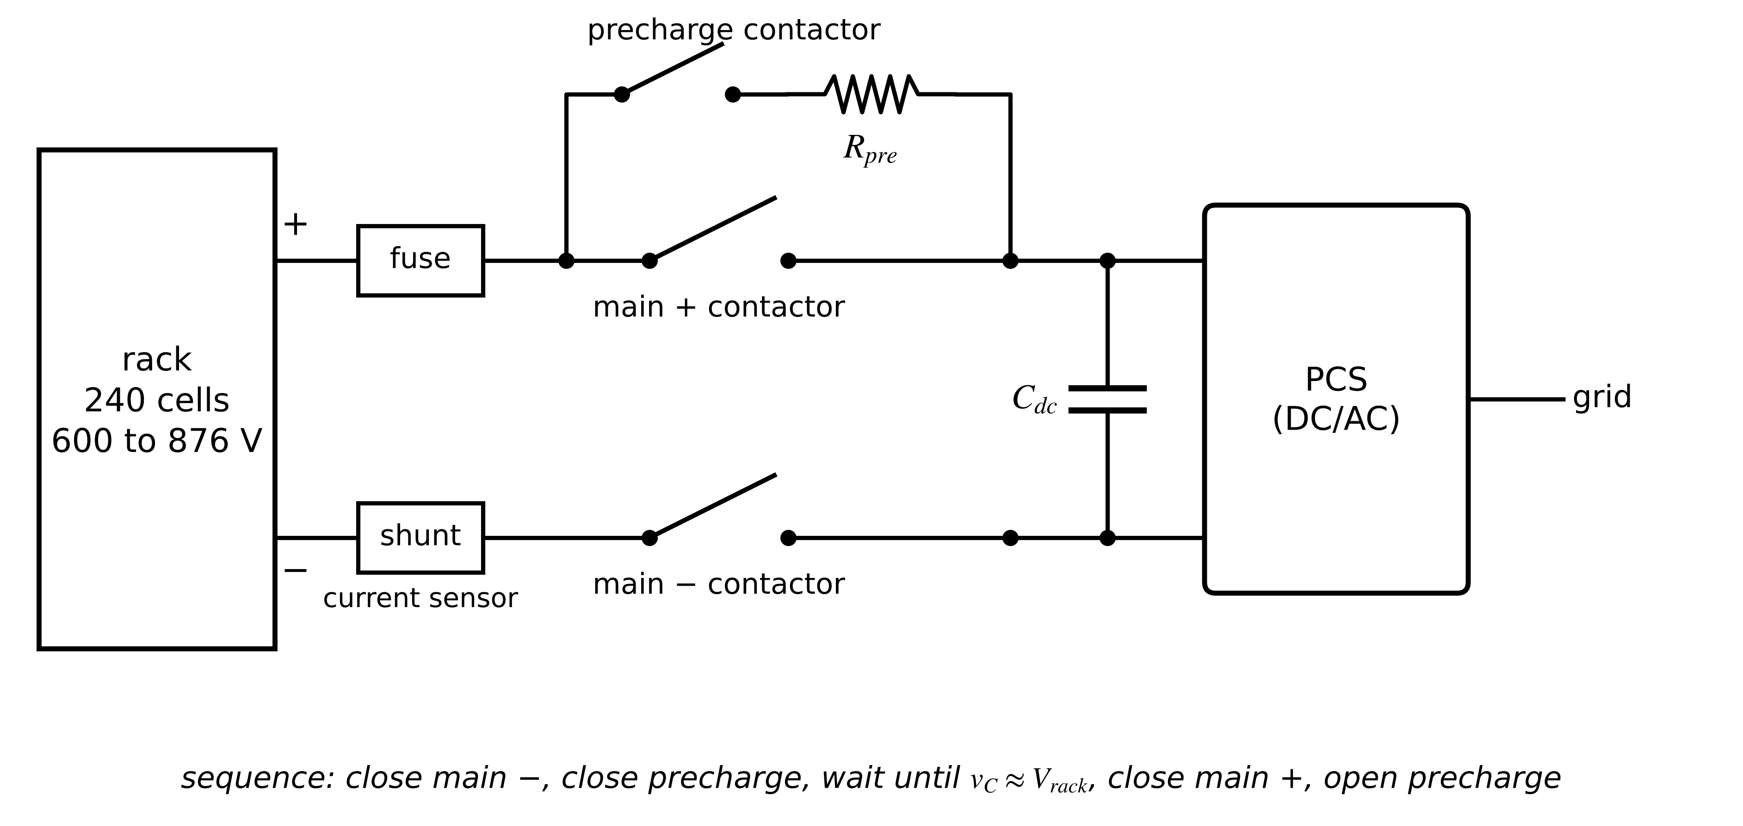
Figure 9.4. Rack contactor and precharge architecture: fuse, current sensor, main positive and negative contactors, precharge contactor and resistor in front of the PCS DC-link capacitance.
Table 9.2. Typical operating limits of the P-1 LFP cell (manufacturer values govern in practice)
Quantity | Limit | Reason
voltage | 2.5 V (discharge) to 3.65 V (charge) | copper dissolution below; electrolyte oxidation above
continuous current | 1C charge and discharge at 15 to 45 °C | heating, plating
10 s pulse current | 2C at 15 to 45 °C; 1C at 0 to 15 °C | heating, plating
charge at low temperature | 0.2C at 0 to 10 °C; no charge below 0 °C | lithium plating on graphite
discharge temperature | −20 to 55 °C | power capability, degradation
cell-to-cell temperature spread | below 5 K within a rack | uneven ageing

What the digital twin adds
Synchronized: cell voltages, rack currents, temperatures and contactor states.
Estimated or updated: pack-level capacity and energy from cell-level states.
Uncertainty carried: cell-to-cell spread hidden by pack averages.
Decision enabled: precharge supervision, contactor and isolation checks.
Validated by: precharge time constants and insulation measurements at every start-up.

9.4 A hierarchy of battery models
Which model should the twin run? The answer depends on the question, and the battery models used in practice form a ladder (Figure 9.9): equivalent-circuit models (ECMs) that mimic the terminal behaviour with resistors and capacitors; fractional-order circuits that capture distributed processes more compactly; and electrochemical models that resolve lithium transport inside the particles and electrolyte. This section climbs the ladder.

9.4.1 Equivalent-circuit models
The simplest circuit (Figure 9.5) is an OCV source $U(z)$ behind an ohmic resistance $R_{0}$ (Rint): the terminal voltage drops instantly with current and recovers instantly when it stops. Real cells relax over seconds to hours as charge transfer and diffusion settle, so one or two parallel RC branches are added. With polarization voltages $v_{1}$, $v_{2}$ across branches of resistance $R_{i}$ and capacitance $C_{i}$ (time constants $τ_{i}=R_{i}C_{i}$), Kirchhoff's current law at each branch and Kirchhoff's voltage law around the circuit give, with $I>0$ on discharge,
$\frac{dz}{dt}=-\frac{η_{c}I}{3600Q}, \frac{dv_{i}}{dt}=-\frac{v_{i}}{R_{i}C_{i}}+\frac{I}{C_{i}} (i=1,2), V=U(z)+M_{h}h-R_{0}I-v_{1}-v_{2}$ (9.4)
where $M_{h}h$ is the hysteresis term introduced below. Each branch equation follows from splitting the current between the capacitor ($C_{i}{\dot{v}}_{i}$) and the resistor ($v_{i}/R_{i}$). The one-RC model is the minimum for dynamic SOC estimation; the two-RC model separates fast charge-transfer relaxation (seconds) from slow diffusion relaxation (minutes), which LFP's flat curve makes essential, as the next example shows.
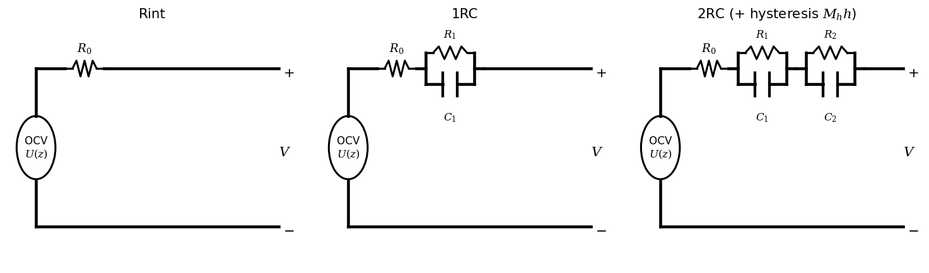
Figure 9.5. Equivalent circuits of increasing fidelity: Rint, one-RC and two-RC (with the hysteresis voltage added to the OCV source).

9.4.2 Exact discretization
A BMS updates the model every sampling period $Δt$ with the current held constant over the step (zero-order hold, Chapter 4, Section 4.10). Solving each branch equation exactly over one step gives a recursion that is exact for any step length, unlike forward Euler, which becomes unstable when $Δt>2τ_{i}$:
$z_{k+1}=z_{k}-\frac{η_{c}Δt}{3600Q}I_{k}, v_{i,k+1}=a_{i}v_{i,k}+R_{i}\left(1-a_{i}\right)I_{k}, a_{i}=e^{-Δt/τ_{i}}$ (9.5)
As $Δt→0$, $a_{i}→1-Δt/τ_{i}$ and forward Euler is recovered; as $Δt≫τ_{i}$, $v_{i}→R_{i}I_{k}$, a resistor. The model fails when the current changes within a step faster than the hold assumes (switching ripple, which the BMS filters out) and when its parameters move with SOC, temperature and age faster than the twin updates them.
Example 9.1 (Level A) Why one RC branch is not enough
Given. Cell B-1 (Table 9.3) carries 100 A for 10 minutes and then rests: $R_{1}=0.15$ mΩ, $τ_{1}=15$ s, $R_{2}=0.20$ mΩ, $τ_{2}=600$ s.
Find. The branch voltages at the end of the pulse and their residuals after 10 s, 60 s, 5 min and 30 min of rest.
Solution. (9.5) with constant current: $v_{1}=100×0.15×{10}^{-3}(1-e^{-40})=15.0$ mV; $v_{2}=100×0.20×{10}^{-3}(1-e^{-1})=12.6$ mV. During rest each decays as $e^{-t/τ_{i}}$: after 10 s, 7.7 and 12.4 mV; after 60 s, 0.27 and 11.4 mV; after 5 min, 0 and 7.7 mV; after 30 min, 0 and 0.63 mV.
Interpretation. On LFP's flat middle (0.7 mV per percentage point), the 11 mV still present after a minute corresponds to about 16 points of SOC. A twin that treats a one-minute rest as an OCV reading, or a one-RC model fitted to the fast decay, misjudges SOC by that much.

9.4.3 Hysteresis
LFP's rested voltage depends on whether the cell was last charged or discharged: after charge it sits on an upper branch, after discharge on a lower one, about $2M_{h}=24$ mV apart for B-1 (Figure 9.6). A one-state model lets a hysteresis variable $h∈[-1,1]$ move towards $-sgn(I)$ at a rate proportional to the charge passed, with a decay factor per step:
$h_{k+1}=a_{h,k}h_{k}-\left(1-a_{h,k}\right)sgn\left(I_{k}\right), a_{h,k}=exp\left(-γ_{h}\frac{\left|η_{c}I_{k}\right|Δt}{3600Q}\right)$ (9.6)
where $γ_{h}$ sets how quickly the branch changes (for B-1, $γ_{h}=36$: the state moves by a factor $e$ for every 2.8 % of capacity passed). The hysteresis state and SOC are hard to separate at rest, because both shift the rested voltage; only charge passed in one direction resolves $h$, a point the estimators of Section 9.6 must respect.
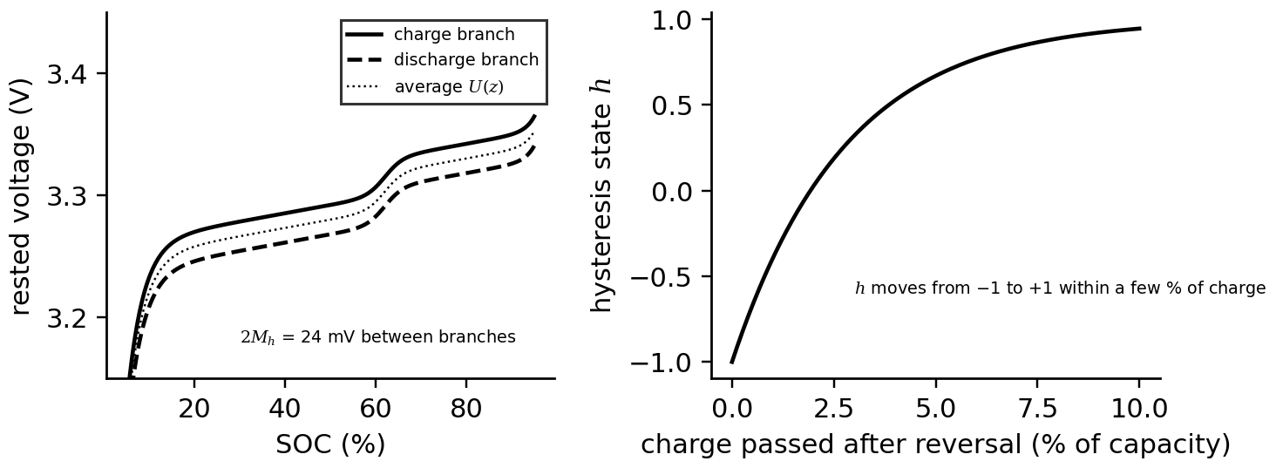
Figure 9.6. Hysteresis of the LFP cell B-1. Left: rested voltage on the charge and discharge branches around the average OCV. Right: the hysteresis state after a current reversal, against the charge passed.

9.4.4 Temperature dependence and the complete model
Resistances fall steeply as temperature rises, because ionic conduction and charge transfer are thermally activated; an Arrhenius law fits most cells over their operating range:
$R_{j}(T)=R_{j,ref}exp\left[\frac{E_{R}}{R_{g}}\left(\frac{1}{T}-\frac{1}{T_{ref}}\right)\right], U(z,T)=U\left(z,T_{ref}\right)+\left(T-T_{ref}\right)\frac{∂U}{∂T}$ (9.7)
with activation energy $E_{R}$, gas constant $R_{g}$ and $T$ in kelvin. For B-1, $E_{R}/R_{g}=3000$ K: resistances double between 25 °C and about 5 °C (Figure 9.7). Parameters also vary with SOC (resistance rises near the ends) and with age. Table 9.3 lists the B-1 parameters used throughout the chapter.
Table 9.3. Model parameters of cell B-1 (280 Ah LFP; synthetic, representative)
Parameter | Value | Parameter | Value
$Q_{nom}$ | 280 Ah | $R_{0}$ at 25 °C | 0.25 mΩ, $E_{R}/R_{g}=3000$ K
$R_{1}$, $τ_{1}$ | 0.15 mΩ, 15 s | $R_{2}$, $τ_{2}$ | 0.20 mΩ, 600 s
$M_{h}$ | 12 mV | $γ_{h}$ | 36
mass, $c_{p}$ | 5.5 kg, 1000 J/(kg·K) | $hA$ to ambient | 0.9 W/K
OCV slope at 50 % SOC | 0.71 mV per point | OCV slope at 10 % SOC | 9.7 mV per point

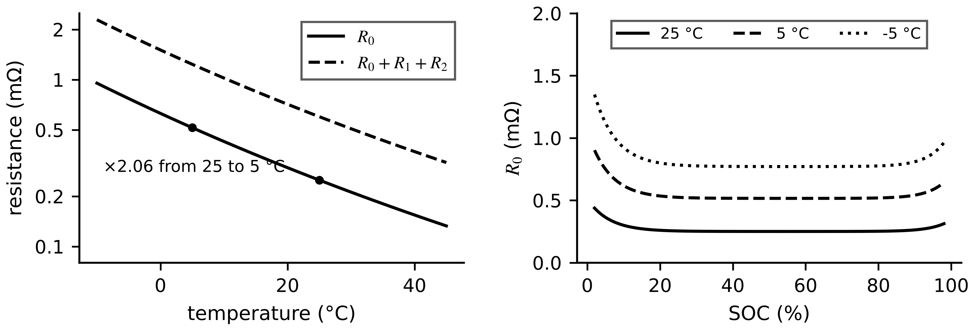
Figure 9.7. Parameter dependence of cell B-1. Left: ohmic and total resistance against temperature (Arrhenius). Right: illustrative SOC dependence of $R_{0}$ at three temperatures, rising near the ends of the SOC range.

9.4.5 [Advanced] Fractional-order and electrochemical models
Impedance spectra of real cells show depressed semicircles that a few RC branches fit only approximately, because charge transfer and diffusion are distributed over many particles and pore depths. A constant-phase element with impedance $Z_{CPE}=1/(Q_{α}(jω)^{α})$, $0<α≤1$, captures this with one extra parameter; its time-domain form is a fractional derivative computed by the Grünwald-Letnikov sum, which needs memory of past steps. Fractional models fit impedance data to the noise level with fewer parameters, but cost more per step and are emerging in BMS practice.
Electrochemical models go further and resolve the physics (Figure 9.8). In the single-particle model (SPM), each electrode is represented by one spherical particle of radius $R_{p}$ in which lithium diffuses (Fick's second law in spherical coordinates); the current sets the flux at the surface:
$\frac{∂c_{s}}{∂t}=\frac{D_{s}}{r^{2}}\frac{∂}{∂r}\left(r^{2}\frac{∂c_{s}}{∂r}\right), {\left.\frac{∂c_{s}}{∂r}\right|}_{r=0}=0, {\left.D_{s}\frac{∂c_{s}}{∂r}\right|}_{r=R_{p}}=-j(t), V=U_{p}\left(c_{s,p}^{surf}\right)-U_{n}\left(c_{s,n}^{surf}\right)-η(I)$ (9.8)
where $c_{s}$ is the solid lithium concentration, $D_{s}$ the solid diffusion coefficient, $j$ the molar flux proportional to current and $η$ the overpotentials. The terminal voltage depends on the surface concentration, which runs ahead of the average during high current; the diffusion time $R_{p}^{2}/D_{s}$ sets how long the gap persists. For a graphite particle with $R_{p}^{2}/D_{s}=833$ s, a 2C pulse of 10 minutes opens a gap of 0.03 in normalized stoichiometry between surface and average, which closes within minutes after the pulse (Figure 9.8). The SPMe adds the electrolyte concentration, and the pseudo-two-dimensional (P2D, Doyle-Fuller-Newman) model resolves both electrodes and the electrolyte across the cell thickness [5]. These models predict quantities ECMs cannot, such as the anode potential that governs lithium plating (Section 9.11), at the cost of many more parameters, which are hard to identify from terminal data alone.
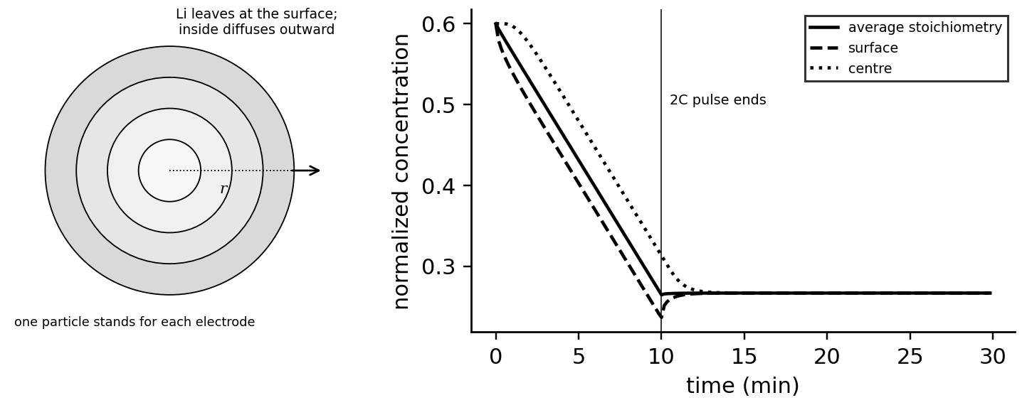
Figure 9.8. Single-particle model. Left: a spherical particle with lithium leaving at the surface during discharge. Right: average, surface and centre concentration during a 2C, 10-minute pulse and the following rest.
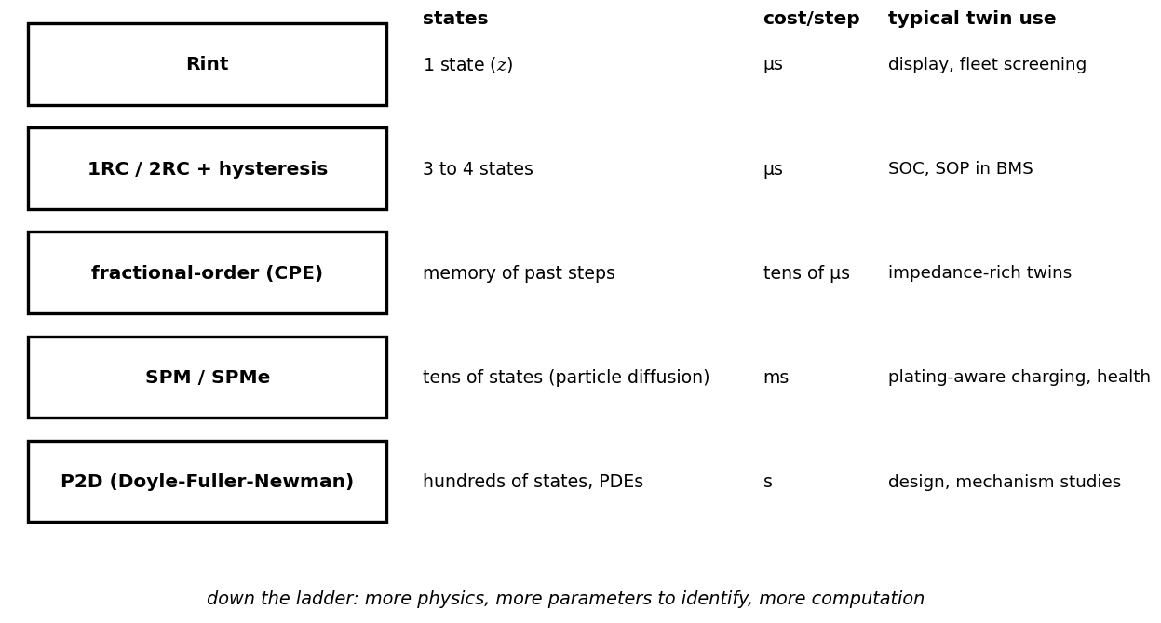
Figure 9.9. The battery model ladder: from Rint to the P2D model, with the number of states, the computation per step and the typical twin use.
Table 9.4. Battery model choices for a twin
Model | States | Parameters | Cost per step | Strength | Limitation | Intended use
Rint | $z$ | $U(z)$, $R_{0}$ | µs | simple | no transients | display, screening
1RC / 2RC + hysteresis | $z$, $v_{1}$, $v_{2}$, $h$ | 8 to 12 | µs | fast, identifiable from pulses | no internal concentrations | SOC, SOP, BMS
fractional-order | with memory | fewer than many RC | tens of µs | fits impedance well | memory, emerging | impedance-rich twins
SPM / SPMe | tens | 15 to 30 | ms | surface concentration, anode potential | parameters hard to identify | plating-aware charging
P2D | hundreds | 30 to 50 | s | full electrochemistry | cost, identifiability | design, mechanism studies

What the digital twin adds
Synchronized: model states at the fidelity the twin function needs.
Estimated or updated: ECM parameters with SOC, temperature and age; electrochemical parameters offline.
Uncertainty carried: model-form error of the chosen rung.
Decision enabled: which model the BMS runs and which the cloud twin runs.
Validated by: pulse, impedance and drive-cycle tests across temperature and age.

9.5 Characterizing the cell and identifying its parameters

9.5.1 The OCV curve
The OCV is measured by charging or discharging slowly with long rests, or by pulses followed by rests long enough for the slow branch to decay (galvanostatic intermittent titration). The twin stores it as a table of points $(z_{j},U_{j})$ per temperature and hysteresis branch, interpolated piecewise linearly or by monotone splines:
$U(z)=U_{j}+\frac{U_{j+1}-U_{j}}{z_{j+1}-z_{j}}\left(z-z_{j}\right), z_{j}≤z≤z_{j+1}, δz≈\frac{δU}{\left|dU/dz\right|}$ (9.9)
The second relation is the key to battery observability: a voltage error $δU$ becomes an SOC error inversely proportional to the slope. For B-1, 1 mV is 0.1 points at 10 % SOC (9.7 mV per point) but 1.4 points at 50 % (0.71 mV per point); for the NMC cell of Chapter 5 it is about 0.15 points almost everywhere (Figure 9.10).
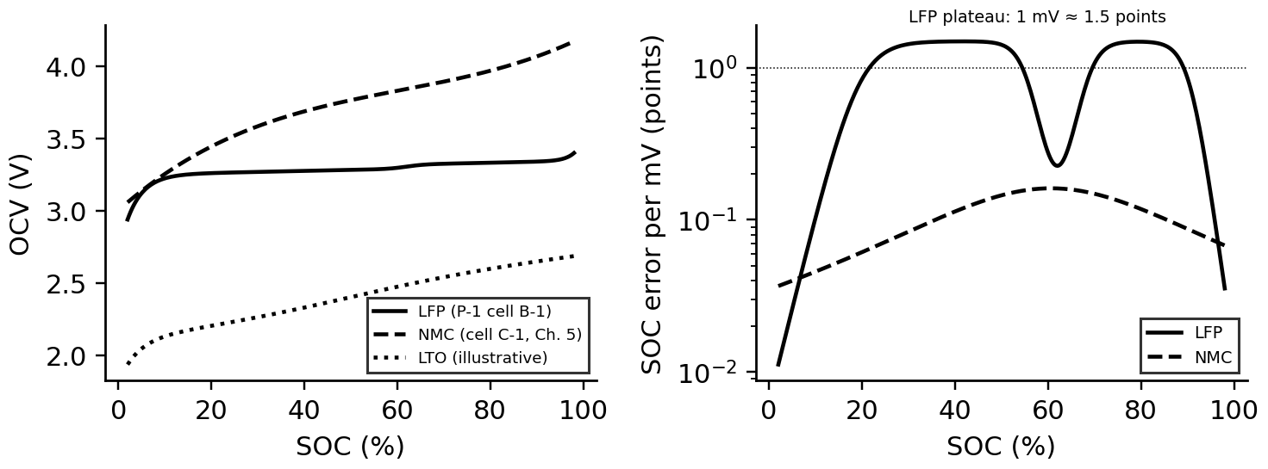
Figure 9.10. Left: OCV curves of LFP (cell B-1), NMC (cell C-1 of Chapter 5) and an illustrative LTO cell. Right: SOC error per millivolt of voltage error, from (9.9): on the LFP plateau one millivolt is worth more than a percentage point.

9.5.2 Parameter identification and the role of excitation
The resistances and time constants are identified from current pulses (Chapter 5, Section 5.4). The instantaneous voltage step at a current change gives $R_{0}=ΔV/ΔI$; the relaxation after the pulse is fitted by a sum of exponentials, whose amplitudes and time constants give the branches:
$V(t)=U_{∞}-\sum_{i}{v_{i}}(0)e^{-t/τ_{i}}, v_{i}(0)=R_{i}I\left(1-e^{-T_{p}/τ_{i}}\right)$ (9.10)
where $T_{p}$ is the pulse length and $U_{∞}$ the rested voltage. Excitation decides identifiability: a time constant is determined only if the record covers several times its value, and $U_{∞}$, which anchors SOC, only if the slow branch has decayed.
Example 9.2 (Level B) Identifying B-1 from a pulse and its relaxation
Given. A synthetic test on B-1 at 50 % SOC: 100 A for 600 s, then 1800 s of rest, sampled at 1 s with 0.5 mV voltage noise (seed 3).
Find. $R_{0}$; one-RC and two-RC fits of the relaxation; and the effect of shortening the rest to 300 s and 60 s.
Solution. The voltage jump at interruption gives ${\hat{R}}_{0}=0.242$ mΩ (true 0.25). A one-RC fit converges to $τ=436$ s and leaves a residual of 0.99 mV RMS, twice the noise (Figure 9.11). The two-RC fit gives $τ_{1}=14.4$ s, $τ_{2}=591$ s, $R_{1}=0.152$ mΩ and $R_{2}=0.199$ mΩ (true 15 s, 600 s, 0.15 and 0.20 mΩ) with a residual at the noise level. With only 300 s or 60 s of rest the slow time constant comes out at 1370 s or 1090 s and the extrapolated rest voltage is 12 mV or 31 mV too high.
Interpretation. One branch cannot represent two processes, and a short rest cannot identify the slow one: its error goes straight into the OCV and, on LFP's plateau, into tens of points of SOC. Test design (pulse amplitude, length and rest) is part of the twin, and the identified parameters must be refreshed at several SOCs and temperatures.
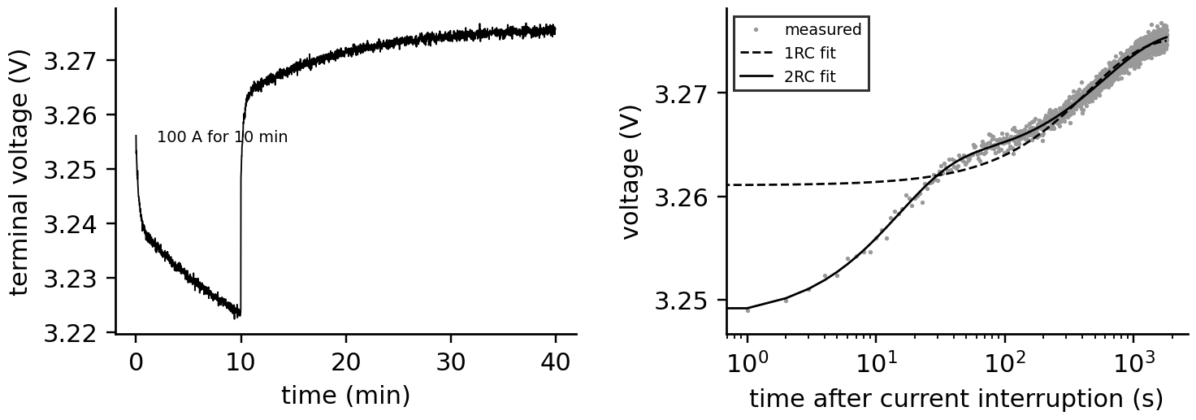
Figure 9.11. Pulse identification on cell B-1. Left: terminal voltage during a 100 A, 10-minute pulse and 30 minutes of rest. Right: the relaxation on a logarithmic time axis with one-RC and two-RC fits; only two branches follow both the fast and the slow decay.
What the digital twin adds
Synchronized: OCV table and ECM parameters to the cell as it is today.
Estimated or updated: $R_{0}$, $R_{i}$, $τ_{i}$, OCV branches, per SOC and temperature.
Uncertainty carried: parameter covariance and the SOC equivalent of voltage errors.
Decision enabled: when and how to re-characterize the cell in service.
Validated by: residuals at the noise level on independent pulses.

9.6 State-of-charge estimation

9.6.1 Coulomb counting and its limits
Integrating current, (9.1), is exact in principle and drifts in practice. With a constant current-sensor offset $b$, white noise of standard deviation $σ_{I}$ per sample, a capacity error $δQ$ and an initial error $δz_{0}$, the SOC error after time $t$ (sampling $Δt$) is
$δz(t)=δz_{0}-\frac{bt}{3600Q}±\frac{σ_{I}\sqrt{tΔt}}{3600Q}-\frac{δQ}{Q}\left(z(t)-z_{0}\right)$ (9.11)
The offset term grows linearly, the noise term only with the square root of time, the capacity term with the charge passed, and the initial error never decays: counting has no means of correcting itself.
Example 9.3 (Level A) Coulomb counting over one P-1 day
Given. The synthetic P-1 day (Figure 9.13): a two-hour charge at 0.36C, regulation through the day, a two-hour evening discharge; current offset 0.2 A, noise 0.3 A per 1 s sample; true starting SOC 20 %.
Find. The SOC error after 24 hours from offset and from noise; the effect of a 5 % capacity overestimate over the evening discharge; the effect of a 50 % initial guess.
Solution. Offset: $0.2×86 400/(3600×280)=1.7$ points (the simulated counter ends 1.69 points low). Noise: $0.3\sqrt{86 400}/(3600×280)=0.009$ points. A 5 % capacity error over the 72-point evening discharge adds 3.6 points, which disappears when the cell returns to its starting charge. A 50 % initial guess stays 30 points wrong for the whole day.
Interpretation. The offset, not the noise, dominates; and counting never corrects an initial error. A twin uses counting for the prediction step of a filter that the voltage corrects wherever the OCV curve has slope.

9.6.2 Kalman filtering for batteries
The filters of Chapter 5 apply directly, as in the battery EKF of [6]: the state is $x=[z,v_{1},v_{2},h]^{⊤}$, the process model (9.5) with (9.6), the measurement $y_{k}=V_{k}$ from (9.4). The battery-specific part is the measurement Jacobian, whose SOC entry is the OCV slope:
$H_{k}=\left[{\left.\frac{dU}{dz}\right|}_{{\hat{z}}_{k}}, -1, -1, M_{h}\right], K_{k}=\frac{P_{k|k-1}H_{k}^{⊤}}{H_{k}P_{k|k-1}H_{k}^{⊤}+R}, {\hat{z}}_{k|k}={\hat{z}}_{k|k-1}+K_{k,z}\left(V_{k}-{\hat{V}}_{k}\right)$ (9.12)
On a flat OCV the SOC entry of $H_{k}$ is small, the gain small and the correction weak; on a steep segment the voltage pins SOC down in a few samples (Figure 9.12).
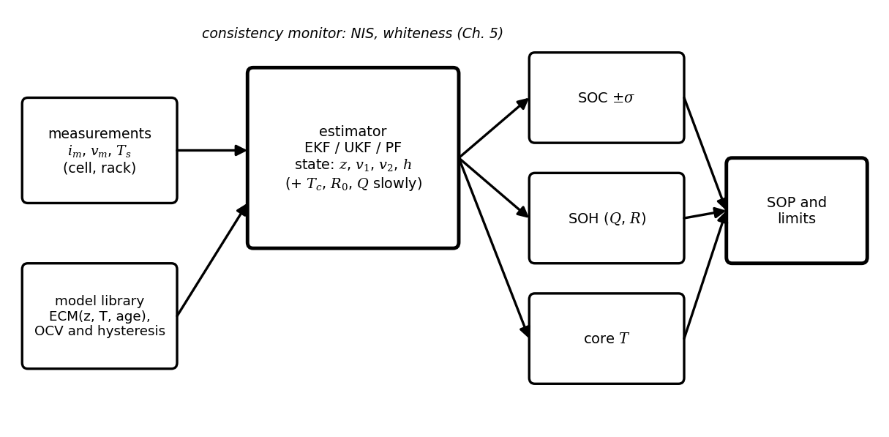
Figure 9.12. Battery estimator architecture: measurements and the model library feed a Kalman-type estimator whose states include SOC, the polarization voltages and hysteresis; SOC, health and core temperature, each with its uncertainty, feed the state-of-power and limit calculation.
Example 9.4 (Level A) One EKF update on the flat plateau and on a steep segment
Given. A prior SOC standard deviation of 10 points, voltage noise 1 mV and an innovation of +2 mV; OCV slope 0.067 V per unit SOC (50 %) or 0.97 V per unit (10 %); only the SOC state uncertain.
Find. Innovation variance, gain, SOC correction and posterior standard deviation in both cases.
Solution. At 50 %: $S={0.067}^{2}×0.01+{10}^{-6}=4.59×{10}^{-5}$ V²; $K=0.01×0.067/S=14.6$ per volt; correction $+2.9$ points; posterior standard deviation 1.5 points. At 10 %: $S=9.42×{10}^{-3}$ V²; $K=1.03$ per volt; correction 0.2 points; posterior 0.10 points.
Interpretation. On the plateau one sample cuts the uncertainty from 10 to 1.5 points but cannot go much further, because 1 mV of noise is worth 1.4 points there; and any unmodelled millivolt (hysteresis, slow polarization) is believed too. On the steep segment the same sample fixes SOC to a tenth of a point.
Example 9.5 (Level C) Filters on one day of P-1 data
Given. The synthetic day of Example 9.3 for B-1 at 25 °C (seed 2026): voltage noise 1 mV, current offset 0.2 A, 4 h rest at 20 % before the charge. Filters use the full model with $R=(1 mV)^{2}$ and SOC process noise equivalent to 1 A. Cases: (a) EKF started from the rested OCV; (b) EKF from 50 %; (c) UKF from 50 %; (d) UKF from 50 % without the slow branch or hysteresis; (e) UKF from 50 % with the hysteresis branch unknown (variance 0.5 instead of 0.01). Separately, the same day at 5 °C with 25 °C or temperature-dependent resistances.
Find. The SOC error during the rest before the charge and after the charge (from 6 h).
Solution. Table 9.5 and Figure 9.13. Inverting the rested OCV gives 20.07 % (true 20.0). During the rest, filters started at 50 % stay 2 to 5 points wrong, and the UKF with an unknown hysteresis branch stays 18 points wrong: it explains the voltage with the wrong branch and the wrong SOC. Once the charge current has driven the hysteresis state to its charge branch and the SOC has crossed the small OCV step near 60 %, about an hour into the charge, all full-model filters agree within 0.5 points RMS (maximum 0.9 points). Without hysteresis and the slow branch the error reaches 9 points; at 5 °C, 25 °C resistances cost up to 10 points, temperature-dependent ones 0.8.
Interpretation. On LFP the filter cannot create information the voltage does not contain: at rest on the plateau SOC and hysteresis are not separately observable, and only charge passed through a steep region fixes them. The twin must therefore report its SOC uncertainty honestly during long plateau operation and schedule occasional excursions to the curve's ends (a full charge at the top of the day) to resynchronize.
Table 9.5. SOC estimators on the synthetic P-1 day (errors in percentage points)
Estimator | RMS during rest, 2 to 4 h | RMS after charge | Maximum after charge
EKF from rested OCV | 0.38 | 0.50 | 0.87
EKF from 50 % | 2.1 | 0.47 | 0.85
UKF from 50 % | 5.2 | 0.48 | 0.85
UKF without slow branch or hysteresis | 6.0 | 3.75 | 9.05
UKF, hysteresis branch unknown | 18.4 | 0.50 | 0.86
UKF at 5 °C with 25 °C resistances |  | 5.30 | 10.2
UKF at 5 °C with temperature-dependent resistances |  | 0.44 | 0.82

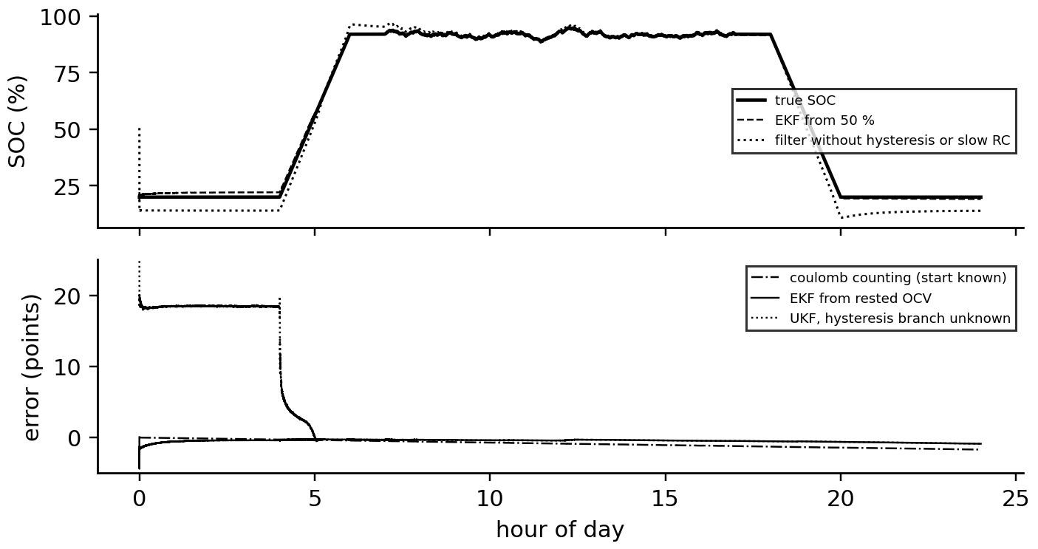
Figure 9.13. SOC estimation over the synthetic P-1 day. Top: true SOC, an EKF started at 50 % and a filter without hysteresis or the slow branch. Bottom: errors of coulomb counting, the EKF started from the rested OCV and a UKF whose hysteresis branch is unknown, which stays wrong until the charge has reset the hysteresis state and crossed the OCV step near 60 % SOC.
What the digital twin adds
Synchronized: SOC, polarization and hysteresis states with their covariance.
Estimated or updated: SOC every second; current offset and capacity slowly.
Uncertainty carried: honest, SOC-dependent uncertainty that grows on the plateau.
Decision enabled: usable energy, resynchronization schedules, SOC-dependent limits.
Validated by: NIS and whiteness online; full-charge anchors and lab references offline.

9.7 SOC, SOH, SOP and temperature as one coupled estimate
A BMS usually reports SOC, SOH, SOP and temperature as four numbers. They are one estimate: SOC is computed with the present capacity, so a wrong SOH biases SOC; SOP depends on SOC, temperature and resistance, so errors in any of them change the power limit; and temperature depends on the current that SOP allows. A twin estimates them together, with the slow quantities (capacity, resistance) updated over days and the fast ones (SOC, polarization, temperature) every second.

9.7.1 Capacity and resistance
Capacity is estimated between two SOC anchors, points where SOC is known from a rested OCV on a steep segment or from the end of a full charge, by counting the charge between them. With anchor uncertainties $u_{z_{1}}$, $u_{z_{2}}$ and a current-gain uncertainty $u_{g}$, the relative uncertainty of the estimate is
$\hat{Q}=\frac{\int_{t_{1}}^{t_{2}}{I} dt/3600}{z_{1}-z_{2}}, \frac{u_{Q}}{Q}=\sqrt{u_{g}^{2}+\frac{u_{z_{1}}^{2}+u_{z_{2}}^{2}}{{\left(z_{1}-z_{2}\right)}^{2}}}$ (9.13)
Example 9.6 (Level A) Measuring the capacity of an aged P-1 cell
Given. A cell whose true capacity has faded to 260 Ah rests after discharge at 10 % SOC, then charges to the end of a constant-voltage charge (taken as 100 %). Voltage noise 1 mV; residual hysteresis uncertainty 6 mV; current-gain uncertainty 0.2 %.
Find. The capacity estimate and its uncertainty, and the uncertainty if the lower anchor were a rest at 50 %.
Solution. At 10 % the slope is 9.7 mV per point, so $u_{z_{1}}=\sqrt{1^{2}+6^{2}}/9.7=0.63$ points. 234 Ah are counted over 90 points: $\hat{Q}=260$ Ah with $u_{Q}/Q=\sqrt{{0.002}^{2}+(0.0063/0.90)^{2}}=0.73$ %, 1.9 Ah. At 50 % the slope is 0.71 mV per point and $u_{z_{1}}=8.6$ points: over a 50-point range the capacity uncertainty rises to about 17 %.
Interpretation. Capacity can be measured on LFP only between anchors on the steep ends. A twin therefore uses the occasional deep cycles a BESS performs anyway, and it must not update capacity from plateau-to-plateau segments.
Resistance SOH is read from current steps, ${\hat{R}}_{0}=ΔV/ΔI$ at a known temperature, normalized to the reference temperature with (9.7), or estimated continuously as a slow state in the filter (Chapter 5, Section 5.10).

9.7.2 State of power
The physical question is how much current the cell can take or give for the next $Δt_{p}$ seconds (typically 10 s or 30 s) without crossing any limit. Starting from the present polarizations and assuming constant current over the horizon, the terminal voltage at the end of the horizon follows from (9.5):
$V\left(Δt_{p}\right)=U(z)+M_{h}h-v_{1}a_{1}^{′}-v_{2}a_{2}^{′}-IR_{eq}, R_{eq}=R_{0}+\sum_{i}{R_{i}}\left(1-e^{-Δt_{p}/τ_{i}}\right), a_{i}^{′}=e^{-Δt_{p}/τ_{i}}$ (9.14)
Setting $V(Δt_{p})$ to the lower (discharge) or upper (charge) voltage limit gives a voltage-limited current; the SOC, current, plating and thermal limits give others, and the most restrictive one sets the SOP:
$I_{dis}^{max}=min\left\{\frac{U+M_{h}h-\sum{v_{i}}a_{i}^{′}-V_{min}}{R_{eq}}, I_{max}(T), \frac{3600Q\left(z-z_{min}\right)}{Δt_{p}}, I_{th}\right\}, P_{dis}=I_{dis}^{max}V\left(Δt_{p}\right)$ (9.15)
and symmetrically for charge with $V_{max}$, $z_{max}$ and the plating limit. The thermal limit $I_{th}=\sqrt{ΔT_{max}hA/R_{tot}}$ applies to sustained operation, where the heat $I^{2}R_{tot}$ must not raise the cell more than $ΔT_{max}$ above its coolant. Each limit depends on a different estimate (SOC, temperature, resistance), so the SOP inherits all their uncertainties; a conservative SOP subtracts a margin proportional to the combined uncertainty (Figure 9.14).
Example 9.7 (Level B) What limits the P-1 battery's power
Given. B-1 at 50 % SOC, branches at rest, 10 s horizon, $V_{min}=2.8$ V for the pulse; current limits from Table 9.2.
Find. $R_{eq}$ and the voltage-limited current at 25 °C, 5 °C and −5 °C; the binding limit and the SOP per cell; the system capability against the PCS rating.
Solution. (9.14): $R_{eq}=0.326$ mΩ at 25 °C, 0.673 mΩ at 5 °C, 1.006 mΩ at −5 °C. Voltage-limited currents from (3.28 − 2.8) V: 1470, 713 and 477 A. The current limits bind at every temperature: 560 A at 25 °C (terminal voltage 3.10 V, 1.73 kW per cell), 280 A at 5 °C, and the charge limit falls to 0.2C (56 A) below 10 °C. The 1200 cells could supply about 2 MW for 10 s at 25 °C, four times the PCS rating.
Interpretation. For this battery the PCS, not the cells, limits discharge power in normal conditions, while cold weather limits charging severely. The twin's SOP is what the EMS needs, together with its uncertainty and the name of the binding constraint, so that operators know whether heating the container, waiting or derating will help.
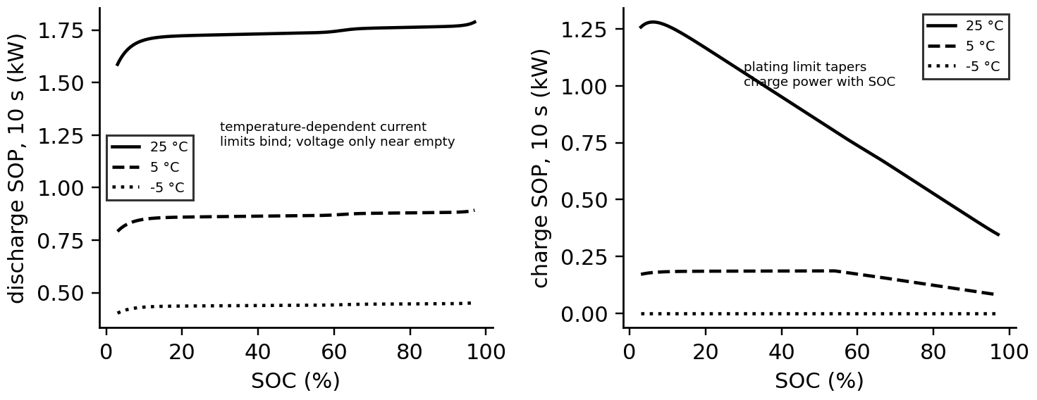
Figure 9.14. Ten-second state of power of cell B-1 against SOC at 25, 5 and −5 °C. Left: discharge, set by temperature-dependent current limits except near empty. Right: charge, set by the plating limit, which tapers power with SOC, and by the 0.2C rule in the cold.
What the digital twin adds
Synchronized: SOC, SOH, SOP and temperature as one coupled estimate.
Estimated or updated: capacity between anchors, resistance from steps, power limits every second.
Uncertainty carried: anchor and slope-dependent SOC uncertainty propagated into SOP margins.
Decision enabled: dispatchable power with the binding constraint named.
Validated by: capacity tests at full cycles, pulse tests across temperature.

9.8 Degradation: mechanisms, signatures and ageing laws

9.8.1 Why cells age
Ageing has a few physical causes, each leaving a different trace (Figure 9.15). SEI growth: the solid-electrolyte interphase, a passivating film on the graphite surface, keeps growing slowly, consuming cyclable lithium (loss of lithium inventory, LLI); it is fastest at high temperature and high SOC and dominates calendar ageing. Lithium plating: when the graphite potential falls below that of lithium metal, during fast or cold charging at high SOC, lithium deposits as metal on the surface, losing inventory and, if dendrites grow, creating short-circuit risk. Loss of active material (LAM): particle cracking from repeated expansion, binder loss and transition-metal dissolution isolate parts of an electrode. Resistance rise: film growth, electrolyte decomposition and contact loss raise impedance, fading power before capacity. Calendar ageing happens with time even at rest; cycle ageing scales with charge throughput and depth; they add.
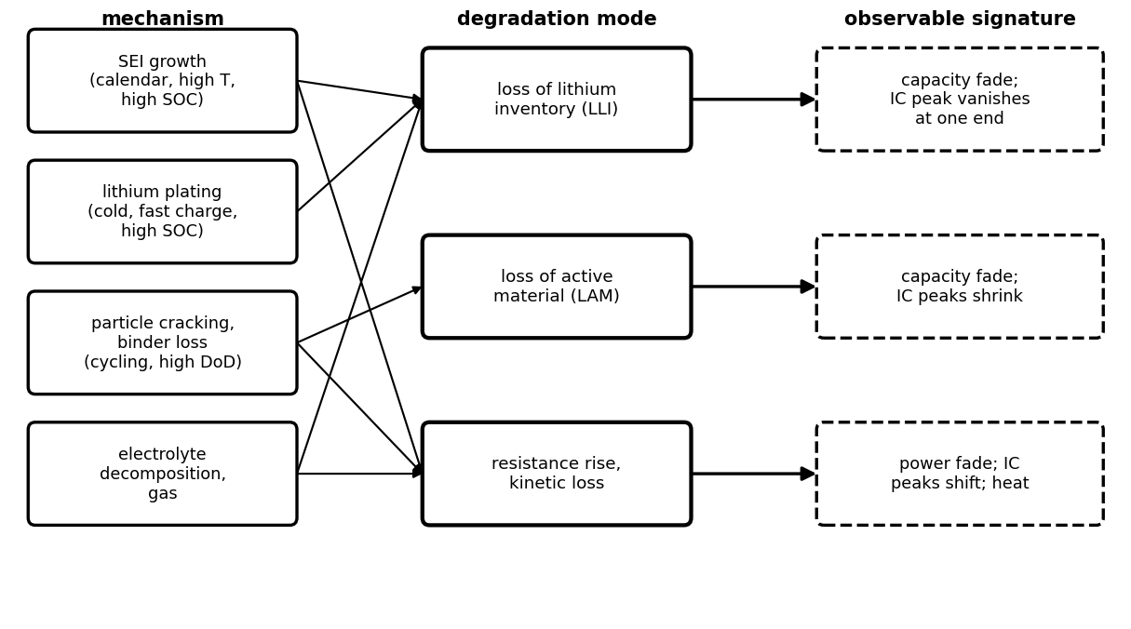
Figure 9.15. Degradation map: physical mechanisms (left) lead to degradation modes (centre), each with an observable signature (right) that a twin can track.

9.8.2 Incremental capacity and differential voltage
Degradation modes can be told apart from slow charge or discharge curves. Incremental-capacity analysis (ICA) differentiates charge with respect to voltage, differential-voltage analysis (DVA) the inverse [7], [8]; with $Q_{rem}=zQ$ and the OCV $U(z)$,
$\frac{dQ}{dV}=\frac{Q}{dU/dz}, \frac{dV}{dQ}=\frac{1}{Q}\frac{dU}{dz}$ (9.16)
so the flat regions of the OCV, phase transitions of the electrode materials, appear as IC peaks. LAM shrinks the peaks in proportion to the material lost; LLI shifts the electrodes' alignment so that a peak at one end of the window shrinks or disappears; a resistance rise shifts all peaks along the voltage axis by $IΔR$ without changing their area (Table 9.6). Noise is amplified by differentiation, so the curves are smoothed or computed from binned charge.
Table 9.6. Degradation modes and their incremental-capacity signatures
Mode | Effect on IC peaks | Capacity | Resistance
LLI | peak at the end of the window shrinks or vanishes; others unchanged | falls | about unchanged
LAM | all peaks of the affected electrode shrink in proportion | falls | may rise
kinetic (resistance) | all peaks shift by $IΔR$; areas unchanged | unchanged at low rate | rises

Example 9.8 (Level B) Incremental-capacity signatures of cell B-1
Given. The B-1 OCV curve and three altered states: 8 % LAM (capacity scaled by 0.92), LLI that ends the usable window at 60 % of the former range, and a 10 mV overpotential.
Find. IC peak positions and heights from (9.16).
Solution. Fresh: peaks at 3.275 V (4170 Ah/V) and 3.330 V (4150 Ah/V). LAM: both in place, 8 % lower (3840 and 3820 Ah/V). LLI: the 3.275 V peak unchanged, the 3.330 V peak gone. Overpotential: both peaks moved to 3.285 and 3.340 V at unchanged height (Figure 9.16).
Interpretation. The three modes are distinguishable from one slow charge, which a BESS can perform monthly. A twin that tracks peak positions and areas assigns capacity fade to its mechanism, which matters for the forecast: LLI from SEI follows calendar time, LAM follows cycling.
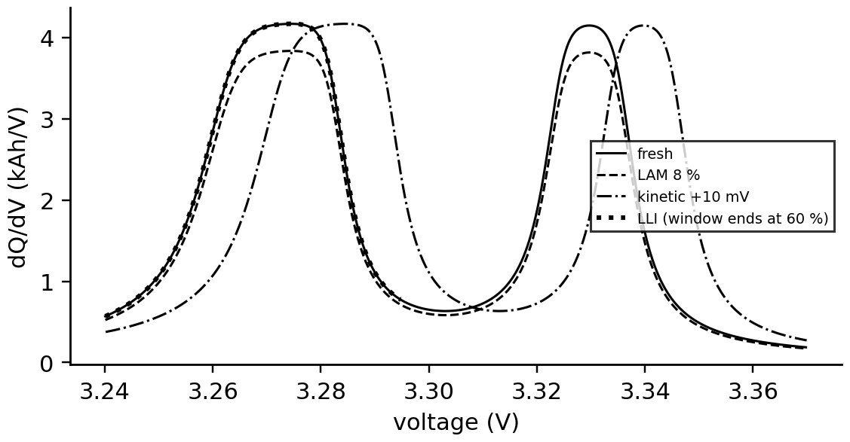
Figure 9.16. Incremental-capacity curves of cell B-1, fresh and with 8 % loss of active material, loss of lithium inventory, and a 10 mV kinetic overpotential.

9.8.3 Semi-empirical ageing laws
Physics suggests the forms and data fix the constants. SEI growth limited by diffusion through the film gives a loss proportional to the square root of time; reaction rates follow Arrhenius laws in temperature; high SOC accelerates side reactions; cycling loss grows with charge throughput as a power law. A widely used combination, of the kind fitted to long storage tests of LFP/graphite cells [9], with $t$ in years, $T$ in kelvin, mean SOC $\overline{z}$ and $N$ equivalent full cycles (EFC, total charge throughput divided by $2Q$), is
$L_{cal}=A_{cal}exp\left[-\frac{E_{a}}{R_{g}}\left(\frac{1}{T}-\frac{1}{T_{ref}}\right)\right]e^{α_{z}\left(\overline{z}-0.5\right)}\sqrt{t}, L_{cyc}=B_{cyc}exp\left[-\frac{E_{b}}{R_{g}}\left(\frac{1}{T}-\frac{1}{T_{ref}}\right)\right]N^{z_{c}}, L=L_{cal}+L_{cyc}$ (9.17)
in per cent of nominal capacity. For B-1: $A_{cal}=1.5$ % per square-root year, $E_{a}=50$ kJ/mol, $α_{z}=1.2$; $B_{cyc}=0.118$ %, $E_{b}=30$ kJ/mol, $z_{c}=0.55$ (synthetic, representative). The laws fail outside the conditions of the tests that fitted them, and in particular below about 10 °C, where plating can dominate cycle ageing and the Arrhenius form predicts the opposite of what happens [10] (Figure 9.17).
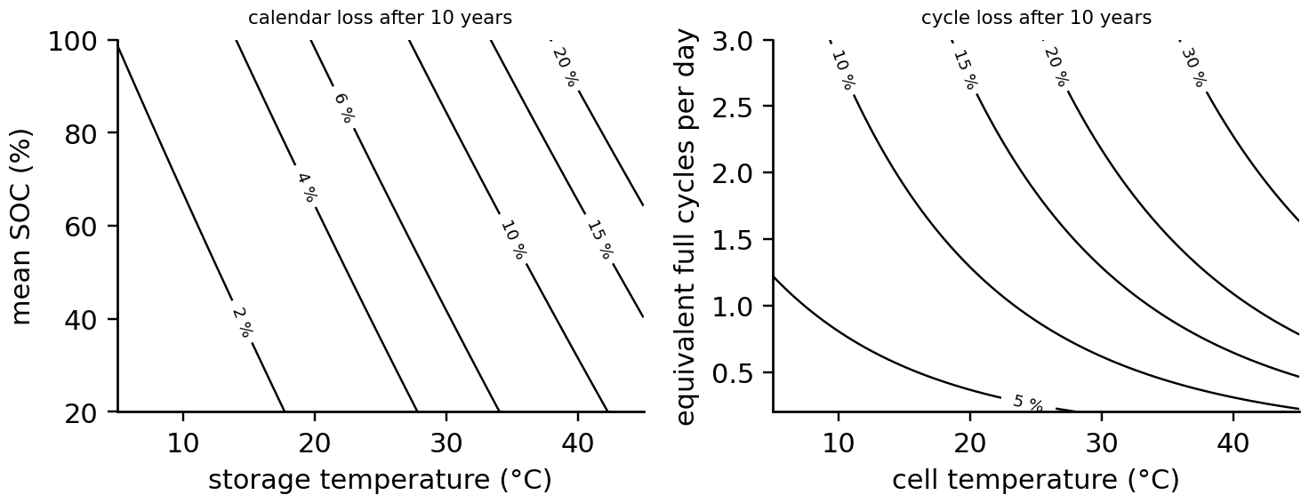
Figure 9.17. Ageing surfaces from (9.17). Left: calendar loss after 10 years against storage temperature and mean SOC. Right: cycle loss after 10 years against temperature and daily cycling.
Example 9.9 (Level B) How long the P-1 battery lasts, and what temperature does to it
Given. The P-1 duty of Example 9.5: 774 Ah per cell per day, 1.38 EFC per day; mean SOC 0.6; (9.17) with the B-1 constants; end of life at 20 % capacity loss; warranty 10 years or 6000 EFC.
Find. Calendar and cycle losses after 1, 5 and 10 years at 25 °C; end of life at 15, 25 and 35 °C; which warranty limit binds.
Solution. At 25 °C: 1.7 % calendar and 3.6 % cycle loss after one year; 3.8 % and 8.7 % after five; 5.4 % and 12.8 % after ten. End of life after 12.0 years (6020 EFC) at 25 °C, 4.9 years (2460 EFC) at 35 °C, and 30 years at 15 °C, where the model is no longer trustworthy. The 6000 EFC limit is reached after 11.9 years, so the 10-year limit binds first at 25 °C.
Interpretation. Ten kelvin of average cell temperature more than halve the life. The twin turns this into an operating decision: cooling energy and dispatch limits against replacement cost (Section 9.11). It must also state that its forecast at 15 °C is an extrapolation.
What the digital twin adds
Synchronized: degradation state by mode, not only total capacity.
Estimated or updated: LLI, LAM and resistance from IC curves, capacity and pulse tests; ageing-law constants.
Uncertainty carried: model-form error outside the fitted conditions.
Decision enabled: thermal management, SOC windows, cycling limits.
Validated by: periodic reference performance tests and IC curves.

9.9 Thermal behaviour: from cell to pack, and thermal runaway

9.9.1 Heat generation
Where does battery heat come from? An energy balance on the cell answers it (Figure 9.18). The chemical energy released per second is $IU$ (the OCV times current, with $I>0$ on discharge); part of it leaves as electrical work $IV$, and the rest stays as heat, together with a reversible term from the entropy change of the reaction. Bernardi's equation for a cell of uniform temperature is [11]
$\dot{q}=I\left(U-V\right)-IT\frac{∂U}{∂T}={\dot{q}}_{irr}+{\dot{q}}_{rev}$ (9.18)
The irreversible part $I(U-V)=I^{2}R_{0}+I(v_{1}+v_{2})$ is always positive (losses in resistance and polarization); the reversible part changes sign with current direction and with the entropic coefficient $∂U/∂T$, which depends on SOC and chemistry. Limiting cases: at zero current there is no heat; at low current the reversible term, linear in $I$, can dominate the quadratic irreversible one.
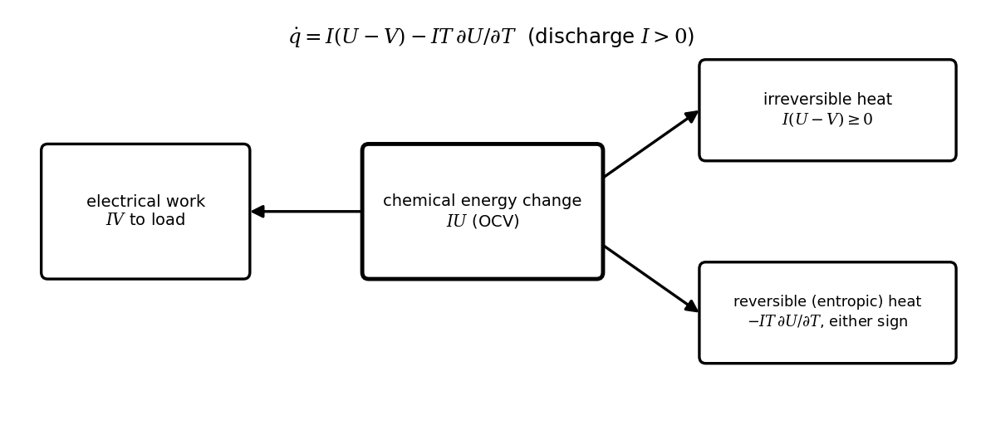
Figure 9.18. Energy flows in a cell during discharge: the chemical energy change $IU$ splits into electrical work $IV$, irreversible heat $I(U-V)$ and reversible entropic heat.
[Advanced] Deriving Bernardi's heat equation from the first law
Treat the cell as a closed system at uniform temperature $T$ in which one electrochemical reaction proceeds, transferring $n$ electrons per formula unit. A current $I$ (positive on discharge) advances the reaction at $I/nF$ moles per second. The first law states that the rate of change of the cell's enthalpy equals the heat received from the surroundings minus the electrical work delivered, so the heat that must be removed to keep the temperature constant is
$\dot{q}=\frac{I}{nF}\left(−ΔH\right)−IV$
where $ΔH$ is the molar reaction enthalpy. The OCV is the reversible work per unit charge, $ΔG=−nFU$, and the Gibbs-Helmholtz relation gives the reaction entropy from the temperature coefficient of the OCV, $ΔS=−∂ΔG/∂T=nF ∂U/∂T$. With $ΔH=ΔG+TΔS$,
$\frac{I}{nF}\left(−ΔH\right)=IU−IT\frac{∂U}{∂T} ⇒ \dot{q}=I\left(U−V\right)−IT\frac{∂U}{∂T}=I\left(U_{H}−V\right), U_{H}=U−T\frac{∂U}{∂T}$
which is (9.18). The quantity $U_{H}$ is the enthalpy potential: the voltage at which a cell would run with no heat generation at all. The first term, $I\left(U−V\right)$, is the work lost to overpotentials and is never negative, because on discharge $V<U$ and on charge $V>U$ with $I<0$. The second is the reversible exchange of entropy with the surroundings; it reverses sign with the current, so it integrates to nearly zero over a full cycle but shifts the temperature within a charge or discharge.
The derivation makes the assumptions explicit. The temperature is uniform, so the result applies to the lumped cell or to one node of the network of Section 9.9.2. Only one reaction occurs, so side reactions (the start of thermal runaway) and heat of mixing from concentration gradients are excluded; Bernardi's general balance [11] adds these terms, and the mixing term becomes noticeable after high-rate pulses. Phase changes and work against pressure are neglected. As a check with Example 9.10 at 10 % SOC: $U_{H}−U=−298×\left(−0.10×{10}^{−3}\right)=+29.8$ mV, so at 100.8 A the reversible part adds $100.8×0.0298=3.0$ W to the 6.1 W of irreversible heat.

Example 9.10 (Level A) Irreversible and reversible heat of cell B-1
Given. B-1 discharging at 0.36C (100.8 A) with total steady polarization 0.60 mΩ at 298 K; $∂U/∂T=+0.03$ mV/K at 50 % SOC and −0.10 mV/K at 10 % SOC; lumped heat capacity 5.5 kJ/K, $hA=0.9$ W/K.
Find. Irreversible and reversible heat at both SOCs, the steady temperature rise and the thermal time constant.
Solution. $U-V=60.5$ mV: ${\dot{q}}_{irr}=6.1$ W. At 50 %: ${\dot{q}}_{rev}=-100.8×298×0.03×{10}^{-3}=-0.90$ W (cooling). At 10 %: $+3.0$ W of heating, half the irreversible heat. Lumped: $ΔT_{∞}=6.1/0.9=6.8$ K; time constant $5500/0.9=6100$ s, 1.7 hours.
Interpretation. The reversible heat cannot be ignored near the ends of the SOC range, and with a 1.7-hour time constant the cell never reaches steady state during a two-hour block; the twin must integrate the heat, not apply a steady formula.

9.9.2 Core and surface
A large prismatic cell is not isothermal: heat generated in the jelly roll must cross the cell to its can before the coolant removes it. A two-node network with core and surface temperatures $T_{c}$, $T_{s}$, heat capacities $C_{c}$, $C_{s}$, internal resistance $R_{cs}$ and surface-to-ambient resistance $R_{sa}$ (Figure 9.19) gives
$C_{c}{\dot{T}}_{c}=\dot{q}-\frac{T_{c}-T_{s}}{R_{cs}}, C_{s}{\dot{T}}_{s}=\frac{T_{c}-T_{s}}{R_{cs}}-\frac{T_{s}-T_{a}}{R_{sa}}$ (9.19)
Only the surface is measured. The core is observable from the surface through the coupling $R_{cs}$ (Chapter 5, Section 5.3), so a Kalman filter with (9.19) as its model and $\dot{q}$ from (9.18) estimates it.
Example 9.11 (Level C) Estimating the core temperature of B-1 from its surface sensor
Given. The P-1 day; $C_{c}=4000$ J/K, $C_{s}=1500$ J/K, $R_{cs}=1.0$ K/W, $R_{sa}=1.1$ K/W, ambient 25 °C; heat from the cell's resistance and polarization; surface sensor noise 0.2 K; a Kalman filter whose heat input is 10 % too high.
Find. The largest core-surface difference and the core-temperature error after the first hour, compared with taking the surface reading as the core.
Solution. During the charge and discharge blocks the core runs up to 3.7 K hotter than the surface (peak 32.2 °C). The filter estimates it with an RMS error of 0.06 K and a maximum of 0.23 K despite the heat error; the surface reading as a proxy errs by 1.56 K RMS and 4.2 K at worst (Figure 9.19).
Interpretation. Limits, ageing laws and SOP all depend on the core temperature, which the BMS does not measure. A few kelvin matter: by (9.17), a cell held 4 K warmer loses calendar life about 30 % faster.
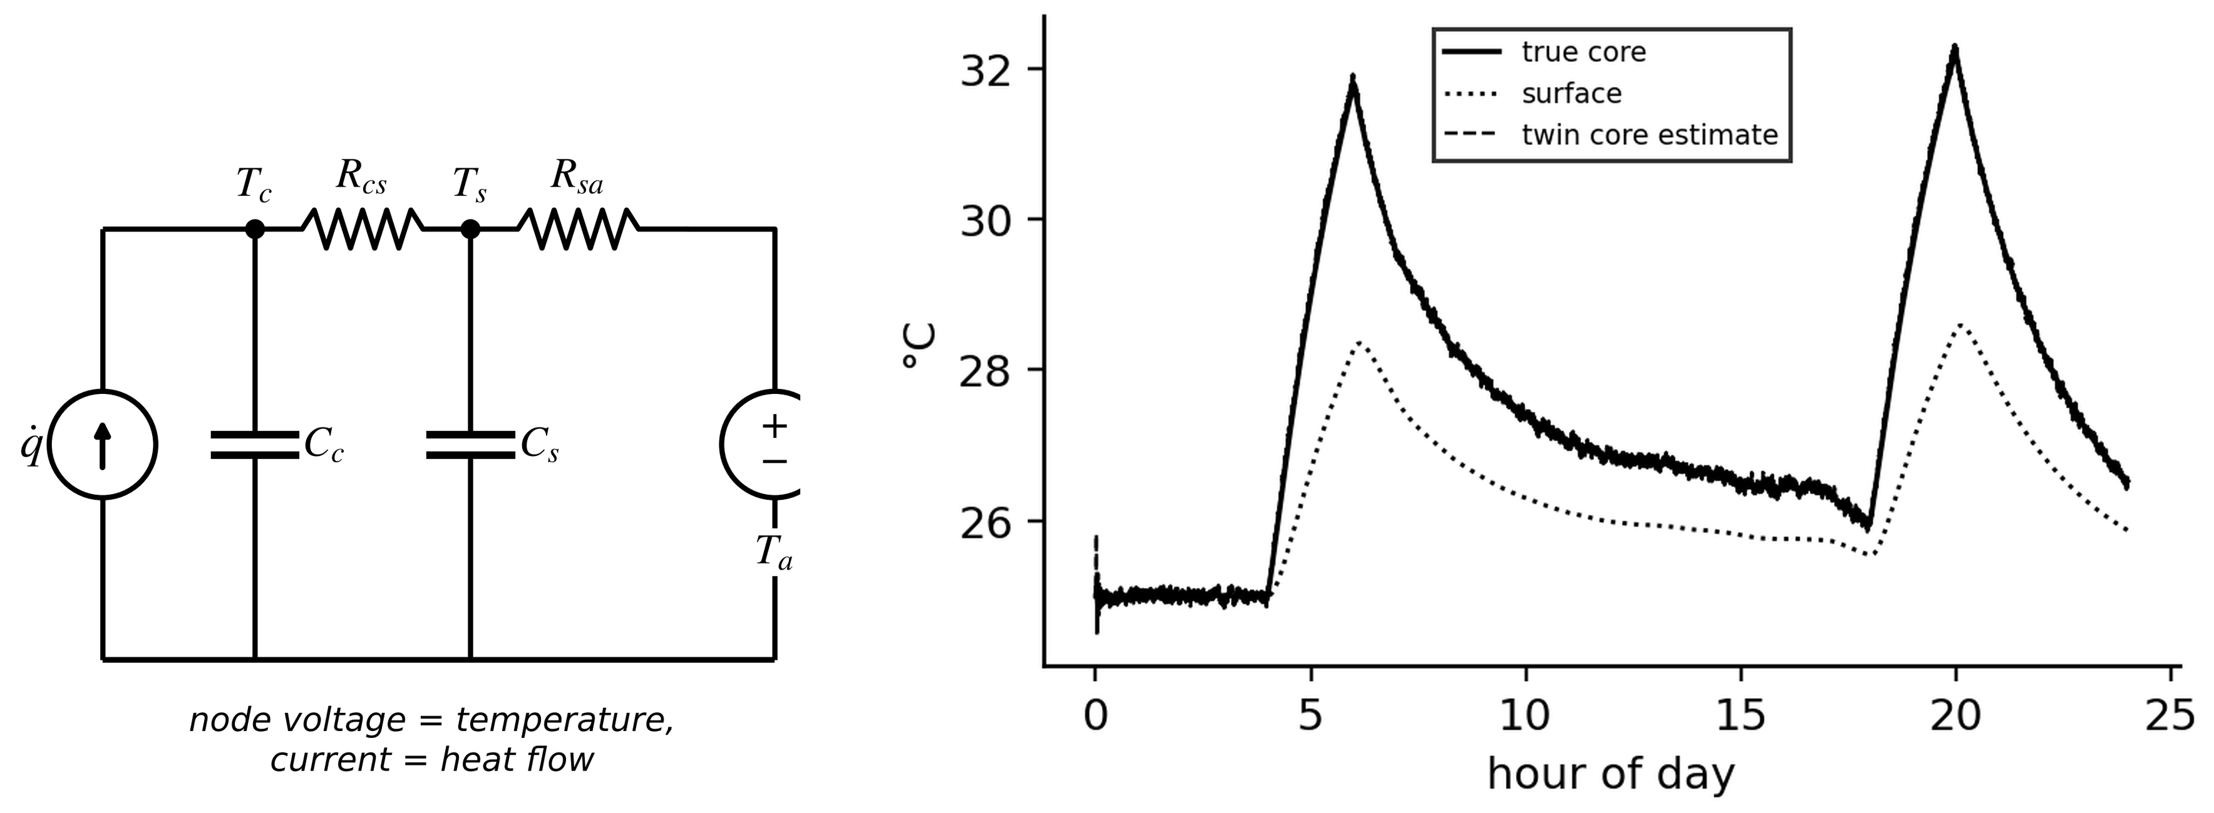
Figure 9.19. Left: two-node core-surface thermal network of a prismatic cell. Right: true core and surface temperatures over the P-1 day and the twin's core estimate from the surface sensor.

9.9.3 The pack and its cooling
In a rack, modules sit along a cooling loop (liquid plates or ducted air). The coolant warms as it collects heat, so modules near the outlet run hotter (Figure 9.20). With module heat ${\dot{Q}}_{m}$, module-to-coolant resistance $R_{mc}$, coolant mass flow $\dot{m}$ and specific heat $c_{p}$, the coolant temperature rises module by module and each module sits above its local coolant:
$T_{cool,j+1}=T_{cool,j}+\frac{{\dot{Q}}_{m}}{\dot{m}c_{p}}, T_{m,j}=T_{cool,j}+{\dot{Q}}_{m}R_{mc}, ΔT_{spread}≈\frac{(N-1){\dot{Q}}_{m}}{\dot{m}c_{p}}$ (9.20)
Example 9.12 (Level B) Sizing the coolant flow of a P-1 rack
Given. 15 modules of 16 cells at 6.1 W each (97.6 W per module) on one loop; $R_{mc}=0.08$ K/W; glycol $c_{p}=3600$ J/(kg·K) entering at 22 °C; flow 0.05 kg/s; a spread limit of 5 K (Table 9.2).
Find. The coolant rise, module temperatures and spread; the effect of halving the flow; the flow for a 3 K coolant rise.
Solution. Coolant rise $15×97.6/(0.05×3600)=8.1$ K; modules from 29.8 to 37.4 °C, a 7.6 K spread, above the limit. At half flow, 15.2 K spread and 45 °C at the outlet. A 3 K rise needs $1464/(3600×3)=0.136$ kg/s.
Interpretation. The spread, not the mean temperature, drives uneven ageing. The twin estimates each module's temperature from the coolant model and a few sensors, detects a falling flow (a pump or a clogged plate) as a growing spread, and feeds module temperatures to the ageing model.
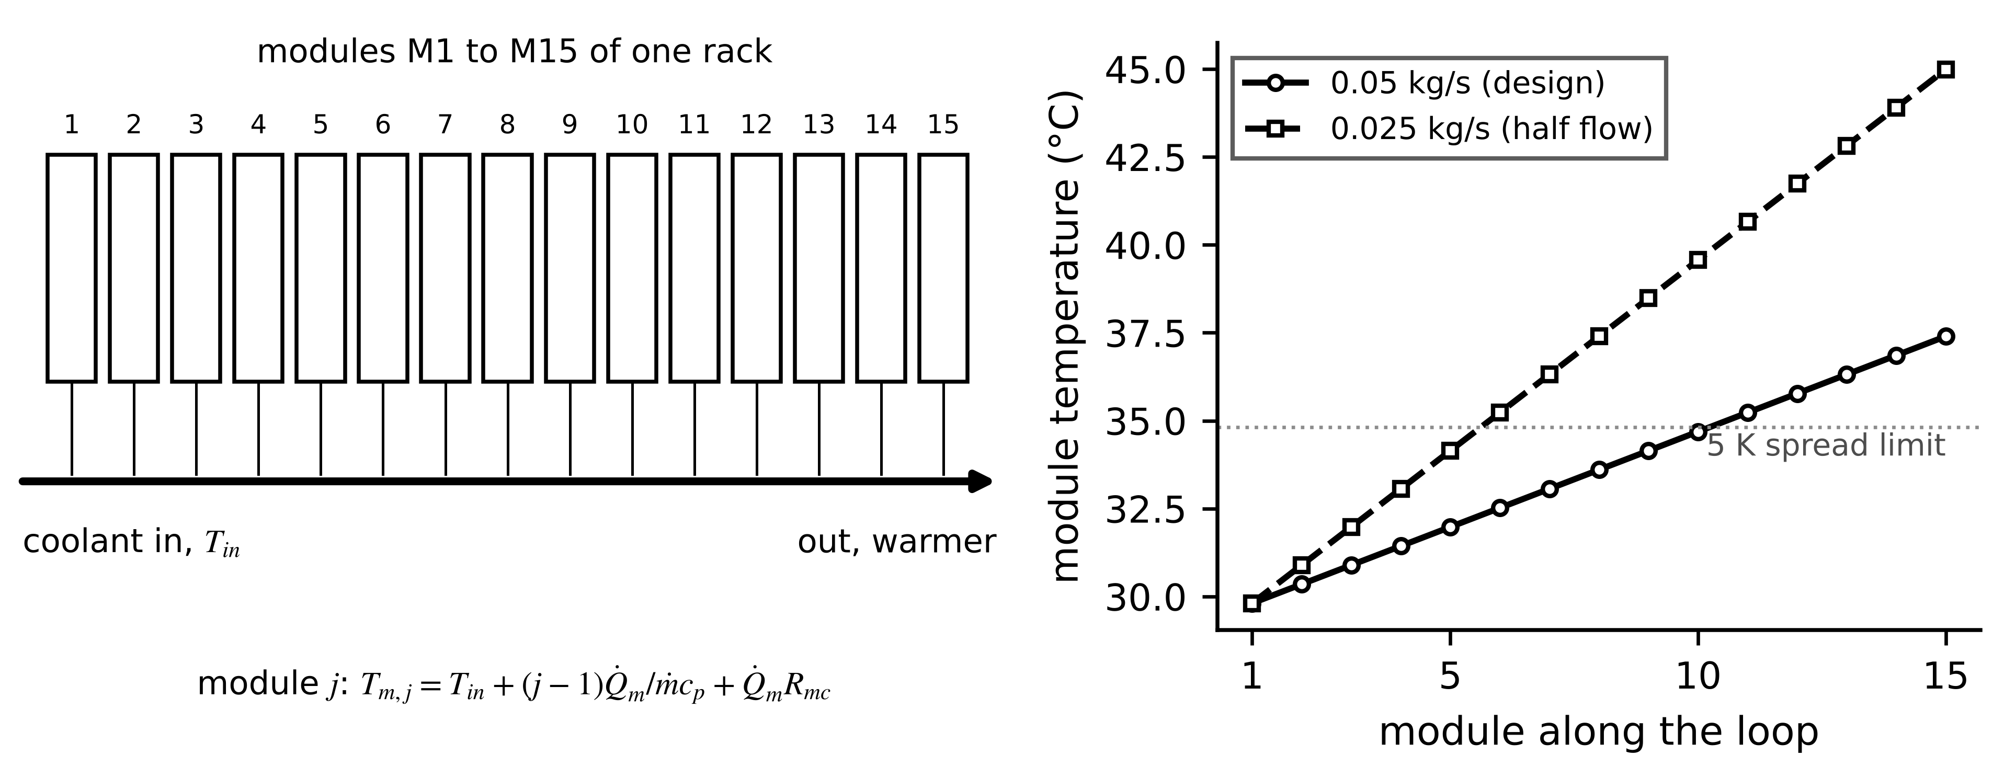
Figure 9.20. Left: modules along a coolant loop. Right: module temperatures along the loop at the design flow and at half flow; the outlet modules run hottest.

9.9.4 Thermal runaway and propagation
Thermal runaway is a self-accelerating chain of exothermic reactions (Figure 9.21). Representative stages, whose temperatures depend strongly on chemistry and state of charge and are measured by accelerating-rate calorimetry for each cell type: SEI decomposition from about 80 to 120 °C, separator melting around 130 to 170 °C (internal short), anode-electrolyte reactions, and positive-electrode decomposition from about 180 to 250 °C for NMC (with oxygen release) and higher for LFP [12]. Whether a hot cell runs away is a balance between heat generated by an Arrhenius reaction and heat lost to the surroundings. Semenov's analysis equates both the heat rates and their slopes at the critical point:
${\dot{q}}_{gen}=A e^{-E_{a}/R_{g}T}, {\dot{q}}_{loss}=hA_{s}\left(T-T_{a}\right), {\dot{q}}_{gen}={\dot{q}}_{loss}, \frac{d{\dot{q}}_{gen}}{dT}=\frac{d{\dot{q}}_{loss}}{dT} ⇒ T_{cr}-T_{a}≈\frac{R_{g}T_{a}^{2}}{E_{a}}$ (9.21)
For $E_{a}=100$ kJ/mol near 400 K the critical rise is only $8.314×{400}^{2}/{10}^{5}=13.3$ K: a cell that self-heats more than about 13 K above its surroundings at that temperature cannot be cooled back by the same path. Propagation to neighbours follows when the heat released by one cell raises its neighbour above its own onset; barriers, spacing and venting design slow or stop it, and pack-level tests (UL 9540A [13]) verify them.
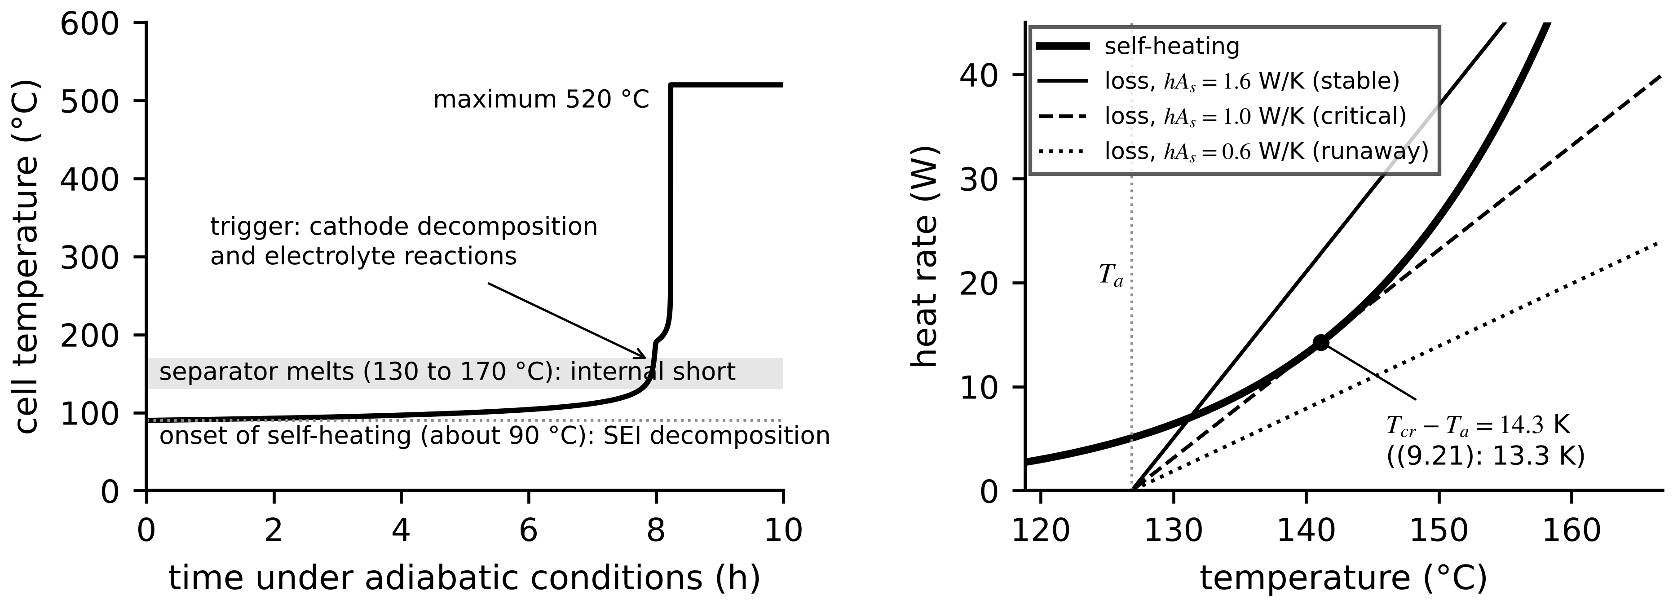
Figure 9.21. Left: illustrative adiabatic temperature history, from a two-reaction Arrhenius model, of a cell entering thermal runaway, with chemistry-dependent stage temperatures. Right: Semenov diagram: self-heating against heat loss for three cooling strengths: two crossings (a stable operating point), tangency (critical) and no crossing (runaway).
Early detection. The twin's best opportunities come long before runaway: an internal short shows as a cell that self-discharges faster than its neighbours (Section 9.10.3), a temperature rising beyond the Bernardi prediction at the same current, a voltage drop at rest, and gas (hydrogen, carbon monoxide) detected by pack sensors minutes before venting. Combining these, with the cell-level residuals as the earliest signal, is an established safety function of grid BESS twins.
What the digital twin adds
Synchronized: heat generation, core, surface, module and coolant temperatures.
Estimated or updated: core temperature, coolant flow health, entropic coefficients.
Uncertainty carried: thermal-parameter and heat-model errors in core estimates.
Decision enabled: derating, cooling setpoints, early safety warnings.
Validated by: instrumented cells at commissioning, coolant-flow tests, calorimetry data.

9.10 Pack heterogeneity, balancing and faults

9.10.1 The weakest cell rules the string
Cells of one type differ by a percent or two in capacity and resistance when new, and the differences grow with uneven temperature and age. In a series string every cell carries the same current, so the string must stop discharging when its emptiest cell reaches its lower limit and stop charging when its fullest reaches the upper. With cell SOCs $z_{i}$ and capacities $Q_{i}$, the dischargeable and chargeable charge of the string and a pack SOC consistent with them are
$Q_{dis}=\min_{i}z_{i}Q_{i}, Q_{chg}=\min_{i}\left(1-z_{i}\right)Q_{i}, z_{pack}=\frac{Q_{dis}}{Q_{dis}+Q_{chg}}$ (9.22)
$z_{pack}$ is 0 when the weakest cell is empty and 1 when the fullest is full; it equals the average only if all cells are identical. The usable charge $Q_{dis}+Q_{chg}$ is at most the smallest capacity, reached when the cells are balanced at one end (Figure 9.22).
Example 9.13 (Level A) A weak cell hidden by the average
Given. A 12-cell string: 11 cells at 45 % SOC with 50 Ah, one aged cell at 18 % with 42 Ah.
Find. The capacity-weighted average SOC and (9.22).
Solution. Average $(11×50×0.45+42×0.18)/592=43.1$ %. $Q_{dis}=min(22.5,7.56)=7.56$ Ah, set by the weak cell; $Q_{chg}=min(27.5,34.4)=27.5$ Ah, set by the healthy cells; $z_{pack}=21.6$ %.
Interpretation. The average says 43 %; the string can deliver only a fifth of its range before the weak cell stops it. A twin reports pack SOC by (9.22) and names the limiting cell.
Example 9.14 (Level B) Heterogeneity of a P-1 rack
Given. A 240-cell rack with capacities spread normally by 1.5 % around 280 Ah and SOCs by 1.5 points around 50 % (seed 2026).
Find. The usable charge unbalanced and after top balancing, and the balancing charge and time for passive (0.33 A) and active (2 A) balancing.
Solution. Mean capacity 280.3 Ah, smallest 264.3 Ah. Unbalanced, (9.22) gives 253.6 Ah usable, 90.5 % of the mean capacity; top-balanced, 264.3 Ah (94.3 %), limited by the weakest cell. The largest charge to bleed is 23.2 Ah: 70 hours passively, 11.6 hours actively (Figure 9.22).
Interpretation. Balancing recovers 4 points of usable capacity; the rest is lost to the weakest cell, which the twin should flag for replacement when its capacity sets the rack's limit. Passive balancing at top of charge needs days of short daily windows; the twin plans it from estimated SOCs and capacities rather than from voltages.
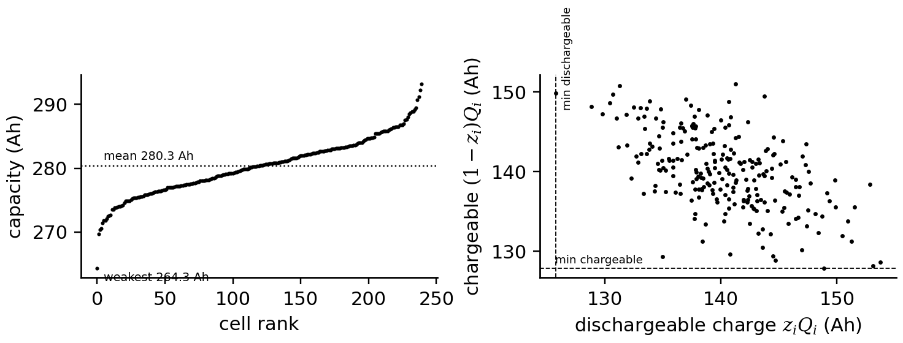
Figure 9.22. Heterogeneity of a simulated P-1 rack. Left: cell capacities in rank order, with the mean and the weakest cell. Right: dischargeable against chargeable charge of each cell; the dashed lines mark the two minima that set the string's usable charge.

9.10.2 Balancing
Passive balancing bleeds the fullest cells through a resistor $R_{b}$ until the others catch up; active balancing moves charge from strong to weak cells through a converter or switched capacitors (Figure 9.23). For passive balancing, and for the charge to move with estimate-based balancing towards a common top of charge,
$I_{b}=\frac{V_{cell}}{R_{b}}, P_{b}=\frac{V_{cell}^{2}}{R_{b}}, t_{b}=\frac{ΔQ_{i}}{I_{b}}, ΔQ_{i}=\max_{j}\left[\left(1−z_{j}\right)Q_{j}\right]−\left(1−z_{i}\right)Q_{i}$ (9.23)
where $ΔQ_{i}$ is the charge to remove from cell $i$ so that all cells reach full together. A 3.3 V cell through 10 Ω bleeds 0.33 A and dissipates 1.09 W: removing 1 % of 280 Ah takes 8.5 hours. On LFP, balancing from voltage alone is unreliable on the plateau, where SOC differences of several points are within the hysteresis; the twin balances from estimated SOCs and capacities and verifies at the steep top of charge.
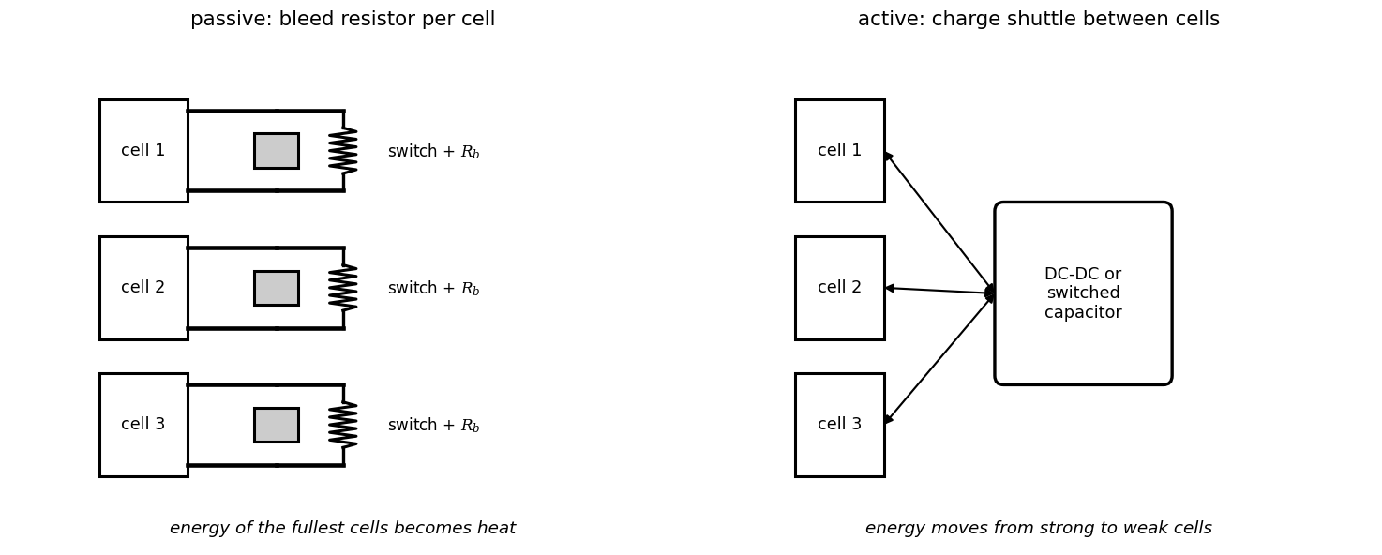
Figure 9.23. Balancing architectures: passive (a switched bleed resistor per cell, converting excess charge to heat) and active (a converter or switched capacitor moving charge between cells).
Example 9.15 (Level A) Balancing four P-1 cells from their estimates
Given. Estimated SOCs 62.0, 60.0, 63.5 and 60.5 % and capacities 280, 275, 282 and 279 Ah; passive balancing at 0.33 A.
Find. (9.23) for each cell, the balancing times, and the OCV differences a voltage balancer would see in the middle and at the top of the range.
Solution. $ΔQ=[3.8, 0.2, 7.3, 0]$ Ah: 11.5, 0.6, 22.0 and 0 hours of bleeding. The 3.5-point spread between 60.0 and 63.5 % is about 15 mV here (it straddles a small step of the OCV) but would be under 3 mV on the flat part, within hysteresis and sensor offsets; the same spread at 93.5 to 97 % is 30 mV.
Interpretation. Estimate-based balancing knows where to bleed in the middle of the range; voltage-based balancing sees the imbalance reliably only at the top, and only if charging reaches it.

9.10.3 Internal shorts and sensor faults
A developing internal short circuit of resistance $R_{isc}$ drains its cell continuously, so the cell falls behind its string mates by a growing SOC lag while heating slightly:
$I_{isc}=\frac{U}{R_{isc}}, Δz_{day}=\frac{24I_{isc}}{Q}, {\dot{q}}_{isc}=\frac{U^{2}}{R_{isc}}$ (9.24)
Cross-cell comparison at the steep top of charge, where SOC is known within about 0.3 points, detects the lag. Sensor faults (a voltage tap that drifts, a stuck temperature sensor, a current-sensor gain error) mimic cell faults; Table 9.7 lists the evidence that separates them.
Example 9.16 (Level A) How fast an internal short can be found
Given. A B-1 cell (3.3 V) develops a 20 Ω internal short; cross-cell comparison uncertainty 0.3 points; detection at three times that.
Find. The short-circuit current, daily SOC lag, heat and detection time; repeat for 200 Ω.
Solution. 20 Ω: 0.165 A, 1.4 points per day, 0.54 W: the 0.9-point threshold is crossed within the first day. 200 Ω: 0.0165 A, 0.14 points per day: about 6.4 days if the lag accumulates without balancing, or visible earlier as the cell's persistent extra balancing demand.
Interpretation. Self-discharge, not temperature, reveals early shorts: 0.5 W is invisible against operating heat. A twin that disables passive balancing would hide this signal in the balancing log; one that monitors balancing demand per cell finds it.
Table 9.7. Battery fault signatures and the evidence that separates them
Condition | Primary signature | Separating evidence
internal short circuit | cell SOC lags its neighbours; extra balancing demand | lag grows during rest; slight extra heat
voltage-tap drift | one cell voltage biased, SOC lag appears | bias constant with current; neighbour tap shows opposite error
temperature-sensor fault | temperature departs from Bernardi prediction | voltage and SOC track neighbours; jumps or stuck value
current-sensor gain error | all cells drift together; capacity estimate biased | consistent across racks sharing the sensor type; anchor mismatch
high contact resistance | voltage drop at high current, local heating | drop proportional to current, at module joints
cooling loss | growing module temperature spread | coolant-flow measurement, pump status

What the digital twin adds
Synchronized: every cell's SOC, capacity, resistance and temperature, not only pack averages.
Estimated or updated: limiting cells, balancing demand, short-circuit and sensor-fault indicators.
Uncertainty carried: cell-level estimate uncertainty in pack limits.
Decision enabled: balancing schedules, cell replacement, early isolation.
Validated by: top-of-charge comparisons, maintenance findings.

9.11 Uncertainty-aware decisions: life, fast charging and dispatch

9.11.1 Remaining useful life with an honest interval
Remaining useful life (RUL) is a forecast, not a measurement: the time until capacity loss reaches the end-of-life threshold $L_{EOL}$ (often 20 %) under an assumed future duty. A model-based forecast fits a degradation law to the capacity history and propagates the fit's uncertainty, for example by bootstrap resampling of the residuals, into a distribution of the end-of-life time:
$\hat{L}(t)=\hat{α}t^{\hat{β}}, {\hat{t}}_{EOL}={\left(\frac{L_{EOL}}{\hat{α}}\right)}^{1/\hat{β}}, RUL(t_{0})={\hat{t}}_{EOL}-t_{0}, \left[t_{EOL}^{(5)},t_{EOL}^{(95)}\right] from {\left\{{\hat{t}}_{EOL}^{(b)}\right\}}_{b=1}^{B}$ (9.25)
where ${\hat{t}}_{EOL}^{(b)}$ are the end-of-life times of $B$ bootstrap refits. Two limits matter as much as the interval: the forecast is valid only for the duty and temperature range of the data it was fitted on, and fits on early data cannot see knee points where ageing accelerates (for example when plating sets in).
Example 9.17 (Level C) Forecasting the P-1 cell's end of life after two years
Given. Monthly capacity estimates for two years at 25 °C from Example 9.9 with 0.7 % noise (the uncertainty of Example 9.6; seed 2026). True end of life 12.0 years.
Find. The fitted law, the end of life and RUL with a 90 % bootstrap interval (2000 refits), and whether the forecast applies at 35 °C.
Solution. Least squares gives $\hat{α}=5.24$ %/year^β, $\hat{β}=0.530$; ${\hat{t}}_{EOL}=12.5$ years with a 90 % interval of 9.7 to 16.9 years (Figure 9.24). At two years the RUL is 10.5 years (7.7 to 14.9); the true 10.0 lies inside. At 35 °C the true end of life is 4.9 years, far outside the interval.
Interpretation. Two years of data narrow the life to about ±30 %, and that is the honest statement. The interval is conditional on the duty; a change of site temperature invalidates it, which the twin must detect as an input outside the training domain (Chapter 6, Section 6.9). Learned fleet models with conformal calibration give distribution-free intervals across many cells, under the same exchangeability caveat.
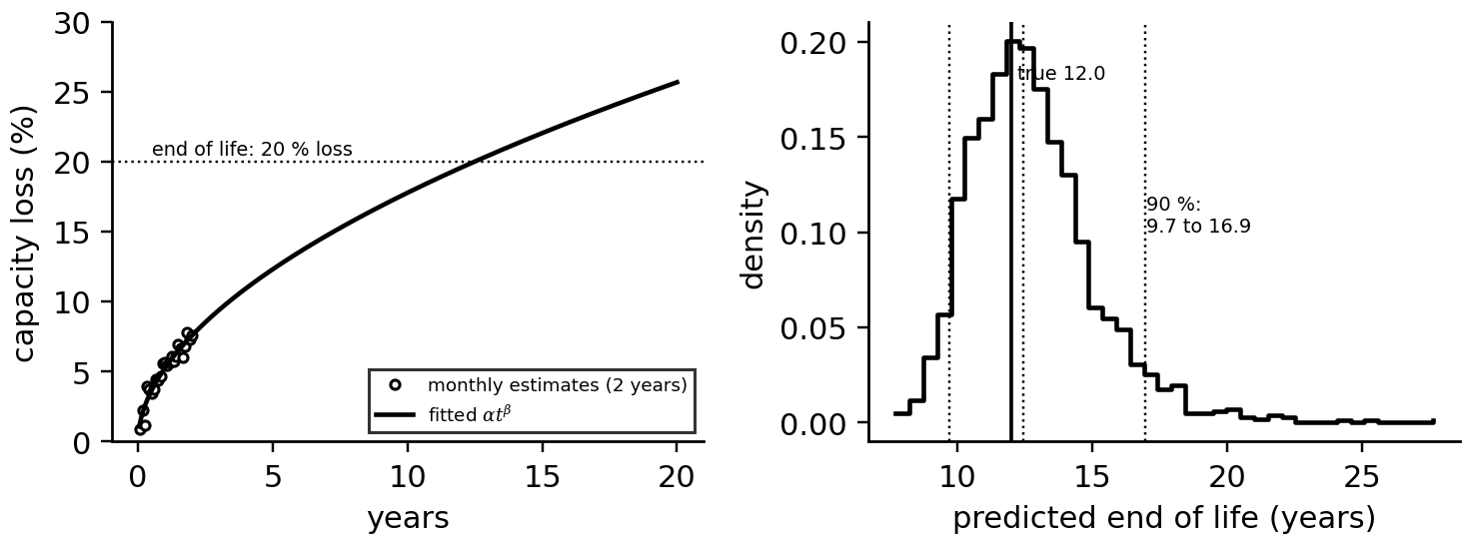
Figure 9.24. Left: two years of monthly capacity-loss estimates with the fitted power law, extrapolated to the 20 % end-of-life threshold. Right: bootstrap distribution of the predicted end of life, with the 5, 50 and 95 % quantiles and the true value.

9.11.2 Fast charging without plating
Charging pushes lithium into the graphite. At high current, low temperature or high SOC the graphite surface potential $φ_{n}$ against a lithium reference can fall below zero, and lithium plates as metal instead of intercalating. An SPM-based twin (Section 9.4.5) estimates the anode potential; a simple form uses the graphite equilibrium potential $U_{n}(z)$, which falls as the graphite fills, and an anode-side resistance $R_{n}(T)$ that rises in the cold (charging current $I_{ch}>0$):
$φ_{n}=U_{n}(z)-I_{ch}R_{n}(T)≥φ_{min} ⇒ I_{ch}^{max}(z,T)=\frac{U_{n}(z)-φ_{min}}{R_{n}(T)}$ (9.26)
with a safety margin $φ_{min}$ (for example 20 mV). A plating-aware charge follows $min(I_{ch}^{max},I_{max})$, the envelope of Figure 9.25; a thermal constraint (the cell must not exceed its charge temperature limit) caps it further, and the SOH estimate feeds back through $R_{n}$, which rises with age.
Example 9.18 (Level B) Charging B-1 from 10 to 80 % at 25 °C and 5 °C
Given. An illustrative graphite potential falling linearly from 0.19 V at 10 % SOC to 0.09 V at 80 %; $R_{n}=0.45$ mΩ at 25 °C with activation temperature 6000 K (1.91 mΩ at 5 °C); $φ_{min}=20$ mV; 1C current limit.
Find. Charging time and lowest anode potential for constant 0.5C, constant 1C and the plating-aware charge (9.26); the heat at 1C.
Solution. At 25 °C: 0.5C takes 84 min (lowest $φ_{n}$ 27 mV); 1C takes 42 min but $φ_{n}$ falls to −36 mV near 80 %; the plating-aware charge runs at 1C to about 40 % SOC and tapers to 156 A, taking 50 min with $φ_{n}≥20$ mV. At 5 °C: 0.5C reaches −178 mV and 1C −446 mV, both deep in plating; the plating-aware charge needs 200 min, tapering from 89 A to 37 A. At 1C the cell generates 47 W at 25 °C and 97 W at 5 °C; over a 42-minute charge with no cooling the 25 °C cell would warm by about 21 K.
Interpretation. The fast-charge envelope is a function of SOC, temperature and age, not a single C-rate. Warming the cell before charging in the cold, which the twin can schedule from the weather forecast, recovers most of the lost time; the plating margin itself must be validated against cells opened after testing, because the anode potential is estimated, not measured.
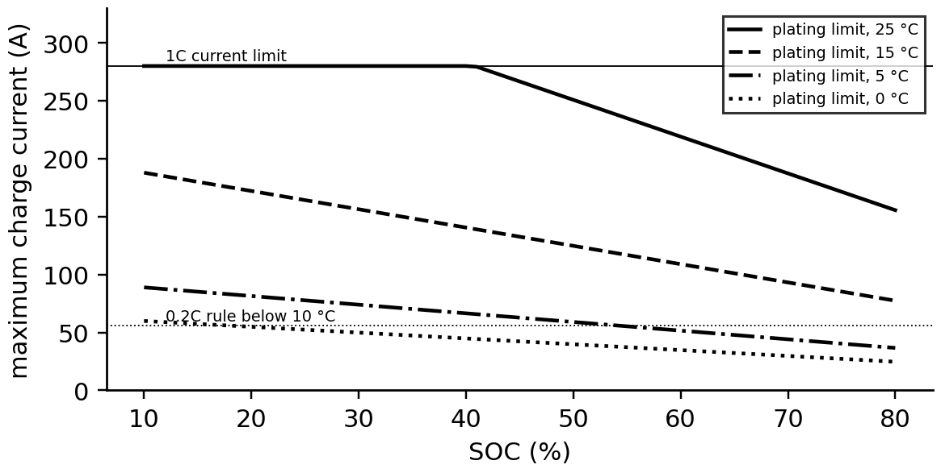
Figure 9.25. Plating-limited charge current of cell B-1 against SOC at four temperatures, with the 1C current limit and the 0.2C rule used below 10 °C.

9.11.3 Dispatch with degradation cost
Every cycle consumes life. Dividing the replacement cost $C_{rep}$ by the capacity loss budget $L_{EOL}$ and multiplying by the marginal loss per equivalent full cycle $∂L/∂N$ gives a degradation cost per cycle; a trade is worth it only if the spread pays for losses and life:
$c_{deg}=C_{rep}\frac{∂L/∂N}{L_{EOL}}, Π=E_{use}\left(p_{s}-\frac{p_{b}}{η_{RT}}\right)-c_{deg}, η_{RT}=η_{cell}{\left(η_{dc}η_{PCS}η_{tr}\right)}^{2}-η_{aux}$ (9.27)
where $E_{use}$ is the energy discharged per cycle, $p_{b}$ and $p_{s}$ the buying and selling prices, $η_{RT}$ the round-trip efficiency from cell, DC wiring, PCS and transformer efficiencies, and $η_{aux}$ the auxiliary (cooling, BMS) energy as a fraction.
Example 9.19 (Level A) Is tonight's spread worth a cycle?
Given. P-1: replacement cost 150 USD/kWh on 1075 kWh ($C_{rep}=161 250$ USD), usable 1 MWh, $η_{RT}=0.883$; after five years the marginal cycle loss from (9.17) is 0.0019 % per EFC at 25 °C and 0.0028 % at 35 °C; $L_{EOL}=20$ %.
Find. $c_{deg}$ at both temperatures and the profit of one cycle for (buy 40, sell 110) and (buy 40, sell 60) USD/MWh at 25 °C.
Solution. $c_{deg}=161 250×0.0019/20=15.4$ USD per cycle at 25 °C and 22.6 USD at 35 °C. Wide spread: $110-40/0.883-15.4=49.3$ USD. Narrow spread: $60-45.3-15.4=-0.7$ USD.
Interpretation. The narrow spread loses money once life is priced in; at 35 °C a spread must be wider still. The degradation cost comes from the twin's ageing model and its uncertainty; a risk-averse operator uses an upper quantile of $c_{deg}$, not its mean.
What the digital twin adds
Synchronized: health forecasts, charging envelopes and dispatch values with the cell's present state.
Estimated or updated: RUL distribution, anode-potential margin, degradation cost per cycle.
Uncertainty carried: bootstrap or conformal intervals, plating margins, validity domains.
Decision enabled: warranty planning, charge profiles, trade or hold.
Validated by: reference performance tests, teardown of test cells, realized degradation against forecast.

9.12 Real-time BMS implementation and validation
The battery twin splits across three layers: the cell-monitoring and rack units run the fast estimators (SOC, polarization, hysteresis, core temperature, SOP) every 0.1 to 1 s on microcontrollers; the site controller aggregates racks; and a cloud or server twin runs ageing, ICA, RUL and fleet comparisons over days. Embedded implementation has its own failure modes. Single-precision floating point has a spacing of $2^{-24}≈6×{10}^{-8}$ near 1, while a 0.05 A current over one second changes the SOC of a 280 Ah cell by $5×{10}^{-8}$: a float32 SOC accumulator rounds every step to one spacing unit and drifts by about 20 %. SOC must be accumulated in double precision or as integer charge counts. Filter covariances must be kept symmetric and positive definite (Joseph form or square-root filters), lookup tables interpolated monotonically, and every estimator bounded and supervised.
$ε_{32}=2^{-24}≈5.96×{10}^{-8}, Δz_{k}=\frac{\left|I_{k}\right|Δt}{3600Q} must exceed ε_{32}z for float32 accumulation$ (9.28)
Hardware in the loop. Before deployment the BMS software is tested against a real-time cell or pack emulator running the twin's own models (Chapter 7, Section 7.17), with injected faults (sensor drift, open taps, internal shorts, contactor failures) and extreme conditions that are unsafe or slow to create on real cells. Validation then compares the twin with reference measurements across the conditions that matter: temperatures from the coldest to the hottest site conditions, the full SOC range including the plateau, aged as well as new cells, and duty cycles not used in tuning. A scorecard records each test, its criterion and its result, so that the twin's claims are bounded by evidence (Table 9.8).
What the digital twin adds
Synchronized: embedded estimators with the cloud twin, at different rates.
Estimated or updated: numerical health of the embedded filters.
Uncertainty carried: discretization and arithmetic errors, measured not assumed.
Decision enabled: deployment of BMS software and estimator updates.
Validated by: HIL with fault injection; scorecards across temperature, SOC, age and duty.

9.13 Case study: the P-1 battery twin and its validation scorecard
Figure 9.26 assembles the twin: BMS, EMS and weather data feed an ECM with hysteresis and temperature dependence, a core-surface and pack thermal model, ageing laws and fault detectors; SOC, SOH, SOP and temperature are estimated jointly with covariances; decisions on limits, charging, balancing and dispatch follow; a slow layer forecasts life with intervals. Table 9.8 summarizes the evidence gathered in this chapter on the synthetic data.
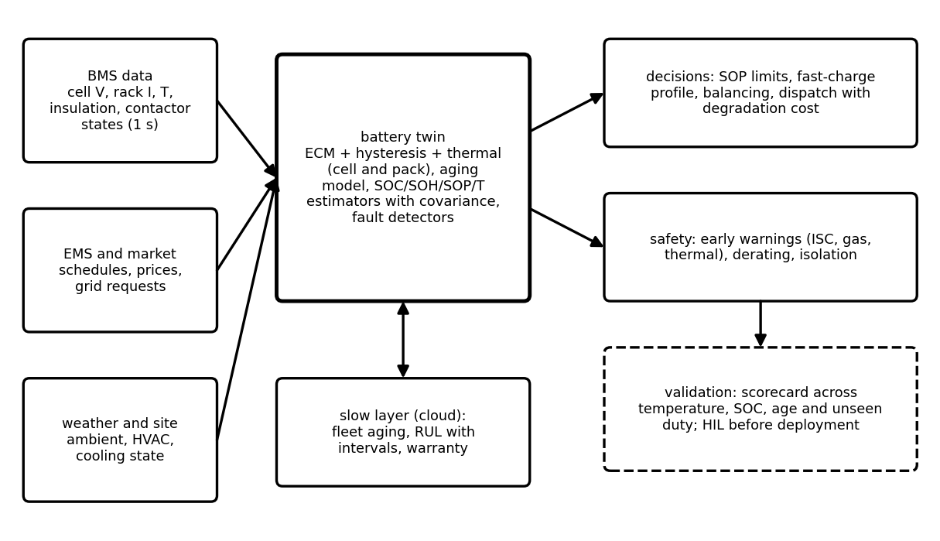
Figure 9.26. The P-1 battery twin: inputs from the BMS, EMS and site; a model and estimator core; decisions on limits, charging, balancing and dispatch; safety functions; a slow fleet and life layer; and validation before deployment.
Table 9.8. Validation scorecard of the P-1 battery twin (synthetic data; criteria are examples for a grid BESS)
Function | Evidence in this chapter | Criterion | Result
SOC after a full charge | Example 9.5 | ≤ 1 point RMS | 0.5 points (pass)
SOC at rest on the plateau | Example 9.5 | uncertainty reported | 2 to 18 points without resynchronization (flagged)
SOC at 5 °C | Example 9.5 | ≤ 1 point RMS | 0.44 with temperature model; 5.3 without (fail)
capacity | Example 9.6 | ≤ 1 % | 0.73 % between steep anchors (pass)
parameters | Example 9.2 | residual at noise level | two-RC only (pass); one-RC fails
core temperature | Example 9.11 | ≤ 0.5 K RMS | 0.06 K (pass); surface proxy 1.56 K
pack temperature spread | Example 9.12 | ≤ 5 K | 7.6 K at design flow (fail: raise flow)
degradation mode | Example 9.8 | modes distinguishable | LLI, LAM, kinetic separated (pass)
RUL | Example 9.17 | truth inside 90 % interval | yes at 25 °C; invalid at 35 °C (domain flagged)
fast charge | Example 9.18 | $φ_{n}≥20$ mV | plating-aware profile meets it; fixed 1C does not

Two results are failures, and they are the most useful lines of the scorecard: the pack's coolant flow is too low for the 5 K spread limit, and SOC without temperature compensation fails in the cold. A twin that reports only its passes is not validated. The data are synthetic so that each estimate has a truth; field deployment replaces the truths with reference performance tests, laboratory cells of the same lot and maintenance findings, and the scorecard is renewed as the battery ages.

9.14 Recent developments and open research problems
Battery twins are among the most active areas of energy-twin research; each development is labelled with its status in 2026. The 2026 reviews emphasize physics-guided, uncertainty-aware twins with adaptive synchronization and phased deployment [1], [2], [3].
Physics-guided learning. Hybrid models that keep an ECM or SPM core and learn residual behaviour or parameter drifts (Chapter 6), with calibrated intervals (emerging). Richer sensing. Impedance spectroscopy performed by the BMS or PCS at chosen frequencies for temperature and health, gas sensing for early warning, and research on strain, pressure, ultrasonic and fibre-optic sensors inside cells (emerging to research). Chemistries. LMFP (manganese-doped LFP) with a slightly higher voltage, sodium-ion for cold climates and supply-chain security, and semi-solid and solid-state cells whose models and failure modes are still being established (emerging to research). Fast charging. Model-based plating-aware charging and preheating in EVs and buses (established in leading products), with field validation of anode-potential margins still an open problem. Fleet twins and data rules. Cloud BMS analytics across thousands of packs, second-life assessment of retired EV batteries, and the battery passport of the EU Battery Regulation (EU) 2023/1542, which requires state-of-health information for industrial and EV batteries [14]; open problem: validated health metrics comparable across manufacturers.
Verified results behind these directions. Several of the methods in this chapter rest on results that can be checked in the literature. The battery EKF with an OCV-slope Jacobian was set out in a three-part study of hybrid-vehicle packs [6]. The use of open-circuit and incremental-capacity curves to separate loss of lithium inventory from loss of active material on each electrode was validated on cells built with known amounts of each loss [7], following the degradation-mode framework of [8]. For LFP/graphite cells, a 29-month calendar test at 17 storage conditions supports a semi-empirical model of the form of (9.17) [9], and post-mortem analysis of cells cycled at different temperatures showed lithium plating dominating ageing at low temperature and SEI growth at high temperature [10], which is why the Arrhenius law fails in the cold. For data-driven life prediction, a model trained on 124 commercial LFP/graphite cells under fast charging predicted cycle life from the first 100 cycles with a 9.1 % test error [15], and a closed-loop combination of such early prediction with Bayesian optimization searched fast-charging protocols far faster than exhaustive testing [16]; both results hold within the conditions of their data sets, which is the same domain restriction as Example 9.17. Open, tested implementations of the SPM and P2D models, such as PyBaMM [17], allow an electrochemical twin to be audited and reproduced, and a cloud BMS that estimates SOC and SOH of field batteries in a server-side twin has been demonstrated [18]. At the system level, the fifth edition of UL 9540A (2025) sharpened the criteria for cell-to-cell propagation and extended the method to non-lithium chemistries such as sodium-ion [13].
Table 9.9. Emerging directions with measurable research targets
Direction | Status | Measurable target
physics-guided learned health models | emerging | interval coverage on cells from unseen temperatures and duties
BMS impedance spectroscopy | emerging | core-temperature and health error against references
plating-aware fast charging in the field | established in products, open validation | plating detected in teardown against predicted margin
sodium-ion and solid-state twins | research to emerging | model error across temperature with new chemistry parameters
second-life assessment | emerging | RUL error of repurposed modules after one year in service
battery passport health metrics | regulatory, emerging | agreement of SOH across manufacturers for the same cell

9.15 How this chapter feeds the rest of the book
From Chapter 4 this chapter took the state-space and discretization tools, from Chapter 5 the estimators and consistency tests, from Chapter 6 learned and calibrated models, from Chapter 7 the bidirectional converters that connect batteries, and from Chapter 8 the hybrid plant whose curtailment and ramps the battery absorbs. It hands on a battery twin with coupled SOC, SOH, SOP and temperature estimates. Chapter 10 applies it to electric-vehicle packs and chargers; Chapter 11 aggregates batteries in microgrids and virtual power plants; Chapter 12 builds diagnosis and prognosis on the ageing signatures and fault table of this chapter; Chapter 13 uses SOP and degradation cost in optimal dispatch; and Chapter 14 asks how falsified BMS data could hide a fault or trigger an unsafe action.

Chapter summary
The chapter built the battery twin from electrochemistry upwards: intercalation, lithium inventory and OCV as the physical basis; chemistries and formats compared by energy, life, OCV shape and safety, with chemistry-specific limits; the hierarchy from cell to a 1200-cell, 1 MWh BESS with its precharge and contactors. The model ladder ran from Rint through two-RC with hysteresis and temperature dependence, derived with its exact discretization, to fractional-order, SPM/SPMe and P2D models. Pulse tests identified two branches correctly only with enough rest; LFP's flat OCV made SOC observable only on its steep ends, so filters reached 0.5-point accuracy after a full charge but could not separate SOC from hysteresis on the plateau, and omitting hysteresis or temperature cost up to 9 or 10 points.
SOC, SOH, SOP and temperature were treated as one coupled estimate: capacity from steep anchors to 0.7 %, SOP from voltage, current, SOC, plating and thermal limits with the binding constraint named. Degradation mechanisms were mapped to modes and signatures; incremental capacity separated LLI, LAM and resistance growth; ageing laws gave 12 years at 25 °C and under 5 at 35 °C. Thermal models ran from Bernardi heat through a core-surface network (core estimated to 0.06 K) and a pack cooling loop (7.6 K spread, too much) to thermal runaway and Semenov criticality. Pack heterogeneity, balancing and internal shorts were quantified; RUL was forecast with an honest 90 % interval; plating-aware charging and degradation-priced dispatch turned estimates into decisions; and a validation scorecard recorded passes and failures alike.
Table 9.10. Key relationships of Chapter 9
Relationship | Expression | Eq.
SOC, SOH, energy | $z=z_{0}-\int{η_{c}}I dt/3600Q$; $Q/Q_{nom}$; $\int{U}Q dz$ | (9.1)
Pack scaling; precharge | $N_{s}V$, $N_{p}Q$; $V(1-e^{-t/RC})$ | (9.2), (9.3)
ECM | ${\dot{v}}_{i}=-v_{i}/τ_{i}+I/C_{i}$; $V=U+M_{h}h-R_{0}I-\sum{v_{i}}$ | (9.4)
Exact discretization | $v_{i,k+1}=a_{i}v_{i,k}+R_{i}(1-a_{i})I_{k}$ | (9.5)
Hysteresis | $h_{k+1}=a_{h}h_{k}-(1-a_{h})sgn(I)$ | (9.6)
Arrhenius resistance | $R(T)=R_{ref}e^{(E_{R}/R_{g})(1/T-1/T_{ref})}$ | (9.7)
SPM diffusion | (9.8) | (9.8)
OCV interpolation; SOC per volt | $δz≈δU/|dU/dz|$ | (9.9)
Coulomb-counting error | offset, noise, capacity and initial terms | (9.11)
Battery EKF Jacobian | $H=[dU/dz,-1,-1,M_{h}]$ | (9.12)
Capacity estimate | $\hat{Q}=\int{I} dt/(3600Δz)$ with uncertainty | (9.13)
State of power | $R_{eq}$; minimum of voltage, current, SOC, thermal limits | (9.14), (9.15)
ICA and DVA | $dQ/dV=Q/(dU/dz)$ | (9.16)
Ageing laws | calendar $∝\sqrt{t}$, cycle $∝N^{z_{c}}$, Arrhenius | (9.17)
Bernardi heat | $I(U-V)-IT ∂U/∂T$ | (9.18)
Core-surface model | (9.19) | (9.19)
Pack cooling | coolant rise ${\dot{Q}}_{m}/\dot{m}c_{p}$ per module | (9.20)
Semenov criticality | $T_{cr}-T_{a}≈R_{g}T_{a}^{2}/E_{a}$ | (9.21)
Pack SOC | $Q_{dis}=minz_{i}Q_{i}$; $Q_{chg}=min(1-z_{i})Q_{i}$ | (9.22)
Balancing | $I_{b}=V/R_{b}$; $ΔQ_{i}$ | (9.23)
Internal short | $I=U/R_{isc}$; daily lag | (9.24)
RUL | $t_{EOL}=(L_{EOL}/α)^{1/β}$ with bootstrap interval | (9.25)
Plating limit | $I^{max}=(U_{n}-φ_{min})/R_{n}$ | (9.26)
Dispatch | $c_{deg}$, profit, $η_{RT}$ | (9.27)
Float32 limit | $ε_{32}=2^{-24}$ | (9.28)

Exercises
The fifteen exercises are grouped by theme. Most combine a derivation, a conceptual question and a numerical part, so that each can be set as one assignment; the last is an open design project that builds the complete B-1 twin. Complete solutions to all fifteen are given in the Answer key.

Group A: the cell, its models and its state of charge
9.1 Quantities and the system. (a) A 280 A·h cell is discharged at 140 A. Find the C-rate and the discharge time from full. (b) A cell with $Q=80$ A·h and $η_{c}=0.99$ is charged at 25 A for 900 s. Find the change of SOC. (c) A 700 V rack precharges a 5 mF DC link through 100 Ω. Find the time constant, the time to 99 %, the peak current and the energy dissipated in the resistor. (d) Show that the resistor energy in (c) equals $\frac{1}{2}CV^{2}$ whatever the value of $R$, and explain why the precharge resistor is sized by energy and pulse rating rather than by resistance alone.
9.2 Equivalent circuits and their discretization. (a) A one-RC model has $R_{0}=0.02$ Ω, $R_{1}=0.015$ Ω and $C_{1}=3000$ F. Find $τ_{1}$ and state whether one branch can represent the relaxation after a two-hour load. (b) Derive the exact update (9.5) from the branch equation (9.4) under a zero-order hold. (c) For cell B-1 (Table 9.3) find $a_{1}$ and $a_{2}$ at $Δt=1$ s and compare $a_{1}$ with the forward-Euler value $1−Δt/τ_{1}$; repeat at $Δt=20$ s and explain what goes wrong with Euler. (d) Derive the equivalent resistance (9.14) for a constant current applied for $Δt_{p}$ from known initial polarizations, and evaluate it for B-1 at 25 °C and 10 s.
9.3 Hysteresis, OCV slope and incremental capacity. (a) A cell's rested voltage at 60 % SOC is 3.72 V after charge and 3.69 V after discharge. Find $M_{h}$ and the SOC ambiguity if the OCV slope is 0.67 mV per point. (b) At 50 % SOC an NMC cell's OCV slope is 6 mV per point. With 3 mV of voltage error, estimate the SOC uncertainty. (c) Derive (9.16) from the definition of SOC, and explain physically why flat regions of the OCV produce IC peaks.
9.4 One Kalman update on the plateau and on the steep end. A scalar EKF for B-1 has prior SOC standard deviation 5 points and voltage noise 1 mV. (a) Find the gain and posterior standard deviation for one voltage measurement where the OCV slope is 0.71 mV per point (50 % SOC) and where it is 9.7 mV per point (10 % SOC). (b) Repeat (a) when the hysteresis branch is unknown, treating $M_{h}h$ with $M_{h}=12$ mV and $σ_{h}=1$ as additional measurement noise. (c) Explain why the result of (b) at 50 % SOC is the scalar form of the statement that SOC and hysteresis are not separately observable at rest on the plateau.

Group B: health, power and ageing
9.5 Capacity and state of power. (a) Between rested anchors at 95 % and 10 % SOC, with standard uncertainties 0.3 and 0.6 points, a cell passes 180 A·h measured with 0.2 % gain uncertainty. Find $\hat{Q}$ and its standard uncertainty. (b) A cell has $R_{0}=0.4$ mΩ, $R_{1}=0.2$ mΩ with $τ_{1}=20$ s, OCV 3.3 V, $V_{min}=2.8$ V and a 600 A current limit. Find $R_{eq}$ for 30 s, the voltage-limited current, the binding limit and the 30-second discharge power. (c) Explain why an SOP computed with a 25 °C resistance and a SOC that is 10 points too high is unsafe in the cold.
9.6 The weakest cell and balancing. (a) A 16-cell string has 15 cells at 60 % SOC with 100 A·h and one at 35 % with 88 A·h. Find the arithmetic and capacity-weighted average SOC, $Q_{dis}$, $Q_{chg}$ and $z_{pack}$ from (9.22). (b) Show that (9.22) gives 0 when the weakest cell is empty and 1 when the cell with least headroom is full. (c) Using (9.23), find how much charge must be bled from each of the 15 strong cells so that all cells reach full together, the time at 0.33 A, and the string's usable charge before and after. (d) A passive balancer bleeds a 3.3 V cell through 10 Ω. Find the current, the power and the time to remove 1 % of 280 A·h, and explain why active balancing would recover the same charge with much less heat.
9.7 Ageing laws and remaining life. (a) A cell stored at 25 °C for 180 days lost 1.8 % of its capacity. Estimate the loss after two years with the square-root law. (b) Calendar ageing costs 2 % in the first year at 25 °C. Estimate the first-year loss at 40 °C for $E_{a}=50$ kJ/mol. (c) A capacity-loss history is fitted by $L=4.8t^{0.55}$ (%, years). Find $t_{EOL}$ for 20 % and the RUL at three years, and state the conditions under which the forecast is valid. (d) Show from (9.17) that the marginal cycle loss is $∂L/∂N=z_{c}L_{cyc}/N$, evaluate it after five years of the P-1 duty of Example 9.9 at 25 °C, and explain why a degradation cost computed from it falls as the battery ages.
9.8 Reading degradation from incremental capacity. (a) An IC curve measured at 0.5C (140 A) shows all peaks shifted 15 mV higher on charge with unchanged heights. Identify the mode and estimate the resistance rise. (b) What happens to the peaks for 8 % loss of active material and for loss of lithium inventory that moves the end of the window to 60 % SOC (Figure 9.16)? (c) Why must IC curves be taken at low current, and why does differentiation call for smoothing or binning?

Group C: heat, safety and faults
9.9 Heat generation. (a) A cell discharges at 25 A with $U−V=0.09$ V at 295 K and $∂U/∂T=+0.08$ mV/K. Find the irreversible, reversible and total heat. (b) Derive (9.18) from the first law and the Gibbs-Helmholtz relation, stating each assumption. (c) For the lumped B-1 cell of Example 9.10 at 50 % SOC, find the temperature rise after a two-hour block at 100.8 A, and explain why a steady-state formula overestimates it.
9.10 Pack cooling and thermal runaway. (a) A rack loop has 15 modules of 120 W and glycol with $c_{p}=3600$ J/(kg·K). Find the flow needed for a 4 K coolant rise. (b) Derive the Semenov criterion (9.21) and state the approximation used. (c) Evaluate the critical temperature rise for $E_{a}=80$ kJ/mol at an ambient of 350 K. (d) Name three design or operating measures that move a hot module away from criticality, and the twin quantity that monitors each.
9.11 Internal shorts and look-alike faults. (a) A 3.3 V, 280 A·h cell develops a 50 Ω internal short. Find the current, the daily SOC loss and the heat. (b) How long until its SOC lag reaches three times a 0.3-point cross-cell uncertainty, if balancing does not mask it? (c) One cell's temperature departs increasingly from the Bernardi prediction while its voltage and SOC track its neighbours. What are the candidate causes, and what test separates them?

Group D: decisions and implementation
9.12 Plating-aware fast charging. (a) With $U_{n}=0.12$ V, $φ_{min}=20$ mV and $R_{n}=1.2$ mΩ, find the plating-limited charge current, and its value when $R_{n}$ doubles with age. (b) For a graphite potential that falls linearly with SOC, $U_{n}\left(z\right)=U_{n0}−s\left(z−z_{0}\right)$, derive a closed-form expression for the time to charge from $z_{a}$ to $z_{b}$ along $I=\left(U_{n}−φ_{min}\right)/R_{n}$. (c) Use (b) to confirm the 50-minute and 200-minute charging times of Example 9.18. (d) Estimate the energy needed to warm one B-1 cell from 5 to 25 °C before charging, and compare it with the energy stored by the 10 to 80 % charge.
9.13 Dispatch with losses and degradation. (a) Find $η_{RT}$ from (9.27) for $η_{cell}=0.96$, $η_{dc}=0.995$, $η_{PCS}=0.975$, $η_{tr}=0.99$ and 4 % auxiliary energy. (b) A 2 MWh battery (200 USD/kWh, usable 1.8 MWh, $η_{RT}=0.87$) loses 0.003 % of capacity per cycle against a 20 % budget. Find $c_{deg}$ and the profit of buying at 30 and selling at 90 USD/MWh. (c) From (9.27), derive the minimum selling price at which a cycle is profitable and evaluate it for (b). (d) Why should a risk-averse operator use an upper quantile of $c_{deg}$?
9.14 Arithmetic in the embedded BMS. (a) Find the float32 spacing near $z=0.8$ and the per-second SOC decrement of a 0.05 A current in a 280 A·h cell. What happens to a float32 SOC accumulator? (b) Repeat for 0.02 A. (c) Show that a signed 32-bit integer counter in milliampere-seconds can hold the full charge of the cell, and state its resolution. (d) Why do embedded Kalman filters use the Joseph form or square-root forms of the covariance update?

Group E: design project
9.15 Building and validating the B-1 twin. (a) Implement the two-RC hysteresis model with temperature dependence, generate the P-1 day, identify the parameters from a pulse test with short and long rests, and run an EKF and a UKF; reproduce Table 9.5 and test a resynchronization strategy for long plateau operation. (b) Add the core-surface thermal filter and the SOP calculation, fit the ageing law to synthetic monthly capacities, and forecast end of life with a bootstrap interval at two temperatures. (c) Assemble a validation scorecard in the style of Table 9.8, with at least two deliberate failures, for one of: a second-life battery built from retired EV modules, a sodium-ion storage system, or a BESS in a cold climate that must preheat before charging. State what transfers from this chapter and what must be measured anew.

Answer key
9.1 (a) $140/280=0.5$C; two hours from full.
(b) $Δz=0.99×25×900/\left(3600×80\right)=0.0773$, an increase of 7.73 points.
(c) $τ=RC=100×0.005=0.5$ s; $v_{C}$ reaches 99 % after $τln100=2.3$ s; peak current $700/100=7$ A; resistor energy 1225 J from (d).
(d) $E_{R}=\int_{0}^{∞}{i^{2}}R dt=\frac{V^{2}}{R}\int_{0}^{∞}{e^{−2t/τ}}dt=\frac{V^{2}}{R}\frac{RC}{2}=\frac{1}{2}CV^{2}=\frac{1}{2}×0.005×{700}^{2}=1225$ J. The source delivers $CV^{2}$; half is stored and half is dissipated, independent of $R$. The resistance sets only how fast and how high the pulse is, so the resistor is chosen for its single-pulse energy and its repetition rating (a failed precharge retried several times), and $R$ is chosen for the time and peak current.
9.2 (a) $τ_{1}=0.015×3000=45$ s. No: after a long load the relaxation contains a slow diffusion part lasting tens of minutes to hours, which a 45 s branch cannot follow; a second, slow branch is needed (Example 9.1).
(b) With $I\left(t\right)=I_{k}$ constant on $[t_{k},t_{k}+Δt)$, the branch equation $\dot{v}=−v/τ+I_{k}/C$ is linear with constant input. Its solution is $v\left(t_{k}+s\right)=e^{−s/τ}v_{k}+\int_{0}^{s}{e^{−\left(s−σ\right)/τ}}\left(I_{k}/C\right) dσ=e^{−s/τ}v_{k}+RI_{k}\left(1−e^{−s/τ}\right)$, using $τ=RC$. At $s=Δt$ this is (9.5) with $a=e^{−Δt/τ}$. The update is exact for piecewise-constant current; it fails when the current varies within a step, when $R$ and $C$ change during the step, and for the slow diffusion that a finite set of RC branches only approximates.
(c) $Δt=1$ s: $a_{1}=e^{−1/15}=0.9355$ (Euler 0.9333), $a_{2}=e^{−1/600}=0.99833$. $Δt=20$ s: $a_{1}=e^{−20/15}=0.264$, while Euler gives $1−20/15=−0.333$: a negative pole makes the polarization oscillate in sign every step, which is physically impossible; Euler is stable only for $Δt<2τ_{1}$ and accurate only for $Δt≪τ_{1}$, while the exact form is valid for any step.
(d) Applying (9.5) $p$ times with constant $I$ gives $v_{i}\left(Δt_{p}\right)=e^{−Δt_{p}/τ_{i}}v_{i,0}+R_{i}\left(1−e^{−Δt_{p}/τ_{i}}\right)I$. Substituting into $V=U+M_{h}h−R_{0}I−∑v_{i}$: $V=U+M_{h}h−∑e^{−Δt_{p}/τ_{i}}v_{i,0}−R_{eq}I$ with $R_{eq}=R_{0}+∑R_{i}\left(1−e^{−Δt_{p}/τ_{i}}\right)$, which is (9.14). For B-1: $0.25+0.15\left(1−e^{−10/15}\right)+0.20\left(1−e^{−10/600}\right)=0.25+0.073+0.003=0.326$ mΩ, as in Example 9.7.
9.3 (a) $M_{h}=\left(3.72−3.69\right)/2=15$ mV. Without knowing the branch, the rested voltage is consistent with SOCs $±15/0.67=±22$ points around the true value, a band of about 45 points.
(b) $3/6=0.5$ points.
(c) The remaining charge is $Q_{rem}=zQ$, so $dQ_{rem}=Q dz$; on a slow (near-OCV) curve $dV=dU=\left(dU/dz\right) dz$. Dividing, $dQ/dV=Q/\left(dU/dz\right)$, and $dV/dQ$ is its inverse. Flat OCV regions are two-phase regions of an electrode (graphite staging, the LiFePO4/FePO4 transition): the electrode potential stays fixed while the phase boundary moves, so much charge passes for little change of voltage, $dU/dz→0$, and $dQ/dV$ peaks. The peak positions mark the phase transitions and their areas the charge exchanged in them.
9.4 (a) In SOC units the slope is $H=0.071$ V and $0.97$ V per unit SOC; $P={0.05}^{2}$, $R={10}^{−6}$ V². At 50 %: $S=H^{2}P+R=1.36×{10}^{−5}$, $K=PH/S=13.0$, $KH=0.926$, posterior $σ=5\sqrt{1−0.926}=1.36$ points. At 10 %: $S=2.35×{10}^{−3}$, $KH=0.9996$, posterior $σ=0.10$ points.
(b) $R={10}^{−6}+{0.012}^{2}=1.45×{10}^{−4}$ V². At 50 %: $S=1.58×{10}^{−4}$, $K=1.13$, $KH=0.080$, posterior $σ=4.8$ points: the measurement is almost useless. At 10 %: $KH=0.942$, posterior $σ=1.2$ points.
(c) On the plateau a 12 mV hysteresis uncertainty corresponds to $12/0.71=17$ points of SOC, so the voltage cannot tell a change of SOC from a change of hysteresis branch. In the full filter, where $h$ is a state, this appears as two columns of the observability matrix that are nearly parallel; only where the slope is large, or after the current has driven $h$ to a known branch, does the voltage carry SOC information.
9.5 (a) $\hat{Q}=180/\left(0.95−0.10\right)=211.8$ A·h. Relative uncertainty of the SOC difference $\sqrt{{0.3}^{2}+{0.6}^{2}}/85=0.79$ %; with the gain term $\sqrt{{0.2}^{2}+{0.79}^{2}}=0.81$ %, about 1.7 A·h.
(b) $R_{eq}=0.4+0.2\left(1−e^{−1.5}\right)=0.555$ mΩ; voltage-limited current $\left(3.3−2.8\right)/0.555×{10}^{−3}=900$ A, so the 600 A current limit binds. Terminal voltage $3.3−600×0.555×{10}^{−3}=2.97$ V; power 1.78 kW for 30 s.
(c) In the cold the true resistance is two or three times the 25 °C value (Figure 9.7), so the voltage limit is reached at a much lower current than the SOP predicts; a SOC 10 points too high also overstates the OCV, most strongly near empty where the slope is large. Both errors make the promised power larger than the cell can deliver, so the cell crosses its minimum voltage under a commitment the EMS believed safe. SOP must use the estimated temperature and SOC together with their uncertainties.
9.6 (a) Arithmetic mean $\left(15×60+35\right)/16=58.4$ %; capacity-weighted $0.586$. $Q_{dis}=min\left(60, 0.35×88\right)=min\left(60,30.8\right)=30.8$ A·h; $Q_{chg}=min\left(40, 0.65×88\right)=min\left(40,57.2\right)=40$ A·h; $z_{pack}=30.8/\left(30.8+40\right)=43.5$ %. The average overstates the usable state by 15 points.
(b) $z_{pack}=Q_{dis}/\left(Q_{dis}+Q_{chg}\right)$. If the weakest cell is empty, $minz_{i}Q_{i}=0$, so $Q_{dis}=0$ and $z_{pack}=0$ even if other cells hold charge; if the cell with least headroom is full, $Q_{chg}=0$ and $z_{pack}=1$. The string is empty when any cell is empty and full when any cell is full.
(c) Headrooms $\left(1−z_{i}\right)Q_{i}$ are 40 A·h for the strong cells and 57.2 A·h for the weak one, so (9.23) gives $ΔQ=57.2−40=17.2$ A·h for each strong cell and 0 for the weak one: 52 hours at 0.33 A. After balancing the strong cells hold 42.8 A·h, $Q_{dis}=30.8$ and $Q_{chg}=57.2$ A·h, so the usable charge rises from 70.8 to 88 A·h, the weak cell's full capacity, which is the most any balancing can give a series string. The price is $15×17.2=258$ A·h turned into heat.
(d) $I_{b}=3.3/10=0.33$ A; $P_{b}={3.3}^{2}/10=1.09$ W; $2.8/0.33=8.5$ hours. An active balancer moves the charge from strong to weak cells with converter losses of typically 10 to 20 %, so the weak cell is filled instead of the strong ones being emptied; it can also raise $Q_{dis}$ above the weakest cell's own charge by feeding it during discharge.
9.7 (a) $1.8\sqrt{730/180}=3.6$ %.
(b) $exp\left[\frac{50 000}{8.314}\left(\frac{1}{298.15}−\frac{1}{313.15}\right)\right]=2.63$: about 5.3 % in the first year.
(c) $t_{EOL}={\left(20/4.8\right)}^{1/0.55}=13.4$ years; RUL $13.4−3=10.4$ years. The forecast holds only for the duty, temperature and SOC window of the data, should carry a bootstrap interval, and cannot anticipate a knee in the ageing curve.
(d) $L_{cyc}=BN^{z_{c}}$ gives $∂L_{cyc}/∂N=z_{c}BN^{z_{c}−1}=z_{c}L_{cyc}/N$. After five years, $N=1.38×365×5=2519$ EFC and $L_{cyc}=0.118×{2519}^{0.55}=8.76$ %, so $∂L/∂N=0.55×8.76/2519=0.0019$ % per EFC, as in Example 9.19. Because $z_{c}<1$ the marginal loss falls as $N^{−0.45}$, so each cycle costs less life as the battery ages, as long as the law holds and no knee appears.
9.8 (a) Kinetic degradation (resistance rise): every peak moves by $IΔR$ with unchanged area. $ΔR=0.015/140=0.11$ mΩ.
(b) LAM of 8 % lowers every peak by about 8 % (4.16 to 3.83 kA·h/V in Figure 9.16) because each phase transition holds less charge. LLI shifts the alignment of the two electrodes, so the window of the full cell ends earlier: the peak beyond 60 % SOC disappears while the remaining peak is unchanged.
(c) At high current the overpotential, which itself depends on SOC, smears the peaks and shifts them by different amounts on charge and discharge; at C/20 or below the curve approaches the OCV. Differentiation amplifies noise in proportion to the inverse of the voltage step, so the data are binned in charge, smoothed or fitted before differentiation.
9.9 (a) ${\dot{q}}_{irr}=25×0.09=2.25$ W; ${\dot{q}}_{rev}=−25×295×0.08×{10}^{−3}=−0.59$ W; total 1.66 W.
(b) See the Advanced box of Section 9.9.1: the first law gives $\dot{q}=\left(I/nF\right)\left(−ΔH\right)−IV$; with $ΔG=−nFU$, $ΔS=nF∂U/∂T$ and $ΔH=ΔG+TΔS$ this becomes (9.18). Assumptions: uniform temperature, one reaction, no heat of mixing, no phase change or pressure work.
(c) $ΔT\left(t\right)=ΔT_{∞}\left(1−e^{−t/τ}\right)$ with $ΔT_{∞}=\left(6.1−0.9\right)/0.9=5.8$ K (including the reversible cooling at 50 %) and $τ=6100$ s: after 7200 s, $5.8\left(1−e^{−1.18}\right)=4.0$ K. The steady value is reached only after several time constants, so a steady formula overstates the rise by about 45 % for a two-hour block.
9.10 (a) $\dot{m}=1800/\left(3600×4\right)=0.125$ kg/s.
(b) Tangency of ${\dot{q}}_{gen}=Ae^{−E_{a}/R_{g}T}$ and ${\dot{q}}_{loss}=hA_{s}\left(T−T_{a}\right)$: equal values and equal slopes, ${\dot{q}}_{gen}E_{a}/\left(R_{g}T^{2}\right)=hA_{s}$. Dividing the two conditions, $T_{cr}−T_{a}=R_{g}T_{cr}^{2}/E_{a}$. Since $R_{g}T/E_{a}≪1$, $T_{cr}≈T_{a}$ on the right side, which gives (9.21); the exact root is $T_{cr}=\frac{E_{a}}{2R_{g}}\left(1−\sqrt{1−4R_{g}T_{a}/E_{a}}\right)$.
(c) $8.314×{350}^{2}/80 000=12.7$ K.
(d) Lower the ambient or coolant temperature at the cell (coolant setpoint, monitored by module and coolant temperatures); raise $hA_{s}$ (flow rate and pump health, monitored by flow and temperature rise along the loop); reduce the heat source (current derating and SOC reduction, monitored by the Bernardi heat estimate and the core-temperature filter).
9.11 (a) $I=3.3/50=0.066$ A; $0.066×24/280=0.57$ % per day; ${3.3}^{2}/50=0.22$ W.
(b) $0.9/0.57=1.6$ days.
(c) A temperature-sensor fault (drift or a loose mounting), or a real local heat source such as an internal short, a poor busbar contact or a blocked coolant channel. A real source also leaves other traces: an internal short shows a growing SOC lag and extra balancing demand; a poor contact shows a voltage drop proportional to current at the module joint; a blocked channel heats the neighbouring cells. If none of these appears and the reading jumps or sticks, the sensor is at fault; a check with a portable thermometer or thermal camera confirms it.
9.12 (a) $\left(0.12−0.02\right)/0.0012=83$ A; 42 A when $R_{n}$ doubles.
(b) $dz/dt=I/\left(3600Q\right)$ with $I=\left(U_{n0}−φ_{min}−s\left(z−z_{0}\right)\right)/R_{n}$. Separating variables, $t=3600QR_{n}\int_{z_{a}}^{z_{b}}{\frac{dz}{c−s\left(z−z_{0}\right)}}=\frac{3600QR_{n}}{s}ln\frac{c−s\left(z_{a}−z_{0}\right)}{c−s\left(z_{b}−z_{0}\right)}$ with $c=U_{n0}−φ_{min}$. Where the current limit binds, the time is $3600Q\left(z_{b}−z_{a}\right)/I_{max}$.
(c) $s=0.1/0.7=0.143$ V per unit SOC, $c=0.17$ V. At 25 °C the limit equals 280 A where $0.17−0.143\left(z−0.1\right)=0.126$, at $z=0.408$: 1C from 10 to 40.8 % takes 18.5 min, and the tapered part takes $\frac{3600×280×0.45×{10}^{−3}}{0.143}ln\frac{0.126}{0.070}=1866$ s = 31.1 min; total 49.6 min. At 5 °C ($R_{n}=1.91$ mΩ) the plating limit binds throughout: $\frac{3600×280×1.913×{10}^{−3}}{0.143}ln\frac{0.170}{0.070}=11 975$ s = 199.6 min.
(d) $5500×20=110$ kJ = 30.6 W·h per cell, against $0.7×280×3.2=627$ W·h charged: about 5 %. For the 1200-cell system this is 37 kWh, a modest price for cutting the charging time from 200 to 50 minutes.
9.13 (a) $0.96×{\left(0.995×0.975×0.99\right)}^{2}=0.886$; minus 0.04 gives $η_{RT}=0.846$.
(b) $c_{deg}=400 000×0.003/20=60$ USD per cycle; profit $1.8×\left(90−30/0.87\right)−60=39.9$ USD: worth cycling.
(c) $Π>0$ requires $p_{s}>p_{b}/η_{RT}+c_{deg}/E_{use}=30/0.87+60/1.8=34.5+33.3=67.8$ USD/MWh.
(d) The ageing law and its constants are uncertain, and the cost of underestimating degradation (early replacement, warranty loss) is larger than the cost of skipping a marginal trade. Using an upper quantile of $c_{deg}$ trades a little expected profit for protection against that outcome.
9.14 (a) In $[0.5,1)$ the float32 spacing is $2^{−24}=5.96×{10}^{−8}$. The decrement is $0.05/\left(3600×280\right)=4.96×{10}^{−8}$, more than half a spacing, so each step rounds to one full spacing: the accumulator counts 20 % too much charge (a simulation over one hour gives 1.20).
(b) $0.02/\left(3600×280\right)=1.98×{10}^{−8}$ is less than half a spacing ($2.98×{10}^{−8}$), so $z−Δz$ rounds back to $z$: the accumulator stops counting altogether, and the SOC error grows without any sign in the arithmetic.
(c) $280×3600×1000=1.008×{10}^{9}$ mA·s, below $2^{31}=2.15×{10}^{9}$; the resolution is 1 mA·s, ${10}^{−9}$ of the capacity, and integer addition is exact.
(d) The textbook update $P=\left(I−KH\right)P$ loses symmetry and positive definiteness through rounding, most quickly when the gain is large; the Joseph form $P=\left(I−KH\right)P{\left(I−KH\right)}^{⊤}+KRK^{⊤}$ is symmetric and positive semidefinite by construction, and square-root forms propagate a factor of $P$ so that $P$ stays positive definite with half the dynamic range.
9.15 Open. (a) Graded on reproducing Table 9.5 within the stated noise, on showing that a short rest biases the slow branch (Example 9.2), and on a resynchronization rule that states its trigger and its effect on the SOC uncertainty.
(b) Graded on core-temperature error against the simulated truth, on SOP that names its binding limit, and on a life forecast whose interval covers the truth at the fitted temperature and is flagged as invalid at the other.
(c) Graded on criteria fixed before testing, on validation domains, and on what is re-measured: for second-life modules the unknown history (capacity and resistance spread, IC signatures); for sodium-ion the OCV, hysteresis, ageing laws and thermal-runaway stages, while the ECM structure, filters and thermal network transfer; for the cold climate the plating margin, preheating energy and the use of the weather forecast.

References
[1] A. Abuabed and J. Kittur, "A systematic literature review on the use of digital twin technology in electrical engineering research and applications," Front. Smart Grids, vol. 5, Art. no. 1805035, Jun. 2026, doi: 10.3389/frsgr.2026.1805035.
[2] P. R. Satpathy and V. K. Ramachandaramurthy, "Digital twins in energy and power systems: Architectures, applications, enabling tools, and actionable roadmap for utility-scale implementation," Appl. Energy, vol. 420, Art. no. 128129, Oct. 2026, doi: 10.1016/j.apenergy.2026.128129.
[3] R. Manimaran et al., "Recent updates in digital twin driven smart energy systems for intelligent grid integration," Discover Appl. Sci., vol. 8, Art. no. 803, May 2026, doi: 10.1007/s42452-026-08720-z.
[4] IEC 62619:2022, Secondary Cells and Batteries Containing Alkaline or Other Non-acid Electrolytes, Safety Requirements for Secondary Lithium Cells and Batteries, for Use in Industrial Applications. Geneva, Switzerland: IEC, 2022.
[5] M. Doyle, T. F. Fuller, and J. Newman, "Modeling of galvanostatic charge and discharge of the lithium/polymer/insertion cell," J. Electrochem. Soc., vol. 140, no. 6, pp. 1526-1533, 1993.
[6] G. L. Plett, "Extended Kalman filtering for battery management systems of LiPB-based HEV battery packs: Part 3. State and parameter estimation," J. Power Sources, vol. 134, no. 2, pp. 277-292, 2004, doi: 10.1016/j.jpowsour.2004.02.033.
[7] C. R. Birkl, M. R. Roberts, E. McTurk, P. G. Bruce, and D. A. Howey, "Degradation diagnostics for lithium ion cells," J. Power Sources, vol. 341, pp. 373-386, 2017, doi: 10.1016/j.jpowsour.2016.12.011.
[8] M. Dubarry, C. Truchot, and B. Y. Liaw, "Synthesize battery degradation modes via a diagnostic and prognostic model," J. Power Sources, vol. 219, pp. 204-216, 2012, doi: 10.1016/j.jpowsour.2012.07.016.
[9] M. Naumann, M. Schimpe, P. Keil, H. C. Hesse, and A. Jossen, "Analysis and modeling of calendar aging of a commercial LiFePO4/graphite cell," J. Energy Storage, vol. 17, pp. 153-169, 2018, doi: 10.1016/j.est.2018.01.019.
[10] T. Waldmann, M. Wilka, M. Kasper, M. Fleischhammer, and M. Wohlfahrt-Mehrens, "Temperature dependent ageing mechanisms in lithium-ion batteries: A post-mortem study," J. Power Sources, vol. 262, pp. 129-135, 2014, doi: 10.1016/j.jpowsour.2014.03.112.
[11] D. Bernardi, E. Pawlikowski, and J. Newman, "A general energy balance for battery systems," J. Electrochem. Soc., vol. 132, no. 1, pp. 5-12, 1985.
[12] X. Feng, M. Ouyang, X. Liu, L. Lu, Y. Xia, and X. He, "Thermal runaway mechanism of lithium ion battery for electric vehicles: A review," Energy Storage Mater., vol. 10, pp. 246-267, 2018.
[13] UL 9540A, Test Method for Evaluating Thermal Runaway Fire Propagation in Battery Energy Storage Systems, 5th ed. Northbrook, IL, USA: UL Standards & Engagement, 2025.
[14] Regulation (EU) 2023/1542 of the European Parliament and of the Council concerning batteries and waste batteries, Off. J. Eur. Union, L 191, Jul. 28, 2023.
[15] K. A. Severson et al., "Data-driven prediction of battery cycle life before capacity degradation," Nature Energy, vol. 4, no. 5, pp. 383-391, 2019, doi: 10.1038/s41560-019-0356-8.
[16] P. M. Attia et al., "Closed-loop optimization of fast-charging protocols for batteries with machine learning," Nature, vol. 578, no. 7795, pp. 397-402, 2020, doi: 10.1038/s41586-020-1994-5.
[17] V. Sulzer, S. G. Marquis, R. Timms, M. Robinson, and S. J. Chapman, "Python Battery Mathematical Modelling (PyBaMM)," J. Open Res. Softw., vol. 9, no. 1, Art. no. 14, 2021, doi: 10.5334/jors.309.
[18] W. Li, M. Rentemeister, J. Badeda, D. Jöst, D. Schulte, and D. U. Sauer, "Digital twin for battery systems: Cloud battery management system with online state-of-charge and state-of-health estimation," J. Energy Storage, vol. 30, Art. no. 101557, 2020, doi: 10.1016/j.est.2020.101557.

