CHAPTER 2
Digital Twin Architecture, Frameworks, Lifecycle and Standards

Introduction
Chapter 1 built a thermal twin of one motor and showed that it can find a partly blocked fan inlet twenty minutes before a fixed alarm would. That twin ran on one computer beside the motor, read two sensors and was written by one engineer who knew every wire. Real installations are not like that. A food-processing plant with twenty motors, a rooftop photovoltaic (PV) array and a battery energy storage system (BESS) has hundreds of measurement channels from half a dozen vendors, several computers on different networks, a cellular link to a cloud region it does not control, and a life of twenty years or more during which firmware, models and data formats will all change. A utility has the same problems multiplied by thousands of assets and several owners. Once a twin covers more than one asset, the questions that decide whether it works are no longer about the model inside it. They are about where each computation runs, how long data take to arrive, what each number means, which version of what produced each output, and what happens when a part of the system fails. The set of decisions that answers those questions is the architecture of the twin, and this chapter is about designing it with numbers.
Architecture is often taught as a matter of boxes and arrows. Diagrams matter, and this chapter has many, but a diagram cannot tell whether a frequency-response setpoint will reach a battery converter within 100 ms, whether a cloud-hosted alarm will be down for eight seconds or nine hours a year, or whether a firmware update has silently changed the scale of a temperature register. Each of those questions has a quantitative answer that can be computed before anything is bought and tested before anything is commissioned. The chapter therefore pairs every architectural idea with the mathematics that sizes it. Delay is treated with queueing theory and network calculus, and tested on percentiles rather than means. Data volume is sized from sampling rates, retention periods and the information-theoretic limit on compression. Meaning is protected by identifiers, unit and dimension checks, schema-compatibility rules and cryptographic content hashes. Availability is computed with series, parallel, k-out-of-n and common-cause models, and turned into downtime, cost and error budgets. Model selection becomes a constrained Pareto choice with a schedulability test.
The running example is Plant P-1, the plant of Chapter 1, now considered as a whole: twenty induction motors, a 1.2 MWp PV array with two 550 kVA inverters, a 500 kW / 1 MWh lithium iron phosphate BESS, a 2 MVA transformer at the point of common coupling and an 11 kV switchgear panel. Every section asks the same practical question of this plant. Which function runs in a protection relay, which on an edge computer, which on the site server and which in the cloud, and what evidence justifies the choice? By the end of the chapter, every function of Plant P-1 has a tier, an interface, a deadline test, an availability figure and a fallback, and the whole design has an acceptance plan.
The chapter is organized as follows. Section 2.1 explains why a twin needs an architecture and separates the reference architecture, the implementation architecture and the deployment topology. Section 2.2 introduces the eight-layer stack and four cross-cutting planes used throughout the book and maps them onto SGAM, RAMI 4.0, ISO 23247, the Industrial Internet Reference Architecture and the standards published in 2025 and 2026, including ISO/IEC 30188, IEEE 3835 and ITU-T Y.4517. Section 2.3 treats timing: the anatomy of end-to-end delay, percentiles and worst cases, queueing tails, clocks and packet age, and a reproducible timing campaign. Section 2.4 places functions on device, edge, fog and cloud with a feasibility test followed by a weighted score. Section 2.5 sizes data rates, storage, compression and message overhead. Sections 2.6 and 2.7 develop the semantic and configuration architecture and the digital thread, with the information models IEC 61850, CIM, OPC UA and the Asset Administration Shell. Section 2.8 covers prototypes, instances, aggregates and federated twins across ownership borders. Section 2.9 is a full treatment of availability engineering, Section 2.10 the trade-off between model fidelity and computation, Section 2.11 standards and security, and Section 2.12 verification and acceptance. Section 2.13 joins everything in a case study of the Plant P-1 architecture, and Section 2.14 reviews recent developments and open research problems.
As in Chapter 1, the text is layered. Sections 2.1 and 2.2 need no specialist background, and the Level A examples can be done by hand by an undergraduate. Paragraphs marked [Advanced], the Level B and C examples and the derivations in queueing, network calculus, scheduling and reliability are aimed at postgraduate readers and practising engineers. Research students will find the open problems of Section 2.14 stated with measurable targets. Standards are cited only for what their published scope says, synthetic data are labelled as synthetic, and every numerical result can be reproduced from the parameters given.
After studying this chapter, the reader will be able to explain why a twin of more than one asset needs an architecture and to separate a reference architecture, an implementation architecture and a deployment topology. The reader will be able to map a plant onto the eight-layer stack and its data, control, management and security planes, and to relate that stack to the main published reference architectures without claiming a one-to-one correspondence. The reader will be able to build an end-to-end latency budget, compute queueing delay and its tail, bound delay with network calculus, state clock and packet-age requirements, and judge a timing campaign by its percentiles and confidence bounds. The reader will be able to place each twin function on device, edge, fog or cloud, size data rates, retention, compression and protocol overhead, and design a self-describing message with identifiers, units, timestamps, quality and lineage. The reader will also be able to keep models, parameters, firmware, schemas and datasets under configuration control along a digital thread, compute availability for series, parallel, k-out-of-n, repairable and common-cause-limited designs and convert it into downtime, cost and error budgets, choose a model from a Pareto set with a schedulability test, and plan the verification and staged commissioning of a complete twin architecture.
How to read this chapter
Sections 2.1 and 2.2 need no specialist background. Paragraphs and examples marked [Advanced] can be skipped on a first reading. Worked examples carry a level: Level A is hand-solvable from the section just read; Level B couples several effects as plant work does; Level C involves noisy data, constraints or real-time computation and publishes every parameter needed to reproduce it.
Chapter 1 is assumed: its contract of twelve clauses, the model, shadow and twin classes, the autonomy layers, age of information and the M-07 thermal twin. They are recapped in one or two lines where used. Methods are labelled established, emerging or research-stage. Each major section ends with a panel titled What the digital twin adds.

2.1 Why a twin needs an architecture
Chapter 1 ended with a working thermal twin of one motor. Motor M-07 drives a conveyor in Plant P-1; an RTD and a current transformer feed a first-order thermal model every 30 s; the twin caught a partly blocked fan inlet and warned the shift supervisor about 23.5 minutes before the winding crossed its advisory threshold (Section 1.15). The whole thing ran on one PC beside the motor control centre, written by one engineer who knew every wire.
The plant now wants the same capability everywhere. Plant P-1 has twenty induction motors, a 1.2 MWp photovoltaic (PV) array feeding two 550 kVA inverters, and a 500 kW / 1 MWh lithium iron phosphate (LFP) battery energy storage system (BESS) with its own power conversion system (PCS). All three connect to a 415 V bus supplied through a 2 MVA, 11/0.415 kV transformer at the point of common coupling (PCC). Figure 2.1 shows the plant with its sensing points and the computers that will host its twins, and Table 2.1 lists what is measured and how often.
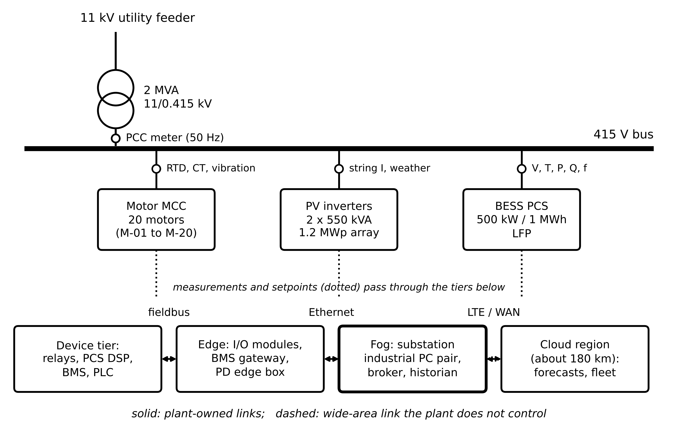
Figure 2.1. Plant P-1 deployment topology. Upper part: single-line diagram with measurement points (small circles). Lower part: the four computing tiers and the links between them. The wide-area link to the cloud is the only link the plant does not own.
Table 2.1. Plant P-1 asset and sensing inventory (design values for the reference plant, not field measurements)
Asset group | Quantity measured | Channels | Rate | Bits per sample
Motors (20) | Winding RTD temperature | 20 | 1 per 30 s | 16
Motors (20) | Phase-current RMS | 60 | 1 Hz | 16
Motors (4 critical) | Vibration, 10 s burst every 10 min | 4 | 10.24 kHz | 16
PV array | String current | 80 | 1 Hz | 16
PV array | Irradiance, module and ambient temperature, wind | 4 | 1 Hz | 16
BESS | Module voltage | 240 | 1 Hz | 16
BESS | Module temperature | 60 | 0.1 Hz | 16
BESS PCS | P, Q, V, I, f, operating state | 20 | 10 Hz | 32
PCC | Power-quality meter (per-cycle values) | 16 | 50 Hz | 32

Scaling from one motor to this plant is not a matter of copying the M-07 PC twenty-two times. Five questions appear that the single motor never raised, and each has a numerical answer. Where does each computation run: in a protection relay, on an industrial PC in the substation room, or in a cloud region about 180 km away? How long may a PCC measurement take to reach the BESS setpoint before a frequency-response service is late? How many gigabytes a year does the plant produce, and how many survive the retention policy? If the internet link fails for ninety seconds, which functions stop, which degrade and which do not notice? And when a sensor vendor pushes a firmware update that changes a register scale, what stops every twin in the plant from silently using wrong numbers?
An architecture is the set of decisions that answers these questions in advance. It names the components, says which one is responsible for each function, fixes the interfaces between them, and states what happens when any of them fails. Without it, responsibilities and failure behaviour are decided by accident during the first outage. With it, they can be reviewed, tested and audited, and that is the engineering reason for the rest of the chapter.

2.1.1 Three levels of architecture description
Three different documents are all called ‘the architecture’, and confusing them causes most of the misunderstandings in tenders and papers. Table 2.2 separates them.
Table 2.2. Three levels of architecture description, illustrated on Plant P-1
Level | Answers | Example for Plant P-1 | Changes when
Reference architecture | What kinds of component and concern exist, in a vocabulary shared across projects | The eight-layer stack with four planes (Section 2.2); ISO/IEC 30188 views | Rarely; it is a standard or a book convention
Implementation architecture | Which functions, interfaces, data contracts and models this system has, and who is responsible for each | Selection matrix of Section 2.13; message schema p1.motor.thermal/2.1.0; command gateway with limits | When functions or interfaces change
Deployment topology | Which physical computer, network segment and site hosts each function | Figure 2.1: fog industrial PC pair in the substation room; LTE router; cloud region | When hardware is replaced or moved

A reference architecture is reused across projects and makes no promise about timing. An implementation architecture fixes the contracts that timing, availability and validation are tested against. A deployment topology is where the numbers of this chapter (milliseconds, gigabytes, hours of downtime) are finally decided, because those numbers depend on physical distances, link rates and the specific computers. A good specification states all three and keeps them consistent.
Architecture descriptions themselves are standardized. ISO/IEC/IEEE 42010:2022 defines an architecture description in terms of the stakeholders of a system, their concerns, and the viewpoints and views that address those concerns [1]. The three levels of Table 2.2 can each be written in that form, and a reference architecture is in effect a reusable set of viewpoints.
What the digital twin adds
Synchronized: nothing new yet; the twin of Chapter 1 is now one of many.
Estimated or updated: the inventory of assets, channels and computers (Table 2.1).
Uncertainty carried: none yet; the five questions identify where it will enter.
Decision enabled: which level of architecture document a design review must ask for.
Validated by: consistency between reference, implementation and deployment descriptions.

2.2 The eight-layer stack, cross-cutting planes and published reference architectures

2.2.1 From five dimensions to eight layers
Tao et al. describe a twin by five dimensions: physical entity, virtual entity, data, connections and services [2]. That description decides whether something is a twin (Chapter 1, Section 1.3). It is too coarse for deciding what to buy. The single ‘connections’ dimension covers a four-wire RTD lead, a switched Ethernet segment and a cellular backhaul to a cloud region; each has a different delay, failure mode and owner. This book therefore uses an eight-layer stack, split where responsibility, technology and failure behaviour change in electrical plants. The layers refine the five dimensions; they do not compete with them (Table 2.3).
Table 2.3. The eight-layer stack against the five-dimension model
Layer | Primary concern | Five-dimension element | Developed in
1 Physical asset | Plant and its physics | Physical entity | Chapters 7 to 11
2 Sensing and acquisition | Transducer, conditioning, sampling, timestamp | Physical entity, data | Chapter 3
3 Connectivity | Links, protocols, time distribution | Connections | Chapter 3; Section 2.3
4 Edge and fog computing | Deterministic local processing | Connections, virtual entity | Section 2.4
5 Data management | Ingestion, storage, retention, schemas | Data | Sections 2.5, 2.6
6 Model and estimator | Physics, data-driven and hybrid models, synchronization | Virtual entity | Chapters 4 to 6
7 Intelligence and analytics | Diagnosis, prognosis, optimization | Services | Chapters 6, 12, 13
8 Application and actuation | Operator interface, alarms, work orders, setpoints | Services | Chapter 13; throughout

Follow one measurement through the stack. The Pt100 RTD in the winding of M-07 (Layer 1) is read by a 16-bit input module that stamps the sample with time from a Precision Time Protocol (PTP) clock (Layer 2). The module publishes it over plant Ethernet as a Message Queuing Telemetry Transport (MQTT) message to a broker on the substation industrial PC (Layers 3 and 4). A historian stores it (Layer 5). The thermal model and observer of Chapter 1 update the twin state (Layer 6). A 30-minute forecast is compared with the 120 °C threshold (Layer 7). When it is crossed, the operator panel shows an advisory and a work order opens (Layer 8). The motor's own thermal overload relay sits outside the chain and protects the motor whatever the twin does.

2.2.2 Cross-cutting planes
Some concerns do not belong to any one layer. Forcing them into a layer hides them, so the book adds four planes that cross all eight layers (Figure 2.2). The data plane carries measurements, states and history upward; it is high volume and tolerates batching and loss, provided every sample is timestamped. The control plane carries setpoints, commands and limits downward; it is low volume, must never be batched, needs a bounded delay and must be checked by limits enforced in the receiving device. The management and configuration plane deploys software and models, records versions, monitors health and pushes configuration; Sections 2.6 and 2.7 develop it. The security and trust plane handles identity, keys, zones, conduits and audit (Section 2.11, Chapter 14).
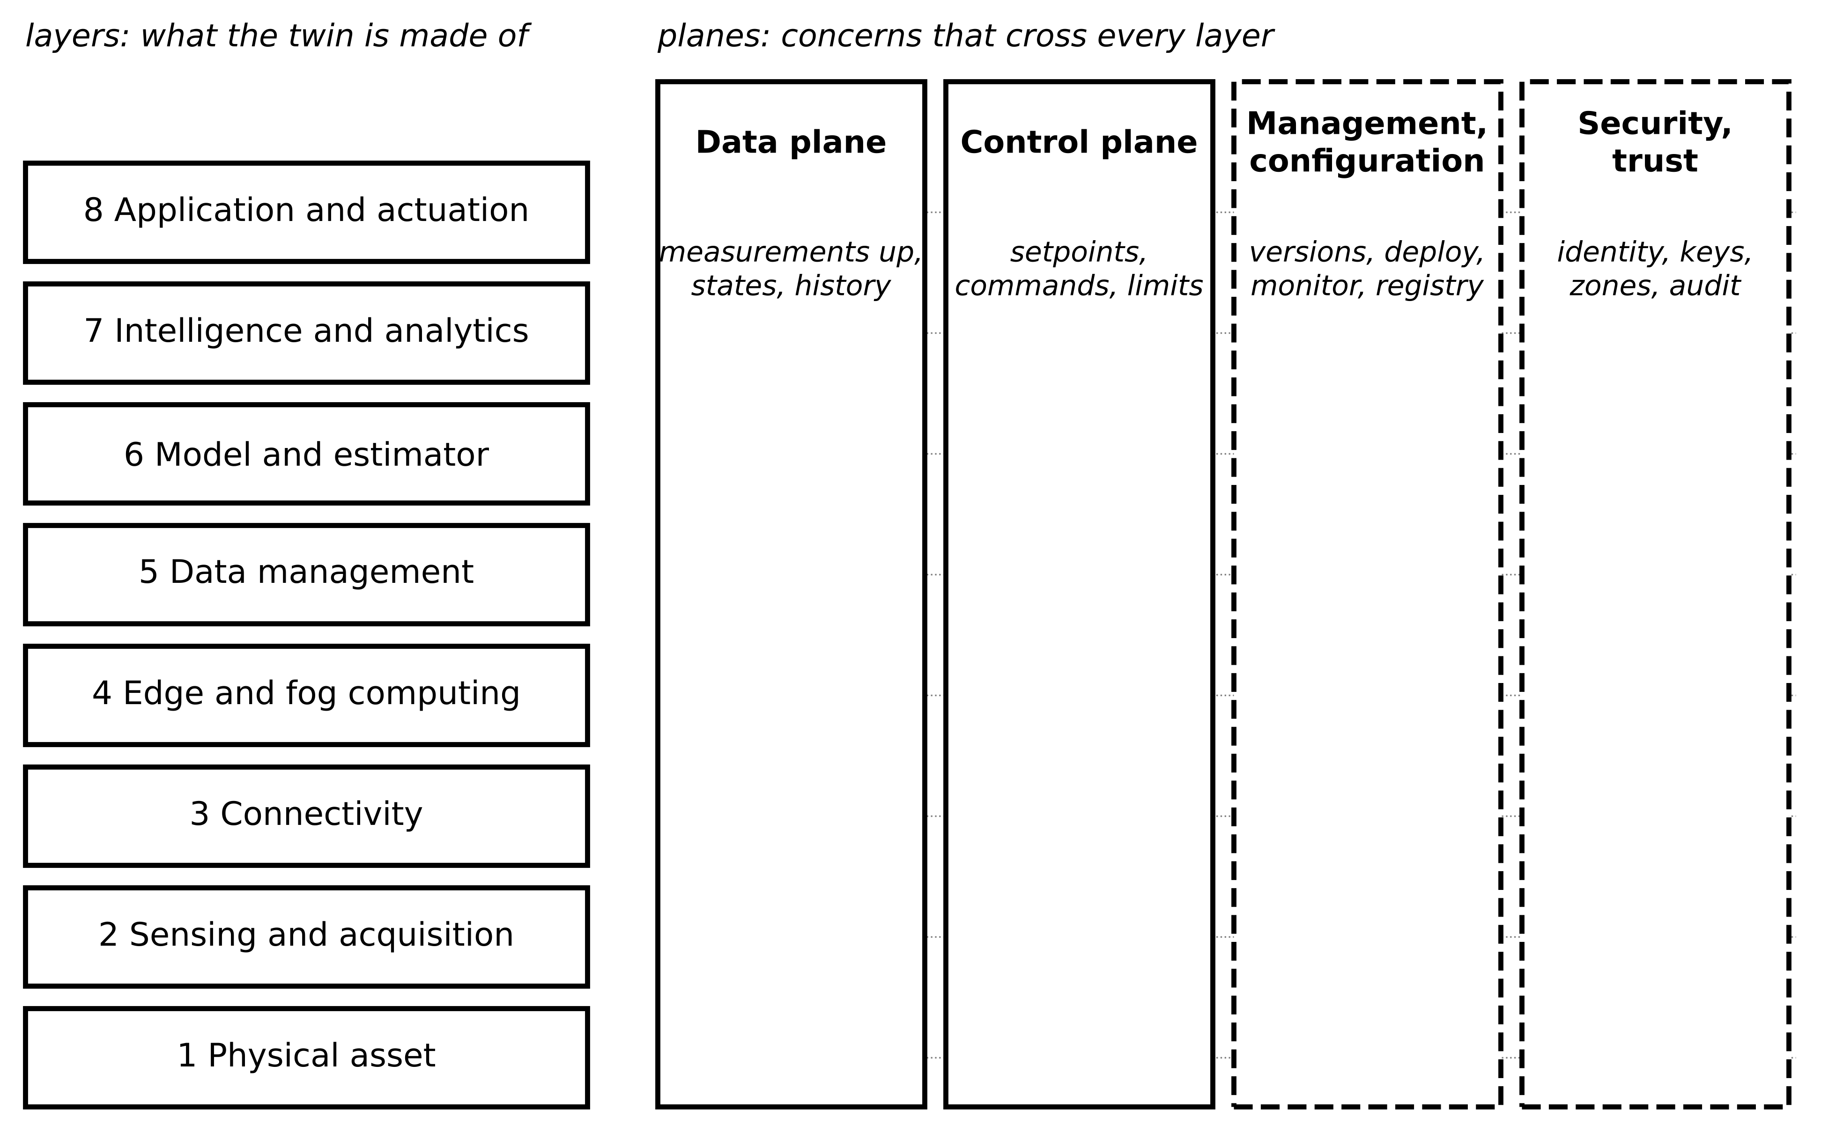
Figure 2.2. The eight-layer stack used throughout the book (left) and four cross-cutting planes (right). The data plane flows up and the control plane flows down through every layer; management and security concerns exist at every layer and are drawn dashed because they act on the system rather than carry its signals.
Separating the data plane from the control plane is the single most useful architectural decision for an energy twin (Figure 2.3). The two have opposite requirements. Data-plane traffic is optimized for throughput: batch it, compress it, buffer it through outages. Control-plane traffic is optimized for bounded delay and authority: send each command alone, give it an expiry time, authenticate it, and let the device reject anything outside its limits. A design that sends setpoints through the historian, or alarms through a batched telemetry stream, has merged the planes and inherited the worst property of each.
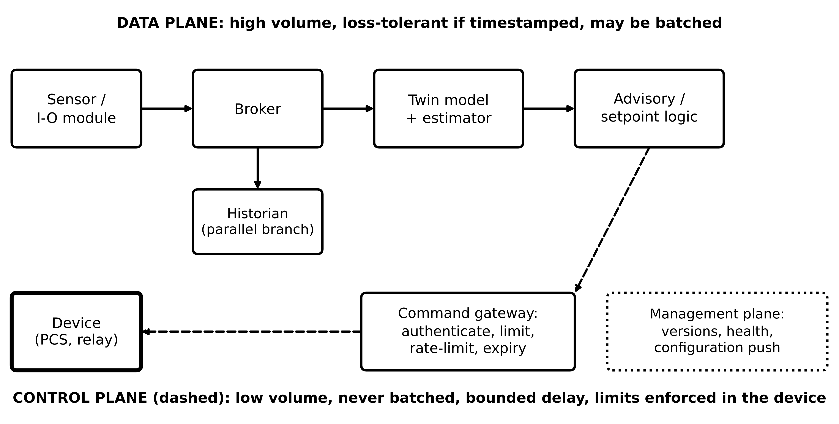
Figure 2.3. Data plane against control plane for Plant P-1. Measurements flow from the broker to the model, with the historian on a parallel branch so that storage never sits in series with a real-time path; setpoints leave through a command gateway that authenticates, limits, rate-limits and stamps an expiry time before reaching the device. The management plane acts on both.
Table 2.4. Responsibilities of the four cross-cutting planes
Plane | Carries or does | Key requirement | Typical failure if neglected
Data | measurements, states, history, features | throughput, timestamps, quality flags | residuals built from misaligned or stale data
Control | setpoints, commands, mode changes | bounded delay, authority, expiry, device-side limits | stale setpoint applied after an outage
Management and configuration | deployment, versions, health, configuration | traceability, rollback, change review | firmware change silently alters a register scale
Security and trust | identity, keys, zones, conduits, audit | authenticated paths; timed security cost | unauthenticated setpoint path; untimed encryption breaks a deadline

2.2.3 The stack as a graph
For timing and availability the stack is treated as a directed graph. Each component is a node and each data path an ordered sequence of nodes $π=(n_{1},n_{2},…,n_{K})$ from sensor to consumer. If a function needs every node of its path, and if delays add and failures are independent, then
$T_{π}=\sum_{i=1}^{K}{T_{n_{i}}}, A_{π}=∏_{i=1}^{K}A_{n_{i}}$ (2.1)
where $T_{n_{i}}$ is the delay contributed by node or link $n_{i}$ (s) and $A_{n_{i}}$ its availability (the long-run fraction of time it works, dimensionless). Sections 2.3 and 2.9 refine both: delays are random with long tails, and nodes share failure causes. The structural rule is visible already: a long path through many layers is slower and less available than a short one, whatever the technology. Two limiting cases help. If one node has availability far below the others, it sets $A_{π}$ almost alone. If one stage has a delay far above the others, it sets $T_{π}$ almost alone, and improving the rest is wasted effort.
Example 2.1 (Level A) Latency and availability of the M-07 advisory path
Given. The M-07 advisory path has six nodes: input module (0.5 s acquisition and averaging, $A=0.9995$), plant switch (2 ms, 0.9998), broker (50 ms, 0.9999), historian write (10 ms, 0.999), twin computation (20 ms, 0.9995) and advisory delivery to the supervisor terminal (1.0 s, 0.9998).
Find. (a) $T_{π}$ and $A_{π}$ from (2.1). (b) Annual downtime. (c) The node that contributes most to each, and what removing the historian from the path would change.
Solution. (a) $T_{π}=0.5+0.002+0.05+0.01+0.02+1.0=1.582$ s. $A_{π}=0.9995×0.9998×0.9999×0.999×0.9995×0.9998=0.99750$. (b) $(1-0.99750)×8760=21.9$ h per year. (c) Delivery (1.0 s) and acquisition (0.5 s) set the delay; the historian ($A=0.999$, 8.76 h alone) is the largest contributor to downtime. If the twin reads the broker directly and the historian stores in parallel, the path loses one series node: $A_{π}$ rises to 0.99850, downtime 13.1 h.
Interpretation. The 1.58 s total matches the latency budget of Chapter 1, Section 1.6.4, which was built from the same stages. Putting a storage component in series with a real-time path is a common and avoidable error: storage belongs on a parallel branch of the data plane.

2.2.4 Published reference architectures and how they map
Several reference architectures predate this book's stack, and readers will meet them in tenders. They differ in origin, in what they decompose and in whether they are normative. The Smart Grid Architecture Model (SGAM) arranges a system on five interoperability layers (component, communication, information, function, business), the energy-conversion domains and the automation zones [3]. The Reference Architecture Model Industrie 4.0 (RAMI 4.0) has a similar three-axis form for manufacturing and is the home of the Asset Administration Shell [4]. ISO 23247-2 specifies an entity-based reference architecture for manufacturing twins, with an observable manufacturing element, a data-collection and device-control entity, a core entity and a user entity [5], [6]. The Industrial Internet Reference Architecture (IIRA) uses business, usage, functional and implementation viewpoints [7].
Three newer documents matter for energy twins. ISO/IEC 30188:2026, published in July 2026, specifies a general reference architecture for a digital twin system, defining its fundamentals through architecture views [8]; the names and content of those views must be taken from the licensed text. IEEE 3835-2025 defines a twin technology framework for integrated energy systems [9]. ITU-T Recommendation Y.4517 (06/2026) addresses the architecture of a digital twin system in the power grid, with continuous synchronization, multi-source data, model management and standardized interfaces as its published scope [10]. Research work bridges concept and deployment: Fett et al. map reference models onto cloud, edge and cloud-edge deployments [11], Somma et al. derive the TwinArch reference architecture from a literature synthesis [12], Thwe et al. review power-system twins with attention to data federation [13], and Zomerdijk et al. propose a power-system-specific definition with a standard ecosystem architecture developed with system operators and market parties [14]. For abstracts used here, only public scope statements are relied on; clause-level conformance must be read from the licensed texts.
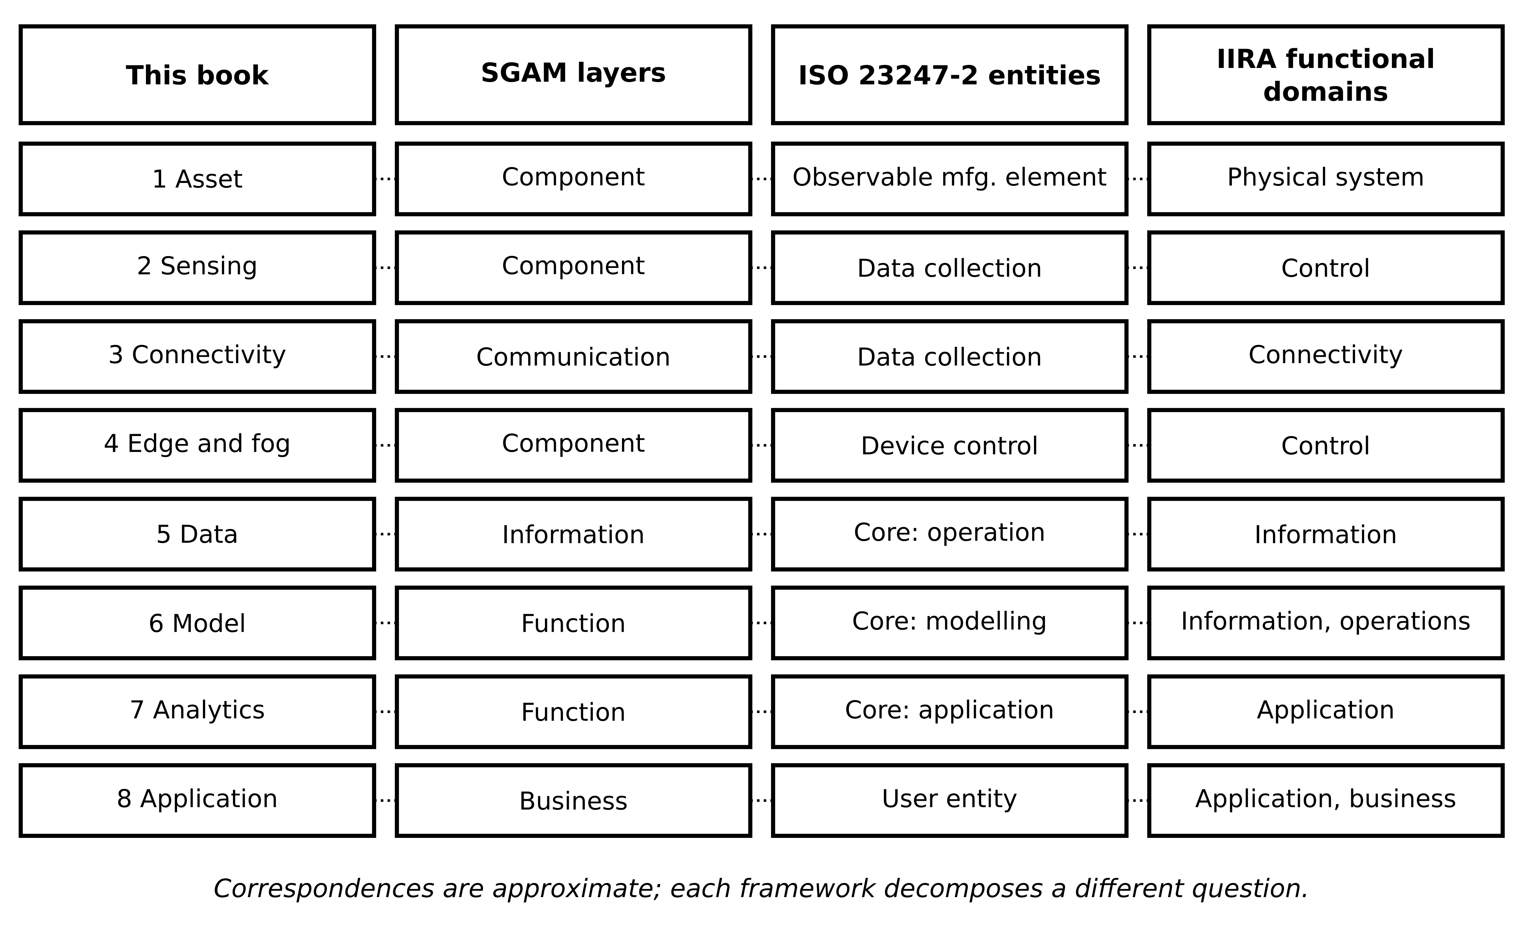
Figure 2.4. Approximate mapping of the book's eight layers onto SGAM interoperability layers, ISO 23247-2 functional entities and the functional domains of the Industrial Internet Reference Architecture. Each framework answers a different question, so several layers map onto one element and the correspondence is not one to one.
Table 2.5. Reference architectures compared with the book's eight-layer stack and four planes
Framework | Status | Decomposes | Maps to stack | Covers planes? | Strength for energy twins | Limitation
SGAM [3] | informative framework | interoperability layers x domains x zones | 1, 3, 5, 6-7, 8 | data; security as zones | shared grid vocabulary; places IEC 61850 and CIM | no timing, execution or synchronization
RAMI 4.0 [4] | pre-standard (DIN SPEC 91345) | layers x life cycle x hierarchy | 1-8 with life-cycle axis | management via life cycle | home of AAS; life-cycle axis | manufacturing hierarchy, no grid domains
ISO 23247-2 [5] | International Standard | functional entities | 1-2, 4-8 | data, control | clean split of collection, core and user | manufacturing scope
IIRA [7] | consortium framework | four viewpoints | all (implementation view) | all, generically | three-tier edge, platform, enterprise patterns | generic, not twin-specific
ISO/IEC 30188 [8] | International Standard, 2026 | architecture viewpoints | all | through viewpoints | first generic twin reference architecture standard | new; field evidence still to come
IEEE 3835 [9] | IEEE Standard, 2025 | framework for integrated energy systems | all | framework level | energy-specific scope | adoption evidence limited
ITU-T Y.4517 [10] | ITU-T Recommendation, 2026 | power-grid twin system | all | synchronization, model management | grid-specific | new; field evidence still to come

No single stack is universal. SGAM decomposes interoperability, ISO 23247 decomposes functions, ISO/IEC 30188 decomposes stakeholder concerns, and this book's stack decomposes failure and responsibility borders. A project should choose one as its working frame and keep the mapping to the others in a table like Table 2.5. None of these frameworks says how many milliseconds a message may take or how available a path must be. That is not a defect: reference architectures fix vocabulary and responsibilities, and the numbers depend on the function. The rest of the chapter supplies the numbers.
What the digital twin adds
Synchronized: each layer and plane has a named owner and interface.
Estimated or updated: path delay and availability by (2.1).
Uncertainty carried: which framework correspondences are approximate (Figure 2.4).
Decision enabled: whether a function's path is too long, and where storage and commands belong.
Validated by: the mapping table and a reviewed layer-by-layer fallback list (Section 2.9).

2.3 Timing: latency, queueing, clocks and packet age

2.3.1 Anatomy of end-to-end delay
Consider a twin function that reads a measurement, computes and acts: the BESS of Plant P-1 must raise its output when the PCC frequency falls, using a setpoint computed by a twin on the fog computer. The function has a deadline $T_{dl}$, the longest time allowed from the physical event to the effect at the asset. Every stage between the two consumes part of it (Figure 2.5). The end-to-end delay of one pass $k$ is the sum of its stages:
$T_{e2e,k}=T_{age,k}+T_{acq,k}+T_{ser,k}+T_{prop}+T_{q,k}+T_{sec,k}+T_{proc,k}+T_{act,k}$ (2.2)
where $T_{age}$ is the time from the physical event to the next sampling instant (between 0 and the sampling period $T_{s}$), $T_{acq}$ the acquisition and filtering delay in the measuring device, $T_{ser}$ the serialization time to clock the message onto each link, $T_{prop}$ the propagation time, $T_{q}$ the waiting time in queues of switches, brokers and servers, $T_{sec}$ the time for authentication and encryption, $T_{proc}$ the execution time of model and decision logic, and $T_{act}$ the time from command arrival to physical effect, including any wait for the actuator's own control cycle. All terms are in seconds and positive; subscript $k$ marks terms that vary from pass to pass, while $T_{prop}$ is fixed by geometry. The sum assumes the stages run in sequence; parallel branches contribute their slowest member.
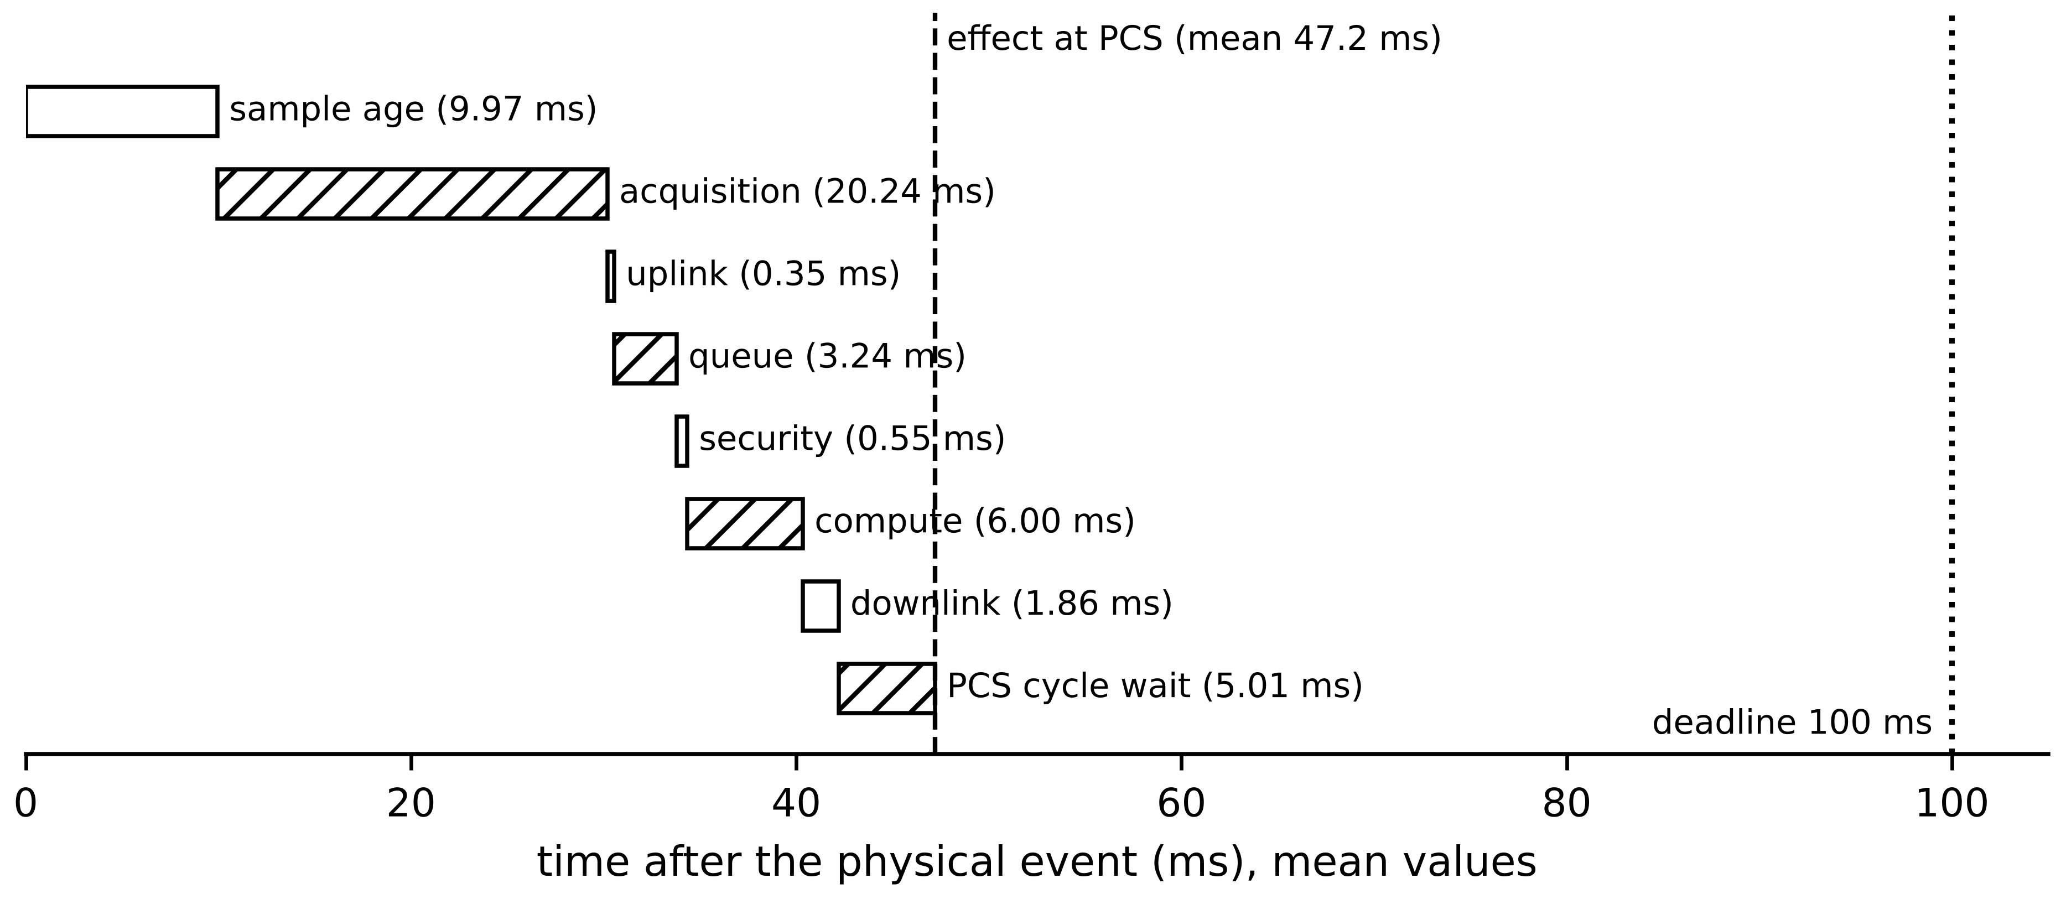
Figure 2.5. Latency decomposition of one pass of the BESS frequency-response function, mean values from the timing campaign of Section 2.3.5. The sample-age term exists because the event can fall anywhere in a sampling interval; the PCS wait exists because the converter accepts setpoints only at its own control cycle.
Propagation follows from signal speed. In optical fibre the group index is about $n_{g}≈1.47$, so
$T_{prop}=\frac{d}{v}, v=\frac{c}{n_{g}}≈\frac{3.0×{10}^{8}}{1.47}≈2.0×{10}^{8} m/s$ (2.3)
where $d$ is the route length (m, not the straight-line distance) and $c$ the speed of light: about 5 µs per kilometre. Serialization is the time to clock $L$ bits onto a link of rate $B$, and an Ethernet frame adds 38 bytes of header, check sequence, preamble and gap to a payload padded to at least 46 bytes:
$T_{ser}=\frac{L_{pay}+L_{oh}}{B}, L_{frame}=8\left[max(P,46)+38\right] bits$ (2.4)
where $L_{pay}$ and $L_{oh}$ are payload and overhead bits, $B$ the bit rate (bit/s) and $P$ the payload in bytes; even a 2-byte sample costs 672 bit times. A store-and-forward switch receives a whole frame before forwarding it, so over $H$ links serialization and propagation add, with $T_{sw,h}$ the internal switching time of hop $h$:
$T_{path}=\sum_{h=1}^{H}{\left(\frac{L_{frame}}{B_{h}}+\frac{d_{h}}{v}+T_{sw,h}\right)}, ρ_{link}=\frac{1}{B}\sum_{i}{λ_{i}}L_{i}$ (2.5)
where $ρ_{link}$ is the link utilization, $λ_{i}$ the message rate (1/s) and $L_{i}$ the frame length (bits) of stream $i$. If the event is equally likely anywhere in a sampling interval, the sample age is uniform on $[0,T_{s}]$, with mean and variance
$𝔼\left[T_{age}\right]=\frac{T_{s}}{2}, var\left(T_{age}\right)=\frac{T_{s}^{2}}{12}$ (2.6)
so slow sampling adds delay and jitter before any electronics are involved: at 20 ms reporting this term alone contributes a mean of 10 ms and a standard deviation of 5.8 ms.

2.3.2 Mean, percentile and worst case
A function meets its deadline on pass $k$ when $T_{e2e,k}≤T_{dl}$. Because the terms vary, the test that matters is never on the mean. Three different quantities are used, and specifications often confuse them. The mean is a capacity-planning figure. The percentile $T_{e2e}^{(q)}$ is the value not exceeded in a fraction $q$ of passes, estimated from a measurement campaign; it is the right test for soft real-time functions such as a frequency-response service with a contractual miss allowance. The worst-case latency is an upper bound proved by analysis: worst-case execution time (WCET) of every computation plus network-calculus bounds for every network stage [15]. A measured maximum is evidence, not a bound, because a rarer event may not yet have occurred. The design requirement is written with an explicit margin:
$T_{e2e}^{(q)}+mT_{dl}≤T_{dl} (soft), \sum_{i}{C_{i}^{WC}}+\sum_{h}{D_{h}^{max}}≤(1-m) T_{dl} (hard)$ (2.7)
where $m$ is the margin fraction (typically 0.1 to 0.2, always stated), $C_{i}^{WC}$ the WCET of computing stage $i$ and $D_{h}^{max}$ the bounded delay of network stage $h$. For independent stages the variances in (2.2) add, so the jitter of the whole path, as a standard deviation, is $J_{e2e}=\sqrt{\sum_{i}{J_{i}^{2}}}$; correlated stages, such as two queues loaded by the same disturbance, add more.
[Advanced] Analytical network bounds come from network calculus. If a stream is shaped so that in any interval of length $t$ it sends at most $α(t)=b+rt$ bits (a token bucket with burst $b$ and rate $r$), and a switch port guarantees at least $β(t)=R (t-T)^{+}$ bits of service after a latency $T$, the delay through that port is bounded by
$D_{max}≤T+\frac{b}{R}, r≤R$ (2.8)
where $(x)^{+}=max(x,0)$ and $R$ is the guaranteed rate (bit/s). A 12 000-bit burst through a port guaranteeing 10 Mbit/s after 50 µs cannot wait more than 1.25 ms, however the other traffic behaves. This is the mathematics behind Time-Sensitive Networking (Chapter 3) [16].
Example 2.2 (Level B) [Advanced] A bounded delay across three switches
Given. The frequency-response stream is shaped to a burst of two 1000-byte frames, $b=16 000$ bits, at a sustained rate far below 20 Mbit/s. It crosses three switches in series, each guaranteeing $R=20$ Mbit/s to this stream after a latency $T=20$ µs.
Find. (a) The bound per switch from (2.8). (b) The sum of three per-switch bounds. (c) The end-to-end bound when the three service curves are first combined into one with rate $minR$ and latency $\sum{T}$.
Solution. (a) $20 μs+16 000/(20×{10}^{6}) s=20+800=820$ µs. (b) $3×0.82=2.46$ ms. (c) Concatenation gives $β(t)=20×{10}^{6}(t-60 μs)^{+}$, so $D_{max}≤60+800=860$ µs.
Interpretation. The burst has to be paid for only once along a path, not once per hop, so adding hop-by-hop bounds overstates the delay almost threefold. This ‘pay bursts only once’ property is why an end-to-end analysis gives much tighter guarantees than summing switch data sheets.
Example 2.3 (Level A) Mean-value budget for a switchgear partial-discharge alarm, edge against cloud
Given. The 11 kV switchgear carries a partial-discharge (PD) sensor whose alarm must reach the annunciator within $T_{dl}=50$ ms. Cloud path: $T_{acq}=2$ ms; uplink message 12 000 bits at 10 Mbit/s; fibre route 180 km each way; mean queueing 4 ms; $T_{proc}=8$ ms; 800-bit alarm back over the same route at 10 Mbit/s; $T_{act}=3$ ms. Edge path (computer inside the switchgear): $T_{acq}=2$ ms, $T_{ser}=0.3$ ms, $T_{proc}=22$ ms, $T_{act}=3$ ms, negligible propagation and queueing.
Find. (a) Mean latency of each path. (b) Whether each meets 50 ms on the mean. (c) The effect of a 350 km route. (d) What the mean-value result does not tell.
Solution. (a) Cloud, with (2.3) and (2.4): $T_{prop}=180×{10}^{3}/(2.0×{10}^{8})=0.90$ ms each way; uplink $T_{ser}=12 000/{10}^{7}=1.20$ ms; downlink $800/{10}^{7}=0.08$ ms. Total $2+0.90+1.20+4+8+0.90+0.08+3=20.08$ ms. Edge: $2+0.3+22+3=27.3$ ms. (b) Both pass on the mean. (c) At 350 km, $T_{prop}=1.75$ ms each way and the cloud total becomes 21.78 ms; distance is not binding here. (d) The 4 ms queueing figure is a mean, and Section 2.3.3 shows queueing has a long tail; Section 2.9 shows that the cloud path's availability, not its mean latency, decides the placement.
Interpretation. A mean-value budget eliminates impossible placements quickly but cannot approve one for a function with a hard deadline. The return path is easily forgotten; here it adds about 1 ms.

2.3.3 Queueing: where the tail comes from
Any shared resource (switch port, broker, database writer, processor core) forms a queue when requests arrive faster than it can serve them for a while. The simplest model with the right behaviour is the M/M/1 queue: Poisson arrivals at mean rate $λ$, exponentially distributed service times with mean $1/μ$, one server. The number in the system, $n$, rises at rate $λ$ and falls at rate $μ$. In steady state the probability flow between states $n$ and $n+1$ must balance:
$ρ=\frac{λ}{μ}<1, λP_{n}=μP_{n+1} ⇒ P_{n}=(1-ρ)ρ^{ n}, N=\sum_{n=0}^{∞}{n}P_{n}=\frac{ρ}{1-ρ}$ (2.9)
where $ρ$ is the utilization, $P_{n}$ the probability of $n$ requests present and $N$ the mean number present; the factor $(1-ρ)$ normalizes the geometric distribution, which converges only for $ρ<1$. Little's law, $N=λW$, holds for any stable queue [17] and converts $N$ into the mean time in the system $W$; subtracting the mean service time leaves the mean wait $W_{q}$:
$W=\frac{N}{λ}=\frac{1}{μ-λ}, W_{q}=W-\frac{1}{μ}=\frac{ρ}{μ-λ}$ (2.10)
As $ρ→1$ both grow without bound because $μ-λ$ vanishes (Figure 2.6). Means are not what a deadline tests. For M/M/1 with first-come, first-served service the sojourn time is exponential with rate $μ-λ$, so its tail and $q$-quantile are
$P\left(T_{soj}>t\right)=e^{-(μ-λ)t}, T_{soj}^{(q)}=\frac{ln\left[1/(1-q)\right]}{μ-λ}$ (2.11)
The 99th percentile is $ln100=4.6$ times the mean and the 99.9th is 6.9 times: a queue that looks harmless on average carries a long tail as a matter of mathematics. Two refinements matter in practice. Deterministic service (every message takes exactly $1/μ$) halves the wait, by the Pollaczek-Khinchine formula. Bursty traffic increases it; Kingman's heavy-traffic approximation for general arrivals and service keeps the $ρ/(1-ρ)$ growth and scales it by variability [18]:
$W_{q}^{M/D/1}=\frac{ρ}{2μ(1-ρ)}, W_{q}≈\frac{ρ}{1-ρ}·\frac{c_{a}^{2}+c_{s}^{2}}{2}·\frac{1}{μ}$ (2.12)
where $c_{a}$ and $c_{s}$ are the coefficients of variation (standard deviation over mean) of inter-arrival and service times. For Poisson arrivals and exponential service $c_{a}^{2}=c_{s}^{2}=1$ and Kingman's form returns (2.10) exactly. Real industrial traffic is rarely Poisson: polling cycles synchronize, event storms arrive together after a disturbance, and uploads are bursty.
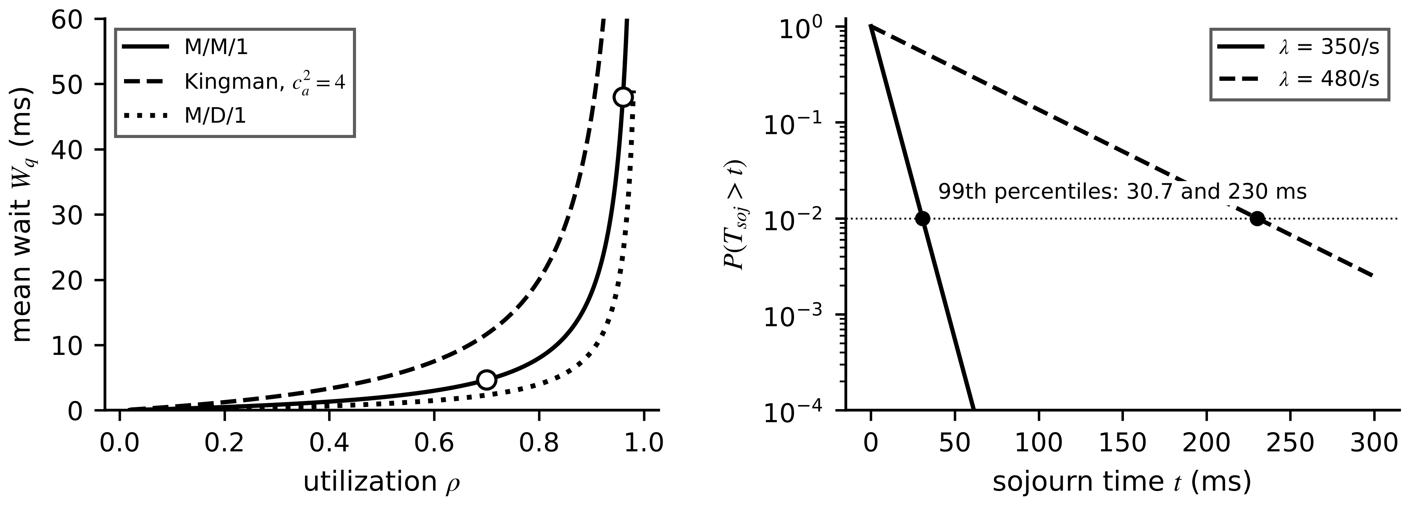
Figure 2.6. Left: mean wait against utilization for a server with $μ=500$ requests/s, from M/M/1, Kingman with $c_{a}^{2}=4$, and M/D/1; markers are the operating points of Example 2.4. Right: sojourn-time tail at the two loads of that example, with the 99th percentiles marked.
Example 2.4 (Level B) Queueing at the fog message broker
Given. The broker on the Plant P-1 fog PC serves $μ=500$ messages/s. Normal traffic is $λ=350$ messages/s; during a disturbance, event reports push it to $λ=480$.
Find. (a) $W$, $W_{q}$ and the 99th-percentile sojourn at both loads. (b) $W_{q}$ at $λ=350$ with bursty arrivals, $c_{a}^{2}=4$, exponential service, and with deterministic service.
Solution. (a) At 350/s: $ρ=0.70$, $W=1/150=6.67$ ms, $W_{q}=0.70/150=4.67$ ms, $T^{(0.99)}=ln100/150=30.7$ ms. At 480/s: $ρ=0.96$, $W=50$ ms, $W_{q}=48$ ms, $T^{(0.99)}=230$ ms. A 37 % rise in load multiplies the wait by ten. (b) Kingman: $(0.7/0.3)×(4+1)/2×2$ ms $=11.7$ ms, 2.5 times the Poisson value; M/D/1: 2.33 ms.
Interpretation. Brokers and historians are loaded hardest exactly when the plant is disturbed and the twin is most needed. A practical rule for resources on time-critical paths is to keep normal-operation utilization below about 0.5, measure $c_{a}^{2}$ during recorded disturbances, and give control-plane topics their own pre-allocated queue.

2.3.4 Clocks, timestamps and packet age
Every residual compares values that must refer to the same instant, so two clock quantities matter. Timestamp error is the difference between the attached time and the true sampling instant. A sinusoid $cos(ω_{0}t)$ sampled at $t+δt$ equals $cos(ω_{0}t+ω_{0}δt)$, a rotation by $ω_{0}δt$, so in degrees
$δφ={360}^{∘}f_{0} δt, x\left(T_{sync}\right)=y T_{sync} ⇒ T_{sync}≤\frac{ε_{t}}{|y|}$ (2.13)
where $f_{0}$ is the fundamental frequency (Hz) and $δt$ the timestamp error (s). At 50 Hz an NTP error of 5 ms gives 90°, which makes phasor comparison meaningless, whereas PTP to IEC/IEEE 61588 at 1 µs gives 0.018° [19]. Between corrections a clock drifts at its fractional frequency offset $y$; $x$ is the accumulated time error and $ε_{t}$ the error budget, so a 10 ppm crystal must be corrected every 0.1 s to hold 1 µs. Slow thermal signals tolerate milliseconds; phasor, protection and converter functions do not. Chapter 3 treats clock distribution.
Example 2.5 (Level A) A clock budget for phasors and for thermal twins
Given. A phasor comparison at 50 Hz may tolerate 0.1° of phase error from timestamps. The local oscillator has a fractional frequency offset of 20 ppm. Separately, the M-07 winding heats at most at 0.044 K/s and its clock error is 5 ms.
Find. (a) The timestamp error budget from (2.13). (b) The longest interval between clock corrections that keeps drift within that budget. (c) The temperature error caused by the 5 ms clock error in the thermal twin.
Solution. (a) $δt≤0.1/(360×50)=5.56$ µs. (b) $T_{sync}≤5.56×{10}^{-6}/(20×{10}^{-6})=0.28$ s, so the clock must be corrected several times a second, which PTP does. (c) $0.044×0.005=0.0002$ K, utterly negligible against 0.3 K RTD noise.
Interpretation. The same 5 ms that ruins a phasor comparison is irrelevant to a thermal twin. Clock requirements belong to functions, not to plants; one plant can run PTP for its PCC meter and plain NTP for its motor fleet.
Packet age, the age of information of Chapter 1 (Section 1.6.4), is how old the newest available sample is when it is used: $Δ(t)=t-u(t)$, with $u(t)$ the sampling instant of the newest sample that has arrived [20]. With periodic sampling and a delivery delay that varies between $D_{min}$ and $D_{max}$, the age is a sawtooth (Figure 2.7); with constant delay $D$ its time average is $D+T_{s}/2$, and in general
$Δ_{max}≤T_{s}+D_{max}$ (2.14)
because a value that arrived early may have to serve until the next one, which may be as late as $D_{max}$. Packet age, not network latency alone, is what a controller or twin experiences: a fast network with slow sampling still delivers old data.
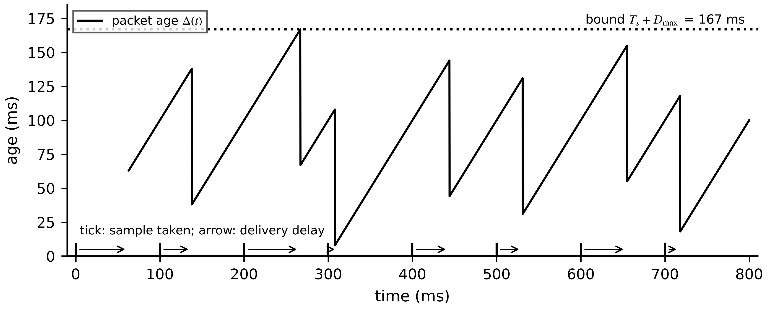
Figure 2.7. Packet age with 100 ms sampling and delivery delays varying between 8 and 67 ms. Each arrival resets the age $Δ\left(t\right)$ to the delay of that sample; the age never exceeds $T_{s}+D_{max}=167$ ms.
Table 2.6. Timing quantities a specification should state separately
Quantity | Definition | How obtained | Used for
Mean latency | average of $T_{e2e,k}$ | campaign average | capacity planning, screening
Percentile $T^{(q)}$ | value not exceeded in a fraction $q$ of passes | empirical quantile with stated sample size | soft real-time acceptance
Worst-case latency | proved upper bound | WCET analysis plus network calculus; a measured maximum is only a lower estimate | protection and safety functions
Jitter | spread, here $T^{(0.99)}-T^{(0.50)}$ | campaign | controller tuning, buffer sizing
Packet age $Δ(t)$ | age of newest sample at use | timestamps at source and at use | estimator and controller design
Deadline-miss ratio | fraction of passes with $T_{e2e,k}>T_{dl}$ | count over campaign | service-level acceptance
Consecutive misses | longest run of misses | campaign | fallback trigger design

2.3.5 A timing campaign for the BESS frequency-response path (Level C)
Mean budgets cannot approve a function with a deadline. The accepted practice is a timing campaign: timestamp every stage of every pass, collect a large sample under realistic load including disturbances, and report the statistics of Table 2.6. The campaign below is synthetic: stage distributions resemble typical behaviour of the components named, and the record is generated with a fixed seed so every number can be reproduced. It is not a measurement of a particular product.
Function and path. When the PCC frequency falls below a trigger, the fog twin computes a BESS power setpoint and writes it to the PCS. The illustrative contractual deadline from the frequency sample to the setpoint taking effect in the PCS is $T_{dl}=100$ ms; the PCS power ramp after that is a separate contractual term. Stages: sample age uniform on 0 to 20 ms; one-cycle measurement window 20 ms plus a half-normal jitter of 0.3 ms standard deviation, capped at 1 ms; uplink log-normal with median 0.33 ms (shape 0.35); broker queueing exponential with mean 3 ms plus, in 0.4 % of passes, a stall uniform on 40 to 90 ms (a garbage-collection pause of the broker runtime); transport security uniform on 0.3 to 0.8 ms; estimator and setpoint gamma with shape 6 and scale 1 ms; downlink and Modbus write 1.2 ms plus gamma (shape 2, scale 0.33 ms); and a wait for the PCS 10 ms control cycle, uniform on 0 to 10 ms. The campaign has 100 000 passes, about 33 minutes at 50 Hz, generated with NumPy default_rng(2026).
Table 2.7. Synthetic timing campaign for the BESS frequency-response path (100 000 passes, all values in ms)
Stage | Mean | 99th percentile | 99.9th percentile | Maximum
Sample age (20 ms reporting) | 9.97 | 19.80 | 19.98 | 20.00
Acquisition and one-cycle filter | 20.24 | 20.77 | 20.99 | 21.00
Uplink network | 0.35 | 0.75 | 0.97 | 1.44
Broker queueing | 3.24 | 15.09 | 80.37 | 96.90
Transport security | 0.55 | 0.80 | 0.80 | 0.80
Estimator and setpoint | 6.00 | 13.12 | 16.44 | 22.54
Downlink and Modbus write | 1.86 | 3.40 | 4.26 | 6.18
PCS control-cycle wait | 5.01 | 9.89 | 9.99 | 10.00
End-to-end | 47.22 | 66.02 | 122.95 | 148.02

Figure 2.8. Synthetic timing campaign. Left: histogram of end-to-end delay (log count) with mean, 99th and 99.9th percentiles and the 100 ms deadline. Right: complementary cumulative distribution before and after the broker stalls are removed, with the 85 ms limit set by a 15 % margin.
How certain is a miss ratio? With $k$ misses in $N$ independent passes, the estimate and its approximate 95 % half-width, and, when no misses are observed, the one-sided 95 % upper bound obtained from $(1-p)^{N}=0.05$, are
$\hat{p}=\frac{k}{N}±1.96\sqrt{\frac{\hat{p}(1-\hat{p})}{N}}, p_{95}≈\frac{3}{N} (k=0)$ (2.15)
the second being the ‘rule of three’, since $-ln0.05≈3$.
Example 2.6 (Level C) Reading the timing campaign
Given. Table 2.7 and Figure 2.8; $T_{dl}=100$ ms; required margin $m=0.15$ at $q=0.999$.
Find. (a) Mean, median, 99th and 99.9th percentiles, jitter, miss ratio with its confidence interval and longest run of misses. (b) Whether (2.7) is met. (c) The effect of removing the broker stalls. (d) What zero misses after the fix supports.
Solution. (a) Mean 47.2 ms; median 46.9 ms; $T^{(0.99)}=66.0$ ms; $T^{(0.999)}=123.0$ ms; maximum 148.0 ms; jitter $66.0-46.9=19.1$ ms. 270 of 100 000 passes miss, $\hat{p}=0.270±0.032$ % by (2.15); the longest run of consecutive misses is 2. (b) The requirement is $T^{(0.999)}≤(1-0.15)×100=85$ ms; it fails, 123.0 > 85 ms, although the mean is under half the deadline. (c) With the stalls removed (a runtime without stop-the-world pauses, or a dedicated pre-allocated queue for the frequency-response topic), the same generator gives mean 47.0 ms, $T^{(0.999)}=71.5$ ms and maximum 91.7 ms, with no misses: $71.5≤85$ ms passes. (d) By (2.15), zero misses in 100 000 passes supports a miss probability below $3×{10}^{-5}$, no more; a claim of ${10}^{-6}$ needs about three million clean passes.
Check. Adding the per-stage 99.9th percentiles gives 153.8 ms, above the observed maximum. Summing per-stage extremes is conservative because extremes rarely coincide; it is the right first-design figure, and the campaign shows how much of it is real.
Interpretation. Every stage but one behaved well. One component with a rare, long stall decided acceptability, and only tail statistics exposed it. For protection functions the lesson is stronger: a campaign is not enough, and the bound must be analytical.
What the digital twin adds
Synchronized: samples, states and setpoints, with timestamps whose error is stated.
Estimated or updated: per-stage delay distributions and the end-to-end percentile.
Uncertainty carried: tail latency, miss probability with confidence bounds, packet age.
Decision enabled: whether a placement meets its deadline with the stated margin.
Validated by: a reproducible campaign for soft deadlines, analytical bounds for hard ones.

2.4 Where functions run: device, edge, fog and cloud

2.4.1 The continuum and its six criteria
Where a function runs decides more of its behaviour than any algorithm inside it. The device tier is the controller or relay that is part of the asset: the digital signal processor or FPGA of an inverter, a protection relay (IED), a programmable logic controller (PLC) or the battery management system (BMS). Its cycle is fixed, its WCET is known, and it keeps working when every network is down. The edge tier is a computer beside the asset or in the same cabinet. The fog tier is a site-level server that sees all assets of the site. The cloud tier is a remote data centre with elastic computing, reached over a wide-area network the plant does not control. Figure 2.9 places the tiers against the time scales of electrical-energy functions.
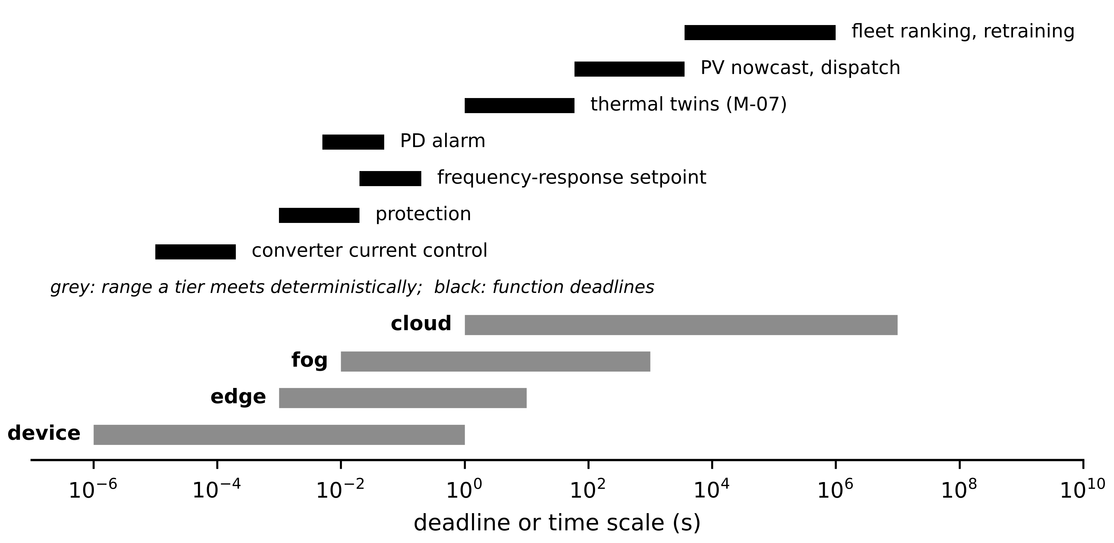
Figure 2.9. Computing tiers against the deadlines of Plant P-1 functions (log scale). Grey bars: range over which each tier can meet a deadline deterministically; black bars: function deadlines. Converter control and protection lie entirely in the device tier.
Six criteria decide placement, in this order. The deadline excludes any tier whose bounded delay exceeds it. Data locality asks where the inputs are: a function that needs one asset's data runs near that asset, one that needs a fleet runs where the fleet's data meet. Bandwidth asks whether the inputs can be moved at all (Section 2.5). Privacy and ownership ask whether the data may leave the site or the owner's control. Availability asks whether the path to the tier, including links in series, meets the function's target (Section 2.9). Fallback asks what runs if the tier is lost, and whether that fallback lives somewhere the fault cannot reach. A function that fails any of the first five on a tier cannot be placed there, whatever the cost advantage.
Table 2.8. Computing platforms against function classes (representative ranges; verify for any product)
Platform | Deterministic cycle | Protection (certified, ≤ 20 ms) | Converter control (10-200 µs) | Forecasting (s to h) | Fleet analytics
Protection IED | 0.25-1 ms, type-tested | yes | no | no | no
PLC or RTU | 1-100 ms bounded scan | interlocks, slow protection | no | simple rules | no
DSP, FPGA or SoC in converter | 1-100 µs, cycle-exact | device self-protection | yes, the only viable platform | no | no
Industrial PC, real-time OS | 0.1-10 ms with RT kernel | no; advisory only | no | yes | site level
Edge GPU accelerator | not deterministic (ms, heavy tail) | no | no | yes, neural surrogates, imaging | limited
Cloud service | not bounded; depends on WAN | no | no | yes, day-ahead and ensembles | yes

The table encodes one rule worth stating plainly: a protective or converter control loop never closes through a network the plant does not control, and never through the cloud. A twin can supervise these loops, tune them offline and change their setpoints within limits that the device enforces; it does not replace them.
How far from a converter may its controller sit? A control loop crosses the distance twice, so solving (2.2) with (2.3) for the distance gives
$d_{max}=\frac{v}{2}\left(T_{dl}-\sum_{i≠prop}{T_{i}}\right)$ (2.16)
where the sum runs over every stage except propagation, and $v$ is the signal speed in the medium.
Example 2.7 (Level A) How far away can the computer of a converter current loop be?
Given. A grid-tied inverter samples its current at 10 kHz and must apply the new modulation command within one period, $T_{dl}=100$ µs. Sensing and conversion take 8 µs, the control computation 30 µs, and gate-driver and modulator update 12 µs. Assume zero queueing and serialization, which favours a remote computer.
Find. The largest fibre distance between converter and computer, and the distance left if one store-and-forward switch adds 10 µs.
Solution. Time left for propagation: $100-8-30-12=50$ µs. From (2.16), $d_{max}=2.0×{10}^{8}×50×{10}^{-6}/2=5.0$ km. With a 10 µs switch, 40 µs remain and $d_{max}=4.0$ km.
Interpretation. Five kilometres is an upper bound with every other delay set to zero; realistic switching and serialization consume most of it. The loop computer must be in the converter, and the cloud is excluded by physics before reliability is even considered.

2.4.2 A placement test: feasibility first, then a weighted score
When several tiers pass the hard criteria, a score helps compare them. The order matters: constraints first, score second, so that a cheap tier can never ‘win’ while missing a deadline. For a function $f$ and candidate tier $ℓ$, define the feasible set and the score
$ℱ=\left\{ℓ: T_{ℓ}^{(q)}≤(1-m)T_{dl}, ρ_{ℓ}<1, {priv}_{ℓ}=1, A_{ℓ}≥A_{req}\right\}, S_{ℓ}=\sum_{j}{w_{j}} s_{j,ℓ}, \sum_{j}{w_{j}}=1$ (2.17)
where $T_{ℓ}^{(q)}$ is the delay quantile on tier $ℓ$, $ρ_{ℓ}$ the load factor of the links it needs, ${priv}_{ℓ}$ equals 1 if data policy allows the data to go there, $A_{ℓ}$ the availability of the whole path to the tier and $A_{req}$ the required availability. Each normalized sub-score $s_{j,ℓ}$ lies between 0 (worst acceptable) and 1 (best), for example $s=1-T/T_{dl}$ for latency margin, $s=1-D/D_{max}$ for downtime with $D_{max}=(1-A_{req})×8760$ h, $s=1-C/C_{max}$ for cost. The weights $w_{j}$ express the owner's priorities and must be published with the result, together with how far a weight can move before the ranking flips.
Example 2.8 (Level B) Placing the motor-fleet thermal twins
Given. Twenty thermal twins (one per motor) with a 30 s cycle and $A_{req}=0.995$. Edge option (one small computer per motor): $T^{(0.999)}=0.4$ s, $A=0.998$, cost 12 000 USD/yr, maintainability 2 of 5. Fog option (redundant site pair): 1.6 s, $A=0.9995$, 3000 USD/yr, maintainability 4 of 5. Cloud option: 2.5 s, $A=0.99490$ including the plant's single LTE link, 1500 USD/yr. Weights: latency 0.2, availability 0.3, cost 0.3, maintainability 0.2; $C_{max}=15 000$ USD/yr.
Find. (a) The feasible set. (b) Sub-scores and $S_{ℓ}$. (c) The latency weight at which the edge would overtake the fog, if the other weights shrink in proportion.
Solution. (a) Latency passes everywhere ($≪0.85×30$ s). Availability: edge 0.998 and fog 0.9995 pass; the cloud's 0.99490 fails 0.995 because of the LTE link in series, so the cloud is infeasible whatever its cost. (b) $D_{max}=0.005×8760=43.8$ h. Edge: latency $1-0.4/30=0.987$, downtime $17.5$ h gives $1-17.5/43.8=0.60$, cost $1-12 000/15 000=0.20$, maintainability 0.40; $S=0.2×0.987+0.3×0.60+0.3×0.20+0.2×0.40=0.517$. Fog: 0.947, downtime 4.38 h gives 0.90, cost 0.80, maintainability 0.80; $S=0.859$. The fog wins clearly. (c) Solving $S_{edge}=S_{fog}$ with the other weights scaled by $(1-w_{lat})/0.8$ gives $w_{lat}=0.92$: only an owner who cares almost exclusively about a 1.2 s latency difference on a 30 s cycle would choose the edge.
Interpretation. The decisive step was the feasibility test, not the score: a single unredundant link made the cheapest option illegal. The sensitivity check shows the fog choice is not an artefact of the weights.

2.4.3 Software deployment on edge and fog: containers and real-time partitions
Twins are software, and how that software is packaged affects timing and configuration control. Container platforms let a site deploy twenty identical twin instances from one prototype image, roll back a failed update and record exactly which image ran (Section 2.7). They are now common for supervisory twins. They do not by themselves give bounded latency: containers share caches, memory bandwidth and the kernel scheduler, so a co-located workload can stretch another's execution time unpredictably. The usual pattern (Figure 2.10) isolates processor cores for a real-time partition that runs the few time-critical tasks natively, and runs the rest in containers under an orchestrator that pulls signed images and pins versions. Industrial initiatives are standardizing this layer: the Linux Foundation's Margo initiative, launched in 2024, published a first preview of its interoperable edge application-management specification in January 2026, with a general release planned for 2026 [21] (emerging).
Figure 2.10. Software deployment on a fog industrial PC. Time-critical acquisition, setpoint and command-gateway tasks run natively in an isolated real-time partition; supervisory twins, nowcast, historian and agents run as containers deployed from a signed image registry by an orchestrator.
What the digital twin adds
Synchronized: each function on a tier whose bounded delay and availability meet its contract.
Estimated or updated: feasibility set and placement score with weight sensitivity.
Uncertainty carried: delay quantiles and path availability, not mean figures.
Decision enabled: device, edge, fog or cloud for each function, and the fallback location.
Validated by: timing campaigns on the target tier and a recorded weight-sensitivity check.

2.5 Data architecture: rates, retention, compression and message overhead

2.5.1 Data rate and storage
A sensing deployment with channel groups $i=1,…,G$ produces a raw data rate
$R=\sum_{i=1}^{G}{n_{i}} f_{i} b_{i} δ_{i}, f_{i}>2f_{max,i}$ (2.18)
where $n_{i}$ is the number of channels in group $i$, $f_{i}$ the sampling rate (Hz), $b_{i}$ the bits per sample, $δ_{i}$ the duty factor (1 for continuous recording; 1/60 for a 10 s burst every 10 min) and $f_{max,i}$ the highest frequency the twin must see, so that the sampling rate follows from physics (Chapter 3) rather than habit. $R$ is in bit/s. Over a retention period $T_{r}$ (s), with lossless compression removing a fraction $c$ of the bytes, the stored volume in bytes and the cost of a linearly growing archive in retention year $y$ are
$V=\frac{R T_{r}}{8} (1-c), C_{y}=12 p\int_{y-1}^{y}{V_{1}} σ dσ=12 p V_{1}\left(y-\frac{1}{2}\right)$ (2.19)
where $p$ is the price per gigabyte-month, $V_{1}$ one year's stored volume (GB) and $σ$ time in years. Summing over $Y$ years gives $6pV_{1}Y^{2}$: the cost of a growing archive rises every year even when the plant does not change, so retention policy, not disk price, dominates long-term data cost.
How much can lossless compression save? No code can use fewer bits per symbol on average than the entropy of the symbols, $H=-\sum_{j}{p_{j}}\log_{2}p_{j}$. Slowly varying measurements are compressed by coding successive differences; for differences that are approximately normal with standard deviation $σ_{Δ}$, quantized with step $Δ_{q}$, the entropy is close to
$H≈\log_{2}\left(\frac{σ_{Δ}}{Δ_{q}}\sqrt{2πe}\right) bits per sample, CR=\frac{b}{H}=\frac{1}{1-c}$ (2.20)
where $CR$ is the achievable compression ratio relative to $b$-bit storage. For the M-07 RTD (0.01 K resolution, 0.3 K noise, so $σ_{Δ}=0.3\sqrt{2}=0.42$ K), $H=7.45$ bits instead of 16, a ratio of 2.1 or $c≈0.53$. Measurement noise, not the algorithm, limits the saving: noise is incompressible information.
Table 2.9. Raw data rate of Plant P-1 from (2.18)
Channel group | $n_{i}$ | $f_{i}$ (Hz) | $b_{i}$ | $δ_{i}$ | $R_{i}$ (bit/s)
Motor winding RTD | 20 | 1/30 | 16 | 1 | 10.7
Motor phase-current RMS | 60 | 1 | 16 | 1 | 960
Motor vibration (bursts) | 4 | 10 240 | 16 | 1/60 | 10 923
PV string current | 80 | 1 | 16 | 1 | 1280
PV weather | 4 | 1 | 16 | 1 | 64
BESS module voltage | 240 | 1 | 16 | 1 | 3840
BESS module temperature | 60 | 0.1 | 16 | 1 | 96
BESS PCS | 20 | 10 | 32 | 1 | 6400
PCC power-quality meter | 16 | 50 | 32 | 1 | 25 600
Total |  |  |  |  | 49 173

For Plant P-1 the total raw rate is modest, 49.2 kbit/s (Table 2.9), because the only high-rate channels are recorded in bursts. The daily volume is $49 173×86 400/8=531$ MB, or 194 GB a year before compression and about 97 GB after compression at $c=0.5$. Figure 2.11 shows the pipeline from sensors to archive.
Example 2.9 (Level A) Storage volume and cost for Plant P-1
Given. The raw rate of Table 2.9, lossless compression $c=0.5$, a 90-day hot store of uncompressed data, and archive storage at 0.023 USD per GB-month.
Find. (a) Raw and compressed annual volume. (b) Hot-store size. (c) Archive cost in year 1, year 10 and over ten years from (2.19).
Solution. (a) $49 173×31 536 000/8=193.8$ GB raw; $96.9$ GB compressed. (b) $531$ MB $×90=47.8$ GB. (c) Year 1: $0.023×12×0.5×96.9=13.4$ USD; year 10: $0.023×12×9.5×96.9=254$ USD; ten years: $6pV_{1}Y^{2}=6×0.023×96.9×100=1337$ USD.
Interpretation. The numbers are small for one plant, but the archive cost grows every year and multiplies across a fleet of plants. Deciding retention per stream at design time costs nothing; changing it after ten years means migrating terabytes.
Figure 2.11. Data-rate and retention pipeline for Plant P-1. Checks at the edge quarantine bad data before storage; the hot store keeps 90 days of full-rate data; the archive keeps years of compressed data and features.
Example 2.10 (Level B) Data volume of a wind-farm vibration twin
Given. 40 turbines, each with 12 vibration channels at 25.6 kHz and 16 bits, recorded continuously, plus 30 SCADA channels at 1 Hz and 32 bits. Raw vibration is kept 90 days ($c=0$); SCADA 10 years with $c=0.4$.
Find. (a) Farm vibration rate and 90-day volume. (b) SCADA rate and 10-year volume. (c) Which stream dominates storage.
Solution. (a) $R=40×12×25 600×16=196.6$ Mbit/s; one day $196.608×{10}^{6}×86 400/8=2.12$ TB; 90 days 191.1 TB. (b) $40×30×32=38.4$ kbit/s; one day 0.415 GB; ten years $0.41472×3650×0.6=908$ GB. (c) The 90-day vibration store is 210 times the 10-year SCADA store, although it covers 2.5 % of the time span.
Interpretation. High-rate condition-monitoring data is never kept raw for long; what is kept is a feature set (spectra, envelopes, event snapshots). Retention is an architecture decision with first-order cost, made together with latency and availability decisions.

2.5.2 Protocol overhead and batching
Samples do not travel alone. If a message carries $P$ bytes of values and $O$ bytes of everything else, the payload efficiency and the bandwidth needed for a payload rate $R_{pay}$ are $η=P/(P+O)$ and $B_{req}=R_{pay}/η$. Batching $n_{b}$ successive sampling instants of $P_{1}$ bytes each, taken every $T_{s}$, into one message gives, by substituting $P=n_{b}P_{1}$,
$η=\frac{P}{P+O}, B_{req}\left(n_{b}\right)=R_{pay}\left(1+\frac{O}{n_{b}P_{1}}\right), Δa_{max}\left(n_{b}\right)=\left(n_{b}-1\right)T_{s}$ (2.21)
where $Δa_{max}$ is the extra age of the oldest sample in a batch. Bandwidth falls hyperbolically with $n_{b}$ while age grows linearly (Figure 2.12), so the batch size is set by the age the consuming function tolerates.
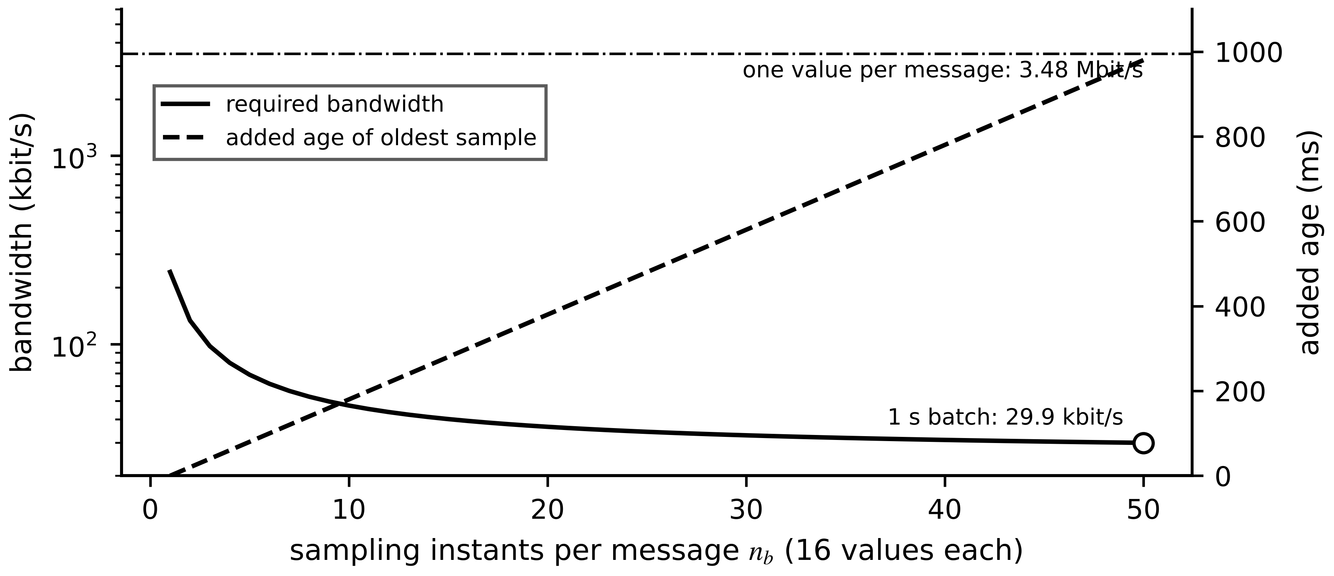
Figure 2.12. Batching trade-off for the PCC meter: required bandwidth (solid) falls with the number of sampling instants per message, while the added age of the oldest sample (dashed) grows. The two designs of Example 2.11 are marked.
Example 2.11 (Level A) Per-sample against batched messages for the PCC meter
Given. The PCC meter produces $R_{pay}=25.6$ kbit/s (16 channels at 50 Hz, 4-byte values). A self-describing message (Section 2.6) carries about $O=540$ bytes besides values: about 420 bytes of JSON metadata, 40 of MQTT header and topic, 40 of TCP/IP headers and 38 of Ethernet framing.
Find. $η$, $B_{req}$ and added age (a) with one value per message, (b) with one message per second carrying all 800 values.
Solution. (a) $η=4/544=0.0074$; $B_{req}=25 600/0.0074=3.48$ Mbit/s; no added age. (b) $η=3200/3740=0.856$; $B_{req}=29.9$ kbit/s; the oldest value is up to $(50-1)×20$ ms $≈1$ s old on arrival.
Interpretation. The same information needs 116 times more bandwidth when each value is wrapped alone. Self-description is worth paying for once per batch. The 1 s of added age suits the historian and is unacceptable for the frequency-response path, which therefore gets its own compact, unbatched control-plane stream (Section 2.2.2).
What the digital twin adds
Synchronized: the stored history, with retention matched to each stream's value.
Estimated or updated: raw and stored rates, archive cost, compression limit.
Uncertainty carried: compression is bounded by measurement noise, (2.20).
Decision enabled: batch size per stream from its age tolerance; retention per stream.
Validated by: measured link load and storage growth against the budget.

2.6 Semantic and configuration architecture
Moving bytes is the easy half of interoperability. For an operational twin, knowing what a value means, which asset it belongs to, which unit it carries, and which model version and parameter set produced a decision from it is as important as delivering it on time. This section treats the meaning of data (semantics) and the identity of everything that touches it (configuration) as an architecture of its own, with its own failure modes and its own checks.

2.6.1 What a value means: identifiers, units and metadata
A number is useful to a second system only if that system can tell what it measures, on which asset, in which unit, at what time, how trustworthy it is, and which version of the data contract it follows. Six kinds of metadata answer these questions. A global asset identifier names the physical unit, not its position: if M-07 is replaced, the new motor gets a new identifier and the position keeps its own. A semantic identifier points to a shared definition of the quantity in a concept dictionary (IEC 61360-style, as used by the AAS [22]), so that ‘winding temperature’ cannot be read as an average when it means a hot spot. A unit code from a controlled list, such as UCUM [23], removes ambiguity between W and kW or K and °C. A timestamp in UTC with a stated time quality says when the sample was taken and how good the clock was. A quality attribute (validity good, questionable or invalid; source process or substituted; test flag), modelled on the IEC 61850 quality attribute [24], tells a model whether it may use the value. And lineage records the firmware and mapping versions that produced it. Figure 2.13 shows a message for M-07 that carries all of them; in compact JSON it is about 426 bytes, which is where the overhead figure of Example 2.11 comes from.
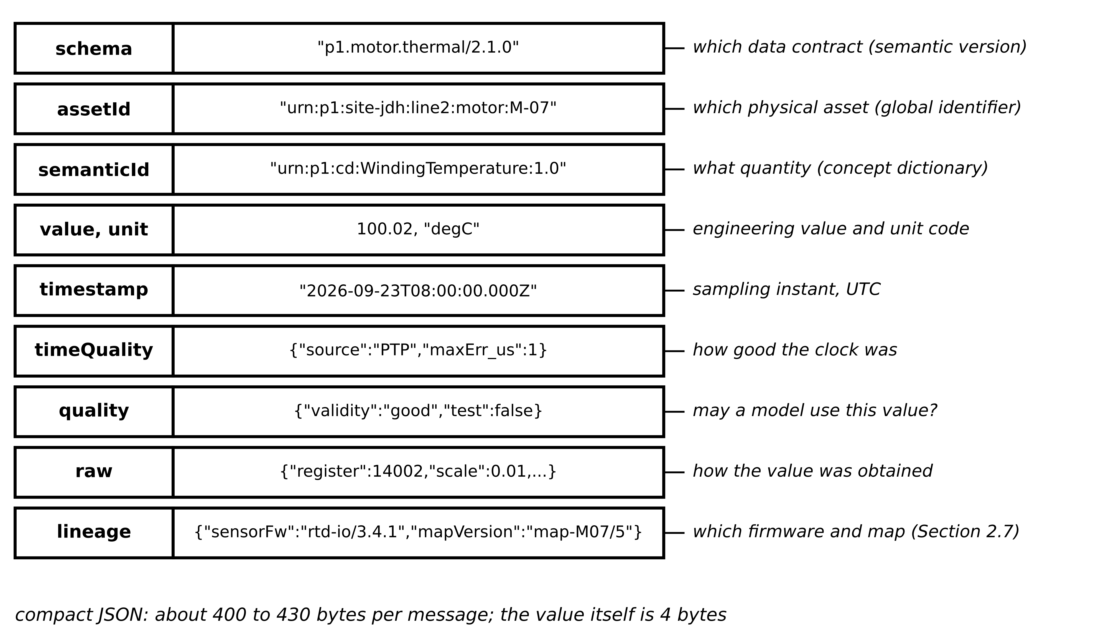
Figure 2.13. Anatomy of a self-describing message for the M-07 winding temperature. Each field answers one question a second system would otherwise have to guess; the same content maps onto an AAS submodel element or an IEC 61850 data attribute.
Table 2.10. Fields of an interoperable twin message
Field | Purpose | Practice it follows | What goes wrong without it
schema | names the data contract and its semantic version | schema registry, semantic versioning | consumers misread a changed format
assetId | globally unique identity of the physical asset | AAS global asset identifier; IEC 61850 object reference | data attached to the wrong motor after a replacement
semanticId | points to a shared definition of the quantity | concept dictionary (IEC 61360 style) | hot spot read as average temperature
value, unit | engineering value with explicit unit | controlled unit codes (UCUM) | kelvin read as degrees Celsius; kW read as W
timestamp, timeQuality | sampling instant in UTC and bound on clock error | PTP or NTP; IEC 61850 time quality | residuals built from misaligned samples
quality | validity, source, test flag | IEC 61850 quality attribute | substituted or test values used as real
raw, lineage | register value, mapping constants, firmware and map versions | vendor device description; digital thread | no way to trace a wrong value to its cause

The engineering value is obtained from the register by an affine map, checked against the sensor's rated range, and inverting the map gives the register limits and the resolution:
$y=r s+o valid only if y_{lo}≤y≤y_{hi}, r_{lo}=\frac{y_{lo}-o}{s}, r_{hi}=\frac{y_{hi}-o}{s}, Δy=|s|$ (2.22)
where $r$ is the raw register value (an integer), $s$ the scale (engineering units per count), $o$ the offset (engineering units), $[y_{lo},y_{hi}]$ the rated range and $Δy$ the resolution. A value outside the rated range is not clipped; it is delivered with validity ‘invalid’ so that no model consumes it.
[Advanced] Units can be checked mechanically. Every physical quantity has a dimension vector of exponents over the seven SI base dimensions (length, mass, time, current, temperature, amount, luminous intensity). A producer and a consumer agree on a quantity only if the dimension vectors match, and the conversion between their units is then affine:
$d\left(Q_{p}\right)=d\left(Q_{c}\right)∈ℤ^{7}, y_{c}=k y_{p}+o_{pc}$ (2.23)
where $d$ is the dimension vector, $k$ the scale factor between units (1000 from kW to W) and $o_{pc}$ an offset that is non-zero only for temperature scales with different zeros (273.15 between °C and K). Power has $d=(2,1,-3,0,0,0,0)$; energy $(2,1,-2,0,0,0,0)$. A check on $d$ catches a power sent where an energy was expected; a check on $k$ and $o_{pc}$ catches the prefix and scale errors that the dimension check cannot see.
Example 2.12 (Level A) Mapping, range and unit checks
Given. (i) The M-07 RTD input register is 16-bit unsigned with $s=0.01$ °C/count, $o=-40.0$ °C, rated range $-40$ to $200$ °C; readings $r_{1}=14 002$ and $r_{2}=26 500$. (ii) A BESS module temperature arrives as 298.15 with unit code K but is read by a consumer that assumes °C. (iii) A PV twin expecting kW receives 6575 from a feed that switched to W.
Find. (a) Engineering values, validity and the valid register range in (i). (b) The error in (ii) and which check catches it. (c) The error in (iii) and which check catches it.
Solution. (a) $y_{1}=14 002×0.01-40.0=100.02$ °C, valid. $y_{2}=265.00-40.0=225.00$ °C, above 200 °C, invalid. From (2.22), $r_{lo}=0$ and $r_{hi}=(200+40)/0.01=24 000$; the full 16-bit span would map up to 615.35 °C. (b) Read as °C, the value is 298.15 °C instead of 25.00 °C, an error of $o_{pc}=273.15$ K; the dimension vectors agree, so only the unit-code check, or a module range check (say $-20$ to 60 °C), catches it. (c) The twin sees 6575 kW instead of 6.575 kW, a factor $k=1000$; a range check against the 1.1 MW inverter rating catches it, and the unit-code check catches it before any value is used.
Interpretation. Range checks cost nothing and stop a whole class of errors (open RTD, wrong scale) before any model sees them, but they cannot see an error that stays inside the range. Explicit unit codes, checked at ingestion in Layer 5, close that gap.

2.6.2 Information models for energy twins
Four families of information model meet in an energy twin, and each was designed for a different question (Figure 2.14, Table 2.11). IEC 61850 models substation and DER equipment as logical devices containing logical nodes with standardized data objects and attributes [24]; an object reference such as P1_PCC/MMXU1.TotW.mag.f names the total active power magnitude of a measurement unit. Its configuration is exchanged in the System Configuration Language (SCL, IEC 61850-6), in files that describe a system specification (SSD), a substation configuration (SCD), an IED's capabilities (ICD), its configured instance (CID) and an instantiated IED (IID). DER logical nodes are defined in IEC 61850-7-420 [25]. The Common Information Model (IEC 61970-301, IEC 61968) models networks, topology and assets for energy and distribution management systems [26]; the harmonization of CIM and IEC 61850 is described in IEC TR 62361-102 [27]. OPC UA (IEC 62541) combines an information-modelling framework with transport and security, and companion specifications map domain models onto it [28]. The Asset Administration Shell (IEC 63278-1 for structure, IDTA specifications for the metamodel, at version 3.2 since July 2026) describes an asset through submodels such as a digital nameplate, technical data and time-series data [29], [22].
Figure 2.14. How the main information models relate in an energy twin. IEC 61850 describes devices and substations, CIM the network, the AAS each asset, and OPC UA can carry the AAS and other models; the twin model registry and time-series stores sit beside them. Every arrow is a mapping, and every mapping is a place where meaning can be lost.
Table 2.11. Information models compared by assumptions, data need, cost, strengths, limitations and use
Model | Assumes | Data and effort needed | Strengths | Limitations | Appropriate use
IEC 61850 + SCL | substation or DER device view; standardized logical nodes | SCL engineering per site; vendor ICD files | precise device semantics; GOOSE and sampled values for fast paths | little about network topology or asset life | device data and fast protection-adjacent paths
IEC CIM | network-wide view for EMS and DMS | network model maintenance, often CGMES exchange | topology, connectivity, utility-scale exchange | heavy; less device detail | grid twins, power flow, state estimation
OPC UA | address space with typed objects; client-server or pub-sub | companion specification per domain | information model plus security and transport | semantics only as good as the companion spec | plant integration across vendors
AAS | one shell per asset with submodels | submodel templates; identifiers | life-cycle record of an asset; manufacturer data | time-critical data out of scope | asset-level twin records, handover, digital thread

The practical rule is not to invent a parallel vocabulary. A twin consuming PCC data should map to the IEC 61850 MMXU data objects it already has; a grid twin should use CIM for topology; the asset twin of M-07 should publish its parameters and history in an AAS submodel. Mapping between them is still largely hand-made, and loss-free round-trip mapping between IEC 61850, CIM and the AAS remains a research target (Section 2.14). IEC 61850 IED instance descriptions (IID files) have been generated automatically from AAS records for the devices of a low-voltage benchmark grid, with the AAS as the single source of truth [30] (emerging).

2.6.3 The semantic asset graph and the integration arithmetic
The relations among assets, channels, models, parameter sets, firmware and calibration records form a graph (Figure 2.15). Storing them as a graph rather than as columns in many tables turns audit questions into queries: which twins used data from firmware 3.4.1 last month; which parameter sets rest on calibration certificate 117; which decisions came from model version 2.3.
Figure 2.15. A semantic asset graph around motor M-07. Nodes are assets, channels, models, parameter sets, firmware and records; labelled edges give their relations, so lineage questions become graph queries.
Without a shared information model, every pair of systems that exchange data needs its own translator. For $n$ systems with bidirectional exchange
$N_{bespoke}=\frac{n(n-1)}{2}, N_{shared}=n$ (2.24)
where $N_{bespoke}$ counts pairwise translators and $N_{shared}$ adapters to one shared model. Plant P-1 has six vendor systems (motor I/O, PV inverters, BMS, PCS, PQ meter, historian): 15 translators against 6 adapters. At 20 systems the numbers are 190 and 20 (Figure 2.16). Model transformations between twin specifications can be generated rather than hand-coded, as shown between DTDL and the AAS [31] and for file- and API-based AAS exchange [32].
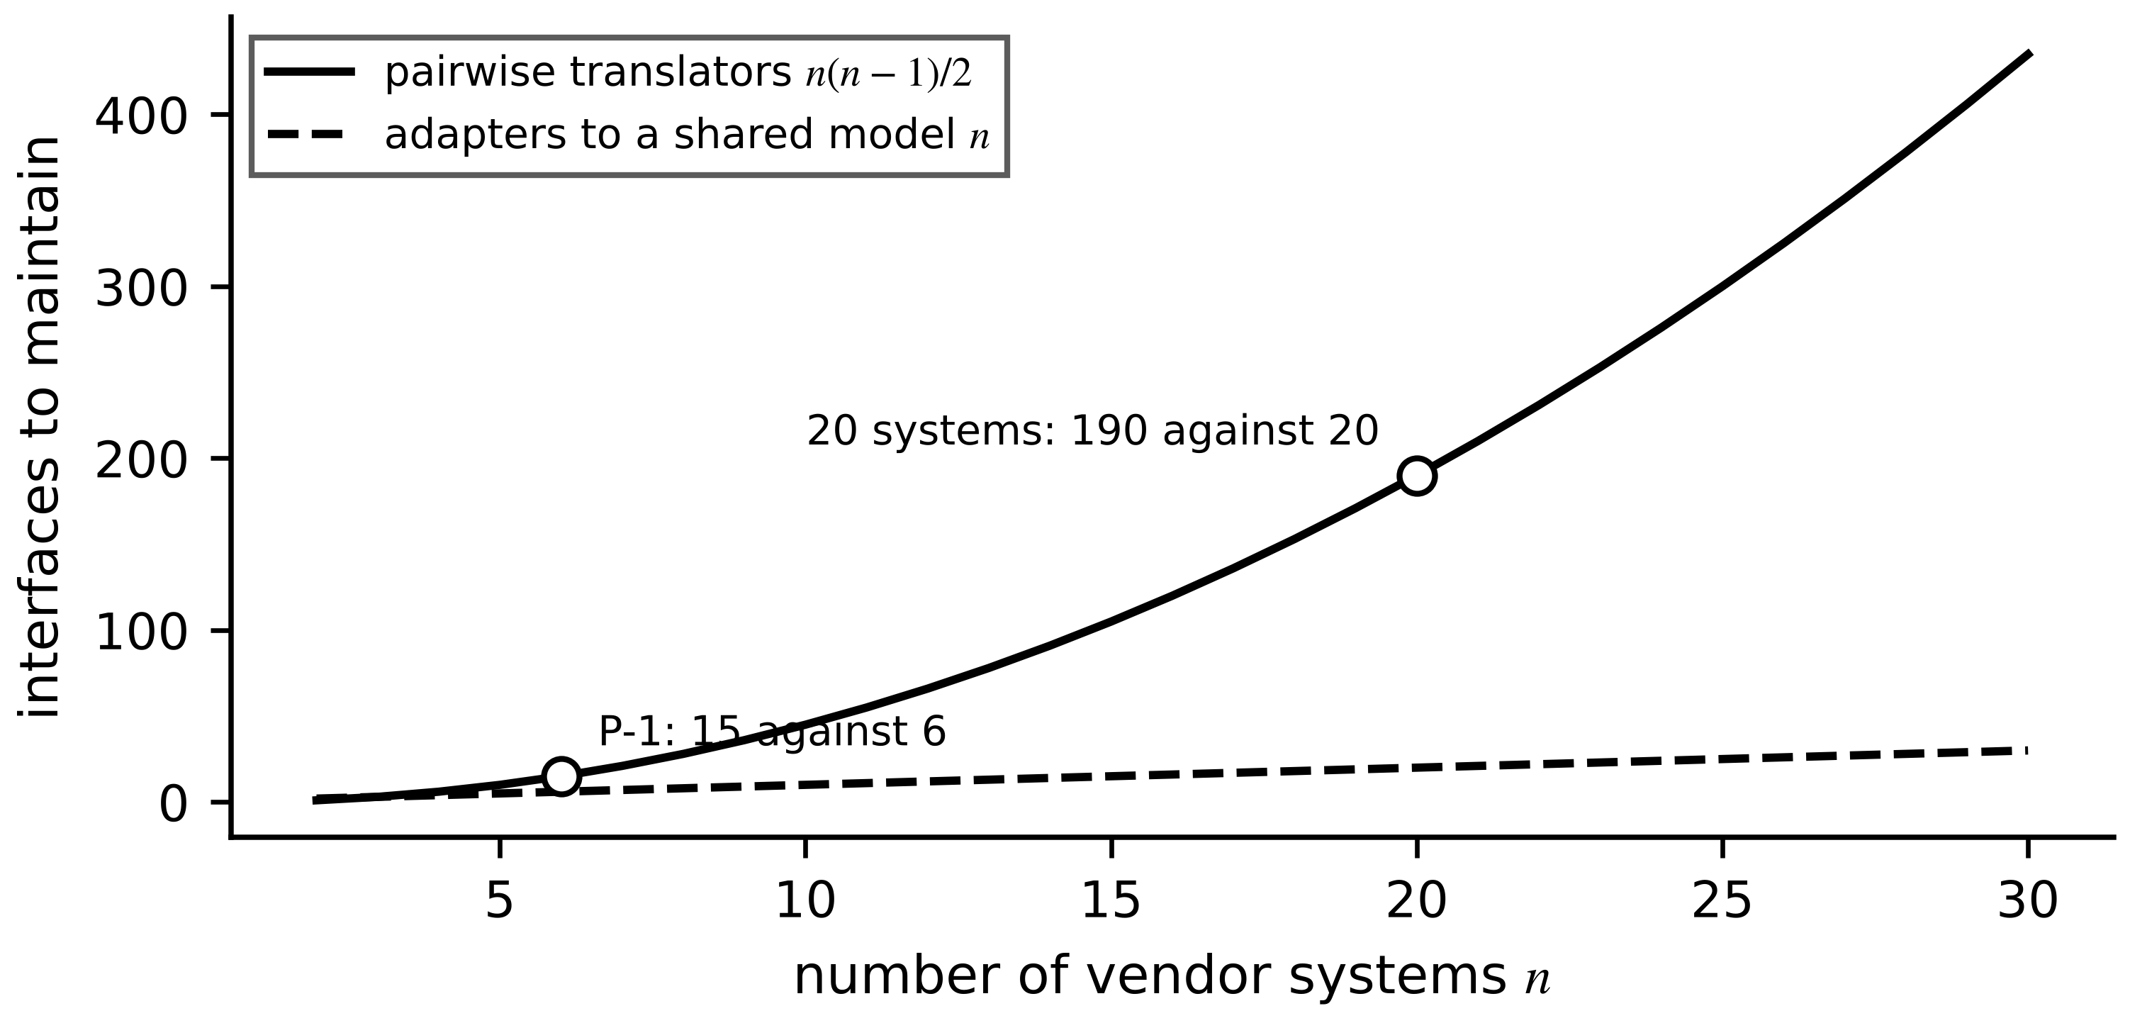
Figure 2.16. Interfaces to build and maintain against the number of vendor systems, for pairwise translators and for adapters to one shared model.

2.6.4 Schemas, interfaces and version compatibility
Twins live longer than the software around them. A message format or application programming interface (API) changes several times during a motor's 20-year life, and every change is a chance for silent corruption. The schema field follows semantic versioning MAJOR.MINOR.PATCH [33]: PATCH fixes documentation without changing meaning; MINOR adds optional fields that old consumers may ignore; MAJOR changes meaning, units or required fields. A consumer that needs at least version $(M_{c},m_{c})$ may accept a producer at $(M_{p},m_{p},p_{p})$ only if
$accept=\left(M_{p}=M_{c}\right)∧\left(m_{p}≥m_{c}\right)$ (2.25)
where $∧$ is logical AND and the patch number $p_{p}$ never affects compatibility. Three rules make this enforceable (Figure 2.17): ingestion accepts only versions registered in a schema registry and quarantines the rest; each consumer declares the MAJOR version it reads; a MAJOR change runs in parallel with the old version for a stated overlap, with outputs compared, before the old one retires.
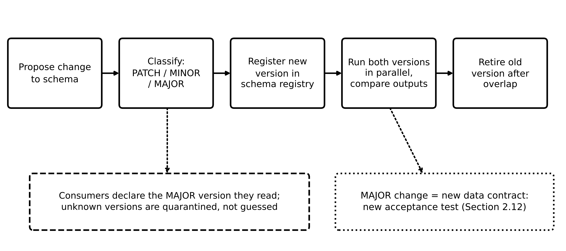
Figure 2.17. Interface and API versioning workflow. A MAJOR change is a new data contract and needs its own acceptance test; unknown versions are quarantined rather than guessed.
Example 2.13 (Level A) Which consumers accept a new schema?
Given. The motor-thermal schema moves from 2.1.0 to 2.2.0 (an optional ‘ambient’ field added) and later to 3.0.0 (temperature unit changed from °C to K). Consumers: the M-07 twin requires 2.1; the fleet aggregate requires 2.2; an old dashboard requires 1.4.
Find. Which consumers accept 2.2.0 and 3.0.0 under (2.25), and what the overlap period must demonstrate.
Solution. 2.2.0: the M-07 twin accepts ($2=2$, $2≥1$); the aggregate accepts ($2≥2$); the dashboard rejects ($2≠1$), which was already true for 2.1.0. 3.0.0: every consumer rejects it, because the MAJOR number differs. During the overlap the producer publishes 2.2.0 and 3.0.0 together; the comparison must show that $y_{3.0}=y_{2.2}+273.15$ for every sample, and each consumer must be revalidated on 3.0.0 before 2.2.0 is retired.
Interpretation. A unit change is never a MINOR change, however small the code edit. Treating it as one is exactly how a twin ends up 273 K wrong without any error message.

2.6.5 Configuration identity
Every twin output must be traceable to the exact combination of things that produced it. The mechanism is a trace tuple attached to each output:
$τ=\left(asset ID, model version, \hat{θ} version, schema version, firmware version, dataset ID, t\right)$ (2.26)
where each element points into a version-controlled store (Figure 2.18) and $t$ is the output timestamp. An output whose tuple contains a combination never validated together is flagged automatically. Each artifact (model file, parameter set, firmware image, dataset) is identified by a cryptographic hash of its content, so any change, however small, changes its identifier. With $n_{a}$ artifacts and a $b$-bit hash, the birthday bound gives the probability that two different artifacts share an identifier:
$P_{coll}≈\frac{n_{a}^{2}}{2^{ b+1}}, n_{a}≪2^{b/2}$ (2.27)
With a 256-bit hash even ${10}^{9}$ artifacts give $P_{coll}≈4×{10}^{-60}$: identifiers based on content are, for engineering purposes, unique.
Figure 2.18. Configuration and version registry. Six stores feed the trace tuple carried by every twin output; combinations never validated together are flagged.
What the digital twin adds
Synchronized: meaning as well as values; every sample carries identity, unit, time and quality.
Estimated or updated: mapped engineering values, validity flags, schema compatibility.
Uncertainty carried: time quality and validity per sample; untested version combinations flagged.
Decision enabled: whether a value may enter a model, and which consumers accept a new schema.
Validated by: ingestion tests with bad units, schemas and versions (Section 2.12).

2.7 Digital thread and lifecycle configuration control
A running twin answers ‘what is the asset doing now?’. The digital thread answers a different question: ‘which design, data, calibration and software produced this answer, and when did each change?’. The thread is a lineage record; the twin is an executing model (Chapter 1, Section 1.2). ISO 23247-5:2026 specifies how a digital thread supports manufacturing twins across the product life cycle [34], and the idea transfers directly to electrical assets with 20- to 40-year lives. Figure 2.19 shows the stages and the records carried across them.
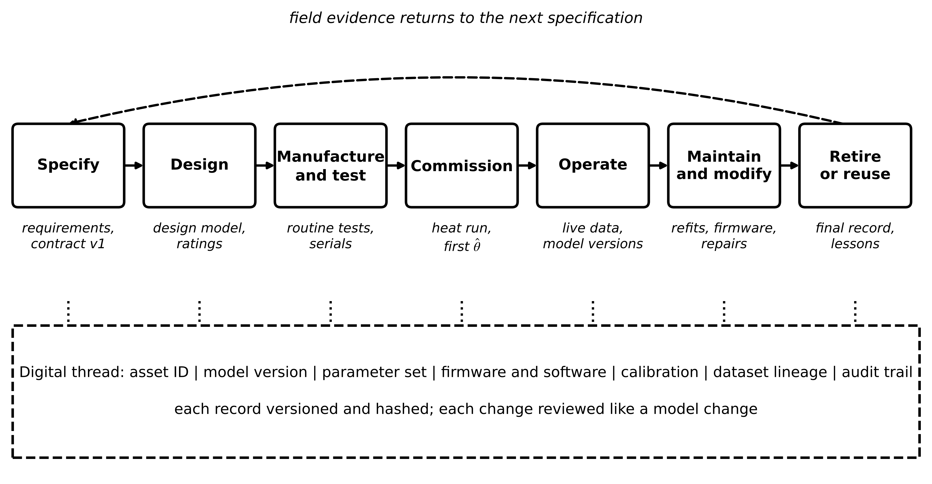
Figure 2.19. Digital thread across the life cycle of an electrical asset. Each stage adds records; the thread carries asset identity, model version, parameter set, firmware and software, calibration, dataset lineage and the audit trail, and returns field evidence to the next specification.

2.7.1 The seven configuration items
Seven items recur for every asset in this book, and each needs an explicit record rather than institutional memory. The asset identifier survives every stage and changes only when the physical unit does. The model version names the prototype code and structure (Section 2.8). The parameter set $\hat{θ}$ records the values an instance was last calibrated to, with date, method and data window. The firmware and software versions cover sensors, gateways and the twin runtime, because a firmware change can change a register's meaning. The calibration record links each sensor to its certificate and each $\hat{θ}$ to its uncertainty. The dataset lineage identifies, by content hash and time window, the data used for every fit and every validation. The audit trail records who changed what and when, and must itself be tamper-evident.
A tamper-evident audit trail can be built as a hash chain: each record includes the hash of the previous one, so altering any past record changes every later hash.
$h_{k}=H\left(h_{k-1} ‖ r_{k}\right), h_{0}=H\left(genesis\right)$ (2.28)
where $r_{k}$ is the $k$-th record, $‖$ denotes concatenation and $H$ a cryptographic hash function. Verification recomputes the chain and compares the final hash with one stored independently, for example in the cloud and at the site. With 32-byte SHA-256 hashes, a million records a year add 32 MB of overhead, negligible beside the data of Section 2.5.

2.7.2 Is a recalibration a real change?
A calibration history is useful only if a change can be tested for significance. With two successive estimates and their standard uncertainties, the standardized change and its false-declaration probability at threshold $z_{0}$ are
$z=\frac{{\hat{θ}}_{new}-{\hat{θ}}_{old}}{\sqrt{σ_{new}^{2}+σ_{old}^{2}}}, P\left(|z|>z_{0}\right)=2 Q\left(z_{0}\right)$ (2.29)
where $σ_{old}$ and $σ_{new}$ are the standard uncertainties, assumed independent, so that the variance of the difference is their sum, and $Q$ is the standard normal tail. Under no physical change $z$ is approximately standard normal; $|z|>3$ is a common threshold, with 0.27 % false declarations per comparison.
Example 2.14 (Level B) Two configuration events on motor M-07
Given. (i) The M-07 thermal resistance was commissioned at ${\hat{R}}_{th}=0.200±0.004$ K/W; the refit of Chapter 1, Section 1.15 gives $0.249±0.002$ K/W. (ii) Months later, firmware 4.0.0 of the RTD input module changes the register from ‘0.01 °C per count, offset −40 °C’ to ‘0.1 °C per count, no offset’, and the plant installs it without updating the mapping. At a true winding temperature of 100 °C the module sends $r=1000$.
Find. (a) Whether change (i) is significant. (b) What the twin receives in (ii), and which checks catch it, in the order they act.
Solution. (a) From (2.29): $z=(0.249-0.200)/\sqrt{{0.004}^{2}+{0.002}^{2}}=0.049/0.00447=11.0$. The change is real; it was the blocked fan inlet. (b) With the old mapping (2.22): $y=1000×0.01-40=-30.0$ °C, inside the rated range, so the range check passes it. First to act is the trace-tuple check (2.26): firmware 4.0.0 paired with mapping map-M07/5 is a combination never validated, flagged before the first sample is used. Next the rate check (a jump from about 100 °C to −30 °C in 30 s, far beyond the 5 K limit of Chapter 1), then a plausibility check against ambient (a running motor cannot be 60 K colder than the air around it).
Interpretation. Range checks are necessary and insufficient. The only check that acts before the first wrong sample is configuration control: a firmware update is a configuration change and passes the same review as a model update.
What the digital twin adds
Synchronized: the record of what produced each output, alongside the output.
Estimated or updated: significance of each recalibration, (2.29).
Uncertainty carried: parameter uncertainty in every history entry.
Decision enabled: whether a parameter change is ageing, a fault or noise; whether an update may go live.
Validated by: hash-chain verification and flagged untested combinations.

2.8 Prototypes, instances, aggregates and federated twins

2.8.1 Where each kind of twin lives
Chapter 1 (Section 1.10.2) introduced the digital twin prototype (DTP), instance (DTI) and aggregate (DTA). Each has a natural home (Figure 2.20). The prototype (model code, calibration procedure, validation report) is written once and version-controlled centrally. Each instance holds the live state and parameters of one asset and runs close to it, at edge or fog, so that its synchronization depends on no other asset and no wide-area link. The aggregate combines instances and runs where their data meet.
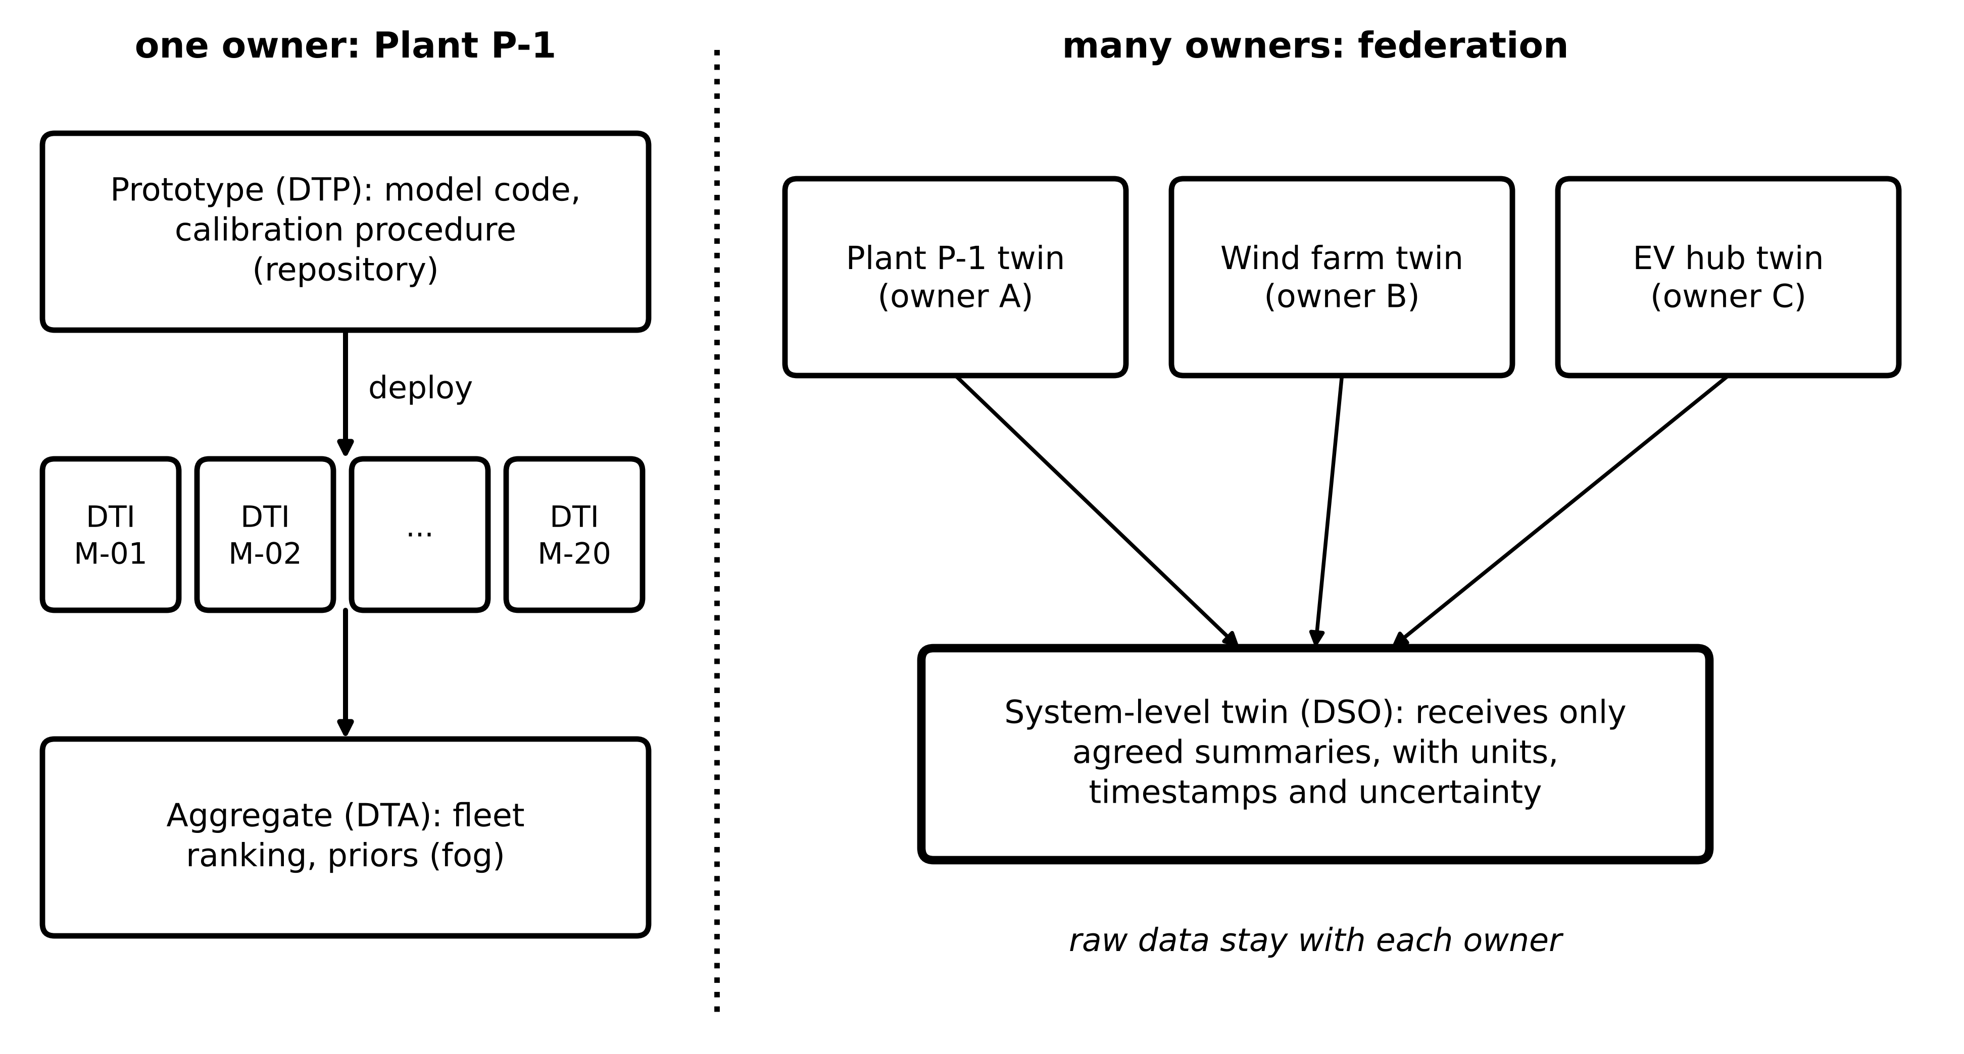
Figure 2.20. Left: prototype, instances and aggregate for the Plant P-1 motor fleet under one owner. Right: a federation in which separately owned twins keep their raw data and share only agreed summaries with a system-level twin.
An aggregate is slower than any of its instances for a structural reason: it cannot complete until the last instance reports. If $N$ instances report independently with exponential delays of mean $\overline{m}$, then after the first arrival the remaining $N-1$ start afresh (memorylessness), so the successive gaps have means $\overline{m}/N,\overline{m}/(N-1),…,\overline{m}$ and
$𝔼\left[\max_{j}D_{j}\right]=\overline{m} H_{N}, H_{N}=\sum_{k=1}^{N}{\frac{1}{k}}≈lnN+0.577, t^{(q)}=-\overline{m}ln\left(1-q^{1/N}\right)$ (2.30)
where $D_{j}$ is the delay of instance $j$, $H_{N}$ the $N$-th harmonic number and $t^{(q)}$ the $q$-quantile of the completion time, obtained from $P(\max_{j}D_{j}≤t)=(1-e^{-t/\overline{m}})^{N}$. If the aggregate closes at a cut-off $t_{c}$, the expected number of instances missing is $Ne^{-t_{c}/\overline{m}}$.
Example 2.15 (Level A) Latency of the motor-fleet aggregate
Given. Twenty instances report with independent exponential delays of mean 2 s.
Find. (a) Expected completion time for 20 and for 200 instances. (b) The 99th-percentile completion for 20, against one instance. (c) Expected missing instances at a 10 s cut-off.
Solution. (a) $H_{20}=3.598$, so $2×3.598=7.2$ s; $H_{200}=5.878$, so 11.8 s. (b) $t^{(0.99)}=-2ln(1-{0.99}^{1/20})=15.2$ s, against $-2ln0.01=9.2$ s for one instance. (c) $20e^{-5}=0.13$.
Interpretation. Ten times more instances cost only 63 % more waiting, but the aggregate is always several times slower than a typical instance (Figure 2.21). Practical aggregates close at a cut-off and label the result with the list of missing instances.
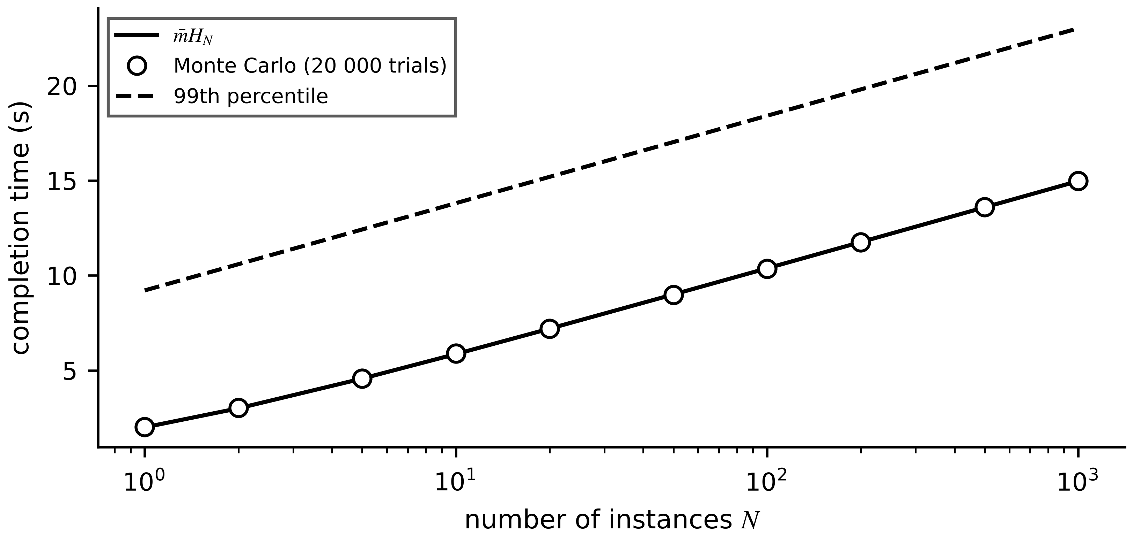
Figure 2.21. Expected completion time of an aggregate that waits for all $N$ instances (mean instance delay 2 s), with a Monte Carlo check (20 000 trials per point) and the 99th percentile.

2.8.2 Composable and federated twins across ownership borders
A composable twin is built from twins that other parties developed. ISO 23247-6:2026 distinguishes three kinds of composition and gives requirements and implementation steps for each [35]: an integrated twin merges components into one model under one owner; a unified twin keeps components separate but runs them under one common platform and data model; a federated twin keeps components independently owned and operated, connected only through agreed interfaces. Energy systems are federated by nature: a generation owner, a distribution operator, an aggregator of flexible loads and a plant such as P-1 each hold part of the data and part of the model. The TwinEU project builds its pan-European grid twin as a federation of local twins for this reason [36], and Thwe et al. discuss the data-federation requirements of power-system twins [13].
Federation moves the hard problems to the interfaces (Figure 2.22). Each exchanged quantity needs an interface contract: name and semantic identifier, unit, rate, resolution, uncertainty, maximum age, owner signature and usage policy. Synchronization across organizations adds two errors that a single-owner twin hides. Clock offset between owners turns into a value error at a rate equal to the quantity's rate of change, $e_{clk}≈\dot{y} δt$. Publication period and delay give an age of information $\overline{Δ}=D+T_{s}/2$ (Chapter 1, Section 1.6.4), and over the worst-case age the quantity can move by up to $|\dot{y}|_{max}Δ_{max}$ unless its semantics bound it.
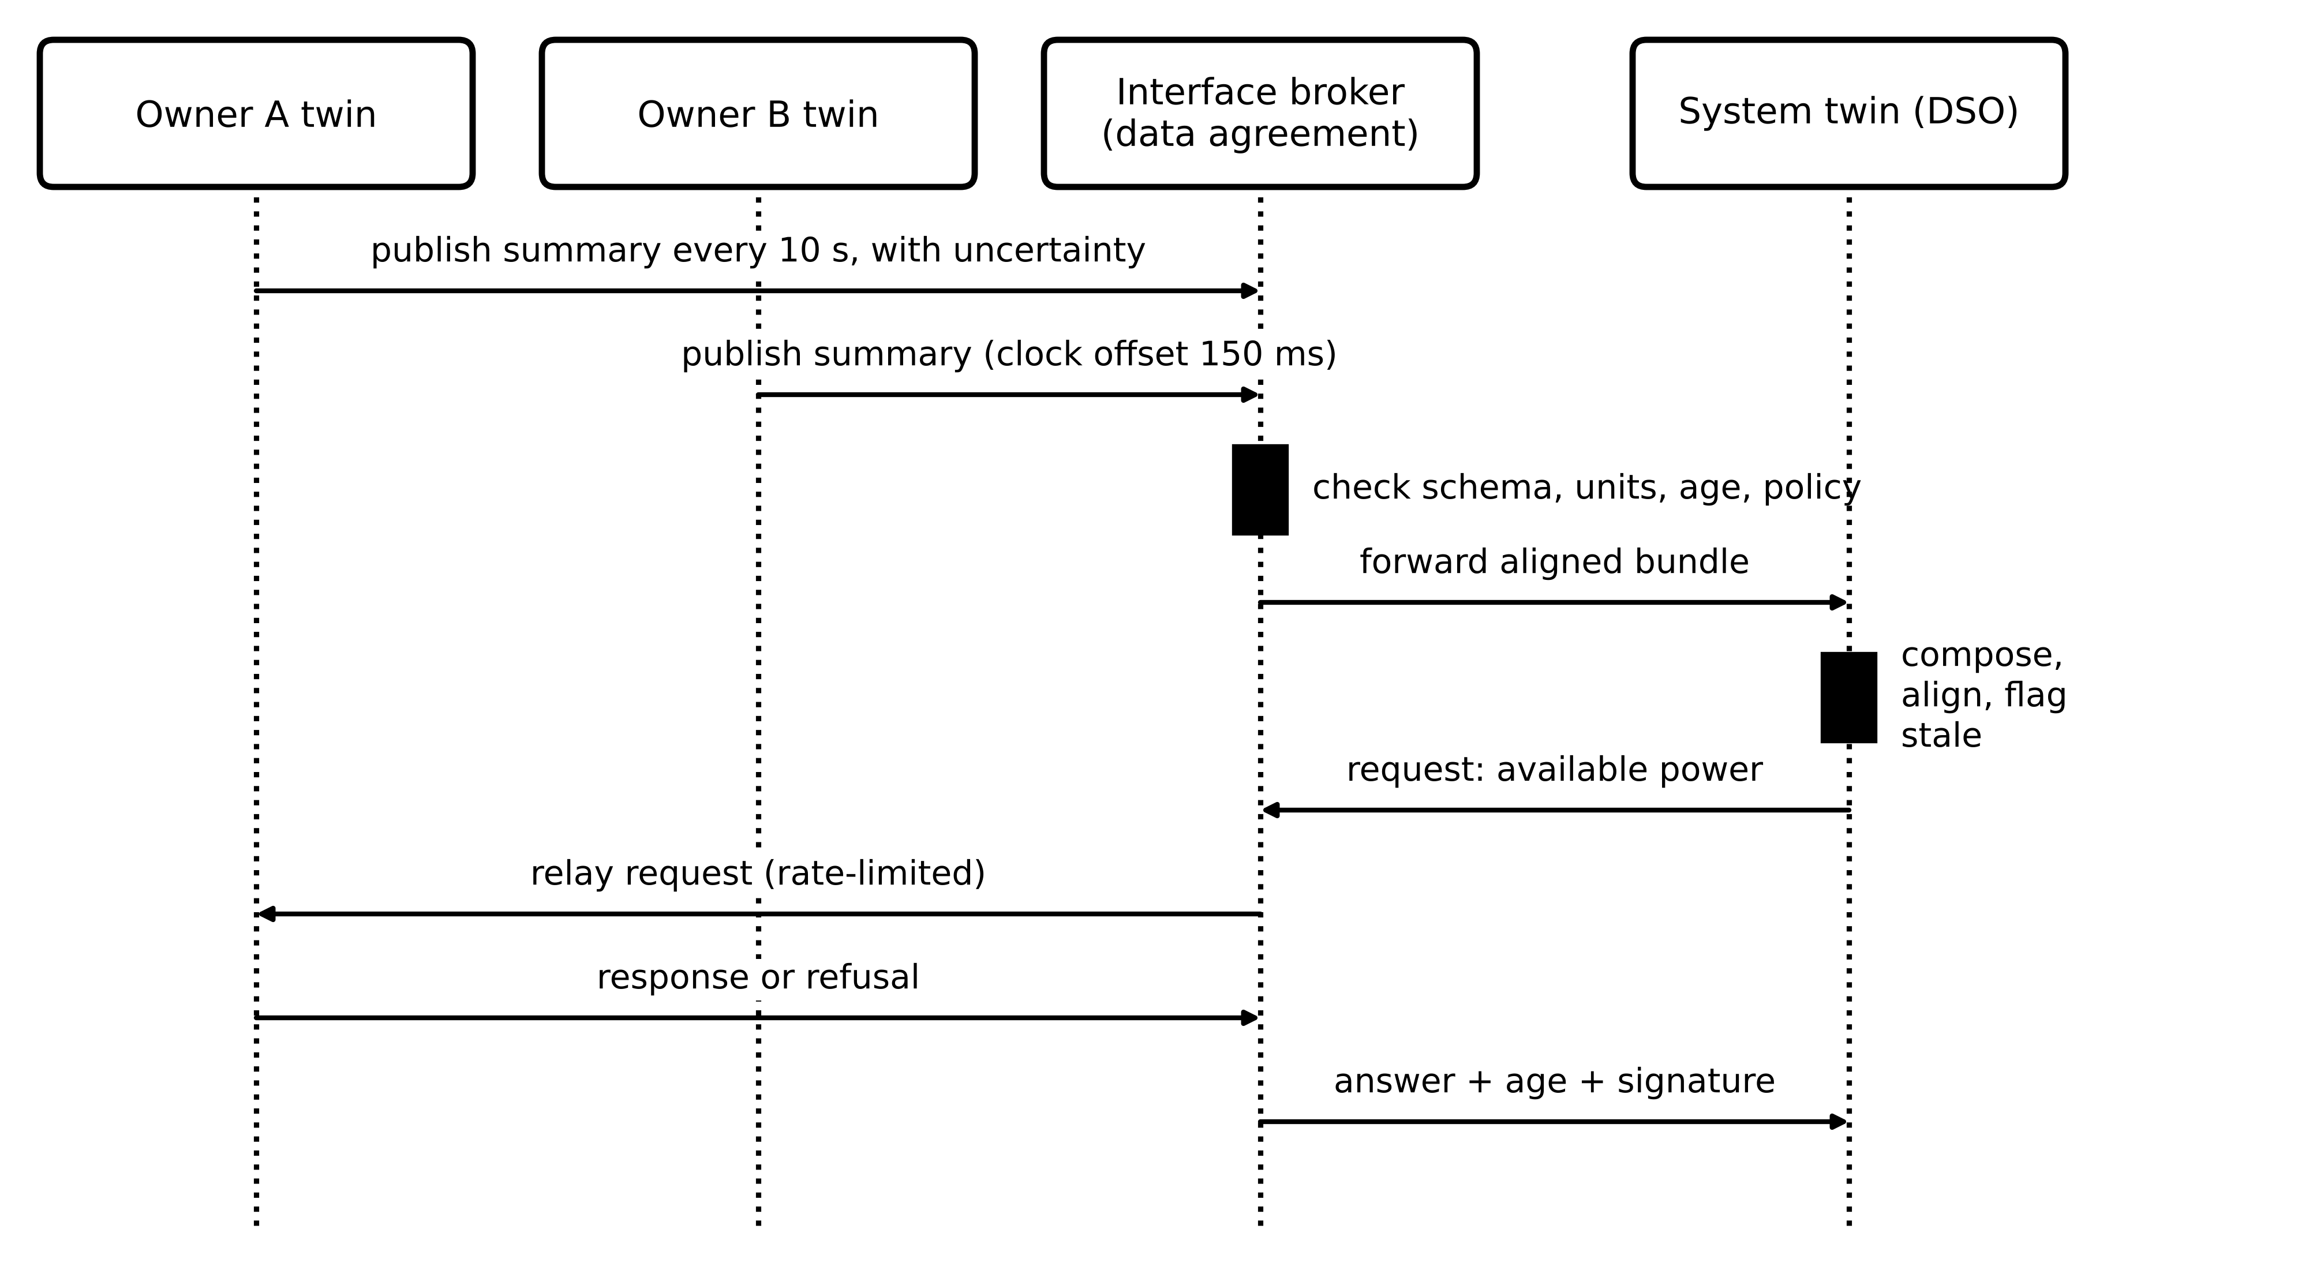
Figure 2.22. Orchestration of a federated twin. Owners publish summaries to an interface broker that checks schema, units, age and policy; the system twin composes them and its requests are relayed under rate limits. Raw data never leave the owners.
When parties share model parameters instead of data, a common aggregation rule is the sample-weighted average of federated learning,
$θ_{glob}=\frac{\sum_{j=1}^{M}{n_{j}} θ_{j}}{\sum_{j=1}^{M}{n_{j}}}$ (2.31)
where $θ_{j}$ is the parameter vector trained by party $j$ on $n_{j}$ samples and $M$ the number of parties. Each party learns from all without disclosing its data, but a party with unrepresentative data pulls the global model towards itself in proportion to its sample count.
Example 2.16 (Level B) Synchronizing a BESS owner with a distribution operator
Given. A BESS owner publishes available discharge power to the distribution operator's twin every 10 s, with 0.8 s delivery delay. The owner's clock is NTP-synchronized with a 150 ms offset from the operator's. The available power can change at up to 50 kW/s while the BESS ramps. Separately, three plants train a thermal-resistance model on 2000, 500 and 8000 samples and obtain 0.21, 0.25 and 0.20 K/W.
Find. (a) The value error caused by the clock offset during a ramp. (b) Mean and peak age at the operator. (c) The largest change of available power over the peak age, and what the interface contract should say. (d) The federated average.
Solution. (a) $e_{clk}=50×0.15=7.5$ kW. (b) $\overline{Δ}=0.8+10/2=5.8$ s; $Δ_{max}=0.8+10=10.8$ s. (c) $50×10.8=540$ kW, more than the whole 500 kW rating, so a bare value is meaningless during ramps. The contract should publish the value with its timestamp, the ramp rate or a guaranteed band for the next interval, and a maximum age after which the operator treats it as unknown. (d) $θ_{glob}=(2000×0.21+500×0.25+8000×0.20)/10 500=0.204$ K/W, dominated by the largest plant.
Interpretation. Across an ownership border, the clock and the publication rate matter more than the network. Interface contracts that state units, rate, age limits and uncertainty are the engineering substance of a federated twin.
What the digital twin adds
Synchronized: instances with their assets; the aggregate and federation with agreed summaries.
Estimated or updated: aggregate completion time; federated parameters.
Uncertainty carried: missing instances, clock offset and age across ownership borders.
Decision enabled: aggregate cut-off; interface contracts between organizations.
Validated by: interface conformance tests and measured age at each border.

2.9 Availability engineering

2.9.1 One component: availability, outage frequency and reliability
A component alternates between working and being restored. If failures arrive at a constant rate $λ_{f}=1/MTTF$ and restorations complete at a constant rate $μ_{r}=1/MTTR$, it is a two-state Markov process. In steady state the probability flow out of the up state equals the flow into it, $λ_{f}π_{up}=μ_{r}π_{down}$, and with $π_{up}+π_{down}=1$:
$A=π_{up}=\frac{μ_{r}}{λ_{f}+μ_{r}}=\frac{MTTF}{MTTF+MTTR}, D_{yr}=(1-A)×8760 h$ (2.32)
where MTTF is the mean time to failure and MTTR the mean time to restore service (h), and $D_{yr}$ the expected annual downtime. Availability says how much of the time a function works, not how often it stops. The component leaves the up state at rate $λ_{f}$ for the fraction $A$ of time it is up, so the outage frequency, mean outage duration and, without repair, the reliability are
$f_{out}=λ_{f}A=\frac{A}{MTTF}, {\overline{τ}}_{out}=MTTR, R(t)=e^{-λ_{f}t}$ (2.33)
A component with MTTF = 4000 h fails about 2.2 times a year; it survives a year of continuous operation without repair with probability $e^{-8760/4000}=0.11$. Availability with repair and reliability without it are very different numbers, and an unattended remote site needs the second.

2.9.2 Series, parallel, k-out-of-n and common cause
A path whose components must all work is a series system; a group of $n$ redundant components of which any one suffices fails only if all fail; and a group that needs $k$ of $n$ identical, independent units follows the binomial distribution:
$A_{s}=∏_{i=1}^{n}A_{i}, A_{p}=1-∏_{i=1}^{n}\left(1-A_{i}\right), A_{koon}=\sum_{j=k}^{n}{\frac{n!}{j! (n-j)!}}A^{j}(1-A)^{n-j}$ (2.34)
Two-out-of-three voting with $A=0.999$ per unit gives 0.999997, and it tolerates one wrong unit as well as one failed unit, which a one-out-of-two pair cannot. Without repair, two units in parallel have ${MTTF}_{1oo2}=3/(2λ_{f})$, only 50 % longer than one: redundancy delays failure but does not prevent it.
[Advanced] Redundancy with repair: why a maintained pair lasts for centuries
The figure $MTTF_{1oo2}=3/\left(2λ_{f}\right)$ assumes that a failed unit is never repaired. In a maintained plant it is, and the effect is dramatic. Model a one-out-of-two pair of identical units with failure rate $λ_{f}$ and repair rate $μ_{r}$ as a Markov chain on the number of working units, 2, 1 or 0. From state 2 the pair moves to state 1 at rate $2λ_{f}$; from state 1 it returns to state 2 at rate $μ_{r}$ or falls to state 0 at rate $λ_{f}$. Writing $T_{2}$ and $T_{1}$ for the mean times to reach state 0 from states 2 and 1, one step of the chain gives $T_{2}=1/\left(2λ_{f}\right)+T_{1}$ and $T_{1}=1/\left(λ_{f}+μ_{r}\right)+μ_{r}T_{2}/\left(λ_{f}+μ_{r}\right)$. Eliminating $T_{1}$ gives
$MTTF_{1oo2,rep}=\frac{3λ_{f}+μ_{r}}{2λ_{f}^{2}}≈\frac{μ_{r}}{2λ_{f}^{2}} \left(μ_{r}≫λ_{f}\right)$
The steady-state unavailability depends on how many repairs can proceed at once. With two independent repair crews the two units are independent and $U={\left[λ_{f}/\left(λ_{f}+μ_{r}\right)\right]}^{2}$, the value used in (2.34). With a single crew, state 0 is left only at rate $μ_{r}$, and balancing the probability flows gives
$U_{1oo2,1crew}=\frac{2λ_{f}^{2}}{2λ_{f}^{2}+2λ_{f}μ_{r}+μ_{r}^{2}}≈2{\left(\frac{λ_{f}}{μ_{r}}\right)}^{2}$
For the cloud servers of Example 2.18 (MTTF 4000 h, MTTR 2 h), a pair without repair survives on average 6000 h, whereas the repaired pair survives on average $\left(3/4000+0.5\right)/\left(2/{4000}^{2}\right)=4.0×{10}^{6}$ h, about 457 years. Independent repair gives $U=2.50×{10}^{−7}$ and a single repair crew $U=5.00×{10}^{−7}$, twice as much. Two lessons follow. Redundancy pays off only together with prompt repair, so an unattended site without a repair process gains far less than (2.34) suggests. And the organization of maintenance is itself an architecture parameter: one administrator responsible for both nodes is a single repair crew, and in practice often a common cause as well (Section 2.9.2).

Example 2.17 (Level A) Voting sensors for the PCC frequency measurement
Given. The frequency-response function reads PCC frequency from sensors with availability $A=0.995$ each. Options: one sensor; a one-out-of-two (1oo2) pair; two-out-of-three (2oo3) voting.
Find. (a) The availability of each option from (2.34). (b) Which option can tolerate one sensor that reports a wrong value while appearing healthy.
Solution. (a) One sensor: 0.995 (43.8 h/yr down). 1oo2: $1-{0.005}^{2}=0.999975$ (0.22 h/yr). 2oo3: $A^{3}+3A^{2}(1-A)=0.985075+0.014851=0.999925$ (0.66 h/yr). (b) Only 2oo3: with two of three agreeing, the third is outvoted. A 1oo2 pair that disagrees cannot tell which sensor is right.
Interpretation. The 1oo2 pair is the more available, and the 2oo3 voter the more trustworthy. A twin that drives a setpoint cares about wrong values as much as missing ones, which is why voting appears wherever a measurement feeds the control plane.
Independence is the weak assumption. Redundant servers share a software image, a power feed, a cooling system and an administrator. The beta-factor model of functional-safety practice (IEC 61508-6 [37]) splits each unit's unavailability $U$ into an independent part $(1-β)U$ and a common-cause part $βU$ that takes all units down together [38]. For two identical units with small $U$:
$U_{1oo2}≈{\left[(1-β)U\right]}^{2}+βU$ (2.35)
where $β$ (0 to 1) is the common-cause fraction, typically 0.01 to 0.1 for separated hardware and higher for identical software. For any realistic $β$ the second term dominates. A third effect is often confused with common cause: an element that is not redundant at all but sits in series with the redundant group, such as the one internet gateway through which both ‘redundant’ cloud servers are reached. It enters through $A_{s}$, not through $β$ (Figure 2.23).
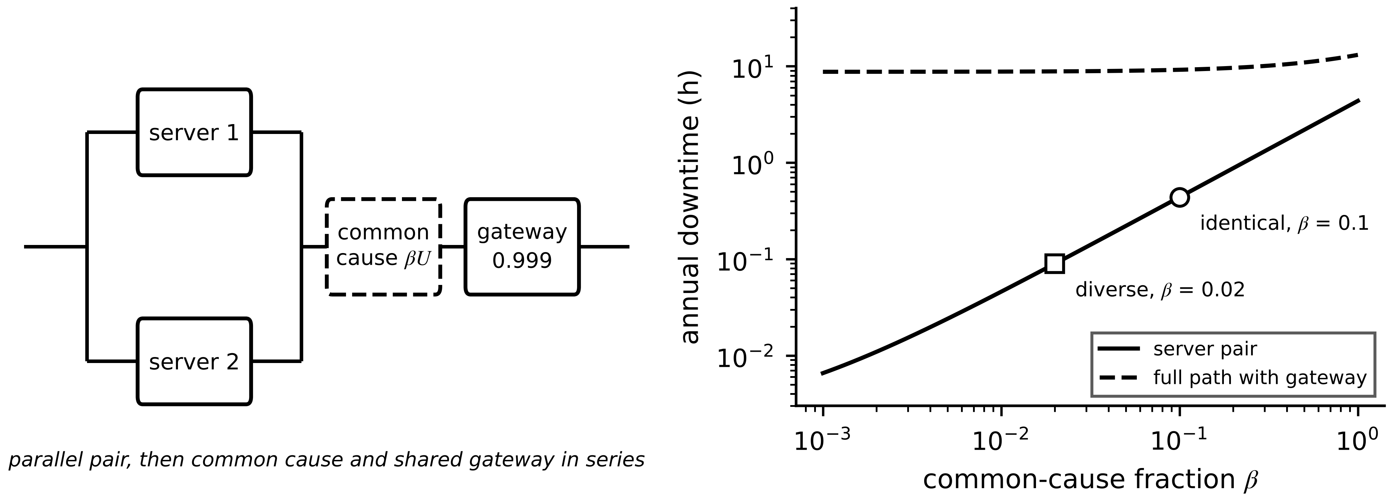
Figure 2.23. Left: reliability block diagram of a cloud-hosted alarm, two servers in parallel followed by a common-cause element and a shared gateway in series. Right: annual downtime against the common-cause fraction, for the pair alone and the full path; markers show identical ($β=0.1$) and diverse ($β=0.02$) server software.
Example 2.18 (Level B) Availability of a cloud-hosted alarm service, and the value of diversity
Given. The PD alarm of Example 2.3 is hosted on two cloud server instances, each with MTTF = 4000 h and MTTR = 2 h, running the same software image ($β=0.1$). Both are reached through the plant's single internet gateway, $A_{gw}=0.999$. A diverse design runs the second instance on a different operating system and runtime, estimated $β=0.02$.
Find. Availability and annual downtime (a) of one server; (b) of the pair assuming independence; (c) with common cause; (d) of the whole path; (e) of the diverse pair.
Solution. (a) $A=4000/4002=0.99950$, $U=5.0×{10}^{-4}$, 4.38 h/yr. (b) $1-(5.0×{10}^{-4})^{2}=0.99999975$, about 8 s/yr. (c) From (2.35): $(0.9×5.0×{10}^{-4})^{2}+0.1×5.0×{10}^{-4}=5.02×{10}^{-5}$; $A=0.999950$, 26 min/yr. (d) $0.999950×0.999=0.99895$, 9.20 h/yr; the gateway alone gives 8.76 h, 95 % of it. (e) $(0.98×5.0×{10}^{-4})^{2}+0.02×5.0×{10}^{-4}=1.02×{10}^{-5}$, 5.4 min/yr for the pair, but the path still has 8.8 h/yr because of the gateway.
Interpretation. The naive calculation promised eight seconds a year; the honest one gives more than nine hours, a factor of about 4000, and it came from drawing the dependency diagram before applying formulas. Diversity cuts the server term fivefold, but it is wasted while a single gateway sits in series. For a protection-relevant alarm the answer is to move it to the edge with a local fallback (Section 2.13).

2.9.3 Graceful degradation, recovery time and service-level objectives
Availability treats a function as either up or down. Real architectures degrade in steps: losing the wide-area link stales cloud forecasts but leaves site functions intact; losing one fog node removes redundancy but not service. If the architecture has states $s$ with long-run probabilities $π_{s}$ and each state delivers a fraction $r_{s}$ of full value, the expected delivered value, called performability, is
$Ψ=\sum_{s}{π_{s}} r_{s}, \sum_{s}{π_{s}}=1, 0≤r_{s}≤1$ (2.36)
The same weighting gives the expected value of any per-state quality measure. For instance, a PV forecast served from the cloud with availability 0.9949 and RMSE 6 %, falling back to a fog persistence forecast with RMSE 14 %, has an expected RMSE of $0.9949×6+0.0051×14=6.04$ %: the fallback costs almost nothing on average because it is rarely used, provided it exists and is tested. Figure 2.24 gives the degradation states of Plant P-1.
Figure 2.24. Architecture-level degradation and fallback states of Plant P-1. Each transition is triggered by a measurable event; the safe state needs no computation; return to full service requires resynchronization and acceptance checks.
Redundancy only helps if the switch to the spare is fast enough. The recovery time after a failure in an active/standby pair (Figure 2.25) is the sum of detection, decision, switchover and the time to drain the backlog that publishers buffered meanwhile. If heartbeats every $T_{hb}$ are declared lost after $k$ misses, and messages arrive at $λ$ and are served at $μ$, a backlog $λT_{out}$ accumulates during the outage $T_{out}$ and drains at the net rate $μ-λ$:
$T_{out}=kT_{hb}+T_{dec}+T_{sw}, T_{rec}=T_{out}+\frac{λ T_{out}}{μ-λ}=\frac{μ}{μ-λ} T_{out}$ (2.37)
where $T_{dec}$ is the decision (election) time, $T_{sw}$ the switchover time and $T_{rec}$ the time until consumers again receive current data. The factor $μ/(μ-λ)$ shows that a heavily loaded node takes much longer to catch up: at $ρ=0.7$ it multiplies the outage by 3.3.
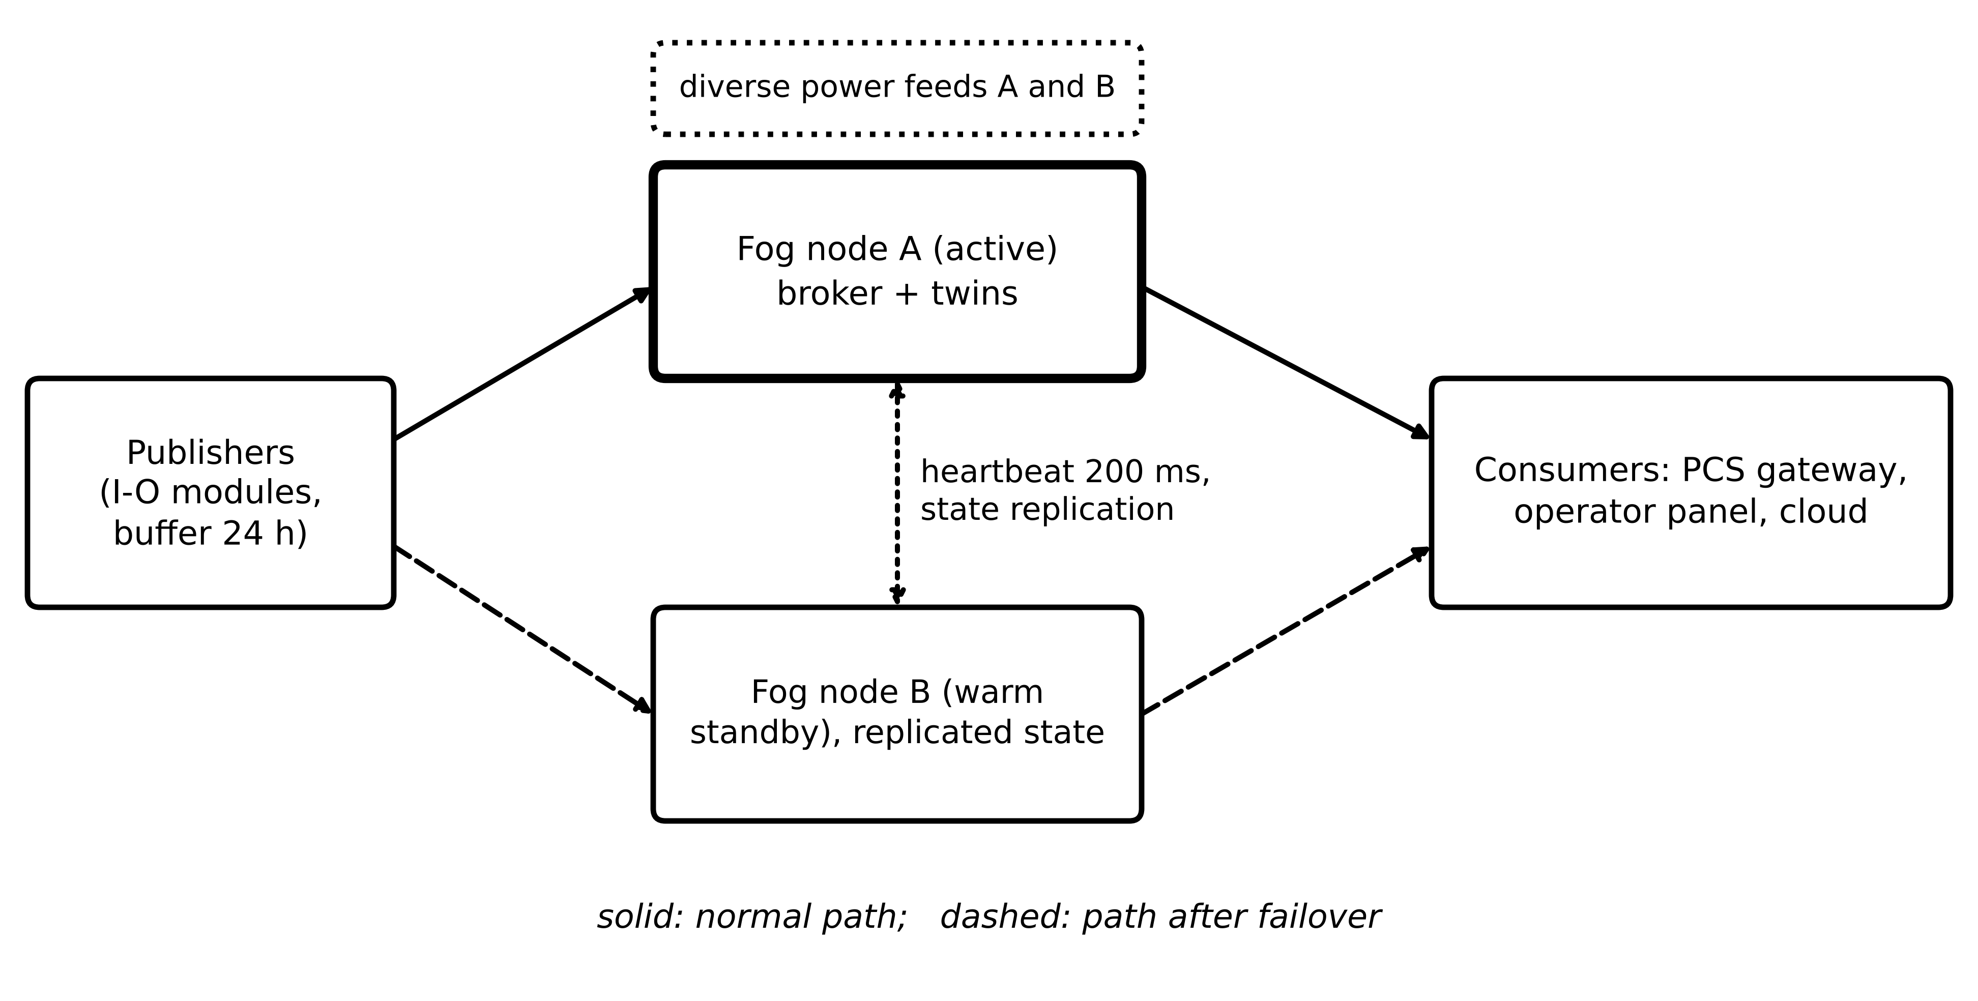
Figure 2.25. Active and warm-standby fog nodes for Plant P-1. Publishers buffer during an outage; heartbeats and state replication link the nodes; diverse power feeds avoid an obvious common cause.
Example 2.19 (Level B) Failover recovery time of the fog broker pair
Given. Heartbeats every 200 ms; a node is declared failed after 3 misses, with up to one further period of phase, so detection takes up to 0.8 s. Election 0.3 s. Warm standby switches in 0.4 s; a cold standby container starts in 8 s. Traffic 350 messages/s; service 500 messages/s. The PCS holds a frequency-response setpoint for 2 s before reverting to droop.
Find. Outage, backlog, drain time and $T_{rec}$ for warm and cold standby, and the consequence for the frequency-response function and the 30 s M-07 cycle.
Solution. Warm: $T_{out}=0.8+0.3+0.4=1.5$ s; backlog $350×1.5=525$ messages; drain $525/150=3.5$ s; $T_{rec}=5.0$ s. Cold: $T_{out}=9.1$ s; backlog 3185; drain 21.2 s; $T_{rec}=30.3$ s (Figure 2.26). The frequency-response path cannot rely on either: even warm failover exceeds the 2 s hold, so the PCS droop fallback is the real protection. For M-07, warm failover costs nothing visible; cold failover costs one 30 s cycle.
Interpretation. Recovery time is dominated by catching up, not by switching. A dedicated, pre-allocated control-plane queue that bypasses the backlog lets the setpoint path recover in $T_{out}$ alone.
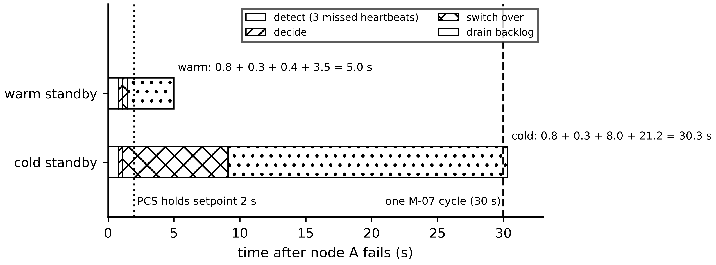
Figure 2.26. Failover timelines for warm and cold standby from Example 2.19, decomposed into detection, decision, switchover and backlog drain, against the 2 s PCS hold and one 30 s M-07 cycle.
Operators express availability targets as service-level objectives (SLO) over a stated window. An SLO $A_{SLO}$ over a window $T_{w}$ implies an error budget, the downtime allowed in the window [39]:
$E_{b}=\left(1-A_{SLO}\right)T_{w}$ (2.38)
A 99.9 % monthly objective allows 43.2 minutes per 30-day month. The budget turns availability into a management rule: when incidents have consumed most of it, risky changes such as new model versions are frozen until the next window.
Example 2.20 (Level A) Error budget of the fog twin service
Given. SLO 99.9 % per 30-day month for the fog twin service. In one month: twelve warm failovers, each leaving consumers without current data for 5 s, and one disk-full incident lasting 35 min.
Find. The error budget, the consumption and the decision.
Solution. $E_{b}=0.001×30×24×60=43.2$ min. Consumed: $12×5/60+35=36.0$ min, that is 83 %. Remaining 7.2 min.
Interpretation. One more small incident breaks the objective, so the planned model update waits for the next month, and the disk-full cause (missing retention enforcement, Section 2.5) becomes the top engineering task.
When an outage has a cost rate $C_{out}$ per hour and a fixed cost $C_{ev}$ per event, the annual cost of an architecture option is
$C_{an}=C_{fix}+8760 f_{out}\left(C_{ev}+{\overline{τ}}_{out}C_{out}\right)$ (2.39)
where $C_{fix}$ is the annual fixed cost (licences, storage, depreciation). With $C_{ev}=0$ it reduces to $C_{fix}+(1-A)×8760 C_{out}$. Two options with the same availability can then differ sharply: frequent short outages are expensive when $C_{ev}$ dominates, rare long ones when $C_{out}$ does.
What the digital twin adds
Synchronized: service continues through defined degraded states.
Estimated or updated: availability, outage frequency, recovery time, error budget.
Uncertainty carried: common-cause fraction and shared series elements, not only redundancy.
Decision enabled: redundancy type (warm, cold, diverse), fallback design, change freezes.
Validated by: fault-injection and failover tests with measured recovery times (Section 2.12).

2.10 Model fidelity against computation
A more detailed model is not automatically a better twin (Chapter 1, Section 1.8). It costs execution time, and an answer that arrives after the deadline is worth nothing to a real-time function. Each candidate model therefore needs two numbers measured on the target hardware: an error metric on held-out data and a worst-case execution time. A single ‘fidelity percentage’ is not used, for the reasons given in Chapter 1.
Candidate $A$ dominates $B$ when it is no worse on both axes and strictly better on one:
$A≻B ⇔ \left(ε_{A}≤ε_{B}\right)∧\left(t_{A}≤t_{B}\right)∧\left(ε_{A}<ε_{B}∨t_{A}<t_{B}\right)$ (2.40)
where $ε$ is the held-out error (here RMSE in K, lower is better) and $t$ the WCET (ms); $∨$ is logical OR. A dominated model is never chosen. Among the non-dominated set, the Pareto front, the choice is made as a constrained problem rather than with a weighted sum, because a weighted sum $ε+wt$ can never select a point on a non-convex part of the front:
$j^{*}=arg\min_{j∈𝒫}ε_{j} subject to t_{j}≤T-\sum_{i≠j}{C_{i}} \frac{T}{T_{i}} and ε_{j}≤ε_{max}$ (2.41)
where $𝒫$ is the Pareto set, $T$ the period of the twin task, $ε_{max}$ the acceptance criterion, and the first constraint is a quick utilization check that is made exact by the schedulability tests below.
Schedulability. A twin rarely has a processor to itself. When periodic tasks with WCET $C_{i}$ and period $T_{i}$ share a core under fixed-priority rate-monotonic scheduling (shorter period, higher priority), all deadlines equal to periods are met if the Liu-Layland bound holds [40]; exact response-time analysis computes the worst-case response $R_{i}$ by iterating from $R_{i}=C_{i}$; under earliest-deadline-first scheduling the bound is 1:
$U_{cpu}=\sum_{i=1}^{n}{\frac{C_{i}}{T_{i}}}≤n\left(2^{1/n}-1\right), R_{i}=C_{i}+\sum_{j∈hp(i)}{\left\lceil \frac{R_{i}}{T_{j}}\right\rceil }C_{j}≤T_{i}, U_{cpu}≤1 (EDF)$ (2.42)
where $hp(i)$ is the set of higher-priority tasks and $⌈·⌉$ rounds up: in a window of length $R_{i}$, task $j$ is released at most $⌈R_{i}/T_{j}⌉$ times. The Liu-Layland bound falls from 1 for one task towards $ln2=0.693$ for many and is sufficient, not necessary.
Table 2.12. Candidate transformer thermal models (illustrative benchmark on one industrial PC; held-out month, fibre-optic reference)
Model | Structure | RMSE (K) | WCET (ms)
A | single-node lumped (Chapter 1 form) | 3.8 | 2
B | two-node, oil and winding | 1.4 | 9
C | finite-element thermal-hydraulic | 0.6 | 140
D | two-node with a neural correction term | 2.1 | 12

Example 2.21 (Level B) Choosing a transformer thermal model for the fog computer
Given. Table 2.12. The twin must update every $T=30$ ms because it feeds a dynamic-loading function that follows the BESS dispatch. The same core runs a message-handling task ($C=1$ ms, $T=10$ ms) and a PV nowcast ($C=40$ ms, $T=300$ ms). Acceptance: RMSE ≤ 2.0 K.
Find. (a) Dominated candidates. (b) The choice from (2.41). (c) Schedulability with (2.42). (d) The speed-up a 16-core accelerator would give model C if 90 % of it parallelizes.
Solution. (a) B dominates D (1.4 < 2.1 K, 9 < 12 ms); A, B and C form the Pareto front (Figure 2.27). (b) A fails 2.0 K; C cannot run every 30 ms; B is chosen. (c) $U_{cpu}=1/10+9/30+40/300=0.533$, below $3(2^{1/3}-1)=0.780$. Exact analysis: B responds within $9+⌈10/10⌉×1=10$ ms; the nowcast iterates $40→62→74→75→75$ ms, within 300 ms. (d) Amdahl's law, $S=1/[(1-p)+p/N_{c}]$, gives $1/(0.1+0.9/16)=6.4$, so C would need about 22 ms on 16 cores: inside the 30 ms period on its own, but occupying 16 cores for 73 % of every period.
Interpretation. C is the most accurate and the least useful here; it remains valuable offline, for auditing B monthly or training B's successors. D shows that adding machine learning does not guarantee a better point on the front. The choice used measured WCET; a mean execution time would hide any tail.
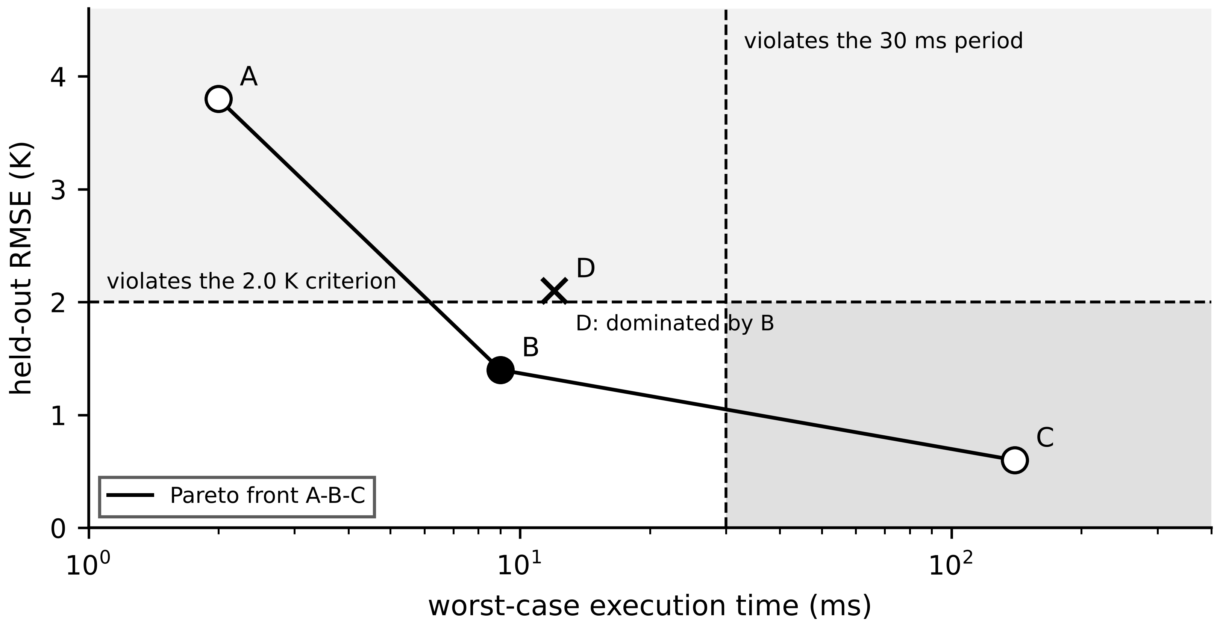
Figure 2.27. Held-out RMSE against WCET for the candidates of Example 2.21. A, B and C form the Pareto front; D is dominated by B. Shaded regions violate the 30 ms period or the 2.0 K criterion; the dotted line is an illustrative envelope only.
Recent practice moves the front in two directions. Reduced-order and surrogate models, including the physics-informed networks of Chapter 6, move accurate models to the left. FPGA-based real-time simulators run detailed electromagnetic-transient models with microsecond steps for hardware-in-the-loop testing (Chapter 7), moving detailed models into the deterministic tier at a hardware cost that limits them to testing and a few critical assets (established for testing, emerging in operation).
What the digital twin adds
Synchronized: a model fast enough to keep its state current at the required period.
Estimated or updated: Pareto set, utilization and worst-case response times.
Uncertainty carried: held-out error with its window; WCET, not mean time.
Decision enabled: which model runs online and which audits it offline.
Validated by: benchmark on the target hardware with the co-located task set.

2.11 Standards and security as architecture properties

2.11.1 What each standard covers
A standard helps an architect only if its scope is read correctly. Table 2.13 summarizes the standards most relevant to energy twins from the publishers' public scope statements; clause-level requirements must be read in the licensed texts, and no conformance is claimed here.
Table 2.13. Standards for electrical-energy digital twins (scope from public abstracts; editions current in 2026)
Standard | Scope | Nature | Layers and planes
ISO/IEC 30173:2023 [41] | twin concepts and terminology | vocabulary | all
ISO/IEC 30188:2026 [8] | general reference architecture through viewpoints | normative, generic | all
ISO/IEC 30186:2025 [42] | maturity model and assessment guidance | guidance | management
ISO 23247-1..-4:2021, -5, -6:2026 [5], [34], [35] | manufacturing twin framework; digital thread; composition | normative, manufacturing | 2, 4-7; management
IEEE 3835-2025 [9] | twin framework for integrated energy systems | normative framework | 1-8
ITU-T Y.4517 (06/2026) [10] | architecture of a twin system in the power grid | Recommendation | 1-8
IEC 63278-1:2023; IDTA specs [29], [22] | Asset Administration Shell structure and metamodel | normative structure | 5, 6; management
IEC 61850 series [24] | substation and DER communication, data model, SCL | normative | 2, 3, 5; data, control
IEC 61970 / 61968 (CIM) [26] | network and asset information model | normative | 5, 6
IEC 62541 (OPC UA) [28] | information modelling, transport, security | normative | 3, 5; security
IEC/IEEE 61588:2021 [19] | precision time protocol | normative | 2, 3
IEC 62351 series [43] | security of power-system protocols | normative | 3, 5; security
IEC 62443 series [44] | security of industrial automation: zones, conduits, levels | normative | all; security
NIST IR 8356 (2025) [45] | security and trust considerations for twins | informative report | all; security

Three distinctions prevent common specification errors. Vocabulary standards fix words, not formats; citing them does not make two systems interoperable. The Asset Administration Shell fixes how an asset's information is structured; the protocol that carries it (OPC UA, HTTP/REST) is a separate choice. IEC 61850 already defines a rich device model; a twin that consumes it should map to it rather than invent a parallel vocabulary.

2.11.2 Security has a place and a time cost
A twin that can issue setpoints is part of the control system and inherits its security requirements. IEC 62443 organizes a plant into zones with a target security level, connected by controlled conduits [44]. For Plant P-1 the natural zones are the device tier, the site network with the fog pair, and the enterprise and cloud side; the setpoint path crosses a conduit and must be authenticated, rate-limited and bounded by limits enforced in the device. IEC 62351 supplies protocol-level mechanisms for IEC 61850 and related protocols [43]; NIST IR 8356 adds twin-specific threats, including manipulation of synchronization data so that the twin misrepresents its asset [45]. Chapter 14 treats attacks and defences in depth.
Security consumes time, and the time belongs in (2.2). For supervisory functions with deadlines of tens of milliseconds, transport encryption and message authentication cost well under a millisecond (0.3 to 0.8 ms in Table 2.7). The fastest protection messages must fit inside transfer-time classes down to 3 ms [46], which is why they use lightweight message-authentication codes and dedicated hardware. Security also has its own arithmetic: a $t_{mac}$-bit authentication tag is guessed with probability $2^{-t_{mac}}$ per forgery attempt, so over $N_{a}$ attempts
$P_{forge}≤N_{a} 2^{-t_{mac}}$ (2.43)
by the union bound. A 32-bit tag allows one success in about $4.3×{10}^{9}$ attempts, adequate against an attacker limited by a substation LAN's message rate; a 128-bit tag removes the question. Tag length is a timing and bandwidth decision as well as a security one, and a security design that has not been timed is not finished.
What the digital twin adds
Synchronized: authenticated data and commands across each conduit.
Estimated or updated: security time cost inside the latency budget; forgery bound.
Uncertainty carried: which standard clauses are verified and which are only scope-read.
Decision enabled: zones, conduits, tag lengths, and where enforcement lives (in the device).
Validated by: conduit tests rejecting unauthenticated and out-of-limit commands (Section 2.12).

2.12 Architecture verification and acceptance
An architecture is accepted with evidence, not with a diagram. Verification is planned with the design, level by level, in the V-model of systems engineering (Figure 2.28) [47]: each design level on the left is verified by a test level on the right. For a twin the levels are the service contract (Chapter 1, Section 1.4), the architecture (tiers, planes, interfaces), the component design (models, schemas, tasks) and the implementation.
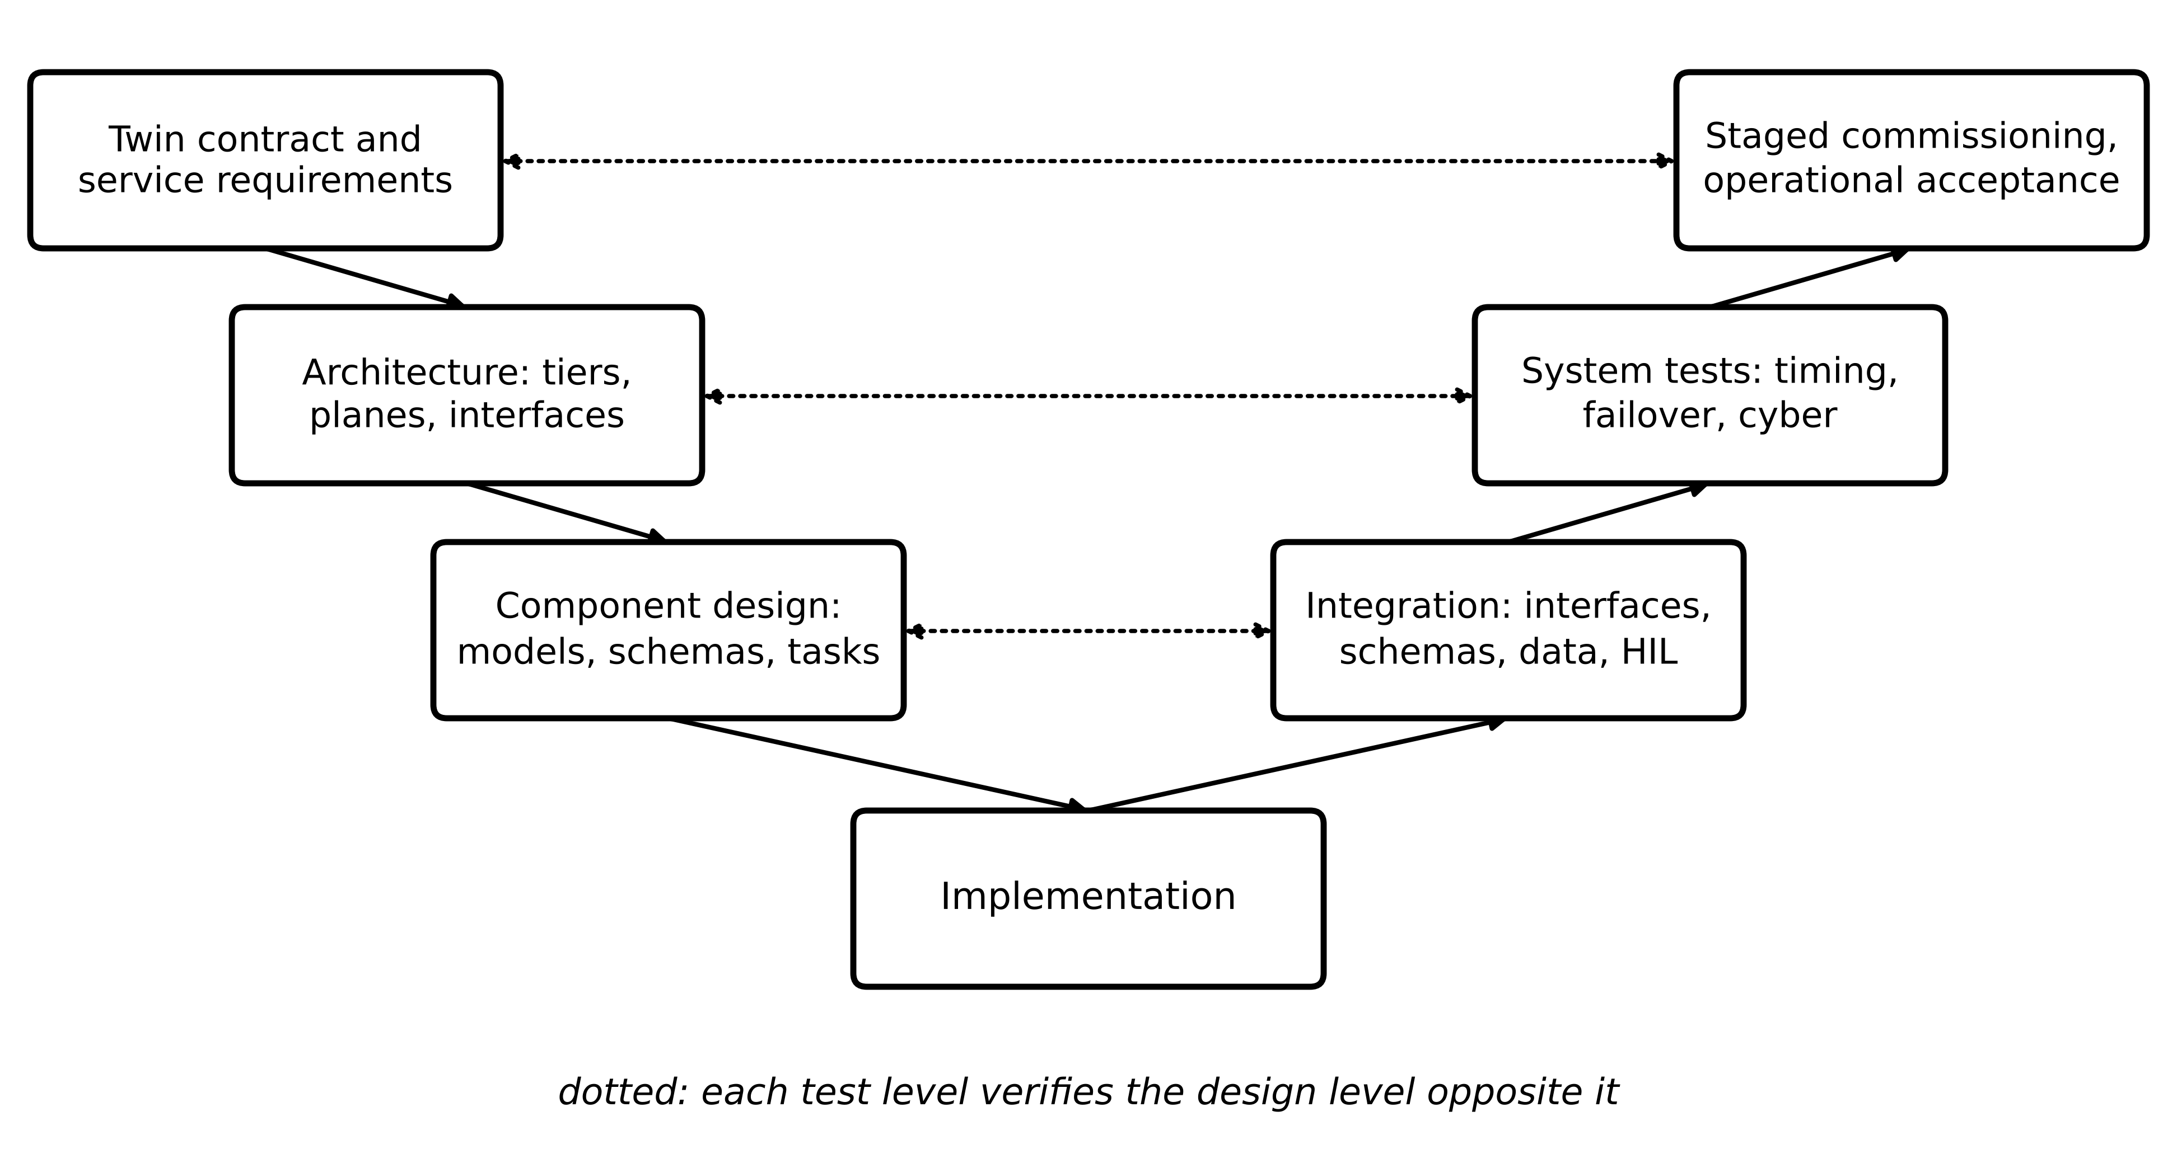
Figure 2.28. Architecture acceptance V-model for a twin. Integration tests verify the component design, system tests verify the architecture, and staged commissioning verifies the service contract.
Table 2.14. Architecture verification: what is tested, how, and the pass criterion
Test | Method | Evidence | Pass criterion (Plant P-1 example)
Interface and schema | replay messages with every registered version, plus unknown version, bad unit, out-of-range value, stale timestamp, firmware-map mismatch | ingestion log | all bad cases quarantined and alarmed; good cases accepted
Latency and WCET | timing campaign under load with injected disturbances; static or measurement-based WCET with margin | campaign record, WCET report | (2.7) met at stated quantile or bound
Fault injection | pull cables, stop broker, reboot gateway, fill disk, skew a clock | event log with timestamps | each fallback entered within its specified time
Failover | repeated controlled failure of the active node | measured recovery times | $T_{rec}$ within budget in every trial
Data quality | compare twin inputs with independent references over a week | quality report | validity flags correct; no unflagged drift
Cybersecurity gate | conduit tests, unauthenticated and out-of-limit commands, configuration review | test report | all rejected; review signed
HIL | twin and command gateway against a real-time plant simulator (Chapter 7) | HIL record | setpoint behaviour and limits correct over the envelope
Staged commissioning | shadow mode (no commands), advisory mode, then limited authority | stage reports | each stage meets its criterion before the next

Two quantitative rules size the tests. A timing claim needs enough passes: by (2.15), zero misses in $N$ passes supports a miss probability below $3/N$. A failover or fault-injection claim needs enough trials: to demonstrate a success probability of at least $R$ with confidence $C$ when every trial succeeds, the number of trials must satisfy
$R^{ n}≤1-C ⇒ n≥\frac{ln(1-C)}{lnR}$ (2.44)
since the probability of $n$ consecutive successes from a design whose true success probability is only $R$ is $R^{n}$. For WCET, measurement-based estimates take the highest observed execution time under worst-case co-located load and add an engineering margin, commonly 20 to 50 %; static analysis gives a bound but needs a processor model [15].
Example 2.22 (Level A) How many failover trials?
Given. The fog pair must be shown to fail over successfully with probability at least 0.99, at 95 % confidence. Each trial takes about 3 min including resynchronization checks.
Find. The number of successful trials needed, the test time, and what one failed trial would mean.
Solution. From (2.44), $n≥ln0.05/ln0.99=298.1$, so 299 trials, about 15 h of testing. One failure does not simply require a few more trials: it is a defect to be diagnosed and fixed, after which the count restarts.
Interpretation. ‘We tested failover and it worked’ usually means a handful of trials, which supports almost nothing. Automated fault injection overnight makes the statistically meaningful number affordable.
Staged commissioning deserves emphasis because it limits the damage of what the tests missed. In shadow mode the twin computes setpoints but sends none, and its outputs are compared with what operators did. In advisory mode it informs people (autonomy Layer 2, Chapter 1). Only after both stages meet their criteria does it receive limited authority (Layer 3) inside an envelope enforced by the device. The test results, with the software and configuration versions tested, become the first entries of the plant's digital thread.
What the digital twin adds
Synchronized: verified, not assumed, at each design level.
Estimated or updated: miss probabilities, recovery times, WCET with margin.
Uncertainty carried: confidence of each claim from the number of trials, (2.44).
Decision enabled: progression from shadow to advisory to limited authority.
Validated by: the V-model test records, filed in the digital thread.

2.13 End-to-end case study: the architecture of Plant P-1 (Level C)

2.13.1 The selection matrix
Every quantity developed so far is now applied jointly, function by function. Table 2.15 is the implementation architecture of Plant P-1: for each function, the deadline, the data scope, the consequence of a wrong or missing output, the tier and platform, the interface and plane, and the fallback.
Table 2.15. Architecture selection matrix for Plant P-1
Function | Deadline | Consequence of failure | Tier and platform | Interface (plane) | Fallback
Motor thermal protection | seconds (thermal image) | winding damage | device: protection relay, independent of twin | hard-wired trip (control) | none needed; relay is the fallback for all above it
BESS PCS current control | ≈ 100 µs | overcurrent, trip | device: DSP or FPGA in PCS | internal | hardware overcurrent trip
PD alarm, 11 kV switchgear | 50 ms | undetected insulation failure | edge computer in switchgear | IEC 61850 GOOSE to annunciator (control) | local threshold on raw PD magnitude
BESS frequency-response setpoint | 100 ms (illustrative) | missed service, penalty | fog pair, real-time partition, dedicated queue | Modbus TCP or IEC 61850 MMS to PCS (control) | PCS holds 2 s, then droop
M-01..M-20 thermal twins | 30 s cycle | missed early warning | fog pair, containers | MQTT with self-describing messages (data) | raw-RTD alarm; twin flagged unsynchronized
BESS SOC synchronization | 5 s | wrong energy availability for dispatch | edge: BMS gateway (Example 2.23) | BMS protocol (data) | Coulomb counting only, growing uncertainty
PV forecast, 15 min to day ahead | minutes | poorer dispatch | cloud, with fog nowcast | HTTPS API (data) | persistence forecast at fog
Fleet ranking, model retraining | hours to days | delayed maintenance planning | cloud | batch export (data, management) | last ranking with staleness flag

The matrix has a visible structure. Everything that protects or controls the asset sits in the device tier and does not depend on the twin. Everything that needs a bounded delay of milliseconds to seconds runs on site. The cloud receives the functions whose value comes from breadth (many plants, external data, heavy training) and whose deadline is minutes or longer. Figure 2.29 draws the result.
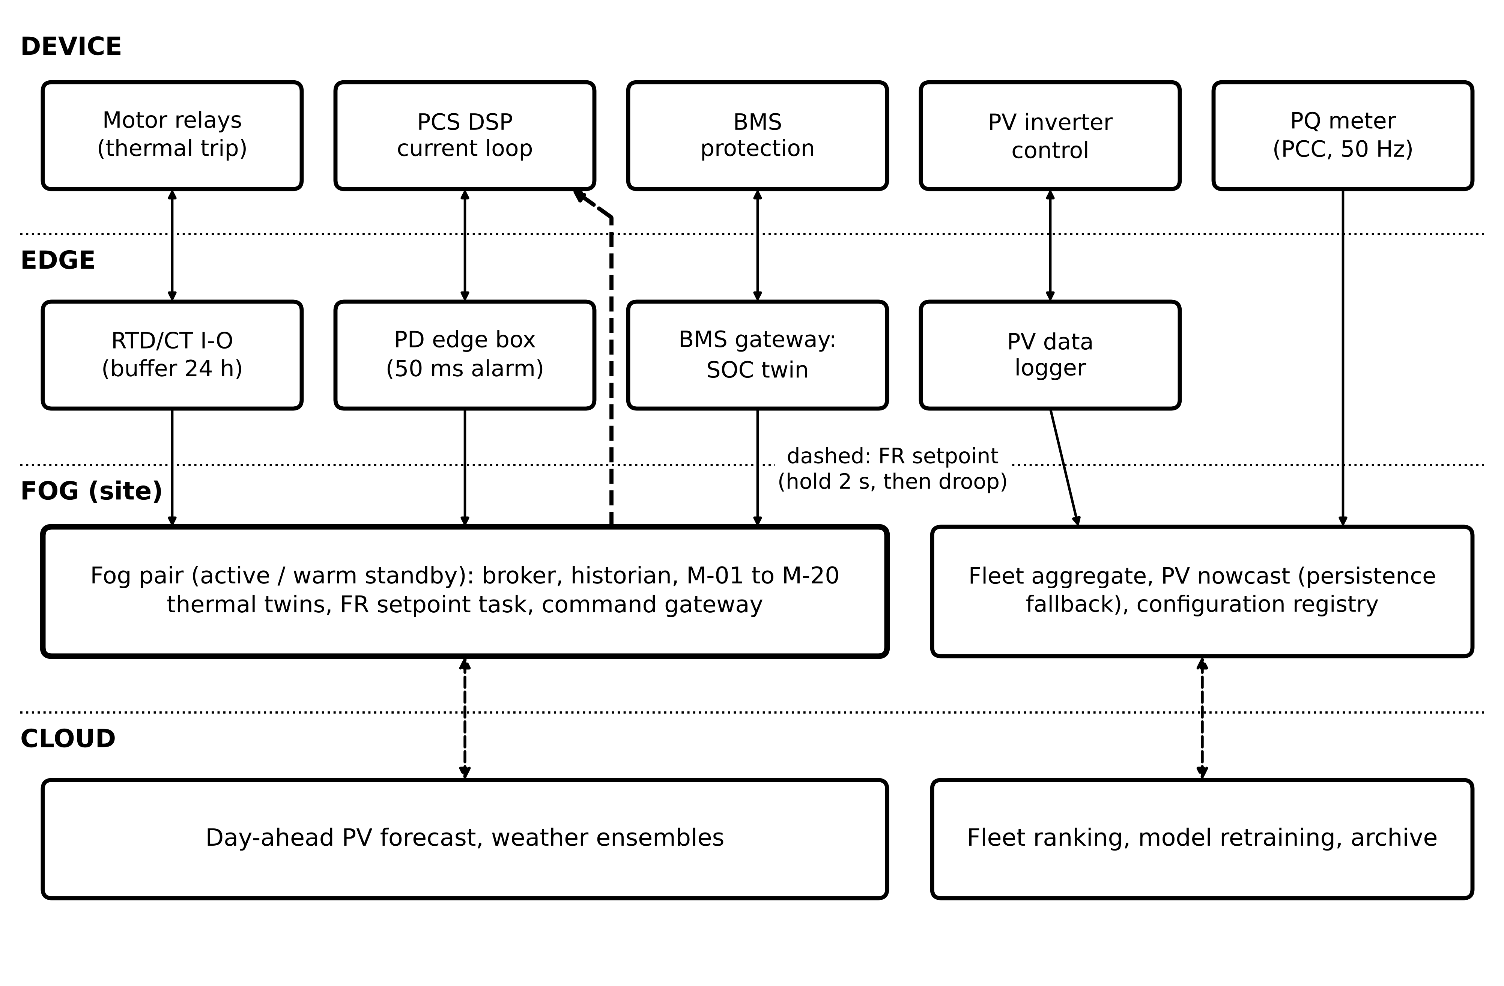
Figure 2.29. The end-to-end architecture of Plant P-1 after applying Table 2.15. Protection and converter control are self-contained in the device tier; time-bounded twin functions run at edge or fog; the cloud serves forecasting and fleet analytics. The dashed path is the frequency-response setpoint, with its 2 s hold-and-droop fallback.

2.13.2 A capstone placement decision
Example 2.23 (Level C) Where should the BESS state-of-charge twin run?
Given. The BESS state-of-charge (SOC) synchronization twin of Chapter 1, Section 1.14.3, has $T_{dl}=5$ s and margin $m=0.15$. Edge candidate (BMS gateway), worst-case times from a campaign: acquisition 0.05 s, transport 0.02 s, computation 0.30 s, actuation 0.05 s; availability 0.998 (single device). Cloud candidate: acquisition 0.05 s, transport 0.80 s (cellular backhaul, 99.9th percentile), computation 0.10 s, actuation 0.05 s; cloud service $A=0.9999$, reached through the plant's LTE link with $A_{link}=0.995$. An hour without synchronization costs $C_{out}=500$ USD in reduced dispatchable energy; fixed costs are equal.
Find. (a) Whether each meets (2.7). (b) Effective availability. (c) Annual downtime and cost with (2.39). (d) The effect of a second, independent wired link with $A=0.999$, and of a shared power supply for both routers with $A=0.9995$. (e) The recommendation.
Solution. (a) Allowed: $0.85×5=4.25$ s. Edge $0.05+0.02+0.30+0.05=0.42$ s; cloud $1.00$ s. Both pass. (b) Edge 0.998; cloud $0.9999×0.995=0.99490$ by (2.34). (c) Edge $(1-0.998)×8760=17.5$ h, 8760 USD/yr; cloud 44.7 h, 22 338 USD/yr. (d) Two independent links: $1-0.005×0.001=0.999995$; path $0.9999×0.999995=0.99990$, 0.92 h/yr. With the shared power supply in series: $0.99990×0.9995=0.99940$, 5.3 h/yr; still better than the edge, but only if the second link truly has independent routing.
Interpretation. The edge is preferred with the present single link, and the reason is not latency, which both meet, but a hidden dependency on one link. A sensible final design uses both tiers: the edge runs the synchronization loop and keeps the SOC estimate alive through any outage, while the cloud retrains the battery model weekly on fleet data and pushes a validated prototype version through configuration control (Section 2.7).

2.13.3 Acceptance of the Plant P-1 architecture
The acceptance criteria are written before commissioning, following Table 2.14. For each time-bounded function: a timing campaign of at least 100 000 passes including injected disturbances, meeting (2.7); for the frequency-response path this exposed the broker stalls of Example 2.6 and led to the dedicated queue. For each fallback: a forced failure demonstrating the fallback within its time and the automatic return; for the fog pair, 299 successful failovers by (2.44). For data: ingestion tests with unregistered schemas, wrong units, out-of-range values, stale timestamps and firmware-map mismatches, all quarantined and alarmed. For security: conduit tests rejecting unauthenticated and out-of-limit commands. Commissioning then proceeds through shadow, advisory and limited-authority stages, and every test record enters the digital thread with the versions tested.
What the digital twin adds
Synchronized: every function of Plant P-1 on a tier that meets its contract.
Estimated or updated: the selection matrix and its timing, availability and cost figures.
Uncertainty carried: tail latency, path availability, hidden series dependencies.
Decision enabled: the deployable architecture with a fallback for every function.
Validated by: the acceptance plan, from interface tests to staged commissioning.

2.14 Recent developments and open research problems
Twin architecture is moving quickly. Each development below is labelled with its status in 2026. The recent reviews agree on the direction: Abuabed and Kittur's systematic review of 84 electrical-engineering studies calls for standardized interoperability (CIM, IEC 61850), hierarchical and federated architectures and adaptive synchronization, and names the move from descriptive to prescriptive twins as the main barrier [48]; Satpathy and Ramachandaramurthy analyse a four-layer architecture with phased, utility-scale deployment [49]; and Manimaran et al. stress real-time validation, scalability, cybersecurity and the fidelity against speed trade-off [50].
Standard reference architectures (established standards, emerging use). ISO/IEC 30188:2026, IEEE 3835-2025, ITU-T Y.4517 and ISO 23247-5 and -6 give, for the first time, standard architectures, digital threads and composition rules for twins. Open problem: evidence that systems specified against them interoperate in the field. Semantic interoperability (emerging). AAS submodel templates for energy equipment, generation of IEC 61850 configuration from AAS records, and CIM-61850 harmonization are active. Open problem: loss-free round-trip mapping with verified semantics. Edge orchestration (emerging). Container platforms and interoperable edge application management, such as the Margo specification [21], are entering operational technology. Open problem: WCET guarantees for co-located containerized workloads. Deterministic networking (established standards, pilot use). Time-Sensitive Networking [16] and 5G ultra-reliable low-latency communication could carry bounded-latency twin traffic. Open problem: end-to-end bounds that include computation. Federated grid twins (research and large pilots). TwinEU and ISO 23247-6 address multi-owner systems. Open problem: propagating uncertainty across federation borders when each party discloses only summaries. Age-aware design (research-stage in energy). Scheduling sampling and transmission to minimize packet age rather than latency [20]. Open problem: joint design of sampling rates, batching and estimator gains for a target state error. Twin integrity (research-stage). NIST IR 8356 frames trust in twins as open [45], and the National Academies place VVUQ at the centre [51]. Open problem: detecting a twin whose synchronization data were altered so that it agrees with a falsified measurement.
Table 2.16. Emerging directions with status and a measurable research target
Direction | Status | Open problem | Measurable target
Standard twin architectures | standards published 2025-2026 | field interoperability evidence | share of interfaces passing conformance tests between vendors
IEC 61850 / CIM / AAS mapping | emerging | loss-free semantic round trip | fraction of attributes mapped both ways without loss
Containerized edge twins | supervisory use; Margo preview | WCET under co-location | worst-case response time under stated interference
TSN and 5G URLLC for twin traffic | pilots | end-to-end bound including computation | guaranteed $T^{(1)}$ verified by campaign
Federated grid twins | research, large pilots | uncertainty across borders | coverage of federated prediction intervals on held-out data
Age-aware sampling | research | joint rate and estimator design | state error per kbit/s of uplink
Twin integrity | research | detecting falsified synchronization | detection delay and false-alarm rate on injected attacks

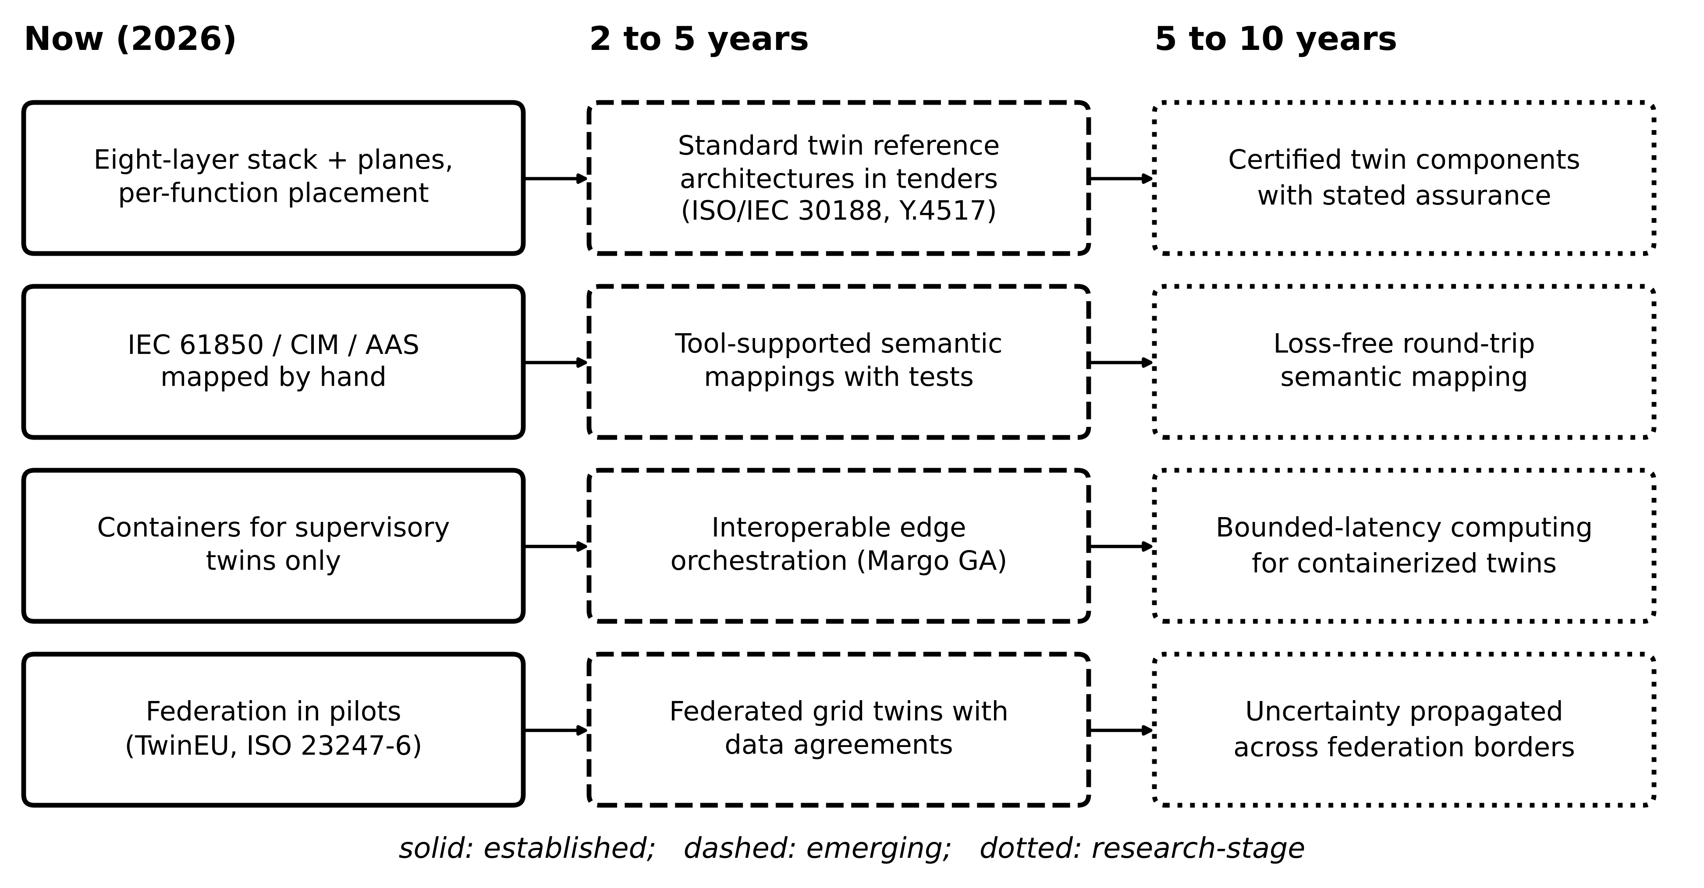
Figure 2.30. Architecture roadmap for energy twins: practice in 2026 (established), developments expected within 2 to 5 years (emerging) and research targets for 5 to 10 years.
Figure 2.30 arranges these into a roadmap. The 2-to-5-year column is driven by standards that already exist and need tools and field evidence. The 5-to-10-year column contains problems that need new theory: bounded latency for shared computing, semantic mappings that can be proved loss-free, and uncertainty that survives federation borders.

2.15 How this chapter feeds the rest of the book
The architecture of this chapter is the frame every later chapter fills. Chapter 3 builds Layers 2 and 3: the sensors, clocks and protocols whose timing and data rates were budgeted here. Chapter 4 supplies the models whose WCET and error define the Pareto choices of Section 2.10. Chapter 5 supplies the estimators that run inside each instance and whose synchronization depends on the packet age of Section 2.3. Chapter 6 adds data-driven and hybrid models with their own computational cost. Chapters 7 to 11 instantiate the stack for converters, renewables, batteries, electric vehicles and microgrids, the last as a federation. Chapters 12 and 13 run the analytics and control-plane functions on the tiers chosen here, and Chapter 14 attacks and defends the security plane. The selection matrix, the semantic and configuration registry and the acceptance plan of this chapter are the artefacts each of those chapters extends.

Chapter summary
An architecture says where the parts of a twin run, how fast its data move, what its data mean, which versions produced each output, how often it is unavailable and what happens then. The chapter separated reference architecture, implementation architecture and deployment topology, refined the five-dimension model into an eight-layer stack with four cross-cutting planes, and mapped it onto SGAM, RAMI 4.0, ISO 23247-2, IIRA, ISO/IEC 30188, IEEE 3835 and ITU-T Y.4517, concluding that no single stack is universal.
Timing was decomposed stage by stage and tested on percentiles and worst cases, not means; queueing theory explained the long tail, and a reproducible 100 000-pass campaign showed a path whose mean was under half its deadline but whose 99.9th percentile failed it because of one stalling component. Placement followed six criteria with feasibility before scoring. Data rate, retention, compression and overhead were sized from first principles. The semantic and configuration architecture made meaning explicit: identifiers, units with dimension checks, quality, information models (IEC 61850 with SCL, CIM, OPC UA, AAS), schema compatibility and a trace tuple on every output, with the digital thread and a significance test catching a firmware change that a range check missed. Composition and federation were treated across ownership borders. Availability engineering went beyond series and parallel to common cause, diversity, performability, recovery time and error budgets; an honest dependency diagram turned eight seconds of annual outage into nine hours. Model choice was framed as a constrained Pareto problem with schedulability tests, and verification was planned in a V-model with quantitative trial counts and staged commissioning. The Plant P-1 case joined everything into a deployable architecture with a fallback for every function.
Table 2.17. Key relationships of Chapter 2
Relationship | Expression | Eq.
Path delay and availability | $T_{π}=\sum{T_{n_{i}}}$, $A_{π}=∏A_{n_{i}}$ | (2.1)
End-to-end delay | $T_{e2e}=T_{age}+T_{acq}+T_{ser}+T_{prop}+T_{q}+T_{sec}+T_{proc}+T_{act}$ | (2.2)
Soft and hard deadline tests | $T^{(q)}+mT_{dl}≤T_{dl}$; $\sum{C^{WC}}+\sum{D^{max}}≤(1-m)T_{dl}$ | (2.7)
Network-calculus bound | $D_{max}≤T+b/R$ | (2.8)
M/M/1 delays and tail | $W=1/(μ-λ)$; $T^{(q)}=ln[1/(1-q)]/(μ-λ)$ | (2.10), (2.11)
Kingman approximation | $W_{q}≈\frac{ρ}{1-ρ}\frac{c_{a}^{2}+c_{s}^{2}}{2}\frac{1}{μ}$ | (2.12)
Phase error; packet-age bound | $δφ={360}^{∘}f_{0}δt$; $Δ_{max}≤T_{s}+D_{max}$ | (2.13), (2.14)
Miss ratio; rule of three | $\hat{p}±1.96\sqrt{\hat{p}(1-\hat{p})/N}$; $p_{95}≈3/N$ | (2.15)
Placement feasibility and score | $ℱ$; $S_{ℓ}=\sum{w_{j}}s_{j,ℓ}$ | (2.17)
Data rate, volume, entropy | $R=\sum{n_{i}}f_{i}b_{i}δ_{i}$; $V=RT_{r}(1-c)/8$; $H≈\log_{2}(σ_{Δ}\sqrt{2πe}/Δ_{q})$ | (2.18), (2.19), (2.20)
Batching | $B_{req}=R_{pay}(1+O/(n_{b}P_{1}))$; $Δa_{max}=(n_{b}-1)T_{s}$ | (2.21)
Register map; unit check | $y=rs+o$; $d(Q_{p})=d(Q_{c})$, $y_{c}=ky_{p}+o_{pc}$ | (2.22), (2.23)
Schema compatibility | $(M_{p}=M_{c})∧(m_{p}≥m_{c})$ | (2.25)
Hash collision; audit chain | $P_{coll}≈n_{a}^{2}/2^{b+1}$; $h_{k}=H(h_{k-1}‖r_{k})$ | (2.27), (2.28)
Recalibration significance | $z=({\hat{θ}}_{new}-{\hat{θ}}_{old})/\sqrt{σ_{new}^{2}+σ_{old}^{2}}$ | (2.29)
Aggregate completion | $\overline{m}H_{N}$; $t^{(q)}=-\overline{m}ln(1-q^{1/N})$ | (2.30)
Availability; series; parallel; k-of-n | $A=MTTF/(MTTF+MTTR)$; $∏A_{i}$; $1-∏(1-A_{i})$ | (2.32), (2.34)
Common cause | $U_{1oo2}≈[(1-β)U]^{2}+βU$ | (2.35)
Performability; recovery time; error budget | $Ψ=\sum{π_{s}}r_{s}$; $T_{rec}=μT_{out}/(μ-λ)$; $E_{b}=(1-A_{SLO})T_{w}$ | (2.36), (2.37), (2.38)
Annual cost | $C_{an}=C_{fix}+8760f_{out}(C_{ev}+{\overline{τ}}_{out}C_{out})$ | (2.39)
Pareto dominance; constrained choice | $A≻B$; $argminε_{j}$ s.t. timing and accuracy | (2.40), (2.41)
Schedulability | $\sum{C_{i}}/T_{i}≤n(2^{1/n}-1)$; $R_{i}=C_{i}+\sum{⌈}R_{i}/T_{j}⌉C_{j}$ | (2.42)
Trials for a success claim | $n≥ln(1-C)/lnR$ | (2.44)

Exercises
Fifteen exercises follow. Exercises 2.1 to 2.3 test concepts, 2.4 to 2.7 ask for derivations, 2.8 to 2.14 are numerical design problems and 2.15 is a research-level project. Most exercises contain linked parts. Complete solutions to all fifteen are given in the answer key.

Group A: concepts
2.1 Architecture levels and planes. (a) Classify each document as reference architecture, implementation architecture or deployment topology: (i) the eight-layer stack; (ii) a list stating that the PD alarm runs on the switchgear edge box and publishes by GOOSE; (iii) a drawing showing the fog PC pair in rack 3 of the substation room. (b) Assign each flow to a plane: (i) the 30 s RTD stream; (ii) a BESS power setpoint; (iii) a new model image pushed to the fog pair; (iv) a certificate renewal for the command gateway. (c) Give two requirements in which the data plane and the control plane are opposite, and explain why a historian must not sit in series on a real-time path.
2.2 Frameworks and meaning. (a) Explain why the mapping of the eight-layer stack onto SGAM and onto ISO 23247-2 (Figure 2.4) cannot be one to one. (b) Distinguish a unit check from a dimension check and give one error that each catches and the other misses. (c) A consumer requires schema version 4.3. Which of 4.2.9, 4.3.0, 4.7.2 and 5.0.0 does it accept under (2.25), and why is a change of unit never a MINOR change?
2.3 Timing and placement concepts. (a) Explain the difference between mean, percentile and worst-case latency and state which must be used to accept motor protection, the BESS frequency-response service and fleet ranking. (b) Name the six placement criteria of Section 2.4 and explain why feasibility must be tested before any weighted score. (c) An architect proposes one shared cloud region for a protection-relevant alarm and a fleet dashboard. Using Sections 2.3, 2.4 and 2.9, explain the risks and propose an alternative.

Group B: derivations
2.4 Queueing. (a) Starting from the balance equations of the M/M/1 queue, derive $N=ρ/\left(1−ρ\right)$ and, with Little's law, $W$ and $W_{q}$. (b) Evaluate them for a historian writer with $μ=1000$ and $λ=800$ writes/s, together with the 99th-percentile sojourn time and the mean wait with deterministic service. (c) With bursty arrivals, $c_{a}^{2}=3$ and $c_{s}^{2}=0.5$, estimate $W_{q}$ with Kingman's approximation and compare it with the M/M/1 value.
2.5 Packet age and recovery time. (a) Show that the maximum packet age satisfies $Δ_{max}≤T_{s}+D_{max}$. A sensor is sampled every 100 ms with delays between 8 and 67 ms; bound its maximum age, and give the mean age for a constant 20 ms delay. (b) Derive (2.37) for the recovery time after failover. For the fog pair of Example 2.19 with warm standby, find $T_{rec}$ when traffic rises to 450 messages/s, and comment.
2.6 How much testing is enough? (a) Derive (2.44) for the number of successful trials needed to demonstrate a success probability $R$ with confidence $C$, and find it for $R=0.999$ at 90 % confidence. (b) Derive the rule of three in (2.15). A timing campaign of 20 000 passes shows no misses: what miss probability can be claimed at 95 % confidence, and how many clean passes would support ${10}^{−5}$?
2.7 Aggregates and schedulability. (a) Derive the completion-time quantile in (2.30). For 50 instances with mean delay 1.5 s, find the expected completion time, the 99th percentile and the expected number of instances missing at an 8 s cut-off. (b) Apply exact response-time analysis (2.42) to the task set $\left(C,T\right)=\left(2,10\right),\left(9,30\right),\left(5,100\right),\left(40,300\right)$ ms in rate-monotonic order, and compare the result with the Liu-Layland test.

Group C: numerical design
2.8 Distance, bounded delay and clocks. (a) A converter current loop has $T_{dl}=200$ µs, $T_{acq}=20$ µs and $T_{act}=15$ µs. Find the time left for computation and communication and the largest fibre distance to a remote computer if computation, queueing and serialization took no time. Could a cloud service close this loop? (b) A stream with an 8000-bit burst passes a switch port that guarantees 100 Mbit/s after 10 µs; bound its delay with (2.8). (c) Two phasor devices at 50 Hz are synchronized by NTP with 5 ms error. Find the phase error; repeat for PTP with 1 µs and for a 60 Hz system with the NTP error.
2.9 Data volume, batching and compression. (a) A PV plant has 200 string-current sensors sampled at 10 Hz with 12 bits per sample. Find the aggregate rate and the uncompressed annual volume; then, with $c=0.6$ and 0.023 USD per GB-month, estimate the storage cost in the first and tenth year of retention and over ten years. (b) The BESS reports 240 module voltages at 1 Hz, 2 bytes each, with $O=540$ bytes of overhead per message. Find $η$ and $B_{req}$ for one value per message and for one message per second carrying all 240 values. (c) A current channel is quantized at 1 mA with 50 mA RMS noise. Estimate the entropy of successive differences and the achievable lossless compression ratio relative to 16-bit storage, and the annual overhead of a hash-chained audit trail with 5 million records.
2.10 Register mapping and recalibration. (a) A 16-bit register reads 18 432 with $s=0.01$ °C/count and $o=−40.0$ °C; the sensor is rated $−40$ to 200 °C. Find the engineering value, its validity and the valid register range. (b) A thermal-resistance estimate changes from $0.200±0.005$ to $0.212±0.004$ K/W. Is the change significant at $\left|z\right|>3$, and what should the maintenance team do?
2.11 Availability with common cause and shared elements. (a) A component has MTTF = 8000 h and MTTR = 6 h. Find its availability, annual downtime and failures per year; then the availability and downtime of an independent one-out-of-two pair. (b) Repeat the pair with a common-cause fraction $β=0.2$, and then in series with a shared element of availability 0.997. (c) A cloud path uses two cellular links with $A=0.995$ each, assumed independent. Find the link-pair availability and downtime, and recompute if both routers share one UPS with $A=0.9995$.
2.12 Cost, error budget and federation. (a) An option costs 12 000 USD/yr and delivers $A=0.999$ for a function whose outage costs 2000 USD/h. Find the annual cost; then repeat with 2.2 outages a year, each costing a fixed 3000 USD in addition. (b) Find the error budget of a 99.95 % weekly SLO in minutes. (c) A federated partner publishes every 5 s with 0.3 s delay and a 0.5 s clock offset, and the quantity ramps at 20 kW/s. Find the clock-offset error, the mean and peak age, and the performability of a forecast service with $A=0.998$ that falls back to a mode delivering 60 % of full value.
2.13 Model choice and placement weights. (a) Two candidate models have (RMSE 1.8 K, WCET 5 ms) and (RMSE 2.3 K, WCET 8 ms). Does either dominate? (b) Repeat the placement score of Example 2.8 with weights latency 0.1, availability 0.5, cost 0.2 and maintainability 0.2. Does the ranking change, and what does that say about the robustness of the choice?
2.14 A repairable redundant pair. Two identical fog nodes each have MTTF = 8000 h and MTTR = 6 h. (a) Find the mean time to failure of the pair without repair and with repair, using the [Advanced] box of Section 2.9.2. (b) Find the pair's unavailability and annual downtime with two independent repair crews and with a single crew. (c) Explain what these results imply for an unattended site and for a plant where one administrator maintains both nodes.

Group D: research project
2.15 Research project: architecture of Plant P-1 in software. (a) Reproduce the timing campaign of Section 2.3.5 from the stated distributions and seed, report the statistics of Table 2.7, and show the effect of removing the broker stalls. (b) Design, in the format of Table 2.15, the placement of a voltage-support function for a grid-forming BESS inverter that must respond to a local voltage excursion within 100 ms, with its deadline test, platform, plane, fallback and acceptance evidence. (c) Propose a test that measures how much meaning is lost in a round trip IEC 61850 → AAS → IEC 61850 for the PCC meter, with a measurable pass criterion. (d) A vendor claims that its twin achieves '96 % fidelity'. Write the questions you would ask before accepting it for Plant P-1, and the acceptance criterion you would write instead.

Answer key
2.1 (a) (i) reference architecture; (ii) implementation architecture; (iii) deployment topology.
(b) (i) data plane; (ii) control plane; (iii) management and configuration plane; (iv) security and trust plane.
(c) The data plane is optimized for throughput: it may batch, compress and buffer through outages. The control plane is optimized for bounded delay and authority: each command travels alone, carries an expiry time, is authenticated and is checked against limits in the receiving device. A historian adds its own write delay and its own unavailability in series (Example 2.1: $A=0.999$, 8.76 h/yr alone), so a real-time path through it is both slower and less available; storage belongs on a parallel branch fed from the broker.
2.2 (a) Each framework decomposes a different thing: SGAM decomposes interoperability (component, communication, information, function, business), ISO 23247-2 decomposes functional entities of a manufacturing twin, and the book's stack decomposes failure and responsibility borders. Several layers therefore map onto one element (Layers 6 and 7 both onto the SGAM function layer) and one layer can touch several elements, so the correspondence is many to one and approximate.
(b) A dimension check decides whether two quantities can be compared at all by comparing their exponent vectors over the SI base dimensions. It rejects a power in kW sent where an energy in kWh is expected, which a check that looks only at prefixes and scale factors would pass because both carry the prefix k. A unit check compares scale and offset within one dimension. It catches kW read as W ($k=1000$) or K read as °C ($o=273.15$), which the dimension check cannot see because the dimensions agree.
(c) Under (2.25) the consumer accepts 4.3.0 and 4.7.2, rejects 4.2.9 (MINOR too low) and rejects 5.0.0 (MAJOR differs). A unit change alters the meaning of every value, so old consumers would read wrong numbers without any error; by definition that is a MAJOR change.
2.3 (a) The mean is a capacity-planning figure; a percentile is the value not exceeded in a stated fraction of passes and is measured by a campaign; a worst-case latency is a proved bound (WCET plus network-calculus bounds). Motor protection needs a proved worst case and in practice lives in a certified relay; the frequency-response service, which has a contractual miss allowance, is accepted on a high percentile with margin, (2.7) soft; fleet ranking needs only a mean or a loose percentile.
(b) Deadline, data locality, bandwidth, privacy and ownership, availability and fallback. Feasibility comes first because a weighted score can trade a violated hard constraint against cheaper cost; a tier that misses a deadline or an availability target must be excluded however well it scores elsewhere.
(c) The shared region couples a time-critical alarm to the queues and tails of the dashboard traffic (Section 2.3.3), places the wide-area link in series with the alarm (Example 2.18: about 9 h/yr from the gateway alone), introduces common cause between the two services (Section 2.9.2) and offers no bounded latency. The alternative is to run the alarm at the edge or fog with a local fallback threshold, and feed the dashboard in the cloud asynchronously from the fog historian.
2.4 (a) Balancing the flow between states $n$ and $n+1$ gives $λP_{n}=μP_{n+1}$, so $P_{n}=ρ^{n}P_{0}$; normalization gives $P_{0}=1−ρ$ for $ρ<1$. Then $N=∑nP_{n}=\left(1−ρ\right)∑nρ^{n}=ρ/\left(1−ρ\right)$. Little's law gives $W=N/λ=1/\left(μ−λ\right)$, and subtracting the mean service time gives $W_{q}=W−1/μ=ρ/\left(μ−λ\right)$.
(b) $ρ=0.8$: $W=1/200=5.0$ ms, $W_{q}=0.8/200=4.0$ ms, 99th-percentile sojourn $ln100/200=23.0$ ms; with deterministic service $W_{q}=0.8/\left(2×1000×0.2\right)=2.0$ ms.
(c) $W_{q}≈\left(0.8/0.2\right)×\left(3+0.5\right)/2×1$ ms $=7.0$ ms, against 4.0 ms for M/M/1: burstiness raises the wait by 75 % even though the service is less variable than exponential.
2.5 (a) A sample generated at $t_{k}$ arrives at $t_{k}+D_{k}$ and is replaced when sample $k+1$ arrives at $t_{k}+T_{s}+D_{k+1}$. Just before that instant its age is $T_{s}+D_{k+1}≤T_{s}+D_{max}$, and between arrivals the age only grows, so no larger value can occur. Here $Δ_{max}≤100+67=167$ ms; with a constant 20 ms delay the mean age is $20+100/2=70$ ms.
(b) Detection takes $kT_{hb}$, the election $T_{dec}$ and switchover $T_{sw}$, so service is lost for $T_{out}=kT_{hb}+T_{dec}+T_{sw}$. Publishers buffer $λT_{out}$ messages meanwhile, and the new node clears them at the net rate $μ−λ$, so $T_{rec}=T_{out}+λT_{out}/\left(μ−λ\right)=μT_{out}/\left(μ−λ\right)$. At 450 messages/s: $T_{rec}=500/\left(500−450\right)×1.5=15.0$ s, three times the 5.0 s at 350 messages/s. A node that must catch up should be sized for the disturbance load, not the normal load.
2.6 (a) If the true success probability were only $R$, the probability of observing $n$ successes in $n$ independent trials would be $R^{n}$. Requiring this to be at most $1−C$ gives $n≥ln\left(1−C\right)/lnR$. For $R=0.999$ and $C=0.9$: $n≥ln0.1/ln0.999=2301.4$, so 2302 successful trials.
(b) With zero misses in $N$ passes, the largest miss probability still consistent at 95 % confidence solves ${\left(1−p\right)}^{N}=0.05$, so $p=1−{0.05}^{1/N}≈−ln0.05/N≈3/N$. For 20 000 passes, $p_{95}≈1.5×{10}^{−4}$; supporting ${10}^{−5}$ needs about 300 000 clean passes.
2.7 (a) The aggregate is complete when the slowest of $N$ independent instances has reported, so $P\left(\max_{j}D_{j}≤t\right)={\left(1−e^{−t/\overline{m}}\right)}^{N}$. Setting this equal to $q$ and solving gives $t^{\left(q\right)}=−\overline{m}ln\left(1−q^{1/N}\right)$. For $N=50$ and $\overline{m}=1.5$ s: expected completion $1.5H_{50}=1.5×4.499=6.75$ s; $t^{\left(0.99\right)}=−1.5ln\left(1−{0.99}^{1/50}\right)=12.8$ s; expected missing at 8 s, $50e^{−8/1.5}=0.24$ instances.
(b) Iterating Ri=Ci+j∈hpi​⌈Ri/Tj⌉Cj: task 1, $R=2$ ms; task 2, $9→11→13→13$ ms; task 3, $5→16→18→18$ ms; task 4, $40→71→88→90→90$ ms. All are within their periods. $U_{cpu}=0.2+0.3+0.05+0.133=0.683$ against the Liu-Layland bound $4\left(2^{1/4}−1\right)=0.757$, so both tests pass; the exact analysis also gives the actual response times.
2.8 (a) Time left: $200−20−15=165$ µs. From (2.16), $d_{max}=2.0×{10}^{8}×165×{10}^{−6}/2=16.5$ km with every other delay set to zero. A cloud service cannot close this loop: cloud regions are typically hundreds of kilometres away, and switching, serialization and queueing would consume most of the 165 µs even at short range. The loop must close in the converter.
(b) $D_{max}≤10$ µs $+8000/{10}^{8}$ s $=10+80=90$ µs.
(c) From (2.13): at 50 Hz with 5 ms, $δφ=360×50×0.005={90}^{∘}$; with PTP at 1 µs, ${0.018}^{∘}$; at 60 Hz with 5 ms, ${108}^{∘}$. NTP is useless for phasor comparison and adequate for slow thermal twins.
2.9 (a) $R=200×10×12=24$ kbit/s; $V=24 000×31 536 000/8=94.6$ GB per year raw and $V_{1}=37.8$ GB compressed. From (2.19), year 1 costs $0.023×12×0.5×37.8=5.2$ USD, year 10 costs $0.023×12×9.5×37.8=99$ USD, and ten years cost $6pV_{1}Y^{2}=522$ USD.
(b) The payload rate is $240×2×8=3840$ bit/s. One value per message: $η=2/542=0.0037$ and $B_{req}=3840/0.0037=1.04$ Mbit/s. One message per second: $η=480/1020=0.471$ and $B_{req}=8.16$ kbit/s, 128 times less.
(c) $σ_{Δ}=50\sqrt{2}=70.7$ mA, so $H≈\log_{2}\left(70.7×4.133\right)=8.2$ bits per sample and the compression ratio is about $16/8.2=1.95$. The hash chain adds $5×{10}^{6}×32$ B $=160$ MB per year.
2.10 (a) $y=18 432×0.01−40.0=144.32$ °C. It is valid by range alone; whether it is credible is decided by the rate and plausibility checks. The valid register range is 0 to $\left(200+40\right)/0.01=24 000$.
(b) $z=0.012/\sqrt{{0.005}^{2}+{0.004}^{2}}=0.012/0.0064=1.87<3$, so the change is not significant. The team should keep the commissioned baseline, record the new estimate with its uncertainty in the digital thread, and watch the trend; a sequence of estimates moving the same way would justify a closer look before $\left|z\right|$ reaches 3.
2.11 (a) $A=8000/8006=0.99925$, $U=7.49×{10}^{−4}$; downtime 6.57 h/yr; failures $8760×0.99925/8000=1.1$ per year. Independent pair: $1−{\left(7.49×{10}^{−4}\right)}^{2}=0.99999944$, about 18 s per year.
(b) From (2.35): $U_{1oo2}={\left(0.8×7.49×{10}^{−4}\right)}^{2}+0.2×7.49×{10}^{−4}=1.50×{10}^{−4}$, so $A=0.99985$ and 1.32 h/yr. With the shared element in series: $0.99985×0.997=0.99685$, 27.6 h/yr, dominated by the shared element.
(c) Link pair: $1−{0.005}^{2}=0.999975$, 0.22 h/yr. With the shared UPS in series: $0.999975×0.9995=0.999475$, 4.6 h/yr; the UPS adds twenty times more downtime than the redundant links leave.
2.12 (a) Downtime $\left(1−0.999\right)×8760=8.76$ h, costing $8.76×2000=17 520$ USD; with the fixed cost the total is 29 520 USD/yr. With fixed event costs: $+2.2×3000=6600$ USD, total 36 120 USD/yr.
(b) $E_{b}=0.0005×7×24×60=5.04$ min per week.
(c) Clock-offset error $20×0.5=10$ kW. Mean age $0.3+5/2=2.8$ s; peak age $0.3+5=5.3$ s. Performability $Ψ=0.998×1+0.002×0.6=0.9992$.
2.13 (a) The first dominates the second: it is better on both axes (1.8 < 2.3 K and 5 < 8 ms).
(b) Edge: $0.1×0.987+0.5×0.60+0.2×0.20+0.2×0.40=0.519$. Fog: $0.1×0.947+0.5×0.90+0.2×0.80+0.2×0.80=0.865$. The fog still wins, by a wider margin, because availability now carries more weight. A choice that survives a large change of weights is stable; one that flips under small changes should be reported as a judgement, not a calculation.
2.14 (a) $λ_{f}=1/8000=1.25×{10}^{−4}$ /h and $μ_{r}=1/6$ /h. Without repair, $MTTF_{1oo2}=3/\left(2λ_{f}\right)=12 000$ h. With repair, $\left(3λ_{f}+μ_{r}\right)/\left(2λ_{f}^{2}\right)=\left(3.75×{10}^{−4}+0.1667\right)/\left(3.125×{10}^{−8}\right)=5.35×{10}^{6}$ h, about 610 years.
(b) Two crews: $U={\left[λ_{f}/\left(λ_{f}+μ_{r}\right)\right]}^{2}={\left(7.494×{10}^{−4}\right)}^{2}=5.62×{10}^{−7}$, about 18 s per year. One crew: $U=2λ_{f}^{2}/\left(2λ_{f}^{2}+2λ_{f}μ_{r}+μ_{r}^{2}\right)=1.12×{10}^{−6}$, about 35 s per year.
(c) Without repair the pair lasts only 50 % longer than one node, so an unattended site gains little from redundancy unless failed units are replaced promptly or restored automatically. With one administrator for both nodes, repairs are serialized, which doubles the unavailability of the pair and, more importantly, makes the administrator a common cause: a single wrong configuration push can take both nodes down, and that effect enters through $β$ in (2.35), not through the repair rate.
2.15 (a) A faithful implementation of the stated generator with default_rng(2026) reproduces Table 2.7 exactly: mean 47.22 ms, median 46.90 ms, $T^{\left(0.99\right)}=66.02$ ms, $T^{\left(0.999\right)}=122.95$ ms, maximum 148.02 ms, 270 misses of the 100 ms deadline in 100 000 passes and a longest run of 2. Removing the broker stalls gives mean 46.98 ms, $T^{\left(0.999\right)}=71.48$ ms, maximum 91.68 ms and no misses, which meets the 85 ms requirement of (2.7). (Drawing the random numbers in a different order changes individual values in the second decimal place but not the conclusion.)
(b) A strong answer: deadline 100 ms from the voltage sample to the inverter's response; the function belongs in the inverter controller itself or in an edge controller on the same local network, because the inverter's own voltage control acts within cycles; the deadline is tested with a hard bound (2.7), since the function supports grid stability; commands travel on the control plane with expiry and device-side limits; the fallback is the inverter's autonomous voltage-droop or volt-var characteristic, which needs no communication; acceptance evidence is a timing campaign with injected voltage dips plus hardware-in-the-loop tests over the voltage envelope (Chapter 7).
(c) Export every PCC data attribute from the SCD file, map each to an AAS submodel element and back, and compare object references, semantic identifiers, units, quality attributes and timestamps attribute by attribute. The pass criterion is that 100 % of attributes return identical with no manual edits; otherwise the fraction preserved is reported, with the attributes that changed and why.
(d) Ask which quantity and metric the figure refers to, in which unit, over which held-out data and operating envelope, against which reference measurement and with what reference uncertainty, and whether it is a mean or a worst case. A single percentage hides all of these (Chapter 1, Section 1.8). An acceptable criterion would be, for example, hot-spot RMSE of at most 2.0 K and bias of at most 0.5 K on a held-out month at 40 to 100 % load, against fibre-optic reference sensors, with $N_{eff}$ reported.

References
[1] ISO/IEC/IEEE 42010:2022, Software, Systems and Enterprise: Architecture Description. Geneva, Switzerland: ISO, 2022.
[2] F. Tao, H. Zhang, A. Liu, and A. Y. C. Nee, "Digital twin in industry: State-of-the-art," IEEE Trans. Ind. Informat., vol. 15, no. 4, pp. 2405-2415, Apr. 2019.
[3] CEN-CENELEC-ETSI Smart Grid Coordination Group, Smart Grid Reference Architecture. Brussels, Belgium, Nov. 2012.
[4] DIN SPEC 91345:2016-04, Reference Architecture Model Industrie 4.0 (RAMI4.0). Berlin, Germany: DIN, 2016.
[5] ISO 23247-2:2021, Automation Systems and Integration: Digital Twin Framework for Manufacturing, Part 2: Reference Architecture. Geneva, Switzerland: ISO, 2021.
[6] G. Shao, S. Frechette, and V. Srinivasan, "An analysis of the new ISO 23247 series of standards on digital twin framework for manufacturing," National Institute of Standards and Technology, Gaithersburg, MD, USA, 2023.
[7] Industry IoT Consortium, The Industrial Internet Reference Architecture, Version 1.10, Nov. 2022.
[8] ISO/IEC 30188:2026, Digital Twin: Reference Architecture, 1st ed. Geneva, Switzerland: ISO/IEC, Jul. 2026.
[9] IEEE Standard for Digital Twin Technology Framework for Integrated Energy Systems, IEEE Std 3835-2025, IEEE Standards Association, Piscataway, NJ, USA, 2025.
[10] ITU-T Recommendation Y.4517 (06/2026), Architecture of the Digital Twin System in Power Grid. Geneva, Switzerland: International Telecommunication Union, 2026.
[11] M. Fett, M. Kraft, F. Wilking, S. Goetz, S. Wartzack, and E. Kirchner, "Medium-level architectures for digital twins: Bridging conceptual reference architectures to practical implementation in cloud, edge and cloud-edge deployments," Electronics, vol. 13, no. 7, Art. no. 1373, 2024.
[12] A. Somma, D. Amalfitano, A. De Benedictis, and P. Pelliccione, "TwinArch: A digital twin reference architecture," J. Syst. Softw., vol. 231, 2026; preprint arXiv:2504.07530.
[13] M. M. Thwe, A. Ştefanov, V. S. Rajkumar, and P. Palensky, "Digital twins for power systems: Review of current practices, requirements, enabling technologies, data federation, and challenges," IEEE Access, vol. 13, pp. 105517-105540, 2025, doi: 10.1109/ACCESS.2025.3580055.
[14] W. Zomerdijk, P. Palensky, T. AlSkaif, and P. P. Vergara, "On future power system digital twins: A vision towards a standard architecture," Digital Twins Appl., vol. 1, no. 2, pp. 103-117, 2024, doi: 10.1049/dgt2.12020.
[15] R. Wilhelm et al., "The worst-case execution-time problem: Overview of methods and survey of tools," ACM Trans. Embedded Comput. Syst., vol. 7, no. 3, Art. no. 36, 2008.
[16] IEEE Standard for Local and Metropolitan Area Networks: Bridges and Bridged Networks, IEEE Std 802.1Q-2022, 2022.
[17] J. D. C. Little, "A proof for the queuing formula: L = λW," Oper. Res., vol. 9, no. 3, pp. 383-387, 1961.
[18] J. F. C. Kingman, "The single server queue in heavy traffic," Math. Proc. Cambridge Philos. Soc., vol. 57, no. 4, pp. 902-904, 1961.
[19] IEC/IEEE 61588:2021, Precision Clock Synchronization Protocol for Networked Measurement and Control Systems. Geneva, Switzerland: IEC, 2021.
[20] S. Kaul, R. Yates, and M. Gruteser, "Real-time status: How often should one update?" in Proc. IEEE INFOCOM, Orlando, FL, USA, 2012, pp. 2731-2735.
[21] Linux Foundation, "Margo initiative accelerates interoperable edge application management with Preview Release 1," press release, San Francisco, CA, USA, Jan. 13, 2026.
[22] Industrial Digital Twin Association, Specification of the Asset Administration Shell, Part 1: Metamodel, IDTA-01001, Version 3.2. Frankfurt, Germany: IDTA, Jul. 2026.
[23] G. Schadow and C. J. McDonald, The Unified Code for Units of Measure (UCUM). Indianapolis, IN, USA: Regenstrief Institute (current version).
[24] IEC 61850 series, Communication Networks and Systems for Power Utility Automation. Geneva, Switzerland: IEC (current editions).
[25] IEC 61850-7-420:2021, Communication Networks and Systems for Power Utility Automation, Part 7-420: Basic Communication Structure, Distributed Energy Resources and Distribution Automation Logical Nodes. Geneva, Switzerland: IEC, 2021.
[26] IEC 61970-301, Energy Management System Application Program Interface (EMS-API), Part 301: Common Information Model (CIM) Base. Geneva, Switzerland: IEC (current edition).
[27] IEC TR 62361-102:2018, Power Systems Management and Associated Information Exchange: Interoperability in the Long Term, Part 102: CIM - IEC 61850 Harmonization. Geneva, Switzerland: IEC, 2018.
[28] IEC 62541 (all parts), OPC Unified Architecture. Geneva, Switzerland: IEC.
[29] IEC 63278-1:2023, Asset Administration Shell for Industrial Applications, Part 1: Asset Administration Shell Structure. Geneva, Switzerland: IEC, 2023.
[30] T. Schwierz, "Asset Administration Shells with automatically generated IEC 61850 IID artefacts for a digital local substation," dataset, IEEE DataPort, TU Dortmund University. [Online]. Available: https://ieee-dataport.org (accessed Oct. 2026).
[31] C. Schmidt, F. Volz, L. Stojanovic, and G. Sutschet, "Increasing interoperability between digital twin standards and specifications: Transformation of DTDL to AAS," Sensors, vol. 23, no. 18, Art. no. 7742, Sep. 2023.
[32] M. Platenius-Mohr, S. Malakuti, S. Grüner, J. Schmitt, and T. Goldschmidt, "File- and API-based interoperability of digital twins by model transformation: An IIoT case study using Asset Administration Shell," Future Gener. Comput. Syst., vol. 113, pp. 94-105, Dec. 2020.
[33] T. Preston-Werner, Semantic Versioning 2.0.0. [Online]. Available: https://semver.org
[34] ISO 23247-5:2026, Automation Systems and Integration: Digital Twin Framework for Manufacturing, Part 5: Digital Thread for Digital Twin. Geneva, Switzerland: ISO, 2026.
[35] ISO 23247-6:2026, Automation Systems and Integration: Digital Twin Framework for Manufacturing, Part 6: Digital Twin Composition, 1st ed. Geneva, Switzerland: ISO, Jul. 2026.
[36] European Commission, "TwinEU: Digital Twin for Europe," Horizon Europe Innovation Action, grant agreement 101136119, CORDIS project record, 2024. [Online]. Available: https://cordis.europa.eu/project/id/101136119
[37] IEC 61508-6:2010, Functional Safety of Electrical/Electronic/Programmable Electronic Safety-related Systems, Part 6: Guidelines on the Application of IEC 61508-2 and IEC 61508-3, 2nd ed. Geneva, Switzerland: IEC, 2010.
[38] M. Rausand and A. Høyland, System Reliability Theory: Models, Statistical Methods, and Applications, 2nd ed. Hoboken, NJ, USA: Wiley, 2004.
[39] B. Beyer, C. Jones, J. Petoff, and N. R. Murphy, Eds., Site Reliability Engineering: How Google Runs Production Systems. Sebastopol, CA, USA: O'Reilly, 2016.
[40] C. L. Liu and J. W. Layland, "Scheduling algorithms for multiprogramming in a hard-real-time environment," J. ACM, vol. 20, no. 1, pp. 46-61, 1973.
[41] ISO/IEC 30173:2023, Digital Twin: Concepts and Terminology. Geneva, Switzerland: ISO/IEC, 2023.
[42] ISO/IEC 30186:2025, Digital Twin: Maturity Model and Guidance for a Maturity Assessment, 1st ed. Geneva, Switzerland: ISO/IEC, Jul. 2025.
[43] IEC 62351 (all parts), Power Systems Management and Associated Information Exchange: Data and Communications Security. Geneva, Switzerland: IEC.
[44] IEC 62443 (all parts), Security for Industrial Automation and Control Systems. Geneva, Switzerland: IEC.
[45] J. Voas, P. Mell, P. Laplante, and V. Piroumian, "Security and trust considerations for digital twin technology," National Institute of Standards and Technology, Gaithersburg, MD, USA, NIST IR 8356, Feb. 2025, doi: 10.6028/NIST.IR.8356.
[46] IEC 61850-5:2013, Communication Networks and Systems for Power Utility Automation, Part 5: Communication Requirements for Functions and Device Models, 2nd ed. Geneva, Switzerland: IEC, 2013.
[47] ISO/IEC/IEEE 15288:2023, Systems and Software Engineering: System Life Cycle Processes. Geneva, Switzerland: ISO, 2023.
[48] A. Abuabed and J. Kittur, "A systematic literature review on the use of digital twin technology in electrical engineering research and applications," Front. Smart Grids, vol. 5, Art. no. 1805035, Jun. 2026, doi: 10.3389/frsgr.2026.1805035.
[49] P. R. Satpathy and V. K. Ramachandaramurthy, "Digital twins in energy and power systems: Architectures, applications, enabling tools, and actionable roadmap for utility-scale implementation," Appl. Energy, vol. 420, Art. no. 128129, Oct. 2026, doi: 10.1016/j.apenergy.2026.128129.
[50] R. Manimaran et al., "Recent updates in digital twin driven smart energy systems for intelligent grid integration," Discover Appl. Sci., vol. 8, Art. no. 803, May 2026, doi: 10.1007/s42452-026-08720-z.
[51] National Academies of Sciences, Engineering, and Medicine, Foundational Research Gaps and Future Directions for Digital Twins. Washington, DC, USA: The National Academies Press, 2024, doi: 10.17226/26894.

