CHAPTER 11

Digital Twins for Microgrids, Smart Grids and Power Systems

Introduction
For most of the twentieth century the electricity grid was a one-way system. Large synchronous generators fed a transmission network, the transmission network fed distribution feeders, and the feeders delivered power to customers who did nothing but consume it. Operators could watch the transmission system through SCADA and, from the 1970s, through state estimators fed by telemetered flows and voltages, but the distribution network was largely blind: its voltages were planned for, not measured, and its first sign of trouble was often a customer's telephone call. That arrangement is ending. Rooftop and utility-scale PV, wind turbines, batteries, electric vehicles and heat pumps now connect at every voltage level, power flows in both directions on feeders that were designed for one, and converters are replacing the rotating machines whose inertia and fault current the old protection and control schemes assumed.
A microgrid makes these changes concrete. It is a group of loads and distributed energy resources within clear electrical boundaries that acts as a single controllable entity and can run connected to the grid or as an island. Inside it, almost every question an operator asks involves several assets at once and the network that joins them. Whether the far end of a feeder stays within its voltage limits depends on the PV output, the loads, the tap changer and the reactive power of every inverter. Whether frequency survives an unplanned islanding depends on the battery's control mode, its current limit and its stored energy, as much as on the size of the power deficit. Whether protection trips for a fault in island depends on the converters' fault current, which their control, not their physics, decides. The single-asset twins of Chapters 7 to 10 cannot answer these questions on their own; a grid twin must couple them through a network model that is itself synchronized with measurements.
The step from a power-system model to a grid twin is the subject of the first sections. Section 11.1 states the synchronization contract of an operational twin: what it must track (topology, state, parameters, events and model version), with what uncertainty, and what validation it must pass before it may drive a decision. Section 11.2 revisits the power-system fundamentals that a twin builder uses daily, with explicit sign conventions: phasors, complex power, the per-unit system and symmetrical components, including the voltage-unbalance definitions that different standards actually use. Section 11.3 compares AC, DC and hybrid microgrids and derives the stability condition for constant-power loads on a DC bus. Section 11.4 turns to the data on which the twin rests, from the measurement hierarchy and time synchronization to the IEC 61850 and CIM semantics that turn device data into a computable network, and Section 11.5 builds the network models themselves, with uncertain parameters and their online identification.
Sections 11.6 to 11.10 cover the physics a microgrid twin must compute. Power flow is solved by Newton-Raphson, DistFlow and the forward-backward sweep, balanced and unbalanced, with a guide to when the linear approximation is adequate and when quasi-static, RMS, dynamic-phasor or electromagnetic-transient simulation is needed. Voltage regulation with tap changers and Volt/VAR control leads to probabilistic hosting capacity. Grid-following and grid-forming converter control is developed with its current limits, energy limits and fault behaviour, then islanding, black start and resynchronization, and finally droop and hierarchical control, the swing equation and the limits of virtual inertia. Section 11.11 identifies load and DER models from field data.
Sections 11.12 to 11.18 turn the twin into an operational tool. Distribution system state estimation is developed from weighted least squares through observability, bad-data detection, robust estimation, topology and parameter errors and three-phase, multi-rate estimation, and compared with learned estimators on faulted data. Cable and transformer twins estimate thermal ratings and asset health; power-quality twins analyse events; adaptive protection is designed for both operating modes; energy management carries forecast uncertainty from a deterministic linear program to stochastic, chance-constrained, robust and predictive formulations; and flexibility, DERMS and TSO-DSO coordination, reliability indices, N-1 contingency analysis and climate resilience complete the operational picture. Sections 11.19 to 11.23 cover real-time and edge-cloud implementation, validation by HIL, PHIL and co-simulation, a reproducible P-1 benchmark whose full data are published, assurance and safe fallback, and a dated research roadmap.
The running example is the 11 kV feeder that serves Plant P-1 and nine other groups of customers, with the plant's PV array, wind turbine, battery, car park and motors behind a 2 MVA transformer. Every result is computed on this synthetic but physically consistent system, and several carry general lessons. A linear power flow that is accurate on a lightly loaded feeder can mislead near its loadability limit. A state estimator that detects a bad voltage reading reliably can still miss a wrong switch status in a quarter of cases, and a stale time stamp corrupts every estimator tested. Overcurrent protection set for grid-connected operation cannot see a bolted fault in island, because current-limited inverters supply less than twice the load current. A reserve sized from calibrated forecast uncertainty lowers the expected cost of a day, while the same reserve can erode the battery's readiness to island. Each of these results is stated with the evidence behind it, and the chapter's validation and assurance sections say how the evidence would be gathered on a real network.
The chapter draws on the models of Chapter 4, the estimators and residual tests of Chapter 5, the learned and hybrid models of Chapter 6, the converter twins of Chapter 7 and the PV, wind, battery and vehicle twins of Chapters 8 to 10. Standards are followed where they define a quantity or a test, among them IEEE 1547-2018 for DER interconnection, IEC 61850 and the CIM family for semantics, IEC 60255 for relay characteristics and IEEE 1366 for reliability indices. Methods are labelled with their maturity, and research results are separated from established practice.
After studying this chapter, the reader will be able to state the synchronization contract of an operational grid twin and the validation each level must pass before the twin may drive a decision; to work with three-phase phasors, complex power, per-unit quantities and symmetrical components with explicit sign conventions, and choose the unbalance metric a given standard uses; to analyse AC, DC and hybrid microgrids, including constant-power-load instability and interlinking-converter coordination; and to build network models from IEC 61850 and CIM data, stamp lines and off-nominal transformers into the admittance matrix, and estimate uncertain parameters with confidence intervals. The reader will be able to solve balanced and unbalanced power flow by Newton-Raphson, DistFlow and the forward-backward sweep and choose the right simulation fidelity; to regulate feeder voltage and compute hosting capacity deterministically and probabilistically; to explain grid-following and grid-forming control with current and energy limits and analyse droop stability; and to plan islanding, black start and resynchronization and analyse the frequency dynamics of converter-dominated microgrids. Finally, the reader will be able to estimate the three-phase state of a distribution network from asynchronous SCADA, PMU and smart-meter data while detecting bad data, topology, parameter and false-data errors; to model cable and transformer ratings, power-quality events and adaptive protection in both operating modes; to formulate energy management from a deterministic linear program to stochastic, chance-constrained, robust and predictive programs and compute flexibility, reliability, contingency and resilience measures; and to specify, implement, validate and assure a microgrid twin and place its technologies on a dated roadmap.

11.1 From Interconnected Assets to a Grid Digital Twin
Chapters 7 to 10 built twins of single assets: converters and machines, PV plants and wind turbines, batteries, vehicles and chargers. Plant P-1 now contains all of them. Its 1.2 MWp PV array, 2 MW wind turbine T-1, 500 kW / 1 MWh battery, staff car park with thirty 11 kW chargers and twenty induction motors connect through a 2 MVA transformer to an 11 kV distribution feeder. That feeder serves nine other groups of customers. Together they form a microgrid: a group of loads and distributed energy resources (DERs) within clear electrical boundaries that acts as a single controllable entity with respect to the grid and can operate either connected to it or islanded [1], [9].
Once assets are connected, questions arise that no single-asset twin can answer:
- Voltage. Is the voltage at the far end of the feeder within limits when the plant imports in the evening, or when the PV and wind export at noon?
- Frequency. If the feeder breaker opens, can the battery hold frequency while the plant islands?
- Estimation. Which SCADA reading is wrong when the state estimator reports an inconsistency, and is it a bad reading, a wrong switch status or a wrong line parameter?
- Protection. Will the protection still trip for a fault when the microgrid is islanded and the only fault current comes from current-limited inverters?
- Dispatch. How should the battery be dispatched tomorrow, given forecasts that may be wrong?
- Resilience. How long can critical loads be served if a storm cuts the feeder?
These are the questions of this chapter, and each is answered with a number on one synthetic but physically consistent system whose full data are given in Section 11.21:
- Voltage. Serving the plant, the 11 kV feeder falls to 0.940 pu at its end. Volt/VAR control nearly doubles the PV it can host, from 3.3 to 6.2 MW at the feeder end.
- Frequency. Losing an 800 kW import when islanding would drive frequency to a quasi-steady 42.5 Hz without load shedding. With the battery and a 350 kW shed, the nadir stays at 48.7 Hz.
- Estimation. A 0.05 pu error on one voltage transducer is detected and identified, while a switch-status error is detected in only 72 % of cases and a stale PMU timestamp corrupts every estimator tested.
- Protection. In island, a bolted feeder fault draws 94 A from the current-limited inverters against a normal island load current of 58 A, so overcurrent protection set for grid-connected operation cannot see it.
- Dispatch. On a calm day the battery saves 153 $, and a reserve sized from calibrated forecast uncertainty cuts the expected daily cost, imbalance payments included, by 15 %.
- Resilience. Through a 24-hour storm outage, the twin shows that the existing battery serves only 59 % of the essential energy, and by how much it falls short.

11.1.1 From a power-system model to an operational grid twin
A power-flow program run once with nominal data is a model. It becomes an operational twin when four conditions hold together: it is synchronized continuously with measurements of the real network; it knows how far it can be trusted at each moment; its outputs feed decisions back to the network through a controlled path; and every output can be traced to the model version and data that produced it. The first condition is the familiar one. The other three are what separate a twin that can safely change a tap position or a protection setting from a simulation that happens to receive live data.
Synchronization in a grid twin has six levels, and all six must work (Table 11.1):
- Topology. Which breakers and switches are closed, and which phase each single-phase customer and DER is connected to, determines the network graph. A topology error is worse than a state error, because it makes the twin model the wrong network.
- State. Bus voltage magnitudes and angles, frequency, battery state of charge and equipment temperatures are estimated from measurements (Section 11.12).
- Parameters. Line impedances, transformer taps, cable ratings and load-model coefficients are calibrated from residuals (Sections 11.5.4 and 11.12.6).
- Events. Faults, trips, mode changes and setting-group changes arrive asynchronously and must be placed on the same time base as the analogue data.
- Model version. The model structure, parameter set and software that produced each output are recorded in a registry, so a decision can be reproduced and a faulty version rolled back.
- Uncertainty. Every estimate carries a covariance or interval, and the twin checks that its intervals actually cover the truth at the stated rate.
Above these sits the trust state: a summary of whether the synchronized twin is currently valid, degraded (usable for advice but not for automatic action) or untrusted (disconnected from the decision path). Figure 11.1 shows how the levels feed the trust state and how a safe-command gate stands between the decision layer and the physical system. The gate checks authorization, limits and trust state before any command reaches equipment, and falls back to local droop or the last valid set-point when the twin is not trusted.
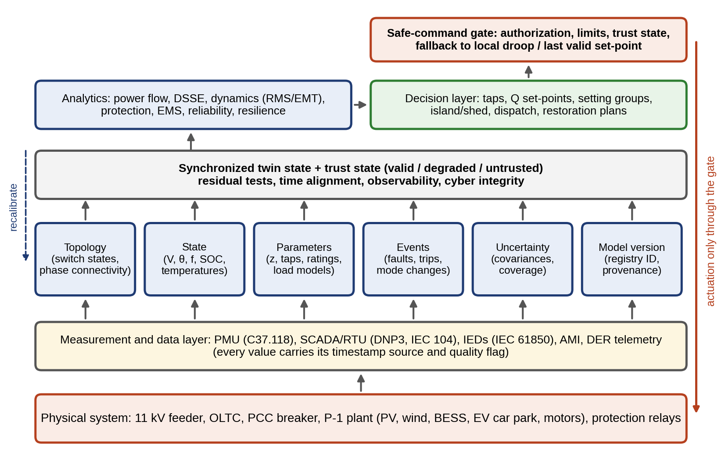
Figure 11.1. Architecture of an operational microgrid twin: the physical system and its measurement layer (bottom), six synchronization loops (topology, state, parameters, events, uncertainty and model version) that feed a synchronized twin state with an explicit trust state, the analytics and decision layers, and a safe-command gate through which every actuation must pass.
TABLE 11.1 The six synchronization levels of a grid twin and the validation each must pass
Level | What is synchronized | Validation before decisions are allowed | Typical failure if skipped
Topology | Breaker and switch status, phase connectivity, earthing | Status consistency with flows and voltages; topology hypothesis test on residuals (Section 11.12.5) | Estimator fits the wrong network; protection studies miss a path
State | $V$, $θ$, $f$, SOC, temperatures | Chi-square test, normalized residuals, observability and critical-measurement check (Section 11.12.3) | Voltage control acts on a biased estimate
Parameters | $z$, taps, ratings, load models | Confidence interval narrower than the decision margin; identifiability check (Section 11.12.6) | Hosting capacity or rating computed with a wrong impedance
Events | Faults, trips, mode and setting changes | Time alignment within the event-ordering tolerance; sequence-of-events consistency | Wrong mode assumed after an island
Model version | Structure, parameter set, code | Signed registry entry, regression tests passed, rollback target defined | Untraceable decision; silent regression
Uncertainty | Covariances, intervals | Coverage of held-out measurements within the stated rate | Overconfident decisions

11.1.2 Hard real-time, operational and planning twins
Grid-twin functions run on time scales from microseconds to years, and they cannot share one computer, one model or one trust requirement. Three classes are distinguished here and used throughout the chapter:
- Hard real-time twins run inside or next to controllers and relays, with deterministic deadlines of microseconds to tens of milliseconds. Examples are an observer inside a grid-forming converter, a local model that predicts a relay’s reach, or a fault-current estimator that selects a setting group. They must be verified like the controller they serve, run on local hardware, and never wait for a network message to take a primary safety action.
- Operational twins run at the site or substation every second to minutes: topology processing, state estimation, Volt/VAR optimization, contingency screening and the microgrid controller’s supervisory logic. Their outputs change equipment set-points, so they need the trust state and the safe-command gate of Figure 11.1.
- Planning twins run offline or in the cloud over hours to years: hosting capacity, reliability, resilience and investment studies. They tolerate latency but need the longest data histories and the most careful uncertainty treatment.
The chapter’s functions are placed in these classes, with their deadlines and fallbacks, in Section 11.19.
Twin contract for the P-1 microgrid
Table 11.2 states the contract for the P-1 microgrid twin: for each physical quantity, how it is measured, which model or estimator synchronizes it, how often, and which decision it supports.
TABLE 11.2 Digital-twin contract for the P-1 microgrid and its feeder
Physical quantity | Measured by | Model or estimator | Update rate | Decision
Breaker, switch states, phase connectivity | SCADA status, IED events, AMI phase identification | Topology processor (Section 11.5.2) | Event-driven | Network model used by all functions
Bus voltages and angles | SCADA, PMUs, smart meters | Three-phase DSSE (Section 11.12) | 1 to 4 s | Voltage control, security assessment
Frequency, RoCoF | PMUs, inverter measurements | Swing and converter models (Section 11.10) | 20 to 100 ms | Islanding, load shedding, battery set-points
Line, cable, transformer loading and temperature | CTs, DTS, top-oil sensors | Thermal models (Section 11.13) | 1 s to 15 min | Dynamic ratings, overload relief
Fault currents | Relays, fault recorders | Short-circuit model with converter limits (Section 11.15) | Event-driven, per mode change | Adaptive protection settings
Generation and load | Meters, forecasts | Forecast models (Chapters 6, 8, 10) | 15 min to 24 h | Energy management, reserves
Reliability and resilience | Outage records, weather | Reliability and restoration models (Section 11.18) | Months; during events | Investment, restoration plans

11.2 Power-system Fundamentals for Twin Builders
This section is written for readers who meet power-system notation for the first time. Every later result depends on getting phase and line quantities, sign conventions and per-unit bases right, and most errors in practical twins are made here rather than in the advanced algorithms.

11.2.1 Single-line diagrams and three-phase quantities
A power system is drawn as a single-line diagram, which represents each balanced three-phase circuit by one line and each piece of equipment by a symbol. Figure 11.5 shows the P-1 microgrid in this form. In balanced three-phase operation, the three phase voltages have equal magnitude and are displaced by 120°:
 | $$v_{a}\left(t\right)=\sqrt{2}Vcos\left(ωt+θ\right), v_{b}\left(t\right)=\sqrt{2}Vcos\left(ωt+θ−\frac{2π}{3}\right), v_{c}\left(t\right)=\sqrt{2}Vcos\left(ωt+θ+\frac{2π}{3}\right),$$ | (11.1)
where $V$ is the RMS phase (line-to-neutral) voltage, $ω=2πf$ the angular frequency and $θ$ the phase angle. The line-to-line voltage is the difference of two phase voltages, whose phasor magnitude is
 | $$V_{LL}=\left|{\overset{‾}{V}}_{a}−{\overset{‾}{V}}_{b}\right|=\left|1−e^{−j2π/3}\right|V=\sqrt{3}V,$$ | (11.2)
so an “11 kV” system has 6.35 kV per phase. A useful property of balanced three-phase circuits is that their total instantaneous power is constant: summing $v_{k}i_{k}$ over the three phases, the double-frequency terms cancel, leaving $p\left(t\right)=3VIcosφ$. Machines connected to a balanced supply therefore feel a steady torque, unlike single-phase machines.
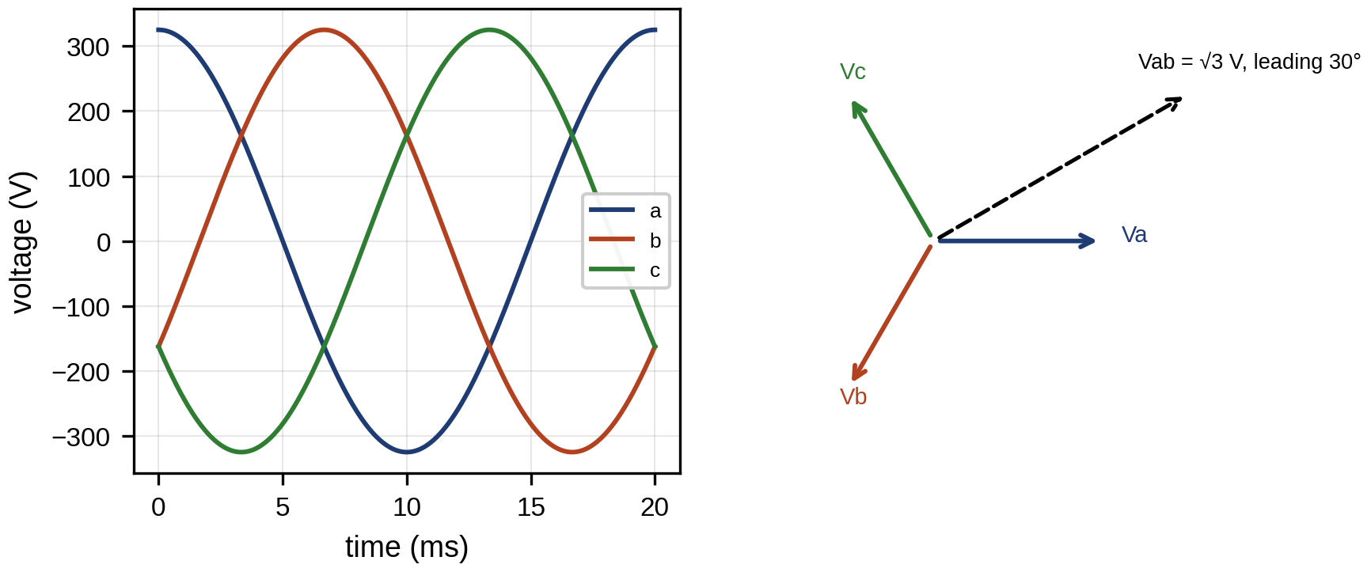
Figure 11.2. Balanced three-phase voltages over one cycle (left) and their phasors with the line-to-line voltage ${\overset{‾}{V}}_{ab}$, of magnitude $\sqrt{3}$ times the phase voltage (right).
Figure 11.2 shows the waveforms and phasors. Each sinusoid is represented by a phasor, a complex number holding its RMS magnitude and angle, $\overset{‾}{V}=Ve^{jθ}$. The phasor turns derivatives into multiplications by $jω$, which makes AC circuit analysis algebraic.

11.2.2 Complex power
The power flowing into a single-phase element with voltage phasor $\overset{‾}{V}$ and current phasor $\overset{‾}{I}$ is the complex power
 | $$\overset{‾}{S}=\overset{‾}{V}{\overset{‾}{I}}^{*}=P+jQ, P=VIcosφ, Q=VIsinφ, pf=\frac{P}{\left|\overset{‾}{S}\right|}=cosφ,$$ | (11.3)
where $​^{*}$ is the complex conjugate, $φ$ the angle by which the voltage leads the current, $P$ the active power that does work, $Q$ the reactive power that oscillates between source and fields, and pf the power factor. For a balanced three-phase circuit the total is three times the per-phase value, ${\overset{‾}{S}}_{3ϕ}=3\overset{‾}{V}{\overset{‾}{I}}^{*}=\sqrt{3}V_{LL}I_{L}e^{jφ}$, with $I_{L}$ the line current. Reactive power loads the network without doing work, so it is compensated locally. Raising a load of active power $P$ from power factor $cosφ_{1}$ to $cosφ_{2}$ needs a capacitor bank of
 | $$Q_{c}=P\left(tanφ_{1}−tanφ_{2}\right),$$ | (11.4)
where $Q_{c}$ is the capacitor’s reactive power; it is 0.42 Mvar for a 1 MW load corrected from 0.80 to 0.95.
Sign conventions used in this chapter
Two conventions are in use, and mixing them is the commonest error in grid twins. In the load (consumer) convention, $\overset{‾}{S}=\overset{‾}{V}{\overset{‾}{I}}^{*}$ with $\overset{‾}{I}$ flowing into the element, so a motor has $P>0$ and an inductive load $Q>0$. In the generator (injection) convention, $\overset{‾}{I}$ flows out of the element, so a generator exporting power has $P>0$ and an over-excited machine or capacitor supplying reactive power has $Q>0$. In this chapter, loads ${\overset{‾}{S}}^{L}=P^{L}+jQ^{L}$ use the load convention, bus injections ${\overset{‾}{S}}_{i}$ in power flow and state estimation use the injection convention (${\overset{‾}{S}}_{i}={\overset{‾}{S}}_{i}^{G}−{\overset{‾}{S}}_{i}^{L}$), inverter reactive power in Volt/VAR curves is positive when injected, and flows at the point of common coupling (PCC) are positive when exported from the microgrid unless stated otherwise. Every table and figure states which applies.
Figure 11.3 shows the phasors and the power triangle.
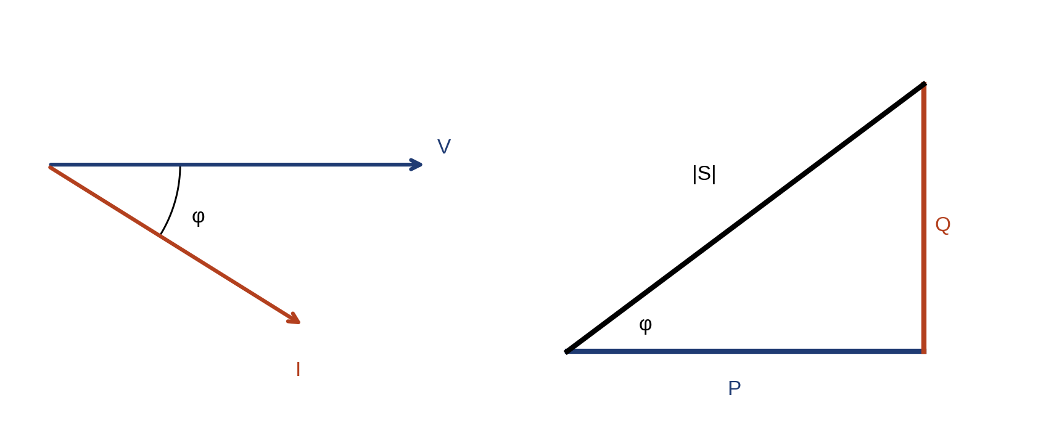
Figure 11.3. Phasor diagram of the voltage and current at a lagging load (left) and the corresponding power triangle $\overset{‾}{S}=P+jQ$ (right).

11.2.3 The per-unit system
Networks contain voltages from 400 V to 400 kV, and quantities expressed in volts, amperes and ohms are hard to compare. The per-unit system normalizes them. A three-phase power base $S_{b}$ and a line-to-line voltage base $V_{b}$ are chosen, and the current and impedance bases follow from them:
 | $$I_{b}=\frac{S_{b}}{\sqrt{3}V_{b}}, Z_{b}=\frac{V_{b}/\sqrt{3}}{I_{b}}=\frac{V_{b}^{2}}{S_{b}}, x_{pu}=\frac{x}{x_{b}}.$$ | (11.5)
Transformers disappear in per unit when the voltage bases on their two sides follow the turns ratio, and equipment data given on its own rating $S_{rated}$ convert to the system base by $z_{pu,new}=z_{pu,old}\left(S_{b,new}/S_{rated}\right){\left(V_{rated}/V_{b,new}\right)}^{2}$. For $S_{b}=10$ MVA and $V_{b}=13.8$ kV, $I_{b}=418.4$ A and $Z_{b}=19.04$ Ω. The P-1 feeder uses $S_{b}=1$ MVA and $V_{b}=11$ kV, so $Z_{b}=121$ Ω and a 1 km section of $0.25+j0.35$ Ω becomes $0.00207+j0.00289$ pu.
Example 11.1 Phase, line, phasor, complex power and per unit on one 11 kV feeder
Given. The P-1 connection at feeder bus 6 imports ${\overset{‾}{S}}_{3ϕ}=1.0+j0.3$ MVA (load convention) at a line-to-line voltage of 11 kV. System base $S_{b}=1$ MVA, $V_{b}=11$ kV. The plant transformer T1 is 2 MVA, 11/0.4 kV, with a leakage impedance of 6 % on its own rating.
Find. The phase voltage phasor, the line current phasor, the power factor, the current in per unit, and the transformer impedance on the system base.
Solution. Taking phase a as reference, ${\overset{‾}{V}}_{a}=11 000/\sqrt{3}∠0^{∘}=6351∠0^{∘}$ V, and the line-to-line phasor is ${\overset{‾}{V}}_{ab}=\sqrt{3} {\overset{‾}{V}}_{a}e^{j{30}^{∘}}=11 000∠{30}^{∘}$ V. From (11.3) per phase, ${\overset{‾}{I}}_{a}={\left({\overset{‾}{S}}_{3ϕ}/3{\overset{‾}{V}}_{a}\right)}^{*}=54.8∠−{16.7}^{∘}$ A: the current lags because the load absorbs reactive power, and pf $=cos{16.7}^{∘}=0.958$. The current base from (11.5) is $I_{b}={10}^{6}/\left(\sqrt{3}×11 000\right)=52.5$ A, so the current is 1.044 pu. On a 1 MVA base the transformer’s 6 % becomes $z_{pu,new}=0.06×\left(1/2\right)×{\left(11/11\right)}^{2}=0.03$ pu.
Interpretation. The same numbers can be written four ways: 6351 V phase or 11 kV line, 54.8 A or 1.044 pu, 1.044 MVA or 1.044 pu, 6 % on 2 MVA or 3 % on 1 MVA. A twin must store which one each database field holds. A factor of $\sqrt{3}$ or of the base ratio lost between a GIS record and the power-flow model produces a perfectly converged but wrong solution.

11.2.4 Symmetrical components and voltage unbalance
Unbalanced three-phase quantities are decomposed into three balanced sets [3]. With the operator $a=e^{j2π/3}$, which rotates a phasor by 120° and satisfies $1+a+a^{2}=0$ and $a^{3}=1$, any three phasors can be written as the sum of a zero-sequence set (three equal phasors), a positive-sequence set (a, b, c in the order of normal rotation) and a negative-sequence set (reverse order):
 | $$\left[\begin{matrix}{\overset{‾}{V}}_{a} \\ {\overset{‾}{V}}_{b} \\ {\overset{‾}{V}}_{c}\end{matrix}\right]=\left[\begin{matrix}1 & 1 & 1 \\ 1 & a^{2} & a \\ 1 & a & a^{2}\end{matrix}\right]\left[\begin{matrix}{\overset{‾}{V}}_{0} \\ {\overset{‾}{V}}_{1} \\ {\overset{‾}{V}}_{2}\end{matrix}\right]=A\left[\begin{matrix}{\overset{‾}{V}}_{0} \\ {\overset{‾}{V}}_{1} \\ {\overset{‾}{V}}_{2}\end{matrix}\right],$$ | (11.6)
where ${\overset{‾}{V}}_{0}$, ${\overset{‾}{V}}_{1}$ and ${\overset{‾}{V}}_{2}$ are the zero-, positive- and negative-sequence components referred to phase a. Because the columns of $A$ are orthogonal, $A^{H}A=3I$ (with $​^{H}$ the conjugate transpose), so the inverse is simply $A^{−1}=\frac{1}{3}A^{H}$:
 | $$\left[\begin{matrix}{\overset{‾}{V}}_{0} \\ {\overset{‾}{V}}_{1} \\ {\overset{‾}{V}}_{2}\end{matrix}\right]=\frac{1}{3}\left[\begin{matrix}1 & 1 & 1 \\ 1 & a & a^{2} \\ 1 & a^{2} & a\end{matrix}\right]\left[\begin{matrix}{\overset{‾}{V}}_{a} \\ {\overset{‾}{V}}_{b} \\ {\overset{‾}{V}}_{c}\end{matrix}\right], VUF=\frac{\left|{\overset{‾}{V}}_{2}\right|}{\left|{\overset{‾}{V}}_{1}\right|}×100 \%.$$ | (11.7)
Here ${\overset{‾}{V}}_{1}$ is the component that drives motors forward, ${\overset{‾}{V}}_{2}$ produces a backward-rotating field that heats them, ${\overset{‾}{V}}_{0}$ circulates in neutrals and delta windings, and VUF is the voltage unbalance factor. Each row of (11.7) follows from (11.6) by multiplying by the conjugate row and using $1+a+a^{2}=0$: for example, ${\overset{‾}{V}}_{a}+a{\overset{‾}{V}}_{b}+a^{2}{\overset{‾}{V}}_{c}={\overset{‾}{V}}_{0}\left(1+a+a^{2}\right)+{\overset{‾}{V}}_{1}\left(1+a^{3}+a^{3}\right)+{\overset{‾}{V}}_{2}\left(1+a^{2}+a^{4}\right)=3{\overset{‾}{V}}_{1}$.
Example 11.2 Sequence components of a single-phase sag
Given. Phase voltages in per unit ${\overset{‾}{V}}_{a}=1∠0^{∘}$, ${\overset{‾}{V}}_{b}=0.9∠−{120}^{∘}$ and ${\overset{‾}{V}}_{c}=1∠{120}^{∘}$: phase b has sagged by 10 % with no angle change.
Find. The sequence components and VUF.
Solution. Writing ${\overset{‾}{V}}_{b}=0.9a^{2}$ and ${\overset{‾}{V}}_{c}=a$, (11.7) gives ${\overset{‾}{V}}_{1}=\frac{1}{3}\left(1+0.9a^{3}+a^{3}\right)=0.967$ pu, ${\overset{‾}{V}}_{2}=\frac{1}{3}\left(1+0.9a^{4}+a^{2}\right)=\frac{1}{3}\left(−0.1a\right)=0.0333∠−{60}^{∘}$ pu and ${\overset{‾}{V}}_{0}=\frac{1}{3}\left(1+0.9a^{2}+a\right)=0.0333∠{60}^{∘}$ pu. VUF $=0.0333/0.967=3.45$ %.
Interpretation. A 10 % sag on one phase splits evenly between negative and zero sequence. A delta-connected motor sees only the negative-sequence part, and a 3.45 % VUF would derate it noticeably.
Different documents quantify unbalance differently, and a twin must compute the metric that its applicable document specifies (Table 11.3). EN 50160 [4] states that, under normal operating conditions, the 10-minute mean RMS values of the negative-sequence component should be within 0 to 2 % of the positive-sequence component for 95 % of each week, with up to about 3 % in some areas, and the measurement method comes from IEC 61000-4-30 [30]. That is a statistical statement about a public supply, not a hard instantaneous limit, and it does not apply to a private microgrid’s internal bus unless a contract adopts it. Motor standards use line-voltage deviation from the average instead, and grid codes for DER connection may set their own limits on the unbalance a plant may cause.
TABLE 11.3 Voltage-unbalance metrics are not interchangeable
Metric | Definition | Typical user | Value for Example 11.8
VUF (IEC, true definition) | $|{\overset{‾}{V}}_{2}|/|{\overset{‾}{V}}_{1}|$ from phasors; EN 50160 evaluates 10-min means, 95 % of a week | IEC 61000-4-30, EN 50160, IEC 61000-2-2 compatibility levels | 1.98 %
LVUR (NEMA MG 1) | Largest deviation of a line-to-line RMS voltage from their average, divided by the average | Motor derating | 1.85 %
PVUR (IEEE 1159 usage) | Largest deviation of a phase-to-neutral RMS voltage from their average, divided by the average | Some utility practice; LV feeders with single-phase loads | 8.3 %
$|{\overset{‾}{V}}_{0}|/|{\overset{‾}{V}}_{1}|$ | Zero-sequence ratio | Neutral loading, earthing studies | 6.9 %
The last column shows why: the same unbalanced low-voltage feeder is at 1.98 % by VUF but at 8.3 % by the phase-voltage ratio, because its neutral shift moves the phase-to-neutral voltages far more than the line-to-line voltages. Faults, protection and unbalanced feeders are analysed with these components in Sections 11.6.6 and 11.15.

11.2.5 Grid-following and grid-forming converters
Most DERs connect through power converters, which come in two families. A grid-following (GFL) converter measures the voltage at its terminals with a phase-locked loop (PLL) and injects a current synchronized to it (Chapter 10, Section 10.15.2). It therefore needs a voltage and frequency reference established by something else in the network; it can operate in an island only if another source provides that reference. A grid-forming (GFM) converter [5], [34] regulates its own internal voltage magnitude and angle, so over the time scales of its outer control it behaves like a voltage source behind an impedance and can set the voltage and frequency of an island. Synchronous generators also form the grid, but their fault current, inertia and time constants come from physics, whereas a GFM converter’s come from control and from its current and energy limits, so the two are not equivalent in every dynamic situation. A microgrid that must island needs at least one grid-forming source, in P-1 the battery inverter; the PV and wind converters remain grid-following and share power by following the frequency and voltage it sets. Section 11.8 develops both families in depth, including the current limiting that governs their fault behaviour.

11.3 AC, DC and Hybrid Microgrid Architectures

11.3.1 Three architectures
AC microgrids connect DERs and loads to a common AC network, and are the most common because loads and the grid are AC. DC microgrids connect DC sources (PV, batteries) and DC loads (EV chargers, data centres, LED lighting) through a DC bus, avoiding conversion stages. Hybrid microgrids combine AC and DC sections through an interlinking converter (Figure 11.4). Table 11.4 compares the three.
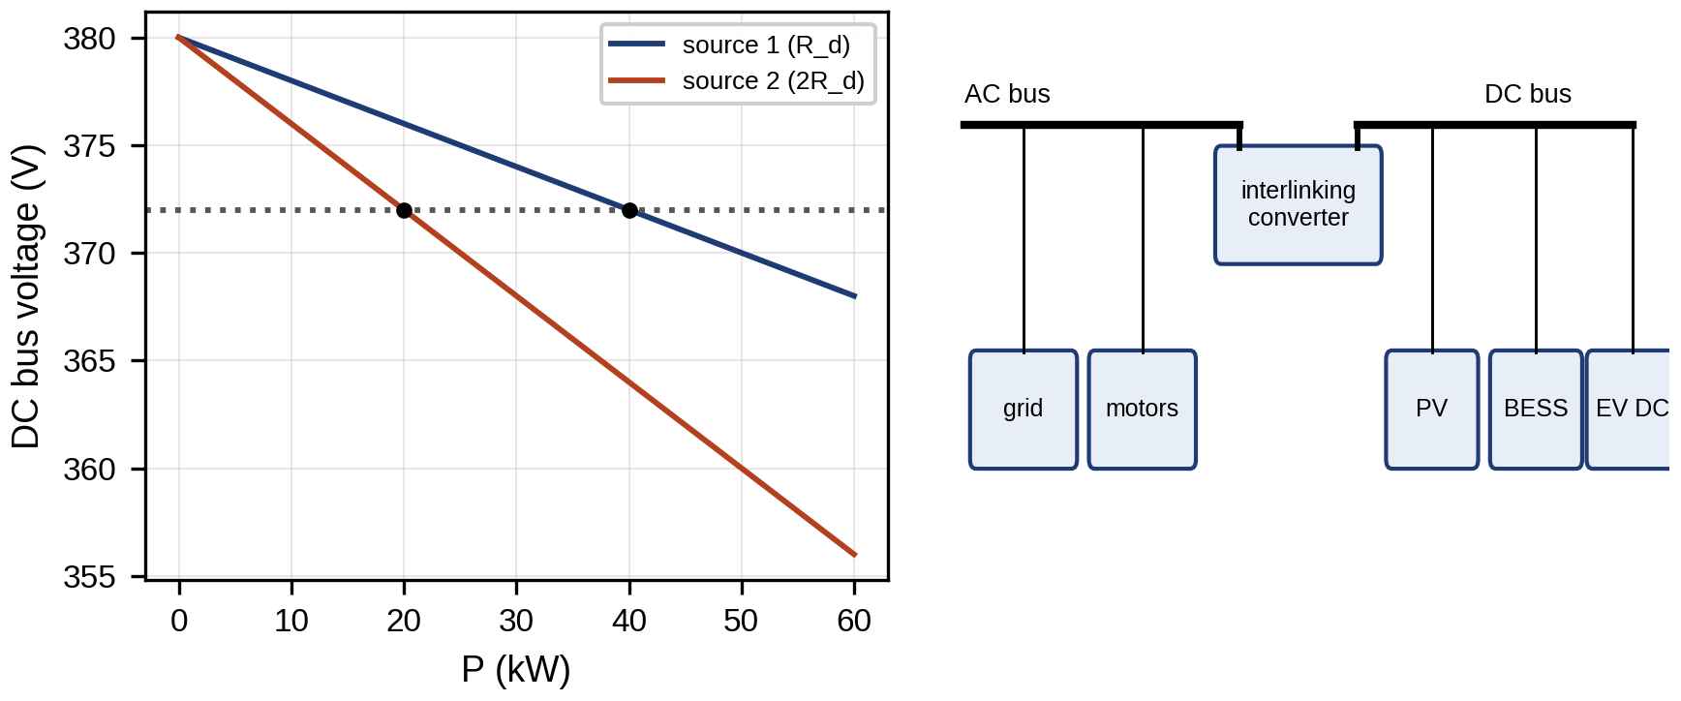
Figure 11.4. DC microgrid droop: DC bus voltage against power for two sources with droop resistances in the ratio 1:2 (left), and a hybrid AC–DC microgrid with an interlinking converter (right).
TABLE 11.4 Microgrid architectures compared
Property | AC microgrid | DC microgrid | Hybrid
Common bus | AC (50/60 Hz) | DC (for example 380 V or 750 V) | Both, with interlinking converter
Conversion stages for PV and batteries | DC/AC | DC/DC | Reduced for DC loads
Power sharing signal | Frequency (P) and voltage (Q) | DC voltage | Both, coordinated through the interlinking converter
Protection | Mature AC practice | DC breakers, no current zero | Both
Typical use | Campuses, industrial sites, communities | Data centres, EV hubs, ships | Sites with large DC loads and AC grid
The P-1 microgrid (Figure 11.5) is an AC microgrid. The 11 kV point of common coupling (PCC) at feeder bus 6 connects through the 2 MVA, 11/0.4 kV transformer T1 to the plant’s low-voltage switchboard, which carries the PV inverters, the battery inverter, the car park and the motors. The wind turbine T-1 connects at 11 kV through its own 0.69/11 kV transformer. Meters are placed at the PCC (a PMU and a revenue meter), at every DER and at the transformer, and the feeder has SCADA at the substation and at its end and smart meters at every customer.
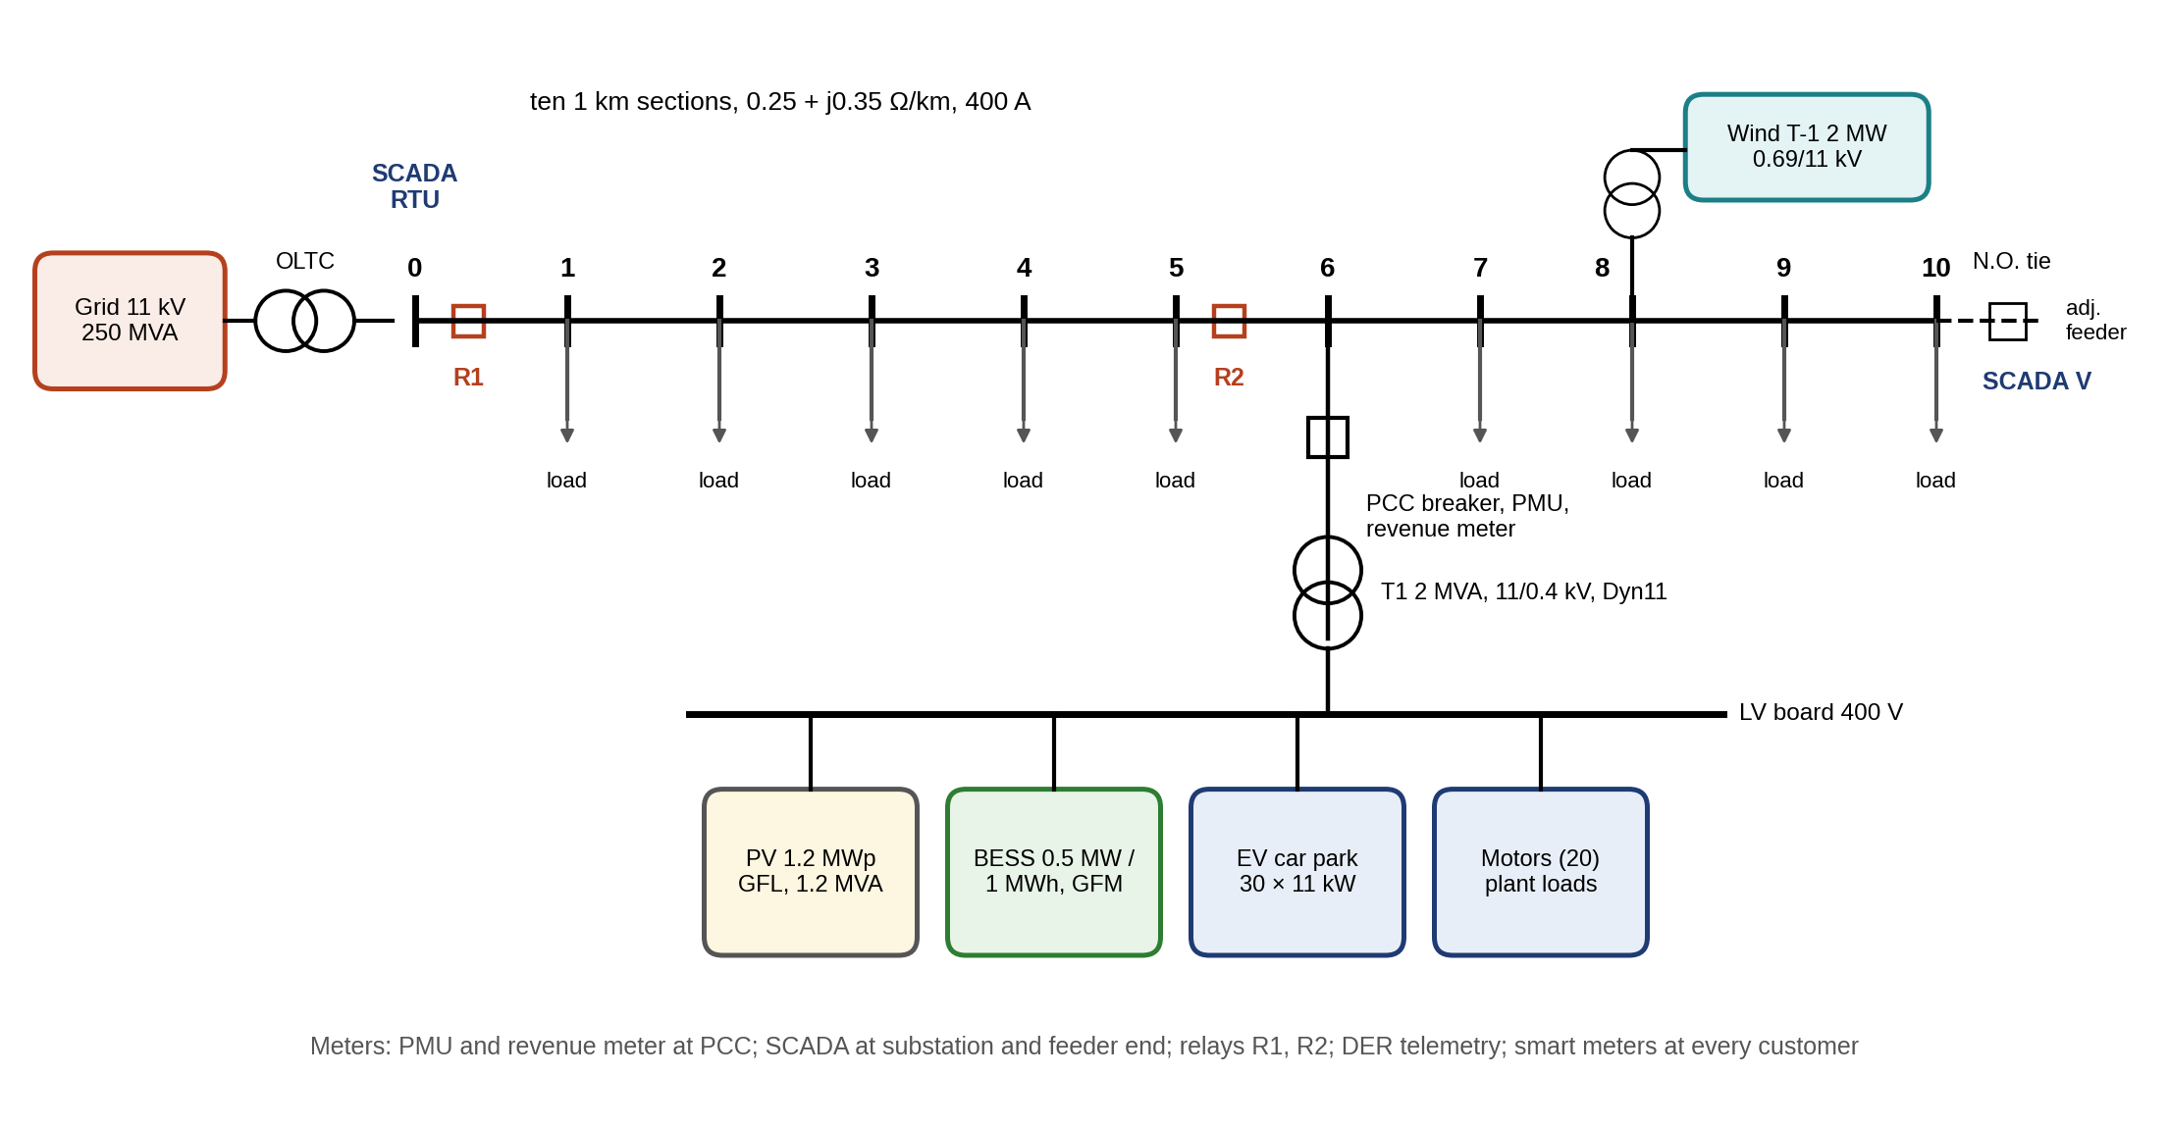
Figure 11.5. Single-line diagram of the P-1 microgrid and its 11 kV feeder, showing the substation with its on-load tap changer, the ten feeder sections, the point of common coupling at bus 6 with its breaker, the plant transformer and low-voltage board with PV, battery, car park and motors, the wind turbine, the normally open tie at bus 10, relays R1 and R2, and the placement of SCADA, PMU and smart-meter measurements.

11.3.2 DC microgrids: droop, cable resistance and constant-power loads
The DC bus voltage is regulated by DC droop. In its power form each source follows
 | $$V_{dc,i}=V_{dc,0}−R_{d,i}P_{i},$$ | (11.8)
where $V_{dc,i}$ is the output voltage of source $i$, $V_{dc,0}$ the no-load reference, $P_{i}$ its output power and $R_{d,i}$ its droop coefficient in V/W. Most converters implement the current form $V_{dc,i}=V_{dc,0}−r_{d,i}I_{i}$, with $r_{d,i}$ a virtual resistance in ohms and $I_{i}$ the output current. If every source saw the same bus voltage, currents would divide in inverse proportion to $r_{d,i}$. They do not, because each source reaches the common bus through a cable of resistance $R_{c,i}$, so source $i$ delivers
 | $$I_{i}=\frac{V_{dc,0}−V_{bus}}{r_{d,i}+R_{c,i}}, \frac{I_{A}}{I_{B}}=\frac{r_{d,B}+R_{c,B}}{r_{d,A}+R_{c,A}},$$ | (11.9)
where $V_{bus}$ is the common-bus voltage. Sharing is exact only when the cable resistances are in the same ratio as the droop resistances, or negligible beside them. Larger droop resistances improve sharing but worsen voltage regulation, which is the basic trade-off of DC droop and the reason secondary control shifts $V_{dc,0}$ (Section 11.10.4).
Sharing is a steady-state property; stability is not guaranteed by it. Many DC loads are tightly regulated converters that draw constant power $P$ whatever the bus voltage. Their current $P/v$ falls as $v$ rises, so their incremental resistance is negative:
 | $$\frac{∂\left(P/v\right)}{∂v}=−\frac{P}{V^{2}} ⇒ r_{inc}=−\frac{V^{2}}{P},$$ | (11.10)
where $V$ is the operating bus voltage and $r_{inc}$ the small-signal resistance seen by the bus [35]. Consider a source represented by a voltage $V_{0}$ behind a resistance $R$ (cable, filter and any resistive part of the droop) and an inductance $L$, feeding a bus capacitance $C$ that supplies the constant-power load. With $i$ the source current and $v$ the bus voltage,
 | $$L\frac{di}{dt}=V_{0}−Ri−v, C\frac{dv}{dt}=i−\frac{P}{v}.$$ | (11.11)
Linearizing about the equilibrium ($Δi$, $Δv$ the deviations) with (11.10) gives $L dΔi/dt=−RΔi−Δv$ and $C dΔv/dt=Δi+\left(P/V^{2}\right)Δv$. Eliminating $Δi$ yields the characteristic polynomial
 | $$s^{2}+\left(\frac{R}{L}−\frac{P}{CV^{2}}\right)s+\frac{1}{LC}\left(1−\frac{RP}{V^{2}}\right)=0,$$ | (11.12)
and a second-order polynomial has both roots in the left half-plane if and only if both coefficients are positive:
 | $$C>\frac{LP}{RV^{2}} \text{and} \frac{RP}{V^{2}}<1.$$ | (11.13)
The first condition says the bus capacitance must be large enough that the passive damping $R/L$ outweighs the negative damping $P/\left(CV^{2}\right)$ of the load. The second says the load must not demand more than the source can deliver through its resistance, which is the DC counterpart of the loadability limit of Section 11.6.2. Low-loss cables make the first condition harder to meet, because $R$ falls while $L$ does not, which is why active damping (a virtual resistance acting only on the voltage oscillation) is common. Converter inner loops with finite bandwidth add phase lag that the lumped model ignores, so (11.13) is necessary rather than sufficient; an impedance-based check with the measured converter output impedances is the proper validation (Section 11.8.4).
Example 11.3 Sharing and stability on a 380 V DC bus
Given. A 380 V DC bus fed by source A (20 kW) and source B (10 kW), each with a current droop allowing 5 % voltage deviation at rating, so $r_{d,A}=0.361$ Ω and $r_{d,B}=0.722$ Ω. Cable resistances $R_{c,A}=0.05$ Ω and $R_{c,B}=0.20$ Ω. A 24 kW constant-power load. For stability, an equivalent source path of $R=0.1$ Ω and $L=1$ mH.
Find. The power split with and without cable resistance, and the minimum bus capacitance.
Solution. Without cables, the bus settles at 364.1 V and the sources deliver 16.0 and 8.0 kW, exactly in proportion to rating. With the cables, (11.9) and the load’s power balance give 361.1 V, and A delivers 16.7 kW while B delivers 7.5 kW: A carries 69.0 % of the load instead of 66.7 %, a 3.6 % overload relative to its fair share (B delivers 7 % less than its share). By (11.13), $C>{10}^{−3}×24 000/\left(0.1×{380}^{2}\right)=1.66$ mF, and $RP/V^{2}=0.017$ is far below 1. An installed 2.2 mF is stable up to 31.8 kW of constant-power load (Figure 11.6).
Interpretation. The twin’s value is in the numbers the designer did not have: the actual cable resistances, which it can estimate from the measured current split, and the actual constant-power share of the load, which grows as resistive loads are replaced by regulated converters. Both move the system toward the boundary without any visible warning in steady state.
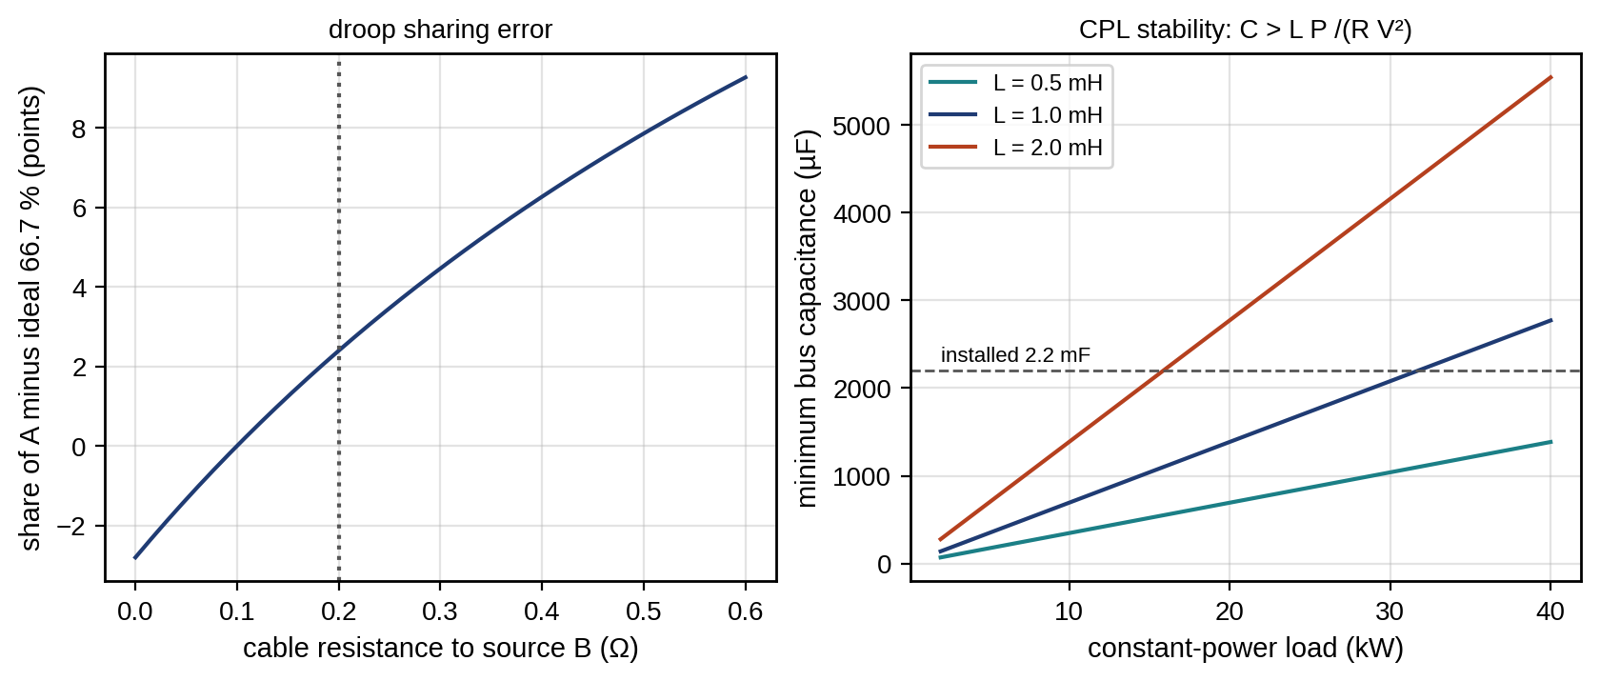
Figure 11.6. DC microgrid of Example 11.3: error in source A’s share against the cable resistance to source B, with the droop resistances of the example (left); minimum bus capacitance for stability against constant-power load for three source inductances, from (11.13), with the installed 2.2 mF (right).
DC faults are harder to interrupt than AC faults. The bus capacitors discharge into a fault with a rate of rise limited only by cable inductance, $di/dt≈V/L_{loop}$, which is 380 A/ms for 1 mH, and there is no natural current zero to extinguish an arc. DC microgrids therefore use solid-state or hybrid breakers that interrupt within tens of microseconds to a few milliseconds, converters with current-limiting or blocking capability, and fault detection from $di/dt$ and voltage collapse rather than from current magnitude alone. A DC twin must model the capacitor energy and the breaker’s interruption time, not only the steady-state droop.

11.3.3 Hybrid microgrids and interlinking-converter coordination
In a hybrid microgrid the AC section signals its loading through frequency and the DC section through voltage. The interlinking converter (ILC) must move power from the lightly loaded side to the heavily loaded one, but frequency and voltage have different units and ranges. Normalizing each to its allowed band makes them comparable:
 | $$f_{pu}=\frac{f−f_{mid}}{\left(f_{max}−f_{min}\right)/2}, v_{pu}=\frac{V_{dc}−V_{mid}}{\left(V_{max}−V_{min}\right)/2},$$ | (11.14)
where $f_{mid}$ and $V_{mid}$ are the centres of the allowed frequency and DC-voltage bands and $f_{pu},v_{pu}∈\left[−1,1\right]$; $−1$ means the side is fully loaded. The ILC then transfers power from DC to AC in proportion to the difference,
 | $$P_{IC}=K_{IC}\left(v_{pu}−f_{pu}\right),$$ | (11.15)
with $K_{IC}$ its gain (kW per unit of normalized difference) and $P_{IC}>0$ meaning DC-to-AC transfer. With a large $K_{IC}$ the steady state is $f_{pu}=v_{pu}$: both sides sit at the same fraction of their bands, which means every droop-controlled source on either side carries the same fraction of its rating. Let the AC droop sources provide $K_{ac}$ kW per unit of $−f_{pu}$ and the DC sources $K_{dc}$ kW per unit of $−v_{pu}$. A load step $ΔP$ on either side then gives
 | $$f_{pu}=v_{pu}=−\frac{ΔP}{K_{ac}+K_{dc}},$$ | (11.16)
so the step is shared in proportion to the total droop capacity of the two sides, independent of where it occurs.
Example 11.4 A load step in a hybrid microgrid
Given. An AC section with droop sources totalling 100 kW over a 49.5 to 50.5 Hz band ($K_{ac}=100$ kW) and a DC section with droop sources totalling 50 kW over 360 to 400 V ($K_{dc}=50$ kW). A 60 kW step on the AC side.
Find. The frequency, DC voltage, the power from each side and the ILC transfer.
Solution. By (11.16), $f_{pu}=v_{pu}=−60/150=−0.4$, so $f=50−0.4×0.5=49.8$ Hz and $V_{dc}=380−0.4×20=372$ V. The AC sources supply 40 kW and the DC sources 20 kW, which the ILC carries to the AC side.
Interpretation. Both sides end at 40 % of their bands, and every source at 40 % of its capacity. The ILC’s rating must cover the largest transfer that (11.16) can demand, and when it saturates the two sides decouple and share separately. The twin checks the ILC rating against the largest credible step on either side.

11.4 Data, Semantics, Topology and Synchronization
A grid twin is only as good as its inputs, and the inputs are not simply numbers. Each value arrives with a time, a delay, a quality and a meaning that must be mapped onto the right place in the network model. This section treats measurements as engineering objects with those attributes.

11.4.1 The measurement hierarchy, with time and data quality
Grid data arrive at very different rates, and the twin must respect what each source can and cannot resolve (Table 11.5). A voltage sag lasting 100 ms is visible to a PMU but invisible to a smart meter that reports a 15-minute average. Conversely, only smart meters cover every customer.
Figure 11.7 places these sources on axes of reporting rate and coverage.
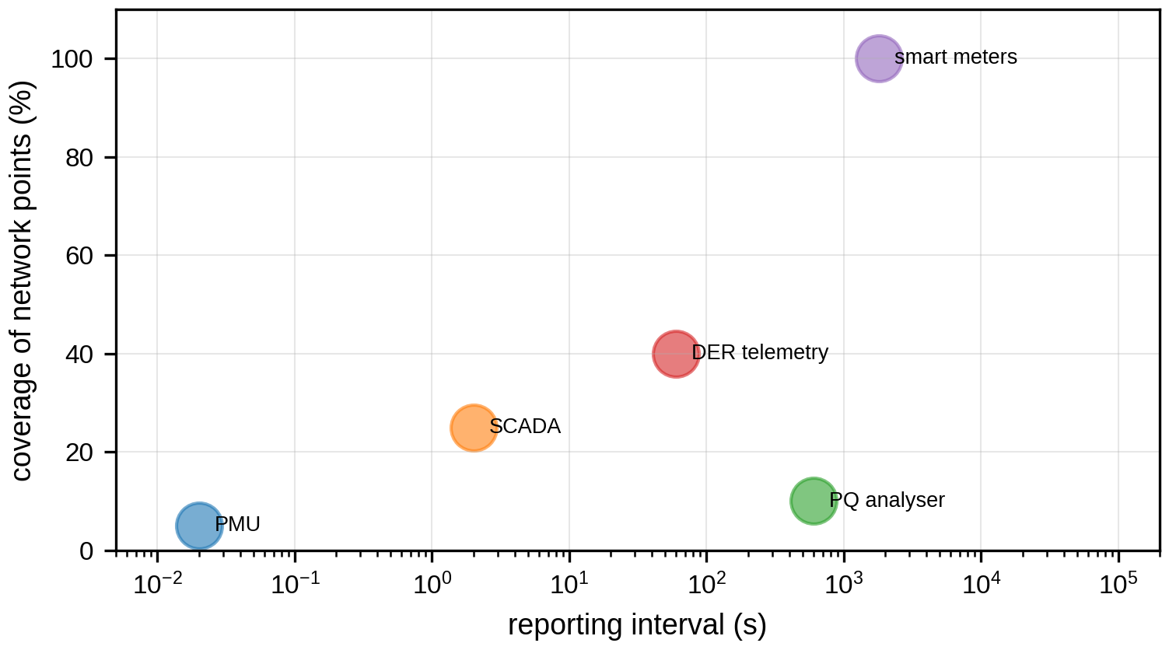
Figure 11.7. The measurement hierarchy: reporting interval (logarithmic) against coverage of the network for PMUs, SCADA, power-quality analysers, DER telemetry and smart meters.
Table 11.5 extends the usual list of sources with the attributes that decide how a twin may use them. Two points deserve emphasis. First, reporting rate is not measurement bandwidth. A PMU reporting 50 frames/s passes its values through filters, and IEEE C37.118.1 [2] requires accurate tracking of amplitude and phase modulation only up to $min\left(F_{s}/10, 2 \text{Hz}\right)$ for P-class and $min\left(F_{s}/5, 5 \text{Hz}\right)$ for M-class devices, where $F_{s}$ is the reporting rate. A 50 frames/s stream therefore does not resolve a 12 Hz oscillation, however many samples it delivers. A smart meter reporting a 15-minute average has a bandwidth of about one cycle per half hour. Second, time is a measurement too. A SCADA value stamped when the master receives it, rather than when the RTU sampled it, can be several seconds late, and an estimator that treats it as simultaneous with a PMU angle combines two different network states.
TABLE 11.5 The measurement hierarchy of a distribution twin with the attributes that govern its use (typical values)
Source | Timestamp source | Reporting rate | Latency | Time uncertainty | Quality information | Missing-data behaviour | Twin use
PMU, µPMU (C37.118) | GNSS or PTP at the device | 25 to 100 frames/s (50 Hz systems) | 20 to 100 ms | Below 1 µs when locked; drifts in holdover | STAT word: data valid, sync lost, time-quality code | Frame dropped; gaps flagged | Angles, dynamics, islanding detection
SCADA RTU, IED (DNP3, IEC 104, IEC 61850 MMS) | At RTU or IED if configured, else at master | 1 to 4 s scan; events by exception | 1 to 10 s | 1 ms to seconds, depending on where stamped | IEC 61850 q (good, invalid, questionable, substituted, test); DNP3 flags | Last value held; stale flag after timeout | State estimation, control
IED sequence of events | At IED | Event-driven | 0.1 to 5 s | 1 ms with PTP | Event quality, chatter filter | Buffered and replayed | Topology, protection analysis
Power-quality analyser (IEC 61000-4-30 class A) | At device, synchronized | 10/12-cycle values; 10-min aggregates | Minutes | 20 ms class A | Flagging of intervals with dips, swells or interruptions | Flagged interval excluded from statistics | PQ indices, events
Smart meter (AMI) | Meter clock, corrected at read | 15 to 60 min averages | Hours to a day | Seconds to minutes (clock drift) | Estimated or validated flags from meter data management | Estimated values substituted | Pseudo-measurements, load models, phase identification
DER telemetry (IEEE 2030.5, IEEE 1815, SunSpec) | Device or aggregator | 1 s to 5 min | Seconds to minutes | Seconds | Vendor-specific | Aggregator fills gaps | DER states, flexibility
Weather, forecasts | Provider | Minutes to hours | Minutes | Not applicable | Forecast issue time and horizon | Previous forecast reused | Generation and load forecasts
A value that arrives late is not useless; it is older. The twin aligns all inputs to an estimation epoch $t_{k}$ and inflates the variance of each input according to its age. If a quantity changes at a rate whose standard deviation over one second is $σ_{\dot{z}}$, a value measured at $t_{k}−τ$ with instrument variance $σ^{2}$ is used with
 | $$σ_{eff}^{2}=σ^{2}+{\left(τ σ_{\dot{z}}\right)}^{2},$$ | (11.17)
where $τ$ is its age at the epoch. An interval average is treated the same way, with $τ$ replaced by half its averaging window. Values flagged invalid are excluded; values flagged questionable or substituted are kept with a large variance and never used as the only evidence for a decision.

11.4.2 Time synchronization
Angle measurements are meaningless without a common time. A 1 µs time error corresponds to 0.018° at 50 Hz, a 1 ms error to 18°. PMUs are traditionally synchronized by GNSS receivers, which are exposed to antenna faults, jamming and spoofing. Substations increasingly distribute time over the Ethernet network itself using the Precision Time Protocol (PTP) of IEEE 1588 with the power-utility profile of IEC/IEEE 61850-9-3 or the power profile of IEEE C37.238 [26], which achieves sub-microsecond accuracy with transparent or boundary clocks and holdover oscillators. A twin should record, for every source, the time source, the claimed time quality and whether the device is currently synchronized, because a loss of synchronization turns a precise angle into a misleading one. Protection functions that depend on time alignment, such as line differential over a packet network, block themselves on loss of synchronization; the twin must do the same with the functions that depend on angles.

11.4.3 Semantics: from device data to a computational network
A value is useful only when the twin knows what it measures: which quantity, which phase, which unit, at which terminal of which piece of equipment. Two families of standards carry that meaning (Figure 11.8).
Inside substations and plants, IEC 61850 [23] models each device as logical devices containing logical nodes, each a standardized function with standardized data objects. MMXU holds three-phase measurements (for example, the phase-a voltage magnitude as MMXU1.PhV.phsA.cVal.mag.f, with its quality q and timestamp t), XCBR and XSWI represent breakers and switches, CSWI their controllers, PTOC time overcurrent protection, and IEC 61850-7-420 adds logical nodes for DERs. The configuration is exchanged in the System Configuration Language (SCL): an IED Capability Description (ICD) states what a device can do, a System Specification Description (SSD) describes the single-line diagram and required functions, the Substation Configuration Description (SCD) binds functions to IEDs and communication, and a Configured IED Description (CID) is loaded into each device. IEC TR 61850-90-30:2025 [24] extends SCL so that functions and their information flows can be specified independently of the hardware that will implement them. For a twin this matters directly: the SSD and SCD contain the single-line diagram, the mapping of every measurement to a terminal, and the protection functions and their settings, which is most of what a topology processor and a protection study need.
At the enterprise level, the Common Information Model (CIM) of IEC 61970 and IEC 61968 [25] and its CGMES profiles describe the network, assets and their identifiers (mRIDs) for planning, operations and data exchange between operators. CIM distinguishes a switch-node (connectivity) model, in which every breaker and switch is an explicit element between connectivity nodes, from a bus-branch (topological) model, in which connectivity nodes joined by closed switches are merged into topological nodes. Power flow and state estimation run on the bus-branch model. The topology processor of Section 11.5.2 is exactly the function that converts one into the other from switch statuses, and the twin must keep the mapping so that a residual on a bus-branch element can be traced back to a physical device.
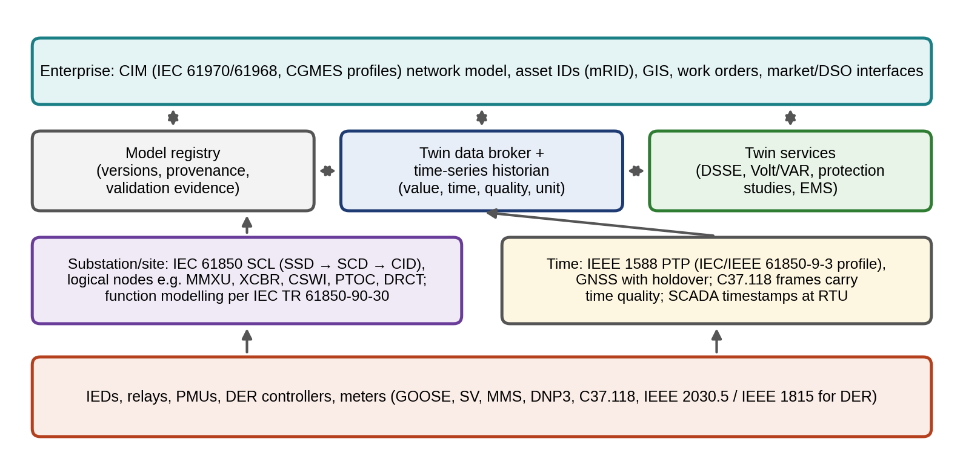
Figure 11.8. Semantic data architecture of the P-1 twin: IEC 61850 SCL at substation and plant level, CIM network models and asset identifiers at enterprise level, PTP time distribution, and a data broker and historian that store every value with its time, quality and unit, alongside a model registry that stores model versions and their validation evidence.

11.4.4 Model versions and provenance
Every twin output depends on a model structure, a parameter set, the input data and the software that combined them. A model registry stores each version with its source data, calibration residuals, validation results and approval, and assigns it an identifier that is attached to every output. When a decision later proves wrong, the registry answers the first question of any investigation: which model, calibrated on which data, produced it? It also defines the rollback target, the last version that passed validation, to which the twin reverts if a new version fails online checks. The same discipline applies to settings: a protection setting group computed by the twin is a versioned, signed artifact, and the relay reports which version it is running (Section 11.15).

11.5 Network and Component Models

11.5.1 Lines, cables and transformers
A distribution line or cable of length $ℓ$ is represented by the $π$ model: a series impedance $z=\left(r′+jx′\right)ℓ$ and half the shunt admittance $y/2=jb′ℓ/2$ at each end, where $r′$, $x′$ and $b′$ are the per-length resistance, reactance and susceptance. Its terminal relations are
 | $${\overset{‾}{V}}_{s}=\left(1+\frac{zy}{2}\right){\overset{‾}{V}}_{r}+z{\overset{‾}{I}}_{r}, {\overset{‾}{I}}_{s}=y\left(1+\frac{zy}{4}\right){\overset{‾}{V}}_{r}+\left(1+\frac{zy}{2}\right){\overset{‾}{I}}_{r},$$ | (11.18)
with subscripts $s$ and $r$ for the sending and receiving ends. For overhead lines under a few tens of kilometres the shunt term is usually negligible, but cables have much larger capacitance. Their charging reactive power, $Q_{ch}=V_{LL}^{2}ωc′ℓ$ with $c′$ the capacitance per length, is 57 kvar for 5 km of 11 kV cable at 0.3 µF/km; it raises voltage at light load and matters for islanded operation, where the grid-forming source must absorb it. A transformer is its series leakage impedance $z_{t}$ in series with an ideal transformer. With an off-nominal tap ratio $t$ (for example 1.025 for a +2.5 % tap) on the primary side, its admittance matrix between primary bus $i$ and secondary bus $k$ is
 | $$\left[\begin{matrix}{\overset{‾}{I}}_{i} \\ {\overset{‾}{I}}_{k}\end{matrix}\right]=\left[\begin{matrix}y_{t}/t^{2} & −y_{t}/t \\ −y_{t}/t & y_{t}\end{matrix}\right]\left[\begin{matrix}{\overset{‾}{V}}_{i} \\ {\overset{‾}{V}}_{k}\end{matrix}\right], y_{t}=\frac{1}{z_{t}},$$ | (11.19)
which is how on-load tap changers (OLTCs) enter power flow and state estimation. The winding connections (star, delta) and their earthing determine how zero-sequence currents flow, and therefore earth-fault currents and protection. An earthing error in the twin changes every fault calculation.
The admittance matrix of Section 11.5.2 is assembled by stamping: each branch adds its $2×2$ admittance block to the rows and columns of its two buses. A $π$-model line between buses $i$ and $k$ with series admittance $y=1/z$ and total shunt susceptance $b$ contributes
 | $$\left[\begin{matrix}y+jb/2 & −y \\ −y & y+jb/2\end{matrix}\right],$$ | (11.20)
and a transformer with off-nominal tap $t$ on the bus-$i$ side contributes the block of (11.19). The transformer block is not symmetric in its diagonal entries. It can be written as a $π$ circuit with series admittance $y_{t}/t$, shunt $y_{t}\left(1−t\right)/t^{2}$ at bus $i$ and $y_{t}\left(t−1\right)/t$ at bus $k$, which shows why a tap change shifts reactive power between the two sides.
Example 11.5 Stamping a line and an off-nominal transformer
Given. A line from bus 1 to bus 2 with $z=0.02+j0.04$ pu and total shunt susceptance $b=0.01$ pu, and a transformer from bus 2 to bus 3 with $z_{t}=j0.05$ pu and tap $t=1.025$ on the bus-2 side.
Find. The $3×3$ admittance matrix.
Solution. The line has $y=1/\left(0.02+j0.04\right)=10−j20$ pu; by (11.20) it adds $10−j19.995$ to $Y_{11}$ and $Y_{22}$ and $−10+j20$ to $Y_{12}$ and $Y_{21}$. The transformer has $y_{t}=−j20$; by (11.19) it adds $y_{t}/t^{2}=−j19.036$ to $Y_{22}$, $y_{t}=−j20$ to $Y_{33}$ and $−y_{t}/t=+j19.512$ to $Y_{23}$ and $Y_{32}$. Hence
 | $$Y=\left[\begin{matrix}10−j19.995 & −10+j20 & 0 \\ −10+j20 & 10−j39.031 & j19.512 \\ 0 & j19.512 & −j20\end{matrix}\right] \text{pu}.$$ | (11.21)
Interpretation. Setting $t=1$ would give $Y_{22}=10−j39.995$ and $Y_{23}=j20$: a 2.5 % tap changes three entries by 2.5 to 5 %. A tap position that is not telemetered, or telemetered wrongly, therefore enters every calculation downstream of the transformer, a fault the twin must detect (Exercise 11.39).

11.5.2 The admittance matrix and topology processing
Kirchhoff’s current law at every bus, with branches represented by their admittances, gives the nodal equations
 | I=YV, Yii=k∈Ni​yik+ysh,ik2, Yik=−yik, | (11.22)
where $\overset{‾}{I}$ is the vector of current injections, $\overset{‾}{V}$ of bus voltages, $N\left(i\right)$ the set of buses connected to $i$, $y_{ik}$ the series admittance and $y_{sh,ik}$ the total shunt admittance of branch $ik$. $Y$ is sparse, because each bus connects to only a few others. The topology processor builds $Y$ from the switch and breaker states reported by SCADA, merging buses joined by closed switches and removing de-energized sections. Its output is the network model every other twin function uses, so its errors propagate everywhere (Section 11.12.5).

11.5.3 Three-phase network models, phase connectivity and earthing
Distribution networks are not balanced, and a twin that must see the voltage on the worst phase needs a phase-by-phase model (Figure 11.9). Each section carries a $4×4$ primitive impedance matrix for phases a, b, c and neutral, with self and mutual impedances computed from conductor geometry and earth resistivity by Carson’s equations; the neutral is eliminated by Kron reduction to a $3×3$ phase matrix (Section 11.6.6). Three additional pieces of data are essential and are frequently wrong in utility records:
- Phase connectivity. Which phase each single-phase customer, lateral and DER is connected to. It is identified from correlations between smart-meter voltage time series and those of known-phase transformers, because customers on the same phase see the same voltage fluctuations.
- Transformer vector group. A Dyn11 transformer shifts positive-sequence voltages by $+{30}^{∘}$ and negative-sequence voltages by $−{30}^{∘}$, and blocks zero-sequence current between its windings. A twin that models it as Yy0 gets every angle wrong by 30° on the secondary and every earth-fault current wrong.
- Earthing. Whether the neutral is solidly earthed, earthed through an impedance or isolated sets the zero-sequence network and therefore the earth-fault current and the voltage rise on healthy phases during an earth fault.
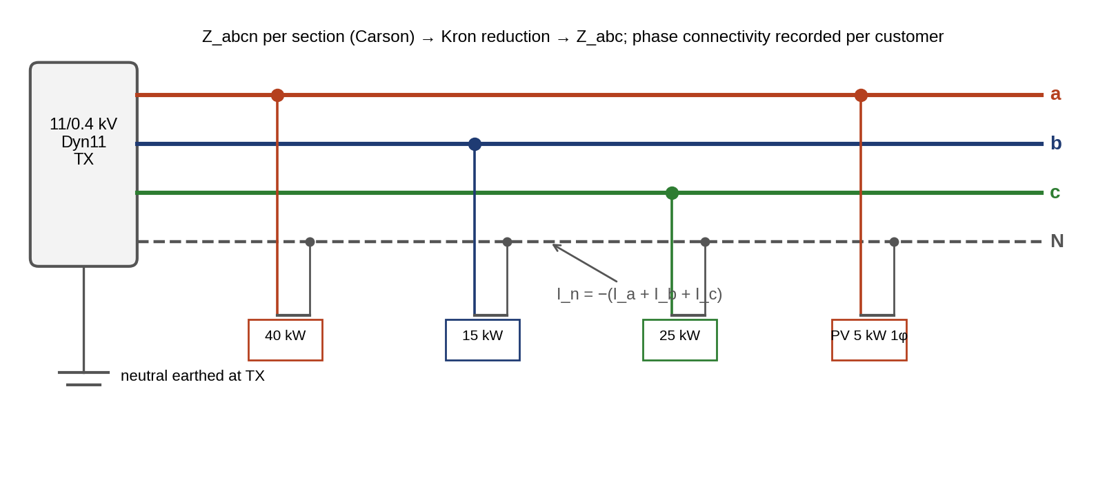
Figure 11.9. A three-phase four-wire low-voltage feeder as a twin must represent it: phase conductors a, b and c and the neutral, single-phase loads and a single-phase PV system on identified phases, the neutral current returning the unbalance, and the Dyn11 transformer with its earthed neutral.

11.5.4 Parameter uncertainty and online identification
Network parameters are themselves uncertain. Conductor resistance rises by about 0.4 % per kelvin; line lengths in GIS records can be wrong by several per cent; transformer taps are often not telemetered. A twin should therefore carry parameter uncertainty and calibrate the most influential parameters from measurement residuals (Chapter 5, Section 5.10).
Parameters are estimated by augmenting the state vector with the uncertain parameters $p$ (for example a line-impedance scale factor or a tap position) and solving the same weighted least-squares problem as for the state (Section 11.12.1), with $h\left(x,p\right)$ in place of $h\left(x\right)$. The estimate comes with a covariance, and the question is not only its value but whether the data can determine it at all. A parameter is identifiable from a measurement set when the columns of the Jacobian $∂h/∂p$ are not (nearly) linear combinations of the state columns, which in practice means that the measurements must include quantities on both sides of the element whose parameter is sought. Example 11.18 shows a line impedance that cannot be identified from SCADA and pseudo-measurements but can be pinned to ±11 % by two µPMUs. The twin should update a parameter only when its confidence interval is narrower than the margin of the decision it affects, and only after a sustained residual pattern, not after one snapshot.

11.6 Balanced, Unbalanced and Multi-fidelity Power Flow

11.6.1 The power-flow equations
Power flow computes the steady-state bus voltages from the specified injections. Multiplying each nodal equation (11.22) by the conjugate of its voltage gives the complex power injected at bus $i$:
 | Si=ViIi*=Vik​Yik*Vk*, | (11.23)
and in polar form, with $Y_{ik}=G_{ik}+jB_{ik}$ and $θ_{ik}=θ_{i}−θ_{k}$,
 | Pi=Vik​VkGikcosθik+Biksinθik, Qi=Vik​VkGiksinθik−Bikcosθik, | (11.24)
where $V_{i}$ and $θ_{i}$ are the voltage magnitude and angle at bus $i$ and $G_{ik}$, $B_{ik}$ the conductance and susceptance entries of $Y$. Each bus has four quantities ($P$, $Q$, $V$, $θ$), two of which are specified. At PQ buses (loads, grid-following DERs) $P$ and $Q$ are given. At PV buses (voltage-controlling generators) $P$ and $V$ are given. At the slack bus (the substation, or the grid-forming source in an island) $V$ and $θ$ are given, and it balances the losses. The nodal power balance at every bus is then $P_{i}^{spec}−P_{i}\left(V,θ\right)=0$ and likewise for $Q$.

11.6.2 Two buses by hand
A single line of impedance $R+jX$ from a source bus at voltage $V_{1}$ (reference angle zero) to a load bus drawing $P+jQ$ can be solved exactly. The line current is $\overset{‾}{I}=\left(P−jQ\right)/{\overset{‾}{V}}_{2}^{*}$, and ${\overset{‾}{V}}_{1}={\overset{‾}{V}}_{2}+\left(R+jX\right)\overset{‾}{I}$. Multiplying by ${\overset{‾}{V}}_{2}^{*}$ and separating real and imaginary parts,
 | $$V_{1}V_{2}cosδ=V_{2}^{2}+PR+QX, V_{1}V_{2}sinδ=PX−QR,$$ | (11.25)
where $δ$ is the angle by which ${\overset{‾}{V}}_{1}$ leads ${\overset{‾}{V}}_{2}$. Squaring and adding eliminates $δ$ and leaves a quadratic in $V_{2}^{2}$:
 | $$V_{2}^{4}+\left[2\left(PR+QX\right)−V_{1}^{2}\right]V_{2}^{2}+\left(P^{2}+Q^{2}\right)\left(R^{2}+X^{2}\right)=0,$$ | (11.26)
whose larger root is the normal operating point. The quantities may be per unit, or three-phase powers with line-to-line voltages and per-phase impedances. Neglecting the angle, $V_{1}V_{2}cosδ≈V_{1}V_{2}$ and $V_{2}≈V_{1}$ on the right, gives the familiar approximate voltage drop
 | $$ΔV=V_{1}−V_{2}≈\frac{PR+QX}{V_{1}}.$$ | (11.27)
The quadratic has real roots only while its discriminant is non-negative. The boundary is the maximum power the line can deliver at a given power factor, the nose of the P–V curve (Figure 11.10), beyond which no steady state exists and voltage collapses.
Example 11.6 Voltage at the P-1 connection by three methods
Given. An 11 kV source, 5 km of line at $0.25+j0.35$ Ω/km ($R=1.25$ Ω, $X=1.75$ Ω) and a load of 3 MW and 1 Mvar. Separately, a 13.8 kV segment with $R=0.3$ Ω and $X=0.5$ Ω carrying 500 kW and 200 kvar.
Find. The receiving voltage by (11.26), by fixed-point iteration ${\overset{‾}{V}}_{2}←V_{1}−\left(R+jX\right){\left(\overset{‾}{S}/{\overset{‾}{V}}_{2}\right)}^{*}$, and by (11.27); the maximum power at 0.95 power factor; and the drop on the 13.8 kV segment.
Solution. (11.26) gives $V_{2}=10.468$ kV, a 4.84 % drop; the iteration converges to the same value, with an angle of −1.99°, in 5 iterations to a change below 0.01 V; (11.27) gives 10.500 kV, underestimating the drop by 0.3 percentage points. The discriminant of (11.26) vanishes at 14.8 MW at 0.95 power factor, the loadability limit of this line. On the 13.8 kV segment, (11.27) gives $\left(500 000×0.3+200 000×0.5\right)/13 800=18.1$ V, 0.13 %.
Interpretation. The approximation is adequate for short, lightly loaded lines and misleads as load approaches the nose, which is precisely where a twin is needed. The iteration used here is the two-bus case of the forward–backward sweep of Section 11.6.5.
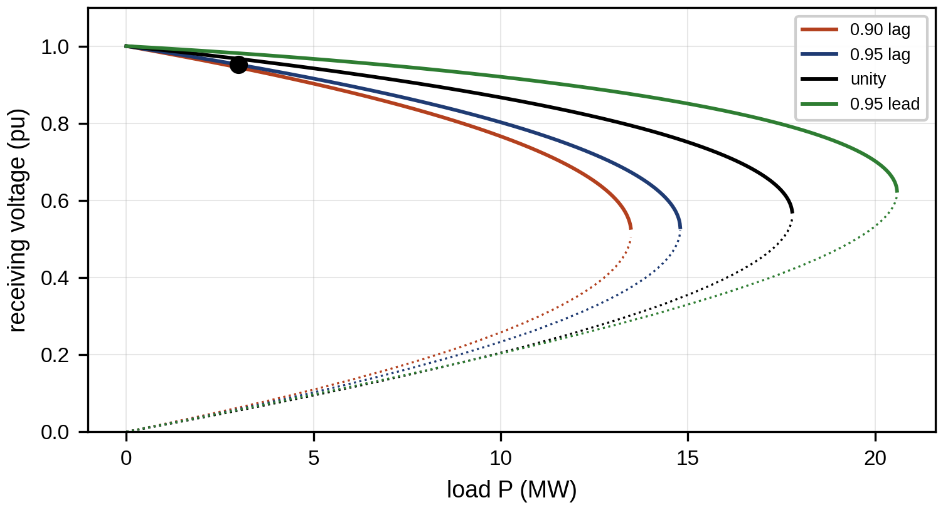
Figure 11.10. P–V (nose) curves of the 5 km, 11 kV line for power factors 0.9 lagging, 0.95 lagging, unity and 0.95 leading, from (11.26); the tip of each curve is its loadability limit, and the marked point is Example 11.6.

11.6.3 Newton–Raphson power flow
For a general meshed network, the unknowns $x=\left[θ, V\right]$ at all non-slack buses are found by Newton–Raphson. Linearizing the mismatches about the current estimate gives
 | $$\left[\begin{matrix}ΔP \\ ΔQ\end{matrix}\right]=\left[\begin{matrix}∂P/∂θ & ∂P/∂V \\ ∂Q/∂θ & ∂Q/∂V\end{matrix}\right]\left[\begin{matrix}Δθ \\ ΔV\end{matrix}\right], x^{\left(k+1\right)}=x^{\left(k\right)}+J^{−1}\left[\begin{matrix}ΔP \\ ΔQ\end{matrix}\right],$$ | (11.28)
where $ΔP=P^{spec}−P\left(x^{\left(k\right)}\right)$ and $ΔQ$ are the mismatches and $J$ the Jacobian of (11.24), whose entries follow by differentiating it (for example $∂P_{i}/∂θ_{k}=V_{i}V_{k}\left(G_{ik}sinθ_{ik}−B_{ik}cosθ_{ik}\right)$ for $k≠i$). Convergence is quadratic once the iterate is close to the solution, and well-conditioned networks solved from a flat start ($V=1$, $θ=0$) often need only a few iterations [6]. That behaviour is not guaranteed: the iteration count grows, and convergence may fail, for heavily loaded or poorly conditioned networks, poor initial estimates, voltage-control limits that switch bus types, and operation close to the loadability limit. At the nose of Figure 11.10 the Jacobian of the corresponding load-flow formulation becomes singular, which is why continuation methods rather than plain Newton iterations are used to trace the curve through it. The remaining entries follow in the same way, for example
 | $$\frac{∂P_{i}}{∂θ_{i}}=−Q_{i}−B_{ii}V_{i}^{2}, \frac{∂P_{i}}{∂V_{i}}=\frac{P_{i}}{V_{i}}+G_{ii}V_{i}, \frac{∂Q_{i}}{∂V_{i}}=\frac{Q_{i}}{V_{i}}−B_{ii}V_{i}.$$ | (11.29)
In transmission networks, where $X≫R$ and angles are small, active power depends mainly on angles and reactive power on magnitudes. The fast-decoupled method exploits this by replacing the Jacobian with two constant matrices, $ΔP/V=B′Δθ$ and $ΔQ/V=B″ΔV$, factorized once. The same assumptions fail on distribution feeders with R/X near 1, which is why they are solved differently.

11.6.4 DistFlow and LinDistFlow: assumptions and error
Distribution feeders are usually operated radially (often with normally open ties that make them weakly meshed when closed), and their R/X ratios are often near or above 1. High R/X invalidates the decoupling assumptions of transmission studies, and together with long radial paths it can make Newton’s method less well conditioned, although Newton itself remains applicable. Radial structure, however, allows a simpler formulation. For a branch from parent bus $i$ to child bus $k$ with impedance $r_{k}+jx_{k}$ and sending-end power flow $P_{k}+jQ_{k}$, conservation of power and Ohm’s law give the DistFlow equations of Baran and Wu [7]:
 | Pk=pkL+c∈Ck​Pc+rkPk2+Qk2Vi2, Qk=qkL+c∈Ck​Qc+xkPk2+Qk2Vi2, | (11.30)
 | $$V_{k}^{2}=V_{i}^{2}−2\left(r_{k}P_{k}+x_{k}Q_{k}\right)+\left(r_{k}^{2}+x_{k}^{2}\right)\frac{P_{k}^{2}+Q_{k}^{2}}{V_{i}^{2}},$$ | (11.31)
where $p_{k}^{L}+jq_{k}^{L}$ is the net load at bus $k$ (load minus generation), $C\left(k\right)$ the set of children of bus $k$, and the terms with $\left(P_{k}^{2}+Q_{k}^{2}\right)/V_{i}^{2}$ are the branch losses. Dropping the loss terms gives the linear LinDistFlow model, $V_{k}^{2}=V_{i}^{2}−2\left(r_{k}P_{k}+x_{k}Q_{k}\right)$ with $P_{k}$ and $Q_{k}$ the sums of downstream loads, which is widely used inside optimizers because it is linear in $V^{2}$, $P$ and $Q$.
LinDistFlow rests on three assumptions, and each can be checked by the twin: that losses are small compared with flows (so the squared-flow terms can be dropped); that voltages stay near 1 pu (so that $V_{i}^{2}$ in the loss terms can be replaced by 1 and voltage drops add linearly along the path); and that the network is radial (so each branch flow is the sum of downstream injections). Its error therefore grows roughly with the square of loading. Figure 11.11 quantifies this on the P-1 feeder by comparing LinDistFlow with the exact sweep for loadings from 20 to 200 % of the evening case and four X/R ratios at fixed impedance magnitude. The maximum voltage error is 2 mpu (milli-per-unit) at the evening case and exceeds 5 mpu, a tenth of a 0.05 pu voltage band, only above about 140 % loading. The X/R ratio changes the error by less than 20 % across the range, because the neglected terms depend on ${\left|z\right|}^{2}$ rather than on its angle. The practical rule for a twin that optimizes with LinDistFlow is to verify every optimized set-point with the exact power flow and to tighten the optimizer’s voltage limits by the observed error.
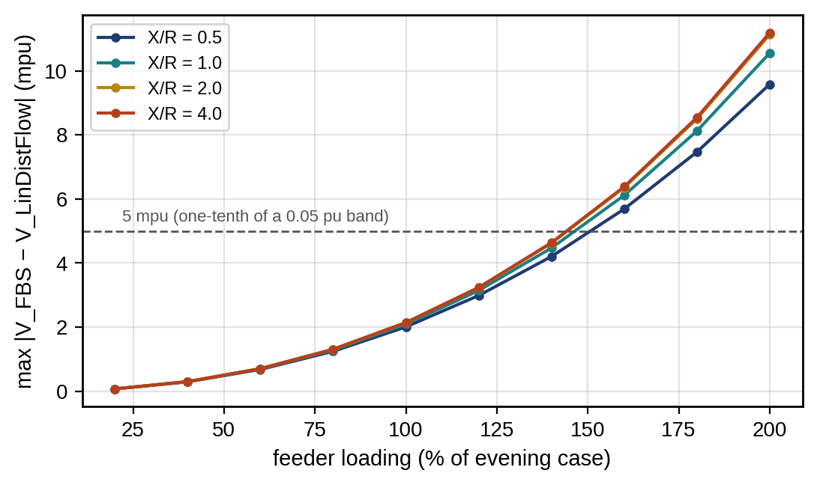
Figure 11.11. Maximum voltage error of loss-free LinDistFlow against the exact forward–backward sweep on the P-1 feeder, as a function of loading (100 % is the evening case of Example 11.7) for four X/R ratios at the same impedance magnitude.

11.6.5 The forward–backward sweep
The exact complex equations are solved by the forward–backward sweep (FBS), a Gauss–Seidel-like iteration that follows the tree:
- Start with all voltages equal to the substation voltage.
- Backward sweep: compute each bus’s load current ${\overset{‾}{I}}_{k}^{L}={\left({\overset{‾}{S}}_{k}^{L}/{\overset{‾}{V}}_{k}\right)}^{*}$ and accumulate branch currents from the leaves to the root, Ik=IkL+c∈Ck​Ic.
- Forward sweep: update voltages from the root, ${\overset{‾}{V}}_{k}={\overset{‾}{V}}_{i}−\left(r_{k}+jx_{k}\right){\overset{‾}{I}}_{k}$.
- Repeat until the largest voltage change is below a tolerance.
Each iteration costs one pass through the branches, so the work per iteration grows linearly with feeder size; the number of iterations grows with loading and is not bounded in advance. The feeder’s active losses follow from the converged branch flows,
 | Ploss=k​rkPk2+Qk2Vik2=k​rkIk2, | (11.32)
with $i\left(k\right)$ the parent of bus $k$; losses grow with the square of flow, which is why supplying load locally, from the microgrid, reduces them.
Example 11.7 Power flow on the P-1 feeder
Given. The 11 kV feeder of Figure 11.5: ten 1 km sections of $0.25+j0.35$ Ω/km, substation at 1.00 pu; loads of 0.20 to 0.30 MW at 0.95 power factor at buses 1 to 10 except bus 6 (2.35 MW in total; the values bus by bus are listed in Table 11.13); the P-1 microgrid at bus 6 importing 1.0 MW and 0.3 Mvar (evening case). Also a midday case with feeder loads at 40 % and P-1 exporting 2.0 MW at unity power factor.
Find. The voltage profile by FBS and by Newton–Raphson, the error of LinDistFlow, the feeder losses and the head-end power.
Solution. FBS converges in 11 iterations and Newton–Raphson in 4 to a tolerance of ${10}^{−12}$ pu, and the two solutions agree to ${10}^{−14}$ pu. The voltage falls to 0.940 pu at bus 10, below a 0.95 pu planning limit, and the P-1 connection sits at 0.949 pu. LinDistFlow errs by at most 0.002 pu. Losses are 118 kW, and the substation supplies 3.468 MW and 1.237 Mvar. In the midday export case the voltage rises instead, to a maximum of 1.012 pu at bus 6.
Figure 11.12 compares the convergence of the two methods and the error of LinDistFlow along the feeder.
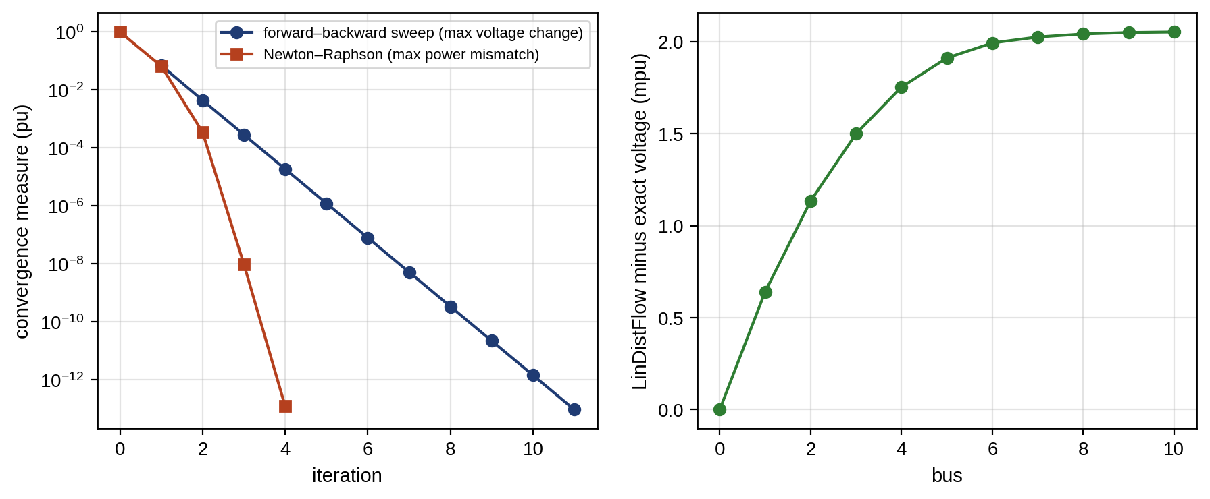
Figure 11.12. Convergence of the forward–backward sweep and Newton–Raphson on the P-1 feeder (left: largest voltage change per iteration for the sweep and largest power mismatch for Newton–Raphson, logarithmic), and the error of the loss-free LinDistFlow approximation along the feeder (right).
Figure 11.13 shows the profiles.
Interpretation. The same feeder is under-voltage in the evening and slightly over-voltage at midday: the direction of the plant’s power flow reverses the problem. Loss-free LinDistFlow is accurate enough for optimization here, with errors ten times smaller than the voltage limits. FBS is the right tool for radial feeders, and Newton–Raphson for meshed networks or as a validation.
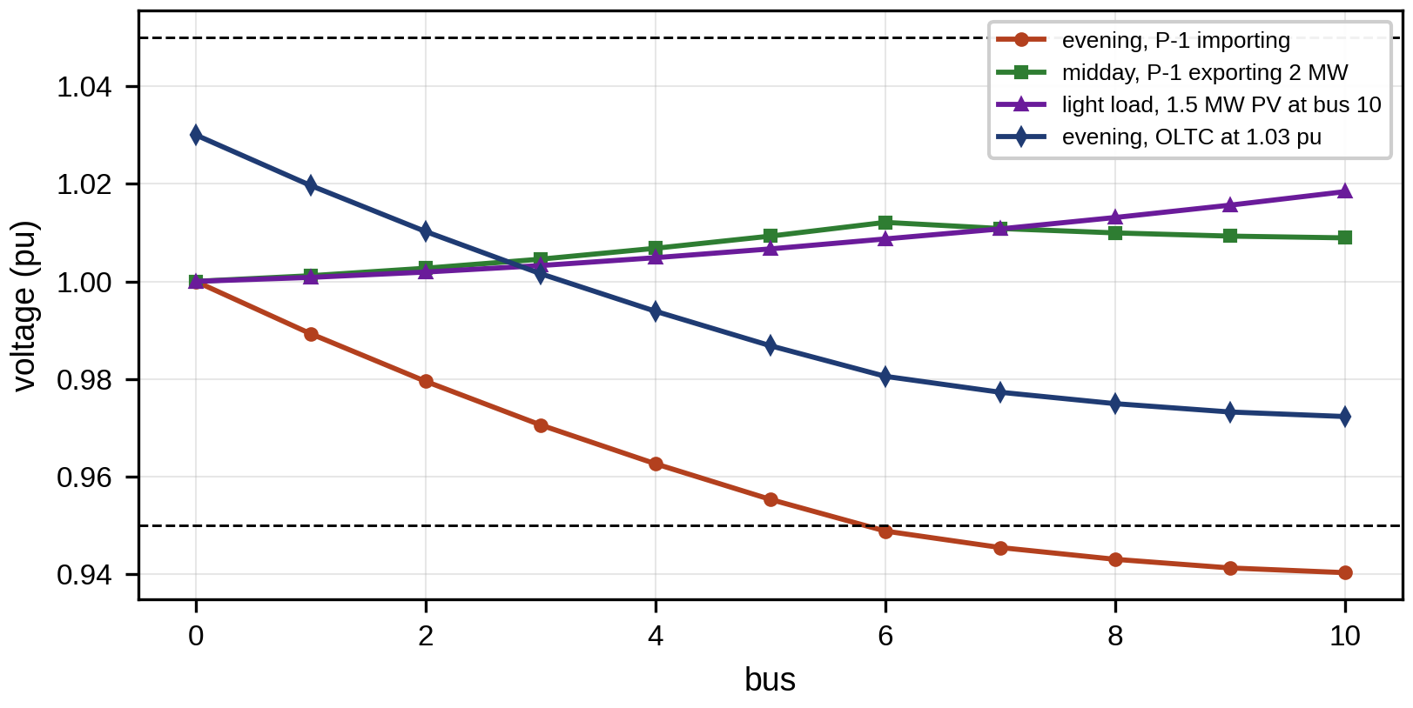
Figure 11.13. Voltage profiles along the P-1 feeder for the evening import case, the midday export case, a light-load case with 1.5 MW of PV at the feeder end, and the evening case with the tap changer raised to 1.03 pu; dashed lines mark the 0.95 and 1.05 pu limits.
The basic sweep assumes a strictly radial feeder with constant-power loads and fixed taps. Practical twins extend it in four ways. Weakly meshed feeders, with a few closed loops through normally open points, are handled by breaking each loop at a breakpoint, solving the radial network with a compensating current injection at the two break nodes, and updating that injection from the voltage mismatch across the break until it vanishes. Voltage regulators and OLTCs enter as ideal transformers whose ratio is updated between iterations according to their control law, with a deadband and a limit on steps per iteration to avoid oscillation. Voltage-dependent loads use the ZIP model of Section 11.11, which changes the load current in each backward sweep. PV buses (voltage-controlled DERs) are handled by a reactive-power injection updated from the voltage error through a sensitivity. The sweep converges linearly rather than quadratically, and its iteration count grows with loading and with the number of controlled devices, so convergence is not guaranteed near the loadability limit; a twin falls back to Newton–Raphson with the same model when the sweep stalls.

11.6.6 Unbalanced three-phase power flow
Real distribution networks are unbalanced. Single-phase laterals, single-phase loads and single-phase PV and EV chargers load the phases unequally, and each phase conductor is magnetically coupled to the others and to the neutral. A three-phase feeder model therefore uses a $3×3$ phase impedance matrix $Z_{abc}$ per section. It is obtained from the conductors’ self and mutual impedances by Carson’s equations, with the neutral eliminated by Kron reduction,
 | $$Z_{abc}=Z_{pp}−Z_{pn}Z_{nn}^{−1}Z_{np},$$ | (11.33)
where $Z_{pp}$ contains the phase self and mutual impedances, $Z_{nn}$ the neutral’s and $Z_{pn}$ the phase–neutral mutual terms [3]. The sweep then runs per phase with $3×3$ matrix operations. Converter limits enter the same model. A PV inverter’s reactive power is bounded by its apparent-power rating, $Q^{2}≤S_{max}^{2}−P^{2}$, and its fault current by its current rating (Section 11.8.3), so treating DERs as ideal sources overstates their support precisely when it is needed.
Example 11.8 Unbalance on a low-voltage feeder
Given. A 400 V, 300 m four-wire feeder with $0.32+j0.08$ Ω/km per phase and an equal neutral; single-phase loads of 40, 15 and 25 kW (0.98 power factor) on phases a, b and c.
Find. The phase voltages at the end, the sequence components, VUF and the neutral current; compare with the same total load balanced.
Solution. Iterating the per-phase sweep with the neutral voltage drop gives 199.3, 232.4 and 220.5 V. Phase b rises above its nominal 230 V because the neutral current, 114 A, shifts the neutral point. (11.7) gives $V_{1}=217.3$ V, $V_{2}=4.3$ V and $V_{0}=15.0$ V, a VUF of 1.98 %, just inside the 2 % level that EN 50160 applies to 10-minute values of a public supply (Table 11.3). The line-voltage metric LVUR of motor standards gives 1.85 %, and the phase-voltage ratio 8.3 %. Balanced, the same 80 kW would give 217.6 V on every phase.
Interpretation. Figure 11.14 shows the distorted phasor star. The worst phase is 13 % low while the balanced model predicts 5 %. A single-phase twin would miss the violation completely, and it would also miss the over-voltage on the lightly loaded phase. Phase identification of every customer and every single-phase DER is therefore part of building a distribution twin.
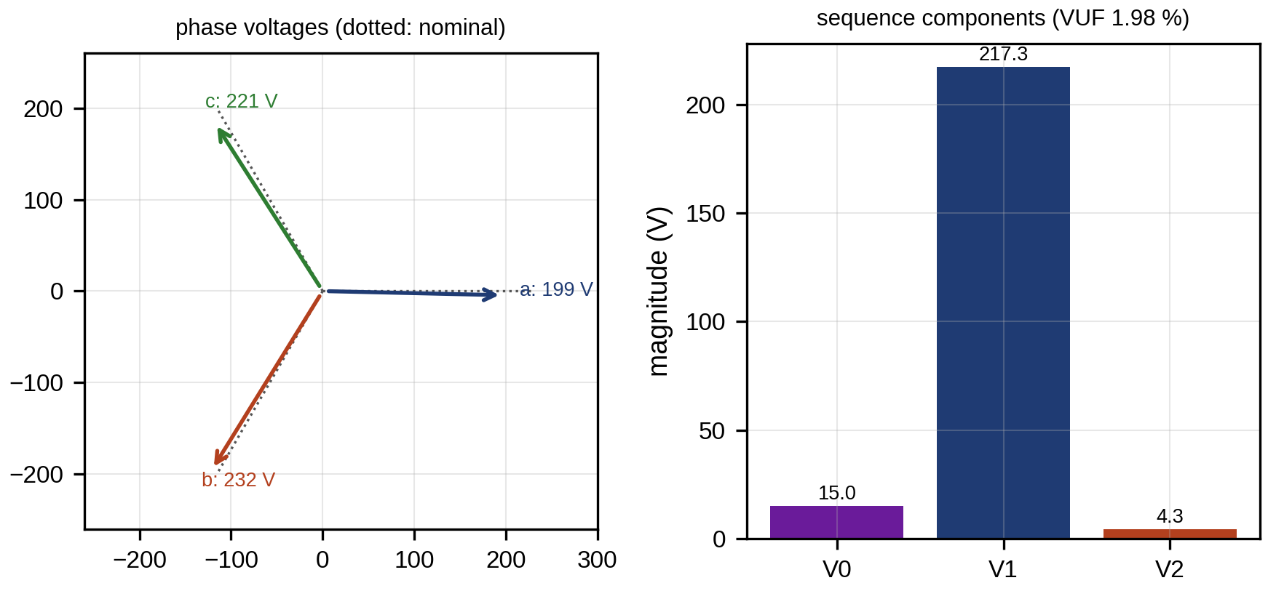
Figure 11.14. Phase voltages at the end of the unbalanced low-voltage feeder of Example 11.8 as phasors (left), and their decomposition into positive-, negative- and zero-sequence components (right).

11.6.7 Choosing a power-flow method
Table 11.6 compares the methods of this section and the three-phase optimal power flow surrogates used inside optimizers.
TABLE 11.6 Power-flow methods compared
Method | Network | Accuracy | Convergence | Cost per solve | Typical twin use
AC Newton–Raphson (polar) | Any, balanced or three-phase | Exact for the model | Quadratic near the solution; may fail near the nose or from a poor start | Sparse LU per iteration | Validation, meshed networks, contingency AC checks
Fast-decoupled | Meshed, X/R well above 1 | Exact at convergence | Linear; degrades for R/X near 1 | Two constant factorizations | Transmission screening
Forward–backward sweep | Radial or weakly meshed; three-phase | Exact for the model | Linear; iterations grow with load | One pass through branches per iteration | Real-time feeder twin, QSTS
LinDistFlow | Radial | Error grows with loading squared (Figure 11.11) | Direct (linear) | One pass | Inside optimizers (Volt/VAR, EMS, hosting capacity)
DC power flow | Meshed, X/R well above 1 | Active flows only, no voltage, no losses | Direct | One factorization | N-1 screening (Section 11.18.2)
Three-phase OPF with convex relaxation or linearization | Radial or meshed | Relaxation exact under conditions; otherwise approximate | Interior point | Much higher | DER dispatch, hosting-capacity maximization

11.6.8 Multi-fidelity simulation: QSTS, RMS, dynamic phasor and EMT
Power flow is a snapshot. A twin also needs time, and the right time resolution depends on the question (Figure 11.15, Table 11.7):
- Quasi-static time series (QSTS) solves a power flow at every step of a load and generation time series, typically 1 s to 1 h over days to years, with the discrete controls (taps, capacitor switching, Volt/VAR with its time constants) updated between steps. It is the tool for hosting capacity, tap wear and energy losses, and it is where the sweep’s speed matters.
- RMS (phasor) simulation represents the network by phasors at fundamental frequency and the machines and controllers by differential equations, with steps of about 1 to 10 ms over seconds to minutes. It captures frequency response, droop, islanding and load shedding (Sections 11.9 and 11.10) but not sub-cycle phenomena.
- Dynamic-phasor simulation represents each quantity by slowly varying Fourier coefficients at the fundamental and selected harmonics, with steps of tens to hundreds of microseconds. It captures unbalance, PLL dynamics in weak grids and some harmonic interactions at a fraction of EMT’s cost.
- Electromagnetic-transient (EMT) simulation integrates the instantaneous circuit equations with steps of 1 to 50 µs, with converters as switching or averaged models. It is required for faults with converter current limiting, protection behaviour, transformer inrush and control interactions above a few hertz.
The twin runs the cheapest model that answers the question and hands over to a more detailed one when a trigger fires: a QSTS step that shows a voltage close to a limit triggers an RMS study of the next control action; an RMS event that drives a converter into current limit triggers an EMT replay of that interval. Hand-over requires consistent initialization: the detailed model starts from the operating point of the simpler one, which is straightforward from RMS to EMT (by constructing sinusoidal waveforms from phasors) and lossy from EMT to RMS (by extracting phasors over a window). The validation question is the same at every level: does the simpler model reproduce the more detailed one on the events for which the twin uses it (Section 11.20)?
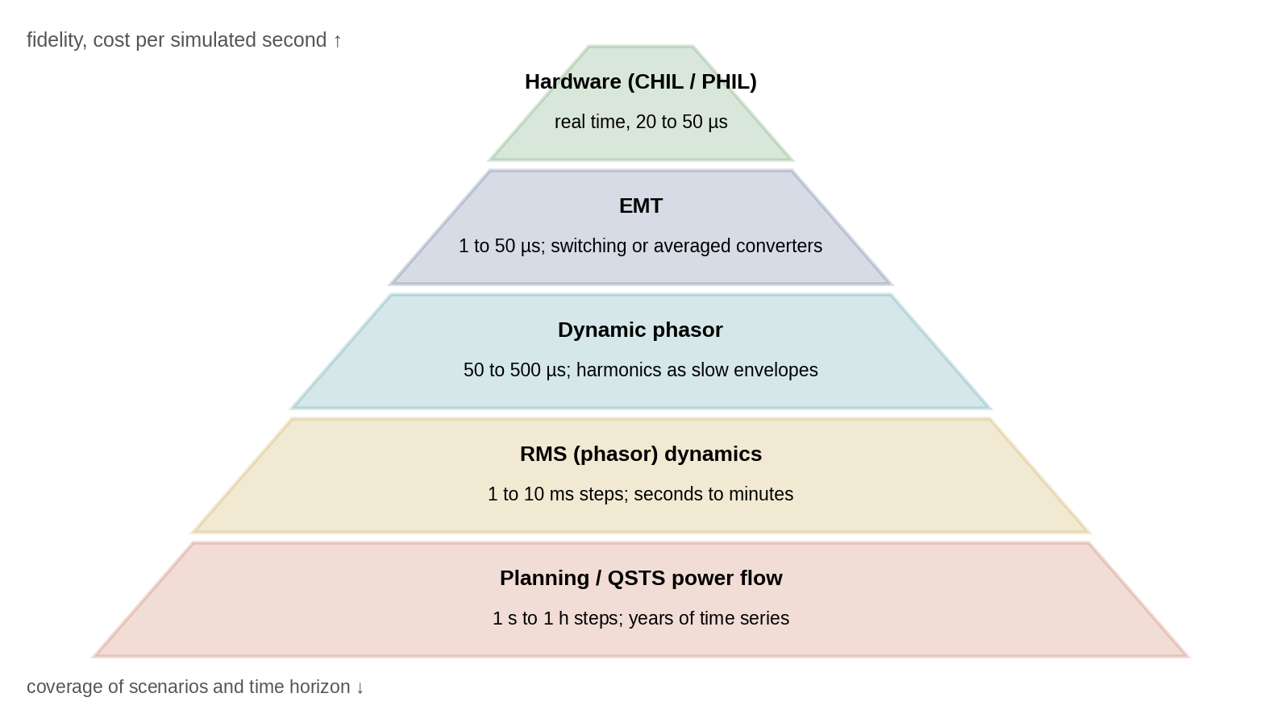
Figure 11.15. The model-fidelity hierarchy of a grid twin: from planning QSTS at the base, covering long horizons and many scenarios, through RMS and dynamic-phasor models to EMT and hardware-in-the-loop at the top, with typical time steps.
TABLE 11.7 Simulation fidelity levels of a grid twin
Model | Time step | Horizon | Captures | Misses | P-1 use
QSTS power flow | 1 s to 1 h | Days to years | Voltage, loading, losses, tap operations | All dynamics | Hosting capacity, tap wear
RMS phasor | 1 to 10 ms | Seconds to minutes | Frequency, droop, islanding, UFLS, motor stalling | Sub-cycle transients, harmonics, fast current limiting | Islanding and black-start plans
Dynamic phasor | 50 to 500 µs | Seconds | Unbalance, PLL and weak-grid dynamics | Switching detail | Weak-grid checks of GFL units
EMT (averaged or switching) | 1 to 50 µs | Milliseconds to seconds | Faults, current limiting, protection, inrush | Long horizons (cost) | Protection and fault-ride-through studies
CHIL / PHIL | 20 to 50 µs, real time | Seconds to hours | Real controller or hardware behaviour | Scenarios not scripted | Controller and relay validation

11.7 Voltage Regulation and Probabilistic Hosting Capacity

11.7.1 Voltage sensitivities
Differentiating (11.27) shows how injections move the voltage at a bus. For a bus fed through a path of total resistance $R_{path}$ and reactance $X_{path}$ (per unit),
 | $$\frac{∂V}{∂P}≈R_{path}, \frac{∂V}{∂Q}≈X_{path},$$ | (11.34)
per unit of power injected at that bus. At the end of the P-1 feeder, $R_{path}=0.0207$ and $X_{path}=0.0289$ pu: 1 MW of injection raises the voltage by about 2.1 %, and 1 Mvar absorbed lowers it by 2.9 %. The X/R ratio of 1.4 means reactive power is only moderately more effective than active power. On low-voltage cables, with X/R near 0.25, it is far less effective, and active-power curtailment becomes the main lever.

11.7.2 Tap changers and Volt/VAR control
The substation’s on-load tap changer (OLTC) regulates the feeder-head voltage in steps that are commonly between about 0.6 and 1.25 %, with an intentional delay (often tens of seconds) to avoid responding to transients; the actual step and delay are equipment settings the twin must read, not assume. It moves the tap when the regulated voltage leaves a dead band around the set-point; with line-drop compensation, the regulated voltage is an estimate of the voltage at a load centre,
 | $${\overset{‾}{V}}_{LDC}={\overset{‾}{V}}_{sec}−\left(R_{set}+jX_{set}\right){\overset{‾}{I}}_{sec},$$ | (11.35)
where ${\overset{‾}{V}}_{sec}$ and ${\overset{‾}{I}}_{sec}$ are the measured secondary voltage and current and $R_{set}+jX_{set}$ the compensator settings, chosen to equal the impedance to the load centre. Reverse power flow from DERs makes the compensator raise the voltage when it should lower it, a classic interaction the twin must check. Raising the P-1 substation to 1.03 pu brings the evening case of Example 11.7 to a minimum of 0.972 pu. But a tap high enough for the evening pushes midday voltages up when the PV and wind export, so a fixed tap cannot serve both. Inverters can help locally. IEEE 1547-2018 [8] defines a Volt/VAR characteristic: a piecewise-linear reactive-power set-point against local voltage,
 | $$\frac{Q}{S_{rated}}=\left\{\begin{matrix}+0.44, & V≤V_{1} \\ 0.44\frac{V_{2}−V}{V_{2}−V_{1}}, & V_{1}<V≤V_{2} \\ 0, & V_{2}<V≤V_{3} \\ −0.44\frac{V−V_{3}}{V_{4}−V_{3}}, & V_{3}<V≤V_{4} \\ −0.44, & V>V_{4}\end{matrix}\right.$$ | (11.36)
with positive $Q$ meaning injection. The breakpoints used here, $V_{1}=0.92$, $V_{2}=0.98$, $V_{3}=1.02$ and $V_{4}=1.08$ pu with a reactive limit of 44 % of rating, are the default settings of IEEE 1547-2018 for Category B DERs. They are illustrative: Category A DERs have different defaults, the standard allows each parameter to be adjusted within specified ranges, and the utility or regional grid code sets the values that actually apply, which the twin must read from the DER’s configured settings. A companion Volt–Watt function curtails active power when voltage is too high; with the Category B defaults it falls linearly from full output at 1.06 pu to 20 % at 1.10 pu,
 | $$\frac{P_{max}}{P_{avail}}=1−0.8 clip\left(\frac{V−1.06}{1.10−1.06}, 0, 1\right),$$ | (11.37)
which is the last resort when reactive power cannot hold the voltage. Because $Q$ changes $V$ and $V$ sets $Q$, each inverter’s response is a closed loop, and in the twin it is solved by iterating the power flow with the characteristic (with damping to avoid oscillation).
Example 11.9 Volt/VAR and PV hosting capacity at the feeder end
Given. The P-1 feeder at 30 % load with P-1 exchanging no power and a PV plant at bus 10 whose inverter is rated at 1.1 times its active power; limits of 1.05 pu voltage and 400 A per section.
Find. The end voltage with 2.5 MW of PV with and without Volt/VAR, and the hosting capacity in each case, defined as
 | $$HC=max\left\{P_{PV}: V_{k}\left(P_{PV}\right)≤V_{max}, \left|I_{k}\left(P_{PV}\right)\right|≤I_{k,max} ∀k\right\},$$ | (11.38)
the largest PV power at bus 10 for which every bus voltage and branch current stays within its limit.
Solution. With 2.5 MW and unity power factor the end voltage is 1.037 pu. With Volt/VAR, the plant absorbs 0.21 Mvar at a power factor of 0.996 and the voltage settles at 1.030 pu; feeder losses rise from 87 to 90 kW. Searching by bisection, the hosting capacity is 3.3 MW without Volt/VAR, where the voltage limit binds, and 6.2 MW with it, where the voltage limit binds again with the most heavily loaded section carrying 313 A.
Interpretation. Figure 11.16 shows the characteristic and the voltage against PV size. Volt/VAR nearly doubles the PV this feeder can accept, at the cost of a few kilowatts of losses and some reactive power drawn from the grid. The twin’s value is in computing this for the actual feeder, load and settings, because hosting capacity depends strongly on where the PV connects and on the X/R ratio along the way.
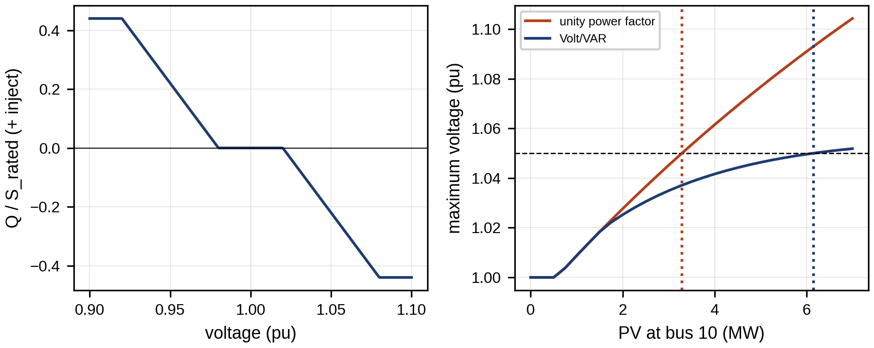
Figure 11.16. Volt/VAR characteristic with the IEEE 1547-2018 Category B default settings, used here as an illustration (left), and end-of-feeder voltage against PV power with and without Volt/VAR, with the 1.05 pu limit and the resulting hosting capacities (right).

11.7.3 Probabilistic hosting capacity
The hosting capacity of Example 11.9 holds for one load level and one PV location. Both vary: load changes through the day and the year, and the connection point of the next PV plant is not known when the study is made. Probabilistic hosting capacity treats these as random variables and reports a distribution:
 | $$F_{HC}\left(h\right)=Pr\left\{HC\left(ξ\right)≤h\right\}, HC_{α}=F_{HC}^{−1}\left(α\right),$$ | (11.39)
where $ξ$ collects the uncertain inputs (load level, PV location, DER settings, and in a fuller study irradiance correlation and unbalance), $HC\left(ξ\right)$ is the deterministic hosting capacity of (11.38) for one sample, and $HC_{α}$ the $α$-quantile. A utility that accepts a 5 % risk of a limit violation at the worst credible condition uses $HC_{0.05}$ as the connectable amount. The quantity is estimated by Monte Carlo sampling of $ξ$, with one bisection search per sample.
Example 11.10 Probabilistic hosting capacity of the P-1 feeder end
Given. The P-1 feeder of Example 11.9, with load uniformly distributed between 15 and 60 % of the evening case and the PV plant connecting with equal probability at bus 7, 8, 9 or 10; P-1 exchanging no power; 300 samples; the same voltage and current limits.
Find. The 5th, 50th and 95th percentiles of hosting capacity with and without Volt/VAR.
Solution. Without Volt/VAR the percentiles are 3.2, 4.0 and 5.1 MW; with Volt/VAR they are 5.8, 7.7 and 8.3 MW (Figure 11.17). The upper tail with Volt/VAR is cut off by the 400 A current limit of the head sections, which Volt/VAR cannot relieve.
Interpretation. The deterministic worst case of Example 11.9 (PV at the feeder end, 30 % load) is close to the 5th percentile, which is reassuring but not guaranteed in general. The distribution shows two further things a single number hides: Volt/VAR moves the whole distribution, not just one point, and once it is enabled the binding limit changes from voltage to thermal for 35 % of the cases, which changes the next reinforcement from a voltage measure to a cable upgrade.
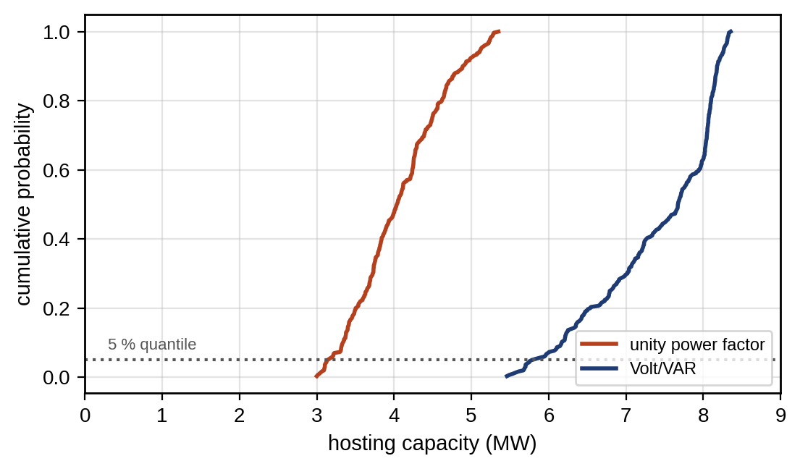
Figure 11.17. Cumulative distribution of the hosting capacity of the P-1 feeder over 300 samples of load level and PV location, with and without Volt/VAR (Example 11.10).

11.7.4 Coordinating tap changers, capacitors and inverters
Tap changers, switched capacitors and inverter Volt/VAR act on the same voltage with different speeds, and uncoordinated they fight. Inverters respond in seconds, an OLTC after its 30 to 60 s delay, and a capacitor bank after minutes. Two failure modes are common. Hunting occurs when a regulator’s dead band is narrower than the voltage step one tap operation produces, so each step overshoots into the opposite side of the band; the dead band must satisfy $2 DB>ΔV_{tap}$, where $DB$ is the half-width of the band and $ΔV_{tap}$ the step, with a margin for measurement noise. Masking occurs when fast inverter Volt/VAR pulls the regulated voltage back into the band before the OLTC’s timer expires, so the tap never moves and inverters remain at their reactive limits, wasting capability and increasing losses. The remedy is to give the slow devices the steady-state job (bringing the average voltage to the centre of the band) and the fast devices the transient job, by setting inverter Volt/VAR with a response time of several seconds and a dead band around the OLTC set-point, or by a supervisory Volt/VAR optimization (VVO) that sets taps, capacitors and inverter reactive set-points together every few minutes from the twin’s state estimate. VVO is typically formulated with LinDistFlow constraints and verified with the exact power flow, and it can minimize losses, conservation-voltage-reduction energy, or tap operations, which the twin counts as a wear measure (Section 11.13.2).

11.8 Grid-following and Grid-forming Converter Dynamics
Section 11.2.5 introduced the two converter families. Their behaviour in faults, islands and weak grids decides most of the questions a microgrid twin must answer, so this section develops their control structures, their limits and the models a twin needs for each (Figure 11.18).
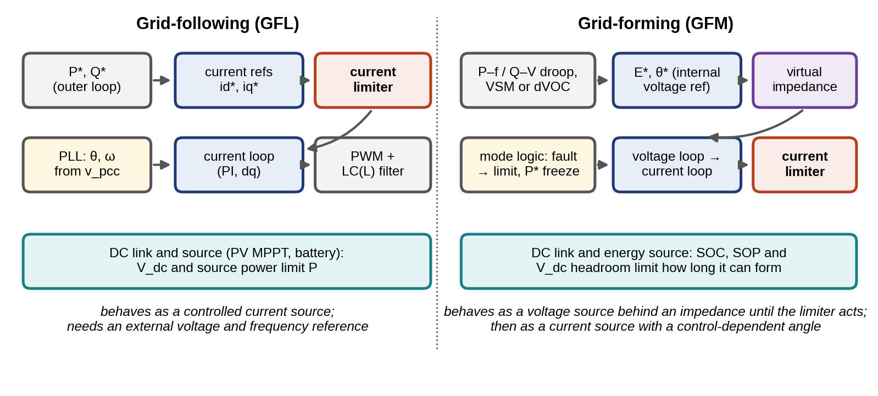
Figure 11.18. Internal control of a grid-following converter (left): outer power loop, PLL, current references, current limiter and current loop; and of a grid-forming converter (right): droop, virtual-synchronous or dispatchable-virtual-oscillator outer loop that sets an internal voltage reference, virtual impedance, voltage and current loops with a current limiter, and fault-mode logic. Both sit on a DC link whose source limits the power and energy available.

11.8.1 Grid-following control: current loops and the phase-locked loop
A GFL converter controls its output current in a reference frame aligned with the terminal voltage. With $L_{f}$ and $R_{f}$ the filter inductance and resistance, $v_{c}$ the converter voltage and $v$ the terminal voltage, the current dynamics in the synchronous $dq$ frame rotating at $ω$ are
 | $$L_{f}\frac{di_{d}}{dt}=v_{c,d}−v_{d}−R_{f}i_{d}+ωL_{f}i_{q}, L_{f}\frac{di_{q}}{dt}=v_{c,q}−v_{q}−R_{f}i_{q}−ωL_{f}i_{d},$$ | (11.40)
where the terms $±ωL_{f}i$ couple the axes. A PI controller with feed-forward of $v$ and decoupling of $ωL_{f}i$ makes each axis a first-order loop with a bandwidth of typically several hundred hertz, so on the time scale of power-system dynamics the converter is a current source that injects $i_{d}^{*}$ (active) and $i_{q}^{*}$ (reactive) in phase with its estimate of the terminal-voltage angle.
That estimate comes from the synchronous-reference-frame PLL. It rotates the measured voltage into a frame at its estimated angle $\hat{θ}$ and drives the $q$-component to zero. With terminal voltage magnitude $V$ and true angle $θ$,
 | $$v_{q}=Vsin\left(θ−\hat{θ}\right)≈V\left(θ−\hat{θ}\right), \frac{d\hat{θ}}{dt}=ω_{0}+k_{p}v_{q}+k_{i}∫v_{q} dt,$$ | (11.41)
where $k_{p}$ and $k_{i}$ are the PI gains and $ω_{0}$ the nominal angular frequency. Linearized, the PLL tracks the voltage angle as a second-order system,
 | $$\frac{\hat{θ}\left(s\right)}{θ\left(s\right)}=\frac{Vk_{p}s+Vk_{i}}{s^{2}+Vk_{p}s+Vk_{i}}, ω_{n,PLL}=\sqrt{Vk_{i}}, ζ_{PLL}=\frac{k_{p}}{2}\sqrt{\frac{V}{k_{i}}},$$ | (11.42)
with natural frequency $ω_{n,PLL}$ and damping $ζ_{PLL}$. Two facts follow. The loop gain is proportional to $V$, so a voltage dip slows the PLL precisely when a fault demands fast tracking. And in a weak grid the terminal voltage depends on the converter’s own current through the grid impedance, so the PLL partly tracks the angle its own injection created. The weakness is measured by the short-circuit ratio
 | $$SCR=\frac{S_{sc}}{S_{rated}},$$ | (11.43)
where $S_{sc}$ is the short-circuit power at the connection point and $S_{rated}$ the converter’s rating. Below an SCR of roughly 2 to 3 (the exact threshold depends on the controls and X/R), GFL converters with fast PLLs are prone to oscillatory instability and loss of synchronism [12], [34], which a phasor model cannot reveal. In an island, the SCR seen by each GFL unit is set by the GFM units’ virtual impedance and current limits, which is why GFL behaviour must be re-checked in islanded operation.

11.8.2 Grid-forming control families
A GFM converter sets an internal voltage phasor $E∠δ$ behind an impedance, and its outer loop decides how $E$ and $δ$ move. Three families are in use [34]:
- Droop control makes frequency and voltage fall with filtered active and reactive power, as in (11.50) of Section 11.10.1. The power measurement is filtered with a cut-off $ω_{c}$ of typically a few hertz, $dP_{f}/dt=ω_{c}\left(P−P_{f}\right)$, with $P_{f}$ the filtered power.
- Virtual synchronous machines (VSM) emulate the swing equation, $J_{v} dω/dt=P^{*}−P−D_{v}\left(ω−ω_{0}\right)$, with virtual inertia $J_{v}$ and damping $D_{v}$, and set $dδ/dt=ω−ω_{0}$.
- Dispatchable virtual oscillator control (dVOC) derives the voltage dynamics from a nonlinear oscillator whose synchronization properties can be proved for networks of many units, at the cost of less intuitive tuning.
Droop with a low-pass filter and the VSM are the same dynamics in different notation. With $P^{*}$ the set-point, droop gives $ω−ω_{0}=−m_{p}\left(P_{f}−P^{*}\right)$. Differentiating and substituting the filter equation,
 | $$\frac{1}{m_{p}ω_{c}}\frac{dω}{dt}=P^{*}−P−\frac{1}{m_{p}}\left(ω−ω_{0}\right),$$ | (11.44)
which is the VSM equation with $J_{v}=1/\left(m_{p}ω_{c}\right)$ and $D_{v}=1/m_{p}$. The filter of a droop controller is its inertia. A twin that models a droop GFM without its power filter therefore models it without inertia.

11.8.3 Current limiting, energy limits and fault behaviour
A synchronous machine can deliver several times its rated current for hundreds of milliseconds. A converter’s semiconductors cannot, and GFM and GFL units alike limit their current to a value set by the manufacturer, commonly in the range of about 1.1 to 1.5 pu but device-specific and sometimes time-dependent. The limit is not a detail: it changes the converter from a voltage source into a current source exactly when the network needs voltage support, and how the transition is made governs whether the unit stays synchronized.
Two limiting methods dominate [37]. Current-reference saturation clips the output of the voltage loop to the allowed magnitude. It is fast and precise but leaves the voltage loop’s integrators winding up and the internal angle free to drift, since the unit no longer controls its terminal voltage. Virtual impedance adds an impedance to the internal voltage reference whenever the current exceeds the limit, choosing its size so that the current just reaches the limit. For a GFM unit with internal voltage $E∠δ$ behind a total reactance $X$ to a grid voltage $V_{g}∠0$, the added reactance is
 | $$X_{v}=max\left(0, \frac{\left|E−V_{g}e^{−jδ}\right|}{I_{max}}−X\right), P\left(δ\right)=\frac{EV_{g}}{X+X_{v}}sinδ,$$ | (11.45)
where $I_{max}$ is the current limit. Voltage-source behaviour is retained, but the power that can be transferred at a given angle falls, because $X_{v}$ grows with the voltage difference. During a deep fault the maximum of $P\left(δ\right)$ may fall below the unit’s power set-point, and then the droop or VSM loop accelerates the angle until the unit slips a pole unless the fault clears first or the set-point is reduced.
A second limit is energy. A GFM battery can form the grid only while its state of charge and state of power allow, and a GFM PV inverter only while the array can deliver the power the network demands; when the DC-link voltage collapses the unit must reduce its output or trip. The twin must therefore carry, for each GFM unit, its current limit, its limiting method, its DC-side power and energy limits, and the logic that switches between modes.
Example 11.11 A current-limited grid-forming unit through a grid fault
Given. A droop-controlled GFM unit with $E=1$ pu behind $X=0.25$ pu, set-point $P^{*}=0.8$ pu, droop 0.5 Hz per unit and power filter at 10 Hz. A remote fault depresses the grid voltage to $V_{g}=0.3$ pu for a duration $t_{f}$. Current limit 1.2 pu by virtual impedance (11.45). A quasi-static phasor model (RMS level).
Find. The fault current without limiting, the maximum transferable power during the fault with limiting, and the longest fault the unit survives with and without reducing its set-point during the fault.
Solution. Without limiting, the unit would stay synchronized for any fault duration (the fault-time maximum is $1×0.3/0.25=1.2$ pu, above $P^{*}$), but its current would reach 2.93 pu, which no converter can supply. With the 1.2 pu limit, (11.45) caps the fault-time power at 0.36 pu, less than half the set-point. The angle then drifts at a rate set by the droop gain, and the unit loses synchronism if the fault lasts more than 1.02 s. If the fault-mode logic reduces the set-point in proportion to the grid voltage ($0.8×0.3=0.24$ pu, below the 0.36 pu maximum), the unit remains synchronized for any fault duration (Figure 11.19).
Interpretation. The current limit protects the hardware and costs synchronizing power. How long the unit survives depends on its droop gain, filter, limiting method and fault-mode logic, all of which are control settings, not physics. The same unit with a stiffer droop or a current-saturation limiter would give a different answer, which is why a twin must represent the vendor’s actual limiter and why the RMS model used here must be confirmed in EMT, where sub-cycle current transients and PLL-free angle dynamics are resolved (Section 11.6.8).
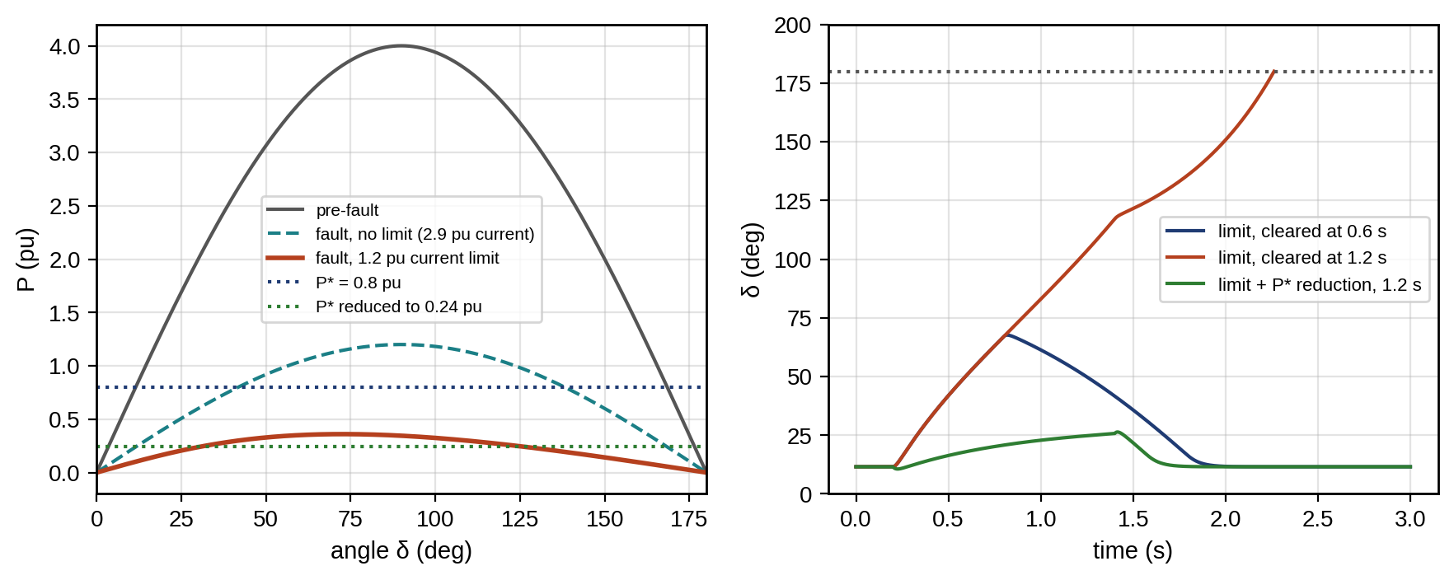
Figure 11.19. Grid-forming unit of Example 11.11: power–angle curves before the fault, during the fault without current limit, and during the fault with a 1.2 pu virtual-impedance limit, against the original and reduced power set-points (left); angle trajectories for faults cleared at 0.6 s and 1.2 s, and for a 1.2 s fault with the set-point reduced during the fault (right).

11.8.4 Small-signal and impedance-based stability
Converter controls interact with each other and with the network over a wide frequency range: droop and secondary loops near 0.1 to 10 Hz, PLLs and power filters at a few to tens of hertz, voltage and current loops at hundreds of hertz, and filter resonances above. Two tools are used. State-space small-signal analysis linearizes the full model of converters and network around an operating point and inspects the eigenvalues, as Example 11.14 does for droop. Impedance-based analysis represents each converter by its small-signal output impedance $Z_{s}\left(s\right)$ and the network or load by $Z_{l}\left(s\right)$ at the interface; the interconnection is stable when the minor-loop gain $Z_{s}\left(s\right)/Z_{l}\left(s\right)$ satisfies the Nyquist criterion, which in three-phase systems becomes the generalized Nyquist criterion applied to $2×2$ $dq$ impedance matrices. Impedances can be measured on the real equipment by injecting small perturbations, which makes this the natural way for a twin to validate converter models that vendors supply only as black boxes. The constant-power-load condition (11.13) is the simplest case of the same idea.

11.8.5 GFL and GFM compared, and the standards that apply
Table 11.8 summarizes the differences that matter for a twin.
TABLE 11.8 Grid-following and grid-forming converters compared
Property | Grid-following | Grid-forming
Behaviour (outer-loop time scale) | Controlled current source synchronized by a PLL | Controlled voltage source behind an impedance
Needs external voltage reference | Yes | No; can energize and hold an island
Weak-grid behaviour | PLL instability risk at low SCR | Generally improves with lower SCR; risk rises with a very stiff grid and fast loops
Inertia and fast frequency response | Only if programmed, after PLL detection delay | Inherent through droop filter or VSM dynamics
Fault current | Limited, controlled magnitude and angle, often positive sequence only | Limited; voltage-source behaviour until the limiter acts
Main stability risks | PLL, weak grid, control interactions | Loss of synchronism under current limit, interactions among many GFM units, DC-side limits
Twin model needs | Current limits, PLL and current-loop parameters, ride-through logic | Outer-loop family and gains, power filter, virtual impedance, limiter method, fault-mode logic, SOC and SOP
Standards are catching up with grid-forming technology. IEEE 1547-2018 and its test standard IEEE 1547.1-2020 [8], [19] set requirements for DERs on distribution networks but do not define grid-forming performance. IEEE 2800-2022 [20] covers inverter-based resources on transmission systems, and its test and verification recommended practice was published as IEEE 2800.2-2026. In December 2025 the IEEE standards board approved two projects on grid-forming equipment [21]: P2800a, an amendment to IEEE 2800 intended to reduce barriers for resources with grid-forming equipment, and P2800.1, a recommended practice for the functional capabilities, performance and model-based testing of grid-forming equipment. Both were active projects, not published standards, when this chapter was written. A microgrid twin should therefore state which document each converter requirement comes from, and for grid-forming behaviour it will usually rely on the manufacturer’s specification and on its own validation (Section 11.20).

11.9 Islanding, Black Start and Resynchronization

11.9.1 Transitions and island detection
A microgrid moves between two modes. Connected, the grid sets voltage and frequency, and the microgrid’s DERs follow; islanded, its grid-forming sources set them. An unintentional island begins when the upstream breaker opens for a fault. The microgrid must detect it (loss of grid voltage at the PCC, a rate-of-change-of-frequency relay, or a transfer-trip signal), open its PCC breaker and hand control to its grid-forming battery within tenths of a second, or trip its DERs as anti-islanding rules require unless intentional islanding is approved. An intentional island is planned: the controller first brings the PCC power flow near zero, then opens the breaker, so the transition is smooth. The microgrid controller that manages these transitions is specified in IEEE 2030.7 [9].
Island detection methods fall into three classes. Passive methods watch local quantities (under- and over-voltage, under- and over-frequency, RoCoF, voltage-vector shift) and trip when they leave a band. Active methods perturb the DER output (frequency drift, reactive-power or impedance injection) so that an island drifts out of the band on its own. Communication-based methods use a transfer-trip signal from the upstream breaker or compare the local PMU angle with a remote one. Passive methods have a non-detection zone (NDZ): if the local generation almost matches the local load when the island forms, voltage and frequency barely move. For a resistive load of $P_{L}=V^{2}/R_{L}$ supplied before islanding by a DER producing $P_{DER}$ and by the grid providing $ΔP=P_{L}−P_{DER}$, the island voltage $V′$ after the grid is lost satisfies $V′^{2}/R_{L}=P_{DER}$, so ${\left(V′/V\right)}^{2}=P_{DER}/P_{L}$. Detection requires $V′$ to leave the band $\left[V_{min},V_{max}\right]$, which gives the NDZ in active-power mismatch
 | $${\left(\frac{V}{V_{max}}\right)}^{2}−1 ≤ \frac{ΔP}{P_{DER}} ≤ {\left(\frac{V}{V_{min}}\right)}^{2}−1,$$ | (11.46)
where $V$ is the pre-island voltage. For $V=1$, $V_{min}=0.88$ and $V_{max}=1.10$ pu, an island goes undetected by voltage when the grid had supplied between $−17.4$ % and $+29.1$ % of the DER’s output. The reactive-power mismatch gives a similar frequency window that depends on the load’s resonant quality factor. For a microgrid that intends to island this is the wrong question: it must not trip, but it must know it has islanded, so it relies on breaker status and transfer-trip signals and uses passive methods only as backup. The twin computes the NDZ for the current operating point and warns when the mismatch approaches it.

11.9.2 Intentional transfer and resynchronization
Reconnection requires synchronization. The PCC breaker may close only when the voltage magnitude, frequency and phase-angle differences across it are within limits. IEEE 1547-2018 gives such limits for a DER, or an energized local system, synchronizing to an energized area system [8]: for aggregate ratings up to 0.5 MVA, 0.3 Hz, 10 % and 20°; from 0.5 to 1.5 MVA, 0.2 Hz, 5 % and 15°; and above 1.5 MVA, 0.1 Hz, 3 % and 10°:
 | $$\left|Δf\right|≤Δf_{max}, \frac{\left|ΔV\right|}{V_{n}}≤ΔV_{max}, \left|Δθ\right|≤Δθ_{max},$$ | (11.47)
where $Δf$, $ΔV$ and $Δθ$ are the frequency, voltage and angle differences across the breaker and $V_{n}$ the nominal voltage. These are the limits the standard specifies for its scope; the reconnection of a whole microgrid at its PCC is governed by the interconnection agreement with the distribution operator, which may adopt them or set tighter ones, and the microgrid controller’s functions for this transition are specified in IEEE 2030.7 and tested per IEEE 2030.8 [9], [22]. Closing outside the limits causes a transient current driven by the phasor difference across the breaker. For equal magnitudes and an angle difference $Δθ$, that difference is
 | $$\left|Δ\overset{‾}{V}\right|=\left|V−Ve^{jΔθ}\right|=2Vsin\frac{Δθ}{2}, I_{close}≈\frac{\left|Δ\overset{‾}{V}\right|}{\left|Z_{loop}\right|},$$ | (11.48)
where $Z_{loop}$ is the impedance around the loop closed by the breaker; at 15° the difference is already 26 % of the voltage, which with a stiff grid and a low loop impedance drives a current transient comparable to a fault.

11.9.3 Black start, cold-load pickup and motor starting
After a blackout, the microgrid restarts from its grid-forming battery. The sequence: energize the battery inverter and the plant’s low-voltage board at reduced voltage (soft start, to limit transformer inrush); energize the transformer; restore critical loads in blocks small enough for the battery’s power and the frequency limits; start grid-following DERs, which need the voltage and frequency now present; and finally synchronize with the grid when it returns. Figure 11.20 summarizes the modes and transitions. The twin plans the block sizes and order from the frequency model of Section 11.10.5 and the battery’s state of power (Chapter 9, Section 9.17.2).
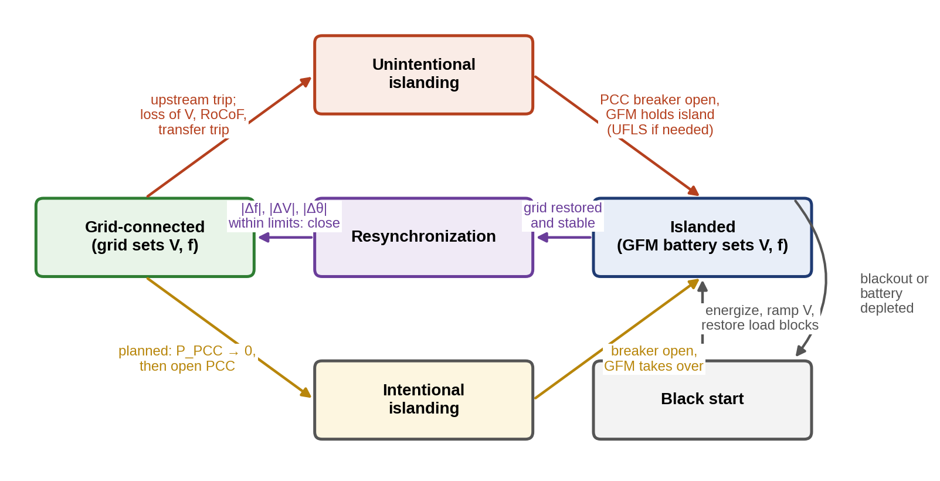
Figure 11.20. Operating modes of the P-1 microgrid as a state machine: grid-connected, unintentional islanding, islanded, intentional islanding, resynchronization and black start, with the conditions for each transition.
Each restoration step is limited by the grid-forming source’s current limit as well as its power and energy. Three phenomena produce current peaks well above the steady-state load. Transformer inrush on energization can reach several times rated current for hundreds of milliseconds when a transformer is switched onto full voltage with residual flux; a GFM source avoids it by ramping its voltage from zero with the transformer already connected. Cold-load pickup follows an outage because thermostatic loads (refrigeration, heating, air conditioning) all start together; the demand can be twice the pre-outage value and decays over tens of minutes. Motor starting direct on line draws about six times rated current at a power factor of about 0.3 for a few seconds. The twin checks every step against the GFM unit’s current limit and its state of power (SOP), and reorders or splits steps that exceed either.
Example 11.12 Staged black start of the P-1 plant
Given. The P-1 battery inverter rated 0.6 MVA with a current limit of 1.2 pu (0.72 MVA) and a state of power of 0.5 MW. Restoration steps in the planned order: transformer T1 energized by voltage ramp (0.02 MW, 0.01 Mvar magnetizing); essential loads (0.15 MW, 0.05 Mvar); refrigeration (0.10 MW, 0.04 Mvar before the outage, doubled by cold-load pickup); a 75 kW motor group started direct on line (6 times rated current, power factor 0.3); process block A (0.20 MW, 0.07 Mvar).
Find. The apparent power at each step as a fraction of the current limit, and whether the SOP allows the final step.
Solution. Accumulating the steps, the apparent power reaches 0.022, 0.18, 0.40, 0.81 and 0.58 MVA, which is 3, 25, 55, 112 and 81 % of the 0.72 MVA limit. The motor start, with 0.50 MVA of starting demand on top of 0.37 MW of load that includes refrigeration at twice its normal power, exceeds the limit (112 %). After the process block the active power, 0.545 MW once cold-load pickup has decayed, exceeds the 0.5 MW SOP.
Interpretation. Two changes make the plan feasible with margin: starting the motors before the refrigeration (or through a soft starter, which roughly halves the starting current), and starting the PV inverters, which need the voltage and frequency the battery now provides, before the process block. The twin’s contribution is to evaluate the plan against the battery’s actual SOP and the day’s cold-load estimate, rather than against nameplate values.

11.10 Droop, Hierarchical Control and Frequency Stability

11.10.1 Why frequency and voltage can carry power commands
A grid-forming source $i$ with internal voltage $V_{i}∠δ_{i}$ connected through a mainly inductive reactance $X_{i}$ to a common bus at $V∠0$ exports, from (11.25) with $R≈0$,
 | $$P_{i}=\frac{V_{i}V}{X_{i}}sinδ_{i}≈\frac{V_{i}V}{X_{i}}δ_{i}, Q_{i}=\frac{V_{i}Vcosδ_{i}−V^{2}}{X_{i}}≈\frac{V}{X_{i}}\left(V_{i}−V\right).$$ | (11.49)
Active power follows the angle, and reactive power the voltage difference. The angle is the integral of frequency, so if each source lowers its frequency as its active power rises, a source that takes more than its share drops its angle and sheds load. This is droop control.
This argument rests on four assumptions, which should be kept beside the equations: the coupling impedance is mainly inductive ($R_{i}≪X_{i}$); the angle difference is small ($sinδ_{i}≈δ_{i}$, $cosδ_{i}≈1$); the network is quasi-static, represented by phasors at a common frequency; and in steady state all sources share one frequency. Under them, each source is given a droop, the decentralized scheme that synchronous generators have always used and that grid-forming inverters imitate [10]:
 | $$f_{i}=f_{0}−m_{p,i}\left(P_{i}−P_{0,i}\right), V_{i}=V_{0}−n_{q,i}\left(Q_{i}−Q_{0,i}\right),$$ | (11.50)
where $f_{0}$ and $V_{0}$ are the no-load frequency and voltage, $P_{0,i}$ and $Q_{0,i}$ set-points, and $m_{p,i}$ (Hz/kW) and $n_{q,i}$ (V/kvar) the droop gains. In steady state all sources share one frequency, so a load change $ΔP_{L}$ is shared as
 | Δf=−ΔPLi​1/mp,i, ΔPi=−Δfmp,i=ΔPL/mp,ik​1/mp,k, | (11.51)
in inverse proportion to the droop gains. Choosing $m_{p,i}=Δf_{max}/P_{rated,i}$ shares load in proportion to rating.
Example 11.13 Sharing a load step between two battery inverters
Given. Two grid-forming inverters: A rated 100 kW and B rated 50 kW, each with a droop that allows 0.5 Hz at full rating ($m_{A}=0.005$ Hz/kW, $m_{B}=0.01$ Hz/kW). A 60 kW load step. For reactive power: $n_{q}$ of 5 % voltage at rated reactive power; coupling reactances $X_{A}=0.05$ pu and $X_{B}=0.15$ pu on a 100 kVA base; a 60 kvar step.
Find. The active-power split and frequency change, and the reactive-power split with and without a virtual impedance.
Solution. By (11.51), $Δf=−60/\left(200+100\right)=−0.2$ Hz; A takes 40 kW and B 20 kW, exactly in proportion to rating. Reactive power is different: voltage is not common to both units, because each sees its own reactance. From $V_{A}−X_{A}Q_{A}=V_{B}−X_{B}Q_{B}$ with (11.50), the split is $Q_{A}/Q_{B}=\left(n_{B}+X_{B}\right)/\left(n_{A}+X_{A}\right)$, giving 42.9 and 17.1 kvar instead of 40 and 20. Adding a virtual impedance of 0.025 pu to A’s control makes the total impedances proportional to the inverse ratings, and the split returns to 40 and 20 kvar.
Interpretation. Figure 11.21 shows both effects. Frequency is a global signal and shares active power exactly; voltage is local and shares reactive power only approximately, with errors set by the network. The twin, knowing the network impedances, can compute the virtual impedances that correct the error. It also flags a further problem: on low-voltage cables, where $R≫X$, (11.49) reverses its roles and active power couples to voltage, so the P–f/Q–V droop must be modified (virtual impedance or P–V droop).
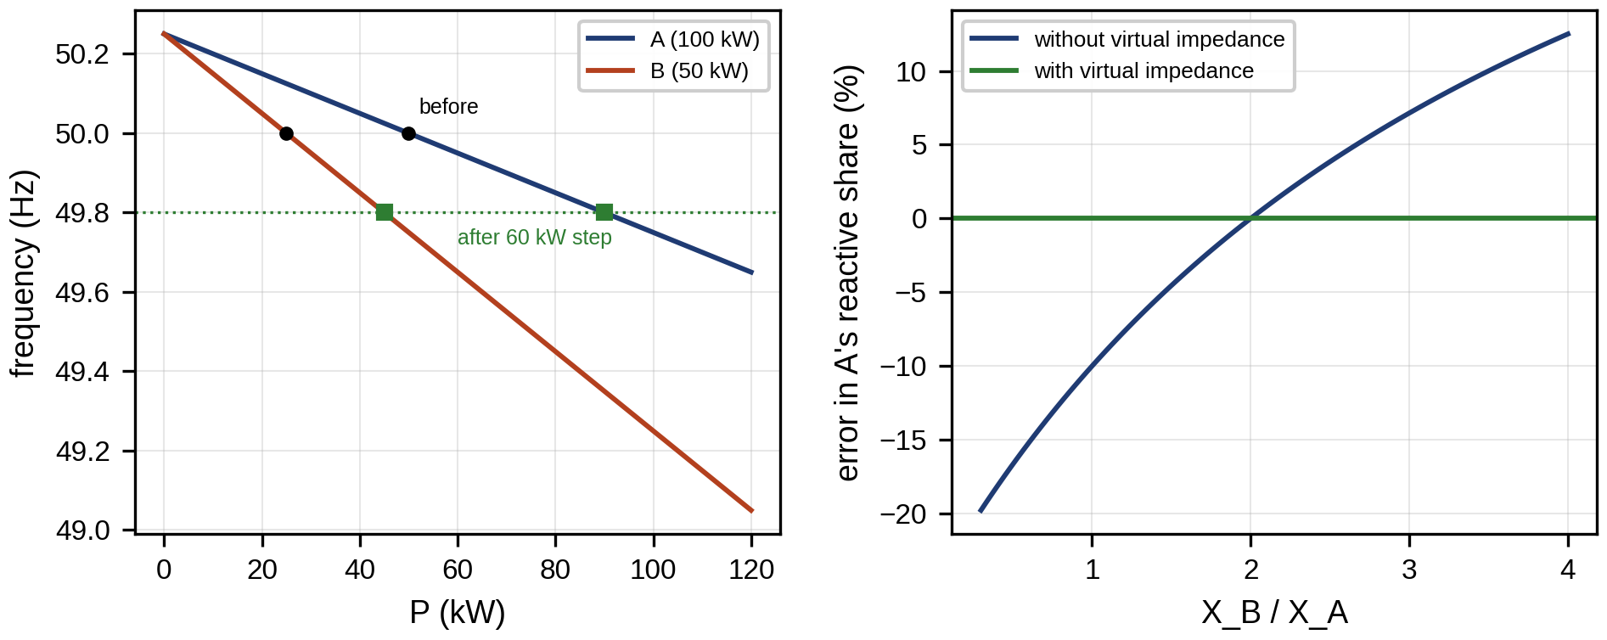
Figure 11.21. Droop characteristics of inverters A and B before and after a 60 kW load step (left): the common frequency falls by 0.2 Hz and the units move along their lines in proportion to rating; reactive-power sharing error against the ratio of coupling reactances, with and without virtual impedance (right).

11.10.2 Droop in resistive networks and virtual impedance
The first assumption fails on low-voltage cables, where $R≳X$. For a coupling impedance $Z∠θ_{z}$, the exact expressions are $P=\left(EV/Z\right)cos\left(θ_{z}−δ\right)−\left(V^{2}/Z\right)cosθ_{z}$ and $Q=\left(EV/Z\right)sin\left(θ_{z}−δ\right)−\left(V^{2}/Z\right)sinθ_{z}$. Rotating the powers by the impedance angle,
 | $$\left[\begin{matrix}P′ \\ Q′\end{matrix}\right]=\left[\begin{matrix}sinθ_{z} & −cosθ_{z} \\ cosθ_{z} & sinθ_{z}\end{matrix}\right]\left[\begin{matrix}P \\ Q\end{matrix}\right] ⇒ P′=\frac{EV}{Z}sinδ, Q′=\frac{EVcosδ−V^{2}}{Z},$$ | (11.52)
recovers the decoupled inductive form for any $θ_{z}$, so droop applied to $P′$ and $Q′$ works on resistive networks. For $θ_{z}=90°$ it reduces to the ordinary droop; for a purely resistive line ($θ_{z}=0$) $P′$ becomes $−Q$ and $Q′$ becomes $P$, so frequency must droop with reactive power and voltage with active power. The rotation requires the impedance angle, which varies along a feeder, and the alternative used in practice is to make the effective coupling inductive by control, with a virtual impedance in each unit’s voltage reference:
 | $${\overset{‾}{V}}_{ref,i}=\left[V_{0}−n_{q,i}\left(Q_{i}−Q_{0,i}\right)\right]e^{jδ_{i}}−{\overset{‾}{Z}}_{v,i}{\overset{‾}{I}}_{i},$$ | (11.53)
where ${\overset{‾}{Z}}_{v,i}$ is the emulated impedance and ${\overset{‾}{I}}_{i}$ the unit’s output current; making ${\overset{‾}{Z}}_{v,i}$ mainly inductive also restores the P–f/Q–V decoupling on resistive low-voltage networks.

11.10.3 Small-signal stability of droop control
Droop shares power correctly in steady state, but its dynamics are those of coupled oscillators, and large droop gains make them oscillate. A state-space model of two GFM units feeding a common load [33] shows how. Unit $i$ has internal voltage $E_{i}∠δ_{i}$ behind $Z_{i}$, filtered powers $P_{f,i}$ and $Q_{f,i}$ with cut-off $ω_{c}$, and droops $dδ_{i}/dt=−m_{p,i}\left(P_{f,i}−P_{i}^{*}\right)$ (angle measured in a frame rotating at the nominal frequency) and $E_{i}=E_{0}−n_{q,i}\left(Q_{f,i}−Q_{i}^{*}\right)$. Only the angle difference $δ_{21}=δ_{2}−δ_{1}$ matters, so the state is $x={\left[δ_{21},P_{f,1},P_{f,2},Q_{f,1},Q_{f,2}\right]}^{T}$ and
 | $$\frac{dδ_{21}}{dt}=−m_{p,2}P_{f,2}+m_{p,1}P_{f,1}, \frac{dP_{f,i}}{dt}=ω_{c}\left(P_{i}\left(x\right)−P_{f,i}\right), \frac{dQ_{f,i}}{dt}=ω_{c}\left(Q_{i}\left(x\right)−Q_{f,i}\right),$$ | (11.54)
with $P_{i}\left(x\right)$ and $Q_{i}\left(x\right)$ from the network equations. Linearizing about the equilibrium gives $Δ\dot{x}=AΔx$, with $A$ the Jacobian of the right-hand side. The eigenvalues of $A$ determine stability and damping; each complex pair $λ=−σ±jω_{d}$ has damping ratio $ζ=σ/\sqrt{σ^{2}+ω_{d}^{2}}$.
Example 11.14 Droop gain, coupling X/R and damping
Given. Units rated 1.0 and 0.5 pu with droop gains inversely proportional to rating, coupling impedances of magnitude 0.08 and 0.16 pu, a constant-impedance load of $0.9+j0.3$ pu, power filters at 5 Hz and voltage droop 5 % (unit 1) and 10 % (unit 2). Droop gain of unit 1 swept from 0.1 to 5 Hz per unit, for coupling X/R of 5 and 1.
Find. The eigenvalues and the damping of the least-damped mode.
Solution. At equilibrium the units share $0.586$ and $0.293$ pu, exactly 2:1. At 0.5 Hz/pu and X/R = 5 the eigenvalues are $−15.5±j31.3$, $−51.6$, $−32.1$ and $−31.4$ s$​^{−1}$: one oscillatory mode at 5.0 Hz with $ζ=0.44$. Raising the droop to 2 Hz/pu moves it to $−15.5±j67.9$ ($ζ=0.22$). Across the sweep the minimum damping falls from 0.30 at 1.1 Hz/pu to 0.15 at 4.1 Hz/pu for X/R = 5, and from 0.25 to 0.11 for X/R = 1 (Figure 11.22).
Interpretation. The oscillatory mode’s real part is pinned near $−ω_{c}/2$ by the filter, while its frequency grows with the droop gain, so damping falls as the droop is made stiffer. Resistive coupling lowers the damping further, because active and reactive loops no longer decouple. The system stays stable in this range, but a twin that sees a droop setting changed, or a unit added, re-runs this analysis before accepting the new configuration.
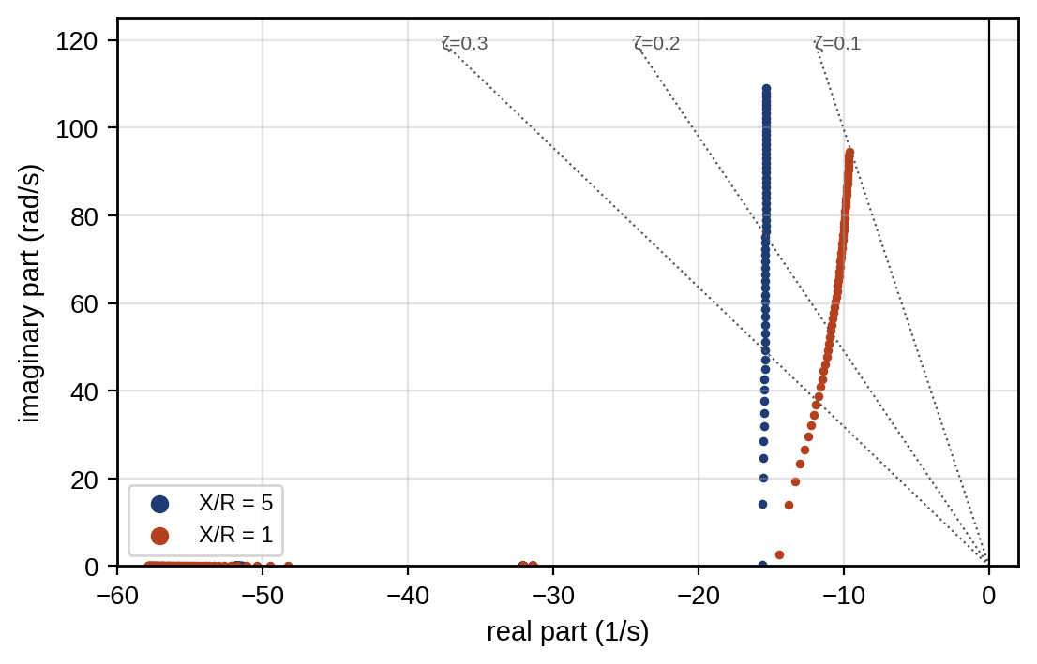
Figure 11.22. Eigenvalues of the two-unit droop model of Example 11.14 as the droop gain of unit 1 is swept from 0.1 to 5 Hz/pu, for coupling X/R of 5 and 1, with lines of constant damping ratio.

11.10.4 Hierarchical and distributed secondary control
Droop alone leaves a steady-state frequency and voltage error. A secondary controller, usually in the microgrid controller, restores them by integrating the frequency error and shifting all droop set-points together,
 | $$ΔP_{0,i}=\frac{k_{I}}{m_{p,i}}∫\left(f_{0}−f\right)dt,$$ | (11.55)
with integral gain $k_{I}$ and the division by $m_{p,i}$ preserving the sharing ratio. It acts slowly enough (seconds) not to disturb the sharing. A tertiary level, the energy management system of Section 11.16, sets the power exchanged with the grid and each unit’s economic set-point over minutes to hours. The same hierarchy appears in DC microgrids with (11.8). The virtual impedance of Example 11.13 enters each unit’s voltage reference as in (11.53).
Centralized secondary control needs one controller and a communication link to every unit, and fails with either. Distributed secondary control replaces it with a consensus among neighbours: each unit exchanges its frequency correction (or its normalized power) with the units it communicates with and moves toward their average. For a correction $x_{i}$ exchanged over a graph with adjacency weights $a_{ij}$ and a communication delay $τ$,
 | dxidt=−kj​aijxit−τ−xjt−τ, τ<τc=π2kλmax, | (11.56)
where $k$ is the consensus gain and $λ_{max}$ the largest eigenvalue of the graph Laplacian; the delay bound is the stability condition for this protocol with uniform delay [36]. For three fully connected units ($λ_{max}=3$) with $k=5$ s$​^{−1}$, $τ_{c}=105$ ms. Wireless or cloud-routed links easily exceed that, and the twin must know the actual latency of the secondary-control network, not its nominal value, before approving a gain. Consensus also creates a cyber exposure: a compromised unit that reports false values pulls every other unit with it, which is why resilient consensus variants discard outlying neighbours.

11.10.5 Frequency dynamics: the swing equation
When generation and load differ, the difference is taken from, or stored in, the kinetic energy of rotating machines. For an aggregate of machines with total kinetic energy $E_{k}=\frac{1}{2}Jω^{2}$, the per-unit swing equation follows from the energy balance $dE_{k}/dt=P_{m}−P_{e}$:
 | $$\frac{2H}{f_{0}}\frac{df}{dt}=ΔP_{pu}−D\frac{f−f_{0}}{f_{0}}, H=\frac{E_{k}}{S_{b}},$$ | (11.57)
where $H$ is the inertia constant (seconds of rated energy stored), $S_{b}$ the system base, $ΔP_{pu}$ the power imbalance in per unit (positive for surplus generation) and $D$ the load damping, the per-unit change of load per per-unit change of frequency (1 to 2 for motor-rich loads). The initial rate of change of frequency (RoCoF), before any control acts, is [11]
 | $${RoCoF}_{0}=\frac{f_{0} ΔP_{pu}}{2H}.$$ | (11.58)
A microgrid dominated by converters has little rotating mass. Its inertia comes from directly connected motors and from converters that emulate inertia. How much of a motor’s kinetic energy is available depends on its rating, its load torque characteristic and the voltage during the event, and drive-connected motors contribute none, so the effective inertia is a parameter to be identified from recorded events rather than taken from nameplates (Application B).

11.10.6 Primary response, virtual inertia and their limits
A grid-forming battery with droop gain $1/R$ (per-unit power per per-unit frequency) and a response time constant $T_{b}$ adds power
 | $$T_{b}\frac{dP_{b}}{dt}={sat}_{\left[−P_{b,max}, P_{b,max}\right]}\left(−\frac{1}{R}\frac{f−f_{0}}{f_{0}}S_{b}\right)−P_{b},$$ | (11.59)
where the saturation is the inverter’s power limit. Virtual inertia adds a term proportional to $df/dt$ to the power reference, so that the converter behaves like a rotating mass,
 | $$P_{vi}=−\frac{2H_{v}S_{b}}{f_{0}}\frac{df}{dt},$$ | (11.60)
where $H_{v}$ is the emulated inertia constant; at a RoCoF of 2 Hz/s, $H_{v}=1$ s on a 2 MVA base demands 0.16 MW. It is not free. Converters have hard current limits set by their manufacturer (Section 11.8.3), and a battery can only supply inertia while it has power headroom and stored energy. Measuring $df/dt$ quickly is also noisy, and the phase-locked loop’s own dynamics can destabilize a converter in weak grids [12]. Virtual inertia therefore shapes the first hundreds of milliseconds but does not replace the need for enough fast power to cover the largest credible imbalance. When power runs out, the last line of defence is under-frequency load shedding (UFLS): relays that disconnect blocks of load when frequency falls below set thresholds.
Example 11.15 Unintentional islanding of the P-1 microgrid
Given. The P-1 microgrid importing 0.8 MW when the feeder breaker opens. System base 2 MVA; effective inertia $H=1.0$ s (motors plus emulated inertia), or 0.5 or 2.0 s; load damping $D=1$. The grid-forming battery has a 1 % droop, 50 ms response and 0.5 MW limit. UFLS sheds 0.35 MW of non-critical load (car-park chargers and process loads) 100 ms after frequency falls below 49.0 Hz.
Find. The initial RoCoF, the frequency nadir and the settling frequency for each inertia, without UFLS, and with a 1 MW battery.
Solution. By (11.58), the deficit of 0.4 pu gives an initial RoCoF of −10 Hz/s at $H=1$ s, −20 Hz/s at 0.5 s and −5 Hz/s at 2 s. Integrating (11.57) and (11.59), the battery reaches its 0.5 MW limit within tens of milliseconds. The remaining 0.3 MW deficit carries frequency through 49 Hz, the shed restores balance, and the nadir is 48.68 Hz at $H=1$ s (48.25 Hz at 0.5 s, 48.84 Hz at 2 s). Frequency then settles at 49.89 Hz. Without UFLS the 0.3 MW deficit is never covered: by (11.61) with the battery saturated, only the load damping absorbs it, and frequency heads for a quasi-steady 42.5 Hz, far below any generator’s or inverter’s trip setting, so in practice the DERs would trip first and the island would collapse. With a 1 MW battery no shedding is needed: the nadir is 49.59 Hz and frequency settles at 49.80 Hz.
After the transient, frequency settles where the battery’s droop and the load damping together absorb the imbalance. Setting $df/dt=0$ in (11.57) with the battery below its limit gives the quasi-steady deviation
 | $$Δf_{ss}=−\frac{ΔP_{pu} f_{0}}{D+1/R},$$ | (11.61)
which for a deficit that the battery can cover (as with the 1 MW battery) is small. For small disturbances, where the battery stays inside its limit, combining (11.57) with (11.59) gives a second-order system whose characteristic equation
 | $$2HT_{b}s^{2}+\left(2H+DT_{b}\right)s+\left(D+\frac{1}{R}\right)=0, ω_{n}=\sqrt{\frac{D+1/R}{2HT_{b}}}, ζ=\frac{2H+DT_{b}}{2\sqrt{2HT_{b}\left(D+1/R\right)}},$$ | (11.62)
sets the frequency oscillation: with $H=1$ s, $T_{b}=0.05$ s, $R=0.01$ and $D=1$, $ω_{n}=31.8$ rad/s and $ζ=0.32$, an underdamped response whose nadir after a 0.1 pu step is 0.091 Hz below nominal, almost twice the quasi-steady 0.050 Hz of (11.61). Faster battery response (smaller $T_{b}$) raises $ζ$ and the nadir. For the 0.5 MW battery, the limit is reached, (11.61) no longer applies, and only load shedding restores balance.
Figure 11.24 shows the trajectories, and Figure 11.23 generalizes the example to all combinations of inertia and battery power.
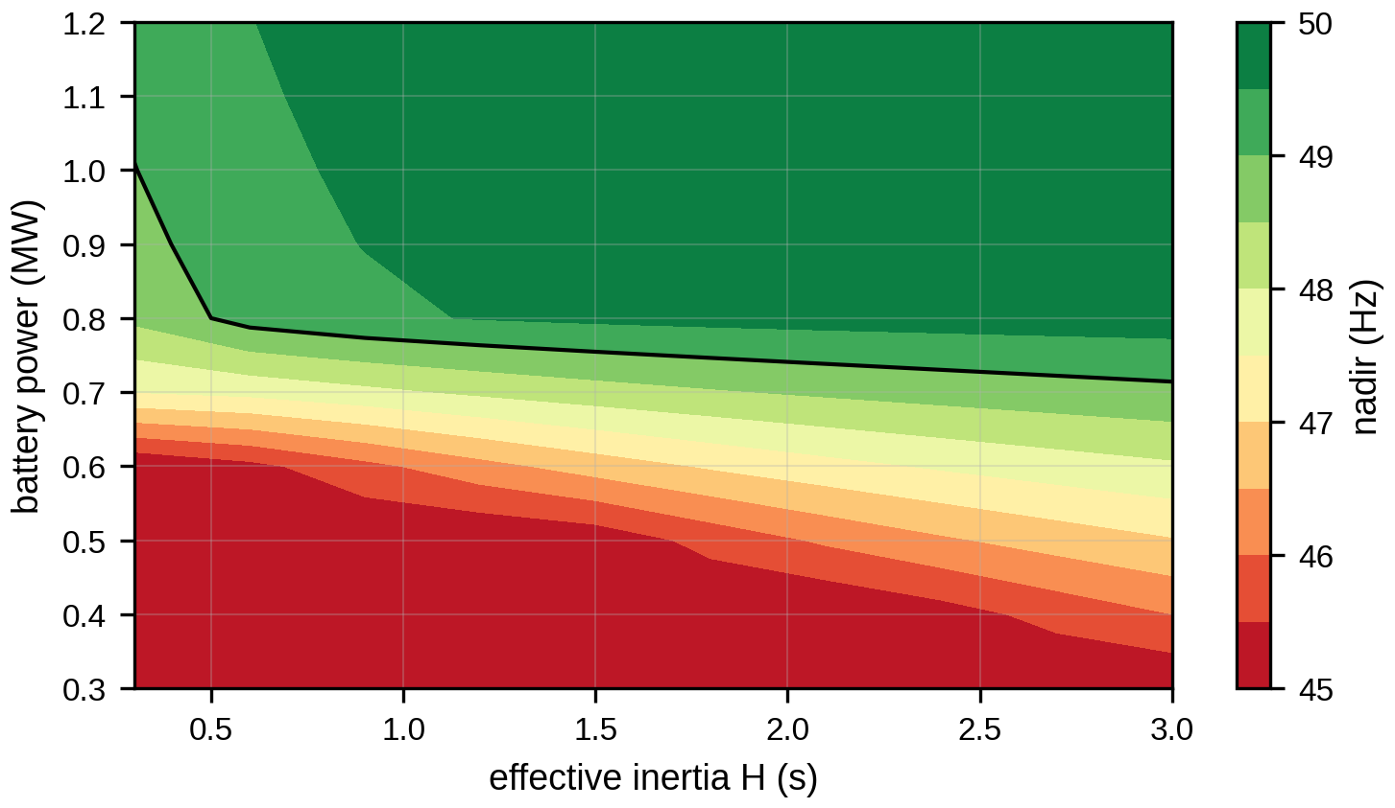
Figure 11.23. Frequency nadir after the 0.8 MW islanding event as a function of effective inertia and grid-forming battery power, without load shedding; the 49 Hz contour marks the boundary beyond which shedding is needed.
Interpretation. Inertia sets how fast frequency falls; power sets whether it recovers. Doubling the inertia raises the nadir by only 0.16 Hz, while doubling the battery’s power removes the need to shed. The twin’s decision is therefore about power headroom. Before the plant imports more than the battery can cover, it either reduces the import, arms the load-shedding scheme, or accepts that an unintentional island will shed load. Protection limits bound all of this: RoCoF relays, where they are used, are often set in the region of 1 to 2 Hz/s and would trip at these rates, so islanding detection and RoCoF settings must be coordinated with the intended islanded operation.
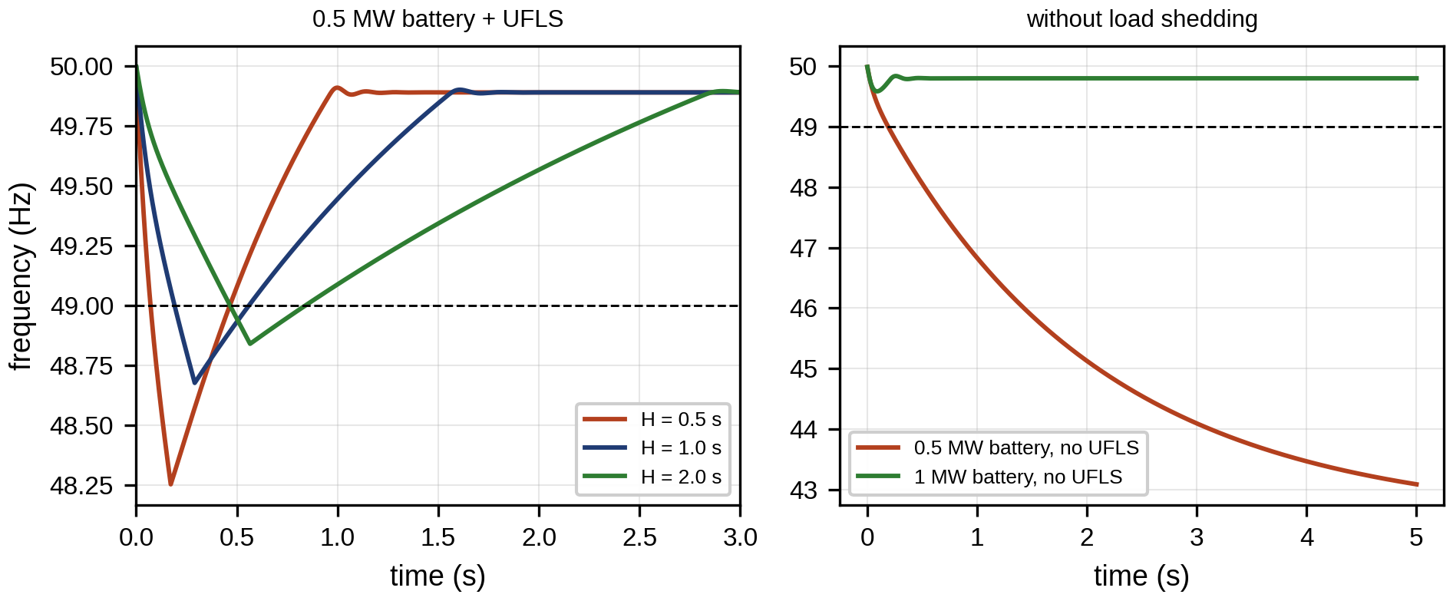
Figure 11.24. Frequency after unintentional islanding of the P-1 microgrid with 0.8 MW import: effect of inertia with UFLS (left), and with no UFLS and with a 1 MW battery (right); the 49 Hz UFLS threshold is marked.

11.10.7 Application B: validating the aggregate frequency model
Application B. Does the one-inertia model reproduce a more detailed microgrid?
Setup. Example 11.15 used one aggregate inertia. To test it, the same islanding event was simulated with a higher-fidelity RMS model: two motor groups with their own inertias (0.35 and 0.25 s on the 2 MVA base) coupled to the bus through synchronizing stiffness and speed-dependent load torque, 0.4 s of emulated inertia, a 20 ms frequency-measurement filter in the battery controller, and the same droop, limit and UFLS. Its output, with PMU noise of 0.01 Hz added, plays the role of the measurement. The acceptance criterion was set before the comparison: 95 % of samples within a ±0.15 Hz band around the twin over the first 4 s, and the nadir within 0.1 Hz.
Result. The nadirs agree (48.68 Hz twin, 48.76 Hz detailed model), but after the nadir the detailed model recovers much faster: the residual reaches 0.39 Hz between 0.3 and 1.4 s, and only 87 % of samples lie within the band (Figure 11.25). The RMS residual is 0.11 Hz.
Verdict. The aggregate model passes on nadir and fails on recovery. The cause is physical: the motors release kinetic energy and their load torque falls as they slow, which the aggregate model represents only through a constant damping. For load-shedding design the twin is conservative and usable; for secondary-control tuning it is not, and the motor dynamics must be added or the damping recalibrated from recorded events. This is the pattern of every validation in this chapter: a model is valid for a purpose and a range, and the twin records both.
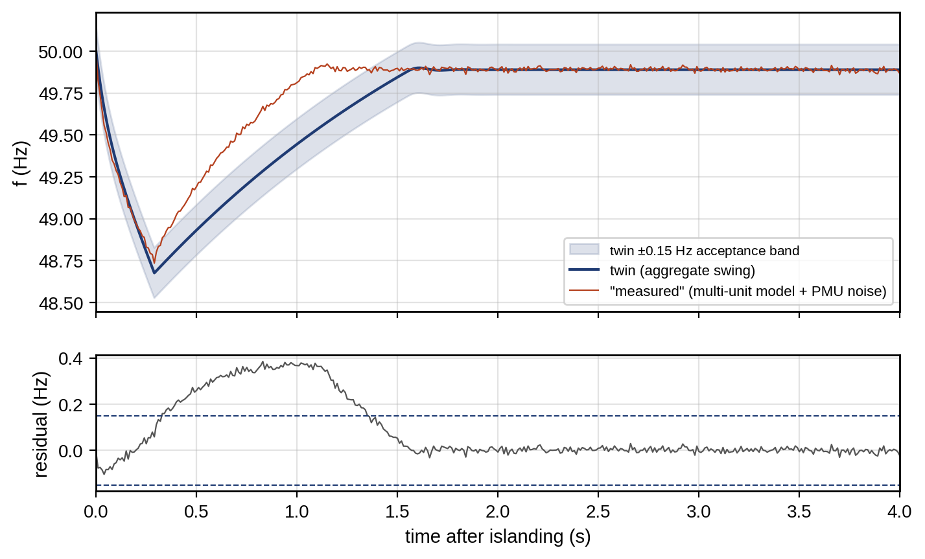
Figure 11.25. Validation of the aggregate islanding model (Application B): twin prediction with its ±0.15 Hz acceptance band and the “measured” response from a multi-unit model with PMU noise (top); residual with the band limits (bottom). The model reproduces the nadir but not the recovery.

11.11 Load and DER Models and Their Identification
Power flow and dynamics need models of how loads respond to voltage and frequency. The ZIP model mixes constant-impedance, constant-current and constant-power parts,
 | $$P=P_{0}\left[a_{Z}{\left(\frac{V}{V_{0}}\right)}^{2}+a_{I}\frac{V}{V_{0}}+a_{P}\right]\left(1+k_{pf}Δf\right), a_{Z}+a_{I}+a_{P}=1,$$ | (11.63)
with a similar expression for $Q$, where $P_{0}$ is the power at nominal voltage $V_{0}$ and $k_{pf}$ the frequency sensitivity. The exponential model $P=P_{0}{\left(V/V_{0}\right)}^{α}$ is its compact alternative, with $α$ near 0 for converter-fed loads (constant power), 1 for heating with thermostats, and 2 for lamps and resistive loads. Constant-power loads are the hardest for voltage stability, because their current rises as voltage falls, which is why converter-dominated loads (EV chargers, drives) move the nose of Figure 11.10 inward. Induction motors need dynamic models, because they stall and draw large currents when voltage dips, delaying recovery. DERs enter as PQ or PV sources with their limits (Chapters 8 to 10). Load-model parameters are identified from measured responses to voltage changes, with limits that Example 11.16 makes explicit.
Static models are not enough when voltage dips are deep or long. Composite load models, such as the WECC composite load model used in North American planning, combine a static ZIP part with several classes of induction motors, a power-electronic load that drops out below a voltage threshold, and a distribution-equivalent impedance, because motor stalling after a fault delays voltage recovery in ways a static model cannot show. Flexible loads (EV chargers, thermostatic loads, batteries behind the meter) add controllable behaviour that depends on state (state of charge, temperature) and on price or control signals, and are modelled as aggregates with energy and power bounds (Chapter 10). Inverter-based DERs are represented in aggregate by models such as WECC DER_A, which include ride-through thresholds, partial tripping and Volt/VAR and frequency-watt functions, so that the twin captures how many DERs disconnect during a disturbance.
Small voltage steps from OLTC operations are natural experiments, but they reveal less than the ZIP model’s three coefficients. Linearizing (11.63) about $V_{0}$ with $Δv=\left(V−V_{0}\right)/V_{0}$,
 | $$\frac{P}{P_{0}}≈1+\left(2a_{Z}+a_{I}\right) Δv,$$ | (11.64)
so a small step identifies only the combination $k_{pv}=2a_{Z}+a_{I}$, which equals the exponent $α$ of the exponential model. Separating $a_{Z}$ from $a_{I}$ needs the curvature, which is visible only in larger excursions such as fault-induced sags recorded by PMUs.
Example 11.16 Identifying a load model from tap steps
Given. A feeder load with true coefficients $a_{Z}=0.35$, $a_{I}=0.25$, $a_{P}=0.40$; thirty recorded voltage steps uniformly distributed within ±3 %, with power measured with 0.2 % noise. Also thirty fault-induced excursions within ±10 %.
Find. The least-squares estimates of $a_{Z}$ and $a_{I}$ (with $a_{P}=1−a_{Z}−a_{I}$) and their standard deviations, and the estimate of $k_{pv}$.
Solution. From the ±3 % steps, ${\hat{a}}_{Z}=0.04±0.81$ and ${\hat{a}}_{I}=0.85±1.62$, with a correlation of $−0.9999$ between them: individually meaningless. The combination ${\hat{k}}_{pv}=0.94±0.02$ (true 0.95) is well determined, as is the exponential model’s $\hat{α}=0.94$. From the ±10 % excursions, ${\hat{a}}_{Z}=0.42±0.08$ and ${\hat{a}}_{I}=0.10±0.16$: the constant-impedance share is now identifiable, the constant-current share still only roughly.
Interpretation. Reporting ZIP coefficients fitted from tap steps as if they were known is a classic twin error. The twin should store what the data determine, here $k_{pv}$ with its uncertainty, and refine the split only when larger disturbances are recorded. The same identifiability test applies to every parameter the twin estimates (Section 11.12.6).

11.12 Distribution System State Estimation
State estimation is the heart of an operational grid twin: it turns noisy, incomplete, asynchronous and occasionally wrong data into a state the other functions can use, and it is the first place where errors in topology, parameters, timing or data integrity become visible. This section develops it from the weighted-least-squares estimator to three-phase, multi-rate and adversarial settings.

11.12.1 The weighted-least-squares estimator
A distribution twin has more unknowns than direct measurements, and its measurements disagree slightly because each carries error. State estimation finds the voltage magnitudes and angles $x$ that best explain all measurements $z$ [13]. Each measurement is a nonlinear function of the state plus noise,
 | $$z=h\left(x\right)+e, e∼N\left(0,R\right), R=diag\left(σ_{1}^{2},…,σ_{m}^{2}\right),$$ | (11.65)
where $h$ collects the power-flow expressions (11.24) for power injections, branch-flow expressions for flows, and the state itself for voltage magnitudes and PMU angles, and $σ_{i}$ is the standard deviation of measurement $i$. The weighted-least-squares (WLS) estimate minimizes
 | $$J\left(x\right)={\left[z−h\left(x\right)\right]}^{T}R^{−1}\left[z−h\left(x\right)\right],$$ | (11.66)
The gradient of (11.66) is $∇J=−2H^{T}R^{−1}\left[z−h\left(x\right)\right]$, with $H\left(x\right)=∂h/∂x$ the $m×n$ measurement Jacobian. Setting it to zero and linearizing $h\left(x^{\left(k\right)}+Δx\right)≈h\left(x^{\left(k\right)}\right)+HΔx$ gives the Gauss–Newton iteration of Chapter 5 (Section 5.3):
 | $$G\left(x^{\left(k\right)}\right)Δx=H^{T}R^{−1}\left[z−h\left(x^{\left(k\right)}\right)\right], G=H^{T}R^{−1}H,$$ | (11.67)
where $G=H^{T}R^{−1}H$ is the gain matrix. At convergence the estimation error is, to first order, $\hat{x}−x≈G^{−1}H^{T}R^{−1}e$, whose covariance is $G^{−1}H^{T}R^{−1} R R^{−1}HG^{−1}=G^{−1}$. The inverse gain matrix is therefore the covariance of the estimate only under assumptions that must be stated beside it: the measurement model $h$ (topology and parameters) is correct; the errors are zero-mean, independent and Gaussian with the covariance $R$ actually used; the linearization error around $\hat{x}$ is small compared with the noise; the network is observable; and no bad data remain. When any of these fails, $G^{−1}$ is optimistic, and Application A shows by how much. The network is observable when $G$ is non-singular, which requires at least as many independent measurements as states:
 | $$rank\left(H\right)=n, Cov\left(\hat{x}\right)=G^{−1}.$$ | (11.68)

11.12.2 Observability, pseudo-measurements and correlated errors
Adding a measurement with Jacobian row $h_{new}^{T}$ and variance $σ_{new}^{2}$ reduces the covariance by a rank-one update, which is how the twin ranks candidate meter locations by the reduction in the variance of the worst-estimated bus. Distribution networks rarely have enough real-time measurements, so smart-meter data and load forecasts are added as pseudo-measurements with large variances (15 to 50 %). They make the problem solvable but weakly constrained.
Pseudo-measurement errors are not independent. Loads on one feeder respond to the same temperature, the same time of day and the same holiday, so when a forecast is wrong it is wrong for many buses in the same direction. Modelling this requires a full covariance for the pseudo-measurements,
 | $$R_{ps}=D C D, D=diag\left(σ_{1},…,σ_{p}\right), C_{ij}=ρ_{ij},$$ | (11.69)
where $σ_{i}$ is the standard deviation of pseudo-measurement $i$ and $ρ_{ij}$ the correlation between the forecast errors of $i$ and $j$, estimated from historical forecast residuals. Using a diagonal $R$ when the errors are correlated leaves the estimate unbiased but makes the chi-square test of Section 11.12.3 fire far more often than its nominal rate, because correlated errors do not average out in $J$. In Application A, a common forecast-error component with correlation 0.81 raised the false-alarm rate from 1 % to 25 %.

11.12.3 Detecting and identifying bad data
If the model is right and the errors are Gaussian, $J\left(\hat{x}\right)$ follows a chi-square distribution with $m−n$ degrees of freedom, where $m$ is the number of measurements and $n$ the number of states. The test declares bad data when
 | $$J\left(\hat{x}\right)>χ_{m−n, 1−α}^{2},$$ | (11.70)
the $\left(1−α\right)$ quantile, for example 99 %, which fixes the false-alarm rate at $α$ when all data are good. Detection is not identification. The residuals $r=z−h\left(\hat{x}\right)$ have covariance
 | $$Ω=R−HG^{−1}H^{T}, r_{i}^{N}=\frac{\left|r_{i}\right|}{\sqrt{Ω_{ii}}},$$ | (11.71)
and the measurement with the largest normalized residual $r_{i}^{N}$, if it exceeds about 3, is the most likely culprit. It is removed and the estimation repeated until $J$ passes the test. A bad measurement also contaminates its neighbours’ residuals, so they must not be removed together. Measurements whose removal would make the network unobservable (critical measurements) have zero residual and can never be checked. A twin must know which of its measurements are critical, because it cannot validate them.
Example 11.17 Estimating the P-1 feeder state and finding a bad transducer
Given. The evening case of Example 11.7 as the truth. Measurements:
- SCADA. Voltage magnitudes at buses 0 and 10 ($σ=0.004$ pu) and the active and reactive flow at the feeder head ($σ=0.01$ pu).
- PMU at the P-1 connection. Voltage magnitude and angle at bus 6 ($σ=0.001$ pu and 0.0005 rad).
- Smart-meter pseudo-measurements. Active and reactive injections at buses 1 to 10 ($σ$ = 15 % of the value, at least 0.02 pu).
That is 26 measurements for 21 states, with Gaussian noise. Then a gross error of +0.05 pu is added to the SCADA voltage at bus 10.
Find. The estimate and test statistic without and with the error; the identification; the result after removal; and the estimate’s uncertainty with and without the PMU and the bus-10 voltage measurement.
Solution. With clean data, $J=5.8$ against a threshold of 15.1 (5 degrees of freedom, 99 %), and the estimated minimum voltage is 0.9402 pu against a true 0.9401 pu. With the gross error, $J=157$ and the test fails. The largest normalized residuals are 12.3 on the bus-10 SCADA voltage, 8.6 on the PMU voltage (contaminated by its neighbour) and 4.4 on the bus-10 reactive-power pseudo-measurement. The bus-10 voltage is correctly identified. After removing it, $J=5.7$ (threshold 13.3) and the minimum voltage is 0.9401 pu. With both, the estimate of the bus-10 voltage has a standard deviation of 0.0011 pu. Without the PMU and the bus-10 voltage, the network is still observable, but that standard deviation grows to 0.0044 pu and the gain matrix’s condition number rises nineteenfold.
Interpretation. Figure 11.26 shows the estimates and residuals. The estimator both detected and identified the bad transducer, but the second-largest residual, on a perfectly good PMU, shows why only one measurement is removed at a time. Without the two voltage measurements the twin’s voltage uncertainty quadruples, because it then relies on pseudo-measurements. The decision this supports is where to place the next measurement: the twin can compute which new meter reduces its uncertainty most.
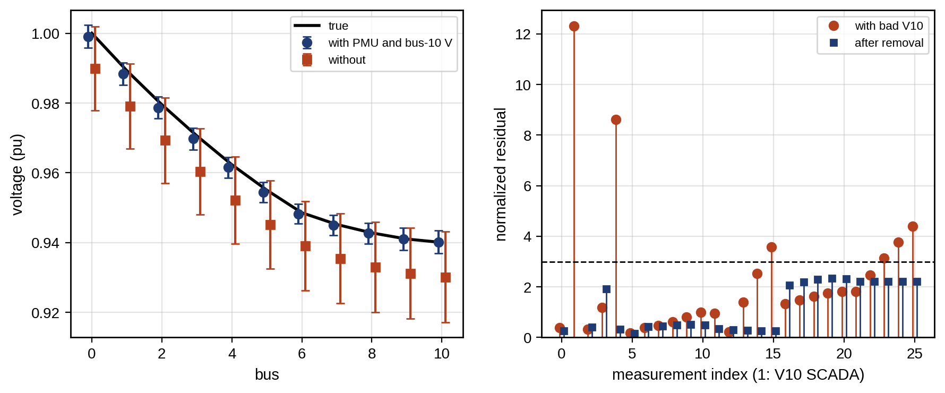
Figure 11.26. State estimation on the P-1 feeder: true voltages, estimates with their ±3σ bands with and without the PMU and bus-10 SCADA voltage (left); normalized residuals before and after removing the bad measurement, against the identification threshold of 3 (right).
The largest-normalized-residual test is best understood as a pedagogical baseline and a useful first screen, not a complete defence. It assumes a single gross error, or several that do not interact, on measurements with adequate redundancy. It fails for leverage points, measurements whose Jacobian rows are far from the others (a flow on a short, low-impedance line, or a heavily weighted PMU), which pull the estimate toward themselves so strongly that their own residuals stay small. It fails for interacting bad data, where two errors in the same neighbourhood mask each other. And it cannot see errors on critical measurements at all.

11.12.4 Robust estimation and adversarial data
Robust estimators reduce the influence of large residuals instead of removing measurements one at a time. The Huber M-estimator minimizes i​ρri/σi with
 | $$ρ\left(u\right)=\left\{\begin{matrix}1/2u^{2}, & \left|u\right|≤c \\ c\left|u\right|−1/2c^{2}, & \left|u\right|>c\end{matrix}\right., w_{i}=min\left(1, \frac{c}{\left|r_{i}/σ_{i}\right|}\right),$$ | (11.72)
where $c$ (typically 1.5) separates the quadratic region from the linear one. It is solved by iteratively reweighted least squares: (11.67) with $R^{−1}$ replaced by $diag\left(w_{i}/σ_{i}^{2}\right)$, recomputing the weights $w_{i}$ each iteration. The least-absolute-value (LAV) estimator uses $ρ\left(u\right)=\left|u\right|$ and is solved as a linear program; it rejects bad data automatically but is itself vulnerable to leverage points, which the Schweppe-type Huber generalized M-estimator (SHGM) handles by down-weighting measurements according to their leverage as well as their residual [31].
No residual-based method detects a stealthy false-data-injection attack. The residual vector at convergence of a linearized estimator is $r=Sz$ with $S=I−HG^{−1}H^{T}R^{−1}$. Because $SH=H−HG^{−1}G=0$, an attacker who adds
 | $$a=Hc ⇒ r\left(z+a\right)=Sz+SHc=r\left(z\right), \hat{x}\left(z+a\right)=\hat{x}\left(z\right)+c,$$ | (11.73)
leaves every residual and $J$ unchanged while shifting the estimate by any chosen $c$ [32]. For the nonlinear estimator the attacker uses $a=h\left(\hat{x}+c\right)−h\left(\hat{x}\right)$. On the P-1 feeder, an attack of this form on the measurements of Example 11.17 with $c$ lowering the bus-10 voltage by 0.02 pu changed $J$ from 5.804 to 5.803 and moved the estimated bus-10 voltage by $−0.020$ pu: an undervoltage that does not exist, invisible to every test above, which would push the tap changer up. The attack needs knowledge of $H$ and write access to the measurements it alters. Defences therefore work on those two needs: authenticated and encrypted measurement channels (IEC 62351), a set of protected measurements (typically PMUs with secured time) chosen so that no nonzero $c$ leaves them all unchanged, physical watermarking of control signals, and consistency checks against physics the attacker does not control, such as recorded responses to known tap operations (Chapter 14).

11.12.5 Topology errors
When the reported status of a switch is wrong, the estimator fits the measurements to the wrong network. The residuals of several measurements around the switch then grow together, and the pattern differs from a single bad analogue measurement. Topology errors are identified by re-estimating with the suspect switch’s status modelled as unknown, or by comparing candidate topologies’ $J$ values. PMU angle measurements are particularly powerful here, because an open or closed switch changes angles across a section far more than it changes magnitudes.
In Application A, a normally open tie at bus 10 that had actually closed, importing 0.5 MW from a neighbouring feeder, was detected by the chi-square test in 72 % of trials; no estimator, robust or learned, removed the resulting bias, because the error is in the model, not in a measurement. Topology errors are corrected by changing the model, never by down-weighting data.

11.12.6 Parameter and tap estimation
The same machinery estimates parameters (Section 11.5.4). The state is augmented with the uncertain parameters, and the question is first whether the measurements can determine them.
Example 11.18 Estimating a line impedance: SCADA versus µPMUs
Given. The P-1 feeder in the evening case, with section 8 (bus 7 to bus 8) actually 30 % higher in impedance than the GIS record. Two measurement sets: the SCADA, PMU and pseudo-measurements of Example 11.17 plus two AMI voltage magnitudes at buses 7 and 8 ($σ=0.002$ pu); or the same plus µPMUs at buses 7 and 8 ($σ_{V}=0.0005$ pu, $σ_{θ}=0.0001$ rad). The impedance of section 8 is modelled as its record value times an unknown scale $s_{8}$, estimated with the state; 100 noise realizations.
Find. The estimate of $s_{8}$, its model-predicted and empirical standard deviations, and the coverage of the 95 % interval.
Solution. With AMI voltages only, ${\hat{s}}_{8}=1.21$ on average, with a standard deviation of 0.77 across realizations (0.85 predicted by $G^{−1}$), and the interval covers the truth in 98 % of cases: consistent, but useless for a decision. With the µPMUs, ${\hat{s}}_{8}=1.30±0.14$ (0.145 predicted), with 96 % coverage.
Interpretation. The voltage magnitudes at the two ends of the section cannot separate its impedance from the uncertain loads beyond it; the angle difference across the section can. The same test decides where µPMUs are worth installing: at elements whose parameters matter for decisions and cannot be identified otherwise.

11.12.7 Three-phase, branch-current and multi-rate estimation
A distribution twin needs the voltage on each phase, so the state is a three-phase vector, $x=\left[V_{k}^{a},V_{k}^{b},V_{k}^{c},θ_{k}^{a},θ_{k}^{b},θ_{k}^{c}\right]$ at every bus $k$ (with only the phases that exist), and $h$ uses the three-phase admittance matrix built from the phase impedance matrices of Section 11.5.3. Two structural choices matter in practice. Branch-current formulations take the branch currents in rectangular form as states, which makes the Jacobian of current and power measurements nearly constant on radial feeders and speeds the estimator considerably. Phase-decoupled formulations ignore mutual coupling in the Jacobian while keeping it in the residual, trading convergence speed for simplicity. In both, the phase connectivity of every customer (Section 11.5.3) is part of the model, and a wrong phase label behaves exactly like a topology error.
Data arrive at different rates and ages (Table 11.5). The twin estimates at a fixed epoch, uses each input with its age-inflated variance (11.17), and between the arrival of slow data carries the state forward with a process model, which turns the estimator into a forecasting-aided (Kalman-type) estimator:
 | $${\hat{x}}_{k|k−1}={\hat{x}}_{k−1|k−1}+BΔu_{k}, P_{k|k−1}=P_{k−1|k−1}+Q_{k},$$ | (11.74)
where $Δu_{k}$ are known changes (tap moves, DER set-points) with sensitivity $B$, $P$ the state covariance and $Q_{k}$ the process-noise covariance that represents unmodelled load changes. The prediction then enters the WLS problem as a prior with covariance $P_{k|k−1}$. A value whose timestamp is wrong is more dangerous than one that is missing: in Application A a PMU value two seconds stale, taken just after a 0.5 MW step at P-1, corrupted the WLS, LNR and Huber estimates by about 6 mpu (the learned estimator by 2.7 mpu) and made the 95 % intervals cover the truth in at most 11 % of cases, although the chi-square test did flag the inconsistency every time.

11.12.8 The complete estimator
Algorithm 11.1 Distribution system state estimation in a twin
- Topology. Build the bus-branch model from switch statuses, phase connectivity and the model registry version; record the mapping to physical devices.
- Alignment. Align all measurements to the estimation epoch; drop invalid values; inflate variances by age (11.17) and by quality flags.
- Observability. Check the rank of $H$; add pseudo-measurements with correlated covariance (11.69) until observable; list critical measurements.
- Estimate. Solve (11.67) (or its robust or three-phase variant) from the forecast-aided prior (11.74).
- Test. Apply the chi-square test (11.70); if it fails, examine normalized residuals (11.71) and their spatial pattern: an isolated large residual suggests an analogue error, a cluster around a switch a topology error, a persistent same-sign pattern along a path a parameter error, and an inconsistency confined to one fast device a timestamp error.
- Correct. Remove one analogue measurement at a time, or re-estimate with the suspect switch free, or estimate the suspect parameter with its confidence interval; return to step 4.
- Report. Publish the state with its covariance, the list of removed or suspect data, the critical measurements and the trust state; record the model and data versions.
- Monitor coverage. Compare estimates at buses with unused measurements against those measurements over time; if coverage falls below the target, downgrade the trust state (Section 11.22).
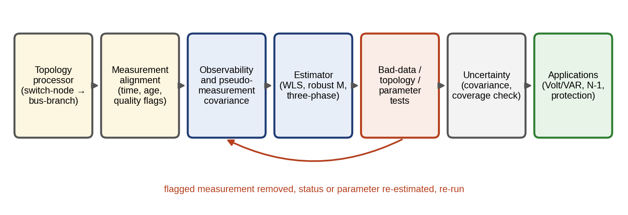
Figure 11.27. Workflow of the distribution state-estimation twin (Algorithm 11.1): topology processing, measurement alignment, observability and pseudo-measurement covariance, estimation, bad-data, topology and parameter tests with a loop back, uncertainty checking, and the applications that consume the state.

11.12.9 Application A: comparing estimators on faulted data
Application A. A distribution state-estimation twin on six data conditions
Setup. On the P-1 feeder with the measurement set of Example 11.17, 60 snapshots per condition were generated with loads varied randomly between 80 and 110 % of the evening case. Four estimators were compared: plain WLS; WLS with largest-normalized-residual elimination (LNR, up to three removals); a Huber M-estimator ($c=1.5$); and a learned estimator, a ridge regression from the 26 measurements to the 11 voltages trained on 3000 simulated snapshots of normal operation, with its uncertainty taken from the training residuals. Six conditions: clean data; a +0.05 pu bad analogue on the bus-10 voltage; a wrong switch status (a tie at bus 10 closed but reported open, importing 0.5 MW); correlated pseudo-measurement errors (common component, correlation 0.81); a stale PMU timestamp (values from before a 0.5 MW step); and a wrong line parameter (section 8 impedance 30 % high). Metrics: RMS voltage error over all buses, coverage of the 95 % intervals, detection rate of the chi-square test at 99 %, and computing time per estimate in an unoptimized Python implementation.
TABLE 11.9 Estimator comparison on the P-1 feeder (60 snapshots per condition; WLS about 5 ms, Huber 6 to 17 ms, learned estimator 0.01 ms per estimate)
Condition | WLS RMSE (mpu) / coverage | WLS + LNR RMSE / coverage | Huber RMSE / coverage | Learned RMSE / coverage | $χ^{2}$ detection
Clean | 0.85 / 94 % | 0.85 / 94 % | 0.85 / 94 % | 0.35 / 95 % | 0 %
Bad analogue (+0.05 pu) | 2.76 / 25 % | 0.83 / 97 % | 0.86 / 96 % | 1.13 / 21 % | 100 %
Wrong switch status | 2.35 / 67 % | 1.91 / 75 % | 2.41 / 68 % | 2.44 / 55 % | 72 %
Correlated pseudo-measurements | 0.78 / 95 % | 0.88 / 93 % | 0.81 / 93 % | 0.27 / 97 % | 25 %
Stale PMU timestamp | 6.13 / 0 % | 5.85 / 11 % | 5.80 / 7 % | 2.71 / 0 % | 100 %
Wrong line parameter (+30 %) | 0.90 / 93 % | 0.90 / 93 % | 0.91 / 93 % | 0.45 / 93 % | 2 %
Findings. Table 11.9 gives the results. Five conclusions follow, and each is a design rule for the twin. (i) For an isolated bad analogue, LNR elimination and the Huber estimator both restore accuracy and calibrated intervals; plain WLS does not. (ii) Model errors (switch status, stale time, wrong parameter) are not repaired by any estimator, robust or learned; the chi-square test catches the switch and timestamp errors most of the time, but the 30 % parameter error on one section is invisible to it at this redundancy, which is why parameters are estimated explicitly (Example 11.18). (iii) Correlated forecast errors mainly corrupt the test, producing false alarms, which is fixed by the covariance (11.69), not by a different estimator. (iv) The learned estimator is the most accurate on data like its training data and the fastest by two orders of magnitude, but it has no residual test, so it detects nothing, and its intervals collapse on every abnormal condition. It is valuable as a fast prior or a cross-check beside a physics-based estimator, not as a replacement for one. (v) The detection rate, not the RMSE on clean data, is what separates a usable operational estimator from an unusable one.

11.13 Cable and Transformer Twins

11.13.1 Steady-state, cyclic and emergency cable ratings
A cable’s current rating is the current at which its conductor reaches its maximum temperature (90 °C for XLPE) under assumed conditions of soil temperature and thermal resistivity. Neglecting dielectric losses, the steady heat balance of IEC 60287 reduces to
 | $$I_{R}=\sqrt{\frac{θ_{max}−θ_{soil}}{R_{ac}T_{tot}}},$$ | (11.75)
where $R_{ac}$ is the conductor’s AC resistance per metre at maximum temperature and $T_{tot}$ the total thermal resistance per metre from conductor to ambient soil; with a 65 K allowable rise, 0.1 mΩ/m and 1.5 K·m/W, $I_{R}=658$ A. Dry soil can double the soil’s thermal resistivity, which lowers the rating by a factor of up to $\sqrt{2}$, which is why soil moisture is a twin input. The rating assumes steady state, and the soil around a buried cable has a thermal time constant of hours, so a cable can carry more than its rating for a limited time. With a first-order thermal model of the conductor’s temperature rise $Δθ$, whose steady value at rated current $I_{R}$ is $Δθ_{R}$ and time constant is $τ_{c}$,
 | $$Δθ\left(t\right)=Δθ_{0}e^{−t/τ_{c}}+Δθ_{R}{\left(\frac{I}{I_{R}}\right)}^{2}\left(1−e^{−t/τ_{c}}\right), \frac{I_{em}\left(t_{em}\right)}{I_{R}}=\sqrt{\frac{1−\left(Δθ_{0}/Δθ_{R}\right)e^{−t_{em}/τ_{c}}}{1−e^{−t_{em}/τ_{c}}}},$$ | (11.76)
where $Δθ_{0}$ is the rise before the overload and $I_{em}$ the emergency current that reaches the limit exactly after $t_{em}$. From a cold start ($Δθ_{0}=0$) with $τ_{c}=1.5$ h, a cable may carry 1.43 times its rating for 1 hour or 1.17 times for 2 hours. Figure 11.28 shows the heating curves behind these numbers. A cable twin that measures or estimates the conductor temperature (from distributed temperature sensing along the route or from the load history and soil model of IEC 60287) turns this into a dynamic rating, so restoration and contingency plans (Section 11.18) can use real rather than nominal capacity.
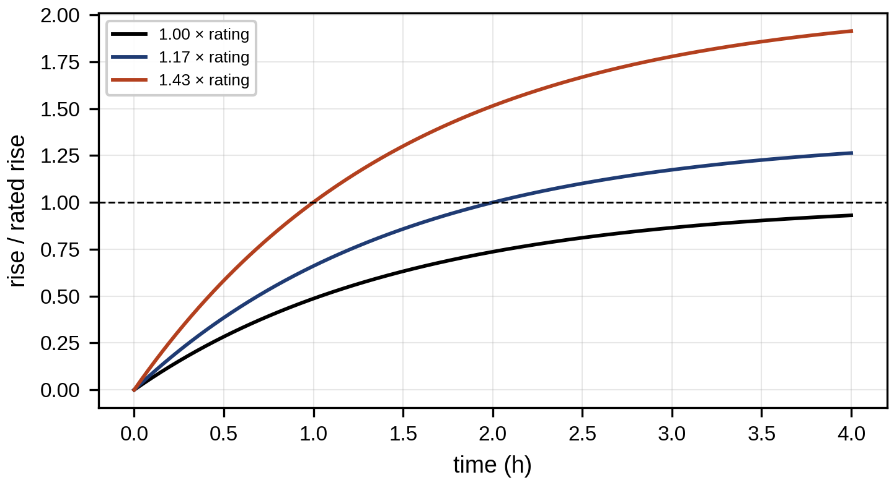
Figure 11.28. Conductor temperature rise of a cable starting cold at 1.0, 1.17 and 1.43 times its rating (time constant 1.5 h), reaching the limit at 2 h and 1 h respectively for the two overloads.
Two standards govern these calculations and should not be confused. IEC 60287 gives the steady-state (100 % load factor) rating from the thermal resistances of the insulation, sheath, serving and surrounding soil. IEC 60853 gives cyclic and emergency ratings, which account for the thermal capacitance of the cable and soil through a ladder network of thermal resistances and capacitances with several time constants, from minutes (conductor and insulation) to days (soil) [28]. The first-order model (11.76) is a pedagogical reduction of that ladder to its dominant time constant; it shows the mechanism and gives the right order of magnitude, but emergency ratings for operation must come from the IEC 60853 method or from a calibrated multi-node thermal model.
The largest uncertainty is usually the soil. Its thermal resistivity $ρ_{s}$ varies with moisture along the route and through the seasons, and a cable twin estimates it from distributed temperature sensing (DTS). In steady state the conductor temperature rise is $Δθ=I^{2}R_{ac}\left(T_{123}+ρ_{s}G\right)$, where $T_{123}$ lumps the cable’s internal thermal resistances and $G=ln\left(4L/D\right)/\left(2π\right)$ is the geometric factor of the soil for a cable at depth $L$ with outer diameter $D$. The soil resistivity is then a linear regression coefficient.
Example 11.19 Estimating soil thermal resistivity from DTS
Given. A cable at 1.0 m depth with outer diameter 0.1 m ($G=0.587$), $R_{ac}=0.1$ mΩ/m, $T_{123}=0.45$ K·m/W. Forty-eight steady-state records of current (300 to 600 A) and DTS temperature rise with 0.8 K noise, generated with a true $ρ_{s}=1.8$ K·m/W.
Find. The estimate of $ρ_{s}$ with its 95 % interval, and the resulting steady-state rating for a 65 K allowable rise, compared with the rating from a design value of 1.0 K·m/W.
Solution. Least squares gives ${\hat{ρ}}_{s}=1.804$ K·m/W with a 95 % interval of 1.787 to 1.821. From (11.75) with $T_{tot}=T_{123}+ρ_{s}G$, the rating is 656 A, or 654 A at the upper end of the interval, against 792 A from the design value.
Interpretation. The design assumption overstated the cable’s capacity by 21 %. A dynamic rating built on it would allow overloads that age the insulation; the twin’s rating, with its interval, is lower but defensible. Soil resistivity changes with moisture, so the estimate is repeated seasonally and after long dry spells.

11.13.2 Transformers, tap changers and asset health
The distribution transformer twin reuses the IEEE C57.91 hot-spot and aging model of Chapter 10 (Section 10.16.3), with the harmonic loss factor of Chapter 10 (Section 10.16.3), and adds its tap changer. An OLTC’s contacts wear with every operation; wear is roughly proportional to the switched current, so the twin counts operations weighted by current and forecasts maintenance. DER-rich feeders make taps move far more often, as passing clouds swing the voltage, and coordinating Volt/VAR control (Section 11.7.4) with the OLTC reduces this wear.
IEC 60076-7 provides the loading guide equivalent to IEEE C57.91 [29], with a thermal model of top-oil and hot-spot temperatures and a relative ageing rate that doubles for every 6 K of hot-spot rise above 98 °C for non-thermally-upgraded paper. Condition information adds to the thermal model: dissolved-gas analysis (DGA) interpreted per IEEE C57.104-2019 or IEC 60599 indicates overheating, partial discharge or arcing; bushing capacitance and power factor indicate insulation ageing; and OLTC contact wear follows from the counted, current-weighted operations. The twin combines them into an asset-health state that constrains operation. A transformer with rising acetylene is given a lower loading limit in the EMS and the restoration plan; a tap changer near its maintenance threshold is given a higher cost per operation in the Volt/VAR optimizer (Section 11.7.4). This is where a grid twin and the asset twins of earlier chapters meet: the network model supplies the loading history, and the asset model returns the limits the network model must respect.

11.14 Power-quality Twins and Event Analytics
Power quality describes how far voltage and current depart from ideal sinusoids of nominal magnitude and frequency. The main indices are total harmonic distortion, total demand distortion, unbalance, and the depth and duration of sags:
 | THDV=h≥2​Vh2V1, TDD=h≥2​Ih2IL, | (11.77)
where $V_{h}$ and $I_{h}$ are the RMS harmonic components of order $h$ and $I_{L}$ the maximum demand current. Harmonic currents injected by converters produce harmonic voltages through the source impedance, which rises with frequency: $V_{h}=hX_{s}I_{h}$ for a mainly inductive source of fundamental reactance $X_{s}$.
The two distortion indices of (11.77) are not interchangeable. THD normalizes by the fundamental and therefore rises at light load even when harmonic currents are small in amperes; total demand distortion (TDD) normalizes by the maximum demand current $I_{L}$ and is the quantity IEEE 519-2022 [14] limits for current at the point of common coupling, as a function of the ratio $I_{sc}/I_{L}$ of short-circuit current to maximum demand current. The voltage limits of IEEE 519 are on THD. For generating equipment, IEEE 1547-2018 sets its own current-distortion limits on the total rated-current distortion (TRD), normalized by the DER’s rated current, together with limits on individual odd harmonics.
A power-quality twin needs more than distortion indices. Voltage dips (sags), swells and interruptions are characterized by residual voltage and duration from half-cycle RMS values ($U_{rms\left(1/2\right)}$) per IEC 61000-4-30; flicker by the short- and long-term severities $P_{st}$ and $P_{lt}$ of IEC 61000-4-15; rapid voltage changes by their step size; and supraharmonics (2 to 150 kHz), emitted by converters and chargers, by the methods added in recent editions of IEC 61000-4-30 and IEC 61000-4-7. The measurement method matters: class A instruments compute basic values over 10-cycle (50 Hz) or 12-cycle (60 Hz) windows synchronized to the fundamental, aggregate them to 150/180-cycle, 10-minute and 2-hour values, and flag intervals containing dips, swells or interruptions so that they do not contaminate the statistics [30]. A twin that averages unflagged data over a dip reports a smooth voltage that never existed. Each index also carries a measurement uncertainty from the instrument class and the voltage and current transformers, which is often larger than the margin to a limit and must be stated.
Events are also data for localization. A dip recorded at several PQ meters, with the phase and magnitude pattern of the sequence components, identifies the fault type (single-phase dips with a zero-sequence component on an earthed system point to an earth fault) and, by comparing depths along the feeder with the twin’s short-circuit model, the probable section. The same comparison classifies the cause (fault, motor start, transformer energization) from the dip’s shape and recovery.
Example 11.20 Harmonic voltage at the P-1 connection
Given. The P-1 microgrid exporting 2 MW (105 A at 11 kV) with current harmonics of 4 %, 3 %, 1.5 % and 1 % at orders 5, 7, 11 and 13; the 11 kV source has a short-circuit level of 250 MVA ($X_{s}=0.484$ Ω).
Find. The current and voltage distortion at the PCC.
Solution. ${THD}_{I}=\sqrt{{0.04}^{2}+{0.03}^{2}+{0.015}^{2}+{0.01}^{2}}=5.3$ %. The harmonic voltages are $5×0.484×4.2=10.2$ V, 10.7 V, 8.4 V and 6.6 V, so ${THD}_{V}=18.2/6351=0.29$ % of the phase voltage.
Figure 11.29 shows the two spectra.
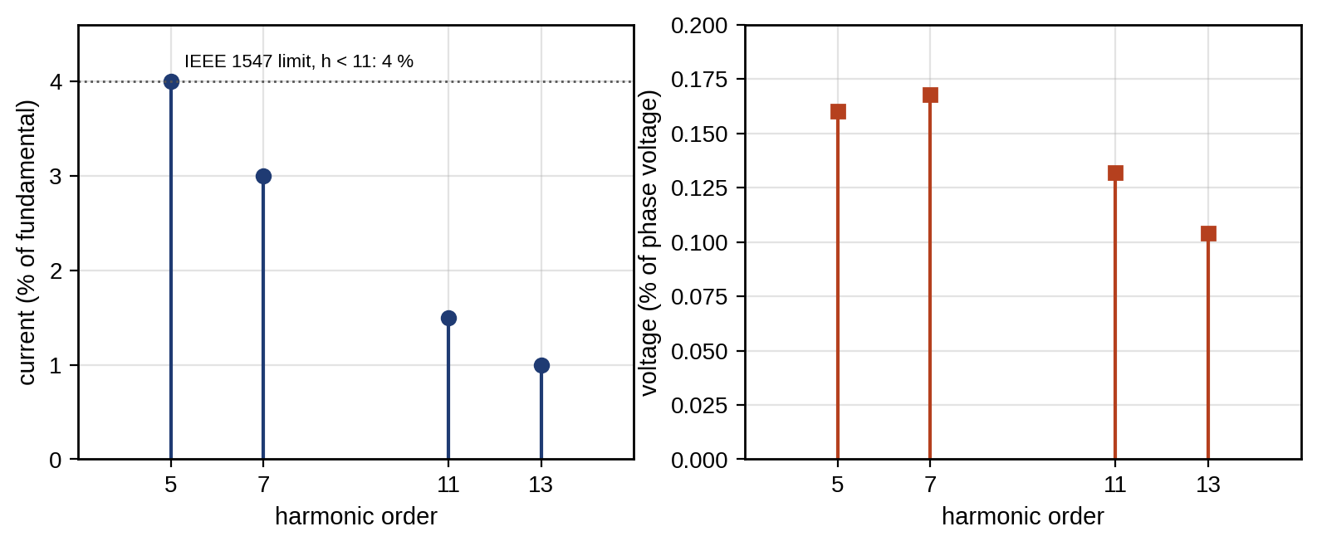
Figure 11.29. Harmonic spectra at the P-1 connection: current harmonics in per cent of the fundamental, with the IEEE 1547-2018 individual limit of 4 % below order 11 (left), and the resulting voltage harmonics in per cent of the phase voltage, which follow V_h = h X_s I_h: the source reactance amplifies each current harmonic in proportion to its order (right).
Interpretation. A strong 11 kV source keeps voltage distortion tiny. The same currents in an island, where the source impedance is the battery inverter’s, can raise ${THD}_{V}$ by an order of magnitude, which is why power quality must be assessed separately for islanded operation. Resonance between cable capacitance and source inductance can amplify particular harmonics, and the twin’s frequency-domain network model identifies it.
With the P-1 plant treated as a DER, the relevant check is IEEE 1547-2018: the individual harmonics of this example (4 %, 3 %, 1.5 % and 1 % at orders 5, 7, 11 and 13) are within its individual limits, but the total of 5.3 % exceeds the 5 % limit on total rated-current distortion. At full output the plant is marginally non-compliant, an issue that neither the voltage THD nor an IEEE 519 TDD check at a customer PCC would reveal.

11.15 Adaptive Protection for Inverter-dominated Microgrids

11.15.1 Overcurrent coordination and what islanding does to it
Radial feeders are protected by overcurrent relays whose operating time falls as the fault current rises. The IEC standard-inverse characteristic (IEC 60255-151) is
 | $$t_{op}=TMS\frac{0.14}{{\left(I/I_{s}\right)}^{0.02}−1},$$ | (11.78)
where $I$ is the fault current seen by the relay, $I_{s}$ its pickup (setting) current and TMS the time multiplier setting. Inverter-based sources contribute far less fault current than machines, because their current controllers limit it to a device-specific multiple of rated current:
 | $$I_{f,inv}≈k_{lim}I_{rated}, k_{lim}>1 \text{(device-specific)},$$ | (11.79)
and they may contribute mainly positive-sequence current, which changes how negative-sequence and directional elements behave. Relays are coordinated so that the one nearest the fault operates first, and the upstream relay waits at least a coordination time interval (CTI, commonly 0.2 to 0.4 s; 0.3 s here) longer, for every fault current the downstream relay can see. The three-phase fault current at distance $ℓ$ along the feeder follows from the source and line impedances,
 | $$I_{f}=\frac{V_{LL}/\sqrt{3}}{\left|Z_{s}+z′ℓ\right|},$$ | (11.80)
with $Z_{s}=jV_{LL}^{2}/S_{sc}$ the source impedance from the short-circuit level $S_{sc}$ and $z′$ the line impedance per kilometre.
Example 11.21 Coordinating two relays, and what islanding does to them
Given. The P-1 feeder with a 250 MVA source. Relay R1 at the substation ($I_{s}=400$ A) and relay R2 at bus 5 ($I_{s}=200$ A, TMS = 0.1). In island, the only fault sources are the battery and PV inverters (1.5 MVA of the installed inverter capacity assumed in service), limited to 1.2 times rated current.
Find. The fault currents, R1’s TMS for a 0.3 s CTI, the CTI for faults further out, and the fault current in island.
Solution. By (11.80), faults at 0, 5, 6 and 10 km draw 13.1, 2.48, 2.13 and 1.35 kA. At 2.48 kA, the largest current R2 sees, (11.78) gives $t_{R2}=0.271$ s, so R1 must take 0.571 s there: ${TMS}_{1}=0.571×\left[{\left(2481/400\right)}^{0.02}−1\right]/0.14=0.152$. For faults at 6, 8 and 10 km the CTIs are 0.34, 0.41 and 0.50 s, all above 0.3 s. In island, the inverters supply $1.2×1.5 MW/\left(\sqrt{3}×11 kV\right)=94$ A, while the normal island load current on the feeder toward buses 7 to 10 is 58 A, and R2’s 200 A pickup is never reached.
Interpretation. Figure 11.30 shows why on the relays’ time–current curves. Coordination that works perfectly when grid-connected fails completely in island. The inverter-limited fault current is below the pickup and barely above load, so no current-magnitude setting can separate fault from load. Microgrid protection therefore needs adaptive protection: setting groups switched by the twin when it detects islanding, with lower pickups and definite-time elements. It also needs protection principles that do not rely on large currents, such as undervoltage, negative-sequence, directional and differential protection over communication links. And fault ride-through settings of the DERs must be coordinated with them. Distance protection, which measures the apparent impedance
 | $$Z_{app}=\frac{{\overset{‾}{V}}_{relay}}{{\overset{‾}{I}}_{relay}},$$ | (11.81)
and trips when it falls inside a zone set as a fraction of the line impedance, is less sensitive to the fault-current magnitude and is increasingly used on meshed microgrids, though inverter current limits and angle control distort its reach. Every change of topology or DER status changes the fault currents, so the twin recomputes them and checks the settings continuously, flagging any configuration in which a fault would go undetected.
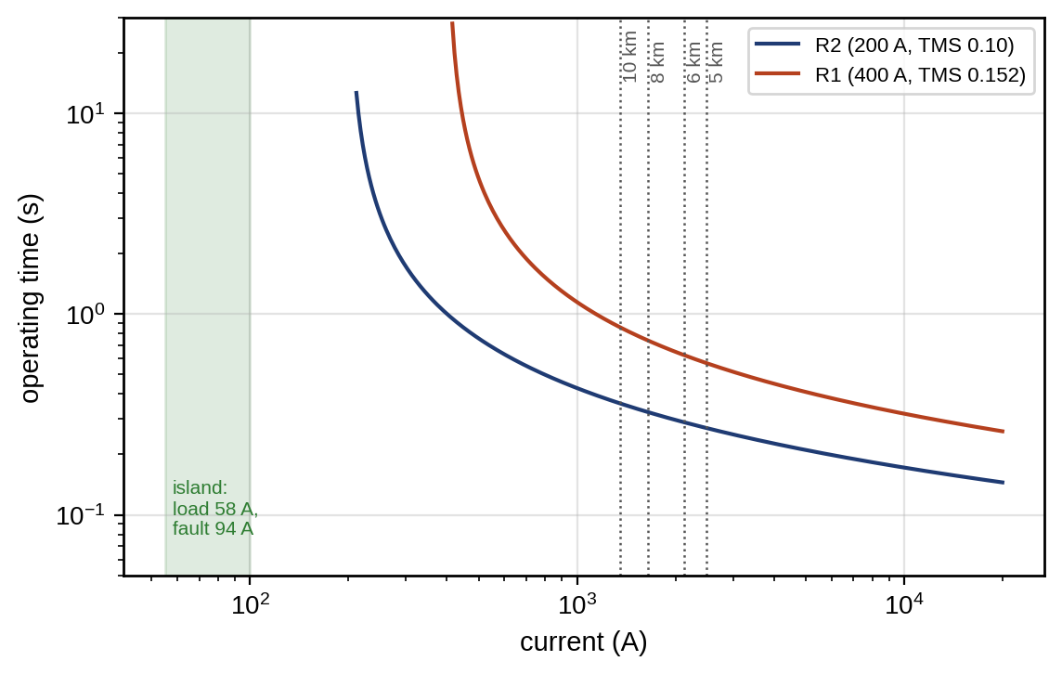
Figure 11.30. Time–current characteristics of relays R1 and R2 on log–log axes, with the fault currents at 5, 6, 8 and 10 km (grid-connected) and the inverter-limited fault current (94 A) and island load current (58 A), which lie below R2’s pickup.

11.15.2 Fault signatures of converter-based sources
Converter fault contributions differ from those of machines in magnitude, sequence content and angle, and each difference defeats some protection principle. The contribution is limited in magnitude, as (11.79) states; the factor $k_{lim}$ is a device property that must be taken from the manufacturer, and the 1.2 used in Example 11.21 is representative only. Its angle is set by control: a GFL unit injects current at the angle its fault-mode logic prescribes (often mostly reactive during deep dips), not at the angle the network impedance would impose, which disturbs directional and distance elements that assume a source behind an inductive impedance. Its sequence content is often positive sequence only, because many GFL controllers regulate balanced currents even during unbalanced faults; negative-sequence directional elements, which rely on the source’s negative-sequence impedance, then see little or nothing. IEEE 2800-2022 requires negative-sequence current injection from transmission-connected inverter-based resources during unbalanced faults partly for this reason, but distribution DERs under IEEE 1547 are not required to provide it. A GFM unit behaves as a voltage source in all sequences until its limiter acts, after which its behaviour depends on how the limiter treats each sequence.
The twin therefore builds a mode-specific fault model. For each operating mode (grid-connected, islanded with each combination of GFM units), it represents every converter by its limited current magnitude, angle rule and sequence behaviour, and recomputes the currents and voltages each relay would see for faults at every bus. That table is what adaptive protection is designed and verified against.

11.15.3 Protection principles and adaptive schemes
The principles available for inverter-dominated microgrids are:
- Adaptive overcurrent. Setting groups switched by mode, with lower pickups and definite-time elements in island. Limited by the small margin between island fault and load currents.
- Voltage-based protection. Undervoltage (and negative- or zero-sequence overvoltage for unbalanced faults). Dependable in island, where faults collapse the voltage, but not selective, because the whole island sees the collapse.
- Directional elements. Use the direction of current relative to voltage to distinguish a fault ahead from one behind, and supervise low pickups. They depend on the converter’s fault-current angle.
- Differential protection. Compares currents at the ends of a zone over a communication link and trips when they do not balance. Independent of fault-current magnitude above a small pickup, but dependent on the link and on time synchronization.
- Distance protection. Measures the apparent impedance (11.81); its reach is distorted by converter current limits and angle control.
- Travelling-wave protection. Detects the high-frequency wavefronts launched by a fault, which are independent of source type, with sub-millisecond speed; it needs high sampling rates and is emerging for distribution.
Adaptive protection combines these with the twin (Figure 11.31). The twin detects the mode and topology, computes the mode-specific fault study, selects or computes the setting group, verifies it against the fault table, and sends it to the relays as a signed, versioned artifact. The relays act on their active group without any dependence on the twin or the network at the moment of a fault. Communication-assisted schemes (GOOSE blocking, transfer trip, line differential) run in parallel and are supervised by channel health. If the channel, the time synchronization or the twin itself fails, relays fall back to the most conservative group, with local definite-time backup, rather than waiting for a new one.
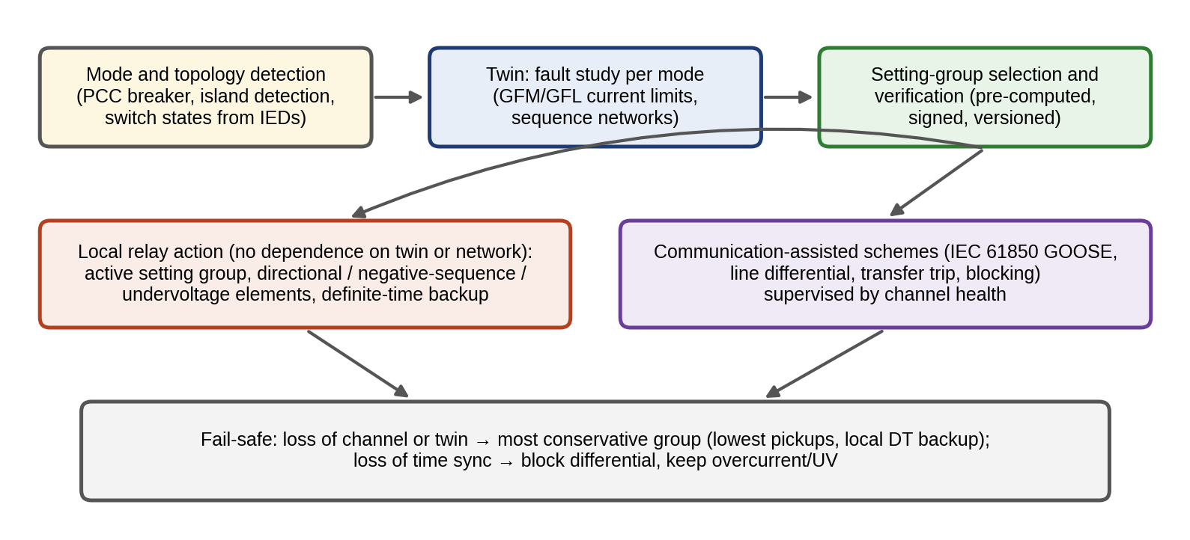
Figure 11.31. Adaptive protection architecture of the P-1 twin: mode and topology detection, a mode-specific fault study, selection and verification of signed setting groups, local relay action on the active group with no dependence on the twin at fault time, communication-assisted schemes supervised by channel health, and fail-safe fallback to the most conservative group.

11.15.4 Application C: protection in both modes
Application C. Screening protection schemes for the P-1 microgrid in both modes
Setup. Faults on the feeder section between bus 7 and bus 8 (2 km from P-1), bolted three-phase and through 20 Ω, grid-connected (250 MVA source) and islanded (the section from bus 6 to bus 10 supplied by the P-1 inverters, 1.5 MVA assumed in service, limited to 1.2 pu, with a normal island load current of 58 A). Candidate schemes: the fixed overcurrent settings of Example 11.21; an island setting group with a lower pickup; undervoltage at 0.5 pu; directional overcurrent with GOOSE blocking; line differential with a 20 A pickup; negative-sequence directional elements. Screening uses the mode-specific fault model with representative converter behaviour (balanced positive-sequence current from GFL units).
Results. Grid-connected, the bolted fault draws 1.65 kA and every scheme operates. In island, the fault current is 94 A for both the bolted and the 20 Ω fault (both are current-limited), and the voltage at the P-1 bus falls to 1.3 % for the bolted fault and to about 30 % for the 20 Ω fault. Table 11.10 summarizes the outcome.
TABLE 11.10 Screening of protection schemes for a fault between buses 7 and 8 in both modes (representative converter behaviour)
Scheme | Grid-connected | Island, bolted | Island, 20 Ω | Loss of communication
Fixed overcurrent (200 A) | Operates | Fails (94 A below pickup) | Fails | Unaffected
Island group, pickup 75 A | Blocked by mode | Operates with 1.25 margin over pickup | Operates, same margin | Unaffected; margin too small for dependable use
Undervoltage 0.5 pu | Operates | Operates, not selective | Operates, not selective | Unaffected
Directional OC + GOOSE blocking | Operates | Operates, selective | Operates, selective | Falls back to non-selective backup
Line differential (20 A) | Operates | Operates, selective | Operates, selective | Blocks; needs local backup
Negative-sequence directional (unbalanced faults) | Operates | Unreliable: GFL units supply no negative sequence | Unreliable | Unaffected
Verdict. No single principle is dependable, selective and independent of communication in island. The design that passes is a combination: a communication-assisted selective scheme (differential or directional with blocking) as the main protection, undervoltage with definite time as non-selective backup that is independent of communication, and an island setting group switched by the twin with verified fallback. Its correctness must then be demonstrated in protection HIL, because the screening assumed a converter behaviour that must be confirmed for the actual devices.

11.15.5 Protection-HIL validation workflow
Protection for an inverter-dominated microgrid is validated in closed loop before deployment: the real relays, with their real settings and firmware, are connected through amplifiers or low-level interfaces to a real-time EMT simulation of the microgrid with vendor-validated converter models (Section 11.20). The test matrix covers every mode, every fault type and location, fault resistances up to the design value, loss of the communication channel, loss of time synchronization, a setting-group change during a fault, and the twin itself unavailable. The pass criterion is stated per case (operating time, selectivity, no nuisance trip for load steps and motor starts), and the evidence is stored with the setting-group version it validated.

11.16 Energy Management Under Uncertainty

11.16.1 The dispatch problem
The microgrid’s energy management system (EMS) decides, for each interval $t$ of a horizon, the grid import $g_{t}^{+}$ and export $g_{t}^{−}$, the battery charge and discharge powers $p_{t}^{ch}$ and $p_{t}^{dis}$, and any curtailment $c_{t}$, to minimize cost:
 | min t​πtbuygt+−πtsellgt−+cdegptch+ptdis2+πcurctΔt, | (11.82)
subject to the power balance, the battery’s energy dynamics and the limits:
 | $$g_{t}^{+}−g_{t}^{−}+p_{t}^{dis}−p_{t}^{ch}+P_{t}^{PV}+P_{t}^{W}−c_{t}=P_{t}^{L}+P_{t}^{EV}, E_{t+1}=E_{t}+\left(ηp_{t}^{ch}−\frac{p_{t}^{dis}}{η}\right)Δt,$$ | (11.83)
 | $$0≤g_{t}^{±}≤P_{PCC}, 0≤p_{t}^{ch},p_{t}^{dis}≤P_{b}−r_{t}, E_{min}+r_{t}Δt_{r}≤E_{t}≤E_{max}, E_{T}=E_{0},$$ | (11.84)
where $π_{t}^{buy}$ and $π_{t}^{sell}$ are the import and export prices, $c_{deg}$ the battery degradation cost per unit of throughput (Chapter 9, Section 9.17.4), $π^{cur}$ a curtailment penalty, $P^{PV}$, $P^{W}$, $P^{L}$ and $P^{EV}$ the forecast PV, wind, load and EV power, $η$ the one-way battery efficiency, $P_{PCC}$ the PCC limit, $P_{b}$ the battery power rating, and $r_{t}$ a reserve of battery power held back for forecast errors and islanding, with energy for $Δt_{r}$ hours. The problem is a linear program.
Two points about this formulation are often misstated. First, whether the LP can return simultaneous charging and discharging depends on the prices, not on luck. If both $p_{t}^{ch}$ and $p_{t}^{dis}$ are positive, reducing both by the same small amount $ϵ$ leaves the power balance unchanged (up to the change $ϵ\left(1/η−η\right)$ in stored energy, which only increases $E$) and lowers the degradation cost by $c_{deg}ϵ$; so with a positive degradation cost and efficiency below one, simultaneous operation is never strictly optimal as long as extra stored energy has no penalty. It can be optimal when energy must be dissipated: when export is capped at $P_{PCC}$ and curtailment carries a penalty, or when prices are negative, cycling the battery through its losses is a way of consuming power, which the LP will exploit. The twin then either accepts it (if the converter can do it) or adds binary variables that forbid it, making the problem a mixed-integer program. Second, the reserve $r_{t}$ serves two different purposes that must be kept apart: a forecast reserve $r_{t}^{f}$ of power (and energy for its deployment) to cover forecast errors while grid-connected, and an islanding reserve $E^{isl}$ of energy to carry the critical load through an unintentional island. The first is used routinely and replenished; the second must not be consumed by the first, so the energy constraint becomes $E_{min}+r_{t}^{f}Δt_{r}+E^{isl}≤E_{t}$.

11.16.2 Carrying forecast uncertainty into the reserve
The reserve comes from the forecast’s calibrated uncertainty. If the net-load forecast error is approximately Gaussian with standard deviation $σ_{f}$, a reserve that covers under-forecasts with probability $1−α$ is
 | $$r=z_{1−α} σ_{f},$$ | (11.85)
with $z_{0.95}=1.645$ for a one-sided 95 % coverage. A net-load forecast of 850 kW with $σ_{f}=45$ kW therefore needs 74 kW of reserve, and the planned schedule should be feasible up to 924 kW. When the error distribution is skewed or its calibration uncertain, the quantile is taken from a conformal interval (Chapter 6, Section 6.13.3) instead. In operation the problem is re-solved every 15 minutes with updated forecasts, applying only the first interval’s decisions: model predictive control (Chapter 13). At each update $k$, the controller solves
 | $$u_{k:k+N−1}^{*}=argmin\sum_{t=k}^{k+N−1}{c_{t}}\left(u_{t},{\hat{w}}_{t|k}\right) \text{s.t. (11.83), (11.84),} E_{k}={\hat{E}}_{k},$$ | (11.86)
where $u$ are the decisions, ${\hat{w}}_{t|k}$ the forecasts made at time $k$, $N$ the horizon and ${\hat{E}}_{k}$ the battery energy estimated by its twin (Chapter 9), and applies $u_{k}^{*}$ only.

11.16.3 From deterministic to stochastic, chance-constrained, robust and predictive formulations
Equation (11.85) sizes a reserve after the fact. The formulations below build uncertainty into the optimization itself (Figure 11.32). Write the deterministic problem compactly as $\min_{u}c\left(u,\hat{w}\right)$ subject to $g\left(u,\hat{w}\right)≤0$, with decisions $u$, forecast $\hat{w}$, cost $c$ and constraints $g$.
- Scenario-based stochastic programming separates decisions made now (the schedule $u$) from recourse decisions $y_{s}$ made after uncertainty is revealed in scenario $s$ (reserve deployment, imbalance), and minimizes the expected cost over $S$ sampled scenarios with probabilities $π_{s}$:
 | $$\min_{u, y_{1},…,y_{S}} c\left(u\right)+\sum_{s=1}^{S}{π_{s}} q\left(y_{s}\right) \text{s.t.} g\left(u,y_{s},w_{s}\right)≤0 ∀s,$$ | (11.87)
where $q$ is the recourse cost and $w_{s}$ the realization in scenario $s$. Its size grows linearly with $S$, and its quality depends on whether the scenarios represent the joint, time-correlated error distribution.
- Chance-constrained programming requires each constraint to hold with a stated probability, $Pr\{g_{j}\left(u,w\right)≤0\}≥1−α_{j}$. For a constraint linear in a Gaussian error with standard deviation $σ_{j}$ this becomes the deterministic tightening
 | $$g_{j}\left(u,\hat{w}\right)+z_{1−α_{j}}σ_{j}≤0,$$ | (11.88)
which is exactly how (11.85) enters the constraints. For non-Gaussian errors the quantile is taken from calibrated (for example conformal) intervals.
- Robust optimization requires feasibility for every realization in an uncertainty set $W$, $\max_{w∈W}g_{j}\left(u,w\right)≤0$. With a box set of half-width $Γσ_{j}$ this is (11.88) with $z$ replaced by $Γ$, and with budget sets it limits how many errors can be at their worst simultaneously.
- Rolling-horizon MPC (11.86) re-solves any of the above every interval with updated forecasts and the battery twin’s estimated state, and applies only the first decision [41]. It corrects the open-loop weakness of all the others: a schedule computed in the morning does not know that the reserve was partly used at noon.
Three practical elements complete any rung of this ladder. Network constraints are added with LinDistFlow (Section 11.6.4) for the plant’s internal network and the PCC voltage, with limits tightened by the linearization error. Degradation enters as a throughput cost or, better, as a state-of-health-dependent cost from the battery twin (Chapter 9). And the solver must return an answer in time: a time limit is set below the dispatch interval; infeasibility is avoided by making operational limits soft with large penalties while physical limits stay hard; and if the solver still fails, the EMS falls back to the last feasible schedule shifted by one interval, then to a rule-based schedule, and flags the trust state as degraded.
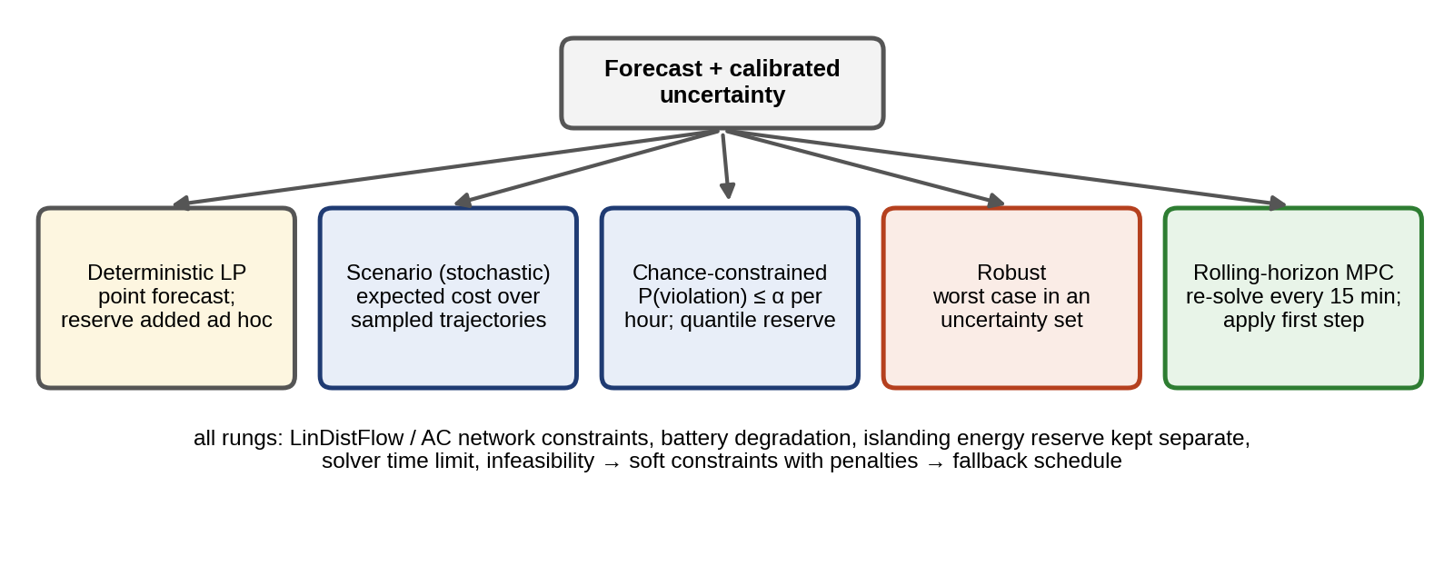
Figure 11.32. The formulation ladder of an uncertainty-aware EMS: from a deterministic LP with an ad hoc reserve to scenario-based, chance-constrained and robust programs and rolling-horizon MPC, all sharing network constraints, degradation, separate islanding reserves and fallback handling.
Example 11.22 A day of dispatch at P-1
Given. Hourly synthetic profiles: plant load 0.4 MW (00:00 to 06:00), 0.7 MW (06:00 to 08:00), 1.1 MW (08:00 to 17:00), 0.8 MW (17:00 to 21:00) and 0.5 MW (21:00 to 24:00); PV from the 1.2 MWp array on a clear day with a 0.85 derating; wind of $0.30±0.10$ MW on a calm day and $1.75±0.12$ MW on a windy day; and the car park’s smart-charged EV load of 0.2 MW from 09:00 to 15:00. Import prices are 0.10 $/kWh at night, 0.18 by day and 0.30 in the evening peak; export 0.06 $/kWh. PCC limit 2 MW; battery 0.5 MW, 1 MWh, 95 % one-way efficiency, 10 % minimum energy, degradation cost 16 $/MWh; the battery ends the day at its starting energy.
Find. Daily net cost, imports, exports and battery throughput without the battery, with it, and with a 74 kW reserve.
Solution. On the calm day, without the battery the site imports 5.10 MWh at a net cost of 1129 $. With the battery it imports 5.13 MWh (slightly more, because of battery losses) and cycles 1.92 MWh, charging at night and discharging in the evening peak, for 976 $ (a saving of 153 $). Holding an hourly reserve sized by (11.85) at 95 %, with $σ_{t}=45 \text{kW}+0.10 P_{t}^{PV}$ (a reserve of 124 kW on average and 240 kW at the solar peak), costs 12 $ more (988 $). On the windy day the site is a net exporter (29.8 MWh, a net income of 1786 $), the export peak of 1.56 MW stays inside the 2 MW limit, and the battery adds nothing, because the flat export price leaves no spread to exploit. The LP never charges and discharges simultaneously on either day, as the argument of Section 11.16.1 predicts.
Figure 11.34 shows the calm day’s schedule, and Figure 11.33 the windy day, when the site exports all day and the battery sits almost idle.
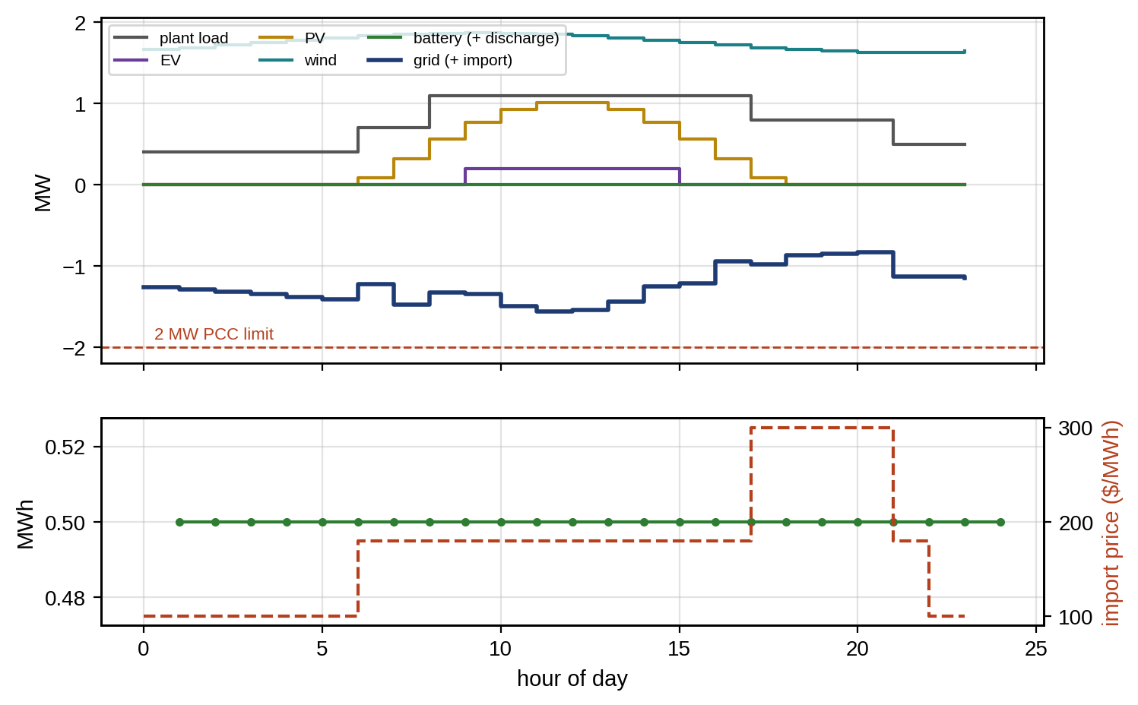
Figure 11.33. Dispatch of the P-1 microgrid on a windy day: net export within the 2 MW PCC limit, with the battery idle (top), and battery energy with the import price (bottom).
Interpretation. The battery’s value is seasonal and depends on the wind. On calm days it earns its keep by arbitrage, on windy days nothing. The planned cost of the reserve, 12 $ a day, is small; Application D shows that its value, once imbalances are paid, is far larger. The twin’s role is to supply calibrated forecasts and the battery’s true state, and to re-plan as they change.
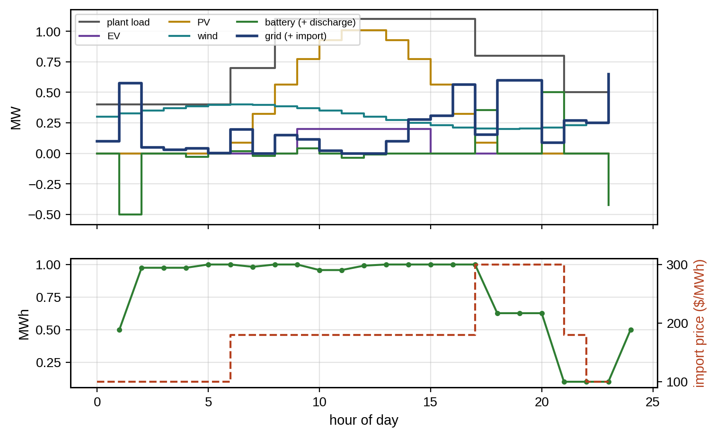
Figure 11.34. Dispatch of the P-1 microgrid on a calm day: load, EV demand, PV, wind, battery and grid exchange (top), and battery energy with the import price (bottom).

11.16.4 Application D: how much is uncertainty handling worth?
Application D. Five EMS formulations evaluated out of sample
Setup. The calm day of Example 11.22, with a net-load forecast error of standard deviation $σ_{t}=45 \text{kW}+0.10 P_{t}^{PV}$ in each hour and a first-order autoregressive correlation of 0.7 from hour to hour. Five schedules were computed: deterministic (no reserve); chance-constrained with a 95 % hourly reserve (11.88); robust with a $3σ_{t}$ box; scenario-based, in which the reserve scaling $k$ in $r_{t}=kσ_{t}$ was chosen to minimize the sample-average cost over 200 scenarios (giving $k=1.75$); and chance-constrained with a separate islanding energy reserve to carry the 250 kW critical load for one hour. Each schedule was then evaluated on 1000 fresh error trajectories. Positive errors are covered by deploying the battery reserve where possible and otherwise by imbalance purchases at 400 $/MWh. Islanding readiness is the fraction of hours in which the battery could carry the critical load for one hour.
TABLE 11.11 Out-of-sample evaluation of EMS formulations on the P-1 calm day (1000 error trajectories)
Formulation | Expected cost ($) | 95th-percentile cost ($) | Hours with imbalance (%) | Islanding readiness (%) | Battery throughput (MWh)
Deterministic LP | 1269 | 1666 | 50.3 | 87.5 | 1.92
Chance-constrained (95 %) | 1081 | 1346 | 18.0 | 65.8 | 1.78
Robust ($3σ$ box) | 1086 | 1378 | 15.0 | 65.0 | 1.65
Scenario-based ($k=1.75$) | 1079 | 1367 | 16.8 | 65.9 | 1.77
Chance-constrained + islanding energy | 1153 | 1485 | 20.6 | 78.3 | 1.25
Findings. The chance-constrained, robust and scenario-based formulations lower the expected cost by about 15 % and the 95th-percentile cost by 17 to 19 % relative to the deterministic schedule, whose planned cost (976 $) is fiction once imbalances are paid. The three uncertainty-aware methods differ from each other by less than 1 % in expected cost here, because the errors are nearly Gaussian and the reserve is the only recourse; the choice between them matters more when errors are skewed or when many constraints interact. Reserve for forecast errors reduces islanding readiness, because deploying it drains the energy an island would need. Keeping an explicit islanding reserve restores part of it, at 72 $ a day in expectation, but only to 78 %, because an open-loop schedule cannot replenish energy that was used earlier in the day. That residual gap is what rolling-horizon MPC closes, and it is the reason the twin runs the EMS in a loop rather than once.

11.17 Flexibility, DERMS and TSO–DSO Coordination

11.17.1 Diversity and aggregation
A substation serves feeders whose peaks do not coincide. The diversity factor is the ratio of the sum of individual peaks to the coincident peak of their sum, and the coincidence factor its inverse:
 | Fdiv=i​Ppeak,iPpeak,∑, Fcoin=1Fdiv. | (11.89)
Three feeders peaking at 3.5, 2.8 and 4.1 MW whose sum peaks at 9.1 MW have $F_{div}=1.14$ and $F_{coin}=0.875$. Figure 11.35 shows such a case.
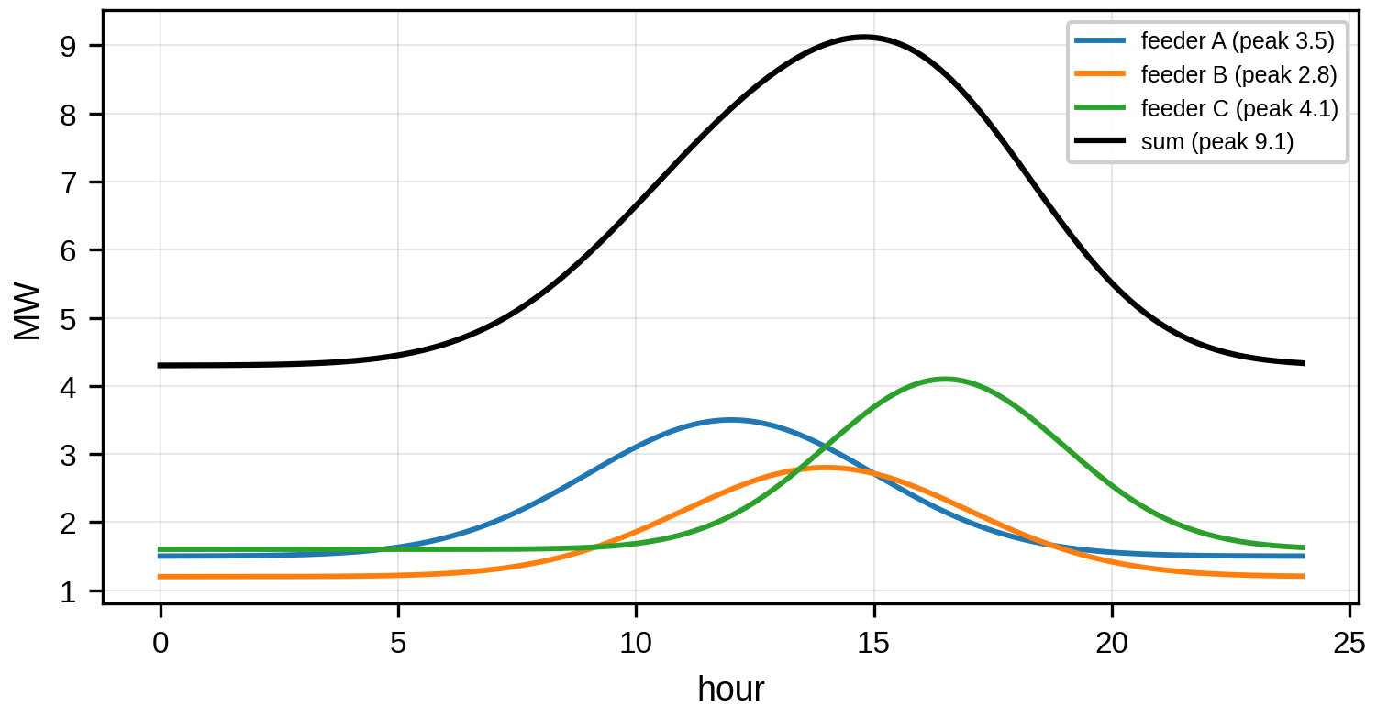
Figure 11.35. Daily load curves of three feeders with different peak times and their sum at the substation: the sum’s peak is smaller than the sum of the individual peaks.
The same idea sized EV loads in Chapter 10 (Section 10.22). Diversity falls as behaviour becomes synchronized, for example when many EVs respond to the same price signal, which a twin must anticipate before it recommends a tariff.

11.17.2 The microgrid as a flexible resource
Seen from the transmission system, a distribution network with active microgrids is no longer a passive load but a resource whose active and reactive power at the substation or PCC can be adjusted within a feasible operating region. For the P-1 microgrid, that region at the PCC is the set of all $\left(P,Q\right)$ reachable by its DERs within their own limits, net of the plant load:
 | FPCC=i​Pi−PL, i​Qi−QL:Pi2+Qi2≤Si2, Pimin≤Pi≤Piavail, | (11.90)
where $P_{i}^{avail}$ is the power currently available from DER $i$ (wind, sun, battery state) and $S_{i}$ its apparent-power rating. With each DER’s feasible set $F_{i}$, the region is their Minkowski sum shifted by the load,
 | $$F_{PCC}=F_{1}⊕F_{2}⊕⋯⊕F_{N}−\left(P_{L},Q_{L}\right), A⊕B=\left\{a+b:a∈A, b∈B\right\},$$ | (11.91)
Two refinements separate a usable region from an optimistic one. The first is the internal network: the plant transformer’s rating, the PCC voltage limits (which depend on the feeder state through the sensitivities of Section 11.7.1) and the low-voltage board’s voltage limits all cut the region. The second is time coupling: a battery that exports at its limit for an hour has less energy afterwards, so the region at one hour depends on what was used before, and a region offered for a period must be feasible for every hour of it. A twin computes the first by solving, for each direction $d$ in the $P$–$Q$ plane, the linear program $max d^{T}\left(P_{PCC},Q_{PCC}\right)$ subject to the DER limits and the linearized network constraints; the maximizers trace the region’s boundary.
Example 11.23 How much the internal network shrinks the P-1 flexibility region
Given. The P-1 microgrid at midday with 1.0 MW of PV available (inverter 1.2 MVA), 1.2 MW of wind (converter 2.2 MVA), the battery at ±0.5 MW (0.6 MVA) and a plant load of $0.9+j0.3$ MVA; the feeder at 40 % load. Constraints: T1 rated 2 MVA carrying PV, battery and load; PCC voltage within 0.95 to 1.05 pu, with the feeder sensitivities to bus 6 ($R_{path}=0.0124$, $X_{path}=0.0173$ pu) and a zero-exchange voltage of 0.988 pu; LV board voltage within 0.94 to 1.06 pu with T1 reactance 0.03 pu. Capability circles approximated by 48-sided polygons.
Find. The region with DER limits only and with the network constraints.
Solution. The DER-only region has an area of 23.7 (MW·Mvar); with the network constraints it has 16.0, 68 % of the former (Figure 11.36). The maximum export (1.8 MW) is unchanged, but reactive capability falls from 3.7 to 3.3 Mvar exported and from 4.3 to 2.7 Mvar absorbed, and the corner of simultaneous import and reactive absorption is cut off by the PCC’s lower voltage limit.
Interpretation. An offer based on DER nameplates would promise about 60 % more reactive absorption than the plant can deliver without violating its own voltage limits. Because the cut depends on the feeder state, the region must be recomputed as the feeder loading changes; offering it as a fixed contract would be wrong at some times of day.
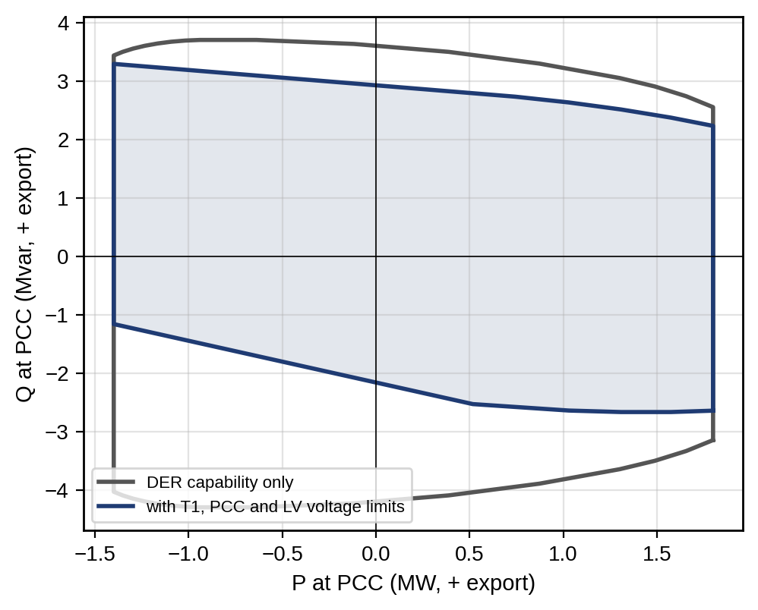
Figure 11.36. Feasible $P$–$Q$ region of the P-1 microgrid at its point of common coupling at midday: with DER capability limits only, and with the transformer rating and the PCC and low-voltage board voltage limits (shaded); positive $P$ and $Q$ are exports (Example 11.23).

11.17.3 DERMS, ADMS and hierarchical coordination
The EMS of one microgrid sits inside a hierarchy. The DSO coordinates the microgrids and flexible customers on its feeders, using their operating regions (11.90) and its own network constraints, and offers the aggregated flexibility to the TSO. Each level runs its own twin at its own time scale, and they exchange forecasts, regions and set-points rather than raw data. Forecasting underpins all of them: load, PV and wind forecasts with calibrated intervals (Chapter 6, Section 6.13.3; Chapter 8, Section 8.17), and EV arrival and energy forecasts (Chapter 10, Section 10.16). Errors propagate upward and aggregate: independent errors partly cancel, while errors driven by common weather do not. For $N$ microgrids with forecast standard deviations $σ_{i}$ and pairwise correlation $ρ$, the aggregate standard deviation is
 | σagg=i​σi2+ρi≠j​σiσj, | (11.92)
which for ten equal microgrids is $\sqrt{10} σ$ when $ρ=0$ but $10σ$ when $ρ=1$. The higher-level twin must therefore know the correlation structure, not only the individual intervals.
Operationally, the distribution operator’s advanced distribution management system (ADMS) runs the network twin (state estimation, Volt/VAR optimization, outage management), and a distributed energy resource management system (DERMS) aggregates DERs and microgrids, forecasts their flexibility and dispatches them within network limits [38]. The microgrid controller of IEEE 2030.7 is the DERMS’s interface to P-1. Coordination between these layers is increasingly iterative rather than one-way: the DSO publishes network prices or limits, each microgrid returns the region or schedule that is optimal for it under those prices, and the DSO updates its prices until the requested flows are feasible. Decomposition methods such as the alternating direction method of multipliers make this converge to the jointly optimal schedule without any party revealing its internal model or data, which addresses both scale and privacy. The price of iteration is time and communication, and a twin at each level must decide what to do when coordination has not converged by the deadline, typically by falling back to the last agreed region.

11.18 Reliability, Contingencies and Climate Resilience

11.18.1 Reliability indices and their uncertainty
Distribution reliability is measured by customer-weighted indices defined in IEEE 1366 [15]:
 | SAIFI=i​λiNii​Ni, SAIDI=i​UiNii​Ni, CAIDI=SAIDISAIFI, ENS=i​UiPi, | (11.93)
where $λ_{i}$ is the interruption frequency (per year) and $U_{i}$ the annual interruption duration (hours) at load point $i$, $N_{i}$ its number of customers, ${\overset{‾}{P}}_{i}$ its average load and ENS the energy not supplied. For a radial feeder with a breaker only at the head, a fault on any section interrupts every customer. Customers upstream of the fault are restored after the faulted section is isolated (switching time $t_{sw}$); those downstream wait for repair ($t_{r}$). So
 | λi=s​λs, Ui=s upstream of i​λstr+s downstream of i​λstsw, | (11.94)
where “upstream of $i$” includes the section feeding bus $i$ itself [16]. Meshed networks, protection failures and weather-dependent failure rates make analytic formulas impractical, and the indices are then estimated by sequential Monte Carlo simulation. Times to failure and to repair are drawn from their distributions, for exponential failures by
 | $$t_{fail}=−\frac{lnu}{λ}, u∼U\left(0,1\right),$$ | (11.95)
and each simulated year’s interruptions are accumulated into the indices, which yields their distributions as well as their means.
Example 11.24 Reliability of the P-1 feeder and the value of islanding
Given. Ten sections of 1 km with 0.1 failures per kilometre per year, 4 h repair, 1 h manual switching; 1261 customers, with P-1 a single customer at bus 6 averaging 1 MW.
Find. SAIFI, SAIDI and CAIDI; P-1’s annual interruption time and energy not supplied; the effect of islanding at P-1 and of automated switching (3 min).
Solution. SAIFI = 1.00 interruptions per customer-year, SAIDI = 2.63 h, CAIDI = 2.63 h. P-1 is interrupted for 2.8 h per year, 2.8 MWh of energy not supplied. If P-1 islands seamlessly, its own interruptions fall to zero, but SAIDI barely changes (2.63 h), because it is one customer among 1261. Automated switching (3 min) instead cuts SAIDI to 2.20 h for everyone.
Figure 11.37 shows the annual interruption time at every bus for the three cases.
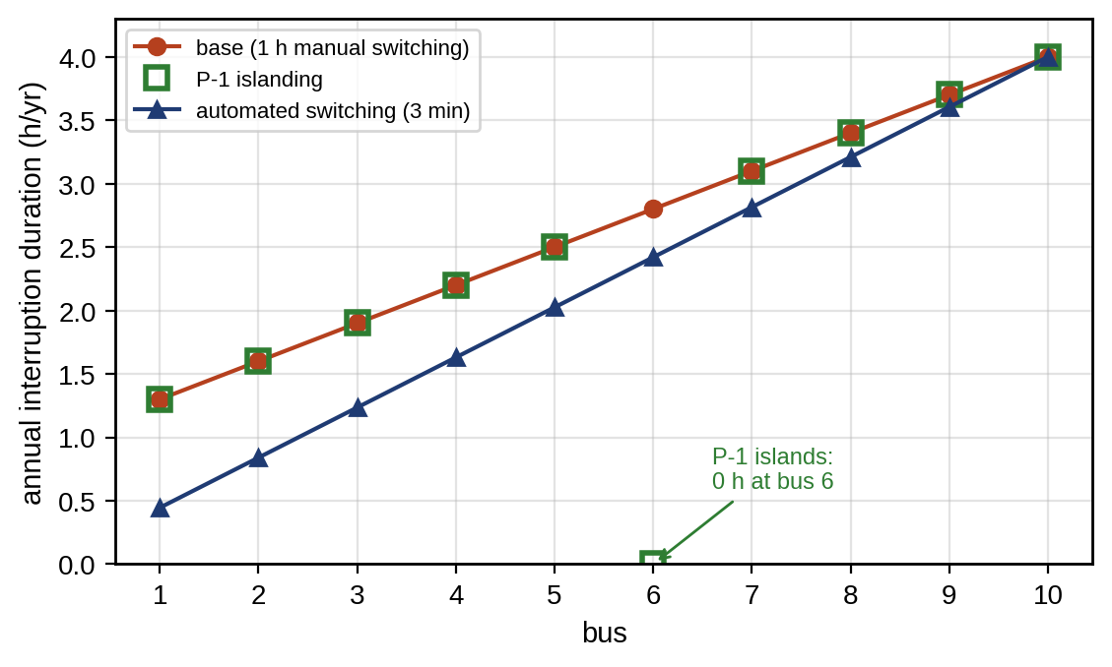
Figure 11.37. Annual interruption duration at each bus of the P-1 feeder: base case, with P-1 islanding and with automated switching; customers further from the substation wait longer, and islanding removes the interruptions only at bus 6.
Interpretation. Islanding transforms the reliability of the microgrid’s own customer and does almost nothing for the feeder’s indices; automation helps everyone moderately. A utility twin that ranks investments by SAIDI will therefore never favour a microgrid, while a customer twin that values its own lost production will. Both views are legitimate, and the chapter’s case study keeps them separate.
Analytic indices give expected values. A sequential Monte Carlo simulation of the same feeder (2000 years, exponential failures and repair and switching times) gives a mean SAIDI of 2.68 h with a 95 % confidence interval for the mean of 2.51 to 2.84 h, consistent with the analytic 2.63 h, but it also shows what the mean hides: in 35 % of years no customer is interrupted at all, and the 90th percentile of annual SAIDI is 7.8 h. A regulator’s penalty on annual SAIDI therefore has a highly skewed outcome, which the analytic formula cannot show. A fuller reliability twin adds momentary interruptions (MAIFI) from reclosing, weather-dependent failure rates (failures cluster in storms), common-mode failures (two circuits on one pole line), protection failures and DER availability, all of which the Monte Carlo structure accommodates and the analytic formulas do not.

11.18.2 N-1 contingency analysis in meshed networks
Security assessment asks whether the network stays within limits after the loss of any single element (the N-1 criterion) [17]. Checking every outage with full AC power flow is expensive, so screening uses the linear DC approximation, which is appropriate for meshed networks with X/R well above 1 and voltages near nominal, such as the sub-transmission ring below; radial distribution needs the different treatment of Section 11.18.3. With flat voltages, small angle differences and negligible resistance, (11.24) reduces to
 | $$P_{ik}=\frac{θ_{i}−θ_{k}}{x_{ik}}, P=B′θ, f=DAXP=PTDF P,$$ | (11.96)
where $P_{ik}$ is the active flow on line $ik$ of reactance $x_{ik}$, $B′$ the susceptance matrix, $A$ the branch–bus incidence matrix, $D$ the diagonal matrix of branch susceptances, $X=B′^{−1}$ (with the slack row and column removed) and PTDF the matrix of power-transfer distribution factors: the change of flow on each line per megawatt injected at each bus and withdrawn at the slack. When line $k$ from bus $m$ to bus $n$ trips, its pre-outage flow redistributes to the other lines according to the line-outage distribution factors:
 | $$f_{l}^{post}=f_{l}+{LODF}_{l,k}f_{k}, {LODF}_{l,k}=\frac{{PTDF}_{l,m}−{PTDF}_{l,n}}{1−\left({PTDF}_{k,m}−{PTDF}_{k,n}\right)},$$ | (11.97)
derived by modelling the outage as injections at $m$ and $n$ that cancel the line’s flow. The denominator vanishes when the outage islands part of the network.
Example 11.25 N-1 screening of a 33 kV sub-transmission ring
Given. A five-bus 33 kV network (Figure 11.39): the grid supply at bus 0 and six lines on a 100 MVA base: 0–1 ($x=0.08$ pu, 30 MW), 0–2 (0.10, 30 MW), 1–2 (0.15, 15 MW), 1–3 (0.10, 25 MW), 2–4 (0.12, 20 MW) and 3–4 (0.15, 12 MW), with $r=0.4x$ for the AC check. Loads of 15, 10 and 18 MW at buses 1, 2 and 3; a 12 MW wind farm at bus 4.
Find. Base-case flows, the post-contingency flows for each single line outage, the violations, and a remedy.
Solution. Base-case flows are 19.8 and 11.2 MW on the two supply lines and 10.0 MW on line 3–4, flowing from bus 4 to bus 3 (rating 12 MW). The outages produce:
- Line 0–1 out. Line 0–2 reaches 31.0 MW against 30, line 1–2 17.2 MW against 15, and line 3–4 15.7 MW against 12.
- Line 0–2 out. Line 0–1 reaches 31.0 MW against 30.
- Line 1–3 out. Bus 3 hangs on line 3–4 alone, which must then carry its entire 18 MW load against a 12 MW rating.
- Line 2–4 out. Line 3–4 carries exactly its 12 MW rating. The outages of lines 1–2 and 3–4 cause no violation.
For the line 1–3 outage, the post-contingency sensitivity of line 3–4 to the wind farm’s output is zero: bus 3 is fed radially, so curtailing wind does not help, and 6 MW of load at bus 3 must be transferred or shed. The supply-line overloads, by contrast, can be removed by redispatching generation.
Figure 11.38 shows the PTDF matrix that makes this screening fast.
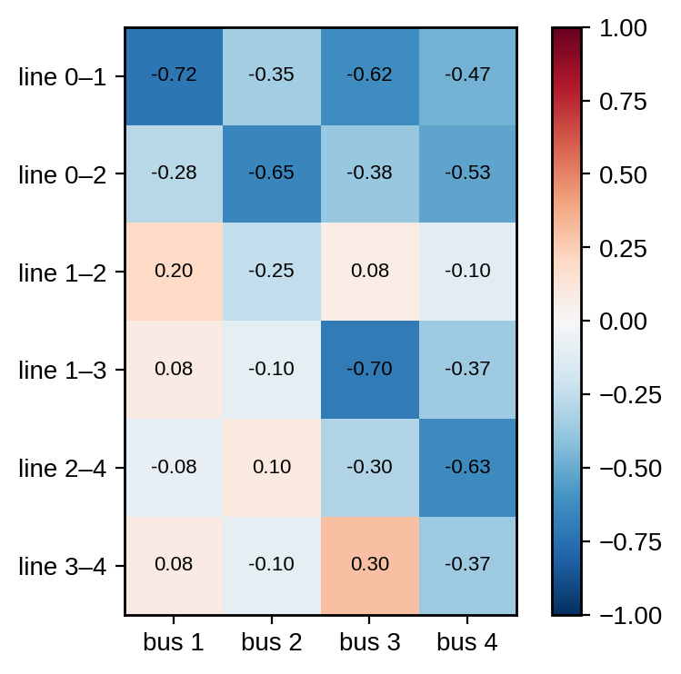
Figure 11.38. Power-transfer distribution factors of the five-bus ring: the change of flow on each line, in the listed from–to direction, per megawatt injected at each bus and withdrawn at the grid supply.
Interpretation. Sensitivity factors turn N-1 screening into matrix products that a twin can run every few seconds, and they also say which remedy works. When the sensitivity is zero, no amount of generation redispatch helps. Violations flagged by the linear screen are re-checked with full AC power flow, which also covers voltage. For the line 1–3 outage, the AC solution confirms 18.0 MW on line 3–4 (18.9 MVA, since the line now also carries bus 3’s reactive power) and shows bus 3 at 0.954 pu, a voltage consequence the DC screen cannot see.
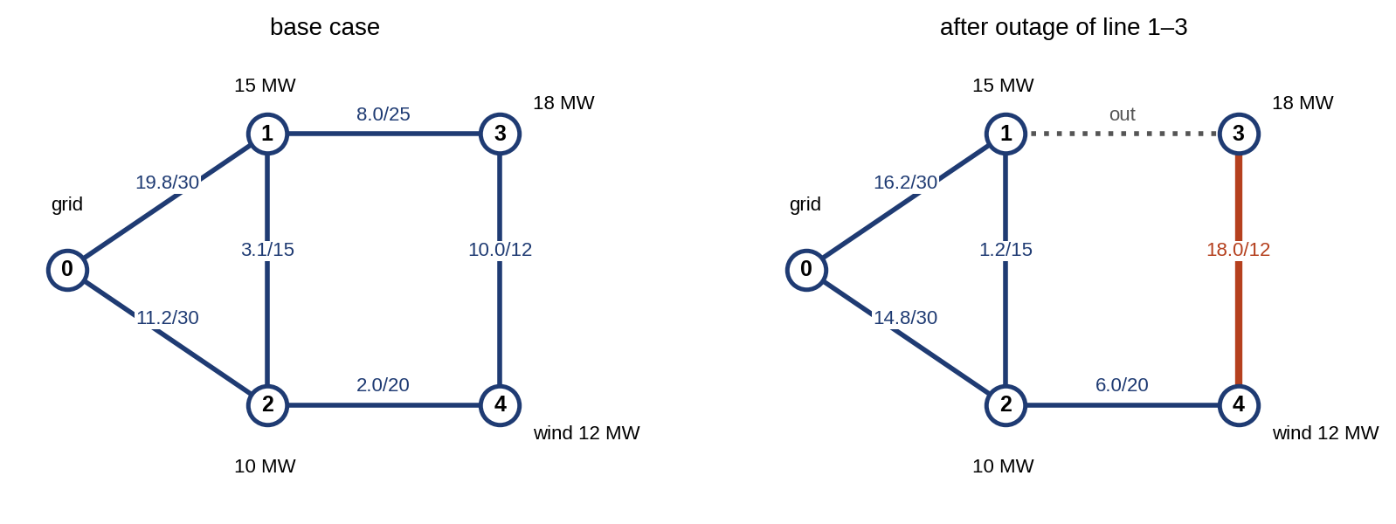
Figure 11.39. The five-bus 33 kV ring: base-case flows (left) and post-contingency flows after the outage of line 1–3 (right), with flow/rating in MW and overloaded lines highlighted.

11.18.3 N-1 in radial distribution: restoration by reconfiguration
In a radial feeder the loss of a section interrupts every customer downstream, and the question is not whether flows exceed ratings but whether the interrupted part can be restored through another path. The distribution counterpart of N-1 screening is therefore: for each section fault, isolate it with the nearest switches, close a tie to an adjacent feeder, and check with a power flow on the reconfigured network that voltages and currents are within limits.
Example 11.26 Restoring the P-1 feeder through a tie
Given. The P-1 feeder in the evening case, with a normally open tie at bus 10 to an adjacent feeder whose bus is held at 1.00 pu, through 1 km of the same conductor. A permanent fault on section 3 (bus 2 to bus 3).
Find. After isolating section 3 and closing the tie, the minimum voltage on the restored buses 3 to 10 and the tie current; then the same with P-1 exporting 0.5 MW during the transfer.
Solution. A sweep from the tie gives a minimum voltage of 0.960 pu (at bus 3, now the far end) and a tie current of 159 A. With P-1 exporting 0.5 MW instead of importing, the minimum rises to 0.981 pu.
Interpretation. The reconfigured feeder is within limits, so the tie can restore all customers beyond the fault within the switching time rather than the repair time, which would reduce SAIDI further than the automated switching of Example 11.24, whose 2.20 h assumes no tie. The microgrid’s contribution during the transfer (supporting voltage rather than islanding) is a service the twin can quantify and the DSO can contract.

11.18.4 Resilience and storm restoration
Reliability describes frequent, small events; resilience describes rare, severe ones: storms, floods, heatwaves, cyber attacks. A resilience event follows a trapezoid: performance degrades as damage accumulates, stays low during the degraded state, and recovers as restoration proceeds [18]. Figure 11.40 sketches it. A simple metric is the fraction of demand served over the event,
 | $$R=\frac{\int_{t_{0}}^{t_{1}}{P_{served}}\left(t\right) dt}{\int_{t_{0}}^{t_{1}}{P_{demand}}\left(t\right) dt},$$ | (11.98)
computed separately for critical and non-critical loads. A microgrid improves resilience by islanding and serving critical loads from local resources, and its twin decides which loads to serve, when, and how to prepare before the event arrives.
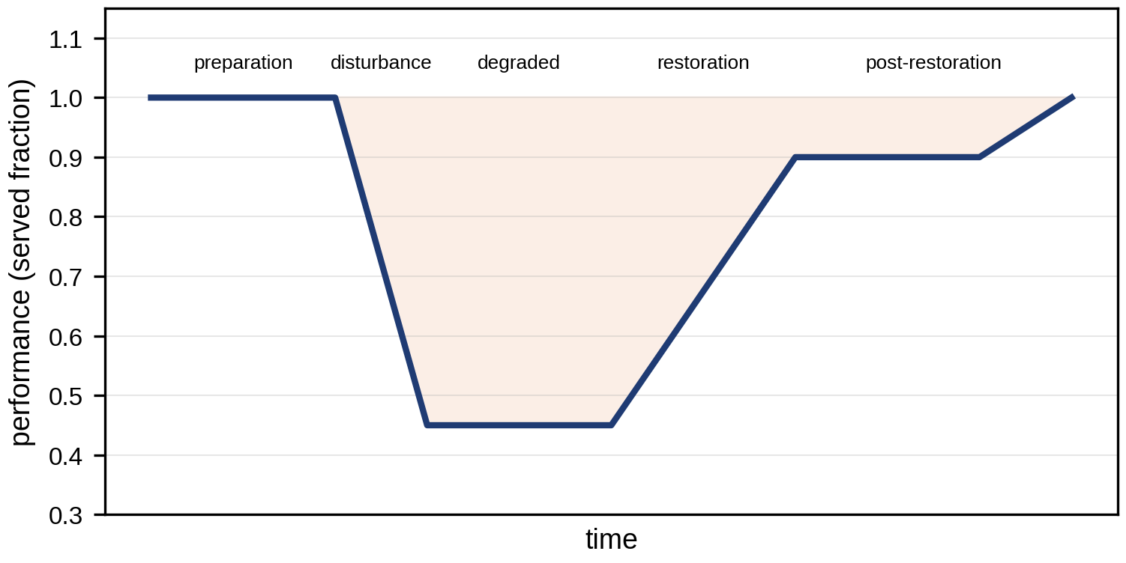
Figure 11.40. The resilience trapezoid: system performance against time through disturbance, degraded state, restoration and post-restoration, with the preparation phase before the event where a twin can act.
Example 11.27 Riding through a 24-hour storm outage
Given. A storm cuts the feeder at 14:00 for 24 hours. Wind above the turbine’s cut-out speed stops T-1. PV runs at 30 % of clear-sky output under cloud. The battery starts at 90 % of 1 MWh. Critical loads are 250 kW (of which 150 kW are essential: safety systems, control, refrigeration). A twin-informed strategy charges the battery to 100 % when the storm is forecast, serves the 100 kW of non-essential critical load only while PV or the battery’s energy above 50 % allows, and draws up to 150 kWh from parked EVs (vehicle-to-building, Chapter 10).
Find. The share of critical and essential energy served, and what additional resource would carry the essential load through. A first estimate of the island’s endurance without generation is
 | $$t_{end}=\frac{\left(E_{0}−E_{min}\right)η}{P_{crit}−P_{gen}},$$ | (11.99)
where $E_{0}$ is the stored energy at the start, $E_{min}$ the minimum, $η$ the discharge efficiency, $P_{crit}$ the critical load and $P_{gen}$ the local generation; for 0.8 MWh usable at 95 % and 250 kW with no generation, 3.0 hours.
Solution. With the battery alone serving all 250 kW, the first shortfall comes at 19:15, and only 46.8 % of the critical energy is served. With the twin-informed strategy, 59 % of the essential energy is served: essential supply is held until 21:30, after which the stored energy is exhausted until PV returns the next morning. The unserved essential energy, 1.47 MWh, sizes the missing resource: a further 1.6 MWh of storage, or a 200 kW standby generator running for about 7.5 hours.
Interpretation. Figure 11.41 shows both strategies through the event. The twin cannot create energy, but it can say precisely how much is missing and when, which turns a vague resilience goal into a sized investment. Preparation (charging before the storm) and load tiering matter as much as hardware. The same model, run on the day’s forecast, tells the operator in advance which loads will have to go dark and at what time.
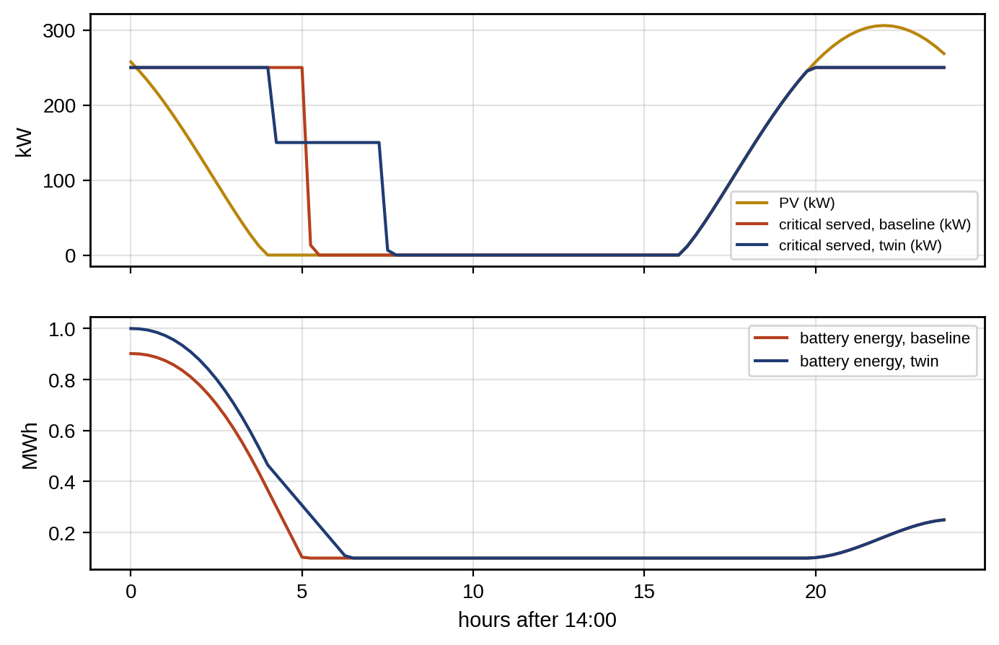
Figure 11.41. Storm outage of the P-1 microgrid: PV and critical load served for the baseline and the twin-informed strategy (top), and battery energy for both (bottom).
A single ratio hides the shape of an event, so resilience is reported with several metrics, each tied to one phase of the trapezoid [39]: the minimum performance reached (how far), the rate of degradation (how fast), the duration of the degraded state, the recovery time to full service, and the energy not served, weighted by load criticality. A twin produces these from a chain of models: a hazard model (the storm’s wind field over the network), fragility curves that give each component’s failure probability as a function of the hazard intensity, an outage model that turns failures into disconnected customers through the protection and topology, and a restoration model with crews, access delays and repair times. Because every link is uncertain, the result is a distribution over storms, not a number.

11.18.5 Application E: a climate-resilience twin of the P-1 feeder
Application E. How resilient is the P-1 feeder to a design storm?
Setup. Two thousand storms were sampled with a peak gust at the feeder that is log-normally distributed with a median of 30 m/s. Each of the ten overhead sections fails with probability given by a log-normal fragility curve, $Pr\{\text{fail} | w\}=Φ\left(ln\left(w/w_{50}\right)/β\right)$, with median failure gust $w_{50}=38$ m/s and $β=0.25$, where $Φ$ is the standard normal distribution function. One crew starts after an access delay uniformly distributed between 2 and 8 h and repairs failed sections from the substation outward, each taking a log-normal time with a median of 5 h; a bus is re-energized when every section between it and the substation is repaired. P-1 islands and serves its essential load with the twin-informed strategy of Example 11.27, which carries the essential load for 7.5 h from the start of an outage.
Results. In 27 % of storms nothing fails. Over all storms, the energy not supplied to the other customers has a median of 18.9 MWh and a 95th percentile of 64.4 MWh; full restoration takes a median of 13.4 h and a 95th percentile of 45 h; and in the median storm the minimum performance is 33 % of customers served (Figure 11.42). P-1’s own outage outlasts its essential-load endurance in 58 % of storms.
Interpretation. The distribution changes the investment question. The mean restoration curve suggests a moderate event; the 95th percentile shows a two-day outage in which P-1’s battery, sized for hours, is inadequate most of the time. Two levers follow directly from the model: pre-positioning a second crew shortens the tail of recovery time for the whole feeder, while the missing essential energy computed in Example 11.27 sizes P-1’s own backup. The fragility parameters used here are illustrative; a deployed twin must calibrate them from the utility’s own damage records, which is the main barrier identified in the roadmap (Section 11.23).
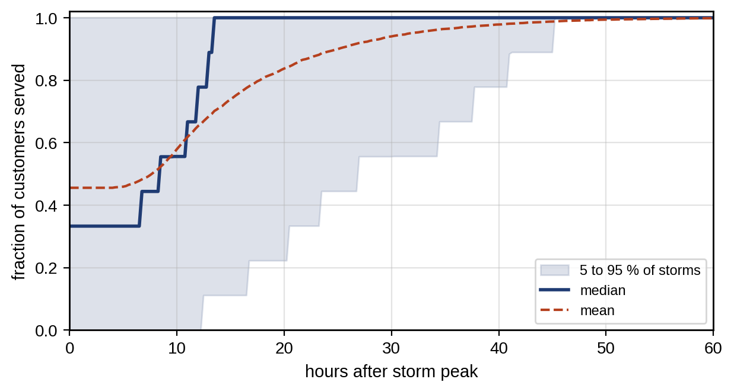
Figure 11.42. Restoration curves of the P-1 feeder over 2000 sampled storms (Application E): median, mean, and the band between the 5th and 95th percentiles of the fraction of customers served.

11.19 Real-time Implementation, Edge–cloud Architecture and Interoperability
A grid twin runs functions from microseconds to months, and they cannot share one computer, one update rate or one trust requirement (Figure 11.43):
- Protection and converter control. These act within microseconds to tens of milliseconds, run in relays and converter controllers, and must take their primary safety actions from local measurements without waiting for the twin or for any network message. A twin may still select or verify their settings in advance (Section 11.15.3), and a hard real-time twin may run inside the device as an observer (Section 11.1.2), but the trip or current-limit decision itself remains local and deterministic.
- Microgrid controller. At the edge, it runs islanding detection, secondary frequency and voltage control and load shedding at 10 to 100 ms, using PMU and IED data over local networks (IEC 61850 GOOSE and sampled values, Chapter 3).
- Site or substation twin. It runs topology processing, state estimation, Volt/VAR and contingency screening every 1 to 60 s.
- Cloud twin. It runs the EMS, forecasting, reliability and resilience studies and model calibration, over minutes to days.
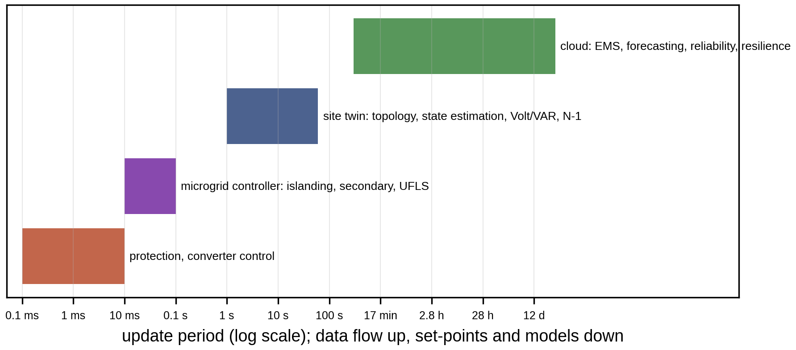
Figure 11.43. Multi-rate architecture of the P-1 microgrid twin: protection and converter control (milliseconds), microgrid controller at the edge (10 to 100 ms), site twin with state estimation and Volt/VAR (seconds), and cloud twin with EMS, forecasting and planning (minutes to days), with data flowing up and set-points and models flowing down.
Each layer must keep working when the one above it fails: the microgrid controller holds the last valid set-points and falls back to droop, the site twin falls back to fixed schedules, and relays fall back to their most conservative setting group. Table 11.12 specifies each function of the P-1 twin in the form a deployment needs, and Figure 11.44 places the functions on a common time axis.
TABLE 11.12 Function specification of the P-1 twin: class, location, timing, data, protocol, fallback and validation
Function | Class | Compute location | Cycle | Deadline | Data source | Protocol | Fallback | Validation
Overcurrent, UV, differential protection | Hard real-time | Relays | 1 to 4 ms | 20 to 100 ms to trip | CTs, VTs | Hard-wired, GOOSE, SV | Conservative group, local backup | Protection HIL
GFM current limiting, fault-mode logic | Hard real-time | Converter controller | 50 to 200 µs | Sub-cycle | Local sensors | Internal | Trip on DC or thermal limit | EMT and CHIL
Island detection and UFLS | Hard real-time | Microgrid controller | 10 to 20 ms | 100 to 200 ms | PMU, breaker status | GOOSE, C37.118 | Local UF relays | CHIL (IEEE 2030.8)
Secondary frequency and voltage control | Operational | Microgrid controller | 0.1 to 1 s | 1 s | PMU, DER telemetry | IEC 61850, IEEE 2030.5 | Droop only | CHIL
Topology processing | Operational | Site twin | Event-driven | 1 s | IED status, SCL | MMS, DNP3 | Last valid topology, trust degraded | Status–flow consistency
DSSE | Operational | Site twin | 1 to 4 s | 5 s | SCADA, PMU, AMI | DNP3, C37.118, MDM | Forecast-aided prior, trust degraded | Coverage on held-out meters
Volt/VAR optimization | Operational | Site twin | 1 to 5 min | 1 min | DSSE state | IEC 61850, IEEE 2030.5 | Local Volt/VAR curves | QSTS replay
Protection setting selection | Operational | Site twin | Per mode change | 1 s after mode change | Topology, DER status | MMS (signed files) | Pre-loaded conservative group | Protection HIL
EMS / MPC | Operational | Cloud or site | 15 min | 5 min | Forecasts, battery twin | Broker API | Last feasible schedule, then rules | Out-of-sample evaluation
Reliability, resilience, planning | Planning | Cloud | Daily to yearly | Hours | Historian, GIS, weather | Files, CIM | Previous study | Back-casting on recorded events
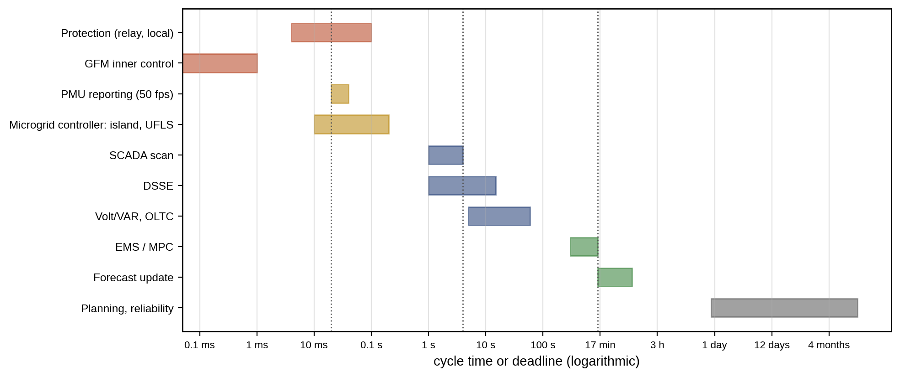
Figure 11.44. Cycle times and deadlines of the P-1 twin’s functions on a logarithmic time axis, from converter current control and protection (hard real-time, local) through the site twin (seconds) to the cloud (minutes to years).
Data flow upward with timestamps from a common time base (Section 11.4.2); models and settings flow downward with versions from the registry (Section 11.4.4). The software stack that implements this is less exotic than its diagrams suggest. At the edge, functions run as containerized services on industrial computers with real-time kernels where deadlines require them. A message broker distributes measurements and set-points with quality and time attributes; a time-series historian stores them; the model registry stores models and settings with their validation evidence; and every service can be rolled back to the previous version. Two situations need explicit design. After a communication outage, each layer has continued on its fallback, and on reconnection the twin must resynchronize before resuming control: re-read switch statuses and settings, re-estimate the state from fresh data, confirm that the devices are running the setting and model versions it believes they are, and only then return its trust state to valid. After a version change, the new model runs in shadow mode beside the old one until it has passed its validation gates on live data.
The state estimator’s cost scales with the network: a Gauss–Newton step on the 21-state feeder of Example 11.17 takes about 5 ms in an unoptimized script and well under a millisecond in compiled code, and sparse solvers handle thousands of three-phase buses within a second. The bottleneck is usually data latency and completeness, not computation.

11.20 HIL, PHIL and Co-simulation Validation
A twin that drives decisions must be validated against something more trustworthy than itself. Three kinds of closed-loop test provide it:
- Controller hardware-in-the-loop (CHIL). The real microgrid controller, relay or converter control board runs against a real-time EMT or phasor simulation of the network at time steps of 20 to 50 µs, exchanging low-level analogue and digital signals and protocol messages. Islanding, black start, protection and communication-failure sequences can then be exercised repeatedly and safely (Chapter 7, Section 7.18.3). IEEE 2030.8 [22] specifies test procedures for microgrid controllers in this setting.
- Power hardware-in-the-loop (PHIL). Real power equipment (an inverter, a battery, a load) is connected to the simulated network through a power amplifier. The interface is itself a closed loop with delay, and it can be unstable even when both sides are stable. With the ideal-transformer method, in which the simulation imposes a voltage on the hardware and receives its measured current, the interface is stable only if the ratio of the simulated network impedance to the hardware impedance satisfies $\left|Z_{sim}\left(jω\right)/Z_{hw}\left(jω\right)\right|<1$ over the frequencies where the loop delay adds significant phase [40]; otherwise damping-impedance or other interface algorithms are required. The interface delay and amplifier bandwidth also limit the accuracy of fast transients.
- Co-simulation. Power-system and communication-network simulators run together, synchronized in time, so that latency, packet loss and cyber attacks on the twin’s communications can be studied with their effect on the power system. Standard co-simulation interfaces (for example the Functional Mock-up Interface and time-synchronization frameworks) connect tools that were not designed together; the synchronization step of the co-simulation must be shorter than the fastest interaction being studied.
Validation compares the twin with the reference (field data, HIL or a more detailed model) on metrics chosen for the twin’s purpose, fixed in advance with acceptance thresholds: RMS and maximum errors of trajectories, errors of specific features (nadir, settling value, operating time, voltage at a limit), timing errors, and coverage of the twin’s stated uncertainty bands. Application B is a small example of the pattern: a pre-declared criterion, a comparison, a verdict for a purpose, and a recorded reason when the model fails.

11.21 A Reproducible P-1 Benchmark and Case Study
Every number in this chapter comes from one benchmark whose data are given here, so that each result can be reproduced and each method compared on the same system. Tables 11.13 to 11.16 give the loads, the network, DER, control and protection data, the measurements and the event scripts. All data are synthetic.
TABLE 11.13 P-1 benchmark: feeder loads (total 2.35 MW excluding P-1) and customers
Bus | 1 | 2 | 3 | 4 | 5 | 6 (P-1) | 7 | 8 | 9 | 10
Evening load $P$ (MW) at pf 0.95 lagging | 0.30 | 0.25 | 0.20 | 0.30 | 0.25 | 1.0 + j0.3 import | 0.30 | 0.20 | 0.25 | 0.30
Customers | 140 | 140 | 140 | 140 | 140 | 1 | 140 | 140 | 140 | 140

TABLE 11.14 P-1 benchmark: network, DER, control and protection data
Element | Data
Source | 11 kV, 1.00 pu at the substation busbar; short-circuit level 250 MVA ($X_{s}=0.484$ Ω)
Feeder | Ten 1 km sections, $0.25+j0.35$ Ω/km, rating 400 A; base 1 MVA, 11 kV ($Z_{b}=121$ Ω)
Tie | Normally open at bus 10 to an adjacent feeder held at 1.00 pu, 1 km of the same conductor
Plant transformer T1 | 2 MVA, 11/0.4 kV, Dyn11, 6 % on own rating
PV | 1.2 MWp, inverters 1.2 MVA, grid-following, Volt/VAR with IEEE 1547-2018 Category B defaults when enabled
Wind turbine T-1 | 2 MW, converter 2.2 MVA, grid-following, own 0.69/11 kV transformer
Battery | 0.5 MW / 1 MWh, inverter 0.6 MVA, grid-forming droop 1 % (frequency), response 50 ms, current limit 1.2 pu, one-way efficiency 95 %, 10 % minimum energy
EV car park, motors | Thirty 11 kW chargers (0.2 MW smart-charged, 09:00 to 15:00); twenty induction motors, group M1 75 kW
Inertia (islanding studies) | $H=1.0$ s on 2 MVA (motors plus emulated), load damping $D=1$
UFLS | 0.35 MW of non-critical load, 49.0 Hz threshold, 100 ms delay
Protection | R1 at substation: IEC standard inverse, 400 A, TMS 0.152; R2 at bus 5: 200 A, TMS 0.10
Critical loads | 250 kW, of which 150 kW essential
Prices | Import 0.10 $/kWh (00:00 to 06:00, 22:00 to 24:00), 0.18 (06:00 to 17:00, 21:00 to 22:00), 0.30 (17:00 to 21:00); export 0.06 $/kWh; imbalance 0.40 $/kWh

TABLE 11.15 P-1 benchmark: measurement placement and accuracy
Measurement | Location | Standard deviation | Rate
SCADA voltage magnitude | Buses 0 and 10 | 0.004 pu | 2 s
SCADA active and reactive flow | Feeder head | 0.01 pu | 2 s
PMU voltage magnitude and angle | Bus 6 (PCC) | 0.001 pu, 0.0005 rad | 50 frames/s
µPMU (Example 11.18) | Buses 7 and 8 | 0.0005 pu, 0.0001 rad | 50 frames/s
AMI voltage (Example 11.18) | Buses 7 and 8 | 0.002 pu | 15 min
Pseudo-measurements of $P$, $Q$ | Buses 1 to 10 | 15 % of value, at least 0.02 pu | Forecast

TABLE 11.16 P-1 benchmark: event scripts
Event script | Content | Used in
E1 Evening | P-1 imports 1.0 + j0.3 MW; loads of Table 11.13 | Examples 11.7, 11.17
E2 Midday export | Loads at 40 %; P-1 exports 2.0 MW at unity power factor | Example 11.7
E3 Hosting | Loads at 30 %; P-1 at zero exchange; PV at bus 10 | Examples 11.9, 11.10
E4 Unintentional island | 0.8 MW import lost at $t=0$ | Example 11.15, Application B
E5 Faulted data | Bad analogue, closed tie, correlated pseudo-measurements, stale PMU, section-8 impedance +30 % | Application A, Example 11.18
E6 Feeder fault | Bolted and 20 Ω faults between buses 7 and 8, both modes | Example 11.21, Application C
E7 Dispatch day | Profiles of Example 11.22; AR(1) forecast errors | Example 11.22, Application D
E8 Storm | Feeder cut at 14:00 for 24 h; storm ensemble | Example 11.27, Application E
Solver settings used throughout: forward–backward sweep and Newton–Raphson to a tolerance of ${10}^{−12}$ pu; WLS state estimation to a step below ${10}^{−10}$; frequency simulations by explicit Euler integration with a 0.1 ms step; LPs by the HiGHS solver; Monte Carlo seeds fixed and recorded. Table 11.17 lists the reference results a reimplementation should reproduce, with tolerances that allow for different solvers and random-number streams.
TABLE 11.17 Reproducibility table: reference results of the P-1 benchmark
Result | Reference value | Tolerance
Minimum evening voltage (E1) | 0.940 pu at bus 10 | ±0.001 pu
Feeder losses and head power (E1) | 118 kW; 3.468 MW | ±1 kW; ±0.002 MW
Hosting capacity at bus 10 without / with Volt/VAR (E3) | 3.3 / 6.2 MW | ±0.1 MW
Islanding nadir, $H=1$ s, with UFLS (E4) | 48.68 Hz | ±0.02 Hz
Bad-data identification (E5) | Largest normalized residual on bus-10 voltage | Same measurement
Island fault current / island load current (E6) | 94 A / 58 A | ±1 A
Calm-day cost without / with battery (E7) | 1129 / 976 $ | ±2 $
Essential energy served in the storm, twin strategy (E8) | 59 % | ±1 point
Probabilistic HC 5th percentile with Volt/VAR | 5.8 MW | ±0.3 MW (sampling)
Application E median full-recovery time | 13.4 h | ±1 h (sampling)
Table 11.18 assembles the chapter into the specification of the P-1 twin. Each row lists the measurements a function needs, the model it runs, the result obtained on the benchmark, and the decision it supports.
TABLE 11.18 The P-1 microgrid twin: specification and results on the benchmark (synthetic data)
Function | Measurements | Model | Result | Decision
Feeder power flow | SCADA at head and end, PMU at PCC, AMI | FBS (11.30)–(11.31) | Minimum 0.940 pu (evening), 1.012 pu (midday export) | Raise OLTC set-point to 1.03 pu in the evening; enable Volt/VAR
Hosting capacity | Feeder model, DER settings | FBS with Volt/VAR; Monte Carlo (11.39) | 3.3 to 6.2 MW; 5th percentile 5.8 MW with Volt/VAR | Approve PV connections with Volt/VAR enabled
State estimation | 26 measurements incl. pseudo | WLS (11.67), LNR (11.71), Huber (11.72) | Bad transducer identified; switch error detected in 72 % | Replace transducer; add tie status telemetry; keep PMU
Parameter estimation | µPMUs at buses 7, 8 | Augmented WLS | Section-8 impedance 1.30 ± 0.14 of record | Correct GIS record
Islanding | PMU frequency, battery state | Swing (11.57), battery (11.59) | Nadir 48.7 Hz with 0.35 MW shed | Cap import at battery power or arm UFLS
GFM fault behaviour | Converter settings | Current-limited droop (11.45) | Loss of synchronism beyond 1.0 s without set-point reduction | Enable fault-mode set-point reduction; confirm in EMT
Protection | Topology, DER status | Mode-specific fault model | Island fault 94 A below 200 A pickup | Differential or directional with blocking, UV backup
Dispatch | Forecasts, prices, battery state | LP and chance-constrained LP | 153 $ saving; expected cost down 15 % with uncertainty-aware reserve | Daily chance-constrained schedule in MPC loop
Contingency | Network model, flows | PTDF/LODF (11.97), AC check | Outage of 1–3 overloads 3–4 by 6 MW | Pre-plan load transfer at bus 3
Resilience | Storm forecast, battery, EVs | Energy balance, tiering; storm ensemble | Essential load 59 % served; P-1 outage exceeds endurance in 58 % of storms | Size 1.6 MWh extra storage or a generator
The case study also records what was not shown. The reference “measurements” were generated by models that share much of the twin’s structure, so structural model error is tested only where a higher-fidelity model was used (Application B); the converter behaviour in the protection and GFM studies is representative, not vendor-specific; and the fragility and forecast-error parameters are illustrative. Each is a validation task for deployment: comparing estimated and measured voltages at buses not used by the estimator, recording islanding and fault transients with PMUs and fault recorders, testing the actual relays and converter controls in HIL, and calibrating fragility curves from damage records.

11.22 Assurance, Trust and Safe Fallback
Following the gate-plus-KPI structure of Chapter 10 (Section 10.24), a microgrid twin is deployed only after passing mandatory gates. It is then scored on performance indicators, with evidence for each (Table 11.19). A single weighted score is not used, because an excellent state estimator cannot compensate for a protection scheme that fails in island.
TABLE 11.19 Assurance case for the P-1 microgrid twin: gates first, then KPIs (criteria are examples)
Type | Criterion | Evidence in this chapter | Status
Gate: protection | Every fault detected in every operating mode, with no dependence on the twin at fault time | Application C screening | Passes in screening with differential or directional + UV backup; to be confirmed in protection HIL
Gate: stability | Frequency above UFLS and DER trip limits for the largest credible event; GFM units synchronized through credible faults | Example 11.15; Example 11.11 | Passes with UFLS armed; GFM requires fault-mode set-point reduction
Gate: timing | Island detection and shedding within 200 ms; secondary-control delay below its stability bound (11.56) | Simulated 100 ms shed delay; 105 ms delay bound | To be verified in CHIL
Gate: cybersecurity | Authenticated measurements and set-points; protected measurement set against stealthy FDI | Section 11.12.4; Chapter 14 | To be verified
Gate: command path | Every actuation passes the safe-command gate; fallback tested for loss of twin, channel and time | Section 11.1.1, Table 11.12 | To be verified in HIL
KPI: voltage estimation | Error at unmonitored buses below 0.005 pu; 95 % interval coverage 90 to 98 % | 0.85 mpu, 94 % (clean) | Pass (synthetic)
KPI: data-fault handling | Gross errors above 5σ identified; switch errors detected above 90 % | 100 %; 72 % | Partial: add tie status telemetry
KPI: model validity | Pre-declared validation criteria met for each use | Application B: nadir passes, recovery fails | Use restricted to UFLS design
KPI: dispatch value | Realized cost within 5 % of plan | Application D (out-of-sample) | Needs operation data
KPI: forecast calibration | Interval coverage 85 to 95 % | Chapters 6 and 8 | Needs site data
KPI: resilience | Essential load served for 24 h | 59 % | Fails: resource gap sized
Trust is not a one-time certificate. NIST IR 8356 [27] identifies security and trust considerations specific to digital twins: the twin is an additional attack surface that holds a complete model of the system; its data and models can be poisoned during calibration; its commands can be spoofed; and its outputs are only as trustworthy as its synchronization with the physical system. A grid twin answers these with the mechanisms developed in this chapter, and runs them continuously:
- Trust state. Valid, degraded or untrusted, computed from the synchronization checks of Table 11.1, residual tests, time-synchronization status and model-version checks. Only a valid twin may issue automatic commands; a degraded twin may advise an operator; an untrusted twin is disconnected from the decision path.
- Out-of-distribution detection. Inputs far from the conditions on which a model (especially a learned one) was validated downgrade the trust state, as Application A showed is necessary.
- Uncertainty coverage. Stated intervals are checked against held-out measurements; coverage below target is a failure of the twin, not of the data.
- Command authorization. Commands are signed, rate-limited, bounded by physical limits and checked against the current trust state at the safe-command gate before reaching equipment.
- Safe state. For every twin function there is a defined behaviour without the twin: local droop, last valid set-point, conservative setting group, rule-based schedule. It is tested, not assumed.

11.23 Research Frontiers and Technology Roadmap
The directions below are grouped by how soon they can be deployed, with the evidence each needs to move to the next column (Table 11.20, Figure 11.45). Table 11.21 gives the status of the standards and guidance cited in the chapter.
Grid-forming converters at scale. Grid-forming inverters must provide voltage, synchronizing power and system strength as synchronous machines retire. Open problems are the stability of many interacting GFM units with current limits, their behaviour during unbalanced faults, and specifications that can be tested: the IEEE P2800.1 and P2800a projects approved in December 2025 are the first dedicated IEEE efforts.
Three-phase state estimation with sparse, asynchronous data. Smart meters are slow and PMUs few. Forecast-aided, robust and physics-informed estimators with calibrated uncertainty, optimal µPMU placement for identifiability, and phase identification from AMI data are active topics, with the open problem of provable coverage when most inputs are pseudo-measurements.
Semantic and interoperable twins. IEC TR 61850-90-30 allows functions to be specified independently of devices in SCL, and CIM carries network models between organizations; the open problem is an automatic, verified path from these descriptions to executable twin models, with provenance.
Adaptive and communication-assisted protection. Protection that reconfigures with topology and DER status, travelling-wave and differential schemes over packet networks, and converter fault signatures; the open problem is assuring dependability and security under communication failure and cyber attack.
Hybrid physics–AI twins. Learned surrogates for EMT models, learned estimators and forecasters beside physics-based ones; the open problem is formal bounds on their error and detection of when they are outside their domain.
Resilience under climate change. Probabilistic hazard models joined to fragility and restoration models; the open problem is validated fragility curves and restoration models from real events, and their change with climate.
TABLE 11.20 Roadmap of microgrid and grid twins by deployment horizon
Horizon | Topic | Enabling data or technology | Main barrier | Measurable target
Deployable now | Volt/VAR with OLTC coordination; VVO | Feeder model, DER telemetry, DSSE | Model accuracy, DER setting management | Voltage violations and tap operations per year
Deployable now | Adaptive setting groups | Topology and DER status, protection HIL | Verification effort | Faults detected in all modes in HIL
Deployable now | WLS DSSE with PMU/µPMU; dynamic cable ratings | SCADA, PMU, AMI, DTS | Sparse data, soil uncertainty | Estimate error and interval coverage at unmonitored buses
2 to 5 years | GFM specifications and conformance testing | IEEE P2800.1, P2800a; vendor models | Standards in development, EMT model access | Nadir, RoCoF and fault ride-through with high converter share
2 to 5 years | Edge three-phase DSSE with phase identification | AMI, µPMU | Data access and latency | Phase-level voltage error and coverage
2 to 5 years | Semantic twins from SCL and CIM | IEC TR 61850-90-30, CGMES | Tool support, data quality | Share of twin model generated automatically and validated
2 to 5 years | Probabilistic hosting capacity in planning | QSTS, AMI | Computational cost, data | Connections approved against quantiles
5 to 10 years | Federated TSO–DSO twins | Flexibility regions, privacy-preserving coordination | Market design, trust between parties | Flexibility delivered against offered
5 to 10 years | Autonomous restoration with verified guarantees | Twin, switching automation | Assurance of autonomous actions | Restoration time with no unsafe action in HIL
5 to 10 years | Climate-fragility twins | Event and damage records | Rare-event data | Energy served in validated storm scenarios
5 to 10 years | Stability certificates for many GFM units | Converter models, impedance data | Scalability of analysis | Certified stable operating envelope
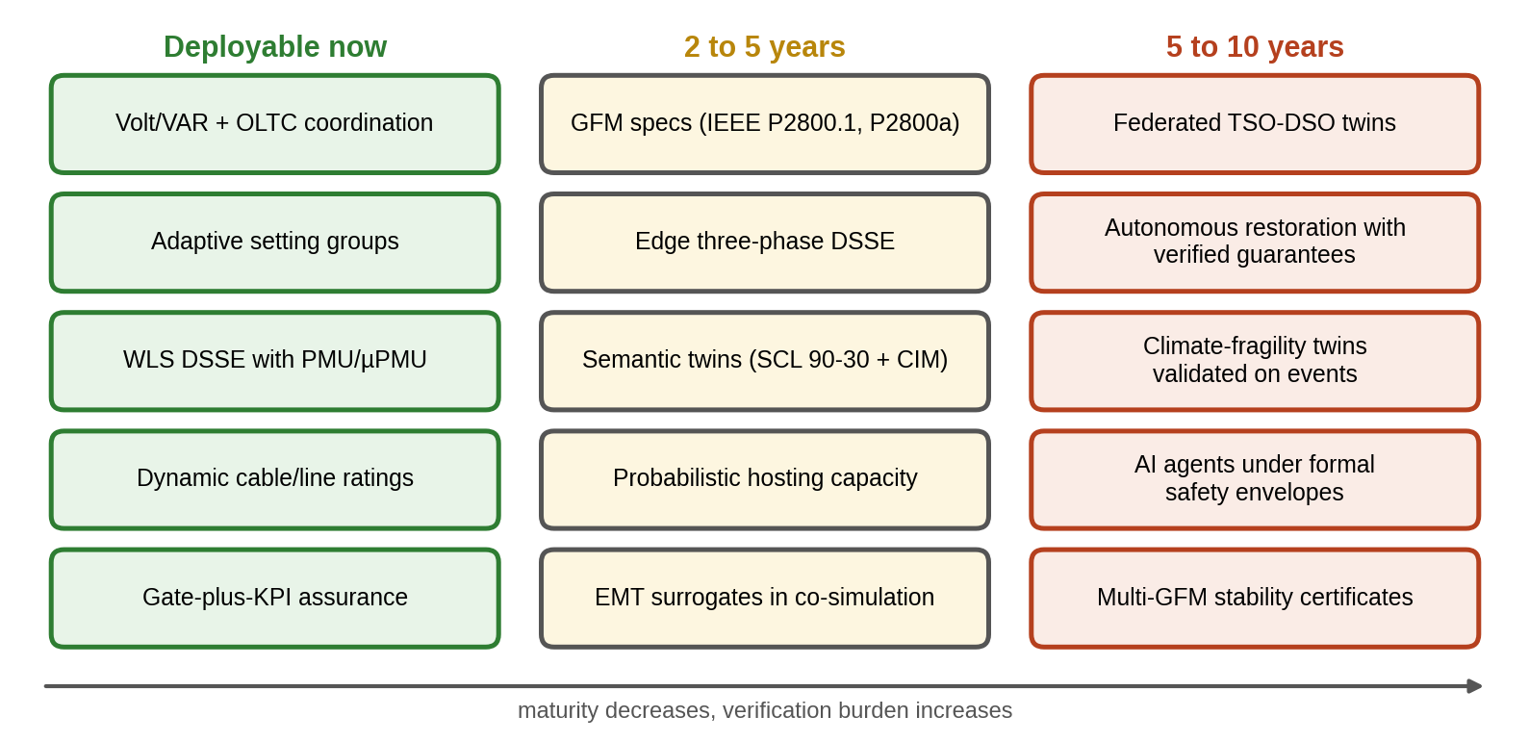
Figure 11.45. Technology roadmap for microgrid and grid twins: capabilities deployable now, expected within 2 to 5 years, and research targets for 5 to 10 years, with maturity decreasing and verification burden increasing from left to right.
TABLE 11.21 Status of the standards and guidance cited in this chapter
Document | Scope relevant to this chapter | Status (September 2026)
IEEE 1547-2018, IEEE 1547.1-2020 | DER interconnection and conformance tests (distribution) | Published
IEEE 2800-2022 | Inverter-based resources on transmission | Published
IEEE 2800.2-2026 | Test and verification for IEEE 2800 conformity | Published 2026
IEEE P2800.1 | Recommended practice for grid-forming equipment | Project (PAR approved December 2025)
IEEE P2800a | Amendment of IEEE 2800 for grid-forming equipment | Project (PAR approved December 2025)
IEEE 2030.7-2017, IEEE 2030.8-2018 | Microgrid controller specification and testing | Published; check for revisions
IEC 61850 series; IEC TR 61850-90-30:2025 | Substation communication; function modelling in SCL | Published
IEC 61970/61968 (CIM), CGMES | Network model exchange | Published, maintained
IEC 60287, IEC 60853 | Steady-state and cyclic/emergency cable ratings | Published
IEC 61000-4-30, EN 50160, IEEE 519-2022 | Power-quality measurement, supply characteristics, harmonic limits | Published
NIST IR 8356 (February 2025) | Security and trust considerations for digital twins | Published

11.24 Summary and Key Equations
A microgrid connects the assets of the earlier chapters into a system whose behaviour none of them shows alone, and its twin must be synchronized with that system in topology, state, parameters, events, model version and uncertainty, with an explicit trust state and a safe-command gate between its decisions and the equipment. The chapter built this from the basics: phasors, complex power with stated sign conventions, per unit and symmetrical components on a real feeder, with the observation that unbalance metrics are not interchangeable. AC, DC and hybrid architectures followed, including constant-power-load instability and normalized interlinking-converter coordination. Measurements were treated as objects with time, latency and quality, and semantics from IEC 61850 SCL and CIM as the route from device data to a network model.
Power flow was solved by hand, by Newton–Raphson and by the forward–backward sweep, with LinDistFlow’s error quantified and a hierarchy of simulation fidelity from QSTS to EMT. The P-1 feeder fell to 0.940 pu in the evening; Volt/VAR nearly doubled its hosting capacity, and a probabilistic study showed the distribution behind that number. Grid-following and grid-forming converters were developed with their loops, limits and fault behaviour: a current-limited GFM unit lost synchronism in a long fault unless its set-point was reduced. Islanding needed load shedding to hold 48.7 Hz, a small-signal model showed how droop gain and resistive coupling erode damping, and a higher-fidelity model showed that the aggregate frequency twin is valid for the nadir but not for the recovery.
State estimation detected and identified a bad transducer, but switch-status, timestamp and parameter errors were model errors that no estimator could repair, a stealthy attack passed every residual test, and a learned estimator was fast and accurate in distribution but blind outside it. Protection coordinated for grid-connected operation failed in island, where inverter fault current barely exceeds load current, and a combination of communication-assisted and voltage-based protection with adaptive setting groups passed the screening. Uncertainty-aware energy management lowered the expected daily cost by about 15 %, while showing that forecast reserves erode islanding readiness unless re-planned. Flexibility regions shrank by a third once the internal network was considered, reliability indices were shown with their distribution, N-1 screening was checked in AC and extended to radial restoration, and a storm ensemble turned resilience into distributions of energy not served and recovery time. A function specification, HIL and co-simulation validation, a reproducible benchmark, an assurance case and a dated roadmap closed the chapter. Table 11.22 collects the key equations.
TABLE 11.22 Key equations of Chapter 11
Relationship | Expression | Eq.
Complex power | $\overset{‾}{S}=\overset{‾}{V}{\overset{‾}{I}}^{*}=P+jQ$ | (11.3)
Per unit | $I_{b}=S_{b}/\left(\sqrt{3}V_{b}\right)$, $Z_{b}=V_{b}^{2}/S_{b}$ | (11.5)
Symmetrical components, VUF | $A^{−1}=\frac{1}{3}A^{H}$; $VUF=|{\overset{‾}{V}}_{2}|/|{\overset{‾}{V}}_{1}|$ | (11.7)
CPL stability | $C>LP/\left(RV^{2}\right)$, $RP/V^{2}<1$ | (11.13)
ILC coordination | $P_{IC}=K_{IC}\left(v_{pu}−f_{pu}\right)$ | (11.15)
Age-inflated variance | $σ_{eff}^{2}=σ^{2}+{\left(τσ_{\dot{z}}\right)}^{2}$ | (11.17)
Admittance matrix | $\overset{‾}{I}=Y\overset{‾}{V}$ | (11.22)
Two-bus exact solution | $V_{2}^{4}+\left[2\left(PR+QX\right)−V_{1}^{2}\right]V_{2}^{2}+\left(P^{2}+Q^{2}\right)\left(R^{2}+X^{2}\right)=0$ | (11.26)
DistFlow | (11.30), (11.31) | (11.31)
Volt/VAR | (11.36) | (11.36)
Probabilistic hosting capacity | $HC_{α}=F_{HC}^{−1}\left(α\right)$ | (11.39)
PLL closed loop | $ω_{n}=\sqrt{Vk_{i}}$, $ζ=\frac{k_{p}}{2}\sqrt{V/k_{i}}$ | (11.42)
Droop–VSM equivalence | $J_{v}=1/\left(m_{p}ω_{c}\right)$, $D_{v}=1/m_{p}$ | (11.44)
Virtual-impedance current limit | $X_{v}=max\left(0,|E−V_{g}e^{−jδ}|/I_{max}−X\right)$ | (11.45)
Island-detection NDZ | ${\left(V/V_{max}\right)}^{2}−1≤ΔP/P_{DER}≤{\left(V/V_{min}\right)}^{2}−1$ | (11.46)
Droop and sharing | $f_{i}=f_{0}−m_{p,i}\left(P_{i}−P_{0,i}\right)$; (11.51) | (11.50)
Consensus delay bound | $τ<π/\left(2kλ_{max}\right)$ | (11.56)
Swing equation, RoCoF | $\frac{2H}{f_{0}}\dot{f}=ΔP−DΔf/f_{0}$; ${RoCoF}_{0}=f_{0}ΔP/\left(2H\right)$ | (11.57), (11.58)
ZIP small-signal sensitivity | $P/P_{0}≈1+\left(2a_{Z}+a_{I}\right)Δv$ | (11.64)
WLS state estimation | $GΔx=H^{T}R^{−1}\left(z−h\right)$ | (11.67)
Normalized residual | $r_{i}^{N}=|r_{i}|/\sqrt{Ω_{ii}}$ | (11.71)
Stealthy FDI | $a=Hc⇒r$ unchanged | (11.73)
Cable emergency rating | (11.76) | (11.76)
Harmonic distortion | ${THD}_{V}=\sqrt{∑V_{h}^{2}}/V_{1}$ | (11.77)
Inverse-time relay | $t=TMS 0.14/\left({\left(I/I_{s}\right)}^{0.02}−1\right)$ | (11.78)
Dispatch LP | (11.82)–(11.84) | (11.84)
Chance constraint | $g_{j}\left(u,\hat{w}\right)+z_{1−α}σ_{j}≤0$ | (11.88)
Reliability indices | (11.93) | (11.93)
DC flow, PTDF, LODF | (11.96), (11.97) | (11.97)
Resilience | $R=∫P_{served}/∫P_{demand}$ | (11.98)

Exercises
The fifteen exercises are grouped by theme. Most combine a numerical part, a derivation and a question about what can go wrong, so that each can be set as one assignment; the last two are open research and design projects. Complete solutions to all fifteen are given in the Answer Key.

Group A: fundamentals and microgrid architectures
11.1 Per-unit and three-phase quantities. (a) A system has $S_{b}=10$ MVA and $V_{b}=13.8$ kV. Find $I_{b}$ and $Z_{b}$ by (11.5). (b) A low-voltage system uses $S_{b}=100$ kVA and $V_{b}=400$ V. Find $I_{b}$ and $Z_{b}$. (c) Phase voltages are $230∠0°$, $225∠−122°$ and $228∠119°$ V. Find $V_{1}$, $V_{2}$ and VUF by (11.7). (d) Current harmonics are 5 %, 3.5 % and 2 % of the fundamental. Find $THD_{I}$.
11.2 Voltage drop and loadability. (a) A feeder segment carries 500 kW and 200 kvar through $R=0.3$ Ω and $X=0.5$ Ω at 13.8 kV. Find the voltage drop by (11.27). (b) A line with $R=0.02$ and $X=0.04$ pu feeds a load of $0.8+j0.3$ pu from a 1.0 pu source. Find the load voltage exactly by (11.26) and approximately by (11.27). (c) Derive (11.26) from (11.25), and show that the loadability limit is where its discriminant vanishes. Why is the approximate drop misleading near this limit?
11.3 DC and hybrid microgrids. (a) A DC bus at 380 V is fed through $R=0.05$ Ω and $L=0.5$ mH and supplies a 10 kW constant-power load. Find the minimum bus capacitance by (11.13). (b) Derive (11.12) from (11.11) and show that (11.13) is necessary and sufficient for stability of the lumped model. (c) In the hybrid microgrid of Example 11.4, a 30 kW step occurs on the DC side instead. Find the frequency, the DC voltage and the interlinking-converter transfer.

Group B: control, dynamics and islanding
11.4 Droop sharing and the virtual synchronous machine. (a) Two grid-forming inverters, A (80 kW) and B (40 kW), have droop gains inversely proportional to rating. How do they share a 60 kW load step? (b) Three units rated 200, 100 and 100 kW share an 80 kW step with droops allowing 0.5 Hz at rating. Find each share and the frequency change by (11.51). (c) Derive (11.51) from (11.50) with a common steady-state frequency. (d) Derive the droop-VSM equivalence (11.44), and find the equivalent inertia constant $H=J_{v}ω_{0}/2$ at 50 Hz of a unit with $m_{p}$ corresponding to 0.5 Hz per unit and a 5 Hz power filter.
11.5 Frequency dynamics and secondary control. (a) A microgrid has $H=2.5$ s and faces a 0.2 pu deficit. Find the initial RoCoF at 50 Hz by (11.58), and state how halving $H$ changes it. (b) Derive (11.57) and (11.58) from the kinetic energy of the rotating masses. (c) Why does inertia affect how fast frequency falls but not whether it recovers? (d) Four units in a ring communicate with their two neighbours (Laplacian eigenvalues 0, 2, 2 and 4) with consensus gain $k=2$ s$​^{−1}$. Find the largest tolerable uniform delay by (11.56).
11.6 Islanding detection and resynchronization. (a) Using (11.46), find the active-power non-detection zone of a passive voltage relay with $V_{min}=0.90$ and $V_{max}=1.10$ pu at a pre-island voltage of 1.0 pu. (b) Derive (11.46) for a resistive island load. (c) A 1 MVA DER wants to reconnect with $Δf=0.15$ Hz, $ΔV=4$ % and $Δθ=18°$. May the breaker close under the IEEE 1547-2018 limits quoted in Section 11.9.2?
11.7 Converter limits, Volt/VAR and load response. (a) In Example 11.11, the unlimited unit never loses synchronism but the limited one does. Explain why with (11.45), and state two control changes that restore fault ride-through. (b) An inverter's Volt/VAR curve follows (11.36) with Category B defaults. What reactive power does it absorb at 1.05 pu, as a fraction of its rating? (c) A tap step raises the voltage by 1.5 % and the feeder load by 1.2 %. Estimate $k_{pv}$ and say what can and cannot be concluded about the ZIP coefficients.

Group C: state estimation and data trust
11.8 Weighted least squares. (a) Derive the normal equations (11.67) from (11.66). (b) A state estimator gives $J\left(\hat{x}\right)=35.2$ against a 99 % chi-square threshold of 30.1. Is bad data indicated, and what is the next step? (c) Using Table 11.5, which measurement type most directly resolves a lack of phase-angle information in a network segment, and why?
11.9 Bad data, topology errors and stealthy attacks. (a) Show that $SH=0$ for the residual sensitivity matrix of Section 11.12.4, and hence derive (11.73). (b) Residuals grow on several measurements around one switch at once, while each alone is only moderately large. What kind of error is likely, and how is it confirmed? (c) Why can a critical measurement never be checked by the estimator, and what should the twin do about it? (d) Correlated pseudo-measurement errors raised the chi-square false-alarm rate from 1 % to 25 % without degrading accuracy much. Explain, and give the remedy.
11.10 Stale data, failed twins and learned estimators. (a) A SCADA voltage with $σ=0.005$ pu arrives 3 s old; the voltage changes with a standard deviation of 0.002 pu/s. Find its effective standard deviation by (11.17). (b) The P-1 twin reports all feeder voltages within limits, while customers at bus 10 complain of low voltage every evening. Logs show that the substation tap changer's position has been read as 0 since a firmware update. Explain the failure using (11.19), and propose residual checks that would have detected it. (c) In Application A, the learned estimator is the most accurate on clean data, but its interval coverage collapses on every abnormal condition. Why, and how should it be used in a twin?

Group D: assets, protection and operation
11.11 Ratings and protection. (a) A cable with $τ_{c}=2$ h, starting cold, must carry an emergency current for 1 h. Find the allowed ratio $I_{em}/I_{R}$ by (11.76). (b) Find the operating time of an IEC standard-inverse relay with $I_{s}=400$ A and TMS = 0.2 for a 2000 A fault by (11.78). (c) A microgrid relay coordinated for grid-connected operation fails to trip for an island fault. Explain why with (11.80), name two protection principles that would work, and explain why a relay's trip decision must never wait for the twin.
11.12 Forecast uncertainty, reserves and aggregation. (a) A net-load forecast has $σ_{f}=60$ kW. Find the reserve for 99 % one-sided coverage by (11.85). (b) Five microgrids have net-load forecast standard deviations of 50 kW with pairwise correlation 0.5. Find the aggregate standard deviation by (11.92), and compare with independent and perfectly correlated errors. (c) Why can a reserve held for forecast errors reduce the microgrid's readiness to island?
11.13 Reliability and contingencies. (a) A radial feeder has three sections in series, each with $λ=0.2$ per year, feeding load points with 100, 200 and 100 customers at the ends of sections 1, 2 and 3; repair takes 5 h and switching 1 h. Find SAIFI, SAIDI and CAIDI by (11.94) and (11.93). (b) Line $l$ carries 20 MW and line $k$ (buses $m$ to $n$) 30 MW. With $PTDF_{l,m}=0.3$, $PTDF_{l,n}=0$, $PTDF_{k,m}=0.5$ and $PTDF_{k,n}=0$, find $LODF_{l,k}$ and the flow on $l$ after $k$ trips. (c) Derive (11.97) by representing the outage of line $k$ as a pair of injections that cancel its flow.

Group E: research and design
11.14 Research project: modelling and estimation on the P-1 feeder. Using the parameter tables of Section 11.21: (a) build a three-phase unbalanced model of the feeder with single-phase laterals and compare its voltage violations with the balanced model of Example 11.7; (b) place two additional PMUs to minimize the maximum standard deviation of the estimated voltages; (c) build a three-phase estimator for the low-voltage feeder of Example 11.8 with smart-meter data, including phase identification of the customers, and report the coverage of its intervals; (d) reproduce Example 11.11 with an averaged EMT model of the converter and compare the critical fault duration with the RMS result.
11.15 Design project: a twin for a community microgrid. A community microgrid serves 400 homes, a school (emergency shelter) and a health centre from a 1 MW PV plant, a 1 MW / 2 MWh grid-forming battery and the 11 kV feeder of this chapter. Stating the provenance of every number and labelling synthetic data, produce: (a) a single-line diagram with meter placement, time sources and the SCL/CIM model of the site; (b) balanced and unbalanced power flow and probabilistic hosting capacity; (c) an islanding, black-start and resynchronization plan with RMS frequency simulations, EMT checks of the grid-forming unit's current limiting, and load-shedding settings; (d) a three-phase state-estimation design with observability, bad-data, topology and parameter analysis; (e) adaptive protection for both modes, specified for protection HIL; (f) a daily EMS in a rolling-horizon MPC loop with separate forecast and islanding reserves, extended to a multi-stage stochastic program; (g) reliability and 48-hour storm-resilience assessments for the shelter and health centre, reported as distributions; and (h) a function specification with timing and fallbacks, and an assurance case with gates, KPIs and a trust-state design.

Answer Key
11.1 (a) $I_{b}={10}^{7}/\left(\sqrt{3}×13 800\right)=418.4$ A; $Z_{b}=13 {800}^{2}/{10}^{7}=19.04$ Ω.
(b) $I_{b}={10}^{5}/\left(\sqrt{3}×400\right)=144.3$ A; $Z_{b}={400}^{2}/{10}^{5}=1.6$ Ω.
(c) With $a=1∠120°$, $V_{1}=\frac{1}{3}\left(V_{a}+aV_{b}+a^{2}V_{c}\right)$ and $V_{2}=\frac{1}{3}\left(V_{a}+a^{2}V_{b}+aV_{c}\right)$ give $V_{1}=227.6$ V and $V_{2}=2.55$ V, so VUF $=V_{2}/V_{1}=1.12$ %.
(d) $THD_{I}=\sqrt{{0.05}^{2}+{0.035}^{2}+{0.02}^{2}}=6.4$ %.
11.2 (a) $ΔV≈\left(PR+QX\right)/V=\left(500 000×0.3+200 000×0.5\right)/13 800=18.1$ V, 0.13 %.
(b) Exact: $V_{2}=0.9708$ pu from (11.26); approximate: $1−\left(0.8×0.02+0.3×0.04\right)=0.972$ pu.
(c) Squaring and adding the real and imaginary parts of (11.25) eliminates the angle $δ$ and leaves a quadratic in $V_{2}^{2}$: $V_{2}^{4}+\left[2\left(PR+QX\right)−V_{1}^{2}\right]V_{2}^{2}+\left(P^{2}+Q^{2}\right)\left(R^{2}+X^{2}\right)=0$, whose larger root is (11.26). Real roots exist only while ${\left[2\left(PR+QX\right)−V_{1}^{2}\right]}^{2}≥4\left(P^{2}+Q^{2}\right)\left(R^{2}+X^{2}\right)$; the loadability limit is where the discriminant vanishes and the two roots merge. Near it $dV_{2}/dP$ becomes unbounded, while the linear approximation keeps a constant slope, so it underestimates the drop just where the error matters most.
11.3 (a) $C>LP/\left(RV^{2}\right)=0.5×{10}^{−3}×{10}^{4}/\left(0.05×{380}^{2}\right)=0.69$ mF.
(b) Linearizing the load current $P/v$ about $V_{0}$ gives an incremental resistance $−V_{0}^{2}/P$; Laplace-transforming the lumped RLC equations and eliminating the current gives a second-order characteristic polynomial with positive leading coefficient, which is Hurwitz if and only if its other two coefficients are positive. These two conditions are (11.12); for the usual parameters the binding one is (11.13).
(c) $f_{pu}=v_{pu}=−30/150=−0.2$, so $f=49.9$ Hz and $V_{dc}=376$ V; the AC sources supply 20 kW, which the interlinking converter carries to the DC side, and the DC sources 10 kW.
11.4 (a) In proportion to rating: 40 kW and 20 kW.
(b) 40, 20 and 20 kW; $Δf=−80/\left(400+200+200\right)=−0.1$ Hz.
(c) Equal frequencies give $m_{p,i}ΔP_{i}=−Δf$ for all $i$; summing $ΔP_{i}=−Δf/m_{p,i}$ over the units equals $ΔP_{L}$, so Δf=−ΔPL/i​1/mp,i and each unit takes its share in proportion to $1/m_{p,i}$.
(d) Differentiating $ω−ω_{0}=−m_{p}\left(P_{f}−P^{*}\right)$ and substituting ${\dot{P}}_{f}=ω_{c}\left(P−P_{f}\right)$, then eliminating $P_{f}$ with the droop equation, gives $\frac{1}{m_{p}ω_{c}}\dot{ω}=P^{*}−P−\frac{1}{m_{p}}\left(ω−ω_{0}\right)$, the swing equation with $J_{v}=1/\left(m_{p}ω_{c}\right)$ and damping $1/m_{p}$. With $m_{p}=2π×0.5=3.14$ rad/s per pu and $ω_{c}=2π×5=31.4$ rad/s, $J_{v}=0.0101$ and $H=0.0101×314.2/2=1.6$ s.
11.5 (a) $\dot{f}=f_{0}ΔP/\left(2H\right)=50×0.2/\left(2×2.5\right)=2$ Hz/s; halving $H$ doubles it to 4 Hz/s.
(b) $dE_{k}/dt=Jω\dot{ω}=P_{m}−P_{e}$; with $H=E_{k}/S_{b}$ and $ω/ω_{0}≈1$, $2H\dot{f}/f_{0}=ΔP_{pu}$, which is (11.58); integrating over the machines gives (11.57).
(c) Inertia sets the rate at which a power imbalance changes the stored kinetic energy, so it scales the initial RoCoF and, with the response speed, the nadir. Whether frequency recovers depends on whether primary and secondary control can close the power imbalance, which inertia does not supply.
(d) $τ_{c}=π/\left(2kλ_{max}\right)=π/\left(2×2×4\right)=0.196$ s.
11.6 (a) From ${\left(1/1.1\right)}^{2}−1=−17.4$ % to ${\left(1/0.9\right)}^{2}−1=+23.5$ % of the DER output.
(b) Before islanding $P_{L}=V^{2}/R_{L}=P_{DER}+ΔP$; after, $V′^{2}/R_{L}=P_{DER}$. Dividing, $V′/V=\sqrt{P_{DER}/\left(P_{DER}+ΔP\right)}$; requiring $V_{min}≤V′≤V_{max}$ for non-detection gives ${\left(V/V_{max}\right)}^{2}−1≤ΔP/P_{DER}≤{\left(V/V_{min}\right)}^{2}−1$.
(c) No: the 18° angle difference exceeds the 15° limit, although the frequency and voltage differences are within theirs.
11.7 (a) The current limiter adds a virtual impedance $X_{v}$, which lowers the fault-time maximum of $P\left(δ\right)$ below $P^{*}$, so the droop loop keeps accelerating the angle until synchronism is lost. Reducing $P^{*}$ during the fault below the limited maximum, or freezing the angle by switching the outer loop to a fault mode, restores ride-through; a smaller droop gain lengthens the survivable fault.
(b) $Q/S=−0.44×\left(1.05−1.02\right)/\left(1.08−1.02\right)=−0.22$: it absorbs 22 % of its rating.
(c) $k_{pv}≈1.2/1.5=0.8$, so $2a_{Z}+a_{I}≈0.8$ and an exponential model would have $α≈0.8$. The individual ZIP coefficients cannot be separated from small steps, because one equation constrains three unknowns (Example 11.16); larger excursions or several operating points are needed.
11.8 (a) $∇J=−2H^{T}R^{−1}\left[z−h\left(x\right)\right]=0$; linearizing $h$ about $x^{\left(k\right)}$ gives $H^{T}R^{−1}H Δx=H^{T}R^{−1}\left[z−h\left(x^{\left(k\right)}\right)\right]$, the normal equations (11.67).
(b) Yes, $J$ exceeds the threshold. Compute the normalized residuals (11.71), remove the measurement with the largest if it exceeds about 3, re-estimate, and repeat one measurement at a time.
(c) A PMU, because it measures the voltage phase angle directly against a common time reference; SCADA magnitudes and flows constrain angles only through the network model.
11.9 (a) $SH=H−HG^{−1}H^{T}R^{−1}H=H−HG^{−1}G=0$; hence $r\left(z+Hc\right)=r\left(z\right)$, and the estimate shifts by $G^{−1}H^{T}R^{−1}Hc=c$: an injection of the form $Hc$ moves the state without changing any residual, which is (11.73).
(b) A topology (switch-status) error. Confirm it by re-estimating with the switch status as a free variable, or by comparing $J$ for the candidate topologies; PMU angles are especially informative.
(c) Its residual is always zero, because removing it would make the network unobservable, so nothing else can contradict it. Add a redundant measurement so that it becomes checkable, and meanwhile mark the estimates that depend on it as untested in the trust state.
(d) $J$ assumes independent errors; a common error component does not average out and inflates $J$ without moving the estimate much. Model the correlation in $R$ (11.69) from historical forecast residuals.
11.10 (a) $\sqrt{{0.005}^{2}+{\left(3×0.002\right)}^{2}}=0.0078$ pu.
(b) With the tap modelled at nominal instead of its real, lower position, (11.19) gives the wrong secondary voltage, and every feeder voltage is offset by the same amount, so the twin reports healthy voltages that do not exist. The voltage residuals at the substation and at bus 10 would show a persistent bias of the same sign. Checks: estimate the tap position as a parameter from voltage residuals, and alarm on biased residuals rather than only on the chi-square test.
(c) It has no model of the measurements, so it has no residual test, and its uncertainty was learned on normal data only. Use it as a fast prior or cross-check beside a physics-based estimator, with an out-of-distribution test that downgrades the trust state when its inputs leave the training domain.
11.11 (a) $I_{em}/I_{R}=\sqrt{1/\left(1−e^{−0.5}\right)}=1.59$.
(b) $t=0.2×0.14/\left(5^{0.02}−1\right)=0.856$ s.
(c) Inverter fault current is limited to about 1.2 times rating, far below the grid's contribution and close to load current, so a pickup set above island load current is never reached. Undervoltage, directional, negative-sequence or communication-assisted differential protection would work. The relay must act on local measurements within its own time budget; the twin may choose its setting group, but a protection decision that waited for a network, a server or a model would fail in exactly the conditions (communication loss, cyber incident) in which protection is most needed.
11.12 (a) $2.326×60=140$ kW.
(b) $σ=\sqrt{5×2500+0.5×20×2500}=194$ kW; independent: 112 kW; perfectly correlated: 250 kW.
(c) Upward reserve for forecast errors is held in the battery as headroom or energy that the schedule may draw down; if the reserve is used, or the battery is held at a state of charge that suits the market rather than islanding, less energy is left for an unplanned island. The two reserves must be sized and held separately.
11.13 (a) Every customer sees $λ=0.6$ per year, so SAIFI = 0.6. $U_{1}=0.2×5+0.4×1=1.4$ h, $U_{2}=0.4×5+0.2×1=2.2$ h, $U_{3}=0.6×5=3.0$ h; SAIDI $=\left(140+440+300\right)/400=2.2$ h; CAIDI $=2.2/0.6=3.67$ h.
(b) $LODF=0.3/\left(1−0.5\right)=0.6$; post-outage flow $20+0.6×30=38$ MW.
(c) Inject $ΔP$ at $m$ and withdraw it at $n$ so that line $k$'s flow is cancelled: $ΔP\left(1−PTDF_{k,m}+PTDF_{k,n}\right)=f_{k}$. The other lines change by $\left(PTDF_{l,m}−PTDF_{l,n}\right)ΔP$, so $LODF_{l,k}=\left(PTDF_{l,m}−PTDF_{l,n}\right)/\left(1−PTDF_{k,m}+PTDF_{k,n}\right)$, which is (11.97).
11.14 Open. Graded on reproducible models with stated assumptions, on uncertainty reported for every result (interval coverage for the estimator), and on comparison with the chapter's reference results (Table 11.17).
11.15 Open. Graded on traceable data, on separating forecast and islanding reserves, on protection that works in both modes without depending on the twin, on reliability and resilience reported as distributions, and on an assurance case whose gates and trust states are tested.

Conceptual and Review Questions
- Why does a microgrid that must island need at least one grid-forming source?
- Why is the approximate voltage drop adequate on short, lightly loaded lines but misleading near the loadability limit?
- Why does the forward–backward sweep suit radial feeders better than Newton–Raphson with decoupling?
- Why can an unbalanced feeder have both under-voltage and over-voltage phases at the same time?
- Why does frequency share active power exactly among droop-controlled units while voltage shares reactive power only approximately?
- Why does inertia affect how fast frequency falls but not whether it recovers?
- What is the difference between detecting and identifying bad data, and why is only one measurement removed at a time?
- Why does overcurrent protection coordinated for grid-connected operation fail in island?
- Why does islanding improve the microgrid customer’s reliability but hardly change the feeder’s SAIDI?
- Why can a zero post-contingency sensitivity make generation redispatch useless?
- Why is the inverse gain matrix of a state estimator an honest covariance only under stated assumptions, and which assumption did each faulted-data case of Application A break?
- Why does a current limit change a grid-forming converter’s transient stability?
- Why can a twin’s reserve for forecast errors reduce the microgrid’s readiness to island?
- Why must a relay’s trip decision never wait for the twin, even when the twin chose its settings?

References
[1] D. E. Olivares et al., “Trends in microgrid control,” IEEE Trans. Smart Grid, vol. 5, no. 4, pp. 1905–1919, Jul. 2014.
[2] IEEE Std C37.118.1-2011, IEEE Standard for Synchrophasor Measurements for Power Systems. New York, NY, USA: IEEE, 2011.
[3] W. H. Kersting, Distribution System Modeling and Analysis, 4th ed. Boca Raton, FL, USA: CRC Press, 2017.
[4] EN 50160:2022, Voltage Characteristics of Electricity Supplied by Public Electricity Networks. Brussels, Belgium: CENELEC, 2022.
[5] J. Rocabert, A. Luna, F. Blaabjerg, and P. Rodríguez, “Control of power converters in AC microgrids,” IEEE Trans. Power Electron., vol. 27, no. 11, pp. 4734–4749, Nov. 2012.
[6] J. D. Glover, T. J. Overbye, and M. S. Sarma, Power System Analysis and Design, 6th ed. Boston, MA, USA: Cengage Learning, 2017.
[7] M. E. Baran and F. F. Wu, “Network reconfiguration in distribution systems for loss reduction and load balancing,” IEEE Trans. Power Del., vol. 4, no. 2, pp. 1401–1407, Apr. 1989.
[8] IEEE Std 1547-2018, IEEE Standard for Interconnection and Interoperability of Distributed Energy Resources with Associated Electric Power Systems Interfaces. New York, NY, USA: IEEE, 2018.
[9] IEEE Std 2030.7-2017, IEEE Standard for the Specification of Microgrid Controllers. New York, NY, USA: IEEE, 2018.
[10] J. M. Guerrero, J. C. Vasquez, J. Matas, L. G. de Vicuña, and M. Castilla, “Hierarchical control of droop-controlled AC and DC microgrids: A general approach toward standardization,” IEEE Trans. Ind. Electron., vol. 58, no. 1, pp. 158–172, Jan. 2011.
[11] P. Kundur, Power System Stability and Control. New York, NY, USA: McGraw-Hill, 1994.
[12] P. Tielens and D. Van Hertem, “The relevance of inertia in power systems,” Renew. Sustain. Energy Rev., vol. 55, pp. 999–1009, 2016.
[13] A. Abur and A. Gómez Expósito, Power System State Estimation: Theory and Implementation. New York, NY, USA: Marcel Dekker, 2004.
[14] IEEE Std 519-2022, IEEE Standard for Harmonic Control in Electric Power Systems. New York, NY, USA: IEEE, 2022.
[15] IEEE Std 1366-2022, IEEE Guide for Electric Power Distribution Reliability Indices. New York, NY, USA: IEEE, 2022.
[16] R. Billinton and R. N. Allan, Reliability Evaluation of Power Systems, 2nd ed. New York, NY, USA: Plenum Press, 1996.
[17] A. J. Wood, B. F. Wollenberg, and G. B. Sheblé, Power Generation, Operation, and Control, 3rd ed. Hoboken, NJ, USA: Wiley, 2014.
[18] M. Panteli and P. Mancarella, “The grid: Stronger, bigger, smarter? Presenting a conceptual framework of power system resilience,” IEEE Power Energy Mag., vol. 13, no. 3, pp. 58–66, May/Jun. 2015.
[19] IEEE Std 1547.1-2020, IEEE Standard Conformance Test Procedures for Equipment Interconnecting Distributed Energy Resources with Electric Power Systems and Associated Interfaces. New York, NY, USA: IEEE, 2020.
[20] IEEE Std 2800-2022, IEEE Standard for Interconnection and Interoperability of Inverter-Based Resources (IBRs) Interconnecting with Associated Transmission Electric Power Systems. New York, NY, USA: IEEE, 2022.
[21] IEEE P2800.1, Recommended Practice for Functional Capabilities and Performance of Grid Forming Equipment in Inverter-Based Resources (IBRs)/Converter-Based Resources (CBRs), and IEEE P2800a, Amendment: Reduce Barriers for IBRs with Grid-Forming Equipment, project authorization requests approved Dec. 2025.
[22] IEEE Std 2030.8-2018, IEEE Standard for the Testing of Microgrid Controllers. New York, NY, USA: IEEE, 2018.
[23] IEC 61850 series, Communication Networks and Systems for Power Utility Automation. Geneva, Switzerland: IEC.
[24] IEC TR 61850-90-30:2025, Communication Networks and Systems for Power Utility Automation, Part 90-30: IEC 61850 Function Modelling in SCL. Geneva, Switzerland: IEC, 2025.
[25] IEC 61970-301 and IEC 61968 series, Common Information Model (CIM). Geneva, Switzerland: IEC.
[26] IEEE Std 1588-2019, IEEE Standard for a Precision Clock Synchronization Protocol for Networked Measurement and Control Systems; IEC/IEEE 61850-9-3:2016, Precision Time Protocol Profile for Power Utility Automation; IEEE Std C37.238-2017.
[27] J. Voas, P. Mell, P. Laplante, and V. Piroumian, Security and Trust Considerations for Digital Twin Technology, NIST IR 8356. Gaithersburg, MD, USA: NIST, Feb. 2025.
[28] IEC 60287-1-1, Electric Cables: Calculation of the Current Rating, and IEC 60853-2, Calculation of the Cyclic and Emergency Current Rating of Cables. Geneva, Switzerland: IEC.
[29] IEC 60076-7:2018, Power Transformers, Part 7: Loading Guide for Mineral-oil-immersed Power Transformers; IEEE Std C57.91-2011, IEEE Guide for Loading Mineral-Oil-Immersed Transformers and Step-Voltage Regulators.
[30] IEC 61000-4-30:2015+AMD1:2021, Electromagnetic Compatibility, Part 4-30: Power Quality Measurement Methods. Geneva, Switzerland: IEC.
[31] A. Primadianto and C.-N. Lu, “A review on distribution system state estimation,” IEEE Trans. Power Syst., vol. 32, no. 5, pp. 3875–3883, Sep. 2017.
[32] Y. Liu, P. Ning, and M. K. Reiter, “False data injection attacks against state estimation in electric power grids,” ACM Trans. Inf. Syst. Secur., vol. 14, no. 1, pp. 1–33, 2011.
[33] N. Pogaku, M. Prodanović, and T. C. Green, “Modeling, analysis and testing of autonomous operation of an inverter-based microgrid,” IEEE Trans. Power Electron., vol. 22, no. 2, pp. 613–625, Mar. 2007.
[34] R. Rosso, X. Wang, M. Liserre, X. Lu, and S. Engelken, “Grid-forming converters: Control approaches, grid-synchronization, and future trends, a review,” IEEE Open J. Ind. Appl., vol. 2, pp. 93–109, 2021.
[35] A. Emadi, A. Khaligh, C. H. Rivetta, and G. A. Williamson, “Constant power loads and negative impedance instability in automotive systems: Definition, modeling, stability, and control of power electronic converters and motor drives,” IEEE Trans. Veh. Technol., vol. 55, no. 4, pp. 1112–1125, Jul. 2006.
[36] R. Olfati-Saber and R. M. Murray, “Consensus problems in networks of agents with switching topology and time-delays,” IEEE Trans. Autom. Control, vol. 49, no. 9, pp. 1520–1533, Sep. 2004.
[37] B. Fan, T. Liu, F. Zhao, H. Wu, and X. Wang, “A review of current-limiting control of grid-forming inverters under symmetrical disturbances,” IEEE Open J. Power Electron., vol. 3, pp. 955–969, 2022.
[38] IEEE Std 2030.11-2021, IEEE Guide for Distributed Energy Resources Management Systems (DERMS) Functional Specification. New York, NY, USA: IEEE, 2021.
[39] M. Panteli, P. Mancarella, D. N. Trakas, E. Kyriakides, and N. D. Hatziargyriou, “Metrics and quantification of operational and infrastructure resilience in power systems,” IEEE Trans. Power Syst., vol. 32, no. 6, pp. 4732–4742, Nov. 2017.
[40] W. Ren, M. Steurer, and T. L. Baldwin, “Improve the stability and the accuracy of power hardware-in-the-loop simulation by selecting appropriate interface algorithms,” IEEE Trans. Ind. Appl., vol. 44, no. 4, pp. 1286–1294, Jul./Aug. 2008.
[41] A. Parisio, E. Rikos, and L. Glielmo, “A model predictive control approach to microgrid operation optimization,” IEEE Trans. Control Syst. Technol., vol. 22, no. 5, pp. 1813–1827, Sep. 2014.

