CHAPTER 12

Condition Monitoring, Fault Diagnosis and Prognostics with Digital Twins

Introduction
Every piece of equipment in an energy system degrades. Bearings pit and spall, gear teeth crack, insulation paper loses its strength, capacitors dry out, solder joints in power modules fatigue, and battery cells lose lithium. For most of the history of the industry, maintenance responded to this in one of two ways: run the equipment until it failed and then repair it, or replace parts on a fixed calendar whether they needed it or not. Both are expensive. The first accepts unplanned outages, secondary damage and safety risks; the second throws away useful life and, through the disturbance of maintenance itself, can introduce the very faults it was meant to prevent. Condition-based and predictive maintenance replace both with decisions based on the measured condition of each asset, and they are the setting of this chapter.
Condition monitoring is older than the digital twin. Vibration analysis of rotating machines, dissolved-gas analysis of transformer oil and infrared thermography were established practice long before the term existed, and many of the indicators in this chapter, from kurtosis and envelope spectra to the Duval triangle, come from that tradition. What a digital twin adds is a model of what the asset should be doing now. A vibration level, a winding temperature or a converter's efficiency means little on its own, because each depends on load, speed, ambient temperature and operating mode. A twin that is synchronized with the asset predicts the healthy value at the present operating point, so that the residual between measurement and prediction isolates the effect of degradation from the effect of duty. The same model carries uncertainty into prognosis, so that a remaining-life forecast comes with an interval that a maintenance planner can trust, and it records each maintenance outcome, so that the models improve with the fleet's experience.
The chapter climbs a staircase from the physics of failure to the maintenance decision. Section 12.1 states the health contract of a PHM twin, and Section 12.2 separates normal variability, degradation, anomaly, fault and failure, and treats the P-F interval as a quantity that depends on the mechanism and the method. Sections 12.3 and 12.4 cover sensing, sampling, anti-alias filtering and ADC resolution, and the time-domain, spectral, envelope and order-domain indicators with their assumptions. Section 12.5 generates residuals from the twin and addresses the adaptation dilemma: a twin that learns too fast will learn the fault. Sections 12.6 and 12.7 design thresholds, EWMA and CUSUM detectors under autocorrelation and drift, and evaluate detectors and classifiers honestly, with prevalence-corrected precision, calibration and cost.
Sections 12.8 to 12.14 turn detection into diagnosis. Bearing defect frequencies are derived from the rolling kinematics; structured residuals isolate sensor faults from process faults; FMEA and FMECA rank failure modes by risk; multivariate statistics and health indices combine many indicators; and data-driven, deep and hybrid methods are placed on a ladder of evidence and tested for data leakage and domain shift, before multimodal sensor fusion. Sections 12.15 to 12.18 turn diagnosis into prognosis and decision: deterministic, Wiener, gamma and state-space degradation models; remaining-life prediction with quantified uncertainty and validation against naive baselines; Weibull reliability with censored fleet data; and maintenance economics, from the optimal age-replacement interval to decisions that include spare lead time, imperfect repair and the value of prognostic information.
Sections 12.19 to 12.23 apply the methods to the assets of earlier chapters: power-electronic converters with junction-temperature cycling, open-switch faults and DC-link capacitors; PV strings, where faults must be separated from weather and sensor errors; batteries; wind-turbine gearboxes; and transformers. Sections 12.24 to 12.27 cover the real-time edge-cloud architecture, sensor selection, data quality, trust and model governance, a cross-asset capstone that ranks Plant P-1's maintenance actions by expected cost, and a dated roadmap of emerging directions.
Every dataset in the chapter is synthetic and labelled as such, and every result can be regenerated from its stated recipe, so that each estimate can be compared with a known truth. Several results carry general lessons. A bearing's broadband kurtosis barely moves while its outer race is already damaged, but rises clearly once the signal is band-passed around the structural resonance. A single threshold for two operating modes misses a winding fault that a mode-conditioned threshold catches most of the time. A CUSUM detects small shifts much faster than a three-sigma rule, but raises false alarms several times as often once the residuals are autocorrelated. A classifier that scores 97 % on randomly split windows scores far lower on machines it has never seen. And the capstone ranks a gearbox first, not because its health indicator is worst, but because its spare-part lead time is close to its median remaining life.
The chapter uses the estimators, residual tests and change detectors of Chapter 5, the learned models and calibration methods of Chapter 6, and the asset twins of Chapters 7 to 11, whose faults it gathers into one discipline. Where a standard defines a method or a limit, such as ISO 10816 and ISO 20816 for vibration severity, IEC 60599 and IEEE C57.104 for dissolved-gas analysis or IEC 60076-7 for transformer thermal ageing, the chapter follows it. Methods are labelled with their maturity, and synthetic results are never presented as field evidence.
After studying this chapter, the reader will be able to explain what separates a PHM digital twin from an ordinary condition-monitoring system and state its health contract; to distinguish normal variability, degradation, anomaly, fault and failure and treat the P-F interval as a mechanism- and method-dependent quantity; to specify sensors, sampling, anti-alias filtering and ADC resolution, and compute time-domain, spectral, envelope and order-domain indicators with their limitations; and to generate output, parameter and parity residuals from a twin, normalize them by their covariance and adapt the twin without letting it learn the fault. The reader will be able to design thresholds, EWMA and CUSUM detectors under autocorrelation and drift and evaluate detectors and classifiers with leakage-free splits, prevalence-corrected precision, calibration and cost; to diagnose bearing, gear, sensor and electrical faults with characteristic frequencies, structured residuals, FMEA and FMECA and multivariate statistics; and to place data-driven, deep, self-supervised and hybrid methods on a diagnosis ladder and test them for leakage and domain shift. Finally, the reader will be able to model degradation with deterministic, Wiener, gamma and state-space models and predict remaining life with calibrated uncertainty; to fit survival models to censored fleet data and turn prognoses into maintenance decisions that include imperfect repair, spare lead time and the value of information; and to apply these methods to converters, PV strings, batteries, wind gearboxes and transformers within a real-time edge-cloud architecture with timing, fallback, data quality and governance.
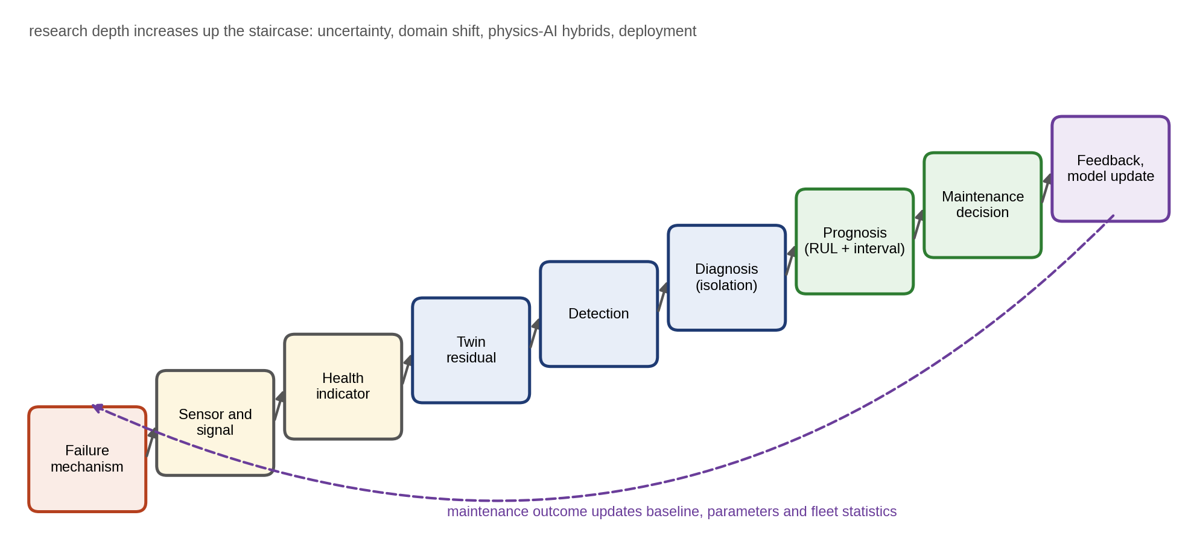
Figure 12.1. The educational staircase of this chapter: from the physical failure mechanism through sensing, indicators, twin residuals, detection, diagnosis and prognosis to the maintenance decision, whose outcome feeds back into the models. Each step rests on the one below it.

12.1 PHM and the Digital-twin Health Contract
Chapters 7 to 11 built twins of Plant P-1’s assets and of the network that connects them, and each touched on faults: an inverter’s open switch, a PV string outage, a battery’s internal short, a yaw misalignment, a bad transducer in the state estimator. This chapter turns those scattered methods into one discipline, prognostics and health management (PHM). It answers four questions for every asset: is anything wrong, what is wrong and where, how long until it fails, and what should be done and when [1].
The P-1 maintenance team faces these questions every week. A motor’s vibration has risen; is the bearing failing, or has the pump simply moved to a heavier duty? The wind turbine’s gearbox shows new lines in its spectrum; how long does it have, given that a replacement pinion takes ten weeks to arrive? A capacitor bank’s ESR is climbing; will it last until the next planned outage? And with limited crews and budget, which of these comes first?
The chapter works synthetic but physically consistent data from P-1’s assets through every method (every dataset is labelled synthetic and every result can be regenerated from the stated recipe), and it states each answer with a number:
- Indicators. A bearing’s broadband kurtosis barely moves while its outer race is already damaged; band-passed around the structural resonance, it rises from 3.0 to 9.3, and the envelope spectrum puts the defect line 1 % below the computed outer-race frequency.
- Thresholds. One threshold for two operating modes detects only 0.3 % of samples of a 2 K winding fault that a mode-conditioned threshold catches 84 % of the time.
- Small shifts. A CUSUM detects a half-standard-deviation shift in 24 samples where a 3σ rule takes 158, at the same nominal false-alarm rate, but it raises false alarms almost five times as often once the residuals are autocorrelated.
- Validation. A classifier that scores 97 % on randomly split windows scores 64 % on machines it has never seen; twin-normalized features restore 89 %, and keep 88 % at a new speed.
- Remaining life. A Bayesian Wiener predictor halves the RUL error of a naive fleet-average baseline, and its 90 % intervals cover the truth for 88 to 92 % of 200 held-out units.
- Maintenance. An optimal preventive interval cuts maintenance cost by 58 % against running to failure, and perfect condition information would cut it by a further three-quarters.
The chapter ends by ranking P-1’s maintenance actions by expected cost. The gearbox comes first, because its ten-week spare lead time is close to its median remaining life.

12.1.1 Condition monitoring, diagnostics, prognostics and the PHM twin
The field uses several overlapping terms, and it pays to fix them at the start. Condition monitoring acquires and processes data about an asset’s condition. Diagnostics detects, isolates and identifies faults from those data. Prognostics predicts how the condition will evolve and when the asset will no longer perform its function, the remaining useful life (RUL). Predictive maintenance uses diagnostics and prognostics to schedule work. PHM is the whole chain, from sensor to maintenance decision and back. ISO 17359 gives the general condition-monitoring programme, ISO 13379-1:2025 the data-interpretation and diagnostic techniques, ISO 13381-1:2025 the prognostic process and its terminology, and ISO 13374-1 (confirmed in 2025) the data-processing architecture [12], [14]–[16].
Follow one motor through the chain. The physical asset is pump motor M-07. Sensors measure its vibration, phase currents and winding temperature. A healthy twin, synchronized with the measured load, speed and ambient temperature, predicts what these signals should be. The difference between measured and predicted, the residual, stays near zero while the motor is healthy. When the outer race of a bearing begins to spall, the residual of the envelope vibration at the outer-race frequency grows; the twin detects the change, isolates it to the bearing rather than to the cooling or the current sensors, and estimates how long the bearing has left. The maintenance planner books the replacement for the next outage. After the replacement, the twin records the finding (a spall of a certain size, as expected) and updates two things: the bearing’s degradation statistics for the fleet, and its own healthy baseline for the new bearing, which vibrates slightly differently from the old one.
That last step is what a static diagnostic model does not do, and it answers a question worth asking of any product sold as a PHM twin.
When is a PHM model truly a digital twin?
A PHM model qualifies as a digital twin of an asset’s health when it meets all of the following, and each can be checked:
- Bidirectional synchronization. Its states and slow parameters are updated from the asset’s measurements, and its outputs (alarms, RUL, maintenance actions) act back on the asset through an authorized path.
- A healthy baseline conditioned on operation. It knows what “normal” looks like at each load, speed and temperature, rather than comparing every measurement with one fixed limit.
- Controlled adaptation. Parameters adapt to benign change (seasons, a new bearing) but not to the fault it is trying to detect (Section 12.5.3).
- Quantified uncertainty. Every residual, diagnosis and RUL carries an uncertainty that has been checked against data.
- Versioning and provenance. Each output can be traced to the model version and data that produced it.
- Maintenance feedback. The outcome of each intervention returns to update the models.
A vibration analyser with fixed alarm limits meets none of these; a trained classifier deployed once meets perhaps one. Both can be useful, but neither is a twin (Figure 12.2).
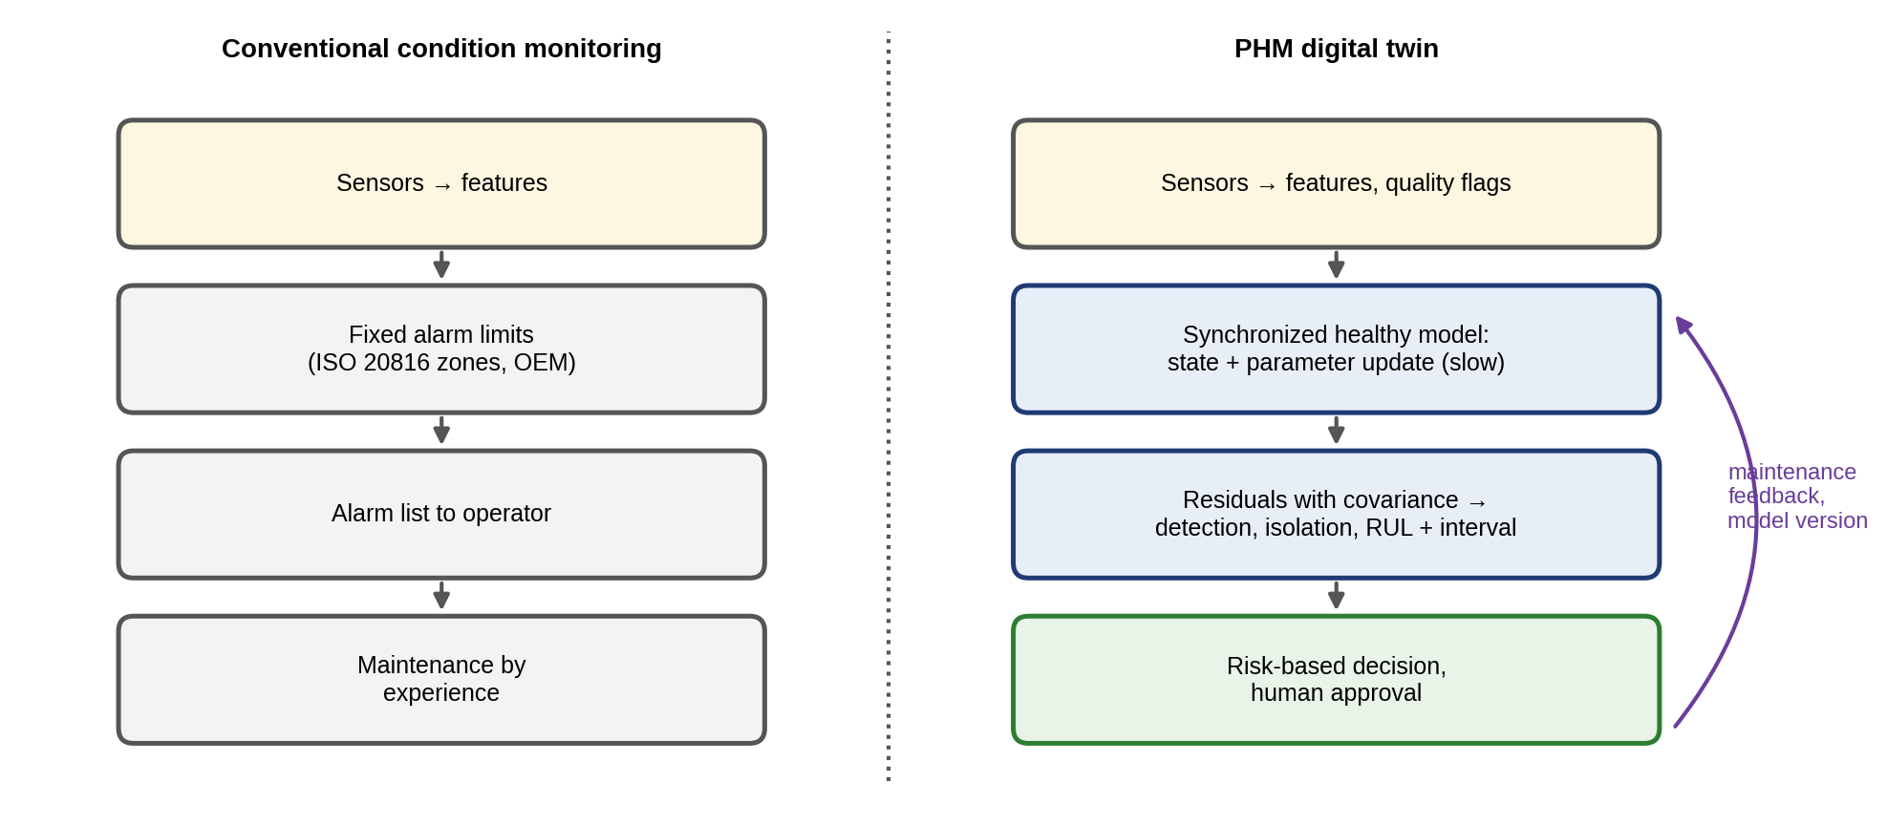
Figure 12.2. A conventional condition-monitoring system (left) compared with a PHM digital twin (right): the twin adds a synchronized healthy model with controlled parameter updating, residuals with covariance, uncertainty on diagnosis and RUL, risk-based decisions with human approval, and feedback of maintenance outcomes and model versions.

12.1.2 The PHM contract
As in Chapters 10 and 11, a monitoring function becomes part of a digital twin only when it is tied to measurements, states, uncertainty and a decision. For PHM the contract adds two elements specific to health: the baseline against which “normal” is judged, which must be conditioned on operating mode, and the maintenance action the diagnosis triggers, with its lead time. Table 12.1 states it for P-1’s monitored assets.
TABLE 12.1 PHM contract for the monitored assets of Plant P-1
Asset | Failure mechanism | Measured signal | Health indicator | Model or method | Decision
Motor M-07 bearing | Spalling of outer race | Vibration (25.6 kHz) | Band kurtosis, envelope at BPFO | Envelope analysis, CUSUM (Sections 12.4, 12.8) | Replace at next outage or earlier
Motor windings | Insulation aging from heat | Winding temperature estimate (Chapter 7) | Thermal residual | Twin residual, mode-conditioned threshold (Sections 12.5, 12.6) | Derate, inspect cooling
Drive D-3 DC-link capacitors | Electrolyte loss | Ripple voltage and current | ESR, capacitance | Exponential degradation (Section 12.19) | Replace before 2 × ESR
PV strings | Open circuit, soiling, degradation | String currents, irradiance | Twin power ratio | Residual, CUSUM (Section 12.20) | Repair, clean
BESS modules | Capacity fade | Voltage, current, temperature | SOH | Degradation model, RUL (Section 12.21) | Plan replacement, derate
Wind T-1 gearbox | Tooth pitting and cracking | Vibration, oil debris | Sidebands around mesh frequency | Spectral analysis (Section 12.22) | Order spares, derate, replace

12.2 Failure, Fault, Anomaly, Degradation and the P–F Concept
Five terms are often used loosely, and PHM needs them precisely.
- Normal variability. The spread of a healthy asset’s signals under changing load, speed, temperature and weather. A motor’s vibration rises with load, a PV string’s output with irradiance. Variability is not a fault, and a monitor that treats it as one produces false alarms.
- Degradation. A slow, usually irreversible change in a physical property that reduces margin without yet preventing function. Examples: bearing surface fatigue, electrolyte evaporation in a capacitor, capacity fade in a battery.
- Anomaly. An observation that departs from what the baseline makes likely. It may be a fault, a sensor problem, an unmodelled but benign operating state, or chance. Anomaly is a statistical statement; fault is a physical one.
- Fault. An abnormal condition of a component that can cause it to fail to perform its function, for example a spall on a bearing race or an open string connector.
- Failure. The termination of the ability to perform a required function: the bearing seizes, the string produces nothing, the capacitor vents.
Faults also differ in how they appear in time, and the difference decides which detector can see them. An incipient fault develops slowly from an undetectable size (a growing spall, a drying capacitor), so trend and cumulative detectors (Section 12.6.2) suit it. An intermittent fault appears and disappears (a loose connector, a cracked solder joint that opens when hot), so it is caught by event counting and persistence logic rather than by a steady threshold. A permanent fault, once present, stays (an open string, a failed switch). Fault severity is the size of the fault on a scale that relates to consequence, such as spall area, ESR increase or percentage of lost string current.
Three properties decide what a monitoring system can promise for a given fault. A fault is detectable if some residual changes when it occurs, diagnosable (isolable) if the pattern of residual changes differs from that of every other fault (Section 12.9), and prognosable if its severity evolves in a way that can be extrapolated with useful accuracy before failure. A fault can be detectable without being diagnosable, and diagnosable without being prognosable: a sudden semiconductor failure is easy to detect and isolate and almost impossible to predict from ordinary signals.
Figure 12.3 illustrates the five terms on one signal.
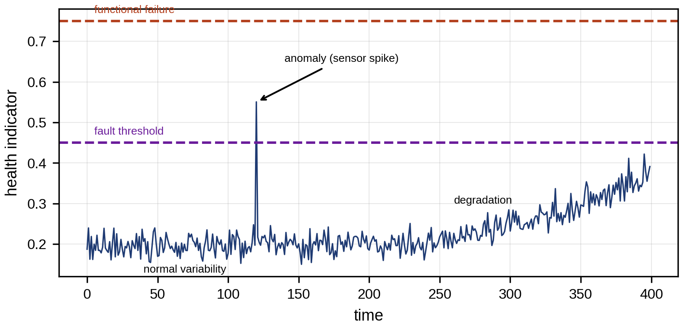
Figure 12.3. The five terms on one health indicator: normal variability around a baseline, a degradation trend, an isolated anomaly (here a sensor spike), the fault threshold and functional failure.
The P–F curve (Figure 12.4) links them in time. Between the point P at which a developing failure first becomes detectable and the functional failure F lies the P–F interval. Inspections or monitoring must sample more often than this interval to catch the fault before failure; a widely used rule of thumb is
 | $$Δt_{mon}≤\frac{t_{F}−t_{P}}{2},$$ | (12.1)
where $Δt_{mon}$ is the interval between inspections or monitoring updates, and $t_{P}$ and $t_{F}$ are the times of the detectable onset and of functional failure. The rule is a maintenance heuristic, not a law, and its origin shows its limits. Suppose inspections are spaced $Δt_{mon}$ apart, the P–F interval is $L=t_{F}−t_{P}$, the onset time falls uniformly between two inspections, and each inspection that sees the fault detects it with probability $p_{d}$. The number of inspections that fall inside the interval is then $n=⌊L/Δt_{mon}⌋$ or $n+1$, and the probability of detecting the fault before failure is
 | $$P_{det}≈1−{\left(1−p_{d}\right)}^{L/Δt_{mon}}, E\left[t_{lead}\right]≈L−\frac{Δt_{mon}}{2} \left(p_{d}=1\right),$$ | (12.2)
where $t_{lead}$ is the time from detection to failure, the time available to plan the repair. With $p_{d}=1$, one inspection inside the interval suffices and halving the interval guarantees at least two chances; with $p_{d}=0.7$ and $L/Δt_{mon}=2$, $P_{det}$ is only 0.91, so a less reliable technique needs a shorter interval. The interval must also cover the lead time of the repair itself: if $E\left[t_{lead}\right]$ is shorter than the time to obtain a spare and a crew, detection comes too late whatever its probability. And $L$ is not a constant: it varies from unit to unit and with load, so a design that uses the median P–F interval misses the units that fail fast. The P–F interval depends on both the mechanism and the technique. A bearing whose envelope signature appears twelve weeks before failure shows a rise in overall vibration perhaps four weeks before it and audible noise days before. Continuous monitoring removes the sampling constraint but not the need for the planning time the interval provides.
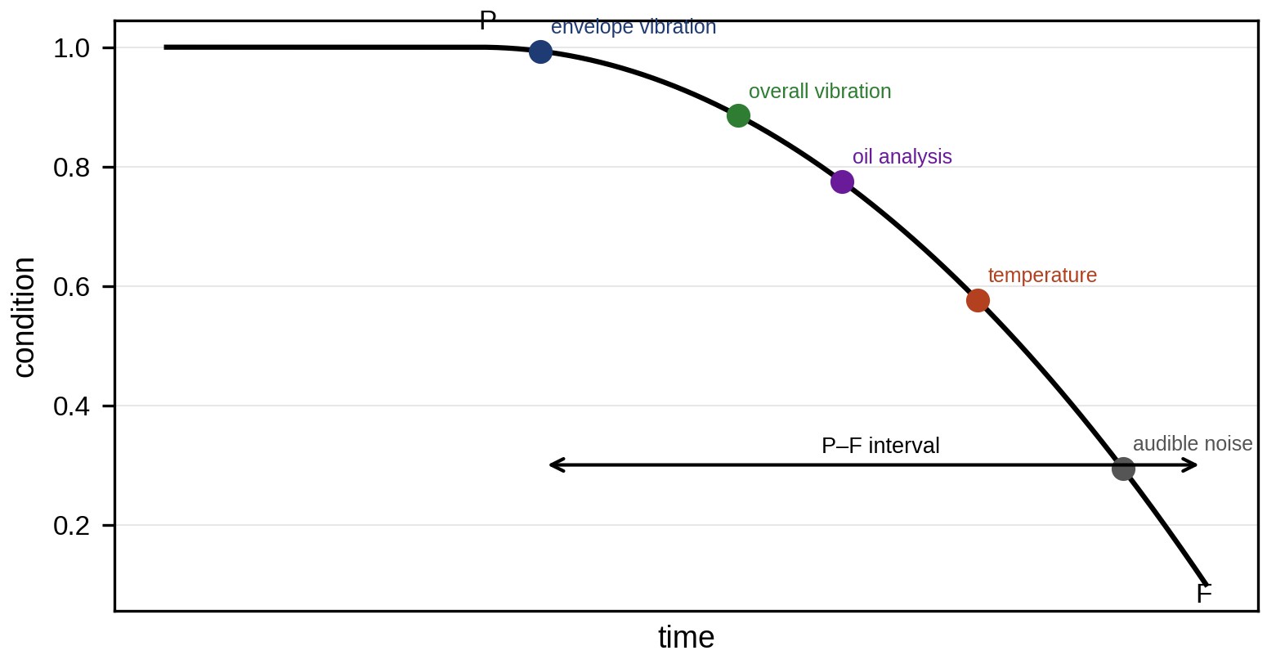
Figure 12.4. The P–F curve: condition against time, with the point P at which each technique (envelope vibration, overall vibration, oil analysis, temperature, audible noise) first detects the degradation and the functional failure F; the P–F interval sets the monitoring interval.
Table 12.2 connects mechanisms to signatures for the assets of this book. The column “confounder” lists benign causes that produce a similar signature; separating them is the core of diagnosis.
TABLE 12.2 Failure mechanisms, their signatures and confounders
Asset | Mechanism | First signature | Later signature | Confounder
Rolling bearing | Surface fatigue, spalling | Impacts at defect frequency in envelope spectrum; band kurtosis | Overall vibration, temperature | Speed change, looseness, lubrication
Motor insulation | Thermal aging | Winding-temperature residual | Partial discharge, insulation resistance | Load, ambient, cooling
Electrolytic capacitor | Electrolyte loss | ESR rise, capacitance fall | Ripple, case temperature | Temperature dependence of ESR
PV string | Connector failure, cracked cells, soiling | Current ratio against twin | Power loss, hot spots | Shading, irradiance-sensor drift
Li-ion battery | SEI growth, lithium plating | Capacity and resistance trend, IC-curve changes | Heat, voltage spread | Temperature, SOC estimation error
Gearbox | Tooth pitting, crack | Sidebands around mesh frequency, time-synchronous average | Mesh amplitude, debris | Load and speed variation

12.3 Sensors, Sampling and Signal-quality Fundamentals

12.3.1 From sensor output to physical units
Most health indicators start with a transducer whose output must be converted into a physical quantity. A piezoelectric accelerometer produces a charge or, with built-in electronics (IEPE), a voltage proportional to acceleration, with a sensitivity $S_{a}$ of typically 10 to 100 mV/g ($g=9.81$ m/s²). Vibration severity standards use velocity, bearing and gear diagnostics use acceleration, and shaft motion in journal bearings uses displacement. For a sinusoidal component of frequency $f$, the three are related by integration,
 | $$v=\frac{a}{2πf}, x=\frac{a}{{\left(2πf\right)}^{2}}, V_{out}=S_{a} a,$$ | (12.3)
where $a$, $v$ and $x$ are the amplitudes of acceleration, velocity and displacement and $V_{out}$ the sensor output voltage. The $1/f$ and $1/f^{2}$ factors explain why velocity emphasizes the low-frequency unbalance and misalignment that dominate ISO vibration zones, while acceleration emphasizes the high-frequency impacts of bearing defects. Numerically integrating a broadband acceleration record amplifies low-frequency noise and sensor offset without bound, so integration is always preceded by a high-pass filter (typically 2 to 10 Hz). A 1 g acceleration at 50 Hz is a velocity of 31.2 mm/s and a displacement of 99 µm; the same 1 g at 3 kHz is only 0.52 mm/s and 0.028 µm.
The analogue-to-digital converter (ADC) sets the smallest and largest signals the system can see. For an ideal $b$-bit converter spanning $±V_{FS}$, the quantization step and the signal-to-quantization-noise ratio of a full-scale sinusoid are
 | $$q=\frac{2V_{FS}}{2^{b}}, SQNR=6.02 b+1.76 \text{dB},$$ | (12.4)
where $V_{FS}$ is the full-scale voltage. A 24-bit converter offers about 146 dB in theory and perhaps 110 to 120 dB in practice. The range must be chosen so that the largest expected shock does not saturate (clipping destroys exactly the impulsive content that bearing diagnosis needs) while the healthy signal remains well above the noise floor.

12.3.2 Sampling, anti-alias filtering and windowing
A health indicator can only be as good as the signal it is computed from. A signal sampled at rate $f_{s}$ contains unambiguous information only up to the Nyquist frequency $f_{s}/2$. A component at frequency $f$ above it appears at the alias frequency
 | $$f_{alias}=\left|f−kf_{s}\right|, k=round\left(\frac{f}{f_{s}}\right),$$ | (12.5)
where $k$ is the integer nearest to $f/f_{s}$. A 30 kHz structural resonance sampled at 25.6 kHz would therefore appear as a false 4.4 kHz line. An analogue anti-aliasing filter must attenuate everything that could fold into the band of interest before sampling. Its design follows from four numbers: the sampling rate, the highest frequency to be preserved $f_{pass}$, the frequency at which the filter must reach its stop-band attenuation $A_{stop}$, and the attenuation itself. Components above $f_{s}−f_{pass}$ fold into the passband, so the transition band must fit between $f_{pass}$ and $f_{s}−f_{pass}$. An $n$-th order Butterworth filter falls at about $20n$ dB per decade, so it needs
 | $$n≥\frac{A_{stop}/20}{\log_{10}\left(\left(f_{s}−f_{pass}\right)/f_{pass}\right)},$$ | (12.6)
where $A_{stop}$ is in dB. For 90 dB of protection with $f_{pass}=10$ kHz and $f_{s}=25.6$ kHz, the ratio is 1.56 and $n≥23.3$, which no analogue filter provides; the practical answer is a modest analogue filter plus oversampling and a sharp digital decimation filter, as in delta-sigma converters. The familiar rule of setting $f_{s}$ to 2.56 times the highest frequency of interest is a convention of spectrum analysers built around such decimation filters (their usable band ends at $f_{s}/2.56$), not a general law. Figure 12.5 shows aliasing and leakage on a small example.
A record of $N$ samples, of duration $T_{r}=N/f_{s}$, gives a spectrum with frequency resolution
 | $$Δf=\frac{f_{s}}{N}=\frac{1}{T_{r}},$$ | (12.7)
so 65 536 samples at 25.6 kHz (2.56 s) resolve 0.39 Hz. The discrete Fourier transform assumes the record repeats periodically. A sinusoid whose period does not fit an integer number of times into the record therefore leaks energy into neighbouring bins. Multiplying the record by a window that tapers to zero at both ends, such as the Hann window $w_{n}=\frac{1}{2}\left[1−cos\left(2πn/\left(N−1\right)\right)\right]$, reduces leakage at the cost of a slightly wider main lobe. The spectrum amplitude at bin $k$ is then
 | Xk=n=0N−1wnxne−j2πkn/N, Ak=2Xkn​wn, | (12.8)
where $x_{n}$ are the samples and $A_{k}$ the amplitude of a sinusoid at frequency $kf_{s}/N$, corrected for the window’s coherent gain. The fast Fourier transform computes all $N$ bins in about $5N\log_{2}N$ floating-point operations. For broadband signals the power spectral density is estimated instead, by averaging windowed periodograms of $K$ overlapping segments (Welch’s method), which trades resolution for variance:
 | Sxxfk=1Km=1KXkm2fsn​wn2, 1Nn​xn2=k​Sxxfk Δf, | (12.9)
where $X_{k}^{\left(m\right)}$ is the windowed DFT of segment $m$; the second relation (Parseval’s theorem) says that the RMS can be computed from the spectrum, which allows band-limited RMS values, such as the broadband velocity RMS used by the ISO 20816 evaluation zones, to be taken directly from it. The Hann window’s equivalent noise bandwidth is 1.5 bins, which must be included when converting an amplitude spectrum scaled by (12.8) to a PSD.
The mean-square value of a signal is the area under its one-sided PSD, which is the form most vibration standards use. Periodogram estimates have a large variance: for Gaussian noise, a single-segment estimate at one frequency has a standard deviation equal to its mean, whatever the record length. Averaging $K$ independent segments divides the variance by $K$, which is why Welch’s method trades frequency resolution for confidence. A PSD bin with $K$ averages follows approximately a scaled chi-square distribution with $2K$ degrees of freedom, so the 90 % confidence band of a 16-average estimate spans roughly 0.63 to 1.44 times the true value. A spectral line that rises by 20 % between two 16-average spectra is therefore not evidence of change.
For vibration severity, the ISO 20816 series has replaced the older ISO 10816 series for most machine types, with evaluation zones for broadband velocity (typically 10 to 1000 Hz) or displacement specific to the machine class; ISO 20816-21:2025 covers horizontal-axis wind turbines, and ISO 20816-1 was under revision in 2026, so the applicable part and edition must be cited for each machine [17].
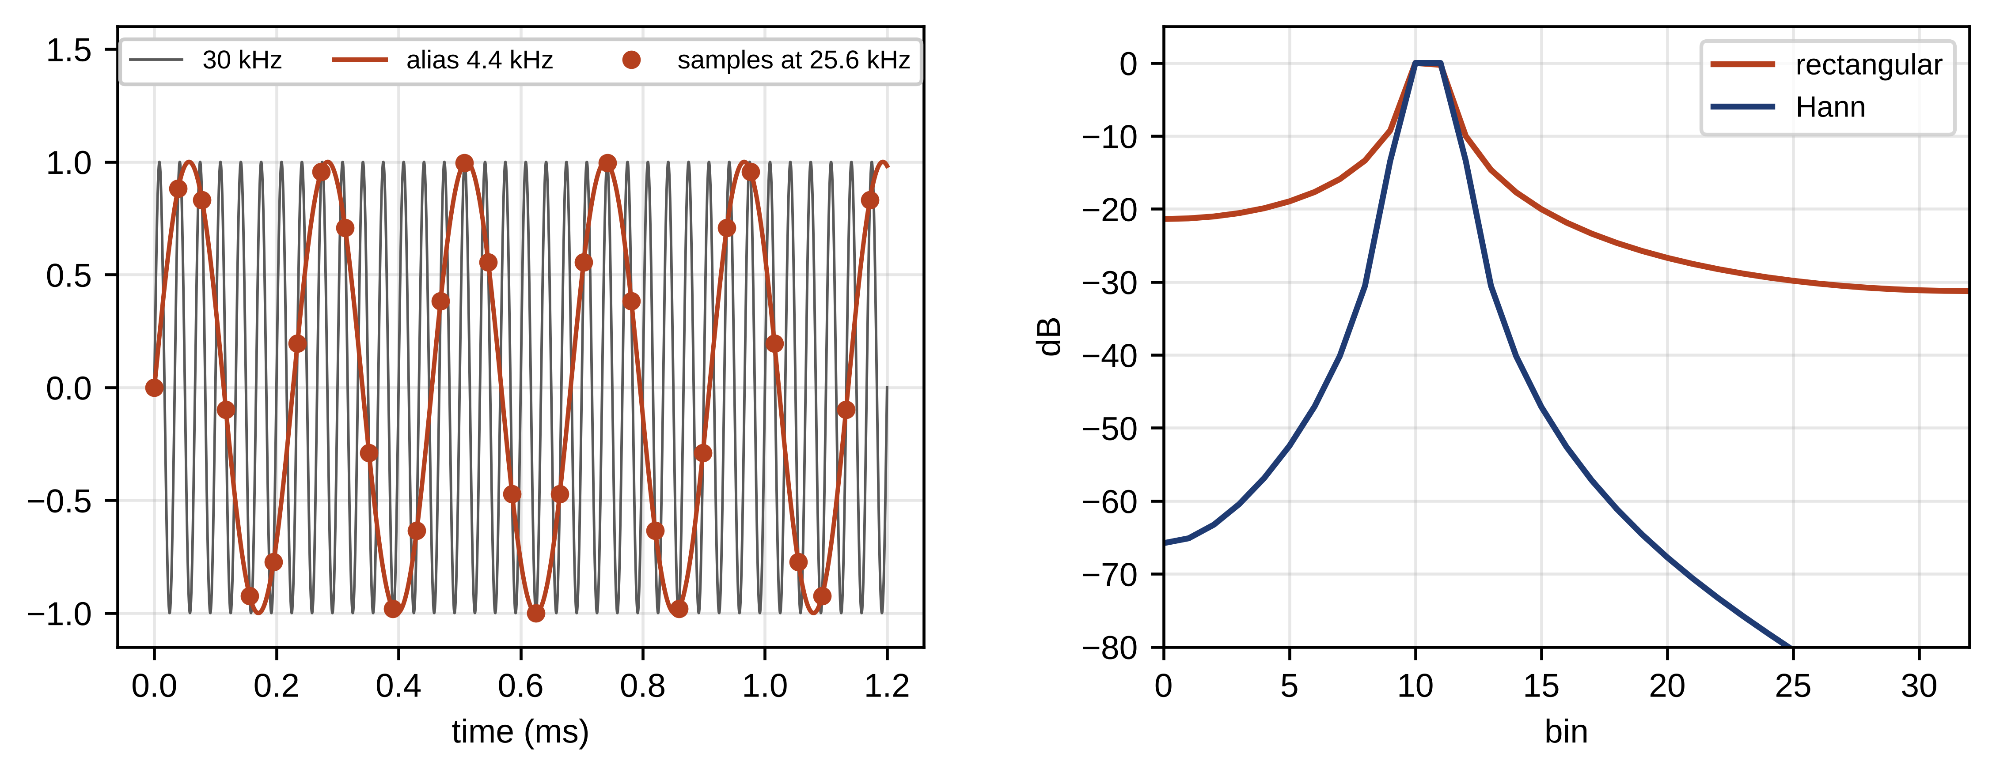
Figure 12.5. Sampling and windowing on a small example: a 30 kHz component aliasing to 4.4 kHz when sampled at 25.6 kHz (left), and leakage of a non-integer-period sinusoid with a rectangular and a Hann window (right).
Finally, channels must be sampled together. Vibration from two bearings, or the three phase currents of a motor, are useful jointly only if their samples are simultaneous or their skew is known. Simultaneous-sampling ADCs or a shared sampling clock give sample-level alignment on one device; across devices, IEEE 1588 time synchronization (Chapter 11) gives microsecond alignment, which is enough for phase comparisons up to a few kilohertz.

12.4 Time-, Frequency- and Order-domain Health Indicators

12.4.1 Time-domain indicators
Four statistics of a vibration record $x_{n}$ with mean $\overset{‾}{x}$ summarize its energy and its peakiness:
 | xRMS=1Nn​xn2, xpk=maxnxn, CF=xpkxRMS, κ=1Nn​xn−x41Nn​xn−x22, | (12.10)
where CF is the crest factor and $κ$ the kurtosis. Their reference values follow from simple signals. For a sinusoid of amplitude $A$, $x_{RMS}=A/\sqrt{2}$ and $x_{pk}=A$, so $CF=\sqrt{2}$, and averaging $\sin^{4}$ over a period gives $κ=\left(3/8\right)/{\left(1/2\right)}^{2}=1.5$. For Gaussian noise the fourth moment is $3σ^{4}$, so $κ=3$. Repetitive impacts, the signature of a localized defect, add rare large peaks that raise CF and $κ$ well above these values long before the RMS changes. Each impact excites a lightly damped structural mode, so a defect signal is well modelled as a train of decaying oscillations,
 | ximpt=i​Aie−ζωrt−tisinωdt−tiut−ti, | (12.11)
where $t_{i}$ are the impact times (spaced at the defect period with a small random jitter from slip), $A_{i}$ their amplitudes, $ω_{r}$ the resonance angular frequency, $ζ$ its damping ratio, $ω_{d}=ω_{r}\sqrt{1−ζ^{2}}$ the damped angular frequency and $u$ the unit step. The two ratios respond to such a train in a predictable way. If a record contains $M$ impacts of peak $A$ on a Gaussian background of standard deviation $σ_{n}$, and each impact’s energy is concentrated in a short time $τ_{i}$, the impacts occupy a fraction $ϵ=Mτ_{i}/T_{r}$ of the record. For small $ϵ$ the fourth moment is dominated by the impacts while the second is dominated by the background, so
 | $$κ≈\frac{3σ_{n}^{4}+ϵ \overline{A^{4}}}{{\left(σ_{n}^{2}+ϵ \overline{A^{2}}\right)}^{2}},$$ | (12.12)
where the overbars denote averages of the impact waveform’s powers over its duration. Kurtosis rises steeply with $A/σ_{n}$ while $ϵ$ is small, and falls back toward 3 as $ϵ$ grows, because many overlapping impacts again look Gaussian by the central limit theorem. This explains the common observation that kurtosis responds early to a localized impulsive defect and may then decrease as the damage spreads, while the RMS keeps rising. It is not a universal rule: kurtosis is also driven up by unrelated transients (a door slam, electrical spikes, a loose guard), is sensitive to single outliers, and does not respond to faults that are not impulsive, such as unbalance or misalignment. It must therefore be computed in a band where the defect’s impacts dominate, and trended rather than read against a fixed number.
Example 12.1 Health indicators of the M-07 bearing
Given. Synthetic vibration of the M-07 motor bearing, generated by a stated recipe: sampling at 25.6 kHz for 2 s; shaft components $0.30sin\left(2π 25t\right)+0.10sin\left(2π 50t+0.4\right)$; white Gaussian noise of standard deviation 0.20; and, for the faulty bearing, impacts at 0.99 times the outer-race defect frequency (1 % slip), with 1 % timing jitter, each exciting a 3 kHz resonance that decays at 800 s⁻¹ ($ζ=0.042$). Impact amplitudes 0, 0.5 and 1.0 (arbitrary units); noise generator seed 1; ten seeds for the averaged curves. Band-pass filter: fourth-order Butterworth, 2 to 4 kHz, applied forward and backward.
Find. RMS, crest factor and kurtosis of the raw signal, and kurtosis after band-pass filtering.
Solution. Healthy: RMS 0.299, CF 3.86, $κ$ 2.61, band kurtosis 2.98. With impacts of amplitude 1.0: RMS 0.337 (+13 %), CF 5.25, broadband $κ$ 3.28, band kurtosis 9.30. With amplitude 0.5: broadband $κ$ 2.69, practically unchanged, but band kurtosis 5.37.
Interpretation. Figure 12.6 shows how the indicators evolve with impact amplitude (averaged over ten seeds), and Figure 12.8 the signals behind them. The broadband statistics are dominated by the shaft components and noise, which mask the impacts; the healthy broadband kurtosis is even below 3 because sinusoids have $κ=1.5$. Filtering to the band where the impacts excite the structure removes those components and reveals the defect.
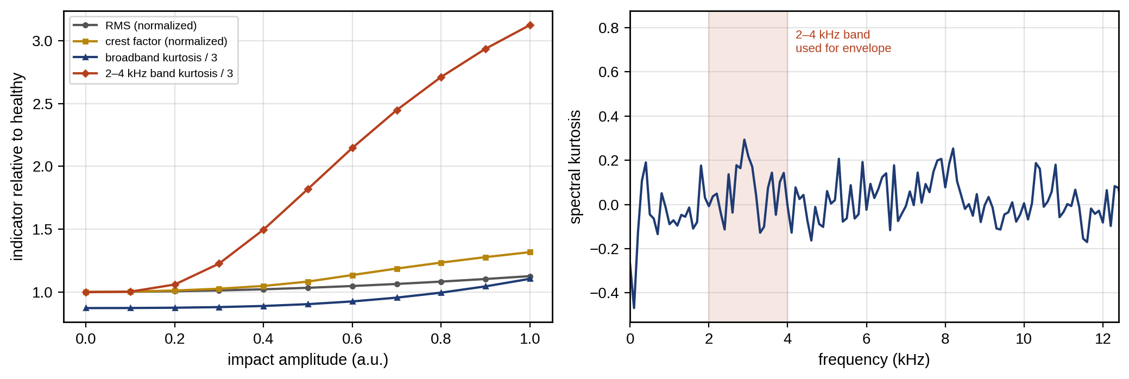
Figure 12.6. Health indicators of the M-07 bearing against impact amplitude, relative to the healthy values and averaged over ten noise seeds: RMS, crest factor, broadband kurtosis and 2–4 kHz band kurtosis, of which only the band kurtosis responds early (left); spectral kurtosis of the record with impact amplitude 0.5, which peaks in the resonance band (right).
The best band is not known in advance, which is what spectral kurtosis (SK) is used to find [2]. The idea extends kurtosis from a whole signal to each frequency. Compute a short-time Fourier transform $X\left(t,f\right)$ with a window short enough to follow individual impacts, and take the normalized fourth moment of its magnitude at each frequency:
 | $$SK\left(f\right)=\frac{{\left\langle {\left|X\left(t,f\right)\right|}^{4}\right\rangle }_{t}}{{\left\langle {\left|X\left(t,f\right)\right|}^{2}\right\rangle }_{t}^{2}}−2,$$ | (12.13)
where $⟨⋅⟩_{t}$ is the average over time frames. The constant 2 appears because the STFT coefficients of stationary Gaussian noise are complex Gaussian, whose magnitude has $⟨{\left|X\right|}^{4}⟩/⟨{\left|X\right|}^{2}⟩^{2}=2$; SK is therefore zero for noise, negative for a stationary sinusoid (whose magnitude is constant, giving $−1$), and positive in bands where impacts come and go. The kurtogram evaluates SK over a dyadic grid of centre frequencies and bandwidths and picks the band of maximum SK for envelope analysis. For the record of Example 12.1 with amplitude 0.5, SK peaks at 2.9 kHz, inside the resonance band (Figure 12.6). SK depends on the STFT window: a window longer than the impact spacing smears the impacts and lowers SK, and non-impulsive nonstationarity, such as speed variation, also raises it.

12.4.2 Envelope analysis
A localized bearing defect produces impacts at a characteristic rate (Section 12.8). Each impact rings the structure at its resonance, so the raw spectrum shows energy near the resonance, not at the defect frequency, and it is buried among many other components. Envelope analysis recovers the impact rate. The signal is band-pass filtered around the resonance, its envelope is computed as the magnitude of the analytic signal, and the envelope’s spectrum is taken:
 | $$x_{a}\left(t\right)=x_{bp}\left(t\right)+jH\left\{x_{bp}\right\}\left(t\right), e\left(t\right)=\left|x_{a}\left(t\right)\right|,$$ | (12.14)
where $x_{bp}$ is the band-passed signal and $H$ the Hilbert transform, which shifts every frequency component by −90°. In practice the analytic signal is computed in the frequency domain by zeroing the negative frequencies and doubling the positive ones,
 | $$X_{a}\left(f\right)=\left\{\begin{matrix}2X_{bp}\left(f\right), & f>0 \\ X_{bp}\left(0\right), & f=0 \\ 0, & f<0\end{matrix}\right.$$ | (12.15)
and transforming back. The envelope $e\left(t\right)$ rises at each impact and decays between them, so its spectrum shows lines at the impact rate and its harmonics [3].
The analytic-signal construction works because the Hilbert transform of $cosωt$ is $sinωt$, so for a narrowband signal $x_{bp}\left(t\right)=e\left(t\right)cos\left(ω_{r}t+φ\left(t\right)\right)$ with slowly varying $e$ and $φ$, the analytic signal is $e\left(t\right)e^{j\left(ω_{r}t+φ\left(t\right)\right)}$ and its magnitude is exactly $e\left(t\right)$ (Bedrosian’s theorem requires the envelope’s spectrum to lie below the carrier frequency, which the band-pass filter ensures). Envelope analysis is an industrial baseline, and its steps can be written as an algorithm (Figure 12.7):
Algorithm 12.1 Envelope analysis for rolling-bearing diagnosis
- Select the band. Choose a resonance band excited by the impacts, from the kurtogram or from an impact test on the housing; typical widths are 1 to 4 kHz.
- Band-pass filter the acceleration with a zero-phase filter.
- Form the analytic signal by (12.15) and take its magnitude, the envelope $e\left(t\right)$.
- Detrend and window the envelope: subtract its mean (otherwise a large DC line dominates) and apply a Hann window.
- Transform the envelope to its spectrum, or to its order spectrum if the speed varies (Section 12.4.3).
- Compare the lines with the defect frequencies FTF, BPFO, BPFI and BSF and their harmonics, and look for the sidebands that identify load-zone modulation (Section 12.8).
The method fails in recognizable ways. A band chosen away from the excited resonance leaves only noise. Speed variation within the record smears the lines (order tracking fixes this). A change of resonance with temperature or mounting moves the useful band. And impacts from another source, such as a gear mesh or a loose component, produce envelope lines that are not bearing lines at all, which is why matching must use exact frequencies and the measured speed.
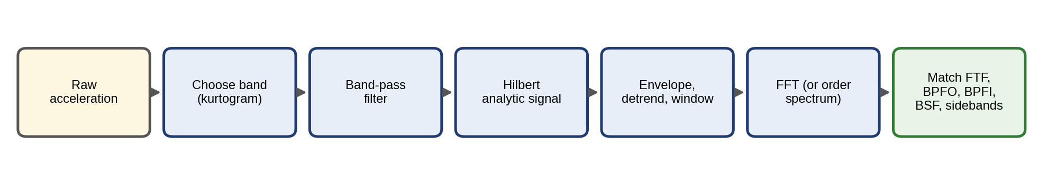
Figure 12.7. The envelope-analysis workflow for rolling bearings: raw acceleration, band selection by kurtogram, band-pass filtering, analytic signal, detrended and windowed envelope, spectrum or order spectrum, and matching against the characteristic frequencies and sidebands.
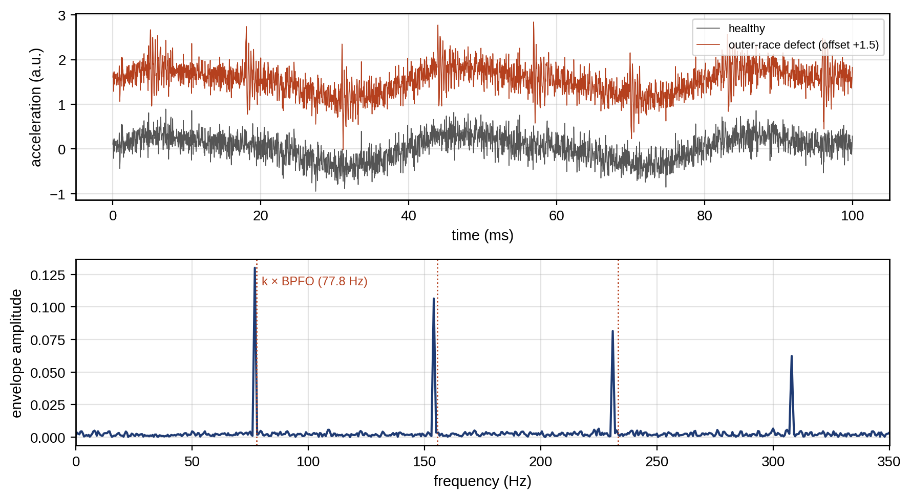
Figure 12.8. Vibration of the M-07 bearing (synthetic, Example 12.1): healthy and faulty time records over 100 ms (top), and the envelope spectrum of the faulty bearing with lines at 77.0 Hz and its harmonics, 1 % below the multiples of the computed outer-race frequency (bottom).

12.4.3 Order tracking
When shaft speed varies, every speed-related frequency varies with it, and a spectrum computed over a record smears each line over the range of speeds. Order tracking removes this by resampling the signal at constant increments of shaft angle rather than time, using a tachometer or an estimated speed. With shaft angle $ϕ\left(t\right)=2π\int_{0}^{t}{f_{r}}\left(τ\right) dτ$ and $s$ samples per revolution,
 | $$x[m]=x\left(t_{m}\right), ϕ\left(t_{m}\right)=\frac{2πm}{s}, \text{order }o=\frac{f}{f_{r}},$$ | (12.16)
where $ϕ$ is the shaft angle in radians, $f_{r}\left(τ\right)$ the instantaneous shaft rotation frequency, $x\left[m\right]$ the angle-domain samples, $t_{m}$ the times at which the angle reaches $2πm/s$, and the order $o$ is frequency expressed in multiples of $f_{r}$. With a tachometer giving one pulse per revolution at times $τ_{i}$, the angle is known exactly at the pulses ($2πi$) and is interpolated between them, usually with a cubic spline, which assumes that the speed changes smoothly within a revolution. The times $t_{m}$ are found by inverting the interpolated angle, and the vibration is interpolated at those times. A spectrum of the angle-resampled signal shows each speed-locked component at a fixed order, whatever the speed.
For the M-07 bearing (the recipe of Example 12.1, seed 2) with speed ramping linearly from 1400 to 1600 r/min during a 2 s record, the slipped outer-race frequency sweeps from 71.9 to 82.1 Hz. The time-based envelope spectrum shows a broad peak near 77 Hz of height 0.057; the order-tracked envelope spectrum (Figure 12.9) shows a sharp peak at order 3.08, the theoretical 3.11 less the 1 % slip, of height 0.131, 2.3 times as high.
Without a tachometer, computed order tracking estimates the instantaneous speed from the signal itself, for example by tracking the ridge of a strong shaft harmonic or gear-mesh line in a time–frequency representation and integrating it to angle. The speed estimate then carries an error that grows when the tracked line is weak or when two lines cross, and an angle error $δϕ$ accumulated over a record smears order $o$ by roughly $o δϕ/\left(2πN_{rev}\right)$ orders over $N_{rev}$ revolutions. Order tracking is essential for variable-speed wind turbines (Section 12.22), where the rotor speed changes continuously, and for EV and industrial drives that run at many speeds.
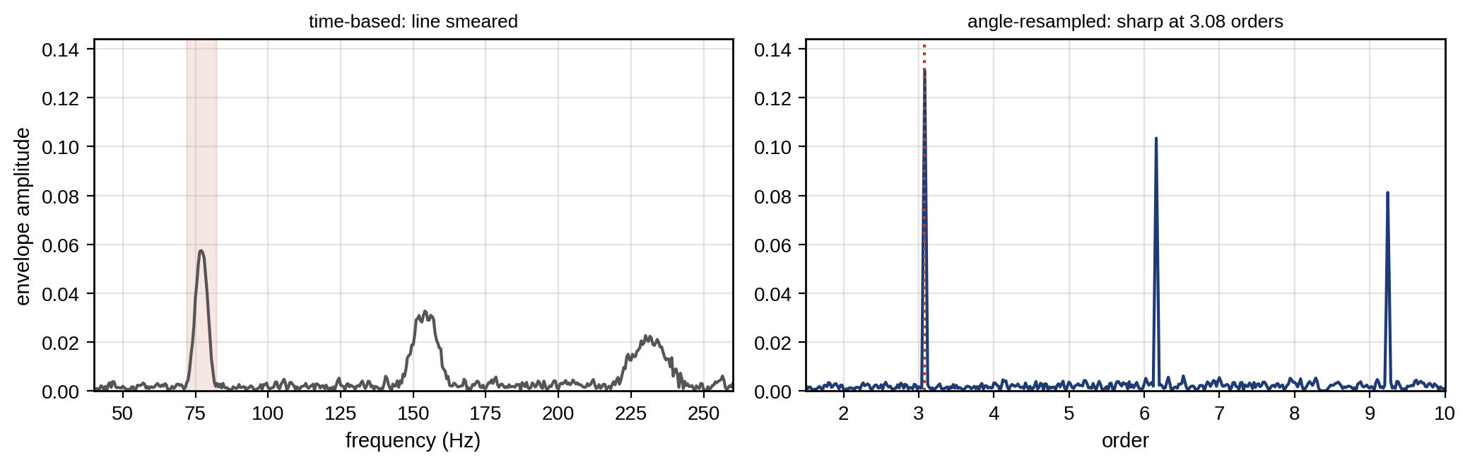
Figure 12.9. Speed rising from 1400 to 1600 r/min during a 2 s record: the envelope spectrum against frequency, where the defect line is smeared over the swept band (left), and the order-tracked envelope spectrum against order, where it is sharp at 3.08 orders (right).

12.5 Digital-twin Residual Generation and Adaptive Baselines

12.5.1 Output, parameter and parity residuals
Signal-based indicators judge a signal against its own history. A digital twin allows a stronger test: it predicts what a healthy asset should measure under the present inputs, and compares that prediction with what it does measure. The difference is the residual,
 | $$r_{k}=y_{k}−{\hat{y}}_{k}\left(u_{1:k},\hat{θ}\right),$$ | (12.17)
where $y_{k}$ is the measurement at sample $k$, ${\hat{y}}_{k}$ the twin’s prediction from the inputs $u_{1:k}$ (load, speed, ambient temperature, irradiance) with calibrated parameters $\hat{θ}$. In a healthy asset the residual is noise with near-zero mean, because the twin already explains the effect of load and weather. A fault adds a component the twin does not explain. This removes the largest source of false alarms, normal variability, before any threshold is applied. Residuals come in three forms, and each follows from a short derivation.
Output residuals. Let the healthy asset obey $y_{k}=g\left(u_{1:k},θ\right)+v_{k}$, with $g$ the twin’s model, $θ$ the true parameters and $v_{k}$ measurement noise of variance $σ_{v}^{2}$, and let a fault add $f_{k}$. Linearizing $g$ about the estimate $\hat{θ}$ with sensitivity $g_{θ}=∂g/∂θ$,
 | $$r_{k}=f_{k}+v_{k}+g_{θ}^{T}\left(θ−\hat{θ}\right), Var\left(r_{k}\right)≈σ_{v}^{2}+g_{θ}^{T}P_{θ} g_{θ},$$ | (12.18)
where $P_{θ}$ is the covariance of the parameter estimate. The second term explains Example 12.2: where the twin is more sensitive to its uncertain parameters (high load, large $g_{θ}$), the residual is noisier, and a threshold must follow.
Parameter residuals. The twin re-estimates a physically meaningful parameter, such as thermal resistance, ESR or drag area, from recent data and compares it with its healthy baseline, $r_{θ}={\hat{θ}}_{recent}−θ_{0}$. By the least-squares result of Chapter 5, its covariance is ${\left(J^{T}R^{−1}J\right)}^{−1}$ for Jacobian $J$ and noise covariance $R$, so a parameter residual is only detectable when the data excite the parameter (a thermal resistance cannot be estimated at zero load).
Parity residuals. Several measurements are combined into a relation that holds whenever the system is healthy, such as the sum of three phase currents. For a linear model $y=Cx+f+v$ with more measurements than states, any matrix $W$ whose rows span the left null space of $C$ ($WC=0$) removes the unknown state:
 | $$r=Wy=Wf+Wv.$$ | (12.19)
where $y$ is the measurement vector, $x$ the unknown state, $C$ the measurement matrix, $f$ the fault vector and $v$ the noise. The rows of $W$ can be chosen so that each residual is insensitive to selected faults, which is the basis of the structured residuals of Section 12.9.
Dynamic twins generate residuals with an observer (Chapter 5): ${\hat{x}}_{k+1}=A{\hat{x}}_{k}+Bu_{k}+L\left(y_{k}−C{\hat{x}}_{k}\right)$, $r_{k}=y_{k}−C{\hat{x}}_{k}$, with state matrices $A$, $B$, $C$ and observer gain $L$. The estimation error $e_{k}=x_{k}−{\hat{x}}_{k}$ then obeys $e_{k+1}=\left(A−LC\right)e_{k}+Ef_{k}−Lv_{k}$ for a fault entering through $E$, so a large gain suppresses noise-driven error quickly but also pulls the estimate toward the faulty measurement and shrinks the residual. For a process fault $f$ that steps on and stays, the error settles at $e_{∞}={\left(I−A+LC\right)}^{−1}Ef$, so the residual settles at $r_{∞}=C{\left(I−A+LC\right)}^{−1}Ef$, which shrinks as $L$ grows. For a sensor bias $f_{s}$ added to $y$, the same steps give $r_{∞}=\left[I−C{\left(I−A+LC\right)}^{−1}L\right]f_{s}$, and the observer design trades this fault sensitivity against noise suppression.
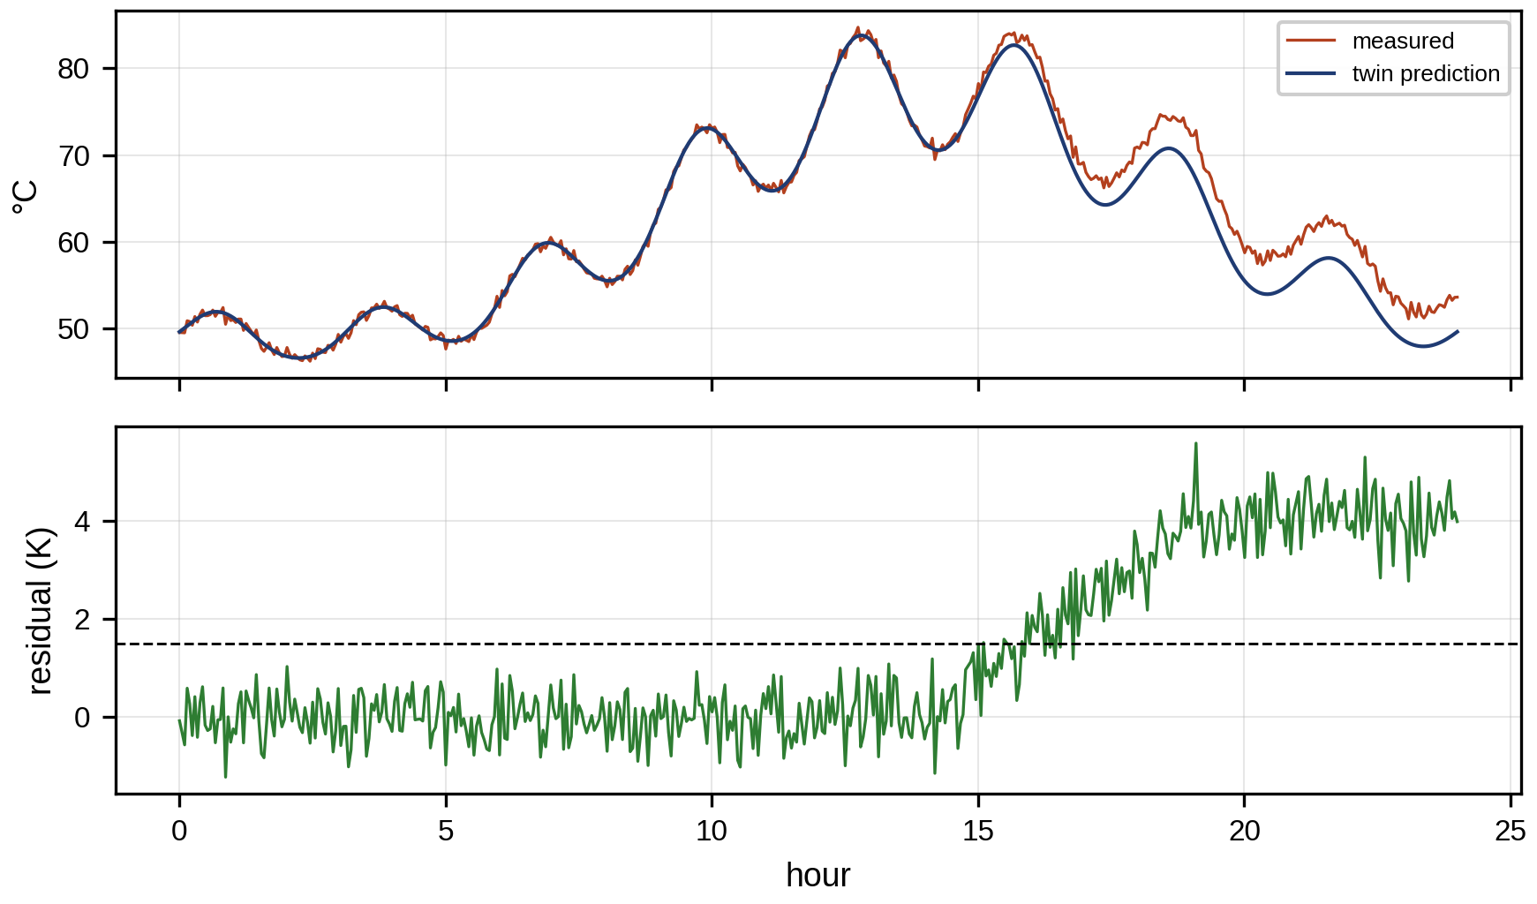
Figure 12.10. Residual generation on M-07’s winding temperature: measured and twin-predicted temperature over a day of varying load (top), and the residual, flat until a cooling fault begins at hour 14 (bottom).

12.5.2 Residual covariance and normalized residuals
Residuals from different signals have different units and noise levels, so they are compared after normalization. For a residual vector $r_{k}$ with covariance $Σ_{r}$ estimated on healthy baseline data (or propagated through (12.18)), the normalized residual and its squared norm are
 | $$z_{k}=Σ_{r}^{−1/2}r_{k}, q_{k}=r_{k}^{T}Σ_{r}^{−1}r_{k}∼χ_{m}^{2} \text{(healthy, Gaussian)},$$ | (12.20)
where $Σ_{r}^{−1/2}$ is a matrix square root (for example the inverse Cholesky factor) and $m$ the number of residuals. Each element of $z_{k}$ is unit-variance and uncorrelated with the others in healthy operation, so a single threshold applies to all of them, and $q_{k}$ is the multivariate test of Section 12.11. The covariance must be estimated in each operating mode, and it changes whenever the twin is recalibrated.

12.5.3 Adaptive baselines and the adaptation dilemma
A twin must adapt. Bearings are replaced, fans are cleaned, seasons change the cooling air, and a twin that never updates its parameters drifts away from the healthy asset and raises false alarms. But a twin that adapts too quickly has a worse problem: it learns the fault. A slowly rising thermal resistance caused by a clogged cooling duct is, to an adaptive estimator, just a new value of the parameter, and if the twin absorbs it, the residual that should have revealed it disappears.
Consider a parameter tracked by exponential forgetting with time constant $τ_{a}$ (in samples), ${\hat{θ}}_{k}={\hat{θ}}_{k−1}+τ_{a}^{−1}\left(θ_{k}^{meas}−{\hat{θ}}_{k−1}\right)$, and a residual $r_{k}=θ_{k}^{meas}−{\hat{θ}}_{k−1}$. For a fault that ramps at rate $ρ$ per sample, the estimate lags the truth by a steady amount, and the residual settles at
 | $$r_{∞}=ρ τ_{a},$$ | (12.21)
where $ρτ_{a}$ is the tracking lag of a first-order filter to a ramp. A fast adaptation (small $τ_{a}$) thus shrinks the fault residual in direct proportion. The residual of a step fault of size $Δ$ decays as $Δ{\left(1−τ_{a}^{−1}\right)}^{k}$, so it is visible only for about $τ_{a}$ samples. The benign changes the twin must follow (seasonal cooling, slow aging) have their own time scales, and the design rule is separation of time scales: adapt more slowly than the fault develops, and faster than the benign drift that would otherwise cause false alarms. When the two overlap, the twin needs an explicit model of the benign change (a seasonal term driven by ambient temperature) rather than faster adaptation.
A practical dual-timescale policy has three elements. States (temperatures, SOC) are updated every sample by the observer. Slow parameters are updated with a long time constant, and only from data that pass the health checks. And adaptation is frozen when a residual alarm is raised, so the twin keeps the last healthy baseline while the alarm is investigated; after maintenance, the baseline is re-established from post-repair data. Figure 12.11 shows the effect on a synthetic thermal-resistance parameter with a 3 % seasonal swing and a 20 % fault that ramps in over 30 days from day 120 (measurement noise 1 %): with $τ_{a}=2$ days the residual never exceeds 0.037 and the fault goes unseen against a 0.05 alarm limit; with $τ_{a}=60$ days it peaks at 0.16 and alarms, but then decays as the twin slowly learns the fault; with the freeze, the alarm comes on day 127 and the residual rises to about 0.20 and stays there, apart from the seasonal drift, until the fault is repaired.
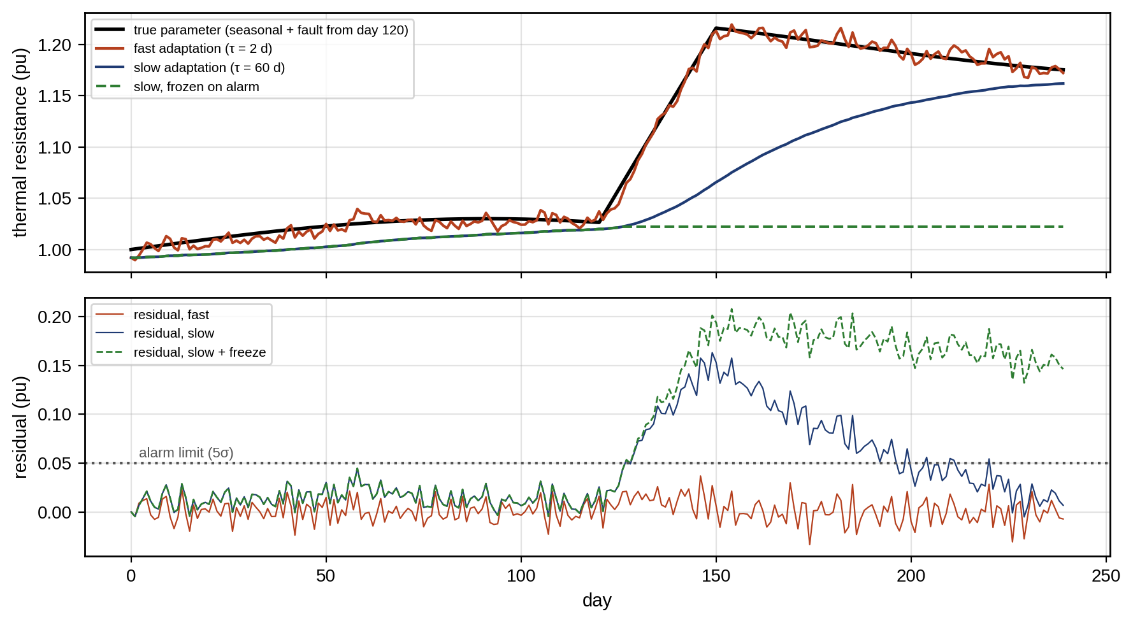
Figure 12.11. The model-adaptation dilemma (synthetic): a parameter with a seasonal swing and a fault from day 120, tracked with fast adaptation (the twin absorbs the fault), slow adaptation (the fault shows, then fades) and slow adaptation frozen on alarm (top); the corresponding residuals against the alarm limit (bottom).

12.6 Thresholds, EWMA, CUSUM and Alarm Design

12.6.1 Baselines and operating modes
A threshold separates “normal” from “abnormal”, so it is set from a baseline: residuals or indicators recorded while the asset is known to be healthy. That period must be long enough to cover every operating mode and season, and far enough from commissioning that infant-mortality effects have settled. For a baseline with mean $μ_{0}$ and standard deviation $σ_{0}$, the classic Shewhart limit [4] flags any sample outside $μ_{0}±Lσ_{0}$. For Gaussian residuals the probability of a false alarm per sample is
 | $$α=2\left[1−Φ\left(L\right)\right],$$ | (12.22)
where $Φ$ is the standard normal distribution function; $L=3$ gives $α=0.0027$, one false alarm in 370 samples on average. The baseline’s mean and standard deviation are themselves estimates from $n$ samples. A limit that accounts for their uncertainty uses the prediction interval of the Student $t$ distribution,
 | $$μ_{0}±t_{n−1, 1−α/2} {\hat{σ}}_{0}\sqrt{1+\frac{1}{n}},$$ | (12.23)
where $t_{n−1, 1−α/2}$ is the Student quantile with $n−1$ degrees of freedom and ${\hat{σ}}_{0}$ the sample standard deviation. For $n=30$ and the 3σ-equivalent $α$ it widens the limit from 3.00 to 3.33 standard deviations; short baselines therefore need wider limits or more data.
One threshold cannot serve all operating modes when the residual’s spread depends on the mode. With baseline data pooled over modes $m$ of probabilities $p_{m}$ and variances $σ_{m}^{2}$ (and zero means), the pooled variance is σpool2=m​pmσm2, which is too wide for the quiet modes and too narrow for the noisy ones. The remedy is to condition the baseline on the mode: $μ_{0,m}$ and $σ_{0,m}$ are estimated separately, and each sample is judged against its own mode’s limits.
Example 12.2 One threshold for two load regimes
Given. M-07’s winding-temperature residual has a standard deviation of 0.5 K at low load and 1.5 K at high load (from the twin’s larger uncertainty at high current, as (12.18) predicts), each mode occupying half the time, both with zero mean. A cooling fault adds 2 K at low load.
Find. The pooled 3σ threshold and its false-alarm rates per mode, and the probability of detecting the fault with the pooled threshold and with a mode-conditioned 3σ threshold.
Solution. The pooled variance is $σ_{pool}^{2}=0.5×{0.5}^{2}+0.5×{1.5}^{2}=1.25$ K², so $σ_{pool}=1.118$ K and the pooled threshold is $±3.354$ K. At low load a false alarm needs $\left|r\right|>3.354$ K, which is 6.7 standard deviations, so the rate is $2\left[1−Φ\left(6.71\right)\right]≈2×{10}^{−11}$, effectively zero. At high load the rate is $2\left[1−Φ\left(3.354/1.5\right)\right]=2\left[1−Φ\left(2.236\right)\right]=2.5$ %, more than nine times the design rate of 0.27 %. The faulty low-load residual is Gaussian with mean 2 K and standard deviation 0.5 K, so the pooled threshold detects it with probability $1−Φ\left(\left(3.354−2\right)/0.5\right)=1−Φ\left(2.71\right)=0.34$ % (the lower limit contributes nothing). Against the low-load threshold of $3×0.5=1.5$ K, the detection probability is $1−Φ\left(\left(1.5−2\right)/0.5\right)=Φ\left(1\right)=84.1$ %.
Interpretation. Figure 12.12 shows the two distributions against the pooled and conditioned limits. The pooled threshold is simultaneously too sensitive in the noisy mode and almost blind in the quiet one. Conditioning on mode costs nothing but the discipline of labelling the baseline by mode, which the twin can do automatically from its own inputs.
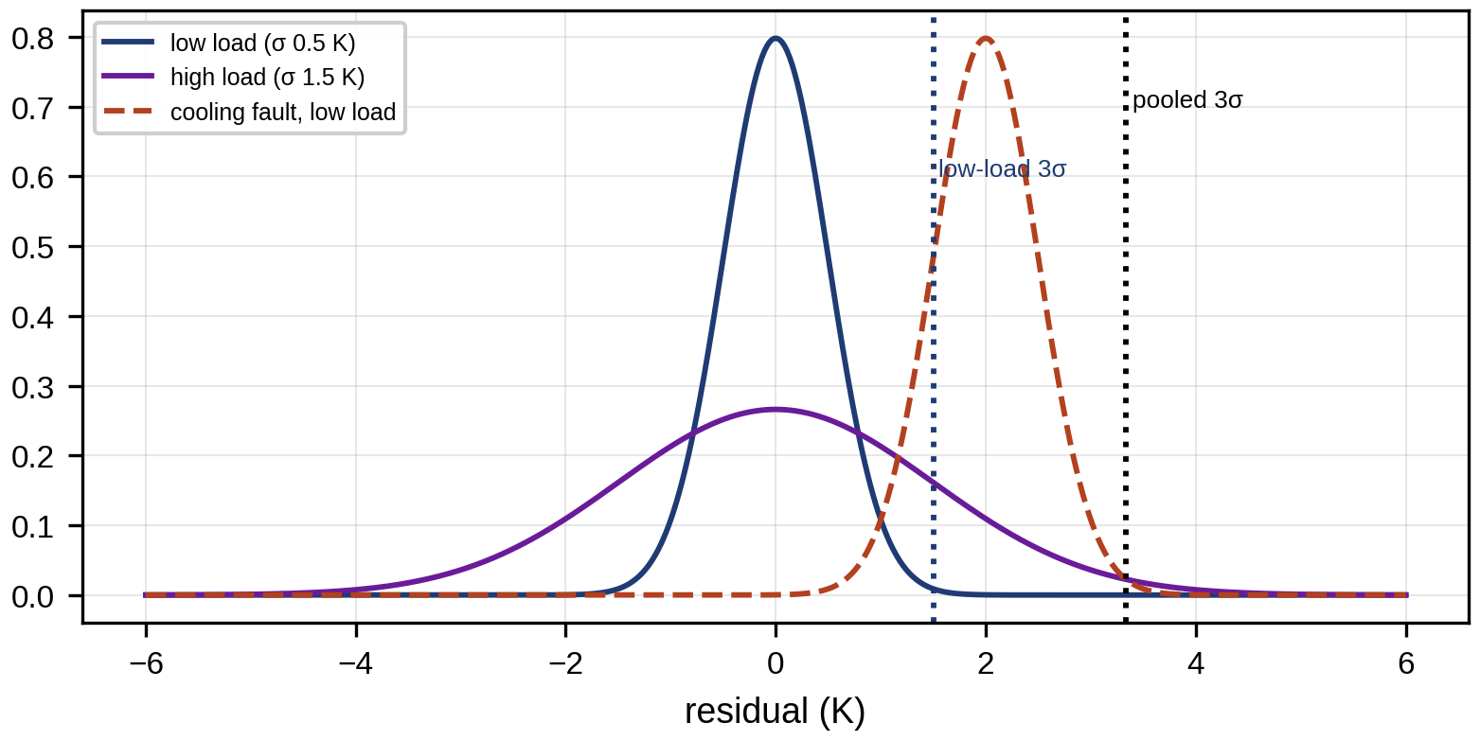
Figure 12.12. Winding-temperature residual distributions in the low-load and high-load modes, with the pooled 3σ limit, the low-load mode-conditioned limit, and the low-load fault distribution.

12.6.2 EWMA and CUSUM for small shifts
A Shewhart chart detects large jumps quickly but small persistent shifts slowly, because it looks at one sample at a time. Accumulating evidence over samples detects small shifts much sooner. The exponentially weighted moving average (EWMA) smooths the standardized residuals $z_{k}$,
 | $$s_{k}=λz_{k}+\left(1−λ\right)s_{k−1}, \text{alarm if} \left|s_{k}\right|>L_{E}\sqrt{\frac{λ}{2−λ}},$$ | (12.24)
where $λ∈(0,1]$ sets the memory and the limit scales with the steady-state standard deviation of $s_{k}$, which follows from summing the geometric series of weights: Vars=λ2i​1−λ2i=λ/2−λ. The cumulative sum (CUSUM) accumulates deviations above a reference value $k$, resetting at zero,
 | $$g_{k}=max\left(0, g_{k−1}+z_{k}−k\right), \text{alarm if} g_{k}>h,$$ | (12.25)
where $k$ is usually half the shift to be detected (in standard deviations) and $h$ the decision interval. CUSUM is the sequential form of the likelihood-ratio test between “no shift” and “shift of $2k$”: for unit-variance Gaussian samples, the log-likelihood ratio of a sample under the two hypotheses is
 | $$ln\frac{ϕ\left(z_{k}−δ\right)}{ϕ\left(z_{k}\right)}=δ\left(z_{k}−\frac{δ}{2}\right),$$ | (12.26)
with $ϕ$ the normal density, so accumulating $z_{k}−δ/2$ and resetting at zero is the recursive maximum of the log-likelihood ratio over all possible change times, with $k=δ/2$. Its optimality is precise but narrow. For independent observations whose distribution changes once, from a known pre-change to a known post-change distribution, Lorden’s criterion measures the worst-case (over change times and pre-change histories) conditional mean delay; among all detectors whose in-control ARL is at least a given value, the CUSUM tuned to that post-change distribution minimizes this delay (Lorden’s asymptotic result, made exact by Moustakides) [5]. For a different shift size, dependent samples or an unknown post-change distribution, it is a good detector, not an optimal one. Performance is measured by the average run length (ARL): ${ARL}_{0}$, the mean number of samples to a false alarm, and ${ARL}_{1}$, the mean delay to detect a real shift. Siegmund’s approximation for the one-sided CUSUM with a shift of $δ$ standard deviations is
 | $$ARL\left(δ\right)≈\frac{e^{−2Δb}+2Δb−1}{2Δ^{2}}, Δ=δ−k, b=h+1.166,$$ | (12.27)
which tends to $b^{2}$ as $Δ→0$. For the in-control run length, $δ=0$ and $Δ=−k$.
Example 12.3 Detecting a half-sigma shift
Given. Standardized, independent Gaussian residuals with a persistent shift of 0.5σ after a fault. Three detectors tuned to similar ${ARL}_{0}$ near 375: a two-sided Shewhart chart at 3σ; a two-sided EWMA with $λ=0.1$ and $L_{E}=2.7$; a one-sided (upper) CUSUM with $k=0.25$ and $h=6.75$. Each statistic starts at zero at the change (zero-state ARL).
Find. ${ARL}_{0}$ and ${ARL}_{1}$ by Monte Carlo simulation with 3000 runs per case (seed 12), and the CUSUM values from (12.27).
Solution. By simulation: Shewhart ${ARL}_{0}=375$, ${ARL}_{1}=158$; EWMA 366 and 28; CUSUM 377 and 24. With 3000 runs the standard error of each ${ARL}_{0}$ is about 7 samples (a run length is roughly geometric, so its standard deviation is close to its mean). Siegmund’s approximation (12.27) gives 379 and 23.8 for the CUSUM, within 1 % of the simulation. For a 1σ shift the CUSUM needs 9.7 samples by both methods.
Interpretation. Figure 12.13 shows the three statistics on one record. At the same false-alarm rate, CUSUM detects the small shift about six times faster than the 3σ rule, because it accumulates evidence. The false-alarm rate itself must be read in operating terms: with a sample every 10 minutes, an ${ARL}_{0}$ of 375 is 140 false alarms a year per indicator.
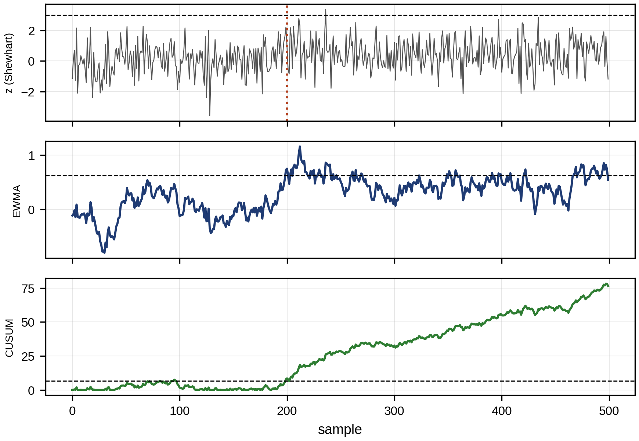
Figure 12.13. One record with a 0.5σ shift beginning at sample 200: standardized residuals with the 3σ Shewhart limits (top), EWMA statistic (middle) and CUSUM statistic (bottom) with their limits.

12.6.3 Dependent, non-Gaussian and drifting residuals
The false-alarm formulas above assume independent, identically distributed Gaussian samples. Real residuals are none of these. Successive residuals are autocorrelated because the twin’s errors change slowly (a thermal model that is 0.5 K high at 10:00 is still high at 10:10). They are heteroscedastic, with a spread that depends on the operating point. And they are often heavy-tailed. The per-sample probability $α$ of (12.22) then no longer translates into an alarm rate.
For a first-order autoregressive residual, $z_{k}=ϕz_{k−1}+\sqrt{1−ϕ^{2}} e_{k}$ with unit variance and lag-one correlation $ϕ$, the EWMA statistic sk=λi≥0​1−λizk−i has variance
 | Vars=λ2i,j≥0​1−λi+jϕi−j=λ2−λ⋅1+ϕ1−λ1−ϕ1−λ, | (12.28)
where the second factor is the inflation caused by correlation; the double sum splits into the diagonal and two geometric off-diagonal series. For $λ=0.1$ and $ϕ=0.5$ it is 2.64, so the EWMA’s standard deviation is 1.62 times what the independent-sample limit assumes, and the chart alarms far too often. The CUSUM suffers similarly: in simulation with $ϕ=0.5$, the CUSUM of Example 12.3 has ${ARL}_{0}=80$ instead of 377, nearly five times as many false alarms, while the Shewhart chart, which looks at one sample at a time, is almost unaffected (${ARL}_{0}=405$). Two remedies are standard. Prewhitening fits a time-series model to the healthy residual and applies the detector to its one-step prediction errors (innovations), which are close to independent. Alternatively the limits are recalibrated by simulation, or by using an effective sample size $n_{eff}=n\left(1−ϕ\right)/\left(1+ϕ\right)$ in place of $n$ when estimating baseline statistics.
When the residuals are not Gaussian, thresholds are set from empirical quantiles of a long healthy baseline. For the very small $α$ needed in fleets, few baseline samples exceed the threshold, and the tail is modelled instead. Above a high level $u$, the excesses of many distributions follow a generalized Pareto distribution, $P\left(X>x∣X>u\right)={\left(1+ξ\left(x−u\right)/σ_{u}\right)}^{−1/ξ}$, with shape $ξ$ and scale $σ_{u}$ fitted to the $N_{u}$ excesses out of $n$ baseline samples. Solving for the level exceeded with probability $α$,
 | $$x_{α}=u+\frac{σ_{u}}{ξ}\left[{\left(\frac{nα}{N_{u}}\right)}^{−ξ}−1\right],$$ | (12.29)
gives the threshold. Extreme-value modelling is justified only when the excesses are stationary and independent (declustered), and it extrapolates, so its uncertainty should be reported.
Concept drift is a change in the healthy residual’s distribution that is not a fault: a new operating regime, a sensor replaced with a slightly different one, a twin recalibration. It is handled by the governance of Section 12.25: drift in the healthy statistics is monitored separately, and thresholds are re-derived only from data that have been confirmed healthy, never automatically from the recent data that may contain the fault.

12.6.4 Alarm persistence and fleet-level false-alarm budgets
Operators judge a monitoring system by its alarms, not by its statistics. Two tools turn per-sample detectors into usable alarms. Persistence (debounce) logic raises an alarm only if $k$ of the last $n$ samples exceed the threshold. For independent samples with per-sample exceedance probability $α$, the probability that a window alarms is
 | $$P_{k/n}=\sum_{j=k}^{n}{\left({n \atop j}\right)}α^{j}{\left(1−α\right)}^{n−j},$$ | (12.30)
so a 3-of-5 rule on a 1 % threshold alarms falsely with probability about $10α^{3}={10}^{−5}$ per window, while a persistent fault that exceeds the threshold 70 % of the time still triggers it with probability 0.84. Persistence costs delay, a few samples, and misses intermittent faults, which need event counting instead.
The second tool is a false-alarm budget. The plant decides how many false alarms per year it can investigate, say 12 across all monitored indicators, and allocates it. For $N_{ind}$ independent indicators each sampled $n_{s}$ times a year, the per-sample rate must be
 | $$α=\frac{FA_{year}}{N_{ind} n_{s}},$$ | (12.31)
where $FA_{year}$ is the budget. With 100 indicators sampled every 10 minutes ($n_{s}=52 560$), $α=2.3×{10}^{−6}$, which for Gaussian residuals is a two-sided limit of 4.73σ, not 3σ. This explains why plants that deploy textbook 3σ limits on every indicator soon ignore their alarms, and why accumulating detectors such as CUSUM, which reach low false-alarm rates without losing sensitivity to small shifts, are worth their extra complexity.

12.7 Detector and Classifier Evaluation and Cost-sensitive Decisions

12.7.1 ROC, precision–recall and cost
Every threshold trades false alarms against missed detections. For a threshold $τ$ on an indicator, the true-positive rate (recall) and false-positive rate are
 | $$TPR\left(τ\right)=P\left(r>τ∣\text{fault}\right), FPR\left(τ\right)=P\left(r>τ∣\text{healthy}\right),$$ | (12.32)
and sweeping $τ$ traces the receiver operating characteristic (ROC), whose area (AUC) is the probability that a random faulty case scores higher than a random healthy one. It can be computed directly from the scores as the Mann–Whitney statistic,
 | AUC=1NfNhi∈faulty​j∈healthy​1ri>rj, | (12.33)
which makes clear that it measures ranking, not calibration. ROC hides the effect of rarity. What the maintenance team experiences is precision, the fraction of alarms that are real, which by Bayes’ rule depends on the prevalence $π$ of faults:
 | $$Precision=\frac{π TPR}{π TPR+\left(1−π\right) FPR}.$$ | (12.34)
The precision–recall curve therefore matters more than ROC when faults are rare. The threshold is chosen by expected cost: with a false-alarm cost $C_{FA}$ (an unnecessary inspection) and a miss cost $C_{miss}$ (an unplanned failure),
 | $$E[C]\left(τ\right)=N_{h} FPR\left(τ\right) C_{FA}+N_{f}\left[1−TPR\left(τ\right)\right]C_{miss},$$ | (12.35)
where $TPR$ and $FPR$ are the true- and false-positive rates at the chosen threshold, $N_{h}$ and $N_{f}$ the numbers of healthy and faulty periods in the evaluation set, and $E[C]$ the expected cost. Two cautions apply. First, (12.35) uses the counts of the evaluation set, whose fault prevalence is usually far higher than in service because faulty periods were collected on purpose; the deployment cost must be recomputed with the deployment prevalence $π$, as
 | $$E[C]_{dep}\left(τ\right)=N\left[\left(1−π\right) FPR\left(τ\right) C_{FA}+π\left(1−TPR\left(τ\right)\right)C_{miss}\right],$$ | (12.36)
for $N$ periods in service. Second, the threshold must be chosen on a validation set and its performance reported on a separate test set; choosing the threshold on the test set reports the best case of many trials, not the expected performance. The area under the precision–recall curve, estimated as average precision AP=n​Rn−Rn−1Pn over the ranked scores (with recall $R_{n}$ and precision $P_{n}$ at the $n$-th threshold), summarizes ranking under rarity better than the ROC AUC, but it depends on the prevalence of the set it was computed on.
Example 12.4 Choosing a threshold from validation data
Given. A residual detector evaluated on a labelled validation set of 500 healthy and 50 faulty periods (prevalence 9.1 %). Healthy residuals are heavy-tailed, Student’s $t$ with 4 degrees of freedom scaled to unit variance; faulty ones are Gaussian with mean 3.2 and unit variance (seed 4). Candidate thresholds 2.0, 2.5 and 3.0. An unnecessary inspection costs 500 $, a missed fault 20 000 $. In service, faults are present in 1 % of periods.
Find. False alarms, detections, precision and expected cost for each threshold on the validation set; precision and expected cost per 1000 periods at 1 % prevalence; the AUC and average precision.
Solution. AUC = 0.989 and AP = 0.85.
- Threshold 2.0. 15 false alarms (FPR 3.0 %), 46 of 50 faults detected (TPR 92 %), precision 75 %, validation cost 87 500 $.
- Threshold 2.5. 7 false alarms (1.4 %), 42 detections (84 %), precision 86 %, cost 163 500 $.
- Threshold 3.0. 4 false alarms (0.8 %), 33 detections (66 %), precision 89 %, cost 342 000 $.
At 1 % prevalence the precisions fall to 24 %, 38 % and 45 %, and by (12.36) the expected costs per 1000 service periods are 30 850 $, 38 930 $ and 71 960 $. The threshold of 2.0 is cheapest on both sets.
Interpretation. Figure 12.14 places the three thresholds on the ROC and precision–recall curves. The conventional 3σ rule is the most expensive choice here, because a missed fault costs forty times a false alarm. The healthy residuals are not Gaussian: at 2.0 they give 15 false alarms where a Gaussian would give 11, and at 3.0 four where a Gaussian would give 0.7, so thresholds must be set from the empirical distribution. In service, three alarms in four at the cost-optimal threshold will be false, because faults are rare. The maintenance process must be designed for that, with a quick second check before a crew is sent.
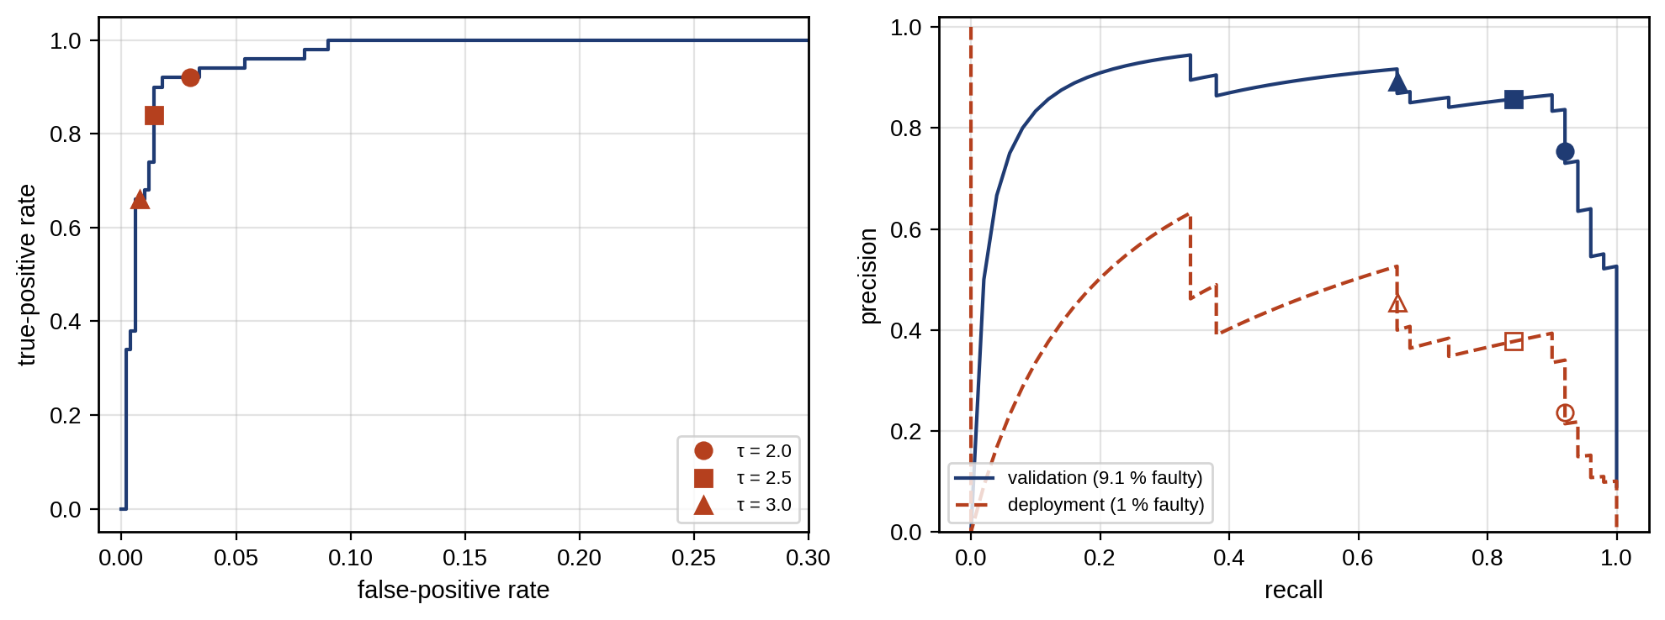
Figure 12.14. Detector evaluation on the validation set of Example 12.4: ROC curve with the three candidate thresholds (left); precision–recall curves at the validation prevalence (9.1 %) and at the deployment prevalence (1 %), with the three thresholds marked (right).

12.7.2 Validation discipline for classifiers
Before any classifier metric means anything, the data must be split so that the test set represents what the system will meet in service. Three rules follow from how PHM data are produced. Windows cut from one run overlap and are strongly correlated, so they must not be split between training and test. Machines differ in mounting, resonance and baseline, so a test set must contain machines the model has not seen. And degradation evolves in time, so a model must not be trained on data from after the time at which it predicts. The splits are therefore machine-wise, run-wise or time-wise, never random over windows (Section 12.13).
Faults are rare, so class imbalance is the norm. Overall accuracy is then misleading (a model that always says “healthy” is 99 % accurate at 1 % prevalence), and the per-class measures below are used instead. Many detectors output a score that is read as a probability, and that probability must be calibrated: of all cases given probability 0.8, about 80 % should be faulty. Calibration is shown by a reliability diagram (observed frequency against predicted probability in bins) and summarized by the Brier score,
 | $$BS=\frac{1}{N}\sum_{i=1}^{N}{{\left(p_{i}−y_{i}\right)}^{2}},$$ | (12.37)
where $p_{i}$ is the predicted probability of fault for case $i$ and $y_{i}∈\{0,1\}$ its label. A logistic model fitted to the residual of Example 12.4 has $BS=0.023$ against 0.083 for a constant forecast of the validation prevalence. A poorly calibrated but well-ranking model can be recalibrated (Platt scaling, isotonic regression) on the validation set. Finally, maintenance cares about events, not samples. A fault that lasts 200 samples and is flagged on 30 of them is one detected event with a delay, not 170 misses; a burst of 50 alarm samples from one transient is one false alarm. Event-level scoring counts detected events, false-alarm events and detection delay, and it is the scoring that should be reported for PHM.

12.7.3 Multi-class diagnosis: the confusion matrix
When a diagnostic system assigns one of several fault classes, its performance is summarized by the confusion matrix $M$, whose entry $M_{ij}$ counts cases of true class $i$ assigned to class $j$ (Chapter 10, Section 10.21.1 showed an example). Per-class measures follow from its rows and columns:
 | Recalli=Miij​Mij, Precisioni=Miij​Mji, F1,i=2 Precisioni RecalliPrecisioni+Recalli, | (12.38)
and the macro-averaged $F_{1}$ (the mean over classes) weights rare classes equally with common ones, which overall accuracy does not. When misses cost more than false alarms, the $F_{β}$ score weights recall $β$ times as much as precision:
 | $$F_{β}=\frac{\left(1+β^{2}\right)Precision⋅Recall}{β^{2} Precision+Recall}.$$ | (12.39)
where $M_{ij}$ counts cases of true class $i$ assigned to class $j$ and $β$ weights recall relative to precision. With several classes, the balanced accuracy is the mean of the per-class recalls, BA=1Ki​Recalli over $K$ classes, and equals 0.5 for a trivial classifier on two classes whatever the imbalance. A diagnostic classifier must also know what it does not know. Fault classes met in service are never all present in training, so the classifier needs a reject or unknown option: a case is rejected when its highest class probability falls below a threshold, or when its features lie outside the training distribution (for example, when its Mahalanobis distance to every class exceeds a chi-square limit). A rejected case is sent to an engineer, which is better than a confident wrong label. And a classifier’s metrics are credible only if they were measured on assets and operating conditions it was not trained on; a confusion matrix built from random windows of the training runs describes the training runs.

12.8 Bearing Diagnosis: Characteristic Frequencies, Envelope and Order Tracking

12.8.1 Deriving the defect frequencies
Consider a rolling bearing with $N_{b}$ rolling elements of diameter $d$ on a pitch diameter $D$ (the diameter of the circle through the element centres), contact angle $α$, inner race turning at shaft frequency $f_{r}$ and outer race fixed (Figure 12.15). The derivation rests on four assumptions: ideal geometry, a stationary outer race, pure rolling without slip at both contacts, and a known, constant contact angle. The contact point on the inner race lies at radius $\left(D−dcosα\right)/2$ from the shaft axis, so its surface speed is $v_{i}=2πf_{r}\left(D−dcosα\right)/2$; the outer-race contact is stationary, $v_{o}=0$. A rolling element that does not slip moves its centre at the mean of the two contact speeds, $\left(v_{i}+v_{o}\right)/2$, around a circle of radius $D/2$, so the cage turns at
 | $$f_{FTF}=\frac{f_{r}}{2}\left(1−\frac{d}{D}cosα\right),$$ | (12.40)
the fundamental train frequency (FTF). A defect on the outer race is struck by each of the $N_{b}$ elements as they pass it at the cage speed; a defect on the inner race by each element at the relative speed of shaft and cage, $f_{r}−f_{FTF}$; and a defect on a rolling element strikes a race once per revolution of the element about its own axis, whose rate follows from equating the element’s surface speed with the outer race’s speed relative to the cage:
 | $$f_{BPFO}=\frac{N_{b}}{2}f_{r}\left(1−\frac{d}{D}cosα\right), f_{BPFI}=\frac{N_{b}}{2}f_{r}\left(1+\frac{d}{D}cosα\right), f_{BSF}=\frac{D}{2d}f_{r}\left[1−{\left(\frac{d}{D}cosα\right)}^{2}\right].$$ | (12.41)
where $f_{BPFO}$, $f_{BPFI}$ and $f_{BSF}$ are the ball-pass frequencies of the outer and inner races and the ball-spin frequency. With speed in r/min, $f_{r}=n_{r}/60$, and the ratio $f_{BPFO}/f_{r}$, the defect order, is independent of speed, which is why order tracking (12.16) preserves the defect lines. Real bearings violate the assumptions: elements slip, especially when lightly loaded; the contact angle changes with axial load; and internal clearance changes the load zone. Measured lines therefore typically fall a little below the computed values, often by about 1 to 2 %, but the amount depends on the bearing and its load, so it should be treated as an uncertainty band to be confirmed, not a fixed correction.
The load zone also shapes the spectrum. With the outer race fixed and a radial load, an outer-race defect in the load zone is struck with similar force by every passing element, so its envelope spectrum shows clean harmonics of BPFO. An inner-race defect rotates with the shaft through the load zone once per revolution, so its impacts are amplitude-modulated at $f_{r}$ and its envelope spectrum shows sidebands at $f_{BPFI}±f_{r}$. A rolling-element defect enters the load zone once per cage revolution, giving sidebands at $±f_{FTF}$ around its lines.
Example 12.5 Is it the outer race?
Given. M-07’s drive-end bearing (synthetic data sheet): $N_{b}=8$ rolling elements, element diameter $d=10$ mm, pitch diameter $D=45$ mm, contact angle $α=0$ (deep-groove ball bearing under radial load), shaft at $n_{r}=1500$ r/min. The envelope spectrum of Example 12.1 shows its strongest line at 77.0 Hz with harmonics at 154.0 and 231.0 Hz. In a second case, an envelope spectrum shows a line at 84.4 Hz with harmonics at 168.8 and 253.2 Hz.
Find. The four defect frequencies, and the diagnosis in each case.
Solution. The shaft frequency is $f_{r}=1500/60=25$ Hz and the geometric ratio is $\left(d/D\right)cosα=10/45=0.2222$. By (12.40) and (12.41): FTF $=12.5×\left(1−0.2222\right)=9.72$ Hz; BPFO $=8×9.72=4×25×0.7778=77.78$ Hz; BPFI $=4×25×1.2222=122.22$ Hz; BSF $=\left(45/20\right)×25×\left(1−{0.2222}^{2}\right)=56.25×0.9506=53.47$ Hz. As orders: 0.389, 3.111, 4.889 and 2.139. The first case’s 77.0 Hz is 1.0 % below BPFO, with harmonics at exactly two and three times it: an outer-race defect with normal slip. The second case’s 84.4 Hz is 8.5 % above BPFO, and slip can only lower the frequency. It matches no defect frequency of this bearing at 25 Hz. Either the speed is not what was assumed (84.4 Hz would be BPFO at $84.4/3.111=27.1$ Hz, 1628 r/min), or the bearing’s geometry differs from the data sheet, or the line has another source.
Interpretation. Figure 12.15 shows the computed frequencies against the measured spectrum. Matching a line to a defect frequency needs a tolerance based on physics and a measured speed. An 8.5 % mismatch must not be explained away as “close enough”. The twin’s first action is to check the tachometer or estimate the speed from the spectrum’s 1× line, and then to recompute; only if the line still matches no defect frequency is another source (electrical, structural, a neighbouring machine) investigated.
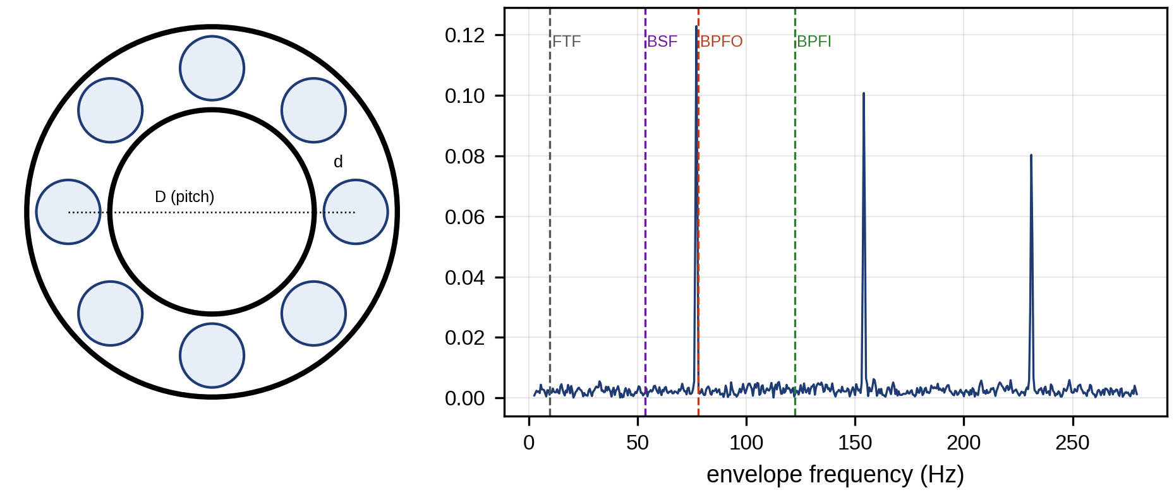
Figure 12.15. Rolling-bearing geometry (left) and the M-07 envelope spectrum with the computed FTF, BSF, BPFO and BPFI marked (right); the measured line sits 1 % below BPFO, consistent with slip.

12.8.2 What the twin adds: predicted healthy vibration
A signal-based monitor compares today’s spectrum with last month’s. A twin can predict what the healthy spectrum should be at today’s speed and load, which removes most of the variation that confuses trend analysis. The simplest such model scales each component with its physical cause: unbalance force grows with the square of speed, so the 1× velocity line of a rigid rotor grows roughly as $f_{r}^{2}$ below the first critical speed; the background vibration level in a band grows with load and speed according to an empirical law fitted on healthy data, ${\overset{‾}{A}}_{band}=A_{0}{\left(f_{r}/f_{r0}\right)}^{p}{\left(P/P_{0}\right)}^{q}$, with exponents $p$ and $q$ estimated from the baseline. The healthy prediction for each order or band then defines a normalized residual (measured minus predicted, divided by the baseline scatter at that condition), and the defect detector of Section 12.6.2 runs on that residual. Section 12.13 shows that exactly this normalization is what lets a classifier trained at one speed work at another.

12.9 Structured Residuals, Isolability and Sensor-fault Diagnosis
Detection says something is wrong; isolation says what. With several residuals, each sensitive to some faults and not to others, a fault signature matrix $S$ records which residuals respond to which fault: $S_{ij}=1$ if fault $j$ affects residual $i$. A fault is isolable when its column differs from every other column, and the observed pattern of fired residuals $o$ is matched to the nearest column:
 | $$\hat{j}=arg\min_{j} d_{H}\left(o,S_{:,j}\right),$$ | (12.42)
where $o$ is the binary vector of fired residuals, $S_{:,j}$ the $j$-th column of the signature matrix and $d_{H}$ the Hamming distance (the number of positions in which two binary vectors differ).
Binary signatures discard useful information. A residual may respond to two faults, but with very different strength. The sensitivity matrix $Ψ$ records the size of each response: for a fault of unit severity $f_{j}$, residual $i$ changes by $Ψ_{ij}=∂r_{i}/∂f_{j}$ in units of its own standard deviation. For an observed normalized residual vector $z$ and a single fault of unknown size $f$, $z≈Ψ_{:,j}f+n$ with unit-variance noise $n$, and the least-squares size and fit are
 | $${\hat{f}}_{j}=\frac{Ψ_{:,j}^{T}z}{Ψ_{:,j}^{T}Ψ_{:,j}}, J_{j}={∥z−Ψ_{:,j}{\hat{f}}_{j}∥}^{2}, \hat{j}=arg\min_{j}J_{j},$$ | (12.43)
where $J_{j}$ is the residual sum of squares when fault $j$ is assumed. In healthy noise $J_{j}$ follows a chi-square distribution with $m−1$ degrees of freedom for $m$ residuals, so a best-fitting fault whose $J_{j}$ still exceeds its chi-square limit points to a fault not in the matrix, an unknown class, which must be reported as such. Two faults are hard to separate when their columns point in nearly the same direction; the angle between them, $cosγ_{jl}=Ψ_{:,j}^{T}Ψ_{:,l}/\left(∥Ψ_{:,j}∥∥Ψ_{:,l}∥\right)$, is a graded measure of isolability, and the smaller the angle, the larger the fault must be before the noise stops confusing them. Simultaneous faults are handled by fitting pairs of columns, at the cost of more ambiguity. Structured residuals connect naturally to observer-based fault detection and isolation, where banks of observers are each designed to be insensitive to one fault or one sensor, and to causal and graph reasoning, where the network of physical relations among variables is used to decide which residual can respond to which fault.
Sensor faults deserve special attention because they are common and they mimic process faults. Their usual forms are a bias, a drift, a gain error and a frozen value:
 | $$y_{k}^{f}=y_{k}+b, y_{k}^{f}=y_{k}+ck, y_{k}^{f}=\left(1+g\right)y_{k}, y_{k}^{f}=y_{k_{0}} \left(k≥k_{0}\right),$$ | (12.44)
where $b$, $c$ and $g$ are the bias, drift rate and gain error and $k_{0}$ the time the value froze. A biased temperature sensor looks like a thermal fault; a drifting current sensor looks like a battery that is losing charge. Three properties separate them:
- Physics. A sensor fault breaks relations between sensors that no physical fault breaks. The energy balance, the heat balance and Kirchhoff’s laws must still hold among the other measurements.
- Redundancy. A sensor fault appears in residuals that use that sensor and in no others, including redundant measurements of the same quantity.
- Time. Sensor faults often appear as steps or frozen values, while degradation drifts.
Table 12.3 is the signature matrix for the M-07 motor and its drive, built from the residuals of Chapter 7.
TABLE 12.3 Fault signature matrix for motor M-07 and drive D-3 (1 = residual responds)
Residual | Bearing | Cooling fault | Winding short | Current-sensor bias | Temperature-sensor bias | Inverter open switch
Envelope at BPFO | 1 | 0 | 0 | 0 | 0 | 0
Winding-temperature residual | 0 | 1 | 1 | 0 | 1 | 0
Housing-temperature residual | 0 | 1 | 0 | 0 | 0 | 0
Negative-sequence current | 0 | 0 | 1 | 0 | 0 | 1
Current-sum parity ($i_{a}+i_{b}+i_{c}$) | 0 | 0 | 0 | 1 | 0 | 0
Phase-current DC offset | 0 | 0 | 0 | 1 | 0 | 1
Every column differs, so every fault is isolable (Figure 12.16). The temperature-sensor bias fires the winding residual alone, without the housing residual that a real cooling fault would also fire. Winding short and inverter open switch share the negative-sequence residual, but only the open switch fires the DC offset.
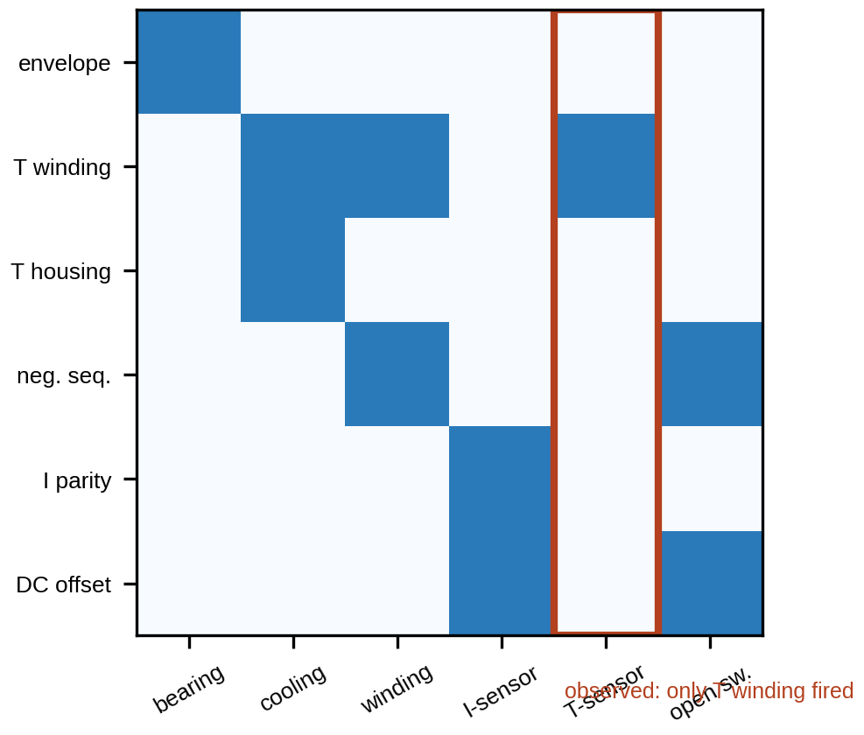
Figure 12.16. The fault signature matrix of Table 12.3 as a map, with the observed pattern of a temperature-sensor bias matched to its column.

12.10 FMEA, FMECA and Risk-informed PHM
Failure mode and effects analysis (FMEA) lists, for each component, its failure modes, their effects, causes and detection means, and ranks them. The traditional ranking is the risk priority number,
 | $$RPN=S×O×D,$$ | (12.45)
with severity $S$, occurrence $O$ and detection $D$ each scored from 1 to 10 (a high $D$ meaning poor detectability) [6]. For M-07: bearing wear $7×5×4=140$; insulation breakdown $10×2×6=120$; capacitor dry-out $8×4×3=96$; fan failure $5×6×2=60$.
RPN remains useful for teaching and for structuring a review, but it is not a validated risk measure. Its ordinal scores are multiplied as if they were ratios. Very different combinations give the same product ($S=10$, $O=2$, $D=6$ equals $S=5$, $O=6$, $D=4$ at 120). And a catastrophic but rare mode can rank below a nuisance. IEC 60812:2018 [6] describes FMEA and FMECA without prescribing one ranking method, and practice uses several alternatives. The automotive sector, following the AIAG–VDA FMEA handbook, replaces RPN with an action priority table that gives severity precedence over occurrence and detection; this is sector guidance, not a requirement of IEC 60812. Risk matrices plot severity against likelihood with regions agreed in advance. And quantitative FMECA replaces the scores with criticality in physical units,
 | $$C_{m}=λ_{p} α_{m} β_{m} t,$$ | (12.46)
where $λ_{p}$ is the part failure rate, $α_{m}$ the fraction of failures in mode $m$, $β_{m}$ the conditional probability that the mode causes the effect and $t$ the operating time. Figure 12.17 contrasts the RPN ranking with a severity-first view.
Criticality is converted into risk by multiplying by the consequence $C_{cons}$ of the effect (cost, safety category), $Risk_{m}=C_{m} C_{cons}$, and the monitoring system changes risk through the probability that it detects the mode in time, so the residual risk becomes $Risk_{m}\left(1−P_{det,m}\right)$ with $P_{det,m}$ from (12.2) and the validated detector performance. A digital twin supplies the evidence for these numbers and keeps it current. Fleet failure records update $λ_{p}$ and $α_{m}$ (Section 12.17); validated detection rates update $P_{det,m}$; and after each maintenance finding, the twin records whether the mode was detected, how early and at what severity. The FMEA then stops being a document written once at design and becomes a table whose occurrence and detection columns are estimated from data.
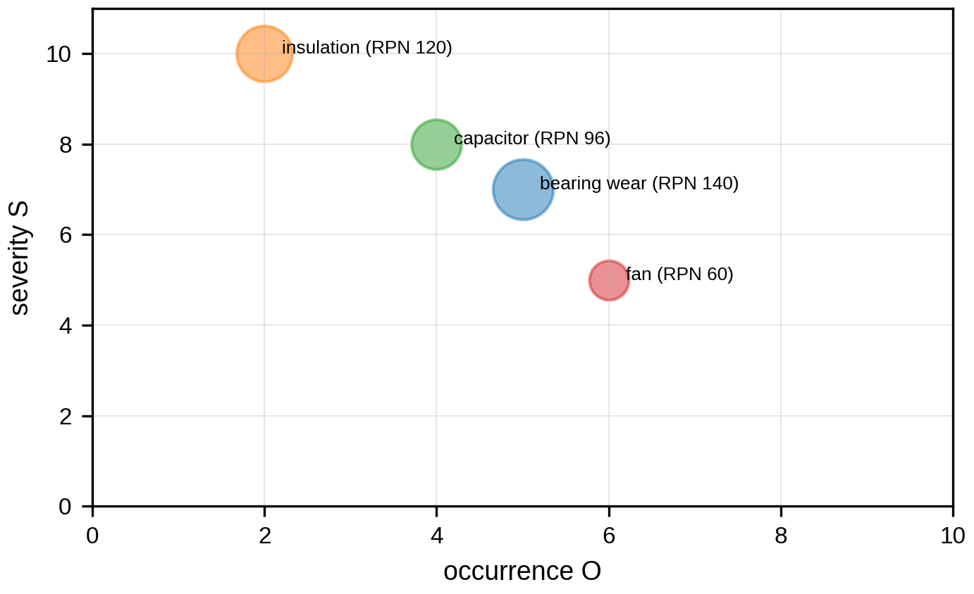
Figure 12.17. Risk matrix of the M-07 failure modes: severity against occurrence with bubble size proportional to RPN; insulation breakdown has the highest severity but not the highest RPN.

12.11 Multivariate Anomaly Detection and Health Indices

12.11.1 Covariance, the Mahalanobis distance and PCA
When several indicators are correlated, judging each against its own limits misses combinations that are individually normal but jointly impossible. The Mahalanobis distance measures a vector of indicators $x$ against the baseline mean $μ$ and covariance $Σ$:
 | $$D^{2}\left(x\right)={\left(x−μ\right)}^{T}Σ^{−1}\left(x−μ\right)∼χ_{p}^{2},$$ | (12.47)
where $p$ is the number of indicators and the chi-square distribution holds for Gaussian baseline data. In the coordinates of the covariance’s eigenvectors it is the sum of squared standardized principal components,
 | $$D^{2}=\sum_{i=1}^{p}{\frac{{\left[v_{i}^{T}\left(x−μ\right)\right]}^{2}}{λ_{i}}},$$ | (12.48)
with eigenvalues $λ_{i}$ and eigenvectors $v_{i}$ of $Σ$, so it penalizes departures along directions in which the baseline varies little (small $λ_{i}$). With many indicators, principal component analysis splits the test in two. Hotelling’s $T^{2}$ covers the retained components, and the squared prediction error covers the residual subspace,
 | $$T^{2}=t^{T}Λ_{r}^{−1}t, SPE=\left.∥\left(I−P_{r}P_{r}^{T}\right)\left(x−μ\right)\right.∥^{2},$$ | (12.49)
where $P_{r}$ holds the first $r$ eigenvectors, $t=P_{r}^{T}\left(x−μ\right)$ the scores and $Λ_{r}$ their variances. SPE flags new kinds of behaviour that break the baseline’s correlation structure.
Covariance is easiest to see in two dimensions. For two indicators with standard deviations $σ_{1}$, $σ_{2}$ and correlation $ρ$, the contours of constant $D^{2}$ are ellipses whose axes lie along the eigenvectors of $Σ$ with half-lengths $\sqrt{D^{2}λ_{i}}$. A strong positive correlation stretches the ellipse along the diagonal and squeezes it across, so a point that moves against the correlation leaves the ellipse after a small step, while a point that moves along it can travel far. Figure 12.18 shows this for M-07.
Example 12.6 A jointly abnormal motor
Given. Baseline indicators for M-07: winding-temperature residual (mean 0 K, σ 1.0 K), vibration RMS (mean 2.0 mm/s, σ 0.3 mm/s) and current unbalance (mean 1.0 %, σ 0.5 %), with correlations 0.8 (temperature–vibration), 0.6 (temperature–unbalance) and 0.5 (vibration–unbalance), because all three rise with load. Two observations: A = (1.8 K, 1.6 mm/s, 0.5 %) and B = (2.0 K, 2.6 mm/s, 2.0 %).
Find. The standardized value of each indicator and $D^{2}$, against the 99 % threshold $χ_{3,0.99}^{2}=11.34$.
Solution. Writing $Σ=D_{σ}CD_{σ}$ with $D_{σ}=diag\left(1.0,0.3,0.5\right)$ and correlation matrix $C$, the distance becomes $D^{2}=z^{T}C^{−1}z$ with standardized $z$, which is easier to compute by hand:
 | $$Σ=\left[\begin{matrix}1.00 & 0.24 & 0.30 \\ 0.24 & 0.09 & 0.075 \\ 0.30 & 0.075 & 0.25\end{matrix}\right], C^{−1}=\left[\begin{matrix}3.261 & −2.174 & −0.870 \\ −2.174 & 2.783 & −0.087 \\ −0.870 & −0.087 & 1.565\end{matrix}\right].$$ | (12.50)
For A, $z=\left(1.8,−1.333,−1.0\right)$, none beyond 2σ, but $D^{2}=z^{T}C^{−1}z=30.4$, far above the threshold (tail probability $1.1×{10}^{−6}$). For B, $z=\left(2,2,2\right)$, every indicator at 2σ, yet $D^{2}=5.39$, normal (tail probability 0.15).
Interpretation. Figure 12.18 shows why. B is simply a heavily loaded motor: all three indicators rise together, as the baseline says they should. A has high temperature with low vibration and low unbalance, which a healthy motor never shows, pointing to a cooling or sensor problem rather than load. Univariate 2σ warning limits would flag all three of B’s indicators and none of A’s; the multivariate test does the opposite, and it is right. The contribution of each indicator, $c_{i}=\left(x_{i}−μ_{i}\right){\left[Σ^{−1}\left(x−μ\right)\right]}_{i}$, sums to $D^{2}$ and here assigns 17.3 of A’s 30.4 to the temperature residual, which is the diagnostic lead.
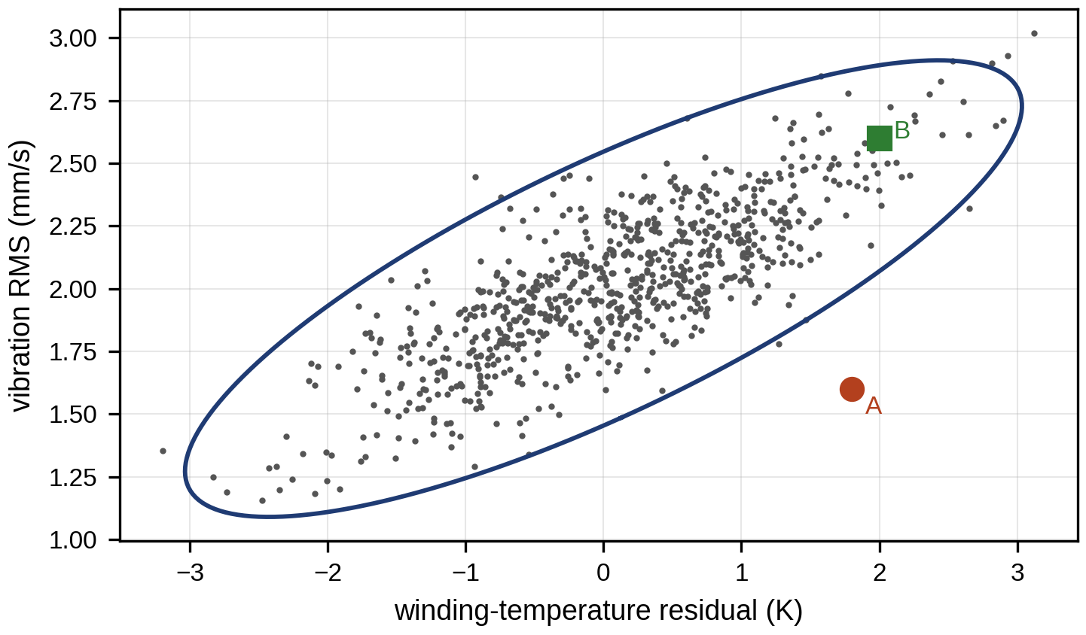
Figure 12.18. Baseline of winding-temperature residual against vibration RMS with the 99 % Mahalanobis ellipse (projected), and the two observations: B lies along the correlation and inside, A lies across it and outside.

12.11.2 When the covariance itself is uncertain
The chi-square limit assumes that $μ$ and $Σ$ are known. They are estimated from $n$ baseline samples, and with many indicators the estimate is poor: the sample covariance of $p$ indicators is singular when $n≤p$ and badly conditioned when $n$ is only a few times $p$, so its inverse amplifies noise in exactly the small-variance directions that (12.48) weights most. For Gaussian data, a new observation’s distance computed with the sample estimates follows a scaled $F$ distribution,
 | $$\frac{n\left(n−p\right)}{p\left(n+1\right)\left(n−1\right)} D^{2}∼F_{p, n−p},$$ | (12.51)
where $F_{p,n−p}$ is the $F$ distribution with $p$ and $n−p$ degrees of freedom. For $p=3$ and $n=30$, the 99 % limit is 15.3 instead of 11.3. Two remedies stabilize the estimate itself. Shrinkage blends the sample covariance $S$ with a well-conditioned target, ${\hat{Σ}}_{γ}=\left(1−γ\right)S+γ \frac{tr\left(S\right)}{p}I$, with the intensity $γ∈\left[0,1\right]$ chosen from the data (the Ledoit–Wolf estimator gives it in closed form). Robust estimators such as the minimum covariance determinant fit the mean and covariance to the most concentrated subset of the baseline, so that a few unlabelled faulty or erroneous samples in the baseline do not inflate the limits. Whatever the estimator, the false-alarm rate of the resulting limit is checked on held-out healthy data.
Two extensions handle common cases. When indicators are autocorrelated, dynamic PCA augments each observation with its own lagged values, ${\tilde{x}}_{k}={\left[x_{k}^{T},x_{k−1}^{T},…,x_{k−l}^{T}\right]}^{T}$, so that the model captures the serial correlation instead of treating it as a fault. When the healthy data are clearly non-Gaussian or multi-modal, distribution-free novelty detectors are used as baselines: the one-class support vector machine, which learns a boundary around the healthy data in a kernel space, and the isolation forest, which scores a point by how few random splits isolate it. Both are in increasing industrial use, both need their thresholds set on held-out healthy data, and neither explains an alarm as directly as a contribution plot does.

12.11.3 Health-index construction
A single indicator rarely captures degradation well over the whole life, so several are combined into a health index (HI). Each indicator $x_{i}$ is first normalized to a common scale between its healthy baseline $x_{i,0}$ and its failure level $x_{i,f}$, and the normalized values are combined with weights:
 | xi=xi−xi,0xi,f−xi,0, HI=i​wixi, i​wi=1. | (12.52)
The weights are chosen for three properties measured on run-to-failure histories [8]:
- Monotonicity: does the indicator move in one direction?
- Trendability: do different units follow similar shapes?
- Prognosability: does it end at a similar value at failure, so that a common threshold works?
For $K$ histories of length $n_{k}$,
 | Mon=1Kk​#{Δx>0}−#{Δx<0}nk−1, Prog=exp−stdkxktf,kmeankxktf,k−xk0, | (12.53)
and trendability is the smallest correlation between any two units’ trajectories on a common time scale,
 | $$Trend=\min_{j,k}\left|corr\left(x_{j},x_{k}\right)\right|,$$ | (12.54)
with the trajectories resampled to a common normalized life before correlating. A good HI scores close to 1 on all three (Figure 12.19).
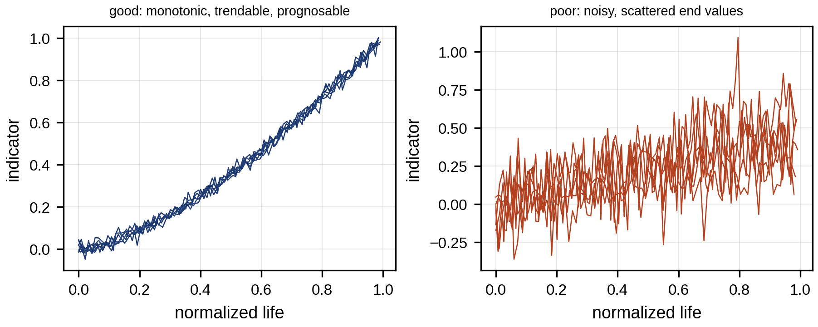
Figure 12.19. Health-index properties: an indicator that is monotonic, trendable and prognosable (left) against one that is noisy and ends at scattered values at failure (right).
Learned alternatives (autoencoder reconstruction error, the first principal component of many features) are common, but their HIs must be checked for the same three properties, because a feature that separates healthy from failed does not necessarily trend smoothly between them.
Three further properties matter in service. Robustness is the insensitivity of the HI to operating conditions and noise, measured for example as the mean ratio of the smoothed trend to the raw HI. Cross-unit normalization scales each unit’s HI by its own healthy baseline (the first weeks after installation), because units differ in their absolute levels far more than in their trends; without it, a prognostic threshold fitted to the fleet fails on each unit. And no future leakage: the normalization, weights and smoothing at time $t$ may use only data up to $t$, since a centred moving average or a min–max scaling over the whole life uses information that a real-time system does not have and makes every HI look more monotonic than it will be.
HIs are constructed in two ways. Supervised construction fits the weights of (12.52) (or a regression model) to a target such as the fraction of life consumed on run-to-failure histories. Unsupervised construction needs no failure labels: the first principal component of the normalized indicators, the Mahalanobis distance from the healthy baseline, or the reconstruction error or latent coordinate of an autoencoder trained on healthy data. A physics-constrained HI enforces what physics says about the damage, for example monotonicity (spall area cannot shrink) and a known sensitivity to load, by fitting under those constraints or by building the HI from a physical parameter such as ESR or thermal resistance. Whatever the construction, the resulting HI is checked on units not used to build it.

12.12 Data-driven, Deep and Hybrid Intelligent Diagnosis
The methods so far rest on explicit physics and statistics, and in most plants they are the industrial baseline. Data-driven methods earn a place when the signatures are too complex to write down, when many sensors must be combined, or when labelled examples are plentiful. The question is always what a new method adds over the simpler one below it, and the answer must come from the validation discipline of Section 12.7.2. Table 12.4 places the methods on a ladder.
TABLE 12.4 The fault-diagnosis ladder
Level | Method | When it is justified | Typical maturity
1 | Rule or threshold on an indicator (ISO 20816 zones, temperature limits) | One dominant, well-understood signature | Industrial baseline
2 | Model-based residual from the twin | Operating conditions vary; a model of healthy behaviour exists | Industrial baseline
3 | Statistical multivariate (Mahalanobis, PCA $T^{2}$/SPE) | Several correlated indicators; mostly healthy data | Industrial baseline
4 | Classical machine learning on features (logistic regression, SVM, random forest) | Labelled fault examples exist; features are meaningful | Increasing deployment
5 | Deep learning on raw signals (1-D CNN, LSTM/TCN, Transformer) | Large labelled datasets; signatures hard to engineer | Increasing deployment
6 | Self-supervised, few-shot, domain adaptation and generalization | Few labels, new machines or conditions | Research and emerging
7 | Physics-informed and hybrid models | Physics known in part; data used for the rest | Research, early deployment
8 | Decision-grade deployment | Any of the above, validated prospectively with uncertainty and fallback | Required before automatic action
The first data-driven rung is a classifier on engineered features. Logistic regression models the probability of a fault as $P\left(y=1∣x\right)=1/\left(1+e^{−\left(w^{T}x+b\right)}\right)$ with weights $w$ and bias $b$ fitted by maximizing the likelihood; its weights are directly interpretable and its probabilities are often well calibrated. A support vector machine finds the separating boundary with the widest margin, possibly in a kernel-transformed space. A random forest averages many decision trees, each trained on a bootstrap sample and random feature subsets, and handles nonlinear interactions with little tuning. All three are strong baselines, and a deep model that cannot beat them on a leakage-free split adds nothing.
Deep networks learn the features themselves [13], [23]. A one-dimensional convolutional neural network (1-D CNN) applies learned filters to the raw vibration or current waveform, hcn=σk​wck xn−k+bc for filter $c$ with weights $w_{c}$, bias $b_{c}$ and nonlinearity $σ$, followed by pooling and further layers; the first-layer filters often resemble the band-pass filters an analyst would choose. Recurrent networks (LSTM) and temporal convolutional networks (TCN) model longer sequences, such as a health-index history for RUL. Transformers relate every time step to every other through attention weights, $Attention\left(Q,K,V\right)=softmax\left(QK^{T}/\sqrt{d_{k}}\right)V$, where the query, key and value matrices are learned projections of the input and $d_{k}$ is the key dimension. Autoencoders trained only on healthy data compress and reconstruct the input, and their reconstruction error is an anomaly score; self-supervised learning trains a representation on unlabelled data with a pretext task (predicting a masked segment, telling whether two augmented views come from the same record) and then needs few labels to diagnose. Table 12.5 compares these methods. Physics-informed models add physical knowledge, either as inputs (twin residuals, order spectra), as constraints in the loss (monotone damage, energy balance) or as a known model whose unexplained part a network learns (hybrid residual modelling).
TABLE 12.5 Data-driven and hybrid diagnosis methods compared (qualitative)
Method | Input | Output | Strength | Limitation | Data need | Interpretability | Compute (edge) | Robustness to domain shift | Maturity
SVM, random forest | Engineered features | Class, score | Strong baseline, fast | Only as good as features | Hundreds of labelled cases | Medium (feature importance) | Very low | Medium with normalized features | Increasing deployment
1-D CNN | Raw waveform | Class, score | Learns filters | Overfits machine identity | Thousands of windows, many machines | Low | Low to medium | Low unless trained across domains | Increasing deployment
LSTM, TCN | Sequences | Class, RUL | Temporal context | Long training, drift | Many run-to-failure sequences | Low | Medium | Low | Research to pilots
Transformer | Sequences, spectra | Class, RUL | Long-range relations | Data hungry | Large | Low (attention is not explanation) | Medium to high | Low to medium | Research
Autoencoder | Healthy data | Anomaly score, latent HI | No fault labels | Scores any novelty, not only faults | Healthy data only | Low to medium | Low to medium | Medium | Increasing deployment
Self-supervised | Unlabelled data | Representation | Few labels needed | Pretext choice matters | Large unlabelled | Low | Medium | Medium | Research
Few-shot | Few labelled examples | Class | New fault classes | Unstable with very few | Few per class | Low | Low | Medium | Research
Physics-informed, hybrid | Signals + twin | Class, RUL, HI | Consistent with physics | Needs a partial model | Moderate | Medium to high | Low to medium | Higher | Research, early deployment
A diagnostic probability from any of these models must be tied back to evidence an engineer can check: the characteristic frequency present in the envelope spectrum, the residual that fired, the contribution plot, the temperature that is physically consistent with the claimed fault. Saliency maps and attention weights show which parts of the input influenced the output, but influence is not explanation; a network that attends to a 25 Hz line may be recognizing the machine, not the fault. The twin makes the link possible, because it can compute what each candidate fault should do to each signal and compare.

12.13 Data Leakage, Domain Shift and Generalization
Benchmark accuracies of 99 % and more are common in published fault-diagnosis papers, and plants that deploy the same methods often find them far less reliable. The main reason is not the method but the evaluation. Windows cut from one run of one machine share its mounting, resonances and noise, and overlapping windows share samples. When such windows are split randomly between training and test (Figure 12.20), the test set contains near-copies of the training data, and a classifier can score well by recognizing the machine rather than the fault. This is data leakage.
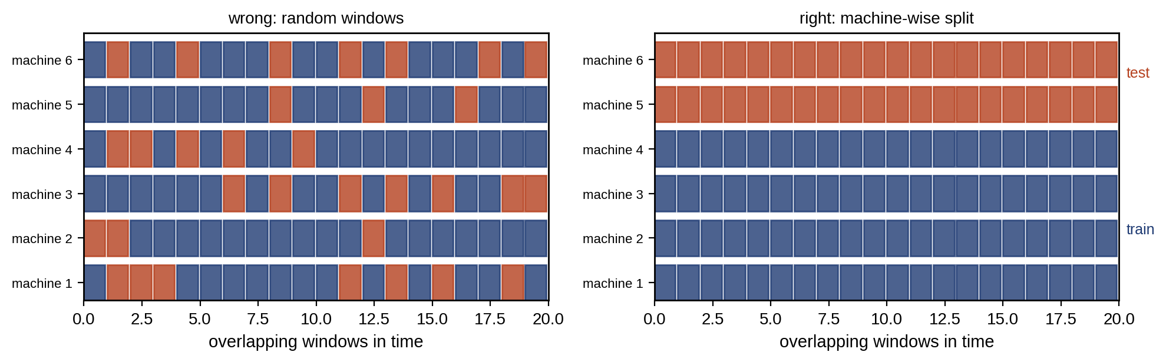
Figure 12.20. Splitting windows for validation: the wrong way, with test windows drawn at random from the same runs as the training windows (left), and a machine-wise split, where the test machines are never seen in training (right).
Example 12.7 Leakage, domain shift and what the twin does about them
Given. A synthetic fleet of 12 machines (seed 21). Each window yields five features whose values combine a machine-specific offset (standard deviation 1.0 per feature, from mounting and resonance), a speed-dependent term (the first and fourth features scale with the logarithm of speed, as vibration levels do), a fault effect of 0.25 to 1.2 per feature, and a slowly varying window-to-window component (first-order autoregressive, coefficient 0.9), so that neighbouring windows are correlated. Sixty windows per machine, condition and health state. A random forest of 200 trees. Twin-normalized features subtract each machine’s healthy baseline, recorded at commissioning (first 20 healthy windows at 1500 r/min), and the twin’s prediction of how the baseline changes with speed.
Find. The balanced accuracy on test data for: a random 70/30 split over windows; a machine-wise split (8 machines for training, 4 for test); the machine-wise split with twin-normalized features; and a domain shift in which the model is trained at 1500 r/min and tested at 1000 r/min on the four unseen machines, with raw and with twin-normalized features.
Solution. Random window split: 96.8 %. Machine-wise split, raw features: 64.0 %. Machine-wise, twin-normalized: 89.4 %. New machines at a new speed, raw features: 56.7 % (64.4 % on the same new machines at the training speed). New machines at a new speed, twin-normalized: 88.1 % (Figure 12.21).
Interpretation. The random split overstates accuracy by 33 points, all of it leakage. The fault effect is small compared with the differences between machines, so a model trained on raw features learns machine identities and fails on new machines, and fails further at a new speed. Subtracting the twin’s healthy prediction removes most of both effects, because it removes what the twin already explains, and leaves mostly what it does not: the fault. This is the simplest and most reliable form of physics-informed domain generalization, and it needs no fault data from the new machine, only a healthy baseline.
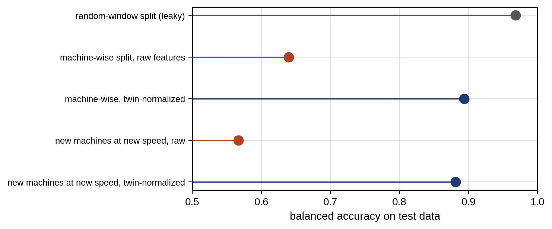
Figure 12.21. Balanced accuracy of the same classifier under different validation designs (synthetic fleet of Example 12.7): a leaky random-window split, machine-wise splits with raw and twin-normalized features, and unseen machines at an unseen speed.
Shift between training and service takes many forms: speed and load (as above), site and installation, asset model, season and temperature, and sensor type or placement. Several families of methods respond to it. Transfer learning pretrains a model on a large source domain and fine-tunes some of its layers on a small labelled set from the target. Domain adaptation uses unlabelled target data during training and penalizes the difference between source and target feature distributions, for example the maximum mean discrepancy,
 | $$MMD^{2}={∥\frac{1}{n_{s}}\sum_{i=1}^{n_{s}}{φ}\left(h_{i}^{s}\right)−\frac{1}{n_{t}}\sum_{j=1}^{n_{t}}{φ}\left(h_{j}^{t}\right)∥}^{2},$$ | (12.55)
where $h^{s}$ and $h^{t}$ are learned features of the $n_{s}$ source and $n_{t}$ target samples and $φ$ a kernel feature map; minimizing it together with the classification loss pulls the two feature distributions together. Domain generalization trains on several source domains so that the model works on an unseen one without any target data. Few-shot learning classifies new fault types from a handful of examples, for instance by comparing a new case’s embedding with the mean embedding (prototype) of each class. All of these are active research, and each can fail: adaptation can align the healthy data of one domain with the faulty data of another (negative transfer). Benchmark accuracy on public datasets, where train and test come from the same test rig, is not industrial validation. The minimum credible evidence is performance on machines, sites and conditions the model has never seen, reported with its uncertainty.

12.14 Multimodal Sensor Fusion
No single sensor sees every fault. Vibration sees bearings and gears, motor current sees electrical faults and, through torque ripple, some mechanical ones; temperature sees losses and cooling; oil debris sees wear particles; acoustic emission and ultrasound see early lubrication and crack events; thermal imaging sees hot joints; and the operating context (speed, load, ambient) explains much of the variation in all of them. Fusion combines them, at one of three levels (Figure 12.22). Early (data-level) fusion stacks time-aligned raw signals into one input, which preserves the most information but needs synchronized sampling and suffers most when one sensor is missing. Feature-level (intermediate) fusion concatenates features or learned latent vectors from each modality. Decision-level (late) fusion combines the outputs of per-modality detectors, which is the most tolerant of missing or unreliable modalities.
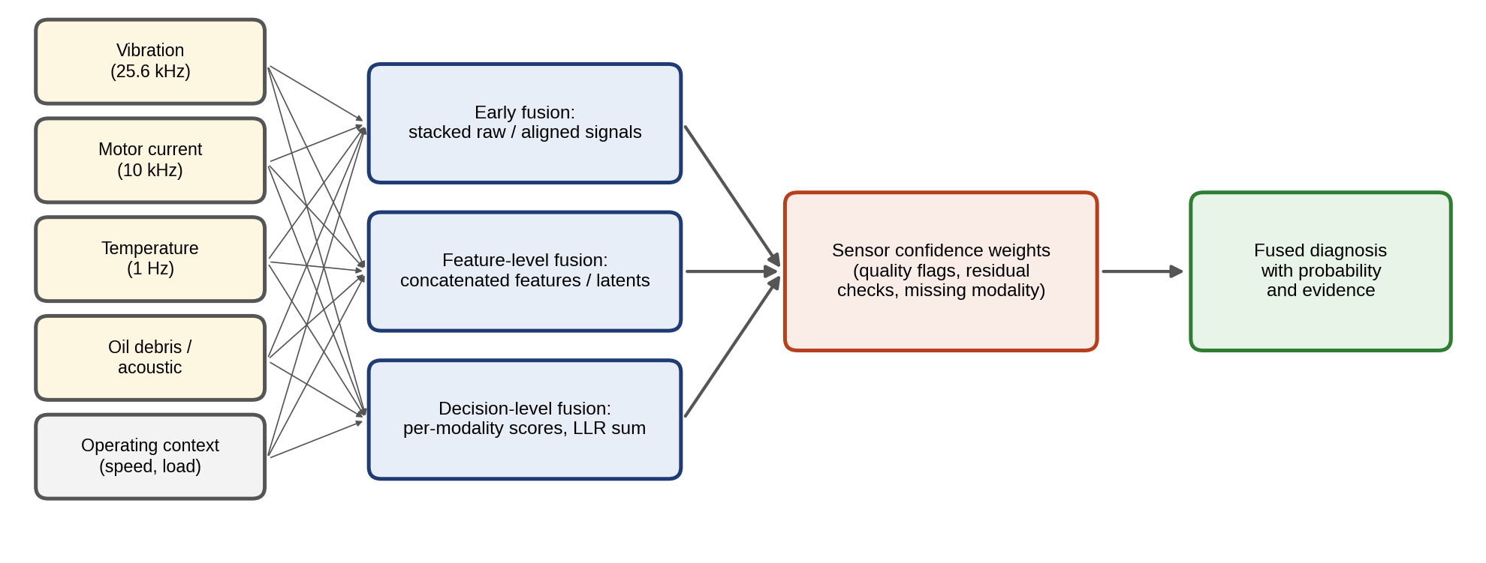
Figure 12.22. Multimodal fusion for PHM: vibration, motor current, temperature, oil-debris or acoustic signals and operating context combined at the data, feature or decision level, with sensor confidence weights that account for data quality and missing modalities.
Decision-level fusion has a clean derivation. If the modalities’ measurements $x_{1},…,x_{M}$ are conditionally independent given the health state, Bayes’ rule gives the posterior log-odds of a fault $F$ against health $H$ as the prior log-odds plus a sum of per-modality log-likelihood ratios (LLRs):
 | $$ln\frac{P\left(F∣x_{1:M}\right)}{P\left(H∣x_{1:M}\right)}=ln\frac{P\left(F\right)}{P\left(H\right)}+\sum_{i=1}^{M}{w_{i}} ln\frac{p\left(x_{i}∣F\right)}{p\left(x_{i}∣H\right)}, ln\frac{p\left(x_{i}∣F\right)}{p\left(x_{i}∣H\right)}=μ_{i}x_{i}−\frac{μ_{i}^{2}}{2},$$ | (12.56)
where $w_{i}=1$ in the ideal case, and the second expression holds for a unit-variance Gaussian score that shifts by $μ_{i}$ under the fault. The fused separability is then d′=i​μi2, larger than that of any single modality. The weights $w_{i}∈\left[0,1\right]$ are sensor confidence weights: set to zero for a missing modality (which then simply drops out of the sum) and reduced for a modality whose data-quality checks or cross-sensor residuals indicate a problem. Conditional independence rarely holds exactly; correlated modalities make the sum overconfident, which is corrected by calibrating the fused score on validation data.
Example 12.8 Fusing vibration, current and temperature
Given. Three unit-variance Gaussian detector scores for a bearing fault, with fault-induced shifts $μ=1.2$ (vibration), 0.9 (current) and 0.6 (temperature), conditionally independent; 20 000 synthetic cases, half faulty (seed 21); decision at fused log-odds zero.
Find. The AUC of each modality and of the fused score; the accuracy with all modalities, with the temperature sensor biased by +2 units, with the biased sensor given zero weight, and with the vibration channel missing.
Solution. Single-modality AUCs are 0.81, 0.74 and 0.67; fused, 0.88 ($d′=1.62$). Fused accuracy is 79.8 % with all three; a +2 bias on temperature lowers it to 73.5 %; setting that sensor’s weight to zero restores 77.8 %; without vibration it is 71.0 %.
Interpretation. Fusion beats the best single sensor, but a faulty sensor included at full weight costs more than the sensor is worth. That is why sensor validation (Section 12.9) must feed the fusion weights, and why the loss of the strongest modality must be announced with the lower confidence it implies rather than hidden.

12.15 Degradation Processes and Stochastic Models

12.15.1 Deterministic trends
A health indicator $X\left(t\right)$ that drifts toward a failure threshold $X_{f}$ can be modelled in several ways. The simplest are deterministic trends fitted to its history,
 | $$X\left(t\right)=a+bt \text{(linear)}, X\left(t\right)=a e^{bt} \text{(exponential)},$$ | (12.57)
where $X\left(t\right)$ is the health indicator at time $t$, and $a$ and $b$ are fitted by least squares (the exponential model after taking logarithms, $lnX=lna+bt$). The time to reach the threshold $X_{f}$ is then $t_{f}=\left(X_{f}−a\right)/b$ or $t_{f}=ln\left(X_{f}/a\right)/b$. An exponential trend is often a reasonable empirical description of damage that accelerates, but it is not inherently the right form for any mechanism, and the functional form must be chosen from the physics and checked against data. Fatigue crack growth follows the Paris law,
 | $$\frac{da_{c}}{dN}=C_{P}{\left(ΔK\right)}^{m_{P}}, ΔK=YΔσ\sqrt{πa_{c}},$$ | (12.58)
where $a_{c}$ is the crack length, $N$ the number of load cycles, $ΔK$ the stress-intensity range for stress range $Δσ$ and geometry factor $Y$, and $C_{P}$ and $m_{P}$ material constants ($m_{P}$ is typically 2 to 4 for metals). Substituting gives $da_{c}/dN∝a_{c}^{m_{P}/2}$, which is exponential growth only for $m_{P}=2$ and grows faster than exponential (reaching infinity in finite time) for $m_{P}>2$. A bearing spall enlarges in bursts that depend on load and lubrication. Capacitor ESR rises roughly exponentially over much of life in accelerated tests, but its rate depends strongly on temperature and ripple current (Section 12.19). An exponential fitted to early data and extrapolated far outside it can be badly wrong in either direction.

12.15.2 The Wiener process and its first-passage time
Deterministic trends ignore the randomness of degradation itself. The Wiener process with drift is the simplest stochastic degradation model [7]:
 | $$X\left(t\right)=X_{0}+μt+σB\left(t\right),$$ | (12.59)
where $μ$ is the drift rate, $σ$ the diffusion coefficient and $B\left(t\right)$ standard Brownian motion, whose increments over $Δt$ are independent Gaussian with variance $Δt$. The remaining life from the current level $x$ is the first time the process crosses the threshold, the first-passage time. For a positive drift, its distribution is inverse Gaussian with remaining distance $a=X_{f}−x$:
 | $$f_{T}\left(t\right)=\frac{a}{\sqrt{2πσ^{2}t^{3}}}exp\left[−\frac{{\left(a−μt\right)}^{2}}{2σ^{2}t}\right], E[T]=\frac{a}{μ}, Var[T]=\frac{aσ^{2}}{μ^{3}},$$ | (12.60)
a closed-form RUL distribution. Its distribution function is
 | $$P\left(T≤t\right)=Φ\left(\frac{μt−a}{σ\sqrt{t}}\right)+e^{2μa/σ^{2}}Φ\left(\frac{−μt−a}{σ\sqrt{t}}\right),$$ | (12.61)
whose first term is the probability that the process lies beyond the threshold at $t$ and whose second counts the paths that crossed it earlier and came back. The derivation uses the reflection principle. Paths that reach $X_{f}$ before $t$ and are then below it are mirrored by paths that end above it, which relates the first-passage probability to the Gaussian distribution of $X\left(t\right)$; differentiating gives $f_{T}$. Units differ in their drift, so $μ$ is itself random across a fleet, $μ∼N\left(m_{0},s_{0}^{2}\right)$. As a unit’s own history accumulates, its drift estimate is updated by Bayes’ rule (conjugate Gaussian). With $n$ increments summing to $ΔX_{n}$ over time $t_{n}$,
 | $$\frac{1}{s_{n}^{2}}=\frac{1}{s_{0}^{2}}+\frac{t_{n}}{σ^{2}}, m_{n}=s_{n}^{2}\left(\frac{m_{0}}{s_{0}^{2}}+\frac{ΔX_{n}}{σ^{2}}\right),$$ | (12.62)
so early predictions lean on the fleet and later ones on the unit. The RUL distribution is then the inverse Gaussian averaged over the posterior of $μ$. The gamma process, whose increments are always positive, suits monotonic degradation such as wear. Its increments over $Δt$ follow a gamma distribution with shape proportional to $Δt$,
 | $$f_{ΔX}\left(x\right)=\frac{x^{νΔt−1}e^{−x/u}}{Γ\left(νΔt\right) u^{νΔt}}, E[ΔX]=νuΔt, Var[ΔX]=νu^{2}Δt,$$ | (12.63)
where $ν$ is the shape rate, $u$ the scale and $Γ\left(⋅\right)$ the gamma function. Because gamma increments are never negative, the gamma process suits monotone degradation such as wear, crack length or capacity loss, where the Wiener process’s occasional negative increments are unphysical. Its first-passage time to a remaining distance $a$ follows directly from monotonicity: the unit has failed by $t$ exactly when $X\left(t\right)≥a$, so
 | $$P\left(T≤t\right)=P\left(X\left(t\right)≥a\right)=\frac{Γ_{u}\left(νt,a/u\right)}{Γ\left(νt\right)},$$ | (12.64)
where $Γ_{u}\left(s,x\right)=\int_{x}^{∞}{y^{s−1}}e^{−y}dy$ is the upper incomplete gamma function.
Example 12.9 Gamma and Wiener models with the same mean and variance
Given. A health indicator 0.4 below its failure threshold, degrading with mean rate 0.01 per week and increment variance 0.0002 per week. A gamma process with $ν=0.5$ per week and $u=0.02$ matches these moments ($νu=0.01$, $νu^{2}=0.0002$), as does a Wiener process with $μ=0.01$ and $σ^{2}=0.0002$.
Find. The median RUL and the 5th and 95th percentiles under each model.
Solution. Gamma, by (12.64): median 40.7 weeks, 90 % interval 26.9 to 56.2 weeks. Wiener, by (12.61): median 39.0 weeks, 27.1 to 56.2 weeks.
Interpretation. With the same mean and variance, and a remaining distance of 40 mean increments, the two models agree closely; they differ when the remaining distance is only a few increments, where the Wiener process’s negative excursions and the gamma process’s jumps matter, and in whether the sample paths are physically admissible. The model is chosen for its physics and checked by testing the increments: gamma increments must be positive and their variance proportional to the time step.

12.15.3 Nonlinear state-space and covariate-dependent degradation
Real degradation rates depend on how the asset is used. A covariate-dependent drift makes this explicit, for example $dX=μ_{0}exp\left(β^{T}z\left(t\right)\right) dt+σ dB$, where $z\left(t\right)$ is a vector of stresses (temperature, load, speed) with sensitivities $β$, so that the twin’s forecast of future operation becomes a forecast of future degradation. When the health state is not measured directly, a state-space degradation model separates the hidden damage $d_{k}$ from the measured indicator $y_{k}$:
 | $$d_{k+1}=d_{k}+g\left(d_{k},z_{k};θ\right)Δt+w_{k}, y_{k}=h\left(d_{k},z_{k}\right)+v_{k},$$ | (12.65)
where $g$ is the damage rate (possibly nonlinear in $d_{k}$, as in the Paris law), $h$ the measurement function (for example, envelope amplitude as a function of spall size and load), $θ$ the uncertain parameters, and $w_{k}$ and $v_{k}$ process and measurement noise. The twin estimates $d_{k}$ and $θ$ jointly with a particle filter or an unscented Kalman filter (Chapter 5), and predicts RUL by propagating the particles forward under the expected future stresses until each crosses the failure threshold; the spread of crossing times is the RUL distribution. This is the natural home of physics-of-failure models in a twin. Table 12.6 compares the families.
TABLE 12.6 Degradation model families compared
Model | Form | Assumptions | Suits | Watch out for
Linear or exponential trend | (12.57) | Deterministic, fixed form | Short-horizon extrapolation, screening | No uncertainty; form not physical
Wiener with drift | (12.59) | Gaussian, independent increments | Noisy indicators, closed-form RUL | Negative increments; linear mean
Gamma process | (12.63) | Positive, independent increments | Monotone wear, crack length | Needs positive increments; no noise term unless added
Covariate or state-space | (12.65) | Known damage law up to parameters | Physics-of-failure, varying duty | Model form, identifiability
Learned (LSTM, TCN) | Data-driven | Training fleet resembles target | Complex multi-sensor HIs | Leakage, domain shift, calibration
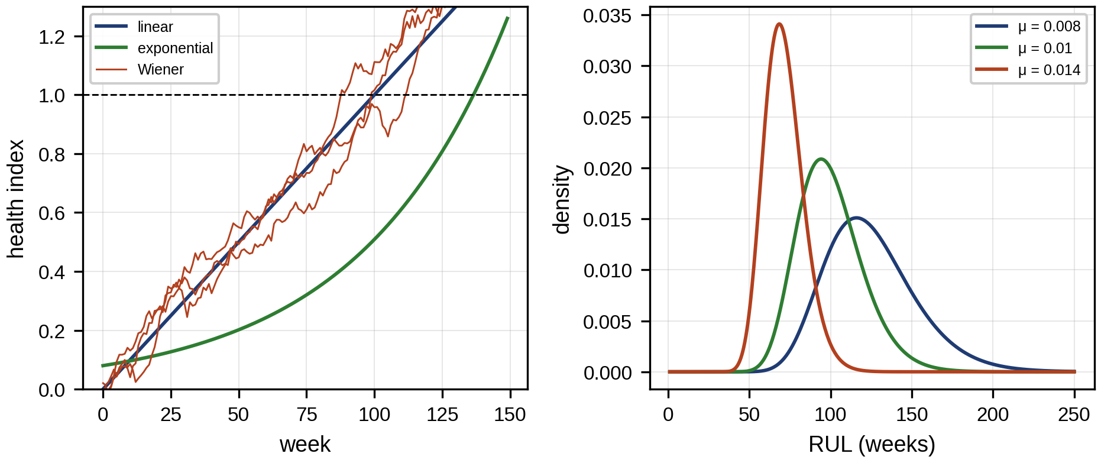
Figure 12.23. Degradation models: linear, exponential and Wiener sample paths toward a failure threshold (left), and the inverse-Gaussian first-passage (RUL) density for three drift rates (right).

12.16 RUL Prediction and Uncertainty Quantification

12.16.1 From threshold crossing to an RUL distribution
The simplest RUL is deterministic: fit a trend to the health indicator, and report when it crosses the failure threshold. That number is a forecast, and a forecast without an uncertainty cannot support a maintenance decision, because the decision depends on the probability of failure before a date, not on a point estimate. The RUL at time $t$ is the random variable $T−t$ given the history up to $t$, and the twin should report its distribution: the median, quantiles such as the 5th and 95th, and the probability of failure before each decision date.
Uncertainty has several sources (Figure 12.24). Measurement noise and sensor bias corrupt the indicator. State and parameter estimation error remains because the history is finite. Model-form error arises when the degradation law is wrong. Future loading and environment are unknown, often the largest source, because degradation rates depend on them. And population variability makes each unit differ from the fleet. The first and last are aleatoric, randomness that more data about the model will not remove; the parameter and model-form terms are epistemic, lack of knowledge that more data or a better model can reduce; future loading is handled by scenarios.
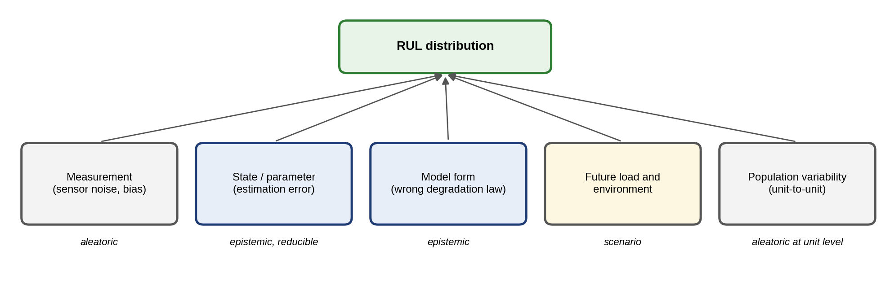
Figure 12.24. Sources of uncertainty in an RUL prediction: measurement, state and parameter estimation, model form, future load and environment, and population variability, with their aleatoric, epistemic or scenario character.
In the simplest treatment, three of these sources are combined: model parameters, measurement noise and future load. If the three contributions are independent with standard deviations $σ_{mod}$, $σ_{meas}$ and $σ_{load}$, the total and a two-sided interval with coverage $1−α$ are
 | $$σ_{RUL}=\sqrt{σ_{mod}^{2}+σ_{meas}^{2}+σ_{load}^{2}}, \hat{RUL}±z_{1−α/2} σ_{RUL},$$ | (12.66)
where $z_{0.975}=1.96$. For a battery pack with a point estimate of 180 days, $σ_{mod}=15$, $σ_{meas}=8$ and $σ_{load}=35$ days, $σ_{RUL}=38.9$ days and the 95 % interval is 104 to 256 days. The future load dominates. Reducing it requires scenarios: the RUL is computed for each plausible future duty (for example, the current regime, a heavier summer regime, a derated regime), and the maintenance decision uses the scenario that the operator intends, or the worst credible one.
The Gaussian form (12.66) is a first approximation, and practice uses three ways of producing an honest distribution. Bayesian methods place a prior on uncertain parameters and update it with data, as in (12.62), and propagate the posterior through the degradation model; they represent epistemic uncertainty explicitly. Ensembles train several models (different seeds, bootstrap samples or architectures) and use their spread as a measure of epistemic uncertainty. Quantile methods train a model to predict chosen quantiles $q_{τ}$ directly by minimizing the pinball loss j​maxτyj−qτ,τ−1yj−qτ, where $y_{j}$ are the true RULs and $τ$ the target quantile level.
Whatever the method, its intervals must be calibrated: a nominal 90 % interval should contain the truth 90 % of the time on units the model has not seen. Two numbers summarize this: the prediction interval coverage probability and the mean prediction interval width,
 | $$PICP=\frac{1}{M}\sum_{j=1}^{M}{1}\left[L_{j}≤{RUL}_{j}≤U_{j}\right], MPIW=\frac{1}{M}\sum_{j=1}^{M}{\left(U_{j}−L_{j}\right)},$$ | (12.67)
where $L_{j}$ and $U_{j}$ are the interval limits for prediction $j$ of $M$ and $1\left[⋅\right]$ is the indicator function. A PICP well below the nominal level means overconfidence; far above it, intervals too wide to be useful. Conformal prediction is an emerging distribution-free way of calibrating intervals from held-out units: with nonconformity scores $s_{j}=\left|{\hat{RUL}}_{j}−{RUL}_{j}\right|/{\hat{σ}}_{j}$ on $n$ calibration units, the interval
 | $$\left[\hat{RUL}−\hat{q}\hat{σ}, \hat{RUL}+\hat{q}\hat{σ}\right], \hat{q}=s_{\left(⌈\left(n+1\right)\left(1−α\right)⌉\right)},$$ | (12.68)
where $\hat{q}$ is the $⌈\left(n+1\right)\left(1−α\right)⌉$-th smallest score, has coverage at least $1−α$ on average over units exchangeable with the calibration set. The caveat is essential: degrading units are not exchangeable with the fleet when their duty, temperature or chemistry differs, and conformal coverage then fails exactly as the battery case of Chapter 9 showed (Section 9.19.4).

12.16.2 Validation against run-to-failure data and naive baselines
A prognostic method is validated on held-out run-to-failure units, never on the units used to fit it, by comparing its prediction at several points in each unit’s life with the true RUL. Three measures are standard [9]. The first is the RMSE of the point prediction. The second is the coverage of the prediction interval (PICP). The third is the $α$–$λ$ accuracy: the fraction of predictions made at time $t_{λ}=t_{0}+λ\left(t_{f}−t_{0}\right)$ that fall within $±α$ of the true RUL,
 | RMSE=1Mj​RULj−RULj2, α–λ accuracy=1Mj​1RULj−RULj≤α RULj. | (12.69)
Every method must be compared with a naive baseline, typically the fleet’s mean life minus the unit’s age, which uses no condition data at all. A prognostic model that cannot beat it adds nothing. A fourth measure, the prognostic horizon, is the earliest time from which the predictions stay within the $±α$ band until failure,
 | $$PH=t_{f}−min\left\{t_{j}:\left|\hat{RUL}\left(t\right)−RUL\left(t\right)\right|≤α RUL\left(t\right) ∀t≥t_{j}\right\},$$ | (12.70)
Symmetric errors are not what maintenance cares about. A late prediction (predicted RUL longer than the truth) leads to failure in service; an early one only wastes some life. Scoring functions therefore penalize late predictions more, for example the widely used exponential score
 | $$S=\frac{1}{M}\sum_{j=1}^{M}{\left\{\begin{matrix}e^{−Δ_{j}/a_{1}}−1, & Δ_{j}<0 \\ e^{Δ_{j}/a_{2}}−1, & Δ_{j}≥0\end{matrix}\right.}, Δ_{j}={\hat{RUL}}_{j}−{RUL}_{j},$$ | (12.71)
where $a_{1}>a_{2}$ (for instance 13 and 10 time units) makes late errors cost more. Performance also depends on the prediction horizon: predictions made early in life are necessarily less accurate than predictions made near failure, so results are reported at several fractions $λ$ of life, as in (12.69), not averaged over all times. Finally, a model validated on one fleet under one duty must be re-validated when the covariates shift, because both its accuracy and its coverage depend on them.
Example 12.10 Wiener-process RUL for a fleet of bearings
Given. A synthetic fleet whose health index follows (12.59) from 0 to a failure threshold of 1, with unit drifts $μ∼N\left(0.010,{0.0025}^{2}\right)$ per week (truncated below at 0.003) and $σ=0.02$ per √week, observed weekly (seed 7). Thirty units form the training set and 200 are held out. At 50 % and 80 % of each held-out unit’s life, the RUL distribution is predicted by the Bayesian Wiener model (12.60)–(12.62) (4000 Monte Carlo samples of the posterior drift and the inverse-Gaussian first-passage time), and point RULs by linear extrapolation of the unit’s own trend and by the naive baseline (training-fleet mean life minus age).
Find. RMSE of each method, the late-penalized score (12.71), the PICP and MPIW of the Wiener model’s 90 % intervals, and the full RUL distribution for one held-out unit.
Solution. From the training set: mean life 111 weeks (standard deviation 65); estimated $m_{0}=0.0111$, $s_{0}=0.0036$, $σ=0.0198$. At 50 % of life, the RMSEs are 22.3 weeks (Wiener), 34.3 (linear) and 41.7 (naive); the Wiener 90 % intervals cover 92 % of the 200 true values with a mean width of 79 weeks, and the median error is small (bias −2.5 weeks). At 80 % of life: RMSEs 10.6, 14.6 and 29.6 weeks, PICP 88 % and MPIW 42 weeks, with scores (12.71) of 1.6 (Wiener), 6.4 (linear) and 25.1 (naive). For one held-out unit, failing at week 70 and predicted at week 35 (true RUL 35 weeks), the predicted RUL quantiles are 28.6 (5 %), 37.2 (25 %), 45.9 (50 %), 56.8 (75 %) and 81.4 (95 %) weeks.
Interpretation. Figure 12.25 shows the training fleet. Condition monitoring pays: the Wiener model roughly halves the naive error at both horizons and beats simple extrapolation, because it combines the unit’s own trend with the fleet’s knowledge and accounts for randomness. Its intervals narrow as the unit ages, which is what a planner needs, and with 200 test units their coverage can be checked properly: 88 to 92 % against a nominal 90 %. The single-unit distribution is right-skewed, and its median (45.9 weeks) is later than the truth; a planner who acts on the 25th percentile instead of the median trades a little life for protection against exactly this kind of late prediction.
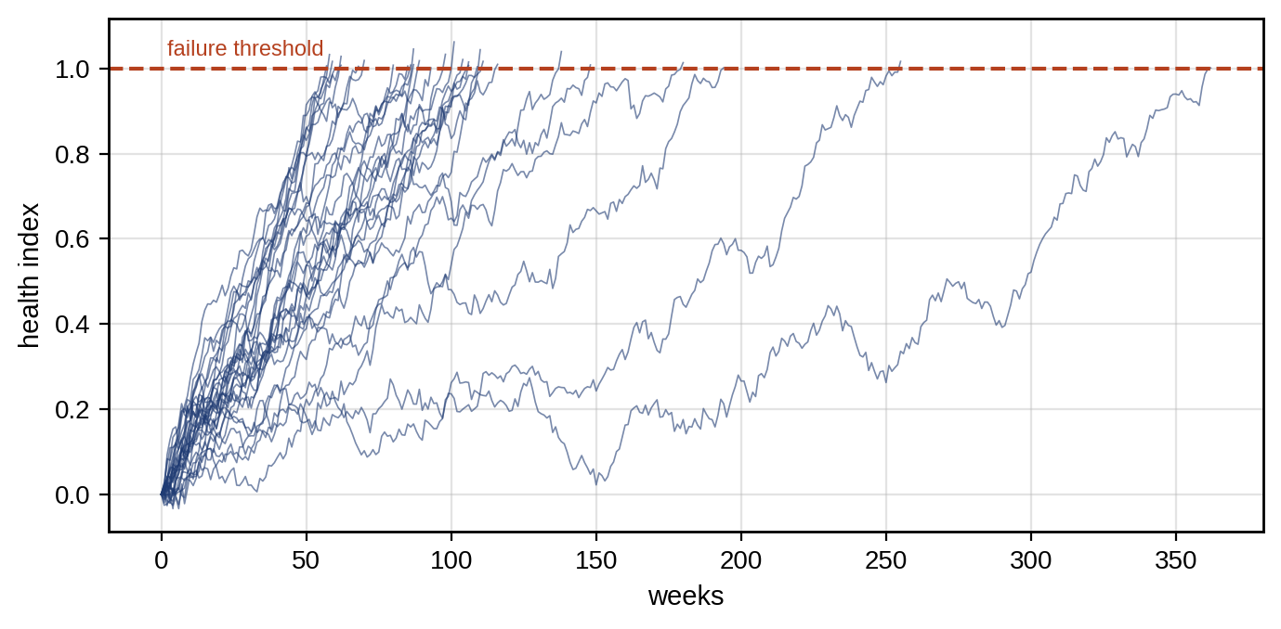
Figure 12.25. Health-index trajectories of the 30 training units of the synthetic bearing fleet (Example 12.10), with the failure threshold.

12.17 Reliability, Censoring and Survival Analysis

12.17.1 The Weibull model
When the condition of each unit is not monitored, reliability is described statistically by the distribution of lifetimes. The Weibull distribution is the workhorse:
 | $$R\left(t\right)=exp\left[−{\left(\frac{t}{η}\right)}^{β}\right], f\left(t\right)=\frac{β}{η}{\left(\frac{t}{η}\right)}^{β−1}e^{−{\left(t/η\right)}^{β}}, h\left(t\right)=\frac{f\left(t\right)}{R\left(t\right)}=\frac{β}{η}{\left(\frac{t}{η}\right)}^{β−1},$$ | (12.72)
where $R$ is the reliability (survival) function, $f$ the density, $h$ the hazard rate (the failure rate of survivors), $η$ the scale (characteristic life, at which 63.2 % have failed) and $β$ the shape. $β<1$ describes infant mortality (falling hazard), $β=1$ random failures (constant hazard, the exponential distribution), and $β>1$ wear-out (rising hazard). Together they form the bathtub curve of a population (Figure 12.27). The mean life and the $B_{10}$ life (by which 10 % have failed) are
 | $$MTTF=η Γ\left(1+\frac{1}{β}\right), B_{10}=η{\left[−ln0.9\right]}^{1/β}.$$ | (12.73)
The Weibull distribution is a flexible lifetime model, not evidence of a particular failure mechanism. A good Weibull fit with $β=2.5$ says that the hazard rises with age in this population; it does not say why, and a mixture of two mechanisms can produce almost any fitted shape. Before using the fit to plan replacements, three checks are made: that the probability plot is straight (a curved plot suggests a mixture, a failure-free period that needs a three-parameter model, or competing mechanisms), that the population is homogeneous in duty and design, and that the shape is stable when the data are split by site or period.

12.17.2 Censoring and maximum-likelihood estimation
Fleet data are incomplete. Most units have not yet failed when the analysis is done, and some were replaced preventively. Their lifetimes are right-censored: known only to exceed the observed time. Discarding them biases every estimate toward short lives, because only the early failures are kept. Censored units enter the likelihood through their survival probability rather than their density, as derived below. Non-parametrically, the Kaplan–Meier estimator of the survival function reduces the survival probability only at observed failure times,
 | Rt=ti≤t​1−dini, | (12.74)
where $d_{i}$ is the number of failures at time $t_{i}$ and $n_{i}$ the number of units still at risk just before it, a count that censored units leave without contributing a failure.
Each unit’s contribution to the likelihood follows from what is known about it. A unit that failed at $t_{i}$ contributes the probability density of failing then, $f\left(t_{i}\right)$; a unit still running at $t_{i}$ (right-censored) contributes the probability of surviving at least that long, $R\left(t_{i}\right)$. For $n$ independent units with failure indicators $δ_{i}$ (1 for a failure, 0 for censored),
 | $$L\left(β,η\right)=\prod_{i=1}^{n}{f}{\left(t_{i}\right)}^{δ_{i}}R{\left(t_{i}\right)}^{1−δ_{i}}=\prod_{i=1}^{n}{h}{\left(t_{i}\right)}^{δ_{i}}R\left(t_{i}\right),$$ | (12.75)
where the second form uses $f=hR$. Taking logarithms and substituting the Weibull forms (12.72) gives
 | lnLβ,η=i​δilnβη+β−1lntiη−i​tiηβ, | (12.76)
maximized numerically; the inverse of the Hessian of $−lnL$ at the maximum gives the parameters’ covariance and confidence intervals [10]. A quick graphical check uses the linearization of (12.72),
 | $$ln\left[−lnR\left(t\right)\right]=βlnt−βlnη, {\hat{F}}_{i}≈\frac{i−0.3}{n+0.4},$$ | (12.77)
where ${\hat{F}}_{i}$ is Bernard’s median-rank estimate of the failure probability for the $i$-th of $n$ ordered failures: on Weibull probability paper the data fall on a straight line of slope $β$.
The Kaplan–Meier estimate carries its own uncertainty, estimated by Greenwood’s formula,
 | VarRt=Rt2ti≤t​dinini−di, | (12.78)
from which pointwise confidence bands are drawn.
Example 12.11 Fleet reliability of motor bearings with censored data
Given. Sixty motor bearings with true Weibull lives ($β=2.5$, $η=6$ years), each observed for a period drawn uniformly between 3 and 9 years (seed 8): 42 failed within observation and 18 are censored.
Find. The maximum-likelihood estimates with 95 % intervals, the $B_{10}$ life and MTTF, the Kaplan–Meier estimate at 5 years with its standard error, and the estimates if the censored units are ignored.
Solution. A failed unit at $t_{i}=4.0$ years contributes, for trial values $β=2.5$ and $η=6$, $lnf\left(4.0\right)=ln\left(2.5/6\right)+1.5ln\left(4/6\right)−{\left(4/6\right)}^{2.5}=−0.875−0.608−0.363=−1.846$; a unit censored at 7.0 years contributes $lnR\left(7.0\right)=−{\left(7/6\right)}^{2.5}=−1.470$. Summing all 60 contributions and maximizing (12.76) numerically gives $\hat{β}=2.54$ (95 % interval 1.99 to 3.23) and $\hat{η}=5.69$ years (5.05 to 6.41), both containing the true values, with intervals from the inverse Hessian on the logarithmic scale. $B_{10}=5.69×{\left(0.1054\right)}^{1/2.54}=2.34$ years (true 2.44) and MTTF $=5.69 Γ\left(1.394\right)=5.05$ years. The Kaplan–Meier estimate at 5 years is 0.489 with a standard error of 0.069, against 0.487 from the fitted Weibull. Fitting only the 42 failures gives $\hat{η}=4.80$ years, 16 % too short.
Interpretation. Ignoring censored units is the most common error in reliability analysis, and it is not small: here it would have planned replacements almost a year earlier than necessary. Figure 12.26 compares the Kaplan–Meier estimate with the fitted model. The shape $β>2$ indicates wear-out in this population, which is what makes preventive replacement worthwhile (Section 12.18); for $β≤1$ it would not be.
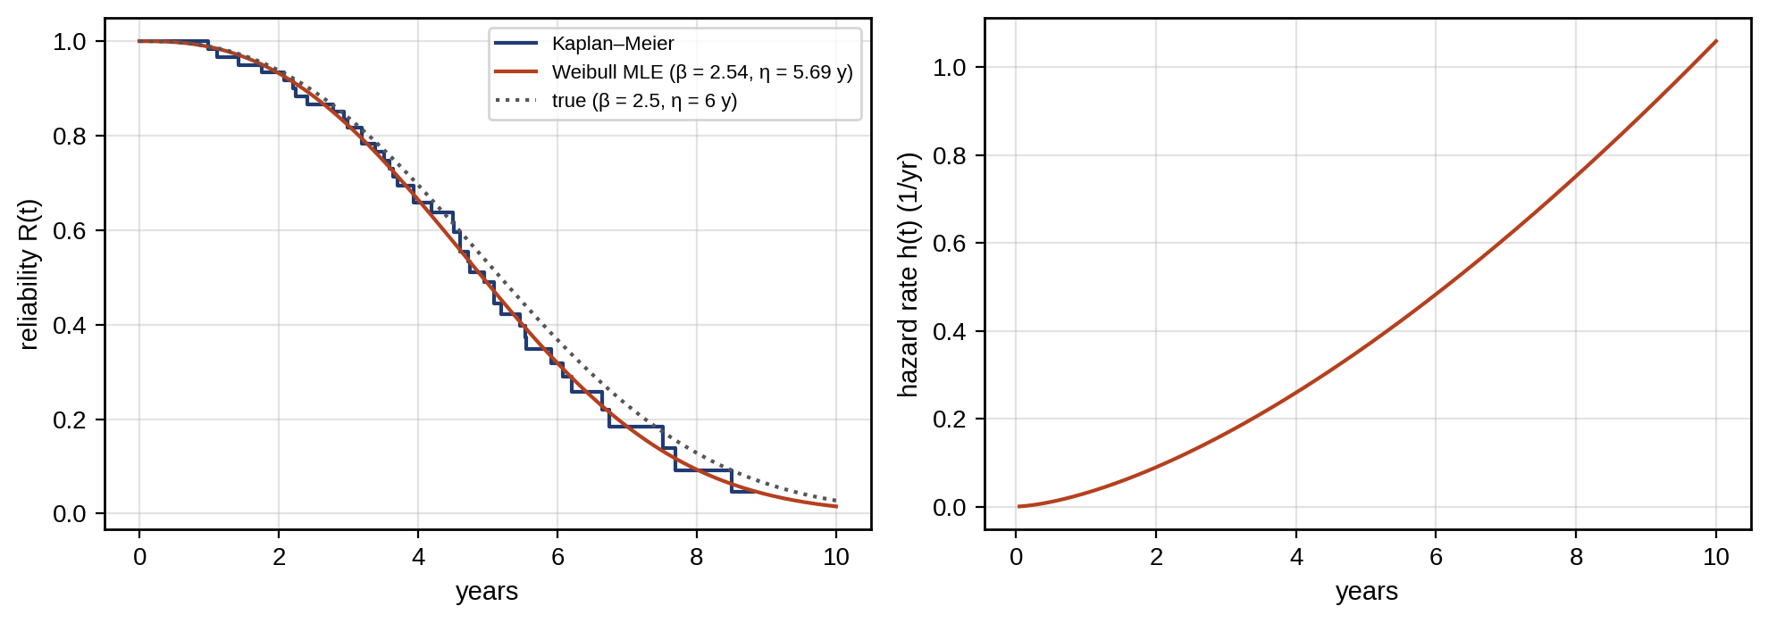
Figure 12.26. Bearing fleet reliability (synthetic, Example 12.11): Kaplan–Meier estimate from the censored data with the fitted and true Weibull reliability functions (left), and the fitted hazard rate rising with age, the wear-out region of the bathtub curve (right).
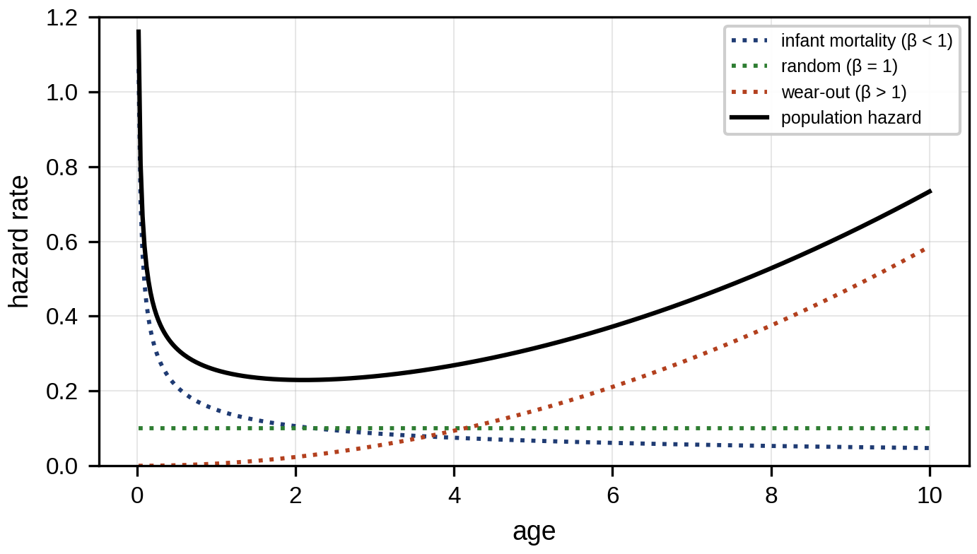
Figure 12.27. The bathtub curve: hazard rate of a population as the sum of infant-mortality ($β<1$), random ($β=1$) and wear-out ($β>1$) components.

12.17.3 Covariates, competing risks and heterogeneous fleets
A single Weibull describes a homogeneous population. Real fleets are not: bearings in hot, heavily loaded pumps fail earlier than those in cool, light ones. The Cox proportional-hazards model [24] lets covariates scale the hazard,
 | $$h\left(t∣z\right)=h_{0}\left(t\right)exp\left(β_{c}^{T}z\right),$$ | (12.79)
where $h_{0}\left(t\right)$ is an unspecified baseline hazard, $z$ a vector of covariates (average temperature, load, lubricant type) and $β_{c}$ their log-hazard ratios, estimated by partial likelihood without assuming a form for $h_{0}$. A covariate with $β_{c}=0.07$ per kelvin, for example, doubles the hazard for every 10 K. The model assumes that the hazard ratio between two units is constant over time, which is checked with scaled Schoenfeld residuals or by comparing log-cumulative-hazard curves for groups, which should be parallel. When a unit can fail by several mechanisms (bearing, winding, seal), each is a competing risk, and treating failures from the others as censoring estimates each mechanism’s cause-specific hazard; the probability of failing by a given mechanism by time $t$ is then its cumulative incidence, not one minus its Kaplan–Meier estimate. Unobserved differences between units are modelled by a frailty, a random multiplier of the hazard shared by units at one site or from one batch.
Reliability models describe populations; prognostics describes individual assets. The two are complementary, and the twin needs both (Table 12.7).
TABLE 12.7 Population reliability and individual prognostics
Aspect | Population reliability (survival analysis) | Individual-asset prognostics
Question | What fraction of the fleet fails by age $t$? | When will this unit fail?
Data | Failure and censoring times, covariates | Condition-monitoring history of the unit
Models | Weibull, Kaplan–Meier, Cox, frailty | Degradation processes, state-space, learned RUL
Output | $R\left(t\right)$, hazard, $B_{10}$, MTTF | RUL distribution for one unit
Uses | Spares planning, warranty, age replacement | Condition-based maintenance, scheduling
Link | Provides the prior for a new unit | Updates that prior with the unit’s own data

12.18 Maintenance Economics and Prognostic Decision-making

12.18.1 Reactive, preventive and predictive maintenance
Three strategies differ in when they act. Reactive (run-to-failure) maintenance acts after failure and pays the full failure cost $C_{f}$: repair, collateral damage, lost production, safety consequences. Preventive maintenance replaces at fixed age or intervals at the planned cost $C_{p}<C_{f}$, but discards useful life and still suffers the failures that come early. Predictive (condition-based) maintenance acts when the monitored condition indicates impending failure. It captures most of the life while avoiding most failures, at the cost of monitoring and of the false alarms and misses of Section 12.7. The long-run cost per unit time of run-to-failure is
 | $$c_{RTF}=\frac{C_{f}}{MTTF},$$ | (12.80)
and that of condition-based maintenance with detection probability $p_{d}$, false-alarm rate $λ_{FA}$ per unit time and monitoring cost $c_{m}$ per unit time is approximately
 | $$c_{CBM}≈\frac{p_{d}C_{p}+\left(1−p_{d}\right)C_{f}}{MTTF′}+λ_{FA}C_{FA}+c_{m},$$ | (12.81)
where $MTTF′$ is the mean time between interventions, slightly less than the MTTF because action is taken before failure, and $C_{FA}$ the cost of acting on a false alarm. Predictive maintenance wins when $p_{d}$ is high, false alarms are cheap and rare, and $C_{f}≫C_{p}$: exactly the conditions that the detector design of Sections 12.6 and 12.7 aims for. The strategies also differ in availability,
 | $$A=\frac{MTBF}{MTBF+MTTR},$$ | (12.82)
Figure 12.28 compares the strategies’ cost rates as detection quality varies. Here MTTR, the mean time to restore, is far shorter for planned than for unplanned interventions, because parts, crews and access are prepared; a 24-hour unplanned outage once a year gives 99.73 % availability.
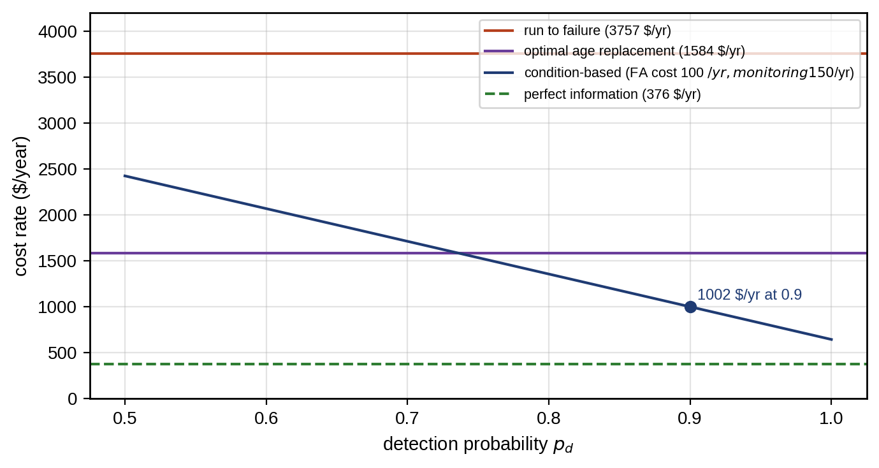
Figure 12.28. Long-run cost rate of run-to-failure, optimal age replacement and condition-based maintenance for the bearing population, against the detection probability of the condition monitor, with the assumptions of Section 12.18.3 (false-alarm cost 100 $ per year, monitoring 150 $ per year) and the perfect-information bound.

12.18.2 The optimal age-replacement interval
Under an age-replacement policy, a unit is replaced preventively at age $T$ or correctively at failure, whichever comes first. By the renewal-reward theorem [11], the long-run cost rate is the expected cost per cycle divided by the expected cycle length:
 | $$c\left(T\right)=\frac{C_{p}R\left(T\right)+C_{f}\left[1−R\left(T\right)\right]}{\int_{0}^{T}{R}\left(t\right) dt},$$ | (12.83)
because a cycle ends preventively with probability $R\left(T\right)$ and by failure otherwise, and its expected length is the integral of the survival function up to $T$. Setting $dc/dT=0$ gives the optimality condition
 | $$h\left(T\right)\int_{0}^{T}{R}\left(t\right) dt−\left[1−R\left(T\right)\right]=\frac{C_{p}}{C_{f}−C_{p}},$$ | (12.84)
which has a finite solution only if the hazard rate increases ($β>1$); for constant hazard, preventive replacement never pays.
The derivation follows from the renewal-reward theorem: over a long horizon, the cost rate equals the expected cost of one cycle divided by its expected length. Writing $N\left(T\right)=C_{p}R\left(T\right)+C_{f}\left(1−R\left(T\right)\right)$ and $D\left(T\right)=\int_{0}^{T}{R} dt$, the condition $dc/dT=0$ is $N′D=ND′$. With $R′=−hR$, $N′=\left(C_{f}−C_{p}\right)h\left(T\right)R\left(T\right)$ and $D′=R\left(T\right)$, so $\left(C_{f}−C_{p}\right)h\left(T\right)D\left(T\right)=N\left(T\right)$, which rearranges to (12.84).
Example 12.12 The optimal replacement age for motor bearings
Given. The bearing population of Example 12.11, taken at its true parameters ($β=2.5$, $η=6$ years), a planned replacement cost of 2000 $ and a failure cost of 20 000 $ (including downtime).
Find. The optimal age, the cost rate and the saving against running to failure, and the sensitivity of the result to the shape parameter and the cost ratio.
Solution. Minimizing (12.83) numerically gives $T^{*}=2.13$ years with $c\left(T^{*}\right)=1584$ $ per year. The MTTF is $6 Γ\left(1.4\right)=5.32$ years, so running to failure costs $20 000/5.32=3757$ $ per year, and the optimal policy saves 58 %. Table 12.8 shows how the result depends on the assumptions.
TABLE 12.8 Sensitivity of the optimal replacement age ($η=6$ years, $C_{p}=2000$ $)
Shape $β$ | Cost ratio $C_{f}/C_{p}$ | $T^{*}$ (years) | Saving against run-to-failure
1.5 | 5 / 10 / 20 | 4.05 / 2.27 / 1.36 | 11 % / 25 % / 39 %
2.0 | 5 / 10 / 20 | 3.06 / 2.02 / 1.38 | 28 % / 46 % / 61 %
2.5 | 5 / 10 / 20 | 2.96 / 2.13 / 1.57 | 39 % / 58 % / 72 %
3.5 | 5 / 10 / 20 | 3.12 / 2.47 / 1.99 | 51 % / 69 % / 81 %
Interpretation. The saving comes from the steep rise of the hazard and the cost ratio, and both matter: at $β=1.5$ and a ratio of 5 the policy barely pays. The cost curve (Figure 12.29) is flat near its minimum, so a practical interval aligned with planned outages loses little. Age replacement still discards much of each bearing’s life, which is what condition-based maintenance tries to recover.
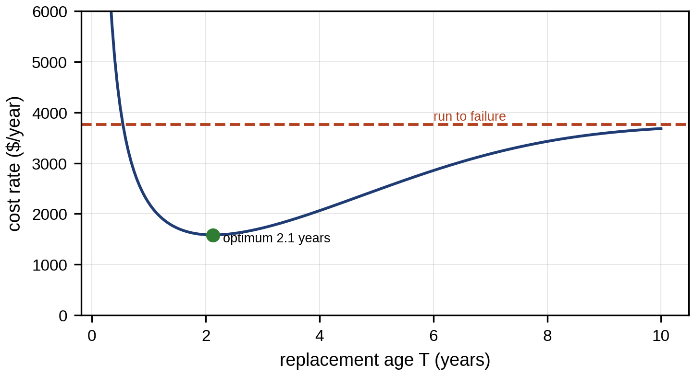
Figure 12.29. Long-run cost rate of age replacement against the replacement age for the bearing population, with the optimum at 2.1 years and the run-to-failure cost rate for comparison.

12.18.3 From the mathematical optimum to an operational decision
The age-replacement optimum assumes perfect repair, instant spares, negligible downtime cost differences and no safety constraint. Each assumption fails somewhere. Imperfect maintenance returns the unit to a state between new and old; a common model gives it a virtual age $V_{k}=V_{k−1}+q x_{k}$ after the $k$-th repair, where $x_{k}$ is the time since the previous repair and $q∈\left[0,1\right]$ the restoration factor ($q=0$ as good as new, $q=1$ as bad as old). Inspection has a cost and a detection probability, and its interval follows from (12.2). Downtime costs differ between planned and unplanned stops. Spare lead times mean that the decision to act must be taken a lead time before the action. Opportunity windows, such as a planned outage or a scheduled crane, make an action cheaper at some times than others, so a unit near its threshold is often replaced at the opportunity before it. And safety constraints override cost: a mode with a safety consequence is acted on when its probability of failure exceeds an agreed limit, whatever the economics.
Prognostic information has a measurable value, found by comparing the cost rate of the best decision with and without it. For the bearing population of Example 12.12: with no condition information the best policy is age replacement at 1584 $ per year; with perfect information each bearing would be replaced just before it fails, at $C_{p}/MTTF=376$ $ per year; with uncertain information from a condition monitor that detects 90 % of failures in time, at a false-alarm cost of 100 $ per year and a monitoring cost of 150 $ per year, (12.81) gives roughly $\left(0.9×2000+0.1×20 000\right)/\left(0.95×5.32\right)+100+150=1002$ $ per year. The monitor is worth about 580 $ per bearing-year against age replacement, and a better one could be worth up to 1200 $; these numbers bound what the monitoring system may cost.

12.19 Power-electronic Converter PHM
Power converters connect every P-1 source and load, and their failures stop production. Field surveys of converter failures consistently point at a few components: power semiconductor modules, DC-link capacitors, gate drivers and connectors, with solder and wire-bond fatigue in the modules and electrolyte loss in the capacitors among the leading mechanisms [21], [22]. A converter twin must distinguish what can be measured online from what can only be inferred. Currents, DC-link voltage, heatsink or baseplate temperature and switching commands are measured. Junction temperature, ESR, bond-wire state and accumulated damage are inferred from models.

12.19.1 Junction temperature and thermal cycling
Semiconductor wear-out is driven by temperature swings. Each swing $ΔT_{j}$ strains the interfaces between materials with different expansion coefficients (silicon, solder, copper, aluminium wire), and the bond wires and die-attach solder crack after a number of cycles that falls steeply as the swing grows. The twin estimates the junction temperature from the losses and a thermal network. Conduction and switching losses of one device are approximated as
 | $$P_{loss}=V_{CE0} \overset{‾}{I}+r_{CE} I_{rms}^{2}+f_{sw}\left(E_{on}+E_{off}\right)\frac{I}{I_{ref}}\frac{V_{dc}}{V_{ref}},$$ | (12.85)
where $V_{CE0}$ and $r_{CE}$ are the on-state threshold voltage and slope resistance, $\overset{‾}{I}$ and $I_{rms}$ the average and RMS device currents, $f_{sw}$ the switching frequency, and $E_{on}$ and $E_{off}$ the switching energies measured at reference current $I_{ref}$ and voltage $V_{ref}$. The junction temperature then follows from a Foster thermal network of $n$ first-order stages,
 | $$T_{j}\left(t\right)=T_{a}+\sum_{i=1}^{n}{Δ}T_{i}\left(t\right), τ_{i}\frac{dΔT_{i}}{dt}=R_{th,i}P_{loss}\left(t\right)−ΔT_{i},$$ | (12.86)
where $T_{a}$ is the ambient or coolant temperature and $R_{th,i}$ and $τ_{i}=R_{th,i}C_{th,i}$ the thermal resistance and time constant of stage $i$, taken from the module data sheet (junction to case) and from the heatsink model. A measured baseplate or heatsink temperature anchors the slow stages and removes most of the uncertainty in the cooling. Where the device can be measured briefly, temperature-sensitive electrical parameters (the on-state voltage at a known low current, or the gate threshold voltage) give a direct estimate of $T_{j}$ for calibration.
Lifetime is estimated from the mission profile. The $T_{j}$ history is decomposed into cycles by rainflow counting, which pairs rising and falling half-cycles into closed hysteresis loops, each with a swing $ΔT_{j,k}$ and a mean $T_{m,k}$. An empirical cycles-to-failure law such as the Coffin–Manson–Arrhenius form,
 | $$N_{f}\left(ΔT_{j},T_{m}\right)=A ΔT_{j}^{−a}exp\left(\frac{E_{a}}{k_{B}T_{m}}\right),$$ | (12.87)
with fitted constants $A$ and $a$ (typically 4 to 6), activation energy $E_{a}$, Boltzmann’s constant $k_{B}$ and absolute mean temperature $T_{m}$, gives the life at each cycle type, and Miner’s rule adds the damage linearly,
 | D=k​nkNfΔTj,k,Tm,k, | (12.88)
where $n_{k}$ is the number of cycles of type $k$; failure is expected when $D$ reaches 1. These laws are fitted to power-cycling tests over a limited range of swings, mean temperatures and heating times, and they must not be extrapolated outside it; Miner’s rule ignores the order of loading.
Example 12.13 Lifetime consumption of a drive IGBT
Given. A synthetic mission profile for one IGBT of drive D-3: a 16-hour working day (06:00 to 22:00) alternating every 15 minutes between 100 A and 30 A RMS, and 20 A otherwise. Device losses $P_{loss}=1.08 I+0.008 I^{2}$ W. A four-stage Foster network with $R_{th}=\left(0.05,0.10,0.05,0.25\right)$ K/W and $τ=\left(0.05,1,20,600\right)$ s, coolant at 40 °C. Lifetime law (12.87) with $a=5$ and $E_{a}=0.8$ eV, with $A$ chosen so that $N_{f}={10}^{6}$ cycles at $ΔT_{j}=40$ K and $T_{m}=80$ °C (illustrative constants, not a data-sheet model). Uncertainty: $a$ Gaussian with standard deviation 0.25 (re-anchored at the same point) and a 5 % scale error on the estimated $ΔT_{j}$.
Find. The junction temperature range, the damage per day and the lifetime with its 90 % interval.
Solution. Integrating (12.86) with a 1 s step, $T_{j}$ swings between 51 and 118 °C (daily mean 78 °C). Rainflow counting gives 32 cycles per day larger than 2 K, the largest with $ΔT_{j}=67$ K. By (12.88) the damage is $3.1×{10}^{−4}$ per day, a lifetime of 8.9 years. With the stated parameter uncertainty (2000 Monte Carlo samples), the 90 % interval is 5.9 to 14.0 years (Figure 12.30).
Interpretation. The damage comes almost entirely from the large 15-minute swings, which the heatsink’s 600 s time constant cannot smooth. Halving that duty-cycle swing, for example by holding a minimum load between batches, would extend the life several-fold because of the fifth-power law. The twin’s value lies in making this visible and in updating the estimate from the actual mission profile rather than a design assumption; its limitation is that the lifetime law is itself uncertain by a factor of about two, which the interval reflects.
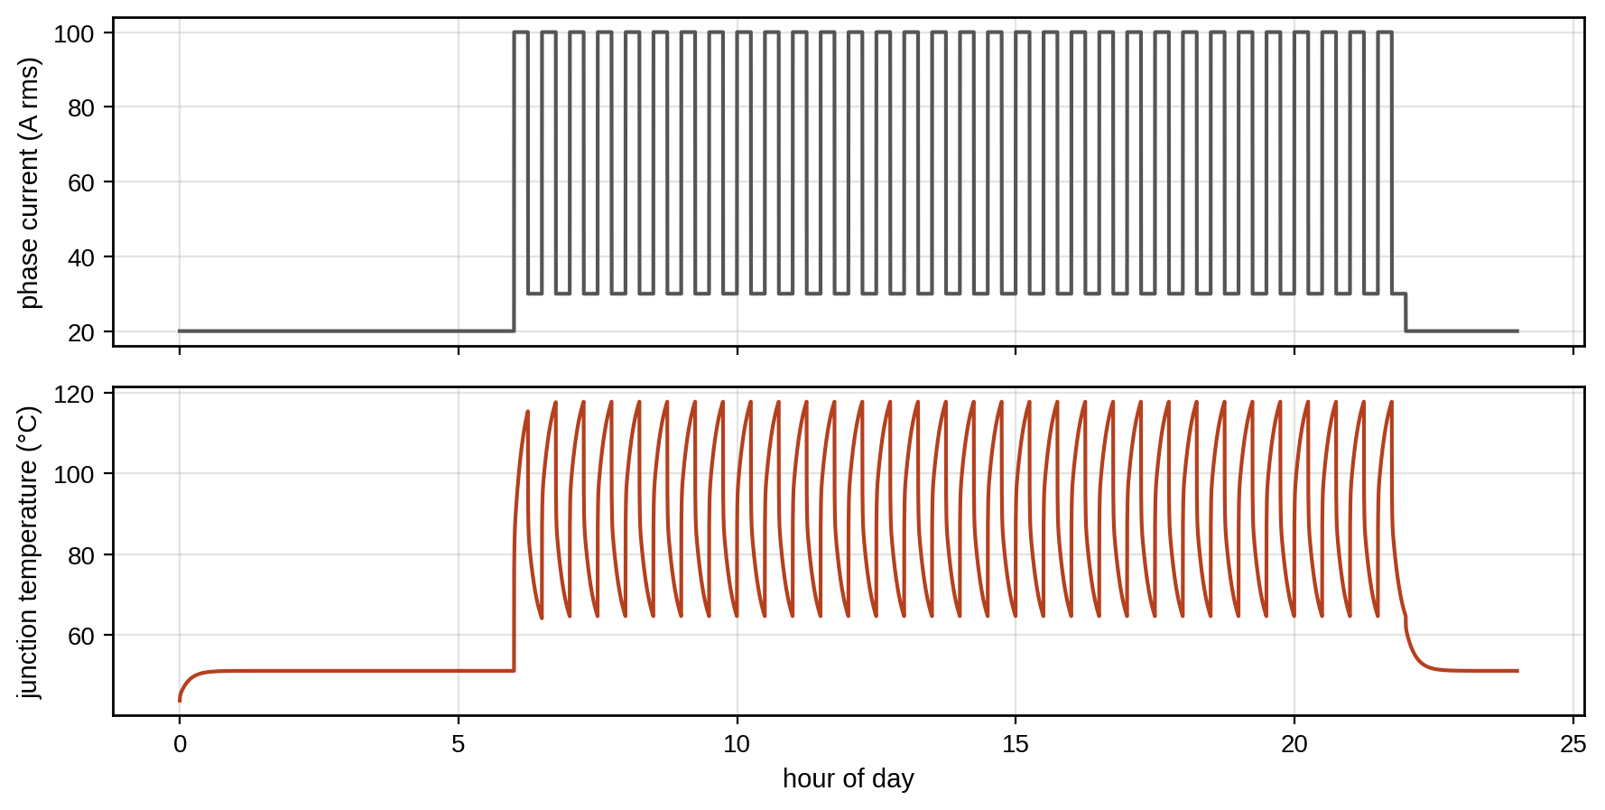
Figure 12.30. Mission profile of a drive IGBT (synthetic, Example 12.13): phase current over a day (top) and the junction temperature from the Foster thermal twin (bottom), whose large 15-minute swings dominate the lifetime consumption; the first hours show the start from 40 °C, before the daily cycle settles.

12.19.2 Open-switch faults
An open-circuit switch in a two-level inverter removes one half-cycle of the affected phase current, so the current acquires a DC component with the sign opposite to that of the missing half. A widely used diagnostic normalizes each phase current’s mean over one fundamental period by its mean absolute value,
 | $$d_{x}=\frac{⟨i_{x}⟩}{⟨\left|i_{x}\right|⟩}, x∈\{a,b,c\},$$ | (12.89)
where $⟨⋅⟩$ is the average over a period. For a healthy sinusoidal current $d_{x}=0$. If the upper switch of phase $a$ is open, the positive half-cycle is missing, $⟨i_{a}⟩=−\hat{I}/π$ and $⟨\left|i_{a}\right|⟩=\hat{I}/π$ (for peak $\hat{I}$), so $d_{a}=−1$ in the ideal case; in practice the other phases redistribute and $d_{a}$ settles near $−0.5$ to $−1$, with a threshold of about $±0.3$ separating it from noise and transients. The sign identifies the upper or lower switch, and the phase identifies the leg. Normalization makes the indicator independent of load, but it fails at very low currents and during fast transients, which a persistence rule (Section 12.6.4) handles.

12.19.3 DC-link capacitors
Drive D-3’s DC-link aluminium electrolytic capacitors age mainly by electrolyte evaporation. Their ESR rises roughly exponentially and their capacitance falls (Chapter 7, Section 7.11), and the usual end-of-life criterion is ESR at twice its initial value. The twin estimates ESR online from ripple voltage and current (Chapter 7), and fits the exponential model of (12.57) in logarithmic form, $lnESR\left(t\right)=ln{ESR}_{0}+kt$. The end-of-life time and its standard error follow by the delta method from the fitted coefficients $\hat{c}=\left(ln{\hat{ESR}}_{0},\hat{k}\right)$ with covariance $C$:
 | $${\hat{t}}_{EOL}=\frac{ln\left(2 {ESR}_{0,nom}\right)−{\hat{c}}_{0}}{\hat{k}}, σ_{t_{EOL}}^{2}=∇t_{EOL}^{T} C ∇t_{EOL}, ∇t_{EOL}={\left[−\frac{1}{\hat{k}}, −\frac{{\hat{t}}_{EOL}}{\hat{k}}\right]}^{T}.$$ | (12.90)
where ${\hat{c}}_{0}=ln{\hat{ESR}}_{0}$ and $\hat{k}$ are the fitted intercept and slope, ${ESR}_{0,nom}$ the nominal initial ESR, $C$ the covariance of the fitted coefficients and $∇t_{EOL}$ the gradient of the end-of-life time with respect to them. ESR is not a fixed number. It falls with temperature (by roughly a factor of two between 25 and 85 °C for many aluminium electrolytic capacitors), rises at low frequency, and is estimated from ripple quantities that also depend on the converter’s operating point. The twin therefore normalizes each estimate to a reference temperature and frequency before trending it; otherwise the daily temperature cycle looks like degradation. The capacitor’s temperature is itself a twin output: the ripple current $I_{c,rms}$ heats the core by $ΔT_{c}=I_{c,rms}^{2} ESR R_{th,c}$, where $R_{th,c}$ is the core-to-ambient thermal resistance, so a rising ESR raises the temperature, which accelerates the electrolyte loss that raised the ESR, a positive feedback that the exponential model captures only approximately.
Example 12.14 How long D-3’s capacitors will last
Given. Thirteen ESR estimates at 1000-hour intervals from 0 to 12 000 hours of operation, normalized to the reference temperature, with 2 % estimation noise (seed 10), from capacitors whose true ESR doubles at 40 000 h at the present hot-spot temperature (70 °C); nominal initial ESR 10 mΩ, end of life at 20 mΩ.
Find. The fitted end of life, its 90 % interval and the RUL at 12 000 h, and the effect of operating 10 K hotter from now on.
Solution. The least-squares fit of $lnESR$ against time gives $\hat{k}=1.78×{10}^{−5}$ per hour (true $1.73×{10}^{−5}$) and, by (12.90), ${\hat{t}}_{EOL}=39 300$ h with a standard error of 1900 h; the 90 % interval, $39 300±1.645×1900$, is 36 200 to 42 500 h and contains the true 40 000 h. The RUL at 12 000 h is 27 300 h. Capacitor life roughly halves for every 10 K rise in hot-spot temperature, the empirical ten-degree rule derived from the Arrhenius law,
 | $$L\left(T\right)=L_{0}⋅2^{\left(T_{0}−T\right)/10 K},$$ | (12.91)
where $L_{0}$ is the life at the reference hot-spot temperature $T_{0}$ and $T$ the actual hot-spot temperature; if the drive runs 10 K hotter from now on, the remaining life halves to about 13 700 h.
Interpretation. Figure 12.31 shows the fit and its extrapolation. The first 12 000 hours show only 24 % of the ESR rise to end of life, so the extrapolation is long and would be wide without the strong exponential prior. The temperature scenario matters more than the fit, which is why the RUL must be stated with its assumed future temperature, and why the thermal twin of Chapter 7 is part of the prognosis. The ten-degree rule and the exponential form are both empirical and valid only within the temperature and ripple range over which the manufacturer tested; the parameters here are synthetic and do not describe any particular capacitor.
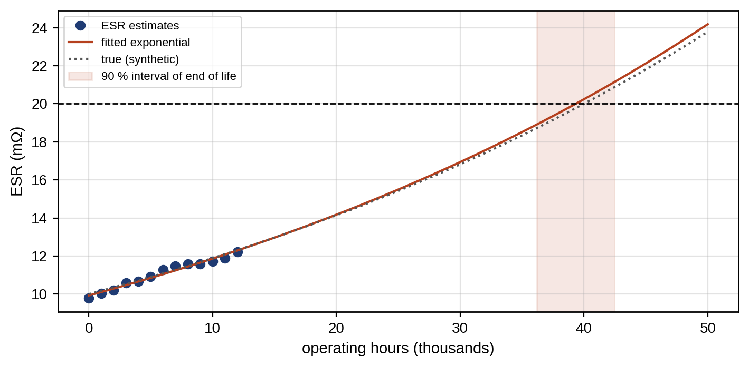
Figure 12.31. ESR of D-3’s capacitors (synthetic, Example 12.14): estimates to 12 000 h, the fitted exponential extrapolated to the 2 × ESR₀ threshold with the 90 % interval of the end of life, and the true trajectory.

12.20 PV PHM: Separating Faults from Weather and Sensors
The PV twin of Chapter 8 predicts each string’s power from measured irradiance and temperature, so the ratio of measured to predicted power is a residual free of weather. For P-1, the daily plant-level ratio scatters by 0.9 % on healthy days, and three failed strings (2 % of the array) lower it by 1.9 %. A single day’s drop of $1.9/0.9=2.1$σ is below a 3σ threshold, so one day cannot confirm the fault. A CUSUM with $k=1$ (half the 2σ shift) and $h=4$ on the standardized daily ratio accumulates $2.1−1=1.1$ per day on average, and by (12.27) its average delay is 4.3 days, matching the five-day averaging of Chapter 8 (Section 8.9). Figure 12.32 shows one realization, in which the CUSUM crosses its limit on the fourth day. String-level current measurement reduces the problem to a trivial one: a failed string’s current is zero from the first hour. This case shows the chapter’s broader lesson that sensor placement often matters more than algorithms. The same residual also carries soiling and irradiance-sensor drift, and the fault-signature analysis of Chapter 8 (Section 8.9) separates them.
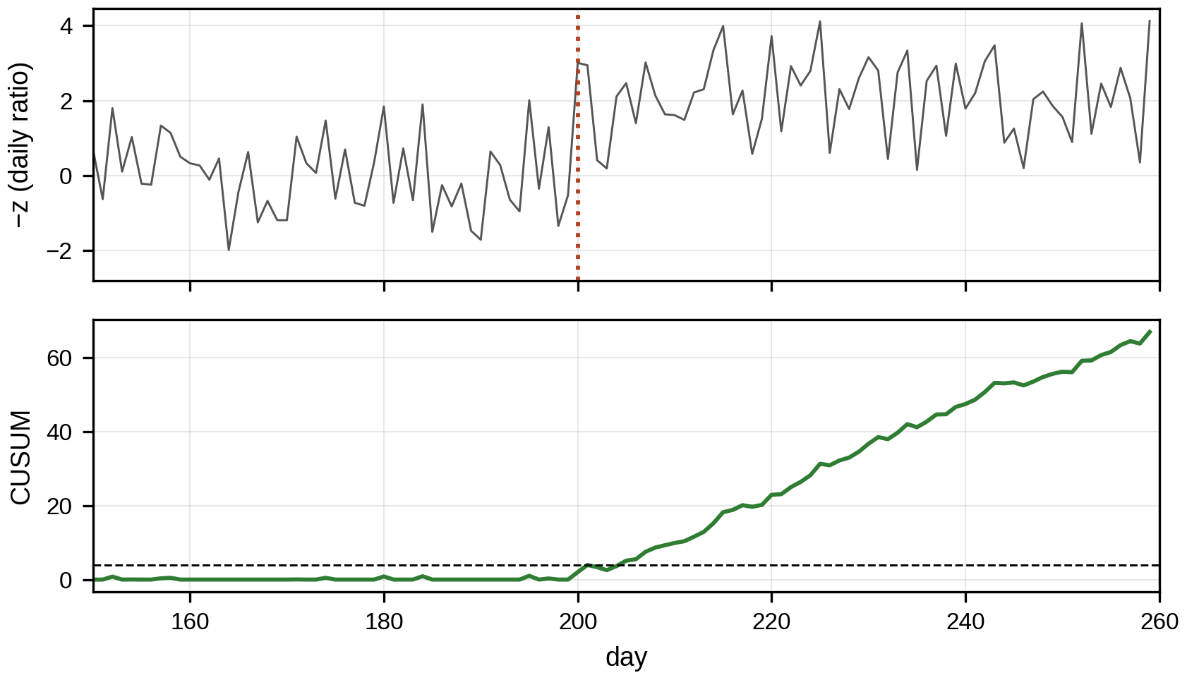
Figure 12.32. Standardized daily PV performance ratio before and after three strings fail on day 200 (top), and the CUSUM statistic crossing its decision interval on the fourth day (bottom).
The daily ratio mixes several mechanisms that lower PV output, and they must be separated because their remedies differ. Table 12.9 lists the separating evidence. The twin normalizes every residual by irradiance and temperature, so that weather disappears, and then uses two further dimensions: time (a step, a slow trend, a daily pattern, a recovery after rain) and space (one string against its neighbours, which share weather and soiling). String-level currents make most separations easy; plant-level power makes them hard. When the residual evidence is ambiguous, confirmatory measurements settle it: an I–V curve trace distinguishes series-resistance increase, shunt loss, bypass-diode activation and open circuits, and infrared thermography shows hot cells, hot junction boxes and failed diodes.
TABLE 12.9 Separating PV loss mechanisms with twin residuals
Mechanism | Time signature | Spatial signature | Separating check
Open string or connector | Step to zero current | One string only | String current; I–V trace
Partial shading | Repeats at the same sun positions | Some strings, time-of-day dependent | Pattern against solar geometry
Soiling | Slow decline, recovery after rain or cleaning | Most strings similarly | Rain events; reference cell cleaned and uncleaned
Irradiance-sensor bias or drift | Residual changes for all strings together | Whole plant | Compare two irradiance sensors, satellite estimate, clear-sky model
Degradation (cells, encapsulant) | Slow, monotone, about 0.5 % per year | Whole plant or module type | Long-term trend after weather normalization
Bypass-diode failure, hot spot | Step of one-third of a module’s voltage | One module | Thermography; I–V curve steps
MPPT, inverter clipping or curtailment | Output flat at a limit | Whole inverter | Inverter set-points and status

12.21 Battery PHM
The P-1 battery’s capacity fade was modelled in Chapter 9 with calendar and cycle terms (Section 9.10). At two years, a power-law fit to monthly capacity estimates predicted an RUL of 10.5 years, with a 90 % bootstrap interval of 7.7 to 14.9 years that contained the true 10.0 years (Chapter 9, Section 9.14). A learned fleet model with conformal calibration gave intervals that held their coverage on cells like those in the training fleet but lost it outside the training temperature range (Chapter 9, Section 9.19.4). Two points from this chapter complete the picture. First, the battery’s capacity trajectory can also be modelled as a Wiener process with drift in capacity loss, which gives the inverse-Gaussian RUL of (12.60) directly and updates the drift as each capacity estimate arrives. Second, the RUL is meaningful only with its load scenario: the same pack at 35 °C instead of 25 °C reaches end of life in under 5 years instead of 12 (Chapter 9, Section 9.10). The prognosis must therefore be issued per scenario, and the decision (plan replacement, derate, improve cooling) compares them.
Battery state of health is two quantities, not one. Capacity SOH is the ratio of present to rated capacity, $SOH_{Q}=Q/Q_{rated}$, and governs energy; resistance SOH, often expressed as $SOH_{R}=R_{0}/R$ with $R$ the present internal resistance at a reference temperature and SOC, governs power and heat. Both are estimated online by the equivalent-circuit twin of Chapter 9, whose parameters are updated by a recursive estimator from current and voltage, and both depend on temperature, SOC and C-rate, which must be held fixed or modelled before a trend is read. Incremental-capacity (IC) and differential-voltage (DV) analysis give mechanistic insight: the peaks of $dQ/dV$ against $V$ correspond to phase transitions in the electrodes, and their shrinkage or shift separates loss of lithium inventory from loss of active material.
A pack is only as good as its weakest series string. For $N_{s}$ cells in series, each with capacity $Q_{i}\left(t\right)$, the usable pack capacity without active balancing is
 | $$Q_{pack}\left(t\right)=\min_{i}Q_{i}\left(t\right),$$ | (12.92)
so cell-to-cell variation in initial capacity and fade rate brings the pack’s end of life forward relative to the average cell. Cell-to-cell differences in temperature, which are common in racks, widen the fade-rate spread over time.
Example 12.15 The weakest cell sets the pack’s life
Given. A synthetic string of 192 cells in series with initial capacities $N\left(100 \%,1.0 \%^{2}\right)$, a calendar fade coefficient $N\left(0.035,{0.004}^{2}\right)$ per √year and a cycling fade $N\left(0.008,{0.0015}^{2}\right)$ per year, so that $Q_{i}\left(t\right)=Q_{0,i}\left[1−k_{i}\sqrt{t}−l_{i}t\right]$ (seed 9); end of life at 80 % of rated capacity.
Find. The end-of-life time of the mean cell and of the pack.
Solution. The mean cell reaches 80 % after 10.7 years; the pack, limited by its weakest cell by (12.92), after 7.2 years (Figure 12.33).
Interpretation. A prognosis made for the average cell would overstate the pack’s life by almost half. The twin must therefore track the distribution of cell states, identify the weakest cells, and treat pack RUL as the first-passage time of the minimum of many correlated processes. The maintenance decision then becomes specific: replace or rebalance the weak modules, or derate. The fade model is illustrative and must not be carried to another chemistry, temperature, C-rate or duty cycle without recalibration.
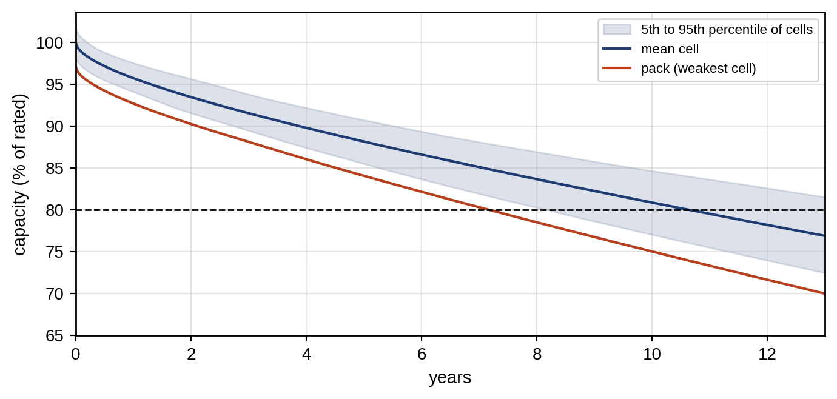
Figure 12.33. Capacity of a 192-cell series string (synthetic, Example 12.15): mean cell, 5th to 95th percentile band of the cells, and the pack capacity set by the weakest cell, which reaches the 80 % end-of-life threshold three and a half years before the mean cell.
Three prognostic approaches are in use. Physics-based models (SEI growth, lithium plating, the semi-empirical calendar and cycle laws of Chapter 9) extrapolate well when the mechanism is right and the operating range is covered. Machine-learning models trained on fleet data capture complex dependences but degrade outside their training conditions, as Chapter 9 showed for temperature. Hybrid models use the physics for the trend and learning for the residual, and are the current research direction; data augmentation from physics-based simulation helps when fleet data are scarce. Fleet learning across sites raises data-ownership questions that federated learning, in which models are trained locally and only parameter updates are shared, may address; it remains an emerging direction for battery PHM.

12.22 Wind-turbine Gearbox PHM
A gear pair with $z_{1}$ teeth on the pinion turning at $f_{1}$ meshes at
 | $$f_{m}=z_{1}f_{1}=z_{2}f_{2},$$ | (12.93)
where $z_{2}$ and $f_{2}$ are the wheel’s teeth and speed. For a stage of T-1’s gearbox with a 23-tooth pinion at 25 Hz and a 97-tooth wheel, $f_{m}=575$ Hz and the wheel turns at 5.93 Hz. A healthy mesh produces lines at $f_{m}$ and its harmonics. A local defect on one pinion tooth modulates the mesh amplitude once per pinion revolution, which by the product-to-sum identity creates sidebands at $f_{m}±kf_{1}$:
 | $$\left[1+mcos\left(2πf_{1}t\right)\right]sin\left(2πf_{m}t\right)=sin\left(2πf_{m}t\right)+\frac{m}{2}\left[sin2π\left(f_{m}+f_{1}\right)t+sin2π\left(f_{m}−f_{1}\right)t\right],$$ | (12.94)
where $m$ is the modulation depth. The sidebands’ spacing identifies the damaged gear (25 Hz for the pinion, 5.93 Hz for the wheel), and their strength relative to the mesh line is a health indicator, the sideband energy ratio:
 | $$SER=\frac{\sum_{k=1}^{K}{\left(A_{f_{m}+kf_{1}}+A_{f_{m}−kf_{1}}\right)}}{A_{f_{m}}}.$$ | (12.95)
On synthetic mesh vibration with noise (Figure 12.34), SER is 0.03 for a healthy mesh, 0.11 with 10 % modulation and 0.32 with 30 %. Because speed varies on a wind turbine, the vibration is first angle-resampled (12.16) and averaged over many revolutions synchronized to the pinion,
 | $$\overset{‾}{x}\left(ϕ\right)=\frac{1}{N_{r}}\sum_{i=0}^{N_{r}−1}{x}\left(ϕ+2πi\right), 0≤ϕ<2π,$$ | (12.96)
the time-synchronous average over $N_{r}$ revolutions, which attenuates components not locked to that shaft by roughly $\sqrt{N_{r}}$ and leaves the pinion’s own tooth-by-tooth signature. The twin trends SER with load, because mesh amplitude and sidebands both rise with torque. A trending SER then feeds the degradation model of Section 12.15 and the maintenance decision of Section 12.26, where the gearbox’s long spare lead time dominates.
Two further tools make gear diagnosis work at variable speed. The cepstrum, the inverse Fourier transform of the logarithm of the power spectrum, $c\left(τ_{q}\right)=F^{−1}\left\{ln{\left|X\left(f\right)\right|}^{2}\right\}$ with quefrency $τ_{q}$ in seconds, turns a family of equally spaced sidebands into a single peak at the quefrency $1/f_{1}$, which is easier to trend than many small lines and is insensitive to the transmission path. And the residual signal, the time-synchronous average with the mesh harmonics removed, highlights the local tooth defect, whose kurtosis rises as a tooth cracks.
No single signal justifies a gearbox replacement costing hundreds of thousands. The twin combines vibration indicators with oil-debris counts (ferrous particle counts from an inline sensor, whose rate of increase tracks active wear), oil temperature and condition, and the load context from SCADA, because both mesh amplitude and sidebands rise with torque. A finding is confirmed when independent modalities agree, for example rising SER at the pinion’s order, a rising particle rate and an unchanged bearing envelope, before the spare is ordered. For wind turbines, ISO 20816-21:2025 gives the vibration evaluation framework for horizontal-axis machines [17].
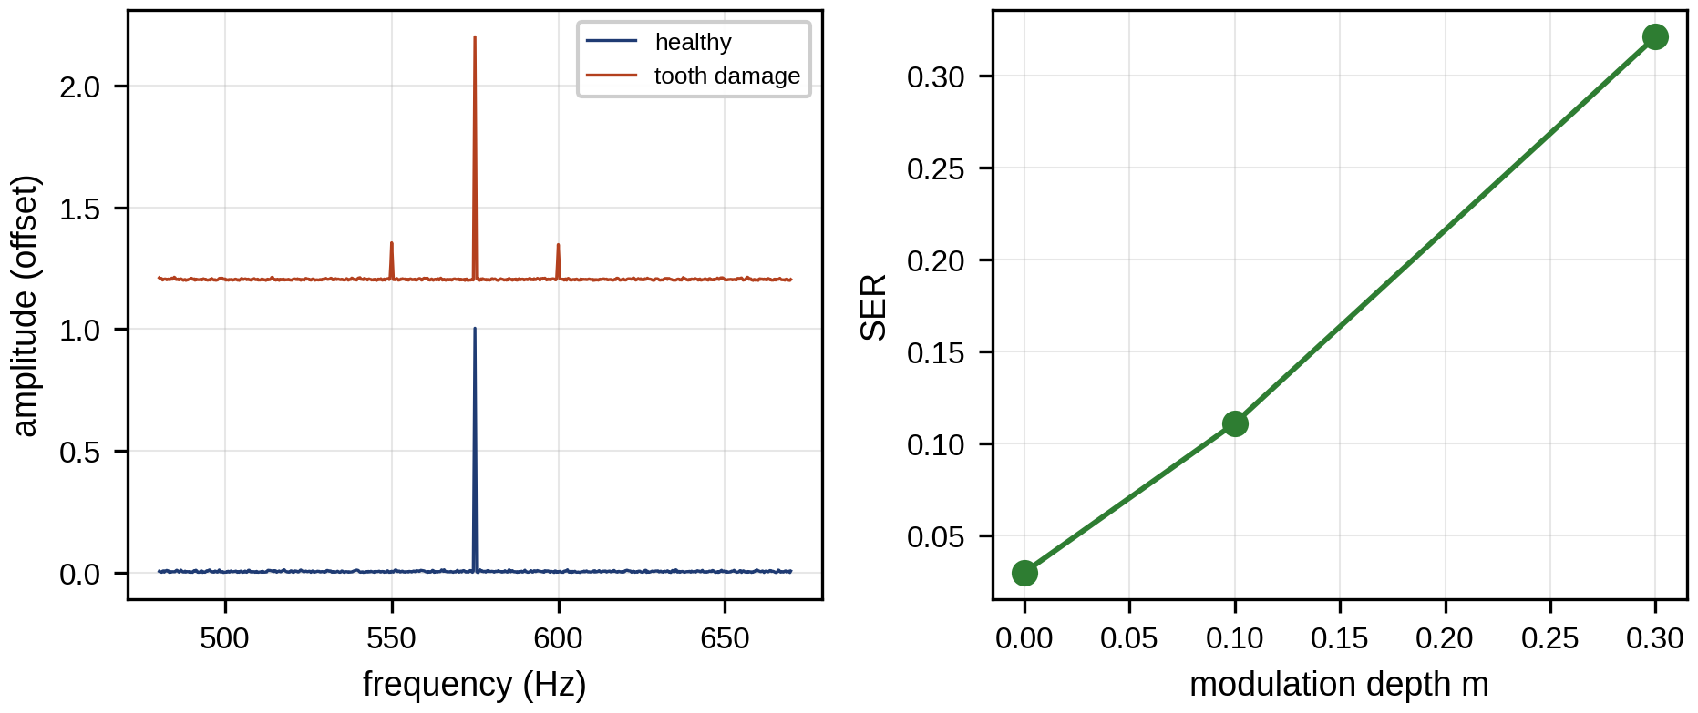
Figure 12.34. Gear mesh spectra around 575 Hz for a healthy pinion and for local tooth damage producing 25 Hz sidebands (left), and the sideband energy ratio against modulation depth (right).

12.23 Transformer PHM
Power transformers are among the most valuable and least replaceable assets of an electrical system: a large unit costs millions and takes a year or more to replace, and its failure can end in fire. Transformer PHM rests on four families of indicators (Figure 12.35).
Thermal. Insulation paper ages with temperature, so the hot-spot temperature is the key thermal state. It is estimated by the thermal twin of IEC 60076-7 [19] (the loading guide, similar in structure to IEEE C57.91), whose steady-state form for a load factor $K$ (load current over rated current) is
 | $$θ_{h}=θ_{a}+Δθ_{or}{\left[\frac{1+RK^{2}}{1+R}\right]}^{x}+Hg_{r}K^{y},$$ | (12.97)
where $θ_{h}$ is the hot-spot temperature, $θ_{a}$ the ambient, $Δθ_{or}$ the top-oil rise at rated load, $R$ the ratio of load losses to no-load losses at rated current, $Hg_{r}$ the hot-spot-to-top-oil gradient at rated current, and $x$ and $y$ the oil and winding exponents set by the cooling mode; the dynamic form adds oil and winding time constants. For non-thermally-upgraded paper, the relative ageing rate doubles for every 6 K,
 | $$V=2^{\left(θ_{h}−98\right)/6}, L_{eq}=∫V dt,$$ | (12.98)
where $V=1$ at a hot spot of 98 °C and $L_{eq}$ is the equivalent ageing over the period.
Chemical. Faults decompose oil and paper into characteristic gases: hydrogen and methane from partial discharge and low-temperature overheating, ethylene from high-temperature overheating, acetylene from arcing, carbon oxides from paper. Dissolved-gas analysis (DGA) interprets concentrations, rates of increase and ratios, with methods such as the IEC 60599 ratios [20] and the Duval triangle. Ratios are meaningful only when concentrations are well above detection limits and when the gas increase, not the background, is analysed; the trend matters more than any single sample.
Moisture. Water in the paper lowers its dielectric strength and accelerates ageing. It is inferred from moisture in oil, which depends strongly on temperature, so readings are compared only at similar temperatures or through equilibrium curves.
Dielectric. Bushing capacitance and dissipation factor ($tanδ$) trends, and partial-discharge activity measured electrically or acoustically, indicate insulation defects that thermal and chemical indicators may miss.
Example 12.16 Hot-spot temperature and ageing of an ONAN transformer
Given. An oil-natural, air-natural (ONAN) distribution transformer with illustrative parameters $Δθ_{or}=52$ K, $Hg_{r}=26$ K, $R=5$, $x=0.8$, $y=1.6$. Ambient 30 °C.
Find. The steady-state hot spot and ageing rate at $K=0.8$, 1.0 and 1.2, and the equivalent ageing of a day with 16 hours at $K=0.7$ and 8 hours at $K=1.1$ (quasi-steady approximation).
Solution. At $K=1.0$: $θ_{h}=30+52+26=108$ °C and $V=2^{10/6}=3.17$. At $K=1.2$: ${\left[\left(1+5×1.44\right)/6\right]}^{0.8}={1.367}^{0.8}=1.284$, so the top-oil rise is 66.7 K, the gradient $26×{1.2}^{1.6}=34.8$ K and $θ_{h}=131.6$ °C, $V=48$. At $K=0.8$: $θ_{h}=87.3$ °C, $V=0.29$. The day’s equivalent ageing is 97 hours: four days of life consumed in one.
Interpretation. Ageing is so steeply nonlinear that a few hot hours dominate. At 20 °C ambient the same transformer at rated load ages at exactly the reference rate ($θ_{h}=98$ °C). The twin’s actions follow directly: shift load to cooler hours, add forced cooling, or accept the ageing knowingly. A hot-spot estimate that is 6 K too low understates ageing by a factor of two, which is why fibre-optic hot-spot sensors are used to calibrate the thermal twin on large units.
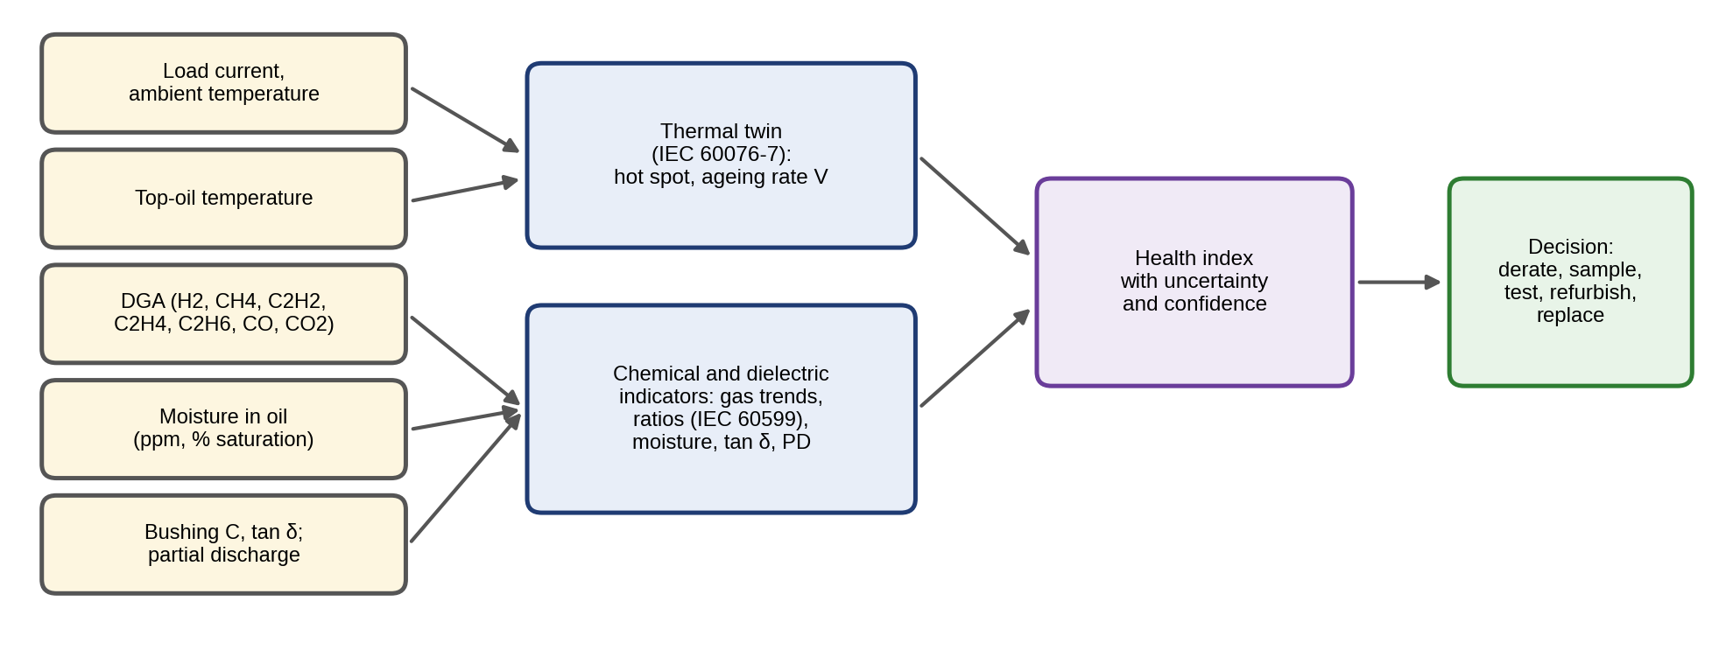
Figure 12.35. Transformer PHM: load and temperatures feed the thermal twin, DGA, moisture and dielectric measurements feed chemical and dielectric indicators, and all combine into a health index with uncertainty that drives the maintenance decision.
A health index combines these indicators, typically as a weighted score of each indicator’s condition class, HI=i​wisi/i​wi with scores $s_{i}$ and weights $w_{i}$ set by engineering judgement and validated against inspection findings. The decision ladder runs from derating and resampling at shorter intervals, through diagnostic tests (DGA confirmation, frequency-response analysis, dielectric tests), to refurbishment, oil treatment or replacement. Because the weights and class boundaries are partly judgement, the HI should carry its uncertainty and its data age, and a single alarming DGA sample triggers a confirmation sample rather than a replacement.

12.24 Real-time Edge–cloud PHM Architecture
PHM data rates differ by orders of magnitude between signals, and the processing chain from data acquisition to advisory generation is standardized in ISO 13374 [12]. The raw data rate of $N_{ch}$ channels sampled at $f_{s}$ with $b$ bits per sample is
 | $$R_{data}=N_{ch} f_{s} \frac{b}{8} \text{bytes/s},$$ | (12.99)
where $R_{data}$ is the raw data rate. The timing budget of a detection chain must satisfy
 | $$t_{acq}+t_{feat}+t_{det}+t_{comm}+t_{act}≤t_{PF}/2,$$ | (12.100)
where $t_{acq}$, $t_{feat}$, $t_{det}$, $t_{comm}$ and $t_{act}$ are the times to acquire a record, compute its features, run detection, communicate the result and act on it, and $t_{PF}$ is the P–F interval. The right side is the deadline set by the physics of the failure, not by the computer, and with (12.2) it is a heuristic rather than a strict bound. For bearings (P–F intervals of weeks) any sensible architecture meets it. For insulation breakdown or power-semiconductor failure, where the interval can be seconds or milliseconds, detection and protective action must happen on the device itself (Chapters 7 and 10).
That observation fixes the architecture (Figure 12.36). Local protection and monitoring (overcurrent and desaturation trips, overtemperature limits, vibration trips) runs in the device or its controller with deterministic timing and never depends on a network or a cloud service. Edge diagnosis computes features and runs detection and isolation near the asset, because raw waveforms are too large to move: eight vibration channels at 25.6 kHz with 24-bit samples produce 614 kB/s by (12.99), more than a day of SCADA data every second. A 65 536-point FFT takes about $5N\log_{2}N=5.2$ million floating-point operations, some tens of milliseconds on an embedded processor, so a spectrum per channel every few seconds is easy. Site and cloud prognosis updates RUL, trains fleet models and plans maintenance over hours to months. Cloud analytics can advise and plan, but a safety-critical loop must not be closed through it unless the latency is deterministic and a local fallback exists. Table 12.10 specifies the chain for P-1.
TABLE 12.10 Real-time PHM chain for the P-1 twin: rates, locations, budgets and fallbacks
Function | Sensor rate | Processing rate | Location | Latency budget | Storage | Fallback
Protection, device limits | kHz to MHz | Continuous | Device, controller | µs to ms | Event records | Hard-wired trip
Vibration features (RMS, SK, envelope, orders) | 25.6 kHz per channel | One record every 10 s to 10 min | Edge node | Seconds | Features; raw records on trigger | Local trend alarm on RMS
Electrical signatures (currents, $d_{x}$, negative sequence) | 5 to 20 kHz | Per cycle to per second | Drive, edge | Cycles to seconds | Features | Drive’s own fault detection
Twin residuals, detection, isolation | 1 s to 1 min | 1 s to 10 min | Site twin | Minutes | Residuals, alarms | Fixed limits from last valid baseline
RUL update | Features | Hourly to daily | Site or cloud | Hours | HI history, RUL distributions | Last RUL with widened interval
Fleet learning, retraining | Aggregated | Weekly to quarterly | Cloud | Days | All, with provenance | Current model version stays in service
Four supporting functions turn the chain into a system. A model registry stores every model with its version, training data reference, validation results and approval, and each output carries the version that produced it. A drift monitor watches the healthy statistics of every input and residual (Section 12.6.3) and flags when a model is operating outside its validated domain. Update control retrains or recalibrates only on confirmed-healthy data, runs the new version in shadow beside the old one, and promotes it only after it passes the same validation gates. And human approval is required before any maintenance action with significant cost or safety impact; the twin supplies the evidence and the expected-cost comparison.
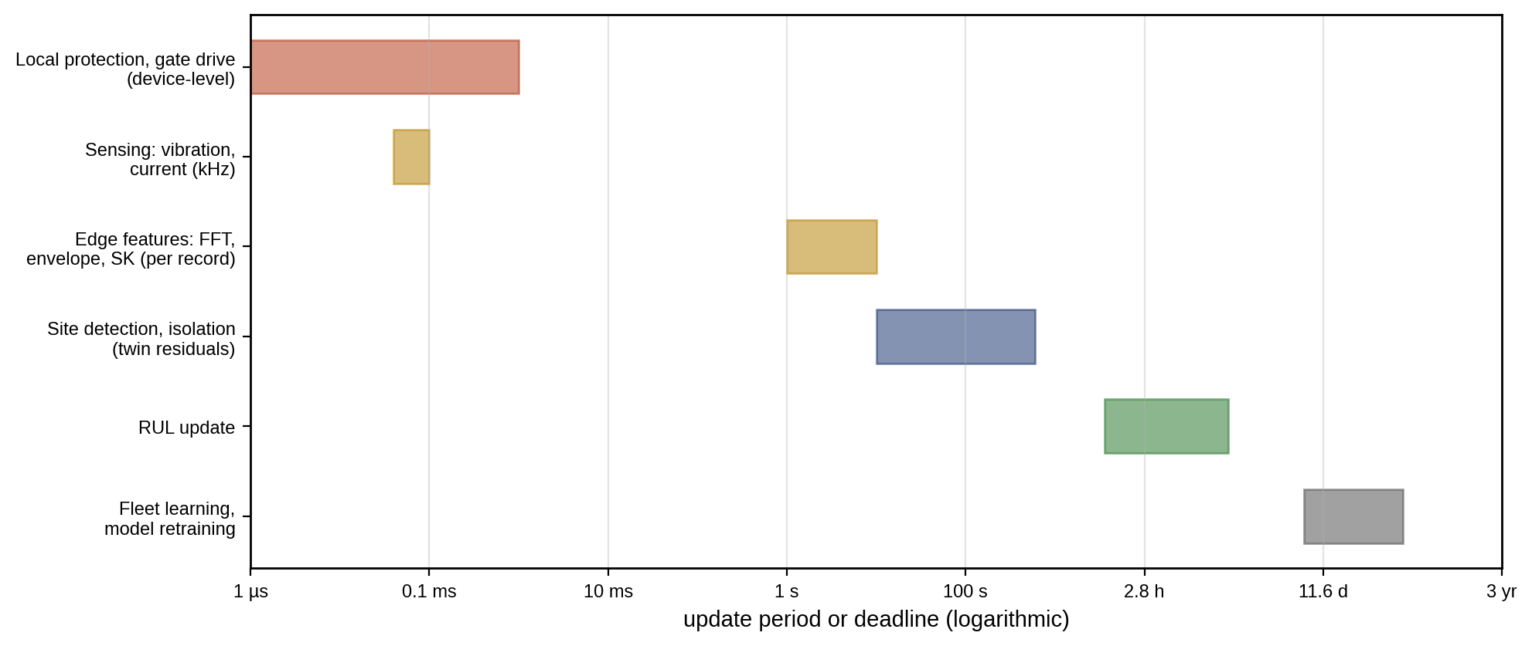
Figure 12.36. Timing architecture of PHM for the P-1 plant: device-level protection in microseconds, kilohertz sensing, edge feature extraction per record, site detection and isolation in seconds to minutes, RUL updates in hours and fleet learning over weeks to months.

12.25 Sensor Selection, Data Quality, Trust and Model Governance

12.25.1 Choosing sensors
A monitoring system fails most often not in its algorithms but in its data. Sensor selection follows from the mechanism and its P–F interval. For bearings: accelerometers with bandwidth covering the structural resonances (typically up to 10 to 20 kHz), mounted stiffly close to the load zone, and sampled through an anti-alias chain designed as in Section 12.3.2. For thermal faults: temperature sensors with the time constant to follow the process. For electrical faults: current and voltage sampling fast enough for the waveform features used. A sensor placement is judged by the faults it makes detectable and isolable, which the signature matrix quantifies.
The choice can be posed as an optimization: select the cheapest set of sensors whose residuals make every critical fault detectable and every pair of faults isolable. With a binary decision $s_{j}$ for each candidate sensor package $j$ of cost $c_{j}$, and the signature matrix $S\left(s\right)$ of the residuals the chosen packages enable,
 | mins∈{0,1}J j​cjsj s.t. S:,fs≠0 ∀f, S:,fs≠S:,gs ∀f≠g, | (12.101)
where the first constraint requires detectability of each fault $f$ and the second isolability of each pair $\left(f,g\right)$. Small problems are solved by enumeration, large ones by integer programming.
Example 12.17 The cheapest isolating sensor set for M-07
Given. The six faults of Table 12.3 and five candidate packages with illustrative installed costs: an accelerometer (400 $, gives the BPFO envelope residual), a winding RTD (150 $, winding-temperature residual), a housing thermocouple (80 $, housing-temperature residual), two phase current sensors (300 $, negative-sequence and DC-offset residuals) and a third current sensor (150 $, current-sum parity, useful only with the other two).
Find. The cheapest set that detects all six faults and the cheapest that also isolates them.
Solution. Enumerating the 31 combinations: the accelerometer, the RTD and two current sensors (850 $) detect every fault, but a cooling fault and a temperature-sensor bias then produce the same signature (only the winding residual fires). Adding the housing thermocouple (930 $ in total) separates them, and all six columns become distinct. The third current sensor is not needed: with two sensors, a current-sensor bias fires the DC-offset residual alone, while an open switch also fires the negative-sequence residual.
Interpretation. An 80 $ thermocouple is what turns “something thermal is wrong” into “the cooling has failed” rather than “the sensor has drifted”, which decide between sending a mechanic and sending an instrument technician. Sensor selection by isolability often buys more than a better algorithm.

12.25.2 Data quality
Data quality is checked before any indicator is computed, because a detector evaluated only on clean data will perform worse in service. The checks, and the defect each catches, are:
- Calibration traceability. Each sensor’s calibration certificate and date, so that a drift can be distinguished from a real change.
- Placement and mounting. An accelerometer on a flexible cover or on the wrong side of the load zone attenuates bearing impacts; placement is recorded and re-checked after maintenance.
- Range and saturation. Values at the ADC limits, or clipped peaks, invalidate kurtosis and crest factor.
- Dropouts, stuck and frozen values. Missing samples, repeated identical values or a variance that falls to zero.
- Spikes. Single samples far outside the local distribution, from electrical interference.
- Clock drift and timestamps. Gaps, duplicates and offsets between devices, which break the alignment that residuals and fusion need.
- Physics consistency. Relations between sensors that must hold (Section 12.9), and noise floors that have changed.
- Redundancy. Where it exists, a comparison of redundant sensors identifies which one is wrong.
Each indicator carries its data-quality flags and the model version that produced it, so that a later review can tell whether an alarm came from the asset or from its data (Figure 12.37). The validation set of every detector must contain the data defects it will meet.
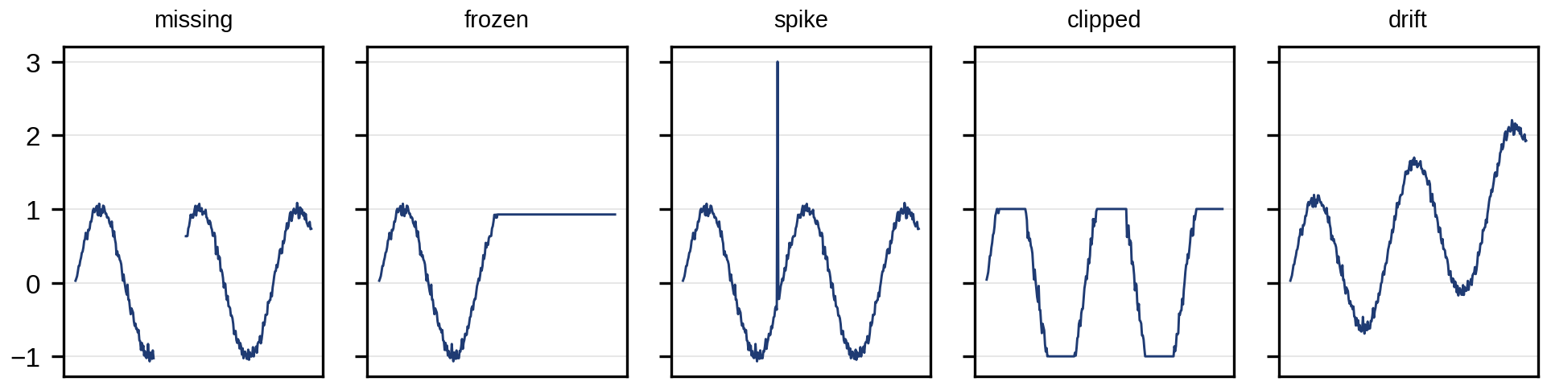
Figure 12.37. Common data defects that must be caught before indicators are computed: missing samples, a frozen value, a spike, clipping at the sensor range, and a slow drift.

12.25.3 Trust, security and governance
A PHM twin can cause harm through its data as easily as through its models. NIST IR 8356 [18] identifies the security and trust considerations specific to digital twins, and three are central here: the integrity of sensor data and models (a manipulated vibration stream or a replaced model file can hide a fault or trigger an unnecessary shutdown), their provenance (which data trained which model, and who approved it), and trust in commands (a maintenance or derating decision issued by the twin must be authenticated and authorized). A governed PHM twin therefore keeps a model registry with signed versions, authenticates its data links, monitors for inputs outside its validated domain, and records who approved each decision it supported.

12.25.4 PHM maturity and evidence
Individual detectors become a PHM system when they share a data model, a baseline process, a validation practice and a decision process across asset types. Maturity is judged by evidence, not by the sophistication of the algorithm. Five levels are useful, and each requires the evidence of the level below it:
- Descriptive: synchronized, quality-checked data and trends are available.
- Diagnostic: residuals are validated across operating modes, with measured false-alarm rates and a validated signature matrix.
- Prognostic: RUL distributions are validated on held-out run-to-failure units, with measured coverage.
- Prescriptive: maintenance decisions are optimized by expected cost and safety, and validated prospectively against what actually happened.
- Fleet-learning: outcomes of maintenance feed back to update models and statistics across the fleet, under version control.
Table 12.11 places P-1’s assets on this scale with the evidence this chapter produced.
TABLE 12.11 PHM maturity of P-1 assets (synthetic evidence from this chapter)
Asset | Level reached | Evidence in this chapter | Missing for the next level
Motor bearings | Prognostic | Envelope detection; Wiener RUL with 88 to 92 % coverage on 200 held-out units | Prospective decisions against real replacements
Motor windings | Diagnostic | Mode-conditioned thresholds, signature matrix | Run-to-failure insulation data
DC-link capacitors | Prognostic (model-based) | ESR trend with interval containing truth | Field validation of temperature scenarios
IGBT modules | Diagnostic (lifetime model unvalidated) | Mission-profile damage, open-switch indicator | Power-cycling data for the actual module
PV strings | Diagnostic | Residual and CUSUM detection, separation table | Degradation prognosis
BESS modules | Prognostic | RUL with bootstrap and conformal intervals (Chapter 9), weakest-cell analysis | Validation at other temperatures
Gearbox | Diagnostic | SER trend, order tracking | Isolation between gear and bearing faults; run-to-failure data
Transformer | Descriptive to diagnostic | Hot-spot and ageing twin; DGA practice | Validated health index against inspections

12.26 Cross-asset P-1 Capstone: A Decision-grade Maintenance Ranking
The P-1 maintenance team meets weekly with the next planned outage four weeks away. The twin reports five findings, each with a RUL distribution (lognormal, fitted to its median and 90 % interval), a failure cost including downtime and consequential damage, a planned-action cost and a spare-part lead time. For each asset, the probability of failure before the earliest possible action, which is the later of the next outage and the spare’s arrival, is
 | $$p_{f}=F_{RUL}\left(max\left(t_{outage}, t_{lead}\right)\right), \text{net benefit}=p_{f}C_{f}−C_{p},$$ | (12.102)
where $F_{RUL}$ is the RUL distribution function, $C_{f}$ the failure cost and $C_{p}$ the planned-action cost. Assets are then ranked by net benefit, with safety-critical findings escalated regardless of cost.
Example 12.18 Ranking P-1’s maintenance actions
Given. Table 12.12 lists the five findings.
TABLE 12.12 Findings reported by the P-1 PHM twin (synthetic)
Finding | RUL median (90 % interval) | Failure cost | Planned action cost | Spare lead time | Safety-relevant
Wind T-1 gearbox pinion (SER rising) | 12 weeks (6 to 24) | 350 000 $ | 60 000 $ | 10 weeks | Yes
Motor M-07 bearing (BPFO in envelope) | 6 weeks (3 to 12) | 88 000 $ | 3 000 $ | 1 week | No
Drive D-3 capacitors (ESR trend) | 145 weeks (110 to 190) | 25 000 $ | 2 000 $ | 4 weeks | No
BESS rack 3 module (capacity fade) | 78 weeks (52 to 110) | 30 000 $ | 8 000 $ | 6 weeks | No
PV string 17 (open circuit) | Already failed; loses 15 $/day | n/a | 400 $ | None | No
Find. For each finding, the probability of failure before the earliest possible action, the expected failure cost avoided and the net benefit of acting now; then the sensitivity of the ranking to the spare lead time, the failure cost and the width of the RUL distribution.
Solution. Each RUL distribution is lognormal with median $m$ and 90 % interval $\left[q_{05},q_{95}\right]$, so its log-standard deviation is $s=ln\left(q_{95}/q_{05}\right)/\left(2×1.645\right)$ and $F_{RUL}\left(t\right)=Φ\left(ln\left(t/m\right)/s\right)$.
- Gearbox. $s=ln\left(24/6\right)/3.29=0.421$. The action cannot happen before the spare arrives at 10 weeks, so $p_{f}=Φ\left(ln\left(10/12\right)/0.421\right)=Φ\left(−0.433\right)=0.33$. The expected failure cost is $0.33×350 000=116 000$ $ and the net benefit of ordering and planning the replacement now is 56 000 $.
- M-07 bearing. $s=0.421$; action at the 4-week outage gives $p_{f}=Φ\left(ln\left(4/6\right)/0.421\right)=0.168$ and a net benefit of $0.168×88 000−3000=11 800$ $.
- Capacitors and BESS module. The probabilities of failure before action (4 and 6 weeks) are below ${10}^{−6}$, so acting now costs 2000 $ and 8000 $ and saves nothing; both are scheduled for later outages and monitored.
- PV string. It pays back its 400 $ repair in 27 days of lost energy, so it goes into the next routine visit.
Table 12.13 shows how the gearbox decision depends on the spare lead time, and how the bearing decision depends on its failure cost and on the width of its RUL distribution.
TABLE 12.13 Sensitivity of the capstone decisions
Case | Change | $p_{f}$ | Net benefit of acting now ($)
Gearbox | Lead time 6 weeks | 0.05 | −42 500
Gearbox | Lead time 8 weeks | 0.17 | −1 200
Gearbox | Lead time 10 weeks (base) | 0.33 | 56 400
Gearbox | Lead time 12 weeks | 0.50 | 115 000
Gearbox | Lead time 14 weeks | 0.64 | 165 000
M-07 bearing | Base | 0.17 | 11 800
M-07 bearing | Failure cost halved to 44 000 $ | 0.17 | 4 400
M-07 bearing | RUL log-spread doubled | 0.31 | 24 700
Interpretation. Figure 12.38 shows the RUL distributions against the outage and lead times. The ranking is not the ranking of the health indicators. The gearbox comes first because its ten-week lead time is close enough to its twelve-week median life that a third of the probability mass lies before the spare can arrive, and a gearbox failure is expensive. The sensitivity table shows where the decision is fragile: with an 8-week lead time, ordering the spare now is roughly break-even, and with 6 weeks it would be premature. For the bearing, wider uncertainty raises the value of acting at the outage, because it puts more probability on early failure; a twin that reports narrow but overconfident intervals would therefore delay exactly the actions that need to be taken. The twin also offers derating: lower gearbox torque slows the damage, and if it extends the median RUL well beyond the lead time, the expected loss falls further at the cost of some energy.
The decision still passes through human review. The engineer checks the gearbox spectrum and the speed used, confirms the finding with the oil-debris trend (Section 12.22), considers the safety implications of a gearbox failure at height and the availability of a crane window, and signs off. The twin supplies the evidence and the expected-cost comparison; it does not replace accountability.
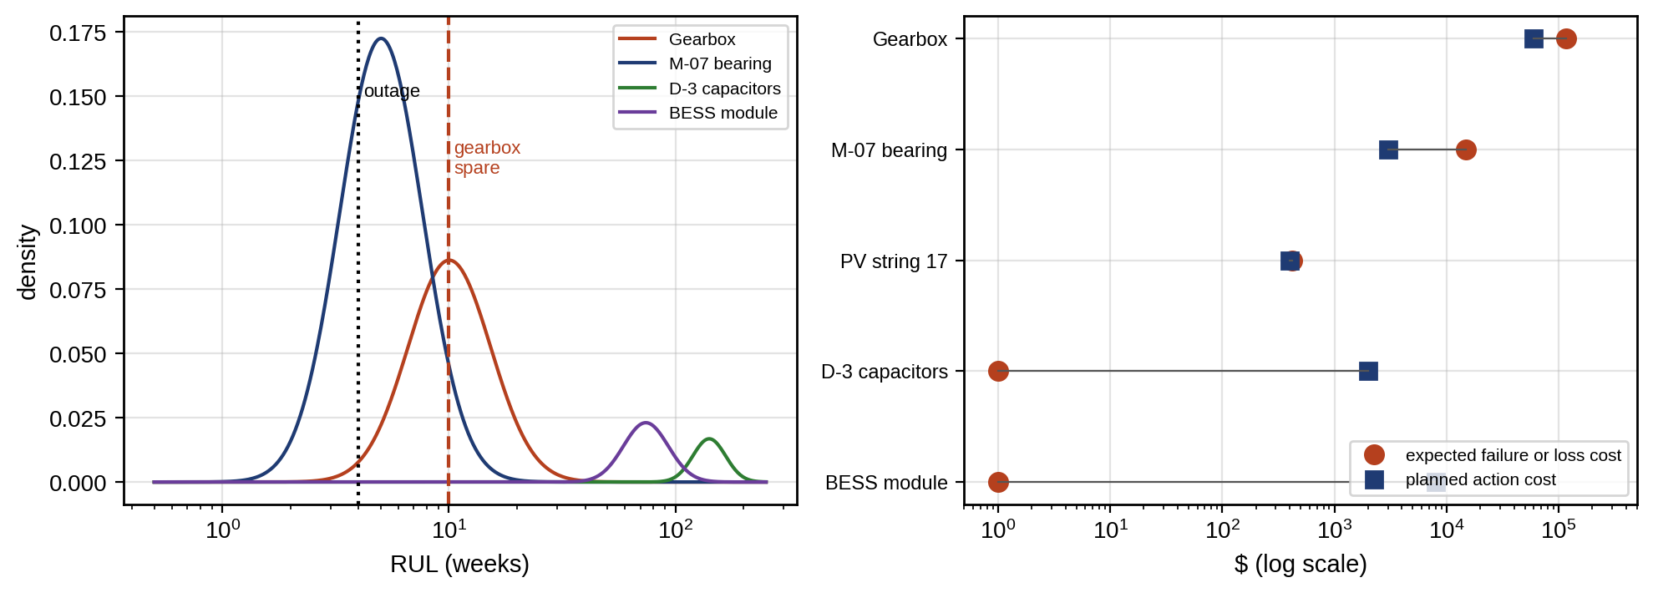
Figure 12.38. Fleet decision: RUL distributions of the five findings with the planned outage and spare lead times marked (left), and expected failure cost (for the PV string, four weeks of lost energy) against planned action cost for each finding (right).

12.27 Emerging Directions: A 2–5 and 5–10 Year Roadmap
The methods of this chapter divide into three groups by maturity, and a responsible deployment keeps them apart (Figure 12.39, Table 12.14). The industrial baseline (indicators, envelope and order analysis, twin residuals, statistical detectors, Weibull and age replacement, oil, DGA and thermography programmes) is proven and should be in place before anything else. Within two to five years, several research directions are maturing into deployment: self-supervised and few-shot representations that reduce the need for labelled faults; domain generalization across speed, load and site; physics-informed and hybrid RUL models; calibrated uncertainty through ensembles and conformal methods; multimodal fusion at the edge; and fleet or federated learning. Over five to ten years, more ambitious directions are emerging: validated foundation models for industrial time series, autonomous maintenance planning, causal and agentic diagnosis, and twins that span fleets from different owners and manufacturers. These are research today. They require evidence of benefit over simple baselines on leakage-free benchmarks, and any system that plans or acts autonomously requires human oversight and safety governance proportionate to the consequences of its errors.
TABLE 12.14 Roadmap for PHM with measurable research targets
Horizon | Direction | Status | Measurable target
Now | Twin residuals with mode-conditioned thresholds and CUSUM | Industrial baseline | False alarms per year within budget; detection delay
2–5 years | Domain generalization across speed, load and site | Research to pilots | Balanced accuracy on unseen machines and conditions
2–5 years | Physics-informed and hybrid RUL | Research, early deployment | RUL error and coverage against Wiener and naive baselines on held-out assets
2–5 years | Calibrated RUL intervals (ensembles, conformal) | Research, early use | PICP under temperature and duty shift
2–5 years | Edge multimodal fusion, federated fleets | Pilots | Accuracy with a missing modality; accuracy at a new site with few labels
5–10 years | Foundation models for condition monitoring | Emerging | Benchmark results with leakage-free splits against strong baselines
5–10 years | Autonomous, prescriptive maintenance planning | Emerging | Realized cost against plan over a year, with human override rate
5–10 years | Causal and agentic diagnosis | Emerging | Correct root cause on held-out incidents, with auditable reasoning
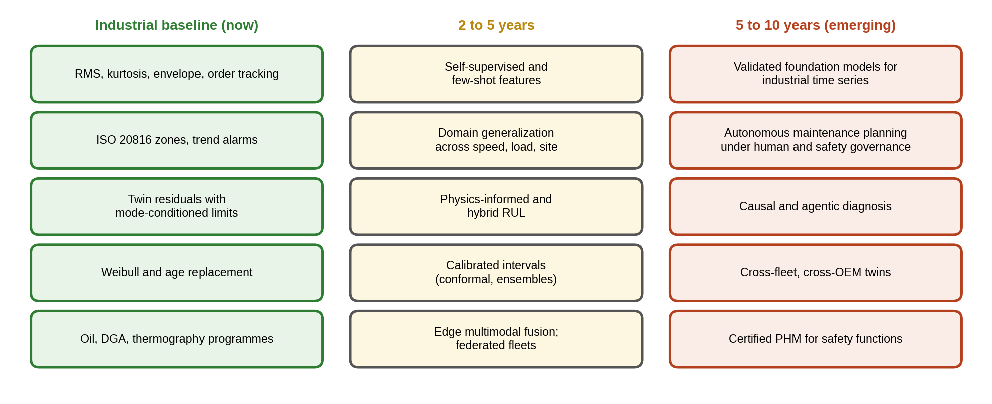
Figure 12.39. PHM technology roadmap: the industrial baseline in use now, directions maturing over two to five years, and emerging directions for five to ten years that require validation and human and safety governance.
Table 12.15 lists the standards and guidance used in the chapter with their status.
TABLE 12.15 Standards and guidance used in this chapter
Standard or guidance | Scope in this chapter | Status (September 2026)
ISO 17359:2018 | General guidelines for condition-monitoring programmes | Current
ISO 13374-1:2003 | Data processing, communication and presentation | Current (confirmed 2025)
ISO 13379-1:2025 | Data interpretation and diagnostic techniques | Current edition
ISO 13381-1:2025 | Prognostics: general guidelines and requirements | Current edition
ISO 20816 series | Vibration measurement and evaluation (replaces most of ISO 10816) | Part 1 under revision in 2026; part 21 (wind turbines) published 2025
IEC 60812:2018 | FMEA and FMECA | Current
IEC 60076-7, IEC 60599 | Transformer loading guide; DGA interpretation | Current
NIST IR 8356 (2025) | Security and trust in digital twins | Published

12.28 Summary, Key Equations and Graded Exercises
PHM answers four questions for every asset: is anything wrong, what, how long until failure, and what to do. The chapter built each answer from its foundations and marked where a digital twin changes the answer: a synchronized healthy baseline, controlled adaptation, quantified uncertainty and maintenance feedback. It began with vocabulary. Variability, degradation, anomaly, fault and failure are different things; faults are incipient, intermittent or permanent; and the P–F interval, which sets how often an asset must be watched, depends on both mechanism and technique. Sensing and signal processing came next: transducer units and integration, ADC range and anti-alias design, the DFT and PSD with their variance, time-domain indicators, spectral kurtosis, envelope analysis and order tracking. On the M-07 bearing, band-passed kurtosis rose from 3.0 to 9.3 while broadband kurtosis barely moved, and the envelope spectrum put the defect 1 % below the computed outer-race frequency.
Detection rested on twin residuals with covariance and on baselines conditioned by operating mode, since one pooled threshold caught 0.3 % of a fault that mode-conditioned limits caught 84 % of the time. A twin that adapts too fast learns the fault, which a dual-timescale policy prevents. CUSUM found a half-sigma shift six times faster than a 3σ rule, but autocorrelated residuals multiplied its false alarms by five, so dependence, heavy tails and fleet false-alarm budgets must be designed for. Evaluation needs leakage-free splits, prevalence-corrected precision, calibration and event-level scoring: a classifier scoring 97 % on random windows scored 64 % on unseen machines, and twin-normalized features restored 89 %, holding 88 % at a new speed. Structured residuals with graded sensitivities isolated sensor from process faults; FMECA replaced RPN with evidence-based criticality; and multivariate statistics with robust covariance flagged a jointly impossible state that univariate limits passed. Data-driven and hybrid methods were placed on a ladder above these baselines, and fusion of vibration, current and temperature beat any single sensor as long as a faulty sensor was weighted down.
Prognosis used deterministic, Wiener, gamma and state-space degradation models. RUL was reported as a calibrated distribution: the Wiener predictor halved the naive error and its 90 % intervals covered 88 to 92 % of 200 held-out units. Censoring-aware Weibull estimation avoided a 16 % underestimate of life; Cox models, competing risks and frailty extended it to heterogeneous fleets; and an optimal replacement age cut cost by 58 %, with perfect prognostic information worth a further three-quarters. Applications covered IGBT thermal cycling and open switches, DC-link capacitors, PV fault separation, weakest-cell battery packs, variable-speed gearboxes and transformer hot-spot ageing. A real-time architecture kept safety-critical action local, a governance section covered data quality, trust and maturity evidence, and the capstone ranked P-1’s actions by expected cost with a sensitivity analysis and a human engineer’s sign-off. Table 12.16 collects the key equations.
TABLE 12.16 Key equations of Chapter 12
Relationship | Expression | Eq.
Detection before failure | $P_{det}≈1−{\left(1−p_{d}\right)}^{L/Δt_{mon}}$ | (12.2)
Acceleration to velocity | $v=a/\left(2πf\right)$ | (12.3)
Frequency resolution | $Δf=f_{s}/N$ | (12.7)
Time-domain indicators | RMS, CF, kurtosis | (12.10)
Spectral kurtosis | $SK\left(f\right)=⟨{\left|X\right|}^{4}⟩/⟨{\left|X\right|}^{2}⟩^{2}−2$ | (12.13)
Envelope | $e\left(t\right)=\left|x_{bp}+jH\{x_{bp}\}\right|$ | (12.14)
Order | $o=f/f_{r}$ | (12.16)
Residual and its variance | $Var\left(r\right)≈σ_{v}^{2}+g_{θ}^{T}P_{θ}g_{θ}$ | (12.18)
Normalized residual | $q=r^{T}Σ_{r}^{−1}r$ | (12.20)
Adaptation lag | $r_{∞}=ρτ_{a}$ | (12.21)
Shewhart false-alarm probability | $α=2\left[1−Φ\left(L\right)\right]$ | (12.22)
EWMA, CUSUM | (12.24), (12.25) | (12.25)
Siegmund ARL | (12.27) | (12.27)
EWMA variance with AR(1) residuals | (12.28) | (12.28)
False-alarm budget | $α=FA_{year}/\left(N_{ind}n_{s}\right)$ | (12.31)
Precision with prevalence | $πTPR/\left(πTPR+\left(1−π\right)FPR\right)$ | (12.34)
Deployment cost of a threshold | (12.36) | (12.36)
Brier score | $\frac{1}{N}∑{\left(p_{i}−y_{i}\right)}^{2}$ | (12.37)
Bearing frequencies | (12.40), (12.41) | (12.41)
Graded isolation | $J_{j}=∥z−Ψ_{:,j}{\hat{f}}_{j}∥^{2}$ | (12.43)
Mahalanobis distance | $D^{2}={\left(x−μ\right)}^{T}Σ^{−1}\left(x−μ\right)$ | (12.47)
Decision fusion | i​wilnpxi∣F/pxi∣H | (12.56)
Paris law | $da_{c}/dN=C_{P}{\left(ΔK\right)}^{m_{P}}$ | (12.58)
Wiener first-passage time | $E[T]=a/μ$, $Var[T]=aσ^{2}/μ^{3}$ | (12.60)
Bayesian drift update | (12.62) | (12.62)
Gamma-process first passage | (12.64) | (12.64)
Interval coverage and width | PICP, MPIW | (12.67)
Late-penalized score | (12.71) | (12.71)
Weibull reliability, hazard | (12.72) | (12.72)
Censored likelihood | $∏h{\left(t_{i}\right)}^{δ_{i}}R\left(t_{i}\right)$ | (12.75)
Cox proportional hazards | $h\left(t∣z\right)=h_{0}\left(t\right)e^{β_{c}^{T}z}$ | (12.79)
Age-replacement cost rate | (12.83) | (12.83)
Semiconductor damage | $D=∑n_{k}/N_{f}\left(ΔT_{j,k},T_{m,k}\right)$ | (12.88)
Weakest-cell pack capacity | $Q_{pack}=\min_{i}Q_{i}$ | (12.92)
Gear mesh and sidebands | $f_{m}=z_{1}f_{1}$; $f_{m}±kf_{1}$ | (12.93), (12.94)
Transformer ageing rate | $V=2^{\left(θ_{h}−98\right)/6}$ | (12.98)
Maintenance decision | $p_{f}=F_{RUL}\left(max\left(t_{outage},t_{lead}\right)\right)$ | (12.102)

Exercises
The fifteen exercises are grouped by theme. Most combine a numerical part, a derivation and a question about what can go wrong, so that each can be set as one assignment; the last four are open research and design projects. Complete solutions to all fifteen are given in the Answer Key.

Group A: signals, indicators and detection
12.1 Sensors, sampling and indicators. (a) Show that a sinusoid has a crest factor of $\sqrt{2}$ and a kurtosis of 1.5. (b) An accelerometer of 100 mV/g sensitivity reads 0.2 V peak at 50 Hz. Find the acceleration, velocity and displacement amplitudes by (12.3). (c) Find the quantization step and the ideal SQNR of a 16-bit ADC spanning ±5 V by (12.4). (d) A vibration record has $f_{s}=10 240$ Hz and $N=8192$ samples. Find its duration and frequency resolution by (12.7).
12.2 Bearings and gears. (a) A bearing has $N_{b}=9$, $d=12$ mm, $D=60$ mm, $α=0$ and runs at 1800 r/min. Find FTF, BPFO, BPFI and BSF by (12.40) and (12.41). (b) Derive (12.40) and (12.41) from the rolling-without-slip condition. (c) An envelope spectrum shows a line at 118 Hz with sidebands at ±25 Hz for the bearing of Example 12.5. What is the likely defect, and why the sidebands? (d) A 31-tooth pinion turns at 20 Hz. Find the mesh frequency and the first pair of pinion sidebands by (12.93) and (12.94). (e) A bearing's envelope line is 8 % above its computed BPFO. List three explanations and the check for each.
12.3 Control charts and alarm budgets. (a) Find the per-sample false-alarm probability and the in-control ARL of a Shewhart chart with $L=2.5$ by (12.22). (b) Derive the steady-state variance $λ/\left(2−λ\right)$ of the EWMA statistic of (12.24), and find the EWMA limit for $λ=0.2$ and $L_{E}=3$. (c) A 2-of-3 persistence rule is applied to a threshold with $α=0.02$. Find the false-alarm probability per window by (12.30). (d) A plant monitors 40 indicators every minute and can investigate 20 false alarms a year. Find the per-sample false-alarm probability and the two-sided Gaussian limit by (12.31).
12.4 Autocorrelation, drift and adaptation. (a) Derive (12.28) for an AR(1) residual and explain what it does to the false-alarm rate of an EWMA designed for independent data. (b) Derive the steady-state residual (12.21) of exponential forgetting for a ramp fault. (c) A parameter-adaptive twin never alarms although the asset later fails. What is the likely cause, and what policy prevents it? (d) A winding-temperature residual alarms only during high-load periods. What is the likely cause, and what should be changed?

Group B: evaluation and diagnosis
12.5 Evaluating detectors and classifiers. (a) A detector has TPR = 0.9 and FPR = 0.02. What fraction of its alarms are real when 2 % of periods are faulty, by (12.34)? (b) Derive (12.34) from Bayes' rule. (c) A classifier is 99 % accurate on data with 1 % faults. Why may it be useless, and which measures would reveal it? (d) A classifier trained on randomly split windows reports 97 % accuracy. List the checks you would demand before accepting it, and predict what a machine-wise split will show.
12.6 Multivariate statistics and fusion. (a) Two indicators have $Σ=\left[\begin{matrix}4 & 1.8 \\ 1.8 & 1\end{matrix}\right]$ and zero mean. Find the standardized values and $D^{2}$ for $x=\left(2,−0.5\right)$, and judge it against $χ_{2,0.99}^{2}=9.21$. (b) Explain why each indicator alone would not alarm. (c) Derive the decision-fusion rule (12.56) from Bayes' rule and conditional independence, and the Gaussian log-likelihood ratio.
12.7 Risk, electrical faults and batteries. (a) Two FMEA modes have $\left(S,O,D\right)=\left(10,2,6\right)$ and $\left(5,6,4\right)$. Compute their RPNs, and explain why they should not be treated as equal risks and why RPN is not a validated risk measure. (b) Show that $d_{a}=−1$ in (12.89) when the positive half-cycle of a sinusoidal current is missing. (c) A series string's cells have capacities 98, 97, 95 and 99 Ah. What is the usable pack capacity, and what does it imply for balancing and maintenance?

Group C: prognostics, reliability and decisions
12.8 Degradation and remaining life. (a) A health index is 0.4 below its failure threshold and drifts at 0.01 per week with $σ=0.02$ per √week. Find the mean and standard deviation of the RUL by (12.60). (b) An RUL estimate has $σ_{mod}=10$, $σ_{meas}=5$ and $σ_{load}=20$ days. Find $σ_{RUL}$ and the 95 % half-width by (12.66), and say which term to reduce first. (c) A capacitor's ESR grows as $ESR_{0}e^{kt}$ with $k=2×{10}^{−5}$ per hour. When does it reach twice its initial value? (d) A conformal RUL interval calibrated on a fleet at 25 °C is applied to a pack at 40 °C. Why may its coverage fail?
12.9 Reliability with censored data. (a) For a Weibull population with $β=2$ and $η=5$ years, find $R\left(3\right)$, $h\left(3\right)$, MTTF and $B_{10}$ by (12.72) and (12.73). (b) Six units have times 2 (failure), 3 (censored), 4 (F), 5 (F), 6 (C) and 7 (F) years. Compute the Kaplan-Meier estimate by (12.74). (c) Derive the censored log-likelihood (12.76). (d) A plant's bearing life model, fitted to the lives of bearings replaced over five years, predicts much shorter lives than the bearings achieve. The analysis used only bearings that had failed. Explain the error and the correction.
12.10 Maintenance economics and inspection. (a) Derive (12.83) from the renewal-reward theorem, and (12.84) by differentiation. (b) Show from (12.84) that preventive age replacement never pays when failures are exponential ($β=1$). (c) With $Δt_{mon}=4$ weeks, a P-F interval of 8 weeks and a per-inspection detection probability of 0.6, find $P_{det}$ by (12.2), and the effect of halving the inspection interval.
12.11 Transformer thermal ageing. (a) An ONAN transformer with the parameters of Example 12.16 runs at $K=1.0$ with 25 °C ambient. Find $θ_{h}$ and $V$. (b) How many days of normal ageing does one day at this condition consume, and what ambient temperature would give $V=1$ at the same load? (c) Why must a transformer health index combine thermal ageing with dissolved-gas and insulation tests rather than rely on one of them?

Group D: research and design
12.12 Research project: signal processing and detection. (a) Implement spectral kurtosis to select the optimal band for envelope analysis on the synthetic bearing data, and compare with the fixed 2 to 4 kHz band. (b) Design a CUSUM for the PV daily ratio of Section 12.20 with a target of one false alarm per year, and compute its detection delay for a 1 % loss. (c) Design the sensor set for T-1's gearbox and bearings that makes all faults of a given signature matrix isolable at minimum cost.
12.13 Research project: prognostics. (a) Compare Wiener, gamma-process and neural-network RUL predictors on the synthetic bearing fleet with a leakage-free split, reporting RMSE, PICP and $α$-$λ$ accuracy. (b) Build a health index for the battery of Chapter 9 from capacity, resistance and IC-peak features, and evaluate its monotonicity, trendability and prognosability. (c) Replace the Coffin-Manson-Arrhenius model of Example 12.13 with a model fitted to published power-cycling data for a specific module, and propagate its uncertainty to the lifetime.
12.14 Research project: data-driven diagnosis and decisions. (a) Reproduce Example 12.7 with raw vibration from a public bearing dataset using machine-wise splits, fixed seeds and a random-forest baseline, and test whether twin-normalized features improve cross-machine accuracy, reporting uncertainty over at least five seeds and the data provenance. (b) Add a derating option to the capstone decision, modelling how reduced torque slows gearbox damage, and find the derating that minimizes expected cost.
12.15 Design project: PHM for a pumping station. A pumping station has four induction-motor pumps with variable-speed drives, a 1 MVA transformer and a battery-backed control system. Stating the provenance of every number and labelling synthetic data, produce: (a) an FMEA with quantitative criticality for the main failure modes; (b) a sensor plan and signature matrix that makes the critical faults isolable; (c) mode-conditioned thresholds and CUSUM detectors with a false-alarm budget per year; (d) envelope and order-tracking analysis for pump and motor bearings; (e) a Wiener or Weibull prognostic model validated against a naive baseline, with calibrated RUL intervals and their measured coverage, and a machine-wise validation of any data-driven model; (f) an optimal maintenance policy and a weekly decision process with spare lead times, safety review and human sign-off; and (g) the edge-cloud partition with the fallback of every function.

Answer Key
12.1 (a) For $Asinωt$: $x_{RMS}=A/\sqrt{2}$ and $x_{pk}=A$, so $CF=\sqrt{2}$; $\overline{\sin^{4}}=3/8$ and ${\overline{\sin^{2}}}^{2}=1/4$, so $κ=\left(3/8\right)/\left(1/4\right)=1.5$.
(b) $a=0.2/0.1=2$ g $=19.6$ m/s²; $v=19.6/\left(2π⋅50\right)=62.4$ mm/s; $x=19.6/{\left(2π⋅50\right)}^{2}=0.199$ mm.
(c) $q=10/65 536=153$ µV; $SQNR=6.02×16+1.76=98.1$ dB.
(d) $T_{r}=8192/10 240=0.8$ s; $Δf=1/T_{r}=1.25$ Hz.
12.2 (a) $f_{r}=30$ Hz, $d/D=0.2$: FTF $=\frac{1}{2}×30×0.8=12$ Hz; BPFO $=4.5×30×0.8=108$ Hz; BPFI $=4.5×30×1.2=162$ Hz; BSF $=2.5×30×0.96=72$ Hz.
(b) Without slip, the cage moves at the mean of the contact-point speeds of the two races, which gives FTF; a race defect is struck by each of the $N_{b}$ elements at the relative speed of race and cage, which gives BPFO and BPFI; a rolling element spins at the speed set by the race speed at its contact radius, and strikes a race once per revolution relative to the cage, which gives BSF.
(c) The nearest defect frequency is BPFI (122.2 Hz), and the ±25 Hz sidebands at the shaft frequency are the signature of an inner-race defect, which rotates with the shaft through the load zone and modulates the impacts. But 118 Hz is 3.5 % below BPFI, more than the usual 1 to 2 % slip, so the shaft speed must be confirmed (tachometer or 1× line) before the line is attributed; Example 12.5 warns against explaining such mismatches away.
(d) $f_{m}=31×20=620$ Hz; sidebands at 600 and 640 Hz.
(e) Wrong speed (check the tachometer or the 1× line); wrong bearing geometry (check the part number and the contact angle); another source (check neighbouring machines and electrical frequencies).
12.3 (a) $α=2\left[1−Φ\left(2.5\right)\right]=0.0124$; $ARL_{0}=1/α=80.5$ samples.
(b) sk=λi​1−λizk−i with unit-variance, independent $z$: Var=λ2i​1−λ2i=λ2/1−1−λ2=λ/2−λ. The limit is $3\sqrt{0.2/1.8}=1.0$ in standardized units.
(c) $3α^{2}\left(1−α\right)+α^{3}=3×0.0004×0.98+0.000008=0.0012$.
(d) $n_{s}=525 600$ samples per year; $α=20/\left(40×525 600\right)=9.5×{10}^{−7}$; two-sided limit $Φ^{−1}\left(1−4.8×{10}^{−7}\right)=4.90σ$.
12.4 (a) Write sk=λi​cizk−i with $c=1−λ$ and $E\left[z_{k−i}z_{k−j}\right]=ϕ^{\left|i−j\right|}$; the diagonal sum is $λ^{2}/\left(1−c^{2}\right)$ and the two off-diagonal geometric series add $2λ^{2}cϕ/\left[\left(1−c^{2}\right)\left(1−cϕ\right)\right]$, which simplifies to (12.28). With $ϕ>0$ the true variance exceeds $λ/\left(2−λ\right)$, so limits designed for independent data are too tight and false alarms become much more frequent.
(b) With $θ_{k}=ρk$, the residual $e_{k}=θ_{k}−{\hat{θ}}_{k−1}$ and the update ${\hat{θ}}_{k}={\hat{θ}}_{k−1}+τ_{a}^{−1}e_{k}$, one step gives $e_{k+1}=\left(1−τ_{a}^{−1}\right)e_{k}+ρ$, whose fixed point is $e_{∞}=ρτ_{a}$: the faster the forgetting, the smaller the residual a drifting fault leaves.
(c) The twin adapted fast enough to absorb the fault into its parameters. Use dual time scales, adapt only on confirmed-healthy data, freeze adaptation on alarm, and monitor the parameter trajectory itself (Section 12.5.3).
(d) A threshold pooled across load modes, which is too tight at high load, where the healthy residual variance is larger. Condition the baseline and threshold on load (Example 12.2).
12.5 (a) $0.9×0.02/\left(0.9×0.02+0.02×0.98\right)=0.48$: fewer than half.
(b) $P\left(fault∣alarm\right)=P\left(alarm∣fault\right)P\left(fault\right)/P\left(alarm\right)$ with $P\left(alarm\right)=π TPR+\left(1−π\right)FPR$, which is (12.34).
(c) Predicting 'healthy' always gives 99 % accuracy. Per-class recall, precision and $F_{1}$, balanced accuracy and the precision-recall curve reveal it.
(d) Machine-wise, run-wise or time-wise splits; a simple baseline model; balanced accuracy and per-class recall; calibration; performance at other speeds and loads. Overlapping windows from the same run leak into the test set under a random split, so a machine-wise split will usually show much lower accuracy (Example 12.7).
12.6 (a) $z=\left(2/2,−0.5/1\right)=\left(1.0,−0.5\right)$, $ρ=1.8/2=0.9$; $D^{2}=\left(z_{1}^{2}−2ρz_{1}z_{2}+z_{2}^{2}\right)/\left(1−ρ^{2}\right)=2.15/0.19=11.3>9.21$: anomalous.
(b) Each standardized value is within one standard deviation, but the two indicators, normally strongly positively correlated, move in opposite directions; only the covariance-aware distance sees that this combination is improbable.
(c) Bayes' rule gives the posterior odds as prior odds times $p\left(x_{1:M}∣F\right)/p\left(x_{1:M}∣H\right)$, which factorizes under conditional independence into a sum of log-likelihood ratios; for $N\left(μ_{i},1\right)$ against $N\left(0,1\right)$ each term is $μ_{i}x_{i}−μ_{i}^{2}/2$.
12.7 (a) Both RPNs are 120, but the first mode has maximum severity and should take priority, which the product hides. RPN multiplies ordinal scores, so equal products can mean very different risks, small changes in one score reorder the ranking, and the scale has no probabilistic meaning; criticality based on failure rates and consequences, or a severity-first rule, is better.
(b) Over one period only the negative half-cycle remains: $⟨i⟩=−\hat{I}/π$ and $⟨\left|i\right|⟩=\hat{I}/π$, so $d_{a}=⟨i⟩/⟨\left|i\right|⟩=−1$.
(c) 95 Ah, set by the weakest cell. Balancing aligns states of charge but cannot recover the 2 to 4 Ah by which that cell falls short of the others, so the weak cell is the maintenance target.
12.8 (a) Mean $0.4/0.01=40$ weeks; standard deviation $\sqrt{0.4×{0.02}^{2}/{0.01}^{3}}=12.6$ weeks.
(b) $σ_{RUL}=\sqrt{100+25+400}=22.9$ days; half-width $1.96×22.9=44.9$ days. The load term dominates, so a better forecast of future duty narrows the interval most.
(c) $t=ln2/k=34 700$ h, about four years of continuous operation.
(d) Conformal coverage requires exchangeability between calibration and test cases; ageing at 40 °C follows a different law, so calibration scores from 25 °C do not represent its errors.
12.9 (a) $R\left(3\right)=e^{−0.36}=0.698$; $h\left(3\right)=0.4×0.6=0.24$ per year; MTTF $=5Γ\left(1.5\right)=4.43$ years; $B_{10}=5\sqrt{0.1054}=1.62$ years.
(b) $\hat{R}=5/6=0.833$ after year 2; unchanged by the censoring at 3; $0.833×3/4=0.625$ at 4; $0.625×2/3=0.417$ at 5; unchanged at 6; 0 at 7.
(c) Failures contribute $lnf\left(t_{i}\right)$ and censored units $lnR\left(t_{i}\right)$; substituting the Weibull forms of (12.72) gives (12.76).
(d) Using only failures discards the censored survivors, which carry the information that long lives occur, and biases the lives short (Example 12.11). Fit (12.76) with all units, failed and censored.
12.10 (a) The expected cycle cost is $C_{p}R\left(T\right)+C_{f}\left[1−R\left(T\right)\right]$ and the expected cycle length $\int_{0}^{T}{R} dt$; by the renewal-reward theorem the long-run cost rate is their ratio, (12.83). Differentiating with $dR/dT=−hR$ and setting the derivative to zero gives (12.84).
(b) With constant $h=1/η$, $h\int_{0}^{T}{R} dt=1−R\left(T\right)$, so the left side of (12.84) is zero for all $T$ and never reaches the positive right side; the cost rate decreases monotonically towards run-to-failure.
(c) Two inspections fall within the P-F interval: $P_{det}=1−{0.4}^{2}=0.84$. Halving the interval gives four chances: $1−{0.4}^{4}=0.974$.
12.11 (a) $θ_{h}=25+52+26=103$ °C; $V=2^{5/6}=1.78$.
(b) 1.78 days of normal ageing per day. $V=1$ requires $θ_{h}=98$ °C, a 5 K lower ambient: 20 °C.
(c) Thermal ageing predicts the average loss of paper life from load and temperature, but cannot see local defects such as partial discharge, overheating at a joint or moisture; dissolved gases and insulation tests reveal those but give no rate of ageing. Combining them separates normal ageing from developing faults.
12.12 Open. Graded on reproducible implementation, leakage-free validation, stated assumptions and comparison with the chapter's reference results.
12.13 Open. Graded on leakage-free validation, calibrated intervals with measured coverage, comparison with a naive baseline and stated data provenance.
12.14 Open. Graded on machine-wise splits, fixed seeds, baselines, uncertainty over seeds and an expected-cost comparison that includes spare lead time.
12.15 Open. Graded on quantitative criticality, isolability, false-alarm budgets, validated prognostics with measured coverage, a decision process with human sign-off, and a fallback for every function.

Conceptual and Review Questions
- Why does kurtosis rise early in a bearing’s damage and fall later, while RMS rises late?
- Why must speed be measured, or estimated, before a spectral line is attributed to a bearing defect?
- Why can one threshold not serve all operating modes?
- Why does CUSUM detect small shifts faster than a Shewhart chart at the same false-alarm rate?
- Why does precision fall when faults become rare, even for a detector with a high AUC?
- How do physics, redundancy and time behaviour separate sensor faults from process faults?
- Why is RPN not a validated risk measure?
- Why does ignoring censored units shorten estimated lives?
- Why must a prognostic model be compared with a naive baseline on held-out units?
- Why can a maintenance ranking differ from the ranking of health indicators?
- Why is a PHM model with fixed alarm limits not a digital twin?
- Why can a twin that adapts its parameters fail to detect a fault?
- Why does a random split of overlapping windows overstate accuracy?
- Why must a safety-critical protective action never depend on cloud analytics?

References
[1] A. K. S. Jardine, D. Lin, and D. Banjevic, “A review on machinery diagnostics and prognostics implementing condition-based maintenance,” Mech. Syst. Signal Process., vol. 20, no. 7, pp. 1483–1510, 2006.
[2] J. Antoni, “The spectral kurtosis: A useful tool for characterising non-stationary signals,” Mech. Syst. Signal Process., vol. 20, no. 2, pp. 282–307, 2006.
[3] R. B. Randall and J. Antoni, “Rolling element bearing diagnostics: A tutorial,” Mech. Syst. Signal Process., vol. 25, no. 2, pp. 485–520, 2011.
[4] D. C. Montgomery, Introduction to Statistical Quality Control, 8th ed. Hoboken, NJ, USA: Wiley, 2019.
[5] M. Basseville and I. V. Nikiforov, Detection of Abrupt Changes: Theory and Application. Englewood Cliffs, NJ, USA: Prentice Hall, 1993.
[6] IEC 60812:2018, Failure Modes and Effects Analysis (FMEA and FMECA). Geneva, Switzerland: IEC, 2018.
[7] X.-S. Si, W. Wang, C.-H. Hu, and D.-H. Zhou, “Remaining useful life estimation: A review on the statistical data driven approaches,” Eur. J. Oper. Res., vol. 213, no. 1, pp. 1–14, 2011.
[8] J. Coble and J. W. Hines, “Identifying optimal prognostic parameters from data: A genetic algorithms approach,” in Proc. Annu. Conf. Prognostics Health Manag. Soc., 2009.
[9] A. Saxena, J. Celaya, B. Saha, S. Saha, and K. Goebel, “Metrics for offline evaluation of prognostic performance,” Int. J. Prognostics Health Manag., vol. 1, no. 1, 2010.
[10] W. Q. Meeker and L. A. Escobar, Statistical Methods for Reliability Data. New York, NY, USA: Wiley, 1998.
[11] R. E. Barlow and F. Proschan, Mathematical Theory of Reliability. New York, NY, USA: Wiley, 1965.
[12] ISO 13374-1:2003, Condition Monitoring and Diagnostics of Machines: Data Processing, Communication and Presentation, Part 1: General Guidelines. Geneva, Switzerland: ISO, 2003.
[13] Y. Lei, N. Li, L. Guo, N. Li, T. Yan, and J. Lin, “Machinery health prognostics: A systematic review from data acquisition to RUL prediction,” Mech. Syst. Signal Process., vol. 104, pp. 799–834, 2018.
[14] ISO 17359:2018, Condition Monitoring and Diagnostics of Machines: General Guidelines. Geneva, Switzerland: ISO, 2018.
[15] ISO 13379-1:2025, Condition Monitoring and Diagnostics of Machine Systems: Data Interpretation and Diagnostics Techniques, Part 1: General Guidelines. Geneva, Switzerland: ISO, 2025.
[16] ISO 13381-1:2025, Condition Monitoring and Diagnostics of Machine Systems: Prognostics, Part 1: General Guidelines and Requirements. Geneva, Switzerland: ISO, 2025.
[17] ISO 20816 series, Mechanical Vibration: Measurement and Evaluation of Machine Vibration, including ISO 20816-1:2016 (General guidelines, under revision) and ISO 20816-21:2025 (Horizontal-axis wind turbines with gearbox). Geneva, Switzerland: ISO.
[18] J. Voas, P. Mell, P. Laplante, and V. Piroumian, Security and Trust Considerations for Digital Twin Technology, NIST IR 8356. Gaithersburg, MD, USA: NIST, 2025.
[19] IEC 60076-7:2018, Power Transformers, Part 7: Loading Guide for Mineral-oil-immersed Power Transformers. Geneva, Switzerland: IEC, 2018.
[20] IEC 60599:2022, Mineral Oil-filled Electrical Equipment in Service: Guidance on the Interpretation of Dissolved and Free Gases Analysis. Geneva, Switzerland: IEC, 2022.
[21] H. Wang and F. Blaabjerg, “Reliability of capacitors for DC-link applications in power electronic converters: An overview,” IEEE Trans. Ind. Appl., vol. 50, no. 5, pp. 3569–3578, Sep./Oct. 2014.
[22] Y. Song and B. Wang, “Survey on reliability of power electronic systems,” IEEE Trans. Power Electron., vol. 28, no. 1, pp. 591–604, Jan. 2013.
[23] Y. Lei, B. Yang, X. Jiang, F. Jia, N. Li, and A. K. Nandi, “Applications of machine learning to machine fault diagnosis: A review and roadmap,” Mech. Syst. Signal Process., vol. 138, art. 106587, 2020.
[24] D. R. Cox, “Regression models and life-tables,” J. R. Stat. Soc. B, vol. 34, no. 2, pp. 187–220, 1972.

