CHAPTER 13

Digital Twin-based Control, Optimization and Energy Management

Introduction
The earlier chapters of this book used digital twins mainly to watch: to estimate states that cannot be measured, to detect and isolate faults, and to forecast remaining life. This chapter uses them to act. A twin that can predict how a converter, a battery, a microgrid or a car park will respond to a candidate action can be used to choose the best action subject to limits, and to repeat that choice whenever new measurements arrive. That simple idea connects the fastest and the slowest decisions in an energy system: the current loop of a power converter switching at 100 kHz and the day-ahead schedule of a microgrid trading in an electricity market are both problems of predicting, optimizing and correcting with feedback.
Control and optimization in power systems have long histories of their own. Economic dispatch by equal incremental cost dates from the 1920s and 1930s; linear programming and the simplex method appeared in the late 1940s; the linear-quadratic regulator and the Kalman filter came around 1960; and model predictive control grew from the process industries in the 1970s and 1980s before reaching power electronics, buildings and energy management. What the digital twin adds is a model that is synchronized with the real system and carries its uncertainty. A controller that optimizes over a stale or overconfident model will act confidently on the wrong information, and the chapter is careful to separate what makes a controller twin-based, live synchronization, state and parameter updating, uncertainty, an authorized actuation path, model identity and validation status, from what is simply good control engineering.
The chapter climbs from the fastest loops to the slowest decisions. Section 13.1 states what distinguishes online control with a twin from offline what-if analysis, and the extra requirements of the online case: hard deadlines, safe fallbacks, interlocks the optimizer cannot override and a gate for model updates. The following sections build the control foundations: PI loops with anti-windup, exact discretization and sampled-loop stability; multirate, linearized and disturbance-augmented prediction models; LQR and LQG derived from Bellman's equation; and model predictive control from first principles, with horizons, constraints, terminal ingredients, recursive feasibility, offset-free tracking and nonlinear and economic variants. Robust, tube, stochastic and distributionally robust formulations are then compared by the information each needs and the guarantee each gives.
The middle of the chapter turns to optimization for energy management. The Karush-Kuhn-Tucker conditions are applied with a fixed sign convention, so that dual variables can be read as the shadow prices of energy balance, congestion, reserve and stored energy. Economic dispatch, DC optimal power flow and locational marginal prices, battery arbitrage with degradation cost, EV charging that avoids herding, and microgrid energy management are formulated with realistic asset and network constraints, including equipment health in the objective or the constraints. Calibrated forecast uncertainty is carried into decisions through scenarios, chance constraints, recourse and ambiguity sets, and the value of the stochastic solution and of perfect information measure what better modelling and better forecasts are worth.
The last part covers multi-objective trade-offs with Pareto fronts, distributed optimization by ADMM, safe reinforcement learning and learning-based MPC, and the implementation of twin-based controllers under real-time deadlines with runtime assurance, fallback controllers and governed model updates. A reproducible microgrid and EV energy-management case, a decision-grade capstone for a PV-battery-EV microgrid, a review of standards, interoperability and controller lifecycle, and a dated research roadmap complete the chapter.
Every dataset is synthetic and published in the chapter, so each result can be reproduced, and several carry general lessons. Model predictive control of a buck converter that uses the twin's load-current estimate reaches its set point without overshoot, while nominal MPC leaves a steady error after a load step; the same quadratic program, however, takes longer to solve on a server core than the converter's switching period, which separates the simulated control rate from what hardware can achieve. Pricing battery wear cuts arbitrage throughput by almost a fifth for a small loss of revenue. Rolling-horizon MPC with a persistence forecast captures most of the saving that perfect foresight would give on average, but much less on its worst day. And a cost-only EV schedule herds charging into one cheap period and creates a new peak on a small transformer, which a peak term in the objective removes at almost no energy cost.
The chapter relies on the state-space models and discretization of Chapter 4, the estimators of Chapter 5, the learned and calibrated models of Chapter 6, the converter, battery and vehicle twins of Chapters 7, 9 and 10, the microgrid models of Chapter 11 and the health models of Chapter 12. Each method is labelled with its maturity, the conditions under which each guarantee holds are stated, and synthetic results are not presented as field evidence.
After studying this chapter, the reader will be able to state what makes a controller twin-based, from live synchronization to an authorized actuation path and validation status; to design PI loops with anti-windup, discretize models exactly, analyse sampled-loop stability and build multirate, linearized and disturbance-augmented prediction models; to derive LQR and MPC from first principles and handle horizons, constraints, terminal ingredients, recursive feasibility, offset-free tracking and nonlinear and economic MPC; and to formulate robust, tube, stochastic and distributionally robust controllers and plans and choose among them by the information each needs and the guarantee each gives. The reader will be able to apply the KKT conditions with a fixed sign convention and read dual variables as shadow prices; to formulate economic dispatch, DC optimal power flow, battery, EV and microgrid energy management with realistic asset, network and health constraints; and to carry calibrated forecast uncertainty into decisions through scenarios, chance constraints, recourse and ambiguity sets, computing the value of the stochastic solution and of perfect information. Finally, the reader will be able to trace Pareto fronts with normalized objectives, explain distributed MPC, safe reinforcement learning and learning-based MPC with their guarantees and limits, and implement twin-based controllers under real-time deadlines with runtime assurance, fallbacks and governed model updates.
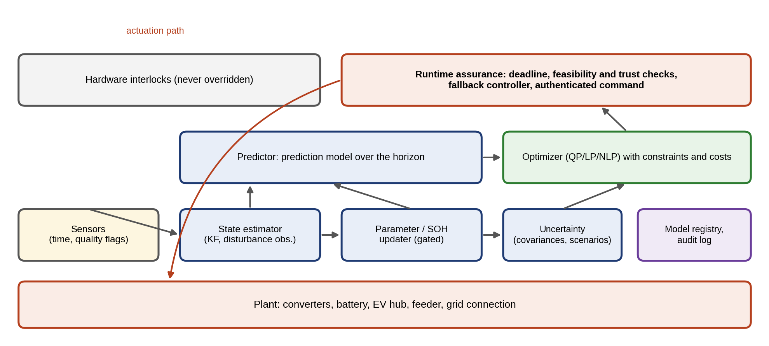
Figure 13.1. From plant to decision-grade control twin: sensors with time and quality flags feed a state estimator and a gated parameter updater; the predictor, with its uncertainty, supplies the optimizer; runtime assurance checks deadline, feasibility and trust before an authenticated command reaches the plant, and hardware interlocks sit outside every optimization. A model registry and audit log record which version produced each command.

13.1 From Monitoring Twins to Decision and Control Twins
Chapters 7 to 12 used digital twins mainly to watch: to estimate states that cannot be measured, to detect faults, to forecast failures. This chapter uses them to act. A twin that can predict how a system will respond to a candidate action can be used to choose the best action, subject to limits, and then to repeat the choice as new measurements arrive. That is the principle of model predictive control, and at the scale of a plant it is energy management (Figure 13.1).
The difference between offline and online use is important and often blurred. Offline, a twin answers what-if questions: what would a different battery schedule have saved last month, how would a new controller tuning behave, which EV-charging policy keeps the transformer within rating. Nothing reaches the plant until an engineer decides. Online, the twin sits inside the control loop, and its predictions set actuator commands every few microseconds or minutes. Online use therefore carries requirements that offline use does not: a hard deadline for every computation, a safe fallback when the optimizer fails, interlocks that the optimizer cannot override, and a gate that stops an untested model update from reaching the loop.
The chapter works P-1’s control problems from the fastest to the slowest. Every dataset is synthetic and published in the chapter, so each result can be reproduced, and each is stated with a number:
- Converter. Drive D-3’s 48 V to 12 V buck converter is controlled in simulation at 100 kHz. MPC that uses the twin’s load-current estimate reaches 12 V with no overshoot while riding its 25 A current limit; nominal MPC leaves a 1.3 V error after a load step. The QP needs a median of 23 µs on a 2.1 GHz server core, so the same controller cannot run at 100 kHz there, which separates simulated control rate from achieved hardware rate.
- Battery. Arbitrage on a published price day earns 150.5 $; pricing wear at 16 $/MWh cuts throughput from 2.20 to 1.80 MWh. Q-learning reaches the exact optimum of its coarse action set in five of five training seeds, which is only 87 % of the LP value.
- Microgrid. Over 20 synthetic days, rolling-horizon MPC with a persistence forecast captures on average 97 % of the saving that perfect foresight could have achieved, but only 80 % on its worst day; a fixed rule captures 56 %.
- EV car park. Cost-only optimization herds charging into one part of the cheap period and creates a 183 kW peak on a 100 kVA transformer; a peak term removes it at no extra energy cost.
- Capstone. A reserve sized by the Gaussian rule is violated in 6.9 % of hours when forecast errors are skewed, and a battery derating makes the 95 % reserve infeasible, which the twin must report rather than hide.

13.1.1 What makes control twin-based?
A controller that uses a model is not automatically twin-based. The term is earned when all of the following hold, and each can be checked:
- Live synchronization. The twin’s states are updated from time-stamped measurements at a rate matched to the loop, and it knows when its data are stale.
- State and parameter update. An estimator reconstructs unmeasured states; slow parameters (resistance, capacity, efficiency, grid strength) are re-estimated and admitted to the controller only through an update gate.
- Uncertainty. Predictions carry an uncertainty that the controller uses (tightened constraints, reserves, chance constraints) and that has been checked against data.
- Bidirectional plant interaction. Twin outputs reach actuators through an authorized, authenticated path, and the plant’s response returns to the twin.
- Model and version identity. Every command can be traced to the model version, parameter set and data that produced it.
- Validation status and safe actuation. The controller runs only in the regimes for which it has evidence, with a fallback and hardware interlocks outside the optimizer.
A simulator used to tune a PI loop once meets none of these; an MPC with a fixed model and no estimator meets perhaps one. Both can be useful, but neither is a twin.

13.1.2 The control-oriented twin contract
Table 13.1 states the contract for P-1’s control loops: what enters the twin, what it keeps synchronized, what it outputs, how fast, with what latency budget, what evidence it has, and what happens when it fails. Table 13.2 fixes the interface of each exchanged variable, because most failures of deployed energy-management systems are interface failures (Exercise 13.31).
TABLE 13.1 The control-oriented digital-twin contract for P-1 (examples)
Loop | Twin input | Synchronized states | Parameters | Uncertainty | Controller output | Update rate | Latency budget | Validation status | Fallback | Audit
Buck converter D-3 | $v_{C}$, $i_{L}$, $V_{in}$ | $i_{L}$, $v_{C}$, load current | $L$, $C$, $r_{L}$ | Load-current estimate error | Duty cycle | 100 kHz (simulated) | 10 µs | Simulation, not yet target hardware | Cascaded PI | Version per build
Battery inverter | $V$, $I$, $T$ | SOC, SOP, temperature | Capacity, resistance | SOC covariance | Power set-point | 1 s | 100 ms | HIL (Chapter 9) | Last valid set-point, droop | Per update
Site EMS | Meters, forecasts, prices | SOC, EV queue, transformer load | Efficiency, degradation cost | Forecast quantiles | Hourly schedule | 15 min to 1 h | 1 min | Out-of-sample tests | Rule-based schedule | Signed schedule
Day-ahead plan | Forecasts, tariffs | Next-day state | Load and PV models | Scenarios | Purchase schedule | Daily | 1 h | Back-testing | Previous day’s plan | Market record

TABLE 13.2 Digital-twin control interface (examples)
Variable | Unit | Sign convention | Source | Timestamp | Quality flag | Update rate | Authority
Battery power $p_{b}$ | kW | Positive = discharge (export from battery) | Inverter meter | Inverter clock, PTP-synchronized | Valid / stale / substituted | 1 s | Read by EMS; set by EMS within SOP
Grid exchange $g$ | kW | Positive = import | Revenue meter | Meter clock | Valid / estimated | 1 s to 15 min | Read only
SOC | % | 0 empty, 100 full | Battery twin estimator | Estimation epoch | With covariance | 1 s | Read by EMS; never written
Duty cycle $d$ | per unit | 0 to 1 | Converter MPC | Control period | Solver status | 10 µs | Written by MPC or PI fallback only
Price $π_{t}$ | $/MWh | Cost of import | Tariff or market | Publication time | Firm / forecast | 15 min to 1 day | Read only

13.2 Control-oriented Digital-twin Architecture, Synchronization and Validation

13.2.1 Roles of the twin and the control hierarchy
A digital twin can take three roles in a control system (Figure 13.3):
- Observer. It estimates the states that the controller needs but cannot measure: a battery’s SOC, a motor’s winding temperature, a converter’s load current (Chapters 5 and 9).
- Predictor. It forecasts the response to candidate actions over a horizon, which is what MPC and energy management optimize over.
- Simulator. It stands in for the plant during design and testing (model-in-the-loop, software-in-the-loop, hardware-in-the-loop), so that controllers are tuned and verified before they touch the plant.
Power-system control is organized in a hierarchy, and a twin appears at every level with a different model and a different clock (Figure 13.2). Primary control (converter current and voltage loops, droop and grid-forming control) acts in microseconds to milliseconds on local measurements. Secondary control (voltage and frequency restoration, site-level MPC) acts in seconds. Tertiary control (energy management and optimal power flow) acts in minutes to hours, and scheduling (day-ahead purchase, commitment, market bids) over days. Each level sends references and constraints down and treats the level below as a tracker; each lower level may override the one above for safety, never the reverse.
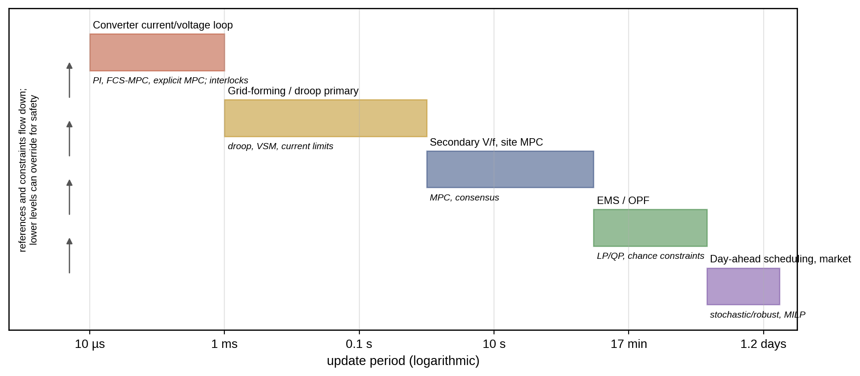
Figure 13.2. The control hierarchy on a logarithmic time axis, from converter loops at microseconds to day-ahead scheduling at days, with the methods used at each level. References and constraints flow down, measurements flow up, and a lower level may override a higher one for safety.
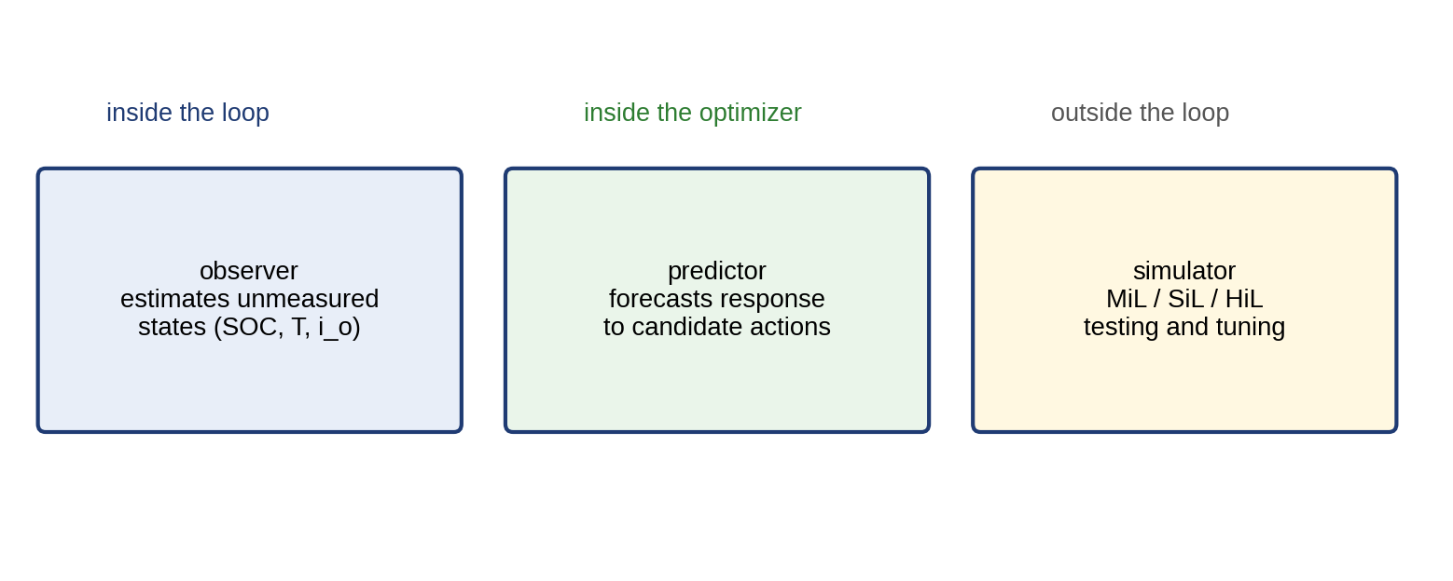
Figure 13.3. Three roles of the twin in control: observer inside the loop estimating unmeasured states, predictor inside the optimizer evaluating candidate actions, and simulator outside the loop for model-, software- and hardware-in-the-loop testing.

13.2.2 The model-update gate
In online use the twin’s model is updated from data, and an update that changes the controller’s behaviour must pass a gate before deployment, with a rollback path (Chapter 6, Section 6.13.4). For a linear time-invariant closed loop the gate can be written as conditions on the candidate model $M′$,
 | $${RMSE}_{val}\left(M′\right)≤{RMSE}_{val}\left(M\right), \max_{i}\left|λ_{i}\left(A_{cl}\left(M′\right)\right)\right|<1−δ_{s}, \text{constraint tests passed},$$ | (13.1)
where ${RMSE}_{val}$ is the prediction error on held-out validation data, $λ_{i}$ the eigenvalues of the closed-loop matrix $A_{cl}$ obtained with the candidate model and $δ_{s}$ a stability margin. The eigenvalue test applies directly only to a linear time-invariant closed loop. For controllers that saturate, switch, or contain nonlinear models, the stability evidence must be of the appropriate kind: a Lyapunov or dissipativity argument, a small-gain or passivity margin, or at least closed-loop simulation over the validated operating envelope. Three further tests are added before any update is admitted: an out-of-distribution test that the data used to fit the update lie within the envelope over which the model was validated; an uncertainty test that the new model’s prediction intervals still cover held-out data at their stated rate; and timing and cybersecurity tests that the updated controller still meets its worst-case deadline and that the update arrived through an authenticated channel from a known source. A rejected update leaves the previous version in service, and every accepted one is versioned so that it can be rolled back.
The validation ladder that produces this evidence, from model-in-the-loop to staged field deployment, is developed in Section 13.21.

13.3 Feedback, Feedforward, PI and Anti-windup

13.3.1 Feedback and the PI controller
Feedback compares a measured output $y$ with its reference $r$ and acts on the error $e=r−y$. The proportional–integral (PI) controller, the workhorse of power electronics and drives [1], is
 | $$u\left(t\right)=K_{p}e\left(t\right)+K_{i}\int_{0}^{t}{e}\left(τ\right) dτ,$$ | (13.2)
where $K_{p}$ and $K_{i}$ are the proportional and integral gains. For a first-order plant $G\left(s\right)=K/\left(τs+1\right)$ with time constant $τ$ and gain $K$, the PI controller $C\left(s\right)=K_{p}+K_{i}/s$ gives the closed-loop transfer function
 | $$T\left(s\right)=\frac{C\left(s\right)G\left(s\right)}{1+C\left(s\right)G\left(s\right)}=\frac{K\left(K_{p}s+K_{i}\right)}{τs^{2}+\left(1+KK_{p}\right)s+KK_{i}},$$ | (13.3)
a second-order system with natural frequency $ω_{n}=\sqrt{KK_{i}/τ}$ and damping ratio $ζ=\left(1+KK_{p}\right)/\left(2\sqrt{τKK_{i}}\right)$. Choosing $K_{i}/K_{p}=1/τ$ places the controller zero on the plant pole (pole–zero cancellation) and makes the loop first order with time constant $τ/\left(KK_{p}\right)$: 0.25 s for $τ=0.5$ s, $K=1$ and $K_{p}=2$. The integral term removes steady-state error for constant references and disturbances, because a constant non-zero error would make the integral grow without bound.
The pole–zero cancellation used here is a teaching device, not a general design rule. It works only as well as the plant pole is known: if the true time constant is 0.4 s instead of 0.5 s, the cancelled pole reappears as a slow closed-loop pole close to the zero, which gives a long, small-amplitude tail in the response to disturbances entering at the plant input. Cancelling a lightly damped or unstable pole is worse still, because the cancelled mode remains in the loop, excited by disturbances and invisible in the reference response. Robust PI design therefore places the closed-loop poles through a margin-based method (phase margin, sensitivity peak) that tolerates the expected parameter spread, and the twin’s role is to supply that spread.
Many power-electronic and drive loops use PI alone. Where a derivative term is needed (thermal loops with long lags, mechanical positioning), the PID law adds $K_{d} de/dt$, always with a first-order filter $K_{d}s/\left(1+sτ_{f}\right)$ of time constant $τ_{f}$ so that measurement noise is not amplified without bound, and often applied to $−y$ rather than to $e$ so that a reference step does not produce a derivative kick.
A bridge from PI to the model-based controllers later in the chapter is the disturbance observer. For a plant $y=G\left(s\right)\left(u+d\right)$ with an input disturbance $d$ and a nominal model $G_{n}$, the disturbance estimate
 | $$\hat{d}\left(s\right)=Q_{f}\left(s\right)\left[G_{n}^{−1}\left(s\right)y\left(s\right)−u\left(s\right)\right], u=u_{c}−\hat{d},$$ | (13.4)
where $Q_{f}\left(s\right)$ is a low-pass filter of unit DC gain that makes $Q_{f}G_{n}^{−1}$ proper and $u_{c}$ the command of the outer controller, subtracts the estimated disturbance from the input. At low frequencies, where $Q_{f}≈1$, both the disturbance and model mismatch are cancelled, which removes steady-state error without an integrator in the outer controller. The same idea, written in state space, is the offset-free MPC of Section 13.7.4.

13.3.2 Sampling and discrete-time stability
Digital controllers sample the error every $T_{s}$ seconds and hold their output constant between samples (zero-order hold). A continuous pole at $s=p$ maps to a discrete pole at
 | $$z=e^{pT_{s}},$$ | (13.5)
so the continuous stability condition $Re\left(p\right)<0$ becomes $\left|z\right|<1$: a discrete loop is stable when every closed-loop pole lies inside the unit circle (Figure 13.4).
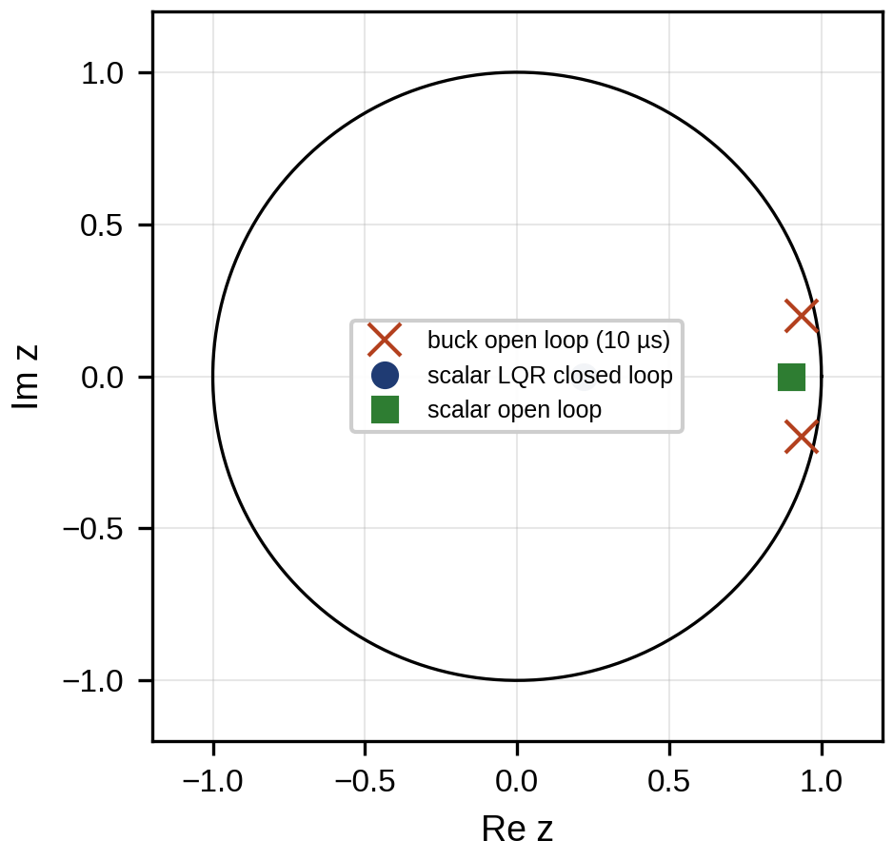
Figure 13.4. Mapping of continuous poles to the z-plane by z = exp(pT_s): the left half-plane maps inside the unit circle; the buck converter’s open-loop poles at 10 µs sampling and the scalar example’s LQR closed-loop pole are marked.
Sampling adds delay, about $T_{s}/2$ from the hold and often one further sample for computation. That delay erodes phase margin: a total delay $T_{d}$ contributes a phase lag
 | $$Δφ=ω_{c}T_{d},$$ | (13.6)
at the crossover frequency $ω_{c}$, which for $T_{d}=1.5T_{s}$ with $T_{s}=100$ µs and a 1 kHz crossover is $2π×1000×150×{10}^{−6}=0.94$ rad, or 54°, most of a typical 60° margin. Figure 13.5 shows the effect on a loop’s frequency response. A common rule of thumb keeps the closed-loop bandwidth at about one tenth of the sampling frequency or below. It is a rule of thumb, not a theorem: the real limit comes from the phase margin that remains after the computation and PWM delay, from any plant resonance near the crossover, and from the discretization method, and it must be checked on the discretized loop. The controller itself is discretized, usually by the Tustin (bilinear) mapping $s←\frac{2}{T_{s}}\frac{z−1}{z+1}$, which for the PI gives the difference equation
 | $$u_{k}=u_{k−1}+\left(K_{p}+\frac{K_{i}T_{s}}{2}\right)e_{k}−\left(K_{p}−\frac{K_{i}T_{s}}{2}\right)e_{k−1}.$$ | (13.7)
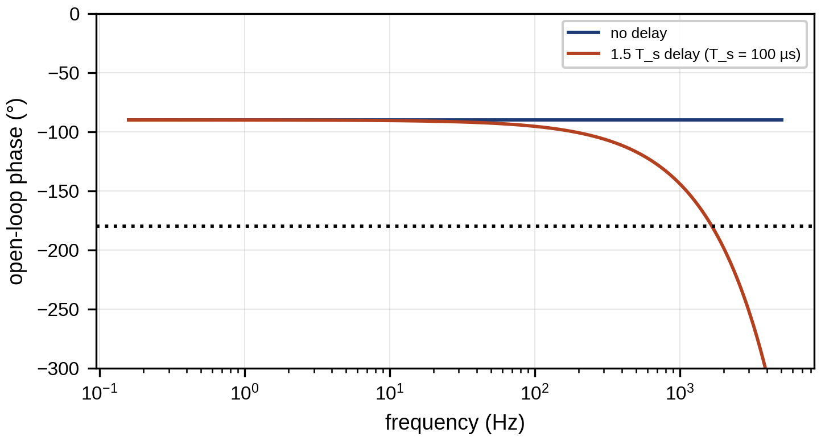
Figure 13.5. Open-loop phase of a PI-controlled first-order loop without delay and with 1.5 sample periods of delay, showing the phase margin lost at crossover.

13.3.3 Saturation and anti-windup
Every actuator saturates: a converter’s duty cycle lies between 0 and 1, a battery’s power between its limits. While the actuator is saturated, the loop is effectively open, but the integrator keeps accumulating error, winds up, and must unwind after the error changes sign, which causes overshoot and slow settling. Back-calculation anti-windup feeds the difference between the saturated and the unsaturated command back into the integrator:
 | $$\dot{I}=K_{i}e+\frac{1}{T_{t}}\left(u_{sat}−u\right), u=K_{p}e+I, u_{sat}={sat}_{\left[u_{min}, u_{max}\right]}\left(u\right),$$ | (13.8)
where $I$ is the integrator state and $T_{t}$ the tracking time constant, typically a fraction of the integral time $T_{i}=K_{p}/K_{i}$.
Example 13.1 Integrator windup on a saturating actuator
Given. A first-order plant with $τ=0.5$ s and $K=1$, actuator limits $0≤u≤10$, a PI with $K_{p}=2$ and $K_{i}=10$ s⁻¹, and a reference step to 9 (90 % of the actuator’s reach). Back-calculation with $T_{t}=0.2$ s. Plant and integrator integrated by forward Euler with a 1 ms step, output and integrator starting at zero.
Find. The overshoot and 2 % settling time with and without anti-windup.
Solution. Simulating with 1 ms steps: without anti-windup the output overshoots by 10.8 % before the reference changes at 3 s (the saturated actuator allows at most 11.1 %) and has not settled by then. With anti-windup the overshoot is 2.3 % and the output settles in 1.52 s.
Interpretation. Figure 13.6 shows the two responses. The windup overshoot is set by the actuator limit, not by the gains, and it gets worse the closer the reference lies to the limit. Every controller in this chapter, from PI to MPC, must handle saturation explicitly. MPC does it by construction, because the limits are constraints of its optimization.
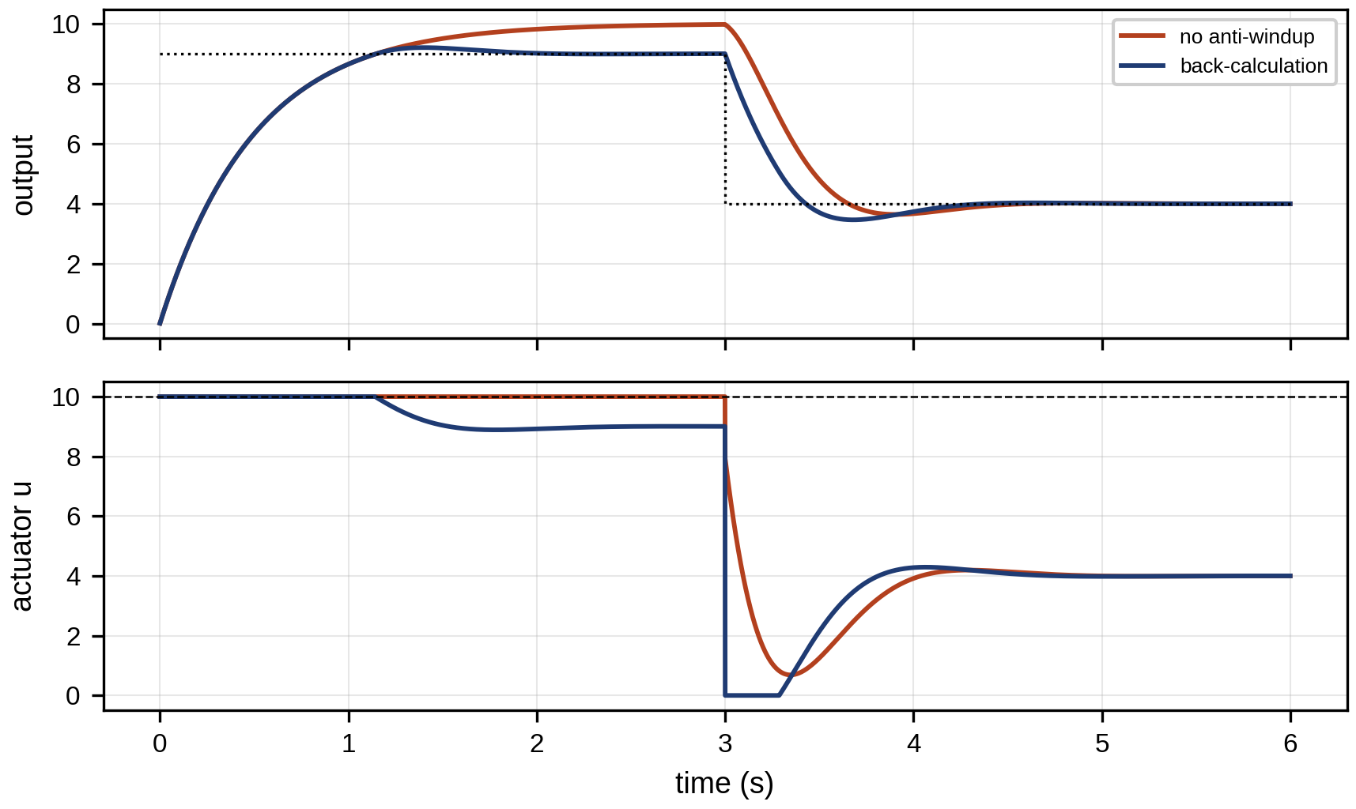
Figure 13.6. PI control of a saturating first-order plant: output and actuator command without and with back-calculation anti-windup, for a reference step to 90 % of the actuator’s reach, followed at 3 s by a step down.

13.3.4 Feedforward, gain scheduling and adaptive control
Feedback reacts only after an error appears. Feedforward acts on a measured disturbance or a known reference before it causes an error. For a plant $y=G\left(s\right)u+G_{d}\left(s\right)d$ with a measured disturbance $d$, the ideal feedforward is
 | $$u_{ff}=−G^{−1}\left(s\right)G_{d}\left(s\right) d,$$ | (13.9)
which cancels the disturbance exactly if the model is exact and $G$ is invertible. It is realizable only if the inverse is causal and stable, so in practice a static or low-order approximation is used. In the buck converter of Section 13.22, feeding forward the load current to the inductor-current reference is what removes the voltage dip on a load step, and the twin supplies that current when it is not measured. Adaptive control adjusts the controller’s parameters online from an estimate of the plant. Gain scheduling switches gains with the operating point (for example battery temperature or converter load). Self-tuning control re-estimates the plant by recursive least squares (Chapter 5, Section 5.3) and redesigns the controller. A self-tuning controller updates its parameter vector $\hat{θ}$ from the regressor $φ_{k}$ and the output $y_{k}$ by recursive least squares with forgetting factor $λ_{f}$,
 | $${\hat{θ}}_{k}={\hat{θ}}_{k−1}+L_{k}\left(y_{k}−φ_{k}^{T}{\hat{θ}}_{k−1}\right), L_{k}=\frac{P_{k−1}φ_{k}}{λ_{f}+φ_{k}^{T}P_{k−1}φ_{k}}, P_{k}=\frac{1}{λ_{f}}\left(I−L_{k}φ_{k}^{T}\right)P_{k−1},$$ | (13.10)
where ${\hat{θ}}_{k}$ is the parameter estimate, $φ_{k}$ the regressor, $L_{k}$ the gain, $λ_{f}∈(0,1]$ the forgetting factor and $P_{k}$ the parameter covariance. Gain scheduling and adaptation differ in an important way. A gain schedule interpolates between controllers designed and verified offline at known operating points, so its behaviour between the points can be checked in advance. An adaptive controller changes itself according to data it has not yet seen, so its behaviour cannot be fully verified offline. Separating the time scales, with adaptation much slower than the closed-loop dynamics, is a common and effective practical design, but it is not a universal requirement and not by itself a guarantee. Safe adaptation also needs parameter projection (keeping $\hat{θ}$ inside physically meaningful bounds), sufficient excitation so that the estimate does not drift when the data carry no information (persistent excitation), robust modifications such as dead zones or leakage against unmodelled dynamics, and the update gate of Section 13.2.2 before an adapted parameter reaches the controller.

13.4 Sampling, Discrete-time, Multirate and Hybrid Prediction Models

13.4.1 Exact discretization
A predictive controller needs a discrete model $x_{k+1}=Ax_{k}+Bu_{k}$ that reproduces the continuous model at the sampling instants. For a continuous linear model $\dot{x}=A_{c}x+B_{c}u$ with the input held constant over each sample, integrating the solution over $T_{s}$ gives
 | $$A=e^{A_{c}T_{s}}, B=\int_{0}^{T_{s}}{e^{A_{c}τ}} dτ B_{c}, \left[\begin{matrix}A & B \\ 0 & I\end{matrix}\right]=exp\left(\left[\begin{matrix}A_{c} & B_{c} \\ 0 & 0\end{matrix}\right]T_{s}\right),$$ | (13.11)
where the block-matrix exponential computes both at once. The forward Euler approximation $A≈I+A_{c}T_{s}$ is simpler but distorts the dynamics and can be unstable when $T_{s}$ is not small compared with the fastest time constant (Figure 13.7). Before a model is used for control, two structural properties are checked. It must be controllable, so that the input can move every state, and observable, so that the estimator can reconstruct every state from the measurements:
 | $$rank\left[B AB ⋯ A^{n−1}B\right]=n, rank\left[\begin{matrix}C \\ CA \\ ⋮ \\ CA^{n−1}\end{matrix}\right]=n,$$ | (13.12)
where $n$ is the number of states and $C$ the output matrix.
The zero-order-hold model is exact at the sampling instants only under its assumptions: that the continuous model is linear and time-invariant, that the input is piecewise constant between samples, and that nothing else acts within the sample. It is not exact if the model omits switching (a converter’s duty cycle is realized by switching within the period, and the averaged model describes only its mean), input or measurement delays, nonlinearities, or disturbances faster than the sample. A delay of $τ_{d}=T_{s}$, the usual computation delay, is included by augmenting the state with the previous input, $x_{k+1}=Ax_{k}+Bu_{k−1}$.
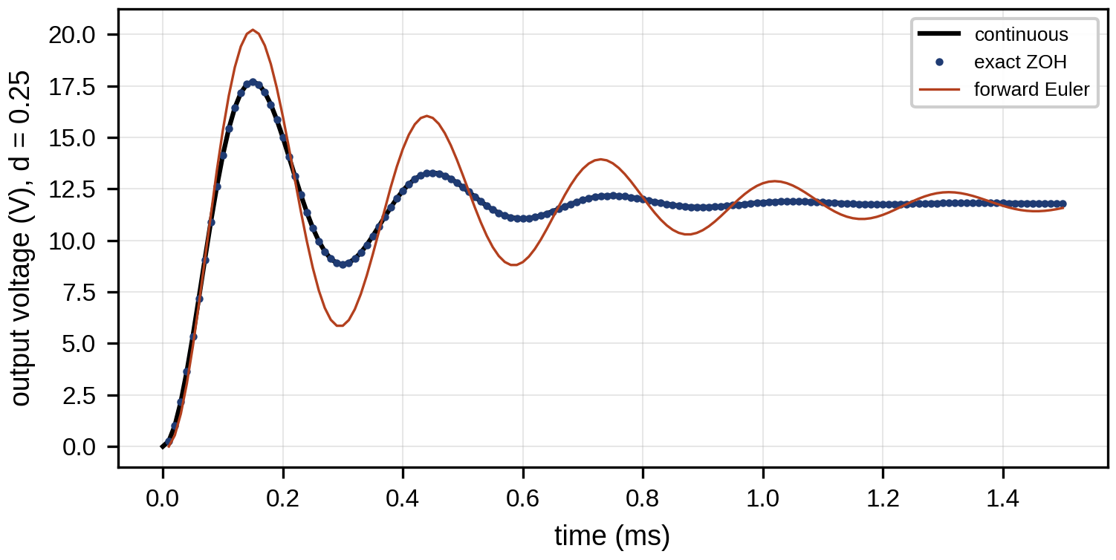
Figure 13.7. Step response of the buck converter’s duty-to-voltage dynamics from the exact zero-order-hold model and from forward Euler at the same 10 µs step, against the continuous solution; Euler distorts the damping of the LC resonance.

13.4.2 The buck converter’s prediction model
The averaged model of a buck converter with input voltage $V_{in}$, inductor $L$ with resistance $r_{L}$, output capacitor $C$ and duty cycle $d$ as input (Chapter 7, Section 7.2) has the inductor current $i_{L}$ and capacitor voltage $v_{C}$ as states. With the load current $i_{o}$ as a second, measured or estimated, input,
 | $$\frac{d}{dt}\left[\begin{matrix}i_{L} \\ v_{C}\end{matrix}\right]=\left[\begin{matrix}−r_{L}/L & −1/L \\ 1/C & 0\end{matrix}\right]\left[\begin{matrix}i_{L} \\ v_{C}\end{matrix}\right]+\left[\begin{matrix}V_{in}/L \\ 0\end{matrix}\right]d+\left[\begin{matrix}0 \\ −1/C\end{matrix}\right]i_{o},$$ | (13.13)
while a model that assumes a fixed load resistance $R$ replaces the load-current input by the term $−v_{C}/\left(RC\right)$ in the second row. For $V_{in}=48$ V, $L=22$ µH, $r_{L}=20$ mΩ, $C=100$ µF and a nominal 1.2 Ω load (12 V, 10 A), the LC resonance is at $1/\left(2π\sqrt{LC}\right)=3.39$ kHz with a damping ratio of 0.22. At $T_{s}=10$ µs (100 kHz), (13.11) gives, for the fixed-load model,
 | $$A=\left[\begin{matrix}0.9691 & −0.4308 \\ 0.0948 & 0.8987\end{matrix}\right], B=\left[\begin{matrix}21.56 \\ 1.054\end{matrix}\right],$$ | (13.14)
with eigenvalues of magnitude 0.955, inside the unit circle as the underdamped, stable open-loop plant requires. Figure 13.8 shows the circuit and the states. For a voltage reference $V_{r}$ and load current $i_{o}$, the steady state that the controller must reach follows from setting the derivatives in (13.13) to zero,
 | $$i_{L,ss}=i_{o}, d_{ss}=\frac{V_{r}+r_{L}i_{o}}{V_{in}},$$ | (13.15)
which is the target $\left(x_{r},u_{r}\right)$ around which MPC regulates; it depends on the load current, so an error in $i_{o}$ becomes an error in the target.
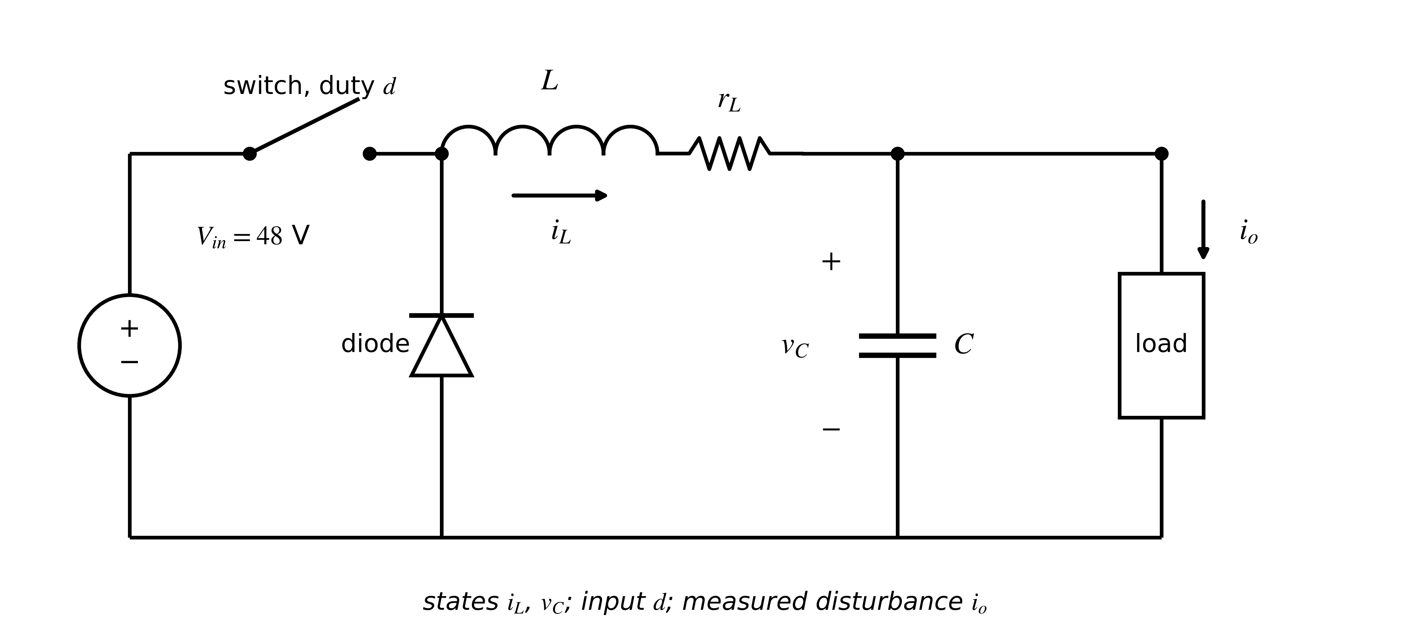
Figure 13.8. The D-3 buck converter: switch, diode, inductor with its resistance, output capacitor and load, with the averaged states $i_{L}$ and $v_{C}$, the duty-cycle input and the load current as a measured disturbance.

13.4.3 Lifting: predictions over a horizon
Applying the model $N$ times expresses all future states as a linear function of the initial state and the future inputs. Stacking $X={\left[x_{1}^{T},…,x_{N}^{T}\right]}^{T}$ and $U={\left[u_{0}^{T},…,u_{N−1}^{T}\right]}^{T}$,
 | $$X=Φx_{0}+ΓU, Φ=\left[\begin{matrix}A \\ A^{2} \\ ⋮ \\ A^{N}\end{matrix}\right], Γ=\left[\begin{matrix}B & 0 & ⋯ & 0 \\ AB & B & ⋯ & 0 \\ ⋮ & & ⋱ & ⋮ \\ A^{N−1}B & A^{N−2}B & ⋯ & B\end{matrix}\right],$$ | (13.16)
where $Φ$ carries the free response and the block lower-triangular $Γ$ the forced response. Measured disturbances such as $i_{o}$ add a third term of the same structure. This “lifted” or “condensed” form turns every prediction into a matrix product, which is what makes MPC a quadratic program.

13.4.4 Multirate, linearized and hybrid models
Energy systems contain dynamics on widely separated time scales. In a battery system, converter currents settle in tens of microseconds, cell temperature in minutes, SOC changes over hours and capacity fades over months. A single prediction model sampled at the fastest rate would be enormous and badly conditioned, so each control layer uses a model sampled at its own rate, with the faster states either at their quasi-steady values or treated as disturbances, and the slower states as parameters. If the fast subsystem is stable and fast, singular perturbation justifies this: writing ${\dot{x}}_{s}=f\left(x_{s},x_{f}\right)$ and $ϵ{\dot{x}}_{f}=g\left(x_{s},x_{f}\right)$ with small $ϵ$, the slow model sets $g\left(x_{s},x_{f}\right)=0$ and solves for $x_{f}$.
Nonlinear models are linearized around an operating point $\left(\overset{‾}{x},\overset{‾}{u}\right)$ for use in linear MPC:
 | $$δx_{k+1}=A\left(\overset{‾}{x},\overset{‾}{u}\right) δx_{k}+B\left(\overset{‾}{x},\overset{‾}{u}\right) δu_{k}, A={\left.\frac{∂f}{∂x}\right|}_{\overset{‾}{x},\overset{‾}{u}}, B={\left.\frac{∂f}{∂u}\right|}_{\overset{‾}{x},\overset{‾}{u}},$$ | (13.17)
where $f$ is the discrete nonlinear model and $δx=x−\overset{‾}{x}$, $δu=u−\overset{‾}{u}$ are deviations. When the operating point moves, as a battery’s open-circuit-voltage slope does with SOC, the matrices become functions of a measured scheduling variable $ρ$, giving a linear parameter-varying (LPV) model $x_{k+1}=A\left(ρ_{k}\right)x_{k}+B\left(ρ_{k}\right)u_{k}$, the bridge between linear MPC and the nonlinear MPC of Section 13.8.
Converters are switched systems. The averaged model of Section 13.4.2 holds when the switching frequency is well above the dynamics of interest and the converter stays in continuous conduction. At light load a buck converter enters discontinuous conduction, where the inductor current reaches zero within the period and the averaged model changes its structure; a controller designed on the continuous-conduction model may then misbehave. Hybrid models with discrete modes, or finite-control-set MPC that uses the switch states directly (Section 13.20), handle this explicitly.

13.5 State Estimation, Disturbance Estimation and Adaptive Models for Control
A controller can act only on what it knows, and in most energy systems it knows far less than the full state: a battery’s SOC and polarization voltages, a converter’s load current, a motor’s winding temperature are not measured directly. The twin supplies them through an estimator. For the linear model $x_{k+1}=Ax_{k}+Bu_{k}+w_{k}$, $y_{k}=Cx_{k}+v_{k}$ with process and measurement noise covariances $Q_{w}$ and $R_{v}$, the Kalman filter of Chapter 5 alternates a prediction and a correction,
 | $${\hat{x}}_{k|k−1}=A{\hat{x}}_{k−1|k−1}+Bu_{k−1}, P_{k|k−1}=AP_{k−1|k−1}A^{T}+Q_{w}, {\hat{x}}_{k|k}={\hat{x}}_{k|k−1}+L_{k}\left(y_{k}−C{\hat{x}}_{k|k−1}\right),$$ | (13.18)
where ${\hat{x}}_{k|j}$ is the estimate at step $k$ given measurements up to $j$, $P$ its error covariance and $L_{k}=P_{k|k−1}C^{T}{\left(CP_{k|k−1}C^{T}+R_{v}\right)}^{−1}$ the Kalman gain. The controller then acts on $\hat{x}$ instead of $x$, and the estimation error $e=x−\hat{x}$ enters the loop as an extra disturbance: a constraint met by the estimate may be violated by the true state, which is why the covariance $P$ should feed the constraint tightening of Section 13.9.
Disturbance estimation. Unmeasured, slowly varying disturbances (a load current, an ambient-temperature error, model mismatch) are estimated by adding them to the state as random walks, $d_{k+1}=d_{k}+w_{d,k}$, and running the same filter on the augmented model. This is the estimator half of offset-free MPC (Section 13.7.4).
Joint state and parameter estimation. Slowly varying parameters, such as a battery’s capacity or a converter’s inductor resistance, can be appended to the state in the same way and estimated by an extended or unscented Kalman filter. Their estimates must pass the update gate of Section 13.2.2 before they change the controller’s model, because a parameter estimate that drifts during a fault would otherwise teach the controller to accept the fault (Chapter 12, Section 12.5.3).
Estimator–controller interaction. A fast estimator reacts quickly but passes more noise into the controller; a slow one filters noise but delays the controller’s knowledge of disturbances. The estimator’s bandwidth must therefore be designed together with the controller’s, not independently, and the controller must know when the estimator’s data are stale: if the latest measurement is older than a set age, the twin marks the state estimate as degraded and the runtime-assurance logic of Section 13.20.2 takes over.

13.6 LQR and Constrained MPC from First Principles

13.6.1 The linear-quadratic regulator
Without constraints, the optimal control of a linear system with quadratic cost over an infinite horizon is a linear state feedback. Minimizing
 | $$J=\sum_{k=0}^{∞}{\left(x_{k}^{T}Qx_{k}+u_{k}^{T}Ru_{k}\right)}$$ | (13.19)
by dynamic programming. Two assumptions are needed before the answer can be written: the pair $\left(A,B\right)$ must be stabilizable (every unstable mode can be influenced by the input), and $\left(A,Q^{1/2}\right)$ detectable (every unstable mode is seen by the cost), with $Q≽0$ and $R≻0$. Under them the dynamic-programming argument below has a unique positive semidefinite solution that stabilizes the loop. Bellman’s equation $V\left(x\right)=\min_{u}\left[x^{T}Qx+u^{T}Ru+V\left(Ax+Bu\right)\right]$ with the quadratic guess $V\left(x\right)=x^{T}Px$ is minimized by setting its gradient in $u$ to zero, $2Ru+2B^{T}P\left(Ax+Bu\right)=0$, which gives the gain
 | $$u=−Kx, K={\left(R+B^{T}PB\right)}^{−1}B^{T}PA,$$ | (13.20)
and substituting back makes both sides equal for all $x$ only if $P$ satisfies the discrete algebraic Riccati equation
 | $$P=Q+A^{T}PA−A^{T}PB{\left(R+B^{T}PB\right)}^{−1}B^{T}PA.$$ | (13.21)
For the scalar plant of Section 13.6.4, (13.21) reduces to a quadratic in $P$ whose positive root is $P=1.2452$, and (13.20) gives $K=abP/\left(R+b^{2}P\right)=1.362$. The finite-horizon problem is solved by running the same recursion backwards from the terminal weight,
 | $$P_{N}=P_{f}, P_{k}=Q+A^{T}P_{k+1}A−A^{T}P_{k+1}B{\left(R+B^{T}P_{k+1}B\right)}^{−1}B^{T}P_{k+1}A,$$ | (13.22)
which gives time-varying gains $K_{k}$; as $N$ grows they converge to (13.20). The closed loop $x_{k+1}=\left(A−BK\right)x_{k}$ is stable, with all eigenvalues of $A−BK$ inside the unit circle, whenever $\left(A,B\right)$ is stabilizable and $\left(A,Q^{1/2}\right)$ detectable; for the scalar example the closed-loop pole is $a−bK=0.219$. LQR is optimal only without constraints; with them, it is the controller MPC reduces to whenever no constraint is active.

13.6.2 LQG and the separation principle
When the state is estimated by the Kalman filter (13.18) and the controller applies $u=−K\hat{x}$, the combination is the linear-quadratic-Gaussian (LQG) controller. In the coordinates of state and estimation error the closed loop is block-triangular,
 | $$\left[\begin{matrix}x_{k+1} \\ e_{k+1}\end{matrix}\right]=\left[\begin{matrix}A−BK & BK \\ 0 & A−LCA\end{matrix}\right]\left[\begin{matrix}x_{k} \\ e_{k}\end{matrix}\right]+\text{noise terms},$$ | (13.23)
with $L$ the steady-state Kalman gain, so its eigenvalues are those of the regulator and of the estimator separately. This is the separation principle: the controller and the estimator can be designed independently, and for linear Gaussian systems with quadratic cost the combination is optimal. Its assumptions are strong. With constraints, saturation, nonlinear dynamics or model error, separation no longer holds exactly, and LQG loops are well known to have no guaranteed robustness margins at all; the estimator must then be designed with the controller’s robustness in mind.

13.6.3 The receding-horizon idea
At every sampling instant, model predictive control (MPC):
- measures or estimates the current state;
- uses the model to predict the effect of a sequence of $N$ future inputs;
- chooses the sequence that minimizes a cost while satisfying all constraints;
- applies only the first input;
- at the next instant, repeats with the new measurement.
Re-planning from the measured state at every step is the receding-horizon principle, and it is what makes an open-loop optimization into a feedback controller: errors in the model or disturbances are corrected at the next step because the plan starts from where the plant actually is [2]. The resulting control law is implicit, the first element of the optimal sequence as a function of the current state,
 | $$u_{k}=κ_{MPC}\left(x_{k}\right)=\left[I 0 ⋯ 0\right]U^{*}\left(x_{k}\right),$$ | (13.24)
evaluated online by solving the optimization (Figure 13.9).
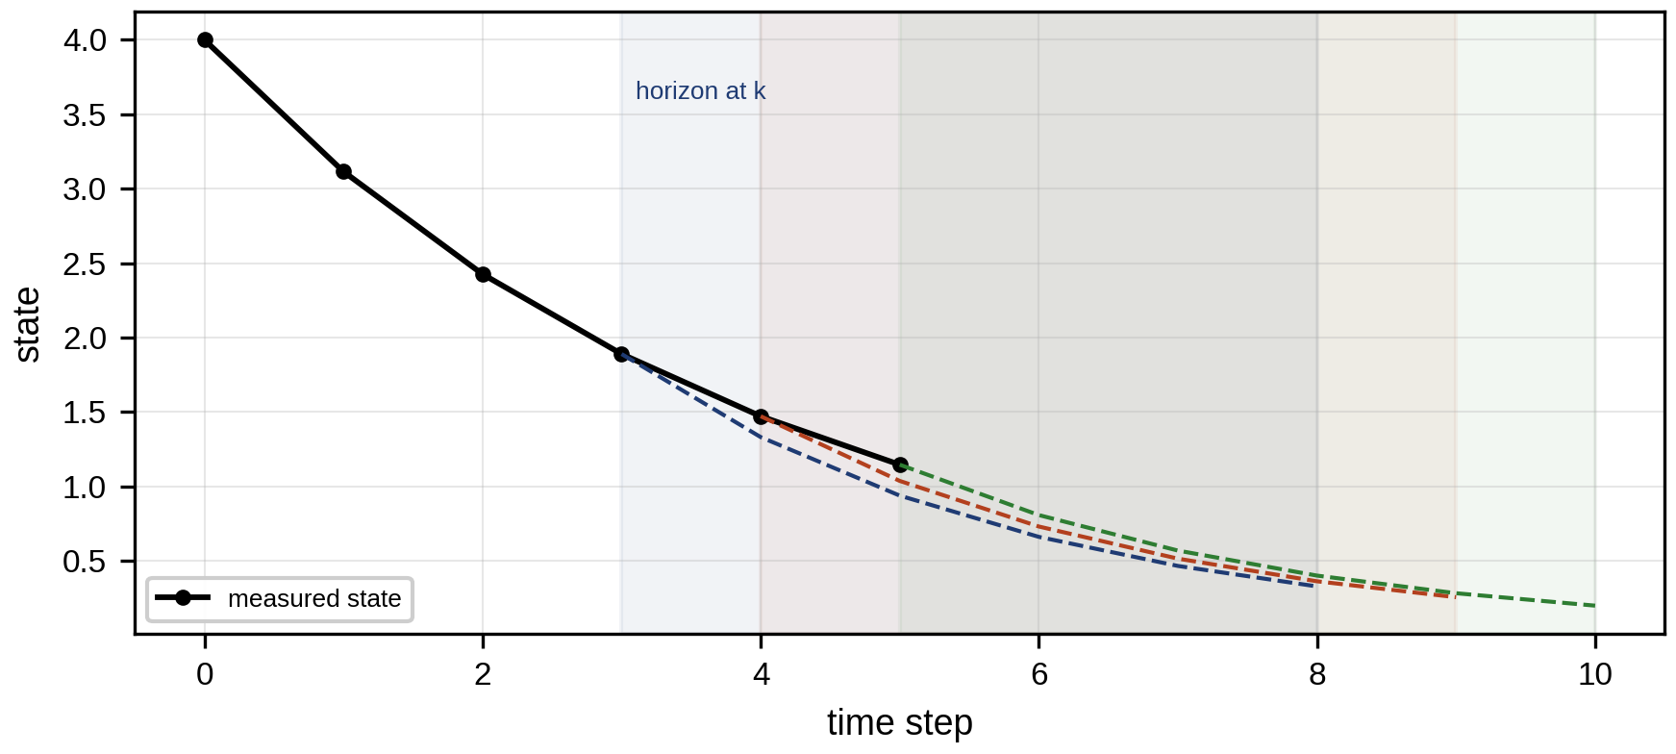
Figure 13.9. The receding-horizon principle: at each step the controller predicts over N steps, optimizes the input sequence, applies only the first input, and re-plans from the new measured state; the predicted trajectories slide forward with time.

13.6.4 A scalar example by hand
Consider the scalar plant $x_{k+1}=ax_{k}+bu_{k}$ with $a=0.9$ and $b=0.5$, a horizon of $N=2$, and the cost
 | $$J=Qx_{1}^{2}+Qx_{2}^{2}+R\left(u_{0}^{2}+u_{1}^{2}\right),$$ | (13.25)
with state weight $Q=1$ and input weight $R=0.1$, starting from $x_{0}=10$. The predictions are $x_{1}=ax_{0}+bu_{0}$ and $x_{2}=a^{2}x_{0}+abu_{0}+bu_{1}$. Substituting them makes $J$ a quadratic function of the two inputs, $J=u^{T}Hu+2f^{T}u+\text{const}$, with
 | $$H=QΓ^{T}Γ+RI=\left[\begin{matrix}0.5525 & 0.225 \\ 0.225 & 0.35\end{matrix}\right], f=QΓ^{T}Φx_{0}=\left[\begin{matrix}8.145 \\ 4.05\end{matrix}\right],$$ | (13.26)
where $Γ=\left[\begin{matrix}b & 0 \\ ab & b\end{matrix}\right]$ and $Φ={\left[a, a^{2}\right]}^{T}$ from (13.16). Setting the gradient $2Hu+2f$ to zero gives the unconstrained optimum $u^{*}=−H^{−1}f=[−13.59, −2.84]^{T}$. If the actuator is limited to $\left|u\right|≤5$, the first input exceeds its limit, and the constrained problem (a quadratic program) gives $u=[−5, −5]^{T}$ with both lower bounds active. Only $u_{0}=−5$ is applied, and $x_{1}=0.9×10+0.5×\left(−5\right)=6.5$. At the next step the problem is solved again from $x_{1}=6.5$.
The constrained solution can be checked with the KKT conditions of Section 13.10. Write the bounds as $−u_{j}−5≤0$ with multipliers $μ_{j}≥0$. Stationarity of uTHu+2fTu+j​μj−uj−5 gives $2Hu+2f−μ=0$. At $u={\left[−5,−5\right]}^{T}$, $2Hu+2f={\left[−7.775+16.29, −5.75+8.10\right]}^{T}={\left[8.515,2.35\right]}^{T}$, so $μ={\left[8.515,2.35\right]}^{T}$, both non-negative: both bounds are active and the point is optimal.
Repeating the procedure produces the closed-loop trajectory 10, 6.5, 3.35, 0.74, 0.16, 0.04 (Figure 13.10). For this simple plant, clipping the infinite-horizon LQR command (Section 13.6.1) to the limits produces almost the same trajectory (10, 6.5, 3.35, 0.73, 0.16). MPC’s advantage appears when constraints act on states rather than only inputs, when several inputs interact, or when the plant must be kept away from a limit that saturation alone does not respect. The buck converter’s current limit (Section 13.22) is such a case.
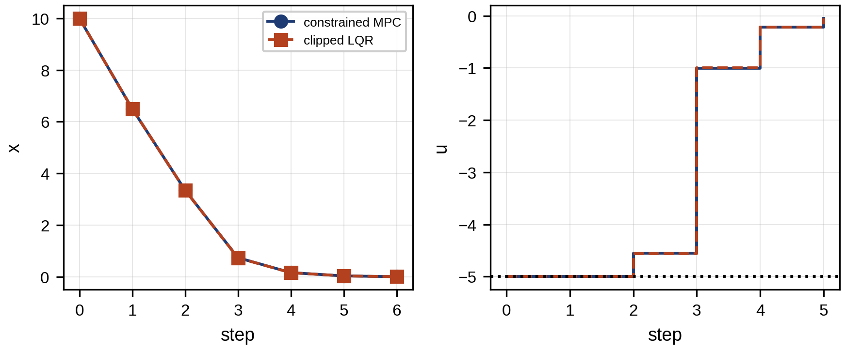
Figure 13.10. Scalar example: closed-loop state and input under constrained MPC and under the LQR law clipped to the same limits, from $x_{0}=10$ with $\left|u\right|≤5$.

13.6.5 The general quadratic program
With the lifted predictions (13.16), a quadratic cost on state deviations from a reference $X_{r}$ and on inputs, and linear constraints, MPC solves at each step
 | $$\min_{U} {\left(X−X_{r}\right)}^{T}\overset{‾}{Q}\left(X−X_{r}\right)+{\left(U−U_{r}\right)}^{T}\overset{‾}{R}\left(U−U_{r}\right) \text{s.t.} X=Φx_{0}+ΓU, U_{min}≤U≤U_{max}, C_{x}X≤d_{x},$$ | (13.27)
where $\overset{‾}{Q}$ and $\overset{‾}{R}$ are block-diagonal weights (with a terminal weight $P$ in the last block of $\overset{‾}{Q}$), $U_{r}$ the steady-state input for the reference, and $C_{x}X≤d_{x}$ the state constraints. Substituting the prediction gives a convex quadratic program in $U$ alone, with Hessian $2\left(Γ^{T}\overset{‾}{Q}Γ+\overset{‾}{R}\right)$, solvable to global optimality by active-set, interior-point or operator-splitting (ADMM, as in OSQP) methods [3]. In condensed form, with $E=Φx_{0}−X_{r}$,
 | $$\min_{U} \frac{1}{2}U^{T}HU+f^{T}U, H=2\left(Γ^{T}\overset{‾}{Q}Γ+\overset{‾}{R}\right), f=2\left(Γ^{T}\overset{‾}{Q}E−\overset{‾}{R}U_{r}\right),$$ | (13.28)
Uniqueness needs a precise condition. The condensed Hessian $H=2\left(Γ^{T}\overset{‾}{Q}Γ+\overset{‾}{R}\right)$ is positive definite whenever $\overset{‾}{R}≻0$ and $\overset{‾}{Q}≽0$, because then $U^{T}HU≥2U^{T}\overset{‾}{R}U>0$ for every nonzero $U$. A strictly convex QP over a nonempty convex feasible set has exactly one minimizer, so the optimal input sequence is unique. With $\overset{‾}{R}$ only positive semidefinite (some inputs free of cost), several input sequences can give the same cost, and a solver may return any of them; in non-condensed formulations, where states are also decision variables, uniqueness of the inputs still implies uniqueness of the predicted states, because the dynamics determine them.
Regulation, tracking and economic MPC
Three kinds of MPC share the same machinery and differ in their stage cost. Regulation MPC drives the state to the origin or to a fixed steady state, $ℓ=x^{T}Qx+u^{T}Ru$. Tracking MPC follows a time-varying reference, $ℓ=∥x−x_{r,k}∥_{Q}^{2}+∥u−u_{r,k}∥_{R}^{2}$, computed by a higher layer. Economic MPC minimizes the actual operating cost, emissions or wear, $ℓ=c\left(x,u\right)$, and has no reference at all (Section 13.8.2).

13.7 Practical MPC: Horizons, Constraints, Feasibility and Offset-free Tracking

13.7.1 Weights, horizon and terminal cost
The weights express priorities. A large state weight relative to the input weight gives aggressive control; a large input weight gives smooth control. The horizon should be long enough that constraints which will matter in the near future are seen in time, and that the terminal ingredients below make up for what lies beyond it. For the D-3 buck converter ($L=22$ µH, $C=100$ µF), the undamped LC resonance is at $f_{0}=1/\left(2π\sqrt{LC}\right)=3.39$ kHz, so one period is $T_{0}=0.295$ ms, and $N=10$ samples at 10 µs span 100 µs, about $0.34 T_{0}$. That fraction is not what justifies the horizon. For a converter with $L=47$ µH and $C=470$ µF, for comparison, $f_{0}=1.07$ kHz and the same 100 µs is only $0.107 T_{0}$. The horizon is justified by closed-loop evidence: with the Riccati terminal weight below, the 10-step controller reproduces the infinite-horizon LQR whenever no constraint is active, and in simulation it meets the current limit during start-up without any violation; lengthening the horizon to 20 steps changes the start-up and load-step responses by less than 1 mV and 0.01 A, while doubling the QP size. Horizon length is therefore chosen by testing closed-loop performance and constraint satisfaction against horizon length, with terminal ingredients, not by a fraction of a period.
The terminal weight $P$ approximates the cost beyond the horizon. Choosing it as the solution of the Riccati equation (13.21) makes the finite-horizon controller equal to the infinite-horizon optimal controller whenever no constraint is active, and is part of the standard stability argument below.
Smoothness is often better expressed through input changes than input levels. Penalizing and limiting $Δu_{k}=u_{k}−u_{k−1}$,
 | J←J+k​ΔukTSΔuk, Δumin≤Δuk≤Δumax, | (13.29)
with weight $S$, adds integral-like behaviour and represents slew-rate limits such as a battery inverter’s ramp rate or a generator’s ramp limit.

13.7.2 Terminal sets and invariance
A terminal set $X_{f}$ is a region around the target from which a known local controller, usually the LQR gain $K$, keeps the system inside all constraints forever. It must be positively invariant under that controller and constraint-admissible:
 | $$x∈X_{f} ⇒ \left(A−BK\right)x∈X_{f}, X_{f}⊆X, −KX_{f}⊆U,$$ | (13.30)
where $X$ and $U$ are the state and input constraint sets. The largest such set is computed by intersecting the constraint set with its preimages under $A−BK$ until the intersection stops changing, which for stable linear systems with polytopic constraints happens after finitely many steps. A simple ellipsoidal subset is a level set of the LQR cost, $\{x:x^{T}Px≤α\}$, which is invariant because the LQR cost decreases along the closed loop, and constraint-admissible if $α$ is small enough that every point in it satisfies the constraints. For a single input bound $\left|Kx\right|≤u_{max}$ the largest admissible level is $α=u_{max}^{2}/\left(KP^{−1}K^{T}\right)$, because the maximum of $\left|Kx\right|$ over the ellipsoid is $\sqrt{α KP^{−1}K^{T}}$. For the scalar example this gives $α=25/\left({1.362}^{2}/1.245\right)=16.8$, so $\left|x\right|≤3.67$; from any state inside it, the clipped LQR command is not clipped at all.

13.7.3 Hard and soft constraints, feasibility and protection
A nonempty input box is individually feasible: some input inside it always exists. But input, state, terminal and rate constraints together can have no common solution. After a large disturbance, no input sequence may keep a voltage or temperature inside its limits, and the QP is then infeasible. A controller that returns no answer is unacceptable, so state constraints are usually softened with a non-negative slack $ϵ$ penalized heavily,
 | $$C_{x}X≤d_{x}+ϵ, ϵ≥0, J←J+ρ_{1}1^{T}ϵ+ρ_{2}\left.∥ϵ\right.∥^{2},$$ | (13.31)
where $ρ_{1}$ and $ρ_{2}$ weight the linear and quadratic slack penalties. Under standard regularity conditions, a sufficiently large linear ($L_{1}$) penalty makes the soft problem return the hard solution whenever the hard problem is feasible: the penalty is exact. The precise requirement is that $ρ_{1}$ exceed the dual norm of the multipliers of the softened constraints at the hard optimum (for the $L_{1}$ penalty, the largest multiplier), which is rarely known in advance, so $ρ_{1}$ is set with a large margin above the largest multiplier seen in simulation, and the quadratic term keeps the problem well conditioned (Figure 13.11).
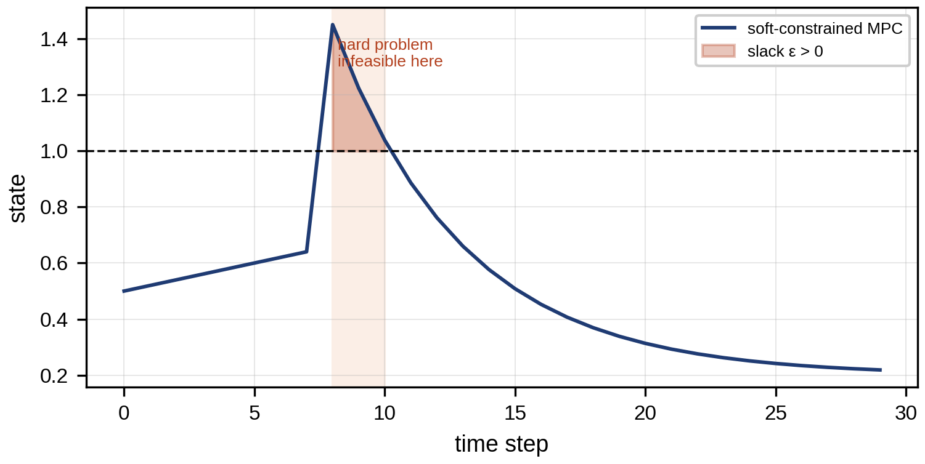
Figure 13.11. Hard and soft state constraints after a large disturbance: the hard-constrained problem becomes infeasible, while the softened problem returns the smallest possible violation and recovers.
Protection limits that must never be exceeded, such as a converter’s peak-current trip, are not left to the optimizer at all: they are enforced by hardware and interlocks (Section 13.20.2).
Which constraints may be softened and which may not follows from what their violation means. Comfort, economic and soft equipment limits (a preferred SOC band, a voltage band inside the statutory band) may be softened. Limits whose violation causes damage or danger may not; they are kept outside the optimizer, in protection and interlocks, and the optimizer’s constraints are set with a margin inside them. When even the softened problem fails, the controller follows a feasibility-restoration hierarchy: first relax the lowest-priority soft constraints, then shorten the horizon, then fall back to the shifted previous plan, and finally to the fallback controller (Section 13.20.2).
Numerical scaling matters as much as formulation. A problem that mixes volts, amperes and megawatt-hours can have Hessian entries spanning ten orders of magnitude, and first-order solvers such as OSQP then converge slowly or to poor accuracy. Scaling every variable to a range near one, by dividing by its nominal value, is the first remedy; diagonal equilibration of the KKT matrix, applied inside most solvers, the second.

13.7.4 Offset-free tracking
MPC based on an imperfect model leaves a steady-state error, just as proportional control does. The standard remedy augments the model with a disturbance state $d_{k}$ that absorbs the mismatch, estimated by an observer from the measured outputs,
 | $$x_{k+1}=Ax_{k}+Bu_{k}+B_{d}d_{k}, d_{k+1}=d_{k}, y_{k}=Cx_{k}+C_{d}d_{k},$$ | (13.32)
where $B_{d}$ and $C_{d}$ describe how the disturbance enters the state and the output. The steady-state target $\left(x_{r},u_{r}\right)$ is then recomputed from the estimated disturbance at every step, by solving
 | $$\left[\begin{matrix}I−A & −B \\ C & 0\end{matrix}\right]\left[\begin{matrix}x_{r} \\ u_{r}\end{matrix}\right]=\left[\begin{matrix}B_{d}\hat{d} \\ r−C_{d}\hat{d}\end{matrix}\right],$$ | (13.33)
where $r$ is the output reference. Two conditions make this work [4]. The augmented system must be detectable, which for a detectable $\left(A,C\right)$ holds if and only if
 | $$rank\left[\begin{matrix}A−I & B_{d} \\ C & C_{d}\end{matrix}\right]=n+n_{d},$$ | (13.34)
with $n_{d}$ disturbance states. This requires $n_{d}≤p$, the number of measured outputs. And for zero offset in all $p$ outputs under any constant disturbance, the usual construction takes $n_{d}=p$, one disturbance per output, so that the estimated disturbances can absorb any constant mismatch in every output. Choosing $n_{d}=p$ is therefore a common and sufficient construction, not a universal requirement; with fewer disturbance states, offset-free tracking is still achieved for the outputs whose mismatch the chosen $B_{d}$, $C_{d}$ can explain. Input disturbances ($B_{d}=B$) suit actuator offsets and unknown loads; output disturbances ($C_{d}=I$) suit sensor offsets and slow model mismatch, but may respond slowly to disturbances that actually enter at the input. The buck converter’s load current is an input-side disturbance, and estimating or measuring it removes the offset (Section 13.22).

13.7.5 Recursive feasibility and stability
A controller must remain feasible at every future step once it is feasible now (recursive feasibility). The standard argument uses the terminal ingredients: if the optimal sequence at step $k$ ends inside the terminal set, then at step $k+1$ the shifted sequence, the old sequence without its first element and with the local controller’s input appended, $\left[u_{1|k},…,u_{N−1|k},−Kx_{N|k}\right]$, satisfies all constraints and ends inside the terminal set again [5]. This holds for the nominal model under the terminal-set assumptions. With plant disturbances, estimation errors, model changes or changed constraints, the actual state at $k+1$ differs from the predicted one, and the shifted sequence may be infeasible; robust formulations (Section 13.9) restore the property for bounded disturbances. Under the same nominal assumptions, the optimal cost is a Lyapunov function: with a terminal cost that bounds the local controller’s cost-to-go inside the terminal set,
 | $$J^{*}\left(x_{k+1}\right)−J^{*}\left(x_{k}\right)≤−ℓ\left(x_{k},u_{k}\right),$$ | (13.35)
where $ℓ$ is the stage cost, positive away from the target, so the state converges to it.

13.8 Nonlinear and Economic MPC

13.8.1 Nonlinear MPC
Many twins are nonlinear: a battery’s open-circuit voltage depends nonlinearly on SOC and its resistance on temperature; a grid-forming inverter’s power transfer depends on the sine of the angle difference; converter losses grow with the square of current. Nonlinear MPC (NMPC) keeps the nonlinear model in the prediction,
 | $$\min_{u_{0:N−1}} \sum_{k=0}^{N−1}{ℓ}\left(x_{k},u_{k}\right)+V_{f}\left(x_{N}\right) \text{s.t.} x_{k+1}=f\left(x_{k},u_{k}\right), g\left(x_{k},u_{k}\right)≤0, x_{N}∈X_{f},$$ | (13.36)
where $f$ is the nonlinear model, $g$ the (possibly nonlinear) constraints, $ℓ$ the stage cost and $V_{f}$ the terminal cost. The problem is a nonlinear program, generally nonconvex, solved by sequential quadratic programming (SQP), which repeatedly linearizes the dynamics and constraints around the current guess and solves a QP for the step, or by interior-point methods. Only a local optimum is guaranteed, so the result depends on the starting point; in closed loop, warm-starting from the shifted previous solution usually keeps the solver near the same local optimum from step to step. Real-time NMPC often performs one SQP iteration per sample (the real-time iteration scheme), trading optimality for a bounded computation time. An electro-thermal battery twin illustrates the need: limiting cell temperature at high C-rate requires the heat generation $I^{2}R\left(T\right)$ with temperature-dependent resistance in the prediction, which a linear model cannot represent across the operating range.

13.8.2 Economic MPC
Economic MPC replaces the tracking cost by the operating economics itself, $ℓ\left(x,u\right)=c\left(x,u\right)$: energy cost, emissions, wear. The optimal trajectory then need not converge to any fixed set-point; for a battery facing a price profile, the economically best SOC trajectory moves deliberately. Stability theory for economic MPC is subtler than for tracking MPC, because the cost is not positive definite around a steady state; it relies on dissipativity of the system with respect to the economic cost, and in energy management the practical safeguards are the terminal energy condition and the constraint set.
Example 13.2 Tracking a SOC reference against minimizing cost
Given. The P-1 battery (0.5 MW, 1 MWh, 95 % one-way efficiency, stored energy 0.1 to 1 MWh, starting and ending at 0.5 MWh) facing the published price day of Table 13.5, with wear priced at 16 $/MWh of throughput. Two controllers over the 24 hours: tracking MPC that penalizes ${\left(E_{t}−0.5\right)}^{2}$ with a small throughput term, and economic MPC that maximizes revenue minus wear.
Find. The stored-energy trajectories and the revenue of each.
Solution. The tracking controller holds the battery at 0.5 MWh all day and earns nothing. The economic controller charges twice and discharges twice, reaching both energy limits, and earns 144.9 $ of revenue with 28.8 $ of wear, a net value of 116.1 $ (Figure 13.12).
Interpretation. The economically optimal trajectory intentionally does not track a fixed SOC reference. A tracking MPC can only perform well if a higher layer computes the right reference, which is itself an economic optimization; economic MPC merges the two layers.
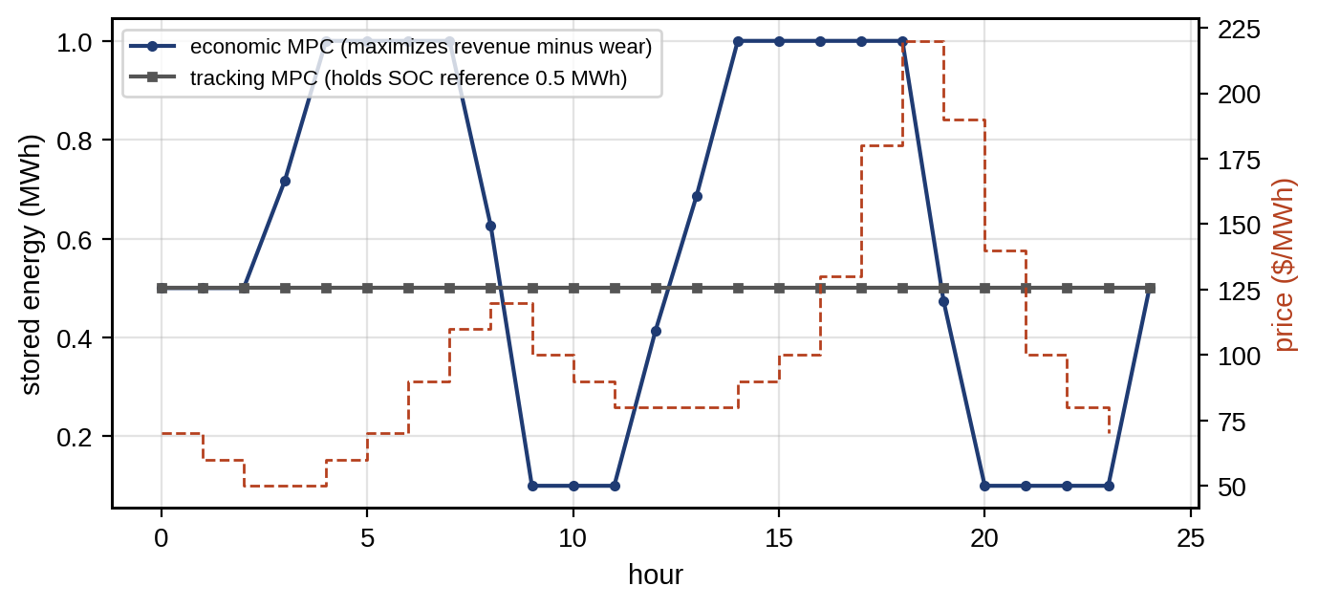
Figure 13.12. Stored energy under tracking MPC (held at the 0.5 MWh reference) and under economic MPC (moving deliberately with the price), with the price profile.

13.9 Robust, Stochastic and Distributionally Robust MPC

13.9.1 Constraint tightening without feedback
Nominal MPC ignores disturbances in its predictions, so a plan that just satisfies a constraint in prediction can violate it in reality. If the disturbance is bounded, $x_{k+1}=Ax_{k}+Bu_{k}+w_{k}$ with $∥w_{k}∥_{∞}≤w_{max}$, the error between the true and nominal trajectories after $j$ steps is bounded by the accumulated effect of the disturbances. Tightening each state constraint by that bound guarantees that the true state stays within the original limit. For a scalar system with $\left|a\right|<1$ and no feedback on the error,
 | $$\left|x_{j}\right|≤x_{max}−w_{max}\sum_{i=0}^{j−1}{{\left|a\right|}^{i}} \text{at prediction step }j,$$ | (13.37)
which for $a=0.9$, $w_{max}=0.2$ and five steps tightens the limit by 0.82.
The bound follows by writing the true state as the nominal prediction plus the accumulated disturbance, $x_{j}={\overset{‾}{x}}_{j}+\sum_{i=0}^{j−1}{a^{i}}w_{j−1−i}$, and taking the worst case of each term. It is educational but conservative: over an infinite horizon the tightening approaches $w_{max}/\left(1−\left|a\right|\right)=2.0$, twice the constraint’s own size for $x_{max}=1$, and for an unstable plant it grows without bound. The remedy is to control the error, not only to predict it.

13.9.2 Tube MPC
Tube MPC separates the plan from the correction. The true state is written as a nominal state plus an error,
 | $$x_{k}=z_{k}+e_{k}, u_{k}=v_{k}−Ke_{k}, e_{k+1}=\left(A−BK\right)e_{k}+w_{k},$$ | (13.38)
where $z_{k}$ and $v_{k}$ are the nominal state and input planned by MPC, $e_{k}$ the error and $K$ an ancillary feedback gain chosen so that $A_{K}=A−BK$ is strictly stable. The guarantee rests on four assumptions, which should be stated whenever tube MPC is used: the disturbance is additive and lies in a known bounded set $W$; the model $\left(A,B\right)$ is exact; the full state (or a bounded-error estimate) is available; and the constraint sets are convex. Under them the error stays forever in a robust positively invariant (RPI) set $E$, one that satisfies $A_{K}E⊕W⊆E$, where $⊕$ is the Minkowski sum. The smallest such set, the minimal RPI set, is
 | $$E_{∞}=⨁_{i=0}^{∞}A_{K}^{i}W,$$ | (13.39)
and the nominal problem uses the tightened sets $X⊖E$ and $U⊖KE$, where $⊖$ is the Pontryagin difference (the set of points that stay inside after adding any element of $E$). For the scalar plant with the LQR gain $K=1.362$, $a_{K}=0.219$ and $w_{max}=0.2$, the minimal RPI set is $\left|e\right|≤0.2/\left(1−0.219\right)=0.256$: the state constraint is tightened by 0.256 at every step, against 0.82 after five steps and 2.0 in the limit without feedback. The price is the input margin: the input constraint must be tightened by $\left|K\right|×0.256=0.35$ so that the ancillary feedback always has room to act. Figure 13.13 shows the nominal trajectory and the tube around it.
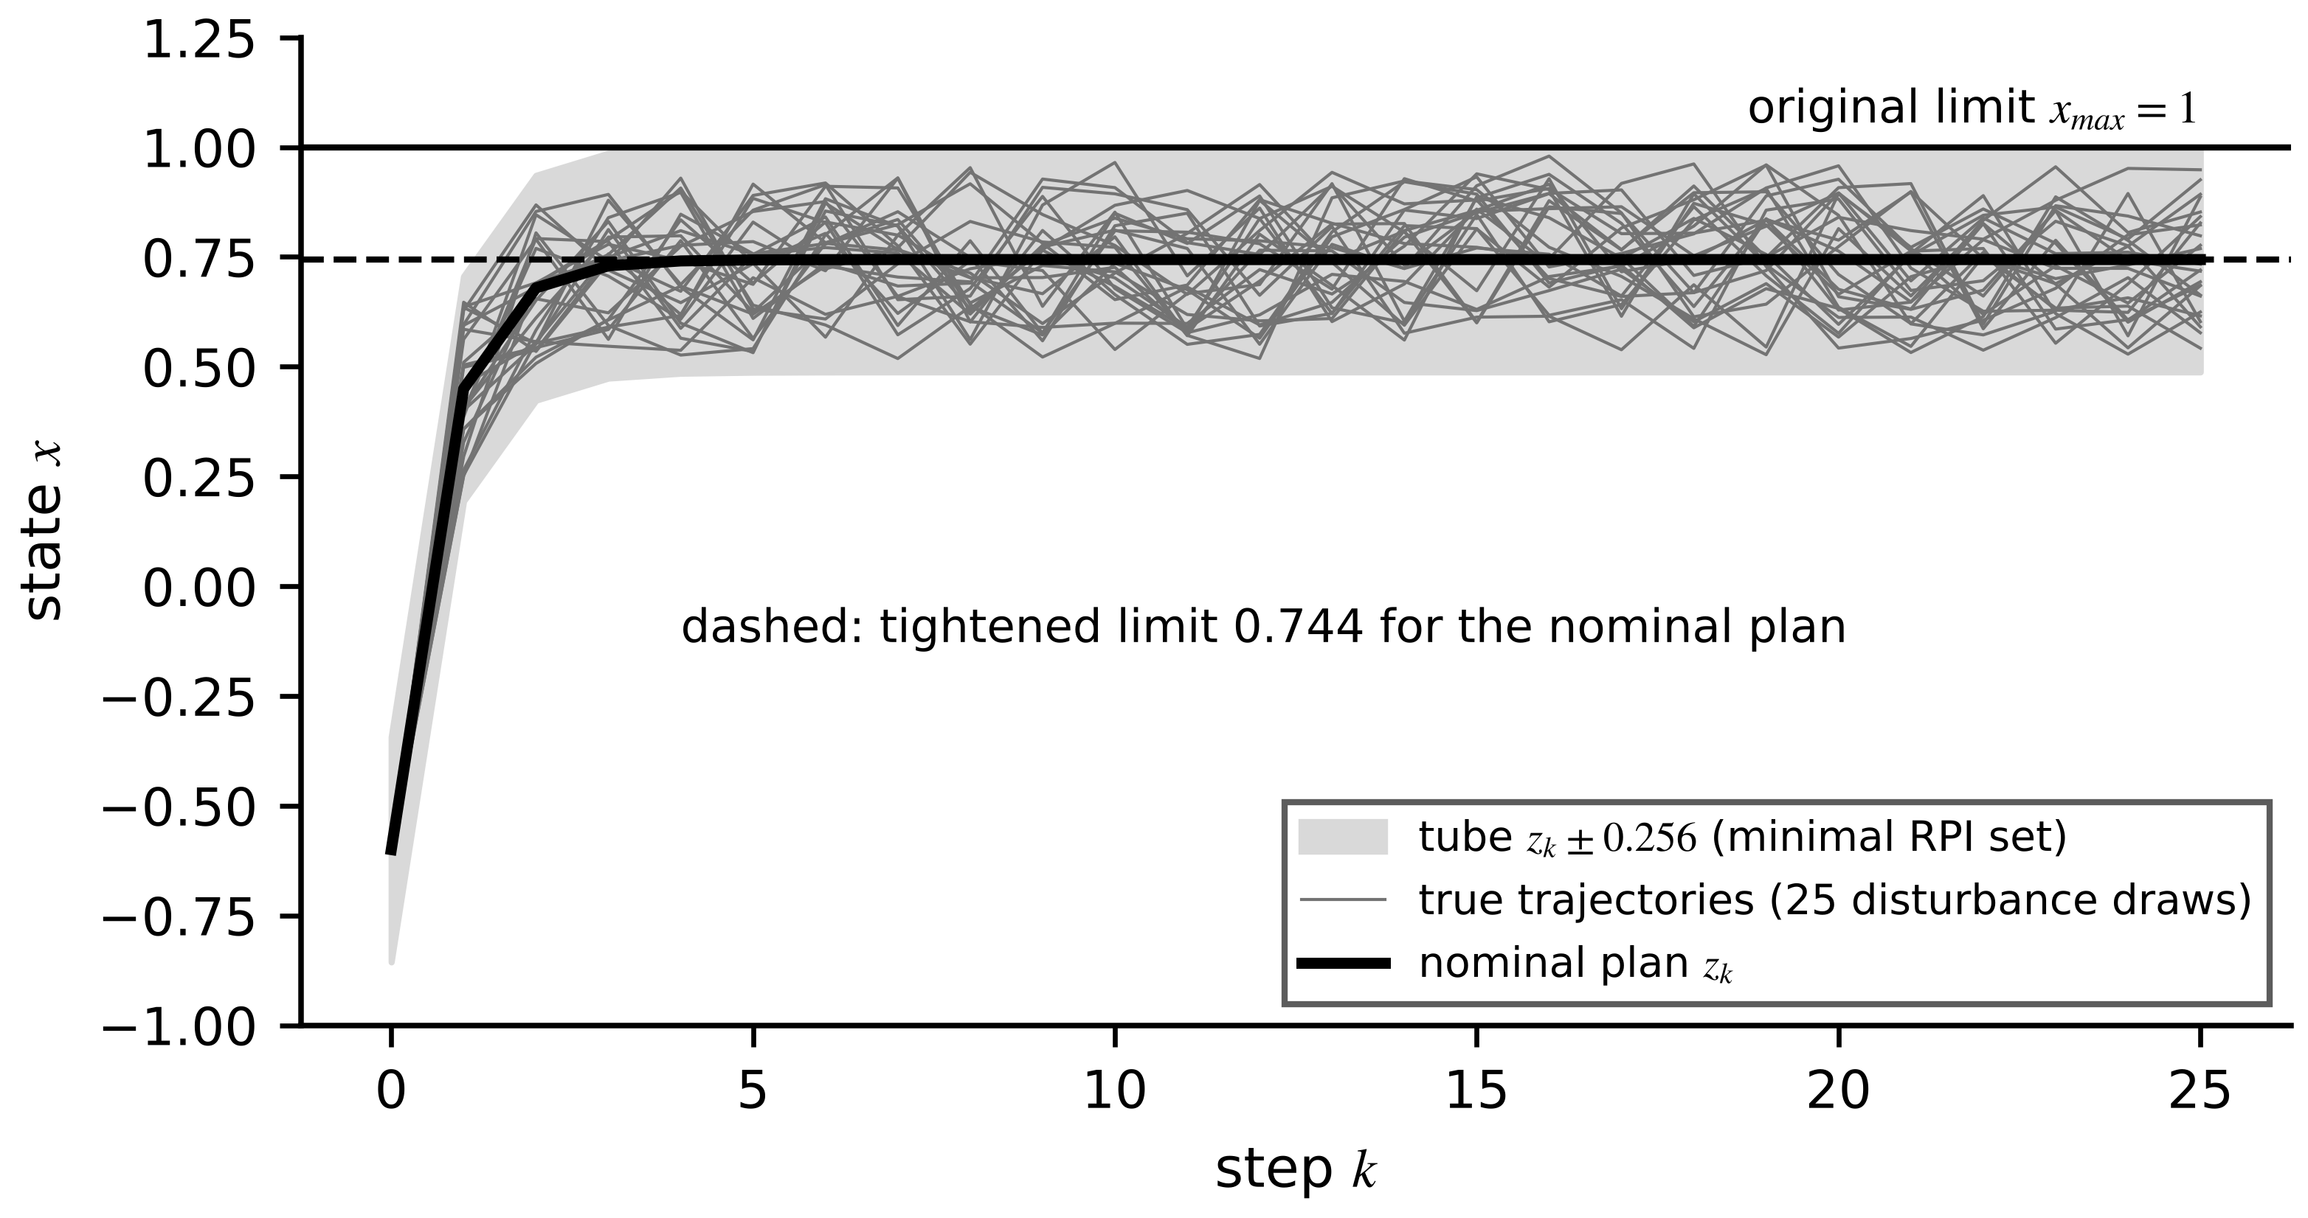
Figure 13.13. Tube MPC: the nominal trajectory planned against tightened constraints, and the tube of possible true trajectories around it under bounded disturbances, which stays within the original constraint (scalar plant of Section 13.6.4, ancillary gain K = 1.362, |w| ≤ 0.2, minimal RPI half-width 0.256).
The disturbance set $W$ is where the twin enters. It is identified from the twin’s one-step prediction residuals over a validation period, as the smallest box or polytope containing, say, 99.9 % of them, and re-identified when the plant changes. A set that is too small voids the guarantee; one that is too large makes the tightened problem infeasible. Parametric uncertainty, in which $A$ and $B$ themselves are uncertain, is harder: the error then depends on the state and input, the tube must be computed for the whole family of models, and the result is usually much more conservative.

13.9.3 Stochastic MPC
When the disturbance is better described by a distribution than by a bound, stochastic MPC replaces hard state constraints by chance constraints, $Pr\{c^{T}x_{k}≤d\}≥1−α$. For a linear system with Gaussian disturbances and the tube decomposition above, the error $e_{k}$ has covariance $Σ_{k+1}=A_{K}Σ_{k}A_{K}^{T}+Σ_{w}$, and the chance constraint becomes the deterministic tightening
 | $$c^{T}z_{k}≤d−z_{1−α}\sqrt{c^{T}Σ_{k}c},$$ | (13.40)
where $z_{1−α}$ is the standard normal quantile and $Σ_{w}$ the disturbance covariance. The tightening grows along the horizon as the covariance propagates, and it is smaller than the robust one because rare disturbances are allowed to cause rare violations.

13.9.4 Distributionally robust optimization
Stochastic MPC assumes the distribution is known; robust MPC assumes only a bound. Between them lies distributionally robust optimization (DRO), which admits that the distribution is itself uncertain. It optimizes against the worst distribution in an ambiguity set $P$ of plausible distributions,
 | $$\min_{x} \sup_{P∈P} E_{P}\left[c\left(x,ξ\right)\right], P=\left\{P:W\left(P,{\hat{P}}_{N}\right)≤ε_{W}\right\},$$ | (13.41)
where, following the data-driven formulation of [18], $ξ$ is the uncertain quantity, ${\hat{P}}_{N}$ the empirical distribution of $N$ observed samples, $W$ the Wasserstein distance (the least “transport cost” of moving one distribution’s probability mass onto the other’s) and $ε_{W}$ the radius of the ball. A radius of zero recovers the sample-average (stochastic) problem, and a very large radius approaches the robust one, so $ε_{W}$ tunes the conservatism, and it can be chosen so that the ball contains the true distribution with a stated confidence. Moment-based ambiguity sets, which contain every distribution with a given mean and variance, give a simple closed form for chance constraints. For a scalar constraint $Pr\{ξ≤r\}≥1−α$ over every distribution with mean $μ$ and standard deviation $σ$, the worst case is attained by a two-point distribution and the constraint becomes
 | $$r≥μ+\sqrt{\frac{1−α}{α}} σ,$$ | (13.42)
the one-sided Chebyshev (Cantelli) bound, with factor 4.36 at $α=5$ % instead of the Gaussian 1.645. DRO problems with Wasserstein balls over polyhedral uncertainty often reduce to linear or conic programs of moderate size. Figure 13.14 places the methods on one ladder, and Table 13.3 compares them.
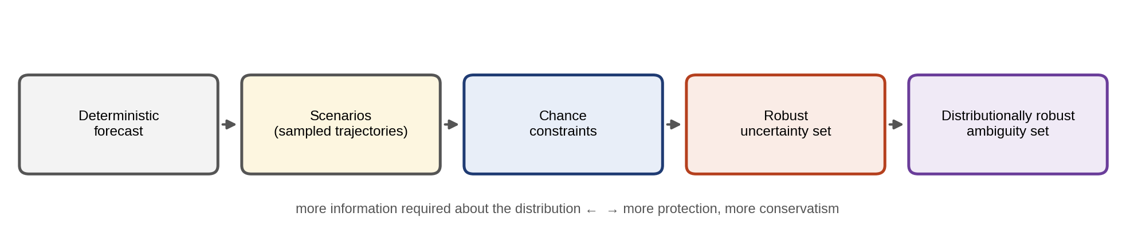
Figure 13.14. The uncertainty ladder: deterministic forecast, sampled scenarios, chance constraints, a robust uncertainty set and a distributionally robust ambiguity set, requiring progressively less trust in the assumed distribution and giving progressively more protection at more cost.
TABLE 13.3 Methods for planning under uncertainty compared
Method | Information needed | Guarantee | Conservatism | Computation
Deterministic | Point forecast | None against forecast error | None (optimistic) | LP/QP
Chance-constrained (Gaussian) | Mean, covariance, Gaussian assumption | Violation probability $≤α$ if Gaussian | Low | LP/QP with tightening
Scenario / stochastic | Samples of the distribution | In expectation over the samples; probabilistic bound on violation | Low to medium | Grows with scenarios
Robust (box, polytope) | Bounds only | Worst case within the set | High | LP/QP, often same size
Tube MPC | Bounded additive disturbance, exact model | Constraint satisfaction for all disturbances in the set | Medium | Offline set computation, online QP
Distributionally robust | Samples plus ambiguity radius, or moments | Worst case over plausible distributions | Tunable, medium to high | LP/conic, larger

13.10 KKT Conditions, Dual Variables and Sensitivity
Every optimization in this chapter is a problem of the form
 | $$\min_{x} f\left(x\right) \text{s.t.} g_{i}\left(x\right)≤0, h_{j}\left(x\right)=0.$$ | (13.43)
Its Lagrangian adds each constraint weighted by a multiplier, L=f+i​μigi+j​λjhj. At an optimum of a problem satisfying mild regularity conditions, the Karush–Kuhn–Tucker (KKT) conditions hold [6]:
 | ∇f+i​μi∇gi+j​λj∇hj=0, gi≤0, hj=0, μi≥0, μigi=0, | (13.44)
stationarity, primal feasibility, dual feasibility and complementary slackness. For convex problems (convex $f$ and $g_{i}$, affine $h_{j}$) they are also sufficient. Complementary slackness says each inequality is either inactive ($g_{i}<0$, $μ_{i}=0$) or active with a non-negative multiplier. The multiplier measures how much the optimal cost would fall if the constraint were relaxed by one unit.
The sign of that change depends on how the constraint is written, so one convention is fixed here and used throughout the chapter. Every inequality is written as $g_{i}\left(x\right)≤b_{i}$ with multiplier $μ_{i}≥0$ and Lagrangian L=f+i​μigi−bi+j​λjhj−cj for equalities $h_{j}\left(x\right)=c_{j}$. Then, for a minimization,
 | $$\frac{∂f^{*}}{∂b_{i}}=−μ_{i}≤0, \frac{∂f^{*}}{∂c_{j}}=−λ_{j},$$ | (13.45)
where $f^{*}$ is the optimal cost: relaxing an inequality (raising $b_{i}$) can only lower the cost, at the rate $μ_{i}$. For an equality, the sign of $λ_{j}$ depends on the direction in which it is written: for a power balance written as i​Pi−D=0 with $h=∑P_{i}$ and $c=D$, the marginal cost of demand is $∂f^{*}/∂D=−λ$ with this Lagrangian, which is why many texts write the balance as $D−∑P_{i}=0$ so that the multiplier is the (positive) system price. Solvers use their own conventions, and the twin must record which one each reported dual follows.
Three cautions apply to shadow prices. They are local: the derivative holds only while the same set of constraints stays active (the active set), and a larger change in $b_{i}$ may activate or release other constraints. They are well defined only under regularity: at a degenerate optimum, where an active constraint has a zero multiplier or more constraints are active than the problem has degrees of freedom, the multiplier may not be unique and the one-sided derivatives differ. And they measure marginal value, not total value. In energy systems, duals carry economic meaning directly: the balance multiplier is the system or locational price, a line-flow multiplier the congestion rent (Section 13.12.3), a transformer-capacity multiplier the value of one more kVA, a reserve multiplier the price of flexibility, and the multiplier of a battery’s energy-balance constraint the marginal value of stored energy at that hour.
Example 13.3 A constrained set-point, a dispatch and a congested network
Given. (a) A twin-based set-point problem: minimize ${\left(u−5\right)}^{2}$ subject to $u≤3$ (an actuator limit). (b) The scalar MPC of Section 13.6.4 with $\left|u\right|≤5$. (c) The economic dispatch of Example 13.5 below.
Find. The optimum and the multiplier in each case, and its meaning.
Solution. (a) With $g\left(u\right)=u≤3$, the unconstrained minimum $u=5$ violates the limit, so the constraint is active: $u^{*}=3$, and stationarity of ${\left(u−5\right)}^{2}+μ\left(u−3\right)$ gives $2\left(u−5\right)+μ=0$, so $μ=4$. By (13.45), raising the limit from 3 to 3.1 lowers the optimal cost by about $4×0.1=0.4$; exactly, from 4 to 3.61. (b) Writing the bounds as $−u_{j}≤5$, both lower bounds are active, with multipliers 8.515 and 2.35 (Section 13.6.4). The first input’s limit is by far the more costly, which says that a larger actuator would help most at the first step. (c) For the dispatch of Example 13.5, with the balance written as $D−∑P_{i}=0$, the multiplier is the system price $λ=34.35$ $/MWh: one more MW of demand costs 34.35 $/h more.
Figure 13.15 shows the geometry of case (a).
Interpretation. Multipliers are not a mathematical by-product; they are the most informative output of an optimization, because they say which limits cost money and how much. Every energy-management twin should report them.
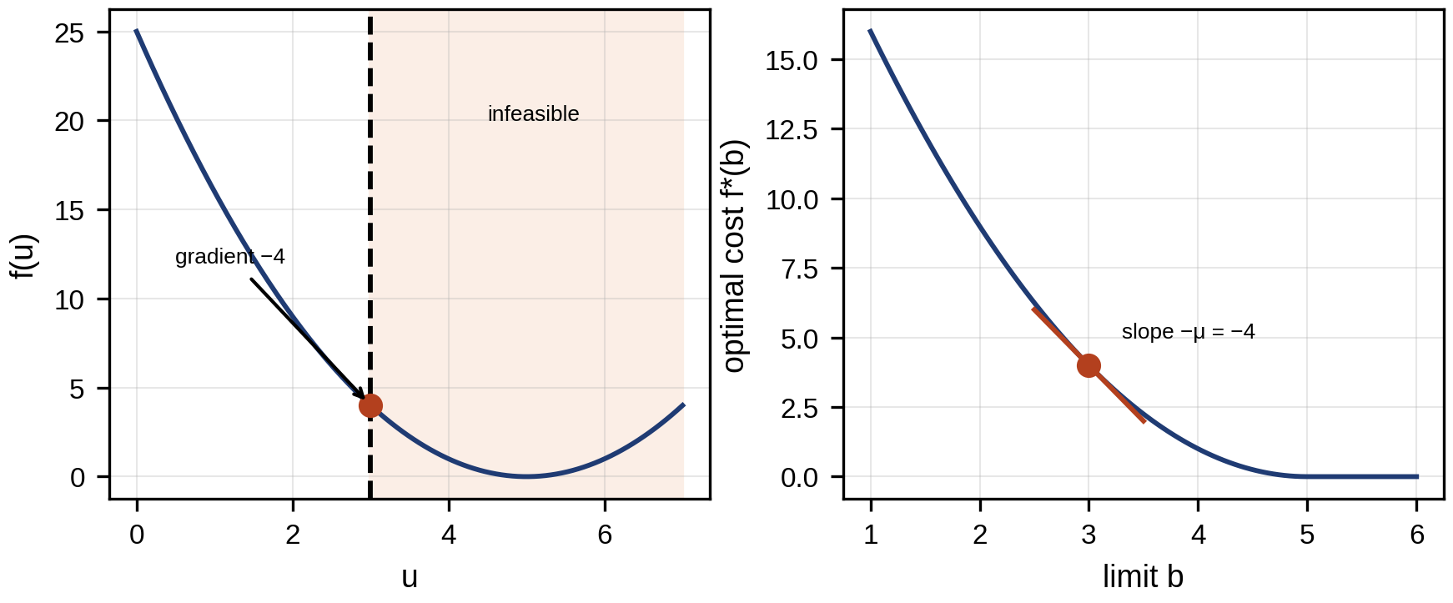
Figure 13.15. Geometry of the KKT conditions for case (a): the cost’s gradient at the constrained optimum is balanced by the multiplier times the constraint’s gradient, and the multiplier equals the slope of the optimal cost against the constraint limit.

13.11 Fault-tolerant and Health-aware Control

13.11.1 Fault-tolerant control
When the twin’s diagnosis (Chapter 12) detects a fault, the controller can accommodate it rather than shut down. Examples: reducing a converter’s current limit when a device is overheating, redistributing power among parallel battery racks when one is derated, switching a drive to a degraded but safe control mode after an open-switch fault. In MPC, fault accommodation amounts to changing the model or the constraints that the optimizer uses. This is natural when the twin already estimates the fault’s size; the change must still pass through the supervisory logic of Section 13.20.2.
Example 13.4 A derated converter
Given. The buck converter of Section 13.4.2 under the twin-in-the-loop MPC of Example 13.13. At commissioning its current limit is 25 A. The twin detects rising junction temperature in the switch and reduces the limit to 18 A through the update gate.
Find. The start-up time and the response to the 10 to 20 A load step with the reduced limit.
Solution. Start-up to 98 % of 12 V takes 0.11 ms instead of 0.08 ms, with the current held at 18 A. After the load step the converter cannot supply 20 A: the MPC holds the current at its new 18 A limit, and the output settles at $18×0.6=10.8$ V.
Interpretation. Changing the constraint is easy; living with its consequence is not. A derating changes what the plant can deliver, not only how it is controlled, so the twin must also report the new capability upward: to the drive, which should reduce its demand, and to the energy-management layer. Fault accommodation is complete only when every layer that relied on the old limit has been told.

13.11.2 Health-aware and degradation-aware control
Control objectives can include the health of the equipment itself. Adding a degradation term to the cost makes the controller trade performance against life:
 | J=Jperf+k​cdegxk,uk, | (13.46)
where $c_{deg}$ is the marginal cost of damage, obtained from the degradation models of Chapters 7, 9 and 12. For a battery, the throughput form of Chapter 9 is
 | $$c_{deg}=\frac{C_{rep}}{ΔQ_{EOL}}\frac{∂Q_{loss}}{∂N_{EFC}}⋅\frac{1}{2E_{nom}},$$ | (13.47)
per unit of energy charged or discharged, where $C_{rep}$ is the replacement cost, $ΔQ_{EOL}$ the capacity loss allowed at end of life, $∂Q_{loss}/∂N_{EFC}$ the capacity loss per equivalent full cycle and $E_{nom}$ the nominal energy, since one cycle moves $2E_{nom}$ of throughput. Figure 13.16 shows the resulting trade-off. Examples: the battery degradation cost per unit throughput of Chapter 9 (Section 9.17.4), the thermal-cycling damage of power modules (Chapter 7, Section 7.10), the plating penalty of health-aware charging (Chapter 10, Section 10.12.1), and the gearbox-derating option of Chapter 12 (Section 12.25). For the P-1 battery on the price day of Table 13.5, pricing degradation at 16 $/MWh of throughput reduces cycling from 2.20 to 1.80 MWh per day. Arbitrage revenue falls only from 150.5 to 144.9 $, while the wear incurred falls from 35.2 to 28.8 $, so the net value rises from 115.2 to 116.1 $ a day (Example 13.7). The cycles dropped were those whose price spread barely exceeded their wear. Health-aware control is only as good as its degradation model, and that model’s uncertainty should be carried into the decision, as the degradation-cost interval of Chapter 10 (Section 10.17) was.
The constant-throughput cost (13.47) is an intentionally simple first-order surrogate, not a general battery-ageing model. It prices a kilowatt-hour cycled at 10 % SOC the same as one at 90 %, a cold cell the same as a hot one, a 0.2C rate the same as 1C, and ignores the calendar ageing that proceeds while the battery rests. A useful hierarchy runs from this baseline upward:
- Throughput surrogate. Constant cost per MWh, (13.47); linear, convex, good for screening.
- Semi-empirical stress model. A cost that depends on the stress factors, $c_{deg}\left(t\right)=c_{0} f_{SOC}\left({\overline{SOC}}_{t}\right) f_{T}\left(T_{t}\right) f_{C}\left(\left|p_{t}\right|/E_{nom}\right)+c_{cal}\left(SOC_{t},T_{t}\right) Δt$, with calendar term $c_{cal}$ and stress functions fitted to cell tests (Chapter 9); convex approximations keep the problem tractable.
- Physics-informed model. SEI-growth or lithium-plating models in the twin, usually too nonlinear for the optimizer and used instead to calibrate the stress functions or as a constraint check.
- Uncertainty-aware cost. The degradation cost as an interval or distribution, with the decision tested against its upper end.
Health can enter the problem in two different ways. In the objective, it is traded against revenue at a price. As a constraint, it is a budget: a damage budget t​Dt≤Dmax per month derived from the remaining-useful-life target (Chapter 12), or a minimum RUL at the next planned replacement. The constraint form suits assets with a fixed replacement date; the price form suits assets whose replacement is itself an economic choice.
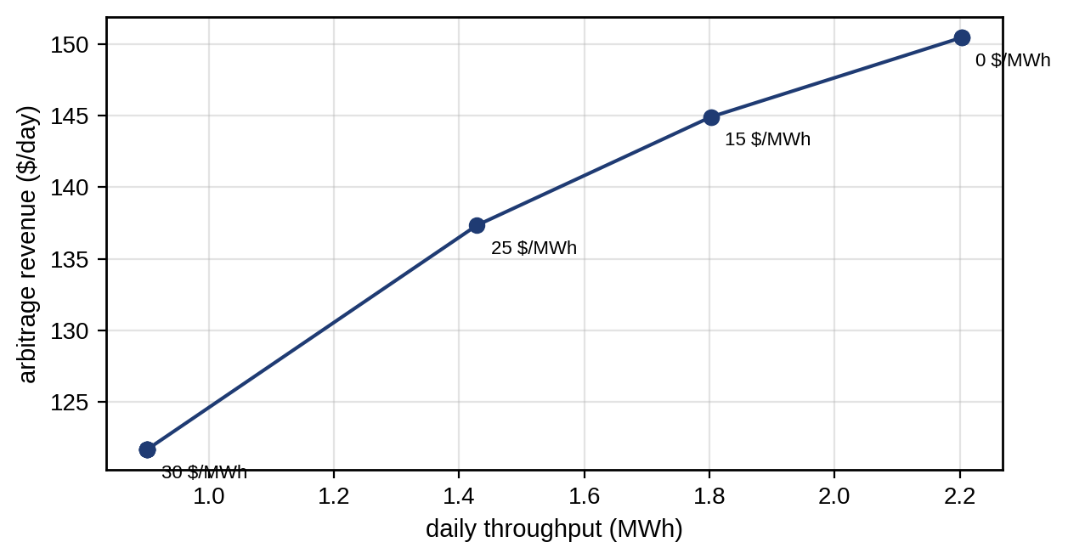
Figure 13.16. Health-aware battery scheduling: arbitrage revenue against daily throughput as the degradation price is swept from 0 to 60 $/MWh; on the price day of Table 13.5; throughput falls in steps as successively wider cycles stop paying for their wear.

13.12 Economic Dispatch, the Unit-commitment Bridge and OPF

13.12.1 Classical economic dispatch
Economic dispatch allocates a demand $D$ among $G$ generating units so that the total cost is minimal. With convex quadratic cost curves $C_{i}\left(P_{i}\right)=a_{i}+b_{i}P_{i}+c_{i}P_{i}^{2}$ and limits $P_{i}^{min}≤P_{i}≤P_{i}^{max}$,
 | minPi i​CiPi s.t. i​Pi=D, Pimin≤Pi≤Pimax. | (13.48)
Applying (13.44) with multiplier $λ$ on the balance, every unit that is not at a limit runs at the same incremental cost:
 | dCidPi=bi+2ciPi=λ ⇒ Pi=λ−bi2ci, λ=D+i​bi/2cii​1/2ci, | (13.49)
where the closed form holds when no limit binds. Units at a limit are fixed there and the rest re-balance, so in general $λ$ is found by bisection (the $λ$-iteration). $λ$ is the marginal cost of supplying one more megawatt, the system price. When network losses $P_{loss}\left(P\right)$ matter, the balance becomes i​Pi=D+Ploss and the condition becomes $λ=\frac{dC_{i}}{dP_{i}} {PF}_{i}$, with the penalty factor ${PF}_{i}={\left(1−∂P_{loss}/∂P_{i}\right)}^{−1}$ penalizing units whose output increases losses [7]. The losses are commonly approximated by Kron’s B-coefficient formula,
 | $$P_{loss}=P^{T}BP+B_{0}^{T}P+B_{00},$$ | (13.50)
where $B$, $B_{0}$ and $B_{00}$ are the quadratic, linear and constant loss coefficients, fitted from power-flow studies of the network around a base case. B-coefficients are a classical approximation, valid near the operating point at which they were fitted and kept here for their teaching value. Modern operational studies obtain losses, flows and voltage limits from the network model itself, in DC- or AC-OPF formulations (Section 13.12.3), because the coefficients drift as topology, loading and DER output change.
Example 13.5 Dispatching three units
Given. Three units with $\left(b_{i},c_{i}\right)$ = (20, 0.050), (18, 0.080) and (22, 0.040) in $/MWh and $/MW²h, limits 10 to 200, 10 to 150 and 10 to 180 MW; demand 400 MW, then 500 MW.
Find. The dispatch, $λ$ and total variable cost.
Solution. By (13.49), $∑1/\left(2c_{i}\right)=10+6.25+12.5=28.75$ and $∑b_{i}/\left(2c_{i}\right)=200+112.5+275=587.5$, so $λ=\left(400+587.5\right)/28.75=34.35$ $/MWh. The units produce $P_{1}=\left(34.35−20\right)/0.1=143.5$, $P_{2}=102.2$ and $P_{3}=154.3$ MW, all inside their limits; a convex-optimization solver returns the same values with $λ$ as the balance constraint’s multiplier. At 500 MW, the unconstrained solution would push unit 3 beyond 180 MW, so it is fixed at its limit. The other two share the remaining 320 MW at $λ=38.92$ $/MWh: 189.2 and 130.8 MW. The variable cost, excluding the fixed terms $a_{i}$, is $∑\left(b_{i}P_{i}+c_{i}P_{i}^{2}\right)=10 922$ $/h at 400 MW and 14,553 $/h at 500 MW; both solutions are global optima of a convex QP (solver status optimal, feasibility tolerance ${10}^{−8}$).
Interpretation. Figure 13.17 shows the incremental-cost curves and the common $λ$. When a unit reaches its limit, the price is set by the remaining units, and it rises faster. The limit’s multiplier (here $λ−dC_{3}/dP_{3}=38.92−36.40=2.52$ $/MWh) is what an extra megawatt of unit 3’s capacity would be worth.
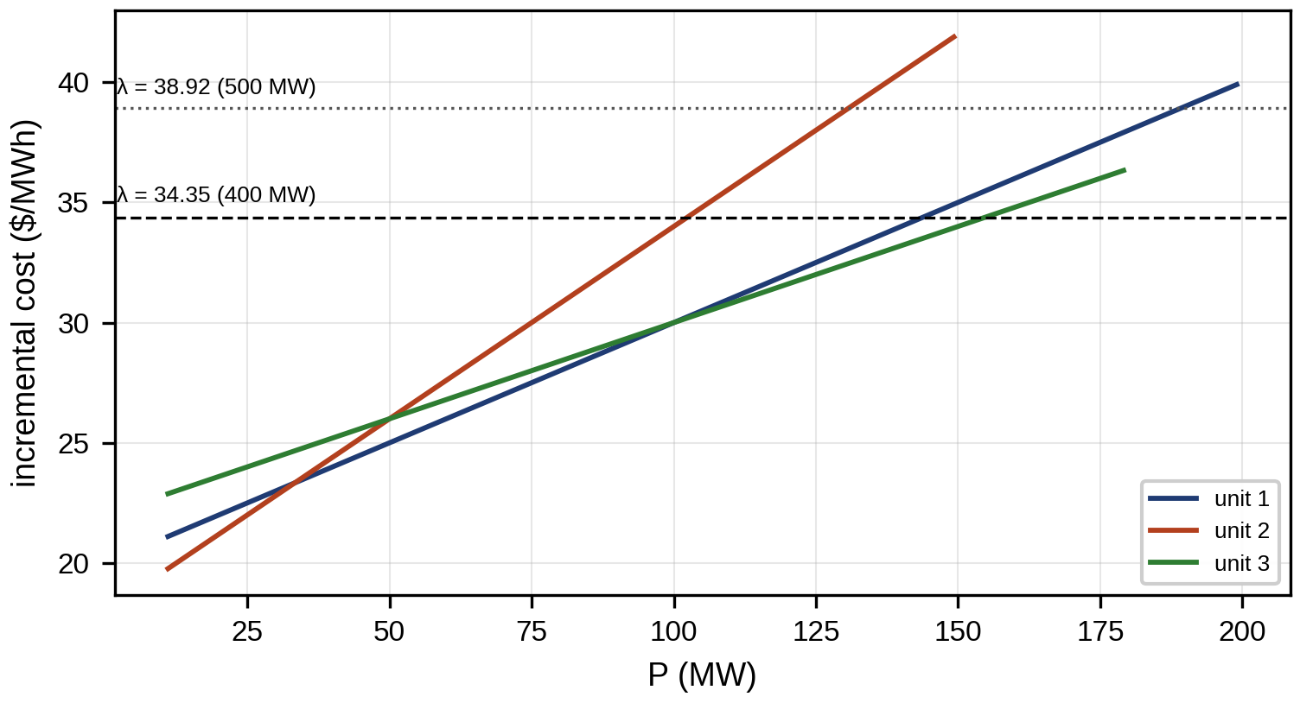
Figure 13.17. Incremental-cost curves of the three units with their limits: at 400 MW all run at λ = 34.35 $/MWh; at 500 MW unit 3 is at its limit and λ rises to 38.92 $/MWh.

13.12.2 Reserve, ramp limits and unit commitment
Real dispatch adds three kinds of constraint. A spinning reserve requirement keeps enough headroom online to cover the largest credible loss, i​Pimax−Pi≥Rreq. Ramp limits couple successive periods, $\left|P_{i,t}−P_{i,t−1}\right|≤RR_{i}Δt$ with ramp rate $RR_{i}$. And minimum output means a unit is either off or at least at $P_{i}^{min}$, which cannot be written with continuous variables alone. With an on/off variable $u_{i,t}∈\{0,1\}$, a start-up indicator $s_{i,t}$ and start-up cost $C_{i}^{SU}$,
 | min t​i​CiPi,t+CiSUsi,t s.t. ui,tPimin≤Pi,t≤ui,tPimax, si,t≥ui,t−ui,t−1, | (13.51)
with balance, reserve, ramp and minimum up- and down-time constraints, is the unit-commitment problem, a mixed-integer program. Its continuous relaxation is convex, but the integer problem is not, and it is solved by branch-and-bound with a stated optimality gap. Once the commitment is fixed, the remaining dispatch is again the convex problem of Section 13.12.1, whose multipliers give prices.

13.12.3 Merit order, optimal power flow and locational prices
A merit-order dispatch sorts resources by marginal cost and uses the cheapest first (Figure 13.18). It is transparent and adequate when resources have no time coupling.
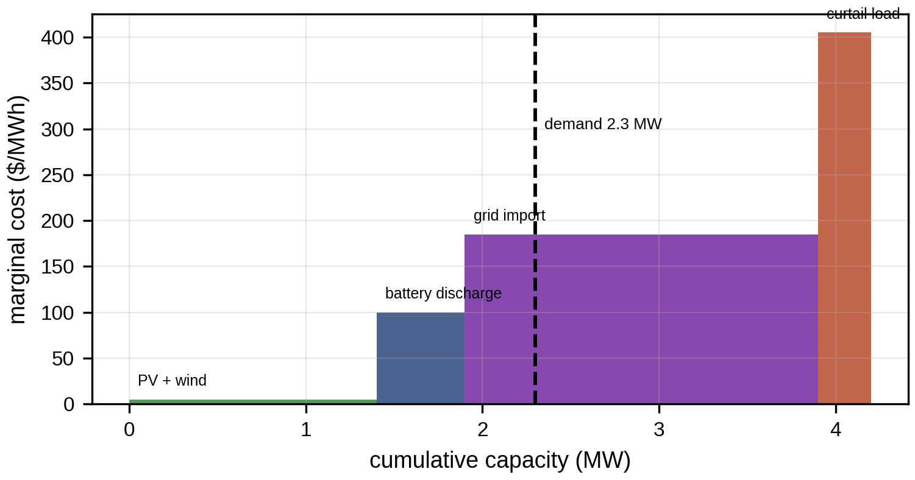
Figure 13.18. Merit order of the P-1 microgrid’s resources at one hour: PV and wind at near-zero marginal cost (drawn as a small step for visibility), battery discharge at its opportunity cost, grid import at the tariff and curtailable load at its value, with the demand line setting the marginal resource.
Batteries, EVs and flexible loads couple time, because energy used now is not available later. Network limits couple space. Both break the merit order, and the microgrid energy management system (EMS) of Chapter 11 (Section 11.17) solves an optimization instead, with power balance, storage dynamics, reserve and network constraints over a horizon.
Economic dispatch balances total power but ignores where it flows. Optimal power flow (OPF) adds the network:
 | min i​CiPg,i s.t. AC power-flow equations (Chapter 11, Section 11.5), Vimin≤Vi≤Vimax, Sik≤Sikmax, generator limits, | (13.52)
a nonconvex problem because the power-flow equations are nonlinear. The DC-OPF replaces them with the linear DC flow of Chapter 11 (Section 11.20):
 | min i​CiPg,i s.t. Pg−Pd=B′θ, θi−θkxik≤Fikmax, Pg,imin≤Pg,i≤Pg,imax, | (13.53)
a linear or quadratic program that gives each bus its own locational marginal price (LMP), the multiplier of that bus’s balance. Written with the PTDFs of Chapter 11, the LMP at bus $n$ separates into the energy price at the reference bus and a congestion component,
 | LMPn=λref−ℓ​μℓ PTDFℓ,n, | (13.54)
where $μ_{ℓ}$ is the multiplier of line $ℓ$’s flow limit; without congestion every LMP equals $λ_{ref}$ (losses neglected).
Relaxations of the AC-OPF are useful but must be used with care. In radial distribution networks the branch-flow (DistFlow) model of Chapter 11 writes the flow equations in terms of squared voltages $v_{i}=V_{i}^{2}$ and squared currents $ℓ_{ij}={\left|I_{ij}\right|}^{2}$, with the one nonconvex relation $ℓ_{ij}v_{i}=P_{ij}^{2}+Q_{ij}^{2}$. Relaxing it to the second-order cone $ℓ_{ij}v_{i}≥P_{ij}^{2}+Q_{ij}^{2}$ gives a convex SOCP. The relaxation is exact (the inequality holds with equality at the optimum) under conditions that often hold in radial networks with no binding upper voltage bounds and cost increasing in losses, but not in general: meshed networks, reverse flows with binding voltage limits, discrete devices (taps, capacitor steps) and some voltage-dependent loads can make it inexact, so the twin must check the equality at the solution and recover a feasible AC operating point if it fails. DER set-points enter as bounded variables with the inverter’s apparent-power capability $P_{i}^{2}+Q_{i}^{2}≤S_{i,max}^{2}$, itself a second-order cone, and with the active- and reactive-power response modes required by the connection code (IEC TS 62786-1 and national grid codes), not as free abstract numbers. Unbalanced three-phase feeders need three-phase formulations, with phase voltages and phase-coupled impedances.
Example 13.6 Locational prices in a congested three-bus network
Given. Three buses connected by three identical lines. A cheap generator (20 $/MWh, up to 300 MW) at bus 1, an expensive one (40 $/MWh, up to 300 MW) at bus 2, and a 250 MW load at bus 3. The line from bus 1 to bus 3 is limited to 100 MW.
Find. The DC-OPF dispatch, flows and LMPs.
Solution. With equal reactances, power injected at bus 1 and withdrawn at bus 3 flows two-thirds on the direct line and one-third via bus 2, and power from bus 2 splits the other way. The flow on line 1–3 is therefore $\left(2P_{1}+P_{2}\right)/3=\left(P_{1}+250\right)/3$, which the 100 MW limit caps at $P_{1}=50$ MW. The expensive unit supplies the other 200 MW. The LMPs are 20 $/MWh at bus 1, 40 $/MWh at bus 2 and 60 $/MWh at bus 3. Supplying one more MW at bus 3 requires $+2$ MW from bus 2 and $−1$ MW from bus 1 to keep line 1–3 at its limit: $2×40−20=60$. The flows are 100 MW on line 1–3 (at its limit), 150 MW on line 2–3 and 50 MW from bus 2 to bus 1. The same result follows from (13.54): with bus 1 as reference and flows positive from the lower- to the higher-numbered bus, the PTDFs of line 1–3 for injection at buses 2 and 3 (withdrawn at bus 1) are $−1/3$ and $−2/3$, the line’s multiplier is $μ=60$ $/MWh per MW, and ${LMP}_{2}=20+60/3=40$, ${LMP}_{3}=20+2×60/3=60$ $/MWh. The congestion rent collected on the line is $μ×100=6000$ $/h. The solution is the global optimum of the LP.
Interpretation. Figure 13.19 summarizes the result. The price at the load exceeds both generators’ costs, a counter-intuitive but correct consequence of the network constraint. An ED that ignores the network would dispatch 250 MW from the cheap unit and load line 1–3 to 167 MW, 67 % above its limit. Price signals sent by a microgrid EMS to flexible resources must therefore be locational when the network is congested.
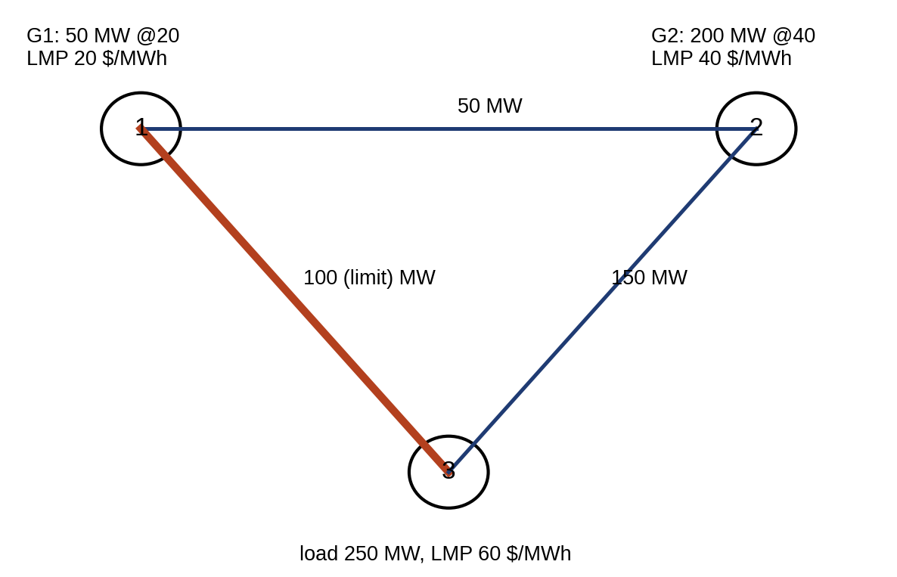
Figure 13.19. The congested three-bus network of Example 13.6: dispatch, line flows with the binding limit on line 1–3, and locational marginal prices at each bus.
Table 13.4 summarizes the optimization classes that appear in this chapter.
TABLE 13.4 Optimization classes used in this chapter
Class | Convexity | Typical energy application | Solver implication
LP | Convex | DC-OPF, battery arbitrage, EMS | Global optimum; simplex or interior point; duals are prices
QP | Convex if Hessian $≽0$ | Economic dispatch, linear MPC | Global optimum; active set, interior point, ADMM (OSQP)
SOCP | Convex | Relaxed radial OPF, inverter capability, some chance constraints | Global optimum of the relaxation; check exactness
NLP | Generally nonconvex | AC-OPF, nonlinear MPC | Local optimum; depends on starting point
MILP / MIQP | Nonconvex (integers) | Unit commitment, battery with binaries, switching | Branch-and-bound; report optimality gap

13.13 Battery, EV and Microgrid Energy Management

13.13.1 Battery scheduling and arbitrage
A battery bought low and sold high earns the spread minus losses and wear. Over hourly intervals $t$ with price $π_{t}$, charge and discharge powers $p_{t}^{ch},p_{t}^{dis}≥0$ and stored energy $E_{t}$,
 | max t​πtptdis−ptchΔt−cdegt​ptch+ptdis2Δt, | (13.55)
subject to $E_{t+1}=E_{t}+\left(ηp_{t}^{ch}−p_{t}^{dis}/η\right)Δt$, power and energy limits, and a terminal condition $E_{T}=E_{0}$. The round-trip efficiency $η^{2}$ means that a cycle pays only if
 | $$π^{sell}>\frac{π^{buy}}{η^{2}}+c_{deg},$$ | (13.56)
a spread condition that at 95 % one-way efficiency, a 0.08 $/kWh buy price and 16 $/MWh wear requires a sell price above 0.105 $/kWh. Charging and discharging in the same hour wastes energy through losses, so with positive prices, positive wear cost and no other incentive, the LP has no reason to do it: reducing both by the same amount keeps the energy balance feasible and lowers cost. That argument fails when wasting energy has value: at negative prices, when curtailment carries a penalty and export is capped, when a reserve product pays for headroom, or when subsidies reward throughput. Binary variables $z_{t}$ with $p_{t}^{ch}≤P_{max}z_{t}$ and $p_{t}^{dis}≤P_{max}\left(1−z_{t}\right)$ then forbid simultaneous operation where the hardware cannot do both at once, at the price of a mixed-integer program.
Real assets add constraints the simple model omits. The allowed charge power falls near full SOC and the discharge power near empty (the constant-voltage phase and the voltage limits), $p_{t}^{ch}≤P_{max}^{ch}\left(E_{t}\right)$, which is convex when the limit is concave in $E_{t}$ and is usually approximated piecewise linearly. Power limits also fall at low and high temperature, and efficiency varies with power and SOC, which an efficiency map from the twin captures. A state-of-power (SOP) reserve from Chapter 9 keeps headroom for grid services, and a separate energy reserve keeps islanding capability (Chapter 11). Finally, the hard terminal condition $E_{T}=E_{0}$ is arbitrary: tomorrow’s value of stored energy is uncertain. A more honest formulation values the terminal energy, adding $+v_{T}E_{T}$ to the objective with $v_{T}$ an estimate of its value tomorrow, or requires $E_{T}$ to exceed a robust minimum that covers tomorrow’s first-hour needs in a pessimistic scenario.
TABLE 13.5 Synthetic day-ahead price profile used in Examples 13.2, 13.7 and 13.12
Hour | 0 | 1 | 2 | 3 | 4 | 5 | 6 | 7 | 8 | 9 | 10 | 11 | 12 | 13 | 14 | 15 | 16 | 17 | 18 | 19 | 20 | 21 | 22 | 23
$/MWh | 70 | 60 | 50 | 50 | 60 | 70 | 90 | 110 | 120 | 100 | 90 | 80 | 80 | 80 | 90 | 100 | 130 | 180 | 220 | 190 | 140 | 100 | 80 | 70
Example 13.7 A day of arbitrage for the P-1 battery
Given. The 0.5 MW, 1 MWh battery with 95 % one-way efficiency and 10 % minimum energy, starting and ending at 50 %; the price profile of Table 13.5; wear charged on both charge and discharge throughput at $c_{deg}\left(p^{ch}+p^{dis}\right)/2$, with $c_{deg}$ = 0, 16 and 30 $/MWh.
Find. Revenue, throughput and simultaneous charging hours for each degradation cost, and the effect of binary constraints and of one negative-price hour.
Solution. Solved as an LP with HiGHS (status optimal, a global optimum). Without a degradation cost the LP earns 150.5 $ with 2.20 MWh of throughput, about two full cycles. At 16 $/MWh, revenue is 144.9 $ with 1.80 MWh and 28.8 $ of wear, a net value of 116.1 $; the schedule optimized without wear but then charged for it would net only 115.2 $. At 30 $/MWh the battery makes one cycle less: 121.7 $ of revenue with 0.90 MWh and a net value of 94.6 $. No hour has simultaneous charge and discharge, and the mixed-integer version returns the same 150.5 $. With the 03:00 price set to −50 $/MWh, the LP earns 200.5 $, still without simultaneous operation, because the battery can absorb the negative-price energy by charging.
Interpretation. Figure 13.20 shows the schedules. Once wear is priced, the cycles with the thinnest margins disappear first, and throughput falls in steps (Figure 13.16). The binary variables were unnecessary here, but they cost little to include and prevent a physically meaningless schedule in the cases where prices or penalties make it attractive.
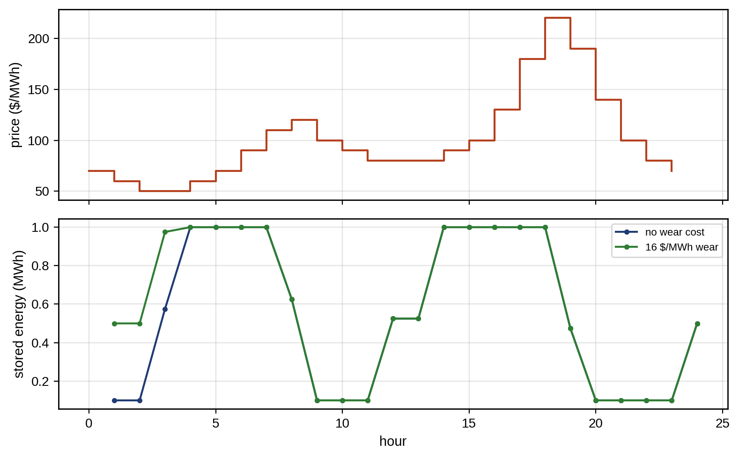
Figure 13.20. Battery arbitrage on the price day of Table 13.5: price (top) and stored energy with and without a wear cost of 16 $/MWh (bottom).

13.13.2 EV charging
Chapter 10 (Section 10.16) formulated smart charging as a linear program. A time-of-use (TOU) tariff adds a trap that every EV twin should know. Minimizing energy cost alone, with $n$ vehicles plugged in overnight,
 | minPi,k k​πkΔti​Pi,k s.t. k​ηPi,kΔt=Ereq,i, 0≤Pi,k≤Pmaxai,k, | (13.57)
leaves the timing within the cheap period undetermined, because nothing distinguishes one cheap slot from another; the solver returns one vertex of a large set of equally optimal schedules, and that vertex typically stacks vehicles at full power into the same slots, at the start or at the end of the period. The cure is to add a peak or a quadratic term, which breaks the tie in favour of valley filling at no extra energy cost:
 | J=k​πkΔti​Pi,k+γmaxkLk+i​Pi,k or J=k​πkΔti​Pi,k+γk​Lk+i​Pi,k2, | (13.58)
where $L_{k}$ is the base load and $γ$ a weight; the quadratic form flattens the total load as far as the vehicles’ availability allows.
The two terms in (13.58) are not economically equivalent. The quadratic term is a smoothing device: it spreads charging over the available hours (valley filling) and penalizes every kilowatt of load, large or small. The max term, written with an epigraph variable Ppk≥Lk+i​Pi,k for all $k$ and cost $γP_{pk}$, is what a demand charge actually bills: only the highest interval matters, and the problem remains an LP. A tariff with a demand charge should use the max term with $γ$ equal to the charge per kW; the quadratic term is used when the goal is a flat profile for the transformer’s thermal life. Real hubs add more: the transformer’s hot-spot temperature as a dynamic constraint rather than a fixed kW limit (Chapter 10), phase balance of single-phase chargers, power sharing among dispensers on one feeder, uncertain departure times, fairness (a minimum share for each user, or a max–min objective on the fraction of requested energy delivered) and, with bidirectional chargers, vehicle-to-grid discharge limited by the owner’s minimum departure SOC.
Example 13.8 TOU herding on a residential transformer
Given. Twenty EVs with arrival times uniform between 17:00 and 21:00, departures uniform between 06:00 and 08:00, and energy needs uniform between 10 and 30 kWh (398 kWh in total), all on 7.4 kW chargers with 92 % efficiency, generated with seed 6 and rounded to 15 minutes; household base load $35+40exp\left(−{\left(\left(t−19.5\right)/1.8\right)}^{2}\right)$ kW with $t$ in hours, peaking at 75 kW at 19:30; a 100 kVA transformer, taken as 100 kW because EV chargers and the residential base load are assumed to run near unity power factor. Tariff 0.30 $/kWh from 17:00 to 21:00, 0.18 until 23:00 and 0.10 from 23:00 to 08:00. Fifteen-minute intervals.
Find. The energy cost and peak load for uncontrolled charging, cost-only optimization, and cost optimization with a peak term of 0.5 $/kW or with a quadratic term.
Solution. Uncontrolled: 103.51 $ and a 163 kW peak at 19:45, above the transformer rating for 4.0 hours. Cost-only (LP): 43.24 $, but the solver’s schedule stacks the vehicles into the same cheap intervals and peaks at 183 kW (at 06:00 in this solution; other equally cheap vertices place the stack elsewhere), overloading the transformer for 3.0 hours. With the peak term: the same 43.24 $ and a peak of 85.2 kW, inside the rating. The quadratic term gives the same cost and peak and a flatter profile.
Interpretation. Figure 13.21 shows the load curves. A tariff designed to move load out of the evening peak creates a new, sharper peak inside the cheap period. The optimizer did nothing wrong: it was not told that the transformer mattered. The twin supplies the missing term, the transformer’s limit or its thermal model, and valley filling costs nothing.
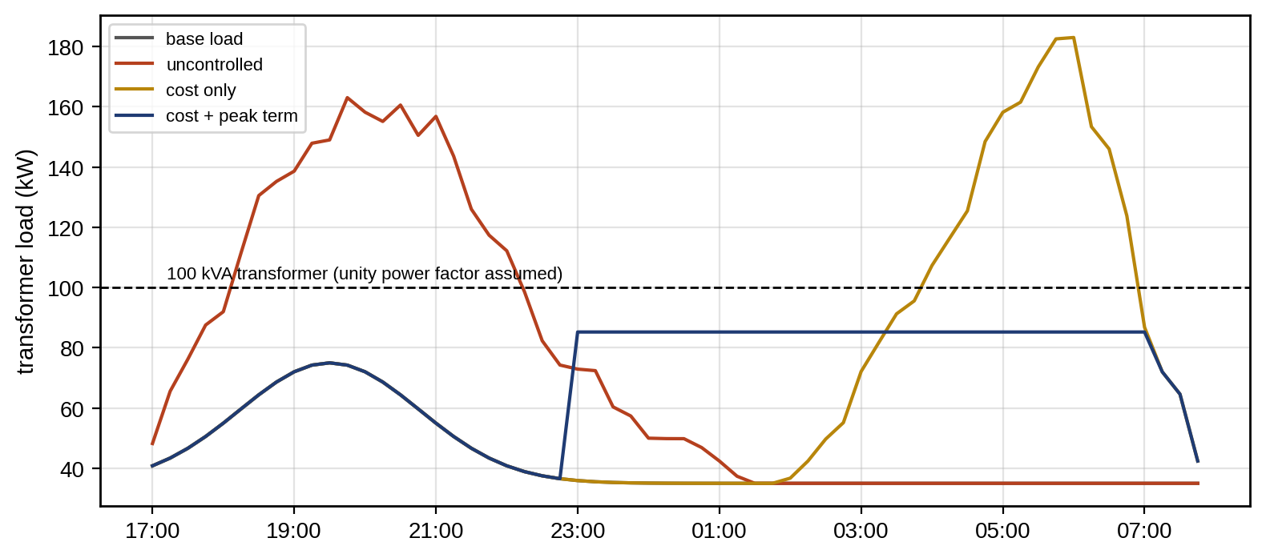
Figure 13.21. Transformer load under the TOU tariff (Example 13.8): uncontrolled charging (evening peak), cost-only optimization (a stacked peak inside the cheap period) and cost optimization with a peak term (valley filling), against the 100 kVA rating.

13.13.3 Network-aware microgrid EMS
A microgrid EMS combines the battery and EV problems with the site’s own network. Its decision variables are set-points for converters that are themselves controlled by fast inner loops, and the EMS normally assumes those loops track perfectly. That assumption is checked by the twin: each set-point must lie within the converter’s current, apparent-power and SOP limits at the predicted voltage and temperature, and a set-point change must be slower than the inner loop’s closed-loop bandwidth. With the LinDistFlow model of Chapter 11, bus voltages are linear in the injections, $v=v_{0}1+R_{v}p+X_{v}q$ with sensitivity matrices $R_{v}$ and $X_{v}$, so voltage limits $v_{min}≤v_{i}≤v_{max}$ become linear constraints on the EMS decisions, and reactive-power set-points join the problem within each inverter’s capability circle. In islanded operation, the EMS must also respect the roles of the converters: grid-forming units hold voltage and frequency and must keep power and current headroom to do so, while grid-following units follow set-points (Section 13.19).

13.14 Forecast Uncertainty, Scenarios, Chance Constraints and Recourse

13.14.1 Chance constraints
A microgrid that offers flexibility to a grid operator commits to a quantity it must deliver even though its available resources, PV in particular, are forecast with error. A chance constraint requires the commitment to be met with a stated probability:
 | $$P\left(P_{avail}≥P_{com}\right)≥1−α.$$ | (13.59)
If the available power is Gaussian with mean $μ$ and standard deviation $σ$, it becomes the deterministic constraint
 | $$P_{com}≤μ−z_{1−α}σ,$$ | (13.60)
with $z_{0.95}=1.645$ for 95 %. For a forecast of 800 kW with $σ=120$ kW, the microgrid may commit 602.6 kW. If the distribution is unknown and only its mean and variance are trusted, the one-sided Chebyshev (Cantelli) inequality gives a distribution-free bound, $P_{com}≤μ−\sqrt{\left(1−α\right)/α} σ$, which here allows only 277 kW. The gap between 603 and 277 kW is the price of not knowing the distribution. A calibrated forecast, one whose quantiles have been checked on data (Chapter 6, Section 6.15.2), is worth that much committed capacity. Joint chance constraints over many hours are harder, because a 95 % guarantee per hour gives far less than 95 % for the whole day. Bonferroni’s inequality gives a safe split of the risk over $T$ hours,
 | P⋂Tt=1Pavail,t≥Pcom,t≥1−t​αt, αt=αT, | (13.61)
so a 95 % daily guarantee over 24 hours needs 99.79 % per hour ($z=2.87$ instead of 1.645), a conservative but simple remedy; scenario methods are less conservative (Figure 13.22).
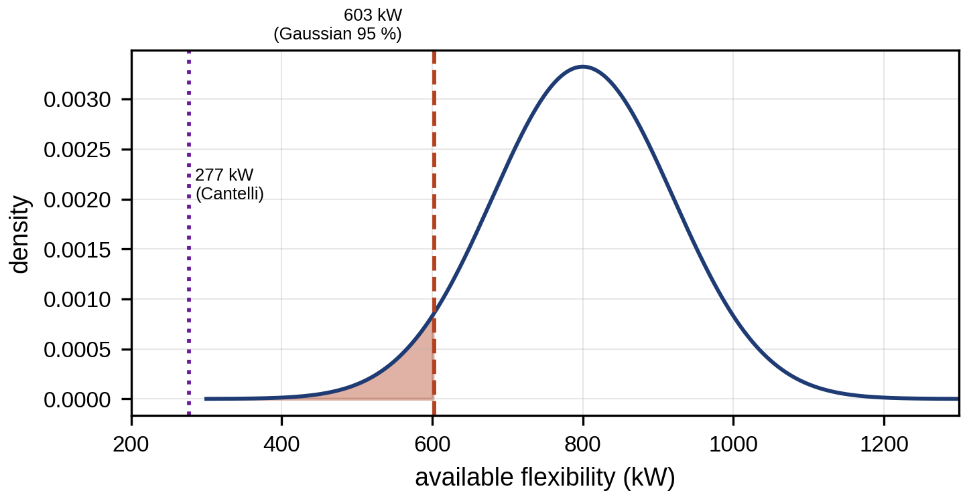
Figure 13.22. Chance-constrained commitment: distribution of available flexibility (mean 800 kW, σ 120 kW) with the 95 % Gaussian commitment at 603 kW and the distribution-free Cantelli commitment at 277 kW.
The Gaussian conversion (13.60) is exact only for its assumption: a scalar constraint that is affine in one Gaussian uncertainty. When the forecast error is skewed or heavy-tailed, the same $z$ gives a different violation rate, and the quantile should come from the empirical distribution of past forecast errors, $P_{com}≤μ+{\hat{q}}_{α}$, where ${\hat{q}}_{α}$ is the $α$-quantile of the observed errors (negative for a shortfall), or from a calibrated quantile forecast checked as in Chapter 6. Errors in successive hours are also correlated: a cloudy morning makes a cloudy afternoon likely. The Bonferroni split above is safe whatever the correlation, but conservative; scenario methods and copula-based trajectories account for the correlation directly.
Probabilistic forecasts enter the optimizer in three forms (Table 13.6). Quantile forecasts give the chance-constraint tightening directly. Scenario or trajectory forecasts give whole days sampled from the joint distribution, preserving temporal correlation; they are generated from marginal quantile forecasts by drawing correlated uniform variables through a Gaussian copula, in which a latent multivariate Gaussian with the empirical hour-to-hour correlation is mapped through each hour’s forecast quantiles. And ambiguity-set forecasts give a nominal distribution with a radius of doubt for DRO. A distributionally robust chance constraint requires the constraint to hold with probability $1−α$ under every distribution in the ambiguity set; with a moment-based set it reduces to the Cantelli form (13.42), and with a Wasserstein set around the empirical errors it becomes a conditional-value-at-risk constraint that is only slightly more conservative than the empirical quantile when enough data are available.
TABLE 13.6 Forecast types, metrics and their use
Forecast type | Output | Appropriate metric | Use in optimization
Point | One value per hour | RMSE, MAE | Deterministic plan
Quantile | Several quantiles per hour | Pinball loss, interval coverage | Chance constraints, reserves
Probabilistic trajectory | Sampled days with temporal correlation | CRPS, energy score, coverage of daily totals | Scenario and stochastic programs
Decision-focused | Point or quantiles trained for the decision | Realized decision cost (regret) | Specific downstream optimizer

13.14.2 Robust, stochastic and two-stage planning
A deterministic plan optimizes against the expected forecast and hopes. A robust plan optimizes against the worst case within an uncertainty set [8], for example PV at its 5th and load at its 95th percentile in every hour. It is safe but expensive, because such bad luck in every hour at once is very unlikely. A stochastic plan optimizes the expected cost over scenarios, with first-stage decisions made now and second-stage (recourse) decisions adapted to each scenario:
 | $$\min_{x} c^{T}x+E_{ξ}\left[\min_{y_{ξ}} q^{T}y_{ξ}\right]≈c^{T}x+\frac{1}{S}\sum_{s=1}^{S}{q^{T}}y_{s} \text{s.t.} T_{s}x+Wy_{s}=h_{s},$$ | (13.62)
where $x$ is the first-stage decision (a day-ahead purchase schedule), $y_{s}$ the recourse in scenario $s$ (battery dispatch and real-time imbalance), $q$ their costs and the right-hand side the sample average over $S$ scenarios. A robust plan with box uncertainty $ξ_{t}∈\left[{\underline{ξ}}_{t},{\overset{‾}{ξ}}_{t}\right]$ in a linear constraint $a^{T}x+ξ_{t}≤b$ replaces $ξ_{t}$ by its worst value, $a^{T}x+{\overset{‾}{ξ}}_{t}≤b$, which is why it pays for the worst hour in every hour.
The scenario approach sits between the robust and stochastic plans. Its guarantee is a theorem with precise assumptions [16]: the problem must be convex in the decision variables, the $S$ scenarios independent and identically distributed samples of the uncertainty, and the solution unique. Then, with $d$ the number of decision variables, the probability that the optimal solution violates the constraint for a new sample exceeds $ε$ with probability at most $\sum_{i=0}^{d−1}{\left({S \atop i}\right)}ε^{i}{\left(1−ε\right)}^{S−i}$, and a sufficient sample size for this to be below $β$ is
 | $$S≥\frac{2}{ε}\left(ln\frac{1}{β}+d\right),$$ | (13.63)
so 24 hourly decisions with $ε=5$ % and $β={10}^{−6}$ need $\left(2/0.05\right)\left(13.8+24\right)≈1500$ scenarios (Figure 13.23).
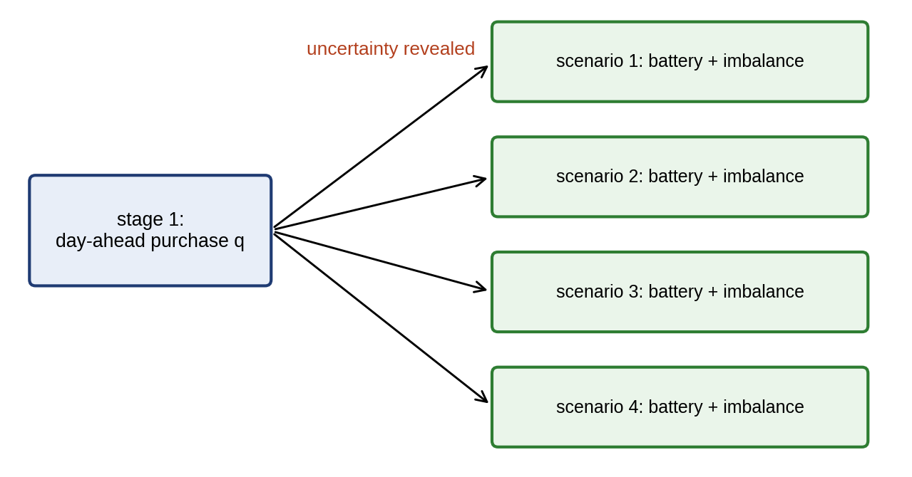
Figure 13.23. Two-stage decision structure: first-stage day-ahead purchase decided before the uncertainty is revealed, and second-stage battery dispatch and imbalance adapted to each scenario.
The bound uses the number of decision variables $d$ because at most $d$ scenarios can be support constraints that determine the solution; problems whose solution is fixed by fewer support constraints admit smaller $S$, and the bound does not hold for nonconvex problems or for scenarios that are not independent samples.
The value of the stochastic solution, $VSS=EEV−RP$, compares the expected cost of the deterministic plan (EEV) with that of the stochastic one (RP). The expected value of perfect information, $EVPI=RP−WS$, compares the stochastic plan with the wait-and-see cost of deciding after the uncertainty is revealed [9].
Example 13.9 Buying tomorrow’s energy under PV uncertainty
Given. P-1 buys a day-ahead schedule at the TOU prices of the microgrid case (0.10, 0.18 and 0.30 $/kWh); shortfalls are bought in real time at twice the day-ahead price and surpluses sold at 0.03 $/kWh. The battery (0.5 MW, 1 MWh, 95 % one-way efficiency, 10 % minimum energy, start at 50 %, end at least 50 %, wear 16 $/MWh) is the recourse. Load follows the profile of Table 13.10 with independent hourly noise of 5 %; PV is the clear-sky profile of 1.2 MWp scaled by a day-wide cloud factor $N\left(1,{0.25}^{2}\right)$ clipped to [0.2, 1.3] and by independent hourly noise of 8 %. Plans are optimized on 40 in-sample scenarios (seed 1) and all are evaluated on 300 independent out-of-sample scenarios (seed 2), by solving the recourse LP in each. The robust plan uses the 5th percentile of PV and 95th of load in every hour.
Find. The expected cost of the deterministic, robust and stochastic plans, the VSS and the EVPI.
Solution. All problems are LPs solved to optimality with HiGHS. Deterministic: 2107 $ (day-ahead purchase 10.48 MWh). Robust: 2571 $ (15.79 MWh bought, much of it sold back cheaply), 22 % more, but with the lowest 95th-percentile cost (2672 $ against 3102 $ for the deterministic plan). Stochastic: 2090 $ (10.53 MWh). The VSS is therefore 16 $ per day. The wait-and-see cost is 1854 $, so the EVPI is 236 $.
Interpretation. Figure 13.24 compares the plans. The stochastic plan improves on the deterministic one only slightly, because the battery already absorbs most forecast errors in real time. The robust plan pays 22 % more on average, but it is the only one that protects against the worst days, a choice that matters if the site cannot afford a bad day. The large EVPI says that a better forecast is worth far more than a better optimizer, up to 236 $ a day, which bounds what forecast improvement is worth paying for. These conclusions are specific to this price structure and battery size; with a smaller battery or a steeper imbalance price the VSS grows.
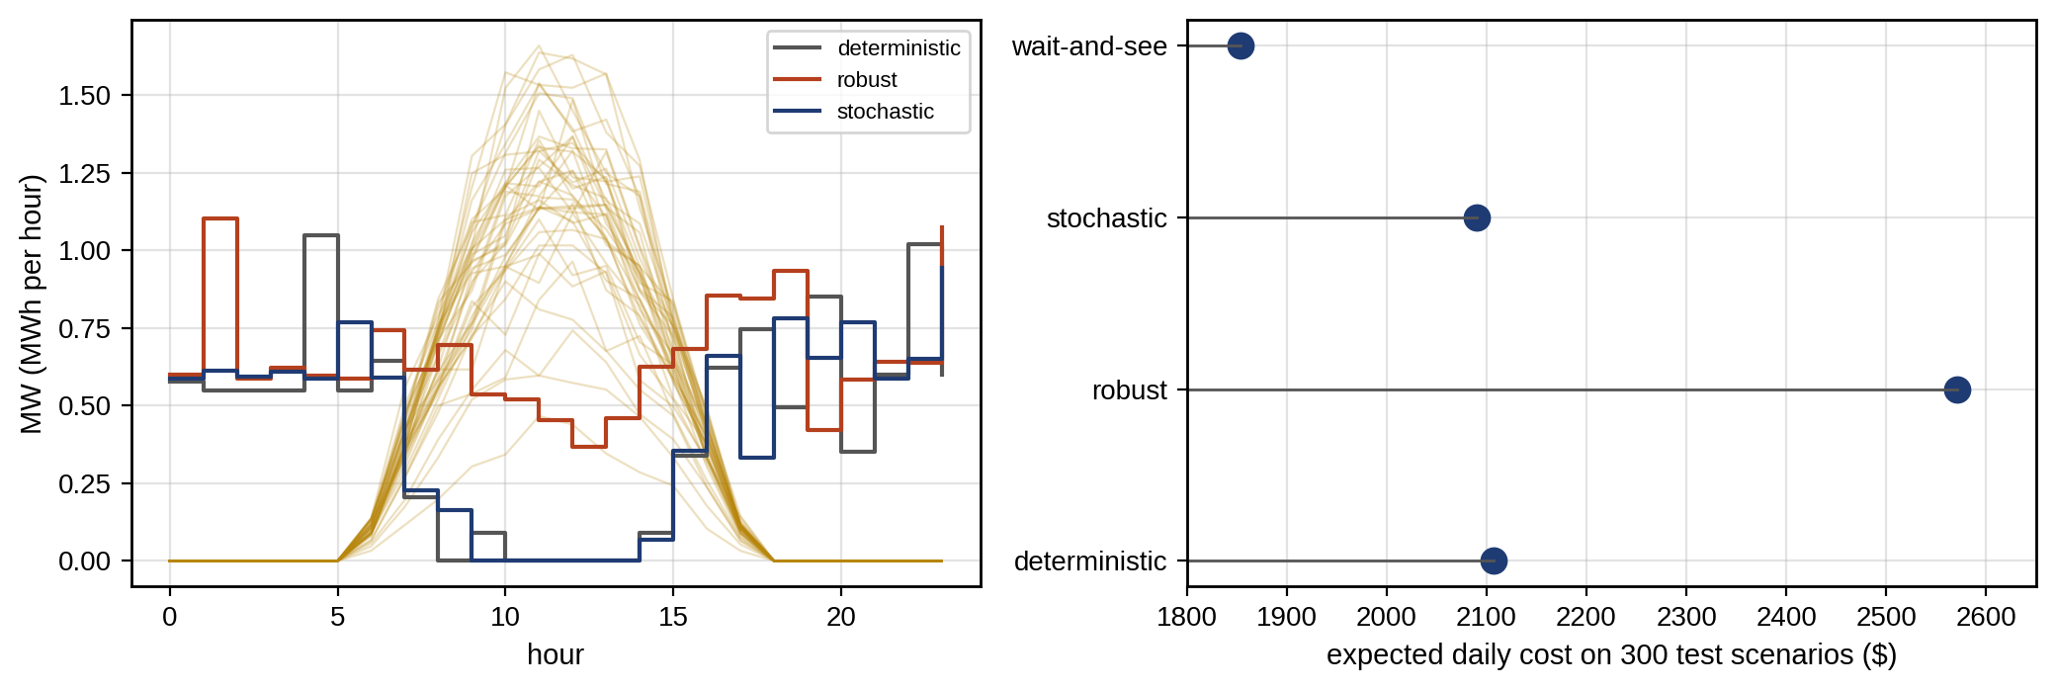
Figure 13.24. Day-ahead purchase schedules of the deterministic, robust and stochastic plans with the in-sample PV scenarios (left), and their expected costs on 300 out-of-sample scenarios with the wait-and-see bound (right).

13.14.3 Decision-focused forecasting
The usual pipeline is forecast, then optimize: train a forecaster to minimize a statistical loss such as RMSE, then feed its output to the optimizer. Forecast accuracy is not the same as decision quality, because the optimizer’s decision depends on the forecast only through a few comparisons (is the spread large enough to cycle? will the reserve cover the shortfall?), and errors that change those comparisons cost money while others cost nothing.
Example 13.10 Two forecasts, similar accuracy, different profit
Given. A 1 MWh battery with 90 % round-trip efficiency decides whether to buy 1 MWh in hour 1 and sell 0.9 MWh in hour 2. It cycles if the forecast hour-2 price exceeds the hour-1 price divided by 0.9. True prices are 100 and 130 $/MWh. Three forecasts: A = (110, 140), B = (105, 115), C = (100, 112) $/MWh.
Find. Each forecast’s RMSE and realized profit.
Solution. A: errors (10, 10), RMSE 10.0; it cycles because $140>110/0.9=122.2$, and the realized profit is $0.9×130−100=17$ $. B: errors (5, −15), RMSE 11.2; since $115<105/0.9=116.7$, it stays idle and earns 0. C: errors (0, −18), RMSE 12.7, the least accurate; since $112>100/0.9=111.1$, it cycles and earns 17 $ (Figure 13.25).
Interpretation. The most accurate forecast after A (B) loses the whole profit, while the least accurate (C) keeps it, because what matters is the sign of the predicted spread relative to the break-even, not the size of the errors.
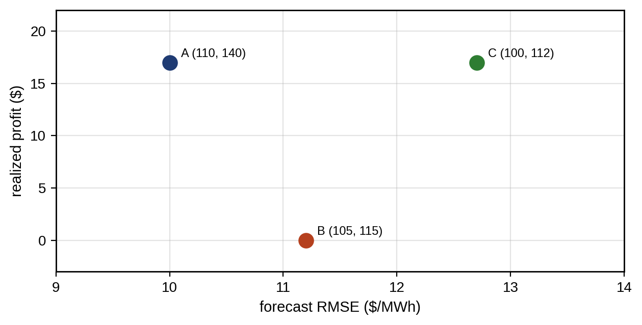
Figure 13.25. Decision-focused forecasting (Example 13.10): forecast RMSE against realized profit for three forecasts of a two-hour price.
Decision-focused learning trains the forecaster on the realized cost of the decisions it induces, the regret against perfect-information decisions. Because the decision is the solution of an optimization, training needs the derivative of that solution with respect to the forecast, obtained by differentiating the KKT conditions of a convex problem (differentiable optimization layers), by smoothing the problem, or by surrogate losses such as SPO+ for linear objectives [20]. The approach is research and early adoption: it needs the downstream optimizer fixed and known, it can overfit to one decision problem, and a forecast trained for one decision may be poor for another. The honest baseline is always a well-calibrated forecast-then-optimize pipeline.

13.15 Multi-objective Optimization and Pareto Analysis
Energy management rarely has one objective. Cost, emissions, battery wear, comfort and grid support compete. A solution is Pareto-optimal if no objective can be improved without worsening another, and the set of such solutions is the Pareto front. Two methods trace it:
 | min m​wmJm (weighted sum), min J1 s.t. Jm≤εm, m≥2 (ε-constraint), | (13.64)
where $J_{m}$ are the objectives, $w_{m}$ non-negative weights and $ε_{m}$ bounds. The weighted sum finds only the convex part of the front and often jumps between a few solutions of linear programs. The $ε$-constraint method traces the whole front by sweeping the bounds, and its multipliers are the marginal trade-off rates, for example the cost of abating one tonne of CO₂. On a front traced by the $ε$-constraint method, the local trade-off rate equals the multiplier of the bound,
 | $$\frac{∂J_{1}^{*}}{∂ε_{m}}=−μ_{m},$$ | (13.65)
which for a cost–CO₂ front is the marginal abatement cost in $ per tonne. The final choice among Pareto-optimal points is a value judgment, which the twin supports but does not make, often guided by a knee, where further gains in one objective become expensive in another (Section 13.24).
Two practical points decide whether a front helps a decision. First, scaling: a weighted sum of objectives in different units (dollars, tonnes, MWh of wear) depends entirely on those units, so objectives are normalized before weighting, ${\tilde{J}}_{m}=\left(J_{m}−J_{m}^{U}\right)/\left(J_{m}^{N}−J_{m}^{U}\right)$, with the utopia value $J_{m}^{U}$ (the best achievable for objective $m$ alone) and the nadir value $J_{m}^{N}$ (its worst value among the individual optima). Second, the knee is not uniquely defined; if one is reported, its definition must be stated. In this chapter the knee is the point of the normalized front with the largest perpendicular distance to the straight line joining its two extreme points, a common and reproducible choice. Fronts from different methods or plans are compared by their hypervolume, the area (or volume) dominated by the front and bounded by a reference point, larger being better. The final preference remains a human value judgment.

13.16 Distributed and Hierarchical MPC
A single optimizer for many microgrids, buildings or EV hubs needs all their models, data and decisions in one place, which raises problems of scale, privacy, communication and single points of failure. Three architectures are possible (Figure 13.26). Centralized MPC solves one problem for everyone. Decentralized MPC lets each subsystem solve its own problem and ignore the coupling, which is simple but loses optimality and can violate shared limits. Distributed MPC (DMPC) lets each subsystem solve its own problem and coordinate with its neighbours through the coupling variables, such as the power on a shared tie-line, until they agree.
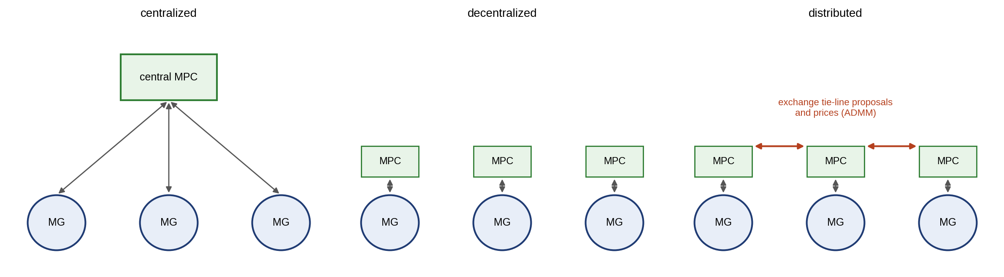
Figure 13.26. Centralized, decentralized and distributed MPC for three microgrids: one central optimizer, independent local optimizers, and local optimizers that exchange tie-line proposals and prices with their neighbours.
The alternating direction method of multipliers (ADMM) [17] is the most used coordination scheme. Two subsystems with local costs $f_{1}\left(x_{1}\right)$ and $f_{2}\left(x_{2}\right)$ must agree on a shared variable $z$ ($x_{1}=z$, $x_{2}=z$). With scaled dual variables $u_{1}$, $u_{2}$ and penalty $ρ>0$, each iteration solves
 | xik+1=argminxi fixi+ρ2xi−zk+uik2, zk+1=ΠZ12i​xik+1+uik, uik+1=uik+xik+1−zk+1, | (13.66)
where $Π_{Z}$ projects onto the tie-line limits. Each subsystem solves only its own problem and sends only $x_{i}$ and $u_{i}$; at convergence $ρu_{i}$ is the local price of the shared variable. For convex problems ADMM converges for any $ρ>0$, though its speed depends strongly on $ρ$.
Example 13.11 Two microgrids sharing a tie-line
Given. Microgrid 1 serves a 20 MW load with a generator costing $20P+0.05P^{2}$ $/h; microgrid 2 serves 30 MW with a generator costing $40P+0.05P^{2}$ $/h. A tie-line carries up to 15 MW from 1 to 2. Microgrid 1 chooses its export $x_{1}$, microgrid 2 its import $x_{2}$, and ADMM (13.66) with $ρ=0.5$ coordinates the agreed flow $z$, starting from $z=0$, $u=0$.
Find. The centralized solution, the first ADMM iterations and the converged prices.
Solution. Centralized: equal marginal costs, $20+0.1\left(20+t\right)=40+0.1\left(30−t\right)$, would need $t=105$ MW, so the tie-line limit binds and $t=15$ MW. ADMM, first iteration: microgrid 1 alone would like to export $x_{1}=−36.7$ MW (it wants to import cheap power it believes is free, since $z=0$ carries no price yet) and microgrid 2 to import 71.7 MW; the projected average is $z=15$. Second iteration: $x_{1}=18.9$, $x_{2}=36.9$; third: 15.6 and 18.7; by the fifth iteration both are within 0.1 MW of $z=15$ MW. The converged scaled duals give the local prices $ρu_{1}=−23.5$ and $ρu_{2}=41.5$ $/MWh, which are exactly the two microgrids’ marginal generation costs, $20+0.1×35=23.5$ and $40+0.1×15=41.5$ $/MWh; the 18 $/MWh difference is the tie-line’s congestion price.
Interpretation. Neither microgrid revealed its cost function, only proposals and prices, which is the privacy argument for DMPC. In practice communication delay and loss, asynchronous updates, strategic agents who misreport, and the need to stop after a fixed number of iterations (with a feasible, not optimal, agreement) dominate the design, and DMPC schemes are validated in HIL with the real communication network before deployment.

13.17 Reinforcement Learning: from Q-learning to Safe RL

13.17.1 Markov decision processes and Q-learning
Reinforcement learning (RL) learns a control policy from interaction instead of from an explicit model. The problem is a Markov decision process with states $s$, actions $a$, rewards $r\left(s,a\right)$ and transitions $s′∼P\left(⋅∣s,a\right)$. The optimal action-value function satisfies Bellman’s optimality equation,
 | $$Q^{*}\left(s,a\right)=E\left[r\left(s,a\right)+γ\max_{a′}Q^{*}\left(s′,a′\right)\right],$$ | (13.67)
with discount factor $γ≤1$, and tabular Q-learning approximates it from samples by the update
 | $$Q\left(s,a\right)←Q\left(s,a\right)+α_{lr}\left[r+γ\max_{a′}Q\left(s′,a′\right)−Q\left(s,a\right)\right],$$ | (13.68)
where $α_{lr}$ is the learning rate and actions are chosen $ε$-greedily: with probability $ε$ a random admissible action, otherwise the action with the highest current $Q$. Tabular Q-learning converges to $Q^{*}$ when every state–action pair is visited infinitely often and the learning rate decays appropriately.
Example 13.12 Q-learning against the optimum for battery arbitrage
Given. The arbitrage problem of Example 13.7 without degradation cost. Stored energy is discretized in 0.1 MWh steps from 0.1 to 1.0 MWh; three actions per hour change the stored energy by $−0.4$, 0 or $+0.4$ MWh, costing $+0.4/0.95$ MWh of purchase when charging and earning $0.4×0.95$ MWh of sales when discharging; actions that leave the energy range are not admissible. The episode is one day starting at 0.5 MWh, with a terminal penalty of 500 $ per 0.1 MWh away from 0.5 MWh at the end. Undiscounted ($γ=1$), learning rate $α_{lr}=0.1$, $ε$ falling linearly from 1 to 0.05 over the first 10 000 episodes, $Q$ initialized to zero, 40 000 episodes, five training seeds (0 to 4); the greedy policy is evaluated every 250 episodes.
Find. The profit of the Q-learned greedy policy against the exact dynamic-programming optimum over the same discrete actions and against the continuous LP.
Solution. Backward dynamic programming over the 24 hours gives the discrete optimum, 130.85 $. In all five seeds the greedy policy reaches this value by 1000 episodes (by 500 in one seed, which fell back to about 127 $ at 750 episodes before regaining it); the final profit is 130.85 $ in every seed, with the same action sequence as the DP solution. The continuous LP earns 150.47 $, so the coarse action set costs 13 % (Figure 13.27).
Interpretation. Where an accurate model and a convex formulation exist, RL rediscovers what an optimizer computes directly, after about a thousand simulated days even for this tiny problem (larger ones need millions), which in practice come from a twin, not from the plant. Its limitation here is the discretization, not the learning.
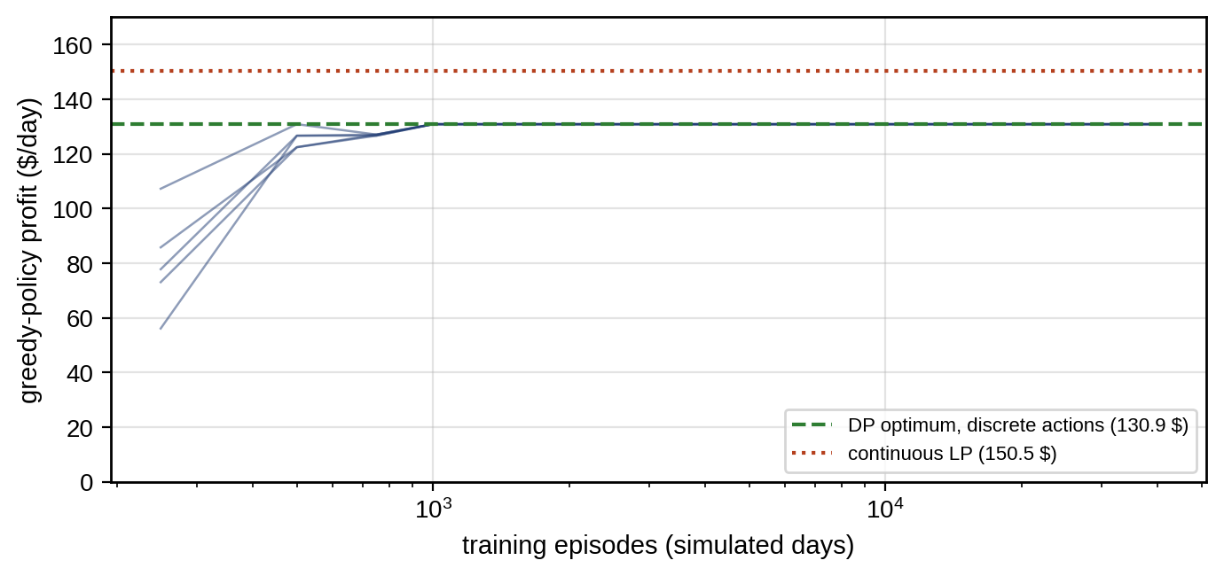
Figure 13.27. Q-learning on the battery arbitrage problem over five training seeds: greedy-policy profit against training episodes, reaching the dynamic-programming optimum for the discrete action set, with the continuous LP optimum above it.

13.17.2 Safe reinforcement learning
The statement that RL is useful when the model is unknown is incomplete in a digital-twin setting. Model-free RL still needs experience, and experience gathered by exploring on a real power system is unsafe. In practice RL agents for energy systems are trained offline or in simulation, on the twin, and the question becomes whether the policy transfers. Modern practice builds a sequence of safeguards around the learning.
Function approximation and actor–critic methods. Deep RL replaces the table with neural networks: an actor $π_{θ}\left(a∣s\right)$ that outputs actions (continuous set-points) and a critic $Q_{ϕ}\left(s,a\right)$ that estimates their value, trained together (for example by deterministic or soft actor–critic methods). This scales to large state spaces at the cost of sample efficiency, stability and interpretability [10].
Constrained MDPs. Safety is expressed as constraints on expected cumulative costs, maxπ Et​γtrt subject to Et​γtct≤Cmax, with a constraint cost $c_{t}$ (for example, a voltage violation) and budget $C_{max}$. A Lagrangian relaxation adjusts a multiplier on the constraint during training. The guarantee is in expectation, which permits individual violations, so a CMDP policy alone is not a safety mechanism for hard limits.
Safety layers and shields. The learned action $a_{RL}$ is passed through a safety filter that returns the closest action the twin certifies as safe,
 | $$a_{safe}=arg\min_{a∈A_{safe}\left(x\right)}\left.∥a−a_{RL}\right.∥^{2},$$ | (13.69)
where $A_{safe}\left(x\right)$ is the set of actions from which the constraints can be satisfied for the rest of the horizon.
The filter is itself a small MPC or a control-barrier-function QP, solved at every step with the twin’s model and constraints, and it is what gives the hard guarantee, within the accuracy of the twin (Figure 13.28). Safety during exploration is a separate problem from safety of the final policy: a shield can protect both, but a policy trained without the shield may rely on it heavily and perform badly when the shield is active.
Model-based and MPC-guided RL. Model-based RL learns or uses a dynamics model to plan, which is far more sample-efficient; MPC-guided RL uses MPC as the expert the policy imitates, or uses RL to tune MPC weights, horizon or terminal cost, keeping MPC’s constraint handling.
Offline RL. Learning only from logged operating data avoids exploration entirely, but the policy is trustworthy only near the states and actions in the log; conservative offline algorithms penalize actions the data do not support, and the policy must be evaluated for distribution shift before deployment.
Multi-agent RL. Many agents (EV chargers, buildings, inverters) learning simultaneously face a non-stationary environment, since each one’s environment includes the others’ changing policies; coordination through shared rewards, centralized training with decentralized execution, or market-like signals is an active research area.
The evidence required before any RL policy reaches a plant is the same as for any controller, and more: evaluation on held-out scenarios not used in training; comparison against an optimization baseline (LP or MPC) on the same scenarios; constraint-violation statistics with and without the shield; worst-case behaviour, not only average return; and HIL testing with the real controller hardware.
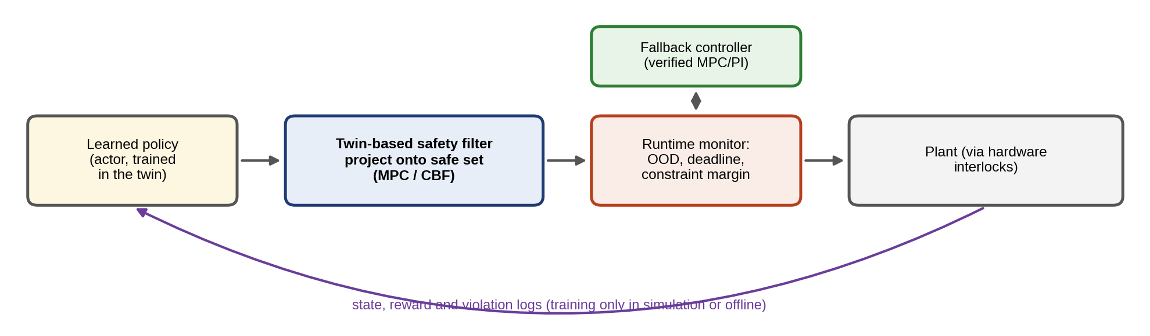
Figure 13.28. Safe-RL architecture: a learned policy trained in the twin proposes an action, a twin-based safety filter projects it onto the safe set, a runtime monitor checks distribution shift, deadline and constraint margin and hands over to a verified fallback controller when needed, and hardware interlocks guard the plant.

13.18 Learning-based MPC
MPC is only as good as its model, and learning offers better models; learning is only as safe as its guarantees, and MPC offers constraints. Learning-based MPC combines them in three ways (Figure 13.29) [19].
Learn the dynamics or the residual. The twin’s physics model $f_{0}$ is kept and a learned term corrects it, $x_{k+1}=f_{0}\left(x_{k},u_{k}\right)+g_{θ}\left(x_{k},u_{k}\right)$, with $g_{θ}$ a Gaussian process, a neural network or a linear model in lifted coordinates. A Gaussian process returns a mean and a variance for the residual,
 | $$μ\left(z_{*}\right)=k_{*}^{T}{\left(K+σ_{n}^{2}I\right)}^{−1}y, σ^{2}\left(z_{*}\right)=k\left(z_{*},z_{*}\right)−k_{*}^{T}{\left(K+σ_{n}^{2}I\right)}^{−1}k_{*},$$ | (13.70)
where $z_{*}=\left(x,u\right)$ is a query point, $k$ the kernel, $K$ the kernel matrix of the training inputs, $k_{*}$ the kernel vector between the query and the training inputs, $y$ the observed residuals and $σ_{n}^{2}$ the noise variance. The variance grows away from the training data, which is exactly the signal the controller needs: the constraints are tightened by a multiple of $σ$, and a large $σ$ flags that the controller is outside its training domain. Koopman models lift the state into a space of observables $ψ\left(x\right)$ in which the dynamics are approximately linear, $ψ\left(x_{k+1}\right)≈A_{K}ψ\left(x_{k}\right)+B_{K}u_{k}$, so that linear MPC can be applied to a nonlinear plant. Neural state-space models learn $f$ entirely, and need the most data and the most caution.
Learn the cost, constraints or MPC parameters. The model stays physical, and learning tunes the weights, the horizon, the terminal cost or constraint back-offs from closed-loop data, for example by Bayesian optimization of a closed-loop KPI or by RL on the MPC’s parameters.
Use MPC as a safety filter. A learned policy proposes actions and an MPC with the twin’s model certifies them, as in (13.69).
Whichever family is used, the requirements are the same: an uncertainty estimate for the learned part, a test that the current operating point lies inside the training domain, constraint tightening that accounts for the learned model’s error, and a fallback to the physics-based controller when the learned model is outside its domain.
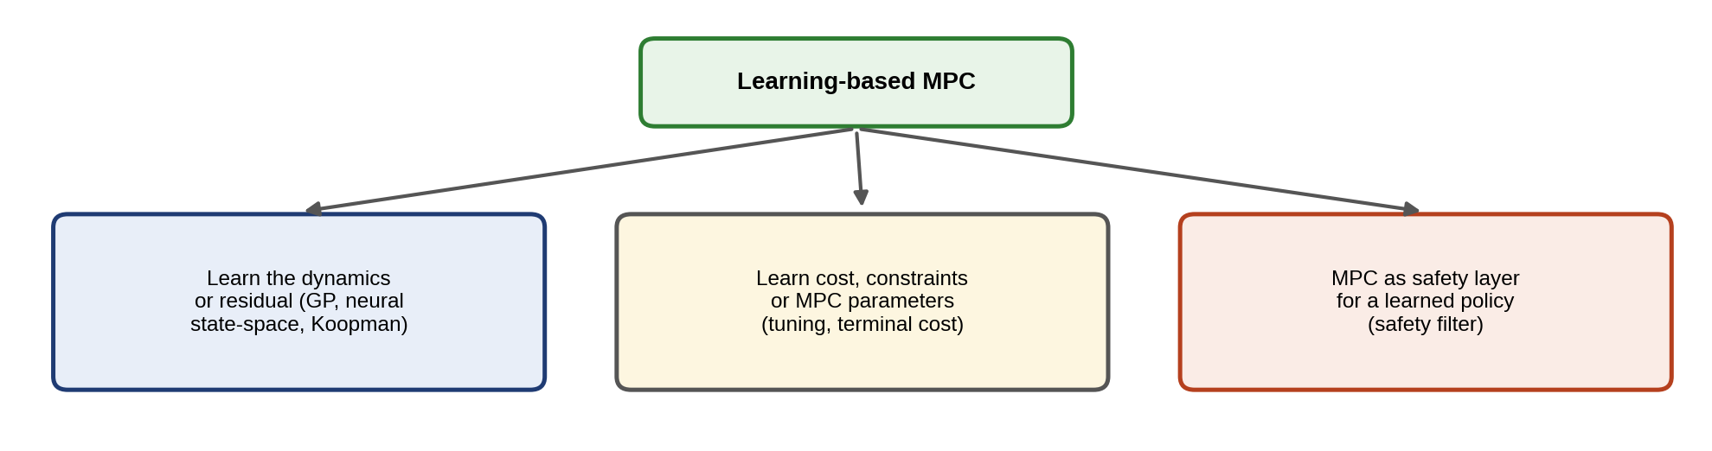
Figure 13.29. Learning-based MPC: learning the dynamics or residual (Gaussian process, neural state-space, Koopman), learning the cost, constraints or MPC parameters, and using MPC as a safety layer for a learned policy.

13.19 Grid-forming and Inverter-dominated Systems
As synchronous machines retire, inverters must form the grid themselves (Chapter 11). A grid-following inverter measures the grid voltage with a phase-locked loop and injects current in phase with it; it needs an existing voltage to follow. A grid-forming inverter regulates its own voltage magnitude and angle and behaves like a voltage source behind an impedance, sharing power through droop laws,
 | $$ω=ω_{0}−m_{p}\left(P−P^{*}\right), V=V_{0}−n_{q}\left(Q−Q^{*}\right),$$ | (13.71)
where $ω$ and $V$ are the inverter’s frequency and voltage references, $ω_{0}$ and $V_{0}$ their nominal values, $P$ and $Q$ the measured active and reactive power, $P^{*}$ and $Q^{*}$ set-points from the EMS, and $m_{p}$ and $n_{q}$ the droop gains. With a 1 % frequency droop on a 500 kW unit ($m_{p}=0.01×2π×50/500$ rad/s per kW), a 100 kW load step lowers the frequency by $0.01×50×100/500=0.1$ Hz in steady state. A virtual synchronous machine (VSM) adds a swing equation with virtual inertia $H$ to the frequency law, $2H dω/dt=P^{*}−P−D\left(ω−ω_{0}\right)$, which provides inertia-like response to the grid.
The twin’s role at this level is supervisory, not a replacement for the inner controller (Figure 13.30). It estimates the grid strength (short-circuit ratio and impedance) from small perturbations or event responses; it predicts whether the inverter’s current limit, which is typically only 1.1 to 1.5 times rated current, will be reached after a fault or load step and whether the inverter will stay synchronized; it tunes droop gains and virtual inertia to the estimated grid strength; and it checks that the EMS’s set-points leave the grid-forming units enough headroom in power, current and energy to do their job. Protection must also be coordinated with the limited fault current of inverters. Optimization enters as constraint-aware supervisory tuning: choosing $m_{p}$, $n_{q}$, $H$ and the set-points to meet frequency-nadir and RoCoF limits for credible events while respecting the current limits.
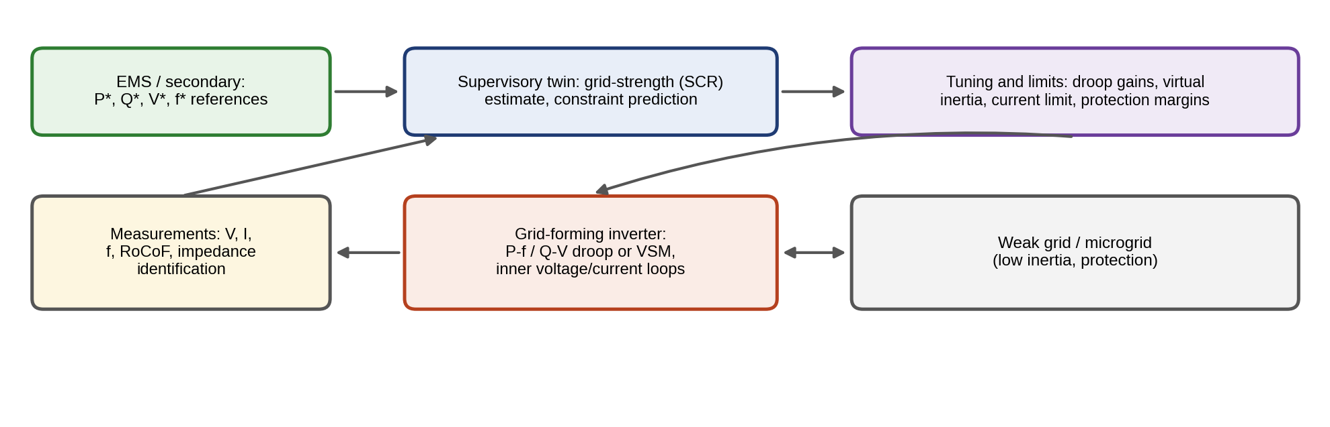
Figure 13.30. Grid-forming inverter with a supervisory twin: the twin estimates grid strength from measurements, predicts constraint margins, and tunes droop gains, virtual inertia and limits, while the EMS supplies power and voltage references and the inverter’s own loops run at microsecond to millisecond time scales.

13.20 Real-time Solvers, Runtime Assurance and Fallback

13.20.1 Meeting the deadline
An online controller must return a safe command before its deadline, every time. Four mechanisms make optimization-based control dependable. The first is a solver timeout. Iterative solvers are given a fixed iteration or time budget; if the budget runs out, the controller uses the best feasible iterate or, if it has none, the shifted solution of the previous step, $U_{k}^{warm}=\left[u_{1|k−1},…,u_{N−1|k−1},−Kx_{N|k−1}\right]$. That shifted solution is a standard warm start that usually halves solve time, and under the nominal assumptions of Section 13.7.5 it is feasible when the previous one was; a disturbance or model change can invalidate it, so it is checked before being used as a fallback. The second is explicit MPC. For small problems, the QP is solved offline for all states as a piecewise-affine function of the state, and online control reduces to finding the state’s region and applying its affine law,
 | $$u^{*}\left(x\right)=F_{r}x+g_{r} \text{for} x∈R_{r}=\left\{x:H_{r}x≤k_{r}\right\},$$ | (13.72)
which takes microseconds and is deterministic [11] (Figure 13.31). The number of regions grows combinatorially with horizon and constraints, which limits the approach to a few states and short horizons. The third is a fallback controller: a simple, verified controller (PI or saturated LQR) that takes over on solver failure, twin failure or stale data. The fourth is a set of supervisory interlocks: hard limits enforced outside the optimizer, such as peak-current trip, over-temperature, SOC limits and islanding protection, which no optimizer command can override.
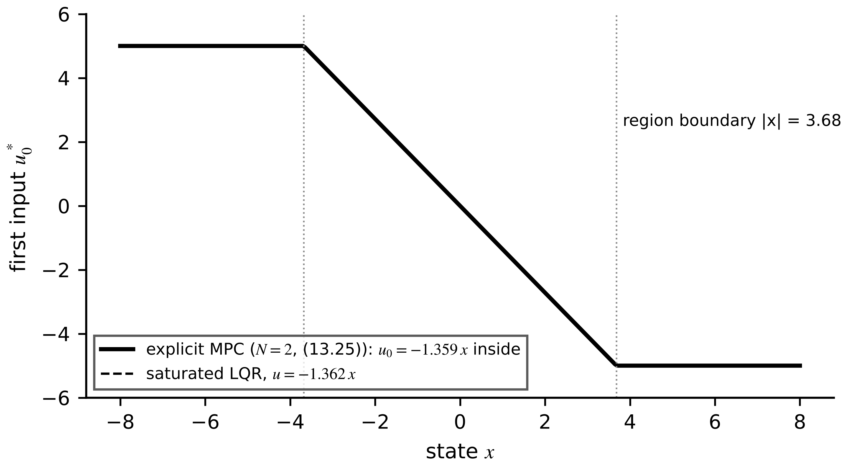
Figure 13.31. Explicit MPC for the scalar example: the optimal first input as a piecewise-affine function of the state, linear in the unconstrained region and saturated outside it; for this example it nearly coincides with saturated LQR.
Four implementation routes close the gap between a QP and a hard microsecond deadline:
- Explicit MPC. A lookup of precomputed affine laws (13.72) takes microseconds but needs memory that grows with the number of regions.
- Embedded solvers. Code-generated solvers with a fixed iteration count and warm start (generated OSQP, first-order methods on an FPGA, active-set solvers in C). The iteration cap bounds the worst case; the price is suboptimality, which must be quantified against the fully converged solution.
- Finite-control-set MPC. It evaluates the few switching states of the converter directly instead of solving a QP for the duty cycle, choosing the one whose predicted next state is best [12]. It avoids the modulator and the QP, at the cost of a variable switching frequency.
- Separated time scales. MPC runs in an outer loop at a slower rate, for example 10 kHz for the voltage reference, while a fast analogue or digital current loop handles the switching-rate dynamics.
Solver tolerance trades time against optimality: a first-order solver reaches a loose tolerance in a few iterations and a tight one in many, and for control a loose tolerance is often enough if the constraints are still met. The trade-off must be measured, not assumed.

13.20.2 Runtime assurance
An online controller must return a safe command before its deadline, every time, and it must detect when it cannot. Runtime assurance separates four kinds of failure, because each needs a different response:
- Optimizer failure. The solver returns infeasible, hits its iteration cap without a feasible point, or exceeds its time budget. Response: use the best feasible iterate if one exists; otherwise apply the shifted previous plan, $U_{k}^{warm}=\left[u_{1|k−1},…,u_{N−1|k−1},−Kx_{N|k−1}\right]$, if it still satisfies the constraints at the current state; otherwise the fallback controller. The shifted plan is a standard warm start and supports recursive feasibility under the nominal assumptions of Section 13.7.5, but a disturbance or model change can make it infeasible, so it is checked before use and is not an unconditional guarantee.
- Twin or model failure. The model’s prediction residuals exceed their validated bound, or the operating point leaves the validated domain. Response: switch to the fallback controller and flag the model for review.
- Sensor failure. Data are stale, frozen, out of range or inconsistent between redundant sensors. Response: a stale-data timer marks inputs older than their allowed age; the estimator runs on the remaining sensors if observability allows, or the fallback takes over.
- Communication failure. Set-points or measurements from other layers stop arriving. Response: hold the last valid set-point for a bounded time, then fall back to local droop or a safe schedule.
The implementation elements are deterministic scheduling on a real-time operating system, a measured worst-case execution time (WCET) for every task, a watchdog that forces the fallback if the controller task misses its deadline, a feasibility monitor on every solution, bumpless transfer between controllers (initializing the fallback’s integrator so that the command is continuous at the switch), supervisory interlocks outside all software, and post-event logging with the model and controller versions in effect. Figure 13.32 summarizes the supervisory logic.
The timing constraint of each control loop generalizes that of Chapter 10 (Section 10.1.1): the worst-case, not the mean, execution time counts,
 | $$t_{meas}+t_{est}+t_{opt}^{wc}+t_{comm}+t_{act}≤T_{s},$$ | (13.73)
where $t_{opt}^{wc}$ is the solver’s worst-case time with the chosen iteration cap.
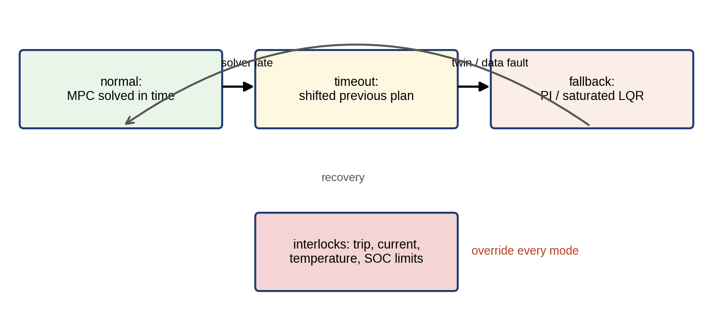
Figure 13.32. Supervisory logic of a twin-based controller: normal MPC operation, warm-started fallback on solver timeout, fallback controller on twin or data failure, and hardware interlocks that override every mode.
Every term in (13.73) must be a measured worst case on the target hardware, not an average. WCET is established by measurement over long runs under stress (maximum constraint activity, cache and interrupt load) with a safety margin, or by static timing analysis of the compiled code, and iterative solvers are made deterministic by a fixed iteration count. Model updates reach the controller only through the gate of Section 13.2.2, every deployed model and controller carries a version, and commands to actuators are authenticated.
Table 13.7 summarizes these choices by control layer.
TABLE 13.7 Real-time implementation by control layer
Layer | Sample time | Horizon | Solver class | Acceptable fallback
Converter current/voltage | 10 to 100 µs | 1 to 20 steps | Explicit MPC, FCS-MPC, fixed-iteration QP | PI, saturated LQR
Secondary control, site MPC | 0.1 to 1 s | Seconds to minutes | QP | Droop, last set-point
EMS | 5 to 60 min | Hours to a day | LP/QP/SOCP, MILP | Rule-based schedule
Day-ahead | Daily | 1 to 2 days | Stochastic LP, MILP | Previous day’s plan

13.21 MIL, SIL, PIL, HIL, PHIL and Deployment Gates
A controller earns the right to actuate a real plant through a ladder of tests, each validating something the previous one could not (Figure 13.33):
- Model-in-the-loop (MIL). Controller model and plant twin in simulation. Validates the control concept, stability margins and constraint handling across scenarios. Cannot validate code, timing or hardware.
- Software-in-the-loop (SIL). The generated or hand-written controller code against the twin, on a desktop. Validates the code’s numerical behaviour (fixed point, solver tolerance) against MIL. Cannot validate timing.
- Processor-in-the-loop (PIL). The code on the target processor, communicating with the simulated plant. Validates execution time and memory on the real processor. Cannot validate I/O and electrical interfaces.
- Hardware-in-the-loop (HIL, CHIL). The real controller hardware against a real-time simulator of the plant with electrical I/O. Validates timing, I/O, fault handling and fallbacks, including faults too dangerous to create on the real plant. Cannot validate the real power stage.
- Power-hardware-in-the-loop (PHIL). Real power hardware (a converter, a battery) connected through a power amplifier to the simulated network. Validates the power stage and its interaction with the network, within the stability limits of the amplifier interface.
- Staged field deployment. Shadow mode (the controller computes but does not act), then advisory mode, then limited authority (bounded set-points, restricted hours), then full authority. Validates behaviour on the real plant with real data.
Each gate has pass/fail criteria set before the test: prediction error, constraint violations (count and magnitude), stability evidence, performance against the baseline, WCET with margin, correct fallback and rollback behaviour, and cybersecurity checks on the command path. Table 13.8 states the evidence each controller in this chapter has reached.
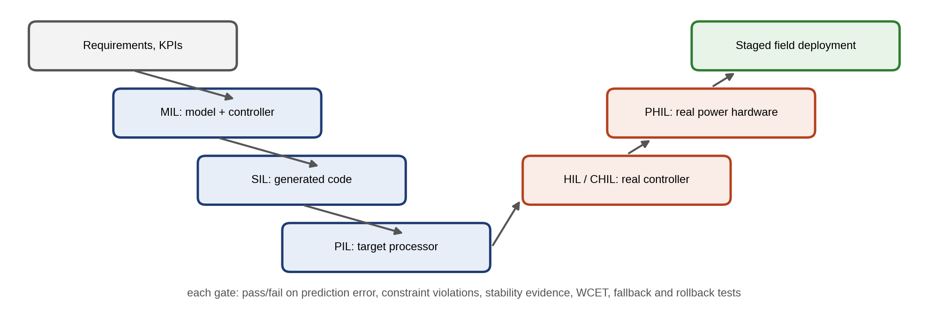
Figure 13.33. Validation V-model for a twin-based controller: requirements and KPIs, MIL, SIL and PIL on the design side, HIL/CHIL, PHIL and staged field deployment on the verification side, with pass/fail evidence at every gate.
TABLE 13.8 Controller evidence table for the methods demonstrated in this chapter
Controller | Model fidelity | Stability / feasibility evidence | Constraint guarantee | Uncertainty treatment | WCET | Fallback | Validation level reached
PI with anti-windup | First-order plant | Linear analysis, simulation | Actuator saturation only | Integral action | Microseconds | Not needed | Simulation
Buck-converter MPC | Averaged LTI, exact ZOH | Terminal cost, simulation | Inputs and current limit (nominal) | Load current from twin | Not met on server CPU | Cascaded PI | Simulation (MIL)
Battery LP/EMS | Linear energy model | Convex, global optimum | Nominal | Rolling horizon, reserve | Milliseconds | Rule-based schedule | MIL, 20-day test set
Stochastic day-ahead | Linear, scenarios | Convex | In expectation | 40 scenarios, 300 test | Seconds | Deterministic plan | MIL, out-of-sample
Q-learning policy | Discrete | None (tabular) | Via action set only | None | Microseconds | LP schedule | MIL, five seeds

13.22 Reproducible Converter Control Case
Example 13.13 MPC, nominal MPC and cascaded PI on the D-3 buck converter
Given. The buck converter of Section 13.4.2: $V_{in}=48$ V, $L=22$ µH, $r_{L}=20$ mΩ, $C=100$ µF, regulating $V_{r}=12$ V from start-up at zero current and voltage; at 2.5 ms the resistive load steps from 1.2 Ω (10 A) to 0.6 Ω (20 A). All controllers sample at 100 kHz ($T_{s}=10$ µs). The plant is simulated with the exact ZOH discretization of the averaged model with the true load resistance at each step, so the results are simulation results. Three controllers:
- Twin-in-the-loop MPC. Prediction model (13.13) discretized by (13.11), with the load current supplied by the twin as the input $i_{o}$ and the target (13.15) recomputed every step; horizon $N=10$; $Q=diag\left(0.01,10\right)$ on $\left(i_{L},v_{C}\right)$ deviations, $R=1$ on the duty-cycle deviation; terminal weight $P$ from the Riccati equation (13.21), $P=\left[\begin{matrix}0.024 & 0.213 \\ 0.213 & 13.79\end{matrix}\right]$; constraints $0≤d≤1$ and $i_{L}≤25$ A at every predicted step. The condensed QP (13.28) is solved by OSQP with absolute and relative tolerances ${10}^{−5}$, warm start on, polishing off and an iteration cap of 4000.
- Nominal MPC. The same, but its model and target assume the fixed 1.2 Ω load.
- Cascaded PI. An outer voltage PI ($K_{p}=2$ A/V, $K_{i}=500$ A/(V·s)) sets the inductor-current reference with load-current feedforward and a 25 A limit (integration stopped at the limit); an inner proportional current loop sets $d=\left(v_{C}+r_{L}i_{L}+0.6 \left(i_{L}^{*}−i_{L}\right)\right)/V_{in}$.
Find. Start-up peak voltage, peak inductor current, 2 % settling time, voltage after the load step and computation time.
Solution. Table 13.9 collects the results and Figure 13.34 shows the transients.
- Twin-in-the-loop MPC. At start-up the voltage reaches 12.00 V with no overshoot, settling in 0.08 ms, while the inductor current rides on its 25 A limit. After the load step the voltage dips to 11.79 V and returns to 12.000 V.
- Nominal MPC. Start-up peaks at 12.22 V; after the step the voltage settles at 10.68 V, a 1.3 V steady-state error.
- Cascaded PI. It overshoots to 12.37 V (3.0 %) with a 16.9 A current peak at start-up (20.3 A after the load step) and settles in 0.31 ms; after the step it dips to 10.63 V and has recovered to 12.08 V by the end of the 2.5 ms window, within the 2 % band.
TABLE 13.9 Buck converter: controller comparison (simulation of the averaged model at a 100 kHz control rate; solve times measured separately on a server CPU, see text)
Controller | Start-up peak voltage | Peak inductor current | 2 % settling | Voltage after 10 → 20 A step (min / end) | Online computation
Twin-in-the-loop MPC | 12.00 V | 25.0 A (at limit) | 0.08 ms | 11.79 V / 12.000 V | QP: median 23 µs, 99th percentile 62 µs, worst 99 µs
Nominal MPC (fixed load) | 12.22 V | 25.0 A | 0.07 ms | 10.67 V / 10.68 V | Same QP size
Cascaded PI | 12.37 V | 20.3 A | 0.31 ms | 10.63 V / 12.08 V | A few multiply–adds
Interpretation. MPC’s advantage comes from the constraint: it charges the output capacitor as fast as the 25 A limit allows and stops exactly at 12 V, which a PI can approximate only with conservative tuning. But MPC is only as good as its model. Without the load current, the nominal model believes the load is still 1.2 Ω and the controller settles where its wrong model is satisfied, the offset problem of Section 13.7.4. The PI loops’ integrators remove offset implicitly, which is why well-designed cascaded PI remains the industrial default and a fair baseline. The 100 kHz rate is a simulation rate: the solve times below show that this QP cannot run at that rate on the processor used.
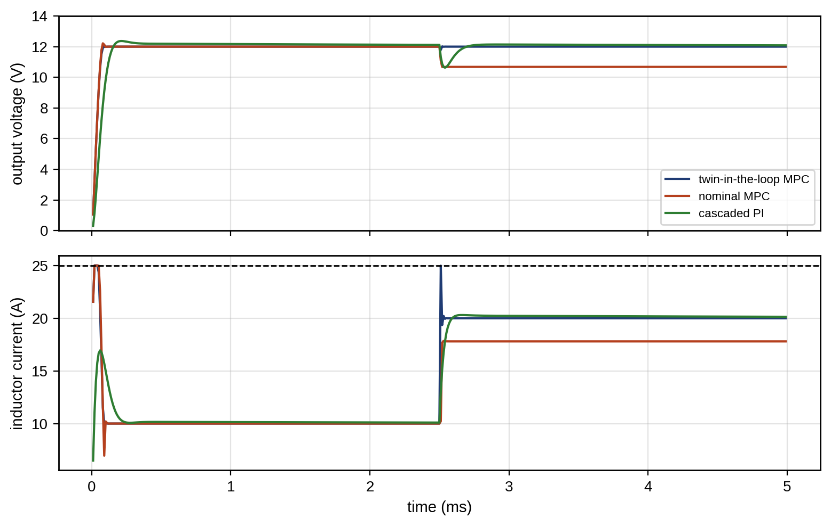
Figure 13.34. Start-up and load step of the D-3 buck converter (simulation): output voltage (top) and inductor current with the 25 A limit (bottom) under twin-in-the-loop MPC, nominal MPC and cascaded PI.
Timing evidence. The QP (10 decision variables, 20 constraints) was solved at every one of the 500 steps of the start-up and load-step run by OSQP 1.1 through its Python interface, on one core of an Intel Xeon processor at 2.1 GHz, with the settings above. The median solve time was 23 µs, the 99th percentile 62 µs and the worst of the 500 solves 99 µs (Figure 13.35). The median alone is more than twice the whole 10 µs period, before measurement, estimation and PWM update are counted. These figures describe this benchmark only: a general-purpose server with an interpreted interface is neither the target hardware nor a worst-case measurement, and a code-generated solver on an embedded processor or FPGA could be several times faster or slower. The budget for a 10 µs sample on the target might be 1 µs for ADC conversion and filtering, 1 µs for the state estimate, 5 µs for the optimizer or lookup, 1 µs for the PWM update and 2 µs of margin, and each entry must be a measured worst case on that hardware. On this evidence the practical options are those of Section 13.20.1: explicit MPC, an embedded fixed-iteration solver, FCS-MPC, or MPC in a slower outer loop.
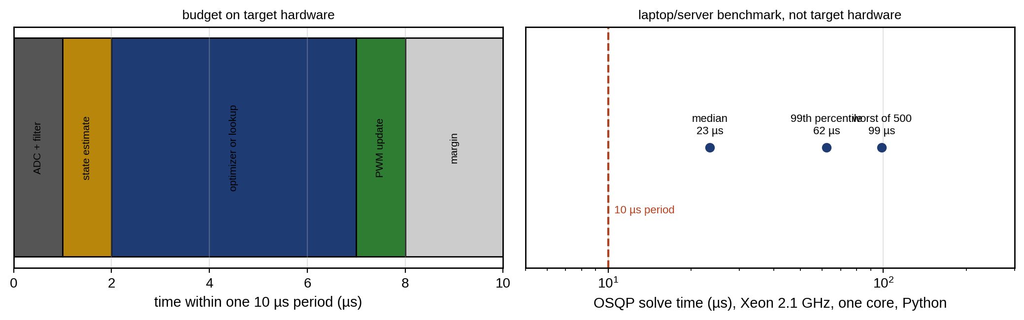
Figure 13.35. Timing budget of a 10 µs converter control period on target hardware (left), and the OSQP solve times of the converter QP measured on a 2.1 GHz server core through a Python interface, far beyond the period (right). The benchmark is not target-hardware evidence.

13.23 Reproducible Microgrid and EV Energy-management Case
Table 13.10 specifies a reproducible rolling-horizon dispatch of the P-1 microgrid, and Example 13.14 tests it against a fixed rule and perfect foresight on 20 synthetic days rather than one.
TABLE 13.10 Specification of the rolling-horizon microgrid dispatch (synthetic data)
Item | Specification
Plant | Load profile 0.55 MW (00:00 to 06:00), 0.75 (06:00 to 08:00), 1.0 (08:00 to 17:00), 0.85 (17:00 to 21:00), 0.6 MW (21:00 to 24:00), times $\left(1+0.05 ϵ_{t}\right)$; PV $1.2\sin^{1.2}\left(π\left(h+0.5−6\right)/12\right)$ MW on the day’s clearness $c∼U\left(0.3,1.0\right)$ with 10 % hourly noise, and on 30 % of days a drop to 20 to 50 % from a random hour between 10:00 and 14:00; battery 0.5 MW, 1 MWh, 95 % one-way efficiency, energy 10 to 100 %, start 50 %, end at least 50 %
Network | Export limited to 0.3 MW at the point of connection (curtailment otherwise)
Prices | Import 0.10 / 0.18 / 0.30 $/kWh (00:00 to 06:00 and 22:00 to 24:00 / day / 17:00 to 21:00); export 0.03 $/kWh; wear 16 $/MWh on $\left(p^{ch}+p^{dis}\right)/2$
Forecast | Present hour measured; future PV = clear-sky profile × the current hour’s realized clearness (persistence); load = profile
Optimizer | LP over the remaining day (shrinking horizon), re-solved hourly; HiGHS via CVXPY
Baselines | No battery; fixed rule (charge from surplus PV, discharge from 17:00 to 21:00); perfect foresight
Test set | 20 days, seed 10
Metric | Daily cost including wear and the value of any end-of-day energy shortfall; constraint violations; end-of-day energy; solve time
Example 13.14 Rolling-horizon MPC against a rule and perfect foresight on 20 days
Given. Table 13.10.
Find. The distribution of daily savings against no battery, the fraction of the perfect-foresight saving that MPC captures, constraint violations and solve times.
Solution. Mean daily saving: fixed rule 89 $ (range 69 to 188 $), rolling-horizon MPC 152 $ (133 to 211 $), perfect foresight 158 $ (147 to 213 $). MPC captures on average 97 % of the perfect-foresight saving, but only 80 % on its worst day, a day on which clouds arrived after the persistence forecast had committed the battery; the rule captures 56 %. No constraint was violated, every day ended with at least 50 % stored energy, and the export limit did not bind with this PV size. The hourly LP took a median of 8.5 ms, a 99th percentile of 10.5 ms and at most 32 ms (Figure 13.36).
Interpretation. Re-planning every hour recovers most of the value of perfect information here, because the battery’s decisions depend mainly on the price shape, which is known in advance. That conclusion belongs to this synthetic site and price structure: the worst day shows that it does not hold every day, and a site whose decisions depend more strongly on the weather, for example one with a tight export limit and more PV, would show a larger gap. A single day, however realistic, is not evidence of how a method performs.
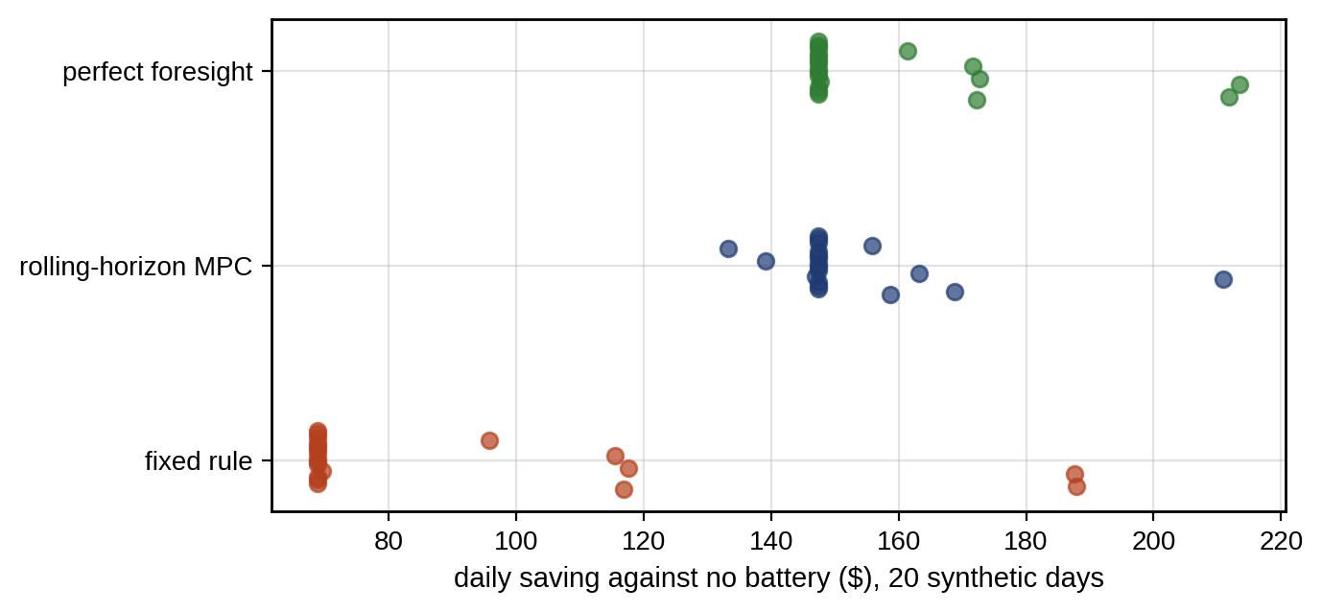
Figure 13.36. Daily savings against no battery on 20 synthetic days for the fixed rule, rolling-horizon MPC and perfect foresight.

13.23.1 A multi-timescale EV-hub twin
The EV case of Chapter 10 extends naturally to a public hub, and it is the clearest example of a multi-timescale control twin (Figure 13.37):
- Day-ahead. An energy schedule for the hub and its BESS against the next day’s tariff and forecast arrivals, with the transformer’s thermal model as a constraint and the peak or demand-charge term of Section 13.13.2 (Example 13.8).
- Every 5 to 15 minutes. A site MPC re-plans with the actual queue of vehicles: their arrival times, requested energy, declared (and uncertain) departure times and priority, scheduling against conservative departure quantiles. The deterministic schedule of Chapter 10 (Section 10.16.2) left 40 % of vehicles short and the uncertainty-aware one only 5 %.
- Every few seconds. A charger-allocation layer shares the available power among dispensers with a fair-share rule, so that no user is always deferred, and each vehicle’s charging curve limits its power.
- Local limits. Charger and battery converters enforce their own current and temperature limits and the transformer protection acts independently.
The hub’s energy-management twin therefore combines the scheduling LP (13.57), the queueing model of Chapter 10 (Section 10.18), the transformer hot-spot model, and the health-aware charging limits of Chapter 10 (Section 10.12.1).
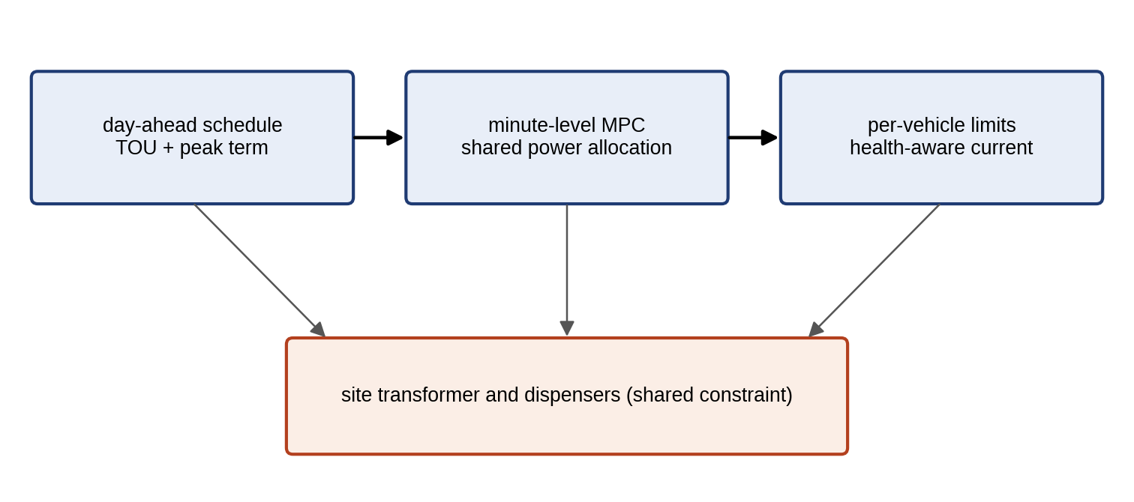
Figure 13.37. Energy-management architecture of an EV charging hub: day-ahead scheduling under TOU tariffs, minute-level MPC allocating shared power among dispensers, and per-vehicle health-aware current limits, with the site transformer as a shared constraint.

13.24 Decision-grade Integrated Capstone: a PV–BESS–EV Microgrid Twin
The capstone brings the chapter’s tools into one decision and asks what each layer of sophistication actually buys. P-1’s energy management chooses tomorrow’s schedule for its battery and its flexible EV car park, and the twin must show that the schedule is economical, clean, safe against forecast error, within network limits, and robust to a fault.
Physical layer. Load and PV as in Table 13.10 (PV at 80 % of clear sky); the 0.5 MW, 1 MWh battery (95 % one-way efficiency, 10 to 100 % energy, start 50 %, end at least 50 %); the car park’s 0.62 MWh of flexible EV energy to be delivered between 07:00 and 19:00 at up to 0.33 MW; a 1.5 MW import limit (transformer) and a 0.3 MW export limit at the connection.
Twin layer. State of charge and state of health from the battery twin; net-load forecast errors with standard deviation $σ_{t}=45 \text{kW}+0.1 P_{t}^{PV}$ (up to 140 kW at noon); hourly grid carbon intensity from 0.30 t/MWh at midday to 0.65 t/MWh in the evening and at night; wear priced at 16 $/MWh.
Control hierarchy. The day-ahead plan below; a 15-minute site MPC that re-plans against it; the battery inverter’s own current and SOP limits.
Optimization. Minimize energy cost plus wear, subject to a reserve held in battery power and energy, $r_{t}=k σ_{t}$, with $p_{t}^{dis}≤P_{max}−r_{t}$ and $E_{t}≥E_{min}+r_{t}⋅1 \text{h}$, and trace the cost–CO₂ front by the $ε$-constraint method (13.64). All problems are LPs solved to global optimality with HiGHS.
Example 13.15 Cost, emissions, uncertainty and a fault for tomorrow’s schedule
Given. The capstone specification above. For the uncertainty test, 2000 days of forecast errors drawn from a skewed (shifted gamma, shape 2) distribution with the stated standard deviations (seed 13), representing clear-sky days on which the forecast is more often too high than too low. For the fault test, the battery derated to 0.2 MW by the twin’s thermal diagnosis.
Find. (a) The minimum-cost schedule and the cost of the reserve; (b) the cost–CO₂ front, its marginal abatement costs and a knee; (c) the violation rates of reserves sized by the Gaussian rule, by the empirical quantile and by a moment-based distributionally robust rule; (d) the effect of the derating.
Solution. (a) With no battery and uncontrolled EV charging the day costs 2322 $ and emits 7.49 t of CO₂. The minimum-cost schedule with a 95 % Gaussian reserve ($k=1.645$) costs 2186.6 $ (2173.4 $ of energy and 13.2 $ of wear, with 0.83 MWh of throughput); without the reserve it would cost 2174.5 $, so the reserve costs 12.1 $ a day. Among the equally cheap schedules, emissions range from 7.52 to 7.44 t: the first 0.08 t of abatement is free, obtained by moving EV charging into low-carbon midday hours.
- Tightening the CO₂ bound further traces the front of Figure 13.38. The multiplier of the bound, the marginal abatement cost by (13.65), rises in steps: 135 $/t down to 7.33 t, then 201, 256, 288, 375 and 452 $/t, and above 1700 $/t in the last steps to the minimum of 7.16 t at 2306 $. With both objectives normalized between their utopia and nadir values, the point with the largest distance to the chord joining the two extremes, the knee by this chapter’s definition, is at 7.21 t and 2230 $, where the marginal abatement cost is 375 $/t. Adjacent points confirm the multipliers: between 7.428 and 7.418 t the cost rises by 1.35 $, 135 $/t.
- Under the skewed errors, the Gaussian 95 % reserve is exceeded in 6.9 % of hours, not 5 %, and on 82 % of days at least one hour is exceeded. A reserve sized from the empirical 95 % quantile of past errors ($k=1.92$) is exceeded in exactly 5.0 % of hours and costs 2 $ more. The moment-based distributionally robust reserve (13.42) at 95 % needs $k=4.36$, which the battery cannot provide at noon: the problem is infeasible, and the largest feasible factor is 3.55. At 90 % ($k=3.0$) it is feasible, is exceeded in 1.4 % of hours and on 28 % of days, and costs 10 $ more than the Gaussian plan.
- With the battery derated to 0.2 MW, even the 95 % Gaussian reserve becomes infeasible. The twin must report this rather than silently relax it: with $k=1.0$ the plan costs 2205.9 $ and with $k=0.5$ 2193.5 $, each with a correspondingly weaker guarantee that the operator has to accept.
TABLE 13.11 Capstone schedule options for the P-1 microgrid (synthetic; “about” marks values not separately optimized for emissions)
Schedule | Cost incl. wear ($) | CO₂ (t) | Throughput (MWh) | Reserve factor $k$ | Hours exceeded (skewed errors) | Note
No battery, uncontrolled EVs | 2322 | 7.49 | 0 | none | not applicable | Reference
Minimum cost, no reserve | 2174.5 | 7.53 | 0.90 | 0 | 40.5 % | Cheapest, unprotected
Minimum cost, Gaussian reserve | 2186.6 | 7.44 to 7.52 | 0.83 | 1.645 | 6.9 % | Assumes Gaussian errors
Empirical-quantile reserve | 2188.6 | about 7.5 | about 0.8 | 1.92 | 5.0 % | Calibrated on past errors
Moment-based DRO reserve, 90 % | 2196.6 | about 7.5 | about 0.8 | 3.0 | 1.4 % | 95 % version infeasible
Knee of the cost–CO₂ front | 2230.2 | 7.21 | 1.26 | 1.645 | 6.9 % | 375 $/t marginal
Minimum emissions | 2306.0 | 7.16 | 0.88 | 1.645 | 6.9 % | Above 2000 $/t marginal
Battery derated to 0.2 MW | 2205.9 | about 7.5 | lower | 1.0 | not recomputed | 95 % reserve infeasible
Table 13.11 summarizes the options.
Interpretation. Three layers of sophistication were tested, and they paid differently. Uncertainty-aware reserve sizing paid clearly: the Gaussian rule, the textbook default, gave a false sense of security under skewed errors, and a reserve sized from the twin’s own error record met its target for 2 $ a day. Distributional robustness paid only at a reduced confidence level, because the fully robust reserve was more than the battery could hold, which is itself a finding for the next investment decision. Emission reduction was partly free and then expensive, and the knee is a decision aid under a stated definition, not the correct answer. A learned policy was not deployed: the Q-learning of Example 13.12 reached only the optimum of its coarse action set, and nothing in this problem needs a learned controller when a convex program solves it exactly in milliseconds. Before the schedule goes online it passes the deployment gate: every hourly set-point inside the battery’s SOP and SOC limits and the transformer and export limits, the declared reserve level and its measured violation rate recorded, a fallback schedule loaded, the model and data versions logged, and an operator’s sign-off, which is the audit trail if the day goes wrong.
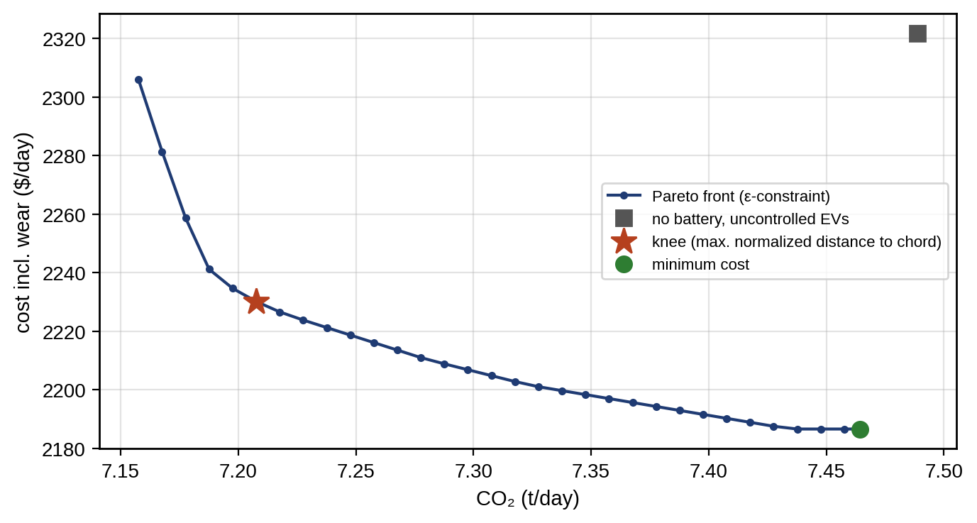
Figure 13.38. Capstone Pareto front of daily cost (including wear) against CO₂ emissions for the P-1 microgrid, traced by the ε-constraint method with a 95 % Gaussian reserve, with the minimum-cost point, the knee (largest normalized distance to the chord) and the no-battery reference.

13.25 Standards, Interoperability, Trust and Controller Lifecycle
Composed and federated twins. A site twin is rarely one model. It is a composition of a battery twin, converter twins, an EV-hub twin, a feeder twin, a market twin and a weather twin, often from different vendors (Figure 13.39). ISO 23247-6:2026 [13], written for manufacturing, distinguishes integrated, unified and federated composition and gives requirements for each; the same architectural ideas apply to energy systems. Each component twin exposes an interface contract (variables, units, sign conventions, timestamps, quality flags, update rates and authority, as in Table 13.2), and the composed twin checks the contracts at run time, so that a sign error in one component (Exercise 13.31) is caught at the interface rather than in the economics.
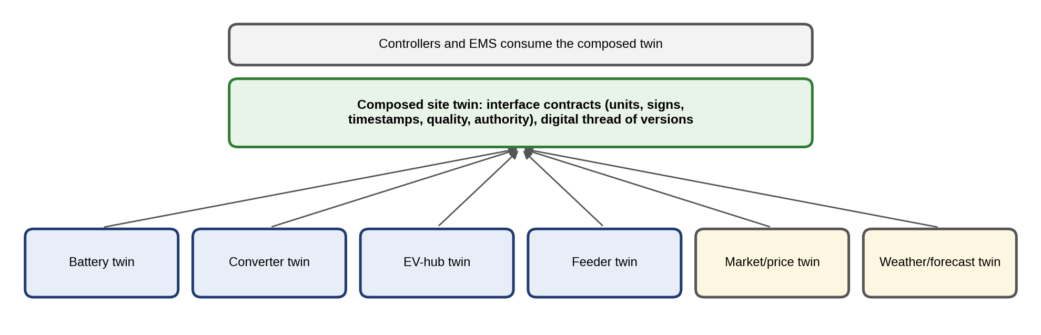
Figure 13.39. Composed energy-system twin: battery, converter, EV-hub, feeder, market and weather twins joined through interface contracts and a digital thread of versions, consumed by the controllers and the EMS.
Digital thread. The ISO 23247 series has added a part on the digital thread, ISO 23247-5:2026 [13], again manufacturing-oriented. Its idea transfers directly to controllers: every deployed controller should be traceable from the model version and the parameter data it was tuned on, through its validation evidence at each gate, to its deployment and any later rollback.
Trust and security. A twin that can command actuators is an attack surface. NIST IR 8356 [14] sets out security and trust considerations specific to digital twins. For a control twin the central risks are: manipulated or replayed sensor data driving the estimator; a poisoned model update; and, most dangerous, a compromised twin issuing set-points that are physically valid, inside every limit the interlocks check, yet malicious in combination or timing. The defences are the mechanisms of this chapter used together: authenticated and time-stamped measurements with a stale-data timer, the update gate with provenance checks, authenticated commands, runtime monitors that compare commanded and expected behaviour, independent hardware interlocks, and the ability to roll back to a known version.
DER interface requirements. DER set-points are not free variables. IEC TS 62786-1:2023 [15] sets general requirements for connecting distributed energy resources to distribution networks, including active- and reactive-power response, monitoring, control and communication, and national codes such as IEEE 1547-2018 do the same; the optimizer’s variables must respect them (Section 13.12.3).
Table 13.12 lists the status of the standards and guidance referred to in this chapter.
TABLE 13.12 Standards and guidance referred to in this chapter
Document | Relevance to this chapter | Status (checked September 2026)
ISO 23247-6:2026 | Digital-twin composition (integrated, unified, federated) | Published July 2026 (manufacturing framework)
ISO 23247-5:2026 | Digital thread | Published 2026 (manufacturing framework); confirm edition before citing clauses
NIST IR 8356 | Security and trust considerations for digital twins | Published 2025
IEC TS 62786-1:2023 | DER grid-connection requirements | Published
IEC TR 62786-100, IEC TS 62786-42 | Mapping of grid-connection standards; voltage measurement for DER control | Recent additions; confirm status before citing
IEEE 1547-2018, IEEE 1547.1-2020 | DER interconnection and conformance testing | Published
IEEE 2030.7-2017, IEEE 2030.8-2018 | Microgrid controller specification and testing | Published
IEC 61850 series | Communication for utility automation, DER information models | Published, maintained

13.26 2–5 and 5–10 Year Research Roadmap
Table 13.13 organizes the research directions of this chapter by horizon, with the maturity each has reached, the benefit it promises, the evidence it still needs and the risk that remains. Two principles run through it. A sophisticated method must be compared with the simple baseline on the same data (PI, LP, deterministic MPC), and a method that has not been validated out of sample, on target hardware and with its fallback has not yet shown that it is worth its complexity.
TABLE 13.13 Roadmap of twin-based control and energy management
Horizon | Direction | Maturity | Expected benefit | Evidence needed | Unresolved risk
2–5 years | Distributed MPC for microgrid clusters | Pilots | Scale, privacy | HIL with real communication, convergence under delay | Strategic agents, asynchronous updates
2–5 years | Learning-based MPC with uncertainty-aware models | Research to pilots | Better models, fewer violations | Out-of-domain tests, violation statistics against nominal MPC | Guarantees when the learned model is wrong
2–5 years | Decision-focused forecasting | Research, early adoption | Lower operating cost for a fixed optimizer | Realized cost against calibrated forecast-then-optimize | Overfitting to one decision problem
2–5 years | Distributionally robust EMS | Research to pilots | Calibrated protection without Gaussian assumptions | Out-of-sample violation rate and cost | Choosing the ambiguity radius
2–5 years | Safe RL as supervisory assistance | Research | Complex, nonconvex objectives | Shielded violation rate, comparison with MPC/LP | Safety during exploration, distribution shift
2–5 years | Embedded, code-generated optimization | Early deployment | Microsecond MPC on target hardware | Measured WCET on target | Certification of iterative solvers
2–5 years | Grid-forming supervisory optimization | Research to pilots | Low-inertia stability with limited current | PHIL and field trials | Interaction of many grid-forming units
5–10 years | Composed and federated twins across fleets and grids | Emerging | Reuse, interoperability | Interface conformance, cross-vendor trials | Authority and liability across owners
5–10 years | Privacy-preserving multi-agent control | Emerging | Coordination without data sharing | Convergence and privacy guarantees | Attacks on the coordination protocol
5–10 years | Certified learning components and differentiable optimization in the loop | Emerging | Adaptive yet verifiable control | Formal or runtime assurance evidence | Scalability of verification
5–10 years | Autonomous controller retuning and agentic decision support | Emerging | Less engineering effort | Prospective field trials, human-authority design | Accountability, drift

13.27 Summary, Key Equations and Graded Exercises
A digital twin that can predict is a digital twin that can control, but only if it earns the name: live synchronization, updated states and parameters, quantified uncertainty, an authorized actuation path, version identity and validation evidence. The chapter built that capability from its foundations. PI control with anti-windup cut a saturated loop’s overshoot from 10.8 to 2.3 %, pole–zero cancellation was shown to be fragile, and the sampling rule of thumb was traced to phase margin. Exact discretization turned the buck converter’s physics into a prediction model with stated limits, multirate, linearized and switched models extended it, and the Kalman filter and disturbance estimation supplied what cannot be measured. LQR was derived from Bellman’s equation under stated assumptions and connected to LQG, and MPC was worked by hand, generalized to a QP with a precise uniqueness condition, and made practical with terminal sets, soft constraints with an exact-penalty condition, offset-free disturbance models with their rank condition, and recursive feasibility under nominal assumptions. Nonlinear and economic MPC followed, and an economic controller earned 145 $ where a tracking controller earned nothing.
Robust control moved from open-loop tightening (0.82 after five steps) to tube MPC with a minimal robust invariant set (0.256), and on to stochastic and distributionally robust formulations. The KKT conditions were stated with one sign convention and read as prices of balance, congestion and reserve. A derated converter showed that fault accommodation must propagate upward, and health-aware control moved from a throughput surrogate to stress models and damage budgets. Economic dispatch, unit commitment and DC-OPF were verified to the last dollar, with LMPs of 20, 40 and 60 $/MWh and a congestion rent of 6000 $/h, and relaxations were qualified. Battery arbitrage on a published price day earned 150.5 $, and TOU herding produced a 183 kW peak that a peak term removed at no cost. Under uncertainty, stochastic planning beat deterministic by 16 $ a day while perfect information was worth 236 $, and two forecasts of similar accuracy produced 17 $ and nothing. ADMM coordinated two microgrids to the tie-line limit in five iterations without sharing their costs, Q-learning reached only its coarse optimum, and learning-based MPC, safe RL and grid-forming supervision were set out with the evidence they need.
The implementation sections separated simulation from hardware: the converter MPC worked in simulation at 100 kHz but its QP took a median of 23 µs on a server core, so it needs explicit, embedded or finite-control-set implementation. Runtime assurance distinguished optimizer, model, sensor and communication failures, and the V-model set pass/fail gates from MIL to staged field deployment. The microgrid case, run on 20 days rather than one, showed MPC capturing 97 % of the perfect-foresight value on average and 80 % on its worst day. The capstone found that a Gaussian reserve fails under skewed errors, that a fully robust reserve can be infeasible, and that a fault must be reported as a weaker guarantee, not hidden. Table 13.14 collects the key equations.
TABLE 13.14 Key equations of Chapter 13
Relationship | Expression | Eq.
PI control, anti-windup | (13.2), (13.8) | (13.8)
Disturbance observer | $\hat{d}=Q_{f}\left(G_{n}^{−1}y−u\right)$ | (13.4)
Pole mapping, delay phase | $z=e^{pT_{s}}$, $Δφ=ω_{c}T_{d}$ | (13.5), (13.6)
Exact discretization | $A=e^{A_{c}T_{s}}$ | (13.11)
Lifted prediction | $X=Φx_{0}+ΓU$ | (13.16)
Kalman filter | (13.18) | (13.18)
LQR gain, Riccati | (13.20), (13.21) | (13.21)
MPC quadratic program | (13.27), (13.28) | (13.28)
Terminal set | $\left(A−BK\right)X_{f}⊆X_{f}$ | (13.30)
Soft constraints | (13.31) | (13.31)
Offset-free rank condition | (13.34) | (13.34)
Nonlinear MPC | (13.36) | (13.36)
Minimal RPI set | $E_{∞}=⊕_{i}A_{K}^{i}W$ | (13.39)
Stochastic tightening | $c^{T}z≤d−z_{1−α}\sqrt{c^{T}Σc}$ | (13.40)
DRO, Cantelli | (13.41), (13.42) | (13.42)
KKT conditions, shadow price | (13.44), $∂f^{*}/∂b_{i}=−μ_{i}$ | (13.45)
Equal incremental cost | $b_{i}+2c_{i}P_{i}=λ$ | (13.49)
LMP decomposition | LMPn=λref−ℓ​μℓPTDFℓ,n | (13.54)
Battery arbitrage, spread | (13.55), (13.56) | (13.56)
Chance constraint | $P_{com}≤μ−z_{1−α}σ$ | (13.60)
Two-stage stochastic program | (13.62) | (13.62)
Scenario sample size | (13.63) | (13.63)
Pareto methods, abatement cost | (13.64), (13.65) | (13.65)
ADMM | (13.66) | (13.66)
Bellman, Q-learning, safety filter | (13.67), (13.68), (13.69) | (13.69)
Gaussian-process residual | (13.70) | (13.70)
Droop | $ω=ω_{0}−m_{p}\left(P−P^{*}\right)$ | (13.71)
Real-time deadline | $t_{meas}+t_{est}+t_{opt}^{wc}+t_{comm}+t_{act}≤T_{s}$ | (13.73)

Exercises
The fifteen exercises are grouped by theme. Most combine a numerical part, a derivation and a question about what can go wrong, so that each can be set as one assignment; the last four are open research and design projects. Complete solutions to all fifteen are given in the Answer Key.

Group A: models, LQR and MPC
13.1 Sampling and prediction models. (a) A continuous pole at $s=−5$ s⁻¹ is sampled at $T_{s}=10$ ms. Where does it lie in the $z$-plane by (13.5)? (b) Derive (13.11) from the solution of the continuous state equation with a constant input. (c) Derive (13.16) by repeated substitution. (d) For $L=47$ µH and $C=470$ µF, compute the LC resonance frequency and period, and the fraction of a period spanned by a 10-step horizon at 10 µs. What does this imply for the horizon?
13.2 LQR and LQG. (a) Solve the scalar Riccati equation (13.21) for $a=0.8$, $b=1$, $Q=R=1$, and find the LQR gain and the closed-loop pole. (b) Derive (13.20) and (13.21) from Bellman's equation with a quadratic cost-to-go. (c) Derive the block-triangular LQG closed loop (13.23) by writing the estimation-error dynamics, and state the separation principle it shows. (d) Show that with the terminal weight from (13.21) and no active constraints, the MPC law equals the LQR law.
13.3 MPC: formulation, terminal sets, offset and timing. (a) For $x_{k+1}=x_{k}+u_{k}$ with $Q=R=1$, $N=2$ and $x_{0}=4$, compute $H$, $f$ and the unconstrained optimal inputs as in Section 13.6.4. (b) Derive the admissible level $α=u_{max}^{2}/\left(KP^{−1}K^{T}\right)$ of an ellipsoidal terminal set. (c) A nominal MPC leaves a steady-state voltage error after a load step. Why, and give two remedies. (d) An MPC solves its QP in a median of 40 µs and a worst case of 1.7 ms. Can it run at 10 kHz? At 100 kHz? What would you change?
13.4 Robust and tube MPC. (a) Tighten the constraint $\left|x\right|≤1$ for $a=0.8$ and $w_{max}=0.1$ over four prediction steps by (13.37). (b) Compute the minimal RPI bound for $a=0.8$, $b=1$, LQR gain $K=0.462$ and $\left|w\right|≤0.1$, and compare it with the open-loop tightening of (a). (c) Explain why feedback inside the tube reduces conservatism, and what it costs.

Group B: optimization, prices and energy management
13.5 KKT conditions, dispatch and prices. (a) Minimize ${\left(u−5\right)}^{2}$ subject to $u≤3$. Find $u^{*}$ and the multiplier, and state what the multiplier means. (b) Two units have $C_{1}=10P_{1}+0.05P_{1}^{2}$ and $C_{2}=12P_{2}+0.04P_{2}^{2}$ ($/h, MW) and share 100 MW. Find $λ$ and the dispatch by (13.49). (c) Derive (13.49) from the KKT conditions of (13.48). (d) In Example 13.6, compute the LMP at bus 3 if the line 1-3 limit is raised to 150 MW, and the limit at which congestion disappears.
13.6 Battery economics. (a) A battery with 95 % one-way efficiency and a wear cost of 16 $/MWh buys at 0.08 $/kWh. Above what sell price does a cycle pay? (b) In Example 13.10, find the smallest hour-2 forecast at which forecast B would have cycled. (c) An RL policy for battery dispatch earns more than the LP in simulation. List three checks before believing it.
13.7 Distributed and hierarchical control. (a) With a 2 % frequency droop on a 1 MW grid-forming unit, what steady-state frequency deviation does a 250 kW load step cause at 50 Hz? (b) Repeat the first two ADMM iterations of Example 13.11 with $ρ=1$, and state what the multipliers converge to. (c) The twin reduces a converter's current limit after a thermal alarm. Which layers must be informed, and why?

Group C: decisions under uncertainty
13.8 Chance constraints and distributional robustness. (a) A demand-response forecast is 500 kW with $σ=50$ kW. What may be committed at 99 % by (13.60), and by the distribution-free bound? (b) Derive (13.60) from (13.59) for a Gaussian variable, and the Cantelli bound (13.42) from the one-sided Chebyshev inequality. (c) A reserve must hold with 90 % probability for a forecast error of standard deviation 100 kW. Compare the Gaussian and the moment-based distributionally robust reserves. (d) A reserve sized with $z=1.645$ is exceeded in 7 % of hours in operation. Give two possible causes and the remedy for each.
13.9 The value of modelling and of forecasts. (a) A two-stage plan has an expected cost of 1700 $, the deterministic plan 1711 $ and wait-and-see 1433 $. Compute VSS and EVPI, and interpret them. (b) Why can a forecast with lower RMSE lead to a worse decision? (c) Explain, with Example 13.8, why a TOU tariff can increase the peak load, and write the objective term that prevents it.

Group D: faults and implementation
13.10 When the optimizer fails. (a) The optimizer of an EMS returns 'infeasible' at 17:00. What might have caused it, and what should the controller do in that step? (b) A microgrid EMS scheduled the battery to charge at full power every evening, doubling the site's peak demand charge. The logs show the battery-power sign convention in the twin was 'positive = discharge', while the optimizer assumed 'positive = charge'. Explain how such an error can pass unnoticed, and propose checks against it.
13.11 Runtime assurance. (a) List the failure classes a runtime-assurance layer must separate (optimizer, model, sensor, communication) and the fallback for each in a battery-inverter current loop and in a microgrid EMS. (b) Why must the worst-case, not the mean, solve time be compared with the sampling period, and how does an embedded solver with a fixed iteration count change the guarantee? (c) What must a model-update gate check before a retrained twin reaches the loop?

Group E: research and design
13.12 Research project: converter control. (a) Implement offset-free MPC for the buck converter with a disturbance observer instead of a measured load current, and compare its load-step response with Example 13.13. (b) Generate an explicit MPC for the buck converter with horizon 3 and compare its memory and worst-case execution time with the online QP.
13.13 Research project: dispatch under uncertainty. (a) Formulate the dispatch of Example 13.9 with chance constraints on the day-ahead purchase and compare with the stochastic program. (b) Implement the capstone with a Wasserstein-ball DRO reserve and compare its out-of-sample violation rate and cost with the empirical-quantile reserve as the number of historical samples grows.
13.14 Research project: learning and multiple objectives. (a) Train a deep RL policy for the arbitrage problem with continuous actions and compare it with the LP on held-out price days. (b) Implement a shielded RL policy for the capstone battery, and report violations with and without the shield on held-out days against the LP. (c) Extend the capstone to three objectives (cost, CO₂, battery wear) and visualize the Pareto surface.
13.15 Design project: twin-based control of a campus microgrid. A campus microgrid has 2 MWp of PV, a 1 MW / 2 MWh battery, 40 EV chargers, a 1.5 MW gas genset and a 3 MVA grid connection with a demand charge. Stating the provenance of every number and labelling synthetic data, produce: (a) discrete prediction models of the battery and genset; (b) an MPC for the battery inverter's current loop with a timing budget; (c) a rolling-horizon EMS with chance-constrained reserves; (d) an EV scheduling scheme that avoids herding; (e) a comparison with a rule-based baseline and perfect foresight on an out-of-sample set of at least 20 days; (f) a cost-emissions Pareto front; (g) a runtime-assurance design separating optimizer, model, sensor and communication failures, with fallback controllers, interlocks and a model-update gate; and (h) a validation plan from MIL to staged field deployment with pass/fail criteria.

Answer Key
13.1 (a) $z=e^{−5×0.01}=e^{−0.05}=0.951$, inside the unit circle.
(b) $x\left(T_{s}\right)=e^{A_{c}T_{s}}x\left(0\right)+\int_{0}^{T_{s}}{e^{A_{c}\left(T_{s}−τ\right)}}B_{c}u dτ$ with constant $u$; substituting $τ′=T_{s}−τ$ gives $A=e^{A_{c}T_{s}}$ and $B=\int_{0}^{T_{s}}{e^{A_{c}τ′}}dτ′ B_{c}$, which is (13.11).
(c) $x_{k}=A^{k}x_{0}+\sum_{j=0}^{k−1}{A^{k−1−j}}Bu_{j}$ for $k=1,…,N$; stacking these rows gives (13.16).
(d) $f_{0}=1/\left(2π\sqrt{47×{10}^{−6}×470×{10}^{−6}}\right)=1.071$ kHz, $T_{0}=0.934$ ms; 100 µs is $0.107 T_{0}$. The horizon sees only a tenth of the dominant oscillation, so it cannot anticipate the LC ringing; a terminal cost or a longer, move-blocked horizon is needed.
13.2 (a) $P=1+0.64P−0.64P^{2}/\left(1+P\right)$ reduces to $P^{2}−0.64P−1=0$, so $P=1.370$; $K=0.8P/\left(1+P\right)=0.462$, and the closed-loop pole is $0.8−0.462=0.338$.
(b) Setting $∂/∂u$ of $u^{T}Ru+{\left(Ax+Bu\right)}^{T}P\left(Ax+Bu\right)$ to zero gives $u=−{\left(R+B^{T}PB\right)}^{−1}B^{T}PAx$, which is (13.20); substituting back and matching the quadratic forms in $x$ gives the Riccati equation (13.21).
(c) With $u=−K\hat{x}=−K\left(x−e\right)$, $x_{k+1}=\left(A−BK\right)x_{k}+BKe_{k}$, and the error of the filter with steady-state gain $L$ obeys $e_{k+1}=\left(A−LCA\right)e_{k}$ plus noise, independent of $x$. The closed-loop matrix is block-triangular, so its eigenvalues are those of the regulator and of the estimator: the two can be designed separately.
(d) With $P_{f}$ the Riccati solution, the cost-to-go beyond the horizon is exact, so the finite-horizon problem equals the infinite-horizon one, whose solution is $u=−Kx$.
13.3 (a) $x_{1}=4+u_{0}$, $x_{2}=4+u_{0}+u_{1}$; $J=x_{1}^{2}+x_{2}^{2}+u_{0}^{2}+u_{1}^{2}$ gives $H=\left[\begin{matrix}3 & 1 \\ 1 & 2\end{matrix}\right]$, $f={\left[8, 4\right]}^{T}$ and $u^{*}=−H^{−1}f={\left[−2.4, −0.8\right]}^{T}$.
(b) Maximize $Kx$ subject to $x^{T}Px≤α$: the maximizer is $x=\sqrt{α} P^{−1}K^{T}/\sqrt{KP^{−1}K^{T}}$ and the maximum $\sqrt{αKP^{−1}K^{T}}$; setting it equal to $u_{max}$ gives $α$.
(c) Model-plant mismatch: the model's load differs from the true load, so the optimizer's steady state is not the plant's. Remedies: measure or estimate the disturbance and include it in the prediction (13.32), or add integral action.
(d) At 10 kHz (100 µs) the median fits but the worst case does not, so a timeout with a fallback is required; at 100 kHz neither fits. Use explicit MPC, an embedded solver with a fixed iteration count, finite-control-set MPC, or run MPC in a slower outer loop.
13.4 (a) $0.1×\left(1+0.8+0.64+0.512\right)=0.295$; the limit becomes $\left|x\right|≤0.705$ at the fourth step.
(b) $a_{K}=0.8−0.462=0.338$; $\left|e\right|≤0.1/\left(1−0.338\right)=0.151$, against 0.295 after four open-loop steps and $0.1/\left(1−0.8\right)=0.5$ in the limit.
(c) Feedback $u=\overset{‾}{u}−K\left(x−\overset{‾}{x}\right)$ keeps the true state in a tube around the nominal one whose size is set by the closed-loop pole, not the open-loop one, so constraints are tightened less. The cost is that part of the input range is reserved for the feedback correction.
13.5 (a) $u^{*}=3$, $μ=4$: relaxing the limit by one unit would reduce the cost by about 4, to first order.
(b) $λ=\left(100+100+150\right)/\left(10+12.5\right)=15.56$ $/MWh; $P_{1}=55.6$ MW, $P_{2}=44.4$ MW.
(c) Stationarity of $∑C_{i}−λ\left(∑P_{i}−D\right)$ gives $C_{i}′\left(P_{i}\right)=λ$ for units inside their limits, which with the balance constraint is (13.49).
(d) The flow on line 1-3 is $\left(P_{1}+250\right)/3$, so a 150 MW limit allows $P_{1}=200$ MW, with 50 MW from bus 2. The line still binds, and the LMP at bus 3 remains $2×40−20=60$ $/MWh. The congestion, and the price difference, disappear only when the limit reaches 166.7 MW, at which the cheap unit can supply all 250 MW and every LMP equals 20 $/MWh.
13.6 (a) $0.08/{0.95}^{2}+0.016=0.105$ $/kWh.
(b) It cycles if the forecast exceeds $105/0.9=116.7$ $/MWh.
(c) Check that it respects every constraint (energy conservation, terminal SOC, power limits), that it was evaluated on the same prices and horizon as the LP, and that it generalizes to held-out days; an RL policy that beats the exact optimum of the same problem has violated one of these.
13.7 (a) $0.02×50×250/1000=0.25$ Hz below nominal, 49.75 Hz.
(b) $x_{1}^{1}=\left(−22+0\right)/1.1=−20.0$, $x_{2}^{1}=43/1.1=39.1$, $z^{1}=9.55$, then $u_{1}=−29.55$ and $u_{2}=29.55$; the second iteration follows from (13.66). Convergence is to the same $z=15$ MW, and the scaled multipliers converge to the marginal prices of the coupling constraint.
(c) The converter's own MPC (a changed constraint), the drive or load (demand it can no longer meet) and the EMS (capability and reserve), because each relied on the old limit; a limit change that reaches only one layer creates infeasible commands in the others.
13.8 (a) $500−2.326×50=383.7$ kW; distribution-free: $500−\sqrt{99}×50=2.5$ kW, almost nothing.
(b) $P\left(P_{avail}≥P_{com}\right)=1−Φ\left(\left(P_{com}−μ\right)/σ\right)≥1−α$ gives $\left(P_{com}−μ\right)/σ≤−z_{1−α}$, which is (13.60). Cantelli: $Pr\{ξ−μ≥t\}≤σ^{2}/\left(σ^{2}+t^{2}\right)$; setting the right side to $α$ gives $t=σ\sqrt{\left(1−α\right)/α}$, and the bound is attained by a two-point distribution.
(c) Gaussian: $1.2816×100=128$ kW; moment-based: $\sqrt{0.9/0.1}×100=300$ kW.
(d) The errors are not Gaussian (skewed or heavy-tailed): use empirical quantiles or a distributionally robust reserve. The forecast has drifted and its $σ$ is understated: recalibrate the forecast intervals on recent data.
13.9 (a) VSS $=1711−1700=11$ $: small, because recourse is cheap; EVPI $=1700−1433=267$ $: large, so better forecasts would be valuable.
(b) RMSE weights every hour equally and penalizes errors symmetrically, while the decision's cost depends on errors in particular hours (peaks, price spikes) and in one direction, and on whether the forecast's uncertainty is calibrated. A forecast that is slightly worse on average but better at the peak, or honest about its spread, can give the cheaper decision.
(c) All vehicles start charging when the price drops, so the cheap period gets a new peak. Adding $γP_{pk}$ to the objective, with $P_{pk}$ bounded below by every slot's load (or a quadratic load term), spreads charging across the valley at no extra energy cost.
13.10 (a) A state constraint that cannot be met, for example a state of charge too low for a committed discharge after a forecast error. Use soft constraints with penalties, apply the shifted previous solution or the fallback controller for that step, and log the event for review.
(b) Both parts of the system are internally consistent, so no single test fails; the error appears only as poor economics. Checks: a unit test with a known price profile and a known correct answer, energy-balance residuals between the optimizer's plan and the twin's prediction, and sign conventions declared and checked in the data interface.
13.11 (a) Optimizer failure (infeasible or late): apply the shifted previous solution or a saturated LQR or rule. Model failure (residuals beyond their bounds): downgrade the trust state and switch to a robust or rule-based controller. Sensor failure: use the estimator's prediction for a bounded time, then a safe set point. Communication failure: hold the last valid command for a bounded time and fall back to local droop or autonomous rules. In the current loop the fallback is a fixed PI controller; in the EMS a rule-based schedule.
(b) A deadline is missed by the worst case, not the mean, so the worst-case execution time must fit the period with a margin. A fixed iteration count bounds the time but not the optimality, so the controller must remain safe with a suboptimal solution, for example by tightening constraints or projecting onto a feasible set.
(c) Validation on held-out and abnormal data, identical sign conventions and units, unchanged interfaces, performance against the current model in shadow mode, version and provenance records, and an approved rollback.
13.12 Open. Graded on reproducible implementation, a fair comparison with Example 13.13 and timing measured on stated hardware.
13.13 Open. Graded on out-of-sample evaluation, stated assumptions about the uncertainty and a fair baseline.
13.14 Open. Graded on held-out evaluation against the LP, reported constraint violations and normalized objectives.
13.15 Open. Graded on traceable data, timing budgets, calibrated reserves, a fair comparison with baselines, separated failure classes with tested fallbacks, and pass/fail criteria at every validation stage.

Conceptual and Review Questions
- What distinguishes online control with a twin from offline what-if analysis, and which extra requirements does it impose?
- Why does integrator windup occur, and how does back-calculation prevent it?
- Why does the receding-horizon principle turn an open-loop plan into feedback?
- When does MPC offer more than saturated LQR?
- What does a Lagrange multiplier mean in economic dispatch?
- Why can the price at a load bus exceed the cost of every generator?
- Why can TOU pricing create a new peak?
- What do VSS and EVPI measure, and what decisions do they support?
- When is reinforcement learning preferable to optimization, and how should it be guarded?
- Why must worst-case, not mean, solve time be compared with the sampling period?
- What makes a controller twin-based, and which of the six conditions does a fixed-model MPC fail?
- Why is the Gaussian chance constraint unsafe under skewed errors, and what replaces it?
- Why can a forecast with lower RMSE lead to a worse decision?
- Why must the simulated control rate be distinguished from the achieved hardware rate?

References
[1] K. J. Åström and R. M. Murray, Feedback Systems: An Introduction for Scientists and Engineers. Princeton, NJ, USA: Princeton Univ. Press, 2008.
[2] J. B. Rawlings, D. Q. Mayne, and M. M. Diehl, Model Predictive Control: Theory, Computation, and Design, 2nd ed. Madison, WI, USA: Nob Hill Publishing, 2017.
[3] B. Stellato, G. Banjac, P. Goulart, A. Bemporad, and S. Boyd, “OSQP: An operator splitting solver for quadratic programs,” Math. Program. Comput., vol. 12, pp. 637–672, 2020.
[4] G. Pannocchia and J. B. Rawlings, “Disturbance models for offset-free model-predictive control,” AIChE J., vol. 49, no. 2, pp. 426–437, 2003.
[5] D. Q. Mayne, J. B. Rawlings, C. V. Rao, and P. O. M. Scokaert, “Constrained model predictive control: Stability and optimality,” Automatica, vol. 36, no. 6, pp. 789–814, 2000.
[6] S. Boyd and L. Vandenberghe, Convex Optimization. Cambridge, U.K.: Cambridge Univ. Press, 2004.
[7] A. J. Wood, B. F. Wollenberg, and G. B. Sheblé, Power Generation, Operation, and Control, 3rd ed. Hoboken, NJ, USA: Wiley, 2014.
[8] A. Ben-Tal, L. El Ghaoui, and A. Nemirovski, Robust Optimization. Princeton, NJ, USA: Princeton Univ. Press, 2009.
[9] J. R. Birge and F. Louveaux, Introduction to Stochastic Programming, 2nd ed. New York, NY, USA: Springer, 2011.
[10] R. S. Sutton and A. G. Barto, Reinforcement Learning: An Introduction, 2nd ed. Cambridge, MA, USA: MIT Press, 2018.
[11] A. Bemporad, M. Morari, V. Dua, and E. N. Pistikopoulos, “The explicit linear quadratic regulator for constrained systems,” Automatica, vol. 38, no. 1, pp. 3–20, 2002.
[12] J. Rodriguez and P. Cortes, Predictive Control of Power Converters and Electrical Drives. Chichester, U.K.: Wiley, 2012.
[13] ISO 23247-5:2026 and ISO 23247-6:2026, Automation Systems and Integration: Digital Twin Framework for Manufacturing, Part 5: Digital Thread; Part 6: Digital Twin Composition. Geneva, Switzerland: ISO, 2026.
[14] J. Voas, P. Mell, P. Laplante, and V. Piroumian, Security and Trust Considerations for Digital Twin Technology, NIST IR 8356. Gaithersburg, MD, USA: NIST, 2025.
[15] IEC TS 62786-1:2023, Distributed Energy Resources Connection with the Grid, Part 1: General Requirements. Geneva, Switzerland: IEC, 2023.
[16] G. C. Calafiore and M. C. Campi, “The scenario approach to robust control design,” IEEE Trans. Autom. Control, vol. 51, no. 5, pp. 742–753, May 2006.
[17] S. Boyd, N. Parikh, E. Chu, B. Peleato, and J. Eckstein, “Distributed optimization and statistical learning via the alternating direction method of multipliers,” Found. Trends Mach. Learn., vol. 3, no. 1, pp. 1–122, 2011.
[18] P. Mohajerin Esfahani and D. Kuhn, “Data-driven distributionally robust optimization using the Wasserstein metric: Performance guarantees and tractable reformulations,” Math. Program., vol. 171, pp. 115–166, 2018.
[19] L. Hewing, K. P. Wabersich, M. Menner, and M. N. Zeilinger, “Learning-based model predictive control: Toward safe learning in control,” Annu. Rev. Control Robot. Auton. Syst., vol. 3, pp. 269–296, 2020.
[20] A. N. Elmachtoub and P. Grigas, “Smart ‘predict, then optimize’,” Manage. Sci., vol. 68, no. 1, pp. 9–26, 2022.

