CHAPTER 14

Cybersecurity, Privacy, Trust and Resilient Digital Twins

Introduction
Electrical energy systems were not designed with an adversary in mind. Protection relays, SCADA protocols and substation networks grew up in a world of closed, proprietary equipment, where the main threats were faults, storms and human error, and where an engineer could assume that a measurement arriving from the field was the measurement the field had made. That assumption no longer holds. Utilities and plant operators connect their equipment to corporate networks, vendors maintain it remotely, cloud services analyse its data, and millions of inverters, chargers and meters with their own software and communication links now sit inside the grid. Attacks on power systems have moved from theory to record: the 2015 and 2016 incidents in Ukraine showed that remote access to control systems can disconnect customers, and later malware was written specifically to speak industrial protocols. Every one of these trends applies with extra force to a digital twin, because a twin is built precisely to connect data, models and decisions.
Each capability added in the earlier chapters of this book is also a way in. A twin that estimates the state of a feeder can be fed false measurements crafted to pass its bad-data test. A twin that sets a converter's duty cycle can be deceived by recorded measurements replayed from a calm period. A twin that schedules a thousand electric-vehicle chargers can, if its backend is compromised, switch them all at once. A twin whose models are learned can be poisoned through its training data, and a twin that updates its own software can be given a malicious update. The same openings are exploited by ordinary failures: a clock that drifts, a sensor that sticks, a network that drops packets in bursts, a software update that was never tested. A trustworthy twin must therefore treat security, safety and dependability as one engineering problem, stated in physical terms: what can go wrong, what it does to the plant, how fast it can be detected and what the system does while it is under suspicion.
This chapter is written from the defender's side and for electrical engineers. It does not teach attacks; it derives the conditions under which a twin can and cannot be fooled, and the mechanisms that bound the consequences. Section 14.1 explains why a twin is also an attack surface, and Section 14.2 defines the security vocabulary an engineer needs, arguing that priorities in operational technology follow from the mission and the hazard rather than from a fixed ordering of confidentiality, integrity and availability. Sections 14.3 and 14.4 draw the twin's assets, identities, trust boundaries, zones and conduits and connect every cyber event to its physical consequence. Sections 14.5 to 14.7 analyse the attacks that reach the physics: false-data injection and the protected-measurement condition derived from the state-estimation residual; replay, timing, GNSS and PTP threats; and denial of service, burst losses and the age of information, each translated into estimator and controller deadlines.
Sections 14.8 to 14.11 secure the twin's own foundations: the software, firmware, data and model supply chain; AI-enabled twins exposed to poisoning, evasion, backdoors and unsafe autonomous action; identity, authentication, public-key infrastructure and cryptographic engineering built from first principles; and privacy engineering with differential privacy for fleet data. Sections 14.12 to 14.18 develop detection and resilience: statistical and sequential detectors with honest false-alarm rates, dynamic watermarking and moving-target defence, secure state estimation under sparse attacks, resilient consensus for distributed twins, redundancy and diversity against common-mode compromise, and trust evidence for learned components.
The final part turns detection into safe operation. Section 14.19 places risk and governance in the frame of the NIST Cybersecurity Framework 2.0. Sections 14.20 to 14.22 design graceful degradation with hard safety invariants, local autonomy, secure recovery and resynchronization, and a worst-case security timing budget on stated hardware. Section 14.23 plans validation from cyber range through software, controller and power hardware in the loop. Section 14.24 presents reproducible cyber-physical case studies, Section 14.25 maps the standards, zero-trust architecture and supply-chain governance, Section 14.26 plans crypto agility and post-quantum migration, Section 14.27 builds a security assurance case for a decision-capable PV-battery-EV twin, and Section 14.28 closes the book.
Every case study uses published parameters and seeds, and several results carry general lessons. A manipulation of nine measurements built from the network model passes a residual detector designed for random errors, while protecting a small, well-chosen set of measurements makes any such manipulation visible. A small random watermark added to a converter's duty cycle exposes a replay that a passive detector cannot see, at a measurable cost in control performance. A local cap on a battery's response keeps frequency within limits when its commands are suspect, but only if the cap follows the battery's real headroom. A CUSUM on a physics-based residual catches a slowly growing bias in a learned estimator that an accuracy dashboard misses. Each result is stated with the assumption it rests on, because a security guarantee that hides its assumptions is not a guarantee.
The chapter uses the estimators and residual tests of Chapter 5, the learned models of Chapter 6, the converter, battery and charging twins of Chapters 7, 9 and 10, the state estimator and microgrid models of Chapter 11, the detectors of Chapter 12 and the controllers of Chapter 13, and examines each from the defender's side. Where a standard defines a requirement, among them IEC 62443 for industrial automation security, IEC 62351 for power-system communication, ISO 15118 and OCPP for charging, the NIST Cybersecurity Framework and the NIST post-quantum standards FIPS 203, 204 and 205, the chapter follows it and dates its status. All exercises and examples are defensive.
After studying this chapter, the reader will be able to define the security vocabulary an electrical engineer needs and explain why operational-technology priorities depend on the mission and the hazard; to draw a twin's assets, identities, trust boundaries, zones and conduits, state a threat model in terms of access, knowledge, capability, persistence and physical objective, and connect every cyber event to its physical consequence and safe response; and to derive the state-estimation residual, the condition under which injected data are invisible to it, the security index and the protected-measurement condition, stating the assumptions each result needs. The reader will be able to analyse replay, timing, GNSS and PTP threats, denial of service, burst losses and age of information and translate each into deadlines with defined fallbacks; to secure the software, firmware, data and model supply chain and analyse attacks on AI-enabled twins; to build cryptographic protection from first principles and apply differential privacy to fleet data; and to design detectors from baseline to validated threshold with false-alarm budgets and detection delays. Finally, the reader will be able to design resilient mechanisms, from sparse-attack estimation and resilient consensus to diverse redundancy, watermarking, graceful degradation and secure recovery, to build a worst-case security timing budget on stated hardware, to plan validation from cyber range to power hardware in the loop, and to assemble an assurance case with evidence, residual risk and revalidation triggers.

14.1 Why a Digital Twin Is Also a Cyber-physical Attack Surface

14.1.1 Every capability is also an opening
Every chapter of this book has made the digital twin more capable. It estimates hidden states, predicts, diagnoses, optimizes and, in Chapter 13, commands real equipment. Each capability is also a way in, for an adversary and for ordinary failure. A twin that estimates the state of a feeder can be fed false measurements so that it reports a healthy voltage while customers are under-supplied. A twin that sets a converter’s duty cycle can be deceived by recorded measurements replayed from a calm period. A twin that schedules a thousand EV chargers can, if its commands are taken over, switch them all at once. A twin that learns can be taught wrong, and a twin that shares data can leak what its operator’s customers do.
This chapter is written from the defender’s side. It explains how threats work only as far as needed to detect them, withstand them and recover from them, and it gives no operational attack procedures. The questions are the ones an engineer responsible for a twin has to answer:
- Assets and trust. What must be protected, from whom, and on what evidence is any input believed?
- Detection. What can be detected, how fast, at what false-alarm rate, and how far can the plant drift before the alarm?
- Cost of defence. What does each defence cost in latency, control performance, accuracy or money?
- Degradation and recovery. How should the system behave while a component cannot be trusted, and on what evidence may it return to normal?
Each answer is given with a number, computed from published parameters and seeds, on the P-1 systems of the earlier chapters:
- Feeder estimator. A manipulation of nine measurements, built from the nonlinear model, raises the estimated feeder-end voltage from 0.942 pu to 0.957 pu while the true value is 0.940 pu, below the 0.95 pu limit, and leaves the chi-square statistic unchanged to three decimal places. One authenticated, PMU-class voltage measurement exposes it with near certainty.
- Converter. A random duty-cycle watermark with a standard deviation of 0.002 exposes a replay on the buck converter with a median delay of 89 samples (0.89 ms) over 300 Monte Carlo runs. It raises the output-voltage ripple from 13.0 to 14.5 mV RMS.
- EV hub. A local 0.3 MW cap on EV charging, enforced independently of the backend, holds an islanded microgrid at a 49.86 Hz nadir during a synchronized charging surge that would otherwise drive frequency toward 42.5 Hz.
- Battery capstone. A slow ramp bias in a battery’s state-of-health report is found by a CUSUM on an independent physics cross-check in a median of 14 to 51 days, with a 3.7 % chance of a false alarm in the 100 days before the attack.

14.1.2 Resilience is a cycle, not a wall
Prevention matters, but no set of controls stops every attack or every fault. A resilient twin is designed for the whole cycle of Figure 14.1: a threat or fault arrives; controls try to prevent it; what gets through is detected; the damage is contained; the plant keeps operating safely, perhaps with reduced capability; the system recovers; and the organization learns and updates its models, thresholds and procedures. Each stage has its own numbers. Detection has a delay and a false-alarm rate. Containment has a maximum physical deviation. Safe operation has a maximum duration. Recovery has a time and a confidence. A twin judged only on prevention will look secure until the first incident.
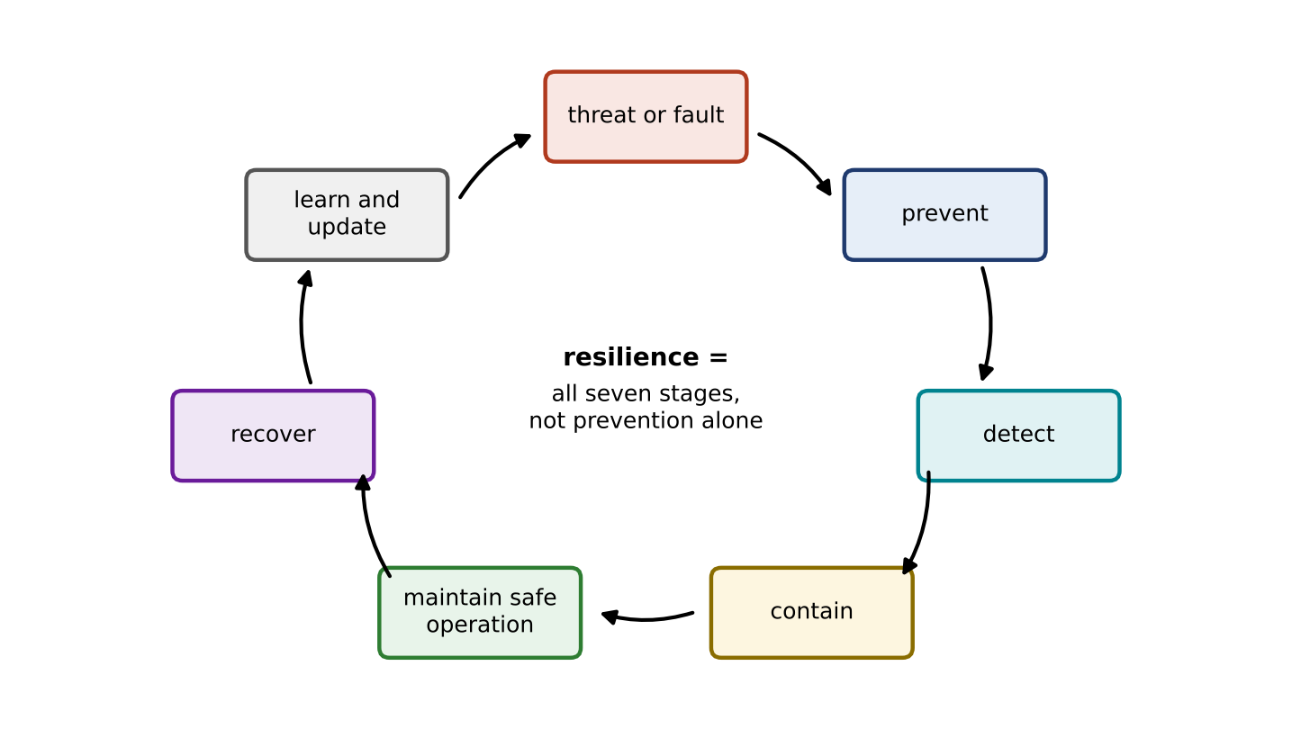
Figure 14.1. The security and resilience lifecycle of a digital twin: threat or fault, prevention, detection, containment, safe operation under reduced capability, recovery, and learning that feeds back into the next cycle. Resilience is the whole cycle, not prevention alone.

14.1.3 Security of the twin and the twin for security
Two directions run through the chapter, and it helps to name them early (Figure 14.2). Security of the twin protects the twin’s own inputs, models, software, outputs and commands: if any of them is wrong, the twin’s decisions are wrong. The twin for security uses the twin’s physical models to defend the plant and the other systems around it: residuals that expose manipulated data, watermarks that expose replays, cyber ranges that rehearse incidents, and predictions of what a compromised command would do. Recent reviews describe a fast-growing literature on the second direction, from microgrid detection and mitigation to incident response in critical infrastructure [1], [2], [3], [4]. The two directions depend on each other. A twin used as a detector is only as trustworthy as its own data and code, so every “twin for security” design in this chapter is paired with the controls that secure the twin itself. NIST IR 8356 [5] makes the same point from the standards side: a twin that models, predicts and may command a physical system raises trust questions beyond ordinary IT security, such as whether its model is still valid, where its data came from and how much authority its outputs should have.
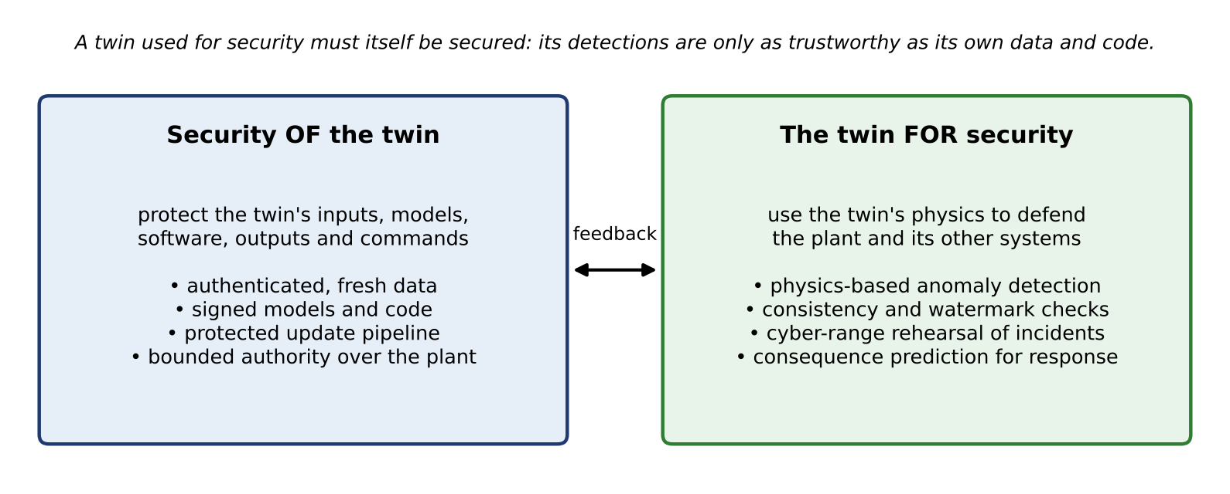
Figure 14.2. Security of the twin (protecting its data, models, software and commands) and the twin for security (using its physics to detect, rehearse and limit attacks on the plant). The two directions feed each other.

14.2 Cybersecurity Fundamentals for Electrical Engineers

14.2.1 The vocabulary, with one energy example each
Security has a precise vocabulary, and misuse of it causes real design errors. Table 14.1 defines the terms used in the rest of the chapter, each with an example from the P-1 system and a common misconception. Figure 14.3 shows how the terms chain together, from an asset to the risk that remains after controls.
TABLE 14.1 Security vocabulary for electrical engineers: plain meaning, a P-1 example and a common misconception
Term | Plain meaning | P-1 example | Common misconception
Asset | Anything of value to protect | Feeder voltage estimate; battery; customer data | Only hardware is an asset
Vulnerability | A weakness that can be exploited | Smart-meter data path without authentication | A vulnerability is the same as an attack
Threat | An actor or event able to exploit a weakness | Someone with write access to the metering head-end | Threats are only external hackers
Exploit | The specific means of using a vulnerability | Altered pseudo-measurements consistent with the network model | Patching removes all exploits at once
Risk | Likelihood combined with consequence | Annual chance of a hidden under-voltage times its cost | Risk is a property of a device alone
Hazard | A potential source of physical harm | Over-current in a battery string | Hazard and threat are the same
Safety | Freedom from unacceptable physical harm | Protection trips the battery contactor | Security failures cannot cause safety failures
Security | Protection against intentional misuse | Signed firmware on the inverter | Security is only encryption
Reliability | Probability of correct function over time under random faults | 2oo3 voltage sensing | Reliable components are secure components
Resilience | Ability to keep essential function, contain damage and recover | Local caps keep frequency up while the backend is compromised | Resilience means the attack never succeeds
Privacy | Protection of individuals’ personal information | Household charging patterns | Removing names makes data anonymous
Identity | A unique, verifiable name for a person, device or service | Certificate of the BESS controller | An IP address is an identity
Authentication | Proving an identity or a message’s origin | MAC on each PMU frame | Encryption alone authenticates
Authorization | Deciding what an authenticated identity may do | The EMS may change set-points, not protection settings | Authenticated users may do anything
Confidentiality | Only authorized parties can read | Market bids, credentials | Confidentiality never matters in OT
Integrity | Data and commands are not altered undetected | Tap-changer set-point arrives unchanged | Integrity checks catch consistent false data
Availability | Timely access to data and functions | Protection messages within 3 ms | Availability means 100 % uptime
Non-repudiation | A party cannot later deny an action | Signed, logged dispatch command | Logs alone give non-repudiation
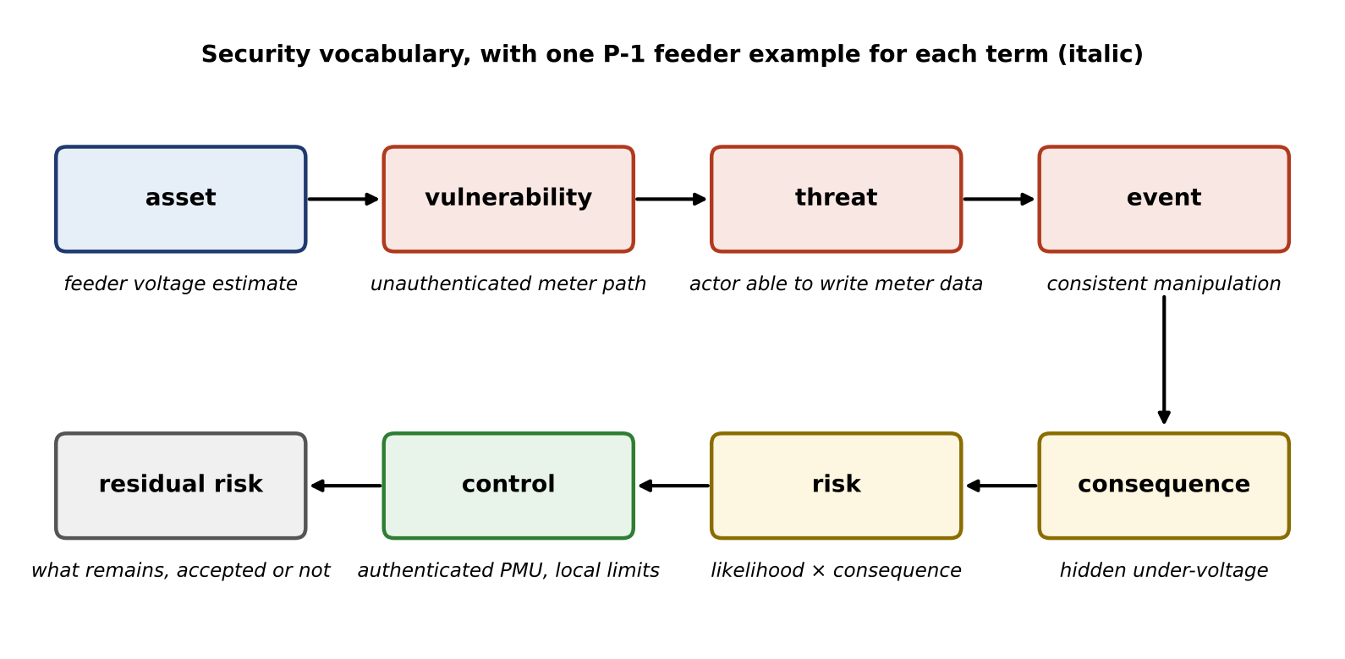
Figure 14.3. Security vocabulary as a chain, with one P-1 feeder example for each term: an asset with a vulnerability meets a threat, an event produces a consequence, risk combines likelihood and consequence, controls reduce it, and residual risk remains to be accepted or treated.

14.2.2 Confidentiality, integrity, availability and the place of safety
The classic objectives of information security are confidentiality, integrity and availability, the CIA triad. Safety is not one of them. Safety is a property of the physical system, and security matters to the electrical engineer because a security failure can become a safety failure. Two errors are common. One treats OT as “IT with the priorities reversed” and declares availability always first. The other copies IT practice wholesale and encrypts everything while leaving commands unauthenticated.
The honest statement is that priorities depend on the mission and the hazard of each data flow. For protection and fast control, integrity and timely availability dominate: a protection trip that arrives late or altered can damage equipment, while a trip message that an outsider can read reveals little. For a credential, a market bid, a customer’s charging record or a vendor’s model parameters, confidentiality can be the first concern, because disclosure is the harm. For a battery management system, integrity of the cell voltages is a safety matter. The same twin therefore carries flows with different priorities, and the design must state the priority of each flow on the data and control planes of the architecture in Section 14.3.

14.2.3 Accidental fault, benign anomaly, attack, or both
The twin’s first job when a symptom appears is often to decide what kind of event it is. Four kinds look similar at first:
- Accidental fault. A failed transducer, a broken fibre, a corrupted configuration.
- Benign anomaly. A real but unusual physical condition: a cold-load pickup, a cloud edge, a feeder reconfiguration not yet in the model.
- Cyberattack. An intentional manipulation, which may be designed to look like either of the above.
- Combined cyber-physical event. An attack timed to coincide with a physical disturbance, or a physical event that exposes a latent cyber weakness.
The distinction matters for the response. A fault calls for repair; a benign anomaly calls for a model update; an attack calls for containment, evidence preservation and a security investigation. A design that cannot tell them apart should respond in the way that is safe for all four: contain first, and decide later with more evidence.

14.3 Assets, Identities, Trust Boundaries, Zones and Conduits

14.3.1 A reference architecture with planes
Figure 14.4 is the reference architecture used throughout the chapter. Its eight layers run from the physical assets through sensing, communication, edge computing, cloud and enterprise services, the model and data layer and the decision layer, to the actuation path. Measurements flow up the data plane and commands flow down the control plane. Three planes cut across all layers. The identity plane holds the identities of devices, workloads (software services) and people, and the keys and certificates that prove them. The management and update plane carries software, firmware, model and configuration changes, with signing, staging and rollback. The safety and protection plane holds relays, interlocks and local limits, and it is deliberately drawn so that it does not depend on the cloud or on the twin. Trust boundaries, the dashed lines in the figure, are where data or commands pass between components that do not share the same level of trust.
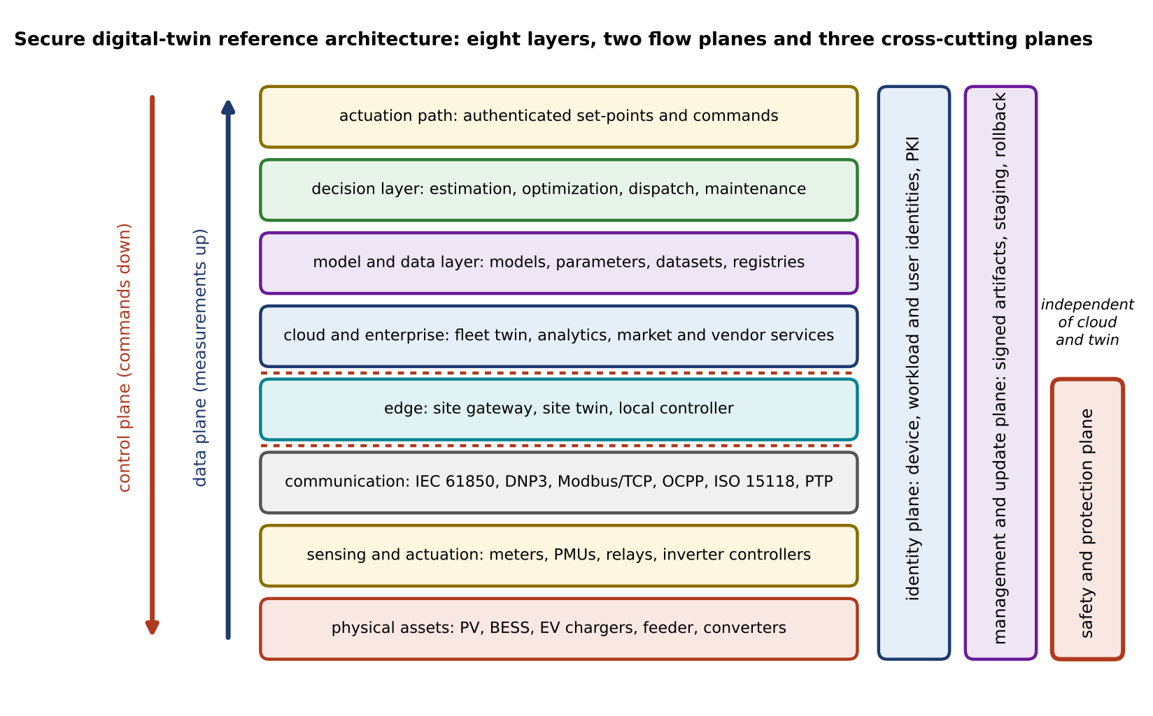
Figure 14.4. Secure digital-twin reference architecture: eight layers from physical assets to the actuation path, the data plane (measurements up) and control plane (commands down), and three cross-cutting planes for identity, management and update, and safety and protection. Dashed red lines mark trust boundaries; the safety plane works without the cloud and without the twin.
The architecture adds two attack surfaces that ordinary automation does not have. The first is the model and its training data (Sections 14.8 and 14.9). The second is the twin’s outputs: other systems consume an estimate, a forecast or a health index as if it were a measurement, so a wrong output propagates with the authority of a sensor.

14.3.2 Zones, conduits and least privilege
IEC 62443 [6] organizes industrial security around zones, groups of assets that share security requirements, and conduits, the controlled communication paths between them. Each zone receives a target security level, and each conduit carries only the flows that the zones need. The asset-owner part, IEC 62443-2-1:2024 [7], sets requirements for the security programme an operator must run, and it recognizes explicitly that industrial control systems are long-lived and that many legacy components cannot be patched or upgraded quickly. For such components the standard’s approach is compensating controls: segmentation, monitoring and restricted access placed around a device that cannot protect itself. That is the normal situation for the old relays, meters and RTUs that an energy twin must coexist with.
Figure 14.5 applies the idea to the PV, battery and EV-charging microgrid. Zone 1 holds field devices and protection, Zone 2 site control and the site twin, Zone 3 a demilitarized zone (DMZ) with a broker and update staging, and Zone 4 the enterprise and cloud services, including the EV backend and vendor remote access. Three rules follow from the figure. Protection and local caps act inside Zones 1 and 2 and keep working if every conduit above them is cut. No connection from Zone 4 reaches Zone 1 directly. Vendor access and updates pass through the DMZ, where they are brokered, logged and staged.
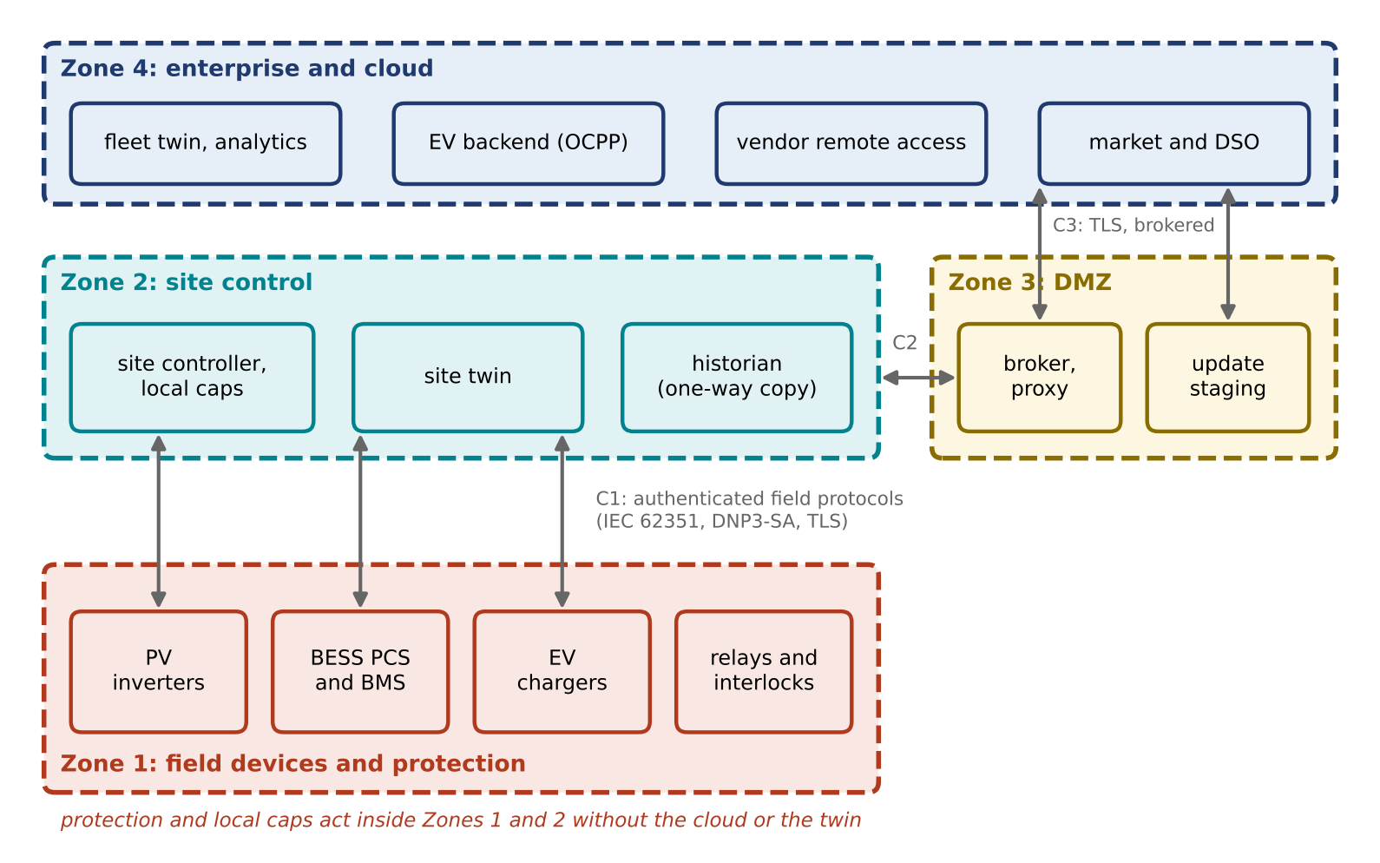
Figure 14.5. Zones and conduits for the P-1 PV, battery and EV microgrid. Field devices and protection (Zone 1) and site control (Zone 2) are separated from the DMZ (Zone 3) and the enterprise and cloud (Zone 4); conduits C1 to C3 carry only authenticated, brokered flows. Protection and local caps work without the cloud or the twin.
Least privilege means each identity holds only the permissions its function needs, for as long as it needs them. For the P-1 twin, the EMS may write battery set-points within limits but may not change protection settings; the vendor’s engineer may read diagnostics but may write firmware only through the staged update path, with approval; the cloud twin may propose schedules but the site controller decides whether to apply them.

14.3.3 Identities and credentials
Every actor, device and software service has an identity, and every identity has permissions and a lifecycle. Table 14.2 lists the identity types in the P-1 twin. The last column matters most in OT: a field device must keep working when it cannot reach a certificate authority, so offline behaviour is a design decision, not an afterthought.
TABLE 14.2 Identities and credentials in the P-1 digital twin
Identity | Example | Credential and owner | Rotation and revocation | Behaviour when offline
Device | PMU, BESS controller, charger | Device certificate in a secure element; owner: asset operator PKI | Renew every 1 to 3 years; revoke on decommissioning or compromise | Keep accepting peers whose certificates were valid at last check, within a grace period
User | Operator, maintenance engineer | Personal account with multi-factor authentication; owner: operator | Remove on role change; review quarterly | Local break-glass account, sealed and logged
Workload or service | Site twin, EMS optimizer, historian | Service certificate or token bound to the workload; owner: platform team | Short-lived (hours to days), issued automatically | Cached token with short expiry; fall back to local control
Vendor | Inverter manufacturer’s support | Federated identity through the DMZ broker; owner: vendor, approved by operator | Time-limited, per session | No access
Code and model signer | Release pipeline | Signing key in a hardware security module; owner: release authority | Rotate on schedule; revoke and re-sign on compromise | Devices verify with stored public keys

14.3.4 Zero trust, adapted to operational technology
Zero trust is the principle that no request is trusted because of where it comes from on the network [8]. Each request is checked for the identity of the device or workload, its authorization for this specific action, the freshness of the message, and its context (time, rate, plant state). For a distributed twin this is the right default: a measurement from inside the site network is not trustworthy just because it is inside.
Enterprise zero-trust designs, however, assume always-on connectivity to policy servers. OT cannot assume that. An OT-aware version keeps the principle and changes the mechanism: verification decisions that protection or fast control depend on are made locally, with cached credentials and pre-agreed policies; deterministic protection never waits for a policy server; and the system has defined behaviour when the identity infrastructure is unreachable. Zero trust is a way to remove implicit trust from the network. It does not remove the need for local, deterministic safety functions.

14.3.5 Protocols: version and profile matter
Industrial and energy protocols are often described as “insecure”, which is too broad to be useful. Security depends on the protocol family, its version and the deployment profile, and most families now have a security mechanism or a companion standard. Figure 14.6 and Table 14.3 separate the base or legacy profile from the secured one [9], [10].
TABLE 14.3 Protocol families, base profiles and the relevant security mechanisms (status checked September 2026; verify editions for a project)
Protocol family | Base or legacy profile | Security mechanism or companion standard | Practical caveat
IEC 61850 GOOSE and sampled values | Layer-2 multicast; no authentication in the base profile | IEC 62351-6: message authentication tags (HMAC or GMAC); group key management by IEC 62351-9 | Tag computation and key distribution must fit the 3 ms class budget
IEC 61850 MMS | Client–server over TCP | IEC 62351-3 (TLS) and IEC 62351-4 (application-level security) | Certificate management for every IED
IEC 60870-5-104 | Telecontrol over TCP | IEC 62351-3 TLS; IEC 62351-5 application-layer authentication | Legacy RTUs may need a security gateway
DNP3 | Many legacy deployments run without authentication | DNP3 Secure Authentication (SAv5 in IEEE 1815-2012, aligned with IEC 62351-5); TLS | Authentication without encryption by design; key update procedures
Modbus/TCP | No security fields in the base protocol | Modbus/TCP Security: TLS with role information in certificates | Many devices only support the base profile; use gateways
CAN and CAN FD inside chargers and BMS | No sender authentication on the bus | Truncated MACs with freshness counters (AUTOSAR SecOC-style); gateway filtering | Bus bandwidth limits tag length
ISO 15118 (vehicle to charger) | ISO 15118-2: TLS required for Plug & Charge, optional for other identification modes | ISO 15118-20: TLS 1.3 required for all sessions; contract-certificate PKI | Mixed fleets run both editions for years
OCPP (charger to backend) | Security profile 1: basic authentication without TLS | Profile 2: TLS with basic authentication; profile 3: TLS with client certificates | Profile is a deployment choice, not a protocol property
Time: PTP and GNSS | Unauthenticated PTP; open civil GNSS signals | IEEE 1588-2019 authentication TLV; multiple sources, holdover | Timing attacks also work through delay asymmetry (Section 14.6)
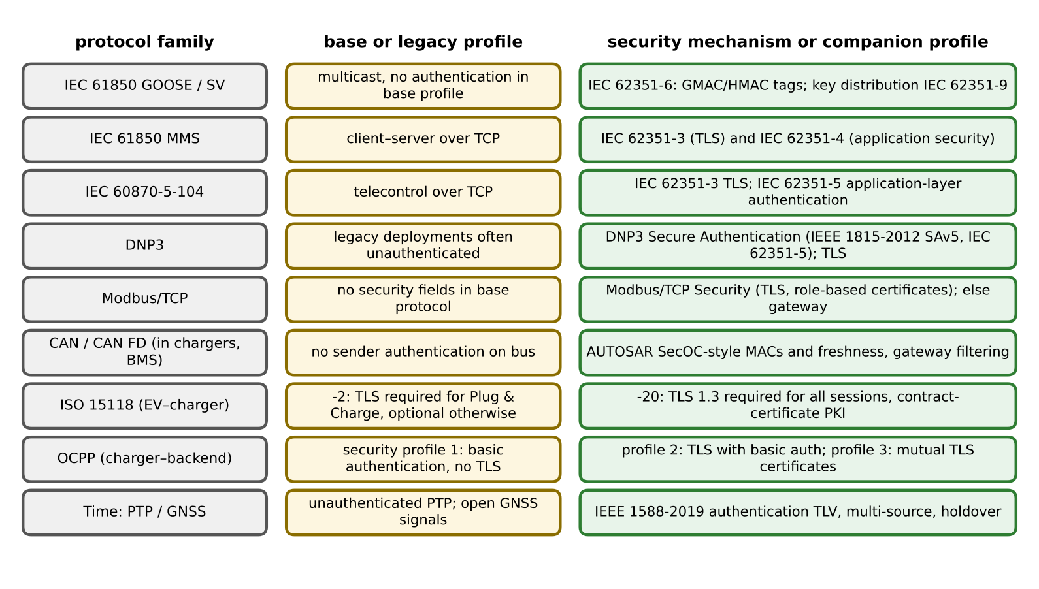
Figure 14.6. Protocol security is version- and profile-specific: for each family, the base or legacy profile (centre) and the mechanism or companion standard that secures it (right).

14.4 Threat Modelling and Cyber-to-physical Consequence Chains

14.4.1 Stating a threat model
A defence is only meaningful relative to a stated threat model. A scheme that defeats an outsider who can alter one unauthenticated meter may fail against an insider with engineering credentials. For a digital twin the threat model has six parts:
- Goal. The physical objective (hide an under-voltage, overload a feeder, shorten battery life) and any financial or informational aim.
- Access. Where the adversary can act: internet edge, remote access, site network, inside firmware or a model.
- Knowledge. How much of the network model $H$, the settings and the detectors the adversary knows.
- Capability. Which identities are compromised, and how many sensors or actuators can be altered at once.
- Persistence. How long the adversary can stay, from hours to years.
- Stealth objective. Whether the adversary must avoid detection, and by which detectors.
Figure 14.7 and Table 14.4 give five adversary classes used later in the chapter. Each class is an assumption, and each result in the chapter is stated against one of them.
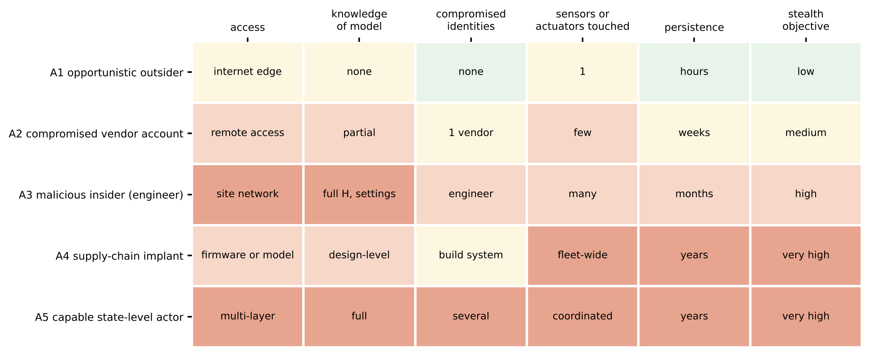
Figure 14.7. Threat-model matrix for the P-1 twin: five adversary classes against access, knowledge of the model, compromised identities, number of sensors or actuators touched, persistence and stealth objective. Darker cells mean a more capable adversary.
TABLE 14.4 Threat model for the P-1 digital twin: adversary classes, assumed capabilities and defences
Adversary | Access and knowledge | Target | Stealth | Physical consequence if unopposed | Assumed defences
A1 opportunistic outsider | Internet-facing service; no model knowledge | Exposed web interface, default passwords | Low | Nuisance, lost data | Segmentation, no direct exposure, MFA
A2 compromised vendor account | Remote access through DMZ; partial knowledge | Diagnostics, firmware staging | Medium | Wrong settings, malicious update | Brokered sessions, staged signed updates
A3 malicious insider | Site network, engineering tools, full $H$ | State estimator inputs, set-points | High | Hidden under-voltage, overload | Protected measurements, two-person rule, logging
A4 supply-chain implant | Inside firmware or a model; design-level knowledge | Many devices at once | Very high | Fleet-wide bias or synchronized action | Signed builds, provenance, diverse redundancy, local caps
A5 capable state-level actor | Several layers, long persistence | Coordinated sensors and actuators | Very high | Coordinated load or generation swings | All of the above, plus consequence limits sized to the worst case

14.4.2 From cyber event to physical consequence
What makes energy-system security different from IT security is the physical consequence. Table 14.5 maps the main event classes to what is observed, what can happen physically, how it is detected and how the system should respond safely. The same table serves for accidental failures, which produce many of the same symptoms. Figure 14.8 draws the chain: a cyber event or fault enters the data, estimate or command path, influences the twin’s decision, reaches the actuator and becomes a physical effect, unless a barrier on the way stops it. The last two barriers, rate limits with local caps and interlocks with protection, act on physics and still work when the twin itself is compromised.
TABLE 14.5 Cyber events in a twin-supported microgrid: symptom, consequence, detection and safe response
Event | Observable symptom | Possible physical consequence | Detection | Safe response
Spoofed or manipulated sensor | Measurement inconsistent with physics or neighbours; or, if consistent, no symptom at all | Wrong estimate, wrong control, hidden limit violation | Residual tests, protected reference measurements, redundancy | Exclude with provenance, fall back to independent data
Replay of recorded data | Plausible data that do not respond to excitation | Controller blind to real disturbances | Authenticated freshness, watermarking | Freeze to safe set-point, alarm
Time-synchronization failure or spoofing | Angle jumps, inconsistent time stamps | Wrong PMU angles, wrong event sequence | Multi-source time comparison, holdover consistency | Flag time-dependent data, use local holdover
Poisoned model or update | Behaviour shifts after update | Degraded decisions over time | Update gate, signatures, protected held-out validation | Roll back, quarantine
Access-control failure | Command from unexpected identity, time or rate | Unsafe set-points, mass switching | Authorization logs, command governor | Reject, rate-limit, local caps
Network outage or denial of service | Missing or late messages; growing age of information | Stale data, lost coordination | Message age against deadline | Local autonomous mode, safe defaults
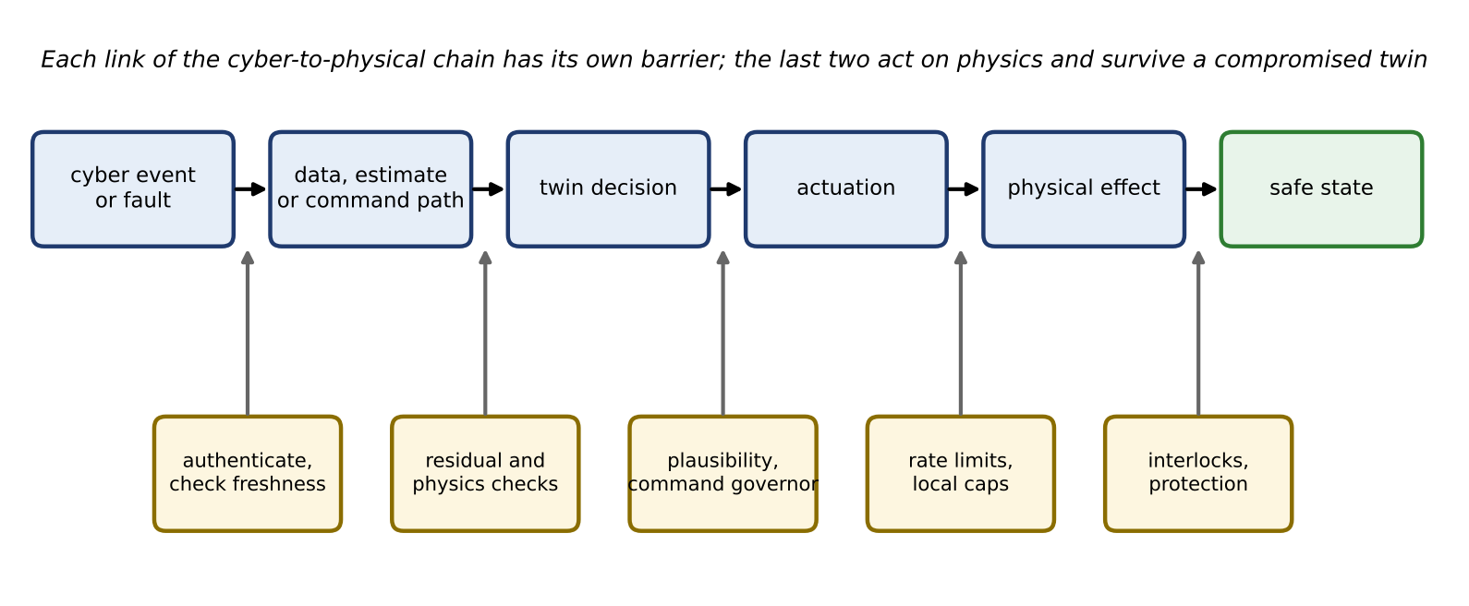
Figure 14.8. Cyber-to-physical consequence chain with a barrier at each link: authentication and freshness, residual and physics checks, plausibility and a command governor, rate limits and local caps, interlocks and protection. The last two act on physics and survive a compromised twin.

14.5 False-data Injection and Protected Measurement Sets
The weighted-least-squares state estimator of Chapter 11 (Section 11.12) is the twin’s gatekeeper for measurements, and its bad-data test is the first line of defence against manipulated data. This section works out exactly what that test can and cannot see. The derivation is done for the linear (DC) model, where every step is exact, and then extended to the nonlinear, dynamic and topology-error cases.

14.5.1 A geometric picture first
Think of the $m$ measurements as one point in an $m$-dimensional space. Each possible state $x$ of the network predicts a set of measurements $Hx$, and as $x$ varies these predictions sweep out a flat subspace of dimension $n$, the column space of $H$. Real measurements lie slightly off this subspace because of noise. The estimator finds the closest point of the subspace (closest in a distance that weights precise meters more), and the residual is the leftover vector from that point to the measurements. Bad-data detection asks whether the residual is longer than noise alone would explain.
Now suppose someone adds a vector to the measurements. If the added vector points along the subspace, the measurement point slides parallel to it, the closest point slides by the same amount, and the residual does not change at all (Figure 14.9). The estimator then reports a different state, and nothing in the residual reveals it. If the added vector has any component that leaves the subspace, part of it shows up in the residual. Everything in this section is a precise version of this picture.
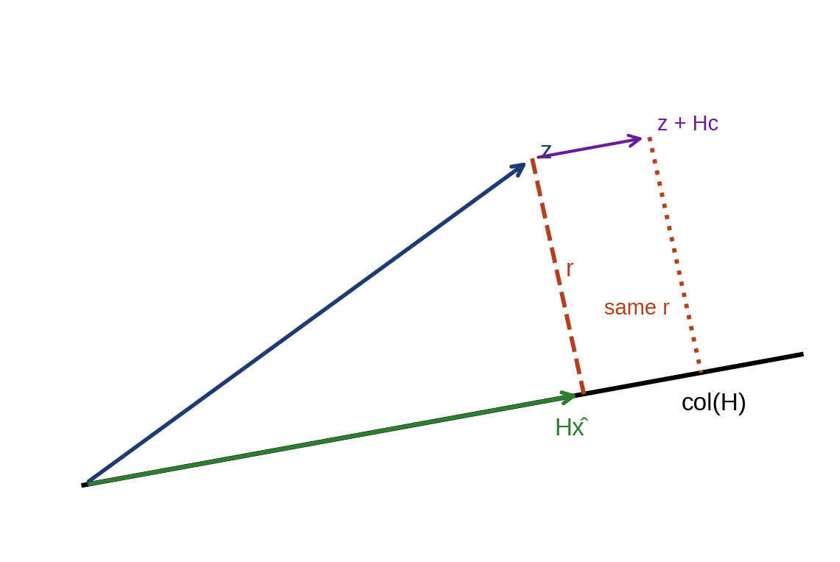
Figure 14.9. Geometry of the residual. The measurement vector $z$ is projected onto the column space of $H$; the residual $r$ is the part outside it. An injection $Hc$ that lies in the column space moves the projection and leaves the residual unchanged.

14.5.2 The weighted-least-squares estimate and its residual
Take the linear measurement model
 | $$z=Hx+e, e∼N\left(0,R\right), W=R^{−1},$$ | (14.1)
where $z$ is the vector of $m$ measurements, $x$ the vector of $n$ states (bus voltage angles in the DC model), $H$ the $m×n$ measurement matrix of full column rank, $e$ the measurement noise with covariance $R$ (diagonal, with entries $σ_{i}^{2}$), and $W$ the weight matrix. The WLS estimate minimizes ${\left(z−Hx\right)}^{T}W\left(z−Hx\right)$. Setting the gradient $−2H^{T}W\left(z−Hx\right)$ to zero gives the normal equations and the estimate
 | $$\hat{x}={\left(H^{T}WH\right)}^{−1}H^{T}Wz=G^{−1}H^{T}Wz, G=H^{T}WH,$$ | (14.2)
where $\hat{x}$ is the estimate and $G$ the gain matrix, invertible when the network is observable. The residual is
 | $$r=z−H\hat{x}=\left(I−K\right)z, K=HG^{−1}H^{T}W,$$ | (14.3)
where $I$ is the $m×m$ identity and $K$ the hat matrix, which maps the measurements to their fitted values. Two identities follow by direct multiplication and carry the whole section. First, $KH=HG^{−1}G=H$, so $\left(I−K\right)H=0$. Second, $K^{2}=HG^{−1}\left(H^{T}WH\right)G^{−1}H^{T}W=K$, so $K$ and $I−K$ are projections. Substituting (14.1) into the residual and using the first identity,
 | $$r=\left(I−K\right)\left(Hx+e\right)=\left(I−K\right)e,$$ | (14.4)
so the residual depends on the noise only, never on the true state.

14.5.3 Why the residual energy is chi-square
The bad-data statistic is the weighted residual energy $J=r^{T}Wr$. To find its distribution, whiten the noise: write $e=R^{1/2}u$ with $u∼N\left(0,I\right)$. Then $W^{1/2}r=Pu$ with $P=W^{1/2}\left(I−K\right)W^{−1/2}=I−W^{1/2}HG^{−1}H^{T}W^{1/2}$, which is symmetric and idempotent. A symmetric idempotent matrix has eigenvalues 0 or 1, and its rank equals its trace, $tr\left(P\right)=m−tr\left(G^{−1}G\right)=m−n$. Hence
 | $$J=r^{T}Wr=u^{T}Pu∼χ_{m−n}^{2}, \text{alarm if} J>τ=F_{χ_{m−n}^{2}}^{−1}\left(1−α\right),$$ | (14.5)
where $J$ is the test statistic, $χ_{m−n}^{2}$ the chi-square distribution with $m−n$ degrees of freedom, $τ$ the threshold, $F^{−1}$ the inverse distribution function and $α$ the false-alarm probability per test. The number $m−n$ is the redundancy: the number of independent checks the measurements can make on each other.
The residual covariance $Ω=Cov\left(r\right)=R−HG^{−1}H^{T}$ (Chapter 11, Section 11.12.3) also tells how well each meter is checked. Its diagonal entry divided by the meter’s own variance, $Ω_{ii}/σ_{i}^{2}=1−K_{ii}$, lies between 0 and 1. A value near 1 means the other meters check meter $i$ well. A value of 0 means meter $i$ is critical: its residual is always zero and no error on it can ever be seen.

14.5.4 Injected data and the noncentrality parameter
Suppose an adversary adds a vector $a$ to the measurements, $z_{a}=z+a$. By linearity the residual becomes $r_{a}=\left(I−K\right)e+\left(I−K\right)a$, and the whitened residual has a mean shift. The statistic then follows a noncentral chi-square distribution,
 | $$J_{a}∼χ_{m−n}^{2}\left(λ\right), λ=a^{T}W\left(I−K\right)a, P_{D}=1−F_{χ_{m−n}^{2}\left(λ\right)}\left(τ\right),$$ | (14.6)
where $λ$ is the noncentrality parameter, the weighted energy of the part of the attack that leaves the column space, and $P_{D}$ the probability that the test detects the attack. For an error of size $s$ on meter $i$ alone, $a=se_{i}$ with $e_{i}$ the $i$-th unit vector, and (14.6) reduces to
 | $$λ_{i}={\left(\frac{s}{σ_{i}}\right)}^{2}\frac{Ω_{ii}}{σ_{i}^{2}}={\left(\frac{s}{σ_{i}}\right)}^{2}\left(1−K_{ii}\right),$$ | (14.7)
where $K_{ii}$ is the $i$-th diagonal entry of the hat matrix, the leverage of meter $i$. A 5σ error on a meter with leverage 0.44 therefore has a noncentrality of only $25×0.56=14$, and, as the example below shows, is missed a third of the time. Detection probability is a design quantity to be computed, never assumed.

14.5.5 Injections that the residual test cannot see
If $a$ lies in the column space of $H$, that is $a=Hc$ for some vector $c$, then $\left(I−K\right)a=0$ and
 | $$r_{a}=\left(I−K\right)\left(z+Hc\right)=r, {\hat{x}}_{a}=\hat{x}+c, λ=0,$$ | (14.8)
where $c$ is the state change the injection produces. The residual, and every statistic computed from it, is unchanged, while the estimate moves by exactly $c$ [11]. The statement needs its assumptions spelled out, because it is often quoted too broadly. The injection is invisible to the residual detector of (14.5), under the linear model (14.1), for an adversary who knows $H$ and can alter every measurement in which $Hc$ is non-zero. It is not automatically invisible to an independent detector: a protected reference measurement, a time-consistency check, a comparison with a forecast from a separate source, or a physics cross-check with another sensor all lie outside the adversary’s reach if they lie outside the compromised set. The property belongs to the model, not to a weak test: data that are consistent with some physically possible state cannot be distinguished from that state by consistency alone.
How many meters must be altered is itself a security measure. The security index of state $j$ is the smallest number of measurements a consistent injection must touch to change that state [12],
 | $$κ_{j}=\min_{c} {∥Hc∥}_{0} \text{subject to} c_{j}=1,$$ | (14.9)
where ${∥⋅∥}_{0}$ counts non-zero entries and $c_{j}$ is the $j$-th entry of $c$. States with a small index are the cheapest to manipulate and the first to protect. The problem is combinatorial in general, but small networks can be solved by enumeration and large ones by mixed-integer or graph-cut formulations.

14.5.6 Beyond the linear, static, correct model
Three extensions matter in practice, and each changes what the adversary needs.
- Nonlinear AC model. The estimator of Chapter 11 uses $z=h\left(x\right)+e$. A consistent injection becomes $a=h\left(\hat{x}+c\right)−h\left(\hat{x}\right)$, which requires the nonlinear model and a good estimate of the current state. To first order it lies in the column space of the Jacobian and is invisible; second-order terms leave a small residual, which on the P-1 feeder (Example 14.6) changes $J$ only in the fourth decimal place.
- Dynamic estimators. A Kalman-type estimator also tests consistency over time, through its innovations. An injection must then be consistent with the dynamics as well, and undetectable attacks exist only if the attack can excite the system without changing the output sequence, which is a statement about the system’s zero dynamics [13]. This is harder for the adversary but not impossible for one with a good model.
- Topology and parameter errors. If the twin’s model $H$ is wrong, because a switch status or a line impedance is wrong, honest data already produce residuals, thresholds may have been loosened to stop false alarms, and an adversary who knows the true network may be able to hide inside the model error. Protection of measurements does not protect the model; switch statuses and parameters need their own provenance (Chapter 11, Sections 11.12.5 and 11.12.6).

14.5.7 Protecting a measurement set
Equation (14.8) also shows how to remove the possibility. Suppose a set $P$ of measurements is protected: authenticated and integrity-checked so that the adversary cannot alter them. A consistent injection must then leave those rows unchanged, $H_{P}c=0$, where $H_{P}$ holds the rows of $H$ for the protected measurements. If those rows alone make the state observable,
 | $$rank\left(H_{P}\right)=n ⇒ H_{P}c=0 \text{only for} c=0,$$ | (14.10)
then no non-zero consistent injection exists, and any manipulation of the unprotected meters must leave a residual [14]. Protecting $n$ well-chosen measurements (a basic measurement set) suffices in principle; in practice more are protected so that the guarantee survives the loss of one. The guarantee is again scoped. It covers injections that cannot alter the protected measurements, under the model $H$ and its observability assumptions. It does not cover a wrong topology or parameter, a compromised protected device, or a key stolen from it, and it says nothing about how large a detectable injection must be to be detected: that is the noncentrality question of (14.6).
Example 14.1 Consistent and inconsistent injections on a four-bus network
Given. The four-bus DC network of Figure 14.10 (left): lines 1–2, 1–3, 2–3, 2–4 and 3–4 with reactances 0.10, 0.20, 0.25, 0.20 and 0.10 pu; bus 1 is the angle reference, so $n=3$ states $\left(θ_{2},θ_{3},θ_{4}\right)$. There are $m=8$ measurements: the five line flows $P_{ij}=\left(θ_{i}−θ_{j}\right)/x_{ij}$ and the injections at buses 2, 3 and 4, each with $σ=0.01$ pu. With rows ordered $P_{12},P_{13},P_{23},P_{24},P_{34},P_{2},P_{3},P_{4}$,
 | $$H^{T}=\left[\begin{matrix}−10 & 0 & 4 & 5 & 0 & 19 & −4 & −5 \\ 0 & −5 & −4 & 0 & 10 & −4 & 19 & −10 \\ 0 & 0 & 0 & −5 & −10 & −5 & −10 & 15\end{matrix}\right].$$ | (14.11)
The true state is $\left(−0.05,−0.08,−0.12\right)$ rad and the noise is drawn with seed 5 (NumPy default generator). The threshold at 99 % with $m−n=5$ degrees of freedom is $τ=15.09$.
Find. (a) $J$ for clean data; (b) $J$ and the detection probability for an error of 0.05 pu (5σ) and of 0.02 pu on the flow meter of line 1–2; (c) the effect of $a=Hc$ with $c={\left(0,0,0.02\right)}^{T}$; (d) the security index of each state; (e) which protected sets satisfy (14.10).
Solution.
- (a) Clean data. $J=3.65$, below the threshold.
- (b) Single-meter errors. The flow meter of line 1–2 has $Ω_{11}/σ^{2}=0.563$ (leverage 0.437). By (14.7), a 0.05 pu error gives $λ=25×0.563=14.1$ and $P_{D}=0.65$; a Monte Carlo check with 20 000 noise draws gives 0.651. In this particular realization the error raises $J$ to 13.48, below the threshold, so it is missed, as happens in 35 % of realizations. A 0.02 pu error gives $λ=2.25$ and $P_{D}=0.057$, barely above the 1 % false-alarm rate.
- (c) Consistent injection. $Hc$ is non-zero on five of the eight measurements ($P_{24},P_{34},P_{2},P_{3},P_{4}$). $J$ stays at exactly 3.65, and the estimated $θ_{4}$ moves by 0.020 rad while $θ_{2}$ and $θ_{3}$ do not move.
- (d) Security index. Enumeration gives $κ_{j}=4$ for all three states. The cheapest injection shifts all three angles equally, $c∝\left(1,1,1\right)$, which leaves flows between buses 2, 3 and 4 and the injection at bus 4 unchanged and touches only $P_{12}$, $P_{13}$, $P_{2}$ and $P_{3}$. So the cheapest attack on $θ_{4}$ is not the obvious one that changes $θ_{4}$ alone.
- (e) Protected sets. The three injections, the flows on lines 1–2, 1–3 and 3–4, and the flows on lines 1–2, 2–4 and 3–4 each give rank 3 and exclude consistent injections. The two injections at buses 2 and 3 give rank 2: the injection along $c∝\left(0.317,0.493,0.810\right)$ leaves both unchanged and remains invisible.
Interpretation. Figure 14.11 summarizes the cases. Bad-data detection catches gross, inconsistent errors, not always even those, and is structurally blind to consistent ones. Protection of an observable measurement set is the structural remedy. The security index shows that intuition about which meters an attack needs can be wrong; it has to be computed.
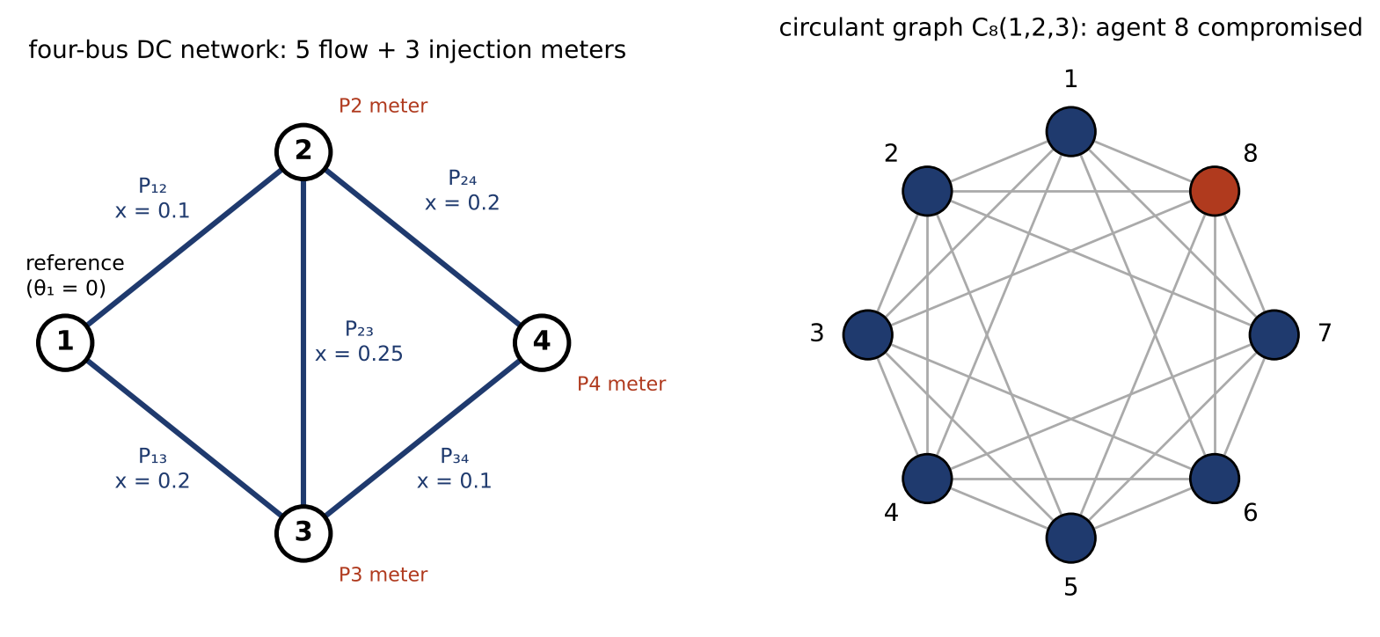
Figure 14.10. The networks used in the examples: the four-bus DC network of Example 14.1 and the moving-target study, with its five flow meters and three injection meters (left); the circulant communication graph $C_{8}\left(1,2,3\right)$ of Example 14.5, in which each agent talks to six others and agent 8 is compromised (right).
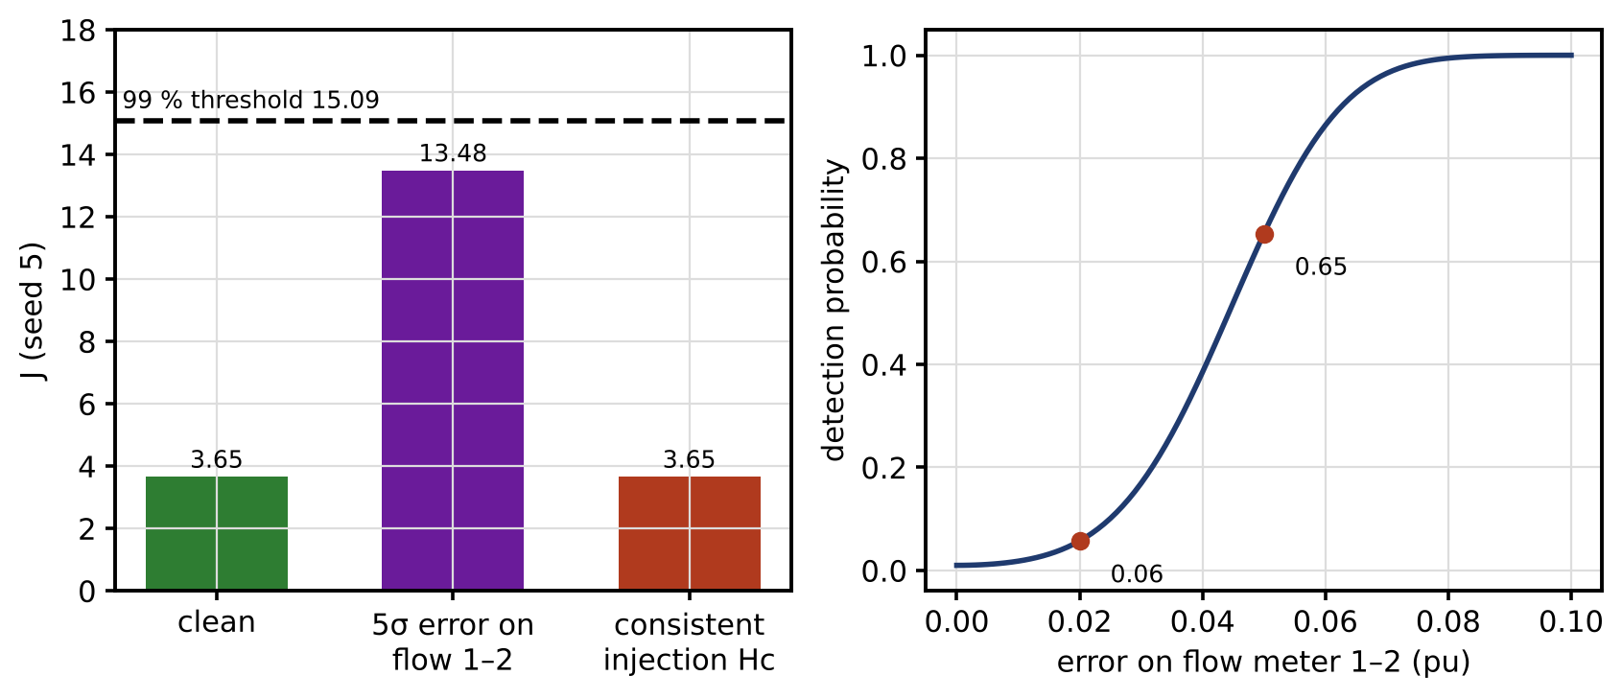
Figure 14.11. Four-bus example (seed 5): chi-square statistic for clean data, a 5σ error on the flow meter of line 1–2 (missed in this realization) and a consistent injection, against the 99 % threshold (left); detection probability of a single-meter error against its size, from the noncentral chi-square distribution (right).

14.6 Replay, Timing, GNSS, PTP and Freshness

14.6.1 Replay and freshness
In a replay, genuine measurements recorded earlier are fed to the controller in place of live ones, perhaps while the plant is being disturbed. Every value is authentic and consistent, so integrity checks and residual tests pass, and the controller keeps acting as if the plant were still in its recorded state. Replay is defeated by freshness. A receiver accepts a message only if its sequence number exceeds the last one accepted from that sender and its time stamp is recent,
 | $$s_{msg}>s_{last}, \left|t_{now}−t_{msg}\right|≤Δt_{max}=d_{max}+2ε_{clk},$$ | (14.12)
where $s_{msg}$ and $s_{last}$ are the sequence numbers of the new message and of the last accepted one, $t_{now}$ the receiver’s clock, $t_{msg}$ the time stamp in the message, $Δt_{max}$ the acceptance window, $d_{max}$ the worst-case path latency and $ε_{clk}$ the bound on each clock’s error. The two conditions are necessary but not sufficient. They work only if:
- The freshness fields are inside the authentication. A sequence number that an attacker can rewrite proves nothing.
- Counter reset and wrap-around are handled. A device that reboots and restarts its counter at zero must either store the counter in non-volatile memory or start a new session with a new key; a counter that wraps must trigger re-keying before it does.
- Reordering is tolerated deliberately. Multicast and UDP paths deliver out of order, so receivers often accept a sliding window of recent sequence numbers rather than strictly increasing ones; the window must be small and tracked per sender.
- Clock failure is detected. The time-stamp test is only as good as the two clocks. If either clock is wrong or spoofed (Section 14.6.3), the window rejects good data or accepts old data.
- Session and key changes are handled. Counters belong to a key or session; a new key starts a new counter space, and old messages under a retired key must be rejected.
At the physical level, freshness is also checked by watermarking (Section 14.13), which makes live data carry a secret random signature that recorded data cannot.

14.6.2 Clock error, phase error and total vector error
Phasor measurements are meaningful only relative to a common time reference, usually GNSS or IEEE 1588 Precision Time Protocol (PTP). A clock error $Δt$ at nominal frequency $f_{0}$ rotates the measured phasor by
 | $$Δθ=2πf_{0} Δt,$$ | (14.13)
where $Δθ$ is the phase error in radians. IEEE C37.118.1 [15] limits the total vector error (TVE), the magnitude of the difference between the measured and true phasors relative to the true magnitude. If the measured phasor has a relative magnitude error $ϵ$ and a phase error $φ$,
 | $$TVE=\left|\left(1+ϵ\right)e^{jφ}−1\right|=\sqrt{{\left(1+ϵ\right)}^{2}−2\left(1+ϵ\right)cosφ+1},$$ | (14.14)
where $j$ is the imaginary unit. For a pure phase error ($ϵ=0$) this becomes $TVE=2sin\left(φ/2\right)≈φ$. At 50 Hz, 1 µs of clock error costs 0.018°, and the 1 % TVE limit, $φ=0.01$ rad = 0.573°, is reached at 31.8 µs.
That 31.8 µs figure needs care. It is the pure-phase equivalent of 1 % TVE for an otherwise ideal sinusoid. In a real PMU the TVE budget is shared with magnitude error, filter and estimation error, harmonics and frequency deviation. If the magnitude error alone already uses 0.5 %, (14.14) leaves only $φ=0.495°$, or 27.5 µs; with 0.8 %, only 19.0 µs. The 31.8 µs value is therefore an upper bound on the clock error, not an allowable budget, and timing specifications for synchrophasor systems are usually set to a few microseconds. Table 14.6 translates clock error into consequences.
TABLE 14.6 Clock error at 50 Hz: phase error, pure-phase TVE and typical consequences
Clock error | Phase error | Pure-phase TVE | Typical consequence
1 µs | 0.018° | 0.03 % | Negligible for PMUs; typical design target
10 µs | 0.18° | 0.31 % | Uses a third of the TVE budget; angle-based estimators slightly biased
31.8 µs | 0.573° | 1.0 % | Pure-phase limit of 1 % TVE, with nothing left for other errors
100 µs | 1.8° | 3.1 % | PMU non-compliant; line-angle monitoring and island detection mislead
1 ms | 18° | 31 % | State estimator sees a disturbance that does not exist; sequence-of-events records at 1 ms resolution misorder
5 ms | 90° | 141 % | A quarter cycle: phasor data meaningless; event analysis fails

14.6.3 Network time, delay asymmetry, GNSS and holdover
Two-way time protocols (NTP and PTP) estimate a clock’s offset from four time stamps: $t_{1}$, request sent by the client; $t_{2}$, request received by the server; $t_{3}$, reply sent by the server; $t_{4}$, reply received by the client. With true offset $θ$ (client minus server) and one-way delays $d_{cs}$ and $d_{sc}$, the time stamps satisfy $t_{2}−t_{1}=d_{cs}−θ$ and $t_{4}−t_{3}=d_{sc}+θ$. Solving under the assumption $d_{cs}=d_{sc}$ gives the protocol’s estimates,
 | $$\hat{θ}=\frac{\left(t_{4}−t_{3}\right)−\left(t_{2}−t_{1}\right)}{2}=θ+\frac{d_{sc}−d_{cs}}{2}, \hat{d}=\frac{\left(t_{2}−t_{1}\right)+\left(t_{4}−t_{3}\right)}{2},$$ | (14.15)
where $\hat{θ}$ is the estimated offset and $\hat{d}$ the estimated one-way delay. Any asymmetry $d_{sc}−d_{cs}$ biases the offset by half its value, and the protocol cannot see it. This is also an attack: delaying packets in one direction by 100 µs shifts the client clock by 50 µs without touching a single packet’s contents, which is why message authentication in PTP (the IEEE 1588-2019 authentication TLV [10]) is necessary but not sufficient. A compromised grandmaster is a further case: an authenticated source that is itself wrong.
GNSS receivers face jamming (loss of signal) and spoofing (a counterfeit signal that pulls the receiver’s time). The defences combine several sources and a good local oscillator. During holdover, when the reference is lost or distrusted, the local clock drifts. With an initial time error $x_{0}$, fractional frequency offset $y_{0}$ and linear frequency drift $D$ (per second), the accumulated time error after $t$ seconds is
 | $$x\left(t\right)=x_{0}+y_{0}t+\frac{1}{2}Dt^{2},$$ | (14.16)
where $x$ is in seconds and $y_{0}$ is dimensionless. For an oven-controlled crystal (assumed $y_{0}=5×{10}^{−10}$, $D$ equivalent to $5×{10}^{−10}$ per day), the clock reaches 1 µs after 33 min and 31.8 µs after 13.8 h. For a rubidium oscillator (assumed $5×{10}^{−12}$ and $5×{10}^{−12}$ per month) it reaches 1 µs after 2.2 days and 31.8 µs after 43 days (Figure 14.12). These assumed values are illustrative; the vendor’s holdover specification and a test on the installed unit are what count.
Holdover also gives a spoofing check. While GNSS is trusted, the twin learns $y_{0}$ and $D$; if GNSS time later departs from the holdover prediction by more than a few standard deviations of the predicted error, the twin distrusts GNSS, stays on holdover and flags all time-dependent data. Multiple independent sources (GNSS, PTP over a separate path, a terrestrial reference) allow a majority comparison of the kind used for sensors in Section 14.17.
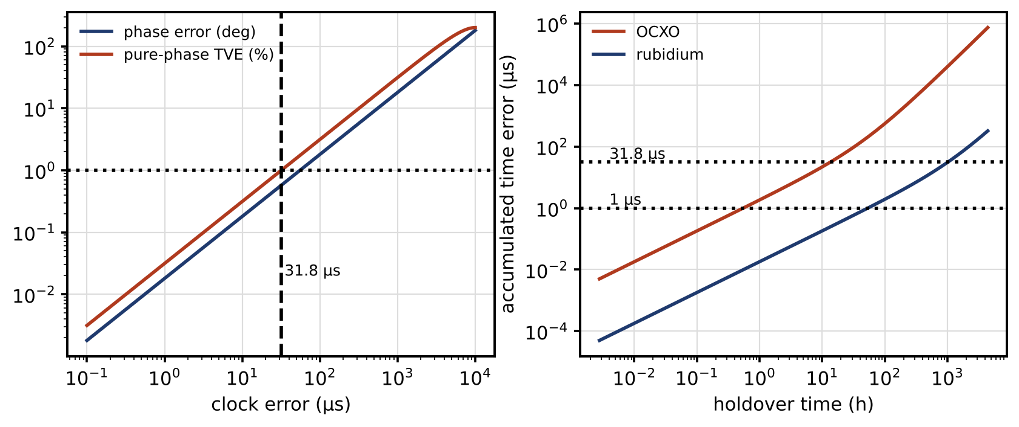
Figure 14.12. Timing at 50 Hz: phase error and pure-phase TVE against clock error, with the 31.8 µs pure-phase equivalent of 1 % TVE (left); accumulated time error in holdover for an assumed oven-controlled crystal and rubidium oscillator (right).

14.7 Denial of Service, Latency, Packet Loss and Age of Information
Interception of unencrypted traffic exposes operational data and credentials. Denial of service (DoS) removes data or commands altogether, or delays them past their deadlines. This section quantifies what missing and late data do to an estimator and a controller, starting from a scalar model that can be solved exactly.

14.7.1 A pedagogical scalar result: intermittent measurements
Consider a scalar state $x_{k+1}=ax_{k}+w_{k}$ measured directly as $y_{k}=x_{k}+v_{k}$, where the measurement reaches the estimator only with probability $γ$ at each step. Here $a$ is the state multiplier, $w_{k}$ and $v_{k}$ are independent zero-mean Gaussian noises with variances $q$ and $r$, and the arrival indicator $γ_{k}$ equals 1 with probability $γ$ and 0 otherwise, independently from step to step. The Kalman filter’s one-step prediction variance $P_{k}$ then follows a random Riccati recursion [16],
 | $$P_{k+1}=a^{2}P_{k}+q−γ_{k}\frac{a^{2}P_{k}^{2}}{P_{k}+r},$$ | (14.17)
whose last term is the variance removed by a measurement when one arrives. Its innovation variance $S_{k}=P_{k}+r$ is what the detectors of Section 14.12 normalize by. For an unstable plant ($\left|a\right|>1$), the expected variance stays bounded only if measurements arrive often enough. In this scalar, directly measured case the threshold can be derived exactly. After an arrival, $P_{k+1}=a^{2}P_{k}r/\left(P_{k}+r\right)+q≤a^{2}r+q$, so arrivals reset the variance below a fixed level. Between arrivals, $P$ is multiplied by $a^{2}$ (plus $q$) at each step. A gap of $L$ missing steps therefore inflates the variance by roughly $a^{2L}$, and gaps are geometric, $Pr\left(L=ℓ\right)=γ{\left(1−γ\right)}^{ℓ}$. The expected inflation ℓ​γ1−γℓa2ℓ is finite only if $\left(1−γ\right)a^{2}<1$, that is
 | $$γ>γ_{c}=1−\frac{1}{a^{2}},$$ | (14.18)
where $γ_{c}$ is the critical arrival probability. For $a=1.2$, $γ_{c}=0.31$.
The result is model-specific and should be read as a teaching result. For vector systems, Sinopoli and colleagues [16] show that the critical rate lies between a lower and an upper bound that coincide only in special cases, such as an invertible output matrix; for nonlinear estimators and correlated losses there is no simple formula. What transfers is the qualitative lesson: unstable modes need a minimum information rate, and the tail of the outage distribution, not its mean, decides whether the estimate survives.
Simulated with $a=1.2$ and $q=r=1$ over 200 000 steps (seed 21), the prediction variance is 1.95 with every measurement arriving. With 90 % arrival its mean is 2.20 and its 99th percentile 6.5. With 50 % the mean is 5.5, the 99th percentile 38 and the largest value 1460. With 35 %, just above $γ_{c}$, the median is still 4.3 but the 99th percentile is 175 and the largest value 18 700: the variance is dominated by rare long outages (Figure 14.13, left).

14.7.2 Bursts, correlation and partitions
Real losses come in bursts: a congested switch, a radio fade, a DoS flood. A two-state Gilbert–Elliott model captures this. In the good state every packet arrives; in the bad state none does; the channel stays in the bad state with probability $q_{bb}$ per step, so bursts have mean length $1/\left(1−q_{bb}\right)$. The gap argument above now applies to the bursts, whose lengths are geometric with continuation probability $q_{bb}$, and the expected variance stays bounded only if
 | $$q_{bb} a^{2}<1,$$ | (14.19)
a condition on the burst structure, not on the average arrival rate [17]. For $a=1.2$, $q_{bb}$ must be below 0.694. Two channels with the same 90 % average arrival show the difference (Figure 14.13, right). With mean bursts of 2 steps ($q_{bb}=0.5$), the variance has mean 2.7 and 99th percentile 15.9. With mean bursts of 5 steps ($q_{bb}=0.8$), the expected variance is unbounded: the median is unchanged at 1.95, but the simulated mean is 523 and the largest value $2.7×{10}^{7}$. An availability figure of “90 % of packets delivered” says nothing about whether the estimator survives.
A network partition is the extreme case: a whole region of the twin is cut off for minutes or hours. Then estimation must continue on the local side with local data and a process model, and every quantity derived from the missing side must be marked as stale (Section 14.20).
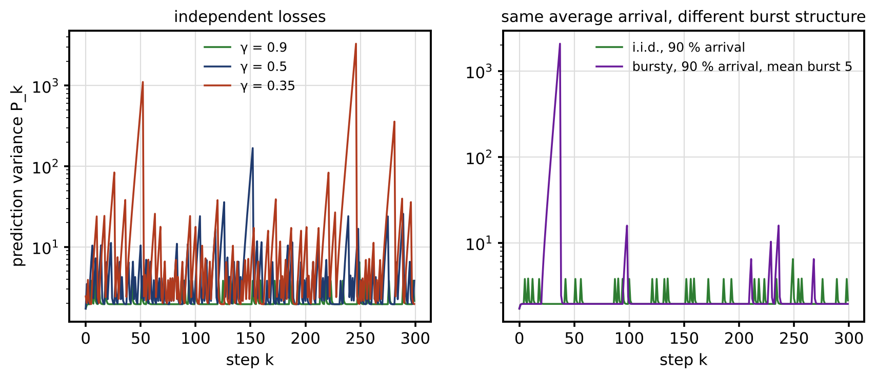
Figure 14.13. Kalman prediction variance under packet loss for an unstable scalar plant ($a=1.2$, $q=r=1$): sample paths with independent losses at 90 %, 50 % and 35 % arrival (left); independent and bursty losses with the same 90 % average arrival but mean burst length 5, which makes the expected variance unbounded (right).

14.7.3 Age of information, latency and deadlines
What a controller cares about is how old its newest information is. The age of information at time $t$ is [18]
 | $$Δ_{AoI}\left(t\right)=t−u\left(t\right),$$ | (14.20)
where $u\left(t\right)$ is the generation time of the newest update received by time $t$. For updates generated every $T$ seconds, each delayed by $d$ and lost independently with probability $ε$, the interval between successful updates is $Y=NT$ with $N$ geometric, $E\left[N\right]=1/\left(1−ε\right)$ and $E\left[N^{2}\right]=\left(1+ε\right)/{\left(1−ε\right)}^{2}$. The age is a sawtooth that starts each cycle at $d$ and grows linearly, so its time average is $d+E\left[Y^{2}\right]/\left(2E\left[Y\right]\right)$:
 | $${\overline{Δ}}_{AoI}=d+\frac{T}{2} \frac{1+ε}{1−ε}, {\overline{Δ}}_{peak}=d+\frac{T}{1−ε},$$ | (14.21)
where ${\overline{Δ}}_{AoI}$ is the average age and ${\overline{Δ}}_{peak}$ the average age just before each update arrives. A PMU stream at 50 frames/s ($T=20$ ms) with 30 ms latency and 10 % loss has an average age of 42.2 ms (a simulation with 200 000 frames gives 42.2 ms) and an average peak age of 52.2 ms. Bursty losses make the peaks far worse than the average suggests.
Latency and jitter add to the age directly, and queueing under a DoS flood can add more than the loss itself. The design consequence is that every function must have a deadline on the age of its inputs and a defined behaviour when the deadline is missed: hold the last safe set-point for a bounded time, switch to local autonomous control, or shut down safely (Section 14.20). Table 14.7 gives typical values for the P-1 twin.
TABLE 14.7 Age-of-information deadlines and fallbacks for P-1 twin functions (representative values; set per project)
Function | Input | Deadline on input age | Fallback when missed
Converter current and voltage loops | Local ADC samples | 10 to 100 µs, inside the device | Hardware current limit, trip
Protection (GOOSE trip) | Trip message | About 3 ms end to end for the fastest class | Local relay acts on its own measurements
Grid-forming battery droop | Local frequency | 10 to 50 ms, local | Fixed droop, independent of the twin
State estimation | SCADA, PMU, pseudo-measurements | 1 to 4 s (SCADA), 100 ms (PMU) | Age-inflated variance, then exclusion
Supervisory EMS | Estimate and forecasts | 1 to 5 min | Hold schedule with widened reserve, for at most $d_{max}$
Fleet analytics | Daily summaries | Hours to days | Mark results stale

14.8 Software, Data, Firmware and Model Supply-chain Security

14.8.1 What a twin is built from
A digital twin is not one program. The P-1 twin runs on an operating system and container images; it uses numerical, optimization and machine-learning libraries; its field devices carry firmware; its models are files of parameters and learned weights; its calibration tables, network model and switch statuses are configuration files; and its learned components were trained on datasets. Every one of these items came from somewhere, and any of them can carry a fault or an implant into the plant. The supply chain is therefore part of the attack surface, and adversary A4 of Table 14.4 works only through it.
The first control is an inventory. A software bill of materials (SBOM) lists every component of a software artifact with its supplier, version and a cryptographic hash [19]. The same idea extends to models (an AI bill of materials listing training data sources, code version, hyper-parameters and evaluation results) and to firmware and configuration. An inventory turns “are we affected by this vulnerability?” from a week of investigation into a database query.
The size of the problem is easy to underestimate. If a twin depends on $N$ third-party components and component $i$ is compromised in a given year with probability $p_{i}$, independently, the chance that at least one is compromised is
 | $$P_{any}=1−\prod_{i=1}^{N}{\left(1−p_{i}\right)}≈1−e^{−Np} \text{for equal small} p_{i}=p,$$ | (14.22)
where $P_{any}$ is the probability of at least one compromised component. With 300 dependencies at $p={10}^{−4}$ each, $P_{any}=3$ %. The numbers are illustrative judgments, but the structure is not: risk grows with the number of dependencies, which is why minimizing and pinning dependencies is a security control.

14.8.2 From source to signed deployment
Figure 14.14 shows the protected pipeline. Its controls, stage by stage:
- Source and dependencies. Pinned versions with hashes, an SBOM and AI-BOM per release, and scanning against vulnerability databases.
- Protected build. Builds run on isolated, ephemeral runners from version-controlled definitions; where feasible the build is reproducible, so two independent builds produce bit-identical artifacts and any difference reveals tampering.
- Sign and attest. The release authority signs each artifact with a key held in a hardware security module and records provenance: which source, which build, which inputs.
- Registry. Signed artifacts, model cards and dataset hashes are stored with their versions.
- Staging and validation. Candidates are tested on protected, held-out data and, for control functions, in HIL, before approval (Section 14.23).
- Deployment. Two-person approval, and devices that verify signatures before installing and again at boot.
- Runtime monitoring and rollback. Version reporting, drift and anomaly monitoring, and a tested path back to the last known-good signed version.
Development, test and production are separate environments with separate credentials; a developer’s laptop must never hold a production signing key.
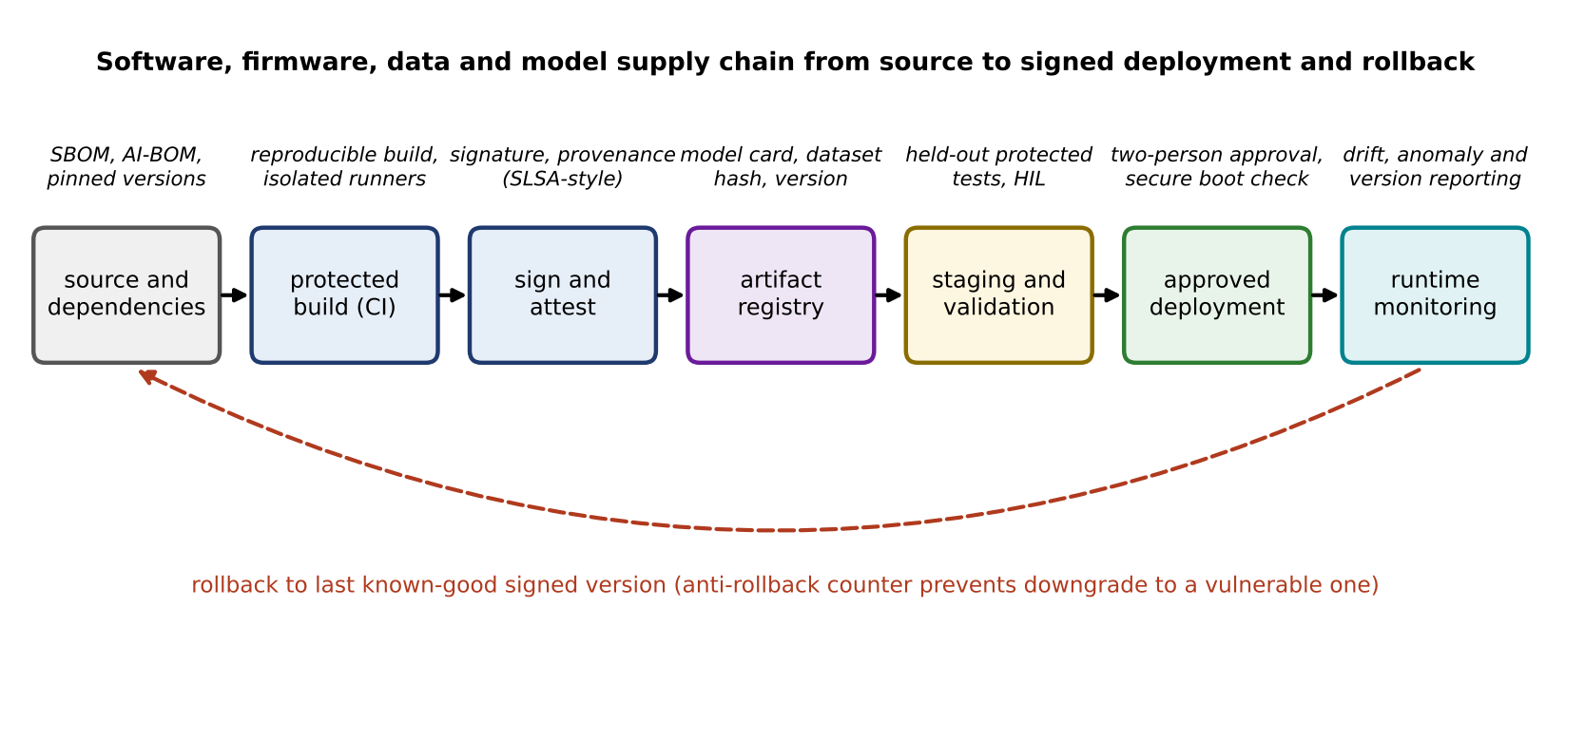
Figure 14.14. Software, firmware, data and model supply chain from source to signed deployment, with the evidence produced at each stage and the rollback path to the last known-good signed version.

14.8.3 Secure boot, measured boot and rollback protection
A device that verifies signatures only when installing an update can still be altered later. Secure boot verifies, at every start, that each stage of software was signed by a trusted key before running it, beginning from an immutable root of trust in hardware. Measured boot also records what ran, by extending a register with the hash of each component in turn,
 | $$M_{k}=H\left(M_{k−1} ∥ H\left(b_{k}\right)\right), M_{0}=0,$$ | (14.23)
where $M_{k}$ is the measurement register after boot stage $k$, $H$ a cryptographic hash function, $∥$ concatenation and $b_{k}$ the code of stage $k$. Because the hash is one-way and the register can only be extended, the final value summarizes the whole boot chain; a remote verifier compares it with the expected value (remote attestation). The same mechanism lets the twin re-attest a device before trusting its data again after an incident (Section 14.21).
Rollback must also be controlled. Returning to an earlier version is a recovery tool, but an adversary who can install an old, vulnerable version has defeated every later patch. Devices therefore keep a monotonic counter in tamper-resistant storage and accept a version only if
 | $$v≥v_{min},$$ | (14.24)
where $v$ is the version number of the candidate image and $v_{min}$ the minimum accepted version, which is raised whenever a security fix makes older versions unacceptable. Recovery rolls back to the last known-good version above $v_{min}$.

14.9 AI-enabled Twin Security: Poisoning, Evasion, Backdoors and Runtime Assurance

14.9.1 A threat model for learning components
Twins that learn from data (Chapters 6, 9 and 12) add attack surfaces at every stage of the learning pipeline (Figure 14.15). Table 14.8 gives the taxonomy, following the structure of the NIST adversarial machine-learning taxonomy [20], with the defensive control for each class.
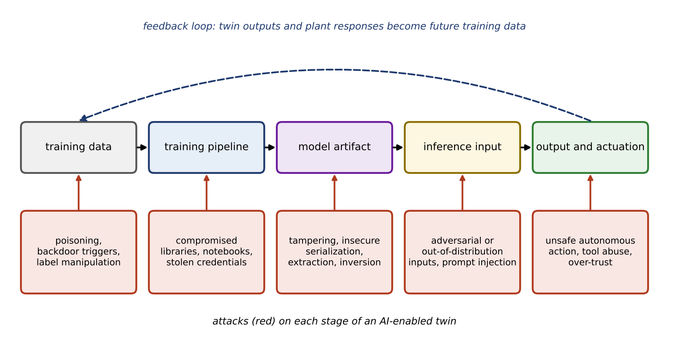
Figure 14.15. Threat surface of an AI-enabled twin: attacks on training data, the training pipeline, the model artifact, inference inputs and outputs, and the feedback loop through which the twin’s outputs and the plant’s responses become future training data.
TABLE 14.8 Threats to AI-enabled twins and their controls
Threat | What happens | Energy-twin example | Main controls
Data poisoning | Crafted records bias the learned model | Fleet degradation model overstates remaining life | Provenance and signed records, robust fitting, protected validation
Backdoor | A hidden trigger makes the model misbehave on chosen inputs | Fault classifier ignores a fault when a specific harmonic pattern is present | Trusted training pipeline, trigger scanning, diverse models
Evasion (adversarial input) | Small input changes cause wrong outputs at run time | Anomaly detector misses a slowly built manipulation | Physics checks, input bounds, ensembles, retraining with hard examples
Model extraction | Repeated queries reconstruct the model | Competitor or adversary copies a vendor’s battery model | Rate limits, query auditing, output rounding
Model inversion and membership inference | Outputs reveal training data | Inferring a household’s presence from a load model | Differential privacy in training (Section 14.11), access control
Insecure model artifact | Model file executes code when loaded or was altered | Pickled model file carrying a payload | Safe formats, signatures, registry with hashes
Dependency compromise | Library or pre-trained component carries an implant | Modified numerical library in the container | SBOM, pinned versions, provenance
Prompt or tool abuse (generative or agentic AI) | Injected text makes an assistant call tools it should not | Maintenance assistant asked to “update the setting” by a document it reads | Least-privilege tools, human approval, no direct control authority
Unsafe autonomous action | Correct-looking output drives an unsafe command | RL dispatch policy pushes the battery past its limits | Command governor, shield, hard interlocks (Section 14.22)

14.9.2 Why least squares is fragile: influence and leverage
Least-squares fits are particularly vulnerable to poisoning because one record can move them arbitrarily far. For a linear model $y=Aθ+v$ fitted to $N$ records, the effect of one added record $\left(a_{0},y_{0}\right)$ follows from the Sherman–Morrison update of ${\left(A^{T}A+a_{0}a_{0}^{T}\right)}^{−1}$:
 | $$Δ\hat{θ}=\frac{{\left(A^{T}A\right)}^{−1}a_{0} r_{0}}{1+h_{0}}, r_{0}=y_{0}−a_{0}^{T}\hat{θ}, h_{0}=a_{0}^{T}{\left(A^{T}A\right)}^{−1}a_{0},$$ | (14.25)
where $A$ is the $N×p$ matrix of features (regressors), $θ$ the parameter vector, $v$ the noise, $a_{0}$ the feature vector of the new record, $y_{0}$ its label, $r_{0}$ its residual against the current fit and $h_{0}$ its leverage. The shift grows without bound in the residual $r_{0}$ (a vertical outlier: an implausible label at an ordinary feature value) and in the direction and size of $a_{0}$ (a leverage point: a record far from the others in feature space). The breakdown point makes this precise: it is the smallest fraction of records that, replaced by arbitrary values, can move the estimate arbitrarily far [21],
 | $$ε^{*}=min\left\{\frac{k}{N}: \sup_{Z_{k}^{′}}∥\hat{θ}\left(Z_{k}^{′}\right)−\hat{θ}\left(Z\right)∥=∞\right\},$$ | (14.26)
where $Z$ is the clean dataset, $Z_{k}^{′}$ any dataset obtained by replacing $k$ of its records and $ε^{*}$ the breakdown point. For least squares $ε^{*}=1/N$, which tends to zero: one record suffices.
Robust estimators bound the influence of large residuals. The Huber loss [22], quadratic for small residuals and linear for large ones, is
 | $$ρ_{c}\left(u\right)=\left\{\begin{matrix}\frac{1}{2}u^{2}, & \left|u\right|≤c \\ c\left|u\right|−\frac{1}{2}c^{2}, & \left|u\right|>c\end{matrix}\right., ψ_{c}\left(u\right)=ρ_{c}^{′}\left(u\right)=max\left(−c,min\left(c,u\right)\right),$$ | (14.27)
where $u=r/\hat{s}$ is a residual scaled by a robust scale estimate $\hat{s}$ (here $1.4826$ times the median absolute deviation), $c$ the transition point and $ψ_{c}$ the influence function, which is bounded. The bound applies to the residual only. Huber regression still weights each record’s influence by its feature vector, so leverage points can pull the fit toward themselves until their own residuals look small, and its breakdown point against leverage contamination is still $1/N$. Estimators with a positive breakdown point in both directions exist: the Theil–Sen estimator (the median of pairwise slopes) reaches about 29 % for a simple linear fit, and least trimmed squares up to 50 %, at more computation and some loss of efficiency on clean data.
Example 14.2 Poisoned battery-degradation training data
Given. 200 synthetic records of SOH (%) against equivalent full cycles, uniformly spread between 0 and 1600 cycles, with true intercept 100 %, true slope −0.0081 % per cycle and Gaussian noise of 0.8 % (seed 42). The true cycle count to 80 % SOH is 2469. Two kinds of poisoning by an adversary with write access to the data lake: (i) label inflation: a random 5, 10, 15 or 20 % of records get their SOH raised by up to 15 points, proportionally to their age; (ii) leverage poisoning: 4, 10 or 20 fabricated records are added at about 3000 cycles with SOH near 92 %. Fits: least squares; Huber with $c=1.5$ on a MAD scale (iteratively reweighted); Theil–Sen.
Find. The predicted cycles to 80 % SOH for each case, and the error against the true value.
Solution. Clean data: least squares 2485 (+0.6 %), Huber 2497, Theil–Sen 2507. Label inflation at 15 %: least squares 2967 (+20.2 %), Huber 2511 (+1.7 %), Theil–Sen 2601 (+5.4 %); at 20 %, 3121 (+26.4 %), 2535 (+2.7 %) and 2679 (+8.5 %). Leverage poisoning with 10 records (4.8 % of the data): least squares 4152 (+68 %), Huber 2700 (+9.4 %), Theil–Sen 2572 (+4.2 %). With 20 records (9.1 %): least squares 5433 (+120 %), Huber 5348 (+117 %), Theil–Sen 2648 (+7.2 %).
Interpretation. Figure 14.16 shows the fits and errors. Against vertical label inflation, Huber regression holds the error to a few per cent. Against leverage points it degrades and then breaks: 20 fabricated records at high cycle counts move it as far as least squares, while the median-based Theil–Sen estimator holds. Robust fitting limits damage but is not a substitute for provenance. Records should carry signatures from the devices that produced them, high-leverage records (cycle counts far beyond the fleet’s experience) deserve review before training, model updates must pass the gate of Chapter 13 (Section 13.2.2), and held-out validation data must be protected from the same write access as training data.
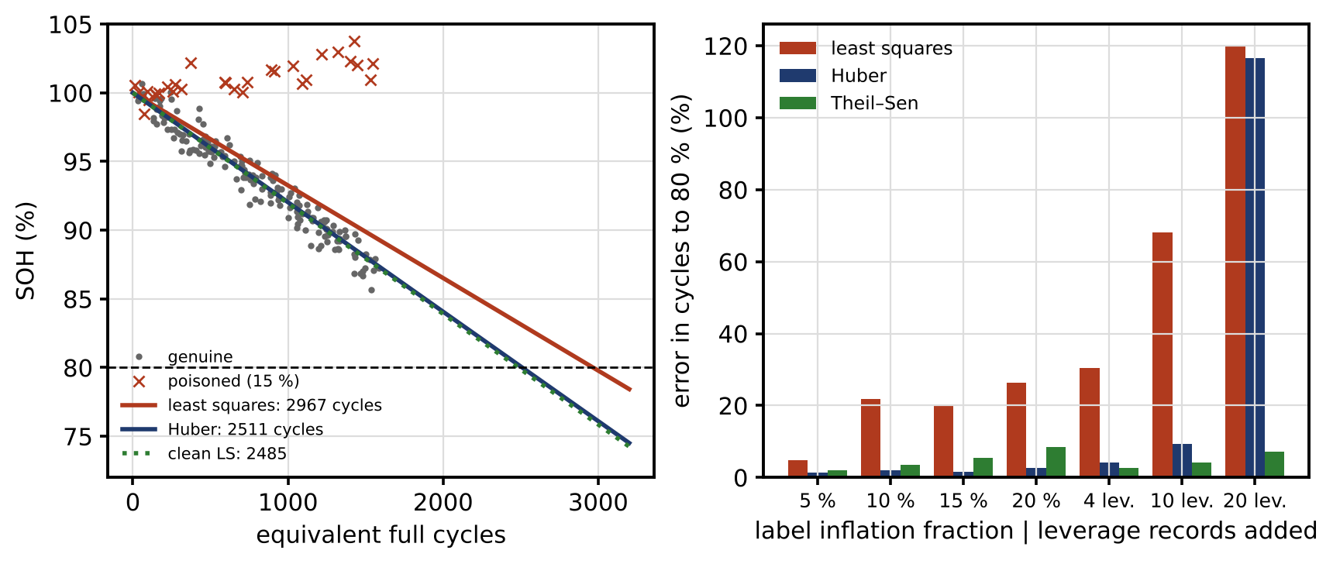
Figure 14.16. Battery degradation data with 15 % label-inflated records: least-squares and Huber fits and the clean least-squares fit, with their predictions of cycles to 80 % SOH (left); error in the predicted cycles for label inflation of 5 to 20 % and for 4, 10 and 20 added leverage records, for least squares, Huber and Theil–Sen (right).

14.9.3 Defences beyond robust fitting
- Protected training and validation pipelines. Training data with provenance; a held-out validation set that the training pipeline cannot write; evaluation results signed with the model.
- Out-of-distribution (OOD) detection. A model is trustworthy only on inputs like those it was trained on. A simple, effective check is the Mahalanobis distance of each input’s features from the training distribution (Section 14.18); inputs beyond a calibrated threshold are flagged and handed to a physics model or a conservative fallback.
- Uncertainty and calibration. Prediction intervals whose coverage has been checked on held-out data, and widened or rejected outside the training domain (Chapter 12).
- Signed models and safe formats. Models are loaded only from the registry, verified by signature, and stored in formats that cannot execute code on loading.
- Runtime guardrails. Whatever a learned component outputs passes through the command governor and the hard interlocks of Section 14.22. A learned policy may propose; only bounded, checked actions reach the plant.
- Generative and agentic assistants. Assistants that read documents or logs and call tools get read-only tools by default, no direct control authority, and human approval for any change; content they read is treated as data, never as instructions.

14.10 Identity, Authentication, Authorization, PKI and Cryptographic Engineering
Most attacks in Sections 14.5 to 14.7 rely on data or commands that the receiver cannot verify. Cryptography supplies the verification, but only together with the engineering around it: keys, nonces, certificates, storage, rotation, revocation and the ability to change algorithms. This section builds from the primitives to that engineering.

14.10.1 The building blocks
- Hash function. $H$ maps any message to a fixed-length digest (256 bits for SHA-256). It must be one-way and collision-resistant. Because of the birthday effect, finding some collision among $q$ digests of $n$ bits succeeds with probability about $q^{2}/2^{n+1}$, so an $n$-bit hash gives about $n/2$ bits of collision resistance.
- Symmetric key. A secret shared by sender and receiver, typically 128 or 256 bits.
- Message authentication code (MAC). A tag computed from the key and the message; only key holders can produce a valid tag.
- Encryption. Hides content (confidentiality). By itself it does not prove origin or integrity.
- Authenticated encryption. Encryption and a MAC in one construction, such as AES-GCM [23].
- Digital signature. Computed with a private key and verified with the matching public key, so many receivers can verify one sender without sharing a secret, and a signer cannot later deny signing.
- Certificate. A signed statement by a certificate authority (CA) that binds a public key to an identity, with a validity period.
- Public-key infrastructure (PKI). The CAs, policies, registration, issuance, revocation and directories that make certificates trustworthy.

14.10.2 Message authentication and its limits
With the HMAC construction over a hash function [24],
 | $${HMAC}_{k}\left(m\right)=H\left(\left(k⊕opad\right) ∥ H\left(\left(k⊕ipad\right) ∥ m\right)\right),$$ | (14.28)
where $k$ is the key padded to the hash’s block length, $m$ the message, $⊕$ bitwise exclusive-or, and opad and ipad two fixed padding constants. The receiver recomputes the tag and compares it in constant time, so that the comparison’s duration does not leak how many bytes matched. A forger without the key who submits $Q$ guesses of a $t$-bit tag succeeds with probability at most
 | $$P_{forge}≤Q⋅2^{−t},$$ | (14.29)
where $Q$ is the number of forgery attempts and $t$ the tag length in bits. Full 256-bit tags make this negligible. Protocols that truncate tags to save bandwidth trade margin for size: a 32-bit tag on a CAN frame gives $2^{−32}$ per attempt, so a bus that accepts ${10}^{4}$ attempts per second would admit a forgery within about five days on average unless failed verifications are counted and acted on. Truncated tags therefore come with rate limiting and alarms on verification failures. Including the sequence number and time stamp inside the authenticated data defeats replay at the protocol level, as Section 14.6.1 requires.

14.10.3 Nonces, IVs and why their uniqueness is absolute
AES-GCM needs a nonce (initialization vector) for every message, and it must never repeat under the same key. If it does, the two ciphertexts reveal the XOR of the plaintexts, and the authentication key can be recovered, after which the adversary can forge any message [23]. Nonce reuse is not a gradual weakening; it is a break. With 96-bit nonces chosen at random, the probability that some pair among $q$ messages collides is about
 | $$P_{coll}≈\frac{q^{2}}{2^{97}},$$ | (14.30)
where $q$ is the number of messages under one key. Keeping it below $2^{−32}$ limits a key to about $2^{32}$ random-nonce messages, which a 50 frames/s PMU stream reaches in 2.7 years. Deterministic nonces built from a per-key message counter avoid collisions entirely, provided the counter survives reboots (Section 14.6.1). Either way, the key must be changed before the limit.

14.10.4 Keys, certificates and their lifecycle
Authentication without sound key management is not a security design. The engineering questions are:
- Generation and storage. Device keys are generated inside a secure element, TPM or HSM and never leave it; a key copied into a configuration file is a shared secret with everyone who sees the file.
- Enrolment. The device sends a certificate signing request; the CA issues a certificate after checking the device’s identity (factory provisioning, or an on-site procedure).
- Rotation. Keys and certificates have limited lifetimes, set by the crypto-period guidance of NIST SP 800-57 [25], the nonce limit above, and the risk of undetected compromise.
- Revocation. A compromised or decommissioned device’s certificate is revoked through certificate revocation lists or an online status protocol. Field devices that cannot reach the revocation service need a policy for how stale their revocation information may be.
- Decommissioning. Keys are zeroized when equipment leaves service.
- Crypto agility. Protocols carry algorithm identifiers, devices can accept new algorithms through signed firmware updates, and the PKI can issue certificates for new algorithms. Without agility, every future change of algorithm means replacing hardware (Section 14.26).

14.10.5 Does security fit in the time budget?
Security that breaks a real-time deadline will be switched off, so its cost must be measured. Figure 14.17 shows an authenticated measurement message and the receiver’s checks, and Figure 14.18 gives measured costs. The measurements were made on one virtual core of an Intel Xeon processor at 2.10 GHz in a shared cloud host, with Python 3.13.16 and the cryptography library 50.0.1 (OpenSSL 4.0.2), on 64-byte messages, with 100 000 trials for symmetric operations, 20 000 for classical signatures and 5000 for post-quantum ones, after warm-up. Table 14.9 lists the median, 99th and 99.9th percentiles and the largest observed time.
TABLE 14.9 Measured cryptographic operation times (µs) on the stated cloud platform; illustrative only, to be repeated on target hardware
Operation | Median | 99th percentile | 99.9th percentile | Maximum observed
HMAC-SHA256, 64 B | 1.5 | 2.9 | 20 | 3023
HMAC-SHA256, 512 B | 1.8 | 4.1 | 20 | 108
AES-256-GCM encrypt, 64 B | 0.55 | 1.1 | 6.1 | 88
ECDSA P-256 sign / verify | 25 / 90 | 60 / 158 | 141 / 251 | 2885 / 1265
Ed25519 sign / verify | 31 / 107 | 55 / 181 | 85 / 478 | 210 / 12 293
ML-DSA-44 sign / verify | 497 / 125 | 2452 / 243 | 4348 / 984 | 8193 / 3189
ML-KEM-768 encapsulate / decapsulate | 34 / 38 | 79 / 69 | 121 / 109 | 841 / 168
Three lessons come out of the table. First, a MAC costs microseconds and fits every loop that crosses a network. Second, the tail matters more than the median: on a shared, non-real-time platform the largest observed time is up to about 2000 times the median (for HMAC) because of scheduling, cache and interrupt effects, so real-time claims need worst-case or bounded measurements on the target hardware under realistic load, not averages from a laptop. Third, signatures cost tens to hundreds of microseconds, and post-quantum signatures more (ML-DSA signing is variable-time by design, which shows in its wide tail, and its 2420-byte signature does not fit in a single small frame). Protection-class messages such as IEC 61850 GOOSE trips, which must arrive within about 3 ms end to end for the fastest class, are the demanding case: the MAC itself fits, but key management, message size and network jitter must all be in the budget of Section 14.22. Fast converter loops (10 to 100 µs) are kept inside the device; what crosses the network is a set-point, and that is what gets authenticated.
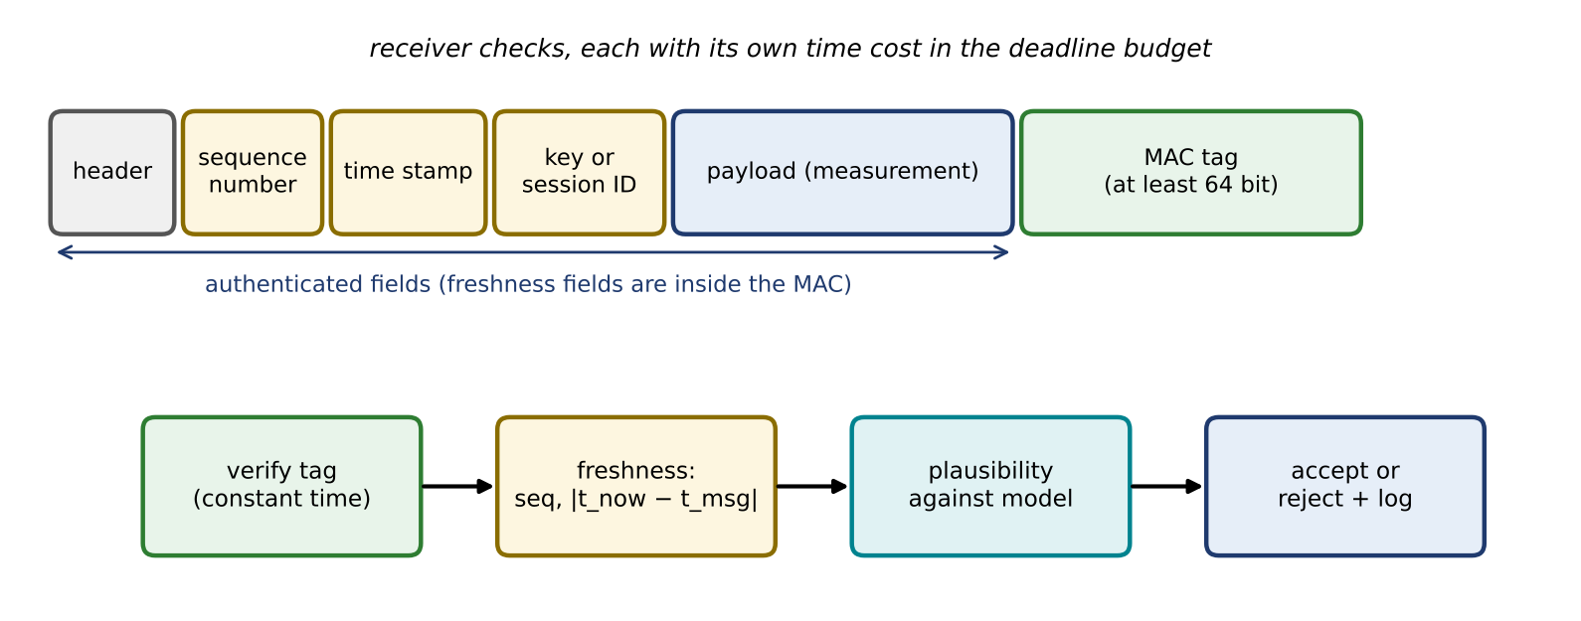
Figure 14.17. An authenticated measurement message: header, sequence number, time stamp and key or session identifier are covered by the MAC together with the payload, and the receiver checks the tag in constant time, then freshness, then plausibility, before accepting and logging.
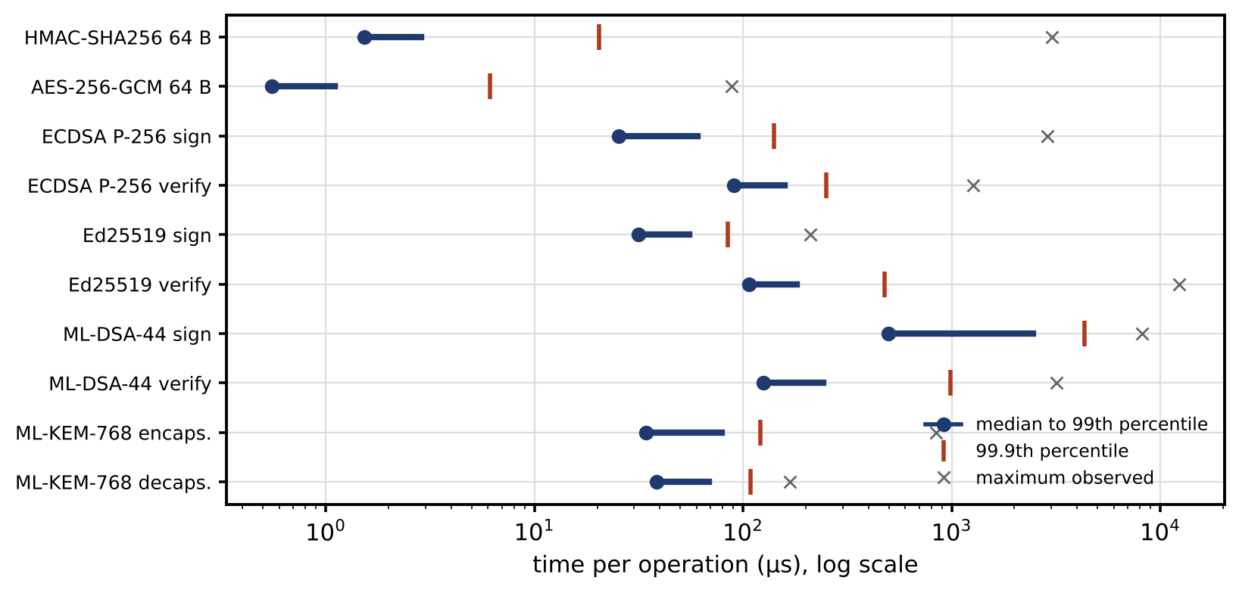
Figure 14.18. Measured times per cryptographic operation on the stated platform: median to 99th percentile (bar), 99.9th percentile and the largest observed value. Tails, not medians, decide whether a real-time deadline is met.

14.11 Privacy Engineering and Differential Privacy

14.11.1 Two different things to protect
Two concerns are often mixed up under the word “privacy”. Customer privacy protects information about people: smart-meter traces show when a household sleeps, cooks and is away; EV charging records reveal where people live and work; a fleet’s battery statistics reveal how individual vehicles are driven. Operational confidentiality protects the operator’s own sensitive assets: network models, protection settings, market bids, vendor model parameters, credentials. Both matter, but they call for different tools. Confidentiality is handled by access control and encryption. Customer privacy also needs those, and in addition it needs care about what can be inferred from data that are legitimately released.
Privacy engineering for a twin starts with ordinary measures, applied before any mathematics:
- Data minimization and purpose limitation. Collect only what a stated purpose needs, at the coarsest resolution that serves it, and use it only for that purpose. A fleet health dashboard needs pack statistics, not GPS traces.
- Access control and logging. Personal data are readable only by roles that need them, and every access is logged.
- Pseudonymization. Identifiers are replaced by keyed pseudonyms. This reduces exposure but is not anonymization: individuals can often be re-identified by linking released data with other sources.
- Retention limits. Raw personal data are deleted or aggregated after a fixed period.
- Federated analytics. Models are trained where the data are (in the vehicle, at the site) and only aggregates or model updates leave, which shrinks what is exposed, although updates can still leak and need their own protection.
- Privacy accounting. Every release that draws on personal data is recorded against a budget, as below.

14.11.2 Differential privacy
When aggregates are published, removing names is not enough. Differential privacy gives a mathematical guarantee instead [26]. A randomized mechanism $M$ is $\left(ε,δ\right)$-differentially private if, for any two datasets $D$ and $D^{′}$ that differ in one individual’s record and any set $S$ of possible outputs,
 | $$Pr\left(M\left(D\right)∈S\right)≤e^{ε}Pr\left(M\left(D^{′}\right)∈S\right)+δ,$$ | (14.31)
where $ε≥0$ is the privacy-loss parameter (smaller means stronger privacy) and $δ$ a small probability with which the bound may fail; $δ=0$ gives pure $ε$-differential privacy. Whatever an observer sees, its probability changes by at most a factor $e^{ε}$ depending on whether any one person took part.

14.11.3 The Laplace and Gaussian mechanisms
For a numerical query $q$ with sensitivity
 | $$Δq=\max_{D,D^{′}}\left|q\left(D\right)−q\left(D^{′}\right)\right|,$$ | (14.32)
the largest change one individual’s record can cause, adding Laplace noise of scale $b$ to the true answer,
 | $$M\left(D\right)=q\left(D\right)+Lap\left(b\right), b=\frac{Δq}{ε}, std=\sqrt{2} b,$$ | (14.33)
achieves $ε$-differential privacy, where $Lap\left(b\right)$ is a Laplace random variable with density $e^{−\left|y\right|/b}/\left(2b\right)$. The proof is two lines. The output density at any value $y$ is $e^{−\left|y−q\left(D\right)\right|/b}/\left(2b\right)$, so the ratio of densities for neighbouring datasets is $exp\left(\left(\left|y−q\left(D^{′}\right)\right|−\left|y−q\left(D\right)\right|\right)/b\right)≤exp\left(\left|q\left(D\right)−q\left(D^{′}\right)\right|/b\right)≤e^{ε}$, by the triangle inequality. The noise’s tail gives an error bound that holds with a stated probability:
 | $$Pr\left(\left|Lap\left(b\right)\right|>t\right)=e^{−t/b} ⇒ \left|\text{error}\right|≤bln\frac{1}{α} \text{with probability} 1−α,$$ | (14.34)
where $t$ is an error level and $α$ the probability of exceeding the bound. The Gaussian mechanism adds normal noise instead and gives $\left(ε,δ\right)$ privacy; the classical calibration, proved for $ε<1$, is
 | $$σ_{G}=\frac{Δq\sqrt{2ln\left(1.25/δ\right)}}{ε},$$ | (14.35)
where $σ_{G}$ is the standard deviation of the added noise.

14.11.4 Composition and privacy accounting
Privacy loss accumulates when the same people’s data are used repeatedly. The simplest bound is sequential composition: $k$ releases with parameters $ε_{i}$ together satisfy εtot=i​εi. It is easy to use and always valid, but loose for many releases. The advanced composition theorem [27] gives, for $k$ releases each $\left(ε_{0},δ_{0}\right)$-private and any $δ^{′}>0$,
 | $$ε_{tot}=\sqrt{2kln\left(1/δ^{′}\right)} ε_{0}+kε_{0}\left(e^{ε_{0}}−1\right), δ_{tot}=kδ_{0}+δ^{′},$$ | (14.36)
which grows like $\sqrt{k}$ rather than $k$. Modern accounting goes further with Rényi differential privacy [28] and zero-concentrated differential privacy (zCDP) [29]. A Gaussian mechanism with sensitivity $Δq$ and noise $σ$ is $ρ$-zCDP with $ρ=Δq^{2}/\left(2σ^{2}\right)$; under composition the $ρ$ values simply add; and the total converts back to the familiar form by
 | ε=ρtot+2ρtotln1/δ, ρtot=i​Δqi22σi2, | (14.37)
where $ρ_{tot}$ is the accumulated zCDP parameter. Accounting of this kind is how large learning pipelines track privacy over thousands of steps. Which bound is tightest depends on the number of releases, as the example shows, so a privacy accountant evaluates them all and uses the best valid one.
Example 14.3 Releasing a fleet’s average state of health
Given. A fleet operator releases the average SOH of 200 vehicles. Individual SOH values lie between 60 % and 100 %; the true average is 87.4 %. All quantities below are in percentage points (pp) of SOH. Privacy budgets $ε=0.1$, 0.5, 1 and 2 for a single release; then twelve monthly or 365 daily releases under a total budget $ε_{tot}=1$ (with $δ={10}^{−6}$ for advanced composition and ${10}^{−5}$ for the Gaussian mechanism).
Find. The sensitivity; the Laplace scale, standard deviation and 95 % error bound for each $ε$; the per-release noise under each composition rule.
Solution. Replacing one vehicle’s record changes the average by at most $\left(100−60\right)/200=0.2$ pp, so $Δq=0.2$ pp. At $ε=1$: $b=0.2$ pp, standard deviation 0.28 pp, and by (14.34) the released value is within $0.2ln20=0.60$ pp of the truth with 95 % probability. At $ε=0.1$: standard deviation 2.8 pp and bound 6.0 pp; at 0.5: 0.57 and 1.2 pp; at 2: 0.14 and 0.30 pp. The Gaussian mechanism at $\left(ε,δ\right)=\left(1,{10}^{−5}\right)$ needs $σ=0.97$ pp by (14.35), a limiting case of its proof; the zCDP route of (14.37) gives 0.98 pp.
For twelve monthly releases, sequential composition gives $ε=1/12$ each and a standard deviation of 3.4 pp per release. Advanced composition is worse here: solving (14.36) for $ε_{tot}=1$ gives $ε_{0}=0.053$ and 5.3 pp, because its $\sqrt{2kln\left(1/δ′\right)}$ factor only pays off for many releases. For 365 daily releases the order reverses: sequential composition gives 103 pp per release (useless), advanced composition 29 pp, and Gaussian noise accounted by zCDP 18.7 pp. Monthly Gaussian releases accounted by zCDP need 3.4 pp, the same as the Laplace result.
Interpretation. Figure 14.19 shows the trade-off and the noise itself. A single fleet average can be released with good privacy at a fraction of a point of error, while frequent releases of the same population erode the budget quickly; a release schedule must be designed with an accountant, not added up afterwards. The same noise would be harmful inside one vehicle’s control loop, where the health-aware constraint of Chapter 13 (Section 13.11.2) needs that vehicle’s own accurate SOH. Differential privacy is most natural for analytics and published statistics. It can be applied to operational signals, but only through a control-aware design that bounds the effect of the noise on stability and constraints, and it is usually inappropriate for fast, safety-critical loops, where access control and encryption protect the data instead.
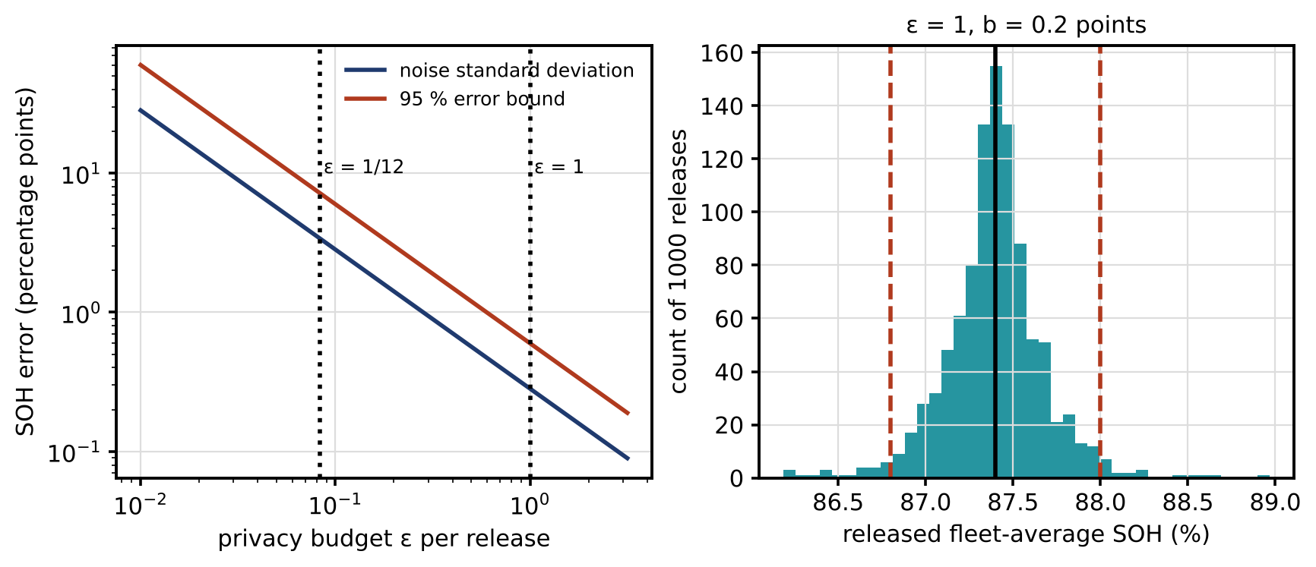
Figure 14.19. Privacy and accuracy for the fleet SOH average: noise standard deviation and 95 % error bound against the per-release budget, with the single-release budget $ε=1$ and the monthly share $ε=1/12$ marked (left); 1000 Laplace releases at $ε=1$ (scale 0.2 pp) around the true value 87.4 %, with the 95 % bound of ±0.6 pp (right).

14.12 Statistical Detection, Sequential Detection and Threshold Design

14.12.1 A design workflow
A detector is designed, not chosen. Figure 14.20 shows the workflow. Start from a baseline distribution of the statistic on clean data, measured rather than assumed. Choose the statistic. Set the threshold from an acceptable false-alarm probability. Turn that probability into an operational false-alarm budget per year, taking correlation between tests into account. Compute the detection delay for the attacks in the threat model and the physical deviation the plant suffers before the alarm. Finally, validate under drift, model updates and realistic attacks, and recalibrate when any of those change.
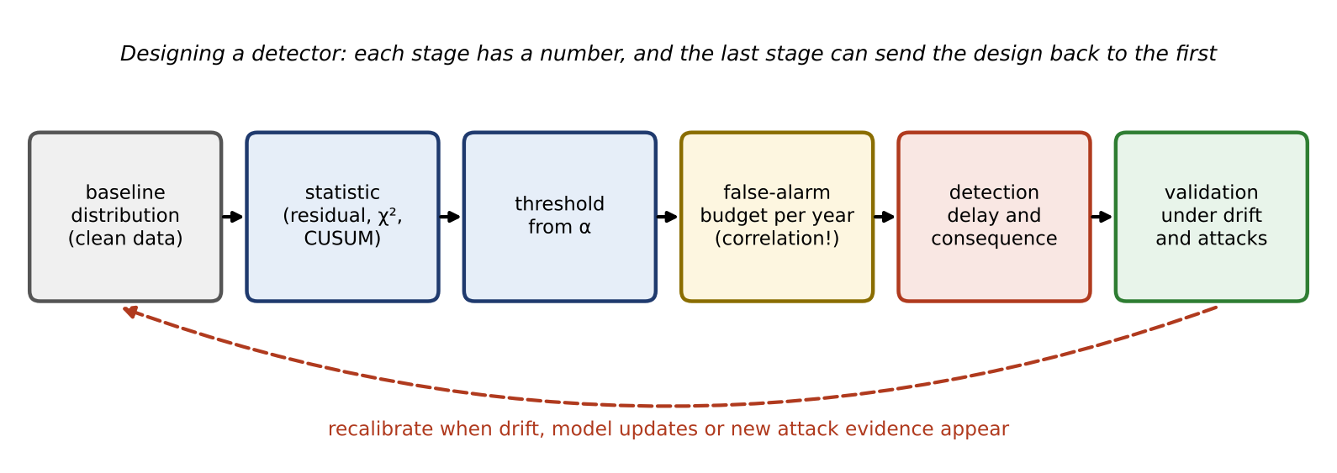
Figure 14.20. Detector design workflow: baseline distribution, statistic, threshold, false-alarm budget, detection delay and consequence, and validation under drift and attacks, with recalibration feeding back to the baseline.

14.12.2 Likelihood ratios and the residual-energy test
Detection is a hypothesis test between $H_{0}$ (no attack) and $H_{1}$ (attack). For two simple hypotheses, with fully specified densities, the Neyman–Pearson lemma states that the test with the highest detection probability at a fixed false-alarm probability $α$ compares the likelihood ratio with a threshold,
 | $$Λ\left(r\right)=\frac{p\left(r∣H_{1}\right)}{p\left(r∣H_{0}\right)}≷η, Pr\left(Λ>η∣H_{0}\right)=α,$$ | (14.38)
where $p\left(⋅∣⋅\right)$ are the densities of the observation $r$ under each hypothesis and $η$ the threshold. For Gaussian residuals with a known attack $a$, this reduces to a linear test along $a$. An attack is not known, so the lemma does not apply directly. A common way forward is the generalized likelihood ratio test, which replaces the unknown attack by its maximum-likelihood estimate. If the whitened residual is Gaussian with identity covariance on its $\left(m−n\right)$-dimensional range and the attack is an unknown mean anywhere in that range, the GLRT statistic is the residual energy $J$ of (14.5), with the chi-square null distribution derived there. The chi-square test is therefore a well-founded test under stated assumptions (Gaussian noise, a correct linear model, an unknown attack direction with no preferred subspace). It is not the most powerful test against every attack, and an attack confined to a known subspace is better detected by projecting onto that subspace.
For dynamic twins, the innovations of a Kalman filter (Chapter 5) are tested instead, usually summed over a window of $L$ samples,
 | $$g_{k}=\sum_{i=k−L+1}^{k}{ν_{i}^{T}}S_{i}^{−1}ν_{i}∼χ_{pL}^{2},$$ | (14.39)
where $ν_{i}$ is the innovation at step $i$, $S_{i}$ its covariance and $p$ the measurement dimension; the null distribution holds when the filter is consistent and innovations are independent, as they are for a correctly specified Kalman filter. Longer windows detect smaller persistent deviations, at the cost of delay.

14.12.3 From a per-test probability to alarms per year
The threshold follows from the acceptable number of false alarms per year, not per sample. If the statistic is evaluated $N_{s}$ times a year and $N_{FA}$ false alarms a year are acceptable, the per-test probability and threshold are
 | $$α=\frac{N_{FA}}{N_{s}}, τ=F_{χ_{ν}^{2}}^{−1}\left(1−α\right),$$ | (14.40)
where $ν$ is the statistic’s degrees of freedom. A detector tested every second that may raise one false alarm a month needs $α=3.9×{10}^{−7}$; for $ν=5$ the threshold rises from 15.1 (at 99 %) to 38.0.
This conversion assumes independent tests, and windowed statistics are not independent. Consecutive values of (14.39) share $L−1$ of their $L$ terms, so exceedances come in clusters. In a simulation of two million sliding windows ($L=50$, $p=2$, $α={10}^{−3}$), the fraction of window positions above threshold was $1.03×{10}^{−3}$, as designed, but they formed only 237 separate alarm episodes per million windows, with a mean length of 4.3 windows (Figure 14.21, right). Whether this matters depends on how alarms are counted: per episode, the naive budget overstates the alarms fourfold; per window position, it is exact. For overlapping, autocorrelated or drifting statistics, thresholds are therefore set by empirical calibration on long clean records, or with sequential-detection theory, rather than by multiplying a per-test probability by the number of tests.

14.12.4 Sequential detection: CUSUM
Slowly growing attacks stay below any one-sample threshold. Sequential tests accumulate evidence instead. The CUSUM of Chapter 12 (Section 12.6.2) [30] applies to a standardized statistic $z_{k}$ that is zero-mean before a change and shifts by $δ$ after it:
 | $$g_{k}=max\left(0, g_{k−1}+z_{k}−κ\right), \text{alarm if} g_{k}>h,$$ | (14.41)
where $g_{k}$ is the CUSUM statistic with $g_{0}=0$, $κ$ the reference value (optimally $δ/2$ for a known shift) and $h$ the decision threshold. Siegmund’s approximation (Chapter 12, Equation (12.27)) [31] gives the average run length for a shift $δ$,
 | $$ARL\left(δ\right)≈\frac{e^{−2Δb}+2Δb−1}{2Δ^{2}}, Δ=δ−κ, b=h+1.166,$$ | (14.42)
where $ARL\left(0\right)={ARL}_{0}$ is the mean time between false alarms and $ARL\left(δ\right)$ the mean detection delay. Section 14.27 uses it on a slow battery-health manipulation.

14.12.5 Rare attacks, precision and “99 % accuracy”
Attacks are rare, which makes accuracy figures misleading. If a fraction $π$ of the windows contain an attack and the detector has true-positive rate $TPR$ and false-positive rate $FPR$, Bayes’ rule gives the precision, the fraction of alarms that are real (Chapter 12, Section 12.7.1):
 | $$precision=\frac{TPR π}{TPR π+FPR\left(1−π\right)},$$ | (14.43)
where $π$ is the prevalence of attacks. A detector with $TPR=0.99$ and $FPR=0.01$ is 99 % accurate at every prevalence. At $π={10}^{−2}$ half its alarms are real; at $π={10}^{−4}$, under 1 % are (Figure 14.21, left). Operators who see a hundred false alarms for each real one stop responding. Precision–recall curves at realistic prevalence, false alarms per day, detection delay and the physical deviation before detection are the figures that matter. Table 14.10 lists them.
TABLE 14.10 Detection metrics for a twin’s security detectors
Metric | Definition | Why it matters | Typical target or check
False-alarm probability | $Pr\left(\text{alarm}∣H_{0}\right)$ per test | Sets the threshold | From the yearly budget, calibrated empirically
False alarms per year | Alarm episodes on clean operation | What operators experience | A few per year per detector
Detection probability (recall) | $Pr\left(\text{alarm}∣H_{1}\right)$ for a stated attack | Coverage of the threat model | Reported per attack class and size
Precision | Fraction of alarms that are real | Operator trust | At realistic prevalence, never “accuracy”
Detection delay | Time from attack start to alarm | Damage window | Median and 95th percentile over many runs
Time to isolate | Time from alarm to excluding the source | Containment | Within the degraded-mode budget
Physical deviation before detection | Largest voltage, frequency or SOH error before the alarm | The engineering consequence | Below a safety margin
Computational latency | Time to compute the statistic | Fits the runtime budget | Worst case on target hardware
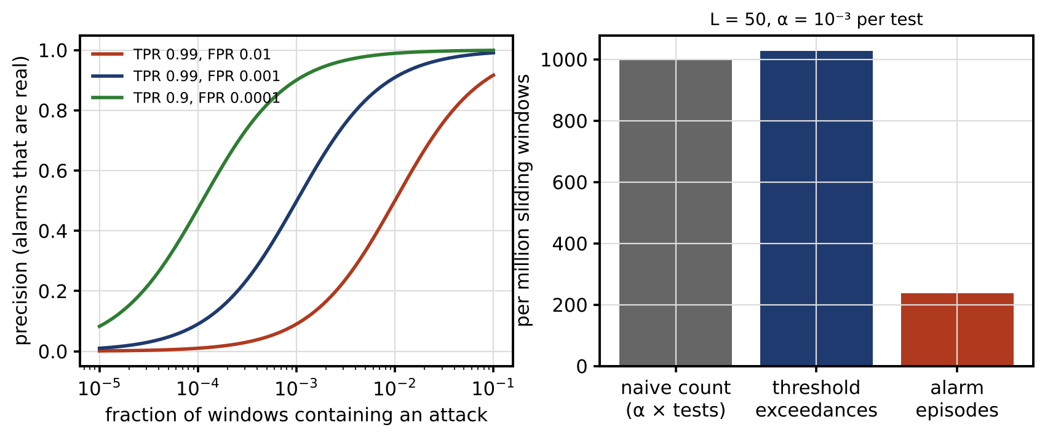
Figure 14.21. Rare attacks and correlated tests: precision of detectors with stated true- and false-positive rates against the fraction of windows containing an attack (left); for a sliding window of 50 samples at $α={10}^{−3}$ per test, the naive count of false alarms, the observed threshold exceedances and the much smaller number of separate alarm episodes per million windows (right).

14.13 Dynamic Watermarking and Active Detection

14.13.1 The idea
A replay reproduces the plant’s past outputs, which carry no trace of the controller’s present actions. If the controller adds a small secret random signal to its input, the live measurements respond to it, and a detector that knows its own signal can check whether they do. Replayed data cannot respond, so the innovations grow. For a plant $x_{k+1}=Ax_{k}+B\left(u_{k}+Δu_{k}\right)+w_{k}$, $y_{k}=Cx_{k}+v_{k}$, under LQG control with a watermark $Δu_{k}∼N\left(0,Σ_{w}\right)$ drawn independently at each step and known to the controller’s own estimator, Mo and Sinopoli [32] show that under replay the expected normalized innovation energy exceeds its nominal value $p$ by a term proportional to the watermark covariance,
 | $$E\left[ν_{k}^{T}S^{−1}ν_{k}\right]=p+tr\left(S^{−1}CM\left(Σ_{w}\right)C^{T}\right),$$ | (14.44)
where $A$, $B$ and $C$ are the plant matrices, $u_{k}$ the control input, $w_{k}$ and $v_{k}$ the process and measurement noises, $y_{k}$ the measurement, $Σ_{w}$ the watermark covariance, $S$ the steady-state innovation covariance and $M\left(Σ_{w}\right)$ a positive semidefinite matrix, linear in $Σ_{w}$, obtained from a Lyapunov equation of the closed-loop and estimator dynamics. Without a watermark the extra term is zero, and if the closed loop is stable a replay of a long enough recording is statistically invisible to (14.39).

14.13.2 What the watermark costs
The cost follows from a short argument. The watermark is known to the estimator, so it does not change the estimation error; it acts on the plant exactly like extra process noise $BΔu_{k}$ and also appears directly in the applied input. For an LQG controller with state weight $Q_{c}$, input weight $R_{c}$ and control Riccati solution $P_{c}$, extra process noise of covariance $Σ$ raises the average cost per step by $tr\left(P_{c}Σ\right)$, a standard result for linear-quadratic control with additive noise. Adding the direct input term gives the cost increase per step,
 | $$ΔJ_{LQG}=tr\left(P_{c}BΣ_{w}B^{T}\right)+tr\left(R_{c}Σ_{w}\right)=tr\left(\left(B^{T}P_{c}B+R_{c}\right)Σ_{w}\right),$$ | (14.45)
which is linear in the watermark covariance; for a scalar input it is $σ_{w}^{2}\left(B^{T}P_{c}B+R_{c}\right)$, where $σ_{w}$ is the watermark’s standard deviation. Detection power (14.44) and cost (14.45) both grow with $Σ_{w}$, so the watermark’s size is a direct trade between detectability and performance, and the shape of $Σ_{w}$ can be designed to excite the directions the detector sees best at the least cost.
Example 14.4 A replay on the buck converter
Given. The D-3 buck converter of Chapter 13 (Section 13.4.2) with the fixed-load model sampled at 100 kHz, $A=\left[\begin{matrix}0.9691 & −0.4308 \\ 0.0948 & 0.8987\end{matrix}\right]$ and $B={\left[\begin{matrix}21.56 & 1.054\end{matrix}\right]}^{T}$, both states measured ($C=I$). Process-noise standard deviations 0.05 A and 0.005 V per step; measurement-noise standard deviations 0.05 A and 0.01 V. LQR weights $Q_{c}=diag\left(0.1,1\right)$ and $R_{c}=10$, giving the gain $L=\left[\begin{matrix}−0.0432 & −0.0590\end{matrix}\right]$; a steady-state Kalman filter. From sample 8000, measurements recorded 4000 samples earlier are replayed to the controller. Detector (14.39) with $L=50$ and $p=2$, so $ν=100$. Watermark standard deviations on the duty cycle $σ_{w}=0$, 0.0005, 0.001, 0.002 and 0.005. 300 Monte Carlo runs per level (seed 11); a run without an alarm in the 4000 replayed samples counts as undetected.
Find. With an illustrative threshold at $α={10}^{−3}$ per window position ($τ=149.4$) and with a deployment threshold at $α={10}^{−12}$ ($τ=233.8$): the fraction of replays detected, the median and 5 to 95 % range of the detection delay, the false alarms before the replay, the cost increase, and the output ripple.
Solution. At $τ=149.4$:
- No watermark. Only 42 % of runs alarm within the replay, after a median of 1797 samples, which is what the false-alarm rate alone produces: the replay is invisible.
- $σ_{w}=0.0005$ and 0.001. 59 % and 92 % of replays detected, medians 1567 and 1000 samples.
- $σ_{w}=0.002$. Every replay detected; median delay 88.5 samples (0.89 ms), 5 to 95 % range 21 to 313 samples, 95 % bootstrap interval of the median 74 to 98. Cost up 49 %; output-voltage ripple 14.5 mV RMS against 13.0 mV without watermark; inductor-current ripple 79 against 65 mA.
- $σ_{w}=0.005$. Median 10.5 samples (2 to 24); cost up 307 %; voltage ripple 20.5 mV.
The simulated cost increases agree with (14.45) to within 1 % at every level. Before the replay, the fraction of window positions above threshold was 0.11 %, as designed; but in 60 % of runs at least one false alarm occurred in the 7000 samples (70 ms) before the replay, because the statistic is evaluated 100 000 times a second. With the deployment threshold $τ=233.8$, no run raised a false alarm. Then $σ_{w}=0.002$ is too small (few replays detected in time), $σ_{w}=0.005$ detects every replay with a median of 33 samples (17 to 51), and $σ_{w}=0.01$ in 8 samples (2 to 16).
Interpretation. Figure 14.22 shows the statistic and the trade-off. Without a watermark a replay of a stable closed loop cannot be seen in the innovations at all. A watermark makes it visible, and the price is ripple and cost, which (14.45) predicts exactly. The example also shows how much the threshold matters: a detector evaluated at 100 kHz needs a per-test false-alarm probability near ${10}^{−12}$ to raise about one false alarm a year, and at that threshold the watermark must be roughly two and a half times larger. Dynamic watermarking does not replace authenticated freshness, and it is not only for unauthenticated analogue paths. Freshness counters stop protocol-level replays and cost no control performance. Watermarking is a physical-layer consistency check: it also detects a sensing or command path that is authenticated but compromised, such as a sensor whose firmware replays its own recordings with valid tags, which no cryptographic check can expose [33]. The two are complements. An adaptive attacker who can estimate the watermark from the plant’s response could try to synthesize it, which is why the watermark is secret, random, and kept small relative to the noise from which it would have to be extracted.
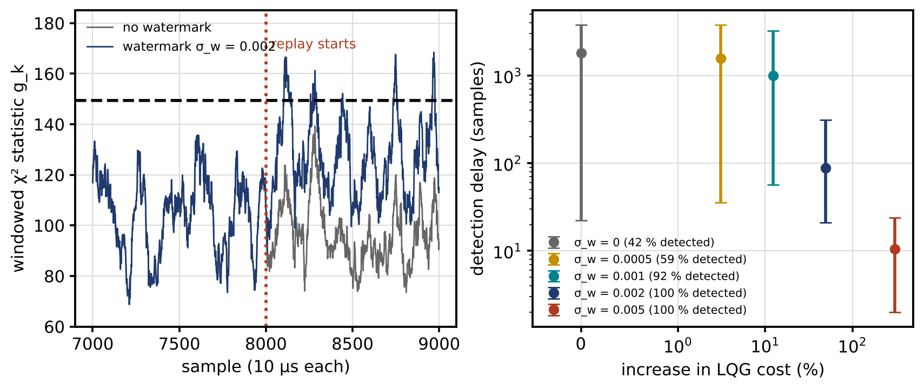
Figure 14.22. Replay on the buck converter (seed 11): windowed chi-square statistic for one run without and with a watermark of standard deviation 0.002, with the illustrative threshold; before the replay the two statistics coincide because the estimator knows its own watermark (left); median and 5 to 95 % range of detection delay against the increase in LQG cost for five watermark levels, 300 runs each, with the fraction of replays detected (right).

14.14 Moving-target Defence
Maturity: research and pilots. Prerequisites in practice: controllable network elements, an accurate model of their effect, and spare operating margin.

14.14.1 Changing the model the attacker relies on
A consistent injection needs the network model $H$ (Section 14.5.5). If the operator changes the model in a way the adversary does not know, an injection built for the old model, $a=H_{old}c$, no longer lies in the column space of the new one, and its noncentrality becomes positive [34]:
 | $$λ_{MTD}=c^{T}H_{old}^{T}W\left(I−K_{new}\right)H_{old}c>0 ⇔ H_{old}c∉col\left(H_{new}\right),$$ | (14.46)
where $H_{old}$ and $H_{new}$ are the measurement matrices before and after the perturbation, $K_{new}$ the hat matrix of the new model and $λ_{MTD}$ the noncentrality that the detector of (14.5) then sees. The detection probability follows from (14.6).
On the four-bus network of Example 14.1, two perturbation patterns were tested against injections $c=\left(0,0,δ\right)$ with $δ=0.02$ and 0.05 rad, with $σ=0.01$ pu and the 99 % threshold of 15.09. The local pattern scales the reactances of lines 2–4 and 3–4, the two lines at the attacked bus, by $\left(1+β\right)$ and $\left(1−β\right)$; the all-line pattern scales lines 1–2, 1–3, 2–3, 2–4 and 3–4 by $\left(1+β\right)$, $\left(1−β\right)$, $\left(1+β\right)$, $\left(1−β\right)$, $\left(1+β\right)$, where $β$ is the perturbation magnitude. Table 14.11 and Figure 14.23 give the results.
TABLE 14.11 Moving-target defence on the four-bus network: detection probability of an injection built for the old model (99 % threshold, $σ=0.01$ pu)
Perturbation magnitude $β$ | Local pattern, 0.02 rad | Local pattern, 0.05 rad | All-line pattern, 0.02 rad | All-line pattern, 0.05 rad
5 % | 0.02 | 0.10 | 0.02 | 0.10
10 % | 0.05 | 0.61 | 0.06 | 0.67
15 % | 0.15 | 0.97 | 0.18 | 0.99
20 % | 0.33 | 1.00 | 0.43 | 1.00
30 % | 0.77 | 1.00 | 0.92 | 1.00
Two lessons follow. MTD works far better against large manipulations than small ones: a 0.05 rad injection is caught with near certainty at 15 % perturbation, a 0.02 rad one only a third of the time at 20 %. And the effective pattern is not simply the one nearest the attacked bus: here the all-line pattern beats the local one, because what matters is how far the perturbation rotates the column space away from the attack direction, which (14.46) computes and intuition does not.
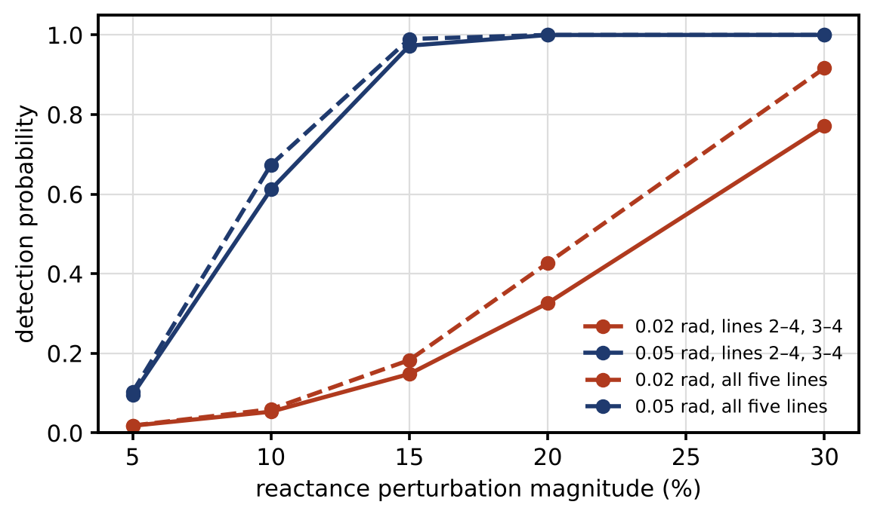
Figure 14.23. Moving-target defence on the four-bus network: detection probability of an injection built for the old model against the perturbation magnitude, for injections of 0.02 and 0.05 rad and for the local and all-line perturbation patterns.

14.14.2 Mechanisms, constraints and an adapting adversary
Changing line reactances needs D-FACTS devices or controllable series compensation, which many distribution feeders do not have. Other mechanisms perturb what the adversary must know:
- Topology. Switching a normally open tie or a sectionalizer changes $H$ with existing equipment.
- Operating point. In the nonlinear model, the Jacobian depends on the state, so changing set-points of DERs or taps changes the consistent-injection direction.
- Sensing. Changing which measurements are used, their weights, or adding secret protected measurements changes the detector without touching the network.
- Model. Estimating and using parameters the adversary cannot observe, such as temperature-corrected line resistances.
Every perturbation must stay inside power-quality, voltage, thermal, stability and protection limits, and its cost (losses, wear on switching devices, flicker) must be budgeted. The perturbation must also stay unknown to the adversary for long enough. An adversary who can observe flows after the change may re-estimate $H_{new}$ and rebuild the attack, so perturbations are randomized and repeated, and the “hiddenness” of the change (whether the adversary can detect that it happened) becomes a design property in its own right. MTD is best treated as one layer: valuable where controllable elements already exist, never a substitute for protected measurements.

14.15 Secure State Estimation and Sparse Attacks

14.15.1 The general condition: sparse observability
When an adversary can alter only some of many sensors, the state can still be recovered if the redundancy is large enough and is in the right places. Consider $p$ sensors observing an $n$-dimensional state,
 | $$y=Cx+a+v, {∥a∥}_{0}≤s,$$ | (14.47)
where $y$ is the vector of $p$ readings, $C$ the $p×n$ observation matrix, $a$ the attack vector with at most $s$ non-zero entries (the adversary controls at most $s$ sensors, but which ones is unknown) and $v$ the noise. In the noise-free case the state can be recovered for every such attack if and only if no two different states can be made to look alike by two $s$-sparse attacks: $Cx_{1}+a_{1}=Cx_{2}+a_{2}$ must imply $x_{1}=x_{2}$. Since $a_{1}−a_{2}$ can be any $2s$-sparse vector, this is equivalent to [35], [36]
 | $$rank\left(C_{\overline{Γ}}\right)=n \text{for every set} Γ \text{of at most} 2s \text{sensors},$$ | (14.48)
where $C_{\overline{Γ}}$ is $C$ with the rows in $Γ$ removed. In words: the state must stay observable after removing any $2s$ sensors. This is the $2s$-sparse observability condition, and it is the general statement.
The popular rule “fewer than half the sensors may be attacked” is a special case. If every single sensor observes the whole state, which is only possible when each row of $C$ alone has rank $n$ (for example a scalar state measured by $p$ sensors), then (14.48) needs only one sensor left after removing $2s$, and the condition becomes
 | $$p−2s≥1 ⇔ s<\frac{p}{2}.$$ | (14.49)
In general it needs at least $n$ sensors left, so $s≤\left(p−n\right)/2$ at best, and less if some sensors carry little information. Two seven-sensor arrays for a two-dimensional state show the difference. With rows $\left(cosϕ_{i},sinϕ_{i}\right)$, $ϕ_{i}=\left(i−1\right)π/7$, every three rows have rank 2, so the array is 4-sparse observable and tolerates $s=2$, not the $s=3$ that the majority rule would suggest. With five sensors measuring only $x_{1}$ and two measuring only $x_{2}$, removing the two $x_{2}$ sensors loses $x_{2}$, so the array does not tolerate even one attacked sensor.

14.15.2 Recovery by $ℓ_{1}$ minimization
Finding the attacked set directly is combinatorial: try every set of $s$ sensors. A convex relaxation minimizes the sum of absolute residuals,
 | $$\hat{x}=arg\min_{x}{∥y−Cx∥}_{1},$$ | (14.50)
where ${∥⋅∥}_{1}$ is the sum of absolute values; it is a linear program. Unlike least squares, it is not pulled far by a few large errors, because the penalty grows only linearly. Exact recovery by (14.50) needs a condition on $C$ somewhat stronger than (14.48), of null-space type; when it fails, (14.50) can still be a good estimate, and the combinatorial search or a satisfiability-modulo-theories solver can be used for guarantees.
For the cosine array above, with $x=\left(1,0.5\right)$, noise of 0.02 (seed 3) and sensors 2 and 5 corrupted by +0.8 and −1.5, least squares errs by 0.46 in the state while the $ℓ_{1}$ estimate errs by 0.04. Its residuals are 0.72 and −1.48 on the attacked sensors and at most 0.04 elsewhere, which identifies the sensors to distrust (Figure 14.24). Least squares spreads the error across all seven residuals and points nowhere.
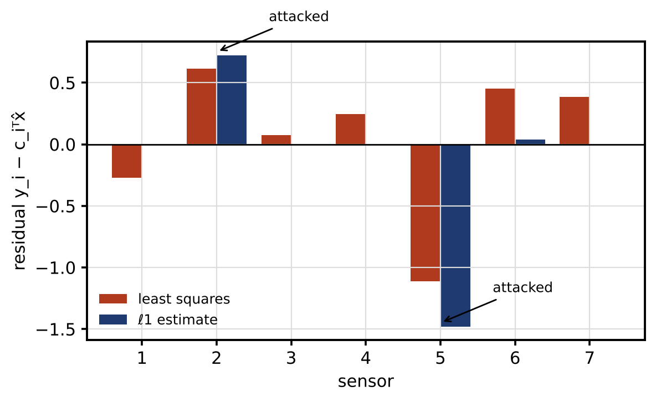
Figure 14.24. Seven redundant sensors of a two-dimensional state with sensors 2 and 5 corrupted: per-sensor residuals of the least-squares and $ℓ_{1}$ estimates. The $ℓ_{1}$ residuals isolate the attacked sensors; least squares spreads the error.

14.15.3 Static, dynamic and distributed settings
The example is static robust regression: one snapshot, no dynamics. Dynamic secure estimation uses a window of $T$ measurements of a dynamic system and stacks them, so that the observability matrix replaces $C$ in (14.48) and an adversary must stay consistent with the dynamics over the window [35]. Observer-based variants run a bank of observers, each excluding a candidate sensor set, and select the consistent one; unknown-input observers treat the attack as an input to be decoupled; set-membership estimators carry bounded uncertainty sets and intersect them, which gives guaranteed bounds rather than point estimates. Distributed versions run these ideas across several twins that share partial estimates, which brings in the resilient-consensus questions of the next section. Every guarantee depends on the sparsity bound $s$. If the adversary can corrupt more sensors than assumed, as a supply-chain implant common to many sensors could, the estimator may confidently return a wrong state. The bound $s$ is a threat-model assumption and must be justified by the diversity of the sensors (Section 14.17).

14.16 Resilient Consensus and Distributed Twins

14.16.1 Why plain averaging is captured
Distributed twins, for example of many battery sites agreeing on a frequency-support set-point, often use consensus: each agent repeatedly replaces its value by a weighted average of its own and its neighbours’ values. A single malicious agent that keeps broadcasting an extreme value drags every honest agent to it. Write the honest agents’ values as $x_{h}$, the averaging weights as a row-stochastic matrix partitioned into $W_{hh}$ (honest to honest) and $w_{hs}$ (honest to the stubborn agent $s$), and the stubborn agent’s constant value as $x_{s}$. Then
 | $$x_{h}\left[k+1\right]=W_{hh}x_{h}\left[k\right]+w_{hs}x_{s} ⇒ x_{h}\left[k\right]→{\left(I−W_{hh}\right)}^{−1}w_{hs}x_{s}=1x_{s},$$ | (14.51)
where $k$ is the iteration index and $1$ the vector of ones. The limit exists because $W_{hh}$ has spectral radius below 1 whenever the stubborn agent influences every honest agent through some path, and it equals $1x_{s}$ because row-stochasticity gives $W_{hh}1+w_{hs}=1$, so $1x_{s}$ is a fixed point. Plain averaging trusts everyone, so one liar decides the outcome.

14.16.2 W-MSR and the adversary models
The weighted mean-subsequence-reduced (W-MSR) algorithm [37] has each agent sort the values it receives, discard up to $F$ values strictly larger than its own (the largest ones) and up to $F$ strictly smaller (the smallest), and average the rest with its own value:
 | xik+1=1Nikeptk+1xik+j∈Nikeptk​xjk, | (14.52)
where $x_{i}\left[k\right]$ is agent $i$’s value, $N_{i}^{kept}\left[k\right]$ the set of neighbours whose values remain after the discards and $\left|⋅\right|$ its size (equal weights are used here; any weights bounded away from zero work). Whether this succeeds depends on the adversary model and on the graph, and “sufficiently connected” is not precise enough. Two adversary dimensions are needed:
- Malicious or Byzantine. A malicious agent sends the same, possibly false, value to all its neighbours (a broadcast medium). A Byzantine agent may send different values to different neighbours.
- F-total or F-local. Under the F-total model, at most $F$ agents in the whole network are adversarial. Under the F-local model, each honest agent has at most $F$ adversarial neighbours, which allows more adversaries in total.
The graph condition is robustness. A set $S$ of agents is $r$-reachable if at least one of its members has at least $r$ neighbours outside $S$. A graph is $r$-robust if, for every pair of non-empty disjoint subsets, at least one is $r$-reachable; it is $\left(r,s\right)$-robust if, for every such pair, either all members of one subset have $r$ neighbours outside it, or together at least $s$ members of the two subsets do. With these definitions, the results of LeBlanc and colleagues [37] are:
- Malicious, F-total: W-MSR reaches resilient consensus if and only if the graph is $\left(F+1,F+1\right)$-robust.
- Malicious, F-local: $\left(2F+1\right)$-robustness is sufficient.
- Byzantine, F-total or F-local: it is sufficient that the graph of honest agents, after removing the adversarial ones, is $\left(F+1\right)$-robust.
“Resilient consensus” means that honest agents converge to a common value that lies within the range of their own initial values. It is generally not the honest average: resilience costs accuracy.
Example 14.5 One compromised agent among eight
Given. Eight battery-site agents on the circulant graph $C_{8}\left(1,2,3\right)$ of Figure 14.10 (right): agent $i$ communicates with agents $i±1$, $i±2$ and $i±3$ (modulo 8), six neighbours each. Honest initial values (a frequency-support set-point in arbitrary units) 48.2, 49.1, 50.4, 51.0, 49.6, 50.3 and 51.1 for agents 1 to 7, mean 49.96. Agent 8 is compromised and broadcasts 100 to all its neighbours. $F=1$.
Find. Check the robustness conditions, then the honest values after 40 iterations with plain averaging and with W-MSR.
Solution. Enumerating all pairs of disjoint subsets of the eight agents ($3^{8}$ labellings) shows that the graph is 3-robust but not 4-robust, and $\left(2,2\right)$-robust. So W-MSR with $F=1$ is guaranteed to work for a malicious agent under the F-local model (needs 3-robust) and the F-total model (needs $\left(2,2\right)$-robust). Removing agent 8 leaves a 7-agent graph that is still 3-robust, more than the 2-robustness required for a Byzantine agent. With plain averaging, all honest agents converge toward the attacker, reaching 99.65 to 99.70 after 40 iterations. With W-MSR, all converge to 50.26, inside the honest range [48.2, 51.1] and 0.31 above the honest mean.
Interpretation. Figure 14.25 shows both runs. Resilience comes from discarding extremes, and it needs a graph with enough redundancy, here six neighbours each, to still connect the honest agents after the discards. The same principle protects distributed estimation and the distributed optimization of Chapter 13 (Section 13.16).
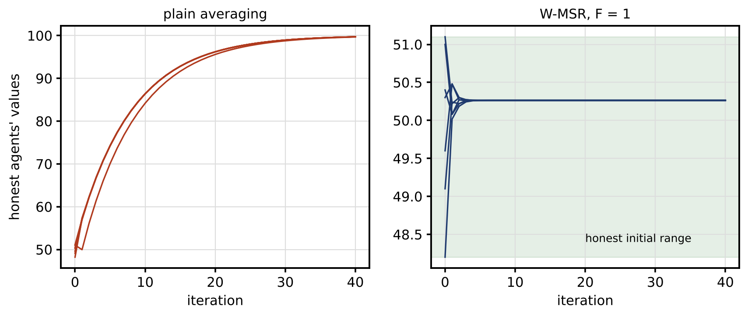
Figure 14.25. Consensus among seven honest agents with one compromised agent broadcasting 100 on the graph $C_{8}\left(1,2,3\right)$: plain averaging is captured (left); W-MSR with $F=1$ keeps the honest agents inside their initial range, shaded (right).

14.16.3 Delays, losses and asynchrony
Real twins exchange values over networks with delays and losses. Extensions of W-MSR allow agents to use the most recent value received from each neighbour within a bounded delay, and update asynchronously; the guarantees then hold under robustness conditions on the graph formed by the links that deliver within the bound. Packet loss removes links temporarily, so the robustness that matters is that of the graph that survives the worst credible loss pattern, not the nominal one. An adversary who can also delay or drop honest messages can reduce robustness, which links this section back to the availability analysis of Section 14.7.

14.17 Redundancy, Diversity and Common-mode Compromise

14.17.1 Voting under random failures
Voting among redundant sensors is the oldest form of resilience. In a two-out-of-three (2oo3) scheme the output follows the majority, or the median for analogue values, so one faulty sensor is outvoted. If each sensor fails independently with probability $p$, the scheme fails only when at least two fail:
 | $$P_{2oo3}=3p^{2}\left(1−p\right)+p^{3}=3p^{2}−2p^{3},$$ | (14.53)
which for $p=0.01$ is $2.98×{10}^{−4}$, about thirty times better than one sensor. For analogue signals the median of three plays the same role,
 | $$y_{vote}=median\left(y_{1},y_{2},y_{3}\right),$$ | (14.54)
where $y_{1}$, $y_{2}$ and $y_{3}$ are the three readings; the median always lies between the two healthy readings, whatever value the faulty one takes. Redundancy is weakened by common-cause failures: shared power, shared firmware, a shared calibration. In the beta-factor model a fraction $β$ of each channel’s failures affects all channels at once,
 | $$P_{2oo3,β}≈3{\left[\left(1−β\right)p\right]}^{2}−2{\left[\left(1−β\right)p\right]}^{3}+βp,$$ | (14.55)
where $β$ is the common-cause fraction; the first two terms are independent double and triple failures and the last is the common-cause event. With $β=0.1$ the failure probability is $1.24×{10}^{−3}$ for $p=0.01$ and $1.09×{10}^{−2}$ for $p=0.05$, dominated by the common-cause term (Figure 14.26).
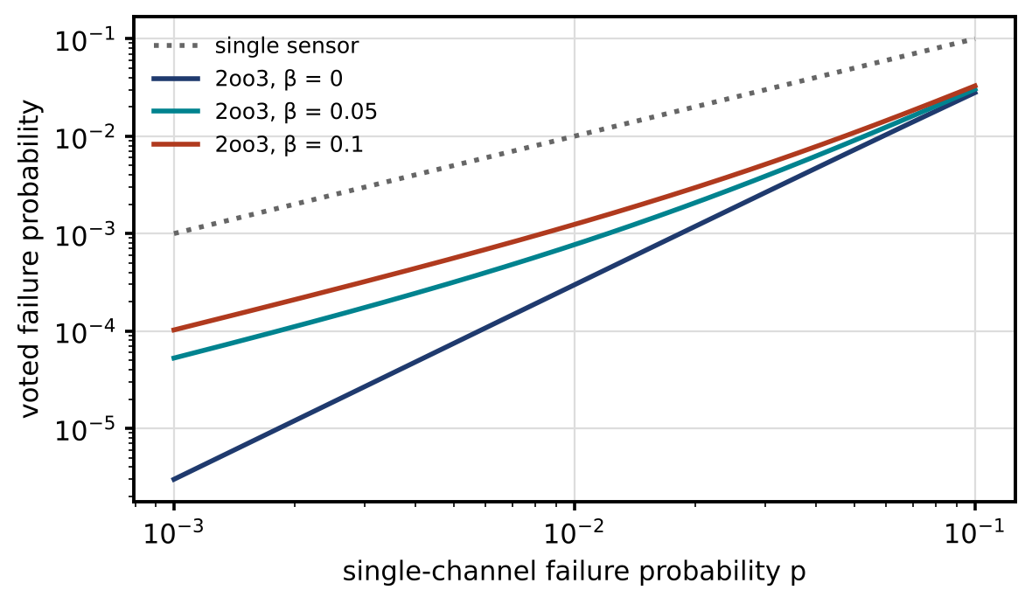
Figure 14.26. Failure probability of 2oo3 voting against single-channel failure probability, for independent failures and beta factors of 0.05 and 0.1: common-cause failures erase most of the benefit of redundancy.

14.17.2 Why a reliability model is not an adversary model
The beta-factor model describes random failures with a common cause. An intelligent adversary is not random: if all three sensors run the same firmware and one implant compromises all of them, the probability that the vote fails given that compromise is one, not $β$. Mixing the two views gives false comfort. The security view asks what an adversary must do to defeat the vote. If the channels are divided into diversity domains (vendor, firmware, credentials, communication path, power supply), defeating a 2oo3 vote requires compromising at least two channels, and the adversary’s cost is
 | $$C_{defeat}=\min_{i≠j}\left(c_{i}+c_{j}−c_{ij}^{shared}\right),$$ | (14.56)
where $c_{i}$ is the cost (effort, access, time) of compromising channel $i$ alone and $c_{ij}^{shared}$ the part of that cost the two channels share through a common domain. If all channels share the same firmware, $c_{ij}^{shared}$ is almost the whole cost and redundancy adds nothing against the adversary. Diversity drives the shared cost toward zero. Figure 14.27 shows an architecture in which the three channels differ in vendor or firmware version, keys, communication path and power. Adversary A4 of Table 14.4, the supply-chain implant, is the reason the firmware domain matters most. Reliability analysis and security analysis are both needed: one with probabilities of random events, the other with an explicit adversary model.
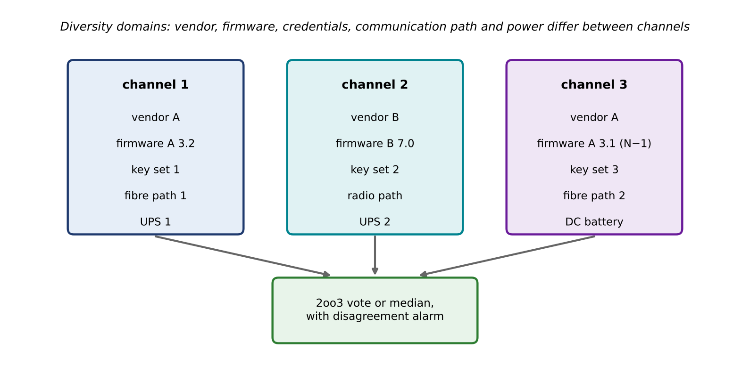
Figure 14.27. Diversity domains for a 2oo3 measurement: the three channels differ in vendor or firmware version, credentials, communication path and power supply, so that most single compromises cannot defeat the vote (channels 1 and 3 share a vendor, so a vendor or build-system compromise remains a common-mode threat that a third vendor would remove); a disagreement alarm flags any channel that departs from the others.

14.18 Trust Evidence and Trustworthy AI

14.18.1 Trust is contextual and has several kinds of evidence
“Do we trust this source?” has no single answer. Trust is about a specific use: a forecast may be good enough for day-ahead scheduling and not for protection. It also rests on different kinds of evidence, which should not be collapsed into one number without saying so. Table 14.12 separates five kinds.
TABLE 14.12 Kinds of trust evidence for a component of a distributed twin
Kind of evidence | Question it answers | How it is established | What it cannot establish
Identity assurance | Is this really the device or service it claims to be? | Certificates, attestation, secure boot | Whether its data are correct
Authorization | May it do or say this? | Policy, least privilege | Whether it is behaving well
Data quality | Are its values plausible and consistent? | Residuals, physics checks, redundancy | Whether consistency was manufactured
Model validity | Is the model behind the output still valid for this condition? | Validation coverage, OOD checks, drift monitoring | Correctness outside the validated domain
Behavioural reputation | Has it been consistent in the past? | Confirmation history (below) | Future behaviour of a patient adversary
Organizational trust | Is the supplier or operator accountable and competent? | Contracts, audits, certifications | Technical correctness of any one output

14.18.2 A reputation score and what it means
A reputation score summarizes how often a component’s reports were confirmed by independent evidence. The beta reputation system [38] counts confirmations $α_{k}$ and contradictions $β_{k}$, discounted by a forgetting factor:
 | $$α_{k}=λ_{f}α_{k−1}+s_{k}, β_{k}=λ_{f}β_{k−1}+\left(1−s_{k}\right), T_{k}=\frac{α_{k}+1}{α_{k}+β_{k}+2},$$ | (14.57)
where $s_{k}=1$ if report $k$ was confirmed and 0 otherwise, $λ_{f}∈(0,1]$ the forgetting factor and $T_{k}$ the trust score, with $α_{0}=β_{0}=0$. Without forgetting ($λ_{f}=1$), $T_{k}$ is the posterior mean of the confirmation probability under a uniform prior and independent reports. With forgetting it is no longer a posterior: it is an exponentially weighted heuristic with an effective memory of about $1/\left(1−λ_{f}\right)$ reports, which is what lets it follow a source that changes. Its steady value for a source confirmed with probability $π_{c}$ is about $\left(π_{c}/\left(1−λ_{f}\right)+1\right)/\left(1/\left(1−λ_{f}\right)+2\right)$.
For a source that is 98 % consistent for 300 reports and then 70 % consistent (seed 5), with $λ_{f}=0.98$ (memory 50 reports), the score is 0.957 at report 300, falls below 0.8 after 59 further reports, is 0.81 after 50 and 0.75 at report 600; the steady values are 0.96 and 0.69 (Figure 14.28). Trust can then weight the source in estimation, for example by inflating its variance,
 | $$σ_{i,eff}^{2}=\frac{σ_{i}^{2}}{T_{i}},$$ | (14.58)
where $σ_{i}^{2}$ is source $i$’s nominal variance and $σ_{i,eff}^{2}$ the variance used by the estimator, and it can trigger an investigation.
A reputation score is evidence about historical consistency. It is not identity and not authorization, and a high score must never override cryptographic identity, provenance, or a hard safety limit. A patient adversary can build trust before exploiting it; a source with a perfect record whose certificate has been revoked is untrusted, and a command that violates an interlock is rejected however trusted its sender.
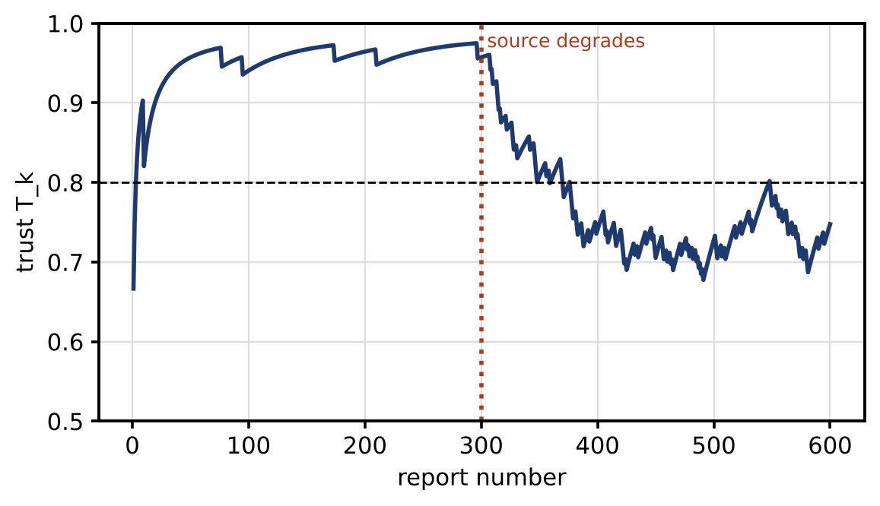
Figure 14.28. Trust score (14.57) of a source that becomes unreliable after 300 reports, with forgetting factor 0.98 (effective memory about 50 reports).

14.18.3 Explanations: evidence for review, not proof
A security alarm that an operator cannot understand will be ignored or overridden, so detectors should say why they fired. For the Mahalanobis statistic of Chapter 12 (Section 12.11.1), the statistic decomposes exactly into per-feature contributions,
 | D2=x−μTΣ−1x−μ=i​xi−μiΣ−1x−μi, | (14.59)
where $x$ is the feature vector, $μ$ and $Σ$ the baseline mean and covariance, and ${\left[⋅\right]}_{i}$ the $i$-th entry; individual terms can be negative when features are correlated. For observation A of motor M-07 in Example 12.6 ($D^{2}=30.4$), the winding-temperature residual contributes 17.4, the vibration RMS 10.1 and the current unbalance 3.0 (Figure 14.29). The alarm is driven by a high temperature together with low vibration, which points to a cooling or sensor problem rather than load.
For learned detectors, attribution methods such as SHAP [39] play a similar role, with four caveats. An attribution describes the model, not the physical cause, and says nothing about whether the detector is right. Attributions can be unstable: small input changes or a different background sample can reorder them. With correlated features, credit is split in ways that depend on the method’s assumptions about feature independence. And attributions can be manipulated: a model can be built to behave badly while presenting innocent-looking explanations. An explanation is evidence for an operator to review, alongside physics checks and other detectors, and never proof of correctness.
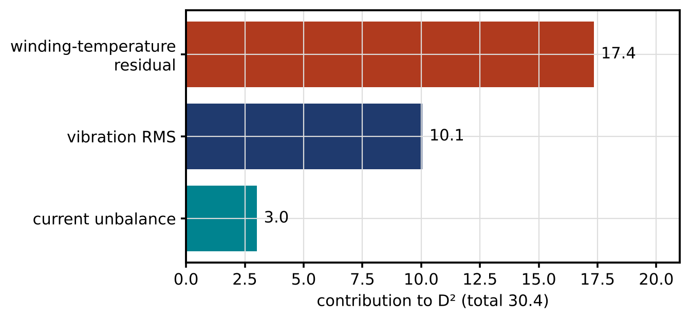
Figure 14.29. Explaining a multivariate alarm: exact contributions of three indicators to the Mahalanobis statistic of motor M-07, observation A (total 30.4).

14.18.4 Trustworthy AI beyond explanation
An AI component in a twin is trustworthy for a stated use when the evidence covers seven properties, each tested rather than claimed:
- Robustness. Performance under noise, drift and the attacks of Section 14.9, measured with worst-case as well as average metrics.
- Uncertainty and calibration. Prediction intervals with checked coverage on held-out data from the deployment conditions.
- Out-of-distribution detection. Inputs outside the training domain are flagged and handled by a fallback.
- Provenance. Data, code and model versions are recorded and signed (Section 14.8).
- Human oversight. Defined points where people review, approve or override, with the information to do so.
- Reproducibility. Results can be regenerated from the recorded versions and seeds.
- Fail-safe behaviour. When the component fails or is distrusted, the system moves to a defined safe mode (Section 14.20).

14.19 Risk, Governance and NIST CSF 2.0

14.19.1 Expected loss and attack trees
Risk combines likelihood and consequence. Quantitatively, the expected annual loss over scenarios $i$ is
 | EAL=i​piCi, | (14.60)
where $p_{i}$ is the annual probability of scenario $i$ and $C_{i}$ its consequence in money. Attack trees build scenario probabilities from steps. If the steps are independent, AND and OR nodes combine as
 | pAND=i​pi, pOR=1−i​1−pi, | (14.61)
where $p_{i}$ are the probabilities of the child events. Independence is often unrealistic. An adversary who succeeds at phishing is more likely to succeed at lateral movement on a flat network, so the AND node should use the conditional probability, $p_{AND}=p_{A} p_{B|A}$, and dependent structures are better modelled as Bayesian networks with conditional probability tables.
For the P-1 site controller (Figure 14.30), compromise might come through phishing and lateral movement ($0.3×0.2=0.06$) or a compromised vendor update ($0.02$), giving an annual probability of $1−\left(1−0.06\right)\left(1−0.02\right)=0.079$. With a consequence of 400 000 $ (equipment damage and outage), the EAL is 31 500 $. Multi-factor authentication (phishing success 0.05) and signed, staged updates (supply-chain success 0.005) reduce the probability to 0.015 and the EAL to 6000 $. If lateral movement after phishing succeeds with probability 0.5 rather than 0.2, because the network is flat, the original probability becomes 0.167: dependence can double the answer.

14.19.2 Uncertainty and sensitivity
Every number above is a judgment. Annual probabilities of rare events cannot be measured from a site’s own history, and consequence estimates have wide ranges. They should be carried as distributions. With triangular distributions (minimum, mode, maximum) of $\left(0.1,0.3,0.5\right)$ for phishing, $\left(0.1,0.2,0.4\right)$ for lateral movement, $\left(0.005,0.02,0.05\right)$ for the supply chain, $\left(0.02,0.05,0.1\right)$ for phishing under MFA, $\left(0.001,0.005,0.015\right)$ for signed updates, and $\left(200,400,800\right)$ thousand $ for the consequence, 200 000 Monte Carlo samples (seed 7) give an EAL of 19 900 to 77 100 $ before controls (5 to 95 %, median 40 600 $) and 4300 to 16 600 $ after (median 8800 $). The reduction, 13 700 to 63 600 $ a year, is what the controls’ cost should be compared with (Figure 14.30). The point estimates sit inside but below the medians, because the input ranges are skewed upward. The value of the exercise is in comparing controls consistently and seeing which inputs dominate the spread, not in the absolute numbers.
Two further qualifications belong to any risk statement. Risk appetite is set by the organization’s governance, not by the engineer: how much residual risk of which kind is acceptable, and who may accept it. Safety consequences are not converted into money and traded against cost: scenarios that could harm people are handled as constraints, through protection and interlocks that bound the consequence whatever the probability. Qualitative schemes, such as the security levels of IEC 62443, likelihood–impact matrices and CVSS scores for vulnerabilities, serve the same comparative purpose when numbers are unavailable.
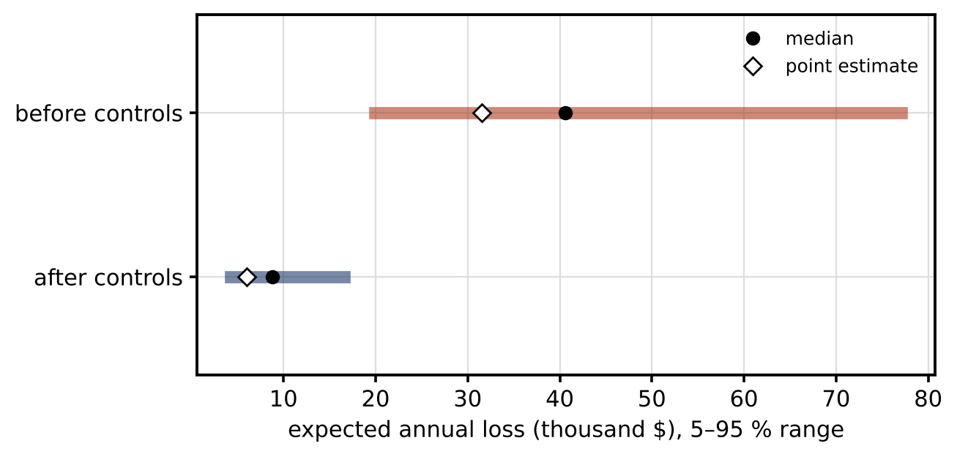
Figure 14.30. Expected annual loss for compromise of the P-1 site controller before and after multi-factor authentication and signed updates: 5 to 95 % range from triangular input distributions (bar), median, and the point estimate from the modal values.

14.19.3 The NIST Cybersecurity Framework 2.0
The NIST Cybersecurity Framework 2.0 [40] organizes a security programme into six functions, and it maps naturally onto the twin’s lifecycle (Figure 14.31). Govern, new in version 2.0, sits at the centre: roles and responsibilities, risk appetite, policy, and supply-chain risk management. Identify covers assets, data flows, the threat model and the SBOM. Protect covers identity, cryptography, segmentation and signed artifacts. Detect covers residual tests, CUSUM, watermarking and provenance checks. Respond covers containment, isolation and degraded modes. Recover covers re-attestation, reconciliation and bumpless restoration. Each section of this chapter falls under one or more functions, and the assurance case of Section 14.27 draws its evidence from all six.
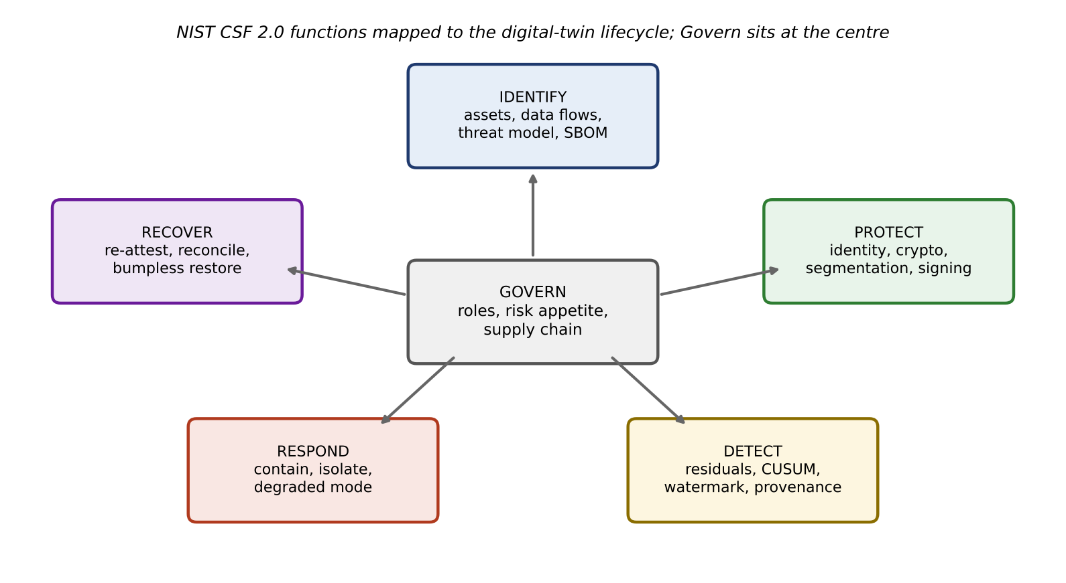
Figure 14.31. NIST CSF 2.0 functions mapped to the digital-twin lifecycle, with Govern at the centre and examples from this chapter under each function.

14.20 Graceful Degradation, Local Autonomy and Safety Invariants

14.20.1 Modes with explicit rules
When a component cannot be trusted, because its data failed authentication, its residuals are anomalous or its messages are late, the system should lose capability gradually and never lose safety. A twin-supported controller therefore runs a mode machine with explicit entry and exit conditions, authority, safety limits and a maximum duration in each mode (Figure 14.32 and Table 14.13).
TABLE 14.13 Cyber-resilience modes of the P-1 twin-supported controller
Mode | Entry trigger | Data used | Control authority | Safety limits | Maximum duration | Exit condition
Normal | All checks pass | All verified, fresh data | Full optimization within the twin’s authority | Nominal limits | Unlimited | Any failed check moves to suspect
Suspect | Anomaly, failed check or late data | Suspect source down-weighted | Optimization continues; no new large commitments | Nominal limits, alarms active | Minutes (set per function) | Cleared by independent evidence, or confirmed
Degraded | Confirmed problem or suspect timer expired | Suspect source excluded; independent or forecast data | Conservative set-points, widened reserves | Tightened (lower current, wider voltage margin) | $d_{max}$ from (14.63) | Cause removed and source re-attested
Autonomous | Loss of communication with site twin or cloud | Local measurements only | Local controllers: droop, fixed schedules, local caps | Hard local limits | Until communication returns or limits approached | Communication restored and verified
Safe stop | Safety invariant at its limit, or maximum duration exceeded | Protection measurements | Protection and interlocks only | Protection settings | Until manual restart | Approved restart
Staged recovery | Cause removed, sources re-attested | Restored sources, checked | Ramped return to normal authority | Tightened limits relaxed in steps | Defined by procedure | Recovery gate passed (Section 14.21)
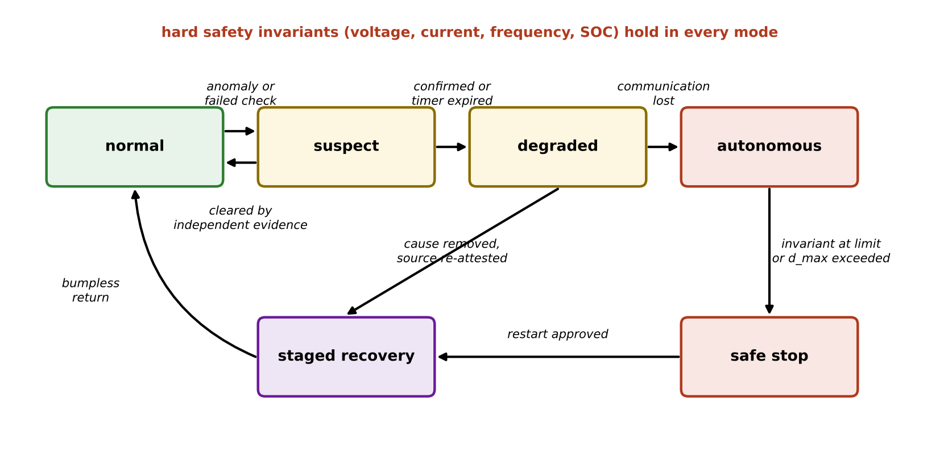
Figure 14.32. Cyber-resilience state machine: normal, suspect, degraded, autonomous, safe stop and staged recovery, with the transitions between them; degraded mode also escalates to safe stop when its maximum duration (14.63) runs out. Hard safety invariants hold in every mode.
The rules that make the machine safe are few. Hard safety invariants (voltage, current, frequency and state-of-charge limits enforced by protection and local controllers) hold in every mode and do not depend on the twin. Authority shrinks as trust shrinks. No mode is open-ended: degraded and autonomous modes have a maximum duration, after which the system escalates to safe stop unless an operator explicitly extends it with a recorded justification. And every transition is logged with its trigger and time stamp.

14.20.2 How long can the plant run on stale information?
The maximum duration of a degraded mode follows from the growth of uncertainty. Suppose the controller runs on the last verified estimate and a forecast, and the quantity it must cover (net load, say) drifts like a random walk with variance $q$ per step. After $d$ steps without verified data,
 | $$P_{k+d}=P_{k}+dq,$$ | (14.62)
where $P_{k}$ is the variance at the last verified estimate. The reserve that covers the uncertainty with probability $1−α$ is $z_{1−α}\sqrt{P_{k+d}}$ (Chapter 13, Section 13.14.1), where $z_{1−α}$ is the standard normal quantile. When it reaches the available headroom $R_{avail}$, the mode must end, which gives
 | $$d_{max}=\frac{1}{q}\left(\frac{R_{avail}^{2}}{z_{1−α}^{2}}−P_{k}\right),$$ | (14.63)
where $d_{max}$ is the maximum number of steps in degraded mode. For the P-1 battery with $\sqrt{P_{k}}=40$ kW, $\sqrt{q}=15$ kW per 5-minute step, $z=2.326$ (99 %) and 250 kW of headroom, $d_{max}=44$ steps, or 3.7 h (Figure 14.33). After that the reserve no longer covers the uncertainty, and the system must either obtain verified data, reduce its commitments, or move to safe stop. The same reasoning applies to any degraded mode: write down how the uncertainty grows and when it exceeds the margin.
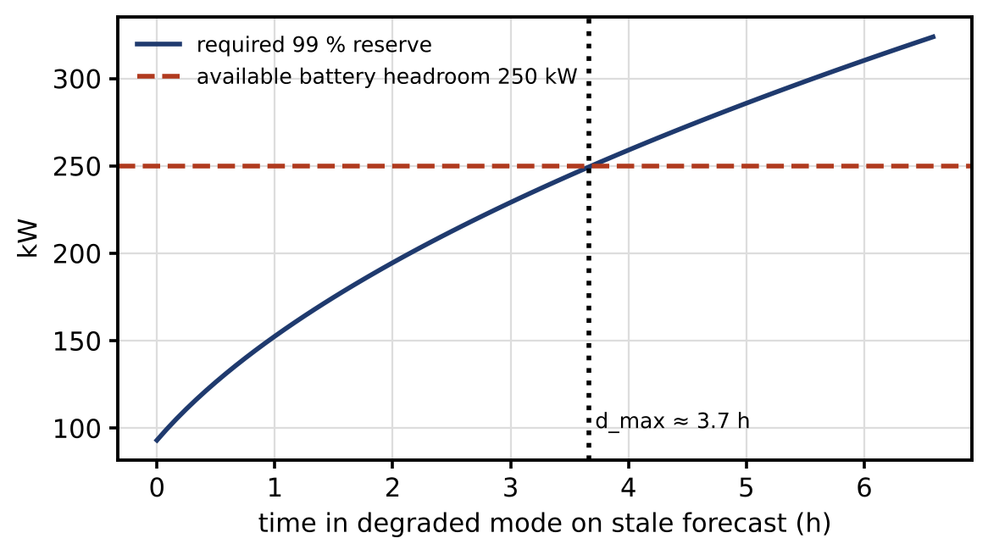
Figure 14.33. Required 99 % reserve while running on a stale forecast, against the available battery headroom of 250 kW: the degraded mode may last at most about 3.7 h.

14.21 Secure Recovery and Resynchronization

14.21.1 Recovery is more than reconnecting
After a manipulated source has been excluded and the cause removed, the twin must return to normal operation without a jolt and without re-admitting the attacker. Recovery has ten steps:
- Preserve evidence. Copy logs, memory images and the affected data before anything is changed.
- Remove the cause. Close the access path; rebuild or restore the affected components from verified, signed images.
- Re-attest sources. Check the boot measurements and firmware versions of every device on the affected path (Section 14.8.3).
- Renew credentials. Rotate keys and revoke certificates that may have been exposed.
- Resynchronize clocks. Verify time sources before trusting time stamps again (Section 14.6.3).
- Check data quality. Compare the restored source against independent and redundant data for a period before giving it weight.
- Reconcile the state. Bring the estimator’s state into agreement with the restored data, using the technique of Section 14.21.2 or a full re-estimation.
- Restore models. Return to the last approved model versions; anything retrained during the incident goes through the update gate again.
- Transfer back bumplessly. Ramp the controller from degraded to normal constraints.
- Approve and record. An operator, or an automatic gate with defined criteria, approves the return to normal; the event and its evidence are recorded for the post-event review.

14.21.2 Reconciling the estimator
The estimator’s state may have drifted while it ran on reduced data, and a controller that switches back to full data at once may see a large innovation and act abruptly. For a scalar estimator ${\hat{x}}_{k+1}=a\left[{\hat{x}}_{k}+K\left(y_{k}−{\hat{x}}_{k}\right)\right]$ with plant $x_{k+1}=ax_{k}$ and fresh measurements, the estimation error $e_{k}=x_{k}−{\hat{x}}_{k}$ obeys
 | $$e_{k}={\left[a\left(1−K\right)\right]}^{k}e_{0}, n_{ϵ}=\left\lceil \frac{lnϵ}{ln\left(a\left(1−K\right)\right)}\right\rceil ,$$ | (14.64)
where $K$ is the filter gain, $e_{0}$ the error at reconnection and $n_{ϵ}$ the number of steps to reduce the error to a fraction $ϵ$ of $e_{0}$. With $a=0.95$ and the steady-state gain $K=0.3$, the error falls to 1 % in 12 steps. Temporarily inflating the estimate’s covariance on reconnection,
 | $$P_{k}^{+}=P_{k}+ΔP_{infl}, K_{k}=\frac{P_{k}^{+}}{P_{k}^{+}+r},$$ | (14.65)
where $ΔP_{infl}$ is the added variance and $r$ the measurement-noise variance, raises the gain (to 0.8, say) and shortens this to 3 steps, at the cost of more noise during those steps (Figure 14.34). Covariance inflation is one estimator technique, appropriate only once step 6 has shown the restored data to be trustworthy; inflating the covariance on unverified data hands the estimate to whoever controls those data. Larger state changes call for a full re-estimation from verified data instead.
The controller transfer of step 9 limits the change of authority per step. A simple form ramps each constraint from its degraded to its normal value over a time $T_{r}$,
 | $$u_{max}\left(t\right)=u_{max}^{deg}+\left(u_{max}^{nom}−u_{max}^{deg}\right)min\left(1,\frac{t−t_{r}}{T_{r}}\right),$$ | (14.66)
where $u_{max}\left(t\right)$ is the active limit, $u_{max}^{deg}$ and $u_{max}^{nom}$ the degraded and nominal limits and $t_{r}$ the time recovery starts; the ramp is aborted and the system returns to degraded mode if any check fails during it.
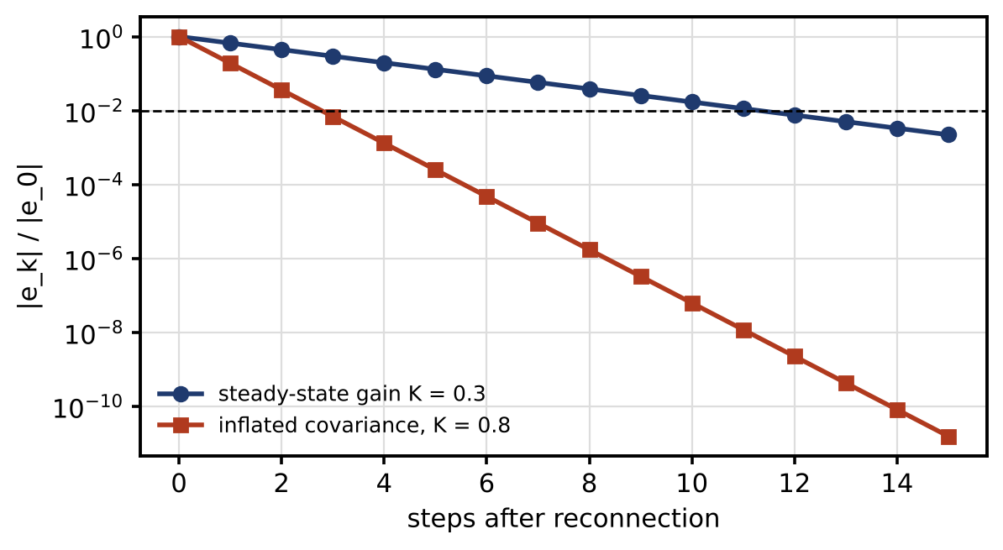
Figure 14.34. Resynchronization after a manipulated source is removed: estimation error decay with the steady-state gain and with temporary covariance inflation, against the 1 % level.

14.22 Real-time Security Budget and Runtime Assurance

14.22.1 A runtime-assurance pipeline
The checks of this chapter form a pipeline around the twin’s decision (Figure 14.35). Every input is authenticated and checked for freshness, with a stale-data timer per source; checked for physical plausibility; passed to an estimator whose health (chi-square statistic, age of information) is monitored; and screened by an anomaly detector. The twin’s decision then passes through a command governor, which checks every command against limits on value, rate and the current mode before it is sent, and through hard interlocks in the field that do not depend on any software above them. A watchdog hands control to a safe local controller if the pipeline misses its deadline or raises an alarm; a tamper-evident, time-synchronized event log records everything; and a recovery gate controls the return to normal. This is the runtime-assurance architecture of Chapter 13 (Section 13.20.2), extended with security checks.
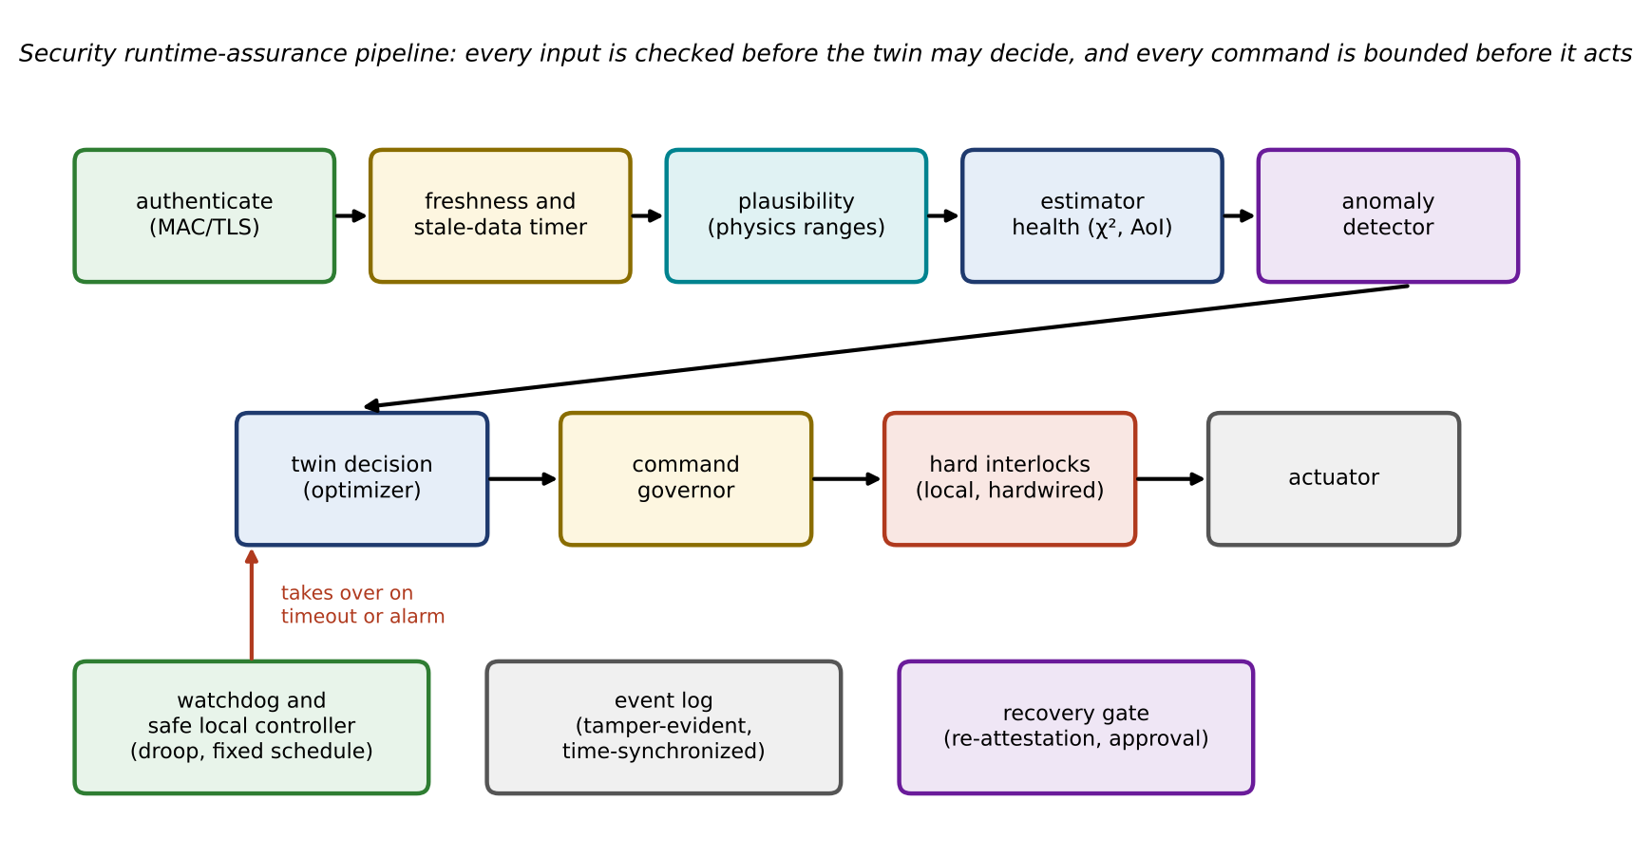
Figure 14.35. Security runtime-assurance pipeline: authentication, freshness and stale-data timers, plausibility, estimator health and anomaly detection before the twin decides; command governor and hard interlocks before the actuator; watchdog with a safe local controller, event log and recovery gate around them.

14.22.2 A worst-case budget
Security steps take time, and a step that breaks the deadline will be bypassed in practice, so each must appear in the budget with a bound, not an average. For a path made of stages $i$ with worst-case (or bounded-probability) times $t_{i}^{wc}$,
 | ttotalwc=i​tiwc≤tdeadline, | (14.67)
where $t_{deadline}$ is the deadline of the function. The bound for a software stage comes from worst-case execution-time analysis or from a high percentile measured on the target hardware under realistic load; the bound for a network stage comes from the network’s configured guarantees (priority queueing, time-sensitive networking, rate limits) or from measurement under the worst credible load, including a DoS that the rate limiter admits.
Table 14.14 and Figure 14.36 give a budget for the P-1 microgrid’s 100 ms supervisory loop. The typical path takes 40 ms; the bounded path 93.7 ms, leaving 6.3 ms of margin. Three entries deserve comment. The optimizer’s bound is its timeout, after which the fallback of Chapter 13 (Section 13.20.1) applies. Certificate operations (TLS handshakes, revocation checks) are kept out of the loop: sessions are established and certificates checked in the background, and only per-message MACs and one command signature are in the loop. Logging writes to a bounded buffer so that a slow disk cannot stall control.
TABLE 14.14 Worst-case security budget for the P-1 100 ms supervisory loop (bounds to be confirmed on target hardware)
Stage | Typical (ms) | Bound used (ms) | Basis of the bound
Acquisition and filtering | 8 | 10 | Device specification
MAC generation at the sensor | 0.002 | 0.02 | 99.9th percentile of Table 14.9 (about 20 µs); to be re-measured on the sensor’s processor
Network to site controller | 2 | 6 | Priority-queued site LAN, measured
Tag verification and freshness | 0.01 | 0.1 | As above
Queueing under rate-limited load | 0 | 5 | Admission limit of the rate limiter
State estimation with chi-square test | 3 | 6 | Measured 99.9th percentile
Anomaly detection and trust update | 2 | 4 | Measured 99.9th percentile
Optimization | 15 | 40 | Solver timeout, then fallback
Command governor and command signature | 0.05 | 0.1 | Signature 99.9th percentile
Command network and verification | 2 | 6 | As for the measurement path
Event logging | 0.2 | 1 | Bounded buffer write
Time-source check | 0.1 | 0.5 | Comparison of two sources
Actuation | 8 | 10 | Inverter specification
Failover reserve | 0 | 5 | Switch to safe local controller
Total | 40.4 | 93.7 | Margin 6.3 ms against 100 ms
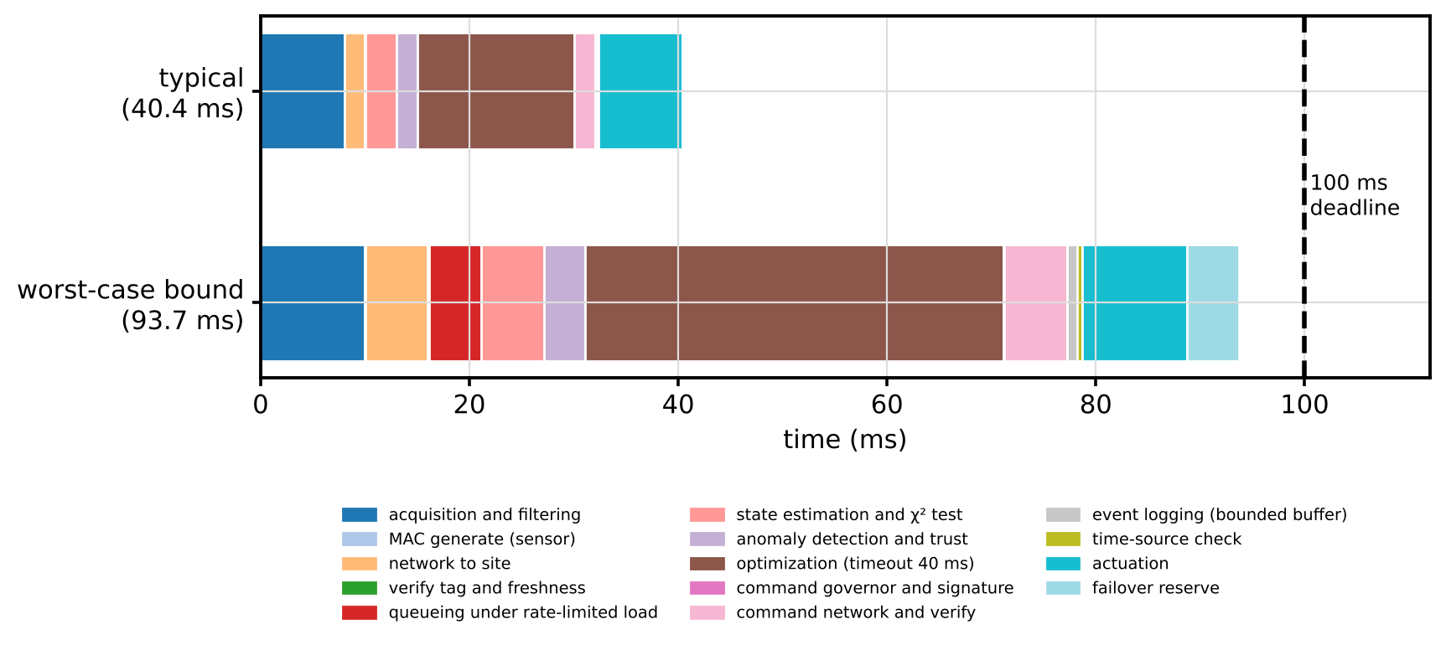
Figure 14.36. Timing budget of the secured 100 ms supervisory loop: typical times and the worst-case bounds used for design, by stage.

14.23 Cyber Range, SIL, CHIL/HIL and PHIL Security Validation
A security claim is only as good as the test behind it, and no single test can prove everything. Figure 14.37 and Table 14.15 arrange the test environments as a ladder, each rung with what it can and cannot show. Model-in-the-loop simulation checks the attack logic and the detector mathematics; software-in-the-loop runs the real code; a cyber range, an isolated replica of the twin, its networks and tools, rehearses incidents with the people who will respond to them without endangering the plant; controller- and hardware-in-the-loop (CHIL, HIL) test real controllers and firmware against a real-time plant model; power-hardware-in-the-loop (PHIL) adds power-level interaction; and a field pilot with safeguards shows behaviour on real data with real operators. The use of digital twins as security test platforms is growing quickly, but published evidence from deployed systems remains scarce [3], [4], which is why each claim should name the rung its evidence comes from.
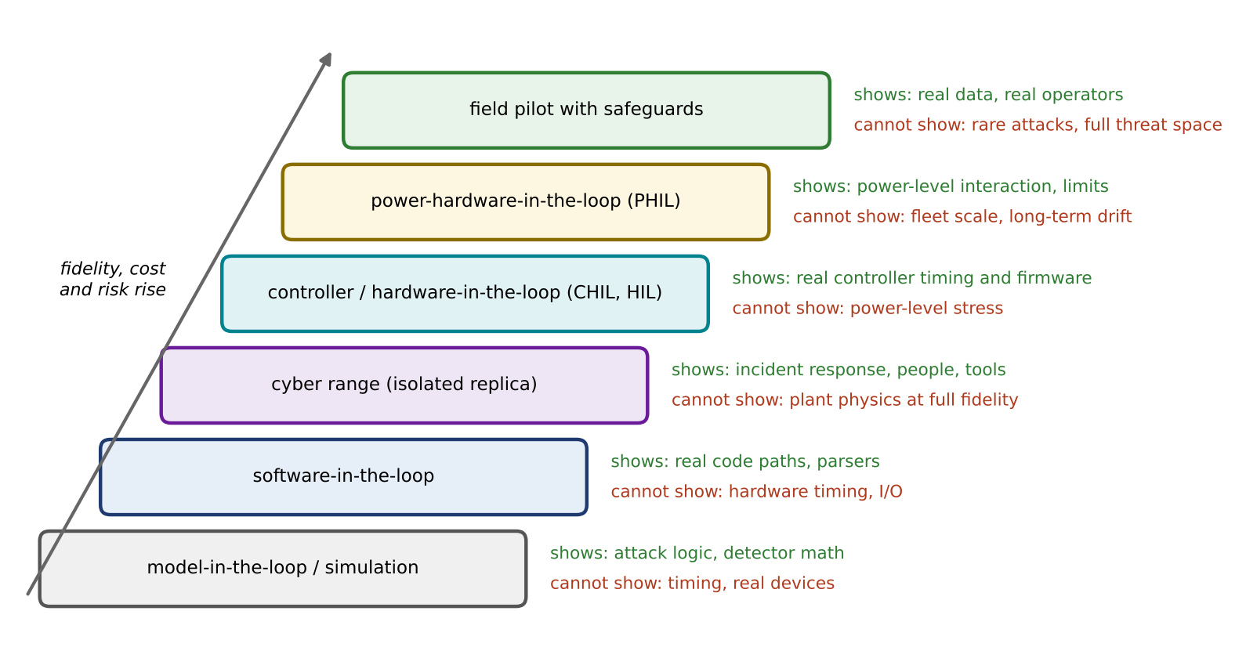
Figure 14.37. Security validation ladder: from model-in-the-loop simulation through software-in-the-loop, cyber range, CHIL/HIL and PHIL to a field pilot, with what each rung can and cannot show. Fidelity, cost and risk rise up the ladder.
TABLE 14.15 What each validation environment can and cannot prove
Environment | Can show | Cannot show | Typical security use
Simulation (model-in-the-loop) | Attack and detector logic, detection probabilities, many Monte Carlo runs | Timing, implementation bugs, device behaviour | Examples 14.1 to 14.8 of this chapter
Software-in-the-loop | Real parsers, protocol stacks, code paths | Hardware timing, I/O | Fuzzing protocol handlers, update-gate logic
Cyber range | Incident response, tools, people, procedures | Plant physics at full fidelity | Tabletop and live-fire exercises
CHIL / HIL | Real controller timing, firmware, protection logic | Power-level stress | Watermark and runtime-assurance timing, safe-mode transitions
PHIL | Power-level interaction and limits | Fleet scale, long-term drift | Local caps and interlocks under attack-shaped loads
Field pilot with safeguards | Real data, real operators, real integration | Rare attacks, the full threat space | False-alarm rates, operator response, drift
The results of any rung are reported with the cyber-resilience metrics of Table 14.10 and four more: the maximum unsafe deviation reached, the fraction of service retained in degraded mode, the recovery time, and the confidence of recovery (how often recovery restored a verified state on the first attempt).

14.24 Reproducible Cyber-physical Case Studies
The three case studies of this section use the P-1 systems of earlier chapters. Each ends with a reproducibility box listing what is needed to regenerate its numbers. All results are from simulation with synthetic data, not from HIL or field experiments.

14.24.1 False-data injection on the P-1 feeder estimator
Example 14.6 Hiding an under-voltage from the feeder’s state estimator
Given. The P-1 feeder and estimator of Chapter 11 (Section 11.12, Example 11.17): 11 kV, ten 1 km sections of $0.25+j0.35$ Ω/km, evening loads of Table 11.13, the P-1 microgrid importing $1.0+j0.3$ MVA at bus 6. Measurements: SCADA voltages at buses 0 and 10 ($σ=0.004$ pu), head-end active and reactive flow (0.01 pu), PMU voltage and angle at bus 6 (0.001 pu, 0.0005 rad), and smart-meter pseudo-measurements of $P$ and $Q$ at buses 1 to 10 (15 % of value, at least 0.02 pu): $m=26$ measurements, $n=21$ states, 99 % threshold 15.09. The true feeder-end voltage is 0.940 pu, below the 0.95 pu limit. Noise seed 1112. Threat model: adversary A3 of Table 14.4, with write access to the metering head-end and the bus-10 SCADA channel and knowledge of the nonlinear model. The manipulation $a=h\left(\hat{x}+c\right)−h\left(\hat{x}\right)$ with $c$ raising the estimated voltages at buses 8 to 10 by 0.015 pu. Three defensive configurations: (i) no authenticated measurement; (ii) the bus-10 SCADA voltage authenticated, so the adversary cannot alter it; (iii) that voltage upgraded to an authenticated PMU-class measurement ($σ=0.001$ pu).
Find. The test statistic, its detection probability and the estimated feeder-end voltage in each configuration; the identification; and a recovery.
Solution.
- Clean data. $J=3.40$; estimated feeder-end voltage 0.942 pu.
- (i) No authentication. The manipulation alters nine measurements: the bus-10 voltage and $P$, $Q$ at buses 7 to 10. $J$ changes from 3.3963 to 3.3960, and the estimate is 0.957 pu: the under-voltage is hidden. The residual to second order is negligible, so the detection probability equals the 1 % false-alarm rate.
- (ii) SCADA voltage authenticated. Eight pseudo-measurements are still altered. By (14.6), $λ=14.2$ and $P_{D}=0.66$; 300 noise realizations detect it in 60 % of cases. In the seeded realization $J=16.0$, just above the threshold, but the estimate is still 0.956 pu because eight altered pseudo-measurements outweigh one accurate meter, and the largest normalized residual, 3.55, falls on the authenticated voltage.
- (iii) PMU-class authenticated voltage. $λ=105$ and detection is certain in practice; $J=100.5$. The three largest normalized residuals are 9.85 on the authenticated bus-10 voltage, 8.93 on the PMU voltage at bus 6 and 7.67 on the bus-10 active-power pseudo-measurement. The two largest point at the two measurements that are right.
- Recovery. Excluding all eight suspect pseudo-measurements leaves 18 measurements whose Jacobian has rank 16, fewer than the 21 states: the network becomes unobservable. Replacing them with pseudo-measurements from an independent load forecast (true values with 10 % random error, assigned 50 % uncertainty) gives $J=2.43$ and a feeder-end estimate of $0.942±0.001$ pu, the same as the clean estimate, against a true 0.940 pu.
Interpretation. Figure 14.38 shows the profiles. Four lessons follow:
- Pseudo-measurements are an attack surface. They are numerous and weakly weighted, so an adversary who can alter them gains great influence over the estimate. Their data path, the metering head-end, must be protected as carefully as SCADA.
- One authenticated measurement is not enough if it is imprecise. Precision and authentication together make the manipulation inconsistent.
- Residual-based identification can blame the honest sensor. Under a coordinated manipulation the largest normalized residuals point at the measurements that disagree with the majority, which are the authentic ones. Identification must use provenance: an authenticated, precise measurement is never the first to be removed.
- Recovery needs an independent source. Removing suspect data alone can leave the network unobservable.
Reproducibility. Model: P-1 feeder of Chapter 11, Table 11.13 loads, bus 0 at 1.00 pu, source impedance neglected. Estimator: Gauss–Newton WLS with numerical Jacobian, flat start, tolerance ${10}^{−10}$. Seed 1112 (NumPy default generator); 300 extra realizations for the Monte Carlo detection rate. Attack: $c$ of +0.015 pu on $V_{8}$, $V_{9}$, $V_{10}$, computed at the clean estimate. Detector: chi-square at 99 %, 5 degrees of freedom. Results: simulation only.
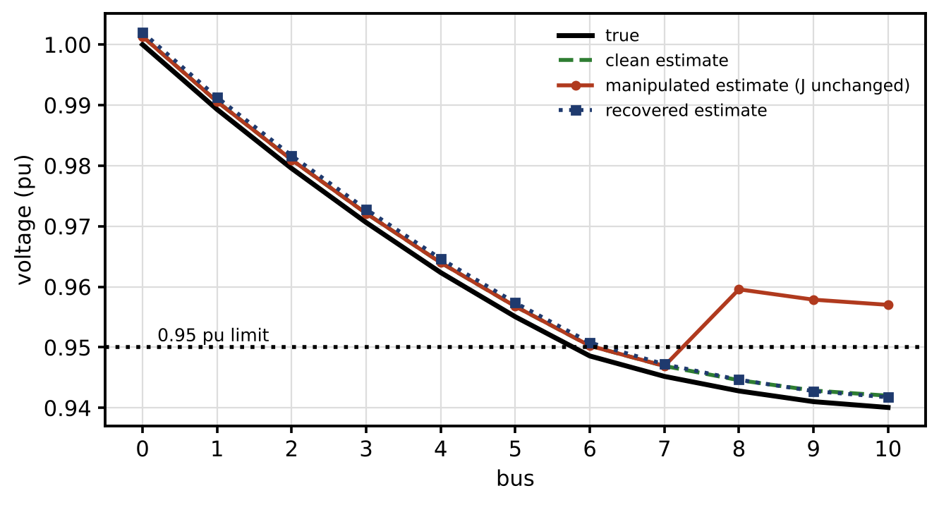
Figure 14.38. Feeder voltages under the manipulation: true profile, clean estimate, manipulated estimate hiding the under-voltage with $J$ unchanged, and recovered estimate using independent forecast-based pseudo-measurements, against the 0.95 pu limit.

14.24.2 Replay and watermarking on the buck converter
Example 14.4 quantified the watermark’s trade-off on the D-3 buck converter. Its operational lessons for a twin-controlled converter are three:
- Where the watermark belongs. Inside the device, where the converter’s own controller adds it and its own detector tests it at the full 100 kHz rate. Sending raw converter data to an external twin for replay detection would add latency far beyond the loop’s budget.
- What happens on detection. The converter moves to a safe mode that does not depend on the suspect measurements, for example reduced output with hardware current limiting, and reports the event to the site twin.
- Why the magnitude is tunable. Because the cost rises with the watermark’s variance by (14.45), the twin can raise it only when its risk assessment warrants, for example during a period of suspected compromise, a form of moving-target defence inside the loop.
Authenticated freshness on the set-point messages protects the digital path from the site controller to the converter; the watermark checks the physical consistency of the sensing path, including sensors that are authenticated but compromised.
Reproducibility. Example 14.4 lists the model, noise, weights, detector, seeds and number of runs; the watermark cost is checked against (14.45).

14.24.3 A load-altering attack on the EV charging hub
Chapter 10 identified set-point manipulation of many chargers as the most consequential threat of connected charging. Its physical effect follows from the frequency model of Chapter 11 (Section 11.10.5).
Example 14.7 A synchronized charging surge in the islanded P-1 microgrid
Given. The P-1 microgrid islanded and balanced, with the Chapter 11 frequency model: $H=1$ s on 2 MVA, load damping $D=1$, a grid-forming battery with 1 % droop, 50 ms response and a 0.5 MW limit, and no load shedding armed. Threat model: adversary A2 or A3 with control of the EV backend. Compromised commands raise the car park’s charging by 0.8 MW: (a) as a step; (b) with a backend rate limit of 0.1 MW/s enforced in the chargers; (c) with a local cap of 0.3 MW on total charging, enforced by the site controller independently of the backend. Initial battery output 0 MW, and also 0.2 MW.
Find. The frequency nadir and the time to reach 49 Hz; the dependence on the initial operating point. The initial rate of change of frequency follows from Chapter 11 (Equation (11.58)) with the attack as a deficit,
 | $${RoCoF}_{0}=−\frac{f_{0} ΔP_{att}}{2HS_{b}},$$ | (14.68)
where $ΔP_{att}$ is the added load in MW, $S_{b}$ the base power in MVA and $H$ the inertia constant on that base. For the 0.8 MW step it is $−10$ Hz/s, which also sets how fast any protective action must respond.
Solution. With the battery initially at 0 MW:
- (a) Step. The surge exceeds the battery’s 0.5 MW; frequency passes 49 Hz after 0.19 s and heads for the quasi-steady value $50−0.15×50/D=42.5$ Hz, below any trip setting.
- (b) Rate limit. The same end state, reached more slowly: 49 Hz after 6.4 s.
- (c) Local cap. The surge is limited to 0.3 MW, within the battery’s headroom; the nadir is 49.86 Hz and frequency settles at 49.93 Hz.
With the battery already supplying 0.2 MW, its headroom is only 0.3 MW. The step then reaches 49 Hz in 0.14 s and heads toward 37.5 Hz; the 0.3 MW cap still holds, with a nadir of 49.79 Hz; but a 0.35 MW cap no longer does (falling below 49 Hz to a quasi-steady 48.75 Hz). Because the model is linear and time-invariant apart from the battery limit, the attack’s timing matters only through the operating point at that moment.
Interpretation. Figure 14.39 shows the three responses. Rate limits buy time, 6 s here, for detection, operator action or load shedding, but do not prevent the outcome if the surge exceeds the available reserve. What prevents it is a physical limit enforced locally, below the level at which the backend can act, sized to the grid-forming headroom at the time, not to the battery’s rating. A fixed cap must therefore be set for the worst operating point, or made dynamic, computed locally from the battery’s actual output. This is consequence-driven defence: bound the physical effect of a compromise rather than rely only on preventing it.
Reproducibility. Swing equation (11.57) and battery model (11.59) of Chapter 11, explicit Euler with a 0.1 ms step, 20 s horizon, attack at 0.5 s, battery set-point $P_{0}$ with droop about it, saturation at ±0.5 MW. No random elements. Simulation only.
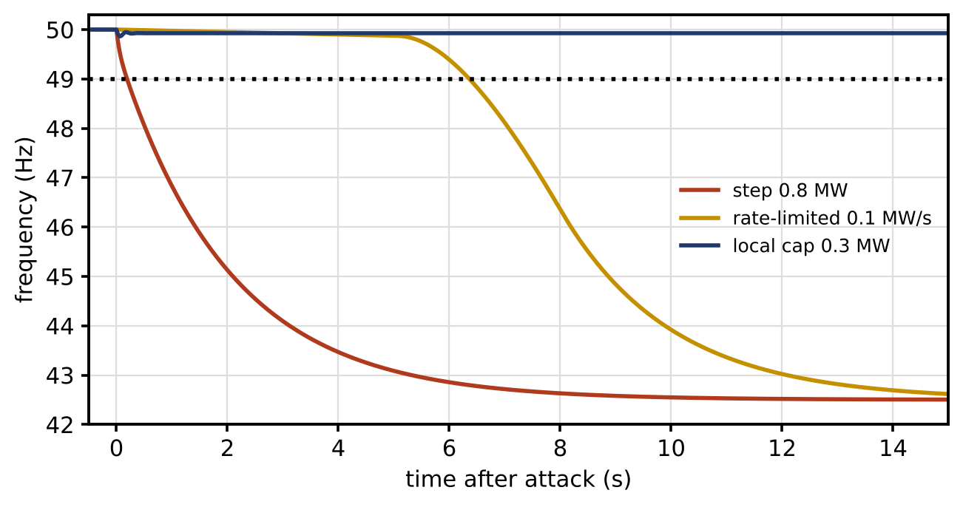
Figure 14.39. Frequency of the islanded P-1 microgrid after a 0.8 MW synchronized charging surge (battery initially at 0 MW): as a step, with a 0.1 MW/s rate limit, and with a local 0.3 MW cap enforced by the site controller.

14.25 Standards Map, Zero Trust and Supply-chain Governance

14.25.1 A dated map of standards and guidance
Table 14.16 organizes the standards and guidance relevant to a secure energy twin, checked in September 2026. It distinguishes formal standards from guidance and frameworks. Editions change, so a project must check the current edition of each document it relies on.
TABLE 14.16 Standards and guidance for secure digital twins in energy systems (status checked September 2026)
Area | Document | Type | Relevance to the twin
DT trust | NIST IR 8356, Security and trust considerations for digital twin technology (Feb. 2025) [5] | Guidance | Model integrity, data provenance, trust in outputs; anchor for twin-specific questions
Governance and risk | NIST Cybersecurity Framework 2.0 (Feb. 2024) [40] | Framework | Govern, Identify, Protect, Detect, Respond, Recover
Governance and risk | ISO/IEC 27001:2022 [41] | Standard (certifiable) | Organization-level information-security management system
IACS / OT | IEC 62443 series [6], including 62443-2-1:2024 [7], 62443-3-3, 62443-4-1, 62443-4-2 | Standards | Asset-owner programme, zones and conduits, security levels, secure development, component requirements
IACS / OT | NIST SP 800-82 Rev. 3 (2023) [42] | Guidance | OT security practice, legacy systems
Zero trust | NIST SP 800-207 (2020) [8] | Guidance | Principles and architectures
Power communication | IEC 62351 series [9] | Standards | TLS profiles, GOOSE/SV authentication, DNP3 and IEC 60870-5 security, key management, role-based access
Power communication | IEEE 1547.3-2023 | Guide | Cybersecurity of DER interconnection
EV and charging | ISO 15118-2 and -20; OCPP security profiles; ISO/SAE 21434:2021 and UN R155 | Standards and regulation | Vehicle and charger communication and engineering
Time | IEEE 1588-2019 [10]; IEEE C37.118.1 [15] | Standards | Authenticated PTP; synchrophasor accuracy
AI | NIST AI 100-2 E2025, adversarial machine-learning taxonomy [20] | Guidance | AI threat classes and mitigations
Supply chain | NTIA SBOM minimum elements (2021) [19] | Guidance | Inventory of software components
Cryptography | FIPS 203, 204 and 205 (Aug. 2024) [43], [44], [45]; NIST SP 800-38D, SP 800-57 | Standards and guidance | ML-KEM, ML-DSA, SLH-DSA; GCM; key management
Cryptography | NIST IR 8547 (initial public draft, Nov. 2024) [46] | Draft guidance | Transition timeline away from quantum-vulnerable algorithms
Privacy | Data-protection law of the jurisdiction (for example India’s Digital Personal Data Protection Act, 2023, or the EU GDPR); ISO/IEC 27701 | Law and standard | Lawful processing, minimization, rights of individuals
Mapping a twin’s controls to these documents organizes the work. It does not demonstrate compliance. Each standard has a scope, an edition, defined roles (asset owner, integrator, product supplier) and its own evidence requirements, and compliance or certification needs the full text, a scoped assessment by a qualified party and evidence for each requirement. A table in a book, including this one, can only orient the reader.

14.25.2 Zero trust and supply-chain governance in practice
The technical controls of Sections 14.3, 14.8 and 14.10 need governance to stay in place, a point that recent reviews of energy-system digitalization make for data and cybersecurity together [47]. For an OT twin the main elements are:
- Device and workload identity for every component, issued and revoked through a managed PKI, with local verification for functions that cannot wait for a server.
- Least privilege and segmentation reviewed whenever the twin gains a function or an interface.
- Continuous verification of identity, freshness and plausibility at every trust boundary.
- Vendor access that is brokered, time-limited, recorded and approved per session.
- Update provenance: only signed, staged artifacts with an SBOM reach production, through two-person approval.
- Third-party risk: suppliers’ security practices are assessed, contractual obligations for vulnerability disclosure and support periods are set, and long asset lives are matched by long support commitments, which is where IEC 62443-2-1:2024’s treatment of legacy systems applies directly.

14.25.3 Defence in depth and a defensive incident exercise
No single control suffices, so controls are layered (Figure 14.40): identity and access, segmentation, secure update and supply chain, monitoring and logging, physics-based detection, and consequence limits around plant safety. Each layer covers failures of the others, and the innermost, consequence limits, still works when every layer outside it has failed.
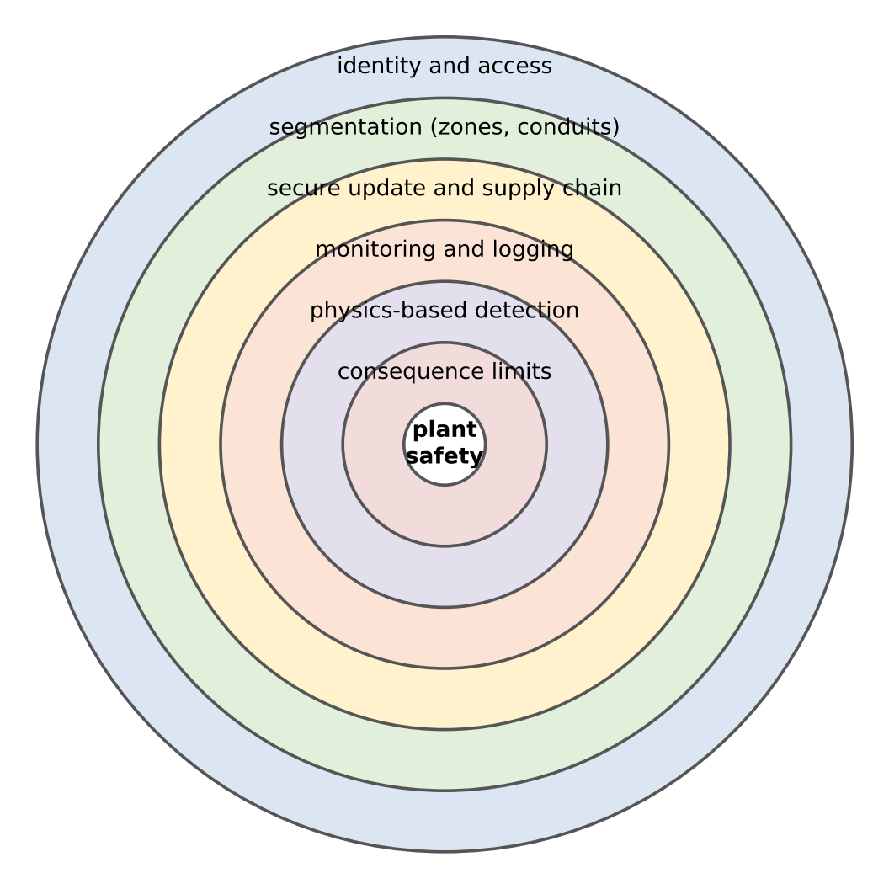
Figure 14.40. Defence in depth for the P-1 twin: identity and access, segmentation, secure update and supply chain, monitoring and logging, physics-based detection and consequence limits around plant safety.
Table 14.17 and Figure 14.41 walk through a defensive exercise for the manipulation of Example 14.6, in configuration (iii) with the authenticated PMU-class voltage. The exercise tests people and procedures as much as algorithms, and every step leaves evidence for the post-event review.
TABLE 14.17 Defensive incident exercise: manipulated feeder data at P-1 (times from the first alarm)
Time | Evidence | Threshold or check | Action | Approval
0 s | $J=100.5$; normalized residual 9.85 on the authenticated bus-10 voltage | $J>15.09$ (99 %) | Alarm; freeze automatic voltage-control changes; enter suspect mode | Automatic
30 s | Suspect channels all come through the metering head-end; authenticated sources agree with each other | Provenance check | Replace head-end data with independent forecast pseudo-measurements; degraded mode | Operator
2 min | Recovered estimate 0.942 pu, below the limit | Voltage limit 0.95 pu | Raise tap-changer set-point within the approved range | Operator
10 min | Head-end access log shows an unexpected session | Access policy | Isolate head-end; preserve evidence; security team engaged | Security lead
2 h | Head-end rebuilt from verified image; credentials rotated; data re-attested | Recovery steps 1 to 6 (Section 14.21) | Reconcile estimator; staged return to normal | Operations manager
1 week | Post-event review | Timeline, logs, decisions | Update thresholds, protected set, procedures and the assurance case | Management
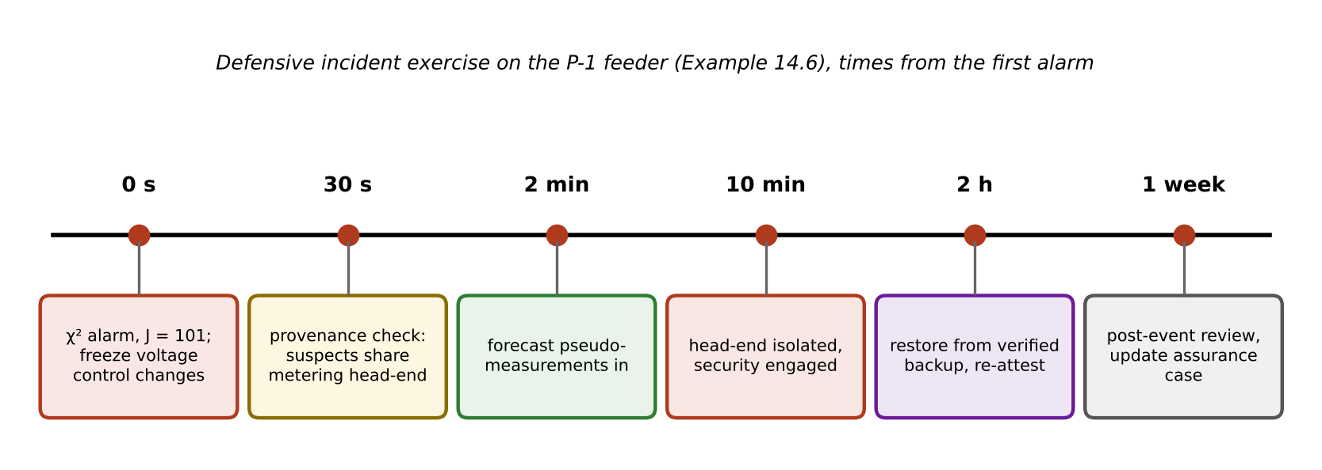
Figure 14.41. Timeline of the defensive incident exercise on the P-1 feeder, from the chi-square alarm to the post-event review.

14.26 Crypto Agility and Post-quantum Migration

14.26.1 Why long-lived assets must plan now
Public-key algorithms in use today (RSA, elliptic-curve Diffie–Hellman, ECDSA, Ed25519) would be broken by a sufficiently large quantum computer. When such a machine will exist is uncertain, and this book does not predict it. What matters for electrical infrastructure is that assets live for decades. Mosca’s inequality [48] states the planning condition: there is a problem if
 | $$x+y>z,$$ | (14.69)
where $x$ is how long the protected information or trust must remain secure (the shelf life: for a firmware-signing key, the remaining life of every device that trusts it), $y$ the time needed to migrate (inventory, standards, products, certification, deployment), and $z$ the time until a cryptographically relevant quantum computer exists. A relay installed today may stay in service for 25 years and trust its firmware-signing key for all of them; if migration of a large fleet takes 8 to 10 years, the inequality can hold for any $z$ under about 35 years, a horizon no one can rule out. Signatures that establish trust in firmware and certificates are the main concern for control systems; encrypted data with a long confidentiality life (market or personal data) face “harvest now, decrypt later” collection today.

14.26.2 The new standards, and what they cost in a field device
NIST finalized three post-quantum standards in August 2024: ML-KEM (FIPS 203) for key establishment, and ML-DSA (FIPS 204) and SLH-DSA (FIPS 205) for signatures [43], [44], [45]. Their engineering consequences are mainly size and time. Measured on the platform of Table 14.9, ML-DSA-44 produces 2420-byte signatures with 1312-byte public keys, against 64 and 32 bytes for Ed25519; ML-KEM-768 has a 1184-byte public key and a 1088-byte ciphertext. A GOOSE frame must fit in one Ethernet frame of about 1500 bytes, and a CAN FD frame carries 64 bytes of data, so post-quantum signatures cannot simply replace classical ones in every message. Per-message authentication in fast paths will continue to use symmetric MACs, whose security is far less affected; the public-key algorithms matter for key establishment, certificates and firmware signing, where size and time are less critical. NIST’s draft transition guidance (IR 8547) proposes deprecating today’s quantum-vulnerable algorithms after 2030 and disallowing them after 2035 [46]; its final form should be checked.

14.26.3 A migration path
Figure 14.42 shows the device’s cryptographic lifecycle (generate, enrol, operate, renew or revoke, decommission) and the migration path that crypto agility makes possible:
- Inventory. Where is which algorithm used, with which keys and certificates, by which devices, with what lifetime?
- Prioritize by shelf life and exposure, using (14.69) for each use.
- Hybrid deployment. Combine classical and post-quantum algorithms so that security holds if either one does, during the long period when both ecosystems coexist.
- Measure on the target. Time, memory, frame size and certificate-chain size on the actual device and network.
- Staged rollout, and retirement of legacy algorithms when the ecosystem (vendors, PKI, certification) is ready.
Blindly replacing every embedded scheme is neither possible nor necessary. Devices that cannot be updated are inventoried and protected by compensating controls until they are replaced, and new procurements require crypto agility and a stated post-quantum roadmap from the supplier.
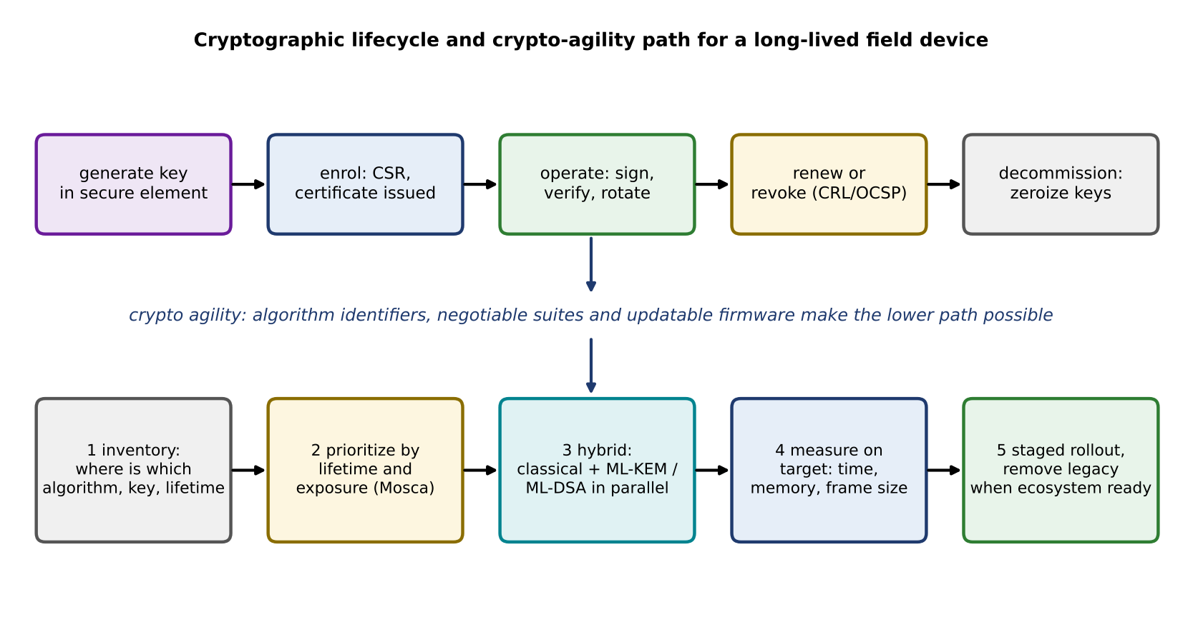
Figure 14.42. Cryptographic lifecycle of a long-lived field device (top) and the crypto-agility path to post-quantum algorithms: inventory, prioritization by Mosca’s inequality, hybrid deployment, measurement on the target, staged rollout (bottom).

14.27 Security Assurance Capstone: a Decision-capable PV–BESS–EV Twin

14.27.1 The system and three threats
The capstone combines the chapter’s threads on one system: the P-1 PV, battery and EV-hub microgrid with synchronized feeder, battery and EV-hub twins that support estimation and supervisory control (Chapters 11 to 13). The question it answers is whether the twin can remain safe when its data, a model update or a communication path becomes untrustworthy. Three threats from Table 14.4 are considered together:
- Threat 1, stealthy measurement manipulation (A3): metering-head-end data hide a feeder under-voltage (Example 14.6).
- Threat 2, compromised model update (A2 or A4): a battery-twin update slowly biases the reported state of health (Example 14.8 below).
- Threat 3, backend command manipulation (A2 or A3): a coordinated EV charging surge (Example 14.7).
The preventive controls are identity and least privilege, signed artifacts with the update gate, protected reference measurements, segmentation into the zones of Figure 14.5, and local caps. Detection combines residual and CUSUM tests, provenance checks, freshness, physics cross-checks and the model-update gate. Containment isolates the suspect source or model, revokes its authority and moves to degraded or autonomous mode. Resilience comes from the safety invariants (voltage, current, frequency and SOC limits) held locally while central optimization is unavailable. Recovery follows Section 14.21.

14.27.2 Threat 2 in detail: a slow bias on reported state of health
A slow manipulation is the hardest to catch. A ramp bias added to the state of health that the battery twin reports could come from a compromised estimator update or a manipulated current-sensor calibration. If SOH is overstated, the battery is dispatched harder than its true health allows, warranty claims are misjudged and end of life arrives as a surprise. Each daily increment is far below the estimate’s noise, so no single-day threshold fires.
The defence combines an independent physical estimate with a change detector. The twin has two paths to capacity: the reported, estimator-based SOH, and an independent one from charge counted between two rest-voltage (OCV) anchor points (Chapter 9), whose uncertainty is about 0.4 points and whose inputs do not pass through the suspect component. Their standardized difference
 | $$r_{d}=\frac{{SOH}_{rep,d}−{SOH}_{phys,d}}{σ_{d}}$$ | (14.70)
is zero-mean for a healthy system, where ${SOH}_{rep,d}$ and ${SOH}_{phys,d}$ are the reported and physics-based values on day $d$ and $σ_{d}$ the standard deviation of their difference. A one-sided CUSUM (14.41) with $κ=0.25$ and $h=10$ accumulates its persistent positive drift. By (14.42) with $δ=0$, the in-control average run length is
 | $${ARL}_{0}≈\frac{e^{2κb}−2κb−1}{2κ^{2}}=2074 \text{days}, b=h+1.166=11.17,$$ | (14.71)
for Gaussian residuals. Run lengths are roughly exponential, so the probability of a false alarm within 100 days is about $1−e^{−100/2074}=4.7$ %.
Example 14.8 Detecting a ramp bias in reported SOH
Given. A battery whose true SOH falls by 0.012 points per day. From day 100, a ramp bias of 0.005, 0.01, 0.02 or 0.05 points per day is added to the reported SOH. The physics cross-check has 0.4 points of noise per day. CUSUM with $κ=0.25$ and $h=10$; for comparison a one-sided 3σ single-day rule. 300 Monte Carlo runs per slope, seed 2026; 20 000 attack-free runs for the false-alarm probability.
Find. The median and 5 to 95 % range of the detection delay, the bias at detection, and the probability of a false alarm in the 100 days before the attack, for both detectors.
Solution. CUSUM: median delays of 51, 34, 22 and 14 days for the four slopes (5 to 95 % ranges 26 to 70, 20 to 46, 14 to 29 and 9 to 17 days). The bias at the median detection is 0.26, 0.34, 0.44 and 0.70 points. In 20 000 attack-free runs the CUSUM raised a false alarm within 100 days in 3.7 % of cases, against 4.7 % from (14.71). The 3σ rule: median delays of 78, 52, 31 and 16 days, with a false-alarm probability of $1−{\left(1−0.00135\right)}^{100}=12.6$ % in 100 days.
Interpretation. Figure 14.43 shows one run with a 0.02 point/day bias (alarm on day 115), and Figure 14.44 summarizes the delays. The CUSUM finds slow manipulations faster and with about a third of the false alarms, because it accumulates evidence. It works only because the cross-check’s inputs are independent of the manipulated path; a detector that compared the estimate with itself would see nothing. Independence of evidence, more than sophistication of the detector, is what makes the defence work. The residual risk is a bias slower than the CUSUM can see within the battery’s warranty horizon, which is bounded by how often OCV anchors occur.
Reproducibility. Daily residual model of (14.70) with Gaussian noise, true SOH and bias as given, CUSUM reset only at day 0, delay counted from day 100 for runs without a pre-attack alarm, seed 2026 (NumPy default generator). Simulation only.
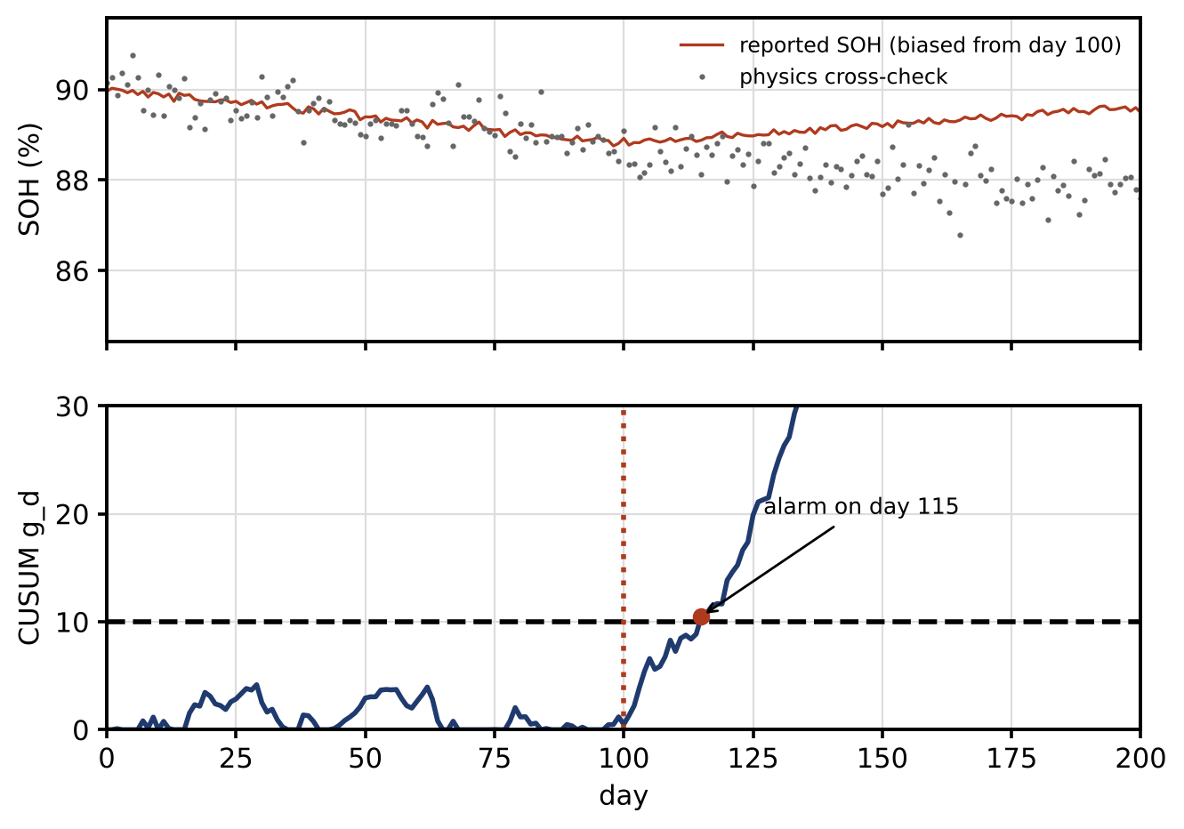
Figure 14.43. Ramp-bias capstone: reported and physics-based SOH with a 0.02 point/day bias from day 100 (top), and the CUSUM statistic crossing its threshold on day 115 (bottom).
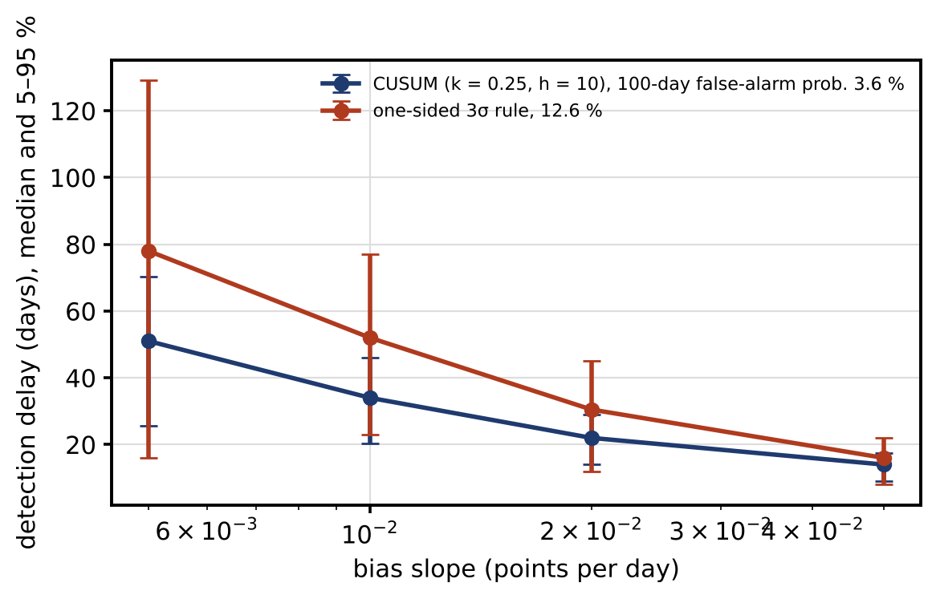
Figure 14.44. Detection delay of a ramp bias in reported SOH against its slope, median and 5 to 95 % range over 300 runs, for the CUSUM on the physics cross-check and a one-sided 3σ single-day rule, with their probabilities of a false alarm in 100 days.

14.27.3 The security assurance case
As in Chapters 10 to 13, a twin is not declared secure by a single score. The chapter ends with an assurance case: a structured argument that a top claim holds, built from sub-claims, each supported by evidence, with the residual risk and the conditions under which the argument must be revisited (Figure 14.45). The top claim for P-1 is that the twin may influence the plant within its stated authority, with an acceptable residual risk. Table 14.18 gives the evidence table, with each row numbered under the sub-claim of Figure 14.45 that it supports and a separate privacy claim alongside. Versions, dates and owners are illustrative; in a real project they are the identifiers of the tested releases and the named roles that signed them.
TABLE 14.18 Security assurance evidence for the P-1 digital twin (synthetic evidence from this chapter; versions and dates illustrative)
Claim | Test or evidence | Version and date | Owner | Residual risk | Revalidation trigger
C1.1 Feeder estimates cannot be shifted undetectably by head-end data | Protected PMU-class set (rank test (14.10)); Example 14.6, $P_{D}≈1$ | SE model v3.2, Sept. 2026 | Grid operations | Topology or parameter error; compromise of the PMU itself | New meter, topology change, PMU firmware update
C1.2 Time-dependent data are flagged on time-source failure | Two-source comparison, holdover test (Section 14.6.3) | Timing config T1, Sept. 2026 | Protection and control | Holdover shorter than assumed | Oscillator replacement; GNSS antenna change
C2.1 Only approved software and models run | Signatures, SBOM, update-gate log, rollback test (Section 14.8) | Release R14.2, Sept. 2026 | Release authority | Third-party model provenance partial | Any model, library or container change
C3.1 Replays on the converter are detected within 1 ms | Watermark and detector, 300 runs; Example 14.4 | Converter FW 2.4, Aug. 2026 | Power electronics team | Adaptive attacker estimating the watermark; HIL timing not yet measured | Firmware change; new noise characterization
C3.2 Slow SOH manipulation is detected within weeks | CUSUM on OCV cross-check; Example 14.8 | Battery twin v5.1, Sept. 2026 | Asset management | Bias slower than 0.005 point/day; few OCV anchors | Change in anchor frequency or estimator
C4.1 A compromised EV backend cannot collapse island frequency | Local cap below headroom; Example 14.7 | Site controller v7.0, Sept. 2026 | Site operations | Cap sized for one operating point | Battery replacement; new loads; change of dispatch policy
C4.2 Distributed set-points resist one compromised site | W-MSR with robustness check; Example 14.5 | Coordination v1.3, July 2026 | Fleet control | More than $F$ compromised sites | Graph change; new sites
P1 (separate privacy claim) Published fleet statistics meet the privacy budget | Accountant records; Example 14.3 | Analytics v2.0, Sept. 2026 | Data protection officer | Linkage with external data | New release type or frequency
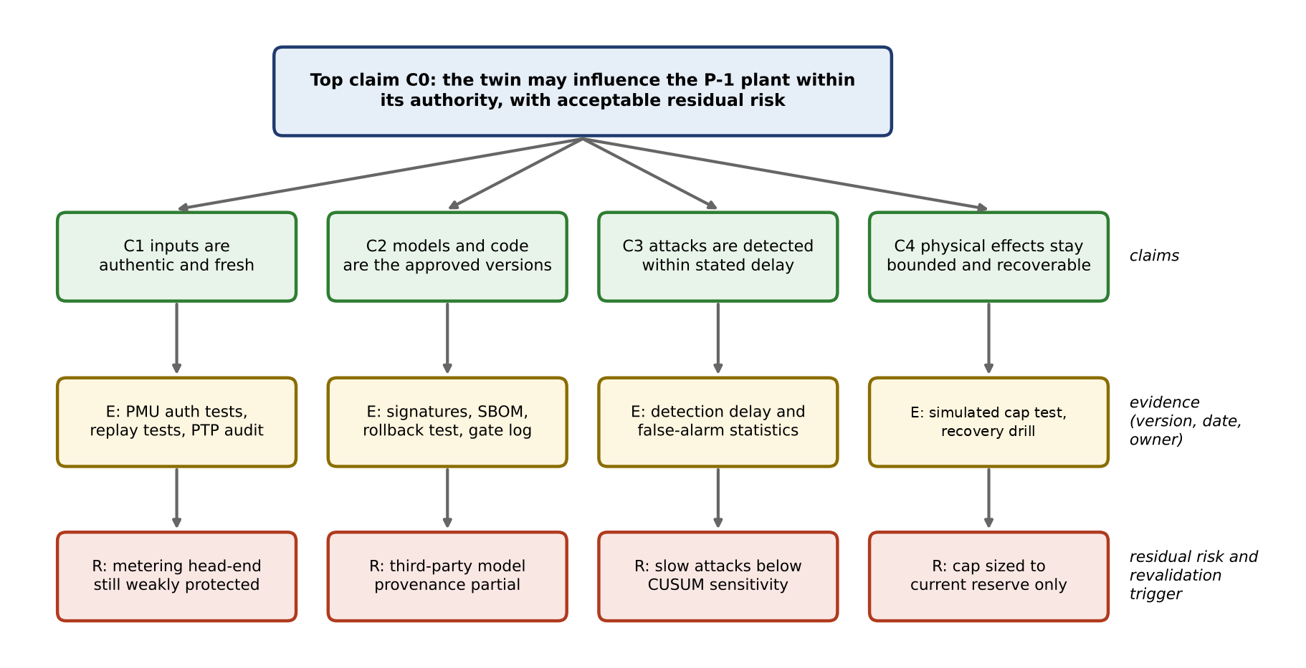
Figure 14.45. Security assurance case for the P-1 twin: a top claim supported by four sub-claims, each with its evidence (with version, date and owner) and its residual risk and revalidation trigger.
Deployment is approved jointly by engineering, operations and security roles, who accept the residual risks in writing. Any revalidation trigger, a failed test, or an incident reopens the relevant claim; if a claim cannot be restored, the twin’s authority is reduced to what the remaining claims support. That is the final use of the assurance case: it decides, on evidence, how much a twin is allowed to do.

14.28 Closing the Book: Trustworthy Digital Twins as an Engineering Discipline
Fourteen chapters ago, a digital twin was introduced as a model synchronized with a physical asset through data and used to make decisions. Everything since has filled in what that sentence demands. Chapters 1 to 6 built the foundations: architectures, data and communication, modelling and validation, estimation and learning. Chapters 7 to 11 applied them to the assets of electrical energy systems, from converters and machines through PV, wind, batteries, vehicles and chargers to microgrids and grids. Chapters 12 to 14 used the resulting twins to watch over their assets, to run them, and to protect them. The running example, Plant P-1, gained a twin for every one of its assets, and each chapter’s numbers were reproducible from stated assumptions.
Read together, the chapters say what makes a twin useful enough to influence a real electrical asset. It must be accurate, validated against data it was not fitted to. It must be synchronized: an estimator and its residuals, not a simulation running beside the plant. It must be uncertainty-aware, carrying calibrated intervals into every decision. It must be secure in its data, models, software and commands, and privacy-aware in what it collects and releases. It must be resilient, degrading gracefully and recovering on evidence. It must be explainable where people must act on it, and verifiable through tests whose rung on the validation ladder is stated. And it must be governed through its whole lifecycle, with owners, versions, approvals and revalidation triggers. None of these properties is a refinement to add at the end; each is what separates a twin that can be trusted with authority from one that cannot.
The open problems listed at the end of each chapter share a thread: twins that stay valid, calibrated and trustworthy as the systems they represent age, change and come under attack. Table 14.19 sets out the directions for secure and trustworthy twins over the next decade and the evidence the field should demand. That is the research and engineering agenda this book hands to its readers.
TABLE 14.19 Roadmap for secure and trustworthy digital twins in energy systems
Horizon | High-value directions | Evidence the field should demand
2 to 5 years | Twin-specific security assurance; cyber-range and HIL validation; zero-trust OT integration; protected AI and model pipelines; SBOM and model provenance; physics-informed anomaly detection; safe local autonomy; crypto agility and early post-quantum migration | Target-hardware timing; realistic threat models; distributions of false alarms and detection delay; HIL and PHIL evidence; provenance and rollback tests; red-team and tabletop exercises; traceability to standards
5 to 10 years | Federated and composed twin trust across operators; privacy-preserving cross-operator analytics; certified learning components; bounded autonomous cyber recovery; post-quantum field deployments; machine-verifiable assurance evidence; resilience to compound cyber, physical and climate events [49] | Formal and runtime assurance; interoperable trust evidence; long-duration field trials; adversarial validation; certification pathways; lifecycle key and model governance; explicit human authority

Chapter Summary
A digital twin that estimates, predicts and controls is also an attack surface, and its security has to be engineered with the same care as its models. The chapter began with the vocabulary an electrical engineer needs and with the point that OT priorities depend on the mission and hazard of each data flow, with safety as a physical objective that security serves. It placed the twin in a reference architecture with identity, management and safety planes, divided the P-1 microgrid into zones and conduits, and stated threat models in terms of access, knowledge, capability, persistence and physical objective.
The analytical core showed exactly what the bad-data test can and cannot see. The residual depends only on noise; its energy is chi-square with $m−n$ degrees of freedom; an injection in the column space of $H$ leaves it unchanged; the security index measures how many meters such an injection needs; and an observable protected set removes the possibility under stated model assumptions. On the four-bus network a 5σ single-meter error was detected with probability 0.65 only, and the cheapest consistent attack was not the obvious one. Timing analysis separated the 31.8 µs pure-phase equivalent of 1 % TVE from a real clock budget, and holdover and delay asymmetry showed how time can be attacked without touching a packet. Packet-loss analysis showed that burst structure, not average availability, decides whether an estimator survives.
The defences were quantified in the same way:
- Supply chain and AI. Signed, provenance-tracked artifacts, measured boot and anti-rollback protect the twin’s software and models. Against label poisoning Huber regression held the error to a few per cent, but 20 leverage records broke it, while Theil–Sen held.
- Cryptography. A MAC costs microseconds; tails, nonces, keys, revocation and agility decide whether it is secure and fits the deadline.
- Privacy. A fleet average was released with 0.28 points of noise at $ε=1$, and composition rules were compared for monthly and daily releases.
- Detection. Thresholds came from yearly budgets with correlation taken into account, and precision, not accuracy, measured usefulness at realistic prevalence.
- Watermarking. A replay invisible without a watermark was detected in under 1 ms with one, at a cost predicted exactly by the LQG formula.
- Resilient estimation and consensus. Sparse observability, $ℓ_{1}$ recovery and W-MSR were given with their exact assumptions and checked on the examples.
- Redundancy, trust and risk. Diversity, not duplication, defends against an adversary; trust scores were treated as evidence, never as identity; risk was carried as ranges.
The case studies and the capstone drew the threads together: a precise authenticated measurement and provenance-aware recovery on the feeder, a locally enforced cap sized to headroom on the EV hub, a CUSUM on an independent physics cross-check for a slow SOH manipulation, a worst-case timing budget, a validation ladder and an assurance case that decides, on evidence, how much authority a twin may have.
Table 14.20 collects the key equations of the chapter.
TABLE 14.20 Key equations of Chapter 14
Relationship | Expression | Eq.
WLS residual | $r=\left(I−K\right)z=\left(I−K\right)e$ | (14.3), (14.4)
Bad-data test | $J=r^{T}Wr∼χ_{m−n}^{2}$ | (14.5)
Noncentrality | $λ=a^{T}W\left(I−K\right)a$ | (14.6)
Undetectable injection | $a=Hc⇒r_{a}=r$ | (14.8)
Protected observable set | $rank\left(H_{P}\right)=n$ | (14.10)
Total vector error | $\left|\left(1+ϵ\right)e^{jφ}−1\right|$ | (14.14)
Time-transfer bias | $\hat{θ}=θ+\left(d_{sc}−d_{cs}\right)/2$ | (14.15)
Critical arrival rate, burst condition | $γ_{c}=1−1/a^{2}$; $q_{bb}a^{2}<1$ | (14.18), (14.19)
Average age of information | $d+\frac{T}{2}\frac{1+ε}{1−ε}$ | (14.21)
Influence of one record | ${\left(A^{T}A\right)}^{−1}a_{0}r_{0}/\left(1+h_{0}\right)$ | (14.25)
Forgery and nonce collision | $Q2^{−t}$; $q^{2}/2^{97}$ | (14.29), (14.30)
Laplace mechanism | $b=Δq/ε$ | (14.33)
Privacy composition | advanced; zCDP | (14.36), (14.37)
Windowed chi-square, CUSUM | $g_{k}∼χ_{pL}^{2}$; $g_{k}=max\left(0,g_{k−1}+z_{k}−κ\right)$ | (14.39), (14.41)
Precision | $TPR π/\left(TPR π+FPR\left(1−π\right)\right)$ | (14.43)
Watermark cost | $tr\left(\left(B^{T}P_{c}B+R_{c}\right)Σ_{w}\right)$ | (14.45)
Sparse observability | $rank\left(C_{\overline{Γ}}\right)=n$, $\left|Γ\right|≤2s$ | (14.48)
W-MSR | trimmed local average | (14.52)
2oo3 and beta factor | $3p^{2}−2p^{3}$; $+βp$ | (14.53), (14.55)
Expected annual loss | i​piCi | (14.60)
Degraded-mode duration | $d_{max}=\left(R_{avail}^{2}/z^{2}−P_{k}\right)/q$ | (14.63)
Worst-case budget | i​tiwc≤tdeadline | (14.67)
Mosca’s inequality | $x+y>z$ | (14.69)

Exercises
The fifteen exercises are grouped by theme and are all defensive. Most combine a numerical part, a derivation and a judgment question, so that each can be set as one assignment; the last four are open research projects graded on reproducibility. Complete solutions to all fifteen are given in the Answer Key.

Group A: estimation, detection and active defence
14.1 False-data injection and protected measurements. (a) Derive (14.8) from (14.3) using the identity $KH=H$. (b) Show that the residual energy $J$ is chi-square with $m−n$ degrees of freedom, (14.5), using the trace of the whitened projection. (c) A detector has 4 degrees of freedom and a 99 % threshold; an attack has noncentrality 20. Find the threshold and the detection probability by (14.6). (d) Using Example 14.1, explain why protecting only the injection measurements at buses 2 and 3 does not prevent consistent injections, and give a direction that remains invisible.
14.2 Sparse attacks and authenticated data. (a) How many corrupted sensors can be tolerated with guaranteed recovery for a scalar state measured by seven sensors, and for the seven-sensor cosine array of Section 14.15.1? Use (14.48). (b) After a suspected manipulation, the largest normalized residual points at an authenticated PMU. What should be done, and why?
14.3 Detector design and evaluation. (a) A detector has $TPR=0.95$ and $FPR=0.001$ per window, and one window in a thousand contains an attack. What fraction of its alarms are real, by (14.43)? (b) A vendor offers 'AI intrusion detection with 99 % accuracy' for the P-1 twin. Which questions would you ask before deploying it?
14.4 Dynamic watermarking. (a) A watermark with $σ_{w}=0.002$ raises the LQG cost of Example 14.4 by $3.18×{10}^{−4}$ per step. What is the increase at $σ_{w}=0.004$, and how does the replay term of (14.44) change? (b) Derive the watermark cost (14.45) from the LQG cost with extra process noise. (c) Why can a watermark expose a replay that a passive residual test cannot see?

Group B: time, communication and freshness
14.5 Time synchronization. (a) What clock error produces a 1° phase error at 50 Hz, by (14.13)? (b) A GNSS-disciplined clock enters holdover with $y_{0}={10}^{−9}$ and negligible drift. How long until it accumulates 1 µs of error, by (14.16)? (c) Derive the offset bias of (14.15) caused by delay asymmetry, and explain why it cannot be detected from the timestamps alone.
14.6 Packet loss and age of information. (a) For a scalar unstable plant with $a=1.5$ measured directly, what packet-arrival probability keeps the expected Kalman variance bounded, by (14.18)? (b) Derive (14.18) from the gap argument of Section 14.7.1, and the burst condition (14.19). (c) Updates are generated every 100 ms, delayed by 50 ms and lost independently with probability 0.2. Find the average and average peak age of information by (14.21). (d) Derive (14.21) for periodic updates with independent losses.

Group C: cryptography, privacy and supply chain
14.7 Cryptographic engineering. (a) A MAC is truncated to 64 bits and an adversary can submit ${10}^{6}$ forgery attempts per second for a year. Bound the probability of a successful forgery by (14.29), and say how to make it negligible. (b) $2^{30}$ messages are sent under one AES-GCM key with random 96-bit nonces. Estimate the probability of a nonce collision by (14.30). (c) A firmware-signing key must stay trustworthy for 20 years and migrating the fleet will take 8 years. For which times $z$ to a cryptographically relevant quantum computer does (14.69) signal a problem?
14.8 Differential privacy and data influence. (a) A query has sensitivity 0.1 and is released with $ε=0.5$. Find the Laplace scale, the noise standard deviation and the 95 % error bound by (14.33) and (14.34). (b) Four quarterly releases of a statistic share an annual budget $ε=1$ under sequential composition. What does each release get, and how does its noise compare with a single annual release? (c) Show that the Laplace mechanism (14.33) satisfies (14.31) with $δ=0$. (d) Derive the influence of one added record, (14.25), from the Sherman-Morrison formula, and explain what it implies for poisoning.
14.9 Supply chain, governance and a failed twin. (a) An attack path needs phishing (0.1) and lateral movement (0.3); an alternative is a supply-chain compromise (0.01). Find the annual probability of success with independent steps and the expected loss for a 500 000 $ consequence. (b) A fleet operator's twin reported steadily good battery health for a year, and several packs then failed early; an estimator update, installed without passing the update gate, had introduced a slowly growing bias. List the controls from this chapter that would have prevented or detected it. (c) A project manager states that the twin 'is IEC 62443 compliant' because each control has been mapped to a clause of the standard. How do you respond?

Group D: resilience, degradation and recovery
14.10 Redundancy, diversity and trust. (a) Sensors fail with probability 0.02. Find the 2oo3 failure probability with independent failures and with a beta factor of 0.05, by (14.53) and (14.55). (b) Derive (14.53) and (14.55). (c) A source has 40 confirmed and 2 contradicted reports. Find its trust score by (14.57) without forgetting. (d) An engineer proposes to accept set-points from a vendor gateway without checking its certificate because its trust score has been above 0.99 for a year. Assess the proposal.
14.11 Degraded operation and recovery. (a) In Section 14.20.2, the operator accepts 95 % coverage ($z=1.645$) but only 200 kW of headroom is available. Find the maximum degraded-mode duration by (14.63). (b) An estimator has $a=0.9$ and gain $K=0.5$ after reconnection. How many steps reduce the error to 1 %, by (14.64)? (c) In Example 14.7 with the battery initially at 0 MW, which local caps keep frequency above 49.5 Hz? Why must the cap be smaller if the battery is already supplying 0.2 MW?

Group E: research and reproducibility
14.12 Research project: secure estimation. (a) Find the minimum protected measurement set for the P-1 feeder estimator, verify it with consistent injections built from the nonlinear model, and report the security index of each state. (b) Implement W-MSR for distributed estimation among ten battery sites with two compromised agents, verify the required robustness of your graph, and test bounded delays and packet loss.
14.13 Research project: active detection and privacy. (a) Design a watermark for the battery inverter's current loop, quantify its detection-cost trade-off over at least 300 runs per level, and plan its HIL validation. (b) Build a privacy accountant for monthly fleet SOH statistics with an annual budget, compare sequential, advanced and zCDP accounting, and quantify utility for fleet planning.
14.14 Research project: a cyber-range exercise. Design and run a cyber-range exercise for a compromised OCPP backend at the P-1 car park, with threat model, evidence, thresholds, approvals, recovery and an updated assurance case.
14.15 Research project: post-quantum migration. Prepare a post-quantum migration plan for the P-1 twin: inventory every cryptographic use, rank them by Mosca's inequality, and measure ML-DSA and ML-KEM costs on a representative embedded controller.

Answer Key
14.1 (a) $\left(I−K\right)H=H−HG^{−1}G=0$, so $\left(I−K\right)\left(z+Hc\right)=\left(I−K\right)z$: the residual is unchanged, and the estimate (14.2), linear in $z$, shifts by $G^{−1}H^{T}WHc=c$.
(b) $W^{1/2}r=Pu$ with $P$ symmetric and idempotent; its eigenvalues are 0 or 1, and the number equal to 1 is $tr\left(P\right)=m−tr\left(G^{−1}G\right)=m−n$. Rotating to the eigenbasis, $J$ is a sum of $m−n$ squared independent standard normals.
(c) $τ=χ_{4,0.99}^{2}=13.28$; $P_{D}=1−F_{χ_{4}^{2}\left(20\right)}\left(13.28\right)=0.89$.
(d) Their rows give rank 2, less than the 3 states, so a non-zero $c$ with $H_{P}c=0$ exists; $c∝\left(0.317,0.493,0.810\right)$ leaves both protected injections unchanged and is therefore invisible.
14.2 (a) Scalar state: every sensor observes the state, so recovery needs $s<7/2$: up to 3. Cosine array: every pair of rows has rank 2 (the seven directions are distinct modulo $π$), but single rows do not, so $7−2s≥2$ is needed and sufficient: up to 2.
(b) Do not remove it. An authenticated, precise measurement that disagrees with many unauthenticated ones indicates manipulation of the others. Check provenance, replace the suspect sources with independent data, and keep the network observable (Example 14.6).
14.3 (a) $0.95×{10}^{−3}/\left(0.95×{10}^{−3}+0.001×0.999\right)=0.49$: about half.
(b) Accuracy on which data, at what prevalence, with what precision and false alarms per day; against which attack classes, including consistent injections and replays; with what detection delay; how it was validated; how it explains alarms; how it fails safe; how its own model and updates are secured; and what it costs in the timing budget.
14.4 (a) The cost is linear in $σ_{w}^{2}$: $4×3.18×{10}^{−4}=1.27×{10}^{−3}$ per step. The replay term of (14.44) is also linear in $Σ_{w}$ and quadruples, so detection improves as the cost grows.
(b) The watermark is known to the estimator, so it leaves the estimation error unchanged and acts as process noise $BΔu$ of covariance $BΣ_{w}B^{T}$, which adds $tr\left(P_{c}BΣ_{w}B^{T}\right)$ to the average cost; the applied input adds $E\left[Δu^{T}R_{c}Δu\right]=tr\left(R_{c}Σ_{w}\right)$; cross terms vanish because $Δu_{k}$ is independent of the state.
(c) A replay reproduces measurements that were consistent with the model, so a passive residual stays normal; the recorded data do not contain the fresh, secret watermark, so the correlation between the injected signal and the measured response disappears.
14.5 (a) $Δt=1/\left(360×50\right)=55.6$ µs.
(b) $t={10}^{−6}/{10}^{−9}=1000$ s, about 17 min.
(c) $t_{2}−t_{1}=d_{cs}−θ$ and $t_{4}−t_{3}=d_{sc}+θ$; subtracting and halving gives $\hat{θ}=θ+\left(d_{sc}−d_{cs}\right)/2$. The four timestamps determine only the sum of the two delays, not their difference, so an asymmetry, natural or introduced by an attacker, is indistinguishable from a clock offset unless an independent time reference is available.
14.6 (a) $γ>1−1/{1.5}^{2}=0.556$.
(b) After an arrival $P≤a^{2}r+q$; a gap of $ℓ$ losses multiplies it by about $a^{2ℓ}$; with $Pr\left(ℓ\right)=γ{\left(1−γ\right)}^{ℓ}$ the expectation $∑γ{\left(1−γ\right)}^{ℓ}a^{2ℓ}$ converges if and only if $\left(1−γ\right)a^{2}<1$. With bursts, the gap length is geometric with continuation probability $q_{bb}$, giving $q_{bb}a^{2}<1$.
(c) Average $50+50×1.2/0.8=125$ ms; average peak $50+100/0.8=175$ ms.
(d) Between successful updates the age rises linearly from $d$; the time average over a renewal cycle of length $Y$ is $d+E\left[Y^{2}\right]/\left(2E\left[Y\right]\right)$; with $Y=NT$ and $N$ geometric, $E\left[Y\right]=T/\left(1−ε\right)$ and $E\left[Y^{2}\right]=T^{2}\left(1+ε\right)/{\left(1−ε\right)}^{2}$, which give (14.21).
14.7 (a) $Q={10}^{6}×3.15×{10}^{7}=3.15×{10}^{13}$; $P_{forge}≤3.15×{10}^{13}/2^{64}=1.7×{10}^{−6}$. Counting failed verifications and blocking the source after a few makes it negligible.
(b) $P≈2^{60}/2^{97}=2^{−37}=7.3×{10}^{−12}$.
(c) A problem exists if $z<x+y=28$ years.
14.8 (a) $b=0.1/0.5=0.2$; standard deviation $0.2\sqrt{2}=0.28$; 95 % bound $0.2ln20=0.60$.
(b) $ε=0.25$ each, so each release's Laplace scale and standard deviation are four times those of a single release at $ε=1$.
(c) The density ratio $exp\left(−\left|y−q\left(D\right)\right|/b\right)/exp\left(−\left|y−q\left(D′\right)\right|/b\right)≤exp\left(\left|q\left(D\right)−q\left(D′\right)\right|/b\right)≤e^{ε}$ by the triangle inequality; integrating over any set $S$ gives (14.31) with $δ=0$.
(d) ${\left(M+a_{0}a_{0}^{T}\right)}^{−1}=M^{−1}−M^{−1}a_{0}a_{0}^{T}M^{−1}/\left(1+h_{0}\right)$ with $M=A^{T}A$; multiplying by $A^{T}y+a_{0}y_{0}$ and simplifying gives (14.25). A single record with high leverage $h_{0}$ and a large residual moves the fit far, which is why poisoning targets leverage points and why leverage should be monitored.
14.9 (a) $1−\left(1−0.03\right)\left(1−0.01\right)=0.0397$; expected loss $0.0397×500 000=19 850$ $ per year.
(b) Signed updates through the update gate with protected held-out validation; SBOM and provenance of the estimator; version reporting and audit; a physics cross-check with CUSUM (Example 14.8); and an assurance claim with a revalidation trigger on any estimator change.
(c) Mapping organizes the work but is not compliance. Ask for the scope and edition of the standard, the roles it applies to, the target security levels of each zone, the evidence for each requirement, and an assessment by a qualified party.
14.10 (a) Independent: $3{\left(0.02\right)}^{2}−2{\left(0.02\right)}^{3}=1.18×{10}^{−3}$. With $β=0.05$: $q=0.019$ and $3q^{2}−2q^{3}+0.001=2.07×{10}^{−3}$, almost twice as large.
(b) Two or three of three fail: $3p^{2}\left(1−p\right)+p^{3}=3p^{2}−2p^{3}$. With common cause, the independent part of each channel fails with probability $\left(1−β\right)p$, giving the same expression in $\left(1−β\right)p$, plus the common event with probability $βp$ (the small overlap is neglected).
(c) $T=41/44=0.93$.
(d) Reject it. A reputation score is evidence about past consistency, not identity or authorization; a patient adversary can build a high score. Certificate verification, least-privilege authorization and the command governor must apply regardless of the score.
14.11 (a) $d_{max}=\left({200}^{2}/{1.645}^{2}−{40}^{2}\right)/{15}^{2}=58.6$, so 58 steps, or 4.8 h.
(b) $a\left(1−K\right)=0.45$; $⌈ln0.01/ln0.45⌉=⌈5.77⌉=6$ steps.
(c) With the battery at 0 MW its headroom is 0.5 MW, and caps from 0.2 to 0.5 MW give nadirs from 49.91 to 49.66 Hz, so any cap up to 0.5 MW keeps frequency above 49.5 Hz. At 0.2 MW output the headroom is 0.3 MW: a 0.3 MW cap gives 49.79 Hz, but a 0.35 MW cap exceeds the headroom and frequency falls below 49 Hz. The cap must follow the headroom.
14.12 Open. Graded on stated threat models and assumptions, verification against the nonlinear model, and reproducibility from published parameters and seeds.
14.13 Open. Graded on the number of runs, uncertainty in the trade-off curves, a correct privacy accounting and a stated utility measure.
14.14 Open. Graded on a defensive threat model, evidence and thresholds fixed in advance, approvals, a tested recovery and an updated assurance case.
14.15 Open. Graded on a complete inventory, a justified ranking and costs measured on stated hardware.

Conceptual and Review Questions
- Why is “availability first” not a universal rule for OT, and where can confidentiality dominate?
- Why can a consistent data injection not be detected by residual tests alone, and under which assumptions does protecting a measurement set remove it?
- Why can a 5σ error on one meter go undetected, and what does leverage have to do with it?
- Why is 31.8 µs not an allowable clock-error budget for a PMU?
- Why can two channels with the same average packet delivery give bounded and unbounded estimation error?
- Why does Huber regression fail against leverage-point poisoning?
- Why is nonce reuse in AES-GCM a break rather than a weakening?
- Why can a per-test false-alarm probability not simply be multiplied by the number of windowed tests?
- Why does a watermark detect a replay that authenticated freshness cannot, and why are the two complements?
- Why does a reliability beta factor not describe a supply-chain implant?
- Why must a trust score never override cryptographic identity or a safety limit?
- Why must a degraded mode have a maximum duration, and how is it computed?
- Why does mapping controls to a standard not demonstrate compliance with it?
- Why do long-lived grid assets need post-quantum planning now, even though the arrival date of a large quantum computer is unknown?

References
[1] “Cyber-physical security for microgrids through digital twin technologies: A review and research outlook,” Energy Convers. Manage.: X, art. 101406, 2025.
[2] A. R. Qureshi, A. Asensio Garcia, M. Imran, J. García Almiñana, and X. Masip Bruin, “A survey on security enhancing digital twins: Models, applications and tools,” Comput. Commun., art. 108158, 2025.
[3] K. E. Kampourakis, V. Gkioulos, G. Kavallieratos, J.-C. Lin et al., “Digital twin-enabled incident detection and response: A systematic review of critical infrastructures applications,” Int. J. Inf. Secur., vol. 24, art. 194, 2025.
[4] K. E. Kampourakis, V. Gkioulos, and S. Katsikas, “Cybersecurity digital twins for industrial systems: From literature synthesis to framework design,” Information, vol. 17, no. 3, art. 286, 2026.
[5] J. Voas, P. Mell, P. Laplante, and V. Piroumian, “Security and trust considerations for digital twin technology,” NIST IR 8356, National Institute of Standards and Technology, Gaithersburg, MD, USA, Feb. 2025.
[6] IEC 62443 (series), Security for Industrial Automation and Control Systems. Geneva, Switzerland: IEC.
[7] IEC 62443-2-1:2024, Security for Industrial Automation and Control Systems – Part 2-1: Security Program Requirements for IACS Asset Owners. Geneva, Switzerland: IEC, 2024.
[8] S. Rose, O. Borchert, S. Mitchell, and S. Connelly, “Zero trust architecture,” NIST SP 800-207, National Institute of Standards and Technology, Gaithersburg, MD, USA, Aug. 2020.
[9] IEC 62351 (series), Power Systems Management and Associated Information Exchange – Data and Communications Security. Geneva, Switzerland: IEC.
[10] IEEE Standard for a Precision Clock Synchronization Protocol for Networked Measurement and Control Systems, IEEE Std 1588-2019.
[11] Y. Liu, P. Ning, and M. K. Reiter, “False data injection attacks against state estimation in electric power grids,” ACM Trans. Inf. Syst. Secur., vol. 14, no. 1, art. 13, 2011.
[12] H. Sandberg, A. Teixeira, and K. H. Johansson, “On security indices for state estimators in power networks,” in Proc. 1st Workshop Secure Control Syst. (SCS), Stockholm, Sweden, 2010.
[13] F. Pasqualetti, F. Dörfler, and F. Bullo, “Attack detection and identification in cyber-physical systems,” IEEE Trans. Autom. Control, vol. 58, no. 11, pp. 2715–2729, Nov. 2013.
[14] R. B. Bobba et al., “Detecting false data injection attacks on DC state estimation,” in Proc. 1st Workshop Secure Control Syst. (SCS), Stockholm, Sweden, 2010.
[15] IEEE Standard for Synchrophasor Measurements for Power Systems, IEEE Std C37.118.1-2011 (with amendment C37.118.1a-2014).
[16] B. Sinopoli, L. Schenato, M. Franceschetti, K. Poolla, M. I. Jordan, and S. S. Sastry, “Kalman filtering with intermittent observations,” IEEE Trans. Autom. Control, vol. 49, no. 9, pp. 1453–1464, Sep. 2004.
[17] M. Huang and S. Dey, “Stability of Kalman filtering with Markovian packet losses,” Automatica, vol. 43, no. 4, pp. 598–607, 2007.
[18] S. Kaul, R. Yates, and M. Gruteser, “Real-time status: How often should one update?” in Proc. IEEE INFOCOM, 2012, pp. 2731–2735.
[19] National Telecommunications and Information Administration, “The minimum elements for a software bill of materials (SBOM),” U.S. Department of Commerce, Jul. 2021.
[20] A. Vassilev et al., “Adversarial machine learning: A taxonomy and terminology of attacks and mitigations,” NIST AI 100-2 E2025, National Institute of Standards and Technology, Gaithersburg, MD, USA, Mar. 2025.
[21] P. J. Rousseeuw and A. M. Leroy, Robust Regression and Outlier Detection. New York, NY, USA: Wiley, 1987.
[22] P. J. Huber, “Robust estimation of a location parameter,” Ann. Math. Statist., vol. 35, no. 1, pp. 73–101, 1964.
[23] M. Dworkin, “Recommendation for block cipher modes of operation: Galois/Counter Mode (GCM) and GMAC,” NIST SP 800-38D, National Institute of Standards and Technology, Gaithersburg, MD, USA, Nov. 2007.
[24] H. Krawczyk, M. Bellare, and R. Canetti, “HMAC: Keyed-hashing for message authentication,” IETF RFC 2104, Feb. 1997.
[25] E. Barker, “Recommendation for key management: Part 1 – General,” NIST SP 800-57 Part 1 Rev. 5, National Institute of Standards and Technology, Gaithersburg, MD, USA, May 2020.
[26] C. Dwork and A. Roth, “The algorithmic foundations of differential privacy,” Found. Trends Theor. Comput. Sci., vol. 9, no. 3–4, pp. 211–407, 2014.
[27] C. Dwork, G. N. Rothblum, and S. Vadhan, “Boosting and differential privacy,” in Proc. 51st IEEE Symp. Found. Comput. Sci. (FOCS), 2010, pp. 51–60.
[28] I. Mironov, “Rényi differential privacy,” in Proc. IEEE 30th Comput. Secur. Found. Symp. (CSF), 2017, pp. 263–275.
[29] M. Bun and T. Steinke, “Concentrated differential privacy: Simplifications, extensions, and lower bounds,” in Proc. Theory of Cryptography Conf. (TCC), 2016, pp. 635–658.
[30] E. S. Page, “Continuous inspection schemes,” Biometrika, vol. 41, no. 1–2, pp. 100–115, 1954.
[31] D. Siegmund, Sequential Analysis: Tests and Confidence Intervals. New York, NY, USA: Springer, 1985.
[32] Y. Mo and B. Sinopoli, “Secure control against replay attacks,” in Proc. 47th Annu. Allerton Conf. Commun., Control, Comput., 2009, pp. 911–918.
[33] B. Satchidanandan and P. R. Kumar, “Dynamic watermarking: Active defense of networked cyber–physical systems,” Proc. IEEE, vol. 105, no. 2, pp. 219–240, Feb. 2017.
[34] K. L. Morrow, E. Heine, K. M. Rogers, R. B. Bobba, and T. J. Overbye, “Topology perturbation for detecting malicious data injection,” in Proc. 45th Hawaii Int. Conf. Syst. Sci., 2012, pp. 2104–2113.
[35] H. Fawzi, P. Tabuada, and S. Diggavi, “Secure estimation and control for cyber-physical systems under adversarial attacks,” IEEE Trans. Autom. Control, vol. 59, no. 6, pp. 1454–1467, Jun. 2014.
[36] Y. Shoukry and P. Tabuada, “Event-triggered state observers for sparse sensor noise/attacks,” IEEE Trans. Autom. Control, vol. 61, no. 8, pp. 2079–2091, Aug. 2016.
[37] H. J. LeBlanc, H. Zhang, X. Koutsoukos, and S. Sundaram, “Resilient asymptotic consensus in robust networks,” IEEE J. Sel. Areas Commun., vol. 31, no. 4, pp. 766–781, Apr. 2013.
[38] A. Jøsang and R. Ismail, “The beta reputation system,” in Proc. 15th Bled Electron. Commerce Conf., 2002.
[39] S. M. Lundberg and S.-I. Lee, “A unified approach to interpreting model predictions,” in Proc. Adv. Neural Inf. Process. Syst. (NeurIPS), 2017, pp. 4765–4774.
[40] National Institute of Standards and Technology, “The NIST Cybersecurity Framework (CSF) 2.0,” NIST CSWP 29, Feb. 2024.
[41] ISO/IEC 27001:2022, Information Security, Cybersecurity and Privacy Protection – Information Security Management Systems – Requirements. Geneva, Switzerland: ISO/IEC, 2022.
[42] K. Stouffer et al., “Guide to operational technology (OT) security,” NIST SP 800-82 Rev. 3, National Institute of Standards and Technology, Gaithersburg, MD, USA, Sep. 2023.
[43] National Institute of Standards and Technology, “Module-lattice-based key-encapsulation mechanism standard,” FIPS 203, Aug. 2024.
[44] National Institute of Standards and Technology, “Module-lattice-based digital signature standard,” FIPS 204, Aug. 2024.
[45] National Institute of Standards and Technology, “Stateless hash-based digital signature standard,” FIPS 205, Aug. 2024.
[46] D. Moody et al., “Transition to post-quantum cryptography standards,” NIST IR 8547 (initial public draft), National Institute of Standards and Technology, Gaithersburg, MD, USA, Nov. 2024.
[47] Z. Pourmirza, M. Bozdal, M. Khalil, E. Judson, and S. Walker, “Digital transformation of energy systems: Technologies, data, governance and cyber security,” IET Smart Grid, 2026.
[48] M. Mosca, “Cybersecurity in an era with quantum computers: Will we be ready?” IEEE Secur. Privacy, vol. 16, no. 5, pp. 38–41, Sep./Oct. 2018.
[49] M. Cavus, J. Jiang, A. Allahham, A. G. Rameshrao, E. Scullion, B. D. Malamud, H. Sun, and W. P. Ng, “Digital twins for hazard-resilient power grids: A systematic review and roadmap,” Renew. Sustain. Energy Rev., vol. 235, art. 116947, 2026.

