CHAPTER 10
Digital Twins for Electric Vehicles and Charging Infrastructure

Introduction
An electric vehicle is the point where the energy system and the transport system meet. Its battery is the largest single electrical load most households will ever connect, its charging session is a negotiation between a battery management system, a power converter, a station backend and a distribution network, and its energy use depends on weather, traffic and the habits of the person driving it. None of these interactions is visible from one place. The vehicle knows its state of charge but not the transformer's temperature; the charger knows its own limits but not when the driver will leave; the network operator sees an aggregate load but not the plating margin of a cold battery. A digital twin that links these views can answer questions that no single model can, and this chapter builds one from the road load of a single car to the coordination of a whole charging ecosystem.
Electric road vehicles are older than the internal-combustion car: battery cars were common in cities around 1900 and lost the market to cheaper gasoline engines. The modern revival rests on the lithium-ion cell of Chapter 9, on the permanent-magnet machine and silicon-carbide inverter of Chapter 7, and on standards that let any car charge at any station. Each of these has a twin of its own. What is new in this chapter is the coupling: a vehicle twin predicts when and in what state a car will arrive; a battery twin decides how fast it may charge; a charger twin allocates power modules and watches its connectors; a site twin keeps a transformer and a demand charge within bounds; and an ecosystem twin uses all of them to act across their interfaces, for example by asking a car to warm its battery before it reaches a busy hub.
The physics starts with Newton's second law. Section 10.2 describes the vehicle's high-voltage architecture, its safety chain and the 400 V and 800 V classes. Section 10.3 draws the free-body diagram of a car on a slope, derives the road-load equation with the rotational-inertia factor, follows energy from the wheels to the battery with an efficiency map, and identifies the road-load coefficients from a coast-down. Section 10.4 treats regenerative braking and its limits, Section 10.5 sizes the motor and gear from the torque-speed envelope, and Section 10.6 turns all of this into range: a drive-cycle integral, an advanced derivation of consumption against cruising speed, the heating loads of winter and a range interval in place of a single number.
The second part follows energy into the vehicle. Section 10.7 explains AC and DC charging, the control pilot that tells a car how much current it may draw, and the charging curve set by the smallest of several limits; it shows why a 350 kW charger does not charge a typical 400 V car faster than a 150 kW one. Section 10.8 builds the flagship health-aware fast-charging twin, which replaces a static current map by constraints on the estimated anode potential and core temperature, with margins set by their uncertainty. Section 10.9 covers the charger's power electronics and modular stations, and Section 10.10 the interoperability stack from connector and signalling through ISO 15118 and OCPP to roaming and grid interfaces, with the security questions each interface raises.
The third part widens the view to the grid. Section 10.11 designs the current control and the P-Q capability of a bidirectional charger, bounds vehicle-to-grid service by a mobility-constrained flexibility envelope and prices it against battery degradation. Section 10.12 schedules a car park within its transformer's thermal ageing and under uncertain departure times. Section 10.13 sizes a fast-charging hub with queueing theory, discrete-event simulation, PV and storage, and Section 10.14 couples vehicle, battery, charger, queue, transformer and user in the flagship charging-ecosystem twin. Sections 10.15 to 10.17 cover fault detection at the vehicle-charger interface, the real-time partition of the twin across vehicle, edge and cloud, and validation from software to field.
The running example is the P-1 site of earlier chapters, now with an electrified fleet: a company SUV with a 77 kWh, 400 V pack, thirty 11 kW chargers in the staff car park on a 300 kVA transformer, and a public hub of six 150 kW chargers at the gate. Every model is evaluated with published parameters and every synthetic data set has a stated seed, so the results can be reproduced. Some of them carry general lessons. Constant drivetrain efficiencies understate urban consumption by 8 %, because motors spend town driving at light load. Heating costs more winter range than all other cold effects together. Above about 166 kW the SUV's own current map, not the charger, limits its fast charge, and preconditioning removes a twenty-minute winter penalty. Smart charging cuts the car park's peak from 355 to 201 kW and the transformer's ageing by a factor of 4.5, but only an uncertainty-aware plan keeps early leavers from going home short. And at the gate hub, PV reduces the energy bought but barely touches the evening peak that sets the demand charge.
The chapter uses the converter and machine models of Chapter 7, the battery models of Chapter 9, the estimators and change-detection tests of Chapter 5 and the calibrated uncertainty of Chapter 6. Where a standard defines a quantity or a protocol, such as ISO 6469-3 for insulation resistance, IEC 61851-1 for the control pilot, ISO 15118 and OCPP for charging communication or IEC 60076-7 for transformer ageing, the chapter follows it, and the status of fast-moving standards is dated. Methods are labelled established, emerging or research-stage, and every major section ends with what the digital twin adds.
After studying this chapter, the reader will be able to describe an electric vehicle as a set of coupled twins with its high-voltage power and information architecture, including the 400 V and 800 V classes and the safety chain; to derive the road-load equation from a free-body diagram with rotational inertia, follow the power chain from wheel to battery with efficiency maps and regenerative limits, and identify road-load coefficients from a coast-down; and to size a traction motor and gear and predict range from a drive cycle, with HVAC, preconditioning, ambient effects and an honest uncertainty interval. The reader will be able to explain AC and DC charging hardware and the limits that shape the charging curve, predict a fast-charge session, and build a health-aware fast-charging twin that respects plating, core temperature, voltage and equipment limits with their uncertainty; and to organize charging interoperability from connector to grid with dated standards status. Finally, the reader will be able to design the current control and P-Q capability of a bidirectional charger, bound vehicle-to-grid service by mobility and degradation, schedule smart charging within a transformer's thermal ageing and uncertain departures, size a charging hub with queueing, simulation and storage, couple vehicle, station, grid and user into an ecosystem twin, and validate it from software to field data.
How to read this chapter
Sections 10.2 to 10.6 follow the vehicle from its architecture through road load and the drivetrain to range; Sections 10.7 to 10.10 follow the energy into the vehicle through chargers and their communication; Sections 10.11 to 10.14 widen the view to V2G, smart charging, hubs and the charging ecosystem; Sections 10.15 to 10.17 cover faults, implementation and validation. Paragraphs marked [Advanced] (trajectory-based coast-down identification, M/G/c corrections, chance-constrained scheduling) can be skipped on a first reading. Worked examples carry a level: Level A hand-solvable, Level B several coupled effects, Level C noisy data, constraints, uncertainty or real-time computation with every parameter published.
Converter and machine models come from Chapter 7 and battery models from Chapter 9; they are recalled briefly here, as Table 10.1 shows, and the new material is what changes when they are combined on wheels and plugged into a network. Methods are labelled established, emerging or research-stage; every major section ends with What the digital twin adds.

Table 10.1. Prerequisite map: what this chapter recalls and what it develops
Topic | Recalled from | Developed here
traction inverter and PMSM | Chapter 7, Sections 7.4, 7.12 and 7.14 (dq model, field weakening, efficiency map) | motor and gear sizing from vehicle requirements; drive-cycle efficiency
charger converters (PFC, DAB) | Chapter 7, Sections 7.3, 7.4 (DAB phase shift, VSC dq model) | charger chain, modular stations, bidirectional P-Q control
battery ECM, SOC, SOP | Chapter 9, Sections 9.4 to 9.7 | SOP under drive cycles, pack-level charging curve
plating and thermal models | Chapter 9, Sections 9.9 and 9.11 | health-aware fast-charging twin with preconditioning
estimation and residuals | Chapter 5 | range uncertainty, fault residuals at the charger
road load, HVAC, range | new | free-body diagram, coast-down, HVAC and range intervals
interoperability, queueing, transformer ageing, hubs | new | layered stack, M/M/c and DES, IEC 60076-7 ageing, ecosystem twin

10.1 A vehicle is a fleet of coupled digital twins
Plant P-1 is electrifying its vehicle fleet and opening its car park to staff. Thirty 11 kW AC chargers will share the car park's 300 kVA transformer with the building, and a public hub with six 150 kW DC chargers is planned at the gate, supported by PV and a battery. Every question the operators ask needs several models at once. How far will a company SUV go on a winter day with the heater on? Why does a fast charge on a 350 kW charger take as long as on a 150 kW one? If all thirty cars plug in at nine o'clock, does the transformer survive? How many chargers keep queues short? Can parked cars support the site in the evening without leaving their drivers short?
No single model answers these. An electric vehicle combines a traction machine and inverter (Chapter 7), a battery pack (Chapter 9), a thermal system and its own chargers; a charging station adds power electronics, communication and a backend; the site adds a transformer, a building load, PV and storage; and drivers add arrival and departure times that no engineer controls. This chapter couples these twins and works one synthetic but physically consistent vehicle, charger, car park and hub through every model. Its main results, all reproducible from published parameters: the SUV consumes 0.170 kWh/km on a mixed cycle with an efficiency map (2 % more than constant efficiencies suggest, 8 % more in town); at −10 °C with resistive heating its range falls from 445 to 267 km, and a heat pump recovers 38 km; a 10 to 80 % fast charge takes 27 minutes whether the charger offers 150 or 350 kW, 47 minutes from a cold pack and 27 minutes again if the pack is preconditioned; smart charging cuts the car park's peak from 355 kW to 201 kW and transformer ageing by a factor of 4.5; and six fast chargers at 4.5 arrivals per hour make 42 % of drivers wait, seven make 22 % wait.
The 2026 reviews of energy twins describe the same move from descriptive to prescriptive twins built on interoperable data, hierarchical and federated architectures, adaptive synchronization and phased deployment [1], [2], [3]; ITU-T Y.4517 sets out continuous synchronization, multi-source data and standardized interfaces for power-grid twins [4]. Electric mobility is where those requirements meet the grid, the vehicle and the user together.
Table 10.2. The digital-twin contract for the P-1 vehicle, charger and site
Twin | Synchronized with | Estimated or predicted | Decision supported
vehicle energy twin | speed, torque, pack V/I/T, HVAC state, GNSS | consumption, range interval | route and charging-stop planning
battery twin (Chapter 9) | cell voltages, currents, temperatures | SOC, SOH, SOP, core temperature | limits, charging current
charger twin | converter V/I, connector and coolant T, insulation | efficiency, connector health, faults | derating, maintenance
site and hub twin | meters, transformer load and T, queue, PV, BESS | peak, hot spot, waits, costs | power allocation, smart charging, sizing
ecosystem twin | backend sessions, user data, grid signals | flexibility, network impact, service levels | tariffs, V2G, grid services

What the digital twin adds
Synchronized: the coupled assets and their data sources are named.
Estimated or updated: nothing yet; the contract fixes what each twin must deliver.
Uncertainty carried: user behaviour enters as the least controllable input.
Decision enabled: which twin answers which question.
Validated by: the validation ladder of Section 10.17.

10.2 The EV powertrain: power and information architecture

10.2.1 Components and power flow
A battery-electric vehicle has a short power path (Figure 10.1). The battery pack supplies DC through its contactors, precharge circuit and pyrotechnic fuse (Chapter 9, Section 9.3) to the high-voltage bus. The traction inverter converts it to three-phase AC for the traction motor, usually a permanent-magnet synchronous machine (Chapter 7, Section 7.12); a single-speed reduction gear and differential drive the wheels. On the same bus sit the onboard charger (OBC) for AC charging, a DC/DC converter that supplies the 12 V network, and the thermal loads: a positive-temperature-coefficient (PTC) heater, the heat pump compressor and the battery chiller. The information layer above it links the battery management system (BMS), vehicle control unit (VCU), inverter, OBC and thermal controllers over CAN, CAN FD and automotive Ethernet, and a telematics gateway connects the vehicle to the cloud.
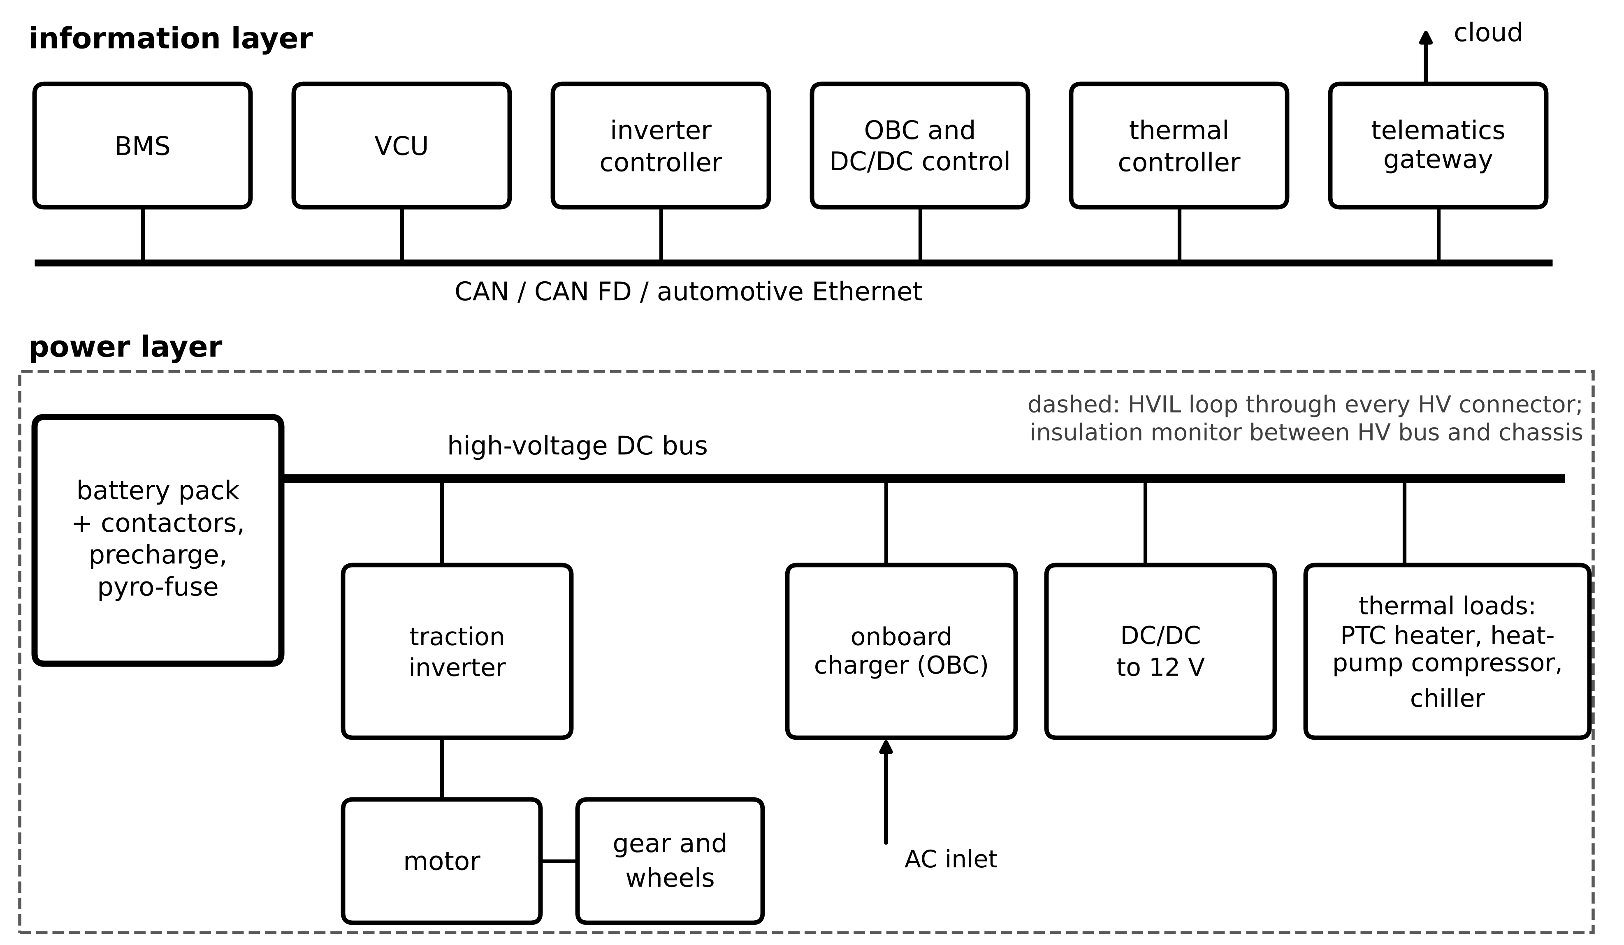
Figure 10.1. EV architecture in two layers. Power layer: battery pack with contactors and pyro-fuse, high-voltage bus, traction inverter, motor and wheels, onboard charger, DC/DC converter and thermal loads. Information layer: BMS, VCU, inverter, charger and thermal controllers and the telematics gateway on the vehicle networks, with the HVIL loop and insulation monitor.

10.2.2 The high-voltage safety chain
Three safety functions govern the high-voltage system, and each produces data the twin uses (Figure 10.2). The contactor sequence closes the negative contactor, then precharges the inverter DC link through a resistor before the main positive contactor closes (Chapter 9, Section 9.3). The high-voltage interlock loop (HVIL) is a low-voltage circuit threaded through every high-voltage connector; opening any connector opens the loop and the contactors. The insulation monitor measures the resistance between the high-voltage system and the chassis; ISO 6469-3 requires at least 100 Ω/V for DC circuits (500 Ω/V where AC is present) [5], so a 400 V system must stay above 40 kΩ. A falling insulation trend is an early warning the twin can track long before the threshold.
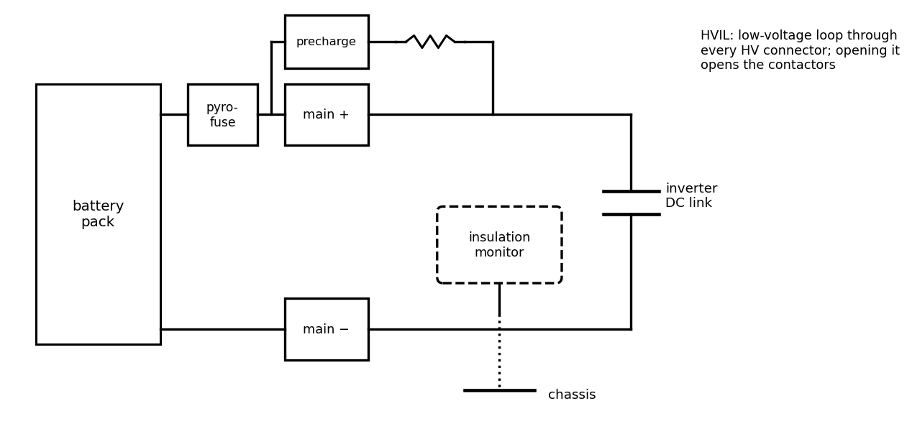
Figure 10.2. High-voltage safety chain: pyro-fuse, main and precharge contactors and resistor, inverter DC link, insulation monitor between the HV system and the chassis, and the HVIL loop through every HV connector.
Table 10.3. Typical signals available to an EV and charging twin (representative values)
Signal | Source | Typical rate | Typical accuracy | Twin use
pack current | BMS sensor | 10 to 100 Hz | 0.5 % plus offset | SOC, SOP, heat
cell voltages | cell-monitoring units | 1 to 10 Hz | 1 to 2 mV | SOC, imbalance, faults
cell and coolant temperatures | NTC sensors | 1 Hz | 0.5 to 1 K | thermal model, limits
motor torque and speed | inverter controller | 0.1 to 1 kHz | 2 to 5 % (torque) | road load, efficiency
wheel speed, GNSS | ABS, GNSS | 1 to 100 Hz | 1 %; 5 to 10 m | distance, grade
ambient temperature | vehicle sensor | 1 Hz | 1 to 2 K | HVAC, air density
charger V, I, limits | ISO 15118 / DIN SPEC 70121 | 0.1 to 1 Hz | charger specification | charge-time prediction
sessions, meter values | OCPP backend | s to min | meter class | smart charging, billing

10.2.3 400 V and 800 V architectures
Most EVs use a nominal pack voltage near 400 V; a growing share use about 800 V. These are classes, not fixed voltages: a 400 V pack swings from about 290 to 410 V with SOC, an 800 V pack from about 580 to 820 V. At a given power $P$ the current and the conduction loss in cables, connectors and contactors of total resistance $R_{cab}$ are
$I=\frac{P}{V_{bus}}, P_{cab}=I^{2}R_{cab}=\frac{P^{2}R_{cab}}{V_{bus}^{2}}$ (10.1)
so doubling the voltage halves the current and quarters the loss (Figure 10.3), at the price of 1200 V semiconductors (Chapter 7, Section 7.9), larger insulation distances and chargers that reach 800 to 1000 V.
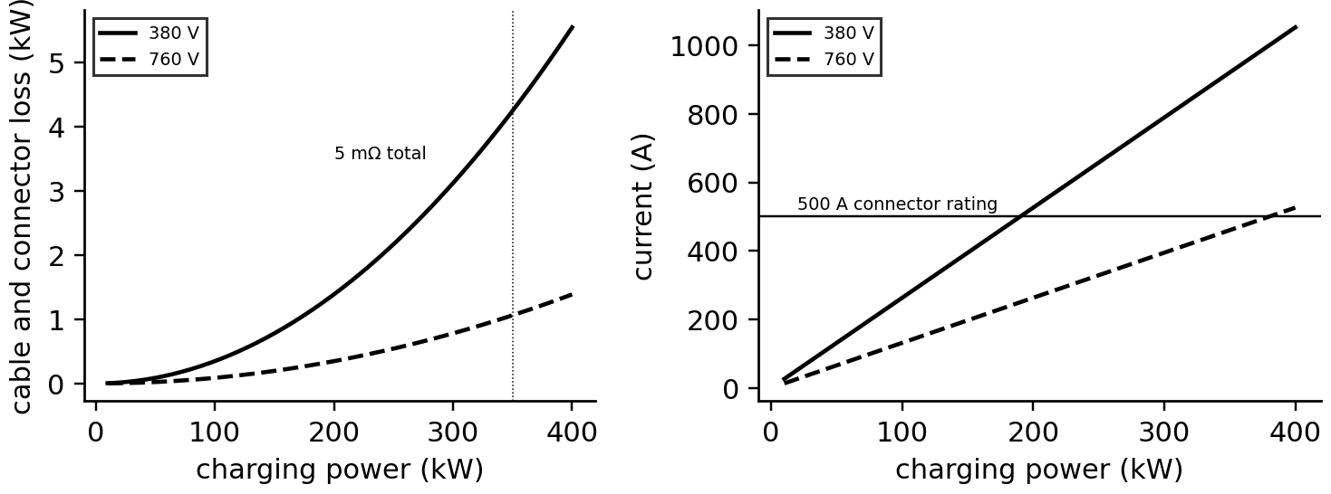
Figure 10.3. Left: cable and connector loss against charging power for 380 V and 760 V packs (5 mΩ). Right: current against power with a 500 A connector rating; above about 190 kW only the 800 V class stays within it.
Example 10.1 (Level A) 150 kW and 350 kW at 400 V and 800 V
Given. Pack voltages of 380 V and 760 V while charging; cable and connector resistance 5 mΩ; connector rating 500 A.
Find. Current and loss at 150 kW and 350 kW.
Solution. At 380 V: 395 A and 0.78 kW at 150 kW; 921 A and 4.24 kW at 350 kW, far above the rating. At 760 V: 197 A and 0.19 kW; 461 A and 1.06 kW.
Interpretation. 350 kW is impractical at 400 V through a standard connector, which is why ultra-fast charging moved to 800 V. Voltage makes high power possible; whether the battery accepts it depends on its cells' current limits and cooling (Sections 10.7 and 10.8).
What the digital twin adds
Synchronized: contactor, HVIL and insulation states, bus voltage and current.
Estimated or updated: insulation trend, cable loss, architecture-specific limits.
Uncertainty carried: sensor accuracies of Table 10.3.
Decision enabled: safe start-up, early insulation warnings, architecture choice.
Validated by: start-up logs, insulation tests, charging-current measurements.

10.3 Longitudinal vehicle dynamics and road load

10.3.1 The free-body diagram
What does it take to move a car? Draw it on a slope of angle $θ$ (Figure 10.4) and list the forces along the road: the tractive force $F_{tr}$ that the tyres exert forward, the rolling resistance $F_{roll}$ from tyre deformation, the aerodynamic drag $F_{aero}$ and the component $mgsinθ$ of gravity along the slope. Newton's second law along the road gives the road-load equation:
$mγ_{m}\frac{dv}{dt}=F_{tr}-F_{roll}-F_{aero}-mgsinθ, F_{roll}=C_{rr}mgcosθ, F_{aero}=\frac{1}{2}ρ_{air}C_{d}A_{f}{\left(v+v_{w}\right)}^{2}$ (10.2)
with $m$ the vehicle mass (kg), $v$ the speed (m/s), $C_{rr}$ the rolling-resistance coefficient (about 0.008 to 0.012), $ρ_{air}$ the air density (1.225 kg/m³ at 15 °C), $C_{d}$ the drag coefficient, $A_{f}$ the frontal area, $v_{w}$ a headwind and $γ_{m}$ the rotational-inertia factor derived next. Rolling resistance is nearly constant, drag grows with the square of speed and dominates above about 70 km/h, and grade dominates on hills: a 3° slope adds 0.052 $mg$, five times the rolling resistance.
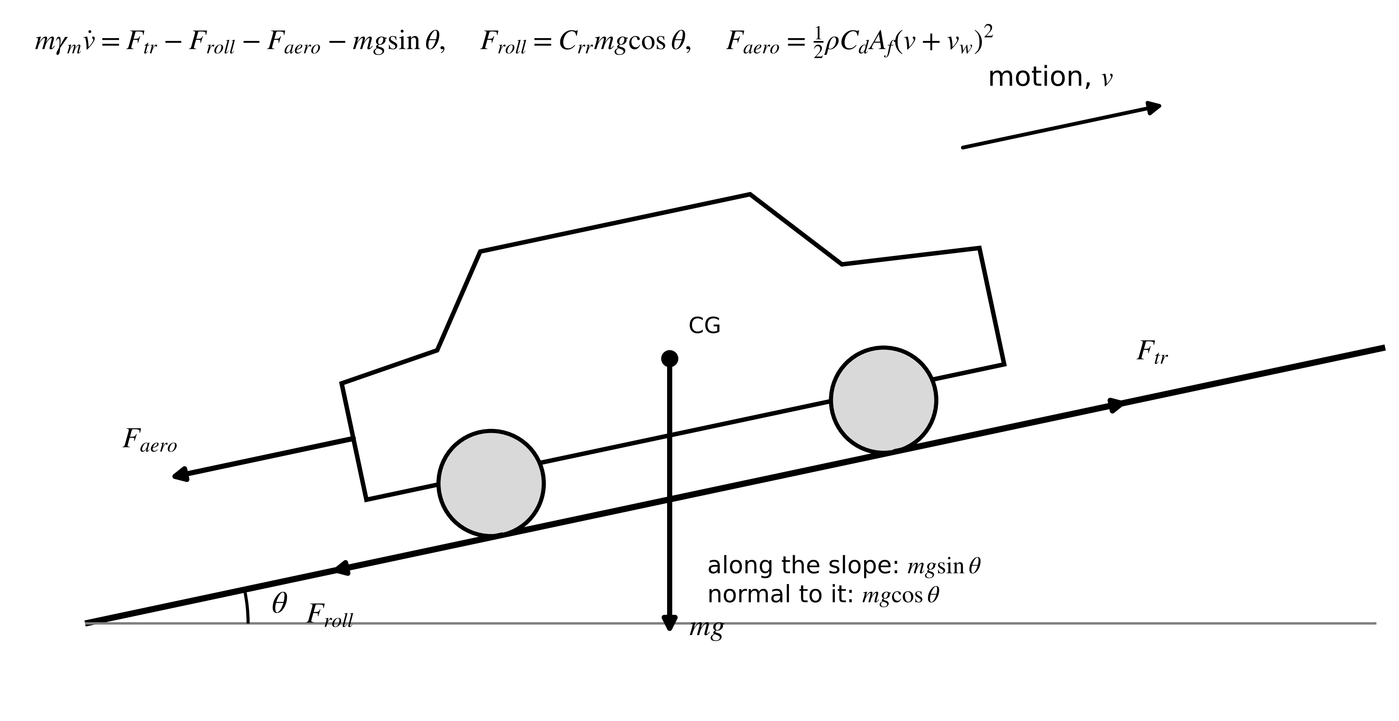
Figure 10.4. Free-body diagram of a vehicle on a slope: tractive force at the wheels against rolling resistance, aerodynamic drag and the slope component of weight.

10.3.2 Rotational inertia
Accelerating the car also spins up its wheels, gear and motor rotor. With wheel radius $r_{w}$, gear ratio $G$ and rotating inertias $J_{w}$ (all wheels) and $J_{m}$ (motor), the angular speeds are $v/r_{w}$ and $Gv/r_{w}$; adding their kinetic energy to that of the translating mass,
$E_{k}=\frac{1}{2}mv^{2}+\frac{1}{2}J_{w}{\left(\frac{v}{r_{w}}\right)}^{2}+\frac{1}{2}J_{m}{\left(\frac{Gv}{r_{w}}\right)}^{2}=\frac{1}{2}mγ_{m}v^{2}, γ_{m}=1+\frac{J_{w}+G^{2}J_{m}}{mr_{w}^{2}}$ (10.3)
so the vehicle behaves as if it were $γ_{m}$ times heavier when accelerating. The gear ratio enters squared: for $m=1800$ kg, $r_{w}=0.33$ m, $J_{w}=4.0$ kg·m², $J_{m}=0.06$ kg·m² and $G=10$, $γ_{m}=1.051$, of which the motor alone contributes 3 %.

10.3.3 From the wheels to the battery
The wheel power $P_{w}=F_{tr}v$ passes through the gear and differential (efficiency $η_{gb}$, about 0.97) and the motor and inverter (efficiency $η_{m}(T_{m},ω_{m})$ from the efficiency map, Section 10.5), and accessories draw $P_{acc}$ (Figure 10.5). Motoring and regenerating differ in direction, so the efficiencies divide in one case and multiply in the other, and regeneration is capped by the battery's charge limit:
$P_{b}=\left\{\begin{matrix}\frac{P_{w}}{η_{gb}η_{m}\left(T_{m},ω_{m}\right)}+P_{acc} & P_{w}≥0 \\ max\left(P_{w} η_{gb}η_{m}\left(T_{m},ω_{m}\right), -P_{reg,max}\right)+P_{acc} & P_{w}<0\end{matrix}\right., T_{m}=\frac{F_{tr}r_{w}}{G}, ω_{m}=\frac{Gv}{r_{w}}$ (10.4)
with battery power $P_{b}$ positive on discharge. On the synthetic mixed cycle of Section 10.6 the battery delivers 7.10 kWh: 6.17 kWh reach the wheels as traction, 0.73 kWh are lost in the motor, inverter and gear while motoring and 0.21 kWh feed accessories; of the traction energy, 1.95 kWh overcome rolling resistance, 3.07 kWh drag and 1.15 kWh is braking energy, of which 1.03 kWh returns to the battery after 0.12 kWh of losses in the regenerating chain. Over the whole cycle the motor and inverter lose 0.66 kWh and the gear 0.19 kWh, and the net battery energy is 7.10 − 1.03 = 6.07 kWh, the 0.170 kWh/km of Example 10.5. Because the cycle starts and ends at rest on level ground, the traction energy must equal the rolling, drag and braking energies exactly, a balance that every vehicle twin should check.
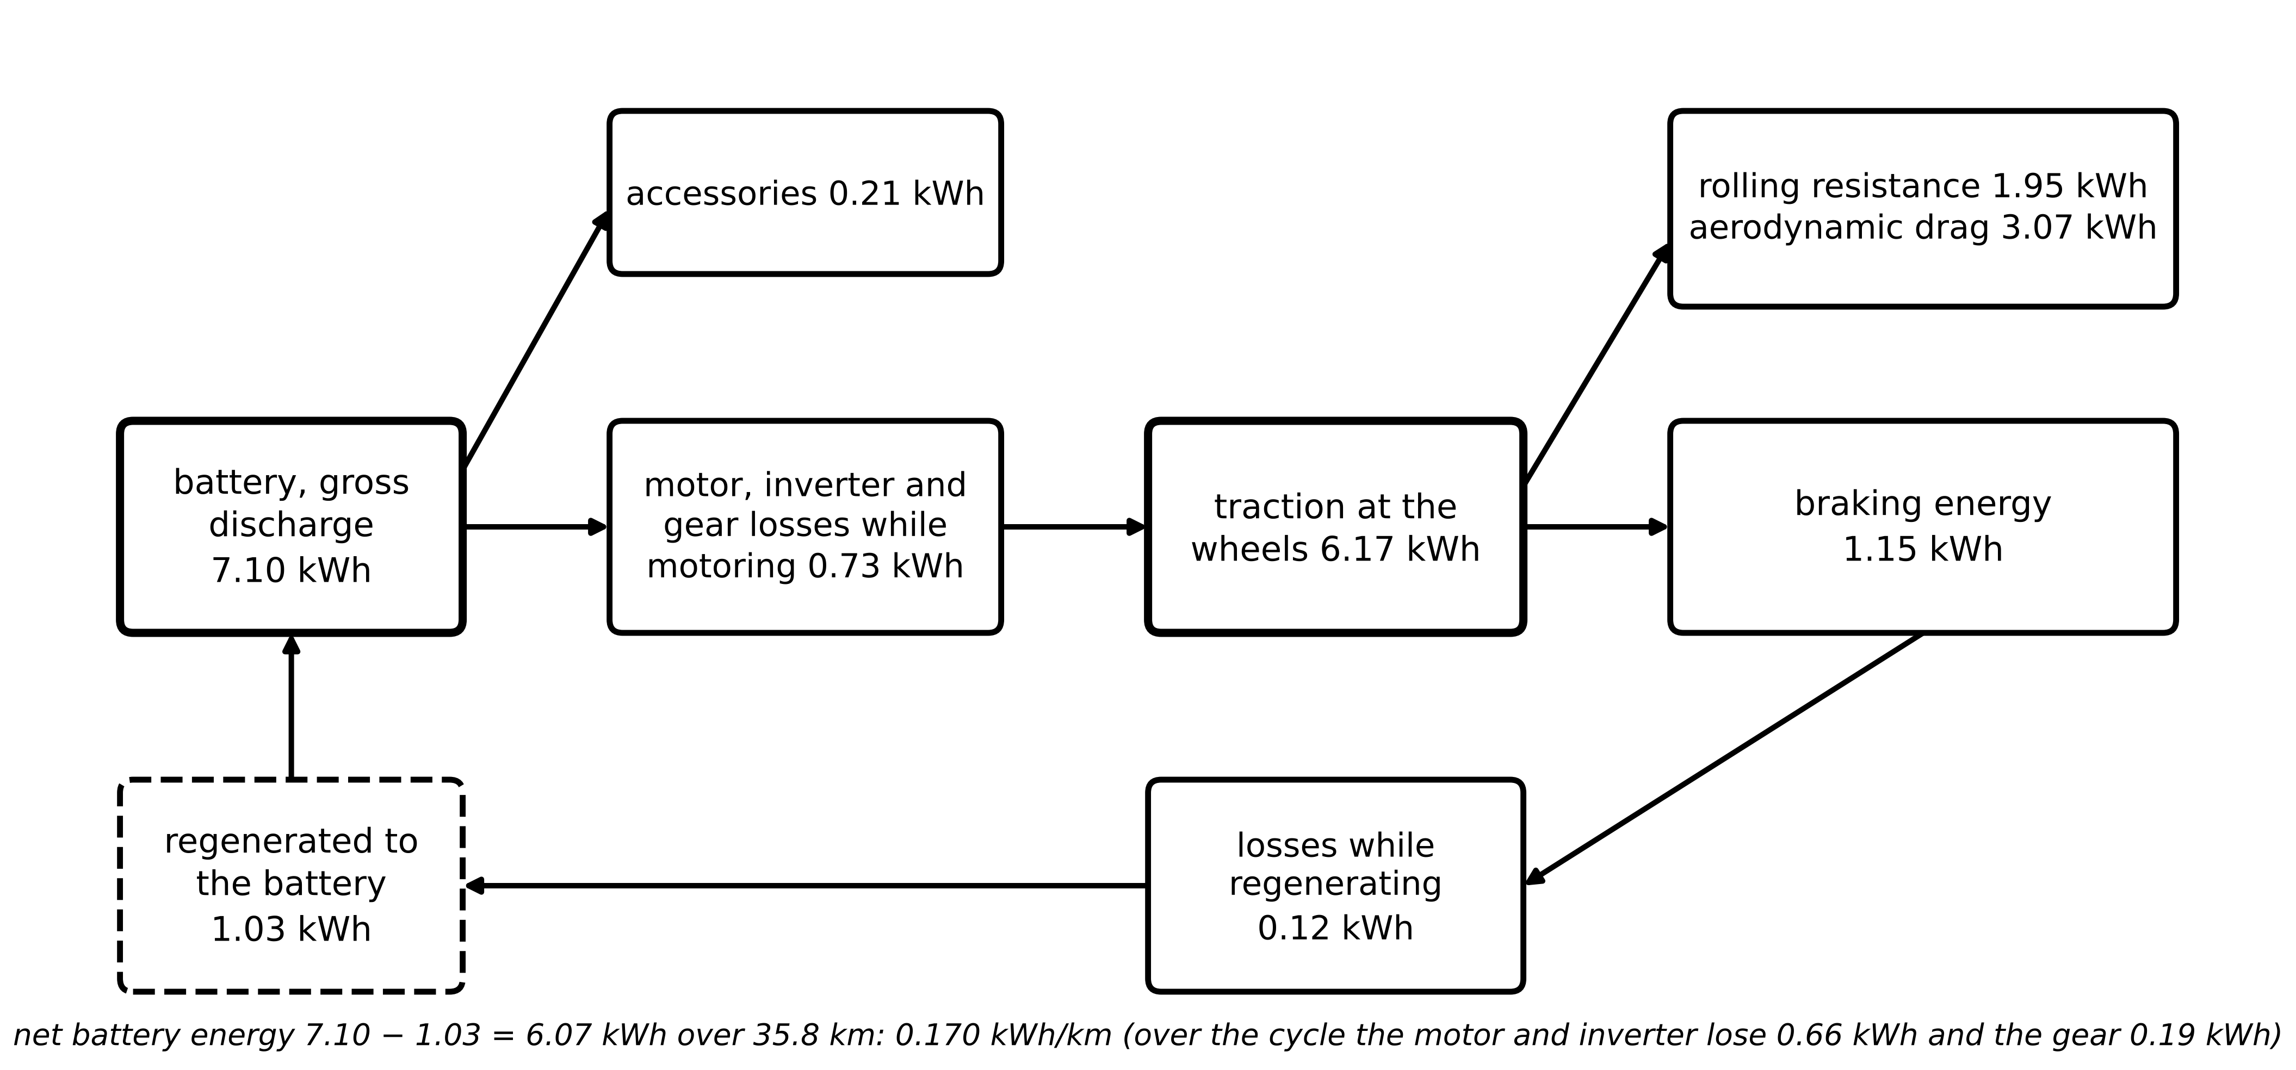
Figure 10.5. Wheel-to-battery energy flow over the synthetic 35.8 km mixed cycle with an efficiency map: battery energy split into accessories, motor and inverter losses, gear losses and traction; traction overcomes rolling resistance and drag or ends as braking energy, part of which regeneration returns.

10.3.4 Identifying road load from a coast-down
The road-load coefficients are not in any datasheet with the needed accuracy; they are measured by a coast-down: the car runs out of gear from about 120 km/h on a level road while speed is logged. With $F_{tr}=0$ and $θ=0$, (10.2) becomes $-mγ_{m}\dot{v}=A_{0}+B_{0}v+C_{0}v^{2}$, with $A_{0}≈C_{rr}mg$, $C_{0}=\frac{1}{2}ρ_{air}C_{d}A_{f}$ and a small linear term $B_{0}$ from bearings and tyres (SAE J2263 [6]). Two estimators are common: regress the force computed from the differentiated speed on $[1,v,v^{2}]$, or fit the simulated speed trajectory to the measured one, which avoids differentiating noise.
Example 10.2 (Level C) Identifying the P-1 SUV's road load
Given. A synthetic coast-down from 120 to 15 km/h ($m=2000$ kg, $γ_{m}=1.05$; true $A_{0}=206$ N ($C_{rr}=0.0105$), $B_{0}=3.0$ N·s/m, $C_{0}=0.412$ N·s²/m² ($C_{d}A_{f}=0.673$ m²)), with gusts of 0.5 m/s and speed noise of 0.05 m/s sampled every 0.5 s (seed 7).
Find. $C_{rr}$ and $C_{d}A_{f}$ by derivative regression and by trajectory fitting, with an uncertainty for the latter.
Solution. The run lasts 160 s (Figure 10.6). Derivative regression gives $A_{0}=212$ N, $B_{0}=2.41$, $C_{0}=0.425$: $C_{rr}=0.0108$, $C_{d}A_{f}=0.694$ m² (+3.2 %). Trajectory fitting gives $A_{0}=203$ N, $B_{0}=3.24$, $C_{0}=0.406$: $C_{rr}=0.0104$, $C_{d}A_{f}=0.663$ m² (−1.5 %) with a standard deviation of 0.008 m², so the truth lies 1.2 standard deviations away.
Interpretation. Differentiating noisy speed biases the estimate; fitting the trajectory does not. The gusts set a floor on what one run can achieve; paired runs in opposite directions average out steady wind, and the twin can refine the coefficients continuously from logged torque and speed on level roads.
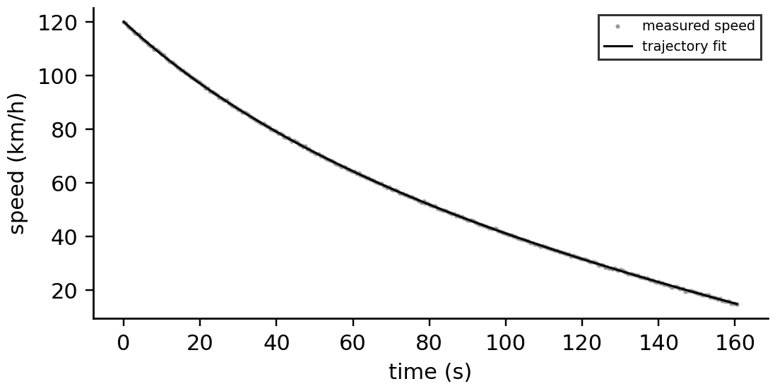
Figure 10.6. Synthetic coast-down of the P-1 SUV: measured speed and the trajectory fitted with the identified road-load coefficients.
What the digital twin adds
Synchronized: speed, torque, grade and road load with the vehicle as it is driven.
Estimated or updated: $C_{rr}$, $C_{d}A_{f}$, $γ_{m}$, mass and payload.
Uncertainty carried: wind and noise-limited coefficient uncertainty.
Decision enabled: energy prediction per route and condition.
Validated by: paired coast-downs, logged-torque regression on level roads.

10.4 Regenerative braking and brake blending
When the driver brakes, the motor can act as a generator and return part of the vehicle's kinetic energy to the battery. Between two speeds $v_{1}>v_{2}$ the recoverable energy, with the chain efficiency $η_{reg}$ of (10.4), is
$E_{reg}=η_{reg}\frac{1}{2}mγ_{m}\left(v_{1}^{2}-v_{2}^{2}\right)-\int{\left(F_{roll}+F_{aero}\right)}v dt, F_{reg,max}(v)=min\left(\frac{ηT_{m,max}G}{r_{w}}, \frac{P_{reg,max}}{v}\right)$ (10.5)
less the energy that rolling and drag remove during the deceleration anyway. Regeneration is limited three ways (Figure 10.7): by motor torque at low speed, by the battery's charge power $P_{reg,max}$ at high speed (lower when the battery is cold or full, Chapter 9, Section 9.7), and by stability, because only the driven axle can regenerate and braking force must be shared between axles in proportion to their load. The brake controller blends: regenerative braking first, friction brakes for the rest, and friction alone near standstill and in emergency stops.
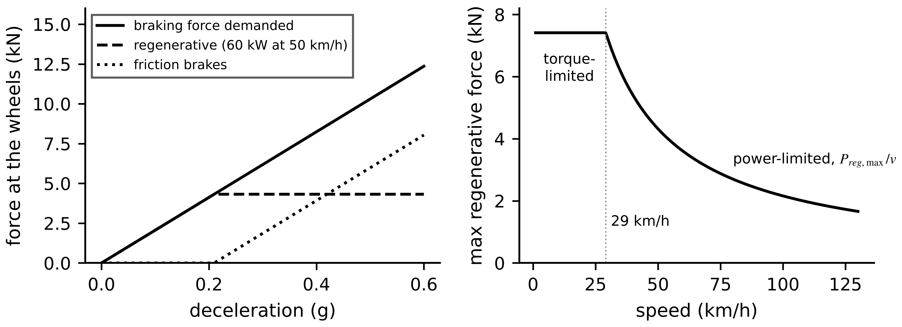
Figure 10.7. Brake blending. Left: braking force demanded at 50 km/h against deceleration, split into regenerative braking (limited to 60 kW, about 0.22 g) and friction braking. Right: the maximum regenerative force against speed, torque-limited at low speed and power-limited above.
Example 10.3 (Level B) Regeneration with a full or cold battery
Given. The synthetic cycle with $P_{reg,max}$ of 60 kW and, for a cold or nearly full battery, 15 kW.
Find. The consumption in both cases, with constant efficiencies.
Solution. 0.166 kWh/km with 60 kW and 0.173 kWh/km with 15 kW, 4 % more.
Interpretation. A cold morning and a battery charged to 100 % cost energy before the heater is even considered; the twin predicts the regenerative limit from the battery's SOC and temperature and lowers its range estimate accordingly.
What the digital twin adds
Synchronized: braking demand, regenerative and friction braking.
Estimated or updated: available regenerative power from SOC and temperature.
Uncertainty carried: driver braking behaviour.
Decision enabled: energy recovery, charge-limit settings (for example, not charging to 100 % before a descent).
Validated by: logged regenerative energy against prediction.

10.5 Motor sizing and the torque-speed envelope
The traction motor and gear must deliver four things: enough wheel force to start on a steep grade, enough power to accelerate, enough speed for the top speed, and enough continuous capability to climb or cruise without overheating (Figure 10.8). Through the gear, wheel force and vehicle speed map to motor torque and speed:
$F_{w}=\frac{η_{gb}GT_{m}}{r_{w}}, v=\frac{ω_{m}r_{w}}{G}, ω_{b}=\frac{P_{max}}{T_{max}}, sinθ_{max}+C_{rr}cosθ_{max}=\frac{F_{w,max}}{mg} ⇒ sinθ_{max}≈\frac{F_{w,max}}{mg}−C_{rr}$ (10.6)
where $ω_{b}$ is the base speed, above which field weakening holds power constant (Chapter 7, Section 7.14). The efficiency map (Figure 10.9) adds the losses: copper loss grows with torque squared, iron and inverter switching losses with speed, and fixed losses dominate at light load, which is where urban driving operates. A twin that assumes a constant 90 % misjudges urban consumption most.
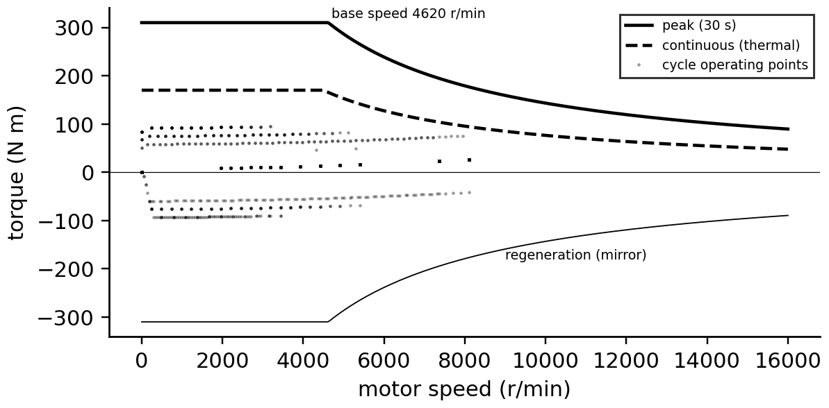
Figure 10.8. Torque-speed envelope of the P-1 SUV motor: peak (30 s) and continuous (thermal) limits for motoring and regeneration, with the operating points of the synthetic cycle.
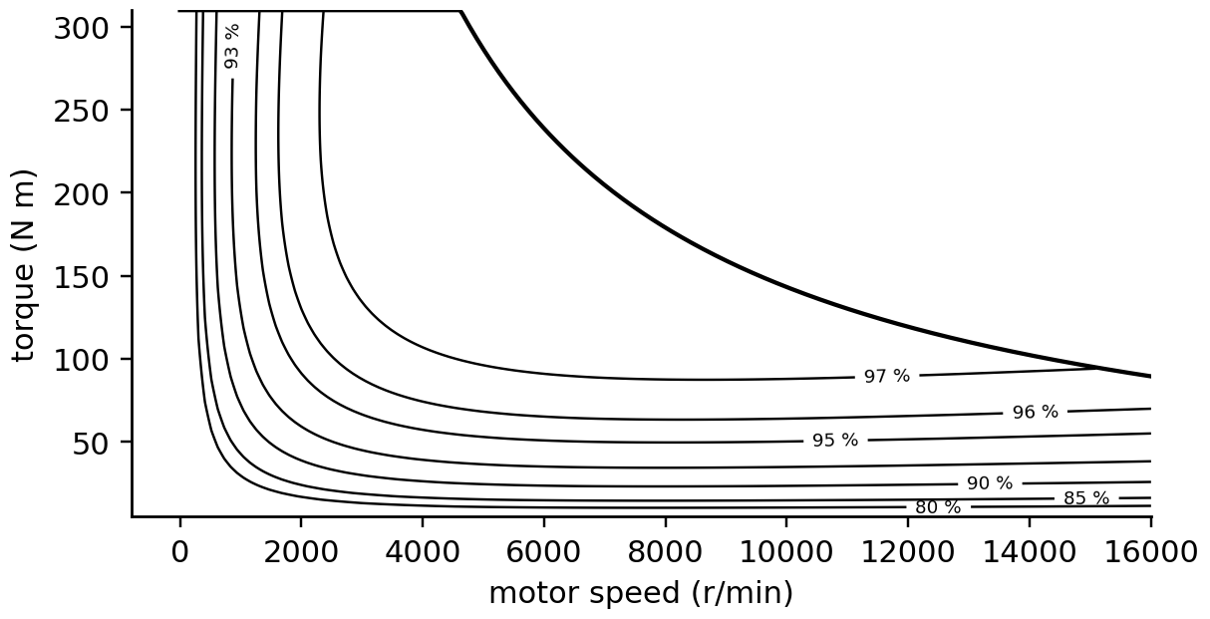
Figure 10.9. Motor-plus-inverter efficiency map of the P-1 SUV (illustrative loss model: copper loss proportional to torque squared, iron loss to speed to the power 1.5, 700 W fixed losses), with the peak torque envelope.
Example 10.4 (Level A) Checking the P-1 SUV's motor and gear
Given. Motor: 310 N·m peak, 150 kW peak, 16 000 r/min maximum; $G=9.0$, $r_{w}=0.35$ m, $η_{gb}=0.93$ (gear and drivetrain), $m=2000$ kg, $C_{rr}=0.010$, $C_{d}A_{f}=0.672$ m², $γ_{m}=1.05$.
Find. Base speed, maximum vehicle speed from motor speed, starting force and gradeability, 0 to 100 km/h time and the wheel power at 120 km/h.
Solution. $ω_{b}=150 000/310=484$ rad/s (4620 r/min), reached at 68 km/h. 16 000 r/min corresponds to 235 km/h. $F_{w}=0.93×9.0×310/0.35=7410$ N, 0.38 $mg$; with rolling resistance the steepest grade is 21.6° (40 %). Integrating (10.2) gives 8.9 s to 100 km/h. Cruising at 120 km/h needs 21.8 kW at the wheels, one-seventh of the peak.
Interpretation. Peak torque and power are set by acceleration and grade; the continuous rating, set by cooling, must cover long climbs and towing. The twin tracks motor temperature against the continuous envelope and predicts derating on a long mountain pass.
What the digital twin adds
Synchronized: motor torque, speed, temperature and efficiency map.
Estimated or updated: losses by operating point, thermal headroom.
Uncertainty carried: map accuracy at light load, thermal parameters.
Decision enabled: sizing, derating prediction, eco-routing.
Validated by: dynamometer maps, logged inverter losses.

10.6 Range: drive cycles, HVAC and uncertainty

10.6.1 Integrating a drive cycle
Range is usable battery energy divided by consumption, and consumption is the battery energy per kilometre over a representative speed profile. With the battery power of (10.4) integrated over a drive cycle of duration $T_{c}$ and distance $d_{c}$, and usable energy $E_{use}$,
$c=\frac{1}{d_{c}}\int_{0}^{T_{c}}{P_{b}}(t) dt, d_{c}=\int_{0}^{T_{c}}{v}(t) dt, Range=\frac{E_{use}(T)}{c}$ (10.7)
in kWh/km and km. Standard cycles (WLTP, EPA) make vehicles comparable; a twin uses the routes and speeds its vehicle actually drives. The synthetic P-1 cycle (Figure 10.10) has urban, suburban and highway parts over 35.8 km.
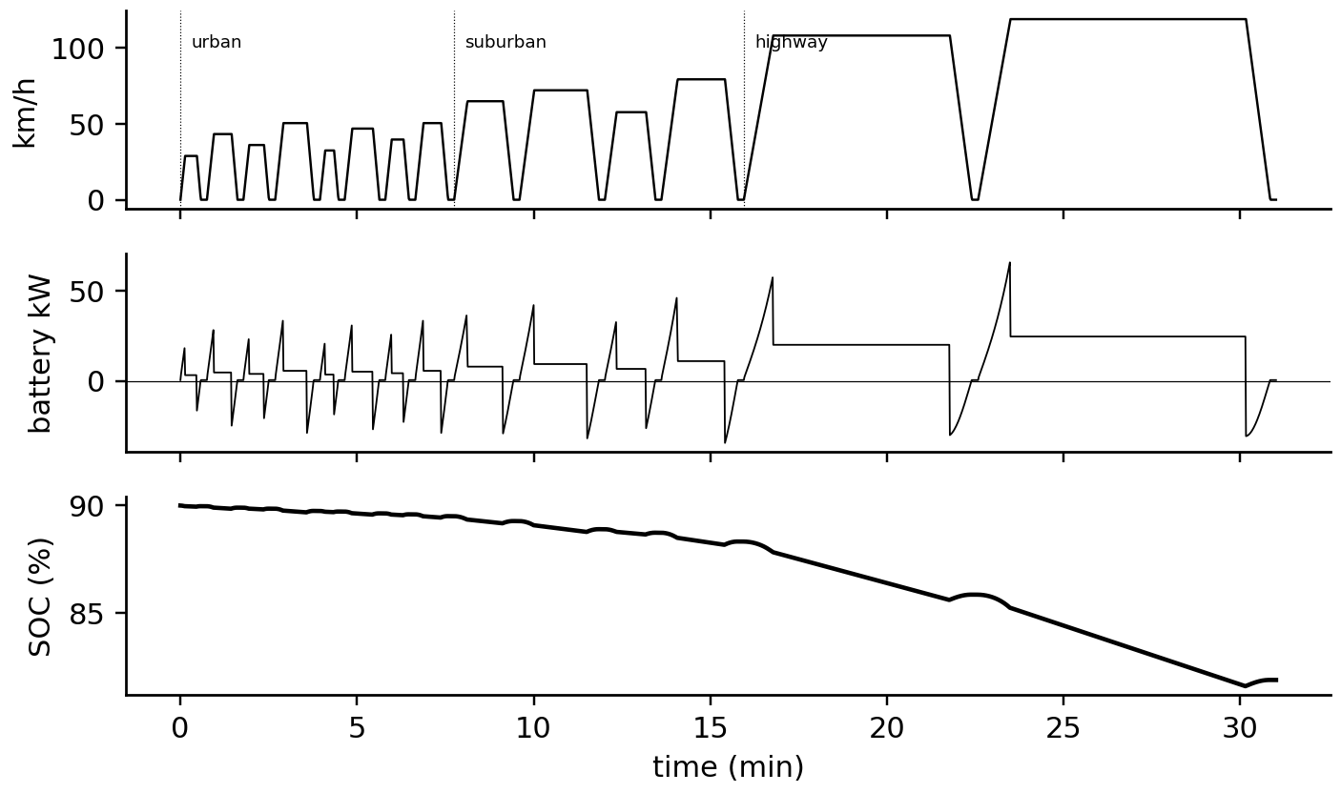
Figure 10.10. The synthetic mixed cycle of the P-1 SUV: speed (urban, suburban and highway parts), battery power with regeneration, and SOC over 31 minutes.
Example 10.5 (Level B) Consumption and range of the P-1 SUV
Given. The synthetic cycle; $m=2000$ kg, $C_{rr}=0.010$, $C_{d}A_{f}=0.672$ m², $γ_{m}=1.05$; accessories 0.4 kW; regeneration limited to 60 kW; $E_{use}=75$ kWh. (a) Constant efficiencies $η=0.90$ motoring and 0.85 regenerating; (b) the efficiency map of Figure 10.9 with $η_{gb}=0.97$.
Find. Consumption by segment and overall, and range.
Solution. (a) Urban 0.097, suburban 0.120, highway 0.189 kWh/km; overall 0.166 kWh/km, 451 km. (b) Urban 0.104, suburban 0.124, highway 0.192 kWh/km; overall 0.170 kWh/km, 442 km.
Interpretation. The map raises urban consumption by 8 % because the motor spends town driving at light load, where fixed losses dominate; on the highway the two agree within 2 %. Constant efficiencies are acceptable for first teaching examples, not for a twin that predicts urban fleet energy.
[Advanced] Consumption against cruising speed, and why heating moves the optimum
At a constant speed $v$ on a level road with no wind, (10.2) and (10.4) give the battery power $P_{b}=\left(C_{rr}mg+C_{0}v^{2}\right)v/η+P_{acc}$, with $C_{0}=\frac{1}{2}ρ_{air}C_{d}A_{f}$ and $η$ the wheel-to-battery efficiency. Dividing by $v$ gives the energy per metre, which is the consumption:
$c\left(v\right)=\underset{a}{\underset{⏟}{\frac{C_{rr}mg}{η}}}+\underset{b}{\underset{⏟}{\frac{C_{0}}{η}}}v^{2}+\frac{P_{acc}}{v}$
Rolling resistance costs the same per kilometre at any speed, drag grows with $v^{2}$, and the accessories, which draw power for as long as the trip lasts, cost less per kilometre the faster the car goes. Setting $dc/dv=2bv−P_{acc}/v^{2}=0$ gives the speed of minimum consumption and its value:
$v^{*}={\left(\frac{P_{acc}}{2b}\right)}^{1/3}={\left(\frac{ηP_{acc}}{ρ_{air}C_{d}A_{f}}\right)}^{1/3}, c^{*}=a+3b v^{*2}$
For the P-1 SUV ($m=2000$ kg, $C_{rr}=0.010$, $C_{0}=0.412$ N·s²/m², $η=0.90$): with 0.4 kW of accessories $v^{*}=7.6$ m/s (27 km/h) and $c^{*}=0.083$ kWh/km; with 4.5 kW of PTC heating added, $v^{*}=17.5$ m/s (63 km/h) and $c^{*}=0.177$ kWh/km. At 120 km/h the consumption is 0.205 kWh/km without heating and 0.243 kWh/km with it (366 and 309 km from 75 kWh); at 50 km/h it is 0.093 and 0.183 kWh/km, so heating doubles town consumption while adding only 18 % on the motorway.
The cube root makes $v^{*}$ insensitive to the parameters, but the lesson holds: a twin that recommends slower driving in winter must account for the heating, which penalizes slow trips most. The formula ignores acceleration, regeneration and the efficiency map, so it describes cruising, not a drive cycle; (10.7) handles the general case.

10.6.2 HVAC, ambient temperature and preconditioning
In winter the largest single load is often not the motor but the cabin heater. The heat needed to hold the cabin at $T_{set}$ against an ambient $T_{a}$ is approximately a conductance $UA_{cab}$ (walls, glazing and ventilation air) times the temperature difference; a PTC heater converts electricity to heat one for one, while a heat pump moves heat from outside with a coefficient of performance (COP) that falls as it gets colder (Figure 10.11):
${\dot{Q}}_{cab}=UA_{cab}\left(T_{set}-T_{a}\right), P_{HVAC}=\frac{{\dot{Q}}_{cab}}{COP\left(T_{a}\right)}, E_{pre}=C_{pack}\left(T_{target}-T_{pack}\right)$ (10.8)
where $E_{pre}$ is the energy to warm the pack before driving or fast charging, from its heat capacity $C_{pack}$. Cold also raises air density, tyre resistance and battery resistance, lowers usable energy and limits regeneration. Preconditioning while plugged in takes these energies from the grid instead of the battery, which is why departure-time scheduling is one of the twin's most valuable functions.
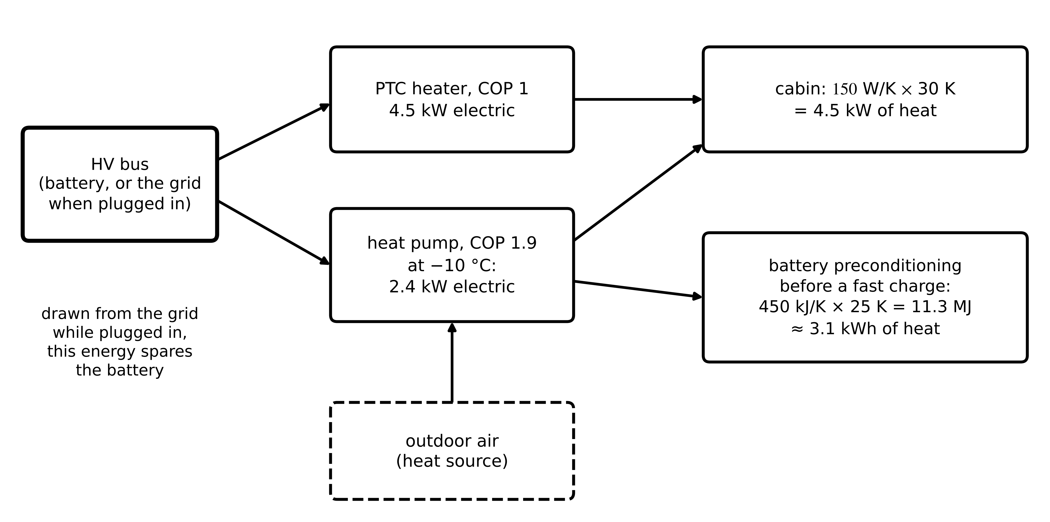
Figure 10.11. HVAC and preconditioning energy at −10 °C: a PTC heater delivers the cabin heat at COP 1, a heat pump at COP 1.9; preconditioning the battery before a fast charge needs about 3 kWh of heat (450 kJ/K × 25 K), best drawn from the grid while plugged in.
Example 10.6 (Level B) A winter day
Given. The cycle of Example 10.5 with the map at −10 °C: air density 1.342 kg/m³, rolling resistance +12 %, usable energy 89 % of 75 kWh; cabin conductance 150 W/K held at 20 °C; PTC heater (COP 1) or heat pump (COP 1.9 at −10 °C).
Find. The range loss by cause.
Solution. At 20 °C without HVAC, 445 km. Cold air and tyres: 405 km. Reduced usable energy: 361 km. Heating 4.5 kW by PTC: 267 km; by heat pump (2.3 kW): 305 km (Figure 10.12).
Interpretation. Heating costs more range than all the other cold effects together. The heat pump recovers 38 km, and preheating the cabin from the grid before departure recovers more still; a range twin that ignores HVAC is wrong by 40 % on winter days.

10.6.3 Range with an honest interval
A range estimate is a forecast under uncertain weather, speed, payload and wind. Sampling these inputs and propagating them through the model gives a distribution; its quantiles are the honest statement, and their coverage on held-out trips is the test (Chapter 6, Section 6.8).
Example 10.7 (Level C) A 90 % range interval for the P-1 SUV
Given. 300 scenarios (seed 2026): ambient temperature $𝒩(10 °C,8 K)$ with heat-pump heating (150 W/K, COP falling from 3.2 at 20 °C to 1.5), wind $𝒩(0,3 m/s)$, a speed scale $𝒩(1,0.05)$, payload uniform from 0 to 300 kg; the map model of Example 10.5.
Find. The median and the 90 % interval.
Solution. Median 382 km; 90 % interval 303 to 483 km (Figure 10.12).
Interpretation. A single number of 445 km describes a mild day without heating and misleads most of the season. The interval, its coverage on real trips and the dominant uncertainty (temperature through heating) are what a fleet planner needs.
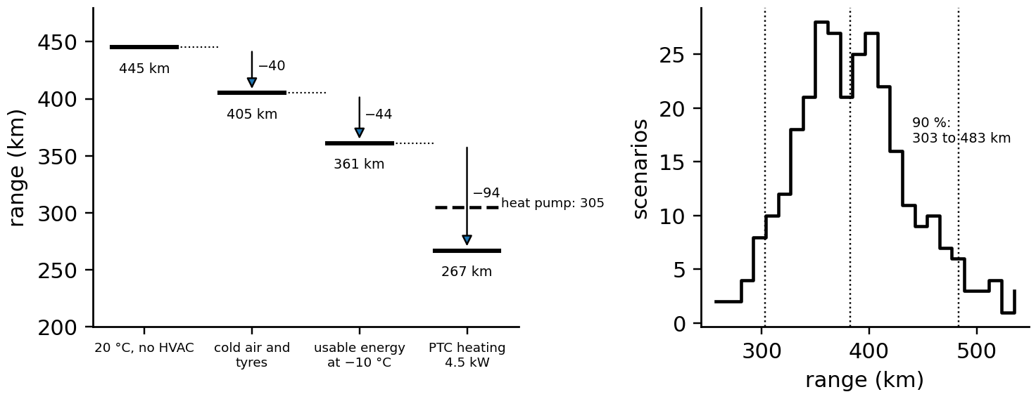
Figure 10.12. Left: range waterfall from 445 km at 20 °C to 267 km at −10 °C with PTC heating (305 km with a heat pump). Right: distribution of range over 300 weather, speed and payload scenarios, with the 5, 50 and 95 % quantiles.

10.6.4 The battery on wheels
The pack models of Chapter 9 apply unchanged; what changes is the duty. Drive cycles impose second-scale power pulses up to 3C, regeneration imposes charging pulses whenever the driver brakes, and the pack's temperature follows the weather and the thermal system. The vehicle twin therefore runs the battery's SOP (Chapter 9, Section 9.7) continuously to tell the VCU how much power is available, and its ageing model (Chapter 9, Section 9.8) with the vehicle's own history; a battery passport under the EU Battery Regulation will make state-of-health data part of the vehicle's record [7].
What the digital twin adds
Synchronized: route, weather, HVAC state, battery state and consumption.
Estimated or updated: consumption by condition, range distribution, preconditioning needs.
Uncertainty carried: weather, speed and payload scenarios; coverage checked on held-out trips.
Decision enabled: charging stops, departure preconditioning, fleet assignment.
Validated by: predicted against measured trip energy and interval coverage.

10.7 Charging fundamentals: hardware, charging curve and limits

10.7.1 AC and DC charging
There are two ways to put energy into a vehicle (Table 10.4). In AC charging the station (EVSE) is little more than a protected switch; the vehicle's onboard charger rectifies the grid voltage with power-factor correction and controls the battery current through an isolated DC/DC stage (Figure 10.13). In DC charging the conversion happens in the station, which can therefore be much larger; the vehicle tells the station what voltage and current to supply and closes its DC contactors to connect the battery directly (Figure 10.14).
Table 10.4. AC and DC charging compared
Feature | AC charging | DC charging
where conversion happens | onboard charger (OBC) | in the station
typical power | 3.7 to 22 kW | 50 to 400 kW (cars); up to several MW (trucks, MCS)
who sets the current | EVSE offers a maximum via the control pilot; OBC decides | vehicle requests V and I; station supplies within limits
communication | control-pilot PWM (IEC 61851-1); optional ISO 15118 | ISO 15118 / DIN SPEC 70121 over PLC; CAN for CHAdeMO, GB/T
typical use | home, workplace, depots | highways, hubs, fleets

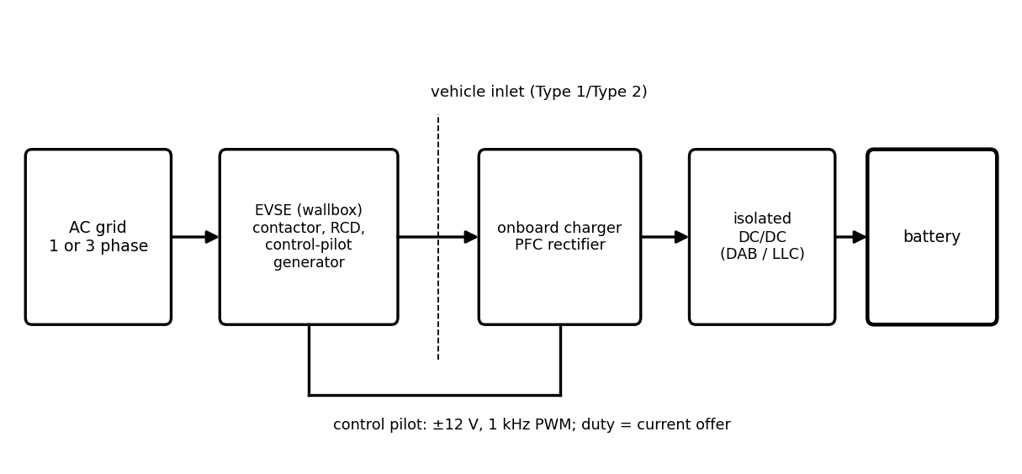
Figure 10.13. AC charging: the EVSE switches and protects the AC supply and signals the available current on the control pilot; the onboard charger performs power-factor correction and isolated DC/DC conversion to the battery.
The control pilot (IEC 61851-1 [8]) is a ±12 V, 1 kHz signal on a dedicated pin. The vehicle loads it with resistors to signal its state (connected, ready to charge), and the EVSE's PWM duty cycle $D$ (in per cent) states the maximum current it can supply:
$I_{max}=0.6 D A (10≤D≤85), I_{max}=2.5\left(D-64\right) A (85<D≤96)$ (10.9)
so 16 A is a duty cycle of 26.7 % and 90 % offers 65 A. Smart charging of AC vehicles works by changing this duty cycle, which the OBC must follow within seconds.
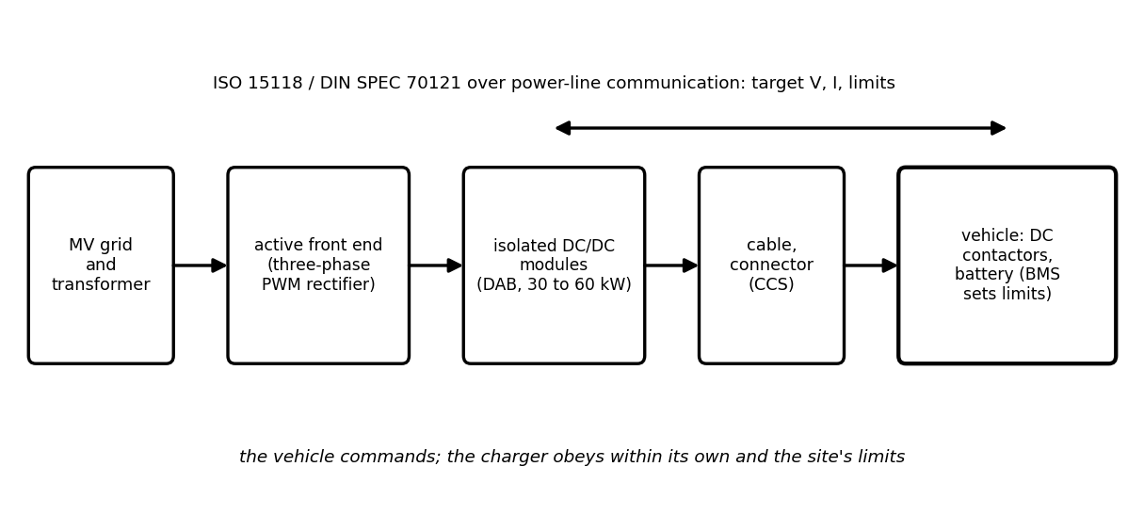
Figure 10.14. DC fast charging: grid transformer, active front end, isolated DC/DC modules, cable and connector, and the vehicle's DC contactors; the vehicle requests voltage and current over ISO 15118 or DIN SPEC 70121 and the station obeys within its own and the site's limits.

10.7.2 The charging curve
A DC session does not run at the charger's rating. At every instant the current is the smallest of several limits (Figure 10.15): the charger's power limit, its current limit and that of the cable; the battery's current map against SOC and temperature (Chapter 9, Section 9.11); its voltage limit, which forces a constant-voltage taper near full; and thermal limits of cells, cable and connector. With a pack modelled as OCV $U(z)$ behind a resistance $R_{p}(T)$, the power limit and the voltage limit give
$I_{P}=\frac{-U+\sqrt{U^{2}+4R_{p}P_{ch}}}{2R_{p}}, I_{V}=\frac{V_{max}-U}{R_{p}}, I=min\left(I_{P},I_{V},I_{ch,max},I_{cell}(z,T),I_{th}\right)$ (10.10)
where the first follows from $P_{ch}=VI=(U+IR_{p})I$, a quadratic in $I$. The time between two SOCs then follows from integrating the current, and the energy drawn from the grid adds the losses:
$t_{z_{1}→z_{2}}=\int_{z_{1}}^{z_{2}}{\frac{3600Q}{I(z,T)}} dz, E_{grid}=\int{\frac{\left(U+IR_{p}\right)I}{η_{ch}}} dt$ (10.11)
The naive estimate $Δz E/P_{ch}$ holds only if the charger's power is the binding limit throughout, which is rarely true.

10.7.3 Cable, connector and site limits
A connector heats through its contact resistance $R_{c}$; with a thermal resistance $R_{th,c}$ to ambient and an allowed temperature rise $ΔT_{max}$, the steady current limit is
$ΔT_{c}=I^{2}R_{c}R_{th,c}≤ΔT_{max} ⇒ I_{max}=\sqrt{\frac{ΔT_{max}}{R_{c}R_{th,c}}}$ (10.12)
With 0.3 mΩ, 0.5 K/W and 40 K, $I_{max}=516$ A; liquid-cooled cables lower $R_{th,c}$ and allow 500 to 600 A continuously. A rising contact resistance shows as a temperature rise beyond (10.12) at the same current, a fault signature the charger twin tracks (Section 10.15). The site limits the sum of all sessions: a hub's grid connection, its transformer and its demand charge cap how much power each vehicle can get (Section 10.13).
Example 10.8 (Level B) Why a 350 kW charger does not charge this car faster
Given. The P-1 SUV pack: 96s2p, 110 Ah NMC cells (220 Ah, about 77 kWh), pack resistance 0.058 Ω at 25 °C (Arrhenius, 3000 K); manufacturer current map 2C up to 50 % SOC tapering to 0.7C at 80 %, reduced at low temperature; two-node pack thermal model (core 300 kJ/K, plate 150 kJ/K, 0.004 K/W between them), coolant at 25 °C through 250 W/K with a 7 kW chiller; core limited to 45 °C; chargers of 150 and 350 kW, 500 A. Cases: 25 °C on 150 kW and 350 kW; 0 °C without and with preconditioning to 25 °C; 35 °C with a 4 kW chiller; an 800 V version (192s1p, 4C cells, 12 kW chiller, 500 W/K) on 350 kW.
Find. Time from 10 to 80 % SOC, losses, peak core temperature and peak power.
Solution. Table 10.5 and Figure 10.15. At 25 °C: 27.3 minutes on 150 kW and 26.5 on 350 kW, where the current map, not the charger, limits power above 166 kW. At 0 °C without preconditioning: 46.6 minutes at a peak of 117 kW; preconditioned: 26.5 minutes. At 35 °C with a weak chiller the core reaches its 45 °C limit and the time rises to 28.8 minutes. The 800 V pack draws 329 kW, reaches the thermal limit at a third of the charge and finishes in 21.8 minutes.
Interpretation. The battery's map and its cooling, not the charger's rating, set the session. A 350 kW charger helps only a vehicle whose cells and cooling accept more than 166 kW; the 800 V example shows that once current limits rise, cooling becomes the bottleneck. Preconditioning recovers almost all of the winter penalty, and the twin can schedule it from the navigation destination.
Table 10.5. Fast-charge sessions of the P-1 SUV from 10 to 80 % (synthetic)
Case | Time (min) | Losses (kWh) | Peak core (°C) | Peak power (kW)
25 °C, 150 kW | 27.3 | 2.26 | 42.3 | 150
25 °C, 350 kW | 26.5 | 2.32 | 42.9 | 166
0 °C, not preconditioned | 46.6 | 2.92 | 20.4 | 117
0 °C, preconditioned to 25 °C | 26.5 | 2.49 | 38.3 | 166
35 °C, 4 kW chiller | 28.8 | 1.79 | 45.0 (limit) | 163
800 V pack, 350 kW | 21.8 | 2.89 | 45.0 (limit) | 329

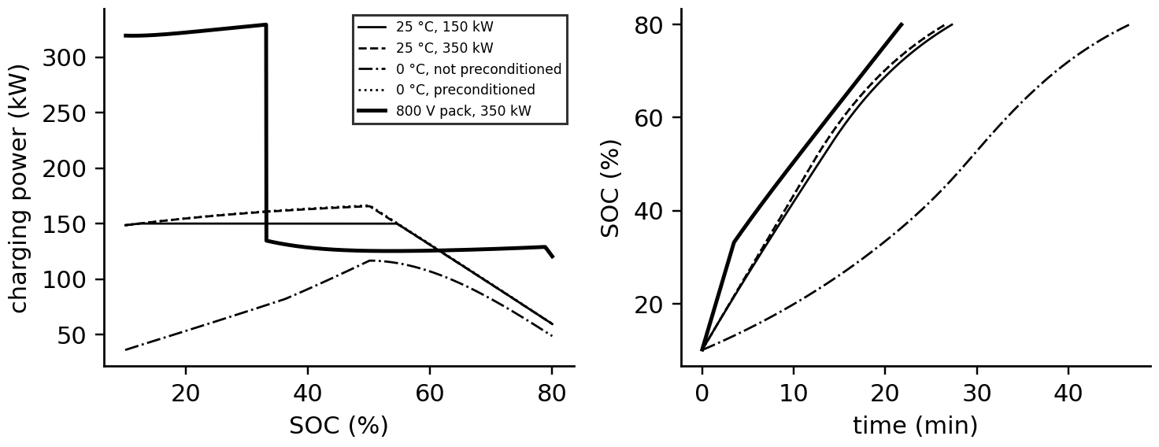
Figure 10.15. Fast-charge curves of the P-1 SUV. Left: charging power against SOC for the cases of Table 10.5. Right: SOC against time; the 800 V pack starts fastest but is held back by its thermal limit after a third of the session.
What the digital twin adds
Synchronized: charger, cable, connector and battery limits with the session in progress.
Estimated or updated: the binding limit at each instant, session time, losses.
Uncertainty carried: battery temperature and current map, arrival SOC.
Decision enabled: preconditioning, charger choice, stop planning, site power allocation.
Validated by: logged session curves against prediction.

10.8 Flagship: a health-aware fast-charging twin
A manufacturer's current map is a static compromise: conservative enough for an old pack on a cold day, too conservative for a new pack on a warm one, and blind to what the pack has experienced. A health-aware twin replaces it by constraints evaluated on the pack's estimated state, with uncertainty, at every second of the session. It brings together the battery twin of Chapter 9 and the charging curve of Section 10.7.

10.8.1 The constraints
Four physical constraints bound the charging current $I$ (Figure 10.16). Plating: the graphite surface potential must stay above a margin $φ_{min}$ (Chapter 9, Section 9.11); with the anode equilibrium potential $U_{n}(z)$, the anode-side resistance $R_{n}(T,SOH)$ that rises in the cold and with age, and $N_{p}$ cells in parallel. Core temperature: the cells' hottest point, estimated by the core-surface filter of Chapter 9 (Section 9.9), must stay below $T_{c,max}$; once it is reached, the current is held so that the heat generated equals the heat leaving the core. Voltage: the terminal voltage must not exceed $V_{max}$. Equipment: the charger, cable and site limits of Section 10.7. Writing them together,
$φ_{n}=U_{n}(z)-\frac{I}{N_{p}}R_{n}\left({\hat{T}}_{c},\hat{SOH}\right)≥φ_{min}+kσ_{φ}, {\hat{T}}_{c}≤T_{c,max}⇒I^{2}R_{p}≤\frac{{\hat{T}}_{c}-{\hat{T}}_{p}}{R_{cs}}, U+IR_{p}≤V_{max}, I≤I_{eq}$ (10.13)
where $σ_{φ}$ is the standard deviation of the estimated anode potential, propagated from the uncertainties of SOC, temperature and $R_{n}$, and $k$ sets the confidence (Chapter 6, Section 6.8). The policy chooses at each step the largest current that satisfies all of them, which minimizes charging time for a fixed set of constraints because the time integral (10.11) is minimized by maximizing $I$ pointwise; adding a degradation-cost term (Chapter 9, Section 9.11) turns it into a trade-off between time and life.
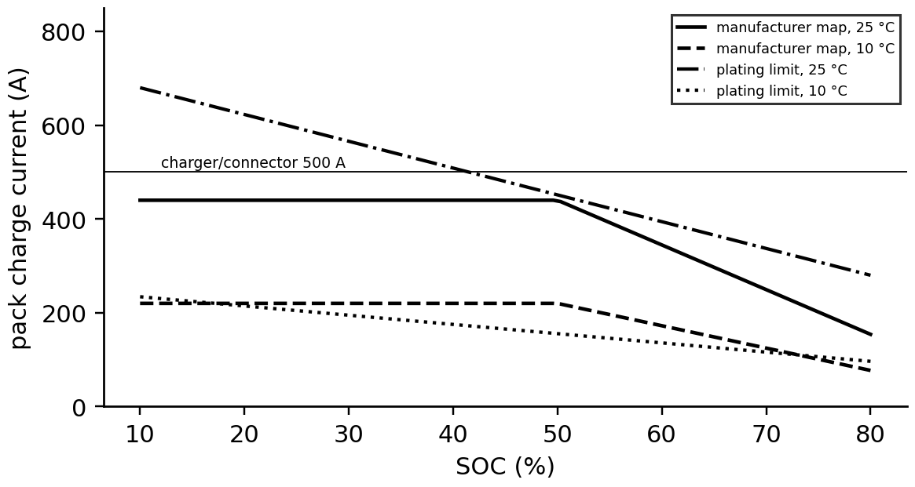
Figure 10.16. Charge-current constraints of the P-1 SUV against SOC: the manufacturer map at 25 and 10 °C, the plating limits at 25 and 10 °C, and the charger and connector limit. The health-aware twin follows the lowest physical limit rather than the map.
Example 10.9 (Level C) Fixed CC-CV, a manufacturer map and a health-aware charge
Given. The P-1 pack of Example 10.8 on a 350 kW, 500 A charger from 10 to 80 %; graphite potential falling from 0.19 V at 10 % SOC to 0.09 V at 80 %; anode resistance 0.5 mΩ per cell at 25 °C (activation temperature 6000 K); $φ_{min}=20$ mV; core limit 45 °C. Policies: fixed CC-CV at 1.5C; the manufacturer map; the health-aware charge (10.13). Pack and ambient at 25 °C and at 10 °C; then at 10 °C with an aged anode ($R_{n}$ ×1.5), a larger margin ($kσ_{φ}=20$ mV) and preconditioning.
Find. Charging time, peak core temperature and plating exposure (the integral of the negative anode potential, in V·s).
Solution. At 25 °C: CC-CV 28.0 minutes, map 26.5, health-aware 22.4 minutes with the core held at 45 °C; none plates. At 10 °C: CC-CV 28.0 minutes but plates (exposure 2.6 V·s); the map 29.7 minutes without plating; health-aware 23.2 minutes without plating, core 38.6 °C. With the aged anode the health-aware charge slows to 43.1 minutes; with the larger margin 25.5 minutes; with both 64.9 minutes. Preconditioned to 25 °C: 21.0 minutes.
Interpretation. The twin is faster than the map when the pack is healthy and warm, and slower, correctly, when it is aged and cold; the static map is wrong in both directions. Its value depends on the honesty of its uncertainty: the margin $kσ_{φ}$ costs minutes on a cold day, and shrinking it requires validated anode-potential estimates (Chapter 9, Section 9.14). Preconditioning is the cheapest lever: about 3 kWh of heat saves more than 40 minutes on an aged pack in winter.
What the digital twin adds
Synchronized: SOC, core temperature, SOH and anode-potential estimates with the session.
Estimated or updated: the binding constraint and the largest safe current every second.
Uncertainty carried: $σ_{φ}$ margins, core-temperature uncertainty, ageing state.
Decision enabled: charging current, preconditioning, the time-life trade-off.
Validated by: cell teardowns for plating, instrumented packs for core temperature, fleet ageing against prediction.

10.9 The charger: power electronics and modular stations

10.9.1 The converter chain
A DC charger is two converters in series (Figure 10.17): an active front end (AFE) that rectifies the three-phase grid voltage at unity power factor and regulates an intermediate DC link (the VSC of Chapter 7, Section 7.4), and an isolated DC/DC stage, typically a dual active bridge or LLC converter (Chapter 7, Section 7.3), that adapts the link voltage to the battery and provides galvanic isolation. With stage efficiencies $η_{AFE}≈0.985$, $η_{DC}≈0.98$ and cable and auxiliary losses, the chain reaches about 96 %:
$η_{ch}=η_{AFE} η_{DC} η_{cab}-\frac{P_{aux}}{P_{out}}, P_{loss}=P_{out}\left(\frac{1}{η_{ch}}-1\right)$ (10.14)
so a 150 kW session dissipates about 6 kW in the charger, which its own cooling must remove; at partial load the auxiliary term (fans, pumps, control) lowers efficiency markedly, a reason modular stations switch modules off.
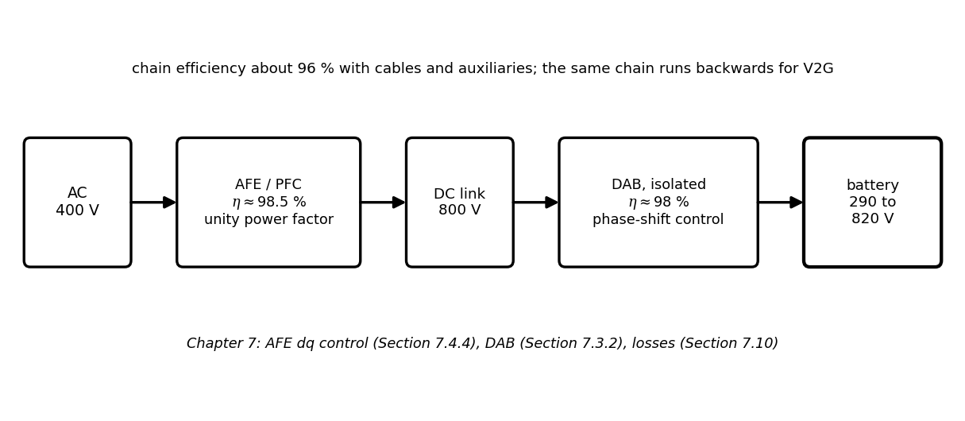
Figure 10.17. Charger power-electronics chain: active front end with power-factor correction, DC link and isolated DC/DC converter; the same chain runs in reverse for V2G.

10.9.2 Modular stations and heavy-duty charging
Large stations are built from power modules (typically 30 to 60 kW) connected through a DC switch matrix to several dispensers (Figure 10.18). The site EMS assigns modules to vehicles according to each vehicle's current request, so the power of a station follows the vehicles' charging curves rather than a fixed split. Megawatt charging for trucks (the MCS of SAE J3271, issued in 2025 [9], developed for up to 3.75 MW at 1250 V and 3000 A) uses the same principle at larger scale, with depot twins that schedule overnight charging against a grid connection.
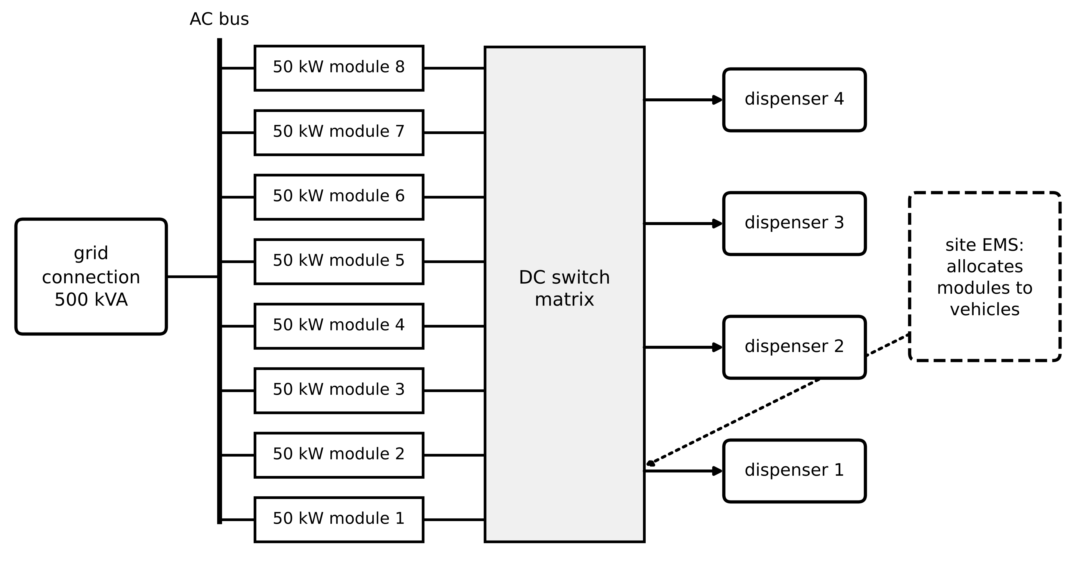
Figure 10.18. Modular charging station: eight 50 kW power modules connected through a DC switch matrix to four dispensers; the site EMS allocates modules to vehicles according to their requests.
Example 10.10 (Level A) Allocating modules between two cars
Given. Eight 50 kW modules (400 kW) and two vehicles: the P-1 SUV at 20 % SOC requesting 166 kW (its map limit) and an 800 V car requesting 329 kW.
Find. The allocation with whole modules, and the power each car receives.
Solution. The SUV needs four modules (166 kW of 200 available); the other four go to the 800 V car (200 kW of its 329 kW request). As the SUV tapers below 150 kW, the EMS moves one module to the other car.
Interpretation. Sharing power according to the vehicles' twins raises the station's utilization; at the start this allocation equals a fixed 200 kW split, with 34 kW of the SUV's modules idle, but as the SUV tapers each freed module moves to the 800 V car instead of idling until the session ends.
What the digital twin adds
Synchronized: module states, dispenser requests, converter temperatures.
Estimated or updated: chain efficiency, module allocation, thermal headroom.
Uncertainty carried: vehicles' future requests (their charging curves).
Decision enabled: module allocation, module shutdown at light load, maintenance.
Validated by: metered input and output energy, module temperature logs.

10.10 Charging interoperability: from connector to grid
A charging session works only if six layers agree (Figure 10.19): the physical connector fits and carries the current; the signalling circuit (control pilot and proximity) confirms a safe connection; vehicle-EVSE communication negotiates voltage, current and, optionally, identity and schedules; the EVSE-backend link reports sessions and receives limits and tariffs; roaming and payment let a driver of one service provider charge at another operator's station; and the grid and aggregator interfaces let the site respond to network operators and markets. A twin of a charging network must model each layer, because each can fail independently.
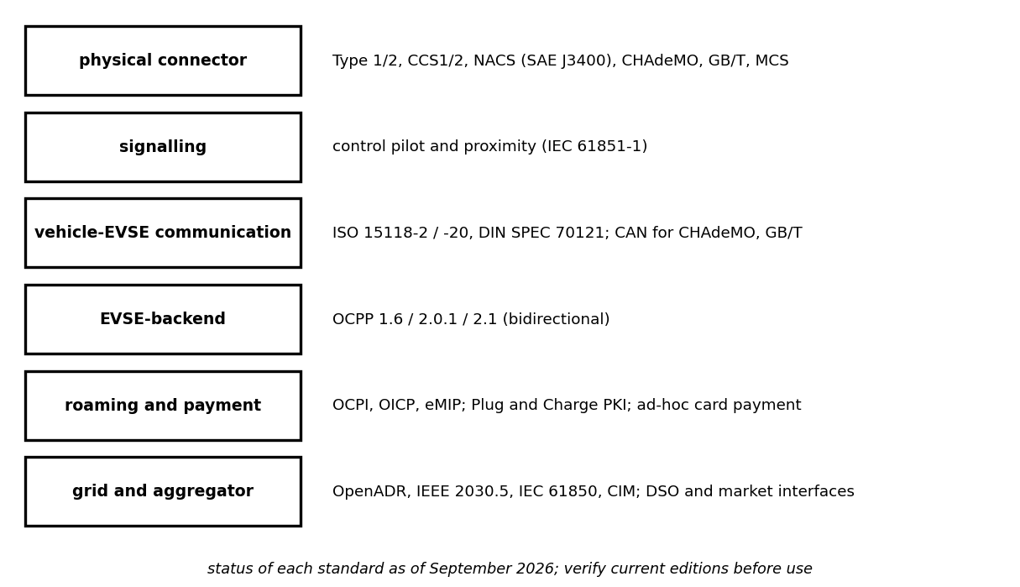
Figure 10.19. The interoperability stack of EV charging, from physical connector through signalling, vehicle-EVSE communication, EVSE-backend, roaming and payment to grid and aggregator interfaces.
Table 10.6. Layers of EV charging interoperability (status as understood in September 2026; verify current editions before use)
Layer | Main standards | Status and notes
physical connector | IEC 62196 (Type 1, Type 2, CCS1/CCS2), SAE J3400 (NACS), CHAdeMO, GB/T 20234, MCS for trucks | CCS2 dominant in Europe and India; J3400 spreading in North America; MCS for megawatt charging
signalling | IEC 61851-1 control pilot and proximity | established; defines the PWM current offer (10.9)
vehicle-EVSE communication | DIN SPEC 70121; ISO 15118-2 (2014); ISO 15118-20 (2022) | -20 adds bidirectional power transfer and schedules; CHAdeMO and GB/T use CAN
EVSE-backend | OCPP 1.6, 2.0.1 (also IEC 63584), 2.1 (2025) | 2.1 adds bidirectional charging and local energy management functions
roaming and payment | OCPI, OICP, eMIP; Plug and Charge (ISO 15118 PKI) | several roaming protocols coexist; ad hoc payment required by some regulations
grid and aggregator | OpenADR, IEEE 2030.5, IEC 61850, CIM (IEC 61968/61970) | choice depends on market and network operator

The sequence of a DC session shows how the layers interlock (Figure 10.20): plug-in and pilot state change; power-line communication link; authorization through the backend (or Plug and Charge with certificates); parameter discovery, in which the vehicle states its energy needs and limits; profile setting, in which the backend may cap power; insulation check and precharge; the current-demand loop; metering; and the stop sequence with contactor welding detection. Every message carries data the twin needs: the vehicle's requested current is its battery twin speaking, and the backend's charging profile is the site twin speaking.
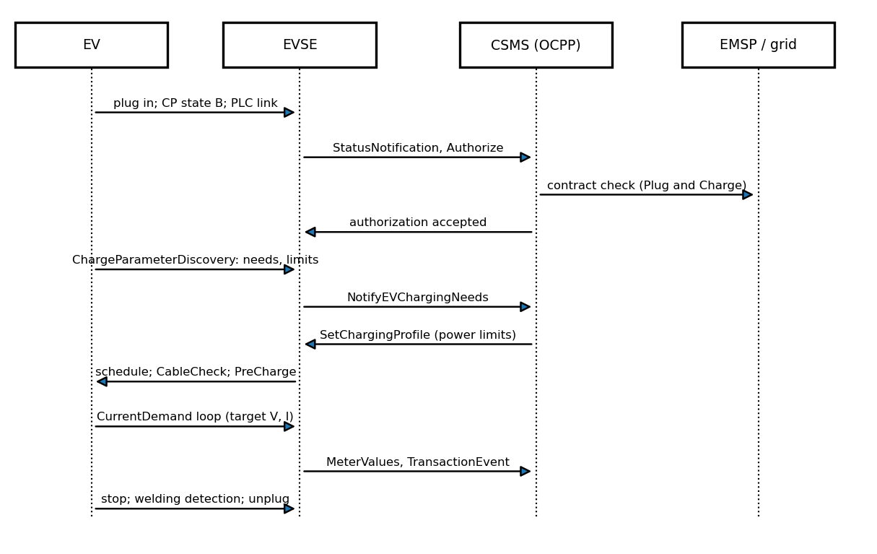
Figure 10.20. Simplified sequence of a DC charging session between the vehicle, the EVSE, the charging-station management system (OCPP) and the mobility-service and grid side.
Security. Each interface is an attack surface: a forged state of charge can steer a smart-charging optimizer, a compromised backend can switch thousands of chargers at once, and a manipulated meter defeats billing. ISO 15118 uses TLS and a public-key infrastructure for Plug and Charge, and OCPP 2.x defines security profiles; the twin adds plausibility checks across layers (a requested current inconsistent with the vehicle's reported SOC and temperature, a load step inconsistent with session messages), which Chapter 14 develops.
What the digital twin adds
Synchronized: session messages across all six layers with physical measurements.
Estimated or updated: vehicle needs, departure times, backend limits, protocol health.
Uncertainty carried: missing or inconsistent messages, version mismatches.
Decision enabled: interoperability diagnosis, plausibility checks, profile control.
Validated by: conformance testing, interoperability events, field session logs.

10.11 Vehicle-to-grid: control, capability, flexibility and cost

10.11.1 Controlling a bidirectional charger
A bidirectional charger can deliver power from the battery to the grid (V2G) or to a home (V2H). Its grid-side converter is the VSC of Chapter 7 (Section 7.4.4), controlled in a frame rotating with the grid voltage, which a phase-locked loop (PLL) aligns with the $d$ axis. With filter inductance $L$ and resistance $R$, grid voltage amplitude $V_{d}$ and converter voltages $v_{d}$, $v_{q}$, the current equations and the power exchanged with the grid follow directly (Figure 10.21):
$L\frac{di_{d}}{dt}=V_{d}−v_{d}−Ri_{d}+ωLi_{q}, L\frac{di_{q}}{dt}=−v_{q}−Ri_{q}−ωLi_{d}, P=\frac{3}{2}V_{d}i_{d}, Q=\frac{3}{2}V_{d}i_{q}$ (10.15)
with $P>0$ when the vehicle charges (power drawn from the grid, with the current counted from the grid into the charger) and $Q>0$ when the charger injects reactive power, in the amplitude-invariant transform of Chapter 7 (Section 7.11). Because $P$ depends only on $i_{d}$ and $Q$ only on $i_{q}$, two PI controllers with decoupling ($±ωL$ terms) and grid-voltage feedforward control them independently; placing the controller zero on the plant pole gives a first-order closed loop of bandwidth $ω_{b}$ with
$K_{p}=Lω_{b}, K_{i}=Rω_{b}, i_{d}^{*}=\frac{2P^{*}}{3V_{d}}, i_{q}^{*}=\frac{2Q^{*}}{3V_{d}}$ (10.16)
Example 10.11 (Level B) Current control of an 11 kW bidirectional charger
Given. Three-phase 230 V (phase RMS) grid, $V_{d}=325$ V; $L=3$ mH, $R=0.05$ Ω; bandwidth 800 Hz; averaged converter model. Commands: charge at 11 kW, reverse to −11 kW at 50 ms, then 8 kW with 6 kvar injection at 100 ms.
Find. The PI gains, the current references and the response time of the power reversal.
Solution. $K_{p}=0.003×2π×800=15.1$ Ω and $K_{i}=0.05×5027=251$ Ω/s. $i_{d}^{*}=2×11 000/(3×325)=22.5$ A; for 6 kvar, $i_{q}^{*}=12.3$ A. In simulation the power reverses from +11 to −11 kW and passes 90 % of the step in about 0.5 ms (ln 10 divided by the bandwidth, 0.46 ms, for the ideal first-order loop); $P$ and $Q$ settle at 8.0 kW and 6.0 kvar without interaction (Figure 10.21).
Interpretation. The converter can reverse its full power in about a millisecond: its speed is never the limit for grid services; the battery, the vehicle's mobility needs and the network are.
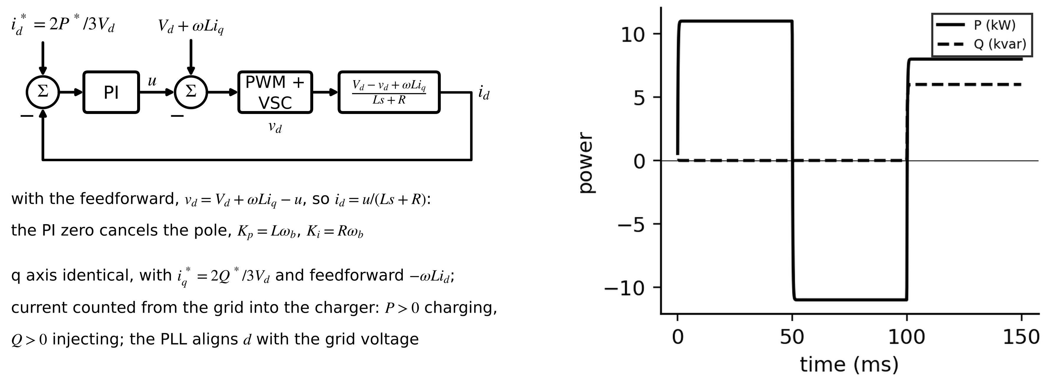
Figure 10.21. Left: d-axis current loop of a grid-following bidirectional charger with decoupling and grid-voltage feedforward, current counted from the grid into the charger (the q axis is identical). Right: active and reactive power during a charge, a full reversal to V2G and a combined P-Q command.

10.11.2 Capability: what P and Q are possible
Four limits shape the P-Q capability (Figure 10.22): the converter's apparent-power rating; the battery's discharge and charge power (its SOP, Chapter 9) and the SOC reserve; and the converter's voltage, because injecting reactive power needs a converter voltage above the grid's, which the DC-link voltage bounds. With the space-vector limit of Chapter 7,
$P^{2}+Q^{2}≤S_{max}^{2}, −P_{dis}^{max}≤P≤P_{ch}^{max}, \sqrt{{\left(V_{d}−Ri_{d}+ωLi_{q}\right)}^{2}+{\left(Ri_{q}+ωLi_{d}\right)}^{2}}≤\frac{m_{max}V_{dc}}{\sqrt{3}}$ (10.17)
With $V_{dc}=650$ V and $m_{max}=0.95$ the converter can supply 356 V and inject the full 11 kvar; at 600 V it can supply only 329 V, 4 V above the grid, which allows about 2 kvar of injection, while absorbing reactive power remains unrestricted. A twin that knows the battery voltage (and hence the DC-link voltage the DAB can sustain) knows when the charger can support grid voltage.
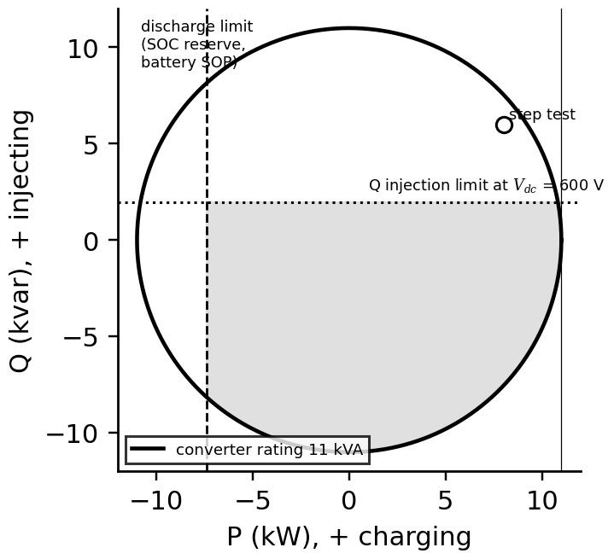
Figure 10.22. P-Q capability of the 11 kVA bidirectional charger: the converter rating, a discharge limit from the SOC reserve and battery SOP, and the reactive-injection limit at a 600 V DC link; the shaded region is feasible.

10.11.3 The mobility-constrained flexibility envelope
A plugged-in vehicle's battery is the driver's before it is the grid's. With stored energy $E(t)$, charging and discharging power limits $P_{ch}$, $P_{dis}$ and efficiency $η$, a minimum reserve $E_{min}$ for unplanned trips, and a departure energy $E_{d}$ required at time $t_{d}$, every feasible trajectory lies in an envelope (Figure 10.23):
$max\left[E_{min}, E_{0}-\frac{P_{dis}}{η}\left(t-t_{0}\right), E_{d}-ηP_{ch}\left(t_{d}-t\right)\right]≤E(t)≤min\left[E_{cap}, E_{0}+ηP_{ch}\left(t-t_{0}\right)\right]$ (10.18)
The lower bound's last term is the key: from any time $t$, charging at full power must still reach $E_{d}$ by $t_{d}$. An aggregator schedules within the envelope; a departure-time forecast error moves its right-hand corner and is the main source of risk (Section 10.12).
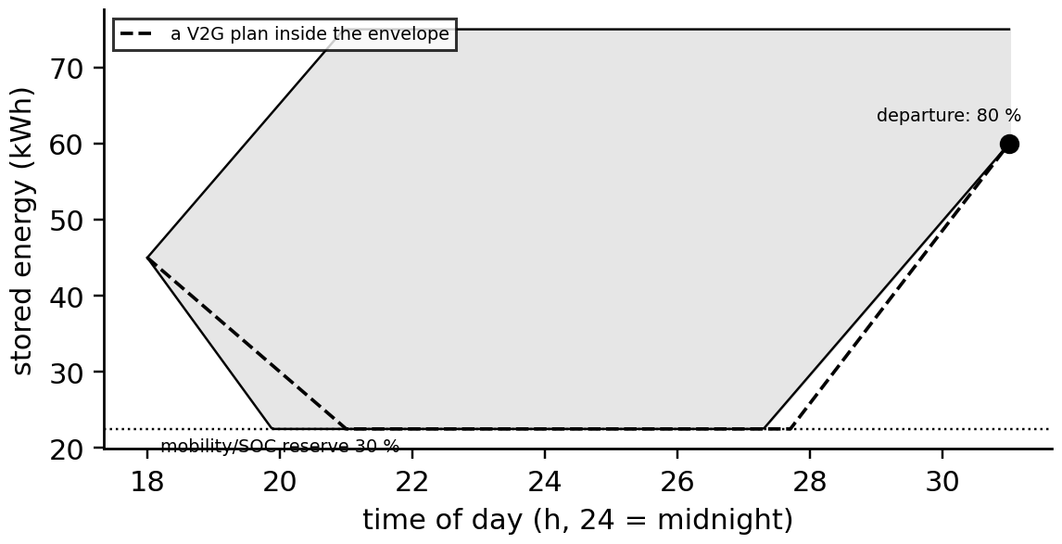
Figure 10.23. Flexibility envelope of a plugged-in P-1 SUV from 18:00 to 07:00: the feasible stored energy between the charging and discharging limits, the 30 % mobility reserve and the departure requirement of 80 %, with a V2G plan inside it.

10.11.4 Degradation and network constraints
Each V2G kilowatt-hour costs battery life. Using the ageing law of Chapter 9 (Section 9.8) with throughput weighted by depth of discharge, shallow V2G cycles cost far less per kilowatt-hour than deep ones (Figure 10.24). The net value of one kilowatt-hour delivered to the grid, sold at $p_{s}$, bought back at $p_{b}$ through round-trip losses, and charged a degradation cost $c_{deg}$ per kilowatt-hour discharged, is
$v=p_{s}-\frac{p_{b}}{η^{2}}-\frac{c_{deg}}{η}, c_{deg}=\frac{C_{bat}}{E_{use}}·\frac{∂L/∂N}{L_{EOL}}$ (10.19)
On the network, a vehicle injecting power raises the voltage at its connection point. For a feeder of resistance $R_{f}$ and reactance $X_{f}$ at voltage $V$, the rise is $ΔV≈(PR_{f}+QX_{f})/V$; reactive absorption ($Q<0$) offsets part of the active-power rise, which is why the capability of Figure 10.22 matters to the network operator.
Example 10.12 (Level B) An evening of V2G from a P-1 fleet vehicle
Given. The SUV plugs in at 18:00 with 60 % of 75 kWh and leaves at 07:00 needing 80 %; 11 kW, 92 % efficiency each way; 30 % reserve. Evening price 0.30 USD/kWh, night price 0.10 USD/kWh; battery cost 9250 USD with 0.008 % loss per equivalent full cycle against a 20 % budget.
Find. The energy available for V2G, the recharge time, the degradation cost per kWh and the net value of the evening.
Solution. Down to 30 %: 22.5 kWh from the battery, 20.7 kWh at the grid, so the reserve, not the 11 kW, limits the service. Recharging to 80 % (37.5 kWh) takes $37.5/(11×0.92)=3.7$ hours, well inside the night, so (10.18) holds. $c_{deg}=9250×0.008/20=3.70$ USD per equivalent full cycle of 75 kWh, 0.049 USD per kWh discharged. (10.19): $v=0.30-0.10/{0.92}^{2}-0.049/0.92=0.30-0.118-0.054=0.128$ USD/kWh, about 2.66 USD for the evening.
Interpretation. V2G pays when the price spread exceeds round-trip losses plus degradation, here with 0.13 USD/kWh to spare. Over ten years (Figure 10.24), daily shallow V2G raises capacity loss from 10.2 % to 12.0 %, about the same as habitual fast charging (12.9 %), while daily deep cycling raises it to 19.8 %: the twin should offer the battery for shallow services and price deep ones accordingly.
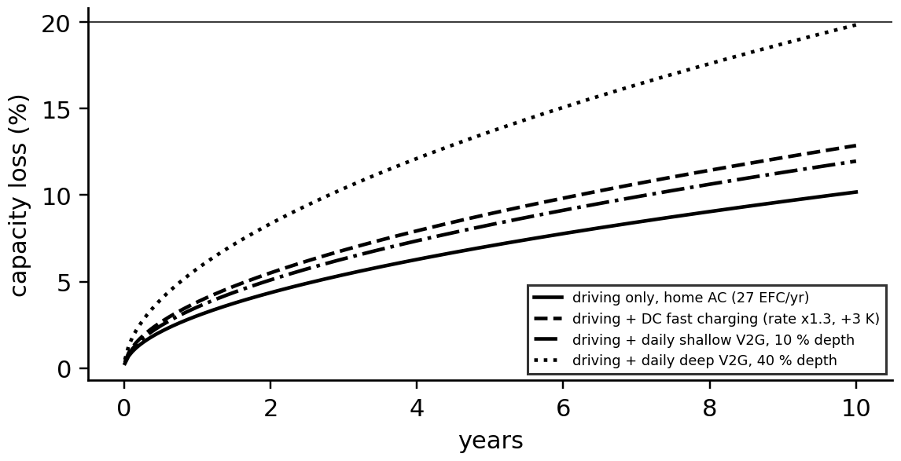
Figure 10.24. Ten-year capacity loss of the P-1 SUV pack under driving with home AC charging, with habitual DC fast charging, with daily shallow V2G and with daily deep V2G (calendar and depth-weighted cycle ageing).
Example 10.13 (Level B) EV charging on a residential feeder
Given. Homes with 7.4 kW chargers; arrival times $𝒩(18:30,1.5 h)$; daily distance lognormal with mean 40 km at 0.16 kWh/km and 92 % efficiency; uncontrolled charging (seed 2026).
Find. The after-diversity maximum demand (ADMD) per vehicle and the coincidence factor for 1, 10, 100 and 1000 vehicles.
Solution. 7.4 kW (factor 1.0) for one vehicle; 3.1 kW (0.41) for 10; 2.0 kW (0.28) for 100; 1.8 kW (0.24) for 1000.
Interpretation. A feeder with 100 EV homes must carry about 200 kW of EV load at peak, not the 740 kW the charger ratings suggest; managed charging lowers it further and shifts it past the evening residential peak, which raises the feeder's hosting capacity for EVs.
What the digital twin adds
Synchronized: converter currents, battery state, plug-in times and network voltages.
Estimated or updated: P-Q capability, flexibility envelope, degradation cost.
Uncertainty carried: departure times, prices, ageing-law uncertainty.
Decision enabled: V2G offers, reactive support, pricing of deep cycles.
Validated by: HIL tests of the charger, metered V2G sessions, battery ageing monitoring.

10.12 Smart charging and the transformer

10.12.1 The scheduling problem
Thirty cars arriving at a car park around nine o'clock will, left alone, all charge at once and overload a transformer that also feeds the building. Since most stay for eight hours and need two or three hours of charging, the power can be spread. With charging power $P_{i,k}$ of vehicle $i$ in slot $k$ of length $Δt$, building load $B_{k}$, price $p_{k}$, demand charge $c_{D}$ (per kW of peak), charger limit $P_{max}$, presence indicator $a_{i,k}$, efficiency $η$ and energy need $E_{i}$, a linear program schedules them:
$\min_{P,\hat{P}} \sum_{k}{\sum_{i}{p_{k}}}P_{i,k}Δt+c_{D}\hat{P} s.t. B_{k}+\sum_{i}{P_{i,k}}≤\hat{P}, 0≤P_{i,k}≤a_{i,k}P_{max}, η\sum_{k}{P_{i,k}}Δt=E_{i}$ (10.20)
The auxiliary variable $\hat{P}$ is the peak that the demand charge prices. Transformer limits can be added as a constraint on the peak, but they are better handled through the transformer's thermal model, because transformers tolerate short overloads and age according to temperature, not load.

10.12.2 Transformer thermal ageing
The insulation of an oil-immersed transformer ages with its hot-spot temperature. IEC 60076-7 [10] models the top-oil rise as a first-order response to the load factor $K=S/S_{r}$, adds a hot-spot gradient, and expresses relative ageing by a doubling every 6 K above 98 °C:
$τ_{TO}\frac{dθ_{TO}}{dt}=θ_{a}+Δθ_{TO,R}{\left(\frac{1+R_{L}K^{2}}{1+R_{L}}\right)}^{n}-θ_{TO}, θ_{H}=θ_{TO}+Δθ_{H,R}K^{2m}, V=2^{\left(θ_{H}-98\right)/6}$ (10.21)
with $R_{L}$ the ratio of load to no-load losses at rated current, $Δθ_{TO,R}$ and $Δθ_{H,R}$ the rated top-oil and hot-spot rises, exponents $n$, $m$ and ambient $θ_{a}$; the loss of life over a day is $\int{V} dt$, one day of normal ageing per day at a constant 98 °C. The model is for oil-immersed units of normal paper; thermally upgraded paper uses a different law (Arrhenius with a 110 °C reference), and dry-type transformers have their own standard.
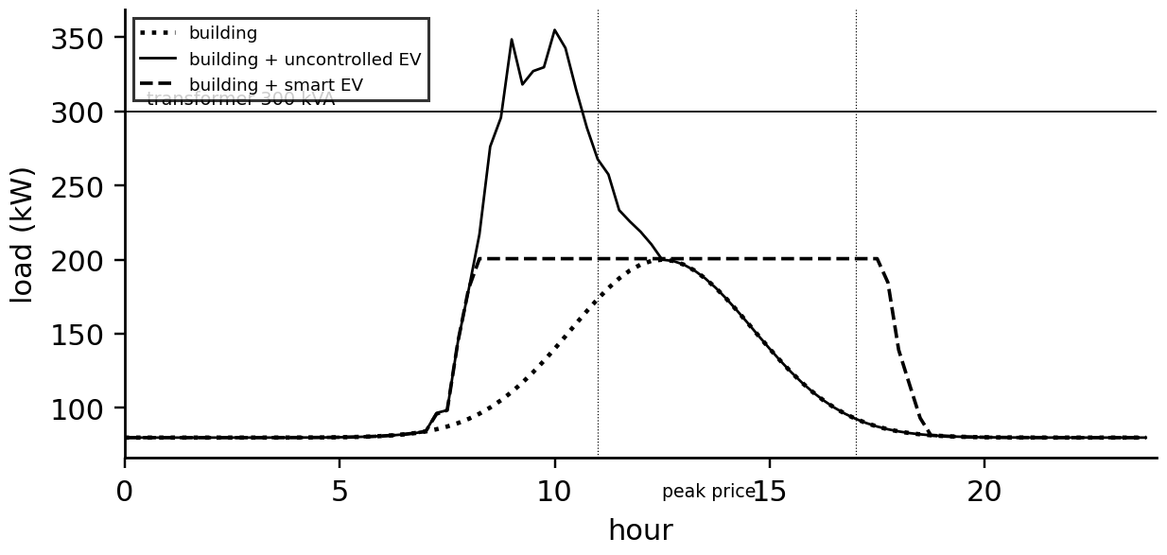
Figure 10.25. The P-1 car park over a day: building load, building plus uncontrolled EV charging, which exceeds the 300 kVA transformer rating, and building plus smart charging, which fills the valley below the building peak.
Example 10.14 (Level C) Smart charging in the P-1 car park
Given. Thirty vehicles (seed 2026) arriving between 07:00 and 10:00 and leaving between 16:00 and 19:00, needing 8 to 30 kWh (616 kWh drawn in total) at 11 kW and 93 % efficiency; building load peaking at 200 kW at 12:30; 300 kVA transformer; prices 0.15 USD/kWh before 07:00 and after 17:00, 0.20 until 11:00 and 0.28 from 11:00 to 17:00; demand charge 15 USD/kW per month; transformer $R_{L}=4.87$, $Δθ_{TO,R}=55$ K, $Δθ_{H,R}=25$ K, $n=m=0.8$, $τ_{TO}=3$ h, ambient 30 °C; 15-minute slots.
Find. Peak, energy cost, demand charge, hot spot and daily ageing for uncontrolled and smart charging.
Solution. Uncontrolled: peak 355 kW, 18 % above the rating for 1.75 hours; energy cost 129 USD/day; demand charge 5325 USD/month; hot spot 102 °C; ageing 3.0 equivalent hours per day. Smart charging by (10.20): peak 201 kW (the building's own peak); energy cost 136 USD/day; demand charge 3010 USD/month; hot spot 76 °C; ageing 0.67 hours per day (Figure 10.25, Figure 10.26).
Interpretation. The optimizer accepts 7 USD/day more energy cost to save 2315 USD/month in demand charges and cuts transformer ageing by a factor of 4.5. It needs only the cars' energy needs and departure times, which is precisely what the vehicle-EVSE communication of Section 10.10 can supply.
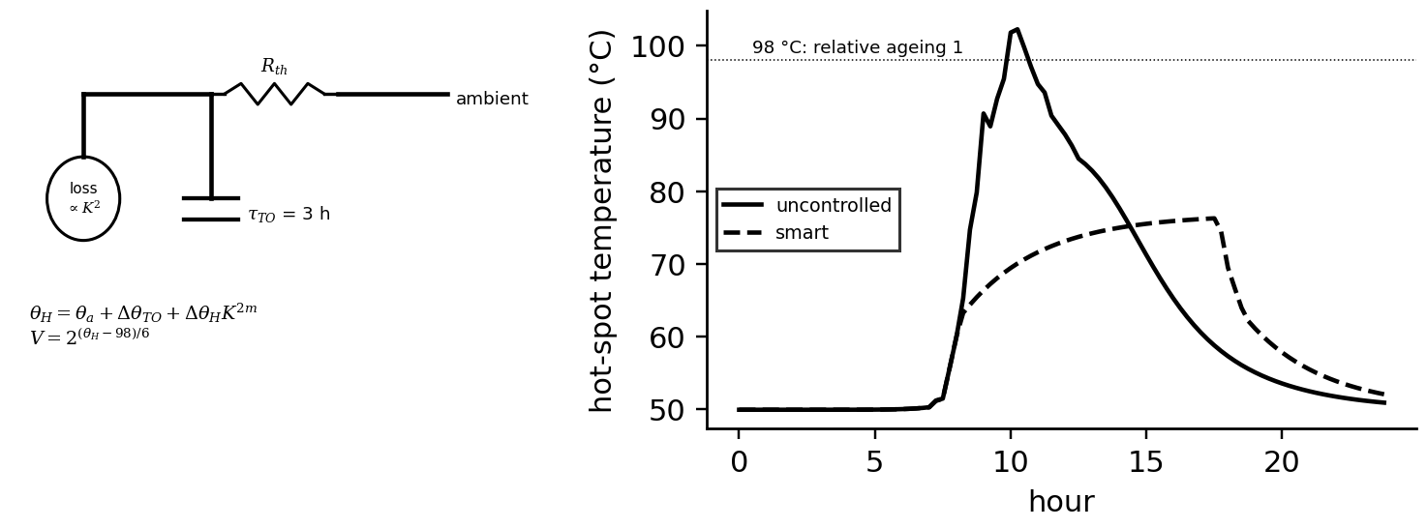
Figure 10.26. Left: first-order thermal model of the transformer from IEC 60076-7. Right: hot-spot temperature over the day with uncontrolled and smart charging, against the 98 °C reference.

10.12.3 Uncertain departures
The schedule assumes departure times; people leave early. A deterministic plan that defers charging until just before the forecast departure leaves early leavers short. A chance-constrained plan requires each vehicle's energy to be delivered before a low quantile of its departure distribution, $P(t_{dep,i}<{\tilde{t}}_{i})≤ε$, which for a normal forecast error with bias $b$ and standard deviation $σ$ means planning to ${\tilde{t}}_{i}={\hat{t}}_{i}+b-z_{1-ε}σ$.
Example 10.15 (Level C) Deterministic against uncertainty-aware smart charging
Given. The car park of Example 10.14; actual departures differ from the forecast by $𝒩(-15 min,45 min)$. The deterministic plan uses forecast departures; the uncertainty-aware plan uses the 10 % quantile ($-15-1.28×45=-73$ min). Both are evaluated over 300 sampled days.
Find. The fraction of vehicles leaving with less than 98 % of their energy, and the peak.
Solution. Deterministic: 45 % of vehicles leave short. Uncertainty-aware: 6 %, with the peak rising from 201 to 217 kW.
Interpretation. Sixteen kilowatts of peak buy reliability for drivers; the twin's departure forecast and its calibrated uncertainty are worth as much as the optimizer.
What the digital twin adds
Synchronized: arrivals, departures, energy needs, building load and transformer temperature.
Estimated or updated: schedules, peak, hot spot, ageing, departure-time distributions.
Uncertainty carried: departure and energy-need forecasts through chance constraints.
Decision enabled: charging profiles sent through OCPP, demand-charge management.
Validated by: metered peaks, transformer temperature sensors, delivered energy per vehicle.

10.13 The charging-hub twin

10.13.1 Queueing
How many chargers does a hub need? If drivers arrive at random at rate $λ$ per hour and each session lasts an exponentially distributed time with mean $1/μ$, the hub is an M/M/c queue (Figure 10.27). Balance of probability flows between states (number of vehicles present) gives the Erlang C formula for the probability that an arriving driver must wait, and the mean wait follows:
$ρ=\frac{λ}{cμ}<1, P_{wait}=\frac{\frac{a^{c}}{c!(1-ρ)}}{\sum_{k=0}^{c-1}{\frac{a^{k}}{k!}}+\frac{a^{c}}{c!(1-ρ)}}, a=\frac{λ}{μ}, W_{q}=\frac{P_{wait}}{cμ-λ}$ (10.22)
Sessions are not exponential: a fast charge from 10 to 80 % takes 20 to 40 minutes with a modest spread. For general session times with coefficient of variation $c_{s}$, the Allen-Cunneen approximation scales the M/M/c wait, $W_{q}≈W_{q}^{M/M/c}(1+c_{s}^{2})/2$, and a discrete-event simulation (DES) gives the full distribution, including peaks in arrivals, reservations and power limits.
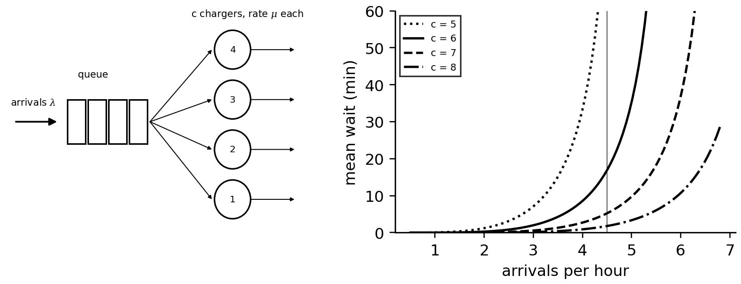
Figure 10.27. Left: a charging hub as a queue with $c$ chargers. Right: mean waiting time against arrival rate for 5 to 8 chargers with one-hour mean sessions (M/M/c).
Example 10.16 (Level A) How many fast chargers the P-1 gate hub needs
Given. 4.5 arrivals per hour at the busiest time; mean session 60 minutes.
Find. Utilization, probability of waiting and mean wait for 5 to 8 chargers.
Solution. Five: $ρ=0.90$, 76 % wait, 91.5 minutes. Six: 0.75, 42 %, 16.9 minutes. Seven: 0.64, 22 %, 5.2 minutes. Eight: 0.56, 10 %, 1.8 minutes.
Interpretation. Waiting falls steeply with each charger near saturation: the sixth charger cuts the mean wait from 91 to 17 minutes. The choice between six and seven is a service-level decision, which the DES and the hub's revenue model inform.
Example 10.17 (Level C) Discrete-event simulation against Erlang C
Given. 4.5 arrivals per hour; sessions either exponential or lognormal with mean 1 h and coefficient of variation 0.3; 20 000 simulated hours.
Find. Probability of waiting, mean wait and the 95 % quantile of waiting for six and seven chargers.
Solution. Exponential sessions reproduce Erlang C (six chargers: 42 % wait, 17.1 minutes; seven: 22 %, 5.2 minutes). Lognormal sessions: six chargers 40 % and 10.0 minutes, 95 % quantile 49 minutes; seven chargers 21 % and 3.2 minutes, 95 % quantile 22 minutes (Figure 10.28). Allen-Cunneen predicts 9.2 and 2.8 minutes.
Interpretation. Erlang C overestimates waits for regular sessions by about 70 %; sizing on it buys an unneeded charger. The DES, fed by session times from the charging twin of Section 10.7, is the hub twin's planning core.
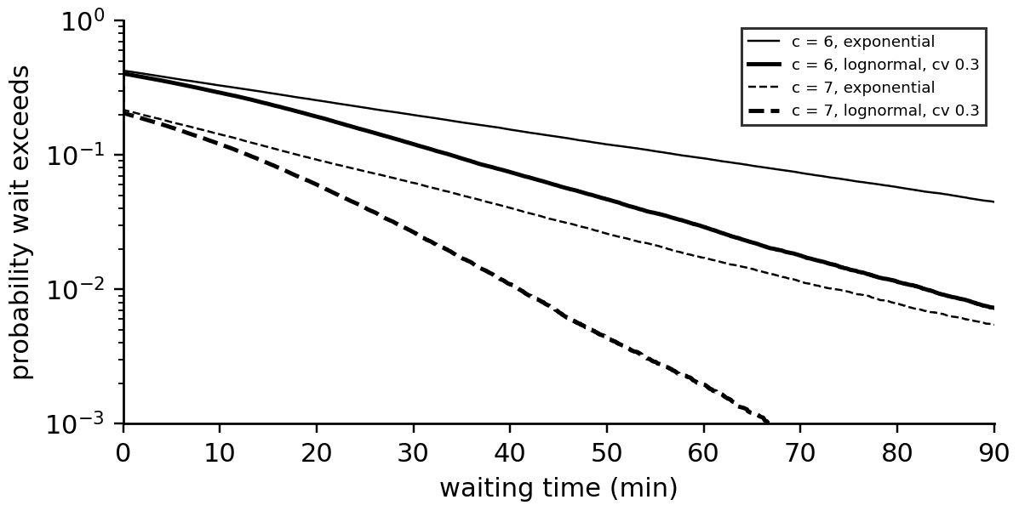
Figure 10.28. Discrete-event simulation of the gate hub: probability that the wait exceeds a given time, for six and seven chargers, with exponential and with more regular (lognormal, coefficient of variation 0.3) sessions.

10.13.2 PV, storage and demand charges
A hub's grid connection and demand charge are often its largest fixed costs. PV reduces the energy bought; a battery shaves the peaks the queue creates (Figure 10.29). For a peak threshold $P_{th}$, the battery must supply the power and energy above it:
$P_{B}≥\max_{t}\left(P_{hub}(t)-P_{PV}(t)-P_{th}\right), E_{B}≥\max_{events}\int{{\left(P_{hub}-P_{PV}-P_{th}\right)}^{+}}dt / \left(η ΔSOC\right)$ (10.23)
Example 10.18 (Level B) Peak shaving at the gate hub
Given. Six 150 kW chargers; 30 sessions on a synthetic day (seed 2026), with arrivals from 06:00 to 22:00 peaking at about 3 per hour in the morning and 4.5 per hour at 17:00, arrival SOC uniform from 10 to 30 %, charging to 80 % on a curve that approximates the 25 °C, 150 kW curve of Figure 10.15; 300 kWp of PV; a 15 USD/kW monthly demand charge on the 15-minute mean import.
Find. The uncontrolled peak, the net peak with PV, the battery needed to hold 300 kW and the monthly saving.
Solution. The sessions draw 1.39 MWh and no driver waits. The charging demand peaks at 663 kW over one minute and at 534 kW as a 15-minute mean, at 17:45. PV lowers the net 15-minute peak only to 453 kW, because the busiest quarter-hour falls in the evening, when the array gives 81 kW. Holding 300 kW needs 153 kW of battery power and 45 kWh of usable energy, recharged from the midday PV surplus; with margins for busier days, a 200 kW / 100 kWh battery holds the threshold (Figure 10.29). The demand charge falls by $\left(534−300\right)×15=3510$ USD per month, of which PV alone gives 1215 USD.
Interpretation. PV reduces the energy bought but not the evening peak that sets the demand charge; the battery's size follows from the queue's peaks, which follow from the arrival statistics, so hub sizing couples the simulation, the charging curves and the storage twin (Chapter 9). The one-minute peak is what the grid connection and its protection see; the 15-minute mean is what the tariff bills. Reservations, which make arrivals less random, reduce both waits and peaks.
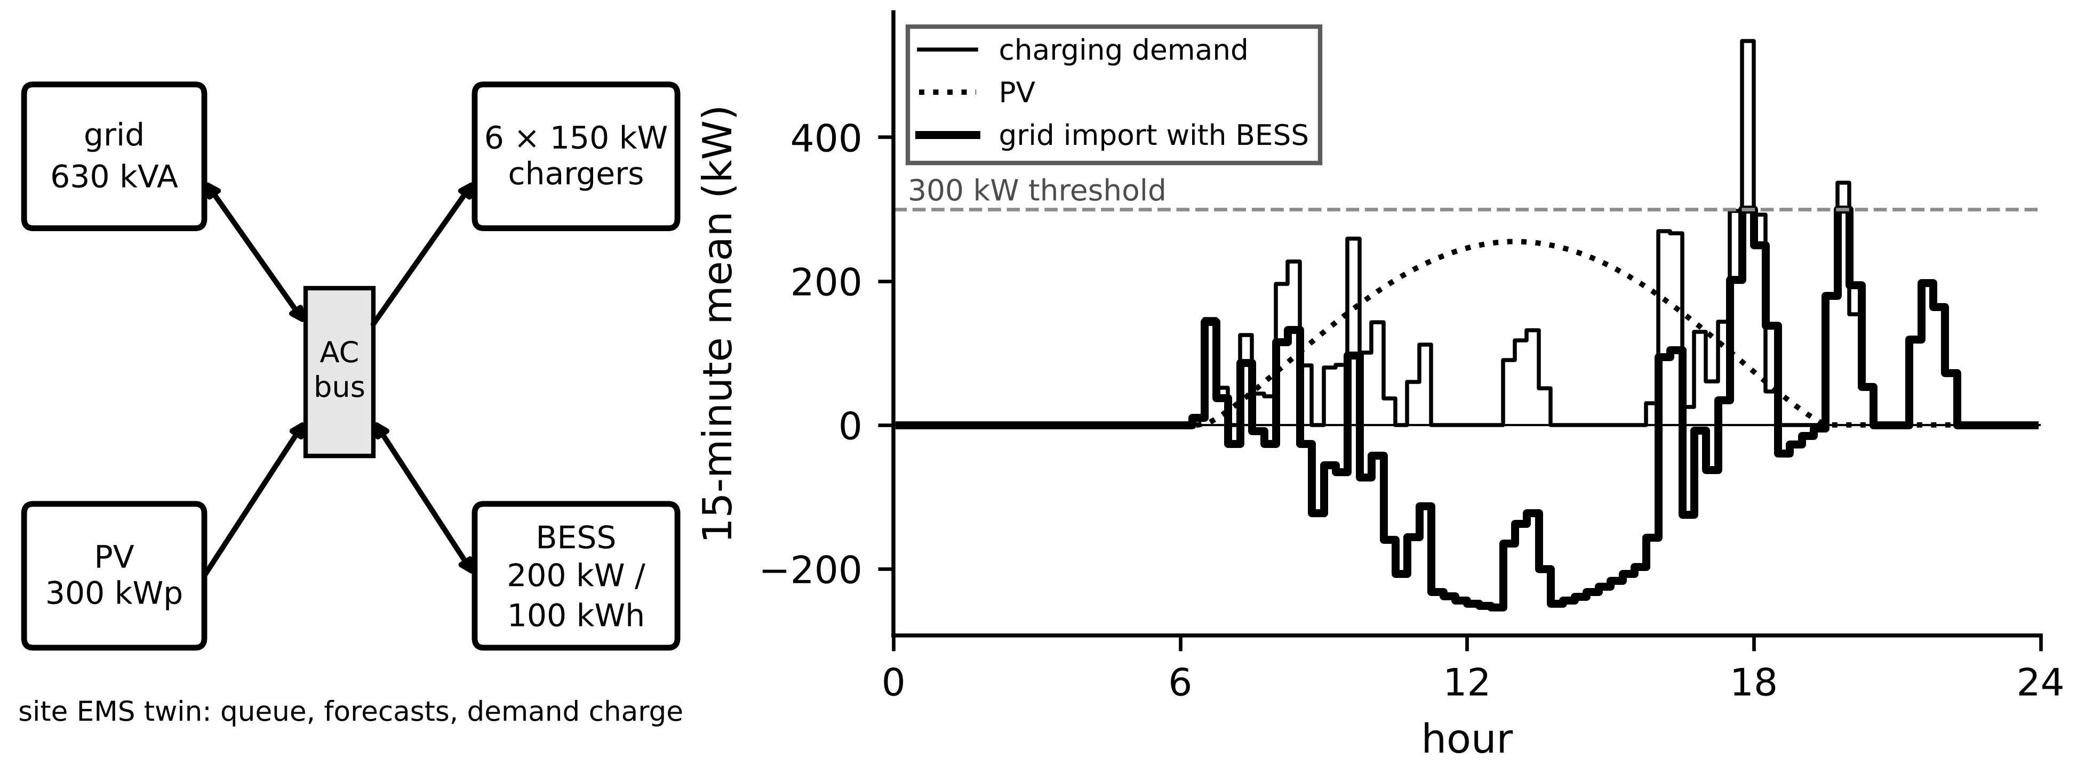
Figure 10.29. Left: a PV-BESS-EV hub. Right: one synthetic day of charging demand (15-minute mean), PV output and grid import with the 200 kW / 100 kWh battery holding a 300 kW threshold (negative import is PV export).
What the digital twin adds
Synchronized: queue, sessions, PV, battery and grid import.
Estimated or updated: waiting-time distributions, peaks, battery needs.
Uncertainty carried: arrival and session-time distributions; simulation confidence.
Decision enabled: number of chargers, battery and connection sizing, reservations, pricing.
Validated by: observed queues and waits, metered peaks.

10.14 Flagship: the charging-ecosystem twin
The previous sections modelled the vehicle, the charger, the station, the transformer and the user separately. Their behaviour is coupled: the vehicle's range and route decide when and at what SOC and temperature it arrives; its battery's state decides its charging curve; the curves and the arrivals decide the queue and the power; the power decides the transformer's temperature and the demand charge; the site's limits feed back into every session's power; and the backend's prices and reservations change when drivers arrive. A charging-ecosystem twin couples these models and synchronizes each with its own data (Table 10.7). Its distinctive capability is to act across these interfaces: tell a vehicle to precondition because the hub will be busy, or cap the site because the transformer is hot, knowing what each action does to every other part.
Table 10.7. Coupling in the charging-ecosystem twin
Model | Inputs from other models | Outputs to other models | Data that synchronize it
vehicle energy and range (10.3 to 10.6) | route, weather, HVAC | arrival time, SOC, pack temperature | trip logs, telematics
battery and charging curve (10.7, 10.8) | arrival SOC and temperature, preconditioning | session power profile and duration | ISO 15118 requests, BMS data
charger and station (10.9) | session requests, site cap | module allocation, losses, faults | converter and connector telemetry
hub queue and DES (10.13) | arrivals, session durations | waits, simultaneous sessions, load | OCPP sessions, reservations
site, transformer and storage (10.12, 10.13) | hub load, PV, building load | peak, hot spot, demand charge, power cap | meters, transformer temperature
grid and market (10.11) | site load and flexibility | prices, limits, V2G requests | DSO and aggregator signals

Example 10.19 (Level C) A winter afternoon at the P-1 gate hub
Given. Six 150 kW chargers; arrivals from 06:00 to 22:00 at up to 7.2 per hour (seed 11); arrival SOC 10, 20 or 30 %; packs at 0 °C unless preconditioned to 25 °C; session curves from Example 10.8 and Example 10.9. Four policies: (1) cold packs with the manufacturer map; (2) the ecosystem twin triggers navigation-based preconditioning, which 80 % of drivers accept; (3) as (2) with the health-aware charge; (4) as (3) with a 450 kW site cap that the transformer model calls for.
Find. Share of drivers waiting more than a minute, mean wait, mean session, peak power and summed plating exposure over the 73 sessions.
Solution. (1) 27 % wait, mean 4.7 minutes; sessions 44.9 minutes; peak 427 kW; plating 1789 V·s. (2) 1 % wait, 0.7 minutes; sessions 27.4 minutes; peak 693 kW; plating 339 V·s from the unconditioned 20 %. (3) 5 % wait, 0.8 minutes; sessions 27.1 minutes; peak 689 kW; no plating. (4) 11 % wait, 1.2 minutes; sessions 30.1 minutes; peak 450 kW; no plating.
Interpretation. Preconditioning, a vehicle-side action triggered by the site twin, shortens sessions by 40 % and shrinks the queue; it also raises the peak, because warm packs accept more power, which the transformer twin then caps at a cost of three minutes per session. The health-aware charge removes plating at no cost in time. No single twin would find this combination: each policy's benefit and side effect lives in a different model.
What the digital twin adds
Synchronized: vehicles, chargers, queue, site and grid models, each with its own data.
Estimated or updated: arrivals, sessions, waits, peaks, hot spots, plating exposure.
Uncertainty carried: arrival and preconditioning behaviour, weather, session curves.
Decision enabled: cross-asset actions such as preconditioning requests, site caps, reservations and pricing.
Validated by: each model on its own data, then the coupled twin against site-level outcomes.

10.15 Fault detection at the vehicle-charger interface
Faults at this interface are costly: a degrading connector overheats, a current-sensor offset corrupts SOC and billing, a weak chiller lengthens every session, an insulation fault trips the charger. The twin predicts each measured quantity from its models at the same inputs and monitors the residuals (Figure 10.30); which residuals fire isolates the fault (Table 10.8). For the connector, the steady temperature rise $ΔT_{c}=I^{2}R_{c}R_{th,c}$ of (10.12) gives a contact-resistance estimate from every session:
${\hat{R}}_{c}=\frac{ΔT_{c}^{meas}}{I^{2}R_{th,c}}, r_{k}=\frac{y_{k}-{\hat{y}}_{k}}{σ_{y}}, g_{k}=max\left(0,g_{k-1}+r_{k}-κ\right)$ (10.24)
with a CUSUM statistic $g_{k}$ on the normalized residual (Chapter 5, Section 5.12).
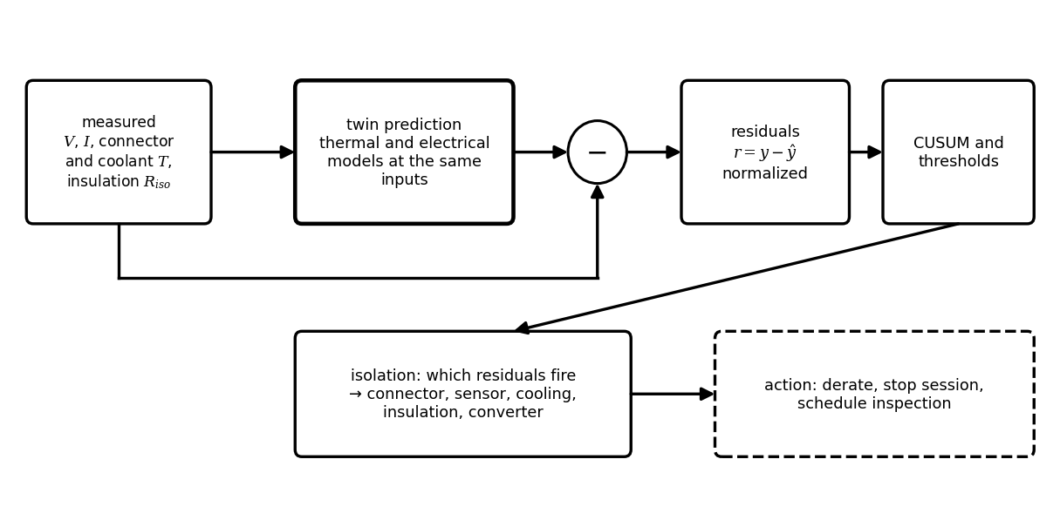
Figure 10.30. Residual-based fault detection: measurements are compared with the twin's predictions at the same inputs; normalized residuals feed CUSUM tests, and the pattern of firing residuals isolates the fault and selects the action.
Table 10.8. Fault signatures at the EV-charger interface
Fault | Residual that fires | Separating evidence | Action
connector contact degradation | connector temperature above $I^{2}R_{c}R_{th,c}$ | rise scales with $I^{2}$; coolant normal | derate, inspect, replace pin
current-sensor offset | charger and vehicle energy disagree | constant difference independent of current | recalibrate; correct billing
cooling degradation | pack or cable temperature rises faster than model | coolant flow or chiller power low | derate, maintain
insulation degradation | insulation resistance trend falling | humidity correlation; one session or all | stop, isolate, inspect
converter module fault | module efficiency or temperature residual | one module only | disable module, reallocate

Example 10.20 (Level A) A connector that is getting hot
Given. A DC connector with $R_{th,c}=0.5$ K/W normally rises 24 K at 400 A ($R_{c}=0.30$ mΩ). Today it rises 39 K at the same current.
Find. The estimated contact resistance and the current that keeps the rise below 40 K.
Solution. (10.24): ${\hat{R}}_{c}=39/({400}^{2}×0.5)=0.49$ mΩ, up 63 %. (10.12): $I_{max}=\sqrt{40/(0.49×{10}^{-3}×0.5)}=404$ A, against 516 A when healthy.
Interpretation. One session's residual is enough to derate the connector to about 400 A and schedule inspection before it melts; without the twin the first symptom would be a failed session or a burnt pin.
What the digital twin adds
Synchronized: measured temperatures, currents, energies and insulation with model predictions.
Estimated or updated: contact resistance, sensor offsets, cooling capacity, insulation trend.
Uncertainty carried: residual noise and thresholds; false-alarm rate.
Decision enabled: derating, session stop, maintenance scheduling, billing correction.
Validated by: injected-fault tests in HIL, maintenance findings.

10.16 Real-time partition, security and data governance
The twin runs on three layers at different speeds (Figure 10.31). In the vehicle, the BMS, inverter and thermal controllers run their estimators in milliseconds to seconds and decide the current request. At the charger and site edge, converter control, connector thermal models, insulation monitoring and the site EMS run in seconds to minutes and allocate power within transformer and connection limits. In the cloud and backend, fleet ageing, range statistics, smart-charging optimization, forecasting, roaming and billing run in minutes to days. Each slower layer sets limits and schedules for the faster ones, through ISO 15118 between vehicle and charger and OCPP between charger and backend. Data governance follows the same partition: vehicle data are personal data (location, habits) and must be minimized and protected when they leave the vehicle; security relies on the protocol-level protections of Section 10.10 plus the twin's cross-layer plausibility checks (Chapter 14).
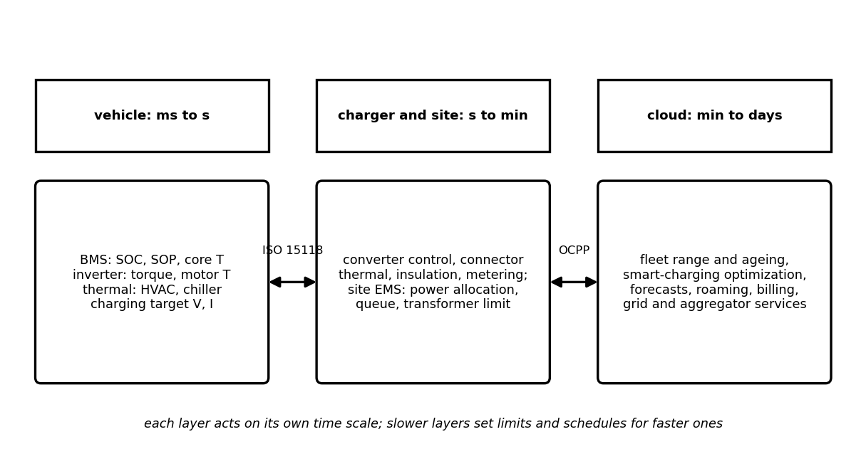
Figure 10.31. Partition of the EV and charging twin across vehicle, charger and site edge, and cloud and backend, with their time scales and the protocols that connect them.

10.17 Validation from software to field
A twin that couples many models must be validated rung by rung before the coupled system is trusted (Figure 10.32). Model and software in the loop: vehicle and battery models against reference data (coast-downs, dynamometer maps, cell tests), and algorithms in software. Controller HIL: the real BMS, VCU or charger controller against a real-time model of its plant, with injected faults (sensor offsets, connector heating, communication loss). Communication and backend testbeds: ISO 15118 and OCPP conformance and interoperability testing, including security profiles. Power HIL: a real charger or battery emulator against a simulated grid and vehicle, which tests V2G anti-islanding and grid-code behaviour safely; PHIL interface stability (Chapter 7, Section 7.17) must be checked first. Site pilot: the EMS, transformer and queue twins against meters at one site. Fleet field data: range intervals, charging curves and ageing forecasts against operation, with coverage of their stated uncertainty. Table 10.9 records the evidence from this chapter, including what is not yet validated.
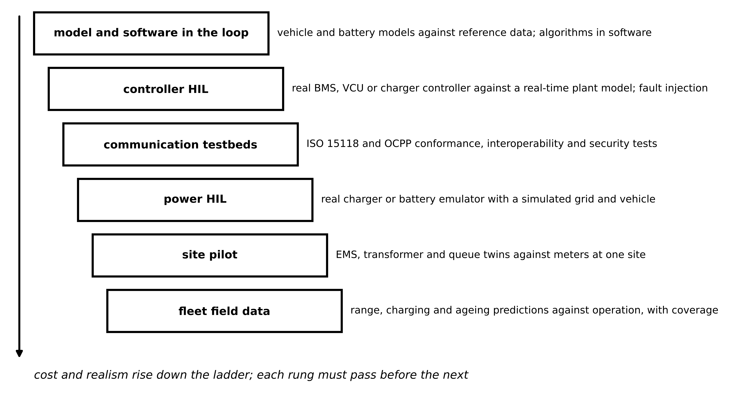
Figure 10.32. Validation ladder of the EV and charging twin, from model and software in the loop through controller HIL, communication testbeds, power HIL and site pilots to fleet field data.
Table 10.9. Validation scorecard of the P-1 EV and charging twin (synthetic data; criteria are examples)
Function | Evidence | Criterion | Result
road-load identification | Example 10.2 | $C_{d}A_{f}$ within 3 % | trajectory fit −1.5 % (pass); derivative regression +3.2 % (fail)
range model | Example 10.5, Example 10.6 | map-based; HVAC included | urban +8 % vs constant efficiency (constant efficiency fails)
range interval | Example 10.7 | coverage near 90 % on held-out trips | interval computed; field coverage to be measured
fast-charge prediction | Example 10.8 | session time within 5 % | to be validated against logged sessions
health-aware charging | Example 10.9 | no plating; core ≤ 45 °C | met in simulation; plating margin needs teardown evidence
bidirectional control | Example 10.11 | P/Q steps decoupled, < 5 ms | about 0.5 ms, no interaction (pass in simulation; HIL pending)
smart charging | Example 10.14, Example 10.15 | peak ≤ transformer rating; ≤ 5 % vehicles short | peak met; 6 % short (marginal)
hub sizing | Example 10.16, Example 10.17 | DES agrees with observed waits | to be validated at the pilot site
fault detection | Example 10.20 | detect 50 % rise in $R_{c}$ in one session | detected (single example; statistics pending)

What the digital twin adds
Synchronized: each model with its own reference data before coupling.
Estimated or updated: validation evidence per rung, renewed with each model change.
Uncertainty carried: coverage checks of stated intervals.
Decision enabled: deployment gates for each twin function.
Validated by: the ladder itself, with failures recorded.

10.18 Recent developments and open research problems
Electric mobility is one of the fastest-moving fields that twins serve; each development is labelled with its status in 2026. The 2026 reviews of energy twins stress interoperability (CIM, IEC 61850), hierarchical and federated architectures, adaptive synchronization and the move from descriptive to prescriptive twins [1], [2], [3], and ITU-T Y.4517 defines continuous synchronization and standardized interfaces for grid twins [4]; charging ecosystems are a natural test of all of them.
Vehicles. 800 V platforms with SiC inverters (established in new models), heat pumps with battery-integrated thermal management (established), and navigation-triggered preconditioning (established in leading products). Charging. Megawatt charging for trucks (emerging), the spread of the SAE J3400 connector in North America (established), ISO 15118-20 and OCPP 2.1 enabling bidirectional and locally managed charging (emerging deployment), and Plug and Charge (established, growing). V2G and V2H. Bidirectional AC and DC chargers with grid-code-compliant inverters (emerging), aggregators bidding fleets into frequency and flexibility markets (pilots to early commercial), and school-bus and depot fleets as the first large V2G resources (emerging). Twins. Fleet range and ageing twins (established in large fleets), health-aware charging using estimated anode potential (emerging, validation open), and digital twins of hubs and their grid connections for planning and operation (emerging).
Verified results behind these directions. A simulation study of uncoordinated home charging, built on measured household load and travel data, found that charging can substantially raise residential peak demand and that its impact on distribution transformers depends strongly on charging power and on how many vehicles share a transformer [11], which is the effect Example 10.13 quantifies with after-diversity demand. A review of fast charging traced its limits from the electrode particle to the pack and identified lithium plating, heat and low temperature as the binding constraints [12], the same constraints that the health-aware twin of Section 10.8 evaluates on estimated states; a closed-loop combination of early life prediction and Bayesian optimization has shown how charging protocols can be searched with far fewer cell tests than exhaustive experiments [13]. The economic framing of vehicle-to-grid used in Section 10.11 goes back to an analysis that derived the basic capacity and revenue equations and concluded that V2G suits fast, high-value services better than bulk energy [14]; ageing experiments on commercial cells under added bidirectional cycling confirmed that V2G accelerates capacity fade and that the size of the penalty depends on the depth and frequency of cycling [15], which is why (10.19) prices degradation per kilowatt-hour. On the protocol side, OCPP 2.1, released in January 2025 with bidirectional and local energy-management functions, has been published by the IEC as IEC 63584-210:2025 [16], and the megawatt charging system for heavy vehicles was issued as SAE J3271 in March 2025 [9].
Table 10.10. Roadmap of EV and charging twins: maturity and measurable research targets
Direction | Status | Measurable target
health-aware fast charging in the field | emerging | plating detected in teardown against predicted margin; time saved against maps
navigation-based preconditioning | established in products | session-time reduction against preconditioning energy
V2G with degradation pricing | pilots to early commercial | realized ageing against the twin's forecast over years
hub twins with DES and storage | emerging | predicted against observed waits and peaks at operating sites
charging-ecosystem coordination | research to emerging | combined waits, peaks and plating exposure against siloed control
federated fleet twins | research | model quality without sharing raw personal data

10.19 How this chapter feeds the rest of the book
This chapter combined the converter and machine twins of Chapter 7 and the battery twins of Chapter 9 into vehicles, chargers and hubs, and used the estimators of Chapter 5 and the uncertainty methods of Chapter 6. It hands on to Chapter 11 the flexibility envelopes, smart-charging profiles and aggregated feeder loads that microgrids and distribution networks must absorb; to Chapter 12 the fault signatures of the vehicle-charger interface; to Chapter 13 the scheduling problems (10.20) and (10.18) as building blocks of optimization; and to Chapter 14 the communication interfaces whose security this chapter could only outline.

Chapter summary
The chapter treated an electric vehicle as coupled twins. Its high-voltage architecture, safety chain and the 400 V and 800 V classes framed the vehicle; a free-body diagram gave the road-load equation with rotational inertia; a coast-down identified its coefficients, with trajectory fitting beating derivative regression; and the wheel-to-battery chain with efficiency maps and regenerative limits gave 0.170 kWh/km and 442 km on a mixed cycle, 8 % more urban consumption than constant efficiencies predict. Winter heating cost more range than every other cold effect, a heat pump recovered 38 km, and a 90 % range interval of 303 to 483 km replaced a single number.
Charging was built from AC and DC hardware to the charging curve and its limits: the battery map and cooling, not the charger rating, set a 27-minute session; preconditioning removed a 20-minute winter penalty; and a health-aware twin charged faster than the map when healthy and slower, correctly, when aged and cold, without plating. The chapter organized interoperability from connector to grid, designed dq control and P-Q capability for a bidirectional charger, bounded V2G by a mobility envelope, degradation and network voltage, and scheduled a car park within its transformer's thermal ageing. Queueing, DES and storage sized a hub; the charging-ecosystem twin coupled vehicle, battery, charger, queue, transformer and user, and showed that preconditioning, health-aware charging and site caps interact in ways no single twin can see. Fault residuals, a three-layer partition and a validation ladder from software to field completed the twin.
Table 10.11. Key relationships of Chapter 10
Relationship | Expression | Eq.
Cable loss | $P_{cab}=P^{2}R_{cab}/V^{2}$ | (10.1)
Road load | $mγ_{m}\dot{v}=F_{tr}-F_{roll}-F_{aero}-mgsinθ$ | (10.2)
Rotational inertia | $γ_{m}=1+(J_{w}+G^{2}J_{m})/(mr_{w}^{2})$ | (10.3)
Wheel to battery | motoring divides, regeneration multiplies by $η$; regen cap | (10.4)
Regeneration | $η_{reg}\frac{1}{2}mγ_{m}(v_{1}^{2}-v_{2}^{2})$; force limits | (10.5)
Motor and gear sizing | $F_{w}=ηGT_{m}/r_{w}$; $ω_{b}=P/T$ | (10.6)
Consumption and range | $c=\int{P_{b}} dt/d$; $E_{use}/c$ | (10.7)
HVAC and preconditioning | $\dot{Q}=UAΔT$; $P=\dot{Q}/COP$; $CΔT$ | (10.8)
Control pilot | $I=0.6D$ or $2.5(D-64)$ | (10.9)
Charging limits | $I_{P}$, $I_{V}$, minimum of all limits | (10.10)
Charge time | $\int{3600}Q dz/I$ | (10.11)
Connector limit | $I_{max}=\sqrt{ΔT/(R_{c}R_{th})}$ | (10.12)
Health-aware constraints | plating, core temperature, voltage, equipment | (10.13)
Charger efficiency | $η_{AFE}η_{DC}η_{cab}-P_{aux}/P$ | (10.14)
dq charger model | (10.15) | (10.15)
PI design | $K_{p}=Lω_{b}$, $K_{i}=Rω_{b}$ | (10.16)
P-Q capability | $S$, SOP and DC-link voltage limits | (10.17)
Flexibility envelope | (10.18) | (10.18)
V2G value | $p_{s}-p_{b}/η^{2}-c_{deg}/η$ | (10.19)
Smart charging LP | (10.20) | (10.20)
Transformer ageing | $θ_{H}$; $V=2^{(θ_{H}-98)/6}$ | (10.21)
Erlang C | $P_{wait}$, $W_{q}=P_{wait}/(cμ-λ)$ | (10.22)
Peak shaving | battery power and energy above threshold | (10.23)
Connector resistance; CUSUM | ${\hat{R}}_{c}=ΔT/(I^{2}R_{th})$ | (10.24)

Exercises
The fifteen exercises are grouped by theme. Most combine a derivation, a conceptual question and a numerical part, so that each can be set as one assignment; the last is an open design project that builds the P-1 charging-ecosystem twin. Complete solutions to all fifteen are given in the Answer key.

Group A: the vehicle, its road load and its range
10.1 Road load and rotational inertia. (a) A vehicle of 2100 kg with $C_{rr}=0.011$ travels at 20 m/s up a 3° grade. Find $F_{roll}$ and the grade force. (b) With $C_{d}=0.24$, $A_{f}=2.3$ m² and $ρ_{air}=1.225$ kg/m³, find the drag at 30 m/s in still air. (c) Derive (10.3) from the kinetic energy of the translating and rotating parts, and evaluate $γ_{m}$ for $m=1800$ kg, $r_{w}=0.33$ m, wheels totalling 4.0 kg·m², motor 0.06 kg·m² and $G=10$; explain why $G$ enters squared. (d) A vehicle of 1800 kg ($C_{rr}=0.01$) climbs a 12 % grade slowly. Find the wheel force and the motor torque for $r_{w}=0.33$ m, $G=10$ and $η=0.93$.
10.2 Regeneration and motor sizing. (a) A vehicle of 1850 kg with $γ_{m}=1.05$ decelerates from 25 to 8 m/s with $η_{reg}=0.75$. Find the recoverable energy, ignoring road load during braking. (b) For the motor and gear of Example 10.4, find the steepest grade exactly from $sinθ+C_{rr}cosθ=F_{w,max}/mg$ and compare it with the approximation of (10.6). (c) Find the speed below which regeneration is torque-limited for $F_{w,max}=7.41$ kN and $P_{reg,max}=60$ kW, and explain why a cold or full battery lowers the power limit.
10.3 Consumption, range and speed. (a) A cycle is 40 % urban at 0.14 kWh/km and 60 % highway at 0.21 kWh/km by distance. Find the blended consumption and the range with 75 kWh. (b) Using the Advanced box of Section 10.6.1, derive the speed of minimum consumption and evaluate it for the P-1 SUV with 0.4 kW and with 4.9 kW of accessory load. (c) Explain why the optimum speed rises with accessory load, and why a constant-efficiency model misjudges urban consumption.
10.4 Winter operation. (a) A cabin with $UA=150$ W/K is held at 20 °C at −15 °C. Find the heater power for a PTC heater and for a heat pump of COP 1.7, and the extra energy over a one-hour, 60 km trip on a car using 0.18 kWh/km. (b) Find the heat needed to precondition a pack of 450 kJ/K from −5 °C to 25 °C, and say where it should come from. (c) A fleet twin predicts 0.16 kWh/km, but winter trips measure 0.23 kWh/km. List three causes in order of likely size and the data that would confirm each.

Group B: charging
10.5 AC charging and the charging curve. (a) An EVSE offers 16 A. Find the control-pilot duty cycle, and the current offered at 90 %. (b) In the constant-voltage phase, $V_{max}=410$ V, $U=395$ V and $R_{p}=0.06$ Ω. Find the current. (c) Derive $I_{P}$ in (10.10) from $P=\left(U+IR_{p}\right)I$, and find the current and terminal voltage of a pack at $U=380$ V with $R_{p}=0.06$ Ω charging at 100 kW.
10.6 Voltage class, cables and connectors. (a) Compare the cable loss of 200 kW through 10 mΩ at 400 V and at 800 V. (b) Show that the charging power at a given C-rate is proportional to pack energy and independent of pack voltage, and explain what 800 V changes. (c) A connector with $R_{c}=0.3$ mΩ and $R_{th,c}=0.5$ K/W must stay below a 40 K rise. Find the maximum current, and repeat after $R_{c}$ rises to 0.45 mΩ. (d) A connector's temperature rises 15 K more than usual at 400 A while the vehicle reports a normal battery temperature. Estimate the change in contact resistance and state the action.
10.7 Predicting a fast-charge session. (a) A 75 kWh pack charges from 20 to 80 % on 150 kW. Find the naive time and explain why the real time is longer. (b) The P-1 SUV pack (220 A·h) follows its 25 °C current map: 2C up to 50 % SOC, then a linear taper to 0.7C at 80 %. Using (10.11), derive the time from 10 to 80 % in closed form and compare it with Table 10.5. (c) Explain why the same pack takes longer on a 150 kW charger, even though the map is the same.
10.8 Health-aware charging constraints. For the P-1 pack of Example 10.9 ($N_{p}=2$, graphite potential falling linearly from 0.19 V at 10 % SOC to 0.09 V at 80 %, $R_{n}=0.5$ mΩ per cell at 25 °C with activation temperature 6000 K, $φ_{min}=20$ mV): (a) find the plating-limited pack current at 10 and 80 % SOC at 25 °C and at 10 °C; (b) repeat at 10 °C and 80 % with an uncertainty margin $kσ_{φ}=20$ mV; (c) explain why maximizing the current pointwise minimizes the charging time for a fixed set of constraints, and what changes when a degradation cost is added.

Group C: vehicle-to-grid and the network
10.9 The bidirectional charger. (a) Derive $K_{p}=Lω_{b}$ and $K_{i}=Rω_{b}$ by cancelling the plant pole of $1/\left(Ls+R\right)$ with the PI zero. (b) Evaluate them for $L=3$ mH, $R=0.05$ Ω and an 800 Hz bandwidth, with the 10 to 90 % rise time. (c) An 11 kVA charger on a 325 V grid amplitude with $L=3$ mH and $m_{max}=0.95$: how much reactive power can it inject with a 600 V DC link, and what changes at 650 V?
10.10 Vehicle-to-grid energy and value. (a) An EV plugs in with 70 % of 60 kWh, must not go below 40 % and discharges at 90 % efficiency. How much energy can it deliver to the grid? (b) Derive the lower bound of (10.18) from the requirement to reach $E_{d}$ at $t_{d}$. (c) A V2G vehicle sells at 0.25 USD/kWh and buys back at 0.12 USD/kWh with 90 % efficiency each way and a degradation cost of 0.06 USD per kWh discharged. Is the trade worthwhile?
10.11 Feeders and transformers. (a) A transformer hot spot is 120 °C for two hours and 98 °C for the rest of the day. Find the daily ageing in equivalent hours. (b) Fifty homes each add a 7.4 kW charger. With an after-diversity maximum demand of 2.1 kW per EV, estimate the added peak and compare it with the sum of ratings. (c) Explain why smart charging reduces transformer ageing far more than it reduces the peak.
10.12 Smart charging with uncertain departures. (a) A smart-charging optimizer assumed departures at 17:30, but many drivers leave at 16:00. What goes wrong, and how should the twin change? (b) Departure errors are $N\left(−15 min,45 min\right)$ about the forecast. Find the planning time for a 5 % risk of leaving short. (c) What does the extra margin cost, and how can the twin reduce it?

Group D: hubs, faults and design
10.13 Queueing at a hub. (a) A hub has 4 chargers, 3 arrivals per hour and one-hour sessions. Find $ρ$, $P_{wait}$ and $W_{q}$. (b) Derive the Erlang C formula from the balance equations of the birth-death process. (c) A hub has 6 chargers, 4.5 arrivals per hour and one-hour sessions with coefficient of variation 0.3. Estimate $W_{q}$ with Allen-Cunneen and explain why Erlang C overestimates it.
10.14 Fault detection at the interface. (a) A DC connector with $R_{th,c}=0.5$ K/W rises 30 K at 350 A. Estimate $R_{c}$ and the current that keeps the rise below 40 K. (b) In every session the charger meters 0.4 kWh more than the vehicle's integrated energy, whatever the session length; in another station the difference is 1.2 % of the energy. Which faults do these patterns suggest? (c) Why does a CUSUM test on the normalized residual detect a slow contact degradation earlier than a fixed threshold?
10.15 Design project: the P-1 charging-ecosystem twin. (a) Implement (10.2) and (10.4) with an efficiency map, reproduce Examples 10.5 and 10.6, and identify road load from a synthetic coast-down by trajectory fitting. (b) Implement the charging curve (10.10) with a pack thermal model, reproduce Table 10.5 and add the health-aware constraints (10.13). (c) Solve the car-park problem (10.20) with the transformer model (10.21) and uncertain departures, build the hub simulation with PV and storage, and couple it with the charging curves and preconditioning. (d) Assemble a validation scorecard in the style of Table 10.9 for one of: a V2G school-bus depot, a highway hub, or the ecosystem twin's preconditioning policy, stating criteria before testing and recording failures.

Answer key
10.1 (a) $F_{roll}=0.011×2100×9.81×cos3°=226$ N; grade force $2100×9.81×sin3°=1078$ N, almost five times larger.
(b) $0.5×1.225×0.24×2.3×{30}^{2}=304$ N.
(c) The kinetic energy is $\frac{1}{2}mv^{2}+\frac{1}{2}J_{w}{\left(v/r_{w}\right)}^{2}+\frac{1}{2}J_{m}{\left(Gv/r_{w}\right)}^{2}$; factoring out $\frac{1}{2}mv^{2}$ gives $γ_{m}=1+\left(J_{w}+G^{2}J_{m}\right)/\left(mr_{w}^{2}\right)=1+\left(4.0+0.06×100\right)/\left(1800×{0.33}^{2}\right)=1.051$. The motor turns $G$ times faster than the wheels, and kinetic energy is quadratic in angular speed, so its inertia is weighted by $G^{2}$: here the small rotor contributes more than all four wheels.
(d) $θ=arctan0.12=6.84°$; $F=1800×9.81×\left(0.01cosθ+sinθ\right)=2279$ N; $T_{m}=2279×0.33/\left(0.93×10\right)=80.9$ N·m.
10.2 (a) $0.75×0.5×1.05×1850×\left({25}^{2}−8^{2}\right)=408.6$ kJ, 113.5 Wh.
(b) $F_{w,max}/mg=7413/19 620=0.378$. Solving $sinθ+0.010cosθ=0.378$ gives $θ=21.6°$ (a 40 % grade). The approximation $sinθ_{max}≈F_{w,max}/mg−C_{rr}=0.368$ gives 21.6° as well, because $cosθ$ is close to 1; replacing $sin$ by $tan$ would give 20.2°, which is why (10.6) is written with the sine.
(c) $v=P_{reg,max}/F_{w,max}=60 000/7413=8.1$ m/s, 29 km/h. A cold battery has a higher resistance and a plating limit, and a full battery has little headroom below its maximum voltage, so the battery's charge SOP, which sets $P_{reg,max}$, falls (Chapter 9, Sections 9.7 and 9.11).
10.3 (a) $0.4×0.14+0.6×0.21=0.182$ kWh/km; $75/0.182=412$ km.
(b) $c=a+bv^{2}+P_{acc}/v$ with $b=C_{0}/η$; $dc/dv=0$ gives $v^{*}={\left(P_{acc}/2b\right)}^{1/3}$. With $C_{0}=0.412$ N·s²/m² and $η=0.90$: 7.6 m/s (27 km/h) for 0.4 kW and 17.5 m/s (63 km/h) for 4.9 kW.
(c) Accessory energy per kilometre is $P_{acc}/v$, so a large accessory load rewards finishing the trip sooner, pushing the optimum to higher speed until drag catches up. At light load, which is where town driving operates, fixed and iron losses make the motor's efficiency far below a constant 90 %, so a constant-efficiency model underestimates urban consumption (8 % in Example 10.5).
10.4 (a) $\dot{Q}=150×35=5.25$ kW: 5.25 kW for PTC heating and $5.25/1.7=3.09$ kW for the heat pump. Over one hour, 5.25 or 3.09 kWh against $60×0.18=10.8$ kWh for driving: 49 % or 29 % more energy.
(b) $450×30=13 500$ kJ = 3.75 kWh of heat. It should come from the grid while the car is plugged in, scheduled from the departure time or the navigation destination, so that the battery's own energy is kept for driving.
(c) Cabin heating (largest; confirmed by HVAC power logs against ambient temperature); reduced usable energy and regeneration in the cold (BMS charge-power limits and energy at the end of trips); higher air density and tyre resistance, plus winter tyres and wet roads (ambient data, coast-down or level-road torque regression).
10.5 (a) $D=16/0.6=26.7$ %; at 90 %, $\left(90−64\right)×2.5=65$ A.
(b) $\left(410−395\right)/0.06=250$ A.
(c) $R_{p}I^{2}+UI−P=0$, whose positive root is $I_{P}=\left(−U+\sqrt{U^{2}+4R_{p}P}\right)/\left(2R_{p}\right)$. Numerically $\left[−380+\sqrt{{380}^{2}+4×0.06×{10}^{5}}\right]/0.12=253$ A, and $V=380+253×0.06=395$ V.
10.6 (a) At 400 V: 500 A and ${500}^{2}×0.01=2.5$ kW; at 800 V: 250 A and 0.625 kW, a quarter.
(b) $P=VI=V⋅c_{rate}Q=c_{rate}E$ with $E=VQ$: for the same energy a higher voltage means fewer ampere-hours and the same power at a given C-rate. What 800 V changes is the current, and with it the cable and connector loss and the connector's current limit, so the cell's C-rate limit can be used at high power without exceeding 500 A.
(c) $\sqrt{40/\left(0.3×{10}^{−3}×0.5\right)}=516$ A; with 0.45 mΩ, 422 A.
(d) $ΔR_{c}=15/\left({400}^{2}×0.5\right)=0.19$ mΩ, a rise of about 60 %. Derate the connector to keep the rise below its limit, and schedule an inspection of the pins and contact springs; the normal battery temperature rules out a battery-side cause.
10.7 (a) $0.6×75/150=0.3$ h, 18 minutes. The current map, the constant-voltage phase near full and the battery's temperature hold the power below 150 kW for most of the session, so the real time is longer.
(b) With $Q=220$ A·h, $I=440$ A from 10 to 50 % and $I\left(z\right)=440−953\left(z−0.5\right)$ A from 50 to 80 %: $t=3600Q\left[\frac{0.4}{440}+\frac{1}{953}ln\frac{440}{154}\right]=792 000×\left(0.000909+0.001101\right)=1592$ s = 26.5 minutes, the 350 kW entry of Table 10.5.
(c) At low SOC the pack voltage is low, so 150 kW corresponds to less than 440 A: the charger's power limit binds below about 55 % SOC, and the session takes 27.3 minutes.
10.8 (a) Per cell $I=\left(U_{n}−φ_{min}\right)/R_{n}$, times $N_{p}=2$. At 25 °C: $2×0.17/0.5×{10}^{−3}=680$ A at 10 % and $2×0.07/0.5×{10}^{−3}=280$ A at 80 %. At 10 °C, $R_{n}=0.5exp\left[6000\left(1/283.15−1/298.15\right)\right]=1.45$ mΩ: 234 A and 96 A.
(b) $2×\left(0.09−0.02−0.02\right)/1.45×{10}^{−3}=69$ A: the margin cuts the end-of-charge current by 28 %.
(c) The time (10.11) is $∫3600Q dz/I\left(z\right)$; with constraints that act on each SOC separately, making $I$ as large as allowed at every $z$ minimizes every term of the integral. A degradation cost adds a term that grows with current, so the optimum moves below the constraint boundary where the marginal time saved is worth less than the marginal life consumed.
10.9 (a) Open loop $\frac{K_{p}s+K_{i}}{s}⋅\frac{1}{Ls+R}=\frac{K_{p}\left(s+K_{i}/K_{p}\right)}{s L\left(s+R/L\right)}$; with $K_{i}/K_{p}=R/L$ it becomes $K_{p}/\left(Ls\right)$, and the closed loop $ω_{b}/\left(s+ω_{b}\right)$ with $ω_{b}=K_{p}/L$.
(b) $K_{p}=0.003×2π×800=15.1$ Ω, $K_{i}=0.05×5027=251$ Ω/s; 10 to 90 % rise time $ln9/ω_{b}=0.44$ ms.
(c) At 600 V the converter can produce $0.95×600/\sqrt{3}=329$ V, 4 V above the grid; injecting reactive power needs $V_{d}+ωLi_{q}$, so $i_{q}≤4.1/0.94=4.4$ A and $Q≈\frac{3}{2}×325×4.4=2$ kvar. At 650 V it can produce 356 V, enough for the full 11 kvar ($i_{q}=22.6$ A needs 346 V).
10.10 (a) $\left(0.70−0.40\right)×60×0.90=16.2$ kWh.
(b) If charging at full power from time $t$ is to reach $E_{d}$ by $t_{d}$, then $E\left(t\right)+ηP_{ch}\left(t_{d}−t\right)≥E_{d}$, that is $E\left(t\right)≥E_{d}−ηP_{ch}\left(t_{d}−t\right)$; together with the reserve $E_{min}$ and the fastest possible discharge from $E_{0}$, this is the lower bound of (10.18).
(c) $0.25−0.12/0.81−0.06/0.9=0.25−0.148−0.067=0.035$ USD/kWh: marginally positive; a small extra cost, such as an aggregator fee, makes it negative.
10.11 (a) $V\left(120\right)=2^{22/6}=12.7$; $2×12.7+22×1=47.4$ equivalent hours, about two days of normal ageing in one.
(b) $50×2.1=105$ kW against 370 kW of ratings.
(c) Relative ageing doubles every 6 K of hot spot, and the hot-spot rise grows faster than linearly with load; a modest reduction of the peak therefore removes the hours spent at high temperature, which dominate the day's ageing (in Example 10.14 a 43 % lower peak gives 4.5 times less ageing).
10.12 (a) A plan that defers charging until just before 17:30 leaves early leavers short of energy. The twin should plan to a low quantile of each vehicle's departure distribution (chance constraints), re-optimize as vehicles leave or update their departure, and learn per-driver departure distributions.
(b) $\tilde{t}=\hat{t}+b−z_{0.95}σ=\hat{t}−15−1.645×45=\hat{t}−89$ minutes.
(c) Energy must be delivered earlier, which compresses the schedule and raises the peak (in Example 10.15, from 201 to 217 kW for a 10 % risk). The twin can reduce the margin by narrowing the forecast: asking drivers for departure times through ISO 15118 or an app, and learning individual habits.
10.13 (a) $a=3$, $ρ=0.75$; $P_{wait}=0.509$; $W_{q}=0.509/\left(4−3\right)$ h = 30.6 minutes.
(b) Balance between states $k−1$ and $k$: $λp_{k−1}=min\left(k,c\right)μp_{k}$, so $p_{k}=p_{0}a^{k}/k!$ for $k≤c$ and $p_{k}=p_{c}ρ^{k−c}$ above. Summing the geometric tail, k≥c​pk=p0acc!1−ρ; normalizing with p0−1=k<c​ak/k!+ac/c!1−ρ gives (10.22).
(c) $16.9×\left(1+0.09\right)/2=9.2$ minutes. Erlang C assumes exponential sessions, whose long tail makes chargers stay busy unpredictably; real fast-charge sessions are more regular, so queues clear faster.
10.14 (a) ${\hat{R}}_{c}=30/\left({350}^{2}×0.5\right)=0.49$ mΩ; $I_{max}=\sqrt{40/\left(0.49×{10}^{−3}×0.5\right)}=404$ A.
(b) A constant difference per session, independent of length, points to a fixed per-session error (for example a start or stop timing offset, or energy drawn by the charger's own auxiliaries counted on one side); a difference proportional to energy points to a current or voltage sensor gain error on one side. A current offset gives a difference proportional to session duration. Comparing the residual against session energy, duration and current separates them.
(c) A slow degradation shifts the residual's mean by much less than its noise; a fixed threshold must be set high to avoid false alarms, while the CUSUM accumulates the small shift over many samples and crosses its threshold after a delay inversely proportional to the shift (Chapter 5).
10.15 Open. (a) Graded on reproducing Examples 10.5 and 10.6 within a few per cent and on recovering $C_{d}A_{f}$ within its stated uncertainty.
(b) Graded on reproducing the session times of Table 10.5 and on naming the binding constraint at each SOC.
(c) Graded on meeting the transformer and departure constraints with stated risk and on a hub model whose peaks and waits are reported with uncertainty.
(d) Graded on rungs, measured quantities, acceptance criteria fixed in advance and recorded failures; for a school-bus depot, on route-dependent departure energy and summer V2G availability; for a highway hub, on joint sizing of chargers, storage and grid connection.

References
[1] A. Abuabed and J. Kittur, "A systematic literature review on the use of digital twin technology in electrical engineering research and applications," Front. Smart Grids, vol. 5, Art. no. 1805035, Jun. 2026, doi: 10.3389/frsgr.2026.1805035.
[2] P. R. Satpathy and V. K. Ramachandaramurthy, "Digital twins in energy and power systems: Architectures, applications, enabling tools, and actionable roadmap for utility-scale implementation," Appl. Energy, vol. 420, Art. no. 128129, Oct. 2026, doi: 10.1016/j.apenergy.2026.128129.
[3] R. Manimaran et al., "Recent updates in digital twin driven smart energy systems for intelligent grid integration," Discover Appl. Sci., vol. 8, Art. no. 803, May 2026, doi: 10.1007/s42452-026-08720-z.
[4] ITU-T Recommendation Y.4517 (06/2026), Architecture of the Digital Twin System in Power Grid. Geneva, Switzerland: International Telecommunication Union, 2026.
[5] ISO 6469-3:2021, Electrically Propelled Road Vehicles, Safety Specifications, Part 3: Electrical Safety. Geneva, Switzerland: ISO, 2021.
[6] SAE J2263, Road Load Measurement Using Onboard Anemometry and Coastdown Techniques. Warrendale, PA, USA: SAE International.
[7] Regulation (EU) 2023/1542 of the European Parliament and of the Council concerning batteries and waste batteries, Off. J. Eur. Union, L 191, Jul. 28, 2023.
[8] IEC 61851-1:2017, Electric Vehicle Conductive Charging System, Part 1: General Requirements. Geneva, Switzerland: IEC, 2017.
[9] SAE J3271_202503, SAE Megawatt Charging System for Electric Vehicles (Technical Information Report). Warrendale, PA, USA: SAE International, Mar. 2025.
[10] IEC 60076-7:2018, Power Transformers, Part 7: Loading Guide for Mineral-Oil-Immersed Power Transformers. Geneva, Switzerland: IEC, 2018.
[11] M. Muratori, "Impact of uncoordinated plug-in electric vehicle charging on residential power demand," Nature Energy, vol. 3, no. 3, pp. 193-201, 2018, doi: 10.1038/s41560-017-0074-z.
[12] A. Tomaszewska et al., "Lithium-ion battery fast charging: A review," eTransportation, vol. 1, Art. no. 100011, 2019, doi: 10.1016/j.etran.2019.100011.
[13] P. M. Attia et al., "Closed-loop optimization of fast-charging protocols for batteries with machine learning," Nature, vol. 578, no. 7795, pp. 397-402, 2020, doi: 10.1038/s41586-020-1994-5.
[14] W. Kempton and J. Tomić, "Vehicle-to-grid power fundamentals: Calculating capacity and net revenue," J. Power Sources, vol. 144, no. 1, pp. 268-279, 2005.
[15] M. Dubarry, A. Devie, and K. McKenzie, "Durability and reliability of electric vehicle batteries under electric utility grid operations: Bidirectional charging impact analysis," J. Power Sources, vol. 358, pp. 39-49, 2017, doi: 10.1016/j.jpowsour.2017.05.015.
[16] IEC 63584-210:2025, Open Charge Point Protocol 2.1 (OCPP 2.1, Open Charge Alliance, Jan. 2025). Geneva, Switzerland: IEC, 2025.

