CHAPTER 6
Data-Driven, AI and Physics-Informed Digital Twins

Introduction
Every chapter so far has built the digital twin from physics. Chapter 4 wrote the asset as differential equations, and Chapter 5 kept the states and parameters of those equations synchronized with measurements. Physics is the right foundation because it extrapolates: a thermal model derived from conservation of energy remains valid on a hotter day than any it was calibrated on. Real assets, however, are never described completely. The copper loss of a winding rises with temperature, a battery cell polarizes on several time scales, a converter's losses depend on switching details that no lumped model contains, and the load and weather that drive every energy system cannot be written as equations at all. Where physics is incomplete, data can fill the gap. This chapter is about how to let data in without losing what physics guarantees.
Machine learning entered power and energy engineering long before the current wave of interest. Neural networks were used for short-term load forecasting and for security assessment in the early 1990s, and Kalman filters and least squares, which Chapter 5 treated, are themselves learning from data in the statistical sense. What changed in the last decade is scale and tooling: automatic differentiation, graphics processors and open libraries made it practical to train networks with millions of parameters, and recurrent, convolutional and attention-based architectures (transformers) learned to read long time series, vibration spectra and images. Gaussian processes and ensembles gave learned models a way to state their uncertainty. Since 2019, physics-informed neural networks, neural ordinary differential equations and operator learning have offered ways of building physical laws into learned models, and conformal prediction has offered intervals with guaranteed coverage under stated assumptions. Large time-series models pretrained on many data sets now forecast new series with little task-specific training. Each of these developments is useful to a digital twin, and each fails in a characteristic way that a twin engineer must recognise.
The central difficulty is extrapolation. A learned model is reliable only where it has seen data, and a twin exists precisely to answer questions about conditions that have not yet occurred: the overload, the heatwave, the aged cell, the fault. A network that forecasts a motor winding to within 1.7 K on ordinary days can be wrong by almost 30 K on the first hot day with heavy loading, while a physics model with one added term stays within about 2 K. That contrast, reproduced in this chapter on a ten-day synthetic benchmark, is the organizing idea. Learned components are tested on data they have not seen and in conditions they were not trained on; they state their uncertainty and have it checked; and they are governed through their lives like any other model version, with drift detection, update gates, shadow deployment and rollback.
The chapter is written for two readers. A student meeting machine learning for the first time will find a self-contained primer: how time-series data become samples, features and tensors; why splits must follow time; how linear, ridge and logistic regression are derived and why they are mandatory baselines; how gradient descent and backpropagation train a network; and what convolutional, recurrent, autoencoder, attention and Gaussian-process models do, each with an electrical example, its parameter count and its typical failure. A research reader will find the comparison that matters for twins: parameter learning, residual correction, physics-structured networks, differentiable simulators, physics-informed neural networks, neural ODEs and operator learning, set against each other by data need, extrapolation, online cost and failure mode, and tested on the same problems. The treatment of uncertainty goes from the split between aleatoric and epistemic parts to conformal prediction and its extension to drifting data, and the treatment of deployment covers out-of-distribution testing, continual learning with forgetting checks, compression for edge devices, interpretability and provenance.
Two running examples connect the chapter to the rest of the book. The first is the 30-minute forecast of the winding temperature of motor M-07, the thermal asset of Chapters 1 to 5, generated from the two-node model of Chapter 4 with temperature-dependent copper loss; nine days lie inside the training conditions and a tenth, hotter and more heavily loaded, is held apart as the out-of-distribution test. The second is the battery cell C-1 of Chapter 5, whose one-branch equivalent circuit misses a slow diffusion branch; a physics-guided residual model with five inspectable coefficients brings its voltage error from about 10 mV down to the 2 mV sensor noise, a conformal interval states its uncertainty, and an ageing record tests the drift monitor and the update gate. All data are synthetic and generated from stated seeds, so every number in the chapter can be reproduced and every learned model can be scored against the truth.
Physics-guided learning is the centre of the chapter, and its conclusions are deliberately practical. When the missing physics is known in form, a grey-box parameter beats any learned model inside and outside the training data. When it is known only in kind, such as an unknown first-order lag, physics can choose the features, and a small regression on them reaches the noise floor. When nothing is known, a flexible model may be the only option, but it must then be gated by an out-of-distribution test and fall back to physics where it cannot be trusted. A physics-informed neural network is an expensive solver for a forward problem whose equation is complete; its value lies in inverse problems, and it inherits the identifiability limits of its equation. These results are not arguments against learning. They are arguments for deciding, component by component, where physics ends and learning begins, and for writing that decision into the twin's validation and governance.
After studying this chapter, the reader will be able to prepare twin data correctly, with windows and tensor shapes, scaling fitted on training data only, chronological splits with gaps, and the leakage paths that make a model look better than it is. The reader will be able to derive linear, ridge and logistic regression and use them as baselines, train models by gradient descent and backpropagation, and choose among convolutional, recurrent, autoencoder, attention and Gaussian-process models from their tensor shapes, parameter counts, computation and failure modes. The reader will be able to use self-supervised and transfer learning when labels are scarce, distinguish and compare the forms of physics-guided learning by data need, extrapolation and online cost, and build a physics-guided residual model and a physics-informed neural network while respecting identifiability. The reader will be able to quantify aleatoric and epistemic uncertainty, construct and check conformal intervals, including their adaptive form under drift, and use intervals in decisions. Finally, the reader will be able to make out-of-distribution testing a mandatory gate, govern continual learning with drift detection, update gates, shadow deployment, forgetting checks and rollback, and deploy learned components responsibly through compression, interpretability and provenance records.
How to read this chapter
Sections 6.2 to 6.4 are a primer that assumes only Chapters 4 and 5 and first-year statistics. Paragraphs marked [Advanced] (attention scaling, operator learning, gradient balancing in PINNs, domain-adversarial training) can be skipped on a first reading. Worked examples carry a level: Level A hand-solvable, Level B several coupled effects, Level C noisy data, constraints or real-time computation with every parameter published.
Two running examples connect the chapter to the rest of the book: forecasting the M-07 winding temperature 30 minutes ahead (Chapters 1 to 5), and the battery cell C-1 of Chapter 5, whose physics model misses a slow diffusion branch. All data are synthetic and every number is reproducible from the stated seeds. Methods are labelled established, emerging or research-stage; every major section ends with What the digital twin adds.

6.1 When does a twin need learning?
The thermal twin of motor M-07 forecasts the winding temperature 30 minutes ahead so that an operator can reduce load before the insulation limit is reached (Chapter 1). Its physics model is simple, honest and slightly wrong: it ignores the rise of copper loss with temperature and the fast mode between winding and frame (Chapter 4). A neural network trained on six days of logs forecasts better on ordinary days. On a hot day with heavier loading than anything in its training data, the same network under-predicts the winding temperature by about 28 K, while a physics model with one added term, the temperature dependence of copper loss, stays within about 2 K (Figure 6.27).
That contrast is the subject of this chapter. Data-driven models learn what physics leaves out; physics constrains what data cannot see. The digital-twin question is never ‘physics or AI?’ but which part of the twin each should carry, how the combination is validated, and how it keeps working when the asset, its duty or its sensors change. The 2026 reviews of energy twins describe the same tension as a move from descriptive towards predictive and prescriptive twins, which requires learned components that are calibrated, explainable and governed [1], [2], [3]. Learned models enter a twin in four places: as surrogates of slow physics (Chapter 4, Section 4.13), as corrections of a physics model's systematic error, as detectors of anomalies and faults (Chapter 12), and as forecasters of loads, weather and asset response (Chapter 13). Each use brings the same three obligations, which run through every section below: the model must be tested on data it has not seen, in conditions it was not trained on; it must state its uncertainty honestly; and it must be governed through its life like any other model version (Chapter 2).
What the digital twin adds
Synchronized: nothing new yet; the four roles of learned models are named.
Estimated or updated: which twin functions need learning and which need physics.
Uncertainty carried: the gap between in-distribution and out-of-distribution performance.
Decision enabled: where a learned component is worth its validation cost.
Validated by: the out-of-distribution gate of Section 6.9, from the first experiment on.

6.2 A data primer for twins

6.2.1 Samples, features, targets and windows
A data set is a collection of $N$ samples, each a pair $(x_{n},y_{n})$. The features $x_{n}∈ℝ^{d}$ are what the model sees: measured quantities, derived quantities such as an RMS value, or known future inputs such as a planned load. The target $y_{n}$ is what it must predict: the winding temperature in 30 minutes, the voltage residual of a cell, a fault label. A model $g(x;w)$ with parameters $w$ is trained to minimize the average of a loss $ℓ$ over the training samples, the empirical risk:
$\hat{w}=arg\min_{w}\frac{1}{N}\sum_{n=1}^{N}{ℓ}\left(y_{n},g\left(x_{n};w\right)\right)+λ_{r}Ω(w)$ (6.1)
where $Ω$ is a regularizer weighted by $λ_{r}≥0$ (Section 6.2.4). For the M-07 forecast the features are the present winding temperature, present loss, ambient temperature, the planned mean loss over the next 30 minutes and the forecast mean ambient: $d=5$. Twin data are time series, so samples are cut from sliding windows. A window of $L$ time steps of $d$ channels, taken every $S$ samples (the stride), produces a tensor of shape $N×L×d$ (Figure 6.1); a 10 s vibration burst at 10.24 kHz with three axes is one sample of shape $102 400×3$, usually cut further into shorter windows. Convolutional, recurrent and attention models consume such windows directly; regression models need summary features.
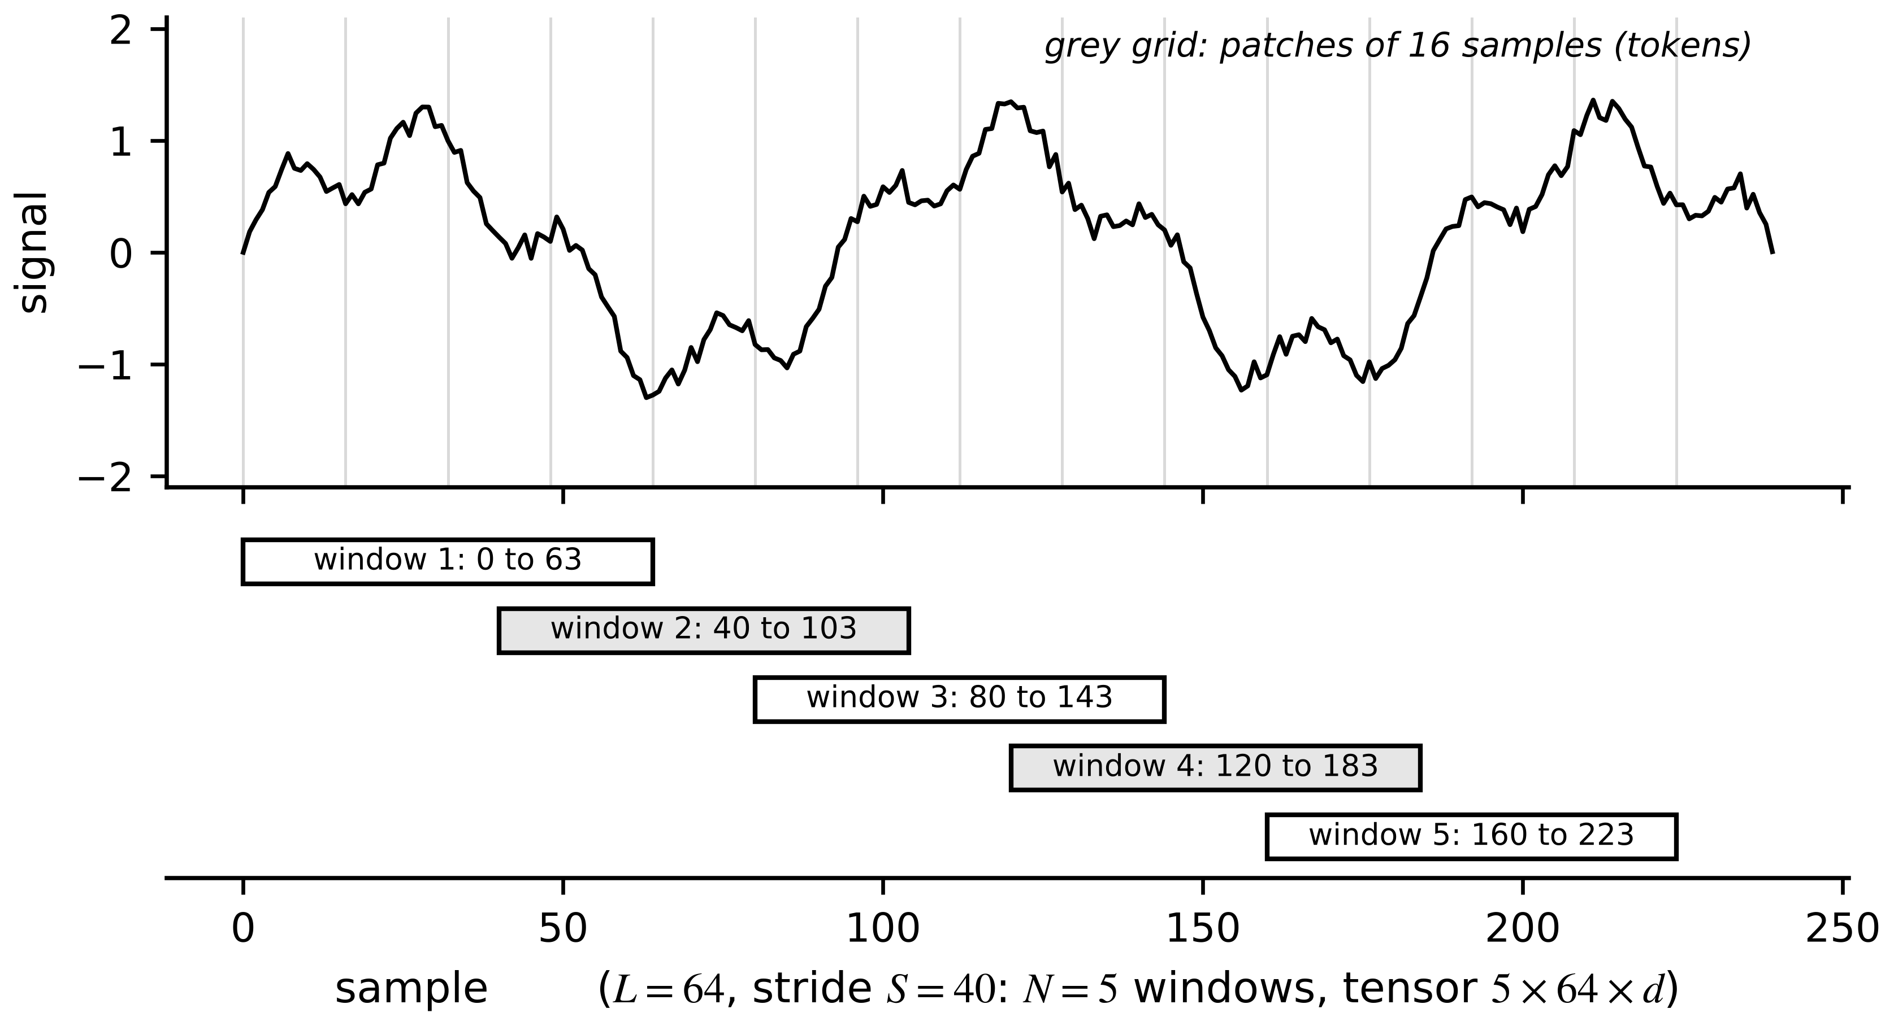
Figure 6.1. Cutting a time series into samples: sliding windows of 64 samples with stride 40 form an $N×L×d$ tensor; a transformer may further split each window into patches that act as tokens.

6.2.2 Normalization
Features with very different scales (kelvin and watts) slow gradient training and distort distance-based models. Standardization subtracts the mean and divides by the standard deviation of each feature, computed on the training data only, and the same constants are applied to validation, test and live data:
${\tilde{x}}_{n,j}=\frac{x_{n,j}-μ_{j}}{s_{j}}, μ_{j}=\frac{1}{N_{tr}}\sum_{n∈𝒟_{tr}}{x_{n,j}}, s_{j}^{2}=\frac{1}{N_{tr}-1}\sum_{n∈𝒟_{tr}}{{\left(x_{n,j}-μ_{j}\right)}^{2}}$ (6.2)
where $𝒟_{tr}$ is the training set and $N_{tr}$ its size. Fitting $μ_{j}$ and $s_{j}$ on all data lets test statistics leak into training, and in a deployed twin the constants must be stored with the model version, because a live feed normalized with different constants is a different model.
Example 6.1 (Level A) Normalization leakage on one input
Given. On the M-07 training days the planned loss has mean 351 W and standard deviation 48 W; over all ten days (including the OOD day) it has mean 361 W and standard deviation 62 W. A live input of 500 W arrives.
Find. The standardized value with training constants and with all-data constants.
Solution. Training constants: $(500-351)/48=3.10$. All-data constants: $(500-361)/62=2.24$.
Interpretation. With all-data constants the model is trained on a version of the world in which 500 W looks ordinary, and its test results will flatter it. With training constants, the live value is correctly seen as far outside the training range, which the OOD test of Section 6.9 can then flag.

6.2.3 Splits, leakage and the out-of-distribution test
A model's error on the data it was trained on says almost nothing about its error in service. Data are therefore split into a training set (fit the parameters), a validation set (choose hyperparameters and stop training) and a test set (report performance once). For time series the split must be chronological (Figure 6.2), with a gap between blocks so that autocorrelation does not carry information across the split; rolling-origin evaluation repeats the split forward in time:
${\hat{ℛ}}_{RO}=\frac{1}{F}\sum_{f=1}^{F}{\frac{1}{\left|𝒯_{f}\right|}}\sum_{n∈𝒯_{f}}{ℓ}\left(y_{n},g\left(x_{n};{\hat{w}}^{(f)}\right)\right)$ (6.3)
where $F$ is the number of folds, ${\hat{w}}^{(f)}$ the model trained on all data before fold $f$ minus a gap, and $𝒯_{f}$ the test samples of fold $f$. Leakage is any path by which information unavailable at prediction time reaches training (Figure 6.3): random splits of correlated samples, scalers fitted on all data, features computed with future values, the same asset or the same day in training and test. A fourth set matters most for a twin: an out-of-distribution (OOD) test set, recorded in conditions the training data do not cover. For M-07 it is a tenth day with 380 to 540 W of loss and about 43 °C ambient, against 250 to 450 W and about 28 °C in training.
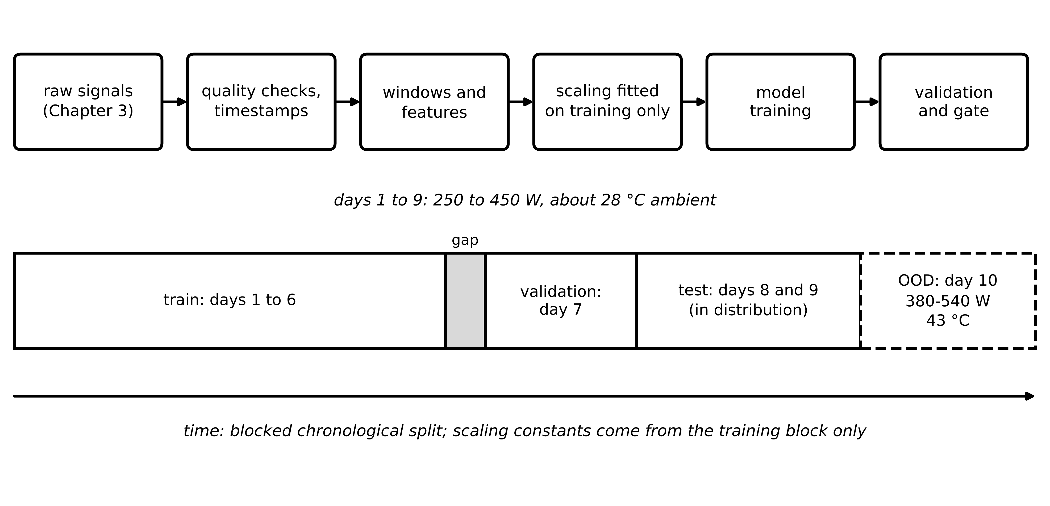
Figure 6.2. Data pipeline and split chronology for the M-07 benchmark. Scaling constants are fitted on training data only; training, validation and in-distribution test days are blocked in time, and an out-of-distribution day is held apart.
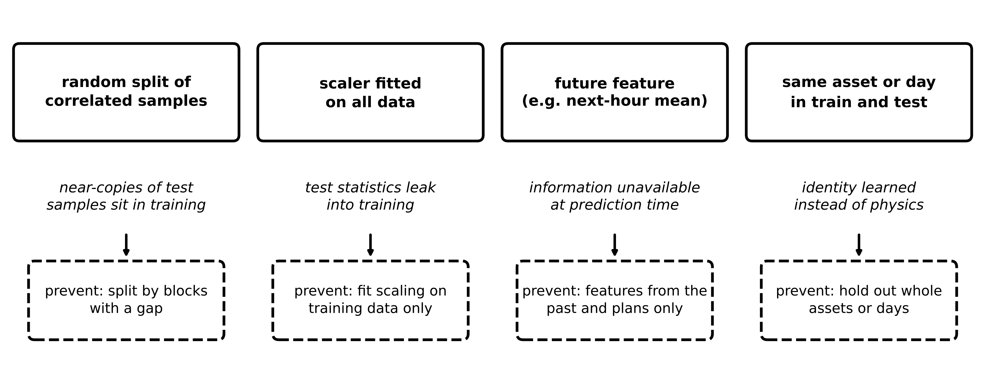
Figure 6.3. Four common leakage paths in twin data. Each makes the test error look better than the error the twin will meet in service.
Example 6.2 (Level B) A random split flatters the model
Given. The synthetic M-07 benchmark of Section 6.7.2: nine days in distribution and one OOD day, 1-minute samples, a 30-minute horizon. The same network (two hidden layers of 32 tanh units) is trained on a random 70 % of the nine days, and on days 1 to 6 only.
Find. The reported test errors and the error on the OOD day.
Solution. The random split reports a test RMSE of 1.07 K; the blocked split, tested on days 8 and 9, reports 1.73 K. On the OOD day both models fail, with about 29.9 K.
Interpretation. The random split reports an error 38 % lower than the honest blocked estimate (1.07 against 1.73 K), because neighbouring minutes are near-copies of one another. Neither split warns about the OOD day; only a separate OOD test does. A report that gives only an in-distribution error is incomplete.

6.2.4 Bias, variance and regularization
Why does a more flexible model not always predict better? For data $y=f(x)+ε$ with noise variance $σ^{2}$, and a model $\hat{g}$ trained on a random training set with average $\overline{g}=𝔼[\hat{g}]$, the expected squared error at a point splits into three parts. Writing $y-\hat{g}=(f-\overline{g})+(\overline{g}-\hat{g})+ε$, squaring and taking expectations, the cross terms vanish because $𝔼[\overline{g}-\hat{g}]=0$ and $ε$ is independent:
$𝔼\left[{\left(y-\hat{g}(x)\right)}^{2}\right]={\left(f(x)-\overline{g}(x)\right)}^{2}+𝔼\left[{\left(\hat{g}(x)-\overline{g}(x)\right)}^{2}\right]+σ^{2}$ (6.4)
The three terms are the squared bias (systematic error of the average model), the variance (how much the model changes from one training set to another) and the irreducible noise.
A rigid model has high bias, a flexible one high variance, and the noise $σ^{2}$ is a floor no model can cross (Figure 6.4). Regularization trades a little bias for less variance, by penalizing large weights, stopping training early on the validation loss, or building in structure, which is where physics enters.
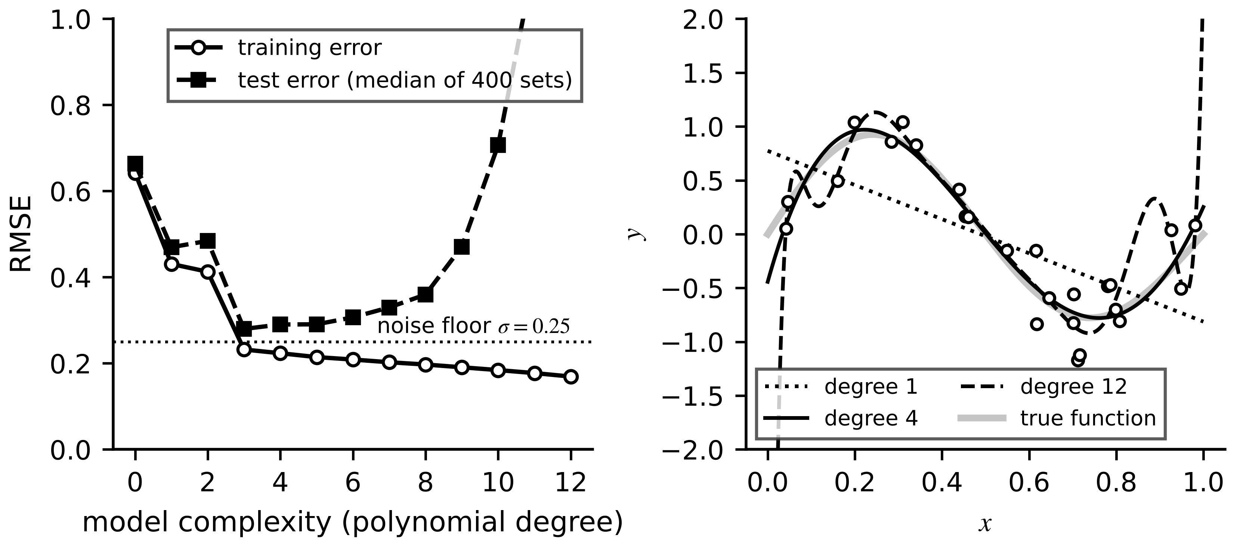
Figure 6.4. Bias and variance. Left: training error falls with complexity while test error has a minimum above the noise floor. Right: under-fitting (degree 1), a good fit (degree 4) and over-fitting (degree 12) on the same 25 noisy points.
What the digital twin adds
Synchronized: training data cut into windows that match what the twin will see live.
Estimated or updated: scaling constants stored with the model version.
Uncertainty carried: honest test error from blocked splits, and a separate OOD error.
Decision enabled: whether a model's reported accuracy can be believed.
Validated by: chronological, gapped splits and an OOD day held apart from the start.

6.3 Baselines: linear, ridge and logistic regression
Every learned twin component must beat a simple baseline, or it has not earned its complexity. Two baselines are mandatory: a linear (or ridge) regression for continuous targets and a logistic regression for classes. Both are fast, interpretable and hard to beat on small data.

6.3.1 Linear and ridge regression
Collect the features in an $N×d$ matrix $X$ (a column of ones for the intercept) and the targets in $y$. Minimizing the squared error plus a penalty $λ_{r}‖w‖^{2}$ and setting the gradient $-2X^{⊤}(y-Xw)+2λ_{r}w$ to zero gives (Chapter 5, Section 5.4.1, for the geometry)
$\hat{w}={\left(X^{⊤}X+λ_{r}I\right)}^{-1}X^{⊤}y, λ_{r}=0 ⇒ {\hat{w}}_{LS}={\left(X^{⊤}X\right)}^{-1}X^{⊤}y$ (6.5)
Ridge regression shrinks the weights towards zero and keeps $X^{⊤}X+λ_{r}I$ invertible when features are correlated; in practice the intercept is not penalized. As $λ_{r}→∞$ all weights vanish; as $λ_{r}→0$ least squares returns.
Example 6.3 (Level A) A linear baseline by hand
Given. A one-parameter model $y=wx$ and data $x=[1,2,3]$, $y=[2.1,3.9,6.2]$.
Find. The least-squares and ridge ($λ_{r}=1$) estimates, and the training mean squared error of each.
Solution. $\sum{x^{2}}=14$, $\sum{x}y=28.5$. Least squares: $\hat{w}=28.5/14=2.036$. Ridge: $\hat{w}=28.5/(14+1)=1.900$ (Figure 6.5). Training MSE: 0.014 for least squares and 0.100 for ridge.
Interpretation. Ridge fits the training data worse on purpose; it pays off when data are few and noisy or features correlated, which is judged on validation data, never on training error.
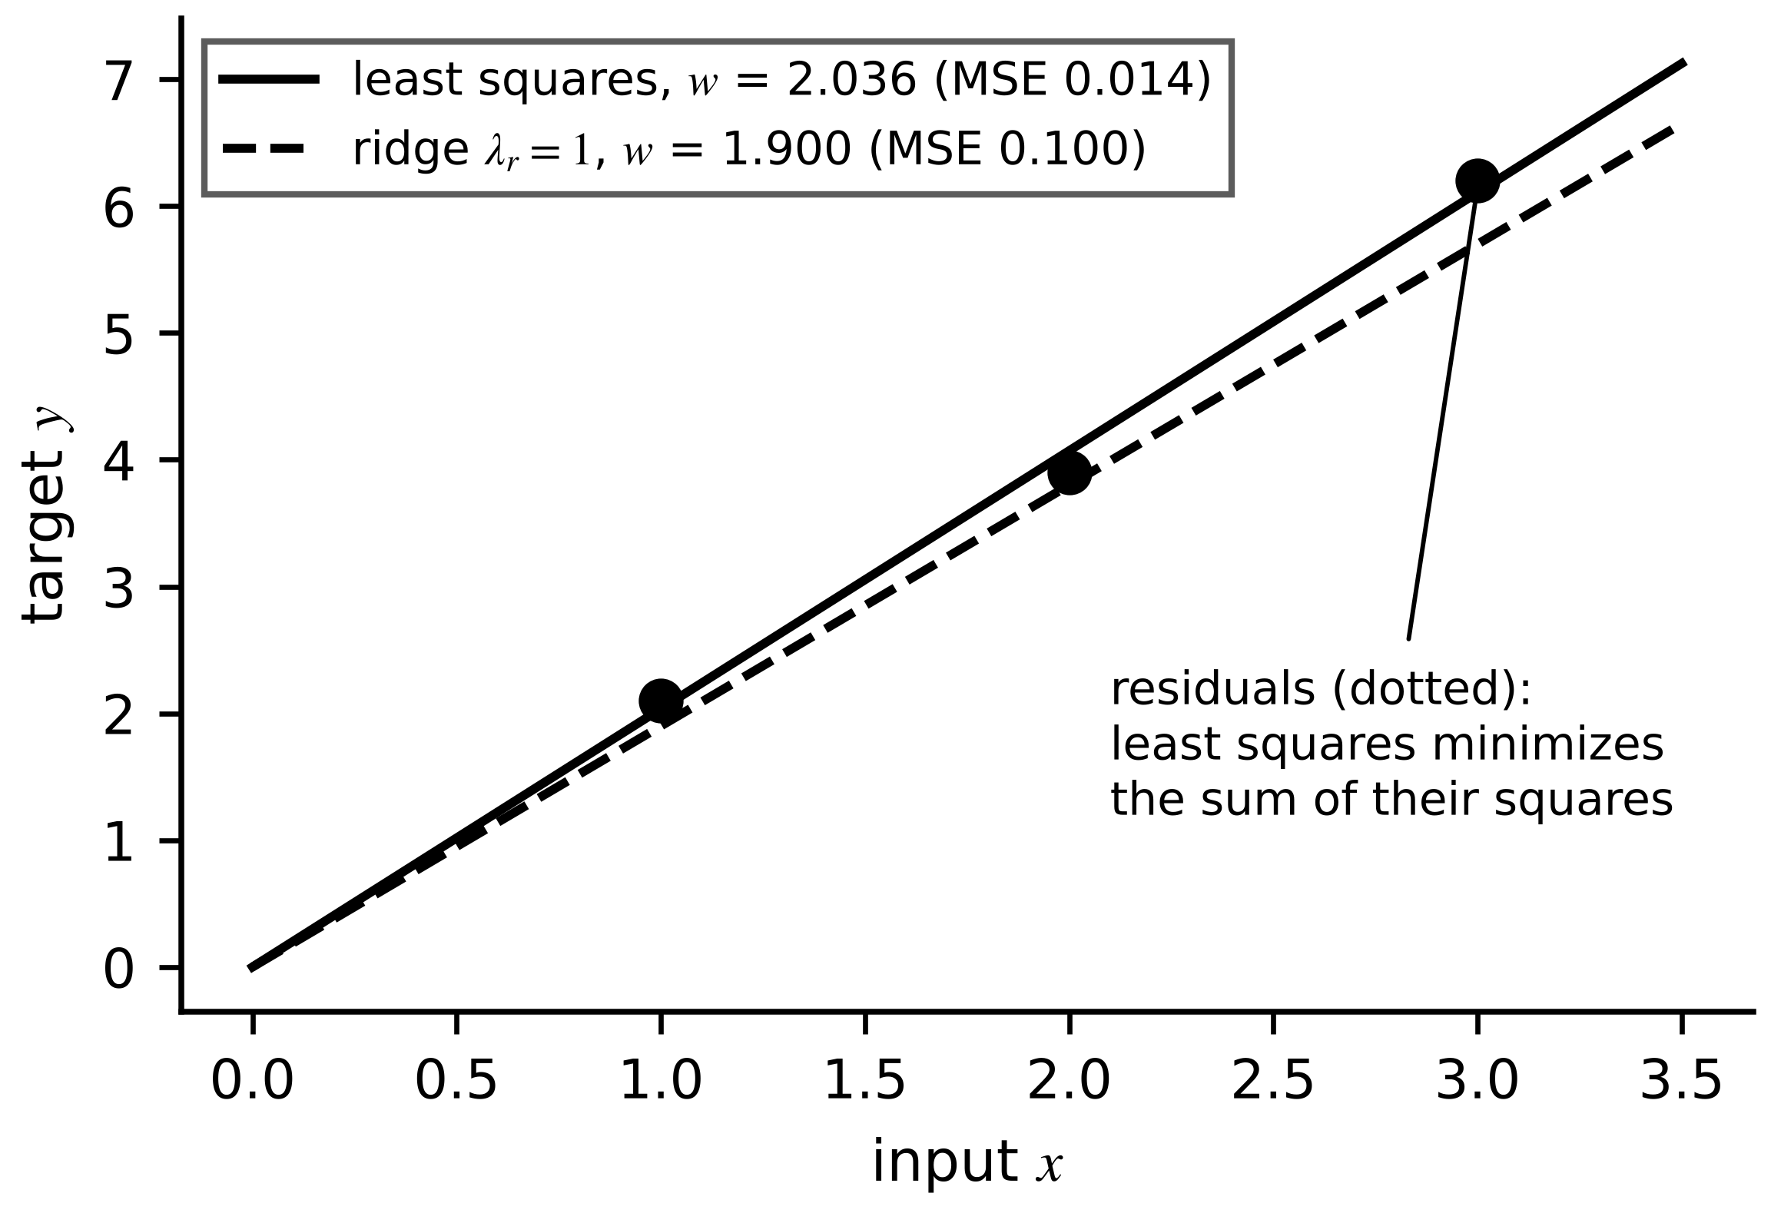
Figure 6.5. Linear regression through the origin for Example 6.3: least-squares and ridge lines and the residuals that least squares minimizes in square.

6.3.2 Gradient descent on one parameter
Closed forms exist only for linear models. Everything else is trained by gradient descent: move the parameters a small step against the gradient of the loss, $w_{t+1}=w_{t}-η ∂ℒ/∂w$, with learning rate $η$. For the mean-squared loss of the example above,
$ℒ(w)=\frac{1}{2N}\sum_{n=1}^{N}{{\left(wx_{n}-y_{n}\right)}^{2}}, \frac{∂ℒ}{∂w}=\frac{1}{N}\sum_{n=1}^{N}{\left(wx_{n}-y_{n}\right)}x_{n}, w_{t+1}=w_{t}-η\frac{∂ℒ}{∂w}$ (6.6)
The loss is a parabola with curvature $\frac{1}{N}\sum{x_{n}^{2}}$; a step is stable only if $η$ is below $2N/\sum{x_{n}^{2}}$, and in several dimensions the largest curvature sets the limit while the smallest sets the speed, which is why ill-conditioned problems zig-zag (Figure 6.6).
Example 6.4 (Level A) One gradient step
Given. The data of Example 6.3, $w_{0}=0$, $η=0.1$.
Find. The gradient, $w_{1}$, and the loss before and after the step.
Solution. At $w=0$ the gradient is $-(2.1×1+3.9×2+6.2×3)/3=-9.5$; $w_{1}=0+0.1×9.5=0.95$. Loss: $ℒ(0)=9.68$, $ℒ(0.95)=2.76$.
Interpretation. One step removes 71 % of the loss; further steps converge to 2.036. The stability limit here is $η<2×3/14=0.43$.
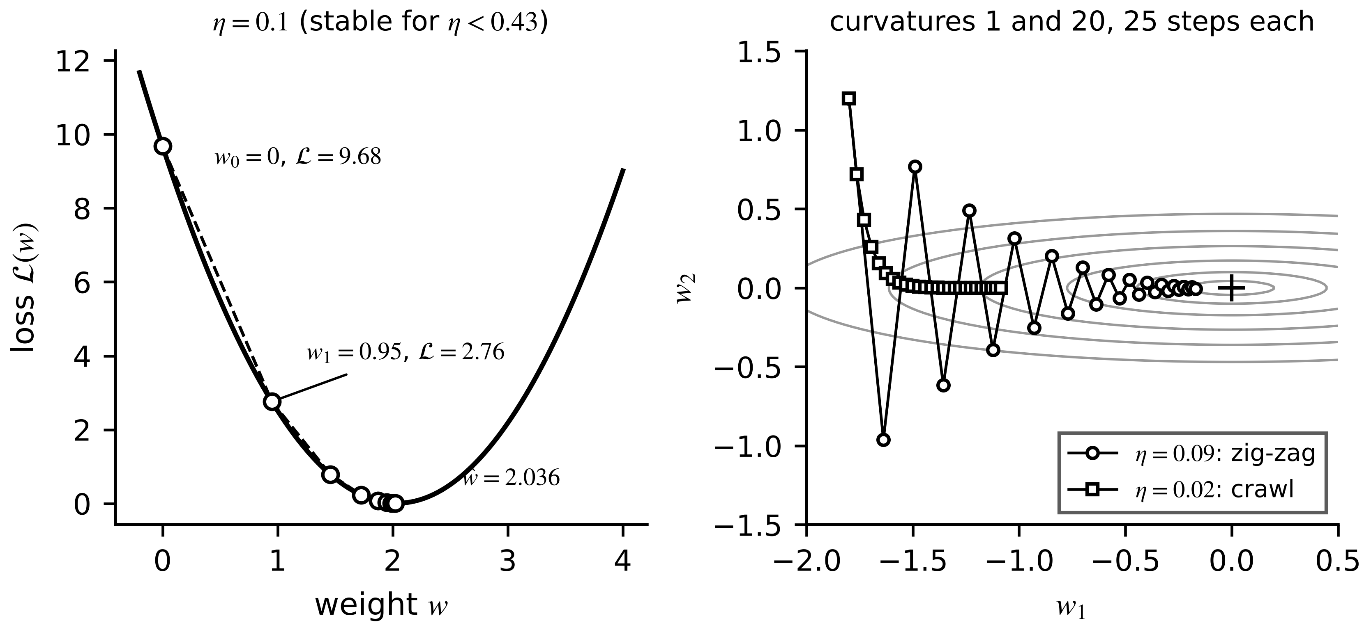
Figure 6.6. Gradient descent. Left: the first steps on the one-parameter loss of Example 6.4. Right: on an ill-conditioned two-parameter loss, a large step zig-zags across the narrow valley and a small one crawls along it.

6.3.3 Logistic regression and cross entropy
For a two-class target (healthy or faulty), the model outputs a probability by passing a linear score through the sigmoid, and is trained by maximizing the likelihood of the labels. Taking the negative log of the Bernoulli likelihood ${\hat{p}}^{ y}(1-\hat{p})^{1-y}$ gives the cross-entropy loss; its gradient has the same simple form as the linear one (Figure 6.7):
$\hat{p}=σ(z)=\frac{1}{1+e^{-z}}, z=w^{⊤}x+b, ℓ=-yln\hat{p}-(1-y)ln\left(1-\hat{p}\right), \frac{∂ℓ}{∂w}=\left(\hat{p}-y\right)x$ (6.7)
using $σ'(z)=σ(z)(1-σ(z))$. For $K$ classes the softmax ${\hat{p}}_{c}=e^{z_{c}}/\sum_{j}{e^{z_{j}}}$ and the loss $-ln{\hat{p}}_{y}$ generalize it.
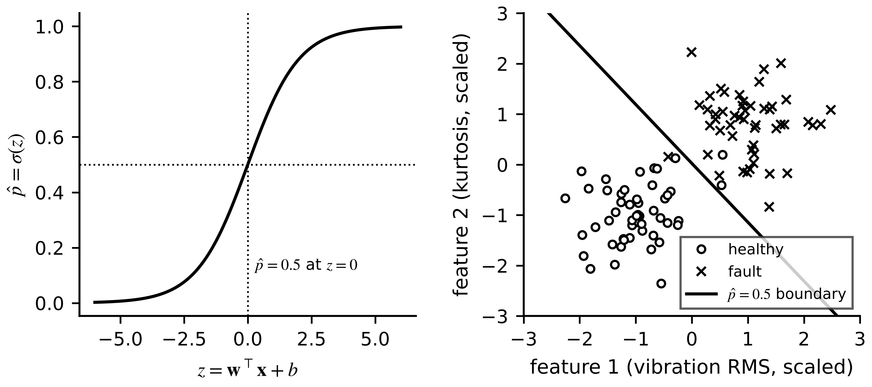
Figure 6.7. Logistic regression. Left: the sigmoid maps a linear score to a probability. Right: a linear decision boundary between healthy and faulty windows in a two-feature space.
Example 6.5 (Level A) Cross entropy and its gradient
Given. Logistic regression with $x=[1, 2]$, $w=[0.5, -0.25]$, $b=0$ and label $y=1$.
Find. $z$, $\hat{p}$, the cross-entropy loss and the weight gradient from (6.7).
Solution. $z=0.5-0.5=0$; $\hat{p}=0.5$; loss $-ln0.5=0.693$; gradient $(\hat{p}-y)x=[-0.5, -1.0]$.
Interpretation. A step against the gradient raises both weights, pushing $z$ and the predicted fault probability up for this labelled fault. The model is maximally uncertain at $z=0$, where the loss is $ln2$.
Classification metrics must account for rare faults. With true and false positives TP, FP, false negatives FN and fault prevalence $π$, precision and recall (true-positive rate, TPR) are
$precision=\frac{TP}{TP+FP}=\frac{TPR π}{TPR π+FPR (1-π)}, recall=\frac{TP}{TP+FN}, F_{1}=\frac{2TP}{2TP+FP+FN}$ (6.8)
where FPR is the false-positive rate. For small $π$, FPR must be far smaller than $π$ itself before most alarms are real.
Example 6.6 (Level A) A good-looking fault classifier on rare faults
Given. 10 000 monitoring windows of which 50 contain a developing bearing fault; TPR 0.90, FPR 0.02.
Find. TP, FN, FP, TN, precision and $F_{1}$.
Solution. TP = 45, FN = 5, FP = $0.02×9950=199$, TN = 9751. Precision $45/244=0.18$; $F_{1}=90/(90+199+5)=0.31$.
Interpretation. Four alarms in five are false, and operators will ignore them within a week. With rare faults, alarms must be confirmed by a second, independent indicator such as a physics residual (Section 6.8.4) or the false-positive rate pushed far lower than intuition suggests.
What the digital twin adds
Synchronized: a baseline every learned model must beat on the same split.
Estimated or updated: closed-form or gradient-trained weights.
Uncertainty carried: class prevalence and its effect on precision.
Decision enabled: whether complexity is justified at all.
Validated by: the same blocked and OOD tests as every other model.

6.4 Neural networks from the neuron up

6.4.1 Neuron, layer, activation and forward pass
A neuron forms a weighted sum of its inputs plus a bias and passes it through a nonlinear activation (Figure 6.8); a layer applies many neurons to the same input; a feedforward network (multilayer perceptron, MLP) chains layers, each feeding the next:
$a=σ\left(w^{⊤}x+b\right), a^{(l)}=σ\left(z^{(l)}\right), z^{(l)}=W^{(l)}a^{(l-1)}+b^{(l)}, a^{(0)}=x$ (6.9)
where $W^{(l)}$ ($n_{l}×n_{l-1}$) and $b^{(l)}$ are the weights and biases of layer $l$. A layer from $n_{l-1}$ to $n_{l}$ units has $n_{l}(n_{l-1}+1)$ parameters, so the 5-32-32-1 network of the M-07 benchmark has $32×6+32×33+1×33=1281$. Without the nonlinearity the whole network would collapse to one linear map. Common activations (Figure 6.9) are the sigmoid and tanh, whose derivatives are small away from zero, and the rectified linear unit $max(0,z)$ and its smooth variants, whose derivative is 1 for positive inputs. A network with one wide enough hidden layer can approximate any continuous function on a bounded set; that universality is also why it extrapolates without any constraint outside the data.
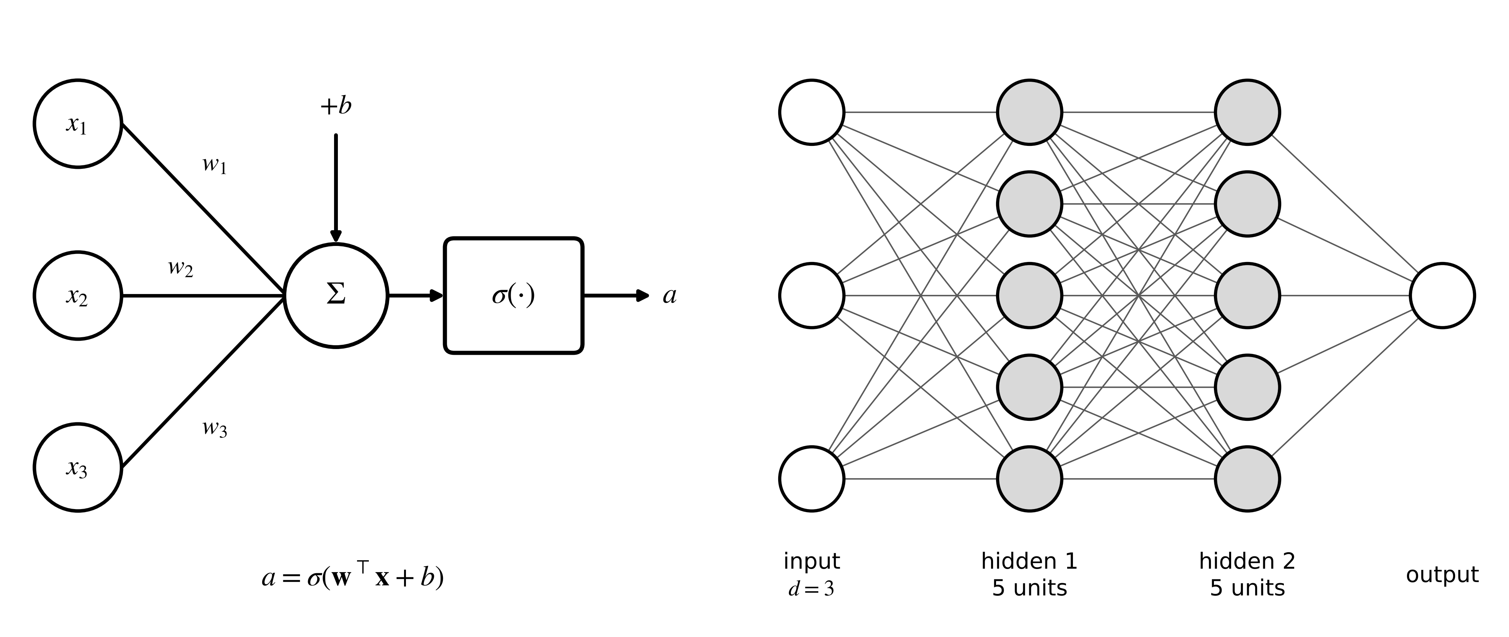
Figure 6.8. Left: a single neuron. Right: a feedforward network with two hidden layers; every unit in one layer feeds every unit in the next.
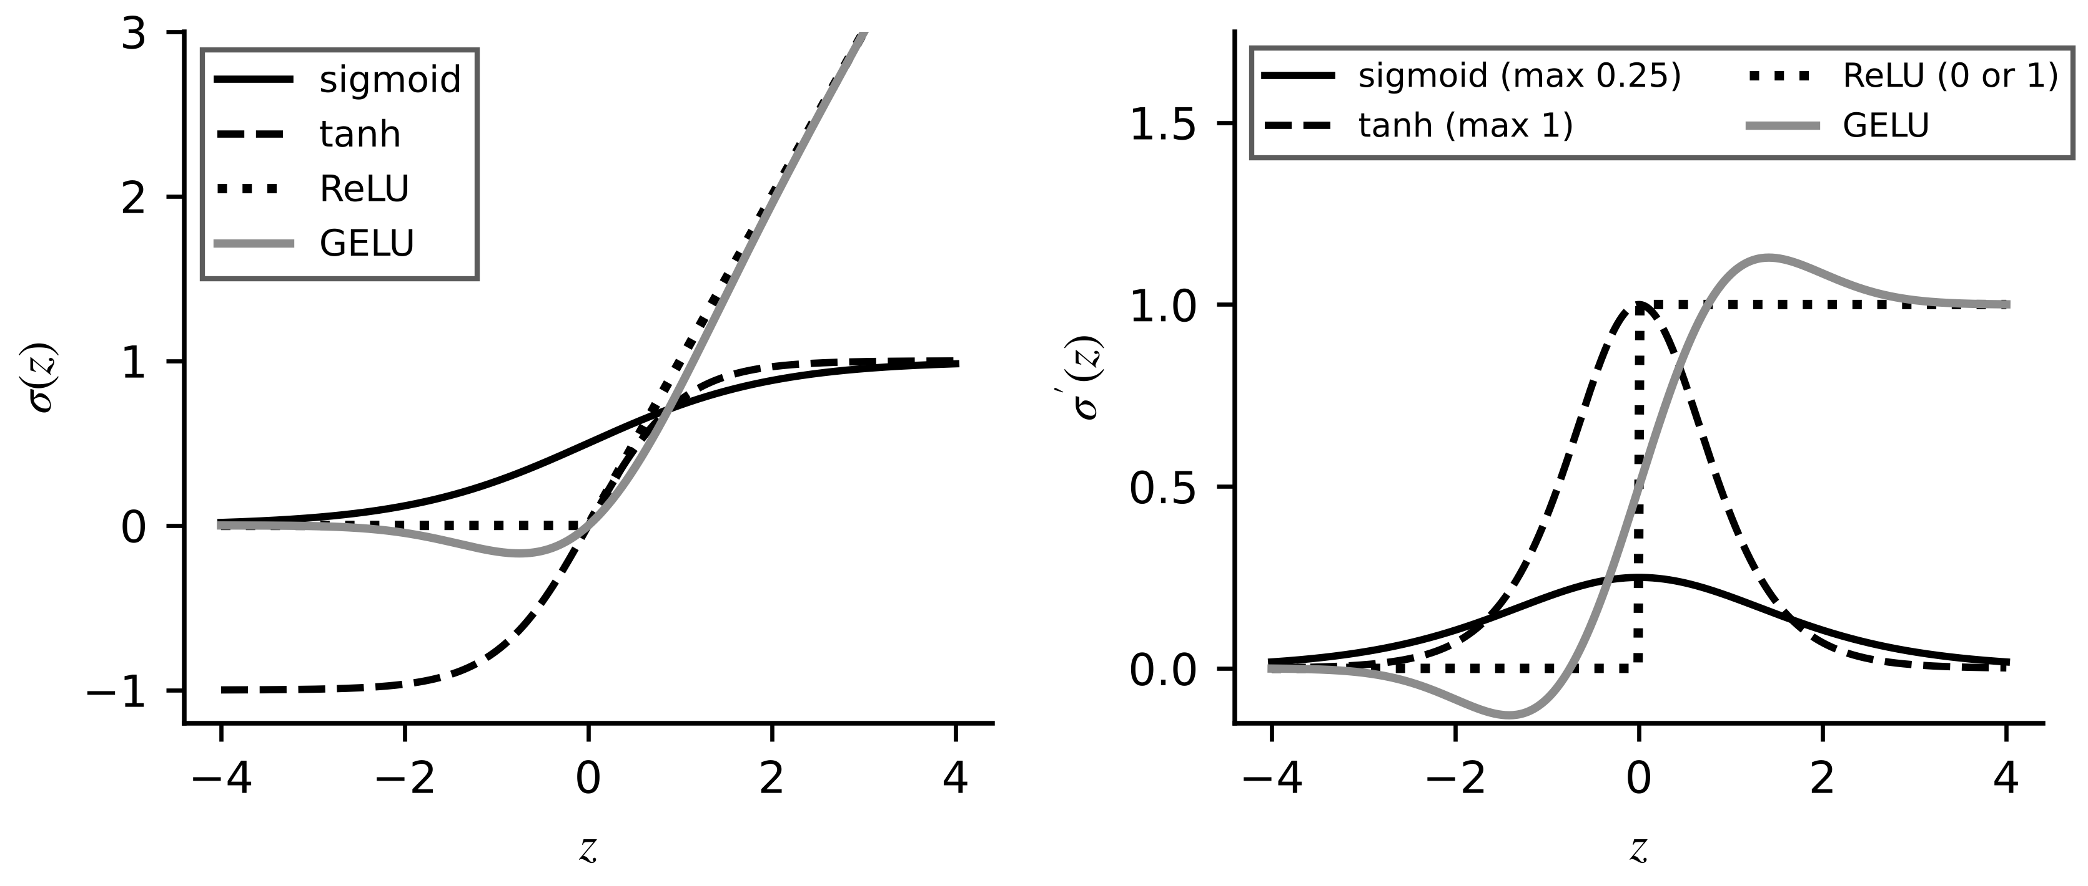
Figure 6.9. Activation functions (left) and their derivatives (right). Saturating functions have small derivatives away from zero, which shrinks gradients in deep or recurrent networks.

6.4.2 Loss, backpropagation and optimizers
Training minimizes the loss over all weights by gradient descent, and backpropagation computes all the gradients in one backward sweep using the chain rule (Figure 6.10) [4]. Define the error signal of layer $l$ as $δ^{(l)}=∂ℒ/∂z^{(l)}$. Because $z^{(l+1)}$ depends on $z^{(l)}$ only through $a^{(l)}$,
$δ^{(L)}=\frac{∂ℒ}{∂a^{(L)}}⊙σ^{′}\left(z^{(L)}\right), δ^{(l)}=\left(W^{(l+1)⊤}δ^{(l+1)}\right)⊙σ^{′}\left(z^{(l)}\right), \frac{∂ℒ}{∂W^{(l)}}=δ^{(l)}a^{(l-1)⊤}$ (6.10)
where $⊙$ is the element-wise product. Each layer's gradient needs one matrix-vector product, so a backward pass costs about the same as a forward pass. The repeated factors $σ'$ explain the vanishing-gradient problem: many factors smaller than one shrink the signal geometrically. Plain gradient descent is improved in practice by momentum, which averages gradients over steps, and by Adam [5], which also scales each weight's step by a running estimate of its gradient magnitude:
$m_{t}=β_{1}m_{t-1}+\left(1-β_{1}\right)g_{t}, v_{t}=β_{2}v_{t-1}+\left(1-β_{2}\right)g_{t}^{2}, w_{t+1}=w_{t}-η\frac{{\hat{m}}_{t}}{\sqrt{{\hat{v}}_{t}}+ε}$ (6.11)
where $g_{t}$ is the gradient, ${\hat{m}}_{t}=m_{t}/(1-β_{1}^{t})$ and ${\hat{v}}_{t}=v_{t}/(1-β_{2}^{t})$ are bias-corrected averages, typically with $β_{1}=0.9$, $β_{2}=0.999$ and $ε={10}^{-8}$. Initialization matters too: weights drawn with variance near $1/n_{l-1}$ (or $2/n_{l-1}$ for ReLU) keep activations and gradients of similar size through the layers.
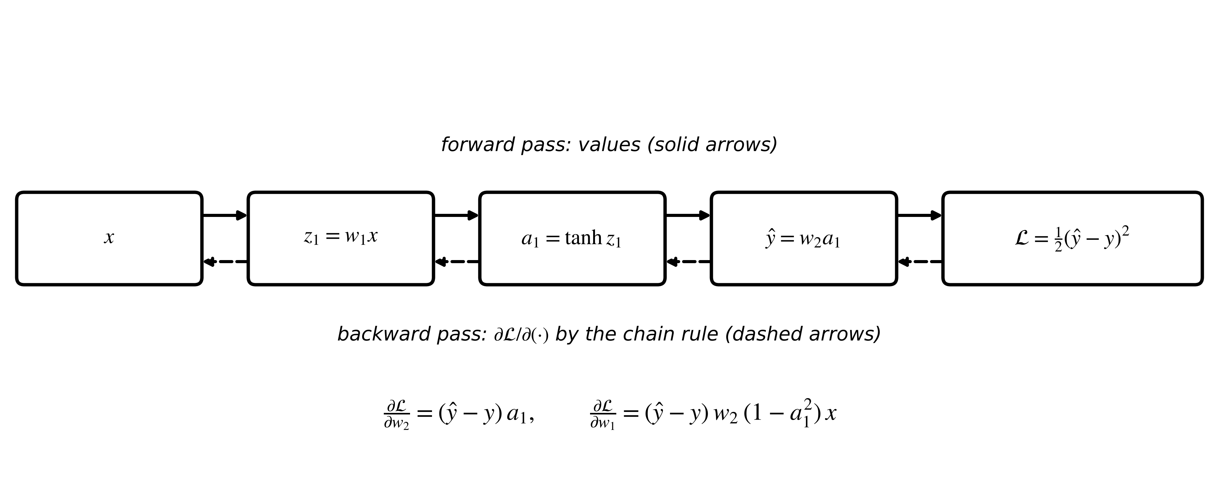
Figure 6.10. Forward and backward passes through a two-weight network. Values flow forward; derivatives of the loss flow backward by the chain rule, giving every weight gradient in one sweep.
Example 6.7 (Level A) One gradient step on a two-weight network
Given. $x=1$, $w_{1}=0.5$, $w_{2}=1.0$, target $y=1$; $\hat{y}=w_{2}tanh(w_{1}x)$; loss $\frac{1}{2}(\hat{y}-y)^{2}$; learning rate 0.5.
Find. Forward values, the two gradients, the updated weights and the new loss.
Solution. $z_{1}=0.5$, $a_{1}=0.4621$, $\hat{y}=0.4621$, $ℒ=0.1447$. Backward: $∂ℒ/∂\hat{y}=-0.5379$; $∂ℒ/∂w_{2}=-0.5379×0.4621=-0.2486$; $∂ℒ/∂w_{1}=-0.5379×1.0×(1-{0.4621}^{2})×1=-0.4230$. Update: $w_{2}=1.1243$, $w_{1}=0.7115$; new $\hat{y}=0.6876$, $ℒ=0.0488$.
Interpretation. One step cuts the loss by two thirds. The factor $1-a_{1}^{2}$ is the tanh derivative; in a deep network a product of many such factors is what vanishes.
What the digital twin adds
Synchronized: a flexible function fitted to twin data.
Estimated or updated: weights by backpropagation and Adam.
Uncertainty carried: none by default; Section 6.8 adds it.
Decision enabled: whether a network beats the baselines enough to justify its governance cost.
Validated by: blocked and OOD tests, never training loss.

6.5 Architectures for twin signals
Each architecture below is introduced with one electrical example, its tensor shape, how its parameters and computation scale, its strength, its typical failure and the baseline it must beat. Table 6.1 collects them.

6.5.1 Convolutional networks for vibration and waveforms
A bearing defect on motor M-07 shows as short, repeated bursts in the vibration signal, wherever they occur in the window. A one-dimensional convolutional layer slides the same short kernel along time, so a pattern is detected wherever it appears (Figure 6.11). For $C_{in}$ input channels of length $L_{in}$, $C_{out}$ kernels of length $k$, stride $s$ and padding $p$,
$y_{c,t}=b_{c}+\sum_{c^{′}=1}^{C_{in}}{\sum_{j=0}^{k-1}{w_{c,c^{′},j}}} x_{c^{′},st+j}, L_{out}=\left\lfloor \frac{L_{in}+2p-k}{s}\right\rfloor +1, N_{par}=C_{out}\left(C_{in}k+1\right)$ (6.12)
and the multiply-accumulate count is $C_{out}L_{out}C_{in}k$. Weight sharing keeps the parameter count independent of the window length; pooling and global averaging summarize where a pattern occurred.
Example 6.8 (Level A) Shape and parameter count of a vibration CNN
Given. A three-axis vibration window of 4096 samples; first layer: 8 kernels of length 32, stride 8, no padding.
Find. Output length, parameters and multiply-accumulates of the layer.
Solution. $L_{out}=⌊(4096-32)/8⌋+1=509$; $N_{par}=8(3×32+1)=776$; multiply-accumulates $8×509×96=390 912$.
Interpretation. A dense layer from the same 12 288 inputs to 8×509 outputs would need about 50 million weights. The convolution's built-in assumption (the same pattern matters wherever it appears) is what makes it data-efficient; its failure mode is patterns longer than its receptive field, and its baseline is an envelope spectrum with a classifier (Chapter 12).
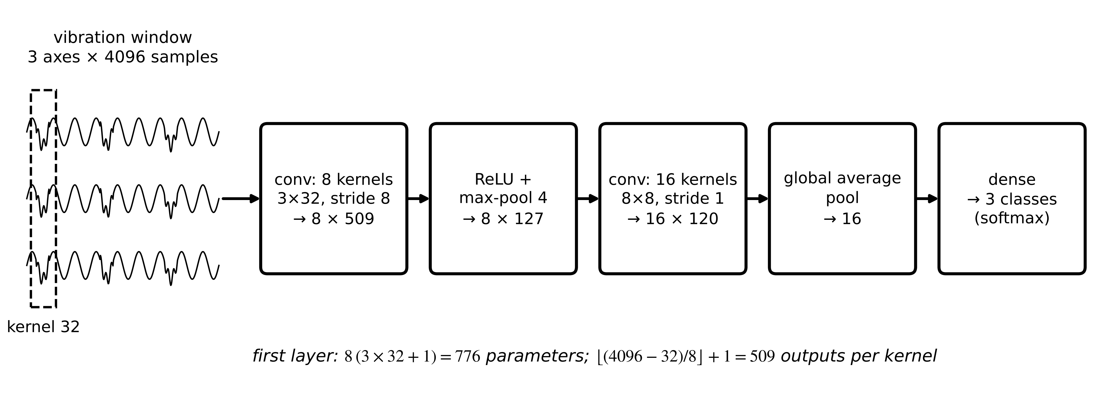
Figure 6.11. A one-dimensional CNN for three-axis vibration windows, with the tensor shape after each layer. The same kernel slides along time, so the first layer has only 776 parameters.

6.5.2 Recurrent networks: RNN, LSTM and GRU
The winding temperature depends on the history of losses, not only on the present one. A recurrent network carries a hidden state $h_{t}$ from step to step, $h_{t}=tanh(Wh_{t-1}+Ux_{t}+b)$. Backpropagating through $T$ steps multiplies $T$ Jacobians of the form $diag(1-h^{2})W$, so gradients shrink or explode geometrically and long memories are hard to learn. The long short-term memory (LSTM) cell [6] adds a cell state $c_{t}$ with gated, additive updates (Figure 6.12):
$\left[\begin{matrix}f_{t} \\ i_{t} \\ o_{t} \\ {\tilde{c}}_{t}\end{matrix}\right]=\left[\begin{matrix}σ \\ σ \\ σ \\ tanh\end{matrix}\right]\left(W\left[\begin{matrix}h_{t-1} \\ x_{t}\end{matrix}\right]+b\right), c_{t}=f_{t}⊙c_{t-1}+i_{t}⊙{\tilde{c}}_{t}, h_{t}=o_{t}⊙tanh\left(c_{t}\right)$ (6.13)
where $f$, $i$, $o$ are the forget, input and output gates and $\tilde{c}$ the candidate. Because $c_{t}$ is updated by addition, its gradient passes through the forget gate rather than through a squashing nonlinearity, and information can persist for hundreds of steps. With input size $d$ and hidden size $h$, an LSTM layer has $4h(h+d+1)$ parameters; the gated recurrent unit (GRU) [7] merges gates into update and reset gates, with $3h(h+d+1)$.
Example 6.9 (Level A) One LSTM update and its size
Given. (i) A scalar cell with forget gate 0.7, input gate 0.6, candidate 0.5, previous cell state $-0.8$, output gate 0.9. (ii) A layer with $d=8$ inputs and $h=64$ hidden units.
Find. The new cell state and output in (i); LSTM and GRU parameter counts in (ii).
Solution. (i) $c_{t}=0.7×(-0.8)+0.6×0.5=-0.26$; $h_{t}=0.9tanh(-0.26)=-0.229$. (ii) LSTM $4×64×(64+8+1)=18 688$; GRU $3×64×73=14 016$.
Interpretation. The forget gate kept 70 % of the old memory and the input gate wrote 60 % of the new candidate. Recurrent networks suit asset histories but are sequential (slow to train), and like every flexible model they extrapolate poorly; their baseline is the physics state-space model of Chapter 4 with a Kalman filter.
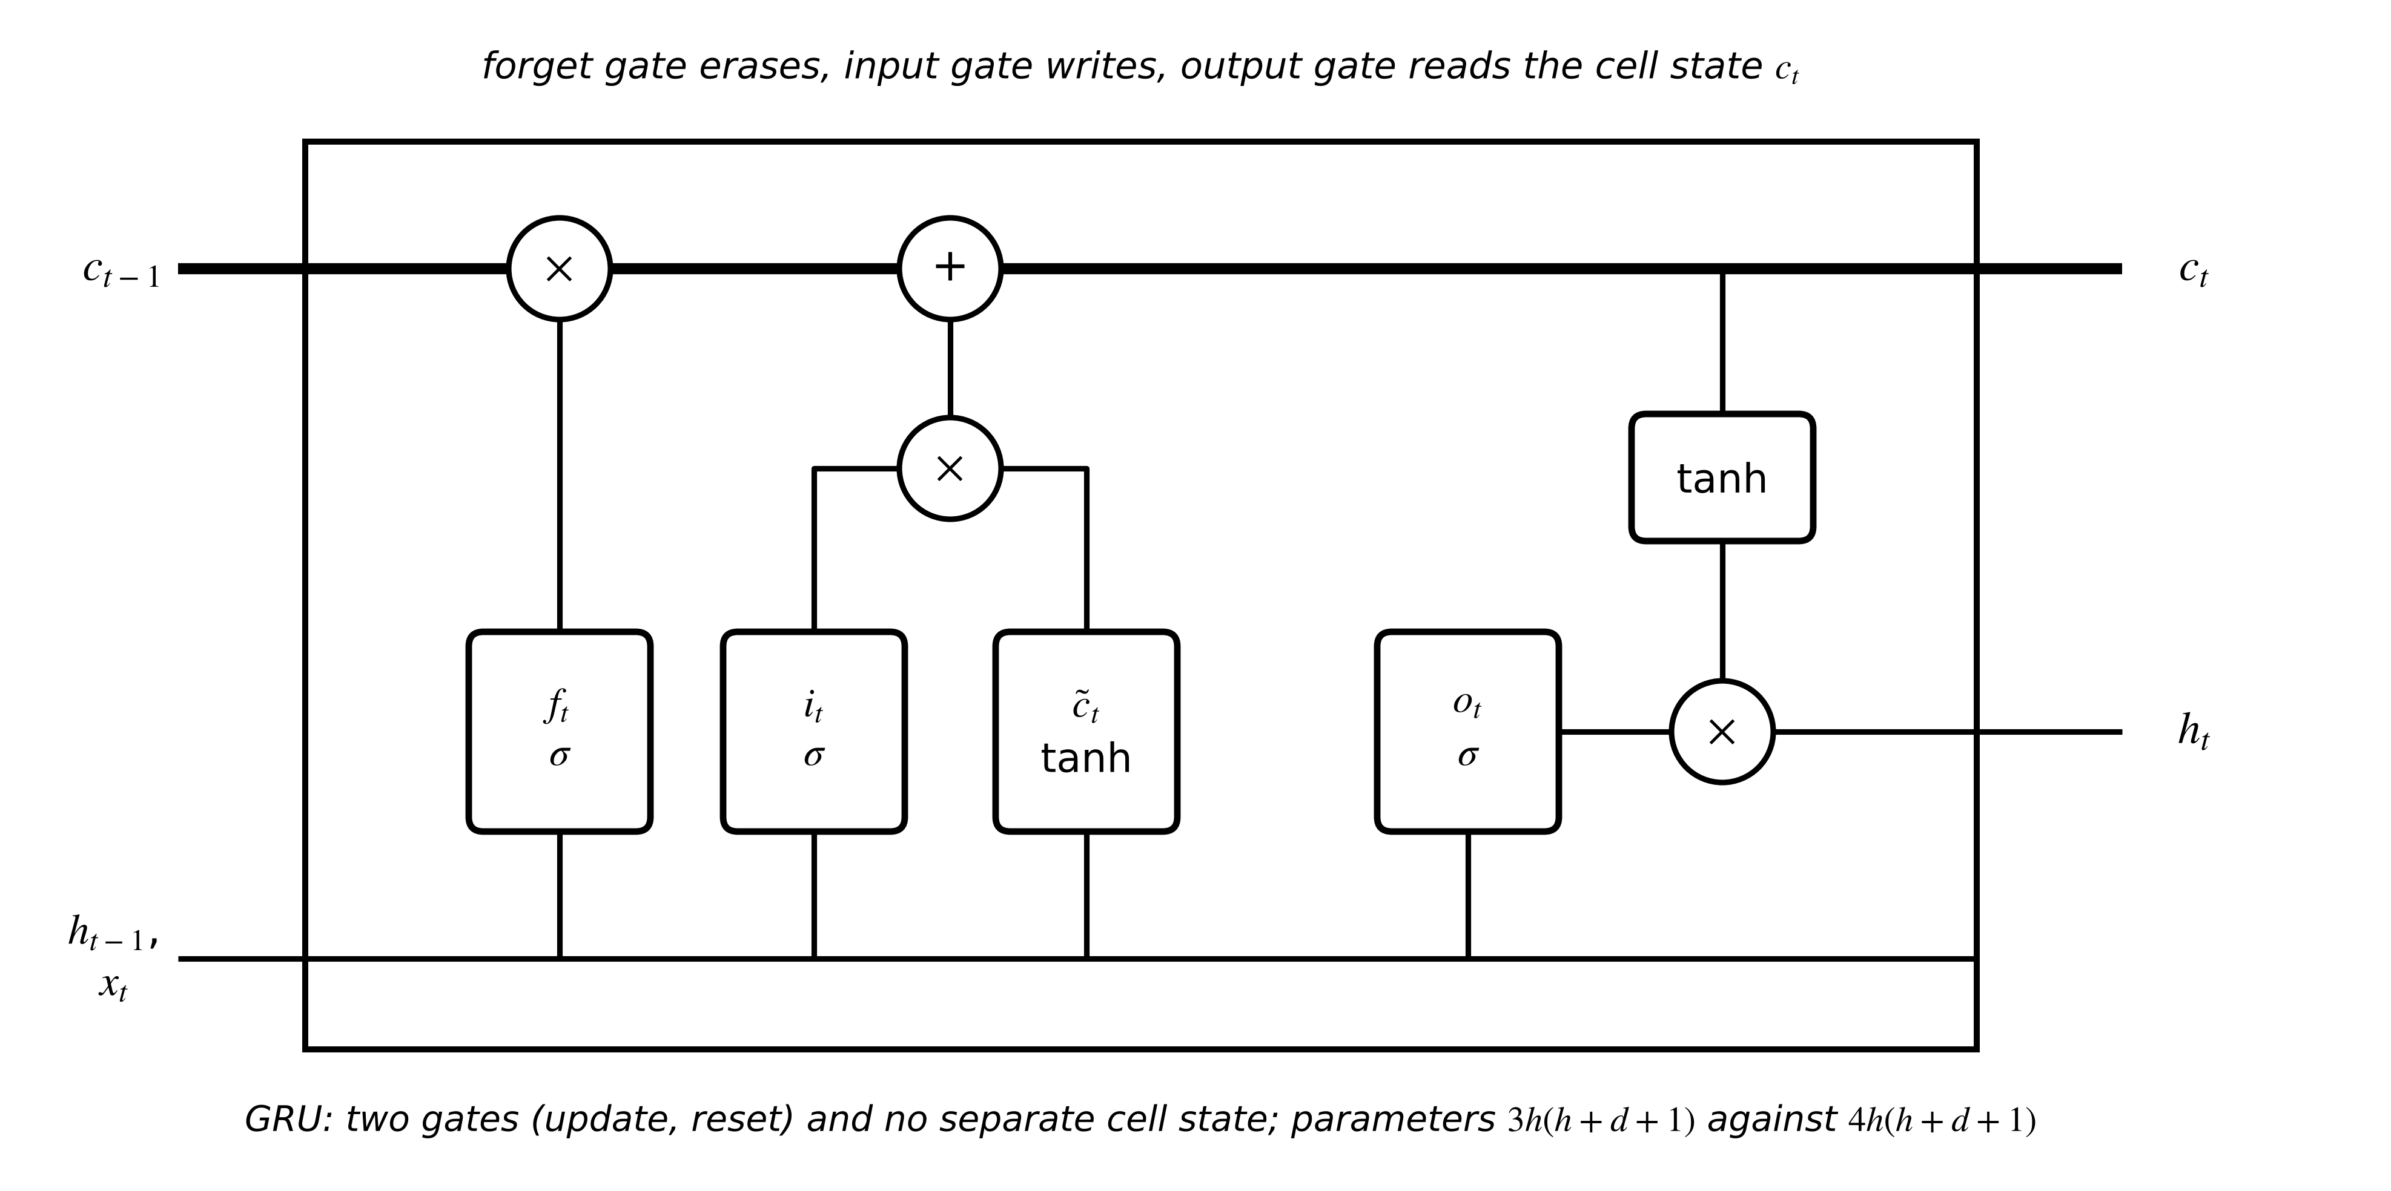
Figure 6.12. The LSTM cell: the cell state runs along the top and is changed only by multiplication with the forget gate and addition of gated new content; the output gate decides how much of it appears in $h_{t}$.

6.5.3 Autoencoders for anomaly detection
Faults are rare, but healthy data are plentiful. An autoencoder learns to compress a healthy window $x$ into a short code and reconstruct it, $\hat{x}=g_{dec}(g_{enc}(x))$, by minimizing the reconstruction error on healthy data only (Figure 6.13). A window it cannot reconstruct is unlike anything it has seen, and is flagged when its score exceeds a threshold set from healthy statistics:
$e(x)=\frac{1}{d}{\left\|x-\hat{x}\right\|}^{2}, flag if e(x)>μ_{e}+3σ_{e}$ (6.14)
where $μ_{e}$ and $σ_{e}$ are the mean and standard deviation of healthy scores on held-out data (or an empirical quantile if the scores are skewed). With healthy scores $0.020±0.005$, the threshold is 0.035 and a window scoring 0.038 is flagged. Autoencoders detect novelty, not faults: a new but healthy operating mode is flagged too, which is why their alarms feed a diagnosis step (Chapter 12). The baseline is principal component analysis with the same score.
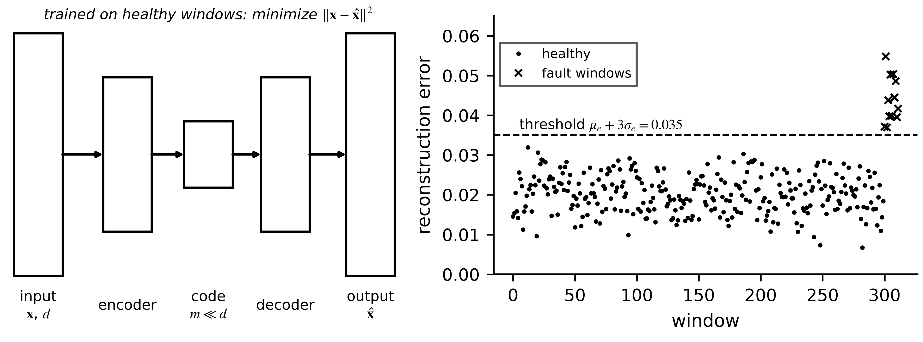
Figure 6.13. Autoencoder anomaly detection. Left: encoder, short code and decoder trained on healthy windows. Right: reconstruction errors with the threshold at three healthy standard deviations; the last windows contain a fault.

6.5.4 Transformers and attention
A load forecast may depend on yesterday at the same hour more than on the last ten minutes. Attention lets every time step look at every other one and weight them by relevance (Figure 6.14) [8]. Tokens (time steps or patches, Figure 6.1) are mapped to queries $Q$, keys $K$ and values $V$, and each output is a weighted average of the values:
$Attention(Q,K,V)=softmax\left(\frac{QK^{⊤}}{\sqrt{d_{k}}}\right)V, Q=XW_{Q}, K=XW_{K}, V=XW_{V}$ (6.15)
where $X$ is the $L×d$ token matrix and $d_{k}$ the key dimension. The scaling by $\sqrt{d_{k}}$ keeps the dot products of unit-variance components at unit variance, so the softmax does not saturate. The score matrix is $L×L$, so computation and memory grow as $L^{2}d$: for $L=512$ tokens and $d=64$, one head needs about 16.8 million multiply-accumulates for the scores alone; cutting the same window into patches of 16 samples ($L=32$) needs 65 536. Attention has no built-in sense of order, so positional encodings are added, and transformers need far more data than the other architectures here.
Example 6.10 (Level A) Attention over three time steps
Given. $d_{k}=4$; a query gives dot products $[2, 0, -2]$ with three keys whose values are $[10, 20, 30]$.
Find. The attention weights and the output.
Solution. Scaled scores $[2,0,-2]/\sqrt{4}=[1,0,-1]$; softmax weights $[0.665, 0.245, 0.090]$; output $0.665×10+0.245×20+0.090×30=14.25$.
Interpretation. The output is a soft selection, mostly of the first value. Attention is the right tool when the relevant history is long and variable; on short, physics-dominated horizons a state-space model usually wins with a fraction of the data.
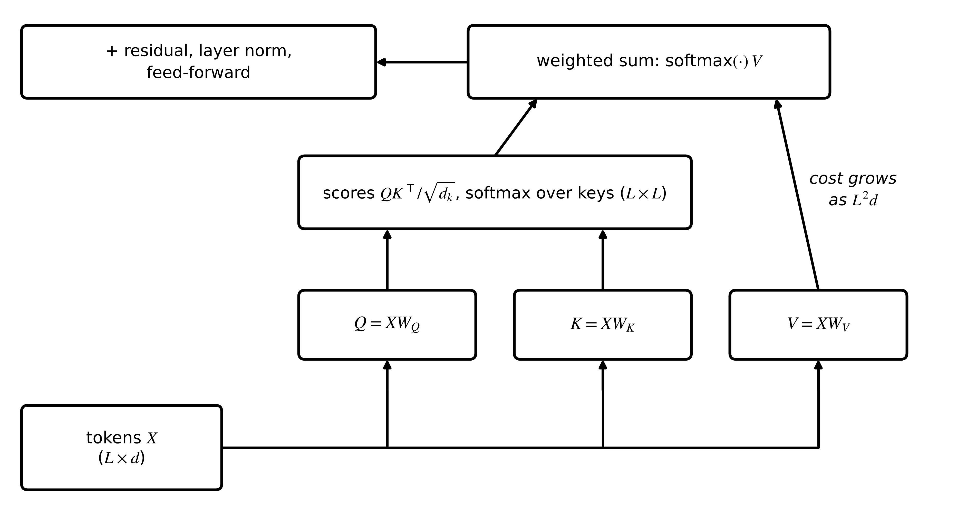
Figure 6.14. One attention block: tokens are projected to queries, keys and values; scaled dot-product scores weight the values; a residual connection, normalization and feed-forward layer follow. The score matrix makes cost grow with the square of the sequence length.

6.5.5 Gaussian processes
A Gaussian process (GP) places a prior directly on functions: any finite set of function values is jointly Gaussian with covariance given by a kernel, for example the squared exponential $k(x,x')=σ_{f}^{2}exp(-‖x-x'‖^{2}/2ℓ^{2})$ with signal variance $σ_{f}^{2}$ and length scale $ℓ$ [9]. With training inputs $X$, targets $y$ and noise variance $σ_{n}^{2}$, conditioning the joint Gaussian of training and test values gives the predictive mean and variance at a new input $x_{*}$:
$μ_{*}=k_{*}^{⊤}{\left(K+σ_{n}^{2}I\right)}^{-1}y, σ_{*}^{2}=k\left(x_{*},x_{*}\right)-k_{*}^{⊤}{\left(K+σ_{n}^{2}I\right)}^{-1}k_{*}$ (6.16)
where $K$ is the kernel matrix of the training inputs and $k_{*}$ the vector of kernels between $x_{*}$ and each training input. The variance grows away from the data (Figure 6.15), which is a GP's strength; its cost grows as $N^{3}$ for training and $N$ per predictive mean ($N^{2}$ for the variance), which limits it to a few thousand points without approximations.
Example 6.11 (Level A) A Gaussian process with one training point
Given. $σ_{f}^{2}=1$, $ℓ=2$, $σ_{n}^{2}=0.01$; one training point $x=0$, $y=1$; predict at $x_{*}=1$.
Find. $k_{*}$, the predictive mean and variance.
Solution. $k_{*}=e^{-1/8}=0.8825$; $μ_{*}=0.8825×1/1.01=0.874$; $σ_{*}^{2}=1-{0.8825}^{2}/1.01=0.229$.
Interpretation. Half a length scale away ($x_{*}=1$ with $ℓ=2$), the GP keeps 87 % of the observed value and 23 % of the prior variance; at $x_{*}=4$, $k_{*}=0.135$ (two length scales) and almost all prior uncertainty returns.
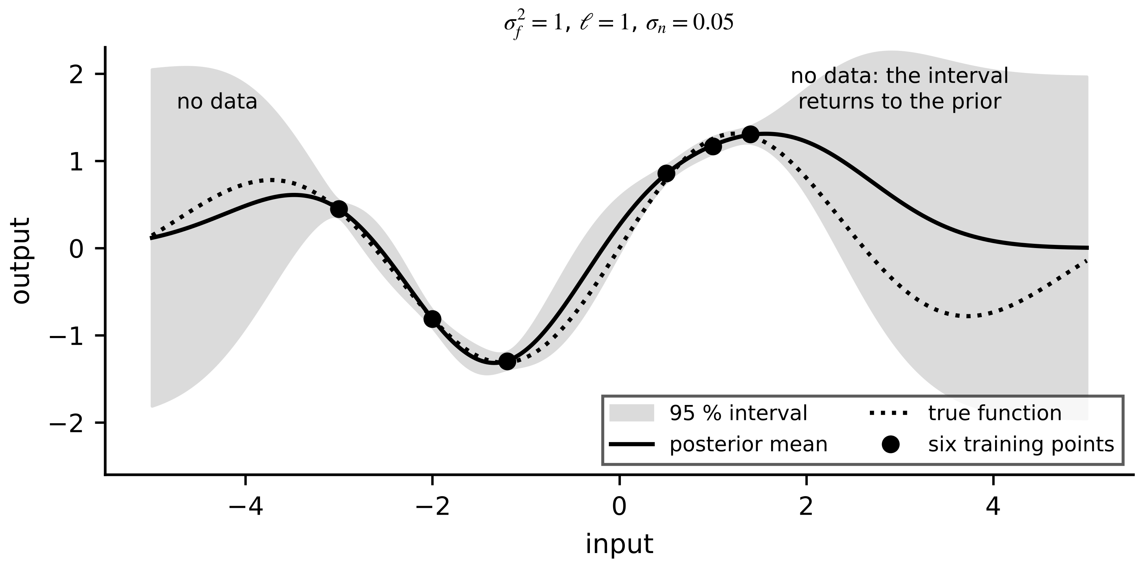
Figure 6.15. Gaussian-process regression: posterior mean and 95 % interval from six noisy points. The interval widens where there are no data.
Table 6.1. Model families for electrical-energy twins (data needs are orders of magnitude)
Family | Electrical example | Tensor shape | Parameters / compute | Strength | Typical failure | Baseline to beat
linear / ridge | 30-min winding forecast | $N×d$ | $d+1$; trivial | interpretable, small data | misses nonlinearity | persistence
MLP | residual of a physics model | $N×d$ | $\sum{n_{l}}(n_{l-1}+1)$ | flexible | extrapolates without limit | ridge
1-D CNN | bearing fault from vibration | $N×C×L$ | $C_{out}(C_{in}k+1)$; $∝L$ | local patterns, weight sharing | long-range context | envelope spectrum + classifier
LSTM / GRU | thermal or SOC history | $N×L×d$ | $4h(h+d+1)$; sequential | long memory | slow training, extrapolation | state-space model + Kalman filter
autoencoder | novelty in healthy data | $N×d$ or windows | encoder + decoder | needs no fault labels | flags new healthy modes | PCA reconstruction
transformer | day-ahead load or PV | $N×L×d$ | $∝L^{2}d$ per layer | long, variable context | data hungry | seasonal regression
Gaussian process | residual correction with uncertainty | $N×d$ | $O(N^{3})$ train | calibrated variance near data | cost; variance not a guarantee OOD | ridge with intervals

What the digital twin adds
Synchronized: the architecture's inductive bias to the structure of the signal.
Estimated or updated: weights; kernel hyperparameters for GPs.
Uncertainty carried: only the GP carries it natively; others need Section 6.8.
Decision enabled: which family a twin function should use, against which baseline.
Validated by: Table 6.1 criteria on blocked and OOD tests.

6.6 Learning when labels are scarce
Fault and ageing labels are rare and expensive: an asset may run for years before failing once, and every site, motor or cell lot is slightly different. Two families of methods address this, and both are moving from research into practice (emerging).
Self-supervised learning creates a training signal from unlabelled data. A network is pretrained on a pretext task, such as reconstructing randomly masked segments of a vibration or current window, or pulling together two augmented views of the same window while pushing apart views of different windows (contrastive learning). The pretrained encoder then needs only a few labelled examples for the real task. For masking, with a binary mask $m$ marking hidden samples,
$ℒ_{mask}=\frac{1}{\sum_{j}{m_{j}}}\sum_{j}{m_{j}}{\left(x_{j}-{\hat{x}}_{j}\left(\left(1-m\right)⊙x\right)\right)}^{2}$ (6.17)
so the network must predict what it cannot see from what it can, which forces it to learn the signal's structure. Transfer learning reuses a model trained on a source asset for a target asset; domain adaptation adjusts for the difference between source and target distributions [10]. Three levels are common: reuse the model as is; fine-tune some or all weights on a few target data; or align the source and target feature distributions during training, for example by importance weighting with $w(x)=p_{T}(x)/p_{S}(x)$ or by a domain-adversarial penalty that makes features indistinguishable between sites [11]. In a twin there is a fourth level that is often the best: transfer the physics structure and refit its few parameters.
Example 6.12 (Level B) Moving the M-07 forecaster to motor M-12
Given. Motor M-12 has a different thermal network ($C_{1}=2200$, $C_{2}=7200$ J/K, $R_{12}=0.10$, $R_{2a}=0.13$ K/W); only one day of its data is labelled and two later days are used for testing. Options: (a) the M-07 network unchanged; (b) the same network trained from scratch on M-12's one day; (c) the M-07 network fine-tuned on that day; (d) the grey-box model of Section 6.7.2 with $R$, $C$ and $β$ refitted on that day.
Find. The 30-minute forecast RMSE on M-12's test days.
Solution. (a) 11.0 K; (b) 2.24 K; (c) 6.5 to 9.1 K, depending on the fine-tuning schedule; (d) 0.88 K, with $\hat{R}=0.234$ K/W against the physical 0.23 (Figure 6.16, left).
Interpretation. A model learned on one motor does not transfer unchanged, and naive fine-tuning of all weights on little data did not help here: it moved the network away from what it knew without enough data to learn the new asset. Transferring the physics structure and refitting three parameters beat every data-driven option by a factor of 2.5 or more. Fleet twins should share structure and priors across assets (Chapter 1, Section 1.10) and learn only what differs.
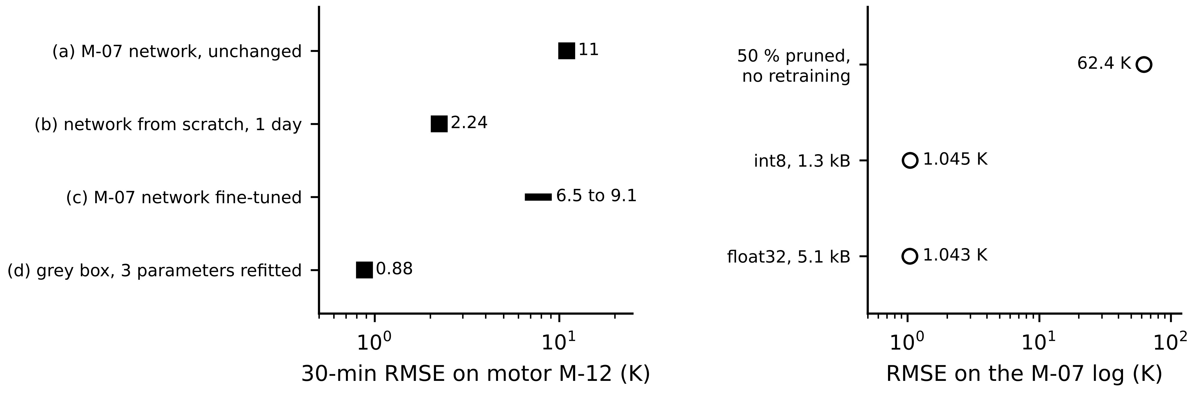
Figure 6.16. Left: forecast error on motor M-12 for four ways of reusing the M-07 forecaster (Example 6.12). Right: the M-07 network after int8 quantization and after 50 % magnitude pruning without retraining (Example 6.20).
What the digital twin adds
Synchronized: knowledge across assets, sites and operating modes.
Estimated or updated: pretrained encoders, fine-tuned weights or refitted physics parameters.
Uncertainty carried: distribution shift between source and target.
Decision enabled: how to bring a learned twin to a new asset with few labels.
Validated by: tests on the target asset's own held-out data.

6.7 Physics-guided learning beyond PINNs
Physics-informed neural networks (PINNs) have become the popular face of physics-informed AI, but they are one tool among several. What the M-07 and battery twins need is not a particular network but a decision about where physics ends and learning begins. This section is the chapter's centre: it separates the ways of combining physics and data, compares them on the same problems, and shows where each succeeds and fails [12], [13].

6.7.1 A taxonomy of hybrid models
Figure 6.17 arranges the options from most to least physical structure. Parameter learning keeps the physics equations and learns only their parameters, as in Chapter 5's estimators or the grey-box fit below. Residual correction runs the physics model and learns its error, $\hat{y}=y_{phys}+\hat{r}$. Physics-structured networks build conservation laws or known symmetries into the architecture, for example an energy-balance layer or a monotone output. Differentiable simulators write the solver itself in a framework that can differentiate through it, so physical parameters and embedded learned terms are fitted end to end through the simulated trajectory. PINNs fit a network to data while penalizing the residual of the governing equation at chosen points. Neural ODEs learn all or part of the right-hand side $f$ of $\dot{x}=f(x,u)$ and integrate it with an ordinary solver [14]. Operator learning learns maps between whole functions, such as from a loss distribution along a winding to its temperature field [15], [16]. Constrained learning trains any of these subject to physical limits (positivity, bounds, monotonicity) by penalty or projection.
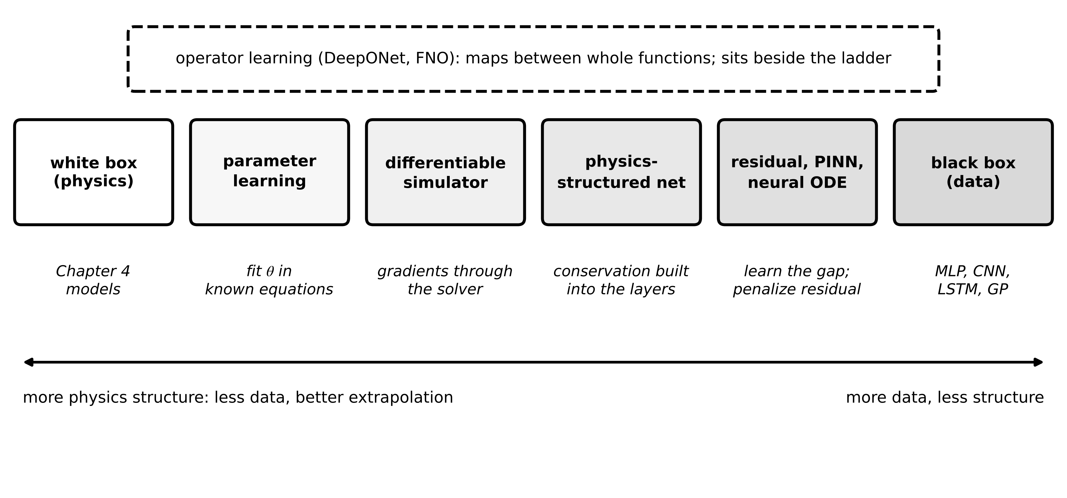
Figure 6.17. A taxonomy of physics and data combinations, from white-box physics to black-box learning. Operator learning maps between functions and sits beside the ladder.
Table 6.2. Physics-guided learning compared
Approach | What is learned | Data need | Extrapolation | Compute online | Main failure | Use in this book
parameter learning | a few physical parameters | low | good if the structure is right | very low | wrong structure absorbed into parameters | Ch. 4, 5; grey box below
residual correction | the physics model's error | moderate | limited by the residual model | low to moderate | correction extrapolates badly | battery twin, Section 6.7.3
physics-structured network | a network with built-in laws | moderate | better than black box | low | hard to design; partial structure | energy-conserving surrogates
differentiable simulator | parameters and embedded terms through the solver | low to moderate | good | solver cost | gradients through stiff solvers | calibration of Ch. 4 models
PINN | a network penalized by the equation residual | low (plus collocation) | good if equation complete | high training, low inference | hard optimization; wrong equation fitted confidently | heat run, Section 6.7.4
neural ODE | all or part of $f$ in $\dot{x}=f$ | moderate | partly; depends on learned part | solver cost | unstable learned behaviour | unmodelled effects
operator learning | maps between functions | high (many simulations) | within training function family | very low after training | outside the family | fast field surrogates

6.7.2 A benchmark: forecasting the M-07 winding temperature
The benchmark uses a synthetic ten-day log at 1-minute resolution from the two-node motor model of Chapter 4 (Section 4.8.1), whose copper loss (60 % of the total) rises at 0.393 % per kelvin above 75 °C, with 0.3 K RTD noise and NumPy default_rng(2026). Nine days have loads of 250 to 450 W in blocks of 20 to 90 minutes and an ambient of about 28 °C; the tenth, the OOD test, has 380 to 540 W and about 43 °C. The target is the winding temperature 30 minutes ahead, with the five features of Section 6.2.1 and the planned loss profile. Days 1 to 6 train, day 7 validates, days 8 and 9 test in distribution. The grey-box model adds one parameter to the single-node model of Chapter 1, the temperature coefficient of the loss:
$C\frac{dT}{dt}=P\left[1+β\left(T-T_{ref}\right)\right]-\frac{T-T_{amb}}{R}, β≈f_{cu}α_{cu}=0.6×0.00393=0.0024 K^{-1}$ (6.18)
where $P$ is the loss at $T_{ref}=75$ °C and $f_{cu}$ the copper share; its three parameters are fitted by minimizing the 30-minute forecast error over the training days (a small differentiable-simulator problem solved here by nonlinear least squares), giving $\hat{R}=0.203$ K/W, $\hat{C}=4645$ J/K and $\hat{β}=0.0019$ K⁻¹. The hybrid is the nominal single-node model ($R=0.20$ K/W, $C=9000$ J/K) plus a Gaussian-process correction of its residual. Table 6.3 gives the results and Figure 6.18 the OOD day.
Table 6.3. Thirty-minute winding-temperature forecast on the synthetic M-07 log (RMSE in K; bias = mean OOD error; time per forecast in vectorized interpreted software)
Model | Test RMSE (days 8-9) | OOD RMSE (day 10) | OOD bias | Time per forecast
persistence | 11.07 | 8.92 | −0.12 | < 0.01 µs
single-node physics (Chapter 1 form) | 4.95 | 12.13 | −11.48 | 0.56 µs
grey box, (6.18) | 0.63 | 2.24 | −2.09 | 0.55 µs
ridge regression | 1.69 | 4.41 | −3.87 | 0.04 µs
neural network (5-32-32-1) | 1.73 | 29.85 | −28.36 | 0.73 µs
Gaussian process (720 training points) | 1.46 | 28.14 | −23.28 | 54 µs
hybrid: physics + GP residual | 1.10 | 7.31 | −6.14 | 38 µs

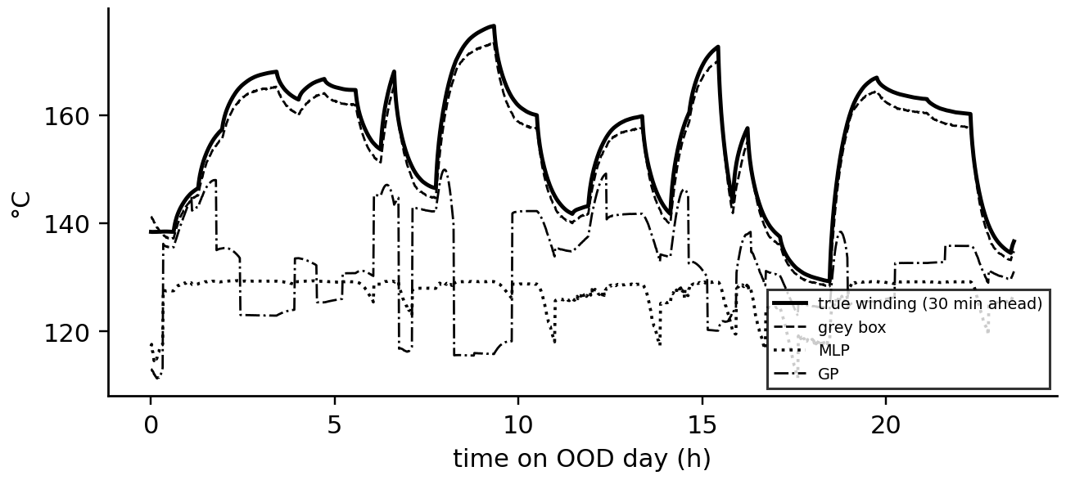
Figure 6.18. Forecasts on the out-of-distribution day against the truth. The neural network and the Gaussian process under-predict by tens of kelvin; the grey-box model, whose structure contains the temperature dependence of copper loss, stays close.
Three lessons follow. In distribution, every learned model beats the nominal physics model, and the grey box beats every learned model because its one extra term is the dominant missing physics. Out of distribution the ranking reverses for the flexible models: the network and the GP, the best learned models in distribution, are the worst outside it, by more than ten times their in-distribution error. All OOD errors are negative: the models under-predict exactly when the temperature matters. Adding the right physics beat adding data.

6.7.3 Residual learning: a hybrid battery twin
Chapter 5's cell C-1 was modelled with one RC branch. Real cells also show slow diffusion polarization with time constants of minutes, which the synthetic ‘true’ cell of this section includes as a second branch with $R_{2}=0.8$ mΩ and $τ_{2}=400$ s:
$y_{k}=OCV\left(z_{k}\right)-R_{0}i_{k}-v_{1,k}-v_{2,k}+v_{k}, v_{2,k+1}=a_{2}v_{2,k}+R_{2}\left(1-a_{2}\right)i_{k}, a_{2}=e^{-T_{s}/τ_{2}}$ (6.19)
The twin's physics baseline keeps the one-branch model with known SOC and parameters, so its residual is the missing branch plus noise, $r_{k}=-v_{2,k}+v_{k}$: 9 to 14 mV RMS on the synthetic records, five to seven times the 2 mV sensor noise (Figure 6.19). Rather than give a network a long raw current window, physics suggests the features. The residual is the output of an unknown first-order filter of the current, so a bank of first-order filters with time constants spanning the plausible range,
$φ_{j,k+1}=e^{-T_{s}/τ_{j}}φ_{j,k}+\left(1-e^{-T_{s}/τ_{j}}\right)i_{k}, {\hat{r}}_{k}=\sum_{j=1}^{J}{w_{j}}φ_{j,k}+w_{0}i_{k}+b, \left|{\hat{r}}_{k}\right|≤R_{2,max}{\left|i\right|}_{max}$ (6.20)
represents the missing branch exactly when one $τ_{j}$ equals $τ_{2}$ (then $v_{2,k}=R_{2}φ_{τ_{2},k}$) and approximately otherwise. With $τ_{j}∈\{100,300,1000\}$ s and ridge regression this is a five-coefficient model any engineer can inspect, and the bound with $R_{2,max}=3$ mΩ clips any correction the physics cannot explain: a correction that asks for more is a fault signal, not a better model. Trained on one 7200 s record (seed 2031), it reduces the error to 1.99 mV, and to 2.10 and 2.12 mV on independent calibration and test records (seeds 2032, 2033), the sensor-noise floor.
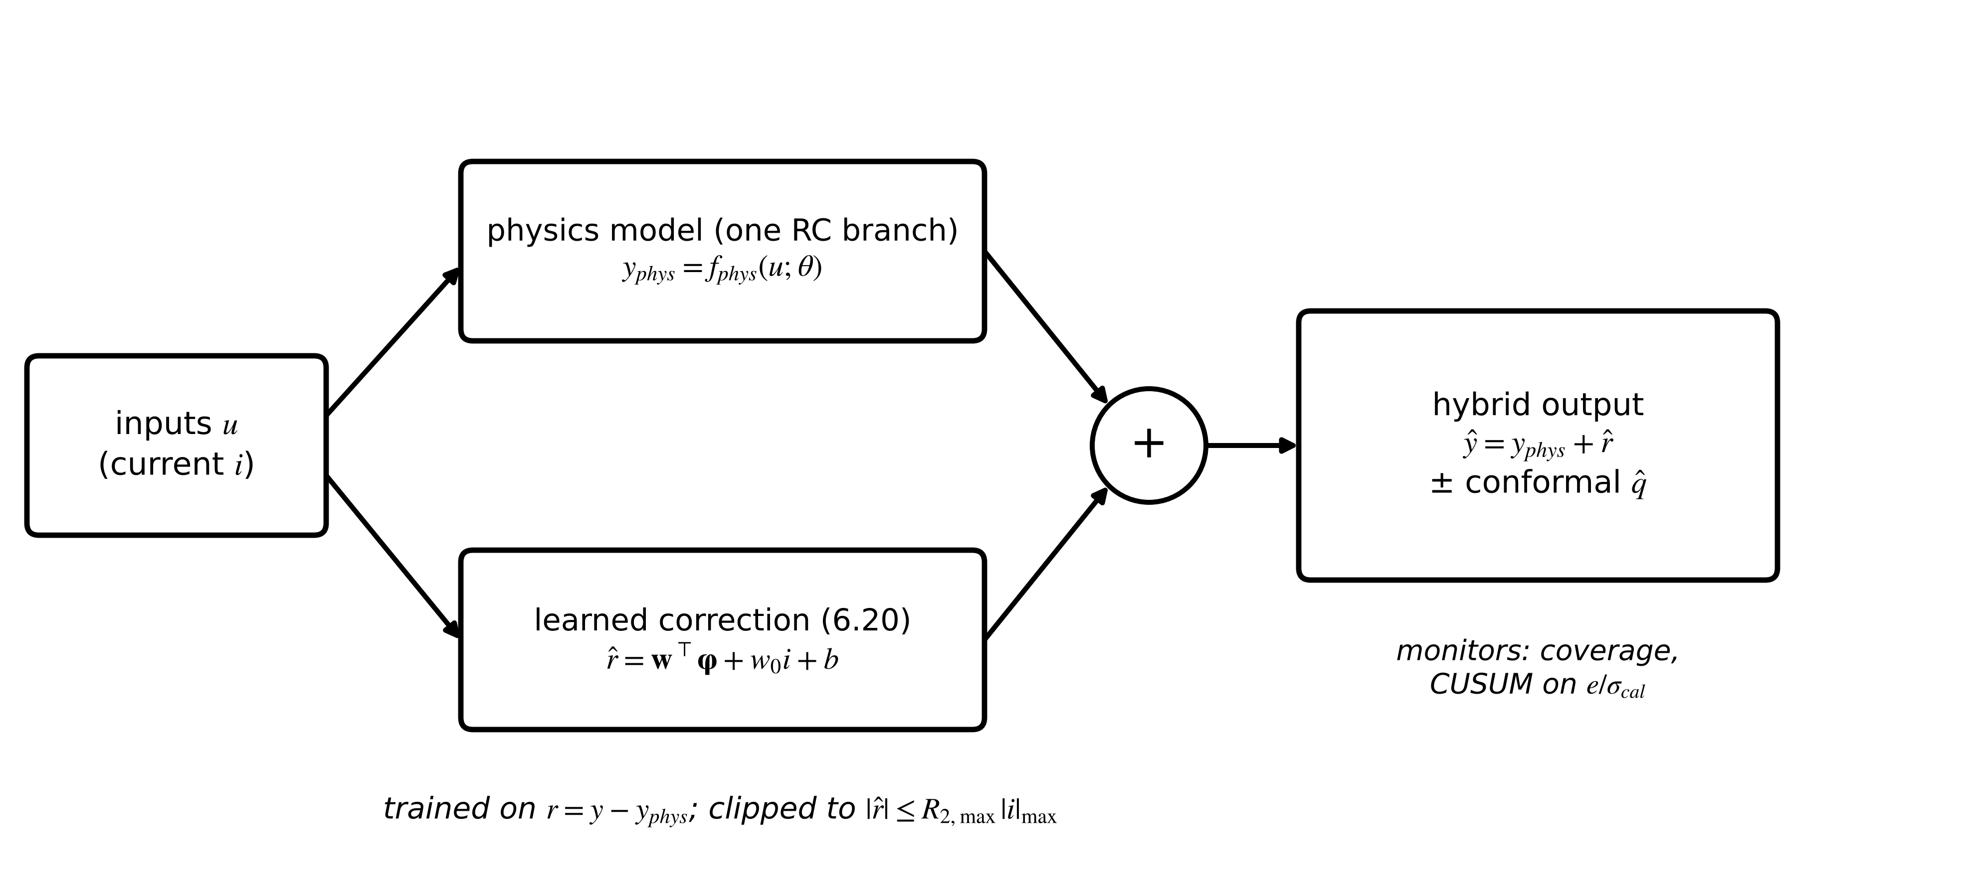
Figure 6.19. Residual-learning architecture: the physics model and a learned correction run in parallel; the correction is trained on the physics residual, bounded by physics, and its output carries a conformal interval.

6.7.4 Physics-informed neural networks
A PINN trains a network $\hat{θ}(t;w)$ to fit data while satisfying a governing equation at collocation points where no data exist [17]. For the M-07 heat run with temperature rise $θ=T-T_{amb}$, the single-node equation $C\dot{θ}=P-θ/R$ is made dimensionless with $\tilde{θ}=θ/θ_{ref}$ and $\tilde{t}=t/t_{ref}$. With $θ_{ref}=80$ K, $t_{ref}=3$ h, $P=400$ W, $R=0.2$ K/W and $C=9000$ J/K it becomes
$\frac{d\tilde{θ}}{d\tilde{t}}=\frac{t_{ref}}{Cθ_{ref}}\left(P-\frac{θ_{ref}\tilde{θ}}{R}\right)=6\left(1-\tilde{θ}\right), \tilde{θ}(0)=0$ (6.21)
Writing the network output as $\tilde{θ}=\tilde{t} N(\tilde{t};w)$ satisfies the initial condition exactly. The composite loss adds the mean squared data error at $N_{d}$ measured points and the mean squared equation residual $ϱ$ at $N_{c}$ collocation points, computed by automatic differentiation of the network (Figure 6.20):
$ℒ(w)=\frac{1}{N_{d}}\sum_{i=1}^{N_{d}}{{\left(\tilde{θ}\left({\tilde{t}}_{i}\right)-{\tilde{θ}}_{i}\right)}^{2}}+λ\frac{1}{N_{c}}\sum_{j=1}^{N_{c}}{ϱ}{\left({\tilde{t}}_{j}\right)}^{2}, ϱ=\frac{d\tilde{θ}}{d\tilde{t}}-6\left(1-\tilde{θ}\right)$ (6.22)
where $λ$ weights physics against data. Balancing the two terms is the main practical difficulty: gradient magnitudes of the two losses can differ by orders of magnitude, and adaptive schemes rescale $λ$ during training so that both gradients matter [18]. Stiff or multiscale equations make the loss surface hard for gradient methods, and a PINN can converge to a trivial or wrong solution while its loss looks small [19].
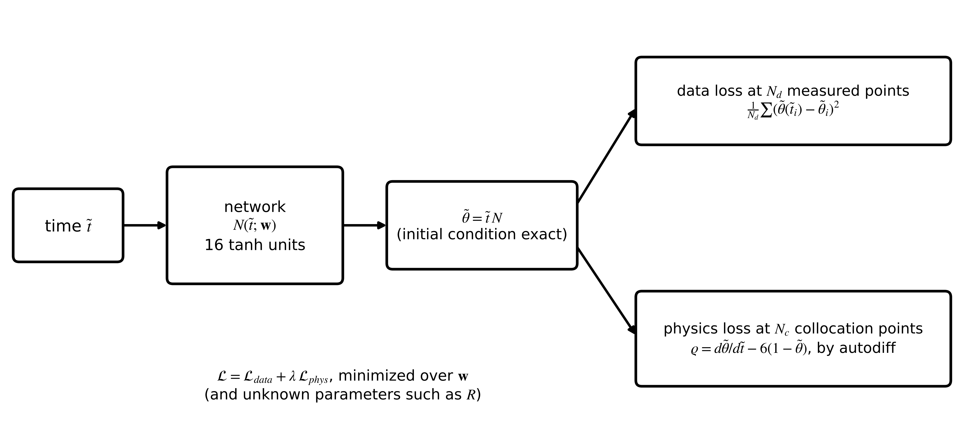
Figure 6.20. PINN construction for the RC heat run: the network output is multiplied by time so the initial condition holds exactly; the loss combines a data term and the equation residual at collocation points, obtained by automatic differentiation.
Example 6.13 (Level C) A PINN for the M-07 heat run
Given. A 400 W step from ambient; true $R=0.20$ K/W, $C=9000$ J/K (30-minute time constant, final rise 80 K). Six noisy measurements ($σ=0.3$ K) at 3, 8, 13, 18, 23 and 28 minutes. A network with 16 tanh units, trained by L-BFGS with exact gradients (automatic differentiation) on 120 collocation points over 3 hours.
Find. The RMS error inside and beyond the data window, and the predicted rise at 3 h, for a pure data fit ($λ=0$) and for $λ=0.01$, 1 and 100; then $\hat{R}$ when $R$ is a trainable unknown.
Solution. Table 6.4 and Figure 6.21. With $R$ trainable and $λ=1$, $\hat{R}=0.2006$ K/W.
Interpretation. Without physics the network fits the six points and then leaves the physical range entirely. With even a small weight on the physics it reproduces the exact solution, because equation, loss and initial condition are all known; in that forward setting the PINN is an expensive ODE solver, and a Runge-Kutta step (Chapter 4) is cheaper and more accurate. Its value lies in inverse problems such as estimating $R$ from sparse data while respecting the physics, and in field problems where the equation is known but boundary data are sparse.
Table 6.4. Data fit against physics-informed training for the M-07 heat run (synthetic; RMS errors in K)
Training | RMS error, 0 to 30 min | RMS error, 30 to 180 min | Predicted rise at 3 h (true 79.8 K)
data only ($λ$ = 0) | 0.49 | about 2500 (diverges) | −5020
PINN, $λ$ = 0.01 | 0.034 | 0.013 | 79.80
PINN, $λ$ = 1 | < 0.001 | < 0.001 | 79.80
PINN, $λ$ = 100 | < 0.0001 | < 0.0001 | 79.80

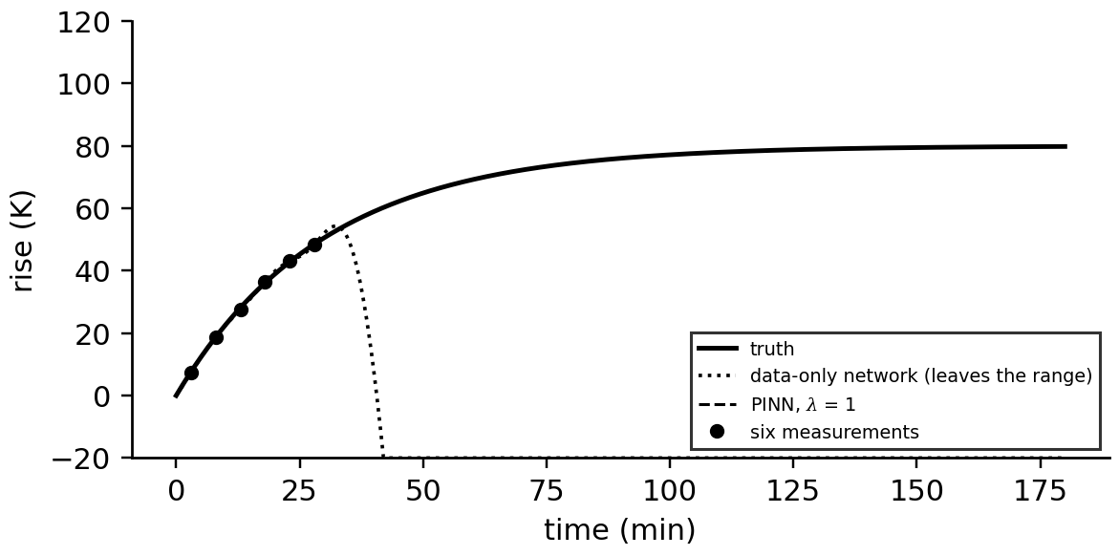
Figure 6.21. The heat-run data (dots), the truth, the data-only network, which leaves the physical range after the last measurement, and the PINN with λ = 1, which coincides with the truth.
Identifiability. A PINN inherits the identifiability of its equation (Chapter 4, Section 4.12). With both $R$ and $C$ unknown and the six measurements in the first 30 minutes, two different starting guesses both return $\hat{C}≈9050$ J/K. With six measurements between 4 and 5 hours, when the winding is close to steady state, the same procedure returns 10 130 J/K from one start and 9750 J/K from the other, with the same small loss: near steady state $dθ/dt≈0$ and the data carry almost no information about $C$. Physics-informed does not mean physically validated; the validation of Chapter 4 (Section 4.15) applies in full.

6.7.5 Neural ODEs, differentiable simulators and operator learning
A neural ODE keeps the solver and learns the right-hand side, often as a correction to known physics, a form also called a universal differential equation [20] (Figure 6.22):
$\dot{x}=f_{phys}\left(x,u;θ\right)+f_{NN}\left(x,u;w\right), \min_{θ,w}\sum_{k}{{\left\|y_{k}-h\left(x_{k}\right)\right\|}^{2}}, x_{k+1}=ODESolve\left(x_{k},u_{k};θ,w\right)$ (6.23)
Gradients reach $θ$ and $w$ through every solver step, either by differentiating the discrete steps or by an adjoint equation integrated backwards. This is the differentiable-simulator idea in general form: the grey-box fit of (6.18) was its simplest case, with no learned term. The danger is a learned term that destabilizes the model outside the training range; bounding $f_{NN}$ or penalizing its Lipschitz constant mitigates it. [Advanced] Operator learning trains a network $𝒢_{w}$ that maps an input function, such as the loss distribution along a winding or a boundary temperature profile, to an output function, such as the temperature field, from many simulations of a detailed model (Figure 6.23). DeepONet splits the map into a branch network for the input function and a trunk network for the output location, $𝒢(u)(x)≈\sum_{k}{b_{k}}(u)t_{k}(x)$ [15]; Fourier neural operators learn convolution kernels in the frequency domain [16]. After training they evaluate a field in milliseconds, which suits the fast hot-spot surrogates of Chapter 4's fidelity hierarchy, but only for inputs from the family they were trained on (research-stage in energy twins).
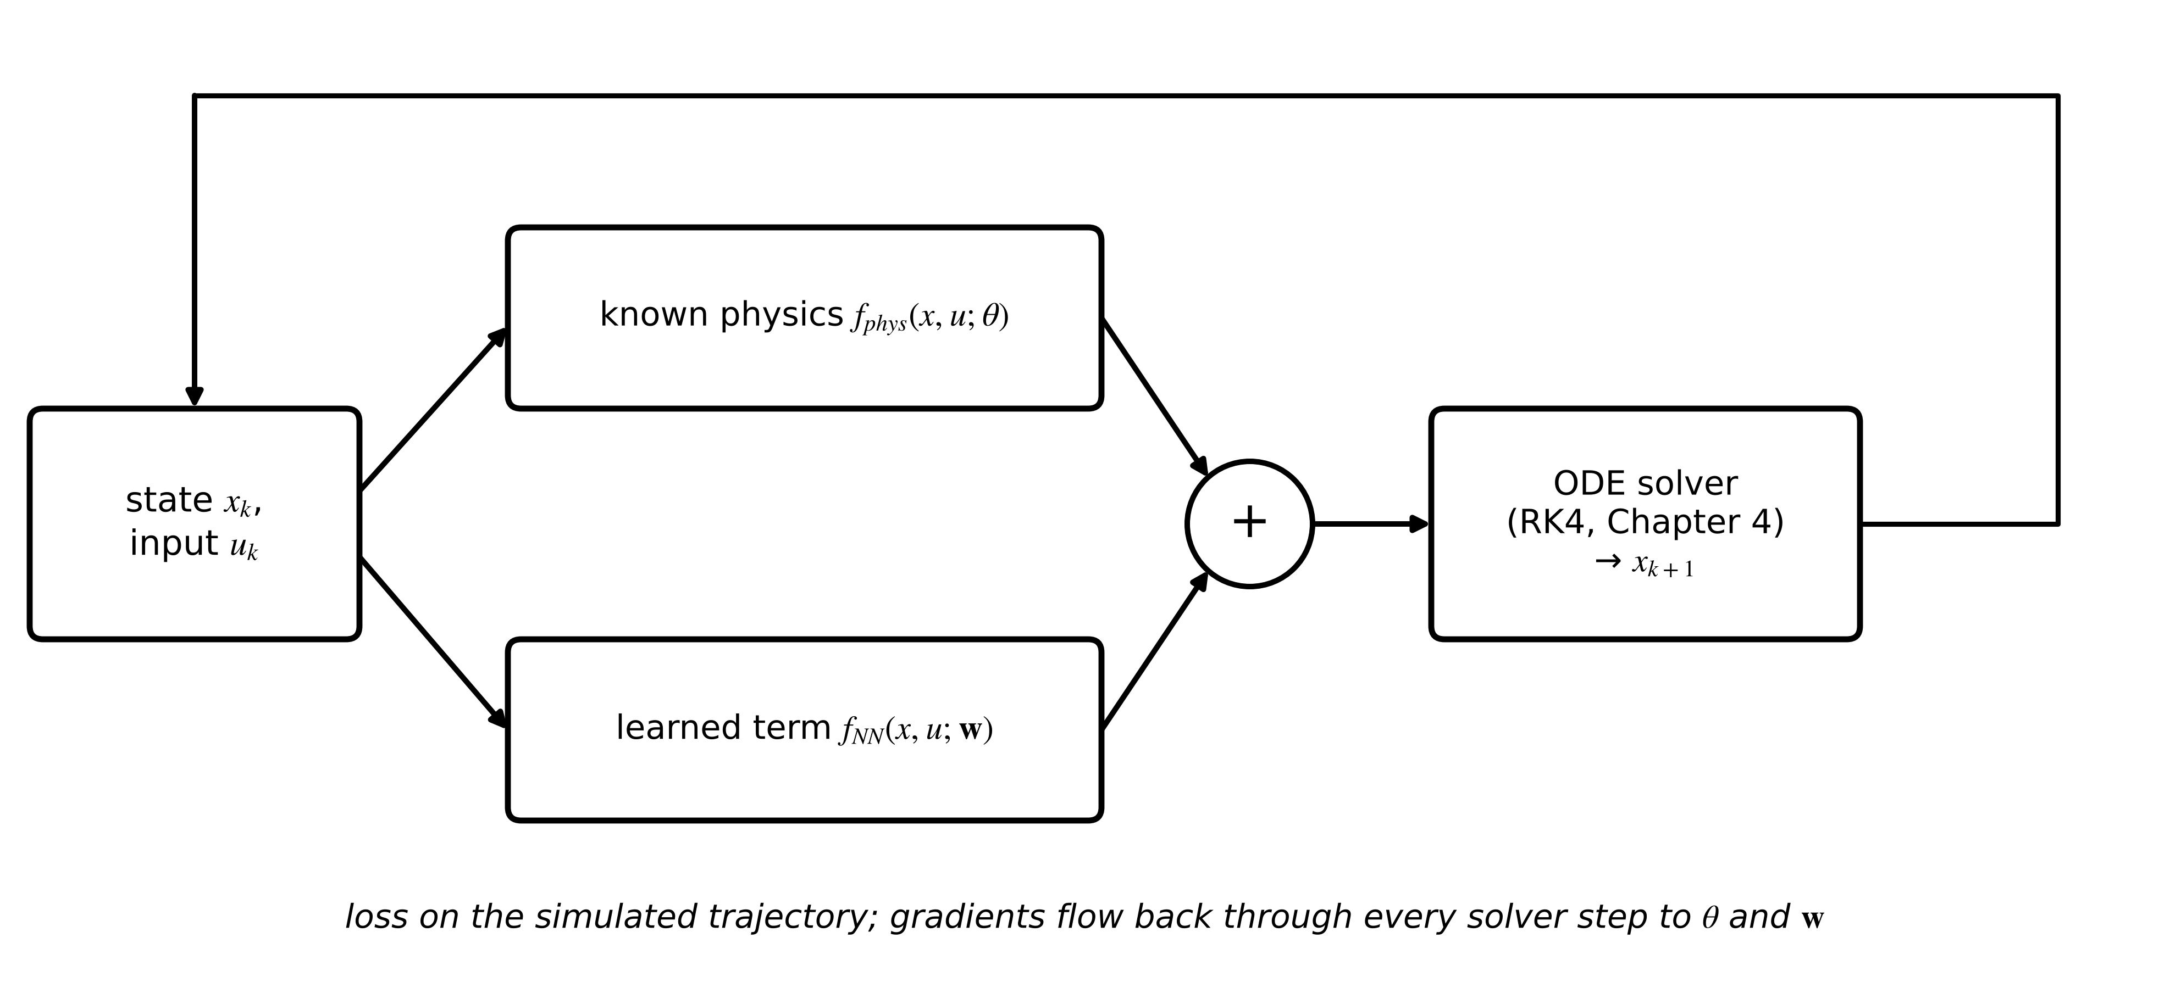
Figure 6.22. Neural ODE and differentiable simulator: known physics and a learned term form the right-hand side; an ordinary solver advances the state, and the loss on the simulated trajectory is differentiated back through every step.
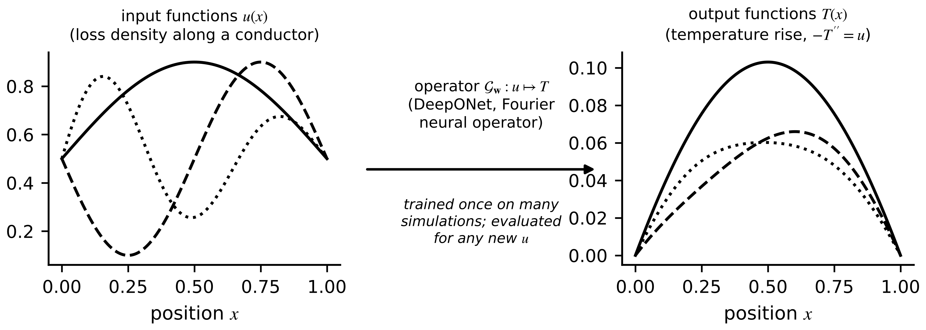
Figure 6.23. Operator learning maps whole input functions (left) to output functions (right) with one trained network, instead of learning one input-output point at a time.
Constrained learning. Physical knowledge often comes as limits rather than equations: a resistance is positive, a temperature rise is monotone in loss, a correction is bounded. A penalty adds $μ\sum{max}(0,c(\hat{y}))^{2}$ to the loss for constraint functions $c≤0$; a projection maps each output to the feasible set, as (6.20) clips the residual; architectural constraints (monotone layers, positive weights) enforce them exactly. Constraints are cheap and are often the most valuable physics a learned model can receive.
What the digital twin adds
Synchronized: a model whose physical structure is kept and whose gaps are learned.
Estimated or updated: physics parameters, residual models, PINN or neural-ODE weights.
Uncertainty carried: model-form error that physics leaves and learning cannot remove outside its data.
Decision enabled: where physics ends and learning begins for each twin function.
Validated by: OOD tests that separate structure from fit, and identifiability checks.

6.8 Uncertainty, calibration and decisions

6.8.1 Aleatoric and epistemic uncertainty
A twin's forecast is uncertain for two different reasons (Figure 6.24). Aleatoric uncertainty is noise in the data itself: sensor noise, unmeasured disturbances. More data of the same kind do not reduce it. Epistemic uncertainty is the model's ignorance: too few data, or none, in the region asked about. More data, or the right physics, reduce it [21]. An ensemble of $M$ models trained from different initializations or data resamples estimates both: if member $m$ predicts mean $μ_{m}$ and variance $σ_{m}^{2}$, the law of total variance splits the ensemble variance into an average of member variances and the spread of their means [22]:
$\overline{μ}=\frac{1}{M}\sum_{m=1}^{M}{μ_{m}}, σ_{tot}^{2}=\frac{1}{M}\sum_{m=1}^{M}{σ_{m}^{2}}+\frac{1}{M}\sum_{m=1}^{M}{{\left(μ_{m}-\overline{μ}\right)}^{2}}$ (6.24)
The first term is the aleatoric part and the second the epistemic part. Three members predicting 10, 11 and 12 with variance 1 each give mean 11, aleatoric variance 1 and epistemic variance 0.667. Gaussian processes ((6.16)) and Bayesian neural networks estimate epistemic uncertainty directly; dropout kept active at prediction time is a cheap approximation. None of these is guaranteed to be honest outside the data, which is why calibration is checked, not assumed.
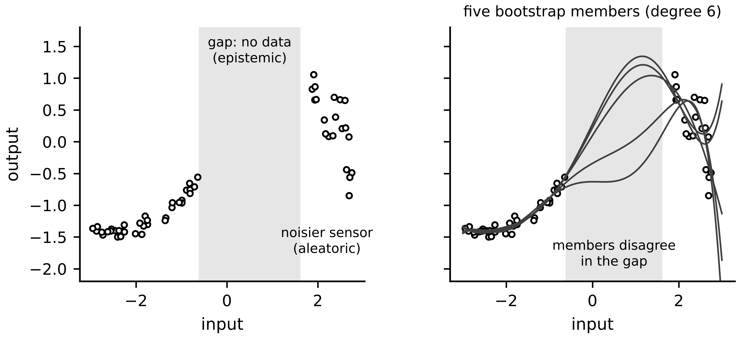
Figure 6.24. Left: aleatoric uncertainty (a noisier region of the data) and epistemic uncertainty (a gap with no data). Right: an ensemble of five models fitted to resampled data disagrees most in the gap, which estimates the epistemic part.

6.8.2 Conformal prediction
Conformal prediction wraps any point predictor in an interval with a guaranteed coverage, under one assumption: calibration errors and future errors are exchangeable (their joint distribution is unchanged by reordering) [23]. With the absolute errors $s_{i}=|y_{i}-{\hat{y}}_{i}|$ of a calibration set of size $n$ and target miscoverage $α$,
$\hat{q}=s_{\left(\left\lceil (n+1)(1-α)\right\rceil \right)}, P\left(\left|y_{new}-{\hat{y}}_{new}\right|≤\hat{q}\right)≥1-α$ (6.25)
where $s_{(j)}$ is the $j$-th smallest calibration error. The guarantee follows because, under exchangeability, the new error is equally likely to fall at any rank among the $n+1$ errors. It is distribution-free and holds for any model, which suits hybrid twins whose error distribution is unknown; it breaks exactly when the asset or its duty changes, which makes coverage itself a drift monitor (Section 6.10); the Advanced box below shows how far adaptive methods can restore it.
Example 6.14 (Level B) Conformal intervals for the hybrid battery twin
Given. The residual model of Section 6.7.3; a calibration record of $n=7200$ samples (seed 2032); $α=0.1$; an independent test record (seed 2033).
Find. The order statistic used, $\hat{q}$ and the test coverage.
Solution. $⌈7201×0.9⌉=6481$; $\hat{q}=3.45$ mV; on the test record 89.8 % of errors lie within $±3.45$ mV (Figure 6.25).
Interpretation. The promised 90 % is delivered on data the model never saw, without any assumption about the error distribution. The interval is honest because calibration and test records come from the same healthy cell; Section 6.10 shows what happens when that stops being true.
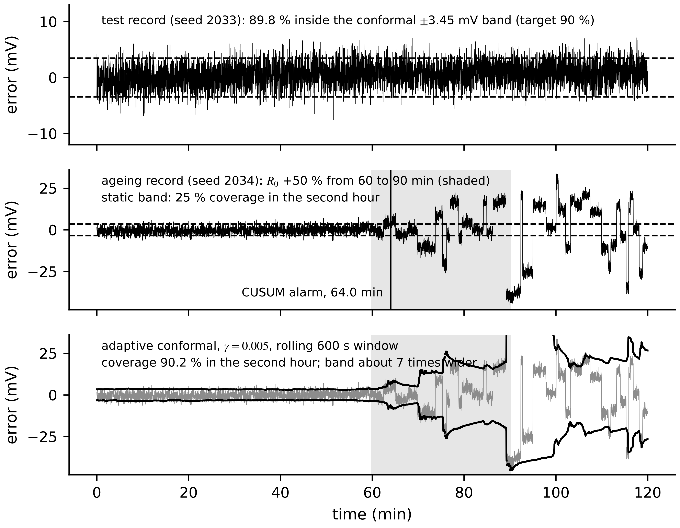
Figure 6.25. Hybrid battery twin. Top: test-record error inside the conformal 90 % band. Middle: the ageing record, where the resistance rises by 50 % from 60 to 90 min; errors leave the band and a CUSUM alarm fires at 64 min. Bottom: an adaptive conformal interval on a rolling window restores 90 % coverage by widening about seven times (Advanced box below).
[Advanced] Conformal prediction under drift: adaptive conformal inference
Split conformal prediction (6.25) guarantees coverage only while calibration errors and future errors are exchangeable. The ageing record of Example 6.19 (Section 6.10) shows how quickly that fails: once $R_{0}$ starts to rise, the static $±3.45$ mV band covers 25 % of the second hour. Adaptive conformal inference (ACI) treats the miscoverage level as a control variable and corrects it by feedback from the observed misses [24]:
$α_{t+1}=α_{t}+γ\left(α−{err}_{t}\right), {err}_{t}=1\left[ \left|y_{t}−{\hat{y}}_{t}\right|>{\hat{q}}_{t}\left(α_{t}\right)\right]$
where ${\hat{q}}_{t}\left(α_{t}\right)$ is the conformal quantile (6.25) at level $α_{t}$ and $γ>0$ a step size. A miss lowers $α_{t}$ and widens the next interval; a run of covered points raises $α_{t}$ and narrows it.
The long-run guarantee takes two lines. If $α_{t}$ falls below zero the interval is infinite and cannot miss, so $α_{t}$ rises again; if it exceeds one the interval is empty and every point misses, so it falls. Hence $α_{t}$ stays within $\left[−γ, 1+γ\right]$. Summing the update over $T$ steps telescopes, for any sequence of data, exchangeable or not:
$\left|\frac{1}{T}\sum_{t=1}^{T}{{err}_{t}}−α\right|=\frac{\left|α_{T+1}−α_{1}\right|}{γT}≤\frac{max\left(α_{1}, 1−α_{1}\right)+γ}{γT}$
With $α_{1}=α=0.1$, $γ=0.005$ and $T=3600$ samples the bound is 0.050: over one hour the average miss rate stays within five points of the target, whatever the drift. The guarantee is about the average over time, not about any single interval.
Applied to the ageing record (seed 2034) with the original calibration errors (seed 2032), ACI with $γ=0.005$ restores 89.6 % coverage in the second hour, but only by declaring the interval infinite 61 % of the time: once the errors exceed every calibration score, no finite quantile is wide enough. Replacing the fixed calibration set by the 600 most recent errors keeps the intervals finite (1 % infinite) and gives 90.2 % coverage; the median half-width after the resistance ramp is 24.4 mV, seven times the healthy 3.45 mV (Figure 6.25, bottom).
Two lessons follow. Coverage can be bought back under drift, but the price is width, and an interval seven times wider is honest yet nearly useless for decisions. Width is therefore a drift signal in its own right, and it points to the cure, which is a model update: candidate B of Example 6.19 brings the error back to 2.06 mV. Ensemble-based intervals for time series such as EnbPI [25] trade the exact finite-sample guarantee for adaptivity in a similar way; none of these methods removes the need to update the model.

6.8.3 Checking calibration
A predictor with stated intervals is calibrated when its $p$ % intervals contain the truth $p$ % of the time. The prediction-interval coverage probability (PICP) checks one level; the reliability diagram plots empirical against nominal coverage for all levels (Figure 6.26); the expected calibration error summarizes the gap; the continuous ranked probability score (CRPS) is a proper score for comparing probabilistic forecasts and reduces to the absolute error for a point forecast. For Gaussian predictions with mean $μ$ and standard deviation $σ$,
$PICP=\frac{1}{N}\sum_{n=1}^{N}{1}\left[y_{n}∈I_{n}\right], ECE=\sum_{b=1}^{B}{\frac{N_{b}}{N}}\left|{\hat{c}}_{b}-p_{b}\right|, CRPS=σ\left[ζ\left(2Φ(ζ)-1\right)+2φ(ζ)-\frac{1}{\sqrt{π}}\right]$ (6.26)
where $I_{n}$ is the interval, ${\hat{c}}_{b}$ the empirical and $p_{b}$ the nominal coverage of bin $b$ containing $N_{b}$ predictions, $ζ=(y-μ)/σ$, and $Φ$, $φ$ the standard normal distribution and density. A PICP of 141 out of 150 for a 90 % interval (0.94) is slightly conservative; with 150 points its sampling standard deviation is about 0.025, so the difference is not significant.
Example 6.15 (Level C) Calibration in and out of distribution
Given. The Gaussian process and the hybrid model of Table 6.3, each producing Gaussian predictive intervals.
Find. Their 90 % coverage on the in-distribution test days and on the OOD day, and their mean predictive standard deviations.
Solution. In distribution the GP covers 88.1 % and the hybrid 88.3 %, close to nominal. Out of distribution the GP covers 29.1 % although its mean standard deviation grows from 1.32 to 9.80 K, and the hybrid covers 69.9 % with its standard deviation growing from 0.99 to 4.30 K (Figure 6.26).
Interpretation. Both models are honest where they were trained. Out of distribution the GP's variance grows, but far less than its error, so its intervals mislead; the hybrid is both more accurate and better calibrated there, because its physics part carries most of the prediction. A twin must check calibration separately out of distribution and gate its outputs with an input-novelty test (Section 6.9).
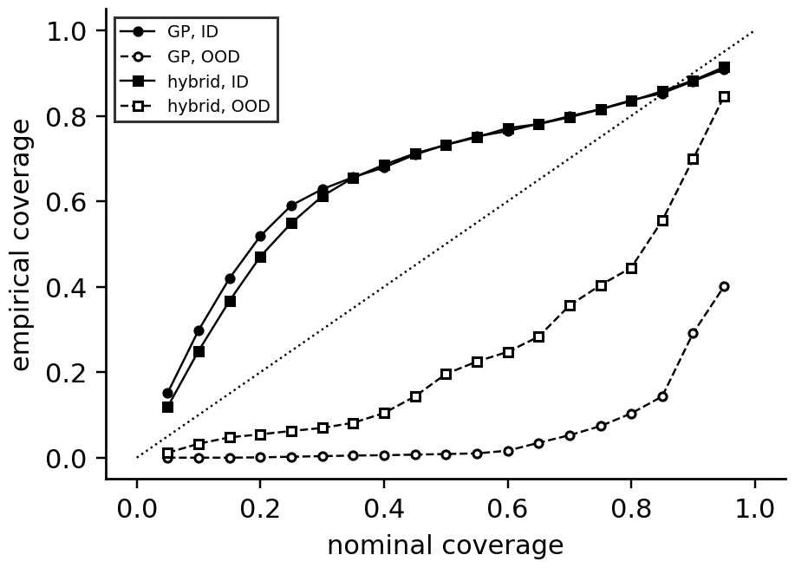
Figure 6.26. Reliability diagram: empirical against nominal coverage for the Gaussian process and the hybrid model, in distribution (filled) and on the OOD day (open). Curves below the diagonal are overconfident.

6.8.4 Using uncertainty in decisions
An interval is useful only if a decision uses it. Three patterns recur. Risk-aware thresholds act on an upper quantile rather than the mean: derate M-07 when the 95 % upper bound of the 30-minute forecast crosses 120 °C, not when the mean does. Abstention withholds an automatic action when the interval is too wide or the input is novel, and hands the decision to an operator (autonomy Layer 2, Chapter 1). Model disagreement between two architecturally different models is itself a signal:
$Δ_{k}=\frac{{\hat{y}}_{A,k}-{\hat{y}}_{B,k}}{\sqrt{σ_{A,k}^{2}+σ_{B,k}^{2}}}$ (6.27)
where $A$ and $B$ might be the grey box and the GP. When $|Δ_{k}|$ stays large, either the asset has left the data model's training range or it has changed in a way the physics does not describe; both deserve an engineer's attention, and neither model should drive an automatic action until it is resolved.
Example 6.16 (Level A) A risk-aware derating decision
Given. The 30-minute forecast of the M-07 winding is 114.0 °C. The insulation-based advisory limit is 120 °C and the twin acts on the 95 % one-sided upper bound $μ+1.645σ$.
Find. The decision when the forecast standard deviation is 3 K and when it is 4 K.
Solution. $σ=3$ K: bound $114.0+4.9=118.9$ °C, below the limit: no derating. $σ=4$ K: bound $120.6$ °C: derate.
Interpretation. The same mean forecast leads to different actions depending on the twin's honesty about its uncertainty. An overconfident model (too small $σ$) runs the motor hotter than intended; that is why calibration is checked before intervals are used in decisions.
What the digital twin adds
Synchronized: predictions together with honest intervals.
Estimated or updated: ensemble spreads, GP variances, conformal quantiles.
Uncertainty carried: aleatoric and epistemic parts separately, with coverage checked.
Decision enabled: risk-aware thresholds, abstention and disagreement alarms.
Validated by: PICP, reliability diagrams and CRPS, in and out of distribution.

6.9 Out-of-distribution and domain-shift testing as a mandatory gate
High accuracy on a random or even a blocked split is not sufficient for a twin, because a twin is most needed exactly when the asset leaves its usual conditions. Out-of-distribution testing is therefore a gate every learned component must pass before deployment and keep passing in service (Figure 6.27).
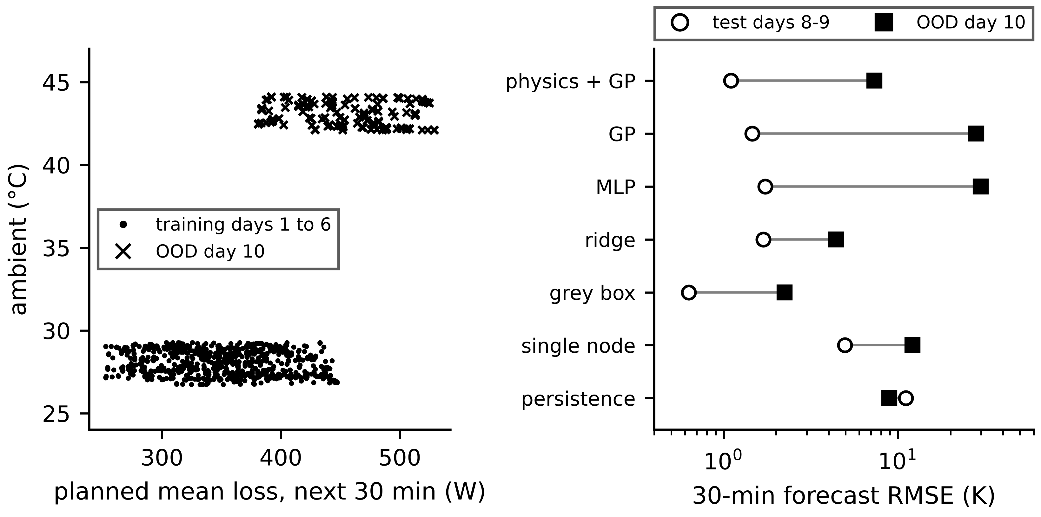
Figure 6.27. Left: training and OOD operating points of the M-07 benchmark in the space of planned loss and ambient temperature. Right: in-distribution and OOD forecast RMSE for each model (log scale).
Detecting novel inputs. At run time, an input far from the training data is flagged before its prediction is trusted. The Mahalanobis distance from the training mean $\overline{x}$ with covariance $Σ_{x}$ is the simplest test; for a whole batch of recent inputs, the population stability index over $B_{p}$ bins and the two-sample Kolmogorov-Smirnov statistic compare distributions:
$D_{M}=\sqrt{{\left(x-\overline{x}\right)}^{⊤}Σ_{x}^{-1}\left(x-\overline{x}\right)}, PSI=\sum_{b=1}^{B_{p}}{\left(p_{b}^{new}-p_{b}^{ref}\right)}ln\frac{p_{b}^{new}}{p_{b}^{ref}}, D_{KS}=\sup_{x}\left|F_{new}(x)-F_{ref}(x)\right|$ (6.28)
where $p_{b}$ are bin fractions and $F$ empirical distribution functions. A PSI above about 0.25 is usually taken as a significant shift; the KS test rejects at level 0.05 when $D_{KS}>1.36\sqrt{(n_{1}+n_{2})/(n_{1}n_{2})}$. With the large samples of twin logs tiny, harmless shifts become statistically significant, so an effect-size measure such as PSI is needed alongside the test. Reference fractions $[0.25,0.25,0.25,0.25]$ against recent $[0.10,0.20,0.30,0.40]$ give PSI = 0.228, a moderate shift.
Example 6.17 (Level A) Is this input out of distribution?
Given. M-07 training features have planned loss mean 351 W, standard deviation 48 W, and ambient mean 28.0 °C, standard deviation 1.41 °C, nearly uncorrelated (correlation −0.06). A live input has 480 W and 43 °C.
Find. The Mahalanobis distance (6.28) and the verdict, if 99 % of training inputs lie within 3.0.
Solution. $D_{M}=\sqrt{(129/48)^{2}+(15/1.41)^{2}}=\sqrt{7.2+113}=11.0$.
Interpretation. The ambient alone is more than ten training standard deviations away. Every learned model's output for this input is unvalidated; the twin uses its grey-box physics model and labels the forecast accordingly.
Example 6.18 (Level B) OOD performance comparison as a deployment gate
Given. Table 6.3; a gate requiring OOD RMSE below 3 K and OOD bias within ±2.5 K for any model that drives the overload advisory.
Find. Which models pass.
Solution. Grey box: 2.24 K and −2.09 K, pass. Ridge: 4.41 K, fail. Hybrid: 7.31 K, fail. Neural network and GP: 29.9 and 28.1 K, fail. Persistence and single-node physics fail.
Interpretation. Only the grey box may drive the advisory outside the training domain. The hybrid, best of the learned models in distribution, may still be used inside it, behind the novelty test of Example 6.17, with automatic fallback to the grey box outside.
The gate. Before deployment a learned component must report, on held-out data: blocked in-distribution error against its baseline; error and calibration on at least one OOD set chosen from the conditions where the twin's decisions matter (high load, extreme ambient, aged assets, another site); and its behaviour on inputs the novelty test flags. The Table 6.3 results show why: the two best learned models in distribution were the two worst out of it, and only the OOD column revealed it. In service, outputs for inputs beyond a distance threshold are labelled unvalidated and the twin falls back to its physics model or abstains.
What the digital twin adds
Synchronized: learned components only within conditions they were tested in.
Estimated or updated: novelty distances and distribution-shift statistics.
Uncertainty carried: an explicit ‘unvalidated’ status outside the tested domain.
Decision enabled: deploy, restrict, fall back to physics or abstain.
Validated by: OOD sets chosen where decisions matter, before and after deployment.

6.10 Online and continual learning with governance
A deployed model meets data that slowly stop resembling its training data. The joint distribution of inputs and targets can shift in its input part $p(x)$ (covariate shift: a new duty cycle), in its conditional part $p(y|x)$ (concept drift: an ageing asset responds differently to the same inputs), or both [26]. Input shift is detected with (6.28); concept drift shows in the errors, and a CUSUM on the standardized error ${\overline{e}}_{k}=(y_{k}-{\hat{y}}_{k})/σ_{cal}$ detects a persistent change:
$g_{k}=max\left(0, g_{k-1}+\left|{\overline{e}}_{k}\right|-κ\right), alarm if g_{k}>h$ (6.29)
where $κ$ is a reference value and $h$ a threshold. The simplest online adaptation is a stochastic-gradient step on each new sample, $w_{k}=w_{k-1}-η∇_{w}ℓ(y_{k},g(x_{k};w_{k-1}))$, where a constant step weights recent data like the forgetting factor of Chapter 5. Online updating carries a risk that batch training does not: catastrophic forgetting, where fitting recent data erases what was learned about conditions not currently present (winter behaviour forgotten in summer) [27]. It is checked by keeping a replay set of earlier conditions and requiring the updated model to stay within tolerance on it, and mitigated by mixing replayed data into updates or penalizing changes to weights that mattered for old tasks.
Retraining is never automatic. A governed update follows a fixed sequence (Figure 6.28): detect, diagnose (input shift, concept drift, or a physical change better handled by physics), propose candidates, test them through a gate on data none of them saw, deploy in shadow mode (the candidate runs alongside the deployed model without driving decisions) and then live with the previous version kept, monitor, and roll back if needed. The gate used below accepts a candidate only if
${RMSE}_{cand}≤\left(1-ρ_{imp}\right){RMSE}_{dep}, \left|{PICP}_{cand}-(1-α)\right|≤ε_{cov}, all {\hat{r}}_{k} within physical bounds, {RMSE}_{replay}≤\left(1+ρ_{f}\right){RMSE}_{replay,dep}$ (6.30)
where $ρ_{imp}$ is the required improvement (10 % here), $ε_{cov}$ the allowed coverage error (0.05) and $ρ_{f}$ the allowed degradation on the replay set (forgetting check).
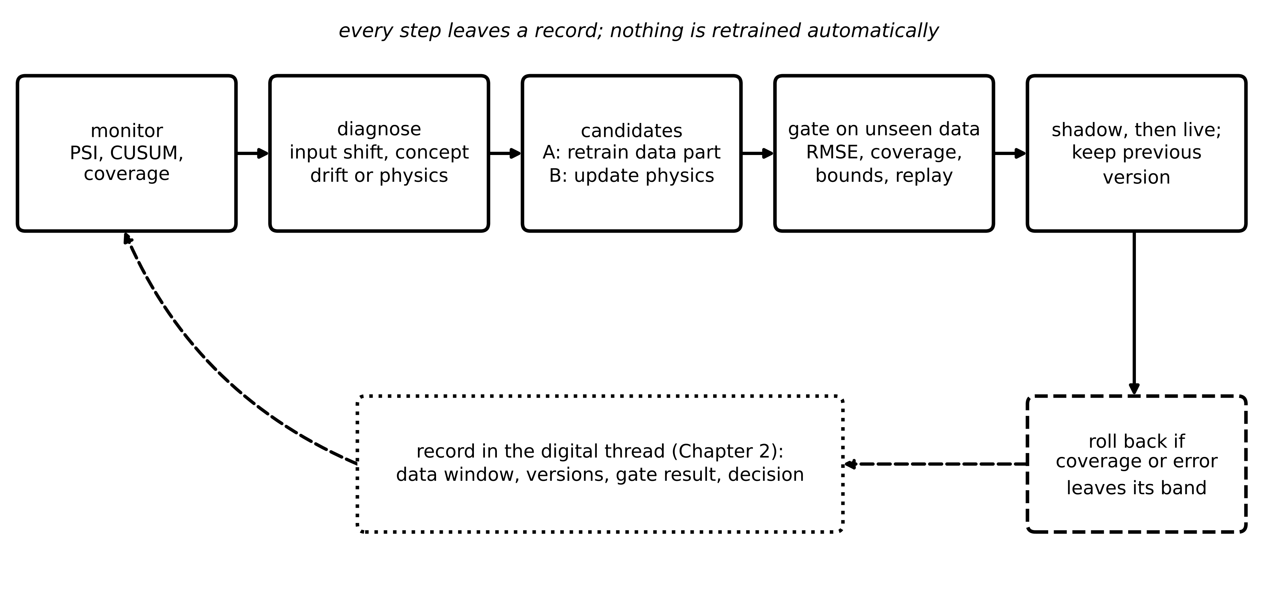
Figure 6.28. Governed update loop for a learned twin component: monitoring detects drift, diagnosis chooses between a physics and a data update, candidates pass a gate on unseen data, shadow deployment precedes live use, and the previous version is kept for rollback; every step is recorded in the digital thread.
Example 6.19 (Level C) Drift, update gate and rollback in the hybrid battery twin
Given. The hybrid twin of Section 6.7.3 on a fourth record (seed 2034) in which $R_{0}$ rises by 50 % between 60 and 90 minutes, as in Chapter 5. CUSUM (6.29) with $σ_{cal}=2.09$ mV, $κ=1.5$, $h=20$. Candidate A retrains the residual model on 5400 to 6600 s; candidate B treats the drift as a physics change and re-estimates $R_{0}$ from the same window, $Δ{\hat{R}}_{0}=-\sum{e_{k}}i_{k}/\sum{i_{k}^{2}}$. Hold-out block: 6600 to 7200 s; second aged record: seed 2035.
Find. Coverage and error without update, the alarm time, $Δ{\hat{R}}_{0}$, and both candidates' errors on the hold-out block and on the second record; the decision.
Solution. Without update the 90 % interval covers only 25 % of the second half and the error rises to 15.7 mV RMS. CUSUM alarms at 3840 s, when $R_{0}$ has risen by 6.7 %. $Δ{\hat{R}}_{0}=0.747$ mΩ against the true 0.750. Hold-out: deployed 15.5 mV, A 2.09 mV, B 2.06 mV; aged part (5400 to 7200 s) of the second record: A 1.99 mV, B 1.99 mV. Both pass the gate.
Interpretation. Here the data update and the physics update generalize equally well, because the current itself is one of the residual model's features and can absorb a resistance change exactly. The governance rule then decides: prefer the physics update, because it explains the change with one physical parameter that the ageing twin of Chapter 12 can trend and report, keeps the learned part bounded to the diffusion branch it was designed for, and adds no new free coefficients. B is adopted in shadow mode, then live; the previous version is retained for rollback and the decision is recorded in the digital thread.
Table 6.5. Governance decision points for learned twin components
Decision point | Evidence required | Typical rule
deploy a new model | blocked test, OOD test, calibration, runtime, baseline comparison | beats baseline and deployed model; PICP within tolerance
detect drift | PSI and KS on inputs, CUSUM on errors, coverage | alarm on persistent breach, not on single samples
choose update type | diagnosis of the drift source | prefer a physics-parameter update when the change is physical
accept an update | gate (6.30) on unseen data, second-record test, replay set | all conditions met; otherwise keep the deployed model
go live | shadow period with agreement checks | no new disagreement alarms during shadow
roll back | post-update monitoring | revert if coverage or error leaves its band
retire | repeated failures, asset change | return to physics-only twin with advisory

What the digital twin adds
Synchronized: learned components to the asset as it changes, under control.
Estimated or updated: drift statistics, candidate models, the accepted version.
Uncertainty carried: coverage as a live monitor of exchangeability.
Decision enabled: retrain, update physics, keep, roll back or retire.
Validated by: the gate, shadow deployment, replay checks and digital-thread records.

6.11 Trustworthy and efficient AI for twins

6.11.1 Interpretability and its limits
Engineers trust what they can inspect. The most reliable route to interpretability is structural: a grey-box parameter, a five-coefficient residual model or a bounded correction can be read directly. Post-hoc explanation methods attribute a black-box prediction to its inputs; Shapley-value methods such as SHAP distribute the prediction among features by averaging each feature's marginal contribution over all subsets [28]. They describe the model, not the asset: correlated features share credit arbitrarily, attributions can be unstable across retrainings, and a plausible explanation of a wrong prediction is still wrong. Explanations are therefore aids to debugging and review, not evidence of validity, and regulation increasingly asks for documented risk management and human oversight rather than explanations alone; the EU Artificial Intelligence Act (Regulation (EU) 2024/1689) classifies AI used as a safety component in the management of critical infrastructure such as electricity supply as high-risk [29] (Regulation (EU) 2026/1744 deferred the application of these obligations to 2 December 2027 [30]), and the NIST AI Risk Management Framework sets out comparable practices [31].

6.11.2 Edge deployment: pruning, quantization and distillation
Many twin functions run on edge devices with little memory, fixed deadlines and energy budgets (Chapter 2, Section 2.4). Three techniques shrink a trained model [32]. Quantization stores weights (and often activations) as 8-bit integers with a scale $s$ per tensor, $w_{q}=s·round(w/s)$ with $s=max|w|/127$ for symmetric int8, cutting memory by four and enabling integer arithmetic [33]. Pruning removes small weights or whole units and is followed by fine-tuning to recover accuracy. Distillation trains a small student to imitate a large teacher's outputs [34]. Each must be followed by the full validation of the original, on the target hardware, with worst-case execution time (Chapter 2, Section 2.10).
Example 6.20 (Level A) Shrinking the M-07 forecaster
Given. The 5-32-32-1 network of Table 6.3 (1281 parameters). (i) Symmetric int8 quantization of all weight matrices. (ii) Removal of the 50 % smallest weights in every layer without retraining.
Find. Memory and RMSE over the whole synthetic log for each version.
Solution. Float32: 5.1 kB, RMSE 1.043 K. Int8: 1.3 kB, RMSE 1.045 K. 50 % pruning without retraining: RMSE 62.4 K (Figure 6.16, right).
Interpretation. Quantization cost nothing measurable; unstructured pruning without fine-tuning destroyed the model. Compression is a model change and passes the same gate as any other update.

6.11.3 Reproducibility and provenance
A learned twin component is reproducible only if its whole recipe is recorded: data window and its content hash, preprocessing and scaling constants, split definitions, model code version, hyperparameters, random seeds, software environment, hardware, and the validation results against which it was accepted. These are the configuration items of the digital thread (Chapter 2, Section 2.7), extended to learning; a model card summarizes intended use, training data, OOD tests and known limits for reviewers [35]. Table 6.6 is the checklist used for every learned component in this book.
Table 6.6. Reproducibility and provenance checklist for learned twin components
Item | Recorded as | Why
data window and content hash | time range, sources, SHA-256 of the data file | re-train on exactly the same data
preprocessing | scaling constants, filters, window length and stride | live data must be transformed identically
splits | day or block edges, gaps, OOD set definition | results comparable across versions
model and hyperparameters | code version, architecture, regularization, schedule | re-create the model
seeds and environment | random seeds, library versions, hardware | bit-level or statistical reproducibility
validation evidence | baseline, blocked, OOD, calibration, runtime results | acceptance traceable to evidence
model card | intended use, limits, known failure modes | reviewers and operators know what not to do

What the digital twin adds
Synchronized: learned components that can be explained, run on the edge and re-created.
Estimated or updated: compressed models, attributions, provenance records.
Uncertainty carried: accuracy loss from compression, measured not assumed.
Decision enabled: what runs where, and what reviewers may rely on.
Validated by: full re-validation after compression; checklist completeness.

6.12 Case study: the hybrid battery twin of Plant P-1 (Level C)
The BESS of Plant P-1 uses the cell twin of Chapter 5 for state and parameter estimation and the hybrid of this chapter for voltage prediction with calibrated intervals. Table 6.7 collects what each stage contributed on the synthetic records (seeds 2031 to 2035).
Table 6.7. End-to-end hybrid battery twin (synthetic records; voltage errors in mV RMS; sensor noise 2 mV)
Stage | Result
physics baseline (one RC branch) | 9.2 to 13.9 mV on healthy records
plus physics-guided residual model (6.20) | 1.99 to 2.12 mV
conformal 90 % interval | $\hat{q}$ = 3.45 mV; test coverage 89.8 %
ageing record, no update | coverage 25 % in the second half; 15.7 mV
CUSUM drift alarm | 3840 s, $R_{0}$ up 6.7 %
candidate A (retrain residual) | 2.09 mV hold-out; 1.99 mV on the aged part of a new record
candidate B (update $R_{0}$ in physics) | 2.06 mV hold-out; 1.99 mV on the aged part of a new record; $Δ{\hat{R}}_{0}$ = 0.747 mΩ (true 0.750)
decision | adopt B by the physics-first rule; shadow, then live; keep the previous version

The learned component earned its place by removing a systematic error the physics could not see, and earned trust by stating calibrated uncertainty. When the asset changed, coverage collapsed and the monitor noticed within four minutes; the gate then preferred an update to physics over an update to data because it explained the change with one physical, reportable parameter. That order of preference is a design principle of hybrid twins, not an accident of this example.

6.13 Recent developments and open research problems
Learning for energy twins is moving fast; each development is labelled with its status in 2026. The 2026 reviews of electrical-engineering twins stress interoperability, adaptive synchronization and the step from descriptive to prescriptive twins, all of which depend on learned components that can be validated and governed [1], [2], [3].
Time-series foundation models (research, early pilots). Large models pretrained on many time series, such as Chronos [36] and TimesFM [37], forecast new series with little or no task-specific training. Open problem: calibration and OOD behaviour on physical assets, and how to combine them with physics. Physics-guided learning beyond PINNs (emerging). Differentiable simulators, neural ODEs with physics cores and constrained learning are increasingly preferred where PINN optimization is fragile; operator learning provides fast field surrogates (research-stage in energy). Uncertainty with guarantees (emerging). Conformal methods adapted to time series and drift [24], [25], and ensembles of hybrid models; open problem: coverage under the distribution shifts twins exist to detect. Transfer across fleets (emerging). Self-supervised pretraining and hierarchical models across assets and sites; open problem: knowing when transfer hurts. Efficient edge AI (established for inference). Quantization and distillation on embedded processors; open problem: certified worst-case latency for learned components. Governance and regulation (established requirements, emerging practice). The EU AI Act and the NIST AI RMF require documented risk management, data governance and human oversight for high-risk uses such as critical-infrastructure safety components [29], [31]; open problem: practical evidence packages for continually learning twins.
Verified recent results behind these directions. Gibbs and Candès showed that a one-line feedback on the miscoverage level gives long-run coverage under arbitrary distribution shift [24]; the Advanced box of Section 6.8.2 applies it to the battery twin. EnbPI builds prediction intervals for time series from bootstrap ensembles without assuming exchangeability [25]. TimesFM, a decoder-only model pretrained on about 100 billion time points, reached zero-shot accuracy close to supervised models on public forecasting benchmarks [37]; like Chronos, it has not been shown to respect physical limits or to stay calibrated outside its pretraining distribution, which is why Table 6.8 asks for a comparison against a grey-box baseline on held-out assets. Universal differential equations embed learned terms in mechanistic models and provide a software basis for the neural-ODE hybrids of Section 6.7.5 [20]. In power systems, PINNs were first applied to the swing equation to estimate rotor angle and frequency [38]. For batteries, Aykol et al. reviewed architectures that combine physics-based and machine-learning models for lifetime prediction and weighed their ease of implementation and viability against the data that cells actually provide [39]. On regulation, the Digital Omnibus on AI, Regulation (EU) 2026/1744, deferred the high-risk obligations for stand-alone systems, which include safety components of critical infrastructure, to 2 December 2027 [30]. The obligations were deferred, not removed, so the evidence package of Table 6.6 remains the target.
Table 6.8. Emerging directions with a measurable research target
Direction | Status | Measurable target
time-series foundation models | research, early pilots | OOD RMSE and coverage against a grey-box baseline on held-out assets
differentiable simulators and neural ODEs | emerging | parameter recovery and OOD error against PINNs at equal data
operator learning for field surrogates | research | field error and speed-up against FEM inside and outside the training family
conformal prediction under drift | emerging | coverage over time through injected ageing and duty changes
fleet transfer and self-supervision | emerging | labels needed to reach a target error on a new asset
certified edge inference | established inference, open certification | worst-case latency and accuracy after compression on target hardware
governed continual learning | emerging practice | fraction of updates passing gate, rollback rate, forgetting on replay sets

6.14 How this chapter feeds the rest of the book
From Chapter 4 this chapter took the physics models and their fidelity hierarchy; from Chapter 5, the estimators that keep states and parameters synchronized. It hands on four kinds of learned component and the rules for trusting them. Chapters 7 to 11 use hybrid models for converters, renewables, batteries, electric vehicles and microgrids. Chapter 12 builds diagnosis and prognosis on autoencoders, residuals, disagreement signals and calibrated intervals. Chapter 13 uses calibrated forecasts and risk-aware thresholds in control and optimization. Chapter 14 asks how learned components can be attacked, through poisoned training data or adversarial inputs, and why the OOD gate, the update gate and provenance records are also security controls.

Chapter summary
Learning enters a twin as surrogate, correction, detector or forecaster, and in every role it must be tested on unseen data and conditions, state honest uncertainty and be governed through its life. The chapter began with the data primer that most failures trace back to: samples, features, targets, windows, normalization fitted on training data only, chronological splits with gaps, leakage, and a separate OOD set. Linear, ridge and logistic regression were derived as mandatory baselines, gradient descent was shown on one parameter, and neural networks were built from the neuron through backpropagation and Adam. CNN, LSTM, GRU, autoencoder, transformer and Gaussian process were each given an electrical example, tensor shape, parameter and compute scaling, strength, failure mode and baseline, and self-supervised and transfer learning addressed scarce labels; moving the M-07 forecaster to another motor worked best by transferring physics and refitting three parameters.
The flagship section treated physics-guided learning beyond PINNs. On the M-07 benchmark the grey box with one physical term beat every learned model in distribution (0.63 K) and stayed close out of distribution (2.24 K), while the network and Gaussian process, best among learned models in distribution, failed by about 28 to 30 K outside it. A physics-guided residual model brought a battery twin to the sensor-noise floor; a PINN recovered a thermal resistance from six points but could not identify a heat capacity from steady-state data. Uncertainty was separated into aleatoric and epistemic parts and calibrated by conformal prediction (89.8 % coverage for a 90 % target); OOD testing was made a mandatory gate; continual learning was governed by drift detection, a gate, shadow deployment, forgetting checks and rollback, with a physics-first rule for updates; and compression, interpretability and provenance completed the path to trustworthy deployment.
Table 6.9. Key relationships of Chapter 6
Relationship | Expression | Eq.
Empirical risk | $argmin\frac{1}{N}\sum{ℓ}(y_{n},g(x_{n};w))+λ_{r}Ω$ | (6.1)
Standardization | $\tilde{x}=(x-μ)/s$ from training data | (6.2)
Bias-variance | $𝔼[(y-\hat{g})^{2}]={bias}^{2}+variance+σ^{2}$ | (6.4)
Ridge regression | $(X^{⊤}X+λ_{r}I)^{-1}X^{⊤}y$ | (6.5)
Gradient descent | $w_{t+1}=w_{t}-η ∂ℒ/∂w$ | (6.6)
Logistic regression, cross entropy | $\hat{p}=σ(z)$; $∂ℓ/∂w=(\hat{p}-y)x$ | (6.7)
Precision under rarity | $TPR π/(TPR π+FPR(1-π))$ | (6.8)
Backpropagation | $δ^{(l)}=(W^{(l+1)⊤}δ^{(l+1)})⊙σ^{′}(z^{(l)})$ | (6.10)
Convolution shape and size | $L_{out}=⌊(L_{in}+2p-k)/s⌋+1$; $C_{out}(C_{in}k+1)$ | (6.12)
LSTM | gates and $c_{t}=f_{t}⊙c_{t-1}+i_{t}⊙{\tilde{c}}_{t}$ | (6.13)
Attention | $softmax(QK^{⊤}/\sqrt{d_{k}})V$ | (6.15)
Gaussian-process posterior | $μ_{*}=k_{*}^{⊤}(K+σ_{n}^{2}I)^{-1}y$; $σ_{*}^{2}$ | (6.16)
Grey-box thermal model | $C\dot{T}=P[1+β(T-T_{ref})]-(T-T_{amb})/R$ | (6.18)
Physics-guided residual features | filter bank and bounded linear correction | (6.20)
PINN composite loss | $ℒ_{data}+λℒ_{phys}$ | (6.22)
Neural ODE | $\dot{x}=f_{phys}+f_{NN}$ through a solver | (6.23)
Ensemble variance | aleatoric mean variance + epistemic spread | (6.24)
Split conformal | $\hat{q}=s_{(⌈(n+1)(1-α)⌉)}$ | (6.25)
Calibration metrics | PICP, ECE, CRPS | (6.26)
OOD and shift tests | Mahalanobis distance, PSI, KS | (6.28)
CUSUM; update gate | $g_{k}=max(0,g_{k-1}+|{\overline{e}}_{k}|-κ)$; gate conditions | (6.29), (6.30)

Exercises
The fifteen exercises are grouped by theme. Most combine a conceptual question, a derivation and a numerical part, so that each can be set as one assignment; the last is an open design project. Complete solutions to all fifteen are given in the Answer key.

Group A: data, baselines and networks
6.1 Data, windows and splits. (a) Define sample, feature, target and window, and give the tensor shape for windows of 64 samples of three channels. How many windows of length $L=60$ with stride $S=10$ does one day of 1-minute data give? (b) Why must scaling constants be fitted on training data only and stored with the model version? (c) List four leakage paths in twin data and how each is prevented. (d) A data set of 500 sequential samples is to be split for training and testing. Explain why an 80/20 chronological split is preferred to a random one, and use Example 6.2 to state by how much a random split flattered the M-07 network.
6.2 Baselines. (a) Derive the ridge solution (6.5) and show that it is the maximum a posteriori estimate under a Gaussian prior on the weights, identifying $λ_{r}$. (b) For the data of Example 6.3, find the ridge estimate and training MSE for $λ_{r}=2$. (c) Derive $∂ℓ/∂w=\left(\hat{p}−y\right)x$ for logistic regression from the cross entropy and $σ′=σ\left(1−σ\right)$. (d) Derive the bias-variance decomposition (6.4) and explain why linear and logistic regression are mandatory baselines for every learned twin component.
6.3 Neurons and backpropagation. (a) A neuron has weights $\left[0.2, −0.6, 0.4\right]$, inputs $\left[1.5, 0.5, 2.0\right]$ and bias $−0.2$. Compute $z$ and the output with ReLU, sigmoid and tanh. (b) For the network of Figure 6.10 with $x=1$, $y=1$, $w_{1}=0.5$ and $w_{2}=2$, compute $\hat{y}$, the loss and both weight gradients. (c) Explain backpropagation as the chain rule, and bound the factor by which a gradient can shrink through ten sigmoid layers when each weight has magnitude at most one.
6.4 Sizing architectures. (a) A convolutional layer with 16 filters of length 16 and stride 4 acts on a 2-channel input of length 2048 without padding. Find the output length, parameters and multiply-accumulates. (b) Count the parameters of an 8-64-64-2 feedforward network and of an LSTM and a GRU layer with $d=8$ and $h=64$, and derive the LSTM count $4h\left(h+d+1\right)$. (c) For a CNN, an LSTM and a transformer, state how parameters and computation scale with the window length $L$.
6.5 Attention. (a) With $d_{k}=4$, a query gives dot products $\left[4, 0, 0\right]$ with three keys whose values are $\left[1, 2, 3\right]$. Compute the attention weights and output. (b) Show that the dot product of two independent $d_{k}$-dimensional vectors with zero-mean, unit-variance components has variance $d_{k}$, and explain the $\sqrt{d_{k}}$ in (6.15). (c) What happens to the weights in (a) if the scaling is omitted?
6.6 Gaussian processes. A squared-exponential kernel has $σ_{f}^{2}=1$ and $ℓ=2$; one training point $x=0$, $y=1$ has noise variance $σ_{n}^{2}=0.01$. (a) Compute $k$ for distances 1 and 4. (b) Compute the predictive mean and variance at $x_{*}=4$ and compare with Example 6.11. (c) Why is a GP's growing variance away from data an advantage, and why is it not an out-of-distribution guarantee? Use Example 6.15. (d) State the training cost and the per-prediction cost of the mean and the variance for $N$ training points.

Group B: physics-guided learning
6.7 Choosing the combination. (a) Distinguish residual correction, a PINN, a neural ODE and operator learning by what is learned and what is kept. (b) Using Table 6.3, argue for a model family for a twin function that must extrapolate well beyond its training data. (c) A physics model's residual has correlation below 0.15 with every candidate feature and near-zero autocorrelation. Is a learned correction likely to help? Why?
6.8 Physics-guided features for the battery residual. (a) Show that the missing branch of (6.19) equals $R_{2}φ_{τ_{2},k}$ when a filter of (6.20) has $τ_{j}=τ_{2}$, starting from rest. (b) For $R_{2}=0.8$ mΩ and $τ_{2}=400$ s, find $v_{2}$ after 400 s and in steady state for a 50 A discharge step from rest. (c) Why does a filter bank with $τ_{j}∈\{100,300,1000\}$ s still represent the 400 s branch well, and what does the bound $\left|{\hat{r}}_{k}\right|≤R_{2,max}{\left|i\right|}_{max}$ with $R_{2,max}=3$ mΩ and ${\left|i\right|}_{max}=60$ A allow?
6.9 A PINN for the heat run. (a) Derive the dimensionless equation (6.21) and its coefficient 6. (b) A PINN's data and physics losses start at 0.2 and 80. Choose an initial $λ$ that balances them and explain why a fixed choice may fail later in training. (c) Explain why six measurements near steady state cannot identify $C$, and propose a measurement schedule that can.

Group C: uncertainty, monitoring and governance
6.10 Ensembles and calibration. (a) Three ensemble members predict means 10, 11 and 12 with variances 1 each. Compute the ensemble mean and its aleatoric and epistemic variances, and say which part the ensemble's spread estimates. (b) A 90 % interval contains the truth for 141 of 150 held-out points. Compute PICP and its sampling standard deviation, and comment on calibration.
6.11 Conformal intervals and drift. (a) A conformal calibration set has $n=199$ absolute errors. Which order statistic gives a 95 % interval by (6.25)? What is the smallest $n$ for which a finite 95 % interval exists? (b) State what conformal prediction guarantees and under which assumption, and why drift breaks it. (c) For adaptive conformal inference with $α_{1}=α=0.1$ and $γ=0.005$, evaluate the long-run bound of the Advanced box after $T=3600$ and $T=36 000$ samples. (d) Why did ACI with a fixed calibration set produce infinite intervals on the ageing record?
6.12 Out-of-distribution inputs and drift alarms. (a) A new input has a Mahalanobis distance of 4.2 from the training data, while 99 % of training data lie within 3.0. What should the twin do, and why is OOD testing a mandatory gate? (b) Reference bin fractions are $\left[0.25,0.25,0.25,0.25\right]$ and recent ones $\left[0.10,0.20,0.30,0.40\right]$. Compute the PSI. (c) In the CUSUM (6.29) with $κ=1.5$ and $h=20$, the standardized error jumps from about 0.8 to 4 and stays there. After how many samples does the alarm fire? (d) Of 20 000 windows, 40 contain faults. A classifier has TPR 0.95 and FPR 0.005. Compute TP, FP and precision, and the FPR needed for a precision of 0.9.
6.13 Governed updates. (a) A deployed model was retrained six times last year with no retained previous version and no validation gate. List the governance failures and their risks. (b) A model updated online every hour improves recent error, but its error on last winter's replay set doubles. Name the effect and two remedies. (c) Check candidate B of Example 6.19 against the gate (6.30) with $ρ_{imp}=0.1$ and $ε_{cov}=0.05$, given a hold-out PICP of 0.915, and explain the physics-first rule.
6.14 Edge deployment. (a) A weight matrix has largest magnitude 0.635. Find its symmetric int8 scale, the quantized value of a weight 0.100, and the largest rounding error for any weight in the matrix. (b) Find the memory of the 1281-parameter M-07 network in float32 and int8. (c) Explain why 50 % pruning without retraining destroyed the network in Example 6.20 while int8 quantization cost nothing measurable, and state what must follow any compression.

Group D: design project
6.15 A governed hybrid twin. (a) Design a fault-aware ensemble for a battery twin: two architecturally different models, the disagreement signal (6.27), its threshold and the action on alarm. (b) Design a physics-informed model for a transformer hot spot with a temporary fibre-optic probe available only during commissioning; address identifiability and validation. (c) Write the model card for the hybrid battery twin of Section 6.12.

Answer key
6.1 (a) A sample is one input-target pair; features are the inputs, the target is what is predicted, and a window is a block of $L$ consecutive time steps of $d$ channels. Windows of 64 samples of three channels give a tensor of shape $N×64×3$. One day has 1440 samples: $N=⌊\left(1440−60\right)/10⌋+1=139$ windows.
(b) Live data must be transformed exactly as training data were. Constants fitted on all data carry information from the test set into training and make the reported error optimistic; constants not stored with the model version make the live transform irreproducible.
(c) Random splits of correlated samples (prevent by blocked splits with a gap); scalers fitted on all data (fit on the training block only); features using future values (build features only from the past and from plans available at prediction time); the same asset or day in training and test (hold out whole assets or days).
(d) Neighbouring samples are strongly correlated, so a random split places near-copies of test samples in training and overstates accuracy; a chronological split tests forecasting of the future, as the twin must. In Example 6.2 the random split reported 1.07 K against the honest 1.73 K, an error 38 % too low, and neither split revealed the 29.9 K OOD error.
6.2 (a) Setting $∇\left(∥y−Xw∥^{2}+λ_{r}∥w∥^{2}\right)=−2X^{⊤}\left(y−Xw\right)+2λ_{r}w=0$ gives $\left(X^{⊤}X+λ_{r}I\right)\hat{w}=X^{⊤}y$. With likelihood $N\left(Xw,σ^{2}I\right)$ and prior $N\left(0,σ_{w}^{2}I\right)$, the negative log-posterior is $∥y−Xw∥^{2}/\left(2σ^{2}\right)+∥w∥^{2}/\left(2σ_{w}^{2}\right)$ plus a constant; multiplying by $2σ^{2}$ gives the same cost with $λ_{r}=σ^{2}/σ_{w}^{2}$.
(b) $\hat{w}=28.5/\left(14+2\right)=1.781$; residuals $0.319$, $0.338$, $0.856$; training MSE 0.316.
(c) $∂ℓ/∂\hat{p}=−y/\hat{p}+\left(1−y\right)/\left(1−\hat{p}\right)$; times $∂\hat{p}/∂z=\hat{p}\left(1−\hat{p}\right)$ gives $−y\left(1−\hat{p}\right)+\left(1−y\right)\hat{p}=\hat{p}−y$; times $∂z/∂w=x$.
(d) Write $y−\hat{g}=\left(f−\overset{‾}{g}\right)+\left(\overset{‾}{g}−\hat{g}\right)+ε$, square and take expectations; the cross terms vanish because $E\left[\overset{‾}{g}−\hat{g}\right]=0$ and $ε$ is independent of the training set, leaving bias squared, variance and $σ^{2}$. Linear and logistic regression are fast, interpretable and hard to beat on small data, so a complex model that cannot beat them has not earned its complexity, and one that beats them only slightly must justify its extra cost and risk.
6.3 (a) $z=0.3−0.3+0.8−0.2=0.6$; ReLU 0.6; sigmoid 0.646; tanh 0.537.
(b) $z_{1}=0.5$; $a_{1}=tanh0.5=0.4621$; $\hat{y}=0.9242$; $L=\frac{1}{2}{\left(0.9242−1\right)}^{2}=0.00287$. $∂L/∂w_{2}=\left(\hat{y}−y\right)a_{1}=−0.0758×0.4621=−0.0350$; $∂L/∂w_{1}=\left(\hat{y}−y\right)w_{2}\left(1−a_{1}^{2}\right)x=−0.0758×2×0.7865=−0.1192$. Both gradients are negative, so gradient descent increases both weights and $\hat{y}$ moves towards 1.
(c) The loss depends on an early weight through a chain of functions; its derivative is the product of the local derivatives along the chain, and the backward pass computes all of them in one sweep from the output towards the input, reusing each intermediate product. Each sigmoid layer multiplies the gradient by $σ′≤0.25$ and by a weight of magnitude at most one, so after ten layers the gradient is multiplied by at most ${0.25}^{10}≈9.5×{10}^{−7}$: it vanishes.
6.4 (a) $L_{out}=⌊\left(2048−16\right)/4⌋+1=509$; parameters $16\left(2×16+1\right)=528$; multiply-accumulates $16×509×32=260 608$.
(b) MLP $64×9+64×65+2×65=4866$; LSTM $4×64×73=18 688$; GRU $3×64×73=14 016$ with one bias vector per gate (libraries that keep separate input and recurrent biases count $3×64×74=14 208$). Derivation: each of the four LSTM blocks (forget, input, output gate and candidate) computes $W\left[h_{t−1};x_{t}\right]+b$ with an $h×\left(h+d\right)$ matrix and $h$ biases, so the total is $4\left(h\left(h+d\right)+h\right)=4h\left(h+d+1\right)$.
(c) CNN: parameters independent of $L$, computation proportional to $L$. LSTM: parameters independent of $L$, computation proportional to $L$ but sequential, so it cannot be parallelized over time. Transformer: parameters independent of $L$ (apart from positional encodings), attention computation and memory proportional to $L^{2}d$.
6.5 (a) Scaled scores $\left[2,0,0\right]$; weights $e^{2}/\left(e^{2}+2\right)=0.787$ and $0.107$, $0.107$; output $0.787+0.213+0.320=1.32$.
(b) vari​qiki=i​Eqi2Eki2=dk, because the terms are independent with zero mean. Dividing by $\sqrt{d_{k}}$ restores unit variance whatever the key dimension and keeps the softmax out of saturation, where its gradients vanish.
(c) Unscaled scores $\left[4,0,0\right]$ give weights $0.965$, $0.018$, $0.018$ and output 1.05: the softmax becomes almost a hard selection, and its gradient with respect to the losing scores is nearly zero, which slows or stalls training.
6.6 (a) $k\left(1\right)=e^{−1/8}=0.8825$; $k\left(4\right)=e^{−16/8}=0.1353$.
(b) $μ_{*}=0.1353/1.01=0.134$; $σ_{*}^{2}=1−{0.1353}^{2}/1.01=0.982$. At half a length scale (Example 6.11) the GP kept 87 % of the observed value and 23 % of the prior variance; at two length scales it keeps 13 % and 98 %: the prediction has returned almost to the prior.
(c) The variance signals where data are absent, which a network does not. But it depends only on the kernel and the input locations, not on the true error: in Example 6.15 the GP's standard deviation grew from 1.32 to 9.80 K out of distribution while its error grew far more, giving 29 % coverage of a nominal 90 % interval.
(d) Training $O\left(N^{3}\right)$ for the factorization of $K+σ_{n}^{2}I$; per prediction $O\left(N\right)$ for the mean and $O\left(N^{2}\right)$ for the variance.
6.7 (a) Residual correction keeps the physics model and learns its error. A PINN learns the solution itself and keeps the equation as a penalty. A neural ODE keeps the solver and the known part of the right-hand side and learns the missing part. Operator learning keeps nothing at run time: it learns the map from input functions to output functions from simulations of a detailed model.
(b) A grey-box model: its physical structure extrapolated (2.24 K OOD) where the flexible models failed (about 28 to 30 K). Learned corrections should be added only with physical bounds and OOD gating.
(c) Unlikely: the residual looks like white noise, the aleatoric floor. Learning it would fit noise; improve the sensor or accept the floor.
6.8 (a) With $a_{2}=e^{−T_{s}/τ_{2}}$ the branch obeys $v_{2,k+1}=a_{2}v_{2,k}+R_{2}\left(1−a_{2}\right)i_{k}$ and the filter obeys $φ_{k+1}=a_{2}φ_{k}+\left(1−a_{2}\right)i_{k}$. Multiplying the filter recursion by $R_{2}$ gives the branch recursion; with both starting at zero, $v_{2,k}=R_{2}φ_{τ_{2},k}$ for all $k$, so the weight on that filter is exactly $R_{2}$ (with the sign of the residual, $−R_{2}$).
(b) $v_{2}\left(400 s\right)=0.8×{10}^{−3}×50×\left(1−e^{−1}\right)=25.3$ mV; steady state $0.8×{10}^{−3}×50=40$ mV. Errors of this size explain the 9 to 14 mV RMS residual of the one-branch model.
(c) The responses of first-order filters with neighbouring time constants overlap strongly, so a weighted sum of the 300 s and 1000 s filters, plus the 100 s filter and the direct current term for the faster part, approximates the 400 s response closely; the fitted model reaches the 2 mV noise floor. The bound allows corrections up to $3×{10}^{−3}×60=0.18$ V; a correction asking for more is treated as a fault signal, not as a better model.
6.9 (a) Substitute $θ=θ_{ref}\tilde{θ}$ and $t=t_{ref}\tilde{t}$ into $C\dot{θ}=P−θ/R$ and divide by $Cθ_{ref}/t_{ref}$: $d\tilde{θ}/d\tilde{t}=t_{ref}P/\left(Cθ_{ref}\right)−t_{ref}\tilde{θ}/\left(RC\right)$. Here $t_{ref}P/\left(Cθ_{ref}\right)=10 800×400/\left(9000×80\right)=6$ and $t_{ref}/\left(RC\right)=10 800/1800=6$, giving $6\left(1−\tilde{θ}\right)$.
(b) $λ=0.2/80=0.0025$ balances the two terms at the start. As training proceeds the ratio of their gradient magnitudes changes by orders of magnitude, so a fixed $λ$ lets one term dominate; adaptive weighting rescales $λ$ from the gradient statistics during training.
(c) Near steady state $dθ/dt≈0$, so the equation reduces to $θ≈PR$ and the data constrain $R$ but carry almost no information about $C$; different starting guesses return different $\hat{C}$ with the same loss. Measurements during the rise, within one or two time constants (here the first 30 to 60 minutes), make $C$ identifiable; a step change of load later in the test does the same.
6.10 (a) Mean 11; aleatoric variance 1 (the average of the members' variances); epistemic variance $\left({\left(−1\right)}^{2}+0+1^{2}\right)/3=0.667$; total 1.667. The spread of the members' means estimates the epistemic part.
(b) PICP $141/150=0.94$; standard deviation $\sqrt{0.9×0.1/150}=0.0245$, so 0.94 lies about 1.6 standard deviations above 0.90: slightly conservative, not significantly miscalibrated.
6.11 (a) $⌈200×0.95⌉=190$: the 190th smallest error. A finite interval needs $⌈\left(n+1\right)\left(1−α\right)⌉≤n$, that is $n≥19$ for $α=0.05$.
(b) Under exchangeability of calibration and future errors, $P\left(\left|y_{new}−{\hat{y}}_{new}\right|≤\hat{q}\right)≥1−α$, for any model and error distribution; for continuous errors coverage is also at most $1−α+1/\left(n+1\right)$. Drift makes recent errors systematically larger than calibration errors, so they are no longer exchangeable and coverage falls, to 25 % in the ageing record.
(c) $\left(0.9+0.005\right)/\left(0.005×3600\right)=0.050$; $\left(0.9+0.005\right)/\left(0.005×36 000\right)=0.005$: the average miss rate converges to the target as $1/\left(γT\right)$.
(d) After the ramp most errors exceeded the largest calibration error, so each miss lowered $α_{t}$ until $⌈\left(n+1\right)\left(1−α_{t}\right)⌉>n$, where the only valid quantile is infinite. A rolling calibration window lets the scores themselves grow with the errors.
6.12 (a) Treat the input as out of distribution: label the prediction unvalidated, suppress or widen its interval, and fall back to physics or abstain. Learned models fail without warning outside their data (Table 6.3), and a twin is consulted most often in exactly those conditions, so the gate must run on every input before a learned output is used.
(b) $0.137+0.011+0.009+0.071=0.228$: moderate shift, just below the usual 0.25 alarm level.
(c) Before the jump $g$ stays at zero because $\left|\overset{‾}{e}\right|<κ$. After it, $g$ grows by $4−1.5=2.5$ per sample: 20 after eight samples, which is not above $h$, so the alarm fires on the ninth.
(d) TP $=0.95×40=38$; FP $=0.005×19 960≈100$; precision $38/138=0.28$. For precision 0.9 with prior $π=0.002$: $FPR=0.95×0.002×\left(1/0.9−1\right)/0.998=2.1×{10}^{−4}$, about 24 times lower than the present value.
6.13 (a) No previous version kept for rollback, no gate on unseen data, no drift diagnosis, no record in the digital thread: a bad update cannot be detected, explained or undone, and the twin's behaviour cannot be reproduced for an audit.
(b) Catastrophic forgetting. Remedies: mix replayed earlier data into each update; penalize changes to weights important for earlier conditions; and gate every update on the replay set.
(c) $2.06≤0.9×15.5=13.95$ mV, and $\left|0.915−0.90\right|=0.015≤0.05$: B passes (so does A, with 2.09 mV and 0.908). The physics-first rule prefers B because it explains the change with one physical, reportable parameter ($Δ{\hat{R}}_{0}=0.747$ mΩ against the true 0.750) that the ageing twin can trend, keeps the learned part bounded to the branch it was designed for, and adds no free coefficients.
6.14 (a) $s=0.635/127=0.005$; $0.100/0.005=20$, stored as 20 and reconstructed as 0.100. The largest rounding error is $s/2=0.0025$, a relative error of 0.4 % of the largest weight.
(b) $1281×4=5124$ bytes, about 5.1 kB, in float32; 1281 bytes plus one scale per tensor, about 1.3 kB, in int8.
(c) Quantization perturbs every weight by at most 0.0025, a small, unbiased change spread over all weights. Pruning half the weights without retraining deletes many weights that are small but not negligible, shifting every unit's input systematically, and the error rises to 62.4 K RMSE. Any compressed model is a new model version and must pass the full validation, including OOD tests and runtime on the target hardware.
6.15 Open. (a) Graded on architectural diversity (for example a physics-guided residual model and a recurrent network), the use of (6.27) with a persistence rule against single-sample spikes, a threshold set from healthy disagreement statistics, and an action that hands over to an engineer rather than acting automatically.
(b) Graded on the equation used (for example the IEC 60076-7 thermal model with its parameters as unknowns), identifiability from the probe's commissioning data (load steps that excite the time constants), OOD tests at loads and ambients beyond commissioning, and the plan once the probe is removed: freeze the identified parameters, monitor top-oil residuals and trigger re-identification on drift.
(c) Graded on intended use, training and calibration data with seeds, splits, OOD and calibration results (Table 6.7), known limits (exchangeability of conformal intervals, the bounded correction), and the update policy with its gate and the physics-first rule.

References
[1] A. Abuabed and J. Kittur, "A systematic literature review on the use of digital twin technology in electrical engineering research and applications," Front. Smart Grids, vol. 5, Art. no. 1805035, Jun. 2026, doi: 10.3389/frsgr.2026.1805035.
[2] P. R. Satpathy and V. K. Ramachandaramurthy, "Digital twins in energy and power systems: Architectures, applications, enabling tools, and actionable roadmap for utility-scale implementation," Appl. Energy, vol. 420, Art. no. 128129, Oct. 2026, doi: 10.1016/j.apenergy.2026.128129.
[3] R. Manimaran et al., "Recent updates in digital twin driven smart energy systems for intelligent grid integration," Discover Appl. Sci., vol. 8, Art. no. 803, May 2026, doi: 10.1007/s42452-026-08720-z.
[4] I. Goodfellow, Y. Bengio, and A. Courville, Deep Learning. Cambridge, MA, USA: MIT Press, 2016.
[5] D. P. Kingma and J. Ba, "Adam: A method for stochastic optimization," in Proc. Int. Conf. Learning Representations (ICLR), 2015.
[6] S. Hochreiter and J. Schmidhuber, "Long short-term memory," Neural Comput., vol. 9, no. 8, pp. 1735-1780, 1997.
[7] K. Cho et al., "Learning phrase representations using RNN encoder-decoder for statistical machine translation," in Proc. EMNLP, 2014, pp. 1724-1734.
[8] A. Vaswani et al., "Attention is all you need," in Proc. Advances in Neural Information Processing Systems (NeurIPS), vol. 30, 2017.
[9] C. E. Rasmussen and C. K. I. Williams, Gaussian Processes for Machine Learning. Cambridge, MA, USA: MIT Press, 2006.
[10] S. J. Pan and Q. Yang, "A survey on transfer learning," IEEE Trans. Knowl. Data Eng., vol. 22, no. 10, pp. 1345-1359, Oct. 2010.
[11] Y. Ganin et al., "Domain-adversarial training of neural networks," J. Mach. Learn. Res., vol. 17, no. 59, pp. 1-35, 2016.
[12] G. E. Karniadakis, I. G. Kevrekidis, L. Lu, P. Perdikaris, S. Wang, and L. Yang, "Physics-informed machine learning," Nat. Rev. Phys., vol. 3, no. 6, pp. 422-440, 2021.
[13] J. Willard, X. Jia, S. Xu, M. Steinbach, and V. Kumar, "Integrating scientific knowledge with machine learning for engineering and environmental systems," ACM Comput. Surv., vol. 55, no. 4, Art. no. 66, 2022.
[14] R. T. Q. Chen, Y. Rubanova, J. Bettencourt, and D. Duvenaud, "Neural ordinary differential equations," in Proc. Advances in Neural Information Processing Systems (NeurIPS), vol. 31, 2018.
[15] L. Lu, P. Jin, G. Pang, Z. Zhang, and G. E. Karniadakis, "Learning nonlinear operators via DeepONet based on the universal approximation theorem of operators," Nat. Mach. Intell., vol. 3, no. 3, pp. 218-229, 2021.
[16] Z. Li et al., "Fourier neural operator for parametric partial differential equations," in Proc. Int. Conf. Learning Representations (ICLR), 2021.
[17] M. Raissi, P. Perdikaris, and G. E. Karniadakis, "Physics-informed neural networks: A deep learning framework for solving forward and inverse problems involving nonlinear partial differential equations," J. Comput. Phys., vol. 378, pp. 686-707, 2019.
[18] S. Wang, Y. Teng, and P. Perdikaris, "Understanding and mitigating gradient flow pathologies in physics-informed neural networks," SIAM J. Sci. Comput., vol. 43, no. 5, pp. A3055-A3081, 2021.
[19] A. S. Krishnapriyan, A. Gholami, S. Zhe, R. M. Kirby, and M. W. Mahoney, "Characterizing possible failure modes in physics-informed neural networks," in Proc. NeurIPS, vol. 34, 2021.
[20] C. Rackauckas et al., "Universal differential equations for scientific machine learning," arXiv:2001.04385, 2020.
[21] A. Kendall and Y. Gal, "What uncertainties do we need in Bayesian deep learning for computer vision?," in Proc. NeurIPS, vol. 30, 2017.
[22] B. Lakshminarayanan, A. Pritzel, and C. Blundell, "Simple and scalable predictive uncertainty estimation using deep ensembles," in Proc. NeurIPS, vol. 30, 2017.
[23] A. N. Angelopoulos and S. Bates, "Conformal prediction: A gentle introduction," Found. Trends Mach. Learn., vol. 16, no. 4, pp. 494-591, 2023.
[24] I. Gibbs and E. Candès, "Adaptive conformal inference under distribution shift," in Proc. Advances in Neural Information Processing Systems (NeurIPS), vol. 34, 2021.
[25] C. Xu and Y. Xie, "Conformal prediction interval for dynamic time-series," in Proc. 38th Int. Conf. Machine Learning (ICML), PMLR, vol. 139, 2021, pp. 11559-11569.
[26] J. Gama, I. Žliobaitė, A. Bifet, M. Pechenizkiy, and A. Bouchachia, "A survey on concept drift adaptation," ACM Comput. Surv., vol. 46, no. 4, Art. no. 44, 2014.
[27] J. Kirkpatrick et al., "Overcoming catastrophic forgetting in neural networks," Proc. Natl. Acad. Sci. USA, vol. 114, no. 13, pp. 3521-3526, 2017.
[28] S. M. Lundberg and S.-I. Lee, "A unified approach to interpreting model predictions," in Proc. NeurIPS, vol. 30, 2017.
[29] Regulation (EU) 2024/1689 of the European Parliament and of the Council laying down harmonised rules on artificial intelligence (Artificial Intelligence Act), Off. J. Eur. Union, L series, Jul. 12, 2024.
[30] Regulation (EU) 2026/1744 of the European Parliament and of the Council amending Regulation (EU) 2024/1689 as regards the simplification of the implementation of harmonised rules on artificial intelligence (Digital Omnibus on AI), Off. J. Eur. Union, L series, Jul. 24, 2026.
[31] National Institute of Standards and Technology, Artificial Intelligence Risk Management Framework (AI RMF 1.0), NIST AI 100-1. Gaithersburg, MD, USA, Jan. 2023.
[32] S. Han, H. Mao, and W. J. Dally, "Deep compression: Compressing deep neural networks with pruning, trained quantization and Huffman coding," in Proc. ICLR, 2016.
[33] B. Jacob et al., "Quantization and training of neural networks for efficient integer-arithmetic-only inference," in Proc. IEEE/CVF CVPR, 2018, pp. 2704-2713.
[34] G. Hinton, O. Vinyals, and J. Dean, "Distilling the knowledge in a neural network," arXiv:1503.02531, 2015.
[35] M. Mitchell et al., "Model cards for model reporting," in Proc. ACM Conf. Fairness, Accountability, and Transparency (FAT)*, 2019, pp. 220-229.
[36] A. F. Ansari et al., "Chronos: Learning the language of time series," Trans. Mach. Learn. Res., 2024.
[37] A. Das, W. Kong, R. Sen, and Y. Zhou, "A decoder-only foundation model for time-series forecasting," in Proc. 41st Int. Conf. Machine Learning (ICML), PMLR, vol. 235, 2024, pp. 10148-10167.
[38] G. S. Misyris, A. Venzke, and S. Chatzivasileiadis, "Physics-informed neural networks for power systems," in Proc. IEEE Power Energy Soc. General Meeting, Montreal, QC, Canada, 2020.
[39] M. Aykol et al., "Perspective: Combining physics and machine learning to predict battery lifetime," J. Electrochem. Soc., vol. 168, no. 3, Art. no. 030525, 2021, doi: 10.1149/1945-7111/abec55.

