UKA TARSADIA UNIVERSITY
SAARTHI
Smart Skill Development & Outcome Tracking Platform
DETAILED PROJECT REPORT
Hackathon / Academic Project — 2026
Prepared By
Nishant Makwane
Team Saarthi
Uka Tarsadia University
Training → Skills → Career Passport → Employment → Skill-Gap Analysis → Insights → Improvement

Table of Contents
3. Executive Summary 4
4. Introduction 4
4.1 Vision 5
4.2 Mission 5
4.3 Need for the Solution 5
5. Problem Statement 5
6. Objectives 6
7. Existing System / Current Challenges 6
8. Proposed Solution — Saarthi 7
8.1 Solution Overview 7
8.2 Core Concept 7
8.3 Target Users 7
8.4 Key Features 7
8.5 Benefits 7
9. Saarthi Outcome-Tracking Methodology 8
10. System Architecture 9
11. System Workflow 10
12. Modules 11
12.1 Overview Dashboard 11
12.2 Career Journey 11
12.3 Skills Management 11
12.4 Certificates 11
12.5 Verification 11
12.6 Recent Activity 12
12.7 Profile / Professional Identity 12
12.8 Training & Progress Tracking 12
13. User Interface & UX 12
14. Technologies Used 14
15. Data Management 15
16. Data Accuracy & Verification 15
17. Data Privacy & Security 16
18. Scalability 16
19. Implementation Approach 17
20. Testing 17
21. Results & Expected Impact 18
22. Challenges & Mitigations 18
23. Limitations 18
24. Future Scope 19
24.1 AI-Assisted Skill Recommendations 19
24.2 Skill-Gap Analysis 19
24.3 Career Recommendations 19
24.4 Advanced Analytics 19
24.5 Mobile Application 19
24.6 Multilingual Support 19
24.7 Institutional Integrations 19
24.8 Employer Integrations 20
24.9 Verified Digital Credentials 20
24.10 Advanced Notifications 20
25. Deployment 20
26. Project Repository Structure 20
27. Conclusion 21
28. References 21
29. Team 21

3. Executive Summary
Saarthi is a digital platform designed to bring together a learner's training records, skills, professional identity, certificates, verification status, employment information, and progress into a single, unified view. Rather than leaving this information scattered across certificates, spreadsheets, institutional records, and personal memory, Saarthi organizes it into one continuously updated professional profile that a learner, an institution, or an authorized stakeholder can refer to with confidence.
The problem Saarthi addresses is one of fragmentation. Learners today accumulate training completions, skill endorsements, certifications, and work experience across many disconnected sources. Without a common structure to hold this information, it becomes difficult to track outcomes, verify claims, or understand where genuine skill gaps exist. This fragmentation matters because it weakens the link between the effort a learner invests in training and the recognition, trust, and opportunity that effort should translate into.
Saarthi works by organizing a learner's journey around a clear, sequential methodology: Training leads to Skills, which are consolidated into a Career Passport, which supports Employment outcomes, which in turn inform Skill-Gap Analysis, generate Insights, and drive continuous Improvement. This outcome-tracking loop keeps the platform focused not just on storing information, but on connecting training activity to measurable, verifiable outcomes over time.
The current prototype demonstrates a role-oriented dashboard experience in which a learner can view a consolidated overview of their professional identity, track their career journey, manage skills with proficiency indicators, maintain certificates, monitor verification status, and review recent activity. Verified information is clearly distinguished from self-reported or pending information, which establishes the foundation of trust the platform is built around.
In the long term, Saarthi is intended to grow into a scalable, cloud-ready platform capable of supporting multiple institutions, larger learner populations, and richer analytics — including skill-gap analysis and AI-assisted recommendations — while maintaining strict standards for data privacy, role-based access, and verification integrity. This report documents the problem, the proposed solution, the prototype as it currently stands, and the roadmap toward that long-term vision.

4. Introduction
Skill development has become a central concern for learners, training institutions, employers, and policymakers alike. As formal education is increasingly supplemented by short-term training programs, certifications, internships, and self-directed learning, the record of what a person has learned and achieved is spread across an ever-growing number of sources. This makes it difficult to answer a simple question with confidence: what does this learner actually know, and how has their training translated into real-world outcomes?
Connecting training to measurable outcomes is important because training that is not tracked, verified, or reflected in a learner's professional identity has limited practical value. When certificates, endorsements, and employment records exist in isolation, learners struggle to present a coherent professional identity, institutions struggle to demonstrate the impact of their programs, and employers struggle to trust the claims made on a resume. A digital, unified skill and career identity addresses this gap by giving every stakeholder a single, structured, and verifiable reference point.
Saarthi has been conceived as a response to this need. It is built around the idea that a learner's professional identity should be continuously maintained rather than manually reconstructed each time it is needed — for a job application, an institutional audit, or a personal review of progress.

4.1 Vision
To become a trusted, unified digital identity layer for skill development and career outcomes — one where a learner's training, skills, certificates, and employment history are always current, verifiable, and easy to present.

4.2 Mission
To provide learners, training institutions, and authorized stakeholders with a centralized platform that organizes training, skills, verification, and employment information, and that progressively adds skill-gap analysis and insights to support continuous improvement.

4.3 Need for the Solution
- Learner information is fragmented across certificates, institutional records, and informal sources.
- Training completion is rarely linked in a structured way to the skills it is meant to produce.
- There is no consistent way to distinguish verified achievements from self-reported claims.
- Institutions and employers lack a simple, trustworthy way to view a learner's consolidated profile.
- Learners lack visibility into their own progress, skill gaps, and areas for improvement.

5. Problem Statement
Learners currently maintain their training, skill, and career information across a wide range of disconnected sources — physical and digital certificates, institutional transcripts, personal notes, and informal endorsements. This fragmentation creates friction at every stage of a learner's journey, from tracking day-to-day training progress to presenting a credible professional identity to an employer.

Key Problem Areas
- Fragmented learner information: training records, skills, and certificates are stored in separate, disconnected places.
- Difficulty tracking training outcomes: there is no consistent mechanism linking completed training to demonstrated skills or employment results.
- Difficulty maintaining an updated professional identity: profiles go stale because there is no simple, recurring process to keep them current.
- Verification challenges: claims about certificates, skills, and employment are often unverified, reducing their credibility.
- Skill-gap visibility issues: learners and institutions have limited insight into which skills are missing relative to career goals.
- Privacy and access-control requirements: sensitive professional and personal information must be protected and shared only with authorized parties.
- Scalability requirements: any solution must be able to grow to support more learners, institutions, and data over time.

Problem Impact
Left unaddressed, these problems reduce the practical value of training investment. Learners find it harder to demonstrate their capabilities credibly, institutions find it harder to evidence the outcomes of their programs, and the broader skill ecosystem loses the ability to identify and close skill gaps efficiently. A unified, verifiable, and privacy-conscious platform is needed to close this gap.

6. Objectives
Saarthi has been designed around the following core objectives:
- Provide a centralized, unified profile for every learner that consolidates training, skills, certificates, and employment information.
- Enable structured tracking of training activities and their completion status.
- Maintain a consolidated, continuously updated record of a learner's skills and proficiency levels.
- Support certificate management, including issuing authority and validity information.
- Establish a clear verification mechanism that distinguishes verified data from self-reported or pending data.
- Build a coherent professional and career identity — a "Career Passport" — for every learner.
- Improve visibility into a learner's overall progress through dashboards and activity tracking.
- Lay the foundation for future skill-gap analysis that compares current skills against desired career outcomes.
- Ensure data privacy through authentication and role-based, controlled access to information.
- Design the platform on a scalable, cloud-ready architecture capable of incremental expansion.

7. Existing System / Current Challenges
In the absence of a unified platform, learners and institutions typically rely on manual or fragmented approaches to manage training, skill, and career information. Certificates are stored as individual files or physical documents, skills are self-declared on resumes without a consistent verification process, and career history is reconstructed manually whenever it is needed. This traditional approach is functional at a small scale but becomes increasingly unreliable and time-consuming as the amount of information grows.
Aspect | Traditional / Fragmented Approach | Saarthi Approach
Information management | Scattered across files, certificates, and personal records | Centralized, structured learner profile
Verification | Manual, inconsistent, often unverifiable | Explicit verified / pending status for each item
Skill tracking | Self-declared, without proficiency context | Skill cards with proficiency indicators and source
Career identity | Reassembled manually for each use case | Continuously maintained Career Passport
Progress monitoring | No consolidated view of progress | Dashboard-based visualization of key metrics
Data visibility | Limited, dependent on manual sharing | Role-oriented, controlled-access visibility
This is not a claim that any specific existing product or competitor performs poorly; rather, it reflects the general limitations of unstructured, manual approaches that most learners currently rely on in the absence of a dedicated platform such as Saarthi.

8. Proposed Solution — Saarthi

8.1 Solution Overview
Saarthi is proposed as a unified digital platform that consolidates a learner's training, skills, certificates, verification status, and employment information into a single, role-oriented interface. The platform is designed around a continuous outcome-tracking methodology that connects training activity to measurable career outcomes, rather than treating each category of information as an isolated record.

8.2 Core Concept
At its core, Saarthi treats a learner's professional identity as a living record — the "Career Passport" — that is updated as training is completed, skills are endorsed or self-reported, certificates are issued, and employment is confirmed. Verified information is clearly distinguished from information that is pending confirmation or self-reported, which keeps the platform trustworthy as it grows.

8.3 Target Users
- Trainees / learners who need a consolidated, verifiable professional identity.
- Training institutions that need to track and evidence the outcomes of their programs.
- Administrators responsible for managing verification and platform oversight.
- Other authorized stakeholders who require controlled visibility into learner outcomes, such as prospective employers.

8.4 Key Features
- Consolidated professional identity and profile overview.
- Role-oriented dashboard experience tailored to the logged-in user.
- Career Journey view that traces a learner's progression over time.
- Skills management with proficiency indicators and verification status.
- Certificate management, including issuing authority and validity tracking.
- Verification workflow with periodic re-confirmation reminders.
- Recent activity feed that logs meaningful profile events.
- Foundation for future skill-gap analysis and insight generation.

8.5 Benefits
- A single, trustworthy reference point for a learner's training and career information.
- Clear separation of verified and unverified data, improving credibility.
- Improved visibility into training completion and overall progress.
- A scalable foundation that can extend to skill-gap analysis and career insights.

9. Saarthi Outcome-Tracking Methodology
Saarthi is built around a sequential outcome-tracking methodology that connects a learner's training activity to long-term career improvement. Each stage of the workflow feeds into the next, ensuring that information gathered early in the journey — such as training completion — remains connected to later stages such as employment and skill-gap analysis, rather than existing as an isolated record.
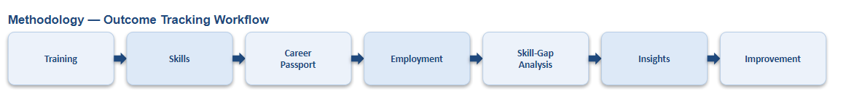
Figure 1. Saarthi Outcome-Tracking Workflow

Stage-by-Stage Explanation

Training
The workflow begins with training — structured learning activities such as courses, internships, or institutional programs that a learner completes. Training completion status is recorded and forms the basis for the skills that follow.

Skills
Completed training, along with self-reported learning and endorsements, is consolidated into a set of skills. Each skill carries a proficiency indicator and a source, such as a training center, institution, or self-declaration, and can be verified or left pending.

Career Passport
Verified skills, certificates, and training history are combined into a Career Passport — a consolidated professional identity that represents the learner's current standing in a single, presentable format.

Employment
The Career Passport supports employment outcomes by giving employers and institutions a consolidated, credible view of a learner's capabilities. Employment information, once confirmed, becomes part of the learner's ongoing record.

Skill-Gap Analysis
With training, skills, and employment information consolidated, the platform is positioned to compare a learner's current skill set against the skills required for their career goals, identifying gaps that training can address. This capability is part of Saarthi's future scope, described in Section 24.

Insights
Skill-gap analysis, once implemented, is intended to generate actionable insights — highlighting which skills to prioritize and which training paths are most relevant to a learner's goals.

Improvement
Insights feed back into the learner's training choices, closing the loop and driving continuous improvement. This completes the cycle and positions Training as the starting point for the next iteration.

10. System Architecture
Saarthi follows a layered architecture that separates the user-facing presentation layer from application logic and backend services. The diagram below represents the intended architecture; layers not yet fully implemented in the current prototype are explicitly labeled as proposed or future production architecture, in line with the honest, prototype-accurate scope of this report.
Users
↓
Presentation Layer — React + Vite + Tailwind CSS
↓
Application / Role-Based Services
Role-oriented dashboards, profile & skill views
↓
FastAPI Backend / APIs
Proposed / Future Production Architecture
↓
Data / Verification / External Integrations
Proposed / Future Production Architecture

Layer Explanation

Users
Learners, institution representatives, administrators, and other authorized stakeholders who interact with Saarthi through role-oriented dashboards.

Presentation Layer — React + Vite + Tailwind CSS
The frontend of the current prototype is built using React, bundled with Vite, and styled with Tailwind CSS. This layer implements the dashboard, career journey, skills, certificates, verification, and activity views demonstrated in the prototype.

Application / Role-Based Services
This layer is responsible for presenting role-appropriate views and organizing data for each type of user. In the current prototype, this is implemented at the frontend level using sample and locally structured data.

FastAPI Backend / APIs
FastAPI is the intended backend framework for Saarthi, responsible for serving APIs for authentication, profile management, verification workflows, and data persistence. Full backend implementation and integration is labeled as proposed / future production architecture in the current prototype stage.

Data / Verification / External Integrations
This layer represents persistent data storage, the verification engine, and integrations with external issuing authorities or employers. As with the backend layer, this is part of the proposed production architecture rather than a fully implemented component of the current prototype.

11. System Workflow
The end-to-end system workflow describes how a user moves through Saarthi from initial access to continuous improvement. The current prototype implements the dashboard, skills, certificates, verification, and activity experience shown after role identification; authentication and backend-driven role management are part of the intended production workflow.
User
↓
Authentication
↓
Role Identification
↓
Role-Based Dashboard
↓
Training / Activities
↓
Skills / Certificates
↓
Verification
↓
Career / Employment Information
↓
Insights
↓
Improvement

A user first accesses the platform and authenticates. Once authenticated, the system identifies the user's role and presents a role-based dashboard. From this dashboard, the user can review training and activities, manage skills and certificates, track verification status, and view career and employment information. This information ultimately supports the generation of insights and drives continuous improvement, closing the loop back to further training.

12. Modules

12.1 Overview Dashboard
Purpose: Provide a single, consolidated snapshot of a learner's professional identity and key metrics.
Main functionality: Displays the learner's profile summary, verification status, certificate and skill counts, employment information, training completion percentage, and profile view statistics.
User benefit: Learners can immediately understand where they stand without navigating multiple sections.
Future enhancement: Integration of skill-gap and insight summaries directly on the overview dashboard.

12.2 Career Journey
Purpose: Present a learner's progression over time in a structured, chronological format.
Main functionality: Traces training, employment, and milestone events as part of a continuous career narrative.
User benefit: Gives learners and reviewers a clear sense of professional growth over time.

12.3 Skills Management
Purpose: Maintain a structured record of a learner's skills and proficiency levels.
Main functionality: Displays each skill with a proficiency level (e.g., Beginner, Intermediate, Advanced, Expert), a completion indicator, and a source such as a training center, institution, internship, or self-reported entry. Skills can be filtered by All, Verified, or Pending status, and new skills can be added.
User benefit: Learners gain a clear, filterable view of their verified and developing skills.
Future enhancement: Automated skill-gap comparison against target roles.

12.4 Certificates
Purpose: Track certificates earned by the learner, including issuing authority and validity.
Main functionality: Maintains a count of verified and pending certificates, linked to the learner's overall profile.
User benefit: Centralizes certificate records that would otherwise be scattered across files and documents.

12.5 Verification
Purpose: Establish and maintain trust in the information presented on a learner's profile.
Main functionality: Tracks verification status for skills, certificates, and employment, and issues periodic reminders — such as a monthly profile verification due notice — to keep information current.
User benefit: Distinguishes verified achievements from self-reported claims, increasing the credibility of the profile.

12.6 Recent Activity
Purpose: Provide a chronological log of meaningful events on a learner's profile.
Main functionality: Lists events such as employment confirmation, certificate verification, skill endorsement, monthly verification completion, and profile completion reminders, each with a relative timestamp.
User benefit: Gives learners and reviewers visibility into how and when a profile was updated and verified.

12.7 Profile / Professional Identity
Purpose: Present the learner's core professional identity in a consistent, presentable format.
Main functionality: Displays name, student/identification number, current role, verification badge, location, and date joined.
User benefit: Gives the learner a single, ready-to-share professional identity card.

12.8 Training & Progress Tracking
Purpose: Track training completion and overall progress toward a complete, verified profile.
Main functionality: Displays training completion percentage alongside the training programs or institutions involved.
User benefit: Helps learners understand how much of their intended training has been completed and verified.

13. User Interface & UX
Saarthi's interface is designed around clarity, role-oriented navigation, and a clean visual hierarchy that makes it easy for a learner to understand their status at a glance. The prototype uses a card-based dashboard layout, consistent iconography, and colour-coded indicators to communicate verification status and progress without requiring the user to read dense text.

Overview Dashboard
The overview dashboard greets the learner by name and presents a consolidated summary: a professional identity card with a verification badge, followed by metric cards for certificates, skills, experience, employment, training completion, and profile views. A verification reminder banner is shown prominently when action is required.
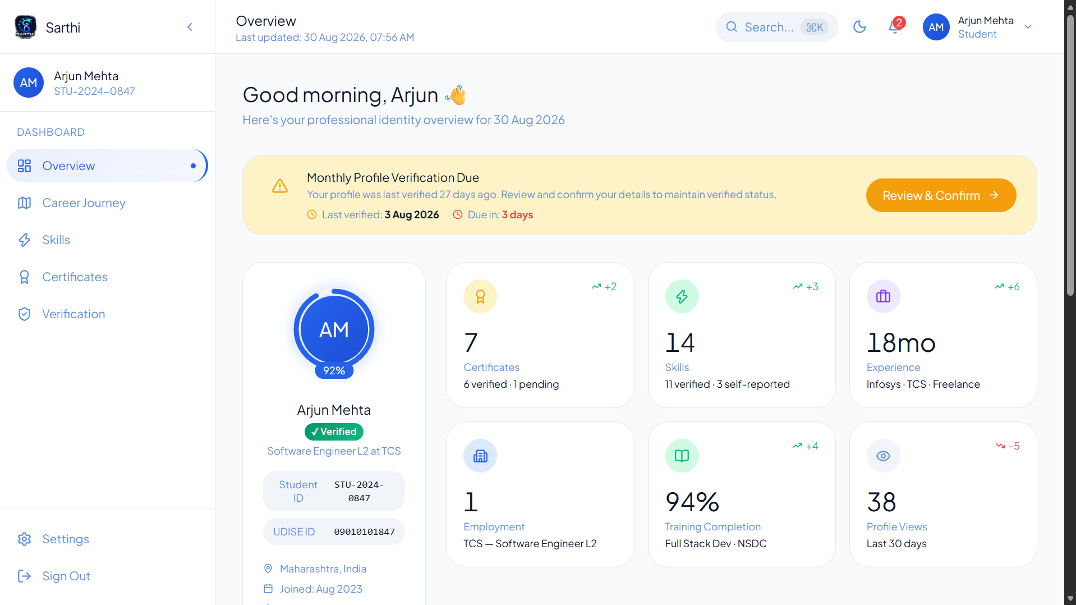
Figure 2. Saarthi Overview Dashboard

Recent Activity & Verification
The recent activity panel presents a clean, chronological list of profile events, each paired with an icon that communicates the type of event — such as verification, endorsement, or employment confirmation — along with a relative timestamp for quick scanning.
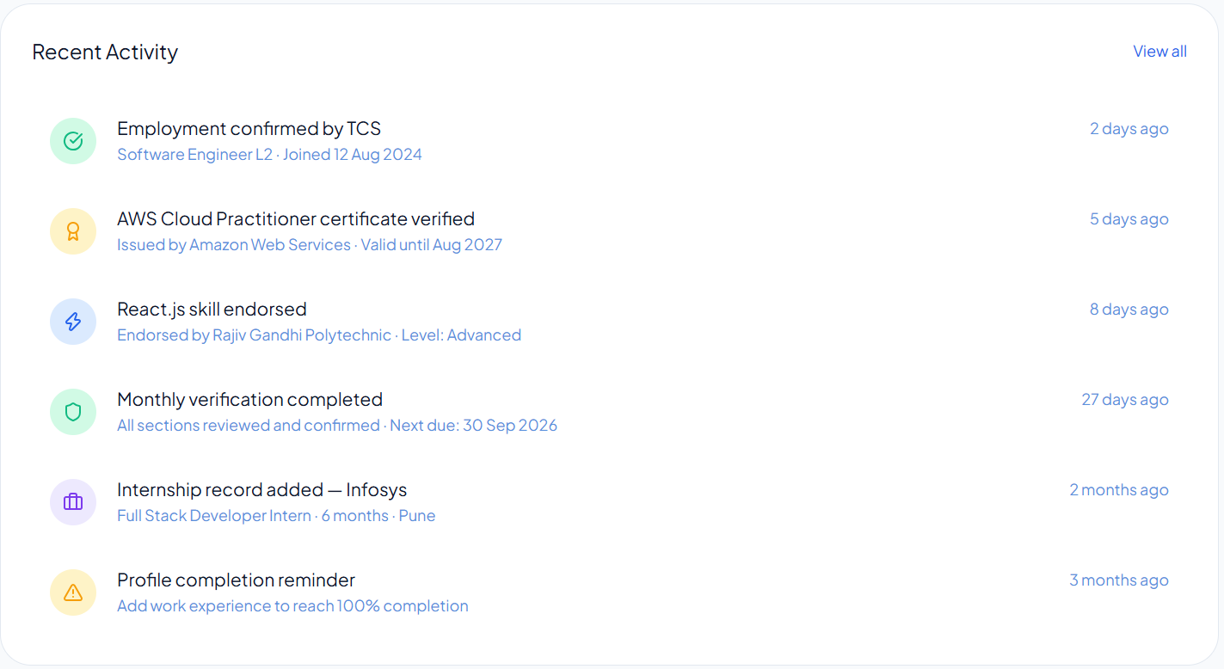
Figure 3. Recent Activity Panel

Skills Management
The skills interface displays each skill as an individual card showing its proficiency level, a progress bar, its source, and a verification icon. Filter controls allow the learner to switch between All, Verified, and Pending views, and an Add Skill action supports self-reporting new skills.
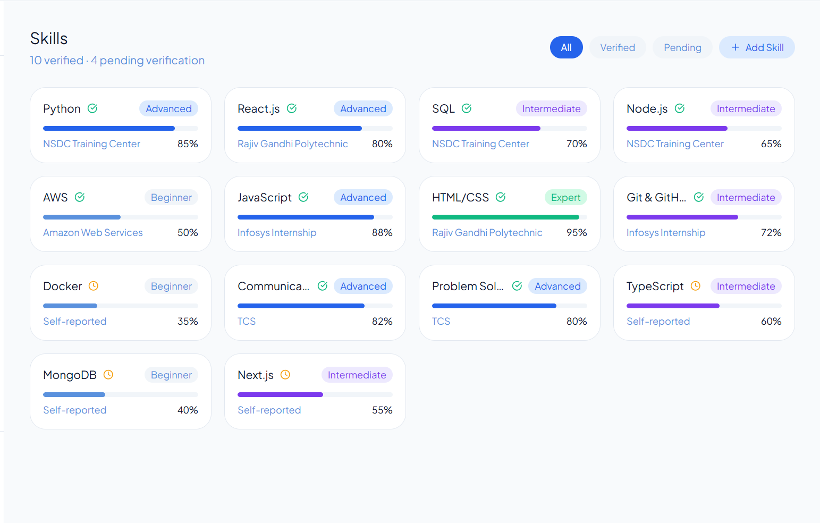
Figure 4. Skills Management Interface

Navigation and Visual Hierarchy
A persistent left-hand navigation panel organizes the platform into Dashboard, Career Journey, Skills, Certificates, and Verification sections, with Settings and Sign Out placed separately at the bottom. Consistent card styling, spacing, and colour-coded status indicators throughout the interface support a clean, professional, and readable visual hierarchy.

14. Technologies Used
Saarthi's current prototype has been built using a modern, lightweight technology stack chosen for rapid development, clean design, and straightforward deployment.
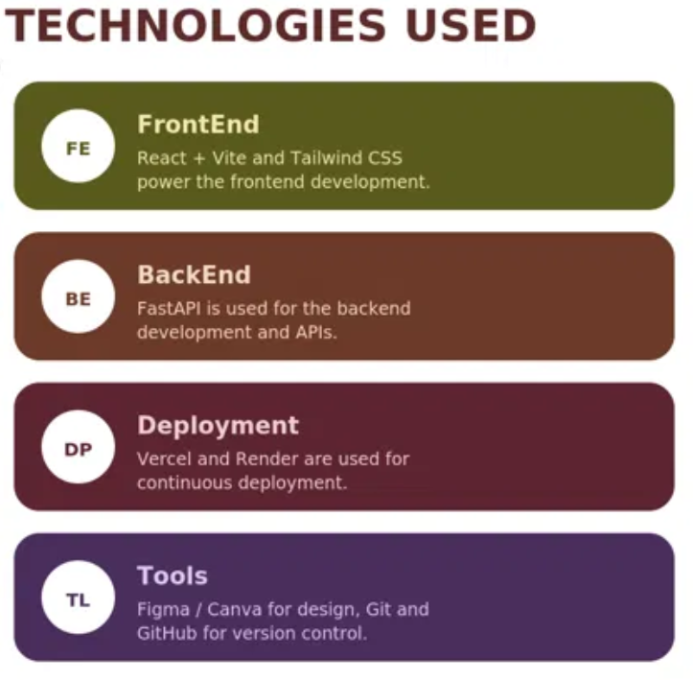
Figure 5. Technologies Used in the Saarthi Prototype
Layer | Technology | Purpose
Frontend | React + Vite + Tailwind CSS | Frontend development
Backend | FastAPI | Backend / API development
Deployment | Vercel + Render | Deployment
Design | Figma / Canva | UI / UX design
Version Control | Git + GitHub | Source-code management

15. Data Management
Saarthi organizes learner-related information into a small number of structured categories that together form a unified professional identity:
- User information — identity details such as name, student/identification number, role, and location.
- Skills — proficiency levels, sources, and verification status.
- Certificates — issuing authority, validity, and verification status.
- Training records — completed programs and training completion percentage.
- Verification states — verified, pending, or self-reported status for each data category.
- Employment information — current role, employer, and confirmation status.
- Activity records — a chronological log of profile events.
By structuring information into these consistent categories, Saarthi allows a learner's professional identity to be assembled, updated, and presented reliably, without relying on ad-hoc documents or manual reconstruction. The specific database technology to be used for persistent storage in a production deployment has not been finalized as part of the current prototype and is therefore not claimed in this report.

16. Data Accuracy & Verification
Because Saarthi is intended to serve as a trustworthy record of a learner's skills and achievements, maintaining data accuracy is central to its design. Inaccurate or outdated information would undermine the platform's core value proposition.

Approach
- Regular verification of profile information, rather than a single one-time check.
- Periodic profile re-confirmation, prompted through reminders such as the monthly verification due notice shown in the prototype.
- Clear verified and pending states for every skill, certificate, and employment entry.
- Source and evidence attribution — each skill or certificate records where it originated, such as a training center, institution, employer, or self-report.
- Controlled updates, so that changes to verified information follow a defined confirmation process rather than silent edits.
Note: The verification mechanism demonstrated in the prototype represents the intended workflow. Full automation of verification against external issuing authorities is part of the platform's future scope.

17. Data Privacy & Security
Saarthi is designed with data privacy as a foundational concern, since it consolidates sensitive professional and personal information about each learner.

Prototype Concept
- Authentication to establish a learner's identity before granting access to their profile.
- Role-based access so that different types of users see only the information relevant and appropriate to their role.
- Controlled data access that limits visibility of sensitive fields to authorized parties.

Production Implementation Requirements
- Least-privilege access control across all backend services and APIs.
- Secure API communication using encrypted connections (HTTPS/TLS).
- Secrets and credentials managed through environment variables rather than hard-coded values.
- Audit logging of access to sensitive profile and verification data.
- Formal security review and hardening prior to any production deployment involving real learner data.
Note: These production-grade security measures are requirements for a live deployment; the current prototype demonstrates the intended user experience and data model rather than a hardened production security implementation.

18. Scalability
Saarthi's architecture is designed to expand incrementally rather than requiring a complete redesign as usage grows.
- Cloud deployment through platforms such as Vercel and Render supports elastic scaling of frontend and backend services.
- A modular frontend and API-based backend allow individual components to be scaled or replaced independently.
- The platform can extend to support a growing number of learners without structural changes to its core data model.
- Additional training institutions can be onboarded as independent data sources within the same unified profile structure.
- Larger datasets can be accommodated as the backend and data layer mature beyond the current prototype stage.
- Additional services — such as skill-gap analysis or notifications — can be added as independent modules.
- External integrations with issuing authorities or employers can be layered on top of the existing API-based architecture.
- Analytics capabilities can be introduced incrementally as the underlying data volume grows.

19. Implementation Approach
The development of the Saarthi prototype followed a structured lifecycle, moving from requirement identification through to deployment:
- Requirement identification — defining the core problem and the information categories Saarthi needed to unify.
- User journey design — mapping how a learner would move through training, skills, verification, and career tracking.
- Information architecture — structuring learner data into profile, skills, certificates, verification, and activity categories.
- UI/UX design — designing the dashboard and module layouts using Figma and Canva.
- Frontend development — building the interface using React, Vite, and Tailwind CSS.
- Backend/API development — designing the intended FastAPI-based backend and API structure.
- Integration — connecting frontend views with the underlying data model.
- Testing — reviewing interface behaviour, navigation, and responsiveness.
- Git/GitHub version control — maintaining source-controlled, incremental development history.
- Deployment — publishing the frontend prototype via Vercel, with Render available for backend deployment.

20. Testing
The following table summarizes the testing scope for the Saarthi prototype. Areas without direct evidence of execution are marked as planned or to be verified, rather than claiming completed results that cannot be substantiated.
Test Area | Test Objective | Expected Result | Status
Navigation | Verify sidebar and section navigation function correctly | All sections load without error | Planned / To be verified
Dashboard rendering | Confirm overview dashboard displays profile and metric cards | Cards render with correct data | Demonstrated in prototype
Skills interface | Verify skill cards, filters, and proficiency indicators | Filters correctly show All / Verified / Pending | Demonstrated in prototype
Verification interface | Confirm verification status and reminders display correctly | Verification banner and status shown accurately | Demonstrated in prototype
Recent activity | Verify activity feed lists events with correct icons and timestamps | Activity items render in chronological order | Demonstrated in prototype
Responsive layout | Confirm interface adapts to different screen sizes | Layout remains usable across devices | Planned / To be verified
API integration | Verify frontend correctly communicates with FastAPI backend | Data loads and updates via API calls | Planned / To be verified
Error handling | Confirm graceful handling of failed requests or missing data | User sees clear error states, not crashes | Planned / To be verified
Deployment | Verify prototype is accessible via the live deployment URL | Application loads correctly at the deployed link | Demonstrated in prototype

21. Results & Expected Impact
The Saarthi prototype demonstrates a working, role-oriented interface that consolidates a learner's professional identity, skills, certificates, verification status, and recent activity into a single, coherent experience. This section describes what the prototype demonstrates in qualitative terms, without introducing statistics, percentages, or outcome figures that have not been established through real-world deployment.
- A unified professional identity that consolidates previously fragmented learner information.
- Improved visibility into a learner's skills, certificates, and training completion status.
- Clear verification awareness through explicit verified, pending, and self-reported states.
- A structured foundation for connecting training activity to skill development over time.
- A clean, role-oriented user experience that reduces the effort needed to review a learner's status.
- A foundation upon which future analytics, such as skill-gap analysis and insights, can be built.

22. Challenges & Mitigations
Challenge | Mitigation
Data Accuracy | Regular verification and periodic status re-confirmation.
Data Privacy | Authentication with role-based, controlled data access.
Scalability | Cloud-ready architecture designed for incremental expansion.
User Complexity | Simple, role-oriented interface and clear navigation.
Information Fragmentation | Centralized profile, skills, certificates, verification, and activity views.

23. Limitations
In the interest of an honest and accurate report, the following limitations of the current prototype are acknowledged:
- Saarthi is currently at the prototype stage; several backend and data layers described as "proposed" have not yet been fully implemented.
- A production-grade backend and security implementation — including hardened authentication, audit logging, and access control — is required before real learner data can be safely managed.
- The prototype currently uses sample/UI data; verified, real-world datasets from training institutions and issuing authorities are required for production use.
- Authorized external integrations with issuing authorities and employers have not yet been established.
- Large-scale testing across many concurrent users and institutions has not yet been performed.
- AI-based or automated skill-gap recommendations, once introduced, will require validated models and are not part of the current prototype.

24. Future Scope
The following areas represent planned future scope for Saarthi. None of the capabilities described in this section are implemented in the current prototype; they are documented here to communicate the platform's intended long-term direction.

24.1 AI-Assisted Skill Recommendations
Future versions of Saarthi may use AI-assisted analysis to recommend relevant training or skills based on a learner's existing profile and career goals.

24.2 Skill-Gap Analysis
A dedicated skill-gap analysis engine is planned to compare a learner's current skills against the requirements of target roles, identifying specific gaps to address.

24.3 Career Recommendations
Building on skill-gap analysis, the platform may offer career path recommendations aligned with a learner's demonstrated and developing skills.

24.4 Advanced Analytics
Aggregated, privacy-respecting analytics could help institutions understand training outcomes across cohorts and programs.

24.5 Mobile Application
A dedicated mobile application is planned to extend Saarthi's accessibility beyond the web interface.

24.6 Multilingual Support
Multilingual interfaces are planned to make the platform accessible to a broader range of learners.

24.7 Institutional Integrations
Direct integrations with training institutions could allow training completion and skill endorsements to be recorded automatically.

24.8 Employer Integrations
Integrations with employers could enable direct employment confirmation and streamlined verification of professional history.

24.9 Verified Digital Credentials
Future versions may support cryptographically verifiable digital credentials for certificates and skills.

24.10 Advanced Notifications
An expanded notification system could proactively alert learners to verification deadlines, skill-gap updates, and relevant opportunities.

25. Deployment
The Saarthi prototype is version-controlled and deployed using the following setup:
- Project Repository — source code is maintained on GitHub for version control and collaboration.
- Frontend Deployment — the React/Vite frontend is deployed via Vercel.
- Backend Deployment — Render is designated as the deployment platform for the FastAPI backend.
- Environment Variables — configuration and secrets are intended to be managed through environment variables rather than hard-coded values.
- Continuous Deployment — changes pushed to the repository can be deployed automatically through the connected hosting platforms.
Project Repository:
https://github.com/nishantmak04/Saarthi_Prototype
Live Prototype:
https://saarthi-prototype-three.vercel.app/

26. Project Repository Structure
The Saarthi_Prototype repository follows a standard Vite + React project structure:

Saarthi_Prototype/
│
├── public/
├── src/
├── index.html
├── package.json
├── vite.config.js
├── README.md
└── .gitignore

The public/ directory holds static assets, src/ contains the React application source (components, pages, and styles), and standard configuration files (package.json, vite.config.js) manage dependencies and build behaviour. This structure may be extended as additional modules and backend integration are added.

27. Conclusion
Saarthi has been designed to address a real and widely experienced problem: the fragmentation of a learner's training, skills, certificates, and career information across disconnected sources. By organizing this information around a clear outcome-tracking methodology — Training, Skills, Career Passport, Employment, Skill-Gap Analysis, Insights, and Improvement — Saarthi provides a structured path from training activity to verifiable, measurable career outcomes.
The current prototype demonstrates a clean, role-oriented dashboard experience that consolidates professional identity, skills management, certificate tracking, verification status, and recent activity into a single, coherent interface, with verified information clearly distinguished from self-reported or pending data. While significant components — particularly the production backend, security hardening, and skill-gap analytics — remain part of the platform's future scope, the prototype establishes a credible and well-structured foundation.
Built on a modern, scalable technology stack and designed with cloud-ready deployment in mind, Saarthi is positioned to grow incrementally — supporting more learners, more institutions, and increasingly sophisticated analytics — without requiring a fundamental redesign. With continued development, Saarthi has the potential to serve as a unified, trustworthy platform connecting skill development to real, measurable career outcomes.

28. References
- Ministry of Skill Development & Entrepreneurship (MSDE), Government of India.
- Skill India Digital.
- National Skill Development Corporation (NSDC).
- Periodic Labour Force Survey (PLFS), Ministry of Statistics and Programme Implementation.
- NITI Aayog, Government of India.
- World Bank — skill development and employment research publications.
- International Labour Organization (ILO).
- React documentation — react.dev.
- Vite documentation — vitejs.dev.
- Tailwind CSS documentation — tailwindcss.com.
- FastAPI documentation — fastapi.tiangolo.com.
- Git documentation — git-scm.com; GitHub documentation — docs.github.com.

29. Team
Field | Details
Project | Saarthi
Institution | Uka Tarsadia University
Team Leader | Nishant Makwane
Member 1 | Harshal Patil
Member 2 | Aditi Singh
Member 3 | Yash Patil
Member 4 | Dhairya Desai
Member 5 | Soheli Pradhan

