URL SHORTENER
Architecture & Design
Detailed system design, implementation choices, operational model, and validation evidence

Reference implementation | Python, FastAPI, PostgreSQL, Redis, Redpanda/Kafka, Kubernetes

Prepared 25 October 2026

Executive summary
This project implements a Python URL-shortening service with a low-latency redirect path, durable click analytics, operational metrics, a local Docker Compose topology, Kubernetes deployment examples, and a separately usable governed SDLC workflow engine. The design separates redirect lookup from analytics persistence while deliberately requiring durable broker acknowledgement before returning a redirect.
The implementation favors explicit reliability behavior: relational uniqueness for short codes, expiry-aware cache TTLs, event IDs for deduplication, consumer offset commits after database writes, a dead-letter topic for malformed events, readiness/liveness probes, resource requests/limits, rollout gates, and human approvals for high-impact release stages.
Area | Implemented baseline
Public API | Create links; redirect by short code; per-link total and daily analytics; readiness, liveness, and Prometheus metrics.
Storage / events | PostgreSQL links and clicks; Redis read-through cache; Redpanda/Kafka-compatible durable event stream with 12 partitions.
Runtime / delivery | Docker Compose local stack; Kubernetes Kustomize base/overlays; Argo Rollouts blue/green and canary examples; Argo CD and Flux templates.
Governance | DAG workflow with parallel tests/docs, sequential security/compliance/change-control/release approvals, audit lineage, bounded retry/fallback, rollback, safe stop, and re-plan.
Observed validation | 28 Python tests passed; local Kubernetes blue/green and canary paths exercised; repeated 1,000-RPS / 60-second redirect load test; resources removed after testing.

Scope note: local Docker Desktop Kubernetes is single-node and the local data stores are single-replica. The prototype demonstrates behavior and deployment mechanics, not production multi-zone high availability or a certified 10,000-RPS service-level objective.

Contents
- 1. Goals, requirements, and design constraints
- 2. System architecture and request flows
- 3. Data model, API contract, and consistency
- 4. Reliability, security, and observability
- 5. Runtime, deployment, rollout, and GitOps
- 6. Governed SDLC workflow engine
- 7. Test strategy and measured results
- 8. Technology choices and market alternatives
- 9. Risks, trade-offs, and production readiness
- 10. Repository map and operations quick reference

1. Goals, requirements, and design constraints

1.1 Service goals
- Create short URLs from valid HTTP/HTTPS destinations, with optional custom aliases and timezone-aware expiry.
- Serve redirects efficiently while preserving durable analytics events and exposing per-link daily/total aggregates.
- Offer a local runnable development stack and Kubernetes deployment patterns with rollout control and operational guardrails.
- Demonstrate an agent-ready SDLC orchestration model with dependencies, parallel work, approval checkpoints, auditability, recovery and re-planning.

1.2 Non-functional priorities
Priority | Design response | Boundary
Durable analytics | A 302 is emitted only after broker acknowledgement. | Broker outage causes 503; this prefers analytics integrity over redirect availability.
Low redirect latency | Redis read-through lookup avoids relational reads on hot links. | Every accepted redirect also waits for durable event publication.
Scale out | Stateless API and consumer group can use replicas; event topic has 12 partitions. | Local performance depends on one host, one broker and one database.
Safe release | Argo Rollouts blue/green/canary, metric analysis, manual promotion and undo. | Production analysis needs version-aware signals and real authorization.
Governed change | Explicit dependency graph, approval groups and append-only audit records. | Local approver identity is self-asserted and is not an IAM control.

1.3 Main engineering assumptions
- A short code is globally unique within the service database; PostgreSQL primary-key enforcement is the source of truth.
- Click analytics are eventually visible through the read API after the worker writes events; redirects wait for broker acknowledgement, not database aggregation.
- Referer data is intentionally not captured. URLs and workflow context still require data classification, retention, and access controls.
- The target of 1,000/10,000 redirects per second is a workload to measure, not a guaranteed capacity statement.

2. System architecture and request flows

2.1 Runtime components
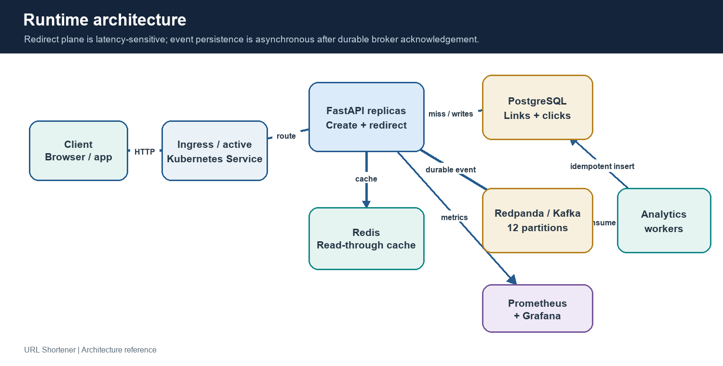
Figure 1. Logical runtime topology and the redirect/analytics split.
Component | Responsibility | State / failure mode
FastAPI API | Link creation, cache-backed resolution, redirect event production, analytics query, health and metrics endpoints. | Stateless replicas; 503 when durable event publication fails.
PostgreSQL | Authoritative link mapping, expiry timestamp, idempotent click event rows, analytics aggregations. | Local StatefulSet is single replica; production should use managed HA, backup and restore.
Redis | Cache destination and expiry by short code; cache TTL is bounded by link expiry. | Cache failure falls back to PostgreSQL; it is not authoritative.
Redpanda / Kafka | Durable redirect event stream; 12 partitions permit parallel consumer work. | Local broker is a single replica; production requires replication and broker failure testing.
Analytics worker | Validates event shape, batch writes clicks, routes invalid payloads to DLQ, commits offsets after DB write. | Consumer group scales to partitions; duplicates are handled by event ID primary key.
Prometheus / Grafana | Scrape API/worker metrics and visualize operational trends. | Local observability is for the prototype; alert rules and production retention need configuration.
Kubernetes + Argo Rollouts | Schedule replicas, health checks, resource budgets, traffic switch, analysis, pause and rollback. | Local cluster is one node; no actual node-level HA.

2.2 Create-link request
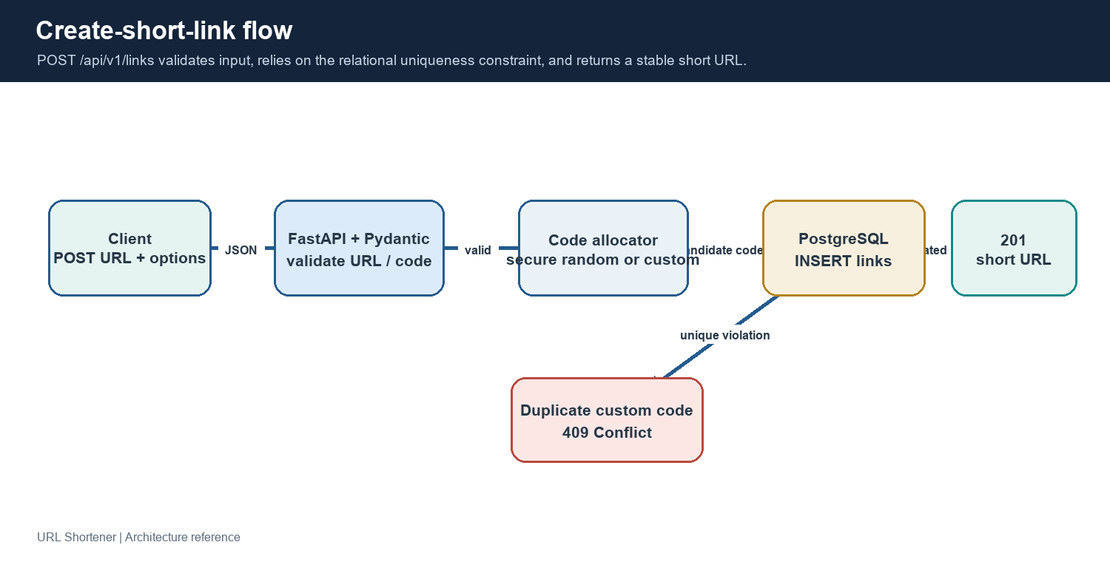
Figure 2. Create-link validation, allocation, persistence, and response.
The API validates the destination with Pydantic's HTTP URL type, rejects embedded credentials, constrains custom codes to letters/digits/underscore/hyphen, requires timezone-aware expiration, and rejects already expired values. Generated seven-character codes use Python's secrets module over a 62-character alphabet. PostgreSQL uniqueness resolves races. A duplicate custom alias returns 409; invalid request data returns 422; repeated generated-code collision exhaustion returns 503.

2.3 Redirect request and durability contract
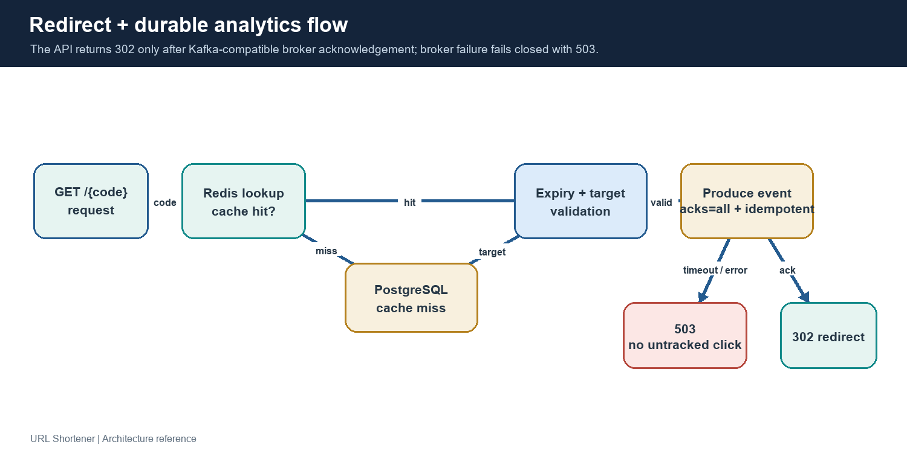
Figure 3. Redirect control flow and explicit fail-closed analytics contract.
A redirect first resolves Redis, then falls back to PostgreSQL and populates cache on a miss. Cache TTL never exceeds remaining link lifetime. Unknown codes return 404 and expired links return 410. For a valid link, the API publishes a UUID event with code and UTC click timestamp using all acknowledgements and producer idempotence. If the broker fails or exceeds the configured one-second bound, the service increments failure metrics, logs the error and returns 503 rather than silently issuing an untracked redirect. On acknowledgement it returns HTTP 302.

2.4 Analytics event ingestion and query
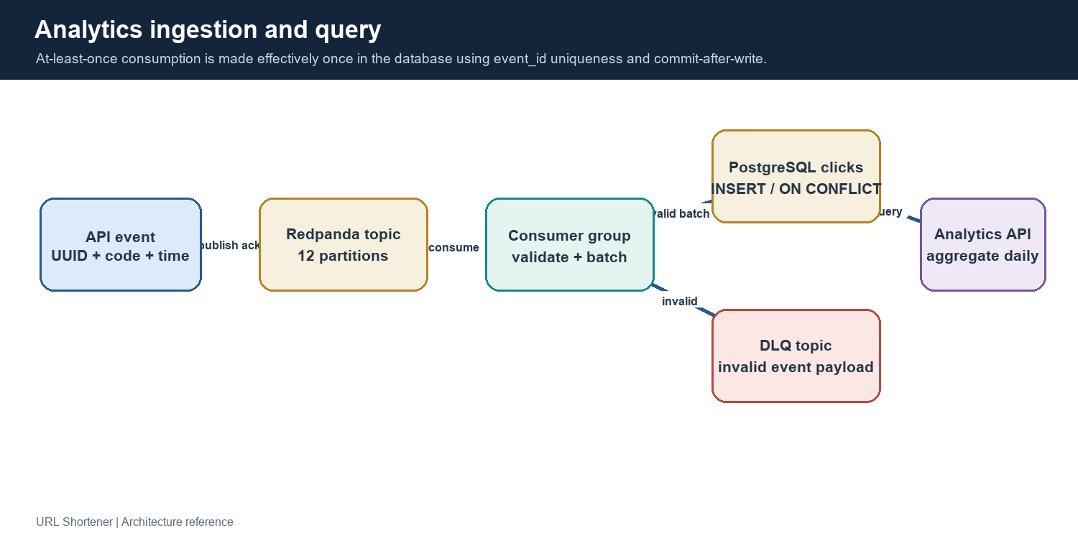
Figure 4. Event ingestion, idempotent persistence, dead lettering, and query path.
The analytics worker joins the analytics-writer consumer group, disables automatic offset commits, polls batches up to 500 records, validates events, inserts rows in a batch, and commits offsets only after database writes. The clicks table uses event_id as its primary key and ON CONFLICT DO NOTHING, so redelivery is safe. Malformed records are sent to redirect-events.dlq. Analytics reads validate a 1–90 day range and aggregate click rows by day; aggregation is query-time, not a precomputed rollup.

2.5 End-to-end flows at a glance
Flow | Synchronous steps | Asynchronous / delayed steps
Create | Validate -> allocate or accept alias -> INSERT link -> 201. | None.
Redirect | Cache/DB resolution -> expiry check -> publish event and await ack -> 302. | Consumer persists event; analytics API becomes current after commit.
Analytics query | Confirm link exists -> aggregate click rows for requested window -> JSON response. | The data set can lag redirects while the event is still queued or being processed.

3. Data model, API contract, and consistency

3.1 Relational model
Table | Columns / constraints | Purpose
links | code TEXT PRIMARY KEY; destination TEXT NOT NULL; created_at TIMESTAMPTZ default now(); expires_at nullable. | Authoritative mapping and lifetime metadata.
clicks | event_id UUID PRIMARY KEY; code TEXT FK links(code) ON DELETE CASCADE; clicked_at TIMESTAMPTZ NOT NULL. | Durable, deduplicated redirect event records.
Index | clicks_code_clicked_at_idx(code, clicked_at DESC). | Per-link analytics time-range filter and grouping.

3.2 HTTP endpoints
Method / route | Behavior | Important responses
POST /api/v1/links | Create a link: url, optional custom_code, optional expires_at. | 201 created; 409 duplicate alias; 422 invalid inputs; 503 allocation exhaustion.
GET /{code} | Resolve and issue a redirect after durable click event acknowledgement. | 302 success; 404 unknown; 410 expired; 503 analytics broker unavailable.
GET /api/v1/links/{code}/analytics?days=30 | Return total_clicks and daily_clicks for 1–90 days. | 200 analytics; 404 unknown; 422 invalid range.
GET /health/live | Process liveness endpoint. | 200 alive.
GET /health/ready | Readiness check verifies PostgreSQL query succeeds. | 200 ready; 503 PostgreSQL unavailable.
GET /metrics | Prometheus scrape endpoint for API counters and latency histogram. | Prometheus exposition format.

3.3 Consistency decisions
- PostgreSQL is the system of record for links; cache entries are disposable and reloaded on misses.
- Kafka publication acknowledgement is the redirect's analytics durability boundary. Click-row persistence happens later.
- The event ID makes consumer redelivery safe. Offset commit after database write avoids loss at the cost of possible replay.
- A database failure after event publication delays analytics visibility; the consumer retries by not committing the consumed offset if processing fails.
- Deleting a link cascades click history under the current schema; retention and deletion policies should be reviewed against business and compliance needs.

4. Reliability, security, and observability

4.1 Resilience patterns
Concern | Current control | Remaining production work
Cache outage | Redis lookup/write errors are logged and lookup falls back to PostgreSQL. | Test failure rates at load; consider circuit-breaking/backpressure and cache capacity alerts.
Broker outage | Bounded publish timeout; fail closed as 503; metric and error log. | Define SLO/error budget and decide whether a durable local buffer is ever acceptable.
Database outage | Readiness fails; API readiness probe removes unhealthy pods. | Database HA, pool sizing, failover tests, restore and migration strategy.
Duplicate event | UUID primary key plus ON CONFLICT DO NOTHING. | Reconcile broker retention, DLQ replay, and event schema compatibility.
Malformed event | Pydantic validation and durable DLQ publication. | Alert on DLQ rate; define replay/quarantine retention and operations.
Process rollout | Startup, readiness, liveness probes; graceful termination; PDB. | Exercise dependency brownouts and pod disruption in a multi-node staging cluster.

4.2 Security and privacy
- API container runs as UID/GID 10001, with privilege escalation disabled, all Linux capabilities dropped, read-only root filesystem, and RuntimeDefault seccomp profile in Kubernetes.
- Input validation blocks URL credentials and constrains aliases. Random codes use a cryptographically secure generator.
- Kubernetes production example separates secret references from config and enforces restricted Pod Security labels; local overlay uses explicitly demo-only credentials.
- Production hardening includes default-deny NetworkPolicy templates, TLS-ready ingress shape, and dedicated-node scheduling example; policies require a compatible CNI and endpoint-specific adaptation.
- No API authentication, authorization, rate limiting, TLS termination, or identity-backed approver authorization is implemented for the local demo. Add these before public exposure.
- Do not log full destination URLs by default; classify user URLs and workflow context, apply least-privilege access, encryption, retention and deletion policies.

4.3 Metrics and dashboards
Signal | Use
urlshortener_redirects_total{outcome} | Redirect rate and outcome breakdown: success, not_found, expired, analytics_unavailable.
urlshortener_redirect_duration_seconds | Latency distribution; PromQL histogram_quantile supports percentile estimation.
urlshortener_analytics_publish_failures_total | Failure count for durable event publication.
urlshortener_analytics_events_processed_total | Worker processing volume.
urlshortener_analytics_dead_letter_total | Invalid event volume routed to DLQ.
Workflow metrics | Success rate, retries, rollback frequency, MTTR, and end-to-end latency through CLI metrics.

Monitor request rate and p95/p99, broker publish latency/errors, consumer lag, DLQ growth, database pool saturation/query latency, Redis hit ratio/evictions, pod restarts, HPA metrics availability, and resource pressure. The local Kubernetes run reported that metrics-server was unavailable; HPA objects rendered/applied but autoscaling was not dynamically validated.

5. Runtime, deployment, rollout, and GitOps

5.1 Development and container topology
Docker Compose starts PostgreSQL, Redis with append-only persistence, Redpanda in development mode, topic initialization, API, analytics worker, Nginx load balancer, Prometheus, Grafana and an optional k6 load profile. Named volumes retain data between container recreation. The Docker image is based on python:3.12-slim, installs pinned requirements, copies only application/orchestrator source, runs as non-root UID 10001, and starts Uvicorn with one worker per container.
Compose is a single-host development/performance-test setup: Redpanda replication factor is one, credentials are development values, and TLS/authentication are not configured. It should not be exposed to untrusted networks.

5.2 Kubernetes baseline
Control | Prototype configuration | Purpose / caveat
API replicas | Argo Rollout starts at 3; HPA min 3 / max 20, CPU target 65%. | Horizontal scaling with room for surge; local one-node placement cannot prove HA.
Worker replicas | 3 workers; HPA min 3 / max 12, CPU target 70%; topic has 12 partitions. | Consumer group parallelism; concurrency is bounded by partition count and DB capacity.
Pod health | API startup, readiness and liveness endpoints; worker metrics probes. | Startup absorbs cold boot; readiness gates traffic; liveness recovers deadlocked containers.
Availability | PDB minAvailable=2 for API and workers; preferred pod anti-affinity/topology spread. | PDB requires multi-node scheduling to protect from node failure; soft spread is not a guarantee.
Resources | API/worker requests 250m CPU / 256Mi and limits 1 CPU / 768Mi. | Initial sizing only; profile and tune against observed load.
Storage/dependencies | Local PostgreSQL and Redpanda StatefulSets, Redis Deployment; local-only single replicas. | Data plane is not HA; production uses managed HA services and tested backup/restore.
Security | App containers non-root, read-only root filesystem, capabilities dropped, service token disabled. | Local dependency containers have different security constraints; production hardening needs reviewed images.
Network / ingress | TLS-ready Ingress plus default-deny and component NetworkPolicy templates. | Ingress controller and enforcing CNI are external prerequisites; adapt selectors/endpoints.

5.3 Blue/green and canary delivery
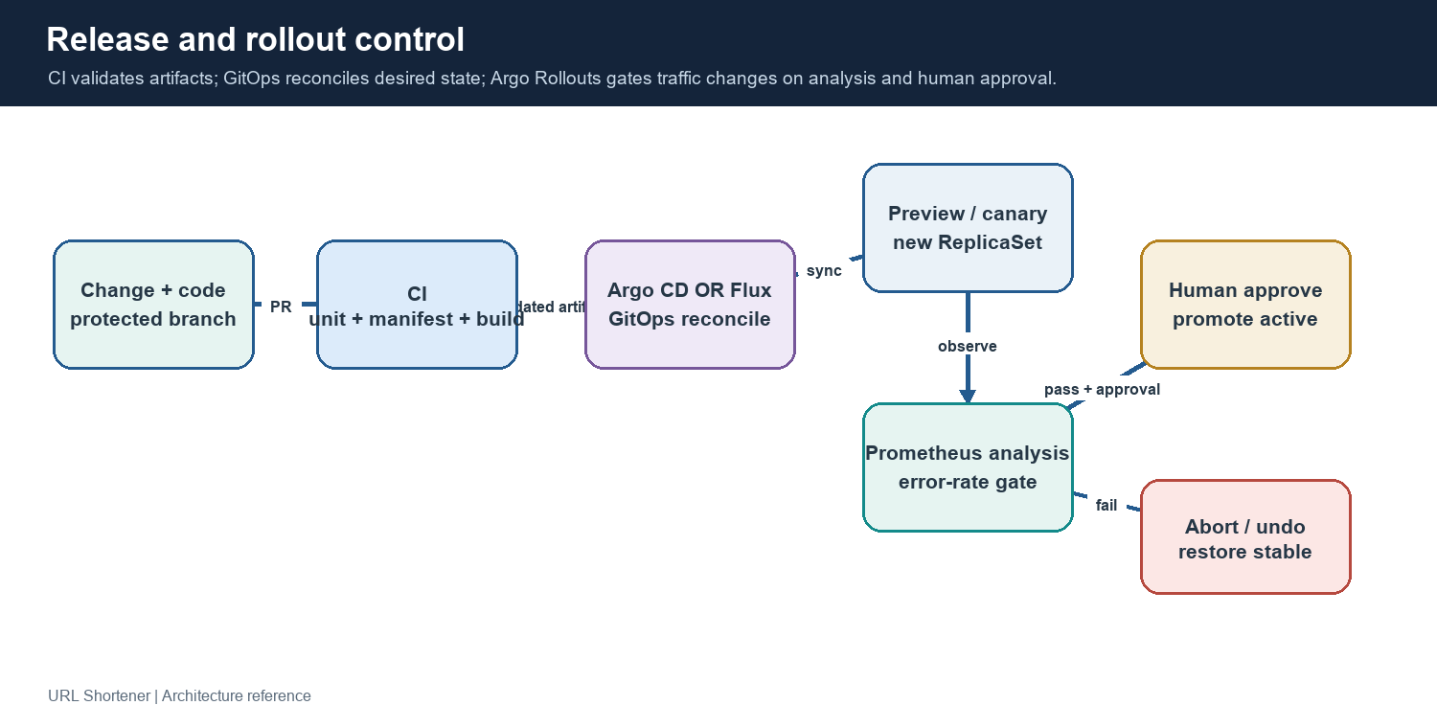
Figure 5. CI, GitOps, Argo Rollouts analysis, approval and rollback control.
Blue/green is the default. A new ReplicaSet is made ready behind the preview service; pre-promotion Prometheus analysis checks a redirect error-rate signal; auto-promotion is disabled; a human-approved promote changes the active-service selector. A rollback/undo creates a prior revision and may itself pause for explicit approval. Canary uses weighted replica steps (20%, analysis, 50% pause, then 100%) and routes through stable/canary services.
These examples demonstrate mechanics, but a production canary needs version-specific metric labels, representative split traffic, stable-window baselines, tested alerts, and a defined automatic abort threshold. The analysis metric should distinguish canary from stable traffic.

5.4 GitOps and control-plane ownership
Argo CD Application and Flux GitRepository/Kustomization examples are alternatives. Choose one reconciler per resource set. Protected branches, required checks, credential management, and human approvals should gate production manifest changes. Argo Rollouts performs traffic progression; GitOps reconciliation does not replace security, compliance, change-control, or release approval.
etcd is a Kubernetes control-plane datastore and is not an application dependency. Do not deploy an etcd workload for the URL shortener. Managed Kubernetes operators own control-plane HA; self-managed clusters need multi-member etcd quorum, encryption, backups and restore drills.

6. Governed SDLC workflow engine
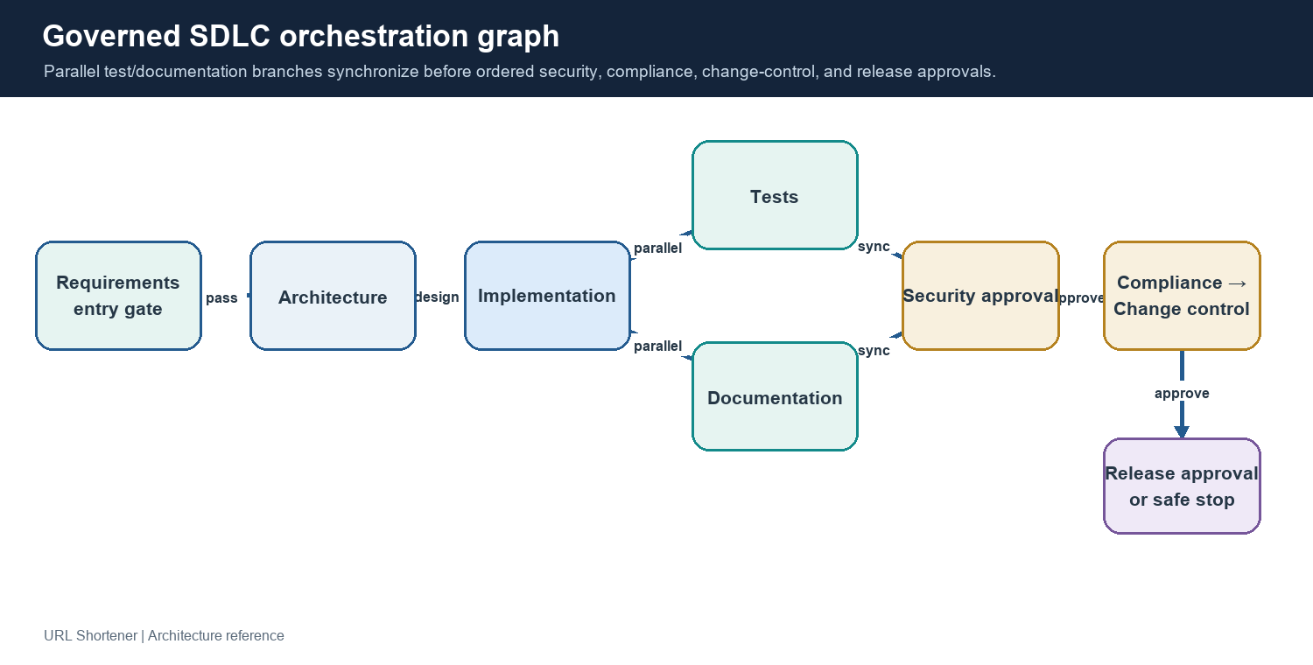
Figure 6. Stateful dependency graph with parallel validation and sequential approval gates.

6.1 Graph and control behavior
The orchestrator is a persistent SQLite-backed dependency graph in orchestrator/. It applies entry gates, executes independent branches concurrently, synchronizes dependents, records stage outputs and dependency hashes, and checks an exit gate. Tests and documentation execute in parallel after implementation. Their results converge before four distinct, sequential approvals: security, compliance, change control, and release.
Stage family | Example control
Entry context | Greenfield requires a request; brownfield requires affected modules; ambiguous scenario requires recorded assumptions.
Parallel validation | Tests and documentation run independently after implementation and must both complete before governance reviews.
Approval checkpoints | Approval decision stores named group, actor, reason, and time; rejection blocks downstream release.
Failure recovery | Bounded retry, fallback handler, compensation/rollback handler, and explicit failure status.
Re-planning | Changed upstream inputs invalidate dependent outputs/approvals; compensate in reverse order before recomputation.
Safe stop / audit | Safe stop prevents resumption through stale approval; append-only audit entries and lineage capture decisions.
Reliability measures | Success rate, retry/rollback frequency, MTTR and end-to-end latency are exposed through CLI metrics.

6.2 Governance boundary
The included handlers are examples, not production autonomous coding agents. Tool integrations should be explicit allowlists with least privilege and policy enforcement. Local CLI actor names are self-asserted; production must bind approvals to SSO/RBAC, signed identity, protected change windows, and auditable policy evidence. High-impact actions need human approval; retries and autonomy should be bounded by cost/time and safe-stop controls.

6.3 Scenario handling
Scenario | Gate/context | Expected workflow adaptation
Greenfield | Feature request is present. | Establish requirements and architecture, implement, validate, document and review.
Brownfield | Request plus at least one affected module. | Preserve current API/data behavior; retain impacted module context for design/test review.
Ambiguous | Request plus explicit assumption(s). | Make uncertainty explicit; pass assumptions forward and require confirmation before risky execution.

7. Test strategy and measured results

7.1 Validation layers
Layer | Coverage / evidence
Unit | Input validation, URL credential rejection, custom code rules, timezone requirements, redirect status and broker failure behavior.
Orchestrator | DAG validation, cycle detection, parallel branches, approval/rejection, safe stop, retry/fallback, rollback failure, audit lineage and re-plan.
Manifest tests | Rollout strategy, replicas, resources, probes, security controls, HPA/PDB, canary pause/analysis, ingress TLS, GitOps contracts and network policies.
Static/render | Kustomize renders local, canary, dedicated, production and production-hardening overlays; PostgreSQL schema parity check.
Container/runtime | Docker image build and non-root API import validation.
Kubernetes E2E | Docker Desktop: install Rollouts, deploy dependencies, smoke create/redirect/analytics, promote blue/green/canary, execute rollback and check service health.
Load | k6 constant-arrival redirect scenario at configured rate with 302 checks, HTTP failure thresholds and p95/p99 latency thresholds.

7.2 Observed results (25 October 2026)
Test | Observed result | Interpretation
Python suite | 28 tests passed after final regression coverage was added. | Unit and manifest behavior passed.
Kustomize / schema | Five overlays rendered; local SQL schema matched db/init.sql. | Static deployment configuration consistency passed.
Blue/green | Active service promoted; undo restored a healthy prior revision after a separate approval pause. | Traffic selector and rollback flow exercised in the local cluster.
Canary | Analysis successful; reached 50% manual pause; preview smoke passed; promoted revision reached Healthy. | Progression and human gating exercised; not production traffic validation.
1k RPS run 1 | 60,001 successful redirect checks; no failed HTTP requests; p95 6.96 ms; p99 508.42 ms. | Configured rate maintained; p99 narrowly exceeded the 500 ms threshold.
1k RPS warmed repeat | 60,000 successful 302 checks; no failed HTTP requests; p95 8.62 ms; p99 244.46 ms. | Thresholds passed. k6 http_reqs also included setup calls; constant-arrival iterations were the redirect measure.
Durability | PostgreSQL showed 120,003 click rows after both runs and smoke requests. | Redirect events were persisted after analytics worker processing.
Cleanup | Application and Rollouts resources, CRDs, PVC/PV, and test port-forwards removed; Docker Desktop Kubernetes left running. | Local application workload no longer consumes resources.

The 1k-RPS result is a short local single-node benchmark with host-side k6 and Kubernetes service port-forward. It is not a production capacity claim. The first run's tail-latency threshold failure is reported rather than hidden; the warmed repeat passed.

7.3 Reproducible local validation
.\.venv\Scripts\python.exe -m unittest discover -s tests -v
.\scripts\validate-k8s.ps1
.\scripts\k8s-local-e2e.ps1 -Strategy bluegreen -TestRollback
.\scripts\k8s-local-e2e.ps1 -Strategy canary
kubectl port-forward service/url-shortener-active 18080:80 -n url-shortener
k6 run --summary-trend-stats 'avg,min,med,max,p(90),p(95),p(99)' -e BASE_URL=http://127.0.0.1:18080 -e RATE=1000 -e DURATION=60s -e PREALLOCATED_VUS=1000 -e MAX_VUS=3000 load\benchmark.js
kubectl delete namespace url-shortener

8. Technology choices and market alternatives
Layer / choice | Why this implementation uses it | Alternatives and trade-off
Python 3.12 + FastAPI | Fast iteration, strong typing/validation, async request handlers, OpenAPI support and mature Python ecosystem. | Django REST Framework adds batteries/admin but more framework surface; Go/Java can be attractive for CPU efficiency/large platform teams but increase language/tooling cost here.
Pydantic v2 | Declarative payload validation for URL, code and expiry; clear 422 errors. | Manual validation duplicates logic; marshmallow/attrs are viable but less integrated with FastAPI.
PostgreSQL + asyncpg | Relational integrity, unique primary keys, timestamps, indexed analytics query and mature operational ecosystem. | MySQL is comparable; DynamoDB/Cassandra may scale key lookup but complicate range aggregation and transactions; SQLite is not suitable for concurrent production service.
Redis | Simple low-latency TTL cache for hot code-to-destination reads; disposable and rebuildable from PostgreSQL. | Memcached is simpler but less feature rich; process-local cache is non-shared and inconsistent; direct DB reads raise read pressure.
Redpanda / Kafka protocol | Durable partitioned stream, producer acknowledgements, consumer groups, replay and DLQ workflow; Redpanda is easy to run locally. | Managed Kafka reduces broker operations; RabbitMQ fits task queues but is less aligned to retained partitioned event logs; direct database writes couple latency and persistence.
Docker Compose | Low-friction Windows developer stack and repeatable local dependencies. | Local Kubernetes can exercise manifests but is heavier; Podman Compose is a compatible alternative with differing ecosystem support.
Kubernetes + Kustomize | Standard scheduling, probes, resources, HPA/PDB, overlays and portable manifests. | Helm adds packaging/templating and charts; raw YAML is simpler but harder to reuse; managed PaaS reduces ops but is less portable/control-rich.
Argo Rollouts | Native blue/green/canary steps, pause gates, analysis, promotion, abort and undo. | Flagger integrates with several service meshes/metrics providers; native Deployment rolling update is simpler but less explicit about traffic gates; choose based on platform ecosystem.
Argo CD or Flux | Both provide GitOps reconciliation; examples show either without forcing both. | Argo CD offers a visual application UI; Flux is composable Kubernetes controllers and CLI-centered; evaluate RBAC, team workflow and ecosystem.
Prometheus + Grafana | Open instrumentation format, pull-based metrics, PromQL and local dashboards. | Datadog/New Relic simplify hosted operations at commercial cost; OpenTelemetry Collector complements metrics/logs/traces but does not replace a backend.
k6 | Scriptable constant-arrival load model and checks/thresholds with low-friction CLI and Compose image. | Locust (Python) is familiar for complex user journeys; JMeter is broad and GUI-oriented; wrk/hey are lightweight but less expressive about scenario/checks.
SQLite workflow persistence | Portable, dependency-light persistence for local DAG demo and audit/event records. | PostgreSQL is preferred for multi-user distributed production coordination and stronger operational HA; workflow vendor products add managed UI but lock in conventions.

Selection criterion was fit for a runnable Windows-first prototype, maintainability and representation of core reliability semantics—not a claim that these tools are universally superior. Production choices should be confirmed against throughput, team expertise, SLOs, managed-service availability, compliance and total cost.

9. Risks, trade-offs, and production readiness
Risk / limitation | Impact | Recommended action
Fail-closed click durability | Broker disruption turns valid redirects into 503. | Make explicit product decision, publish error budget, consider durable local queue only if semantics are preserved.
Single-node local data tier | Node loss takes database, cache, broker and API offline; no replicated durable data. | Use managed multi-AZ PostgreSQL/Kafka-compatible service and Redis HA; rehearse failover/restore.
Click-table growth | Per-click rows and aggregation cost grow with traffic and retention. | Define retention, partitioning/rollups, archive and anonymization strategy; benchmark analytics queries.
Cache hot keys/eviction | Redis degradation shifts load to PostgreSQL; burst traffic can saturate DB pool. | Observe hit ratio/evictions, capacity plan, pool ceilings, backpressure, and load test cache outage.
Unvalidated 10k RPS capacity | No 10k Kubernetes result or multi-generator production-style run in this evidence. | Run sustained staged test with realistic traffic mix, resource dashboards, consumer lag and database metrics.
HPA metrics-server unavailable | CPU-based scaling did not dynamically validate in local cluster. | Install/verify metrics-server or platform metrics adapter, test scale-up/down and stabilization.
Canary metric scope | Cluster-wide rate may hide a failing canary version; local traffic split not representative. | Add version labels, service-mesh/Ingress weighted routing, stable baseline, and automatic rollback thresholds.
GitOps placeholders | Repo URL/image digest/TLS/secret values are examples only. | Use protected repository, immutable images, secret manager, policy checks and one reconciler.
Approval identity prototype | Actor field is caller supplied; not a real authorization boundary. | Integrate SSO/OIDC/RBAC, signed approvals, separation of duties, evidence attachments and immutable audit export.
Missing public API controls | Unauthenticated create and redirect endpoints can be abused if exposed. | Add auth/tenant model, rate limiting, abuse prevention, URL safety policy, TLS, WAF and audit controls.

9.1 Suggested release readiness gates
- Functional: API contract, schema migration compatibility, idempotency and expiry tests pass.
- Security: threat model, dependency/image scan, secrets review, SSRF and abuse policy, auth/rate limits, network policy validation.
- Reliability: broker/database/cache failover tests, alerting/ownership, backup restore, DLQ runbook and load/soak evidence.
- Governance: distinct authorized security, compliance, change-control and release approvers; approvals tied to immutable artifact digest.
- Operations: rollout analysis validated on per-version metrics, rollback tested with backward-compatible schema, dashboards and on-call runbooks.

10. Repository map and operations quick reference
Path | Role
app/main.py, app/schemas.py, app/config.py | FastAPI routes, models, validation, runtime settings and resource pools.
app/worker.py, app/metrics.py | Event consumer, DLQ, metrics and processing controls.
db/init.sql | Relational schema for links and click events.
compose.yaml, Dockerfile, deploy/ | Local stack, non-root image and Nginx/Prometheus/Grafana configuration.
load/benchmark.js | k6 constant-arrival redirect workload and thresholds.
k8s/base/, k8s/local-dependencies/, k8s/overlays/ | Kubernetes base and local, canary, dedicated-node, production, hardening overlays.
k8s/gitops/ | Alternative Argo CD and Flux reconciliation examples.
orchestrator/ | Stateful DAG execution, approvals, audit, re-plan and workflow CLI.
tests/, scripts/ | Unit/manifest checks, local E2E, and offline Kustomize/schema validation.
.github/workflows/ci.yml | Automated Python, manifest and container build checks.

Operational stop and cleanup
After local Kubernetes testing, remove the test namespace with kubectl delete namespace url-shortener. If the Argo Rollouts controller was installed only for the prototype, remove its pinned install resources and namespace as documented in README.md. Port-forward processes should also be stopped. Keep the Docker Desktop Kubernetes control plane intact unless the operator separately chooses to disable it.
Document provenance: implementation and observed results are based on the workspace source, test suite, Kubernetes end-to-end run and k6 output available on 25 October 2026. Review this design alongside changes to APIs, schema, deployment manifests, benchmarks and governance policies.

