

Project Report
on
Blogging Website
Submitted to
LOVELY PROFESSIONAL UNIVERSITY
for
Bachelor of Computer Science and Engineering

Submitted By Submitted to
Nishant Mehta Navneet Kaur
11912641 Assistant Professor

LOVELY FACULTY OF TECHNOLOGY & SCIENCES
LOVELY PROFESSIONAL UNIVERSITY
PUNJAB
November 2021

CHAPTER 1
INTRODUCTION

  - Introduction to Blogging
“Blog” is an abbreviated version of “weblog,” which is a term used to describe websites that maintain an ongoing chronicle of information. A blog features diary-type commentary and links to articles on other websites, usually presented as a list of entries in reverse chronological order. Blogs range from the personal to the political, and can focus on one narrow subject or a whole range of subjects.
Many blogs focus on a particular topic, such as web design, home staging, sports, or mobile technology. Some are more eclectic, presenting links to all types of other sites. And others are more like personal journals, presenting the author’s daily life and thoughts.
Generally speaking (although there are exceptions), blogs tend to have a few things in common:
- A main content area with articles listed chronologically, newest on top. Often, the articles are organized into categories. An archive of older articles.
  - A way for people to leave comments about the articles.
  - A list of links to other related sites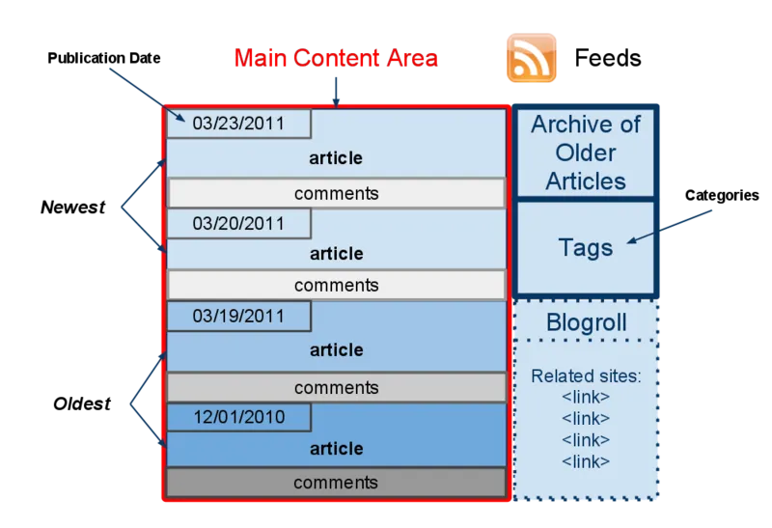
Figure1.1 Structure of a blog

1.1.1 What is a “blogger”?
A blogger is a person who owns or runs a blog or a person who maintains the blog. That is, posting articles or new posts, information, sharing the most up-to-date news, opinions and case studies to name but a few. Such entries are known as blog posts.

1.1.2 The Blog Content
Content is the reason for being for any website. Retail sites feature a catalog of products. University sites contain information about their campuses, curriculum, and faculty. News sites show the latest news stories. For a personal blog, you might have a bunch of observations, or reviews. Without some sort of updated content, there is little reason to visit a website more than once.

On a blog, the content consists of articles (also sometimes called “posts” or “entries”) that the author(s) writes. Yes, some blogs have multiple authors, each writing his/her own articles. Typically, blog authors compose their articles in a web-based interface, built into the blogging system itself. Some blogging systems also support the ability to use stand-alone “weblog client” software, which allows authors to write articles offline and upload them at a later time.

Chapter 2
Technologies Used

2.1 HTML
HTML stands for Hyper Text Markup Language. It is used to design web pages using a markup language. HTML is the combination of Hypertext and Markup language. Hypertext defines the link between the web pages. A markup language is used to define the text document within tag which defines the structure of web pages. This language is used to annotate (make notes for the computer) text so that a machine can understand it and manipulate text accordingly. Most markup languages (e.g. HTML) are human-readable. The language uses tags to define what manipulation has to be done on the text.

HTML is a markup language used by the browser to manipulate text, images, and other content, in order to display it in the required format. HTML was created by Tim Berners-Lee in 1991. The first-ever version of HTML was HTML 1.0, but the first standard version was HTML 2.0, published in 1999.

2.1.1Elements and Tags
HTML uses predefined tags and elements which tell the browser how to properly display the content. Remember to include closing tags. If omitted, the browser applies the effect of the opening tag until the end of the page.

2.1.2 HTML page structure
The basic structure of an HTML page is laid out below. It contains the essential building-block elements (i.e. doctype declaration, HTML, head, title, and body elements) upon which all web pages are created.
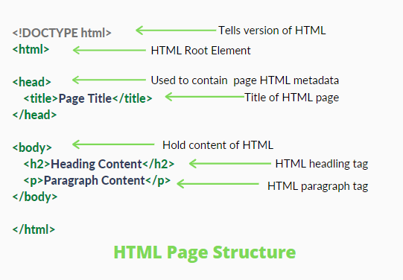
2.1 Figure HTML Page Structure
2.2 CSS
Cascading Style Sheets, fondly referred to as CSS, is a simply designed language intended to simplify the process of making web pages presentable. CSS allows you to apply styles to web pages. More importantly, CSS enables you to do this independent of the HTML that makes up each web page.
CSS is easy to learn and understand, but it provides powerful control over the presentation of an HTML document.
2.2.1 CSS saves time
You can write CSS once and reuse the same sheet in multiple HTML pages.
Easy Maintenance: To make a global change simply change the style, and all elements in all the webpages will be updated automatically.
2.2.2 Search Engines
CSS is considered a clean coding technique, which means search engines won’t have to struggle to “read” its content.
2.2.3 Superior styles to HTML
CSS has a much wider array of attributes than HTML, so you can give a far better look to your HTML page in comparison to HTML attributes.
2.2.4Offline Browsing
CSS can store web applications locally with the help of an offline cache. Using this we can view offline websites.

2.3 JavaScript
JavaScript is a lightweight, cross-platform, and interpreted scripting language. It is well-known for the development of web pages, many non-browser environments also use it. JavaScript can be used for Client-side developments as well as Server-side developments. JavaScript contains a standard library of objects, like Array, Date, and Math, and a core set of language elements like operators, control structures, and statements.
2.3.1 Client-side
It supplies objects to control a browser and its Document Object Model (DOM). Like if client-side extensions allow an application to place elements on an HTML form and respond to user events such as mouse clicks, form input, and page navigation. Useful libraries for the client-side are AngularJS, ReactJS, VueJS and so many others.
2.3.2 Server-side
It supplies objects relevant to running JavaScript on a server. Like if the server-side extensions allow an application to communicate with a database, and provide continuity of information from one invocation to another of the application, or perform file manipulations on a server. The useful framework which is the most famous these days is node.js.

2.4 VS Code
Visual Studio Code is a source-code editor made by Microsoft for Windows, Linux and macOS. Features include support for debugging, syntax highlighting, intelligent code completion, snippets, code refactoring, and embedded Git. Users can change the theme, keyboard shortcuts, preferences, and install extensions that add additional functionality.

Visual Studio Code was first announced on April 29, 2015, by Microsoft at the 2015 Build conference. A preview build was released shortly thereafter.

On November 18, 2015, the source of Visual Studio Code was released under the MIT License, and made available on GitHub. Extension support was also announced. On April 14, 2016, Visual Studio Code graduated from the public preview stage and was released to the Web. Microsoft has released most of Visual Studio Code's source code on GitHub under the permissive MIT License, while the releases by Microsoft are proprietary freeware.

2.5 GitHub
GitHub is a provider of Internet hosting for software development and version control using Git. It offers the distributed version control and source code management (SCM) functionality of Git, plus its own features. It provides access control and several collaboration features such as bug tracking, feature requests, task management, continuous integration and wikis for every project. Headquartered in California, it has been a subsidiary of Microsoft since 2018.

It is commonly used to host open-source projects. As of November 2021, GitHub reports having over 73 million developers and more than 200 million repositories (including at least 28 million public repositories). It is the largest source code host as of November 2021.

Chapter 3
Modules

3.1 Home

Home page is main page of website. It consists of various different sections of the website. It displays various blogs contact us and search. The home page is made by using html and styled by using CSS. Various pages are connected with home page. It also display some blog pictures.

3.2 Contact

On this page a person can contact by providing his information so that we know what he wants from us. He need to provide his name email contact information and his query. It is designed with html and styled with CSS.

3.3 Search
Search bar is locate on the home page right upper corner. It is used to find various blogs present on the website. User can simply surf to various blogs using search bar.

3.4 Blog Post

Blog post is where whole blog is present. It shows the date and the time when the log is posted. It also shows us who published the blog. Along with the time how long it was published. There are various blogs posted on the website.

3.5 Blog Post Footer
Blog post various relayed blogs along with pictures of blogs. You can go to those blogs by simply clicking on them.

Chapter 4
Website snapshots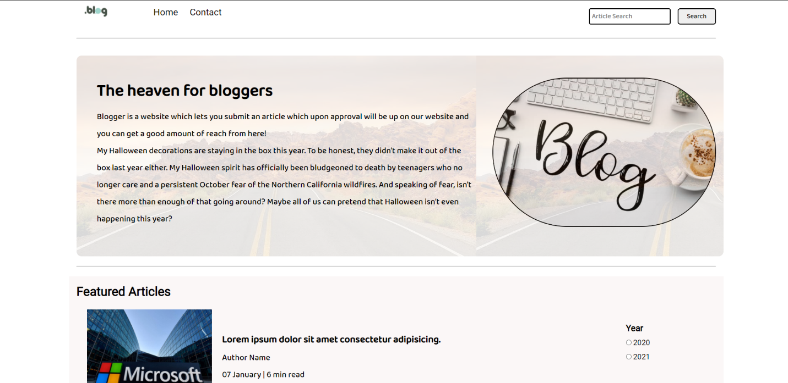

Figure 4.1 Home page

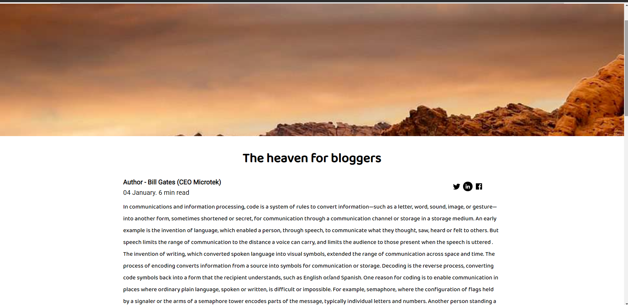
Figure 4.2 Blog Post

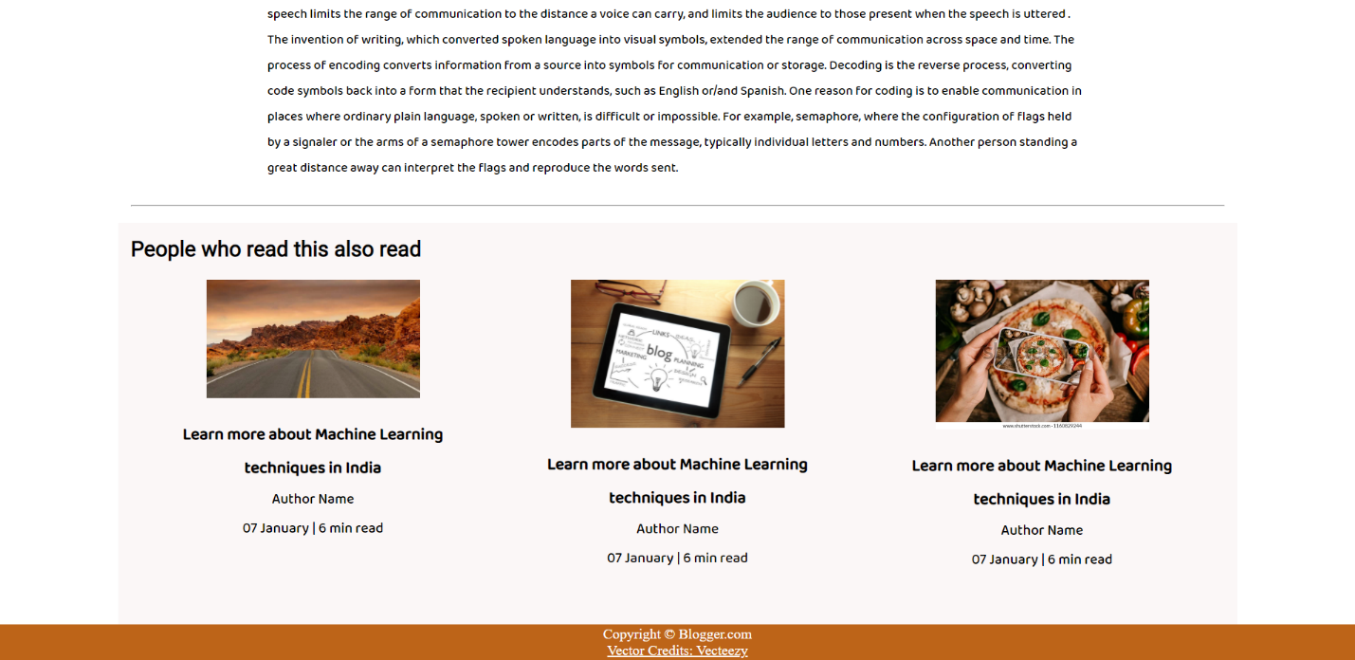

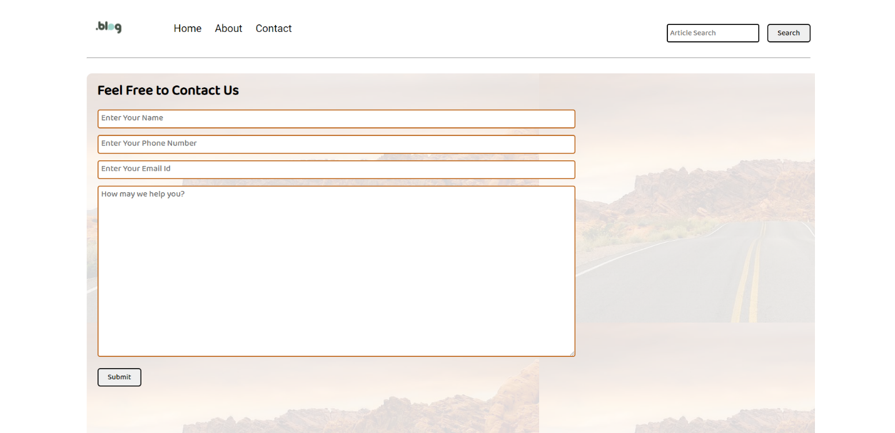
4.3 Blog Post footer

Figure4.4 Contact us

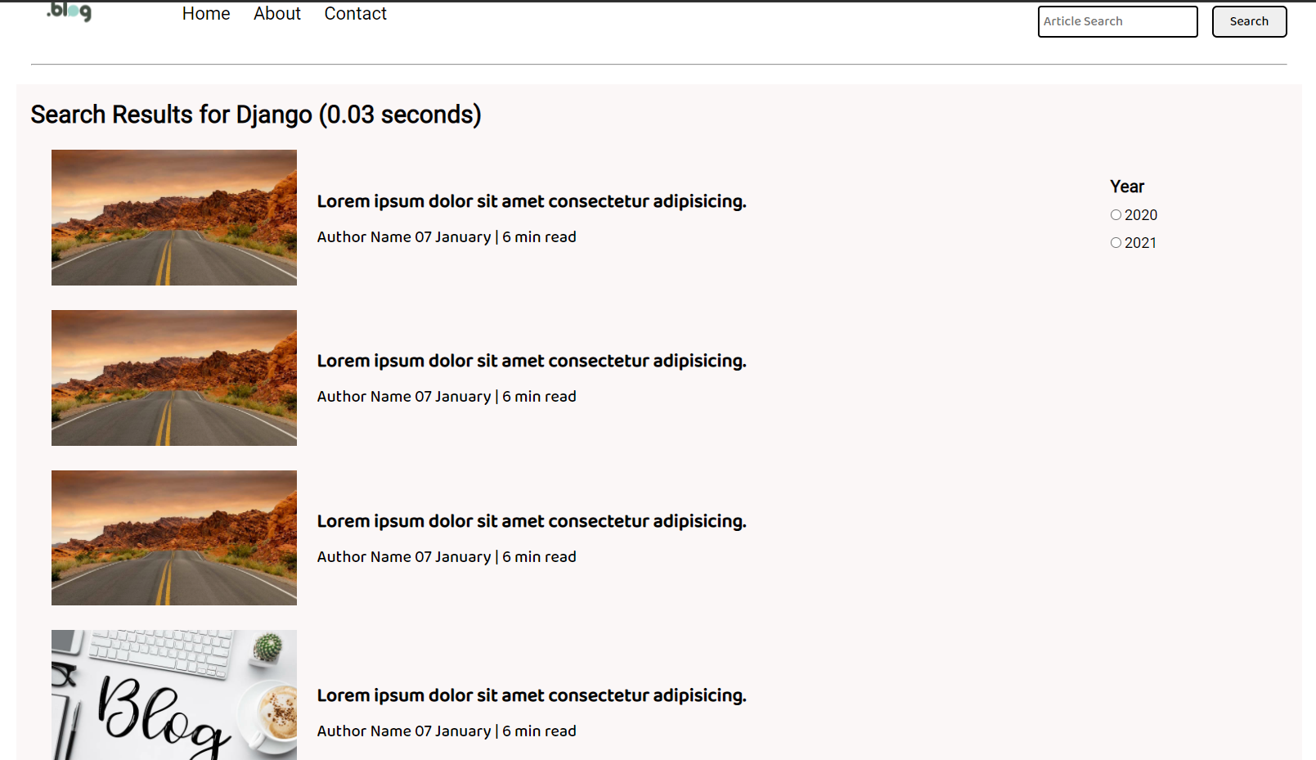

Figure 4.5 Search

Chapter 5

5.1 GitHub Link
https://github.com/nishantmehta1/blogger-website

References

- Wikipedia
- W3Schools.com
- Youtube.com

