Antibacterial activity of extracts and silver nanoparticles from Vitex Agnus Castus against bacteria isolated from Hospital wastewater
Mustafa A. Jadoua
Department of Ecology, College of Science, University of Basrah. Basrah, Iraq
Munther Abduljaleel Muhammad-Ali
Department of Ecology, College of Science, University of Basrah. Basrah, Iraq
Nassir Abdullah Alyousif*
Department of Ecology, College of Science, University of Basrah. Basrah, Iraq
*Corresponding author. Email: nassir.hillo@uobasrah.edu.iq
Abstract
The plants extract and silver nanoparticles are gaining popularity and are being used in medical technologies due to their antibacterial activity. This study aimed to evaluate the potential antimicrobial properties of an aqueous leaves extract of Vitex agnus-castus and biosynthesized Ag NP particles. The extract was made using three distinct methods, and silver nanoparticles were formed by adding 0.2 grams of silver nitrate to the extract. UV-Vis Spectroscopy, scanning electron microscopy (SEM), Energy-Dispersive X-ray spectroscopy (XRD), Fourier transform infrared (FTIR) spectroscopy, and Gas chromatography-mass spectrometry (GC-MS) were used to determine the characteristics of the silver nanoparticles. The results indicated that the Soxhlet extraction method produced the highest percentage of silver nanoparticles, measuring 56.13%. The antibacterial activity of both the extracts and the silver nanoparticles was tested against Gram-positive and Gram-negative bacteria isolated from hospital wastewater at three different concentrations: 25, 35, and 50 mg/mL. The extracts exhibited the strongest inhibition of 25 mm against Enterobacter cloacae strain NCTC 9394 (FP929040) when using an aqueous Soxhlet extract at a concentration of 35 mg/mL. Conversely, the lowest inhibition recorded was 11 mm against Pseudomonas aeruginosa strain WPB098 (CP031876) with an acetone Soxhlet extract at a concentration of 50 mg/mL. In addition, at a concentration of 35 mg/mL, the cold soak extract did not affect Citrobacter sedlakii strain NWPK (MW720666). The antibacterial activity of biosynthesized silver nanoparticles showed inhibition against Pseudomonas aeruginosa strain WPB098 (CP031876) reached 25 mm from the aqueous Soxhlet extract at a concentration of 50 mg/mL was combined with biosynthesized silver nanoparticles from the hot soaking extract at 50°C at a concentration of 50 mg/ml. Meanwhile, the lowest inhibitory against Escherichia coli strain S51 (CP015995) was 15 mm, which was achieved by using biosynthesized silver nanoparticles from aqueous Soxhlet extract at a concentration of 35 mg/mL. Biosynthesized silver nanoparticles from Vitex agnus-castus exhibited strong antibacterial activity against both Gram-positive and Gram-negative bacteria, as promising antibacterial agents.
Keywords: Antibacterial, Hospital wastewater, Pathogenic bacteria, silver nanoparticles, Vitex Agnus-Castus L.
INTRODUCTION
The purified water is considered the most crucial natural resource for human survival (Tang et al., 2022). The purity of water is critical to the health of all living things on Earth. The world's population continues to grow, as do industry, urbanization, and chemically enhanced agriculture, which damages water supplies (Mohammad et al., 2021; Rathi et al., 2021). Microbial pollution of urban water is a global concern for public health safety, especially in developing countries. Microorganisms such as bacteria and viruses are the predominant pathogens in drinking water. The main sources of pathogens in water are livestock and wildlife feces, sewage, industrial wastewater, and pharmaceuticals. Poor management and ignorance contribute to waterborne diseases in humans by consumption of contaminated drinking water (Rani et al., 2024; Al-Khafaji et al., 2025). Several pathogenic bacteria in wastewater can cause diarrhoea, cholera, gastrointestinal disorders, and limit nutrient absorption, resulting in malnutrition (Zhan et al., 2024). Traditional water treatment methods, such as charcoal filtration, sand filtration, and sedimentation, have limited promise for widespread use. As a result, the use of low-cost alternative materials with desirable qualities, such as photocatalytic activity, absorption capacity, quick adsorption kinetics, and separation and regeneration, has been highlighted. Recently, nanoparticles have been used to remove pollutants (Ajith et al., 2021).
A nanoparticle, or ultrafine particle, is a particle of matter having dimensions of one nanometer to one hundred nanometers (Altammar, 2023). Nanoparticles can be crystalline (single or polycrystalline solids) or amorphous. They can be either solitary or aggregated, and homogeneous or composed of several layers (Joudeh and Linke, 2022). The term "green synthesis" refers to ecologically benign techniques for manufacturing materials, particularly nanoparticles such as AgNPs, using biological systems such as plants, algae, fungi, and bacteria. Green synthesis seeks to eliminate waste, mitigate environmental impacts, and rely on sustainable, renewable resources. The core concepts of green synthesis include the utilization of renewable resources such as plant extracts and microorganisms (Fahim et al., 2024). Plant extracts are frequently selected for their simplicity, convenience of use, scalability, chemical diversity, and cost-effectiveness. Furthermore, plant extracts can be derived from various sources, including stems, roots, fruits, seeds, leaves, flowers, agricultural waste, peels, and bark. These advantages make plant extract-based nanoparticle synthesis more appealing, particularly for large-scale manufacturing for fine nanoparticle applications in agriculture and biomedicine (Oselusi et al., 2025). The plant parts used in the process can be cleaned, cooked in distilled water, and then filtered. Following that, nanoparticles are produced by adding the appropriate extract solution to the desired nanoparticles, and the solution's colour change is usually associated with their presence (Mohammadidargah et al., 2024).
Silver nanoparticles have become increasingly popular in the medical sciences due to advances in nanotechnology and their high antibacterial potential. Green synthesis methods for nanoparticles are preferred over physical and chemical methods due to their lower cost, reduced energy use, and greater time efficiency (Al-assdy et al., 2025). They do not use toxic solvents or environmentally hazardous components and are regarded as environmentally and biologically friendly. Biologically produced silver nanoparticles exhibit excellent therapeutic properties, including antioxidant, anticancer, anti-inflammatory, antidiabetic, antiparasitic, and antibacterial effects (Ghani et al., 2022). The present study aimed to evaluate the potential of an aqueous extract of Vitex agnus-castus (Chasteberry) leaves and to manufacture silver nanoparticles using the green synthesis method from AgNO₃, and to determine the antimicrobial properties of these compounds against bacteria isolated from local hospital wastewater.
MATERIALS AND METHODS
Preparation of plant extracts and nanoparticles
Collection of plant samples
Vitex agnus-castus plants were collected from the Qarmat_Ali is an Iraqi town located in Al-Hartha District, Basrah. (30.56953.9″N, 47.74971.2″E) during November and December 2024. The collected plant leaves were placed in plastic bags and transferred to the laboratory, where they were washed with distilled water to remove accumulated dust, then allowed to dry for a week. Following that, the plant was ground in a ceramic mortar and the powder was stored in plastic containers.
Extraction techniques
Several methods were used to prepare the aqueous extract of the selected plant, including:
Cold Soaking: This method involves placing 20 grams of plant powder in a 500 ml conical flask with 150 ml of distilled water and allowing it to sit for 24 hours. Afterward, the mixture is filtered through filter paper, and 25 ml of the extract was reserved for further use, while the remaining solution was allowed to dry (Sankeshwari et al., 2018).
Hot Soaking: Twenty grams of powdered plant were placed in a 500 mL conical flask with 150 mL of distilled water. The mixture was heated on a magnetic stirrer plate at 50°C for two hours. Afterwards, filter the mixture through filter paper, reserving 25 mL for later use, and allow the remainder to dry (Logeswari et al., 2015).
Extraction using the Soxhlet apparatus: Aqueous, alcoholic, and acetone extracts were prepared by taking 20 grams of powder from each plant and placing it in a thimble. Water, alcohol, and acetone were used as solvents; 25 ml of each was collected for later use, while the remainder was dried in dishes, ground, and stored in plastic containers (Mokaizh et al., 2024).
Green synthesis of silver nanoparticles
The silver nanoparticles were made using a process (Ahmed et al., 2016) that involved adding 25 ml of the chosen plant's non-dried extract to a 500 ml glass flask containing 150 ml of deionized distilled water. Then, 0.2 g of silver nitrate was added and heated to 50 degrees Celsius on a magnetic stirring plate while stirring. The mixture was then stored in an area for 2 days. It was subsequently placed in Petri dishes and allowed to dry at room temperature. Finally, the particles were scraped and put in plastic bins.
Characterization of plant extracts and silver nanoparticles AgNPs
A variety of techniques were used as mentioned following to determine and confirm the nano characteristics of plant extracts and AgNPs. The optical properties of AgNPs were investigated with a UV-vis spectrophotometer. Fourier transform infrared (FTIR) spectroscopy was used to analyze the dried material of plant extracts and AgNPs. X-ray diffraction (XRD) and scanning electron microscopy (SEM) were used to characterize the structural properties and particle size and shape of AgNPs. Gas chromatography-mass spectrometry (GC-MS) were used to determine the characteristics of the silver nanoparticles (Hamid et al., 2024).
Isolation and identification of bacterial species
Collection of wastewater samples
Wastewater samples were collected from Ports Teaching Hospital and Al-Fayhaa Hospital in Basrah Governorate between 1 November and 30 December, 2024. The samples were obtained at depths of 10-15 cm, with 0.5 L collected at several points using a sterile plastic container. They were placed in sterile laboratory plastic containers, transferred to the laboratory, and kept in the refrigerator at 4°C until the laboratory analyses were completed.
Isolation of bacteria
A serial dilution method was used to isolate bacteria from a wastewater sample. Initially, 1 ml of wastewater was added to 9 ml of sterile distilled water to obtain a 10⁻¹ dilution. To obtain a 10⁻² dilution, 1 ml was transferred from the first tube to a second tube containing 9 ml of sterile distilled water. This process was repeated to obtain dilutions up to 10⁻⁶. Next, the nutrient agar plates were inoculated under sterile conditions with 0.1 ml of each sample, with two replicates per dilution. The samples were evenly spread across the plates using a glass spreader. The plates were incubated at 37°C for 24 hours, then examined after 24 hours.
Purification of bacterial isolates
The bacterial isolates were purified by transferring a portion of each colony to a new plate containing nutrient agar. The plates were then incubated at 37 °C for 24 hours. Their purity was confirmed by Gram staining the bacteria and examining them under a light microscope. The pure colonies were then grown on slant nutrient agar and kept in the refrigerator at 4°C (Mohammad and Alyousif, 2022).
Diagnosis of isolated bacteria
The pure bacterial isolates were activated on nutrient agar and transferred to Al-Fayhaa Hospital in a cooling container for identification using the VITEK 2 system. The VITEK 2 system was used according to the manufacturer's instructions, with ID Gram Positive and ID Gram Negative cards used for identification. The bacterial isolates including Leuconostoc mesenteroides strain F17, Kocuria rosea strain MG2, Staphylococcus hominins strain MK-1, Escherichia coli strain S51, Enterobacter cloacae strain NCTC 9394, Pseudomonas aeruginosa strain WPB098, Citrobacter sedlakii strain NWPK, Morganella morganii strain UM869, and Serratia marcesceens strain UMH5.
Antibacterial activity of plant extracts and silver nanoparticles
The agar well diffusion method was employed to assess the activity of plant extracts and silver nanoparticles, with various concentrations (25, 35, and 50 mg\ mL). These extracts were dissolved in 1 mL of DMSO and left to stand for at least 3 hours to fully dissolve. The bacterial species isolated from hospital wastewater isolates including Leuconostoc mesenteroides strain F17 (CP178852), Kocuria rosea strain MG2 (JX534199), Staphylococcus hominins strain MK-1 (JX961712.1), Escherichia coli strain S51 (CP015995), Enterobacter cloacae strain NCTC 9394 (FP929040), Pseudomonas aeruginosa strain WPB098 (CP031876), Citrobacter sedlakii strain NWPK (MW720666), Morganella morganii strain UM869 (ON533444.1), and Serratia marcesceens strain UMH5 (CP0189171) were activated individually on Mueller-Hinton agar. 0.1 mL of dissolved extract and silver nanoparticles was added to the wells of the cultured bacterial plates, which were then incubated at 37 °C for 24 hours. The inhibition zones of plant extracts and silver nanoparticles against bacterial colony growth were determined by measuring the diameter of each inhibition zone for each bacterial isolate (Alyousif et al., 2023).

RESULTS AND DISCUSSION
Characterization of plant extracts
Gas chromatography-mass spectrometry (GC-MS)Gas chromatography-mass spectrometry revealed the existence of several aromatic and aliphatic chemicals. The components of the V. agnus-castus plant's Cold extract were characterized, revealing that there are compounds with high concentrations belonging to the organic categories of phenols, esters, carboxylic acids, and heterocyclic compounds, with concentration ratios ranging from 23.51% to 1.31% as indicated in Fig. 1. The results of the analysis of V. agnus-castus extracts using GC-MS were consistent with the study conducted by (Khames and Ahmed, 2025; Jasim et al., 2024), which evaluates the synergistic and antibacterial effects of V. agnus-castus leaf extract on multidrug-resistant P. aeruginosa isolates. The combining Vitex extract with antibiotics has the potential to be beneficial as a therapeutic agent against drug-resistant P. aeruginosa.
Fig. 1. Chromatogram of Cold-soaked extract of Vitex agnus-castus plant
The plant components of a 50 °C hot extract from Vitex agnus-castus contained active chemicals such as alcohols, phenols, non-homogeneous cyclic compounds, and amides, with concentrations ranging from 41.51% to 0.79%, as shown in fig. 2.
Fig. 2. Chromatogram of Hot-soaked extract at 50 C° of Vitex agnus-castus plant
The plant components of the aqueous extract of the V. agnus-castus plant using a Soxhlet apparatus. Active compounds such as alcohols, phenols, non-homogeneous cyclic compounds, and fluorine-substituted aromatic compounds are present, with concentration ratios ranging from 12.90% to 1.05% as in fig. 3.
Fig. 3. Chromatogram of Soxhlet extract of the Vitex agnus-castus plant
The plant components of the alcoholic extract of the Vitex agnus-castus plant were obtained using a Soxhlet apparatus. Active compounds such as alkenes, phenols, non-homogeneous cyclic compounds, fluorine-substituted aromatic compounds, and cholesterol derivatives are present, with concentration ratios ranging from 1.39% to 14.13% as indicated in fig. 4.
Fig. 4. Chromatogram of the alcoholic extract of the Vitex agnus-castus plant
The plant components of the acetone extract of the V. agnus-castus plant using the Soxhlet apparatus, revealing the presence of active compounds such as alkenes, phenols, non-homogeneous cyclic compounds, fluorine-substituted aromatic compounds, cholesterol derivatives, and lactone compounds with concentrations ranging from 1.70 to 8.02% as shown in fig. 5.
Fig. 5. Chromatogram of acetone extracts of the Vitex agnus-castus plant
Fourier transform infrared (FTIR) spectroscopy
The extracts of the cold and hot V. agnus-castus, as well as Soxhlet, exhibited distinct absorption bands that corresponded to different functional groups in the organic components adsorbed on the silver surface. All aqueous extracts revealed bands at 3200 cm⁻¹, which corresponded to the stretching vibration of the phenolic or alcoholic O-H bond. The bands at 2900-2800 cm⁻¹ correspond to the stretching vibration of C-H bonds in aliphatic molecules. Furthermore, bands in the 1680-1690 cm⁻¹ range correlate to the stretching vibration of carbonyl bonds in various ester and ketone compounds, as shown in Fig. 6.
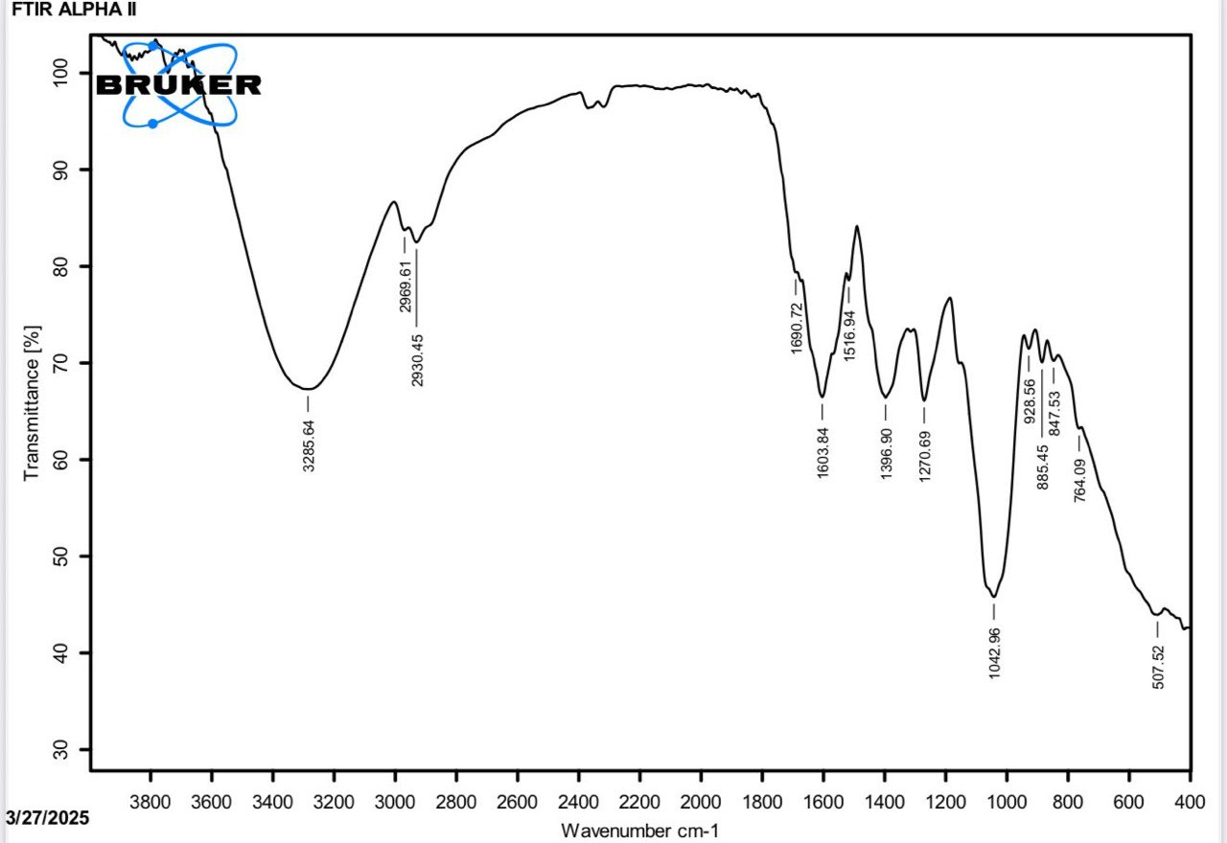
Fig. 6. FTIR spectrum of Cold-soaked extract of the plant Vitex agnus-castus
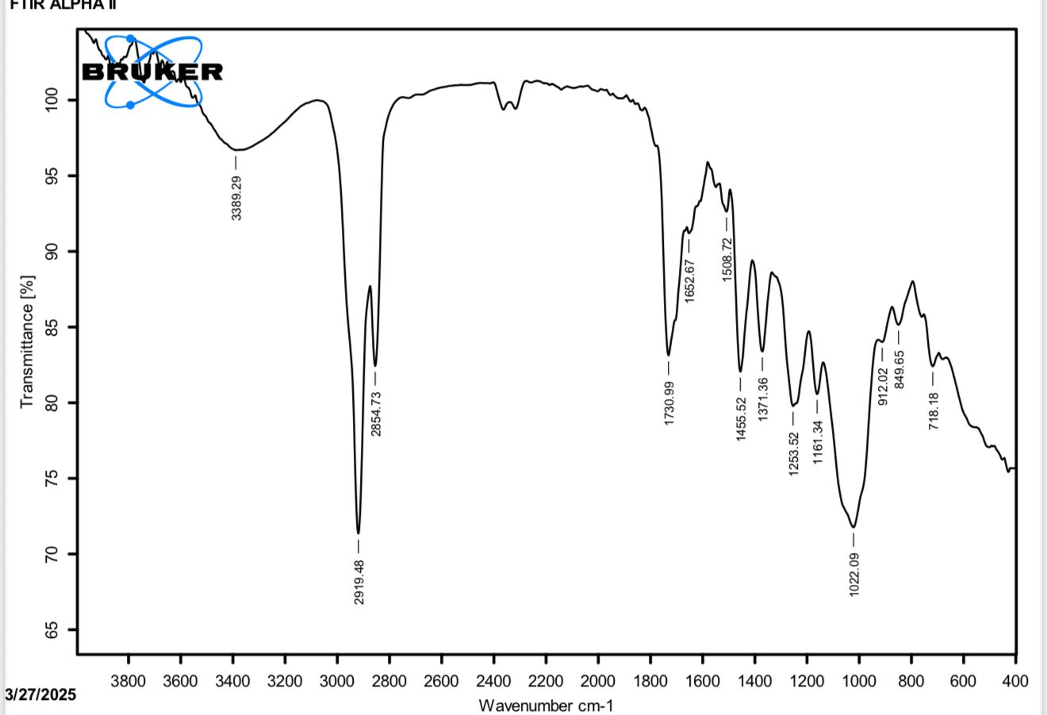
The alcoholic and acetone extracts of the plant V. agnus-castus revealed distinct absorption bands that corresponded to different functional groups in chemical components. The extracts revealed bands between 3300 and 3200 cm⁻¹, which corresponded to the stretching vibration of the phenolic or alcoholic O-H bond. The bands at 2910-2920 cm⁻¹ correspond to the stretching vibration of C-H bonds in aliphatic molecules. Additionally, bands between 1692 and 1730 cm⁻¹ correspond to the stretching vibration of carbonyl bonds in several ester and ketone molecules. The bands in the 1000 cm⁻¹ range correspond to the stretching vibration of the C-O and C-N bonds in heterocyclic aromatic organic compounds, as illustrated in fig.7. The results of the analysis of V. agnus-castus extracts using FTIR were consistent with the study conducted by Abada et al. (2024) , Muhammad-Ali et al. (2025), who also showed that the active groups of V. agnus-castus extracts matched the current study.
Fig. 7. Fourier transform infrared spectrum of the acetone extract of the plant Vitex agnus-castus

Silver nanoparticles synthesis using plant extracts and their characterization
The present study revealed that adding an aqueous plant extract of V. agnus-castus to silver nitrate (0.2 grams) caused the mixture to change from green to brown, indicating excitation of silver nanoparticles' plasmonic resonance, as shown in fig. 8.
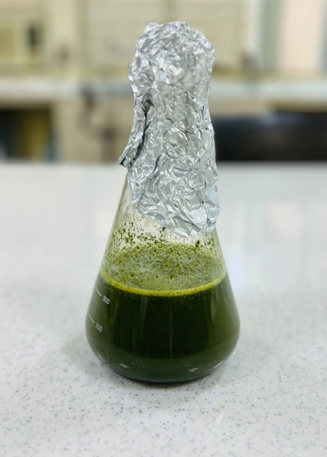
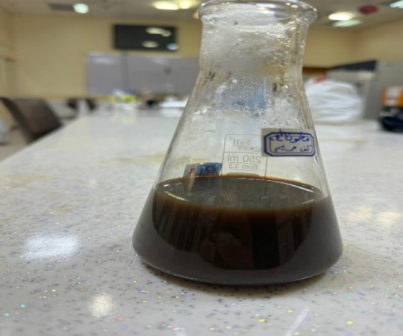
A
B

Fig. 8. AgNPs Synthesis A: The green color of the extract before adding silver nitrate, B: the Brown color of the extract after adding silver nitrate
UV-Vis Spectroscopy
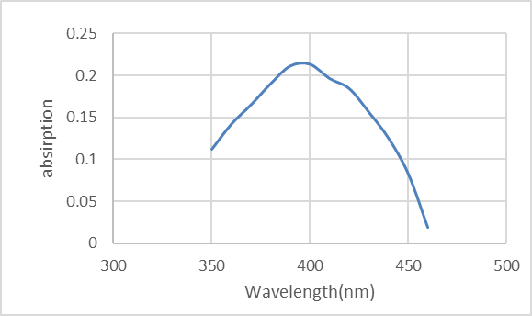
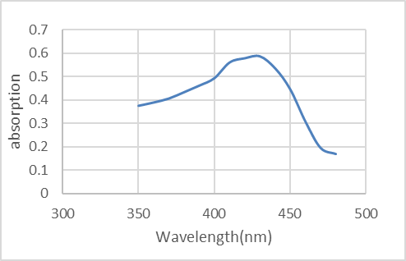
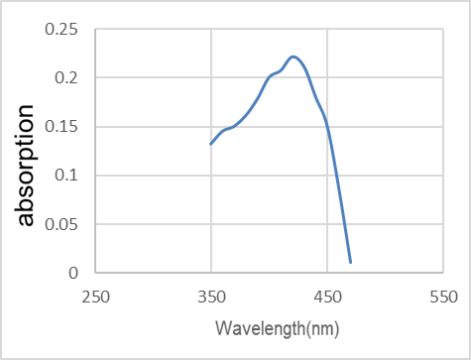
UV-Vis spectroscopy was used to monitor the bioreduction of silver ions to silver nanoparticles. The absorption peaks of the silver nanoparticle combination demonstrated silver surface plasmon resonance at 410, 420, and 430 nm, as shown in fig. 9, which showed the ultraviolet and visible light ranges, demonstrating how silver nanoparticles are made from the V. agnus-castus plant using cold soaking, hot soaking 50 C°, and Soxhlet extraction methods. The maximum absorption values were obtained at 410, 420, and 430 nanometers, which are within the diagnostic range for silver nanoparticles (400-450 nanometers). The results of the present work are consistent with those of Hashemi et al. (2021), as the UV-visible spectrum of biosynthesized silver nanoparticles from Alcea rosea showed the largest absorption peak at 425 nm.
A

B
C
(AU)
(AU)
(AU)

Fig. 9. A: UV-Vis spectrum of silver nanoparticles biosynthesized from cold soak extract; B: The UV-Vis spectrum of silver nanoparticles biosynthesized from hot soak extract at 50 ⁰ C; C: The UV-Vis spectrum of silver nanoparticles biosynthesized from Soxhlet extraction

Energy-Dispersive X-ray (EDX) analysis
The main structures of AgNPs derived organically from the plant V. agnus-castus using three different extraction procedures (cold soaking, hot soaking at 50 °C, and Soxhlet extraction) were characterized using EDX. The results showed that AgNPs obtained using the Soxhlet extraction procedure yielded the highest proportion of silver nanoparticles (56.13), compared with the other two methods, indicating that this method was the preferred method for nanoparticle synthesis (Ghavam, 2023), as shown in Table 1 and Fig. 10.
Table 1. Percentage of oxygen, carbon and silver in AgNPs manufactured by methods (cold soaking, hot soaking of 50 C°, Soxhlet extraction)
Carbon | Oxygen | Ag | Type of nanoparticles
29.75 | 11.75 | 46.12 | Cold silver nano
19.73 | 11.26 | 53.80 | 50°C hot nano silver
13.53 | 4.39 | 56.13 | Nano silver Soxhlet
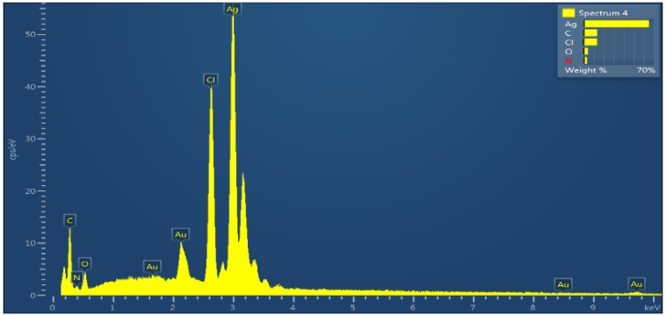
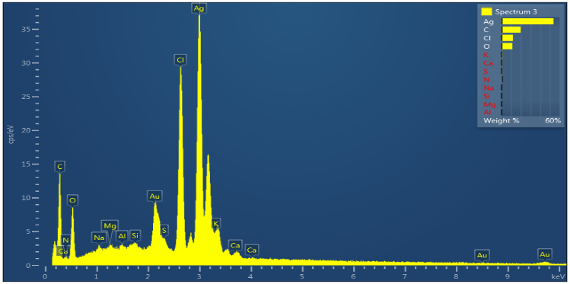
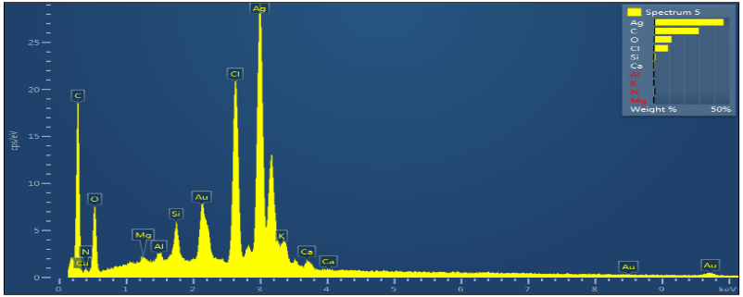
A
B
C

Fig. 10. EDX spectra of AgNPs biosynthesized from the Vitex agnus-castus plant, A: Cold extract, B: Hot extract, C: Soxhlet extract.

Scanning Electron Microscope (SEM)
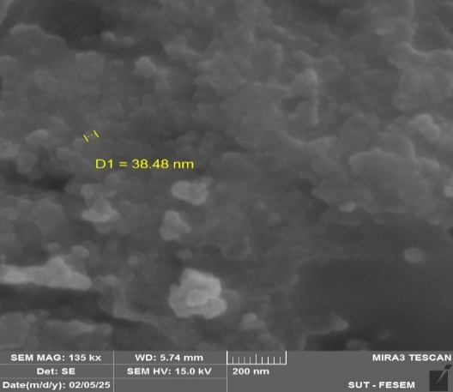
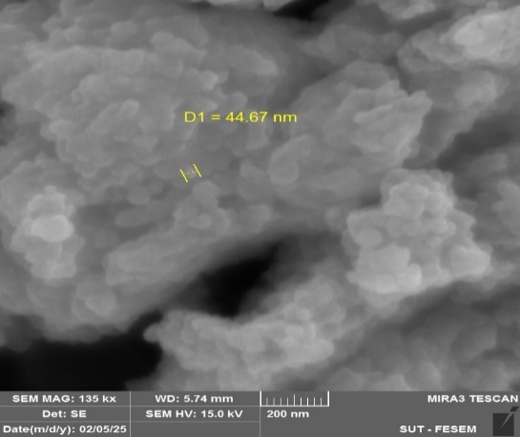
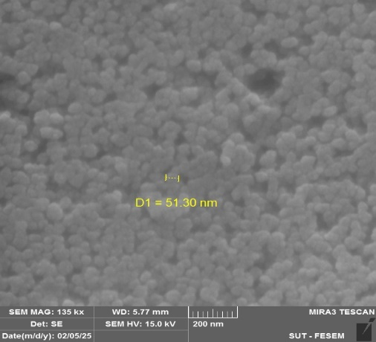
A B C

The silver nanoparticles biosynthesized from V. agnus-castus plant with distinct morphologies and surface sizes were characterized by scanning electron microscopy, which revealed that the silver nanoparticles had a smooth, spherical shape. The average size of the silver nanoparticles biosynthesized from the cold-soaked extract of the plant was 38.48 nanometers, whereas the average size of the silver nanoparticles biosynthesized from the hot-soaked extract at 50 C° was 51.30 nanometers. The silver nanoparticles biosynthesized from the Soxhlet extract measured 44.67 nanometers. The results of the current study agree with those of Ghabban et al. (2022), who reported that the silver nanoparticles produced by the prickly caltrop plant were spherical and ranged in size from 30 to 40 nanometers, as shown in Fig. 11.

Fig. 11. SEM of AgNPs biosynthesized from the Vitex agnus-castus plant A: Cold extract, B: Hot extract, C: Soxhlet extract
Fourier transform infrared (FTIR) spectroscopy
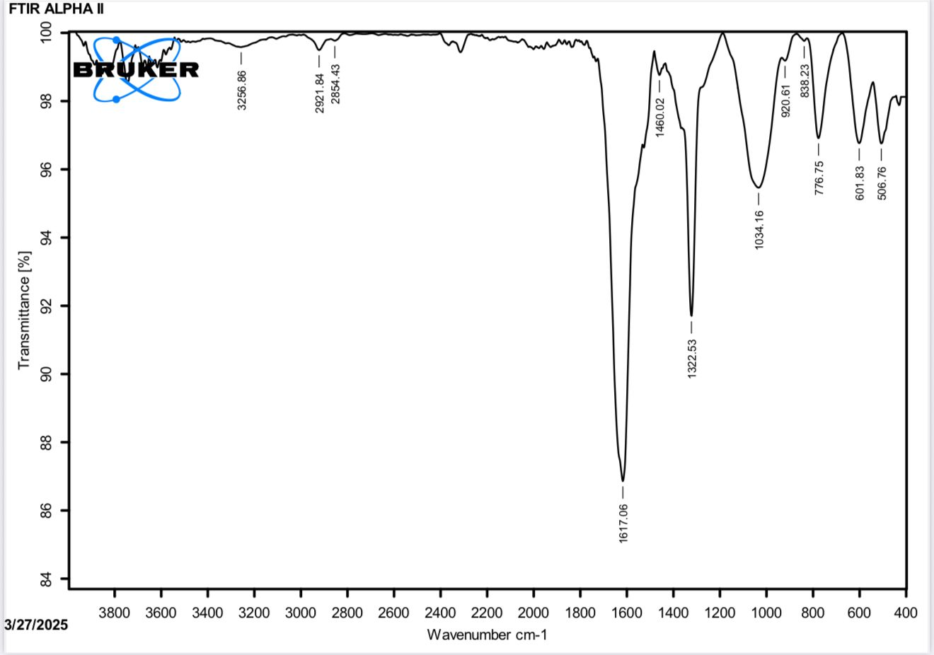
FTIR analysis can help identify the biomolecules responsible for silver ion reduction and nanoparticle stabilization. The qualitative examination uses infrared laser scanning to evaluate the chemical bonds of materials. The functional groups responsible for nanoparticle formation can be identified by FTIR spectroscopy. The silver nanoparticles biosynthesized from both cold and hot extracts of V. agnus-castus and Soxhlet extracts showed several absorption bands that matched different functional groups in the organic materials attached to the silver surface. All of the aqueous extracts exhibited bands at 3200 cm⁻¹, which corresponded to the stretching vibration of the phenolic or alcoholic O-H bond. The bands at 2900-2800 cm⁻¹ correspond to the stretching vibration of C-H bonds in aliphatic molecules. Furthermore, bands in the 1680-1690 cm⁻¹ range correspond to the stretching vibration of carbonyl bonds in various ester and ketone compounds, as illustrated in Figure 12. The present results support previous studies in identifying the biomolecules in Camellia sinensis and Prunus africana responsible for silver ion reduction (Ssekatawa et al., 2021; Alharbi et al., 2022).

Fig. 12. Fourier transform infrared spectrum of nano silver Soxhlet of the Vitex agnus-castus plant
Antibacterial activity of plant extracts and silver nanoparticles
The activity of V. agnus-castus plant extract against Gram-negative and Gram-positive bacteria isolated from hospital wastewater was determined at concentrations of 25, 35, and 50 mg/mL using the diffusion method. The results demonstrated that the plant extracts from V. agnus-castus L. had antibacterial activity against Gram-positive bacteria with maximum inhibition diameter was 21 mm against bacteria Staphylococcus hominins when the alcoholic Soxhlet extract was used at a concentration of 50 mg/ml, while the minimum inhibition diameter was 12 mm against bacteria Kocuria rosea when the aqueous Soxhlet extract was used at a concentration of 25 mg/ml, while some extracts did not show any effectiveness against bacteria as shown in Table 2 and Fig. 13.

Table 2. Antibacterial activity of V. agnus-castus extract against Gram-positive bacteria isolated from hospital wastewater
Extract method | Concentrations mg/ml | Inhibition zone (mm)
Extract method | Concentrations mg/ml | Leuconostoc mesenteroides spp cremoris | Kocuria rosea | Staphylococcus hominins
 | 25 | 14 | 13 | 0
Cold soaking extract | 35 | 13 | 13 | 13
 | 50 | 16 | 14 | 16
 | 25 | 15 | 14 | 17
50°C hot soaking extract | 35 | 14 | 15 | 15
 | 50 | 18 | 19 | 14
 | 25 | 17 | 12 | 0
Soxhlet water extract | 35 | 13 | 14 | 13
 | 50 | 15 | 15 | 14
 | 25 | 16 | 13 | 15
Alcoholic soxhlet extract | 35 | 13 | 14 | 13
 | 50 | 16 | 18 | 21
 | 25 | 15 | 15 | 16
Soxhlet acetone extract | 35 | 14 | 15 | 19
 | 50 | 17 | 20 | 20

The activity of the V. agnus-castus plant extract against Gram-negative bacteria showed a maximum inhibition diameter of 25 mm against Enterobacter cloacae complex using an acetone Soxhlet extract at a concentration of 50 mg/mL. Meanwhile, the minimum inhibition diameter was 11 mm against Pseudomonas aeruginosa, when an aqueous soxhlet extract was used at a concentration of 50 mg/ml. Furthermore, at a concentration of 35 mg/mL, the cold-soak extract was ineffective against Citrobacter sedlakii, as shown in Table 3 and Figure 11. It was found that the best inhibitory activity of the extracts was observed with the acetone Soxhlet extract against Gram-positive bacteria, due to its content of bioactive compounds that inhibit bacterial growth, such as phenols, heterocyclic compounds, and fluorine-substituted aromatic compounds. The effect of this extract is attributed to the fact that the cell wall structure of Gram-positive bacteria is more sensitive to plant extracts, in addition to the absence of an outer membrane, which gives it high permeability properties, destroys the bacterial membrane, inhibits biofilm formation, DNA synthesis, and protein synthesis (Jubair et al., 2021). This study is consistent with the study by Nigussie et al. (2021), which examined the effects of extracts from the leaves of Azadirachta indica, Lawsonia inermis, and Achyranthes aspera against Staphylococcus aureus, Streptococcus pyogenes, and E. coli. Water, methanol, and ethyl acetate were used as solvents, and methanol extract was the most effective at inhibiting bacterial growth. The study by Kozłowska et al. (2022) demonstrated the effectiveness of plant extracts from Betula pendula, Rubus idaeus, Morus alba, and Cistus incanus, extracted with water and ethanol, against Staphylococcus aureus and E. coli, with the ethanol extract being more effective at inhibiting bacterial growth.

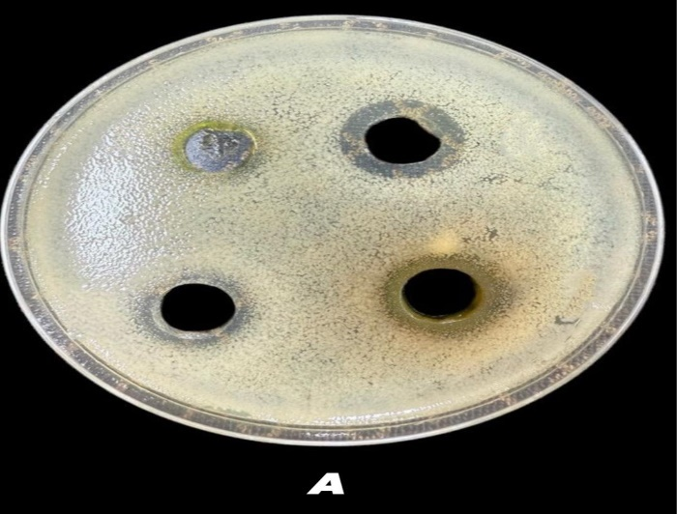  1 2  3 4  1 2  3 4 | 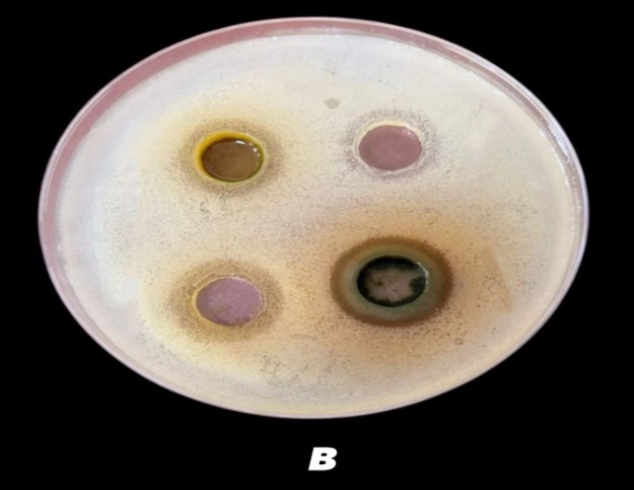

Fig. 13. Antibacterial activity of V. agnus-castus plant extract, A: Staphylococcus hominis, B: Kocuria rosea, 1: Cold soaking extract, 2: 50°C hot soaking extract, 3: Soxhlet water extract, 4: Alcoholic soxhlet extract

Table 3. The antibacterial activity of V. agnus-castus extract on Gram-negative bacteria isolated from hospital wastewater
Extract method | Concentrations mg/ml | Inhibition zone (mm)
Extract method | Concentrations mg/ml | Escherichia coli | Enterobacter cloacae complex | Pseudomonas aeruginosa | Citrobacter sedlakii | Morganella morganii | Serratia marcesceens
 | 25 | 16 | 16 | 19 | 14 | 16 | 12
Cold soaking extract | 35 | 17 | 14 | 14 | 0 | 14 | 12
 | 50 | 17 | 19 | 12 | 16 | 18 | 18
 | 25 | 17 | 18 | 17 | 17 | 17 | 15
50°C hot soaking extract | 35 | 15 | 16 | 15 | 16 | 16 | 15
 | 50 | 16 | 20 | 13 | 18 | 20 | 17
 | 25 | 17 | 17 | 20 | 15 | 16 | 13
soxhlet water extract | 35 | 17 | 18 | 15 | 13 | 14 | 13
 | 50 | 21 | 22 | 11 | 15 | 21 | 17
 | 25 | 18 | 16 | 19 | 18 | 20 | 14
Alcoholic soxhlet extract | 35 | 15 | 20 | 14 | 14 | 15 | 13
 | 50 | 19 | 23 | 15 | 17 | 18 | 16
 | 25 | 14 | 18 | 18 | 15 | 18 | 18
Soxhlet Acetone Extract | 35 | 17 | 19 | 24 | 16 | 17 | 15
 | 50 | 19 | 25 | 14 | 22 | 17 | 18

The antibacterial activity of biosynthesized silver nanoparticles from V. agnus-castus against Gram-positive bacteria showed a maximum inhibition diameter of 25 mm against Kocuria rosea when the nanoparticles were cold-soaked at 25 mg/mL. Meanwhile, the lowest inhibition diameter was 16 mm against bacteria Kocuria rosea, which was achieved by using biosynthesized silver nanoparticles from hot soaking at 50 °C at a concentration of 25 mg/ml and biosynthesized silver nanoparticles from an aqueous soxhlet extract at a concentration of 35 mg/ml against Leuconostoc mesenteroides, as shown in Table 4 and fig. 14.

Extract method | Concentrations mg/ml | Inhibition zone (mm)
Extract method | Concentrations mg/ml | Leuconostoc mesenteroides spp cremoris | Kocuria rosea | Staphylococcus hominins
 | 25 | 19 | 25 | 20
Cold nano silver | 35 | 18 | 18 | 19
 | 50 | 19 | 23 | 19
 | 25 | 18 | 16 | 18
50°C hot nano silver | 35 | 17 | 17 | 18
 | 50 | 20 | 20 | 23
 | 25 | 17 | 17 | 17
Nano silver Soxhlet | 35 | 16 | 19 | 19
 | 50 | 17 | 22 | 19
Table 4. Antibacterial activity of biosynthesized silver nanoparticles from V. agnus-castus against Gram-positive bacteria isolated from hospital wastewater

The results demonstrated the antibacterial activity of biosynthesized silver nanoparticles derived from V. agnus-castus against Gram-negative bacteria. The highest inhibition diameter against Pseudomonas aeruginosa was 25 mm, achieved with biosynthesized silver nanoparticles from an aqueous Soxhlet extract at 50 mg/ml and Soxhlet silver nanoparticles from a hot-soaking extract at 50°C, both at 50 mg/ml. Meanwhile, the lowest inhibitory diameter against E. coli was 15 mm, achieved using biosynthesized silver nanoparticles from an aqueous Soxhlet extract at a concentration of 35 mg/mL, as shown in Table 5.

Table 5. Antibacterial activity of biosynthesized silver nanoparticles from the V. agnus-castus L. plant against Gram-negative bacteria isolated from hospital wastewater
Extract method | Concentrations mg/ml | Inhibition zone (mm)
Extract method | Concentrations mg/ml | Escherichia coli | Enterobacter cloacae complex | Pseudomonas aeruginosa | Citrobacter sedlakii | Morganella morganii | Serratia marcesceens
Cold nano silver | 25 | 19 | 19 | 22 | 20 | 19 | 22
Cold nano silver | 35 | 19 | 16 | 23 | 18 | 16 | 17
Cold nano silver | 50 | 17 | 17 | 23 | 17 | 19 | 18
50°C hot nano silver | 25 | 19 | 18 | 21 | 24 | 17 | 20
50°C hot nano silver | 35 | 16 | 17 | 23 | 17 | 17 | 17
50°C hot nano silver | 50 | 20 | 20 | 25 | 19 | 21 | 18
Nano silver Soxhlet | 25 | 16 | 19 | 21 | 19 | 20 | 19
Nano silver Soxhlet | 35 | 15 | 19 | 23 | 19 | 18 | 18
Nano silver Soxhlet | 50 | 19 | 22 | 25 | 17 | 21 | 19

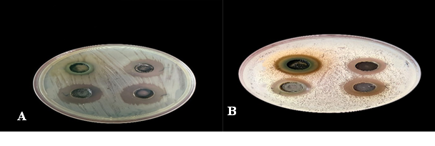
- 2

3 4
- 2

3 4

Fig. 14. Antibacterial activity of V. agnus-castus plant extracts and biosynthesized silver nanoparticles, A: Pseudomonas aeruginosa, B: Kocuria rosea, 1: Soxhlet acetone extract, 2: Cold nano silver, 3: 50°C hot nano silver, 4: Nano silver Soxhlet

All the biosynthesized silver nanoparticles from the cold soak extract, hot soak extract, and aqueous Soxhlet extract of the V. agnus-castus plant showed high activity against both Gram-positive and Gram-negative bacteria, as indicated by the inhibition diameter, which ranged between 25-15 mm among the different types of silver nanoparticles. This is attributed to direct interaction with the bacterial cell wall, inhibiting biofilm formation, triggering an innate and adaptive host immune response, producing reactive oxygen species (ROS), and inducing intracellular effects, e.g., interactions with DNA and/or proteins (Anand et al., 2022). Furthermore, depending on the outcome, silver nanoparticles have demonstrated a modest antibacterial effect against Gram-positive bacteria compared to Gram-negative bacteria. Gram-positive bacteria contain a thick covering of peptidoglycan. This makes it difficult to disseminate silver nanoparticles over the cell wall (Sumitha et al., 2018), so disrupting cell function and preventing growth. In contrast to Gram-negative bacteria, the outer membrane of Gram-positive bacteria may prevent a greater amount of silver from reaching the cytoplasmic membrane. As a result, Gram-positive bacteria showed greater tolerance to the produced silver nanoparticles than Gram-negative bacteria (Samuggam et al., 2021). The present study is consistent with the study by Feng et al. (2022), which biosynthesized silver nanoparticles from the glycyrrhizin plant by increasing the inhibition diameters with the increase of reduced silver nanoparticles concentrations. They evaluated the antibacterial activities of silver nanoparticles against E. coli and Staphylococcus aureus using the Oxford cup method and the filter paper diffusion method, respectively. Moreover, with the increase in concentrations of Glycyrrhizin -reduced silver nanoparticles (20, 60, 100 µg/mL), the inhibition diameters for both types of bacteria treated with Glycyrrhizin -reduced silver nanoparticles increased. The results showed that the inhibition diameter of E. coli caused by reduced silver nanoparticles was at a concentration of 100 µg/ml to 22 and 16 mm using the Oxford cup method and the filter paper method, respectively. Similarly, the inhibition diameter of Staphylococcus aureus after treatment with reduced silver nanoparticles at 100 µg/ml using the Oxford cup method and the filter paper method was 18 and 14 mm, respectively.
The present study is consistent with the study by Abdellatif et al. (2022) in the activity of biosynthesized silver nanoparticles from the plants. The biosynthesized silver nanoparticles from the plants Mentha piperita showed strong antibacterial activity against pathogenic bacteria including E. coli, Staphylococcus aureus, Bacillus cereus, Salmonella typhimurium except Proteus mirabilis. Furthermore, AgNPs from Zingiber officinale showed substantial activity against Staphylococcus aureus, E. coli, and Klebsiella pneumoniae. While Csakvari et al., (2021) evaluated the antibacterial activity of Cannabis sativa leaf extracts, with or without biosynthesized silver nanoparticles, on four bacterial strains, three Gram-negative bacteria (E. coli, Klebsiella pneumoniae, and Pseudomonas aeruginosa) and one Gram-positive bacterium (Staphylococcus aureus) using the agar disc diffusion method. Their results showed the antibacterial effect of Cannabis leaf extracts alone and their mixture containing prepared silver nanoparticles against both Gram-positive and Gram-negative bacterial strains.
Conclusion
The extract of V. agnus-castus plant and biosynthesized silver nanoparticles showed antibacterial activity against bacterial species isolated from hospital wastewater. The biosynthesised silver nanoparticles from plants exhibited strong antibacterial activity against both Gram-positive and Gram-negative bacteria (Staphylococcus hominins strain MK-1, Enterobacter cloacae strain NCTC 9394, Pseudomonas aeruginosa strain WPB098, Citrobacter sedlakii strain NWPK, and Escherichia coli strain S51) demonstrating the benefits of their antimicrobial properties. Therefore, silver nanoparticles can be considered promising antibacterial agents and a viable alternative to antibiotics. The extraction and biosynthesis of silver nanoparticles from V. agnus-castus can be an environmentally friendly, cost-effective, and safe process for their antimicrobial activities and healthcare applications.
ACKNOWLEDGEMENTS
We would like to thank the head of the Ecology department at the College of Science for their valuable support in completing this work.
Conflict of interest
The authors declared no conflict of interest in this manuscript regarding publication.
REFERENCES
Abada, E., Mashraqi, A., Modafer, Y., Al Abboud, M. A. & El-Shabasy, A. (2024). Review green synthesis of silver nanoparticles by using plant extracts and their antimicrobial activity. Saudi Journal of Biological Sciences, 31(1): 103877.‏ https://doi.org/10.1016/j.sjbs.2023.103877

Abdellatif, A. A., Alhathloul, S. S., Aljohani, A. S., Maswadeh, H., Abdallah, E. M., Hamid Musa, K. & El Hamd, M. A. (2022). Green synthesis of silver nanoparticles incorporated aromatherapies utilized for their antioxidant and antimicrobial activities against some clinical bacterial isolates. Bioinorganic Chemistry and Applications, 2022(1): 2432758.‏ https://doi.org/10.1155/2022/2432758
Ahmed, S., Ahmad, M., Swami, B. L. & Ikram, S. (2016). A review on plants extracts mediated synthesis of silver nanoparticles for antimicrobial applications: a green expertise. Journal of advanced research, 7(1): 17-28.‏ https://doi.org/10.1016/j.jare.2015.02.007
Ajith, M. P.; Aswathi, M; Priyadarshini, E; and Rajamani, P. (2021). Recent innovations of nanotechnology in water treatment: A comprehensive review. Bioresource technology, 342: 126000.‏ https://doi.org/10.1016/j.biortech.2021.126000
Al-assdy, H. Q., Al-Tamimi, W. H. & Almansoory, A. F. (2025). Treatment Wastewater of Oil Refinery by Fe2O3 NPs produce by the novel Alishewanella Jeotgali strain HAQ8. Karbala International Journal of Modern Science, 11(2): 7. https://doi.org/10.33640/2405-609X.3404
Alharbi, N. S., Alsubhi, N. S. & Felimban, A. I. (2022). Green synthesis of silver nanoparticles using medicinal plants: Characterization and application. Journal of Radiation Research and Applied Sciences, 15(3): 109-124.‏ https://doi.org/10.1016/j.jrras.2022.06.012
Al-Khafaji, A. M., Al-mansoory, A. F. & Alyousif, N. A. (2025). Utilizing Bioflocculants Produced by Bacteria to Remediate Oil Contaminated Water. Pollution, 11(2): 440-453. DOI: https://doi.org/10.22059/poll.2024.380806.2507
Altammar, K. A. (2023). A review on nanoparticles: characteristics, synthesis, applications, and challenges. Frontiers in microbiology, 14: 1155622.‏ https://doi.org/10.3389/fmicb.2023.1155622
Alyousif, N. A., Al-Tamimi, W. H., & Al-luaibi, Y. Y. (2023). Antimicrobial and antioxidant activity of rhamnolipids biosurfactant is produced by Pseudomonas aeruginosa. Revista Bionatura, 8: 1-11. http://dx.doi.org/10.21931/RB/2023.08.04.25
Anand, U., Carpena, M., Kowalska-Góralska, M., Garcia-Perez, P., Sunita, K., Bontempi, E. & Simal-Gandara, J. (2022). Safer plant-based nanoparticles for combating antibiotic resistance in bacteria: A comprehensive review on its potential applications, recent advances, and future perspective. Science of the Total Environment, 821: 153472.‏ https://doi.org/10.1016/j.scitotenv.2022.153472
Csakvari, A. C., Moisa, C., Radu, D. G., Olariu, L. M., Lupitu, A. I., Panda, A. O. & Copolovici, D. M. (2021). Green synthesis, characterization, and antibacterial properties of silver nanoparticles obtained by using diverse varieties of Cannabis sativa leaf extracts. Molecules, 26(13): 4041.‏ https://doi.org/10.3390/molecules26134041
Dilbar, S., Sher, H., Ali, H., Ullah, R., Ali, A. & Ullah, Z. (2023). Antibacterial efficacy of green synthesized silver nanoparticles using Salvia nubicola extract against Ralstonia solanacearum, the causal agent of vascular wilt of tomato. ACS omega, 8(34): 31155-31167.‏ https://doi.org/10.1021/acsomega.3c03164
Fahim, M., Shahzaib, A., Nishat, N., Jahan, A., Bhat, T. A. & Inam, A. (2024). Green synthesis of silver nanoparticles: A comprehensive review of methods, influencing factors, and applications. JCIS Open, 100125.‏ https://doi.org/10.1016/j.jciso.2024.100125
Feng, D., Zhang, R., Zhang, M., Fang, A., and Shi, F. (2022). Synthesis of eco-friendly silver nanoparticles using glycyrrhizin and evaluation of their antibacterial ability. Nanomaterials, 12(15): 2636.‏ https://doi.org/10.3390/nano12152636
Ghabban, H., Alnomasy, S. F., Almohammed, H., Al Idriss, O. M., Rabea, S. & Eltahir, Y. (2022). Antibacterial, cytotoxic, and cellular mechanisms of green synthesized silver nanoparticles against some cariogenic bacteria (Streptococcus mutans and Actinomyces viscosus). Journal of Nanomaterials, 2022 (1): 9721736.‏ https://doi.org/10.1155/2022/9721736
Ghani, S., Rafiee, B., Bahrami, S., Mokhtari, A., Aghamiri, S. and Yarian, F. (2022). Green synthesis of silver nanoparticles using the plant extracts of vitex agnus castus L: An ecofriendly approach to overcome antibiotic resistance. International Journal of Preventive Medicine, 13: 133. DOI: 10.4103/ijpvm.ijpvm_140_22
Ghavam, M. (2023). Antibacterial potential of biosynthesized silver nanoparticles using Nepeta sessilifolia Bunge and Salvia hydrangea DC. ex Benth. extracts from the natural habitats of Iran's Rangelands. BMC Complementary Medicine and Therapies, 23(1): 299.‏‏ DOI: 10.1186/s12906-023-04101-w
Hamid, L. L., Ali, A. Y., Ohmayed, M. M., Ramizy, A. & Mutter, T. Y. (2024). Antimicrobial activity of silver nanoparticles and cold plasma in the treatment of hospital wastewater. Kuwait Journal of Science, 51(2): 100212.‏ https://doi.org/10.1016/j.kjs.2024.100212
Hashemi, Z., Shirzadi-Ahoodashti, M., and Ebrahimzadeh, M. A. (2021). Antileishmanial and antibacterial activities of biologically synthesized silver nanoparticles using Alcea rosea extract (AR-AgNPs). Journal of Water and Environmental Nanotechnology, 6(3): 265-276. https://doi.org/10.22090/jwent.2021.03.007
Jasim, E. Q., Muhammad-Ali, M. A. & Al-Abdullah, A. A. (2024). In Vitro Studies of Biosynthesized Nanoparticles of Dysphania Aqueous Leaves Extract Against Some Isolated Bacteria from Wounds and Burns and In Silico Evaluations of Compounds Identified in its GC-MS Spectra. Tropical Journal of Natural Product Research, 8(11). https://doi.org/10.26538/tjnpr/v8i11.26
Joudeh, N. & Linke, D. (2022). Nanoparticle classification, physicochemical properties, characterization, and applications: a comprehensive review for biologists. Journal of Nanobiotechnology, 20(1): 262.‏ https://doi.org/10.1186/s12951-022-01477-8
Jubair, N., Rajagopal, M., Chinnappan, S., Abdullah, N. B., and Fatima, A. (2021). Review on the antibacterial mechanism of plant‐derived compounds against multidrug‐resistant bacteria (MDR). Evidence‐Based Complementary and Alternative Medicine, 2021(1): 3663315.‏ https://doi.org/10.1155/2021/3663315
Khames, S. A. S. K. & Ahmed, S. T. (2025). Evaluation of Antibacterial and Synergistic Effects of Vitex agnus-castus Leaves Extract on Multidrug-Resistant Pseudomonas aeruginosa Isolates. Iraqi journal of biotechnology, 24(SI).
Kozłowska, M., Ścibisz, I., Przybył, J. L., Laudy, A. E., Majewska, E., Tarnowska, K. & Ziarno, M. (2022). Antioxidant and antibacterial activity of extracts from selected plant material. Applied Sciences, 12(19): 9871.‏ https://doi.org/10.3390/app12199871
Logeswari, P., Silambarasan, S. & Abraham, J. (2015). Synthesis of silver nanoparticles using plants extract and analysis of their antimicrobial property. Journal of Saudi Chemical Society, 19(3): 311-317. https://doi.org/10.1016/j.jscs.2012.04.007
Mohammadidargah, M., Pedram, P., Cabrera-Barjas, G., Delattre, C., Nesic, A., Santagata, G. & Moeini, A. (2024). Biomimetic synthesis of nanoparticles: A comprehensive review on green synthesis of nanoparticles with a focus on Prosopis farcta plant extracts and biomedical applications. Advances in Colloid and Interface Science, 103277.‏ https://doi.org/10.1016/j.cis.2024.103277

Mohammad, A. J. and Alyousif, N. A. (2022). Short Communication: Molecular identification and assessment of bacterial contamination of frozen local and imported meat and chicken in Basrah, Iraq using 16S rDNA gene. Biodiversitas 23(3): 1598-1604. DOI: 10.13057/biodiv/d230350.
Mohammad, A. J., Alyousif, N. A., Al-Mosawi, U. A. S. & Al-Hejuje, M. M. (2021). Assessment of water quality supplies in some areas of Basrah Governorate, Iraq. Ecology Environment and Conservation, 27(1): 408-413.
Mokaizh, A. A. B., Nour, A. H., Alazaiza, M. Y., Mustafa, S. E., Omer, M. S. & Nassani, D. E. (2024). Extraction and characterization of biological phytoconstituents of Commiphora gileadensis leaves using soxhlet method. Processes, 12(8): 1567.‏‏ https://doi.org/10.3390/pr12081567
Muhammad-Ali, M. A., Jasim, E. Q. & Mohammed, A. I. (2025). Synthesis, Molecular Docking Study and Antimicrobial Evaluation of Some 1, 2, 4-Triazole Compounds. Indian Journal of Pharmaceutical Education and Research, 59(1s): s375-s389
Nigussie, D., Davey, G., Legesse, B. A., Fekadu, A., & Makonnen, E. (2021). Antibacterial activity of methanol extracts of the leaves of three medicinal plants against selected bacteria isolated from wounds of lymphoedema patients. BMC Complementary Medicine and Therapies, 21(1): 2. https://doi.org/10.1186/s12906-020-03183-0
Oselusi, S. O., Sibuyi, N. R., Meyer, M., Meyer, S. & Madiehe, A. M. (2025). Phytofabrication of silver nanoparticles using Ehretia rigida leaf aqueous extract, their characterization, antioxidant and antimicrobial activities. Materials Today Sustainability, 29: 101059.‏ https://doi.org/10.1016/j.mtsust.2024.101059
Rani, D., Rana, V., Rani, A., Malyan, S. K., Kumar, A., Dhaka, R. K. & Rana, A. (2024). Microbial contamination in municipal water: Potential sources, analytical methods and remediation strategies. In Algae Based Bioelectrochemical Systems for Carbon Sequestration, Carbon Storage, Bioremediation and Bioproduct Generation (pp. 125-141). Academic Press.‏ https://doi.org/10.1016/B978-0-323-91023-1.00009-0
Rathi, B. S., Kumar, P. S. & Vo, D. V. N. (2021). Critical review on hazardous pollutants in water environment: Occurrence, monitoring, fate, removal technologies and risk assessment. Science of the Total Environment, 797: 149134.‏ https://doi.org/10.1016/j.scitotenv.2021.149134
Samuggam, S., Chinni, S. V., Mutusamy, P., Gopinath, S. C., Anbu, P., Venugopal, V. & Enugutti, B. (2021). Green synthesis and characterization of silver nanoparticles using Spondias mombin extract and their antimicrobial activity against biofilm-producing bacteria. Molecules, 26(9): 2681.‏ DOI: 10.3390/molecules26092681
Sankeshwari, R. M., Ankola, A. V., Bhat, K. & Hullatti, K. (2018). Soxhlet versus cold maceration: Which method gives better antimicrobial activity to licorice extract against: Streptococcus mutans:?. Journal of the Scientific Society, 45(2): 67-71.‏ DOI: 10.4103/jss.JSS_27_18
Ssekatawa, K., Byarugaba, D. K., Kato, C. D., Wampande, E. M., Ejobi, F., Nakavuma, J. L. & Kirabira, J. B. (2021). Green strategy–based synthesis of silver nanoparticles for antibacterial applications. Frontiers in Nanotechnology, 3: 697303.‏ https://doi.org/10.3389/fnano.2021.697303
Sumitha, S., Vasanthi, S., Shalini, S., Chinni, S. V., Gopinath, S. C., Anbu, P. & Ravichandran, V. (2018). Phyto-mediated photo catalyzed green synthesis of silver nanoparticles using Durio zibethinus seed extract: antimicrobial and cytotoxic activity and photocatalytic applications. Molecules, 23(12): 3311.‏ https://doi.org/10.3390/molecules23123311
Tang, W., Pei, Y., Zheng, H., Zhao, Y., Shu, L. & Zhang, H. (2022). Twenty years of China's water pollution control: Experiences and challenges. Chemosphere, 295: 133875. https://doi.org/10.1016/j.chemosphere.2022.133875
Zhan, J., Xu, S., Zhu, Y., Han, Y., Li, L., Liu, J., & Guo, X. (2024). Potential pathogenic microorganisms in rural wastewater treatment process: Succession characteristics, concentration variation, source exploration, and risk assessment. Water Research, 254: 121359.‏ https://doi.org/10.1016/j.watres.2024.121359

