asaniSe
Brand Guidelines
Minimal visual identity system for the AI learning platform
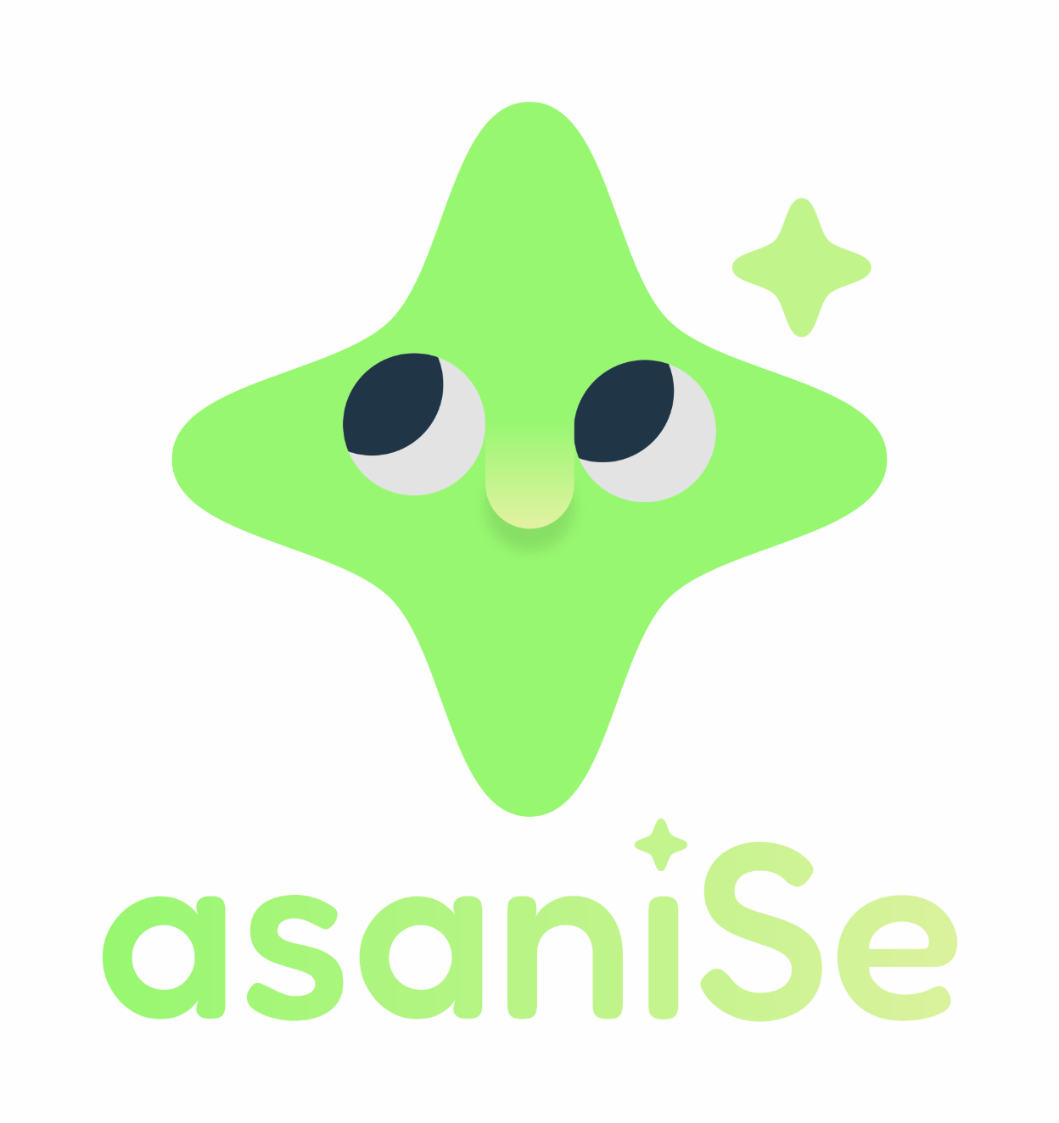
Core idea: bright, trustworthy, playful AI learning - not childish, not corporate-heavy.
Design references: final asaniSe mascot/icon supplied by the founder, BCG-inspired green/dark-neutral UI tokens supplied in CSS, and a minimal rounded product aesthetic.

1. Brand Essence
asaniSe helps learners move from curiosity to employability through practical, gamified AI learning. The visual system should feel fresh, friendly, credible, and action-oriented.
Attribute | Direction
Personality | Helpful, optimistic, simple, energetic, trusted
Audience feel | Approachable for first-time AI learners, but polished enough for colleges, employers, and partners
Visual principle | Few colors, large rounded shapes, generous whitespace, clear CTAs
Mascot role | A small AI-learning companion: warm, non-threatening, memorable
Avoid | Overly childish graphics, too many colors, heavy shadows, generic tech-blue AI visuals
2. Logo System

The approved direction uses a soft four-point sparkle mascot with expressive AI-style eyes and a subtle nose form, paired with the asaniSe wordmark. The primary logo can use the green gradient shown in the supplied final asset, but the flat primary color remains rgb(150, 248, 120) for consistency across UI.
Rule | Guideline
Clear space | Leave at least the height of the “i” dot around the logo on all sides. For icon-only usage, leave 20% of icon width as padding.
Minimum size | Full lockup: 120 px wide digital / 35 mm print. Icon only: 32 px digital / 10 mm print.
Primary usage | White or warm-neutral backgrounds. Use the green logo when contrast is strong.
Dark usage | On dark ink-black backgrounds, use white wordmark with green icon, or a one-color white mark.
Do not | Do not stretch, rotate, recolor randomly, add drop shadows, crowd with text, or use the mascot face separately from the sparkle unless intentionally creating UI stickers.

3. Minimal Color Palette
Use the lean palette below. The system is inspired by the provided BCG-style CSS tokens, but simplified for asaniSe. The green is the brand’s own distinctive learning-action color.
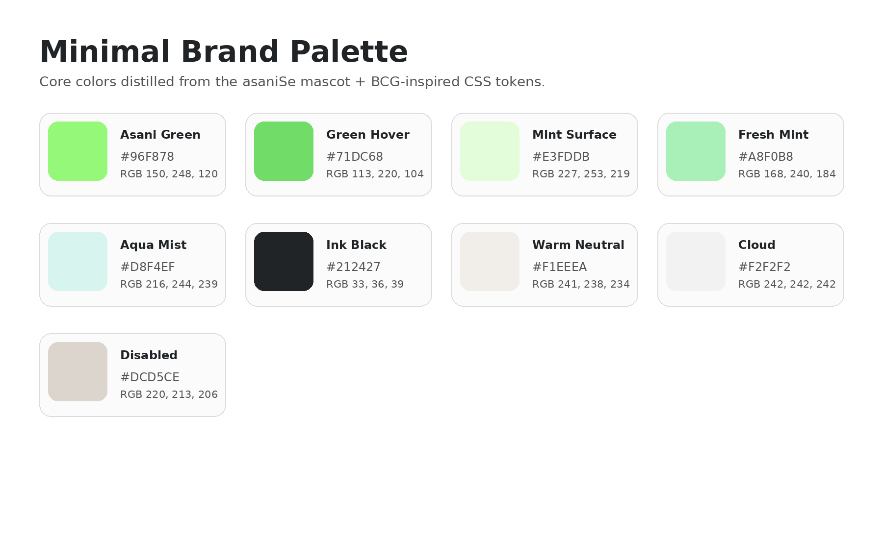
Color | HEX | RGB | Use
Asani Green / Primary CTA | #96F878 | RGB(150, 248, 120) | Primary brand color, hero highlights, main buttons
Green Hover | #71DC68 | RGB(113, 220, 104) | Button hover, secondary green emphasis
Mint Surface | #E3FDDB | RGB(227, 253, 219) | Soft backgrounds, success cards
Fresh Mint | #A8F0B8 | RGB(168, 240, 184) | Badges, soft highlights
Aqua Mist | #D8F4EF | RGB(216, 244, 239) | Cool gradient stop, calm panels
Ink Black | #212427 | RGB(33, 36, 39) | Primary text, dark sections, active states
Warm Neutral | #F1EEEA | RGB(241, 238, 234) | Page background, large surfaces
Cloud | #F2F2F2 | RGB(242, 242, 242) | Dividers, subtle panels
Disabled | #DCD5CE | RGB(220, 213, 206) | Disabled fill/borders
Recommended usage ratio
- 60% white / warm neutral surfaces for calm and clarity.
- 25% ink and ink-black text/surfaces for credibility and contrast.
- 10% Asani Green for CTAs, progress, icons, and highlights.
- 5% mint/aqua support colors for cards, badges, and gradient backgrounds.

4. Gradients
Use gradients sparingly: hero panels, onboarding backgrounds, special certificates, and celebration moments. Core UI should remain mostly flat for simplicity.
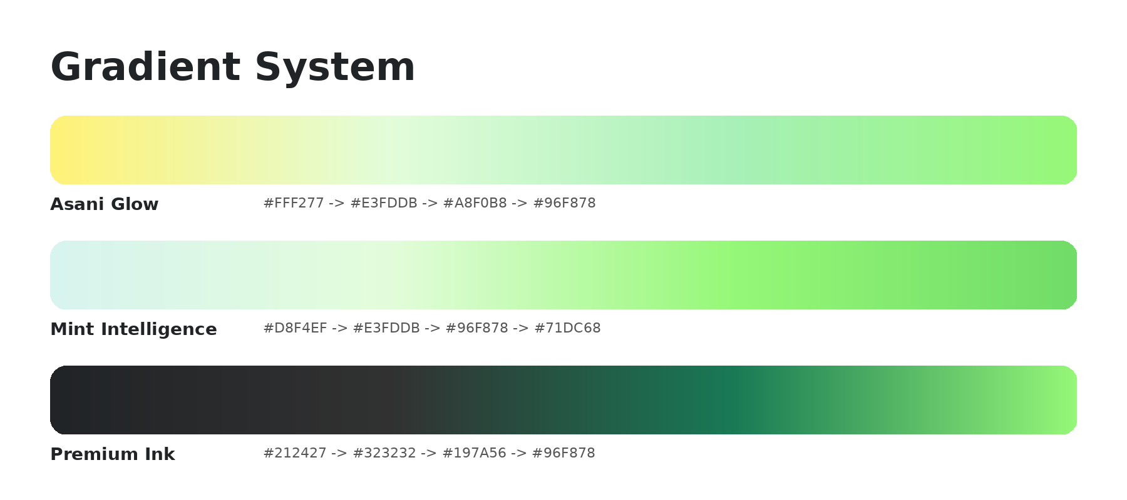
Gradient | CSS direction
Asani Glow | linear-gradient(135deg, #FFF277 0%, #E3FDDB 28%, #A8F0B8 70%, #96F878 100%)
Mint Intelligence | linear-gradient(135deg, #D8F4EF 0%, #E3FDDB 35%, #96F878 72%, #71DC68 100%)
Premium Ink | linear-gradient(135deg, #212427 0%, #144622 45%, #197A56 75%, #96F878 100%)
5. Typography
Use a rounded, friendly headline font and a highly legible body font. This keeps the product warm without reducing credibility.
Use case | Font | Weight | Suggested size
Hero headline | Fredoka Medium | 500 | Mobile: 32-36 px / Desktop: 48-64 px
Section headings | Fredoka Medium | 500 | 24-32 px
Card titles | Fredoka Medium | 500 | 18-22 px
Body copy | Google Sans | 400 | 15-17 px
Small labels | Google Sans | 500 | 12-14 px
Buttons | Google Sans or Fredoka Medium | 500 | 15-17 px
Type rules
- Use short, direct headings. Avoid long sentence-style headings in app UI.
- Body copy should be Google Sans with line-height around 145%-155%.
- Use title case sparingly; sentence case feels warmer and more accessible.
- Keep heading color Ink Black (#212427) on light backgrounds and White (#FFFFFF) on dark ink-black backgrounds.

6. UI Components
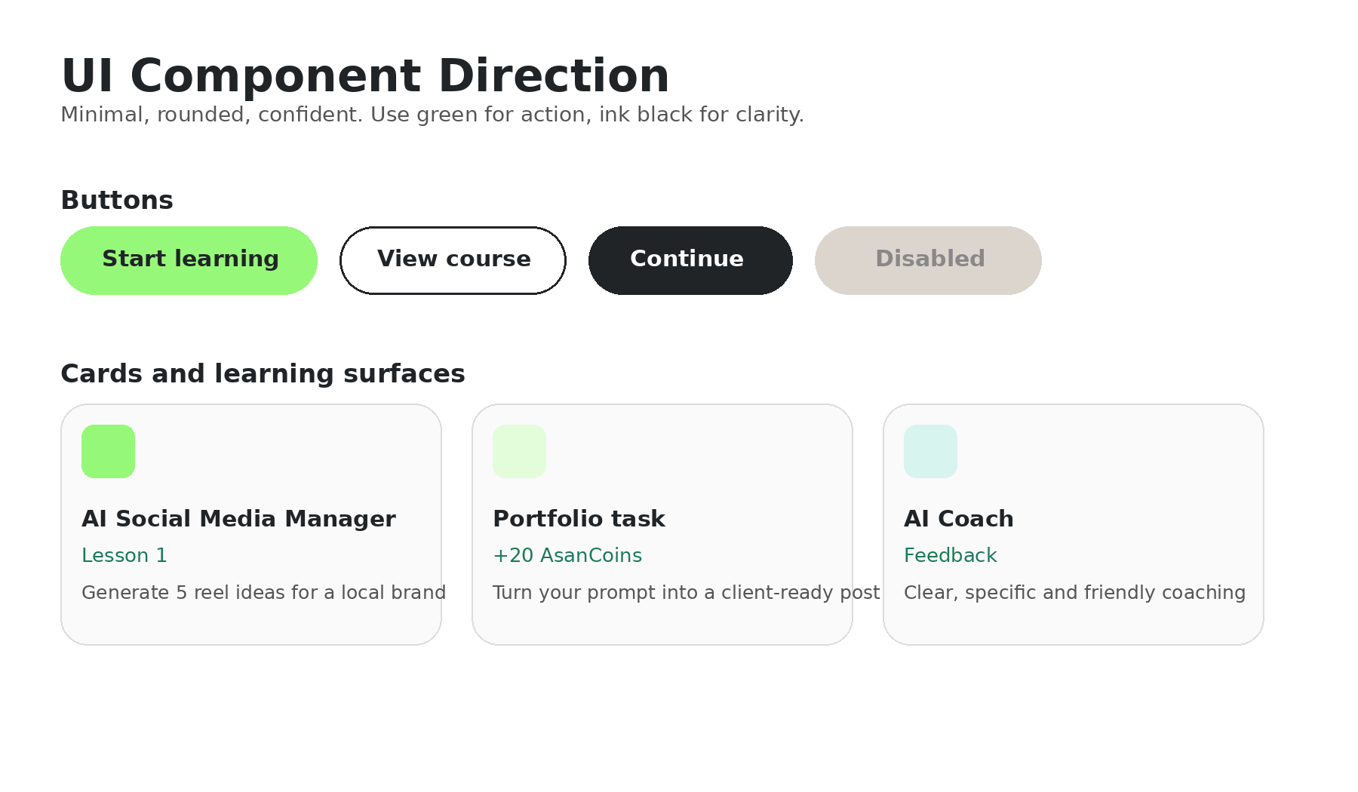
Button system
Component | Default | Hover | Active / Focus | Disabled
Primary CTA | BG #96F878 / Text #212427 / Radius 15-16 px | BG #71DC68 / Text #212427 | BG #212427 / Text #FFFFFF | BG #DCD5CE / Text #898888
Secondary | White fill / #212427 border / #212427 text | BG #F2F2F2 | Border #212427 | Border #DCD5CE / Text #898888
Ghost | Transparent / #212427 text | BG #F2F2F2 | BG #E3FDDB | Text #898888
Cards, chips, and surfaces
- Cards: 20-28 px radius, white or warm-neutral fill, subtle 1 px border #DCD5CE or no border on tinted backgrounds.
- Hero modules: use Asani Glow gradient with dark text (#212427); avoid white text unless the background is ink black.
- Chips/badges: #E3FDDB background, #212427 text, 999 px pill radius.
- Progress bars: track #F2F2F2, active fill #96F878, completed states may use #21BF61.
- Icons: rounded line icons, 1.75-2 px stroke, use #212427 for default and #212427 for active.
7. Layout Principles
Area | Guideline
Grid | Mobile-first. Use 16 px outer margins, 8 px spacing scale, 24 px card padding.
Spacing | Prefer roomy cards and fewer elements per screen. Remove labels if icons and context are clear.
Corners | Use rounded corners consistently: 15-16 px buttons, 20-28 px cards, 999 px pills.
Elevation | Avoid heavy shadows. Use flat surfaces; if needed, use a very subtle shadow or a 1 px border.
Imagery | Use real learner/job imagery sparingly. The mascot should support coaching, rewards, and progress moments.

8. Voice and Messaging
The brand voice should make AI feel easy to start and useful for getting work-ready. Use Hindi + English naturally where it helps comprehension.
Principle | Example
Simple and practical | “Aaj ka task: ek local brand ke liye 5 reel ideas banao.”
Encouraging, not childish | “Good start. Ab is prompt ko more specific banate hain.”
Outcome-oriented | “Add this to your portfolio after one improvement round.”
Action-first CTA | “Start Lesson”, “Improve Prompt”, “Submit Task”, “View Portfolio”
Avoid jargon | Prefer “AI se kaam kaise karein” over “deploy generative AI workflows”.
9. Sample Design Tokens
These tokens can be used directly by design and engineering teams as a starting point.
:root {
--asani-green: #96F878;
--asani-green-hover: #71DC68;
--asani-mint-surface: #E3FDDB;
--asani-fresh-mint: #A8F0B8;
--asani-aqua-mist: #D8F4EF;
--asani-ink: #212427;
--asani-warm-neutral: #F1EEEA;
--asani-cloud: #F2F2F2;
--asani-disabled: #DCD5CE;
--font-heading: 'Fredoka Medium', Fredoka, 'Google Sans', Arial, sans-serif;
--font-body: 'Google Sans', Arial, sans-serif;
--radius-button: 15px;
--radius-card: 24px;
--radius-pill: 999px;
--gradient-asani-glow: linear-gradient(135deg, #FFF277 0%, #E3FDDB 28%, #A8F0B8 70%, #96F878 100%);
}
10. Quick Application Checklist
- Use the approved sparkle mascot/logo as the primary brand mnemonic.
- Use Asani Green (#96F878) only where the user should notice or act.
- Keep screens light, rounded, and spacious; use dark text for readability.
- Use Fredoka Medium for warm, memorable headings; Google Sans for readable product copy.
- Primary buttons should be green with ink text and 15-16 px radius.
- Gradients should support large moments, not every component.
- All UI should feel easy, practical, and employability-focused.

