ADANI INSTITUTE OF DIGITAL TECHNOLOGY MANAGEMENT
PGDM (Artificial Intelligence & Data Science)
Course: Introduction to Artificial Intelligence (252C101)
Individual Report, Group 09
AI in Cybersecurity for a Financial Services Company
Real-Time Threat Detection, Anomaly Identification and Automated Response to Protect Sensitive Customer Data
Companies studied: Quick Heal (India), Palo Alto Networks (Global), Microsoft (Global)
Submitted by: Nishant Purohit
Enrolment No.: 20262007
Group: 09
Faculty: Mr. Chintan Patel
Month: October 2026

1. Introduction
Banks, NBFCs and fintech companies hold the money and personal data of lakhs of customers. This is why hackers target them again and again. The attacks are also getting smarter. Phishing mails, stolen passwords, ransomware and even employees copying customer data are common problems. A human team cannot watch millions of events every day, so AI has become a need and not just a nice extra.
This report answers one question: how can AI be used for real-time threat detection, anomaly identification and automated response to protect sensitive customer data in a financial services company? I studied this through three companies: Quick Heal (India), Palo Alto Networks (global) and Microsoft (global).
The report has five parts. First, I explain why old rule-based security is not enough. Second, I explain how machine learning finds unusual behaviour and how we check whether a model is good. Third, I explain automated response. Fourth, I study the three companies. Fifth, I discuss explainability, ethics and regulation, and give my recommendations. I link the ideas to our Introduction to AI course along the way. All graphs and tables are in the Appendix. One note: most company information comes from vendor documents and interviews, so I treat their claims with care.
2. From Rules to Learning
The oldest way to protect a system is to write rules. For example, "block any transfer above Rs 5 lakh" or "lock the account after three wrong passwords". This is a rule-based system, which we studied in Unit III along with expert systems. Rules have one big advantage: anyone can read them and understand why an action was taken.
But rules have three problems. First, attackers learn the rules and stay just below the limit, for example by sending ten transfers of Rs 4.9 lakh. Second, people must write a new rule for every new attack, and attacks change faster than people can write. Third, rules cannot handle doubt, and real life is not always a clear yes or no. The history in Unit I shows a similar lesson. Expert systems became popular in the 1980s, but they were hard to maintain and failed outside their narrow area, which is part of why interest in them fell (Russell & Norvig, 2020).
Security software faced the same problem with signatures. A signature is like a fingerprint of a known virus. If the virus is new, there is no fingerprint and it is missed. This is called a zero-day attack. Quick Heal's own journey shows the change: it began with signature matching and then added behaviour-based detection, which watches what files and processes actually do (Free Press Journal, n.d.).
So modern systems learn from data. This is narrow AI (Unit I). It does one job well, such as spotting abnormal logins, but it does not understand the bank or its business. We should expect it to help analysts, not replace them. In practice the best setup is a hybrid: rules for things that must be exact, such as compliance limits, and ML for things that are fuzzy, such as odd behaviour.
3. Anomaly Identification Using Machine Learning
Anomaly identification means finding activity that does not fit the normal pattern. Think of a bank branch manager who knows his regular customers. If a customer who always withdraws Rs 5,000 in Ahmedabad suddenly tries Rs 5 lakh from another country at 3 AM, the manager feels something is wrong. Nobody gave him a rule. The activity just does not match. ML does this for millions of users at the same time.
The method is called User and Entity Behaviour Analytics (UEBA). The system builds a profile of each user and device from things like login time, location, device, usual data volume and systems accessed. Microsoft explains that Sentinel compares current activity with the entity's own history, with its peer group and with the whole organisation (Microsoft Learn, n.d.-a). Some unusual patterns that this can catch:
- Impossible travel: a login from Ahmedabad, and ten minutes later another login from a different country.
- Account takeover: a new device, then a password reset, then a big transfer in one session.
- Insider threat: an employee downloads far more customer records than others in the same team.
- Ransomware behaviour: one program suddenly changes thousands of files in a short time.
Types of ML (Unit IV). Supervised learning learns from labelled examples of past attacks, using models such as Random Forest. It is accurate for known attacks but blind to new ones. Unsupervised learning has no labels. It learns what normal looks like and flags what is odd. Isolation Forest is one example. It works because anomalies are few and different, so they are easy to isolate (Liu et al., 2008). Deep learning uses neural networks. An autoencoder learns to rebuild normal data, and when it cannot rebuild some activity properly, that activity is unusual. Chandola et al. (2009) explain that anomaly detection can be done in all three settings, but labelled attack data is rare in real life. This is why unsupervised and hybrid methods matter so much in security.
Choosing between methods (my analysis). No single type is enough (Appendix Table 5). Unsupervised methods can catch new attacks, but "unusual" is not always "bad". A manager working late in audit month looks unusual, so false positives rise. Supervised models are more precise on known attacks, but they need labelled data, which is scarce and may be outdated. Rules are clear and fast but easy to avoid. So a hybrid works best: anomaly detection finds what is unusual, a supervised model checks whether it looks like a known attack, and rules enforce hard limits. Cortex XDR follows this idea by letting analysts add custom detection rules alongside its ML analytics (Palo Alto Networks, 2019).
Real-time detection. Microsoft's documentation says that one of Sentinel's two UEBA outputs works near real-time at event level, while the other works in batches at behaviour level (Microsoft Learn, n.d.-a). So real-time and batch analysis are often used together.
Reasoning with uncertainty (Unit III). A good system does not just say "attack" or "safe". It gives a risk score. One signal alone, like a login at 2 AM, is weak. A 2 AM login plus a new device plus a foreign IP plus a large download together make an attack much more likely. This is probabilistic reasoning: many small clues are combined to handle uncertainty. Microsoft's UEBA also gives risk scores that consider the entities involved, how severe the anomaly is and the context (Microsoft Learn, n.d.-a).
4. Model Performance and Data Quality
A model is useful only if we can measure how good it is. In security, two mistakes matter. A false positive is a normal event flagged as an attack, for example a manager logging in from a hotel. A false negative is a real attack that is missed. A false negative means a data breach. A false positive wastes analyst time and can lock out real customers.
The accuracy trap. Suppose a bank's system checks 1,000,000 login and network events in a day and only 100 are real attacks. Say it catches 90, misses 10 and wrongly flags 5,000 normal events (Appendix Table 1). Accuracy is 99.5%, which looks excellent. But precision, meaning how many alerts were real, is only about 1.8%. Recall, meaning how many attacks were caught, is 90%. A lazy model that says "everything is safe" would get 99.99% accuracy and catch nothing (Appendix Figure 1). So accuracy is the wrong measure when attacks are rare. We should look at precision, recall, F1-score and PR-AUC. ROC-AUC can look very good when normal events are the huge majority, because the many easy normal events push the score up. PR-AUC looks only at the quality of the alerts, so it is more honest when attacks are rare (Saito & Rehmsmeier, 2015). These numbers are my own example for learning and are not real bank data.
Alert fatigue. If each alert needs ten minutes to check, 5,090 alerts need nearly 850 hours of work in one day. No team can do this, so analysts start ignoring alerts and real attacks slip through. Reducing this noise is one of the main selling points of modern detection platforms such as Cortex XDR (Palo Alto Networks, 2019).
Trade-off. We can lower the alert threshold to catch more attacks, but false alarms then rise. In Appendix Table 2, a stricter threshold gives far fewer alerts and higher precision, but recall falls and more attacks are missed. There is no perfect setting. For high-value actions like admin access or big transfers, a bank should accept more false alarms. For small actions it can relax.
Cost-based thinking (my analysis). A better question than "which threshold has higher precision?" is "which threshold costs less?". Suppose, only for illustration, that a missed attack costs Rs 10 lakh on average and each false alarm costs Rs 500 of analyst time (about ten minutes). The loose setting then costs about Rs 1.25 crore (10 misses and 5,000 false alarms) and the strict setting about Rs 2.03 crore (20 misses and 500 false alarms). So the loose setting is cheaper even with 1.8% precision (Appendix Table 2). The two settings cost the same when one missed attack costs about Rs 2.25 lakh. Below that value, the strict setting is better. This simple model ignores one real problem: analysts have limited hours, and a team that cannot review 5,000 alerts will be forced to ignore some. In real life the bank must pick a middle path that fits both its risk and its team size.
Data quality. A model is only as good as its data. Five problems are common. (1) Class imbalance: attacks are only 0.01% of events in the example, so the model sees few examples. Class weights or SMOTE, which creates synthetic examples of the rare class, can help (Chawla et al., 2002). (2) Dirty logs: missing timestamps and duplicate records. The model cannot detect what it cannot see. (3) Wrong labels: some "normal" events may be undiscovered attacks. (4) Concept drift: attackers change methods, so a model trained on last year's attacks becomes weaker and needs regular retraining. (5) Adversarial attacks: smart attackers behave "normally" for weeks or feed poisoned data. The RBI FREE-AI report also warns that fraud detection systems can misfire because of model drift or data issues (KPMG India, 2025).
5. Automated Response
Detection alone is not enough. If an attack is found at 3 AM, nobody should wait till morning. Automated response means the system takes the first action by itself. A good design uses tiers (Appendix Figure 2). For a low-risk alert, the system asks for an extra OTP or second check. For medium risk, it limits the session and forces a password reset. For high risk, it isolates the device or blocks the account and calls a human analyst.
Why a human must stay in the loop. A wrong automatic action can hurt a real customer, for example by freezing the account of someone who is travelling. So high-impact actions should be approved or reviewed by people. Quick Heal's CEO says that every AI decision in Seqrite is reviewed by their Threat Ops team as a check against adversarial AI attacks (TimesTech, 2025).
Link to search and decision-making (Unit II). This is my own analogy and not something the vendors claim. When an alert fires, an analyst traces the chain of events back to the first cause across a graph of users, devices and files. This is like graph search (BFS or DFS). Palo Alto describes some of its analytics alerts as showing a chain of causality (Palo Alto Networks Live Community, n.d.). And when hundreds of alerts arrive, a good team handles the highest risk score first. This is similar to Greedy Best First Search, where the risk score works like a heuristic. It is also AI for business decision-making, because the bank must decide how to spend limited analyst time.
6. Study of the Three Companies
6.1 Quick Heal (India)
Quick Heal is an Indian security company, and Seqrite is its enterprise brand. It holds a US patent (US20170124327A1) for signatureless behaviour-based detection, and this technology is part of its GoDeep.AI framework, which is used in Seqrite products (ITVoice, n.d.). The company says the technology uses AI, cloud and real-time threat intelligence to block zero-day malware. In an April 2025 interview, the CEO said its XDR solutions use ML models and learn from an installed base of 8.44 million (TimesTech, 2025). In my view, Quick Heal is strong in endpoint protection and understands Indian conditions and budgets, so it suits smaller banks, co-operative banks and branch networks. A limit is that public material is mostly press releases and interviews, so I could not verify the technical depth, especially for cloud and network data.
6.2 Palo Alto Networks (Global)
Cortex XDR joins data from endpoints, networks and cloud in one place and applies ML to profile behaviour and find unseen attacks (Palo Alto Networks, 2019). Its Analytics Engine studies logs to build a baseline of normal activity and raises alerts when activity is abnormal. A profile can be a simple statistical one or a more complex ML one (Palo Alto Networks Live Community, n.d.). It also allows custom detection rules, so humans can add knowledge where ML is weak, which is a good hybrid. Strength: seeing across endpoint, network and cloud makes it harder for an attacker to hide. Limit: in my view it needs good data sources and skilled analysts to give full value, which may be hard for smaller firms.
6.3 Microsoft (Global)
Microsoft Sentinel is a cloud SIEM, and its UEBA feature builds behaviour profiles and compares each user with their own history, peers and the organisation (Microsoft Learn, n.d.-a). It uses two scores to help analysts decide what to check first. It also supports data from Microsoft Entra ID, AWS, Google Cloud and Okta (Microsoft Tech Community, n.d.). A newer behaviours layer turns raw logs into short plain-language summaries of who did what to whom, with the users, hosts and IP addresses involved (Microsoft Learn, n.d.-b). This helps explainability. Strength: a very wide ecosystem and easy fit for banks already using Microsoft 365 and Azure. Limit: it works best inside the Microsoft ecosystem, and Indian banks must check where their data is stored and processed.
6.4 Comparison
All three use behaviour-based ML instead of only signatures, and all three still need human analysts. They differ in focus: Quick Heal on endpoints and the Indian market, Palo Alto on correlation across domains, and Microsoft on identity and cloud logs through a SIEM. Appendix Table 3 compares them. In my view, no single vendor is best for every bank.
6.5 A Worked Scenario: Account Takeover
This is my own illustration and not a case documented by any vendor. At 1:50 AM, a customer service employee's account is taken over after a phishing mail. Step 1: the attacker logs in from a new device and a foreign IP. The profile shows that the employee never works at night and never from that country, so the anomaly score rises. Step 2: within minutes the account opens many more customer records than peers do. Now several weak clues add up and the risk score crosses the high level (Section 3). Step 3: the system acts by itself. It blocks the session and asks the real owner to verify through another channel, and if the device is a bank-managed endpoint it can be isolated (Section 5). Step 4: an analyst gets an alert with reasons in plain words: new device, foreign IP, unusual night login, abnormal record views. The analyst confirms it, and the decision is logged with the model version (Section 7). Step 5: the case is marked as a true attack, and this feedback is used when the model is retrained. Each company's strength fits a different step: endpoint behaviour from the Quick Heal or Cortex XDR agents, correlation across domains from Cortex XDR, and sign-in and cloud analysis from Sentinel with Entra ID. In real life, the step that most often fails is Step 1, because logs are missing or late. This is the data quality problem again.
7. Explainable AI, Ethics and Regulation
A doctor who says "you need surgery" without any reason will not be trusted. A black-box AI that says "block this account" has the same problem. In finance there are four reasons to explain. Regulators ask for it: the RBI FREE-AI report of August 2025 lists seven principles, including fairness, accountability and explainability, with 26 recommendations (KPMG India, 2025), though at present the framework is advisory (Legal500, n.d.). Analysts will not act on alerts they do not understand. Customers whose accounts are frozen deserve a reason. And explanations help find bias and bugs.
Black box and glass box. Deep neural networks are powerful but hard to read. Decision trees and logistic regression are easy to read but may be less accurate. A common middle path is to use a strong model and add an explanation layer. SHAP shows how much each factor pushed a decision, for example: new device (+40%), foreign location (+35%), unusual amount (+20%), where the numbers are only illustrative (Lundberg & Lee, 2017). LIME explains a single decision by testing small changes around it (Ribeiro et al., 2016).
Auditability means a paper trail for AI. The bank should log the input data, model version, score and action for every decision, keep versions of models and data, run regular bias checks and name the people who are responsible. Explanations also help catch adversarial tricks, because a decision that depends on a strange feature is a warning sign.
Ethics (Unit I). Bias: if training data comes mostly from some regions or devices, honest customers from other groups may be flagged more often. Transparency: customers and auditors should know that automated checks exist. Privacy: behaviour monitoring itself collects personal data such as location and device details, and even employee activity. India's Digital Personal Data Protection Act, 2023 puts duties on organisations to protect personal data (Government of India, 2023), so the system should collect only what it needs and protect its own logs. Regulation: with RBI guidance and the DPDP Act, a bank cannot say "the AI decided" and escape responsibility. There is also a trade-off: more explainable models can be slightly less accurate, so banks must balance power and transparency.
8. Application of Course Topics
To make the links clear, I list them here. Appendix Table 4 gives the same mapping in table form.
- Unit I: narrow AI (security AI does one task), evolution from expert systems to ML and GenAI, finance as a business application, and ethics covering bias, transparency, privacy and regulation (Sections 2 and 7).
- Unit II: graph search and heuristic analogy, and AI for business decision-making through risk-based prioritisation (Section 5).
- Unit III: rule-based and expert systems (Section 2), probabilistic reasoning (Section 3), and the knowledge graph idea. Microsoft's behaviours layer maps users, hosts and IPs and their roles, which is similar to a knowledge graph of entities and relations (Microsoft Learn, n.d.-b).
- Unit IV: supervised, unsupervised and deep learning with autoencoders (Section 3). For Generative AI, attackers can use it for convincing phishing, and Quick Heal's CEO speaks of "AI for AI" to detect AI-generated attacks (TimesTech, 2025).
9. Challenges and Recommendations
The main challenges are poor data, class imbalance, drift, alert fatigue, adversarial attacks, privacy and the cost of skilled people. Attackers also use Generative AI to write convincing phishing mails in many languages, so defenders cannot depend on spotting bad grammar any more. Based on this study, my recommendations for a financial services company are:
- Use a layered hybrid system: rules for exact limits, supervised ML for known attacks and anomaly detection for new ones.
- Fix the data first: complete logs from identity, endpoint, network and cloud with correct timestamps.
- Judge models on precision, recall and PR-AUC, not accuracy, and set thresholds by risk level.
- Automate only low-risk actions fully. Keep humans for high-impact actions like freezing accounts.
- Build explainability and audit logs from day one, and test regularly for bias and adversarial attacks.
- Retrain models regularly, watch for drift and run attack simulations.
- Choose vendors by company size, existing tools, budget and data location, and run a pilot before full rollout.
Limits of this study. I used public vendor material, regulator summaries and standard research papers. I did not test the products myself, so I cannot compare their real detection accuracy. All numbers in the examples are illustrative. Vendor statements are also marketing, so a bank should check them through independent tests, for example MITRE ATT&CK evaluations, and through a pilot before buying.
10. Conclusion
AI helps a financial company protect customer data because it can watch millions of events, learn normal behaviour and act in seconds. But it is not magic. A model with high accuracy can still be useless if it floods analysts with false alarms, and an automatic decision that nobody can explain can harm customers and break regulation. The best approach is a careful mix of rules and ML, good data, tiered automation, human review and clear explanations. Quick Heal, Palo Alto Networks and Microsoft each show a part of this picture, and a bank should choose according to its own size, needs and regulation.

References
Chandola, V., Banerjee, A., & Kumar, V. (2009). Anomaly detection: A survey. ACM Computing Surveys, 41(3), 1–58.
Chawla, N. V., Bowyer, K. W., Hall, L. O., & Kegelmeyer, W. P. (2002). SMOTE: Synthetic minority over-sampling technique. Journal of Artificial Intelligence Research, 16, 321–357.
Free Press Journal. (n.d.). Do I still need an antivirus? https://www.freepressjournal.in/brandsutra/do-i-still-need-an-antivirus
Government of India. (2023). The Digital Personal Data Protection Act, 2023.
ITVoice. (n.d.). Quick Heal Technologies Limited receives patent for its signatureless behaviour-based detection technology. https://www.itvoice.in/quick-heal-technologies-limited-receivespatent-for-its-signatureless-behaviour-based-detection-technology
KPMG India. (2025, September). RBI's FREE-AI committee report in the financial sector. https://kpmg.com/in/en/insights/2025/09/rbis-free-ai-committee-report-in-the-financial-sector.html
Legal500. (n.d.). RBI's FREE-AI framework: Navigating the legal and regulatory landscape. https://www.legal500.com/developments/thought-leadership/rbis-free-ai-framework-navigating-the-legal-and-regulatory-landscape/
Liu, F. T., Ting, K. M., & Zhou, Z.-H. (2008). Isolation forest. Proceedings of the IEEE International Conference on Data Mining (ICDM), 413–422.
Lundberg, S. M., & Lee, S.-I. (2017). A unified approach to interpreting model predictions. Advances in Neural Information Processing Systems, 30.
Microsoft Learn. (n.d.-a). Advanced threat detection with User and Entity Behavior Analytics (UEBA) in Microsoft Sentinel. https://learn.microsoft.com/en-in/azure/sentinel/identify-threats-with-entity-behavior-analytics
Microsoft Learn. (n.d.-b). UEBA behaviors layer in Microsoft Sentinel. https://learn.microsoft.com/en-ca/azure/sentinel/entity-behaviors-layer
Microsoft Tech Community. (n.d.). Microsoft Sentinel UEBA: Multi-cloud and Okta support [Blog post]. https://techcommunity.microsoft.com/blog/microsoft-security-blog/-/4460428
Palo Alto Networks. (2019, February). Introducing Cortex XDR: The new wave of detection and response. https://www2.paloaltonetworks.com/blog/2019/02/introducing-cortex-xdr-new-wave-detection-response
Palo Alto Networks Live Community. (n.d.). Learning behaviour of Cortex XDR [Discussion post]. https://live.paloaltonetworks.com/t5/cortex-xdr-discussions/learning-behaviour-of-cortex-xdr/m-p/530532
Ribeiro, M. T., Singh, S., & Guestrin, C. (2016). "Why should I trust you?": Explaining the predictions of any classifier. Proceedings of the 22nd ACM SIGKDD Conference, 1135–1144.
Russell, S., & Norvig, P. (2020). Artificial intelligence: A modern approach (4th ed.). Pearson.
Saito, T., & Rehmsmeier, M. (2015). The precision-recall plot is more informative than the ROC plot when evaluating binary classifiers on imbalanced datasets. PLOS ONE, 10(3), e0118432.
TimesTech. (2025, April). Seqrite CEO Vishal Salvi on AI-led cybersecurity and India's digital future. https://timestech.in/seqrite-ceo-vishal-salvi-on-ai-led-cybersecurity-and-indias-digital-future/

Appendix
Table 1: Confusion matrix for the illustrative example (1,000,000 events in one day)
 | Actually an attack | Actually normal
Flagged as attack | True Positives: 90 | False Positives: 5,000
Not flagged | False Negatives: 10 | True Negatives: 994,900
Accuracy = 99.5%. Precision = 90 / 5,090 = 1.8%. Recall = 90 / 100 = 90%. F1-score = 3.5%. These numbers are illustrative and made by me for learning. They are not real bank data.
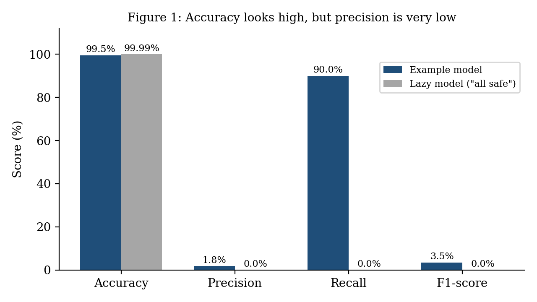
Table 2: Effect of changing the alert threshold (illustrative)
Setting | Attacks caught / missed | False alarms | Precision / Recall | Illustrative cost*
Loose (example above) | 90 caught / 10 missed | 5,000 | 1.8% / 90% | Rs 1.25 crore
Strict | 80 caught / 20 missed | 500 | 13.8% / 80% | Rs 2.03 crore
*Assumes a missed attack costs Rs 10 lakh and a false alarm costs Rs 500. These are my assumptions for illustration only.
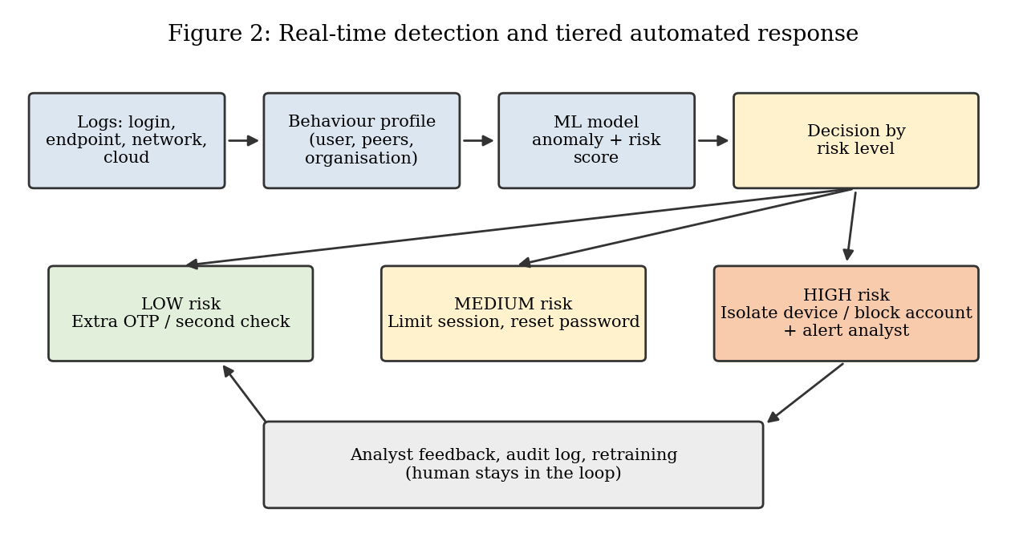
Table 3: Comparison of the three companies (from public sources)
Point | Quick Heal / Seqrite | Palo Alto Networks (Cortex XDR) | Microsoft (Sentinel UEBA)
Main focus | Endpoint and enterprise security, India | XDR across endpoint, network and cloud | Cloud SIEM with identity and cloud logs
AI idea | Signatureless behaviour-based detection, GoDeep.AI, ML in XDR | Behaviour profiling with statistics and ML, baseline of normal activity | Profiles vs own history, peers and organisation, anomaly and risk scores
Response and human role | AI decisions reviewed by Threat Ops team | Analytics alerts with causality chain, custom rules by analysts | Anomalies tagged for analysts, plain-language behaviour summaries
Strength (my view) | Fits Indian market and smaller banks | Wide visibility across domains | Strong fit with Microsoft ecosystem
Limit (my view) | Public technical detail is limited | Needs good data and skilled staff | Best inside Microsoft stack, data location to check
Table 4: Mapping of course topics to this report
Unit | Course topic | Where used in the report
Unit I | Narrow AI, evolution, finance application, ethics (bias, transparency, privacy, regulation) | Sections 2 and 7
Unit II | Search (BFS, DFS), Greedy Best First Search, AI for business decision-making | Section 5
Unit III | Rule-based and expert systems, knowledge graphs, probabilistic reasoning | Sections 2, 3 and 8
Unit IV | Types of ML, deep learning and neural networks, basics of Generative AI | Sections 3 and 8
Table 5: Comparison of detection approaches (my summary)
Approach | Needs labelled data? | Catches new attacks? | Easy to explain? | Main weakness
Rule-based | No | No, only what the rule covers | Yes | Attackers avoid the rule; manual upkeep
Supervised ML (e.g., Random Forest) | Yes | Weak | Medium | Blind to new attacks; labels are scarce
Unsupervised ML (e.g., Isolation Forest, autoencoder) | No | Yes | Hard to medium | Many false positives; unusual is not always bad
Hybrid | Partly | Yes | Medium | More complex to build and maintain

