Saarthi
The AI that drives you to the finish line.
Coding Ninjas × Google for Developers · Vibe2Ship Hackathon · Project Description
Live app (Cloud Run) | saarthi-143887443744.asia-south1.run.app
GitHub repository | github.com/nishantr14/Saarthi
Problem statement | PS1 — The Last-Minute Life Saver

Problem Statement Selected
Problem Statement 1 — The Last-Minute Life Saver. An AI-powered productivity companion that proactively helps users plan, prioritize, and complete tasks before deadlines are missed — moving beyond passive reminders to help users actually take action.

Solution Overview
Saarthi (Sanskrit: the charioteer who guides you to victory) is an autonomous AI chief-of-staff. Instead of pinging you with reminders you ignore, it runs a continuous Sense → Think → Act → Reflect loop and takes real action on your behalf:
- Sense — captures commitments from voice (any Indian language / Hinglish), text, your Google Calendar and Gmail.
- Think — Gemini decomposes each task, estimates effort, and computes a live deadline-risk score (0–100).
- Act — autonomously books focus blocks on your real Google Calendar, drafts the actual email in Gmail, and sends escalating voice nudges via Sarvam.
- Reflect — when you fall behind, it re-plans on its own and escalates how hard it intervenes.
Under the hood, the think-and-act stage is a real Gemini function-calling agent swarm: a Planner decides which tools to invoke, and specialized agents — Sentinel (risk), Scheduler (Calendar), Drafter (Gmail) and Voice (Sarvam) — execute them, with every decision shown in a transparent reasoning trace. A deterministic safety-net guarantees no at-risk task is ever left unhandled.
The signature experience is Rescue Mode: one tap when you are out of time, and Saarthi triages everything, narrates a 2-hour survival plan aloud, and has already drafted the work and blocked the time. Saarthi is also genuinely proactive — a Cloud Scheduler job runs the swarm every 30 minutes and pushes voice and Telegram nudges, so it acts even when the app is closed.

Key Features
- Gemini function-calling agent swarm — a Planner calls real tools; Sentinel / Scheduler / Drafter / Voice agents execute, with a visible reasoning trace.
- Autonomous Sense→Think→Act→Reflect loop — a continuously acting agent, reliable and intelligent via an LLM + deterministic hybrid.
- Live escalation engine — each task carries a 0–100 risk score mapped to a tier (calm → nudge → act → rescue); the agent decides when and how hard to intervene.
- Real-world actions — books focus blocks on Google Calendar and creates Gmail drafts you review and send.
- Proactive by design — Cloud Scheduler runs the swarm every 30 minutes and sends Telegram + voice nudges, even with the app closed.
- Rescue Mode — instant triage, a narrated 2-hour plan, and pre-done prep when you are panicking.
- Voice-first, India-first — talk to it in Hinglish via Sarvam saaras (STT); hear it reply via Sarvam bulbul (TTS).
- Transparent agent activity feed — every autonomous decision is logged; no black box.
- AI task decomposition — new tasks are auto-split into estimated subtasks and categorized by Gemini.
- Graceful degradation — runs fully even with zero API keys, so the live link never breaks.

Technologies Used
- Frontend / full-stack: Next.js 14 (App Router, TypeScript), React 18, Tailwind CSS, Framer Motion, Lucide icons.
- AI brain: Google Gemini via @google/generative-ai (function-calling), model gemini-2.5-flash-lite.
- Voice: Sarvam AI REST — saaras:v3 (speech-to-text, code-mix) and bulbul:v3 (text-to-speech).
- Actions: googleapis — Google Calendar and Gmail.
- Packaging / deploy: Docker (Next.js standalone) → Google Cloud Run; Cloud Scheduler for proactive runs.

Google Technologies Utilized
- Gemini API (function-calling) — the swarm's Planner and tool execution, decomposition, drafting, and chat.
- Google Cloud Run — hosts the deployed application (mandatory target).
- Google Cloud Scheduler — triggers the autonomous proactive runs.
- Google Calendar API — autonomously books real focus blocks.
- Gmail API — drafts emails the user reviews and sends.
- Cloud Build — builds the container from source on deploy.
- Google Fonts — Sora, Inter, JetBrains Mono. (Firestore-ready storage interface for production persistence.)

Architecture
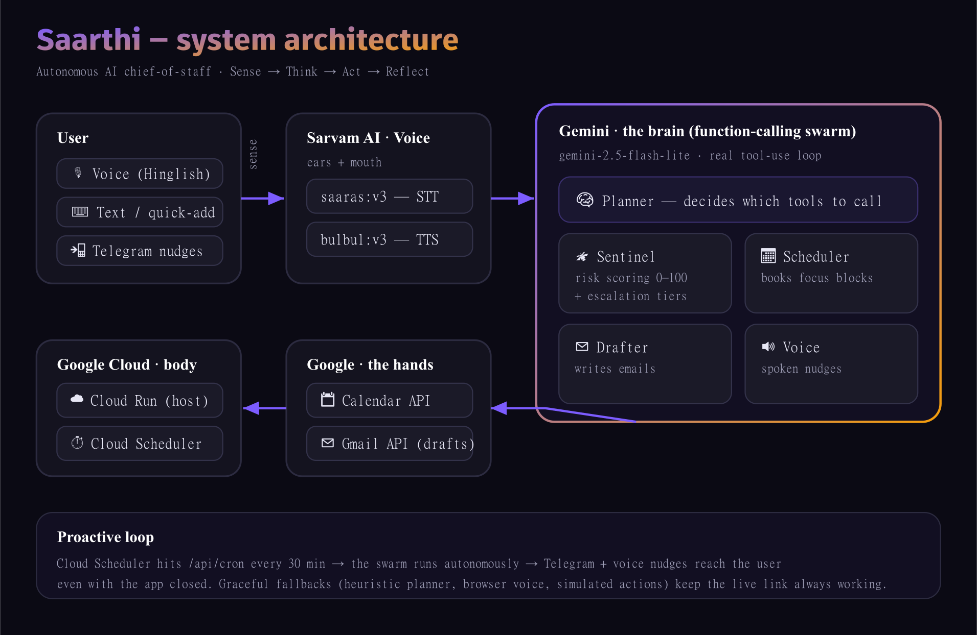
Sarvam = ears + mouth · Gemini = brain · Google Calendar/Gmail = hands · Cloud Run + Scheduler = body.

How It Maps to the Evaluation Matrix
Criteria | Weight | How Saarthi scores
Problem Solving & Impact | 20% | Attacks the universal pain of missed deadlines with proactive action, not reminders.
Agentic Depth | 20% | A real Gemini function-calling swarm (Planner + 4 agents) with a reasoning trace, real Calendar/Gmail actions, and a Cloud Scheduler proactive loop.
Innovation & Creativity | 20% | Rescue Mode, voice-first Hinglish, and a live risk-escalation engine.
Usage of Google Technologies | 15% | Gemini · Cloud Run · Cloud Scheduler · Calendar API · Gmail API · Cloud Build · Fonts.
Product Experience & Design | 10% | Premium command-center UI: accessible, animated, responsive.
Technical Implementation | 10% | Typed end-to-end, clean module boundaries, graceful fallbacks, containerized.
Completeness & Usability | 5% | Works end-to-end out of the box; the live link never breaks.

Demo (90 seconds)
- Open the live app and click “Launch Saarthi.”
- On the dashboard, note the live risk scores and the green Gemini / Sarvam / Google status chips.
- In “Talk to Saarthi,” say “kal raat 10 baje DBMS exam hai, bach lo” — it replies in Hinglish, in voice, and adds the task.
- Hit “Run agent” — the agent-swarm reasoning trace appears (Sentinel → Scheduler → Drafter → Voice → Planner), then the activity feed fills and Saarthi narrates the summary.
- Switch to Google Calendar and Gmail — the focus block and the draft are really there.
- Tap “Rescue” — a narrated 2-hour survival plan with the work already prepped.

