As per our scenario, we trying to execute a process chani in SAP BW (7.5 SPS14).

Process Chain Start variant has been set as External Start(via API or Metachain)

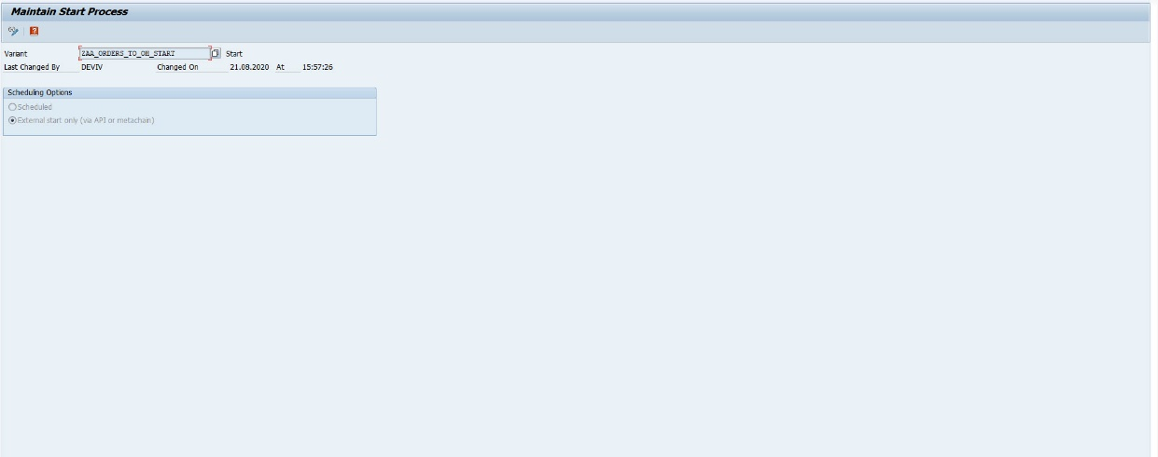

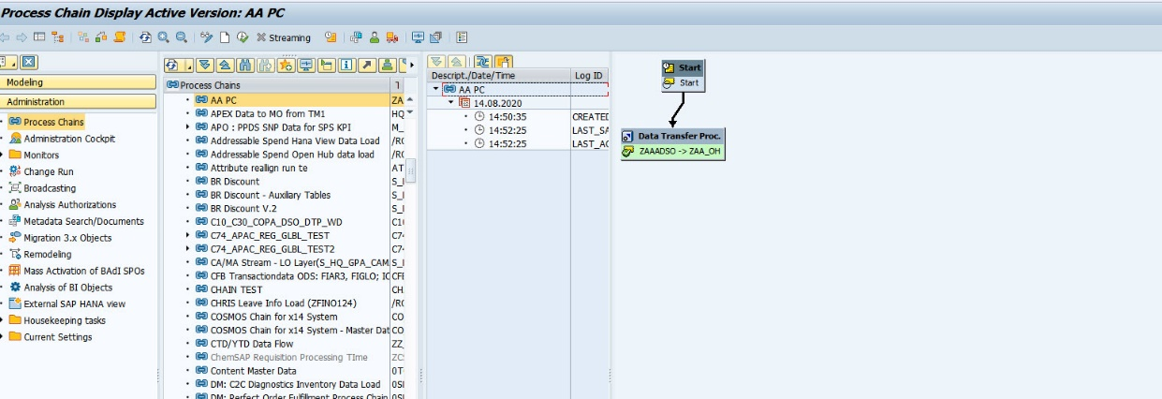

For triggering the BW Process Chain from DI, we created the below graph.

We have used the BW Process Chain operator to orchestrate the data load in BW, by triggering the PC from SAP DI.

Graph Name: AA.STUDY.dev-perf-dnt.PC

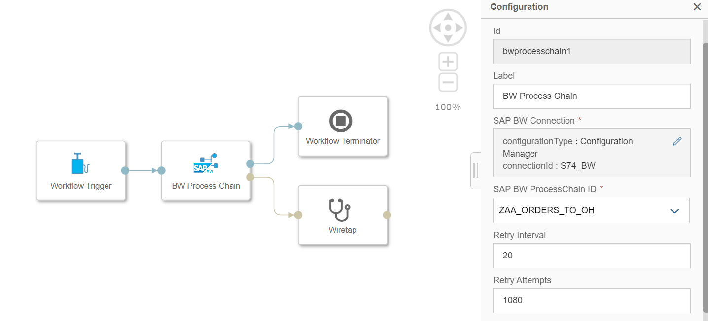

When we are triggering this graph, we see the graph going to dead state with the below error in the Process Logs:

As per the process log, it failed to execute the SAP BW Process Chain

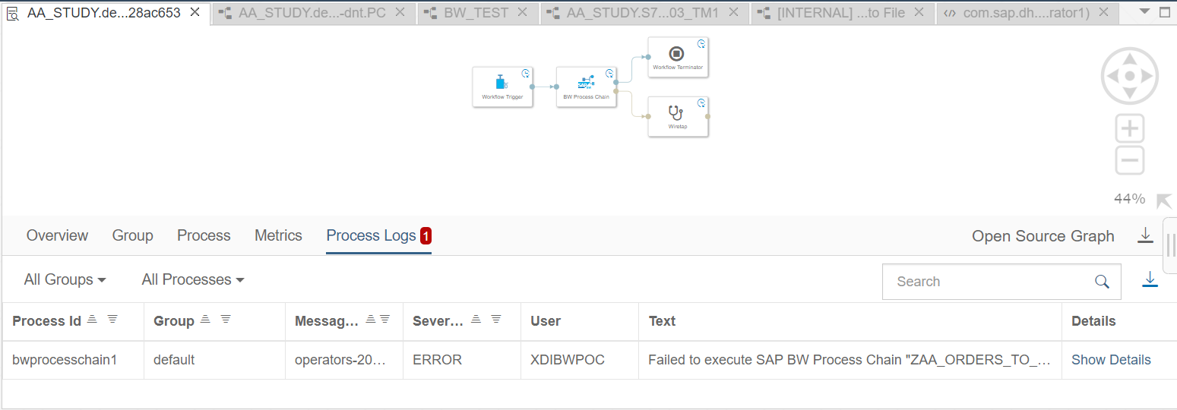

Log Details:

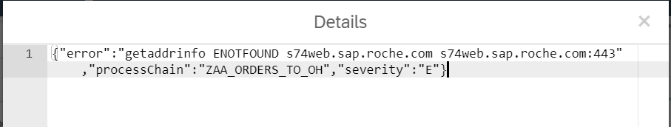

Connection Status With BW:

