INTRODUCTION TO DATA MANAGEMENT
PROJECT REPORT
(Project Semester January-April 2025)

Olympics Dashboard

Submitted by

Nishant Raj

Registration No 12308423

Programme and Section B. Tech CSE K23GS
Course Code INT217

Under the Guidance of

BALJINDER KAUR
27952

Discipline of CSE/IT

Lovely School of Computer Science and Engineering

Lovely Professional University, Phagwara

DECLARATION

I, Nishant Raj, student of B. Tech CSE under CSE/IT Discipline at Lovely Professional University, Punjab, hereby declare that all the information furnished in this project report is based on my own intensive work and is genuine.

Date: 13/04/25 Signature
Registration No. 12308423 Nishant Raj

CERTIFICATE

This is to certify that Nishant Raj bearing Registration no. 12308423 has completed INT217 project titled, “Olympics Dashboard” under my guidance and supervision. To the best of my knowledge, the present work is the result of his/her original development, effort and study.

Baljinder Kaur (27952)
School of Computer Science and Engineering
Lovely Professional University
Phagwara, Punjab.

Date: 13/04/25

ACKNOWLEDGEMENT

I am deeply grateful for the guidance and support I received during this project. I would like to sincerely thank Baljinder Kaur, my faculty, for her continuous encouragement, expert advice, and constructive feedback. Her mentorship played a vital role in shaping the direction and outcome of this work.
I also extend my heartfelt thanks to Lovely Professional University for providing the necessary resources and academic environment that enabled me to explore and work on this project effectively.
My appreciation goes out to my peers and friends who provided valuable insights, helped in discussions, and contributed in various ways throughout this journey.
Finally, I would like to acknowledge the constant support and understanding of my family, which has been a source of strength and motivation throughout my academic endeavors.
This project has enriched my understanding of data analysis and visualization concepts, and I am thankful to everyone who contributed to its successful completion.

Nishant Raj
Registration No. 12308423
School of Computer Science & Engineering
Lovely Professional University
Phagwara, Punjab

TABLE OF CONTENTS

Chapter | TITLE
1. | Introduction | INTRODUCTION
2. | Source of Dataset | SOURCE
3. | Dataset Preprocessing | PREPROCESSING
4. | Analysis on Dataset | ANALYSIS
 | Objective 1
 | Objective 2
 | Objective 3
 | Objective 4
 | Objective 5
5. | Conclusion | CONCLUSION
6. | Future Scope | FUTURE SCOPE
7. | References | REFERENCES
8. | LinkedIn | LINKEDIN
9. | Dashboard and other Screenshots | DASHBOARD

INTRODUCTION
The Olympic Games are a celebration of human athleticism, determination, and global unity. Originating in ancient Greece and revived in the modern era in 1896, the Olympics have evolved into the largest and most prestigious sporting event in the world. Over the years, the Olympics have reflected global historical events, political climates, technological advancements, and social progress.
This project involves the development of a highly interactive and analytical Excel-based dashboard that visualizes over a century of Olympic history, spanning from 1896 to 2016. Using modern data visualization techniques and Excel slicers, this dashboard provides users with an intuitive interface to explore how athlete participation, gender equality, medal distribution, seasonal variation, and age demographics have evolved over time.
The dashboard serves the dual purpose of enhancing analytical thinking and showcasing the potential of Excel as a powerful business intelligence tool. It is a testament to how historical sports data can be transformed into actionable insights through effective data visualization.
The Olympics serve not only as a platform for exceptional athletic performance but also as a mirror to society’s progress in areas such as international cooperation, gender equality, political diplomacy, and technological advancement. From Jesse Owens’ legendary sprints in the 1936 Berlin Olympics to the recent record-breaking feats of athletes like Usain Bolt and Simone Biles, the Olympics have chronicled numerous pivotal moments in world history.
In a world increasingly driven by data, such dashboards not only serve as analytical tools but also as educational platforms that enhance data literacy and storytelling. This Olympic dashboard project demonstrates how historical sports data, when presented visually, can offer compelling narratives and highlight both achievements and disparities that have shaped the global athletic landscape.
Through this endeavor, this report not only provides meaningful insights into over a century of Olympic history but also highlights how data visualization bridges the gap between raw data and human understanding. It is a demonstration of how digital tools like Excel can empower individuals to make sense of complex datasets, fostering deeper exploration and decision-making capabilities.

SOURCE OF DATASET

https://mavenanalytics.io/data-playground?order=date_added%2Cdesc&search=olympic

DATASET PREPROCESSING

Before creating the dashboard and conducting any analysis, a series of data preprocessing steps were carried out to ensure the dataset was clean, consistent, and suitable for structured analysis. These steps were crucial for improving the quality of the data and enhancing the reliability of insights derived during the analysis phase. The preprocessing process included the following key tasks:

Missing Values:
Several columns in the dataset, including Age, Height, Weight, and Medal, contained “NA” values, which needed to be addressed to prevent errors in analysis and ensure meaningful visualizations.
- Age, Height, and Weight Columns:
For these numeric fields, missing values were replaced with the median of the respective columns. The formula used for this was:
=MEDIAN(IF(ISNUMBER(Column Range), Column Range)) Then I added a helper column and applied this formula =IF(D2= “NA”, [MEDIAN],D2). Then I dragged the formula down. Copied entire Column and pasted over the Original Column with Paste Special (Values Only) and deleted helper column. I repeated this method for Height and Weight also. This approach helped preserve data distribution while filling the gaps, ensuring the values were consistent with the central tendency of the available data.
- Medal Column:
The Medal column contained "NA" values, which indicated that certain athletes did not win a medal. To make this distinction clearer, a helper column was created to replace the "NA" with a more readable value: "No Medal". The formula used was:
=IF(O2= “NA”, “No Medal”, O2). Then I dragged the formula down. Copied entire Column and pasted over the Original Column with Paste Special (Values Only) and deleted helper column. This transformation made it easier to differentiate between missing data and non-medal athletes.

Data Validation and Consistency:
After addressing missing values, a thorough review was performed to ensure data consistency across all columns. This involved checking for any anomalies, such as non-numeric characters in numeric fields and ensuring that categorical fields (like Season, Sport, Medal, etc.) contained appropriate and standardized values.
Age Categorization:
To better analyze age-based trends in athlete performance and participation, an Age Category column was created. This column grouped athletes into meaningful age brackets using the following formula: =IF(D2<=19,"Under 20",IF(D2<=29,"20-29",IF(D2<=39,"30-39","40 and Over"))) This categorization enabled more effective visualization and comparison of performance across different age groups.

Data Visualization: Telling Olympic Stories Through Data
This project transforms more than a century of Olympic data into clear, engaging, and insightful visual stories through the power of data visualization. Drawing from a rich dataset spanning the years 1896 to 2016, which includes detailed athlete demographics, event participation records, and medal outcomes, various analytical techniques were applied to uncover meaningful patterns and long-term trends embedded in Olympic history.

Using Microsoft Excel as the primary analytical tool, the raw data was meticulously cleaned, structured, and enhanced. The refined dataset was then visualized using a variety of elements including column charts, line graphs, pie charts, and interactive slicers, allowing users to explore the data from multiple angles. These visual components simplify complex historical insights, making them accessible and compelling. Key stories explored through this visual framework include:

- The evolution of athlete participation across the years, segmented by gender.
- Changing dominance of specific age groups in various sports over time.
- The influence of seasonality (Summer vs. Winter) on participation trends and medal distribution.
- The impact of global events such as World Wars on Olympic schedules and athlete attendance.

This approach demonstrates that effective data storytelling is not just about presenting numbers—it’s about conveying narratives of human achievement, societal evolution, and cultural milestones. Through this dashboard, users are invited to witness the Olympic journey in a new light—visually, intuitively, and interactively.

Dashboard Development: Bringing the Olympics to Life in Excel
The centerpiece of this project is an interactive Excel-based dashboard that bridges historical Olympic data with modern visualization techniques. Designed for usability and analytical depth, the dashboard allows users to explore over a century of Olympic trends through a streamlined, engaging interface.
Developed using a combination of Excel features—such as PivotTables, slicers, dynamic charts, and VBA macros—the dashboard empowers users to filter, compare, and analyze Olympic data in real time. Key filters include Year, Gender, and Season, which offer granular control over the visual output and encourage exploratory analysis.
The dashboard is built around five core analytical objectives:
- Athlete Participation Over Time: A line chart tracking the number of athletes over different Olympic years and season, showing growth patterns and global disruptions.
- Top 10 Countries by Total Medals: A bar chart highlighting national dominance and performance consistency across decades.
- Medal Distribution by Type: A Pie chart illustrating how gold, silver, and bronze medals are distributed.
- Age Distribution of Athletes: A Column Chart reveal the most common age groups competing in the Games, providing insight into age trends.
- Top 5 Athletes by Total Medals: A leaderboard view showcasing the most decorated Olympians in history, fostering appreciation for individual excellence.
Additionally, a “Reset Filters” macro button was implemented to improve user experience by quickly clearing all applied filters and returning the dashboard to its default state.
Collectively, these features create a comprehensive, exploratory experience for users from various backgrounds—whether students, educators, historians, or sports enthusiasts. The dashboard doesn’t just visualize Olympic history—it invites users to interact with it, discover trends, and draw their own conclusions. It's a clear demonstration of how Excel, when used creatively, can serve as a powerful platform for both business intelligence and storytelling.

ANALYSIS ON DATASET

- OBJECTIVE 1: Medal Count by Type (Gold, Silver, Bronze)

- General Description: Medals are the universal symbol of Olympic achievement, representing not only individual or team success but also the culmination of years of training, national investment, and competitive spirit. By examining the overall distribution of gold, silver, and bronze medals awarded from 1896 to 2016, we gain perspective on both the scale of the Games and the relative frequency of each level of achievement. This view serves as a high-level benchmark against which more granular analyses—such as country- or sport-level performance can be compared.

- Specific Requirement:

Created a PivotTable with:
Rows: Medal
Values: Count of ID

Compute the total count for each medal category across all years and events.

- Analysis Results:

• Total Medals Awarded: Across 120 years, approximately one medal has been awarded for every three athlete-event entries.
• Proportional Breakdown: Gold medals constitute roughly one-third of all awards, with silver and bronze each close behind reflecting the three-tier podium system.
• Insight: The near-equality in counts underscores the structured awarding process, where for most events exactly one gold, one silver, and one bronze are given.

- Visualization:

A Pie Chart was chosen for its intuitive presentation of proportional data.
Key design elements include:
- Colour Coding: Traditional medal hues—Gold (#FFD700), Silver (#C0C0C0), Bronze (#CD7F32).
- Legend Placement: Positioned at the Left to maximize chart area and maintain readability.

- OBJECTIVE 2: Athlete Participation Over the Years

- General Description: The growth and fluctuations in athlete participation illustrate the Olympics’ evolving global reach and the impact of historical events. From the inaugural 1896 Games with a few hundred competitors to modern editions featuring tens of thousands, this trend reflects societal changes such as post-war recoveries, boycotts, and increased emphasis on gender equality.
- Specific Requirement:
Created a PivotTable with:
Rows: Year
Columns: Season (Summer/Winter)
Values: Distinct Count of ID
Quantify how many unique athletes competed in each edition, separately for Summer and Winter Games.

- Analysis Results:
• Long-Term Trend: Summer participation rose from 176 athletes in 1896 to over 11,079 by 2016—a more than 40× increase.
• Winter Growth: Winter Games, beginning in 1924, grew from under 313 to 2,745 athletes, reflecting niche expansion.
• Historical Dips: No Data of 1916, 1940, and 1944 years when Games were cancelled due to World Wars.
• Gender Impact: (When filtered by the Gender slicer) female participation grew from under 5% in early 20th century to roughly 45% by 2016.

- Visualization:
A dual-line chart plots Summer (blue line) and Winter (white line) participation over time:
- Markers: Data points highlighted at each Olympic year for clarity.
- Dual Axes: Both lines share the same axis since the scale difference is instructive (Summer >> Winter).

- OBJECTIVE 3: Top 10 Countries by Total Medals

- General Description: National performance in the Olympics serves as a proxy for a country’s sports infrastructure, investment, and tradition. Ranking the top medal-winning countries not only celebrates athletic prowess but also highlights geopolitical shifts—such as the rise of new sporting powers and the enduring dominance of established ones.

- Specific Requirement:
Created a PivotTable with:
Rows: Team
Columns: Medal
Values: Count of Medal
Sort by Grand Total in descending order.
Use cell referencing to extract the top 10 teams with the highest cumulative medal counts for visualization.

- Analysis Results:
- Leading Nations: The United States tops the list with over 5,219 medals, followed by the Soviet Union/Russia, Germany, and Great Britain all exceeding 1,600 medals.
- Medal Profiles: The U.S. leads in gold count more than twice than second country i.e. Soviet Union, while other nations may have higher silver or bronze ratios, reflecting different areas of athletic strength.
- Emerging Trends: Since the 1980s, China’s medal haul has surged, indicating strategic sports investment.
- Visualization:
A Horizontal stacked column chart presents each country’s medal breakdown:
- Order: Countries sorted top to down by total medals.
- Colour Segments: Gold, silver, and bronze stacks in their respective hues.
- Data Labels: Total medal count from left to right.

- OBJECTIVE 4: Age Distribution of Athletes

- General Description: Athlete age is a key determinant of performance, with different sports favoring younger or more experienced competitors. Analyzing age distribution reveals peaks in prime performance years and the extent to which longevity in sport has changed over time.

- Specific Requirement:
Created a PivotTable with:
Rows: Age
Values: Count of Distinct ID

- Analysis Results:
• Peak Ages: The 20–29 bracket accounts for over 60% of competitors, reflecting general athletic prime.
• Youth and Experience: “Under 20” athletes represent roughly 10%, while “40 and Over” make up under 5%, indicating sports where experience prevails.

- Visualization:
• Single-Age View: A column chart plots counts by each age.
• Styling: Gridlines behind columns for visual distinction.

- OBJECTIVE 5: Top 5 Athletes with Highest Number of Total Medals
- General Description: Highlighting individual athletes’ cumulative achievements celebrates personal excellence and provides role models whose careers span multiple Games. It also illustrates the rarity of sustained success at the highest level of competition.

- Specific Requirement:
Created a PivotTable with:
Rows: ID and Name
Columns: Medal
Values: Count of Medal
Sort by Grand Total in descending order.
Use cell referencing to extract the top 5 Athletes with the highest cumulative medal counts for visualization.

- Analysis Results:
• Leading Figures: The dataset up to 2016 highlights icons such as Michael Phelps (28 medals: 23 gold, 3 silver, 2 bronze), Larisa Latynina (18 medals), and others who dominated their sports across multiple Olympiads.

- Visualization:
A horizontal stacked column chart was used for better readability of long names:
Bar Segments: Gold, silver, and bronze portions clearly delineated.
Ordering: Athletes ordered top to bottom by total medals.

CONCLUSION
The Olympic Dashboard project stands as a comprehensive exercise in data analysis, visualization, and storytelling, transforming over a century of raw Olympic data into meaningful and interactive insights. Through systematic data preprocessing, thoughtful design, and analytical rigor, this project illustrates the power of Excel not just as a spreadsheet tool, but as a capable platform for business intelligence and historical analysis.
From tracking athlete participation across years to understanding medal distributions, age demographics, and seasonal patterns, the dashboard captures the dynamic evolution of the Olympic Games. It highlights not only athletic milestones but also the broader societal shifts—such as increased gender representation and the influence of world events on global sports.
The project also reinforces key principles in data science: the importance of clean data, the value of visual representation, and the impact of user-driven exploration. With features like slicers, interactive charts, and reset filters, the dashboard empowers users to engage with the data on their own terms, encouraging curiosity and deeper understanding.
The completion of this project marks a significant step in understanding how historical data, when visualized effectively, can reveal powerful stories hidden within numbers. By focusing on the Olympic Games—a global phenomenon that transcends borders, politics, and generations—this project aimed to do more than just analyze statistics. It sought to bring to life the journey of athletes, the evolution of sports, and the changing dynamics of global participation over a span of 120 years.
Through the development of a comprehensive Excel dashboard, this project succeeded in transforming raw data into an interactive visual experience. Each objective—whether it was analyzing athlete participation by gender, studying medal counts, comparing seasonal trends, understanding age distributions, or evaluating year-wise participation—was carefully visualized to offer clarity and insight. With the help of slicers and dynamic filters, users can personalize their exploration of the dataset, making the dashboard not just a tool, but a gateway to discovery.
One of the most striking findings was the progressive increase in female participation over time, reflecting broader societal changes and the gradual dismantling of gender-based barriers in sports. Similarly, the ability to analyze athlete age across different years highlighted how physical excellence and career longevity have evolved, influenced by advancements in training, nutrition, and medical support. Seasonal analysis showed how the Summer Olympics have traditionally attracted far more athletes, but also how the Winter Games have carved a niche of their own.
The use of Microsoft Excel, often considered a basic data tool, proved to be surprisingly powerful in creating professional-level dashboards. Features such as PivotTables, slicers, conditional formatting, and various chart types were instrumental in building a responsive and insightful user interface. This emphasizes the point that with the right approach, even simple tools can yield profound results when applied creatively and strategically.
Moreover, the project highlighted the importance of data cleaning and preprocessing, which, although time-consuming, forms the backbone of any successful data analysis. Ensuring that the dataset was structured, consistent, and accurate was key to delivering meaningful visualizations. Every chart and table built in the dashboard is the result of deliberate planning, logical segmentation, and keen attention to detail.
Beyond technical achievement, this project offered an opportunity to think critically about the stories embedded in data. It allowed for a deeper appreciation of how sports can reflect historical moments—wars, political shifts, social revolutions, and cultural change. For instance, dips in athlete participation during the world wars, the absence of some nations in specific years, or the sudden rise of new sporting powerhouses—all of these were not just data points but historical narratives.
In conclusion, this project is a testament to how data, when organized and visualized thoughtfully, can educate, inspire, and inform. It reinforces the idea that data dashboards are not just analytical instruments, but storytelling mediums that bridge the gap between information and understanding. The Olympic dataset was an ideal canvas for this visualization journey—rich, diverse, and historically profound. The dashboard serves as both a tribute to global athleticism and a tool for further exploration, inviting users to engage, question, and learn from the legacy of the world’s greatest sporting event.

FUTURE SCOPE
While this project has successfully visualized over a century of Olympic history using Excel, the possibilities for further development and refinement are vast. The current dashboard provides a robust foundation, but there are numerous directions in which it can be extended to deliver deeper insights, broader utility, and more immersive experiences for a global audience.
One of the most promising directions involves integration with advanced analytical tools and platforms. While Excel proves that even traditional tools can deliver powerful insights, incorporating technologies such as Power BI, Tableau, or Python-based dashboards using Dash or Streamlit could dramatically elevate the interactivity, aesthetics, and analytical capabilities of the project. These tools offer dynamic visuals, real-time filtering, drill-down capabilities, and a much smoother user experience. The integration of machine learning models could even enable predictive analytics—estimating future medal counts, identifying breakout sports or athletes, and modeling participation growth across regions.
As we move toward a data-rich future, real-time data ingestion and automation become crucial. With the Olympic Games continuing beyond 2016—including Tokyo 2020 and Paris 2024—updating the dashboard with current datasets is essential to maintaining its relevance. Automating data collection from official Olympic APIs or public databases can convert this from a static historical tool into a live, evolving analytics platform, providing up-to-date insights without manual updates.
Another powerful area of growth lies in country-specific and sport-specific analytics. Expanding the dashboard to include in-depth profiles of countries—tracing their participation, athlete highlights, and medal trends—can enrich the storytelling aspect significantly. Likewise, sport-centric visualizations (like the evolution of swimming, track and field, or gymnastics) can offer valuable insights into how different disciplines have developed over time, which can be particularly useful for sports analysts, historians, and policymakers.
Adding socioeconomic and geopolitical context represents an opportunity to move beyond sports and into multidisciplinary research. By correlating Olympic data with metrics such as GDP, education levels, or national investment in sports, one can begin to answer more nuanced questions: Do wealthier nations inherently dominate? How do wars or political upheavals impact athlete turnout? This expansion would not only make the dashboard more comprehensive but also pave the way for academic research and policy studies around sports development and social equity.
Improving accessibility and reach is another key focus. Developing a mobile-optimized or web-embedded version of the dashboard would allow users to engage with it from anywhere—on desktops, tablets, or smartphones. A responsive and interactive web-based version could transform the dashboard into a global learning and research platform, benefiting students, educators, fans, and researchers alike.
To make the dashboard more engaging, personalization and recommendation systems could be introduced. Letting users select a country, sport, or athlete of interest and presenting them with custom insights—such as "Your country’s most successful Olympic year" or "Top 3 female athletes in gymnastics"—adds a discovery element. These features turn a data tool into a personal storytelling engine, encouraging deeper exploration and continuous engagement.
Finally, the dashboard has strong potential in educational and institutional settings. It can be used to teach students about history, data analytics, global cooperation, and even socio-political trends. Its applicability across disciplines—sports, sociology, data science, and international relations—makes it a powerful teaching tool in schools, colleges, and training programs. Institutions could use it to demonstrate real-world applications of Excel, data preprocessing, visualization, and interactive design in a relatable and impactful way.

REFERENCES

[1] Maven Analytics, “Olympics Data Set,” Maven Analytics Data Playground. [Online]. Available: https://mavenanalytics.io/data-playground?search=olympic
[2] International Olympic Committee, “Olympic Results,” Olympics.com, 2024. [Online]. Available: https://olympics.com/en/olympic-games

LINKEDIN

Link: https://www.linkedin.com/posts/nishantrajx_exceldashboard-olympicsdata-datavisualization-activity-7317223869142994944-AwRg?utm_source=share&utm_medium=member_desktop&rcm=ACoAAEbk7sQBXGzMPWRpwFFMPMFzWdqTb7h3LOg

Screenshots:
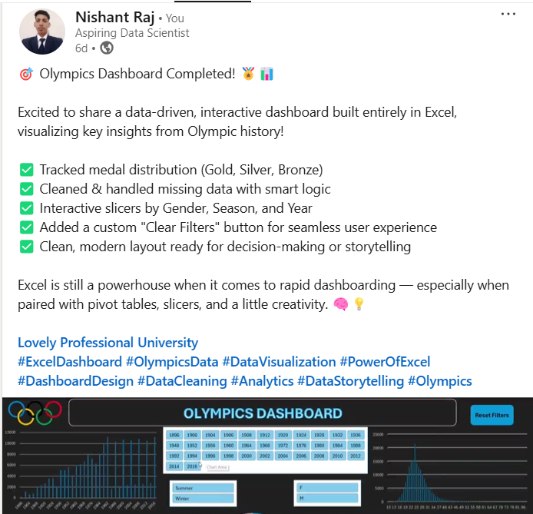



DASHBOARD
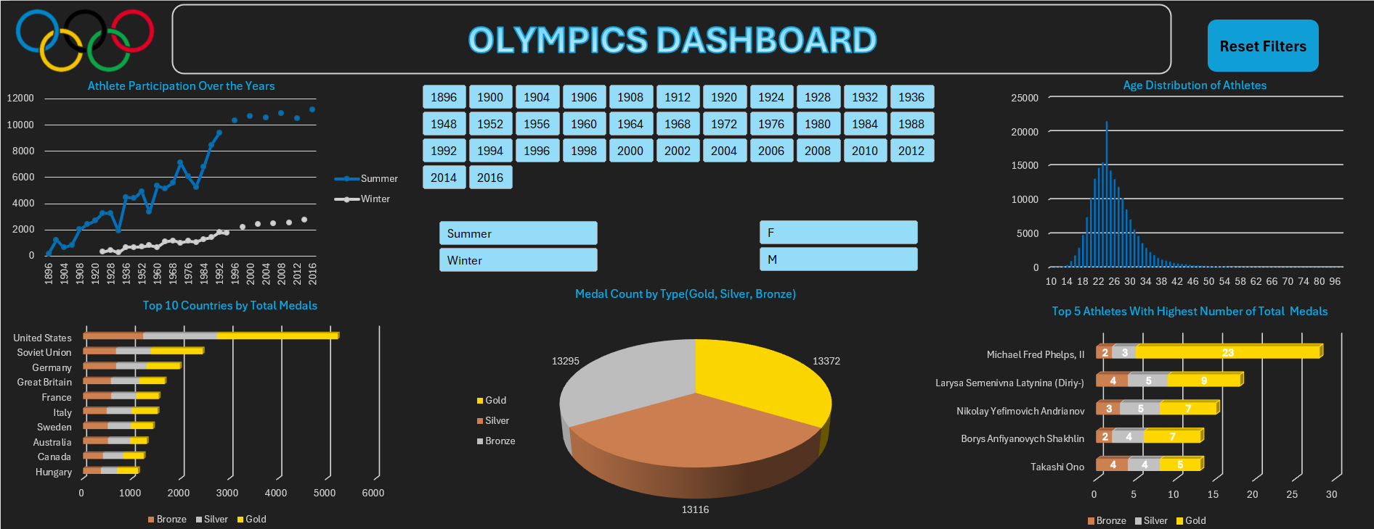

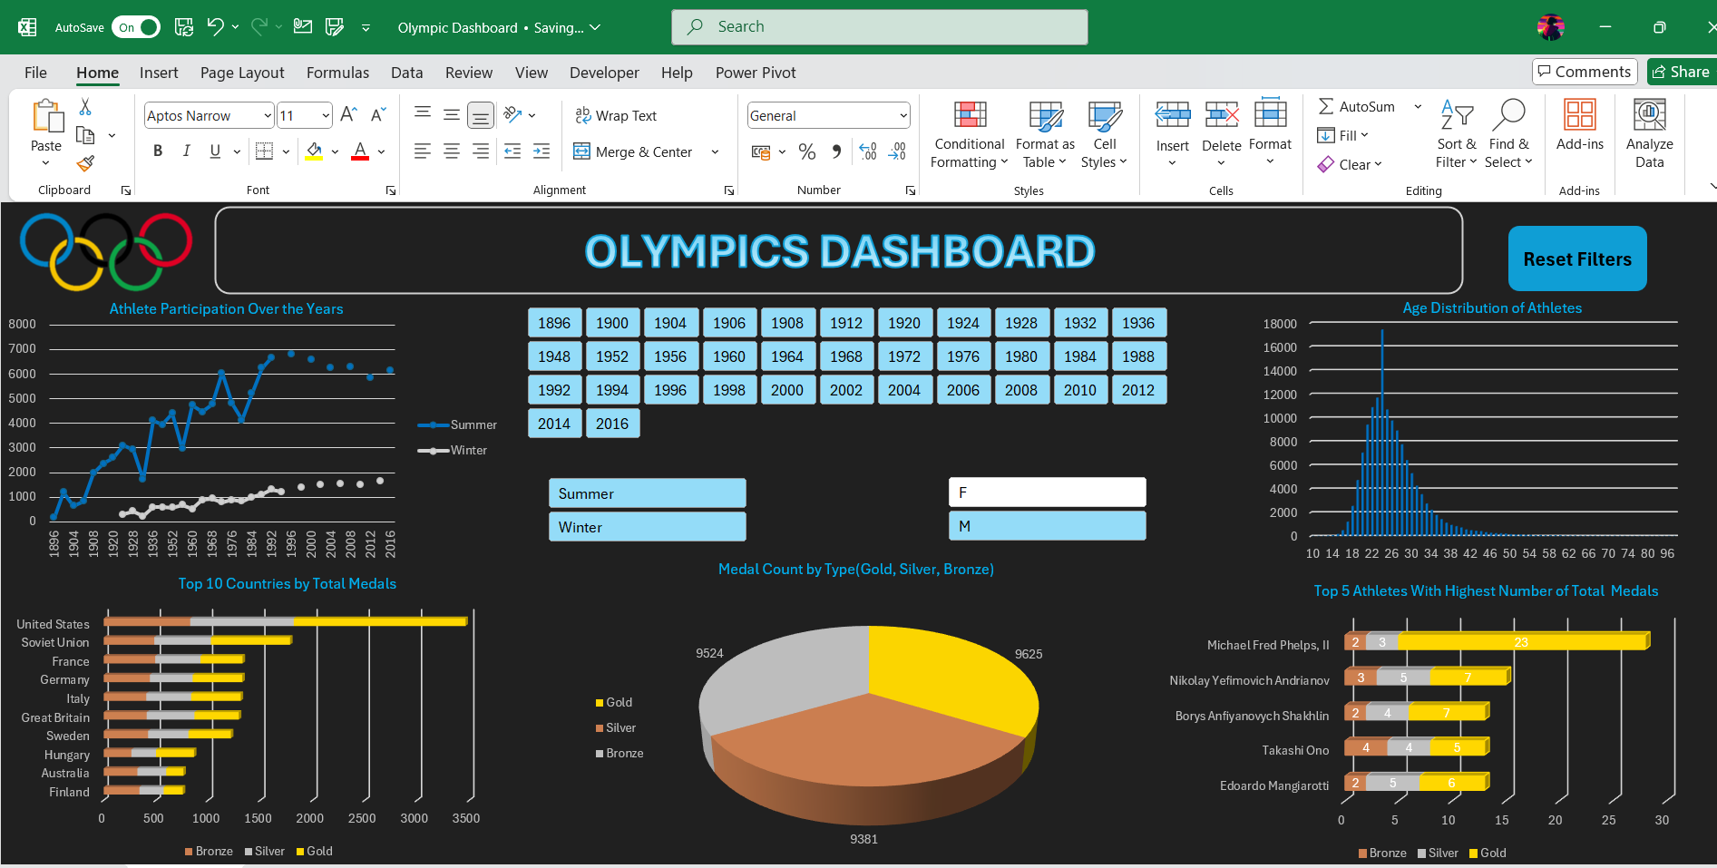
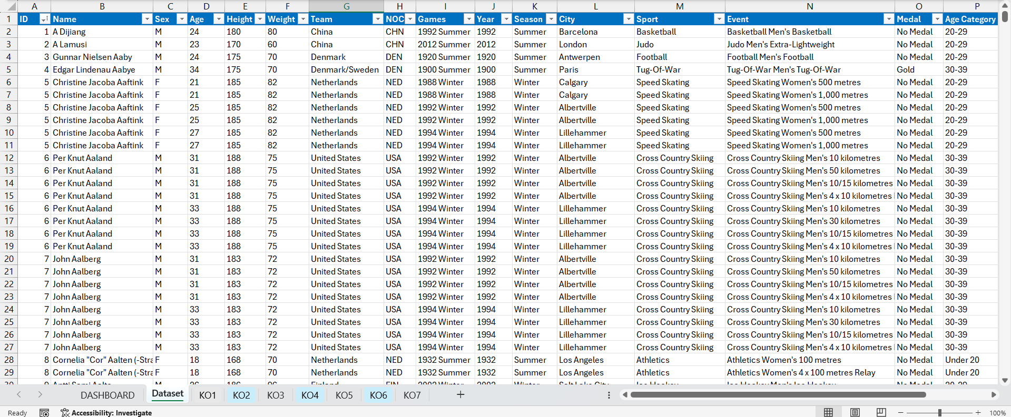
AFTER APPLYING MALE (M) FILTER
DATASET AND MORE CHARTS:

Comparison of Average (Age, Height, Weight) Over Gender

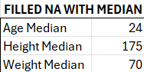

THANK YOU

