# Placement Eligibility Stream-lit Application

## Project Overview:

This project aims to develop a Streamlit-based application that filters and displays students eligible for placement based on user-defined criteria. It combines data generation, database management, SQL querying, and interactive dashboard development.

## Objectives:

* Build a dynamic Stream-lit app to evaluate student eligibility for placement.
* Use synthetic datasets representing real-world student metrics.
* Implement SQL queries for insights and analytics.
* Apply OOP principles in Python for structured and maintainable code

## Technology Stack:

1. Frontend: Stream-lit
2. Backend: Python, SQLite
3. Libraries: Faker, pandas, Random, Num-py SQL Libraries
4. Database: SQLite
5. Development Tools: Jupyter Notebook, Git- Hub

## Dataset Design:

Includes:  
1. Students Table  
2. Programming Table  
3. Soft Skills Table  
4. Placements Table

## System Architecture:

1.Data is generated using Faker and inserted into SQLite.  
2. Stream-lit UI accepts input filters for eligibility.  
3. SQL queries fetch and filter eligible candidates.  
4. Results are displayed in a Stream-lit Application.

## Application Features:

1. Input-based student filtering (e.g., problem count > 50, communication > 75).  
2. Real-time display of eligible candidates.  
3. Stream-lit Application with key insights from SQL analytics.

## SQL Queries and Insights:

1. Top 50 Students by Mock Interview Score  
2. Students Who Completed Certificates More Than 2  
3. Programming Language Used by Students  
4. Top 50 Soft Skill Performers  
5. Average Placement Package by Batch  
6. Placement Status Count  
7. Students Who Completed More Than 1 Internship  
8. Students with Strong Leadership Skills (>75)  
9. Companies That Have Placed Students  
10. Students Eligible for Placement (User Eligibility Criteria)

## Stream-lit Features:

1.Simple sidebar name as **Home Page** input for filter criteria.

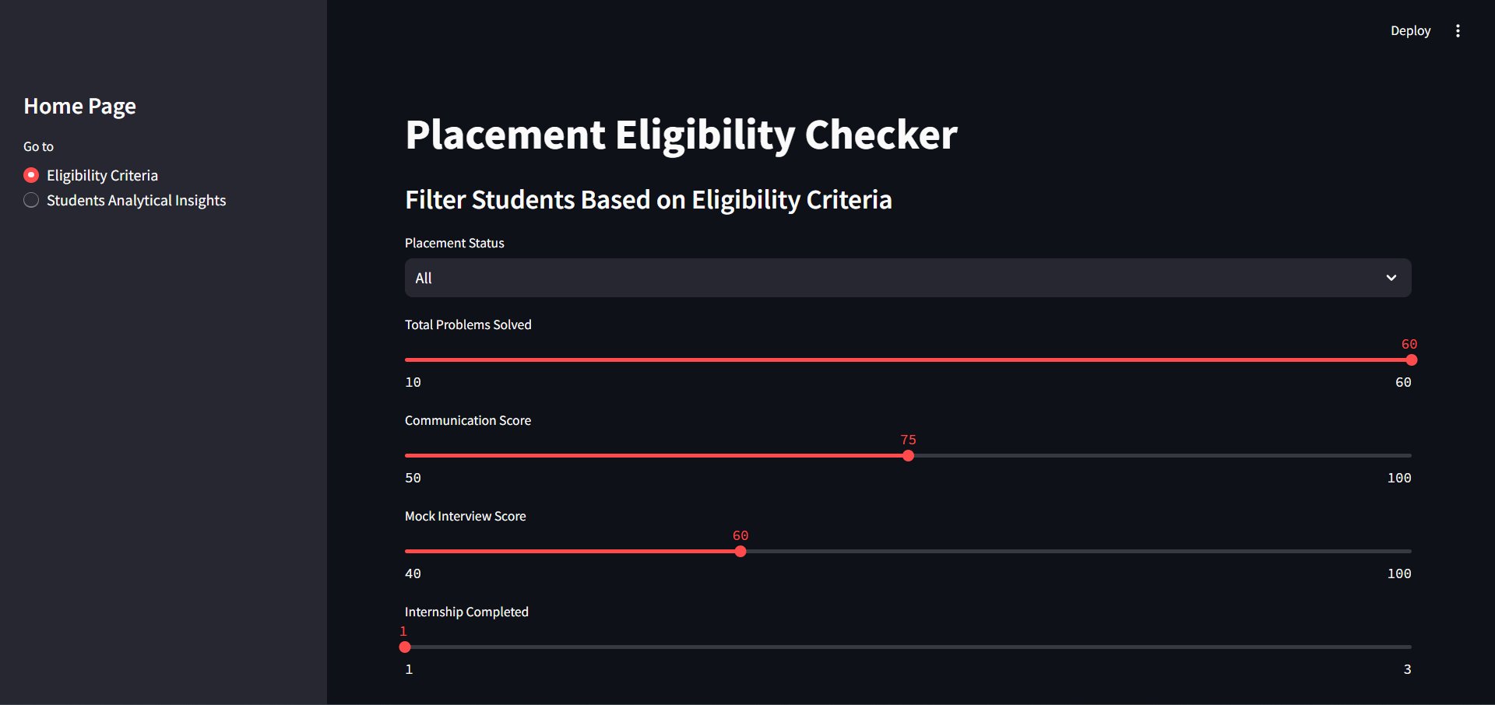

2. Tables showing live results.

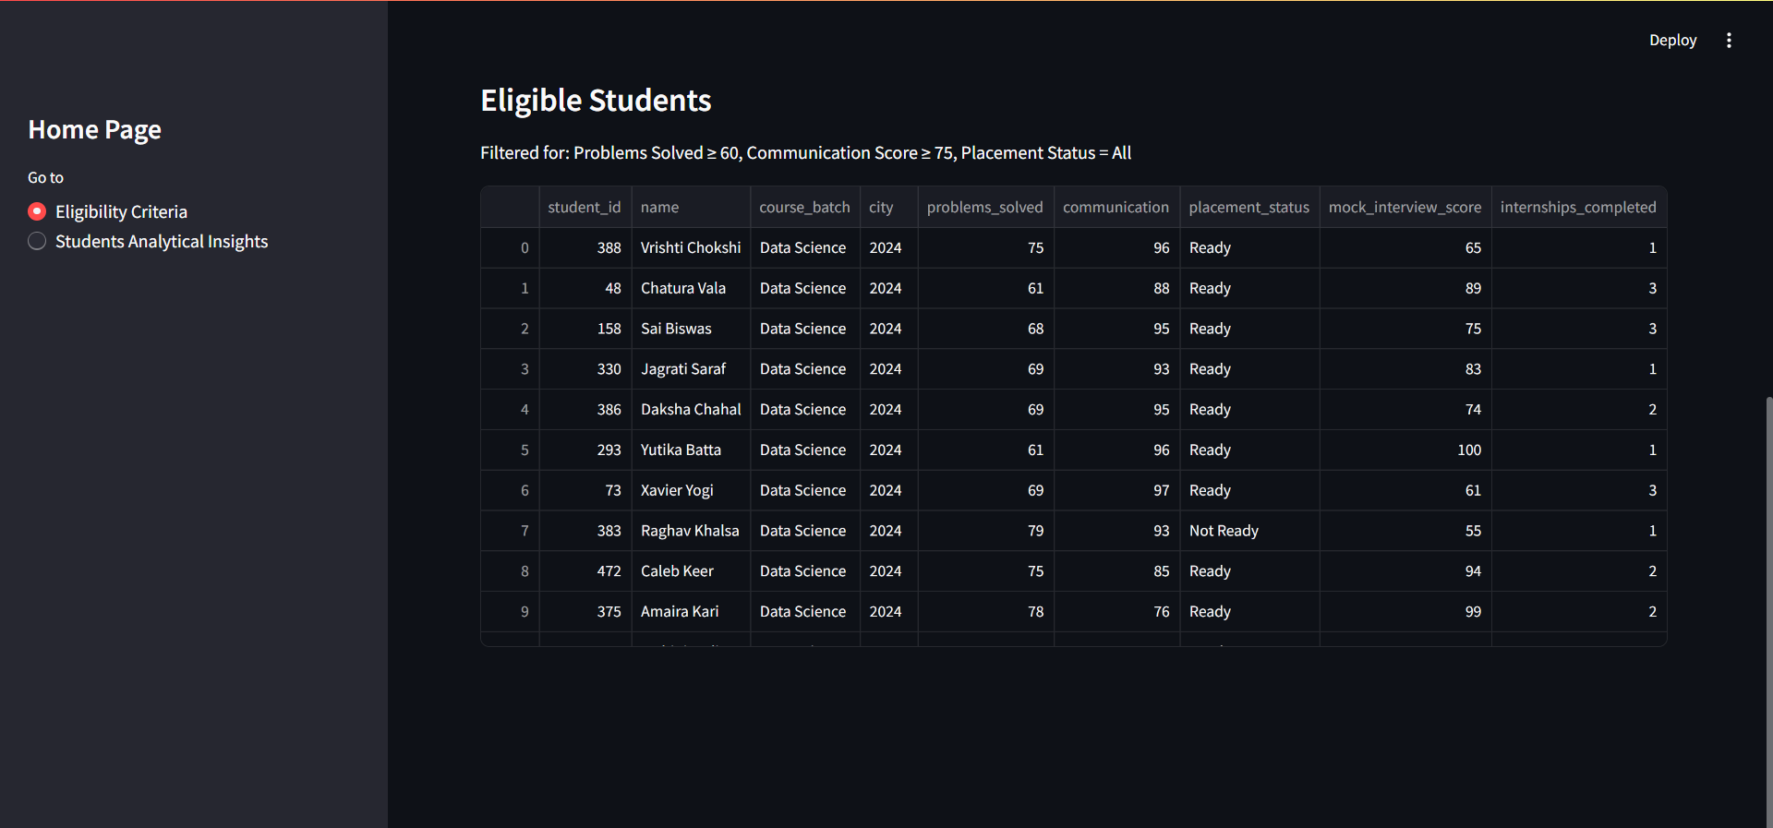

3. Clean layout with collapsible sections.

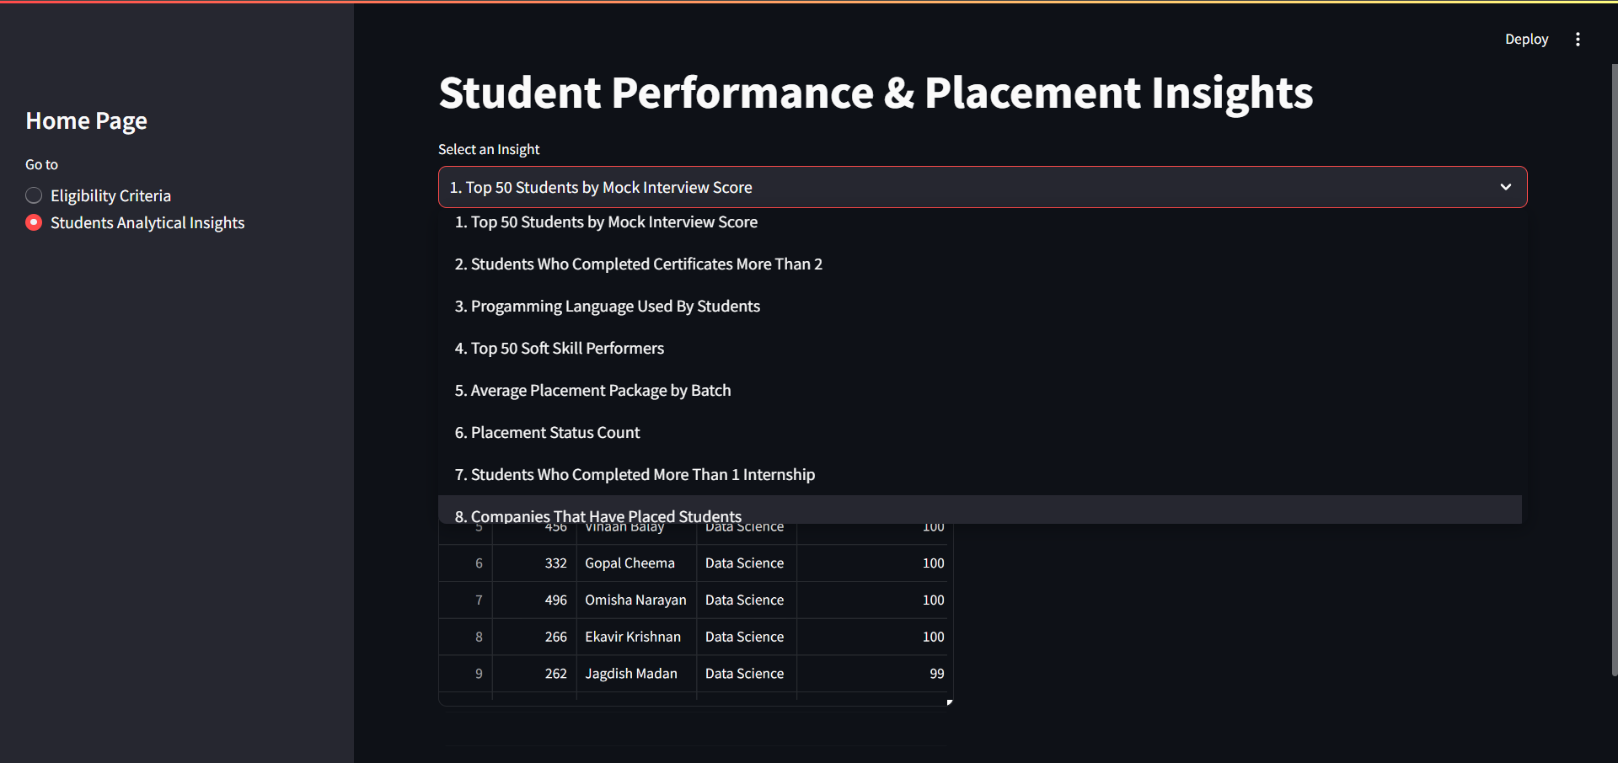

4. Box showing all 10 SQL queries and Insights.



## Project Evaluation Metrics:

✅Functionality (filters and displays students)  
✅SQL Insights (actionable and well-formed queries)  
✅OOP (classes and modular code)  
✅UI (Streamlit interactivity)  
✅Documentation (this!)

## References

1. Stream-lit Documentation: https://docs.streamlit.io  
2. Project orientation and guide videos (as in documents)